Edge Computing for Real-time Process Monitoring

Abstract
Filling error control is an important but challenging problem in most production systems for a wide spectrum of liquid products. The major challenges behind this control problem include uncontrollable ambient factors, highly diversified products in modern manufacturing plants, limited budget for complex feedback control schemes, etc. To devise a low cost solution that is suitable massive replication, this paper proposes a data-driven approach for filling error control by using Just-In-Time Deep Belief Networks (JIT-DBN). The proposed method aims to construct a local DBN model based on historical data to suggest stopping time for the filling process by collectively considering the fluid viscosity, filling temperature and many other affecting factors. Based on the proposed method, a systematic framework for implementation is further devised. The proposed framework leverages the advantages of edge computing and cloud platforms to present a scalable solution with guaranteed computation efficiency and excellent adaptiveness to highly diversified products. In the validation experiments, both the proposed method and the proposed implementation framework are tested in the real-world filling production line for massive production. It is found that the proposed method can effectively reduce the mean filling errors and the filling uncertainties.

Index terms: Flow control, deep learning, just-in-time modeling, edge computing, data driven, deep belief neural network.

INTRODUCTION
* Corresponding Author:
Email address: gsmith65@student.mtsac.edu (Wang Chao)
The global movement towards Industry 4.0 has initiated the emergence and advancement of different analytic tools such as machine learning and deep learning in manufacturing systems with promising impact on productivity, efficiency, speed, and resilience. However, realization of the full potentials of these tools is highly restricted by the computation, storage, and communication capacities of manufacturing assets. For instance, a PLC (Programmable Logic Control) controller lacks the sufficient resources to perform advanced analytics by itself and therefore still traditional control methods with low computational requirements are preferred in industrial applications. To resolve these challenges, in recent years, edge/fog computing has been proposed as a supplementary technology that facilitates advanced computations by bringing resources close to the operational devices. Therefore, resource-restricted devices (such as PLC controller) would be able to use the resources provided by the edge to perform computationally expensive tasks. Using edge computing is essential for deployment of deep learning especially in delay-sensitive applications. Moreover, traditional control logics mostly lack the capacity to incorporate valuable knowledge from historical data during the control process. Thus, their performance deteriorates as the experimental condition changes.
Filling error control is an important but challenging problem in many production systems that produce liquid products like beverages, detergents, gasoline, etc. For most automatic filling machines, the goal of filling error control is to determine an optimal stopping time of the filling process, so that the bottle is precisely filled to a target volume. This is important to the manufacturers of liquid products since the under-filled bottles might negatively affect customer satisfaction and result in customer complaints and lawsuits. On the other hand, over-filled bottles may cause transportation problems and increased manufacturing costs. Facing fierce competition in the market and the increasing needs of lean manufacturing, the financial loss introduced by filling errors is becoming a more and more prominent problem for most manufacturers.
Despite the importance of the problem, devising a low-cost solution that is suitable for massive production is quite challenging. The difficulties include the uncertainties of fluid viscosity and filling temperature, the soaring cost associated with sophisticate feedback control system, the adaptiveness to a wide spectrum of the liquid products, etc. Consequently, the trial-and-error method is still widely adopted in most liquid filling systems. This method normally stops the filling process when the flowmeter reaches a pre-defined threshold. The pre-defined threshold is tuned by human experts from product to product. This method suffers large filling error and it is unable to compensate the uncertainties of fluid viscosity and filling temperature. One can simply imagine filling up a vehicle, it is challenging for a human to control the filling nozzle to let the flow meter stop precisely at a certain number.
In the recent literature, many control methods are explored and proposed [1-6]. By summarizing these studies, it is found that most of these methods are proposed in a lab environment. The effectiveness of these methods under massive production is untested and the implementation cost is less discussed. Moreover, some of these methods still require human to tune the control parameters for new products. This renders the method less effective when the change of products happens very often. Detailed literature survey and discussions can be found in Section II.B.
Digitization of industrial assets under the Industry 4.0 initiative has enabled increased availability of condition monitoring data and thus has resulted in the widespread use of intelligent data-driven models in manufacturing systems [7,8]. In this paper, in order to address the challenges mentioned above, an intelligent data-driven method for filling error control is proposed by using Just-In-Time Deep Belief Networks (JIT-DBN). The method fits a local DBN model based on the historical data from the same or similar products. The model is designed to suggest stopping time for the filling process by collectively considering the fluid viscosity, filling temperature and many other affecting factors. The advantages of the proposed method include: 1) its effectiveness in reducing filling error in massive production; 2) its adaptiveness to the change of products; 3) Guaranteed model efficiency for filling error control. Based on the proposed JIT-DBN model, a novel framework for implementation is also proposed. The proposed framework consists of a centralized data server and edge computers that are operating locally at the shop floor. The data server is needed to store effective samples for modeling, to store trained DBN models for products, to share data and models across production lines and plants. The edge computers are essentially used to train and deploy the DBN models to suggest stopping time for the filling process with minimal communication latency.
The remainder of this paper is organized as follows. The problem statement and the literature survey are presented in Section II. Section III highlights the novelties and details the proposed methodology. Results and discussion can be read in Section IV and the conclusion remarks are stated in Section V.

Problem Statement and Literature Survey

Problem Description
The goal of this research is to retrofit the existing automatic filling production line, as shown in Fig. 1, to reduce the bottle filling errors. The machine has some filling mechanisms (shown with F1 to F16) that are rotating clockwise to fill the bottles. The filling process is controlled by pneumatic valves as shown in Fig. 2. The valve opening and closing time is controlled by a typical PLC controller.
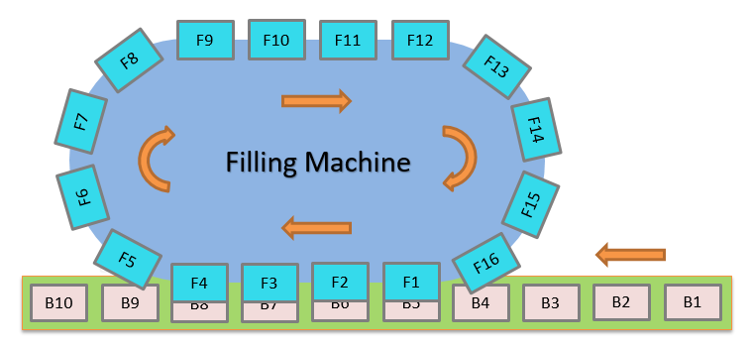
Fig. 1 Structure of the filling production line.
The control of each filling valve is governed by the counter module, which records the volume that has been filled into the bottle. The scientific problem in this investigation is to estimate a valve closing time that can reduce the filling error. The reference signal in each filling process is the flow-counter reading. In the current control setting, the filling process is stopped once the reading of flow counter reaches a certain target value. Normally, this target value is slightly lower than the target filling volume and it is set by experienced operators.
The flow-counter thresholding method may suffer large filling error due to the uncertainty of valve reaction time as shown in Fig. 3. If we wait until the flow-counter reading rises to the target volume to stop the valve, the bottle is over-filled. However, if we stop the valve early, the bottle might be under-filled. Also, the optimal timing for valve closing is affected not only by the valve reaction time, but also by the physical properties of the liquid product, such as viscosity, filling pressure, speed of the conveyor belt, etc.

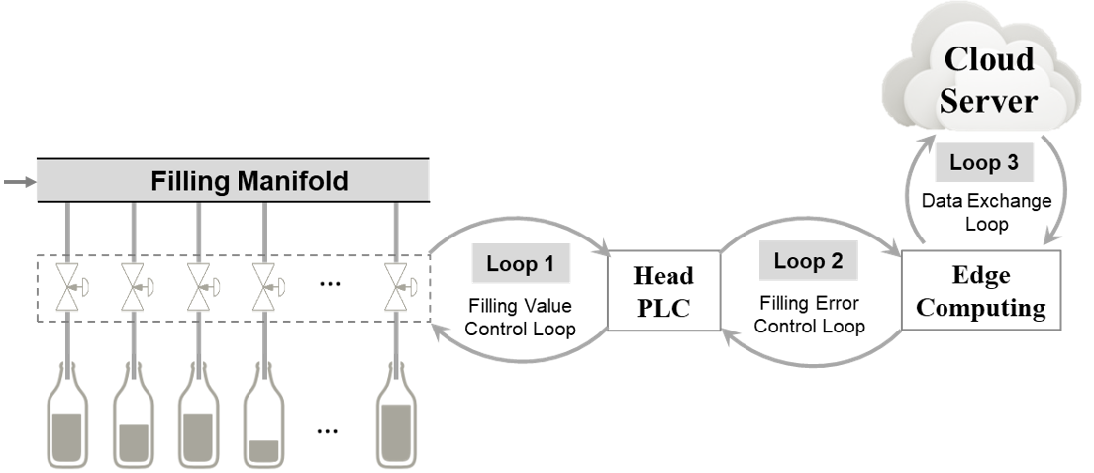
Fig. 2 The proposed framework for the filling error control.

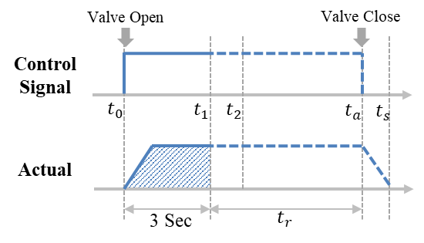
Fig. 3 Illustration of the current control logics and the research tasks
Other challenges of the research problem are listed as follows. 1) Model adaptiveness to a wide spectrum of the liquid products must be properly handle, especially the adaptiveness to new products; 2) The ambient temperature must be considered as an affecting factor, since it may change the viscosity of the liquid significantly; 3) Only open-loop control can be adopted, since designing a feed-back mechanism could be expensive; 4) The efficiency of the control model must be guaranteed to ensure in-process control; 5) The cost must be tightly controlled and the method must be suitable for massive productions.
Facing all the above-mentioned challenges, a novel framework is proposed in Fig. 2. The control loop 1 in Fig. 2 utilizes the existing hardware to control the actuators to open and close the valves. The control loop 2 takes the total flow rate in the first 3 seconds $f_{r}^{\left(3\right)}$ in each filling cycle and then feeds back the valve closing time to the PLC. The edge computing device is an industrial computer that is installed beside the filling machine which will have data exchanges with the centralized data platform. In this framework, the core is a data-driven model that is trained and deployed in the edge device. This model will take $f_{r}^{\left(3\right)}$ as one of the input variables and output $t_{a}$to trigger valve actions. More importantly, this data-driven should be product-specific to adapt to highly diversified products.
Fig. 3 better illustrates the proposed idea. Related nomenclatures are listed in TABLE I. The shadowed area in Fig. 3 indicates the value of $f_{r}^{\left(3\right)}$ which is recorded by the flow counter. At the 3rd second after filling begins, the $f_{r}^{\left(3\right)}$ is sent to the edge for computation and the estimated value of $t_{a}$is feedback to the PLC at $t_{2}$.
It is important to note that the proposed framework in Fig. 2 will require very little change to the existing systems. In Fig. 2, Loop 1 is the existing control loop for the legacy machines. Loop 2 and Loop 3 are additional control loops that need to be added. Benefits of the proposed framework are as follows:1) The cloud server can store historical data and the trained models for future usage. The data and models can be shared across different production lines and plants. 2) The additional control loops, Loop 2 and Loop 3 in Fig. 2, supplement the existing filling valve control loop. In case of a new product being filled, the traditional flow-counter thresholding method is used to generate effective samples for model training. Once a local model is constructed and tested, it can be deployed for control purpose.

Literature Survey
Filling error control is still a less explored problem in the literature, especially under the setting of massive production. Several related in the lab environment can be read in [1-6]. Mallaradhya and Prakash [2] highlighted that majority of the industrial bottle filling machines can only handle a particular type of containers of certain height. The study proposed an automatic bottle filling system fully controlled by a PLC depending upon height of the bottle. H. Ahuja et al. [6] proposes to use proximity sensor to monitor filling process. However, it requires too much efforts to retrofit the production line and the cost of installing and maintenance of those sensors might be high. Renganathan and Bhaskar [9] proposed a methodology for fault diagnosis and Fault Tolerant Control in a typical bottle-filling plant using Hybrid Petri nets. The propose methodology allows the system to decide whether to tolerate the fault (liquid overflow, sensor error and improper valve functioning) or isolate it from the main process for repair. Saif and Akram [10] proposed to update the gain parameters of the controllers based on a Gain-Scheduled Methodology to make the system under observation insensitive to sources of variability. The proposed methodology was validated with Application to a Carbonated Beverage Filling Process. Although many of these approaches can improve the filling accuracy to certain product, most of them still need human intervention to tune the control parameters when the machine is switched to fill a different product.
TABLE I
Nomenclatures
Variables | Symbol
Flow Rate | $$f_{r}$$
Total Flow Rate in the first 3 seconds | $$f_{r}^{\left(3\right)}$$
Pressure | $$p$$
Ambient Temperature | $$T$$
Bottle Volume | $$V_{b}$$
Viscosity | $$ϑ$$
Density | $$d$$
Air Percentage | $$a$$
Speed of Conveyer Belt | $$s$$
A set of product-specific parameters  $$Θ_{G}=\left\{p,T,V_{b},ϑ ,d,a,s\right\}$$ | $$Θ_{G}$$
Filling Error | $$e$$
Predicted Remaining Filling Time | $$t_{r}$$
Filling Valve Closing time  $$t_{a}=t_{r}+3$$ | $$t_{a}$$
Filling Stopping Time | $$t_{s}$$

Methodology
By summarizing the literature, the major contributions and benefits of this study are summarized as follows:

1) A novel framework for filling error control is proposed in Fig. 2. The proposed framework consists of three control loops and it embraces many key features in smart manufacturing including the edge computing and the cloud platform.

2) A novel JIT-DBN model is proposed to effectively reduce the filling error.
3) The proposed method requires very little modification to the existing system. It can switch back to the flow-counter thresholding control method when a new product is filled or when the data-driven model is not performing well.
4) The proposed framework can be easily scaled up for massive production at low cost. Additionally, the data assets in the cloud platform can be shared across multiple plants at different locations. Moreover, the computation of the trained data-driven model is very efficient.

Just-In-Time Modeling
Just-In-Time (JIT) modeling, which is also known as lazy learning[11-13], is widely used to model nonlinear processes with a significant amount of variations. The core idea of JIT is to build a local model from the historical data with similar process characteristics. This method simplifies the learning problem to a desired sub-region of the original sample space. It is thus likely to outperform other methods in handling nonlinearities or process variations. Besides, JIT learning provides a simple framework for implementation and it can integrate a wide range of machine algorithms for modeling. Various JIT modeling variants are reviewed in [14]. Application of JIT modeling can be found in semiconductor manufacturing for virtual metrology and failure detections. Typical JIT algorithms such as sequential update model (SUM), locally weighted regression (LWR) and locally weighted partial least squares (LW- PLS) are proposed and benchmarked in [15, 16].
In the present case, JIT is used to query the historical data under the same or similar production conditions. The historical samples are regarded as similar if all the parameters in $Θ_{G}$ are found similar to the current product. This makes the proposed method to be product specific. Once a different product is filled, the local model for filling error control must be changed or re-trained accordingly.

Deep Belief Networks
First proposed by Hinton [17,18], DBN architecture mainly contains an unsupervised learning subpart which consists of restricted Boltzmann machines (RBMs) as its building blocks. An RBM is a stochastic neural network which can learn the probability distribution over the input dataset. The energy function for individual RBM layer can be written as:
 | $$E\left(v,h;θ\right)=-\sum_{i=1}^{V}{a_{i}v_{i}}-\sum_{j=1}^{H}{b_{j}h_{j}}-\sum_{i=1}^{V}{\sum_{j=1}^{H}{w_{ij}v_{i}h_{j}}}$$ | (1)
where $θ=\left(w,a,b\right)$ are the model parameters; $v_{i}$ and $h_{j}$ are the visible unit $i$ and hidden unit $j$, respectively; $w_{ij}$ is the weight connection between $v_{i}$ and $h_{j}$, with $a_{i}$ and $b_{j}$ their biases; and V and H are the number of visible and hidden units, respectively. Given the probabilistic nature of RBM, the objective is to maximize the conditional probability of visible units given the parameters $θ$.
 | $$p\left(v,h;θ\right)=\frac{1}{Z\left(θ\right)}exp\left(-E\left(v,h;θ\right)\right)$$ | (2)
where $Z\left(θ\right)=\sum_{v}{\sum_{h}{exp\left(-E\left(v,h;θ\right)\right)}}$ is the normalization constant.
By stacking multiple layers of RBMs together, the resulting network is DBN. The advantage of this stacked network is that it can be trained in a bottom-up fashion, which is known as greedy layer-wised pre-training. After the pre-training is complete, the network can be fine-tuned by back propagation for a specific purpose.
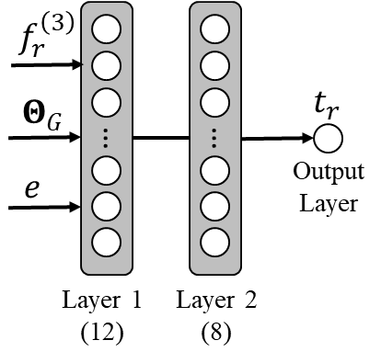
Fig. 4 The proposed network structure for filling error control
The proposed DBN structure for filling error control is shown in Fig. 4. The input variables include $f_{r}^{(3)},Θ_{G}$ and $e$, where $Θ_{G}$ is not updated for the same batch of product and $f_{r}^{(3)}$ is different for different filling cycle. Normally, it takes 2~3 hours to fill one batch of products. The $Θ_{G}$ is not updated for the same batch of products since the physical properties and the ambient temperature are unlikely to change significantly in 2~3 hours. The variable $e$ is a real-valued number from the historical data in the model training. This value is always set to 0 throughout the model testing phase. The first two layers in Fig. 4 are RBM layers which have 12 neurons and 8 neurons respectively. The output layer is a simple linear regression node. The proposed network structure in Fig. 4 is tuned based on multiple liquid product. In case of filling a new product, the network has to re-trained, but the network structure can be kept the same.

Methods for Filling Error Control
The proposed method for filling error control is named as JIT-DBN, which fits a product-specific DBN model for filling error control. In the proposed method, the historical data samples from the same or similar products are firstly queried from database. All the queried samples should have similar $Θ_{G}$ with the current product.
The DBN model is product-specific which is fitted by using the historical samples with similar $Θ_{G}$. In model training, the inputs of the DBN model include the $f_{r}^{(3)},Θ_{G}$ and $e$ of the
historical samples, as shown in TABLE II. The target variable is the valve closing time $t_{a}$. In model testing phase, the inputs are $f_{r}^{(3)}$ and $Θ_{G}$ for the current product, and the filling error $e=0$. The local DBN model will then estimate a desired valve closing time. It is important to note that $f_{r}^{(3)}$ is different for different filling cycle. However, $Θ_{G}$ is kept the same for the same product and $e$is always set to 0 throughout the testing phase.
TABLE II
The Proposed Method for Filling Error Control
Model Training | Input | $$X_{v}=\left\{f_{r}^{(3)},Θ_{G}, e\right\}$$
Model Training | Output | $$Y_{v}=t_{a}-3$$
Model Testing | Input | $$x_{v}=\left\{f_{r}^{(3)},Θ_{G}, e=0\right\}$$
Model Testing | Output | $$y_{v}=t_{r}$$

Implementation
There are seven key steps to implement the proposed method
for filling error control, as shown in Fig. 5. These steps are also detailed as follows:
① | Request product properties $Θ_{G}$ from filling PLC controller;
② | Query data records for same or similar products from cloud server;
③ | Download the data records from the cloud server;
④ | Train the DBN model using the queried data records and deploy the trained model for testing
⑤ | Request $f_{r}^{(3)}$ from PLC at each filling cycle;
⑥ | Feedback $t_{a}$ to the PLC for actions;
⑦ | Upload data and the trained model to the cloud server for future usage.
When the machine is switched to fill a different type of liquid product, steps ①~④ must re-implemented to build a new model for this specific product. In case of new product, the flow-counter based control logic is adopted in the first place until enough samples are accumulated to train a useful model. The model after step ④ must be carefully calibrated through cross-validation and tested for robustness. An empirical fail-safe mechanism is also necessary to limit the range of the model outputs after deployment. Steps ⑤ and ⑥ are repeated at each filling cycle to suggest valve closing time. Step ⑦ is triggered after a certain number of filling cycles. The interval of data uploading is determined by the performance of hardware.
(a) | 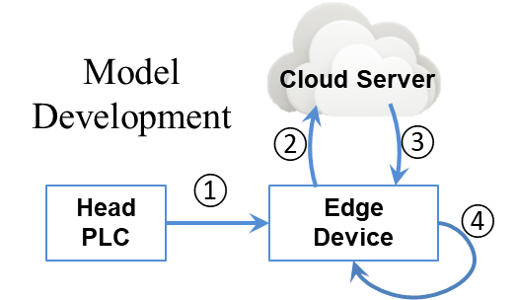
(b) | 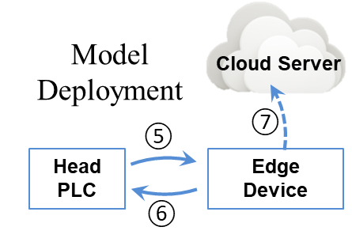
Fig. 5 Key steps (a) model development and (b) model deployment.

Results and Discussion
In this Section, the proposed method is implemented and tested on an automatic filling machine. To consider the variation of products and the influence of ambient factors, three products with high (# 277), medium (# 315) and low (# 411) level of viscosity are filled in the experiments. For each product, the filling errors are observed under 10 different filling temperature and 16000 bottles are filled in each run. The mean squared filling error for all the testing runs (30% of the total samples) are tabulated in TABLE III.
In TABLE III, the proposed JIT-DBN method is benchmarked against the traditional filling error control method and other JIT models. The results in TABLE III clearly indicate that the proposed JIT-DBN gives the lowest filling error under all the testing conditions. Other findings based on the results in TABLE III are summarized as follows. 1) The liquid product with high viscosity tends to have large filling error. This is because the required filling pressure for the high viscosity fluid is normally higher than other products, which makes the filling error difficult to control; 2) The mean squared filling error has a decreasing trend over the filling temperature. This is understandable because the fluid with higher temperature is less viscous and thus requires smaller filling pressure. 3) All the JIT models can apparently reduce the filling error comparing with the traditional method. It is believed that this improvement in the filling error is brought by the feed-back mechanism that is brought by the filling error control loop in Fig. 2. 4) It is found that JIT-DBN outperforms other JIT model, including JIT-LR (Linear Regression), JIT-SVR (Support Vector Regression) and JIT-RBM. This implies the DBN model is a good option and its learning performance is significantly better than the rest three machine learning algorithms.

To better highlight the improvements made by the proposed method, the distributions of the filling error under all the testing conditions are shown in Fig. 6.

TABLE III
Benchmarking of Mean Squared Filling Error of Multiple Data-Driven Approaches
 | Run | T (℉) | Traditional Method | JIT-LR | JIT-SVR | JIT-RBM | JIT-DBN
# 277  (High Fluid Viscosity) | 1 | 47.11 | 341.70 | 323.08 | 37.95 | 21.34 | 13.65
# 277  (High Fluid Viscosity) | 2 | 49.08 | 327.95 | 310.05 | 36.41 | 20.48 | 13.10
# 277  (High Fluid Viscosity) | 3 | 53.42 | 314.45 | 297.25 | 34.91 | 19.63 | 12.56
# 277  (High Fluid Viscosity) | 4 | 62.75 | 301.24 | 284.73 | 33.45 | 18.81 | 12.04
# 277  (High Fluid Viscosity) | 5 | 65.03 | 288.29 | 272.51 | 32.01 | 18.00 | 11.52
# 277  (High Fluid Viscosity) | 6 | 69.42 | 275.64 | 260.53 | 30.60 | 17.21 | 11.01
# 277  (High Fluid Viscosity) | 7 | 72.54 | 263.25 | 248.83 | 29.23 | 16.44 | 10.52
# 277  (High Fluid Viscosity) | 8 | 76.21 | 251.18 | 237.37 | 27.89 | 15.68 | 10.04
# 277  (High Fluid Viscosity) | 9 | 79.75 | 239.41 | 226.21 | 26.58 | 14.95 | 9.56
# 277  (High Fluid Viscosity) | 10 | 81.00 | 227.86 | 215.32 | 25.29 | 14.23 | 9.10
# 315  (Medium Fluid Viscosity) | 1 | 46.45 | 150.00 | 136.26 | 16.86 | 9.27 | 5.84
# 315  (Medium Fluid Viscosity) | 2 | 48.11 | 135.08 | 122.36 | 15.19 | 8.34 | 5.25
# 315  (Medium Fluid Viscosity) | 3 | 52.31 | 120.92 | 109.23 | 13.61 | 7.46 | 4.69
# 315  (Medium Fluid Viscosity) | 4 | 65.23 | 107.57 | 96.83 | 12.12 | 6.63 | 4.17
# 315  (Medium Fluid Viscosity) | 5 | 67.00 | 95.00 | 85.20 | 10.72 | 5.85 | 3.67
# 315  (Medium Fluid Viscosity) | 6 | 68.62 | 83.21 | 74.30 | 9.40 | 5.12 | 3.20
# 315  (Medium Fluid Viscosity) | 7 | 73.11 | 72.25 | 64.15 | 8.17 | 4.44 | 2.77
# 315  (Medium Fluid Viscosity) | 8 | 76.42 | 62.02 | 54.74 | 7.03 | 3.80 | 2.37
# 315  (Medium Fluid Viscosity) | 9 | 79.31 | 52.63 | 46.10 | 5.98 | 3.22 | 2.00
# 315  (Medium Fluid Viscosity) | 10 | 83.15 | 44.00 | 38.19 | 5.02 | 2.68 | 1.66
# 411  (Low Fluid Viscosity) | 1 | 45.13 | 81.16 | 54.50 | 6.83 | 3.74 | 2.38
# 411  (Low Fluid Viscosity) | 2 | 49.23 | 72.92 | 47.04 | 5.93 | 3.24 | 2.06
# 411  (Low Fluid Viscosity) | 3 | 51.44 | 65.09 | 40.14 | 5.10 | 2.77 | 1.76
# 411  (Low Fluid Viscosity) | 4 | 63.41 | 57.73 | 33.79 | 4.33 | 2.35 | 1.49
# 411  (Low Fluid Viscosity) | 5 | 65.00 | 50.81 | 27.98 | 3.62 | 1.95 | 1.24
# 411  (Low Fluid Viscosity) | 6 | 69.32 | 44.30 | 22.73 | 2.98 | 1.60 | 1.01
# 411  (Low Fluid Viscosity) | 7 | 72.41 | 38.26 | 18.02 | 2.40 | 1.28 | 0.81
# 411  (Low Fluid Viscosity) | 8 | 74.52 | 32.65 | 13.87 | 1.89 | 0.99 | 0.63
# 411  (Low Fluid Viscosity) | 9 | 79.25 | 27.50 | 10.25 | 1.44 | 0.75 | 0.47
# 411  (Low Fluid Viscosity) | 10 | 82.31 | 22.80 | 7.19 | 1.06 | 0.54 | 0.34
The results in Fig. 6 clearly indicate that the proposed method can effectively reduce the filling uncertainty comparing with the traditional method. In addition, these results imply that the proposed method is superior than simply thresholding the reading of flow-counter. The improvement in the filling uncertainty that is made by the proposed method has been better visualized in Fig. 7.
(a) | (b) | (c)
(d) | (e) | (f)
Fig. 6 Filling error distribution over the change of liquid temperature. The results in (a) (b) (c) are given by the traditional filling error control method for product #277, #315 and #411 respectively. The results in (d) (e) (f) are given by the proposed JIT-DBN method for product #277, #315 and #411. The center lines with markers indicate the mean filling error. The dashed lines indicate the $±2σ$ filling uncertainty.

Conclusion
As a summary, this paper proposed a novel framework for filling error control with three control loops, as shown in Fig. 2.
(a) | (b) | (c)
(d) | (e) | (f)
Fig. 7 Distribution of filling errors given by the traditional approach (a) (b) (c) and by the proposed JIT-DBN approach (d) (e) (f) for different products. The center line indicates the mean value of the distribution. The dashed lines show the $±2σ$ of the distribution.
Based on the framework, a JIT-DBN model is proposed for filling error control. The proposed network structure is shown in Fig. 4 and the implementation details are stated in Fig. 5. The performance of the proposed method is validated based on three different liquid products with high, medium and low viscosity. Benchmarking results are tabulated in TABLE III, which supports the conclusion that the results from the proposed JIT-DBN significantly outperform the flow-counter based control and other JIT models.
Based on the validation results, the proposed method is found as low-cost solution for filling error control which requires limited efforts to retrofit the existing system. Proven benefits of the proposed method include. 1) reduced filling error; 2) easy switching between the proposed method and the traditional control method; 3) adaptiveness to the new products and the product characteristic change; 4) the proposed method is scalable for massive replications; 5) the data assets and trained models can be shared across manufacturing plants via the cloud platform.
In the future research, a reliance index will be explored to monitor the robustness of models. Besides, the online updating strategy will be also investigated to keep the model updated.
References
[1] S. L. Kulkarni and M. Elango, "Development of PLC based controller for bottle filling machine," in International Journal Of Innovations In Engineering Research And Technology, ed, 2016, pp. 1-10.
[2] Lee J, Azamfar M, Singh J, Siahpour S. Integration of digital twin and deep learning in cyber-physical systems: towards smart manufacturing. IET Collaborative Intelligent Manufacturing. 2020 Apr 9;2(1):34-6.
[3] M. Sreejeth and S. Chouhan, "PLC based automated liquid mixing and bottle filling system," in 2016 IEEE 1st International Conference on Power Electronics, Intelligent Control and Energy Systems (ICPEICES), 2016, pp. 1-5.
[4] D. Baladhandabany, S. Gowtham, T. Kowsikkumar, P. Gomathi, and P. Vijayasalini, "PLC based automatic liquid filling system," International Journal of Computer Science and Mobile Computing, vol. 4, pp. 684-692, 2015.
[5] M. Panchal, A. Panaskar, and L. Kumar, "PLC based liquid filling and mixing," International Journal of Electrical and Electronics Research, vol. 3, pp. 249-253, 2015.
[6] H. Ahuja, A. Singh, S. Tandon, S. Srivastava, and S. Pal, "Automatic filling management system for industries," International Journal of Emerging Technology and Advanced Engineering, vol. 4, pp. 241-244, 2014.
[7] J. Lee, M. Azamfar, J. Singh, "A blockchain enabled Cyber-Physical System architecture for Industry 4.0 manufacturing systems," Manufacturing Letters, vol. 20, pp. 34-39, 2019.
[8] Azamfar, Moslem, Jaskaran Singh, Inaki Bravo-Imaz, and Jay Lee. "Multisensor data fusion for gearbox fault diagnosis using 2-D convolutional neural network and motor current signature analysis." Mechanical Systems and Signal Processing 144 (2020): 106861.
[9] Renganathan, K., and Vidhyacharan Bhaskar. "Modeling, analysis and performance evaluation for fault diagnosis and Fault Tolerant Control in bottle-filling plant modeled using Hybrid Petri nets." Applied Mathematical Modelling 37.7 (2013): 4842-4859.
[10] Saif, A. W. A., & Akram, M. A. (2011, December). A Robust-Gain-Scheduled methodology for process parameter design and control with application to a carbonated beverage filling process. In 2011 IEEE International Conference on Industrial Engineering and Engineering Management (pp. 1670-1674). IEEE.
[11] Lee, J., Singh, J. and Azamfar, M., 2019. Industrial Artificial Intelligence. arXiv preprint arXiv:1908.02150..
[12] O. Maron and A. W. Moore, "The racing algorithm: Model selection for lazy learners," Artificial Intelligence Review, vol. 11, pp. 193-225, 1997.
[13] C. Atkeson, A. Moore, and S. Schaal, "Locally weighted learning. AI Review 11: 11-73," ed: Kluwer, 1997.
[14] M. Kano and K. Fujiwara, "Virtual sensing technology in process industries: trends and challenges revealed by recent industrial applications," Journal of chemical engineering of Japan, p. 12we167, 2012.
[15] T. Hirai, K. Hazama, and M. Kano, "Application of locally weighted partial least squares to design of semiconductor virtual metrology," in Control Applications, 2014.
[16] T. Hirai and M. Kano, "Adaptive virtual metrology design for semiconductor dry etching process through locally weighted partial least squares," IEEE Transactions on Semiconductor Manufacturing, vol. 28, pp. 137-144, 2015.
[17] G. E. Hinton, S. Osindero, and Y.-W. Teh, "A fast learning algorithm for deep belief nets," Neural computation, vol. 18, pp. 1527-1554, 2006.
[18] Azamfar M, Li X, Lee J. Intelligent ball screw fault diagnosis using a deep domain adaptation methodology. Mechanism and Machine Theory. 2020 Sep 1;151:103932.
[19] Singh J, Azamfar M, Ainapure A, Lee J. Deep learning-based cross-domain adaptation for gearbox fault diagnosis under variable speed conditions. Measurement Science and Technology. 2020 Feb 6;31(5):055601.

