
Group 2218—Miread Brandes, Chelsea Ker, Margaret McCluskey, Robert Newman, and Amanda Sauls
Chemical Engineering Program
Department of Chemical and Environmental Engineering
University of Cincinnati
PO Box 210012
Cincinnati, Ohio 45221-0012
To: S.W. Thiel

From: Team 2218 for Project 5046-2218

Date: 25 April 2022

Subject: Enzymatic Recycling of Polyethylene Terephthalate

Dear Dr. Stephen W. Thiel,

Per your request, Team 2218 has written and compiled the following design report with supporting documentation. Supporting documentation for this report is the economic evaluation as well as a Process Hazard Analysis report (PHA) detailing potential hazards associated with equipment and piping. The current design with supporting utilities and operations has an estimated total capital investment of $54.68 million dollars. The team recommends selling terephthalic acid (rTPA) at $2.21 per kilogram to reach a net present value of $0 after 10 years. This price is not yet competitive with the current market of virgin TPA, which historically has been between $1.00 and $1.50 per kilogram. This process also produces liquid ethylene glycol (EG) and sodium sulfate salt (SS) that can be sold as co-products. The return on investment (ROI) is 24.4% and the venture profit is $1.34 million.
The current state of the economic and PHA analyses leads the team to recommend proceeding with the process under the condition that there is opportunity for further optimization. This process is an important emerging green technology and proposes a circular approach to plastic production. Optimization of on-site wastewater treatment, and unit operation modification could bring the price of rTPA closer to that of virgin TPA.
Research into process and safety hazards of this process has been conducted using the What-If methodology and is discussed in the PHA report. There are a few notable process hazards and safety recommendations to remedy those identified. If you have any questions about this report, please contact the team through the appropriate channels.

Best Regards,
Team 2218

List of Process Design Attachments:
- 5046-2218 Economic Forms Spring
- 5046-2218 Capital Cost Build-Up Spring
- DWG 5046-03928-B
- DWG 5046-03936-A
- DWG 5046-03937-A
- DWG 5046-03038-A
- DWG 5046-03041-B
- DWG 5046-03042-B
- DWG 5046-03043-B

ENZYMATIC RECYCLING OF POLYETHYLENE TEREPHTHALATE, PROJECT 5046-2218

Miread Brandes, Chelsea Ker, Margaret McCluskey, Amanda Sauls, Robert Newman
Department of Chemical and Environmental Engineering
University of Cincinnati

25 April 2022

Table of Contents
Abstract 1
1. Scope Definition 2
2. Design Basis 3
2.1 Plant Capacity 3
2.2 Feed Specifications 3
2.3 Product Specifications 3
2.4 Process Specifications 5
2.5 Siting Considerations 6
3. Process Description 7
3.1 Process Synthesis 7
3.2 Recommended Process 8
3.3. Process Control 21
3.4. Technology Risk 27
3.5. Environmental Performance 28
3.6. Process Safety 31
3.7. Regulations and Standards 32
3.8. Preliminary Equipment Specifications 35
4. Process Economics 36
4.1 Estimated Sales Revenue, Capital Costs, and Operating Costs 36
4.2. Economic Analysis 42
5. Recommendations and Future Work 45
References 47
Appendices 49
A. Hyperlinks to Safety Data Sheets 49
B. Summary of Physical Properties 49
C. Material and Energy Balance for Process and Utility Streams 50
D. Example Process Calculations 54
E. Emission Calculations 54
F. Example Economic Calculations 54
G. Specification Sheet 55

Abstract

The goal of this project was to research and propose the implementation of a polyethylene terephthalate (PET) recycling plant. At this phase of the project, the team presents a process design and its safety considerations. There were no explicit restraints put on this team aside from legal standards and regulations which are outlined in section 3.7 of this report. The recommended process is recycling PET flakes into its base polymers and monomers via a hydrolase enzyme biocatalyst. Future work includes further optimization of on-site wastewater treatment, unit operation modification, and consideration of internal storage for the products and reactants. A PHA will be submitted separately from this report to exemplify the safety concerns which are remedied by the proposed engineering controls. With this current design, the team is recommending selling terephthalic acid (rTPA) at $2.21 per kilogram to reach a net present value of $0 after 10 years. The determination of this unit price is further discussed in sections 4.1 and 4.2.

1. Scope Definition
The purpose of this project is to design a plant for the enzymatic recycling of polyethylene terephthalate to produce recycled terephthalic acid flake and co-products liquid ethylene glycol and sodium sulfate salt. The scope of this project is based on the baseline model by Singh et al. (2021) in “Techno-Economic, Life-Cycle, and Socioeconomic Impact Analysis of Enzymatic Recycling of Poly(ethylene terephthalate).” This process produces 31,600 tons/year of rTPA and operates for 8,000 hours/year. The feed rate of PET flakes is 6,250 kg/hr and the hourly production rate of rTPA is 3,950 kg/hr.
The project is a greenfield site and will require the purchase of land. Based on the information given at this stage, there will be no collateral work in contiguous areas, no work will be required outside of plant boundaries, or property improvement. The modeled plant assumes that the facility produces its own steam, provides its own tower water, cooling water, and wastewater treatment is priced as a utility operating expense. However, the production of steam and cooling water are outside of the battery limits of this process design.
There is technology risk associated with this project because the process has not been conducted on an industrial scale. The specific technology risk involves the use of generic PET hydrolase enzymes, which are still in the developmental stage. Hydrolase enzymes have been used in other applications, but not for the conversion of PET to rTPA. Because the process is new it must carefully consider the implications of scale-up and biosafety. The scope of this project also includes a PHA carried out using the What-If Analysis method. The PHA report can be found in the separate submission file titled “CHE 5046 Team 2218 PHA Report.”

2. Design Basis

2.1 Plant Capacity

The feed rate of PET flakes is 6,250 kg/hr and the hourly production rate of rTPA is 3,950 kg/hr. This process produces 31,600 tons/year of rTPA and operates for 8,000 hours/year.

2.2 Feed Specifications

The PET flake feedstock is 95% pure and contains 5.0 wt % contaminants consisting of caps, labels, dirt, etc. The caustic for the PET depolymerization and crystallization steps is “as pure” or >99 wt % purity. The enzyme feedstock is assumed to be 100% pure generic hydrolase enzymes. The sulfuric acid used in the crystallization step is 93 wt %. See Table 2.2.1 below for the compositions and conditions of the feed streams.

Table 2.2.1: Feed Specifications

Component | Composition (wt %) | Flow Rate (kg/hr) | Temperature (°C) | Pressure (bar)
PET flake feedstock | 95% | 6,250 | 25 | 1.0
Caustic | >99% | 2,184 | 25 | 1.0
Enzyme | 100% | 28 | 25 | 1.0
Sulfuric acid | 93% | 2,702 | 25 | 1.0

2.3 Product Specifications

The rTPA product is 96 wt% pure, the SS co-product is 98.5 wt% pure, and the EG co- product is 99 wt % pure. See Table 2.3.1 for specifications. The recovered product and co-products have sufficient purity to be sold to customers.
After the depolymerization step, the primary solution is passed through a filter where solids are separated from solution, this solution is then filtered again to remove the enzymes. This filter will produce solid waste that is 55 wt% PET and the enzyme filter removes 100 wt% enzymes. Waste from the activated carbon column is 87 wt% H₂O and sent to wastewater. During the crystallization step, rTPA is precipitated and the remaining solution is passed through a reverse osmosis (RO) membrane unit, the retentate proceeds in the process which is 97 wt % water and is sent to wastewater treatment. See Table 2.3.1 for the waste specifications.

Table 2.3.1: Product Specifications

Component | Composition (wt %) | Flow Rate (kg/hr) | Temperature (°C) | Pressure (bar)
rTPA | 96% | 3,946 | 32 | 0.5
SS | 99% | 6,569 | 0 | 1.0
EG | 99% | 827 | 25 | 1.0
Solid waste | 55% PET | 1,025 | 35 | 1.2
Enzyme waste | 100% | 28 | 35 | 1.1
Column waste | 87% H2O | 3,370 | 35 | 8.0
RO permeate waste | 97% H2O | 16,441 | 21 | 1.0

2.4 Process Specifications

Table 2.4.1: Process Utility Specifications
Component | Usage | Unit Cost
LP Steam 90 psig | 78.74  (MMBTU/hr) | $7.42/MMBTU
Tower Water | 3299 gpm | $0.27/1000 gal
50:50 EG/H₂O Refrigerant | 0.06  (MMBTU/hr) | $5.58/MMBTU
Electricity | 275.16  (kW) | $0.065/kW-hr
HP Steam 600 psig | 0.21 MMBTU/hr | $9.88/MMBTU
Cooling Water | 3.84 MMBTU/hr | $2.68/MMBTU
Process Water | 5898 gpm | $1.50/1000 gal
Waste Streams | - | $1.635 MM/year

Table 2.4.1 shows the utility specifications for the entire process. The modeled plant assumes that the facility produces its own steam, provides its own tower water, refrigerant, cooling water, and process water. Wastewater treatment is priced as a utility operating expense. However, the production of steam, plant air, and cooling water are outside of the battery limits of this process design.
Currently, there is 1,200 kg per hour of PET waste that is produced from the F-200 filter press. At this stage in the process, waste processing for this PET sludge is to send it to landfills as other unrecyclable plastics currently are. There is also 672 kg per day of enzyme waste extracted from the F-215 ultra-filtration unit. This waste stream has a large biological oxygen demand and is expensive to source as wastewater. This is farther discussed in the Future Recommendations portion of this report in section 5.
The goal of the enzymatic recycling of PET is to produce a high yield of high quality TPA. A product of 96% pure solid TPA is produced, which is a recovery rate of 90%. This was done by adding 2,702 kg/hr of sulfuric acid from raw material sourcing outside the battery limits. This stream is at a low pressure and temperature to avoid process safety concerns. The chemical reaction happens within the confines of the U-235 crystallizer at 20°C.
It was found that purifying sodium sulfate salt is a profitable venture for this plant site, so it is being produced in the crystallization unit at 99% solid sodium sulfate crystal by weight with 76% overall recovery. This is done by running a high-water content stream with ethylene glycol and sodium sulfate ions through an RO membrane system which relies on osmotic pressure to remove the high-water content. The stream is sent through to the U-320 crystallizer where 51 kg of solid sodium hydroxide is added every hour. U-320 operates at 0°C to allow for the exothermic chemical reaction to occur within the confines of the equipment safely. Overall, this process employs relatively low temperature and pressure conditions to ensure safety in the plant.

2.5 Siting Considerations
An important siting consideration is proximity to materials recovery facilities (MRFs) for the PET flake feedstock. The further the facility is from the MRFs, the higher the potential for increased transportation costs of the raw material. Safety siting considerations are included in the PHA report.
The process facility will be in southwest Ohio and typically has the following conditions throughout the course of a year:
- Dry Bulb: 22°F - 87°F
- Wet Bulb: 20°F - 75°F
- Rainfall: 44 inches/year
- Snowfall: 15 inches/year
- Humidity: 54%
In addition, SW Ohio observed an all-time minimum temperature of -25°F and an all-time maximum temperature of 108°F.

3. Process Description

3.1 Process Synthesis
In the paper by Singh et al. (2021) three alternate case studies were conducted. See Figure 1 for depolymerization rection sequence and Table 3.1.1 for kinetics of reaction. These case studies make modifications to the base case scenario to change the selling price of rTPA. The first case study, no mechanical pretreatment, decreases the pretreatment standards to reduce operational costs. This case eliminates mechanical pretreatment while theoretically still achieving the same amount of depolymerization. However, this case relies on the assumption that the enzyme can activate the crystalline and amorphous domains of PET. Thereby rendering the pretreatment steps of extrusion, amorphization, and microionization unnecessary.
The second case briefly examines the purchase cost of enzymes but primarily focuses on the enzyme loading and bioreactor residence time as these had the greatest impact on the minimum selling price (MSP). Previous research conducted has shown that enzyme cost depends on a multitude of factors leading to its cost to vastly vary between $25-$110/kg (Singh, et al 2021). This is much higher than other fungal cellulases which are roughly $5/kg. Therefore, it was estimated that an enzyme would cost $15/kg. The base model also assumes 5 PPM of enzyme loading, and a 96h residence time, yielding a 90% PET degradation. Sensitivity studies conducted found that by changing the enzyme loading, a 10% to 20% MSP reduction could be achieved between the two limits. Further MSP reduction was observed when a sensitivity study was conducted on conversion which determined that a change from 0.80 to 0.99 conversion resulted in a $0.46/kg drop in MSP.
The third alternate case study examines the effect product and co-product recovery has on MSP. By increasing the recovery of EG to 65% and rTPA to 98% a lower MSP of $1.87/kg can be achieved. However, increasing EG recovery drastically increases steam loads in the distillation column. Therefore, a more selective EG membrane is deployed that has a 99% retention of EG. the different production methods, the economic assumptions used are not the same as what is required for this project and will differ from the economic analysis discussed in section 4.

Figure 3.1.1: Depolymerization Reaction Scheme
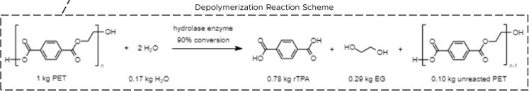

Table 3.1.1: Process Reaction Chemistry

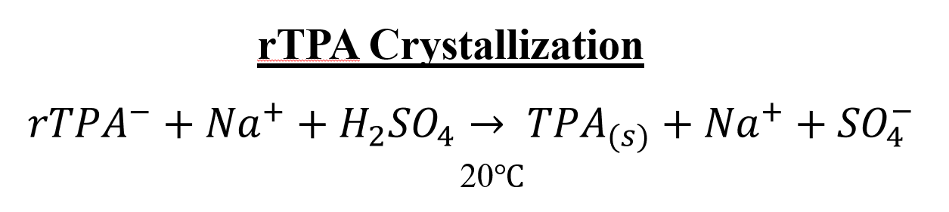
Figure 3.1.2: Process Reaction Chemistry for Crystallizing recycled TPA

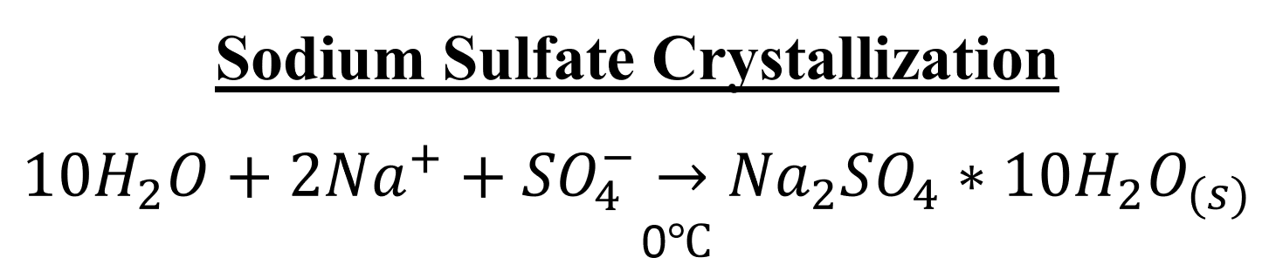
Figure 3.1.3: Process Reaction Chemistry for Crystallizing Sodium Sulfate Decahydrate

3.2 Recommended Process

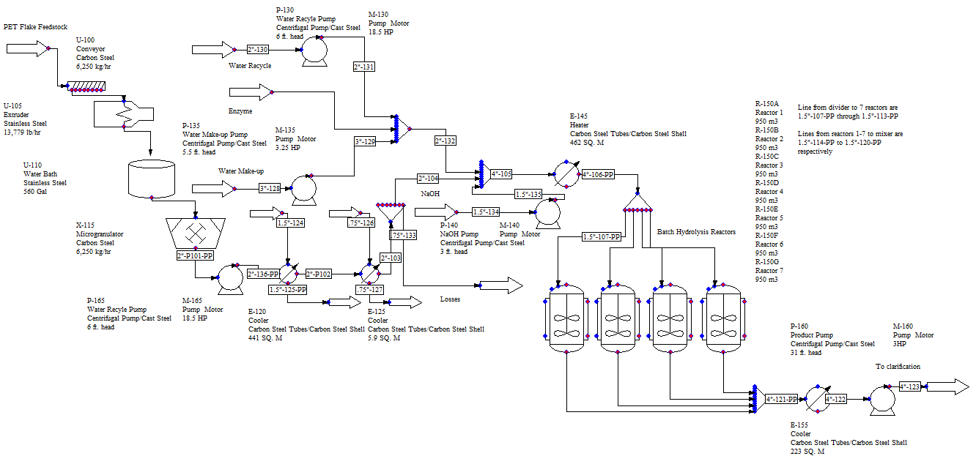
Figure 3.2.1: DWG 5046-03028-B

DWG 5046-03028-B (Figure 3.2.1) shows the process diagram for the depolymerization part of the enzymatic recycling process including equipment, descriptions, and stream names. The PFD with the control loops is included in section 3.3 as Figure 3.3.1. 6,250 kg/hr PET flake feedstock is dumped on to conveyor U-100. U-100 has control loops 1 and 2. Control loop 1 acts as a high-limit shut-off for the conveyor. It contains a speed transmitter, DCS interlock and manipulates V-1. Control loop 2 acts as a low-limit shut-off. It contains a speed transmitter, DCS interlock and manipulates V-2.
From there, the feedstock is transported to the extruder, U-105 where it is heated to 265 °C. U-105 has control loops 3-6. Control loop 3 acts as a high-limit shut-off for the extruder. It contains a speed transmitter, DCS interlock and manipulates V-2. Control loop 4 acts as a low-limit shut-off. It contains a speed transmitter, DCS interlock and manipulates V-3. Control loop 5 acts as a U-105 motor power shut-off. It contains a U-110, water bath, temperature transmitter, DCS interlock, and manipulates U-105. Control loop 6 acts as a high level shut off. It contains a U-110 level transmitter, DCS interlock, and manipulates U-105 and X-115, the microgranulator.
The extruded PET is then cooled in water bath U-110 that has a volume of 561 gal. The size of the water bath was based on the sizing provided on a specification sheet from Berlyn ECM, a water bath manufacturer. U-110 has control loop 7. Control loop 7 acts as a low level shut off. It contains a U-110 level transmitter, DCS interlock, and manipulates U-105 and X-115.
Next, the semi-cool, 35 °C extruded plastic, proceeds to the microgranulator, X-115. Here it is chopped into fine pieces less than 1 mm. It is then pumped using a solids handling pump P-165 with motor M-165. This stream is then pumped to the vertical heat exchanger E-120 where the process fluid is cooled to 10 °C with 3,452 kg/hr of cooling water. E-120 has control loops 9 and 10. Control loop 9 acts as a high-pressure shut-off for the exchanger. It contains a pressure transmitter, DCS interlock and manipulates E-120. Control loop 10 acts as a temperature control loop for the exchanger. It contains a temperature transmitter and manipulates E-120. It also has PSV-1 as a backup if the pressure transmitter were to fail.
The process continues through exchanger E-125 where 328 kg/hr of 50:50 EG/Water cool the process fluid to 5 °C. E-125 has the same control schema as E-120 except it is control loops 11 and 12 and PSV-2. In stream 0.75”-133 there are some solid losses. At the top of the PFD, stream 2”-130, there is the water recycle pump P-130 and motor M-130. There is also Pump P-135 and motor M-135 for the water make-up that is being introduced to the process. The solid enzyme is introduced where streams 2”-131 and 3”-129 meet. The PET stream combines with the water and enzyme streams. The caustic NaOH is pumped by P-140 and M-140. The caustic is added to the water/enzyme/PET stream, 4”-105. This stream is heated in E-145 from a temperature of 51 °C to a temperature of 60 °C with 12,530 kg/hr of low-pressure steam. E-145 has the same control schema as E-120 except it is control loops 16 and 17 and PSV-3.
This stream is then split into 7 equal sized pipes and sent to 7 separate reactors. R-150 A through G are 950 m³ and the batch has a resonance time of 96 hours. Each reactor has two controls for high pressure shut-off and an outlet temperature control loop. The high pressure shut off control loop contains a pressure transmitter, DCS Interlock, and manipulates the reactor it is attached to. The outlet temperature control loops contain a temperature transmitter and manipulate V-9. The controls for the reactors are loops 18-31 respectively. Each reactor also has a PSV labeled PSV-4 through PSV-10. In the PFD, only four reactors are drawn for the sake of saving space on the PFD, however there are truly 7 reactors in use in the process.
After the reactors, the 7 exit streams are combined into one 4”-121-PP stream and run through the cooler E-155. It cools the stream to 35 °C using 35,373 kg/hr of cooling water. E-155 has the same control schema as E-120 except it is control loops 32 and 33 and PSV-11. Finally, this stream is pumped to the next part of the process, the clarification section, by pump P-160 and motor M-160. A summary of the utilities in this section can be found in Table 2.4.1. A full list of the PSV equipment can be found in Table 3.3.2 and a full list of equipment and description can be found in Table 3.2.1.
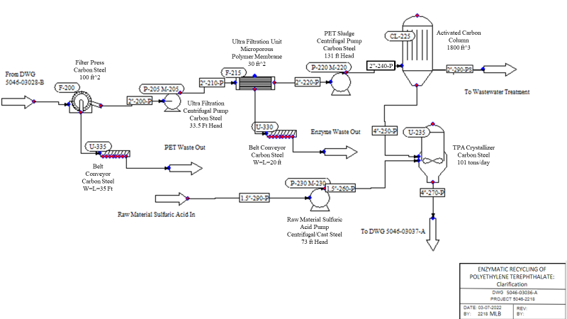
Figure 3.2.2: DWG 5046-03036-A

DWG 5046-03036-A (Figure 3.2.2) shows the process diagram for clarification portion of the enzymatic recycling process including equipment, descriptions, and stream names. The PFD with the control loops is included in section 3.3 as Figure 3.3.1. This section of the plant begins by transferring 41,710 kg/hr of PET/water/enzyme/TPA- ions/Na+ ions sludge with other impurities via the P-160 into clarification. The pump supplies the F-200 Filter press which dumps impure, wet PET sludge onto U-335 belt conveyor and sent to waste processing. U-335 operates on the control loop 36. The liquid stream from the filter press 2’’-200-P is pumped by P-205 to F-215 ultra-filtration unit. This ultra-filtration unit is a microporous polymer membrane to allow enzyme particles of a small molecular weight to go through to waste processing. Since the osmotic pressure of the solution is negligible, nearly 100% separation is possible through ultra-filtration at low pressures (sciencedirect.com). There is a flow indicator on the process outlet stream that communicates with valves 12 and 13 on control loop 37 to stop flow to and from the unit to prevent overflowing the membrane and also to avoid cavitating P-220 and causing impurities in the product. The suspended solids (saturated TPA ions) are retained and pumped out the bottom of the system via P-220. 2’’-240-P is pumped into the CL-225 activated carbon column which acts as another filtration step. An adsorber was chosen based on the criteria of batch slurry systems being favored for small-scale separations (Seider, et al. 2017). The column uses activated carbon which is comparable to a less intense coke process. The activated carbon has small, low volume pores that increase the surface area available for adsorption and removes glues and ash remnant in the process from the re-extrusion of the plastic from PET bottles. Both filtration steps preceeding the TPA crystallization were chosen based on their high microporosity properties. There is a waste stream 2’’-280-PS that is 89% water, 8% ethylene glycol that is sent to wastewater treatment resulting from the activated carbon adsorbing. Whereas the process stream 4’’-250-P that is now a lower percent water by weight and is gravimetrically fed into the U-235 TPA Crystallizer. The process stream is combined with raw material Sulfuric Acid stream 1.5’’-260-P that is pumped by P-230. This crystallizer regulates pressure with PSV-13. In this crystallizer, the TPA ions + water + Sulfuric Acid combine to generate crystallized TPA that has sodium, sulfate, water, and ethylene glycol components. The impure, solid TPA is gravimetrically fed along line 4’’-270-P out of this drawing and into DWG 5046-03037-A for the Crystallization product recovery portion of the plant process. A summary of the utilities in this section can be found in Table 2.4.1. A full list of the PSV equipment can be found in Table 3.3.2 and a full list of equipment and description can be found in Table 3.2.2.

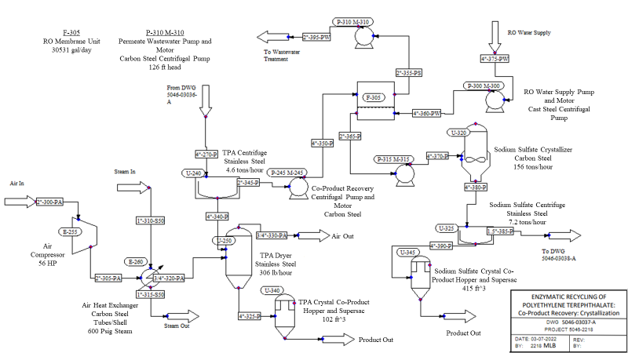
Figure 3.2.3: DWG 5046-03037-A

DWG 5046-03037-A (Figure 3.2.3) shows the process diagram for crystallization co-product recovery portion of the enzymatic recycling process including equipment, descriptions, and stream names. Stream 4’’-270-P continues from DWG 5046-03036-A and is fed gravimetrically into the U-240 centrifuge. This centrifuge produces 4.6 tons per hour of desired TPA product stream which is fed gravimetrically via 4”-340-P into the U-250 dryer. U-240 operates on control loop 38 where a speed indicator will close valve 15 if the speed of the centrifuge is operating outside the accepted range of speed. If the centrifuge operated at abnormal speeds, inefficient separation of the necessary components would be observed, causing undesired purity levels in all 3 final products. There is a “waste” stream 2”-345-P that is comprised of 86% water by weight with other impurities such as ethylene glycol, Na+ ions, and SO4- ions that is currently being process by wastewater treatment outside the battery limits.
The U-250 dryer is 102 cubic feet in size and uses hot, compressed plant air as utility to dry the flake. The air comes from the plant at 1.01 bar and 25°C via 2”-300-PA into the E-255 air compressor which operates at 56 HP. E-255 has a pressure indicator that signals to a pressure relief valve #16. Once the air is at 5 bar, it is fed through heat exchanger E-260 to take it from 110°C to 222°C. This is accomplished by feeding 600 psig steam via line 1”-310-S50. This air stream leaves the heat exchanger by 1”-315-S50 and returns to the plant to be used as utility. U-250 produces 306 lb/hr of 96% pure solid TPA, which is about 90% recovery. Line 4”-325-P feeds the U-340 hopper gravimetrically where the product sits until dropped into supersacs and moved to storage.
The water stream from the centrifuge 2”-345-P is pumped via P-245 into the F-305 RO membrane unit. In this membrane unit, the feed flows axially between two RO membranes separated by a permeable feed spacer. The clean permeate that passes through one of the membranes comes across the impermeable permeate collecting sheet and is diverted to the permeate tube in the middle of the RO module. At the exit, the feed becomes the retentate that contains the contaminant molecules while the permeate contains the filtered water (Seider, et al. 2017). F-305 uses control loop 40. There is a flow indicator on the process outlet stream that communicates with valves 16 and 17 to stop flow to and from the unit to prevent overflowing the membrane and also to avoid cavitating P-315 and causing impurities in the product. Water supplied to the membrane unit is done so via P-300 lines 4’’-275-PW and 4”-360-PW. The filtered water exits the membrane unit via stream 2’’-225-PS and is pumped via P-310 to wastewater treatment. P-315 carries the water/NA+ ions/ SO4- ions/ethylene glycol stream into U-320 crystallizer. The operations team must manually insert 51 kg of solid sodium hydroxide every hour into the crystallizer in order to precipitate solid NA2SO4*10H20 for product recovery. U-320 operates at 0°C and produces 156 tons/hr of NA2SO4*10H20(s) with unreacted EG and other ion impurities. This process stream 4’-380-P is fed gravimetrically to U-325 centrifuge. This centrifuge is on control loop 41 where a speed indicator will close valve 18 if the speed of the centrifuge is operating outside the accepted range of speed. The centrifuge product stream produces 7.2 tons/hr of 99% solid sodium sulfate crystal by weight with 76% overall recovery. Line 4”-390-P feeds the U-345 hopper gravimetrically where the product sits until dropped into supersacs and moved to storage. Sodium sulfate decahydrate product is also called Glauber's salt. It is used for the production of detergents and producing lignocellulose pulps. The salt product is an anhydrous compound so it does not need to be dried as it is incredibly soluble in water and used for those properties in industry.
In the PFD’s for Clarification and Crystallization, unit ops that are not indicative of the intended operation are used to show what the proposed equipment would look like in the field. An example of such being using a dynamic time switch unit op in ChemCad 8 to model belt conveyors. A working simulation was not integral to sizing all of the unit ops, therefore accurately modelling them in ChemCad 8 was not a priority for team 2218 for this design phase. An example of which being sizing the crystallizers and dryers by the amount (kgs) of solid product produced per hour.
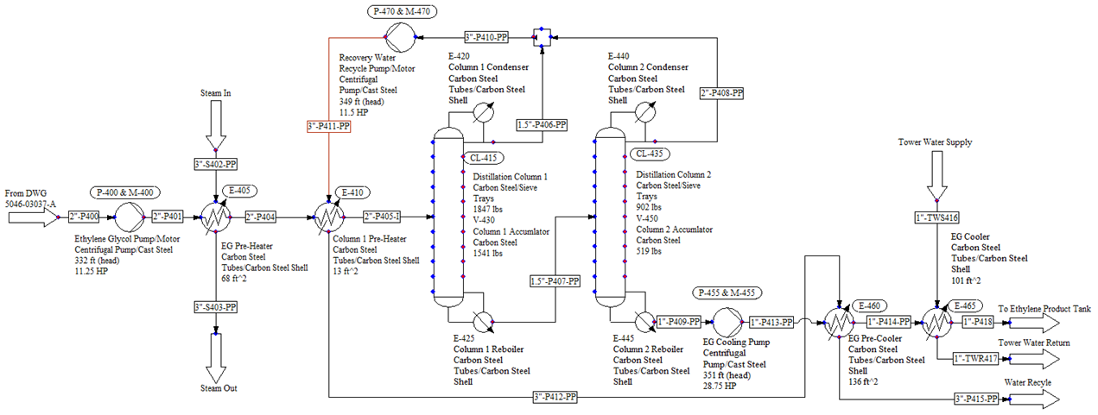
Figure 3.2.4: DWG-5046-03038-A

DWG-5046-03038-A (Figure 3.2.4) shows the process diagram for ethylene glycol recovery section of the enzymatic recycling process including equipment, descriptions, and stream names. The following is the recommended process for the ethylene glycol water separations. Stream P400, 11,757 kg/hr of water ethylene glycol mixture, enters pump P400 at 1.01 bar and 0 degrees C. Pump P400 is used to increase the pressure of stream P400 to 11 bar. Stream P401 then flows into heat exchanger E-405, EG Pre-heater, where the process tube side is heated to 35 degrees C. 90 psig steam is used as the utility for this heat transfer. Stream P404 then flows to the next heat exchanger, E-410 Column 1 Pre-Heater. The process tube side fluid is heated to 41 degrees C using the recycle water, stream P411, as the utility. After pre-heating stream P405-I enters the first distillation column, CL-415. Tower 1 has 9 stages with the feed stage located at the fourth tray. The tower has a total condenser, E-420 which has a heat duty of -40.5 MMBtu/hr, and a kettle reboiler which does 43.2 MMBtu/hr worth of work. The tower separates 8,203 kg/hr of water out the tops, stream P406-PP, and leaves 2,734 kg/hr of water in the bottoms with the 819 kg/hr of ethylene glycol, stream P407-PP. Stream P407-PP then enters the second distillation column, CL-435. Tower 2 has 22 stages with the feed stage located at the fifteenth tray. The tower has a total condenser, E-440 which has a heat duty of -7.9 MMBtu/hr, and a kettle reboiler which does 7.9 MMBtu/hr worth of work. The tower separates 2,726 kg/hr of water out the tops, stream P408-PP, and leaves 8 kg/hr of water in the bottoms with the 819 kg/hr of ethylene glycol, stream P409-PP. Streams P408-PP and P406-PP combine to form stream P410-PP which is then pumped to 11 bar via pump P-470 to form stream P411-PP, the water recycle stream. The bottoms of tower 2, stream P409-PP, are then pumped to a pressure of 11 bar via pump P-455. Stream P413-PP then enters the EG pre-cooler, E-460, where recycle water is again utilized to cool the process fluid from 111 C to 95 C. Stream P414-PP then enters the next heat exchanger, EG Cooler E-465. Here the process fluid is cooled via tower water from 95 C to 40 C. 1,500 kg/hr, stream TWR417 of tower water is heated to 69 C to cool the process fluid. The cooled process fluid, stream P418, then flow to an ethylene product tank which is not in the scope of this project. Note that all equipment used in these separations and heat transforms are constructed entirely of carbon steel. A summary of the utilities in this section can be found in Table 2.4.1. A full list of equipment and description can be found in table 3.2.3 as well as an overall material balance for this section in table 3.2.4.
There were significant challenges the team faced when designing and simulating this process. First and foremost was the inability of ChemCad to model polymers well. Since this process deals with the conversion of PET to TPA and ChemCad doesn’t model PET, the team had to work around this. The team did this by modeling PET in the heat exchange equipment and pumps as 1-Octanol. This was the chosen component because it has a similar heat capacity to PET at ambient temperature (“Standard enthalpy of formation”, 2022). This was used for the sizing of P-165, E-120, E-145, E-155, and P-160. In their paper Singh et al. (2021), assumes that the PET flake feedstock contains small amounts of polypropylene, polyethylene, glues, and ash. With flow rates of 50 kg/hr, 125 kg/hr, 125 kg/hr, and 6 kg/hr respectively. While the team realizes that such contaminants could be present in the PET feedstock from a MRF, the difficulty modeling polymers led the team to exclude these flows since they only made up 5% of the 6,250 kg/hr feedstock stream. The team then modeled these streams as water streams to keep the overall flowrates consistent with the total flowrates in Singh et al. (2021). In future, if looking to scale this process up, testing should be conducted on actual PET feedstock streams and their contaminants. Another challenge was the enzymatic process chemistry. The team decided to use a generic hydrolase enzyme for the process because of the unknown behavior of which specific enzyme is best suited for this process. It would require thorough bench scale testing of different hydrolase enzymes to pick the best one and a sophisticated knowledge of biochemistry. Another problem the team encountered was modeling solids in ChemCad. This led to the team creating a non-functional DWG 5046-03028-B PFD in ChemCad for the depolymerization section of the process. However, because the Singh et al. (2021) paper had material balances and stream conditions for the process, The team was able to use this information to size heat exchangers and pumps in ChemCad. The other equipment was sized based on the Singh et al. (2021) paper and industry information. Examples of this include sizing the U-250 solids dryer, U-250, and U-235 crystallizers based on pounds per hour and tons per hour (respectively) as indicated under “size parameter” using cost equations found in Tables 22.32 in the course textbook, Seider et al. (2016). Another notable deviation from the Singh et al. (2021) paper and the process the team modeled was the introduction of a water bath after the extruder. This was added based on the team’s experience working with extrusion equipment. It also helped to reduce the temperature of the extruded PET before the microgranulator. Also, in the Singh et al. (2021) paper it calls the exchanger after the microgranulator a “cryoquencher” when it is only taking the process stream down to 5°C, which is not a cryogenic temperature. Instead, the team used two heat exchangers to cool the stream from the microgranulator, E-120 and E-125. After the microgranulator the team also added a pump which was not in the original paper. From a pipe sizing perspective, the team used water at the temperature of the stream to size the pipes with a standard pressure drop of 2 psi per 100 ft. Another issue was whether to model the electrolytes for ionic species like NaOH. But because it was determined to be inconsequential to the overall process, the team decided to model ionic species as their whole molecule.

Table 3.2.1: Equipment for DWG 5046-03028-B
Equipment | Tag Name | Formal Name | Material of Construction | Size Parameter
Conveyor | U-100 | PET Flake Conveyor | Carbon Steel | 6250 kg/hr
Extruder | U-105 | PET Extruder | Stainless Steel | 13,779 lb/hr
Microgranulator | U-110 | Water Bath | Stainless Steel | 561 Gal
Water Bath | X-115 | Microgranulator | Carbon Steel | 6250 kg/hr
Heat Exchanger 1 | E-120 | Cryo Heat Exchanger | Carbon Steel Tubes/Carbon Steel Shell | 441 sq m
Heat Exchanger 2 | E-125 | Cryo Cooler | Carbon Steel Tubes/Carbon Steel Shell | 5.9 sq m
Water Recycle Pump | P-130 | Water Recycle Pump | Centrifugal Pump/Carbon Steel | 6 ft (head)
Water Recycle Pump Motor | M-130 | Water Recycle Pump Motor |  | 18.5 HP
Water Make-up Pump | P-135 | Water Make-up Pump | Centrifugal Pump/Carbon Steel | 5.5 ft (head)
Water Make-up Pump Motor | M-135 | Water make-up Pump Motor |  | 3.25 HP
NaOH Pump | P-140 | NaOH Pump | Centrifugal Pump/Carbon Steel | 3 ft (head)
NaOH Pump Motor | M-140 | NaOH Pump Motor |  | 19 HP
Heat Exchanger 3 | E-145 | Reactor Pre-Heater | Carbon Steel Tubes/Carbon Steel Shell | 462 sq m
Reactor 1 | R-150A | Reactor 1 | Stainless Steel | 950 m^3
Reactor 2 | R-150B | Reactor 2 | Stainless Steel | 950 m^3
Reactor 3 | R-150C | Reactor 3 | Stainless Steel | 950 m^3
Reactor 4 | R-150D | Reactor 4 | Stainless Steel | 950 m^3
Reactor 5 | R-150E | Reactor 5 | Stainless Steel | 950 m^3
Reactor 6 | R-150F | Reactor 6 | Stainless Steel | 950 m^3
Reactor 7 | R-150G | Reactor 7 | Stainless Steel | 950 m^3
Heat Exchanger 4 | E-155 | Reactor Cooler | Carbon Steel Tubes/Carbon Steel Shell | 223
Pump 4 | P-160 | To Clarification Pump | Diagram Solids Pump | 31 ft (head)
Pump 4 Motor | M-160 | To Clarification Pump Motor |  | 3 HP

Table 3.2.2: Material Balance for DWG 5046-03028-B
(kg/hr) | In | Out
EG | - | 1,638
ENZYME | 28 | 28
H2O | 33,945 | 33,644
PET | 5,838 | 861
NAOH | 1,213 | 1,213
TPA | - | 4,331
Sum | 41,330 | 41,715

Table 3.2.2 shows the overall material balance for DWG 5046-03028-B. There is a difference of 691 kg/hr between the inlet and the outlet this discrepancy is due to neglecting the electrolyte components of NaOH.

Table 3.2.3: Energy Balance for Heat Exchanger and Pumps on DWG 5046-03028-B
Simulation: 5046-2218 Depolymerization E-120 and E-125
Overall Energy Balance | MJ/hr
 | Input | Output
Total | -78342.2 | -78342.2
Simulation: 5046-2218 Depolymerization E-145, E-155 and P-160
Overall Energy Balance | MJ/hr
 | Input | Output
Feed Streams | -1.87E+06
Total | -1.87E+06 | -1.87E+06
Simulation: 5046-2218 Depolymerization Pumps
Overall Energy Balance | MJ/hr
 | Input | Output
Total | -576882 | -576882

Table 3.2.3 shows a summary energy balance for the pumps and exchangers modeled in ChemCad for DWG 5046-03028-B . See Appendix C for the full energy balance.

Table 3.2.4: Equipment for DWG 5046-03036-A and DWG 5046-03037-A
Equipment | Tag Name | Formal Name | Material of Construction | Size Parameters
Filter Press | F-200 | Filter Press | Carbon Steel | 1000 ft^2
Centrifugal Pump | P-205 | Ultra Filtration Pump | Carbon Steel | 33.5 ft (head)
Pump Motor | M-205 | Ultra Filtration Pump Motor |  | 3 HP
Ultra Filtration | F-215 | Ultra Filtration Unit | Microporous Polymer Membrane | 30 ft^2
Centrifugal Pump | P-220 | Activated Carbon Column Pump | Carbon Steel | 131 ft (head)
Pump Motor | M-220 | Activated Carbon Column Pump Motor |  | 11.5 HP
Activated Carbon Column | CL-225 | Activated Carbon Column |  | 1800 ft^3
Sulfuric Acid Pump | P-230 | Sulfuric Acid Pump | Carbon Steel | 73 ft (head)
Sulfuric Acid Pump Motor | M-230 | Sulfuric Acid Pump Motor |  | 2.75 HP
Sulfuric Acid Crystallizer | U-235 | Terephthalic Acid Crystallizer | Carbon Steel | 101 tons/day
Centrifuge | U-240 | Terephthalic Acid Centrifuge | 316 Stainless Steel | 4.6 tons/hr
Centrifugal Pump | P-245 | Co-Product Recovery Pump | Carbon Steel | 134 ft (head)
Pump Motor | M-245 | Co-Product Recovery Pump Motor |  | 64.5 HP
Solids Dryer | U-250 | Terephthalic Acid Dryer | Stainless Steel | 306 lb/hr
Air Compressor | E-255 | Air Compressor |  | 56 HP
Heat Exchanger | E-260 | Air Heat Exchanger | Carbon Steel Tubes & Shell
Centrifugal Pump | P-300 | RO Water Pump | Carbon Steel | 67 ft (head)
Pump Motor | M-300 | RO Water Pump Motor |  | .75 HP
RO Membrane | F-305 | RO Membrane Unit |  | 30531 gal/day
Centrifugal Pump | P-310 | Permeate Wastewater Pump | Carbon Steel | 126 ft (head)
Pump Motor | M-310 | Permeate Wastewater Pump Motor |  | 10 HP
Centrifugal Pump | P-315 | Sodium Sulfate Crystallizer Pump | Carbon Steel | 119 ft (head)
Pump Motor | M-315 | Sodium Sulfate Crystallizer Pump Motor |  | 7.25 HP
Crystallizer | U-320 | Sodium Sulfate Crystallizer | Carbon Steel | 156 tons/day
Centrifuge | U-325 | Sodium Sulfate Centrifuge | Stainless Steel | 7.2 tons/hr
Belt Conveyor | U-330 | Enzymatic Depolymerization Conveyor | Conveyor | Width 35 ft  Length 35 ft
Belt Conveyor | U-335 | Filter Press Waste Conveyor | Conveyor | Width 35 ft  Length 35 ft
Hopper and Supersac | U-340 | TPA Crystal Co-Product Hopper and Supersac |  | 102 ft^3
Hopper and Supersac | U-345 | Sodium Sulfate Crystal Co-Product Hopper and Supersac |  | 415 ft^3

Table 3.2.5: Mass Balance for DWG 5046-03036-A
(kg/hr) | In | Out
EG | 1,638 | 1,638
ENZYME | 28 | 28
H2O | 34,088 | 33,828
PET | 564 | 564
NAOH | 1,213 | 1,213
TPA | 4,331 | 4,381
H₂SO₄ | 2,504 | 2,466
Sum | 44,366 | 44,118
Table 3.2.5 shows the overall material balance for DWG 5046-03036-A. There is a difference of 248 kg/hr between the inlet and the outlet this discrepancy is due to neglecting the electrolyte components of NaOH and TPA ions.

Table 3.2.6: Mass Balance for DWG 5046-03037-A
(kg/hr) | In | Out
EG | 1,487 | 1,487
H2O | 57,502 | 57,502
NAOH | 1,213 | 1,213
TPA(s) | 4,168 | 4,168
H2SO4 | 2,462 | 2,466
Air | 2,103 | 2,103
Na2SO4*10H20(s) |  | 6,491
Sum | 68,935 | 68,939

Table 3.2.7: Equipment for DWG 5046-03038-A
Equipment | Tag Name | Material of Construction | Size Parameter
Ethylene Glycol Pump | P-400 | Centrifugal Pump/Carbon Steel | 332 ft (head)
Ethylene Glycol Pump Motor | M-400 |  | 11.25 HP
EG Pre-Heater | E-405 | Carbon Steel Tubes/Carbon Steel Shell | 68 ft^2
Column 1 Pre-Heater | E-410 | Carbon Steel Tubes/Carbon Steel Shell | 13 ft^2
Distillation Column 1 | CL-415 | Carbon Steel/Sieve Trays | 1847 lbs
Column 1 Condenser | E-420 | Carbon Steel Tubes/Carbon Steel Shell
Column 1 Reboiler | E-425 | Carbon Steel Tubes/Carbon Steel Shell
Column 1 Accumulator | V-430 | Carbon Steel | 1541 lbs
Distillation Column 2 | CL-435 | Carbon Steel/Sieve Trays | 902 lbs
Column 2 Condenser | E-440 | Carbon Steel Tubes/Carbon Steel Shell | 276 ft^2
Column 2 Reboiler | E-445 | Carbon Steel Tubes/Carbon Steel Shell | 244 ft^2
Column 2 Accumulator | V-450 | Carbon Steel | 519 lbs
EG Cooling Pump | P-455 | Centrifugal Pump/Carbon Steel | 351 ft (head)
EG Cooling Pump Motor | M-455 |  | 28.75 HP
EG Pre-Cooler | E-460 | Carbon Steel Tubes/Carbon Steel Shell | 136 ft^2
EG Cooler | E-465 | Carbon Steel Tubes/Carbon Steel Shell | 101 ft^2
Recovery Water Recycle Pump | P-470 | Centrifugal Pump/Carbon Steel | 349 ft (head)
Recovery Water Recycle Pump Motor | M-470 |  | 11.5 HP

Table 3.2.8: Material Balance for DWG 5046-03038-A
 | In | Out
EG | 819 | 819
Water | 10,938 | 10,938

3.3. Process Control
The process control needs were determined by the PHA and implemented by the team. The main purpose of the controls developed at this point in the design process is for process safety. Alarms, fail safes and the DCS interfaces all still need to be designed and implemented but are outside the scope for this project. The control schemes are shown in Figures 3.3.1 through 3.3.3, and the instrument and pressure relief devices indexes are present in Tables 3.3.1 through 3.3.5.
There is some need for control systems to present real-time data, such as the PET feed, the reactor, membrane units, and distillation columns feed and exit streams, and the PET inventory level. Analyzers were also identified as necessary in the PHA around piping and equipment with EG, sodium sulfate, or sulfuric acid.

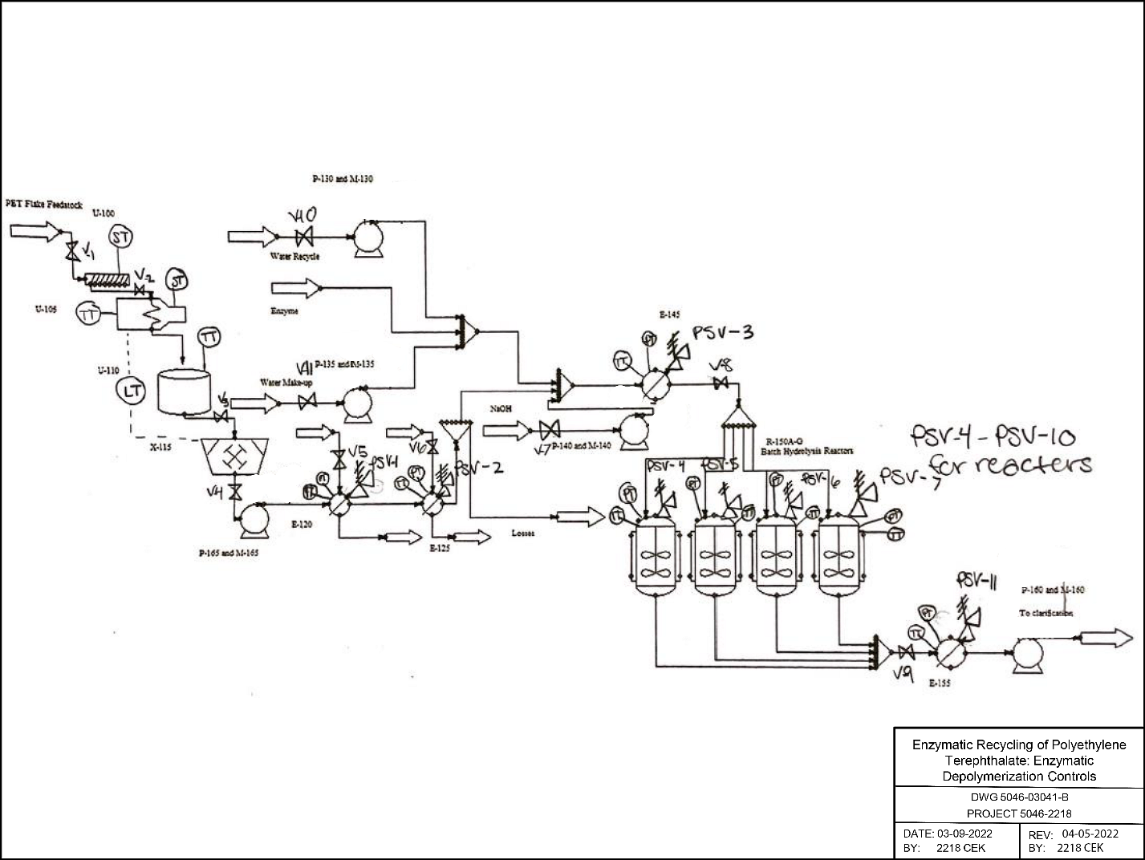
Figure 3.3.1: DWG 5046-03041-B Depolymerization Controls

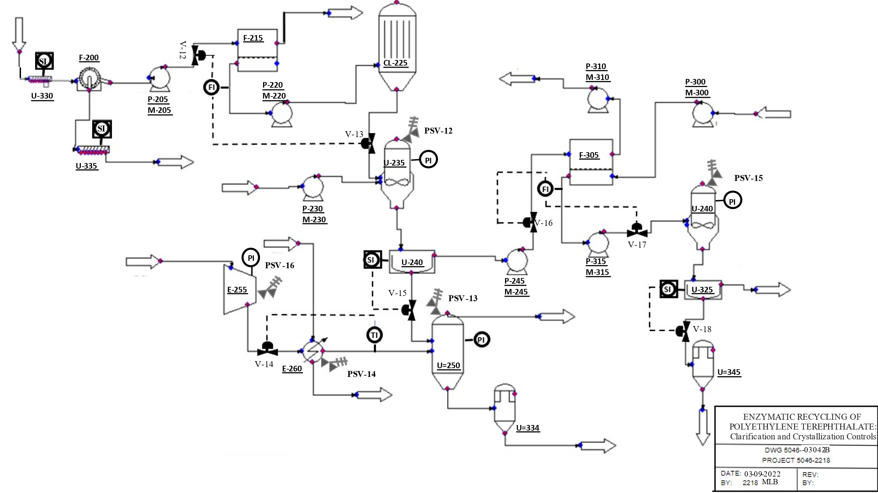
Figure 3.3.2: DWG 5046-03042-B Clarification and Crystallization Controls

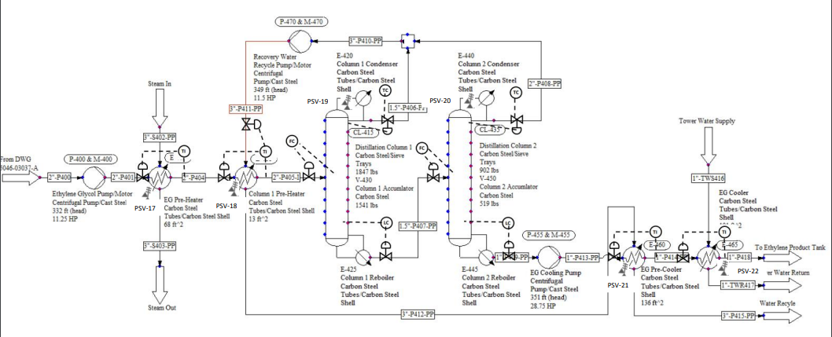

Figure 3.3.3: DWG 5046-03043-B Ethylene Glycol Controls

Table 3.3.1: Depolymerization Instrument, Clarification and Crystallization, Ethylene Glycol Instrument Index

Equipment | Control Loop | Manipulated Equipment | Controller | Indicator | Description
U-100 | 1 | V-1 | DCS Interlock | Speed Transmitter | High limit shut-off
U-100 | 2 | V-2 | DCS Interlock | Speed Transmitter | Low limit shut-off
U-105 | 3 | V-2 | DCS Interlock | Speed Transmitter | High limit shut-off
U-105 | 4 | V-3 | DCS Interlock | Speed Transmitter | Low limit shut-off
U-105 | 5 | U-105 | DCS Interlock | U-110 Temperature Transmitter | U-105 Motor Power shut-off
U-105 | 6 | U-105, X-115 | DCS Interlock | U-110 Level Transmitter | High level shut-off
U-110 | 7 | U-105, X-115 | DCS Interlock | U-110 Level Transmitter | Low level shut-off
E-120 | 9 | E-120 | DCS Interlock | Pressure Transmitter | High pressure shut-off
E-120 | 10 | E-120 | Control loop | Temperature Transmitter | Outlet temperature control loop
E-125 | 11 | E-125 | DCS Interlock | Pressure Transmitter | High pressure shut-off
E-125 | 12 | E-125 | Control loop | Temperature Transmitter | Outlet temperature control loop
E-145 | 16 | E-145 | DCS Interlock | Pressure Transmitter | High pressure shut-off
E-145 | 17 | E-145 | Control loop | Temperature Transmitter | Outlet temperature control loop
R-150A | 18 | R-150A | DCS Interlock | Pressure Transmitter | High pressure shut-off
R-150A | 19 | V-9 | Control loop | Temperature Transmitter | Outlet temperature control loop
R-150B | 20 | R-150B | DCS Interlock | Pressure Transmitter | High pressure shut-off
R-150B | 21 | V-9 | Control loop | Temperature Transmitter | Outlet temperature control loop
R-150C | 22 | R-150C | DCS Interlock | Pressure Transmitter | High pressure shut-off
R-150C | 23 | V-9 | Control loop | Temperature Transmitter | Outlet temperature control loop
R-150D | 24 | R-150D | DCS Interlock | Pressure Transmitter | High pressure shut-off
R-150D | 25 | V-9 | Control loop | Temperature Transmitter | Outlet temperature control loop
R-150E | 26 | R-150E | DCS Interlock | Pressure Transmitter | High pressure shut-off
R-150E | 27 | V-9 | Control loop | Temperature Transmitter | Outlet temperature control loop
R-150F | 28 | R-150F | DCS Interlock | Pressure Transmitter | High pressure shut-off
R-150F | 29 | V-9 | Control loop | Temperature Transmitter | Outlet temperature control loop
R-150G | 30 | R-150G | DCS Interlock | Pressure Transmitter | High pressure shut-off
R-150G | 31 | V-9 | Control loop | Temperature Transmitter | Outlet temperature control loop
E-155 | 32 | E-155 | DCS Interlock | Pressure Transmitter | High pressure shut-off
E-155 | 33 | E-155 | Control loop | Temperature Transmitter | Outlet temperature control loop
U-335 | 36 | F-200 | DCS Interlock | Speed Transmitter | High limit shut-off
U-335 | 36 | F-200 | DCS Interlock | Speed Transmitter | Low limit shut-off
F-215 | 37 | V-12 | DCS Interlock | Flow Transmitter | Low limit shut-off
F-215 | 37 | V-13 | DCS Interlock | Flow Transmitter | Low limit shut-off
U-240 | 38 | V-15 | DCS Interlock | Speed Transmitter | High limit shut-off
U-240 | 38 | V-15 | DCS Interlock | Speed Transmitter | Low limit shut-off
E-260 | 39 | V-14 | DCS Interlock | Pressure Transmitter | High pressure shut-off
F-305 | 40 | V-16 | DCS Interlock | Flow Transmitter | Low limit shut-off
F-305 | 40 | V-17 | DCS Interlock | Flow Transmitter | Low limit shut-off
U-345 | 41 | V-18 | DCS Interlock | Speed Transmitter | High limit shut-off
U-345 | 41 | V-18 | DCS Interlock | Speed Transmitter | Low limit shut-off
E-260 | 39 | V-14 | Control loop | Temperature Transmitter | Outlet temperature control loop
E-405 | 1 | V-19 | DCS Interlock | Pressure Transmitter | High pressure shut-off
E-405 | 1 | V-19 | Control loop | Temperature Transmitter | Outlet temperature control loop
E-410 | 2 | V-20 | DCS Interlock | Pressure Transmitter | High pressure shut-off
E-410 | 2 | V-20 | Control loop | Temperature Transmitter | Outlet temperature control loop
CL-415 | 3 | V-21 | Control loop | Flow Transmitter | Column Inlet Control loop
CL-415 | 4 | V-22 | Control loop | Temperature Transmitter | Outlet temperature control loop
CL-415 | 5 | V-23 | DCS Interlock | Level Transmitter | Low limit shut-off
CL-435 | 6 | V-24 | Control loop | Flow Transmitter | Column Inlet Control loop
CL-435 | 7 | V-25 | Control loop | Temperature Transmitter | Outlet temperature control loop
CL-435 | 8 | V-26 | DCS Interlock | Level Transmitter | Low limit shut-off
E-460 | 9 | V-27 | DCS Interlock | Pressure Transmitter | High limit shut-off
E-460 | 9 | V-27 | Control loop | Temperature Transmitter | Outlet temperature control loop
E-465 | 10 | V-28 | DCS Interlock | Pressure Transmitter | High pressure shut-off
E-465 | 10 | V-28 | Control loop | Temperature Transmitter | Outlet temperature control loop

Table 3.3.2: DWG 5046-03041-B Depolymerization Pressure Relief Valves
Equipment | Manipulated Equipment | Purpose
E-120 | PSV-1 | Pressure Relief Valve
E-125 | PSV-2 | Pressure Relief Valve
E-145 | PSV-3 | Pressure Relief Valve
R-150A | PSV-4 | Pressure Relief Valve
R-150B | PSV-5 | Pressure Relief Valve
R-150C | PSV-6 | Pressure Relief Valve
R-150D | PSV-7 | Pressure Relief Valve
R-150E | PSV-8 | Pressure Relief Valve
R-150F | PSV-9 | Pressure Relief Valve
R-150G | PSV-10 | Pressure Relief Valve
E-155 | PSV-11 | Pressure Relief Valve

Table 3.3.3: Clarification and Crystallization PFD Pressure Relief Valves
Equipment | Manipulated Equipment | Purpose
U-235 | PSV-12 | Pressure Relief Valve
U-250 | PSV-13 | Pressure Relief Valve
E-260 | PSV-14 | Pressure Relief Valve
U-240 | PSV-15 | Pressure Relief Valve
E-255 | PSV-16 | Pressure Relief Valve

Table 3.3.4: Ethylene Glycol PFD Pressure Relief Valves
Equipment | Manipulated Equipment | Purpose
E-405 | PSV-17 | Pressure Relief Valve
E-410 | PSV-18 | Pressure Relief Valve
CL-415 | PSV-19 | Pressure Relief Valve
CL-435 | PSV-20 | Pressure Relief Valve
E-460 | PSV-21 | Pressure Relief Valve
E-465 | PSV-22 | Pressure Relief Valve

3.4. Technology Risk
There is technology risk associated with this project because the process has not been conducted on an industrial scale at all. The specific technology risk involves the use of generic PET hydrolase enzymes, which are still in the developmental stage. Hydrolase enzymes have been used in other applications – most notably in pharmaceutical, food, and detergent production - but not for the conversion of PET to rTPA. Because the process is new, it must carefully consider the implications of scale-up and biosafety. A hydrolase is a biochemical catalyst, specifically including esterases like lipases and other enzymes that cleave ester bonds. It was chosen to cleave the PET molecule at its ester in the polymer. This intended break is shown below in figure 3.4.1. Operational risks include an inefficient conversion of PET by lipase enzyme during the scale-up of this operation. This would push too much unbroken down PET through the process to the TPA crystallizer, potentially causing plugs in the process and impurities in all product streams.
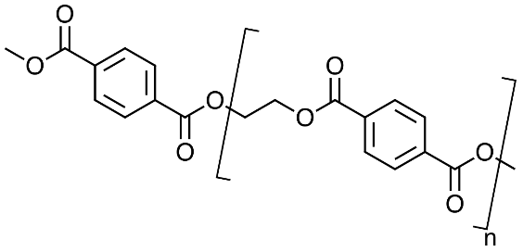
Figure 3.4.1. PET Molecule

It has been determined to continue forward with group 2218’s preliminary suggestion to use a hydrolase enzyme in the breakdown of PET. This is because there is a greater technology risk to consider using an underdeveloped PETase and its unquantified properties. There has been a plastic-eating bacteria discovered called I. Sakaiensis that secretes PETase when grown on PET film (rsscience.com). This bacteria is incredibly slow and inefficient to the process so farther industrial research must be done prior to implementing this enzyme into the process. A diagram of the Lipase enzyme and PETase structure is shown below by figures 3.4.2 and 3.4.3, respectively.

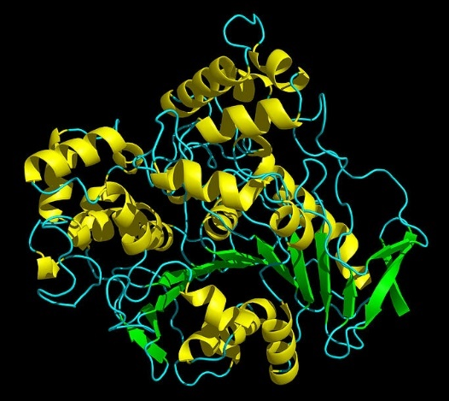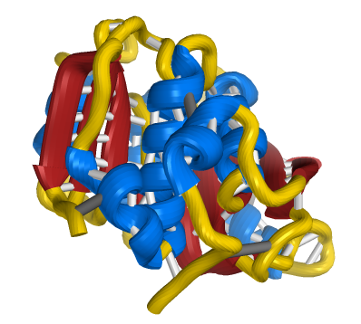
Figure 3.4.2: Lipase Crystal Structure Figure 3.4.3: PETase Crystal Structure

3.5. Environmental Performance
Shown in Figures 3.5.1 to 3.5.3 are the waste points marked by the red X’s. The waste points include expected PET losses from the beginning of the process, PET waste from the F-200 filtration unit, and enzyme waste from the F-215 membrane unit, all of which are being sent to the landfill. Other waste points include water-based waste from the CL-225 activated carbon column and from the F-305 membrane unit to wastewater treatment. There are no air emissions points identified at this point in the project. The waste points are outlined with hourly rates in Table 3.5.1.
Some of the chemicals used pose some environmental risks. PET and SS do not break down in the environment, so a release outside of the plant should be avoided. Sulfuric acid and ethylene glycol need to be kept out of drains that lead anywhere but waste treatment as they are toxic to fish by do not bioaccumulate in those fish.
In regard to waste, a waste minimization assessment needs to be completed in the next design phase. Also, an assessment needs to be done on the inventory amounts of EG held on site. That is also to be done in the next design phase.

Figure 3.5.1: DWG 5046-03028-B with waste points.

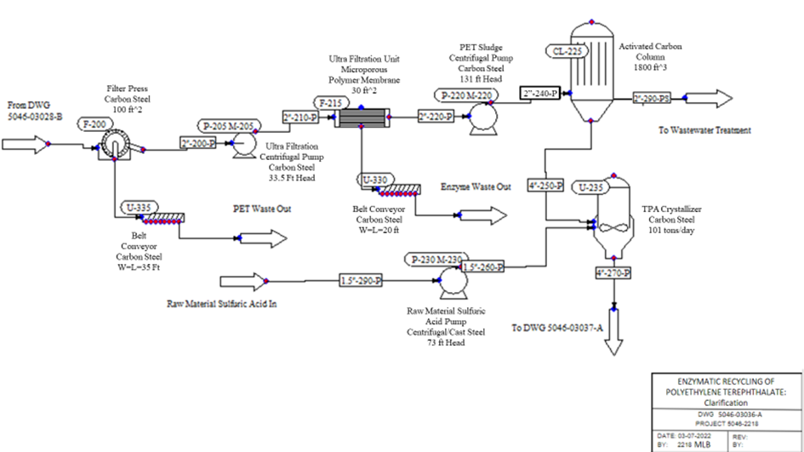
Figure 3.5.2: DWG 5046-03036-A with waste points.

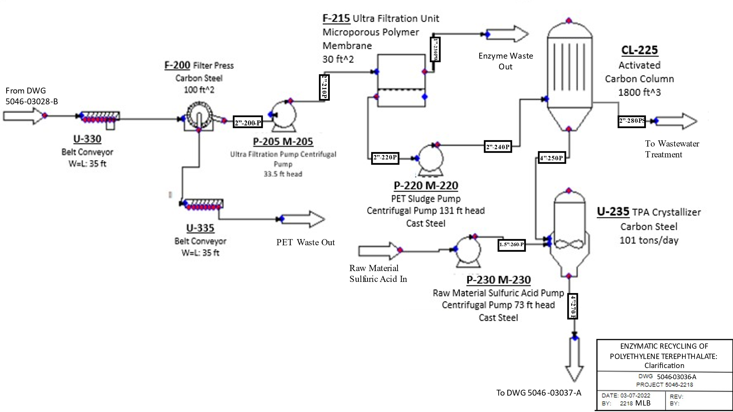
Figure 5.3.3: DWG 5046-03037-A with waste points.

Table 3.5.1: Waste Stream Properties.
Component | Composition (wt %) | Flow Rate (kg/hr) | Temperature (°C) | Pressure (bar)
Solid waste | 55% PET | 1,025 | 35 | 1.2
Enzyme waste | 100% | 28 | 35 | 1.1
Column waste | 87% H2O | 3,370 | 35 | 8.0
RO permeate waste | 97% H2O | 16,441 | 21 | 1.0

3.6. Process Safety
General Process Safety:
The main issues found through the PHA are material spills, conveyer belt issues, equipment failures, and further implementation instrumentation and controls. Material spills and equipment failures can be solved with PMs, which are out of the scope of this project, and by the addition of instrumentation and controls. More information resulting from the PHA can be found in the PHA report.
Recommendations that were adopted from the preliminary PHA were the addition of pressure relief valves on all pressure vessels, along with the controls. The recommendations that were rejected were the need for dikes for containment and a solids filter before heat exchangers. Adding dikes was deemed unnecessary because of the amount of hazardous chemicals and the rates the process is running at. The solids filter was rejected once the process was developed.
Material Safety:
Due to the use of a lipase enzyme, there are extra procedures that will be put into effect. The preliminary lipase selected for this process is rated by the team as a risk group 2 and BSL-2. The risk group associated with this means that the lipase is associated with human disease which is rarely serious and for which preventative or therapeutic interventions are often available. The BSL-2 level means that the enzyme is associated with human disease through percutaneous injury, ingestion, mucous membrane exposure. Since the lipase is categorized as a BSL-2, personnel must follow standard microbiological practices as well as “Sharps” precautions allow limited access to areas containing the enzyme, have biohazard warning signs, and have a biosafety manual that defines any needed waste decontamination or medical surveillance policies. Additional safety equipment like Class I physical containment devices, and laboratory coats, gloves, and face protection are required. There also needs to be an autoclave available. The enzyme is flammable with an NFPA rating of 1.
Other material safety concerns lie with the use and production of ethylene glycol, sulfuric acid, and sodium sulfate. Ethylene glycol targets organs like the cardiovascular and nervous systems and causes eye irritation if exposed. Sulfuric acid is corrosive and toxic by inhalation. Sodium sulfate is more toxic, with both skin and eye irritation on exposure, along with gastrointestinal and respiratory tract irritation.
For a list of SDS for all process components, reference Appendix A.

3.7. Regulations and Standards
Process Safety Management is a standard issued by the U.S Department of Labor’s Occupational Safety and Health Administration (OSHA) that covers manufacturing of explosives, 137 listed highly hazardous chemicals, and processes that involve threshold quantities of flammable liquids and flammable gases (10,000 lbs.). The applicable legislation for this project is directly decreed at a federal level, since Ohio does not have a state registered OSHA (Occupational Safety and Health Administration) plan. Therefore, the plant must operate under the OSH Act of 1970. The OSHA requirements govern, but are not limited to, the construction, operation, storage, training, and management of the chemical plant. Additionally, OSHA’s Combustible Dust National Emphasis Program outlines procedures for workplaces that handle combustible dusts. The 2 main profitable products produced in this process are subject to these policies as a flake and a salt both stored in supersacs.
Hydrolase enzymes have been used in other applications, but not for the conversion of PET to rTPA. Because of this, the Toxic Substances Control Act (TSCA) Experimental Release Application (TERA) is a request for a research and development activity. Microorganisms subject to this rule are newly considered microorganisms by the TSCA for commercial purposes, such as production of industrial enzymes and other chemicals such as production of biofuels, and breakdown of chemical pollutants in the environment (EPA). A more detailed classification can be found in 40 CFR part 725.8 while the entire section 5 of TSCA gives an overview of commercial implementation of newly regulated biomass for commercialization purposes. Additionally, according to EPA's rule, new microorganisms are microorganisms including bacteria, fungi, algae, viruses, protozoa, etc. formed by combining genetic material from organisms in different genera (EPA, 2012). This is referenced from 40 CFR parts 725.1 and 725.3. As more research results arise, the EPA, FDA, and USDA will all put out more classification and regulation requirements. 40 CFR Part 70 is the basis for State and local permitting authorities. 40 CFR Part 71 is used when a State or local Title V permitting program does not exist. This is not the case for this process. Appendix A of Part 70 provides info on the approval status of State and Local operating Permit Programs. This process falls under the Title V operating permits.
The EPA is required by section 112(r) of the Clean Air Act Amendments to publish guidance and regulations for chemical accident prevention at plants that utilize certain hazardous materials. The Risk Management Plan Rule (RMP) requires that facilities have a Risk Management Plan in place in case of an accident. This plan should cover the potential effects of a chemical accident, the steps the facility is taking to prevent an accident and emergency response procedures. An RMP must be submitted every five years by facilities under this rule.
A consolidated list is available from the U.S. EPA that includes chemicals that are subject to reporting requirements set by Title III of the Superfund Amendments and Reauthorization Act of 1986 (SARA), the Emergency Planning and Community Right-to-Know Act (EPCRA), Comprehensive Environmental Response, Compensation and Liability Act (CERCLA), and section 112(r) of the Clean Air Act (CAA). The CAS numbers for the process chemicals considered in this report can be found in table 3.7.1 below.

Table 3.7.1: SARA Information

 | CHEMICAL | CAS- CODE |  | CONCENTRATION
NAOH |  |  | 1310-73-2 |  | 2.00 mg/m³
RECYCLE PET |  |  | 25038-59-9 |  | 99.9 – 100%
SULFURIC ACID |  |  | 7664-93-9 |  | 0.2 mg/m³
TEREPTHALIC ACID |  |  | 100-21-0 |  | 90-100%
SODIUM SULFATE |  |  | 7757-82-6 |  | 99%
ETHYLENE GLYCOL |  |  | 107-21-1 |  | 91%
HYDROLASE CATALYST |  |  | 39450-01-6 |  | 2.5%

The U.S. Nuclear Regulatory Commission is responsible for the public's health regarding the handling of radioactive source material, special nuclear material, and byproducts that are radioactive. The NRC regulates the use of these materials via 10 CFR Part 20, “Standards for Protecting Against Radiation. None of the materials used in this process fall under this regulation set by the NRC.
The National Fire Protection Association or NFPA regulates facilities to minimize death, injury, property and economic loss due to fire, electrical and related hazards. Since the sodium sulfate salt product and recycled TPA flake product are subject to dust explosion hazards, subjecting the process to abiding by NFPA 654. NFPA 654 is the Standard for the Prevention of Fire and Dust explosions from the Manufacturing, Processing, and Handling of Combustible Particulate Solids.
The ASME (American Society of Mechanical Engineers) section VIII Pressure Vessel Code and ASTM (American Society for Testing and Materials) standards would be applicable to this project as it covers a wide variety of construction and material requirements as well as codes and regulations for pressure vessels. The ASME Boiler and Pressure Vessel Code (BPVC) is an ASME standard that regulates the design and construction of boilers and pressure vessels. This process must follow the regulations set by the BPVC. It is not believed that meeting this code would cause challenges or design changes, as the operating pressures all lie below 65 PSIA for this design process. All heat exchangers involved in the process fall under the ASME Pressure Vessel Code MC104 and will need to be inspected, stamped, and maintained accordingly (ASME, 2017).
Created under the Clean Water Act in 1972 the National Pollutant Discharge Elimination System permit program is authorized by the EPA to state governments. Compliance with a NPDES permit is needed to properly discharge pollutants. Title 61 Section 6111.03 of Ohio’s revised wastewater code in accordance with the Federal Water Pollution Control Act guides facilities in Ohio on how to properly manage sludge and discharge dredge or fill materials (permit allowing).
ANSI (American National Standards Institute) safety standards would also be applicable to this project as it covers standards for construction safety, clothing and equipment protection, occupational health, and safety. Additionally, the process design requires ladders for reactor vessel R-150A-G, CL-225, CL-415, CL-435, V-450, and V-430, therefore ANSI ladder safety and fall protection standards will need to be considered and applied to the design.
Furthermore, TEMA standards are applicable to this project as it covers installation, operation, and maintenance standards for heat exchangers. Also, TEMA covers the mechanical and class classifications of heat exchangers and flow induced vibration standards.
Finally, API standards are applicable to this project as it covers standards and recommendations for pipelines, valves, and control equipment. The major application of API
standards in this project will be on pipe sizing and in the future controls and valve equipment recommended in PHA report.

3.8. Preliminary Equipment Specifications

The selected equipment material was chosen based on the heuristics of CHE 5045 and 5046 and from Seider et al., 2016. All heat exchangers and distillation columns are designed to be constructed of carbon steel because it is compatible with all materials in the process and can be used at the temperatures of all streams through the exchangers and towers. The maximum usage temperature of carbon steel is 216 °C. All pumps should be single phase and constructed of carbon steel and meets process needs. No spare pumps or compressors are accounted for in the current scope of the project. This was driven by investment costs, profitability, and supported by the process hazard analysis. Though no spares are considered at this time it is recommended that they are implemented for future work to prevent downtime in the occurrence of a mechanical failure event. For more details on the equipment specifications see Appendix G.

4. Process Economics

4.1 Estimated Sales Revenue, Capital Costs, and Operating Costs
Raw Materials:
Table 4.1.1: Feedstock Streams and Costs
Total Cost: $25.33 million/year
Feedstock | Rate (kg/h) | Unit Cost ($/kg) | Cost (MM/year)
PET Flake | 6250 | $0.19 | $9.51
Caustic (NaOH) | 2134 | $0.61 | $10.38
Sulfuric Acid (H2SO4) | 2702 | $0.10 | $2.08
Enzyme | 28 | $15 | $3.36

The raw materials for this process are PET flakes, caustic, sulfuric acid, and the enzyme. Caustic and sulfuric acid are estimated as being bought directly from a supplier. PET flakes are estimated as being obtained directly from a recycler. This price would most likely fluctuate based upon the supply of recycled flakes and the year. In the past year alone, the price of buying recycled PET flakes has been anywhere from 0.09 cents per pound up to one dollar per pound. The price also fluctuates based upon the desired grade. For example, food and pharmaceutical grade PET flakes are going to be more expensive than regular recycled flakes. The enzyme cost was set at an estimated purchase cost and can be varied upon what the decided enzyme will be and how to source it. The rates for each raw material were determined based upon a material balance of the process streams. Each value can also be found in form ECN-104.

Revenue:
Table 4.1.2: Product Streams and Revenue

Total Revenue: $83.85 million/year
Product | Rate (kg/h) | Unit Cost ($/kg) | Revenue (MM/year)
rTPA | 3946 | $2.21 | $69.62
Sodium Sulfate | 6569 | $0.15 | $7.90
Ethylene Glycol | 827 | $0.96 | $6.40

The main product from this process is recycled polyethylene terephthalate. The pricing of the unit cost for this product was determined from reaching a $0.00 net present value calculation which will be furthered discussed in section 4.2. The unit price of this product contributes to other factors such as general expenses that are based upon the revenue generated. There are also two co-products produced from this process that can also be sold: ethylene glycol and sodium sulfate. The unit pricings for each are assumed to be current market prices. It is assumed all products made are for outside sales and therefore contribute to solid-liquid product inventories. The rates for each product were determined based upon a material balance of the process streams. Each value can also be found in form ECN-104. No utility credits are generated in this current process. However, as noted in the future works section, the ethylene glycol generated from this process could possibly be utilized as a coolant for the heat exchangers used.

Equipment Costs:
Table 4.1.3: Equipment Costs

Tag | Description | Base Cost  (Thousands $) | Purchase Cost  (Thousands $) | Bare Module Cost  (Thousands $)
P-160 | To Clarification Pump | 8.28 | 8.28 | 27.32
P-205 | Ultra Filtration Pump | 8.31 | 8.31 | 27.42
P-230 | Sulfuric Acid Pump | 14.12 | 14.12 | 46.59
P-220 | Carbon Column Pump | 9.86 | 9.86 | 9.86
P-245 | Co-Product Recovery Pump | 25.11 | 25.11 | 82.87
P-310 | Permeate Wastewater Pump | 9.42 | 9.42 | 31.09
P-315 | SS Crystallizer Pump | 8.73 | 8.73 | 28.80
P-400 | EG Pump | 9.21 | 9.21 | 30.40
P-470 | Recovery Water Recycle Pump | 9.24 | 9.24 | 30.50
P-455 | EG Cooling Pump | 14.73 | 14.73 | 48.62
P-300 | RO Water Pump | 8.07 | 8.07 | 26.63
P-165 | Microgranulator Pump | 9.09 | 9.09 | 30.00
E-255 | Air Compressor | 179.91 | 179.91 | 386.81
E-120 | Cryo Heat Exchanger | 57.73 | 57.73 | 173.50
E-125 | Cryo Cooler | 18.32 | 18.32 | 55.05
E-145 | Reactor Pre-Heater | 62.85 | 62.85 | 188.80
E-155 | Reactor Cooler | 42.21 | 42.21 | 126.85
E-260 | Air Heat Exchanger | 18.17 | 18.17 | 54.55
E-405 | EG Pre-Heater | 17.93 | 17.93 | 53.85
E-410 | Column 1 Pre-Heater | 27.29 | 27.29 | 81.94
E-460 | EG Pre-Cooler | 15.82 | 15.82 | 47.51
E-465 | EG Cooler | 17.57 | 17.57 | 52.76
E-420 | Column 1 Condenser | 29.94 | 29.94 | 90.43
E-425 | Column 1 Reboiler | 59.97 | 59.97 | 210.67
E-440 | Column 2 Condenser | 17.17 | 17.17 | 51.86
E-445 | Column 2 Reboiler | 40.37 | 40.37 | 137.01
U-105 | PET Extruder | 411.35 | 411.35 | 1,357.47
CL-415 | Distillation Column 1 | 52.47 | 52.47 | 165.06
CL-435 | Distillation Column 2 | 48.17 | 48.17 | 145.46
V-450 | Column 2 Accumulator | 11.12 | 11.12 | 27.14
V-430 | Column 1 Accumulator | 17.77 | 17.77 | 46.58
R-150A | Enzymatic Reactor 1 | 92.51 | 92.15 | 213.42
R-150B | Enzymatic Reactor 2 | 92.51 | 92.51 | 213.42
R-150C | Enzymatic Reactor 3 | 92.51 | 92.51 | 213.42
R-150D | Enzymatic Reactor 4 | 92.51 | 92.51 | 213.42
R-150E | Enzymatic Reactor 5 | 92.51 | 92.51 | 213.42
R-150F | Enzymatic Reactor 6 | 92.51 | 92.51 | 213.42
R-150G | Enzymatic Reactor 7 | 92.51 | 92.51 | 213.42
U-240 | TPA Centrifuge | 172.21 | 172.21 | 521.80
U-325 | SS Centrifuge | 212.79 | 212.79 | 644.74
U-235 | TPA Crystallizer | 580.95 | 580.95 | 1,196.77
U-320 | SS Crystallizer | 741.09 | 741.09 | 1,526.56
F-305 | RO Membrane Unit | 103.51 | 103.51 | 103.51
U-250 | TPA Dryer | 312.16 | 312.16 | 955.20
X-115 | Microgranulator | 42.38 | 42.38 | 58.91
F-215 | Ultra Filtration Unit | 0.57 | 0.57 | 0.93
U-340 | TPA Crystal Hopper | 6.01 | 6.01 | 17.18
U-345 | SS Crystal Hopper | 11.46 | 11.46 | 32.77
U-100 | PET Flake Conveyor | 188.99 | 188.99 | 304.27
U-335 | Filter Press Waste Conveyor | 188.99 | 188.99 | 304.27
CL-225 | Activated Carbon Column | 67.81 | 67.81 | 157.32
F-200 | Filter Press | 206.66 | 206.66 | 479.45
U-110 | Water Bath | 8.56 | 8.56 | 35.60
P-130 | Water Recycle Pump | 12.57 | 12.57 | 41.47
P-135 | Water Make-Up Pump | 9.21 | 9.21 | 30.40
P-140 | NaOH Pump | 69.20 | 69.20 | 228.35

The table above is an estimated breakdown of equipment in all process areas. The process areas are considered to be as follows: feedstock pretreatment, PET depolymerization, clarification, crystallization, and ethylene glycol recovery. The exact processes are discussed in more detail in section 3. There are approximately eighteen different equipment types in this process. The Individual Factors method was used to cost each piece of equipment. The cost index was originally 567 and scaled up to late 2022-dollar values by using the new index of 712. In-line spare equipment was not considered in this build-up. The prices for distillation columns, reactors, and vessels include the associated cost of platforms and ladders. The prices for pumps and centrifuges include the cost of the associated motor. Several pieces of equipment will most likely go up in cost. The conveyors will require a motor, however, the information to size a conveyor motor is not readily available. This table also corresponds to ECN-101A in the economic forms.

Capital Cost Build-Up:
Total Installed Equipment Base Cost $4.86 million
Bare Module Cost, TBM $14.33 million
Purchased Equipment $12.03 million
Instruments and Controls $2.30 million
Catalyst $0.00 million
Direct Permanent Investment, DPI $32.62 million
Site Preparation $0.72 million
Service Facilities $0.72 million
Total Allocated Capital Costs $16.86 million
Total Depreciable Capital, TDC $38.49 million
Contingency $4.89 million
Contractor Fees $0.98 million
Total Permanent Investment, TPI $44.88 million
Land $0.77 million
Royalties $0.77 million
Startup $3.85 million
Working Capital $10.81 million
Total Capital Investment $54.68 million

The ‘Total Capital Investment’ and its corresponding build-up can be found on form ECN-101. Details can also be found on form ECN-104. Per the ‘Economic Specifications’ sheet from Dr. Thiel, all economic forms were to be considered in this scenario. The ‘Total Capital Investment’ is a build-up containing several factors. It is equivalent to the sum of ‘Total Permanent Investment’ and ‘Working Capital’. Working Capital and its supporting details can be found on form ECN-102 and are also detailed in the ‘Working Capital’ section below. It should be noted that Working Capital was a variable factor based upon the pricing of rTPA. Several cost factors were based on the ‘Capital Cost Estimation’ PowerPoint. ‘Site Preparation’ and ‘Service Facilities’ are based on 5% of the TBM value. ‘Total Allocated Capital Costs’ consisted of allocated values of high-pressure steam, electricity, tower water, and wastewater required by the proposed process design. ‘Contingency’ and ‘Contractors Fees’ are based off 15% and 3% of the DPI, respectively. ‘Land’, ‘Royalties’, and ‘Startup’ are based off 2%, 2%, and 10% of the TPI, respectively. The catalyst is listed as 0 million dollars because the amount is negligible in terms of millions of dollars, but still should be shown as an expense that is taken into account.

Operating Cost Build-Up:
Revenue $83.85 million
Expenses
Utilities $15.52 million
Raw Materials $25.33 million
Operations $2.51 million
Maintenance $3.10 million
Operating Overhead $0.82 million
Property Taxes and Insurance $0.77 million
Depreciation $3.81 million
General Expenses $9.68 million
Total Production Cost: $61.54 million

Tax Information:
Taxable Income $22.31 million
Income Tax (40% Rate) $8.92 million
After-Tax Income $13.38 million
After-Tax Cash Flow $17.19 million

Raw material costs and revenue streams are discussed above in the raw materials section. The utilities include electricity, cooling water, 90 psig steam, 600 psig steam, tower water, process water, refrigerant at –30 degrees Fahrenheit, and the waste streams. Electricity costs come from the pumps and centrifuges. This number will increase in the future due to other electricity costings from conveyors that were not taken into account. The steam, tower water, cooling water, and refrigerant are utilized for the heat exchangers. If the ethylene glycol product is used in the future instead of buying the refrigerant, slight cost expense could be saved. Process water comes from the water introduced in the water make-up stream. The highest cost for utilities is the waste streams which make up two-thirds of the cost. If the wastewater streams could be better treated before sending them to a treatment plant then this cost would greatly decrease. Mainly, ethylene glycol and terephthalic acid need to be more thoroughly removed from the wastewater streams. Operations was based upon 5 shifts of 4 operators working at $40/h. All values are considered to be a yearly cost based upon 8,000 operating hours per year. Economic forms ECN-103 and ECN-104 reflect this information as well.

Working Capital:
Cash Reserves $4.32 million
Solid/Liquid Product Inventory $1.61 million
Accounts Receivable $6.99 million
Accounts Payable $2.11 million
Materials in Transit - million
Working Capital $10.81 million

Working capital was estimated using the project revenues and expenses from form ECN-103. It reflects the information on form ECN-102. The Solid/Liquid Product Inventory takes into account each product because all are considered to be outside sales. Due to this factor, Product Inventory value as well as Accounts Receivable depend upon rTPA unit pricing.

4.2. Economic Analysis
Simple Return Calculations:
Minimum Attractive Return 22%
Income Tax Rate 40%
Total Capital Investment $54.68 million
Total Depreciable Cost $38.49 million
Annual Depreciation $3.81 million
Annual Sales $83.85 million
Total Production Cost $61.54 million

Return on Investment (ROI) 24.5%
Venture Profit 1.35 million
Payback Period 2.2 years

With a minimum attractive return of 22% and an income tax rate of 40%, the return on investment, ROI, for this proposed process is 24.5%. This gives a venture profit return of $1.35 million. The payback period is also relatively short, with the investment being returned in 2.2 years. This information is reflected on form ECN-105. Based solely upon simple profitability, this an attractive design.
From form ECN-106, ‘Net Present Value’, the NPV of this venture is $0.00 million at the proposed minimum attractive return of 22% and the income tax rate of 40%. This value was used to calculate the minimum unit price for rTPA to result in a profitable venture. From this calculation, there is no change in value from the investment. If you lower the minimum attractive rate of return, the NPV would become positive, and the investment would have a higher profit in the coming years.
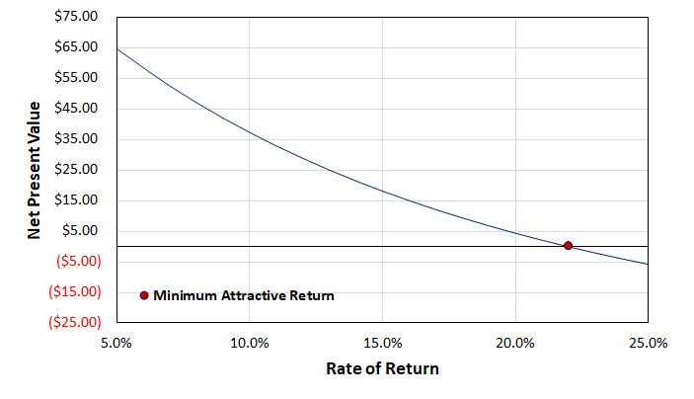
Figure 4.2.1: Rate of Return versus Net Present Value

Using the net present value chart shown upon, with the team’s current pricing and the chosen minimum ROI that the net present value is currently zero. The analysis was completed using a return range of 5% to 25%, based upon a realistic prospective return.
It is likely that expenses are going to be higher than what is listed in this report. Also mentioned in section 4.1, there are several expenses that will be increasing. That includes equipment costing, with more precise calculations and the addition of motors. Due to the fact that manufacturing costs will most likely increase, the present pricing of the rTPA will most likely not be enough to cover the expenses and the ROI will lower along with the NPV becoming negative. Because virgin TPA prices are commonly between $1.00 and $1.50 per kilogram, it is not advantageous to raise the price of the recycled TPA product. Even with the fact that sustainability and recycled products are growing in popularity, the price of rTPA at $2.21/kg, is not very competitive when compared to that of the virgin material.

5. Recommendations and Future Work
The goal of this final process design and the PHA analysis is to ensure the implementation of the proposed process stays profitable and safe. The team has designed a process with an rTPA product sale price to $2.21/kg which is not yet competitive price to that of virgin TPA. Based upon the economic forecast currently, the team recommends continuing with the project to the next phase, but further optimization of the process would be necessary to directly compete with virgin TPA.
The efficiency and yield of the filtration steps in the clarification process needs to be evaluated with real time data. This information should be compared to theoretical data for ultrafiltration, crystallization, and centrifugal sedimentation units. A closer look at cyclones, and vacuum filtration are examples of alternatives to be considered. Future work for wastewater treatment includes quantifying the waste stream from CL-225 carbon column and determining the most economically feasible approach to neutralizing it for proper disposal.
Currently, the waste streams have a large biological oxygen demand due to the EG in the wastewater and are expensive aspect of the process. This led the team to have to increase the price per kg of rTPA product from $1.88/kg to $2.21/kg. Further optimization of wastewater treatment on-site could lead to a more competitive price for rTPA.
Additionally, in the EG recovery part of the process, the EG is distilled to a purity of 99.9%. Further consideration should be given to reducing the purity of EG, as this could be an opportunity for cost savings.
From the process chemistry perspective, further lab development and research regarding which enzyme (PETase, lipase, or another hydrolase) to use in the process is needed. Since this is the beginning stage of the process, bench scale testing, then pilot plant testing, and large-scale production testing are needed. Another recommendation is to partner with the MRFs to obtain a reliable source of PET feedstock. The team recognizes that at this time the price of the rTPA product is not low enough to directly compete with virgin TPA. However, because this process proposes a circular and environmentally conscious approach to plastic production, it is worth considering for serious optimization. The team also acknowledges the need for emerging green technologies and just because the rTPA product isn’t directly competitive with virgin TPA at this point, it does not mean it couldn’t be in the future. Below is a list of recommendations resulting from the PHA. They are in order of completion priority:
• Consider adding leak detection on all lines that contain ethylene glycol, H₂SO₄, and Na₂SO₄.
• Consider inerting piping that contains dust or small particles.
• Replace the conveyer belt out of the dryer with a blower.
• Evaluate and design alarms, interlocks, and fail safes.
• Further consider adding instrumentation to equipment, like pressure, flow, temperature, position, and density indicators, and indication on motors.
• Evaluate the need for further insulation on piping around the heat exchangers and other equipment.
• Look into adding catch systems for spills on the conveyor belts.
• Consider installing weight sensors on the conveyer belts.
• Consider keeping spare microgranulator blades in stores.
• Look into designing manual override on valves and controls.
• Think about adding in check valves to prevent back flow before necessary equipment.

In addition, there are likely process hazards that were not identified in this PHA as the result of the limited process knowledge of the team. In the next design phase, the corresponding PHA should be carried out by a team with greater process knowledge.

References

Authors, Guest. “Prices for Most Recycled Plastics Continue to Rise - Resource Recycling.” Resource Recycling News, Resource Recycling, 16 Feb. 2021, https://resource-recycling.com/recycling/2021/02/16/prices-for-most-recycled-plastics-continue-to-rise/#:~:text=The%20national%20average%20price%20of,over%20the%20course%20of%202021.

Authors, Guest. “Prices Stabilize for PET and HDPE Bales.” Plastics Recycling Update, Plastics Recycling Update, 15 Sept. 2021, https://resource-recycling.com/plastics/2021/09/15/prices-stabilize-for-pet-and-hdpe-bales/.

Barbero, Robert, et al. “Increasing the Transparency, Coordination, and Predictability of the Biotechnology Regulatory System.” National Archives and Records Administration, National Archives and Records Administration, 4 Jan. 2017, https://obamawhitehouse.archives.gov/blog/2017/01/04/increasing-transparency- coordination-and-predictability-biotechnology-regulatory . (accessed 12.6.21).
“Hydrolase.” Wikipedia, Wikimedia Foundation, 17 Oct. 2021, https://en.wikipedia.org/wiki/Hydrolase.
“Hydrolase Introduction.” Hydrolase Introduction - Creative Enzymes, https://www.creative-enzymes.com/resource/hydrolase-introduction_21.html.
“Microbial Products of Biotechnology Summary of Regulations under the Toxic Substances Control Act.” Environmental Protection Agency, Sept. 2012.

“Microbial Products of Biotechnology; Final Regulation Under the Toxic Substances Control Act.” Environmental Protection Agency, 11 Apr. 1997.

Mufara, K., n.d. Title V air permit: Everything you need to know about the operating permit. [WWW Document]. ERA Environmental. URL https://www.era- environmental.com/blog/title-v-air-permit (accessed 12.3.21).
OSHA, n.d. Department of Labor Logo United Statesdepartment of Labor [WWW Document].
1910.119 App A - List of Highly Hazardous Chemicals, Toxics and Reactives (Mandatory)
| Occupational Safety and Health Administration. URL https://www.osha.gov/laws- regs/regulations/standardnumber/1910/1910.119AppA (accessed 12.3.21).
Rachael. “Plastic Eating Bacteria - How They Work - Petase That Can Break down Plastic.” Rs' Science, 10 Aug. 2021, https://rsscience.com/plastic-eating-bacteria/#How_plastic-eating_bacteria_actually_work .
Ryan, Carol. “Empty Plastic Bottles Go from Trash to Hot Commodity.” The Wall Street Journal, Dow Jones & Company, 9 Nov. 2021, https://www.wsj.com/articles/empty-plastic-bottles-go-from-trash-to-hot-commodity-11636455644#:~:text=The%20cost%20of%20food%2Dgrade,PET%20Container%20Resources%20(NAPCOR).
Seider, W.D.; Seader, J.D.; Lewin, D.R.; Widagdo, S.; Gani, R.; Ng, K.M. Product and Process Design Principles: Synthesis, Analysis, and Evaluation, Fourth Edition, John Wiley & Sons, Inc. (2016).

Singh, Avantika, et al. “Techno-Economic, Life-Cycle, and Socioeconomic Impact Analysis of Enzymatic Recycling of Poly(Ethylene Terephthalate).” Joule, vol. 5, no. 9, 15 Sept. 2021,
pp. 2479–2503., https://doi.org/hrttps://doi.org/10.1016/j.joule.2021.06.015.

“Sodium Sulfate Price and Market Analysis - Echemi.” ECHEMI,
https://www.echemi.com/productsInformation/temppid160705011365-sodium-sulfate.html
Standard enthalpy of formation, Gibbs energy of formation, entropy and molar heat capacity of organic substances. https://www.engineeringtoolbox.com/standard-enthalpy-formation-value-Gibbs-free-energy-entropy-heat-capacity-organic-d_1979.html (accessed Mar 9, 2022)

Turton, Richard, et al. Analysis, Synthesis, and Design of Chemical Processes. Pearson Education, Inc., 2018.

Vishali, S, et al. “Ultrafiltration.” Ultrafiltration - an Overview | ScienceDirect Topics, 2017, https://www.sciencedirect.com/topics/chemical-engineering/ultrafiltration.

Water baths. https://www.berlynecm.com/pages/BerlynECM-Products.cfm?id=1007 (accessed
Mar 8, 2022).

Appendices

Hyperlinks to Safety Data Sheets
Below are hyperlinks that lead to the safety data sheet for each specified chemical within the proposed process. Before handling these materials, please read through the appropriate data sheets.
Sodium Hydroxide SDS
Recycle PET Flake SDS
Sulfuric Acid SDS
Terephthalic Acid SDS
Sodium Sulfate SDS
Ethylene Glycol SDS
Lipase Catalyst SDS

Summary of Physical Properties

Table B.1: Physical properties of all components
Compound | MW | Tm (°F) | Tbp (°F) | T_{Auto} (°F)
PET | 8000-31000 | 428 | >212 | N/A
TPA | 166 | 572 | N/A | N/A
Enzyme | 58.4 kDa | N/A | N.A | N/A
NaOH | 40 | N/A | N/A | N/A
Sodium Sulfate | 142 | 1616 | 3092 | N/A
Ethylene Glycol | 62 | 9 | 388 | 752
Sulfuric Acid | 98 | 37 | 554 | N/A

Material and Energy Balance for Process and Utility Streams
Table C.1: DWG 5046-03028-B Material Balance

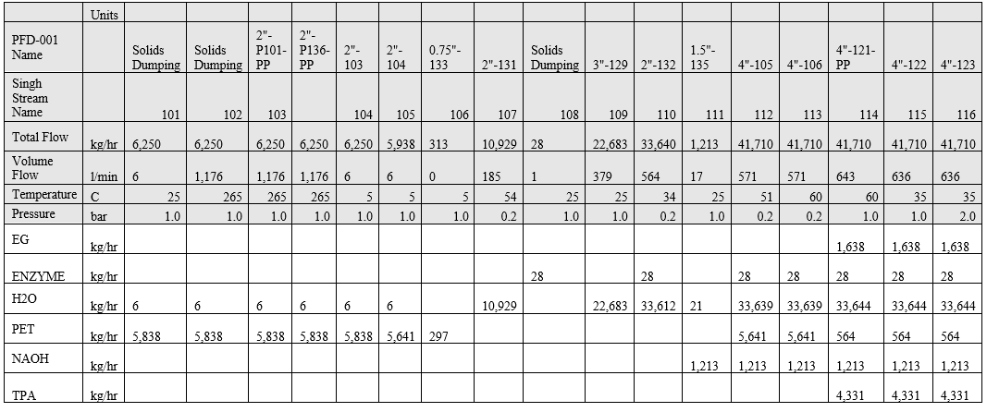

This material balance is based on the material balance from Singh et al. that has been modified to fit the team’s process. The MEB around the heat exchangers are listed below in Table C.4.

Table C.2: DWG 5046-03036-A Material Balance

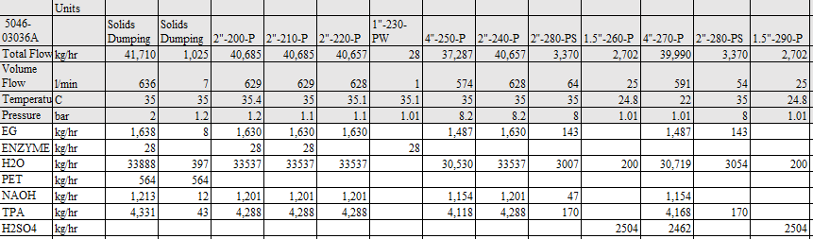

Table C.3: DWG 5046-03037-A Material Balance

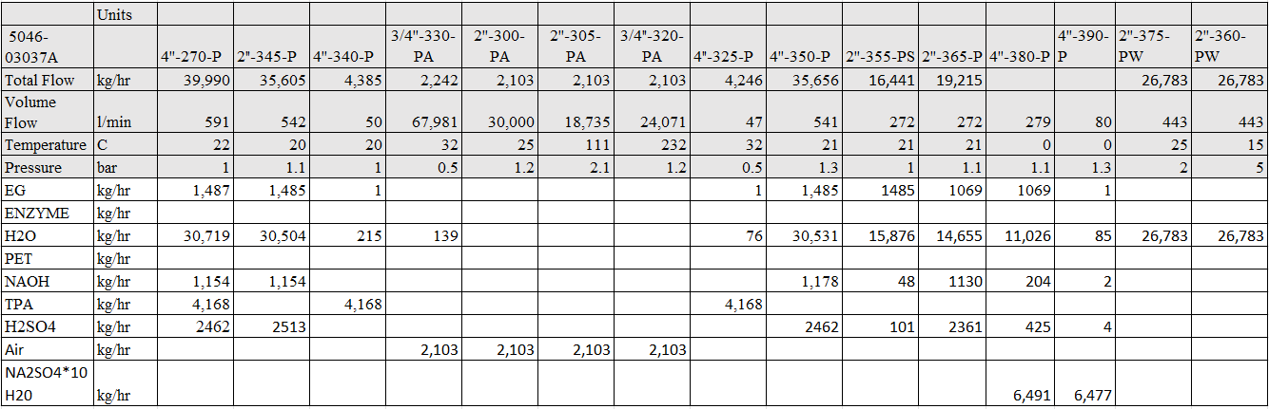
Table C.4: DWG 5046-03038-B Material Balance
 | Units
5046-03038B |  | 2"-P400 | 2"-P401 | 2"-P404 | 2"-P405 | 1.5"-P406 | 1.5"-P407 | 2"-P408 | 1"-P409 | 3"-P412 | 1"-P413 | 1"-P414 | 1"-P418
Total Flow | kg/hr | 11757 | 11757 | 11757 | 11757 | 8203 | 3553 | 2726 | 827 | 10929 | 827 | 827 | 827
Volume Flow | 1/min | 196 | 196 | 196 | 196 | 139 | 59 | 46 | 14 | 185 | 14 | 14 | 14
Temperature | C | 0 | 35 | 41 | 41 | 54 | 56 | 54 | 129 | 54 | 129 | 100 | 33
Pressure | bar | 1 | 6 | 1 | 1 | 0.2 | 0.2 | 0.2 | 0.2 | 0.2 | 11 | 6 | 1
EG | kg/hr | 819 | 819 | 819 | 819 | - | 819 | - | 819 | - | 819 | 819 | 819
H2O | kg/hr | 10938 | 10938 | 10938 | 10938 | 8203 | 2734 | 2726 | 8 | 10929 | 8 | 8 | 8

Table C.5: E-120, E-125, E-145, E-155, P-130, P-135, P-140, P-160, P-165 Energy Balances

Simulation: 5046-2218 Depolymerization E-120 and E-125
Overall Energy Balance | MJ/hr
 | Input | Output
Feed Streams | -78342.2
Product Streams |  | -78342.2
Total Heating | 0
Total Cooling | 0
Power Added | 0
Power Generated | 0
Total | -78342.2 | -78342.2
Simulation: 5046-2218 Depolymerization E-145, E-155 and P-160
Overall Energy Balance | MJ/hr
 | Input | Output
Feed Streams | -1.87E+06
Product Streams |  | -1.87E+06
Total Heating | 0
Total Cooling | 0
Power Added | 3.83678
Power Generated | 0
Total | -1.87E+06 | -1.87E+06
Simulation: 5046-2218 Depolymerization Pumps
Overall Energy Balance | MJ/hr
 | Input | Output
Feed Streams | -576883
Product Streams |  | -576882
Total Heating | 0
Total Cooling | 0
Power Added | 0.766719
Power Generated | -5.67E-08
Total | -576882 | -576882

Example Process Calculations
Pump Sizing:
1. From CHEMCAD obtain the flow rate, Q, and the theoretical horsepower, P_{T}
2. Equation for pump efficiency:
η_{P} = -0.316 + 0.24015 * LN(Q) - 0.01199 * LN(Q)^2
3. Equation for pump brake, HP
P_{B} = P_{T} / η_{P}
4. Equation for motor efficiency
η_{M} = 0.8 + 0.0319 * LN(P_{B}) - 0.0182 * LN(P_{B})^2
5. Equation for final power consumption, returns to the closest .25
P_{C} = (INT(r* P_{B} / η_{M} +1))/4

Emission Calculations
It was determined that there were no air emissions to be calculated.

Example Economic Calculations
Please see excel workbook “5046-2218 Capital Cost Build-Up Spring: for the detailed economic build-up of equipment and operating costs. Excel workbook “5046-2218 Economic Forms Spring” provides economic calculations such as net present value.

Specification Sheet

Pump Specifications
Table G.1: Enzymatic Depolymerization Pump Specifications
Description | Water Recycle | Water Make-up | NaOH | To Clarification | Microgranulator
Tag Number | P-130 | P-135 | P-140 | P-160 | P-165
Type of Pump | 1-stage 3600 rpm VSC Centrifugal |  |  |  | Diaphragm Solids Pump
Materials | 316 Stainless Steel |  |  |  | Carbon Steel
Physical Properties of Fluid  (kg/hr) | 10,929 kg/hr  Water  0.2 Bar  54 °C | 22,683  Water  1.01 Bar  25 °C | 1,213  NaOH  1.01 Bar  25 °C | 6,250  PET  1.01 Bar  35 °C | 41,710  EG, Enzyme, Water, PET, NaOH, TPA  2 Bar  35 °C
Normal and Maximum Flow Rate (kg/hr) | 10,929 | 22,683 | 1,213 | 6,250 | 41,710
Normal and Maximum Temperature (°C) | 54 | 25 | 25 | 35 | 35

Table G.2: Clarification Pump Specifications
 | PET/Sludge Pump | PET/ Sludge Pump | Sulfuric Acid
Tag Number | P-205 | P-220 | P-230
Description | Ultrafiltration Pump | Activated Carbon Feed Pump | Raw Material Feed Pump
Type of Pump | 1-stage 3600 rpm VSC Centrifugal
Materials | Carbon Steel
Physical Properties of Fluid | Ethylene Glycol, Enzyme, Water, PET, NaOH, TPA:  7.0 bar  40 °C | Ethylene Glycol, Water, NaOH, TPA:  10 bar  Temp C: 40 | Sulfuric Acid, Water:  5.0 bar  30 °C
Normal and Maximum Flow Rate (kg/hr) | 40,685 | 40,657 | 2,702
Normal and Maximum Temperature (°C) | 35 | 35 | 25

Table G.3: Co-Product Recovery: Crystallization Pump Specifications
 | Water and Sodium Sulfate (l) | Supply Water | Permeate Wastewater | Sodium Sulfate
Tag Number | P-245 | P-300 | P-310 | P-315
Description | Co-Product Recovery Pump | RO Membrane Water Supply Pump | RO Waste Water Pump | Sodium Sulfate Crystallizer Feed Pump
Type of Pump | 1-stage 3600 rpm VSC Centrifugal
Materials | Carbon Steel
Physical Properties of Fluid | EG, Water, Sodium Sulfate (l):  Pres: 6 bar  Temp C: 26 | Water:  Pres:10 bar  Temp C: 25 | Water/Impurity:  Pres: 10 bar  Temp C: 25 | Water, EG, Sulfuric Acid, NaOH:  Pres: 14.7  Temp C: 25
Normal and Maximum Flow Rate (kg/hr) | 35,656 | 26,000 | 16,441 | 19,215
Normal and Maximum Temperature (°C) | 25 | 25 | 25 | 20

Table G.4: Co-Product Recovery: Ethylene Glycol Pump Specifications
 | Ethylene Glycol | Recovery Water | EG Cooling
Tag Number | P-400 | P-470 | P-455
Description | EG Pump | Recovery Water  Pump | EG Cooling  Pump
Type of Pump | 1-stage 3600 rpm VSC Centrifugal | 1-stage 3600 rpm VSC Centrifugal | 1-stage 3600 rpm VSC Centrifugal
Materials | Carbon Steel | Carbon Steel | Carbon Steel
Physical Properties of Fluid | Water/EG  Pres: 14.7  Temp C: 0  Vapor Frac: 0  Density: 62.3 | Water/EG  Pres: 14.7  Temp C: 54  Vapor Frac: 0  Density: 62.3 | Water/EG  Pres: 14.7  Temp C: 54  Vapor Frac: 0  Density: 62.3
Normal and Maximum Flow Rate (kg/hr) | 12,000 | 12,000 | 1,000
Normal and Maximum Temperature (°C) | 0 | 54 | 85

Heat Exchangers
Table G.5: Enzymatic Depolymerization Heat Exchanger Specifications E-120
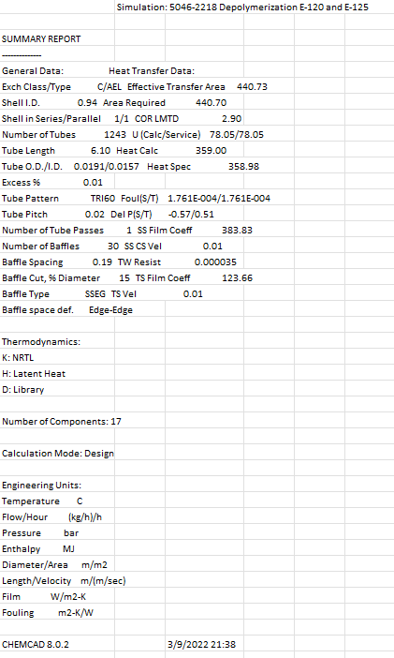

Table G.6: Enzymatic Depolymerization Heat Exchanger Specifications E-125
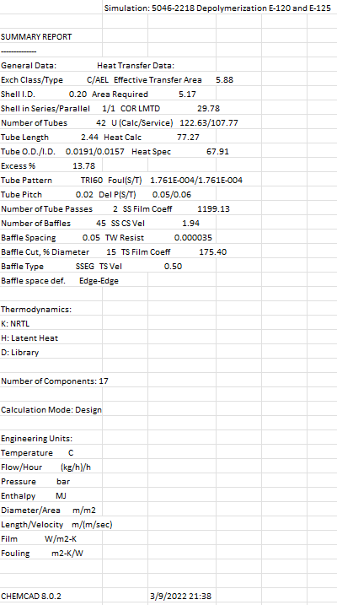

Table G.7: Enzymatic Depolymerization Heat Exchanger Specifications E-145
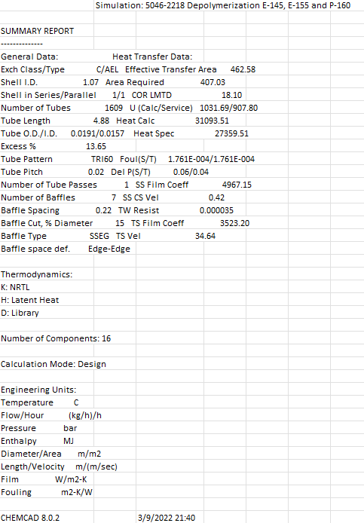

Table G.8: Enzymatic Depolymerization Heat Exchanger Specifications E-155
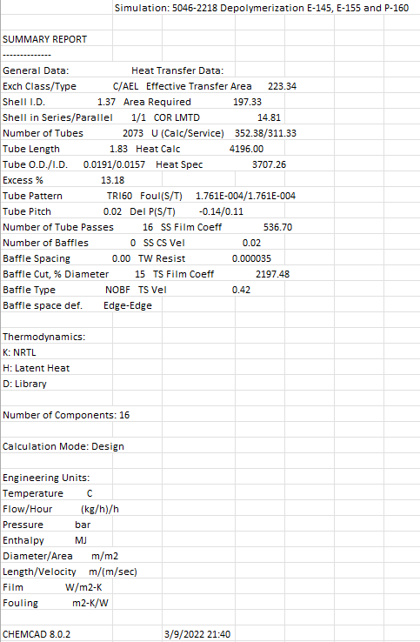

Table G.9: Air Heat Exchanger E-260
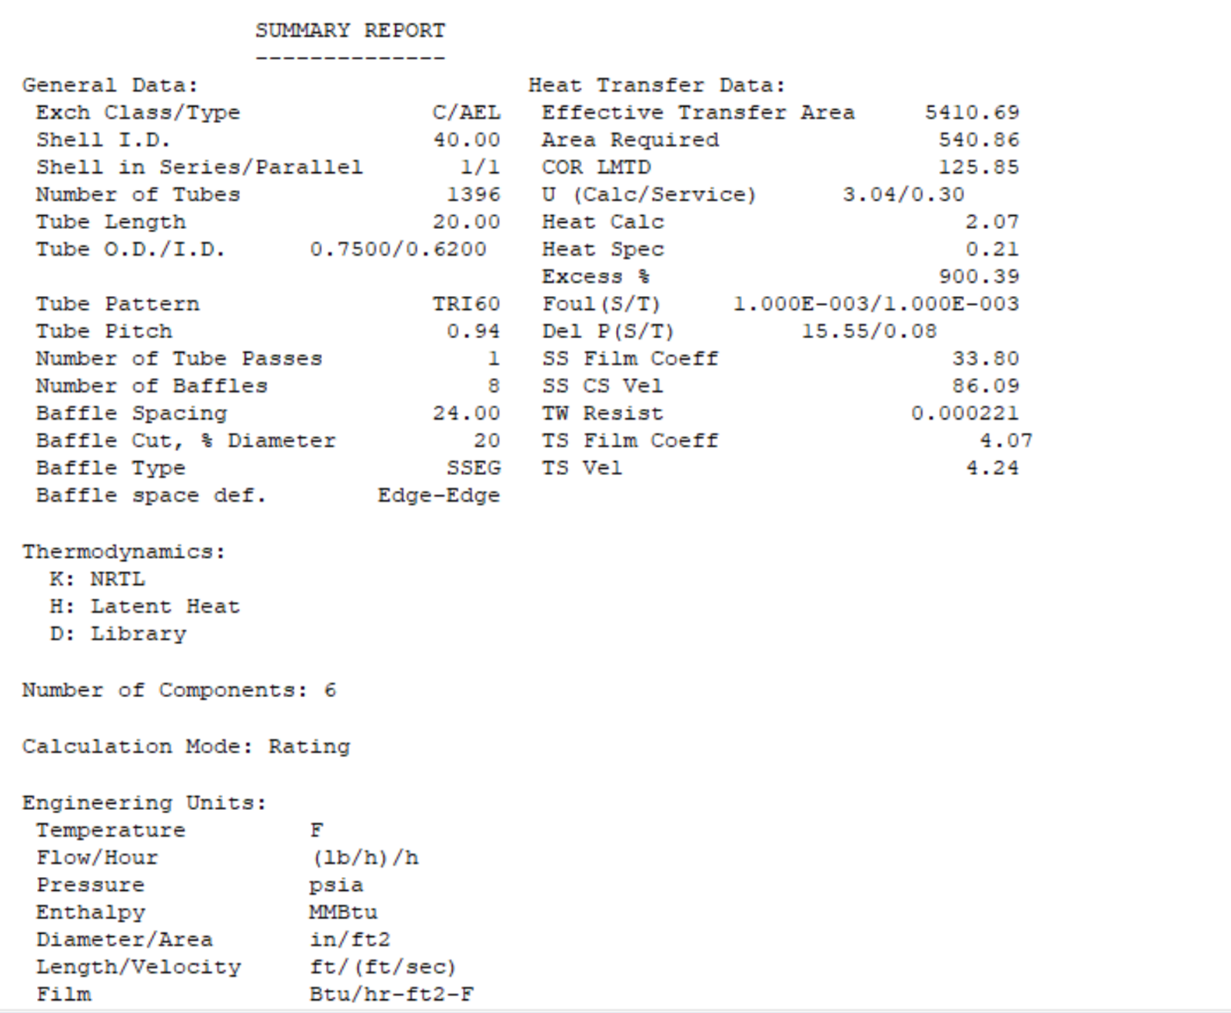

Table G.10: EG Pre-Heater Heat Exchanger Specifications E-405

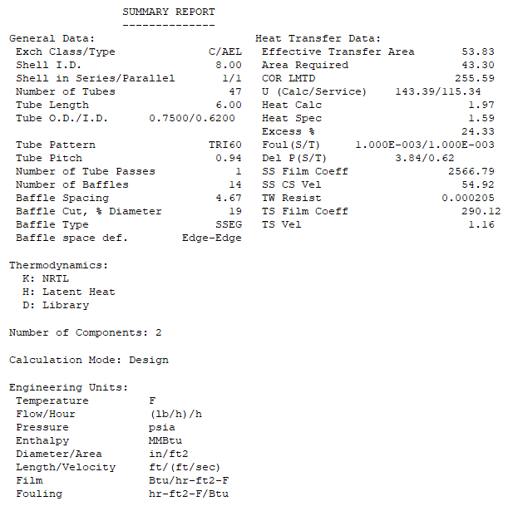

Table G.11: Column 1 Pre-Heater Heat Exchanger Specifications E-410

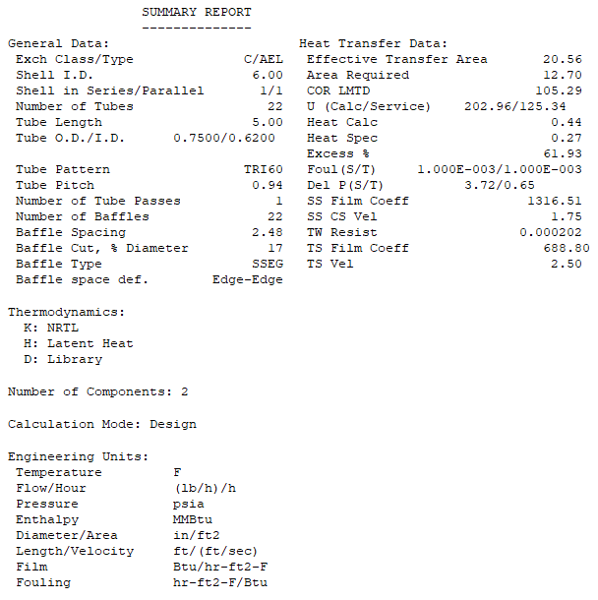

Table G.12: Column 1 Condenser Heat Exchanger Specifications E-420
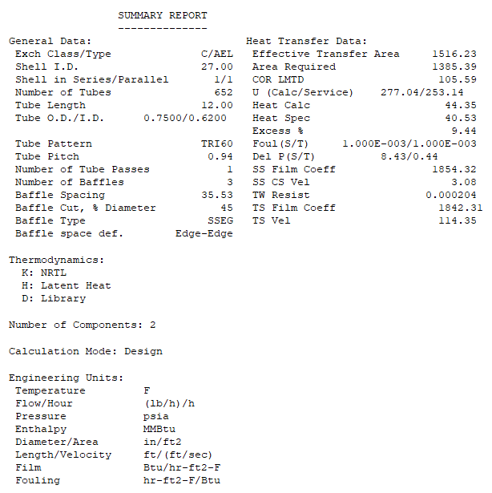

Table G.13: Column 1 Reboiler Heat Exchanger Specifications E-425
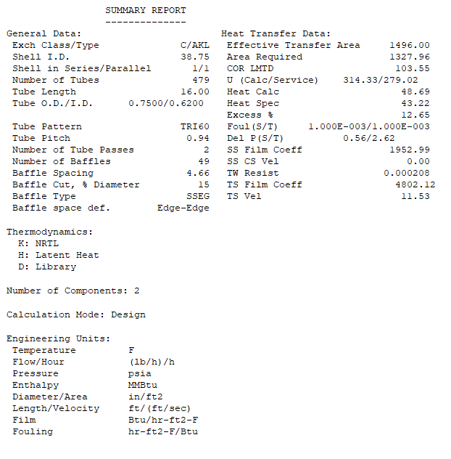

Table G.14: Column 2 Condenser Heat Exchanger Specifications E-440
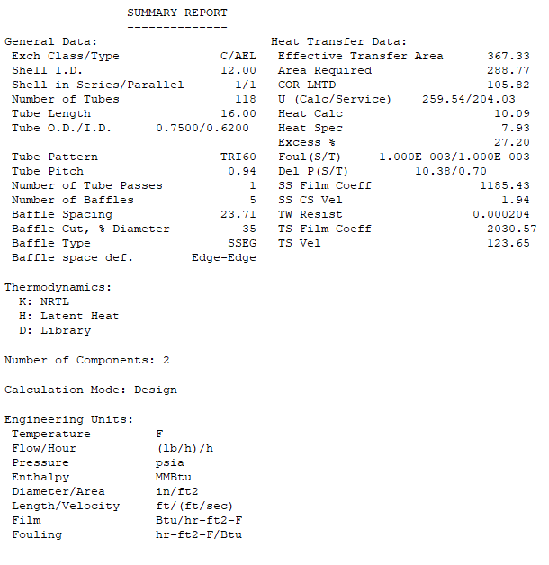

Table G.15: Column 2 Reboiler Heat Exchanger Specifications E-445
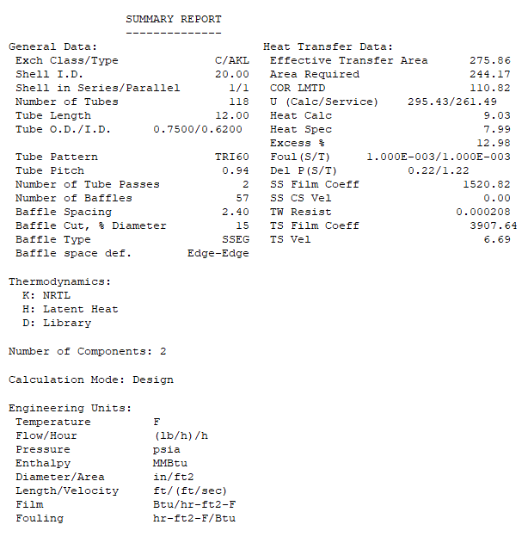

Table G.16: EG Pre-Cooler Heat Exchanger Specifications E-460
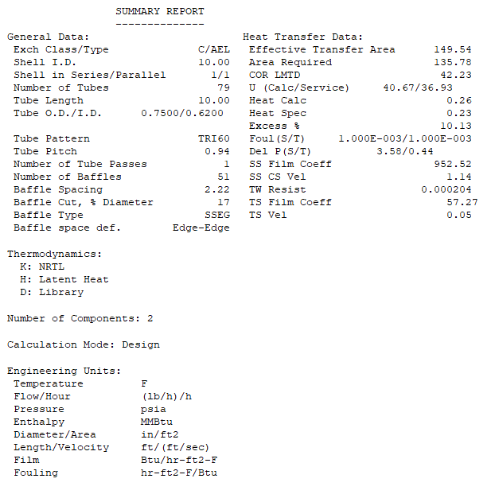

Table G.17: EG Cooler Heat Exchanger Specifications E-465
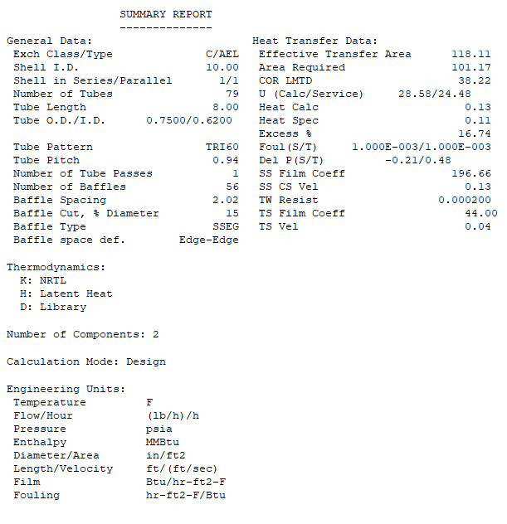

Compressor Specifications

Table G.18: Compressor Specifications
Tag Number | E-255
Description | Air Compressor
Type of Compressor | Adiabatic
Material | 316 Stainless Steel
Power Required (HP) | 75
Physical Properties | Single Stream  Pres: 14.7  Temp F: 85.0  Vapor Frac: 1.00  Flow Rate: 4636 lb/hr  Wt% Air: 100%
Normal and Maximum Inlet/Outlet Pressures (psia) | Atmospheric/60
Normal and Maximum Flow Rate (lb/hrr) | 7240
Normal and Maximum Temperature (°F) | 85.0
Efficiency/Theoretical Power (HP) | 80% / 56

Vessels
Table G.19: Reactor, Vessel, and Distillation Column Specifications
Tag Number | R-150A-G | V-430 |  |  | CL-415 |  | V-450
Description | Enzyme Reactors | Column 1 Accumulator |  |  | Distillation Column 1 |  | Column 2 Accumulator
Diameter (ft) | 5.2 | 3.5 |  |  | 6 |  | 2.5
Weight (lb) | 19,938 | 10,503 |  |  | 14,683 |  | 3,903
Height/Length (ft) | 11.3 | 13.2 |  |  | 14.0 |  | 8.8
Bed Size (m³) and Configuration | 950 | N/A |  |  | N/A |  | N/A
Number and Type of Trays | N/A | N/A |  |  | 7; Sieve |  | N/A
Tray Spacing (ft) | N/A | N/A |  |  | 2 |  | N/A
Number of Nozzles | 4 | 4 |  |  | 3 |  | 4
Normal Operating Pressure (bar) | 1.01 | Atmospheric |  |  | Atmospheric |  | Atmospheric
Normal Operating Temperature (°C) | 60 | 85 |  |  | 100 |  | 100
Design Temperature (°C) | 60 | 100 |  |  | 115 |  | 115
Design Pressure/Vacuum (bar) | 1.01 | Atmospheric |  |  | Atmospheric |  | Atmospheric
Materials of Construction | 316 Stainless Steel |  | Carbon Steel | Carbon Steel |  | Carbon Steel
Allowable Fouling Factors (ft2-°F-hr/BTU) | .001 | .001 |  |  | .001 |  | .001
Special Internals? | N | N |  |  | N |  | N
Insulation Requirements | Insulated to meet temperature requirements | Insulated to meet temperature requirements |  |  | Insulated to meet temperature requirements |  | Insulated to meet temperature requirements

Table G.20: Reactor, Vessel, and Distillation Column Specifications

Tag Number | CL-435
Description | Distillation Column 2
Diameter (ft) | 3
Weight (lb) | 17,836
Height/Length (ft) | 40
Bed Size (m³) and Configuration | N/A
Number and Type of Trays | 20; Sieve
Tray Spacing (ft) | 2
Number of Nozzles | 3
Normal Operating Pressure (bar) | Atmospheric
Normal Operating Temperature (°C) | 100
Design Temperature (°C) | 115
Design Pressure/Vacuum (bar) | Atmospheric
Materials of Construction | Carbon Steel
Allowable Fouling Factors (ft2-°F-hr/BTU) | .001
Special Internals? | N
Insulation Requirements | Insulated to meet temperature requirements

