Saints and Sons, Painting Power, Piety, and the Performance of Nobility in Zurbarán’s Saint Peter Nolasco Recovering the Image of the Virgin of El Puig.
The identity of the young boy in Francisco de Zurbarán’s Saint Peter Nolasco Recovering the Image of the Virgin of El Puig (1630) has been discussed by Zurbarán scholars, but no positive identification of the boy exists. Martin S. Soria has suggested that he could be Juan de Zurbarán, the artist’s son. The setting and time period of the narrative depicted in the painting implies the figure may be Alfonso of Castile, the son of James I of Aragon. There has yet to be significant evidence provided for either case. The lack of a clear identification is a notable gap in knowledge surrounding the most formally important figure in a commission that defined Zurbarán’s career. The following analysis determines that the child in the piece is a composite of Juan de Zurbarán and Alfonso of Castile, and explores the implication of Zurbarán depicting his child in the noble and pious role of James the Conqueror’s son, paying witness to the rediscovery of the Virgin of El Puig. The combined figure of Juan and Alfonso gains significance through an exploration of historical context surrounding the legend and its key figures. By drawing parallels between 17th-century Spanish colonialism and the 13th-century Reconquista, Zurbarán uses this composite figure to assert a vision of his lineage as triumphant and divinely favoured. Ultimately, the elevation in status of his own son places Zurbarán within the Baroque tradition, alongside fellow Spanish Baroque painter Velázquez , of artists asserting their identity as divine, noble, and distinct from craftsmen.
Francisco de Zurbarán (1598-1664) was born in 1598 in Fuente De Cantos, Spain. He was apprenticed from 1614–16 to Pedro Díaz de Villanueva in Seville, and though no works of his teacher remain, Zurbarán’s early pieces suggest he was trained in a similar naturalistic style to that of his contemporary, Diego Velázquez (1599-1660). After his training period he returned to his native province. Though the artist produced a fair amount of portraiture and still life, he was largely revered for his religious and devotional works, primarily of saints, apostles, and monks. Saint Peter Nolasco Recovering the Image of the Virgin of El Puig (fig. 1) was part of a series of twenty-two works commissioned by the convent of the Merced Calzada in Seville. Only eleven of the paintings are still known today. The series was displayed in the small boxwood cloister of the new church. Each of the works in this series depicted important scenes from the life of the founder of the Mercedarian order, Saint Peter Nolasco (c.1182–1256). This large commission, for which he was paid 1,500 ducats, allowed Zurbarán to relocate to Seville, and eventually become the city’s official painter.
The painting depicts two highly important medieval figures, in commemoration of the rediscovery of the Virgin of El Puig in 1238. King James I of Aragon, also known as James the Conqueror, (1208–76; r. 1213–76 ) is just right of center, identified by his suit of armour and his crown, and Saint Peter Nolasco is the frontal figure in the white habit. The overall tone of the work, characteristic of Zurbarán’s style, is reverant and serious. Saint Peter Nolasco bows his head in prayer, while King James takes a wide powerful stance, directing the viewer to the relic of the Virgin of El Puig. The soldiers on the left appear overcome by holy admiration, while the fully rendered soldier in the front has tears welling up in his eyes as he comforts or praises the peasant that presents the relic to the king. The figural gap in the center of the piece, alongside the dress of the figures, creates two distinct rankings of individuals. On the left there are worldly men, dressed in military garb or plain clothing that denotes no specific status. On the right the men are depicted as powerful and in the favor of God. King James I wears an ornate ensemble of shining armour, decorated in gold. He wears a crown rather than a helmet, and he places his hand on the gilded hilt of his sword. Peter Nolasco is presented as a massive swath of pure white, wearing the Mercedarian Habit, which was meant to facilitate access to Muslim territories during the reconquista. The Child stands between them, centered between a man of great noble importance and a highly religious figure—both are under divine grace. Whoever The Child is, he is highly honored and distinguished.
The work in the Cincinnati Art Museum (CAM) stands 65 1/16 in. tall and 82 3/16 in. wide, rendering the figures near life-sized. Despite being merely a portrait, the face of the young boy visually dominates the three fully depicted men in the foreground of the piece. The pale tone of his skin protrudes beyond the dark framing of his background, and is defined against the habit of Saint Peter Nolasco to his right by the tenebristic shadowing on his face. His eyes break the picture plane and meet the viewer’s no matter the angle. It is directly confrontational and complemented by his stoic expression: straight mouth, still brows. He mimics the three quarters turn of the king on his left, establishing a visual connection between the two figures. The cast-down gaze of Saint Peter Nolasco connects with the line of the white habit, up the angled arm of King James, and across again to the saint with the direction of King James’ eyes. This composition creates an implied triangle that directly frames the child’s face. It would be an oversight to not identify the significance of the child’s position in the piece: directly between the King of Aragon and the founder of the Mercedarian Order. All of these elements give the boy visual supremacy.
The boy’s prominence in the work can be supported by a study done at the CAM. Peter Haffner and Drew Morris, working with Peter Bell, the CAM Curator of European Paintings, Sculpture and Drawings, conducted the experiment by having twenty-four individuals look at pre-selected works in the museum for two minutes at a time. The volunteers wore glasses that tracked their eye movements. The researchers analyzed those movements for trends, revealing which areas of the paintings drew the viewer's eye for the longest duration. The ‘heat map’ for Zurbarán’s Saint Peter Nolasco Recovering the Image of the Virgin of El Puig corroborates the assertion that the young boy is the most visually prominent work in the figure. (fig. 2) The yellow and orange highlights areas where people looked for increasing amounts of time, and the red spots denote where they looked the longest. The area viewed for the longest duration, as proven by the study, was the face of the boy in question.
To truly understand the importance of the boy’s position and his identity, some historical events, as well as the legend of the Virgin of El Puig must be explored. The Mercedarian Order was founded in 1218 by Peter Nolasco. The defining trait of the Mercedarian order was their fourth vow, sometimes referred to as a ‘blood vow’. Members of the order were to offer themselves in the stead of Christians who were taken captive during the reconquista, and were in danger of losing their faith. This vow included dying for someone else's faith if necessary. During Nolasco’s lifetime, the order claimed to have freed 70,000 Christian prisoners, though in reality it is believed to be closer to 2,700. Early on in its construction, the organization was also considered a military order, going by the name the Knights of Saint Eulalia. Because of his involvement in the capturing of Valencia, Peter Nolasco, much like King James, was known as The Conqueror. Zurbarán’s piece shows the founder of the Mercedarian order alongside King James, during a moment of triumph resulting from their reconquest.
The event depicted in the painting, as the title reveals, is the recovery of a relic of the Virgin. This legend is believed to have coincided with King James’ capture of Valencia from the Taifa of Valencia on the 28th of September in 1238, after the decisive Battle of El Puig. The tablet of the Virgin was believed to have been brought to El Puig by Benedictine monks when they constructed a convent there shortly after the fall of the Roman Empire. The Benedictines buried the relic to protect it from battles with Muslim armies along the Iberian Peninsula. Directly before the capturing of Valencia, watchmen of King James’ army saw three bright lights fall and disappear into the ground in the space that now holds the Mercedarian Convent of Nuestra Señora del Puig. Upon hearing of this event, Peter Nolasco demanded the spot be excavated. Two discoveries were made; a bell bearing depictions of the Apostles Peter, Paul and James, and the Virgin of El Puig. The bell is seen in the Cincinnati artwork just below the relic, though no distinct images are visible on it. The recently discovered tablet was thought to be carved from angels out of a stone from the tomb of the Virgin Mary in Jerusalem.
The other prominent, identifiable figure in the work is King James I of Aragon (1208-1276), who was a renowned medieval king. He was called James the Conqueror, as he was known for leading the reconquest of the Balearic Islands and Valencia. Despite the religious and social sensibilities of the time, King James was married twice, first to Donna Leanor, then to Yolanda of Hungary. James’ marriage to Donna Leanor was nullified by Pope Gregory IX for the reason of consanguinity. However, the one son they already had together, Alfonso of Castile (1229–1260), was still to be considered a legitimate heir. Given that the legend of the recovery of the relic took place in 1238, Alfonso would have been nine when this event occurred, matching the age of the boy depicted in the piece. James’s next son, Peter III (1240-1285), and the successor of Aragon, Catalonia, and Valencia, would not be born until two years after the event depicted in the painting. Given the wealth of knowledge available on King James because of the common retranscription of his biography, Llibre dels Fets, it is reasonable to assume Zurbarán could have known the ages of James’ children. Therefore, taking into account the formal connections between James and the boy, within the narrative of the painting, he must be Alfonso of Castile.
Given the prominent association of military prowess and Spanish expansion with both King James and Peter Nolasco, as well as the importance of Spain’s colonization of the East and West Indies during the 17th century, one can read Zurbarán’s composition through an association with Christian conquest. The historical conditions of the reconquista, under which the relic of the Virgin was discovered, would have resonated with Zurbarán, Philip IV of Spain, and the contemporary members of the Mercedarian order. The economic stability of Spain was heavily reliant on the import of Silver from their American colonies. In fact, later in the 17th century, a decline in Silver production would lead to royal bankruptcy. Spanish culture, as well as Catholicism, was heavily pushed on native peoples in order to maintain control over these industries. Both the reconquista, and Spanish colonialism in the Americas, were periods of expansion that heavily relied on notions of divine right to rule and heavenly favor. Their military success was considered to be not only due to their strength and prowess, but a manifestation of God’s will to spread the Christian faith. The Mercedarian order had a significant hand in the establishment of Catholic institutions in the colonies. Members of the order accompanied conquistadors to the Americas, where the friars were given land to build convents for the purpose of indoctrinating local peoples. In 1526, the Spanish crown officially approved the Mercedarian expansion, and undertook the cost of the friar’s supplies and passage to Spanish America, in order to support their missionary work, and pressure indigenous peoples into adopting Spanish customs and religious beliefs.
It is important to ask why Zurbarán would include Alfonso of Castile in such a formally important position, within a painting so notably referencing the history of religion-fueled expansion in spain. Though King James I is specifically mentioned to be present in the legend of the recovery of the Virgin’s relic, there is no such mention of his son. In 1953, Martin S. Soria first suggested that the young boy in Zurbarán’s Saint Peter Nolasco Recovering the Image of the Virgin of El Puig was perhaps Zurbarán’s son. Other than proposing the idea, he did not cite specific evidence in support of his argument. The following works to fill the gaps in Soria’s claim. To begin, it is generally accepted by scholars that Zurbarán painted from life, using people he had access to as models. It is reasonable to assume that, given the accessibility of his family, he would have used them as references in some of his works. In the background Zurbarán’s Displaying the Body of Saint Bonaventure (1629) (fig. 3), behind the man wearing the large gold and white mitre, is a noticeably familiar figure. Though his face is largely obscured, similarities are seen in the light blonde hair parted heavily to one side, the curved semicircle of his brow, and the direct glance beyond the picture plane and towards the viewer. He is once again positioned between men of status and power, and stands out because he is rendered as significantly younger than the men around him. His visage is almost cherub-like, his features are soft and radiant, and no wrinkles or marks are to be seen. Given these similarities, as well as the fact that both paintings were produced within the same year, this means he utilized the same model twice. The individual would have been someone within reach of the artist, heightening the argument that it is Zurbarán’s son, Juan, that is depicted in both works.
In addition to these points, it is relevant to mention that Zurbarán is believed to have depicted himself in Crucifixion with a Painter (or St. Luke) (ca. 1650-55) (fig. 4) Scholars debate whether or not this is a literal depiction of Zurbarán, an allegorical depiction, or just a depiction of the Evangelist Luke. This point of contention stems from the lack of a precisely known date for the piece. Some believe the work to be earlier (1630-35), meaning Zurbarán would have been much younger than the figure depicted alongside Christ. Others argue that the work is later (1660s), and that Zurbarán may have used himself directly as a reference. Since no known portraits of Zurbarán are confirmed to still exist, comparisons of visual similarities cannot yet be made. However, many Baroque and Renaissance artists placed themselves in the guise of St. Luke in order to show their piety, and also to associate themselves with the famed portraitist of the Virgin and Child. The subject of the divine painter certainly evokes a relation to Zurbarán’s identity. The pallet of the painter holds the same shades used in the painting, which calls attention to Zurbarán’s own hand in the creation of the piece, associating him with the figure and placing him in the position of the painter paying witness to the Crucifixion.
As scholar Lisandra Estevez states, “The conversation suggested by the interaction between the artist and Christ indicates a crossing of boundaries, the artist stepping out of the realm of the rational and the visible into an extraordinary space where the artist makes contact with Christ.” Within this depiction of the self, whether allegorical or literal, Zurbarán asserts the identity of artists as divine and deeply connected to their subjects. He imagines himself, and those like him, as favored by Christ and ethereal in their own right. If the canon accepts this understanding of Zurbarán’s Crucifixion with a Painter (or St. Luke) (ca. 1650-55), it is entirely likely that he would have rendered his son in a similar position of power and divine rite.
The idea of an artist establishing their identity and status through their artwork is particularly prominent throughout Europe during the Baroque period. An examination of Zurbarán’s contemporary, Diego Velázquez , and scholarship on his methods of asserting a sense of nobility in his piece, Las Meninas, assists in establishing this precedent. (CHANGE SLIDE) In this well studied work many scholars have taken interest in the layered perspective which allows Velázquez to depict himself existing in a space with the spanish monarchs without directly breaching convention. The inclusion of the artist at work, accompanied by elements of his trade, are often considered a commentary on the implications of painting as a noble practice, distinct from other forms of craft. Conversations about this principle held high importance in 15th c. Italy, and by the 16th c. Italian painters were considered a higher class. Velázquez owned several different pieces of literature on this topic, its outcomes in Italy, and he led a workshop on the dignity of Spanish painting. Velázquez ’s claim to nobility is a widely accepted reading of Las Meninas, in addition to some of his other works.
It is also commonly accepted that Velázquez and Zurbarán were socially and professionally involved. It is believed Velázquez invited Zurbarán to travel to Madrid in 1634 to work on the decoration of the Buen Retiro Palace. Early in life, they both lived and trained in Seville. This relationship, as well as the prominence of discussions surrounding the social position of artists in Spain, indicate Zurbarán would have been well aware of this method of commentary. Though, as Velázquez ’s self-imposed identity leans towards that of the noble and monarchical, Zurbarán’s assertion reads more in the realm of the pious and religious. This is in line with the tone and subjects of his larger body of work, which present an air of otherworldliness, piety, and reverence.
The depiction of the young boy in Zurbarán’s Saint Peter Nolasco Recovering the Image of the Virgin of El Puig is a reference to Alfonso of Castile, but the physical portrait is of Juan de Zurbarán. Much like Zurbarán’s self portrait with the Crucifixion, one of the connotations of presenting Juan between King James and Peter Nolasco is an assertion of his son’s power and piety. It is important to note that Juan, much like his father, was an artist. Though very little of his work remains, his legacy lives on in a few known still lives that were originally misattributed to his father. The cultural push to elevate the status of artists was often supported by the relationship between Alexander and Appeles, the argument suggested that art that was patronized by kings was inherently noble art. Zurbarán appears to be making a similar argument in his painting, that art patronized by saintly figures was inherently close to God. The inclusion of his son, paired with analyses of his own self portrait, indicates that Zurbarán was not just depicting the religious importance or dedication of his lineage, but of artists more generally speaking.
Though it appears to be the dominant theme in the painting, Zurbarán is not only indicating a sense of theological elevation for his family. By placing Juan so formally related to King James I, in the place of the young Alfonso of Castile, Zurburan, much like Velazques, suggests an air of nobility. He does not place his son alongside just any aristocrat, but the King of one of the lands that would ultimately become modern Spain, and a saintly figure heavily involved in the reconquista that established those spanish lands. This is particularly relevant given Zurbarán’s context; he lived during a time where colonial expansion determined the economic power of his country. These figures would have still held significant importance given the relevance of religiously fueled territorial acquisition. Zurbarán associates his son with an Aristocracy that is four hundred years old and integral to the foundation of Spain. Within this Zurbarán is both asserting his lineage as powerful and kingly, and also placing his child within a context of divinely endowed military prowess.
Francisco de Zurbarán’s Saint Peter Nolasco Recovering the Image of the Virgin of El Puig functions as more than a devotional retelling of a historical legend, it is a carefully constructed assertion of artistic identity, dynastic pride, and national ideology. By portraying his own son, Juan de Zurbarán, in the guise of Alfonso of Castile, Zurbarán layers personal legacy onto a narrative of conquest, piety, and divine favor. The central placement of the child between King James I of Aragon and Saint Peter Nolasco visually and thematically elevates Juan, suggesting his dual inheritance of both noble and spiritual power. In doing so, Zurbarán aligns himself with contemporaries like Velázquez , using the canvas as a space for positioning the artist⸺ and by extension, his progeny⸺ within the spheres of influence typically reserved for saints and kings. The fusion of personal and hegemonic symbolism situates Zurbarán’s work firmly within the broader Baroque tradition, where art became a vehicle not only glorifying God and monarchy, but for redefining the social status of the artist as one chosen, inspired, and noble in his own right.

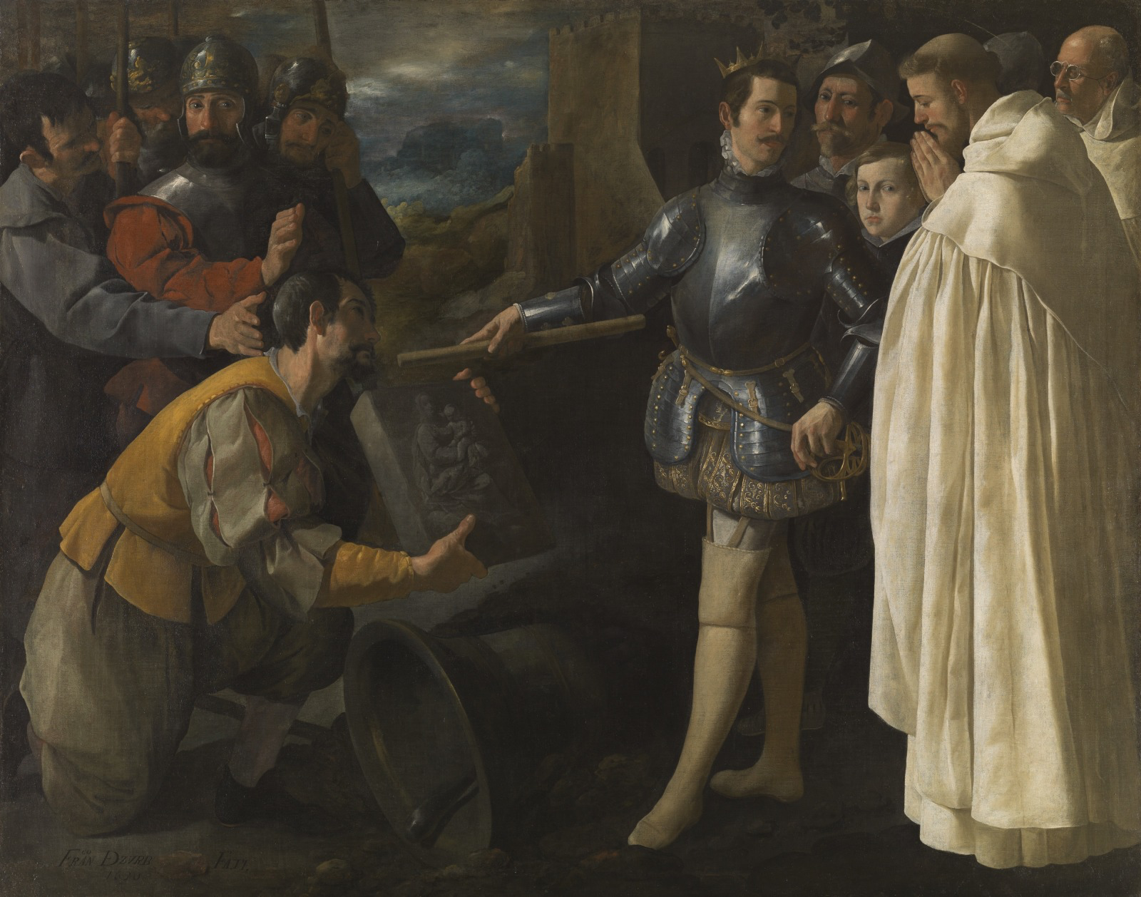
(fig. 1) Francisco Zurbarán, Saint Peter Nolasco Recovering the Image of the Virgin of El Puig, 1630, Oil on Canvas, 65 1/16 x 82 3/16 in., Cincinnati, Cincinnati Art Museum.
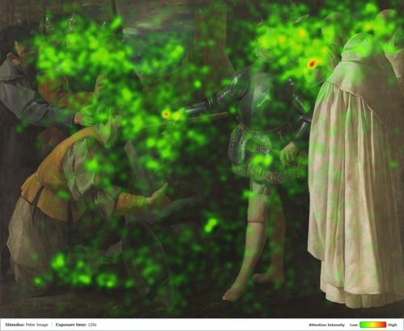
(fig. 2) Francisco Zurbarán, Saint Peter Nolasco Recovering the Image of the Virgin of El Puig, 1630, Oil on Canvas, 65 1/16 x 82 3/16 in., Cincinnati, Cincinnati Art Museum. Study by Peter Haffner and Drew Morris.
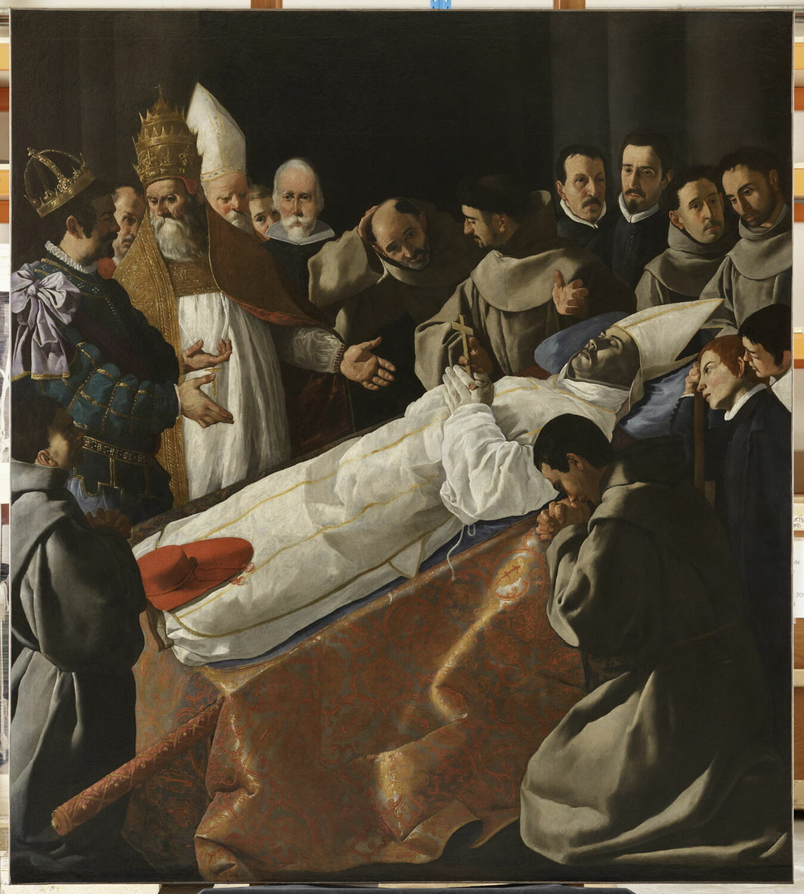
(fig. 3) Francisco Zurbarán, Displaying the Body of Saint Bonaventure, 1629, Oil on Canvas, 2.45 m x 2.69 m., Paris, The Louvre.
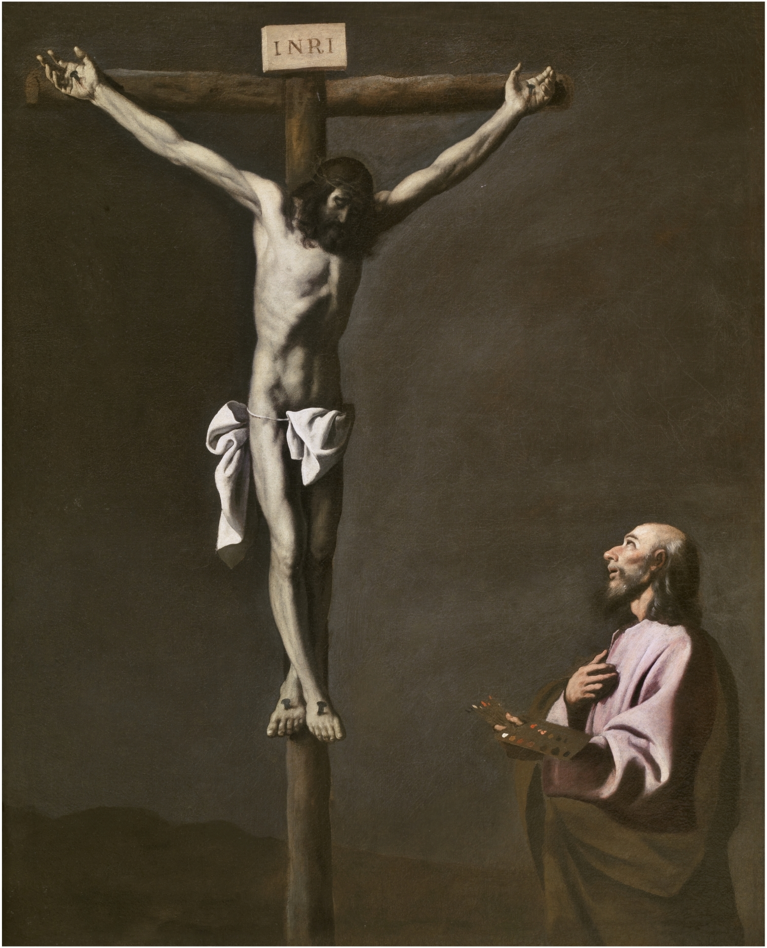
(fig. 4) Francisco Zurbarán, The Crucified Christ with a Painter, 1650, Oil on Canvas, 105 cm x 84 cm, Madrid, Museo del Prado.
Ana Sánchez-Lassa, “Aportación al studio de la técnica de Zurbarán,” in Zurbarán: La obra final 1650–1664 (Bilbao: Museo de Bellas Artes de Bilbao, 2000), 135.

Baticle, Jeannine. “The presentation of the Image of the Virgin of El Puig to King James I of Aragon.” in Zurbarán, New York: The Metropolitan Museum of Art, 1987.

Beazley, Raymond C, James the First of Aragon, Oxford, Printed by E. B. Doe, High Street, 1889.

Estevez, Lisandra. “The Artist as Visionary in Francisco de Zurbarán’s Crucifixion with a Painter,” in The Sixteenth Century Journal 50, no. 4 (2019): 1033-1062

E.d Galassi, Susan Grace. Zurbarán: Jacob and his Twelve Sons. New York, Center for Spain in America, 2018. Pg 94

Hamann, Bryon Ellsworth, “Interventions: The Mirrors of Las Meninas: Cochineal, Silver and Clay” The Art Bulletin 92, no. 1/2 (2010): 6-35

Haffner, Peter and Morris, Drew. “Beauty and the Eye of the Beholder,” CAM Uncovered, Cincinnati Art Museum, August 24, 2023, https://cincinnatiartmuseum.org/about/blog/beauty-the-eye-of-the-beholder/

Jonathan Brown, “On the Meaning of Las Meninas,” in Images and Ideas in Seventeenth-Century Painting (Princeton, N.J.: Princeton University Press, 1978), pgs. 87-110

Olson-Rudenko, Jennifer S. “Francisco de Zurbarán’s Paintings for the Calced and Discalced Mercedarians of Seville”, Doctoral Dissertation, The Pennsylvania State University, 2011.

Ostberg, René. "Mercedarian." Encyclopedia Britannica, July 24, 2024. https://www.britannica.com/topic/Mercedarian-order.
Smith, Damian, and Buffery, Helena, The Book of Deeds of James I of Aragon, A Translation of the Medieval Catalan Llibre dels Fets, Burlington, Ashgate Publishing Limited, 2003.
Soria, Martín S, Zurbarán, New York: Phaidon Publishers Inc, 1953
“Francisco de Zurbarán,” The National Gallery of London, Accessed May 19, 2025, https://www.nationalgallery.org.uk/artists/francisco-de-zurbaran.

“Zurbarán, Francisco de,” Museo del Prado, Accessed May 20, 2025, https://www.museodelprado.es/en/the-collection/artist/Zurbarán-francisco-de/9c8d19fd-a3eb-4fb4-b8b6-e7d37423b0c0#:~:text=He%20learned%20art%20in%20Seville,Pacheco%20and%20Vel%C3%A1zquez%20as%20well.

“Zurbarán, Francisco de,” Museo del Prado, Accessed May 20, 2025, https://www.museodelprado.es/en/the-collection/artist/Zurbarán-francisco-de/9c8d19fd-a3eb-4fb4-b8b6-e7d37423b0c0#:~:text=He%20learned%20art%20in%20Seville,Pacheco%20and%20Vel%C3%A1zquez%20as%20well.
Olson-Rudenko, Jennifer S. “Francisco de Zurbarán’s Paintings for the Calced and Discalced Mercedarians of Seville”, Doctoral Dissertation, The Pennsylvania State University, 2011.
E.d Galassi, Susan Grace. Zurbarán: Jacob and his Twelve Sons. New York, Center for Spain in America, 2018. Pg 94
“Francisco de Zurbarán,” The National Gallery of London, Accessed May 19, 2025, https://www.nationalgallery.org.uk/artists/francisco-de-zurbaran.
Beazley, Raymond C, James the First of Aragon, Oxford, Printed by E. B. Doe, High Street, 1889.
Ostberg, René. "Mercedarian." Encyclopedia Britannica, July 24, 2024. https://www.britannica.com/topic/Mercedarian-order.
Haffner, Peter and Morris, Drew. “Beauty and the Eye of the Beholder,” CAM Uncovered, Cincinnati Art Museum, August 24, 2023, https://cincinnatiartmuseum.org/about/blog/beauty-the-eye-of-the-beholder/
Hamann, Bryon Ellsworth, “Interventions: The Mirrors of Las Meninas: Cochineal, Silver and Clay” The Art Bulletin 92, no. 1/2 (2010): 6-35
Hamann, Bryon Ellsworth, “Interventions: The Mirrors of Las Meninas: Cochineal, Silver and Clay” The Art Bulletin 92, no. 1/2 (2010): 6-35
“Zurbarán, Francisco de,” Museo del Prado, Accessed May 20, 2025, https://www.museodelprado.es/en/the-collection/artist/Zurbarán-francisco-de/9c8d19fd-a3eb-4fb4-b8b6-e7d37423b0c0#:~:text=He%20learned%20art%20in%20Seville,Pacheco%20and%20Vel%C3%A1zquez%20as%20well.
Estevez, Lisandra. “The Artist as Visionary in Francisco de Zurbarán’s Crucifixion with a Painter,” in The Sixteenth Century Journal 50, no. 4 (2019): pg 1050
Estevez, Lisandra. “The Artist as Visionary in Francisco de Zurbarán’s Crucifixion with a Painter,” in The Sixteenth Century Journal 50, no. 4 (2019): pg 1048
Ana Sánchez-Lassa, “Aportación al studio de la técnica de Zurbarán,” in Zurbarán: La obra final 1650–1664 (Bilbao: Museo de Bellas Artes de Bilbao, 2000), 135.
Estevez, Lisandra. “The Artist as Visionary in Francisco de Zurbarán’s Crucifixion with a Painter,” in The Sixteenth Century Journal 50, no. 4 (2019): pg 1038
Baticle, Jeannine. “The presentation of the Image of the Virgin of El Puig to King James I of Aragon.” in Zurbarán, New York: The Metropolitan Museum of Art, 1987. Pg 109
This could potentially be due to the work’s state of restoration.
E.d Galassi, Susan Grace. Zurbarán: Jacob and his Twelve Sons. New York, Center for Spain in America, 2018. Pg 94
Hamann, Bryon Ellsworth, “Interventions: The Mirrors of Las Meninas: Cochineal, Silver and Clay” The Art Bulletin 92, no. 1/2 (2010): 6-35
Baticle, Jeannine. “The presentation of the Image of the Virgin of El Puig to King James I of Aragon.” in Zurbarán, New York: The Metropolitan Museum of Art, 1987. Pg 109
Jonathan Brown, “On the Meaning of Las Meninas,” in Images and Ideas in Seventeenth-Century Painting (Princeton, N.J.: Princeton University Press, 1978), pgs. 87-110
Notably, the thick leather belt and chain that would have held his sword—which is characteristic of the Mercedarian habit—is missing.

