Emma Crossman
Professor Theresa Leininger-Miller
Approaches to Art History
19 November 2020
Dragon and Taotie Motifs on a 12th-Century B.C.E. Fangyi Bronze Ritual Wine Vessel
Central motifs on this bronze ritual wine vessel depict dragon and taotie masks, repeated on each side of this vessel, both commonly seen in Ancient Chinese art. Dragons in the eastern world are often thought to represent good luck, prosperity, and consistent success. The original meaning of taotie motifs is now lost but are thought to “heal and to offer solace in a world full of diffuse and supernatural forces” or a symbol of the finality of death. The permanence of bronze adds to the finality of the rituals this vessel is involved in. This ritual vessel is used in a dual formal ritual setting- used for the living to give sacrifices of food and wine to their deceased ancestors and it is buried with the dead in order to appease other ancestral spirits.
This Wine Vessel is a 12th-century B.C.E. Fangyi from China. A Fangyi is a type of bronze container used to hold different ceremonial offerings, in this case, wine. This wine vessel contains dragon and taotie motifs and is made from cast bronze and is quite dark in color. The bronze is grey-brown and green and is very well preserved. There is a heavy amount of engraving throughout the entirety of this object. This Fangyi depicts two different motifs on the body and the lid-- dragons and taotie masks, repeated on each face of the vessel. The repetition of these symbols relates to their importance, used frequently throughout ancient Chinese art and sculpture.
This Fangyi has a rectangular body and a roughly pyramidal lid, considered to be house-shaped. Two sides of the lid are triangular, and two sides are trapezoidal, the two triangular sides are slanted upwards toward the top. The size of this piece is approximately one foot tall (11 ⅜ inches) and 7.5 inches wide. On the lid of the vessel, there are notched ridges on the four edges of the triangular prism, with one ridge down the middle of each trapezoidal face, also with slits. On each trapezoidal face of the lid, there are raised shapes with engravings on top, these engravings mainly mimicking the raised shape. The lifted portions of this lid to this vessel are semi-circles, floral-like shapes, and curved horseshoe shapes. On the flat part of the lid of the vessel, there are smaller repetitive spirals that cover the empty, undecorated and unlifted background of the vessel. On the triangular sides of the Fangyi are the same heightened curled horseshoe shape, along with other floral-like figures. Similar to the other raised figures on the rest of this Fangyi, the shapes have swirled engravings on them. The top third of the triangular sides are flatter than the rest of the triangle- there are engraved spirals that are flat, unlike the rest of the triangular section. These engraved spirals are similar to the spirals in the background of the rest of the vessel. At the very top of the roughly pyramidal lid, there is a knob that echoes the shape of the lid with two different engravings. The trapezoidal sides feature four small spirals (fig. 2) and the triangular sides have a two-sided spiral with the two ends joining on the bottom two corners of the triangle (fig. 3).
The vessel is rectangular with a square base. At the base of the vessel, there are small, squared, semicircular cutouts to give the vessel four thick legs. Similar to the lid, each edge of the rectangular prism has notched ridges. On each face of the prism, there is a raised vertical line down the middle, also with slits on it. These slits do not go all the way down to the face of the vessel, only carved into the top and sides, stimulating the illusion of a deeper cut. On the face of each side of the rectangular prism is three different sections that resemble registers. The middle register is the largest, taking up about half of the body of the vessel. On each side of the middle vertical raised line, each design of the registers is mirrored. On the top and bottom registers, there is a creature that looks similar to a dragon, which are engraved with lines and small swirls on their bodies. These dragons on the top and bottom registers have differing body shapes, but both are identifiable as dragons. The dragons of the top register are mirrored to face each other, where the dragons on the bottom are mirrored but facing away from each other. The eye of these creatures are even further raised and enlarged, making them more prominent. The middle register is comprised of a collection of raised shapes, including curled horseshoe, one large semi sphere, and some floral-like patterns, all with engraving on them. These patterns are grouped into one cohesive figure, mirrored to the other half of the vessel, depicting a symmetrical mask-like figure. Behind the raised figures in each of these registers are spirals and swirls to cover the background. Due to the three registers that are broken apart by a vertical line in the middle, the composition of this wine vessel is very symmetrical and balanced.
This Fangyi, from 12th century B.C.E. China, meant to hold wine, depicts dragons and taotie masks. Consistently repeated, each of these components of the Fangyi adds to the overall meaning of the wine vessel, with symbolism that gives it more meaning than what meets the eye.
On this Fangyi wine vessel, there are two different sets of dragons (figs. 4 and 5), repeated on each of the four sides of the vessel. On each side, there are two mirrored dragons, each of them appearing to be the same. In the ancient East, a dragon is most often associated with “life-giving rains and water sources,” and is usually seen in a positive light. It is unclear where the imagery of a dragon originates from, but it is thought to be likened to “rainbows or ‘serpent of the sky’ which appears after rain showers or at waterfalls,”. Usually viewed as a just and benevolent creature, the dragon in Chinese culture is very different from depictions in the western world. The dragon is seen as “the harbinger of incredible luck, prosperity, abundance, consistent success, and high achievement,” as well as related to the spring season and new beginnings. The dragon was also “considered [the] king of animals, and [the] image was appropriated by Chinese emperors as a sacred symbol of imperial power,”.
Also pictured on this Fangyi are taotie masks (fig. 6), also known as animal masks. There are four upside down on the lid and four on the middle register of the body of the wine vessel. In the Shang period, the meaning of the taotie tends to be quite elusive. Bronze ritual vessels, often Fangyi, are typically covered in taotie-- “seemingly carved motifs of frightening animal hybrids; vaguely ferocious mask-like motifs,”. One theory of the taotie is that it “seem[s] to represent an array of animalistic energies… to heal, and to offer solace in a world full of diffuse and supernatural forces,”. Other theories about the meaning behind taotie masks range from “the finality of death and the devouring image of the grave, to the belief that they mean nothing within themselves,”. Usually, taotie include prominent eyes with high relief and they can have many different animalistic features including a snout, horns, and a split-open body. The closely packed squared spirals in the background of these figures is called a thunder pattern, or leiwen (fig. 7), seen in many pieces of ancient Chinese art, meant to represent clouds and rolling thunder, symbolizing life-giving rain and abundance.
The 12th century in China is considered a Bronze Age, during the Shang Dynasty. The Chinese Bronze Age is classified by its “excellence is exemplified by the cast-bronze ritual vessels of the Shang [dynasty],”. Ancient China was very rich in copper, tin, and lead, the main ingredients to make bronze alloy. Because of the abundance of metals to make copper, ritual vessels tend to be thick-walled and very heavy. The entire weight of this vessel is just under fifteen pounds. The use of such wine vessels was reserved for higher classes, usually the ruling aristocrats of Shang society.
The Fangyi was used to store wine during rituals of ancestral worship. Other similar vessels were used for making ceremonial offerings of food and wine to the dead. Food offerings included raw and cooked meats and different grains. The wine used was a type of grain liquor made from millet. The ancient Chinese used wine in many different activities, including performing ceremonies for the gods. Shang funerary rites “included human and animal sacrifice to provide for the needs of the deceased in the afterlife”, Bronze vessels were then buried in the tomb, in hopes of appeasing the spirits of their ancestors. Fangyi have a dual purpose and are used in different ways- one is used by the living in their ancestral worship, and the other way is and offering to be buried with the dead, to appease ancestral spirits.
This wine vessel is made of cast bronze, from the 12th century B.C.E., during the Bronze Age of China. There are many examples of cast bronze vessels, widely used in rituals. A Fangyi is a wine vessel, most likely used as an offering in ancestral worship to the gods. The Shang Dynasty, lasting from about 1700 until 1100 B.C.E., there was a large increase in technology. The permanence of the bronze material adds to the finality of the burial with the deceased, as it stays intact where it is left. In the word Fangyi, “fang” refers to the shape of the vessel, a square., which you can see the square shape in the fang ding and the fangyi.
There is much debate about how these pieces were made, either through piece-mold casting or lost-wax casting. Piece-mold casting during China’s Bronze Age is thought to have arisen independently in China, the technique perfected, brought to an unparalleled level of excellence. The process of piece-mold casting is understood to be made out of sculpted clay and dried, then cut away into pieces. Later the cut away pieces were reassembled, then the mixed metals were poured into the mold. Another hypothetical way that these bronze ritual vessels were cast is through lost-wax casting, or cire-perdue. Through lost-wax casting, there are multiple pieces cast in sectional molds, assembled around a solid central core. This process was probably done upside down in order to be able to support the large core from below. It is thought that legs and other pieces are cast separately and later soldered onto the vessel, allowing for more intricate and ornate vessels.
Bronze vessels are very commonly found throughout China, some attributed to the Zhou Dynasty, which came right after the Shang Dynasty. A large number of ritual vessels made of bronze has been found at the city of Anyang, not very far from the city of Zhengzhou, another proposed capital of the Shang Dynasty (fig. 8). It is debated by scholars which is the capital city of the Shang Dynasty. Some historians argue that Anyang is the capital city, because of the abundance of structures and artifacts that have been excavated there, more than at Zhengzhou. Many different types of bronze ritual vessels were found at Yin Ruin in Anyang, including the Fangyi. There are numerous models of bronze vessels found dating back to the Shang and Zhou Dynasties, at least thirty. Most of these vessels have different purposes, for both daily and ritual devotions. The duality of these pieces is seen in their use by the living for ancestral worship, and burial with the deceased, as an offering to appease ancestral spirits.
At multiple excavation sites, specifically at one right outside of Anyang, tombs have been found with over fifty bronze vessels, as well as jade and pottery, some of which was glazed. Due to bronzes being found in tombs, they are well preserved and found in abundance. This site is known as the Yin Ruin, and it is located in the northwest suburb of Anyang City in Henan Province, which is the only documented capital site from the Shang Dynasty, cited in ancient literature and backed by archeological excavations. Twelve royal tombs were discovered in and around Anyang, as well as over one hundred palaces, royal temple foundations, and cellars. Along with Fangyi recovered in these tombs at Anyang, other bronzes were found with a turquoise inlay. These turquoise inlaid bronzes depict taotie figures and dragons on their surfaces.
Earlier Fangyi found in China dated to the Shang Dynasty have many stylistic similarities and differences. In the case of this earlier 13th century B.C.E. Fangyi (fig. 9) housed at the Smithsonian’s Freer Gallery of Asian Art, there are easily identifiable differences. These two Fangyi are meant for the same purpose, to be used as a wine vessel. The Freer vessel’s lid has a more rounded look, whereas the Cincinnati Art Museum’s lid has sharper lines, evidence of more advanced metalwork. Another difference between these two bronze vessels is that The Freer Gallery’s body does not have raised lines and or as distinguished registers as seen in Cincinnati’s. The lack of raised lines and figures in the 13th century Fangyi is replaced with seemingly less intricate relief sculpture on the bronze surface. In the century between the creation of these pieces, from the Freer Gallery’s vessel to the Cincinnati art museum’s vessel, the level of technology, knowledge of metalwork, and increase in design is apparent.
Through the use of bronze casting in this fangyi, depictions of dragons and taotie masks add to the overall meaning of this ritual wine vessel. Typical in ancient Chinese art and sculpture, the use of the dragon and taotie masks are easily recognizable in this piece. Dragons, meant to symbolize good luck, prosperity, and consistent success, and taotie masks, meant to represent the finality of death, healing, and to offer solace in a diffuse world. This ritual wine vessel is used in different ways, both tied to ancestral worship. The Fangyi is used by the living as a vessel for an offering to the ancestors and is later buried with the deceased in order to appease the ancestor’s spirits. The use of bronze, a material meant to be long-lasting and permanent, is perfect for the long-term use and burial of this vessel when used in burial.

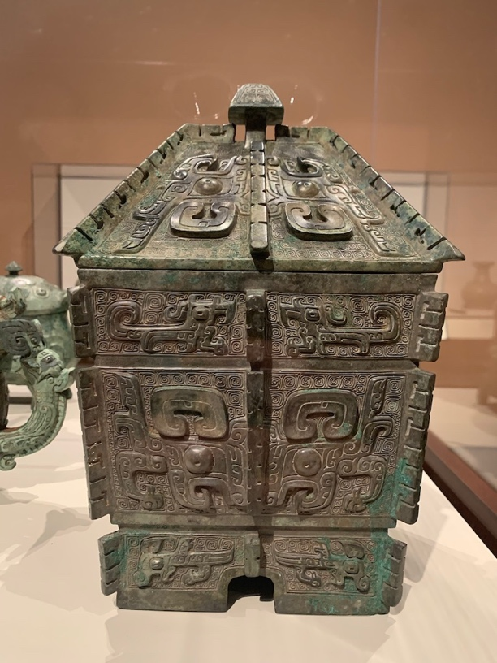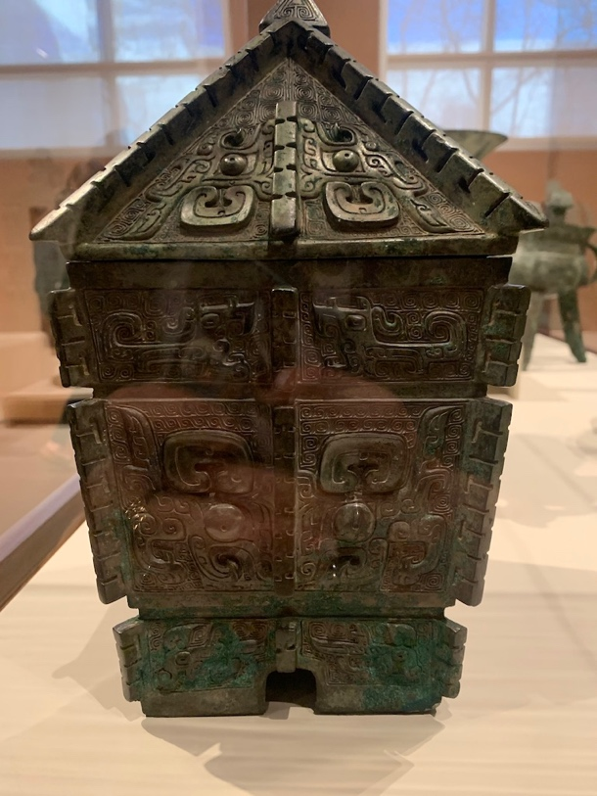

Fig. 1 Shang Dynasty, China, Wine Vessel, Fangyi, 12th century B.C.E., 11 3/8 in., 7 ½ in., cast bronze, Cincinnati Art Museum, 1948.75.

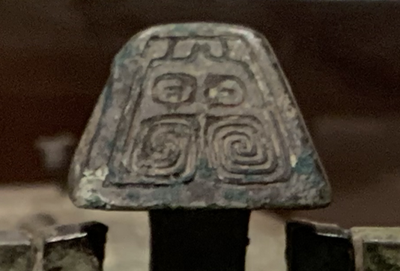

Fig. 2 Detail of Shang Dynasty, China, Wine Vessel, Fangyi, 12th century B.C.E., 11 3/8 in., 7 ½ in., cast bronze, Cincinnati Art Museum, 1948.75.
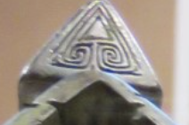

Fig. 3 Detail of Shang Dynasty, China, Wine Vessel, Fangyi, 12th century B.C.E., 11 3/8 in., 7 ½ in., cast bronze, Cincinnati Art Museum, 1948.75.

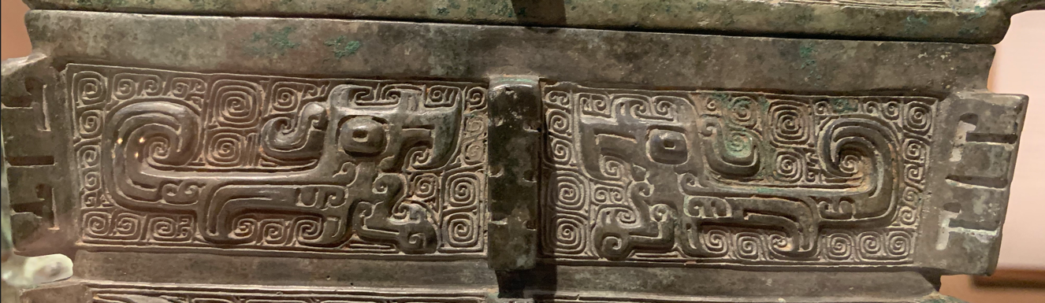

Fig. 4 Detail of Shang Dynasty, China, Wine Vessel, Fangyi, 12th century B.C.E., 11 3/8 in., 7 ½ in., cast bronze, Cincinnati Art Museum, 1948.75.

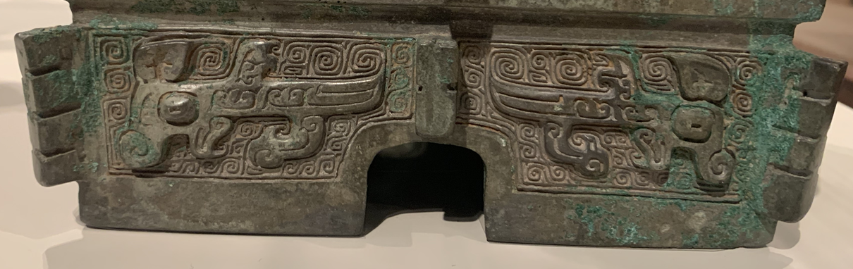

Fig. 5 Detail of Shang Dynasty, China, Wine Vessel, Fangyi, 12th century B.C.E., 11 3/8 in., 7 ½ in., cast bronze, Cincinnati Art Museum, 1948.75.

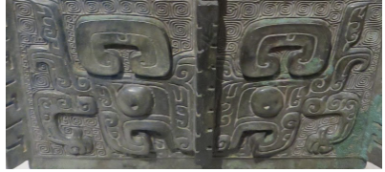

Fig. 6 Detail of Shang Dynasty, China, Wine Vessel, Fangyi, 12th century B.C.E., 11 3/8 in., 7 ½ in., cast bronze, Cincinnati Art Museum, 1948.75.

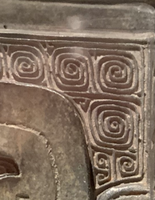

Fig. 7 Detail of Shang Dynasty, China, Wine Vessel, Fangyi, 12th century B.C.E., 11 3/8 in., 7 ½ in., cast bronze, Cincinnati Art Museum, 1948.75.

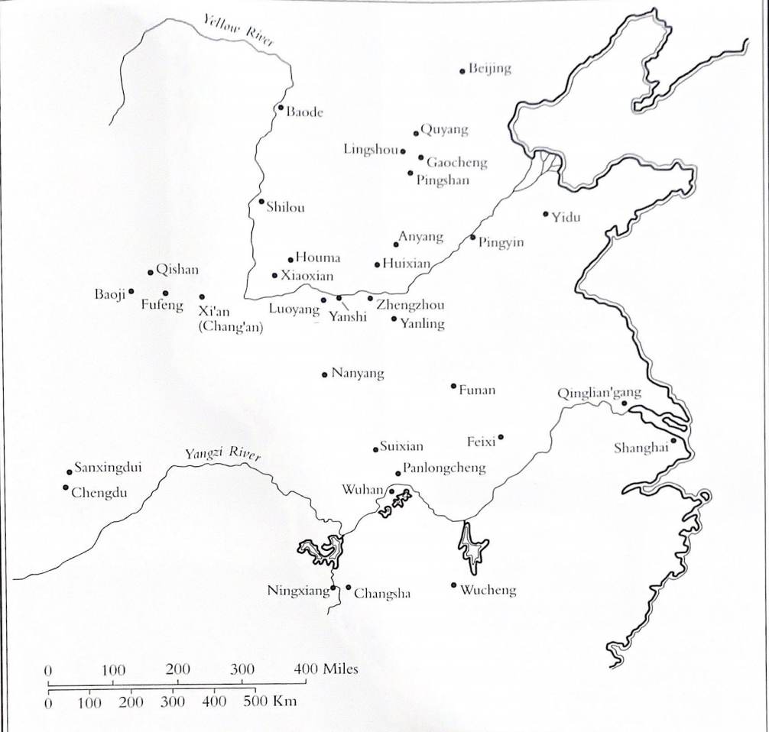

Fig. 8 Map of ancient China, with major Shang and Zhou sites.

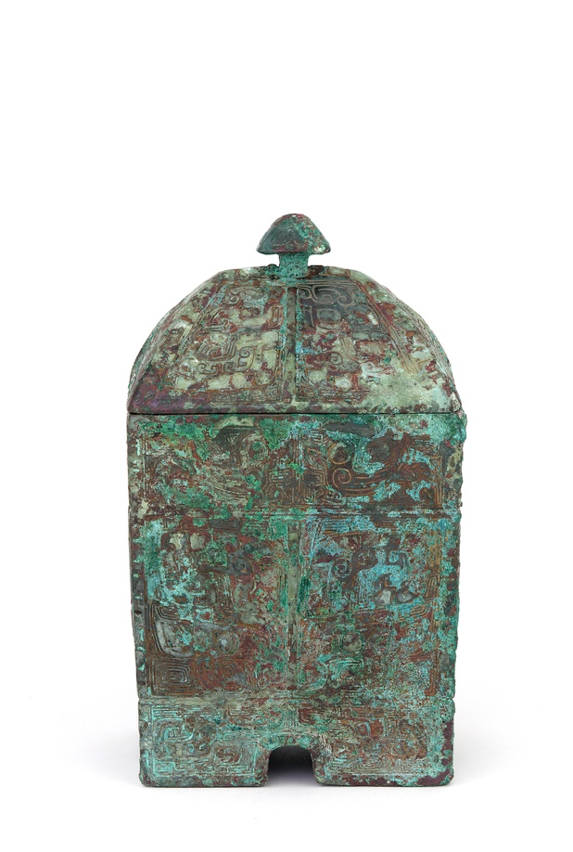
Fig. 9 Shang Dynasty, Wine container (Fangyi), ca. 13th century B.C.E., cast bronze, 18.4 x 11.1 x 8.1 cm (7 1/4 x 4 3/8 x 3 3/16 in), Smithsonian National Museum Freer Gallery of Asian Art

“The Dragon in Ancient China,” Ancient History Encyclopedia, Accessed September 20, 2020, https://www.ancient.eu/article/1125/the-dragon-in-ancient-china/.
“The Dragon in Ancient China,” Ancient History Encyclopedia Accessed September 20, 2020, https://www.ancient.eu/article/1125/the-dragon-in-ancient-china/.
“Dragon Symbolism,” Ancient Symbols, accessed September 24, 2020, https://www.ancient-symbols.com/dragon-symbolism.html.
“Long,” Encyclopædia Britannica (Encyclopædia Britannica, inc., October 18, 2016), Accessed September 23, 2020. https://www.britannica.com/topic/long.
"A New World of Ancient Culture, Recorded in Bronze: [Review]." New York Times, Mar 08, 2002. Accessed September 23, 2020. https://www-proquest-com.proxy.libraries.uc.edu/docview/432030819?accountid=2909.
"A New World of Ancient Culture, Recorded in Bronze: [Review]." New York Times, Mar 08, 2002. Accessed September 23, 2020. https://www-proquest-com.proxy.libraries.uc.edu/docview/432030819?accountid=2909.
"A Documentation of Bronze Age Ritual Vessels from the Shang Dynasty of China within the Collection of the Buffalo Museum of Science, Buffalo, New York." Order No. 1453467, State University of New York at Buffalo, 2008. Accessed September 23, 2020. https://www-proquest-com.proxy.libraries.uc.edu/docview/304386417?accountid=2909.
“Meander, Cloud and Thunder Pattern- Yunwen or Leiwen.” GLOSSARY: Cloud and thunder pattern - yunwen or leiwen. Accessed November 16, 2020. https://gotheborg.com/glossary/meander.shtml.
"A New World of Ancient Culture, Recorded in Bronze: [Review]." New York Times, Mar 08, 2002. Accessed September 23, 2020. https://www-proquest-com.proxy.libraries.uc.edu/docview/432030819?accountid=2909.
Highlights of the Art of Asia, Cincinnati Art Museum, library file.
Art History, New York, Harry N. Abrams, Inc,. (1995), 1281.
“Ritual vessel of the type I,” typed wall label, date unknown, Cincinnati Art Museum, library file.
Art History, New York, Harry N. Abrams, Inc,. (1995), 1281.
“Shang Ritual Bronzes: Casting Technique and Vessel Design”, Archives of Asian Art, Vol. 43, (1990): 9.
“The Arts of China”, fourth edition, University of California Press (1999), 25.
“The Arts of China”, fourth edition, University of California Press (1999), 25.
“Journal of Archaeological Science”, The identification of binding agent used in late Shang Dynasty turquoise-inlayed bronze objects excavated in Anyang, Vol. 59, 2015.

