https://drive.google.com/drive/folders/1He3KtzMKUP99p74u0LjtIxp_AqEhnR5y?usp=sharing
We will use EPA SWMM 5.1.014 version
- install visual studio 2017: https://visualstudio.microsoft.com/vs/older-downloads/

-> choose 2017 version, Visual Studio Community 2017 (version 15.9)

-> make sure to mark the package:
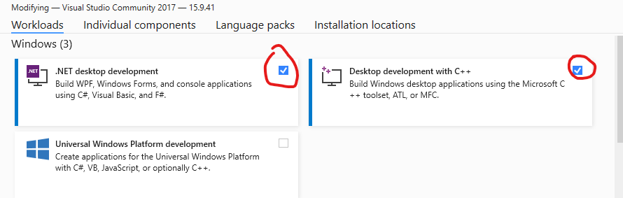

-> Then, install and restart the computer:



- Download cmake: https://cmake.org/download/

- Download windows 10 SDK: https://developer.microsoft.com/en-us/windows/downloads/sdk-archive/
Choose Windows 10 SDK, version 1903 (10.0.18362.1):

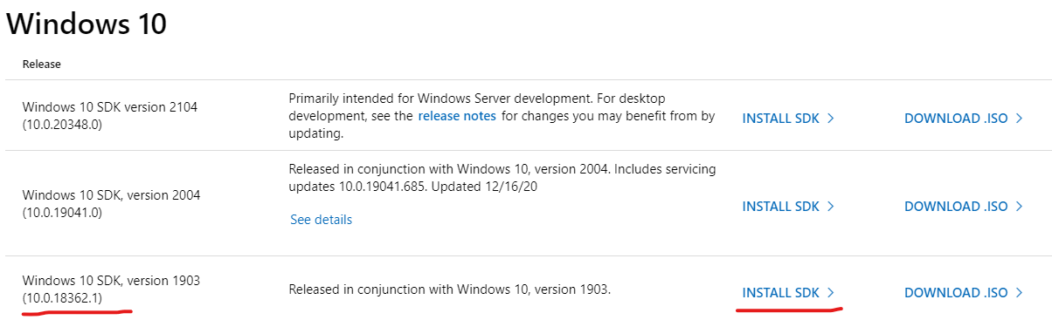

After installing SDK, restart the computer.

- Build SWMM 5.1.014:
- For some computer settings or different versions of VS. The EPA SWMM 5.1.014 is hard to build at VS2017. So, the addition process is needed for build SWMM 5.1.014 at VS2017:

  - Download SWMM 5.1.014 and SWMM 5.1.015. https://www.epa.gov/water-research/storm-water-management-model-swmm
5.1.015 provide better cmake compile support on SV2017. Here, we will use cmake file public at 5.1.015, and source code at 5.1.014.
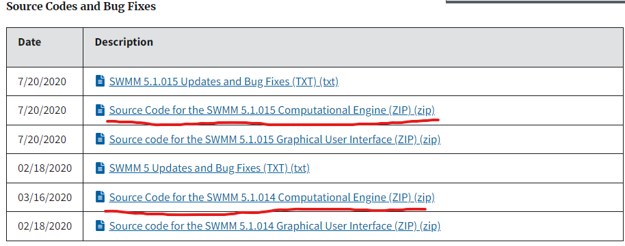

  - Extract file
For “swmm51014_engine_1.zip”, after extracting it, we can find there is ZIP file named “source5_1_014.zip”. extract “source5_1_014.zip” and we should get 76 items in it, like the below figure: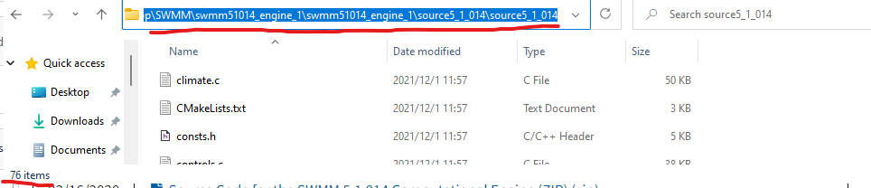
  - On desktop, create a new folder called “SWMM5.1.014”, and create a subfolder named “src”, copy all 76 files on the “src” folder: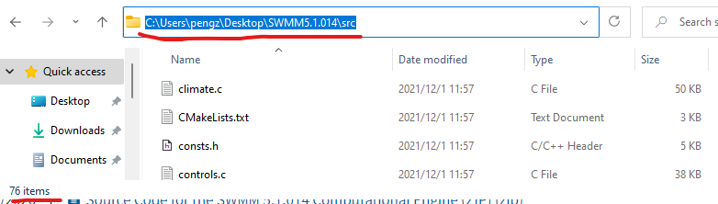

  - For “swmm51015_engine.zip”, extract it, and copy files “CMakeLists.txt”, “Roadmap.txt” to “SWMM5.1.014” folder.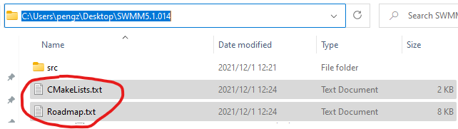

  - Also, in “swmm51015_engine” folder, at subfolder “src”, copy file “swmm5.def” to subfolder “src” in “SWMM5.1.014” folder, 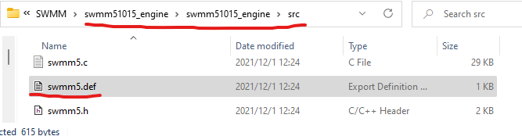
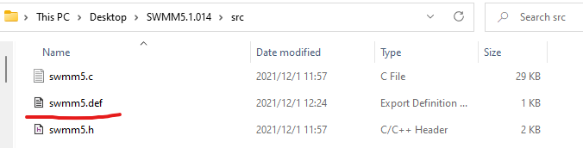

NOTE: “swmm5.def” is just 14 lines of code for cmake compile, display below: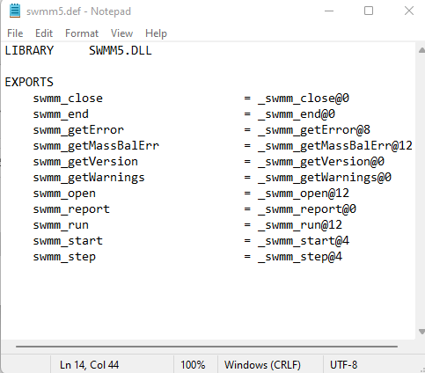
- Build SWMM 5.1.014. Open Command prompt, find the file location (use the command: cd FilePath (the path for “SWMM5.1.014” folder) and use the following commands:
cmake --version
- mkdir build
- cd build
- cmake ..
- cmake --build . --config Release
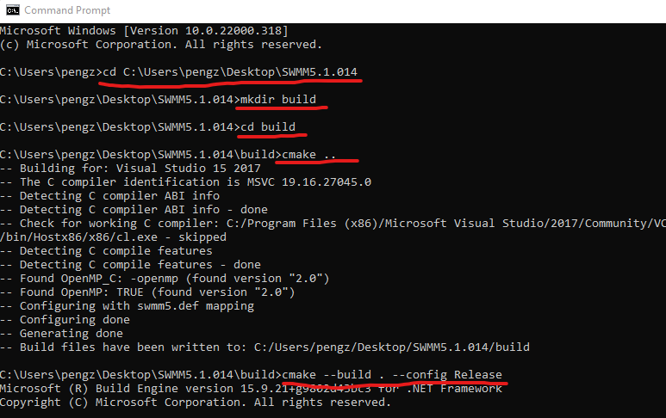

- In “SWMM5.1.014” folder, then go into the “build” folder, right-click Swmm5.exe, open with VS2017:
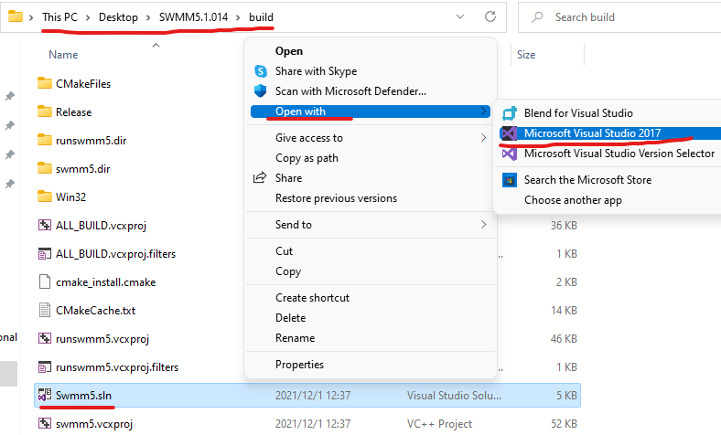

- Install OpenCppCoverage Plugin:
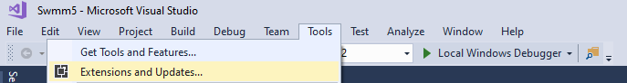
- click Tools -> Extensions and Updates…

- Choose “Online”, and type “opencppcoverage” at the search bar, then install plugin,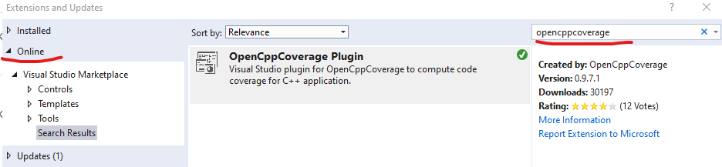

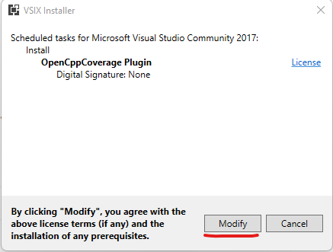

- Prepare input file:
- Go the link: https://github.com/OpenWaterAnalytics/Stormwater-Management-Model (this link list on Table 1) and branches “feature-2dflood”, direct link: https://github.com/OpenWaterAnalytics/Stormwater-Management-Model/tree/feature-2dflood

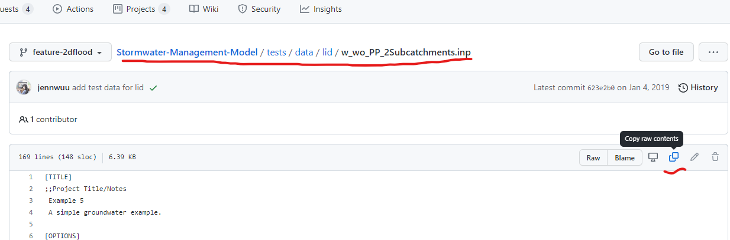
- At Folder “tests”, we can find the unit tests and a folder “data” for the input file. The format of SWMM input file is .inp file. Choose one of .inp file, open, and click copy the raw code.

- Go to desktop, create a folder named “SWMMTest”, and create a new TXT file, we can name it “input”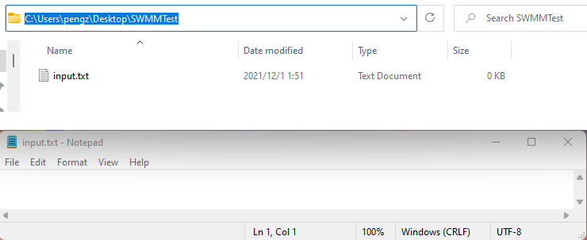

- Paste code from 2) on TXT file, then we need to change the file type from .txt to. inp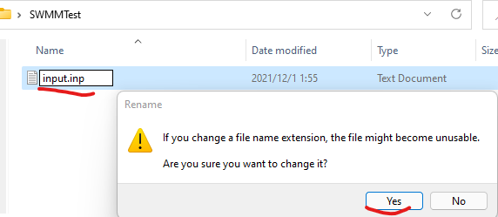
- Run OpenCppCoverage:
- In VS2017, at solution explorer, right click runswmm5, choose OpenCppCoverage Settings
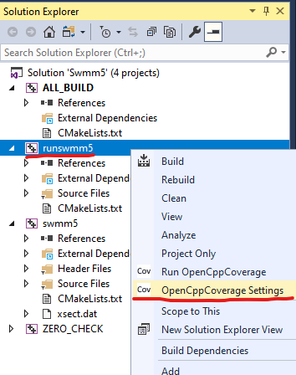

- In setting box -> basic -> rolling down and edit arguments: (Format: input blank output)
C:\Users\pengz\Desktop\SWMMTest\input.inp C:\Users\pengz\Desktop\SWMMTest\output.rpt
Here, we use “input.inp” as input file, at set SWMM output file name as “output.rpt”
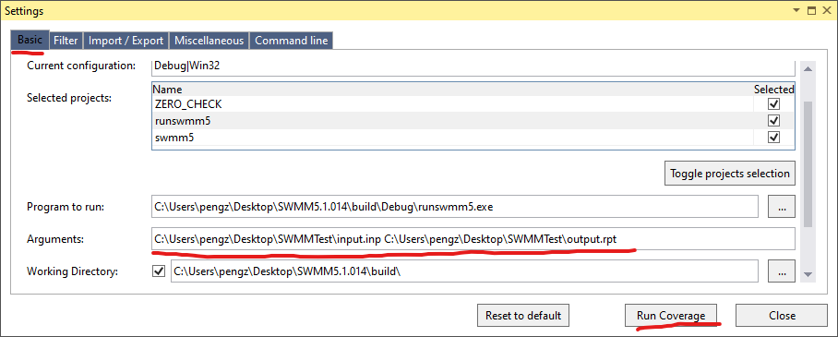
Click Run Coverage

The result will display:
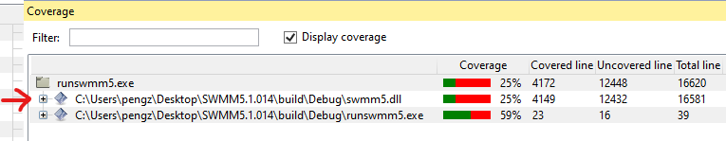

Click “+” for detail of coverage:


