Tre Scherz

March 19, 2026

The Effects of Practice Strategies on Predictable and Unpredictable Patterns of Gross Motor Learning

Introduction
Motor learning is the process by which individuals acquire and refine movement skills through practice and experience. This experiment aimed to investigate how predictable and unpredictable patterns affect the speed and accuracy of gross motor movement. Specifically, the study examined whether practicing with a consistent (predictable) pattern leads to greater improvements in task execution compared to an unpredictable pattern, where the arrangement of targets changes each trial.

Methods
The experiment was conducted in a 10ft x 10ft obstacle-free area. Ten cups were labeled numerically and scattered throughout the area to form the initial predictable pattern.
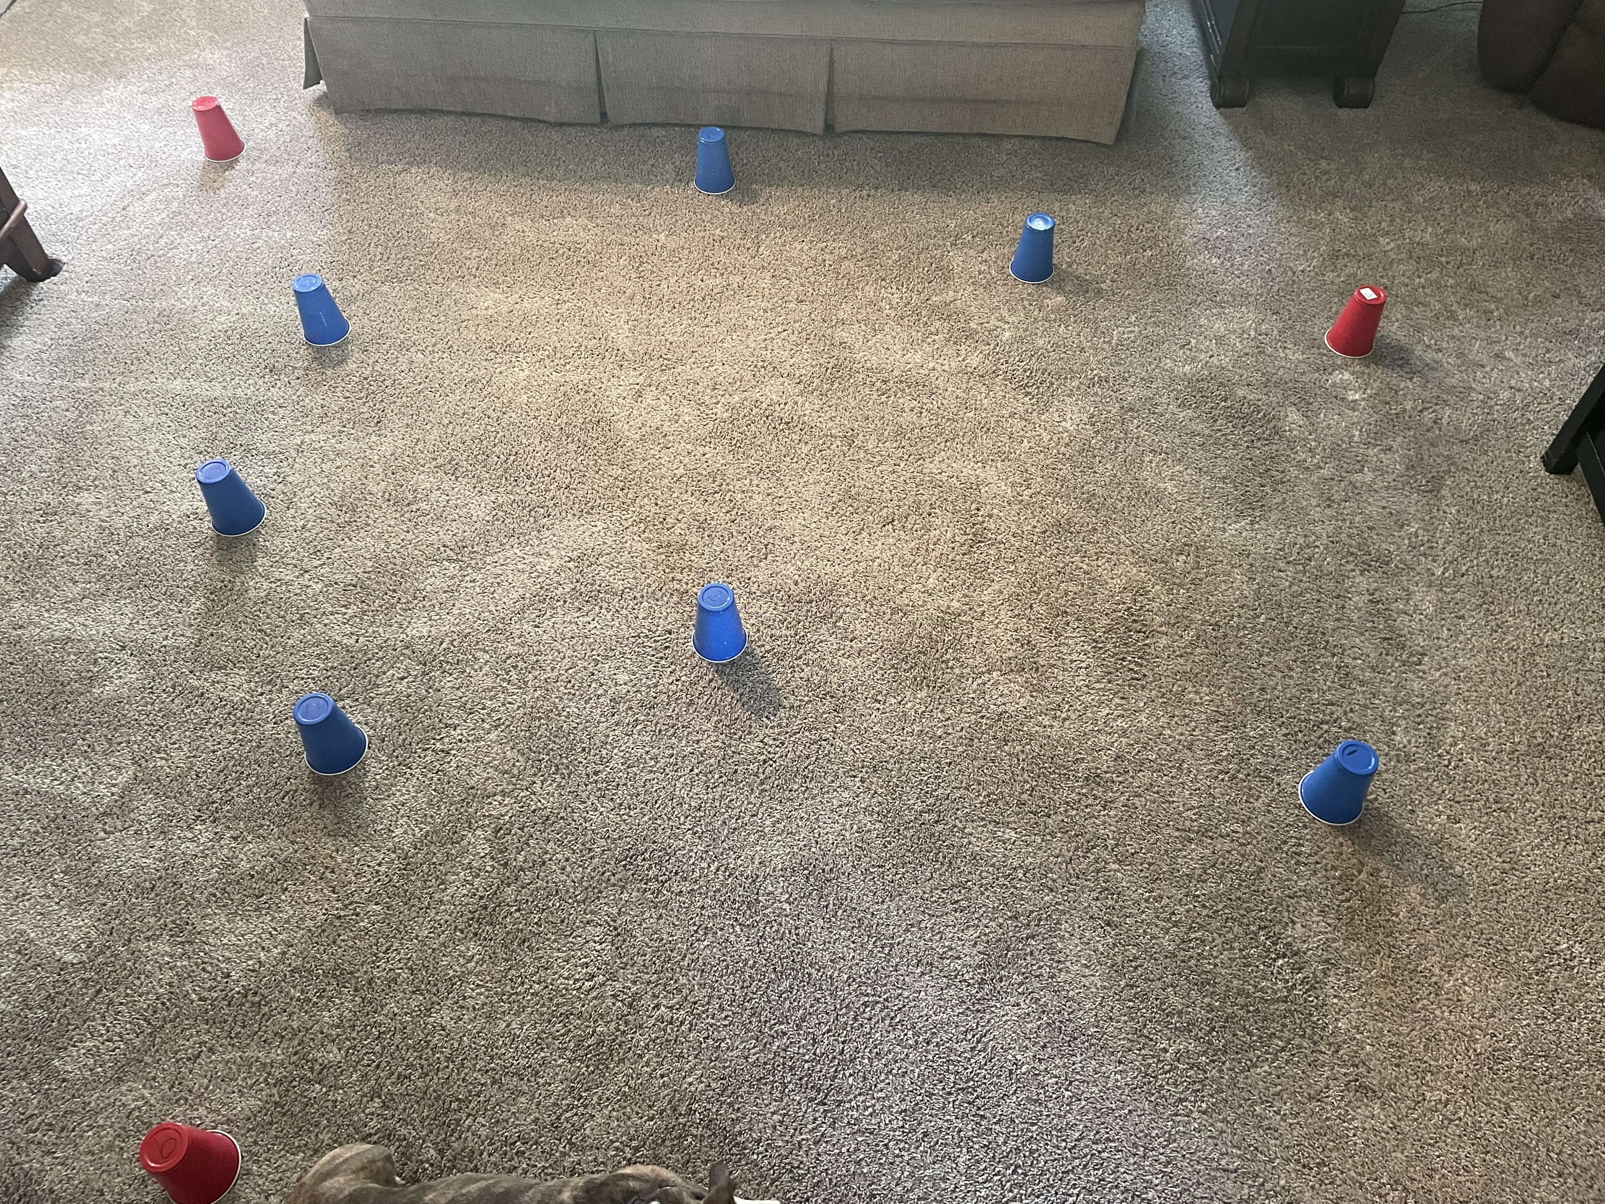
I moved from target to target in order as quickly as possible, and completion time was recorded. A different strategy were utilized each practice day. The practice strategize ncluded memorizing the layout, adjusting starting position, scanning the area, and verbalizing the order out loud. Each strategy was practiced for both pattern types across several sessions. Times and observations were recorded for each trial. Practice was conducted at the same time each day (after dinner) to maintain consistency. There was a day between each practice session. My main focus was on practice strategies to improve performance.
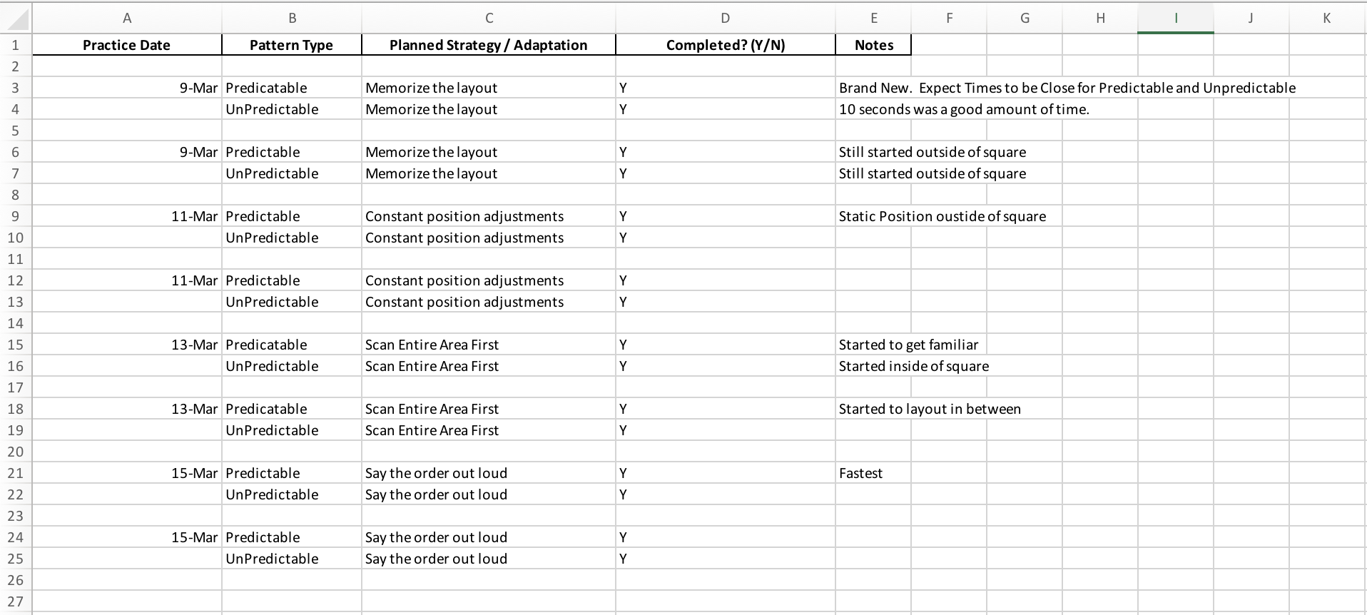

Results
The following chart shows the completion times across sessions for both pattern types:
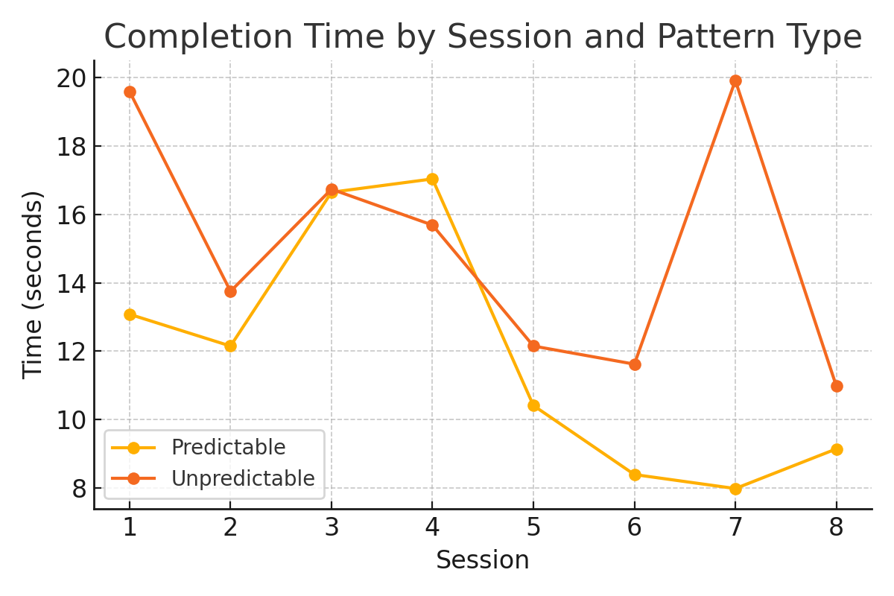
The following bar chart summarizes the median completion times for each strategy:
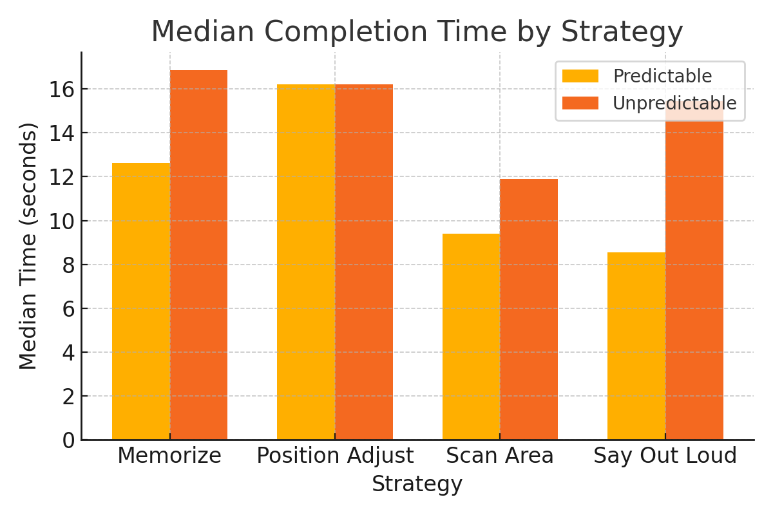

Summary Table of Completion Times (seconds)

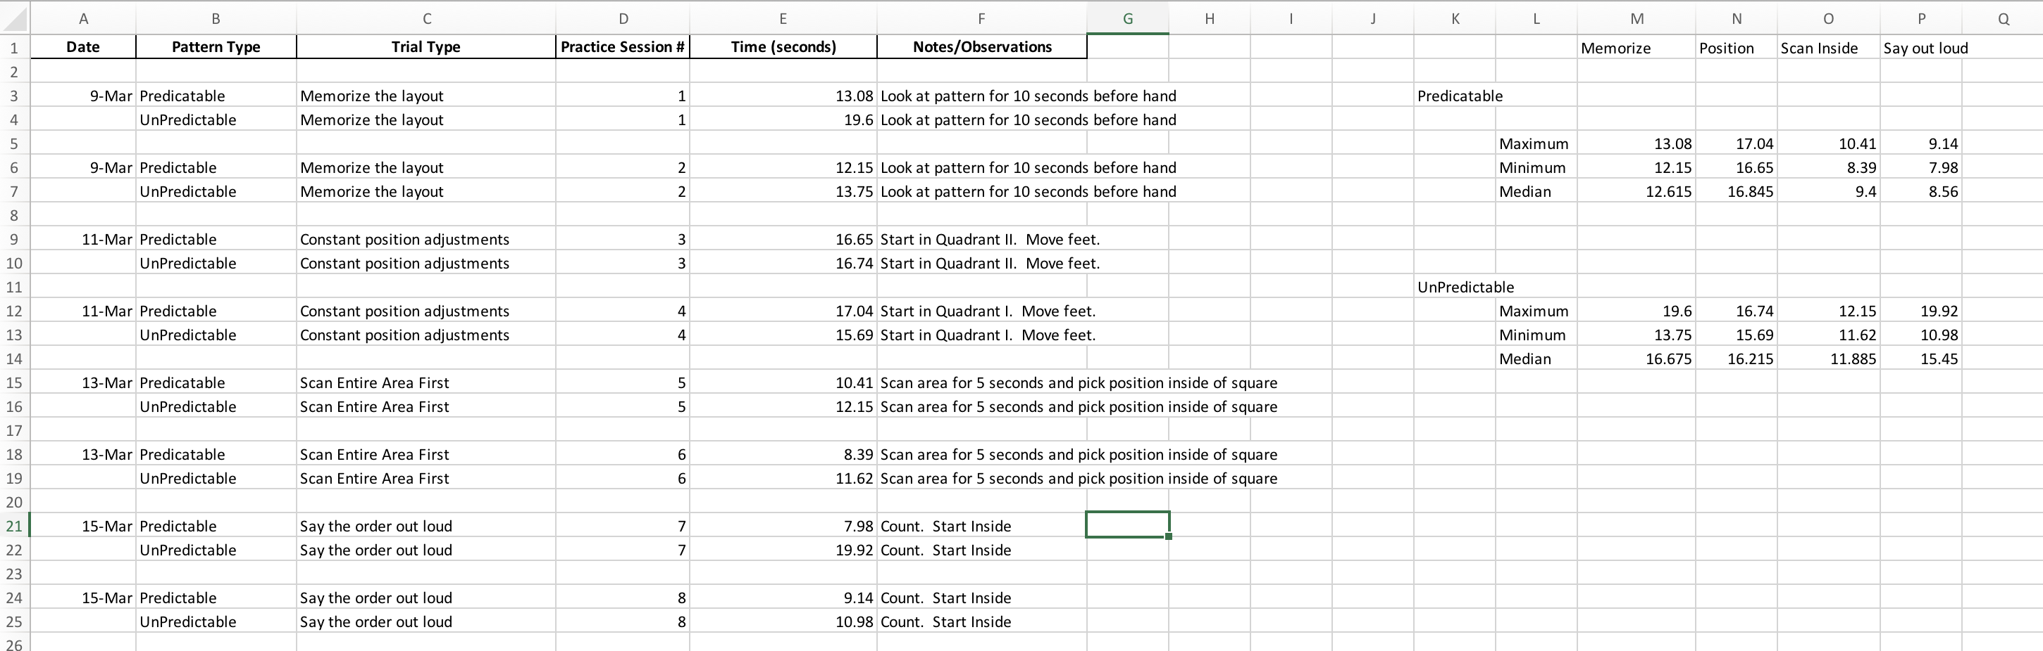

Discussion
The experiment demonstrated that regular practice with a predictable pattern led to steady improvement, while the unpredictable pattern required key strategies showed limited gains. This suggests that consistency and repetition are key factors in gross motor learning. Verbalizing the sequence and taking time to scan the area before starting contributed to better performance for both predictable and unpredictable. Reinforcing the importance of memory and spatial awareness in gross motor learning.
The unpredictable pattern benefited most from a 10-second pre-scan, but overall, improvement was less pronounced. This may be because unpredictability increases cognitive load, making it harder to form and retain an effective movement plan.

Summary and Reflections
Observations: The Predictable times always improved. The Unpredictable times stayed the same.
Potential Reasoning: Verbalizing, consistency, and repetition are key factors in gross motor learning. Time to scan and memorize. Unpredictability increases cognitive load making it harder to form and retain an effective movement plan.
Changes for Next Time: More clearly mark the objects with visible numbers. Try different focus exercises before practice. Stretch more before practice.
Lessons Learned: Better to start inside the space. Predictable got easier throughout, so memorizing is important. Manually resetting the predictable board reinforced learning.

Conclusion
Practicing a gross motor task with a predictable pattern leads to greater improvements in speed and accuracy compared to an unpredictable pattern. Strategies such as scanning the area, starting inside the space, and verbalizing the sequence further enhance performance. For future experiments, clear labeling and consistent starting positions are recommended. This project highlights the importance of repetition, strategy, and environment in motor learning.

