Lightning Carryout
by
Connor Cook, Reco Gunnels, TJ Harvey, Brian Smith
Submitted to
the Faculty of the School of Information Technology
in Partial Fulfillment of the Requirements for
the Degree of Bachelor of Science
in Information Technology

© Copyright 2021 Connor Cook, Reco Gunnels, TJ Harvey, Brian Smith

The authors grant to the School of Information Technology permission
to reproduce and distribute copies of this document in whole or in part.
Connor Cook _______________________________________ Date 4/12/2021

Reco Gunnels Jr ____________________________________ Date 4/12/2021

TJ Harvey __________________________________________ Date 4/12/2021

Brian Smith ________________________________________ Date 4/12/2021

Faculty Advisor: Abdou Fall

University of Cincinnati
College of
Education, Criminal Justice, and Human Services

April 2021

Table of Contents

Table of Contents i
List of Illustrations ii
Tables ii
Figures ii
Abstract 1
Introduction 2
Introduction 2
Problem 2
Solution 3
Project Goals 3
Overview 4
Discussion 4
Project Concept / Solution 4
Objectives/Deliverables 5
Methodology 6
User Profiles 7
Figure 1 7
Figure 2 8
Use Case Diagram 9
Figure 3 10
Technical Architecture 10
Security 11
Testing 11
Test Plan 12
Test Results 12
Budget 13
Figure 4 13
Project Schedule 14
Figure 5 16
Problems Encountered and Analysis of Problems Solved 17
Future Recommendations 17
Conclusion 18
Lessons Learned 18
Abilities and Skills Developed Throughout Project 18
References 19

List of Illustrations

Tables
No. Page
Table 1. Budget.......................................................................................................... 17
Table 2. Schedule....................................................................................................... 18

Figures
No. Page
Figure 1. User Profile.................................................................................................. 12
Figure 2. User Profile ................................................................................................. 13
Figure 3. Use Case Diagram ....................................................................................... 14
Figure 4. Budget ......................................................................................................... 17
Figure 5. Project Schedule ......................................................................................... 18

Abstract
Lightning Carryout is a solution for small restaurants looking to expand their online customer base. While apps like Uber Eats send partners an iPad to run a separate point of sale system, the Mobile Ordering App utilizes the Square API integrating directly with the restaurant’s existing point of sale system. Furthermore, food delivery apps like Door Dash charge restaurants exorbitant fees. Large chain restaurants like McDonald’s and Chipotle have proprietary apps that allow for online ordering, but many small restaurants do not have the customer base or funds to have their own app developed. Lightning Carryout provides users the ability to select small businesses from a list or map, view menu items, and order from within the app. Our team’s app allows users to not only support small businesses but ensure that more of their bill goes to the owners and employees, rather than large corporations.

Introduction

Introduction
Have you ever waited too long for food? Our software developer Reco went to get food one day from a local neighborhood restaurant and waited 10 minutes just to place the order, then another 20 minutes for the order to be completed. Instead of waiting 30 minutes he could have ordered food from a larger chain restaurant and picked up the order in less time with less hassle. He also realized how poorly managed the business was due to the amount of orders coming in from different delivery apps. His passion for supporting small business kept him patient, but he knew there was something that could be done about it.

Problem
The Covid-19 pandemic has led to a spike in use of food delivery apps: Grubhub alone reported a 41% increase in active users from the third quarter in 2019 to the third quarter in 2020.¹ Customers no longer want to dine in, wait in lines, or spend time in crowded areas. In these financially unstable times, the sentiment of supporting small and local businesses has become increasingly important, however, the convenience of ordering local takeout through delivery apps comes with a price: apps like Uber Eats charge restaurants fees ranging from 15-30%.² Small businesses may also have to use multiple 3rd party ordering systems, each with their own separate point of sale (POS) systems. While large chains like McDonald’s have now acquired proprietary mobile applications that allow customers to order food for pickup, many small businesses cannot afford to acquire their own app. An app for a small restaurant may not be worth the buy-in cost of $1,000 - $10,000, especially if they only have a smaller, local customer base.³ What we plan to develop would minimize the absolute advantages that larger businesses have in the industry, as well as minimizing contact between customers and the business’ employees. This innovation would work well with any small business, whether it be a restaurant or a general store, and could expand the customer base of any business dramatically.

Solution
Lightning Carryout is an app that minimizes the use of multiple ordering systems, provides contactless ordering, allows restaurant owners to protect their business and customers from COVID-19 while providing a resource to help small businesses reach more people simultaneously. Customers can find small businesses quickly and easily without having to look through multiple webpages and maps, with our app providing a list and map view for the customer to utilize in their search for their next meal. Customers can also see fully up-to-date information regarding menus and reviews left by previous customers. Once the customer has selected a restaurant, they can interact with the app to complete the ordering process, including payment, all in one place. They can then stop by their favorite restaurant, grab their meal, and enjoy, all with safety as a number one priority. In the world of Covid-19, everyone is looking to keep safety first, and our app is designed to reduce the amount of hassle required for small businesses to upkeep that and allow them to keep doing what they do best.

Project Goals
Here is an outline of what we hope our solution will accomplish for small businesses. We want a product that is good not only for the businesses themselves, but also for the users that are wanting to utilize the app. For this reason, we focused on certain aspects that enhance the user experience and allow them to find a variety of information all in one place. Some of these features include the following:
- Users will be able to view participating locations on a list view so they can search by restaurant name or type of food the restaurant serves.
- Users can store profile and payment information within the application for fast and easy ordering and payment.
- Users can view read and submit reviews for each location to see if customers have had good experiences in the past and find out if they are recommended from other users to try.
- Users can navigate to the location via google maps in order to see the proximity of several local restaurants and find which they would like to order from.

Overview
In the remainder of this report, we outline the project management steps we have implemented to ensure our success as a team. We discuss our Objectives, and deliverables for Spring semester, 2021, as well as the three distinct user roles that we believe will pertain to our application with an appropriate use case diagram to better visualize them. In the report, we cover the budget that we expect to stick to for Senior Design Project Management, as well as our schedule for the two semesters. We wrap up by covering some of the difficulties we faced during this project, and what we did to overcome them, as well as the sources we used to complete different aspects of our project.

Discussion

Project Concept / Solution
This idea originated with our team member and software developer, Reco. Reco experienced a long wait one day while attempting to pick up food from a local restaurant. Reco spoke with the owner of the restaurant, who mentioned it was difficult to manage and keep track of all the orders across multiple point of sale systems. After discussing with the owner, Reco had an idea for an app that could solve problems faced by both restaurant workers and customers. The app is designed to integrate directly with the restaurant’s existing point of sale system, improving efficiency for the restaurant, and reducing wait times for customers.

Objectives/Deliverables
When identifying the deliverables and what aspects we wanted to cover, we wanted to really focus more on the customers and making sure they understood how to use every aspect of the app, and make sure not to confuse them along the way. We also want to implement a good user interface, as to provide the customer with a visually appealing application. We also hope to do our part in minimizing the spread of the Covid-19 pandemic, by eliminating face-to-face transactions, as well as the need for physical touchpoints.
To accomplish this, we wanted to create an application that shows allows the user to select a business from which they want to order food. They can place their order, pay, and leave a review on the order all in one place. The application will provide them with a simple, yet intelligent interface to provide them with the best possible experience.
Users who choose to use our application will be able to show participating locations within their area, from a seamless Google map view. Users can then choose a restaurant, place an order and track their orders. Once the customer has completed their order, they can leave a review and see the reviews left by others, all without leaving the application.
We will also allow users to create and store their user and payment information. This will allow them to easily create orders in the future, as well as leave reviews for the places they have visited. We will be storing this data in Google Firebase, which will allow for enhanced security and an extra layer of protection within our application.
Businesses who choose to partner with our application can upload their menus, hours and any other relevant information on their business page. The app will automatically add them to the Google map view, as well as pull their reviews from the Yelp API. This will allow users to place orders with these businesses and provide a simple ordering process. Businesses can also process payments directly through our application, removing the need for a point of sales system or other touch points.

Methodology
When we started this project in the fall, we had a long list of goals that we wanted to accomplish by the end of the year. As with any project, those ambitions tend to expand as you start making progress and can turn a small project into something far beyond what you intended. The design requirements we implemented at the beginning of the year helped us to stay on track with our original goal and helped in making sure we did get side-tracked along the way. We would rather turn out a product that runs smoothly and does what we want it to do, rather than a half-done application that is overloaded with features. By having a list of items that were expected, we were able to keep on task throughout the course of the development process and create an application that we were all happy with.

User Profiles
With our application, we have identified two different user profiles that will be interacting with the app, including the developers/administrators, the participating businesses, and the customer themselves. The developers/admins (Figure 1) are going to be extremely important to maintaining the app and monitoring for any issues that customers may be met with and providing updates to the app where necessary. The other user profile we will be focusing on is the customers (Figure 2), the ones that are using the application for how we designed it, finding restaurants and ordering food from those restaurants ahead of time in order to skip the lines, while also utilizing the easy-to-understand interface we have set up.

Figure 1
User Roles - Developers/Administrators
Application:
Firebase, React-Native, Square, Node.js
Potential Users:
Developers, Application Administrators
Software and Interface Experience:
The user should be familiar with firebase and how to interact with the created database.
The user should also be familiar with React-Native and Node.js, and how each of the components of the app are formatted and designed.
Experience with Similar Applications:
Need to be familiar with the languages used in the creation of the web application (Node.js, React/React-Native). Should also be familiar with GitHub and Firebase.
Task Experience:
Using the above experiences in the creation and maintenance of Lightning Carryout.
Frequency of Use:
Once the project is completed, the user will only be needed for any maintenance updates and approval of future restaurants. Maintenance updates will vary based on user issues, this could be daily, weekly, monthly, or yearly. Approval of restaurants is also going to be dependent on this role and will be processed as needed.
Key Interface Design Requirements that the Profile Suggests:
This user will need to be able to work with the programming languages and interfaces to create and maintain the application thoroughly and efficiently for quick updates and bug fixes.

Figure 2
User Roles - Customers
Application:
Lightning Carryout
Potential Users:
Small Business Customers
Software and Interface Experience:
User should have experience using the internet, navigating simple touch screen applications on mobile devices, and reading menus to order online.
Experience with Similar Applications:
Facebook, Google Maps, Door Dash, Postmates, Uber Eats and other Mobile Applications.
Task Experience:
Basic touch screen interaction, including navigating through menus on the application, creating and updating their user profile to include security information like logins and credit cards, and possibly being able to type on the touch-screen keyboard to post reviews.
Frequency of Use:
Customers will use this application whenever they want to order food from participating restaurants and leave reviews for those restaurants after they have received their food.
Key Interface Design Requirements that the Profile Suggests:
The application needs to be secure, easily accessible to the user, and easily navigated by the user.

Use Case Diagram
Figure 3 shows our Use Case diagram. This diagram represents the types of users we intend to have, and what they will have access to do within our application. For Users, you can place orders, may for orders and leave reviews. Businesses can view relevant reviews, and admins can authenticate new accounts, and manage payments and database security. These abilities will help create relationships that cover all aspects of our project.

Figure 3
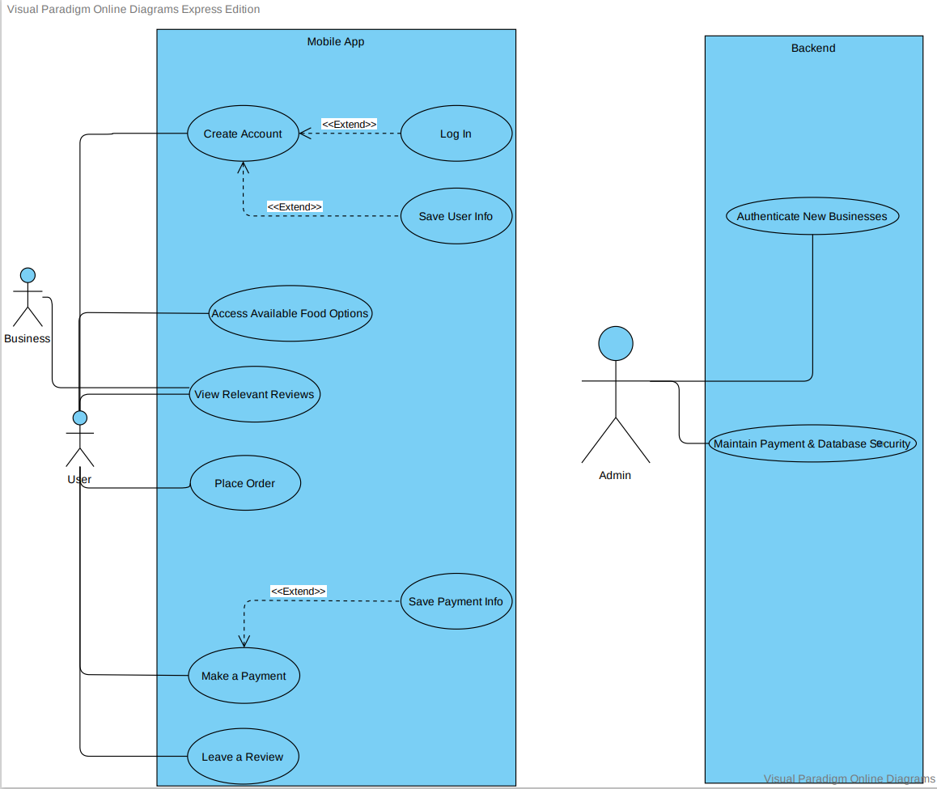

Technical Architecture
The mobile application will be built using Visual Studio Code. We will be using the React Native Framework to develop this cross-platform application. The app will have a NodeJS middleware application that handles Square and customer interactions, hosted as a Firebase Function. The app will also use location tracking to search for nearby restaurants. The application will be supported by Android devices with API level between 16-28 and iOS devices with iOS 13 - 14.1.

Security
Lightning Carryout was secured using SSL certificate pinning and Firebase security rules. The certificate pinner checks the validity of the SSL certificates of incoming traffic against the true certificates of sites like Square and Google that are stored in the app. This is a preventative measure against sophisticated attacks involving modified network traffic like man in the middle attacks. User data is protected with Firebase security rules. These database rules define what data authenticated users can read and write, with restrictions to prevent users from overwriting or reading any private account or payment information that isn’t theirs. In addition to these security measures, the code of the application was adjusted to ensure that no data stored in our Firestore database would be displayed to users who are not authenticated.

Testing
For the testing portion of our application, we took a more informal approach to the process. Because this application is not being distributed soon, we focused more on getting as many functions implemented as possible, rather than trying to write both functions and tests. We know the importance of testing, especially in applications being used by others, and adding those tests in the future would be something we will investigate if this project stretches beyond the requirement of this class. As for the testing we did, we went with the hands-on approach of simply communicating when a major change was being implemented and proceeding to test the application on each of our devices to make sure everything still ran smoothly. If something were to break from our end, we would then get together to meet and discuss what needed to be done in order to fix the problem, and what we could do differently to prevent that in the future. This allowed us to work together on the application and use it just as a user would, which allowed for widespread testing that automated tests cannot necessarily replicate. We felt this was a better way for testing our application and provided the best results for us during development.

Test Plan
The main components that we focused our testing are key features that our users will encounter within the app: finding locations using the menu screen and map locator, finding menu items for their desired restaurant in the selection screen, what the cart/payment process will look like, and ensuring a lack of bugs / errors. All these elements are crucial to the customer experience, so we planned to test with the following objectives in mind:
- All customer-oriented features should be developed and tested before the IT Expo.
- All bugs and warnings that come on launch of the app should be condensed to ones that can be attributed to device specific warnings.
- The app should flow seamlessly from one screen to another and should be easy to follow for anyone that needs to use it.

Test Results
The testing approach that we took for our application was very effective in creating a smooth, working application, however the problem with our approach is that it does result in concrete testing results. Unlike user surveys and automated tests, our approach is focused on communication and cooperation among the team, and we found that as the best way to keep track of bugs and make sure we had them resolved for the IT Expo. With our approach, the result of our testing is simply our application, and we feel that the progress we have made throughout the year speaks to how well this approach worked for us throughout the development cycle.

Budget
The budget for our product is small, with the fact that the Square POS system is already integrated into most small businesses. It made for one less piece of software that we had to purchase, which therefore lowers the overall cost the product. The biggest cost associated with our project in general is the labor cost, as the product is difficult to implement in general, and requires a large amount of research and coding along the way. We also must factor in the cost to upload our app the app store and google play store, as well as any costs associated with using firebase as our database, dependent on how many users we have utilizing our app. Our final budget is the original budget, as the resources and requirements for the app did not change since the creation of our original budget. We did not have any additional software required for production of the application, and the number of hours required for the project was accurate.

Figure 4
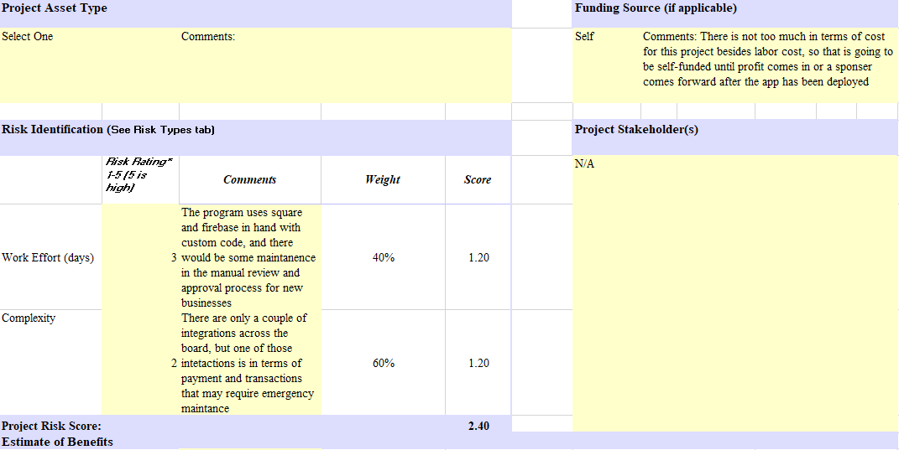
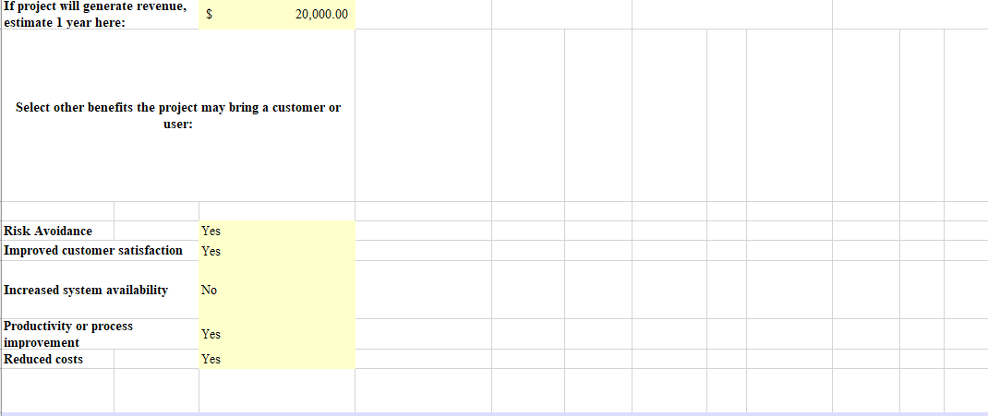
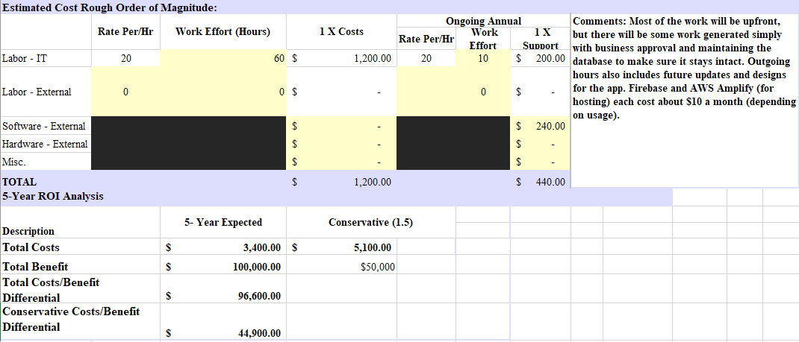

Project Schedule
For both fall and spring semesters, we focused on scheduling tasks linearly at a steady pace, and not trying to complete too many tasks in one or two-week periods. We started with designing and brainstorming all the functionality and timelines for the rest of the semester, making sure we had the fundamentals first. We then began development, creating user profiles, and making sure we knew who we are tailoring our app to. We also wanted to get things setup so we could all get started on some of the work, so we setup the GitHub repository and started on some of the fundamentals. Starting in the spring, we started focusing more on the front-end components surrounding the application, as most of the functionality had already been implemented by this point. We wanted our application to be easy to navigate, and having an intuitive UI is an important facet to making that happen. We also focused on implementing the last functional component, which was placing the order through the application. We needed to add the ability to add products to the cart, display the live cart showing current cost, and then allow the user to place the order and get confirmation of that. When those were completed, we went to work on thorough testing and making sure everything worked smoothly leading up to the 2021 IT expo.

Figure 5
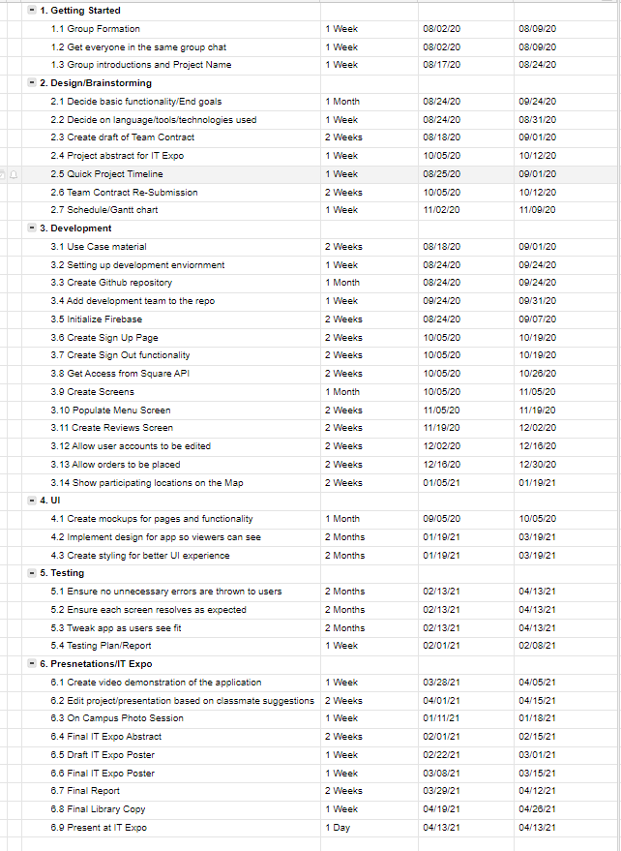

Problems Encountered and Analysis of Problems Solved
There were several problems encountered with the planning of the projects. The Square API supported JavaScript but not in the React Native environment. Our solution was to host a NodeJS application for managing the Square authentication and all interactions for the Square POS systems. For example, authorizing transactions, retrieving menus, location information and finalizing orders. Another problem that we encountered was that the Square API now supports Typescript, which is what React Native supports. Another issue is our lack of cookies used in the project. Our app recalls the same REST endpoints which does not have to be the case if we are using cookies. Recalling the same rest endpoints can be quite expensive overall; especially considering the number of expected users. Other issues with the app arose while implementing database rules involving authentication. When deploying early versions of these security rules, developers had issues logging into the app. The resolution involved reverting to earlier rules while rewriting the security rules and testing them upon redeployment to ensure functionality was not impacted. We ran into an error for some time which prevented us from installing new packages to the project. We were eventually able to get around this by removing the “node_modules” file entirely and re-installing the necessary dependencies for the project. After this, we could install packages as legacy without issue.

Future Recommendations
We would further plan out the flow of data between API’s, SDK’s, data on both the client and server side facing applications. Ensuring there will not be any issues during development. If we had more time, we would add more functionality to the application such as viewing the orders checking the orders status of the app and sending alert notification when the order is ready for pick up. There are no further plans for this project after the semester.

Conclusion

Lessons Learned
Through the process of creating this application thus far, we have learned a lot about what it means to create something truly affordable and efficient for small business owners and their customers. We are striving to make an app that will make life easier for everyone in the mobile ordering process, while also making sure we do not overcharge the small business and then tear down all the relationships we are trying to build. There is truly no room for error, as even a small mistake can prove disaster for a small business, especially during these hard times caused by the COVID 19 pandemic. Making sure we pick cheaper software and work to build our own tools where we can have been crucial to this process.

Abilities and Skills Developed Throughout Project
We have learned things on both the business side and the software development side while working this project. We have learned the essentials of budgeting for a small business and making sure that we created something that would be profitable but also affordable. On the software side, we have learned a lot about the Square API and how it works with payment and user information, as well as Firebase for storing all kinds of data ranging from names to passwords, to credit card information. This project also provided opportunities to learn more about application security through implementing secure sockets layer (SSL) certificate pinning to validate application traffic and database rules to secure user data.

References
Rayome, Alison DeNisco. “Food Delivery Apps Say They're Saving Restaurants. Instead They're Charging Big Fees.” CNET, 15 May 2020, https://www.cnet.com/how-to/food-delivery-apps-say-theyre-saving-restaurants-instead-theyre-charging-big-fees
CodingPixel. “Restaurant App Development Cost & Pricing Guide.” Coding Pixel, 28 Feb. 2020, http://www.codingpixel.com/blog/how-much-does-it-cost-to-build-a-restaurant-app
Grubhub Inc. “Grubhub Reports Third Quarter 2020 Results.” Grubhub, Inc. - Grubhub Reports Third Quarter 2020 Results, 28 Oct. 2020, media.grubhub.com/media/News/press-release-details/2020/Grubhub-Reports-Third-Quarter-2020-Results/default.aspx

