Gracie Roades

***DRAFT EXHIBIT LABELS***
The representation of architecture within art is a main theme for artists of all time periods. Within the UC Art Collection, prints display different stylistic approaches from abstract to realistic when portraying architecture. This exhibit will display five prints that compare and contrast the idea of stylistic approach. By viewing these artworks, there is the question as to why artists chose to portray the two types differently. Does the style dictate the importance or function of the architecture? Through exploration, one could say that there is a correlation between the type of architecture and its stylistic rendering. When viewing the examples of the collection, architecture that is considered monumental, such as cathedrals or government buildings, seem to be portrayed with realistic detailing and perspective, leaving no room for artistic expression in the portrayal. On the other hand, common architecture is portrayed with more abstraction but allows more freedom of expression from the artist to interpret the structure. Is one better than the other or do these two separate approaches give their subjects individualized attention to their charms?

______________________Piece 1________________________
Object 2671 UC Art Collection
Wenceslaus Hollar
British, 1607-1677
St. Paul’s Cathedral, West Front, 1656
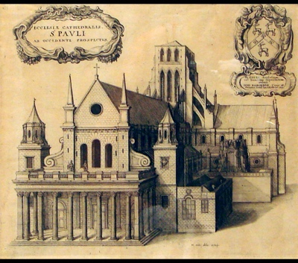
Etching on paper
Hollar’s print is the oldest print to display the clarity of detail of monumental architecture. Prints of cathedrals, universities, and various bird’s eye views highlight his realistic portrayals he was well known for. St. Paul’s Cathedral, West Front is one print of a series of fourteen completed on the church, commissioned by antiquarian William Dugdale. The style Hollar chooses to display the print is similar to Piranesi’s Vatican St. Peter’s in that it avoids distraction from the architecture and uses straight, concise lines.
For a monumental structure like St. Paul’s, Hollar left no details behind, making the viewer play hide-and-seek, but allowing them to find elements like the two sculptural figures that sit on the short columns above the main porch. His forms are straight and bold, especially when looking to the front façade of the cathedral. The use of perspective and the shadows along the cathedral’s long side create a print as close to a photograph as one could get in the 17th century. The use of crosshatching (lines that intersect one another for a 3D look) is remarkably done to create the textures of the building’s stone.

________________________Piece 2________________________
Object 674
Sir Francis Haden
British, 1818-1910
Dusty Millers, 1877
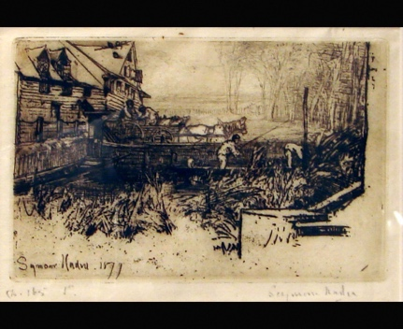
Etching and drypoint on laid paper

First and foremost a surgeon, Haden took up printmaking later in his life, following the avant-garde styles of the 19th century of Realism (depicting the common people) and Impressionism (art without realistic forms) as he travelled into the countryside for inspiration. He was considered to be an amateur in the artistic community, but he was an advocate for printmaking as an artistic medium and founded the Royal Society of Painter Etchers in England. Haden has shown the scene as a working entity in the age where people were interested leaving the cities for the rural life.
This print is of a rural scene of a mill in operation with workers. The light touch of the background creates a haze over the forest, in turn framing the main subject matter which is done in a much darker, and abstract, tone. The mill itself is etched with the freedom of expression, showing its age as it blends with the natural surroundings. There is a lot of texture going on in the midsection of the print, emphasizing the organic surroundings of the overgrown grass and the wooden bridge the horses and cart pass over.

____________________________Piece 3__________________________
Object 2449
Giovanni Battista Piranesi
Italian, 1720-1778
Vatican St. Peter’s, N.D. (MAYBE CIRCA DATE?)
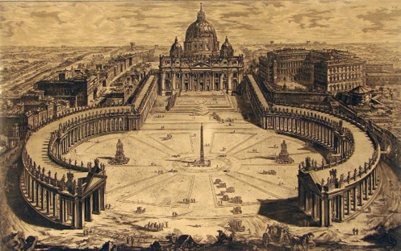
Etching on paper
A well established artist of his time, Piranesi is most known for his made-up architectural prints and ideas, stating that, “I need to produce great ideas, and I believe that if I were commissioned to design a new universe, I would be mad enough to undertake it.” He primarily did works with architecture because he thought of himself as one with all of his structural ideas. There was a clear stylistic approach between prints such as Vatican St. Peter’s and his imaginative prints like the “Carceri d'invenzione” or “Imaginary Prisons.”
Even in the far background of this print, little details are present in great clarity. The large print encompasses St. Peter’s Cathedral in Rome and the surrounding buildings. The use of value gives a shadow that casts over the left sides of the structures, most notably on the top-right side. Stone textures vary from lighter in the courtyard to a coarse and dark stone of the buildings surrounding the cathedral. Piranesi uses light to his advantage to help the viewer follow the curved form of the colonnade (covered walkway supported by columns). Line and perspective are used to create 3D space and realistic structures, A great spot to see this is the central structure.

__________________________Piece 4_________________________
Object 4046
Stephen Parrish
American, 1846-1938
Mill Pond, 1985
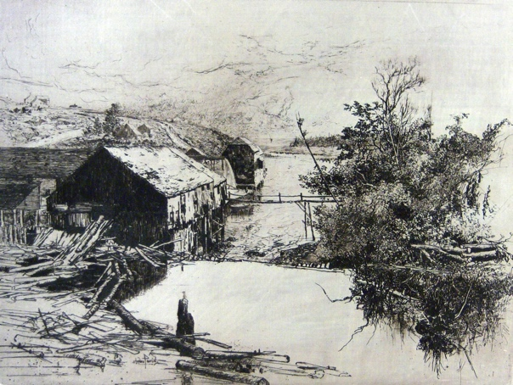
Etching on silk mounted paperboard-cloth
Stephen Parrish is the latest artist part of this exhibition that portrays another scene of common architecture rather than monumental. Parrish was part of the Etching Revival in the United States in connection with the revival in England under Sir Francis Haden who is also included in this exhibition. His work was inspired by Whistler and Haden and his most popular subject matter with the prints are marine and landscape images. This example of common architecture follows the same stylistic approach as Dusty Millers and the townhouses of Leon, with suggested architectural forms rather than clear lines like St. Paul’s Cathedral.
A quiet scene of a sunrise or sunset brushes sunlight over the structures and the landscape surrounding them. The architecture blends with the landscape rather than being the central focus. Parrish used high contrast with little line work to create the forms that make up the trees, structures, banks, and more. Line is used to produce the textures, like the peppering that creates the tree’s foliage or the stippling (etched dots) on the rooftop. The sky in the background is subtle and lightly shaded, much like the background in Dusty Millers.

____________________________Piece 5__________________________
Object 2721
John Taylor Arms
American, 1887-1953
Leon (Spanish Church Series #1), 1923
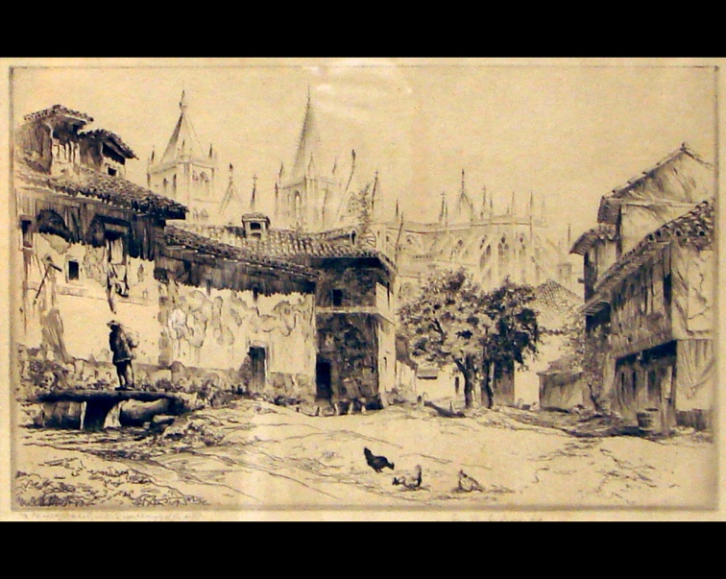
Etching on laid paper
This print serves both sides of the ways to portray architecture. In the foreground, townhouses are shown with character, showing age, deformities, but with abstraction to give them life that can be comparable to the common people who inhabited them. In the background, Catedral de León appears through the haze. Even though it is lightly etched, the monumental architecture is shown with straight line and architectural details, such as the spires and flying buttresses. Arms was inspired by the Gothic style in Europe and most of his work consists of comparisons of common and monumental architecture.
Shading and texture are heavily used to distinguish between the two types of architecture in the print. The foreground consists of townhouses that have lots of textural details, such as the peeling stucco on the left side of the street. Sides of the houses are shaded differently to give them a 3D appearance, but it also makes the structures feel dynamic and aging. The use of negative space is well executed by highlighting the faces of the front structures but separating the cathedral from the sky in the background. This helps to create the perspective with the use of transparency of the cathedral’s form.

Pennington, Richard. A Descriptive Catalogue of the Etched Work of Wenceslaus Hollar 1607-1677. Cambridge University Press, 2002.
https://www.metmuseum.org/art/collection/search/395057
Digital Commonwealth. “Francis Seymour Haden (1818-1910). Prints and Drawings.” Accessed 2 March 2022. https://www.digitalcommonwealth.org/collections/commonwealth: 5138jp89z.
https://www.metmuseum.org/toah/hd/pira/hd_pira.htm
http://www.artoftheprint.com/artistpages/parrish_stephen_november.htm
https://www.nga.gov/collection/artist-info.2348.html#biography

