ReFridgeID
by
Alex Weeks, Luai Musa, Evan Uveges

Submitted to
the Faculty of the School of Information Technology
in Partial Fulfillment of the Requirements for
the Degree of Bachelor of Science
in Information Technology

© Copyright 2017, Alex Weeks, Luai Musa, Evan Uveges


The author grants to the School of Information Technology permission to reproduce and distribute copies of the document in whole or part.

___________________________________________ ____________________________
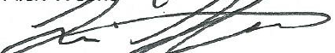
Alex Weeks Date

___________________________________________ ____________________________


Luai Musa Date

___________________________________________ ____________________________

Evan Uveges Date

___________________________________________ ____________________________
Faculty Advisor Date
University of Cincinnati
College of
Education, Criminal Justice, and Human Services

April 2017
Table of Contents

Abstract iv
1. Problem Statement 1-4
1.1 Introduction 1
1.2 Project Description 1
1.3 Problem 2
1.4 User Profile 3
1.4.1 Application Title 3
1.4.2 Potential Users 3
1.4.3 Software and Interface Experience 3
1.4.4 Task Experience 3
1.4.5 Frequency of Use 4
1.4.6 Scalability Assumption 4
2. Project Management 5-7
2.1 Budget 5
2.2 Objectives/Deliverables 5
2.3 Project Schedule 7
3. Technical Elements 8
3.1 Network 8
3.2 Software 8
3.3 Backup 8
4. Conclusion 9-10
5. OWASP 11-14
6. Testing Procedures 15-19
6.1 Overview 15
6.2 Scope 15
6.3 Objectives 15
6.4 Entry & Exit Criteria 16
6.5 Logging Tests and Reports 16
6.6 System Testing 16
6.7 Testing Procedures 17
6.8 Pass/Fail Conditions 17
6.9 Risks 18
7. References 20
8. Appendix 21-22

Abstract

The current trend of smart devices has produced some truly incredible and useful inventions that have changed the way we interact with the world around us. However, some of the current implementations leave much to be desired. ReFridgeID is an advanced ‘smart’ refrigerator, integrated with modern Radio Frequency Identification technology and is geared towards food conservation and user convenience. Built on the .NET framework, ReFridgeID offers a companion application enabling users the ability to intelligently track and manage contents of their refrigerator in terms of existence, expiration, and potential recipe usage. With ease of use guiding the applications design, users can intuitively utilize ReFridgeID technology to optimize routine kitchen tasks and curb food waste, saving time and money for the consumer as well as valuable resources for society as a whole.

- Problem Statement
1.1 Introduction
In today’s busy world, many families and individuals either spend countless hours figuring out what ingredients they have to make a meal with, or what they need to buy when making shopping lists. Others cut corners and find themselves wasting food and money when throwing away expired and spoiled items. 40% of food is wasted in the United States which means nearly 300 pounds being thrown away annually by each individual¹. Providing a solution that does not interfere with or alter day-to-day routines, but helps to streamline these routines is needed. With kitchens providing high returns on investments for homeowners, any solution must be streamlined and adaptable.
1.2 Project Description
We have designed and created a Radio Frequency Identification (RFID) enabled Smart Refrigerator and companion application. The appliance and application serves as a one stop management solution to help automate and streamline the daily routine of figuring out what to eat and what to buy. The final products software solution serves as a Proof of Concept when integrated with the existing RFID Technologies. For a fully deployable and scalable solution, items from manufactures and distributers would need to contain a pre-programed RFID tag. Databases with original manufactured product information must also be made available for the appliance. For this project, these assumptions have been made and items have been manually tagged and a database manually created.

1.3 Problem
The problem many families and individuals face is two-fold; Time Management and Cost Savings. In a sense the two are intertwined. Families and individuals can spend upwards of an hour figuring out what to make for dinner, or any meal for that matter. In most cases, they do not know what items they have thus prolonging the process. Many also find themselves throwing away food that has expired or spoiled on a regular basis which translates to throwing away money. Finally, a normal shopping trip includes time being spent figuring out what one has and what one needs. Individuals who fail to complete this task optimally find themselves spending longer times in stores as they back track retrieving items as their realize they need them, or worse realizing they failed to pick up something while shopping. This individual dilemma of food waste translates to a much larger societal issue when you consider the resources used to create, package and transport the alarming amount of wasted food.

  - User Profile
1.4.1 Application Title
ReFridgeID – RFID Smart Refrigerator
1.4.2 Potential Users
Main Group – Head of Household (anyone who facilitates shopping and cooking in a household)
Secondary Group – Anyone who interacts with a refrigerator
1.4.3 Software and Interface Experience
Requires authentication and paring with refrigerator. Main user interface will provide sortable/searchable lists of real-time inventory, as well as providing easy access to lists of items expired or set to expire soon. Recipe search functionality utilizes contents of the refrigerator to recommend daily recipes as well as providing a user interface for searching recipes. Users are able to automatically generate shopping lists based on items expired or consumed, as well as add other items to the lists.
1.4.4 Task Experience
Users must have minimal knowledge and experience with internet enabled smart phones and similar applications. Interaction with the refrigerator will not alter daily routines. User interaction with RFID tags and readers does not exist. The reader is built into the refrigerator and UHF tags will be applied to items by the manufacturer.

1.4.5 Frequency of Use
Interaction with the refrigerator depends on each user. Daily routines will not be altered. Interactions with the companion application can be accessed when users seek to see inventory of their refrigerator, determine which items are expiring soon, determining a recipe to make, or assisting in making shopping lists.
Interactions could exceed multiple sessions per day.
1.4.6 Scalability Assumptions
ReFridgeID serves as a proof of concept for the utilization of RFID technology in the consumable/perishable grocery market. Once scaled to a production setting, all UHF RFID tags will need to be applied to the item by the manufacturer before being delivered to distributers and resellers. A public database for brand and item information will need to be provided by manufactures as well, as only batch and expiration information are stored on the RFID Tag.

- Project Management
2.1 Budget
Figure 1 presents the project budget. The budget presents a real-world cost of money, but totaling $0.00 as this is a senior design proof of concept solution and will not be sold.
Figure 1: Project Budget
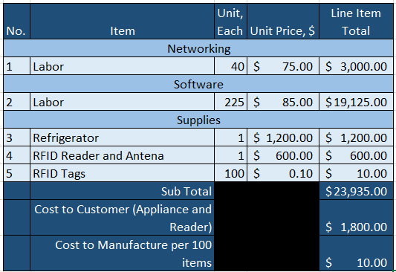

2.2 Objectives/Deliverables
All project deliverables listed below are incremental steps that were covered, addressed, or implemented in feature sets detailed in the project schedule in section 2.3. Deliverables were met on or before the assigned date.

Figure 2 presents key project deliverables.
Figure 2: Deliverables
Acquire Hardware | 9/20/16 | RFID Microservice | 1/21/17
Develop Database Project/Schema | 10/15/16 | RFID Microservice Integration with Web App | 1/28/17
Active Inventory Management | 10/28/16 | Pairing Feature Development | 2/10/17
Spoonacular API Integration | 11/10/16 | Item details API calls and display | 2/20/17
Shopping List Integration | 11/15/16 | Final integrations and build testing | 3/1/16
Initial Testing and local Deployment | 11/20/16 | UI enhancements and flow upgrades | 3/12/16
Recipe Search Functionally | 11/28/16 | Final Testing Procedures | 4/1/16
RFID Tag testing | 1/14/17

2.3 Schedule
Figure 3 presents the Gantt chart for this application (Fall semester).
Figure 3: Gantt Chart (Fall Semester)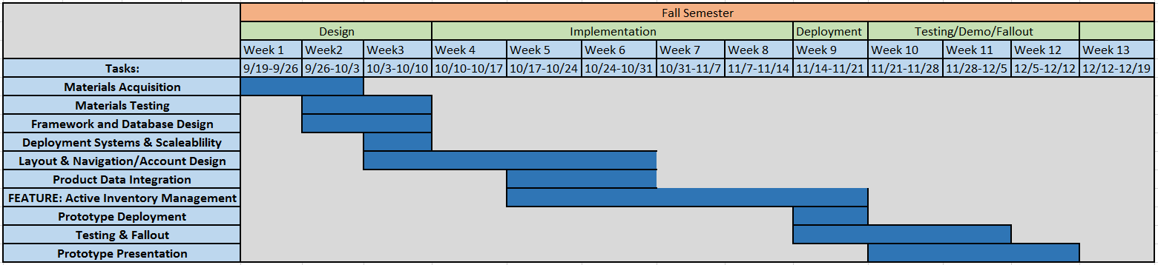

Figure 4 presents the Gantt chart for this application (Spring semester).
Figure 4: Gantt Chart (Spring Semester) 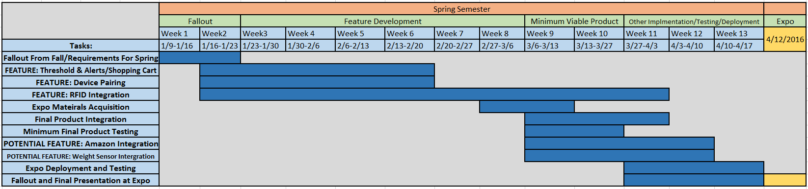

- Technical Element
3.1 Network
A local database and client application are stored locally on a personal computer attached to the refrigerator for the RFID reader. A web server hosted by Azure Web Services is used to service endpoints in relation to the client companion application and communicating with the RFID client application. All servers run in a Microsoft Windows environment.

3.2 Software
The design team developed the software applications with Microsoft’s Visual Studio 2015 utilizing a deployable standalone database project. The Visual Studio Entity Framework library was used as the Object Relational Mapper to assist in development and help protect against SQL injection attacks. Asynchrony developmental methodology provides a seamless speedy user interaction. Bootstrap CSS libraries are used to help style the user interface as well as provide cross platform compatibility. Spoonacular provides the recipe API integration through MashApe.

3.3 Backup
All virtual machines will be backed up daily with daily snapshots of the database being taken. All code is stored in Gitlab. No extensive backup measures needed to be taken as the final product will serve as a proof of concept.

- Conclusion

By the end of the fall 2016 semester we had developed a working companion application prototype. The prototype has the ability to read and list out contents of the refrigerator with associated information in a user friendly design. A modular Spoonacular API provider has also been developed to retrieve user input as to ingredients used in a recipe and provide a list of recipes based on those selected items. Once a recipe is selected, another call is made to provide all details for that recipe.

Some minor complications we have faced this semester center mostly on the selection and integration of RFID hardware solutions into the project. Determining which antenna, broadcast frequencies, and tags to use was quite daunting. Luckily the companion application was able to be created independently of the RFID client application. Both applications connect to the same database where the RFID client application writes data to the associated tables, and the companion application reads and presents that data to consumers. Thus, as we continued to test and decide the best RFID hardware infrastructure for the project, we were able move forward with further development on the companion application throughout the spring semester.

Another potential issue/hardship we face is in the mobile development of the companion application. Our goal is to develop the application to be fully mobile optimized through Bootstrap CSS. At this point the application will serve as a web app rather than a stand-alone application that can be downloaded from app stores. Depending on the development timeline, potential wrappers can be applied to give this downloadable functionality. With the app serving as a web app, accessing the local hardware such as a camera on a phone may be difficult, thus impeding our ability to pair a device with a refrigerator via QR code. Because of this consideration, we decided to use manual pairing by entering in a code presented on the refrigerator tablet into a prompt on the users device.

5. Open Web Application Security Project (OWASP)
A1 Injection: Injection flaws such as SQL, OS, and LDAP occur when purposefully manipulative data is sent to an interpreter as part of a command or query. This data can trick the interpreter into executing unintended commands or accessing data without proper authorization.
Since we are using the Entity framework, there are no stored procedures or in line SQL queries to be injected. Our database design was created with these weaknesses in mind, enabling us to avoid them entirely.
A2 Broken Authentication and Session Management: Application functions related to authentication and session management are often implemented haphazardly, compromising passwords, keys, session tokens, etc. This enables the attacker to potentially assume somebody else's identity.
We are using Visual Studios built-in authentication, which is known to be very secure. An account must be created with a username and password in order to access the application. All data is stored in the database and is only accessible to the proper users.
A3 Cross-Site Scripting (XSS): XSS flaws occur whenever an application takes untrusted data and sends it to a web browser without proper validation or escaping. XSS allows attackers to execute scripts in the victim’s browser, hijacking user sessions, defacing web sites, or redirecting the user to malicious sites.
We do not have any untrusted or external data within out application. We have external APIs that we are using to pull data in, but no hrefs that point to external sites.
A4 Insecure Direct Object References: A direct object reference occurs when a developer exposes a reference to an internal implementation object, such as a file, directory, or database key. Without an access control check or other protection, attackers can manipulate these references to access unauthorized data
We do not have any hard coded files, database keys, or any other links that could point directly to a user’s machine. For local testing, we have database properties set in a web.config file, but this will not be an issue in production.
A5 Security Misconfiguration: Good security requires having a secure configuration defined and deployed for the application, frameworks, application server, web server, database server, and platform. Secure settings should be defined, implemented, and maintained, as defaults are often insecure. Additionally, software should be kept up to date
We are using local DB in Visual Studio. Our deployment will be using .dll files and will not be accessible. This will ensure that the files contents remain secure. All software, Nuget packages, APIs, and external references are all up to date and will continue to be updated as the project progresses.
A6 Sensitive Data Exposure: Many web applications do not properly protect sensitive data, such as credit cards, tax IDs, and authentication credentials. Attackers may steal or modify such weakly protected data to conduct credit card fraud, identity theft, or other crimes. Sensitive data deserves extra protection such as encryption at rest or in transit, as well as special precautions when exchanged with the browser.
Our application does not have any sensitive data, and does not access users sensitive data.
A7 Missing Function Level Access Control: Most web applications verify function level access rights before making that functionality visible in the UI. However, applications need to perform the same access control checks on the server when each function is accessed. If requests are not verified, attackers will be able to forge requests in order to access functionality without proper authorization.
No actions are available or can be selected if a user is not signed into an account. Pages are hidden until a user has logged in. This suffices for the protection and security required for list item A7.
A8 Cross-Site Request Forgery (CSRF): A CSRF attack forces a logged-on victim’s browser to send a forged HTTP request, including the victim’s session cookie and any other automatically included authentication information, to a vulnerable web application. This allows the attacker to force the victim’s browser to generate requests the vulnerable application thinks are legitimate requests from the victim.
We are running this application locally on our own servers, which prevents any malicious activity to a user’s session cookies or other data.
A9 Using Components with Known Vulnerabilities: Components, such as libraries, frameworks, and other software modules, almost always run with full privileges. If a vulnerable component is exploited, such an attack can facilitate serious data loss or server takeover. Applications using components with known vulnerabilities may undermine application defenses and enable a range of possible attacks and impacts.
All libraries, frameworks, external references, and API’s have been marked as safe and approved by Microsoft and Visual Studio, are all accessible through the Nuget Package system in Visual Studio, and nothing is external or unauthorized.
A10 Unvalidated Redirects and Forwards: Web applications frequently redirect and forward users to other pages and websites, and use untrusted data to determine the destination pages. Without proper validation, attackers can redirect victims to phishing or malware sites, or use forwards to access unauthorized pages.
We do not have any redirecting or forwarding in this application. Everything and all pages are just in our project. No external urls are accessed.
Figures 5 presents the OWASP Web Top 10 for 2013.
Figure 4: OWASP Web Top 10, 2013
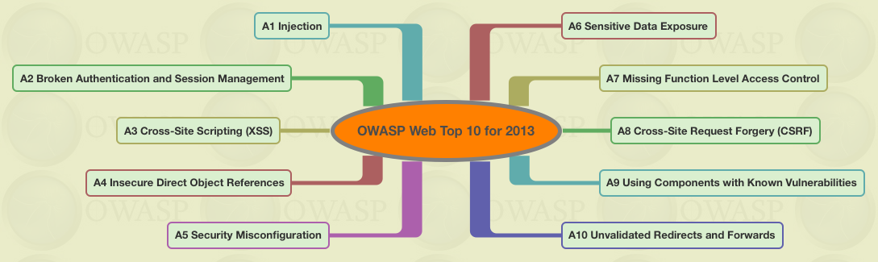

6. Testing Procedures
6.1 Overview
This section will explain the testing methodology for ReFridgeID and the associated companion web application, and should be used as a guide. The following individuals should use this section.
- Developers
- Project Managers
- Smoke Tests
- Q&A Personnel
- Team Members
- Managers
6.2 Scope
The scope of testing is to test the operation of ReFridgeID both in the hardware functionality and in the companion application (on desktop and mobile web enabled devices). The tests will be organized based on requirements of the application.
6.3 Objective
The object of testing is to verify that a particular module of the source code is working as expected and that the hardware is being integrated properly with the application. These tests are designed to test components in isolation or as a unit. Developer or developers will run tests for the components they are working on during and after completion of the code.
6.4 Entry and Exit Criteria
Entry Criteria:
- Build Complete
- Self-testing complete
- Test environment is setup
- RFID antenna and reader connectivity
Exit Criteria:
- All tests are run
- Bugs are documented and fixed
6.5 Logging Tests and Reporting
If a bug is found during testing, the individual will document the bug. Developers will conduct a fallout meeting at the end of each sprint to decide if reported bugs is a bug that needs addressed or if it is a feature yet to be implemented. Any bugs noted will be prioritized and worked on during the start of the next sprint.
6.6 System Testing
ReFridgeID will be tested as a complete application including hardware integration. All modules will be tested as one complete unit. This approach will help to identify defects (bugs) and integration oversights that will only show when the complete application is tested as one unit. It is intended to authenticate the application as one unit.
6.7 Testing Procedures
The following are steps that are needed for testing which consist of:
- Create all test scenarios and cases based on requirements for feature sets
- Prepare testing document used for conducting the test and the intended results
- Specify bugs and other outcomes in the correct report
Below are the tests that will be performed:
- Stability Test – This test will focus on the ReFridgeID Application and API’s being stable and accessible from both desktop and other internet enabled devices.
- Launch Test – This test will focus on the ReFridgeID Application being able to start and stop correctly on all platforms as well as continued RFID reading.
- User Interface Test – This test will focus on the user interface of the companion application and how it appeals to the user.
- Functionality Test – This test will focus on the features that have been implemented and whether or not they function to the requirement documents.
- Hardware Test – This test will focus on the connectivity and proper reading ability of the RFID reader and associated antenna to the rest of the ReFridgeID application.
6.8 Pass/Fail Conditions
It will be expected that the ReFridgeID application must pass all tests in every category to be considered as successful. If it does not pass, the tester will document the issue.
Schedule of Team Member Testing
The schedule of the team member testing is summarized in the table below:
Team Member | Timeline to be Completed | How Often?
Developer | 10/03/2016 – 04/11/2017 | Conclusion of Sprint & Feature
Project Manager | 10/03/2016 – 04/11/2017 | Conclusion of Sprint

Table {X}: Team Member Testing
Schedule of Round Table Testing
The schedule of the round table testing is summarized in the table below:
Round Table | Timeline to be Completed | How Often?
Full Team | 03/20/2017 – 03/31/2017 | Once per week (2 times)
Focus Group | 03/20/2017 – 03/31/2017 | Once per week (2 times)

Table {X}: Round Table Testing
5.9 Risks
The following will impact the test cycle:
- Device Availability
- A new feature that is not available in the latest build
- Inability to access required hardware
- Delay in bug fixes
- Schedule of the round table testing with the specified group.

7. References

- Food, S. T. (n.d.). Save The Food | 10 easy tips for meal planning. Retrieved November 28, 2016, from http://savethefood.com/tips/10-easy-tips-for-meal-planning

8. Appendix
Testing Reports
Stability Test – This test is focused on the application being stable on a desktop and internet enabled devices. Below is the first and last test prior to expo performed on the devices.
Tester | Date | Item# | Expected | Actual | Pass/Fail | Bug
Weeks | 12/05/2016 | 1.1  Mobile Device Web Stability | All UI elements scale to mobile platforms | Worked in debug mode for all Google mobile web frames | Pass
Weeks | 12/05/2016 | 1.2  Desktop Stability | All UI elements scale to all desktop screen resolutions | Worked in debug mode in Google and Firefox Browsers | Pass w/ Recc | Not all elements are contained in proper div’s
Weeks | 12/05/2016 | 4.1  Functionality of Spoonacular API | Searching for a recipe based on selected items brings back recipes -> recipe brings back details | Recipes are brought back and subsequent requests bring back proper data | Pass w/ Recc | UI enhancement for details

Table 1: Round One Testing

Tester | Date | Item# | Expected | Actual | Pass/Fail | Bug
Weeks | 4/8/17 | 1.1  Mobile Device Web Stability | All UI elements scale to mobile platforms | All elements scaled as expected | Pass | N/A
Weeks | 4/8/17 | 1.2  Desktop Stability | All UI elements scale to all desktop screen resolutions | All elements scaled as expected | Pass | N/A
Weeks | 4/8/17 | 4.1  Functionality of Spoonacular API | Searching for a recipe based on selected items brings back recipes -> recipe brings back details | All API endpoints returned proper data as expected | Pass | N/A

Table 2: Final Testing

