Physics in Three-Part Harmony

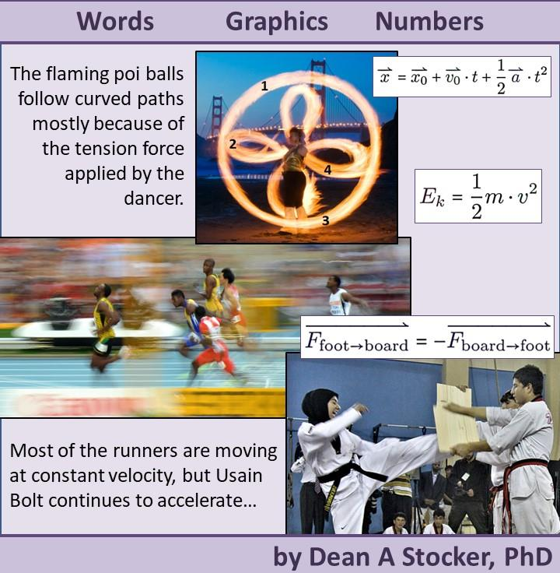
Dean A. Stocker, PhD
University of Cincinnati Blue Ash College
9555 Plainfield Rd
Blue Ash, OH 45236
dean.stocker@uc.edu
Spiral-bound color copies of this work can be purchased at Lulu.com (search for “stocker physics”) for approximately the same cost as printing your own unbound copies.
The digital version of this work is temporarily available at Scholar@UC. Browse or search for works by Dean Stocker.
Canvas Quizzes, polling questions, and a Solutions Manual based upon this work are available to instructors at no cost by emailing dean.stocker@uc.edu and providing a link to their school’s website that verifies their role as an instructor.
©2026 Dean A. Stocker
This work is licensed under a Creative Commons Attribution-ShareAlike 4.0 International License (CC BY 4.0). To view a copy of this license, visit creativecommons.org or send a letter to Creative Commons, PO Box 1866, Mountain View, CA 94042, USA.
You are free to:
- Share — copy and redistribute the material in any medium or format
- Adapt — remix, transform, and build upon the material
Under the following terms:
- Attribution — You must give appropriate credit, provide a link to the license, and indicate if changes were made. You may do so in any reasonable manner, but not in any way that suggests the licensor endorses you or your use.
- No additional restrictions — You may not apply legal terms or technological measures that legally restrict others from doing anything the license permits.
Some of the images used in this book are licensed under different copyrights, so the restrictions on use of these images may be different from what is described on this page. Information about every image can be found in the list of Image Sources at the end of this book.

Acknowledgments
There are many people who have contributed to this work in many ways. In particular, I would like to thank the following:
Pete Schwartz for introducing me to parallel pedagogy, sharing all his materials, connecting me with others who are already using this pedagogy or are interested in using it, and bringing me in as a partner on related research and presentations.
Kris Lui, Sherry Savrda, Frank Cascarano, and Doug Forrest for giving great feedback on the development of this book.
Brian Frank for introducing me to the idea of color coding to help students understand physics.
My colleagues at the University of Cincinnati Blue Ash College who provide continual support and encouragement.
My colleagues in the American Association of Physics Teachers, who are an endless fount of good ideas.
My students, who have suffered through the various versions of this work and provided helpful feedback on it.
My wife Penny, for her constant support, encouragement, patience, and feedback. I cannot imagine who I would be without her.
And finally, some design features of this book, like the three-column format, are, as far as I know, unique. For such inspirations I can only thank my God.
Most alt text for the images was generated using either Gemini, ChatGPT, or BearcatGPT.
Front cover image sources:
Fire_Dancing_Golden_Gate_Bridge.jpg by David Yu is licensed under CC-BY 2.0. This image has been cropped and numbers have been added.
Leichtathletik WM 2013 Moskau 100 m Vorlauf.jpg by Tobi_87 is licensed under CC BY-SA 3.0
111022-A-4076C-124 by ResoluteSupportMedia is licensed under CC BY 2.0. This image has been cropped and filtered.

Learning Objectives
This textbook was designed for use in conceptual and algebra-based physics courses. The content was chosen in such a way that it aligns with two different standards. The first is the physics content in the “Foundational Concepts” on the Association of American Medical Colleges’ Medical College Admissions Test (MCAT). The second is the “Transfer Assurance Guidelines” (TAG) for first-semester and second-semester algebra-based physics in the State of Ohio.
These two standards each contain dozens of learning objectives, some of which overlap. “Appendix F:” in the electronic versions of this textbook lists each of the learning objectives and shows the section in which each appears for the first time in the textbook. In some cases, the learning objectives are developed over the course of several sections; in such cases multiple sections are listed.
The Table of Contents and the titles of many sections of the book contain icons that indicate that the new material presented in the section explicitly covers either MCAT foundational concepts or the State of Ohio learning objectives:
 MCAT foundational concept
Ohio TAG learning objective
In a very small number of cases, a foundational concept or learning objective is first introduced in an end-of-chapter question. In those cases, the question includes the appropriate icon.
It should be noted that in fact nearly every chapter contains material that is strongly related to the learning objectives for both MCAT and Ohio TAG. The icons are used only in the places where the section introduces material that is explicitly named in the learning objectives. For example, the concept of power is not included in the Ohio TAG requirements for the first semester of algebra-based physics. But the Ohio TAG requirements for the second semester of algebra-based physics include describing the power delivered by batteries and the power dissipated in resistors in simple circuits. The concept of power is usually introduced along with energy, which is a concept developed in first-semester physics. So, while the section of this textbook where power is introduced is not marked with the “Ohio TAG” icon since it is not an explicit learning objective, it is prerequisite knowledge for anyone who plans to take the second semester course.
This book is not endorsed by either the Association of American Medical Colleges or the Ohio Department of Higher Education. The determination of which content is relevant to the MCAT Foundational Concepts and Ohio TAG is based solely on the judgement of the author of this textbook.

Table of Contents
Acknowledgments 3
Learning Objectives 4
Table of Contents 5
Chapter 1 – Our Physics Toolbox 12
1.1 : Motion, Momentum, Energy, and Force () 13
1.2 : A Motionless Rock, in the Horizontal Direction ( , ) 15
1.3 : A Motionless Rock, in the Vertical Direction ( , ) 17
1.4 : A Rolling Soccer Ball ( , ) 19
1.5 : A Falling Rock ( , ) 21
1.6 : Summary 23
1.7 : Questions 25
Chapter 2 – Working in One Dimension 29
2.1 : Units ( , ) 30
2.2 : Sliding to the Left ( , ) 32
2.3 : Falling to the Ground ( , ) 34
2.4 : Being Thrown to the Ground ( ) 36
2.5 : Being Thrown Upward ( ) 38
2.6 : Up and Back Down ( , ) 40
2.7 : Accelerating in a Car ( , ) 42
2.8 : Braking in a Car ( ) 44
2.9 : Summary 46
2.10 : Questions 49
Chapter 3 – Two Objects 53
3.1 : Reference Frames ( ) 54
3.2 : An Ant Pushing a Rock ( , ) 56
3.3 : Kicking Horizontally ( , ) 58
3.4 : Elastic Collision ( ) 60
3.5 : Two Moving Balls ( , ) 62
3.6 : Railway Couplers ( ) 64
3.7 : Curling ( , ) 66
3.8 : Car Crash, Initial Impact ( ) 68
3.9 : Car Crash, Sliding ( , ) 70
3.10 : Summary 72
3.11 : Questions 74
Chapter 4 – Working in Two Dimensions 78
4.1 : Floating on the Water ( ) 79
4.2 : Boating in a River ( , ) 81
4.3 : Straight Across a River ( ) 83
4.4 : Kicking in a New Direction ( ) 85
4.5 : Checking in Ice Hockey ( ) 87
4.6 : Standing on a Rope () 89
4.7 : Pulling a Sled ( , ) 91
4.8 : Pulling a Frictionless Sled ( , ) 93
4.9 : Waterslide ( ) 95
4.10 : Summary 97
4.11 : Questions 99
Chapter 5 – Variable Forces 102
5.1 : Pulleys ( , ) 103
5.2 : Spring Scale () 105
5.3 : Bouncing Ball ( , ) 107
5.4 : Pushing a Barrel ( , ) 109
5.5 : Sledding at White Sands ( , ) 111
5.6 : The Truth About Gravity 113
5.7 : Summary 115
5.8 : Questions 116
Chapter 6 – Curving Paths 119
6.1 : Cliff Diving ( , ) 120
6.2 : Basketball Bounce ( ) 122
6.3 : At the Peak ( ) 124
6.4 : Earth’s Orbit ( , ) 126
6.5 : Puck on a String ( ) 128
6.6 : Summary 130
6.7 : Questions 131
Chapter 7 – Rotation 136
7.1 : Kind of the Same ( , ) 137
7.2 : Points and Hoops ( , ) 139
7.3 : Helicopter Blades ( ) 141
7.4 : Figure Skating ( ) 143
7.5 : Charging a Radio () 145
7.6 : Hoop Rolling ( , ) 147
7.7 : Center of Mass ( , ) 149
7.8 : Off-Center Rotation ( ) 151
7.9 : Balancing ( , ) 153
7.10 : Summary 155
7.11 : Questions 156
Chapter 8 – Stability and Oscillations 160
8.1 : The Great Pyramid of Giza ( , ) 161
8.2 : A Horizontal Spring and Mass ( , ) 163
8.3 : Jupiter’s Moons ( ) 165
8.4 : Simple Harmonic Motion ( , ) 167
8.5 : A Vertical Spring and Mass ( , ) 169
8.6 : A Pendulum ( ) 171
8.7 : Summary 173
8.8 : Questions 175
Chapter 9 – Solids 180
9.1 : Modeling a Rope ( , ) 181
9.2 : The End of the Rope ( , ) 183
9.3 : Adding Waves ( , ) 185
9.4 : Beat Frequencies ( ) 187
9.5 : Longitudinal Waves ( , ) 189
9.6 : Stretching and Breaking () 191
9.7 : Summary 193
9.8 : Questions 195
Chapter 10 – Liquids ( ) 199
10.1 : Doric Temple of Athena Lindia ( , ) 200
10.2 : Transfer of Pressure ( , ) 202
10.3 : Floating and Sinking ( , ) 204
10.4 : Flowing ( , ) 206
10.5 : Intermolecular Forces () 208
10.6 : Water Waves ( , ) 210
10.7 : Summary 212
10.8 : Questions 213
Chapter 11 – Gases ( ) 218
11.1 : An Ideal Monatomic Gas ( , ) 219
11.2 : Pressure and Volume ( , ) 222
11.3 : Gauge Pressure () 224
11.4 : Temperature of Ideal Gases ( , ) 226
11.5 : Sound Waves ( , ) 228
11.6 : Sound Level () 230
11.7 : Doppler Effect and Echoes ( , ) 232
11.8 : Non-Ideal Gases () 234
11.9 : Summary 236
11.10 : Questions 237
Chapter 12 – Temperature and Heat 242
12.1 : Heating a Solid ( , ) 243
12.2 : Heating a Liquid ( , ) 245
12.3 : Changing State ( , ) 247
12.4 : Gas at Constant Volume ( , ) 249
12.5 : Gas at Constant Pressure () 251
12.6 : Heat Engines and Thermodynamic Cycles ( , ) 253
12.7 : Refrigerators and Efficiency ( , ) 255
12.8 : Entropy ( , ) 257
12.9 : Summary 259
12.10 : Questions 261
Chapter 13 – Atoms and Subatomic Particles ( , ) 267
13.1 : Electrons in an Atom ( , ) 268
13.2 : The Atomic Nucleus ( , ) 270
13.3 : The Truth About Mass ( ) 272
13.4 : Fusion ( , ) 274
13.5 : Radioactive Decay ( , ) 276
13.6 : The Universal Speed Limit ( ) 278
13.7 : Special Relativity ( ) 280
13.8 : Summary 282
13.9 : Questions 284
Chapter 14 – Fields 289
14.1 : Gravitational Field 290
14.2 : Electric Fields of Point Charges ( , ) 292
14.3 : Electric Forces and Electric Potential Energy ( ) 294
14.4 : Multiple Charges ( , ) 296
14.5 : Dipoles and Charged Plates ( , ) 298
14.6 : Summary 300
14.7 : Questions 301
Chapter 15 – Electricity in Materials 307
15.1 : Parallel Plates ( , ) 308
15.2 : Energy Storage ( , ) 310
15.3 : Insulators () 312
15.4 : Conductors () 314
15.5 : Electric Current ( , ) 316
15.6 : Electrolytic Cells and Electrochemical Cells () 318
15.7 : Summary 320
15.8 : Questions 322
Chapter 16 – Electric Circuits 328
16.1 : Circuit Components () 329
16.2 : In Series ( , ) 331
16.3 : In Parallel ( , ) 333
16.4 : Combination Circuits ( , ) 335
16.5 : Multiple Batteries ( ) 337
16.6 : Charging and Discharging Capacitors ( ) 339
16.7 : Capacitors in Series and Parallel ( , ) 341
16.8 : Summary 343
16.9 : Questions 345
Chapter 17 – Electricity and Magnetism 350
17.1 : Magnetic Fields Created by Electric Current ( , ) 351
17.2 : Solenoids and Bar Magnets ( , ) 353
17.3 : Charged Particles in Magnetic Fields ( , ) 355
17.4 : Current in a Magnetic Field ( ) 357
17.5 : Inductance and Inductors ( ) 359
17.6 : Combining Inductors and Capacitors ( , ) 361
17.7 : Summary 363
17.8 : Questions 365
Chapter 18 – The Electromagnetic Spectrum ( , ) 373
18.1 : Waves or Rays? ( , ) 374
18.2 : Diffraction: Light Acting Like a Wave ( , ) 376
18.3 : Absorption: Light Acting Like a Particle ( , ) 378
18.4 : Reflection of Waves ( , ) 380
18.5 : Ray Diagrams ( , ) 382
18.6 : Refraction: Light Acting Like a Wave ( , ) 384
18.7 : Special Cases of Refraction and Reflection ( , ) 386
18.8 : Lasers ( ) 388
18.9 : Summary 390
18.10 : Questions 392
Chapter 19 – Optical Instruments 399
19.1 : Concave mirrors ( , ) 400
19.2 : Convex Mirrors ( , ) 402
19.3 : Convex Lenses ( , ) 404
19.4 : Concave Lenses ( , ) 406
19.5 : Corrective Lenses ( , ) 408
19.6 : Aberrations in Optical Systems ( , ) 410
19.7 : Physical Limitations of Optical Systems ( , ) 412
19.8 : Summary 414
19.9 : Questions 417
Appendix A: Symbols, Subscripts, & Abbreviations 421
Appendix B: Conversion Factors & Metric Prefixes 428
Appendix C: Physical Constants 430
Appendix D: Geometrical Shapes 431
Rectangle 431
Triangle 431
Circle 431
Rectangular Prism 432
Cylinder 432
Sphere 432
Appendix E: Answers to End-of-Chapter Questions 433
Chapter 1 433
Chapter 2 433
Chapter 3 433
Chapter 4 434
Chapter 5 434
Chapter 6 434
Chapter 7 435
Chapter 8 435
Chapter 9 435
Chapter 10 436
Chapter 11 436
Chapter 12 436
Chapter 13 437
Chapter 14 437
Chapter 15 437
Chapter 16 438
Chapter 17 438
Chapter 18 438
Chapter 19 439
Appendix F: Alignment of Learning Objectives 440
Appendix G: Image Sources 459

– Our Physics Toolbox
Figure 1.1: Template for a concept map in physics
This book approaches physics in a way that is unusual for a physics textbook but is quite natural in our daily lives. If you were an apprentice carpenter, you would expect to quickly start working with an array of different tools. You would also learn to use these tools in a variety of ways, perhaps reading, watching, listening to instructions, and trying them out yourself. Think of yourself now as an apprentice physicist, learning to use the tools of physics.
This chapter introduces two different types of “tool sets.” One is a set of conceptual ideas: motion, momentum, energy, and force. It may be helpful to create a concept map to give yourself a framework for how all these ideas are connected. The template in Figure 1.1 is a good place to start. Make a larger version of it, then add ideas and connections within and between the colored areas. All these concepts will be built up in parallel over the course of this book.
The other “tool set” that is introduced in this chapter includes three different but interrelated approaches to help us understand each of these concepts: Words, Graphics, and Numbers. Each of these approaches is presented in parallel in different columns on most pages of this book, to emphasize that these three approaches are interrelated and can be used together to build a more complete understanding of a physical situation.

: Motion, Momentum, Energy, and Force ()

Words
The left columns of this book generally contain verbal representations of physics.
Physics is an attempt to describe the behavior of the physical universe. But the universe is complicated, so it is necessary to make some simplifications.
The approach of this book is to start out by looking at the behavior of very simple objects and gradually move to more and more complicated systems. An “object” in physics can be anything that doesn’t change shape. A “system” is a collection of one or more objects.
We will start with the area of physics that is called mechanics. There are four main concepts involved in mechanics: motion, momentum, energy, and force.
Pay attention to the color coding. The words, graphics, and numbers are color coded to help show which concept is being considered and how the concepts are interrelated.
Motion is important because it is what we can most directly observe. This includes the object’s position; its velocity, which is another way of saying its speed and its direction of motion; and its acceleration, which is the change of an object’s velocity over time.

Graphics
The center columns of this book generally contain graphical representations of physics.

Photos or drawings
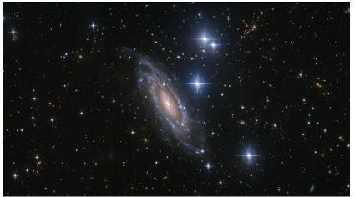
Figure 1.2: A galaxy. Because every physics textbook should include a picture of a galaxy!

Motion maps
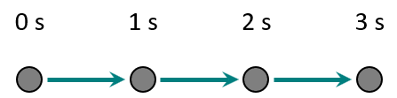
Figure 1.3: Example of a motion map¹

Numbers
The right columns of this book generally contain mathematical representations of physics.
A letter or symbol in italics is a variable used to describe some physical quantity. The same letter will always represent the same type of quantity. A lower-case $m$, for example, will always represent a mass. Mass is an example of a scalar quantity because it has a size (magnitude) but no direction.
A letter or symbol with an arrow on top, like $\vec{x}$, represents a vector. With a vector it is important to remember that it has a specific direction, often positive (+) or negative (-). Subscripts are used to differentiate between several of the same type of variable in a given situation. For example, if a problem includes an adult and a child, their positions could be $\vec{x_{\text{adult}}}$ and $\vec{x_{\text{child}}}$.
Boxed equations are true except for any limitations described in the accompanying text.
$$\boxed{2=2}$$
Unboxed equations are true for a specific example but are not generalizable to all situations.
Motion is described by position $\vec{x}$ , velocity $\vec{v}$, and acceleration $\vec{a}$.
Note that all these physical quantities are vectors.

Words
Momentum is related to the effort that would be needed to stop a moving object. This physics definition overlaps well with the way the word “momentum” is used in our everyday language. If you own a successful business, we say that it has momentum, and your competitors will have a hard time stopping you!
In physics, momentum increases with an object’s velocity and its mass. Velocity and momentum share the same color in this book because of their close relationship with each other.
Energy is the capacity of an object or system to affect another object or system. It is closely related to the idea of “work,” which is a transfer of energy into or out of a system by something external to that system. These physics definitions overlap well with the way the words “energy” and “work” are used in our everyday language. If you have no energy, you can’t do any work!
There are several different forms of energy, often associated with an object’s velocity, an object’s position, or an object’s temperature. Energy can transform from one form to another through various physical processes.
A force is an interaction between objects, often described as a “push” or a “pull.” Forces cause changes in motion, momentum, and energy, so forces are truly the heart of physics. All the grand theories of physics seek to study the forces that are at work in the universe.

Graphics

Momentum vs Time Graphs
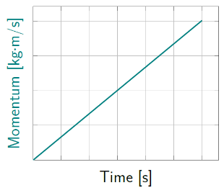
Figure 1.4: A line graph of momentum over a certain period of time.¹

Energy Bar Graphs
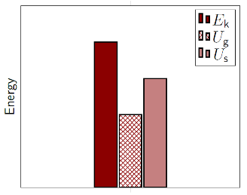
Figure 1.5: Example of an energy bar graph.¹

Force Diagrams
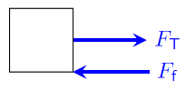
Figure 1.6: Example of a force diagram.¹

Numbers
The symbol for momentum is $\vec{p}$. The momentum of an object is equal to its mass times its velocity:
$$\boxed{\vec{p}=m⋅\vec{v}}$$
( 1.1 )
Note that momentum is a vector. It always points in the same direction as the velocity $\vec{v}$.
There are two different symbols for energy: $U$ is used to represent potential energy, which depends upon the configuration of a system; and $E$ is used to represent other types of energy that do not depend upon configuration. Examples of potential energy are gravitational potential energy $U_{\text{g}}$ and spring (or elastic) potential energy $U_{\text{s}}$. Examples of other types of energy are kinetic energy $E_{\text{k}}$ and thermal energy $E_{\text{th}}$.
Note that energy is a scalar.
The symbol for force is $\vec{F}$. Forces cause acceleration. A force acting over time changes momentum. And a force acting over a distance does work, changing energy.
Note that force is a vector.

: A Motionless Rock, in the Horizontal Direction ( , )

Words
A 5-kg rock is sitting on a flat place on the ground on a calm day. No wind. No earthquake. You watch for ten seconds. It just sits there in the same place, doing absolutely nothing, for the whole time. We will focus on just one object: the rock.
This may seem like a very simple physical situation already, and to make it as simple as possible, we will only consider the horizontal direction.
For this example, it doesn’t matter too much which concept we consider first–we’re going to end up with a lot of zeros in any case!
In the last section, we ended with forces, so just for fun this time let’s start with forces. Remember, a force is an interaction between objects. Looking at the photo and considering the description above, what are the forces in the horizontal direction? There is nothing pushing or pulling the rock to the left or to the right! That means there are no forces in the horizontal direction

Graphics
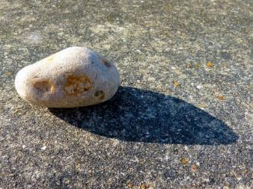
Figure 1.7: A motionless rock.

Force Diagram of Rock - Horizontal Direction
A Force Diagram is a simple sketch showing the forces that are acting on an object. The object is represented simply by a rectangle. Then arrows are used to represent the forces acting on the object. In this case, there are no forces acting on the rock in the horizontal direction (which is all that we are considering right now), so our force diagram ends up being just a rectangle!
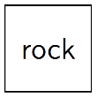
Figure 1.8: Force diagram of a rock with no forces acting on it ¹

Numbers
The only number given in this example is 5. The number by itself is meaningless; it needs to be attached to some physical quantity, and almost always with a specific unit.
The kilogram, abbreviated [kg], is the unit of mass in the Système International (SI) unit system that has been adopted as the official standard by nearly every country in the world.
The other base SI units are the meter [m] for distance and the second [s] for time. Notice that the abbreviations for units are not italicized. This book will use SI units almost exclusively.
When considering forces and how they affect an object, there are often multiple forces acting at one time. It is important to consider the net force that is acting. The net force is defined as the sum of all the forces…
$$\boxed{\vec{F_{\text{net}}}= \sum{\vec{F}}}$$
( 1.2 )
…where the Greek letter Sigma means “the sum of…”
In this particular example, there are no forces at all acting in the horizontal direction, so the net force is zero…
$$\vec{F_{\text{net}}}= 0$$

Words
What can be said about the rock’s motion? The rock is not moving, so its position is constant. If it was 2 meters in front of you when you started watching, it was 2 meters in front of you when you stopped (assuming you didn’t move).
And no matter where it started, its velocity, which is its change in position over time, is zero. Its acceleration, which is the change in velocity over time, is also zero, because the velocity isn’t changing.
How much effort would be needed to stop this rock? The rock isn’t moving, so it would take no effort at all! That means the rock has no momentum.
Remember, energy is a capacity to affect another object or system. This rock can’t do anything! So, it has no (useful) energy. Technically, the rock does have thermal energy, because it has a nonzero temperature. And Albert Einstein correctly theorized that mass is also a form of energy. But for our purposes, we will consider only mechanical energy, which consists of kinetic, gravitational potential energy, and spring potential energy.

Graphics

Motion map- motionless rock
A motion map uses dots to show position at various points in time, as if you were holding a video camera steady and putting a dot at an object’s position in each frame. For this scenario, drawing and numbering one dot per second gives…
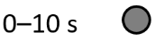
Figure 1.9: Motion map showing no motion¹

Momentum vs Time - motionless rock
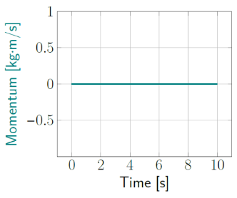
Figure 1.10: Momentum is zero the whole time.¹

Energy bar graph - motionless rock
Kinetic energy, gravitational potential energy, and spring potential energy are all zero, so a bar graph would have no bars.

Numbers
If the net force on an object is constant, as it is in this situation, position is given by…
$$\boxed{\vec{x}=\vec{x_{0}}+\vec{v_{0}}⋅t+\frac{1}{2}\vec{a}⋅t^{2}}$$
( 1.3 )
…where the subscript “0” means the value at time zero. In this case, $\vec{v_{0}}=0$ and $\vec{a_{0}}=0$, so…
$$\vec{x}=\vec{x_{0}}$$
…which means that $\vec{x}$ at any time $t$ is equal to whatever $\vec{x}$ was at time $t=0$.
Average velocity, change in position over time, is given by…
$$\boxed{\vec{v_{\text{avg}}}=\frac{\vec{∆x}}{∆t}}$$
( 1.4 )
“∆” means “change in…,” so for example
$$∆t=t_{\text{f}}-t_{\text{i}}$$
…final time $t_{\text{f}}$ minus initial time $t_{\text{i}}$.
Since the position is not changing, $\vec{∆x}=0$, so the average velocity will always be zero. In fact, at all times in this scenario the velocity $\vec{v}=0$. This means that the momentum is also zero:
$$\vec{p}=m⋅ \vec{v} =0$$
No motion, so $E_{\text{k}}=0$. No spring, so $U_{\text{s}}=0$. And gravitational potential energy is defined based on vertical position $y$. But we are only considering the horizontal direction, so $U_{\text{g}}=0$ as well.

: A Motionless Rock, in the Vertical Direction ( , )

Words
A 5-kg rock is sitting on a flat place on the ground on a calm day. No wind. No earthquake. You watch for ten seconds. It just sits there in the same place, doing absolutely nothing, for the whole time. Again, we will focus on analyzing just one object: the rock.
Yes, this is the same physical situation that we have already studied, but now we will consider the vertical direction, which adds another level of complexity.
Let’s start by considering the motion of the rock. It is doing nothing more in the vertical direction than it did in the horizontal direction. Its vertical position is unchanging; its vertical velocity is zero; and its vertical acceleration is also zero.
What about the rock’s vertical momentum? Again, since this rock isn’t moving in the vertical direction, it won’t take any effort at all in the vertical direction to make it stop! It has no vertical momentum.

Graphics
Figure 1.11: A motionless rock.³

Motion map- motionless rock
Figure 1.12: Motion map of no motion. Again!¹

Momentum vs Time - motionless rock
As in the horizontal direction, a momentum vs time graph would be a horizontal line at zero the whole time.

Numbers
It is helpful to create lists of known and unknown quantities. Only one “known” is specifically listed: 5 kg. Read carefully for others!
- $m=5 \text{kg}$
- $\vec{v_{0}}=0$
- $\vec{a}=0$
We are not asked to find any specific unknowns; instead, we will use our available tools to find everything we can.
This is exactly the same as the horizontal motion of the rock, but to make it clearer that we are looking only at vertical motion, we can remove the arrow and use $y$ in place of $x$…
$$y=y_{0}$$
As with motion, we can remove the arrow and use a $y$ subscript to indicate that we are only considering the y direction, commonly referred to as “$\hat{y}$.”
$$p_{\text{y}}=m⋅v_{y}=0$$
This could also have been done in the x_{ˆ} direction before, with x subscripts instead of y.

Words
When we consider forces, there is a fundamental difference between the horizontal and vertical direction. The rock isn’t moving at all, but there are two different external forces that are acting on the rock. An “external” force is an interaction with something outside of the system that is being considered. In this case, our system is a single object, the rock.
Gravitational force is an interaction between the rock and the entire mass of the earth. Gravitational force is often referred to as “weight.” On the surface of the earth, the gravitational force on an object always points downward, toward the center of the earth.
The other force is a “contact force” that comes from the ground underneath the rock. If the ground were not there, the rock would be falling, so we know that there is a force from the ground that completely opposes the force of gravity. This contact force is called the “normal” force, where the word “normal” means “perpendicular to the surface.” In this case, the normal force is pointing directly upward because the ground is flat.
We can look at energy in two different ways. We can consider work done by an external force of gravity or we can consider earth’s gravity as a source of potential energy. Work is done by a force acting over a distance, but the rock doesn’t move, so no work is done. Gravitational potential energy depends on height–the higher something is, the more gravitational potential energy it has. But the rock is on the ground, so it has no gravitational potential energy.

Graphics

Force Diagram of Rock - Vertical Direction
Gravitational force points downward, and normal force from the ground points upward. Since we know they cancel each other completely, the lengths of the arrows should be the same.
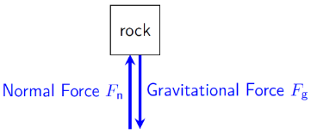
Figure 1.13: Force diagram of a rock resting on the ground.¹
Note that we are concerned only with the forces acting on the rock, not about any forces of the rock on something else like the ground. In this case, the forces cancel each other out–another way to describe this is to say that the forces are “balanced,” giving zero net force.

Energy bar graph - motionless rock
Again, kinetic energy, gravitational potential energy, and spring potential energy are all zero, so a bar graph would have no bars.

Numbers
The rock is doing nothing, so net force is zero.
$$\vec{F_{\text{net}}}=\sum{\vec{F}}=\vec{F_{\text{g}}}+\vec{F_{\text{n}}}=0$$
…so…
$$\vec{F_{\text{g}}}=-\vec{F_{\text{n}}}$$
At the surface of the earth, the gravitational force on an object is…
$$\boxed{\vec{F_{\text{g}}}=-m⋅g \hat{y}}$$
( 1.5 )
…where $g=9.8 \text{N/kg}$, the strength of the gravitational field at the earth’s surface. The magnitude of $\vec{F_{\text{g}}}$ is $\left(m⋅g\right)$ and the direction is $- \hat{y}$ (downward). In this case...
$$\vec{F_{\text{g}}}=-\left(5 \text{kg}\right)⋅\left(9.8 \text{N/kg}\right) \hat{y} \\ =-49 \text{N} \hat{y}$$
…which makes $\vec{F_{\text{n}}}=\left(+49 \text{N} \hat{y}\right)$ in this example. The SI unit for force is the newton [N].
$$1 \text{N}=1\frac{\text{kg}\text{⋅}\text{m}}{{\text{s}}^{\text{2}}}$$
No motion, so $E_{\text{k}}=0$. No spring, so $U_{\text{s}}=0$. Gravitational potential energy is based on vertical position:
$$\boxed{U_{\text{g}}=m⋅g⋅y}$$
( 1.6 )
We are free to define the position where $y=0$, and setting $y=0$ at ground level make the math as easy as possible:
$$U_{\text{g}}=m⋅g⋅0=0$$

: A Rolling Soccer Ball ( , )

Words
A 0.4-kg soccer ball is rolling to the right at a constant speed of 9 m/s across a level soccer pitch. Friction force and air resistance are very small, so we will ignore them. We will consider only the horizontal direction. We will focus on analyzing just one object: the ball.
This situation is different from a motionless rock, because this time the soccer ball is moving. But in terms of horizontal forces, it is exactly the same. Looking at the photo and considering the description above, what are the forces in the horizontal direction? We are specifically told to ignore any friction forces. And there is nothing that is actively pushing or pulling the soccer ball to the left or to the right. That means there are no forces in the horizontal direction.
If there are no forces in the horizontal direction, how does the soccer ball keep moving? It is the ball’s momentum that carries it. Until an outside force tries to make the soccer ball stop, it will just continue going in a straight line with the same momentum. This is called “conservation of momentum;” the momentum of any isolated system remains constant.
An “isolated” system is one that has no interactions with anything outside of the system.
Conservation of momentum is the reason momentum is such a powerful tool for studying physics.

Graphics
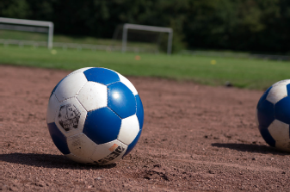
Figure 1.14: A soccer ball rolling to the right.

Force Diagram of Soccer Ball – Horizontal
Since we are ignoring friction, there are no forces acting on the soccer ball in the horizontal direction.
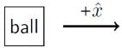
Figure 1.15: Force diagram of a rolling soccer ball, horizontal direction only.¹
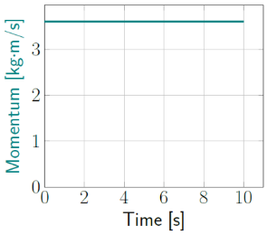
Figure 1.16: Momentum is constant.¹

Numbers
Knowns:
- $m=0.4 \text{kg}$
- $v_{\text{x}}=+9 \text{m/s}$
- $a_{\text{x}}=0$
- $F_{\text{net,x}}=0$
In addition to “knowns” we should also list assumptions. For example, in our analysis we will use the convention “to the right” as the positive horizontal direction, as in Figure 1.15. We are also assuming that friction and air resistance can be ignored.
We know that $a_{\text{x}}$ is zero because the velocity is constant, 9 m/s to the right.
In this example, there are no forces at all acting in the horizontal direction, so the net force is zero…
$$F_{\text{net,x}}=0$$
…where the subscripts “net,x” indicate that we are referring to the net force in the $\hat{x}$ direction.
$$\vec{p}=m⋅\vec{v}$$
…so…
$$p_{\text{x}}=m⋅v_{x} \\ =\left(0.4 \text{kg}\right)⋅\left(+9 \text{m/s}\right) \\ =\left(+3.6 \frac{\text{kg}\text{⋅}\text{m}}{\text{s}}\right)$$
From this equation we find that the units for momentum are $\left[\frac{\text{kg}\text{⋅}\text{m}}{\text{s}}\right]$.

Words
Unlike the motionless rock on the ground, a rolling soccer ball on the ground does have energy. It has kinetic energy, or energy of motion. The SI unit for energy is the joule [J].
Any moving object has kinetic energy that increases with the object’s mass and its speed. Since a motionless object has zero kinetic energy and mass and speed are both always positive numbers, kinetic energy can never be negative.
Thinking about motion becomes much more interesting when something is moving. Since it is rolling, this soccer ball is definitely moving. What do we mean when we say that an object is moving? That means the object has a non-zero velocity. But when we talk more generally about “motion” in physics, we are considering not only velocity but also position and acceleration. This soccer ball has the simplest motion that we can consider for an object that is actually moving. It has non-zero velocity, but the velocity is not changing, so it has zero acceleration.

Graphics

Energy bar graph - rolling soccer ball
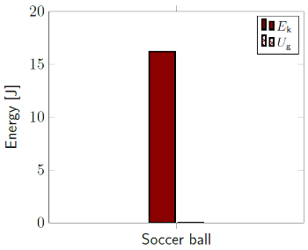
Figure 1.17: Energy bar graph of a rolling soccer ball.¹

Motion map- rolling soccer ball
A motion map tells us about more than just position. It can also tell us about the velocity of the object. Notice that all the arrows between the points are identical. The arrows represent velocity, so the motion map shows that the velocity is constant.
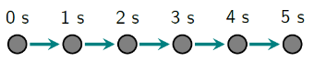
Figure 1.18: Motion map of a soccer ball rolling to the right with a location shown every second for 5 seconds.¹

Numbers
As with the rock on the ground, $U_{\text{g}}=0$ and
$U_{\text{s}}=0$. But this time we have kinetic energy. Kinetic energy depends on an object’s mass and its speed $v$, which is simply the magnitude of its velocity $\left|\vec{v}\right|$...
$$\boxed{E_{\text{k}}=\frac{1}{2}m⋅v^{2}}$$
( 1.7 )
...so, in this example the kinetic energy from the linear motion is...
$$E_{\text{k}}=\frac{1}{2}\left(0.4 \text{kg}\right)⋅{\left(9 \text{m/s}\right)}^{2} \\ =\left(16.2 \text{kg}\text{⋅}{\text{m}}^{\text{2}}\text{/}{\text{s}}^{\text{2}}\right)=16.2 \text{J}$$
The SI unit for energy is the joule [J].
For this example, Equation ( 1.3 ) becomes …
$$\vec{x}=\vec{x_{0}}+\vec{v_{0}}⋅t+\frac{1}{2}\vec{ a} ⋅t^{2}=\vec{x_{0}}+\vec{v_{0}}⋅t$$
…where the subscript “0” is usually pronounced “nought” and means the value at time zero. In this case, $\vec{v_{0}}=9 \text{m/s} \hat{x}$ and $\vec{a}=0$, so…
$$\vec{x}=\vec{x_{0}}+\left(9 \text{m/s} \hat{x}\right)⋅t$$
…which means that $\vec{x}$ moves 9 meters to the right of its initial position in every second that passes.

: A Falling Rock ( , )

Words
A 0.8-kg rock is dropped from a position 2 m above the ground. After 0.5 seconds it is still in the air. Air resistance is very small, so we will ignore it. Describe the behavior of the rock starting from the time just after it was released.
We only need to consider the vertical direction, since there is no motion, momentum, or force in the horizontal direction. “Just after it was released” is when the hand is not touching the rock, but the rock hasn’t yet started to fall.
At first the rock is not moving, but when it is released, gravity creates a unbalanced force that pulls it down. In fact, gravity was affecting the rock before it was released, but the force of gravity was balanced by a force from the hand.
After it is released, the rock is in “free-fall,” which means the only force affecting the rock is gravity.
Since the rock is initially not moving, it has no initial momentum. But after half a second it is moving downward. The momentum is changing because of the force of gravity. The effect of force on momentum is described by Newton’s Second Law of Motion, which defines force as something that changes momentum over time.
The momentum of the rock starts at zero, as it falls downward it gains momentum in the negative direction. This negative momentum gradually increases over the entire time that the rock is falling.

Graphics
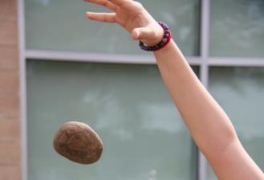
Figure 1.19: A rock falling after being dropped.
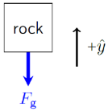
Figure 1.20: Force diagram of a falling rock¹
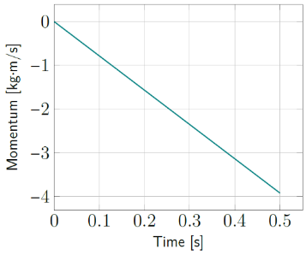
Figure 1.21: Momentum as a function of time.¹

Numbers
Assumptions:
- $+\hat{y}$ is upward
- air resistance is negligible
- free-fall
Knowns:
- $m=0.8 \text{kg}$
- $t=0.5 \text{s}$
- $y_{0}=2 \text{m}$
- $v_{\text{0y}}=0$
Velocity $\vec{v}$ is a vector, but speed $v$ is a scalar that cannot be negative, since it is $\left|\vec{v}\right|$. But $v_{\text{y}}$ is the $\hat{y}$ component of $\vec{v}$, so it can be negative.
$$\vec{F_{\text{net}}}=\sum{\vec{F}}=\vec{F_{\text{g}}}= -m⋅g \hat{y} \\ =-\left(0.8\text{ kg}\right)⋅\left(9.8 \text{N/kg}\right) \hat{y}=-7.84 N \hat{y}$$
This is the first situation we have met where the object is not “in equilibrium,” meaning that this time the net force on the object is not zero. The average net force is given by Newton’s Second Law:
$$\boxed{\vec{F_{\text{net,avg}}}=\frac{\vec{∆p}}{∆t}}$$
( 1.8 )
Rearranging, $\vec{∆p}=\vec{F_{\text{net,avg}}} ⋅ ∆t$. The momentum changes linearly from zero to its final value…
$$p_{\text{y,f}}=\left(-7.84 \text{N} \hat{y}\right)⋅\left(0.5 \text{s}\right)=-3.92 \text{kg}\text{⋅}\text{m/s}$$

Words
Remember, momentum is related to velocity. So, if the momentum of the rock is changing, that means its velocity is also changing. Acceleration is a change in velocity over time, so the same force that causes momentum to change also creates an acceleration.
The force of gravity accelerates the rock in the negative (downward) direction, making it fall faster and faster with a constant acceleration that doesn’t depend on its mass.
This relationship between force and acceleration is another form of Newton’s Second Law.
For this example, we will look at energy in terms of gravitational potential energy, not as work done by the force of gravity. The rock is not moving at the moment it is dropped, so it has no kinetic energy, but it does have gravitational potential energy since it is elevated. While falling, it is gaining kinetic energy but losing gravitational potential energy.
Energy is a useful concept to use when looking at this situation, because energy is conserved. It can never be created or destroyed; it can only change from one form to another. This is what makes energy such a powerful tool in physics.
If you know how much total energy is in an isolated system at any point in time, you know that same amount of energy is present for all points in time. So, if you know, for example, how much gravitational potential energy was lost you can find how much kinetic potential energy was gained.

Graphics
A motion map can give information about acceleration. If the arrows are changing in length or direction, the object is accelerating.
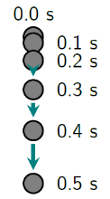
Figure 1.22: Motion map of a falling rock.¹
Since we are considering gravity as a form of energy, conservation of energy tells us that the sum of the heights of all the bars on the energy bar graph at 0 s is equal to the sum of the heights of all of the bars at 0.5 s.
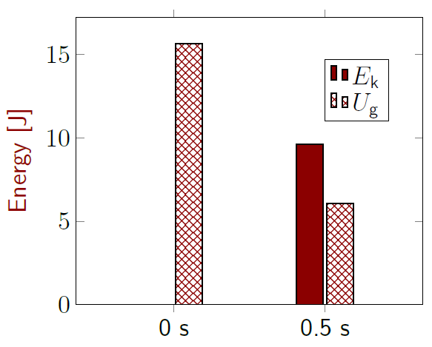
Figure 1.23: Energy bar graph of a falling rock.¹

Numbers
Force also causes acceleration:
$$\boxed{\vec{F_{\text{net}}}=m⋅\vec{a}}$$
( 1.9 )
Rearranging, we find…
$\vec{a}=\frac{\vec{F_{\text{net}}}}{m}=\frac{-7.84 \text{N} \hat{y}}{0.8 \text{kg}}=-9.8\frac{m}{s^{2}} \hat{y}$
In fact, $\vec{a}$ for anything in free-fall is $-9.8\frac{m}{s^{2}} \hat{y}$.
$$y=y_{0}+v_{\text{0y}}⋅t+\frac{1}{2}a_{\text{y}}⋅t^{2} \\ =\left(2\text{m}\right)+\left(0⋅t\right)-\left(4.9 m/s^{2}\right)⋅t^{2}$$
…so after 0.5 s, $y=\left(2-4.9⋅{0.5}^{2}\right)\text{m}=0.775\text{m}$
There is no spring, so $U_{\text{s}}=0$. Using 0 seconds for the initial time and 0.5 s for the final time…
$$E_{\text{0,total}}=E_{\text{f,total}} \\ E_{\text{0k}}+U_{\text{0g}}=E_{\text{f,k}}+U_{\text{f,g}} \\ 0+\left(m⋅g⋅y_{0}\right)=\left(\frac{1}{2}m⋅v_{\text{f}}^{2}\right)+\left(m⋅g⋅y_{\text{f}}\right)$$
Everything in the last equation was given in the knowns or has already been found, except for the final speed, so we can solve for that:
$$v_{f}=\sqrt{2⋅\frac{\left(m⋅g⋅y_{0}\right)-\left(m⋅g⋅y_{\text{f}}\right)}{m}}$$
Note that mass cancels out, so when air resistance is negligible the final speed of a falling object is not dependent upon its mass:
$$v_{f}=\sqrt{2⋅g⋅\left(y_{0}-y_{\text{f}}\right)}$$

: Summary
Chapter summaries in this book are ordered by concept, not necessarily in the order in which they are presented in the chapter. Mathematical models are grouped together at the end of each summary. See the appendices for the meanings of all symbols used in this book.

Forces & Acceleration
- A force is an interaction between objects, often described as a “push” or “pull.”
- Gravitational force is the same as weight.
- Normal force is a contact force that points directly out of a surface.
- Forces cause acceleration.
- Forces change momentum.
- Forces can be shown graphically using a “Force diagram,” which has a box representing the object and arrows representing the external forces affecting the object. Arrows in a force diagram should be drawn in the correct directions, with lengths corresponding to the magnitudes of the forces.
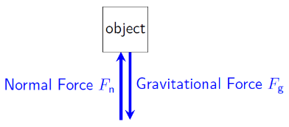
Sample Force Diagram¹

Motion
- An object’s motion is described by its position, velocity, and acceleration.
- Velocity is change in position over time.
- Acceleration is change in velocity over time.
- Velocity includes both speed (which is always positive) and direction, so velocity can be negative.
- Motion can be shown graphically using a “Motion map,” which has a series of dots representing the position of the object at equally spaced intervals of time. Arrows are drawn between the dots to indicate the object’s velocity, and acceleration appears as changes in the arrows.
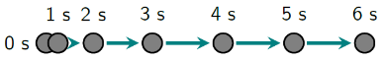
Sample motion map¹

Momentum & Velocity
- Momentum increases with an object’s mass and an object’s velocity.
- The momentum of any isolated system is conserved.

Energy
- Energy is the capacity of an object or system to affect another object or system.
- Work is a transfer of energy into or out of a system by something external to that system.
- Energy of an isolated system is conserved; it cannot be created or destroyed, but it can change form.
- Kinetic energy is energy of motion.
- Gravitational potential energy is related to an elevated position.
- Spring potential energy and thermal energy are other types of energy that will be dealt with later in this book.
- Energy can be shown graphically using an “Energy bar graph.” If the system is isolated, the total height of all energy bars for the system at any point in time is the same as the total height of all energy bars at any other point in time.
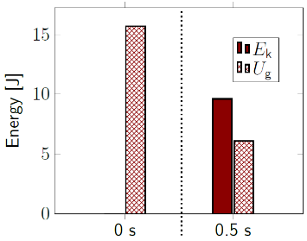
Sample energy bar graph.¹

Mathematical Models
Equation | Reference | Restrictions on the validity of the equation
$$\vec{p}=m⋅\vec{v}$$ | ( 1.1 ) | -none-
$$\vec{x}=\vec{x_{0}}+\vec{v_{0}}⋅t+\frac{1}{2}\vec{a}⋅t^{2}$$ | ( 1.3 ) | only valid when the net force is constant
$$\vec{v_{\text{avg}}}=\frac{\vec{∆x}}{∆t}$$ | ( 1.4 ) | -none-
$$\vec{F_{\text{g}}}=-m⋅g \hat{y}$$ | ( 1.5 ) | on the surface of the earth, with $+\hat{y}$ defined as “up”
$$U_{\text{g}}=m⋅g⋅y$$ | ( 1.6 ) | on the surface of the earth, with $+\hat{y}$ defined as “up”
$$E_{\text{k}}=\frac{1}{2}m⋅v^{2}$$ | ( 1.7 ) | -none-
“Newton’s Second Law”  $$\vec{F_{\text{net,avg}}}=\frac{\vec{∆p}}{∆t}$$ | ( 1.8 ) | -none-
“Newton’s Second Law”  $$\vec{F_{\text{net}}}=m⋅\vec{a}$$ | ( 1.9 ) | -none-

: Questions
Questions are ordered according to Bloom’s Taxonomy, progressing from regurgitating information (Level 1) to synthesizing new information with previous knowledge to create something new (Level 6). The bold letters at the beginning of each question indicate whether the question involves Words [W], Graphics [G], and/or Numbers [N].

Level 1 - Remember
      - [W] How are forces defined in this book?
      - [W] How is energy defined in this book?
      - [W] How is acceleration defined in this book?
      - [N] What does an arrow over a symbol mean?
      - [N] What does it mean in this book if an equation has a box around it?
      - [N] What symbol is used to represent momentum?
      - [G] What do the arrows represent on a motion map?
      - [W & N] Add labels to each boxed equation from this chapter that tell what the symbol to the left of the = sign represents. For example, Equation ( 1.1 ) should be labeled “momentum.”
Symbol | Reference | Label
$$\vec{p}$$ | ( 1.1 ) | momentum
$$\vec{F_{\text{net}}}$$ | ( 1.2 )
$$\vec{x}$$ | ( 1.3 )
$$\vec{v_{\text{avg}}}$$ | ( 1.4 )
$$\vec{F_{\text{g}}}$$ | ( 1.5 )
$$U_{\text{g}}$$ | ( 1.6 )
$$E_{\text{k}}$$ | ( 1.7 )
$$\vec{F_{\text{net,avg}}}$$ | ( 1.8 )
$$\vec{F_{\text{net}}}$$ | ( 1.9 )

Level 2 - Understand
      - [W] What information is included in an object’s velocity that is not included in its speed?
      - [N] Give an example of a vector quantity in physics.
      - [N] Give an example of a scalar quantity in physics.
      - [W] The four main building blocks of physics as described in this book are forces, motion, momentum, and energy. These are foundational physical concepts because…
        - __________ describes some of the most easily observed characteristics of an object, like its position and speed.
        - __________ and __________ are both conserved for an isolated system, so if we can find their values at any point in time, we know that the same values are also valid at any other point in time.
        - __________ can cause changes in momentum and energy and they can also cause acceleration, changing motion.

Level 3 - Apply
      - [G] Draw a motion map for an object moving to the left at constant speed.

Level 4 - Analyze
      - [G] Consider the force diagram in Figure 1.8, reproduced below, where only the horizontal direction is being considered. Should that figure change if the mass of the rock were doubled? If so, in what way?
Force diagram of rock.¹
      - [G] Consider the force diagram in Figure 1.13, reproduced below, where only the vertical direction is being considered. Should that figure change if the mass of the rock were doubled? If so, in what way?
Force diagram of rock.¹
      - [W & N] What is the weight of an 80-kg person? Remember to include direction.
      - [N] One thing that we should have been able to find in Section 1.5 was the time needed for the rock to reach the ground when dropped from a height of 2 m. Find that time for the moment when the rock hits the ground, that is, when $y=0$.
      - [W & G] Explain how the force diagram for the motionless rock in Figure 1.8, reproduced below, can be the same as that for a moving soccer ball in Figure 1.15.
Force diagram of rock.¹

Level 5 - Evaluate
      - [W] In the analysis of a motionless rock in the vertical direction in Section 1.3, it is stated that there is no wind. If there were a horizontal wind, would it have affected our analysis of the vertical direction? Explain your answer.
      - [W] In the analysis of a rolling soccer ball in Section 1.4, we ignored friction to make the analysis simpler and found that the soccer ball would continue rolling in a straight line indefinitely. Was this a realistic simplification to make? If we had included friction, what would the soccer ball have done?
      - [G & N] Estimate the slope of the line in Figure 1.21, reproduced below. Compare it to the net force found in the column to the right of the figure. Explain why they are the same, or why they are different.
Momentum vs time graph.¹
      - [W, G, & N] Figure 1.23, reproduced below, shows the energies of a rock when it is released from a height of 2 m and when it has fallen for 0.5 s.
Energy bar graph.¹
        - Reproduce this graph, with correct heights for each bar, and add a third set of bars for the moment just before the rock hits the ground. You can label the last set of bars “before hitting.”
        - Find the speed of the rock just before it hits the ground.
Combine the speed of the rock with other information you have about the direction of the rock’s motion to find the velocity of the rock just before it hits the ground.

Level 6 - Create
      - [W, G, & N] At the beginning of this chapter in Figure 1.1 was a template for a concept map. Hand-draw your own large version of it, adding in the main ideas from this chapter. Leave plenty of space to add things from other chapters! Here are some examples to help you start:
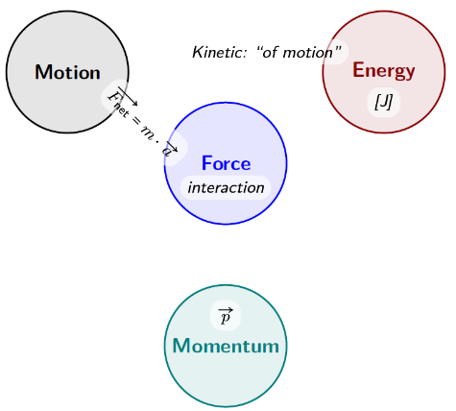
Partially completed concept map¹
      - [W, G, & N] Imagine you are writing a test question related to this chapter. Think of your own example of a situation that you can analyze using the concepts, graphics, and mathematical analyses described in this chapter. Describe the situation, and use the tools from this chapter to analyze the situation as completely as you can, including motion, forces, energy, and momentum.
      - [W, G, & N] Think about possible misconceptions about the material in this chapter. Write a question and an incorrect solution to it that demonstrates a student making such a conceptual error. This cannot be a simple misuse of a vocabulary word, a unit error, or a mathematical error like making an addition error or multiplying when addition was needed, unless the error is rooted in a real misunderstanding about the physics behind the calculation or the misuse of a word. After you have written the question and incorrect solution, explain what is wrong with the student’s solution, and write a correct solution to the problem. Note: You may use a question from this chapter that you got wrong the first time, and explain the initial error in your thinking and how you corrected it.

– Working in One Dimension
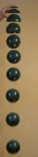
Figure 2.1: Images of a falling ball, taken by a stationary camera at a rate of 20 frames per second.¹

We have now been introduced to most of the concepts and most of the tools that we will use in this entire book to study mechanics. We will continue to look at more and more complicated situations. In this chapter we will continue to restrict ourselves to single objects in one dimension, either horizontal or vertical. We will also continue to consider only constant forces.

: Units ( , )

Words
If you live in the United States or one of a handful of other countries, you may be bothered by the fact that this book is using unfamiliar units. There are good reasons for this.
One reason is that the vast majority of the world has adopted SI units as the official system of measurement.
A second reason is that SI units are based on factors of 10 and universal physical quantities like the speed of light, while most other systems of measurement, including U.S. Customary units, are based upon arbitrary numbers and measurements like the distance between a person’s fingertips and elbow.
A third reason is that attempting to use U.S. Customary units to do physics is difficult and confusing even for those who use those units daily. For example, mass is an important physical property, but in U.S. Customary units people assume that mass is measured in pounds. In fact, pounds are a unit of force, and the correct unit of mass should be slugs, which nobody anywhere in the world uses, even in the U.S.
For all these reasons, SI units are the standard units used in science throughout the world, and also in this book.

Graphics
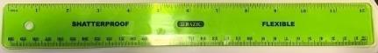
Figure 2.2: Rulers often show inches across the top and centimeters (cm) across the bottom.¹
The U.S. Customary unit for length is the foot, and the SI unit for length is the meter. Conversion factors can be found in the appendices of this book.
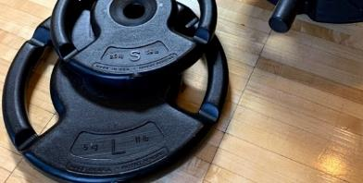
Figure 2.3: Rulers often show inches across the top and centimeters (cm) across the bottom.¹
On earth, a 10-kg object experiences a gravitational force of 98 N, and 98 N corresponds to 22 pounds of force. On the moon, a 10-kg object experiences a gravitational force of 16.2 N, or 3.65 pounds.
So mass is not dependent on gravity, but weight is. This is why we more often refer to an object’s mass than its weight in physics. They are related, but they are different.

Numbers
Note: These calculations are wrong! This is why we avoid U.S. Customary Units!
Consider a 50-pound child. What is the child’s mass? 50 pounds, right? The acceleration due to gravity on the surface of the earth is 32 ft/s². Weight is the gravitational force on an object, so a 50-pound child experiences a gravitational force of 50 pounds on earth. Using Newton’s second law…
$$F_{y}=m⋅a_{y}=m⋅\left(-\frac{32ft}{s^{2}}\right) \\ -50\text{ pounds }=\left(50\text{ pounds }\right)⋅\left(-32ft/s^{2}\right)$$
Dividing both sides by -50 pounds gives us…
$$1=32 \text{ft}\text{/}{\text{s}}^{\text{2}}$$
1 = 32 !? This cannot be correct. Most people who use U.S. Customary units don’t know that the correct unit for mass is the slug. A slug is the mass of an object that weighs 32 pounds on the surface of the earth. That’s why our calculation is off by a factor of 32—we used the wrong units.
To do physics using U.S. Customary Units we must introduce units like the slug that are not in regular use anywhere in the world. Rather than taking this step backwards, we step forward into using SI units.
Note: These calculations are wrong! This is why we avoid U.S. Customary Units!

Words
Failing to pay attention to units can be a costly mistake, as was famously demonstrated in 1999 when NASA lost its $125-million space probe that was supposed to have gone into orbit around Mars. The engineers who designed the rocket system used U.S. Customary Units, but the engineers who designed the guidance system used SI units. When it came time to enter orbit, the probe instead skipped off the Martian atmosphere and was never heard from again.
This NASA error was simply a matter of not converting all units into the same system. But there is another type of error that is common for students who are learning physics. That is having answers with the wrong “dimensions” or doing calculations that are dimensionally impossible.
For example, if someone says a baby weighs six pounds, nine ounces, that makes sense. It is dimensionally correct, even though it is not in the SI units that are preferred in physics. If we want SI units, we can convert to find the answer we wanted.
But, if someone says that a baby weighs fifteen inches, that does not make sense. Weight is a force, and inches are a measure of length, so these two things have different “dimensions.” In physics, a “dimension” doesn’t have to refer to length. It can be any physical quantity: energy, momentum, acceleration, etc.

Graphics
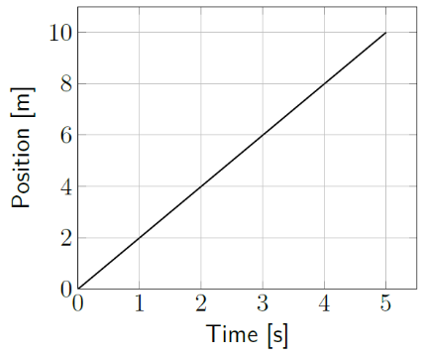
Figure 2.4: Position as a function of time.¹
The slope of a graph often provides useful information. In Figure 2.4, position changes in time, which means that the object must be moving. The slope of a line is the “rise over the run,” how much the vertical value changes divided by how much the horizontal value changes. In this case…
$$\text{slope}=\frac{10 \text{m}-0 \text{m}}{5 \text{s} - 0 \text{s}}=2 \text{m/s}$$
Keeping the units in the slope calculation gives a hint about the meaning of the slope. The unit [m/s] is a velocity, and in fact the slope of a position vs time graph gives velocity.

Numbers
If you walk at a constant speed of 4 miles per hour, what distance will you travel in 30 minutes? Figure out the answer to that question before continuing.
Hopefully you came to an answer of 2 miles. Whether you realize it or not, you went through all these steps, possibly in a different order:
- Compare units, finding both hours and minutes.
- Unit conversion to make time consistent:
$$30 \text{min}⋅\left(\frac{1 hr}{60 \text{min}}\right)=0.5 \text{hr}$$
- Combine given information in such a way that you find an answer with units of distance:
$$\left(\frac{4 mi}{1 hr}\right)⋅0.5 hr=2 mi$$
Notice that units cancel just like variables and numbers. For unit conversion, multiply by a fraction using the appropriate conversion factor (see the appendices), in such a way that units cancel to give the answer required.
This way of canceling only works with multiplication and division. Two numbers cannot be added or subtracted unless they have the same units.
The mathematical model used above is…
$$\boxed{v_{avg}=\frac{s}{Δt}}$$
( 2.1 )
…the average speed $v_{avg}$ is the path length $s$ divided by the time elapsed $∆t$. Since the speed was constant in this example, the average speed is the speed traveled the entire time.

: Sliding to the Left ( , )

Words
A 170-g hockey puck is sliding to the left for four seconds across a smooth sheet of ice at a constant speed of 24 m/s. Frictional force and air resistance are very small, so we will ignore them. We will consider only the horizontal direction.
We have looked at a similar situation with a rolling soccer ball, so some of the analysis will be left for the end-of-chapter exercises. Here we will try a few new approaches. This time there is no picture, and since images are helpful for understanding, we will start with a sketch. The sketch should include as much of the given information as possible.
The net force on an object causes a change in velocity over time, i.e. an acceleration. Since the velocity of this puck is constant, we know that the net force is zero.
A sliding hockey puck can affect another object (for example, if it hits an egg, it can break the egg). That means it has energy, in this case kinetic energy. And since the puck is traveling at a constant speed, the kinetic energy would also be constant.
The hockey puck doesn’t have any other type of mechanical energy, because there is no spring and it is on the ground.

Graphics
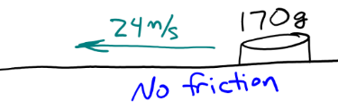
Figure 2.5: Rough sketch of the given physical situation.¹
The sketch does not need to be beautiful, although you can feel free to let your artistic skills shine. The sketch does need to get across the essential information about the situation.
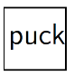
Figure 2.6: Force diagram of a puck with no forces.¹
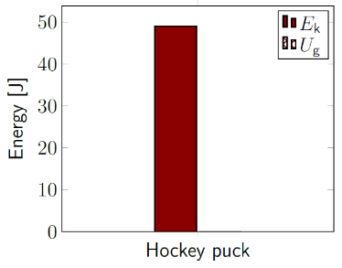
Figure 2.7: Energy bar graph of a sliding hockey puck.¹

Numbers
Assumptions:
- $+\hat{x}$ is to the right
- friction is negligible
Knowns:
- $m=170 \text{g}=0.17 \text{kg}$
- $t=4 \text{s}$
- $v_{\text{x}}=-24 \text{m/s}$
- $a_{\text{x}}=0$
- $F_{\text{f,x}}=0$
Mass needs to be converted to the SI unit kg:
$$170 g⋅\frac{1 kg}{1000 g}=0.17 kg$$
$v_{\text{x}}$ is negative because conventionally right is positive. $a_{\text{x}}$ is zero because velocity is constant. $F_{\text{f,x}}$ is the force of friction in the x direction.
Newton’s Second Law says that $\vec{F_{\text{net}}}=m⋅\vec{a}$, and since $a_{\text{x}}=0$, it follows that $F_{\text{net,x}}=0$.
Kinetic energy is given by…
$$E_{k}=\frac{1}{2}m⋅v^{2}$$
…so, in this case …
$$E_{k}=\frac{1}{2}(0.17 kg)⋅(-24 m/s)^{2}=49 J$$

Words
Like the rolling soccer ball that we considered earlier, the hockey puck is moving, so it has momentum. This time, the puck is moving in the opposite direction from the soccer ball we considered earlier, so its momentum is also in the opposite direction, since momentum is a vector. It is important to remember that momentum also includes direction.
The hockey puck is moving to the left with constant speed, so its position is changing throughout the four seconds. We are not given the initial position of the puck, so we can only describe how much the position changes, not whether after 4 seconds it will reach the goal. The change in the position of an object has a special name, “displacement.”
From the other columns on this page, we can see that the puck travels -96 m in 4 seconds. The right direction is conventionally considered positive, so left is negative. That means the displacement is 96 m to the left. The total distance it moves during this same time is 96 m. Distance is always positive– you would never say that your home is negative five miles from your workplace, right?
In a situation like this, when the object is moving only in one direction, the displacement is the same as the distance that an object moves, but if the object changes direction at any point in its motion, the total distance it moves will be larger than its displacement. We will encounter this type of situation later in this chapter.

Graphics
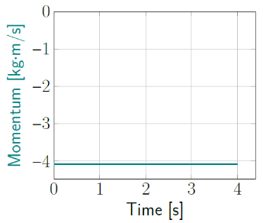
Figure 2.8: Momentum is negative.¹

Motion Map
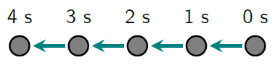
Figure 2.9: A hockey puck sliding to the left.¹
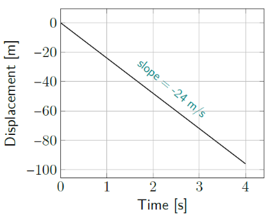
Figure 2.10: Puck displacement over time.¹

Numbers
Momentum is given by…
$$\vec{p}=m⋅\vec{v}$$
…so, in this case…
$$p_{\text{x}}=m⋅v_{\text{x}}=0.17 \text{kg} ⋅\left(-24 \text{m/s}\right) \\ =-4.08 \text{kg}\text{⋅}\text{m/s}$$
If the net force on an object is constant, as it is in this situation, position is given by…
$$\vec{x}=\vec{x_{0}}+\vec{v_{0}}⋅t+\frac{1}{2}\vec{a}⋅t^{2}$$
…and in this case, we are only concerned with the $x$ direction…
$$x=x_{0}+v_{0x}⋅t+ \frac{1}{2}a_{\text{x}}⋅t^{2}$$
$$x=x_{0}-\left(24\frac{m}{s}\right)⋅t$$
We are not given $x_{0}$, but if we subtract it from both sides, we have found the change in $x$, also called displacement.
$$x-x_{0}=Δx=-\left(24\frac{m}{s}\right)⋅t$$
This allows us to find the displacement for any time $t$, including the final time 4 s.
$$Δx_{f}=-96 m$$

: Falling to the Ground ( , )

Words
A 2.4-kg ball is first dropped from a height 1.3 m above the ground. Air resistance is very small, so we will ignore it. We will consider only the vertical direction. Then the same ball is dropped again, this time from a height 2.6 m above the ground.
We should be able to find the amount of time that is needed to reach the ground in each situation and also the kinetic energy, velocity, and momentum of the ball just before it hits the ground.
When considering the motion of the ball, we should note that it is in free-fall, which means that it is affected only by the force of gravity, and has a constant acceleration that doesn’t depend on the mass of the ball.
The first “unknown” mentioned in the description above is the time it takes the ball to fall to the ground. At first guess, one might think that the time needed to drop 2.6 m should be twice as much as the time needed to drop 1.3 m, but this is not correct. Notice in the images and motion map provided that in every interval of time the ball moves a greater distance than in the interval before.
From the images, we can see that the ball fell roughly the same distance in the first 0.3 seconds as it did in the next 0.15 seconds. This is because the longer it falls, the faster it moves.

Graphics
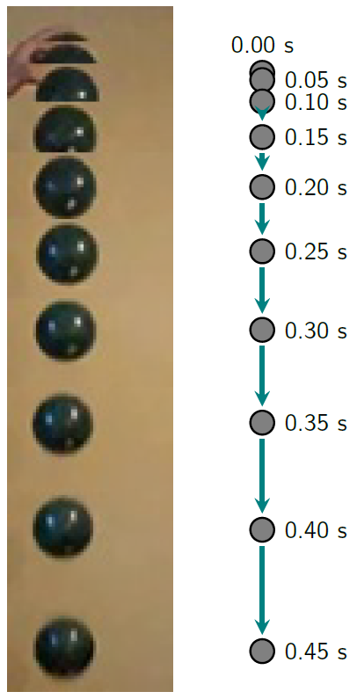
Figure 2.11: Images and corresponding motion map of a falling ball. Images were taken every 0.05 seconds.¹
Comparing with the calculations on the right, we see that this ball fell slightly less than 1.3 m while it was being recorded by the camera.

Numbers
Assumptions: $+\hat{y}$ is upward; negligible air resistance
Knowns | Unknowns
$$m=2.4 \text{kg}$$ | $$t_{\text{f}}$$
$$y_{0}=1.3 \text{m or 2.6 m}$$ | $$E_{\text{k,f}}$$
$$y_{\text{f}}=0$$ | $$v_{\text{y,f}}$$
$$v_{\text{0y}}=0$$ | $$p_{\text{y,f}}$$
$$a_{\text{y}}=-g$$
We can find the time needed to hit the ground by considering the motion of the ball. Since the acceleration is constant…
$$\vec{x}=\vec{x_{0}}+\vec{v_{0}}⋅t+\frac{1}{2}\vec{a}⋅t^{2}$$
…and since we only need the y direction…
$$y=y_{0}+v_{0\text{y}}⋅t+\frac{1}{2}a_{\text{y}}⋅t^{2}$$
Putting in everything we already know for the moment just before the ball hits the ground $\left(t_{\text{f}}\right)$…
$$y_{\text{f}}=0=y_{0}-\frac{1}{2}g⋅t_{\text{f}}^{2}$$
Solving for $t_{\text{f}}$, we find …
$$t_{f}=\sqrt{\frac{2y_{0}}{g}}$$
$t_{\text{f}}$ is 0.515 s when dropped from 1.3 m and 0.728 s when dropped from 2.6 m.

Words
The total energy of an object or system of objects can only change if something external to the system does work on the object(s). This is called the “Work-Energy Theorem.” So, the total gravitational potential energy and kinetic energy of the ball just before it is released is equal to the total energy of the ball just before it hits the ground. This is called conservation of energy.
We will not yet start to consider spring or thermal energy. Kinetic energy is energy of motion, and since the ball isn’t moving at the moment it is released, it doesn’t have any kinetic energy. But we can think of it has having gravitational potential energy since it is elevated above the ground.
Just before it hits the ground, it will not have any gravitational potential energy, so all the gravitational potential energy has changed into kinetic energy, and the ball dropped from 2.6 m will have twice as much kinetic energy as the same ball dropped from 1.3 m.
When the ball is dropped from twice as high, it hits the ground at a higher speed, but not quite double. That is because the acceleration is constant the whole time, and acceleration changes velocity over time. Not over distance. Since the time is not double, neither is the final velocity.
The ball started with no momentum, but the force of gravity acting on it while it was in free-fall gave the ball momentum in the downward direction, and as with energy and velocity, when it is dropped from a higher position it gains more momentum before reaching the ground.

Graphics
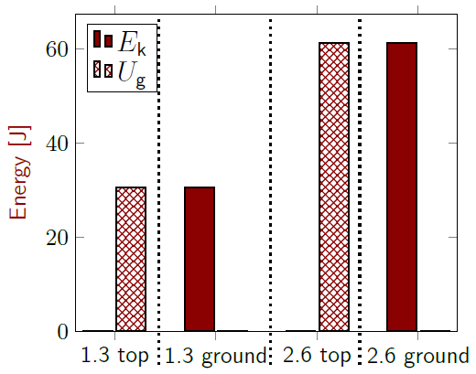
Figure 2.12: Energy bar graph of a ball falling from two different heights.¹
The first set of bars, labeled “1.3 top,” (one of which has zero height) represents the kinetic and gravitational potential energies of a ball at the instant it is dropped from 1.3 m. The second two bars, “1.3 ground,” (again, one of which has zero height) represent the same ball just before it hits the ground. The third and fourth sets of bars are similar, but for a ball dropped from 2.6 m.

Numbers
Work $W$ is a transfer of energy into or out of a system.
$$\boxed{W=E_{tot,f}-E_{tot,i}}$$
( 2.2 )
…where the subscript “tot” means “total.” In this case, we are considering gravity to be a source of potential energy, not an external force doing work on the ball, and we the only types of energy we have are $U_{\text{g}}$ and $E_{\text{k}}$, so…
$$U_{g,i}+E_{k,i}=U_{g,f}+E_{k,f}$$
…or…
$$m⋅g⋅y_{i}+\frac{1}{2}m⋅v_{i}^{2}=m⋅g⋅y_{f}+\frac{1}{2}m⋅v_{f}^{2}$$
…so, in this case…
$$m⋅g⋅y_{0}+0=0+\frac{1}{2}m⋅v_{f}^{2}$$
The term on the right is $E_{\text{k,f}}$, which is equal to $U_{\text{g,i}}$. That is 30.6 J when dropped from 1.3 m and 61.2 J when dropped from 2.6 m.
We can find the final velocities by solving the equation above for $v_{\text{f}}$:
$$v_{f}=\sqrt{2⋅g⋅y_{0}}$$
Adding in the direction, $v_{y,f}=-5.05 \text{m/s}$ for 1.3 m and $v_{y,f}=-7.14 \text{m/s}$ for 2.6 m.
We can use $m$ and $v_{y,f}$ to find $p_{\text{y,f}}$ :
$$p_{y,f}=m⋅v_{y,f}$$
That is, $-12.1\frac{kg⋅m}{s}$ for 1.3 m and $-17.1\frac{kg⋅m}{s}$ for 2.6 m.

: Being Thrown to the Ground ( )

Words
A 2.4-kg ball is thrown straight downward with a speed of 5.05 m/s from a height 1.3 m above the ground. Air resistance is very small, so we will ignore it. We will consider only the vertical direction, and only after the ball has been released.
We should be able to find the amount of time that is needed to reach the ground and also the kinetic energy, velocity, and momentum of the ball just before it hits the ground.
The ball is in free-fall, which tells us that it is accelerating downward because of gravity. The ball is being thrown downward, which also indicates that a force was used to throw the ball, but this situation doesn’t include the actual throwing. This situation describes the ball after it is released, so there is NO “force of throwing” in this situation. If we looked at how the ball was thrown, then there would be a normal force from a hand or something similar to consider. But in this situation the ball has already been thrown, so there is no hand to consider.
There are many different correct ways to go about finding all the unknown quantities. To demonstrate this, since we know the net force on the ball, the calculations in the right column can be done for final momentum after finding the final time when the ball reaches the ground. In the previous section of this book, momentum was the last quantity found.

Graphics
If we are not given an image of some kind, again we should make a sketch of the situation.
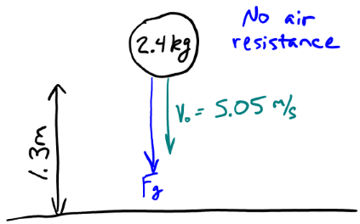
Figure 2.13: Rough sketch of a ball that was thrown downward.¹
Making a sketch like this helps us to see and remember important information, for example in this case the force and the initial velocity are in the same direction.
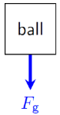
Figure 2.14: Force diagram of a ball in free-fall.¹

Numbers
Assumptions: $+\hat{y}$ is upward; negligible air resistance; start after ball has been released
Knowns | Unknowns
$$m=2.4 \text{kg}$$ | $$t_{\text{f}}$$
$$y_{0}=1.3 \text{m}$$ | $$E_{\text{k,f}}$$
$$y_{\text{f}}=0$$ | $$v_{\text{y,f}}$$
$$v_{\text{0y}}=-5.05 \text{m/s}$$ | $$p_{\text{y,f}}$$
$$a_{\text{y}}=-g$$
We can find $t_{\text{f}}$by considering the motion of the ball. Since the acceleration is constant…
$$y_{\text{f}}=y_{0}+v_{0\text{y}}⋅t_{\text{f}}+\frac{1}{2}a_{\text{y}}⋅t_{\text{f}}^{2}$$
…which can be rearranged to…
$$\left(\frac{1}{2}a_{\text{y}}\right)⋅t_{\text{f}}^{2} + \left(v_{0\text{y}}\right)⋅t_{\text{f}} + \left(y_{0}-y_{\text{f}}\right)=0$$
$t_{\text{f}}$ and $t_{\text{f}}^{2}$ both appear in this equation, so we can use the quadratic formula to get two solutions: 0.213 s and -1.24 s. The negative solution is mathematically correct but cannot physically be the solution, so $t_{\text{f}}=0.213 \text{s}$.
Since in this situation $\vec{F_{\text{net}}}=\vec{F_{\text{g}}}$ , we can use Newton’s Second Law to find the final momentum.

Words
The momentum of the ball just before it hits the ground is directed downward and is actually equal to the final momentum in the last section, for a similar ball that was dropped from a higher initial position. Since the balls have the same mass and the same final momentum, they also have the same final velocity.
We can again use conservation of energy to find the final kinetic energy, but this time we need to remember that the ball also starts with kinetic energy. As it falls, its kinetic energy increases as its gravitational potential energy decreases, so that its total energy stays constant.
Just before hitting the ground, all the ball’s gravitational potential energy has transformed into kinetic energy. For this situation, since the ball has the same mass and the same final velocity as the ball dropped from the higher position in the last section, the two balls also have the same final kinetic energy.
The final condition of the ball described in this section is the same as that of the ball dropped from a higher position in section 2.3. That is because when the ball dropped from the higher position reaches the same height as the ball described in this section, it has the same velocity as the initial velocity of the ball described in this section. It appears that only the time is different, but the time found in this section is equal to the time needed for the ball in section 2.3 to travel the last 1.3 m of its fall.

Graphics
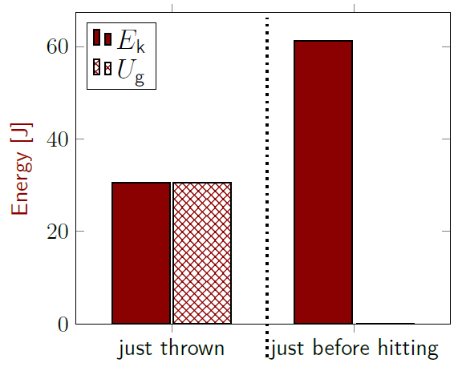
Figure 2.15: Energy bar graph for a ball being thrown to the ground, showing energy when it is just thrown and just before it hits the ground.¹
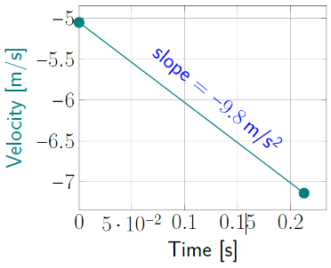
Figure 2.16: Velocity during free-fall.¹

Numbers
$$\frac{Δp_{y}}{Δt}=\frac{p_{y,f}-p_{y,i}}{Δt}=-m⋅g$$
Rearranging,
$$p_{y,f}=-m⋅g⋅Δt+p_{0y} \\ =-m⋅g⋅Δt+m⋅v_{0y}=-17.1 kg⋅\frac{m}{s}$$
Now we can find the final velocity of the ball.
$$p_{y,f}=m⋅v_{y,f}$$
…so…
$$v_{y,f}=\frac{p_{y,f}}{m}=-7.14\frac{m}{s}$$
We can use work and energy, Equation ( 1.1 ), to find $E_{\text{k,f}}$, and since no external work $W$ is being done…
$$U_{g,i}+E_{k,i}=U_{g,f}+E_{k,f} \\ \left(m⋅g⋅y_{0}\right)+\left(\frac{1}{2}m⋅v_{0}^{2}\right)=\left(m⋅g⋅y_{f}\right)+E_{k,f}$$
…which gives $E_{\text{k,f}}=61.2 \text{J}$.
We could also have found the final velocities using the knowledge that average acceleration is the change in velocity over time…
$$\boxed{\vec{a_{\text{avg}}}=\frac{\vec{∆v}}{∆t}=\frac{\vec{v_{\text{f}}}-\vec{v_{\text{i}}}}{∆t} }$$
( 2.3 )
The y components of this equation can be rearranged to solve for $v_{\text{y,f}}$ :
$$v_{y,f}=v_{y,i}+a_{y,avg}⋅Δt$$

: Being Thrown Upward ( )

Words
A 2.4-kg ball is thrown straight upward with a speed of 5.05 m/s from a height 1.3 m above the ground. Air resistance is very small, so we will ignore it. We will consider only the vertical direction, and only after the ball has been released.
We should be able to find the height at the peak of the ball’s flight, the amount of time that is needed to reach the peak, and also the kinetic energy, gravitational potential energy, velocity, and momentum of the ball at the peak.
The ball is in free-fall, which tells us that it is accelerating downward because of gravity. This is almost exactly the same as the situation considered in the last section–the only difference is that now the ball has been thrown upward, opposite the force of gravity. Again, there is no force from the hand that threw it (or of whatever else might have thrown it), because the question begins with the ball already having been thrown.
In every situation up until this one, a force has increased both the speed and the magnitude of the momentum of the object we are considering. This time the force does the opposite. That is because the initial velocity is opposite the direction of the net force.
The ball still accelerates in the direction of the net force, but the acceleration slows down the ball instead of speeding it up!

Graphics
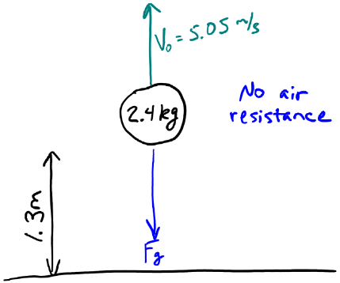
Figure 2.17: Rough sketch of a ball that was thrown upward.¹
Figure 2.18: Force diagram of a ball in free-fall.¹
A force diagram shows downward force with no indication of upward velocity, exactly as in section 2.4.

Numbers
Assumptions: $+\hat{y}$ is upward; negligible air resistance; start after ball has been released
Knowns | Unknowns
$$m=2.4 \text{kg}$$ | $$y_{\text{f}}$$
$$y_{0}=1.3 \text{m}$$ | $$t_{\text{f}}$$
$$v_{\text{0y}}=5.05 \text{m/s}$$ | $$E_{\text{k,f}}$$
$$a_{\text{y}}=-g$$ | $$U_{\text{g,f}}$$
 | $$v_{\text{y,f}}$$
 | $$p_{\text{y,f}}$$
Note that the only changes to the “knowns” from section 2.4 are that there is no “-” on $v_{\text{0y}}$ and $y_{\text{f}}$ is now unknown. $U_{\text{g,f}}$ has also been added as an unknown.
Three of the six unknowns are easy to find, once we realize that at the peak the ball is not moving.
That makes $E_{\text{k,f}}=0$, $v_{\text{y,f}}=0$, and $p_{\text{y,f}}=0$.

Words
In regular English, it is normal to refer to “slowing down” as “decelerating,” and “speeding up” as “accelerating.” That is not the case in physics. We will always use the word “acceleration” to indicate that an object’s velocity is changing. Sometimes the magnitude of the velocity (speed) may increase; sometimes it may decrease; and in some cases, the speed may stay constant while the direction changes. To avoid confusion, we will refer to all these situations as acceleration.
We can again use conservation of energy to find the final gravitational potential energy. At the beginning, the ball has both gravitational potential energy, since it is elevated above the ground, and also kinetic energy, since it is moving. As it goes upward, it slows down, ultimately stopping when it reaches the peak. That means it is losing kinetic energy, and all the kinetic energy it loses is transforming into gravitational potential energy. So, at the peak, all its initial energy has changed into gravitational potential energy.
When the ball reaches the peak, its height and its gravitational potential energy are at a maximum, while its speed and kinetic energy are at a minimum. The momentum was positive as the ball was going up, since “upward” is usually considered a positive direction. At the top, the momentum is zero, and unless something intervenes, a short time later the ball will be moving downward, so the momentum will be negative.

Graphics
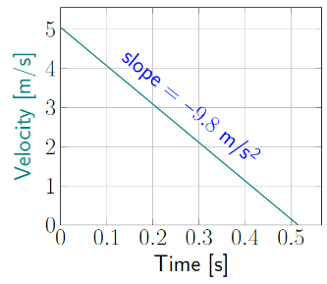
Figure 2.19: Velocity during free-fall.¹
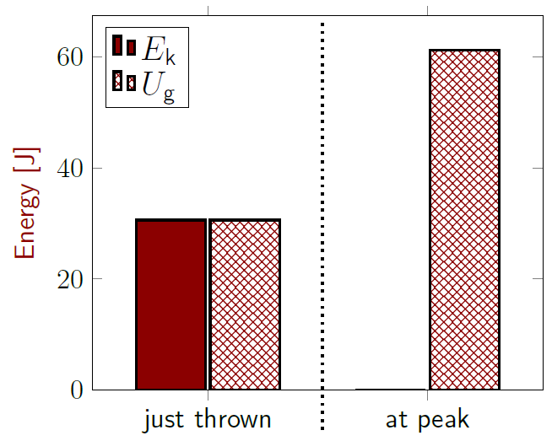
Figure 2.20: Energy bar graph for a ball being thrown upward, showing energy when it is just thrown and at the peak of its flight.¹

Numbers
We know the acceleration and the initial and final velocity of the ball, so we can rearrange the $\hat{y}$ components of Equation ( 2.3 ) to find $t_{\text{f}}$ :
$$Δt=t_{f}-t_{0}=\frac{v_{y,f}-v_{0y}}{a_{y}}$$
…giving $t_{\text{f}}=0.515 \text{s}$, using $t_{\text{0}}=0$.
We can again use conservation of energy with no external work, Equation ( 2.2 ), to find $U_{\text{g,f}}$ .
$$U_{g,i}+E_{k,i}=U_{g,f}+E_{k,f} \\ \left(m⋅g⋅y_{0}\right)+\left(\frac{1}{2}m⋅v_{0}^{2}\right)=U_{g,f}+0$$
…which gives $U_{\text{g,f}}=61.2 \text{J}$.
The final height can be found from the gravitational potential energy.
$$U_{g,f}=m⋅g⋅y_{f}$$
This gives $y_{\text{f}}=2.6 \text{m}$.

: Up and Back Down ( , )

Words
A 2.4-kg ball is thrown straight upward with a speed of 5.05 m/s from a height 1.3 m above the ground. Air resistance is very small, so we will ignore it. We will consider only the vertical direction, and only after the ball has been released.
In Section 2.5 we considered this exact same situation but stopped when the ball reached the peak of its flight. This time we will consider the entire flight of the ball until the moment just before it hits the ground. Let’s focus on the initial condition of the ball when it has just been thrown, the peak of its flight, the time when it passes the same height from which it was thrown, and the moment just before it hits the ground.
Again, the ball is in free-fall, which tells us that it has a constant downward acceleration because of gravity. That acceleration is valid for the entire time that the ball is in the air. Some people are surprised by this, thinking that the acceleration should be zero at the peak of the ball’s flight, but if that were true then the ball would just stay there instead of coming back down.
If we look back at the previous sections of this chapter, we have already found all the pieces of information for the ball as it travels along this entire path. We just need to put it all together.

Graphics
An initial sketch if this situation would look the same as the sketch from Section 2.5. So instead let’s try to sketch a motion map for the ball.
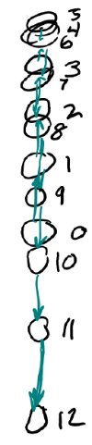
Figure 2.21: An attempt at a motion map. The ball’s path turns back on itself, making a motion map difficult to read. The numbers give the order of the points, but the time scale is not given.¹
A motion map is not the best way to show the motion of an object that retraces its path.

Numbers
Assumptions: $+\hat{y}$ is upward; negligible air resistance; start after ball has been released
Knowns | Unknowns
$$m=2.4 \text{kg}$$ | $y_{\text{peak}}$ ; $y_{\text{down}}$
$$y_{0}=1.3 \text{m}$$ | $t_{\text{peak}}$ ; $t_{\text{down}}$ ; $t_{\text{bottom}}$
$$y_{\text{bottom}}=0$$ | $E_{\text{k,peak}}$ ; $E_{\text{k,down}}$ ; $E_{\text{k,bottom}}$
$$v_{\text{0y}}=5.05 \text{m/s}$$ | $U_{\text{g,peak}}$ ; $U_{\text{g,down}}$ ; $U_{\text{g,bottom}}$
$$a_{\text{y}}=-g$$ | $v_{\text{y,peak}}$ ; $v_{\text{y,down}}$ ; $v_{\text{y,bottom}}$
 | $p_{\text{y,peak}}$ ; $p_{\text{y,down}}$ ; $p_{\text{y,bottom}}$
“Peak” is for the peak of the ball’s flight; “down” is when it passes the same height from which it was thrown; “bottom” is just before it hits the ground. We have already found the time required to go from each of these positions to the next:
Description | Interval | Section
$t=0$ to $t_{\text{peak}}$ | 0.515 s | 2.5
$t_{\text{peak}}$ to $t_{\text{down}}$ | 0.515 s | 2.3
$t_{\text{down}}$ to $t_{\text{bottom}}$ | 0.213 s | 2.4

Section 2.3 gives the time for $t_{\text{peak}}$ to $t_{\text{down}}$ if we realize that the time required for a ball to fall 1.3 m does not depend on the height from which it was dropped. So, the ball that was dropped from a height of 1.3 m reaches the ground in the same amount of time that a ball dropped from a height of 2.6 m falls 1.3 m.

Words
The ball starts out moving upward, steadily slowing down until it reaches the peak of its flight, so that its velocity is zero at the peak. It doesn’t stay at the peak, but turns around and falls downward, steadily speeding up until it hits the ground. When the ball is falling and passes the same point from which it was originally thrown, it will have the same speed that it started with, but the direction will change from upward to downward.
If you graph the position as a function of time, the graph forms a parabola shape with its opening pointed downward.
If you graph the velocity as a function of time, the graph forms a straight line, because the acceleration is the same during the entire flight: the acceleration caused by gravity in the downward direction.
Momentum follows the same pattern as velocity. Initially it is upward, and it decreases as the ball goes upward. At the peak, the ball has no momentum, and on the way down its momentum increases, this time in the downward direction.
Initially, the ball has some gravitational potential energy, since it is above ground level, and it also has some kinetic energy, since it is moving. At the peak of its flight the ball is not moving, so it has no kinetic energy. All the kinetic energy has changed to gravitational potential energy at that point. As the ball falls, the gravitational energy transforms into kinetic energy until by the time it is about to hit the ground it has only kinetic energy.

Graphics
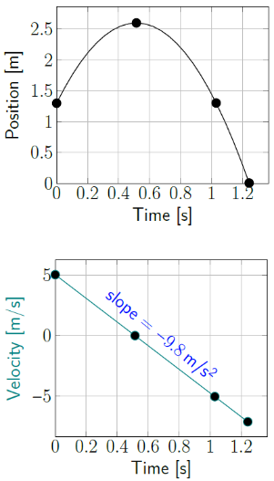
Figure 2.22: Position & velocity for ball in free-fall.¹
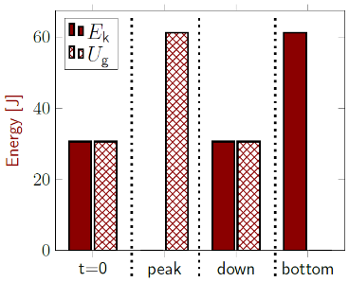
Figure 2.23: Energy bars for ball in free-fall.¹

Numbers
Since the acceleration is constant and we are considering only the vertical direction…
$$y=y_{0}+v_{0y}⋅t+\frac{1}{2}a_{y}⋅t^{2}$$
In this situation…
$$y=\left(1.3 m\right)+\left(5.05\frac{m}{s}\right)⋅t-\frac{1}{2}\left(9.8\frac{m}{s^{2}}\right)⋅t^{2}$$
And for the velocity we can rearrange Equation
( 2.3 ) to find the velocity in the $\hat{y}$ direction at any time $t$:
$$v_{y}=v_{0y}+a_{y}⋅t \\ v_{y}=\left(5.05\frac{m}{s}\right)-\left(9.8\frac{m}{s^{2}}\right)⋅t$$
Momentum is mass times velocity, so…
$$p_{y}=m⋅v_{y}=m⋅\left(v_{0y}+a_{y}⋅t\right) \\ =\left(2.4 kg\right)⋅\left(\left(5.05 \text{m/s}\right)-\left(9.8\frac{m}{s^{2}}\right)⋅t\right)$$
Gravitational potential energy is given by…
$$U_{\text{g}}=m⋅g⋅y \\ =\left(2.4 kg\right)⋅\left(9.8\frac{N}{kg}\right)⋅y$$
Kinetic energy is given by…
$$E_{k}=\frac{1}{2}m⋅v^{2} \\ =\frac{1}{2}\left(2.4 kg\right)⋅v_{y}^{2}$$

: Accelerating in a Car ( , )

Words
So far, we have only worked with acceleration due to the force of gravity. But other forces can cause acceleration. Now we will consider a car sitting motionless, accelerating to a given velocity, and maintaining that velocity.
A 1500-kg Ferrari Enzo can go from zero to 60 mph in 3 seconds. Assume that it accelerates uniformly for 3 s and then maintains its speed for another 3 s. Describe the net force on the car, the energy of the car, the displacement of the car, and the momentum of the car during these time intervals.
Let’s start by just imagining ourselves in the Ferrari. What would it feel like? We would feel the car accelerating as we started, rapidly gaining speed. It is interesting to note that it actually feels like our body is shoved back against the seat as the seat tries to accelerate forward through us. Then it would feel different after the first three seconds because we would just be moving at constant speed. In fact, if you are moving at constant speed, it feels almost like you are not moving at all, unless you are watching the scenery go past outside the window.
Since it is an unbalanced force that causes acceleration, there must be a large net force for the first three seconds pushing us forward, but then the net force drops to zero after three seconds. That doesn’t necessarily mean that there are no forces after three seconds, but the forces are balanced.

Graphics
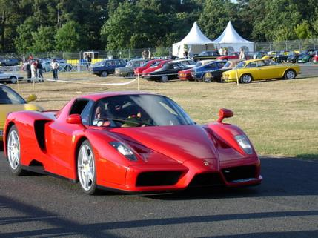
Figure 2.24: A Ferrari Enzo.

Motion Map
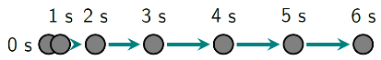
Figure 2.25: A car accelerating for 3 seconds and then moving at constant velocity for 3 seconds.¹
Acceleration on a motion map appears as a change in the arrows from one dot to the next. For the first three seconds, the arrows are getting longer to the right, showing that there is acceleration to the right, and thus a net force to the right. After three seconds the arrows are all the same length and the same direction, showing that there is no acceleration, so zero net force.

Numbers
This situation has two parts that need to be separated mathematically. Acceleration is constant in the first 3 s, and constant in the second 3 s. But they different accelerations, so we need one set of mathematical models from $t=0$ to $t=3 \text{s}$ and another set from $t=3 \text{s}$ to $t=6 \text{s}$.
Knowns | Unknowns
$$m=1500 \text{kg}$$ | $\vec{F_{\text{net,0-3}}}$ ; $\vec{F_{\text{net,3-6}}}$
$$v_{\text{0x}}=0$$ | $E$ for the whole time
$$v_{\text{x,3-6}}=60 \text{mph}$$ | ${∆x}_{\text{0-3}}$ ; ${∆x}_{\text{3-6}}$
 | $\vec{p}$ for the whole time
Let’s begin by finding the net force. Using Newton’s Second Law, we find…
$$\vec{F_{\text{net,avg}}}=\frac{\vec{∆p}}{∆t}=\frac{\vec{p_{\text{f}}}-\vec{p_{\text{i}}}}{∆t}=\frac{m⋅\left(\vec{v_{\text{f}}}-\vec{v_{\text{i}}}\right)}{∆t}$$
Velocity is not changing from 3 to 6 s, so $\vec{F_{\text{net,3-6}}}=0$. And from 0 to 3 s we will assume constant net force:
$$\vec{F_{\text{net,0-3}}}=\frac{\left(1500 \text{kg}\right)⋅\left(60 \text{mph} \hat{x}-0\right)}{3 \text{s}}$$
We still need to convert the units, so…
$$\vec{F_{\text{net,0-3}}}=\left(\frac{1500\text{kg }\text{⋅} 60\text{mph}}{3 \text{s}}\right)\left(\frac{1609\text{m}}{1 \text{mi}}\right)\left(\frac{1\text{hr}}{3600\text{s}}\right)\hat{x} \\ =1.34×{10}^{4} \text{N} \hat{x}$$

Words
What about the energy of the car? If we are on flat ground, the height is not changing, so we don’t need to worry about gravitational potential energy. We can focus on just the horizontal direction in this situation.
Initially the car is not moving, so there is no kinetic energy. But over the first three seconds the speed of the car is increasing, so the kinetic energy is also increasing. After the first three seconds the speed is constant, so for the last three seconds the kinetic energy remains constant at whatever value it had after the first three seconds.
Energy is conserved in a closed system, so if the kinetic energy is increasing then energy is coming from somewhere. This Ferrari burns gasoline, so the source of energy is the chemical potential energy stored in the gasoline. Tracing the energy transformations in the engine and drive train is complicated, but the final result is that the car uses an external frictional force between the tires and the road to push itself forward. This force does work on the car as it moves, increasing its kinetic energy.
The car’s momentum will change in the same way that its velocity changes. So initially it has no momentum; then momentum steadily increases for the first three seconds while a constant net force is applied; and finally, the momentum remains constant after three seconds when there is no net force acting on the car.

Graphics
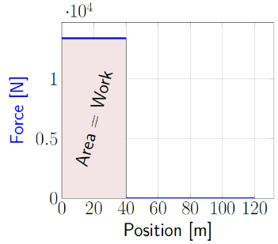
Figure 2.26: A force in the direction of motion does an amount of work equal to the area under the curve in a Force-vs-Position graph.¹
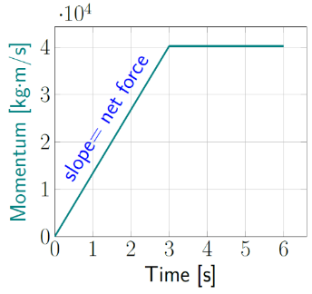
Figure 2.27: Momentum changes while there is a net force, then remains constant when the net force is zero.¹

Numbers
The net force acting on the car does work on the car, giving it kinetic energy. The amount of work done by a constant force depends on the displacement:
$$\boxed{W=\vec{F}⋅\vec{∆x}=F⋅∆x⋅\cos\left(θ\right) }$$
( 2.4 )
…where $θ$ is the angle between $\vec{F}$ and $\vec{∆x}$.
This work will often be used in conjunction with Equation ( 2.2 ) to find the change in energy of a system. In this example, we are only working with kinetic energy. We know the mass of the car and its velocity at $t=0$ and $t=3 \text{s}$, so that gives us the kinetic energy at each of these times. Using Equation ( 2.2 ) and Equation ( 2.4 ) we can find the displacement of the car during that time.
$$∆E_{\text{k}}=W_{\text{net}}=\vec{F_{\text{net}}}⋅\vec{∆x}=F_{\text{net}}⋅∆x⋅\cos\left(0\right)$$
θ is zero because $\vec{F_{\text{net}}}$ and $\vec{∆x}$ are in the same direction. Rearranging to solve for $∆x$ gives…
$$Δx_{0-3}=\frac{ΔE_{k,0-3}}{F_{net,0-3}}=\frac{5.39×{10}^{5} J}{1.34×{10}^{4} N}=40m$$
Now we can find ${∆x}_{\text{3-6}}$ :
$$x=x_{0}+v_{0x}⋅t+\frac{1}{2}a_{x}⋅t^{2}$$
With $a_{\text{x}}=0$ and using 3 s as our “$t=0$”…
$$Δx_{3-6}=\left(x-x_{0}\right)=v_{0x}⋅t+0 \\ =\left(60 mph\right)⋅\left(3 s\right)=80 m$$

: Braking in a Car ( )

Words
A Ferrari Enzo with a mass of 1500 kg is traveling at 26.8 m/s and suddenly applies its brakes, giving it an acceleration of 15 m/s² in the direction opposite its motion. Describe the net force on the car, the car’s momentum, the time required to stop, and the stopping distance.
If the car had been traveling at twice that speed and then braked with the same acceleration, by how much would the net force, the momentum, the time required to stop, and the stopping distance change?
When we are in a car that is braking, its speed decreases. That means the acceleration is opposite the direction of motion, so if your car is moving forward then the acceleration is backwards.
Again, since it is force that causes acceleration, the net force must be pointing in the direction opposite the car’s motion. The acceleration described above, 15 m/s², is larger than the acceleration caused by gravity on the surface of the earth, so this car must be braking very hard. We should expect it to stop quickly.
The car’s momentum changes along with velocity, starting large and steadily decreasing until it reaches zero when the car is stopped.

Graphics
Figure 2.28: A Ferrari Enzo.⁶

Force Diagram
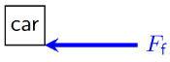
Figure 2.29: Force diagram of a car that is traveling to the right and braking, horizontal direction only.¹

Numbers
Assumptions: initial velocity is in the $+\hat{x}$ direction
Knowns | Unknowns
$$m=1500 \text{kg}$$ | $$\vec{F_{\text{net}}}$$
$$v_{\text{0x}}=26.8 \text{m/s}$$ | $$t_{\text{f}}$$
$$a_{\text{x}}=-15 \text{m/}{\text{s}}^{\text{2}}$$ | $∆x$
$$v_{\text{f}}=0$$
Note that the acceleration is negative, while the initial velocity is positive. This is equivalent to the statement that acceleration is opposite the direction of motion. The stopping distance would be the change in position, in other words, the displacement.
Let’s begin by finding the net force. Using Newton’s Second Law…
$$\vec{F_{\text{net}}}=m⋅\vec{a}=\left(1500 kg\right)⋅\left(-\frac{15m}{s^{2}}\hat{x}\right) \\ =-2.25×{10}^{4} N \hat{x}$$
Since the acceleration is constant until the car stops moving, this force is also constant until the car stops moving.
Since we have the mass and the initial and final velocities, we can find the initial and final momentum of the car:

Words
What would be different if the car had been traveling at twice the speed, and had braked with the same acceleration?
Since force is directly related to acceleration and not directly related to velocity, the frictional force of braking would be the same.
The final momentum would still be zero, but the initial momentum would double along with the velocity.
Remember that acceleration is a change in velocity over time. Since we are more familiar with speed and distance, let’s use that as an example. Speed is a distance over time. If you travel at the same speed but need to go double the distance, the time will have to double, right? It is the same with acceleration and velocity:
- Speed is a distance over time; double the distance means double the time.
- Acceleration is velocity over time; double the velocity means double the time.
The distance traveled before stopping would certainly be longer if we started with double the speed and braked with the same acceleration. In fact, the distance increases by much more than double. If you start at double the speed, it takes half of the braking time just to get down to the original speed; in the first half of the braking time, you will move a much farther distance than if you had been traveling at the original speed that whole time. And you still wouldn’t have stopped!

Graphics
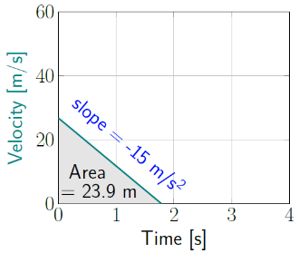
Figure 2.30: Velocity vs time, braking.¹
The area under the curve of a velocity vs time graph is equal to the displacement. In this case, the maximum velocity is 26.8 m/s and the maximum time is 1.79 s. The area of a triangle is:
$$A_{\text{triangle }}=\frac{1}{2}b⋅h$$
…where $b$ is the triangle’s base and $h$ is its height.
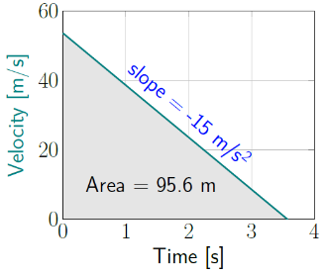
Figure 2.31: Velocity vs time, braking.¹

Numbers
$$\vec{p_{\text{f}}}=m⋅ \vec{v_{\text{f}}} =0$$
$$\vec{p_{0}}=\left(1500 kg\right)⋅\left(26.8 \text{m/s} \right) \hat{x} \\ =4.02×{10}^{4} kg⋅\text{m/s} \hat{x}$$
The time required to stop can be found using Equation ( 2.3 )…
$$\vec{a_{\text{avg}}}=\frac{\vec{∆v}}{∆t}$$
If we set $t_{i}=0$, this can be rearranged to…
$$t=\frac{\vec{v_{\text{f}}}-\vec{v_{\text{0}}}}{\vec{a_{\text{avg}}}}=\frac{0-\left(26.8 \text{m/s} \hat{x}\right)}{-15 \text{m/}{\text{s}}^{\text{2}} \hat{x}}=1.79 \text{s}$$
The displacement can be found by considering energy. Initially the car has kinetic energy, and the braking force acting over a distance does negative work on the car, removing all its kinetic energy:
$$ΔE_{k}=E_{k,f}-E_{k,i}=0-\frac{1}{2}m⋅v_{0x}^{2}$$
And according to Equation ( 2.2 ) and
Equation ( 2.4 )…
$$∆E_{\text{k}}=W_{\text{net}}=F_{\text{net}}⋅∆x⋅\cos\left(θ\right)$$
Setting these equal to each other and solving for $∆x$ gives…
$$Δx=\frac{-\frac{1}{2}m⋅v_{0x}^{2}}{F_{\text{net}}⋅\cos\left(180°\right)} \\ =\frac{-5.39×{10}^{5} J}{-2.25×{10}^{4} N}=23.9 m$$

: Summary
Chapter summaries in this book are ordered by concept, not necessarily in the order in which they are presented in the chapter. Mathematical models are grouped together at the end of each summary. See the appendices for the meanings of all symbols used in this book.

General
• When thinking about a physical scenario, it is often helpful to make a sketch.
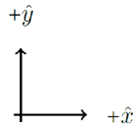
Conventional $x$ and $y$ directions¹

Forces & Acceleration
- If a force acts in the direction opposite to the velocity of an object it will slow the object down.
- A force acting in the direction of an object’s displacement does positive work on the object.
- A force acting opposite the direction of an object’s displacement does negative work on the object.

Motion
- The change in the position of an object is called its displacement.
- Acceleration refers to a change in velocity whether the speed is increasing, decreasing, or staying the same.
- The slope of the line on either a position-vs-time graph or a displacement-vs-time graph is the velocity.
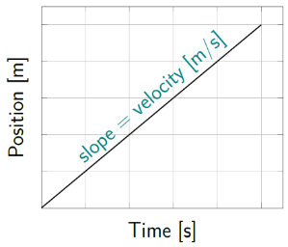
Sample position vs time graph¹
- The slope of the line on a velocity-vs-time graph is the acceleration.
- The area under the curve of a velocity-vs-time graph is the displacement of the object.
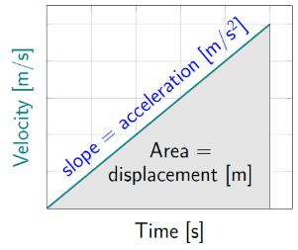
Sample velocity vs time graph¹

Momentum & Velocity
• The slope of the line on a momentum-vs-time graph is the net force on the object.
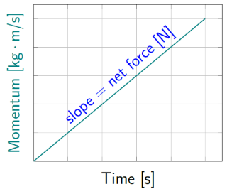
Sample momentum vs time graph¹

Energy
• The area under the curve of a force-vs-position graph is the amount of work done by the force.
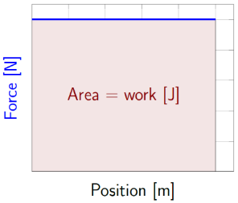
Sample force vs position graph¹

Mathematical Models
Equation | Reference | Restrictions on the validity of the equation
$$v_{avg}=\frac{s}{Δt}$$ | ( 2.1 ) | -none-
“Work-Energy Theorem”  $$W=E_{tot,f}-E_{tot,i}$$ | ( 2.2 ) | -none-
$$\vec{a_{\text{avg}}}=\frac{\vec{∆v}}{∆t}=\frac{\vec{v_{\text{f}}}-\vec{v_{\text{i}}}}{∆t}$$ | ( 2.3 ) | only valid when the net force is constant
$$W=\vec{F}⋅\vec{∆x}=F⋅∆x⋅\cos\left(θ\right)$$ | ( 2.4 ) | only valid when the force is constant

: Questions
Questions are ordered according to Bloom’s Taxonomy, progressing from regurgitating information (Level 1) to synthesizing new information with previous knowledge to create something new (Level 6). The bold letters at the beginning of each question indicate whether the question involves Words [W], Graphics [G], and/or Numbers [N]. See the appendices for conversion factors.

Level 1 - Remember
      - [W] List two reasons for using SI units instead of U.S. Customary Units in physics.
      - [N] Give the appropriate SI units and U.S. Customary units for each of the following:
 | SI (Système International) Unit | U.S. Customary Unit
length
force
mass
speed
      - [G] How does one find work from a graph of force vs. position?
      - [G] How does one find force from a graph of momentum vs. time?
      - [G] How does one find acceleration from a graph of velocity vs. time?
      - [G] How does one find displacement from a graph of velocity vs. time?
      - [G] How does one find velocity from a graph of position vs. time?
      - [W & N] Add labels to each boxed equation from this chapter that tell what the symbol to the left of the = sign represents.
Symbol | Reference | Label
$$v_{\text{avg}}$$ | ( 2.1 )
$$W$$ | ( 2.2 )
$$\vec{a_{\text{avg}}}$$ | ( 2.3 )
$$W$$ | ( 2.4 )

Level 2 - Understand
      - [W] The word “acceleration” is used in physics to mean a change in velocity. What is happening to an object’s speed when it is accelerating?

Level 3 – Apply
      - [G] Draw a force diagram for the ball in Section 2.3.
      - [G & N] What is the total displacement of the ball described in Section 2.6, from the time it is thrown to the moment just before it hits the ground? Remember that displacement is a vector.
      - [G & N] What is the total distance (path length) traveled for the ball described in Section 2.6, from the time it is thrown to the moment just before it hits the ground?
      - [G] Figure 2.22, reproduced below, shows a position-vs-time graph and its corresponding velocity-vs-time graph. Create a corresponding acceleration-vs-time that goes along with these other two graphs.
Position & velocity for ball in free-fall.¹
      - [G & N] Create position-vs-time, velocity-vs-time, and acceleration-vs-time graphs for the soccer ball from Section 1.4, horizontal direction only.
      - [G & N] Create position-vs-time, velocity-vs-time, and acceleration-vs-time graphs for the rock from Section 1.5, vertical direction only.
      - [W] Describe the momentum of a ball that is dropped from the time it leaves a person’s hand until the time just before it hits the ground.
      - [G] Section 2.7 describes a physical situation of a car accelerating and then traveling at constant speed.
        - Draw a velocity vs. time graph for the car in this situation. Be sure to use SI units.
        - Use the graph to find the displacement of the car in the first 3 s.
        - Use the graph to find the displacement of the car in the second 3 s.
        - Use the graph to find the acceleration of the car in the first 3 s.
        - Use the graph to find the acceleration of the car in the second 3 s.

Level 4 - Analyze
      - [G] Figure 2.4, reproduced below, shows a graph of position vs. time for an object that is moving at 2 m/s. Draw a similar graph for an object that is moving at 5 m/s for 10 s.
Position graph.¹
      - [W, G, & N] In Section 2.2, there was a 170-g hockey puck sliding across a sheet of ice. If the mass of the hockey puck had been 340 g and everything else in the situation stayed the same, which of the following would change?
        - The sketch at the beginning of Section 2.2 (and make a new sketch if any change is needed)
        - The force diagram in Section 2.2 (and make a new force diagram if any change is needed)
        - The calculation of kinetic energy in Section 2.2 (and find the new value for the kinetic energy if any change is needed)
        - The motion map in Section 2.2 (and make a new motion map if any change is needed)
        - The calculation of momentum in Section 2.2 (and find the new value for the momentum if any change is needed)
        - The calculation of displacement in Section 2.2 (and find the new value for the displacement if any change is needed)
      - [W, G, & N] In Section 2.2, there was a hockey puck sliding across a sheet of ice at 24 m/s. If the speed of the hockey puck had been 12 m/s and everything else in the situation stayed the same, which of the following would change?
        - The sketch at the beginning of Section 2.2 (and make a new sketch if any change is needed)
        - The force diagram in Section 2.2 (and make a new force diagram if any change is needed)
        - The calculation of kinetic energy in Section 2.2 (and find the new value for the kinetic energy if any change is needed)
        - The motion map in Section 2.2 (and make a new motion map if any change is needed)
        - The calculation of momentum in Section 2.2 (and find the new value for the momentum if any change is needed)
        - The calculation of displacement in Section 2.2 (and find the new value for the displacement if any change is needed)
      - [N] In the last line of the “Numbers” column of Section 2.7, it appears to say that
$6⋅30=80$. Should it be 180?

Level 5 - Evaluate
      - [N] Compare the change in gravitational potential energy for an object of mass $m$ falling a distance $d$ to the work done by the force of gravity on an object of mass $m$ falling a distance $d$. Explain your reasoning.
      - [N] Compare the work done bringing an object of mass $m$ from a complete stop to a speed $v$ over a distance $d$ to the work done bringing that same object from the same speed $v$ to a stop over a distance $d/4$. Explain your reasoning.

Level 6 - Create
      - [W, G, & N] At the beginning of Chapter 1 in Figure 1.1 was a template for a concept map. Add the main ideas from this chapter to the concept map that you began for the question at the end of Chapter 1.
      - [W, G, & N] Imagine you are writing a test question related to this chapter. Think of your own example of a situation that you can analyze using the concepts, graphics, and mathematical analyses described in this chapter. Describe the situation and use the tools from this chapter to analyze the situation as completely as you can, including motion, forces, energy, and momentum.
      - [W, G, & N] Think about possible misconceptions about the material in this chapter. Write a question and an incorrect solution to it that demonstrates a student making such a conceptual error. This cannot be a simple misuse of a vocabulary word, a unit error, or a mathematical error like making an addition error or multiplying when addition was needed, unless the error is rooted in a real misunderstanding about the physics behind the calculation or the misuse of a word. After you have written the question and incorrect solution, explain what is wrong with the student’s solution, and write a correct solution to the problem. Note: You may use a question from this chapter that you got wrong the first time and explain the initial error in your thinking and how you corrected it.

– Two Objects
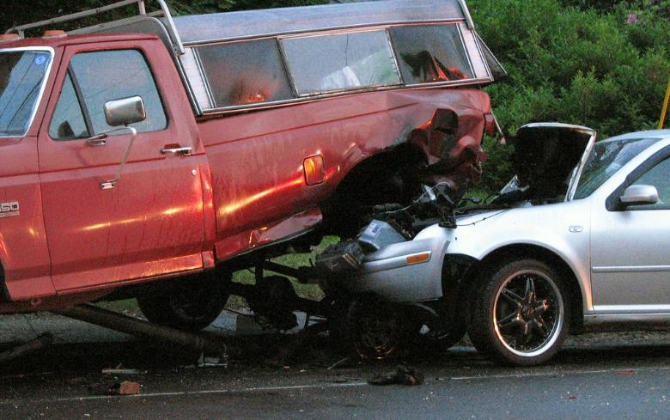
Figure 3.1: Here we see two objects that have interacted with each other. To understand the collision, we need to take both objects into account, and we will have to decide whether to look at the collision from the reference frame of a person in the truck, a person in the car, or a person standing by the side of the road.
Up to this point we have only been looking at a single object. That object has always interacted with something else: A soccer ball rolling across the ground; a hockey puck sliding on ice; a ball falling under the influence of the earth’s gravity; but we have never stopped to consider the second object and how it interacts with the first.
We will consider three new things in this chapter: reference frames (also called frames of reference or points of view), force pairs, and conversion of kinetic energy to thermal energy in collisions or when objects are sliding against each other.
Whenever we look at a physical situation, we need to be mindful of our reference frame. Up to this point, the surface of the earth has been used as a reference and is assumed to be fixed in place as we consider the physics of each situation. But we can also use moving reference frames. For example, if you are a passenger in a moving car, it is still quite easy to pick up an object that is sitting next to you, even though that object is traveling at high speed compared to the ground outside of the car. If the car is moving at a constant velocity, the physics inside the car is just the same as if the car were sitting still.
The idea of force pairs comes about because forces are interactions between objects. If an object exerts a force on another object, the second object exerts the same amount of force back on the first.
Collisions are often divided into categories, elastic or inelastic, depending on what happens during the collision. In a “completely inelastic” collision the objects stick together, and a large amount of kinetic energy is converted into thermal energy. In a “perfectly elastic” collision the objects bounce off each other and no kinetic energy is converted to thermal energy. Most collisions fall between these two extremes, with objects deforming but not sticking together. These collisions are considered elastic or inelastic depending on the amount of kinetic energy that was converted to thermal energy.

: Reference Frames ( )

Words
Imagine standing on a bridge over the highway in the picture on the right. You would look at these vehicles and say that the two cars are going North at 25 m/s and the truck is going South at 25 m/s. You are comparing the velocities of the vehicles to your own velocity, which is zero if the surface of the earth is stationary.
Of course, the surface of the earth is not stationary because the earth is spinning and orbiting the sun! But in many situations, we can ignore the motion of the earth itself. Since you are not moving with respect to the surface of the earth, we say that you are looking at the vehicles from the earth’s reference frame.
What are the velocities of the vehicles in each other’s reference frames?
To consider other reference frames, we just need to imagine ourselves in a different place. What would this situation look like if we were inside the black car? Since the white car that is ahead of us is moving at the same speed, in the same direction as us, it will actually appear not to be moving at all. If it is 20 meters ahead of us, it will stay 20 meters ahead of us as long as neither of us accelerates.

Graphics
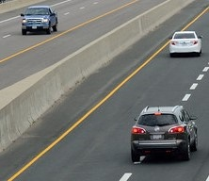
Figure 3.2: Two cars traveling North and a truck traveling South, all at 25 m/s.
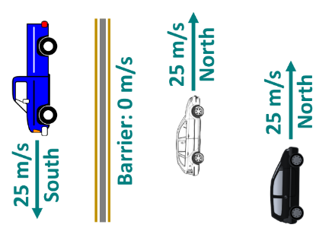
Figure 3.3: The earth’s reference frame.

Numbers
We will need to introduce new notation for velocity in different reference frames: “$\vec{v_{\text{1←2}}}$” will mean “the velocity of object 1 as seen by object 2.” Using this notation, making North the positive direction, and referring to the cars just as “white” and “black” …
Knowns | Unknowns
$$\vec{v_{\text{truck←earth}}}=-25 \text{m/s}$$ | $$\vec{v_{\text{white←truck}}}$$
$$\vec{v_{\text{white←earth}}}=+25 \text{m/s}$$ | $$\vec{v_{\text{black←truck}}}$$
$$\vec{v_{\text{black←earth}}}=+25 \text{m/s}$$ | $$\vec{v_{\text{truck←white}}}$$
 | $$\vec{v_{\text{black←white}}}$$
 | $$\vec{v_{\text{truck←black}}}$$
 | $$\vec{v_{\text{white←black}}}$$
To change from one reference frame to another, simply subtract the velocity of the object whose frame we are entering:
$$\boxed{\vec{v_{\text{2←3}}}=\vec{v_{\text{2←1}}}-\vec{v_{\text{3←1}}} }$$
( 3.1 )
To go from the earth’s reference frame to the black car’s reference frame, we can make “1” the earth, “2” the white car, and “3” the black car:
$$\vec{v_{\text{white←black}}}=\vec{v_{\text{white←earth}}}-\vec{v_{\text{black←earth}}} \\ =\left(+25\frac{m}{s}\right)-\left(+25\frac{m}{s}\right)=0$$

Words
Staying in the black car’s reference frame and looking at the truck, it appears to be moving very fast. From the bridge, the truck appeared to be moving 25 m/s, but since we are moving in the opposite direction of the truck, it appears to be moving much faster.
The earth itself and everything hooked to it appears to be moving in the reference frame of the black car! If you are sitting in the black car, you see houses, trees, and the cement barrier going past your window, even though they are motionless in the earth’s reference frame.
Often, it will be easiest to think about situations in the earth’s reference frame, but all the laws of physics are still true in any reference frame that is not accelerating. A reference frame that is not accelerating is often called an “inertial reference frame.”
If you are riding on a train and sipping from a cup of coffee, you understand the physics of taking a small careful sip, and you can do this as naturally on a train as you would if you were standing on solid ground. The laws of physics work just the same in the moving train as outside on solid ground. That is, unless the train is suddenly lurching out of the station, or applying the brakes, or going around a sharp curve. At those times, the inside of the train is a non-inertial reference frame, so the normal laws of physics do not apply inside the train car, and you spill your coffee.

Graphics
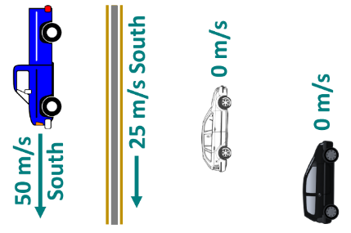
Figure 3.4: The black car’s reference frame.⁹

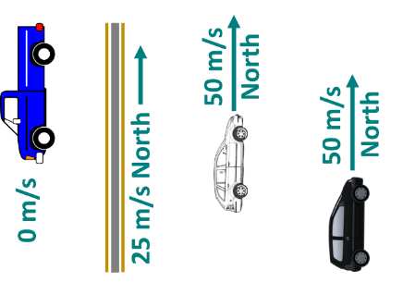
Figure 3.5: The truck’s reference frame.⁹

Numbers
Similarly,
$$\vec{v_{\text{truck←black}}}=\vec{v_{\text{truck←earth}}}-\vec{v_{\text{black←earth}}} \\ =\left(-25\frac{m}{s}\right)-\left(+25\frac{m}{s}\right) \\ =-50 \text{m/s}$$
What happens if we look at the earth from the black car’s reference frame? Using Equation
( 3.1 ) where “3” is again the black car but this time the earth is both “1” and “2,”
$$\vec{v_{\text{earth←black}}}=\vec{v_{\text{earth←earth}}}-\vec{v_{\text{black←earth}}}$$
…and recognizing that the velocity of the earth in the earth’s reference frame is zero…
$$\vec{v_{\text{earth←black}}}=0-\left(+25\frac{m}{s}\right)=-25\frac{m}{s}$$
The earth and everything solidly connected to it has a velocity of -25 m/s in the black car’s reference frame!
Notice that $\vec{v_{\text{earth←black}}}$ is the opposite of $\vec{v_{\text{black←earth}}}$. This will be true for any pair of objects:
$$\boxed{\vec{v_{\text{1←2}}}=-\vec{v_{\text{2←1}}} }$$
( 3.2 )

: An Ant Pushing a Rock ( , )

Words
Figure 1.1 shows an ant pushing a rock. Let’s imagine that at first neither the ant nor the rock is moving, but then the ant begins pushing and the rock and the ant both start moving to the right, accelerating together at a constant 0.5 m/s². The rock looks much larger than the ant, so we will say that the ant has a mass of 0.005 kg and the rock has a mass of 0.015 kg.
The ant is applying a force to the rock to make it accelerate. What are the other forces involved, and how do they compare with the force that the ant is applying to the rock? For simplicity, we will assume that the rock slides freely on the ground, and we will consider only the horizontal direction.
If a drawing is not given, it is good to make a sketch to help with understanding the situation clearly.
The possible forces in the horizontal direction are at each interface. So, between the ant and the rock, between the ant and the ground, and between the rock and the ground.
At each interface there are two forces involved– for example, the ant pushes on the rock, and the rock pushes back on the ant. To some people, it may seem obvious that since the ant is the thing doing the pushing, it is applying the larger force. To others, it may seem obvious that since the rock is larger than the ant, it is applying the larger force.
But in fact, neither of these is correct!

Graphics
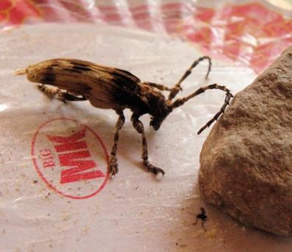
Figure 3.6: An ant pushing a rock.

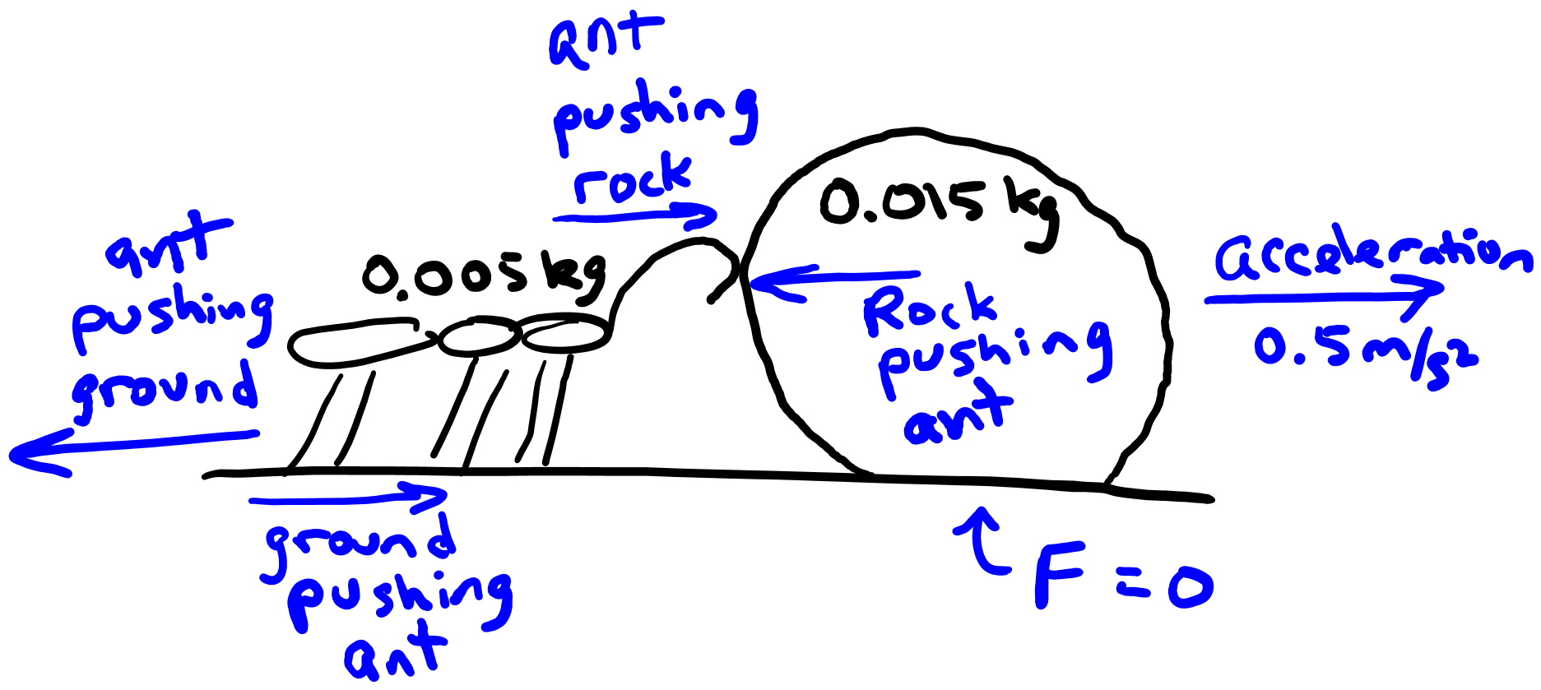
Figure 3.7: A sketch of the ant, the rock, and the forces affecting them.¹

Numbers
Assumptions: $+\hat{x}$ is to the right; negligible friction between the rock and the ground; horizontal direction only
Knowns | Unknowns
$$m_{\text{ant}}=0.005 \text{kg}$$ | $$\vec{F_{\text{ant→rock}}}$$
$$m_{\text{rock}}=0.015 \text{kg}$$ | $$\vec{F_{\text{ground→ant}}}$$
$$\vec{a}=+0.5 \text{m/}{\text{s}}^{\text{2}}$$ | $$\vec{F_{\text{rock→ant}}}$$
$$\vec{F_{\text{ground→rock}}}=0$$
Here, $\vec{F_{\text{ant→rock}}}$ is the force applied by the ant on the rock, and similarly for the other subscripts.
Note that only one acceleration $\vec{a}$ is listed as an unknown, instead of listing $\vec{a_{\text{ant}}}$ and $\vec{a_{\text{rock}}}$ separately. Since the ant and the rock are in contact with each other the whole time, their motion will be identical, so they have the same acceleration. No subscript is needed.
Since we have the acceleration and masses of the objects and are looking for force, we can use Newton’s Second Law:
$$\vec{F_{\text{net}}}=m⋅\vec{a}$$

Words
First, let’s consider the rock because only one force is acting on it in the horizontal direction: the force from the ant. That force is just enough to accelerate the rock at 0.5 m/s²: 0.0075 N.
The ant has two forces acting on it, and we don’t yet know either one, so it is easier instead to consider the ant and the rock to be a single system, and look at the forces affecting that system. Figure 3.7 shows that the only external horizontal force affecting the system is the frictional force of the ground pushing the ant. That force is just enough to accelerate the system at 0.5 m/s²: 0.01 N.
Now we can consider just the ant. The net force from the ground and the rock must be just enough to accelerate the ant at 0.5 m/s². We already know the size of the force from the ground on the ant, so now we can find the force from the rock on the ant. Interestingly, it is exactly the same magnitude as the force of the ant on the rock, but in the opposite direction!
This is a general rule that will be true for all forces. Forces are interactions between two objects, and the force on one object is the same magnitude and opposite direction as the force on the second object. This is called Newton’s Third Law.
When determining how forces affect an object, for example when finding an object’s acceleration, its change in momentum, or its change in energy, only the external forces, those acting on the object from outside, should be considered.

Graphics
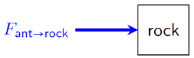
Figure 3.8: Force diagram of rock, horizontal direction only.¹
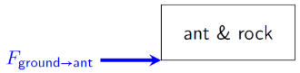
Figure 3.9: Force diagram of ant & rock system, horizontal direction only.¹
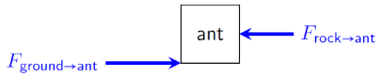
Figure 3.10: Force diagram of ant, horizontal direction only.¹

Numbers
We have the mass and the acceleration of the rock, so we can find the net force on it. The only force on the rock is from the ant, so the net force is just $\vec{F_{ant→rock}}$.
$$\vec{F_{ant→rock}}=m_{rock}⋅\vec{a}=+0.0075 N \hat{x}$$
We have the mass and the acceleration of the combined ant & rock system, so we can find the net force on it as well, and the only external force on the system is from the ground on the ant.
$$\vec{F_{ground→ant}}=\left(m_{ant}+m_{rock}\right)⋅\vec{a}=+0.01 N \hat{x}$$
We have the mass and the acceleration of the ant, so we can find the net force on it as well, and since we already know the force from the ground on the ant we can find the force of the rock on the ant.
$$\vec{F_{net}}=\vec{F_{ground→ant}}+\vec{F_{rock→ant}}$$
Rearranging gives…
$\begin{aligned}\vec{F_{rock→ant}}&=\vec{F_{net}}-\vec{F_{ground→ant}} \\ &=\left(0.005 kg⋅0.5 m/s^{2}-0.01 N\right) \hat{x} \\ &=-0.0075 N \hat{x}\end{aligned}$
We can see that the force of the ant on the rock is equal and opposite to the force of the rock on the ant. This will be true for any physical situation.
$$\boxed{\vec{F_{1→2}}=-\vec{F_{2→1}}}$$
( 3.3 )

: Kicking Horizontally ( , )

Words
Figure 3.11 shows a soccer player about to kick a ball. The 450-gram ball was initially moving to the left at 5 m/s and after the kick it moves to the right at 15 m/s.
What can be said about what happened during the kick from just this information?
There is not really much information to work with here. The mass of the ball shouldn’t change because of the kick. The only change described is the velocity of the ball.
Velocity was to the left, and after the kick velocity is to the right at a higher speed. So, there has been a change in momentum, not only in magnitude but also in direction.
Imagine the kick in slow motion. The ball is moving left, then it contacts a foot. The foot stops the motion to the left, removing all the ball’s initial momentum, and then gives the ball momentum to the right.
This happens quickly, so in a short time the foot created a large change in the ball’s momentum. A change in momentum is often called an impulse, especially when the interaction occurs over a very small amount of time.

Graphics

Figure 3.11: A soccer player kicking a ball.
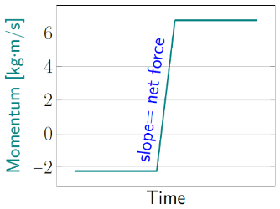
Figure 3.12: Momentum is constant before the kick, changes rapidly during the kick, and then is constant again after the kick.¹
Since momentum is always conserved in an isolated system, something outside of the ball affected it.

Numbers
Assumptions: $+\hat{x}$ is to the right; horizontal direction only
Knowns | Unknowns
$m$ = 0.45 kg | ???
$$v_{0x}=-5 m/s$$
$$v_{f,x}=+15 m/s$$
In this situation we are asked to find anything that we can, so there are no specific unknowns to look for.
Given mass and velocity, perhaps momentum would be a good place to start.
Since we have initial and final information about the ball, we can calculate its change in momentum, knowing that $\vec{p}=m⋅\vec{v}$.
$$\begin{aligned}\vec{Δp}&=\vec{p_{f}}-\vec{p_{i}} \\ &=m⋅\vec{v_{f}}-m⋅\vec{v_{i}} \\ &=m⋅\vec{Δv} \\ &=0.45 kg⋅\left(+15 m/s-\left(-5 m/s\right)\right)\hat{x} \\ &=9 kg⋅m/s \hat{x}\end{aligned}$$
$\vec{Δp}$ is often called impulse.

Words
Changing the momentum of the ball would have taken a force, so the foot applied a force to the ball, to the right. And since forces come in equal-and-opposite pairs, the ball must also have applied that same amount of force to the foot, but in the opposite direction.
This all happened very quickly, so the forces involved had to be very large but acting over a very small amount of time.
We also know something about the kinetic energy of the ball: After the kick it was moving more quickly than it was before the kick. So, its kinetic energy increased. That means work must have been done on the ball.
The foot must have done work on the ball, and if the foot continued moving to the right the entire time, it was doing work for the entire time that it was in contact with the ball.
At the instant the ball contacted the foot, it was moving to the left, so it should be doing work on the foot, except that the foot was moving in the opposite direction. What actually happens during the collision is some of the energy gets stored as elastic, or spring, potential energy and some of the energy is transformed into thermal energy, or heat, warming up the ball. The ball’s kinetic energy and some work from the foot is first transformed into thermal energy and elastic potential energy, and then more work from the foot and the elastic potential energy is transformed into more thermal energy and the final kinetic energy of the ball.

Graphics
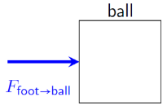
Figure 3.13: Force diagram of the ball during the kick.¹
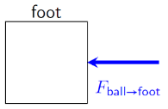
Figure 3.14: Force diagram of the foot during the kick.¹

Numbers
Newton’s Second Law tells us that…
$$\vec{F_{net,avg}}=\frac{\vec{Δp}}{Δt}$$
…but we don’t know $Δt$. We do, however, know that $Δt$ is very small, probably a few milliseconds, so the forces involved must be very large. Using Newton’s Third Law,
$$\vec{F_{foot→ball}}=-\vec{F_{ball→foot}}$$
…so, there is also a very large force applied from the ball to the foot.
We don’t know the amount of time that the force is applied, but we do know that the time that the ball was in contact with the foot is exactly equal to the time that the foot was in contact with the ball. We also know that the force on the foot from the ball was exactly equal to the force on the ball from the foot. Since we know that the times are the same and the forces are equal and opposite…
$$\vec{F_{foot→ball}}⋅Δt=-\vec{F_{ball→foot}}⋅Δt$$
…or…
$$\begin{aligned}\vec{Δp_{ball}}&=-\vec{Δp_{foot}} \\ \vec{p_{ball,f}}-\vec{p_{ball,i}}&=-\left(\vec{p_{foot,f}}-\vec{p_{foot,i}}\right)\end{aligned}$$
…which can be rearranged to show that…
$$\boxed{\vec{p_{tot,i}}=\vec{p_{tot,f}}}$$
( 3.4 )
This is conservation of momentum, which is true for any isolated system of objects, that is, a system that has no interactions with anything outside of the system.

: Elastic Collision ( )

Words
One hard steel ball with a mass of 0.7 kg is sitting motionless when it is hit by an identical steel ball that is moving to the right at 3 m/s. A collision between steel balls is normally an elastic collision, which means that almost no kinetic energy is transformed into thermal energy in the collision. Assume that there are no external forces affecting the balls and the collision is perfectly elastic, so no thermal energy is created. What is the final velocity of each ball?
In any collision, the first thing to consider is momentum, since momentum is always conserved for any isolated system. And the forces between the objects during a collision are usually so large that all other forces can be neglected during the collision. So, for practical purposes, momentum is conserved for any collision, whether there are external forces or not.
We are also assuming that the collision is perfectly elastic, so no kinetic energy is converted to thermal energy in this collision. During the collision the balls deform very slightly, storing elastic potential energy, and this elastic potential energy transforms into kinetic energy after the collision, making the final kinetic energy equal to the initial kinetic energy.

Graphics
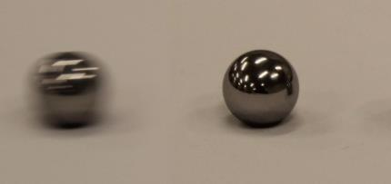
Figure 3.15: A moving ball about to hit a stationary ball.¹
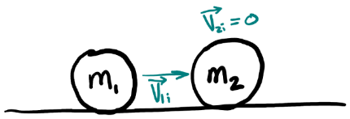
Figure 3.16: Sketch of balls before the collision.¹
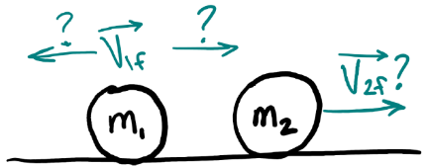
Figure 3.17: Sketch of balls after the collision.¹

Numbers
Assumptions: $+\hat{x}$ is to the right; no external forces; perfectly elastic collision
Knowns | Unknowns
$$m_{1}=m_{2}=0.7 kg$$ | $$\vec{v_{1,f}}$$
$$\vec{v_{1,i}}=+3 m/s \hat{x}$$ | $$\vec{v_{2,f}}$$
$$\vec{v_{2,i}}=0$$
$$E_{k,i}=E_{k,f}$$
Conservation of momentum tells us that:
$$\begin{aligned}\vec{p_{1,i}}+\vec{p_{2,i}}&=\vec{p_{1,f}}+\vec{p_{2,f}} \\ m_{1}⋅\vec{v_{1,i}}+m_{2}⋅\vec{v_{2,i}}&=m_{1}⋅\vec{v_{1,f}}+m_{2}⋅\vec{v_{2,f}}\end{aligned}$$
…but we don’t know $\vec{v_{1,f}}$ or $\vec{v_{2,f}}$. We need a second equation.
Given that the collision is perfectly elastic…
$$E_{k,i}=E_{k,f}$$
…or…
$$\frac{1}{2}m_{1}⋅v_{1,i}^{2}+\frac{1}{2}m_{2}⋅v_{2,i}^{2}=\frac{1}{2}m_{1}⋅v_{1,f}^{2}+\frac{1}{2}m_{2}⋅v_{2,f}^{2}$$

Words
In this case, the ball on the right starts with no momentum, and the ball on the left has momentum. So, the total momentum of the system is to the right. Whatever happens during the collision, the total momentum will still have to be to the right after the collision. That could mean both balls will end up going to the right, one ball stops and the other goes to the right, or one ball goes to the left and the other ball goes faster to the right.
Since there are so many options, to determine what happens in a collision like this, you have to crank through the numbers.
After going through the numbers, we find that there are three possibilities:
Possibility #1: Ball 1 stops completely, and Ball 2 has a final velocity that is the same as the initial velocity of Ball 1.
Possibility #2: The velocities of both balls are the same as their initial velocities. This describes the situation if the first ball would have missed the second ball completely, so it is not the solution to what happens after a collision.
Possibility #3: Ball 1 stops completely and Ball 2 stays still. This cannot be correct, because this solution does not conserve momentum.
So, the first possibility must be the solution: Ball 1’s final velocity is zero and Ball 2’s final velocity is 3 m/s to the right.

Graphics

Possibility #1
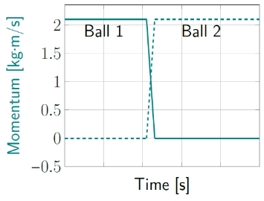
Figure 3.18: If the velocity of Ball 1 goes to zero, its momentum goes to zero. In order to conserve momentum for the system, the momentum of Ball 2 has to increase by the same amount that the momentum of Ball 1 decreased.¹

Possibility #2
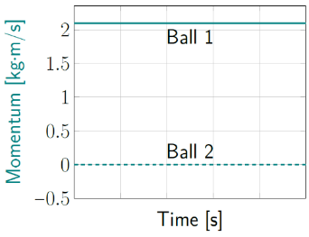
Figure 3.19: If the velocity of Ball 2 does not change, its momentum does not change. So, the momentum of Ball 1 cannot change.¹

Numbers
We have two equations (one each for momentum and energy) and two unknowns, so we can solve for both velocities. We can simplify the equations, since $m_{1}=m_{2}$ and $\vec{v_{2,i}=0}$, giving…
$$\vec{v_{1,i}}=\vec{v_{1,f}}+\vec{v_{2,f}} \left(from momentum\right)$$
…and…
$$v_{1,i}^{2}=v_{1,f}^{2}+v_{2,f}^{2} \left(from energy\right)$$
Since there is only motion in the $x$ direction, we can just consider the $\hat{x}$part of the vectors:
$$v_{1,i,x}=v_{1,f,x}+v_{2,f,x}$$
$$v_{1,i,x}^{2}=v_{1,f,x}^{2}+v_{2,f,x}^{2}$$
Squaring both sides of the first equation…
$$v_{1,i,x}^{2}=v_{1,f,x}^{2}+2⋅v_{1,f,x}⋅v_{2,f,x}+v_{2,f,x}^{2}$$
Now we have two equations for $v_{1,i,x}^{2}$. Setting them equal to each other…
$$v_{1,f,x}^{2}+v_{2,f,x}^{2}=v_{1,f,x}^{2}+2⋅v_{1,f,x}⋅v_{2,f,x}+v_{2,f,x}^{2}$$
…which can only be true if…
$$2⋅v_{1,f,x}⋅v_{2,f,x}=0$$
There are three possibilities:
Possibility # | $$v_{1,f,x}$$ | $$v_{2,f,x}$$
Possibility #1 | $$v_{1,f,x}=0$$ | $$v_{2,f,x}≠0$$
Possibility #2 | $$v_{1,f,x}≠0$$ | $$v_{2,f,x}=0$$
Possibility #3 | $$v_{1,f,x}=0$$ | $$v_{2,f,x}=0$$

Which ones make physical sense?

: Two Moving Balls ( , )

Words
Two identical steel balls have an elastic collision with each other. Both have a mass of 0.7 kg. One is initially moving to the right at 1.5 m/s and the other is initially moving to the left at 1.5 m/s.
What is the final velocity of each ball?
In any collision, the first thing to consider is momentum. The total momentum will be conserved. In this case Ball 1 has momentum to the right and Ball 2 has the exact same amount of momentum but to the left. So, the total momentum of the system is zero. That means that after the collision, the balls will also have equal and opposite momentum. And since they both have the same mass, they will also have equal and opposite velocity, so the same speed but opposite directions.
Since this is an elastic collision, we know that no thermal energy is created. That means initial and final kinetic energy must be equal in this situation. Initially, the speeds and the masses of the two balls are the same. Since the final speeds of the two balls are equal, the only way for the final kinetic energy to be the same as the initial kinetic energy is if the final speeds are the same as the initial speeds. Ball 1 ends up moving to the left at 1.5 m/s and Ball 2 ends up moving to the right at 1.5 m/s.

Graphics
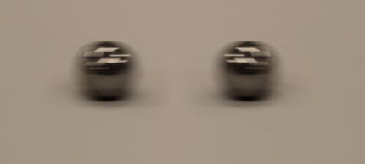
Figure 3.20: Two steel spheres that are about to collide.¹
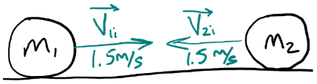
Figure 3.21: Sketch of balls before the collision.¹
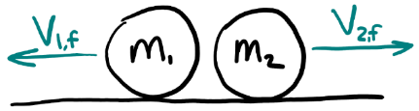
Figure 3.22: Sketch of balls after the collision.¹

Numbers
Assumptions: $+\hat{x}$ is to the right; no external forces; elastic collision
Knowns | Unknowns
$$m_{1}=m_{2}=0.7 kg$$ | $$\vec{v_{1,f}}$$
$$\vec{v_{1,i}}=+1.5 m/s \hat{x}$$ | $$\vec{v_{2,f}}$$
$$\vec{v_{2,i}}=-1.5 m/s \hat{x}$$
$$E_{k,i}=E_{k,f}$$
As in Section 3.4, conservation of momentum tells us that…
$$\vec{p_{1,i}}+\vec{p_{2,i}}=\vec{p_{1,f}}+\vec{p_{2,f}}$$
and conservation of energy tells us that…
$$\frac{1}{2}m_{1}⋅v_{1,i}^{2}+\frac{1}{2}m_{2}⋅v_{2,i}^{2}=\frac{1}{2}m_{1}⋅v_{1,f}^{2}+\frac{1}{2}m_{2}⋅v_{2,f}^{2}$$
But in this case $\vec{p_{1,i}}+\vec{p_{2,i}}=0$, so…
$$\vec{p_{2,f}}=-\vec{p_{1,f}}$$
Since the masses are equal, $\vec{v_{2,f}}=-\vec{v_{1,f}}$. Since the speeds $v_{1,i}=v_{2,i}$ and $v_{1,f}=v_{2,f}$ , the energy equation simplifies to:
$$v_{1,i}=v_{2,i}=v_{1,f}=v_{2,f}$$
So, we are left only with determining the final directions of motion. This can be done by considering conservation of momentum.

Words
Let’s try looking at this question from a different reference frame, one that is moving 1.5 m/s to the left. In that reference frame, Ball 2 is not moving, and Ball 1 is moving at 3 m/s to the right. After the collision, Ball 1 is not moving in this reference frame, but Ball 2 is now moving to the right at 3 m/s.
This is exactly the same as the physical scenario in Section 3.4! So, these two sections have presented exactly the same physical scenario, as seen from two different reference frames. Sometimes a clever choice of reference frame can simplify the analysis of a collision.
The graphs in Figures 3.23, 3.24, & 3.25 show the motion of the two balls over a very brief period of time just before, during, and just after the collision. Since the only force is when the two balls are colliding with each other, there is no acceleration except for sharp spikes during the collision itself.

Graphics
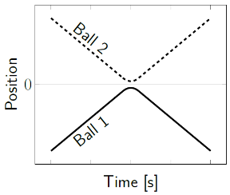
Figure 3.23: Positions in elastic collision.¹
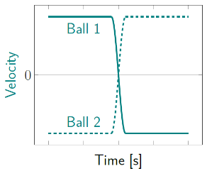
Figure 3.24: Velocities in elastic collision.¹
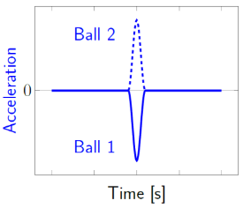
Figure 3.25: Accelerations in elastic collision.¹
Numbers
(This column intentionally left blank)

: Railway Couplers ( )

Words
When railway cars are assembled into a train, they are connected using railway couplers. This is an example of an inelastic collision, because the two train cars stick together after the collision that couples them.
Consider a 90,000 kg boxcar sitting motionless on a track in a railyard. A 500,000 kg engine backs into it at 0.2 m/s. The collision between the cars takes 0.08 seconds, after which they are locked together. We should be able to describe their velocity after the collision, the change in kinetic energy during the collision, the amount of force they applied to each other during the collision, and the acceleration of the engine and the boxcar during the collision.
In any collision, you can’t go wrong by starting to think about it in terms of momentum. Initially the boxcar was not moving, so it had no momentum. The engine did have momentum. After the collision, the two train cars were stuck together, so they have the same velocity. Since momentum is conserved, there must be momentum after the collision. So, after the collision both of the train cars have momentum in the same direction as the initial momentum. The engine transfers just enough of its momentum to the boxcar to bring them both to the same final velocity.

Graphics
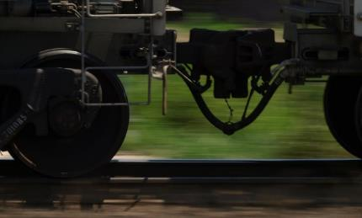
Figure 3.26: Two train cars connected by railway couplers.
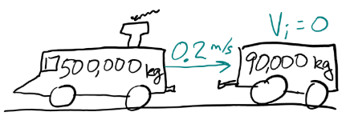
Figure 3.27: Sketch of the train cars before coupling.¹

Numbers
Knowns | Unknowns
$$m_{boxcar}=90,000 kg$$ | $$\vec{F_{boxcar→engine}}$$
$$m_{engine}=500,000 kg$$ | $$\vec{F_{engine→boxcar}}$$
$$\vec{v_{i,boxcar}}=0$$ | $$\vec{v_{f}}$$
$$\vec{v_{i,engine}}=0.2 m/s \hat{x}$$ | $$ΔE_{k}$$
$$t_{collision}=0.08 s$$ | $$\vec{a_{boxcar}}$$
 | $$\vec{a_{engine}}$$
Since a direction is not given, it is easiest to set the problem up so that the initial velocity is in the positive direction. There is only one $\vec{v_{f}}$ because the train cars are stuck together after the collision.
We can start by finding the initial momentum of the system:
$$\vec{p_{i,tot}}=\vec{p_{i,engine}}+ \vec{p_{i,boxcar}} \\ =m_{engine}⋅\vec{v_{i,engine}} \\ =\left(500,000 kg\right)⋅\left(0.2 m/s \hat{x}\right) \\ =100,000 kg⋅m/s \hat{x}$$
Since momentum is conserved in a collision, we can set the final momentum equal to the initial momentum, and use that to find the final velocity of the stuck-together engine-boxcar system:
$$\begin{aligned}\vec{p_{i,tot}}&=\vec{p_{f,tot}} \\ 100,000 kg⋅m/s \hat{x} &=m_{tot}⋅\vec{v_{f}}\end{aligned}$$

Words
No work is done on the engine-boxcar system by anything outside of that system, so the total energy of the system doesn’t change.
We know that this is an inelastic collision, since the two railway cars stick together following the collision. That tells us that some of the kinetic energy was transformed into thermal energy during the collision as the couplings rubbed together and latched into place. Any inelastic collision results in the conversion of some kinetic energy into thermal energy.
Because of conservation of momentum, the less massive boxcar has a larger change in velocity than the more massive engine. And since this change in velocity occurs in the same amount of time, we also know that the acceleration of the boxcar is larger than the acceleration of the engine during the collision.
The force that the boxcar exerts on the engine would have the same magnitude as the force that the engine exerts on the boxcar, but these two forces would be in opposite directions.

Graphics
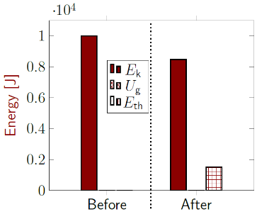
Figure 3.28: Energy bar graph for the collision. Initial thermal energy is taken to be zero. Gravitational energy is zero because both train cars are on the ground before and after the collision.¹
Note that the total height of the columns on the left is equal to the total height of the columns on the right.
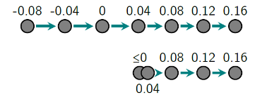
Figure 3.29: Motion map of the engine (top) and the boxcar (bottom). The labels are in seconds, and the collision is from 0 to 0.08 s.¹
Note that the change in the length of the arrows is larger for the boxcar than for the engine.

Numbers
$$\begin{aligned}\vec{v_{f}}&=\frac{100,000 kg⋅\frac{m}{s} \hat{x}}{590,000 kg} \\ =0.169 m/s \hat{x}\end{aligned}$$
Now we can find the change in kinetic energy.
$$\begin{aligned}ΔE_{k}&=E_{k,f,tot}-E_{k,i,tot} \\ &=\frac{1}{2}m_{tot}⋅v_{f}^{2}-\frac{1}{2}m_{engine}⋅v_{i,engine}^{2} \\ &=\left(8,425 J\right)-\left(10,000 J\right) \\ &=-1 575 J\end{aligned}$$
Conservation of energy tells us that this energy doesn’t just disappear. It has to go somewhere. In an inelastic collision, it changes to thermal energy.
∆E_{th} = −∆E_{k} = 1575 J
If we assume that the force is constant during the collision, then the acceleration would be…
$$\vec{a}=\vec{a_{avg}}=\frac{\vec{Δv}}{Δt}$$
This gives a larger acceleration for the boxcar than for the engine: $\vec{a_{boxcar}}=+2.11 m/s^{2} \hat{x}$ and $\vec{a_{engine}}=-0.388 m/s^{2} \hat{x}$.

: Curling ( , )

Words
The conversion of kinetic energy to thermal energy is not limited to collisions. It happens any time that two surfaces rub together. Take, for example, the Olympic sport of curling. One person pushes a heavy “stone” on a sheet of ice and then releases it, and the rest of the curling team sweeps the area in front of the stone as it slides, trying to control the friction to get the stone to stop in a target area.
When it leaves the curler’s hand, the stone has momentum and kinetic energy, but the force of friction opposes the momentum, doing negative work on the stone and slowing it until it eventually comes to rest. After the stone has stopped moving, all the kinetic energy is gone, changed into thermal energy.
Let’s consider an 18 kg curling stone that was initially released with a momentum of $60 kg⋅m/s$, and stops after traveling 45 m across the ice. We should be able to describe the velocity of the stone for the whole time it is sliding, the force of friction on the stone, the energy conversions that take place as it slides across the ice, and the amount of time that the stone is in motion after it has been released.

Graphics
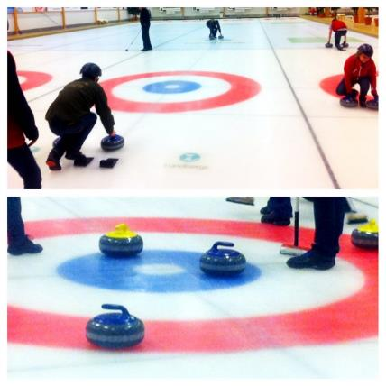
Figure 3.30: Top: A curler preparing to push a stone. Bottom: Stones in the target area.
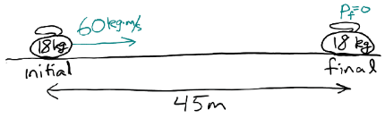
Figure 3.31: Top: A sketch of the curling stone before and after sliding across the ice.¹

Numbers
Assumptions: $+\hat{x}$ is to the right; the force of friction is constant
Knowns | Unknowns
$$m=18 kg$$ | $$\vec{v}$$
$$\vec{p_{i}}=60 kg⋅m/s \hat{x}$$ | $$\vec{F_{f}}$$
$$\vec{p_{f}}=0$$ | Energy transformations
$$\vec{Δx}=45 m \hat{x}$$ | $$Δt$$
$\vec{v_{f}}$ = 0
It is relatively easy to find the initial velocity, and from it the initial kinetic energy:
$$\vec{p_{i}}=m⋅\vec{v_{i}}$$
$$\vec{v_{i}}=\frac{\vec{p_{i}}}{m}=\frac{60 kg⋅m/s}{18 kg}=3.33 m/s \hat{x}$$
$$E_{k,i}=\frac{1}{2}m⋅v_{i}^{2}=\frac{1}{2}(18 kg){\left(3.33 m/s\right)}^{2}=100 J$$
All the initial kinetic energy is converted to thermal energy, so $ΔE_{k}=-100 J$ and $ΔE_{th}=100 J$.

Words
Since specific directions aren’t given, we can choose a direction that is easy to draw or easy to think about. Since “to the right” is conventionally taken to be the positive direction, for simplicity Figure 3.31 is set up so that the initial momentum is to the right. Given that, we know that the initial velocity is also to the right, or positive. And since the stone stops at the end, its final velocity is zero.
The force of friction always opposes the relative motion of two objects, so the force on the stone is to the left, or negative.
The amount of time that the stone spends sliding across the ice depends on the force of friction and the initial momentum. The larger the force, the less time it will take to stop; and the larger the initial momentum, the more time it will take to stop.
Note that the question doesn’t ask about just the initial or final velocity. It says we should be able to describe the velocity for the whole time. So, what about the time during which it is sliding? The velocity will always be to the right, but dropping continuously while the stone slides across the ice, as is shown in Figure 3.33. We could speak of an average velocity of the stone during this time, which would be to the right, and if the force is constant, the average velocity would be half of the initial velocity.

Graphics
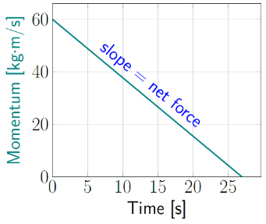
Figure 3.32: Momentum is decreasing over time, indicating a negative net force.¹
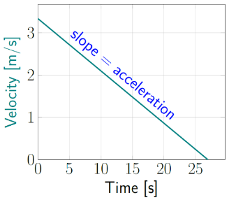
Figure 3.33: Velocity is decreasing over time, indicating a negative acceleration.¹

Numbers
Now we can use the Work-Energy Theorem to find the force of friction.
$$ΔE_{k}=W_{net}=F_{f}⋅Δx⋅cos\left({180}^{∘}\right)$$
$$F_{f}=\frac{ΔE_{k}}{-Δx}=\frac{-100 J}{-45 m}=2.22 N$$
180 degrees was used as the angle because we assume that the force is opposite the direction of the displacement. Since we got a positive value for the force, we know that our assumption was correct. If the number turned out to be negative, then we would know that our assumption was not correct. The velocity varies continuously over the time the stone is moving. We have already found the initial and final velocity. In situations where the net force (and therefore the acceleration) is constant, average velocity is also given by…
$$\boxed{\vec{v_{avg}}=\frac{\vec{v_{i}}+\vec{v_{f}}}{2}}$$
( 3.5 )

: Car Crash, Initial Impact ( )

Words
Let’s consider the car crash in Figure 3.1. We can imagine what happened. Perhaps the 2500 kg truck was stopped, and the 1500 kg car hit it from behind at 25 m/s. The truck would have been shoved forward by the car, and the two stuck together.
The time in which the car and truck were smashing into each other would have been very short, let’s say 30 milliseconds. The drivers of both vehicles probably were applying the brakes, and the vehicles skidded together to a stop after traveling together for 4 m. For now let’s focus on what happened during the early part of the crash when they were smashing into each other, before the vehicles skidded together.
We should be able to find the average force that each vehicle applied to the other during the early part of the crash, the velocity of the car-truck wreckage just after they had finished smashing into each other but before they started skidding together, and the kinetic energy of the vehicles just before and just after they smashed into each other.
Before the car hit the truck, the truck was not moving but the car was; a short time after contact, the car and the truck were connected together and moved as if they were a single object with the combined mass of both vehicles. Because of this, there is only one velocity after the collision, and it is the velocity of both the car and the truck.

Graphics
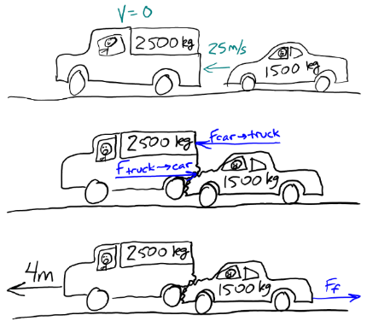
Figure 3.34: Sketches of what could have happened in the crash. In this section we will consider only the top two sketches.¹

Numbers
Assumptions: $+\hat{x}$ is to the right; external forces are negligible
Knowns | Unknowns
$$m_{car}=1500 kg$$ | $$\vec{F_{car→truck}}$$
$$m_{truck}=2500 kg$$ | $$\vec{F_{truck→car}}$$
$$\vec{v_{i,car}}=-25 m/s \hat{x}$$ | $$\vec{v_{f}}$$
$$\vec{v_{i,truck}}=0$$ | $$E_{k,i}$$
$$t_{collision}=0.03 s$$ | $$E_{k,f}$$
The place to start in any collision is with conservation of momentum, which we can use to find the final velocity of the car and truck:
$$\begin{aligned}\vec{p_{i,tot}}&=\vec{p_{f,tot}} \\ \vec{p_{i,car}}&=\vec{p_{f,tot}} \\ m_{car}⋅\vec{v_{i,car}}&=m_{tot}⋅\vec{v_{f}}\end{aligned}$$
$$\vec{v_{f}}=\left(\frac{m_{car}}{m_{tot}}\right)\vec{v_{i,car}}=-9.375 m/s \hat{x}$$
This is the velocity of the two vehicles after they have smashed together and before they start sliding together down the road.

Words
In the crash, the car transferred some of its momentum to the truck, applying a force to the truck. So, the truck applied an equal-but-opposite force to the car. Since momentum is conserved in an isolated system, the change in the truck’s momentum is the same as the change in the car’s momentum, but in the opposite direction.
This tells us something about the acceleration. They have the same change in momentum, but different masses. The more massive truck has a smaller change in velocity than the car, so the acceleration of the truck is less than the acceleration of the car.
Initially the car had kinetic energy, but the truck did not; after the collision they both had some kinetic energy. But in the collision the two vehicles stuck together, a completely inelastic collision, which means that some of the kinetic energy was transformed into thermal energy as the car and truck were deforming.

Graphics
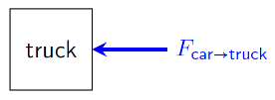
Figure 3.35: Force diagram of the truck during the collision, horizontal direction only. The force of friction is small compared to the force caused by the collision, so it is being neglected.¹
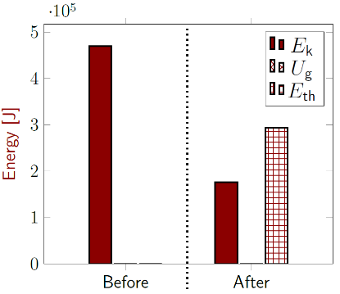
Figure 3.36: Energy bar graph for the collision. Initial thermal energy is taken to be zero. Gravitational energy is zero because both vehicles are on the ground before and after the collision.¹
Note that the total heights of the columns on the left is equal to the total heights of the columns on the right.

Numbers
We can use Newton’s Second Law to find the average force on the truck during the collision:
$$\begin{aligned}\vec{F_{car→truck}}&=\frac{\vec{Δp_{truck}}}{Δt}=\frac{m_{truck}⋅(\vec{v_{f}}-\vec{v_{i,truck}})}{t_{collision}} \\ &=\frac{2500 kg⋅(-9.375-0) m/s \hat{x}}{0.03 s} \\ &=-7.8×{10}^{5} N \hat{x}\end{aligned}$$
From Newton’s Third Law, we know that
$$\vec{F_{truck→car}}=-\vec{F_{car→truck}}=+7.8×{10}^{5} N \hat{x}$$
We already know all the velocities and masses, so we can find the change in kinetic energy.
$$\begin{aligned}E_{k,i}&=\frac{1}{2}m_{car}⋅v_{i,car}^{2}+\frac{1}{2}m_{truck}⋅v_{i,truck}^{2} \\ &=\frac{1}{2}(1500 kg)⋅(-25 m/s)^{2}+0=4.7×{10}^{5} J\end{aligned}$$
$$\begin{aligned}E_{k,f}&=\frac{1}{2}m_{total}⋅v_{f}^{2} \\ &=\frac{1}{2}(4000 kg)⋅(-9.375 m/s)^{2}=1.76×{10}^{5} J\end{aligned}$$
Energy is conserved whenever no work is being done by an external force. Gravity and springs do not play a role in this situation, so lost kinetic energy changes into thermal energy.
$$\begin{aligned}E_{k,i}+E_{th,i}&=E_{k,f}+E_{th,f} \\ E_{k,i}-E_{k,f}&=E_{th,f}-E_{th,i}\end{aligned}$$
$$ΔE_{th}=\left(4.7-1.76\right)×{10}^{5} J=2.94×{10}^{5} J$$

: Car Crash, Sliding ( , )

Words
Now we consider the same collision as in Section 3.8 but focus on what happened when the vehicles skidded together across the ground. During that time, the vehicles were braking, and they skidded to a stop after traveling for 4 m.
We should be able to describe the total braking force that was required, which is a frictional force that we will assume to be constant, acting between the tires and the road; the amount of time that they were skidding; and the energy transformations.
It is usually best to start any analysis with whatever part seems easiest. In this case, it is easiest to think about the energy involved. We know the vehicles are moving when they start to skid down the road, so they have kinetic energy. The road is flat, so we don’t have to worry about any changes in gravitational potential energy. And there are not any springs that are trying to stop them or make them go faster, so we also don’t need to worry about spring potential energy. So, we started with only kinetic energy. And after the vehicles stop moving, they no longer have kinetic energy. So where did all the energy go? The only option left is thermal since we have ruled out potential energies. All the kinetic energy is transformed into thermal energy.

Graphics
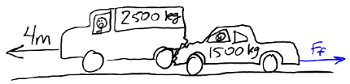
Figure 3.37: Sketch of the car and truck skidding together after the initial impact.¹
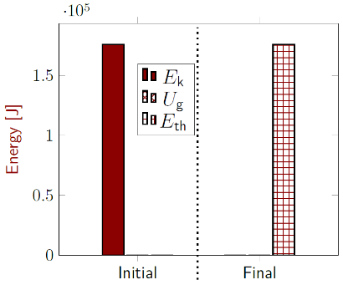
Figure 3.38: Energy bar graph for vehicles skidding on the road. Initial thermal energy is taken to be zero. Gravitational energy is zero because both vehicles are on the ground before and after the collision.¹

Numbers
Assumptions: $+\hat{x}$ is to the right; frictional force is constant
Knowns | Unknowns
$$m_{wreckage}=4000 kg$$ | $$\vec{F_{f}}$$
$$\vec{v_{i}}=-9.375 m/s \hat{x}$$ | $$t_{skidding}$$
$$\vec{v_{f}}=0$$ | $$ΔE_{th}$$
$$\vec{Δx}=-4 m \hat{x}$$ | $$ΔE_{k}$$
Note that the initial velocity for the skidding part of the collision is the final velocity of impact part of the collision.
We already know from the last section that
$ΔE_{k,i}$ for the skidding portion of the collision is $1.76×{10}^{5}J$. Using the Work-Energy Theorem, we can find the work done by friction on the vehicles:
$$W=E_{tot,f}-E_{tot,i}=-1.76×{10}^{5}J$$
Work done by friction is not like work done by gravity. If gravity does negative work on an object, gravitational potential energy is stored. If friction does negative work on something that is sliding, it creates thermal energy. So, in this case, $ΔE_{th}=1.76×{10}^{5}J$.

Words
As the tires skid across the ground, the frictional force does negative work on the vehicles, slowing them down. Whenever two surfaces slide against each other with friction, the friction fights the relative motion of the two surfaces, converting kinetic energy into thermal energy.
This only happens when the surfaces move relative to each other. If a car is sitting on the side of a hill with the brakes locked, there is still friction between the tires and the road, but there is no relative motion, so no work is being done, and kinetic energy is not being transformed by friction into thermal energy.
We can find the time needed to stop the vehicles by considering momentum. The car-truck wreckage has momentum after the initial impact, and then the force of friction reduces the momentum to zero over a certain amount of time.
The larger the force of friction, the less time needed to reduce the momentum to zero.
We could also consider the question of the force between the car and the truck during the time they were skidding. It would depend on how much of the frictional force is coming from the truck's tires and how much from the car's tires. If the car were not braking at all then there would be a large force applied on the car from the truck during the time they were skidding. If they were both braking, then the force between them would be smaller.

Graphics
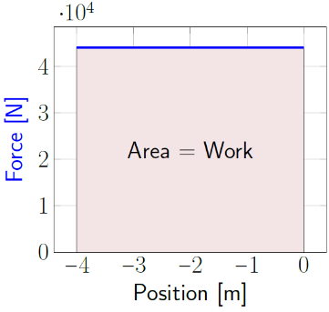
Figure 3.39: A force opposite the direction of motion does negative work equal to the area under the curve in a Force-vs-Position graph.¹
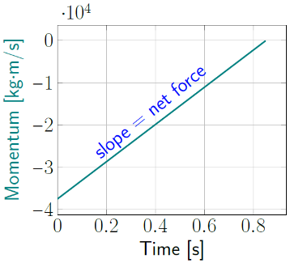
Figure 3.40: Momentum starts with a large negative value, and goes to zero over time because of the force of friction.¹

Numbers
We can find the force of friction from the work done by friction:
$$W_{net}=F_{net}⋅Δx⋅cosθ$$
$$F_{net}=\frac{W_{net}}{Δx⋅cosθ}=\frac{-1.76×{10}^{5} J}{\left(4 m\right)⋅\left(-1\right)}=4.4×{10}^{4} N$$
The force is positive, so it is in the positive direction, opposite the direction of motion. Since friction is the only force in the horizontal direction, $F_{net,x}=F_{f}$.
We can use Newton’s Second Law to find the time needed to stop:
$$\vec{F_{net,avg}}=\frac{\vec{Δp}}{Δt}=\frac{\vec{p_{f}}-\vec{p_{i}}}{t_{skidding}}$$

$$\begin{aligned}t_{skidding}&=\frac{m_{wreckage}⋅v_{f,x}-m_{wreckage}⋅v_{i,x}}{F_{f}} \\ &=\frac{4000 kg⋅0-4000 kg⋅(-9.375 m/s)}{4.4×{10}^{4} N} \\ &=0.85 s\end{aligned}$$

: Summary
Chapter summaries in this book are ordered by concept, not necessarily in the order in which they are presented in the chapter. Mathematical models are grouped together at the end of each summary. See the appendices for the meanings of all symbols used in this book.

General
• The laws of physics are true in any inertial (not accelerating) reference frame.

Forces & Acceleration
- Forces are interactions between two objects, and the force on one object is the same magnitude and opposite direction as the force on the second object.
- During a collision, the forces caused by the collision are usually so much larger than any other force that all other forces can be neglected.
- The force of friction opposes the relative motion of two objects.
- The force of friction converts kinetic energy into thermal energy when two surfaces slide against each other.

Momentum & Velocity
• Considering momentum is a good way to begin any investigation of a collision.

Energy
- An elastic collision is one in which little kinetic energy is transformed into thermal energy.
- A perfectly elastic collision is one in which no kinetic energy is transformed into thermal energy.
- An inelastic collision is one in which a large amount of kinetic energy is transformed into thermal energy.
- Completely inelastic collisions are collisions in which the two objects stick together after the collision.
- If the force is opposite the direction of motion in a force-vs-displacement graph, the area “under” the curve represents negative work.
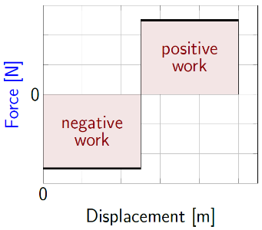
Negative and positive work on a force vs displacement graph¹

Mathematical Models
Equation | Reference | Restrictions on the validity of the equation
$$\vec{v_{2←3}}=\vec{v_{2←1}}-\vec{v_{3←1}}$$ | ( 3.1 ) | -none-
$$\vec{v_{1←2}}=-\vec{v_{2←1}}$$ | ( 3.2 ) | -none-
“Newton’s Third Law”  $$\vec{F_{1→2}}=-\vec{F_{2→1}}$$ | ( 3.3 ) | -none-
“Conservation of Momentum”  $$\vec{p_{tot,i}}=\vec{p_{tot,f}}$$ | ( 3.4 ) | only valid when there is no external net force
$$\vec{v_{avg}}=\frac{\vec{v_{i}}+\vec{v_{f}}}{2}$$ | ( 3.5 ) | only valid when the net force is constant

: Questions
Questions are ordered according to Bloom’s Taxonomy, progressing from regurgitating information (Level 1) to synthesizing new information with previous knowledge to create something new (Level 6). The bold letters at the beginning of each question indicate whether the question involves Words [W], Graphics [G], and/or Numbers [N]. See the appendices for conversion factors.

Level 1 – Remember
      - [W] What does “impulse” mean in physics?
      - [W] What type of energy conversion always happens during an inelastic collision?
      - [W] Differentiate between what is meant by elastic, inelastic, and completely inelastic collisions.
      - [W & N] Add labels to each boxed equation from this chapter that tell what the symbol to the left of the = sign represents.
Symbol | Reference | Label
$$\vec{v_{2←3}}$$ | ( 3.1 )
$$\vec{v_{1←2}}$$ | ( 3.2 )
$$\vec{F_{1→2}}$$ | ( 3.3 )
$$\vec{p_{tot,i}}$$ | ( 3.4 )
$$\vec{v_{avg}}$$ | ( 3.5 )

Level 2 - Understand
      - [W] Which of the following describe inertial reference frames where the normal laws of physics are valid?
        - A typical physics classroom
        - A physics classroom during a violent earthquake
        - The back of a truck that is traveling at constant speed on a long, straight road
        - The back of a truck that is traveling at constant speed on a long, straight, uphill road
        - The back of a truck that is accelerating away from a stoplight
        - A spaceship floating far off in space, away from any sources of gravity
        - A spaceship firing its rockets far off in space, away from any sources of gravity
      - [N] Confirm that Equation ( 1.4 ), $\vec{v_{\text{avg}}}=\frac{\vec{∆x}}{∆t}$ , and Equation ( 3.5 ), $\vec{v_{avg}}=\frac{\vec{v_{i}}+\vec{v_{f}}}{2}$ , give the same result for the physical scenario described in Section 3.7. Show your work.
      - [W & N] In Section 3.8 we found the horizontal force on the car and the truck during the impact.
        - Is the magnitude of the force the same for both the car and the truck? Explain why or why not.
        - Find the accelerations of the car and the truck during the impact.
        - Is the magnitude of the acceleration the same for both the car and the truck? Explain why or why not.
      - [W] Explain why the initial velocity for the physical scenario that is considered in Section 3.9 is the same as the final velocity for the physical scenario that is considered in Section 3.8.
      - [W & N] Find the acceleration of the car and the truck from Section 3.9 during the skidding. Is the acceleration of the car the same as the acceleration of the truck? Why or why not?

Level 3 - Apply
      - [N] There are six “Unknowns” listed at the beginning of Section 3.1, but numerical values are only found for two of them. Find the rest of the numerical values.
      - [G] Section 3.1 includes illustrations in the reference frames of the earth, the black car, and the truck. Draw a similar illustration in the white car’s reference frame.
      - [W & G] Draw an energy bar graph for the soccer ball in Section 3.3 for the time just before and just after the kick. Is energy conserved in this situation? If not, where did the extra energy come from, or where did it go?
      - [N] In Section 3.6 two forces were listed in the unknowns, but they were never found. What are those forces, including magnitude and direction?
      - [N] In Section 3.7 one of the unknowns was time, but it was never explicitly found, though it can be seen in some of the graphs. Exactly how much time does the stone spend sliding across the ice?
      - [G] Section 3.8 includes a force diagram for the truck during the collision, but ignoring the force of friction.
        - Re-draw that force diagram for the forces on the truck in the horizontal direction only, including the force of friction. Assume that the driver of the truck was applying the brakes during the time of the impact.
        - Does including the force of friction result in a larger or smaller magnitude of the net force on the truck in the horizontal direction?
        - Draw another force diagram for the forces on the car in the horizontal direction only, including the force of friction. Assume that the driver of the car was applying the brakes during the time of the impact.
        - Does including the force of friction result in a larger or smaller magnitude of the net force on the car in the horizontal direction?

Level 4 - Analyze
      - [W & N] In Section 3.7 it is mentioned that some of the team members use brooms to change the force of friction as the stone slides across the ice. If they were able to reduce the force of friction by 10%, what effect would that have on the displacement and the time? Would they increase or decrease? Would they also change by 10%, or more, or less? Explain your answers.

Level 5 - Evaluate
      - [W] In the situation given in Section 3.2 it is stated that the ant and rock start motionless. Now imagine what would happen if the forces applied stayed the same but the ant and rock started with an initial velocity in one direction or the other.
        - Would the initial velocity affect the acceleration? Explain why or why not.
        - Would the initial velocity affect the force applied by the ant to the rock or the rock to the ant? Explain why or why not.
      - [W] Two people are moving toward each other across an open field. One is running and the other is walking. Rank the following in terms of the amount of time needed for the two people to come together:
        - Considering this situation in the earth’s reference frame
        - Considering this situation in the reference frame of the person who is running
        - Considering this situation in the reference frame of the person who is walking
Ignore the effects of “special relativity,” if you know what that is!
      - [N] An assertion is made in this chapter that during a collision the forces caused by the impact are usually so much larger than any other forces that all other forces can be neglected. Compare the force of the impact in Section 3.8 to the force of friction in Section 3.9 for the same collision. How many times larger is the force of impact than the force of friction with the road? Probably both cars were braking even during the impact. Does ignoring the force of friction cause a significant (which we will define for this question as larger than 10%) error in the calculation of the force in the impact?
      - [W, G, & N] At the end of Section 3.9 it is noted that the force between the car and the truck during the time that they are skidding depends on the relative amount of frictional force applied by the tires of each vehicle.
        - Find the amount of force applied by the truck on the car while they are skidding if the car is not braking at all and all frictional force comes from the truck’s tires.
        - Find the amount of frictional force that would need to be applied by the car’s tires and by the truck’s tires so that their total frictional force would still be $4.4×{10}^{4} N$ and there would be no net force applied by the truck on the car while they are skidding

Level 6 - Create
      - [W, G, & N] At the beginning of Chapter 1 in Figure 1.1 was a template for a concept map. Add the main ideas from this chapter to the concept map that you began for the question at the end of Chapter 1.
      - [W, G, & N] Imagine you are writing a test question related to this chapter. Think of your own example of a situation that you can analyze using the concepts, graphics, and mathematical analyses described in this chapter. Describe the situation and use the tools from this chapter to analyze the situation as completely as you can, including motion, forces, energy, and momentum.
      - [W, G, & N] Think about possible misconceptions about the material in this chapter. Write a question and an incorrect solution to it that demonstrates a student making such a conceptual error. This cannot be a simple misuse of a vocabulary word, a unit error, or a mathematical error like making an addition error or multiplying when addition was needed, unless the error is rooted in a real misunderstanding about the physics behind the calculation or the misuse of a word. After you have written the question and incorrect solution, explain what is wrong with the student’s solution, and write a correct solution to the problem. Note: You may use a question from this chapter that you got wrong the first time and explain the initial error in your thinking and how you corrected it.

– Working in Two Dimensions
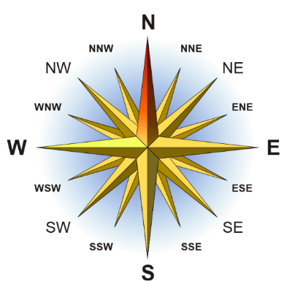
Figure 4.1: A compass rose, showing the traditional direction of North as “up.”
So far, we have only considered objects and forces in one dimension, either horizontally or vertically. But our universe is not one-dimensional. Usually, we think of it as being three-dimensional, and that is correct. We live in three spatial dimensions. It’s also possible to consider time as another “dimension,” in which case we can think of living in a four-dimensional “space-time.” And in some theoretical models of physics called “string theories” there have been attempts made to describe the universe as being 10-, 11-, or even 26-dimensional! For now, let’s just work on expanding our understanding from one dimension to two.
First, we will consider a flat plane that is lying flat on the ground, so North and South, East and West; or left and right, forward and backward. Then we will consider vertical planes, so up and down, left and right. Finally, we will consider planes that are tilted. In all cases, it is important to remember that for our analyses, the two dimensions must be at right angles to each other. That allows us to consider each dimension separately from the other.
For example, if your aunt’s home is West of yours, you have to get there by traveling West and not North or South. In fact, if you do go North, you will then have to undo that motion by going South. North and South must be considered as completely separate from East and West.

: Floating on the Water ( )

Words
Imagine sitting on an inner tube, just floating in the water with a group of friends. If the river isn’t moving and all of you are just lazily floating in the water, you would say that none of you is moving. And if a person were standing on a nearby shore, that person would also say that you aren’t moving.
These ideas should sound very familiar, because they are very similar to our discussion of reference frames in an earlier chapter. The only difference is that some of the objects we are considering now (the inner tubes, you, and your friends) are actually riding on one of the objects (the water). But all the ideas are the same.
But what if the water were moving, and carrying you and your friends along? If a river flows North at 2 m/s, and you and your friends are just floating along with the river, you will also go North at 2 m/s. The person standing on the shore would be able to watch you going North along with the river.

Graphics
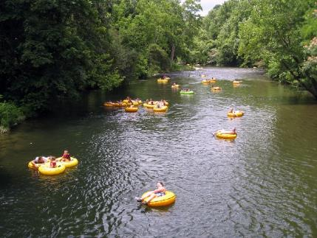
Figure 4.2: A group of people floating in inner tubes on a river. If they don’t try to push themselves through the water by paddling, they will all move together, along with the river.

Numbers
Knowns | Unknowns
$$\vec{v_{river←shore}}=0 or 2 m/s \hat{N}$$ | $$\vec{v_{you←shore}}$$
$$\vec{v_{you←river}}=0$$ | $$\vec{v_{friend←you}}$$
$$\vec{v_{friend←river}}=0$$ | $$\vec{v_{shore←you}}$$

Our equations for motion of one object relative to another work here, though we have never tried to use them where one object is riding on another. Taking objects 1, 2, and 3 to be the river, you, and the shore, respectively…
$$\vec{v_{you←shore}}=\vec{v_{you←river}}-\vec{v_{shore←river}}$$
We aren’t given $\vec{v_{shore←river}}$, but we are given $\vec{v_{river←shore}}$, and we have already learned that…
$$\vec{v_{shore←river}}=-\vec{v_{river←shore}}$$
…So…
$$\vec{v_{you←shore}}=\vec{v_{you←river}}+\vec{v_{river←shore}}$$

If $\vec{v_{river←shore}}=0$, then $\vec{v_{you←shore}}=0$, and if $\vec{v_{river←shore}}=2 m/s \hat{N}$ then $\vec{v_{you←shore}}=2 m/s \hat{N}$.

Words
Now what if you and your friend were deep in conversation, not paying any attention to anything except each other? If you didn’t happen to notice that the shore and the shoreline were moving past you, it would feel to you exactly like you and your friend were sitting still, and meanwhile the shore is slipping by at 2 m/s to the South.

Graphics
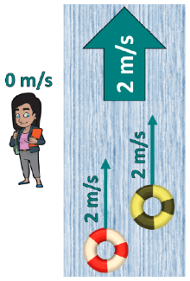
Figure 4.3: From the frame of reference of a person standing on the shore, you and your friend are moving along with the river.
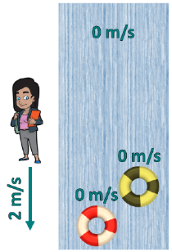
Figure 4.4: From your frame of reference, you and your friend are not moving, and a person standing on the shore is moving South.¹⁶

Numbers
Interestingly, $\vec{v_{friend←you}}$ does not depend at all on the velocity of the river. We can again use our equations for the motion of one object as seen from the frame of another, this time taking objects 1, 2, and 3 to be the river, your friend, and you, respectively.
$$\vec{v_{friend←you}}=\vec{v_{friend←river}}-\vec{v_{you←river}}$$
$\vec{v_{river←shore}}$ does not appear in this expression at all. Regardless of the velocity of the river relative to the shore, the velocity of your friend relative to you will always be zero in this scenario.
The same technique can also tell us the velocity of the shore in your frame of reference as you float down the river…
$$\vec{v_{shore←you}}=\vec{v_{shore←river}}-\vec{v_{you←river}} \\ =-2 m/s \hat{N}$$
In other words, 2 m/s South.

: Boating in a River ( , )

Words
If you are in a boat on a still body of water, and you start rowing South, you will go South. If you row East, you will go East. And whatever speed you achieve in the water, that is the speed that somebody standing on a dock would say that you are moving. But things change if you are in a moving river.
If you are in a river that is slowly flowing East, and you point your boat south and start rowing, you will indeed go South. Compared to the water surrounding you, you will be going directly South. But to somebody who is standing on a dock, they would say that you are going both South and East, because as you row South the current carries you East.
The actual direction that you move, as seen by someone on the dock, depends on how fast you are rowing relative to the speed of the water in the river.
It is tempting to say that the first boat in Figure 4.5 is moving South, which is correct, and the others are moving SouthEast, which is not correct. As shown in Figure 4.1, SouthEast is a specific direction, halfway between South and East. So, unless we are sure that the boat is traveling in exactly that direction, we should say that it is traveling South and East.

Graphics
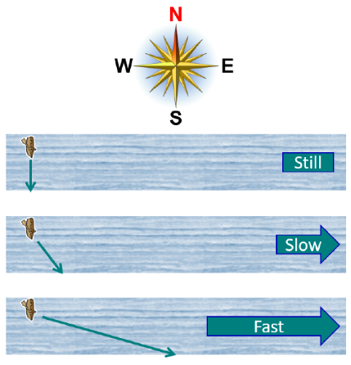
Figure 4.5: The path taken by a boat in a river, as seen by someone on a dock, depends on both the velocity of the boat in the river and the velocity of the river.
The path taken by the boat can be found graphically by adding the velocity vectors “tip to tail,” that is, draw the first vector, then draw the second so that its tail starts at the tip of the previous one. Continue with any other vectors that need to be added together. The resultant vector starts at the tail of the first vector and ends at the tip of the last one.

Numbers
Assumptions: all parts of the river flow with the same velocity.
Knowns | Unknowns
$$\vec{v_{boat←river}}$$ | $$\vec{v_{boat←dock}}$$
$$\vec{v_{river←dock}}$$

Again, our equations for relative motion work here. Taking objects 1, 2, and 3 to be the river, the boat, and the dock, respectively…
$$\vec{v_{boat←dock}}=\vec{v_{boat←river}}-\vec{v_{dock←river}}$$
We aren’t given $\vec{v_{dock←river}}$ , but we are given
$\vec{v_{river←dock}}$ , and we know that…
$$\vec{v_{dock←river}}=-\vec{v_{river←dock}}$$
…So…
$$\vec{v_{boat←dock}}=\vec{v_{boat←river}}+\vec{v_{river←dock}}$$
In order to add the velocity vectors numerically, you have to break up each vector into its component parts, in this case the East/West component (E subscript below) and the North/South component (N subscript).

Words
Let’s consider a situation where you can row the boat at a speed of 5 m/s, and the river flows at a uniform speed of 4 m/s to the East.
If you were to row directly East, along with the river, you would move along very quickly. Since you are rowing in the same direction as the current, the speed of the river would add to your rowing speed, and someone on the dock would see you going past at 9 m/s. This is the highest possible total speed when combining 5 m/s and 4 m/s.
If you were to row directly West, you would be fighting the river and moving very slowly. At 5 m/s, you can row slightly faster than the flow of the river. So, you would be able to go West but only at 1 m/s. This is the lowest possible speed when combining 5 m/s and 4 m/s. If the river were flowing faster than you could row, you would not be able to go West at all, but would slowly go down the river even when paddling upstream as quickly as you could.
If you were to row directly South, you would go both South and East, and your speed would be somewhere between 1 m/s and 9 m/s. For this example, since you are rowing faster than the flow of the river, your direction would be somewhere between South and SouthEast.

Graphics
Remember, vectors have magnitude and direction, so if you keep the magnitude and direction of a vector the same you are free to shift it up, down, left, or right on the page to get the tips & tails to line up correctly. This same technique will work with any type of vector, for example forces, momentum, displacement, and acceleration.
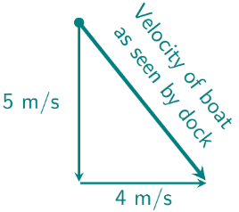
Figure 4.6: Adding a vector of 5 m/s South to a vector 4 m/s East gives a resultant vector at an angle between South and East.¹
If the velocity vectors are drawn to scale, the resultant vector can be measured with a ruler to get a good estimate of the speed of the boat as seen by the dock. A good estimate of the direction can be found by using a protractor.
From the diagram in Figure 4.6, measurement with a ruler and protractor gives a speed of approximately 6.5 m/s, at an angle approximately 40° East of South.

Numbers
$$v_{boat←dock,E}=v_{boat←river,E}+v_{river←dock,E}$$
$$v_{boat←dock,N}=v_{boat←river,N}+v_{river←dock,N}$$
In this example,
$$\vec{v_{boat←dock}}=-5 m/s \hat{N}+4 m/s \hat{E}$$
The North/South direction has been assigned a negative value in the “North” direction. In other words, South. It is usually easier to define North as positive and East as positive when doing calculations, and then if the final answer is negative, you can describe it as a positive value in the South (or West) direction.
A vector can also be described in terms of magnitude and direction. Since the North/South and East/West directions are at right angles to each other, the magnitude of the resultant vector must be found using the Pythagorean theorem:
$$\boxed{A^{2}=A_{x}^{2}+A_{y}^{2}}$$
( 4.1 )
…where $A$ is the magnitude of any vector $\vec{A}$, $A_{x}$ is the $\hat{x}$ component of the vector, and $A_{y}$ is the $\hat{y}$ component of the vector. In our case, we are using East and North in place of $x$ and $y$.
The magnitude of the velocity, in other words the speed, of the boat as seen from the dock would be…
$$v_{boat←dock}=\sqrt{5^{2}+4^{2}} m/s=6.4 m/s$$

: Straight Across a River ( )

Words
Let’s consider attempting to cross a river directly in a boat. If there is any current flowing in the river, aiming your boat directly across the river will mean that you will reach the opposite bank at a point downstream. Is there a way to aim a boat in such a way that it goes directly across the river?
Suppose we have a river that is 50 meters wide from North to South, and it is uniformly flowing East at 4 m/s. If a boat is rowed at a speed of 5 m/s relative to the river, in what direction should it be pointed so that it crosses directly from the North bank of the river to the South bank, as seen from a dock? How much time would be needed to cross the river in this way?
If we want to end up directly South from our starting point, then we need to make sure that our velocity as seen from a dock is directly South. We will be in the river, which is flowing East, so that means that the way we row our boat will have to exactly cancel out the Eastward flow of the river. That means our boat will have to be going 4 m/s West compared to the river, since the river is going 4 m/s East.

Graphics
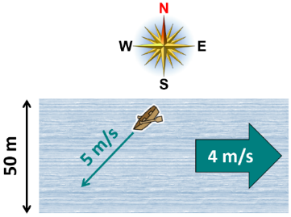
Figure 4.7: In order to go directly South across the river as seen from a dock, the boat will need to be pointed slightly upstream, South and West.¹⁷
If we start by drawing the vector we know, 4 m/s East, we can rotate the 5 m/s until the resultant vector is vertical.
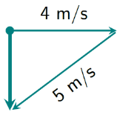
Figure 4.8: Finding the angle to make the resultant vector vertical.¹

Numbers
Assumptions: all parts of the river flow with the same velocity.
Knowns | Unknowns
$$\vec{v_{river←dock}}=4 m/s \hat{E}$$ | $$θ_{boat}$$
$$v_{boat←river}=5 m/s$$ | $$t$$
$$\vec{Δx}=-50 m \hat{N}$$
The angle of any vector is related to its $\hat{x}$ and $\hat{y}$ components by sine, cosine, and tangent.
$$\boxed{sinθ=\frac{A_{y}}{A}}$$
( 4.2 )
$$\boxed{cosθ=\frac{A_{x}}{A}}$$
( 4.3 )
$$\boxed{tanθ=\frac{A_{y}}{A_{x}}}$$
( 4.4 )
…where θ is the angle opposite the $\hat{y}$ component and adjacent to the $\hat{x}$ component of $\vec{A}$.
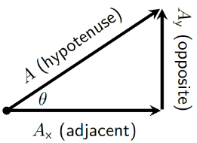

Words
The time needed to cross the river will be longer than if there were no current in the river, because some of the boat’s velocity is used to fight the flow of the river. The faster the river flows, the longer it will take to cross.

Graphics
Using a protractor to measure between the 4 m/s vector and the 5 m/s vector, we find an angle of approximately 35°, so the direction is approximately 35° South of West.
It is important to clearly specify the reference direction and which way the angle is measured from that direction, because compass bearings are measured differently from angles in mathematics and physics.
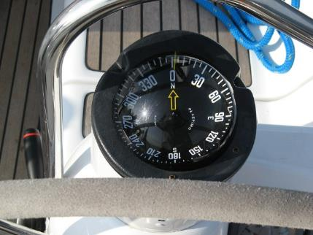
Figure 4.9: Compass bearings start with zero at North and proceed clockwise. Angles in physics usually start at East and proceed counterclockwise.
The speed of the boat as seen from the dock can be found by measuring the vertical vector in Figure 4.8. It is approximately 3 m/s. This can be used to determine the amount of time that is needed to cross the river.

Numbers
“SOHCAHTOA” is a mnemonic used to remember Equations ( 4.2 ), ( 4.3 ), and ( 4.4 ) :
Sine=Opposite/Hypotenuse,
Cosine=Adjacent/Hypotenuse,
Tangent=Opposite/Adjacent.
In this case, using $\hat{x}$ and $\hat{y}$ notation, $\vec{v_{boat←river}}$has a magnitude $v=5 m/s$ and a horizontal component $v_{x}=-4 m/s$. So, we can use SOHCAHTOA, solving for $θ$:
$$θ=arccos\left(\frac{-4 m/s}{5 m/s}\right)={143}^{∘}$$
Unfortunately, in many cases the inverse trigonometric functions like arccos do not give the correct angles on a calculator, because there are multiple possible correct answers mathematically. For that reason, it is usually best to start with a diagram like that in Figure 4.8: Finding the angle to make the resultant vector vertical.¹Figure 4.8 and use only positive values for each part. Finding $θ$ in the upper right of that figure,
$$θ=arccos\left(\frac{4 m/s}{5 m/s}\right)={37}^{∘}$$
…so, 37° South of West. Using Equation ( 4.4 ) we can find that the North/South component of the velocity is -3 m/s. Since velocity is constant in this problem, we can use the average velocity to find the time needed to cross the river.
$$Δt=\frac{\vec{Δx}}{\vec{v_{avg}}}=\frac{-50 m \hat{N}}{-3 m/s \hat{N}}=17 s$$

: Kicking in a New Direction ( )

Words
Since we have started considering two dimensions, we have only looked at motion, not forces, momentum, or energy. Now it’s time to branch out.
A 0.45-kg soccer ball is initially moving at 20 m/s in a direction 30° West of North. A player kicks the ball so that it begins moving at 20 m/s in a direction 30° West of South. The time that the player’s foot is in contact with the ball is 0.02 seconds. How can we describe the ball’s acceleration, energy, momentum, and the force applied to it during the kick?
In the description, the velocity appears to be constant before and after the kick, so the momentum also must be constant before and after the kick, and that also means there is no acceleration before and after the kick. What happens during the kick?
The initial and final speeds are the same, but the direction changes, so the velocity changes during the kick. That means that there was an acceleration, since acceleration is a change in velocity over time. And the time involved, the time of the kick, is very short. That means the acceleration had to be very large to get a large change in velocity in a small amount of time.

Graphics
Figure 4.10: A soccer player kicking a ball.¹¹
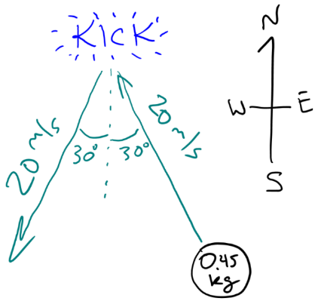
Figure 4.11: A sketch of the physical scenario.¹

Numbers
Assumptions: constant velocity before & after the kick.
Knowns | Unknowns
$$m=0.45 kg$$ | $$\vec{a}$$
$$\vec{v_{0}}=20 m/s @ {30}^{∘} W of N$$ | $$E$$
$$\vec{v_{f}}=20 m/s @ {30}^{∘} W of S$$ | $$\vec{p}$$
$$Δt=0.02 s$$ | $$\vec{F_{foot→ball}}$$
We should start by breaking the velocities up into their component parts using SOHCAHTOA. Since the directions are given in terms of North, South, East, and West, we can use that notation.
$$v_{0,N}=v_{0}⋅cosθ_{0}=17.3 m/s$$
$$v_{0,E}=-v_{0}⋅sinθ_{0}=-10 m/s$$
$$v_{f,N}=-v_{0}⋅cosθ_{f}=-17.3 m/s$$
$$v_{f,E}=-v_{0}⋅sinθ_{0}=-10 m/s$$
Where did the minus signs come from, and why weren’t the angles converted to normal physics notation, with 0° pointing East? The sketch in Figure 4.11 was used to determine positive and negative signs, and to find appropriate triangles using the angles given in the question. This is a simpler approach than converting to normal physics notation, and it avoids the ambiguity in angles that comes from trusting the output of a calculator.

Words
If the velocity changes, that means that the momentum also changes during the kick, which means that a force must have been applied to the ball.
We know that a force applied in the direction of an object’s motion speeds it up, and a force applied opposite the direction of motion slows it down. In this case, a force acted that didn’t actually change the speed of the ball! So, the force must have been in a direction other than the direction of motion.
The ball was initially moving North and West, and after being kicked it was moving South and West. So, we know that there was definitely a change in the North/South direction. There must have been an acceleration to the South, which means that there must have been a force applied to the South, and a change in momentum to the South.
To determine whether a force was also applied to the East or West, details about the velocity or momentum in that direction need to be known.
If we assume that the ball stayed on the ground the whole time, we don’t need to worry about gravitational energy. Kinetic energy depends only on the speed of the ball, and since the initial and final speeds are the same, the kinetic energy is the same before and after the collision.

Graphics
To find a change in momentum, the momentum vectors can be subtracted graphically. So far, we have only learned about adding vectors tip-to-tail. Subtracting a vector is the same as adding its opposite, and the opposite of a vector is another vector with the same magnitude and opposite direction.
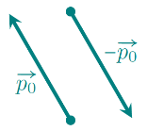
Figure 4.12: Finding the opposite of the initial momentum.¹
Change in momentum is final momentum minus initial momentum, so…
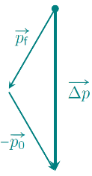
Figure 4.13: Finding the change in the momentum of the soccer ball.¹
The change in momentum of the ball is due South. This means that the force applied to the ball and the acceleration are also due South.

Numbers
If we assume a constant net force during the kick, we can find the acceleration:
$$a_{E}=\frac{v_{f,E}-v_{0_{E}}}{Δt}=0 m/s^{2}$$
$$a_{N}=\frac{v_{f,N}-v_{0_{N}}}{Δt}=-1730 m/s^{2}$$
Combining these, $\vec{a}=-1730 m/s^{2} \hat{N}$.
We can use the masses and velocities to find initial and final momentum:
$$p_{0,N}=m⋅v_{0,N}=7.79 kg⋅m/s \\ p_{0,E}=m⋅v_{0,E}=-4.5 kg⋅m/s \\ p_{f,N}=m⋅v_{f,N}=-7.79 kg⋅m/s \\ p_{f,E}=m⋅v_{f,E}=-4.5 kg⋅m/s$$
Subtracting initial from final momentum gives us the impulse caused during the kick:
$$\vec{Δp}=-15.6 kg⋅m/s \hat{N}$$
Then Newton’s Second Law can be used to find the average force on the ball during the kick:
$$\vec{F_{net,avg,foot→ball}}=\frac{\vec{Δp}}{Δt}=-779 N \hat{N}$$
Since the speed is the same before and after the kick, we know that the kinetic energy is also the same before and after the kick:
$$E_{k}=\frac{1}{2}m⋅v_{0}^{2}=\frac{1}{2}(0.45 kg)(20 m/s)^{2}=90 J$$
Using the velocity vector components instead of the speed gives the same result for energy.

: Checking in Ice Hockey ( )

Words
Ice hockey players commonly run into each other on the ice, often intentionally. During any collision, external forces can generally be neglected because the force of the colliding bodies against each other is so much larger than any other forces that are acting on them.
If a 90-kg hockey player is moving South across the ice at 5 m/s and is struck by an 80-kg hockey player who is moving Northeast at 6 m/s, what can we say about the collision and the two players after the collision? Assume that the collision is perfectly inelastic, so the two become entangled together, not bouncing off each other.
Since this is a collision, we should begin by thinking about momentum. We know that momentum is conserved in any collision, whether it is elastic or inelastic.
Since the 90-kg hockey player was moving South, that player’s initial momentum is to the South. The 80-kg hockey player was moving Northeast, so that player’s momentum was partially North and partially East.
After the two collide and become entangled, their total momentum must be the same as their initial momentum, just as in the one-dimensional problems we have considered previously. But this time we have to think about both directions.

Graphics
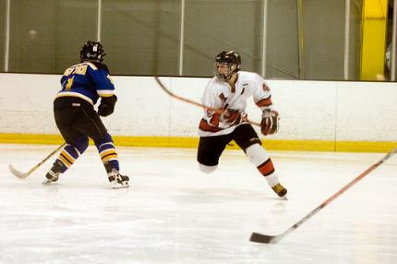
Figure 4.14: Ice hockey players.

Numbers
Assumptions: external forces are negligible; perfectly inelastic collision.
Knowns | Unknowns
$$m_{1}=90 kg$$ | ???
$$\vec{v_{1,i}}=-5 m/s \hat{N}$$
$$m_{2}=80 kg$$
$$\vec{v_{2,i}}=6 m/s @ {45}^{∘} N of E$$
The 45° angle is given, since the direction is listed as Northeast, which is half-way between North and East. $\vec{v_{2,i}}$ can be broken into its component parts using SOHCAHTOA.
$$\vec{v_{2,i}}=4.24 m/s \hat{N}+4.24 m/s \hat{E}$$
As in one dimension, the place to start in any two-dimensional collision is conservation of momentum. But we need to separate the North/South components from the East/West components:
$$\begin{aligned}p_{N,f,tot}&=p_{N,i,tot} \\ p_{E,f,tot}&=p_{E,i,tot}\end{aligned}$$
The North/South component is…
$$\begin{aligned}p_{N,f,tot}&=m_{1}⋅v_{N,i,1}+m_{2}⋅v_{N,i,2} \\ &=\left(90 kg\right)\left(-5 m/s\right)+\left(80 kg\right)\left(4.24 m/s\right) \\ &=-111 kg⋅m/s\end{aligned}$$
And the East/West component is…
$$\begin{aligned}p_{E,f,tot}&=m_{1}⋅v_{E,i,1}+m_{2}⋅v_{E,i,2} \\ &=0+\left(80 kg\right)\left(4.24 m/s\right) \\ &=339 kg⋅m/s\end{aligned}$$

Words
Let’s start with the East/West direction. Initially, the first hockey player has no momentum in that direction, and the second hockey player has momentum to the East. After they collide, the momentum the second hockey player had before the collision is shared by the two hockey players, so they move to the East at a slower speed than the second hockey player had initially.
The North/South direction is more complicated. One hockey player initially has momentum to the North, and the other has momentum to the South. With their different masses, different speeds, and the angle, it is difficult to determine whether after the collision they will be moving slightly North or slightly South, so the final direction should be mostly to the East.
Since the first hockey player was initially moving South and ended up moving mostly East, that player must have experienced a force during the collision that was North and East. That makes sense, because that was the direction the second player was moving before the collision. This means that the second hockey player would have experienced an equal and opposite force, South and West. South is easy to see, because the first hockey player was initially moving South, and there is a force to the West because some of the second player’s Eastward momentum was transferred to the first player.
There was a loss of kinetic energy during the collision; the lost kinetic energy was converted into thermal energy.

Graphics
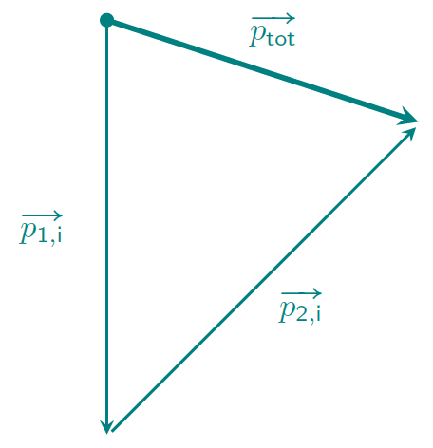
Figure 4.15: Finding the total momentum of the two hockey players.¹
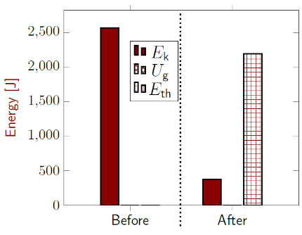
Figure 4.16: Energy bar graph for the collision. Initial thermal energy is taken to be zero. Gravitational energy is zero because both players are on the ground before and after the collision.¹

Numbers
We can convert this into magnitude and direction using the Pythagorean theorem and SOHCAHTOA.
$$\begin{aligned}p_{f,tot}&=\sqrt{{\left(111 kg⋅m/s\right)}^{2}+{\left(339 kg⋅m/s\right)}^{2}} \\ &=357 kg⋅m/s\end{aligned}$$
$$θ_{f}=arctan\frac{p_{N,f,tot}}{p_{E,f,tot}}=-{18}^{∘}$$
The final momentum is correct, but we need to check the angle against a sketch of the situation to be sure. $-{18}^{∘}$ is South and East, and we can use Figure 4.15 to see that this is the correct general direction, so our angle is correct.
Now we can find the final velocity of the hockey players:
$$\vec{v_{f}}=\frac{\vec{p_{f,tot}}}{m_{tot}}=2.10 m/s @ {18}^{∘} S of E$$
Next, we can find the initial and final kinetic energy:
$$E_{k,i}=\frac{1}{2}m_{1}⋅v_{1,i}^{2}+\frac{1}{2}m_{2}⋅v_{2,i}^{2}=2565 J$$
$$E_{k,f}=\frac{1}{2}m_{tot}⋅v_{f}^{2}=375 J$$
Total energy is conserved, and there is no spring energy or gravitational potential energy stored after the collision, so the lost kinetic energy must have been converted to thermal energy.

: Standing on a Rope ()

Words
We have looked in detail at motion and momentum in two dimensions. Let’s turn now to look at forces and energy. Consider the fiddler who is standing on a rope in Figure 4.17. We will assume that the fiddler is not moving. What are the forces that are acting on him? And how much work is he doing? Take the mass of the fiddler to be 70 kg. The rope in front of him and behind him is angled up 25° above the horizontal.
First, it is important to establish the meaning of the question. One way to look at the situation is to say that the only two forces that are affecting the fiddler are the force of gravity, directed downward, and the normal force of the rope pushing up on his feet. That makes this problem essentially the same as the rock sitting motionless on the ground from Section 1.3, which is a one-dimensional question that by now is something that we should be able to answer without much difficulty.
The intent of this question is to investigate the impact of having a rope going off at an angle, so we will use as our system the fiddler and the section of the rope on which he is standing. We aren’t given the mass of the rope, and we will assume that it is negligible compared to the mass of the fiddler.

Graphics
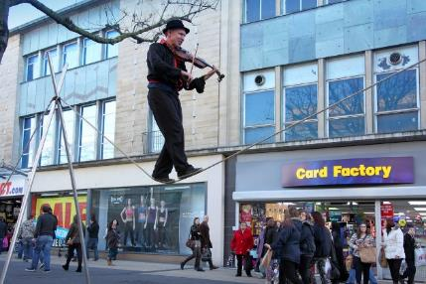
Figure 4.17: A fiddler balancing on a rope.
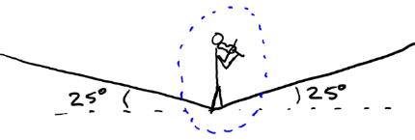
Figure 4.18: Sketch of the fiddler balancing on a rope. The blue dotted line indicates the “system” to be considered when making a force diagram.¹

Numbers
Assumptions: The fiddler is not moving; the mass of the rope is negligible; the part of the rope under the fiddler’s feet is part of the system.
Knowns | Unknowns
$$m=70 kg$$ | Forces on fiddler
$θ_{1}={25}^{∘}$ above horizontal | $$W$$
$θ_{2}={25}^{∘}$ above horizontal
$$g=9.8 N/kg$$

Note that the angles are not necessarily the standard angles in math–they are as described in the text and in Figure 4.18 and Figure 4.19.
To analyze this system, we need to separate the forces shown in Figure 4.19 into $\hat{x}$ & $\hat{y}$ components, using SOHCAHTOA. There are three forces to consider.
Using $+\hat{x}$ to the right and $+\hat{y}$ up…
$$F_{net,x}=F_{t,2}⋅cos{25}^{∘}-F_{t,1}⋅cos{25}^{∘}$$
$$F_{net,y}=F_{t,2}⋅sin{25}^{∘}+F_{t,1}⋅sin{25}^{∘}-F_{g}$$
Since the fiddler is not moving in this scenario, his acceleration is zero. That means, according to Newton’s Second Law, that $\vec{F_{net}}=0$. The $\hat{x}$ direction tells us that
$$F_{t,2}=F_{t,1}$$

Words
Once we have decided on our system, the forces that we need to consider are only the forces that act on our system, not the forces acting inside the system or the forces of the system acting on something else. One force that acts on the system is the force of gravity, which depends on the mass of the system (in this case, the mass of the fiddler, since we are neglecting the mass of the rope).
There are also two ropes that connect our system to things that are outside of the system, and each of those ropes can have a tension force pulling on the system. Tension is always a pulling force, just as the normal force is always a pushing force. Tension is in the direction of the rope, string, chain, etc., and if the rope or other object that is being used to pull is light (often referred to as massless), the tension is the same along the entire length of the rope.
Looking at the sketch in Figure 4.18, we can see that there is symmetry. The angles are the same in front of the fiddler and behind the fiddler, so if the fiddler turned around the picture would be exactly the same. That symmetry tells us that whatever the tension is in the rope in front of the fiddler is the same as the tension behind the fiddler.
When considering the amount of work the fiddler is doing, it was already stated that the fiddler is not moving, and since work is caused by a force acting over a distance, if there is no distance moved then there is no work that is being done.

Graphics
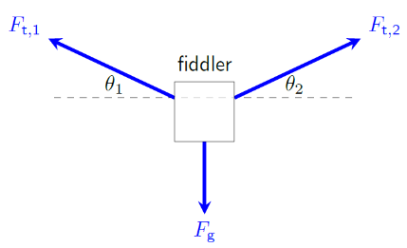
Figure 4.19: Force diagram for the fiddler.¹
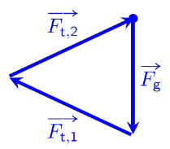
Figure 4.20: Adding the force vectors graphically. The net force is zero, so we know that the arrows must end in the same place where they started.¹
Graphically adding the vectors shows that the horizontal components of the two tension forces must cancel out, because the gravitational force does not have a horizontal component. Graphical addition also shows that the tension force has a slightly larger magnitude than the gravitational force, since all the tension arrows are slightly longer.

Numbers
…so the $\hat{y}$ direction tells us…
$$2⋅F_{t,1}⋅sin{25}^{∘}=F_{g}$$
The magnitude of the force of gravity in this situation is given by $F_{g}=m⋅g$, so…
$$F_{g}=m⋅g=686 N$$
Solving for $F_{t,1}$, we get…
$$F_{t,1}=\frac{F_{g}}{2⋅sin{25}^{∘}}=812 N$$
Because of the angles involved, the tension in the rope is actually larger than the force of gravity!
Now we can find the work that the person is doing:
$$W=\vec{F}⋅\vec{Δx}$$
And since there is no motion $\left(\vec{Δx}=0\right)$, $W=0$. No work is being done.
It may seem strange that no work is being done, because if you have ever tried to balance on a rope, you know that it is tiring, with constant adjustments that need to be made. Your muscles are absolutely doing work with all these small movements. This analysis showing no work simply means that there is no change to the kinetic or gravitational potential energy of the person as they are standing on the rope.

: Pulling a Sled ( , )

Words
Figure 4.19 shows a moose that is connected to a sled. Imagine that the moose is pulling the sled across level ground at a constant velocity of 3 m/s to the left. The strap that it pulls with is at an angle of 30° above the horizontal, the mass of the loaded sled is 200 kg, and the magnitude of the frictional force between the sled and the ground is 800 N.
Analyze this physical scenario as thoroughly as you can.
We are given very little information about the moose, so we should instead focus on the sled for our analysis. Since the velocity is constant, there are several things that we know immediately:
- The momentum must be constant.
- The kinetic energy must be constant.
- The acceleration, which is the change in velocity over time, must be zero.
- Since the momentum is constant (or since the acceleration is zero), the net force on the sled must be zero. In other words, the forces are balanced.

Graphics
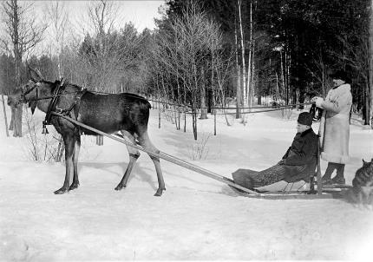
Figure 4.21: A moose strapped to a sled.

Motion Map
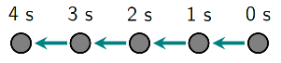
Figure 4.22: Motion map of the sled moving to the left at constant velocity.¹
We could draw a momentum vs time graph, or an energy bar graph with only one bar, but usually those are only useful when we want to show a change in something. Since momentum and energy are both constant, drawing them is not very useful.

Numbers
Assumptions: $+\hat{x}$ direction is to the right; $+\hat{y}$ direction is upward.
Knowns | Unknowns
$$m=200 kg$$ | ???
$θ={30}^{∘}$ above horizontal
$$\vec{v}=-3 m/s \hat{x}$$
$$F_{f}=800 N$$
The momentum of the sled is given byL
$$\vec{p_{sled}}=m⋅\vec{v}=-600 kg⋅m/s \hat{x}$$
We can also find the kinetic energy:
$$E_{k,sled}=\frac{1}{2}m⋅v^{2}=900 J$$
Acceleration is zero since velocity is not changing:
$$\vec{a_{avg}}=\frac{\vec{Δv}}{Δt}=0$$
Since $\vec{a}=0$, Newton’s Second Law tells us that the net force is also zero. So, the sum of the forces in both the $\hat{x}$and the $\hat{y}$directions must be zero.
$$F_{net,x}=F_{f}-F_{t}⋅cosθ=0$$
We are given $F_{f}$, so we can solve for $F_{t}$:
$$F_{t}=\frac{F_{f}}{cosθ}=923 N$$

Words
The force of gravity is balanced partly by the normal force but also partly by the upward part of the tension in the strap, so the normal force should be less than the gravitational force in this case. The forward part of the tension force needs to be just large enough to balance the force of friction.
The net work that is being done is zero, since the energy is not changing, but in fact the moose is doing work by pulling the sled, and the frictional force is doing negative work to try to stop the sled.
Work is caused by a force being applied through a displacement, and the displacement is constantly increasing in time since the sled is moving at a constant velocity. That means that the moose is doing a constant amount of work per time.
In physics we have a special name for work per time: Power. Power is measured in watts, where 1 watt is 1 joule per second.

Graphics
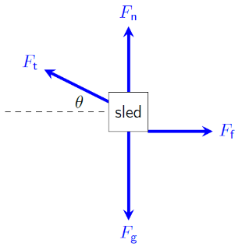
Figure 4.23: Force diagram for the sled, with guesses about the magnitudes of each arrow.¹
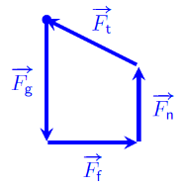
Figure 4.24: Adding the force vectors graphically. The net force is zero, so we know that the arrows must end in the same place where they started.¹
Just from adding the force vectors graphically with correct directions but without doing calculations for magnitudes, we can see that the only way the net force can be zero is for the normal force to be smaller than the gravitational force and for the horizontal component of the tension force to exactly cancel the frictional force.

Numbers
Figure 4.23 shows us that
$$F_{net,y}=F_{n}+F_{t}⋅sinθ-F_{g}=0$$
$F_{g}$ is the mass times the gravitational field strength, or 1960 N. We can solve for the only thing we don’t know in that mathematical model, $F_{n}$.
$$F_{n}=F_{g}-F_{t}⋅sinθ=1500 N$$
The force of friction is opposing the direction of motion, so as the sled moves, friction is doing negative work on the sled. The moose is doing positive work on the sled, so that the net work is zero. The amount of work done by the moose is…
$$W=F⋅Δx⋅cosθ$$
But we don’t have a displacement in this scenario. The displacement increases over time, so the work also increases over time. The moose is doing a constant amount of work per unit time, or supplying a constant power:
$$\boxed{P_{avg}=\frac{W}{Δt}=\frac{F⋅Δx⋅cosθ}{Δt}}$$
( 4.5 )
…where $P_{avg}$ is power, and the last part of the equation is valid while the force is constant. Power can also be expressed as…
$$\boxed{P=F⋅v⋅cosθ}$$
( 4.6 )
So the power supplied by the moose is:
$$P_{moose}=F_{t}⋅v⋅cosθ=2400 W$$

: Pulling a Frictionless Sled ( , )

Words
Let’s consider the same physical scenario as in Section 4.7, but this time consider what would happen if there were no friction between the sled and the ground.
If the moose started at rest and pulled the 200 kg sled with the same force as before, 923 N, at an angle of 30° above the horizontal, across a horizontal distance of 50 m, what would happen?
Again, we are given very little information about the moose, so we should instead focus on the sled for our analysis.
The moose is generating a force that is acting over a certain distance, so a good starting point would be to consider the work that the moose is doing. The moose does work on the sled, which increases the kinetic energy of the sled. At first the sled is not moving, so it begins with zero kinetic energy. The sled stays on level ground the entire time, and there are no springs to worry about, so all the work done by the moose is converted into kinetic energy.

Graphics
Figure 4.25: A moose strapped to a sled.²¹
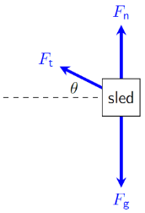
Figure 4.26: Force diagram for the sled, with arrow lengths based on the forces found in Section 4.7.¹

Numbers
Assumptions: $+\hat{x}$ direction is to the right; $+\hat{y}$ direction is upward; negligible air resistance.
Knowns | Unknowns
$$m=200 kg$$ | ???
$$F_{t}=923 N$$
$θ={30}^{∘}$ above horizontal
$$Δx=-50 m \hat{x}$$
$$F_{f}=0 N$$

Since there is no acceleration in the vertical direction, our analysis of the $y$ components of force in Section 4.7 where $F_{net,y}=0$ remains valid. But we need to reconsider$F_{net,x}$.
$$F_{net,x}=-F_{t}⋅cosθ=-800 N$$
Since we know the mass of the sled, we can also find its acceleration:
$$\vec{a}=\frac{\vec{F_{net}}}{m}=-4 m/s^{2}$$
Given net force and displacement, we can use work to find final kinetic energy:
$$W_{net}=F_{net}⋅Δx⋅cosθ=ΔE_{k}=E_{k,f}-E_{k,i}$$

Words
The net force on the sled gives it an acceleration in the same direction as the net force, to the left. Since the sled started at rest, its speed will increase to the left over the entire time that the moose is pulling. That also means that the momentum will be increasing to the left the entire time that the moose is pulling.
In the physical situation examined in Section 4.7, the velocity was constant, so the power supplied by the moose was constant. In this situation, the speed is increasing, so every second the moose is covering more distance than it did in the previous second. That means every second the moose is doing more work than it did in the previous second.
So, the amount of power that the moose is producing increases as its speed increases. For any real creature or machine, the power it can produce limits the amount of force that it is able to apply to an object. Typically, a larger force can be applied when the object is moving at a low speed, and as speed increases power becomes the limiting factor.

Graphics
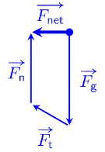
Figure 4.27: Adding the force vectors graphically shows that there is a net force to the left.¹
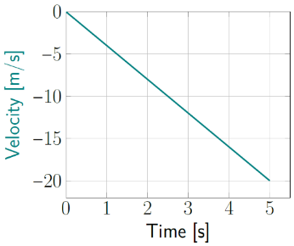
Figure 4.28: Velocity of the sled.¹

Numbers
…where $θ$ is the angle between $\vec{F_{net}}$ and $\vec{Δx}$, not the angle of the strap that the moose is using to pull the sled.
$$E_{k,f}=(800 N)⋅(50 m)⋅cos0^{∘}=40 000 J$$
From here, we can find the final speed of the sled:
$$E_{k,f}=\frac{1}{2}m⋅v_{f}^{2}$$
Interestingly, since we found acceleration earlier, we could have found the velocity in a more direct route. Multiplying the above equation for $W_{net}$ by 2, dividing by $m$, and rearranging it slightly gives:
$$\boxed{2a⋅Δx⋅cosθ=v_{f}^{2}-v_{i}^{2}}$$
( 4.7 )
This is commonly considered to be a standard equation of motion.
Once we have the final velocity and the acceleration, we can also find the time needed for the moose to pull the sled 50 m.
The power that the moose uses to pull the sled increases over time, even though the force stays the same. This can be seen from Equation
( 4.6 ), knowing that the velocity is increasing in time since the force is constant. The maximum power will be needed at the maximum speed:
$$P_{max}=F_{net}⋅v_{f}⋅cos0^{∘}$$

: Waterslide ( )

Words
The waterslide shown in Figure 4.29 has an extremely steep slope at the top. Water is used to lubricate the slide during operation, making it essentially frictionless.
The slide has a height of 9 m and the slope goes down at an angle 70° from the horizontal. If a 50 kg rider starts at the top at rest and slides down the steep slope, what is her acceleration down the steep slope, what is her speed when she reaches the bottom of the steep slope, and how much time does it take her to reach the bottom of the steep slope?
We need to consider the acceleration down the slide. Acceleration is a vector, so it includes direction. We could specify the direction of the acceleration using x and y components, or a magnitude in some direction, but it would be easier if we just created a way to refer to the direction down the slope. We can call that the “parallel” direction, and then the “perpendicular” direction would be at a right angle to the direction of the slope.
If the slope were completely flat, then the rider would just sit there, not accelerating. If the slope were completely vertical then the rider would be in free-fall, accelerating down the slope with the full force of gravity caused by the earth’s gravitational field. Between these two extremes, the steeper the slope, the closer the acceleration would be to that caused by the gravitational field.

Graphics
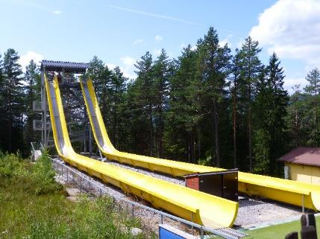
Figure 4.29: A waterslide.
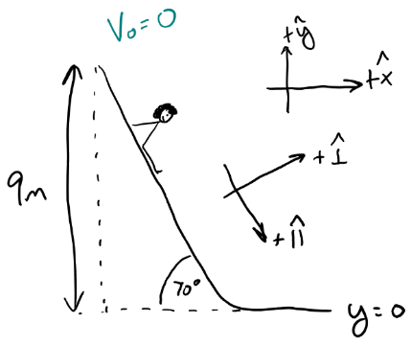
Figure 4.30: A sketch of the rider on the waterslide. x & y axes are shown, as are parallel and perpendicular axes.¹

Numbers
Assumptions: $+\hat{x}$ direction is to the right; $+\hat{y}$ direction is upward; $+\hat{∥}$ direction is down the slide; $+\hat{⟂}$ direction is normal to the surface of the slide.
Knowns | Unknowns
$$m=50 kg$$ | $$\vec{a}$$
$θ={70}^{∘}$ above horizontal | $$v_{f}$$
$$y_{0}=9 m$$ | $$Δt$$
$$y_{f}=0 m$$
$$v_{0}=0 m/s$$
$$F_{f}=0 N$$

We can use work and energy to find the speed at the bottom of the slope. There are no external forces or springs, and no friction to generate thermal energy, so we only need to consider kinetic and gravitational potential energy.
$$E_{k,i}+U_{g,i}=E_{k,f}+U_{g,f}$$
Taking ground level to be _{y} = 0…
$$0+m⋅g⋅y_{0}=\frac{1}{2}m⋅v_{f}^{2}+0$$
$$v_{f}=\sqrt{2g⋅y_{0}}=13.3 m/s$$

Words
If there is really no friction on the waterslide, then the only forces affecting the rider are gravity and the normal force. And since the motion is perpendicular to the normal force, the normal force doesn’t do any work on the rider. So, it is only gravity that affects the rider’s energy. Since energy is conserved, all the rider’s gravitational potential when she is at the top of the waterslide will be converted to kinetic energy when she reaches the bottom. Surprisingly, that means it doesn’t actually matter how steep the slope is–the speed at the bottom will be the same if the rider has dropped the same vertical distance.
The amount of time that the rider takes to reach the bottom will depend on how steep the slope is. If the slope is steep, then the distance traveled will be short and the acceleration will be large. If the slope is shallow, then the distance traveled will be longer and the acceleration will be smaller, and both of these changes will mean a longer time to the bottom with a shallower slope.
In our everyday experience, we would say that the rider would be going faster at the bottom if the slope is steep. That is correct, because in everyday life the friction is never really zero, and in fact the frictional force would be smaller when the slope is steeper.

Graphics
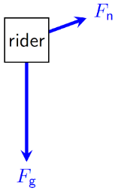
Figure 4.31: Force diagram of the rider on the waterslide.¹
Since the acceleration of the rider is in the parallel direction, the net force also must be in the parallel direction, giving us the relative magnitudes of $F_{g}$, $F_{n}$, and $F_{net}$.
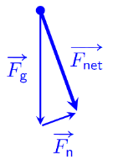
Figure 4.32: Adding the force vectors graphically.¹

Numbers
If we knew the rider’s displacement from the top to the bottom of the steep slope, we could use Equation ( 4.7 ) to find her acceleration down the slope. The magnitude of the displacement is the length of the steep slope, which we can find from Figure 4.30 using SOHCAHTOA:
$$Δx=\frac{y_{0}}{sin{70}^{∘}}$$
Since the displacement and the acceleration are both in the positive parallel direction, Equation ( 4.7 ) gives…
$$2a_{∥}⋅Δx_{∥}⋅ cos0° =v_{f}^{2}-0^{2}$$
$$a_{∥}=\frac{v_{f}^{2}}{2Δx_{∥}}=\frac{2g⋅y_{0}}{2\frac{y_{0}}{sin{70}^{∘}}}=g⋅sin{70}^{∘}$$
Which means that the force due to gravity down a slope is given by
$$F_{g,∥}=m⋅g⋅sinθ$$
…where the positive parallel direction is down the slope and $θ$ is the angle of the slope above the horizontal.
In the direction perpendicular to the slope, the gravitational force pointing into the slope exactly cancels the normal force out of the slope. Using Figure 4.32 and SOHCAHTOA…
$$F_{g,⟂}=-m⋅g⋅cosθ$$
…where the positive perpendicular direction is up out of the slope and is the angle of the slope above the horizontal.

: Summary
Chapter summaries in this book are ordered by concept, not necessarily in the order in which they are presented in the chapter. Mathematical models are grouped together at the end of each summary. See the appendices for the meanings of all symbols used in this book.

General
- The two dimensions at right angles to each other can be considered completely independent from each other in terms of forces, momentum, and motion. For example, a force in the vertical direction does not affect motion in the horizontal direction.
- It is important to sketch a physical situation when dealing with angles, so you have a general idea of the directions. Trusting in a calculator alone to give a correct answer for an angle is risky, because for every trigonometric function there are multiple angles that give the same answer.
- Vectors can be added numerically by breaking them up into components and adding the components separately.
- Vectors can be added graphically by combining them “tip to tail,” with the resultant vector starting at the tail of the first vector and ending at the tip of the last vector. This provides a good estimate of the resultant vector if the drawing is made and measured carefully.
- Subtracting a vector is the same as adding the opposite of the vector. The opposite of a vector is another vector with the same magnitude and opposite direction.
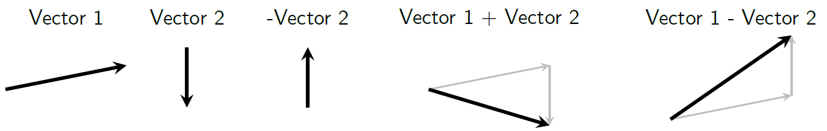
Sample addition and subtraction of vectors1

Forces & Acceleration
- If a force is applied in a direction that is not in the direction of an object’s motion and not opposite the direction the object’s motion, the direction of its motion will change.
- Tension is a pulling force that is in the direction of the string, rope, chain, etc.
- If a rope or other object that is being used to pull is light (often referred to as massless), the tension is the same along the entire length of the rope.

Energy
- Power is work per time.

Mathematical Models
Equation | Reference | Restrictions on the validity of the equation
“Pythagorean theorem”  $$A^{2}=A_{x}^{2}+A_{y}^{2}$$ | ( 4.1 ) | right triangle
“SOHCAHTOA”  $$sinθ=\frac{A_{y}}{A}$$ | ( 4.2 ) | -none-
“SOHCAHTOA”  $$cosθ=\frac{A_{x}}{A}$$ | ( 4.3 ) | calculator may give wrong theta–confirm with a sketch
“SOHCAHTOA”  $$tanθ=\frac{A_{y}}{A_{x}}$$ | ( 4.4 ) | calculator may give wrong theta–confirm with a sketch
$$P_{avg}=\frac{W}{Δt}=\frac{F⋅Δx⋅cosθ}{Δt}$$ | ( 4.5 ) | calculator may give wrong theta–confirm with a sketch
$$P=F⋅v⋅cosθ$$ | ( 4.6 ) | last part only valid when the force is constant
$$2a⋅Δx⋅cosθ=v_{f}^{2}-v_{i}^{2}$$ | ( 4.7 ) | -none-

: Questions
Questions are ordered according to Bloom’s Taxonomy, progressing from regurgitating information (Level 1) to synthesizing new information with previous knowledge to create something new (Level 6). The bold letters at the beginning of each question indicate whether the question involves Words [W], Graphics [G], and/or Numbers [N]. See the appendices for conversion factors.

Level 1 – Remember
      - [G & N] Which gives the most accurate result, adding vectors graphically or numerically?
      - [W & G] Describe the direction that the boat in Figure 4.5 is moving, in terms of compass directions.
Symbol | Reference | Label
$$A^{2}$$ | ( 4.1 )
$$sinθ$$ | ( 4.2 )
$$cosθ$$ | ( 4.3 )
$$tanθ$$ | ( 4.4 )
$$P_{avg}$$ | ( 4.5 )
$$P$$ | ( 4.6 )
$$2a⋅Δx⋅cosθ$$ | ( 4.7 )
      - [W & N] Add labels to each boxed equation from this chapter that tell what the symbol to the left of the = sign represents.

Level 2 - Understand
      - [W & N] Why is it especially important to sketch physical scenarios instead of just trusting a calculator when it comes to angles?
      - [N] How much thermal energy was generated in the collision described in Section 4.5?
      - [W & G] Motion maps can be drawn in two dimensions. Create a motion map showing the soccer ball from Section 4.4 from three seconds before the kick to three seconds after the kick.
      - [N] What are the initial momenta for each of the ice hockey players in Section 4.5, in the earth’s reference frame?
      - [G & N] Equation ( 4.6 ), reproduced below, includes an angle θ, but the text doesn’t say what the angle is. Based on what you know about Equation 2.4, what would this θ be measured between? Make a sketch that shows the angle θ in relation to the other variables in this mathematical model.
$$P=F⋅v⋅cosθ$$
      - [N] In the calculation of final kinetic energy in Section 4.8, $0^{∘}$ is used for $θ$, but in the “knowns” it says $θ={30}^{∘}$. Is this an error in the text? Explain your answer.

Level 3 - Apply
      - [G & N] For the physical scenario considered in Section 4.2, the velocity of the boat as seen by the dock is calculated in component form, and the magnitude of the velocity is also found, but the direction is not found. Find the direction.
      - [N] At the end of Section 4.4, a statement is made that using velocity vector components instead of speed gives the same result when calculating kinetic energy. Verify this statement by calculating the initial and final kinetic energy of the soccer ball in Section 4.4 using the North and East components of the velocity and comparing to the given result that was calculated using the speed.
      - [G & N] If everything else stayed the same, what initial speed of the first hockey player in Section 4.5 would have resulted in a final momentum that was due East?
      - [G & N] If everything else stayed the same, what initial speed of the second hockey player in Section 4.5 would have resulted in a final momentum that was due East?
      - [G] Create a motion map representing the position of the sled in Section 4.8 as the moose pulls it 50 m.
      - [G & N] The final velocity and maximum power are not calculated in Section 4.8. Calculate values for them.

Level 4 - Analyze
      - [W, G, & N] If the river in Section 4.2 were 50 m wide like the river in Section 4.3, how much time would the boat need to cross the river if it were pointed directly South? What is the best direction in which to angle a boat if you want to cross the river as quickly as possible with no regard for the distance the boat travels downstream?
      - [W & G] First, draw the motion map for the soccer ball from the question in the “Level 2 - Understand” section. Then, explain how the motion map shows the acceleration during the kick.
      - [G & N] Find the direction of the force that would have to be applied to the soccer ball in Section 4.4 for its final velocity to be…
        - …due East at 20 m/s.
        - …due West at 10 m/s.
        - …20 m/s @ 30° East of South.
      - [N] Find the magnitudes and directions of the forces on each hockey player in the collision described in Section 4.5, if the length of time that the two players are crashing into each other is 0.05 seconds.
      - [W, G] Redraw Figure 4.18, Figure 4.19, and Figure 4.20 for the rope at the following angles, and describe how the magnitude of the tension force in the ropes would be different from that with the rope at the original angle.
        - $θ={75}^{∘}$ above the horizontal
        - $θ=5^{∘}$ above the horizontal

Level 5 - Evaluate
      - [W, G, & N] According to Section 4.2, for a boat moving at a speed of 5 m/s relative to a river whose speed is 4 m/s, the highest possible speed for the boat as seen from the dock is 9 m/s, and the slowest possible speed is 1 m/s. Is there any direction that the boat could travel such that its speed relative to the water is still 5 m/s, and the speed of the boat relative to the dock is also 5 m/s? If not, explain why not. If so, find the direction graphically or numerically.
      - [W, G, & N] Describe using words and either graphics or numbers how the acceleration, final energy, and final momentum of the soccer ball in Section 4.4 would have been different if the force applied to the ball during the kick were doubled and the time remained the same.
      - [W, G, & N] Consider the physical scenario described in Section 4.5. Are the speeds and masses reasonable? Is the assumption about the collision being perfectly inelastic reasonable? Give reasons for your answers.
      - [W, G, & N] Analyze the physical scenario of the moose pulling the sled in Section 4.8 if the mass of the sled were to be cut in half and all other given quantities remained the same. What effect would this have on the motion, momentum, forces, energy, and power?
      - [W, G, & N] Analyze the physical scenario of the moose pulling the sled in Section 4.8 if the mass of the sled were to be cut in half and the pulling force of the moose were also cut in half. What effect would this have on motion, momentum, forces, energy, and power?
      - [W, G, & N] Is the final speed attained by the moose and sled in Section 4.8 reasonable? Explain your answer. If it is not reasonable, what faulty assumptions or unrealistic starting parameters result in an unreasonable answer?

Level 6 - Create
      - [W, G, & N] At the beginning of Chapter 1 in Figure 1.1 was a template for a concept map. Start a new concept map for two-dimensional scenarios.
      - [W, G, & N] Imagine you are writing a test question related to this chapter. Think of your own example of a situation that you can analyze using the concepts, graphics, and mathematical analyses described in this chapter. Describe the situation and use the tools from this chapter to analyze the situation as completely as you can, including motion, forces, energy, and momentum.
      - [W, G, & N] Think about possible misconceptions about the material in this chapter. Write a question and an incorrect solution to it that demonstrates a student making such a conceptual error. This cannot be a simple misuse of a vocabulary word, a unit error, or a mathematical error like making an addition error or multiplying when addition was needed, unless the error is rooted in a real misunderstanding about the physics behind the calculation or the misuse of a word. After you have written the question and incorrect solution, explain what is wrong with the student’s solution, and write a correct solution to the problem. Note: You may use a question from this chapter that you got wrong the first time and explain the initial error in your thinking and how you corrected it.

– Variable Forces
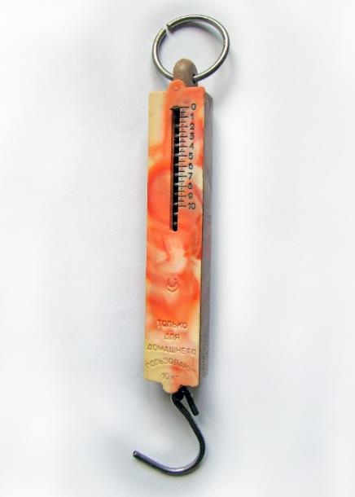
Figure 5.1: A spring scale, which changes in length as the tension force changes.

So far, we have considered only situations where force is constant. That makes life easier, and it allows us to use reasonably simple mathematical models. But the world isn’t simple, and now it is time to begin addressing situations where forces change.
Many machines are built in such a way that they can use a small force to generate a larger force. This is true, for example, with pulleys, screwdrivers, pliers, and systems of gears. We will look at a system of pulleys to demonstrate how a small force can be used to create a larger force.
In the spring scale shown in Figure 5.1, the distance between the ends of the scale is related to the amount of force applied by the scale. That’s what makes it function as a scale–you can read the position to know the amount of force. So, with a spring, force is dependent upon displacement.
Another example of a force that changes depending on the physical scenario is frictional force. Friction opposes the relative motion between two objects, so if the direction of motion changes, the direction of the frictional force also changes. If the two objects are not moving relative to each other, the frictional force changes depending on the net force created by all other forces, adjusting to keep the total net force at zero so the objects remain stationary relative to each other.
Finally, we will look again at gravitational force. We have been using g as the strength of the earth’s gravitational field, but that is only true at the surface of the earth. In fact, the gravitational field changes with distance from the center of the earth...and with distance from the center of everything else in the universe.

: Pulleys ( , )

Words
A pulley is a wheel that can spin around an axle, with a rope, chain, etc., that goes around the outer edge of the wheel. For now, we will assume that both friction and the mass of the pulleys is negligible. Such pulleys can freely rotate, so a rope that is wrapped around a pulley has the same tension on each side of the pulley. Wrapping a rope around a pulley effectively changes the direction of the motion of the rope and the direction of the tension.
We will consider a 4-kg mass hanging from a single pulley that is held up using a rope that is wrapped around two pulleys as shown in Figure 5.2. Note that there are three ropes in the figure: one wrapped around the pulleys, and one connected to the center of each pulley. One end of the longest rope is connected to the ceiling, and the other end is pulled down by an applied force. The mass is moving upward at a constant speed of 3 m/s. We should be able to find the tension in all three ropes and the magnitude of the applied force that is needed to lift the mass at a constant speed. We should also be able to find the amount of power that is being used to lift the mass and the amount of power supplied by the applied force.
Looking at Figure 5.3, there are actually two sections of rope 1 that together hold up the mass. Since the mass is not accelerating, the forces are balanced; the tension in rope 1 must be half of the weight of the mass.

Graphics
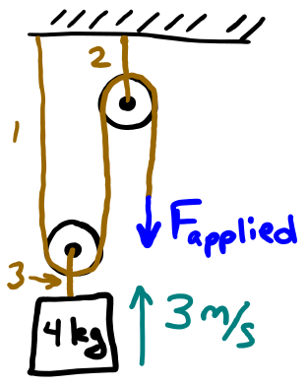
Figure 5.2: A system of two pulleys being used to lift a 4 kg mass. Note that there are three different ropes, labeled 1-3.¹
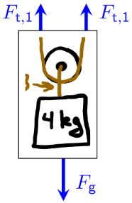
Figure 5.3: Force diagram of the 4 kg mass and the pulley closest to it.¹

Numbers
Assumptions: friction is negligible; mass of pulleys is negligible; near the surface of the earth; upward is $+\hat{y}$.
Knowns | Unknowns
$$m=4 kg$$ | $$F_{t,1}$$
$$v_{mass}=3 m/s$$ | $$F_{t,2}$$
$$g=9.8 N/kg$$ | $$F_{t,3}$$
 | $$F_{applied}$$
 | $$P_{lift}$$
 | $$P_{applied}$$
Since the mass is moving at constant speed, its acceleration is zero. That means the net force on the mass is zero. Using Newton’s Second Law with the force diagram in Figure 5.3…
$$\vec{F_{net}}=m⋅ \vec{a} \\ 2F_{t,1}-m⋅g=0 \\ 2F_{t,1}=m⋅g \\ F_{t,1}=\frac{m⋅g}{2} \\ F_{t,1}=19.6 N$$
Since the tension force in rope 1 is the same everywhere, we can see from Figure 5.2 that $F_{applied}$ is the same as $F_{t,1}$. A similar analysis on the pulley closest to the mass shows that $F_{t,3}$ is 39.2 N.

Words
Rope 3 only has one section, so its tension must be equal to the weight of the mass since the mass is not accelerating.
The applied force supplies the tension on one side of rope 1, so the applied force is also half of the weight of the mass. This system of pulleys creates a type of machine that creates an output force (used to lift the mass) that is twice as large as the input (applied) force, so we say that this machine has a “mechanical advantage” of two. Mechanical advantage is simply the ratio of the output force to the input force.
At first, it may seem that doubling the force should also double the power since power is proportional to force and velocity. That would violate conservation of energy, so that shouldn’t be possible. As can be seen in Figure 5.5, the rope at the position of the applied force is moving faster than the mass. The increased speed is just enough to make the output power the same as the input power. So, energy is conserved even in a machine with a mechanical advantage that is greater than 1.

Graphics
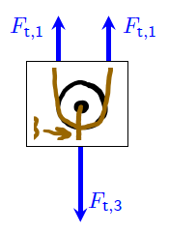
Figure 5.4: Force diagram of the pulley closest to the 4 kg mass.¹
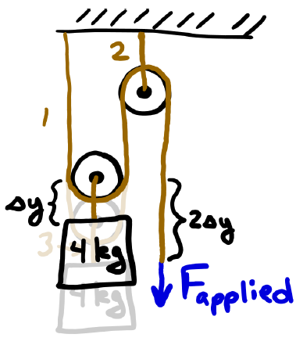
Figure 5.5: The applied force must move twice as quickly as the mass in this system. Notice that when the mass rises by $Δy$ both the left section and the middle section of rope 1 get shorter by $Δy$, so for the rope to stay the same length the right section has to get longer by $2Δy$.¹

Numbers
The mechanical advantage $MA$ of a machine is given by…
$$\boxed{MA=\frac{F_{output}}{F_{input}}}$$
( 5.1 )
In this situation…
$$\begin{aligned}MA&=\frac{F_{output}}{F_{input}} \\ &=\frac{39.2 N}{19.6 N} \\ &=2\end{aligned}$$
We can also find the power needed to lift the mass:
$$\begin{aligned}P_{avg}&=\frac{W}{Δt}=\frac{ΔE}{Δt} \\ &=\frac{m⋅g⋅Δy}{Δt} \\ &=m⋅g\frac{Δy}{Δt} \\ &=\left(4 kg\right)\left(9.8 N/kg\right)\left(3 m/s\right) \\ &=118 W\end{aligned}$$
The power supplied by the applied force can be found using the velocity. But we need to be careful, because as illustrated in Figure 5.5, the applied force is moving at twice the speed of the mass.
$$P=F⋅v⋅ \cos{θ } \\ =\left(19.6 N\right)⋅\left(6 \frac{m}{s}\right) \\ =118 W$$

: Spring Scale ()

Words
Springs are physical objects that are usually made from metal because of many metals’ ability to return to their original shape after being flexed. Springs can produce force, and they can also store potential energy. For an ideal spring, the force required to stretch or compress it is proportional to the amount of extension or compression. This is referred to as “Hooke’s Law.” We will consider only ideal springs. Real springs are more complicated. For example, they do not obey Hooke’s Law when the compression or extension is too large, and springs can become permanently deformed if stretched too far.
Let’s consider the spring inside the scale shown in Figure 5.6. If the markings represent the mass of an object that is hanging from the hook, measured in kg, and the spacing between each number is 0.01 m, what is the stiffness of the spring, and how much potential energy is stored in the spring if a 5 kg mass is hanging from the hook?
It is important to notice that the numbers on the scale do not refer to the length of the spring. They refer to how far the spring is compressed from its natural length.

Graphics
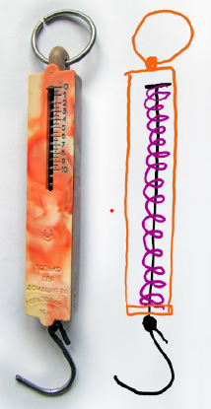
Figure 5.6: spring scale and a schematic of the way the spring is connected inside.
The ring at the top of the scale is connected to the orange body of the scale, which is connected to the bottom of the (purple) spring inside. The black hook at the bottom of the scale is connected to a rod that passes up through the spring and is connected to the top of the spring. Pulling down on the hook presses down on the top of the spring.

Numbers
Assumptions: ideal spring.
Knowns | Unknowns
0.01 m/kg | $$k_{s}$$
 | $U_{s}$ for 5 kg
k_{s}, the spring constant, is a measure of the stiffness of a spring. It is defined using Hooke’s Law:
$$\boxed{\vec{F_{s}}=-k_{s}⋅\vec{Δx}}$$
( 5.2 )
…where $\vec{F_{s}}$ is the force of the spring acting on whatever is extending or compressing it, $k_{s}$ is the spring constant, and $\vec{Δx}$ is the displacement of the end of the spring from its unstretched and uncompressed “equilibrium” position. $k_{s}$ always has a positive value. The minus sign in Hooke’s Law tells us that the force applied by the spring is opposite the direction of the displacement. For example, if a spring is stretched to the right, it will be pulling to the left.
Hanging one kg from this scale compresses the spring by 0.01 m. We can use this information to find the spring constant with Hooke’s Law. As can be seen in the force diagram in Figure 5.7 when the system is in equilibrium, all the forces that are acting on the 1 kg mass are in the vertical direction. So, we only need to consider the $\hat{y}$ components of the forces.

Words
Stiffness is measured in terms of the spring constant, in newtons per meter. A stiffer spring (higher spring constant) compresses less when a force is applied.
A spring at its natural length cannot do any work, so it has no spring potential energy. Any work done on the spring to stretch or compress it gets stored as spring potential energy. The further a spring is stretched or compressed, the more energy it stores. A stiffer spring stores more energy than a less stiff spring when stretched or compressed the same.
An ideal spring stores the same amount of energy whether it is stretched or compressed, if the amount of extension or compression is the same. Spring potential energy is another type of mechanical energy.
Spring force, like other forces we have considered so far, is referred to as a “conservative force.” This means that energy is conserved by the force– it is essentially converting energy between potential (spring) energy and kinetic energy. It doesn’t matter how many times the spring compresses and expands, the energy will be conserved. A nonconservative force would be one that transforms energy into a form other than kinetic or potential energy. With a non-conservative force, the amount of kinetic and potential energy that is “lost” to another form of energy depends on the path that was traveled by the object. If it went back and forth multiple times, for example, the final total kinetic and potential energy would be lower.

Graphics
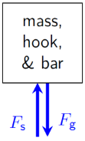
Figure 5.7: Force diagram of the mass, hook, and metal bar when the system is in equilibrium.¹

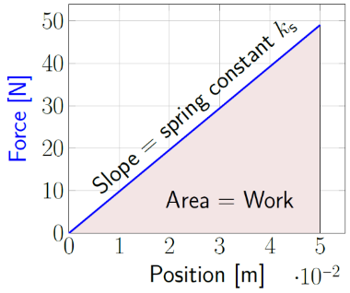
Figure 5.8: As the distance the spring is stretched (or compressed) increases, the force required to stretch (or compress) it also increases in linear fashion.¹

Numbers
$$F_{net,y}=0=\left(-k_{s}⋅(-0.01 m)\right)-\left(m⋅g\right)$$
$$k_{s}=\frac{m⋅g}{0.01 m}=\frac{(1 kg)⋅\left(9.8 N/kg\right)}{0.01 m}=980 N/m$$
We have not only found the value for the spring constant; we have also found that the unit for the spring constant is [N/m].
To find energy stored in the spring, we need to consider how much work is used to stretch or compress the spring. Work is done by a force acting over a distance, so we need the distance that the spring is compressed. We could use Hooke’s law, but it is simpler to use a simple ratio:
$$\left(5 kg\right)⋅\left(0.01 m/kg\right)=0.05 m$$
We can use Figure 5.8 to find the work that was done in compressing the spring by finding the area under the curve. It is triangular, so the area is $\frac{1}{2}b⋅h$. The base is 0_{.05 m}, and the height is the magnitude of the force associated with the maximum distance:
$$F_{s}=k_{s}⋅Δx$$
The area under the curve is therefore:
$$W=\frac{1}{2}⋅Δx⋅k_{s}⋅Δx=\frac{1}{2}⋅k_{s}⋅Δx^{2}$$
So, the potential energy stored in a spring is…
$$\boxed{U_{s}=\frac{1}{2}⋅k_{s}⋅Δx^{2}}$$
( 5.3 )

: Bouncing Ball ( , )

Words
The collision between a tennis ball and a concrete driveway was recorded using high-speed video at a frame rate of 240 frames per second. Five consecutive frames are shown from left to right in Figure 5.9. The tennis ball has a mass of 57 g and a diameter of 6.6 cm. Analyze the motion, forces, energy, and momentum in this situation, considering the vertical direction only.
By using the tennis ball as a length scale, we should be able to determine the initial velocity from the first two images and the final velocity from the last two images.
We can also use the distance above the ground to determine the gravitational potential energy in each frame.
We do not know the exact length of the time the collision lasted, the time that the ball was touching the ground, but we can see that the collision had not yet started in the second image and was finished by the fourth image, so the time of the collision was less than 1/120 s.
Looking at the series of images, it is clear that the most significant changes revolve around the time of the collision. The ball is badly misshapen when it is touching the ground, and the direction of motion (and the direction of the momentum) reverses during that time as well. So, we will focus our attention on the center frame.

Graphics
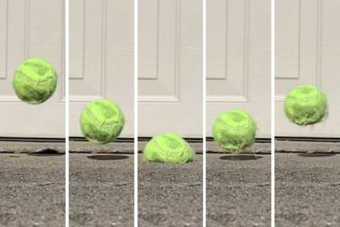
Figure 5.9: Still frames of a tennis ball bouncing off concrete. The images, left to right, were taken at a rate of 240 frames per second. Note the flattening of the ball in the center frame.¹
The still frames in Figure 5.9 are shifted compared to each other. The ball is not actually moving to the right. Careful comparison with the background shows that in fact the ball has a small horizontal velocity to the left. For this analysis, the slight horizontal motion is neglected, and the ball is assumed to be moving only vertically.

Numbers
Assumptions: No horizontal motion; $+\hat{y}$ direction is upward; no initial thermal energy
Knowns | Unknowns
$$m=0.057 kg$$ | $$\vec{v_{i}}$$
$$d=0.066 m$$ | $$\vec{v_{f}}$$
$$t_{frame}=1/{240} s$$ | $$\vec{a}$$
$$t<1/{240} s$$ | $\vec{F}$’s
$y_{0}=0.11$ m | $E$’s & $U$’s
$y_{1}=0.06$ m | $$\vec{Δp}$$
$y_{2}=0.02$ m
$y_{3}=0.05$ m
$y_{4}=0.08$ m
t is used for the duration of the collision. The different values for y of the center of the ball have been estimated from the images and the diameter of the ball. There is no significant motion in the $+\hat{x}$ direction, so we will restrict our analysis to the $+\hat{y}$ direction.
$$\vec{v_{i}}=\frac{y_{1}-y_{0}}{t_{frame}}=\frac{(0.06-0.11) m \hat{y}}{1/{240}s}=-12 m/s \hat{y}$$
$$\vec{v_{f}}=\frac{y_{4}-y_{3}}{t_{frame}}=\frac{(0.08-0.05) m \hat{y}}{1/{240}s}=+7.2 m/s \hat{y}$$
$$\vec{a_{avg}}=\frac{\vec{Δv}}{Δt}=\frac{\left(7.2-\left(-12\right)\right) \frac{m}{s} \hat{y}}{3⋅1/{240}s} \\ =1 540 m/s^{2} \hat{y}$$

Words
The ball must be pressing down very hard on the concrete at that time, so there must also be a correspondingly large normal force pushing up on the ball from the concrete. This is what changes the direction of motion (and therefore also the momentum) of the ball.
What about the energy during that center frame? The force from the ground is external to the system we are considering, which is the ball. But the normal force does no work on the ball because work is done by a force acting over a distance moved, and the position of the concrete doesn’t change at all.
Before and after the center frame, the ball clearly has kinetic energy. But in the center frame the ball does not. Also, before and after the center frame the ball has more gravitational potential energy than in the center frame.
In all our previous examples, when kinetic and gravitational potential energy were reduced it meant that the energy was converted to thermal energy. And that is partly true here as well. In the last frame the ball apparently has less kinetic energy and less gravitational potential energy than in the first frame. So, some was lost to thermal energy. But not all!
The rest of the energy in the center frame was stored as spring (sometimes called elastic) potential energy in the ball. Like a compressed spring, a compressed ball also stores spring potential energy.

Graphics
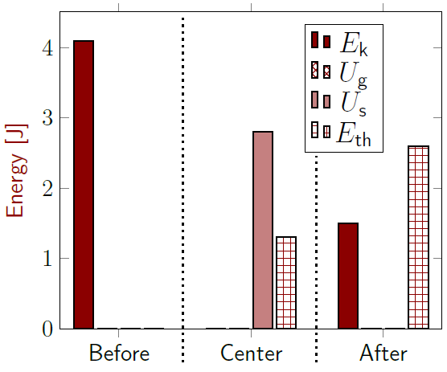
Figure 5.10: Energy bar graph for the collision. Initial thermal energy is taken to be zero. Gravitational potential energy is not zero but is so small that it looks like zero compared to the heights of the other bars.¹
The series of images provides a good estimate of all types of energy before and after the collision. During the collision, in the center frame, kinetic and potential energy should both be at or near zero. But it is not clear for the center frame how the energy should be split between spring and thermal. For this bar graph it has been assumed that the thermal energy for the center frame is roughly half of the thermal energy that is present after the collision.

Numbers
The time used above for the calculation of acceleration was three frames because $\vec{v_{i}}$ was calculated between frames 0 & 1 and $\vec{v_{f}}$ was calculated between frames 3 & 4, so three frames later. The acceleration found is so much larger than the acceleration due to gravity that we can safely ignore the effects of gravity, so in fact nearly all the acceleration occurs between frames 2 & 4. The maximum acceleration is given by
$$\vec{a_{max}}≥\frac{\vec{Δv}}{Δt}=\frac{\left(+7.2-\left(-12\right)\right) \frac{m}{s} \hat{y}}{2⋅1/{240} s} \\ =2 300 m/s^{2} \hat{y}$$
Now we can find the maximum force during the collision:
$$\vec{F_{net,max}}=m⋅\vec{a_{max}}≥131 N \hat{y}$$
The initial and final kinetic energy is given by:
$$E_{k,i}=\frac{1}{2}m⋅v_{i}^{2}=4.1 J$$
$$E_{k,f}=\frac{1}{2}m⋅v_{f}^{2}=1.5 J$$
The gravitational potential energy when the ball is at the highest point in these frames can be found using $U_{g}=m⋅g⋅y$ :
$$U_{g,max}=m⋅g⋅y_{0}=0.06 J$$
Again, with gravity, its contribution to energy is so small compared to the other types of energy that it can safely be ignored in this scenario.

: Pushing a Barrel ( , )

Words
A group of sailors in Figure 5.11 is attempting to slide a barrel across the deck of an aircraft carrier using water from a hose.
If the force that the water applies to the initially motionless 180 kg barrel starts at zero and slowly increases, the barrel remains in place until the applied force reaches 1200 N, at which point it begins to slide with an acceleration of $3 m/s^{2}$.
Find the force of friction between the barrel and the deck of the aircraft carrier over the time that the sailors are spraying water at it.
Before the water is sprayed at the barrel, the barrel is motionless. Since the barrel is motionless, we know that the net force on it must be zero, so the normal force exactly balances the force of gravity in the vertical direction. In the horizontal direction the forces are also balanced, and there is no applied force so the force of friction at that time is zero.
That sounds wrong, because if you were to push on the barrel the friction would probably be strong enough to prevent you from moving it. But the key here is that phrase, if you were to push. If you push to the left, friction will push to the right. If you push to the right, friction will push to the left. Friction will do whatever it has to do to keep the barrel in place. If nothing else tries to push the barrel, friction does nothing!

Graphics
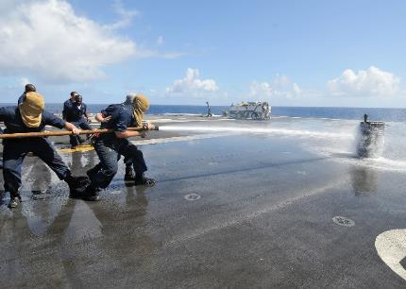
Figure 5.11: Sailors trying to move a barrel using water from a fire hose.
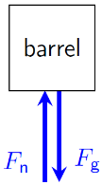
Figure 5.12: Force diagram of the stationary barrel with no applied force from the water.¹

Numbers
Assumptions: near the surface of the earth.
Knowns | Unknowns
$m=$180 kg | $$\vec{F_{f}}$$
$$g=9.8 N/kg$$
$$0≤F_{x,applied}≤1 200 N$$
$$\vec{a_{f}}=3 m/s^{2} \hat{x}$$
$\vec{a}=0$ when $F_{x,applied}<1 200 N$
There are two types of frictional force, “static” $\left(\vec{F_{f,s}}\right)$ when the objects are not moving with respect to each other and “kinetic” $\left(\vec{F_{f,k}}\right)$ when they are sliding against each other.
The magnitude of the maximum static frictional force between two objects is…
$$\boxed{F_{f,s,max}=μ_{s}⋅F_{n}}$$
( 5.4 )
…where $μ_{s}$ is the coefficient of static friction and $F_{n}$ is the magnitude of the normal force. “$μ$” is the lowercase Greek letter “mu.”
The magnitude of the kinetic frictional force between two objects is…
$$\boxed{F_{f,k}=μ_{k}⋅F_{n}}$$
( 5.5 )
…where $μ_{k}$ is the coefficient of kinetic friction and $F_{n}$ is the magnitude of the normal force.

Words
When the water is sprayed at the barrel, it applies a force to the right. As this applied force increases, the frictional force increases along with it, preventing the barrel from moving…until the force from the water reaches 1200 N. Then something changes. The friction is no longer strong enough to hold the barrel in place–we have found the maximum “static” frictional force between the barrel and the deck.
Static frictional force is present when two objects are not moving with respect to each other. Once they start moving, it is “kinetic” frictional force that takes over. Unlike static frictional force, the magnitude of the kinetic frictional force does not depend upon any other applied forces. Kinetic frictional force is always less than or equal to the maximum static frictional force–typically it is much lower.
Since this situation is on an aircraft carrier, we can also consider the situation where the deck is rising and falling. If the deck is accelerating downward, the normal force will be smaller than the force of gravity; in other words, the “apparent weight” (the normal force required to keep the barrel on the deck) will be smaller. This reduces the force of friction between the surfaces, making the barrel easier to move. On the other hand, if the deck is accelerating upward the apparent weight of the barrel will be larger, increasing the frictional force and making it more difficult to move.

Graphics
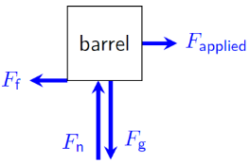
Figure 5.13: Force diagram of the stationary barrel with 600 N of applied force.¹
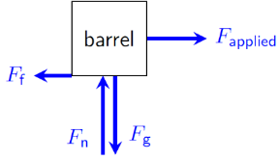
Figure 5.14: Force diagram of the moving barrel with 1200 N of applied force.¹
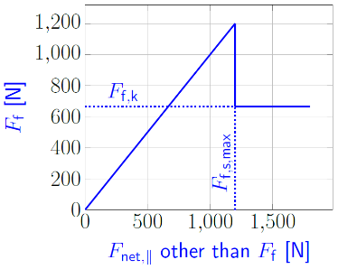
Figure 5.15: Force of friction as a function of net force from other sources parallel to a surface.¹

Numbers
In this physical scenario, the magnitude of the normal force is the same as the magnitude of the force of gravity and the maximum static frictional force is 1200 N, because when the applied force reaches this value, the barrel begins to slide. Using Equation ( 5.4 ) we can find $μ_{s}$:
$$μ_{s}=\frac{F_{f,s,max}}{F_{n}}=\frac{1 200 N}{\left(180 kg\right)⋅\left(9.8 N/kg\right)}=0.68$$
To find $μ_{k}$, we need to know $F_{f,k}$, which we can find by applying Newton’s Second Law to Figure 5.14.
$$F_{net,x}=F_{applied}-F_{f,k}=m⋅a_{x}$$
Solving for $F_{f,k}$ gives 660 N. Then, using Equation ( 5.5 )…
$$μ_{k}=\frac{F_{f,k}}{F_{n}}=\frac{660 N}{\left(180 kg\right)⋅\left(9.8 N/kg\right)}=0.37$$
Notice that there are no units on these coefficients, and that $μ_{k}$ is considerably smaller than $μ_{s}$, which is typical. Tables of $μ_{k} \& μ_{s}$ for various combinations of surfaces can be found by searching the internet for a “table of coefficients of friction.”

: Sledding at White Sands ( , )

Words
At White Sands National Monument in New Mexico, USA, the sand is slippery enough that children can slide down the sand dunes on plastic sleds.
If the angle of the slope is less than 35° from the horizontal, a 25 kg child cannot slide down. But at 35° from the horizontal the child can slide down with an acceleration of $2 m/s^{2}$.
What are the static coefficient of friction and the kinetic coefficient of friction for the surface between the sled and the sand? What is the final speed of the child upon reaching the bottom of a 2.5-m-long sand dune if they started at the top with zero speed? What else can we find for this physical scenario?
Coefficients of friction are ratios of the frictional force to the normal force between two surfaces. Frictional force is not dependent upon the surface area. That is important in this example, because the curved bottoms of the sleds make it difficult to determine the surface area of the sled that is in contact with the sand.
If surface area doesn’t affect friction, why are car tires and most shoes patterned with treads? The main function of the treads is to allow the shoe or the tire to reach the ground firmly if there is water on the surface. A completely smooth car tire would have the same amount of friction as a treaded tire but would easily go out of control, “hydroplaning” if there were any water on the ground.

Graphics
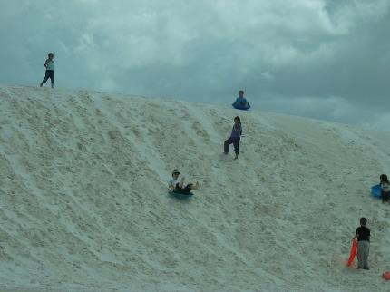
Figure 5.16: Children sledding on dunes at White Sands National Monument.
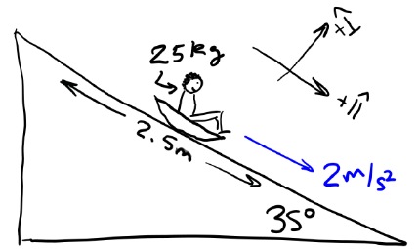
Figure 5.17: Sketch of a child sledding down the dune.¹

Numbers
Assumptions: $+\hat{∥}$ direction is down the slope; $+\hat{⟂}$ direction is normal to the slope.
Knowns | Unknowns
$$θ={35}^{∘}$$ | $$μ_{s}$$
$$g=9.8 N/kg$$ | $$μ_{k}$$
$$\vec{a}=2 m/s^{2} \hat{∥}$$ | $$v_{f}$$
$$Δx_{∥}=2.5 m$$ | ???
$$v_{0}=0$$
$$m=25 kg$$

We can use acceleration and displacement to find $v_{f}$:
$$2a_{∥}⋅Δx_{∥}=v_{f}^{2}-v_{i}^{2}$$
$$v_{f}=\sqrt{2a_{∥}⋅Δx_{∥}}=3.16 m/s$$
By comparing the figures in this section, it can be seen that the net force down the slope is given by:
$$F_{net,∥}=F_{g,∥}-F_{f}=m⋅g⋅sinθ-F_{f}$$
Which $F_{f}$ we use depends on whether the sled is moving or not. Since the angle given is just at the point where the child starts to slide, we can use it to find $F_{s,max}$ and if we include the acceleration given at this angle we can also use it to find $F_{f,k}$. Since $a_{⟂}=0$, we can see from the figures in this section that $F_{n}=F_{g,⟂}$. This is needed to help us find $F_{f,s,max}$ and $F_{f,k}$:

Words
Some shoes, for example golf shoes or crampons that are used for ice climbing, are built with very sharp spikes on the bottom. These do not actually increase the friction with the surface, but increase traction by breaking into the surface, making vertical surfaces where the golfer or climber can apply horizontal normal forces instead of relying on friction.
If we consider the work and energy involved in this scenario, the child starts out not moving at the top of a sand dune, so they have gravitational potential energy but no kinetic energy. As they slide down, they accelerate in the direction of their motion, so they speed up, increasing their kinetic energy. They are also losing gravitational potential energy as they go down.
The frictional force opposes the child’s motion as they go down. A force opposite the direction of motion does negative work on the system, so in this case the friction is doing negative work on the child, removing kinetic energy. That energy is transformed into thermal energy.
So, at the bottom of the sand dune the child has kinetic energy but no gravitational potential energy. And thermal energy has also been released in the process, warming the sand and the sled.
Frictional force is the first nonconservative force that we have seen. Frictional force transforms kinetic energy into thermal energy, not potential energy.

Graphics
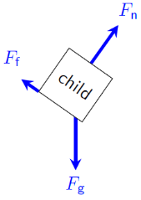
Figure 5.18: Force diagram of child on dune.¹
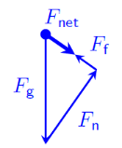
Figure 5.19: Sum of forces for the child.¹
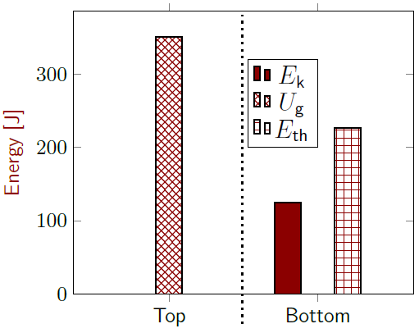
Figure 5.20: Energy bar graph for the child.¹

Numbers
$F_{f,s,max}=μ_{s}⋅F_{n}=μ_{s}⋅F_{g,⟂}=μ_{s}⋅m⋅g⋅cosθ$
Similarly, $F_{f,k}=μ_{k}⋅m⋅g⋅cosθ$. $F_{net,∥}=0$ when considering $μ_{s}$, so combining the equations above…
$$0=m⋅g⋅sinθ-μ_{s}⋅m⋅g⋅cosθ$$
Solving for $μ_{s}$ and using the trigonometric identity that $tanθ=\frac{sinθ}{cosθ}$…
$$μ_{s}=tanθ=0.70$$
Following the same steps for $μ_{k}$ and using Newton’s Second Law since the sled is accelerating gives…
$$m⋅a_{∥}=m⋅g⋅sinθ-μ_{k}⋅m⋅g⋅cosθ$$
$$μ_{k}=\frac{g⋅sinθ-a_{∥}}{g⋅cosθ}=0.45$$
What about energy?⋅ $E_{k,i}=0$; no springs, so no $U_{s}$; if we set $y=0$ at the bottom of the slope then $U_{g,f}=0$; and we can think of the external force of friction not as doing work but as a source of thermal energy. Setting $E_{th,i}=0$, conservation of energy gives…
$${ E}_{k,i} +{ E}_{th,i } +U_{g,i}+ U_{s,i }={ E}_{k,f}+E_{th,f}+ U_{g,f} + U_{s,f}$$
We can find $E_{k,f}$ from $v_{f}$ and $U_{g,i}$ from Figure 5.17 and some trigonometry:
$$\begin{aligned}E_{th,f}&=U_{g,i}-E_{k,f} \\ &=\left(m⋅g⋅\left(Δx_{∥}⋅sinθ\right)\right)-\left(\frac{1}{2}m⋅v_{f}^{2}\right)=226 J\end{aligned}$$

: The Truth About Gravity

Words
So far, we have considered gravity to be a field with a magnitude of $g=9.8 N/kg$, pointing downward.
That is a good model of the gravitational field near the surface of the earth, which is where most of us will probably spend most of our lives. So, it is an approximation that works well in many situations that we will face. But when you leave the surface of the earth, going up or down, that model doesn’t work anymore.
We will now consider the force of gravity acting on a 1 kg mass that is placed either at the exact center of the earth or one earth radius above the surface of the earth.
At the earth’s surface, the force of gravity from the earth acting on a 1-kg mass is 9.8 N, pointing downward. But what if you were at the center of the earth? There is no longer a “downward” direction! Imagine the earth being two pieces, the Southern and Northern hemispheres. At the center of the earth, the gravitational force caused by the Southern hemisphere would pull the mass toward the South pole, but the Northern hemisphere would pull with an equal but opposite force toward the North pole. These forces cancel, so we can use the symmetry of the situation to show that the earth’s gravitational force acting on a mass at the center of the earth is zero. Symmetry arguments like this often provide helpful insights into physical situations.

Graphics
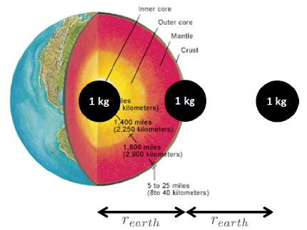
Figure 5.21: Cutaway of the earth, with a 1 kg mass shown at three different positions.
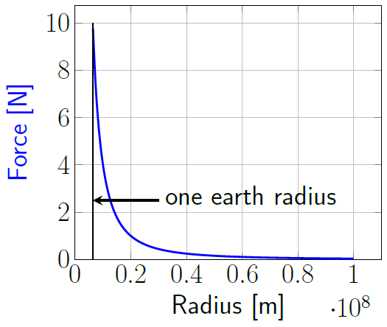
Figure 5.22: Magnitude of gravitational force between the earth and a 1 kg mass, as a function of distance.¹

Numbers
Knowns | Unknowns
$$m=1 kg$$ | $\vec{F_{g}}$ at position $r_{0}$
$$r_{0}=0$$ | $\vec{F_{g}}$ at position $\vec{r_{1}}$
$$r_{1}=2 r_{earth}$$
Radii “$r$” are measured from the center of the earth to the 1 kg mass. The $+\hat{r}$direction is directly away from the center of the earth.
For any location other than the surface of the earth, the mathematical model $\vec{F_{g}}=-m⋅g \hat{y}$ does not work well. Instead, we need to use Newton’s Law of Universal Gravitation:
$$\boxed{F_{g}=\frac{G⋅m_{1}⋅m_{2}}{r^{2}}}$$
( 5.6 )
…where $G$ is the Universal gravitation constant $6.67×{10}^{-11} \frac{N⋅m^{2}}{kg^{2}}$ , $m_{1}$ & $m_{2}$ are the masses of two spherical objects between which the force is acting, and $r$ is the distance between the centers of the two objects. Gravitational force is always attractive, so the force on each object is directed toward the other object. We can use Newton’s Law of Universal Gravitation to find the magnitude of the force when the 1 kg mass is two earth radii from the center of the earth. An internet search can be used to find that the radius of the earth is $6.37×{10}^{6} m$ and the mass of the earth is $5.97×{10}^{24} kg$.

Words
As we move from the center of the earth to the surface of the earth, the force of gravity on our 1 kg mass increases smoothly, reaching a force of 9.8 N at the surface of the earth.
Above the surface, gravity follows an “inverse square law,” meaning that the strength of the force is inversely proportional to the square of the distance from the earth’s center. At one earth radius above the surface of the earth, we are two earth radii from the center of the earth. Our distance has doubled, so the force of gravity is reduced by a factor of four $\left(\frac{1}{2^{2}}\right)$.
What about gravitational potential energy? Work is required to lift a 1 kg mass up away from the center of the earth, regardless of the distance from the center of the earth. So gravitational potential energy is at a minimum at the center of the earth and increases as we move away from the center.
These descriptions are valid for anything that has mass; the gravitational force caused by anything is proportional to its mass.
The more refined model of gravity in this section is consistent with 19th century understanding. But in the 20th century, gravity began to be understood as a curvature of space-time. And in the 21st century perhaps quantum gravity or a better understanding of “dark matter” and “dark energy” will give us an entirely new and better model for gravity. The models in physics and all sciences are constantly growing and evolving as we grow in our understanding of the universe.

Graphics
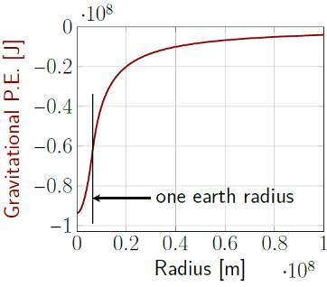
Figure 5.23: Gravitational potential energy of the earth and a 1 kg mass, as a function of distance, assuming uniform density of the earth.¹
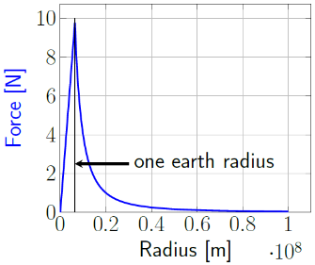
Figure 5.24: Magnitude of gravitational force between the earth and a 1 kg mass, as a function of distance, including when the mass is inside the earth, assuming uniform density of the earth.¹

Numbers
$$F_{g}=\frac{\left(6.67×{10}^{-11}\frac{N⋅m^{2}}{kg^{2}}\right)\left(5.97×{10}^{24}kg\right)\left(1kg\right)}{{\left(2⋅6.37×{10}^{6} m\right)}^{2}}$$
$$\vec{F_{g}}=-2.45 N \hat{r}$$
Let’s try Newton’s Law of Universal Gravitation again to find the magnitude of the force at the center of the earth.
$$F_{g}=\frac{\left(6.67×{10}^{-11}\frac{N⋅m^{2}}{kg^{2}}\right)\left(5.97×{10}^{24}kg\right)\left(1kg\right)}{{\left(0 m\right)}^{2}}$$
$$F_{g}=∞ N$$
An infinitely large force! That cannot be correct. This model only works outside the mass distribution, so not, for example, inside the earth.
Along with this new model of gravitational force, we have a new expression for gravitational potential energy, which is also only valid outside of the mass distributions of the objects themselves:
$$\boxed{U_{g}=\frac{-G⋅m_{1}⋅m_{2}}{r}}$$
( 5.7 )
With this expression we no longer have the option of choosing a height where $U_{g}=0$. Instead, $U_{g}=0$ at $r=∞$, and $U_{g}$ is negative everywhere else.
Inside a mass distribution, the force is smaller than the value calculated from Equation ( 5.6 ), increasing with radial distance. The gravitational potential energy inside a mass distribution is higher than that calculated from Equation ( 5.7 ).

: Summary
Chapter summaries in this book are ordered by concept, not necessarily in the order in which they are presented in the chapter. Mathematical models are grouped together at the end of each summary. See the appendices for the meanings of all symbols used in this book.

General
- The stiffness of a spring is defined by its spring constant k.

Forces & Acceleration
- A pulley can be used to change the direction of the tension in a rope.
- Ideal springs follow Hooke’s Law, where force is proportional to the amount of extension or compression.
- The gravitational force between two objects is proportional to the masses of the objects and inversely proportional to the square of the distance between their centers.
- Gravitational force is always attractive.

Motion
- A pulley can be used to change the direction of the motion of a rope.

Energy
- Deformed objects and stretched or compressed springs store spring potential energy (also called elastic potential energy).
- Gravitational potential energy of two objects increases as the distance between the objects increases.

Mathematical Models
Equation | Reference | Restrictions on the validity of the equation
“Hooke’s Law”  $$\vec{F_{s}}=-k_{s}⋅\vec{Δx}$$ | ( 5.2 ) | For objects that obey Hooke’s Law
$$U_{s}=\frac{1}{2}⋅k_{s}⋅Δx^{2}$$ | ( 5.3 ) | For objects that obey Hooke’s Law
$$F_{f,s,max}=μ_{s}⋅F_{n}$$ | ( 5.4 ) | -none-
$$F_{f,k}=μ_{k}⋅F_{n}$$ | ( 5.5 ) | -none-
“Newton’s Law of  Universal Gravitation”  $$F_{g}=\frac{G⋅m_{1}⋅m_{2}}{r^{2}}$$ | ( 5.6 ) | Outside the mass distribution of spherical objects.
$$U_{g}=\frac{-G⋅m_{1}⋅m_{2}}{r}$$ | ( 5.7 ) | Outside the mass distribution of spherical objects.

: Questions
Questions are ordered according to Bloom’s Taxonomy, progressing from regurgitating information (Level 1) to synthesizing new information with previous knowledge to create something new (Level 6). The bold letters at the beginning of each question indicate whether the question involves Words [W], Graphics [G], and/or Numbers [N]. See the appendices for conversion factors.

Level 1 – Remember
      - [G & N] [W] Mechanical advantage is the ratio of output ________________ to input ________________.
      - [W] The kinetic force of friction is only relevant if the two surfaces are ________________ relative to one another.
      - [W] In what direction does the kinetic force of friction act?
      - [W] The static force of friction is only relevant if the two surfaces are________________ relative to one another.
      - [W] In what direction does the static force of friction act?
      - [W & N] Add labels to each boxed equation from this chapter that tell what the symbol to the left of the = sign represents.
Symbol | Reference | Label
$$MA$$ | ( 5.1 )
$$\vec{F_{s}}$$ | ( 5.2 )
$$U_{s}$$ | ( 5.3 )
$$F_{f,s,max}$$ | ( 5.4 )
$$F_{f,k}$$ | ( 5.5 )
$$F_{g}$$ | ( 5.6 )
$$U_{g}$$ | ( 5.7 )

Level 2 - Understand
      - [W & N] A certain ideal (perfect) machine has a mechanical advantage of ten. A force of 1000 N is supplied at the input of the machine. How large is the output force?
      - [W & N] A certain ideal (perfect) machine has a mechanical advantage of ten. 1 000 J of energy is supplied at the input of the machine. How much is the output energy?
      - [G] Draw force diagrams for the tennis ball in the left, center, and right frames of Figure 5.9.
      - [W, G, & N] Find the momentum of the child at the top and bottom of the sand dune in Section 5.5. Momentum is conserved for an isolated system, so if the child’s momentum changed, what caused that change?

Level 3 - Apply
      - [W, G, & N] The tension force in rope 2 was never found in Section 5.1. Find the amount of tension. Include a force diagram along with your reasoning.
      - [G & N] The amount of potential energy stored in the spring in Section 5.2 is never actually calculated. How much is it?
      - [W & N] Find the change in the momentum of the tennis ball during the collision in Section 5.3. Use the change in momentum to find the force applied to the tennis ball during the collision. Does it agree with the $\vec{F_{net,max}}$ that is found in the text? Explain why or why not.
      - [W & N] If the mass of the barrel in Section 5.4 were doubled, what effect would that have on the maximum static frictional force and the kinetic frictional force?
      - [W, G, & N] Does Newton’s Law of Universal Gravitation agree with the value of $9.8 N/kg$ that we have been using as the strength of the gravitational field at the earth’s surface? Explain why or why not. You will need to look up information about the Earth’s mass and radius to answer this question.

Level 4 - Analyze
      - [W, G, & N] How much force does the pulley system in Section 5.1 apply to the ceiling?
      - [W, G, & N] If the deck of the ship in Section 5.4 remained level but started accelerating downward at 1 m/s² because of stormy seas…
        - …would the horizontal acceleration of the barrel increase, decrease, or remain the same if it had already started moving? Explain your reasoning.
        - …would the static force of friction increase, decrease, or remain the same if the barrel was not yet moving and there was no applied force in the horizontal direction? Explain your reasoning.
        - …would the static force of friction increase, decrease, or remain the same if the barrel was not yet moving and the applied force in the horizontal direction was 200 N? Explain your reasoning.
        - …would the horizontal motion of the barrel change if it was not yet moving and the applied force in the horizontal direction was 1100 N? Explain your reasoning.
      - [W & N] Given the physical scenario described in Section 5.5, is there an angle at which a child would go down the slope at constant speed if they were given an initial push to start them moving? Explain why or why not. If it is possible, find the angle.

Level 5 - Evaluate
      - [W, G, & N] How would the values of each of the following change (increase, decrease, or stay the same) in Section 5.1 if the friction and the mass of the pulleys were not negligible? Assume that all the “knowns” keep their same values. Explain your reasoning.
        - $F_{t,3}$
        - $F_{applied}$
        - $P_{lift}$
        - $P_{applied}$
        - $MA$
      - [G & N] If the spring constant were doubled and the same mass was hung from the scale in Section 5.2, how would that affect the amount of energy stored in the spring? Explain your reasoning.
      - [G & N] If the mass were doubled and the spring constant was kept the same in Section 5.2, how would that affect the amount of energy stored in the spring? Explain your reasoning.
      - [W, G, & N] The height of the bars in the “Center” position of Figure 5.10, reproduced below, are not well defined just from examining the images in Figure 5.9. What are the maximum and minimum possible heights for the bars representing spring potential energy and thermal energy for the “Center” position?
      - [W & N] In Section 5.5 the coefficients of friction are found. Given those coefficients of friction, if the child’s mass were doubled, how would that affect the angle at which the maximum static frictional force can no longer keep the child from sliding down the sand dune? Explain your reasoning.
      - [W & N] In Section 5.5 the coefficients of friction are found. Given those coefficients of friction, if the child’s mass were doubled, how would that affect the acceleration of the child as they slid down the 35° slope? Explain your reasoning.
      - [N] Up until now we have been approximating the force of gravity on an object at the surface of the is there in the actual force of gravity between the highest point on the earth’s surface (the peak of⋅ earth using $m⋅g$. Now that we know a better way to describe gravity, what percentage difference is there in the actual force of gravity between the highest point on the earth’s surface (the peak of Mount Everest) and the lowest known point on the earth’s surface (Challenger Deep, in the Pacific Ocean)? Be sure to list any assumptions that you are making.

Level 6 - Create
      - [W, G, & N] Add the main ideas from this chapter to the concept map that you began for the question at the end of Chapter 4.
      - [W, G, & N] Imagine you are writing a test question related to this chapter. Think of your own example of a situation that you can analyze using the concepts, graphics, and mathematical analyses described in this chapter. Describe the situation and use the tools from this chapter to analyze the situation as completely as you can, including motion, forces, energy, and momentum.
      - [W, G, & N] Think about possible misconceptions about the material in this chapter. Write a question and an incorrect solution to it that demonstrates a student making such a conceptual error. This cannot be a simple misuse of a vocabulary word, a unit error, or a mathematical error like making an addition error or multiplying when addition was needed, unless the error is rooted in a real misunderstanding about the physics behind the calculation or the misuse of a word. After you have written the question and incorrect solution, explain what is wrong with the student’s solution, and write a correct solution to the problem. Note: You may use a question from this chapter that you got wrong the first time and explain the initial error in your thinking and how you corrected it.

– Curving Paths

Figure 6.1: A fire poi dance. The flaming ball on the near side of the dancer traces out a circular path, while the ball on the far side of the dancer follows a more complicated path.

We have already learned that if an object experiences an unbalanced force in the direction in which it is already moving, the force does positive work on the object, increasing its kinetic energy, its momentum, and its speed. Conversely, if an object experiences an unbalanced force opposite the direction in which it is already moving, the force does negative work on the object, decreasing its kinetic energy, its momentum, and its speed.
Now it is time to start looking at unbalanced forces that are pointing in directions that are not parallel to the motion of an object. When that happens, the object follows a curved path.
Looking at the image of the fire dancer, try to imagine the forces that are involved. The dancer is holding two flaming balls that are hanging from chains. She spins them around, making intricate patterns in the air. The flaming balls experience forces due to both gravity and the tension in the chains. How do those combined forces make the balls move in such complicated patterns?
What is happening to the momentum of the balls as they follow these curved paths?

: Cliff Diving ( , )

Words
Figure 6.2 shows a diver jumping horizontally off the edge of a cliff. After leaving the cliff, the diver’s body is in free fall, affected only by the force of gravity. Because of the initial horizontal velocity and the vertical acceleration, the diver’s body follows a curved path.
If the camera took four images per second and the diver jumped horizontally at 3 m/s, for how much time was the diver in the air before hitting the water, what is the height of the cliff, at what speed did the diver enter the water, and what was the horizontal displacement of the diver over that time?
The key to understanding this situation is realizing that the horizontal direction is independent of the vertical direction. This idea was explored in Chapter 4, where the focus was on velocity, momentum, and forces. The same principle applies to position as well.
The force of gravity pulls the diver down into the water in exactly the same amount of time as if she had fallen straight down into the water from the same height. This is perhaps most easily understood by thinking of it in terms of frames of reference. If you are standing on a motionless train and you hold a ball straight out and drop it to the floor, the ball will be in the air for a specific amount of time before hitting the floor.

Graphics
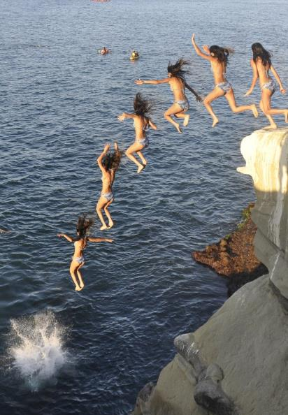
Figure 6.2: A cliff diver jumps horizontally off a cliff. The individual images of the diver are at equal time intervals.

Numbers
Assumptions: air resistance is negligible; $+\hat{x}$ is to the right; $+\hat{y}$ is upward;.
Knowns | Unknowns
$$\vec{v_{0}}=-3 m/s \hat{x}$$ | $$t_{tot}$$
$$t_{image}=0.25 s$$ | $$h_{cliff}$$
$$g=9.8 N/kg$$ | $$Δx$$
 | $$v_{f}$$
If we use the image where the diver has one foot on the cliff as $t=0$, and subsequent images are at 0.25-s intervals, then the splash into the water occurs at
$$t_{tot}=6⋅t_{image}=1.5 s$$
To find the height of the cliff, we can separate the $\hat{x}$ & $\hat{y}$ components of position:
$$x=x_{0}+v_{0x}⋅t+\frac{1}{2}a_{x}⋅t^{2}$$
$$y=y_{0}+v_{0y}⋅t+\frac{1}{2}a_{y}⋅t^{2}$$
In free-fall, the only force acting on an object is gravity, so if the object is near the surface of the earth $\vec{a}=-g \hat{y}$. So, the horizontal and vertical position of an object in free-fall are…
$$\boxed{x=x_{0}+v_{0x}⋅t}$$
( 6.1 )
and

Words
If you are on the same train, dropping the same ball in the same way, but the train is moving at a constant velocity, in your reference frame the ball will behave in the same way. And it will hit the floor in the same amount of time.
In the reference frame of somebody watching the train go by, the ball starts in your hand not at rest but moving with the same horizontal velocity as the train. When you drop the ball, it will continue to move horizontally along with the train, but it will drop vertically. Each person sees the ball following a different path in their reference frame, but both see the ball in the air for the same amount of time.
The horizontal displacement that the ball travels while falling in the reference frame of the person on the train is zero, because the horizontal velocity is zero in that reference frame. But in the reference frame of the person watching the train go by, the horizontal displacement of the ball would be the velocity of the train multiplied by the time that the ball is in the air, since velocity is displacement over time.
In Figure 6.3, the horizontal spacing of the images are almost equally spaced–the slight decrease in spacing on the left is most likely due to the angle of the camera. The vertical spacing, on the other hand, increases with each successive image. This shows acceleration in the vertical direction, due to the force of gravity. It is also clear from the lengths of the arrows that the diver’s speed is increasing during the fall.

Graphics
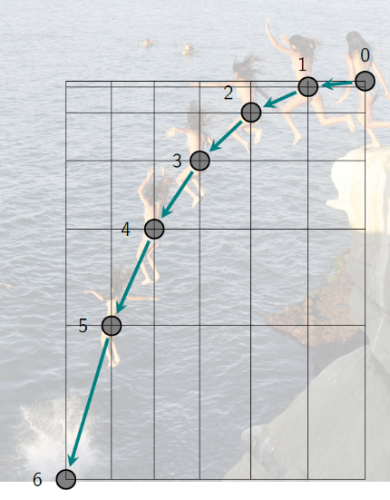
Figure 6.3: 2-D motion map of the diver.

Numbers
$$\boxed{y=y_{0}+v_{0y}⋅t-\frac{1}{2}g⋅t^{2}}$$
( 6.2 )
The only connection between the $\hat{x}$ & $\hat{y}$ directions is time. Often questions about two-dimensional scenarios can be answered by using information known about one direction to solve for time and then using time to solve for information about the other direction. In this case we are given the time and can use it to solve for information about both directions.
The height of the cliff is the opposite of the displacement in the y direction, $y_{0}-y$, since the diver starts at the top and ends at the bottom. So…
$$h_{cliff}=-v_{0y}⋅t_{tot}+\frac{1}{2}g⋅t_{tot}^{2}=11 m$$
The diver’s horizontal displacement comes from the horizontal position in free-fall:
$$Δx=v_{0x}⋅t=-4.5 m$$
Now we can find the speed of the diver by calculating $v_{x,f}$ and $v_{y,f}$ and using the Pythagorean theorem. There is no horizontal acceleration, so $v_{x,f}=v_{0x}$. In the vertical direction…
$$v_{f,y}=v_{0y}+a_{y}⋅t_{tot}=0-g⋅t_{tot}=-14.7 m/s$$
$$v_{f}=\sqrt{v_{f,x}^{2}+v_{f,y}^{2}}=15 m/s$$

: Basketball Bounce ( )

Words
Figure 6.4 shows a ball bouncing, with images captured using a stroboscopic light source that flashed 25 times per second. We will assume that the photograph was taken somewhere near the surface of the earth.
We will analyze the photograph using all our tools to see what we can learn just from the images.
This photograph looks like a 2-D map of the motion of the ball, but it doesn’t contain arrows like a normal motion map. Can we determine which direction the ball is moving? The biggest indicator is the height of the peaks. The first peak is much higher than the second, and the speed of the ball when at the peaks looks like it is probably about the same for each peak.
So, the ball has more mechanical energy at the top of the left peak than it has at the top of the right peak. Most likely some of the initial energy was transformed into thermal energy during an inelastic collision with the floor, so the peak on the left must be the first one, and the ball is moving to the right.
The image of the ball on the far right is considerably smaller than the image of the ball on the left, so it must also be moving away from the camera. That means any measurements of angles or distances will not be exact.

Graphics
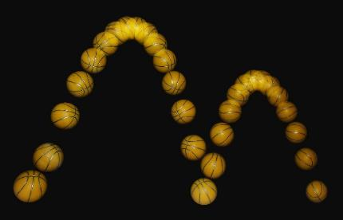
Figure 6.4: This single photograph of a bouncing ball was taken using a stroboscopic light source that flashed 25 times per second.
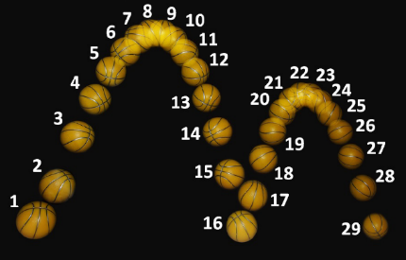
Figure 6.5: The same photograph as above, with the images numbered for reference.³¹

Numbers
Assumptions: $θ$ is measured up from the horizontal direction; gravity near the surface of the earth; air resistance is negligible.
Knowns | Unknowns
$$t_{image}=0.04 s$$ | ???
$$g=9.8 N/kg$$
There are 15 spaces between the images of the ball for the left bounce so…
$$t_{left}=15⋅t_{image}=0.6 s$$
Similarly, $t_{right}=0.52 s$. These “times of flight” can be used to find initial and final vertical velocities and heights. Measuring the angles gives information about the horizontal direction. In this situation, when the initial and final heights are the same and the object is in free-fall, there are three “equations of projectile motion” that can be used. They are derived from the equations of motion that we have already been using.
$$t_{flight}=\frac{2 v_{0}⋅sinθ}{g}$$
$$h_{max}=\frac{v_{0}^{2}⋅\sin^{2}θ}{g}$$
$$Δx_{max}=\frac{v_{0}^{2}⋅sin\left(2θ\right)}{g}$$

Words
The path of motion that the ball follows is in the shape of a parabola. This is the expected shape whenever an object is in free-fall near the surface of the earth. Other names for this type of motion are “projectile motion” and “ballistic motion.”
If we neglect air resistance, which is typically very small at low speeds, then the only force that acts on the ball while it is in the air is the force of gravity, acting downward. When the ball is moving upward, gravity is doing negative work on the ball, slowing it down. When the ball is moving downward, gravity is doing positive work on the ball, speeding it up.
When the ball hits the floor, the ball applies a large normal force downward onto the floor and the floor pushes up on the ball with an equally large normal force. During the collision with the floor, the vertical part of the velocity of the ball changes drastically, from a large downward speed to a large upward speed. Looking at the horizontal direction, however, shows that the horizontal velocity did not change much. The ball continues to move to the right at a fairly uniform rate for the whole time that it was being imaged.

Graphics
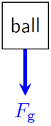
Figure 6.6: Force diagram of the ball for any time when it is in the air, images 2-15 and 17-28 in Figure 6.5.¹
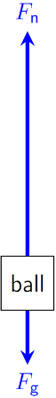
Figure 6.7: Force diagram of the ball when it is in contact with the ground, images 16 & 29 in Figure 6.5. Lengths of the arrows are not exact, but are intended to signify that $F_{g}$ is the same as in Figure 6.6 and that $F_{n}>F_{g}$.¹

Numbers
…where $θ$ is the angle between $v_{0}$ and the horizontal direction, approximately ${70}^{∘}$ in this case for both bounces; $t_{flight}$ is the total time in free-fall; $h_{max}$ is the vertical distance from the initial position to the peak; and $Δx_{max}$ is the horizontal range. It is important to remember that these are not “magic” equations that always give correct answers when you don’t know what to do. They are specific to the situation of free-fall near the surface of the earth when initial height is equal to final height. They will not work in any other situation.
Using these equations, we find:
Quantity | Left Bounce | Right Bounce
$$v_{0}$$ | $$3.1 m/s$$ | $$2.7 m/s$$
$$h_{max}$$ | $$0.88 m$$ | $$0.66 m$$
$$Δx_{max}$$ | $$0.64 m$$ | $$0.48 m$$
Some of these numbers are surprising if you know something about the size of a basketball. The range for the left bounce is 0.64 m and appears in the photograph to be roughly 6 diameters of the ball, so the ball diameter is between 10 and 11 cm, half the size of a basketball! In fact, this is not a real basketball in the photograph, but a child’s toy ball that is made to look like a basketball.
Since we don’t know anything about the mass of the toy ball, we cannot calculate force, momentum, or energy.

: At the Peak ( )

Words
Let’s take a closer look at what is happening just at the peak of the flight of the ball from Section 6.2. We know that the path followed by the ball is parabolic in shape. At the top of the parabola, the motion of the ball is horizontal.
At every point on the parabola, there is a constant net force, which is simply the gravitational force, pointing downward. As a result, at every point on the parabola the ball has a constant downward acceleration. And since acceleration is a change in velocity over time, the velocity of the ball is changing at a constant rate everywhere on the parabola.
The ball is moving upward on the left side of the peak, and since the acceleration is downward that means it is slowing down. We can say that the gravitational force is doing negative work, decreasing the kinetic energy as the ball is moving upward. The ball is moving downward on the right side of the peak, and since the acceleration is downward that means it is speeding up. We can say that the gravitational force is doing positive work, increasing the kinetic energy as the ball is moving downward.
When the ball is right at its peak, its velocity is perpendicular to the net force, so no work is being done on it, positive or negative. That means its speed is not changing. But, it is still accelerating the same as everywhere else, so the velocity is changing!.

Graphics
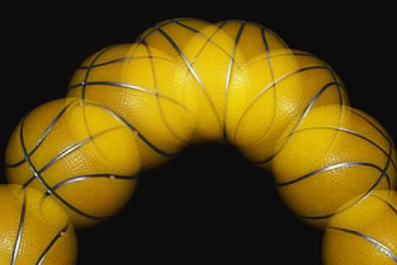
Figure 6.8: A close-up of the top of the first peak for the bouncing ball from Section 6.2.³¹
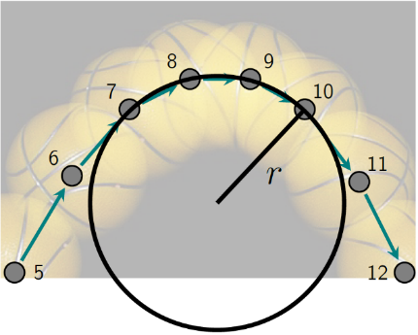
Figure 6.9: At the very peak of the ball’s motion, the path briefly follows a circular path with radius of curvature $r$.³¹

Numbers
Assumptions: gravity near the surface of the earth
Knowns | Unknowns
$$t_{image}=0.04 s$$ | ???
$$g=9.8 N/kg$$
The work that is done on the ball at the top of the parabola is given by:
$$W_{net}=F_{net}⋅Δx⋅cosθ=F_{g}⋅Δx⋅cos{90}^{∘}$$
$cos{90}^{∘}=0$, so…
$$W_{net}=0$$
…at the top of the parabola where the force is perpendicular to the direction of motion. There are no energy transformations happening at that instant, so the speed $v$ is briefly constant at the top of the parabola. And yet the acceleration due to gravity is constant everywhere on the parabolic arc, so $\vec{v}$ is changing. The only way to change $\vec{v}$ while keeping $v$ constant is to change the direction of $\vec{v}$.
The radius of curvature $r$ in Figure 6.9 depends on two things: the acceleration due to gravity and the horizontal speed at the top. The radius would increase if gravity were weaker, allowing the ball to stay up longer, and the radius would also increase if the speed were higher, allowing the ball to move farther horizontally in the time needed for gravity to pull the ball down.

Words
How can the velocity change while the speed stays the same? Velocity is a vector, which includes speed and direction. When the net force (and therefore the acceleration) is perpendicular to the velocity, it causes a change in direction but not a change in speed. The path curves along a circular arc with a radius that is called the “radius of curvature.”
This perpendicular net force is called the “centripetal” force, from the Latin words for “toward the center.” The centripetal force is not a new type of force; it is simply a name for whatever force is causing an object to follow a curved path. In the case of the ball at the top of the arc, the centripetal force is the force of gravity. In other situations, it could be a tension force, a friction force, a normal force, a combination of these, or any other type of applied force.
Imagine now a force that changes direction as the velocity changes direction. If a constant net force were kept always perpendicular to the direction of motion, the object would move in a complete circle. This is what happens, for example, in an Olympic hammer throw. The “hammer,” a heavy ball on the end of a flexible cord, is spun in a circle. The tension in the cord supplies the centripetal force radially inward, and the velocity of the ball is in the “tangential” direction, perpendicular to the radius.

Graphics
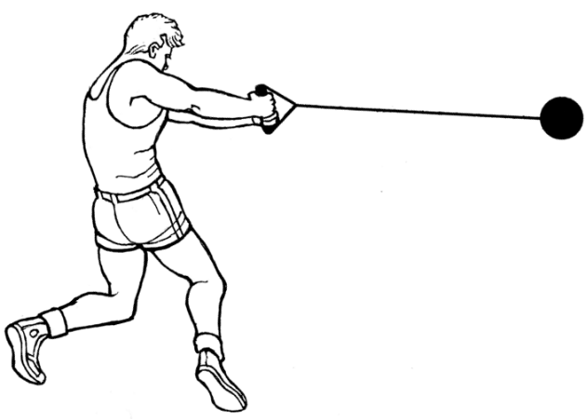
Figure 6.10: An Olympic hammer throw.
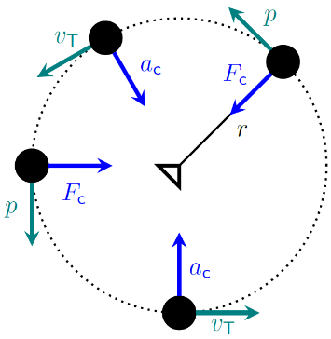
Figure 6.11: Looking down on the hammer throw. The ball is following the dotted line counterclockwise. $\vec{F_{c}}$, $\vec{a_{c}}$, $\vec{p}$, & $\vec{v}$ are shown at various positions.¹

Numbers
The magnitude of the centripetal acceleration $a_{c}$, the tangential (perpendicular to the radius) velocity $v_{T}$, and the radius of curvature $r$ are related by:
$$\boxed{a_{c}=\frac{v_{T}^{2}}{r}}$$
( 6.3 )
In Section 6.2, the speed and initial direction of the ball were found, which gave us horizontal velocity using the cosine. The horizontal velocity is the tangential velocity at the top of the parabola, so we can use it to find the radius of curvature.
$$r=\frac{v_{T}^{2}}{a_{c}}=\frac{{\left(v_{0}⋅cosθ\right)}^{2}}{g}=0.12 m$$
That is roughly the diameter of the ball, and in Figure 6.9 we can see that in fact the radius of curvature is very close to the diameter of the ball. Making this type of comparison can give us confidence that our work is correct. Using the relationship between force and acceleration given by Newton’s Second Law, we could also find the centripetal force if we knew the mass:
$$\boxed{F_{c}=m⋅a_{c}=\frac{m⋅v_{T}^{2}}{r}}$$
( 6.4 )

: Earth’s Orbit ( , )

Words
The earth orbits the sun at a distance of approximately 150 million kilometers, and it takes approximately 365 days to make one complete orbit.
Use this information to find the speed of the earth as it orbits around the sun and the mass of the sun and any other information that can be found.
The speed of the earth can be found by considering that the earth makes one complete circuit around the sun every year. The speed of the earth is simply the path length traveled around the circular path divided by one year.
It seems surprising to think that we would not need to know the mass of the earth to find the mass of the sun for this question, but the force of the earth’s gravity gives objects at the earth’s surface a constant acceleration regardless of their mass. Just as the mass of the earth is much larger than the mass of anything on the surface of the earth, the mass of the sun is much larger than the mass of the earth. So, it should make sense that the sun’s gravitational force causes a constant acceleration at a given distance, at least as long as the other object’s mass is much less than the mass of the sun.

Graphics
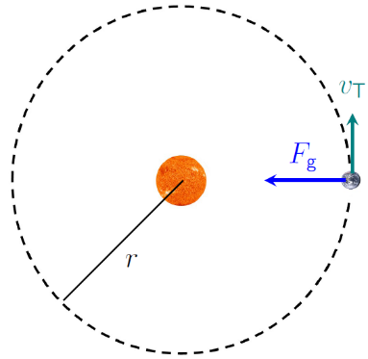
Figure 6.12: The earth’s orbit around the sun is nearly circular.
Note that the earth’s speed is nearly constant as it orbits the sun; but its velocity, which includes direction, is always changing. It is more convenient to use angular velocity when describing a situation like this, because the earth’s angular velocity, like its speed, is nearly constant

Numbers
Assumptions: circular orbit; $m_{earth}<<m_{sun}$
Knowns | Unknowns
$$r=1.5×{10}^{11} m$$ | $$v_{T}$$
$$t_{orbit}=3.15×{10}^{7} s$$ | $$m_{sun}$$
 | ???
In 365 days, the earth orbits the sun once, a path length that is the circumference of a circle whose radius is the distance from the earth to the sun:
$$s_{orbit}=2π⋅r=9.4×{10}^{11} m$$
To find the tangential speed we need to consider the path length traveled:
$$v_{T}=\frac{s_{orbit}}{t_{orbit}}=3×{10}^{4} m/s$$
Now that we know the tangential speed of the earth, we can use that to determine the centripetal acceleration, or with mass the centripetal force. At these distances, we need to use Newton’s Law of Universal Gravitation. It is this force which is the centripetal force that keeps the earth in a circular path, so we can use Equation ( 6.4 ) as well.
$$\begin{aligned}F_{g}&=F_{c} \\ \frac{G⋅m_{sun}⋅m_{earth}}{r^{2}}&=\frac{m_{earth}⋅v_{T}^{2}}{r} \\ \frac{G⋅m_{sun}}{r}&=v_{T}^{2}\end{aligned}$$
$$m_{sun}=\frac{v_{T}^{2}⋅r}{G}=2.0×{10}^{30} kg$$

Words
While it is interesting to know the tangential speed of the earth as it goes around the sun, that doesn’t have a great impact on our daily lives. The thing that most affects our lives about the orbit of the earth around the sun is the passing of the seasons, which is related to angular position. This is an example when expressing position in terms of an angle, and how angle changes over time, is more important than expressing position in terms of distance and how distance changes over time.
There are many other situations where angular changes are more important and easier to think about than changes in distance. For example, many vehicles have tachometers that display the angular speed of the engine measured in rpm (revolutions, or rotations, per minute).
When discussing angular motion, the units used for angles are radians. One radian is the angle created by an arc whose arc length is equal to the radius of the circle. So, one full circle contains $2π$ radians. The angle then becomes a ratio of an arc length over a radius. Length per length. In other words, the unit “radian” is in some sense dimensionless. Expressing angles in radians greatly simplifies problem solving precisely because of this dimensionless quality of the angle measurement.
Just as we have learned about position, velocity, acceleration, momentum, etc. in linear form, we will now start to learn about angular position, angular velocity, angular acceleration, angular momentum, etc.

Graphics
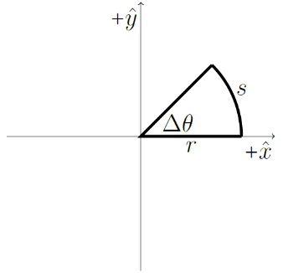
Figure 6.13: The angle $Δθ$ in radians is the ratio of the arc length $s$ to the radius $r$.¹
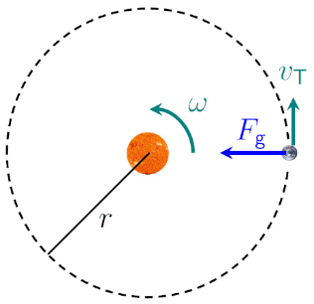
Figure 6.14: The earth’s speed as it orbits the sun can be described in terms of angular velocity $ω$. “$ω$” is the lower-case Greek letter “omega.”.³³

Numbers
It is often useful to describe a system in terms of angles, so for the earth we could give an angular velocity around the sun instead of a tangential velocity. The SI unit for angles is the radian [rad], illustrated in Figure 6.13.
$$\boxed{Δθ=\frac{s}{r}}$$
( 6.5 )
…where $s$ is the arc length and $r$ is the radius of a circle. $θ=0$ is usually at the positive x axis and the positive direction is counterclockwise.
Similarly, we can define angular velocity $ω$ in terms of tangential speed and radius:
$$\boxed{ω=\frac{v_{T}}{r}}$$
( 6.6 )
$ω_{earth}$ of the earth around the sun is…
$$ω_{earth}=\frac{3×{10}^{4} m/s}{1.5×{10}^{11} m}=2×{10}^{-7} rad/s$$
The SI unit for angular velocity is therefore [rad/s]. We can find the period $T$ of the earth’s orbit around the sun, the amount of time for one complete revolution. When $ω$ is constant,
$$\boxed{T=\frac{2π}{ω}}$$
( 6.7 )
So, for the earth, $T=3.14×{10}^{7} s$.

: Puck on a String ( )

Words
For situations where angular velocity is easier to think about than linear velocity, it would be convenient to also have angular versions of kinetic energy and momentum, which are strongly connected to velocity. Take, for example, a 0.2 kg frictionless puck that is connected by a 1.4-m-long string to a bolt that is solidly mounted in the floor.
If the puck is moving at constant angular speed of 4 rad/s in a circle around the bolt, its kinetic energy, which depends only on mass and speed, but not on direction, is constant.
We now have two different ways to look at the motion and the kinetic energy of the puck:
- We can see the puck as a moving object with a linear (tangential) velocity that is always changing direction because of the centripetal acceleration caused by the tension in the string. In this view, the puck has the same kind of kinetic energy that we are used to dealing with, which is usually called “translational” kinetic energy.
- Or we can see the puck as part of a puck-bolt system that does not have any linear velocity (since the bolt is solidly fixed in place), but that is spinning about an axis at a constant angular speed. In this view, the puck-bolt system has rotational kinetic energy, but no translational kinetic energy.

Graphics
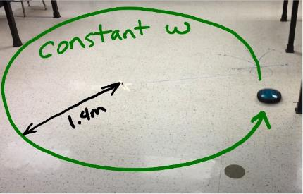
Figure 6.15: A frictionless puck moving in a circle at constant angular speed.
Figure 6.15 and Figure 6.16 are based on a screenshot from a YouTube video: https://youtu.be/mNdLRySeh9o.
Something really interesting happens in the video at a place where the string falls off of the bolt. The puck stops moving in a circle with constant angular velocity, since the source of the centripetal force has disappeared. With no forces in the horizontal direction, the puck instead begins to move in a straight line with constant velocity.

Numbers
Assumptions: friction is negligible
Knowns | Unknowns
$$r=1.4 m$$ | $$E_{k}$$
$$ω=4 rad/s$$ | rotational kinetic energy?
$$m=0.2 kg$$ | angular momentum?
$$F_{f}=0$$
We can use $E_{k}=\frac{1}{2}m⋅v^{2}$ to find the kinetic energy of the puck, recognizing that its speed is simply $v_{T}$. But we don’t have $v_{T}$, so we will also need to use Equation ( 6.6 ):
$$E_{k}=\frac{1}{2}m⋅v_{T}^{2}=\frac{1}{2}m⋅{\left(r⋅ω\right)}^{2}$$
This is referred to as the rotational kinetic energy $E_{k,r}$ of a point mass, and the expression is normally grouped in a slightly different way:
$$E_{k,r}=\frac{1}{2}\left(m⋅r^{2}\right)⋅ω^{2}$$
For the puck in this example…
$$E_{k,r}=\frac{1}{2}\left(0.2 kg⋅{\left(1.4 m\right)}^{2}\right)⋅{\left(4 rad/s\right)}^{2}=3.14 J$$
The kinetic energy could also be found for the puck by finding $v_{T}$ and calculating kinetic energy as we have done before. Whether we choose to consider the puck as having only translational kinetic energy in the tangential direction or only rotational kinetic energy around the pivot, we will get the same result for its kinetic energy.

Words
This type of thinking also works for momentum.
- We can see the puck as a moving object with a linear momentum that is always changing direction because of the tension in the string.
- Or we can see the puck as part of a system that does not have any linear momentum, but that has constant angular momentum around a pivot point at the location of the bolt.
Angular momentum, like linear momentum, is conserved for any isolated system. That is what makes it such a useful concept. An isolated system, remember, is one that does not interact with anything outside of the system.
By watching the video associated with the figures in this section, we can learn something surprising about angular momentum: even an object that is moving in a straight line can have angular momentum! When the string falls off the bolt, there is no force applied to the puck, so its angular momentum can’t change at that time–it must keep the same amount of angular momentum that it had just before the string fell off.
For a pointlike object like this puck, the angular momentum depends on its mass, angular velocity, and distance from the pivot; or, if it is moving in a straight line then it depends on the mass, linear velocity, and the “lever arm,” which is the perpendicular distance from the pivot to the line along which it is traveling.

Graphics
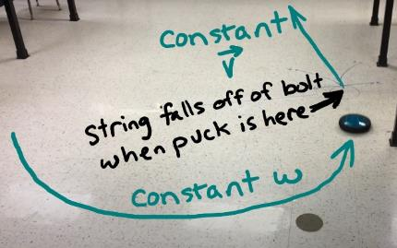
Figure 6.16: When the string falls off the bolt, the puck begins to move in a straight line.³⁴
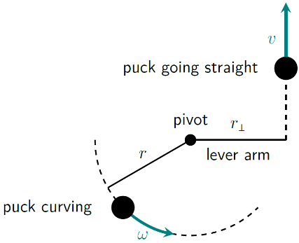
Figure 6.17: Motion of the puck, showing a lever arm, $r_{⟂}$, for an object moving in a direction that is not aligned with a pivot point.¹

Numbers
Angular momentum $L$ is conserved for an isolated system, so…
$$\boxed{L_{f}=L_{i}}$$
( 6.8 )
For an object moving in a straight line that is not aligned with a pivot point, as shown when the puck is going straight in Figure 6.17, $L$ is given by…
$$\boxed{L=m⋅v⋅r_{⟂}}$$
( 6.9 )
…where $r_{⟂}$ is the lever arm.
From Figure 6.17, we can see that in the case of a small object traveling on a circular path, the lever arm is simply $r$ and the speed is simply $v_{T}$. So, for that situation, angular momentum can be described in angular terms using…
$$\begin{aligned}L&=m⋅v_{T}⋅r \\ &=m⋅\left(ω⋅r\right)⋅r \\ &=\left(m⋅r^{2}\right)⋅ω\end{aligned}$$
Notice that $\left(m⋅r^{2}\right)$ has made another appearance. And as we explore rotation we will see more of this same type of grouping of mass and radius. That is why they are usually grouped together in expressions for rotational motion.
Now we can find the angular momentum of the puck:
$$\begin{aligned}L&=\left(m⋅r^{2}\right)⋅ω \\ &=\left(0.2 kg⋅{\left(1.4 m\right)}^{2}\right)⋅4 rad/s \\ &=15.7 kg⋅m^{2}/s\end{aligned}$$

: Summary
Chapter summaries in this book are ordered by concept, not necessarily in the order in which they are presented in the chapter. Mathematical models are grouped together at the end of each summary. See the appendices for the meanings of all symbols used in this book.

General
• The time needed for an object to move in a complete circle is called the period.

Forces
- A net force applied perpendicular to an object’s velocity causes the object to change direction but maintain constant speed.
- Centripetal force is not a new kind of force but is used to describe the force that is causing circular motion.
- Centripetal force is always directed in the radial direction toward the center of the circular path.

Motion
- An object that is in free-fall near the surface of the earth follows a path that is shaped like a parabola.
- Centripetal acceleration is always directed in, toward the center of circular path.

Linear & Angular Momentum & Velocity
- Angular momentum is conserved for any isolated system.
- Even an object moving in a straight line can have angular momentum around a given point in space.

Energy
- Objects can have translational kinetic energy, rotational kinetic energy, or both.

Mathematical Models
Equation | Reference | Restrictions on the validity of the equation
$$a_{c}=\frac{v_{T}^{2}}{r}$$ | ( 6.3 ) | -none-
$$F_{c}=m⋅a_{c}=\frac{m⋅v_{T}^{2}}{r}$$ | ( 6.4 ) | -none-
$$Δθ=\frac{s}{r}$$ | ( 6.5 ) | -none-
$$ω=\frac{v_{T}}{r}$$ | ( 6.6 ) | -none-
$$T=\frac{2π}{ω}$$ | ( 6.7 ) | When $ω$ is constant
$$L_{f}=L_{i}$$ | ( 6.8 ) | For an isolated system
$$L=m⋅v⋅r_{⟂}$$ | ( 6.9 ) | For pointlike objects with linear velocity

: Questions
Questions are ordered according to Bloom’s Taxonomy, progressing from regurgitating information (Level 1) to synthesizing new information with previous knowledge to create something new (Level 6). The bold letters at the beginning of each question indicate whether the question involves Words [W], Graphics [G], and/or Numbers [N]. See the appendices for conversion factors.

Level 1 - Remember
      - [W] What is the difference between free-fall, projectile motion, and ballistic motion?
Symbol | Reference | Label
$$x$$ | ( 6.1 )
$$y$$ | ( 6.2 )
$$a_{c}$$ | ( 6.3 )
$$U_{g}$$ | ( 6.4 )
$$Δθ$$ | ( 6.5 )
$$ω$$ | ( 6.6 )
$$T$$ | ( 6.7 )
$$L_{f}$$ | ( 6.8 )
$$L$$ | ( 6.9 )
      - [W & N] Add labels to each boxed equation from this chapter that tell what the symbol to the left of the = sign represents.

Level 2 - Understand
      - [W] Explain how the photograph in Figure 6.5, reproduced below, shows that the normal force is much larger than the gravitational force when the ball is touching the ground in image 16.
This single photograph of a bouncing ball was taken using a stroboscopic light source that flashed 25 times per second.³¹
      - [W] Describe how the momentum of the ball in Figure 6.5, reproduced below, changes over the course of time during which it is imaged.
This single photograph of a bouncing ball was taken using a stroboscopic light source that flashed 25 times per second.³¹.
      - [W & G] What type of force creates the centripetal force that keeps the ball moving in a circle during the hammer throw shown in Figure 6.11, reproduced below?
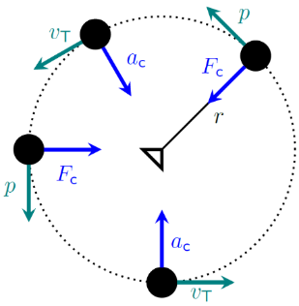
Looking down on the hammer throw. The ball is following the dotted line counterclockwise. $\vec{F_{c}}$, $\vec{a_{c}}$, $\vec{p}$, & $\vec{v}$ are shown at various positions.¹
      - [W, G, & N] In Section 6.5, the lever arm for momentum is described in the “Words” column as being a distance that is related to the momentum vector but in the “Numbers” column it is instead described as being related to the velocity vector. How can both of these be correct, or was this an error?

Level 3 - Apply
      - [N] If the mass of the ball in Section 6.2 were doubled, how would that affect the radius of curvature at the top of the left peak that was found in Section 6.3? Explain your reasoning.
      - [W & G] If the hammer in Figure 6.11, reproduced below, were released when the cord was to the South compared to the thrower, in what direction would the hammer travel?
Looking down on the hammer throw. The ball is following the dotted line counterclockwise. $\vec{F_{c}}$, $\vec{a_{c}}$, $\vec{p}$, & $\vec{v}$ are shown at various positions.¹
Planet | Radius of orbit $r$ [m] | Period of orbit $t$ [s] | Tangential velocity [m/s] $\left(\frac{2⋅π⋅r}{t}\right)$
Mercury
Venus
Earth
Mars
Jupiter
Saturn
Uranus
Neptune
      - [N] Use the same analysis that was used in Section 6.4 to determine which planets in our solar system have a higher tangential velocity than the earth. You will need to look up information about the periods and radii of the orbits of planets in our solar system to answer this question.

Level 4 - Analyze
      - [W, G, & N] Describe the energy of the diver in Section 6.1 at the top of the cliff and just before they hit the water.
      - [G] Make energy bar graphs for the ball in Figure 6.5, reproduced below, for images 1 (where the ball is close to the ground but not touching the ground), 4, 8, 13, 16 (where the ball is on the ground and not moving), 22, and 29 (where the ball is on the ground and not moving). Without a mass for the ball, it is not possible to calculate the actual energies, so just make the relative heights of the bars as accurate as possible.
This single photograph of a bouncing ball was taken using a stroboscopic light source that flashed 25 times per second.³¹
      - [W & N] An angular velocity of the earth around the sun is calculated at the end of Section 6.4. Convert that number into revolutions per year. Does your answer make sense? Explain.
      - [W & G] Look at the photograph of a fire poi dance at the beginning of Chapter 6, reproduced below. Assuming that the balls of fire are moving at constant speed, put the numbered positions in order based on the magnitude of the centripetal acceleration of the balls at those positions.
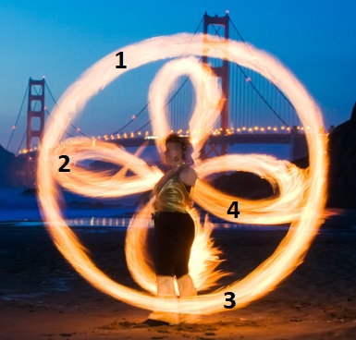
A fire poi dance. The flaming ball on the near side of the dancer traces out a circular path, while the ball on the far side of the dancer follows a more complicated path.²⁸
      - [N] The earth’s mass is approximately $6×{10}^{24} kg$. Use this information and the information in Section 6.4 to find the amount of angular momentum that the earth has due to its orbit around the sun. Use the position of the sun as the pivot point. Do the calculation in two different ways: One using the angular speed of the earth and the other using its tangential speed. Verify that the result is the same either way.
      - [N] The earth’s mass is approximately $6×{10}^{24} kg$. Use this information and the information in Section 6.4 to find the amount of kinetic energy the earth has due to its orbit around the sun. Do the calculation in two different ways: One using the angular speed of the earth and the other using its tangential speed. Verify that the result is the same either way.

Level 5 - Evaluate
      - [G & N] What effect would each of the follow changes have on the total time, final speed, and horizontal displacement of the diver in Section 6.1?
        - Doubling the initial velocity of the diver and keeping everything else the same
        - Doubling the height of the cliff and keeping everything else the same
        - Keeping the same initial speed but jumping up and out instead of just horizontally out from the cliff, and keeping everything else the same

Level 6 - Create
      - [W, G, & N] Add the main ideas from this chapter to the concept map that you began for the question at the end of Chapter 4.
      - [W, G, & N] Imagine you are writing a test question related to this chapter. Think of your own example of a situation that you can analyze using the concepts, graphics, and mathematical analyses described in this chapter. Describe the situation and use the tools from this chapter to analyze the situation as completely as you can, including motion, forces, energy, and momentum.
      - [W, G, & N] Think about possible misconceptions about the material in this chapter. Write a question and an incorrect solution to it that demonstrates a student making such a conceptual error. This cannot be a simple misuse of a vocabulary word, a unit error, or a mathematical error like making an addition error or multiplying when addition was needed, unless the error is rooted in a real misunderstanding about the physics behind the calculation or the misuse of a word. After you have written the question and incorrect solution, explain what is wrong with the student’s solution, and write a correct solution to the problem. Note: You may use a question from this chapter that you got wrong the first time and explain the initial error in your thinking and how you corrected it.

– Rotation
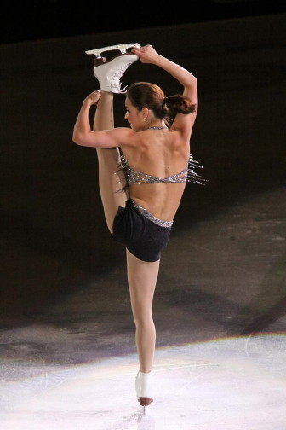
Figure 7.1: Sasha Cohen performs an I-spin at the 2009 Stars on Ice in Halifax, Nova Scotia.

Interesting things happen when objects are allowed to rotate. Ice skaters start a spin and then go faster and faster seemingly without any effort. Children’s tops fall over unless they are spinning.
At a playground or amusement park virtually every piece of equipment involves rotation in one way or another. Spinning wheels are used in almost every form of modern transportation. Even transportation that doesn’t involve wheels, like flying in a helicopter or walking, involves rotation around a joint or axle.
This chapter focuses on a new set of tools– still forces, motion, momentum, and energy–but specifically applied to rotating objects.
Many things do not change. We will see that angular force (called torque) changes angular momentum, causes angular acceleration, and does work, much like force does in linear systems. Energy and angular momentum are still conserved in an isolated system. And most of the mathematical models that we have used will apply equally well to rotation after just a few small changes.

: Kind of the Same ( , )

Words
Let’s look at the similarities between linear and rotational motion, forces, and momentum. Consider a thin, light rod with a small, massive ball on one end, rotating around a fixed pivot location at the opposite end of the rod. A “light” rod means that the mass of the rod itself is negligible.
Linear motion is described by position, velocity, and acceleration. Velocity is a change in position (also called displacement) over time, and acceleration is a change in velocity over time. Angular motion will be described in exactly the same way. The position is replaced by angular position, or simply angle. Angular velocity is a change in angular position over time, and angular acceleration is a change in angular velocity over time.
Each of these angular quantities is also directly related to its corresponding linear quantity in the tangential direction. For example, if the length of the rod were doubled but the angular velocity stayed the same, the ball would trace out a circle with twice the radius in the same amount of time, so the tangential velocity would double; if the length of the rod stayed the same but the angular velocity (rate of spin) was doubled, the ball would trace out a circle of the same size in half the time, so again the tangential velocity would double. So, the angular quantities are a combination of the linear quantities and the radius.

Graphics
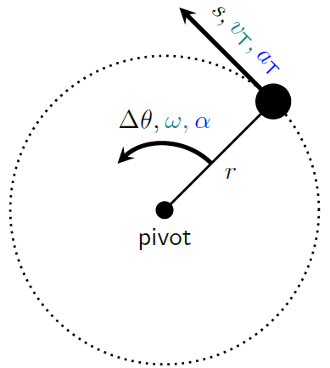
Figure 7.2: Looking down on the rod and ball. The ball follows the dotted line counterclockwise. $s$, $v_{T}$, & $a_{T}$ are the linear quantities corresponding to the angular quantities $Δθ$, $ω$, & $α$, respectively. “$α$” is the lowercase Greek letter “alpha.”¹

Numbers
$Δθ$ and $ω$ were already given in terms of $s$ and $v_{T}$ in Section 6.4. Angular acceleration $α$, whose SI unit is $[rad/s^{2}]$, is similarly related to $a_{T}$.
$$\boxed{α=\frac{a_{T}}{r}}$$
( 7.1 )
Every equation of motion that we have learned works equally well for angular motion, simply by replacing the linear quantities with their angular counterparts. So, for example…
$$\vec{x}=\vec{x_{0}}+\vec{v_{0}}⋅t+\frac{1}{2}\vec{a}⋅t^{2}$$
…becomes…
$$\boxed{θ=θ_{0}+ω_{0}⋅t+\frac{1}{2}α⋅t^{2}}$$
( 7.2 )
Average acceleration becomes…
$$\boxed{α_{avg}=\frac{Δω}{Δt}=\frac{ω_{f}-ω_{i}}{Δt}}$$
( 7.3 )
…and average velocity becomes…
$$\boxed{ω_{avg}=\frac{Δθ}{Δt}=\frac{1}{2}\left(ω_{i}+ω_{f}\right)}$$
( 7.4 )
…with the last part true only when angular acceleration is constant.

Words
When we looked at linear motion, we saw that acceleration only exists if there is an unbalanced force. So, we would again expect that to be true for rotational motion. An angular acceleration only exists if there is an unbalanced angular force, which is called a “torque.” The units of torque are [N ⋅ m].
Several forces are shown in Figure 7.3, all with the same magnitude. Which of them would create the largest angular acceleration?
Two of the forces, F₁ and F₂, are acting right at the pivot point. Since this physical scenario states that the pivot point is at a fixed location, it can’t move. That means neither of those two forces can create any angular acceleration around the pivot.
F₃ looks like a very good choice, and in fact this is where you would probably apply the force if you were in this situation trying to accelerate the ball. Of all the forces in Figure 7.3, F₃ is most effective at creating angular acceleration, because it creates the greatest amount of torque. F₄ and F₅ also create torque and will cause angular acceleration of the rod and ball, but not as much as F₃. That is because F₃ has the largest lever arm.
Just as forces cause a change in linear momentum over time, torques cause a change in angular momentum over time.

Graphics
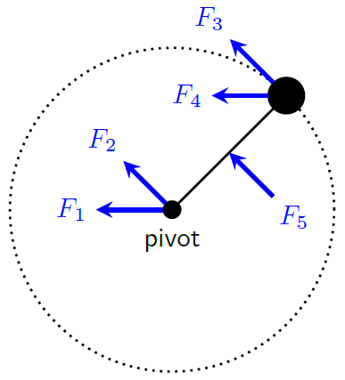
Figure 7.3: Several forces, all with the same magnitude, applied to a ball attached to a pivot by a light rod.¹
The lever arms ($r_{⟂}$’s) are zero for $F_{1}$ & $F_{2}$ since they are both at the pivot. The lever arm for $F_{3}$ is the length of the rod, and the lever arm for $F_{5}$ is half the length of the rod. The lever arm for $F_{4}$ is a bit more difficult to find. It is longer than the lever arm for $F_{5}$ but shorter than the lever arm for $F_{3}$.
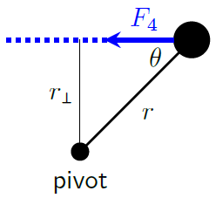
Figure 7.4: Finding the lever arm for $F_{4}$ from Figure 7.3.¹

Numbers
And, finally, the relationship between acceleration, displacement, and velocity becomes…
$$\boxed{2α⋅Δθ=ω_{f}^{2}-ω_{i}^{2}}$$
( 7.5 )
…when $α$ is constant. The angular version of force is torque $τ$. “$τ$” is the lowercase Greek letter “tau.” Torque increases with the length of the lever arm:
$$\boxed{τ=F⋅r_{⟂}}$$
( 7.6 )
As seen in Figure 7.4, the lever arm can be found from the distance $r$ to the pivot and the angle $θ$ between the vector being considered (in this case a force vector) and the vector $\vec{r}$. Using trigonometry gives…
$$\boxed{r_{⟂}=r⋅sinθ}$$
( 7.7 )
Mathematically, torque affects rotating systems in the same way that force affects linear systems. That includes the ability to change angular momentum over time:
$$\boxed{τ_{net,avg}=\frac{ΔL}{Δt}}$$
( 7.8 )

: Points and Hoops ( , )

Words
In Section 7.1, we considered a ball whose mass is concentrated into a small point some distance away from the pivot. Now we will explore what happens to rotational kinetic energy when the mass is distributed across a larger area.
In each of these examples of different mass distributions, we will assume that the total mass of the system $m$ is the same, and that the mass is first distributed and then the system is rotated at the same angular speed $ω$.
To begin, instead of a single mass $m$ at the end of a light rod with length $r$, we will consider two masses, each with a mass of $m/2$, connected by a light rod, keeping each mass at a distance $r$ from the center pivot point, rotating at a constant angular speed $ω$.
For each of these masses, the tangential speed will be the same as it was for the original single mass. We will need to combine their kinetic energies. Instead of a single mass at a certain speed, we have two half-masses at the same speed. The kinetic energy is the same, whether the mass is in one location or split into two locations.
What if we split the mass into three, or four, or six, or ten, or even more pieces, and kept all of them the same distance from the pivot?

Graphics
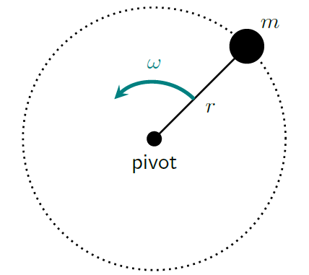
Figure 7.5: The original situation, with a single point mass rotating around a pivot at angular speed $ω$.¹
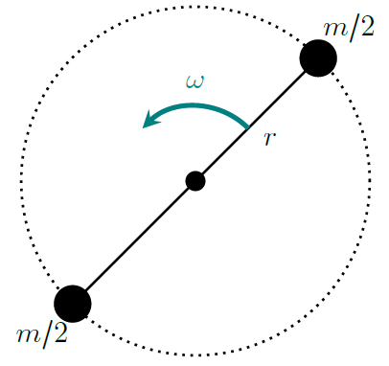
Figure 7.6: The second situation, with the same mass split into two parts, with both parts at the original distance from the pivot and the whole system rotating at the original angular speed $ω$.¹

Numbers
Assumptions: pointlike masses.
From Section 6.5 the rotational kinetic energy for a mass distribution like that in Figure 7.5 is…
$$E_{k,r}=\frac{1}{2}\left(m⋅r^{2}\right)⋅ω^{2}$$
For the mass distribution shown in Figure 7.6, we need to consider each mass separately and add their energies to find the total rotational kinetic energy.
$$\begin{aligned}E_{k,r}&=\frac{1}{2}⋅\frac{m}{2}⋅r^{2}⋅ω^{2}+\frac{1}{2}⋅\frac{m}{2}⋅r^{2}⋅ω^{2} \\ &=\frac{1}{2}\left(m⋅r^{2}\right)⋅ω^{2}\end{aligned}$$
The result is the same as if all the mass were at a single point.
Using the same analysis for a mass distribution where the same mass is divided into a huge number $N$ of small pieces, all kept at the same distance from the pivot, we must add up $N$ energies:
$$E_{k,r}=N⋅\left(\frac{1}{2}⋅\frac{m}{N}⋅r^{2}⋅ω^{2}\right)=\frac{1}{2}\left(m⋅r^{2}\right)⋅ω^{2}$$
If $N$ is large enough, all the mass could be spread out to be completely touching all the way around the circle, creating a hoop, without affecting the rotational kinetic energy.

Words
If the angular speed remains the same, each piece has the same tangential speed as the original single mass. When we combine their kinetic energies, the kinetic energy of the whole system is the same whether the mass is in one location or split into many locations. In fact, the kinetic energy would be the same even if you spread the mass out into a thin hoop at the same distance $r$ from the pivot.
Let’s try one more thing. We will split the mass into five equal parts, space them out equally in a line so that the ones on the ends are at the original distance $r$ and the middle one is at the center and then spin them at the same angular velocity as before.
The two pieces on the ends still move at the same tangential speed as before, but the pieces that are farther in move at a slower speed and the piece in the center doesn’t move at all. So, this time, when we add up the kinetic energies for the five pieces we will end up with less energy than before.
This time the way the mass is distributed has reduced the “rotational inertia” of the system of masses. If an object has a large rotational inertia, that means it is difficult to change its angular velocity. This is analogous to saying that if an object has a large mass, it is difficult to change its linear velocity. Rotational inertia is the angular counterpart of mass.
The closer the mass is to the pivot, the smaller the rotational inertia will be.

Graphics
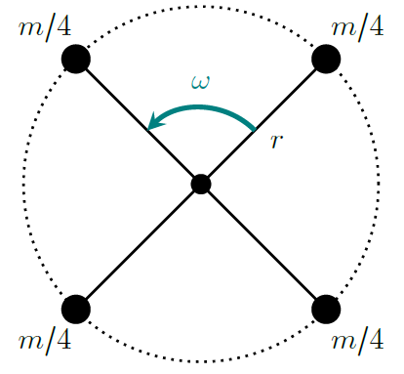
Figure 7.7: The third situation, with the same mass split into four parts, with all parts at the original distance from the pivot and rotating at the original angular speed $ω$.¹
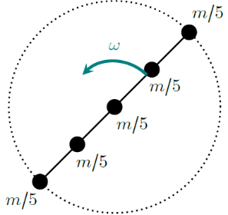
Figure 7.8: The fourth situation, with the same mass split into five parts at varying distances from the pivot and rotating at the original angular speed $ω$.¹

Numbers
For the situation shown in Figure 7.8, we have two masses at radius $r$, two at $r/2$, and one at the pivot point, so radius zero. When we add their kinetic energies we get:
$$\begin{aligned}E_{k,r}&=2⋅\frac{1}{2}⋅\frac{m}{5}⋅r^{2}⋅ω^{2}+2⋅\frac{1}{2}⋅\frac{m}{5}⋅{\left(r/2\right)}^{2}⋅ω^{2}+0 \\ &=\frac{1}{2}⋅\left(\frac{1}{2}m⋅r^{2}\right)⋅ω^{2}\end{aligned}$$
This is a different result! If we want to keep the form of our equation for rotational kinetic energy, the expression in the parentheses is not always going to be $m⋅r^{2}$.
The expression in the parentheses is the “rotational inertia,” $I$, the angular counterpart to mass. There will always be a mass and a distance squared in $I$, but it also contains a multiplier that depends upon the distribution of the mass. The multiplier gets smaller as the mass is brought closer to the pivot.
Replacing linear variables with their angular counterparts, we now have a few more mathematical models for rotating systems:
$$\boxed{E_{k,r}=\frac{1}{2}I⋅ω^{2}}$$
( 7.9 )
$$\boxed{L=I⋅ω}$$
( 7.10 )
$$\boxed{τ=I⋅α}$$
( 7.11 )

: Helicopter Blades ( )

Words
A typical helicopter blade has a mass of approximately 60 kg and a length of approximately 10 m, and the blades typically rotate at approximately 500 rpm. Assume that the blades of the two-blade helicopter shown in Figure 7.9 can go from motionless to full angular speed in 5 seconds, with constant angular acceleration over that time. What can we find from this information?
Since we are dealing with rotational motion, we should be thinking in terms of angular quantities: angular position, angular velocity, angular acceleration, angular momentum, torque, and rotational kinetic energy.
Initially the blade is not moving, so there is no angular velocity, no angular momentum, and no rotational kinetic energy. But once the blade is spinning it has all three of those, so that means that a torque must have been acting on the blade, coming from the engine inside the helicopter.
The torque does several things. For one, it causes angular acceleration, increasing the angular velocity over time. The amount of angular acceleration depends not only on the torque but also on the rotational inertia of the blades. Increasing torque will increase the angular acceleration, but increasing the rotational inertia will decrease the angular acceleration.

Graphics
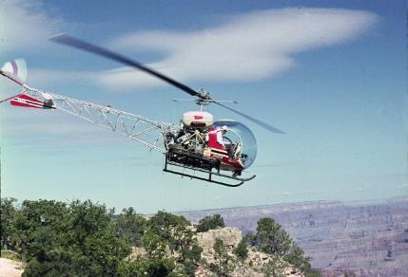
Figure 7.9: A helicopter with two blades.
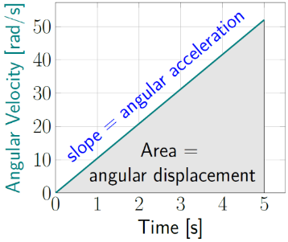
Figure 7.10: Similarly to linear velocity and linear acceleration, the slope of an angular velocity vs time graph is angular acceleration.¹

Numbers
Assumptions: $α$ is constant.
Knowns | Unknowns
$$m_{blade}=60 kg$$ | ???
$$l_{blade}=10 m$$
$$ω_{i}=0 rad/s$$
$$ω_{f}=52 rad/s$$
$$t=5 s$$
2 blades
The value for $ω_{f}$ in the table above was found by converting from rotations per minute (rpm):
$$\frac{500 rotations}{1 min}⋅\frac{2π rad}{rotation}⋅\frac{1 min}{60 s}=52 rad/s$$
We can find the average angular acceleration using Equation ( 7.3 ):
$$α_{avg}=\frac{ω_{f}-ω_{i}}{Δt}=\frac{\left(52-0\right) rad/s}{5 s}=10.4 rad/s^{2}$$
We can also find the total angle that the blades rotate through as they come up to full speed by using Equation ( 7.4 ):
$$\begin{aligned}Δθ&=ω_{avg}⋅Δt=\frac{1}{2}\left(ω_{i}+ω_{f}\right)⋅Δt \\ &=\frac{1}{2}\left(0+52\right) rad/s⋅\left(5 s\right)=130 rad \\ \end{aligned}$$

Words
The torque also changes the angular momentum of the blades. The change in angular momentum depends only on the net torque and the time over which that torque is applied.
And the torque also changes the rotational kinetic energy of the blades. That is because the torque is doing work on the blades, just as a force can do work on an object that has linear velocity. Since the blades are moving in the same direction as the torque, the work is positive, increasing the kinetic energy.

Graphics
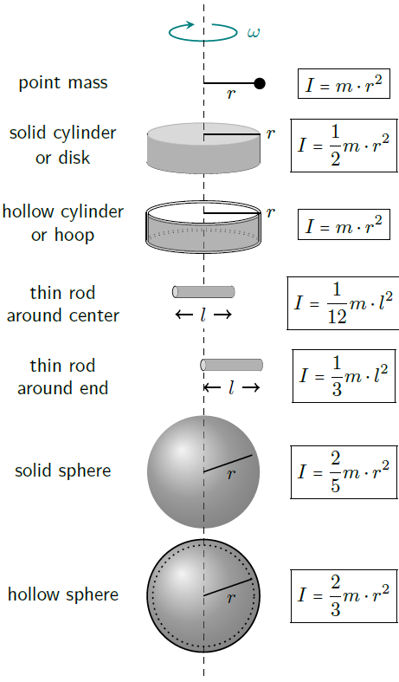
Figure 7.11: Rotational inertia for various shapes, each with mass $m$ and the same radius $r$ or length $l$, when rotated around the vertical dashed line.¹

Numbers
Since we are dealing with rotation, it will be helpful to find rotational inertia. The rotational inertia for several shapes is shown in Figure 7.11. We need to look for the shape that is most like the blades.
In this case, if we consider the two blades as a single object with twice the length of one blade we can use the “thin rod around center” from Figure 7.11.
$$\begin{aligned}I&=\frac{1}{12}m_{tot}⋅l_{tot}^{2} \\ &=\frac{1}{12}\left(120 kg\right)⋅{\left(20 m\right)}^{2} \\ &=4 000 kg⋅m^{2}\end{aligned}$$
Now we can use Equation ( 7.11 ) to find the net torque applied to the blades:
$$\begin{aligned}τ&=I⋅α=\left(4 000 kg⋅m^{2}\right)⋅10.4 rad/s^{2} \\ &=41 600 N⋅m\end{aligned}$$
We can also use Equation ( 7.10 ) to find the final angular momentum of the blades:
$$\begin{aligned}L_{f}&=I⋅ω_{f}=\left(4 000 kg⋅m^{2}\right)⋅52 rad/s \\ &=208 000 kg⋅m^{2}/s\end{aligned}$$
And finally, we can use Equation ( 7.9 ) to find the final rotational kinetic energy:
$$\begin{aligned}E_{k,r,f}&=\frac{1}{2}I⋅ω_{f}^{2}=\frac{1}{2}⋅\left(4 000 kg⋅m^{2}\right)⋅{\left(52 rad/s\right)}^{2} \\ &=5.4×{10}^{6} J\end{aligned}$$

: Figure Skating ( )

Words
Describe what happens if a 60-kg skater who is 1.7 m tall with a torso diameter of 0.3 m is spinning at a rate of 1.5 rad/s in the position shown in Figure 7.12 and then brings themselves into a vertical position, as in Figure 7.13.
When we are dealing with linear motion, we know that the more mass something has, the more difficult it is to move. But once you get it moving, it will have a large amount of momentum and kinetic energy. For rotational motion, it is not just the mass but how the mass is distributed that is important. This combination of mass and distance is called rotational inertia. Figure skaters are experts at changing their rotational inertia, which is what is happening when they go from a horizontal position to a vertical one.
For someone who has observed a spinning figure skater, it is hard to forget what happens when they change their rotational inertia. The figure skater can start a spin, and then spin faster and faster, apparently without any effort, without even pushing off again on the ice.
The only forces on the skater are gravity and the normal force from the ice, exactly the same as for the motionless rock we considered so long ago. The rock didn’t suddenly start spinning faster and faster. So how can a figure skater’s angular speed increase when there is no torque?

Graphics
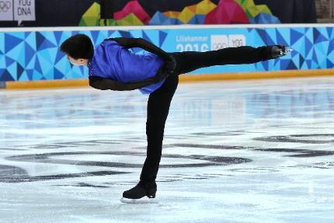
Figure 7.12: Tangxu Li at Lillehammer.
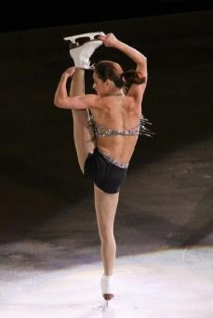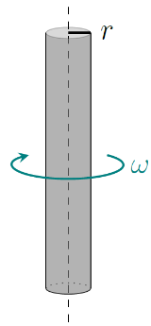
Figure 7.13: Sasha Cohen skating at Stars on Ice in 2009, and an approximation of her shape for finding her rotational inertia.^{35,1}

Numbers
Assumptions: No horizontal forces; $τ=0$.
Knowns | Unknowns
$$m=60 kg$$ | ???
$$l=1.7 m$$
$$r=0.15 m$$
$$ω_{i}=1.5 rad/s$$
We need to find the shape from Figure 7.11 that is most similar to the skater and use the rotational inertia for that shape. In this case, we have two different shapes to consider.
The final position shown in Figure 7.13 is simpler, so we will start there. Sasha Cohen’s body does not form a perfect solid cylinder, but there is no better option among the shapes in Figure 7.11. It should be noted that the location and direction of the axis of rotation is important. The “thin rod” in Figure 7.11 is rotating in such a way that its ends go around, or one end stays in position while the other end goes around. The “solid cylinder” is rotating along the axis of the cylinder, which is the direction in which Sasha is rotating.
Approximating Sasha as a solid cylinder, her rotational inertia is
$$I_{f}=\frac{1}{2}m⋅r^{2}=\frac{1}{2}60 kg⋅{\left(0.15 m\right)}^{2}=0.675 kg⋅m^{2}$$

Words
For an isolated system, angular momentum is conserved. That is the key to what is happening to the figure skater. The figure skater has no linear velocity, but they have angular velocity. Angular momentum of a rotating object is the rotational inertia times the angular velocity, just as linear momentum is the mass times the velocity.
So, when the skater is spinning with their body in a horizontal direction, their mass is spread out far from the vertical axis around which they are spinning. That gives them a large rotational inertia. Then, when they pull themselves into a vertical position, they bring their mass in close to the axis around which they are spinning. This reduces their rotational inertia. Since angular momentum is conserved, reducing the rotational inertia creates a corresponding increase in angular velocity.
This increase in angular velocity also results in an increase in the rotational kinetic energy of the skater, so work was done on the skater. Where did the work come from? The skater does work on their own body. A centripetal force, toward the axis of rotation, is needed to keep something moving in a circle. To move something closer to the axis, the displacement is in the direction of that force, so the skater must do work to come to a vertical position.

Graphics
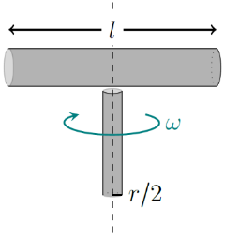
Figure 7.14: An approximation of the shape of Tangxu Li for finding his rotational inertia.¹

Numbers
The position that Tangxu Li is in is more difficult to analyze, because his body is going in two directions. His left leg is vertical and so could be approximated as a cylinder just as we did with Sasha. But the rest of his body is horizontal and spinning end-to-end, which is much more like the “thin rod around center.” To find Tangxu Li’s rotational inertia, we can make both approximations and add their rotational inertia. If we assume that his left leg contains 1/4 of the mass of his whole body and is 1/2 the radius of his torso, we have…
$$\begin{aligned}I_{i}&=I_{leg}+I_{body}=\frac{1}{2}\left(\frac{1}{4}m\right)⋅{\left(\frac{r}{2}\right)}^{2}+\frac{1}{12}\left(\frac{3}{4}m\right)⋅l^{2} \\ &=(0.04+10.8) kg⋅m^{2}=10.8 kg⋅m^{2}\end{aligned}$$
Apparently, we really didn’t even need to take the vertical leg into account. It is so close to the axis compared to the rest of the body that it doesn’t significantly affect rotational inertia. Now we can use conservation of angular momentum to find the final angular velocity of the skater:
$$\begin{aligned}L_{f}&=L_{i} \\ I_{f}⋅ω_{f}&=I_{i}⋅ω_{i}\end{aligned}$$
$$ω_{f}=\frac{10.8}{0.675}⋅1.5 rad/s=24 rad/s$$
The angular velocity increases by more than a factor of 10! Now, using the Work-Energy Theorem with Equation ( 7.9 )eqn:E_kr…
$$W_{net}=ΔE=\frac{1}{2}I_{f}⋅ω_{f}^{2}-\frac{1}{2}I_{i}⋅ω_{i}^{2}=182 J$$
So, 182 J of work was done by the skater to change position while spinning.

: Charging a Radio ()

Words
In areas with limited access to electrical power, hand-cranked devices are often used. Figure 7.15 shows a boy cranking a radio to charge its battery. He must push on the end of the 0.08-m-long handle of the crank with a force of 5 N to get it to move. If he cranks at a constant rate of 10 rad/s, how much time will it take him to store 150 J of energy in the battery, assuming that the charging system is 100% efficient?
In this situation, we are given a force that is applied a certain distance away from a pivot, so the boy is applying a torque to the crank. With linear motion, a force that is applied through a distance does work (and so can store energy). The rotational corollary of this is that a torque that is applied through an angle does work.
The amount of work that the boy does will be proportional to the torque and proportional to the angle. Since he is cranking at a constant rate, the angle will change linearly in time. The force he applies will have to be constant at 5 N so that there is no acceleration. So, the applied torque is also constant. Since the angle changes linearly in time and the force is constant, the energy stored will also increase linearly in time. And since power is energy per time, the power the boy produces and stores is constant while he is cranking.

Graphics
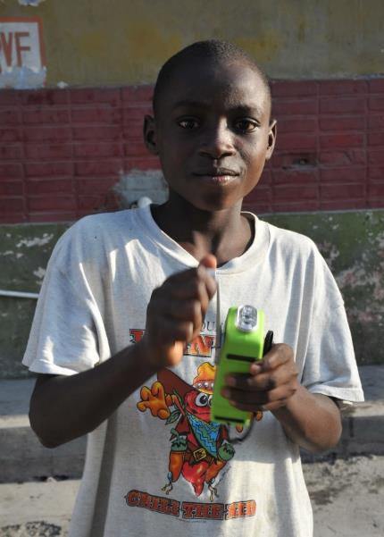
Figure 7.15: A boy charging his hand-cranked radio.

Numbers
Assumptions: 100% efficiency; $+\hat{θ}$ is counterclockwise; viewing image from the left.
Knowns | Unknowns
$$r=0.08 m$$ | $$t$$
$$\vec{F_{applied}}=-5 N \hat{θ}$$
$$ω=-10 rad/s$$
$$W=150 J$$
The torque applied to the handle, as shown in Figure 7.16, is
$$τ=F_{applied}⋅r⋅sinθ=-0.4 N⋅m$$
The angular version of our expression for work done by a force is…
$$\boxed{W=τ⋅Δθ}$$
( 7.12 )
…when the torque is constant. And since power is work per time, it can also be expressed as…
$$\boxed{P=τ⋅ω}$$
( 7.13 )
From Equation ( 7.12 ) the total angle that the boy must crank through to charge the radio is:
$$Δθ=\frac{W}{τ}=\frac{150 J}{-0.4 N⋅m}=-375 rad$$
…or approximately 60 full revolutions.

Words
(This column intentionally left blank)

Graphics
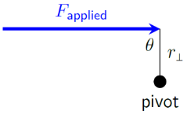
Figure 7.16: The boy applies a clockwise torque on the device, as seen from the left in Figure 7.15. This theta refers to the angle between the force and the lever arm, not the rotation of the crank.¹
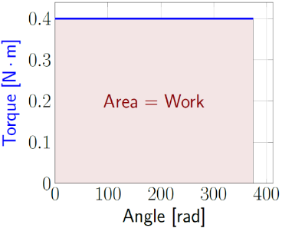
Figure 7.17: A torque in the direction of angular motion does an amount of work equal to the area under the curve in a Torque-vs-Angle graph.¹
Torque and angle are taken to be positive for this graph. Using negative values as described in the “Numbers” section, the area would be negative (so under the x axis) but the angle would go right-to-left instead of left-to-right, which creates another negative. Looking at Figure 7.15 from the right instead of from the left would have made both torque and angle positive.

Numbers
With the angular displacement we can find the time using Equation ( 7.4 ).
$$Δt=\frac{Δθ}{ω_{avg}}=37.5 s$$
This question could also have been answered using a linear analysis of work done in the tangential direction:
$$s=\frac{W}{F_{T}}=\frac{150 J}{-5 N}=-30 m$$
We aren’t given a tangential velocity, but we can find it from the angular velocity:
$$v_{T}=ω⋅r=-0.8 m/s$$
Then we can find the time:
$$Δt=\frac{s}{v_{T}}=37.5 s$$
Whichever way the analysis is done, the result is the same. The power generated by the boy is also the same either way:
$$P_{avg}=\frac{W}{Δt}=\frac{150 J}{37.5 s}=4 W$$
It should be noted that there are two different kinds of “W” in the expression above. The italicized one in the numerator ($W$) is Work; the one at the end that is not italicized is watts.

: Hoop Rolling ( , )

Words
In the children’s game “hoop rolling,” a stick is used to start a hoop moving and then to keep it going. Let’s say that the hoop starts at rest and accelerates uniformly across level ground to a speed of 5 m/s to the right in 2.5 seconds. The hoop has a mass of 0.4 kg and a radius of 0.2 m, and it rolls without slipping. Describe everything you can about this situation.
We know from considering other situations that velocity changes in the direction of acceleration, so acceleration is to the right. Momentum starts at zero and increases to the right along with the velocity, so there is a force to the right. Since the ground is level, we don’t need to consider gravitational potential energy, and there also is no spring potential energy to consider. The hoop rolls without slipping, and usually thermal energy is generated by surfaces sliding together or by collisions. In this case, we don’t have either. So, the hoop starts with no kinetic energy and ends with kinetic energy. This means that positive work was done on the hoop, which makes sense because we have already established that there is a force to the right and the motion is to the right. Force in the direction of motion does positive work.
We have done all of that before. But that’s not all that there is to the story. We haven’t taken into consideration the fact that the hoop is rolling. This is a physical scenario that involves both translation (linear movement) and rotation.

Graphics
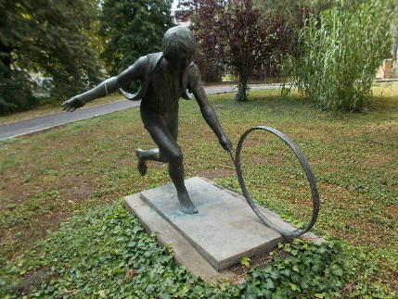
Figure 7.18: Statue of a boy playing “hoop rolling.”
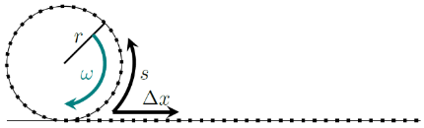
Figure 7.19: As the hoop rolls, it does not slide, so the distance it moves has the same magnitude as the path length on the circumference of the hoop, $Δx=s$. As the hoop rolls, each mark on the hoop will fall on its corresponding, equally spaced mark on the ground.¹

Numbers
Assumptions: $a$ is constant; rolls without slipping.
Knowns | Unknowns
$$\vec{v_{0}}=0$$ | ???
$$\vec{v_{f}}=5 m/s \hat{x}$$
$$Δt=2.5 s$$
$$m=0.4 kg$$
$$r=0.2 m$$
It is possible to approach this question just as we would have after one or two chapters, using a linear analysis of motion, forces, etc. But this analysis will be done by analyzing it from an angular perspective. Our knowns are all linear, but they are connected to angular motion through tangential velocity. In the reference frame of a person sitting at the center of the hoop, the ground goes to the left at the speed at which the hoop is moving, and the bottom edge of the hoop moves along with it.
$$ω_{0}=-\frac{v_{0}}{r}=0$$
$$ω_{f}=-\frac{v_{f}}{r}=-25 rad/s$$
Why the minus signs? It is possible to keep all signs consistent mathematically, but it is often easier just to look at a sketch and see whether the motion (or angular momentum, or torque) is counterclockwise (+) or clockwise (-) and use the appropriate sign. In this example, we can see that the hoop is spinning clockwise.

Words
At first, the hoop is not rolling, so zero angular velocity, but at the end it is rolling to the right, which means that it is turning in the clockwise direction. The standard “positive” angular direction in physics is counterclockwise, so the final angular velocity is negative. That means that the angular acceleration is also negative.
Angular momentum starts at zero and increases along with angular velocity, in the negative direction, so there is a negative torque.
Torque is created by an off-center force. In this case, the child is pushing to the right at some point near the middle of the hoop, and friction with the ground prevents it from rolling by pushing left on the bottom of the hoop. It is the combination of these two forces that creates the torque.
We also have one additional type of energy to consider: rotational kinetic energy. Not all the work that the child did in pushing the hoop went into linear kinetic energy; some went into rotational kinetic energy.

Graphics
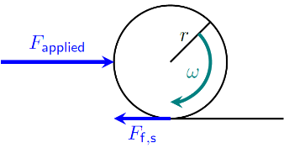
Figure 7.20: We know that the net force is to the right, because that is the direction of acceleration. But we also know that there is a force of friction to the left, because the hoop would slide to the right without this friction.¹
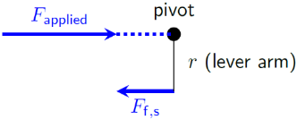
Figure 7.21: Force locations when considering torque.¹
If we use the center of the hoop as the reference frame, the only motion of the hoop is rotational, around the center of the hoop. So, we can use the center of the hoop as our pivot point. In this reference frame, it is the frictional force that is not aligned with the pivot but is separated by a lever arm distance. So, it is the frictional force that creates the torque, making the hoop roll instead of sliding.

Numbers
Knowing the time, we can find the angular acceleration:
$$α=α_{avg}=\frac{Δω}{Δt}=-10 rad/s^{2}$$
We can also find the total angle that the hoop rolls through as it speeds up over 2.5 s.
$$Δθ=θ-θ_{0}= ω_{0} ⋅t+\frac{1}{2}α⋅t^{2}=-31.3 rad$$
It should be clear that the appropriate rotational inertia is that of a hoop, so…
$$I=m⋅r^{2}=0.016 kg⋅m^{2}$$
With this information, we can find final angular momentum, torque, and final rotational kinetic energy:
$$L_{f}=I⋅ω_{f}=-0.4 kg⋅m^{2}/s$$
$$τ=I⋅α=-0.16 N⋅m$$
$$E_{k,r,f}=\frac{1}{2}I⋅ω_{f}^{2}=5 J$$
So, the total work done by the child on the hoop is…
$$W_{net}=ΔE_{k,t}+ΔE_{k,r}=\frac{1}{2}m⋅v_{f}^{2}+5 J=10 J$$
For a rolling hoop, half of its kinetic energy is rotational! We can use the Work-Energy Theorem to find the force applied by the child:
$$F_{applied}=\left|\frac{W_{tot}}{Δx}\right|=\left|\frac{10 J}{r⋅Δθ}\right|=1.6 N$$

: Center of Mass ( , )

Words
The idea of “center of mass” is important for rotation. For one thing, the axis that an isolated, rotating object spins around goes through its center of mass. For another thing, when determining the torque created by an object’s weight, all the object’s mass behaves as though it were sitting at the center of mass.
For some situations, it is easy to find the center of mass–it’s just in the center!
This is the case for something like a bocce ball, which is a uniform, solid sphere. It is also the case for something like a tennis ball, which is a uniform, hollow sphere. Even though there is nothing actually at the center of the ball, that point is still the center of mass.
And even for objects with more unusual shapes, like a dumbbell, if the object is symmetrical, the center of mass will be at its center.
For objects with asymmetrical shapes or for a system of different objects, the center of mass is somewhere in the middle, shifted toward the side with more mass. In the photo of the tennis ball, bocce ball, and dumbbell, the tennis ball has a much smaller mass than the other two, so the center of mass of this group of three objects is somewhere in between the dumbbell and the bocci ball. Where exactly that center of mass is located depends upon the relative masses of the objects.

Graphics
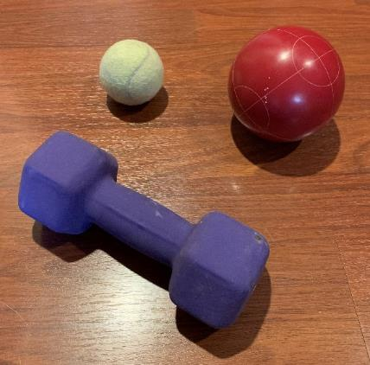
Figure 7.22: A tennis ball (top left), bocce ball (top right), and dumbbell.¹
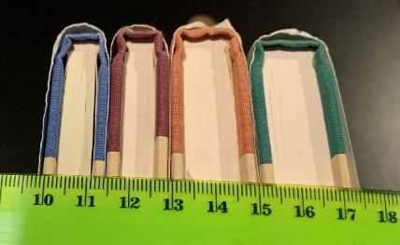
Figure 7.23: A stack of books of varying widths and masses.¹

Numbers
The center of mass of an object or system of objects is a position, so it is a vector quantity.
$$\boxed{\vec{x_{com}}=\frac{m_{1}⋅\vec{x_{1}}+m_{2}⋅\vec{x_{2}}+⋯}{m_{1}+m_{2}+⋯}}$$
( 7.14 )
…where $\vec{x_{com}}$ is the center of mass, $m_{1}$ and $\vec{x_{1}}$ refer to the mass and position of object 1, $m_{2}$ and $\vec{x_{2}}$ are for object 2, and every object in the system is included in the sums.
The easiest way to use this equation is to break the system up into pieces with obvious centers of mass, and use those as objects 1, 2, etc.
Figure 7.23 shows a stack of four books. The center of mass of each individual book is at the center of the book. If we know the mass and position of each book, we can find the center of mass of the stack:
Book | Mass | Position
1 | 0.202 kg | 10.7 cm
2 | 0.242 kg | 12.2 cm
3 | 0.302 kg | 13.9 cm
4 | 0.324 kg | 16.2 cm
Combining this data using Equation ( 7.14 ) gives:
$$x_{com}=\frac{14.6 kg⋅cm}{1.07 kg}=13.6 cm$$

Words
To see how this works with rotation, we will consider a 3-m-long, 3-kg thin rod with a 4-kg point mass on the end. Imagine the rod connected by a hinge to a solid wall, and initially held out horizontally, as shown in Figure 7.24. If the rod-and-mass system is released from this position, what is its initial angular acceleration due to gravity? What is the initial tangential acceleration of the point mass due to gravity?
One end of the rod is held by the hinge, so the rod and point mass will rotate around the hinge because of the torque caused by gravity. Since we are dealing with rotation, we will need to find the rotational inertia of the system. For that, we can add up the rotational inertia of the rod rotating around the end and the point mass.
We will also need to find the torque created by gravity. To do this, we can first find the center of mass of the system and then consider the force of gravity of the whole rod-and-mass system to be acting at that single point.

Graphics
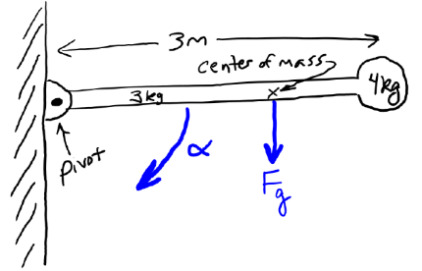
Figure 7.24: A long, thin rod with a mass on the end, connected to a wall with a hinge.¹

Numbers
Knowns | Unknowns
$$m_{rod}=3 kg$$ | $$α_{i}$$
$$l_{rod}=3 m$$ | $$a_{T,i,point}$$
$$m_{point}=4 kg$$
$$g=9.8 N/kg$$
We can add the rotational inertia of the rod and mass to find the rotational inertia of the system:
$$\begin{aligned}I_{system}&=I_{rod}+I_{point} \\ &=\frac{1}{3}m_{rod}⋅l_{rod}^{2}+m_{point}⋅l_{rod}^{2} \\ &=9 kg⋅m^{2}+36 kg⋅m^{2} \\ &=45 kg⋅m^{2}\end{aligned}$$
We can find the center of mass in the $x$ direction, with “$x=0$” at the pivot:
$$\begin{aligned}x_{com}&=\frac{m_{rod}⋅x_{rod}+m_{point}⋅x_{point}}{m_{rod}+m_{point}} \\ &=\frac{\left(3 kg\right)⋅\left(1.5m\right)+\left(4 kg\right)⋅\left(3m\right)}{\left(3 kg\right)+\left(4 kg\right)} \\ &=2.36 m\end{aligned}$$
Now we can use Equations ( 7.6 )and ( 7.11 ) to find the initial angular acceleration:
$$\begin{aligned}α_{i}&=\frac{τ}{I_{system}} \\ &=\frac{-F_{g}⋅x_{com}}{I_{system}} \\ &=\frac{-m_{system}⋅g⋅x_{com}}{I_{system}} \\ &=-3.59 rad/s^{2}\end{aligned}$$

: Off-Center Rotation ( )

Words
For most of the objects in Figure 7.11, the objects are assumed to be rotating around their center of mass. But sometimes we need to work with objects that are rotating around a point that isn’t at their center of mass.
Let’s take the example of the pendulum of a grandfather clock. The pivot is at the top of a 0.9-m-long rod, and the pendulum is composed of the rod itself with a 10-cm-radius disk attached near the bottom of the rod, centered at a position 0.78 m below the pivot. We will assume that the rod and the disk each have a mass of 0.3 kg. We can find the total rotational inertia of the pendulum around the pivot.
We already have expressions for a thin rod rotating around its end and a disk rotating around its center, but we don’t have an expression for a disk rotating far away from its center. Since the mass is farther away from the axis of rotation in this case, we know the rotational inertia must be larger.
It turns out that it is not too difficult to change to a different axis of rotation, if the new axis is parallel to an axis of rotation that you already know around the center of mass of the object. You just need to add one additional piece to the rotational inertia. This is called the “parallel axis theorem.”

Graphics
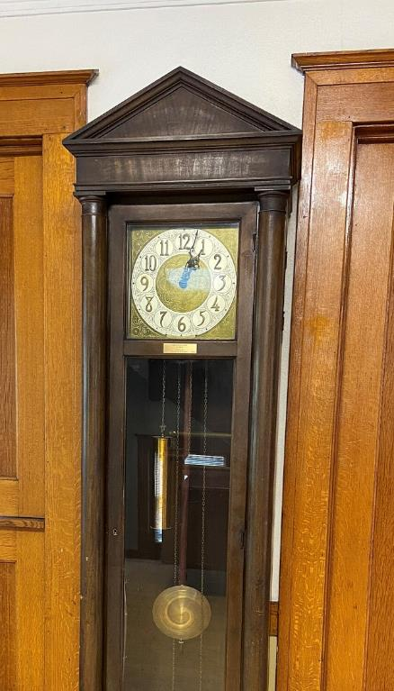
Figure 7.25: A grandfather clock. The pendulum with a dark rod and brass disk can be seen behind the glass.

Numbers
Assumptions: uniform rod and uniform disk.
Knowns | Unknowns
$$m_{rod}=0.3 kg$$ | $$I_{tot}$$
$$l_{rod}=0.9 m$$
$$m_{disk}=0.3 kg$$
$$r_{disk}=0.1 m$$
$$d_{disk}=0.78 m$$

The “parallel axis theorem” gives the rotational inertia for an object that is rotating around an axis other than its center of mass:
$$\boxed{I=I_{com}+m⋅d^{2}}$$
( 7.15 )
…where $d$ is the distance from the pivot to the center of mass of the object

Words
(This column intentionally left blank)

Graphics
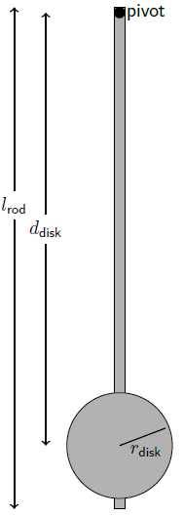
Figure 7.26: Schematic of the pendulum of the grandfather clock.¹

Numbers
In this case, the center of the disk is 0.78 m from the pivot, so…
$$\begin{aligned}I_{disk}&=\frac{1}{2}m_{disk}⋅r_{disk}^{2}+m_{disk}⋅d_{disk}^{2} \\ &=\frac{1}{2}⋅\left(0.3 kg\right)⋅{\left(0.1 m\right)}^{2}+\left(0.3 kg\right)⋅{\left(0.78 m\right)}^{2} \\ &=0.184 kg⋅m^{2} \\ \end{aligned}$$
That only accounts for the disk, not the rod. So, the total rotational inertia of the pendulum is…
$\begin{aligned}I_{tot}&=I_{rod}+I_{disk} \\ &=\left(0.184 kg⋅m^{2}\right)+\frac{1}{3}m_{rod}⋅l_{rod}^{2} \\ &=\left(0.184 kg⋅m^{2}\right)+\frac{1}{3}⋅\left(0.3 kg\right)⋅{\left(0.9 m\right)}^{2} \\ &=\left(0.184 kg⋅m^{2}\right)+\left(0.081 kg⋅m^{2}\right) \\ &=0.265 kg⋅m^{2}\end{aligned}$.

: Balancing ( , )

Words
Figure 7.27 shows a board and a brick balancing on the end of another board. The brick has a mass of 1.76 kg, and its center of mass is 7.5 cm to the left of the upright board. The horizontal board has a length of 49 cm, and its left edge is 9.5 cm to the left of the upright board. We can use this information to find the mass of the horizontal board and the normal force that the upright board applies to the horizontal board.
The key to understanding this scenario is the rotational corollary to Newton’s First Law. That law states that if the net force on a system is zero then the acceleration of that system is also zero. The rotational corollary of that statement would be that if the net torque on a system is zero then the angular acceleration of that system is also zero. Since the system is balancing motionless, the acceleration, both angular and linear, must be zero. That situation is called “static equilibrium.”
There are two ways to approach this problem. One is by considering forces and torque as described above, and the other is by considering the center of mass. Let’s first consider the center of mass.

Graphics
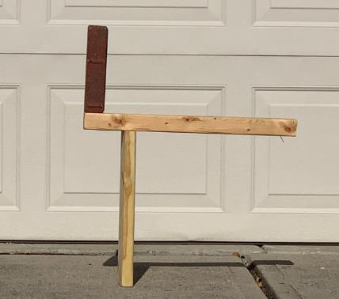
Figure 7.27: Two boards and a brick balancing.¹
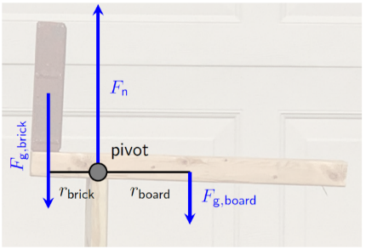
Figure 7.28: The forces and torques on the balancing brick and the horizontal board.¹

Numbers
Assumptions: near the surface of the earth.
Knowns | Unknowns
$$m_{brick}=1.76 kg$$ | $$m_{board}$$
$$r_{brick}=0.075 m$$ | $$F_{n}$$
$$r_{board}=0.15 m$$
$$g=9.8 N/kg$$
$r_{board}$ was found by assuming that the center of mass of the board is at the center of the board, which is 0.245 m to the right of the left end of the board, and thus
$$r_{board}=(0.245 m-0.095 m)=0.15 m$$
For an object that is in static equilibrium, the net force and the net torque are both zero. Calculation of the net torque around the pivot in Figure 7.28 gives…
$$\sum{τ}=τ_{brick}+ τ_{n} -τ_{board}=0$$
$$F_{\text{g.}brick}⋅r_{brick}⋅ \sin{90°} =F_{\text{g.}board}⋅r_{board}⋅ \sin{90°}$$
$$m_{board}=m_{brick}⋅\frac{r_{brick}}{r_{board}}=0.88 kg$$
We can also use Figure 7.28 as a force diagram to find $F_{n}$, since the sum of forces is zero.

Words
Unless the brick and boards are glued or bolted together, to remain balanced their center of mass must be supported. The center of mass of the brick is above the horizontal board. If it were hanging far off the end of the board, the brick would fall. The combined center of mass of the brick and the horizontal board must be above the vertical board for the same reason. The combined center of mass of both boards and the brick also must be above the bottom of the vertical board.
Now, we will consider the situation from the perspective of forces and torque. If the brick and horizontal board were to fall, they would tip around a pivot at the top of the vertical board. It doesn’t tip, so that means the net torque around that pivot must be zero.
There is a gravitational force acting downward on the brick, and since the brick is to the left of the pivot, it would cause counterclockwise (or positive) angular acceleration. So, the brick creates a positive torque. The horizontal board must create an equal but opposite torque to keep the system balanced. When considering torque, an object’s mass acts as if it is at a single point: the center of mass of the object. The center of mass of the horizontal board should be near the center of the board, which is clearly to the right of the pivot. So, the mass of the horizontal board must be just enough that its gravitational force creates enough torque to balance the torque created by the brick.

Graphics
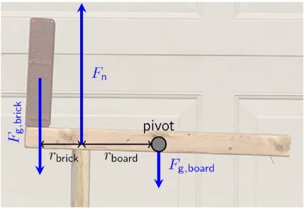
Figure 7.29: An alternate location for the pivot, allowing a solution for the normal force without knowing the mass of the board.¹
For a system in static equilibrium, it isn’t moving around any pivot point, so we are free to use any pivot point that is convenient. Notice that when we set the pivot at the point where the boards meet there was no torque generated by the normal force. If we instead chose a pivot at the center of mass of the horizontal board, its gravitational force would not generate any torque.

Numbers
$$ΣF_{y}=-F_{g,brick}+F_{n}-F_{g,board}=0$$
$$F_{n}=m_{brick}⋅g+m_{board}⋅g=25.9 N$$
We could have found $m_{board}$ using center of mass instead. Since we are free to choose our zero position, it is convenient to put it at the location of the pivot in Figure 7.28, so that the center of mass of the system is at $r=0$.
$$r_{com}=0=\frac{m_{brick}⋅r_{brick}+m_{board}⋅r_{board}}{m_{brick}+m_{board}}$$
$$m_{brick}⋅r_{brick}=-m_{board}⋅r_{board}$$
$$m_{board}=\frac{(-1.76 kg)⋅(-0.075 m)}{0.15 m}=0.88 kg$$
A negative value was assigned to $r_{brick}$ because it is to the left of the zero point at the pivot.
We could also have found $F_{n}$ without knowing $m_{board}$ simply by choosing a different pivot point. This is illustrated in Figure 7.29.
$$\sum{τ}=τ_{brick}-τ_{n}+ τ_{board} =0$$
$$F_{g,brick}⋅(r_{brick}+r_{board})=F_{n}⋅r_{board}$$
$$F_{n}=\frac{m_{brick}⋅g⋅(0.075 m+0.15 m)}{0.15 m}=25.9 N$$

: Summary
Chapter summaries in this book are ordered by concept, not necessarily in the order in which they are presented in the chapter. Mathematical models are grouped together at the end of each summary. See the appendices for the meanings of all symbols used in this book.

General
- Objects have a “rotational inertia” that increases with mass and physical size. The farther an object’s mass is distributed from the axis of rotation, the larger its rotational inertia.
- The rotational inertia of multiple parts can be added together for a complex shape.
- Every linear equation that we have learned works equally well for rotation, simply by replacing the linear quantities with their angular counterparts:
linear | angular
$$\vec{x}$$ | $$θ$$
$$\vec{v}$$ | $$ω$$
$$\vec{a}$$ | $$α$$
$$\vec{p}$$ | $$L$$
$$\vec{F}$$ | $$τ$$
$$E_{k}$$ | $$E_{k,r}$$
$$m$$ | $$I$$

Forces, Torque, and Linear & Angular Acceleration
- Torque $[N⋅m]$ is the angular quantity that corresponds to force. It is a force applied in a direction that is not aligned with the pivot point but separated from it by a lever arm distance.
- Torque causes angular acceleration, changes angular momentum over time, and does work through an angle.
- Static equilibrium is when an object is completely motionless. It can only occur when net force and net torque are both zero.
- When determining the torque created by an object’s weight, all the object’s mass behaves as though it is at the center of mass.

Mathematical Models
Equation | Reference | Restrictions on the validity of the equation
$$α=\frac{a_{T}}{r}$$ | ( 7.1 ) | -none-
$$τ=F⋅r_{⟂}$$ | ( 7.6 ) | -none-
$$r_{⟂}=r⋅sinθ$$ | ( 7.7 ) | -none-
$$\vec{x_{com}}=\frac{m_{1}⋅\vec{x_{1}}+m_{2}⋅\vec{x_{2}}+⋯}{m_{1}+m_{2}+⋯}$$ | ( 7.14 ) | -none-

: Questions
Questions are ordered according to Bloom’s Taxonomy, progressing from regurgitating information (Level 1) to synthesizing new information with previous knowledge to create something new (Level 6). The bold letters at the beginning of each question indicate whether the question involves Words [W], Graphics [G], and/or Numbers [N]. See the appendices for conversion factors.

Level 1 - Remember
linear quantity | linear symbol | angular symbol | angular quantity
position | ($\vec{x}$)
displacement or path length | ($\vec{Δx}$ or $s$)
velocity | ($\vec{v}$)
acceleration | ($\vec{a}$)
linear (or translational) kinetic energy | ($E_{k}$ or $E_{k,T}$)
linear momentum | ($\vec{p}$)
force | ($\vec{F}$)
mass | ($m$)
      - [W & N] Make a table of the names and symbols of the linear quantities and their corresponding angular quantities from the past two chapters.
Symbol | Reference | Label
$$α$$ | ( 7.1 )
$$θ$$ | ( 7.2 )
$$α_{avg}$$ | ( 7.3 )
$$ω_{avg}$$ | ( 7.4 )
$$2⋅α⋅Δθ$$ | ( 7.5 )
$$τ$$ | ( 7.6 )
$$r_{⟂}$$ | ( 7.7 )
$$τ_{net,avg}$$ | ( 7.8 )
$$E_{k,r}$$ | ( 7.9 )
$$L$$ | ( 7.10 )
$$τ$$ | ( 7.11 )
$$W$$ | ( 7.12 )
$$P$$ | ( 7.13 )
$$\vec{x_{com}}$$ | ( 7.14 )
$$I$$ | ( 7.15 )
      - Add labels to each boxed equation from this chapter that tell what the symbol to the left of the = sign represents.

Level 2 - Understand
      - [N] Calculate the rotational inertia $I$ of the rod and ball as described in Section 7.1, if the length of the rod is 0.4 m and the mass of the ball is 1.2 kg.
      - [W,G, & N] Several objects in Figure 7.11 have been ranked in order from those with the most mass concentrated far from the axis of rotation to those with the most mass concentrated near the axis of rotation. How do the numbers multiplying $\left(m⋅r^{2}\right)$ compare when the shapes are put in this order?
Shape | Number multiplying $\left(m⋅r^{2}\right)$
point mass
hoop
hollow sphere
disk
solid sphere
      - [N] At the end of Section 7.2 are three mathematical models with very little explanation. Replace the angular quantities in these three mathematical models with their linear counterparts and verify that they are all valid mathematical models.
        - Equation ( 7.9 ), $E_{k,r}=\frac{1}{2}⋅I⋅ω^{2}$, corresponds to…
        - Equation ( 7.10 ), $L=I⋅ω$, corresponds to…
        - Equation ( 7.11 ), $τ=I⋅α$, corresponds to…

Level 3 - Apply
      - [N] Use dimensional analysis to show that Equation ( 7.10 ), $L=I⋅ω$, and Equation ( 6.9 ),
$L=m⋅v⋅r_{⟂}$, have the same SI units.
      - [N] If the ball described in Section 7.1 has a mass of 3.2 kg and is spinning at a constant rate of 2.5 rad/s on a rod with a length of 0.9 m, find its kinetic energy, its angular momentum, and the net torque that is being applied to keep it spinning at a constant rate.
      - [N] The analysis in Section 7.3 was done taking the two blades to be one object, a thin rod spinning about its center. That wouldn’t work for a helicopter with three blades. Do the same analysis that was done in Section 7.3 but for the helicopter shown in the figure below. Take the mass of each blade, the length of each blade, the time, and the final angular speed to be the same as in Section 7.3.
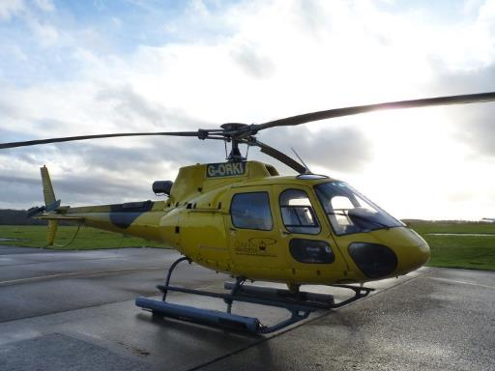
Three-bladed helicopter.
      - [W, G & N] If Sasha Cohen was spinning in the position shown in Figure 7.13 and then changed her position to be that like that of Elena Glebova in the image below, would her angular momentum, angular velocity, and rotational kinetic energy increase, decrease, or remain constant?
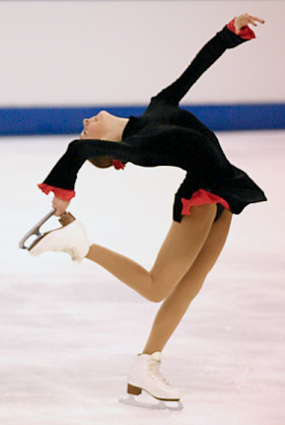
Elena Glebova in a spin.
      - [G & N] Use Figure 7.21 and the torque that was found in Section 7.6 to find the magnitude of the force of friction between the hoop and the ground.
      - [N] Figure 7.11 includes only one object that is not rotating around its center of mass: the “thin rod around end.” Use the parallel axis theorem and the rotational inertia of a thin rod around its center to verify the given rotational inertia for a thin rod around its end.
      - [N] Use the parallel axis theorem and one of the expressions for rotational inertia given in Figure 7.11 to find a simple expression for the rotational inertia of a solid sphere rotating around a point on its outer surface.

Level 4 - Analyze
      - [N] Use dimensional analysis to find the SI unit for $E_{k,r}$. Is it the same unit that $E_{k}$ has for linear motion? Should it have the same unit? Explain your answer.
      - [W, G, & N] What is the total rotational inertia for two thin “half rods,” each of mass $m/2$ and length $l/2$, rotated around their ends? Compare your answer to that for the rotational inertia of a single full rod with mass $m$ and length $l$, rotated around its center. What do you notice? Explain this result.
      - [N] How much work did the engine do on the blades in Section 7.3? Show your work or otherwise explain your answer.
      - [W & N] The initial tangential acceleration of the point mass in Section 7.7 was listed as an unknown, but it wasn’t found. Find it. Consider the value that you found–is it surprising? Why or why not?
      - [W & N] The torque in Section 7.7 was calculated using the center of mass of the system as a whole. Try finding the torques created individually by the rod and by the point mass. Would using individual torques have given the same answer for initial angular acceleration? Explain why or why not.

Level 5 - Evaluate
      - [N] What effect does doubling angular velocity have on angular momentum and rotational kinetic energy?
      - [W, G, & N] In Section 7.6, a child is rolling a hoop. What would change if all of the knowns stayed the same, but the child was instead rolling a solid sphere?
      - [W, G, & N] In Section 7.6, a child is rolling a hoop. What would change if all of the knowns stayed the same, but the radius of the hoop doubled?
      - [W, G, & N] Try placing the pivot in Section 7.9 at the point where the brick is resting on the horizontal board. Does the equation for net torque also yield a valid solution at that location? Explain your answer.
      - [W, G, & N] In the analysis that was done in Section 7.5, it was noted that the angular momentum can’t change when the string falls off of the bolt because there is no force to change the angular momentum. Now that we have learned more about angular momentum, we can see that the angular momentum was also not changing before the string fell off the bolt. Why did the force of tension in the string, which was acting on the puck the whole time it was moving along a circular path, not change the angular momentum of the puck?

Level 6 - Create
      - [W, G, & N] At the beginning of Chapter 1in Figure 1.1 was a template for a concept map. Begin a new concept map just for rotation.
      - [W, G, & N] Imagine you are writing a test question related to this chapter. Think of your own example of a situation that you can analyze using the concepts, graphics, and mathematical analyses described in this chapter. Describe the situation and use the tools from this chapter to analyze the situation as completely as you can, including motion, forces, energy, and momentum.
      - [W, G, & N] Think about possible misconceptions about the material in this chapter. Write a question and an incorrect solution to it that demonstrates a student making such a conceptual error. This cannot be a simple misuse of a vocabulary word, a unit error, or a mathematical error like making an addition error or multiplying when addition was needed, unless the error is rooted in a real misunderstanding about the physics behind the calculation or the misuse of a word. After you have written the question and incorrect solution, explain what is wrong with the student’s solution, and write a correct solution to the problem. Note: You may use a question from this chapter that you got wrong the first time and explain the initial error in your thinking and how you corrected it.

– Stability and Oscillations
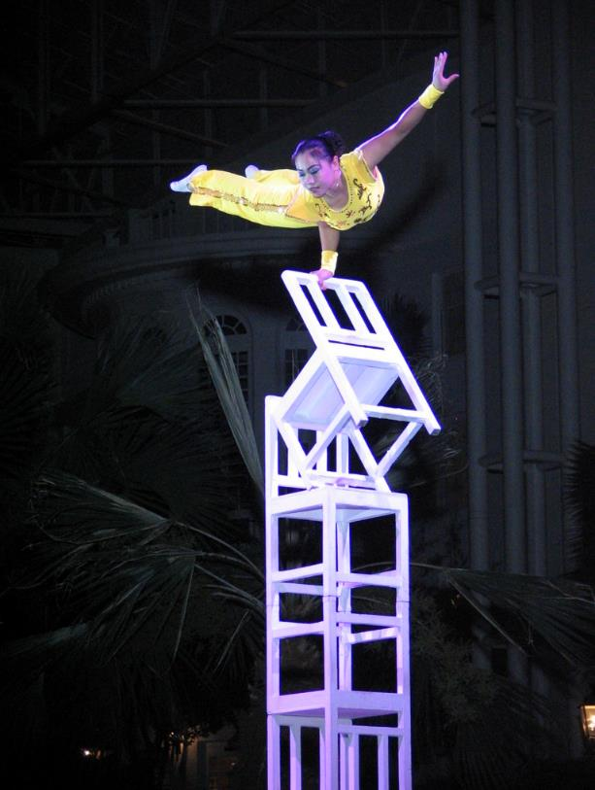
Figure 8.1: A performer with Peking Acrobats performing in Nashville, Tennessee.

An object that is in static equilibrium has zero net force and zero net torque acting on it. But what happens to such an object if a small, unbalanced torque or unbalanced force is briefly applied?
In some situations, like that shown in the image of the acrobat balancing on a pile of chairs, that small torque will result in disaster. That’s what makes acrobatic shows exciting to watch–we know that a tremendous amount of skill is needed to avert such a disaster.
In some situations, a small net torque or net force will cause an object’s position to briefly shift, but then the object will return to its original position.
And in some situations, a small net torque or net force will cause an object to rock or swing back and forth, until eventually friction brings everything back into static equilibrium. This back and forth motion is called an “oscillation.”
In this chapter we will explore what conditions determine whether an object in static equilibrium will experience disaster, return to its original state, or begin to oscillate when it is disturbed, and we will see how motion, momentum, forces, and energy interact during oscillations.

: The Great Pyramid of Giza ( , )

Words
The Great Pyramid of Giza is 137 m tall, 230 m long on each side, and has a mass of roughly 6 billion kg. Its center of mass is centered approximately 34 m above its base. For our purposes we will imagine that the sand it is sitting on is a hard, rough surface that can’t be dented, and we will consider the pyramid to be one solid, unbreakable block, although in fact it is made up of roughly 2 million blocks of stone, and would break into roughly 2 million pieces if we attempted this with the actual pyramid!
First, we will imagine briefly applying a force lifting one side of the pyramid to create a small net torque and see what happens to the pyramid. It would not be easy to apply such a force. When the pyramid is just sitting on the sand, there are two main forces acting on it: The force of gravity, which can be seen as acting downward on the center of mass of the pyramid, and the normal force which is pushing up from the sand all across the base of the pyramid but which is usually shown acting at a single point at the center.
To lift one side, you would have to use a force that is half the weight of the pyramid, as shown in Figure 8.2. All the normal force from the sand would be concentrated on the side opposite you, which is where the pyramid would pivot. So, your force would have to create slightly more torque than the force of gravity, but your lever arm is twice as long as that for gravity.

Graphics
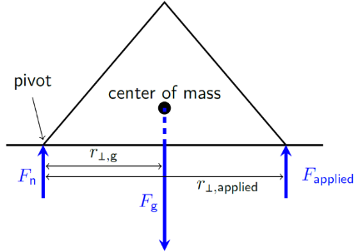
Figure 8.2: A huge applied force is needed to create enough torque around the pivot point to get the pyramid to move.¹
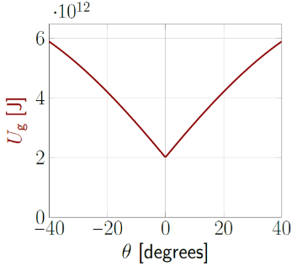
Figure 8.3: Gravitational potential energy is smallest with the pyramid flat on the ground.¹

Numbers
Assumptions: Pyramid is unbreakable; Sand is rough (high friction) and cannot be dented.
Knowns | Unknowns
$$m=6×{10}^{9} kg$$ | $$F_{applied,min}$$
$$h_{pyramid}=137 m$$
$$h_{com}=34 m$$
$$r_{⟂,g}=115 m$$
$$r_{⟂,applied}=230 m$$
One thing we should be able to find in this situation is the minimum force needed to lift one side of the pyramid when it is sitting on its base, $F_{applied,min}$. To find that force, we need to analyze the situation shown in Figure 8.2 when it is in static equilibrium, just before the applied force is enough to lift the pyramid. The net torque around the pivot is zero in static equilibrium, so…
$$τ_{net}=0=τ_{n}+τ_{g}+τ_{applied} \\ =F_{n}⋅{ r}_{⟂,n }-F_{g}⋅r_{⟂,g}+F_{applied}⋅r_{⟂,applied}$$
Rearranging gives…
$$\begin{aligned}F_{applied}&=\frac{F_{g}⋅r_{⟂,g}}{r_{⟂,applied}}=\frac{F_{g}}{2} \\ \\ &=\frac{m⋅g}{2}=2.9×{10}^{10} N\end{aligned}$$

Words
When you release this force, the pyramid will fall back to its original position. It takes a huge force to move the pyramid, and when this force is released, the pyramid just goes back to its original state. It is extremely stable, which is why it is still standing after forty-five centuries!
It is also possible to consider stability from an energy perspective. Objects like to go to the place that will give them the smallest possible amount of potential energy. In the case of the pyramid sitting on its base, there is no other position that has less gravitational potential energy, so it is very stable.
Now let’s imagine flipping the pyramid upside-down. It can still be in static equilibrium if its center of mass is aligned perfectly above the tip, but if a small unbalanced torque is applied to the pyramid, the torque created by the force of gravity will continue to rotate the pyramid in the same direction as the initial torque, giving it more and more angular momentum, and it will come crashing down. This is an extremely unstable situation.
The center of mass in Figure 8.2 is above the base of the pyramid, but in Figure 8.4 it is outside of the “base” of the pyramid. In general, if the center of mass is outside of the base, it is in an unstable equilibrium unless there are other forces holding it in place.
From an energy perspective, any shift in angle of the upside-down pyramid gives it less gravitational potential energy, so more kinetic energy. So, it moves away from the unstable equilibrium position at increasing speed.

Graphics
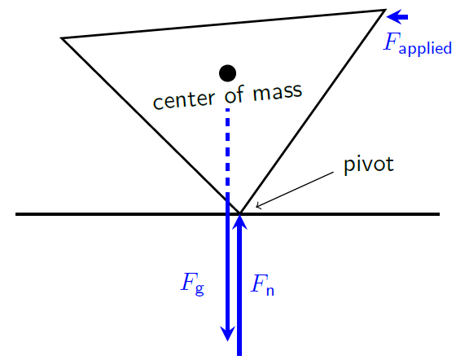
Figure 8.4: A small applied force creates torque around the pivot. This shifts the center of mass, so the gravitational force creates torque in the same direction.¹
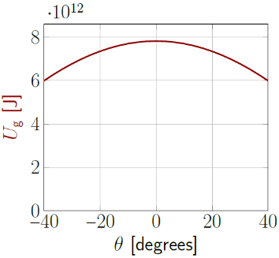
Figure 8.5: Gravitational potential energy is highest with the pyramid balanced on its tip. Here 0° is the upside-down position.¹

Numbers
This is the maximum force that keeps the pyramid in static equilibrium, which is equivalent to the minimum force to start moving it.
There is no minimum force needed to start the pyramid in motion when it is standing on its tip; any applied force at all is enough to start the pyramid in motion.
Gravitational potential energy in Figure 8.3 & Figure 8.5 are calculated using ground level as zero. Since the center of mass of the pyramid is always above ground level, the gravitational potential energy is always positive. The height above the ground is calculated as a function of the angle of rotation, keeping one corner of the pyramid on the ground.

: A Horizontal Spring and Mass ( , )

Words
Now we will consider a horizontal system, ignoring any vertical forces because they are balanced and there is no vertical motion. A 2.4 kg block is motionless on a surface with negligible friction, connected to a solid wall by a spring with a spring constant of 90 N/m. Initially the block is resting at its equilibrium position, but then it is struck by an applied force that suddenly gives it a momentum of 1.2 kg m/s to the left. What happens to the block?
If we look at this scenario in terms of energy, the block is given some kinetic energy and initially has no potential energy. But as the spring compresses, it stores potential energy, taking away the kinetic energy until the block completely stops moving. At that point, the unbalanced force from the spring is pushing the block back toward its starting point, so the spring potential energy transforms back into kinetic energy. The block passes through its equilibrium position where it again has kinetic energy but there is no potential energy and continues with the spring pulling against the motion until again all kinetic energy has been removed from the block and stored as spring potential energy. The block will continue to oscillate back and forth in this way.
As the block oscillates, it is not only the position that is continually changing in time, but also its velocity, acceleration, and momentum, and the force that that spring is applying to it.

Graphics
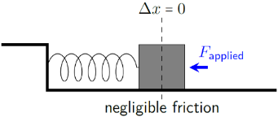
Figure 8.6: A mass on a spring is resting at its equilibrium position, and then is briefly hit with a horizontal applied force, giving it an initial momentum to the left.¹
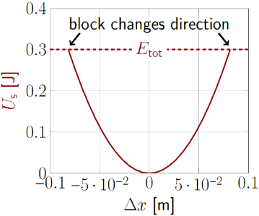
Figure 8.7: Spring potential energy is smallest at the equilibrium position, so the block oscillates around the equilibrium position.¹

Numbers
Assumptions: horizontal direction only; ideal spring; wall is immovable; friction is negligible.
Knowns | Unknowns
$$m=2.4 kg$$ | ???
$$k_{s}=90 N/m$$
$$\vec{p_{i}}=-1.2 kg⋅m/s \hat{x}$$
$$F_{f}=0$$
$$Δx_{0}=0$$
We can use energy to analyze this situation, like we did for the pyramid. We are given the initial momentum and the mass, and we can use them to find the initial kinetic energy.
$$E_{k}=\frac{1}{2}m⋅v^{2}=\frac{1}{2}m⋅\frac{p^{2}}{m^{2}}=0.3 J$$
Rearranging gives kinetic energy in terms of momentum, which is a useful mathematical model even when we aren’t dealing with oscillation:
$$\boxed{E_{k}=\frac{p^{2}}{2m}}$$
( 8.1 )
Now we can use conservation of energy to find the maximum displacement of the spring while it is bringing the block to a stop.

Words
Figure 8.8 shows the position, momentum, and net force on the block as a function of time, although we don’t know what the time scale should be. All three of these follow a sine-wave type of pattern, although they are shifted with respect to each other. Notice that when the position is at a positive maximum the momentum is at zero and the force is at a negative maximum. When the position is zero the force is also zero and the momentum is at a maximum, either positive or negative.
We could also create graphs for velocity and acceleration of the block, but they would be very similar to the graphs for momentum and force. That is because velocity is the momentum divided by the mass and acceleration is the unbalanced force divided by the mass.
The block and spring are in a stable equilibrium because the net force is always in a direction that pushes the block back toward the equilibrium position, never away from it. Or from an energy perspective we could say that the block and spring are in a stable equilibrium because the potential energy is always increasing and kinetic energy decreasing when the block is moving away from the equilibrium position.
This type of oscillation, with an unbalanced, conservative force that is proportional to the distance from the equilibrium position and no nonconservative forces, is called “simple harmonic motion.”

Graphics
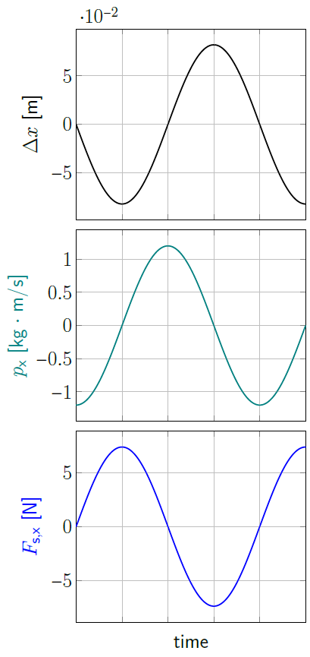
Figure 8.8: Position of the block, momentum of the block, and force on the block as a function of time. We don’t yet know the time scale, but it is the same for all three graphs.¹

Numbers
Using the subscript “0” for the equilibrium position and “$max$” for the position where the spring is maximally stretched or compressed...
$$E_{max}=E_{0} \\ { E}_{k,max} +{ E}_{th,max} +U_{s,max}=E_{k,0}+{ E}_{th,0} + U_{s,0} \\ \frac{1}{2}⋅k_{s}⋅Δx_{\text{max}}^{2}= \frac{p_{0}^{2}}{2m}$$
Solving for $\vec{Δx_{max}}$ gives…
$$\begin{aligned}\vec{Δx}&=±\sqrt{\frac{p_{0}^{2}}{k_{s}⋅m}} \hat{x} \\ &=±\sqrt{\frac{{\left(-1.2 kg⋅m/s\right)}^{2}}{90 N/m⋅2.4 kg}} \hat{x}=±0.082 m \hat{x}\end{aligned}$$
Now that we know that the maximum displacement is $±0.082$ m, we can use Hooke’s Law to find the maximum force that is applied by the spring:
$$\begin{aligned}\vec{F_{s,max}}&=-k_{s}⋅\vec{Δx_{max}} \\ &=-\left(90 N/m\right)⋅\left(±0.082 m \hat{x}\right) \\ &=∓7.38 N \hat{x}\end{aligned}$$
The significance of the upside-down “$±$” is that when the displacement is in the positive direction the force is in the negative direction, and vice-versa.

: Jupiter’s Moons ( )

Words
Circular motion has a lot in common with oscillation. If viewed from the side, an object moving in a uniform circular path appears to be oscillating in exactly the same way as a mass on a spring. For example, the planet Jupiter has four moons that are large enough to see from the earth with an amateur telescope or even a good pair of binoculars. These four moons have roughly circular orbits around Jupiter, but they always appear from earth to be oscillating back and forth across Jupiter in a straight line. We will call that line the parallel direction.
The moon named “Callisto” is on the right of Figure 8.9. Callisto’s orbit has a radius of $1.9×{10}^{9}$ m, and it completes one orbit every 17 earth days. We can use this information to determine Callisto’s position, velocity, and acceleration in the parallel direction as it orbits Jupiter.
If we take time $t=0$ to be when Callisto is all of the way to the right as seen in Figure 8.10, then the initial position of Callisto is at its maximum positive value, $+r$. By the time it reaches the position at the top of Figure 8.10, it would be hidden from the earth, directly behind Jupiter. Its position in the parallel direction is zero at that point. Then it goes to $-r$ (all the way to the left), then back to zero (in front of Jupiter as seen from the earth), and finally back to $+r$ again when it completes one full period.

Graphics
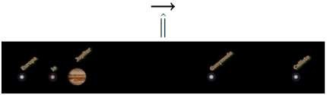
Figure 8.9: Jupiter and its four largest moons, as seen from Earth. The parallel direction $\hat{∥}$ is in the plane of the moons’ orbits.
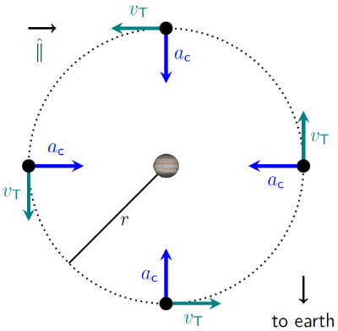
Figure 8.10: Callisto is shown at four different points in its near-circular orbit, but from earth we can only see it going back and forth in the horizontal $\left(\hat{∥}\right)$ direction, so we see only the parallel components of $\vec{x}$, $\vec{v}$, and $\vec{a}$.

Numbers
Assumptions: circular orbit; $+\hat{∥}$ is to the right in Figure 8.9 & Figure 8.10.
Knowns | Unknowns
$$r=1.9×{10}^{9} m$$ | $$x_{∥}$$
$$T=17 earth days$$ | $$v_{∥}$$
 | $$a_{∥}$$
First, we should convert the period of the orbit to SI units: $17 earth days=1.5×{10}^{6} s$. We can also convert period into angular speed $ω$, since we have used that more often more than period.
$$ω=\frac{2π}{T}=4.3×{10}^{-6} rad/s$$
At all times in this full circle, its position in the parallel direction can be described by…
$$x_{∥}=r⋅cos\left(ω⋅t\right)$$

Words
Velocity in the parallel direction also varies, but it starts at zero at $t=0$, since it is only moving upward in Figure 8.10. Then it goes in the negative direction, goes back to zero on the left side, goes in the positive direction, and finally returns to zero as Callisto completes one period.
Centripetal acceleration is always pointed toward the center of the circle, so when the position is at its maximum positive value, acceleration is at its maximum negative value, and vice-versa.
When we analyzed the block on the spring, we considered momentum instead of velocity and net force instead of acceleration but remember that momentum is proportional to velocity and net force is proportional to acceleration, so if we graph them then the shapes of their graphs will look the same, just with a different scale.
Comparing Figure 8.8 and Figure 8.11, we can see that their shapes are very similar. Really there are only two major differences. Their scales are different, and the curves in Figure 8.8 are all shifted horizontally by the same amount compared to the curves in Figure 8.11. That is because the block on the spring was initially at zero and moving to the left while Callisto was initially at the far right and not moving at all in the parallel direction.

Graphics
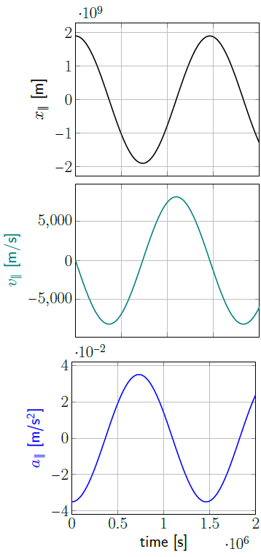
Figure 8.11: Parallel components of the position, velocity, and acceleration of Callisto.¹

Numbers
We know that $v_{T}=r⋅ω$, and the maximum value of $v_{∥}$ is $v_{T}$, so Callisto’s velocity in the parallel direction can be described by…
$$v_{∥}=-r⋅ω⋅sin\left(ω⋅t\right)$$
Since our other mathematical models in this section depend on $ω$, it would be convenient to have a mathematical model for centripetal acceleration that is also dependent upon $ω$. We can create this by taking our expression for centripetal acceleration and converting linear velocity to angular velocity:
$$\boxed{a_{c}=r⋅ω^{2}}$$
( 8.2 )
Using this for the magnitude of the acceleration, Callisto’s acceleration in the parallel direction is…
$$a_{∥}=-r⋅ω^{2}⋅cos\left(ω⋅t\right)$$
Combining Equation ( 8.2 )eqn:a_cAngular with our equation for centripetal force gives us an expression that can be used for centripetal force when we are given angular speed:
$$\boxed{F_{c}=m⋅r⋅ω^{2}}$$
( 8.3 )

: Simple Harmonic Motion ( , )

Words
Simple harmonic motion (SHM) was described in Section 8.2 as being caused by an unbalanced force that is proportional to the distance from the equilibrium position. Here we will consider more closely what SHM looks like.
The position of an object that is undergoing SHM moves back and forth in a regular, periodic way. This means that if you wait for the object to go through one complete cycle of motion, it will follow the same motion through the next complete cycle. The amount of time that you must wait for the object to go through one complete cycle is called the period. This is the same way that a period is used when talking about circular motion: it is the amount of time needed for an object to complete one full rotation.
For SHM, during one period the object never experiences any sudden changes in motion but is gradually speeding up and slowing down. Its position, velocity, acceleration, momentum, and the net force applied to it all follow the same type of curve, which could be described as a sine shape or a cosine shape.
If you look at a sine curve and a cosine curve, you can see that they both have the same shape, but they are shifted with respect to each other. For simple harmonic motion, you could change one to the other just by timing the motion starting from a different point in the cycle, effectively moving the point where time is defined as zero.

Graphics
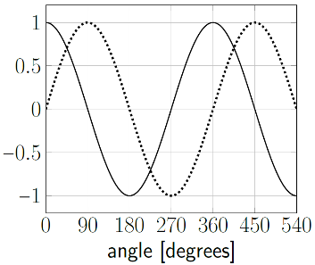
Figure 8.12: Cosine (solid) and sine (dotted) functions have the same shape but are shifted with respect to each other.¹
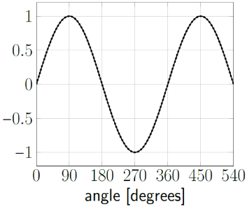
Figure 8.13: Sine of the angle (dotted) and cosine of the angle minus 90° (solid) are the same.¹

Numbers
We can create a mathematical model of SHM that works for any starting conditions by introducing a “phase” $ϕ$, which is the amount by which the object must move to reach its maximum positive position. It makes sense to think of it as an angle when the object is following a circular path like Callisto, but for an object like a spring on a block it is easier to think of it as a shift in starting time to when the block reaches the far right. Then the mathematical model for position during SHM becomes…
$$\boxed{x=A⋅cos\left(ω⋅t-ϕ\right)}$$
( 8.4 )
…where $A$ is the amplitude of the motion, the maximum distance that the object travels from the equilibrium position. In the case of SHM, $A$ has units of length, but in other contexts we will see later $A$ can represent other physical quantities like an electric field.
If an object starts at equilibrium moving in the positive direction, the object travels through 1/4 of a period before reaching the maximum positive position. One period is ${360}^{∘}$, so $ϕ$ is 1/4 of a period, or ${90}^{∘}$. Figure 8.13 shows a plot of the cosine of an angle minus ${90}^{∘}$, illustrating that a shift of ${90}^{∘}$ shifts the cosine function to match an object starting at zero and moving in the positive direction as the angle (or in some scenarios the time) increases.

Words
We have already been introduced to the idea of a “period” as being the time for an object that is following a circular path to complete one revolution. For SHM, the period of oscillation is the time required for the object to complete one full cycle of motion. That could be the time required for the object to move from the maximum positive position back to the maximum positive position. It is also the time required to go from the minimum position back to the minimum position.
Looking at Figure 8.14, you can see that during one period $T$ the object passes through the equilibrium position twice, so if you want to measure one period from the equilibrium position then it is important to measure from the time the object passes the equilibrium position to the time when the object again passes through the equilibrium position in the same direction.
The maximum distance that the object travels from the equilibrium position is called the amplitude of the motion.

Graphics
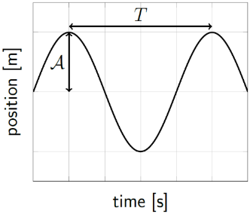
Figure 8.14: Period $T$ and amplitude $A$. Note that $A$ is measured only from the equilibrium position, not top-to-bottom.¹

Numbers
Equation ( 8.4 ) is similar to the expression found for $x_{∥}$ in Section 8.3, just replacing $r$ with $A$ and including $ϕ$ inside the cosine function. Following the same pattern of analysis that was used in Section 8.3, we can find mathematical models for the $\hat{x}$ components of velocity and acceleration for SHM:
$$\boxed{v_{x}=-A⋅ω⋅sin\left(ω⋅t-ϕ\right)}$$
( 8.5 )
…and…
$$\boxed{a_{x}=-A⋅ω^{2}⋅cos\left(ω⋅t-ϕ\right)}$$
( 8.6 )

: A Vertical Spring and Mass ( , )

Words
Now we will consider a vertical system with no horizontal forces and no non-conservative forces. A spring with a spring constant of 4.5 N/m is hanging from the ceiling. You attach a 0.6 kg mass to the end, holding it so that the end of the spring is in the same position that it was in before you attached the mass, and then you suddenly release the mass. What happens?
You can imagine what will happen when you release it. Because of gravity, the mass will fall, stretching the spring, and then will bounce back to the top, and it will continue repeating this same pattern until friction with the air and within the spring slows it to a stop, but we are assuming no friction so it would just continue to bounce forever.
Can we be more precise about the motion of the mass? If we start by looking at this scenario in terms of energy, the mass initially has no kinetic energy and there is no potential energy stored in the spring, but it is being held up, so it has gravitational potential energy. As it falls, the mass loses gravitational potential energy but gains kinetic energy, and the spring also gains spring potential energy since it is stretching. When the mass reaches the lowest point in its bounce it stops moving, so at that point it has lost all its kinetic energy. Since we know it will not go lower than this point, we can call this height $y=0$, so it also has no gravitational potential energy at that point. All the energy has changed into spring potential energy.

Graphics
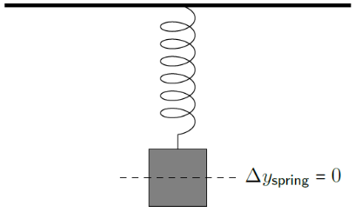
Figure 8.15: A mass is attached to a spring and held in place at the equilibrium position of the empty spring.¹
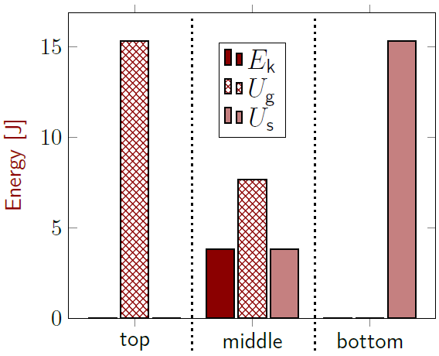
Figure 8.16: Energy bar graphs for the spring and mass.¹

Numbers
Assumptions: Ceiling is immovable; ideal spring; friction is negligible; horizontal direction only; $+\hat{y}$ is upward.
Knowns | Unknowns
$$m=0.6 kg$$ | ???
$$k_{s}=4.5 N/m$$
$$\vec{p_{i}}=0 kg⋅m/s$$
$$g=9.8 N/kg$$
Let’s begin with conservation of energy at three important heights: $y_{top}$ (at the top), $y_{bot}$ (at the bottom), and $y_{mid}$ (at the equilibrium position. To simplify the math, we can make $y_{bot}=0$. We know more about the energy at the top and bottom, so we will begin with those…
$$E_{bot}=E_{top} \\ { E}_{k,bot} +{ U}_{g,bot} +U_{s,bot}={ E}_{k,top} {+U}_{g,top}+ U_{s,top} \\ U_{s,bot}=U_{g,top}$$
$$\frac{1}{2}⋅k_{s}⋅{\left(y_{top}- y_{bot} \right)}^{2}=m⋅g⋅\left(y_{top}- y_{bot} \right)$$
$$y_{top}=\frac{2m⋅g}{k_{s}}=2.61 m$$
This means that the bottom position is 2.61 m below the point where the mass was released. The amplitude of the oscillation is therefore…

Words
At the lowest point, the spring can pull the mass back up, so we know that the spring force must be larger than the force of gravity. Kinetic energy and gravitational potential energy both increase as the mass starts to rise, while the spring potential energy decreases. The mass is not moving at the top or the bottom but has non-zero velocity between the top and bottom, so there must be some point where the speed and the momentum are at a maximum. Momentum increases if the force is in the same direction as the velocity, so there must be some point in the path of the mass where the net force drops to zero and then changes direction. In other words, there must be a new equilibrium position along the path followed by the mass.
Since the force of gravity is constant throughout the path followed by the mass and the spring force increases proportionally with the distance the spring is stretched, the net force is also proportional to the distance from the equilibrium position. That means the oscillation of the mass is simple harmonic motion.
Remarkably, the period of oscillation does not depend on the force of gravity. It also doesn’t depend on the distance that the spring is stretched. The period gets longer (so a slower oscillation) as the mass increases, and the period gets shorter (so a faster oscillation) as the strength of the spring (the spring constant) increases.

Graphics
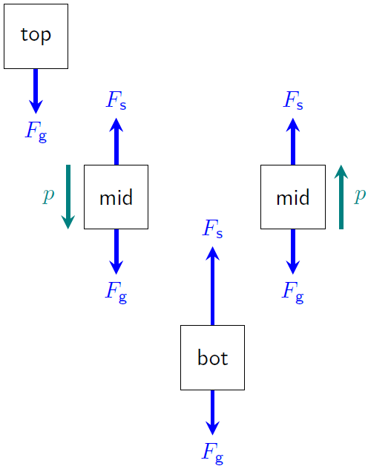
Figure 8.17: Force diagram of the mass in four different positions as it oscillates, including arrows showing the direction of the momentum when the mass is in the equilibrium position.¹

Numbers
$$A=\frac{y_{top}-y_{bottom}}{2}=\frac{m⋅g}{k_{s}}=1.30 m$$
From the perspective of forces, Figure 8.17 shows the two forces that act on the mass. The net force is zero at the equilibrium position and increases linearly with distance from the equilibrium position. The equilibrium position is the point where…
$$F_{g}=F_{s} \\ m⋅g=k_{s}⋅\left(y_{top}-y_{mid}\right)$$
Solving for $y_{mid}$ gives…
$$y_{mid}=y_{top}-\frac{m⋅g}{k_{s}}=1.30 m$$
…at the center of the oscillation. When the mass is at the top position, the only force affecting it is gravity, so its acceleration is $-g \hat{y}$. The mass is also in SHM, so its acceleration is given by Equation ( 8.6 ), so $-A⋅ω^{2}=-g$. Solving for $ω$ and using the expression we found earlier for $A$ gives…
$$ω=\sqrt{\frac{g}{A}}=\sqrt{g⋅\frac{k_{s}}{m⋅g}}=\sqrt{\frac{k_{s}}{m}}$$
Gravity cancels out, so this works for vertical and horizontal systems. In terms of the period…
$$\boxed{T=2π\sqrt{\frac{m}{k_{s}}}}$$
( 8.7 )

: A Pendulum ( )

Words
We have considered stability for objects sitting on the ground and objects connected to springs. Now we will consider an object that is hanging from a rope. When the object is hanging straight down and not moving, it is in an equilibrium position. Is it a stable equilibrium?
If we think about it from the perspective of energy, pushing the object away from the equilibrium position in either direction will make it swing upward, increasing its gravitational potential energy. That means the equilibrium position is stable. The object would begin to swing back and forth. Is the oscillation simple harmonic motion? It depends…
We saw with the orbit of Callisto around Jupiter that uniform circular motion looks like SHM when viewed from the side. Let’s try looking at this motion the same way, in the horizontal direction. If we start with the mass held out horizontally, that will be the maximum possible displacement. But at that point there are no forces in the horizontal direction, when for SHM the horizontal force would be at a maximum at that position. So, a pendulum does not have SHM in the horizontal direction.
Let’s try looking at the vertical direction. Here we see that the equilibrium position is at the bottom, but SHM always has the equilibrium position in the center. So, no SHM in the vertical direction.
We still have another option–maybe there is SHM in the tangential direction?

Graphics
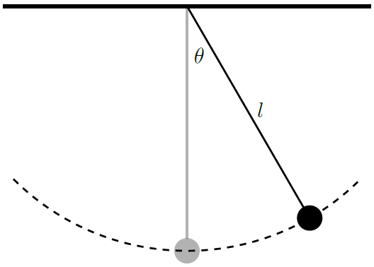
Figure 8.18: A mass hung from a light rope.¹
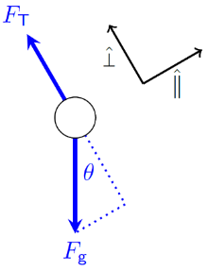
Figure 8.19: Force diagram of the mass on the string when at the position shown in Figure 8.18.¹

Numbers
Assumptions: pointlike mass; negligible friction; negligible rope mass; near surface of earth.
Knowns | Unknowns
$$m=3 kg$$ | $ω$ ?
$$l=1.5 m$$ | $T$ ?
$$g=9.8 N/kg$$
When the mass is a path length $s=l⋅θ$ (with $θ$ measured in radians) away from the equilibrium position, the force in the tangential ($\hat{∥}$) direction as shown in Figure 8.19 would be $F_{g}⋅sinθ$. So the position is proportional to $θ$ but the force is proportional to $sinθ$.
Simple harmonic motion requires that the force be proportional to the displacement, so a pendulum does not display SHM in the tangential direction.
That is unfortunate, because SHM uses such easy mathematical models. This is a good time to remember that many of our mathematical models are really just approximations that work well in some situations. We’ve already used an approximation for gravitational force when analyzing the pendulum, one that is only valid for a limited range of heights at the surface of the earth.
Let’s see if our mathematical models for SHM might also be valid in some limited range of angles for the pendulum.

Words
To be able to work with the numbers, let’s make the mass 3 kg, and hang it at the end of a light, 1.5-m-long rope.
The analysis shown in the “Numbers” column demonstrates that in fact there is not SHM in the tangential direction, but for small angles, when the pendulum is not swinging far away from the vertical position, the motion is almost the same as SHM, so this “small-angle approximation” is often used for analyzing the motion of the pendulum.
In the small-angle approximation, the period of the pendulum does not depend on the mass, but it does depend on the strength of the gravitational field and the length of the rope. The period increases (so it slows down) as the rope gets longer. If the pendulum were in a location where the gravitational field was weaker, for example on the surface of the moon, the period of the pendulum would increase.

Graphics
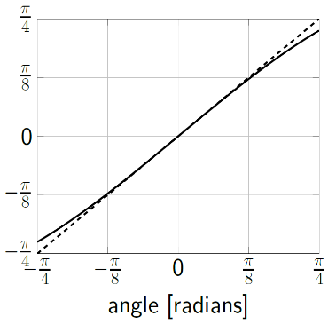
Figure 8.20: Sine of the angle (solid line) compared with the angle itself (dashed line), measured in radians.¹
Figure 8.20 shows that, for small angles, sine of the angle is roughly equal to the angle itself.

Numbers
If we keep the angle small, the force is roughly proportional to the distance along the path length. Then we can use the mathematical models for SHM. Converting from $\hat{x}$ directions to tangential directions, the maximum value for position along the path length for SHM as given by Equation ( 8.4 ) is…
$$s_{max}=A=l⋅θ_{max}$$
The maximum negative value for acceleration in the tangential direction, which occurs at the same position, is given by Equation ( 8.6 )…
$$-a_{T,max}=-A⋅ω^{2}=-\left(l⋅θ_{max}\right)⋅ω^{2}$$
…where the expression found above for $A$ has been substituted in. We can then use Newton’s Second Law to go from $a_{T}$ to $F_{g}$…
$$-\frac{F_{g}}{m}⋅sinθ_{max}=-\frac{m⋅g}{m}⋅sinθ_{max}=-\left(l⋅θ_{max}\right)⋅ω^{2}$$
Solving for $ω$ and canceling $θ_{max}$ with $sinθ_{max}$ since we are using the small-angle approximation gives…
$$ω=\sqrt{\frac{g⋅sinθ_{max}}{l⋅θ_{max}}}=\sqrt{\frac{g}{l}}$$
In terms of the period, for small angles:
$$\boxed{T=2π\sqrt{\frac{l}{g}}}$$
( 8.8 )

: Summary
Chapter summaries in this book are ordered by concept, not necessarily in the order in which they are presented in the chapter. Mathematical models are grouped together at the end of each summary. See the appendices for the meanings of all symbols used in this book.

General
- Simple harmonic motion looks exactly the same as one dimension of uniform circular motion.
- The time needed for an object to go through one complete cycle of simple harmonic motion is called the period.

Forces, Torque, & Acceleration
- An object is in a stable equilibrium position if disturbing the object causes a force or torque that pushes the object back toward the equilibrium position.
- An object is in an unstable equilibrium position if disturbing the object causes a force or torque that pushes the object even further from the equilibrium position.
- Simple harmonic motion is caused by a net force that is proportional to the distance from the equilibrium position.

Momentum & Velocity
• It is an object’s momentum that causes it to continue moving through the equilibrium point during an oscillation.

Energy
- Objects like to go to the position that will give them the smallest possible amount of potential energy.
- An object is in a stable equilibrium position if moving the object away from the equilibrium position causes the object to gain potential energy.
- An object is in an unstable equilibrium position if moving the object away from the equilibrium position causes the object to lose potential energy.

Mathematical Models
Equation | Reference | Restrictions on the validity of the equation
$$E_{k}=\frac{p^{2}}{2m}$$ | ( 8.1 ) | -none-
$$a_{c}=r⋅ω^{2}$$ | ( 8.2 ) | -none-
$$F_{c}=m⋅r⋅ω^{2}$$ | ( 8.3 ) | -none-
$$x=A⋅cos\left(ω⋅t-ϕ\right)$$ | ( 8.4 ) | Simple harmonic motion (SHM)
$$v_{x}=-A⋅ω⋅sin\left(ω⋅t-ϕ\right)$$ | ( 8.5 ) | Simple harmonic motion (SHM)
$$a_{x}=-A⋅ω^{2}⋅cos\left(ω⋅t-ϕ\right)$$ | ( 8.6 ) | Simple harmonic motion (SHM)
$$T=2π\sqrt{\frac{m}{k_{s}}}$$ | ( 8.7 ) | SHM of a spring-mass system
$$T=2π\sqrt{\frac{l}{g}}$$ | ( 8.8 ) | Small-angle approximation, SHM of a pendulum

: Questions
Questions are ordered according to Bloom’s Taxonomy, progressing from regurgitating information (Level 1) to synthesizing new information with previous knowledge to create something new (Level 6). The bold letters at the beginning of each question indicate whether the question involves Words [W], Graphics [G], and/or Numbers [N]. See the appendices for conversion factors.

Level 1 - Remember
      - [W] What are the factors that affect the period of the simple harmonic motion of a spring-mass system?
      - [W] What are the factors that affect the period of the simple harmonic motion of a pendulum that is swinging at a small angle?
      - [W & N] Add labels to each boxed equation from this chapter that tell what the symbol to the left of the = sign represents
Symbol | Reference | Label
$$E_{k}$$ | ( 8.1 )
$$a_{c}$$ | ( 8.2 )
$$F_{c}$$ | ( 8.3 )
$$x$$ | ( 8.4 )
$$v_{x}$$ | ( 8.5 )
$$a_{x}$$ | ( 8.6 )
$$T$$ | ( 8.7 )
$$T$$ | ( 8.8 )

Level 2 - Understand
      - [W & G] For an object that is experiencing simple harmonic motion to the left and to the right, in what direction is its velocity when its position is…
        - … at the far right?
        - … at the far left?
        - … at the equilibrium position?
      - [W & G] For an object that is experiencing simple harmonic motion to the left and to the right, in what direction is its acceleration when its position is…
        - … at the far right?
        - … at the far left?
        - … at the equilibrium position?

Level 3 - Apply
      - [W, & G] Analyze the static equilibrium position of the acrobat in Figure 8.1, reproduced below.
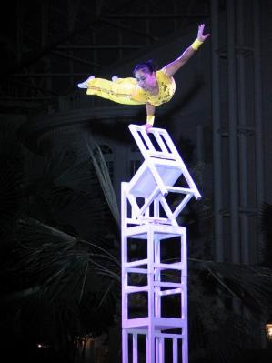
A performer with Peking Acrobats⁴³
        - Create a sketch that includes the main forces acting on the acrobat including an applied force that creates a torque that would shift the acrobat out of equilibrium, as was done with the pyramid in Section 8.1
        - Use the sketch to explain whether the acrobat is in a stable equilibrium position or an unstable equilibrium position.
        - Create a graph of gravitational potential energy vs angle, as was done with the pyramid in Section 8.1. Without knowing mass or lengths, just draw the shape of the curve for the graph–no scale is needed.
        - Use the energy graph to explain whether the acrobat is in a stable equilibrium position or an unstable equilibrium position.
      - [G] Figure 8.6, reproduced below, shows the block and spring at the time when the applied force suddenly gives momentum to the block. This moment corresponds to the left sides of the graphs in Figure 8.8, where the displacement and force from the spring are both zero, and the momentum is at a large negative value. Create your own sketches of the block and spring that correspond to the other times as marked in the displacement graph from Figure 8.8 that is reproduced below. Include arrows in the sketches showing the direction in which the block is moving.
The block and spring at the start.¹
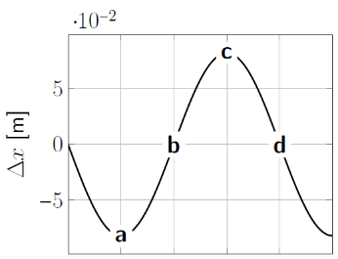
A part of the graph from Section 8.2 with positions marked for this question.¹
        - Position “a”
        - Position “b”
        - Position “c”
        - Position “d”
      - [G & N] Figure 8.11 has numbers on all the axes of each graph, but except at $t=0$ none of the peaks, valleys or zero crossings occur on any of the gridlines. Calculate the values for…
        - …the time when the position first crosses zero.
        - …the time when the position first reaches its maximum negative value.
        - …the time when the velocity first reaches its maximum positive value.
        - …the time when the acceleration first reaches its maximum positive value.
      - [G & N] Figure 8.11 has numbers on all the axes of each graph, but except at $t=0$ none of the peaks, valleys or zero crossings occur on any of the gridlines. Calculate the values for…
        - …the maximum positive value of the position.
        - …the maximum negative value of the position.
        - …the maximum positive value of the velocity.
        - …the maximum negative value of the velocity.
        - …the maximum positive value of the acceleration.
        - …the maximum negative value of the acceleration.
      - [N] Callisto has a mass of $1×{10}^{23} kg$. Use that information along with the information provided in Section 8.3 to find the following:
        - The angular momentum Callisto has due to its orbit around Jupiter.
        - The magnitude of the force of gravity between Callisto and Jupiter.
        - The magnitude of the linear momentum Callisto has in its orbit around Jupiter.
      - [N] Find the period of the simple harmonic motion of the spring and mass from Section 8.5.
      - [N] The unknowns listed in Section 8.6 were never actually calculated. Find their values.

Level 4 - Analyze
      - [W] A statement is made in Section 8.1 that objects like to go to the place that will give them the smallest possible amount of potential energy. Does this agree with what you have learned in earlier chapters? Give at least two examples where this is the case.
      - [N & G] Create two more graphs to go with the others in Figure 8.8. One should be for velocity of the block and one for acceleration of the block. The vertical scales should be correct for both graphs.
      - [N] Find the period of the simple harmonic motion of the spring and mass from Section 8.2.
      - [G & N] Calculate the heights of all the energy bars in Figure 8.16.
      - [N] How could you change the pendulum in Section 8.6 so that its period would double?

Level 5 - Evaluate
      - [W, G, & N] The pyramid sitting on its base in Figure 8.2 is said to be in a stable equilibrium position. But that is only true up to a certain point. How far would the pyramid have to be tilted from this position to put it into an unstable equilibrium?
        - Make a sketch of the pyramid when it reaches this unstable equilibrium position.
        - Explain in words what it is that makes this position an unstable equilibrium.
        - Find the numerical value for the angle at which this unstable equilibrium occurs.
To find the angle, we can start by finding the angle $θ_{com}$ from one of the edges that is normally on the ground to the center of mass:
      - [W, G, & N] In Figure 8.16 the kinetic energy appears to be the same as the spring potential energy at the middle height. Is there any height for this physical system (whether shown in this energy bar graph or not) where…
        - …the kinetic energy is equal to the gravitational potential energy?
        - …the spring potential energy is equal to the gravitational potential energy?
If so, find the height. If not, explain why not.
      - [N]The “small-angle approximation” doesn’t actually say how small the angle needs to be. The critical factor in this approximation is whether $sin\left(θ\right)$ is reasonably close to $θ$ when measured in radians. At what angle is $sin\left(θ\right)$ different from $θ$ by…
        - …0.1%?
        - …1%?
        - …10%?
        - …a factor of 2?

Level 6 - Create
      - [W, G, & N] At the beginning of Chapter 1 in Figure 1.1 was a template for a concept map. Begin a new concept map for stability, oscillations, and waves.
      - [W, G, & N] Imagine you are writing a test question related to this chapter. Think of your own example of a situation that you can analyze using the concepts, graphics, and mathematical analyses described in this chapter. Describe the situation and use the tools from this chapter to analyze the situation as completely as you can, including motion, forces, energy, and momentum.
      - [W, G, & N] Think about possible misconceptions about the material in this chapter. Write a question and an incorrect solution to it that demonstrates a student making such a conceptual error. This cannot be a simple misuse of a vocabulary word, a unit error, or a mathematical error like making an addition error or multiplying when addition was needed, unless the error is rooted in a real misunderstanding about the physics behind the calculation or the misuse of a word. After you have written the question and incorrect solution, explain what is wrong with the student’s solution, and write a correct solution to the problem. Note: You may use a question from this chapter that you got wrong the first time and explain the initial error in your thinking and how you corrected it.

– Solids
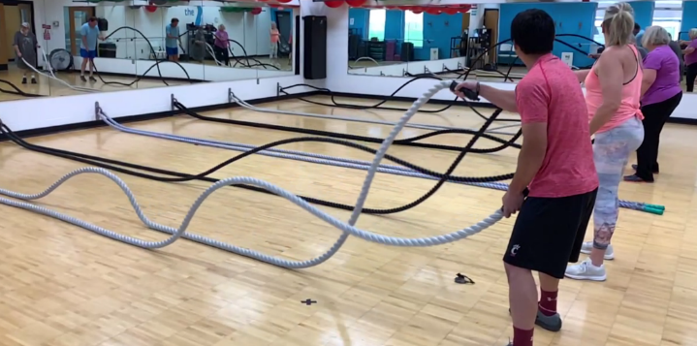
Figure 9.1: Transverse waves traveling along battle ropes.¹

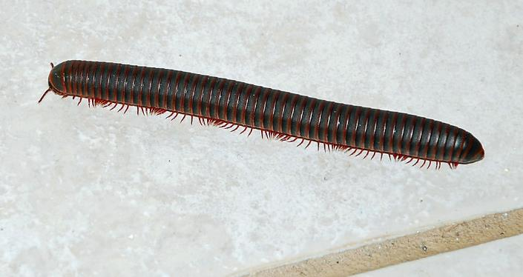

Figure 9.2: A millipede moving its legs in a longitudinal-wave-like fashion.

Up to this point, almost every object that we have dealt with has been assumed to be completely rigid. In this chapter we will start allowing “solid” objects to bend, stretch, and break. When objects bend and stretch, they can transfer energy in waves. In this chapter we will explore two different types of waves in solids: transverse waves and longitudinal waves.
Transverse waves occur when a material bends, as with “battle ropes.” A transverse wave occurs when each segment of the object, in this case each small section of rope, moves back and forth perpendicular to the direction that the wave is traveling. The waves travel horizontally along the length of the rope, but each individual section of rope is moving vertically, perpendicular to the direction in which the wave is moving.
Longitudinal waves occur when a material stretches and compresses. When a millipede walks, it moves its legs in longitudinal waves. A longitudinal wave occurs when each segment of the object, in this case the legs, moves back and forth parallel to the direction that the wave is traveling. The waves travel horizontally along the length of the millipede’s body, and each individual leg also moves forward and back horizontally along the length of the millipede’s body. This creates areas of compression, where the legs are closely spaced, and areas of “rarefaction” where the legs are widely spaced.

: Modeling a Rope ( , )

Words
In the “Numbers” column we have been using “mathematical models” to describe physics with equations. These models are useful tools for describing physical situations, but often they are really only approximations that work under certain conditions. We can also create other types of models to help us simplify physical scenarios to make them easier to understand. Now that we are allowing solid objects to bend and stretch, it can be helpful to think of them not as single objects but as a system of many small, interconnected objects.
For example, a rope can be modeled as a line of small pieces of rope that are all held together. We want the rope to be able to bend and stretch, so we can think of all the small pieces as being held together with springs. Ropes don’t stretch very much, but they bend easily, so for our model of a rope we can assume that each individual piece in Figure 9.3 can move up and down but not left or right.
What would happen if we started moving the rightmost piece of rope up and down with a period of 0.5 s, like the people are doing in Figure 9.1? Let’s assume that the rope has a length of 6 m, a mass of 12 kg, and is being pulled horizontally with a tension of 150 N.
In our model of a rope, each piece of rope is connected to the pieces on either side of it, so they can pull on each other.

Graphics
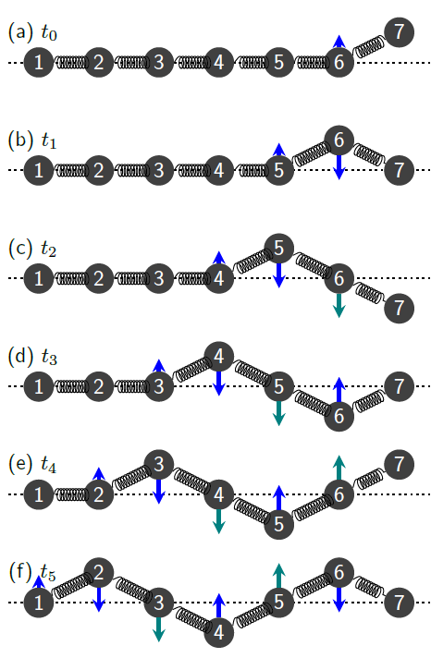
Figure 9.3: Parts (a) through (f) are diagrams of the same pieces of rope at different times. If section “7” of the rope is moved up and down, it creates a chain reaction of forces, momentum, and energy traveling left through the rope.¹

Numbers
Knowns | Unknowns
$$m=12 kg$$ | ???
$$l=6 m$$
$$T=0.5 s$$
$$F_{T}=150 N$$
Each part in Figure 9.3 is a fixed time interval after the previous part. The various “pieces” of the rope are all affected in the same way, but at slightly different times. Note that in part (b) of the figure, section 6 of the rope has no momentum (no green arrow) but is experiencing a large downward force (blue arrow). In part (c), section 5 of the rope has no momentum, but it is experiencing a large downward force. In part (d) it is section 4 that is in the same condition, and so forth. There is a transverse wave moving to the left.
If the transverse displacement of the wave is small compared to the length of the wave, the speed of a transverse wave is given by:
$$\boxed{v=\sqrt{\frac{F_{T}}{μ_{m}}}}$$
( 9.1 )
…where $μ_{m}$ is the linear mass density of the rope, which is defined as…
$$\boxed{μ_{m}=\frac{m}{l}}$$
( 9.2 )

Words
The forces and the momenta of the pieces of rope are shown at different times in Figure 9.3. The force is the net vertical force caused by the two pieces on either side of each piece. The forces on piece 7 aren’t shown because there are unknown forces coming from an external source. Each of the other pieces 1-6 are affected in the same way, just at different points in time. Notice that whatever happens to piece 4, for example, next happens to piece 3. This creates a wave moving to the left, as shown in Figure 9.4.
The speed of the wave depends only on the tension in the rope and the “linear mass density,” the mass per unit of length.
We can see a sine-wave-like pattern developing in the rope. We saw patterns like this in Chapter 8, but before it was normally in a graph with time as the horizontal axis. This time we are seeing the same pattern appearing not in time but in physical space. The time between successive peaks was called the period. The distance between successive peaks in space is called the wavelength.
Wavelength and period are related, because a period is the time required for one wavelength to pass by a given point in space. This can be seen by looking at piece 6 in Figure 9.4. It goes through one complete period from (b) t₁ to (f) t₅, during the time that one wavelength passes by at speed v.
Frequency, measured in hertz (Hz), is the inverse of the period, or the number of times a wavelength passes a given point per second.

Graphics
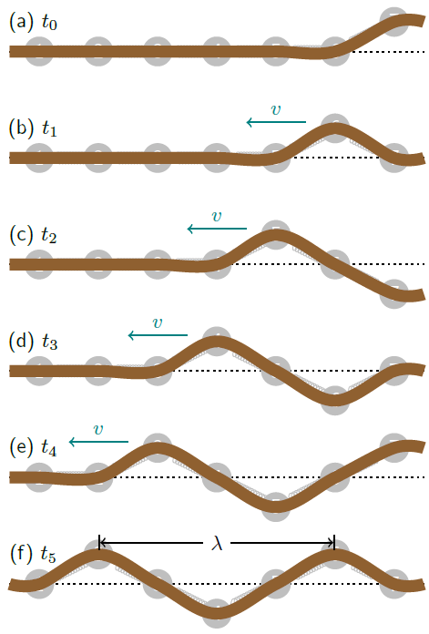
Figure 9.4: This figure is based on Figure 9.3, with the rope itself drawn over our model of the rope. The up-and-down motion of the pieces of rope results in a wave that moves to the left. The length of the wave is called the wavelength $λ$, and can be measured between successive peaks of the wave.¹

Numbers
So, this wave travels to the left at a speed of…
$$v=\sqrt{\frac{\left(150 N\right)⋅\left(6 m\right)}{12 kg}}=8.66 m/s$$
Note that the speed of the wave doesn’t depend on the transverse speed of each individual piece!
Wavelength $λ$ is the physical distance between successive crests in a wave, and it is related to the speed and the period or the frequency $f$ of the wave:
$$\boxed{λ=v⋅T=\frac{v}{f}}$$
( 9.3 )
…where…
$$\boxed{f=\frac{1}{T}}$$
( 9.4 )
So, this wave has a wavelength of…
$$λ=\left(8.66 m/s\right)⋅0.5 s=4.33 m$$
…and a frequency of…
$$f=\frac{1}{0.5 s}=2 Hz$$

: The End of the Rope ( , )

Words
We have seen that a wave can travel along the length of a rope, but what happens when the rope ends? It depends. First, we will consider what happens if the end of the rope is free to move.
Figure 9.5 uses the same model that we used before, but this time we are sending a single pulse to the right instead of constantly shaking one end up and down, and we are letting the end of the rope (“piece 7”) move freely up and down, so it is only affected by the forces from “piece 6.”
Notice what happens in the figure. Piece 7 actually goes much higher than the height of the original pulse, and as it comes down (because of the force from piece 6), it sends a pulse back to the left. Notice that no piece of the rope ever crosses the dotted equilibrium position line where the rope would be if there were no waves on it at all.
The wave pulse that was sent in bounces back from the free end of the rope.

Graphics
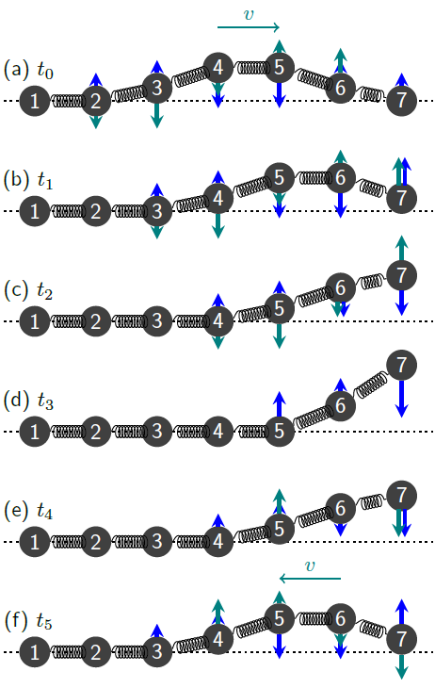
Figure 9.5: If piece “7” at the end of the rope is allowed to move freely up and down, a wave pulse moving to the right reflects back to the left when it reaches the end.¹

Numbers
(This column intentionally left blank)

Words
Now we will consider what happens if a wave pulse reaches the end of a rope that is held firmly in place.
Figure 9.6 again uses the same model that we used before, but this time we are holding the end of the rope (“piece 7”) firmly in place, so whatever force comes from piece 6 will be counteracted by whatever is holding the rope. Since this end of the rope doesn’t move at all, we can say that it is fixed in place.
Notice what happens in the figure. Piece 7 stays fixed in place, and at t₁ and t₄ it is pulling very hard on the rope. In fact, it pulls so hard on the rope that the wave flips over when it reaches the end.
The wave pulse that was sent in flips over and bounces back from the fixed end of the rope. Notice that before it reaches the end of the rope, the wave pulse is completely above the equilibrium position, and when it bounces back it is completely below the equilibrium position.

Graphics
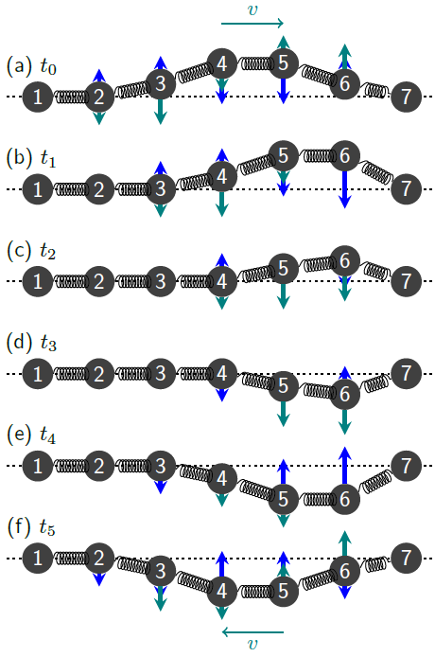
Figure 9.6: If piece “7” at the end of the rope is held firmly in place, a wave pulse moving to the right flips over and reflects back to the left when it reaches the end.¹

Numbers
(This column intentionally left blank)

: Adding Waves ( , )

Words
In Section 9.2 we saw waves that were reflected from the end of a rope. During the time that the wave is reflecting, the pieces near the end of the rope are feeling the effects of both the wave that is traveling to the right and the wave that is bouncing off to the left, at the same time. Interesting things can happen when waves are traveling on a rope in two different directions.
Figure 9.7 shows two waves with equal amplitudes and a sine-wave shape moving in opposite directions on the same rope. On the left and right, in the regions where the waves aren’t interfering with each other yet, each piece of the rope moves up and down just as before. But notice what happens in the center area once the waves meet.
The wave from the left is shown as a dashed line and the wave from the right is a dotted line. When they meet, they interfere with each other. At $t_{3}$, $t_{5}$, and $t_{7}$ the two waves are aligned with each other, so there is “constructive interference.” The displacement of the rope is the sum of the displacements of the two waves, in this case a sine wave with twice the amplitude of each individual wave.
At $t_{4}$ and $t_{6}$ the two waves are completely misaligned with each other. This causes “destructive interference.” The displacement of the rope is still the sum of the displacements of the two waves, which is zero at every point on the rope!

Graphics
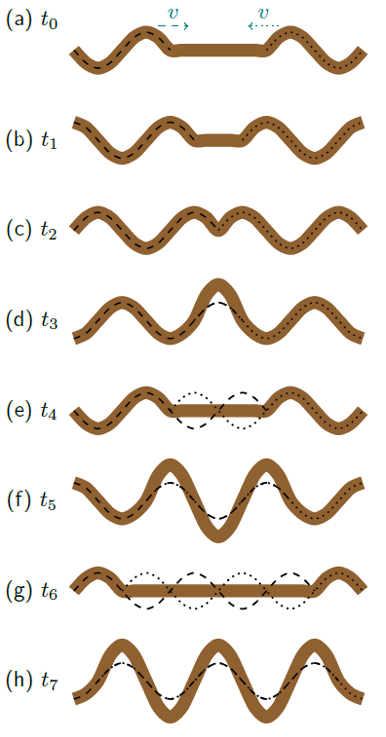
Figure 9.7: The two waves interfere with each other in the region where they overlap, creating a standing wave.¹

Numbers
We can do an example involving a musical instrument. The highest “E” string on a steel-string acoustic guitar has a linear mass density of $4×{10}^{-4}$ kg/m and a length of 0.65 m. How much tension is needed for the string to be correctly tuned with a first harmonic frequency of 330 Hz? What is the frequency of the second harmonic?
Assumptions: the amplitudes of the transverse waves are small compared to the length of the string.
Knowns | Unknowns
$$μ_{m}=4×{10}^{-4} kg/m$$ | $$F_{T}$$
$$l=0.65 m$$ | $$f_{2}$$
$$f_{1}=330 Hz$$
Figure 9.9 shows that for the first harmonic the length of the string is half of one wavelength, so $λ_{1}=2l$. Since the harmonic is created by traveling waves reflecting back and forth from the fixed ends of the string, we can use the same mathematical models that we used for traveling waves. Equation ( 9.3 ) relates the wavelength to the frequency and the speed of the wave, and Equation ( 9.1 ) relates the speed of the wave to the tension and linear mass density. Combining those mathematical models gives…
$$λ=\frac{v}{f}=\frac{1}{f}⋅\sqrt{\frac{F_{T}}{μ_{m}}}$$

Words
The interference of these two identical waves coming from opposite directions creates “standing waves” with some points on the rope, called “nodes,” that don’t move at all. The interference also creates some points on the rope, called “antinodes,” where the amplitude of oscillation is very large. The nodes are equally spaced at intervals of half of the wavelength of the traveling waves.
Stringed instruments use this effect. If the ends of a string are held tightly in place and then the string is plucked, reflections of the resulting waves on the string create “harmonics” in the string. The first harmonic in such a string, shown at the top of Figure 9.9, has a node at each end (since the ends are held in place) and an antinode in the center. The wavelength of the first harmonic is twice the length of the string.
Other harmonics are also allowed on such a string. The second harmonic still has a node at each end but also has a node in the middle. The wavelength of the second harmonic is equal to the length of the string. The third harmonic has two nodes in the middle; the fourth harmonic has three; and so forth. Higher harmonics have shorter wavelengths and faster frequencies.
Our brain interprets a higher (i.e. faster) frequency as a higher pitch. Interestingly, it is possible to “trick” the brain into hearing something different. For example, if a second and third harmonic are played at the same time, you will probably also “hear” the first harmonic even though it isn’t really there.

Graphics
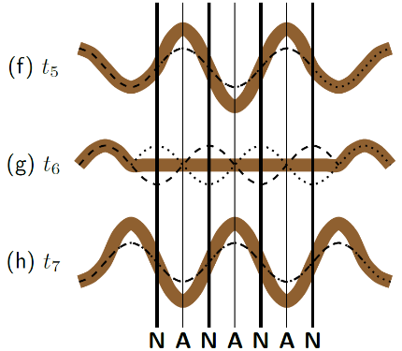
Figure 9.8: Looking at the parts of Figure 9.7 where the waves are interfering with each other, in places called nodes (thick lines) the rope doesn’t move at all and in places called antinodes (thin lines) the motion of the rope is large.¹
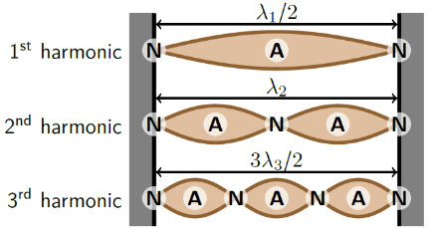
Figure 9.9: The first three harmonics on a string that is tightly anchored at each end. “N” indicates a node and “A” indicates an antinode.¹

Numbers
…which can be rearranged to solve for the tension force:
$$F_{T}={\left(λ⋅f\right)}^{2}⋅μ_{m}$$
Substituting in for the first harmonic…
$$F_{T}={\left(λ_{1}⋅f_{1}\right)}^{2}⋅μ_{m}={\left(2l⋅f_{1}\right)}^{2}⋅μ_{m}=73 N$$
We can again use Figure 9.9 to find information about other harmonics. We have already seen that the wavelength for the first harmonic, $λ_{1}$, is $2l$. Higher harmonics have shorter wavelengths:
$$\boxed{λ_{n}=\frac{λ_{1}}{n}}$$
( 9.5 )
…for the n^{th} harmonic.
We can then use Equation ( 9.3 ) to find the frequency of the n^{th} harmonic:
$$\boxed{f_{n}=n⋅f_{1}}$$
( 9.6 )
Putting in the values we already know gives a second harmonic frequency $f_{2}=660 Hz$.

: Beat Frequencies ( )

Words
We have looked at two waves that interfere with each other while coming from different directions. Waves also interfere with each other when traveling in the same direction. If two waves have the same speed, the same frequency, and are in phase with each other, they interfere constructively, as shown in Figure 9.10. In this case, the amplitude of the combined wave is just the sum of the amplitudes of the other two waves.
On the other hand, if the two waves have the same speed, the same frequency, and are 180° out of phase with each other, they interfere destructively, as shown in Figure 9.11. In this case, the combined wave is zero everywhere. This is the principle used by noise-canceling headphones. The headphones detect sound waves and then create identical waves that are 180° out of phase with the detected waves and feed the combined sound wave to the ear.

Graphics
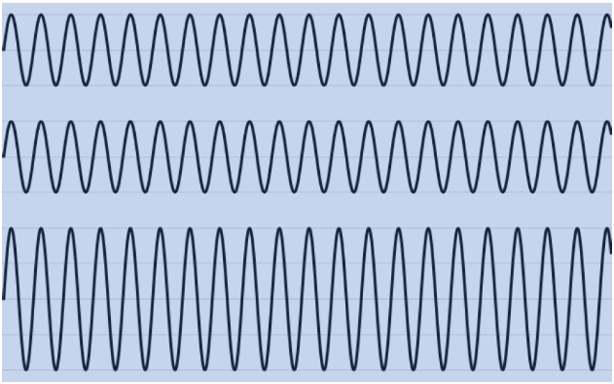
Figure 9.10: The top two patterns are waves traveling in phase in the same direction. The bottom pattern is the sum of the other two.¹
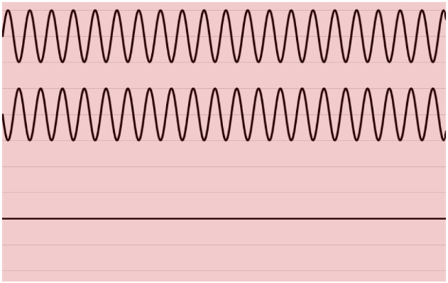
Figure 9.11: The top two patterns are waves traveling 180° out of phase in the same direction. The bottom pattern is the sum of the other two.¹

Numbers
(This column intentionally left blank)

Words
When two waves of slightly different frequencies interfere with each other, they create “beats.” At some times the waves are aligned in such a way that their amplitudes add, and at other times the waves are aligned in such a way that their amplitudes cancel. The result is a sound wave with a frequency that is the average of the frequency of the two slightly different original waves. But the sound is not constant–instead it increases and decreases in amplitude, at a frequency that is equal to the difference between the two original waves.

Graphics
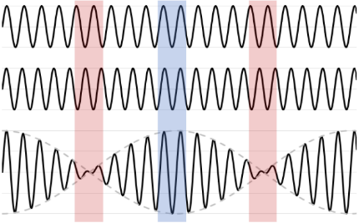
Figure 9.12: The top two patterns are waves with slightly different frequencies traveling in the same direction. They slowly go into phase and out of phase with each other, so they add constructively in some places and destructively in others. The “beat” pattern on the bottom is the sum of the other two. The dashed line is an “envelope” that contains the beat pattern. This envelope travels along with the wave.¹

Numbers
When two waves with similar frequencies $f_{1}$ and $f_{2}$ interfere with each other, they produce a “beating” pattern. The frequency of the beating, corresponding to the dashed “envelope” in Figure 9.12, is…
$$\boxed{f_{beat}=\left|f_{1}-f_{2}\right|}$$
( 9.7 )
It is important to note that $f_{1}$ and $f_{2}$ in this case do not refer to the frequencies of the first and second harmonics of a standing wave. Rather, they refer to the frequencies of any two waves that are being combined to create a beating pattern. The “carrier frequency” of the beating wave, the frequency that is actually heard beating, is simply the average of the two frequencies that were added together:
$$\boxed{f_{carrier}=\frac{f_{1}+f_{2}}{2}}$$
( 9.8 )

: Longitudinal Waves ( , )

Words
Longitudinal waves create areas of compression and rarefaction in a material. Figure 9.13 shows a compression wave pulse initially traveling to the right and then reflecting back to the left.
With longitudinal waves, monitoring the maximum and minimum locations of the pieces of material was a good way to find the location of the wave. But notice that in the figure the positions of the individual pieces do not indicate the location of the wave. Piece 2 shifts to the right when the wave passes, and then it stays in the same position until the wave passes that location again.
A better way to find the location of a longitudinal wave is to look for the places where the spacing between the pieces is different, either a compression or a rarefaction. In Figure 9.13, the location of the compressed spring is clearly moving to the right from t₀ to t₃ and moving to the left from t₄ to t₆.
The location of the pressure wave is also where the pieces of the rope are affected by the largest net force. In the case of a compression wave pulse, the net force on each piece is outward from the compression.
The speed of a longitudinal wave in a solid depends on the density and the elastic properties of the material. A higher density causes a lower speed, and a higher Young’s modulus (a measure of elasticity) causes a higher speed.

Graphics
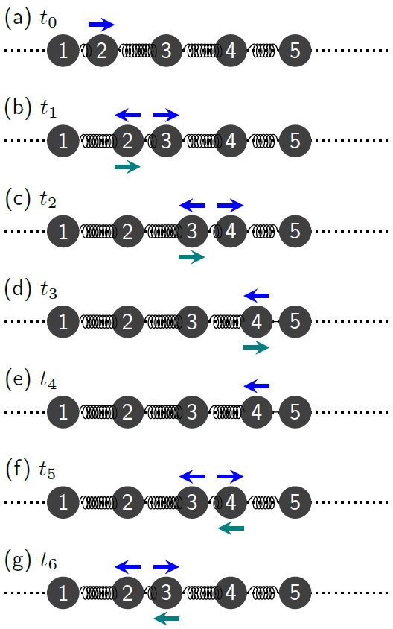
Figure 9.13: If piece “5” is held firmly in place, a compression wave pulse moving to the right reflects back to the left when it reaches the end.¹

Numbers
To find the speed of a longitudinal wave through a material, we need to know the Young’s modulus $Y$ and the mass density $ρ_{m}$ of the material, where density is mass per unit volume:
$$\boxed{ρ_{m} = \frac{m}{V}}$$
( 9.9 )
…where $m$ is the mass of a piece of material and $V$ is the volume of the piece of material. The $m$ subscript on $ρ_{m}$ is to make it clear that we mean mass density. The following table gives these values of $ρ_{m}$ and $Y$ for several different materials. Note that $Y$ varies by a factor of more than $100 000$ across these different materials.
Material | $$ρ_{m} \left[kg/m^{3}\right]$$ | $$Y \left[N/m^{2}\right]$$
Rubber | $$1 500$$ | $$5×{10}^{6}$$
Tendon | $$1 200$$ | $$5×{10}^{8}$$
Nylon | $$1 200$$ | $$3×{10}^{9}$$
Bone | $$4 000$$ | $$2×{10}^{10}$$
Concrete | $$2 400$$ | $$3×{10}^{10}$$
Steel | $$8 000$$ | $$2×{10}^{11}$$
Diamond | $$3 500$$ | $$1×{10}^{12}$$

Words
Figure 9.13 considered a compression wave pulse reflecting off a fixed end of a piece of material. Figure 9.14 shows what happens when the same pulse reaches a free end of the material. With nothing pushing back on piece 5, it moves outward from its original position, pulling on piece 4 as it goes. This sends a rarefaction wave pulse back to the left.
With longitudinal waves, the wave reflected off the end of the rope would be either flipped over or not depending on the conditions at the end of the rope. Longitudinal waves behave in a similar way– compression bounces back as compression if the end is firmly held in place, but compression bounces back as rarefaction if the end is free to move.
Rarefaction in a solid material creates regions of tension, as can be seen by the stretched strings in our model and the resulting net force arrows that pull neighboring pieces of material toward each other. Compression creates areas of pressure in the material, where the springs in our model are compressed and the resulting net forces push neighboring pieces of material away from each other.

Graphics
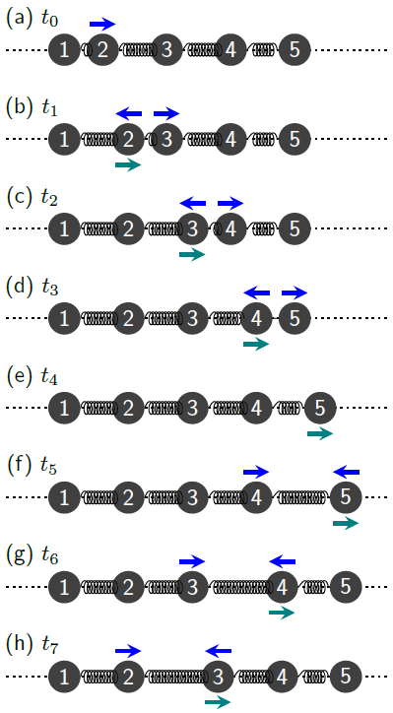
Figure 9.14: If piece “5” is allowed to move freely, a compression wave pulse moving to the right creates a rarefaction pulse that reflects back to the left.¹

Numbers
The speed of a longitudinal wave in a solid material is given by…
$$\boxed{v=\sqrt{\frac{Y}{ρ_{m}}}}$$
( 9.10 )
Using the same guitar string example that we used in Section 9.3, we can find the speed of a longitudinal wave traveling along the length of the string:
$$v=\sqrt{\frac{Y}{ρ_{m}}}=\sqrt{\frac{2×{10}^{11} N/m^{2}}{8 000 kg/m^{3}}}=5 000 m/s$$

: Stretching and Breaking ()

Words
The Young’s modulus tells us more about a material than the speed of waves. It is a measure of how much the material stretches or compresses when a force is applied. The Young’s modulus of a material is determined by its molecular structure–how tightly bound the atoms are to each other and the configuration of bonds in the material.
There is also a limit to how much force can be applied to a given material before it breaks. Depending upon the complexity of the bonds, the Young’s modulus and other measures of the material properties could be dependent upon direction or they could vary depending on whether the material is under tension or compression.
Some materials have structure in them that is not related to the molecules themselves but to larger variations in the material. Wood is a good example of this, because wood has a “grain,” and when placed under tension, wood is much stronger across the grain than it is along the grain.
Materials can also have vastly different properties when they are under compression than when they are under tension. Concrete, for example, is very strong under compression but easily breaks under tension. That is why iron “rebar” is often placed inside concrete slabs in places where the concrete could be under tension. Iron is very strong under tension, so it holds the concrete together.

Graphics
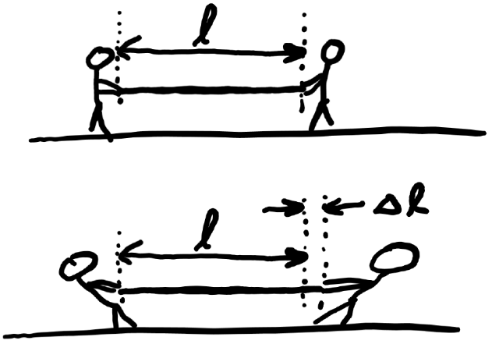
Figure 9.15: A rope of length $l$ stretches to a length
$l+Δl$ when a force is applied.¹
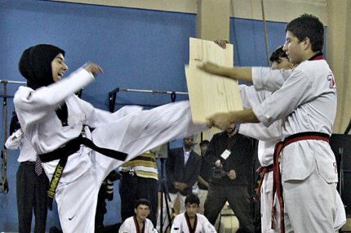
Figure 9.16: The board broke vertically into two pieces, along the grains visible in the board, when the black belt hit it with her foot.

Numbers
By how much does a 5-m-long nylon rope with a diameter of 2 cm stretch when it is pulled by a force of 150 N?
Knowns | Unknowns
$$r=0.01 m$$ | $$Δl$$
$$l=5 m$$
$$F_{T}=150 N$$
nylon
The amount by which the length of a solid changes when a force is applied is given by…
$$\boxed{Δl=\frac{l⋅F}{Y⋅A}}$$
( 9.11 )
…where $l$ is the original length, $F$ is the force applied parallel to the length, $Y$ is Young’s Modulus for the material, and $A$ is the cross-sectional area of the material.
So, for this example…
$$\begin{aligned}Δl&=\frac{\left(5 m\right)⋅\left(150 N\right)}{\left(3×{10}^{9} N/m^{2}\right)⋅π⋅{\left(0.01 m\right)}^{2}} \\ &=8×{10}^{-4} m \\ \end{aligned}$$
Even for a relatively stretchy material like nylon, the change in length is quite small. Most solids are very difficult to stretch or compress.

Words
The breaking point of a material is strongly affected by local factors. Materials often break not in the place where the largest force is applied, but in the place where the largest pressure is applied. Pressure is defined as force per area, and it has units of pascals [Pa]. Often tools that are made for breaking or cutting have sharp edges, so the force will be applied over a very small area, creating large pressure.
If force is applied evenly instead of being concentrated at a single location, then breaks will usually start at an inside corner or a place where the material has a defect. Think of a chain, which is only as strong as its weakest link.
Glass workers take advantage of breaks starting at defects by intentionally scratching one side of a pane of glass in the place where they want it to break. This makes the glass break cleanly along the scratch when the glass is flexed in such a way that the scratched surface is under tension.

Graphics
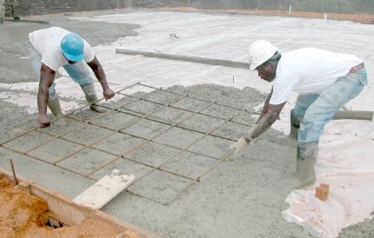
Figure 9.17: Rebar being added to cement.
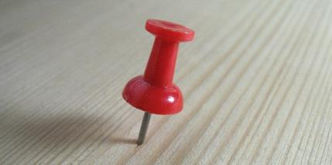
Figure 9.18: A thumbtack creates very little pressure on the thumb, but enough pressure at the bottom to punch into wood.
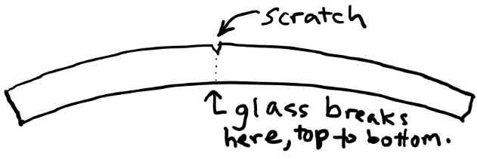
Figure 9.19: Flexing upward creates tension along the top and compression along the bottom.

Numbers
Consider the thumbtack in Figure 9.18. The top surface has a diameter of 6 mm and the point at the bottom narrows to 0.1 mm. How much pressure is applied to the thumb and to the wood if you push down on the thumbtack with a force of 40 N?
Knowns | Unknowns
$$r_{thumb}=0.003 m$$ | $$P_{thumb}$$
$$r_{point}=5×{10}^{-5} m$$ | $$P_{point}$$
$$F_{thumb}=40 N$$
Pressure is defined as force per area:
$$\boxed{P=\frac{F}{A}}$$
( 9.12 )
…where the force is applied parallel to the normal vector; that is, perpendicular to the surface of A.
If we neglect the gravitational force and assume that this is a static situation then the net force on the thumbtack will be zero, so the force between the thumb and the thumbtack is equal to the force between the thumbtack and the wood. This allows us to find the pressures:
$$P_{thumb}=\frac{F_{thumb}}{A_{thumb}}=1.4×{10}^{6} Pa$$
$$P_{point}=\frac{F_{thumb}}{A_{point}}=5×{10}^{9} Pa$$
The pressure on the wood is more than 1000 times larger than the pressure on the thumb!

: Summary
Chapter summaries in this book are ordered by concept, not necessarily in the order in which they are presented in the chapter. Mathematical models are grouped together at the end of each summary. See the appendices for the meanings of all symbols used in this book.

General
- In a transverse wave, each piece of an object is moving in a direction perpendicular to the direction in which the wave is moving.
- In a longitudinal wave, each piece of an object is moving in a direction parallel to the direction in which the wave is moving.
- We can model a solid object as many small, interconnected objects to study how the object bends and stretches.
- Constructive interference occurs where two waves are aligned with each other, so their amplitudes add.
- Destructive interference occurs where two waves are misaligned with each other, so their amplitudes subtract.

Forces & Pressure
- Materials often break not in the area with the largest force but in the area with the largest pressure.

Motion
- When two waves pass by each other, they interfere with each other so that the position of the object is given by the sum of the two waves.
- If the end of a rope is allowed to move freely, transverse waves bounce back from the end of the rope.
- If the end of a rope is held firmly in place, transverse waves flip over and bounce back from the end of the rope.
- If the end of a solid is held firmly in place, longitudinal waves bounce back from the end of the rope.
- If the end of a solid is allowed to move freely, longitudinal waves change from compression to rarefaction (or rarefaction to compression) and bounce back from the end of the rope.
- A node is a place on a vibrating object that does not move.
- An antinode is a place on a vibrating object where the motion is at a maximum.

Energy
• Waves can transfer energy.

Mathematical Models
Equation | Reference | Restrictions on the validity of the equation
$$v=\sqrt{\frac{F_{T}}{μ_{m}}}$$ | ( 9.1 ) | Transverse displacement is small compared to wavelength
$$μ_{m}=\frac{m}{l}$$ | ( 9.2 ) | -none-
$$λ=v⋅T=\frac{v}{f}$$ | ( 9.3 ) | -none-
$$f=\frac{1}{T}$$ | ( 9.4 ) | -none-
$$λ_{n}=\frac{λ_{1}}{n}$$ | ( 9.5 ) | Harmonics of a standing wave
$$f_{n}=n⋅f_{1}$$ | ( 9.6 ) | Harmonics of a standing wave
$$f_{beat}=\left|f_{1}-f_{2}\right|$$ | ( 9.7 ) | $f_{1}$ and $f_{2}$ have similar values
$$f_{carrier}=\frac{f_{1}+f_{2}}{2}$$ | ( 9.8 ) | $f_{1}$ and $f_{2}$ have similar values
$$ρ_{m} = \frac{m}{V}$$ | ( 9.9 ) | -none-
$$v=\sqrt{\frac{Y}{ρ_{m}}}$$ | ( 9.10 ) | Longitudinal wave
$$Δl=\frac{l⋅F}{Y⋅A}$$ | ( 9.11 ) | -none-
$$P=\frac{F}{A}$$ | ( 9.12 ) | -none-

: Questions
Questions are ordered according to Bloom’s Taxonomy, progressing from regurgitating information (Level 1) to synthesizing new information with previous knowledge to create something new (Level 6). The bold letters at the beginning of each question indicate whether the question involves Words [W], Graphics [G], and/or Numbers [N]. See the appendices for conversion factors.

Level 1 - Remember
      - [W] What is the name of a wave in which the pieces of the material don’t actually move along the direction that the wave is moving?
      - [W] What is the name of a wave in which the pieces of the material move parallel to the direction that the wave is moving?
      - [W & N] Add labels to each boxed equation from this chapter that tell what the symbol to the left of the = sign represents
Symbol | Reference | Label
$$v$$ | ( 9.1 )
$$μ_{m}$$ | ( 9.2 )
$$λ$$ | ( 9.3 )
$$f$$ | ( 9.4 )
$$λ_{n}$$ | ( 9.5 )
$$f_{n}$$ | ( 9.6 )
$$f_{beat}$$ | ( 9.7 )
$$f_{carrier}$$ | ( 9.8 )
$$ρ_{m}$$ | ( 9.9 )
$$v$$ | ( 9.10 )
$$Δl$$ | ( 9.11 )
$$P$$ | ( 9.12 )

Level 2 - Understand
      - [W] Can transverse waves travel through a solid? If so, give an example.
      - [W] Can longitudinal waves travel through a solid? If so, give an example.
      - [W & G] Can wavelength be measured from trough to trough instead of from peak to peak?
      - [W & N] How could you change the amount of force to increase the pressure on an object?
      - [W & N] How could you change the area over which a force is applied to increase the pressure on an object?

Level 3 - Apply
      - [W & N] How would doubling the mass of the rope while keeping its length and the tension the same affect the speed of a longitudinal wave?
      - [N] Frequency is a useful concept not just for waves but also for circular motion and oscillations. What is the frequency of Callisto’s orbit around Jupiter, which we considered in Section 8.3?
      - [W & N] The image below shows the end of the neck of a guitar. There are six strings, all made from steel, that are various thicknesses. Each of the strings is connected to a knob at the top that can be used to change the tension in the string. There are also horizontal metal “frets” along the neck of the guitar. The string can be held down tightly against these frets to effectively shorten the length of the string. Explain how each of these three things affects the frequency of the first harmonic of each string:
        - The thickness of the strings?
        - The knobs that change tension?
        - The use of the frets?
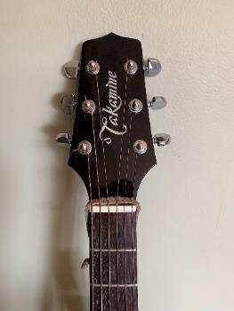
The neck of a guitar, showing the different thicknesses of the strings, the knobs that change tension, and the frets.¹
      - [N] The human range of hearing is roughly 20 Hz to 20 kHz. In addition, some humans can detect beats in sound waves with beat frequencies as high as 7 Hz. Which of the following pairs of frequencies would produce beats that could be audible to a person? Remember to consider both the beat frequency and the carrier frequency.
        - 5 Hz & 7 Hz
        - 50 Hz & 70 Hz
        - 500 Hz & 700 Hz
        - 5 kHz & 7 kHz
        - 500 Hz & 500 Hz
        - 500 Hz & 502 Hz

Level 4 - Analyze
      - [W & G] In Figure 9.3, in what direction is the wave moving and in what direction is the piece of rope moving at piece 5…
        - …at time $t_{2}$?
        - …at time $t_{3}$?
        - …at time $t_{4}$?
        - …at time $t_{5}$?
      - [W & G] Compare the rope at time $t_{1}$ and $t_{5}$ in Figure 9.5. What do you notice about...
        - …the positions of the pieces of the rope?
        - …the forces on the pieces of the rope?
        - …the momenta of the pieces of the rope?
Explain why there are similarities or differences in the forces and momenta.
      - [N] Use the information in the table in Section 9.5 and the linear mass density of the steel string in Section 9.3 to find the diameter of the guitar string. The equation for the volume of a cylinder in Appendix D: may be helpful.
      - [W & G] Compare the rope at time $t_{0}$ and $t_{5}$ in Figure 9.6. What do you notice about...
        - …the positions of the pieces of the rope?
        - …the forces on the pieces of the rope?
        - …the momenta of the pieces of the rope?
      - [N] Find the speed of transverse waves on the guitar string studied in Section 9.3. Compare this to the speed of longitudinal waves on the same string studied in Section 9.5.
      - [W, G, & N] Explain using words, graphics, or numbers why lying down on thin ice is safer than standing on thin ice.

Level 5 - Evaluate
      - [W & G] In the introduction to this chapter it mentions that waves can carry energy. Consider Figure 9.3 & Figure 9.4. Is energy being carried by this wave? What type or types of energy are involved? If energy is being carried, in what direction is it moving on average?
      - [W & G] Explain how the forces shown by blue arrows affect the momentum shown by green arrows in Figure 9.3 for piece 6.
      - [G] Make a sketch showing what the position of the rope would look like in Figure 9.5 at time $t_{6}$.
      - [G] Make a sketch showing what the rope would look like in Figure 9.6 halfway between times $t_{2}$ and $t_{3}$. Include arrows showing the forces and momenta associated with each of the “pieces” of the rope at that time.
      - [G] In all the figures in Section 9.4, the two waves that were being added together had the same amplitudes. Re-draw all three waves in each of the three figures if the middle wave had half the amplitude of the top wave. In each figure, the top wave should be unchanged, the middle wave should be half its current amplitude, and the bottom wave should be the new sum of the top two waves.
      - [W & N] The force of gravity was neglected when considering the pressures involved when using a thumbtack in section 9.6. Determine whether it was reasonable to neglect the force in this situation by determining what the mass of the thumbtack would have to be to create a 10% change in one of the calculated pressures.
      - [W & G] The image below shows a truck sitting on a bridge that is made from a simple slab of concrete, shown with light diagonal markings. Answer the following questions using words or drawings.
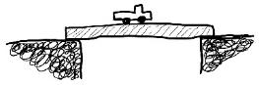
A truck on a bridge. ¹
        - What side of the concrete is under tension?
        - What side of the concrete is under compression?
        - Where is the concrete most likely to break, considering that it is weaker under tension than it is under compression?
        - If you could add iron rebar to only one side of the concrete, where would you put it?
      - [W & G] The image below shows a truck sitting on a cantilever bridge that is made from a simple slab of concrete, shown with light diagonal markings. Answer the following questions using words or drawings.
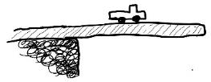
A truck on a cantilever bridge.
        - What side of the concrete is under tension?
        - What part of the concrete is under compression?
        - Where is the concrete most likely to break, considering that it is weaker under tension than it is under compression?
        - If you could add iron rebar to only one part of the concrete, where should you put it?

Level 6 - Create
      - [W, G, & N] At the beginning of Chapter 1 in Figure 1.1 was a template for a concept map. Begin a new concept map just for solids.
      - [W, G, & N] Imagine you are writing a test question related to this chapter. Think of your own example of a situation that you can analyze using the concepts, graphics, and mathematical analyses described in this chapter. Describe the situation and use the tools from this chapter to analyze the situation as completely as you can, including motion, forces, energy, and momentum.
      - [W, G, & N] Think about possible misconceptions about the material in this chapter. Write a question and an incorrect solution to it that demonstrates a student making such a conceptual error. This cannot be a simple misuse of a vocabulary word, a unit error, or a mathematical error like making an addition error or multiplying when addition was needed, unless the error is rooted in a real misunderstanding about the physics behind the calculation or the misuse of a word. After you have written the question and incorrect solution, explain what is wrong with the student’s solution, and write a correct solution to the problem. Note: You may use a question from this chapter that you got wrong the first time and explain the initial error in your thinking and how you corrected it.

– Liquids ( )
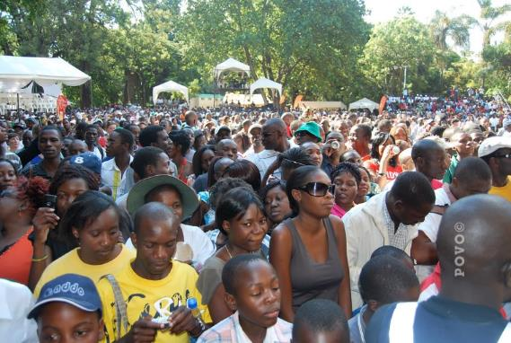
Figure 10.1: Molecules in a liquid behave like people in a crowd.


Figure 10.2: Fluids (of which liquids are one example) take the shape of their container.
We created a model of a solid that was made up of many small pieces all held together by springs. This model works all the way down to the molecular scale, with the springs representing the forces holding individual molecules to each other. Now we will begin to explore liquids. The molecules of a liquid behave differently from those of a solid. They are closely spaced, much like a solid, but there are not strong bonds between the molecules to hold them in place; they are free to move around while still staying close together.
We can think of molecules in a liquid like people in a crowd–they are closely spaced, able to move around, and taking the shape of the available space.
Much like most solids, most liquids are not easily compressed into a smaller volume–we will consider them to be completely incompressible, so they will have a constant volume. But unlike solids, liquids can flow and change shape, usually to fit the shape of a container.
A material that can flow and change shape is called a fluid. Liquids are the first type of fluid that we will consider. Gases are another type of fluid that we will study later.

: Doric Temple of Athena Lindia ( , )

Words
The idea of pressure was already introduced as a force per area. Let’s explore that idea in a solid and a liquid. The ruins of the Doric Temple of Athena Lindia in Rhodes have sandstone columns that are 8 m tall and 1 m in diameter. How much pressure do these columns apply to the floor of the temple? What would the pressure be if the column were instead made of liquid water in a cylindrical tube?
To find the pressure on the floor, it seems like we should need to know the gravitational force and the area. To find the gravitational force we would need the mass, but we aren’t given that. We need some additional information about sandstone: its density, that is its mass per volume. The density of sandstone is
$2 400 kg/m^{3}$.
If we take the column to be a uniform cylinder, its volume is its height times its cross-sectional area. As the area increases, so does the volume, which means a larger mass. But we also know that pressure decreases as area increases. It turns out that while the force on the ground does depend on the diameter of the column, the pressure on the ground doesn’t. It only depends on the density and the height.
It is also important to note that if the column is in static equilibrium, then the ground is applying an equal-but-opposite upward force on the column, over the same area, so the earth also applies the same amount of pressure back on the column.

Graphics
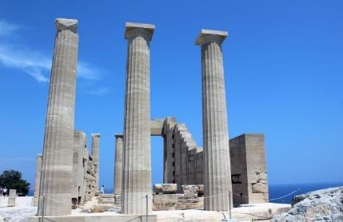
Figure 10.3: The sandstone columns are 8 m tall and 1 m in diameter.
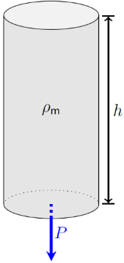
Figure 10.4: A solid column of height $h$ and density $ρ_{m}$ applies pressure on the ground.¹

Numbers
Assumptions: a cylinder is a good approximation of the shape; near the surface of the earth; sandstone and water are incompressible.
Knowns | Unknowns
$$h=8 m$$ | $$P_{sandstone}$$
$$r=0.5 m$$ | $$P_{water}$$
$$ρ_{m,sandstone}=2 400 kg/m^{3}$$
$$ρ_{m,water}=1 000 kg/m^{3}$$
$$g=9.8 N/kg$$
The volume of a cylinder is the height times the cross-sectional area. Taking these to be perfectly round cylinders, that gives…
$$V_{cylinder}=h⋅\left(π⋅r^{2}\right)$$
…where $π⋅r^{2}$ is the cross-sectional area. Since pressure at the bottom of the column is the force per area, near the surface of the earth that would be…
$$P=\frac{F_{g}}{A}=\frac{m⋅g}{π⋅r^{2}}$$
We can rearrange our expression for mass density to solve for $m$, and then combine that with the volume of the cylinder:
$$m=ρ_{m}⋅V=ρ_{m}⋅h⋅π⋅r^{2}$$
Putting this together with our expression for the pressure at the bottom of the cylinder:

Words
If instead of being solid the column was made of a liquid with the same density as sandstone, then the total force and total pressure on the ground would be exactly the same. Of course, if the column were liquid, then it wouldn’t stand up on its own–it would flow downward, spreading all over the ground instead. So, if we want to consider a column of water then we must add a tube holding it in position.
To keep the liquid in place, the tube would have to supply a pressure inward that is exactly equal to the pressure with which the liquid pushes out on the tube. The pressure in a fluid (liquid is a type of fluid) pushes out in all directions. So, at the bottom of the tube, the pressure on the sides of the tube would be the same as the downward pressure on the earth. But the pressure decreases as you go up the column, reaching zero at the top, because there is less and less liquid pushing down from above due to gravity. This is illustrated in Figure 10.5.
If the liquid were fresh water, then the downward pressure on the ground would be less than the pressure for a sandstone column, because the density of water is $1 000 kg/m^{3}$, less than the density of sandstone.
“Specific gravity” is often used in the medical field as a unitless way to refer to density. Specific gravity is simply the density of some material compared to the density of fresh water. So fresh water has a specific gravity of 1. Sandstone, with density 2.4 times that of water has a specific gravity of 2.4.

Graphics
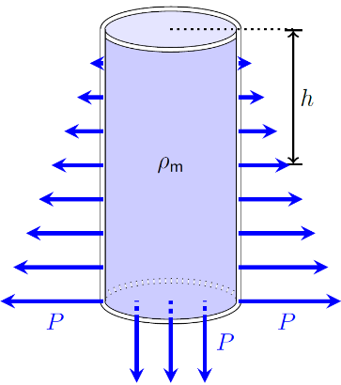
Figure 10.5: A column of liquid in a tube applies outward pressure on the ground and on the sides of the tube. The amount of pressure increases with depth $h$.¹

Numbers
$$P=\frac{ρ_{m}⋅h⋅π⋅r^{2}⋅g}{π⋅r^{2}}$$
$$\boxed{P=ρ_{m}⋅g⋅h}$$
( 10.1 )
It is interesting that the pressure doesn’t depend on the cross-sectional area of the pillar. There is also nothing that limits the analysis to a solid, so it is also valid for liquids. For a liquid, $h$ represents the height of the surface above the point of interest, or alternatively the depth of the point of interest below the surface.
If the column is sandstone, the pressure it applies to the earth is…
$$P_{sandstone}=ρ_{m,sandstone}⋅g⋅h=188 000 Pa$$
If the column is water, the pressure it applies at the bottom (to the earth and to the sides of the tube) is…
$$P_{water}=ρ_{m,water}⋅g⋅h=78 000 Pa$$
At a position higher up the column, for example 1 m from the ground, the pressure that the water applies to the sides of the cylinder is…
$$\begin{aligned}P_{water}&=\left(1 000 kg/m^{3}\right)⋅\left(9.8 N/kg\right)⋅\left(8-1\right) m \\ &=69 000 Pa\end{aligned}$$

: Transfer of Pressure ( , )

Words
We have already noted that liquid takes the shape of the container that it is in, but what happens to the pressure in the liquid if the container is oddly shaped, or if the container is squeezed with some additional applied pressure besides just the force of gravity on the liquid itself?
Many mechanical systems, like brakes in a car or the arms of cranes and backhoes, are controlled by hydraulic systems, in which a liquid fills a series of hoses and chambers, and pistons are used to apply pressure to the liquid in one location, so the liquid applies pressure in another location. We will consider a simple system to understand how these hydraulic systems work: A pitcher with a narrow neck.
The pitcher is 16 cm tall, including a 2 cm diameter neck and an 8 cm diameter sphere at the bottom. We will assume that it contains water, and we will consider it when filled and when “half full” just to the bottom of the neck.
Since the pressure created in a liquid by gravity depends only on the density of the liquid and the distance below the surface, perhaps surprisingly, the actual shape of the container doesn’t matter. If the pitcher is “half full,” meaning up to half of the height, then the pressure at the bottom will be half what it would be if the container were filled.

Graphics
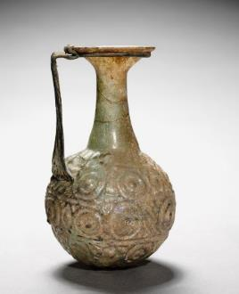
Figure 10.6: A 4th century pitcher with a long, narrow neck.
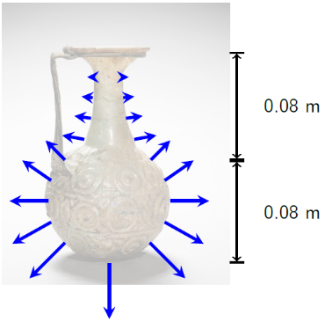
Figure 10.7: Pressure in the filled pitcher.⁵³

Numbers
Assumptions: a cylinder and sphere is a good approximation of the shape; near the surface of the earth; water is incompressible.
Knowns | Unknowns
$$h_{pitcher}=0.16 m$$ | $$P_{filled}$$
$$r_{neck}=0.01 m$$ | $$P_{half-full}$$
$$h_{neck}=0.08 m$$ | $$V_{filled}$$
$$r_{sphere}=0.08 m$$ | $$V_{half-full}$$
$$ρ_{m,water}=1 000 kg/m^{3}$$
$$g=9.8 N/kg$$
First, we will imagine the pitcher filled with water. The volume of the water would be the volume of the neck plus the volume of the sphere:
$$\begin{aligned}V_{filled}&=π⋅r_{neck}^{2}⋅h_{neck}+\frac{4}{3}π⋅r_{sphere}^{3} \\ &=π⋅{\left(0.01 m\right)}^{2}⋅\left(0.08 m\right)+\frac{4}{3}π⋅{\left(0.08 m\right)}^{3} \\ &=\left(2.5×{10}^{-5} m^{3}\right)+\left(2.14×{10}^{-3} m^{3}\right) \\ &=2.17×{10}^{-3} m^{3}\end{aligned}$$
If the pitcher were filled only up to the bottom of the neck, the volume would be just the second term from the calculation above:
$$V_{half-full}=2.14×{10}^{-3} m^{3}$$

Words
Looking at the shape of the container, we can see that it takes very little additional water to completely fill the container once the sphere is full, and yet that small amount of water is enough to double the pressure at the bottom, because the neck is so tall and narrow.
Now let’s consider another situation where the bottom half of the pitcher is filled, the neck of the pitcher is empty, and then a plug is pushed down to the base of the neck and held down with an external applied force. This force creates an external pressure on the water beneath it. That pressure is added equally to every part of the liquid. This is called “Pascal’s Law.”
This principle is used in hydraulic systems. If a force is applied to a small area of the liquid in a closed system, it creates a large pressure increase in all the liquid. If the liquid goes to a movable part of the system with a relatively large area, a force is generated that is much larger than the force applied to the small area.
We have already seen that systems of pulleys can be used to create machines with a “mechanical advantage” larger than one. That means the output force is larger than the input force. Hydraulic systems can behave in the same way if the area is smaller for the input force than it is for the output force.

Graphics
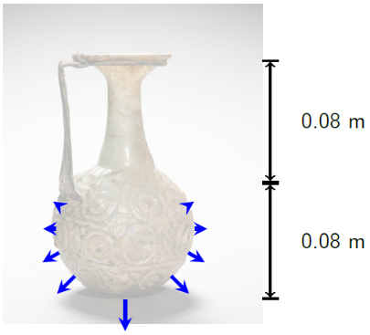
Figure 10.8: Pressure in the half-full pitcher.⁵³
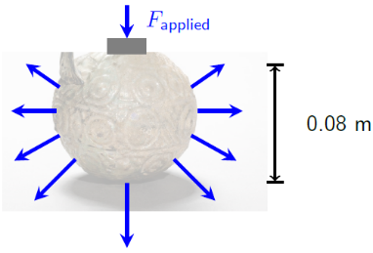
Figure 10.9: Applied pressure on the half-full pitcher.⁵³

Numbers
Comparing these, the neck holds very little water compared to the sphere at the bottom.
According to Equation ( 10.1 ), the pressure created by gravity in a liquid depends only on gravity, the density of the liquid, and the height of the surface above the point of interest. When filled, the pressure at the bottom of the pitcher is:
$$\begin{aligned}P_{filled}&=ρ_{m}⋅g⋅h \\ &=\left(1 000 kg/m^{3}\right)⋅\left(9.8 N/kg\right)⋅\left(0.16 m\right) \\ &=1 568 Pa\end{aligned}$$
Similarly, the pressure at the bottom of the pitcher when it only half-full is 784 Pa.
If an external force applies an additional pressure to a liquid, the force increases by that same amount of pressure, so that the total pressure becomes:
$$\boxed{P_{tot}=ρ_{m}⋅g⋅h+P_{external}}$$
( 10.2 )
To make the pressure at the bottom of the half-filled pitcher the same as that of the filled pitcher, an external pressure of 784 Pa would need to be applied to the liquid at the base of the neck. We could find the amount of force that would need to be applied to a plug in the neck of the pitcher to create such a pressure. Rearranging our expression for pressure…
$$\begin{aligned}F&=P⋅A \\ &=\left(784 Pa\right)⋅π⋅{\left(0.01 m\right)}^{2} \\ &=0.246 N\end{aligned}$$
…which is exactly the weight of the water that fills the neck of the pitcher.

: Floating and Sinking ( , )

Words
Now we will look at solid objects placed into liquids. Some objects sink and other objects float; the determining factor for sinking or floating is density. Materials with lower density tend to rise and those with higher density sink.
The ingredients in the salad dressing shown in Figure 10.10 have separated themselves into layers based on their densities: sugar with the highest density on the bottom, then vinegar, garlic, oil, and finally dried herbs with the lowest density on the top. For our analysis we will use a simpler situation with just two materials each time: Either water and ice or water and aluminum.
First, we will consider a cube of ice 20 cm on each side floating in fresh water. How much of the ice is submerged below the surface of the water and how much is above the surface? The densities of most materials can be found using an internet search.
The ice cube is in equilibrium in this scenario, so the net force must be zero. Gravitational force acts downward, so some other force must be acting upward to balance it. There is nothing like a rope or a spring, so it can’t be tension force or spring force. It isn’t sitting on a solid surface, so no normal force. It isn’t a frictional force, either. This is a new force that we haven’t considered yet, buoyant force. Buoyant force is caused by gravity creating pressure in the fluid around an object, creating a net upward force on the object.

Graphics
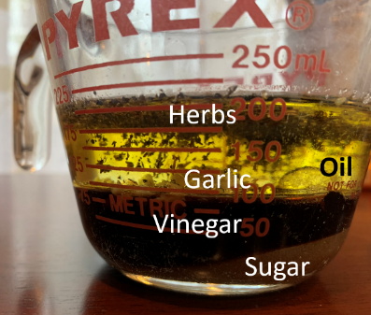
Figure 10.10: Unmixed salad dressing, with ingredients separated according to their densities.¹
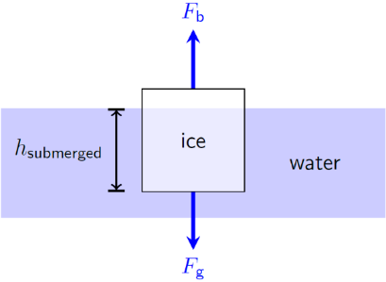
Figure 10.11: Force diagram of ice floating in water, with the water level shown for clarity.¹

Numbers
Assumptions: near the surface of the earth; water and ice are incompressible.
Knowns | Unknowns
$$V_{ice}=0.2×0.2×0.2 m^{3}$$ | $$V_{submerged}$$
$$ρ_{m,water}=1 000 kg/m^{3}$$ | $$m_{ice}$$
$$ρ_{m,ice}=920 kg/m^{3}$$
$$g=9.8 N/kg$$
We can rearrange the definition of mass density to find the mass of the ice block:
$$\begin{aligned}m_{ice}&=ρ_{m,ice}⋅V_{ice} \\ &=920 kg/m^{3}⋅0.2×0.2×0.2 m^{3} \\ &=7.36 kg\end{aligned}$$
The ice is in equilibrium, and we only need to consider the vertical direction for forces, so…
$$F_{net,y}=F_{b}-F_{g}=0$$
$$F_{b}=F_{g}=m_{ice}⋅g=72.1 N$$
The buoyant force is created by the upward pressure of the water on the bottom of the ice, so using Equation ( 10.2 )…
$$\begin{aligned}F_{b}&=P_{bottom}⋅A_{bottom}+{ P}_{external} \\ &=\left(ρ_{m,water}⋅g⋅h_{submerged}\right)⋅A_{bottom} \\ &=ρ_{m,water}⋅g⋅V_{submerged}\end{aligned}$$
…since the submerged volume is the submerged height times the cross-sectional area.

Words
For a floating object, the buoyant force created by the pressure in the fluid exactly balances the gravitational force on the object itself. This happens when a volume of the liquid equal to the submerged volume of the object has the same mass as the object.
Now we will consider instead a 20 cm x 20 cm x 20 cm block of aluminum sinking in fresh water. What is the buoyant force on the aluminum? Again, the buoyant force is created by the pressure in the fluid, but this time there is fluid on all sides. Since pressure increases with depth, the force upward on the bottom is greater than the force downward on the top. Because of this, the buoyant force is always upward.
Much like in the case of the floating ice, the buoyant force is related to the submerged volume of the object (in this case the whole object), but this time the buoyant force is smaller than the gravitational force. That is because buoyant force is equal to the weight of a volume of water equal to the volume of the object, and water has a lower density than the object. If the object and the fluid around it are incompressible, the buoyant force on a completely submerged object does not change as it sinks deeper into the liquid.
If the object sinks to the bottom of the liquid, for example sitting on the bottom of a lake, the forces are again balanced but in this case the buoyant and normal forces together balance the gravitational force.

Graphics
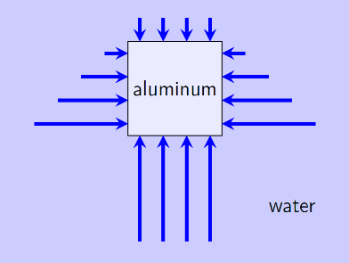
Figure 10.12: Pressure on a block of aluminum sinking in water.¹
Looking at Figure 10.12, we can see that the pressure in the horizontal direction presses equally on both sides of the block, canceling out. But the pressure on the bottom of the block is larger than the pressure on the top
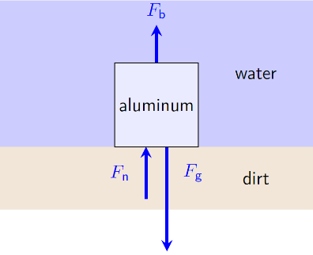
Figure 10.13: Force diagram of aluminum sitting at the bottom of a lake.¹

Numbers
Assumptions: near the surface of the earth; water and aluminum are incompressible
Knowns | Unknowns
$$V_{Al}=0.2×0.2×0.2 m^{3}$$ | $$F_{b}$$
$$ρ_{m,water}=1 000 kg/m^{3}$$ | $$m_{Al}$$
$$ρ_{m,Al}=2 700 kg/m^{3}$$
$$g=9.8 N/kg$$
In the case of a block that is completely submerged, there is pressure at the top and the bottom. The pressure at the top can be considered an external pressure caused by the water above the block, and using Equation ( 10.2 ) the pressure in the water at the bottom becomes…
$$P_{bottom}=ρ_{m,water}⋅g⋅h+P_{top}$$
The buoyant force would be the combined force from the pressure on the top and the bottom. The areas of the top and the bottom are equal, so…
$$\begin{aligned}F_{b}&=P_{bottom}⋅A_{bottom}-P_{top}⋅A_{top} \\ &=\left(P_{bottom}-P_{top}\right)⋅A \\ &=\left(\left(ρ_{m,water}⋅g⋅h+P_{top}\right)-P_{top}\right)⋅A \\ &=ρ_{m,water}⋅g⋅h⋅A \\ &=ρ_{m,water}⋅g⋅V_{submerged}\end{aligned}$$
This is the exact same result that we got for a floating object. It is generally true for any object in any fluid under the influence of gravity:
$$\boxed{F_{b}=ρ_{m,fluid}⋅g⋅V_{submerged}}$$
( 10.3 )

: Flowing ( , )

Words
Now we will allow the liquids to flow, so we will begin to consider motion and energy in addition to forces. The scenario we will consider is water flowing through a horizontal pipe with varying diameter: first with a diameter of 10 cm, then narrowing to 5 cm, and finally returning to 10 cm. The water enters the first part of the pipe flowing to the right at 5 m/s at a pressure of $4×{10}^{5}$ Pa in the center of the pipe.
We will assume for now that water is an ideal fluid; that is, the flow is smooth and constant and there is no friction because only elastic collisions occur within the fluid. We will also assume that the fluid moves at the same speed across the entire cross-section of the pipe at any given horizontal position. What is the speed and pressure of the water at the center, top, and bottom of each section of the pipe?
If we consider just the first section of the pipe, the velocity of the water is constant, to the right. The pressure increases with depth, so the pressure at the bottom of the pipe would be higher than $4×{10}^{5}$ Pa and the pressure at the top of the pipe would be lower than $4×{10}^{5}$ Pa.
The flow of a liquid can be described in terms of the volumetric flux, that is, the volume of flow per time, [m³/s]. In a pipe, the same volume of water flows through each section of pipe, so the volumetric flux is the same for each. This means that the speed of the water must be faster through the narrower section of pipe, since the cross-sectional area of that pipe is smaller.

Graphics
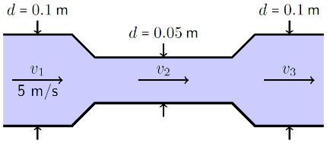
Figure 10.14: Water flowing through a pipe with varying diameter.¹
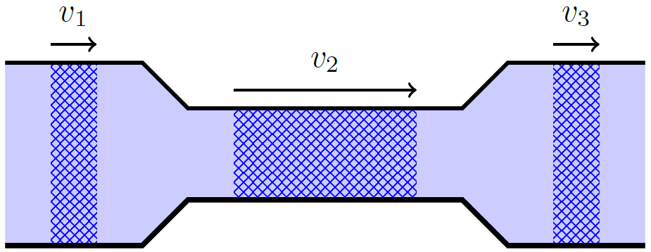
Figure 10.15: Water flowing through a pipe with varying diameter. Equal volumes are marked in each section of pipe. Since the volumetric flux is constant, it takes water the same amount of time to pass through each marked region. That means the speed must be higher in the narrower part of the pipe.¹

Numbers
Assumptions: laminar flow; near the surface of the earth; water is incompressible; ideal fluid.
Knowns | Unknowns
$$A_{1}=7.85×{10}^{-3} m^{2}$$ | $$v_{2}$$
$$A_{2}=1.96×{10}^{-3} m^{2}$$ | $$v_{3}$$
$$A_{3}=7.85×{10}^{-3} m^{2}$$ | $P_{1,top}$, $P_{1,bottom}$
$$v_{1}=5 m/s$$ | $P_{2,top}$, $P_{2,center}$, $P_{2,bottom}$
$$P_{1,center}=4×{10}^{5} Pa$$ | $P_{3,top}$, $P_{3,center}$, $P_{3,bottom}$
$$ρ_{m,water}=1 000 kg/m^{3}$$
$$g=9.8 N/kg$$
The areas were found using $A=π⋅r^{2}$.
Volumetric flux is given by:
$$\boxed{Φ_{V}=v⋅A⋅cosθ}$$
( 10.4 )
…where $v$ is the speed of the fluid, $A$ is the area through which the fluid is flowing, and $θ$ is the angle between the velocity and the normal vector of the area. For flow through a pipe this angle is zero. Volumetric flux is constant in all sections of the pipe…
$$Φ_{V,1}=Φ_{V,2}=Φ_{V,3}$$
$$v_{1}⋅A_{1}=v_{2}⋅A_{2}=v_{3}⋅A_{3}$$
Substituting in our known values, $v_{3}$ is 5 m/s, the same as $v_{1}$, and $v_{2}$ is 20 m/s.

Words
The change in the speed of the water tells us that the water accelerated to the right as it went from the wider section of pipe to the narrower section. So, there must be a net force in the direction of the flow when the pipe narrows. The only forces in that direction are from the pressure in the fluid itself. So, the pressure in the narrow part of the pipe must be lower than in the wider part of the pipe. Then when the water passes into the third part of the pipe, where it is wider again, the water experiences an acceleration to the left, returning to its original speed. So, the pressure in the third part of the pipe is the same as in the first part.
This may seem counter-intuitive, because many people tend to think that pressure must be highest where the speed is highest. But remember that pressure is related to force. And we have already learned that just because an object is moving at high speed does not necessarily mean that there is a large force acting on the object. It just means that for some period in the object’s history there was a net force acting in the direction that the object is currently moving. The same is true here–a larger pressure from the first section of the pipe caused the higher speed in the second section of the pipe.
The reduction of pressure in places where a pipe narrows is referred to as the “Venturi effect.”

Graphics
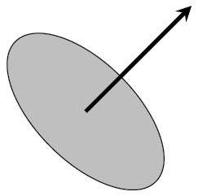
Figure 10.16: The normal vector of an area points directly out of the surface.¹
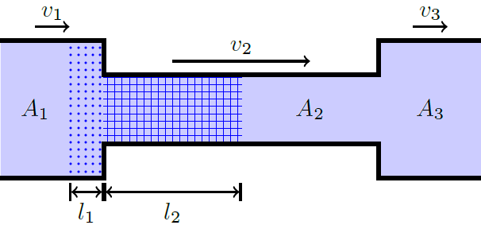
Figure 10.17: This simplified model of water flowing through a pipe makes it easier to find the change in pressure as the water flows through it. A volume of water, shaded with dots in the first section of the pipe, flows to the right, so the same water a short time later occupies the volume shaded with a grid in the second section of the pipe.¹

Numbers
Consider the water in Figure 10.17 that moves from the first section of pipe to the second. Work changes the kinetic energy of the water:
$$W_{net}=ΔE$$
The pressure in the first section of the pipe pushes right for a distance $l_{1}$ while the pressure in the second section of the pipe pushes left for a distance $l_{2}$. This increases the kinetic energy of the water. In addition to these changes in the horizontal direction, any change in the vertical direction creates a change in gravitational potential energy. Combining these three in an incompressible fluid gives “Bernoulli’s Equation:”
$$\boxed{\left(P+\frac{1}{2}ρ_{m}⋅v^{2}+ρ_{m}⋅g⋅h\right) is constant}$$
( 10.5 )
Setting the height $h=0$ at the center of the pipe, the constant value given by Bernoulli’s Equation for this system at the center of the first section of pipe becomes…
$$\begin{matrix}P_{1,center}+\frac{1}{2}ρ_{m,water}⋅v_{1}^{2}+ρ_{m,water}⋅g⋅0 \\ =\left(4×{10}^{5} Pa\right)+\frac{1}{2}\left(1 000 kg/m^{3}\right)⋅{\left(5 m/s\right)}^{2}+0 \\ =412 500 Pa\end{matrix}$$
This constant is valid anywhere in the pipe. At the top of the second section of pipe, for example…
$$\begin{matrix}P_{2,top}+\frac{1}{2}ρ_{m,water}⋅v_{2}^{2}+ρ_{m,water}⋅g⋅0.025 m \\ =412 500 Pa\end{matrix}$$

: Intermolecular Forces ()

Words
Up to this point, we have only been dealing with “ideal fluids,” in which the flow, if any, is smooth and constant and the only interactions between the molecules of the fluid or between the fluid and the walls of a container are like elastic collisions. Now we will introduce turbulent flow and viscosity, which comes from attractive forces between the molecules of the fluid and between the fluid and the walls of a container.
For fluids traveling at relatively low speeds and uninterrupted by obstacles, the fluid flow is laminar. Laminar flow is when the fluid is moving along smooth paths. At higher speeds or when obstacles are introduced, fluid flow becomes turbulent. Turbulent flow is when the flow is erratic, with mixing, rotation, and chaotic changes in magnitude and direction of the velocity. Laminar and turbulent flow can both be seen in Figure 10.18 and are drawn schematically in Figure 10.19.
Figure 10.19 shows laminar flow in a pipe for a fluid with non-zero viscosity (so not an ideal fluid). Viscosity can be thought of as how “thick” a fluid feels. Honey, for example, has high viscosity. For this type of fluid, the speed is higher in the center of the pipe. That is because frictional forces between the pipe wall and the fluid cause the fluid at the edges to slow to a speed near zero. The speed of the fluid increases the further it is from the walls of the pipe, so it is at a maximum in the center.

Graphics
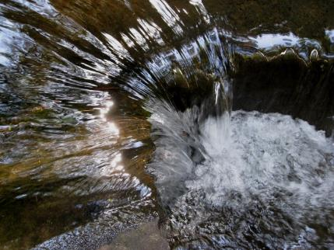
Figure 10.18: The water is experiencing laminar flow as it comes from the left and starts to fall into the pool below. Once the water hits the pool below, the flow becomes turbulent.
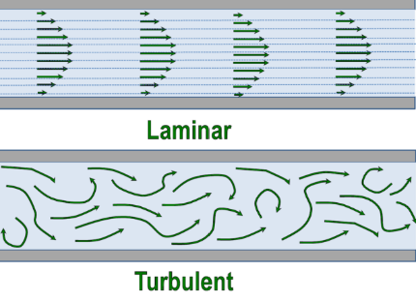
Figure 10.19: Laminar flow is shown in the upper pipe and turbulent flow in the lower pipe.

Numbers
Assumptions: laminar flow; near the surface of the earth; incompressible fluids.
Knowns | Unknowns
$$r=0.002 m$$ | $$ΔP$$
$$l=0.026 m$$
$$Φ_{V}=0.06 l/min$$
$$μ_{v}=0.005 Pa⋅s$$
$$ρ_{m}=994 kg/m^{3}$$
$$g=9.8 N/kg$$
The volumetric flow rate for a viscous fluid in a pipe is highly dependent upon the exact conditions. If the flow in a pipe with a circular cross-section is laminar and the pipe is neither too short nor too wide, then the volumetric flow rate is given by Poiseuille’s equation…
$$\boxed{Φ_{V}=\frac{π⋅r^{4}⋅ΔP}{8μ_{v}⋅l}}$$
( 10.6 )
…where $r$ is the radius of the pipe, $l$ is the length of the pipe, and $μ_{v}$ is the viscosity of the fluid. Before solving Poiseuille’s equation for the change in pressure, the flow rate needs to be converted to SI units:
$$\begin{aligned}Φ_{V}&=\left(0.06 l/min\right)⋅\left(\frac{1 m^{3}}{1 000 l}\right)⋅\left(\frac{1 min}{60 s}\right) \\ &=1×{10}^{-6} m^{3}/s\end{aligned}$$

Words
The frictional force that constantly opposes the motion of the fluid would stop the fluid flow without a pressure difference between the two ends of the pipe. The volumetric flow rate in a pipe depends on the pressure difference between the two ends of the pipe, the viscosity of the fluid, the cross-sectional area of the pipe, and the length of the pipe.
We will consider this effect in a brachial artery, which carries blood to the arm. The brachial artery has a diameter of approximately 4 mm and a length of 26 cm. The flow rate is approximately 0.06 liters per minute. The density of blood is approximately 994 kg/m³ and the viscosity of blood is approximately 0.005 pascal-seconds [Pa ⋅ s].
The analysis in the “Numbers” section shows that a pressure difference of only 20.7 Pa is enough for the blood to flow through the artery if the arm is horizontal, but the heart needs to provide more than ten times that amount if the arm is held straight up. In fact, the heart must provide enough pressure for blood to flow through every artery, vein, and capillary in the body–more than 10,000 Pa of pressure. Blood pressure is usually measured in millimeters of mercury, the pressure to raise a column of mercury against the force of gravity by 1 mm.
Intermolecular forces also cause surface tension. A drop of water tends to pull itself together as much as possible into a shape like a ball. The actual details of the shape change, depending upon the effects of gravity and the surfaces in contact with the drop.

Graphics
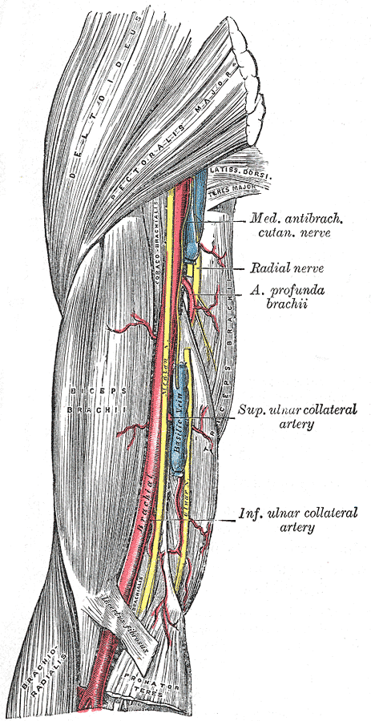
Figure 10.20: The brachial artery is the large artery that runs through the upper arm. It is red in this sketch from Gray’s Anatomy.

Figure 10.21: The smaller water droplets form nearly perfect spheres on this lotus leaf, while the larger drops are deformed by gravity.

Numbers
Now we can find the change in pressure.
$$\begin{aligned}ΔP&=\frac{8μ_{v}⋅l⋅Φ_{V}}{π⋅r^{4}} \\ &=\frac{8⋅\left(0.005 Pa⋅s\right)\left(0.026 m\right)\left(1×{10}^{-6} m^{3}/s\right)}{π⋅{\left(0.002 m\right)}^{4}} \\ &=20.7 Pa\end{aligned}$$
If the arm is horizontal, this change in pressure needs to be provided by the heart. If the arm is hanging down, then gravity provides a change pressure given by Equation ( 10.2 ), taking $P_{tot}$ to be the pressure at the bottom and $P_{external}$ to be the pressure at the top:
$$\begin{aligned}ΔP&=P_{tot}-P_{external} \\ &=ρ_{m}⋅g⋅h \\ &=\left(994 kg/m^{3}\right)⋅\left(9.8 N/kg\right)⋅\left(0.026 m\right) \\ &=253 Pa\end{aligned}$$
…where the length of the artery is used as the height since the artery is vertical. This is more than enough pressure for blood to flow through the artery even without the heart pumping. But if the arm is raised, the heart would have to provide enough additional pressure to make the blood flow upward against gravity.

: Water Waves ( , )

Words
If you have ever watched a wave move across water, you have probably noticed that the water rises and falls. When the wave is caused by something falling into the water, the waves form rings that move outward. When the wave is caused by wind, it looks like long straight lines. Either way, the waves look like transverse waves rising and falling.
In fact, they are more complicated than transverse waves. Transverse waves travel easily through a solid because of the strong forces that hold each atom to all its neighboring atoms. Liquids don’t have such strong forces between atoms, so transverse waves do not travel easily through liquids.
What if instead a longitudinal wave were introduced into a body of water? This would cause compression and rarefaction of the water molecules, but water, like most solids and liquids, is nearly incompressible. Solids cannot flow, so the incompressibility makes longitudinal waves travel at very high speeds through the material. But liquids can flow, so if you try to compress the liquid in the horizontal direction it will flow upward instead of compressing. Then if you try to rarefy the liquid it will flow downward. This creates a circling motion in the water, as can be seen in Figure 10.23. The circling motion is a combination of transverse and longitudinal waves that is often simply referred to as a water wave. Waves tend to travel more slowly through liquids than through solids.

Graphics
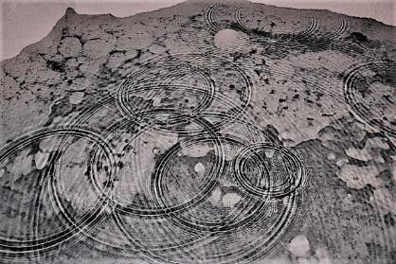
Figure 10.22: Waves move outward from places where water has dropped into the pool. Note that the waves can pass through each other.
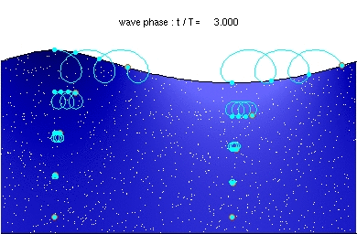
Figure 10.23: Individual particles in a water wave follow a near-circular path, moving both parallel and perpendicular to the wave itself, which is moving to the right in this image.
A moving GIF of Figure 10.23 is viewable at https://commons.wikimedia.org/wiki/ File:Deep_water_wave.gif.

Numbers
Knowns | Unknowns
$$d=0.02 m$$ | $$θ_{node 0}$$
$$λ=0.01 m$$ | $$θ_{antinode 1}$$
 | $$θ_{node 1}$$
The angles $θ_{node 0}$, $θ_{antinode 1}$, and $θ_{node 1}$ are illustrated in Figure 10.25.
For interference between two point sources, the angles for the antinodes where destructive interference occurs can be found by using the following relationship:
$$\boxed{m⋅λ=d⋅sinθ_{antinode m}}$$
( 10.7 )
…where $m$ is an integer (0, $±$1, $±$2, etc.), $λ$ is the wavelength, and $d$ is the distance between the sources of the waves.
If we choose $m=0$, this gives an angle $θ=0$. That direction corresponds to directly in front of the bee in Figure 10.24 or directly above the point sources in Figure 10.25, and in both of these cases we can see that the waves are strong in those directions.
Solving Equation ( 10.7 ) for $θ$ using $m=1$ gives the angle $θ_{antinode 1}={30}^{∘}$, which looks like a reasonable answer if we compare to Figure 10.25.
Using $m=-1$ would give a negative angle–this would simply refer to the same antinode on the other side of the vertical line in Figure 10.25.

Words
Like other kinds of waves, water waves can interfere with each other. In Figure 10.22, the waves pass through each other, as we have seen before with longitudinal and transverse waves in solids. In Figure 10.24, the waves are created in two places very close to each other and in a regular pattern. This creates a situation where the interference between the waves created by the bee’s wings makes a complex pattern.
There are large ripples coming away from the bee in some directions (for example, the direction marked with a dotted line in Figure 10.24). These are the places where the waves created by the two wings are interfering constructively. But the water is almost smooth in other directions (for example, the direction marked with a solid line in the same figure). These are the places where the waves created by the two wings are interfering destructively.
For the analysis of this pattern around the bee, we will assume that the distance between the centers of the wings is 2 cm. Looking carefully at the image, that means the wavelength of the water waves is approximately 1 cm. This pattern is reproduced in Figure 10.25 by creating concentric circles of white and black around two closely spaced positions.
The result is a series of nodes (where the wave amplitude is near zero) and antinodes (where the wave amplitude is at a maximum) radiating from the center point between the two sources of the waves.

Graphics
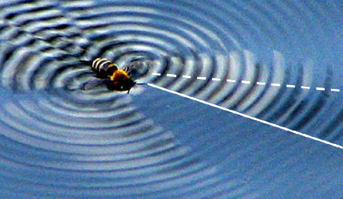
Figure 10.24: A bee beating its wings in water, showing constructive (dotted line) and destructive (solid line) interference.
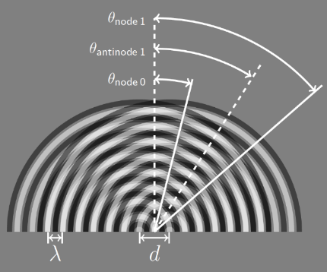
Figure 10.25: This image represents waves with wavelength $λ$ spreading out in circles from two starting positions separated by a distance $d$.¹

Numbers
For the nodes where destructive interference occurs, the mathematical relationship is very similar:
$$\boxed{\left(m+\frac{1}{2}\right)⋅λ=d⋅sin\left(θ_{node m}\right)}$$
( 10.8 )
…where again $m$ is an integer (0, $±$1, $±$2, etc.), $λ$ is the wavelength, and $d$ is the distance between the sources of the waves.
This time if we choose $m=0$ we find an angle for the “zeroth” node $λ_{node 0}={14.5}^{∘}$, which again looks like a reasonable answer if we compare to Figure 10.25.
If we choose $m=1$, we find that $λ_{node 1}={48.6}^{∘}$, which again looks like a reasonable answer.
Every configuration of point sources will have only a limited number of valid solutions for the variable $m$ in the mathematical models given here. The number of valid solutions depends on the relative spacing of the point sources compared to the wavelength. In this situation, if we try to use $m=2$ to find the next node $λ_{node 2}$, we find that $sin\left(λ_{node 2}\right)=1.25$, but there is no angle for which sin is greater than one. But that’s ok–on Figure 10.25 there isn’t another node visible at an angle larger than $λ_{node 1}={48.6}^{∘}$. There is no mathematical solution for another node because there is no other node.

: Summary
Chapter summaries in this book are ordered by concept, not necessarily in the order in which they are presented in the chapter. Mathematical models are grouped together at the end of each summary. See the appendices for the meanings of all symbols used in this book.

General
- The molecules of a liquid are free to move around while still staying close together.
- Most liquids are not easily compressed, so we will consider them to be completely incompressible.
- Materials with lower density tend to rise and those with higher density sink.
- Ideal fluids are those for which the flow, if any, is smooth and constant and only elastic collisions occur between the molecules of the fluid or between the fluid and the walls of a container.

Forces & Pressure
- The pressure in a fluid pushes out in all directions.
- If an external force is applied to a fluid, the pressure caused is added equally to every part of the fluid.
- Buoyant force is caused by the pressure in a fluid around an object.
- Buoyant force always points upward.

Motion and Flow
- The volumetric flux (volume flowing per time) in a pipe is constant throughout the length of the pipe.
- Waves in a liquid are usually a combination of longitudinal and transverse waves, often referred to as “water waves.”

Mathematical Models
Equation | Reference | Restrictions on the validity of the equation
$$P_{tot}=ρ_{m}⋅g⋅h+P_{external}$$ | ( 10.2 ) | no flow, near the surface of the earth
$$F_{b}=ρ_{m,fluid}⋅g⋅V_{submerged}$$ | ( 10.3 ) | near the surface of the earth
$$Φ_{V}=v⋅A⋅cosθ$$ | ( 10.4 ) | -none-
“Bernoulli’s equation”  $$\left(P+\frac{1}{2}ρ_{m}⋅v^{2}+ρ_{m}⋅g⋅h\right) is constant$$ | ( 10.5 ) | within a single, steady flow with no viscosity
“Poiseuille’s equation”  $$Φ_{V}=\frac{π⋅r^{4}⋅ΔP}{8μ_{v}⋅l}$$ | ( 10.6 ) | long, narrow, round pipe with laminar flow
$$m⋅λ=d⋅sinθ_{antinode m}$$ | ( 10.7 ) | -none-
$$\left(m+\frac{1}{2}\right)⋅λ=d⋅sin\left(θ_{node m}\right)$$ | ( 10.8 ) | -none-

: Questions
Questions are ordered according to Bloom’s Taxonomy, progressing from regurgitating information (Level 1) to synthesizing new information with previous knowledge to create something new (Level 6). The bold letters at the beginning of each question indicate whether the question involves Words [W], Graphics [G], and/or Numbers [N]. See the appendices for conversion factors.

Level 1 - Remember
      - [W] What are the main differences between a solid and a liquid at the molecular level?
      - [W] What is meant by “incompressible?”
      - [W] After a solid object is completely submerged in a liquid, how does buoyant force change as the object sinks deeper, assuming that the object and the fluid are both incompressible?
      - [W] What kind(s) of waves can travel easily through a liquid?
      - [W & N] Add labels to each boxed equation from this chapter that tell what the symbol to the left of the = sign represents
Symbol | Reference | Label
$$P$$ | ( 10.1 )
$$P_{tot}$$ | ( 10.2 )
$$F_{b}$$ | ( 10.3 )
$$Φ_{V}$$ | ( 10.4 )
N/A | ( 10.5 ) | (there is no “$=$” sign)
$$Φ_{V}$$ | ( 10.6 )
$$m⋅λ$$ | ( 10.7 )
$$\left(m+\frac{1}{2}\right)⋅λ$$ | ( 10.8 )

Level 2 - Understand
      - [W] What happens to pressure as you move down deeper into a fluid?
      - [W] What happens to pressure in one part of a fluid if you increase the pressure on the fluid in another part of it?
      - [W] Is there any situation where buoyant force points downward? If so, give an example.
      - [N] A steady volumetric flow of 2 liters per second enters a garden hose with a diameter of 2.5 cm. Just before the water comes out of the other end of the hose, a nozzle reduces the diameter to 0.5 cm.
        - What is the magnitude of the volumetric flow out of the nozzle?
        - Is the pressure in the nozzle higher, lower, or equal to the pressure in the hose? Assume that the hose is horizontal.

Level 3 - Apply
      - [W & N] Use the information in Section 10.3 to calculate the specific gravity of ice.
      - [W] What causes pressure to increase as you move down deeper into a fluid?
      - [N] What is the pressure 10 m below the surface of a 40-m-deep freshwater lake?
      - [W & G] The image below shows an oddly shaped container filled with a liquid. Be specific about the locations in your answers.
        - Where in the liquid would the pressure be highest?
        - Where in the liquid would the pressure be lowest?
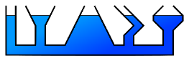
A series of "communicating vessels" that form a single, oddly shaped container.
      - [N] One of the unknowns in Section 10.3 is the submerged volume of the floating ice. Use the buoyant force that was determined using the force diagram to solve for the submerged volume of the ice. What fraction of the ice is submerged? Compare this fraction to the specific gravity of ice.
      - [N] One of the unknowns in Section 10.3 is the mass of the aluminum cube. Calculate the mass of the cube.
      - [N] One of the unknowns in Section 10.3 is the buoyant force on the aluminum cube. Calculate the buoyant force…
        - …if the cube is still sinking, as illustrated in Figure 10.12.
        - …if the cube is sitting on the bottom of the lake, as illustrated in Figure 10.13.
      - [N] In Section 10.4, none of the unknown pressures is found. Calculate them.
      - [G] A curved section of pipe is shown in the image below. Make two sketches of water flowing through this pipe: One with laminar flow and one with turbulent flow.
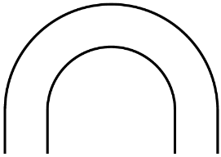
A curved section of pipe.¹
      - [N] In Section 10.6 it was shown that there is no solution for an $m=2$ node. Is there a solution for an $m=2$ antinode?

Level 4 - Analyze
      - [N] How tall would a column of water need to be to apply the same pressure to the ground as the column of sandstone in Section 10.1?
      - [N] How tall would a column of mercury need to be to apply the same pressure to the ground as the column of sandstone in Section 10.1? The density of mercury, which is a liquid at room temperature, is $13 500 kg/m^{3}$.
      - [W & N] The image below shows a measuring cup with a sealable spout. The spout has been sealed such that the level of liquid (assumed to have the same density as water) in the spout is 1 cm below the level of liquid in the main body of the measuring cup. How much external pressure is the seal applying to the liquid?
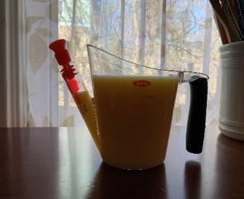
A measuring cup with two different levels of liquid.¹
      - [N] A hydraulic lift is used to raise a 2 500 kg truck off the floor in a repair shop. The total area of the four cylinders that are lifting the truck is 0.5 m². The external pressure applied to the liquid is created by a cylindrical piston with a radius of 0.03 m. How much force does the piston need to use to lift the truck?
      - [W, G, & N] A 1-cm-radius solid ball of lead is dropped into a deep pool of mercury.
        - What is the volume of the lead ball?
        - Look up the density of lead and use it to calculate the mass of the lead ball.
        - Look up the density of mercury. Does the lead ball sink or float?
        - Draw a force diagram of the lead ball.
        - Find the buoyant force on the lead ball.
        - Find the submerged volume of the lead ball.
      - [W] We considered examples where the magnitude of the buoyant force was equal to or less than the force of gravity. Is it possible for buoyant force to be greater than the force of gravity? If so, give an example. If not, explain why not.
      - [N] Consider a horizontal pipe carrying a liquid with high viscosity. What would happen to the volumetric flow rate if everything else remained unchanged except that…
        - The radius of the pipe doubled?
        - The length of the pipe doubled?
        - The pressure difference doubled?
        - The viscosity of the liquid doubled?
      -  [W] “Pitot tubes” like the one in the figure below are used on aircraft to measure the windspeed of the airplane. A Pitot tube depends on the Venturi effect. The Pitot tube has one opening pointing forward on the airplane, and another on the side of the tube. A sensor is used to measure the pressure difference at these two positions. Based on what you know about pressure and fluid flow, explain which of the two openings would be at a higher pressure.
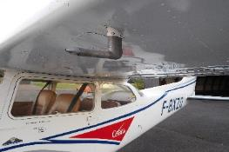
A Pitot tube on the bottom side of an airplane wing.
      - [N] If the distance between two point sources was increased, would the number of possible nodes and antinodes increase, decrease or stay the same? Explain your reasoning.

Level 5 - Evaluate
      - [G & N] Create a line graph that shows the pressure in the column of water in Figure 10.5 as a function of height off the ground. Note that the height off the ground is not the same as “h” in the figure. The total height of the column of water is 8 m.
      - [W, G, & N] Q10.23 asks about a hydraulic lift that is used to lift a truck. The force needed to lift the truck is very large, but the force that is supplied by the piston to do this is very small in comparison. Work is done on the truck to lift it off the ground. That work can only be supplied by small force created by the piston. Does this hydraulic lift violate conservation of energy? If so, could such a machine actually exist? If not, explain how such a large force can be used to do work when the only input is a relatively small force.
      - [W, G, & N] In Figure 10.10, pieces of garlic have sunk through the oil and are floating on the surface of the vinegar. Look up densities of vinegar and olive oil. Assume that the garlic is half submerged in olive oil and half in vinegar in its equilibrium position. If that assumption is correct, what is the density of the garlic?
      - [W] Oil floats on top of water because water is denser than oil. Use an argument based on potential energy and stable equilibrium to explain why the less dense material floats on top of the denser material.
      - [W, G, & N] In Section 10.4, a pipe with varying thickness is analyzed, with the conclusions that the flow rate would be equal in each section, the pressure in the first and last sections would be equal, and the pressure would be lowest in the center section. Are each of these conclusions still valid if the fluid flow is laminar but the fluid has a high viscosity?
        - Is the volumetric flow still equal for all three sections of pipe? If not, where is volumetric flow highest or lowest?
        - Is the pressure in the third section of pipe still the same as in the first section? If not, is it lower or higher?
        - Is the pressure in the center section still lower than for the other sections of pipe?
      - [N] If the wavelength of a water wave was 2 m, what minimum distance would two point sources need to be away from each other in order to create nodes where $m=5$?

Level 6 - Create
      - [W, G, & N] At the beginning of Chapter 1 in Figure 1.1 was a template for a concept map. Begin a new concept map just for liquids.
      - [W, G, & N] Imagine you are writing a test question related to this chapter. Think of your own example of a situation that you can analyze using the concepts, graphics, and mathematical analyses described in this chapter. Describe the situation and use the tools from this chapter to analyze the situation as completely as you can, including motion, forces, energy, and momentum.
      - [W, G, & N] Think about possible misconceptions about the material in this chapter. Write a question and an incorrect solution to it that demonstrates a student making such a conceptual error. This cannot be a simple misuse of a vocabulary word, a unit error, or a mathematical error like making an addition error or multiplying when addition was needed, unless the error is rooted in a real misunderstanding about the physics behind the calculation or the misuse of a word. After you have written the question and incorrect solution, explain what is wrong with the student’s solution, and write a correct solution to the problem. Note: You may use a question from this chapter that you got wrong the first time and explain the initial error in your thinking and how you corrected it.

– Gases ( )

Figure 11.1: The air pressure in the tires must be enough to hold up the heavy load on the bikes.

We have already learned about liquids, which are one type of fluid. Now we will focus on a second type of fluid: gases. In the chapter on liquids, it may have seemed that the words “fluid” and “liquid” were used interchangeably. In fact, they were not. Each time the word “fluid” was used in that chapter, the ideas that were being discussed were equally applicable to gases.
The molecules in a solid are held together with strong bonds; the bonds between molecules in a liquid are weaker than those for a solid; the bonds between the molecules of a gas are extremely weak. We will only consider ideal gases, for which there are no attractive forces at all between the molecules. As a result, the particles of an ideal gas tend to bounce around freely, and unlike liquids they are compressible.
We will look at the motion of gas particles at a molecular level and how the number of molecules and the volume of the gas are related to pressure. We will also consider work done by a gas and sound waves traveling through a gas, including the Doppler effect.

: An Ideal Monatomic Gas ( , )

Words
Our model for a gas will be molecules that bounce around freely through space, interacting with each other only through collisions. With liquids we began by studying ideal liquids that had no viscosity, and then later added viscosity. For gases we will only consider ideal gases.
An ideal gas is one in which:
- molecules of the gas interact with each other only through perfectly elastic collisions
- size of the molecules of an ideal gas is negligible compared to both the size of the container and the average distance between gas molecules
- all the gas molecules are identical
We will focus almost completely on “monatomic” gases–that is, gases where each particle is composed of a single atom like helium or neon. Our atmosphere is mostly nitrogen, which is a diatomic gas since each nitrogen gas molecule is composed of two nitrogen atoms, so later we will also consider diatomic gases.
Let’s begin with a single helium atom bouncing around in an otherwise empty box that is 0.1 meters long on each side. We will use the average speed of a helium atom in our atmosphere, approximately 1350 m/s. How much average pressure does the atom apply to the box?

Graphics
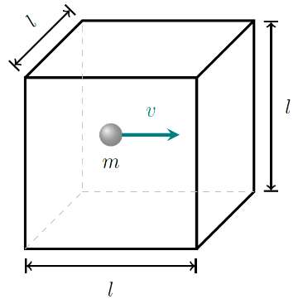
Figure 11.2: A single atom of a monatomic ideal gas with mass $m$ bouncing back and forth with speed $v$ in a box whose sides all have the same length $l$.¹
In the figure above, the size of the atom has been vastly exaggerated. An actual helium atom has a radius of approximately $1×{10}^{-14} m$, so this helium atom is shown approximately 10,000,000,000,000 times larger than it should be! Remember, this is one of the requirements for an ideal gas, that the size of the molecules themselves is very, very small compared to other distances in the physical scenario.

Numbers
Assumptions: ideal gas; ignore gravity.
Knowns | Unknowns
$$l=0.1 m$$ | $$P_{avg}$$
$$v=1 350 m/s$$
$$m=6.7×{10}^{-27} kg$$
We are looking for pressure, which is force per unit area. The atom is striking the walls of the box, and we can find the area of the surface it is hitting. Since we are looking for an average pressure, not just the pressure at one location, we should use the entire surface area of the box. It has six square walls, so…
$$A=6⋅\left(l⋅l\right)=0.06 m^{2}$$
Now we need to find the average force. Force is a change in momentum over time. Each time the atom hits a wall it reverses direction, so there is a change in the sign of its momentum. So, each collision creates a change in momentum with a magnitude of…
$$Δp=m⋅\left(v-(-v)\right)=2m⋅v=1.8×{10}^{-23} kg⋅m/s$$
…pointing toward the center of the box. We can use the path length $s$ and the speed $v$ to find the time $Δt$ between collisions with the walls:
$$Δt=\frac{s}{v}=\frac{0.1 m}{1 350 m/s}=7.4×{10}^{-5} s$$

Words
If the atom only has elastic collisions with the walls of the container and it starts out moving as shown in Figure 11.2., it will bounce back and forth, hitting the right and left walls repeatedly at regular intervals. That means the atom will apply an average outward force on each of these walls. If we ignore the effects of gravity, it will never hit the bottom, and it will also never hit any of the other walls. Perhaps our model is a little bit too simple. Let’s add two more atoms, one bouncing up and down and the other bouncing forward and back while the original atom continues to bounce left and right.
In fact, this is also an unrealistically small number of gas particles in a volume of this size. In a real gas, the atoms are colliding with each other, not just with the walls of the container, so they are scattering around randomly in all different directions. These constant collisions at various angles also mean that the speeds of individual gas molecules change often, although the average speed remains constant. Because of these constant changes, when we deal with gases we are always talking about average values, not values that are correct for any given gas particle.
The pressure in the box increases proportionally with the number of gas molecules. To give a sense for the huge numbers of atoms involved when talking about gases, if we added a million helium atoms to this box every second, and we had started adding them at the time when the universe was created, the pressure in the box would only now be reaching the same pressure as earth’s atmosphere!

Graphics
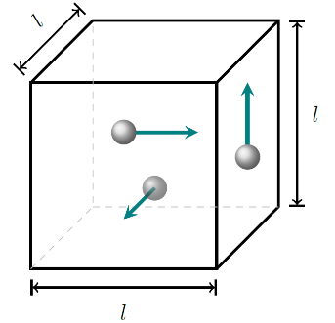
Figure 11.3: Three atoms of a monatomic ideal gas with mass $m$ bouncing around with speed $v$ in a box whose sides all have the same length $l$.¹

Numbers
Now that we have the time between collisions with the walls and the change in momentum of the atom in each of those collisions, we can find the average force:
$$F_{avg}=\frac{Δp}{Δt}=2.4×{10}^{-19} N$$
Since the force of the walls on the atom is equal in magnitude and opposite in direction to the force of the atom on the walls, we can find the average pressure created by the atom on the walls:
$$P_{avg}=\frac{F_{avg}}{A}=\frac{2.4×{10}^{-19} N}{0.06 m^{2}}=4.0×{10}^{-18} Pa$$
If the number of atoms were increased to three, collisions with the walls would happen three times as often, so the pressure would triple. This shows that when the volume and the speed of the molecules remain the same the pressure is proportional to the number of molecules of gas. Atmospheric pressure on earth is $1.01×{10}^{5} Pa$, so the box in this scenario would need to contain approximately $4×{10}^{23}$ atoms of helium to be at atmospheric pressure. That’s 400,000,000,000,000,000,000,000 atoms!.

: Pressure and Volume ( , )

Words
What happens to pressure when we reduce the volume? We can use the same scenario as at the end of Section 11.1 with three helium atoms, but this time we will reduce the height of the box from 0.1 m to 0.05 m.
For the two atoms that are moving horizontally, either left and right or forward and back, nothing has really changed. But the atom that is moving vertically now runs into the walls of the container twice as often, since it is moving at the same speed as before but only can only go half of the distance.
Since the atom that is moving vertically hits the walls twice as often as before, the average force and therefore the average pressure that this atom exerts on the walls of the container has doubled since the volume was reduced by half.
The atoms that are moving horizontally still travel the same distance, applying the same amount of average force to the side walls as they did before. But they also apply twice as much pressure as before, because the area of the walls they are hitting has decreased, and pressure is force per area.
Our simple model accurately predicts what happens when volume is reduced while keeping the speed of the molecules constant: a smaller surface area and a higher rate of collisions combine to increase the pressure in a way that is inversely proportional to the change in volume. So, the pressure doubles if the volume decreases by half.

Graphics
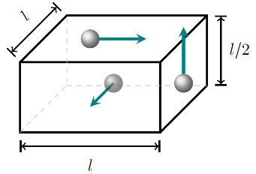
Figure 11.4: Three atoms of a monatomic ideal gas with mass $m$ bouncing around with speed $v$ in a box with one side half the length of the other sides.¹
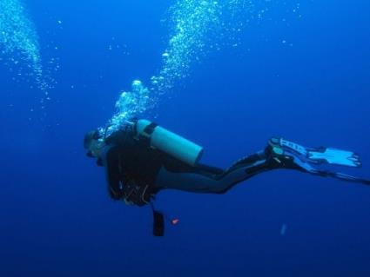
Figure 11.5: A scuba diver blowing bubbles.

Numbers
Assumptions: ideal gas; average speed of molecules is constant.
Knowns | Unknowns
$$V_{i}=6 liters$$ | $$V_{f}$$
$$P_{atm}=1.01×{10}^{5} Pa$$
$$ρ_{m,seawater}=1 026 kg/m^{3}$$
$$h_{i}=40 m$$
$$h_{f}=0 m$$
$$g=9.8 N/kg$$
Technically, liters are not SI units. But they are commonly used throughout the world (just about everyone, even in the USA, knows how big a 2-liter bottle is). Since we are given a known volume in liters and we are looking for a volume, in this situation we will find the answer in this same non-SI unit. The SI unit for volume is m³, and the density is given with this unit, so we will need to be careful to make sure our units are canceled correctly as we work through the question.
The density of seawater was found with an online search; the same can be done for atmospheric pressure, or the value can be found in Appendix C:.

Words
Pressure can affect volume in the same way that volume affects pressure. Let’s consider the volume of the air bubbles exhaled by a scuba diver. Air is not an ideal gas, since it is composed of different types of molecules, most of which are not monatomic. But ideal gas laws still work remarkably well for any gas in most situations. The recommended maximum depth for conventional scuba diving is 40 meters, and the average lung capacity of an adult human is approximately six liters. If a diver exhales six liters of air in the ocean at a depth of 40 meters, what will the volume of the exhaled air be as it reaches the surface?
To a good approximation, pressure underwater increases by one atmosphere every ten meters. So, at a depth of 40 meters the pressure would be about five times the pressure at the surface. And since volume is inversely proportional to pressure that means the volume of the exhaled air would increase by roughly a factor of five from the time it leaves the diver’s lungs until it reaches the surface. That means the volume of the air at the surface would be nearly half the volume of the diver’s entire body! This explains why divers are taught not to hold their breath while surfacing, but to continuously breathe out.

Graphics
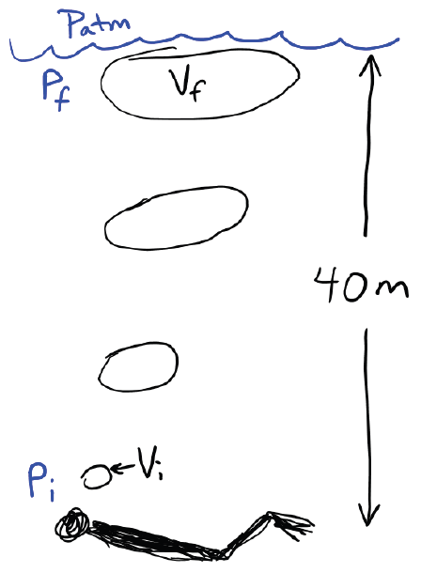
Figure 11.6: Sketch of the scuba diver blowing bubbles.¹

Numbers
There is a lot of information that we don’t know, for example the types of gas molecules and the number of each. But remembering that pressure and volume are inversely related, as long as the number and type of molecules and the average speed of the molecules all remain constant, we can use this simple relationship between pressure and volume:
$$P_{tot,1}⋅V_{1}=P_{tot,2}⋅V_{2}$$
This relationship is referred to as “Boyle’s Law.”
At the surface of the water, the depth is zero, so the final pressure is just that of the atmosphere, $1.01×{10}^{5} Pa$. At the depth of the diver, the seawater is pressing down on the exhaled air, so the initial pressure is given by…
$$\begin{aligned}P_{i}&=ρ_{m,seawater}⋅g⋅h_{i}+P_{atm} \\ &=\left(1 026 kg/m^{3}\right)⋅\left(9.8 N/kg\right)⋅\left(40 m\right)+P_{atm} \\ &=5.03×{10}^{5} Pa\end{aligned}$$
Now we can rearrange Boyle’s Law to find the final volume:
$\begin{aligned}V_{f}&=\frac{P_{i}⋅V_{i}}{P_{f}} \\ &=\frac{\left(5.03×{10}^{5} Pa\right)⋅\left(6 liters\right)}{1.01×{10}^{5} Pa} \\ &=30 liters\end{aligned}$.

: Gauge Pressure ()

Words
If you have used a bicycle or a car, you have likely put air in the tires. Before air is added to a new tire, it is already full of air at the same pressure as the surrounding atmosphere. But even though the tire contains $1.01×{10}^{5} Pa$ of pressure, if you put a tire pressure gauge on it the gauge will read “0.” That is because the gauge does not measure the total (or “absolute”) pressure in the tire–it measures the “gauge pressure,” the pressure difference between the inside and the outside.
Whether it is better to think in terms of gauge pressure or absolute pressure depends on the scenario. If our concern is that a balloon may pop if we try to put too much air into it, then the important factor is the difference between the pressure inside the balloon and the pressure outside of the balloon.
When thinking about the volume of the scuba diver’s bubbles, it was the absolute pressure that was important, because the volume of the bubble depended on the spacing of the air molecules themselves, not on how that spacing would compare to the spacing of the air molecules outside of the bubbles.
Absolute pressure is always positive, because every time a molecule inside a container bounces off one of the walls it creates an outward force on the wall. But gauge pressure is the difference between two pressures, so it could be positive, negative, or zero.

Graphics
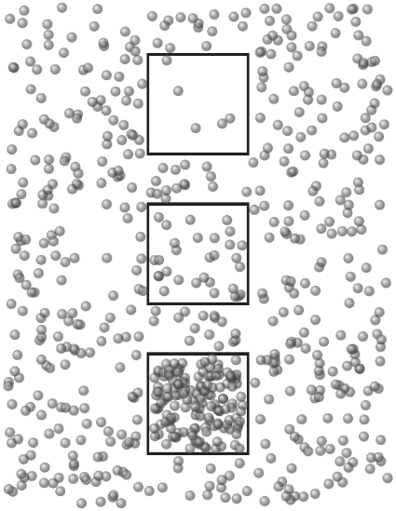
Figure 11.7: Three boxes containing a gas, surrounded by the same gas. The density of gas molecules in the center box is the same as the density of gas molecules outside of the boxes.¹
The total (or absolute) pressure is positive inside each box. But the gauge pressure is negative in the top box, zero in the center box, and positive in the bottom box.

Numbers
Assumptions: rectangular area; same pressure in each tire; same area for each tire; at sea level.
Knowns | Unknowns
$$m_{system}=198 kg$$ | $$P$$
$$A_{front}=A_{back}=0.002 m^{2}$$
$$g=9.8 N/kg$$
$$P_{atm}=1.01×{10}^{5} Pa$$
If we remember that pressure is force per area then mathematically it is relatively easy to find the pressure for one of the tires:
$$\begin{aligned}P&=\frac{F}{A} \\ &=\frac{\frac{1}{2}F_{g}}{A_{back}} \\ &=\frac{\frac{1}{2}m_{system}⋅g}{A_{back}} \\ &=\frac{\frac{1}{2}\left(198 kg\right)⋅\left(9.8 N/kg\right)}{0.002 m^{2}} \\ &=4.85×{10}^{5} Pa\end{aligned}$$
We can check to see if this is a reasonable answer by doing a quick internet search of bike tire pressure. The maximum pressure for a medium bike tire is 70 psi, or 70 pounds per square inch. That converts to $4.8×{10}^{5} Pa$, so these tires are right on the edge of being overinflated.

Words
Consider a bicycle in the picture at the beginning of this chapter, assuming the bicycle is moving at constant speed, carrying a person and three bags of charcoal. The bike’s mass is 8 kg, the person’s mass is 70 kg, and the mass of each bag is 40 kg. Assume the area of the ground touched by each tire is a rectangle, 2 cm by 10 cm. We can use this information to find the air pressure (assumed to be equal) in the tires. We also need to remember to state whether the pressure we have found is the gauge pressure or the absolute pressure.
Think of the bike, rider, and charcoal as a single system with all its weight pressing down on the road, and the road pushing back with the same amount of force. If we now think of just that part of the tires that is touching the road, the road pushes up on the tires and the air inside the tires pushes down. So, the pressure on this part of the tires must be equal to the weight of the bike. The higher the pressure in the tires, the smaller the area needing to touch the ground.
Should we be thinking about gauge pressure or absolute pressure? That depends on whether atmospheric pressure is pushing upward on the bottom of the tire while it is touching the road. Unless something has been done specifically to remove the air from under the tire, then there is still atmospheric pressure there, so it is the gauge pressure that we should be considering. To convince yourself of this, think about picking up a suction cup that is just sitting on a smooth surface, compared to picking up the same suction cup after air has been pressed out from underneath.

Graphics
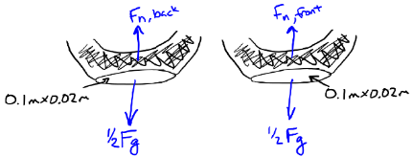
Figure 11.8: Sketch of the bottoms of the two bike tires, including the forces on each of them.¹
If we assume that each tire is supporting half the weight, then we can just think about the pressure and forces for one tire and then apply the same answer to both tires. In the text it said we are assuming that the area touching the ground is a rectangle, but it is shown in the sketch as more of an ellipse, which is probably more accurate.

Numbers
In our calculation we did not take into consideration the outside pressure of the atmosphere pushing up on the bottom of the tire, so our number is the gauge pressure of the tire. To find the total pressure in the tire we would have to add the external pressure to the gauge pressure:
$$\boxed{P_{tot}=P_{external}+P_{gauge}}$$
( 11.1 )
In this situation the external pressure is atmospheric pressure, so…
$$\begin{aligned}P_{tot}&=P_{atm}+P_{gauge} \\ &=1.01×{10}^{5} Pa+4.85×{10}^{5} Pa \\ &=5.86×{10}^{5} Pa\end{aligned}$$
.

: Temperature of Ideal Gases ( , )

Words
Gases are made up of huge numbers of particles that are bouncing around randomly in every direction. Their positions and velocities are constantly changing as they collide with each other and with the walls of the container. And yet one of the assumptions we have been using a lot is that the average speed of the gas particles doesn’t change. But how can we possibly know that is true, or have any control over it? The answer is simple: temperature.
The average velocity of the gas particles increases as the temperature increases. Since the velocity increases, the particles hit the sides of the container with higher force, increasing the pressure. If the walls of the container can move then the walls could be pushed out, increasing the volume. Or if there is a way for gas particles to enter and exit the container then particles will tend to leave the container, decreasing the number of particles in the container. So, with a gas there are multiple factors that all affect the way the gas behaves.
Let’s consider what happens when the temperature of the gas inside a 2 200-cubic-meter hot air balloon is heated to ${80}^{∘}$C and the outside air is ${15}^{∘}$C. The density of air at sea level when the temperature is ${15}^{∘}$C is approximately $1.23 kg/m^{3}$. The total mass of the balloon itself, including a basket holding two passengers but not including the air inside the balloon, is 400 kg.

Graphics
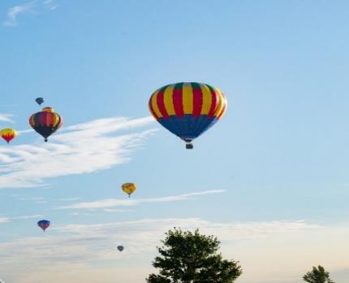
Figure 11.9: Hot air balloons are filled with air that is at a higher temperature than the surrounding air.
The higher speeds of the air molecules inside the balloon create higher pressure. Since the bottom of the balloon is open, the higher pressure inside tends to push air molecules out of the bottom of the balloon. This reduces the density of the air inside the balloon, creating an upward buoyant force on the balloon.

Numbers
Assumptions: ideal gas; volume of the basket is negligible; no air resistance; atmospheric pressure.
Knowns | Unknowns
$$V=2,200 m^{3}$$ | $$F_{net}$$
$$T_{outside}={15}^{∘}C$$
$$T_{inside}={80}^{∘}C$$
$$ρ_{outside}=1.23 kg/m^{3}$$
$$m_{balloon}=400 kg$$
The ideal gas law relates total pressure $P_{tot}$, volume $V$, number of molecules $N$, and temperature $T$ of an ideal gas:
$$\boxed{P_{tot}⋅V=N⋅k_{B}⋅T}$$
( 11.2 )
$k_{B}$ is the Boltzmann constant, $1.38×{10}^{-23} J/K$. Celsius [$​^{∘}$C] and kelvin [K] are both SI units for temperature, but only kelvin can be used with the ideal gas law. We can convert temperatures as follows:
$$\boxed{T_{K}-273K=T_{C}=\frac{5}{9}\left(T_{F}-{32}^{∘}F\right)}$$
( 11.3 )
…where $T_{K}$, $T_{C}$, and $T_{F}$ are temperature measured in kelvin, Celsius, and Fahrenheit, respectively. Note that the degree symbol is used only with Celsius and Fahrenheit, not with kelvin.

Words
Since the hot air balloon is open at the bottom, gas particles can flow in and out. That keeps the pressure inside the balloon the same as the pressure outside. The balloon also stays the same volume as the air inside gets warmer or cooler. So, when we increase the temperature of the air inside some of the air will flow out of the balloon, decreasing the number of air molecules inside. That means the air inside the balloon is less dense than the air outside of the balloon.
Remember that gases are fluids, so the buoyant force that we learned about when studying liquids is also relevant here. The less-dense balloon is completely submerged in the more-dense air outside of the balloon, so that creates a buoyant force that pushes the balloon upward.

Graphics
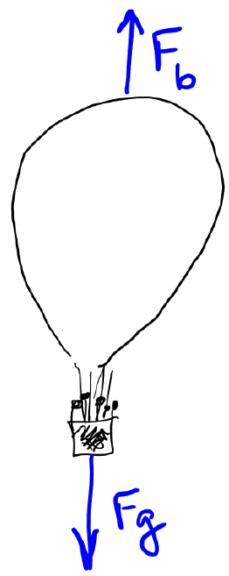
Figure 11.10: Forces on the hot air balloon, assuming negligible air resistance.¹

Numbers
First, we should convert temperatures to kelvin: $T_{outside}=288K$; $T_{inside}=353K$
There are two forces we need to find: gravitational and buoyant. Buoyant force is present in any fluid, not just liquids, and we can think of the balloon as being completely submerged in the air. Using Archimedes’ principle…
$$\begin{aligned}F_{b}&=ρ_{m,fluid}⋅g⋅V_{submerged} \\ &=\left(1.23 kg/m^{3}\right)⋅\left(9.8 N/kg\right)⋅\left(2,200 m^{3}\right) \\ &=26 500 N\end{aligned}$$
To find the gravitational force, we need to know the mass of the balloon. We are given the mass of everything except the air, so we just need to find the mass of the hot air inside the balloon. Looking at the ideal gas law, we can see that if the pressure and the volume are constant, as they are in this case when the container is open at one end, then the number of molecules of the ideal gas is inversely proportional to the temperature. And since all the molecules of an ideal gas are identical, that means the mass is also inversely proportional to the temperature. So, the gravitational force on the ${80}^{∘}$C air inside the balloon is…
$$F_{g,air}=m_{{80}^{∘}C}⋅g=m_{{15}^{∘}C}⋅\frac{T_{inside}}{T_{outside}}⋅g$$
…where $m_{{15}^{∘}C}$ is the mass of the air inside the balloon if it were at ${15}^{∘}$C. We can find that mass from the volume of the balloon and the density of the outside air.
$$F_{g,air}=ρ_{outside}⋅V⋅\frac{T_{inside}}{T_{outside}}⋅g=21 600 N$$

: Sound Waves ( , )

Words
We saw that transverse and longitudinal waves can travel through solids; and a combined transverse/longitudinal wave, a “water wave,” can travel through liquids. Transverse waves require an attractive force between neighboring particles, so transverse waves cannot travel through ideal gases. Longitudinal waves, however, can travel through gases; they are commonly called sound waves.
Compression and rarefaction are created in gas molecules that bounce off an oscillating surface. These areas of compression and rarefaction form pressure waves that move away from the surface at the speed of sound. The speed of sound in dry air at atmospheric pressure is approximately 330 m/s.
As with other types of waves, sound waves can constructively and destructively interfere with each other. And as in the case of longitudinal waves on a string, constructive and destructive interference can create standing waves with nodes and antinodes. Nodes on a string are positions where total destructive interference occurs in the transverse motion of the string, resulting in no movement of the string. Nodes in a sound wave are different. They are positions where total destructive interference of the pressure waves occurs, resulting in no change in pressure. Similarly, antinodes of sound waves are positions where the largest pressure changes are happening, not positions where the most movement is happening.

Graphics
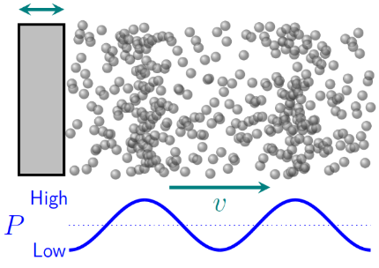
Figure 11.11: Longitudinal waves created in a gas by an object that is oscillating right and left. The waves are regions of higher and lower pressure that move away from the object.¹
Sound waves are often shown graphically simply as lines that represent areas of high pressure.
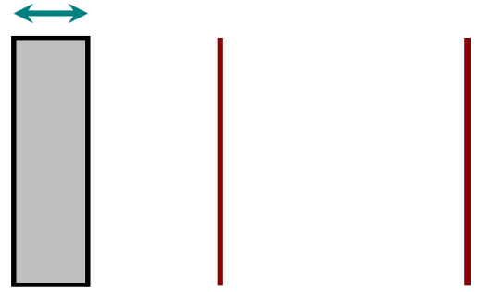
Figure 11.12: A simpler way to sketch the same scenario as in the figure above.¹

Numbers
(This column intentionally left blank)

Words
Wind instruments control the wavelengths of the sound created by changing the length of a hollow tube or by opening and closing holes in the tube. If a sound wave is created inside a tube that is closed at one end, the open end, where the pressure remains the same as the pressure outside the tube, is a node; the closed end is an antinode. Interestingly, the tube can be curved around into different shapes because pressure waves travel easily around the curves.
Higher notes can be made by decreasing the length of the tube (and thus decreasing the length of the wavelength of the first harmonic) as is done with a trombone. Different notes can also be created by using tubes of different lengths, as with a pipe organ or pan flute.
Some instruments, like a clarinet, have holes along the length of the tube that can be opened or closed. Any open hole creates a node at that position.
The first two harmonics of one tube of a pan flute are shown in Figure 11.14. We can use what we learned in Chapter 9 to find the length that a tube of a pan flute should be to produce a “middle C,” a note that is near the middle of a piano keyboard, which has a frequency of 262 Hz. We should also be able to find out what the next harmonic would be for that tube. Interestingly, only odd harmonics can be created in a tube that is open at only one end, so the next harmonic is actually the third harmonic, not the second. A second harmonic would require either nodes at each end or antinodes at each end.

Graphics

Figure 11.13: Different lengths of tubes of a pan flute produce different notes.
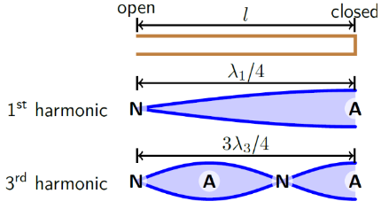
Figure 11.14: The first two harmonics in a tube that is closed at one end. “N” indicates a node and “A” indicates an antinode. Notice that there is no “second harmonic.” Only odd harmonics can be created when there is a node at one end and an antinode at the other. ¹

Numbers
Assumptions: dry air at atmospheric pressure.
Knowns | Unknowns
$$v=330 m/s$$ | $$l$$
$$f_{1}=262 Hz$$ | $$f_{3}$$
We can use the relationship between wavelength, speed, and frequency to find the wavelength of middle C in air:
$$\begin{aligned}λ_{1}&=\frac{v}{f_{1}} \\ &=\frac{330 m/s}{262 Hz} \\ &=1.26 m\end{aligned}$$
Looking at Figure 11.14 we can see that this wavelength is four times the length of the tube:
$$l=\frac{λ_{1}}{4}=\frac{1.26 m}{4}=0.315 m$$
Figure 11.14 also helps us to find the wavelength of the next harmonic for this tube:
$$\frac{3λ_{3}}{4}=l \\ λ_{3}=\frac{4l}{3}=0.42 m$$
The wavelengths and frequencies of the harmonics of a standing wave with a node at one end and an antinode at the other, as in this pan flute, follow the same relationship as standing waves on a string that has a node at both ends. Using Equation ( 9.6 )…
$$f_{3}=3⋅f_{1}=786 Hz$$

: Sound Level ()

Words
When sound waves aren’t confined to small volumes of gas, they tend to spread out in spherical shells, in much the same way that ripples move outward in circles when still water is disturbed. The energy in each pressure wave spreads out over increasing area as the sphere moves outward, so the intensity of the sound drops with distance. That is why something sounds louder when it is closer. The intensity of sound waves can also drop, or “attenuate,” as sound travels through a material, primarily because of intermolecular forces acting against the vibration in the material.
The waves in Figure 11.15 are constantly moving outward; wherever a person is standing relative to the drum set, the waves travel past them at the same speed and the same frequency.
We perceive sounds in terms of pitch and loudness. We have seen already that pitch is related to the frequency of the sound wave. Loudness is related to the amplitude of the sound wave. From a physical perspective, what we call “volume” or “loudness” is measured in terms of a variation of pressure compared to the average pressure in the air. This is called the “sound pressure level” $L_{p}$, and it is usually measured in decibels (dB). Zero dB is typically near the minimum threshold of human hearing, but that is a rough measurement, because the threshold of human hearing varies across different people and different pitches, and changes as we age.

Graphics
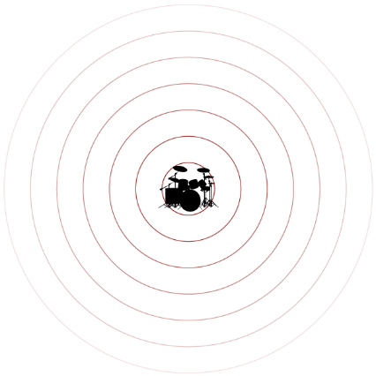
Figure 11.15: Sound waves move outward from the source in spherical shells, getting weaker as their energy spreads out.

Numbers
Sound pressure level $L_{p}$ is related to the pressure differences created by sound waves:
$$\boxed{L_{p}=20 \log_{10}\left(\frac{P_{s}}{P_{0}}\right) dB}$$
( 11.4 )
…where the sound pressure $P_{s}$ is a measure of the variation in pressure caused by sound in a medium, and $P_{0}$ is a reference sound pressure.
Compared to the sound pressure $P_{s,1}$ at a distance $r_{1}$ from the source, the sound pressure at a distance $r_{2}$ from the source is given by:
$$\boxed{P_{s,2}=\frac{r_{1}}{r_{2}}⋅P_{s,1}}$$
( 11.5 )
…if the sound is traveling through open air.

Words
A logarithmic scale is used for sound because many human senses, including hearing, do not respond to stimuli in a linear fashion. For example, while it may be possible for a person to hear a whisper in a quiet room, it would not be possible for the same person to hear the same whisper while standing next to a roaring jet engine. Our ability to hear is dependent not just on the sound pressure created by something, but on the size of that sound pressure compared to the sound pressures created by other simultaneous sounds.
For sounds traveling in open air, the sound pressure decreases with the distance from the source. A good “rule of thumb” is that the sound pressure level decreases by 6 dB with every doubling of distance from the source of the sound.
The $L_{p}$ of a whisper is approximately 25 dB; the $L_{p}$ of a typical car is approximately 60 dB when measured from a distance of 1 m. Let’s find the distance we would need to be away from a car for it to be at the same loudness as a whisper.
There is a difference of 35 dB between the whisper and the car. That is almost 6 times 6 dB, so the distance should have to double about 6 times. That means the distance from the car would have to go from 1 m to about 2⁶ m, or 64 meters. The calculation in the “Numbers” column shows that the actual value is 56 m, so this is a reasonable approximation.

Graphics
(This column intentionally left blank)

Numbers
Assumptions: open air.
Knowns | Unknowns
$$L_{p,1}=60 dB$$ | $$r_{2}$$
$$r_{1}=1 m$$
$$L_{p,2}=25 dB$$

$$\begin{aligned}ΔL_{p}&=L_{p,2}-L_{p,1} \\ &=25 dB-60 dB=-35 dB\end{aligned}$$

$$\begin{aligned}ΔL_{p}&=\left(20 \log_{10}\left(\frac{P_{s,2}}{P_{0}}\right)-20 \log_{10}\left(\frac{P_{s,1}}{P_{0}}\right)\right) dB \\ -35&=20\left(\log_{10}\left(\frac{P_{s,2}}{P_{0}}\right)-\log_{10}\left(\frac{P_{s,1}}{P_{0}}\right)\right) \\ \frac{-35}{20}&=\log_{10}\left(\frac{P_{s,2}}{P_{0}}⋅\frac{P_{0}}{P_{s,1}}\right)=\log_{10}\left(\frac{P_{s,2}}{P_{s,1}}\right) \\ -1.75&=\log_{10}\left(\frac{r_{1}}{r_{2}}\right) \\ {10}^{-1.75}&=\frac{r_{1}}{r_{2}} \\ r_{2}&=r_{1}⋅{10}^{1.75}=\left(1 m\right)⋅56=56 m\end{aligned}$$
So, it should still be possible to hear a whisper when a car is 56 m away.

: Doppler Effect and Echoes ( , )

Words
In the discussion about Figure 11.15, it was stated that wherever a person is standing relative to the drum set, the waves will reach their ears at the same frequency. And that is true if the person is not moving relative to the drum set. But what if the source of the sound was moving at a high speed relative to the observer? This could mean that the source is moving, the observer is moving, or both are moving.
Let’s consider what a person hears when a train passes by at 25 m/s with its whistle making a single, 400 Hz sound wave.
If you are standing by a train track the pitch of a train whistle drops as the engine goes past. The reason for this is illustrated in Figure 11.16. The large outer circle is from when the train was in the center of the image and is centered on the position of the train at that time. The next circle as we move inward came from the time when the train was slightly to the left of center. And so forth until the smallest, darkest circle, which came from the train when it was farthest to the left.
Notice what happens to the spacing between the high-pressure parts of the waves. They are closer together in front of the train and farther apart behind the train. The speed of sound is the same everywhere, so that means the frequency (and therefore the pitch that we can hear) in front of the train is higher than it is behind the train. This is called the “Doppler Effect.”

Graphics
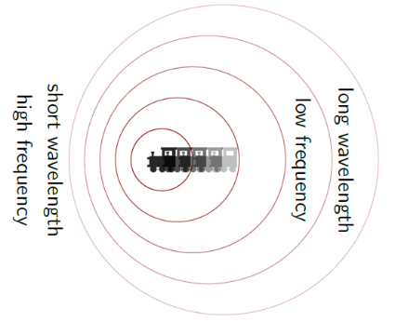
Figure 11.16: Sound waves move outward from the source in spherical shells, but if the source is moving then the center of the shells moves along with the object producing the sound. This creates shorter wavelengths in front of the moving objects and longer wavelengths behind the moving object.

Numbers
Assumptions: dry air at atmospheric pressure.
Knowns | Unknowns
$$v_{sound}=330 m/s$$ | $$f_{initial}$$
$$v_{train}=25 m/s$$ | $$f_{final}$$
$$v_{person}=0$$
$$f_{emitted}=400 Hz$$
The relationship between the observed frequency of sound and the actual emitted frequency of sound is given by:
$$\boxed{f_{observed}=\left(\frac{v_{sound}±v_{observer}}{v_{sound}∓v_{source}}\right)⋅f_{emitted}}$$
( 11.6 )
…if neither the source nor the observer is moving faster than the speed of sound through the medium. A plus sign is used in the numerator if the observer is moving toward the source and a minus sign is used if the observer is moving away from the source. A minus sign is used in the denominator if the source is moving toward the observer and a plus sign is used if the source is moving away from the observer.

Words
Something even more interesting happens when the object is moving faster than the speed of sound, as illustrated in Figure 11.17. The sound waves are completely behind the airplane shown in that figure, so if you are in front of the airplane you will not be able to hear it coming at all. Even if you are directly above or below the airplane you will not be able to hear it until after it has passed you. And when the sound finally does come, the sound waves at the leading edge all interfere with each other constructively, producing a powerful pressure wave sometimes called a shock wave, which creates a “sonic boom.”
An object that is not otherwise producing sound can reflect sound waves; this is what causes an echo. Ultrasound, which is simply sound waves that are too high in pitch for humans to hear, uses echoes to map different types of tissue within a living body. If the object is moving relative to the source of the sound, the Doppler Effect shifts the frequency of the echo. A “Doppler ultrasound” test measures not only the amplitude of the echo but also its frequency, so it can create an image that shows relative velocity in addition to just position. This makes it possible, for example, to observe internal blood flow in a non-invasive way.

Graphics
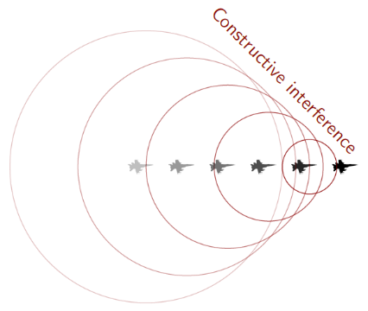
Figure 11.17: An object that is moving faster than sound produces a shock wave of pressure that creates a “sonic boom.”
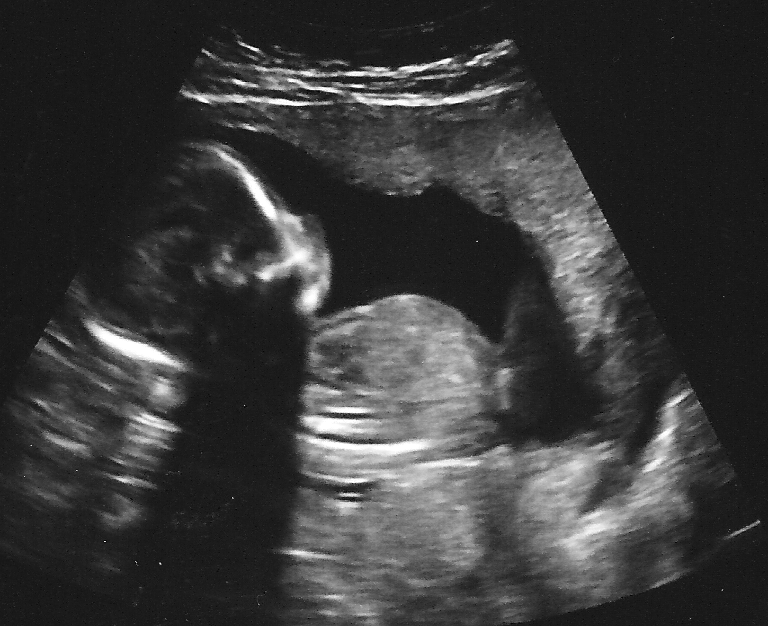
Figure 11.18: The black area near the center of this ultrasound image shows that no sound was reflected by the amniotic fluid. The black area near the bottom left is a “shadow” created by the head of the unborn child.

Numbers
In this case,
$$\begin{aligned}f_{initial}&=\left(\frac{v_{sound}+v_{observer}}{v_{sound}-v_{source}}\right)⋅f_{emitted} \\ &=\left(\frac{v_{sound}+v_{person}}{v_{sound}-v_{train}}\right)⋅f_{emitted} \\ &=\left(\frac{330 m/s+0}{330 m/s-25 m/s}\right)⋅400 Hz \\ &=433 Hz\end{aligned}$$
$$\begin{aligned}f_{final}&=\left(\frac{v_{sound}-v_{observer}}{v_{sound}+v_{source}}\right)⋅f_{emitted} \\ &=\left(\frac{v_{sound}-v_{person}}{v_{sound}+v_{train}}\right)⋅f_{emitted} \\ &=\left(\frac{330 m/s-0}{330 m/s+25 m/s}\right)⋅400 Hz \\ &=372 Hz\end{aligned}$$
The emitted pitch is close to the G above middle C on a piano; the pitch heard as the train is approaching is close to the A above middle C (often called “A440”); the pitch heard after the train passes is close to the F# above middle C. So, the pitch drops by approximately three half-notes as the train passes.

: Non-Ideal Gases ()

Words
This chapter began with a definition of an ideal gas:
- molecules of the gas interact with each other only through perfectly elastic collisions
- size of the molecules of an ideal gas is negligible compared to both the size of the container and the average distance between gas molecules
- all the gas molecules are identical
This model of an ideal gas works well in a great many situations, but in some situations, it is necessary to consider the deviation of a real gas from the model of an ideal gas. We will consider the effects of violating each of the parts listed above for the definition of an ideal gas.
First, gases don’t interact only through perfectly elastic collisions. If gases are highly reactive then they will react chemically with other molecules. But even gases that are completely non-reactive still experience attractive “Van der Waals” forces when the gas particles are close enough to each other. These small attractive forces create a slight decrease in the pressure of the gas compared to what would be expected for an ideal gas. When the gas particles get even closer together, they begin to experience repulsive forces.

Graphics
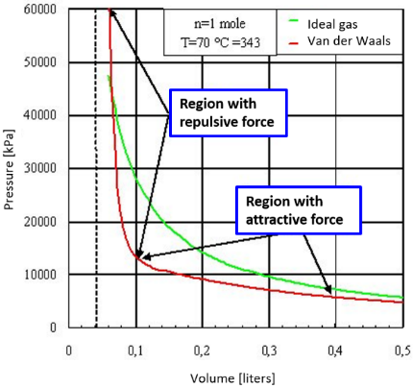
Figure 11.19: This P-V plot shows a sample “isotherm” (curve for a constant temperature) for a non-ideal gas compared to an ideal gas.

Numbers
For non-ideal gases, where the interactions between particles and the total volume of the particles themselves cannot be ignored, the ideal gas law cannot be used. It is instead modified with the introduction of two additional parameters $a$ and $b$. These parameters are experimentally determined for particular gases. The modified ideal gas law is called “Van der Waals’ equation:”
$$\boxed{\left(P+a⋅\frac{n^{2}}{V^{2}}\right)⋅\left(V-n⋅b\right)=n⋅R⋅T}$$
( 11.7 )
The parameter $a$ is related to the interactions between molecules of the gas. The parameter $b$ is the volume occupied by one mole of the gas molecules. Note that when $a$ and $b$ are both zero, the Van der Waals’ equation reduces to a version of the ideal gas law that is written in terms of moles instead of molecules.
All the variables in the ideal gas law–pressure, volume, number of moles, and temperature–are referred to as “state functions,” because they describe the state of the gas at a particular point in time, without giving any information about how the gas came to be in its current state.

Words
Second, ideal gases assume that the size of the gas molecules themselves is negligible compared to the volume of the container. But when the number of molecules is increased or the volume is decreased enough, the volume of the particles themselves can no longer be neglected. As a result, the effective volume of the container is reduced by the volume of the gas molecules. This reduction in the effective volume causes the pressure to be larger than would be expected for an ideal gas.
And finally, it is much more common to find a mixture of different gases rather than a gas that is made up of only one type of molecule. Our atmosphere is an example of this, made up of almost 80% nitrogen and 21% oxygen, with many other gases mixed in. For a gas like this that is made up of many different molecules, the total pressure of the gas is made up of the sum of all the partial pressures of each gas. This is called “Dalton’s Law.”

Graphics
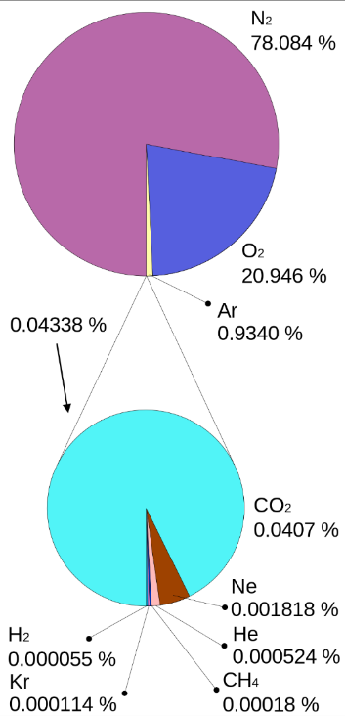
Figure 11.20: These pie charts show the distribution of gases in the earth’s atmosphere.

Numbers
Dalton’s Law states that the total pressure of a gas that is made up of a mixture of multiple molecules is the sum of the partial pressures of each constituent gas:
$$\boxed{P_{tot}=P_{1}+P_{2}+⋯}$$
( 11.8 )

: Summary
Chapter summaries in this book are ordered by concept, not necessarily in the order in which they are presented in the chapter. Mathematical models are grouped together at the end of each summary. See the appendices for the meanings of all symbols used in this book.

General
- Molecules of a gas tend to bounce around freely, interacting with each other only through collisions.
- The size of the molecules of an ideal gas is negligible compared to both the size of the container and the average distance between gas molecules.
- All the molecules of an ideal gas are identical.
- Transverse waves cannot travel through gases.

Forces
- Gauge pressure is the difference between total pressure and external pressure, e.g. atmospheric pressure.
- Nodes in a sound wave are positions where the pressure is constant.
- Antinodes in a sound wave are positions where the largest pressure changes are happening.

Motion
• The frequency of a sound wave changes depending on the motion of the object creating the sound and the observer.

Energy
- Molecules of an ideal gas interact with each other only through perfectly elastic collisions.
- When sound waves aren’t confined, their energy spreads out in spherical shells, and the amplitude of the sound decreases with distance.

Mathematical Models
Equation | Reference | Restrictions on the validity of the equation
$$P_{tot}=P_{external}+P_{gauge}$$ | ( 11.1 ) | -none-
“Ideal gas law”  $$P_{tot}⋅V=N⋅k_{B}⋅T$$ | ( 11.2 ) | ideal gas; temperature must be in kelvin
“Doppler effect”  $$f_{observed}=\left(\frac{v_{sound}±v_{observer}}{v_{sound}∓v_{source}}\right)⋅f_{emitted}$$ | ( 11.6 ) | source & observer speeds are slower  than the speed of sound

: Questions
Questions are ordered according to Bloom’s Taxonomy, progressing from regurgitating information (Level 1) to synthesizing new information with previous knowledge to create something new (Level 6). The bold letters at the beginning of each question indicate whether the question involves Words [W], Graphics [G], and/or Numbers [N]. See the appendices for conversion factors.

Level 1 - Remember
      - [W, G, & N] Which of the following can be negative?
        - absolute pressure
        - atmospheric pressure
        - gauge pressure
        - total pressure
      - [W & N] Add labels to each boxed equation from this chapter that tell what the symbol to the left of the = sign represents
Symbol | Reference | Label
$$P_{tot}$$ | ( 11.1 )
$$P_{tot}$$ | ( 11.2 )
$$T_{K}-273K$$ | ( 11.3 )
$$L_{p}$$ | ( 11.4 )
$$P_{s,2}$$ | ( 11.5 )
$$f_{observed}$$ | ( 11.6 )
$$\left(P+a⋅\frac{n^{2}}{V^{2}}\right)⋅\left(V-n⋅b\right)$$ | ( 11.7 ) | Effective pressure times effective volume
$$P_{tot}$$ | ( 11.8 )

Level 2 - Understand
      - [W & G] Figure 11.6 shows bubbles getting larger as they rise to the surface. Is the way that they are drawn reasonable? Is there anything about that sketch that is not reasonable?
      - [N] An internet search was used in Section 11.3 to find bike tire pressure. Are tire pressures reported on the internet gauge pressures or total pressures? Explain your reasoning.
      - [W & G] The image below shows an unusual kind of pressure gauge. Does it measure total pressure or gauge pressure? How can you tell? What do the numbers to the left of the zero represent?
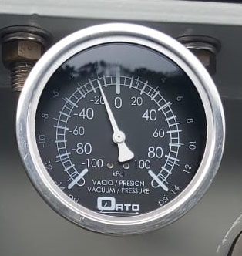
An unusual pressure gauge.
      - [G] Figure 11.14 shows harmonics for a pipe of a pan flute that is open at one end. If the pipes were open at both ends, would the ends of the pipes have pressure nodes or antinodes?

Level 3 - Apply
      - [N] The calculations for net force were not completed in Section 11.4. What is the net force on the balloon, including direction? Don’t forget about the mass of the balloon itself.
      - [N] Practice converting temperatures between the various scales mentioned in Section 11.4:
        - What is 0K in degrees Celsius?
        - What is $0^{∘}$C in degrees Fahrenheit?
        - What is $0^{∘}$F in degrees Celsius?
        - Is there any temperature where the temperature measured in degrees Celsius has the same numerical value as the temperature measured degrees Fahrenheit? If so, find that temperature. If not, explain why not.
        - Is there any temperature where the temperature measured in degrees Celsius has the same numerical value as the temperature measured in kelvin? If so, find it. If not, explain why not.
      - [G] Figure 11.14 shows the first two harmonics for a pipe of a pan flute that is open at one end (the first & third harmonics). Draw the next allowed harmonic for this pipe.
      - [G] Figure 11.14 shows the first two harmonics for a pipe of a pan flute that is open at one end. Draw the first harmonic for a pipe that is open at both ends.
      - [G] Figure 11.14 shows the first two harmonics for a pipe of a pan flute that is open at one end. Draw the first harmonic for a pipe that is closed at both ends.
      - [N] Sounds louder than 70 dB can start to damage hearing. A jackhammer creates a sound pressure level of approximately 100 dB at a distance of 1 m. At what distance is it safe to be exposed to the sound of a jackhammer without hearing protection?

Level 4 - Analyze
      - [W & N] The average speed of the helium atoms in Section 11.1 is given as 1 350 m/s. What is the average velocity of the helium atoms in the box if it is measured over a long period of time? Explain your answer.
      - [N] How would the final volume change in Section 11.2 if the diver were in fresh water instead of seawater?
      - [W, G, & N] Use an internet search to find the mass of an automobile and its recommended tire pressure and use this information to find the area of each tire that is touching the ground, assuming the mass is distributed equally between the tires. Is your result reasonable? Explain.
      - [W] Some hospital rooms are kept at “positive pressure” for patients who are particularly susceptible to airborne illnesses Does this refer to gauge pressure or total pressure? In what direction would air flow around the edges of the door of a room that is kept at positive pressure? Explain why this would be advantageous.
      - [W] Some hospital rooms are kept at “negative pressure” for patients who have illnesses that are easily spread through the air. Does this refer to gauge pressure or total pressure? In what direction would air flow around the edges of the door of a room that is kept at negative pressure? Explain why this would be advantageous.
      - [W, G, & N] A simple mercury barometer can be used to measure atmospheric pressure. It is composed of something like a long test tube, closed at the top end and open at the bottom. The tube is partially filled with liquid mercury, and the open end of the tube is submerged in a pool of mercury. In the space above the mercury in the tube is a near-total vacuum. Because of this, there is zero air pressure pushing down on the top of the mercury in the tube. Look up the density of mercury and use that to find the height $h$ of the column of mercury if there is one atmosphere of pressure pushing down on the pool of mercury.
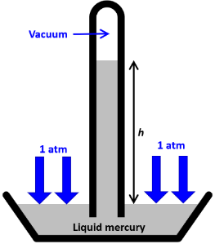
A simple mercury barometer.¹
      - [W, G, & N] One of the assumptions made in Section 11.3 is that the area touching the ground is a rectangle. In fact, the area is probably more like an ellipse. Look up the formula for the area of an ellipse. Compare the areas of a rectangle and an ellipse with the same dimensions as the rectangle. What is the percentage difference between the two?
      - [W & G] Section 11.7 doesn’t describe what happens when the observer is moving relative to the object that is creating the sound. Describe, using Figure 11.16, how the sound of the drums would change if a person were moving quickly toward the drums or quickly away from the drums. Remember that the waves drawn in the figure are not stationary but are moving outward.
      - [N] In Section 11.7 a situation was analyzed where a train was moving past a stationary person. Re-analyze that situation with the train still blowing its 400 Hz whistle, but this time with the train motionless and the person passing the train at a speed of 25 m/s.

Level 5 - Evaluate
      - [W, G, & N] A 100-ml syringe is half-filled with water and half-filled with air at atmospheric pressure. If the plunger is pushed in, increasing the pressure inside the syringe to four times atmospheric pressure…
        - …what is the new volume of the water?
        - …what is the new volume of the air in the syringe?
        - …what assumptions are you making in answering this question?
      - [W & N] Are the assumptions made in Section 11.4 reasonable? Are there any other assumptions that are made but that aren’t listed? Explain your answers.
      - [N] A statement is made in Section 11.4 that it is important to use kelvin to measure temperature when dealing with ideal gases. Explain why that is true. Hint: Look at the ideal gas law and think about what happens to the pressure or the volume when the temperature goes to zero and compare with your personal experience at those temperatures.
      - [W & G] The caption for Figure 11.7 makes statements about the density of the gas molecules in the figure, and the text below the figure depends on those statements. Are there other assumptions that are needed for the text below the figure to correctly compare the gauge pressures in the figure? If so, what are they?
      - [W, G, & N] One of the assumptions made in Section 11.3, the one about the area of each tire that is touching the ground, is probably not a very good one. If the assumption about the air pressure being the same in each tire was correct, and that pressure was $4.85×{10}^{5} Pa$, what would the area be for each tire if the charcoal is positioned directly over the back tire and the person’s center of mass is centered horizontally halfway between the two tires?
      - [N] What temperature would the air in the hot air balloon have to be in Section 11.4 so that the balloon would just hover in the air without going up or down?
      - [N] Boyle’s Law is just an application of the ideal gas law in a situation where the temperature and number of particles is constant. Create a similar mathematical model that is an application of the ideal gas law in a situation where the number of particles is constant, but the temperature is not.
      - [W, G, & N] The calculations in Section 11.5 show that the length of a single pipe of a pan flute should be 0.315 meters long to produce a note near the center of a piano. Looking at Figure 11.13, does it appear that any of the pipes may be close to this length? Are most of the pipes longer or shorter than 0.315 meters? What does that tell you about their frequency or pitch compared to the center keys of a piano?
      - [W & N] Compare the speed of sound in air to the average speed of a gas particle in air. Are they roughly the same size (which in physics often means within a factor of 10 of each other)? Which is larger? Does this make sense to you? Explain why or why not.
      - [W & N] The equation for the Doppler effect says that it is only valid when the observer and source are both moving at speeds lower than the speed of sound. Try to use the equation with one or both moving at the speed of sound, toward and away from each other. What happens? In some situations, you should get a reasonable answer. In others you will not. Explain what is happening physically in the situations when the mathematical answer is not reasonable.

Level 6 - Create
      - [W, G, & N] At the beginning of Chapter 1 in Figure 1.1 was a template for a concept map. Begin a new concept map just for gases. Remember that many ideas about fluids were introduced in the chapter on liquids, so many ideas from that chapter can be used in this concept map for gases.
      - [W, G, & N] Imagine you are writing a test question related to this chapter. Think of your own example of a situation that you can analyze using the concepts, graphics, and mathematical analyses described in this chapter. Describe the situation and use the tools from this chapter to analyze the situation as completely as you can, including motion, forces, energy, and momentum.
      - [W, G, & N] Think about possible misconceptions about the material in this chapter. Write a question and an incorrect solution to it that demonstrates a student making such a conceptual error. This cannot be a simple misuse of a vocabulary word, a unit error, or a mathematical error like making an addition error or multiplying when addition was needed, unless the error is rooted in a real misunderstanding about the physics behind the calculation or the misuse of a word. After you have written the question and incorrect solution, explain what is wrong with the student’s solution, and write a correct solution to the problem. Note: You may use a question from this chapter that you got wrong the first time and explain the initial error in your thinking and how you corrected it.

– Temperature and Heat
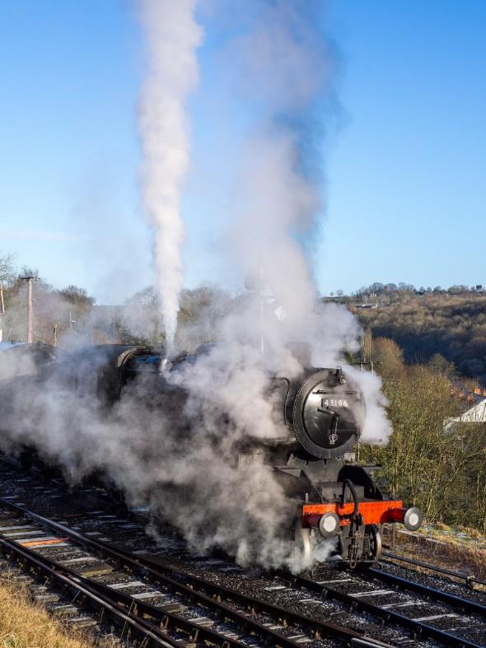
Figure 12.1: A steam engine converts heat into work.

The word “heat” hasn’t been used before in this book, but you know it by a different name: thermal energy. So, we have already looked at both temperature and heat, and now we will study them more closely and see how they interact with each other. In everyday English, “heating something up” means the same as increasing the temperature of the thing. And it is true that adding heat to an object often increases its temperature, but that is not always the case. There are some situations where temperature can change without adding heat, for example if a gas is rapidly compressed. There are other situations where heat can be added to an object without changing its temperature, for example when ice melts in a glass of water.
Temperature affects the volume of solids and liquids. And we have also seen that temperature can affect the volume of a gas, but gas is more complicated since it is compressible. The interplay of volume, pressure, temperature, and heat in gases has spawned an entire field of physics, called “thermodynamics.” Up until this point we have always considered heat (which, remember, is just another name for thermal energy) to be lost. But thermodynamics shows us that this lost thermal energy can be used, for example in a steam engine, to do work. Thermodynamics also shows that there are ways to use energy to reduce the temperature of objects, for example in a refrigerator.

: Heating a Solid ( , )

Words
In most cases we can think of thermal energy as the kinetic energy of atoms moving around randomly on a microscopic level. This kinetic energy isn’t making the object move, because the random motion means that the total momentum of the object is zero. But adding heat to one part of a solid object increases the motion of the molecules in that part. The molecules in a solid are tightly bound to each other, so they stay in the same position within the solid, but they oscillate back and forth, pushing and pulling on the molecules next to them. This oscillation affects nearby molecules, making them oscillate–in this way, the thermal energy spreads through the solid. This method of heat transfer through a solid is called “conduction.” Some solids conduct heat better than others–metals are known for being good conductors of heat, and glass is known for being a poor conductor of heat. That is why cooking pots are usually made of metal and insulation is often made of glass fiber.
These individual microscopic oscillations of the molecules can be observed as a change in the temperature of the object: adding thermal energy increases the temperature. The amount of the temperature change depends on the mass and on the material itself. In addition, the total size of the object changes with temperature. Most materials expand slightly as their temperature increases.

Graphics
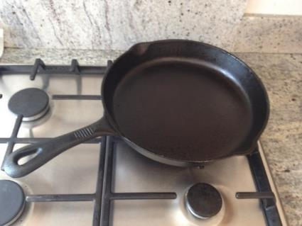
Figure 12.2: A cast iron skillet on a stove.
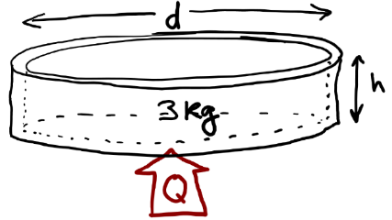
Figure 12.3: Sketch of the skillet showing heat coming in the bottom.¹

Numbers
Assumptions: physical “constants” are valid over the whole temperature range; iron remains solid over the whole temperature range; final temperature is the same throughout the iron skillet; skillet shape remains the same.
Knowns | Unknowns
$$m_{i}=3 kg$$ | $$m_{f}$$
$$T_{i}={20}^{∘}C$$ | $$d_{f}$$
$$T_{f}={90}^{∘}C$$ | $$h_{f}$$
$$d_{i}=0.25 m$$ | $$V_{f}$$
$$h_{i}=0.04 m$$ | $$Q$$
$$α_{iron}=1.0×{10}^{-5} ​^{∘}C^{-1}$$
$$c_{iron}=450 J/\left(kg⋅ ^{∘}C\right)$$
The coefficient of linear thermal expansion $α_{iron}$ and the specific heat capacity $c_{iron}$ were found using an internet search. The specific heat capacity describes the relationship between temperature change $ΔT$ and heat $Q$ (heat is equivalent to $ΔE_{th}$) added to a material with mass $m$:
$$\boxed{Q=m⋅c⋅ΔT}$$
( 12.1 )
We can use this to determine the heat (thermal energy) needed to increase the temperature of the skillet.
$$\begin{aligned}Q&=\left(3 kg\right)⋅\left(450 \frac{J}{kg⋅^{∘}C}\right)⋅\left({90}^{∘}C-{20}^{∘}C\right) \\ &=94 500 J\end{aligned}$$

Words
We will consider what happens to an empty cast iron skillet that is placed on a hot stove. The skillet is initially at 20°C, with a mass of 3 kg, an inside diameter of 25 cm, and an inside depth of 4 cm. For simplicity, we will ignore the handle of the skillet and approximate its shape as a hollow cylinder that is closed on one end. If the skillet is heated to a temperature of 90°C, what is its new mass, diameter, height, and volume? How much heat is needed to reach this temperature?
To answer these questions, we need to know some of the properties of iron. One is the coefficient of linear thermal expansion α, which describes the change in the linear dimensions of an object as the temperature changes. These coefficients can be found online or in reference books, but they are only approximations that are valid over a certain temperature range. We will assume that the values are valid for all temperatures unless the reference source includes the temperature range. The skillet gets slightly larger as the temperature increases. But from your own experience you probably know the change in the size of the skillet is extremely small compared to the size of the skillet itself. And the mass should not change at all, because no iron is being added or removed.
Thermal expansion is not much of an issue for an iron skillet, but if you consider miles of iron railroad tracks, the change in length can be significant enough to warp the tracks and derail a train. Large structures often include expansion joints to protect from damage caused by temperature changes.

Graphics
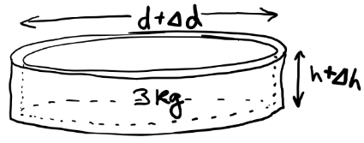
Figure 12.4: Sketch of the skillet after it has increased in size.¹
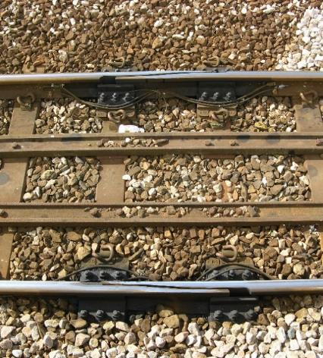
Figure 12.5: This expansion joint allows the length of the rails on either side to expand or contract by several centimeters without losing alignment with each other.

Numbers
The change in any linear dimension of a solid can be found using the coefficient of linear thermal expansion:
$$\boxed{Δl=l⋅α⋅ΔT}$$
( 12.2 )
…where $l$ is any linear dimension, e.g. height, width, radius, or diameter. We can use this to determine the height and diameter of the skillet at ${90}^{∘}$C.
$$\begin{aligned}Δh&=h_{i}⋅α⋅ΔT \\ &=\left(0.04 m\right)⋅\left(1.0×{10}^{-5} ​^{∘}C^{-1}\right)⋅\left({90}^{∘}C-{20}^{∘}C\right) \\ &=2.8×{10}^{-5} m\end{aligned}$$
Similarly, the change in the diameter of the skillet is $Δd=1.75×{10}^{-4}$ m.
The volume of the cylinder is simply the area of the bottom multiplied by the height, so the original volume was…
$$\begin{aligned}V_{i}&=π⋅r_{i}^{2}⋅h_{i} \\ &=π⋅{\left(0.25/2 m\right)}^{2}⋅\left(0.04 m\right) \\ &=1.9635×{10}^{-3} m^{3}\end{aligned}$$
The final volume, using the final diameter and final height, is $1.9676×{10}^{-3} m^{3}$. These extremely small changes in lengths and volume are probably too small to notice or even to measure without using specialized equipment. But since the change in length is proportional to the original length, thermal expansion can easily be seen in very long structures like bridges or railroad tracks.

: Heating a Liquid ( , )

Words
Let’s continue the scenario from the last section, removing the skillet from the heat source and pouring 1.5 liters of cold water into it. The skillet starts at 90°C and the water starts at 10°C. Assuming there is no flow of heat into or out of the skillet-water system, what final temperature will they reach? What is the final volume of the water?
When water is poured into the skillet, heat flows from the skillet into the water. This is because the temperature of the skillet is higher than the temperature of the water. Heat flows from regions of higher temperature to regions of lower temperature unless something is actively working on the system to prevent or even reverse the flow of heat.
Heat continues to flow from the skillet into the water until they are the same temperature, at which point the flow of heat stops. At that point, the system is said to be in “thermal equilibrium.” This is a way of defining temperature: two objects are at the same temperature if heat does not flow between them when they are brought into thermal contact.
This physical scenario can be approached in terms of conservation of energy. Some thermal energy leaves the skillet, and the same amount of thermal energy enters the water. The final temperature of the system should be somewhere between 90°C, the initial temperature of the skillet and 10°C, the initial temperature of the water.

Graphics
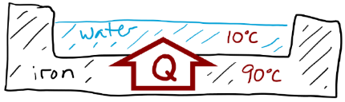
Figure 12.6: Schematic of the skillet just after the water has been added, showing heat transferring from the skillet to the water.¹
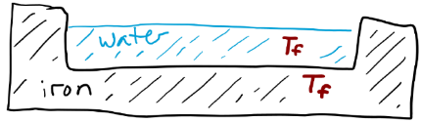
Figure 12.7: Schematic of the skillet and water after they have reached thermal equilibrium.¹

Numbers
Assumptions: isolated system; specific heat capacities and coefficients of bulk thermal expansion are valid over the whole temperature range; iron remains solid and water remains liquid.
Knowns | Unknowns
$$m_{iron}=3 kg$$ | $$T_{f}$$
$$V_{water,i}=0.0015 m^{3}$$ | $$V_{water,f}$$
$$T_{water,i}={10}^{∘}C$$
$$T_{iron,i}={90}^{∘}C$$
$$β_{water}=2.1×{10}^{-4} ​^{∘}C^{-1}$$
$$c_{iron}=450 J/\left(kg⋅ ^{∘}C\right)$$
$$c_{water}=4 182 J/\left(kg⋅ ^{∘}C\right)$$
Using conservation of energy for this isolated system where the only type of energy is thermal, we have…
$$\begin{aligned}0&=ΔE_{tot}=Q_{tot}=Q_{water}+Q_{iron} \\ &=m_{water}⋅c_{water}⋅ΔT_{water}+m_{iron}⋅c_{iron}⋅ΔT_{iron} \\ &=m_{water}⋅c_{water}⋅\left(T_{f}-T_{water,i}\right)+ \\ & m_{iron}⋅c_{iron}⋅\left(T_{f}-T_{iron,i}\right)\end{aligned}$$
Now we can rearrange and solve for $T_{f}$:
$$\begin{matrix}\left(m_{water}⋅c_{water}+m_{iron}⋅c_{iron}\right)⋅T_{f}= \\ m_{water}⋅c_{water}⋅T_{water,i}+m_{iron}⋅c_{iron}⋅T_{iron,i}\end{matrix}$$
We were not given the mass of the water, but it can be found from the density of fresh water, which is $1 000 kg/m^{3}$.

Words
At first, one might think that the temperature should be halfway between the two, so 50°C. But remember that the skillet has twice the mass of the water, so that would tend to make the final temperature closer to 90°C than to 10°C. But it isn’t as simple as that. Another important factor is the specific heat capacity of the materials. Specific heat capacity describes the amount of heat needed to increase the temperature of a material. And the specific heat capacity of water is ten times larger than that of iron. So, in fact the final temperature is much closer to the initial temperature of the water than it is to the initial temperature of the iron.
Like solids, most liquids expand when they are heated, but liquids don’t have linear dimensions. They have coefficients of “bulk” or “volumetric” thermal expansion, β. The value of β is normally reasonably constant, but water is unusual. Its coefficient of bulk thermal expansion decreases at low temperatures and becomes negative below approximately 4°C. So, at low temperatures water expands as the temperature decreases!
Water is physically touching the skillet, so heat transfers into the water by conduction. Heat can also transfer through fluids by conduction, but if the heat is coming from the bottom, then the primary method of heat transfer is convection. Convection is circulation of the molecules that occurs because the warmer fluid at the bottom expands, and its density decreases. This creates a buoyant force that lifts the warmer fluid up, and it is replaced by cooler fluid flowing down.

Graphics
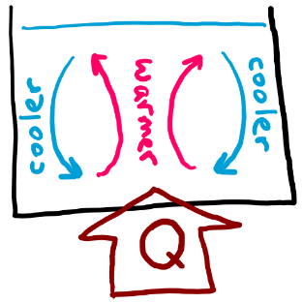
Figure 12.8: As heat enters the bottom of the fluid, the fluid at the bottom gets warmer and expands. The warmer fluid rises since it is less dense than the cooler fluid above it, and the cooler fluid flows down to the bottom. This is called convection.¹
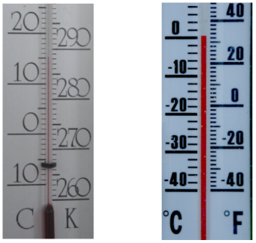
Figure 12.9: On the left the numbers are different but the spacing is the same, so a change of ${10}^{∘}\text{C}$ is a change of 10K. On the right, a change of ${10}^{∘}\text{C}$ is a change of ${18}^{∘}\text{F}$.

Numbers
$$\begin{aligned}T_{f}&=\frac{m_{water}⋅c_{water}⋅T_{water,i}+m_{iron}⋅c_{iron}⋅T_{iron,i}}{m_{water}⋅c_{water}+m_{iron}⋅c_{iron}} \\ &=\frac{\left(62 730+121 500\right) J}{\left(6 273+1 350\right) J/^{∘}C} \\ &={24}^{∘}C\end{aligned}$$
The bulk thermal expansion coefficient $β_{water}$ was found using an internet search. The value found online was in units of $K^{-1}$, so K was replaced with $​^{∘}C$, with no mathematical conversion needed. That is because thermal expansion is calculated using change in temperature, not the temperature itself. Conversions are different for change in temperature than they are for temperature:
$$\boxed{ΔT_{K}=ΔT_{C}=\frac{5}{9}\left(ΔT_{F}\right)}$$
( 12.3 )
The bulk thermal expansion coefficient is used in exactly the same way as the linear thermal expansion coefficient:
$$\boxed{ΔV=V⋅β⋅ΔT}$$
( 12.4 )
So, the final volume of the water is…
$$\begin{aligned}V_{water,f}&=V_{water,i}+ΔV_{water} \\ &=V_{water,i}⋅\left(1+β_{water}⋅ΔT_{water}\right) \\ &=\left(0.0015 m^{3}\right)\left(1+\left(2.1×{10}^{-4} ​^{∘}C^{-1}\right)\left({14}^{∘}C\right)\right) \\ &=0.001504 m\end{aligned}$$
Again, this is an extremely small change in volume.

: Changing State ( , )

Words
Solid, liquid, and gas are the three most common “states” of matter that we interact with daily. It is possible for a material to change from one of these states to another when heat is added or removed. If heat is added to a solid until its temperature reaches the “melting point,” any additional heat will not increase the temperature but will melt the solid into a liquid. Once all the solid has melted, adding more heat will increase the temperature of the liquid. Then, if heat is added to the liquid until its temperature reaches the “boiling point,” any additional heat will not increase the temperature but will evaporate the liquid into a gas. After the liquid has all been evaporated, additional heat can then increase the temperature of the gas.
The same process can also proceed in reverse. If heat is removed from a gas that is already at the boiling point, the gas will condense into a liquid. Once all the gas has condensed, removing heat will lower the temperature of the liquid until it reaches the melting point. At the melting point, removing heat from the liquid freezes it into a solid without changing the temperature. Once all the liquid has frozen, removing more heat will lower the temperature of the solid.
For our scenario we will start with 1.2 kg of ice at a temperature of $-{20}^{∘}$C. How much heat needs to be added to melt all the ice and then boil away half of the water?

Graphics
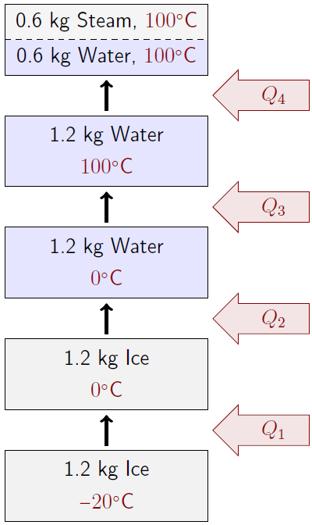
Figure 12.10: $Q_{1}$ brings the ice to its melting point. Then $Q_{2}$ melts the ice. Then $Q_{3}$ brings the water to its boiling point. Finally, $Q_{4}$ boils away half of the water.¹

Numbers
Assumptions: isolated system; specific heat capacities are valid over the whole temperature range; atmospheric pressure.
Knowns | Unknowns
$$m_{ice,i}=1.2 kg$$ | $$Q_{tot}$$
$$T_{i}=-{20}^{∘}C$$
$$T_{water,melting}=0^{∘}C$$
$$T_{water,boiling}={100}^{∘}C$$
$$c_{water}=4 182 J/\left(kg⋅ ^{∘}C\right)$$
$$c_{ice}=2 090 J/\left(kg⋅ ^{∘}C\right)$$
$$L_{f,water}=3.34×{10}^{5} J/kg$$
$$L_{v,water}=2.23×{10}^{6} J/kg$$
$$m_{water,f}=0.6 kg$$
The different processes (changing temperature, melting, and boiling) require different mathematical models. The amount of heat required to melt a solid is…
$$\boxed{Q=m⋅L_{f}}$$
( 12.5 )
…where $L_{f}$ is the latent heat of fusion for the material and $m$ is the amount of the material that melts. Similarly, the amount of heat required to evaporate a liquid is…
$$\boxed{Q=m⋅L_{v}}$$
( 12.6 )
…where $L_{v}$ is the latent heat of vaporization.

Words
The amount of heat required to melt a solid is called the “latent heat of fusion,” and the amount of heat required to evaporate a liquid is called the “latent heat of vaporization.” These latent heats vary depending on the material.
It is also possible to change the state of a material by changing the pressure while keeping temperature constant. This means that melting and boiling points are in fact dependent on pressure; they are normally reported at atmospheric pressure. At some combinations of temperature and pressure it is possible for a solid to “sublimate” directly to a gas without first changing to liquid. A common example of this is “dry ice,” solid carbon dioxide, which sublimates at atmospheric pressure.
The temperatures and pressures at which phase transitions occur can be shown on a phase diagram like the one in Figure 12.12. “Phase” is often used interchangeably with “state,” but some materials have multiple phases within a single state. Water, for example, has at least nine unique crystal phases within its solid state.
Solid lines in a phase diagram indicate the transition points between the states. The near-vertical dotted line in Figure 12.12 is representative of water, which has an unusual slope: solid water can melt as pressure increases! Every material has a “triple point” on its phase diagram at which it can exist in solid, liquid, or gas state; and a “critical point” beyond which there is no clear distinction between the liquid and gas states.

Graphics
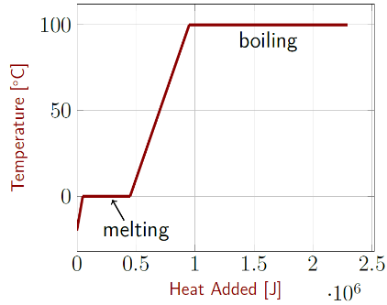
Figure 12.11: Temperature as a function of heat added. The plateaus in the graph occur when the material is changing state, not changing temperature.¹
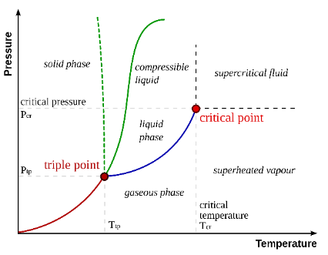
Figure 12.12: This generic phase diagram shows the general trend followed by most materials, with the temperatures and pressures at which a material exists in solid, liquid, or gas states.

Numbers
$L_{f}$ also describes the heat that must be removed to freeze a liquid into a solid, and $L_{v}$ describes the heat that must be removed to condense a gas into a liquid. The melting point, boiling point, latent heats, and specific heats in the “knowns” were found using an internet search.
To find the total heat required, we need to find the heat required for each physical process and add them together. We need the heat capacity of ice to find $Q_{1}$, the heat required to bring the ice up to its melting point:
$$Q_{1}=m_{ice}⋅c_{ice}⋅ΔT_{ice}=50 160 J$$
We need the latent heat of fusion to find $Q_{2}$, the heat required to melt the ice:
$$Q_{2}=m_{ice}⋅L_{f,water}=400 800 J$$
We need the heat capacity for liquid water to find $Q_{3}$, the heat required to bring the water up to its boiling point:
$$Q_{3}=m_{water}⋅c_{water}⋅ΔT_{water}=501 840 J$$
And we need the latent heat of vaporization to find $Q_{4}$, the heat required to boil away half of the water:
$$Q_{4}=\left(m_{water,i}-m_{water,f}\right)⋅L_{v,water}=1 338 000 J$$
So, the total amount of heat required is…
$$\begin{aligned}Q_{tot}&=Q_{1}+Q_{2}+Q_{3}+Q_{4} \\ &=2 290 000 J\end{aligned}$$

: Gas at Constant Volume ( , )

Words
As with solids and liquids, adding heat to a gas can increase its temperature, but the compressibility of gases makes them much more complicated than solids or liquids. So, we will begin by looking at gases that are in a container with a fixed volume, regardless of the pressure, temperature, or number of gas molecules. An air compressor is an example of just such a container.
When heat goes into a gas that is held at constant volume, the energy goes into the molecules of the gas. For an ideal monatomic gas, thermal energy transforms into translational kinetic energy of the gas particles. But the air in the earth’s atmosphere is almost completely made up of the diatomic gases (gases with two atoms per molecule) nitrogen and oxygen. Ideal diatomic gases can carry other types of energy besides just translational kinetic energy. They can also have rotational kinetic energy. And the bond between the two atoms can act like a spring, so they can also oscillate with spring potential energy. For molecules with more than two atoms, like water vapor and carbon dioxide, there are even more ways that they can rotate and oscillate. It is impossible to measure all these different types of energy across all the gas molecules in a typical gas, so this energy is put together into a single category, the “internal energy” of the gas.

Graphics
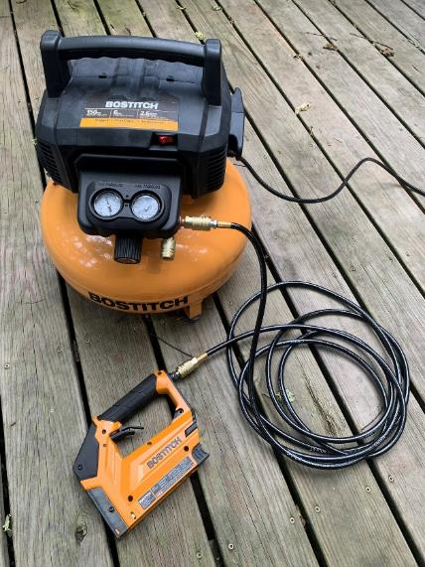
Figure 12.13: Air compressors are designed to hold several atmospheres of air pressure. They are often used for inflating tires and running pneumatic equipment like staplers and nail guns.¹

Numbers
Assumptions: ideal monatomic gas.
Knowns | Unknowns
$$P_{i,gauge}=2 atm$$ | $$P_{f,gauge}$$
$$V=0.023 m^{3}$$ | $$Q$$
$$T_{i}={20}^{∘}C$$ | $$N$$
$$T_{f}={80}^{∘}C$$
The ideal gas law can be used to find the number of molecules in the gas from the initial conditions:
$$P_{i,tot}⋅V=N⋅k_{B}⋅T_{i}$$
This can be rearranged to solve for $N$, but we need to remember first to convert the gauge pressure to absolute pressure and then convert it into pascals and convert the temperature to kelvin.
$$\begin{aligned}N&=\frac{\left(P_{i,gauge}+P_{atm}\right)⋅V}{k_{B}⋅T_{i}} \\ &=\frac{\left(3 atm⋅\frac{1.01×{10}^{5} Pa}{1 atm}\right)\left(0.023 m^{3}\right)}{\left(1.38×{10}^{-23} J/K\right)\left(293K\right)} \\ &=1.7×{10}^{24}\end{aligned}$$
The numbers of molecules $N$ involved with gases in most real-world situations are huge, so the number of “moles” $n$ is often used instead, where one mole is $6.02×{10}^{23}$ molecules. The abbreviation commonly used for for mole is mol. $6.02×{10}^{23}$ is called “Avogadro’s number,” $N_{A}$.

Words
We will consider a physical scenario where a 23-liter air compressor is filled with an ideal monatomic gas at a temperature of 20°C and a gauge pressure of 2 atmospheres. How many molecules of gas are in the air compressor? How much heat needs to be added to the gas to increase its temperature to 80°C, and what would the pressure of the gas be at that temperature?
The number of molecules is huge compared to numbers that we work with every day. More than 1,000,000,000,000,000,000,000,000 molecules, in fact! That’s a trillion trillion, or one septillion–a number larger than our minds can really comprehend. So, another unit is often used when dealing with gases: the mole. One mole is $6.02×{10}^{23}$, and if we count gas molecules in moles then that makes the numbers much easier to work with. A mole is just a number, much like a dozen is 12 of something. One mole of gas molecules in our atmosphere has a volume of 22 liters at sea level at a temperature of 0°C, so we should expect that this 23-liter volume that is higher than atmospheric pressure and higher than 0°C should contain more than one mole of gas molecules.
As for the pressure, we know that the average speed of the molecules increases as the temperature increases. So, the molecules will have higher changes in momentum when colliding with the walls of the container. That means a larger force on the walls of the container, so the pressure will be higher at the higher temperature.

Graphics
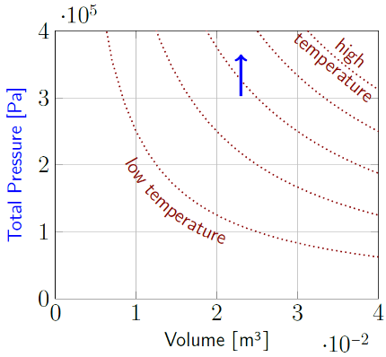
Figure 12.14: A line graph of total pressure versus volume is often called a “P-V plot.” The blue arrow indicates the path followed by the gas in the air compressor as the temperature increased. Pressure increased but volume remained constant. The dotted red lines are isotherms.¹
P-V plots clarify the operation of thermodynamic systems. Lines on the graph that follow curves of constant temperature are called “isotherms.” These are like the “isobars” that follow curves of constant pressure on a weather map, or the contour lines that follow curves of constant elevation on a topographical map. On a P-V plot, higher temperatures are up and to the right.

Numbers
The amount of gas in this scenario is 2.86 moles. The ideal gas law can be rewritten in terms of moles, using the ideal gas constant $R$ in place of the Boltzmann constant $k_{B}$:
$$\boxed{P_{tot}⋅V=n⋅R⋅T}$$
( 12.7 )
$R$ has a value of $8.31 \frac{J}{K⋅mol}$. Since we have the final values for everything except pressure, we can find the final pressure:
$$P_{f,tot}=\frac{n⋅R⋅T_{f}}{V}=3.65×{10}^{5} Pa$$
Subtracting atmospheric pressure gives a final gauge pressure of $2.64×{10}^{5} Pa$ or 2.6 atm.
In this scenario, all the heat that goes into the gas is stored as internal energy $U_{int}$. For an ideal monatomic gas, the mathematical model relating temperature to internal energy is…
$$\boxed{U_{int}=\frac{3}{2}n⋅R⋅T=\frac{3}{2}N⋅k_{B}⋅T}$$
( 12.8 )
For a diatomic gas, the fraction changes from 3/2 to 5/2, and for more complicated molecules the fraction becomes even higher. The change in temperature can be used to find the change in internal energy, which in this scenario is equal to the heat added to the system $Q$:
$\begin{aligned}Q&=ΔU_{int}=\frac{3}{2}n⋅R⋅ΔT \\ &=\frac{3}{2}\left(2.86 mol\right)\left(8.31 \frac{J}{K⋅mol}\right)\left(60K\right) \\ &=2 140 J\end{aligned}$.

: Gas at Constant Pressure ()

Words
Instead of a container with a fixed volume, this time we will study what happens inside a container with a fixed pressure. Pistons are used in many different types of machines, so for this scenario we will look at a sealed vertical piston with negligible friction and a cross-sectional area of $0.02 m^{2}$. The mass of the plunger is 70 kg, and the plunger is initially motionless and in static equilibrium. The initial volume of the ideal monatomic gas inside the piston is $0.05 m^{3}$ and the initial temperature of the gas is ${15}^{∘}C$. The outside pressure is 1 atm.
Find the initial pressure and the number of moles of gas inside the cylinder. Then find the final pressure, temperature, and volume of the gas inside the cylinder when the system again reaches static equilibrium after 10 kJ of heat is added to the gas.
Initially, the pressure inside the gas is just large enough to hold the piston in place against the force of gravity and the atmospheric pressure, which both are pushing down on the piston.
When heat is added to the gas, we should expect that the temperature of the gas will increase, which means that the momenta of the gas molecules would increase, increasing the pressure on the walls of the container. But this time one of the walls, the top surface, is movable. The upward force on the piston would be higher than the downward force, so the piston is forced upward. That increases the volume of the container.

Graphics
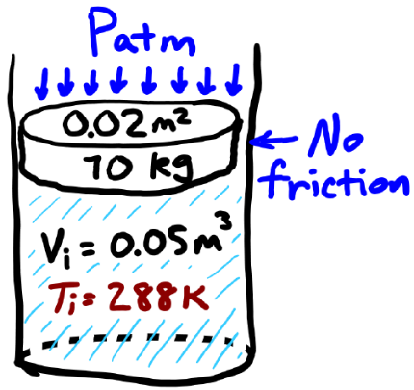
Figure 12.15: Sketch of the vertical piston. The plunger seals in the gas and can move up and down.¹
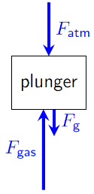
Figure 12.16: Force diagram of the plunger.¹

Numbers
Assumptions: ideal monatomic gas; negligible friction; near the earth’s surface.
Knowns | Unknowns
$$A=0.02 m^{2}$$ | $$P_{tot}$$
$$m=70 kg$$ | $$n$$
$$V_{i}=0.05 m^{3}$$ | $$T_{f}$$
$$T_{i}=288K$$ | $$V_{f}$$
$$Q=1×{10}^{4} J$$
$$P_{ext}=1.01×{10}^{5} Pa$$
Since the plunger starts in static equilibrium, we can use the force diagram to find the force that the gas needs to apply to the plunger to hold it up, and from that find the pressure of the gas.
$$F_{net}=0=F_{gas}-F_{atm}-F_{g}$$
$$F_{gas}=F_{atm}+F_{g}$$
$$P_{gas}=\frac{F_{gas}}{A}=\frac{F_{atm}+F_{g}}{A}$$
$$P_{tot}=\frac{\left(P_{atm}⋅A\right)+\left(m⋅g\right)}{A}=135 300 Pa$$
Now we can find the number of moles using the ideal gas law:
$$n=\frac{P_{tot}⋅V_{i}}{R⋅T_{i}}=2.83 moles$$

Words
When the volume increases, two things happen to the gas molecules inside the container. First, the time between collisions with the top surface increases, which lowers the pressure. And second, since the wall is moving away from the particles that are colliding with it, the magnitude of the momentum of the particles is lower after each collision than it was before the collision, which decreases the temperature. So, allowing the volume to change affects both the pressure and the temperature of the gas.
The piston is in equilibrium when the inside pressure is equal to the outside pressure, so the pressure is the same at the beginning as it was at the end. What about the rest of the time? The change in pressure that starts the piston moving is small compared to the total pressure, and then if the piston is moving at constant speed that means the pressure during that time is the same as the initial pressure. So, the pressure for the whole time is essentially constant.
When the pressure is held constant, the final temperature of the gas is lower than it would have been if the volume had been held constant. That means the final internal energy of the gas is lower than it would have been at constant volume. Where did the rest of the thermal energy go if it didn’t go into the gas? It was used to do work on the cylinder, lifting it up against the force of gravity and the atmospheric pressure. This is simply an application of conservation of energy: The total amount of heat that goes into a gas is equal to the sum of the change in the internal energy of the gas and the work done by the gas.

Graphics
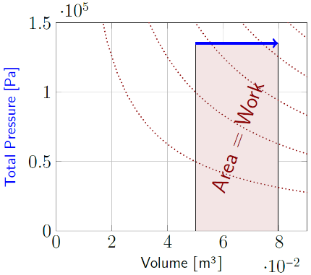
Figure 12.17: A P-V plot for a gas expanding at constant pressure. The blue arrow indicates the path followed by the gas in the piston. The area under the curve shows the amount of work done by the gas.¹
As in a graph of force vs position, the area under the curve shows the work done on a graph of pressure vs volume of a gas.

Numbers
The gas does work on the plunger, pushing it up. If the force is constant, work is force times displacement. A little bit of algebra lets us apply the same principle to gases:
$$\begin{aligned}W&=F_{net}⋅Δx⋅cosθ \\ &=\left(\frac{F_{net}}{A}\right)\left(Δx⋅A\right) \\ &=P_{tot}⋅ΔV\end{aligned}$$
So, if the pressure is constant,
$$\boxed{W=P⋅ΔV}$$
( 12.9 )
If $n$ is also constant, then another expression for work can be found using the ideal gas law:
$$W=P⋅ΔV=n⋅R⋅ΔT$$
Conservation of energy in the gas tells us that the thermal energy $Q$ that goes into the gas is equal to the change in the internal energy of the gas $ΔU_{int}$ plus the work done by the gas $W$:
$$\boxed{Q=ΔU_{int}+W}$$
( 12.10 )
Combining this with the expression found above what we learned about internal energy in the last section …
$$\begin{aligned}Q&=ΔU_{int}+n⋅R⋅ΔT \\ &=\left(\frac{3}{2}n⋅R⋅ΔT\right)+\left(n⋅R⋅ΔT\right) \\ &=\frac{5}{2}n⋅R⋅ΔT\end{aligned}$$
Solving for $ΔT$ for this scenario gives a value of 170K, so the final temperature is 458K.

: Heat Engines and Thermodynamic Cycles ( , )

Words
Now we will consider 0.4 moles of an ideal monatomic gas in a sealed container that goes through four different processes:
- volume is held constant at $0.01 m^{3}$ while the pressure of the gas increases from 100 000 Pa to 300 000 Pa
- pressure is held constant while the volume increases to $0.03 m^{3}$
- volume is held constant while the pressure returns to 100 000 Pa
- pressure is held constant while the volume returns to $0.01 m^{3}$
This is called a “thermodynamic cycle,” in which the gas traces out a closed path on a P-V plot. In the first process, the volume is not changing so the gas is not doing any work. In the second process, the gas is expanding. The pressure that the gas applies to the walls of its container is always pointing outward, and if the volume is expanding then the walls are moving outward (or at least one wall is moving outward), in the same direction as the force on the wall. So, the gas is doing work on the container. In the third process, again no work is being done, because the volume is not changing. In the fourth process the walls are moving inward, against the pressure caused by the gas. That means the container is doing work on the gas.

Graphics
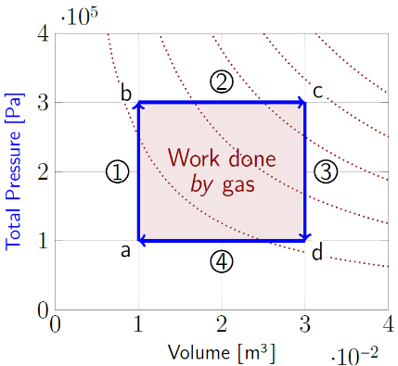
Figure 12.18: P-V plot for a gas going through one complete cycle in four numbered steps. First from “a” to “b,” then “b” to “c,” “c” to “d,” and finally back to “a.” The area inside the loop shows the work done by the gas as it completes one complete cycle.¹
Vertical paths on a P-V plot describe “isovolumetric” (“same-volume”) processes. Horizontal paths on a P-V plot describe “isobaric” (“same-pressure”) processes.
The path along the bottom of the rectangle in the figure above goes from right to left, in the negative direction, so the work done along that path is also negative. So, the area under the rectangle would be added to the total work for the path from b to c and subtracted for the path from d to a. This is equivalent to not including it at all.

Numbers
Assumptions: ideal monatomic gas.
Knowns | Unknowns
$$n=0.4 mol$$ | $$W_{net}$$
$$V_{a}=V_{b}=0.01 m^{3}$$ | $$Q$$
$$V_{c}=V_{d}=0.03 m^{3}$$
$$P_{a}=P_{d}=1×{10}^{5} Pa$$
$$P_{b}=P_{c}=3×{10}^{5} Pa$$
The work for each of the four processes can be added together to get the total work done for one cycle. For the second and fourth processes we can use Equation ( 12.9 ). P is not constant for the first and third processes, so we can’t use that Equation. But the change in V is zero for those processes, so the work done by each of those processes is just zero. That leaves…
$$\begin{aligned}W&=W_{1}+W_{2}+W_{3}+W_{4} \\ &=\left(P_{b}⋅\left(V_{c}-V_{b}\right)\right)+\left(P_{d}⋅\left(V_{a}-V_{d}\right)\right) \\ &=\left(6 000 J\right)-\left(2 000 J\right)=4 000 J \\ \end{aligned}$$
We can also find the change in the internal energy of the gas for each of the four processes using the relationships found at the end of Sections 12.4 & 12.5. But first we would need the temperatures at each of the starting and ending points for each process. These can be found by rearranging the ideal gas law:
$$T=\frac{P⋅V}{n⋅R}$$

Words
So, during the expansion the gas is doing work, and during the contraction work is being done on the gas. The change in volume is the same both times in this example, but the force is higher when the pressure is higher, in the second process. So, in one complete cycle the gas does a net positive amount of work on the container. The gas seems to have created useful energy. But energy can’t come from nowhere–it is coming from the heat that is going into the gas as it goes through the cycle. This is a “heat engine,” which converts heat into work. Which is remarkable. Up until now, every time we have looked at thermal energy it has been energy that was lost from whatever system we have looked at. This time, heat is being captured and used.
We can find the work done and the heat transfer for each process in a cycle.
The net thermal energy going into the gas is equal to the amount of work it does, but if we consider each of the different processes, we can see that not all the thermal energy that goes into the gas is converted to work. In the third process, for example, the volume isn’t changing–that means no work is being done. But the volume is decreasing, so the temperature is decreasing. That means the internal energy of the gas is decreasing, so some of the internal energy is being lost as heat instead of being used for work. So, this heat engine is not 100% efficient. In fact, no heat engine can be 100% efficient, but some thermal energy is lost just as with the other physical scenarios we have considered.

Graphics
The operation of a heat engine is often drawn schematically as shown below.
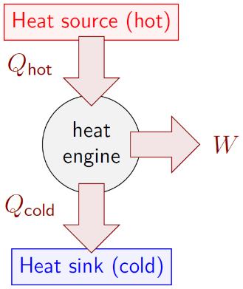
Figure 12.19: Diagram of energy flow through a heat engine.¹
The circle in the middle represents the machine itself, and the arrows show the energy flowing into or out of the machine. Heat naturally flows from high temperature to low temperature, so the heat going into the heat engine must come from a high temperature heat source. Similarly, the heat leaving the heat engine must go into a low temperature “heat sink.”
Heat engines are designed to do work. That work is shown as an output coming from the side of the heat engine.

Numbers
This gives the following temperatures: $T_{a}=301$K; $T_{b}=T_{d}=903$K; and $T_{c}=2709$K
For the first and third processes we should use the relationship found in Section 12.4 for constant volume:
$$Q_{1}=\frac{3}{2}n⋅R⋅\left(T_{b}-T_{a}\right)=3 000 J$$
$$Q_{3}=\frac{3}{2}n⋅R⋅\left(T_{d}-T_{c}\right)=-9 000 J$$
For the second and fourth processes we should use the relationship found in Section 12.5sec:GasAtConstantPressure for constant pressure:
$$Q_{2}=\frac{5}{2}n⋅R⋅\left(T_{c}-T_{b}\right)=15 000 J$$
$$Q_{4}=\frac{5}{2}n⋅R⋅\left(T_{a}-T_{d}\right)=-5 000 J$$
So, the net thermal energy going into the gas is…
$$Q_{net}=\left(3 000+15 000-9 000-5 000\right) J=4 000 J$$
…exactly as expected. But to get 4 000 J of work out of the heat engine, 18 000 J of heat had to be put in. The other 14 000 J of energy left the system as heat.
Since only 4 000 of 18 000 J went where we wanted them to go, we say that the efficiency of this heat engine is 4 000 J/18 000 J, or 22%.

: Refrigerators and Efficiency ( , )

Words
A heat engine converts thermal energy into work while transferring thermal energy from a high-temperature heat source to a low-temperature heat sink. This generally increases the temperature of the heat sink and decreases the temperature of the heat source. What if such a machine could be run in reverse, so that it removes heat from a low-temperature heat sink by transferring it to a high-temperature heat source? Then it could use energy to remove heat from something that is already cold, making it even colder. A refrigerator!
We will consider the same 0.4 moles of an ideal monatomic gas in a sealed container that goes through four different processes, in reverse order compared to Section 12.6:
- pressure is held constant at 100 000 Pa while the volume of the gas increases from $0.01 m^{3}$ to $0.03 m^{3}$
- volume is held constant while the pressure increases to 300 000 Pa
- pressure is held constant while the volume returns to $0.01 m^{3}$
- volume is held constant while the pressure returns to 100 000 Pa
We can find the amount of work that needs to be done on the gas in one cycle and the efficiency of the system at removing heat from the cold side.

Graphics
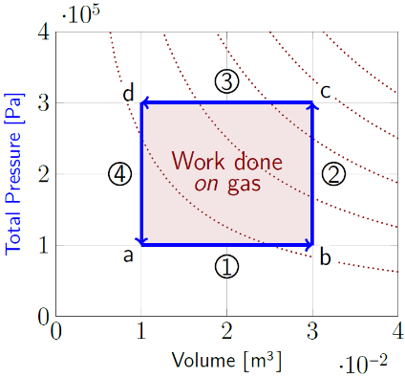
Figure 12.20: P-V plot for a gas going through a cycle. Since the path goes counterclockwise, the area inside the loop shows the amount of work done on the gas as it completes one cycle.¹
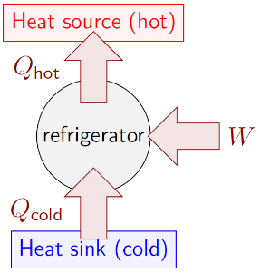
Figure 12.21: Energy flow through a refrigerator.¹

Numbers
Assumptions: ideal monatomic gas.
Knowns | Unknowns
$$n=0.4 mol$$ | $$W_{net}$$
$$V_{a}=V_{d}=0.01 m^{3}$$ | $$e$$
$$V_{b}=V_{c}=0.03 m^{3}$$
$$P_{a}=P_{b}=1×{10}^{5} Pa$$
$$P_{c}=P_{d}=3×{10}^{5} Pa$$
As in Section 12.6, the work for each of the four processes can be added together to get the total work done for one cycle:
$$\begin{aligned}W&=W_{1}+W_{2}+W_{3}+W_{4} \\ &=\left(P_{a}⋅\left(V_{b}-V_{a}\right)\right)+\left(P_{c}⋅\left(V_{d}-V_{c}\right)\right) \\ &=\left(2 000 J\right)-\left(6 000 J\right)=-4 000 J \\ \end{aligned}$$
The amount of work done by the gas is negative–in other words, 4 000 J of work was done on the gas.
A general expression for efficiency that can be used in any situation is
$$\boxed{e=\frac{What we want}{What we put in}}$$
( 12.11 )

Words
The efficiency of any machine depends on what it is made to do and on what must be put in to make it work. One of the most common examples of efficiency is related to vehicles. When buying a vehicle, many people want to know its fuel efficiency. Vehicles are designed to move–that is their primary purpose–so distance moved is part of the efficiency. And if the vehicle uses gasoline or diesel fuel then to make the vehicle move, fuel must be put in. So, the amount of fuel is also part of efficiency. The most efficient vehicles will go the longest distance with the least amount of fuel. In US customary units, we want many miles from few gallons of fuel: many miles per gallon, “mpg.”
For a heat engine we want a large amount of work for a small amount of heat. Both work and heat are measured in joules, so the units are joules/joule. In other words, efficiency is unitless. It is often given as a number or a percentage.
For a refrigerator, we want to remove a lot of heat for a little bit of work, so again efficiency is unitless. For a refrigerator, the efficiency is often called the “coefficient of performance.”
Isobaric and isovolumetric are not the only options for thermodynamic processes. Two other common processes are “isothermal,” in which the temperature of the gas is held constant, and “adiabatic,” in which there is no heat transferred into or out of the gas. Machines that use isothermal and adiabatic processes are usually more efficient than those that use isobaric and isovolumetric processes.

Graphics
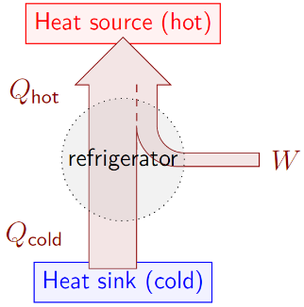
Figure 12.22: Another way to draw the energy flow through a refrigerator. This drawing shows that both the work and the heat from the cold side are transferred as heat to the hot side.¹
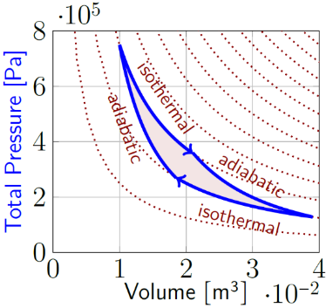
Figure 12.23: P-V plot for a gas going through a clockwise cycle of isothermal and adiabatic processes. This path maximizes the efficiency of a heat engine.¹

Numbers
In the case of a refrigerator, we want to remove heat from the heat sink, and we put in work. Using the numbers calculated for each part of the cycle from Section 12.6, the efficiency of this refrigerator is:
$$e=\frac{14 000 J}{4 000 J}=3.5$$
Converting to a percentage gives 350%! The number can be more than 100% because in this case none of the energy that we put in is going where we want it to go–all of it is going into the heat source. And as it does that, it draws an additional amount of heat out of the heat sink and sends it into the heat source as well. This is shown in Figure 12.22. In a situation like this, the efficiency of a system is often instead called the “coefficient of performance.”
In the case of a heat engine, we want work, and we put in heat from the heat source. The maximum efficiency can be achieved using isothermal and adiabatic processes in what is called a “Carnot cycle.” The maximum efficiency depends on the temperatures (in K) of the heat source and the heat sink:
$$\boxed{e_{max}=1-\frac{T_{cold}}{T_{hot}}}$$
( 12.12 )
For the heat source and heat sink in Section 12.6, a Carnot engine would have an efficiency of…
$$\begin{matrix}e_{max}=1-\frac{301K}{2709K}=89\%\end{matrix}$$

: Entropy ( , )

Words
Potential energy stored in a spring can transform into kinetic energy of a mass. And the kinetic energy of that mass can transform back into spring potential energy. We have also seen that thermal energy can flow from a hot skillet into cold water, cooling the skillet while heating the water. If the skillet and water behaved in the same way as the spring and mass, the flow of thermal energy could then reverse, returning the skillet to its original high temperature and the water to its original cold temperature. But entropy prevents this from happening; it is an irreversible process.
“Entropy” can be understood in terms of temperature and heat or in terms of the number of available states. Systems with higher temperature or more available states generally have higher entropy. Entropy is often described as the amount of disorder in a system, but “disorder” is difficult to identify or even define. In the specific example of solids, liquids, and gases it can be said that solids are held in place in an ordered structure; liquids can move around but the molecules are still close to one another, so they are less ordered; the molecules of gases are free to move around so they have the least order. As such, matter in liquid form tends to have more entropy than matter in solid form, and matter in gaseous form tends to have more entropy than matter in liquid form.

Graphics
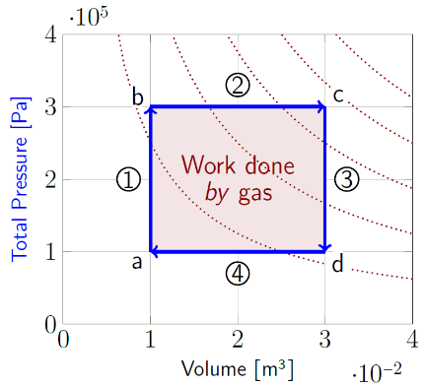
Figure 12.24: P-V plot for a gas going through one complete cycle in four numbered steps. First from “a” to “b,” then “b” to “c,” “c” to “d,” and finally back to “a.”¹

Numbers
The change in entropy $ΔS$ of a system that is at constant temperature is given by
$$\boxed{ΔS=\frac{ΔQ}{T}}$$
( 12.13 )
We can use this relationship to find the change in entropy created by the heat engine from Section 12.6 as it goes through one cycle.
Assumptions: ideal monatomic gas; heat source and heat sink with constant temperatures.
Knowns | Unknowns
$$n=0.4 mol$$ | $$ΔS$$
$$V_{a}=V_{b}=0.01 m^{3}$$
$$V_{c}=V_{d}=0.03 m^{3}$$
$$P_{a}=P_{d}=1×{10}^{5} Pa$$
$$P_{b}=P_{c}=3×{10}^{5} Pa$$
$$Q_{1}=3 000 J$$
$$Q_{2}=15 000 J$$
$$Q_{3}=-9 000 J$$
$$Q_{4}=-5 000 J$$
The entropy of the heat engine is the same at the beginning as it was at the end, since the pressure, temperature, volume, and number of molecules are the same. The change in entropy is in the heat source and the heat sink.

Words
If you have a driveway with one parking spot, and you have one car, then the available states for the car/driveway system are (1) your car is parked in the driveway or (2) it isn’t. If you have a car and a truck, then there are more available states–now your car, your truck, or nothing can be parked in the driveway. If you have an entire parking lot, then there are more possible places for vehicles to park. Entropy increases when you have more vehicles or more spaces.
In a gas, the number of states is affected, for example, by the number and types of gas molecules, their possible momenta (which is related to temperature) and their possible positions (which is related to volume).
Back to the water and skillet, as they came to equilibrium temperature the entropy of the skillet decreased, but the entropy of the water increased even more. The total entropy of the system is higher when their temperatures are the same. And flow of energy stops when entropy is at a maximum. Nothing can reduce the entropy of any isolated system. In an ideal situation a physical process could possibly result in no change in entropy. But ideal situations don’t exist. So, every possible physical process increases entropy.
Since the universe is an isolated system, the entropy of the universe is always increasing. Unless an interaction with something outside of the physical universe intervenes, the entropy of the universe will eventually reach a maximum. At that point, all meaningful activity will stop–this is called the “heat death” of the universe.

Graphics
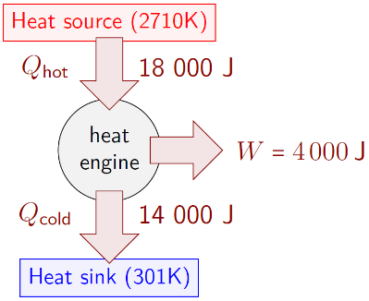
Figure 12.25: Energy flow through a heat engine.¹
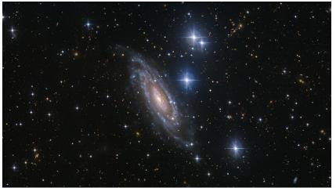
Figure 12.26: Stars contain vast amounts of energy, but if allowed to continue burning for a few hundred million years they will eventually run out of fuel. Their temperature would reach the same as that of their surroundings, entropy would be at a maximum, and no more useful energy would be available for any meaningful activity. This is called “heat death.”²

Numbers
Heat flows into the heat engine when $Q$ is positive, during the first and second processes. Heat flows out during the third and fourth processes. Since the heat is flowing in from the heat source and out to the heat sink…
$$Q_{hot}=Q_{1}+Q_{2}=18 000 J$$
$$Q_{cold}=Q_{3}+Q_{4}=-14 000 J$$
That will allow us to find the change in entropy of the heat source and the heat sink if we can find their temperatures. For heat to flow into the engine from the heat source, the temperature of the heat source must be higher than the temperature of the gas, which is highest at point c. We can find it from the ideal gas law:
$$T_{source,min}=\frac{P_{c}⋅V_{c}}{n⋅R}=2710K$$
Similarly,
$$T_{sink,max}=\frac{P_{a}⋅V_{a}}{n⋅R}=301K$$
If the heat source is at its minimum possible temperature, then the change in entropy of the heat source is…
$$ΔS_{source}=\frac{-Q_{hot}}{T_{source,min}}=-6.6 J/K$$
It is negative because we want heat leaving the source, not entering the engine. Similarly,
$$ΔS_{sink}=\frac{-Q_{cold}}{T_{sink,max}}=46.5 J/K$$
So, this heat engine creates a net entropy of at least 39.9 J/K for every 4 000 J of output work.

: Summary
Chapter summaries in this book are ordered by concept, not necessarily in the order in which they are presented in the chapter. Mathematical models are grouped together at the end of each summary. See the appendices for the meanings of all symbols used in this book.

General
• Every possible physical process increases the entropy of an isolated system.

Energy
- Thermal energy (or heat) is related to the kinetic energy of atoms moving randomly on a microscopic level.
- Heat often travels by conduction through solids and liquids. In conduction, it is microscopic vibrations, not molecules, that carry heat through a material.
- Heat often travels by convection through fluids. In convection, it is the bulk motion of material caused by gravity and density changes, that carries heat through a material.
- The lengths of most solids increase with temperature.
- The volumes of most liquids increase with temperature.
- Heat flows from regions of higher temperature to regions of lower temperature unless something is actively working on the system to prevent or even reverse the flow of heat.
- Thermal equilibrium is a state in which heat is not flowing, so all objects are at the same temperature.
- The amount of heat required to melt a solid is called the latent heat of fusion. The same amount of heat must be removed from a liquid to freeze it into a solid.
- The amount of heat required to evaporate a liquid is called the latent heat of vaporization. The same amount of heat must be removed from a gas to condense it into a liquid.
- The total amount of heat that goes into a gas is equal to the sum of the change in the internal energy of the gas and the work done by the gas.
- The area under the path on a pressure-vs-volume graph is the amount of work done by the gas if the path goes from left to right, or the amount of work done on the gas if the path goes from right to left.
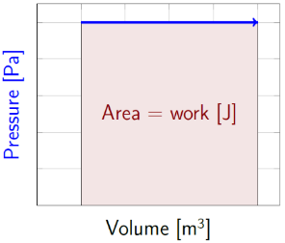
Pressure vs volume graph showing work done by the gas.¹
- A heat engine is able to convert thermal energy into usable work while transferring thermal energy from a high-temperature heat source to a low-temperature heat sink.
- No heat engine can be 100% efficient at converting thermal energy into work.
- The energy flow through a heat engine is often drawn schematically:
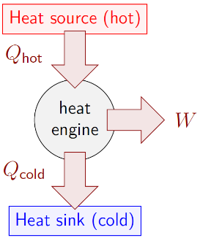
Diagram of energy flow through a heat engine.¹
- Work is done on a gas in a thermodynamic cycle if the path goes counterclockwise on a P-V plot, and work is done by the gas if the path goes clockwise. The amount of work is the area enclosed by the path.

Mathematical Models
Equation | Reference | Restrictions on the validity of the equation
$$Q=m⋅c⋅ΔT$$ | ( 12.1 ) | (approximation over a limited temperature range)
$$Δl=l⋅α⋅ΔT$$ | ( 12.2 ) | (solid, approximation over a limited temperature range)
$$ΔV=V⋅β⋅ΔT$$ | ( 12.4 ) | (solid or liquid, approximation over a limited temperature range)
$$Q=m⋅L_{f}$$ | ( 12.5 ) | -none-
$$Q=m⋅L_{v}$$ | ( 12.6 ) | -none-
“ideal gas law”  $$P_{tot}⋅V=n⋅R⋅T$$ | ( 12.7 ) | ideal gas
$$U_{int}=\frac{3}{2}n⋅R⋅T=\frac{3}{2}N⋅k_{B}⋅T$$ | ( 12.8 ) | ideal monatomic gas
$$W=P⋅ΔV$$ | ( 12.9 ) | ideal gas, constant pressure
$$Q=ΔU_{int}+W$$ | ( 12.10 ) | -none-
$$e=\frac{What we want}{What we put in}$$ | ( 12.11 ) | -none-
$$e_{max}=1-\frac{T_{cold}}{T_{hot}}$$ | ( 12.12 ) | Ideal Carnot engine
$$ΔS=\frac{ΔQ}{T}$$ | ( 12.13 ) | constant temperature

: Questions
Questions are ordered according to Bloom’s Taxonomy, progressing from regurgitating information (Level 1) to synthesizing new information with previous knowledge to create something new (Level 6). The bold letters at the beginning of each question indicate whether the question involves Words [W], Graphics [G], and/or Numbers [N]. See the appendices for conversion factors.

Level 1 - Remember
      - [W] What is another name for heat?
      - [W & N] In what units is heat measured?
Symbol | Reference | Label
$$Q$$ | ( 12.1 )
$$Δl$$ | ( 12.2 )
$$ΔT_{K}$$ | ( 12.3 )
$$ΔV$$ | ( 12.4 )
$$Q$$ | ( 12.5 )
$$Q$$ | ( 12.6 )
$$P_{tot}⋅V$$ | ( 12.7 )
$$U_{int}$$ | ( 12.8 )
$$W$$ | ( 12.9 )
$$Q$$ | ( 12.10 )
$$e$$ | ( 12.11 )
$$e_{max}$$ | ( 12.12 )
$$ΔS$$ | ( 12.13 )
      - [W & N] Add labels to each boxed equation from this chapter that tell what the symbol to the left of the = sign represents

Level 2 - Understand
      - [W] What is the difference between heat and temperature?
      - [N] An assumption was made in Section 12.1 that the iron would remain solid over the entire temperature range. Look up the temperature at which iron melts. Is the assumption valid for this physical scenario?
      - [W] Can convection occur inside a solid material? Explain your answer.
      - [W & N] $0^{∘}C$ is the temperature at which ice melts. What is the temperature at which water freezes?
      - [W & N] ${100}^{∘}C$ is the temperature at which water boils. What is the temperature at which water vapor condenses?
      - [W] Describe the difference between latent heat of fusion and latent heat of vaporization.
      - [W] The size and shape of a container is held constant while the pressure of the gas inside the container increases. What type of process is this (adiabatic, isobaric, isothermal, or isovolumetric)?
      - [W] The pressure inside a container is held constant while the temperature of the gas inside the container increases. What type of process is this (adiabatic, isobaric, isothermal, or isovolumetric)?
      - [W] The temperature of a gas is held constant while the volume of the container increases. What type of process is this (adiabatic, isobaric, isothermal, or isovolumetric)?
      - [W] A container is heavily insulated to prevent heat from entering or leaving it. The volume of the container increases. What type of process is this (adiabatic, isobaric, isothermal, or isovolumetric)?
      - [W] List five things you have done today that have resulted in a net increase in the entropy of the universe. (Don’t think about this one for too long…thinking requires a great deal of electrical activity in the brain, which increases the entropy of the universe!)
      - [W] List everything you have done today that has resulted in a net decrease in the entropy of the universe.

Level 3 - Apply
      - [W] This question has multiple parts about three systems “1,” “2,” and “3.” Step through these parts, and you will discover what is known as the “Zeroth Law of Thermodynamics.”
        - System 1 is brought into thermal contact with System 2, and it is found that no heat transfers between the two systems when they are brought into contact with each other. Are they in thermal equilibrium with each other?
        - System 1 and System 2 are separated and then System 2 is brought into thermal contact with System 3. It is found that no heat transfers between them. Are they in thermal equilibrium with each other?
        - System 2 and System 3 are separated. If System 3 were now brought into thermal contact with System 1, would you expect to find that they are in thermal equilibrium with each other?
        - If you answered yes to all the above parts, then you just discovered the Zeroth Law of Thermodynamics! Incidentally, what does this tell you about the temperatures of these three systems?
      - [N] Assuming that the coefficient of linear thermal expansion that is used in Section 12.1 is valid for any temperature, what would the diameter of the skillet be at a temperature of absolute zero? What would the diameter be at the melting point of iron?
      - [N] The final temperature of cold water poured into a hot skillet was analyzed in Section 12.2. How much ${10}^{∘}$C water would you need to pour into the ${90}^{∘}$C skillet so that the final temperature of the water and skillet would be ${50}^{∘}$C?
      - [N] The final temperature of 1.5 kg of ${10}^{∘}$C water poured into a hot skillet was analyzed in Section 12.2. What if instead of water 1.5 kg of ${10}^{∘}$C lead had been placed in the hot skillet? What would the final temperature be in that situation? You will need to look up the specific heat capacity of lead to answer this question.
      - [N] Practice converting temperature changes between the various scales mentioned in Section 12.2:
        - What is a change of 273K in degrees Celsius?
        - What is a change of $0^{∘}$C in degrees Fahrenheit?
        - What is a change of ${10}^{∘}$F in degrees Celsius?
      - [G & N] The scenario in Section 12.3 starts with ice at a temperature of $-{20}^{∘}C$ and ends with water half boiled away. Re-do the calculations for the energy needed, starting at absolute zero and ending when all the water has boiled away.
      - [W, G, & N] In Section 12.4, an ideal monatomic gas was assumed. In fact, air compressors are generally filled with air, which is mostly composed of diatomic gases. Re-do the analysis using the same volume, temperatures, and initial pressure, but assuming that the air compressor is filled with a diatomic gas instead of a monatomic gas. Do the values change for $N$, $P_{f,tot}$, and $Q$?
      - [N] The final volume is never calculated in Section 12.5, although it is shown in the P-V plot. Find a way to calculate it from the information in the “Numbers” column. Does your answer match reasonably well with the value in the P-V plot?
      - [G & N] Use the P-V plot in Section 12.5 to find the work done by the gas in the cylinder. The work isn’t actually calculated in the numbers section of this chapter. Find a way to use the information there to calculate the work and then compare with the answer that you got using the graph.
      - [N] What is the maximum efficiency possible for a heat engine that is operating between a heat source at ${100}^{∘}C$ and a heat sink at $0^{∘}C$?
      - [N] What is the change in entropy of 0.5 kg of ice at $0^{∘}C$ ice melting completely into $0^{∘}C$ water?

Level 4 - Analyze
      - [W & N] By what percentage did the height and the diameter of the iron skillet change in Section 12.1? Did the volume change by the same percentage? Explain why or why not.
      - [N] The distance between the parallel rails of a standard train track is 1.4 meters. Use that information to estimate the length of the horizontal gap in the expansion joint in the bottom rail of Figure 12.4. Look up the coefficient of linear thermal expansion of steel and search for the maximum and minimum outdoor temperatures where you live. If this type of expansion joint were used in railroad tracks where you live, what is the maximum possible length of each solid piece of rail that will not exceed the limits of the expansion joints?
      - [N] An iron skillet containing water is analyzed in Sections 12.1 & 12.2. What would happen if the same skillet, at ${10}^{∘}$C, was filled with water, also at ${10}^{∘}$C, and then this system was heated? Both the iron and the water would expand. But which would expand faster? Would the water overflow from the skillet, or would the water level drop?
      - [W, G, & N] The scenario in Section 12.3 assumes that all the heat is going into the water and the ice. But the ice and water must have been in some kind of container. Re-do the analysis for the same situation but include a 2-kg copper pot that holds the ice and water. You will need to look up the specific heat capacity of copper. Assume that the copper pot starts at $-{20}^{∘}C$ and ends at ${100}^{∘}C$. Does including the copper pot significantly change the amount of heat required?
      - [W & N] Consider the two different mathematical models of internal energy that are given in Equation ( 12.8 ), reproduced below, one after each “equals” sign. Use these mathematical models to find the relationship between $k_{B}$ and $R$. Describe whether that relationship is supported by the units and numerical values for these two constants.
      - [W & N] Gases don’t have simple expressions for specific heats like solids and liquids do. But sometimes it is convenient to find an expression of specific heat that will work for a gas in a given situation. For example, the specific heat of an ideal gas at constant volume $C_{v}$ or at constant pressure $C_{p}$, both symbolized with an uppercase $C$ instead of a lowercase $c$. Use the information given in the numbers columns to find the values of $C_{v}$ and $C_{p}$ for ideal monatomic gases and for ideal diatomic gases. Show your work. The associated mathematical models are of the following form:
$$Q=n⋅C_{v}⋅ΔT$$and
$$Q=n⋅C_{p}⋅ΔT$$
      - [G & N] Figure 12.21, reproduced below, could just as easily have been for a heat pump whose primary purpose is to increase the temperature of the heat source. What would be the efficiency of that heat pump?
Refrigerator.1
      - [G] Make an alternative diagram of energy flow like that in Figure 12.22 for the heat engine in Figure 12.19, both of which are reproduced below.
Alternative diagram for energy flow.1
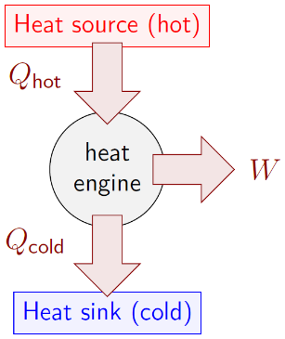
Heat engine.1
      - [N] Boyle’s Law, which states that $P⋅V$ is constant for an ideal gas in a sealed container when the temperature is held constant, is a consequence of the ideal gas law:
$$\begin{aligned}P⋅V&=n⋅R⋅T \\ P⋅V&=(constant)⋅(constant)⋅(constant) \\ P⋅V&=(constant)\end{aligned}$$$n$ is constant, since the container is sealed. $R$ is always a constant, and if $T$ is also held constant, then the entire right side of the equation is constant. Boyle’s Law. There are two other named laws that are also consequences of the ideal gas law. Do the same sort of analysis using the ideal gas law to determine each of the following:
        - “Charles’ Law,” which is valid for an ideal gas in a sealed container when the pressure is held constant.
        - “Avogadro’s Law,” which is valid for an ideal gas in an unsealed container when the pressure and temperature are both held constant.

Level 5 - Evaluate
      - [W, G, & N] In Section 12.1 the linear expansion of iron was used to find measurements. But the volume that was calculated was actually an empty space inside an iron container. If the iron expands uniformly, would that make the empty inside volume larger or smaller? Explain your reasoning.
      - [W & N] In Section 12.2, water is described as unusual because at some temperatures it has a negative coefficient of bulk thermal expansion. How unusual is this property? Do an internet search for other materials that also have a negative coefficient of bulk thermal expansion. Are there any other common materials with this property? Does there seem to be much engineering or scientific interest in this topic?
      - [N] Find a table of specific heat capacities for various materials. Can you find any general trends? Do some types of materials generally have higher specific heat capacities than some other types of materials?
      - [N] Find tables of latent heats for various materials. Can you find any general trends? Is latent heat of fusion generally higher or lower than latent heat of vaporization?
      - [W & N] 1 kg of liquid gold at its melting point is dropped into a bucket of 5 kg of liquid water at its melting point. What is the temperature of the water-gold system when it reaches thermal equilibrium, assuming that the system is thermally isolated from its surroundings? In what state (solid, liquid, or gas) are the water and the gold at thermal equilibrium? You will need to look up the thermal properties of gold to answer this question.
      - [G & N] When P-V plots were introduced in Figure 12.14, reproduced below, the figure showed the relationship between pressure, volume, and temperature for an ideal gas. There is a necessary assumption that was made but not mentioned when the graph was created. Think about the ideal gas law in relation to PV plots. What unmentioned assumption is being made in the plots?
A P-V plot. 1
      - [W, G, & N] Can the efficiency of a heat pump be greater than 100%? Explain your answer.

Level 6 - Create
      - [W, G, & N] At the beginning of Chapter 1 in Figure 1.1 was a template for a concept map. Add the main ideas from this chapter to the appropriate concept maps for earlier chapters.
      - [W, G, & N] Imagine you are writing a test question related to this chapter. Think of your own example of a situation that you can analyze using the concepts, graphics, and mathematical analyses described in this chapter. Describe the situation and use the tools from this chapter to analyze the situation as completely as you can, including motion, forces, energy, and momentum.
      - [W, G, & N] Think about possible misconceptions about the material in this chapter. Write a question and an incorrect solution to it that demonstrates a student making such a conceptual error. This cannot be a simple misuse of a vocabulary word, a unit error, or a mathematical error like making an addition error or multiplying when addition was needed, unless the error is rooted in a real misunderstanding about the physics behind the calculation or the misuse of a word. After you have written the question and incorrect solution, explain what is wrong with the student’s solution, and write a correct solution to the problem. Note: You may use a question from this chapter that you got wrong the first time and explain the initial error in your thinking and how you corrected it.

– Atoms and Subatomic Particles ( , )

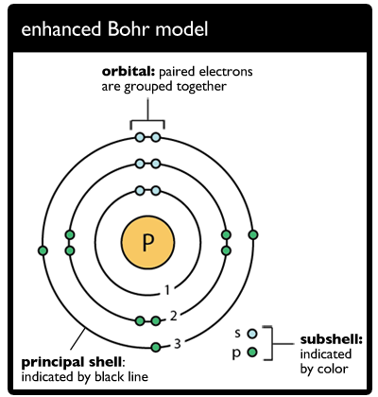
Figure 13.1: The “Bohr Model” of a phosphorus atom. The circle in the center represents the nucleus of the atom. The smaller colored circles represent electrons, each shown in one of the electron shells around the nucleus.

We have looked at the way atoms and molecules behave in relation to each other in a solid, liquid, or gas. Now we will go deeper, looking inside individual atoms, which are made up of subatomic particles: protons, electrons, and neutrons. Motion, forces, momentum, and energy all have roles to play on the atomic level but behave in ways that can be surprising. Subatomic particles can have some of the same properties that we have been dealing with already, such as mass and angular momentum. They can also have other properties that we haven’t yet seen, such as charge and magnetic moment.
The “Bohr model” of an atom was developed based on the results of the “Rutherford experiment,” where high-energy particles were fired at a thin gold film, and it was found that while most of the particles simply blasted through, some of them bounced back. In The Development of the Theory of Atomic Structure (Rutherford 1936), Rutherford described his astonishment at the results, saying, “It was almost as incredible as if you fired a 15-inch shell at a piece of tissue paper and it came back and hit you.” The only way this could happen would be if most of the mass were in a tiny, positively charged nucleus.
This is just one example of an astonishing property of atoms and subatomic particles. In this chapter we will begin to explore strange new physics that appears at the atomic scale, including forces much more powerful than gravity; energy and angular momenta that can exist only at certain well-defined intervals with no allowed values in-between; and particles whose locations get smeared out into wavelike patterns, making it impossible to find a precise position, but only probabilities about where the particle might be.

: Electrons in an Atom ( , )

Words
The way that people usually visualize an atom includes electrons in clear paths circling around a nucleus like planets circling the sun, as depicted in the Bohr model. In fact, electrons could be anywhere in a fuzzy cloud around the nucleus, and their positions are described in terms of the probability of where they could be at any point in time. The electrons act as if they are smeared out across the entire cloud of probabilities, rather than being in discrete locations.
It is also virtually impossible to make a properly scaled drawing of an atom. If the nucleus were drawn the size of the period at the end of this sentence, then the electron cloud would fill a football field, and electrons themselves would still be invisibly small. The diameter of the electron cloud of a hydrogen atom is roughly 1 Å (one angstrom), or 10⁻¹⁰ m, as illustrated in Figure 13.2. The diameter of a proton is roughly 1 fm (one femtometer), or 10⁻¹⁵ m. That is 100,000 times smaller than the electron cloud! The diameter of the electron itself is unknown, but probably not zero. It is likely at least 100 times smaller than a proton, and quite possibly much smaller than that. Electrons are usually considered to be point-like particles without a meaningful diameter, but they can also act like waves rather than particles.
Electrons are bound to the nucleus by electric force. Electrons, with negative electric charge, are attracted by the positively charged nucleus.

Graphics
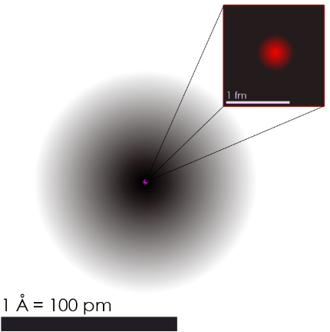
Figure 13.2: A somewhat more accurate picture of what an atom, in this case a hydrogen atom, “looks” like: the fuzzy red dot is a proton and the surrounding black cloud shows likely locations of the accompanying electron. A hydrogen atom is composed of just one proton and one electron¹

Numbers
Each electron shell of an atom is correlated to a ground state energy, the lowest electron energy $E_{0}$. That ground state energy varies from one type of atom to the next; for a hydrogen atom, it is approximately -13.6 eV.
“eV” is a unit of energy that we have not encountered before, the “electron-volt.” 1 eV is $1.6×{10}^{-19} J$.
The energy of an electron in the $n^{th}$ electron shell of an atom is given by…
$$\boxed{E_{n}=\frac{E_{0}}{n^{2}}}$$
( 13.1 )
Notice that this energy is always negative. It is like gravitational potential energy at large distances, which is negative near an object in space and approaches zero as the distance from the object approaches infinity. An object with zero gravitational potential energy has completely escaped from the gravitational force of other objects; similarly, an electron with zero energy has completely escaped from the electrical force of the hydrogen nucleus.
Let’s find the amount of energy needed to first shift an electron in the lowest energy level of a hydrogen atom into the next higher energy level ($ΔE_{first}$), and then from there to completely remove it from the hydrogen nucleus ($ΔE_{second}$)

Words
The spreading out of electrons into waves, combined with being bound to a nucleus, has the effect of making electrons act in much the same way as waves on a string that is fixed on both ends. The lowest energy electron state is like the first harmonic, and higher energy states are like higher harmonics on the string, but in 3-D instead of 1-D.
No more than two electrons can occupy the lowest (“ground state”) energy level. Increasing numbers of electrons can occupy successively higher energy levels. It is possible to add energy to an electron to kick it into a higher energy level “excited state”, and an electron can emit energy to drop back into a lower energy level.
We have seen before that objects prefer lower energy states. So why don’t all the electrons fall into the first shell? Because of the “Pauli exclusion principle,” which says that no two electrons in an atom can be in the exact same state as each other. If the lowest energy states are all full, then the next electron is forced into a state with higher energy.
Two electrons are allowed in the lowest state if they have opposite spins. The spin of an electron has only two allowed values, $±\frac{1}{2}$, corresponding to angular momenta $±ℏ/2$ (pronounced “h-bar”), where $ℏ$ is the reduced Planck constant $6.63×{10}^{-34} kg⋅m^{2}/s$. The lowest-energy state for electrons in an atom can be occupied by two electrons: one with spin $+\frac{1}{2}$ (sometimes called “spin up”) and the other with spin $-\frac{1}{2}$ (“spin down”).

Graphics
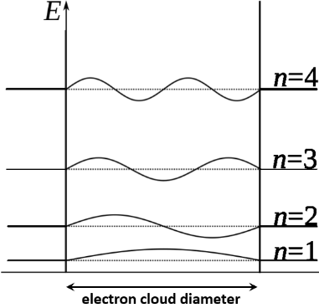
Figure 13.3: “Standing waves” on a string behave similarly to electrons in an atom. The probability of an electron being present is zero at the nodes and highest at the antinodes. Energy level n = 1, 2,… increases with the number of nodes.
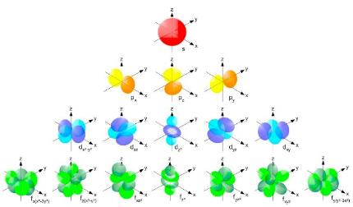
Figure 13.4: “Standing waves” on a string behave similarly to electrons in an atom. The probability of an electron being present is zero at the nodes and highest at the antinodes. Energy level n = 1, 2,… increases with the number of nodes.

Numbers
Assumptions: hydrogen atom.
Knowns | Unknowns
$$E_{0}=-13.6 eV$$ | $$ΔE_{first}$$
$$n_{initial}=1$$ | $$ΔE_{second}$$
$$n_{middle}=2$$
$$n_{final}=∞$$
Using Equation ( 13.1 )…
$$\begin{aligned}ΔE_{first}&=E_{2}-E_{1} \\ &=\frac{E_{0}}{2^{2}}-\frac{E_{0}}{1^{2}} \\ &=-13.6 eV⋅\left(\frac{1}{2^{2}}-\frac{1}{1^{2}}\right) \\ &=10.2 eV\end{aligned}$$
$$\begin{aligned}ΔE_{second}&=E_{∞}-E_{2} \\ &=\frac{E_{0}}{∞^{2}}-\frac{E_{0}}{2^{2}} \\ &=-13.6 eV⋅\left(\frac{1}{∞^{2}}-\frac{1}{2^{2}}\right) \\ &=3.4 eV\end{aligned}$$
The total energy to remove the electron from the hydrogen atom is $ΔE_{first}+ΔE_{second}$, which is 13.6 eV, which makes sense since that is the opposite of the total initial energy. It is interesting that the amount of energy needed to completely remove the electron from the second energy level is much less than the energy needed to move the electron from the first energy level to the second.

: The Atomic Nucleus ( , )

Words
The periodic table of elements categorizes atoms according to their “atomic number” $Z$, which is the number of protons in the nucleus. Protons have positive electric charge, while electrons have the same amount of negative electric charge. The SI unit of charge is the coulomb [C], and the charge on a proton is one elementary charge $\left(+1 e\right)$, or $1.6×{10}^{-19} C$. The charge on an electron is $\left(-1 e\right)$.
In most atoms there is also a third type of particle in addition to protons and electrons: neutrons. Neutrons are roughly the same size as protons but are electrically neutral; that is, they have a net charge of zero. The number of neutrons determines the isotope of the element. Most carbon atoms, for example, contain six protons, six electrons, and six neutrons: Carbon-12, or ¹²C. But roughly 1% of carbon atoms contain six protons, six electrons, and seven neutrons. This is the Carbon-13 isotope, ¹³C.
Carbon-12 is the standard for determining the mass (“atomic weight”) of the isotopes of different atoms; by definition, one atom of ¹²C has a mass of one atomic mass unit (amu), $1.66×{10}^{-27} kg$.

Graphics
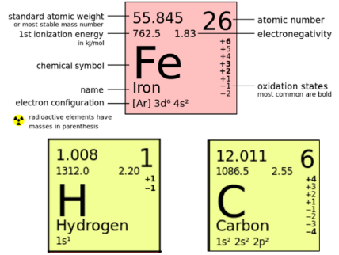
Figure 13.5: Excerpts from a periodic table.
The figure above shows information from a periodic table. “Standard atomic weight” is a weighted average of the isotopes of the element. “1st ionization energy” is the energy required to remove an electron from the lowest-energy electron shell, related to E₀ from Section 13.1. Next are the chemical symbol and name of the element. The last line on the left is the lowest energy electron configuration: the large numbers tell which shells the electrons are in, the letter is the “subshell,” related to the harmonics discussed in Section 13.1, and the superscript is the number of electrons in that subshell. On the right side are atomic number Z and then “electronegativity” and “oxidation states,” which are not discussed in this book.

Numbers
Assumptions: the mass of an object is equal to the sum of the masses of its parts.
Knowns | Unknowns
$$m_{proton}=1.007 amu$$ | $$m_{\left(​^{12}C\right)}$$
$$m_{neutron}=1.008 amu$$
$$m_{electron}=0.0005 amu$$
A ¹²C atom is made up of 6 protons, 6 neutrons, and 6 electrons, so its mass should be…
$$\begin{aligned}m_{\left(​^{12}C\right)}&=6⋅m_{proton}+6⋅m_{neutron}+6⋅m_{electron} \\ &=6⋅\left(m_{proton}+m_{neutron}+m_{electron}\right) \\ &=6⋅\left(1.007 amu+1.008 amu+0.0005 amu\right) \\ &=12.093 amu\end{aligned}$$
…but we already know that the actual mass of ¹²C is exactly 12 amu. There is 0.093 amu “missing” from every ¹²C atom. It turns out that our initial assumption was not correct–the mass of an object is not equal to the sum of the masses of its parts!

Words
A single proton has a mass of approximately 1.007 amu; a neutron has a mass of approximately 1.008 amu; and an electron has a mass of approximately 0.0005 amu. If you’re paying attention, that is going to sound wrong. Based on what we know about the composition of ¹²C, let’s find out what its mass should be, just adding up the component parts.
As calculated in the “Numbers” column, there is 0.093 amu “missing” from every ¹²C atom. This is called the “mass defect.” Mass defect is usually calculated per nucleon, where a nucleon is a proton or a neutron. ¹²C has twelve nucleons, so the mass defect per nucleon is approximately 0.008 amu. Where does the mass go? It turns out that mass and energy are connected, and each nucleon experiences a huge nuclear binding energy that keeps it from leaving its nearest neighbors in the nucleus. This energy is due to yet another kind of force.
In Section 13.1 it was stated that negatively charged electrons are attracted to the positively charged nucleus by the electric force. Electric force is attractive for objects with charges of opposite sign, but it is repulsive for objects with charges of the same sign. And yet all the protons in a nucleus are tightly bound together. The electric force is not strong enough to push them apart, so there must be another force that is stronger than the electric force to hold the nucleus together. That force, appropriately enough, is called the strong force. This strong force creates a powerful nuclear binding energy that holds the nucleus together.

Graphics
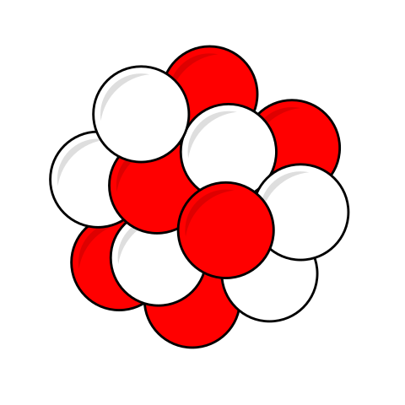
Figure 13.6: Illustration of the nucleus of a ¹²C nucleus, showing six protons (red) and six neutrons (white).
The electric force, with a relatively large range, tries to push the protons in the nucleus away from each other, but the strong force tightly binds neighboring nucleons to each other, holding the nucleus together.

Numbers
The mass defect per nucleon in ¹²C is…
$$\begin{aligned}\frac{Δm}{n_{protons}+n_{neutrons}}&=\frac{\left(12.093 amu\right)-\left(12 amu\right)}{6+6} \\ &=0.0078 amu\end{aligned}$$

: The Truth About Mass ( )

Words
Ever since Chapter 1 we have been using mass, but we have never stopped to define it! We have seen that it is something that resists motion, because the same force acting on two objects with different masses will cause the object with less mass to accelerate more. When taken in that context, the mass is referred to as “inertial mass.” We have also seen that mass causes gravitational force. The gravitational force on an object at the earth’s surface increases with the mass of the object; in fact, the force is proportional to the product of the masses of the two objects that are interacting with each other, in this case the earth and the object at the earth’s surface. When taken in that context, the mass is referred to as “gravitational mass.” Experiments have been designed to look for a difference between inertial and gravitational mass, but so far, no measurable difference has been observed.
…and that still doesn’t say what mass is, only what it does. So, what is mass? Energy! In fact, a lot of energy. Mass can be thought of as the total amount of energy that has been put into an object. This is the famous mass-energy equivalence first proposed by Einstein, $E=m⋅c^{2}$. In the frame of reference where an object is motionless, the energy contained in the mass of an object is equal to the object’s mass times $c^{2}$. $c$ is commonly referred to as the speed of light, $3×{10}^{8} m/s$. In fact, it is more than that. It acts like a universal speed limit–nothing can go faster than $c$.

Graphics
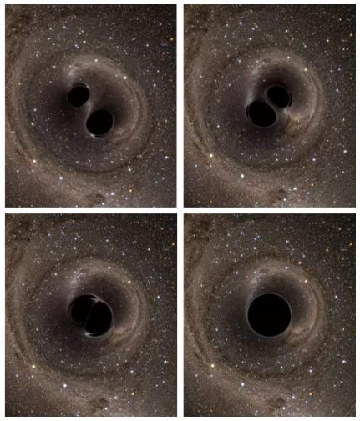
Figure 13.7: Still frames taken from a video simulation of a black hole merger. The video itself has been recognized as one of the finest on English language Wikipedia, Arabic language Wikipedia, and Wikimedia Commons. Go watch it! …and when you do, notice how light is being bent back and forth in waves as space distorts even out at the edges of the video frame. https://en.wikipedia.org/wiki/File:BBH_gravitational_lensing_of_gw150914.webm.

Numbers
Let’s begin by calculating the amount of energy released as gravitational waves during the black hole merger described in the “Words” column on the next page. We can use an internet search to find the mass of the sun.
Assumptions: The center of mass of the black hole system is motionless.
Knowns | Unknowns
$$m_{1}=m_{2}=30⋅m_{sun}$$ | $$E_{released}$$
$$m_{f}=58⋅m_{sun}$$
$$m_{sun}=1.99×{10}^{30} kg$$
$$c=3×{10}^{8} m/s$$
We will need to use mass-energy equivalence, which is valid in the frame of reference where the center of mass is motionless, often called the “rest frame.”
$$\boxed{E=m⋅c^{2}}$$
( 13.2 )
…where $c$ is the speed of light, $3×{10}^{8} m/s$.
We can use conservation of energy:
$$\begin{aligned}E_{i,tot}&=E_{f,tot} \\ \left(m_{1}+m_{2}\right)⋅c^{2}&=m_{f}⋅c^{2}+E_{released} \\ E_{released}&=\left(m_{1}+m_{2}-m_{f}\right)⋅c^{2}=2⋅m_{sun}⋅c^{2} \\ &=2⋅\left(1.99×{10}^{30} kg\right)⋅{\left(3×{10}^{8} m/s\right)}^{2} \\ &=3.6×{10}^{47} J\end{aligned}$$

Words
Mass-energy equivalence has consequences on scales ranging from galactic to submicroscopic. Let’s look at it first on a galactic scale. Black holes are collapsed stars whose gravity is so strong that nothing, not even light, can escape. Sometimes two black holes can orbit each other, slowly spiraling inward until they eventually merge into one black hole. Conservation of angular momentum requires their angular speeds to increase as they spiral inward. The gravity of the black holes warps space itself in the surrounding region, and this warping of space radiates outward in waves: “gravitational waves.” These gravitational waves carry energy. The first black hole merger ever observed was between two black holes, each with masses of approximately 30 times the mass of the sun (30 solar masses). During the merger, the total mass dropped by two solar masses due to the energy radiated away in gravitational waves!
Back on a submicroscopic scale, mass-energy equivalence allows us to correctly interpret the meaning of the mass defect in atoms. The mass defect is the amount of energy that would be required to split an atom’s nucleus into free protons and neutrons, in other words, the binding energy. As can be seen in Figure 13.9, the average binding energy per nucleon for hydrogen is zero. That is because ¹H is already just a proton and an electron.

Graphics
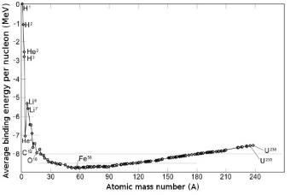
Figure 13.8: Binding energy per nucleon for stable isotopes. The horizontal axis, “Atomic mass number,” refers to the number of nucleons in the isotope. Note that there is a minimum near the middle of the curve, labeled “Fe⁵⁶” (a variant notation for ⁵⁶Fe).
Remember that systems like to move to the minimum possible energy state. So, the minimum in the binding energy per nucleon at ⁵⁶Fe indicates that this is the most stable nuclear configuration. With only a few exceptions, nuclei are more stable the closer their number of nucleons is to 56. Because of this, nuclear fusion reactions (Section 13.4) can occur between lighter elements that bring them closer to 56 nucleons, and nuclear fission (Section 13.5) can occur in heavier elements that bring them closer to 56 nucleons.

Numbers
In Section 13.2 we found the mass defect per nucleon for ¹²C. Now we can find out whether this agrees with the binding energy per nucleon shown in Figure 13.8.
Assumptions: the ¹²C atom is motionless; calculation is for one nucleon.
Knowns | Unknowns
$m_{defect}$ = 0.0078 amu | $$E_{binding}$$
$$c=3×{10}^{8} m/s$$
Again, we will need to use mass-energy equivalence. For a single nucleon:
$$\begin{aligned}E&=m⋅c^{2} \\ E_{binding}&=-m_{defect}⋅c^{2} \\ &=-\left(0.0078 amu\right)⋅\frac{1.66×{10}^{-27} kg}{amu}⋅c^{2} \\ &=-\left(1.3×{10}^{-29} kg\right)⋅{\left(3×{10}^{8} m/s\right)}^{2} \\ &=-1.2×{10}^{-12} J \\ &=-\left(1.2×{10}^{-12} J\right)⋅\left(\frac{1 eV}{1.6×{10}^{-19} J}\right)⋅\left(\frac{MeV}{{10}^{6} eV}\right) \\ &=-7.3 MeV\end{aligned}$$
This is close to the accepted value of -7.7 MeV, as seen in Figure 13.8. The difference can be explained by rounding errors and assumptions made in this atomic model.

: Fusion ( , )

Words
It is fusion of hydrogen atoms into helium that powers our sun and many other stars. The multi-step process shown in Figure 13.10 occurs in the sun to go from four ¹H nuclei to a single ⁴He nucleus. In this section we will walk through each of the steps in this process, calculating the energy released in each step.
Beginning at the top left of Figure 13.10, two ¹H nuclei (a.k.a. protons) collide with each other. In this collision, one of the protons undergoes “beta decay,” in which it transforms into a neutron, a positron, and an electron neutrino. The neutron and the proton that did not undergo beta decay fuse into a ²H nucleus.
A positron is the “antiparticle” of the electron. It is essentially the same as an electron except that it has positive charge instead of negative charge. If a positron collides with an electron, they can annihilate each other, leaving behind only the energy that was present in their masses.
An electron neutrino is tiny, with a mass that is a million times smaller than the mass of an electron. It has no charge and does not interact strongly with anything–most neutrinos that reach the earth from the sun fly straight through the earth without even noticing it was there!

Graphics
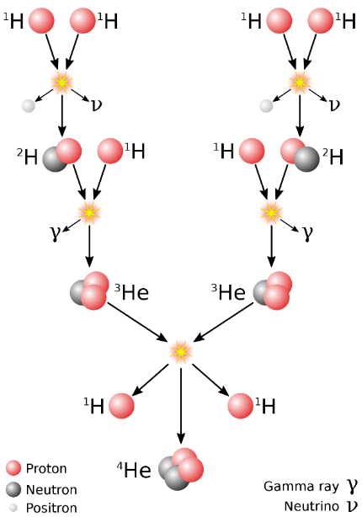
Figure 13.9: This image illustrates the fusion process that occurs in the sun, starting with six hydrogen nuclei and ending with two hydrogen nuclei and a helium nucleus, plus several other byproducts.

Numbers
We can find binding energies per nucleon of each isotope from https://periodictable.com/.
Assumptions: positron mass is the same as electron mass; neutrino mass is negligibly small.
Knowns | Unknowns
$$E_{binding,^{1}H}=0 MeV$$ | $$ΔE_{first}$$
$$E_{binding,^{2}H}=1.11 MeV$$ | $$ΔE_{second}$$
$$E_{binding,^{3}He}=2.57 MeV$$ | $$ΔE_{third}$$
$$E_{binding,^{4}He}=7.07 MeV$$
$$m_{positron}=9.1×{10}^{-31} kg$$
…where $ΔE_{first}$ is the energy released in the top left collision in Figure 13.9; “second” and “third” are the next two collisions moving down.
To keep all our units consistent, we can convert the mass of the positron into its energy equivalent. It is common to use MeV for units when calculating nuclear energy.
$$\begin{aligned}E_{positron}&=m_{positron}⋅c^{2} \\ &=\left(9.1×{10}^{-31} kg\right)⋅{\left(3×{10}^{8} m/s\right)}^{2} \\ &=\left(8.2×{10}^{-14} J\right)⋅\left(\frac{1 eV}{1.6×{10}^{-19} J}\right)⋅\left(\frac{1 MeV}{1×{10}^{6} eV}\right) \\ &=0.51 MeV\end{aligned}$$

Words
Notice that the total charge in that first reaction did not change–that is important! Charge is always conserved for any closed system. In this case, there was an initial charge of $+2 e$ (one on each proton) and a final charge of $+2 e$ (one on a proton and one on the positron).
The next step in the process shown in Figure 13.9 is fusion of the newly created ²H nucleus with another ¹H nucleus. This is a less complex reaction than the reaction that created the ²H. In this case, the two nuclei fuse to create ³He, releasing a gamma ray. A gamma ray is a high-energy photon, which is a massless particle with no charge.
The final step in the process is the fusion of ³He nuclei, each created by the series of steps described above. When these two nuclei fuse, they create a single ⁴He nucleus while ejecting two protons.
This process releases a great deal of energy–enough to power the sun! It would be a great way to generate energy here on earth, because while it is a form of nuclear power, it doesn’t create any radioactive waste. The difficulty is that this process can only occur at very high temperatures. Think of a burning piece of paper: it releases a lot of energy while burning, but something must be done to get the burning to start. The National Ignition Facility in the United States uses an array of high-power lasers to start nuclear fusion reactions, and there are other facilities around the world with the same goal, but it looks like viable fusion power plants are still far in the future.

Graphics
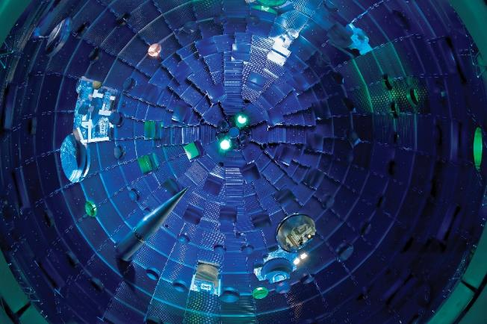
Figure 13.10: This view from the bottom of the National Ignition Facility (NIF) target chamber shows the target positioner being inserted. Pulses from NIF’s high-powered lasers race toward the Target Bay at the speed of light. They arrive at the center of the target chamber within a few trillionths of a second of each other, aligned to the accuracy of the diameter of a human hair. NIF is located at Lawrence Livermore National Laboratory in northern California.

Numbers
Using conservation of energy…
$$\begin{matrix}ΔE_{first}=\left(2⋅E_{binding,^{2}H}+E_{positron}\right)- \\ \left(2⋅E_{binding,^{1}H}\right) \\ =\left(\left(2.22+0.51\right)-0\right) MeV=2.73 MeV\end{matrix}$$
This is released primarily as kinetic energy of the products of the reaction.
$$\begin{matrix}ΔE_{second}=\left(3⋅E_{binding,^{3}He}\right)- \\ \left(2⋅E_{binding,^{2}H}+E_{binding,^{1}H}\right) \\ =\left(\left(7.71\right)-\left(2.22+0\right)\right) MeV=5.49 MeV\end{matrix}$$
This is released primarily as energy of the emitted gamma ray.
$$\begin{matrix}ΔE_{third}=\left(4⋅E_{binding,^{4}He}+2⋅E_{binding,^{1}H}\right)- \\ \left(6⋅E_{binding,^{3}He}\right) \\ =\left(\left(28.28+0\right)-\left(15.42\right)\right) MeV=12.86 MeV\end{matrix}$$
This is released primarily as kinetic energy of the products of the reaction.
The total energy released through the entire reaction would be…
$$2⋅ΔE_{first}+2⋅ΔE_{second}+ΔE_{third}=29.3 MeV$$
…because the first two reactions need to happen twice to produce the necessary components for the third reaction.

: Radioactive Decay ( , )

Words
Atoms with significantly more than 56 nucleons can eject nucleons so that they can get closer to 56, in a process called “fission.” This commonly occurs through “alpha decay.” Beta decay, mentioned in Section 13.4, involves the emission of an electron or a positron. Alpha decay involves the emission of an alpha particle, which contains two protons and two neutrons–a helium-4 nucleus. For example, radium-226, ${}_{}^{226}{\text{Ra}}$ or ${}_{88}^{226}{\text{Ra}}$, is present at varying levels in the crust of the earth. Radium is not stable; it can decay spontaneously into radon-222 and an alpha particle (⁴He), as illustrated in Figure 13.11.
Spontaneous decay is probabilistic–at any point in time there is some likelihood that the decay will happen. This type of process is usually described in terms of a “half-life.” In the case of ${}_{88}^{226}{\text{Ra}}$, the half-life is 1,600 years. If we started with one million radium atoms, after 1,600 years only about half a million radium atoms would remain. After another 1,600 years we would be left with only about a quarter of a million. This doesn’t mean that if we had a single atom of radium, we would know that it will decay in exactly 1,600 years. It could decay instantly, or it could remain for millions of years, but at 1,600 years there is a 50% chance that it would have decayed by that time.
Figure 13.12 & Figure 13.13 show the likely number of atoms present over time. A semi-log plot makes it easier to see the numbers at longer time scales.

Graphics
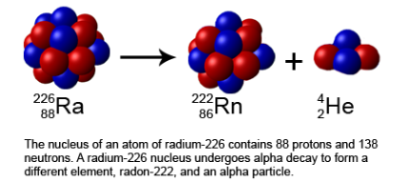
Figure 13.11: A radium nucleus can spontaneously decay into radon and an alpha particle.
The notation used in Figure 13.11 is common when working with radioactive decay, because it provides not only the total number of nucleons (on the upper left of the chemical symbol) but also the number of protons (on the bottom left). ${}_{2}^{4}{\text{He}}$, for example, contains four nucleons including two protons. This makes it possible to understand the reaction without needing to know the atomic number associated with each chemical symbol.
Notice that the sum of the top numbers on the left side of the arrow, before the reaction, is equal to the sum of the top numbers on the right side of the arrow, after the reaction (226 = 222 + 4). This is also true for the bottom numbers (88 = 86 + 2); the number of protons remains constant since this was alpha decay and not beta decay.

Numbers
We can find the energy released in the decay of ${}_{88}^{226}{\text{Ra}}$ in the same way that we found the energy released during fusion of hydrogen into helium, again using binding energy data from https://periodictable.com/.
Assumptions: none?
Knowns | Unknowns
$$E_{binding,^{226}Ra}=7.66 MeV$$ | $$ΔE$$
$$E_{binding,^{222}Rn}=7.69 MeV$$
$$E_{binding,^{4}He}=7.07 MeV$$
Using conservation of energy…
$$\begin{matrix}ΔE=\left(222⋅E_{binding,^{222}Rn}+4⋅E_{binding,^{4}He}\right)- \\ \left(226⋅E_{binding,^{226}Ra}\right) \\ =\left(\left(1707+28\right)-\left(1731\right)\right) MeV=4 MeV \\ \end{matrix}$$
This is released primarily as kinetic energy of the products of the reaction.

Words
High concentrations of radium in the soil can have health consequences. When radium decays, it creates radon, which is an unstable gas with a half-life of just a few days. That half-life is long enough for the gas to find its way out of the ground and into the air where people can breathe it into their lungs. But the half-life is short enough that a significant amount could decay while in the lungs. The products of radon decay are also not stable, with lifetimes on the order of seconds or minutes, so once the radon decays there is a chain of other nuclear reactions that occur quickly. Because of the potential hazards due to all these radioactive decays occurring near people or even in their lungs, houses in some areas are required to have ventilation systems that prevent radon gas from building up in basements.
In other situations, radioactive decay can be useful, for example in radiation therapy using cesium-137 $\left({}_{55}^{137}{\text{Cs}}\right)$. Cesium-137 has a half-life of approximately 30 years before undergoing beta decay. One of its neutrons decays into a proton while ejecting an electron and an anti-electron neutrino, forming an unstable state of Barium-137 $\left({}_{56}^{137}{\text{Ba}}\right)$. The instability of ${}_{56}^{137}{\text{Ba}}$ is caused by it being in a higher-energy configuration than normal, much like an electron in a higher-energy shell when there is an available position in a shell with lower energy. After a few seconds, the Barium nucleus shifts into its stable, lower-energy configuration, releasing a gamma ray. This is called “gamma decay.”

Graphics
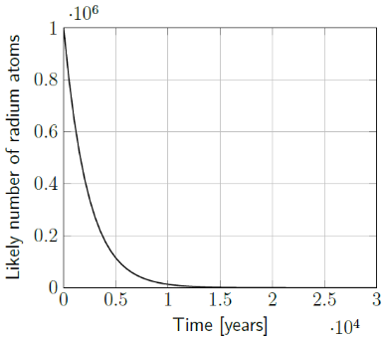
Figure 13.12: The likely number of radium atoms present over the course of 30,000 years, starting with one million atoms.¹
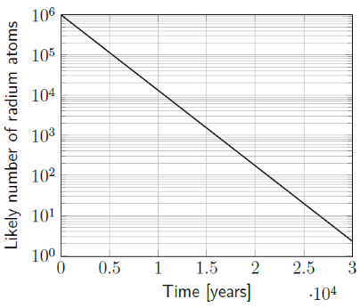
Figure 13.13: The likely number of radium atoms present over the course of 30,000 years, starting with one million atoms, this time using a semi-log scale.¹

Numbers
We can use the half-life $t_{1/2}$ to find the approximate number of atoms that would be present at a later time, or to estimate the number that were present at an earlier time.
In the example of radium atoms given in the “Words” column, we can find the time needed for the number of radium atoms to decrease by a factor of 1000, so that only approximately 0.1% of the original atoms remain.
Assumptions: none?
Knowns | Unknowns
$$n_{initial}=1 000 000$$ | $$t_{0.1\%}$$
$$t_{1/2}=1 600 years$$
A half-life causes an exponential decay, so the number at any point in time is given by…
$$\boxed{N=N_{0}⋅2^{\frac{-t}{\left(t_{1/2}\right)}}}$$
( 13.3 )
…where $N$ is the number at time $t$ and $N_{0}$ is the initial number. We can rearrange to solve for $t$:
$$\begin{aligned}N&=N_{0}⋅2^{\frac{-t}{\left(t_{1/2}\right)}} \\ \frac{N}{N_{0}}&=2^{\frac{-t}{\left(t_{1/2}\right)}} \\ \log_{2}\left(\frac{N}{N_{0}}\right)&=\frac{-t}{t_{1/2}} \\ t&=-t_{1/2}⋅\log_{2}\left(\frac{N}{N_{0}}\right) \\ t_{0.1\%}&=-\left(1 600 yrs\right)⋅\log_{2}\left(\frac{1}{1000}\right)=16 000 yrs\end{aligned}$$

: The Universal Speed Limit ( )

Words
As if the sub-atomic world isn’t strange enough already, with particles only being allowed to have specific energy levels, particles getting smeared out into waves, and mass turning out to be energy, it’s about to get even stranger.
Let’s look again at hydrogen fusion in Figure 13.9. The first reaction shows two hydrogen atoms fusing, releasing a positron and an electron neutrino, and releasing 2.73 MeV of energy. That energy goes primarily into kinetic energy of the products of the reaction. Let’s assume that a third of the energy goes into each of the three products: The positron, the neutrino, and the ²H nucleus. That would give them 0.91 MeV of kinetic energy each. How fast would they be moving?
As shown in the “Numbers” column, pretty fast! The ²H nucleus would be going almost 10⁷ m/s, more than 100 times faster than the speed of the earth going around the sun. And that’s nothing compared to the speeds of the positron and the neutrino. The positron is going almost 100 times faster than the ²H, and the neutrino is going more than 1000 times faster than the positron!
But there’s a problem. Those numbers can’t possibly be correct. Remember c? The speed of light, and the universal speed limit for everything? According to our calculations, both the positron and the neutrino are going faster than c.

Graphics
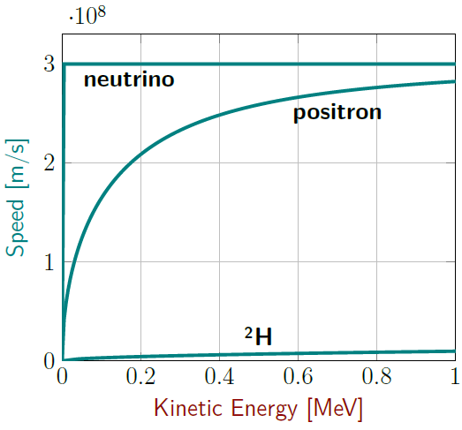
Figure 13.14: Actual speeds of particles as a function of their kinetic energies. They can never go faster than the speed of light.¹
Notice that at a kinetic energy of approximately 0.9 MeV the speed of the ²H nucleus is very close to the calculation in the “Numbers” column, the speed of the positron is different by about a factor of two, and the speed of the neutrino is different by a factor of almost 10,000. The neutrino reaches 99% of the speed of light when it has only about 1 eV of kinetic energy.
It is the ratio of the particle’s mass in its rest frame to the kinetic energy of the particle that creates the differences between the speeds in Figure 13.14.

Numbers
We can use an internet search to find the mass of an electron neutrino and PeriodicTable.com to find the mass of ²H. We already have the mass of a positron from Section 13.4.
Assumptions: none?
Knowns | Unknowns
$$m_{​^{2}H}=2.01 amu$$ | $$v_{f,^{2}H}$$
$$m_{positron}=9.1×{10}^{-31} kg$$ | $$v_{f,positron}$$
$$m_{neutrino}=1.3×{10}^{-37} kg$$ | $$v_{f,neutrino}$$
$E_{k,f}=$ 0.91 eV each
We can convert mass and energy into SI units:
$$m_{​^{2}H}=\left(2.01 amu\right)⋅\frac{1.66×{10}^{-27} kg}{1 amu} \\ =3.37×{10}^{-27} kg$$
$$\begin{aligned}E_{k}&=0.91 MeV⋅\left(\frac{{10}^{6} eV}{1 MeV}\right)⋅\left(\frac{1.6×{10}^{-19} J}{1 eV}\right) \\ &=1.5×{10}^{-13} J\end{aligned}$$
Rearranging the expression for kinetic energy to solve for speed gives…
$$v=\sqrt{\frac{2⋅E_{k}}{m}}$$

Words
In order to better understand why things get strange at high speeds, we need to think about frames of reference. An inertial frame of reference is one that is not accelerating, in which the normal laws of physics operate just the same as in a frame of reference that is not moving at all. In Chapter 3 we learned to calculate the velocities of objects in different frames of reference. But light behaves differently than objects that have mass, and in fact the speed of light is the same, $3×{10}^{8}$ m/s, in any reference frame. Highly sensitive measurements are required to observe this at low speeds, but the effect becomes more obvious at speeds close to the speed of light.
This is illustrated in Figure 13.15, where a bad guy (on the left) fires a laser at another person. Unknown to the bad guy, the other person is a superhero who can run at nearly the speed of light. Although it seems like this should help the superhero escape, in fact in the superhero’s reference frame the laser is coming toward them at the speed of light no matter how fast they run away!
If the laws of physics are to remain the same in any inertial frame of reference, that means our measurement of speed must change, so either our perception of time, our perception of distance, or our perception of both must change at high speeds. As crazy as it sounds, that is exactly what happens!

Graphics
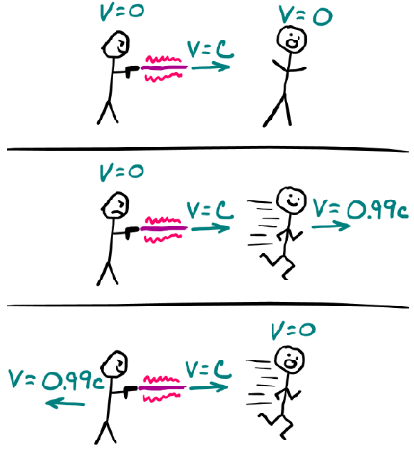
Figure 13.15: A laser being fired at a person, seen from three different perspectives.¹
This figure has three parts. The top part is in the reference frame of the two people when they are just standing. In this frame, both people are motionless and the laser (which is a beam of light) is moving at the speed of light, c.
The middle part is in the reference frame of the bad guy (on the left) after the superhero starts to run away. Again, the laser moves at the speed of light.
The bottom part is in the reference frame of the superhero, who is surprised to find that the laser is still coming toward them at the speed of light!

Numbers
Now we can simply plug in the numbers…
$$v_{​^{2}H}=\sqrt{\frac{2⋅\left(1.5×{10}^{-13} J\right)}{3.37×{10}^{-27} kg}}=9.4×{10}^{6} m/s$$
$$v_{positron}=\sqrt{\frac{2⋅\left(1.5×{10}^{-13} J\right)}{9.1×{10}^{-31} kg}}=5.7×{10}^{8} m/s$$
$$v_{neutrino}=\sqrt{\frac{2⋅\left(1.5×{10}^{-13} J\right)}{1.3×{10}^{-37} kg}}=1.5×{10}^{12} m/s$$
…and get mostly wrong answers!
Our mathematical model for kinetic energy and most of our mathematical models for motion and momentum only work for speeds that are small compared to the speed of light. For our analysis we needed to start with the assumption that the speeds are small compared to the speed of light, and then we would have found that our assumption was not valid, at least for positrons and neutrinos.
We need to make corrections at high speeds using the Lorentz factor $γ$ (lowercase Greek letter “gamma”).
$$\boxed{γ=\frac{1}{\sqrt{1-{\left(\frac{v}{c}\right)}^{2}}}}$$
( 13.4 )
This gamma $\left(γ\right)$ has nothing to do with gamma decay–it is just an unfortunate coincidence that both ideas appear in the same chapter!

: Special Relativity ( )

Words
“Special relativity” deals with objects that are moving at high speeds but are not significantly affected by potential energy. Under these conditions there is lengthening and contraction of the way time and space are perceived–time is not as absolute as it seems! We live in three spatial dimensions and one time dimension–a four-dimensional “spacetime.” While it is not (as far as we know) possible to go backwards in the time dimension, it is possible to slow down in the time dimension.
“General relativity” also allows for the effects of gravity, which causes spacetime to warp. There was a reference to this in Section 13.3: the two black holes that are orbiting one another in that section are warping the surrounding space, and as they move they send ripples (gravitational waves) through spacetime. An artist’s conception of the warping of spacetime around a massive object is shown in Figure 13.16.
According to special relativity, time runs slower for an object as its speed increases. If an object’s speed could reach the speed of light, time would stop completely for that object. This “time dilation” creates something known as the “twin paradox.” It goes like this: Let’s suppose that Albert Einstein had a twin brother, maybe not so great at theoretical physics but a brilliant engineer. We’ll call his brother Wilbur.

Graphics
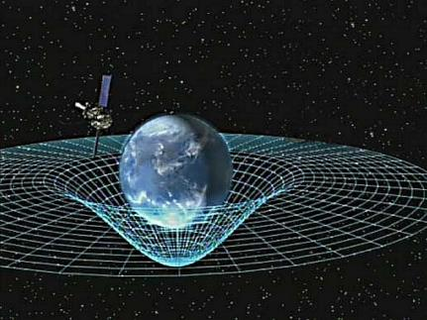
Figure 13.16: Artist concept of Gravity Probe B orbiting the Earth to measure space-time, a four-dimensional description of the universe including height, width, length, and time. The grid is representative of spacetime, which is flat when far from sources of gravity, but massive objects cause it to warp.

Numbers
Time dilation causes a difference in measured times:
$$\boxed{Δt^{'}=γ⋅Δt}$$
( 13.5 )
…where $Δt^{'}$ is the time measured in the observer’s frame and $Δt$ is the time measured in a frame that is moving relative to the observer.
Assumptions: constant speed with negligible turn-around time; gravitational effects are small.
Knowns | Unknowns
$$Δt=17 years$$ | $$v_{Wilbur}$$
$$Δt^{'}=43 years$$
Rearranging the mathematical model for time dilation and inserting the expression for $γ$…
$$\frac{Δt^{'}}{Δt}=γ=\frac{1}{\sqrt{1-{\left(\frac{v}{c}\right)}^{2}}} \\ \sqrt{1-{\left(\frac{v}{c}\right)}^{2}}=\frac{Δt}{Δt^{'}} \\ 1-{\left(\frac{v}{c}\right)}^{2}={\left(\frac{Δt}{Δt^{'}}\right)}^{2} \\ {\left(\frac{v}{c}\right)}^{2}=1-{\left(\frac{Δt}{Δt^{'}}\right)}^{2} \\ \frac{v}{c}=\sqrt{1-{\left(\frac{Δt}{Δt^{'}}\right)}^{2}}=0.92$$

Words
Now we will imagine that by the age of 25 Wilbur designed and built a spacecraft that can travel at nearly the speed of light. In 1904, at the age of 25, Wilbur bids farewell to his also 25-year-old brother Albert, boards his spacecraft, makes a trip to a distant star, takes a quick survey of the planets surrounding it, and returns to earth to report his findings. He arrives back at earth in 1947, where 68-year-old Albert is there to welcome back his 42-year-old twin brother Wilbur. Since he was traveling at speeds so close to the speed of light, only 17 years have passed for Wilbur while 43 years have passed for Albert!
In the “Numbers” column, calculations are done showing that this means Wilbur was moving at 0.92 times the speed of light. Wilbur, who experienced less than half the time that Albert did, would then measure his own speed as almost two times the speed of light. Except that when you look at a distance in a reference frame that is different from your own (like between motionless stars that you are traveling between) the apparent length is reduced through an effect called “length contraction.”
High speeds also have an impact on momentum: Objects moving at speeds near the speed of light have more momentum than just $m⋅v$. The relationship between momentum and energy also changes, with the result that energy becomes proportional to momentum for objects moving near the speed of light.

Graphics
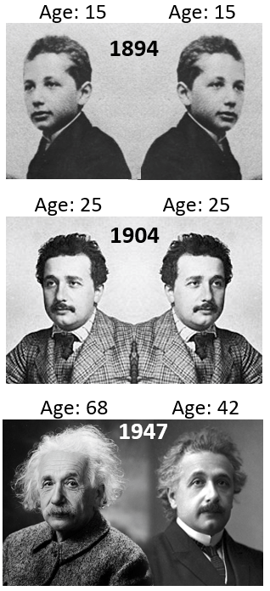
Figure 13.17: Albert Einstein (left) and his fictional twin brother Wilbur (right), at the ages of 15 and 25 before Wilbur goes on a spaceflight near the speed of light, and when Wilbur returns at the age of 42 to find that Albert is now 68.

Numbers
Length contraction causes a difference in lengths:
$$\boxed{l^{'}=\frac{l}{γ}}$$
( 13.6 )
…where $l^{'}$ is the apparent length of an object and $l$ is the length in its own reference frame.
Assumptions: constant speed with negligible turn-around time; gravitational effects are small
Knowns | Unknowns
$$v=0.92⋅c$$ | $$l^{'}/l$$
$$\frac{l^{'}}{l}=\frac{1}{γ}\&=\sqrt{1-{\left(\frac{v}{c}\right)}^{2}}=\sqrt{1-{\left(0.92\right)}^{2}}=\frac{17}{43}$$
Wilbur spent 17/43 as much time traveling 17/43 the distance, meaning that both Albert and Wilbur would measure the same speed.
The Lorentz factor $γ$ also affects momentum:
$$\boxed{\vec{p}=γ⋅m⋅\vec{v}}$$
( 13.7 )
Relativity also impacts the relationship between energy and momentum, the “relativistic momentum-energy principle,” which is valid when there is no potential energy. The first term on the right is kinetic energy and the second is the energy contained in the mass of the object.
$$\boxed{E_{tot}^{2}={\left(p⋅c\right)}^{2}+{\left(m⋅c^{2}\right)}^{2}}$$
( 13.8 )

: Summary
Chapter summaries in this book are ordered by concept, not necessarily in the order in which they are presented in the chapter. Mathematical models are grouped together at the end of each summary. See the appendices for the meanings of all symbols used in this book.

General
- Electrons have negative charge; positrons, or anti-electrons, have positive charge; protons have positive charge; neutrons have no net charge.
- Charge is conserved for any closed system.
- The mass of an atom is concentrated into a small nucleus.
- No two electrons are allowed to be in the same exact state in an atom.
- The “atomic number” of an element tells the number of protons in the nucleus.
- An element can have various isotopes with different numbers of neutrons.
- Alpha decay occurs when a nucleus emits an alpha particle, which is another name for a ⁴He nucleus.
- Beta decay occurs when a proton decays into a neutron, emitting a positron and an electron neutrino, or when a neutron decays into a proton, emitting an electron and an anti-electron neutrino.
- Gamma decay occurs when a nucleus shifts to a lower-energy state, emitting a gamma ray.
- Spontaneous decay is probabilistic, characterized by a half-life t_{1/2}

Forces & Acceleration
- Electric force is attractive for objects with charges of opposite sign, and repulsive for objects with charges of the same sign.
- The strong force holds neighboring nucleons together in a nucleus.

Motion
- Subatomic particles behave sometimes as waves and sometimes as particles.
- Nothing can go faster than the speed of light.
- Time goes slower in a reference frame that is moving at a speed close to the speed of light relative to the observer’s reference frame.
- Lengths appear shorter in a reference frame that is moving at a speed close to the speed of light relative to the observer’s reference frame.

Linear & Angular Momentum & Velocity, and Spin
- Electrons have a spin of $±\frac{1}{2}$.
- Objects with speeds close to the speed of light have more momentum than would be predicted using non-relativistic concepts.
- At high speeds, energy becomes proportional to momentum.

Energy
- Every isotope of an element has a “mass defect” corresponding to the binding energy of the nucleons in the isotope.
- Mass can be thought of as the total amount of energy that has been put into an object.
- ⁵⁶Fe has the most stable nucleus of any isotope. Nuclear reactions tend to bring isotopes closer to having 56 nucleons: fusion for lighter isotopes and fission for heavier isotopes.

Mathematical Models
Equation | Reference | Restrictions on the validity of the equation
$$E_{n}=\frac{E_{0}}{n^{2}}$$ | ( 13.1 ) | -none-
“mass-energy equivalence”  $$E=m⋅c^{2}$$ | ( 13.2 ) | when the center of mass is motionless
$$N=N_{0}⋅2^{\frac{-t}{\left(t_{1/2}\right)}}$$ | ( 13.3 ) | -none-
“Lorentz factor”  $$γ=\frac{1}{\sqrt{1-{\left(\frac{v}{c}\right)}^{2}}}$$ | ( 13.4 ) | -none-
“time dilation”  $$Δt^{'}=γ⋅Δt$$ | ( 13.5 ) | when gravitational effects are small
“length contraction”  $$l^{'}=\frac{l}{γ}$$ | ( 13.6 ) | when gravitational effects are small
$$\vec{p}=γ⋅m⋅\vec{v}$$ | ( 13.7 ) | when gravitational effects are small
“relativistic momentum-energy principle”  $$E_{tot}^{2}={\left(p⋅c\right)}^{2}+{\left(m⋅c^{2}\right)}^{2}$$ | ( 13.8 ) | when gravitational effects are small
Note: Now that we have begun to deal with objects moving at very high speeds, it is important to remember that many of the mathematical models introduced in previous chapters are only valid at speeds significantly lower than the speed of light.

: Questions
Questions are ordered according to Bloom’s Taxonomy, progressing from regurgitating information (Level 1) to synthesizing new information with previous knowledge to create something new (Level 6). The bold letters at the beginning of each question indicate whether the question involves Words [W], Graphics [G], and/or Numbers [N]. See the appendices for conversion factors.

Level 1 - Remember
        - [W] What are the three subatomic particles that make up atoms, which of these are “nucleons,” and what is the sign of the charge on each of them?
Symbol | Reference | Label
$$E_{n}$$ | ( 13.1 )
$$E$$ | ( 13.2 )
$$N$$ | ( 13.3 )
$$γ$$ | ( 13.4 )
$$Δt^{'}$$ | ( 13.5 )
$$l^{'}$$ | ( 13.6 )
$$\vec{p}$$ | ( 13.7 )
$$E_{tot}^{2}$$ | ( 13.8 )
      - [W & N] Add labels to each boxed equation from this chapter that tell what the symbol to the left of the = sign represents

Level 2 - Understand
      - [W & N] Rank the following from largest diameter (1) to smallest (4) diameter:
        - _____ atom
        - _____ electron
        - _____ proton
        - _____ neutron
      - [W & N] Create a table showing the charge in units of $e$ and the mass in amu of each of the following:
particle | charge ($e$) | (amu)
proton
electron
neutron
positron
electron neutrino ($ν$)
gamma ray ($γ$)

      - [N] In the equation for half-life…
$$N=N_{0}⋅2^{\frac{-t}{\left(t_{1/2}\right)}}$$
        - What would the time $t=0$ represent?
        - Does the relationship between $N$ and $N_{0}$ make sense when $t=0$?

Level 3 - Apply
      - [N] The entry for hydrogen in Figure 13.5 gives an atomic weight of 1.008. If the only isotope of hydrogen has no neutrons, what is the mass defect per nucleon for a hydrogen atom? How does the magnitude of the mass defect compare to that of ¹²C?
      - [N] According to the data from the periodic table in Figure 13.5, the 1st ionization energy for hydrogen is 1312.0, but in Section 13.1 $E_{0}$ for a hydrogen atom is given as -13.6 eV. Are those values consistent with each other?
      - [N] Calculate the mass equivalent in MeV for protons and neutrons, using their masses in amu and the conversion that $1 amu=1.66×{10}^{-27} kg$.
      - [N] In the equation for half-life…
$$N=N_{0}⋅2^{\frac{-t}{\left(t_{1/2}\right)}}$$What would $N$ be at time $t=∞$? Does that value for $N$ make sense? Explain your answer.
      - [N] An extremely high-speed train goes past you moving at 80% of the speed of light. As the train passes you at exactly 12:00, you notice that the time on your watch matches the time on the watch of a passenger on the train. After one hour has passed, at 1:00 on your watch, you use a powerful telescope to read the now distant passenger’s watch on the train. What time do you see on the passenger’s watch?
      - [N] You are on a train that passes a station moving at 80% of the speed of light. As your train passes the station at exactly 12:00, you notice that the time on your watch matches the time on the watch of a person standing at the station. After one hour has passed, at 1:00 on your watch, you use a powerful telescope to read the now distant person’s watch at the station. What time do you see on the other person’s watch? [Be careful with this one–remember, you are now the observer, and the train station is in a frame that is moving relative to you. The bizarre situation of the “twin paradox” occurs because the traveling twin changes from one reference frame to another.]
      - [N] An extremely high-speed train goes past you moving at 80% of the speed of light. You know that the train cars were each 10 m long before they started moving. How long do they appear to be as the train goes past you?
      - [N] You are on a train that goes past a train station moving at 80% of the speed of light. You have stopped at that station before, and you know that it was 20 m long when you stopped there and measured it. How long does the station appear to be as you go past it? [Be careful with this one–remember, you are the observer, and the train station is in a frame that is moving relative to you.]
$l^{'}$ is the length that the station appears to be now. $l$ is the length of the station as measured in a frame where it is motionless. So…

Level 4 - Analyze
      - [N] The entry for iron in Figure 13.5 gives a first ionization energy of 762.5 kJ/mol and it also shows an electron configuration that goes out to the 4th electron shell.
        - How much energy, in eV, would be needed to completely remove an electron from the third electron shell of an iron atom?
        - If an electron was removed from the third shell, it is likely that an electron from the fourth shell would then transfer into the third shell, because the third shell is at a lower energy level. How much energy would an electron release as it moves from the 4th shell to the 3rd shell?
      - [W, G, & N] Carbon-12 $\left({}_{6}^{12}{\text{C}}\right)$ is stable–it has no decay products. But if its binding energy were different so that it could decay, what products would it create when undergoing each of the following decays? Explain your answers.
        - Alpha decay?
        - Beta decay in which an electron is emitted?
        - Beta decay in which a positron is emitted?
        - Gamma decay?
      - [W & N] At the end of Section 13.7 there is a statement that energy becomes proportional to momentum for objects moving near the speed of light. Show that this is true using the relativistic momentum-energy principle…
$$E_{tot}^{2}={\left(p⋅c\right)}^{2}+{\left(m⋅c^{2}\right)}^{2}$$
      - [W & N] What does the relativistic momentum-energy principle, $E_{tot}^{2}={\left(p⋅c\right)}^{2}+{\left(m⋅c^{2}\right)}^{2}$, reduce to when the momentum is zero? Does it look familiar?
      - [G & N] The Lorentz factor $γ$ describes the size of the effects caused by relativity. Create a graph of $γ$ as a function of speed $v$, as the speed goes from zero to $c$ (or at least something very close to $c$). How fast does something need to be moving for $γ$ to reach a value of 1.01, the point at which non-relativistic calculations of time, length, and momentum would be off by 1%?

Level 5 - Evaluate
      - [N] The food label for vegan feta shown below gives information about the product, including its energy content (378 kJ) for one serving (30 g). This energy content is the amount that the human body can chemically remove from the food.

The label on a package of vegan feta.
        - If our body were able to use all the energy contained in the mass of the food, how much energy would that be?
        - What percentage of the total energy are we able to use?
        - The average home in the United States of America consumes approximately 1214 Watts of electricity. If you could use all the energy contained in the mass of one serving of vegan feta, for how much time could it power an average American home?
      - [G & N] At the end of Section 13.5 is a calculation finding that the number of radium atoms decreases to 0.1% of its original value after 16,000 years.
        - Does this agree with Figure 13.12, reproduced below?
The likely number of radium atoms present over the course of 30,000 years, starting with one million atoms.¹
        - Does this agree with Figure 13.13, reproduced below?
The likely number of radium atoms present over the course of 30,000 years, starting with one million atoms, this time using a semi-log scale.¹
        - Which graph is easier to use for answering this question?
        - Can you think of a question related to half-life for which the other graph would be easier to use to answer the question?
      - [W] Radiocarbon dating is based on the radioactive decay of carbon-14. Search for information on radiocarbon dating. Describe the physical process that forms carbon-14 and how that process creates the possibility of using this isotope for dating very old samples of living organisms. What are the limitations of radiocarbon dating?
      - [W, G, & N] Section 13.5 describes the production of ${}_{86}^{222}{\text{Rn}}$. There is a diagram at https://periodictable.com/Isotopes/086.222/index.full.html showing the decay chain of this same atom. The thicker lines in the decay chain are the most common transitions. For each of the following transitions in that decay chain, do three things:
        - State what kind of decay is happening.
        - Create a diagram like that in either Figure 13.9 or Figure 13.11, showing emission of various products
        - Calculate the energy released in that transition, in MeV.
These are the first three most common transitions:
          - ${}_{86}^{222}{\text{Rn}}→{}_{84}^{218}{\text{Po}}$
          - ${}_{84}^{218}{\text{Po}}→{}_{82}^{214}{\text{Pb}}$
          - ${}_{82}^{214}{\text{Pb}}→{}_{83}^{214}{\text{Bi}}$

Level 6 - Create
      - [W, G, & N] At the beginning of Chapter 1 in Figure 1.1 was a template for a concept map. Create a new concept map with the main ideas from this chapter.
      - [W, G, & N] Imagine you are writing a test question related to this chapter. Think of your own example of a situation that you can analyze using the concepts, graphics, and mathematical analyses described in this chapter. Describe the situation and use the tools from this chapter to analyze the situation as completely as you can, including motion, forces, energy, and momentum.
      - [W, G, & N] Think about possible misconceptions about the material in this chapter. Write a question and an incorrect solution to it that demonstrates a student making such a conceptual error. This cannot be a simple misuse of a vocabulary word, a unit error, or a mathematical error like making an addition error or multiplying when addition was needed, unless the error is rooted in a real misunderstanding about the physics behind the calculation or the misuse of a word. After you have written the question and incorrect solution, explain what is wrong with the student’s solution, and write a correct solution to the problem. Note: You may use a question from this chapter that you got wrong the first time and explain the initial error in your thinking and how you corrected it.

– Fields
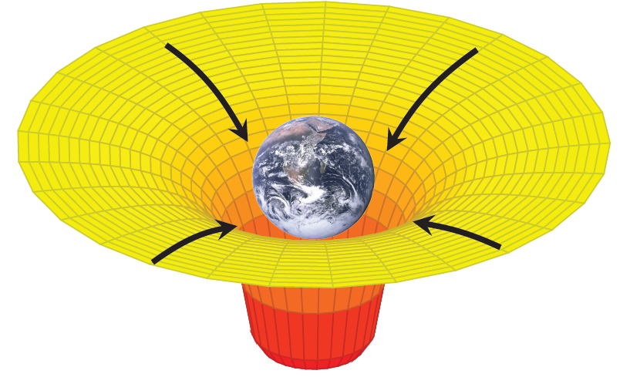
Figure 14.1: The yellow and red 3-D grid shows the shape of the earth’s gravitational potential in a plane cutting through the center of the earth. The arrows show the direction of the earth’s gravitational field, always pointing in the gravitational potential’s “downhill” direction, toward the earth.

Many different forces have been mentioned in this book, including gravitational force, normal force, tension force, frictional force, Van der Waals force, electric force, strong force, and spring force. Only three of these are considered fundamental forces: gravitational, electric, and strong. All the other forces listed here are actually just different ways that fundamental forces manifest themselves.
There is also magnetic force, and something called the “weak force,” which is involved in processes like nuclear decay, that are fundamental. Magnetic force is intertwined with electric force in such a way that they can be considered a single electromagnetic force. In some situations, the weak force is also intertwined with electric and magnetic force such that they can together be considered a single “electroweak” force. It is possible that there may be more fundamental forces, and at the time of this writing there are hints that there may at least be a fifth fundamental force lurking out there, but currently the only ones that we know are gravitational, strong, weak, and electromagnetic.
All these fundamental forces interact through fields, which affect the space around the objects experiencing the interactions. We will look at gravity as a field and then begin to explore electric and magnetic fields. Fields give information about the force and the potential energy that an object would have if it were placed at a given location in the field.

: Gravitational Field

Words
We have considered gravity from two different perspectives: Close to the surface of the earth and at large distances. In either case, if an object is at the surface of the earth or at a distance from another object it feels gravitational force from the other object and it also has gravitational potential energy due to the other object.
Near the surface of the earth, an object feels a downward gravitational force with a magnitude that depends on the mass of the object, because the gravitational field at the surface of the earth is 9.8 N/kg downward. The gravitational field tells you the gravitational force that would be experienced by an object with a given mass.
We can use the same approach with energy, thinking of each point in space as having a “gravitational potential.” The gravitational potential tells you how much gravitational potential energy an object with a given mass would have at that point in space. It increases with distance from the object that is creating the gravitational field. “Equipotential lines” like those in Figure 14.2 are drawn so that every point on each line is at the same potential, so at the same elevation above the earth.

Graphics
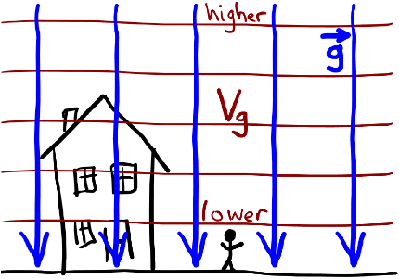
Figure 14.2: A sketch showing the gravitational field and gravitational equipotential lines near the surface of the earth.¹
Figure 14.2 shows the gravitational field lines as a uniform field of arrows (a vector field) pointing downward toward the earth. The equipotential lines are horizontal and equally spaced, with higher gravitational potential at higher positions.
When drawing field lines, they always start and end at either the source that creates them (the earth in this case) or at infinity, so the edge of the drawing. In the case of gravity, they always point toward the mass that creates the field. Equipotential lines always cross field lines at right angles.

Numbers
The gravitational field is a vector: $\vec{g}$ at the surface of the earth is $-9.8 N/kg \hat{y}$, where $+\hat{y}$ is defined as upward. This allows us to re-write the expression for gravitational force near the surface of the earth as:
$$\vec{F_{g}}=m⋅\vec{g}$$
Gravitational potential energy can also be expressed differently, in terms of gravitational potential $V_{g}$. If we define $V_{g}$ near the surface of the earth as…
$$V_{g}=g⋅h$$
…then gravitational potential energy, previously expressed as $m⋅g⋅h$, can be expressed more simply as…
$$U_{g}=m⋅V_{g}$$
The units for gravitational potential are joules per kg [J/kg].

Words
At large distances, the gravitational field still points toward the object creating the field, but the field is stronger near the object and weaker far away from the object, decreasing with the square of the distance. The strength of the field near the dwarf planet Pluto in Figure 14.3 can be estimated from the spacing of the field lines, which get closer together as they approach Pluto. The gravitational potential, represented by the circles in Figure 14.3, decreases (becomes more negative) as we approach Pluto, and the equipotential lines become more closely spaced near Pluto. The closer spacing of the equipotential lines also indicates that the field is stronger in this region.
If we know the mass and position of any object, like Pluto’s largest moon Charon, then Figure 14.3 can be used to determine the gravitational force between Pluto and Charon and the gravitational potential energy associated with placing Charon into Pluto’s gravitational field.
Figure 14.4 is the gravitational field of Pluto and Charon together. This gives information about the net gravitational force and the gravitational potential energy on another object (like a second moon) that could be added to the Pluto-Charon system. It is not, however, useful for determining the force between Pluto and Charon or the gravitational potential energy associated with Pluto and Charon. In the same way that internal forces aren’t considered when calculating the net force on an object, we also don’t consider the field created by the object itself when calculating the net force on the object.

Graphics
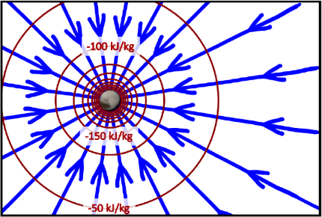
Figure 14.3: Gravitational field lines (arrows) and labeled equipotential lines (circles) near the dwarf planet Pluto. Equipotential lines are always perpendicular to field lines. The potential increases as you move farther from Pluto.
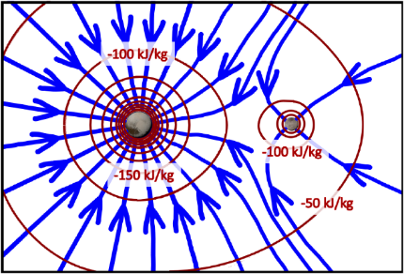
Figure 14.4: Gravitational field lines and equipotential lines near Pluto and Charon. The field lines curve because of the combined effects of Pluto and Charon. Equipotential lines remain perpendicular to the field lines.⁹³

Numbers
The gravitational field at large distances is…
$$\vec{g}=-\frac{G⋅m}{r^{2}} \hat{r}$$
…where the “$-\hat{r}$” direction is toward the center of the object with mass $m$. The gravitational potential at large distances is given by…
$$V_{g}=\frac{-G⋅m}{r}$$
Given these definitions for $\vec{g}$ and $V_{g}$, the gravitational force and gravitational potential energy at large distances can be expressed as…
$$\vec{F_{g}}=m⋅\vec{g}$$
…and…
$$U_{g}=m⋅V_{g}$$
…respectively. Notice that these mathematical models are the same no matter whether we are talking about gravity at the surface of the earth or gravity at large distances!
If there is more than one object, the total gravitational field is the vector sum of the fields; the total gravitational potential is the sum of the potentials created by each object:
$$\vec{g_{tot}}=\vec{g_{1}}+\vec{g_{2}}+⋯$$
$$V_{g,tot}=V_{g,1}+V_{g,2}+⋯$$
The summation is much simpler for potential since it is a scalar. The vector sum for fields typically involves breaking each field into x & y components, adding the components, and then putting them back into magnitude-and-direction format.

: Electric Fields of Point Charges ( , )

Words
Let’s consider the electric fields and potentials generated by individual protons and electrons.
Electricity behaves in almost exactly the same way as gravity. For example, electric potential decreases with the distance from a point charge, just as gravitational potential decreases with distance for large distances (which is equivalent to saying when the objects look round from your perspective). Also, electric fields decrease with the square of the distance from a point charge, just as gravitational fields decrease with the square of the distance for large distances. There are, however, a few differences…
- It is an object’s charge, not its mass, that determines the electric field and the electric potential that the object creates.
- It is an object’s charge, not its mass, that determines the electric force and electric potential energy that it experiences when placed in an external electric field or electric potential.
- Since charge can be positive or negative, electric field lines can point either toward charges or away from the charges.

Graphics
The sizes of the electrons and protons in these figures are greatly exaggerated. If they were drawn to scale, they would be too small to see!
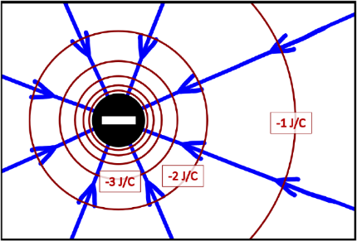
Figure 14.5: Electric field and electric potential around an electron. Three of the equipotential lines have been labeled. The unlabeled equipotential lines closer to the electron continue in the same pattern: -4 J/C, -5 J/C, -6 J/C.
Electric field lines point toward negative charges and away from positive charges. The strength of the electric field can be seen from the spacing between field lines: the field is stronger where the lines are closer together, near the electron. Just as with gravitational fields, equipotential lines are perpendicular to the field lines, creating circles around a single point charge.

Numbers
Assumptions: the charges are in free space; no other charges or objects interact with the charges.
Knowns | Unknowns
$$q_{proton}=+1.6×{10}^{-19} C$$ | $$V_{e}$$
$$q_{electron}=-1.6×{10}^{-19} C$$ | $$\vec{E}$$
…where $q$ is the symbol for electric charge, $V_{e}$ is the electric potential and $\vec{E}$ is the electric field in the space around the charges. For point charges like electrons and protons in free space, the electric potential at a distance $r$ is given by…
$$\boxed{V_{e}=\frac{k_{e}⋅q}{r}}$$
( 14.1 )
…where $k_{e}$ is Coulomb’s constant, $8.99×{10}^{9} N⋅m^{2}/C^{2}$. We can use this to find the distance to the “-1 J/C” equipotential in Figure 14.5:
$$\begin{aligned}r&=\frac{k_{e}⋅q}{V_{e}} \\ &=\frac{\left(8.99×{10}^{9} N⋅m^{2}/C^{2}\right)⋅\left(-1.6×{10}^{-19} C\right)}{-1 J/C} \\ &=1.44×{10}^{-9} m=1.44 nm\end{aligned}$$

Words
Since we have positive and negative charges, we also can have positive and negative electric potentials. So, we need to be careful with our use of words like “increasing,” “decreasing,” “larger,” and “smaller.” In this chapter, decreasing will always mean “getting closer to zero” and larger will always mean “farther away from zero.” So, for example, +6 J/C is larger than +2 J/C and -6 J/C is larger than -2 J/C.
The units for electric potential that are used in this section are joules per coulomb, “J/C.” But there is an equivalent unit for electric potential that is probably more familiar to you: volt. After this section, we will use volt as the unit for electric potential.
As shown in the “Numbers” column, the unit for electric field works out to newtons per coulomb, “N/C.” This is one of two common units for electric field; electric field can also be expressed in volts per meter, “V/m.” 1 N/C is equal to 1 V/m.

Graphics
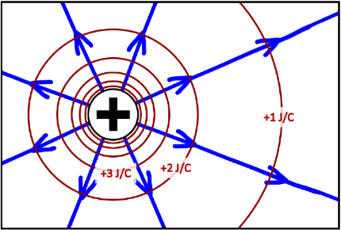
Figure 14.6: Electric field and electric potential around a proton. Three of the equipotential lines have been labeled. The unlabeled equipotential lines closer to the proton continue in the same pattern: +4 J/C, +5 J/C, +6 J/C.94
The electric field created by a proton looks very similar to the field created by an electron, except that the lines point away from the positively charged proton. When drawing field lines, the number of lines entering or leaving a charge should be proportional to the amount of charge. In this case, the magnitude of the charges is the same and both particles are drawn with the same number of field lines.
The electric potential created by a proton also looks very similar to the potential created by an electron, except that it is positive instead of negative. Notice that the electric field lines for both the proton and the electron point in the “downhill” direction of the electric potential, going from higher potential to lower potential.

Numbers
We can also find the electric field generated by the electron at the position of the “-1 J/C” label in Figure 14.5, which is at a radius of 1.44 nm. The magnitude of the electric field created by a point charge in free space is given by Coulomb’s Law:
$$\boxed{E=\frac{k_{e}⋅\left|q\right|}{r^{2}}}$$
( 14.2 )
Note that this gives only magnitude. For direction we can sketch the field lines or remember that the field lines always point away from positive charges and toward negative charges. So, the electric field at a position 1.44 nm to the right of the electron in Figure 14.5 is…
$$\begin{aligned}E&=\frac{\left(8.99×{10}^{9} N⋅m^{2}/C^{2}\right)⋅\left|-1.6×{10}^{-19} C\right|}{{\left(1.44×{10}^{-9} m\right)}^{2}} \\ E&=6.95×{10}^{8} N/C \\ \vec{E}&=6.95×{10}^{8} N/C to the left\end{aligned}$$
For the proton in Figure 14.6, the calculation gives the same number, but we need to remember that the number is only the magnitude of the vector. Looking at the figure, we can see that the field lines point to the right near the “+1 J/C” label on the right side of the proton, so the field at a distance 1.44 nm to the right of the proton would be $6.95×{10}^{8}$ N/C to the right.

: Electric Forces and Electric Potential Energy ( )

Words
We have seen that electric charges create fields in the surrounding space. Now we will see how the field of one charge can affect a second charge that is placed into that field. We can find the amount of work needed to bring two protons to 1 nm apart, starting with them extremely far away from each other. And then we can find the net force on one of the protons when they are 1 nm apart. We will start and end our scenario with both protons motionless.
Just as gravitational potential tells us how much gravitational potential energy an object with a given mass would have if put in a certain position, electric potential tells us how much electric potential energy an object with a given charge would have if put in a certain position.
The same reasoning is also true for forces. Just as the gravitational field tells us the gravitational force that would be exerted on an object with a given mass at a certain location in space, the electric field tells us the electric force that would be exerted on an object with a given charge at a certain location in space. Gravitational force is always in the direction of the gravitational field, but since charge can be positive or negative that makes electric force a little bit more complicated. If the charge is positive, the electric force is in the direction of the electric field; if the charge is negative, the force is opposite the direction of the field.

Graphics
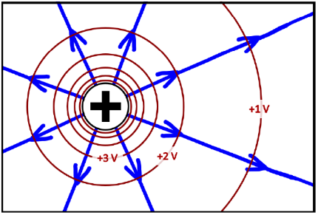
Figure 14.7: Electric field and electric potential , labeled in volts, around a proton.94
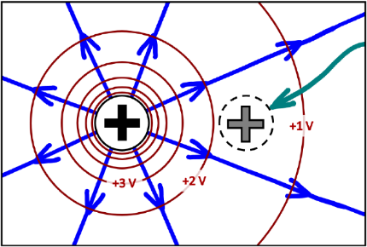
Figure 14.8: Bringing a second proton close to the first. The second is “dotted” to show that the field is only shown for the first proton. The teal arrow shows motion, bringing the proton in.94

Numbers
Assumptions: the protons are in free space; no other charges or objects interact with the protons; no change in thermal energy.
Knowns | Unknowns
$$q_{proton}=+1.6×{10}^{-19} C$$ | $$W$$
$$m_{proton}=1.007 amu$$ | $$\vec{F_{\text{e}}}$$
$$r_{i}=∞$$
$$r_{f}=1×{10}^{-9} m$$
$$v_{i}=v_{f}=0$$
We can use the work-energy theorem to determine the amount of work needed to bring the protons together, but now that we have electrical charges, we will have to include electric potential energy $U_{e}$ in our calculation.
$$\boxed{U_{e}=q⋅V_{e}}$$
( 14.3 )
Adding this term into the work-energy theorem…
$$\begin{aligned}W&=ΔE_{tot}=E_{f,tot}-E_{i,tot} \\ &=\left(E_{k,f}+E_{th,f}+U_{g,f}+U_{s,f}+U_{e,f}\right)- \\ & \left(E_{k,i}+E_{th,i}+U_{g,i}+U_{s,i}+U_{e,i}\right) \\ &=U_{g,f}+U_{e,f}-U_{g,i}-U_{e,i}\end{aligned}$$

Words
Since electric potential decreases with distance charge, at extremely large distances the electric potential is zero. Putting the first proton into position while the other is still extremely far away doesn’t change its electric potential energy–we get to place the first proton for free!
Bringing the second proton close to the first one does not come for free. In Figure 14.8, we can see that the second proton is being pushed in the direction opposite the electric field lines of the first charge. Since the charge of the proton is positive, it feels an electric force pushing in the direction of the field, away from the other proton. So, an external force must push the second proton in, doing positive work on the proton to put it into position.
Nothing (as far as we know) has negative mass, and since gravitational field lines point in toward the mass that means that the gravitational forces between objects are always attractive. But since electric charge can be either positive or negative, that means the electrical forces between objects are sometimes attractive and sometimes repulsive: like charges repel and unlike charges attract.
When bringing the protons together, there is not only electric force but also gravitational force between them. In the numbers column calculations are done to find each of these forces, and it turns out that the electric force is about 1,000,000,000,000,000,000,000,000,000 times stronger than the gravitational force. So, when working with electricity, it is usually safe to ignore the effects of gravity!

Graphics
The dotted charge shown in Figure 14.8 is sometimes referred to as a “test charge,” because it is testing to see what the effect would be of putting a charge in that position. Test charges do not have any effect on electric field or electric potential.
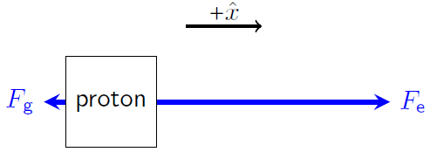
Figure 14.9: Force diagram of the proton on the right (the test charge) when it is in its final position. The arrows are not to scale but are intended to show that $F_{g}$ is much smaller than $F_{e}$.¹

Numbers
We will start with “proton 1” in position and bring “proton 2” into position in the field created by proton 1.
$$\begin{aligned}W&=q_{2}⋅\left(V_{1,e,f}-V_{1,e,i}\right)+m_{2}⋅\left(V_{1,g,f}-V_{1,g,i}\right) \\ &=q_{2}⋅\left(\frac{k_{e}⋅q_{1}}{r_{f}}-\frac{k_{e}⋅q_{1}}{r_{i}} \right)+ \\ & m_{2}⋅\left(\frac{-G⋅m_{1}}{r_{f}}-\frac{-G⋅m_{1}}{r_{i}} \right) \\ &=\frac{k_{e}⋅q_{1}⋅q_{2}}{r_{f}}-\frac{G⋅m_{1}⋅m_{2}}{r_{f}} \\ &=\frac{\left(8.99×{10}^{9} N⋅m^{2}/C^{2}\right)⋅{\left(1.6×{10}^{-19} C\right)}^{2}}{1×{10}^{-9} m} - \\ & \frac{\left(6.67×{10}^{-11} N⋅m^{2}/kg^{2}\right)⋅{\left(1.67×{10}^{-27} kg\right)}^{2}}{1×{10}^{-9} m} \\ &=\left(2.30×{10}^{-19} J\right)-\left(1.86×{10}^{-55} J\right) \\ &=2.30×{10}^{-19} J\end{aligned}$$
The electric force on a charge is given by:
$$\boxed{\vec{F_{e}}=q⋅\vec{E}}$$
( 14.4 )
…so, the net force on the second proton in the final position as shown in Figure 14.9 is given by:
$$\begin{aligned}\vec{F_{net}}&=\left(F_{e}-F_{g}\right) \hat{x} \\ &=\left(q_{2}⋅\frac{k_{e}⋅\left|q_{1}\right|}{r_{f}^{2}}-m_{2}⋅\frac{G⋅m_{1}}{r_{f}^{2}}\right) \hat{x} \\ &=\left(2.30×{10}^{-19}-1.86×{10}^{-46}\right) N \hat{x} \\ &=+2.30×{10}^{-19} N \hat{x}\end{aligned}$$

: Multiple Charges ( , )

Words
We have considered single charges and what happens when one charge is brought near another. Now we will look at a pair of charges and what happens when a third is brought near the other two. In Section 14.3 we used protons, so this time let’s switch to electrons.
If we have two electrons that are locked in position with one of them 1 nm the left of the other, what would the electric field and the electric potential look like around the charges? And what would happen if a third electron was put at a position 0.5 nm below one of the other electrons and then released?
When determining the electric field or electric potential caused by multiple charges, the fields or potentials can be added together. Electric potential is a scalar, so it is relatively easy to add the potentials caused by multiple charges. Electric field is a vector, so vector addition must be used to find the total electric field caused by multiple charges.
At the position where electron 3 is to be placed in Figure 14.11, it is closer to electron 1 than it is to electron 2. Since the electric field created by a point charge decreases with distance, that means the electric field of electron 1 is larger than the electric field of electron 2 at that point in space. The electric field of electron 1 points straight up and the electric field of electron 2 points up and right. Adding those together we get a field that points mostly up and a little bit to the right.

Graphics
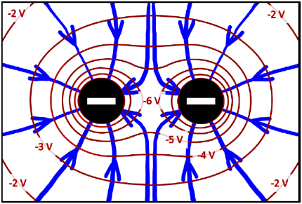
Figure 14.10: Electric field and electric potential around a pair of electrons that are 1 nm apart. The field lines all turn away from the midpoint between the electrons. The field is zero there.94
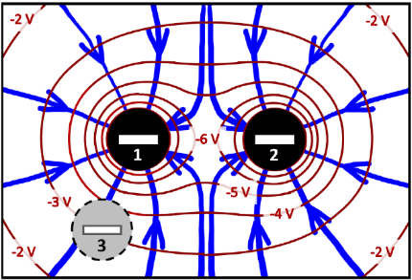
Figure 14.11: Electric field and electric potential around a pair of electrons that are 1 nm apart. The field lines all turn away from the midpoint between the electrons. The field is zero there.94

Numbers
Assumptions: the charges are in free space; no other charges or objects interact with the charges. “electron 1” is at coordinate (0 nm, 0 nm); 2 at (1 nm, 0 nm); 3 at (0 nm, -0.5 nm).
Knowns | Unknowns
$$q_{electron}=-1.6×{10}^{-19} C$$ | ??
$$m_{electron}=9.11×{10}^{-31} kg$$
$$v_{3,i}=0$$
The total electric potential caused by electrons 1 & 2 at the position of electron 3, can be used to find the initial electric potential energy of electron 3.
$$\begin{aligned}V_{e,tot}&=V_{e,1}+V_{e,2} \\ &=\frac{k_{e}⋅q_{1}}{r_{13}}+\frac{k_{e}⋅q_{2}}{r_{23}} \\ &=k_{e}⋅q_{electron}⋅\left(\frac{1}{r_{13}}+\frac{1}{r_{23}}\right) \\ &=\left(8.99×{10}^{9} N⋅m^{2}/C^{2}\right)⋅\left(-1.6×{10}^{-19} C\right)⋅ \\ & \left(\frac{1}{0.5×{10}^{-9} m}+\frac{1}{1.12×{10}^{-9} m}\right) \\ &=-4.16 V \\ U_{e,3,i}&=q_{3}⋅V_{e,tot} \\ &=\left(-1.6×{10}^{-19} C\right)⋅\left(-4.16 V\right) \\ &=6.66×{10}^{-19} J\end{aligned}$$

Words
When electron 3 is released, it will accelerate in the direction of the force, which is opposite the direction of the electric field (because the charge is negative and for negative charges the force is always opposite the direction of the electric field). It will accelerate down and slightly to the left.
As electron 3 moves, away from the other two, it moves to an area where the electric field is lower, so its acceleration decreases. So, the electron will continue to accelerate away from the other two electrons, but with decreasing acceleration.
Since the acceleration is changing as the electron moves, the easiest way to determine speed is not from motion or forces but energy. The electron’s energy is conserved, and the only forms of energy that are significant in this scenario are kinetic energy and electric potential energy. So, if we know the initial kinetic energy and the electric potential energy at any point in space then we can find the kinetic energy at any point in space.

Graphics
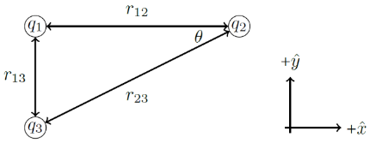
Figure 14.12: Triangle used for calculating sides, angles, and vector components using the Pythagorean theorem and the definitions of sine, cosine, and tangent.¹
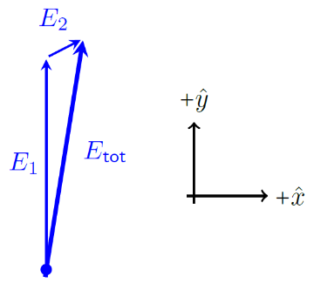
Figure 14.13: Vector sum of the electric fields created by electrons 1 & 2 at the position of electron 3.¹

Numbers
We can also find the electric field caused by electrons 1 & 2 at the position of electron 3 and use that to find the initial acceleration of electron 3 when it is released.
$$\begin{aligned}\vec{E_{tot}}&=\vec{E_{1}+E_{2}} \\ &=\left(E_{1x}+E_{2x}\right) \hat{x}+\left(E_{1y}+E_{2y}\right) \hat{y} \\ E_{1y}&=\frac{k_{e}⋅\left|q_{1}\right|}{r_{13}^{2}}=5.75×{10}^{9} N/C \\ E_{2x}&=\frac{k_{e}⋅\left|q_{2}\right|}{r_{23}^{2}}⋅cos\left(\tan^{-1}\left(\frac{0.5}{1}\right)\right)=1.03×{10}^{9} N/C \\ E_{2y}&=\frac{k_{e}⋅\left|q_{2}\right|}{r_{23}^{2}}⋅sin\left(\tan^{-1}\left(\frac{0.5}{1}\right)\right)=5.15×{10}^{8} N/C \\ \vec{E_{tot}}&=1.03×{10}^{9} N/C \hat{x}+6.27×{10}^{9} N/C \hat{y}\end{aligned}$$
Now we can find the force on electron 3 at that position using Equation ( 14.4 ) and Newton’s 2nd Law.
$$\begin{aligned}\vec{F_{net,3}}&=m_{3}⋅a_{3}=q_{3}⋅\vec{E_{tot}} \\ \vec{a_{3}}&=\frac{q_{3}⋅\vec{E_{tot}}}{m_{3}} \\ &=-1.81×{10}^{20} m/s^{2} \hat{x}-1.10×{10}^{21} m/s^{2} \hat{y}\end{aligned}$$
The electron will accelerate down and left, and we can find its final speed using conservation of energy. Since we are only dealing with kinetic energy and electric potential energy…
$$\begin{aligned}U_{e,3,f}+E_{k,3,f}&=U_{e,3,i}+E_{k,3,i} \\ \frac{1}{2}⋅m_{3}⋅v_{3,f}^{2}&=U_{e,3,i} \\ v_{3,f}&=\sqrt{\frac{2⋅6.66×{10}^{-19} J}{9.11×{10}^{-31} kg}}=1.21×{10}^{6} m/s\end{aligned}$$

: Dipoles and Charged Plates ( , )

Words
There are two combinations of charges that appear often in the world around us. One, which often occurs naturally, is the dipole. The other, which is rarer in nature but is part of many electrical and electronic inventions, is the charged plate.
A dipole is simply two charges of the same magnitude, one positive and one negative, separated by a relatively small distance. A single molecule of table salt (sodium chloride) is an example of a dipole. Each sodium atom tends to lose an electron to a chlorine atom. So, a single molecule of NaCl that is bound to a chlorine atom with a charge of +e is made up of a sodium atom with a charge of −e.
Notice that there is a straight, vertical equipotential directly between the charges in the sketch of a dipole in Figure 14.14. At every point on that line the distance to both charges is the same. Since the signs of the charges are equal and opposite, their electric potentials cancel each other out along that line; the electric potential on that line is zero.
Unlike with point charges, the electric field created by a plate is constant, not decreasing with distance from the plate. This creates a field and potential that looks very much like the gravitational field and gravitational potential near the surface of the earth.

Graphics
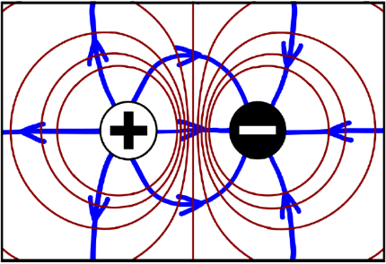
Figure 14.14: A dipole created by a positive and negative charge with equal magnitudes. Only the outer equipotentials have been drawn; there should be many more encircling each charge.94
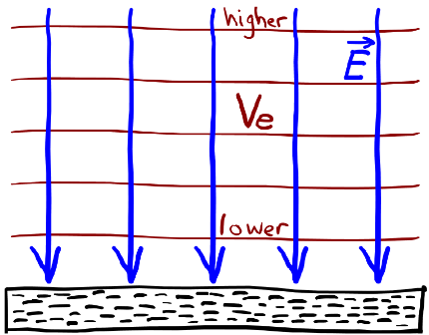
Figure 14.15: Electric field and equipotentials above a negatively charged plate.1

Numbers
Assumptions: the charges are in free space; no other charges or objects interact with the charges. Details from Figure 14.17, $+\hat{x}$ to the right, $+\hat{y}$ up.
Knowns | Unknowns
$$q_{electron}=-1.6×{10}^{-19} C$$ | ??
$$m_{electron}=9.11×{10}^{-31} kg$$
$$\vec{v_{i}}=500 m/s \hat{x}$$
$$\vec{E}=-25 N/C \hat{y}$$
$$\vec{x_{i}}=0 m \hat{x}+0.0005 m \hat{y}$$
$$y_{top}=0.001 m$$
$$y_{bottom}=0 m$$
Since we have the electric field and the charge, we can find the electric force on the electron, and with no other interactions that is also the net force, so we can also find the acceleration.
$$\vec{F_{net}}=\vec{F_{e}}=q_{electron}⋅\vec{E} \\ =\left(-1.6×{10}^{-19} C\right)⋅\left(-25 N/C \hat{y}\right) \\ =4×{10}^{-18} N \hat{y}$$
$$\vec{a}=\frac{\vec{F_{net}}}{m_{electron}}=\frac{4×{10}^{-18} N \hat{y}}{9.11×{10}^{-31} kg} \\ =4.39×{10}^{12} m/s^{2} \hat{y}$$
The electron would rapidly accelerate up toward the positively charged plate. Since we know that distance, we can find the time this takes by considering only the y direction.

Words
When we learned about gravitational potential energy near the surface of the earth, we were free to define “zero” at any height we chose. In the same way, when working with electric potential near charged plates we are free to define zero wherever we choose.
It is relatively easy to create a uniform electric field using “parallel plates,” putting two plates next to each other, charging one positively and the other negatively as shown in Figure 14.16. Notice the region in the center where the electric field lines and equipotential lines are uniform and parallel.
Let’s consider what would happen to an electron that was fired horizontally through the center of such a parallel-plate device. Assume that the spacing between the plates is 0.001 m, the electric field strength is 25 N/C, and the electron has an initial speed of 500 m/s. This situation is sketched in Figure 14.17.
We should expect that the electron, with its negative charge, should be repelled by the negative charges in the lower plate and attracted by the positive charges in the upper plate. In the numbers column the calculations show a large upward acceleration, so that makes sense. It is, however, probably a bit surprising just how large the acceleration is. The electron hits the upper plate after only a few nanoseconds, before it can travel more than a few micrometers to the right.

Graphics
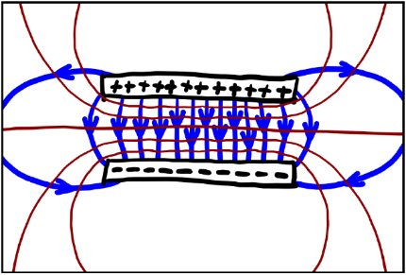
Figure 14.16: Electric field and equipotentials around a pair of charged parallel plates.¹
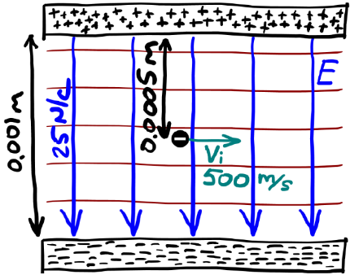
Figure 14.17: Electron initially moving horizontally through a uniform electric field that is pointed down.¹

Numbers
$$\begin{aligned}y&=y_{0}+v_{0,y}⋅t+\frac{1}{2}a_{y}⋅t^{2} \\ y-y_{0}&=\frac{1}{2}a_{y}⋅t^{2} \\ t&=\sqrt{\frac{2⋅\left(y-y_{0}\right)}{a_{y}}} \\ &=\sqrt{\frac{2⋅\left(0.0005 m\right)}{4.39×{10}^{12} m/s^{2}}}=1.5×{10}^{-8} s\end{aligned}$$
In that much time, the electron would only go…
$$\begin{aligned}Δx&=v_{avg,x}⋅t=\left(500 m/s\right)⋅\left(1.5×{10}^{-8} s\right) \\ &=7.55×{10}^{-6} m\end{aligned}$$
…to the right.

: Summary
Chapter summaries in this book are ordered by concept, not necessarily in the order in which they are presented in the chapter. Mathematical models are grouped together at the end of each summary. See the appendices for the meanings of all symbols used in this book.

Forces, Fields, & Acceleration
- Field lines always start and end at either the source that creates them or at infinity.
- Electric field lines point toward negative charges and away from positive charges.
- Closely spaced electric field lines indicate an area with high electric field.
- Positive charges feel a force in the direction of the electric field; negative charges feel a force opposite the direction of the electric field.
- Electric fields created by multiple sources can be added as vectors.
- Parallel plates of charge generate uniform electric fields.

Energy & Potential
- The gravitational potential at a point in space describes the gravitational potential energy per kg that an object would have at that point in space.
- Every point on an equipotential line is at the same potential.
- Equipotential lines always cross field lines at right angles.
- Electric potentials created by multiple sources can be added as scalars.

Mathematical Models
Equation | Reference | Restrictions on the validity of the equation
$$V_{e}=\frac{k_{e}⋅q}{r}$$ | ( 14.1 ) | for a point charge in free space
“Coulomb’s Law”  $$E=\frac{k_{e}⋅\left|q\right|}{r^{2}}$$ | ( 14.2 ) | for a point charge in free space
$$U_{e}=q⋅V_{e}$$ | ( 14.3 ) | -none-
$$\vec{F_{e}}=q⋅\vec{E}$$ | ( 14.4 ) | -none-

: Questions
Questions are ordered according to Bloom’s Taxonomy, progressing from regurgitating information (Level 1) to synthesizing new information with previous knowledge to create something new (Level 6). The bold letters at the beginning of each question indicate whether the question involves Words [W], Graphics [G], and/or Numbers [N]. See the appendices for conversion factors.

Level 1 - Remember
      - [W & G] Field lines are drawn as arrows.
        - Where can the arrows start and end?
        - In what direction do the arrows point around a positive charge?
        - In what direction do the arrows point around a negative charge?
      - [N] Suppose an electric field has a magnitude of 15 N/C. What is the electric field strength in V/m?
      - [W] For each of the following, state whether it is a vector or a scalar.
        - Electric field
        - Gravitational field
        - Electric potential
        - Gravitational potential
        - Electric potential energy
        - Gravitational potential energy
        - Electric force
        - Gravitational force
        - Charge
        - Mass
      - [W & N] Add labels to each boxed equation from this chapter that tell what the symbol to the left of the = sign represents
Symbol | Reference | Label
$$V_{e}$$ | ( 14.1 )
$$E$$ | ( 14.2 )
$$U_{e}$$ | ( 14.3 )
$$\vec{F_{e}}$$ | ( 14.4 )

Level 2 - Understand
      - [G & N] Coulomb’s Law…
$$E=\frac{k_{e}⋅\left|q\right|}{r^{2}}$$…is used for finding the electric field created by a point charge. But electric field is a vector, and that equation only gives the magnitude. How is direction determined?
      - [W & G] Can electric field lines and equipotential lines ever be parallel to each other at one point in space? If yes, give an example; if no, explain why not.
      - [W & G] Describe the similarities and differences you see between Figure 14.5 and Figure 14.6, reproduced below. What causes these similarities and differences?
Electric field and electric potential around an electron.94
Electric field and electric potential around a proton.94
      - [G] There are several sketches for a set of three electrons in Section 14.4. What would each of the sketches look like if the third electron had instead been placed…
        - …0.5 nm above electron 1?
        - …0.5 nm above electron 2?
        - …0.5 nm below electron 2?
      - [W & N] In Section 14.5 how could such a small force have created such a huge acceleration for the electron?
      - [W & N] In Section 14.5 why did the electric field not have to be considered when figuring out how far the electron moved in the horizontal direction?

Level 3 - Apply
      - [N] In Section 14.2 a calculation was done to find the distance from an electron to a point in space where the electric potential created by the electron was -1 J/C. Find the distances corresponding to -2 J/C and -3 J/C.
      - [N] At what distance from a proton is the magnitude of the electric field created by the proton equal to 1 N/C?
      - [N] What is the electric field generated by a proton at 1 cm above the proton? Remember, electric field is a vector.
      - [W & N] In Section 14.3 a calculation is done of the amount of work needed to bring two protons to within 1 nm from each other. Re-do the calculation for a pair of electrons instead of a pair of protons. Does your answer make sense?
      - [W & N] In Section 14.3 a calculation is done of the force between two protons that are 1 nm apart. Re-do the calculation for a pair of electrons instead of a pair of protons. Does your answer make sense?
      - [G] Figure 14.13, reproduced below, shows the electric field at the position of electron 3. Create a force diagram that shows the electric forces on electron 3 in that position.
Vector sum to find the total electric field affecting electron 3.1
      - [N] In Section 14.4 the vectors $\vec{E_{tot}}$ and $\vec{a_{3}}$ are left in component ($\hat{x}$ + $\hat{y}$) notation. Convert them to magnitude-and-direction notation (… at an angle …$​^{∘}$ above/below/right/left of …).
      - [G & N] More could have been done in Section 14.5. Sketch the path of the electron between the two plates and find the velocity of the electron just before it hits the positively charged plate.

Level 4 - Analyze
      - [G] Compare Figure 14.3 and Figure 14.5, reproduced below. What similarities and differences do you see? What does this say about the similarities and differences between gravitational and electric fields and potentials?
The gravitational field around Pluto.93
The electric field around an electron.94
      - [W, G, & N] Compare the calculated electric potential in Section 14.4 to the sketch in Figure 14.11. Does the sketch agree reasonably well with the calculation? If so, how can you tell? If not, what is the problem you see?
      - [W, G, & N] The analysis in Section 14.4 was for three electrons. What changes would there be to the analysis and the final answers if we had three protons instead of three electrons? Remember to consider words, graphics, and numbers.
      - [W, G & N] In the caption of Figure 14.10, reproduced below, it mentions that the electric field is zero at the midpoint between the two electrons. That means if the third electron were placed at the midpoint between the other two it would experience a net force of zero and a net torque of zero. In other words, it would be in static equilibrium. Would it be in a stable equilibrium or an unstable equilibrium? You can consider forces, energy, or both in your response.
The electric field around a pair of electrons.94
      - [W, G & N] In the caption of Figure 14.10, reproduced below, it mentions that the electric field is zero at the midpoint between the two electrons. That means if a proton were placed at the midpoint between the two electrons it would experience a net force of zero and a net torque of zero. In other words, it would be in static equilibrium. Would it be in a stable equilibrium or an unstable equilibrium? You can consider forces, energy, or both in your response.
The electric field around a pair of electrons.94

Level 5 - Evaluate
      - [W] The conclusion at the end of Section 14.3 is that we can ignore the effects of gravity when electricity is involved, because electrical forces are so much larger than gravitational forces. But almost everything in the universe is made up of charged particles. And ever since the beginning of this book we have been getting good results with gravity even though we were completely ignoring electricity and the charges making up the various objects that we have been analyzing. Why were we able to ignore electricity before?
      - [N] At the end of Section 14.4 the calculated value of the electron’s final speed is quite large. Maybe we should have considered special relativity when doing the solution. Would the answer change significantly (more than a few percent) if we took special relativity into account?
      - [W] What would happen to the path of the electron in Section 14.5 if both the top and the bottom plates had negative charge?
      - [W & G] Compare the shape of the gravitational field around Pluto and Charon in Figure 14.4, reproduced below, with the electric field around two electrons in Figure 14.10, also reproduced below.
Gravitational field of Pluto and Charon.93
Electric field of two electrons.94
        - Describe the similarities and differences that you see.
        - Notice that there is a point in space between Pluto and Charon that the field lines seem to avoid the same way that they avoid the midpoint between the electrons. Why is it not in the middle between Pluto and Charon?
        - Use an electric field simulator like the one at https://icphysweb.z13.web.core.windows.net/simulation.html to create an electric field that looks like the gravitational field around Pluto and Charon. Describe what you had to do to make the field correct, and what that means about the relationship between Pluto and Charon.

Level 6 - Create
      - [W, G, & N] At the beginning of Chapter 1 in Figure 1.1 was a template for a concept map. Create a new concept map with the main ideas from this chapter.
      - [W, G, & N] Imagine you are writing a test question related to this chapter. Think of your own example of a situation that you can analyze using the concepts, graphics, and mathematical analyses described in this chapter. Describe the situation and use the tools from this chapter to analyze the situation as completely as you can, including motion, forces, energy, and momentum.
      - [W, G, & N] Think about possible misconceptions about the material in this chapter. Write a question and an incorrect solution to it that demonstrates a student making such a conceptual error. This cannot be a simple misuse of a vocabulary word, a unit error, or a mathematical error like making an addition error or multiplying when addition was needed, unless the error is rooted in a real misunderstanding about the physics behind the calculation or the misuse of a word. After you have written the question and incorrect solution, explain what is wrong with the student’s solution, and write a correct solution to the problem. Note: You may use a question from this chapter that you got wrong the first time and explain the initial error in your thinking and how you corrected it.

– Electricity in Materials
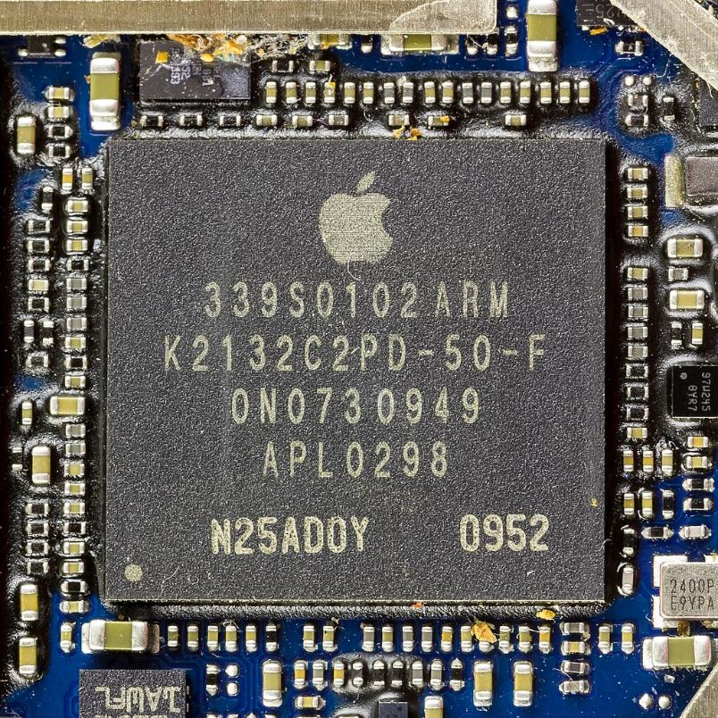
Figure 15.1: This is part of the mainboard of an iPhone. The large square in the center is an integrated circuit that is beyond the level of this course. But all around it are simple boxes (resistors and capacitors) that are essentially parallel plates with different materials between them, exactly what we will be studying in this chapter!.

Chapter 14 introduced the idea of electric fields but dealt with fields only in “free space” where there is nothing else interfering with the individual charges. While the universe contains a lot of free space, it isn’t something we encounter much in our daily lives. The world we inhabit is full of solids, liquids, and gases, all made up of a variety of different atoms and molecules. So, we will need to learn how materials interact with electric fields.
We will focus on uniform electric fields, like those produced between two parallel plates. In fact, everything we will deal with in this chapter happens between two charged parallel plates. In all cases we will assume that there is an equal amount of charge on each plate, that the electric field between the plates is uniform, and that there is no electric field except between the plates. These assumptions sound restrictive, but in fact they are quite reasonable. Notice that almost all the field lines in Figure 14.16 are in fact straight, parallel, equally spaced, and contained in the space between the plates.
We will look a bit more closely at the electric field and the electric potential between the plates, and then we will start filling the space between the plates with various materials to see what happens.

: Parallel Plates ( , )

Words
Let’s begin with two parallel plates, each in the shape of a 0.3 m x 0.3 m square. The plates are facing each other with an empty space of 0.002 m between them, as shown in Figure 15.2. These plates are then charged so that one has a net positive charge and the other has a net negative charge. There is enough charge on the plates to create a uniform electric field of 300 N/C between them. What can we determine about the electric potential and the amount of charge on the plates?
The description above says “net” charge. Why is that important? Materials are mostly made of atoms, and atoms are made of protons, neutrons, and electrons. If there are equal numbers of protons and electrons, there is zero net charge. If we want to give something a positive charge, we don’t need to remove all the electrons. If we just remove a few electrons, or just add a few protons, the excess protons will be enough to create a net charge.
In fact, now that we’re not really dealing with single electrons and protons anymore, we will start referring to amounts of charge in Coulombs. Remember that the elementary charge is $1.6×{10}^{-19} C$, so when we talk about charge in Coulombs we are talking about almost uncountably large numbers of protons and electrons. To show where the excess charge is located, sketches like Figure 15.3 have some “+’s” and “-’s,” but nothing remotely close to the actual number of excess protons or electrons.

Graphics
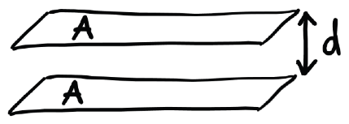
Figure 15.2: A sketch of the configuration of plates that is used throughout this chapter.¹
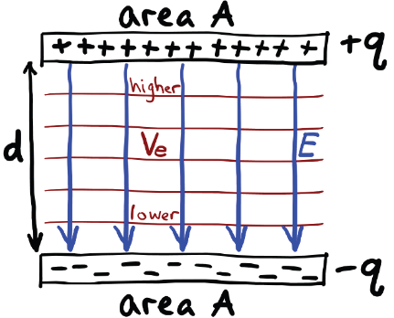
Figure 15.3: An edge-on sketch of the configuration of plates that will be used throughout this chapter, not to scale. Each plate has an area $A$ and contains either a charge $+q$ or $-q$. The plates are separated by a distance $d$. The space between the plates contains a uniform electric field and varying electric potential.¹
Note that the area of the plates is not the size of the rectangles in Figure 15.3; the area extends into the page, so it isn’t visible from this angle.

Numbers
Assumptions: uniform electric field between the plates; there is only empty space between the plates.
Knowns | Unknowns
$$A=\left(0.3×0.3\right) m^{2}=0.09 m^{2}$$ | $$ΔV_{e}$$
$$d=0.002 m$$ | q
$$E=300 N/C$$
This relationship between any uniform electric field and the change in electric potential across any displacement $\vec{Δx}$ within that field is given by…
$$\boxed{ΔV_{e}=-E⋅Δx⋅cosθ}$$
( 15.1 )
…where $θ$ is the angle between $\vec{E}$ and $\vec{Δx}$.
In this scenario, if we take $\vec{Δx}$ to be from the negative plate to the positive plate (opposite the direction of the field)…
$$\begin{aligned}ΔV_{e}&=\left(-300 N/C\right)⋅\left(0.002 m\right)⋅cos\left({180}^{∘}\right) \\ &=0.6 N⋅m/C =0.6 V\end{aligned}$$
The voltage across this set of parallel plates is 0.6 V, with the positive plate at higher potential.
The relationship between the charge and the electric field between two parallel plates is…
$$\boxed{E=\frac{q}{A⋅ϵ}}$$
( 15.2 )

Words
If we think about the electric potential between the plates, we know that positive electric charges create a positive electric potential that decreases with distance from the charge, and negative electric charges create a negative electric potential that decreases with distance from the charge. So, we should expect that the electric potential is more positive at the plate with a net positive charge and more negative at the plate with a net negative charge.
With point charges we usually found the actual electric potential, but with materials the important thing isn’t the electric potential itself but the change in electric potential, usually called a “voltage.” A “high voltage” wire has an electrical potential that is very different, typically by thousands of volts, from the electric potential of the ground below it. A bird can sit on a high-voltage wire as safely as it can sit on the ground. The danger comes if the bird were to touch both the wire and the ground at one time, because then there would be a large change in electric potential across the bird.
The more charge we put on the plates, the higher the change in electric potential. The amount of charge per volt is called the capacitance, and the capacitance depends on the area of the plates and the separation between them.

Graphics
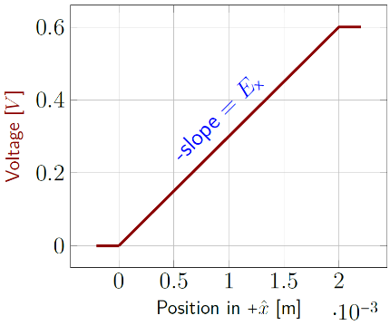
Figure 15.4: When there is a uniform electric field, the opposite of the slope of a voltage-vs-position graph gives the electric field.¹
If the electric field and the displacement are both measured in the same direction, making $θ$ equal to zero, then Equation ( 15.1 ) could be rearranged to…
$$E=-\frac{ΔV_{e}}{Δx}$$
That means if the electric field is uniform, as it is between parallel plates, the electric field is the opposite of the slope on a voltage-vs-position graph.

Numbers
…where $ϵ$ (the lowercase Greek letter epsilon) is the “permittivity” of the material between the plates. If the space is empty, we use the “permittivity of free space,” $ϵ_{0}$, “epsilon nought.” $ϵ_{0}$ is related to Coulomb’s constant:
$$k_{e}=\frac{1}{4π⋅ϵ_{0}}$$
The value for $ϵ_{0}$ is $8.85×{10}^{-12}$ F/m. “F” is for farad, the SI unit for “capacitance.”
Charge is proportional to voltage, and the ratio of the two is called capacitance $C$.
$$\boxed{C=\frac{q}{ΔV_{e}}}$$
( 15.3 )
Combining the equations from this section…
$$\boxed{C_{pp}=\frac{A⋅ϵ}{d}}$$
( 15.4 )
…for a parallel-plate capacitor. Putting in the numbers for this example, we have…
$$C_{pp}=\frac{\left(0.09 m^{2}\right)⋅\left(8.85×{10}^{-12} F/m\right)}{0.002 m}=398 pF$$
…which we can use to find that the magnitude of charge on each plate is $2.39×{10}^{-10} C$..

: Energy Storage ( , )

Words
Let’s use the same parallel-plate capacitor that we used in Section 15.1, but this time focus on energy. We already found the electric potential difference between the plates was 0.6 V when they were charged enough to have an electric field of 300 N/C. But usually, things start out with no net charge, and we need to do something to charge them. So, this time let’s start with no net charge on either plate, and then slowly move charges from one plate to the other until we get to a final electric field strength E_{f} of 300 N/C.
At first it takes almost no work to start moving positive charge from the negative plate to the positive plate, because there is almost no change in electric potential between the two plates. Or looking at it in another way, there is almost no electric field between the two plates to push the charge back toward the negative plate.
But as can be seen in Figure 15.5, the situation changes as more positive charges are moved from the negative plate to the positive plate. It gets harder to move the charges, because they are moving against the force caused by the growing electric field. So, with every charge moved, the amount of energy needed to move the next charge increases.

Graphics
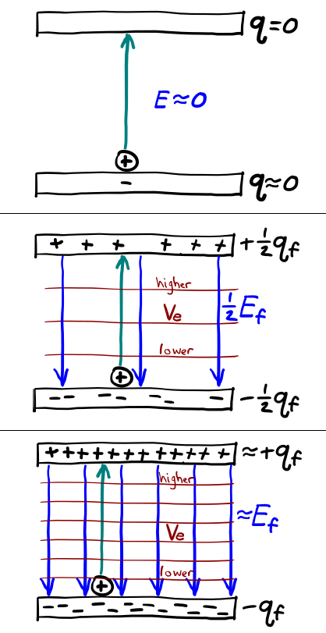
Figure 15.5: As a capacitor is charged, electric field and voltage steadily increase.¹

Numbers
Assumptions: uniform electric field between the plates; there is only empty space between the plates.
Knowns | Unknowns
$$A=0.09 m^{2}$$ | Energy
$$d=0.002 m$$
$$C=398 pF$$
$$E_{i}=0$$
$$E_{f}=300 N/C$$
$$ΔV_{e,i}=0$$
$$ΔV_{e,f}=0.6 V$$
Analysis in the “Graphics” column of the graph in Figure 15.6 gives the following for the electric potential energy stored in a capacitor:
$$U_{c}=\frac{1}{2}q⋅ΔV_{e}$$
If this is used in combination with Equation ( 15.3 ), we can find other relationships as well. For example, we can replace $q$ with $C$ and $ΔV_{e}$:
$$\begin{aligned}U_{c}&=\frac{1}{2}q⋅ΔV_{e} \\ &=\frac{1}{2}\left(C⋅ΔV_{e}\right)⋅ΔV_{e} \\ &=\frac{1}{2}C⋅{\left(ΔV_{e}\right)}^{2}\end{aligned}$$
In fact, there are three different ways to express $U_{c}$.

Words
Let’s pause for a moment and think about how we would actually make charge move from one plate to the other. It isn’t as though we could take a pair of tweezers and pluck charges out of one side and drop them on the other. The way it is normally done is to apply an external voltage to the plates, putting one at a higher electric potential than the other. This creates an electric field that moves charges until everything is balanced. So instead of thinking of the voltage in the capacitor as being determined by the charge, we can think of the amount of charge being determined by the voltage. This is illustrated in Figure 15.6.
For this example, the total energy stored in the capacitor, calculated in the “Numbers” column, would be $7.17×{10}^{-11} J$ when it is charged to 0.6 V. Where, exactly, is that energy? The energy is stored in the electric field. Fields can store energy! We have seen that before with gravity. The two black holes in Section 5.6 lost two solar masses’ worth of energy when they merged. That energy was carried off by waves in the gravitational field.
If the energy stored in a capacitor is in the field, and the field is contained in the capacitor, then we can figure out the energy density inside the capacitor by dividing energy by volume. Energy density is an important concept, for example when designing vehicles. A vehicle must carry enough potential energy to go a reasonable distance, so having a way to store a large amount of energy per volume or energy per mass is necessary for a vehicle to be useful.

Graphics
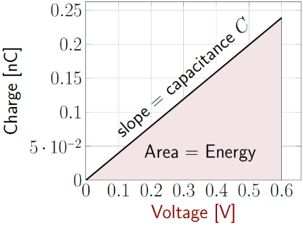
Figure 15.6: Capacitance is charge per volt, so the slope of a charge-vs-voltage graph. The area under the curve represents the amount of potential energy $U_{c}$ stored in the capacitor.¹
Since electric potential energy is charge multiplied by electric potential, the energy required to charge a capacitor is equal to the area under the curve of a charge-vs-voltage graph. This is the amount of energy stored in a capacitor, $U_{c}$. And since any capacitor will have a graph with this same triangular shape…
$$U_{c}=\frac{1}{2}q⋅ΔV_{e}$$
…for any capacitor.

Numbers
$$\boxed{U_{c}=\frac{1}{2}q⋅ΔV_{e}=\frac{1}{2}C⋅{\left(ΔV_{e}\right)}^{2}=\frac{q^{2}}{2⋅C}}$$
( 15.5 )
All these ways to express $U_{C}$ are valid for any capacitor. For this example, the initial potential energy stored in the capacitor is zero and the final potential energy in the capacitor is…
$$U_{c,f}=\frac{1}{2}\left(398×{10}^{-12} F\right)⋅{\left(0.6 V\right)}^{2}=7.17×{10}^{-11} J$$
To find the electric energy density $u_{e}$ in terms of the electric field, we can divide the electric potential energy by the volume, which would be $A⋅d$ then subsitute in for the field using Equation ( 15.2 ):
$$\begin{aligned}u_{e}&=\frac{q^{2}}{2⋅C}⋅\frac{1}{A⋅d} \\ &=\frac{{\left(E⋅A⋅ϵ\right)}^{2}}{2⋅\left(A⋅ϵ/d\right)}⋅\frac{1}{A⋅d} \\ &=\frac{E^{2}⋅A^{2}⋅ϵ^{2}}{2⋅A^{2}⋅ϵ}=\frac{ϵ}{2}E^{2}\end{aligned}$$
This result is valid not just between parallel plates, but anywhere:
$$\boxed{u_{e}=\frac{ϵ}{2}E^{2}}$$
( 15.6 )
For this capacitor,
$$\begin{aligned}u_{e,f}&=\frac{8.85×{10}^{-12} F/m}{2}⋅{\left(300 V/m\right)}^{2} \\ u_{e,f}&=3.98×{10}^{-7} J/m^{3}\end{aligned}$$

: Insulators ()

Words
We will continue to use the same parallel plates in this section, but now we will fill the space between the plates with an insulator. An insulator is a type of material, usually a solid, whose electrons are held tightly to the atoms they are orbiting. In a solid material we already know that the atoms themselves are held in position fairly tightly, so they don’t move around through the material. That means the atomic nuclei, which contain all the positive charges, are stuck in place. If the electrons are held tightly to the atoms, then they, too, are mostly stuck in place. But not completely…
If an electric field is applied across an insulator, the positive nuclei feel a pull in the direction of the field and the negative electrons feel a pull opposite the direction of the field. Remember that nuclei are much more massive than electrons, so they are much more difficult to move. The effect of this is that the electron cloud shifts very slightly in the direction opposite the electric field. This is called “polarization.”
Polarization causes a thin skin of excess negative charge on the side where the electric field is pointing into the insulator. On the other side, where the electric field is pointing out of the insulator, there is a thin skin of excess positive charge.

Graphics
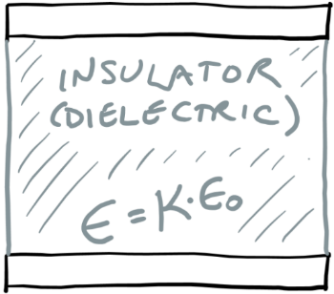
Figure 15.7: This is the same set of plates we have already been using, but this time the space between is filled with an insulator.¹
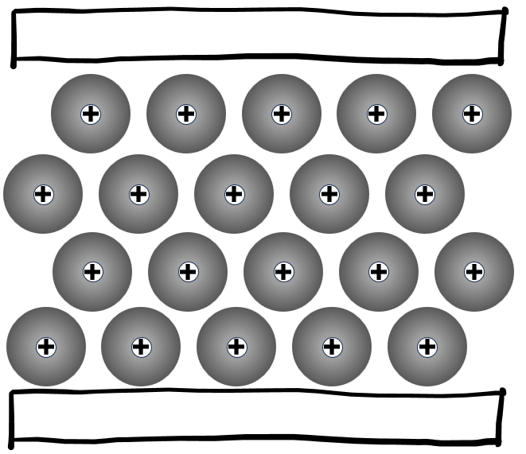
Figure 15.8: A sketch showing the atoms (large gray electron clouds around small nuclei) of the insulator, at a grossly enlarged scale, when there is zero voltage across the plates.¹

Numbers
Assumptions: uniform electric field between the plates.
Knowns | Unknowns
$$A=0.09 m^{2}$$ | $$C$$
$$d=0.002 m$$ | $$q$$
$$κ=2.3$$ | $$u_{e}$$
$$ΔV_{e}=0.6 V$$ | $$U_{c}$$
We already have almost all the necessary tools to find all the unknowns. There is just one piece that we are missing: Relative permittivity $κ$, which relates a material’s permittivity to the permittivity of free space:
$$\boxed{ϵ=κ⋅ϵ_{0}}$$
( 15.7 )
$κ$ is a dimensionless constant.
Many of our mathematical models are written in terms of $ϵ$, and we used them already in free space where $κ$ is 1. Now we need to re-do our calculations with the new value for $κ$. Starting with the capacitance for a parallel-plate capacitor:
$$\begin{aligned}C_{pp}&=\frac{A⋅ϵ}{d}=\frac{A⋅κ⋅ϵ_{0}}{d} \\ &=\frac{0.09 m^{2}⋅2.3⋅8.85×{10}^{-12} F/m}{0.002 m} \\ &=916 pF\end{aligned}$$

Words
When a capacitor is filled with an insulator, the thin skin of charge effectively cancels out some of the charge on the plate, so the capacitor can hold more charge per volt applied. So, the capacitance increases. The amount of change depends on the “relative permittivity,” also called the “dielectric constant,” κ, of the material. The value of κ varies with the material. “Dielectric” is another word for “insulator,” especially in a situation where the dielectric constant is an important design feature.
Let’s use polypropylene in our example, because this is a common polymer that is used in capacitors. Its relative permittivity is approximately 2.3. We will again make a parallel-plate capacitor with the same dimensions as before, but this time we will fill it with polypropylene. We can first find the capacitance, then charge it to 0.6 V and find out how much charge is on the plates, the energy density inside the capacitor, and how much energy is stored in the capacitor.
All these quantities are found in the “Numbers” column. It is interesting to compare the values with the parallel-plate capacitor with only empty space between the plates. The capacitance went up by a factor of 2.3, directly related to the relative permittivity. Since the capacitor was charged with the same voltage, that means the charge also went up by a factor of 2.3, and because of that, the energy stored also went up by a factor of 2.3. And since 2.3 times as much energy is stored in the same volume, the energy density also went up by a factor of 2.3.

Graphics
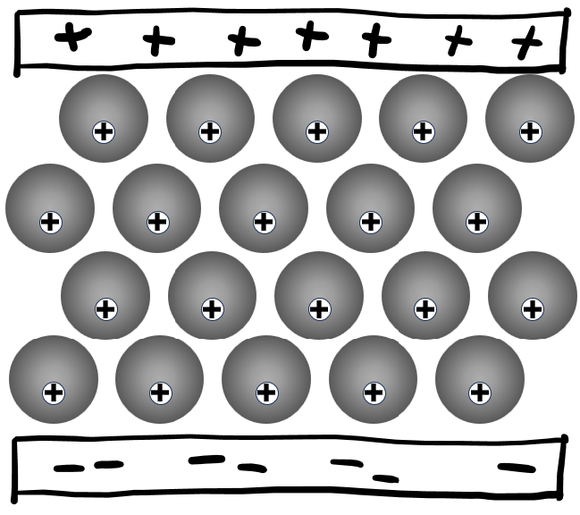
Figure 15.9: When a voltage is applied, the electrons in the insulator shift slightly toward the positive plate, effectively creating a skin of negative charge inside the top of the insulator and a skin of positive charge inside the bottom of the insulator.¹

Numbers
We can use the definition of capacitance to find the charge…
$$\begin{aligned}C&=\frac{q}{ΔV_{e}} \\ q&=C⋅ΔV_{e} \\ &=\left(916 pF\right)⋅\left(0.6 V\right) \\ &=5.5×{10}^{-10} C\end{aligned}$$
…and from that we can find the energy stored:
$$\begin{aligned}U_{c}&=\frac{1}{2}q⋅ΔV_{e} \\ &=\frac{1}{2}⋅\left(5.5×{10}^{-10} C\right)⋅\left(0.6 V\right) \\ &=1.65×{10}^{-10} J\end{aligned}$$
Neither $d$ nor $ΔV_{e}$ changed, so we can look at either Figure 15.4 or Equation ( 15.1 ) to see that there should also be no change in $E$. It remains 300 N/C. Then we can use Equation ( 15.6 ) to find the energy density:
$\begin{aligned}u_{e}&=\frac{ϵ}{2}E^{2} \\ &=\frac{2.3⋅\left(8.85×{10}^{-12} F/m\right)}{2}⋅{\left(300 N/C\right)}^{2} \\ &=9.16×{10}^{-7} J/m^{3}\end{aligned}$.

: Conductors ()

Words
As with insulators, the nuclei in solid conductors do not move. But unlike with insulators, some electrons can freely move through the conductor. Many metals have a small number of electrons that they don’t hold tightly to in their outermost electron shell. These “free” electrons can move from one atom to the next relatively easily. They can’t easily leave the conductor itself, but they can travel around inside the conductor.
What happens if we put a conductor inside the parallel plate capacitor that we’ve been analyzing? For now, we will not allow the conductor to touch the plates–we will let it touch in Section 15.5.
If the conductor is first positioned between the parallel plates as shown in Figure 15.10 and then a voltage is applied between the plates, two things happen fairly quickly. First, an electric field is created between the plates. That happens extremely quickly because electric fields can travel through conductors almost as fast as the speed of light. So almost instantly there is an electric field passing through the conductor.
Second, again happening at almost the speed of light, the free electrons rearrange themselves. They have negative charge, so they move away from the negative plate and toward the positive plate, as shown schematically in Figure 15.11.

Graphics
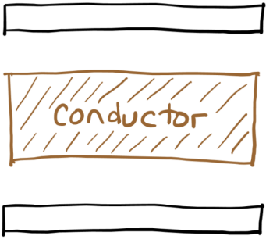
Figure 15.10: A conducting material between the parallel plates, but not touching either one.¹
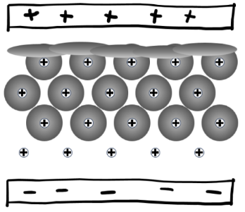
Figure 15.11: Electrons from the outer shell of atoms in a conductor can leave their atoms and move through the conductor. In this situation, some would leave the atoms nearest the negative plate and move close to the positive plate.¹

Numbers
(This column intentionally left blank)

Words
If the electrons were truly free, they would accelerate because of the electric force. But they behave more like a gas, bouncing around off each other, and they still must move through a lattice of nuclei that are attracting them. These interactions create an effect that looks a lot like frictional force, slowing electrons to an average “drift velocity” that is much less than 1 m/s. But for the charge to rearrange from something like Figure 15.8 to something like Figure 15.11, no electrons have to go very far; every free electron just needs to shift up by one atom. That is how the charge distribution in the conductor can move at nearly the speed of light when individual charges are moving at a crawl.
The result looks like Figure 15.12. The same amount of charge builds up on each surface of the conductor as there was on the plates around it, and at that point the electric field everywhere inside the conductor is zero and the electrons stop flowing upward. Interestingly, it ends up looking like two capacitors stacked on top of each other, one between the conductor and the top plate and the other between the conductor and the bottom plate.
This is like the situation for insulators, in that there are skins of negative charge at the top and positive charge at the bottom. But look at the atoms in the middle of the conductor in Figure 15.11 compared to the atoms in the middle of the conductor in Figure 15.9. There is still an electric field shifting the electrons upward in the center of the insulator, because polarization of an insulator is a weaker effect than rearrangement of charge in a conductor.

Graphics
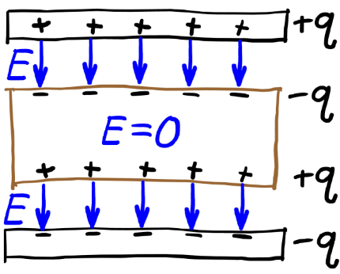
Figure 15.12: Electrons in a conductor rearrange themselves until there is no electric field inside the conductor.¹

Numbers
(This column intentionally left blank)

: Electric Current ( , )

Words
Now, we will let the conductor touch the plates of the capacitor. If we apply a voltage to put positive charge on the top plate and negative charge on the bottom plate, electrons will leave the conductor at the top, bringing the net charge of the top plate back to zero. And electrons will leave the bottom plate, entering the conductor and bringing the net charge of both the conductor and the bottom plate back to zero. This movement of electrons is shown in Figure 15.14. Remember, this redistribution of charge happens at nearly the speed of light, so no matter how quickly charge is pushed onto the plates it will not be able to collect on either plate. We can no longer charge the plates!
Electric current is the amount of charge flowing past a certain point over time. Unfortunately, current is defined in direction that positive charges flow, opposite the direction that electrons flow, as shown in Figure 15.14. The amount of current flow depends on three things: the “resistivity” of the conducting material, the physical dimensions of the conductor, and the voltage across it. A “good” conductor with low resistivity does not resist the flow of current as much as a “poor” conductor with high resistivity.
As the length (l in Figure 15.13) of the conductor increases, there is more material resisting the flow, so current decreases. As the area that the current can flow through increases, it becomes easier for current to flow, so current increases.

Graphics
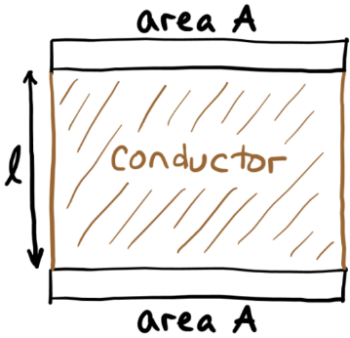
Figure 15.13: A conducting material filling the space between two parallel plates. The distance between plates is labeled “$l$,” for length.¹
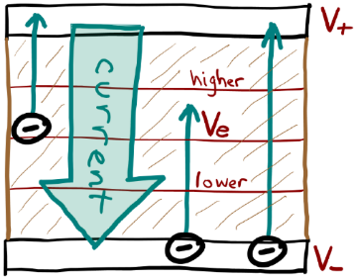
Figure 15.14: Electrons flow from low to high electric potential. But electric current is defined in the direction that positive charges would flow, from high to low electric potential.¹

Numbers
Assumptions: uniform electric field between the plates; made from nichrome; nichrome is “ohmic.”
Knowns | Unknowns
$$d_{coil}=0.15 m$$ | $$A_{wire}$$
$$ΔV_{e}=240 V$$
$$P=1500 W$$
$$ρ_{e,nichrome}=1.09×{10}^{-6} Ω⋅m$$
The resistivity of nichrome in the “knowns” was found using an internet search; the units are “ohm-meters.” The upper-case Greek letter omega is the symbol for ohms, the unit of resistance.
The resistance $R$ of a conductor is determined by its dimensions (length $l$ and area $A$) and by the resistivity $ρ_{e}$ of the material from which it is made:
$$\boxed{R=\frac{ρ_{e}⋅l}{A}}$$
( 15.8 )
The length is measured in the direction of current flow, and the area is for the surface through which the current flows.
To find the amount of current $I$, we can use Ohm’s Law, which is valid for ohmic materials:
$$\boxed{ΔV_{e}=I⋅R}$$
( 15.9 )

Words
It may be helpful to think of current flow using the analogy of vehicles in heavy traffic. A rutted dirt road (high resistivity) resists the flow of traffic much more than a hard, smooth surface (low resistivity). Having to go farther on a rutted dirt road (increased length) also decreases the flow of traffic. But adding more lanes to a road (increased area) increases the flow of traffic.
As electrons flow through a conductor, they lose electric potential energy, but they don’t gain kinetic energy. Instead, the friction-like resistance generates thermal energy. This is how most electric heaters work. Let’s consider the current flow through a six-inch burner for an electric stove, like the one in Figure 15.15. The coil is designed to produce 1500 W of heat when 240 V is applied to it. Most stove coils are made of nichrome, so we will assume this one is the same. We can estimate the length of the coil from the photograph. Let’s see if we can use the electrical properties to find the cross-sectional area of the nichrome wire that is coiled to form the burner.
This calculation is done in the “Numbers” column, finding an area of $3.69×{10}^{-8} m^{2}$. That seems really small! In fact, it’s the area of a circle with a diameter of less than 1 mm. The wire coiled in Figure 15.15 looks much larger than 1 mm. Looking at another coil’s electrical connection, in Figure 15.16, we can see that the nichrome is a small wire inside a much thicker insulating material.

Graphics
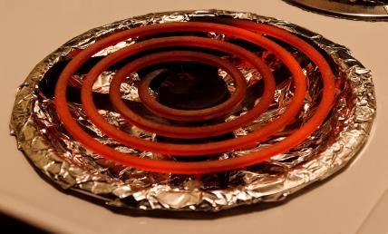
Figure 15.15: A six-inch electric range coil.
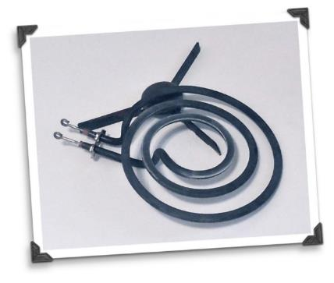
Figure 15.16: Another electric range coil, this time showing the electrical connection.

Numbers
…where current is charge per time, measured in amperes (A), often shortened to “amps:”
$$\boxed{I=\frac{q}{Δt}}$$
( 15.10 )
Power is energy per time, and the amount of electric energy that is converted to thermal energy over time would be…
$$P=\frac{ΔU_{e}}{Δt}=\frac{q⋅ΔV_{e}}{Δt}=I⋅ΔV_{e}$$
Combining this result with Ohm’s Law gives three different expressions for power dissipated into thermal energy in an ohmic material:
$$\boxed{P=I⋅ΔV_{e}=\frac{{\left(ΔV_{e}\right)}^{2}}{R}=I^{2}⋅R}$$
( 15.11 )
In this example, we know the power and the voltage, so we can find the resistance:
$$R=\frac{{\left(ΔV_{e}\right)}^{2}}{P}=\frac{{\left(240 V\right)}^{2}}{1500 W}=38.4 Ω$$
Now we need the length of the coil. Estimating from Figure 15.15, the coil’s length is close to the circumferences of four circles, with diameters 0.15, 0.12, 0.09, and 0.06 m. For a total of 1.3 m. Now, using Equation ( 15.8 )…
$$\begin{aligned}A&=\frac{ρ_{e,nichrome}⋅l}{R}=\frac{\left(1.09×{10}^{-6} Ω⋅m\right)⋅\left(1.3 m\right)}{38.4 Ω} \\ &=3.69×{10}^{-8} m^{2}\end{aligned}$$

: Electrolytic Cells and Electrochemical Cells ()

Words
Pure water is a poor conductor, but when something like salt, acid, or base is added, the solution becomes conductive. This solution, or sometimes just the dissolved solid, is called an “electrolyte.” We will look at two different applications of electrolytes: First an electrolytic cell, in which an external voltage is applied to the two plates, just like we did with insulators and conductors; and second an electrochemical cell, a type of battery.
Electrolytic cells have several applications, including breaking water down into hydrogen gas and oxygen gas for use in fuel cells, electroplating to coat one metal with a thin layer of another metal, and using “conductivity” to determine the purity of a water sample. Conductivity is the reciprocal of resistivity; which one is used depends on the application.
For our electrolytic cell, we will look at copper plating using a copper sulphate solution. A piece of metal to be plated is used as the negative plate, the “cathode,” and a piece of copper is used as the positive plate, the “anode.” Chemical reactions at the two surfaces result in copper ions leaving the copper plate and being deposited on the cathode. In our example, both plates have a surface area of 0.03 m², and they are separated by 0.2 m. When 3 V is applied across the two plates, a current of 2.4 A flows between them. Using this information in the “Numbers” column, the conductivity of the copper sulphate solution is 5.33 S/m.

Graphics
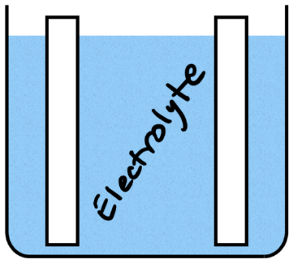
Figure 15.17: Plates are usually positioned vertically in an electrolyte to ensure good contact with the solution.¹
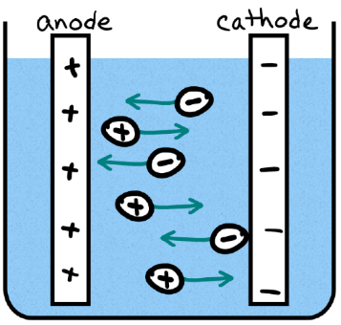
Figure 15.18: Positive and negative ions both contribute to electric current by flowing in opposite directions through an electrolyte.¹

Numbers
Assumptions: uniform electric field between the plates.
Knowns | Unknowns
$$A=0.03 m^{2}$$ | $$σ_{e,CuSO_{4}}$$
$$l=0.2 m$$
$$ΔV_{e}=3 V$$
$$I=2.4 A$$
Electrical conductivity, $σ_{e}$, is the reciprocal of electrical resistivity:
$$\boxed{σ_{e}=\frac{1}{ρ_{e}}}$$
( 15.12 )
The unit for electrical conductivity is siemens per meter [S/m]. We aren’t given the resistivity, but we can use the voltage and current to find the resistance and get resistivity from that. Combining Ohm’s Law with the equations for resistivity and conductivity…
$$ΔV_{e}=I⋅R=I⋅\left(\frac{ρ_{e}⋅l}{A}\right)=I⋅\left(\frac{l}{σ_{e}⋅A}\right)$$
Rearranging to solve for $σ_{e,CuSO_{4}}$ gives:
$$\begin{aligned}σ_{e,CuSO_{4}}&=\frac{I⋅l}{ΔV_{e}⋅A} \\ &=\frac{\left(2.4 A\right)⋅\left(0.2 m\right)}{\left(3 V\right)⋅\left(0.03 m^{2}\right)}=5.33 S/m\end{aligned}$$

Words
For our electrochemical cell, we will consider a lead acid battery like those used in gasoline- and diesel-powered vehicles. The electrolyte in a lead acid battery is sulfuric acid. Some of the plates are lead, and the others are lead dioxide. Chemical reactions occur at both plates:
- At the lead plate, negatively charged sulphate ions combine with the lead to form lead sulphate, injecting electrons into the lead plate in the process.
- At the lead dioxide plate, positively charged hydrogen ions combine with the lead dioxide to form lead sulphate and water, removing electrons from the lead dioxide plate in the process.
So, both plates become charged, one positively, and one negatively. This creates a change in the electric potential between the two plates. If a conductor is connected to the plates, the cell creates an “electro-motive force,” which is a potential difference that causes electrons to flow through the conductor, creating current. The cell is a battery!
Car batteries are rated as 12 V (6 cells of 2 V each stacked in such a way that their voltages add) with a capacity given in “amp-hours.” If we buy a battery labeled “12V 200Ah” and use it to supply a continuous 3 A of current, we should be able to determine the power produced, the total amount of charge, and the time it will take for the battery to run out of charge.
As shown in the “Numbers” column, amp-hours turns out to be a measure of charge.

Graphics
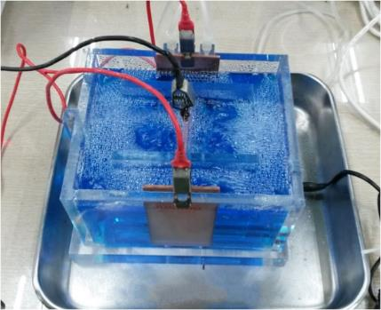
Figure 15.19: An electrolytic cell for copper electroplating. In this set-up there are two anodes and one cathode.
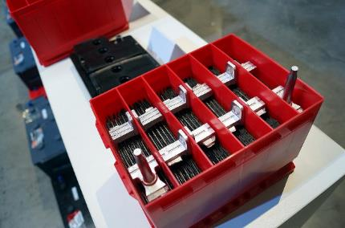
Figure 15.20: A lead-acid car battery during assembly. There are six individual cells, each with multiple plates.

Numbers
Assumptions: none?
Knowns | Unknowns
$$ΔV_{e}=12 V$$ | $$P_{battery}$$
$$200 A⋅hr$$ | $$q$$
$$I=3 A$$ | t
One thing in the “knowns” hasn’t been identified very well. What is “$200 A⋅hr$”? Let’s convert it into SI units to see what it is.
$$\left(200 A⋅hr\right)⋅\frac{3600 s}{1 hr}=7.2×{10}^{5} A⋅s$$
An amp is a coulomb per second, so that’s $7.2×{10}^{5} C$. So, it’s the charge, $q$, measured in different units. We have the total charge and the current, so we can use Equation ( 15.10 ) to find the time:
$$Δt=\frac{q}{I}=\frac{7.2×{10}^{5} C}{3 A}=2.4×{10}^{5} s$$
That’s almost 67 hours.
For power, one of the expressions that we found for power dissipated in ohmic conductors also works for power generated by a battery:
$$P_{battery}=I_{battery}⋅ΔV_{e,battery}$$
So, for this example…
$$P_{battery}=\left(3 A\right)⋅\left(12 V\right)=36 W$$

: Summary
Chapter summaries in this book are ordered by concept, not necessarily in the order in which they are presented in the chapter. Mathematical models are grouped together at the end of each summary. See the appendices for the meanings of all symbols used in this book.

General
- Charges are not free to move in an insulator.
- Some electrons are free to move in a conductor.

Forces, Fields, & Acceleration
- When there is a uniform electric field, the opposite of the slope of a voltage-vs-position graph gives the electric field.
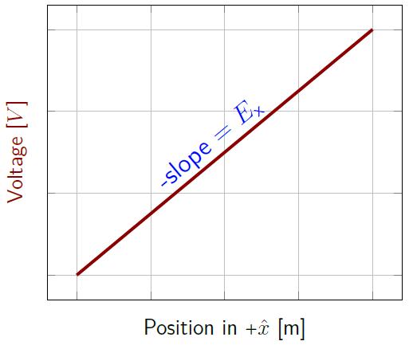
Electric field is the opposite of the slope on a voltage-vs-position graph.1
- When placed in an electric field, insulators become polarized.
- When placed in an electric field, free electrons in conductors rearrange themselves so that the electric field everywhere inside the conductor is zero.

Momentum, Velocity, & Electric Current
- Electric current is charge flowing past a certain point over time.
- In conductors, only the motion of electrons contributes to current flow.
- In electrolytes, positive and negative ions both contribute to current flow.

Energy
- Capacitors can store potential energy.
- Electric fields store energy.
- Electrical energy is transformed into thermal energy when current flows through a conductor.

Mathematical Models
Equation | Reference | Restrictions on the validity of the equation
$$ΔV_{e}=-E⋅Δx⋅cosθ$$ | ( 15.1 ) | uniform electric field
$$E=\frac{q}{A⋅ϵ}$$ | ( 15.2 ) | between parallel plates
$$C=\frac{q}{ΔV_{e}}$$ | ( 15.3 ) | -none-
$$C_{pp}=\frac{A⋅ϵ}{d}$$ | ( 15.4 ) | parallel-plate capacitor
$$U_{c}=\frac{1}{2}q⋅ΔV_{e}=\frac{1}{2}C⋅{\left(ΔV_{e}\right)}^{2}=\frac{q^{2}}{2⋅C}$$ | ( 15.5 ) | for any capacitor
$$ϵ=κ⋅ϵ_{0}$$ | ( 15.7 ) | -none-
$$R=\frac{ρ_{e}⋅l}{A}$$ | ( 15.8 ) | -none-
“Ohm’s Law”  $$ΔV_{e}=I⋅R$$ | ( 15.9 ) | for ohmic materials
$$I=\frac{q}{Δt}$$ | ( 15.10 ) | -none-
$$P=I⋅ΔV_{e}=\frac{{\left(ΔV_{e}\right)}^{2}}{R}=I^{2}⋅R$$ | ( 15.11 ) | -none-

: Questions
Questions are ordered according to Bloom’s Taxonomy, progressing from regurgitating information (Level 1) to synthesizing new information with previous knowledge to create something new (Level 6). The bold letters at the beginning of each question indicate whether the question involves Words [W], Graphics [G], and/or Numbers [N]. See the appendices for conversion factors.

Level 1 - Remember
      - [W & N] We are starting to use a lot of unfamiliar words, symbols, and units. To help keep them straight, fill in the table below with the correct names, symbols, and units.
Name | Symbol | SI Unit
electric potential |  | volts (V)
 |  | coulombs (C)
 | $$\vec{E}$$
electric potential energy
 | $$\vec{F_{e}}$$
 | $$ϵ$$
 | $$ϵ_{0}$$
capacitance
capacitor potential energy
 | $$u_{e}$$
relative permittivity,
or dielectric constant
 | $$R$$
 |  | ohm-meters ($Ω⋅m$)
current
 |  | siemens per meter, (S/m)
      - [W & N] We are starting to use a lot of metric prefixes for really small numbers. To help keep them straight, fill in the table below with the correct names and symbols.
Name | Symbol | meaning
milli- | m | $${10}^{-3}$$
 |  | $${10}^{-6}$$
 |  | $${10}^{-9}$$
 |  | $${10}^{-12}$$
 |  | $${10}^{-15}$$
      - [W] What is the difference between an insulator and a dielectric?
      - [W & N] Add labels to each boxed equation from this chapter that tell what the symbol to the left of the = sign represents
Symbol | Reference | Label
$$V_{e}$$ | ( 15.1 )
$$E$$ | ( 15.2 )
$$C$$ | ( 15.3 )
$$C_{pp}$$ | ( 15.4 )
$$U_{c}$$ | ( 15.5 )
$$u_{e}$$ | ( 15.6 )
$$ϵ$$ | ( 15.7 )
$$R$$ | ( 15.8 )
$$ΔV_{e}$$ | ( 15.9 )
$$I$$ | ( 15.10 )
$$P$$ | ( 15.11 )
$$σ_{e}$$ | ( 15.12 )

Level 2 - Understand
      - [N] Starting with the dimensional analysis at the bottom of the “Numbers” column on the first page of Section 15.1, show that N/C has the same dimensions as V/m.
      - [N] Near the bottom of the “Numbers” column on the second page of Section 15.1 is a unit, “pF” that isn’t explained on that page. What is a “pF”?
      - [G] In Figure 15.4, reproduced below, the voltage appears to be increasing as the position gets larger in the positive x direction. If this is a graph for the parallel plates shown in Figure 15.3, also reproduced below…
A line graph of voltage vs position1
Sketch of a charged parallel-plate capacitor.1
        - …in what direction would $+\hat{x}$ mean in Figure 15.3?
        - …does it make sense that $E_{x}$ should be negative, which seems to be what the graph says? Explain your answer.
      - [W] In Section 15.3 there is a statement on the first page in the “Words” column that “…nuclei are much more massive than electrons, so they are much more difficult to move.” Using ideas from some of the first chapters of this textbook, explain why this is true.
      - [W] A battery sends current out through the positive side and brings current in through the negative side. In which direction do the electrons flow on each side?

Level 3 - Apply
      - [N] The relationship between Coulomb’s constant $k_{e}$ and the permittivity of free space $ϵ_{0}$ that is given on the second page of Section 15.1 seems to show that the dimensions of one should be the reciprocal of the dimensions of the other. Is that true?
      - [N] If you put an electric potential difference of 120 V across a $10 μF$ capacitor, how much charge would it have on each plate?
      - [N] Imagine a capacitor made with two plates that are each the size of a piece of notebook paper, with an empty space between them that is the thickness of a piece of notebook paper. Estimate or look up these measurements and calculate what the capacitance would be of that capacitor.
      - [N] In Section 15.2 it was stated that there are three different ways to express $U_{c}$, but only two of them are demonstrated in the text. Demonstrate that the last term in Equation ( 15.5 ), reproduced below, is also correct.
$$U_{c}=\frac{1}{2}q⋅ΔV_{e}=\frac{1}{2}C⋅{\left(ΔV_{e}\right)}^{2}=\frac{q^{2}}{2⋅C}$$
      - [N] Something else that could have been calculated in Section 15.5 is the current that was flowing through the nichrome wire. Calculate that current in two different ways:
        - Using Ohm’s Law
        - Using power
      - [N] A wire has a constant current of 10 A flowing through it. How much charge passes through the wire in one minute?
      - [N] Conductivity is supposed to be the reciprocal of resistivity, but their units don’t look similar at all. What would the unit be for conductivity in terms of ohms [$Ω$] and meters [m]?
      - [W] If the concentration of electrolytes in a solution was increased, would you expect the conductivity to change? Explain your answer.
      - [G] On the first page of Section 15.6 are sketches of generic electrolytes. Make a sketch like Figure 15.18 that is specific to the example of copper plating. The plates and the ions should each include labels saying what elements, molecules, or ions they represent. You will probably need to look up some of the information.
      - [G] On the first page of Section 15.6 are sketches of generic electrolytes. Make a sketch like Figure 15.18 that is specific to the example of lead-acid batteries. The plates and the ions should each include labels saying what elements, molecules, or ions they represent. You will probably need to look up some of the information.

Level 4 - Analyze
      - [W, G, & N] Equation ( 15.1 ), reproduced below, is given in the textbook with no explanation where it came from.
$$ΔV_{e}=-E⋅Δx⋅cosθ$$It can be derived from information you already have. Show that it is true in one of two ways:
        - Find the work that would have to be done on a charge $q_{1}$ to move it through the field from the negative plate to the positive plate and relate that to the change in electric potential energy.
        - Compare Figure 14.2 and Figure 15.3, both reproduced below. Gravitational field $\vec{g}$ and electric field $\vec{E}$ behave in the same way, and gravitational potential and electric potential behave in the same way. Then use the relationship between gravitational potential and gravitational field to create a similar relationship between electric potential and electric field. You can do this strictly in the vertical direction, taking $θ$ to be either $0^{∘}$ or ${180}^{∘}$.
Gravitational field near the surface of the earth.1
Electric field between parallel plates.1
      - [W & N] For the capacitor described in Section 15.2, how would the amount of energy stored in the capacitor have been different if the area of the plates was doubled but the distance between the plates stayed the same and it was still charged to the same voltage? How would the energy density have been different?
      - [W & N] For the capacitor described in Section 15.2, how would the amount of energy stored in the capacitor have been different if the distance between the plates was doubled but the area of the plates stayed the same and it was still charged to the same voltage? How would the energy density have been different?
      - [W & N] Do an internet search to find one or more tables of relative permittivities (dielectric constants) of different materials.
        - What range of values can you find? Do you think there are theoretical limits to the possible values?
        - For the materials that you recognize, how would you characterize them? Solid/liquid/gas? Insulator/conductor?
      - [N] In the example of copper plating in Section 15.6, there is a current of 2.4 A flowing through the electrolyte. How quickly is copper being added to the cathode while this current is flowing? Answer in grams per second. Think about the amount of charge deposited per second, how much charge each copper ion carries, and the mass of each copper atom. You will have to look up some of these values.

Level 5 - Evaluate
      - [W, G, & N] How would you design a parallel-plate capacitor if your goal was to make one with the largest possible capacitance? What physical limitations do you think you would encounter if you tried building that capacitor?
      - [W] Do an internet search to find the energy density (in joules per kilogram–convert when necessary) of various energy sources that are currently used in vehicles or that are being proposed for use in vehicles. Be sure to include gasoline, batteries, and fuel cells in your search. From an energy density standpoint, what is the best energy source? Why aren’t all vehicles designed to use that energy source?
      - [W & N] For the analysis that was done in Section 15.3, the insulator was put into the empty space and then the capacitor was charged to the same voltage as before. Would things end up differently if instead the capacitor was first charged to 0.6 V, then the same amount of charge remained on the plates while the dielectric was added between the plates? Why or why not?
      - [W & N] The analysis in Section 15.5 was done for the range coil in Figure 15.15. What would be different for each of the following if we instead analyzed the range coil in Figure 15.16? Explain your answers. Assume that the same kind of nichrome wire was used for each, that the length of the new coil is shorter than the previous one, and that it is still going to be connected to the same amount of voltage.
        - Resistivity $ρ_{e}$ of the coil…larger, smaller, or the same?
        - Cross-sectional area $A$ of the wire…larger, smaller, or the same?
        - Resistance $R$ of the coil…larger, smaller, or the same?
        - Current $I$ through the coil…larger, smaller, or the same?
        - Power $P$ dissipated to thermal energy in the coil…larger, smaller, or the same?
      - [W] A lot of drinks advertise that they contain electrolytes, so electrolytes must either taste good or be important for good health. Do an internet search to find out whether electrolytes are important for health or not. If they are important, is it because of their electrical properties or something else?

Level 6 - Create
      - [W, G, & N] At the beginning of Chapter 1 in Figure 1.1 was a template for a concept map. Create a new concept map with the main ideas from this chapter.
      - [W, G, & N] Imagine you are writing a test question related to this chapter. Think of your own example of a situation that you can analyze using the concepts, graphics, and mathematical analyses described in this chapter. Describe the situation and use the tools from this chapter to analyze the situation as completely as you can, including motion, forces, energy, and momentum.
      - [W, G, & N] Think about possible misconceptions about the material in this chapter. Write a question and an incorrect solution to it that demonstrates a student making such a conceptual error. This cannot be a simple misuse of a vocabulary word, a unit error, or a mathematical error like making an addition error or multiplying when addition was needed, unless the error is rooted in a real misunderstanding about the physics behind the calculation or the misuse of a word. After you have written the question and incorrect solution, explain what is wrong with the student’s solution, and write a correct solution to the problem. Note: You may use a question from this chapter that you got wrong the first time and explain the initial error in your thinking and how you corrected it.

– Electric Circuits
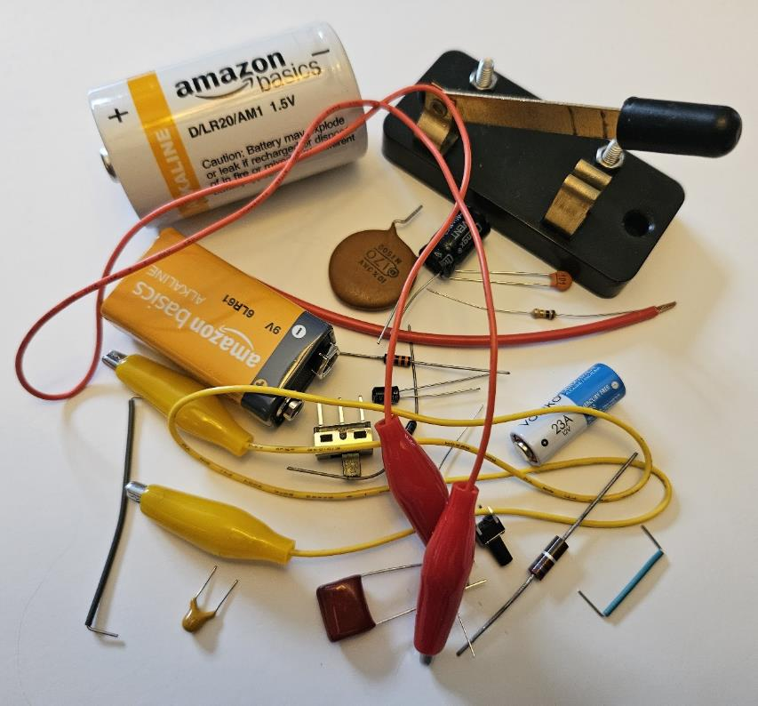
Figure 16.1: A collection of wires, switches, batteries, resistors, and capacitors. These are the basic parts that we will be combining into circuits in this chapter.1

Throughout Chapter 15 we were investigating the interactions between electricity and various materials. We saw how batteries can be a source of voltage, we saw how an applied voltage can cause charge to be stored on a capacitor, and we saw that an applied voltage can cause electric current to flow through conductors.
Now we will see how these three elements, batteries, capacitors, and conductors, can be combined in electric circuits. We will use two different kinds of conductors: good conductors will be used as wires and poor conductors will be used as “resistors.” Just as capacitors are objects with a set amount of capacitance, resistors are objects with a set amount of resistance.
In “regular” English, a “circuit” usually refers to a complete path around or through something, ending in the same place where you started. In electricity, it is much the same. A circuit is a path that forms a complete loop for current to follow. If an electric circuit does not form a complete loop, then it is a special case that is referred to as an “open circuit,” in which no current flows.
While in fact it is negatively charged electrons that are moving through a circuit, remember that current is defined as if there were positive charges moving opposite the direction of the electrons, from higher electric potential to lower electric potential.

: Circuit Components ()

Words
Before we put them together into circuits, let’s go through the basic components of simple electric circuits.
We will use a battery to supply an electromotive force (EMF), creating a voltage. It is an unfortunate language usage that EMF is actually an applied electric potential, not an electric force. A battery can be a single cell or it can be multiple cells stacked together. Most batteries, like those in a car, are a stack of cells, so that is the way it’s drawn in a circuit diagram: A stack of lines with different lengths. Current flows out of the positive side of a battery (drawn with a long line) and returns through the negative side (drawn with a short line).
Wires and electrical connections between components are made from good conductors, often copper or aluminum, which means that current can easily flow through them. In a circuit they are drawn simply as a line. Junctions where there are branches in the circuit, for example where multiple wires go in different directions from the same point, are drawn as a dot where the wires touch. Notice that the wires in Figure 16.3 are covered with insulating material, plastic or rubber, except on the ends where the connections are made. This is to prevent accidental connections along the length of the wire.

Graphics
When drawing electric circuits, it is convenient to define symbols for each component rather than attempting to draw what the component looks like, especially since the components can have many different forms.
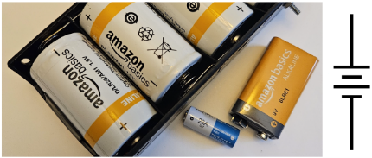
Figure 16.2: An assortment of batteries, and the symbol for a battery. The longer side of the symbol, at the top, is the positive side.
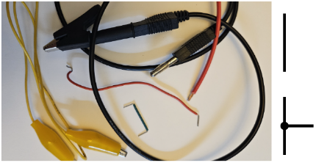
Figure 16.3: An assortment of wires, and the symbols for a wire (top right) and a junction of multiple wires (bottom right).100

Numbers
We won’t do calculations in this section, but we will look at assumptions and some common values for the various components of electric circuits.
We will assume ideal batteries that have no internal resistance and provide the constant EMF that they are rated for, so a 9 V battery supplies an unlimited amount of current at 9 V. Most batteries provide a few volts of EMF, from about 1.5 V up to a few tens of volts.
We will assume that wires and connections are perfect conductors, so they have no resistance and can carry unlimited current. Applying Ohm’s Law to wires…
$$ΔV_{e}=I⋅R$$
…we can see that this means we are assuming that there is also no change in voltage (that is, there is no “voltage drop”) across wires or connections. Every point along a wire is assumed to be at the same electric potential.

Words
Resistors are made from materials that are poor conductors, like carbon or nichrome. Current can flow through resistors, but as with traffic on a rutted dirt road, it is not easy for current to flow through. For that reason, resistors are drawn as jagged lines in circuit diagrams. Current flows from the positive side of the resistor (the side that is at a higher electric potential) through to the negative side of the resistor.
Capacitors contain conducting plates that are separated by a small gap, so that is how they are drawn in circuit diagrams. As with resistors, current flows through a capacitor from the positive side to the negative side. Capacitors can store charge on their plates, but the net charge inside the capacitor remains zero. So, a capacitor with charge $q$ has $+q$ on one plate and $-q$ on the other.
A switch is a place where wires can be connected or disconnected, often with a lever or button. As with a light switch in a house, this allows current in the circuit to flow or not flow depending on the state of the switch. Switches are drawn in circuit diagrams to look like a broken wire with another piece of wire that can close to re-form the connection.

Graphics
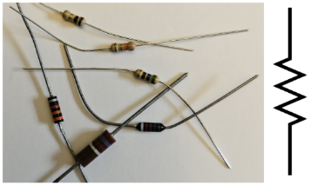
Figure 16.4: An assortment of resistors, and the symbol for a resistor.100
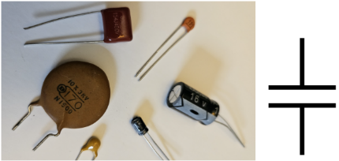
Figure 16.5: An assortment of capacitors, and the symbol for a capacitor.100
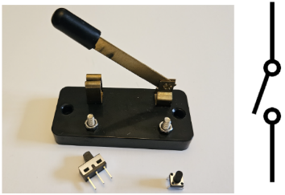
Figure 16.6: An assortment of switches, and the symbol for a switch.100

Numbers
Typical resistor values range from ohms to megaohms. We will assume that the resistance does not change regardless of the amount of voltage or current. Power is dissipated in resistors as electrical energy is converted to heat. For that reason, resistors also have power limits, usually a few watts but for smaller resistors often a fraction of a watt. Applying excessive voltage (or current) can overheat the resistor, causing a fire.
Typical capacitor values range from picofarads to microfarads. We will assume that capacitance does not change regardless of the amount of voltage applied. As the voltage increases, so does the electric field between the plates, and eventually the field becomes strong enough to rip electrons off the atoms in the insulator between the plates. When that happens, a spark is created, burning the insulator. For that reason, capacitors have a maximum voltage rating.
As with wires and connections, we will assume that switches are perfect conductors when they are closed. And we will assume that no current can flow through them when they are open.

: In Series ( , )

Words
Now we are ready to put together our first circuit. We will put a 5V battery in series with two resistors, “R1” ($4.7 kΩ$) and “R2” ($2.2 kΩ$), as shown in the top image in Figure 16.7. We should be able to find the voltage across each of the three components and the current passing through each of the three components.
First, what does it mean to be “in series?” If two components of a circuit are in series, then all the current passing through one of the components also goes through the other component–there is no other path for the current to take. In this case, we know that current goes out of the positive side of the battery and comes back in through the negative side of the battery. There is only one possible path for the current to follow, the one that is shown in the middle image of Figure 16.7. So, all the current from the battery must first go through R1 and then through R2 before returning to the battery. All the components are in series. If we can find the current through any of the three components then we know it must be the same for the other two.
So how can we find the current through one of the components? Here we can use something called the “loop rule.” The loop rule says that the total change in electric potential around a complete loop is equal to zero. To understand why this is true, we can consider another analogy with gravitational potential.

Graphics
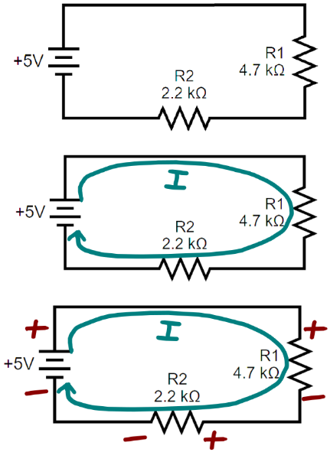
Figure 16.7: A circuit with a battery and two resistors, all in series. In the top image, only the circuit components are shown. In the middle image, an arrow shows the positive direction for current. In the bottom image, “+” and “-” signs on each component show which side is at a higher electric potential compared to the other side of that same component.100

Numbers
Assumptions: ideal battery, wires and connections are perfect conductors, resistors are ohmic.
Knowns | Unknowns
$$ΔV_{e,battery}=5 V$$ | $$ΔV_{e,1}$$
$$R_{1}=4.7×{10}^{3} Ω$$ | $$ΔV_{e,2}$$
$$R_{2}=2.2×{10}^{3} Ω$$ | $$I_{battery}$$
 | $$I_{1}$$
 | $$I_{2}$$
According to the loop rule…
$$\boxed{ΔV_{e,loop}=0}$$
( 16.1 )
…for any complete loop in a circuit. In our example, if we start in the bottom left corner of the circuit as drawn in Figure 16.7, and loop around clockwise in the direction of the arrow drawn for current…
$$ΔV_{e,battery}-ΔV_{e,1}-ΔV_{e,2}=0$$
…where the numbers in the subscripts refer to the resistor numbers. The positive and negative signs are based on the “+” and “-” sides in the bottom image in Figure 16.7. Every component we pass through from - to + gets a positive voltage; every component we pass through from + to - gets a negative voltage.

Words
Imagine a child running an obstacle course as shown in Figure 16.8. They start on the ground, run to a pole and climb up, run across a horizontal beam, climb into the top of a tower, slide down a slide, then run back to the starting point. The gravitational potential along the path changes, increasing with height above the ground. But the total change in gravitational potential around the entire loop is the final gravitational potential, at ground level, minus the initial gravitational potential, also at ground level. If the loop starts and ends at the same place, the total change is zero around the loop.
In the same way, the total change in voltage all the way around an electric circuit must be zero, because you’re comparing the starting electric potential with the ending electric potential, both of which are the same. In this circuit, the battery contributes a positive voltage (like climbing up an obstacle), and then each resistor has a voltage drop (like coming back down from an obstacle), so the total of the two voltage drops on the resistors is equal to the EMF of the battery. From the calculations in the “Numbers” column we see that the larger resistor has a larger voltage drop.
From the perspective of the battery, the circuit with two resistors “feels” like it has a single resistor with a resistance that is the sum of the two resistors. So, we say that the circuit has an equivalent resistance of $6.9 kΩ$. When finding equivalent resistance, it can be helpful to circle the resistors that are being combined, as shown in Figure 16.9. This is especially helpful for more complicated circuits.

Graphics
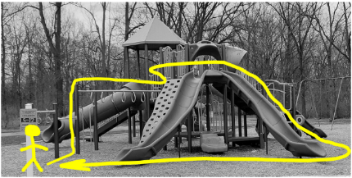
Figure 16.8: For an obstacle course on a playground, if the starting and ending position are the same, the total change in gravitational potential is zero.
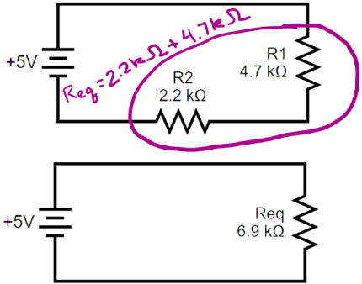
Figure 16.9: Resistors in series can be combined into a single “equivalent resistor.” From the perspective of the battery, both circuits look like a single $6.9 kΩ$ resistor.100

Numbers
By itself, the loop rule is not enough to find the voltages, because we have one equation with two unknowns. But in this case, we also know that the current is the same for all components in series. Using that information along with Ohm’s Law…
$$\begin{aligned}0&=ΔV_{e,battery}-\left(I_{1}⋅R_{1}\right)-\left(I_{2}⋅R_{2}\right) \\ 0&=ΔV_{e,battery}-I⋅\left(R_{1}+R_{2}\right) \\ I&=\frac{ΔV_{e,battery}}{R_{1}+R_{2}}=\frac{5 V}{6.9×{10}^{3} Ω}=7.2×{10}^{-4} A\end{aligned}$$
That current is valid for the battery and both resistors. Now we can again use Ohm’s Law to find the voltage across each resistor. When doing this, it is important to always use the voltage, current, and resistance of each individual component:
$$ΔV_{e,1}=I_{1}⋅R_{1}=3.41 V$$
$$ΔV_{e,2}=I_{2}⋅R_{2}=1.59 V$$
A similar statement can be made regarding the voltage of the battery, but with an equivalent resistance for the whole circuit:
$$ΔV_{e,battery}=I_{battery}⋅R_{eq}$$
For any set of $n$ resistors $R_{1},R_{2},⋯,R_{n}$ in series, the equivalent resistance of the set is given by:
$$\boxed{R_{eq,series}=R_{1}+R_{2}+⋯+R_{n}}$$
( 16.2 )

: In Parallel ( , )

Words
We will use the same circuit components as in Section 16.2, but put them together in a different way. We will connect the 5V battery to two resistors, “R1” ($4.7 kΩ$) and “R2” ($2.2 kΩ$), that are in parallel, as shown in the top image in Figure 16.10. We should be able to find the voltage across each of the three components and the current passing through each of the three components.
First, what does it mean to be “in parallel?” If two components of a circuit are directly connected to each other at both ends, then they are said to be in parallel. In Figure 16.10, the upper end of R1 is directly connected to both the upper end of R2 and the upper end of the battery. And the lower end of R1 is directly connected to both the lower end of R2 and the lower end of the battery. So, all three components are in parallel with each other.
The loop rule still works in parallel circuits. This time we have multiple loops that we can choose from, and the loop rule works on any loop. We know the voltage of the battery, so let’s start by choosing a loop that includes the battery. If we choose to start our loop in the bottom left corner of Figure 16.10 and go clockwise through just the left loop then we would pass through the battery and then through R2, missing R1 completely. So, the EMF of the battery is equal to the voltage drop across R2. A similar loop around the outside of the whole circuit shows that the EMF of the battery is also equal to the voltage drop across R1.

Graphics
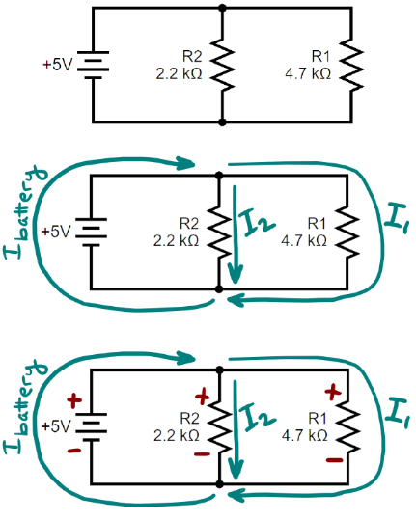
Figure 16.10: A circuit with a battery and two resistors, all in parallel. In the top image, only the circuit components are shown. In the middle image, arrows show the positive direction for current. This time multiple arrows are needed because current can change at junctions. In the bottom image, “+” and “-” signs on each component show which side is at a higher electric potential compared to the other side of that same component.100

Numbers
Assumptions: ideal battery, wires and connections are perfect conductors, resistors are ohmic.
Knowns | Unknowns
$$ΔV_{e,battery}=5 V$$ | $$ΔV_{e,1}$$
$$R_{1}=4.7×{10}^{3} Ω$$ | $$ΔV_{e,2}$$
$$R_{2}=2.2×{10}^{3} Ω$$ | $$I_{battery}$$
 | $$I_{1}$$
 | $$I_{2}$$
Using the loop rule on just the left side of the circuit gives…
$$ΔV_{e,battery}-ΔV_{e,2}=0$$
…$ΔV_{e,2}=ΔV_{e,battery}=5 V$, just like that! The loop around the outside gives…
$$ΔV_{e,battery}-ΔV_{e,1}=0$$
…so, the same result for $ΔV_{e,1}$. We could also have chosen the loop on the right, clockwise from the bottom center:
$$ΔV_{e,2}-ΔV_{e,1}=0$$
Same result. So not all loops are needed, but any can be used. Then we can use Ohm’s Law to find the current in each resistor.

Words
In the series circuit, the voltage from the battery was split, with each resistor getting part of the voltage. But in this parallel circuit, each resistor gets the full amount of voltage from the battery.
In the series circuit, all components had the same amount of current, but calculations in the “Numbers” column show that in this parallel circuit the smaller resistor has more current than the larger resistor. That makes sense if you think about the analogy of heavy traffic. If there are two roads that both start where the people are and end where the people need to be, more people will choose the easier road.
To find the current in the battery, we need the “junction rule,” which says that the total amount of current going into a junction is equal to the total amount of current going out of the junction. Remember that current is made up of moving electrons, and electrons can’t just disappear somewhere along the path. They can choose which path to take, but every electron that goes into a junction must go out one way or another.
Let’s consider the junction at the top center of Figure 16.10. Of the three labeled currents going into the top junction, only $I_{battery}$ is going in. The other two are going out. So, the current through the battery must be the sum of the currents through each resistor. In other words, the current from the battery is shared between the two resistors in parallel.
From the perspective of the battery, the equivalent resistance is less than the resistance of either individual resistor!

Graphics
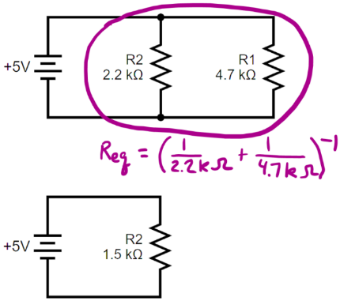
Figure 16.11: Resistors in parallel can be combined into a since “equivalent resistor” whose value is smaller than the resistance of any of the individual resistors. From the perspective of the battery, both circuits look just like a single $1.5 kΩ$ resistor.100

Numbers
$$I_{1}=\frac{ΔV_{e,1}}{R_{1}}=\frac{5 V}{4.7×{10}^{3} Ω}=1.06 mA$$
$$I_{2}=\frac{ΔV_{e,2}}{R_{2}}=\frac{5 V}{2.2×{10}^{3} Ω}=2.27 mA$$
According to the junction rule, at any junction…
$$\boxed{Σ\left(I_{in}\right)=Σ\left(I_{out}\right)}$$
( 16.3 )
…so for the junction at the top of Figure 16.10…
$$I_{battery}=I_{1}+I_{2}=3.33 mA$$
Using Ohm’s Law, this tells us that the equivalent resistance of the circuit is…
$$R_{eq}=\frac{ΔV_{battery}}{I_{battery}}=\frac{5 V}{3.33 mA}=1.5 kΩ$$
That is less than either of the resistors in the circuit! For a set of $n$ resistors in parallel, equivalent resistance is given by:
$$\boxed{R_{eq}={\left(\frac{1}{R_{1}}+\frac{1}{R_{2}}+⋯+\frac{1}{R_{n}}\right)}^{-1}}$$
( 16.4 )

: Combination Circuits ( , )

Words
Now we know how to create equivalent resistances for resistors in series and in parallel, but what if the circuit a more complicated “combination circuit” that isn’t purely series or parallel, like the one in Figure 16.12? Can we still find the currents and voltages for each component of the circuit?
If we had the equivalent resistance of the circuit then we could use Ohm’s Law to find the current supplied by the battery. We can’t find the equivalent resistance in a single step like we have done before, but we can identify pieces of the circuit that we know how to simplify and go one step at a time.
Notice that all the current that goes through R4 also goes through R3. That means those two are in series so we can combine them into a single equivalent resistance “R34.” This is done in the top image in Figure 16.13. At this point the circuit could be redrawn as was done in Figure 16.9 and Figure 16.11, but that isn’t necessary if we just think of the loop that is labeled R34 as being the resistor that is equivalent to R3 and R4 together.
Now that we have combined R3 and R4 into a single R34, we can see that the upper side of R2 is directly connected to the upper side of R34 and the lower side of R2 is directly connected to the lower side of R34. Those two are in parallel with each other, so now we can simplify that part of the circuit into a single “R234,” as shown in the middle image in Figure 16.13.

Graphics
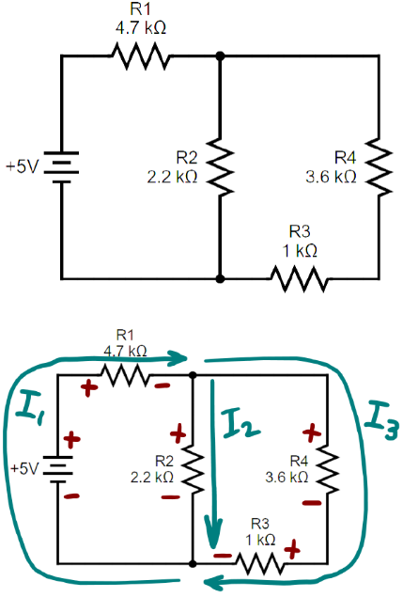
Figure 16.12: A combination circuit with a battery and four resistors. We can still add arrows for the direction of the current through each part of the circuit and add “+” and “-” signs for the electric potential on each component that are consistent with the directions of current flow.100

Numbers
Assumptions: ideal battery, wires and connections are perfect conductors, resistors are ohmic.
Knowns | Unknowns
$$ΔV_{e,battery}=5 V$$ | $$I_{battery}$$
$$R_{1}=4.7×{10}^{3} Ω$$ | $I_{1}$ , $ΔV_{e,1}$
$$R_{2}=2.2×{10}^{3} Ω$$ | $I_{2}$ , $ΔV_{e,2}$
$$R_{3}=1×{10}^{3} Ω$$ | $I_{3}$ , $ΔV_{e,3}$
$$R_{4}=3.6×{10}^{3} Ω$$ | $I_{4}$ , $ΔV_{e,4}$
We can see from Figure 16.12 that $I_{4}=I_{3}$ and $I_{battery}=I_{1}$, and that is all we can easily do without simplifying the circuit. To find the equivalent resistance of the whole circuit, we need to start combining sets of resistors. First, R3 and R4 in series:
$$R_{34}=R_{3}+R_{4}=4.6 kΩ$$
Then R2 and R34 in parallel:
$$R_{234}={\left(\frac{1}{R_{2}}+\frac{1}{R_{34}}\right)}^{-1}=1.49 kΩ$$
And finally, R1 and R234 in series, giving the total equivalent resistance of the circuit:
$$R_{eq}=R_{1234}=R_{1}+R_{234}=6.19 kΩ$$

Words
And finally, now that we have combined R2, R3, and R4 into a single R234, we can see that all the current that flows through R1 must also go through the equivalent resistor R234. That means they are in series, and we can combine them into a single R1234, as shown in the bottom image in Figure 16.13. Since all the resistors have been combined, R1234 is the equivalent resistance of the whole circuit.
Having equivalent resistance allows us to find the current from the battery, and that is the key that opens the ability to find all the currents and voltages in the rest of the circuit. It just takes repeated application of the loop rule, the junction rule, and Ohm’s Law.

Graphics
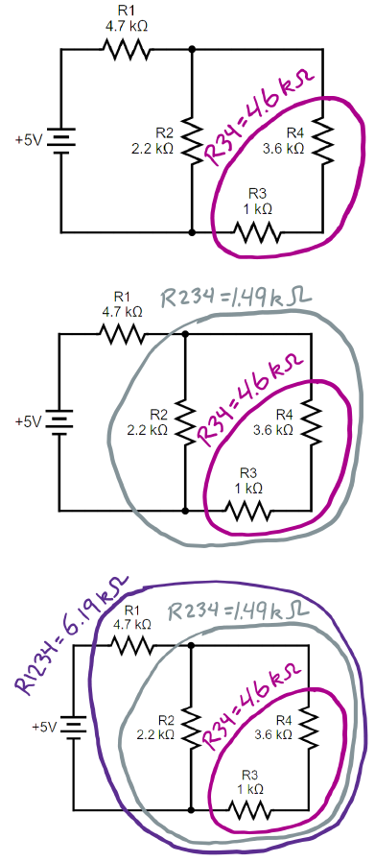
Figure 16.13: A combination circuit can be broken down in steps to find equivalent resistance. Successively larger loops can be added instead of redrawing the circuit each time.100

Numbers
Now we can use Ohm’s Law to find the current supplied by the battery:
$$I_{battery}=\frac{ΔV_{e,battery}}{R_{eq}}=\frac{5 V}{6.19 kΩ}=0.808 mA$$
As noted before, this is equal to $I_{1}$. So, we can use Ohm’s Law to find the voltage across R1:
$$ΔV_{e,1}=I_{1}⋅R_{1}=3.8 V$$
Then the loop rule can be used on the left side of the circuit, clockwise from the bottom left corner:
$$\begin{aligned}ΔV_{e,loop}=0&=ΔV_{battery}-ΔV_{e,1}-ΔV_{e,2} \\ ΔV_{e,2}&=ΔV_{e,battery}-ΔV_{e,1}=1.2 V\end{aligned}$$
Now Ohm’s Law gives the current through R2:
$$I_{2}=\frac{ΔV_{e,2}}{R_{2}}=0.547 mA$$
Next, we can use the junction rule for the junction at the top center of the circuit to find $I_{3}$:
$$\begin{aligned}Σ\left(I_{in}\right)&=Σ\left(I_{out}\right) \\ I_{1}&=I_{2}+I_{3} \\ I_{3}&=I_{1}-I_{2}=0.261 mA\end{aligned}$$
$I_{3}$ is valid for both R3 and R4, so we can use Ohm’s Law to find the voltage across each of those resistors:
$$ΔV_{e,3}=I_{3}⋅R_{3}=0.261 V$$
$$ΔV_{e,4}=I_{4}⋅R_{4}=0.941 V$$

: Multiple Batteries ( )

Words
This time we will analyze another circuit that is almost like the one in Section 16.4, except that one of the resistors has been replaced with a second battery. This may not seem like it is very different, but it creates a problem we haven’t seen before. Always before we have been able to create equivalent circuits with equivalent resistances, so that the circuit is simpler, but it still looks the same from the perspective of the battery. This time, we have two batteries in two different places, so the circuit looks different to each battery. There is no way to reduce the circuit to an equivalent resistance.
We also have another problem. We know that batteries push current out of the positive side, and it returns through the negative side, so we can still confidently predict the direction of current flow on the left and right branches of the circuit. But what about the middle branch with R2? The battery on the left is trying to push current down through R2, while the battery on the right is trying to push current up through it. Which one wins? In a situation like this, we can take our best guess and analyze the circuit that way. If it turns out that we find a negative current for that branch, then we know we guessed wrong.

Graphics
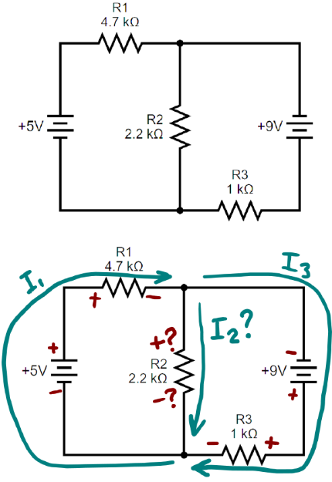
Figure 16.14: A circuit with two batteries. We can still add arrows for the direction of the current through each part of the circuit and add “+” and “-” signs for the electric potential on each component that are consistent with the directions of current flow, but this time the direction of current flow through R2 is unclear.100

Numbers
Assumptions: ideal battery, wires and connections are perfect conductors, resistors are ohmic.
Knowns | Unknowns
$$ΔV_{e,5V}=5 V$$ | $$I_{5V}$$
$$ΔV_{e,9V}=9 V$$ | $$I_{9V}$$
$$R_{1}=4.7×{10}^{3} Ω$$ | $I_{1}$ , $ΔV_{e,1}$
$$R_{2}=2.2×{10}^{3} Ω$$ | $I_{2}$ , $ΔV_{e,2}$
$$R_{3}=1×{10}^{3} Ω$$ | $I_{3}$ , $ΔV_{e,3}$
We can see from Figure 16.14 that $I_{5V}=I_{1}$ and $I_{9V}=I_{3}$, and the junction rule tells us…
$$I_{1}=I_{2}+I_{3}$$
So out of our eight unknowns we have a way to find $I_{5V},I_{9V},$ and $I_{1}$ from the others. But that means we still have five unknowns, so we need a lot more information. Ohm’s Law can relate each resistor’s voltage to its current, so that is a way to eliminate three more unknowns. Using Ohm’s Law with the relationship above,
$$\frac{ΔV_{e,1}}{R_{1}}=\frac{ΔV_{e,2}}{R_{2}}+\frac{ΔV_{e,3}}{R_{3}}$$

Words
From the calculations in the “Numbers” column, it is found that in fact the guess was not correct. In fact, the current is flowing upward through R2. But the drawing doesn’t need to change–if both $I_{2}$ and $ΔV_{e,2}$are reported as being negative then the arrow is correct.
If you wanted to reverse the arrow and the “+” and “-” labels on R2 then that would also be fine, if the mathematical model for the junction rule is changed to reflect the new direction and the calculations are re-done.

Graphics
(This column intentionally left blank)

Numbers
If we use the loop rule on two different loops, that should give us enough information, and the rest will be algebra. Let’s do the loop on the left and the loop on the right, both clockwise from their bottom left corners:
$$ΔV_{e,loop}=0=5V-ΔV_{e,1}-ΔV_{e,2}$$
$$ΔV_{e,loop}=0=ΔV_{e,2}+9V-ΔV_{e,3}$$
Those two mathematical models give us $ΔV_{e,1}$ and $ΔV_{e,3}$ in terms of $ΔV_{e,2}$:
$$ΔV_{e,1}=5V-ΔV_{e,2}$$
$$ΔV_{e,3}=9V+ΔV_{e,2}$$
Substituting these into the expression above for Ohm’s Law gives…
$$\frac{5V-ΔV_{e,2}}{R_{1}}=\frac{ΔV_{e,2}}{R_{2}}+\frac{9V+ΔV_{e,2}}{R_{3}}$$
…which can be solved for $ΔV_{e,2}$:
$$ΔV_{e,2}=\frac{R_{1}⋅R_{3}⋅5V-R_{1}⋅R_{2}⋅9V}{R_{1}⋅R_{2}+R_{1}⋅R_{3}+R_{2}⋅R_{3}}=-4.03 V$$
Negative! So, we guessed incorrectly. In fact, the current is going upward through R2. Ohm’s Law gives…
$$I_{2}=\frac{ΔV_{e,2}}{R_{2}}=-1.83 mA$$
We can find the other voltages using the expressions we found earlier:
$$ΔV_{e,1}=5V-ΔV_{e,2}=9.03 V$$
$$ΔV_{e,3}=9V+ΔV_{e,2}=4.97 V$$

: Charging and Discharging Capacitors ( )

Words
We have already seen that capacitors hold charge– now we will use a circuit with a battery and a resistor to charge and discharge them. We will start with the circuit in Figure 16.15, assuming that the circuit has been sitting in this state for a long time with the left switch closed and the right switch open. The battery is only connected at the bottom, so current cannot flow through it. There is no source of EMF in the closed loop around the outside of the circuit, so there is no current flowing and the voltage across both the resistor and the capacitor is zero.
When we open the switch on the left and then close the switch on the right, like in Figure 16.16, the situation changes. Now the closed loop contains the battery, which provides an EMF. The loop rule tells us that the voltage drops of the capacitor and the resistor have to add up to the 5 V of the battery. Initially there is no charge on the capacitor, so there is no voltage drop across the capacitor. The full voltage drop goes across the resistor, and current begins to flow around the loop.
The current flow starts to charge the capacitor, which slowly increases the voltage drop across the capacitor. That decreases the voltage drop across the resistor, which reduces the current. Eventually the capacitor is fully charged, with a voltage drop equal to the EMF of the battery, at which point there is no voltage drop across the resistor, and the current stops completely.

Graphics
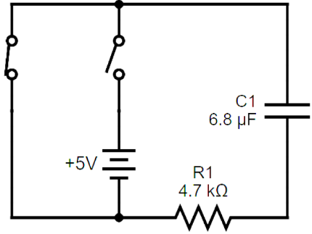
Figure 16.15: RC (“Resistor-Capacitor”) circuit discharging a capacitor.100
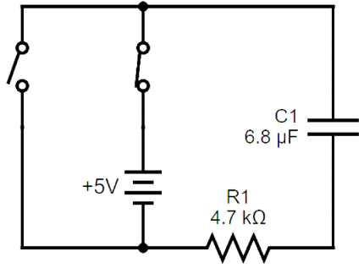
Figure 16.16: RC circuit charging a capacitor.100

Numbers
Assumptions: ideal battery, wires and connections are perfect conductors, resistor is ohmic.
Knowns | Unknowns
$$ΔV_{e,battery}=5 V$$ | $$ΔV_{e,capacitor}$$
$$R_{1}=4.7×{10}^{3} Ω$$ | $$I_{capacitor}$$
$$C_{1}=6.8×{10}^{-6} F$$
When the circuit switches to the charging state, with the battery connected to the capacitor, the voltage across the resistor jumps to the full EMF of the battery, so we can find this maximum current using Ohm’s Law:
$$I_{max}=\frac{ΔV_{e,battery}}{R_{1}}=\frac{5 V}{4.7×{10}^{3} Ω}=1.06×{10}^{-3} A$$
However, the capacitor immediately begins charging, causing the current to decrease, following an exponential decay with a time constant $R⋅C$:
$$\boxed{I_{charging}=I_{max}⋅e^{-t/\left(R⋅C\right)}}$$
( 16.5 )
When discharging, the current is the same, but in the opposite direction:
$$\boxed{I_{discharging}=-I_{max}⋅e^{-t/\left(R⋅C\right)}}$$
( 16.6 )

Words
If we let the capacitor charge for some time and then we change the switches again, going back to the state shown in Figure 16.15, the battery is no longer in the loop, but the charge in the capacitor creates an EMF in the circuit. The loop rule tells us that the voltage drop across the resistor is equal to the EMF of the capacitor and current begins to flow in the opposite direction that it did with the battery. As current flows out of the capacitor, the stored charge decreases, lowering the voltage, which in turn lowers the current through the resistor. Eventually the current drops to zero as the capacitor is fully discharged.
The rate at which the capacitor charges and discharges depends on its capacitance–if it can hold more charge then it takes more time to fill. The rate also depends on the resistor–the larger the resistance the lower the current, reducing the rate of charging.

Graphics
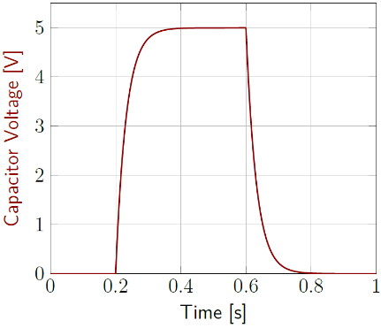
Figure 16.17: Capacitor voltage as a function of time. The switches are set for charging at 0.2 seconds and then set for discharging at 0.6 seconds.¹
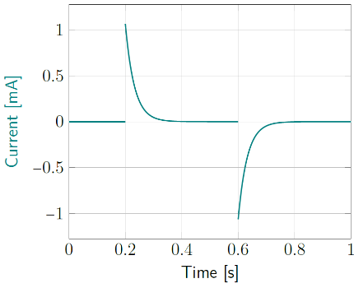
Figure 16.18: Current as a function of time. The switches are set for charging at 0.2 seconds and then set for discharging at 0.6 seconds.¹

Numbers
The maximum voltage that the capacitor can be charged to in this example is the full voltage of the battery, $ΔV_{e,max}=ΔV_{e,battery}=5 V$. During charging, a capacitor starts at zero and slowly builds to the maximum voltage:
$$\boxed{ΔV_{charging}=ΔV_{max}⋅\left(1-e^{-t/\left(R⋅C\right)}\right)}$$
( 16.7 )
When discharging, the voltage starts at the peak and decays:
$$\boxed{ΔV_{discharging}=ΔV_{max}⋅e^{-t/\left(R⋅C\right)}}$$
( 16.8 )

: Capacitors in Series and Parallel ( , )

Words
Just as resistors can be combined to form equivalent resistances, capacitors can also be combined to form equivalent capacitances, but not in the same ways.
When resistors are added in series, the equivalent resistance is the sum of the resistances of all the resistors. But when capacitors are added in parallel, the equivalent capacitance is the sum of the capacitances of all the capacitors. So, capacitors in parallel combine like resistors in series. And capacitors in series combine like resistors in parallel.
The circuits in this section contain batteries and capacitors, but no resistors. With our normal assumptions, that means the time constant for each of these circuits is zero–we won’t need to worry about time-delayed responses.
To understand why capacitors behave differently from resistors, let’s start by looking at the two capacitors combined in parallel in Figure 16.19. Remember that the way they are drawn really represents what a capacitor is, a set of parallel plates. Combining the capacitors in this way increases the area of plates that the battery is charging. And we saw with parallel-plate capacitors that increasing the area increases the capacitance. So, adding capacitors in parallel effectively increases the area, increasing the capacitance.

Graphics
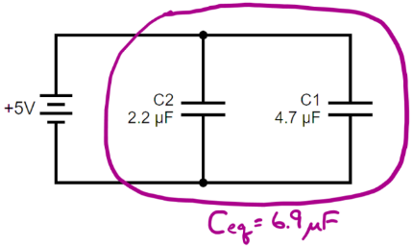
Figure 16.19: A circuit with a battery and two capacitors, all in parallel, showing the equivalent capacitance $C_{eq}$. 100
Figure 16.20: A circuit with a battery and two capacitors, all in series, showing the equivalent capacitance $C_{eq}$.100

Numbers
Assumptions: ideal battery, wires and connections are perfect conductors.
Knowns | Unknowns
$$C_{1}=4.7×{10}^{-6} F$$ | $ΔV_{e,1}$ , $q_{1}$
$$C_{2}=2.2×{10}^{-6} F$$ | $ΔV_{e,2}$ , $q_{2}$
$$C_{3}=1×{10}^{-6} F$$ | $ΔV_{e,3}$ , $q_{3}$
$$C_{4}=1.5×{10}^{-6} F$$ | $ΔV_{e,4}$ , $q_{4}$
$$ΔV_{e,battery}=5 V$$
The equivalent capacitance for $n$ capacitors in parallel is given by:
$$\boxed{C_{eq,parallel}=C_{1}+C_{2}+⋯+C_{n}}$$
( 16.9 )
…and the equivalent capacitance for $n$ capacitors in series is given by:
$$\boxed{C_{eq,series}={\left(\frac{1}{C_{1}}+\frac{1}{C_{2}}+⋯+\frac{1}{C_{n}}\right)}^{-1}}$$
( 16.10 )
In Figure 16.21 we can see that all current that passes through C4 also must pass through C3, so those two are in series. The equivalent capacitance of those two capacitors is…
$$C_{34}={\left(\frac{1}{C_{3}}+\frac{1}{C_{4}}\right)}^{-1}=0.6×{10}^{-6} F$$

Words
To understand why putting capacitors in series decreases the capacitance, we need to remember that the loop rule tells us that the capacitors must split the EMF of the battery between them, so neither one sees the full EMF of the battery. That means the voltage on each capacitor is lower, so neither capacitor can hold as much charge as it would if it were connected to the battery by itself. The combined capacitance in series is lower than the capacitance of the individual capacitors.
Since we can deal with capacitors in series and parallel, let’s try the combination circuit of capacitors in Figure 16.21. We should be able to determine the voltage across every component and the charge on every capacitor.
When the battery charges the circuit, all the charge that leaves the positive side of the battery goes to C1; the charge that goes into the negative side of the battery comes partly from C2 and partly from C3. That means we should expect that C1 will have more charge than either C2 or C3. All the charge that goes to the positive plate of C3 had to come from C4, so we should also expect that C3 and C4 each have the same amount of charge.

Graphics
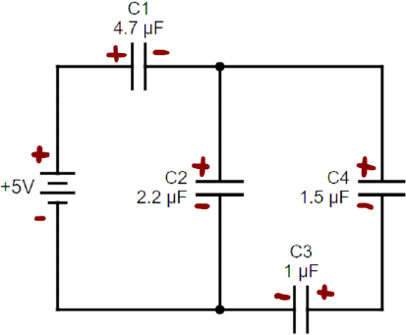
Figure 16.21: A combination circuit of capacitors, with best guesses about which side of each component has a higher voltage than the other. No arrows for current are shown because current is zero when the capacitors are fully charged.100
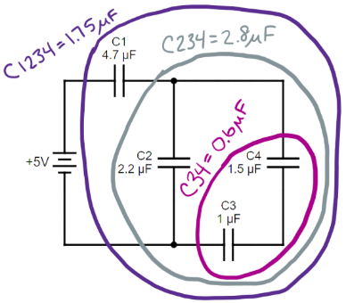
Figure 16.22: Calculating the equivalent capacitance of a combination circuit.100

Numbers
The upper end of C2 is directly connected to the upper end of C34, and the lower end of C2 is directly connected to the lower end of C34, so they are in parallel. Combining them…
$$C_{234}=C_{2}+C_{34}=2.8×{10}^{-6} F$$
Now C234 is in series with C1, so we can combine them:
$$C_{eq}=C_{1234}={\left(\frac{1}{C_{1}}+\frac{1}{C_{234}}\right)}^{-1}=1.75×{10}^{-6} F$$
Now that we have the equivalent capacitance for the whole circuit, we can find the amount of charge that the battery supplies to the circuit:
$$q_{from battery}=C_{eq}⋅ΔV_{e,battery}=8.77×{10}^{-6} C$$
In Figure 16.21 we can see that all of the charge that leaves the positive side of the battery has to go onto C1, so $q_{1}=8.77×{10}^{-6} C$. And capacitance is charge per volt, so…
$$ΔV_{e,1}=\frac{q_{1}}{C_{1}}=1.87 V$$
Using the loop rule clockwise around the left side…
$$ΔV_{e,battery}-ΔV_{e,1}-ΔV_{e,2}=0$$
…so $ΔV_{e,2}=3.13 V$. That means the charge on C2 must be…
$$q_{2}=C_{2}⋅ΔV_{e,2}=6.89×{10}^{-6} C$$
$8.77×{10}^{-6} C$ is the charge that went into the bottom of the battery, and $6.89×{10}^{-6} C$ came from C2, so the rest had to come from C3:
$$q_{3}=q_{from battery}-q_{2}=1.88×{10}^{-6} C$$

: Summary
Chapter summaries in this book are ordered by concept, not necessarily in the order in which they are presented in the chapter. Mathematical models are grouped together at the end of each summary. See the appendices for the meanings of all symbols used in this book.

General
- A circuit is a path that forms a complete loop for current to follow.
- If two components of a circuit are directly connected to each other at both ends, then they are in parallel with each other.
- Multiple resistors in series and/or parallel can be reduced to an equivalent resistor that feels the same to the battery.
- Multiple capacitors in series and/or parallel can be reduced to an equivalent capacitor that feels the same to the battery.

Electric Current
- Current flows out of the positive side of a battery and returns through the negative side.
- Current flows through a resistor from the positive side to the negative side.
- Current flows through a capacitor from the positive side to the negative side.
- If all the current passing through one of the components of a circuit has no choice but to go through another component, then those two components are in series.
- The total amount of current going into a junction is equal to the total amount of current going out of the junction. This is called the “junction rule.”
- In a circuit with resistors and capacitors, current through the capacitor when charging and discharging jumps to its maximum value then decays exponentially with a time constant of R ⋅ C.

Energy & Potential
- The total change in electric potential around a complete loop is equal to zero. This is called the “loop rule.”
- In a circuit with resistors and capacitors, capacitors charge and discharge following an exponential decay with a time constant of R ⋅ C.

Mathematical Models
Equation | Reference | Restrictions on the validity of the equation
“Loop rule”  $$ΔV_{e,loop}=0$$ | ( 16.1 ) | for a complete loop in a circuit
$$R_{eq,series}=R_{1}+R_{2}+⋯+R_{n}$$ | ( 16.2 ) | for resistors in series
“Junction rule”  $$Σ\left(I_{in}\right)=Σ\left(I_{out}\right)$$ | ( 16.3 ) | for a junction in a circuit
$$R_{eq,parallel}={\left(\frac{1}{R_{1}}+\frac{1}{R_{2}}+⋯+\frac{1}{R_{n}}\right)}^{-1}$$ | ( 16.4 ) | for resistors in parallel
$$C_{eq,parallel}=C_{1}+C_{2}+⋯+C_{n}$$ | ( 16.9 ) | for capacitors in parallel
$$C_{eq,series}={\left(\frac{1}{C_{1}}+\frac{1}{C_{2}}+⋯+\frac{1}{C_{n}}\right)}^{-1}$$ | ( 16.10 ) | for capacitors in series

: Questions
Questions are ordered according to Bloom’s Taxonomy, progressing from regurgitating information (Level 1) to synthesizing new information with previous knowledge to create something new (Level 6). The bold letters at the beginning of each question indicate whether the question involves Words [W], Graphics [G], and/or Numbers [N]. See the appendices for conversion factors.

Level 1 - Remember
      - [W] What are wires usually made of?
      - [W & N] When two or more resistors are put together in series, do they each always have the same amount of current or the same amount of voltage?
      - [W & N] When two or more capacitors are put together in parallel, do they each always have the same amount of charge or the same amount of voltage?
      - [W & N] Add labels to each boxed equation from this chapter that tell what the symbol to the left of the = sign represents
Symbol | Reference | Label
$$ΔV_{e,loop}$$ | ( 16.1 )
$$R_{eq,series}$$ | ( 16.2 )
$$Σ\left(I_{in}\right)$$ | ( 16.3 )
$$R_{eq,parallel}$$ | ( 16.4 )
$$I_{charging}$$ | ( 16.5 )
$$I_{discharging}$$ | ( 16.6 )
$$ΔV_{e,charging}$$ | ( 16.7 )
$$ΔV_{e,discharging}$$ | ( 16.8 )
$$C_{eq,parallel}$$ | ( 16.9 )
$$C_{eq,series}$$ | ( 16.10 )

Level 2 - Understand
      - [W & G] Figure 16.1 contains a lot of things that are in Section 16.1, which is all about the parts of circuits. Does Figure 16.1 show a circuit? Explain your answer.
      - [G] Figure 16.10 has a different arrow for the current going through each resistor, but Figure 16.7 has only a single arrow. Why does Figure 16.7 only need one arrow, or should it have three?
      - [W & N] What effect would each of the following have on the time needed to fully charge a capacitor in an RC circuit?
        - Increasing the capacitance?
        - Increasing the resistance?
        - Increasing the voltage of the battery?
      - [W] In the last paragraph in the “Words” column on the first page of Section 16.6 it talks about the current changing as the voltage changes across a resistor. What “law” is it assuming that you understand?

Level 3 - Apply
      - [N] If you have a 100-pF capacitor with a maximum voltage rating of 50 V, what is the maximum amount of charge that can be stored in that capacitor?
      - [N] If you have a $4.7 Ω$ resistor with a maximum power rating of 0.5 W, what is the maximum amount of current that can safely pass through the resistor?
      - [G & N] Analyze the circuit below using the same pattern that was used in Section 16.2.
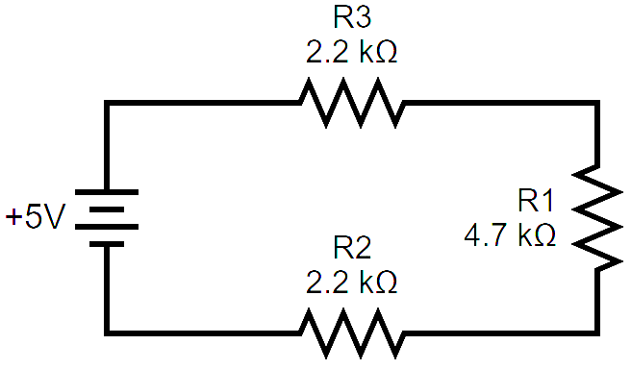
Three resistors in series.100
      - [G & N] Analyze the circuit below using the same pattern that was used in Section 16.3.
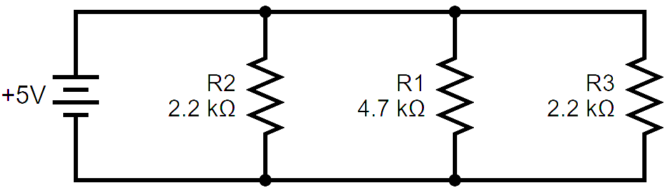
Three resistors in parallel.100
      - [N] The calculations weren’t finished in Section 16.5. Find the values for the remaining unknowns.
      - [N] In Section 16.6 the time constant of the circuit is mentioned but never calculated. What is the value of the time constant for that circuit? What should the unit be in its simplest form?
      - [N] The calculations weren’t finished in Section 16.7. Find the values for the remaining unknowns.
      - [G & N] Find the equivalent capacitance for the circuit below.
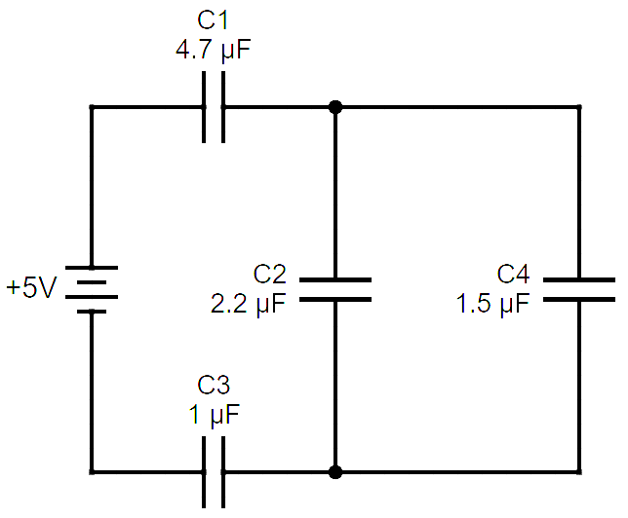
A circuit with a combination of capacitors.100

Level 4 - Analyze
      - [N] For the series circuit in Section 16.2 we could also have asked how much power the battery is producing and how much power is being dissipated by each resistor. Find each of these and determine whether they are consistent with each other.
      - [N] For the parallel circuit in Section 16.3 we could also have asked how much power the battery is producing and how much power is being dissipated by each resistor. Find each of these and determine whether they are consistent with each other.
      - [W, G, & N] Wire is often “stranded” like in the image below, instead of being a single piece of metal, so that it is more flexible. How would the resistance of a stranded wire compare to a solid wire if they are both the same length and the same mass and made from the same metal?
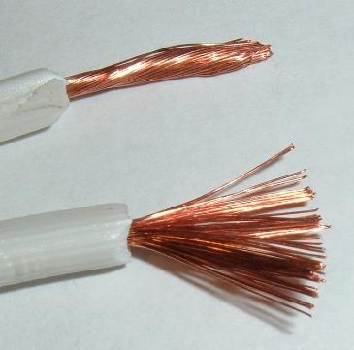
Stranded copper wire, together as it would be inside the insulator and fanned out to make it easier to see.
      - [G & N] Analyze the circuit below using the same pattern that was used in Section 16.4.
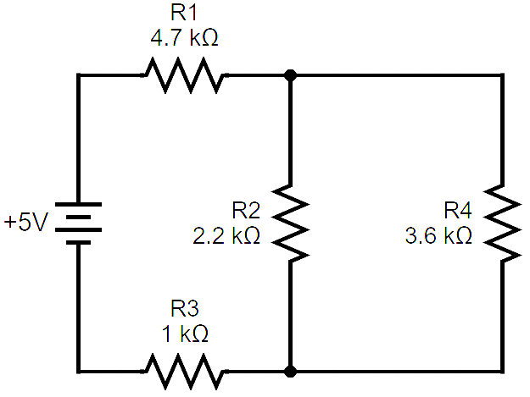
A combination circuit. 100
      - [G] Figure 16.17 shows the voltage across the capacitor as switches are changed in the circuit in Figure 16.15 and Figure 16.16. Create a similar graph showing the voltage across the resistor over the same period of time.
      - [N] For the parallel circuit in Figure 16.19 we could have asked how much charge is stored in each capacitor and how much energy is stored in each capacitor. Find each of these.
      - [N] For the series circuit in Figure 16.20 we could have asked how much charge is stored in each capacitor and how much energy is stored in each capacitor. Find each of these.

Level 5 - Evaluate
      - [N] One of the assumptions listed in Section 16.1 is that wires are perfect conductors. Let’s test that assumption. Elsewhere in the same section it says that resistor values typically start in the ohm range. So, if the resistance of a wire is considerably less than an ohm, let’s say 0.1 $Ω$ or less, then we will say that the assumption is a good one. The long, skinny wire in the middle of Figure 16.3 is made of aluminum. Its length is approximately 10 cm, and its diameter is approximately 0.6 mm. Is our assumption good for that wire? Use an internet search to find the resistivity of aluminum to help you answer this question.
      - [W, G, & N] For the circuit in Section 16.4, what would happen to the voltages and the currents in the battery and the other resistors if R2 were replaced with a wire? Explain your reasoning.
        - The current through R1 would… (increase, remain the same, decrease, or go to zero) …because…
        - The voltage across R1 would… (increase, remain the same, decrease, or go to zero) …because…
        - The current through R3 would… (increase, remain the same, decrease, or go to zero) …because…
        - The voltage across R3 would… (increase, remain the same, decrease, or go to zero) …because…
        - The current through R4 would… (increase, remain the same, decrease, or go to zero) …because…
        - The voltage across R4 would… (increase, remain the same, decrease, or go to zero) …because…
        - The current through the battery would… (increase, remain the same, decrease, or go to zero) …because…
        - The voltage across the battery would… (increase, remain the same, decrease, or go to zero) …because…
This situation is called a “short circuit” because it “shorts out” R3 and R4. In this context, the term “short” has nothing to do with length. In some situations, short circuits can cause dangerous power surges.

Level 6 - Create
      - [W, G, & N] At the beginning of Chapter 1 in Figure 1.1 was a template for a concept map. Create a new concept map with the main ideas from this chapter.
      - [W, G, & N] Imagine you are writing a test question related to this chapter. Think of your own example of a situation that you can analyze using the concepts, graphics, and mathematical analyses described in this chapter. Describe the situation and use the tools from this chapter to analyze the situation as completely as you can, including motion, forces, energy, and momentum.
      - [W, G, & N] Think about possible misconceptions about the material in this chapter. Write a question and an incorrect solution to it that demonstrates a student making such a conceptual error. This cannot be a simple misuse of a vocabulary word, a unit error, or a mathematical error like making an addition error or multiplying when addition was needed, unless the error is rooted in a real misunderstanding about the physics behind the calculation or the misuse of a word. After you have written the question and incorrect solution, explain what is wrong with the student’s solution, and write a correct solution to the problem. Note: You may use a question from this chapter that you got wrong the first time and explain the initial error in your thinking and how you corrected it

– Electricity and Magnetism
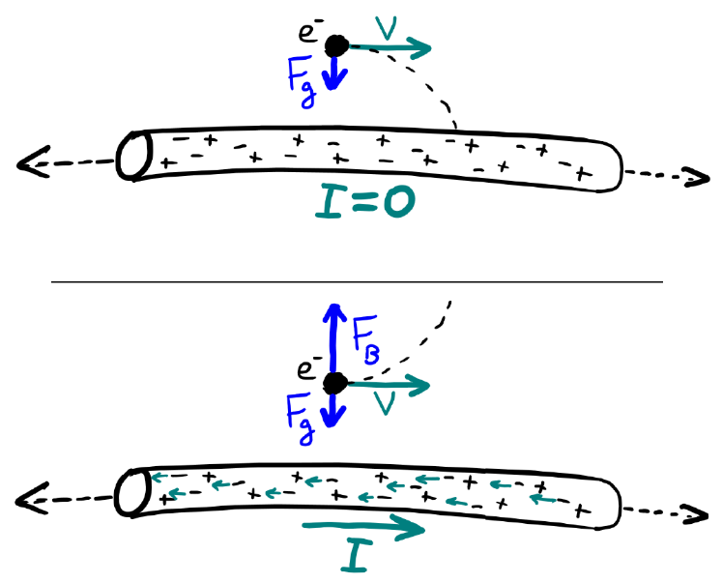
Figure 17.1: A current-carrying wire generates a magnetic field around itself. When a charged particle moves through that field, it experiences a magnetic force.1

Imagine riding on an electron that is flying along through free space. If nothing else is interacting with you and your electron, then conservation of momentum tells us that you will continue moving at the same speed in a straight line. Pretty boring, right? So, let’s add a wire that is so long you can’t see either end, parallel to the path you are traveling. Now instead of traveling in a straight line, your path will curve toward the wire, because of the gravitational field created by the wire.
If we add special relativity into our thinking, since the wire is moving in our reference frame, length contraction makes the spacing between the atoms look shorter along the length of the wire. Still, our path curves toward the wire because of its gravitational field. Now let’s add electric forces. If the net charge on the wire is zero then the wire contains an equal number of protons and electrons in roughly the same positions, so the net electric force from the wire on your electron will be zero. Still, gravity pulls you toward the wire.
Let’s add just one thing more to this “thought experiment.” What if the wire is carrying current in the same direction that the electron is moving? Electron motion is opposite the direction of current, so that means the electrons in the wire are moving opposite the direction that you are moving on your electron. In your frame of reference, the negatively charged electrons in the wire are now moving faster than the positively charged atomic nuclei, so the spacing between electrons contracts more than the spacing between the nuclei. Now the wire appears to have a net negative charge, so it creates an electric field that repels your negatively charged electron, and you start curving away from the wire instead of toward it! You may recall that it was mentioned at the beginning of Chapter 14 that “magnetic force is intertwined with electric force in such a way that they can be considered a single electromagnetic force.” Now you see why: the combination of special relativity and electric fields creates something new: a magnetic field. We will explore magnetic fields in this chapter.

: Magnetic Fields Created by Electric Current ( , )

Words
Let’s find the magnetic field that is created a long, straight wire that is carrying 10 A of current in the direction of the arrow labeled “up” in Figure 17.2. We will first look generally at the magnetic field all around the wire. Then we will find the exact magnetic field caused by the wire at that location 5 cm to the left of the wire.
Iron filings align themselves along magnetic field lines in much the same way that a compass needle aligns itself with the earth’s magnetic field. This can be seen in Figure 17.3, where iron filings formed themselves into rough circles around a current-carrying wire. Notice that the effect is more pronounced near the wire than out at the edges of the photo. That is because the magnetic field is stronger near the wire.
That photograph is three-dimensional. We are going to have to practice making drawings that clearly show directions into and out of the surface. Imagine holding an archery arrow and pointing it directly toward yourself. What would you see? A circular shaft with a point sticking out in the middle. That’s how we will draw an arrow pointing out of the page (toward you), a circle and a point, ⊙, like on the left side in Figure 17.2. Now imagine turning the arrow around so it points away from you. What would you see? The fletching (feathers), which looks a bit like an “x.” That’s how we will draw an arrow pointing into the page (away from you), ⊗, like on the right side in Figure 17.2.

Graphics
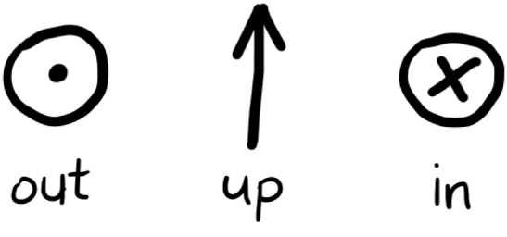
Figure 17.2: Arrows pointing in three different directions: out of the page (a dot, often inside a circle), up, and into the page (an “x,” often inside a circle).¹
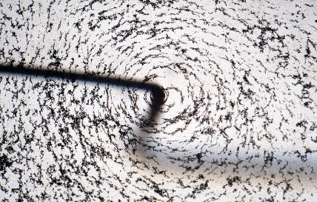
Figure 17.3: The magnetic field around a current-carrying wire can be seen by running the wire through a piece of paper and sprinkling iron filings on the paper. The filings align themselves with the magnetic field, forming circles around the wire.

Numbers
Assumptions: the wire is long, straight, and surrounded by empty space.
Knowns | Unknowns
$$I=10 A$$ | $\vec{B}$, 5 cm left of the wire
$$r=0.05 m$$
The magnitude of the magnetic field $B$ around a long, straight current-carrying wire is given by:
$$\boxed{B=\frac{μ_{0}⋅I}{2⋅π⋅r}}$$
( 17.1 )
…where $μ_{0}$, pronounced “mu-nought,” is the permeability of free space, $4⋅π×{10}^{-7} N/A^{2}$ and $r$ is the distance from the wire.
For this example,
$$B=\frac{\left(4⋅π×{10}^{-7} N/A^{2}\right)⋅\left(10 A\right)}{2⋅π⋅\left(0.05 m\right)}=4×{10}^{-5} T$$
The SI unit for magnetic field is tesla [T].

Words
The magnetic field lines around a long, straight, current-carrying wire are circular, forming complete loops around the wire. Magnetic fields, like electric fields, are vectors. So, they have direction. We need to use the “right-hand rule” (RHR) for current and magnetic field to determine the direction. Using your right hand, point your thumb in the direction of the current, as shown in Figure 17.4. The direction your fingers curl shows the direction of the magnetic field.
It is difficult to draw 3-D sketches, and if they are not drawn well then they can be impossible to interpret. So, we will instead use 2-D sketches like the ones in Figure 17.5. The sketch on the right in Figure 17.5 is equivalent to the sketch in Figure 17.4. The current is going upward. On the left side of the current the magnetic field is coming out of the page, represented by the ⊙’s. On the right side of the current the magnetic field is going into the page, represented by the ⊗’s. The sketch on the left of Figure 17.5 is what Figure 17.4 would look like from above.
The right side of Figure 17.5 answers the question about what the magnetic field looks like in general around the wire. Now if we specifically look at a location 5 cm to the left of the wire, we can see that at that point the magnetic field is pointing out of the page. Calculations are done in the “Numbers” column to show that the strength of the field at that location is $4×{10}^{-5} T$. For reference, that is approximately the same as the strength of the earth’s magnetic field.

Graphics
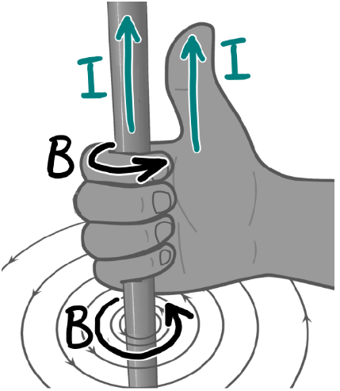
Figure 17.4: Using the Right-Hand Rule (RHR) for current and magnetic field to determine the direction of the magnetic field around a wire.
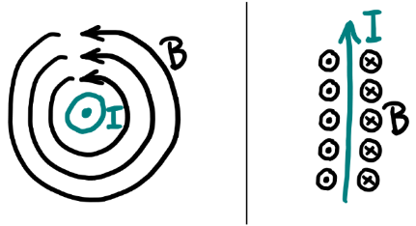
Figure 17.5: The magnetic field caused by a current coming out of the page (on the left) or up (on the right).1

Numbers
The calculation only gives the magnitude of the magnetic field. The direction is found in the “Words” and “Graphics” columns. The current is going in the upward direction as shown on the right side of Figure 17.5. And we are interested in a point to the left of the wire. On the left side of the wire, we can see in the figure that the magnetic field is pointing out of the page ⊙, giving the complete answer for the magnetic field 5 cm to the left of the wire:
$$\vec{B}=4×{10}^{-5} \text{T} ⊙$$
The symbol ⊙ is enough to unambiguously give the direction; if preferred, it could be written out in words, “out of the page,” or else coordinate directions $+\hat{x}$, $+\hat{y}$, and $+\hat{z}$ could be defined and the direction could be given in those coordinates.
.

: Solenoids and Bar Magnets ( , )

Words
We have looked at the magnetic field of a long, straight wire. Now, let’s look at a square-shaped loop of wire, 10 cm on each side, carrying 10 A of current in a clockwise direction, as shown in Figure 17.6. ⊙’s and ⊗’s have been added next to each straight segment of wire, showing the direction of the magnetic field created by that segment.
Each side of the loop of wire creates a magnetic field inside the loop that points into the page. What about the magnetic field at the spot marked with a question mark in the figure? The left wire of the loop creates a magnetic field that points out of the page, and that side is closest, so it has the greatest effect. But the wire on the right side contributes a magnetic field pointing into the page at that location; and it is above the bottom wire and below the top wire, so those also both contribute a magnetic field pointing into the page. Those three wires weaken the field created by the wire on the left.
A loop of current creates a strong magnetic field inside, and a much weaker field outside of the loop. That effect is amplified if many loops are stacked on top of each other in a coil–this is called a “solenoid.” The direction of the field inside the solenoid can be determined using the RHR on one of the loops. Instead of looking at just a single loop like that in Figure 17.6, let’s find the magnetic field inside a 0.12-m-long solenoid with 7.5 of those loops, like in Figure 17.7.

Graphics
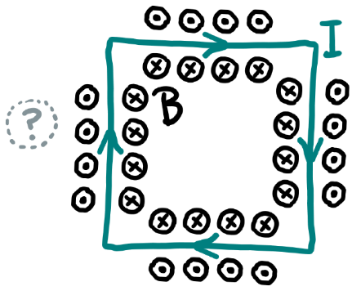
Figure 17.6: The magnetic field created by a loop of current, with an area marked “?” that is discussed in the “Words” column.¹
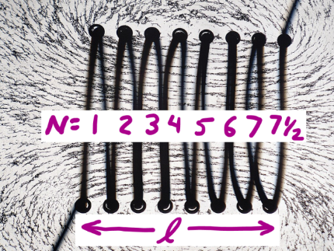
Figure 17.7: The magnetic field created by a loop of current, with an area marked “?” that is discussed in the “Words” column.

Numbers
Assumptions: the solenoid contains empty space.
Knowns | Unknowns
$$l_{square}=0.1 m$$ | $$\vec{B_{inside}}$$
$$I=10 A$$ | $$U_{B}$$
$$l_{solenoid}=0.12 m$$
$$N_{loops}=7.5$$
The magnitude (strength) of the magnetic field inside a long, straight solenoid is given by:
$$\boxed{B_{solenoid}=\frac{μ_{B}⋅N_{loops}⋅I}{l_{solenoid}}}$$
( 17.2 )
…where $μ_{B}$ is the permeability of the material inside the solenoid, which is typically much larger than $μ_{0}$, and $l$ is the length of the solenoid as shown in Figure 17.7. Notice that the size of the loops has no effect on the strength of the magnetic field! In this example, the solenoid is empty, so we can use $μ_{0}$ for $μ_{B}$.
$$\begin{aligned}B_{solenoid}&=\frac{\left(4⋅π×{10}^{-7} N/A^{2}\right)⋅7.5⋅\left(10 A\right)}{0.12 m} \\ &=7.85×{10}^{-4} T\end{aligned}$$

Words
The strength of the magnetic field is calculated in the “Numbers” column. For direction, imagine looking through the solenoid in Figure 17.7 from the right side. If the current is flowing clockwise, as in Figure 17.6, then from the right the magnetic field would be going away. For the view shown in Figure 17.7, the magnetic field inside the solenoid is to the left. Magnetic fields, like electric fields, contain energy. In this case, energy is contained inside the solenoid.
Figure 17.7 and Figure 17.8 show that bar magnets and solenoids have similar magnetic fields. Bar magnets are made from “ferromagnetic” materials whose molecules have “magnetic dipoles” that act like microscopic bar magnets. When they align themselves, they can create a permanent magnet.
We have seen that electric dipoles are made by equal amounts of positive and negative electric charge, separated by a small distance. “Magnetic dipole” makes it sound like there must be magnetic charges. But so far there is no evidence that magnetic charges (called magnetic monopoles) exist; that means magnetic field lines always form loops– they can’t have a beginning or end.
Ferromagnetic materials are strongly attracted by magnetic fields. “Paramagnetic” materials are attracted less strongly by magnetic fields. “Diamagnetic” materials that are repelled by magnetic fields.

Graphics
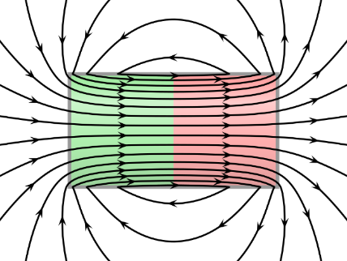
Figure 17.8: The magnetic field of a bar magnet is nearly identical to that of a solenoid. The left side is the “North pole” of the magnet and the right side is the “South pole.”
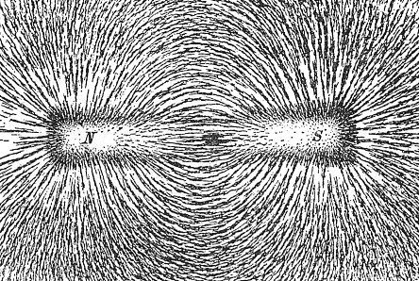
Figure 17.9: Iron filings cannot show what is happening inside the bar magnet, only around it. This image makes it appear that magnetic poles are like magnetic charges, but magnetic charges do not exist.

Numbers
Energy is contained in the magnetic field inside the solenoid, in the same way that energy is contained in the electric field of a capacitor. The energy density $u_{B}$ of a magnetic field is given by:
$$\boxed{u_{B}=\frac{B^{2}}{2⋅μ_{B}}}$$
( 17.3 )
Be careful with the penmanship when working with this mathematical model–it contains both $u_{B}$ and $μ_{B}$! For long solenoids, the magnetic field is almost completely contained within the volume of the solenoid itself, so the total magnetic energy stored by a solenoid is approximately…
$$\begin{aligned}U_{B,solenoid}&=u_{B}⋅l_{solenoid}⋅A_{solenoid} \\ &=\frac{B_{solenoid}^{2}}{2⋅μ_{B}}⋅l_{solenoid}⋅A_{solenoid} \\ &={\left(\frac{μ_{B}⋅N_{loops}⋅I}{l_{solenoid}}\right)}^{2}⋅\frac{l_{solenoid}⋅A_{solenoid}}{2⋅μ_{B}} \\ &=\frac{μ_{B}⋅N_{loops}^{2}⋅I^{2}⋅A_{solenoid}}{2⋅l_{solenoid}}\end{aligned}$$
…where $A_{solenoid}$ is the area of a single loop of the solenoid. In this case…
$$\begin{aligned}U_{B}&=\frac{μ_{0}⋅N_{loops}^{2}⋅I^{2}⋅l_{square}^{2}}{2⋅l_{solenoid}} \\ &=\frac{\left(4⋅π×{10}^{-7} N/A^{2}\right)⋅{7.5}^{2}⋅{\left(10 A\right)}^{2}⋅{\left(0.1 m\right)}^{2}}{2⋅\left(0.12 m\right)} \\ &=2.95×{10}^{-4} J\end{aligned}$$

: Charged Particles in Magnetic Fields ( , )

Words
We have seen that we can make uniform magnetic fields inside solenoids. Now we will look at the motion of charged particles in uniform magnetic fields. We will look specifically at a proton that is sent into the magnetic field, traveling with an initial velocity of 100 m/s to the right. First, we will send the proton into a magnetic field that is 5 T out of the page. Then we will send the proton into a magnetic field that is 5 T to the left.
We can find acceleration if we know the forces. The magnetic force depends on charge, velocity, strength of the magnetic field, and angle between velocity and magnetic field. A particle with no charge or zero velocity feels no magnetic force.
The direction of the force is found using a second right-hand rule, shown in Figure 17.10. For this RHR, the fingers still point in the direction of magnetic field, but this time they are straight. The thumb points in the direction of velocity. Then, if the particle has a positive charge, the magnetic force on the particle points straight out from the palm of the hand; if the particle has a negative charge, the magnetic force points straight out from the back of the hand. The force is perpendicular to the velocity, making the particle follow a curving path at constant speed. Calculations of the magnitude of the force and the radius of the path are done in the “Numbers” column, with the path shown in Figure 17.11.

Graphics
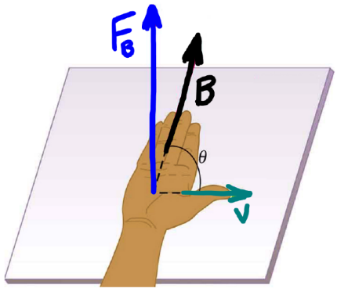
Figure 17.10: The Right-Hand Rule for magnetic force shows the direction of the force on a positively charged particle in a magnetic field.
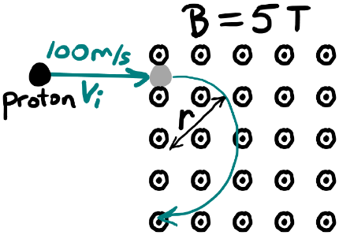
Figure 17.11: The magnetic force is perpendicular to the velocity, causing the particle to move in a circular path.¹

Numbers
Assumptions: the proton is in free space; the effects of gravity are negligible.
Knowns | Unknowns
$$q_{proton}=+1.6×{10}^{-19} C$$ | motion of proton
$$m_{proton}=1.67×{10}^{-27} kg$$
$$\vec{v_{i}}=100 m/s →$$
$$\vec{B}=5 \text{T} ⊙$$
The magnitude of the magnetic force $F_{B}$ on a particle that is moving at speed $v$ through a magnetic field $\vec{B}$ is given by:
$$\boxed{F_{B}=\left|q⋅v⋅B⋅sinθ\right|}$$
( 17.4 )
…where $θ$ is the angle between $\vec{B}$ and $\vec{v}$. In this situation, $sinθ=1$. The force is perpendicular to $\vec{v}$, so it is a centripetal force:
$$\begin{aligned}F_{B}&=F_{c} \\ \left|q⋅v⋅B⋅sinθ\right|&=\frac{m⋅v^{2}}{r}\end{aligned}$$
$$\boxed{r=\left|\frac{m⋅v}{q⋅B}\right|}$$
( 17.5 )
The particle follows a circular path of radius $r$ when $v$ is perpendicular to $B$. in this example,
$$r=\frac{\left(1.67×{10}^{-27} kg\right)⋅\left(100 \frac{m}{s}\right)}{\left(1.6×{10}^{-19} C\right)⋅\left(5 T\right)} \\ =2.09×{10}^{-7} m$$

Words
When the magnetic field points opposite the direction of the velocity, it becomes impossible to use the second RHR, because if you could open your thumb far enough that it pointed in the direction opposite your fingers then you could rotate your hand in any direction keeping the fingers and thumb still pointing in the correct directions, so there is no way of knowing what direction your palm should face. The calculation in the “Numbers” column shows that this isn’t a problem, because when the angle between the velocity and the magnetic field is 180° the magnitude of the force is zero. There is no acceleration, so the velocity of the proton does not change. It follows the path shown in Figure 17.12.
When electric and magnetic fields are combined, more complicated motion is observed. For example, Figure 17.13 shows an electron that starts at rest in a region where the electric field is uniform and pointing downward and the magnetic field is uniform and pointing out of the page. The electric force in this whole region is constant, pointing upward since the electron’s charge is negative. The magnetic force is initially zero, so the electron starts to accelerate upward. As it accelerates, the speed increases, creating an increasing magnetic force that causes the path of the particle to curve. When the electron is moving horizontally, the magnetic force is larger than the electric force, accelerating the particle back downward. Eventually the electron comes to rest, and the cycle begins again.

Graphics
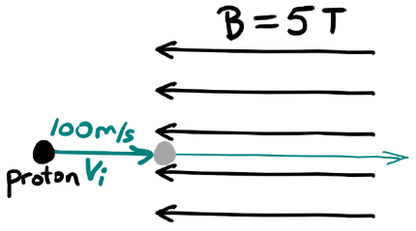
Figure 17.12: When the velocity is parallel to the magnetic field lines, there is no magnetic force.¹
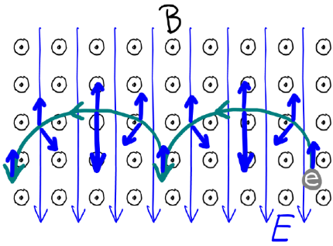
Figure 17.13: An electron placed into this combined electric and magnetic field with an initial velocity of zero follows a path forming a series of arcs. The electric force is represented by heavy blue arrows pointing upward with constant magnitude. The magnetic force is represented by heavy blue arrows pointing downward and sometimes at angles, changing in magnitude and direction as the electron’s velocity changes.¹

Numbers
Assumptions: the proton is in free space; the effects of gravity are negligible.
Knowns | Unknowns
$$q_{proton}=+1.6×{10}^{-19} C$$ | motion of proton
$$m_{proton}=1.67×{10}^{-27} kg$$
$$\vec{v_{i}}=100 m/s →$$
$$\vec{B}=5 \text{T} ←$$
This time, the angle between $\vec{v_{i}}$ and $\vec{B}$ is ${180}^{∘}$, so…
$$F_{B}=\left|q⋅v⋅B⋅0\right|=0$$
There is no magnetic force, so no acceleration.

: Current in a Magnetic Field ( )

Words
Now that we have looked at individual charges in magnetic fields we are ready to look at current, which is just moving charges, in a magnetic field. We will consider a square-shaped loop of wire, 10 cm on each side, carrying 10 A of current in a clockwise direction, in a 5-T magnetic field that is going to the left, as shown in Figure 17.15. What are the magnetic forces on the loop?
The directions of the forces on each side of the loop can be found using another version of the second right-hand rule, shown in Figure 17.14. The fingers again point in the direction of the magnetic field and remain straight. The thumb points in the direction of the current. When the fingers and thumb are correctly oriented, the magnetic force on the current points straight out from the palm of the hand. Note that, since current is defined as the direction of motion of positive charges, this RHR is equivalent to the previous one!
Using this RHR, the force on the left side of the loop is out of the page and the force on the right side of the loop is into the page. The top and bottom sides of the loop are parallel to the magnetic field. Just as with charged particles, a current experiences no magnetic force when moving parallel to magnetic field lines. So, there is no magnetic force on the top or bottom side of the loop. Calculations in the “Numbers” column also show that there is no magnetic force on the top and bottom sides of the loop.

Graphics
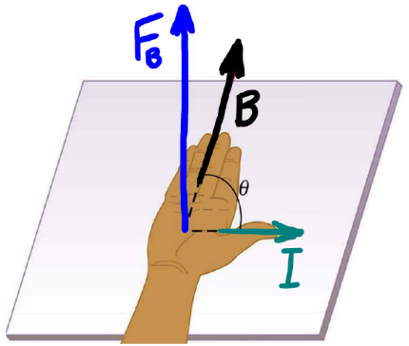
Figure 17.14: The Right-Hand Rule for magnetic force shows the direction of the force on a current in a magnetic field.108
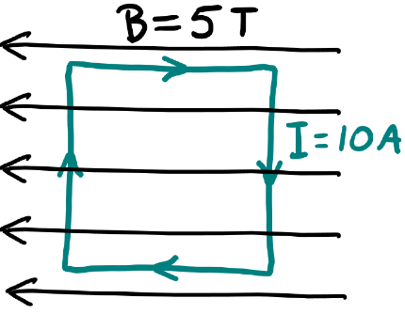
Figure 17.15: A loop of current in an external magnetic field.¹

Numbers
Assumptions: the effects of gravity are negligible.
Knowns | Unknowns
$$l_{square}=0.1 m$$ | magnetic forces on loop
$$I=10 A$$
$$B=5 T ←$$
The magnitude of the magnetic force $F_{B}$ on a current through a wire of length $l$ in a magnetic field $\vec{B}$ is given by:
$$\boxed{F_{B}=\left|I⋅l⋅B⋅sinθ\right|}$$
( 17.6 )
…where $θ$ is the angle between $\vec{B}$ and the current. In this situation, we need to consider each wire separately:
$$F_{B,top}=\left|I⋅l_{square}⋅B⋅sin{180}^{∘}\right|=0$$
$$F_{B,left}=\left|I⋅l_{square}⋅B⋅sin{90}^{∘}\right|=I⋅l_{square}⋅B$$
$$F_{B,bottom}=\left|I⋅l_{square}⋅B⋅sin0^{∘}\right|=0$$
$$F_{B,right}=\left|I⋅l_{square}⋅B⋅sin{90}^{∘}\right|=I⋅l_{square}⋅B$$
For the directions of the magnetic forces, we need to use the RHR.

Words
The forces on the loop are shown in Figure 17.16, and an axis of rotation has also been added through the center. If the loop is free to rotate around that axis, the torque caused by the magnetic forces can make the loop turn. The torque is counterclockwise as viewed from the top of the loop looking down along the axis of rotation. In the setup described here, if we reverse the current every time the loop turns 180°, then the torque would always be in the same direction, and we would be using the magnetic field to transform electrical energy into kinetic energy. An electric motor!
What would happen if we put a wire loop like this in the same magnetic field, without a current, and then applied an external torque to spin the loop? If the loop is made from a conductor, then some of the electrons would be free to move. What would they do? This situation is shown in Figure 17.17.
The electrons on the left side of the loop would experience an upward force, while those on the right side would experience a downward force. The electrons on the top and bottom experience less force since their speed is slower, but they don’t really have anywhere to go. The ones on the sides can flow to the top and bottom, where they will repel the electrons that were already at the top and bottom. The net result is a flow of current around the loop. We are essentially running an electric motor backwards, using a magnetic field to convert the kinetic energy of the loop into electric energy. A generator!

Graphics
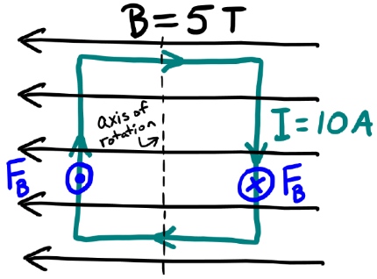
Figure 17.16: The forces create a torque on the loop, which can make it spin around the axis of rotation. This is how an electric motor works.¹
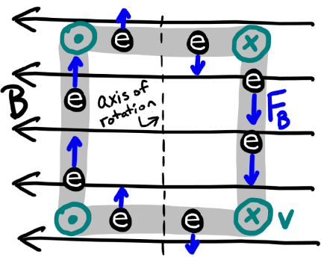
Figure 17.17: Rotating a loop of wire in a magnetic field creates a force on the charges in the wire, creating current. Arrows on the corners of the loop indicate its direction of motion. Arrows on electrons indicate magnetic forces.¹

Numbers
Combining the calculated values for the forces with the directions and locations of the forces in Figure 17.16, we can find the magnitude of the torque caused by the magnetic forces on the left and right sides of the loop. Both forces contribute in the counterclockwise direction, so…
$$\begin{aligned}τ&=F⋅r_{⟂} \\ τ_{net}&=F_{B,left}⋅\frac{l_{square}}{2}+F_{B,right}⋅\frac{l_{square}}{2} \\ &=I⋅l_{square}⋅B⋅l_{square} \\ &=I⋅A_{square}⋅B \\ &=\left(10 A\right)⋅{\left(0.1 m\right)}^{2}⋅\left(5 T\right) \\ &=0.5 N⋅m\end{aligned}$$
This logic works not just for a square loop, but any shape of loop. If we have not just one loop but $N$ loops, then we can just multiply our result by $N$. In Figure 17.16, the area vector of the loop (which points out from the surface of the area, so out of the page in this example) is perpendicular to the magnetic field; if the angle were different then the torque would be smaller. A more general form for the magnitude of the torque, which works for any number of loops in a uniform magnetic field, is…
$$\boxed{τ=\left|N⋅I⋅A⋅B⋅sinθ\right|}$$
( 17.7 )
…where $θ$ is the angle between $\vec{B}$ and the area vector of the loops.

: Inductance and Inductors ( )

Words
Magnetic fields contain energy, just like electric fields do. In an electric circuit, capacitors can be used to store electrical energy in the electric field between the plates. In the same way, inductors can be used in a circuit to store energy in a magnetic field. Inductors are usually small solenoids with a ferromagnetic core that increases the strength of the magnetic field. The magnetic field increases with current, so the energy stored in an inductor increases with current. The “inductance” of inductors is measured in henrys [H], with typical values being millihenrys or lower. A higher inductance means more energy stored for the same amount of current.
Just as it takes time to add or remove charge from a capacitor, it takes time to change the current in an inductor. Let’s examine the circuit in Figure 17.19, to see what happens to the current and voltage in the inductor when the switches are changed and find the maximum amount of energy that the inductor can store in this circuit.
Let’s assume that the circuit was initially in the off position and then the switches are changed to the “on” position. Since it takes time to build up the current in the inductor, and the resistor is in series with the inductor, we know that it will take time for the current to build up in the resistor as well. That means initially there is no voltage drop across the resistor, so all the voltage drop from the battery must be across the inductor.

Graphics
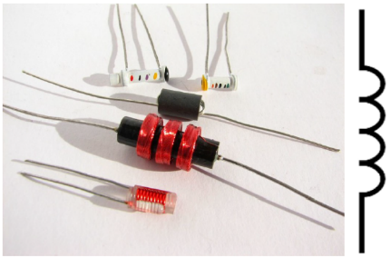
Figure 17.18: An assortment of inductors, and the symbol for an inductor.100,
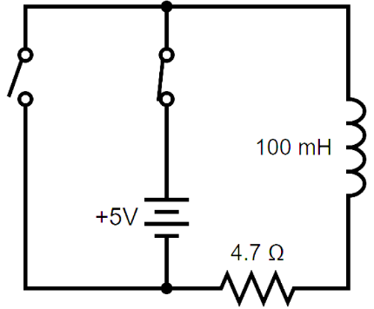
Figure 17.19: Switches set to turn an “RL” (Resistor-Inductor) circuit on. To turn the circuit off, the open switch needs to be closed, and the closed switch needs to be opened.100

Numbers
Assumptions: ideal battery, wires and connections are perfect conductors, ohmic resistor.
Knowns | Unknowns
$$ΔV_{e,battery}=5 V$$ | $$ΔV_{e,inductor}$$
$$R_{1}=4.7 Ω$$ | $$I_{inductor}$$
$$L_{1}=100×{10}^{-3} H$$ | $$U_{L,max}$$
The maximum current will be when the voltage drop across the resistor is the same as the voltage of the battery. Using Ohm’s law…
$$I_{max}=\frac{ΔV_{e,battery}}{R_{1}}=\frac{5 V}{4.7 Ω}=1.06 A$$
The energy stored in an inductor is given by:
$$\boxed{U_{L}=\frac{1}{2}⋅L⋅I^{2}}$$
( 17.8 )
…so the maximum in this case would be…
$$\begin{aligned}U_{L,max}&=\frac{1}{2}⋅\left(100×{10}^{-3} H\right)⋅{\left(1.06 A\right)}^{2} \\ &=0.0566 J\end{aligned}$$

Words
When the current builds up to the point that the voltage drop across the resistor is the same as the voltage drop across the battery then the voltage drop across the inductor goes to zero and the current becomes constant. The amount of time needed to reach the maximum current increases with inductance and decreases as resistance increases. The maximum amount of energy stored in the inductor will be when the current is at a maximum, so after a long enough time has passed with the circuit on.
If the circuit is then switched off, now it will take time for the current through the inductor to decrease. So, the voltage across the resistor starts out the same as it was when the circuit was on, and that voltage decreases as the current decreases. That means there is a sudden spike in the voltage across the inductor to match the voltage drop across the resistor, and then the voltage across the inductor goes to zero along with the voltage and the current across the resistor.

Graphics
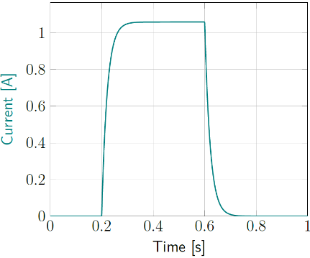
Figure 17.20: Inductor current as a function of time. The switches are set to “on” at 0.2 second and then set to “off” at 0.6 seconds.¹
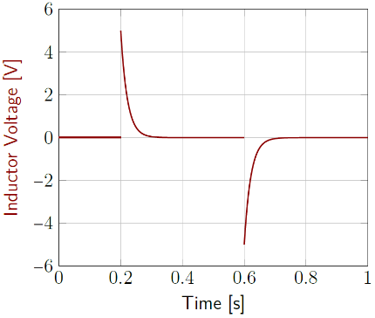
Figure 17.21: Inductor voltage as a function of time. The switches are set to “on” at 0.2 second and then set to “off” at 0.6 seconds.¹

Numbers
The rate of change of the current in an RL circuit is determined by the time constant $L/R$.
$$\boxed{I_{on}=I_{max}⋅\left(1-e^{-\left(t⋅R\right)/L}\right)}$$
( 17.9 )
…and…
$$\boxed{I_{off}=I_{max}⋅e^{-\left(t⋅R\right)/L}}$$
( 17.10 )
The maximum voltage across the inductor is the full EMF of the battery, and voltage varies with the same time constant as current:
$$\boxed{ΔV_{e,on}=ΔV_{e,max}⋅e^{-\left(t⋅R\right)/L}}$$
( 17.11 )
…and…
$$\boxed{ΔV_{e,off}=-ΔV_{e,max}⋅\left(1-e^{-\left(t⋅R\right)/L}\right)}$$
( 17.12 )

: Combining Inductors and Capacitors ( , )

Words
A capacitor takes time to build up charge, and an inductor takes time to build up current. Let’s look at what happens when you put them together in a circuit like the one in Figure 17.22. We will start with the switch open, so no current is flowing, but we will start with the capacitor initially charged to 5 V. What happens when we close the switch?
When the switch is closed, current can start to flow, but it takes time for current to build up in an inductor, so current slowly ramps up. The current is coming from the charge stored in the capacitor, so as charge leaves the capacitor the voltage on the capacitor is dropping. The loop rule says that the sum of the voltages around the loop must stay at zero, so the voltage across the inductor changes along with the voltage across the capacitor. Eventually, all the charge has drained from the capacitor, leaving both the capacitor and the inductor at zero volts. But it doesn’t stop there!
It takes time for the current to change in an inductor, so current continues to flow after the voltage drops to zero, charging the capacitor again but in the opposite direction! The voltage on the capacitor builds up while the current through the inductor goes back down to zero. When the current stops flowing, the capacitor is again fully charged, but in the opposite direction. So, it drives current back the opposite direction through the inductor. If there were really zero resistance in the circuit, this back-and-forth motion would continue indefinitely.

Graphics
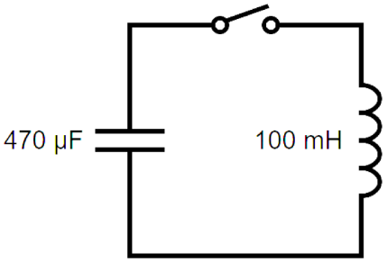
Figure 17.22: An LC (inductor-capacitor) circuit with a switch.100
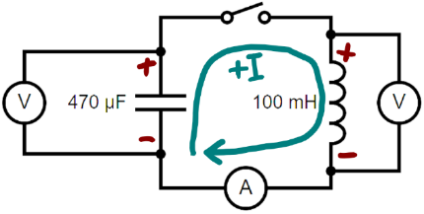
Figure 17.23: An ammeter and two voltmeters added into the LC circuit, with sides of each component marked to show which direction will be considered the positive direction of the voltage, and an arrow showing the positive direction for current.100

Numbers
Assumptions: wires and connections are perfect conductors; the resistance of the ammeter is negligible; the current through the voltmeters is negligible; positive directions as shown in Figure 17.23.
Knowns | Unknowns
$$ΔV_{e,i,capacitor}=5 V$$ | $$ΔV_{e,inductor}$$
$$C=470×{10}^{-6} F$$ | $$ΔV_{e,capacitor}$$
$$L=100×{10}^{-3} H$$ | $$I$$
 | $$U_{L,max}$$
 | $$U_{c,max}$$
Before the switch is closed, the capacitor is at its maximum voltage, which we can use to find the maximum potential energy stored in the capacitor:
$$\begin{aligned}U_{c,max}&=\frac{1}{2}C⋅{\left(ΔV_{e,capacitor}\right)}^{2} \\ &=\frac{1}{2}⋅\left(470×{10}^{-6} F\right)⋅{\left(5 V\right)}^{2} \\ &=0.00588 J\end{aligned}$$
All that energy eventually gets transformed to magnetic potential energy in the inductor, so $U_{L,max}=0.00588 J$. Now we can use Equation ( 17.8 ) to find the maximum current:

Words
This is a simple harmonic oscillator, behaving exactly like a mass on a spring. With the mass and spring, energy was constantly transforming back and forth from spring potential energy to kinetic energy. This time, the transformation is from energy stored in the electric field of the capacitor to energy stored in the magnetic field of the inductor.
Current and voltage can be monitored in a circuit using ammeters (A) and voltmeters (V). The way they would be connected for this circuit is shown in Figure 17.23. An ammeter measures the amount of current that is passing through it, so it needs to be in series with the circuit component whose current you are trying to measure. In this case, the entire circuit is in series, so the ammeter passes the same amount of current as both the capacitor and the inductor. A voltmeter measures the voltage that is across it, so it needs to be in parallel with the component whose voltage you are trying to measure.
Ammeters have very low resistance, to minimize the voltage drop across the ammeter itself, reducing the effect of the ammeter on the operation of the circuit. Voltmeters, on the other hand, have very high resistance, to minimize the current flow around the component you are trying to measure, reducing the effect of the voltmeter itself on the operation of the circuit.

Graphics
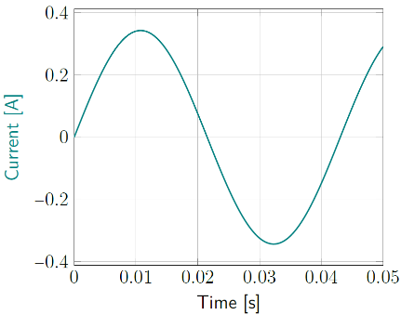
Figure 17.24: Current as a function of time.¹
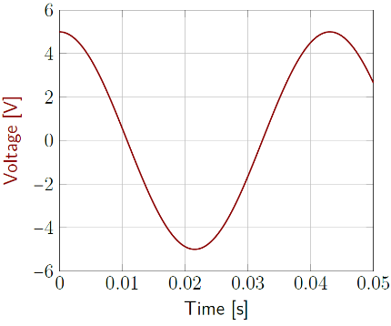
Figure 17.25: Voltage across both the capacitor and the inductor as a function of time.¹

Numbers
$$\begin{aligned}U_{L,max}&=\frac{1}{2}L⋅I_{max}^{2} \\ I_{max}&=\sqrt{\frac{2⋅U_{L,max}}{L}}=0.343 A\end{aligned}$$
LC circuits oscillate with an angular frequency of $ω=\sqrt{1/\left(L⋅C\right)}$:
$$\boxed{ΔV_{e}=ΔV_{e,max}⋅cos\left(\frac{t}{\sqrt{L⋅C}}-ϕ\right)}$$
( 17.13 )
…and…
$$\boxed{I=I_{max}⋅sin\left(\frac{t}{\sqrt{L⋅C}}-ϕ\right)}$$
( 17.14 )
In this situation, $ϕ=0$ since we are starting with the capacitor fully charged. The voltage of the inductor is always the same as the voltage of the capacitor because of the loop rule.

: Summary
Chapter summaries in this book are ordered by concept, not necessarily in the order in which they are presented in the chapter. Mathematical models are grouped together at the end of each summary. See the appendices for the meanings of all symbols used in this book.

General
- “⊗” can represent an arrow pointing into the page; “⊙” can represent an arrow pointing out of the page.
- Solenoids and bar magnets create similar magnetic fields.
- Magnetic field lines always form loops–they can’t have a beginning or end, because there is no such thing as a magnetic charge.

Forces & Acceleration
- The direction of the magnetic force on a particle or current in a magnetic field is determined using the right-hand rule (RHR) for magnetic force.
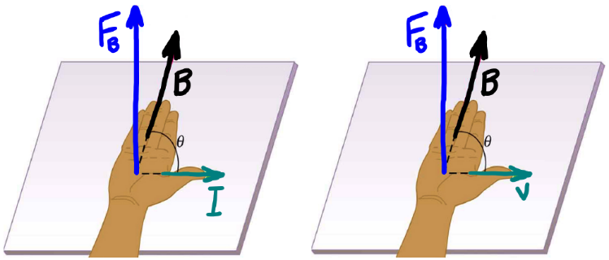
With the RHR for magnetic force, if the thumb of the right hand points in the direction of either the current or the velocity of a positively charged particle and the fingers of the right hand point in the direction of the external magnetic field then the direction of the magnetic force on the current or particle is straight out from the palm of the right hand. For a negatively charged particle, the thumb still points in the direction of the velocity and the fingers still point in the direction of the magnetic field, but the force points straight out from the back of the hand.108

Electric Current
- Electric current generates a magnetic field.
- The magnetic field lines around a long, straight, current-carrying wire are circular, forming complete loops around the wire.
- The strength of the magnetic field caused by current in a wire decreases with distance from the wire.
- The direction of the magnetic field caused by a current is determined using the right-hand rule (RHR) for current and magnetic field.
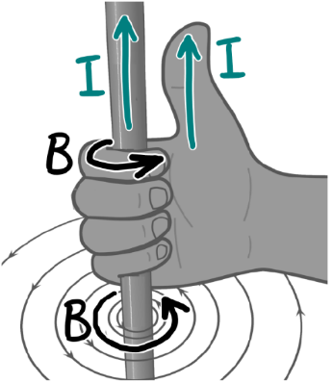
With the RHR for current and magnetic field, if the thumb of the right hand points in the direction of the current then the fingers of the right hand curl around in the direction if the magnetic field created by the current.104

Energy & Potential
- Magnetic fields store energy.
- Inductors can store magnetic potential energy.
- LC circuits form harmonic oscillators that transform energy back and forth between energy stored in the electric field of the capacitor and energy stored in the magnetic field of the inductor.

Mathematical Models
Equation | Reference | Restrictions on the validity of the equation
$$B=\frac{μ_{0}⋅I}{2⋅π⋅r}$$ | ( 17.1 ) | for a long, straight, current-carrying wire surrounded by empty space
$$B_{solenoid}=\frac{μ_{B}⋅N_{loops}⋅I}{l_{solenoid}}$$ | ( 17.2 ) | inside a long, straight solenoid
$$F_{B}=\left|q⋅v⋅B⋅sinθ\right|$$ | ( 17.4 ) | -none-
$$F_{B}=\left|I⋅l⋅B⋅sinθ\right|$$ | ( 17.6 ) | -none-
$$τ=\left|N⋅I⋅A⋅B⋅sinθ\right|$$ | ( 17.7 ) | -none-
$$U_{L}=\frac{1}{2}⋅L⋅I^{2}$$ | ( 17.8 ) | -none-

: Questions
Questions are ordered according to Bloom’s Taxonomy, progressing from regurgitating information (Level 1) to synthesizing new information with previous knowledge to create something new (Level 6). The bold letters at the beginning of each question indicate whether the question involves Words [W], Graphics [G], and/or Numbers [N]. See the appendices for conversion factors.

Level 1 - Remember
      - [W & G] Draw arrows representing each of the following directions:
        - Left
        - Right
        - Up
        - Down
        - into the page
        - out of the page
      - [W & G] Two different right-hand rules were introduced in this chapter. One of them is for finding the magnetic field that is created by a current, and the other one is for finding the magnetic force on a charge or current. For one of them you curl your fingers and for one you keep them straight. For which one do you curl your fingers?
      - [W & N] Add labels to each boxed equation from this chapter that tell what the symbol to the left of the = sign represents
Symbol | Reference | Label
$$B$$ | ( 17.1 )
$$B_{solenoid}$$ | ( 17.2 )
$$u_{B}$$ | ( 17.3 )
$$F_{B}$$ | ( 17.4 )
$$r$$ | ( 17.5 )
$$F_{B}$$ | ( 17.6 )
$$τ$$ | ( 17.7 )
$$U_{L}$$ | ( 17.8 )
$$I_{on}$$ | ( 17.9 )
$$I_{off}$$ | ( 17.10 )
$$ΔV_{e,on}$$ | ( 17.11 )
$$ΔV_{e,off}$$ | ( 17.12 )
$$ΔV_{e}$$ | ( 17.13 )
$$I$$ | ( 17.14 )

Level 2 - Understand
      - [W & G] A statement is made in Section 17.2 that the magnetic fields of bar magnets and solenoids are similar. Point out any similarities or differences that you see when comparing Figure 17.7 and Figure 17.8, both reproduced below.
Magnetic field of a solenoid.105
Magnetic field of a bar magnet.106
      - [W & G] A statement is made in Section 17.2 that magnetic field lines always must form loops because there is no such thing as a magnetic charge. Why would magnetic field lines have to form loops with no beginnings or ends if there is no such thing as a magnetic charge?
      - [W & G] The needles of compasses are bar magnets whose North poles point toward the earth’s geographical North pole (within reason–the earth’s magnetic poles move around slightly over the course of years). Remember that like magnetic poles repel each other and unlike magnetic poles attract each other. In what continent is the earth’s magnetic north pole? (In other words, where do the field lines from the earth’s magnetic north pole come out vertically through the earth’s surface?)
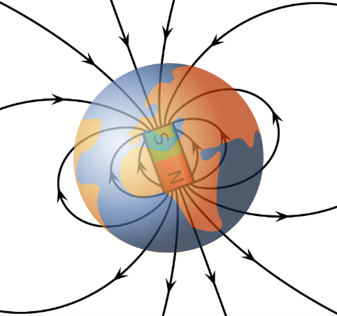
Earth’s magnetic field.
      - [W & N] What effect would each of the following have on the time needed to bring the current in an inductor to its maximum value in an RL circuit?
        - Increasing the inductance?
        - Increasing the resistance?
        - Increasing the voltage of the battery?
      - [G] Re-draw Figure 17.19, reproduced below, adding an ammeter (A) that measures the current from the battery.
RL circuit.100
      - [G] Re-draw Figure 17.19, reproduced below, adding a voltmeter (V) that measures the voltage across the resistor.
RL circuit.100
      - [W & N] What effect would each of the following have on the angular frequency of an LC circuit?
        - Increasing the inductance?
        - Increasing the capacitance?
        - Increasing the initial voltage on the capacitor?

Level 3 - Apply
      - [G] Figure 17.3 shows magnetic field lines around a current that going in a long, straight line either out of the page (on the left side of the figure) or up (on the right side of the figure). Make similar sketches of magnetic field lines for long, straight currents in each of these directions:
        - $⊗$
        - $→$
        - $↖$
      - [G] Figure 17.6 shows the magnetic field created by a square loop of wire with current going in the clockwise direction. Create a similar sketch for a round loop of wire with current going in the counterclockwise direction.
      - [N] What is the strength of the magnetic field inside a 0.1-m-long solenoid that is made of five hundred 0.05-m-diameter circular loops of wire carrying a current of 0.2 A? Assume that the solenoid contains only empty space.
      - [G] Re-draw what Figure 17.11, reproduced below, would look like when a proton comes in from the right side with an initial velocity to the left.
Proton entering a magnetic field.1
      - [G] Re-draw what Figure 17.11, reproduced below, would look like if an electron, instead of a proton, entered from the left. Hint: Remember to think about not only difference in charge but also the difference in mass.
Proton entering a magnetic field.1
      - [G & N] Something that could have been found in Section 17.3 is the magnetic force on the proton.
        - Draw force diagrams for the proton just after it enters the magnetic field and when it is at the point on the path that is marked by the radius.
        - Find the magnitude of the magnetic force on the proton just after it enters the magnetic field and when it is at the point on the path that is marked by the radius.
      - [W, G, & N] Create a sketch like that in Figure 17.16, reproduced below, with the magnetic field pointing upward instead of to the left. How does that change the forces on each side of the wire and the net torque on the wire? If the wire is allowed to freely rotate around any axis, would it still start to spin? If so, in what direction?
A loop of current-carrying wire in an external magnetic field.1

Level 4 - Analyze
      - [W, G, & N] In Section 17.1 there was a long, straight wire carrying 10 A of current vertically upward. The magnetic field at a point 5 cm to the left of the wire was found. What is the magnetic field at a point 0.5 cm to the left of the wire? Show your work and/or explain how you arrived at your answer.
      - [N] The sun creates a “solar wind” of protons and electrons that stream away from the sun, going approximately one million miles per hour as they reach the earth. Assume that the earth creates a constant magnetic field of $4×{10}^{-5} T$, and that the magnetic field is perpendicular to the path followed by the protons and electrons.
        - How deeply can the protons penetrate the earth’s magnetic field?
        - How deeply can the electrons penetrate the earth’s magnetic field?
        - The earth’s “magnetosphere” extends approximately 50,000 km above the surface of the earth. Is that far enough that it can protect the earth’s surface from the solar wind?
      - [W, G, & N] Create a sketch like that in Figure 17.16, reproduced below, with the magnetic field pointing out of the page instead of to the left. How does that change the forces on each side of the wire and the net torque on the wire? If the wire is allowed to freely rotate around any axis, would it still start to spin? If so, in what direction?
A loop of current-carrying wire in an external magnetic field.1
      - [G & N] Find the magnitude of the torque on a solenoid with a diameter of 0.1 m, made up of 100 turns of wire with 10 A of current flowing through it, when it is placed in an external magnetic field of 5 T. Do this in two different orientations:
        - With the axis of the solenoid parallel to the external magnetic field.
        - With the axis of the solenoid perpendicular to the external magnetic field.
      - [W, G, & N] Now we have the tools to more thoroughly analyze the “thought experiment” at the beginning of the chapter, with an electron moving parallel to a long, straight current-carrying wire.
        - Use the appropriate RHR to determine the direction of the magnetic field at the position of the electron for both the top and the bottom sketch in Figure 17.1, reproduced below.
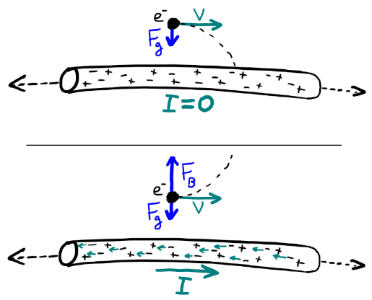
Top: electron near a wire with no current; Bottom: electron near a wire with current to the right.1
        - Use the appropriate RHR to determine the direction of the magnetic force on the electron for both the top and bottom sketch in Figure 17.1.
        - Find a combination of current, electron speed, and distance from the wire that would create a magnetic force on the electron that is equal to the magnitude of the gravitational force on the electron at the surface of the earth.
      - [G & N] Calculate the angular frequency for the LC circuit in Section 17.6, and use it to determine the period of the oscillation. Compare your result to the graphs on the second page of that section. Are the graphs consistent with the value you found for the period?

Level 5 - Evaluate
      - [W & N] For calculating the magnetic fields inside materials, instead of in free space, $μ_{0}$ must be replaced with the permeability of the material. Diamagnetic materials have a permeability that is slightly less than $μ_{0}$; for example, water has a permeability that is $\left(0.999992⋅μ_{0}\right)$. Paramagnetic materials have a permeability that is slightly more than $μ_{0}$; for example, aluminum has a permeability that is $\left(1.00002⋅μ_{0}\right)$. And ferromagnetic materials have a permeability that is many times that of $μ_{0}$; for example, iron can have permeability that ranges from a few times $μ_{0}$ to more than 100,000 times $μ_{0}$, depending on purity and how it is prepared. What would happen to the magnetic field inside a solenoid if the current remained constant and…
        - …the solenoid was submerged in water?
        - …a piece of aluminum was inserted into the solenoid?
        - …a piece of iron was inserted into the solenoid?
      - [W, G, & N] Find a way to add a uniform electric field to the initial situation set up at the beginning of Section 17.3 in such a way that the proton would have gone straight through the magnetic field without changing velocity. Keep the proton traveling with an initial velocity of 100 m/s to the right and a magnetic field of 5 T that is pointing out of the page.
      - [W, G, & N] The image below shows one way to build a mass spectrometer. Explain how it can be used to separate gas molecules according to their masses.
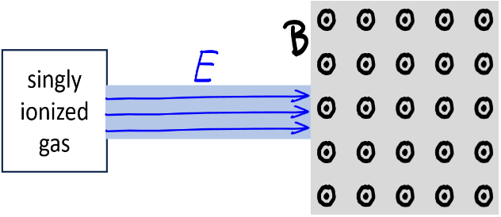
Components of a mass spectrometer.1
      - [N] Combine the symbolic expression found near the end of Section 17.2 for the energy total magnetic energy stored by a solenoid with Equation ( 17.8 ) to find an expression for the inductance of a solenoid in terms of $N_{loops}$, $I$, $A_{solenoid}$, $l_{solenoid}$, and $μ_{B}$.

Level 6 - Create
      - [W, G, & N] At the beginning of Chapter 1 in Figure 1.1 was a template for a concept map. Create a new concept map with the main ideas from this chapter.
      - [W, G, & N] Imagine you are writing a test question related to this chapter. Think of your own example of a situation that you can analyze using the concepts, graphics, and mathematical analyses described in this chapter. Describe the situation and use the tools from this chapter to analyze the situation as completely as you can, including motion, forces, energy, and momentum.
      - [W, G, & N] Think about possible misconceptions about the material in this chapter. Write a question and an incorrect solution to it that demonstrates a student making such a conceptual error. This cannot be a simple misuse of a vocabulary word, a unit error, or a mathematical error like making an addition error or multiplying when addition was needed, unless the error is rooted in a real misunderstanding about the physics behind the calculation or the misuse of a word. After you have written the question and incorrect solution, explain what is wrong with the student’s solution, and write a correct solution to the problem. Note: You may use a question from this chapter that you got wrong the first time and explain the initial error in your thinking and how you corrected it.

– The Electromagnetic Spectrum ( , )
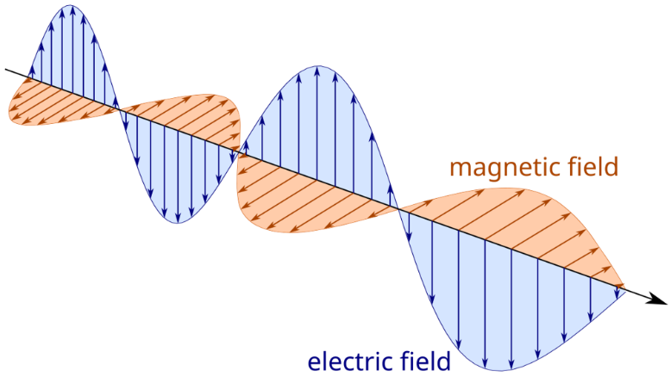
Figure 18.1: An electromagnetic wave traveling in the direction of the black arrow. The electric and magnetic fields form transverse waves that oscillate in unison, at right angles to each other.

In Chapter 14 it was mentioned that electric force and magnetic force are intertwined in such a way that they can be considered a single electromagnetic force.
In Chapter 15 & Chapter 17 we learned that both electric fields and magnetic fields can store energy, and that the energy density has a similar form for each, with one related to permittivity $ϵ$ and the other related to permeability $μ_{B}$:
$$\begin{aligned}u_{e}&=\frac{ϵ}{2}E^{2} \\ u_{B}&=\frac{1}{2⋅μ_{B}}B^{2}\end{aligned}$$
In Chapter 16 & Chapter 17 we learned that a set of parallel conducting plates can store electric potential energy, a coil of wire can store magnetic potential energy, and energy can spontaneously transform back and forth between electric and magnetic potential energy if a set of plates is connected to a coiled wire.
In Chapter 17 we learned that electric current can generate magnetic fields and magnetic fields can generate electric current.
Now we will learn about another way that they are intertwined with each other, quite literally. Just like energy can be carried along by transverse waves on a string or gravity waves in space, electromagnetic energy can be carried in waves through materials or even through empty space. The electric field and magnetic field of the electromagnetic wave are at right angles to each other, and both are transverse to the direction of the wave’s motion, as shown in Figure 18.1.
The speed of an electromagnetic wave is related to $ϵ$ and $μ_{B}$. For free space…
$$v=\frac{1}{\sqrt{μ_{0}⋅ϵ_{0}}}=\frac{1}{\sqrt{\left(4⋅π×{10}^{-7} N/A^{2}\right)⋅\left(8.85×{10}^{-12} F/m\right)}}=3×{10}^{8} m/s$$
That number might look familiar…it is the speed of light. That is because light is an electromagnetic wave!

: Waves or Rays? ( , )

Words
Visible light is an electromagnetic wave, but the spectrum of electromagnetic waves extends far beyond what a human, or any other creature, can see. Figure 18.2 shows the electromagnetic spectrum from radio waves (at the bottom) through gamma rays (at the top). Notice that this spectrum spans more than twelve orders of magnitude, with wavelengths spanning from 0.1 Å (10⁻¹¹ m) to more than 10 m. The portion of this spectrum that is visible to humans is less than one order of magnitude, from violet at about 400 nm to red at about 700 nm. Wavelengths slightly longer than we can see are called “infra-red” (IR) and wavelengths slightly shorter than we can see are called “ultra-violet” (UV). The entire spectrum, visible or not, is often generically referred to as light.
The parts of the spectrum with wavelengths longer than IR are called “waves:” microwaves and radio waves. But the parts with wavelengths shorter than UV are called “rays:” x-rays and gamma rays. The reason for that is related to the energy of the light.
It is possible to have the same amount of energy in a beam of radio waves as in a beam of gamma rays, because the energy carried by an electromagnetic wave is proportional to the square of the amplitude of the wave’s electric field. So, increasing the amplitude of the field increases the power delivered by the wave. If the magnitudes of the electric fields are the same, then their total energies are equal.

Graphics
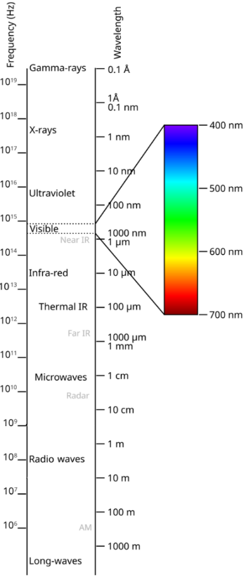
Figure 18.2: The electromagnetic spectrum.

Numbers
The mathematical models that we learned for mechanical waves in solids, liquids, and gases also apply to electromagnetic waves: The wavelength $λ$ is related to the speed $v$ and the frequency $f$:
$$λ=\frac{v}{f}$$
…and the speed of light in vacuum (free space) is $c$, giving this relationship between wavelength $λ_{0}$ and frequency $f$ in vacuum:
$$\boxed{λ_{0}=\frac{c}{f}}$$
( 18.1 )
The relationship between period $T$ and frequency is also still true for electromagnetic waves:
$$f=1/T$$
The intensity $I$ of electromagnetic waves, i.e. the power they carry per unit area in units of watts per square meter, is determined by the amplitude of the electric field of the wave:
$$\boxed{I=\frac{1}{2}c⋅ϵ⋅E_{max}^{2}}$$
( 18.2 )
This intensity represents an average over time of the arrival of electromagnetic waves, or alternatively an average over time of the arrival of photons.
Words
The big difference is that the energy in electromagnetic waves comes in packets called “photons,” and individual gamma ray photons have enough energy to cause changes to atoms and molecules, while individual radio wave photons do not.
If we think of water waves as an analogy, a tidal wave or a surge of water coming down a flooding river can do a lot of damage, but we don’t usually worry about damage being done by a single water molecule. In fact, in the time it takes to read this sentence you will have been struck by more than 10²⁰ water molecules that are present in the air around you, and you don’t even feel it. That is like radio waves–single radio wave photons have so little energy that they don’t really do much all by themselves, but if you put enough of them together then they can make electrons move through a circuit or increase the temperature of a material.
Gamma rays, on the other hand, are more like trucks moving down a highway. Traffic also comes in waves, but it doesn’t take an entire wave of trucks to cause damage in a collision. A single truck can cause plenty of damage all by itself. Individual gamma rays can fry electronic circuits, cause cancer, or destroy cancer cells.
Photons less energetic than visible light tend to be thought of as waves because it usually takes waves of photons acting together to cause an effect. Photons more energetic than visible light tend to be thought of as either rays or particles because individual photons can sometimes have a major effect in a material.

Graphics
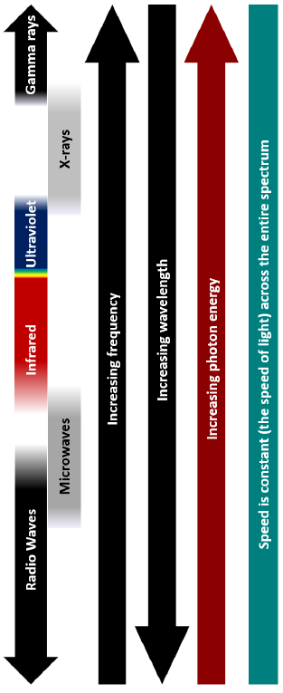
Figure 18.3: Trends in frequency, wavelength, photon energy, and speed across the electromagnetic spectrum in vacuum.¹

Numbers
Each photon carries an amount of energy that depends on its frequency:
$$\boxed{E_{photon}=h⋅f}$$
( 18.3 )
…where $h$ is the Planck constant, $4.136×{10}^{-15} eV/Hz$. We met the Planck constant back in Chapter 13, where the “reduced Planck constant” $ℏ$ was the unit of angular momentum used for electrons. $h$ is just $2π⋅ℏ$.
The energy of an electromagnetic wave can be expressed as the number of photons times the energy per photon. Usually electron-volts (eV) are used as the unit of energy for photons.

: Diffraction: Light Acting Like a Wave ( , )

Words
At the end of Section 18.1 was a conclusion that sounds very clean: that we should think of the electromagnetic spectrum like waves at low energy and like particles at high energy. Unfortunately, there are exceptions to that general rule. When interacting with materials, if there are length scales in the material that are like the wavelength of the photons then we need to consider the effects caused by the wave-like nature of light. This is true for other types of waves as well.
Notice what happens to the ocean waves coming in from the top right through a breakwater in Figure 18.4. Waves pass mostly unchanged through the wide slit near the bottom of the image, causing ripples in the protected beach area that are mostly contained between the dotted white lines. But the narrow slit near the top has a completely different effect. For the narrow slit, the size of the slit itself is like the wavelength of the ripples, so as the waves pass through, they are bent and spread out, “diffracted,” creating circular patterns as they emerge from the breakwater.
The mathematical models that describe the interference caused by diffraction through a slit are like those for the interference caused by the wings of a bee disturbing the surface of the water in Section 10.6. There is a central peak in the amplitude of the wave passing through the slit at 0°, and much weaker peaks on either side of the first antinode.

Graphics
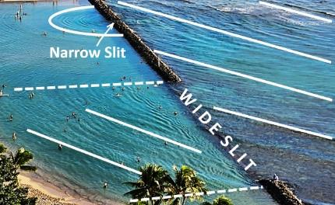
Figure 18.4: Waves coming through a breakwater. The solid white lines emphasize the shapes of the ripples on the ocean. The breakwater blocks the ripples except through two slits.¹
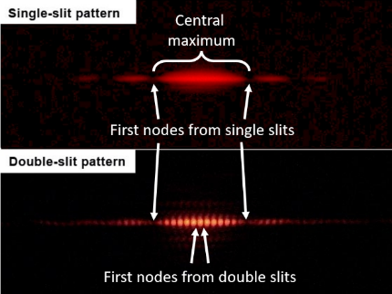
Figure 18.5: Diffraction patterns from a laser going through single and double slits.

Numbers
When waves pass through a slit, they create diffraction patterns with a mathematical relationship that is like that for the waves created by two sources that we saw in Section 10.6. These mathematical models are valid for any type of wave, including electromagnetic waves. The mathematical models for two sources of waves that we learned before…
$$\left(m+\frac{1}{2}\right)⋅λ=d⋅sinθ_{node m}$$
…and…
$$m⋅λ=d⋅sinθ_{antinode m}$$
…where $d$ is the distance beween the slits, are generally referred to as the “double slit” equations because they are used to describe diffraction through a pair of similar slits. The equation for the antinodes also works for finding the maxima of beams diffracted by a grating with spacing $d$.
The two slits in Figure 18.4 are relatively far apart, so they each act like single slits whose nodes are found at angles given by the “single slit” equation:
$$\boxed{m⋅λ=w⋅sinθ_{node m}}$$
( 18.4 )
…where $w$ is the width of the slit and m is a positive integer.

Words
Using people in the image to estimate lengths, the wavelengths of the ripples in Figure 18.4 are probably about 1 m. The wide slit is perhaps 15 m, and the narrow slit is perhaps 0.5 m. We can use this information to determine the angles of the first node for each slit. This is done in the “Numbers” column, finding that the waves pass through the wide slit without spreading out significantly, while the waves that pass through the narrow slit spread out into circles as they go through, just as it appears in Figure 18.4.
The top half of Figure 18.5 shows the pattern created by a laser that passes through a single vertical slit. The laser spreads horizontally because of the slit. There is a central maximum that increases in width as the size of the slit decreases. The bottom half of Figure 18.5 shows the pattern created by a laser that passes through a pair of slits that both have the same width as the slit used for the top half of the figure. The central maximum from the individual slits is still visible, but it has nodes created by the combination of the two slits.
If many slits, a “grating,” is used, then the peaks of the double slit diffraction pattern become much sharper. Figure 18.6 shows a laser beam splitting into three sharp beams as it passes through such a grating. Diffraction patterns can be created by any structure with a repeating pattern. For example, the wavelength of x-rays is like the spacing of atoms in a solid, so illuminating a solid with x-rays creates a complex diffraction pattern that can be used to determine the atomic structure. Such a pattern is shown in Figure 18.7.

Graphics
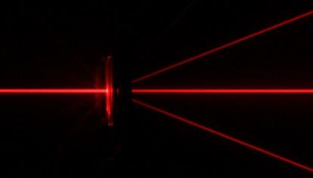
Figure 18.6: A red laser beam passing through a diffraction grating from the left.
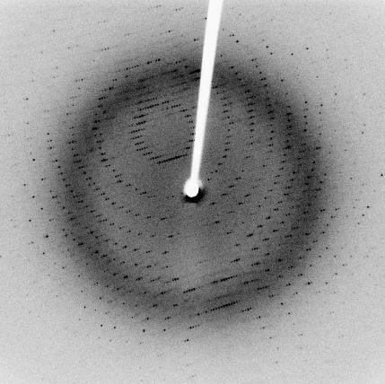
Figure 18.7: X-ray diffraction pattern of crystallized 3Clpro, a SARS protease with 2.1 Å resolution.

Numbers
Assumptions: the slits are far enough apart that they act like two single slits, not a double slit.
Knowns | Unknowns
$$λ=1 m$$ | $$θ_{antinode 1,wide}$$
$$w_{wide}=15 m$$ | $$θ_{antinode 1,narrow}$$
$$w_{narrow}=0.5 m$$
Rearranging Equation ( 18.4 ) to find the angle of the first node…
$$\begin{aligned}1⋅λ&=w⋅sinθ_{node 1} \\ sinθ_{node 1}&=\frac{λ}{w} \\ θ_{node 1}&=\sin^{-1}\frac{λ}{w}\end{aligned}$$
Putting in the given values for $λ$ and $w_{wide}$, we find that $θ_{node 1,wide}=4^{∘}$. So the amplitude of the wave pretty much goes straight through, spreading out by only about $4^{∘}$ as it passes through the wide slit, much like we see in the bottom part Figure 18.4.
For $w_{narrow}$, putting in the numbers gives an error. There is no angle at which a node appears, so the wave spreads out in every direction, much like we see in the top part of Figure 18.4.

: Absorption: Light Acting Like a Particle ( , )

Words
Diffraction is a special case of light interacting with some sort of structure. There are three other primary ways that light interacts with materials: absorption, reflection, and refraction.
The amount of light that is absorbed by a material depends on the wavelength of the light and the material itself. Let’s start with the example of absorption by liquid water, shown in Figure 18.8. We will examine how far light penetrates before the intensity drops to 0.1% of its initial intensity at each of the following wavelengths: 10 nm, 100 nm, 1 µm, 10 µm, 100 µm, 1 mm, and 10 mm.
Figure 18.9 shows the relative intensity of one of these wavelengths as a function of path length through the water. It drops off exponentially, just like we saw before with radioactive decay over time. In the case of light with a wavelength of 1 µm, there is an 80% chance that it would be absorbed after going 0.05 m or less. When a photon is absorbed, it is transferring its energy to the material. That can happen in several ways.
In Figure 18.8 there are several spikes where there is strong absorption, especially in the infrared portion of the spectrum. Those wavelengths correspond to rotational and vibrational modes of the water molecules. If a photon with the right energy to excite one of those modes hits the water molecule, it makes the molecule spin or vibrate.

Graphics
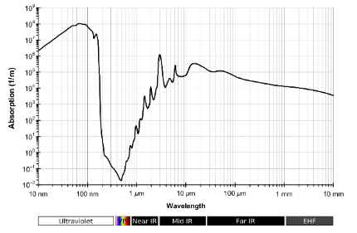
Figure 18.8: The absorption of liquid water in the part of the spectrum from UV through IR.
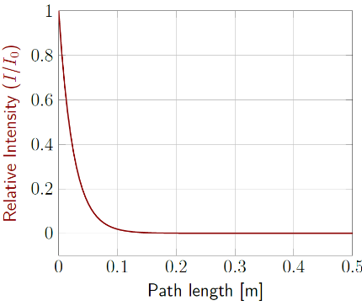
Figure 18.9: Relative intensity of light with a wavelength of 1 $μ$m as it passes through water.¹

Numbers
Assumptions: none?
Knowns | Unknowns
$λ_{1}=10 nm$ , $α_{1}≈2×{10}^{6} m^{-1}$ | $$s_{1}$$
$λ_{2}=100 nm$ , $α_{2}≈7×{10}^{7} m^{-1}$ | $$s_{2}$$
$λ_{3}=1 μm$ , $α_{3}≈40 m^{-1}$ | $$s_{3}$$
$λ_{4}=10 μm$ , $α_{4}≈6×{10}^{4} m^{-1}$ | $$s_{4}$$
$λ_{5}=100 μm$ , $α_{5}≈6×{10}^{4} m^{-1}$ | $$s_{5}$$
$λ_{6}=1 mm$ , $α_{6}≈1×{10}^{4} m^{-1}$ | $$s_{6}$$
$λ_{7}=10 mm$ , $α_{6}≈1×{10}^{4} m^{-1}$ | $$s_{7}$$
$I/I_{0}=0.001$ , | $$s_{1}$$
The intensity of light $I$ decreases with the absorption coefficient $α$ and the path length $s$ that the light travels through the material:
$$\boxed{I=I_{0}⋅e^{-α⋅s}}$$
( 18.5 )
We are looking for the path length where $I/I_{0}=0.001$, so…
$$0.001=I/I_{0}=e^{-α⋅s}$$
$$ln0.001=-α⋅s$$
$$s=\frac{-ln0.001}{α}=\frac{6.9}{α}$$

Words
There are also absorption lines for the individual atoms, hydrogen and oxygen. These correspond to energies that can shift an electron from one orbital to another. These energies for a hydrogen atom are shown in Figure 18.10. The electrons around a hydrogen atom would normally be in the ground state, “n=1.” All the transitions from the ground state to higher-energy states correspond to wavelengths around 100 nm. This explains the high absorption around 100 nm in Figure 18.8. Photons don’t travel very far through the water before hitting an electron that is associated with a hydrogen atom, knocking the electron into a higher-energy state. These electrons can then return to lower energy states by emitting photons that correspond to these same energy level differences.
Even if a photon doesn’t have the right amount of energy to be directly involved in one of these transitions, it can still transfer some of its energy to electrons or nuclei. The photon loses some of its energy in the collision, coming out of the collision with a longer wavelength. These collisions conserve momentum, just like the collisions we have studied before. Photons don’t have mass, but they still have momentum! This type of interaction, which is illustrated in Figure 18.11, is called “Compton scattering.”
If a photon has enough energy, it can eject the electron from the material. In that situation, the ejected electron is called a “photoelectron.” Photoelectrons can only be emitted by a material when the frequency of the light is high enough that individual photons have the energy needed to release electrons from the material.

Graphics
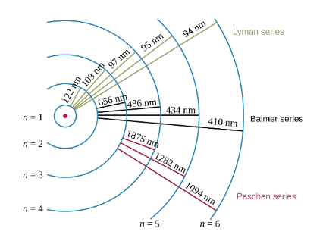
Figure 18.10: Transitions between orbitals for an electron in a hydrogen atom, with the wavelengths corresponding to the associated photon energies.
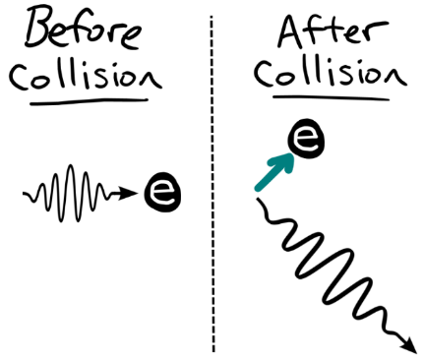
Figure 18.11: A photon scattering off an electron. The photon loses energy, so its wavelength increases.

Numbers
Putting in the values for each wavelength, we get:
Wavelength | Path length
$$10 nm$$ | $$4 μm$$
$$100 nm$$ | $$100 nm$$
$$1 μm$$ | $$0.2 m$$
$$10 μm$$ | $$0.1 mm$$
$$100 μm$$ | $$0.1 mm$$
$$1 mm$$ | $$0.7 mm$$
$$10 mm$$ | $$2 mm$$

: Reflection of Waves ( , )

Words
Light can reflect off many different surfaces, like water, glass, and metals. The reflection is caused by the different ways that materials react to electric and magnetic fields. One thing we learned about conductors was that the electrons rearrange themselves in such a way that there is no electric field inside the conductor. If there can be no electric field, then that means there can be no electromagnetic waves. So, if an electromagnetic wave reaches the surface of the metal, it has two choices: It can be absorbed in a short distance, as we saw in Section 18.3, or it can reflect back off of the surface.
The reflected wave bounces off at the same angle as the incoming “incident wave,” but on the opposite side of the normal vector from the surface. In Figure 18.12, the normal vector would be vertical, 90° from the black surface across the bottoms of the images. The wave comes in on the left side of the normal vector and goes out at the same angle on the right side of the normal vector.
The amount of light reflected depends on many factors, including the materials involved, the wavelength of the light, the incident angle, even the direction of the electric and magnetic fields of the wave. The electric and magnetic field vectors are always perpendicular to the direction that the wave is traveling, but there are different ways for that to occur. These different ways of orienting the electric and magnetic fields are called “polarizations.”

Graphics
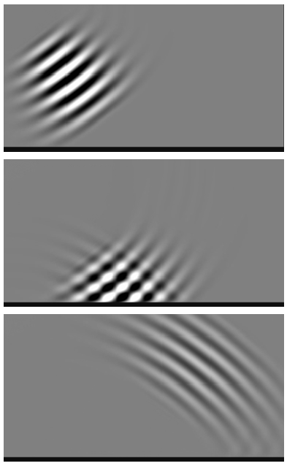
Figure 18.12: A wave comes from the top left, reflects off the bottom surface, and exits toward the top right.

Numbers
(This column intentionally left blank)

Words
Two different polarizations are shown in Figure 18.13. “Transverse Electric” (TE) polarization is when the electric field of an incident beam of light is in the plane of the surface that the beam strikes. “Transverse Magnetic” (TM) polarization is when the magnetic field of an incident beam is in the plane of the surface that the beam strikes. TE and TM polarization are two possible types of linear polarization for photons.
It is also possible for light to be “circularly polarized,” which means that the electric and magnetic fields remain perpendicular to each other, but they rotate around the direction in which the light is traveling. So instead of forming simple sine waves through space, the electric and magnetic fields spin, corkscrewing around each other. Photons with linear polarization do not have any angular momentum, but photons that are circularly polarized have angular momentum of $±ℏ$.
Most light sources create unpolarized light, meaning that the photons have a mixture of different polarizations. But light can become polarized due to various interactions with materials. For example, polarization filters can be made that only allow photons with certain polarizations to pass through. TE waves tend to reflect more strongly than TM waves, so a filter that removes TE waves will greatly reduce reflections. This makes it possible to more clearly see things below the surface of a body of water, as shown in Figure 18.14.

Graphics
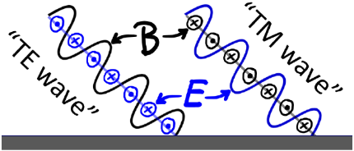
Figure 18.13: Light with Transverse Electric "TE" and Transverse Magnetic "TM" polarization.¹
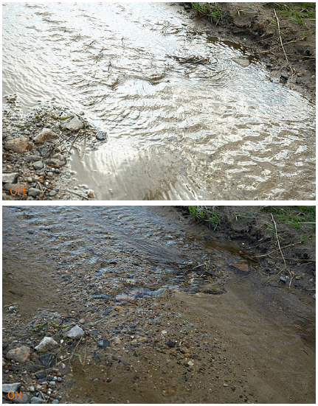
Figure 18.14: The same scene, photographed without (top) and with (bottom) a polarization filter.

Numbers
(This column intentionally left blank)

: Ray Diagrams ( , )

Words
There is an easier way to sketch the reflection of light from a flat surface, like the scenario shown in Figure 18.12, by thinking of the light in terms of rays instead of waves. Rays are arrows that follow the paths of photons. A “ray diagram” for Figure 18.12 is shown in Figure 18.15. This one simple diagram replaces all three images from the original figure, is much easier to draw, and includes additional information. The ray diagram clearly indicates the direction in which the light is traveling and provides labels for the incident angle $θ_{i}$ and the reflected angle $θ_{r}$. Notice that the angles are measured from the normal vector from the surface. For reflection, the incident angle and the reflected angle are equal.
Ray diagrams are especially useful when we are interested in the images that are formed by mirrors and other light-bending instruments. Figure 18.16 is a photograph of former United States President Barack Obama looking at his reflection in a mirror. The photograph shows President Obama twice: the real one, closer to the camera and farther to the left, and a reflected image that is farther from the camera and more centered in the frame.
In Figure 18.16, the person is called the “source,” the thing the light is coming from. Often the source is something like a candle that produces light on its own, but in this case, the light from the source is the light reflecting off the source from other lights in the room.

Graphics
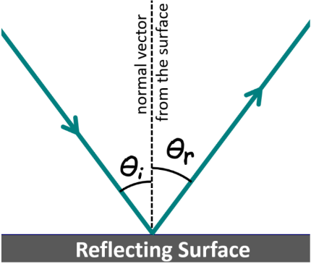
Figure 18.15: A ray diagram corresponding to Figure 18.12.¹
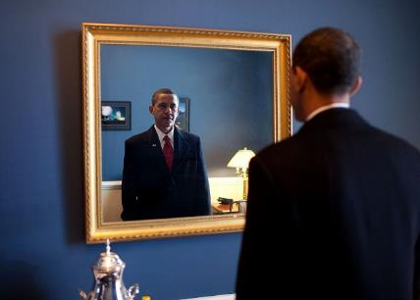
Figure 18.16: Former U.S. President Barack Obama looking at his reflection in a mirror.

Numbers
The angle of reflection $θ_{r}$ from a surface is equal to the angle of incidence $θ_{i}$, as measured from the normal vector:
$$\boxed{θ_{r}=θ_{i}}$$
( 18.6 )
The use of ray diagrams is called “geometrical optics,” because we can often use geometry to find relationships between distances and angles. For example, in Figure 18.18, there is a triangle formed by the mirror, the top ray from the head of the source to the mirror, and the horizontal ray from the head of the source to the mirror. On the other side of the mirror is the same triangle, just flipped horizontally. These are called “similar triangles” because they both have the same three angles. In any pair of similar triangles, the ratios of their sides are the same.

Words
Light from the source goes out in every direction, as shown in Figure 18.17. In fact, an infinite number of rays could have been drawn in every direction. Usually, we will only draw a few rays, often only two or three. Some of the rays that leave the head hit the mirror and bounce off, reflecting at the same angle as the incident ray.
If we look at only the rays that hit the mirror and reflect, and then trace those reflected rays back behind the mirror, we find that all the rays from the source’s head appear to come from a single point behind the mirror. That point is the head of the image. The photo in Figure 18.16 would look the same if instead of a mirror there was a window and another, identical person standing at the position of the image. For a flat (plane) mirror like this, the distance from the image to the mirror is the same as the distance from the source to the mirror.
Since the image is the same size as the source for this situation, we say that the size of the image is “true.” The image is also “upright,” meaning that the head is at the top and the feet are at the bottom, the same as the source. The image is also “virtual” because if you went to the position where the image is located, the light from the source isn’t there. Behind the mirror could be another room, or solid stone, or anything at all really. The image only appears to be there if you look in the mirror. The reflected rays in Figure 18.18 are solid because they are where the photons really go. Dotted lines are used for the rays behind the mirror because they are virtual rays of light.

Graphics
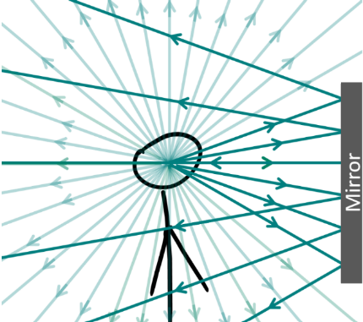
Figure 18.17: Light rays go out in all directions from the head. The ones that hit the mirror are shown darker than the others for reference.¹
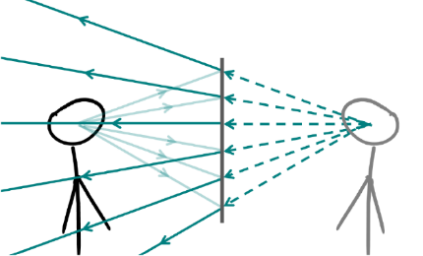
Figure 18.18: Keeping only the rays that hit the mirror in Figure 18.17, the reflected rays all seem to come from the same place. That place is the location of the image in the mirror.¹

Numbers
For this example, the ratio of the height of the triangle to the width of the triangle is the same. And for both triangles the height is the same, just the top part of the mirror. So that means their widths are also the same. In other words, the distance from the mirror to the object, $d_{i}$ is the same size as the distance to the image $d_{o}$. For mirrors, the distance in front of the mirror is considered positive and the distance behind the mirror is considered negative, so for a plane (flat) mirror like this…
$$d_{i}=-d_{o}$$
Similar triangles could also be constructed for the feet of the source, and they could show that in this situation the height of the image $h_{i}$ is equal to the height of the object, $h_{o}$:
$$h_{i}=h_{o}$$
The ratio of the heights is defined as the magnification $M$:
$$\boxed{M=\frac{h_{i}}{h_{o}}=-\frac{d_{i}}{d_{o}}}$$
( 18.7 )
The magnification $M$ for a plane mirror like this is always 1, which tells us that the image is upright (since $M$ is positive) and true (since $\left|M\right|=1$).

: Refraction: Light Acting Like a Wave ( , )

Words
Some materials don’t strongly absorb the light that enters them. Thin layers of dielectric like glass or water can allow most light to pass through. The electrons in conductors rearrange themselves in such a way that there are no electric fields at all inside the material, but electrons in dielectrics only reduce the strength of the electric fields inside the material. As a result, light waves tend to slow down when they enter a dielectric, but they aren’t completely canceled out.
The degree to which light slows down when it enters a material is described by its “index of refraction” n. The index of refraction for free space is 1, and the index of refraction of any material (often called a “medium”) that light travels through has an index of refraction that is larger than 1. The larger the index of refraction of a material, the slower light travels through that material.
Let’s look at what happens to light that goes from air into sapphire. We can use an internet search to find the index of refraction of each of these materials. We will first look at light with a wavelength of 600 nm in vacuum that is going toward the interface along the normal vector, as in Figure 18.19, and then we will look at light with the same wavelength that hits the surface of the sapphire at an angle 35° away from the normal vector, as in Figure 18.20.

Graphics
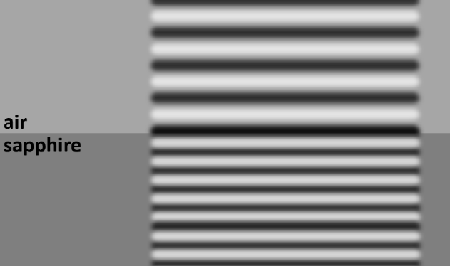
Figure 18.19: A light wave going straight down through an air/sapphire interface. The wavelength changes, but the direction of the waves does not.¹
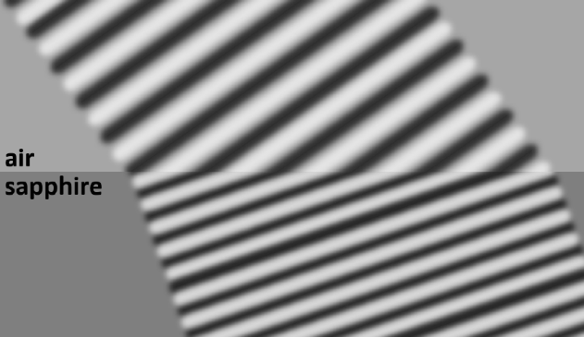
Figure 18.20: A light wave going from air into sapphire at an incident angle of 35°. The wavelength and direction both change as the light goes from one material to the other.¹

Numbers
Assumptions: none?
Knowns | Unknowns
$θ_{1}=0^{∘}$ or ${35}^{∘}$ | $$θ_{2}$$
$n_{1}=1.00$ (air) | $λ_{1}$ & $λ_{2}$
$n_{2}=1.76$ (sapphire) | $v_{1}$ & $v_{2}$
$$λ_{0}=600 nm$$
$$c=3×{10}^{8} m/s$$
The speed of light in a material is given by:
$$\boxed{v=\frac{c}{n}}$$
( 18.8 )
…where $n$ is the index of refraction of the material.
In this case, the speeds in air (material 1) and vacuum (material 2) would be:
$$v_{1}=\frac{c}{1.00}=3×{10}^{8} m/s$$
$$v_{2}=\frac{c}{1.76}=1.7×{10}^{8} m/s$$
The frequency does not change as it goes from one material to another, but the wavelength does change:
$$\boxed{λ=\frac{λ_{0}}{n}}$$
( 18.9 )
Words
In either case, we can see from the figures that the wavelength gets shorter as the light goes from air, which has a lower index of refraction, into sapphire, which has a higher index of refraction. That is because the frequency of the light must stay the same, but it moves slower in the sapphire.
Even though the wavelength changes when the light goes from one material to another, the waves still need to line up with each other at the interface between the two materials. In other words, if the wave is at a maximum in the air at some point on the interface, then the wave also must be at a maximum in the sapphire at that same point on the interface. If the incident angle is anything other than 0○ then the light is forced to bend when going from one material to another.
The angle of the light rays as they cross an interface gets closer to the normal vector (i.e. steeper in Figure 18.21) if they are going into a material with a higher index of refraction. The angle gets farther from the normal vector if the light is going into a material with a lower index of refraction, as in Figure 18.22, where the light is entering from the bottom of the image.

Graphics
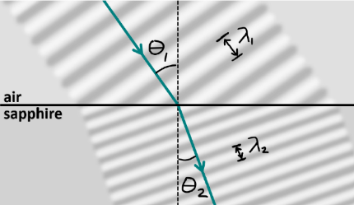
Figure 18.21: Ray diagram corresponding to Figure 18.20.¹
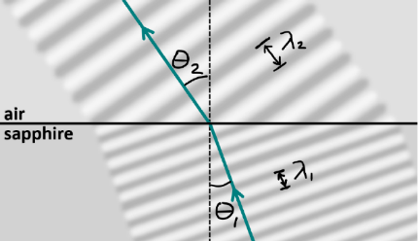
Figure 18.22: The same relationships between angles and wavelengths exist no matter which way light travels through the material. Usually “1” corresponds to the side with the incident light and “2” corresponds to the side with the refracted light.¹

Numbers
In this case…
$$λ_{1}=\frac{λ_{0}}{n_{1}}=\frac{600 nm}{1.00}=600 nm$$
$$λ_{2}=\frac{λ_{0}}{n_{2}}=\frac{600 nm}{1.76}=341 nm$$
Snell’s Law describes the relationship between the angles in the two materials:
$$\boxed{n_{1}⋅sinθ_{1}=n_{2}⋅sinθ_{2}}$$
( 18.10 )
Notice that the angles are not labeled with “i” and “r,” as they were with reflection. Instead, they are labeled based on the material that they are in. Usually, the materials are numbered in the order that the light passes through them, so starting in material 1 with index of refraction $n_{1}$, then going into material 2 with index of refraction $n_{2}$.
In the situation shown in Figure 18.19, $θ_{1}=0^{∘}$, so…
$$θ_{2}=\sin^{-1}\left(\frac{n_{1}}{n_{2}}⋅sinθ_{1} \right)=0$$
In the situation shown in Figure 18.20 & Figure 18.21…
$$\begin{aligned}θ_{2}&=\sin^{-1}\left(\frac{n_{1}}{n_{2}}⋅sinθ_{1}\right) \\ &=\sin^{-1}\left(\frac{1}{1.76}⋅sin{35}^{∘}\right) \\ &={19}^{∘}\end{aligned}$$

: Special Cases of Refraction and Reflection ( , )

Words
The first special case we will look at is light going from a material with a high index of refraction into a material with a lower index of refraction. Refraction across such interfaces was already mentioned in Section 18.6, but there is a limit to the angles that can refract out of a higher-index material.
In the “Numbers” column, calculations are done to find the “critical angle” beyond which refraction cannot occur. At the critical angle, light coming out of the higher-index material bends so far that it comes out parallel to the interface. Beyond that angle, the light cannot pass through the interface at all. Instead, the surface acts like a mirror, reflecting the light back into the material at the same angle as the incident angle. This is called “total internal reflection.”
Total internal reflection is what allows fiber optic cables to carry light so efficiently. The cable has a higher index of refraction than the cladding material around it, and the light inside the cable hits the sides at an angle so far from the normal vector that it is simply reflected repeatedly down the length of the cable, unable to leak out of the sides. The only losses along the length of a fiber optic cable are caused by defects that scatter the light. For our example of total internal reflection, we will look at a fiber of glass, $n=1.5$, with air for cladding.

Graphics
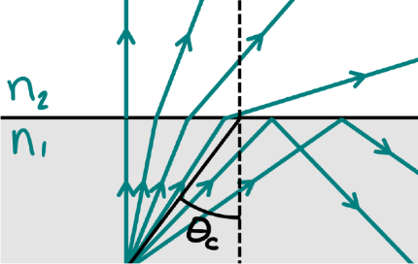
Figure 18.23: Light that is incident at an angle less than the critical angle $θ_{c}$ can refract through the interface. Light that is incident at an angle larger than the critical angle cannot refract and instead reflects back from the interface.¹
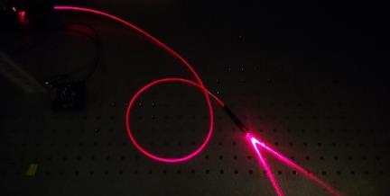
Figure 18.24: Light goes into the fiber optic cable at the top left. Some light escapes because of defects along the length of the cable causing it to glow faintly, but most of the light exits from the other end of the cable at the bottom right.

Numbers
Assumptions: none?
Knowns | Unknowns
$n_{1}=1.5$ (glass) | $$θ_{c}$$
$n_{2}=1.0$ (air)
The critical angle is when the refracted angle $θ_{2}={90}^{∘}$. Using Snell’s Law…
$$n_{1}⋅sinθ_{1}\&=n_{2}⋅sinθ_{2}$$
$$n_{1}⋅sinθ_{1}\&=n_{2}⋅sin{90}^{∘}$$
So, for the critical angle $θ_{c}$,
$$\boxed{sinθ_{c}=\frac{n_{2}}{n_{1}}}$$
( 18.11 )
For this example,
$$θ_{c}=\sin^{-1}\frac{n_{2}}{n_{1}}=\sin^{-1}\frac{1.0}{1.5}={42}^{∘}$$
The light will stay inside the fiber as long as the angle of incidence is greater than ${42}^{∘}$.

Words
The second special case we will look at is a thin film. Specifically, an anti-reflection coating. An interface between different materials is not limited to either reflection or refraction–many surfaces do some of each. A pane of window glass is mostly clear, so light refracts through it. But reflections are also visible on the surface of the glass, and not only from the front surface but also from the back surface.
By putting a thin film on the glass, it is possible to either enhance or reduce the reflections, depending on the indices of refraction and the thickness of the coating. If the coating is designed so that it is 1/4 of a wavelength thick, it will greatly reduce reflections at that wavelength. Conversely, if the coating is 1/2 of a wavelength thick, the reflections at that wavelength will be enhanced. These effects are created by the interference between reflections from the front and back surface of the coating.
For our example, we will calculate the thickness of an anti-reflective coating on a pair of eyeglasses. We will assume regular lenses that have an index of refraction $n≈1.5$, coated with an antireflective coating with index of refraction $n≈2.2$. The range of visible light is from approximately 400-700 nm, so we will design a coating for a wavelength in the middle of this range, 550 nm.

Graphics
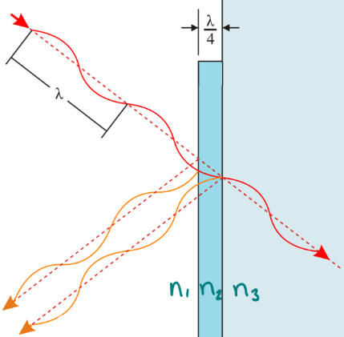
Figure 18.25: An incident light ray from the top left reflects from the front and back surfaces of the thin film. The two reflected waves going down and left interfere destructively with each other, reducing the intensity of the reflected light.
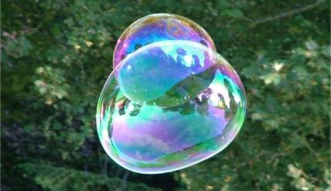
Figure 18.26: Interference with varying thicknesses and incident angles create the rainbow patterns observed on soap bubbles.

Numbers
Assumptions: none?
Knowns | Unknowns
$n_{1}=1.0$ (air) | thickness
$n_{2}=2.2$ (coating)
$n_{3}=1.5$ (lens)
$$λ_{0}=550 nm$$
For an anti-reflective coating, we want a film thickness of $λ/4$, as shown in Figure 18.25. Using Equation ( 18.9 )…
$$thickness=\frac{λ_{2}}{4}=\frac{λ_{0}}{4⋅n_{2}}=\frac{550 nm}{4⋅2.2}=63 nm$$
This would be for a single-layer coating. Multiple layers could be used to optimize the antireflective qualities over the whole visible spectrum.

: Lasers ( )

Words
The emission of light by a material was briefly mentioned in Section 18.3, that electrons can return to lower-energy states by emitting photons that correspond to differences in energy levels in an atom. When an electron is in an excited state, meaning that there is a lower-energy state available to the atom, it can spontaneously shift to the lower energy state, emitting a corresponding photon in any direction. This is called “spontaneous emission,” and is illustrated in Figure 18.27.
Remembering the Pauli exclusion principle from back in Section 13.1, if there is an electron in the lowest energy state in an atom then that state is already filled, and a second electron can’t occupy the same state. But photons are a different kind of particle, one for which the Pauli exclusion principle does not apply. Instead, photons prefer to all be in the same state if possible. In fact, if an electron is in an excited state from which it can release a photon with a given energy and another photon with that same energy passes by, the passing photon can force the electron out of its excited state. When that happens, the electron releases a photon with not only the same energy as the one that was passing by, but also with the same momentum. This is called “stimulated emission,” and is illustrated in Figure 18.28.

Graphics
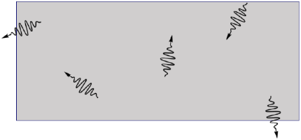
Figure 18.27: Spontaneous emission in a material where the electrons of some atoms are in the same excited state where they can emit photons.118
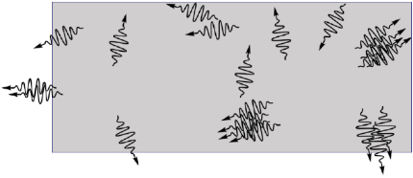
Figure 18.28: Stimulated emission in a material where the electrons of many atoms are in the same excited state where they can emit photons. Note that there are more emitted photons, and they are often in groups with the same momentum, which means the same energy and the same direction of propagation.118

Numbers
(This column intentionally left blank)

Words
If there are always many electrons in excited states, which is achieved by “pumping” a material with a constant supply of energy, then stimulated emission can become more dominant than spontaneous emission.
Adding mirrored surfaces to two parallel ends of the material then creates a resonant cavity for photons. The photons can exit from the other sides, but if they hit the mirrored sides, they bounce back into the material, where they can cause more stimulated emission in that direction. This is illustrated in the progression from Figure 18.29 to Figure 18.30 to Figure 18.31.
In Figure 18.31, the mirror on the right is only partially reflecting, allowing some of the photons to exit the cavity. The photons that exit all have the same energy and the same momentum. We have created a laser beam, which has a very well-defined wavelength (because the energies of the photons are the same) and that stays in a tight beam instead of spreading out (because the momenta of the photons are the same).

Graphics
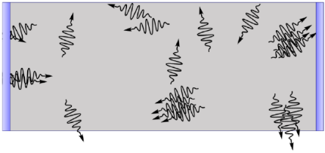
Figure 18.29: Mirrors have been added to both ends. Notice the two photons on the left that have reflected back into the cavity together. 118
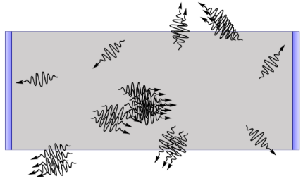
Figure 18.30: A short time after the last figure. The further the photons that reflected off the mirror travel, the more photons they collect. 118
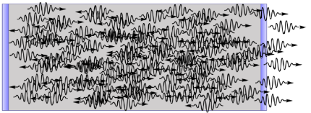
Figure 18.31: Soon the cavity is dominated by photons traveling horizontally. Making one mirror partially transparent creates a laser beam. 118

Numbers
(This column intentionally left blank)

: Summary
Chapter summaries in this book are ordered by concept, not necessarily in the order in which they are presented in the chapter. Mathematical models are grouped together at the end of each summary. See the appendices for the meanings of all symbols used in this book.

General
- Electromagnetic waves come in packets called “photons.”
- Electromagnetic waves diffract when they pass through a slit whose width is similar to or smaller than their wavelength.
- Light can be polarized, meaning that the electric and magnetic fields of most or all the photons are in the same direction.
- Reflected waves bounce off at the same angle as the incident wave, on the opposite side of the normal vector from the surface.
- If light rays don’t reach the position of the image, then the image is “virtual.”
- When light enters a material with a different index of refraction, the wavelength of light changes but the frequency does not.

Momentum, Velocity, & Rays
- Even though they do not have mass, photons still have momentum.
- Angles for incident, reflected, and refracted rays are measured from the normal vector of the surface.
- In a ray diagram, solid arrows represent real rays, and dotted arrows represent virtual rays.
- The speed of light is lower in materials with a higher index of refraction.
- Light bends toward the normal vector when going into a material with a higher index of refraction, and away from the normal vector when going into a material with a lower index of refraction.

Energy
- The electromagnetic spectrum is categorized based on photon energy, which corresponds to both wavelength and frequency. Gamma rays are the most energetic photons and radio waves are the least energetic.
- The energy of an electromagnetic wave is proportional to the square of the amplitude of its electric field.
- The energy of an electromagnetic wave is proportional to both photon energy and the number of photons.
- When light passes through an absorbing material, its intensity decreases exponentially with the path length.
- Atoms can absorb or emit light at wavelengths that correspond to transitions between electron energy levels.
- Photons can scatter off electrons, losing some of their energy in the collision.
- If a photon has enough energy, it can eject an electron from a material in a collision.
- The photons in a laser beam all have the same energy.

Mathematical Models
Equation | Reference | Restrictions on the validity of the equation
$$λ_{0}=\frac{c}{f}$$ | ( 18.1 ) | in vacuum
$$I=\frac{1}{2}c⋅ϵ⋅E_{max}^{2}$$ | ( 18.2 ) | -none-
$$E_{photon}=h⋅f$$ | ( 18.3 ) | -none-
$$m⋅λ=w⋅sinθ_{node m}$$ | ( 18.4 ) | for a single slit
$$I=I_{0}⋅e^{-α⋅s}$$ | ( 18.5 ) | -none-
$$θ_{r}=θ_{i}$$ | ( 18.6 ) | -none-
$$M=\frac{h_{i}}{h_{o}}=-\frac{d_{i}}{d_{o}}$$ | ( 18.7 ) | -none-
$$v=\frac{c}{n}$$ | ( 18.8 ) | -none-
$$λ=\frac{λ_{0}}{n}$$ | ( 18.9 ) | -none-
“Snell’s Law”  $$n_{1}⋅sinθ_{1}=n_{2}⋅sinθ_{2}$$ | ( 18.10 ) | -none-
$$sinθ_{c}=\frac{n_{2}}{n_{1}}$$ | ( 18.11 ) | -none-

: Questions
Questions are ordered according to Bloom’s Taxonomy, progressing from regurgitating information (Level 1) to synthesizing new information with previous knowledge to create something new (Level 6). The bold letters at the beginning of each question indicate whether the question involves Words [W], Graphics [G], and/or Numbers [N]. See the appendices for conversion factors.

Level 1 - Remember
      - [W & N] Sort the following according to their photon energy, from highest (1) to lowest (8). Ties can be marked with the same number.
        - ________ red light
        - ________ microwaves
        - ________ x rays
        - ________ gamma rays
        - ________ blue light
        - ________ infrared
        - ________ ultraviolet
        - ________ radio waves
      - [W & N] Sort the following according to their wavelength in vacuum, from longest (1) to shortest (8). Ties can be marked with the same number.
        - ________ red light
        - ________ microwaves
        - ________ x rays
        - ________ gamma rays
        - ________ blue light
        - ________ infrared
        - ________ ultraviolet
        - ________ radio waves
      - [W & N] Sort the following according to their speed in vacuum, from fastest (1) to slowest (8). Ties can be marked with the same number.
        - ________ red light
        - ________ microwaves
        - ________ x rays
        - ________ gamma rays
        - ________ blue light
        - ________ infrared
        - ________ ultraviolet
        - ________ radio waves
      - [W & N] What are the units for index of refraction?
      - [W & N] Add labels to each boxed equation from this chapter that tell what the symbol to the left of the = sign represents
Symbol | Reference | Label
$$λ_{0}$$ | ( 18.1 )
$$I$$ | ( 18.2 )
$$E_{photon}$$ | ( 18.3 )
$$m⋅λ$$ | ( 18.4 )
$$I$$ | ( 18.5 )
$$θ_{r}$$ | ( 18.6 )
$$M$$ | ( 18.7 )
$$v$$ | ( 18.8 )
$$λ$$ | ( 18.9 )
$$n_{1}⋅sinθ_{1}$$ | ( 18.10 )
$$sinθ_{c}$$ | ( 18.11 )

Level 2 - Understand
      - [G & N] Of all the portions of the electromagnetic spectrum that are shown in Figure 18.8, reproduced below, what part can travel farthest through water?
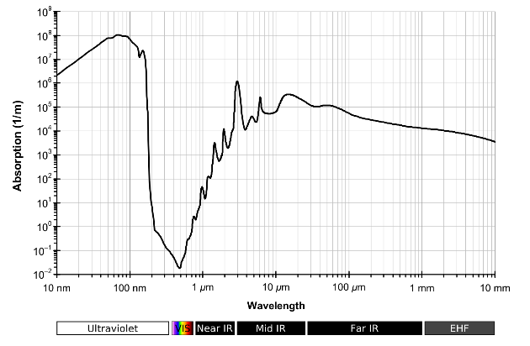
Absorption by liquid water.116
      - [G & N] Of all the portions of the electromagnetic spectrum that are shown in Figure 18.8, reproduced below, what part is absorbed in the shortest distance in water?
Absorption by liquid water.116
      - [G] Label the incident, reflected, and/or refracted angles in this sketch, whichever are appropriate for this situation:
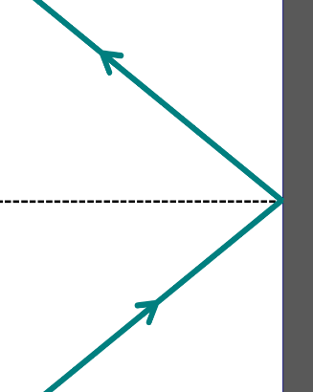
Rays and a surface.1
      - [N] A ray of light hits a surface at an angle of ${17}^{∘}$. At what angle will it reflect?
      - [G & N] Can total internal reflection occur when light is going from a material with a low index of refraction into a material with a higher index of refraction? Explain your reasoning, using graphics or numbers.

Level 3 - Apply
      - [N] Green light has a wavelength of approximately 550 nm in vacuum. Calculate the frequency of a 550-nm photon of green light.
      - [N] Green light has a wavelength of approximately 550 nm in vacuum. Calculate the energy (in eV) of a 550-nm photon of green light.
      - [W, G, & N] Calcium, which is contained in bones, absorbs x-rays much more than the soft tissue that makes up most of the human body. In a hospital, this is exploited to make images of bones inside a person’s body. If x-rays are sent through a person’s body onto a photographic plate on the other side…
        - …how does the absorption of x-rays by calcium affect the intensity of the x-rays reaching the photographic plate?
        - …what color are the more heavily exposed parts of the photographic plate in a typical x-ray image like that shown below?
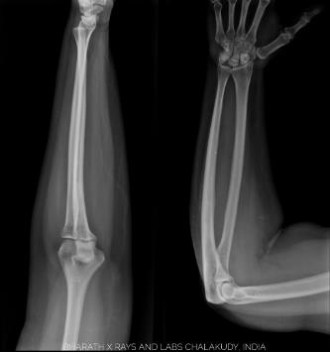
X-ray of an arm.
      - [N] A medical radiation protection vest typically includes a 0.35-mm-thick layer of lead. The absorption coefficient for lead in the x-ray portion of the spectrum is approximately $6×{10}^{6} m^{-1}$. What fraction of x-rays penetrates the vest?
      - [G & N] In Figure 18.16, the former president appears to be about 1 meter away from the flat (plane) mirror. How far is the image behind the mirror?
      - [G & N] Former president Barack Obama is 1.9 m tall. How tall is his image in a flat (plane) mirror?
      - [G & N] In the “Numbers” column of Section 18.5 it talks about some similar triangles in Figure 18.18, reproduced below. Copy that figure, showing where those similar triangles are in the sketch, and adding labels to show which angles are the same in each triangle.
Rays reflecting from a flat (plane) mirror.1
      - [N] Something else we could have found in Section 18.6 is the frequency of the light. Find the frequency of the light in both air and sapphire for that example.
      - [W, G, & N] Re-do the analysis for the example from Section 18.6, but with light going from air into water instead of sapphire. Do an internet search to find the index of refraction for water. The wavelength of the light in vacuum should still be 600 nm, and the angle that the light hits the interface from the air should be ${35}^{∘}$.

Level 4 - Analyze
      - [G & N] How many photons of visible light would be needed to add up to the same amount of energy in a single gamma ray photon?
      - [G] Looking at Figure 18.2, it is difficult to put an exact range on the wavelengths that correspond to what we would call green. Certainly 550 nm is green, but is 600 nm still green, or is it yellow? This kind of overlap also exists in other portions of the electromagnetic spectrum. Looking at Figure 18.3, reproduced below, what are some other parts of the spectrum where it looks like there is not a very clear definition between where one label ends and the next begins?
Trends in frequency, wavelength, photon energy, and speed across the electromagnetic spectrum.1
      - [G & N] Figure 18.6, reproduced below, shows red light passing through a diffraction grating, with m=1 antinodes clearly visible. Estimate the spacing of that grating using the following steps:
Light passing through a diffraction grating.114
        - Use the electromagnetic spectrum shown below to estimate the wavelength of the light.
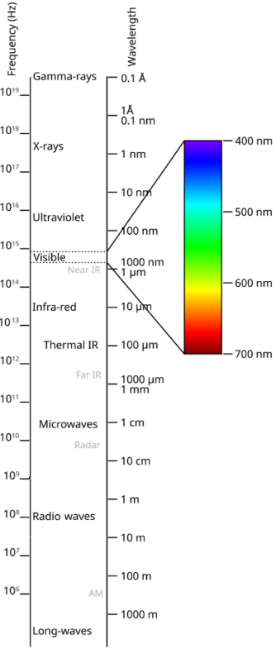
Electromagnetic spectrum.112
        - Use the image of the diffraction grating above to estimate the angle of the first antinode.
        - Use the mathematical model for the antinodes of a double slit, which is also valid for a diffraction grating, to determine the spacing of the grating.
      - [W, G, & N] Imagine that the former president in Figure 18.16 had been holding up a pencil in front of himself as he faced the flat (plane) mirror. If the pencil was 0.1 m tall and was 0.2 m away from the mirror…
        - What would the magnification of the pencil’s image be?
        - What would the height of the pencil’s image be?
        - Where would the image of the pencil be located?
      - [W, G, & N] Re-do the analysis for the example from Section 18.6, but with light going from sapphire to air instead of air to sapphire. The wavelength of the light in vacuum should still be 600 nm, and the angle that the light hits the interface from the sapphire should be ${35}^{∘}$.

Level 5 - Evaluate
      - [G & N] It seems strange that in the analysis for Section 18.3 it was found that the longest path lengths of light through water before light is 99.9% absorbed was 20 cm. And yet we can see underwater for distances much longer than 20 cm! Using the figures and analysis techniques in Section 18.3 find out how far we should be able to see through water.
      - [W, G, & N] A very thin layer of sunscreen, invisible on the skin to our eyes, is enough to protect the skin on a sunny day.
        - What part of the electromagnetic spectrum does sunscreen provide protection from? (You can use an internet source to look this up if you don’t know the answer from all the advertising!)
        - What do you think is happening to the light in that part of the spectrum when it hits the sunscreen?
        - Sunscreen is rated using a numerical scaled called “Sun protection factor,” SPF. What physical characteristic from this chapter corresponds most closely to SPF?
      - [G & N] Looking at Figure 18.24, reproduced below, the light appears to exit the fiber not in a straight line but in a cone; the light on the table is like a slice through the center of the cone. Sketch the end of the fiber optic cable, assuming that the end of the fiber optic cable is cut off flat. Add a light ray that exits the end of the cable at the same angle as the cone of light in Figure 18.24, and estimate that angle as measured from the normal vector from the end surface of the cable. Assuming that the index of refraction of the cable is 1.5, find the angle inside the cable just before the light leaves the glass. At what angle does that ray reflect from the sides of the cable? Is the angle larger than the critical angle calculated in Section 18.7?
Light exiting from a fiber optic cable.122

Level 6 - Create
      - [W, G, & N] At the beginning of Chapter 1 in Figure 1.1 was a template for a concept map. Create a new concept map with the main ideas from this chapter.
      - [W, G, & N] Imagine you are writing a test question related to this chapter. Think of your own example of a situation that you can analyze using the concepts, graphics, and mathematical analyses described in this chapter. Describe the situation and use the tools from this chapter to analyze the situation as completely as you can, including motion, forces, energy, and momentum.
      - [W, G, & N] Think about possible misconceptions about the material in this chapter. Write a question and an incorrect solution to it that demonstrates a student making such a conceptual error. This cannot be a simple misuse of a vocabulary word, a unit error, or a mathematical error like making an addition error or multiplying when addition was needed, unless the error is rooted in a real misunderstanding about the physics behind the calculation or the misuse of a word. After you have written the question and incorrect solution, explain what is wrong with the student’s solution, and write a correct solution to the problem. Note: You may use a question from this chapter that you got wrong the first time and explain the initial error in your thinking and how you corrected it.

– Optical Instruments
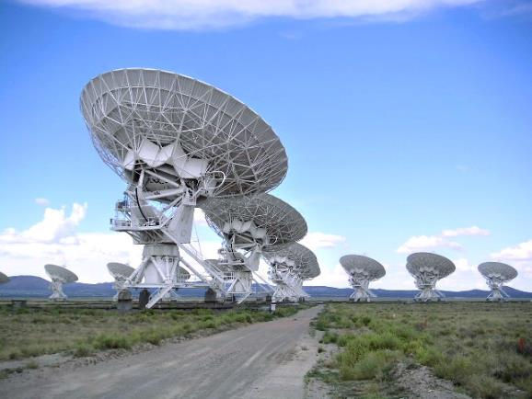
Figure 19.1: Part of the “Very Large Array” telescope.
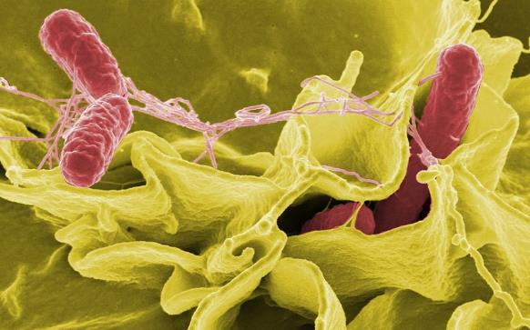
Figure 19.2: An electron microscope image of salmonella bacteria invading cultured human cells. False coloring is used to highlight the bacteria in the image.

We have seen some different ways that light interacts with materials: reflecting, refracting, diffracting, and being absorbed. Now we will look at various instruments that use these principles to create images.
Some of these instruments, like eyeglasses and eyes themselves, operate in the visible part of the electromagnetic spectrum. But we will also consider things like the aptly named “Very Large Array” radio telescope in Figure 19.1. That telescope is made up of a series of dishes that work together as a single sensing device to collect radio waves from deep space. A very large array of telescopes is needed because of the very long radio wavelengths.
We will also consider the very small, like the image of bacteria in Figure 19.2. That image was made with an electron microscope, which uses a beam of electrons to illuminate the image instead of using a beam of photons. The very small wavelength of electrons makes it possible to create these high-resolution images.

: Concave mirrors ( , )

Words
We saw in Section 18.5 that a flat mirror creates an upright, virtual image that is the same size as the object, or “true.” What happens with a concave mirror, like the inside surface of a hollow sphere? If a 0.1-m-tall object is placed 0.5 m from the inside surface of a sphere with a radius of 0.3 m, is an image created? If so, where is it and what are the characteristics of the image? Is the image upright or inverted? Real or virtual? Enlarged, reduced, or true?
First, we need to know about the mirror itself. Figure 19.3 shows what happens when parallel light rays hit a piece of mirror that is shaped like the inside of a piece of a hollow sphere. The point “C” is at the center of the sphere, one radius r from every point on the mirror. If the mirror is a relatively small portion of a sphere, then the parallel light rays all bounce off the mirror and come together at a point “F,” the focal point of the mirror. The distance from the mirror to the focal point is called the focal length f. For a concave spherical mirror, the focal length is half the radius of the mirror.
We can use ray diagrams, like we did with the plane mirror in Section 18.5, to find the image. We will use a person as the object for our example, with the person standing on the “principal axis,” which is a line that goes through C and F. We saw before that rays go out in all directions from the head, but there are three rays that are particularly helpful in locating images in ray diagrams.

Graphics
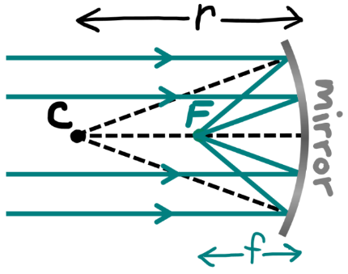
Figure 19.3: A concave piece of a hollow sphere that is reflective on the inside surface. The dotted lines are normal vectors, showing that the incident and reflected angles are equal.¹
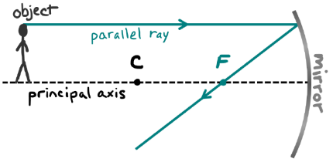
Figure 19.4: The parallel ray goes parallel to the principal axis and then reflects through the focal point.¹

Numbers
If we can find values for the magnification $M$, the height of the image $h_{i}$, and the distance to the image $d_{i}$ then we can use those to answer all the questions asked for this scenario.
Assumptions: the mirror is a relatively small portion of a sphere.
Knowns | Unknowns
$$r=0.3 m$$ | $$M$$
$$h_{o}=0.1 m$$ | $$h_{i}$$
$$d_{o}=0.5 m$$ | $$d_{i}$$
For lenses and mirrors, the focal length $f$ determines the distance to the image:
$$\boxed{\frac{1}{f}=\frac{1}{d_{o}}+\frac{1}{d_{i}}}$$
( 19.1 )
This is called the “thin lens equation,” even though it is also for mirrors. If we knew the focal length of the mirror, then we could find the distance to the image. For a concave mirror that is shaped like a small part of a sphere, the focal length is half of the radius of the sphere:
$$\boxed{f=\frac{r}{2}}$$
( 19.2 )

Words
The first is the “parallel ray” that goes parallel to the principal axis, as shown in Figure 19.4. This is just like one of the rays in Figure 19.3, so it goes through F after reflecting off the mirror.
The second is the “focal ray” that goes through the focal point, as shown in Figure 19.5. This is also like one of the rays in Figure 19.3, but with direction reversed. So, this ray goes parallel to the principal axis after reflecting off the mirror.
The third is the “center ray” that goes through the center point, as shown in Figure 19.6. Since it passed through the center point of the sphere, it hits the surface of the mirror exactly along the normal vector, so it reflects straight back through the center point again.
Figure 19.7 shows all three of these rays in one diagram. The reflected rays, which are darker for emphasis, all meet at the same point. That is the location of the head of the image. Since the object’s feet are on the principal axis, the feet of the image are also on the principal axis.
We can see from Figure 19.7 that the image is inverted. It is also smaller than the object, so it is “reduced.” And the light rays from the head of the object bounce off the mirror and arrive at the image, so it is a real image.
Helpful hints on ray diagrams: It is important to make these diagrams as accurate as possible to get accurate results–graph paper is helpful for that. Also, only two rays are necessary. In some situations, one ray will be harder to draw than the others, so you can just use the two that are easier.

Graphics
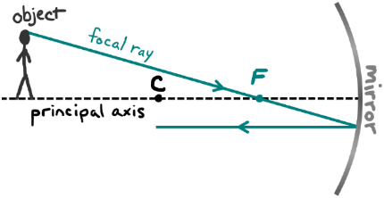
Figure 19.5: The focal ray goes through the focal point and then parallel to the principal axis.¹
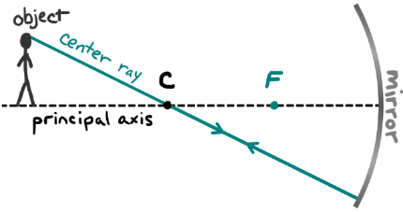
Figure 19.6: The center ray goes through the center point and back on the same path.¹
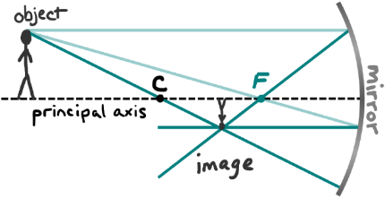
Figure 19.7: All three rays on one diagram.¹

Numbers
Putting the thin lens equation together with Equation ( 19.2 ) for this example…
$$\begin{aligned}\frac{1}{d_{i}}&=\frac{1}{f}-\frac{1}{d_{o}} \\ &=\frac{2}{r}-\frac{1}{d_{o}} \\ &=\left(\frac{2}{0.3 m}\right)-\left(\frac{1}{0.5 m}\right) \\ &=4.67 m^{-1} \\ d_{i}&=0.214 m\end{aligned}$$
This tells us that image is 0.214 m from the mirror, and since it is positive that means the image is real and on the same side of the mirror as the object. Now we can use the relationships between distance, height, and magnification from Chapter 18 to find $M$ and $h_{i}$:
$$\begin{aligned}M&=\frac{h_{i}}{h_{o}}&&=-\frac{d_{i}}{d_{o}} \\ M&=\frac{h_{i}}{0.1 m}&&=-\frac{0.214 m}{0.5 m}\end{aligned}$$
Solving for $M$ and $h_{i}$…
$$M=-0.429$$
$$h_{i}=-0.0429 m$$
The absolute value of $M$ is less than 1, so the image is reduced. $M$ is negative, so the image is inverted. $h_{i}$ is also negative, and that also tells us that the image is inverted.

: Convex Mirrors ( , )

Words
Next, we will see what happens with a convex mirror, like the outside surface of a sphere. If the sphere has a radius of 0.3 m and a 0.1-m-tall object is placed 0.2 m from the surface of the sphere, is an image created? If so, where is it and what are the characteristics of the image?
Figure 19.8 shows what happens when parallel light rays hit a piece of mirror that is shaped like the outside surface of a sphere. As before, point C is at the center of the sphere and focal point F is halfway between C and the surface of the mirror. With the concave mirror in Section 19.1, all the parallel rays converged on the focal point after reflecting. But this time all the rays diverge, going directly away from the focal point after reflecting. For that reason, a concave mirror can be called a “converging” mirror, and a convex mirror can be called a “diverging” mirror.
For a convex mirror, the parallel ray again goes parallel to the principal axis, but then it reflects directly away from the focal point, as shown in Figure 19.9. This ray looks just like one of the rays in Figure 19.8.
The focal ray goes toward the focal point and then reflects parallel to the principal axis, as shown in Figure 19.10. This one is also like one of the rays in Figure 19.8, but with the direction reversed.

Graphics
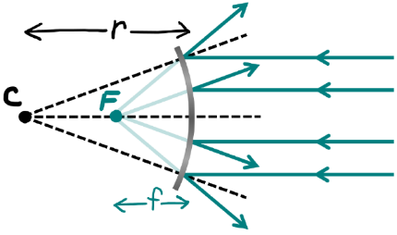
Figure 19.8: A convex piece of a sphere that is reflective on the outside surface. The black dotted lines are normal vectors. The light green lines are extensions of the reflected rays, showing that they all seem to come from the focal point F.¹
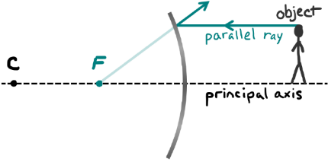
Figure 19.9: The parallel ray goes parallel to the principal axis and then reflects directly away from the focal point F.¹

Numbers
Assumptions: the mirror is a relatively small portion of a sphere.
Knowns | Unknowns
$$r=0.3 m$$ | $$M$$
$$h_{o}=0.1 m$$ | $$h_{i}$$
$$d_{o}=0.2 m$$ | $$d_{i}$$
This analysis will be very similar to the one in Section 19.1, except this time the mirror is convex. Since the focal point is on the opposite side of the mirror from the object, this time the focal length is negative:
$$\boxed{f=-\frac{r}{2}}$$
( 19.3 )
Putting this together with the thin lens equation for this example…
$$\begin{aligned}\frac{1}{d_{i}}&=\frac{1}{f}-\frac{1}{d_{o}} \\ &=-\frac{2}{r}-\frac{1}{d_{o}} \\ &=-\left(\frac{2}{0.3 m}\right)-\left(\frac{1}{0.2 m}\right) \\ &=-11.7 m^{-1} \\ d_{i}&=-0.086 m\end{aligned}$$

Words
The center ray goes toward the center point and reflects straight back along the same direction, as shown in Figure 19.11.
Figure 19.12 shows all three of these rays in a single diagram. The reflected rays, which are shown darker for emphasis, diverge from each other, so this time they do not come together at the same point. That means there is no real image. But we can extend each of those reflected rays backwards through the mirror, like we did with the plane mirror in Section 18.5. If we do that, we can see that all the rays seem to be coming from the same point behind the mirror. That is the location of the head of the virtual image. Since we drew the object’s feet on the principal axis, the feet of the image are also on the principal axis.
We can see from Figure 19.12 that the image is upright. It is also smaller than the object, so it is reduced. And the light rays don’t really arrive at the location of the image, so it is virtual.

Graphics
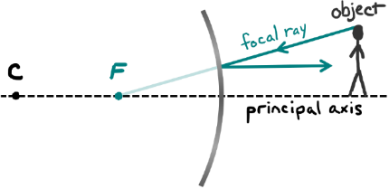
Figure 19.10: The focal ray goes toward the focal point and reflects parallel to the principal axis.¹
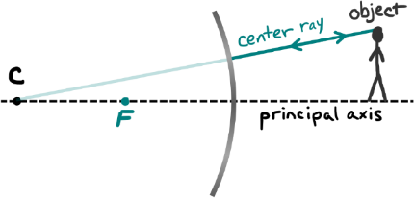
Figure 19.11: The center ray goes toward the center point and back on the same path.¹
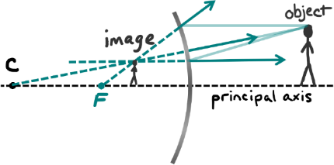
Figure 19.12: All three rays on one diagram.¹

Numbers
So, the image is 0.086 m from the mirror, and the negative means the image is virtual and on the opposite side of the mirror as the object.
Now we can use the relationships between distance, height, and magnification from Chapter 18 to find $M$ and $h_{i}$:
$$\begin{aligned}M&=\frac{h_{i}}{h_{o}}&&=-\frac{d_{i}}{d_{o}} \\ M&=\frac{h_{i}}{0.1 m}&&=-\frac{-0.086 m}{0.2 m}\end{aligned}$$
Solving for $M$ and $h_{i}$…
$$M=0.429 \\ h_{i}=0.0429 m$$
The absolute value of $M$ is less than 1, so the image is reduced. $M$ is positive, so the image is upright. $h_{i}$ is also positive, and that also tells us that the image is upright.
The following are the sign conventions that are used for both lenses and mirrors. These conventions allow all the mathematical models to work in the same way in every scenario.
Symbol | Positive | Negative
$$d_{o}$$ | Always | Never
$$h_{o}$$ | Always | Never
$$d_{i}$$ | Real | Virtual
$$h_{i}$$ | Upright | Inverted
$$f$$ | Converging | Diverging
$$M$$ | Upright | Inverted

: Convex Lenses ( , )

Words
Mirrors use reflection to create images, but if we replace the mirrors with lenses then we can use refraction instead. For mirrors, only the curvature mattered, but for lenses both the curvature and the index of refraction are important. Increasing the index of refraction of a lens makes it so that less curvature is needed. Instead of using the radius of curvature to describe lenses, we will just describe them in terms of their focal length. We will also be assuming that the lenses are thin.
Let’s consider a convex lens, specifically a “double convex” lens, which means that both the front and the back are curved outward. If the focal length is 0.3 m and a 0.2-m-tall object is placed 0.3 m from the center of the lens, is an image created? If so, where is it and what are the characteristics of the image?
Figure 19.13 shows what happens when parallel light rays hit a thin convex lens. The parallel light rays all refract as they go through the lens, coming together at focal point “F” on the opposite side of the lens. Lenses have two focal points, one on each side of the lens, and a midpoint at the center of the lens. Unlike with curved mirrors, there is no center point for lenses. The principal axis goes through the midpoint and both focal points.

Graphics
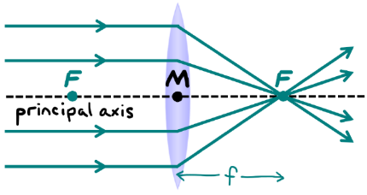
Figure 19.13: A convex lens causes parallel rays to converge. A lens does not have a center point, but it has a midpoint M and two focal points, both the same distance $f$ from the midpoint. With lenses, the refraction is drawn as a single bend in the ray in the middle of the lens.¹
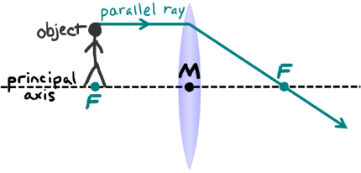
Figure 19.14: The parallel ray goes parallel to the principal axis and then refracts toward the focal point on the far side of the lens.¹

Numbers
Assumptions: a thin lens.
Knowns | Unknowns
$$f=0.3 m$$ | $$M$$
$$h_{o}=0.2 m$$ | $$h_{i}$$
$$d_{o}=0.3 m$$ | $$d_{i}$$
The analysis for a lens works in the same way as the analysis for a mirror. From the thin lens equation…
$$\begin{aligned}\frac{1}{d_{i}}&=\frac{1}{f}-\frac{1}{d_{o}} \\ &=\left(\frac{1}{0.3 m}\right)-\left(\frac{1}{0.3 m}\right) \\ &=0 \\ d_{i}&=∞\end{aligned}$$
The image is infinitely far away…in other words, there is no image. If we try to use this to find the magnification and the height of the image, we get negative infinity for those, again meaning that there is no image:
$$\begin{aligned}M&=\frac{h_{i}}{h_{o}}&&=-\frac{d_{i}}{d_{o}} \\ M&=\frac{h_{i}}{0.2 m}&&=-\frac{∞}{0.3 m} \\ M&=h_{i}&&=-∞ \\ \end{aligned}$$

Words
As with mirrors, there are three rays that are particularly helpful in locating images in ray diagrams. Two are the parallel ray and the focal ray, as before. But this time the third is the “midpoint ray,” which goes through the midpoint of the lens.
The parallel ray goes parallel to the principal axis and then refracts toward the focal point on the far side of the lens, as in Figure 19.14. This ray looks just like one of the rays in Figure 19.13.
The focal ray goes through the focal point on the near side of the lens and then refracts through the lens parallel to the principal axis. Normally. Unfortunately, in this example there is no focal ray! This ray was attempted in Figure 19.15, but the ray goes vertically downward, in a direction that could never hit the lens even if we made the lens infinitely tall and extended the ray forward and backward to infinity.
The midpoint ray goes straight through the midpoint, as in Figure 19.16.
Figure 19.17 shows the two of these rays that are valid for this example, together in one diagram. The rays that passed through the lens are parallel to each other, so they will never meet, even if we extend them forward and backward to infinity. That means there is no image in this example. For other combinations of focal length and distance to the image there can be images formed by a convex lens, but not for this combination!

Graphics
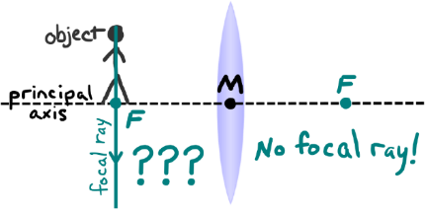
Figure 19.15: The focal ray goes through the near focal point and through the lens parallel to the principal axis…but not this time!¹
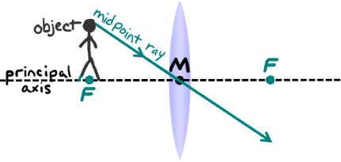
Figure 19.16: The midpoint ray goes straight through the midpoint.¹
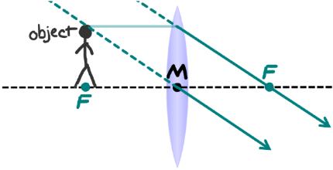
Figure 19.17: The rays don’t meet…no image!¹

Numbers
(This column intentionally left blank)

: Concave Lenses ( , )

Words
Next, we will consider a concave lens, specifically a double concave lens. Since concave lenses are diverging, their focal length is negative. If the focal length is -0.3 m and a 0.2-m-tall object is placed 0.3 m from the midpoint of the lens, is an image created? If so, where is it and what are the characteristics of the image?
Figure 19.18 shows what happens when parallel light rays hit a thin concave lens. The parallel light rays all refract as they go through the lens, going directly away from the focal point on the side of the lens where the light originated.
Again, we will use the parallel, focal, and midpoint rays to find the image created.
The parallel ray goes parallel to the principal axis and then refracts directly away from the focal point on the near side of the lens, as in Figure 19.19. This ray looks just like one of the rays in Figure 19.18.
The focal ray goes toward the far focal point, but it refracts parallel to the principal axis when it reaches the lens, as in Figure 19.20. This ray is like one of the rays in Figure 19.18, but with the direction reversed.
The midpoint ray goes straight through the midpoint, as in Figure 19.21.

Graphics
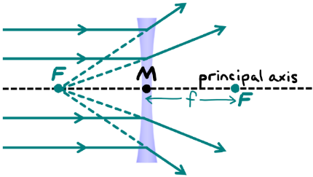
Figure 19.18: A concave lens causes parallel rays to diverge. The dashed green lines show that the diverging rays all appear to come from the focal point on the side where the light originated.¹
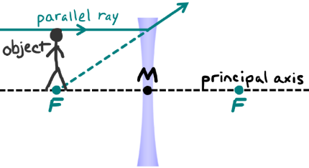
Figure 19.19: The parallel ray goes parallel to the principal axis and then refracts away from the focal point on the near side of the lens.¹

Numbers
Assumptions: a thin lens.
Knowns | Unknowns
$$f=-0.3 m$$ | $$M$$
$$h_{o}=0.2 m$$ | $$h_{i}$$
$$d_{o}=0.3 m$$ | $$d_{i}$$
The analysis is again done in the same way. From the thin lens equation…
$$\begin{aligned}\frac{1}{d_{i}}&=\frac{1}{f}-\frac{1}{d_{o}} \\ &=\left(\frac{1}{-0.3 m}\right)-\left(\frac{1}{0.3 m}\right) \\ &=-6.67 m^{-1} \\ d_{i}&=-0.15 m\end{aligned}$$
The image is virtual, since the distance is negative. Now we can find the magnification and the height of the image:
$$\begin{aligned}M&=\frac{h_{i}}{h_{o}}&&=-\frac{d_{i}}{d_{o}} \\ M&=\frac{h_{i}}{0.2 m}&&=-\frac{-0.15 m}{0.3 m}=0.5 \\ \end{aligned}$$
So, the magnification is 0.5 and the height of the image is 0.1 m. The image is virtual, reduced, and upright.

Words
The ray diagram in Figure 19.22 combines all three of these rays. The rays diverge, but if the refracted rays are extended backwards through the lens, then they all come together at the same point. That point is the location of the image. The image is virtual, upright, and reduced.

Graphics
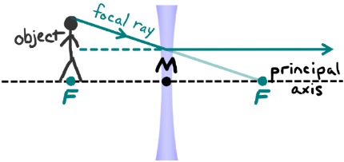
Figure 19.20: The focal ray goes toward the far focal point and refracts through the lens parallel to the principal axis.¹
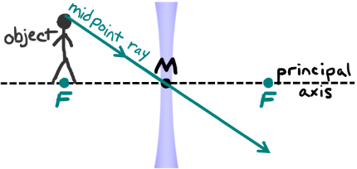
Figure 19.21: The midpoint ray goes straight through the midpoint.¹
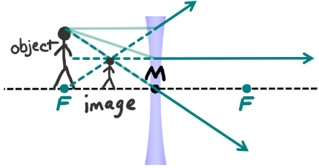
Figure 19.22: All three rays on one diagram.¹

Numbers
(This column intentionally left blank)

: Corrective Lenses ( , )

Words
Optical systems often include multiple lenses and/or mirrors. For our example, we will look at a human eye with a corrective lens. The lens in a human eye is somewhat flexible, and the muscles around it can stretch the lens, changing its focal length. That is how our eye can focus on objects that are near or objects that are far, but not at the same time. When it is working correctly, the lens focuses light on the retina at the back of the eye, as in Figure 19.23.
For some people, the eye does not function correctly, either because the lens is not flexible enough or because the length of the eye does not correspond well with the focal length of the lens. One example of this, “myopia,” or “near-sightedness” is shown in Figure 19.24. With myopia, the focal point is inside the vitreous humor instead of being at the retina. Myopia can be corrected by adding a “corrective” lens: either eyeglasses or contact lenses.
The “back focal length,” the effective focal length from the second lens, is the important factor here. The back focal length needs to be matched with the length of the eye. The length of a typical adult eye is 24 mm, so from Figure 19.24 it appears that for this example the focal length of the lens in the eye is approximately 18 mm. A typical distance from eyeglasses to the eye is approximately 20 mm. What is the focal length of the eyeglasses needed to correct the vision for this eye?

Graphics
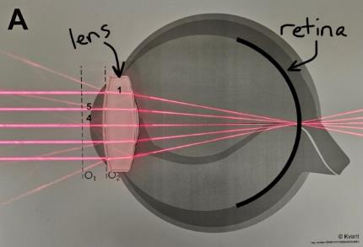
Figure 19.23: The lens of a “normal” eye has a focal length that is equal to the length of the eye.¹
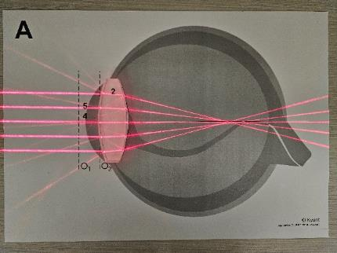
Figure 19.24: The lens of a “near-sighted” person has a focal length that is too short.¹

Numbers
Assumptions: thin lenses.
Knowns | Unknowns
$$f_{back}=24 mm$$ | $$f_{1}$$
$$f_{2}=18 mm$$
$$d=20 mm$$
For a combination of two lenses, as long as the distance $d$ between the lenses is less than the focal length $f_{1}$ of the first lens that the light enters, the back focal length $f_{back}$ is given by:
$$\boxed{f_{back}=\frac{f_{2}⋅\left(d-f_{1}\right)}{d-\left(f_{1}+f_{2}\right)}}$$
( 19.4 )
If the focal length of the first lens is negative, then this mathematical model works for any distance. For this example, we have everything in Equation ( 19.4 ) except for $f_{1}$, so we just need to use algebra on that mathematical model.
$$\begin{aligned}f_{back}&=\frac{f_{2}⋅\left(d-f_{1}\right)}{d-\left(f_{1}+f_{2}\right)} \\ \left(d-\left(f_{1}+f_{2}\right)\right)⋅f_{back}&=f_{2}⋅\left(d-f_{1}\right) \\ \left(d-f_{1}-f_{2}\right)⋅f_{back}&=f_{2}⋅\left(d-f_{1}\right) \\ \left(d-f_{2}\right)⋅f_{back}-f_{1}⋅f_{back}&=f_{2}⋅d-f_{1}⋅f_{2} \\ f_{1}⋅f_{2}-f_{1}⋅f_{back}&=f_{2}⋅d-\left(d-f_{2}\right)⋅f_{back} \\ f_{1}⋅\left(f_{2}-f_{back}\right)&=f_{2}⋅d-\left(d-f_{2}\right)⋅f_{back} \\ f_{1}&=\frac{f_{2}⋅d-\left(d-f_{2}\right)⋅f_{back}}{f_{2}-f_{back}}\end{aligned}$$

Words
Figure 19.25 has the same lens internal to the eye as in Figure 19.24, but a second, corrective lens has been added externally to the eye. Adding the corrective lens has shifted the focal point onto the retina.
The focal length for the corrective lens that is calculated in the “Numbers” column is negative, which means it is a diverging lens. That should be expected, since the corrective lens that is visible in Figure 19.25 is double concave. Notice that the light rays that were originally parallel are diverging slightly in the space between the corrective lens and the lens of the eye.
The strength of eyeglasses is measured in “diopters,” and in this case the lens would be
-19 diopter. That is a high strength, but still within the range of being possible to manufacture.

Graphics
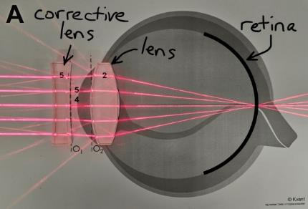
Figure 19.25: Concave “corrective” lenses (glasses or contacts) can be used to correct near-sightedness.¹

Numbers
Now, putting in the numbers…
$$\begin{aligned}f_{1}&=\frac{f_{2}⋅d-\left(d-f_{2}\right)⋅f_{back}}{f_{2}-f_{back}} \\ &=\frac{18⋅20-\left(20-18\right)⋅24}{18-24} mm \\ &=-52 mm \\ &=-0.052 m\end{aligned}$$
The way eyeglasses are measured is in “diopters,” not focal length. The diopter of a lens is the reciprocal of the focal length in meters. So, in this case, the diopter would be…
$$\frac{1}{-0.025 m}=-19 m^{-1}$$

: Aberrations in Optical Systems ( , )

Words
We have been assuming thin lenses. To understand why this assumption is needed, we can consider a simplified convex lens made up of three pieces: A triangular prism at the top and bottom and a rectangular prism in the center. Three possible rays, corresponding to the principal, focal, and midpoint rays as we have been drawing them in our ray diagrams, are shown in Figure 19.26.
Let’s look more closely at the midpoint ray of our simplified lens. As demonstrated in Figure 19.27, it in fact does not just go straight through, which is what we have been assuming in our analyses of lenses! The ray refracts as it enters the lens and then refracts again as it leaves the lens. This results in a shift of the midpoint ray, and the amount of shift depends on the thickness of the lens: A thicker lens means more shift. This shift creates an “aberration” in the lens, meaning that not all the light goes to the focal point.
“Chromatic aberration” also occurs in lenses when the focal length varies with frequency of the light. The focal length of a lens depends on the index of refraction of the material that the lens is made from, and the index of refraction of a material is typically not constant but increases as the frequency of the light increases. So, for example blue light bends more than red light. This is visible in the photo of white light entering a prism and being dispersed into its component colors in Figure 19.28.

Graphics
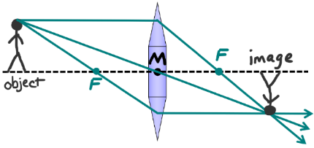
Figure 19.26: A simplified lens.¹
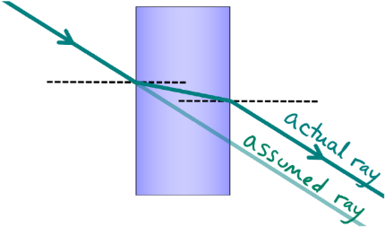
Figure 19.27: The midpoint ray doesn’t really go straight through, as we have been assuming. Instead, it shifts toward the principal axis.¹

Numbers
(This column intentionally left blank)

Words
Chromatic aberration can be avoided by using mirrors instead of lenses, because the reflected angle does not depend on the wavelength of the light. But spherical mirrors also create aberrations. With curved mirrors we have assumed that the mirror is a relatively small portion of a sphere. But as the curvature increases, making the incident angles larger, the reflected light gets farther from the focal point F, as illustrated in Figure 19.29.
This can be corrected by using curved mirrors with a parabolic shape instead of a spherical shape. The reason spherical mirrors are used more often than parabolic mirrors is that spheres are easier to manufacture. For precision scientific instruments like the Very Large Array in Figure 19.1, parabolic mirrors are used, eliminating these aberrations.

Graphics
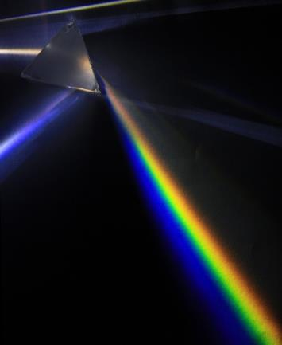
Figure 19.28: White light entering from the bottom of the image is dispersed into different colors as it refracts through a prism because the index of refraction varies with the frequency of the light.
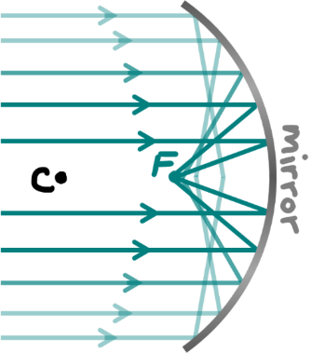
Figure 19.29: If the angles get too large, some light does not go to the focal point F.¹

Numbers
(This column intentionally left blank)

: Physical Limitations of Optical Systems ( , )

Words
Even with precision parabolic mirrors that eliminate aberration, images still aren’t perfect. That is because diffraction limits resolution. A parabolic mirror behaves similarly to the single slits that we saw in Section 18.2: Diffraction increases as the size of the mirror decreases. This limitation of resolution is governed by the “Heisenberg Uncertainty Principle,” which states that it is impossible to know both the location and the momentum of an object with unlimited resolution. The more precisely one of these is measured, the more unpredictable the other becomes.
As an example of the uncertainty principle, suppose you wanted to know the exact location of an electron at some point in time. You would probably shine a light on it to see where it was. But light has momentum, so when it reflects off the electron it can show you where the electron is, but it also transfers momentum to the electron in the process. To get better resolution of the electron’s location, you would need more photons or higher energy photons, which would transfer even more momentum to the electron. So, the more effort you put into finding the position of the electron, the less you can know about the initial momentum of the electron.
The uncertainty principle is illustrated in Figure 19.30 & Figure 19.31, where two imaging systems with differently sized mirrors are designed to focus an incoming beam of parallel light to a single point.

Graphics
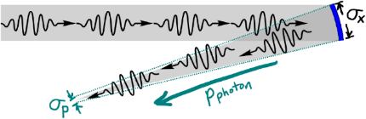
Figure 19.30: If the size of the mirror in an optical system, here labeled $σ_{x}$, is relatively large, the spread in momentum $σ_{p}$ of the reflected beam is relatively small compared to the momentum itself, so the light ends up near the focal point, creating a sharp image.¹
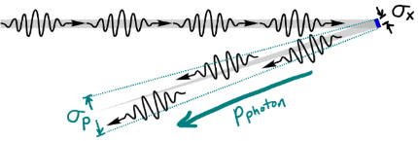
Figure 19.31: If the size of the mirror in an optical system, $σ_{x}$, is relatively small, the spread in momentum $σ_{p}$ of the reflected beam is relatively large compared to the momentum itself, so the light ends up scattered widely around the focal point, creating a blurry image.¹

Numbers
Heisenberg’s Uncertainty Principle relates the uncertainty of a particle’s position $σ_{x}$ to the uncertainty in its momentum $σ_{p}$:
$$\boxed{σ_{x}⋅σ_{p}≥\frac{ℏ}{2}}$$
( 19.5 )
The magnitude of a photon’s momentum is…
$$\boxed{p_{photon}=\frac{h}{λ}}$$
( 19.6 )
We can use these to find an expression for the ratio of the uncertainty in momentum and the momentum itself:
$$\begin{aligned}\frac{σ_{p}}{p_{photon}}&≥\left(\frac{ℏ}{2⋅σ_{x}}\right)⋅\left(\frac{λ}{h}\right) \\ &≥\left(\frac{h}{2π⋅2⋅σ_{x}}\right)⋅\left(\frac{λ}{h}\right) \\ &≥\left(\frac{λ}{4π⋅σ_{x}}\right)\end{aligned}$$
We can use this to analyze the optical systems in Figure 19.30 & Figure 19.31. In the small angle approximation, this calculation shows that the angle over which the beam spreads, represented by the ratio $\frac{σ_{p}}{p_{photon}}$, is proportional to the wavelength of the light and inversely proportional to the size of the mirror.

Words
The design of the light path is shown in gray, but after hitting the mirror the size of the mirror (which is a measure of where the photon was in space when it reflected) creates uncertainty in the momenta of the reflected photons. As a result, the reflected beam does not go directly toward the focal point, but scatters around the focal point. A larger mirror creates less uncertainty in momentum, and thus a sharper focus. Using light with a shorter wavelength (and thus higher momentum) has the same effect of creating a sharper focus.
Another way to improve the resolution for imaging is to switch to using a particle that has higher momentum than a photon. An electron, for example. Electrons (and every other particle) behave like waves, just as photons do. In fact, in a double-slit experiment, individual electron waves pass through both slits before reaching the screen where they are detected as particles. This is demonstrated in the experiment shown in Figure 19.32.
The calculation in the “Numbers” column shows that a diffraction-limited electron microscope could have a resolution that would require gamma rays in an optical system, approximately 10⁵ times better resolution than visible light! That is why electron microscopes can be used to achieve resolutions on the order of nanometers, approaching the scale of individual atoms.

Graphics
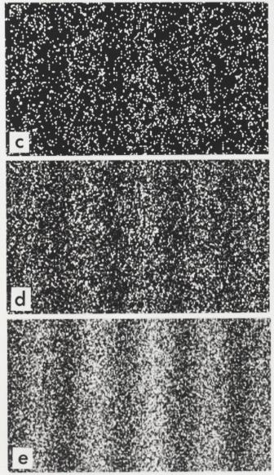
Figure 19.32: An experiment by Tanamura showed that electrons diffract just like photons through a double slit. These images show the results after 6000, 40 000, and 140 000 individual electrons were detected on the screen behind the double slit.

Numbers
We can relate the momentum of an electron to the momentum of a photon to get an idea of the resolution of an electron beam compared to a beam of photons.
A typical energy of electrons in the beam of an electron microscope is 10 keV. We can use the relationship between energy and momentum to find the momentum of the electrons:
$$\begin{aligned}E_{k}&=\frac{p^{2}}{2⋅m} \\ p^{2}&=2⋅m⋅E_{k} \\ p&=\sqrt{2⋅m⋅E_{k}} \\ &=\sqrt{2⋅\left(9.11×{10}^{-31} kg\right)⋅\left(10×{10}^{3} eV\right)} \\ &=\sqrt{2⋅\left(9.11×{10}^{-31} kg\right)⋅\left({10}^{4} eV\right)⋅\frac{1.6×{10}^{-19} J}{1 eV}} \\ &=5.4×{10}^{-23} kg⋅m/s\end{aligned}$$
What would the wavelength of a photon need to be so it could carry as much momentum as an electron in an electron microscope? Using Equation ( 19.6 )…
$$\begin{aligned}p_{photon}&=\frac{h}{λ} \\ λ&=\frac{h}{p_{photon}}=\frac{2π⋅ℏ}{p_{photon}} \\ &=\frac{2π⋅\left(1.15×{10}^{-34} kg⋅m^{2}/s\right)}{5.4×{10}^{-23} kg⋅m/s} \\ &=1.3×{10}^{-11}m\end{aligned}$$

: Summary
Chapter summaries in this book are ordered by concept, not necessarily in the order in which they are presented in the chapter. Mathematical models are grouped together at the end of each summary. See the appendices for the meanings of all symbols used in this book.

General
- Variation of the index of refraction with wavelength causes dispersion of light based on color. This causes chromatic aberration in lens-based optical systems.
- Perfectly constructed optical systems are limited by diffraction; the resolution improves with the size of the optical components and the frequency of light used.

Rays & Momentum
- Concave mirrors and convex lenses cause light rays to converge.
- Convex mirrors and concave lenses cause light rays to diverge.
- The focal length of a curved mirror is half of its radius.
- The three rays that are most helpful when making ray diagrams for curved mirrors are the parallel ray, the focal ray, and the center ray. The image forms where the reflected rays meet.
Parallel rays go parallel to the principal axis and reflect toward (for a concave mirror) or away (for a convex mirror) from the focal point.1
Focal rays go toward the focal point and reflect parallel to the principal axis.1
Center rays go toward the center point and reflect straight back along the same path.1
- The three rays that are most helpful when making ray diagrams for lenses are the parallel ray, the focal ray, and the midpoint ray. The image forms where the reflected rays meet.
Parallel rays go parallel to the principal axis and refract toward the far focal point (for a convex lens) or away from the near focal point (for a concave lens).1
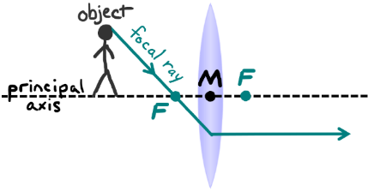
Focal rays go through the near focal point (for a convex lens) or toward the far focal point (for a concave lens) and refract though the lens parallel to the principal axis.1
Midpoint rays go straight through the midpoint.1
- If the reflected or refracted rays in a ray diagram diverge, they can be extended with dotted lines to the other side of the mirror or lens. If they meet on the other side, then the image is virtual.
- If the reflected or refracted rays are parallel to each other then there is no image.
- Multiple lenses and/or mirrors can be combined to create an optical system whose properties depend on the focal lengths of the components and the distances between them.

Mathematical Models
Equation | Reference | Restrictions on the validity of the equation
“Thin lens equation”  $$\frac{1}{f}=\frac{1}{d_{o}}+\frac{1}{d_{i}}$$ | ( 19.1 ) | for thin lenses, and mirrors that are relatively small portions of a sphere
$$f=\frac{r}{2}$$ | ( 19.2 ) | for concave mirrors that are relatively small portions of a sphere
$$f=-\frac{r}{2}$$ | ( 19.3 ) | for convex mirrors that are relatively small portions of a sphere
$$f_{back}=\frac{f_{2}⋅\left(d-f_{1}\right)}{d-\left(f_{1}+f_{2}\right)}$$ | ( 19.4 ) | when $f_{1}$ is negative or the distance between lenses is less than $f_{1}$
$$σ_{x}⋅σ_{p}≥\frac{ℏ}{2}$$ | ( 19.5 ) | -none-
$$p_{photon}=\frac{h}{λ}$$ | ( 19.6 ) | -none-

The following sign conventions are used for both lenses and mirrors.
Symbol | Positive | Negative
$$d_{o}$$ | Always | Never
$$h_{o}$$ | Always | Never
$$d_{i}$$ | Real | Virtual
$$h_{i}$$ | Upright | Inverted
$$f$$ | Converging | Diverging
$$M$$ | Upright | Inverted

: Questions
Questions are ordered according to Bloom’s Taxonomy, progressing from regurgitating information (Level 1) to synthesizing new information with previous knowledge to create something new (Level 6). The bold letters at the beginning of each question indicate whether the question involves Words [W], Graphics [G], and/or Numbers [N]. See the appendices for conversion factors.

Level 1 - Remember
      - [G] For a mirror, if the image is on the same side as the object, is the image real or virtual?
      - [G] For a lens, if the image is on the same side as the object, is the image real or virtual?
      - [W & N] Add labels to each boxed equation from this chapter that tell what the symbol to the left of the = sign represents
Symbol | Reference | Label
$$\frac{1}{f}$$ | ( 19.1 )
$$f$$ | ( 19.2 )
$$f$$ | ( 19.3 )
$$f_{back}$$ | ( 19.4 )
$$σ_{x}⋅σ_{p}$$ | ( 19.5 )
$$p_{photon}$$ | ( 19.6 )

Level 2 - Understand
      - [W, G, & N] If the magnification for a lens, mirror, or other imaging system is -2, which of the following are true?
        - The image is reduced.
        - The distance to the object is negative.
        - The distance to the image is negative.
        - The image is inverted.
      - [W, G, & N] If an optical system is diffraction-limited, which of the following changes could improve its resolution?
        - Increasing the wavelength of the light used.
        - Increasing the frequency of the light used.
        - Increasing the brightness of the light used.
        - Increasing the size of the mirror(s) and/or lens(es).

Level 3 - Apply
      - [W & G] Create a ray diagram for a concave mirror with a radius of 0.3 m when a 0.05-m-tall object is placed 0.1 m from the mirror. What are the characteristics of the image (true/reduced/enlarged, real/virtual, upright/inverted)?
      - [W & N] Use mathematical calculations to determine the characteristics of the image (true/reduced/enlarged, real/virtual, upright/inverted) for a concave mirror with a radius of 0.3 m when a 0.05-m-tall object is placed 0.1 m from the mirror.
      - [W, G, & N] Questions Q19.6 & Q19.7 refer to the same scenario. Do both techniques (graphical from Q19.6 and numerical from Q19.7 ) give the same answers for the characteristics of the image?
      - [W & G] Create a ray diagram for a concave mirror with a radius of 0.3 m when a 0.05-m-tall object is placed 0.15 m from the mirror. What are the characteristics of the image (true/reduced/enlarged, real/virtual, upright/inverted)?
      - [W & N] Use mathematical calculations to determine the characteristics of the image (true/reduced/enlarged, real/virtual, upright/inverted) for a concave mirror with a radius of 0.3 m when a 0.05-m-tall object is placed 0.15 m from the mirror.
      - [W, G, & N] Questions Q19.9 & Q19.10 refer to the same scenario. Do both techniques (graphical from Q19.9 and numerical from Q19.10 ) give the same answers for the characteristics of the image?
      - [W & G] Create a ray diagram for a convex mirror with a radius of 0.3 m when a 0.05-m-tall object is placed 0.15 m from the mirror. What are the characteristics of the image (true/reduced/enlarged, real/virtual, upright/inverted)?
      - [W & N] Use mathematical calculations to determine the characteristics of the image (true/reduced/enlarged, real/virtual, upright/inverted) for a convex mirror with a radius of 0.3 m when a 0.05-m-tall object is placed 0.15 m from the mirror.
      - [W, G, & N] Questions Q19.12 & Q19.13 refer to the same scenario. Do both techniques (graphical from Q19.12 and numerical from Q19.13 ) give the same answers for the characteristics of the image?

Level 4 - Analyze
      - [W & G] The example in Section 19.3 resulted in there being no image. Find a way to arrange the same object with a height of 0.2 m and the same lens with a focal length of 0.3 m so that an enlarged image is created. The only thing you should vary is the distance to the object. Draw a ray diagram of your solution, or if it is not possible then explain why not. If you find a solution with an enlarged image, what are the other characteristics of the image (real/virtual, upright/inverted)?
      - [W & N] The example in Section 19.3 resulted in there being no image. Find a way to arrange the same object with a height of 0.2 m and the same lens with a focal length of 0.3 m so that an enlarged image is created. The only thing you should vary is the distance to the object. Do a mathematical analysis of your solution, or if it is not possible then explain why not. If you find a solution with an enlarged image, what are the other characteristics of the image (real/virtual, upright/inverted)?
      - [W & G] The example in Section 19.3 resulted in there being no image. Find a way to arrange the same object with a height of 0.2 m and the same lens with a focal length of 0.3 m so that a reduced image is created. The only thing you should vary is the distance to the object. Draw a ray diagram of your solution, or if it is not possible then explain why not. If you find a solution with a reduced image, what are the other characteristics of the image (real/virtual, upright/inverted)?
      - [W & N] The example in Section 19.3 resulted in there being no image. Find a way to arrange the same object with a height of 0.2 m and the same lens with a focal length of 0.3 m so that a reduced image is created. The only thing you should vary is the distance to the object. Do a mathematical analysis of your solution, or if it is not possible then explain why not. If you find a solution with a reduced image, what are the other characteristics of the image (real/virtual, upright/inverted)?
      - [W, G, & N] The example in Section 19.5 was for myopia, or near-sightedness. Do the same analysis for the case of hyperopia (far-sightedness) in the image below. Again, assume that the length of the eye is 24 mm and the distance from eyeglasses to the eye should be 20 mm. What does it look like the focal is in the image below? And what focal length would be needed for eyeglasses to correct the vision for this eye?
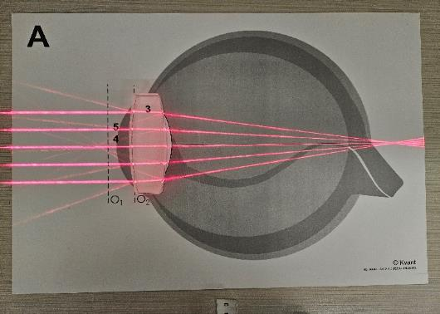
An eye whose lens has a focal length that is too long.1
      - [G & N] Figure 19.27 seems to show that the angle of refraction of the actual ray coming out of the lens is the same as the angle of incidence going into the lens. Is that correct for any angle in a situation like this with air on both sides of the material and both interfaces vertical? Explain your reasoning.

Level 5 - Evaluate
      - [W, G, & N] In every example in this chapter with diverging lenses and mirrors, the images have been virtual and reduced. Is there a way to position an object in front of a diverging lens or a diverging mirror and end up with an image that is real and/or enlarged? If so, give an example. If not, explain why not.
      - [W, G, & N] In the examples for mirrors in Sections 19.1 & 19.2, in one example the object was on the right side of the mirror and in the other example it was on the left. Does it make any difference which side of the mirror the object is on? Explain your answer.
      - [W, G, & N] In the examples for lenses in Sections 19.3 & 19.4, in both examples the object was on the left side of the lens. Does it make any difference which side of the lens the object is on? Explain your answer.
      - [W, G, & N] Equation ( 19.4 ) says it is only valid when the distance between the lenses is less than the focal length of the first lens. Why is that? Hint: look at Figure 19.23 & Figure 19.24. Imagine using that lens as the first lens and placing the second behind it. What goes wrong when you place the second lens too far behind the first?
      - [G & N] Figure 19.27 shows a shift between the actual ray and the assumed ray for the midpoint ray of a lens. Assuming that the incident angle on the front of the lens is ${40}^{∘}$, the index of refraction of the lens is 1.7, and the thickness of the lens is 1 cm…
        - How far does the actual ray shift vertically as compared to the assumed ray?
        - As the thickness of the lens increases, what happens to the amount of vertical shift (increase, decrease, or stay the same)? Explain your reasoning.
        - As the incident angle increases, what happens to the amount of vertical shift (increase, decrease, or stay the same)? Explain your reasoning.

Level 6 - Create
      - [W, G, & N] At the beginning of Chapter 1 in Figure 1.1 was a template for a concept map. Create a new concept map with the main ideas from this chapter.
      - [W, G, & N] Imagine you are writing a test question related to this chapter. Think of your own example of a situation that you can analyze using the concepts, graphics, and mathematical analyses described in this chapter. Describe the situation and use the tools from this chapter to analyze the situation as completely as you can, including motion, forces, energy, and momentum.
      - [W, G, & N] Think about possible misconceptions about the material in this chapter. Write a question and an incorrect solution to it that demonstrates a student making such a conceptual error. This cannot be a simple misuse of a vocabulary word, a unit error, or a mathematical error like making an addition error or multiplying when addition was needed, unless the error is rooted in a real misunderstanding about the physics behind the calculation or the misuse of a word. After you have written the question and incorrect solution, explain what is wrong with the student’s solution, and write a correct solution to the problem. Note: You may use a question from this chapter that you got wrong the first time and explain the initial error in your thinking and how you corrected it.

- Symbols, Subscripts, & Abbreviations
Symbol | Quantity | SI Unit
$$a$$ | acceleration (magnitude or component) | meters per second squared | $$\left[m/s^{2}\right]$$
$$\vec{a}$$ | acceleration (vector) | meters per second squared | $$\left[m/s^{2}\right]$$
$$a$$ | attraction between particles | newton-meters to the 4th power | $$N⋅m^{4}$$
$$A$$ | area | square meters | $$\left[m^{2}\right]$$
$$A$$ | amplitude | (whatever is being measured) | (any)
$$b$$ | volume of particles | meters cubed per mole | $$m^{3}/mol$$
$$\vec{B}$$ | magnetic field | tesla | $$\left[T\right]$$
$$c$$ | speed of light | (this is a constant) | $$3×{10}^{8} m/s$$
$$c$$ | specific heat capacity | joules per kilogram - degree Celsius | $\left[J/\left(kg⋅ ^{∘}C\right)\right]$ or $\left[J/\left(kg⋅K\right)\right]$
$$C$$ | capacitance | farads | $$\left[F\right]$$
$$d$$ | distance or diameter | meters | $$\left[m\right]$$
$$e$$ | efficiency | usually a decimal or percentage | (usually none)
$$e$$ | elementary charge | (this is a constant) | $$1.6×{10}^{-19} C$$
$$E$$ | energy | joules | $$\left[J\right]$$
$$\vec{E}$$ | electric field | newtons per coulomb, or volts per meter | $\left[N/C\right]$ or $\left[V/m\right]$
$$\hat{E}$$ | the East direction | -none-
$$f$$ | frequency | hertz | $$\left[Hz\right]$$
$$f$$ | focal length | meters | $$\left[m\right]$$
$$F$$ | force (magnitude or component) | newtons | $$\left[N\right]$$
$$\vec{F}$$ | force (vector) | newtons | $$\left[N\right]$$
$$g$$ | magnitude of gravitational field at earth’s surface | (this is a constant) | $$9.8 N/kg$$
$$\vec{g}$$ | gravitational field | newtons per kilogram | $$\left[N/kg\right]$$
$$h$$ | height | meters | $$\left[m\right]$$
$$h$$ | Planck constant | (this is a constant) | $$4.136×{10}^{-15} eV/Hz$$
$$ℏ$$ | reduced Planck constant | (this is a constant) | $$6.63×{10}^{-34} kg⋅m^{2}/s$$
$$I$$ | rotational inertia | kilogram meters squared | $$\left[kg⋅m^{2}\right]$$
$$I$$ | electric current | amperes, or amps | $$\left[A\right]$$
$$I$$ | intensity | watts per square meter | $$\left[W/m^{2}\right]$$
$$k_{B}$$ | Boltzmann constant | (this is a constant) | $$1.38×{10}^{23} J/K$$
$$k_{e}$$ | Coulomb’s constant | (this is a constant) | $$8.99×{10}^{9} N⋅m^{2}/C^{2}$$
$$k_{s}$$ | spring constant | newtons per meter | $$\left[N/m\right]$$
$$l$$ | length | meters | $$\left[m\right]$$
$$L$$ | latent heat | joules per kilogram | $$\left[J/kg\right]$$
$$L$$ | inductance | henrys | $$\left[H\right]$$
$$L$$ | angular momentum | kilogram meters squared per second | $$\left[kg⋅m^{2}/s\right]$$
$$L_{p}$$ | Sound Pressure Level | decibels | $$\left[dB\right]$$
$$m$$ | mass | kilograms | $$\left[kg\right]$$
$$m$$ | an integer (0, $±1$, $±2$, etc.) | -none-
$$M$$ | magnification | -none-
$$MA$$ | mechanical advantage | -none-
$$n$$ | an ordinal number (like 2 for 2nd) | -none-
$$n$$ | index of refraction | -none-
$$N$$ | a large number | -none-
$$N_{A}$$ | Avogadro’s number | (this is a constant) | $$6.02×{10}^{23}$$
$$\hat{N}$$ | the North direction | -none-
$$p$$ | momentum (magnitude or component) | kilogram-meters per second | $$\left[kg⋅m/s\right]$$
$$\vec{p}$$ | momentum (vector) | kilogram-meters per second | $$\left[kg⋅m/s\right]$$
$$P$$ | power | watts | $$\left[W\right]$$
$$P$$ | pressure | pascals | $$\left[Pa\right]$$
$$q$$ | charge | coulombs | $$\left[C\right]$$
$$Q$$ | heat | joules | $$\left[J\right]$$
$$r$$ | radius or distance from center | meters | $$\left[m\right]$$
$$R$$ | resistance | ohms | $$\left[Ω\right]$$
$$s$$ | path length | meters | $$\left[m\right]$$
$$S$$ | entropy | joules per kelvin | $$\left[J/K\right]$$
$$t$$ | time | seconds | $$\left[s\right]$$
$$t_{1/2}$$ | half-life | seconds | $$\left[s\right]$$
$$T$$ | period | seconds | $$\left[s\right]$$
$$T$$ | temperature | degrees Celsius or kelvin | $\left[​^{∘}C\right]$ or $\left[K\right]$
$$u$$ | energy density | joules per cubic meter | $$J/m^{3}$$
$$U$$ | potential energy | joules | $$\left[J\right]$$
$$v$$ | speed or component of velocity | meters per second | $$\left[m/s\right]$$
$$\vec{v}$$ | velocity | meters per second | $$\left[m/s\right]$$
$$V_{e}$$ | electric potential, or voltage | volt | $$\left[V\right]$$
$$V_{g}$$ | gravitational potential | joules per kilogram | $$\left[J/kg\right]$$
$$W$$ | work | joules | $$\left[J\right]$$
$$x$$ | horizontal position or component of $\vec{x}$ | meters | $$\left[m\right]$$
$$\vec{x}$$ | position (vector) | meters | $$\left[m\right]$$
$$\hat{x}$$ | the $x$ direction | -none-
$$y$$ | vertical position | meters | $$\left[m\right]$$
$$\hat{y}$$ | the $y$ direction | -none-
$$Y$$ | Young’s modulus | newtons per meter | $$\left[N/m\right]$$
$$α$$ | angular acceleration | radians per second squared | $$\left[rad/s^{2}\right]$$
$$α$$ | coefficient of linear thermal expansion | reciprocal kelvin or reciprocal degrees Celsius | $\left[K^{-1}\right]$ or $\left[​^{∘}C^{-1}\right]$
$$α$$ | absorption coefficient | reciprocal meters | $$\left[m^{-1}\right]$$
$$β$$ | coefficient of bulk thermal expansion | reciprocal kelvin or reciprocal degrees Celsius | $\left[K^{-1}\right]$ or $\left[​^{∘}C^{-1}\right]$
$$γ$$ | Lorentz factor | -none-
$$Δ$$ | “Change in …” | -none-
$$\vec{Δx}$$ | displacement | meters | $$\left[m\right]$$
$$ϵ$$ | permittivity | farads per meter | $$\left[F/m\right]$$
$$θ$$ | angle | degrees or radians | [$​^{∘}$] or [rad]
$$κ$$ | relative permittivity, or dielectric constant | -none-
$$λ$$ | wavelength | meters | $$\left[m\right]$$
$$μ_{0}$$ | permeability of free space | (this is a constant) | $$4⋅π×{10}^{-7} N/A^{2}$$
$$μ_{B}$$ | permeability | newtons per amp squared | $$\left[N/A^{2}\right]$$
$$μ_{k}$$ | coefficient of kinetic friction | -none-
$$μ_{m}$$ | linear mass density | kilograms per meter | $$\left[kg/m\right]$$
$$μ_{s}$$ | coefficient of static friction | -none-
$$μ_{v}$$ | viscosity | -none-
$$ρ_{e}$$ | resistivity | ohm-meters | $$\left[Ω⋅m\right]$$
$$ρ_{m}$$ | mass density | kilograms per cubic meter | $$\left[kg/m^{3}\right]$$
$$σ_{e}$$ | electric conductivity | siemens per meter | $$\left[S/m\right]$$
$$σ_{p}$$ | uncertainty in momentum | kilogram-meters per second | $$\left[kg⋅m/s\right]$$
$$σ_{x}$$ | uncertainty in position | meters | $$\left[m\right]$$
$$∑$$ | “Sum of …” | -none-
$$τ$$ | torque | newton meters | $$\left[N⋅m\right]$$
$$ϕ$$ | phase | degrees or radians | [$​^{∘}$] or [rad]
$$Φ_{V}$$ | volumetric flux | cubic meters per second | $$\left[m^{3}/s\right]$$
$$ω$$ | angular velocity | radians per second | $$\left[rad/s\right]$$
$$\hat{​}$$ | “in the …direction” | -none-
$$\vec{​}$$ | (Indicates a vector quantity) | -none-

Subscript | Meaning
0 | at time $t=0$; reference level; lowest level; or “in vacuum”
1, 2, etc. | of object #1, #2, etc.
1/2 | half-life (for time)
avg | average
atm | atmospheric
b | buoyant
B | magnetic
c | centripetal (for force or acceleration)
c | capacitor (for energy)
C | in degrees Celsius
com | Center of Mass
e | electric
eq | equivalent
E | East
f | friction (for force)
f | fusion (for latent heat)
f | final (for everything except force and latent heat)
F | in degrees Fahrenheit
g | gravitational
i | initial
i | image (for optics)
int | internal
k | kinetic
K | in kelvin
L | inductor
m | mass
max | maximum
mech | mechanical
n | normal (for force)
n | n^{th} ($f_{3}$ is for the 3rd harmonic, for example)
N | North
net | net (total)
o | object
p | pressure (for sound pressure level)
pp | parallel plate
r | rotational
s | static (for frictional force)
s | sound (for pressure)
s | spring
t | tension
T | tangential
th | thermal
tot | total
v | viscosity (with $μ$)
v | vaporization (with $L$)
V | volumetric
x | in the $\hat{x}$ direction
y | in the $\hat{y}$ direction
$$∥$$ | in the parallel direction
$$⟂$$ | in the perpendicular direction
$→$, for example “$1→2$” | of the first object acting on the second
$←$, for example “$1←2$” | of the first object as seen by the second
$$⊗$$ | arrow pointing into the page
$$⊙$$ | arrow pointing out of the page

Abbreviation | Meaning
COM (or com) | Center of Mass
EMF | Electromotive Force
$$MA$$ | Mechanical Advantage
RHR | Right-hand rule
SHM | Simple Harmonic Motion

- Conversion Factors & Metric Prefixes
Measurement | SI Unit | = | Equivalent Unit
Length | 0.0254 m | = | 1 inch (in)
Length | 1 m | = | 3.28 feet (ft)
Length | 1 609 m | = | 1 mile (mi)
Mass | 14.6 kg | = | 1 slug
Mass | 1 kg | = | the mass of an object that weighs 2.2 lb on earth
Mass | $1.66×{10}^{-27}$ kg | = | 1 atomic mass unit (amu)
Volume | 1 m³ | = | 1 000 liters (l)
Speed | 1 m/s | = | 2.24 miles per hour (mph)
Force | 1 N | = | 0.225 pound (lb)
Pressure | 133 Pa | = | 1 millimeter of mercury (mm Hg)
Pressure | 6 895 Pa | = | 1 pound per square inch (psi)
Pressure | $1.01×{10}^{5}$ Pa | = | 1 atmosphere (atm)
Energy | 4.186 J | = | 1 calorie (cal)
Energy | 4 186 J | = | 1 Calorie (Cal) = 1 kilocalorie (kcal)
Energy | $3.6×{10}^{6}$ J | = | 1 kilowatt-hour (kWh)
Energy | 1 055 J | = | 1 British thermal unit (Btu)
Energy | $1.6×{10}^{-19}$ J | = | 1 electron-volt (eV)
Power | 746 W | = | 1 horsepower (hp)
Angle | $π$ rad | = | $${180}^{∘}$$
Angular speed | $\frac{π}{30}$ rad/s | = | 1 rotation per minute (rpm)

Metric prefix | Abbreviation | Meaning
Tera- | T | $${10}^{12}$$
Giga- | G | $${10}^{9}$$
Mega- | M | $${10}^{6}$$
kilo- | k | 1000
centi- | c | 0.01
milli- | m | 0.001
micro- | $$μ$$ | $${10}^{-6}$$
nano- | n | $${10}^{-9}$$
pico- | p | $${10}^{-12}$$
femto- | f | $${10}^{-15}$$

- Physical Constants
Symbol | Description | Approximate value
$$c$$ | speed of light | $$3×{10}^{8} m/s$$
$$e$$ | elementary charge | $$1.6×{10}^{-19} C$$
$$g$$ | magnitude of gravitational field at the earth’s surface | $$9.8 N/kg$$
$$G$$ | Newton’s Universal Gravitation Constant | $$6.67×{10}^{-11} N⋅m^{2}/kg^{2}$$
$$h$$ | Planck constant | $$4.136×{10}^{-15} eV/Hz$$
$$ℏ$$ | reduced Planck constant | $$1.15×{10}^{-34} kg⋅m^{2}/s$$
$$k_{B}$$ | Boltzmann constant | $$1.38×{10}^{-23} J/K$$
$$k_{e}$$ | Coulomb’s constant | $$8.99×{10}^{9} N⋅m^{2}/C^{2}$$
$$m_{electron}$$ | electron mass | $$9.11×{10}^{-31} kg$$
$$m_{neutron}$$ | neutron mass | $$1.67×{10}^{-27} kg$$
$$m_{proton}$$ | proton mass | $$1.67×{10}^{-27} kg$$
$$N_{A}$$ | Avogadro’s number | $$6.02×{10}^{23}$$
$$R$$ | Ideal gas constant | $$8.31 J/\left(K⋅mol\right)$$
$$P_{atm}$$ | Atmospheric pressure at sea level | $$1.01×{10}^{5} Pa$$
$$ϵ_{0}$$ | permittivity of free space | $$8.85×{10}^{-12} F/m$$
$$μ_{0}$$ | permeability of free space | $$4⋅π×{10}^{-7} N/A^{2}$$

- Geometrical Shapes

Rectangle
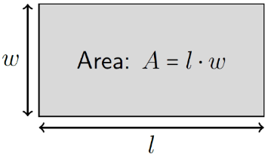

Triangle
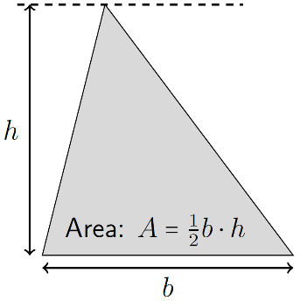

Circle
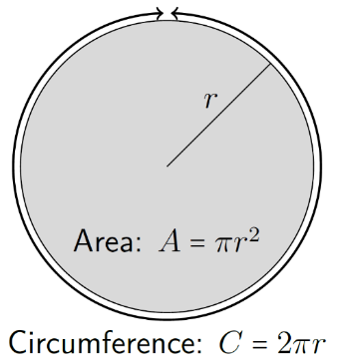

Rectangular Prism
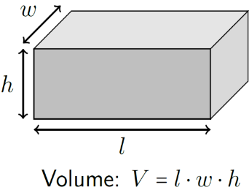

Cylinder
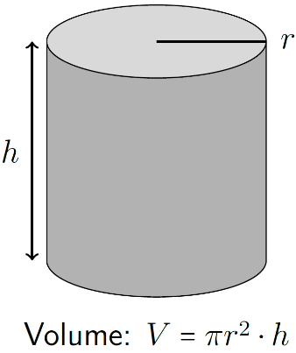

Sphere
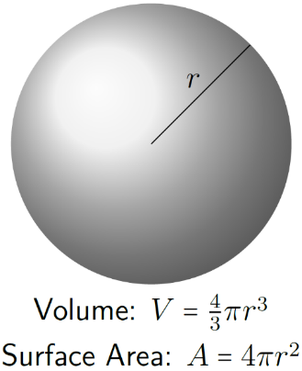
- Answers to End-of-Chapter Questions
The following are not intended to be complete answers for any of the end-of-chapter questions. Not all questions are included. For those that are included, these partial answers are only intended to help you know whether you are on the right track.

Chapter 1
Question | Partial answer
Q1.16 | 784
Q1.17 | 0.638
Q1.19 | No
Q1.21 | -8
Q1.22 (b) | 6.26

Chapter 2
Question | Partial answer
Q2.11 | 1.3
Q2.12 | 3.9
Q2.13 | (The graph should feature a straight line.)
Q2.14 | (All three graphs should feature a straight line.)
Q2.15 | (Two of the three graphs should feature a straight line.)
Q2.17 (b) | 40.2
Q2.17 (c) | 80.4
Q2.17 (d) | 8.93
Q2.17 (e) | 0
Q2.18 | (The graph should feature a straight line.)
Q2.19 | (Changes are needed in three of the six parts to this question.)
Q2.20 | (Changes are needed in four or five, depending on your reasoning, of the six parts to this question.)

Chapter 3
Question | Partial answer
Q3.5 | (“Yes” is the answer to four of the seven parts to this question.)
Q3.6 | 1.67
Q3.7 (b) | 312 & 520
Q3.9 | 11
Q3.10 | (All of them are 0, +50, or -50)
Q3.12 | The energy of the ball is not conserved in this scenario.
Q3.13 | 194 000
Q3.14 | 27
Q3.15 (b) & Q3.15 (d) | (One of these is “larger” and the other is “smaller.”)
Q3.16 | Time and displacement both increase.
Q3.19 | Ignoring friction does not cause a significant error in this calculation.
Q3.20 (a) Q2.20 | $1.65×{10}^{4}$

Chapter 4
Question | Partial answer
Q4.5 | 2 190
Q4.7 | (Remember to include directions.)
Q4.9 | It is not an error in the text.
Q4.10 | 38.7 or 51.3 (depending on the orientation chosen for the angle)
Q4.12 | 3.77
Q4.13 | 7.95
Q4.15 | 20 & 1.6 × 10⁴
Q4.16 | 10
Q4.19 | 8609 & either 65.4 or 24.6
Q4.20 | (One is larger and the other is smaller.)
Q4.21 | Yes, there is such a direction.
Q4.22 | 3 460, 4.5 & 23.4, & 631

Chapter 5
Question | Partial answer
Q5.10 | 0 & 79
Q5.11 | 39.2
Q5.13 | It does agree.
Q5.17 | (The force of friction remains the same for two out of the four parts to this question, and decreases for the other two.)
Q5.18 | Yes, such an angle exists.
Q5.19 | (Of the five parts of this question: two increase, one decreases, and two remain the same.)
Q5.20 | The amount of energy stored in the spring would decrease.
Q5.21 | The amount of energy stored in the spring would increase.
Q5.25 | (The actual value will depend on your assumptions.)  Your calculation should give a difference that is less than two percent.

Chapter 6
Question | Partial answer
Q6.4 | (Remember to consider both horizontal and vertical directions.)
Q6.6 | This was not an error in the textbook.
Q6.9 | (Two planets have a higher tangential velocity than earth.)
Q6.11 | (There are four different types of energy that should appear at some point in the bar graphs.)
Q6.14 | 2.7 × 10⁴⁰
Q6.15 | $2.7×{10}^{33}$
Q6.16 (a) | $v_{f}=15.9 m/s$
Q6.16 (b) | $t=2.12 s$
Q6.16 (c) | The horizontal displacement could be larger, the same, or smaller.

Chapter 7
Question | Partial answer
Q7.7 | 8.1 & 6.48
Q7.8 | 6 000, 62 400, 312 000, & $8.11×{10}^{6}$
Q7.9 | (Only one remains constant.)
Q7.13 | (It should have the same unit.)
Q7.15 | $5.4×{10}^{6}$
Q7.16 | 10.8
Q7.19 | The rotational inertia, final angular momentum, torque, final rotational kinetic energy, work, and applied force should all either increase or decrease.
Q7.20 | The final angular velocity, angular acceleration, rotational inertia, final angular momentum, and torque should all either increase or decrease.
Q7.21 | Yes.

Chapter 8
Question | Partial answer
Q8.8 (a) | $3.65×{10}^{5}$
Q8.9 (a) | $1.9×{10}^{9}$
Q8.9 (e) | $3.5×{10}^{-2}$
Q8.10 (a) | $1.6×{10}^{36}$
Q8.18 (c) | ${73.5}^{∘}$
Q8.19 (a) | Yes.
Q8.19 (b) | Yes.

Chapter 9
Question | Partial answer
Q9.10 | $6.67×{10}^{-7}$
Q9.12 | (Only one beat frequency should be audible)
Q9.15 | $$2.5×{10}^{-4}$$
Q9.17 | (One should be more than 10x faster than the other.)
Q9.19 | (There are two types of energy involved.)
Q9.22 | There should be no forces on any of the pieces.
Q9.24 | It was reasonable to neglect the force of gravity on the thumbtack.
Q9.25 (d) | Rebar should be used on the bottom side of the concrete.
Q9.26 (d) | Rebar should be used on the top side of the concrete.

Chapter 10
Question | Partial answer
Q10.14 | $7.36×{10}^{-3}$
Q10.16 (a) | 78.4
Q10.17 | $P_{1,top}=3.995×{10}^{5} Pa$; $P_{2,bottom}=2.127×{10}^{5} Pa$; $P_{3,center}=4.000×{10}^{5} Pa$
Q10.23 | 139
Q10.24 (b) | $4.73×{10}^{-2}$
Q10.24 (e) | 0.464
Q10.25 | Yes.
Q10.26 | (Of the four parts of this question, all but one results in a flow rate that is either doubled or decreased by half.)
Q10.28 | Increase.
Q10.31 | The actual density of garlic can vary between 920 and 990 kg/m³.
Q10.33 (b) | No.

Chapter 11
Question | Partial answer
Q11.2 | (Of the four parts to this question, only one can be negative.)
Q11.5 | Gauge pressure.
Q11.7 | 980
Q11.8 (d) | Yes.
Q11.13 | Zero.
Q11.19 | (The difference should be less than 30%.)
Q11.21 | 430 & 370
Q11.22 (a) & Q11.22 (b) | (The total volume of water + air should be 62.5 ml.)
Q11.26 | The area for the front tire is $7.88×{10}^{-4} m^{2}$.

Chapter 12
Question | Partial answer
Q12.6 | No.
Q12.17 | (The diameters found should not differ from the original diameter by more than 3%.)
Q12.19 | 80
Q12.23 | $7.98×{10}^{-2}$
Q12.25 | 27%
Q12.27 | Volume does not change by the same percentage as diameter.
Q12.28 | (For Cincinnati, Ohio, USA, this comes out to approximately 250 m.  The answer will vary based on local climate.)
Q12.30 | Including the pot in the analysis does not significantly affect the total heat required.
Q12.32 | ($C_{p,monatomic}$ has the same value as $C_{v,diatomic}$.)
Q12.40 | After reaching thermal equilibrium, the water is liquid and the gold is solid.
Q12.42 | Yes.

Chapter 13
Question | Partial answer
Q13.3 | (Two of the four are basically the same size.)
Q13.6 | (With rounding, this should be basically zero.)
Q13.9 | Zero.
Q13.11 | This should be the same answer as Question 13.10.
Q13.15 | One of the products for each part of this question should be an element; either Boron, Beryllium, Carbon, or Nitrogen.
Q13.19 (c) | This answer is best expressed in thousands of years.
Q13.22 (c) | 6.24 MeV; 5.92 MeV; 15.49 MeV

Chapter 14
Question | Partial answer
Q14.3 | (Four are vectors; six are scalars.)
Q14.6 | No.
Q14.11 | 0.719 nm & 0.479 nm
Q14.12 | $3.79×{10}^{-5} m$
Q14.13 | $1.44×{10}^{-5} N/C$
Q14.17 | $6.35×{10}^{9} N/C$ at ${81}^{∘}$ above $+\hat{x}$
Q14.20 | They match, but not perfectly.
Q14.25 | No.

Chapter 15
Question | Partial answer
Q15.7 (b) | Yes
Q15.11 | $1.2×{10}^{-4}$
Q15.12 | approximately 1-10 nF
Q15.14 | 6.25
Q15.15 | 600
Q15.17 | It should change.
Q15.21 | One would stay the same and one would double.
Q15.22 | Both would decrease.
Q15.27 | Things would end up differently.
Q15.28 | (Three of these responses will be the same, one will be smaller, and two will be larger.)

Chapter 16
Question | Partial answer
Q16.5 | No
Q16.7 | (Two of the three will increase the time.)
Q16.9 | $5×{10}^{-9}$
Q16.10 | 0.33
Q16.11 | (One voltage is 2.58 V.)
Q16.12 | R_{eq} = 891 Ω
Q16.14 | (Remember, the time constant is a time.)
Q16.17 | (One power is 0.00247 W)
Q16.18 | (One power is 0.0114 W)
Q16.22 | (One energy is $5.9×{10}^{-5} J$.)
Q16.23 | (One energy is $1.28×{10}^{-5} J$.)
Q16.25 | (Three would increase, one would remain the same, and four would go to zero.)

Chapter 17
Question | Partial answer
Q17.7 | (One increase, one decrease, one with no effect.)
Q17.10 | (Two decrease, one with no effect.)
Q17.13 | $1.26×{10}^{-3}$
Q17.16 (b) | $8×{10}^{-17}$
Q17.18 | $4×{10}^{-4}$
Q17.19 (a) | 116
Q17.20 | No
Q17.21 (b) | 39.3
Q17.23 | 146
Q17.25 | 500
Q17.27 | (The answer doesn’t include I.)

Chapter 18
Question | Partial answer
Q18.6 | (Look for low absorption.)
Q18.8 | (There is no refracted beam.)
Q18.10 | No.
Q18.11 | (Should be in the range of 10¹³ - 10¹⁶)
Q18.12 | (Should be in the range of 1-10)
Q18.14 | (The number is so small that a calculator will probably just show zero.)
Q18.18 | $5×{10}^{14}$
Q18.22 (a) | The actual wavelength of the laser is 633 nm.
Q18.22 (c) | (It should be in the $μm$ range)
Q18.23 | (You will need information from Section 18.7 to answer this question.)
Q18.27 | ${80}^{∘}$

Chapter 19
Question | Partial answer
Q19.4 | (Only one is true.)
Q19.6 | Enlarged, virtual, upright.
Q19.9 | There is no image!
Q19.12 | Reduced, virtual, upright.
Q19.15 | (It is possible.)
Q19.17 | (It is possible.)
Q19.19 | The focal length of the lens needs to be approximately 0.2 m.
Q19.20 | Yes.
Q19.21 | (It is not possible.)
Q19.23 | No.

- Alignment of Learning Objectives
The learning objectives listed here were collected from the websites of the Ohio Department of Higher Education and the Association of American Medical Colleges on September 9th, 2024.

Section | MCAT Foundational Concepts | Ohio TAG Learning Objectives
1.1 | 4A1.1: Vectors, components  4A1.4: Speed, velocity (average and instantaneous)  4A1.5: Acceleration
1.2 | 4A1.1: Units and Dimensions | I-2a: Make accurate verbal, graphical, and mathematical descriptions of translational and rotational motion in one and two dimensions  I-2b: Use algebra and graphical methods to link displacement, velocity, and acceleration
1.3 | 4A1.3: Vector addition  4A3.1: Vector analysis of forces acting on a point object  4A5.2: Potential Energy: PE = mgh (gravitational, local); PE = 1/2 kx² (spring) | I-2a: Make accurate verbal, graphical, and mathematical descriptions of translational and rotational motion in one and two dimensions
1.4 | 4A2.1: Newton’s First Law, Inertia  4A5.1: Kinetic Energy: KE = 1/2 mv²; units | I-2a: Make accurate verbal, graphical, and mathematical descriptions of translational and rotational motion in one and two dimensions  I-3a: Use Newton’s laws of motion (1st, 2nd, and 3rd) to explain or predict the motion of translating and rotating objects.  I-4b: Explain or predict the motion of translating and/or rotation of objects in 1D using the conservation of momentum.
1.5 | 4A1.5: Acceleration  4A2.2: Newton’s Second Law (F=ma)  4A5.3: Conservation of energy | I-2c: Solve 1D kinematic problems with constant linear and angular acceleration.  I-3a: Use Newton’s laws of motion (1st, 2nd, and 3rd) to explain or predict the motion of translating and rotating objects.  I-4a: Explain or predict the motion of translating and/or rotating objects using conservation of energy.
2.1 | 4A1.1: Units and dimensions  4A1.4: Speed, velocity (average and instantaneous) | I-2a: Make accurate verbal, graphical, and mathematical descriptions of translational and rotational motion in one and two dimensions
2.2 | 4A2.1: Newton’s First Law, Inertia | I-2a: Make accurate verbal, graphical, and mathematical descriptions of translational and rotational motion in one and two dimensions  I-3a: Use Newton’s laws of motion (1st, 2nd, and 3rd) to explain or predict the motion of translating and rotating objects.  I-4b: Explain or predict the motion of translating and/or rotation of objects in 1D using the conservation of momentum.
2.3 | 4A1.4: Speed, velocity (average and instantaneous)  4A4.3: Work Kinetic Energy Theorem  4A5.3: Conservation of energy | I-2b: Use algebra and graphical methods to link displacement, velocity, and acceleration  I-2c: Solve 1D kinematic problems with constant linear and angular acceleration.  I-4a: Explain or predict the motion of translating and/or rotating objects using conservation of energy.
2.4 |  | I-2b: Use algebra and graphical methods to link displacement, velocity, and acceleration  I-2c: Solve 1D kinematic problems with constant linear and angular acceleration.
2.5 |  | I-2b: Use algebra and graphical methods to link displacement, velocity, and acceleration  I-2c: Solve 1D kinematic problems with constant linear and angular acceleration.
2.6 | 4A1.4: Speed, velocity (average and instantaneous) | I-2b: Use algebra and graphical methods to link displacement, velocity, and acceleration
2.7 | 4A4.1: Work done by a constant force: W = Fd cosθ | I-4a: Explain or predict the motion of translating and/or rotating objects using conservation of energy.
2.8 |  | I-2b: Use algebra and graphical methods to link displacement, velocity, and acceleration
3.1 |  | I-2e: Relate the motion of two objects relative to each other.
3.2 | 4A2.3: Newton’s Third Law, forces equal and opposite  4A3.1: Vector analysis of forces acting on a point object | I-3a: Use Newton’s laws of motion (1st, 2nd, and 3rd) to explain or predict the motion of translating and rotating objects.
3.3 | 4A2.3: Newton’s Third Law, forces equal and opposite | I-3a: Use Newton’s laws of motion (1st, 2nd, and 3rd) to explain or predict the motion of translating and rotating objects.
3.4 |  | I-4c: Explain or predict the outcome of collisions.
3.5 | 4A5.3: Conservation of energy | I-4a: Explain or predict the motion of translating and/or rotating objects using conservation of energy.  I-4c: Explain or predict the outcome of collisions.
3.6 |  | I-4c: Explain or predict the outcome of collisions.
3.7 | 4A1.4: Speed, velocity (average and instantaneous)  4A4.1: Work done by a constant force: W = Fd cosθ | I-4a: Explain or predict the motion of translating and/or rotating objects using conservation of energy.
3.8 |  | I-4c: Explain or predict the outcome of collisions.
3.9 | 4A4.1: Work done by a constant force: W = Fd cosθ | I-4a: Explain or predict the motion of translating and/or rotating objects using conservation of energy.
4.1 |  | I-2e: Relate the motion of two objects relative to each other.
4.2 | 4A1.2: Vectors, components | I-2a: Make accurate verbal, graphical, and mathematical descriptions of translational and rotational motion in one and two dimensions  I-2e: Relate the motion of two objects relative to each other.
4.3 |  | I-2a: Make accurate verbal, graphical, and mathematical descriptions of translational and rotational motion in one and two dimensions
4.4 |  | I-4c: Explain or predict the outcome of collisions.
4.5 |  | I-4c: Explain or predict the outcome of collisions.
4.6 | 4A1.3: Vector addition  4A3.1: Vector analysis of forces acting on a point object
4.7 | 4A1.3: Vector addition  4A3.1: Vector analysis of forces acting on a point object  4A5.4: Power, units | I-2a: Make accurate verbal, graphical, and mathematical descriptions of translational and rotational motion in one and two dimensions
4.8 | 4A2.2: Newton’s Second Law (F=ma)  4A3.1: Vector analysis of forces acting on a point object | I-2a: Make accurate verbal, graphical, and mathematical descriptions of translational and rotational motion in one and two dimensions  I-3a: Use Newton’s laws of motion (1st, 2nd, and 3rd) to explain or predict the motion of translating and rotating objects.
4.9 |  | I-2a: Make accurate verbal, graphical, and mathematical descriptions of translational and rotational motion in one and two dimensions
5.1 | 4A2.2: Newton’s Second Law (F=ma)  4A4.2: Mechanical advantage | I-3a: Use Newton’s laws of motion (1st, 2nd, and 3rd) to explain or predict the motion of translating and rotating objects.
5.2 | 4A4.4: Conservative forces  4A5.2: Potential Energy: PE = mgh (gravitational, local); PE =  1/2 kx² (spring)
5.3 | 4A5.3: Conservation of energy | I-4c: Explain or predict the outcome of collisions.  I-4a: Explain or predict the motion of translating and/or rotating objects using conservation of energy.
5.4 | 4A2.2: Newton’s Second Law (F=ma)  4A2.4: Friction, static and kinetic | I-3a: Use Newton’s laws of motion (1st, 2nd, and 3rd) to explain or predict the motion of translating and rotating objects.
5.5 | 4A1.2: Vectors, components  4A2.4: Friction, static and kinetic  4A3.1: Vector analysis of forces acting on a point object  4A4.4: Conservative forces  4A5.3: Conservation of energy | I-2a: Make accurate verbal, graphical, and mathematical descriptions of translational and rotational motion in one and two dimensions  I-4a: Explain or predict the motion of translating and/or rotating objects using conservation of energy.
5.6
6.1 | 4A1.2: Vectors, components | I-2d: Solve 2D projectile motion problems with start and end points at different heights.
6.2 |  | I-2a: Make accurate verbal, graphical, and mathematical descriptions of translational and rotational motion in one and two dimensions
6.3 |  | I-2a: Make accurate verbal, graphical, and mathematical descriptions of translational and rotational motion in one and two dimensions
6.4 | 4A6.1: Amplitude, frequency, phase | I-2a: Make accurate verbal, graphical, and mathematical descriptions of translational and rotational motion in one and two dimensions  I-5a: Explain or predict motion of objects in simple harmonic motion.
6.5 |  | I-4b: Explain or predict the motion of translating and/or rotation of objects in 1D using the conservation of momentum.
7.1 | 4A3.2: Torques, lever arms | I-2b: Use algebra and graphical methods to link displacement, velocity, and acceleration  I-3a: Use Newton’s laws of motion (1st, 2nd, and 3rd) to explain or predict the motion of translating and rotating objects.  I-2a: Make accurate verbal, graphical, and mathematical descriptions of translational and rotational motion in one and two dimensions
7.2 | 4A3.2: Torques, lever arms | I-3a: Use Newton’s laws of motion (1st, 2nd, and 3rd) to explain or predict the motion of translating and rotating objects.  I-4e: Determine the moment of inertia of rigidly connected masses.
7.3 |  | I-2a: Make accurate verbal, graphical, and mathematical descriptions of translational and rotational motion in one and two dimensions  I-2c: Solve 1D kinematic problems with constant linear and angular acceleration.  I-4a: Explain or predict the motion of translating and/or rotating objects using conservation of energy.  I-4e: Determine the moment of inertia of rigidly connected masses.
7.4 |  | I-4b: Explain or predict the motion of translating and/or rotation of objects in 1D using the conservation of momentum.  I-4e: Determine the moment of inertia of rigidly connected masses.
7.5 | 4A5.4: Power, units
7.6 | 4A3.2: Torques, lever arms | I-3a: Use Newton’s laws of motion (1st, 2nd, and 3rd) to explain or predict the motion of translating and rotating objects.  I-2c: Solve 1D kinematic problems with constant linear and angular acceleration.
7.7 | 4A2.5: Center of mass | I-4d: Determine the center of mass of extended objects.
7.8 |  | I-4f: Use the parallel axis theorem in the solution of problems of extended objects of simple symmetries rotating about an axis that is not through their center of mass.
7.9 | 4A3.2: Torques, lever arms | I-3a: Use Newton’s laws of motion (1st, 2nd, and 3rd) to explain or predict the motion of translating and rotating objects.
8.1 | 4A5.3: Conservation of energy | I-4a: Explain or predict the motion of translating and/or rotating objects using conservation of energy.
8.2 | 4A6.1: Amplitude, frequency, phase | I-5a: Explain or predict motion of objects in simple harmonic motion.
8.3 |  | I-2a: Make accurate verbal, graphical, and mathematical descriptions of translational and rotational motion in one and two dimensions
8.4 | 4A6.1: Amplitude, frequency, phase | I-5a: Explain or predict motion of objects in simple harmonic motion.
8.5 | 4A6.1: Amplitude, frequency, phase | I-5a: Explain or predict motion of objects in simple harmonic motion.
8.6 |  | I-5a: Explain or predict motion of objects in simple harmonic motion.
9.1 | 4A6.1: Amplitude, frequency, phase  4A6.2: Transverse and longitudinal waves: wavelength and propagation speed | I-5a: Explain or predict motion of objects in simple harmonic motion.  I-5b: Explain or predict mechanical wave phenomena in terms of frequency, wavelength, wave speed, and simple harmonic motion.
9.2 | 4A6.2: Transverse and longitudinal waves: wavelength and propagation speed | I-5b: Explain or predict mechanical wave phenomena in terms of frequency, wavelength, wave speed, and simple harmonic motion.
9.3 | 4A6.2: Transverse and longitudinal waves: wavelength and propagation speed  4D1.1: Production of sound  4D1.6: Pitch  4D1.7: Resonance in pipes and strings | I-5b: Explain or predict mechanical wave phenomena in terms of frequency, wavelength, wave speed, and simple harmonic motion.  I-5d: Describe standing wave patterns and how their confinement determines the wavelength allowed.  I-5c: Use superposition in solving problems with interference of two waves.
9.4 |  | I-5e: Describe and predict the addition of two waves of similar but not identical frequency aka the beating of waves
9.5 | 4A6.2: Transverse and longitudinal waves: wavelength and propagation speed  4D1.2: Relative speed of sound in solids, liquids, and gases 4B1.1: Density, specific gravity | I-5b: Explain or predict mechanical wave phenomena in terms of frequency, wavelength, wave speed, and simple harmonic motion.
9.6 | 4B3.2: Pressure, simple mercury barometer
Chapter 10 |  | I-7g: Describe properties of phases of matter (solid, liquid, and gas) and their transformations.
10.1 | 4B1.1: Density, specific gravity  4B1.3: Hydrostatic pressure: Pascal’s Law; Hydrostatic pressure; P = ρgh (pressure vs. depth) | I-6a: Describe how the pressure in a fluid varies as a function of depth in terms of the pressure relative to the surface of the fluid and the absolute pressure in the fluid.
10.2 | 4B1.3: Hydrostatic pressure: Pascal’s Law; Hydrostatic pressure; P = ρgh (pressure vs. depth) | I-6a: Describe how the pressure in a fluid varies as a function of depth in terms of the pressure relative to the surface of the fluid and the absolute pressure in the fluid.  I-6e: Explain the physics underlying hydraulic lifts.
10.3 | 4B1.2: Buoyancy, Archimedes’ Principle | I-6d: Predict the apparent weight of objects partially or fully immersed in a fluid.  I-6b: Predict whether an object will sink or float in a fluid.
10.4 | 4B1.5: Continuity equation (A ⋅ v = constant)  4B1.8: Bernoulli’s equation  4B1.9: Venturi effect, Pitot tube | I-6c: Predict the variation in velocity and pressure as an incompressible fluid flows though pipes of varying diameter and height
10.5 | 4B1.4: Viscosity: Poiseuille Flow  4B1.6: Concept of turbulence at high velocities  4B1.7: Surface tension
10.6 | 4D2.1: Concept of Interference; Young’s double-slit experiment | II-4i: Relate the interference pattern of a double slit to the separation of slits and wavelength.
Chapter 11 |  | I-7g: Describe properties of phases of matter (solid, liquid, and gas) and their transformations.
11.1 | 4B3.4: Ideal gas: Definition; Ideal Gas Law: PV = nRT; Boyle’s Law: PV = constant; Charles’ Law: V/T = constant; Avogadro’s  Law: V/n = constant  4B3.5: Kinetic Molecular Theory of Gases: Heat capacity at constant volume and at constant pressure; Boltzmann’s Constant | I-7c: Describe an ideal gas in terms of volume, pressure, temperature, and number of moles.  I-7d: Relate macroscopic and microscopic properties of matter using the kinetic theory of gases.
11.2 | 4B3.4: Ideal gas: Definition; Ideal Gas Law: PV = nRT; Boyle’s Law: PV = constant; Charles’ Law: V/T = constant; Avogadro’s  Law: V/n = constant | I-7c: Describe an ideal gas in terms of volume, pressure, temperature, and number of moles.
11.3 | 4B3.2: Pressure, simple mercury barometer
11.4 | 4B3.1: Absolute temperature, K, Kelvin scale  4B3.4: Ideal gas: Definition; Ideal Gas Law: PV = nRT; Boyle’s Law: PV = constant; Charles’ Law: V/T = constant; Avogadro’s Law: V/n = constant | I-7f: Describe and predict properties of gases using the ideal gas law
11.5 | 4D1.1: Production of sound  4D1.2: Relative speed of sound in solids, liquids, and gases  4D1.7: Resonance in pipes and strings | I-5d: Describe standing wave patterns and how their confinement determines the wavelength allowed.
11.6 | 4D1.3: Intensity of sound, decibel units, log scale  4D1.4: Attenuation (damping)
11.7 | 4D1.5: Doppler Effect: moving sound source or observer, reflection of sound from a moving object  4D1.8: Ultrasound  4D1.9: Shock waves | I-5f: Solve problems where the frequency of a sound detected is affected by the motion of the source and/or the receiver relative to the medium (Doppler Effect).
11.8 | 4B3.6: Deviation of real gas behavior from Ideal Gas Law: Qualitative; Quantitative (Van der Waals’ Equation)  4B3.7: Partial pressure, mole fraction  4B3.8: Dalton’s Law relating partial pressure to composition  5E3.1: Thermodynamic system - state function
12.1 | 5E3.6: Measurement of heat changes (calorimetry), heat capacity, specific heat  5E3.12: Coefficient of expansion  5E3.7: Heat transfer – conduction, convection, radiation | I-7a: Describe the effect of heat on the properties of materials.  I-7h: Transfer of heat by conduction, convection, and radiation.
12.2 | 4B3.1: Absolute temperature, K, Kelvin scale  5E3.3: First Law - conservation of energy in thermodynamic processes  5E3.7: Heat transfer – conduction, convection, radiation  5E3.2: Zeroth Law – concept of temperature | I-7b: Describe/predict the transfer of energy between a system and its environment using the first law of thermodynamics  I-7h: Transfer of heat by conduction, convection, and radiation.
12.3 | 5E3.3: First Law - conservation of energy in thermodynamic processes  5E3.13: Heat of fusion, heat of vaporization  5E3.14: Phase diagram: pressure and temperature | I-7b: Describe/predict the transfer of energy between a system and its environment using the first law of thermodynamics  I-7g: Describe properties of phases of matter (solid, liquid, and gas) and their transformations.
12.4 | 5E3.3: First Law - conservation of energy in thermodynamic processes  5E3.4: PV diagram: work done = area under or enclosed by curve  4B3.3: Molar volume at 0○C and 1 atm = 22.4 L/mol | I-7b: Describe/predict the transfer of energy between a system and its environment using the first law of thermodynamics
12.5 | 5E3.4: PV diagram: work done = area under or enclosed by curve
12.6 | 5E3.4: PV diagram: work done = area under or enclosed by curve | I-7e: Predict the efficiency of a heat engine and its maximum efficiency.
12.7 | 5E3.4: PV diagram: work done = area under or enclosed by curve | I-7e: Predict the efficiency of a heat engine and its maximum efficiency.
12.8 | 5E3.5: Second Law – concept of entropy: Entropy as a measure of  “disorder”; Relative entropy for gas, liquid, and crystal states | I-7i: Distinguish between reversible and irreversible processes.
Chapter 13 | 4E2.7: Bohr atom | II-6f: Relate the outcome of the Rutherford experiment to the atomic model.
13.1 | 4E1.3: Nuclear force, binding energy  4E2.2: Ground state, excited states  4E2.4: Use of Pauli Exclusion Principle | II-6j: Discuss qualitatively the quantum-mechanical picture of the hydrogen atom.  II-7a: Compare the size of atoms and nuclei and the forces between the particles composing them.  II-6e: Relate the wave-like nature of an electrons in its stationary state to the size of a confining potential [particle in a box].
13.2 | 4E1.1: Atomic number, atomic weight  4E1.2: Neutrons, protons, isotopes  4E1.3: Nuclear force, binding energy | II-7a: Compare the size of atoms and nuclei and the forces between the particles composing them.
13.3 |  | II-7b: Calculate the binding energy per nucleon from mass-defect of atoms.  II-7c: Recognize the variation in nuclear stability at low and high Z.
13.4 | 4C1.1: Charge, conductors, charge conservation  4E1.4: Radioactive decay: α, β, γ decay; Half-life, exponential decay, semi-log plots | II-7d: Distinguish between fission and fusion in nuclear reactions and explain how energy is “released.”  II-7e: Describe the initial and final isotopes involved in alpha, beta, and gamma decay.
13.5 | 4E1.4: Radioactive decay: α, β, γ decay; Half-life, exponential decay, semi-log plots | II-7e: Describe the initial and final isotopes involved in alpha, beta, and gamma decay.  II-7f: Describe radioactive decay and activity in terms of half-life and initial number of radioactive isotopes.
13.6 |  | II-5a: Predict the relative perception of a time interval [time dilation] or the length [Lorentz contraction] of an object for observers in different inertial reference frames using the Lorentz transformations.
13.7 |  | II-5a: Predict the relative perception of a time interval [time dilation] or the length [Lorentz contraction] of an object for observers in different inertial reference frames using the Lorentz transformations.  II-5b: Apply the relativistic momentum-energy principle to objects moving at a speed close to the speed of light.
14.1
14.2 | 4C1.3: Coulomb’s Law  4C1.4: Electric field E: Field lines; Field due to charge distribution  4C1.5: Electrostatic energy, electric potential at a point in space | II-2b: Describe electric fields and electrostatic potentials produced by simple charge distributions [point charges, charged plates, and parallel-plate capacitors].  II-2d: Relate electric field lines to equipotential lines.  II-2i: Relate the electric field lines to equipotential lines for simple charge distributions.
14.3 |  | II-2a: Describe the motion of charged particles in external electric fields in terms of forces and energy.
14.4 | 4C1.4: Electric field E: Field lines; Field due to charge distribution  4C1.5: Electrostatic energy, electric potential at a point in space | II-2b: Describe electric fields and electrostatic potentials produced by simple charge distributions [point charges, charged plates, and parallel-plate capacitors].  II-2a: Describe the motion of charged particles in external electric fields in terms of forces and energy.
14.5 | 4C1.4: Electric field E: Field lines; Field due to charge distribution | II-2b: Describe electric fields and electrostatic potentials produced by simple charge distributions [point charges, charged plates, and parallel-plate capacitors].  II-3c: Apply Kirchhoff’s laws to find currents (in magnitude and direction) of multi-loop circuits with multiple batteries.  II-2a: Describe the motion of charged particles in external electric fields in terms of forces and energy.  II-2i: Relate the electric field lines to equipotential lines for simple charge distributions.
15.1 | 4C1.4: Electric field E: Field lines; Field due to charge distribution  4C2.4: Capacitance: Parallel plate capacitor; Energy of charged capacitor; Capacitors in series; Capacitors in parallel; Dielectrics | II-2b: Describe electric fields and electrostatic potentials produced by simple charge distributions [point charges, charged plates, and parallel-plate capacitors].  II-3a: Analyze the voltage drops across and charges on capacitors of a circuit of capacitors arranged in series and parallel.
15.2 | 4C2.4: Capacitance: Parallel plate capacitor; Energy of charged capacitor; Capacitors in series; Capacitors in parallel; Dielectrics | II-2c: Relate the electrostatic energy stored in a capacitor to the energy density of the electric field.
15.3 | 4C1.2: Insulators  4C2.4: Capacitance: Parallel plate capacitor; Energy of charged capacitor; Capacitors in series; Capacitors in parallel; Dielectrics
15.4 | 4C1.1: Charge, conductors, charge conservation
15.5 | 4C2.1: Current _{I} = ∆_{Q}/∆_{t}, sign conventions, units  4C2.3: Resistance: Ohm’s Law: I = V/R; Resistors in series; Resistors in parallel; Resistivity: ρ _{R A L}  4C2.5: Conductivity: Metallic; Electrolytic | II-3b: Analyze the voltage drops across and currents through resistors of a circuit of resistors arranged in series and parallel.  II-3d: Describe the powers delivered by batteries and the powers dissipated in resistors in simple circuits.
15.6 | 4C2.2: Electromotive force, voltage  4C2.5: Conductivity: Metallic; Electrolytic
16.1 | 4C2.2: Electromotive force, voltage
16.2 | 4C2.3: Resistance: Ohm’s Law: I = V/R; Resistors in series; Resistors in parallel; Resistivity: _{ρ} − R ⋅ A/L | II-3b: Analyze the voltage drops across and currents through resistors of a circuit of resistors arranged in series and parallel.  II-3c: Apply Kirchhoff’s laws to find currents (in magnitude and direction) of multi-loop circuits with multiple batteries.
16.3 | 4C2.3: Resistance: Ohm’s Law: I = V/R; Resistors in series; Resistors in parallel; Resistivity: ρ _{R A L} | II-3b: Analyze the voltage drops across and currents through resistors of a circuit of resistors arranged in series and parallel.
16.4 | 4C2.3: Resistance: Ohm’s Law: I = V/R; Resistors in series; Resistors in parallel; Resistivity: _{ρ} − R ⋅ A/L | II-3b: Analyze the voltage drops across and currents through resistors of a circuit of resistors arranged in series and parallel.  II-3c: Apply Kirchhoff’s laws to find currents (in magnitude and direction) of multi-loop circuits with multiple batteries.
16.5 |  | II-3c: Apply Kirchhoff’s laws to find currents (in magnitude and direction) of multi-loop circuits with multiple batteries.
16.6 |  | II-3e: Describe the time-dependence of the voltage and current through a resistor R, capacitor C, and an inductor L.
16.7 | 4C2.4: Capacitance: Parallel plate capacitor; Energy of charged capacitor; Capacitors in series; Capacitors in parallel; Dielectrics | II-3a: Analyze the voltage drops across and charges on capacitors of a circuit of capacitors arranged in series and parallel.
17.1 | 4C3.1: Definition of magnetic field B | II-2f: Describe the magnetic field produced by current-carrying long thin wires and solenoids.  II-2j: Describe magnetic field lines for simple situations [wire, bar magnet, and solenoid].
17.2 | 4E2.5: Paramagnetism and diamagnetism | II-2f: Describe the magnetic field produced by current-carrying long thin wires and solenoids.  II-2j: Describe the magnetic field produced by current-carrying long thin wires and solenoids.  II-2h: Relate the magnetostatic energy stored in a solenoid to the energy density of the magnetic field.
17.3 | 4C3.2: Motion of charged particles in magnetic fields; Lorentz force | II-2e: Describe the motion of charged particles and current-carrying wire segments in uniform magnetic fields in terms of forces and torques.  II-2g: Describe the motion of charged particles in regions with both electric and magnetic fields.
17.4 |  | II-2e: Describe the motion of charged particles and current-carrying wire segments in uniform magnetic fields in terms of forces and torques.
17.5 |  | II-3e: Describe the time-dependence of the voltage and current through a resistor R, capacitor C, and an inductor L.
17.6 | 4C2.6: Meters | II-3e: Describe the time-dependence of the voltage and current through a resistor R, capacitor C, and an inductor L.
17.8 | 4E1.5: Mass spectrometer  4E1.6: Mass spectroscopy
Chapter 18 | 4D2.5: Properties of electromagnetic radiation: Velocity equals constant c, in vacuo; Electromagnetic radiation consists of perpendicularly oscillating electric and magnetic fields; direction of propagation is perpendicular to both | II-4a: Describe light as an electromagnetic wave in terms of frequency, wavelength, and speed of light.
18.1 | 4D2.6: Classification of electromagnetic spectrum, photon energy E= hf  4D2.7: Visual spectrum, color | II-4a: Describe light as an electromagnetic wave in terms of frequency, wavelength, and speed of light.  II-4b: Characterize the spectrum of EM waves in terms of frequency and wavelength.  II-4f: Describe the intensity of EM waves in terms of electric and magnetic energy densities and the speed of light.  II-6a: Differentiate between wave- and particle-like properties of light and relate them to each other.  II-6c: Relate the intensity of light (EM waves) in terms of the number and frequency of photons.
18.2 | 4D2.2: Thin films, diffraction grating, single-slit diffraction  4D2.3: Other diffraction phenomena, X-ray diffraction | II-6a: Differentiate between wave- and particle-like properties of light and relate them to each other.  II-4j: Relate the resolving power of a lens to the diffraction of light by an opening.
18.3 | 4E2.3: Absorption and emission line spectra  4E2.10: Photoelectric effect | II-6a: Differentiate between wave- and particle-like properties of light and relate them to each other.  II-6h: discuss the scattering of a photon off an electron (Compton effect).  II-6b: Describe the production and properties of photoelectrons with the particle -like property of light.
18.4 | 4D4.1: Reflection from plane surface: angle of incidence equals angle of reflection  4D2.4: Polarization of light: linear and circular | II-4g: Analyze the image formed by plane and spherical mirrors using ray tracing and the mirror and magnification equations.  II-6a: Differentiate between wave- and particle-like properties of light and relate them to each other.
18.5 | 4D4.1: Reflection from plane surface: angle of incidence equals angle of reflection | II-4g: Analyze the image formed by plane and spherical mirrors using ray tracing and the mirror and magnification equations.  II-6a: Differentiate between wave- and particle-like properties of light and relate them to each other.
18.6 | 4D4.2: Refraction, refractive index n; Snell’s law: n1 sin θ1 = n2 sin θ2 | II-4c: Describe the speed of light in matter in terms of index of refraction.  II-4d: Describe the refraction of light at interfaces and relate the angles of incoming and refracted rays in terms of Snells’ law.  II-6a: Differentiate between wave- and particle-like properties of light and relate them to each other.
18.7 | 4D4.4: Conditions for total internal reflection  4D2.2: Thin films, diffraction grating, single-slit diffraction | II-6a: Differentiate between wave- and particle-like properties of light and relate them to each other.
18.8 |  | II-6i: Discuss the spontaneous and stimulated emission of light (photons); explain the basic principle underlying a laser.
19.1 | 4D4.5: Spherical mirrors: Center of curvature; Focal length; Real and virtual images | II-4g: Analyze the image formed by plane and spherical mirrors using ray tracing and the mirror and magnification equations.
19.2 | 4D4.5: Spherical mirrors: Center of curvature; Focal length; Real and virtual images  4D4.6: Thin lenses: Converging and diverging lenses; Use of formula 1/p + 1/q = 1/f, with sign conventions; Lens strength, diopters | II-4g: Analyze the image formed by plane and spherical mirrors using ray tracing and the mirror and magnification equations.
19.3 | 4D4.6: Thin lenses: Converging and diverging lenses; Use of formula 1/p + 1/q = 1/f, with sign conventions; Lens strength, diopters | II-4h: Analyze the image formed by one and two lenses using ray tracing and the lens and magnification equations.
19.4 | 4D4.6: Thin lenses: Converging and diverging lenses; Use of formula 1/p + 1/q = 1/f, with sign conventions; Lens strength, diopters | II-4h: Analyze the image formed by one and two lenses using ray tracing and the lens and magnification equations.
19.5 | 4D4.6: Thin lenses: Converging and diverging lenses; Use of formula  1/p + 1/q = 1/f, with sign conventions; Lens strength, diopters  4D4.7: Combination of lenses  4D4.9: Optical Instruments, including the human eye | II-4h: Analyze the image formed by one and two lenses using ray tracing and the lens and magnification equations.
19.6 | 4D4.3: Dispersion, change of index of refraction with wavelength  4D4.8: Lens aberration | II-4e: Explain the dispersion of light by the frequency dependence of the index of refraction.
19.7 | 4E2.8: Heisenberg Uncertainty Principle | II-4j: Relate the resolving power of a lens to the diffraction of light by an opening.  II-6d: Determine if the condition under which wave-like properties of particles are relevant.  II-6g: Determine the resolving power of an electron microscope with the Heisenberg uncertainty principle.

- Image Sources

You could also get there by going really far East, since the earth is spherical–but we will imagine everything as being flat for now. Curved space gets complicated.
Original work of the author.
Catalog Galaxy NGC 1964 by tonynetone is licensed under CC BY 2.0
Portrait of a Pebble by Elsie esq. is licensed under CC BY 2.0
Soccer Ball Blue by HolgerLi is licensed under CC PDM 1.0
IMG_0117 by firecloak is licensed under CC0 1.0
Ferrari Enzo by fklv (Obsolete hipster) is licensed under CC BY-SA 2.0
Oops! by versageek is licensed under CC BY-SA 2.0
Highway 404 & Highway 401 by Open Grid Scheduler / Grid Engine is licensed under CC0 1.0. This image has been cropped.
Original work of the author, using clip art that is available in the public domain at clker.com
bug pushing rock by Hanumann is licensed under CC BY 2.0
CNU Christopher Newport University Captains Virginia Va. Penn State Harrisburg Pennsylvania Pa. women soccer by cnu_sports is licensed under CC BY 2.0
20120520_131547_0225_v02 ... Essentials. by Electroburger is licensed under CC BY-ND 2.0.
Danderyds Curling - Sweden by rafa-alves is licensed under CC BY-SA 2.0.
File:Compass Rose English North.svg by Originally by User:Serg!o; translation and additional compass directions by User:Andrew_pmk is licensed under CC BY-SA 3.0. This image has been converted from .svg to .png.
Townsend - Little River - Tubing by jared422_80 is licensed under CC BY 2.0.
Original work of the author, incorporating File:A_Casually_Cool_Cartoon_Business_Woman.svg by VectorToons, which is licensed under CC SA 4.0.
Original work of the author, incorporating File:Compass Rose en small N.svg by Patrick87(Compass Rose English North.svg by Andrew pmk) is licensed under CC BY-SA 3.0. This image has been converted from .svg to .png.
Heading North by m.prinke is licensed under CC BY-SA 2.0
Image by pointnshoot is licensed under CC BY 2.0
Fiddler on the Rope 2 by charlieishere@btinternet.com is licensed under CC BY 2.0
Moose_Stolta_pulling_sled_1908 by Unknown author / Upplandsmuseet is in the Public Domain in Sweden because the photographer is not known, and cannot be traced, and the work has been created before 1 January 1950. It is in the public domain in the USA because it was published before January 1, 1925.
Bø_Sommarland_-_Splash by Ssu is licensed under CC BY-SA 3.0
Spring_scale._Made_in_USSR.jpg by Bestalex is in the Public Domain, licensed under CC0 1.0
Original work of the author, using Spring_scale._Made_in_USSR.jpg by Bestalex, which is in the Public Domain, licensed under CC0 1.0
US Navy 090902-N-6233H-026 Sailors try to push a barrel across the flight deck with a fire hose during the damage control Olympics aboard the aircraft carrier USS George Washington (CVN 73).jpg U.S. Navy photo by Mass Communication Specialist Seaman Apprentice Rachel N. Hatch. This file is a work of a sailor or employee of the U.S. Navy, taken or made as part of that person’s official duties. As a work of the U.S. federal government, it is in the public domain in the United States.
White_sands_sledding.jpg by Daniel Schwen - Own work is licensed under CC BY-SA 3.0. This image has been flipped horizontally.
Original work of the author, incorporating Earth_layers_NASA.png, which is in the public domain in the United States because it was solely created by NASA. NASA copyright policy states that “NASA material is not protected by copyright unless noted.”
Fire_Dancing_Golden_Gate_Bridge.jpg by David Yu is licensed under CC-BY 2.0.
La_Jolla_Cove_cliff_diving_-_02.jpg by Jarek Tuszyński is licensed under CC-BY 4.0. This image has been cropped.
Original work of the author, incorporating La_Jolla_Cove_cliff_diving_-_02.jpg by Jarek Tuszyński, which is licensed under CC-BY 4.0.
Bouncing_ball_strobe_edit.jpg by MichaelMaggs edit by Richard Bartz is licensed under CC BY-SA 3.0. This image has been edited: One image of the ball has been removed on the left side. In some instances it has also been cropped or numbering and sketches have been added.
Hammer_Throw_(PSF).png by Pearson Scott Foresman has been released into the public domain by its author. This applies worldwide.This image has been edited and rotated.
Original work of the author, incorporating The_Earth_seen_from_Apollo_17.jpg by either Harrison Schmitt or Ron Evans, and The Sun by the Atmospheric Imaging Assembly of NASA’s Solar Dynamics Observatory - 20100819.jpg, both of which are in the public domain in the United States because they were solely created by NASA. NASA copyright policy states that “NASA material is not protected by copyright unless noted.”
Screenshot of the video Circular Motion Demonstration by Steve Maier, which is publicly available on YouTube, uploaded on 24 March 2021. This screenshot has been edited: Arrows and labels have been added.
Sasha_Cohen_Spin_2009_SOI.jpg by David W. Carmichael is licensed under CC BY-SA 3.0
Trans-canyon Pipeline (Historic) 0316 Helicopter Transport by Grand Canyon NPS is licensed under CC BY 2.0
Lillehammer 2016 - Figure Skating Men Short Program - Tangxu Li 3.jpg by Clément Bucco-Lechat is licensed under CC BY-SA 3.0
US Navy 100124-N-6214F-019 A Haitian child uses the hand crank on his multi-purpose self-powered radio.jpg by Chief Mass Communication Specialist Robert J. Fluegel is a work of a sailor or employee of the U.S. Navy, taken or made as part of that person’s official duties. As a work of the U.S. federal government, it is in the public domain in the United States.
Karikázó fiú szobra, Ifjúság utca, 2019 Kapuvár.jpg by Globetrotter19 is licensed under CC BY-SA 3.0. This image has been flipped horizontally.
Charles_Thompson_Memorial_Hall_interior-grandfather_clock.jpg by Myotus is licensed under CC BY-SA 4.0, via Wikimedia Commons. This image has been cropped.
London Helicopter Tour by Check-in-london is licensed under CC BY-SA 2.0
Catch foot layback.jpg by Vesperholly is licensed under CC BY-SA 2.5
Balance by SeeMidTN.com (aka Brent) is licensed under CC BY 2.0
JUPITER by tonynetone is licensed under CC BY 2.0. This image has been rotated and cropped, and an arrow and direction label have been added.
This image is the original work of the author, but includes jupiter-25468_640.png, which is licensed under the Pixabay license.
Millipede on floor.jpg by Bubba73 (Jud McCranie) is licensed under CC BY-SA 3.0
111022-A-4076C-124 by ResoluteSupportMedia is licensed under CC BY 2.0. This image has been cropped and filtered.
File:Concrete rebar 0030.jpg by Pollinator at English Wikipedia is licensed under CC BY-SA 3.0
Red thumbtack by 24oranges.nl is licensed under CC BY-SA 2.0
Crowd by Bayhaus is licensed under CC BY 2.0
Baikanthapur_Tea-_Sacchi_Chai.jpg by Baikanthapur Tea is licensed under CC BY-SA 4.0
Doric temple of Athena Lindia by wit is licensed under CC BY-SA 2.0
Pitcher with Handle by The Cleveland Museum of Art is licensed under CC 0 1.0. In some cases, arrows to denote pressure have been added.
Laminar to Turbulent by brewbooks is licensed under CC BY-SA 2.0
Transicion_laminar_a_turbulento by Joseasorrentino is licensed under CC BY-SA 3.0. Arrows were recolored and labels were translated from Spanish to English.
Gray525 by Henry Vandyke Carter is in the public domain.
Water_droplets_in_lotus2 by Aathavan jaffna is licensed under CC BY-SA 3.0.
Water_ripples.jpg by Georgios Orfeas Katsouris is licensed under CC BY 4.0. Coloring, contrast, and sharpness have been changed.
Deep_water_wave_after_three_periods.png by Kraaiennest is licensed under CC BY-SA 4.0.
Ripples_waves_bee by Bogdan is licensed under CC BY-SA 3.0. Image has been cropped and white lines have been added.
Communicating_vessels is in the public domain.
Cessna_172_Skyhawk_II_-_Pitot_tube.jpg by Cjp24 is licensed under CC BY-SA 4.0, via Wikimedia Commons.
Uganda_(30777863512).jpg by Rod Waddington is licensed under CC BY-SA 2.0. This image has been cropped.
Blowing bubbles by Derek Keats is licensed under CC BY 2.0.
Hot_air_ballon_-_36845329361 by Bob Haarmans is licensed under CC BY 2.0. This image has been cropped.
Pan_flute_2009 by Amos Ben Gershom is licensed under CC BY-SA 4.0
Original work of the author, using drums background by Pixabay, licensed under CC0 1.0 Universal.
Original work of the author, using engine transportation railway cargo by Pixabay, licensed under CC0 1.0 Universal.
Original work of the author, using weapon army vehicle fighter by Pixabay, licensed under CC0 1.0 Universal.
Original work of the author, using weapon army vehicle fighter by Pixabay, licensed under CC0 1.0 Universal.
VanderWaals_attrazione_e_repulsione.jpg by Marc Lagrange, licensed under CC BY-SA 3.0. This image has been cropped and translated into English.
Atmosphere_gas_proportions.svg is in the public domain.
Pressure-vacuum_gauge_transformer by VeRdUgO PY is licensed under CC BY-SA 4.0. This image has been cropped.
Letting_off_steam_at_Highley_Station_on_the_Severn_Valley_Railway by Tom Axford 1 is licensed under CC BY-SA 4.0.
Post-Seasoning by micronova is licensed under CC BY 2.0.
Expansion joint, Hayle by Rwendland is licensed under CC BY-SA 3.0. This image has been cropped.
CelsiusKelvinThermometer by Martinvl is licensed under CC BY-SA 3.0. FahrenheitCelsius by olibac is licensed under CC BY 2.0. These images have been cropped.
Image Phase-diag2 is in the public domain.
Enhanced_Bohr_models.png by Andrea Hazard is licensed under CC SA 4.0.
Particle_in_a_box_wavefunctions.svg by Papa November is licensed under CC BY-SA 3.0. Some of the labels have been changed, and the image has been recolored.
Single_electron_orbitals.jpg by haade is licensed under CC BY-SA 3.0. Colors have been adjusted and image has been cropped.
Periodic_table_modification.svg by Robert Campion is licensed under CC BY-SA 3.0. This image has been cropped.
Isotop_C-12.svg by MikeRun is licensed under CC BY-SA 4.0.
BBH_gravitational_lensing_of_gw150914 by Simulating Extreme Spacetimes is licensed under CC BY-SA 4.0.
Binding_energy_curve_-_common_isotopes2.jpg by Bdushaw is licensed under CC BY-SA 4.0.
Fusion_in_the_Sun.svg by Sarang is in the Public Domain.
National_Ignition_Facility’s_target_chamber.jpg by Lawrence Livermore National Security is licensed under CC BY-SA 3.0. This image has been rotated.
Alpha-decay.png by PerOX has been dedicated to the public domain under CC0 1.0.
GPB_circling_earth.jpg by NASA is in the public domain.
This image was created by the author using several images that are in the public domain. The images have been cropped and some have been flipped.
Food_product_halal_kosher.jpg by Ladnerg310 is licensed under CC BY-SA 4.0.
Original work of the author, incorporating The_Earth_seen_from_Apollo_17.jpg by either Harrison Schmitt or Ron Evans, which is in the public domain in the United States because they were solely created by NASA. NASA copyright policy states that “NASA material is not protected by copyright unless noted.”
Original work of the author, incorporating Pluto_in_True_Color_-_High-Res.jpg and Charon-transparent.png,both taken by New Horizons, which are in the public domain in the United States because they were solely created by NASA. NASA copyright policy states that “NASA material is not protected by copyright unless noted.” The shapes of the curves were made using a physics simulation at https://icphysweb.z13.web.core.windows.net/simulation.html.
Original work of the author. The shapes of the curves were made using a physics simulation at https://icphysweb.z13.web.core.windows.net/simulation.html.
IPhone_3GS_-_mainboard_-_339S0102ARM-9938.jpg by © Raimond Spekking is licensed under CC BY-SA 4.0.
Heating-element.jpg by Cactuscowboy is licensed under CC BY-SA 4.0.
Dead coil by chrstphre is licensed under CC BY 2.0.
Haring_Cell.jpg by cuplating@gmail.com is licensed under CC BY-SA 4.0.
Lead-acid_batteries_components_2.jpg by Mike-fiesta is licensed under CC BY-SA 4.0.
Original work of the author, using a circuit diagram drawing tool at https://www.circuit-diagram.org/editor/.
Original work of the author, incorporating Playground_at_William_Henry_Harrison_Park.jpg by SnugPancake, which is licensed under CC 0. The image has been cropped and recolored, and sketching has been added.
Stranded_lamp_wire.jpg by Scott Ehardt is in the public domain.
Magnetic_field_around_wire.jpg by Maciej J. Mrowinski is licensed under CC BY-SA 4.0.
Original work of the author, incorporating Long-wire-right-hand-rule.svg by MikeRun, which is licensed under CC BY-SA 4.0. The image has been cropped and recolored, text notations and some arrows have been removed, and sketching has been added.
Original work of the author, incorporating Magnetic_field_around_solenoid.jpg by Maciej J. Mrowinski, which is licensed under CC BY-SA 4.0. Writing has been added and the image has been cropped.
VFPt_magnet_B.svg by Geek3 is licensed under CC BY-SA 4.0. This image has been rotated 180○.
Magnet0873.png by Newton Henry Black is in the public domain.
Original work of the author, incorporating Openstax_college-physics_22.17_Lorentz-force-right-hand.jpg by OpenStax, which is licensed under CC BY-SA 4.0. Writing has been removed, other writing has been added, and arrows have been changed.
Inductors 1 by Windell Oskay is licensed under CC BY 2.0.
VFPt_Earths_Magnetic_Field_Confusion_overlay.svg by Geek3 is licensed under CC BY-SA 3.0.
Original work of the author, incorporating Electromagnetic_wave_EN.svg by Piotr Fita, which is licensed under CC 0. An arrow has been removed from the original.
Original work of the author, incorporating Electromagnetic-Spectrum.svg by Victor Blacus, which is licensed under CC BY-SA 3.0. Details of the radio spectrum have been removed.
Original work of the author, incorporating Single_slit_and_double_slit3.jpg by Jordgette, which is licensed under CC BY-SA 3.0. Labels and arrows have been added to this image.
Diffraction-red_laser-diffraction_grating_PNr%C2%B00126.jpg by D-Kuru is licensed under CC BY-SA 3.0 AT. This image has been cropped.
X-ray_diffraction_pattern_3clpro.jpg by Jeff Dahl is licensed under CC BY-SA 3.0.
Absorption_spectrum_of_liquid_water.png by Kebes is licensed under CC BY-SA 3.0.
Hydrogen_transitions.svg by Szdori is licensed under CC BY-SA 2.5.
Original work of the author, incorporating Photon_arrow.svg by Napy1kenobi, which is licensed under CC 0 1.0.
Original work of the author, incorporating Reflection-animation.gif by MikeRun, which is licensed under CC BY-SA 4.0. Screenshots of the video were captured and put together.
Test._Photographs_with_polarization_filter._img_03.jpg by Dmitry Makeev is licensed under CC BY-SA 4.0. The two images have been shifted relative to one another.
Barack_Obama_takes_one_last_look_in_the_mirror,_before_going_out_to_take_oath,_Jan._20,_2009.jpg by The White House from Washington, DC is a work of an employee of the Executive Office of the President of the United States, taken or made as part of that person’s official duties. As a work of the U.S. federal government, it is in the public domain. This image has been flipped and cropped.
Optical_patchcord.jpg by Sunmosk is licensed under CC BY 4.0.
Optical-coating-2.svg by DrBob is licensed under CC BY-SA 3.0. Some labels have been changed.
Soap_Bubble_-_foliage_background_-_iridescent_colours_-_Traquair_040801.jpg by Tagishsimon is licensed under CC BY-SA 3.0. This image has been cropped.
X_ray_of_Fore_arm_ap_and_lat_view.jpg by Challiyan is licensed under CC BY-SA 3.0.
USA.NM.VeryLargeArray.02.jpg by Hajor is licensed under CC BY-SA 2.0.
SalmonellaNIAID.jpg is in the public domain.
Light_dispersion_of_a_mercury-vapor_lamp_with_a_flint_glass_prism_IPNr%C2%B00125.jpg by D-Kuru is licensed under CC BY-SA 3.0.
Double-slit_experiment_results_Tanamura_2.jpg by Belsazar is licensed under CC BY-SA 3.0.

