GRAD STUDENT PRE-CONFERENCE
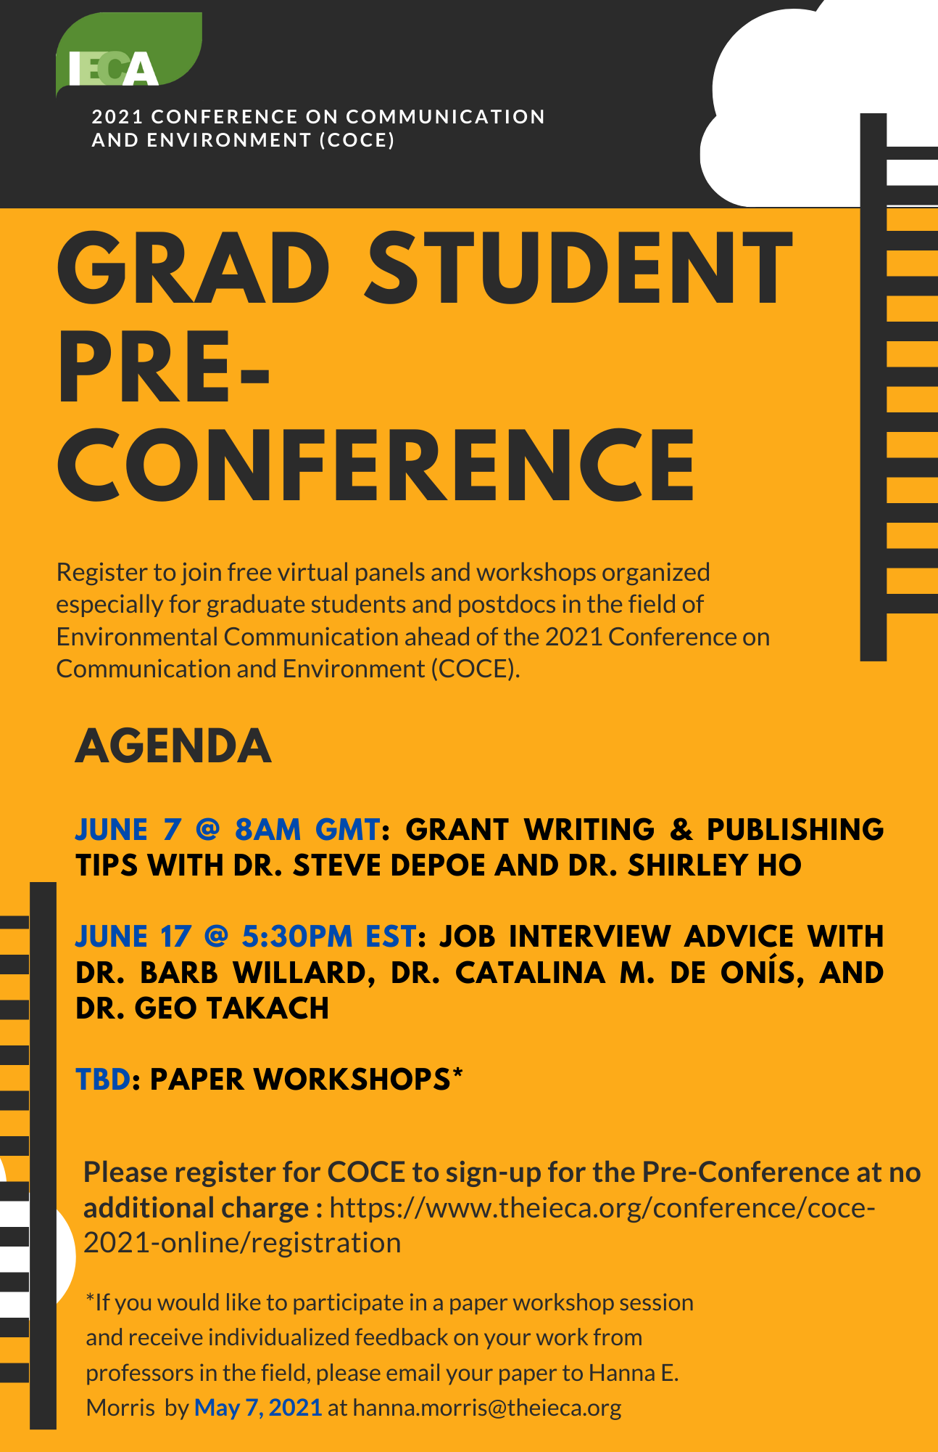
The Graduate Student Pre-Conference for the 2021 Conference on Communication and Environment (COCE) will be held virtually and will bring together the graduate student and postdoc contingent of the International Environmental Communication Association (IECA). The Pre-Conference will consist of two panels with time for live discussion and a Q&A on June 7th and June 17th as well as a series of small paper workshopping sessions that will be arranged in accommodation of participants’ time zones. The objective of the Pre-Conference is to provide current graduate students and postdocs with resources and aid in their development as environmental communication scholars and professionals.
Graduate Student Pre-Conference Planning Committee Members: Hanna Morris, Israel Adeseko, Elja Roy, and Annie Welden
Panel #1: Grant Writing & Publishing Tips with Dr. Steve Depoe and Dr. Shirley Ho, Monday, June 7, 2021, 8 AM to 9:15 AM GMT
Panel #2: Job Interview Advice with Dr. Barb Willard, Dr. Catalina M. de Onís, and Dr. Geo Takach, Thursday, June 17, 2021, 5:30 PM to 6:45 PM EST
The small group paper workshops will be organized based on common research interests, methodological approach, and time zone. The following professors will lead the paper workshopping sessions and provide individualized feedback on students’ projects: Dr. Libby Lester, Dr. Brett Hutchins, Dr. Gabi Mocatta, Dr. Silje Kristiansen, and Dr. Mark Pedelty.
If you wish to take part in the student paper workshopping session, please email your paper to Hanna Morris by May 24, 2021 at hanna.morris@theieca.org.

