College Dreaming

by

Gregory Bond, Devin Williams, Nathan Myers, & Tristan Palmer

Submitted to
the Faculty of the School of Information Technology
in Partial Fulfillment of the Requirements for
the Degree of Bachelor of Science
in Information Technology

© Copyright 2021 Gregory Bond, Devin Williams, Nathan Myers, & Tristan Palmer

The author grants to the School of Information Technology permission
to reproduce and distribute copies of this document in whole or in part.

Signature: Gregory Bond
Gregory Bond Date: 04/20/2021

Signature: Devin Williams
Devin Williams Date: 04/20/2021

Signature: Nathan Myers
Nathan Myers Date: 04/20/2021

Signature: Tristan Palmer
Tristan Palmer Date: 04/20/2021

Signature: Bander Alyami
Bander Alyami, Faculty Advisor Date: 04/20/2021

University of Cincinnati
College of
Education, Criminal Justice, and Human Services

April 2021

TABLE OF CONTENTS

Abstract 1
Introduction 2-5
Introduction 2
Problem 2-3
Solution 3-4
Project Goals 4-5
Overview 5
Discussion 6-26
Project Concept 6
Design Objectives 6-8
Methodology and Technical Approach 8-10
User Profile 10-12
Use Case Diagram 13
Technical Architecture 14
Testing 15-18
Budget 19-20
Project Timeline 21-22
Problems Encountered and Analysis of Problems Solved 22-25
Recommendations for Improvement 25-26
Conclusion 27-29
Lessons Learned 27-28
Abilities and Skills Developed Throughout Project 29
Back Matter 30
References 30

LIST OF ILLUSTRATIONS

Table 1. User Profile 11-12
Table 2. Project Timeline 21-22

Figure 1. Use Case Diagram 13
Figure 2. Technical Architecture Diagram 14
Figure 3. Test Logs 18
Figure 4. Budget 19-20

ABSTRACT

College Dreaming is a mobile-friendly website that provides a more holistic and engaging approach for high school students and their families to search and ultimately apply to universities across the United States. As fewer students are enrolling in college and with the new reality that is COVID, colleges could lose up to 20% of students. With College Dreaming, we took all the traditional and non-traditional information that students and their families are interested in, such as costs and student life, to create a more accurate matching process for students and institutions. College Dreaming also has an engaging quiz feature for a fast and easy way to see potential universities and is integrated with a mapping service to explore a campus virtually. With these features, College Dreaming gives the ability to increase college applications to a wider range of institutions through its personalized and engaging approach, and after the COVID pandemic.

1. INTRODUCTION

1.1 Introduction
When looking to attend a college or university, potential students often use search engines that focus on two metrics: prior education and current finances. Despite this, when attending an institution, a plurality of factors affects a student’s success, including everything from their diet, location, happiness and more. Likewise, people interested in colleges/universities have a variety of situations, from being current students, parents, or returning students. There is a demand to match using a multitude of factors catered to this expanded user-base, and College Dreaming will meet that by providing user-tailored matching based on personal interests and circumstances.

1.2 Problem
In 2018, there were 19.6 million college students enrolled in the United States, with an expected increase to 20.02 million by the year 2029 ⁴. This increase of only 460,000 students within a decade underscores the hyper-competition colleges are currently facing and will be continuing to face well into the future regarding growth in their student base ⁴. With this hyper-competition and, according to Inside Higher Ed, the fact that the number of high school graduates is starting to plateau ², this competition will only increase and has already made some small, private colleges close for good. For example, in one article from Inside Higher Ed⁵, Green Mountain College, a small private institution, was forced to close because they could not attract enough students. Now with a global pandemic, even more colleges are succumbing to closure ⁶.
From our research identifying current solutions for searching and selecting potential institutions, such as College Navigator ⁷, we noticed that most platforms are cluttered websites with limited functionality. They allow users to search for colleges by their names, academic information, and financial information, but leave out other data that is pertinent to the search process and to users. Higher education is not just about academics and finances, as it often involves a complete lifestyle change, moving to a new community and environment during one of the most transformative periods of their lives ⁸. To be successful, people must be content with where they are. Similarly, the transition to higher education is abrupt and dramatic for students and their families who must also deal with the emotional - and financial - consequences of sending them off. Existing college search applications do not take these factors into consideration. Likewise, under current search systems, many well-known institutions are displayed more consistently, leaving many less popular institutions towards the back of the results, despite many of these lesser-known institutions appealing factors to many potential students.

1.3 Solution

College Dreaming is a web application that will recommend colleges/universities based on various user tailored inputs that more accurately represent a user's interests. The inputs provided from the user can include standard information that one would use when searching for colleges/universities such as ACT/SAT scores and tuition price, while also allowing users to search colleges by other factors such as the area’s climate, crime, student demographics, and average earnings after graduation. Furthermore, College Dreaming will allow users to weigh these factors against each other to help them find their ideal college based on their unique preferences. Our web application will also consider how some students may be apprehensive of visiting a university as we are now facing the reality of a pandemic. For this reason, we will integrate our web application with an open-source map service to allow the user to explore the college campus and the surrounding area from the safety and comfort of their own home. Each college/university details page will also display either their logo or a generic image of their university so that a user can see a static image of the university. Likewise, if a user does not want to search for a college/university based on the traditional financial and educational parameters, there will be a webpage with a quiz-like feature to help them personalize and refine their searches. This quiz will ask questions regarding the students’ needs and interests. Based on their answers, the application routes the user to a list of universities that best suits their unique criteria, providing a more engaging college/university search feature. The goal of all these features is to help users find a college that meets their needs and preferences and have all the information they need in one convenient place. By including a wide variety of information about each college that competitor applications leave out, College Dreaming will help smaller, lesser-known colleges find new students by recommending them based on the factors that set them apart from the big-name colleges that many students will already have heard about.

1.4 Project Goals
The goal of College Dreaming is to personalize college admissions during and after the time of COVID while decreasing the amount of time a user spends searching for colleges. Using an engaging quiz and providing a central location to search for potential colleges and providing the functionality to virtually explore the college’s surrounding area, College Dreaming will relieve stress from parents and potential students who are worried about the intricacies and importance of researching which institutions are best for them. Users will no longer have to navigate to countless websites and dig through countless web pages in order to find specific information about a college. College Dreaming will provide extensive data pertaining to small and large colleges that is provided by government databases, such as the College Scorecard API which connects to a massive database related to thousands of institutions across the U.S. College Dreaming is meant to be used by anyone, be it a high school student looking at potential institutions, their parents who may be stressed about their child’s college decisions, or even older adults who are needing a career change. Ultimately College Dreaming will provide a more central and engaging college search, which in turn will increase college applications to a wider range of institutions.

1.5 Overview
The remainder of this final report outlines in detail how the project was completed. The report includes the following sections: project solution, design objectives, methodology & technical approach, user profile, use case diagram, technical architecture diagram, testing logs, budget, project timeline, problems encountered, future recommendations for improvement, lessons learned, and the abilities & skills developed.

2. DISCUSSION

2.1 Project Concept / Solution
The concept of College Dreaming is to offer a more holistic way for students and their families to search for colleges and universities that suit their needs and preferences both academically and personally while giving users the ability to see information related to colleges and universities they may not have heard of before. College Dreaming achieves this by collecting a wide variety of data associated with over six thousand institutions and making it easy for users to narrow down what colleges and universities they might be interested in based on the factors that matter to them. Instead of sorting through the many different fields available for each institution, users will take an interactive quiz about their preferences and requirements. Once the quiz is complete, College Dreaming will automatically search the database based on the users answers and recommend colleges and universities that might appeal to them, many of which are smaller alternative academic institutions.
2.2 Design Objectives
The following are vital features and designs that are being targeted for development for the College Dreaming website:
- Open Service Maps integration - This will allow users to virtually explore the surrounding area of a university/college. Letting the user get an understanding of the type of environment surrounding a university/college. Originally, we planned on using Google Maps, but in order to keep our product free, we decided on open-source alternatives.
- Quiz Feature - This will provide a more engaging and interactive college search. Instead of searching for a specific university or checking off on specific keywords, users will be presented with questions pertaining to potential interests and the result will be a university that accurately represents the interests.
- Search Functionality - If a user already knows what universities/colleges they are interested in but cannot seem to find all of the information in one place, a user will be able to search for a specific university/college and see all of the standard data pertaining to that university/college and non-standard data. A sample could be ACT/SAT scores, tuition, potential earnings after graduation, student demographics, and nearby attractions.
- Profiles & Favoriting - The college search experience takes longer than just a day; therefore, a user can create a profile and favorite a university’s detail page. A user’s favorite universities will be a clickable link on their profile page. Each profile page can be searched and viewed by other users who are currently signed in. These other users can also click on the different profile’s favorited universities.
- Mobile Responsive - As most students are on the go or rather the fact that in 2019 it was reported that over 81% of adults own a smartphone³, our project needs to be mobile responsive. This will allow our users to search through and find potential universities/colleges without the hassle of logging into a laptop/PC. On top of this, being mobile responsive will allow us to target a wider range of users and provide better accessibility to our website.
- Scalable Database - With the amount of data that is publicly available regarding academic institutions, our database needs to be scalable, with the ability to change data, delete data, and add data seamlessly.
2.3 Methodology / Technical Approach
College Dreaming utilizes the front-end website to display product features to users, a MySQL database for persisting vital website and user information, and a plethora of security tools to maintain safety.
Website:
College Dreaming utilizes Django, a web framework for Python, to organize and serve web pages in HTML, CSS, and JavaScript. jQuery and ChartJs have been incorporated to add animations and visualizations. The website revolves around four main features:
- Quiz: The main feature where users can get personalized colleges and universities matched to them based on their selected preferences.
- Favoriting: Allows users to favorite different colleges and university detail pages, which in turn gives them an easy way to view those detail pages later, though the user must be authenticated.
- Profiles: Allows users to search for other users and view favorited universities, the user must be authenticated.
- Basic Search: A String-based search to match against institution search terms such as ACT/SAT, tuition, etc.
The website is also broken down into ten main pages:
- Home: Home page where a basic search can be performed.
- Quiz: The page where the quiz is taken.
- Search Results: Page where a list of search or quiz results is displayed.
- Institution: Page where an institution’s information is presented.
- About: Page displaying information about the website.
- Profile: Page displaying a user’s profile details.
- User Search: Page where logged in users can search for other profiles.
- Password Reset: Page where a logged in user can reset their password.
- Delete Profile: Page where a user can permanently delete their profile.
- Contact: Displays contact information for the website.

Database:
The database is composed of information from government data sources, open datasets and created user information. The data has been sorted, cleaned, and stored into a MySQL server with the following tables:
- Admissions
- Cities
- Climate
- Costs
- Completion Rates
- Crime
- Earnings
- Institutions
- Institution Types
- Favorited Institutions
- Programs
- Undergraduate Information
- User Profiles
- Zip Codes
Security:
The website and its users are kept secure by being HTTPS enabled and having a CAPTCHA challenge-response test enabled during sign-up to prevent bot account creations. The database is also encrypted - along with its backups - using 256 AES encryption. On top of this, Django comes equipped with security features such as cross site scripting protection, cross site request forgery protection, SQL injection protection, and much more.

2.4 User Profile
Our user profile is a collection of potential users and information associated with each user such as how they will use our project, any background information needed to use it, frequency of use, and interface requirements. Our potential user profiles include web developers/system administrators, high school students, high school student’s families, college transfer students, and adults seeking a degree.

Table 1. User Profile
Project Name
- College Dreaming
Potential Users
- Web Developers/System Administrators
- High School Student
- High School Student Family Member
- Current College Student Looking to Transfer (Transfer Student)
- Adult looking for a career change/going back to college (Adult Seeking Degree)
Software & Interface Experience
- Web Developers/System Administrators
  - The user should have experience in web development including best practices and responsive design. They should also have experience working with our technology which includes SQL, AWS, Django, and Python. Lastly, they should be familiar with using the command line/terminal in order to deploy changes and install necessary packages for the website/web application.
- High School Student, High School Student Family Member, Transfer Student, Adult Seeking Degree
  - The user should have experience browsing the internet, navigating through websites and filling out basic forms including account creation forms and login forms.
Experience with Similar Applications
- Web Developers/System Administrators
  - Need to be familiar with the technology being used on the website/web application including languages, frameworks, version control software (such as GitHub), and IT services such as AWS.
- High School Student, High School Student Family Member, Transfer Student, Adult Seeking Degree
  - Experience using Google, Niche, Amazon, YouTube, Chrome, Firefox, Facebook, Yelp, Google Maps.
Task Experience
- Web Developers/System Administrators
  - Using the languages, frameworks, software, and services listed in “Experience with Similar Applications” and “Software and Interface Experience” in order to create and maintain the website/web application.
- High School Student, High School Student Family Member, Transfer Student, Adult Seeking Degree
  - Website navigation, filling out basic forms, using the left mouse click to press inputs (search field, username, etc.) and buttons (such as submit, login, etc.), and using keys on the keyboard to type into inputs.
Frequency of Use
● Web Developers/System Administrators
○ Fixing bugs, maintenance, adding new features, and improving security. This can either be done daily, weekly, or monthly depending on the needs of the customers/users and if and when any bugs are found, or maintenance is needed.
● High School Student, High School Student Family Members, Transfer Student, Adult Seeking Degree
○ Every day, week, or month up until application deadlines for their selected universities.
Key Interface Requirements That the Profile Suggests
- Web Developers/System Administrators
- Ability to efficiently work with and understand the technology being used, meaning:
  - Languages
  - Frameworks
  - Services and software such as AWS and GitHub.
- High School Student, High School Student Family Members, Transfer Student, Adult Seeking Degree
- Visually intuitive.
- Easy to use/navigate.
- Strong website security.
- Personalization based on user type (transfer student, high school student, etc.)
- Geolocation to show nearby restaurants/surrounding areas of universities.

2.5 Use Case Diagram
Our use case diagram is a representation of how our different users will interact with our project, College Dreaming. This includes the high school students, high school student’s families, college transfer students, adults seeking a degree, and the developers/system administrators that continue to work on the project.

Figure 1. Use Case Diagram
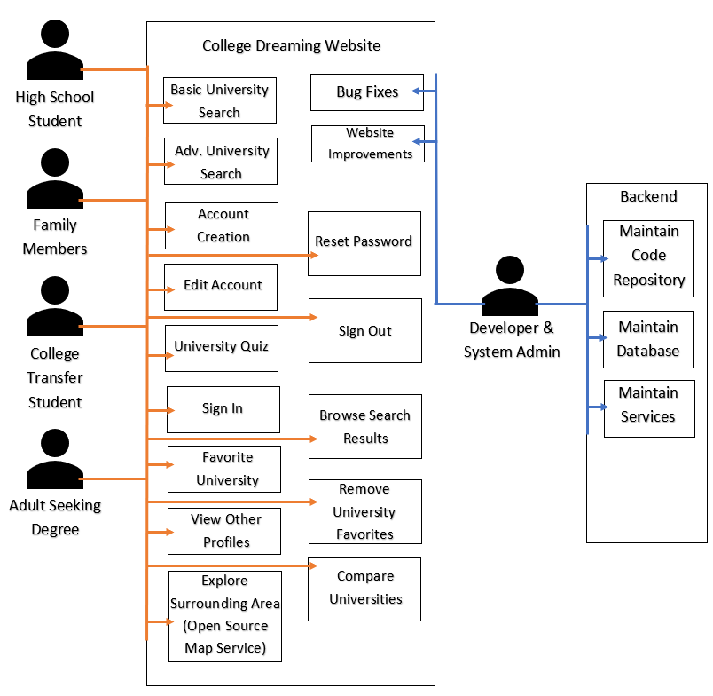
2.6 Technical Architecture
Our technical architecture diagram below is a representation of the technologies being utilized in our project, College Dreaming. The diagram shows how each of the tool’s work together and communicate to create College Dreaming. College Dreaming is a web application that is hosted on AWS Elastic Beanstalk. We also use AWS Route53 to route all web traffic to our SSL domain to establish a secure connection. College Dreaming was developed using Python and Python web framework called Django. Within Django we utilize Bootstrap framework to give College Dreaming attraction and appeal.

Figure 2. Technical Architecture
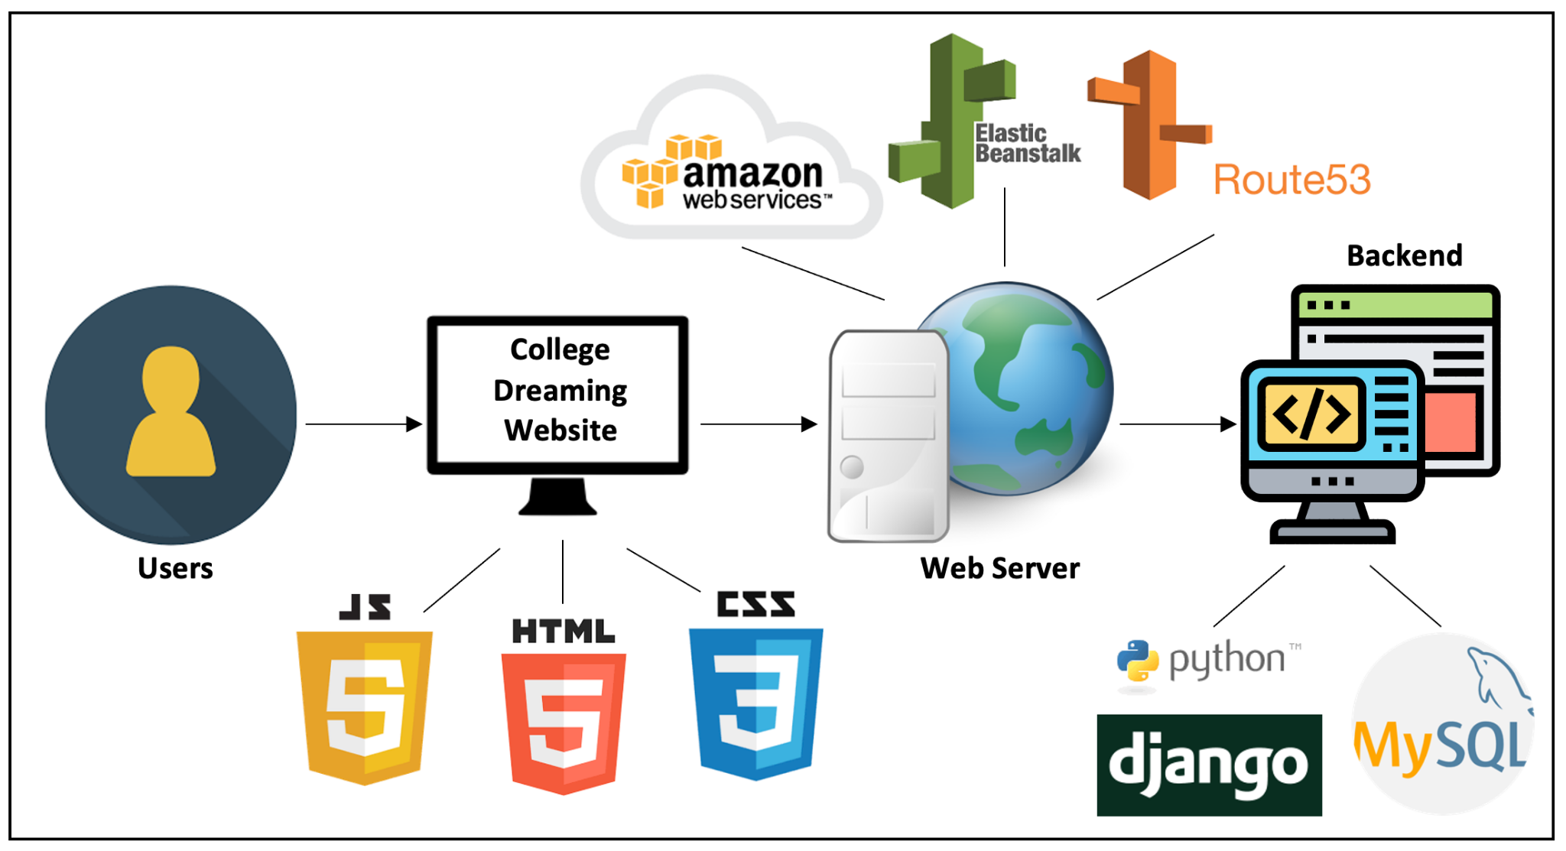

2.7 Testing
This section outlines various aspects of testing our project. This includes our testing methodology, the different use cases and features that we tested, why these features were tested, what our testing objectives are including our end goals, our testing logs which contain the results of our user acceptance tests, and lastly, a retrospective on what we learned throughout testing.
2.7.1 Testing Methodology
For testing, we defined objectives for users to achieve based on use cases. The users were brought to the website and told the object/goal they were to perform (e.g., creating an account), and their progress was monitored as they proceeded. They were encouraged to share their thoughts as they performed the tasks, as to show any issues they may have been encountering or thoughts in general regarding the website and its functionality. Their general experiences and thoughts regarding the websites and tasks were then aggregated and analyzed to determine both positive and negative trends.
2.7.2 Scope of Testing
Our testing scope includes all of our potential use cases outlined in the Use Case Diagram. These use cases include all the features that make our project usable, therefore, testing all these features is necessary for our project to be considered functional. Below is a list that includes different use cases and features that have been tested and the reason why these use cases and features have been tested.
- Authentication and Academic Institution Search
  - This use case includes searching for an academic institution, viewing that institution’s detail page, creating an account, logging into their account, and logging out of their account.
- Updating the User’s Profile
  - This use case includes creating an account, logging into that account, navigating to the account’s “Profile” page, and updating that account’s profile information such as name, GPA, ACT, SAT, and “About” section.
- Favoriting an Academic Institution
  - This use case includes logging into a pre-existing account, searching for an academic institution, viewing that institution’s detail page, clicking “Favorite”, navigating to the user’s “Profile” page, viewing their “Favorites” list, clicking on their favorited institution, unfavoriting the institution, and viewing their “Profile” page again.
- Complete the Academic Institution Search Quiz and Explore the Institution’s Surrounding Area using the OpenStreetMap
  - Navigate to the “Quiz” page, complete the quiz answering as honestly as possible, view results of the quiz, click on one of the academic institutions, and view the surrounding area of that institution using OpenStreetMap.
- Changing the Password of and Deleting a Pre-Existing Account
  - Log into a pre-existing account, navigate to the password change screen, change the account’s current password, log out of the account, log back into the account with the new password, navigate to the “Delete Account” page, delete the account, and try to log into the deleted account.
- Placing Weights on Advanced Search Page
  - Navigate to the “Weighted Search” page, slide each slider from left to right or to a number between 0 and 10, and click on the “Search” button.
By including all these use cases, we can ensure that all of the features of our project have been tested and are working properly and up to the standards of our users.
2.7.3 Objectives
The goal of our testing was to refine the user experience of navigating the College Dreaming website and taking advantage of the features that it offers. The website needs to balance between having the tools users need to search the large amount of data we have collected without sacrificing an intuitive and easy to use interface. In order to achieve this, we had our test users interact with each major feature of the application. This included creating and managing an account, doing a basic search, taking the interactive “quiz” and browsing the pages of specific colleges. We collected their feedback about the experience, focusing on how easily they navigated the website and if the information they found was useful in their search for a college that fits their needs. We adjusted our original plan based on what our test users had to say about their experience in order to ensure that College is dreaming is not only a powerful search tool, but one that prospective students would want to use.

2.7.4 Test Logs
Figure 3. Test Logs
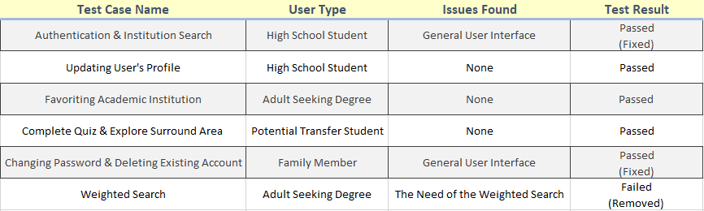
2.7.5 Testing Review
Throughout the testing of our application, we learned quite a lot from our users. For example, one of the feedback items we were told was that the “Weighted Search” feature of our application was confusing, with their main question being “How are these categories even being weighted”. Along with this, the user did not think it was necessary to have this feature as they would not even use it, all the different weights you can place on a certain category can already be filtered to the user’s liking on the home page. Another example of what we learned from our users is that the general user interface needed to be updated. From this feedback, we made changes, accordingly, including removing the “Weighted Search” feature completely and focusing on the “Quiz” and user interface.
Looking back, we would change our approach to testing by having users test our live website earlier in the development cycle rather than just having our group test it. This would have allowed us to take feedback and suggestions early on, ultimately making us direct resources and time to more needed features rather than features that ultimately are unusable or not needed.
2.6 Budget
Our budget illustrates the financial requirements needed for the College Dreaming project. This illustration includes the following financial related information; project asset type, project funding source, risk identification, project stakeholders, estimated benefits, the estimated cost, and the total 5-year ROI analysis.

Figure 4. Budget
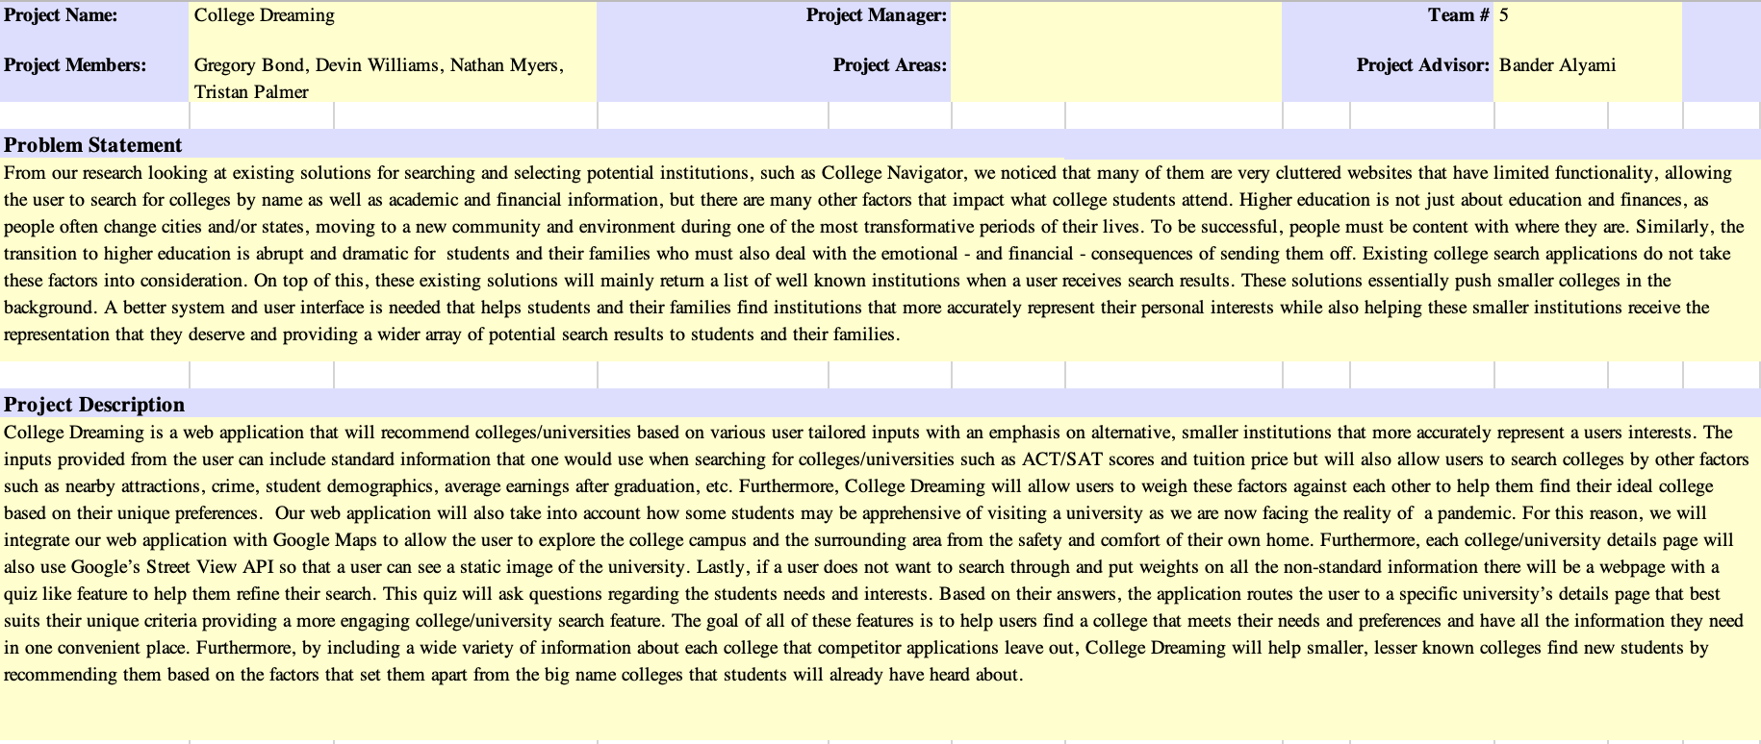
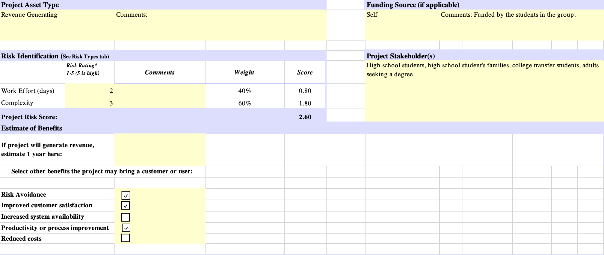
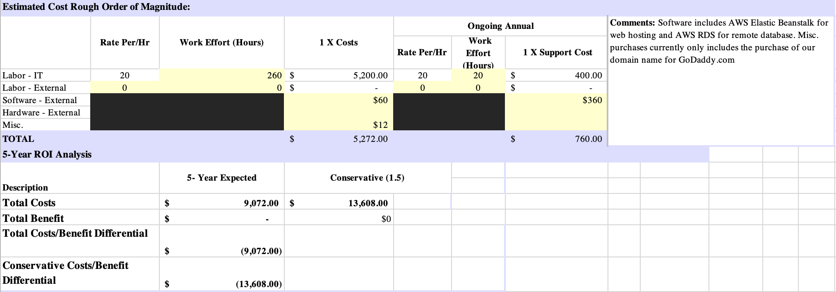

2.7 Project Timeline
From the start of the Fall semester, our group planned that we would finish almost all of our project’s main features during the Fall. That way, during the Spring we could work on improving our user interface, making sure our project is responsive to all screen sizes, fixing any bugs that were previously overlooked during the Fall, and finish any features that were previously pushed to side for more important features. Below is our project timeline that shows the schedule for the work that was completed during the Fall semester and what we are planning on working on during the Spring semester.

Table 2. Project Timeline
Week Of | Goal
8/31 | Form group
9/7 | Gather data for colleges
9/14 | Basic UI of basic search pages and nav bar
9/21 | Basic UI of quiz, login and advanced search pages
9/28 | Implement navbar search
10/5 | Implement basic search
10/12 | Implement login/sign up pages
10/19 | Improve layout of the university template
10/26 | Add graphs to university page template
11/2 | Security improvements
11/9 | Start on implementing quiz
11/16 | Review for presentation
11/23 | Improve based on presentation feedback, finish quiz implementation
11/30 | Misc. improvements and fixes to features already implemented
1/11 | Add favoriting feature
1/18 | Gather more data on climate and cities
1/25 | Start expanding the quiz
2/1 | Continue expanding the quiz
2/8 | Finalize look of university template
2/15 | Implement open-source map service
2/22 | Add additional security
3/1 | Start on website redesign & finish the quiz
3/8 | Finish website redesign
3/15 | Thoroughly test/debug
3/22 | Thoroughly test/debug
3/29 | Thoroughly test/debug
4/5 | Oral Presentation
4/12 | Turn in Final Report
4/13 | IT Expo

2.8 Problems Encountered & Analysis of Problems Solved
Throughout the Fall and Spring semester our group encountered a few different problems, from installing a client for our database, MySQL, to automatically redirecting our website to use HTTPS instead of HTTP. Below there is a list describing in more detail a problem we faced and how we either overcame the problem or ultimately got stuck on it.
2.8.1 Installing MySQL Client for Django, our back end framework
This was the first problem we came across as a group. While deciding what database to use, we met as a group to discuss what experience we have regarding databases and it was ultimately decided that since we each had experience with MySQL, that we were going to use MySQL for our database. So, we connected our project to the database, ran specific Django commands and received an error “Cannot install MySQL Client.” We looked everywhere online for a solution but could not find any. We tried reinstalling MySQL, reconnecting to the database, anything in order to fix this error. Well, as it turns out, this error is almost considered a bug with Django and MySQL. We found a GitHub page that showed the fix, if you were on MacOS you had to install Brew, a more advanced version of the Terminal, if on Linux, you had to run a few extra commands, but if you were on Windows, you would have to do a lot more. Thankfully, we are all using either MacOS or Linux, so what was a headache became an easy fix.
2.8.2 Chart.js is too responsive
In order to visualize our data for a more engaging user experience, we decided to use the Chart.js API, a HTML and JavaScript framework to create different charts and graphs on a webpage. This API has excellent documentation which describes how to create chart/graphs, customize them, and even how to use different layouts. But we realized during the creation of a few pie charts that they were too responsive, meaning that they would continue to shrink at smaller screen sizes, which led them to disappear completely. Well, we had to go back to the documentation and found something that we completely looked over, the charts/graphs are not responsive, rather they follow the same responsiveness as their parent HTML tag. So, in order to fix this, we had to 1). Change the responsiveness to our HTML tags 2). Use media queries in CSS and 3). Break the charts down to show categories instead of all the information in one. From doing this, the charts fix on smaller screens and are readable for the user.
2.8.3 Automatically routing our website to use HTTPS instead of HTTP
Routing our website to use HTTPS instead of HTTP was more difficult than initially thought. Setting up the route for HTTPS was easy enough, since we are using AWS we acquired a free public SSL certificate which allowed us to set up an HTTPS route. But, when loading up our website, it still would route you to HTTP. Truthfully, this was our most major issue. We tried everything we could find online, even enabling a setting in our settings.py file in Django, which was SECURE_SSL_REDIRECT to True. We thought this would work, but instead it would only look for HTTPS in our development environment, which made it so we could not run our development environment project. The fix for this was simple yet hard to find, we had to delete that setting and then delete the cache of our web browser or run our project in a different port, such as port 8080 instead of 8000. After fixing the error that we caused, we looked further into the instructions on how to automatically route to HTTPS that Amazon Web Services provides and figured out that we were configuring the wrong thing, specifically, a load balancer, instead of an instance web server.
2.8.4 Using Google Maps & Getting Directions
The original plan at the start of the semester was to utilize Google Maps in order to let users get directions to various landmarks on a college campus, but after looking at the pricing options and doing further research, we decided to use an alternative mapping service instead. The only problem with this alternative mapping services is, however, the fact that none of the open-source services that we found provided built in directions. In order to get directions while using an open-source service, you would then need to pay for another service that specializes in routing/directions. As a group, we decided that we wanted to utilize open-source alternatives which allows us to keep our application free to the general public, therefore, we had to scrap the idea of using Google Maps and getting directions, though in the future, if the number of users were to rise, we would reconsider the idea.

2.9 Future Recommendations for Improvement
Looking back on the development of our project, as a team we have decided on one primary thing that we would do differently from the start; select test users to test the application during the development process. This would have given us the opportunity to receive valuable feedback from our user base, which in turn would cause us to focus our attention and resources on parts of the project that users believe matter most, such as the user design and quiz feature.
Even though we did not start user testing till the Spring semester, we did receive great feedback and suggestions from our users. This includes getting rid of a certain feature of our project that lets users place weights on various search parameters. Instead of developing this feature, our users all agreed that we should focus on expanding the quiz feature and updating the user interface to have a more modern feel.
With all this being said, if we had more time for developing our project, we would consider implementing more social features for our application. Such as leaving a review system for different college application processes, a friendship system where users can send friend requests to other users, and even a review section on each institution detail page where users could review the college. We would also refine the quiz more, adding more questions to better match users with potential colleges/universities. No matter the features that could have been implemented, we as a team have decided to end development of the project, with all of us agreeing that we would be too busy after graduation to continue working on it.

3. CONCLUSION

In conclusion, our group has learned valuable lessons throughout the past two semesters and has gained skills that will help us achieve our individual career end goals, be that moving up the corporate ladder or starting our own company. Below, you will see subsections consisting of lessons learned throughout the Fall and Spring semester and lastly, the abilities and skills developed over the course of both semesters.
3.1 Fall Semester 2020 Lessons Learned
Over the course of the Fall semester many lessons were learned throughout our group. During this semester, we mainly worked on creating the layout of our website, populating the database with over 6,500 academic institutions and their related information from the government owned College Scorecard API, reflecting the data in our Django models, and setting up most of the core functionality of our website including authentication, search features, a paginated list of all the academic institutions, and visualizing their associated data. Through this work we learned a lot about our technologies including how Django, our back-end framework, connects with the database and how to display that data in a visually appealing way for the users, how to set-up HTTPS in our project, how to use built in Django forms/features for user authentication and pagination.
Along with learning more about our technologies, we learned a lot about the data that we were using, specifically from the government owned College Scorecard API. For instance, we found that many of the smaller academic institutions just do not report some data to the government, which could be expected but nonetheless it was interesting to see. On top of that, through self-reflection and asking questions to our potential users listed in the user’s profile section of this document, we learned what holistic fields potential students and their families would look for and find interesting when searching for an academic institution.
3.2 Spring Semester 2021 Lessons Learned
During the Spring Semester our group mainly focused on adding extra security to our website, cleaning the database, testing our final product including fixing any bugs, redesigning our website, and finishing our quiz feature.
Going into the Spring semester our website was designed by mainly using the web framework Bootstrap. This of course made our website look very close to many other websites using Bootstrap. In order to make our website look more modern and unique, we decided to move away from Bootstrap and create our own custom, responsive CSS. By doing this we learned just how much work goes into front-end development and website design, such as accessibility and developing with a mobile first approach. On top of this, by adding extra security to our website, we learned how valuable a web framework such as Django is at securing projects and just how much security goes into a website to protect against things such as SQL injections and cross site scripting attacks.
Overall, through the work that was done during the Spring semester, the entire team learned quite a lot about web development, our web framework Django, user testing, fixing bugs, and how to better query a database using Django. This work can be looked on in the future for inspiration on how to overcome various challenges that the members of the group will be presented with in the future.

3.3 Abilities & Skills Developed
Over the course of our final two semesters, our entire group developed, and refined skills related to our technology used, including Django, a web-framework that uses Python, MySQL, front-end technologies/languages such as HTML, CSS, and JavaScript, and lastly, web design and development. Our group has also developed a key skill in the modern era, how to work as a team remotely. Using technologies such as Microsoft Teams, GitHub, and Google Drive, our group was able to effectively communicate, share documents, and share the code for the project. Now, though the entire group developed and refined these skills, the level of development depended on the skills each team member had when starting the semester.

4. REFERENCES

- Nadworny, Elissa, and Max Larkin. “Fewer Students Are Going To College. Here's Why That Matters.” NPR, NPR, 16 Dec. 2019, www.npr.org/2019/12/16/787909495/fewer-students-are-going-to-college-heres-why-that-matters.
- Jaschik, Scott. “Inside Higher Ed.” Colleges Could Lose up to 20 Percent of Students, Analysis Says, 29 Apr. 2020, www.insidehighered.com/admissions/article/2020/04/29/colleges-could-lose-20-percent-students-analysis-says.
- Center, P. R. (2020, June 05). Demographics of Mobile Device Ownership and Adoption in the United States. Retrieved November 09, 2020, from https://www.pewresearch.org/internet/fact-sheet/mobile/
- The Condition of Education. (n.d.). Retrieved November 09, 2020, from https://nces.ed.gov/programs/coe/indicator_cha.asp
- Jaschik, S. (n.d.). Green Mountain is latest small college to close. Retrieved November 09, 2020, from https://www.insidehighered.com/news/2019/01/24/green-mountain-latest-small-college-close
- Jaschik, S. (n.d.). Green Mountain is latest small college to close. Retrieved November 09, 2020, from https://www.insidehighered.com/news/2019/01/24/green-mountain-latest-small-college-close
- (n.d.). Retrieved November 09, 2020, from https://nces.ed.gov/collegenavigator/
- Wozniak, A. (2020, September 22). School Distance as a Barrier to Higher Education. Retrieved November 08, 2020, from https://econofact.org/going-away-to-college-school-distance-as-a-barrier-to-higher-education

