CALL FOR SUBMISSIONS

Conference Theme
These are turbulent times for environmental communicators. A shared understanding of what is at stake, let alone the terms of the debates over environmental issues and conflicts, remains elusive. Moreover, the lines of communication among advocates for environmental protection, the public and policy-makers are increasingly choked with misinformation and distrust.
At the same time, global demand for energy seems insatiable. Despite significant movement towards renewable energy sources, powerful interests advance the continued and accelerated extraction of fossil fuels as well as the pollution of public discussion on social, economic and environmental concerns. This makes advancing adequate responses to climate change and other environmental issues ever more urgent and difficult.
At the heart of many such challenges is water: too little, too much, too low, too high, inaccessible, in the wrong place, or outright polluted. Water is all-important to life on Earth, a reality too often tragically at odds with how it is viewed, talked about, and treated. And despite its importance, water remains an understudied area in environmental communication. With this conference, perhaps we can change that a bit by precipitating a confluence of research and experience that will help improve our lines of communication on water.
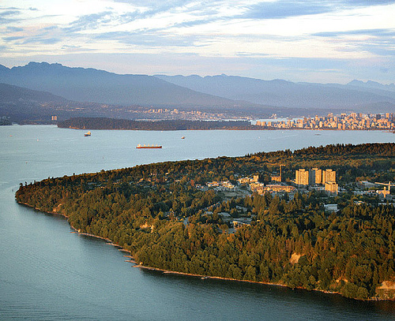Vancouver, and the Pacific Northwest generally, provides a fitting location for exploring the communication of water-related issues. Although often imagined as ‘ecotopia’, the region is beset with numerous environmental challenges, including rapid urbanization, deforestation, and degradation of the marine ecosystems for which the Salish Sea is famous. As the effects of climate change and development keep deepening, the region also faces increasing droughts, forest fires, freshwater contamination, floods, and rising seas.
Energy production and transportation are directly related to these issues, not only for their harmful impacts on fresh and coastal water systems, but also for their effects on climate change. Among the region's most controversial issues is the Site C dam in northern British Columbia, which is set to flood 100 km of fertile agricultural land and old-growth boreal forest to deliver expensive hydro power that may not be needed. Also notable is the Trans-Mountain pipeline expansion to carry bitumen from Alberta across the Rocky Mountains to the Port of Burnaby, in the heart of Vancouver. The project has been fiercely opposed by some local Indigenous peoples’ organizations, diverse environmental organizations, and citizens, and was recently subject to a purchase agreement by the Government of Canada.
In these contexts, environmental communicators can bring several powerful reasons for hope to the surface. We can detect a rising environmental consciousness and a growing acceptance of our connectedness to the Earth. Nations have developed goals for sustainable development that are being widely discussed. Indigenous voices, artists and young people are at the forefront of creative advocacy that is drawing the line on destructive development. Advances in both communication technology and science provide new tools to do our work. And scholars and practitioners alike continue to float fresh perspectives to help us understand and respond to the immense complexity and difficulty of communicating for and about the planet today.
We hope, then, that you will join us in Vancouver for a stimulating and provocative meeting of scholars, artists and practitioners who share a concern and a passion for environmental communication.
We welcome proposals for scholarly papers, practice reflections, panels, posters and artwork relating to all aspects of environmental communication. In particular, we encourage those that relate to the conference theme of communicating about water. We welcome a wide range of approaches, and are especially interested in Indigenous views and perspectives.
Pursuant to the IECA’s green conference policy, we will aim to minimize waste, carbon emissions and other environmental impacts as much as possible as we plan and deliver the conference at the University of British Columbia, an institution recognized for its excellence in sustainability research and practice.

Submission Guidelines
Submissions will be made using online forms on the OpenConf platform available through the IECA website starting September 1, 2018. Submitters will be asked to indicate if their submission is related to the theme. The submission deadline is November 15, 2018.

All submissions must:
- Be written in English.
- Be single-spaced.
- Include a summary of up to 250 words for the programme.
- Be formatted according to APA guidelines when including citations and a references list.
- Contain no information identifying the presenter(s) in the main content.
Please, no more than three submissions associated with any one person. That means as an author, co-author, panelist, etc.

Scholarly Papers
Scholarly paper submissions should be original works of research and analysis that emphasize contributions to knowledge.
- Submit an extended abstract of 400-500 words that clearly explains context, research questions, methods, conclusions and contributions to knowledge.
- If you have citations, include a reference list (word count not included in the word limit).
- If accepted, full papers MAY be required by May 15, 2019.

Practice Reflections
Practice reflections should be critical considerations by practitioners of their own projects and campaigns, and should emphasize effectiveness and applicability in other contexts.
- Submit a self-reflective summary of 400-500 words on your project or campaign. The reflection should critically examine the goals, strategy, tactics, messages and results.
- If you have citations, include a reference list (word count not included in the word limit).
- Submissions should highlight effective advances in the practice of public engagement in environmental communication.
- If accepted, full papers MAY be required by May 15, 2019.

Works of Art
Submissions by artists of their own work (paintings, photography, sculpture, dance, music, comedy, digital art or other new media art, etc.) are encouraged if the work addresses some aspect of environmental issues or human relationships with the rest of the natural world, and especially if it specifically reflects on communication. The art will be considered for exhibition or performance during the conference.
- Submit a description of your art, including, dimensions, and installation or performance requirements; append photographs as necessary in a PDF file; do NOT submit the original work.
- When appropriate, submissions should explain the artist’s intentions for the work by way of an artist’s statement.
- If a video is required to explain or depict the work (e.g dance, theatre, kinetic art), or if the work itself is video-based, then provide a link to where the video can be viewed online.
- If you have citations, include a reference list.

Panels
Panel submissions should focus on a unified topic. They can either be panels of scholarly papers, panels of practice reflections, panels of artists, or roundtable discussion panels. Keep in mind that panels must fit into 90-minute sessions.
- Submit a descriptive panel proposal of up to 500 words, including a rationale for the panel.
- If the panel includes individual scholarly papers, practice reflections or other titled presentations (as opposed to more informal roundtable discussion panels), then each paper/reflection/presentation must also be submitted separately by its main author just like other stand-alone submissions. There is a space in the submission form to indicate that the submission is part of a panel proposal and which panel the submission is attached to. These individual submissions are necessary for peer review and production of the programme.
- For roundtable discussion panels, separate submissions are not necessary, but the panel submission should include the names and brief bios of the panelists as part of the descriptive proposal and all panelists should be included as authors of the panel.
- If you have citations, include a reference list (word count not included in the word limit).

Posters
Poster submissions can address any area of environmental communication scholarship, practice, or creation, and can be submitted in lieu of scholarly papers, practice reflections and artwork.
- Submit an abstract or summary of the poster of up to 500 words, including any relevant details described above (depending on the type of poster).
- If you have citations, include a reference list (word count not included in the word limit).
- Include visual elements of the poster where necessary.
- If accepted, final posters must be submitted by May 15, 2019.

Workshops
Workshop submissions should focus on practical training in some area of environmental communication practice, scholarship, teaching, design, or artistic production. Workshops should normally fit into 90-minute sessions, but exceptions are possible.
- Submit a description of the workshop of up to 1000 words, including time required, a rationale, and learning outcomes.
- Submissions should explain clearly how attendees will participate, and must include a summary of activities, as well as the names and affiliations of all trainers.
- If you have citations, include a reference list (word count not included in the word limit).
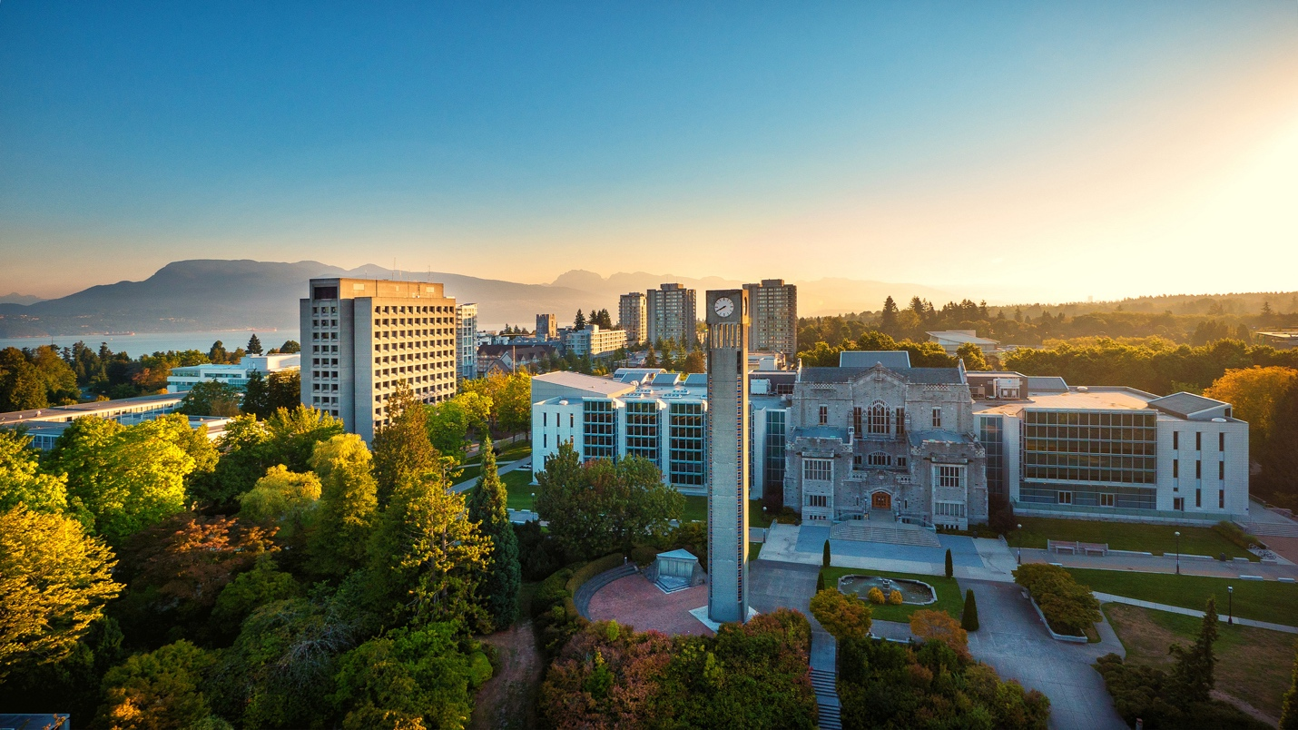

Submission and Review Process
All submissions except workshops will be reviewed anonymously and rated individually for their potential value to conference participants. Reviews will be based on overall quality, as well as the following criteria when appropriate: importance and relevance of topic; potential contribution to knowledge; useful synthesis of current knowledge; potential contribution to practice; creative innovation; and relevance to the conference theme.
- Submissions are due by 11:59 PM Eastern Standard Time on Thursday, November 15, 2018.
- Submissions will be made using online forms, so have your submission ready to cut and paste into the various fields. Keep formatting to a minimum.
- For artists uploading images, please ensure that any photos are optimized before creating the PDF to keep file sizes reasonable.
- All submissions must be made through the COCE 2019 website: http://theieca.org/coce2019.
- Maximum three submissions can be associated with any one person, including as a co-author or panelist.

Virtual Presentations
Presenters may choose to save money and carbon emissions by not traveling to Vancouver. In those cases, presenters may participate via Google Hangouts/Meet or other suitable virtual method to be determined. Virtual presenters will have a reduced registration fee. Unlike the previous three COCEs, we will not be videotaping the conference sessions. We may make audio recordings.

Important Things to Know
You don't need to be an IECA member to submit, but all conference presenters must be members of the IECA in 2019. So, you'll need to join by January 30, 2019 if your proposal is accepted. All members receive discounts on conference registration. Membership information can be found here: http://theieca.org/membership.
All conference attendees must pay for their own travel, accommodation and conference registration. All attendees who need travel visas are responsible for obtaining their own. We will provide invitation letters to those who require them.

About the IECA
Founded in 2011, but with roots going back to 1991, the International Environmental Communication Association (IECA) is a professional nexus of practitioners, teachers, scholars, students, artists and organizations engaged in research and action to find more ethical and effective ways to communicate about environmental concerns to move society towards sustainability. Our mission is to foster effective and inspiring communication that alleviates environmental issues and conflicts, and solves the problems that cause them. More at https://theieca.org.
photo credits justiceatlast and the University of British Columbia

