Ethical Implications in Marina Abramović’s Rhythm 0

Sadie Penix
Department of Art History, DAAP
Professor Christopher Platts
April, 2026

Introduction
“In my opinion, wherever there is a public, there is a sacred place. When there is no public, there is no performance because there is no dialogue,” claimed Marina Abramović (b. 1946) in conversation with Italian art critic and contemporary art historian Achille Bonito Oliva. For Abramović, the presence of an audience is constitutive to performance. Performance art has frequently been defined by its provocative impulse, functioning as a responsive and unstable form that artists have turned to when engaging with political, cultural, or social pressures, and when seeking to unsettle the conventions of more established artistic disciplines. These sentiments are conveyed by her first performance works, The Rhythm Series (1973-1974) (Figures 1– 33). Over the course of two years, she completed five separate performances that explored the physical limits of the body and the relationship between performer and audience. Abramović performed Rhythm 0 (1974), the fifth and final work, at the gallery Studio Morra in Naples, Italy, from 8 pm to 2 am (Figures 1– 13). She placed seventy-two objects on a table that could cause the human body extreme pleasure or pain, including but not limited to objects like a comb, lipstick, paint, a feather, a bone of lamb, cake, and a gun. Instructions posted on the wall declared: “I am the object. During this period I take full responsibility.” This experiment used the art space to expose what audiences are capable of when social inhibition is suspended and moral responsibility is left unguided. This paper asks, in her performance Rhythm 0, how does Abramović's deliberate surrender of bodily agency transforms the audience from passive observers into ethically implicated subjects, forcing an intersubjective encounter with the artist that exposes unconventional, if not revolutionary, social conditions governing the art space?
Drawing on contemporary art historian and theorist Kristine Stiles' theory of performance as a transpersonal visual aesthetic, this paper argues that in Rhythm 0, it is the audience’s behavior, and the ethical residue it produces, that constitute the work’s most significant meaning. In this context, transpersonal visual aesthetic means the experience that emerges between people in the space of the encounter produced through the performer/audience relationship. Stiles first introduced her framework in a short essay written for the book Critical Terms for Art History to define the term “performance” in the field of art history. The existing scholarly literature on Abramović is substantial but tends to center her body and mind’s endurance as the foundation of meaning in her performances. This paper instead focuses on the audience as the primary site of meaning. Mary Richards’ Marina Abramović (2010) is a comprehensive introduction to Abramović’s work, and is instrumental for this paper. Richards’ account is valuable for understanding the logic of Abramović’s evolving methodology, though it centers the artist’s perspective over the audience’s experience, creating a gap for analysis that this paper will fill. Stiles, whose theoretical framework anchors this paper’s analysis, has also written directly on Abramović as a subject. Her contribution to Marina Abramović (2008) analyzes Abramović’s practice from the perspective of performance’s broader art-historical significance in a direct interview, which provides extensive primary material of her political activism leading up to her first performances. However, Stiles’ writing focuses on a comprehensive survey of Abramović’s career, while this paper will concentrate on a single performance, Rhythm 0, and how it exposes the ethical conditions an audience adheres to within the art space and how those conditions can be disrupted.
The broader literature on Abramovic’s performance art provides further context for Rhythm 0 and this paper’s analysis. RoseLee Goldberg’s Performance: Live Art since the 60s (2004) maps the field within which Abramovic emerged, following the timeline of body art, Fluxus, and happenings in the 1950s and 1960s that shaped the conditions for Rhythm 0 to occur. Abramovic’s own archival publication Artist Body: Performances 1969-1998 (1998) is a primary source offering her performance instructions, photographic documentation, and retrospective accounts that illuminate the internal development of her practice. Anna Dezeuze’s The “Do-It-Yourself” Artwork: Participation from Fluxus to New Media (2010) provides useful commentary for understanding Abramovic’s intentions with The Rhythm Series as a whole. This paper will specifically apply Stiles’ theoretical framework to Rhythm 0 to analyze the performance through a new lens. It is through this framework that Abramović’s intentional use of instructions and objects collapsed the boundary between person and thing, the audience’s actions evoked questions of vulnerability and consent, the ethics of intersubjectivity were challenged, and the comfortable passivity of spectatorship was dissolved.
The Rhythm Series
The debut of Abramović’s Rhythm Series in 1974 marked a set of personal investigations into risk, control, and the boundaries between performer and audience. Coming of age under Josip Broz Tito’s (1892 - 1980) communist government (1953 - 1980) in Yugoslavia, Abramović felt compelled to push back against, or at minimum question, the constraints imposed on her, both in her personal life and in the broader political sphere. Across the five performances, Abramović challenged the assumptions we make about the relationship between agency and selfhood, and between agency and action. At the same time, she explored the performer/audience relationship by forcing their role as participants to change the inherent nature of her performance, whether by choice or not. It is important to note that while this series is an evolution of Abramović’s thought, it was not pre-planned in advance, as she designed each performance as a result of the previous, addressing new questions as she discovered them. The first four performances were experiments in Abramović’s own behavior and endurance through dangerous acts, while Rhythm 0 was the ultimate conclusion that put her body entirely in the hands of strangers.
The series began with Rhythm 10 (1973), an adaptation of a traditional Slavic knife game (Figures 14 – 18). Much like Russian roulette, it is a game requiring a balance of courage, recklessness, and a kind of bleak fatalism. Abramović has described this as her first performance work, one in which confronting the mental and physical boundaries of the body felt essential. Following the rules of the game, Abramović rapidly drove a knife between her outstretched fingers, cutting herself repeatedly with ten knives of varying sizes while recording the sounds of each strike. After going through all ten knives, she played back the audio recording and attempted to replicate her exact movements a second time, deliberately recreating each cut with precision. Richards describes that as tension built in the room, she seized control of what had appeared to be purely chance events, reenacting her previous motions with striking accuracy.
In Rhythm 5 (1974), her survival shifted from any suggestion of deliberate artistic shock and instead became a genuine emergency that forced those watching to decide whether or not to step in (Figures 19 – 26). Abramović measured a large wooden star on the floor, roughly six metres in diameter, filled it with wood and petrol, and once the sun set, lit it on fire. After a series of ritualistic gestures, she entered the star and laid on the ground. Though she had planned every element, she had not anticipated that the burning star would deplete the oxygen around her, leaving her unconscious and forcing the audience to intervene. The performance had fundamentally altered the dynamic between artist and audience, sparking considerable debate around where responsibility lies when performance carries genuine physical risk. According to Abramović, she was “very angry because [she] understood there is a physical limit: when you lose consciousness, you can’t be present, you can’t perform.”
That disappointment became a catalyst, driving her to investigate what the body could do and express outside the boundaries of waking awareness, directly leading to Rhythm 2 (1974) (Figures 27 – 29). The performance featured her taking one pill meant to treat catatonia, and another meant to treat schizophrenia. During the first, she experienced uncontrollable body movements while her mind remained fully present. During the second, she sat still and smiled, later recalling almost nothing of that time. She described the work as an exploration of the tension between losing control and holding onto it, yet once each drug had entered her system, her body’s responses were no longer hers to govern.
Later that same year, Abramović performed Rhythm 4 (1974) (Figures 30 – 33) by kneeling naked in front of an industrial air blower and inhaling as much air as she could. She was in a room separate from the audience, who watched on a videotape live-feed with no sense of the state she was in. Since there was such an extreme amount of air pressure from the fan, she quickly lost consciousness, but the air held her body in place, while the audience remained unaware. With this piece, Abramović accomplished what Rhythm 5 had denied her: the ability to remain present as a performer both within and beyond the bounds of consciousness.
A common thread through these four performances is the exploration of pain, danger, and control. For Abramović, pain is not something to be avoided but something to be endured deliberately, a threshold into another state of being. She has also spoken about the relationship between pain and shame, placing both at the center of what makes performance art so uniquely powerful. To act from a place of shame, to expose oneself without defense, is to become profoundly vulnerable, and it is precisely that vulnerability that dissolves the barrier between performer and audience. Across all four works, the audience was only permitted to watch and was not designed to intervene, but due to the risks she underwent, they were frequently forced into an interactive role. It is this tension between assigned passivity and compelled participation that Rhythm 0 would take as its central subject, inverting the dynamic and placing the weight of the performance’s outcome in the audience’s hands.
Historical and Biographical Context
Abramović was born in 1946 in Belgrade, Yugoslavia, into a family of communists whose military and political involvement shaped her early understanding of discipline, sacrifice, and the body as a site of ideological control. Abramović was politically active as a student, participating in demands for reform that contributed to the establishment of the Student Cultural Centre (SKC) in Belgrade in 1971. This space became central to the exchange between Yugoslavian and Western avant-garde art. Richards notes that art under socialism carried a dual obligation: to benefit society while simultaneously questioning its own artistic principles. This tension between political constraint and creative freedom informed Abramović’s early practice and her desire to use the body as both medium and provocation.
By the early 1970s, performance art had emerged as the defining medium of avant-garde art of the decade, expanding to encompass body art, autobiography, feminism, and ritual, largely because conceptual art lost its grip on audiences due to its didactic and anti-commercial tendencies. Artists of this period turned inward, subjecting themselves to feats of endurance and deliberate risk-taking that were, in Abramović’s own words, intended to “shock the public and create a space in them so that they could receive something new.” Pain and fear were constitutive of the work itself as tools for stripping away the psychological and physical defenses that insulate audiences from discomfort and mortality. It was within this context that Abramović developed The Rhythm Series, a set of five performances that would culminate in Rhythm 0.
Rhythm 0
Central to Abramović's practice is the belief that performance art derives its power from direct contact between artist and audience, a live transmission of energy that no other medium can replicate. Rhythm 0, staged at Studio Morra in Naples in 1974, ran for six hours across an evening. Seventy-two common objects sat on a table, and text on the wall declared her instructions: “There are 72 objects on the table that one can use on me as desired. I am the object. During this period I take full responsibility” (Figure 1). The work had no predetermined shape; it was built entirely through the interactions between Abramović, the objects she had laid out, and the people who chose to engage with them and with her. This performance revealed the way that collective anonymity can erode individual moral judgment, allowing people to act in ways they might never contemplate acting alone. To fully grasp just how radical Abramović's position was, it helps to remember the context she was operating in: a woman working in a male-dominated field of art, a citizen of a repressive socialist state, and performing in conservative Catholic Italy, none of which afforded her much protection or artistic legitimacy as her career was just beginning.
As the evening progressed, the audience's behavior took on an increasingly disturbing character, escalating toward outright cruelty to Abramović. There was a gradual diffusion of individual responsibility into the group as an anonymous whole, with participants feeding off one another, collectively pushing further than any single person might have ventured alone. Later, speaking about the performance, Abramović herself said:
In the beginning, the public was really very much playing with me. Later on it became more and more aggressive. It was six hours of real horror. They would cut my clothes. They will cut me with a knife, close to my neck, and drink my blood, and then put the plaster over the wound. They will, carry me around, half-naked, put me on the table, and stuck the knife between my legs into the wood. And, even somebody put the bullet in the pistol, and put in my hand and see if I were pressing it, her hand against my hand, if I would resist.

But, I remember after six hours when the gallerist come and say this piece, it's finished that I start being by myself and start walking through the audience naked and with blood, and tears in my eyes, everybody run away, literally run out of the door.

While not unexpected that the audience would use the objects in a malicious manner, it is jarring just how far they went. It is unclear if the performance ended specifically because someone made her hold a loaded gun to herself, or if the six-hour time limit was simply up. The audience that gathered for Rhythm 0 was largely made up of ordinary people pulled in from the street, alongside a smaller number of those familiar with the art world. This mix created an interesting dynamic. Those who understood the event as an artwork engaged with it cautiously and with a degree of restraint, while those who did not share that frame of reference treated it as an open invitation, testing boundaries and pushing Abramović as far as they could. The time of night furthers the dynamic, as the late hour likely removed a layer of social responsibility and created an implication of the type of behavior that might occur.
The actions carried out that night raise questions about how the crowd could go that far, why they ran away after the performance ended, and what exactly prompted their actions.
To better understand the ethics of the audience’s behavior, this paper adapts Kristine Stiles’ framework to analyze Rhythm 0. Stiles theorized that performance creates a shared visual experience that connects people, which she defined as a “transpersonal visual aesthetic,” and this blurs the boundary between individual viewers through a sense of mutual recognition and commissure. The key term of this framework is ‘transpersonal visual aesthetic,’ which means an experience that emerges between people, in the space of the encounter produced through the performer/audience relationship. “Mutual recognition” means that the viewer recognizes something of themself in the performer, and the performer in the viewer, but not necessarily in a harmonious manner. There might be tension left unresolved and unsettled. “Commissure” is an anatomical word, meaning the place where two things are joined (the corner of the lips or the two hemispheres of the brain). Stiles uses this term to highlight the importance of linkage at the physical site of performance, as well as the concept of entrustment, where both performer and audience hand something over and put their trust in each other. Essentially, she claims that performance art makes the audience and the performer feel connected to the point that the line between “you” and “me” starts to dissolve.
A lot of art is used as a metaphor, meant to represent something, as the viewer stands in front of it to interpret the artist’s meaning. However, rather than representing an experience, performance is one, and the viewer is included whether they want to be or not. This is also created through somatic identification, which means that the viewer is not just intellectually interpreting a performance, but bodily identifying with it by feeling the physical weight of what the performer is doing. So, performance happens to the viewer and their body is part of the experience, rather than just what it represents. Importantly, Stiles claims that this positions performance artists to question the ethics of artistic engagement, which Abramović does in an unprecedented way in Rhythm 0 by intentionally surrendering her bodily agency and forcing the audience to make decisions.
- The Commissure
Going back to the term “commissure,” in Rhythm 0, Abramović’s body becomes the meeting point of commissure, where separate things become connected, bridging the gap between the artist as an autonomous agent and the artist as a surrendered object. The instructions posted on the wall, declaring that she was the object and that she took full responsibility for everyone’s actions, were the rules that collapsed the boundary between her as a person and her as a thing. The table of seventy-two objects extended this idea. It created an intersection between the domestic and everyday on one side and the violent and transgressive on the other. The objects were things with use-histories, that is, objects that bring their everyday contexts with them into the gallery space. Arranged together, they formed a kind of ladder of escalating threat to the human body: a thorny rose that could prick you, scissors and razors that could cut you, and finally a loaded gun that could kill you. The loaded gun at the end of that chain marks the extreme limit of the commissure, the point where the connection between art and reality, and between life and death, becomes impossible to separate.
- The Body as Social and Political Interface
Abramović’s passivity was a direct provocation and highlighted the social implications of the objectification that she underwent. By setting up conditions where an audience could do whatever they wanted to a female body, she forced them to confront uncomfortable realities about how vulnerable women’s bodies are in public spaces, and what it means to violate someone's body with blurry boundaries of consent.
The audience's behavior over the course of six hours made visible several things that are usually hidden in the viewing of a regular artwork. Social inhibitions collapsed quickly once the normal structures of authority and enforcement were removed, meaning the audience was directly encouraged to touch and interact with the “object,” in this case Abramović's body, with no threat of consequence or responsibility. Individual moral responsibility dissolved in the group setting, producing actions that most people would not have taken alone. The crowd dynamic mirrored the psychology of a mob, a point that carried particular weight given Abramović's background in a country where collective political behavior had very real consequences. French social psychologist, sociologist, and physician Gustave Le Bon explained collective behavior, like that seen in Rhythm 0, through the lens of social psychology in his 1895 book, The Crowd: A Study of the Popular Mind. He claimed that a crowd is created by a psychological unification that in turn “lowers deliberative reasoning while amplifying emotion, imagination, and impulsivity.” The loaded gun focused all of these compulsions onto a single object. By placing it on the table alongside everything else, Abramović handed the State's monopoly on violence to anonymous individuals and asked, implicitly, who gets to define the limits of another person's body when that person has stepped aside.
- Being and Doing: Temporal Dimensions
The six-hour duration was purposeful to provide a length of time for the work to accumulate. Over time, the audience members’ actions gradually got more and more dangerous as their moral and social structures dissolved, as well as the visible transformation of her body throughout the performance. This connects directly to what Stiles, drawing on French philosopher Henri Bergson, identifies as the core of performance: its ability to compress conditions of existence across past, present, and future into a single act.
In Rhythm 0, the past existed in Abramovic’s preparation of seventy-two objects, the written instruction, and the preceding works of the Rhythm Series that had led to this final proposition. The present was completely surrendered to the audience as she had no agency in real time, and time acted on her rather than with her. The future resides in the residues of the performance as evidence of its duration: the torn clothing, the cuts on her skin, the tears, a streak of white hair that appeared from the stress she underwent.
This all creates an interesting dynamic where the actual performance of the work was done by others, not the performer. Abramović’s only act was the very beginning to surrender her body, and everything that followed was the audience’s actions. Therefore, the work mainly exists in the memories of the people who were present, in what they did or failed to do, and how they acted once the performance ended. While Abramovic was determined to photograph and have documentation of her performances, they cannot capture the atmosphere of the room or the experience of having been an audience member.
- The Transpersonal Visual Aesthetic and the Ethics of Forced Intersubjectivity
Stiles argues that performance creates a special kind of encounter in which the boundary between separate people becomes permeable, pulling the artist and viewer into a shared ethical and experiential space. In most performance work, this happens because the performer invites the audience to watch or participate, doing something that draws the viewer into an emotional or ethical engagement. Importantly, the viewer has the option not to participate as the connection between performer and viewer is offered but not required.
Rhythm 0 took that option away entirely. By making herself a passive object, placing a loaded gun on the table, and handing full moral agency to the audience, Abramović made the encounter unavoidable and forced the viewers to participate. Every person in the room had to make a choice: to act on her, to stop others from acting, or to do nothing, which was itself a choice with ethical weight. This distinction matters because Stiles frames the commissure as a model of responsible connection, something that performance is in a unique position to make possible. Rhythm 0 tests that model by asking what happens when that connection is forced. The uncomfortable answer was that when one person fully withdraws, the ethical burden falls entirely on everyone else, and that burden is not always handled responsibly. The work reveals both the power of Stiles’ model and its limits, showing that the encounter a performance creates can be exploited just as easily as it can be respected.
The evidence that the transpersonal aesthetic, or that shared experience between viewer and performance, was created is in what happened after the performance ended. When Abramović started walking towards the public, everybody ran away and avoided confrontation. The audience members who had acted aggressively could not face the consequences of their actions. The shame and confusion that followed were not side effects but outcomes, the ethical residue that Stiles’ framework identifies as the interpersonal responsibility, one of performance’s most significant contributions. The unspoken contract of most artistic encounters keeps spectators in a state of comfortable passivity, but here that arrangement is disrupted; watching someone place themselves in genuine danger produces unease and anxiety, as the possibility of real harm becomes impossible to ignore. The performance succeeded as a commissure in the sense that it created a real connection between Abramović and her audience. What she took from this was a hard lesson about the limits of surrendering agency in live performance: “in your own performances you can go very far, but if you leave decisions to the public, you can be killed.”
- Synthesis
It is impossible to tell what the six hours felt like from inside the room, how the atmosphere changed as moral inhibitions dissolved, how it felt to be a bystander, or Abramović’s own thoughts and feelings. The meaning of this work can only exist in the experience of its duration of those six hours. In Rhythm 0, the audience became the work, and what it documented was how quickly social norms collapsed without enforcement. Further, responsibility dissolved in the group setting, and the gallery itself functioned as a space separate from traditional art institutions.
The three concepts drawing from Stiles’ framework build on and reinforce each other. The commissure establishes the foundation, explaining how Abramović’s body became the junction point through which all meaning and action passed. But that junction only becomes politically legible through the body as a social interface, explaining how the audience’s behavior reveals the fragility of social norms and how quickly moral responsibility dissolves when authority is removed. Further, the transpersonal aesthetic explains that nobody in the room could leave unchanged because Abramovic had constructed an encounter that made ethical implications unavoidable rather than optional.
What Rhythm 0 ultimately demonstrates is what the audience, ordinary people, would do when handed complete power over another person’s body with no consequences. In doing so, the work turned the gallery from a space of aesthetic contemplation into something closer to a social experiment. This exposed the conditions of collective moral responsibility much more directly than object-based art could. Rhythm 0 was a sustained inquiry into vulnerability, both how far Abramović herself could open up to it, and how far an audience would go when permitted to act upon another person’s body. What she took from this was a hard lesson about the limits of surrendering agency in live performance: “in your own performances you can go very far, but if you leave decisions to the public, you can be killed.”

Works Cited
Abramović, Marina, Chrissie Iles, RoseLee Goldberg, Thomas McEvilley, David Elliott, and Museum of Modern Art. Marina Abramović: Objects, Performance, Video, Sound. Museum of Modern Art Oxford, 1995.
Abramović, Marina, S. Francesco, and Fondazione Antonio Ratti. Marina Abramović. Charta, 2002.
Abramović, Marina, Velimir Abramović, and Kunstmuseum Bern. Marina Abramović: artist body: performances 1969-1998. Charta, 1998.
Antonucci, Carl A., Jr. Review of The Devil and Dolce Vita: Catholic Attempts to Save Italy's Soul, 1948–1974, by Roy Domenico. The Catholic Historical Review 111, no. 2 (2025): 404-405.
Bonito Oliva, Achille. Encyclopaedia of the Word: Artist Conversations, 1968-2008. 1st ed. Skira, 2010.
“Commissure,” Merriam-Webster, accessed March 23, 2026, https://www.merriam-webster.com/dictionary/commissure.
Dezeuze, Anna. The “do-It-Yourself” Artwork: Participation from Fluxus to New Media. Manchester University Press, 2010.
Goldberg, RoseLee. Performance: Live Art since the 60s. Thames & Hudson, 2004.
Le Bon, Gustave. The Crowd & The Psychology of Revolution: Enriched edition. Two Classics on Understanding the Mob Mentality and Its Motivations. Good Press, 2024.
Lisson Gallery, "Rhythm 10, 1973.” Accessed March 1, 2026. https://www.lissongallery.com/about/confession.
“Metonymy,” Merriam-Webster, accessed March 23, 2026, https://www.merriam-webster.com/dictionary/metonymy.
Moderna Museet. “Biography of Marina Abramović.” Moderna Museet, 2018. https://www.modernamuseet.se/stockholm/en/exhibitions/marina-abramovic/biography-marina-abramovic/.
The Museum of Modern Art. “Marina Abramović. Rhythm 0. 1974.” Accessed January 25, 2026. https://www.moma.org/audio/playlist/243/3118.
Richards, Mary. Marina Abramović. Routledge, 2010.
Sienart, Pascal, Dirk M Dhossche, Davy Vancamp, Marc De Hert, Gábor Gazdag. “A Clinical Review of the Treatment of Catatonia.” Frontiers in psychiatry vol. 5, no. 181 (2014). https://pmc.ncbi.nlm.nih.gov/articles/PMC4260674/.
Stiles, Kristine, Marina Abramović, Klaus Biesenbach, and Chrissie Iles. Marina Abramović. Phaidon, 2008.
Stiles, Kristine. “Performance.” In Critical Terms for Art History, edited by Robert S. Nelson and Richard Shiff. University of Chicago Press, 2003.
Illustrations
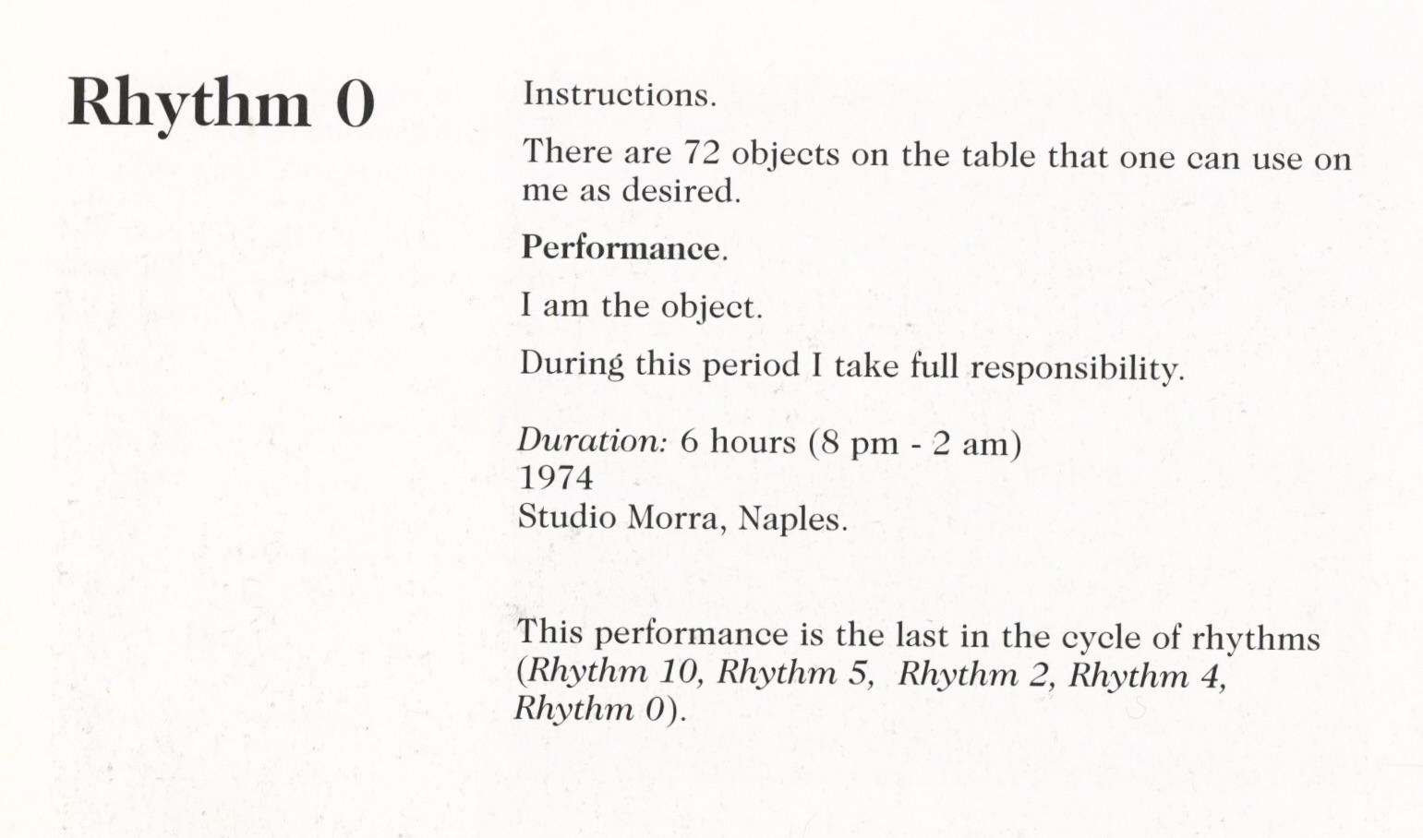
Figure 1 Marina Abramović, Rhythm 0, instructions by the artist placed on the wall of Studio Morra, Naples, 1974
© Marina Abramović

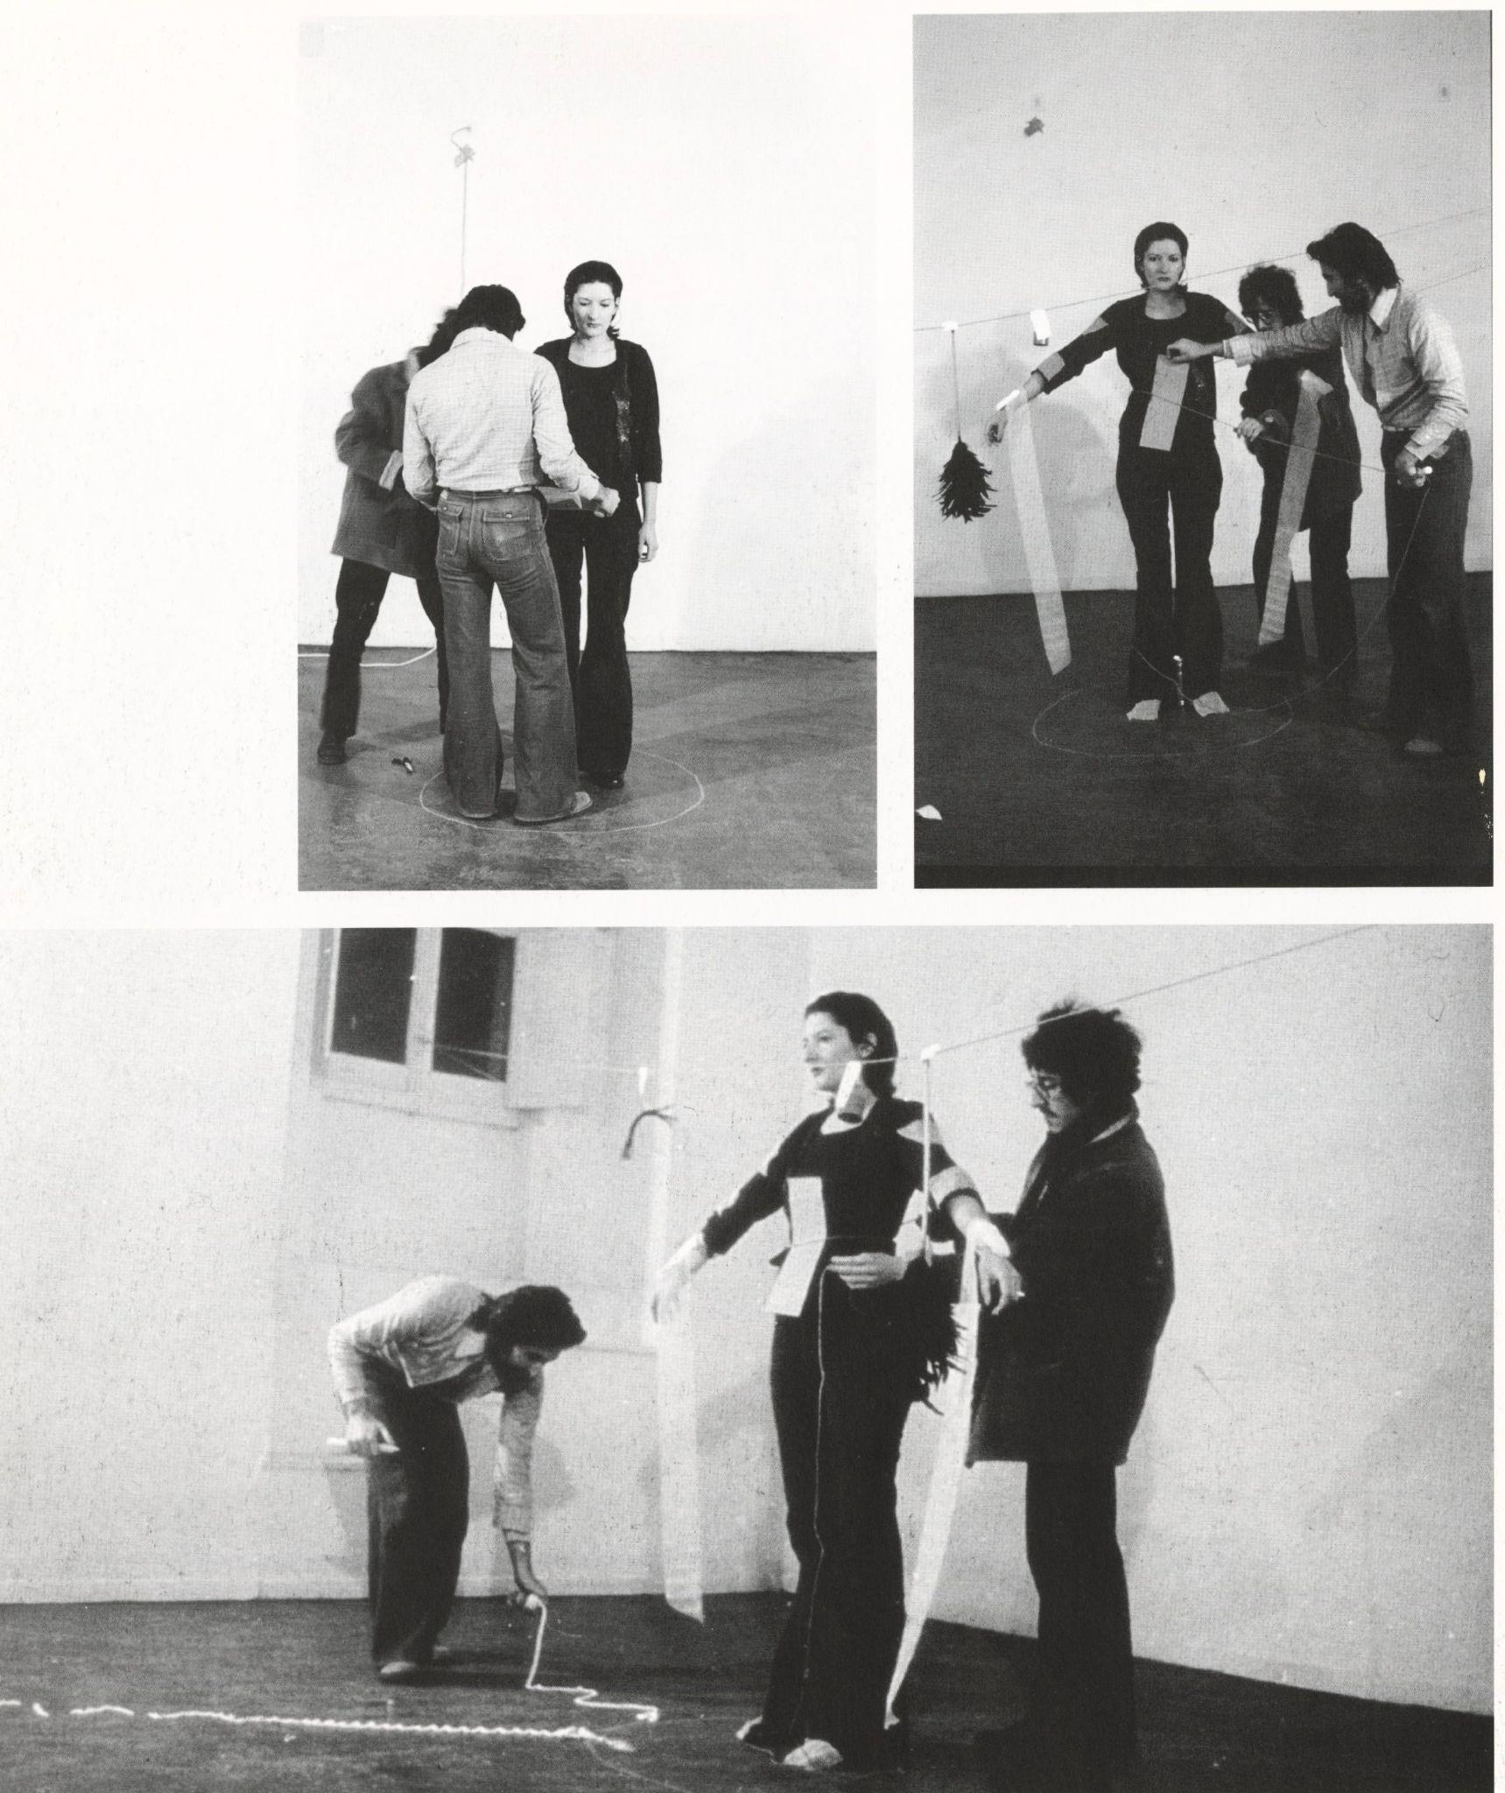
Figure 2 Marina Abramović, Rhythm 0, 1974, performance photograph, Studio Morra, Naples
© Marina Abramović

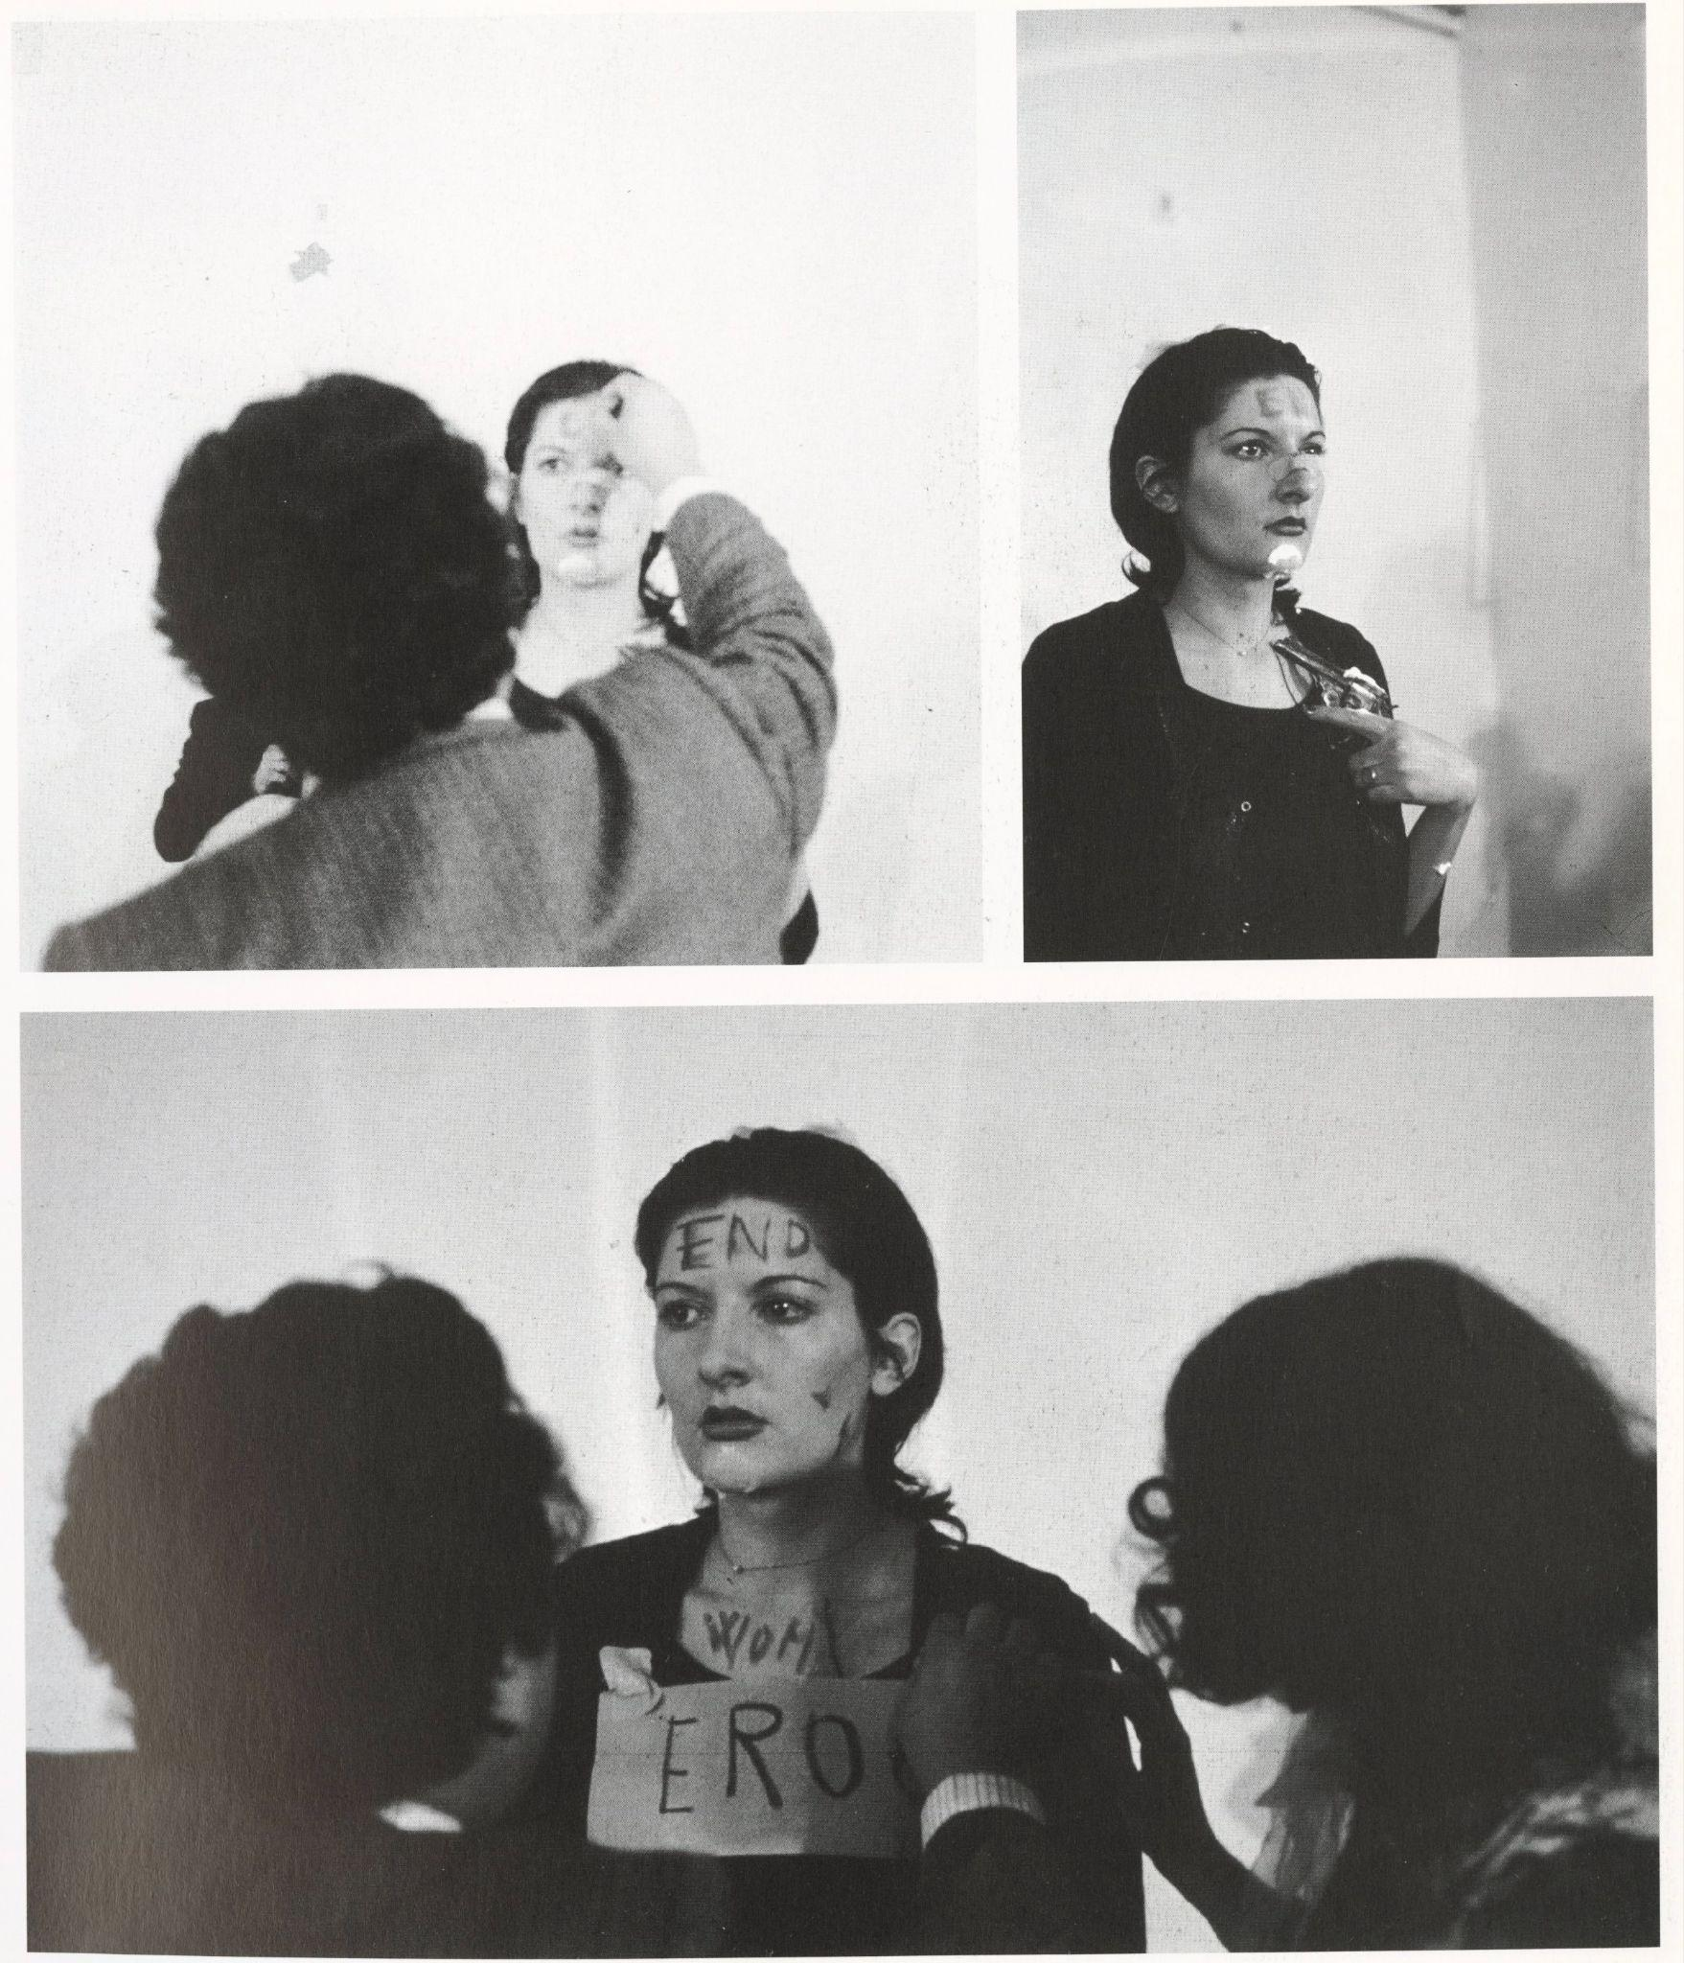
Figure 3 Marina Abramović, Rhythm 0, 1974, performance photograph, Studio Morra, Naples
© Marina Abramović

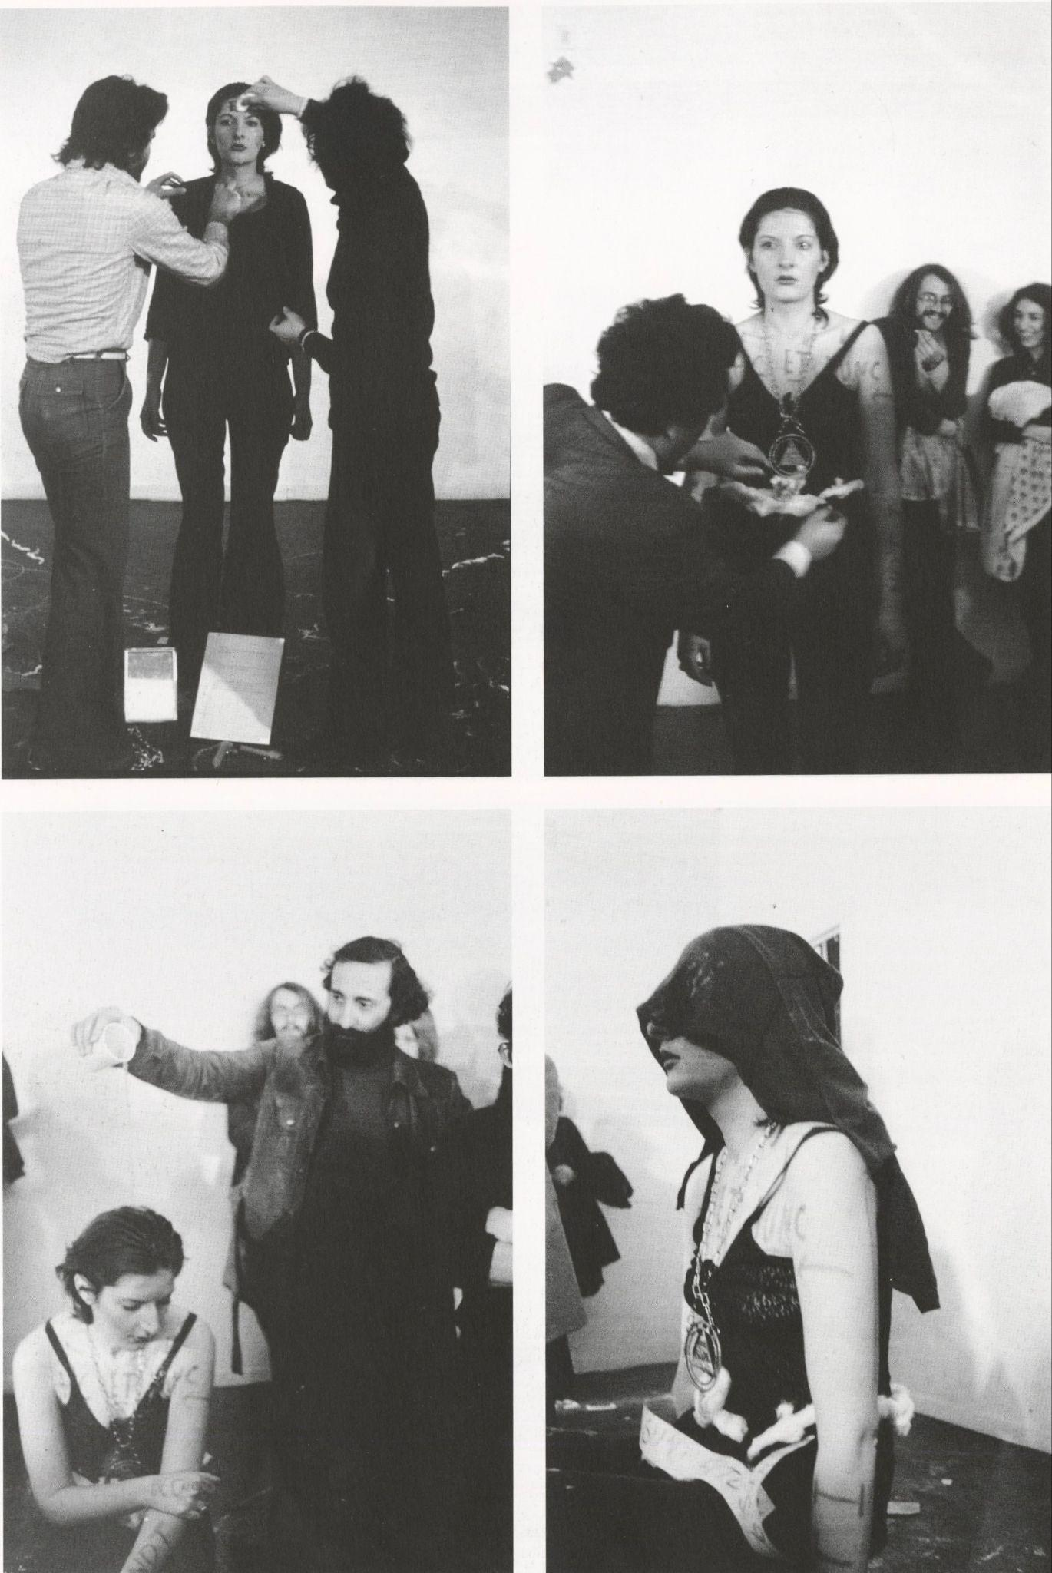
Figure 4 Marina Abramović, Rhythm 0, 1974, performance photograph, Studio Morra, Naples
© Marina Abramović
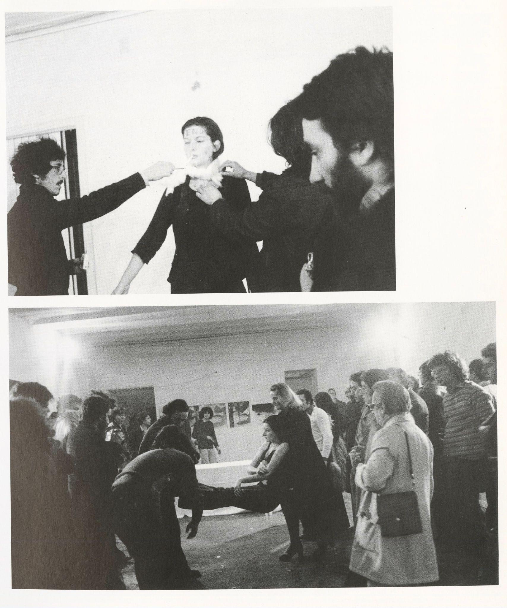
Figure 5 Marina Abramović, Rhythm 0, 1974, performance photograph, Studio Morra, Naples
© Marina Abramović
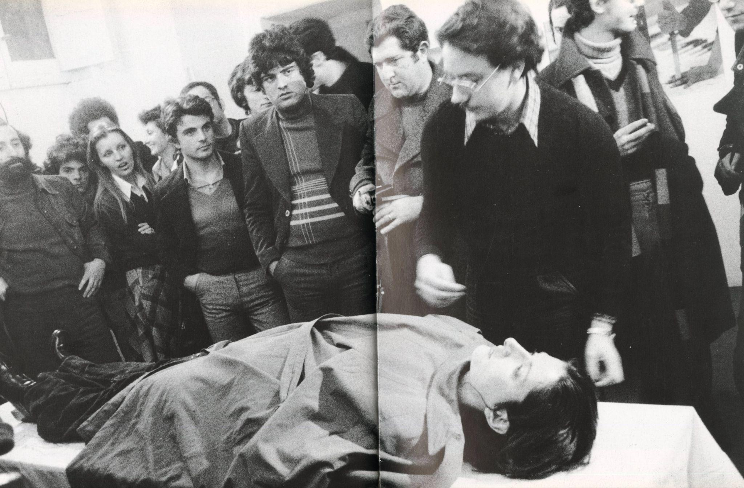
Figure 6 Marina Abramović, Rhythm 0, 1974, performance photograph, Studio Morra, Naples
© Marina Abramović

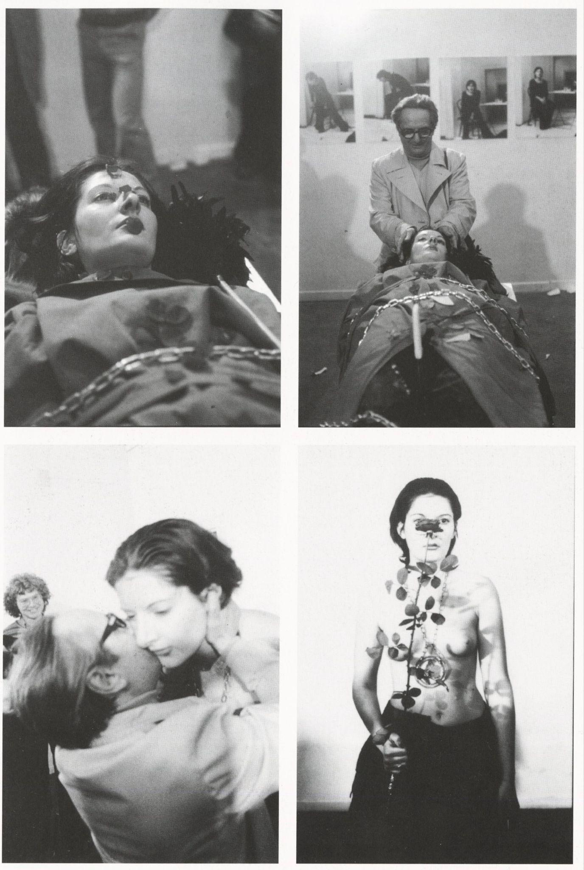
Figure 7 Marina Abramović, Rhythm 0, 1974, performance photograph, Studio Morra, Naples
© Marina Abramović
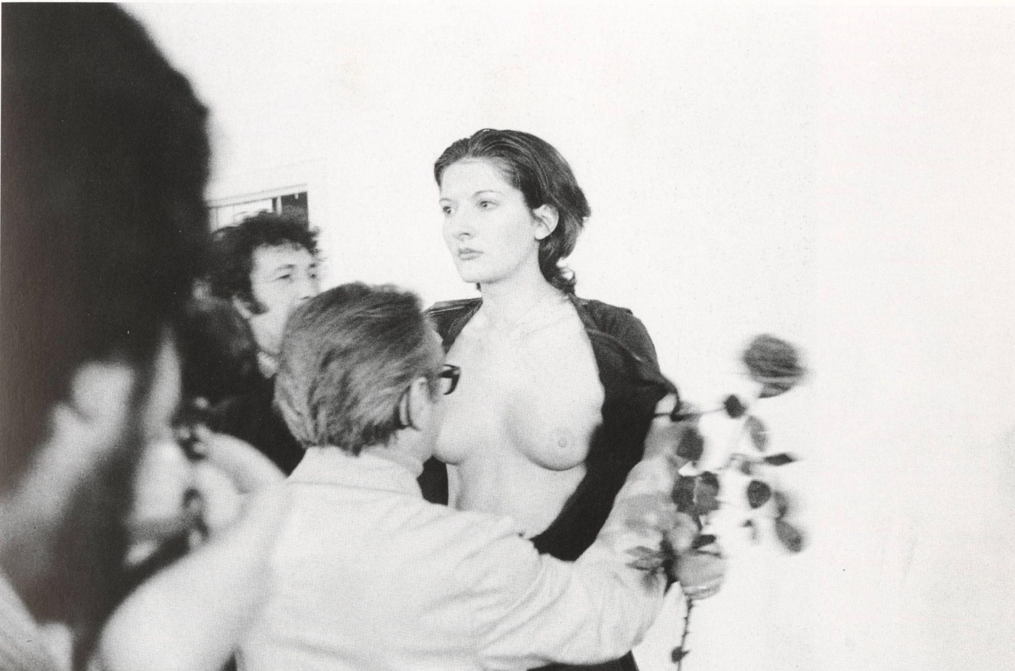
Figure 8 Marina Abramović, Rhythm 0, 1974, performance photograph, Studio Morra, Naples
© Marina Abramović
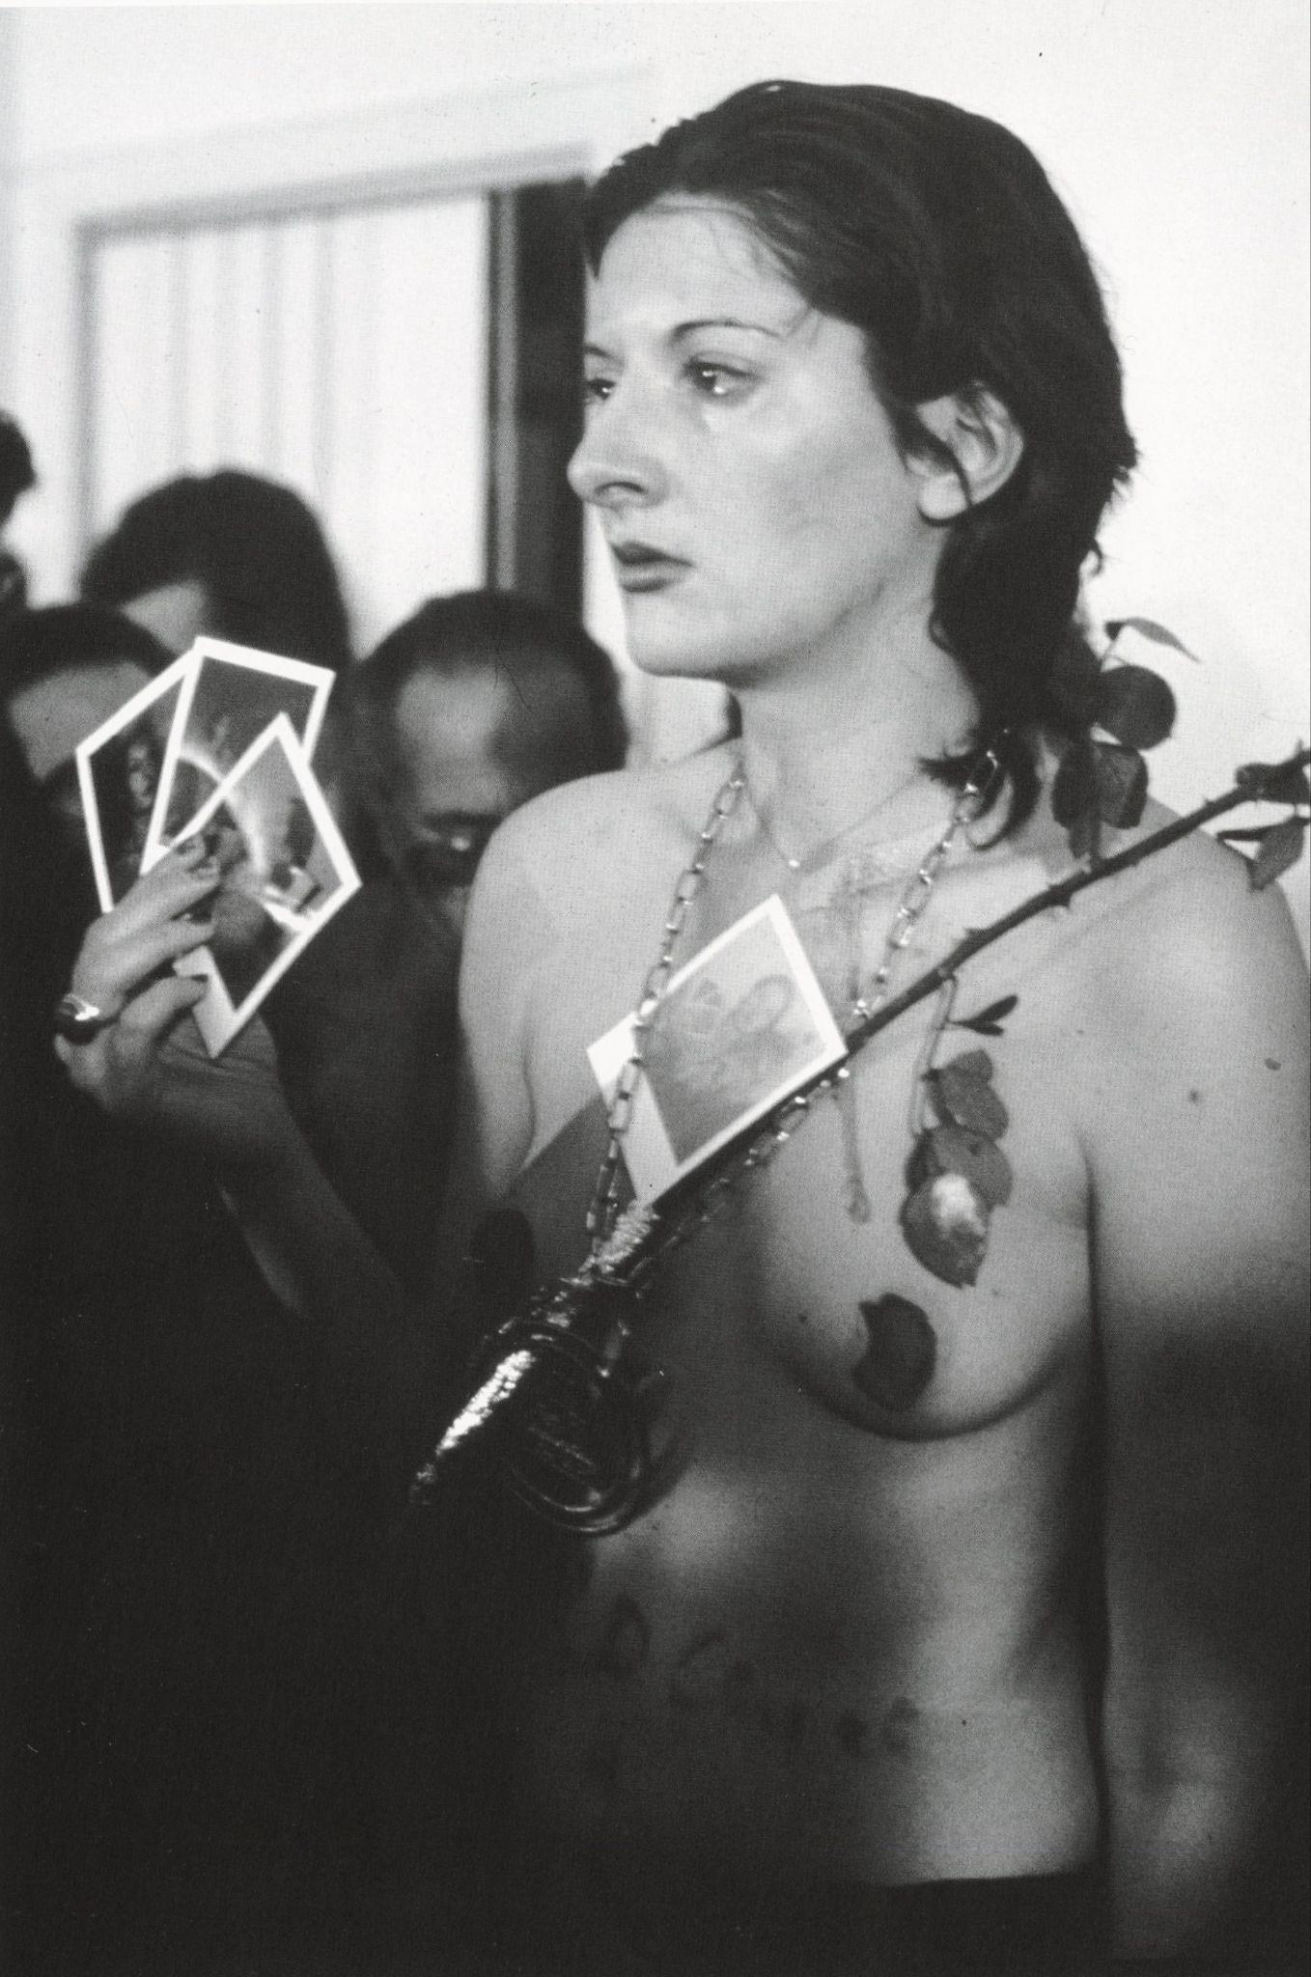
Figure 9 Marina Abramović, Rhythm 0, 1974, performance photograph, Studio Morra, Naples
© Marina Abramović
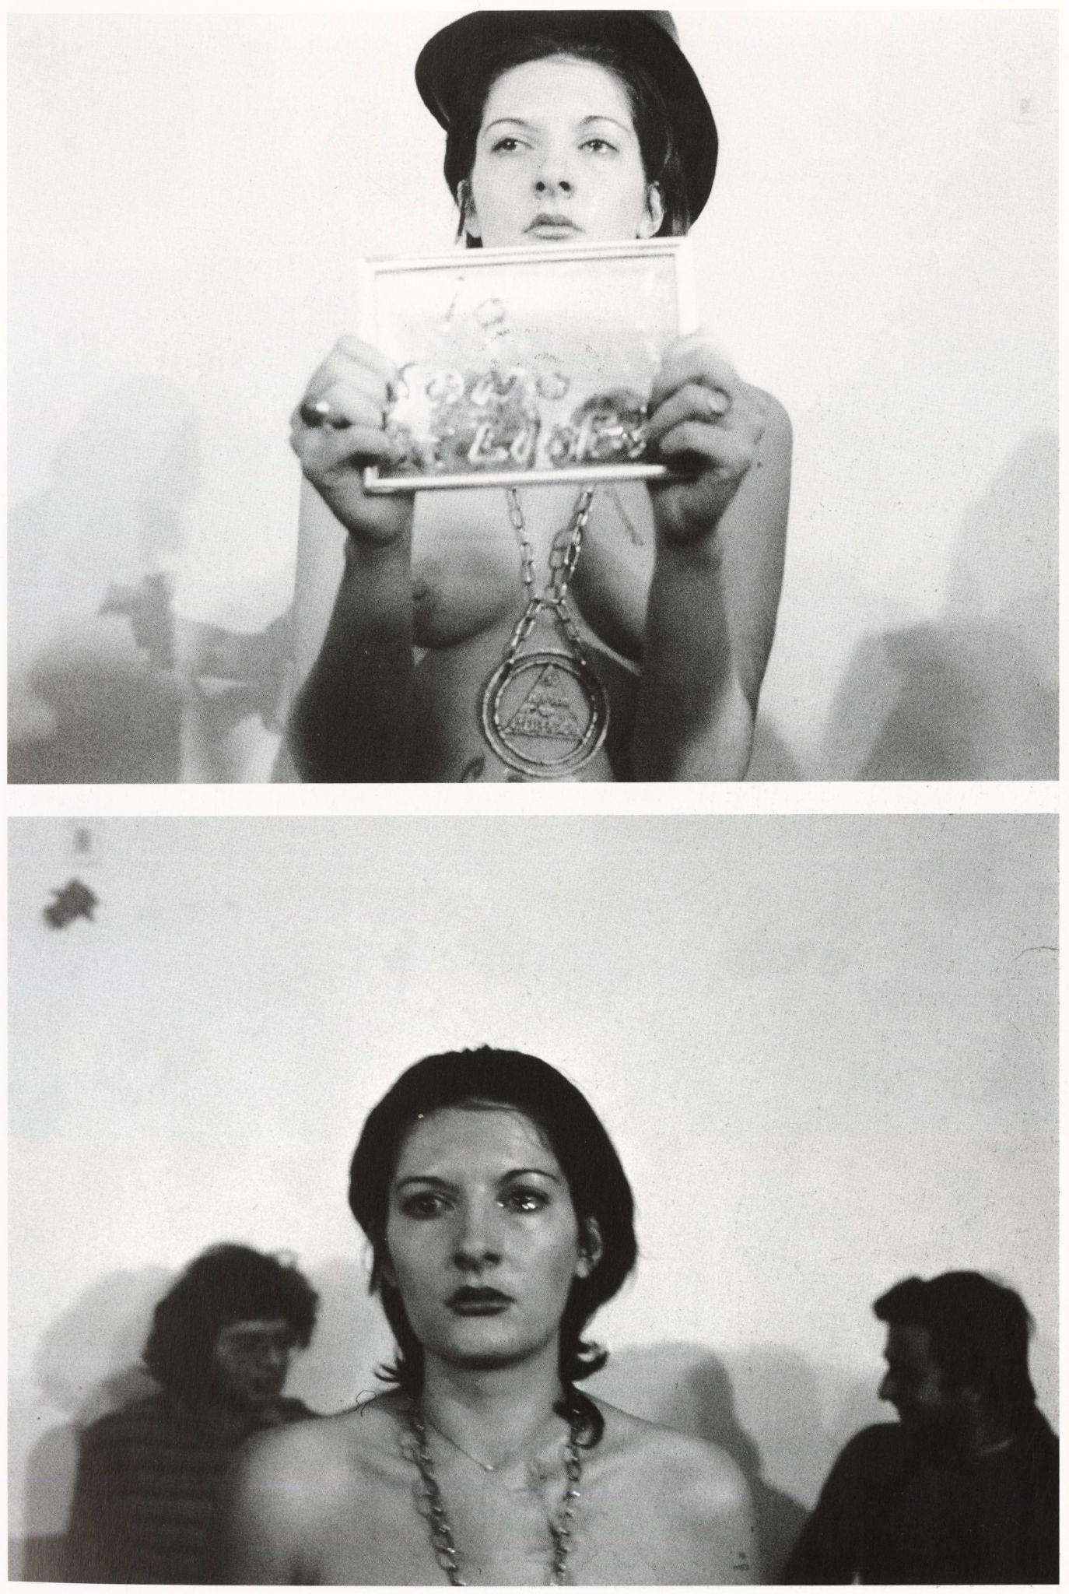
Figure 10 Marina Abramović, Rhythm 0, 1974, performance photograph, Studio Morra, Naples
© Marina Abramović
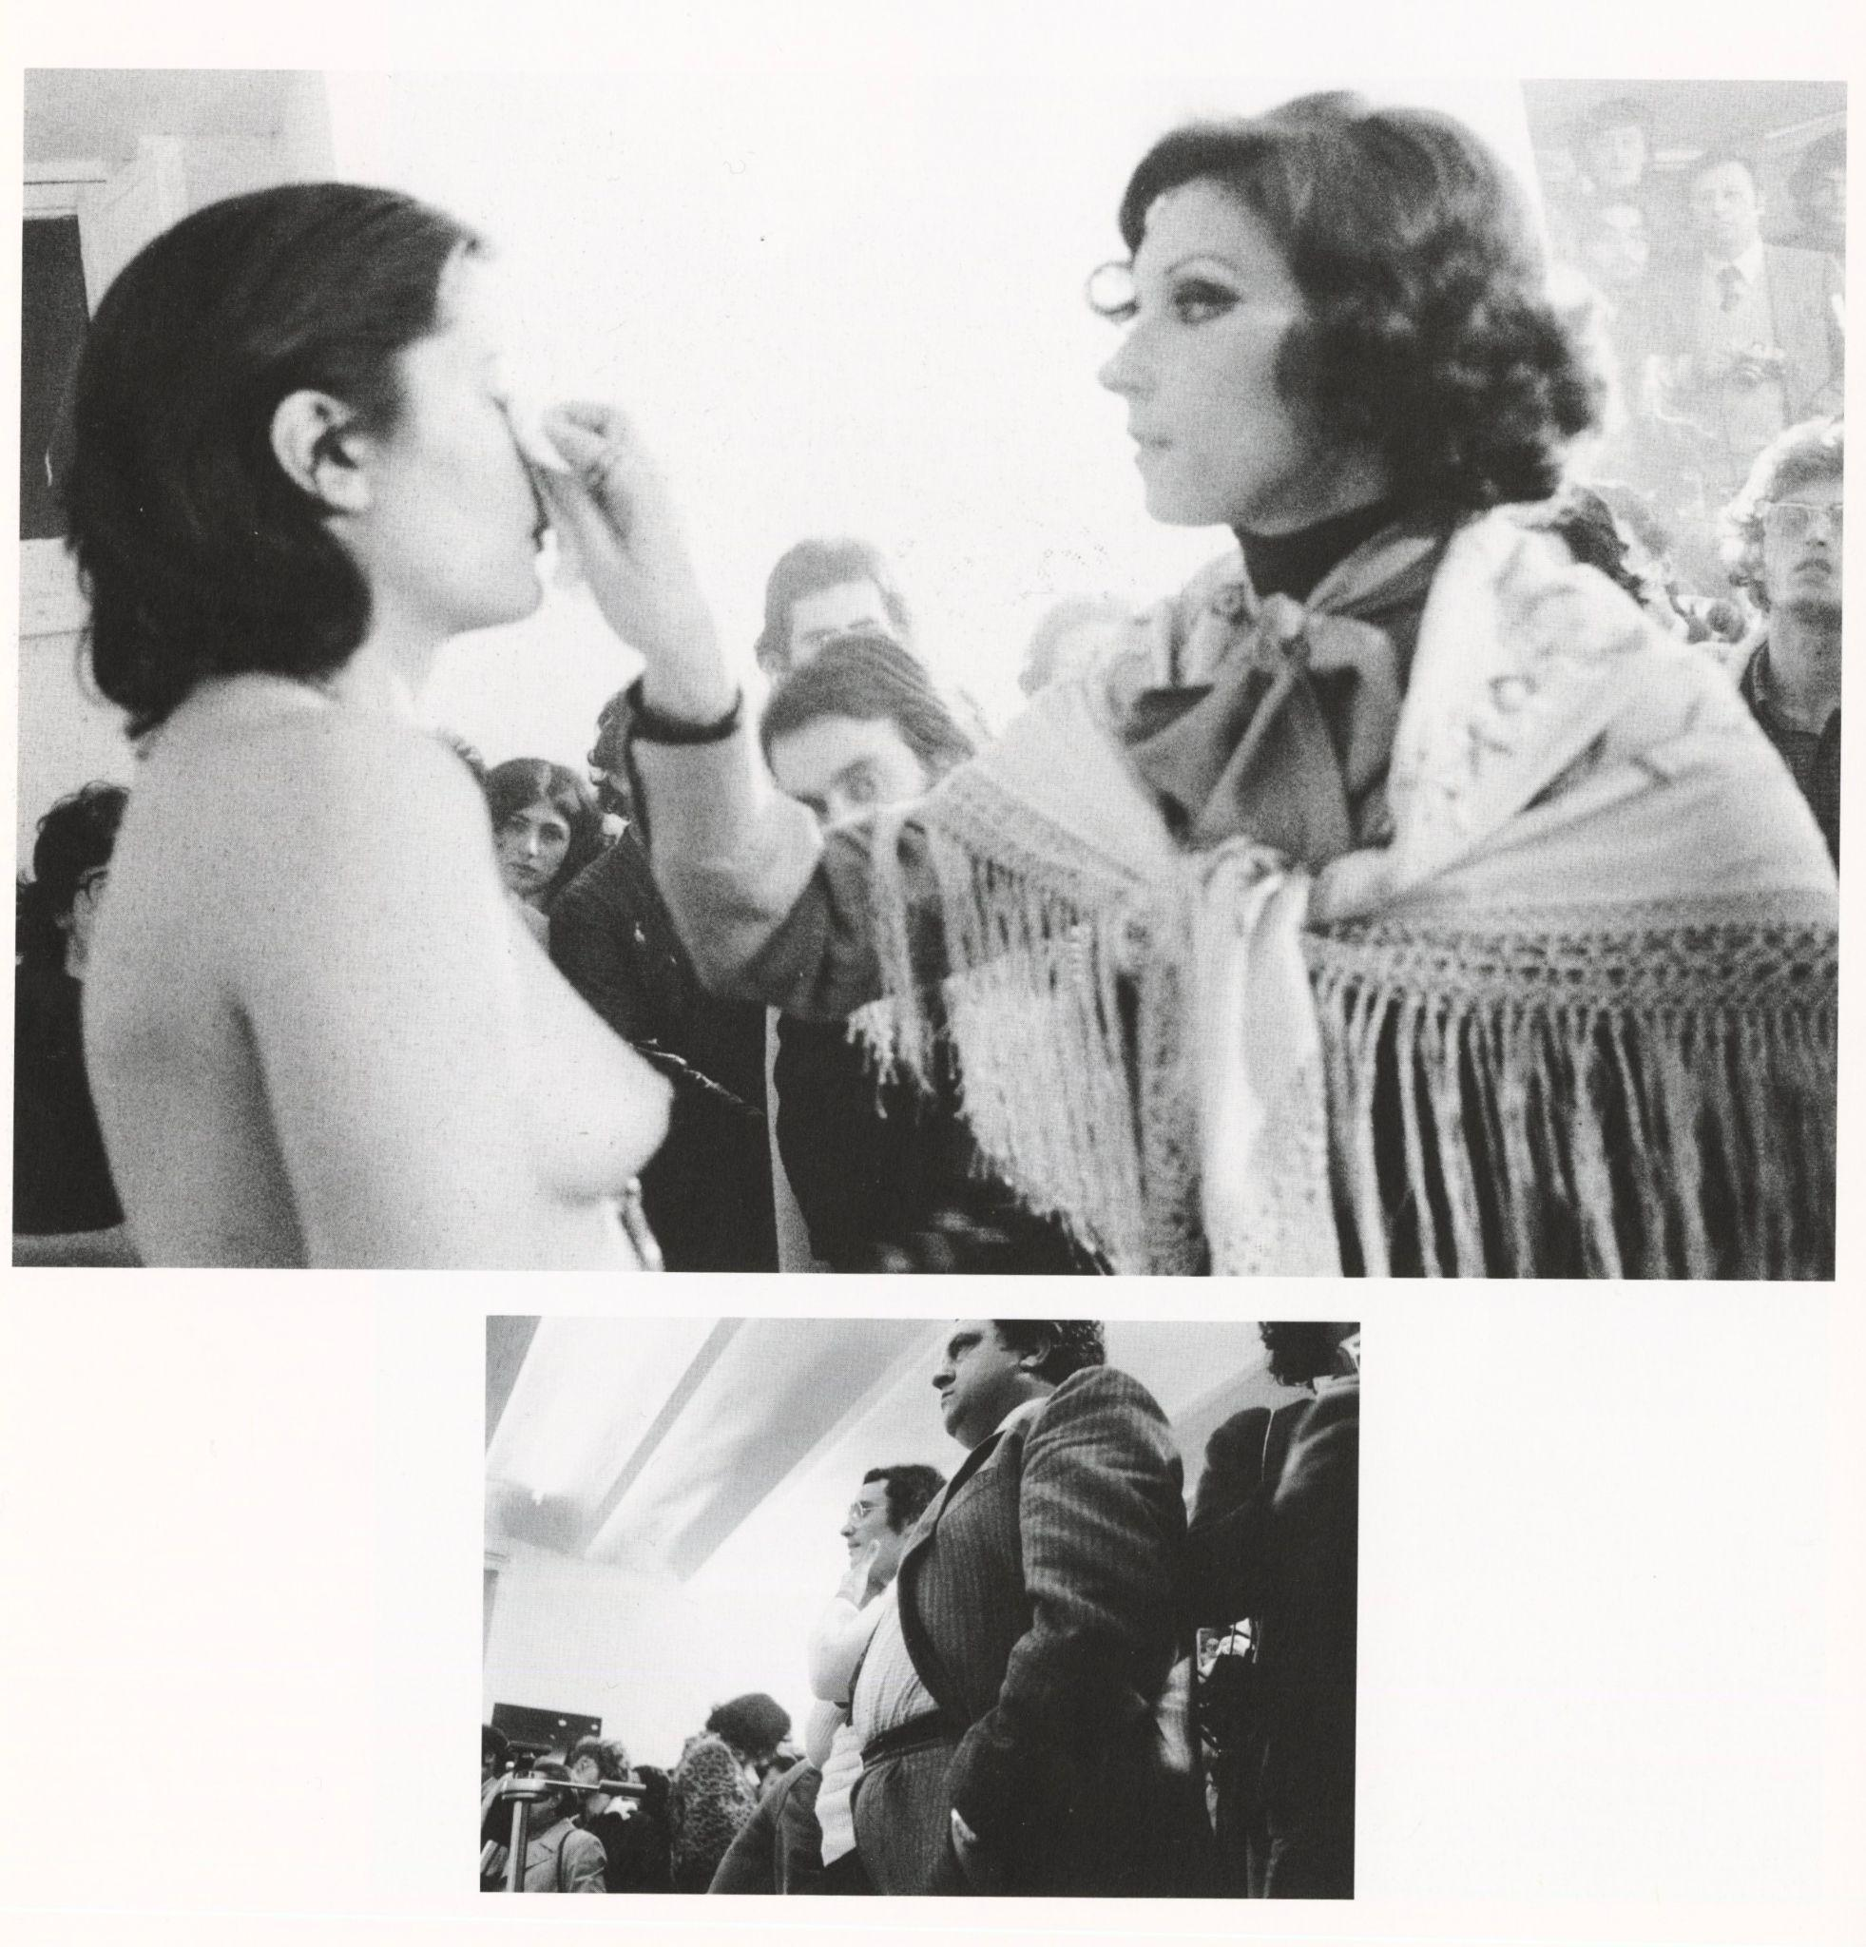
Figure 11 Marina Abramović, Rhythm 0, 1974, performance photograph, Studio Morra, Naples
© Marina Abramović
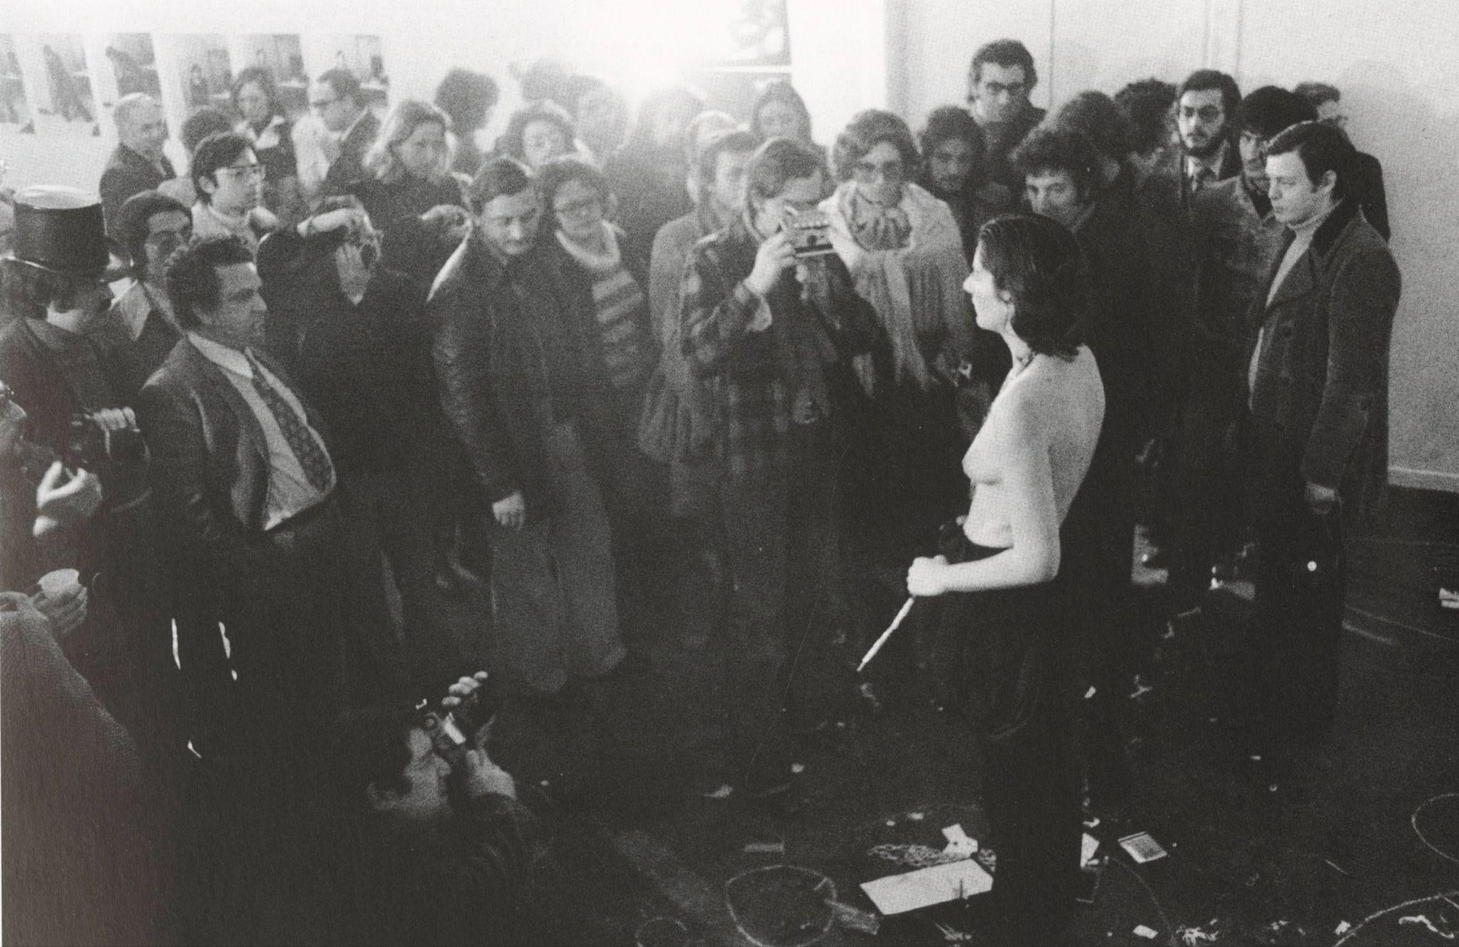
Figure 12 Marina Abramović, Rhythm 0, 1974, performance photograph, Studio Morra, Naples
© Marina Abramović
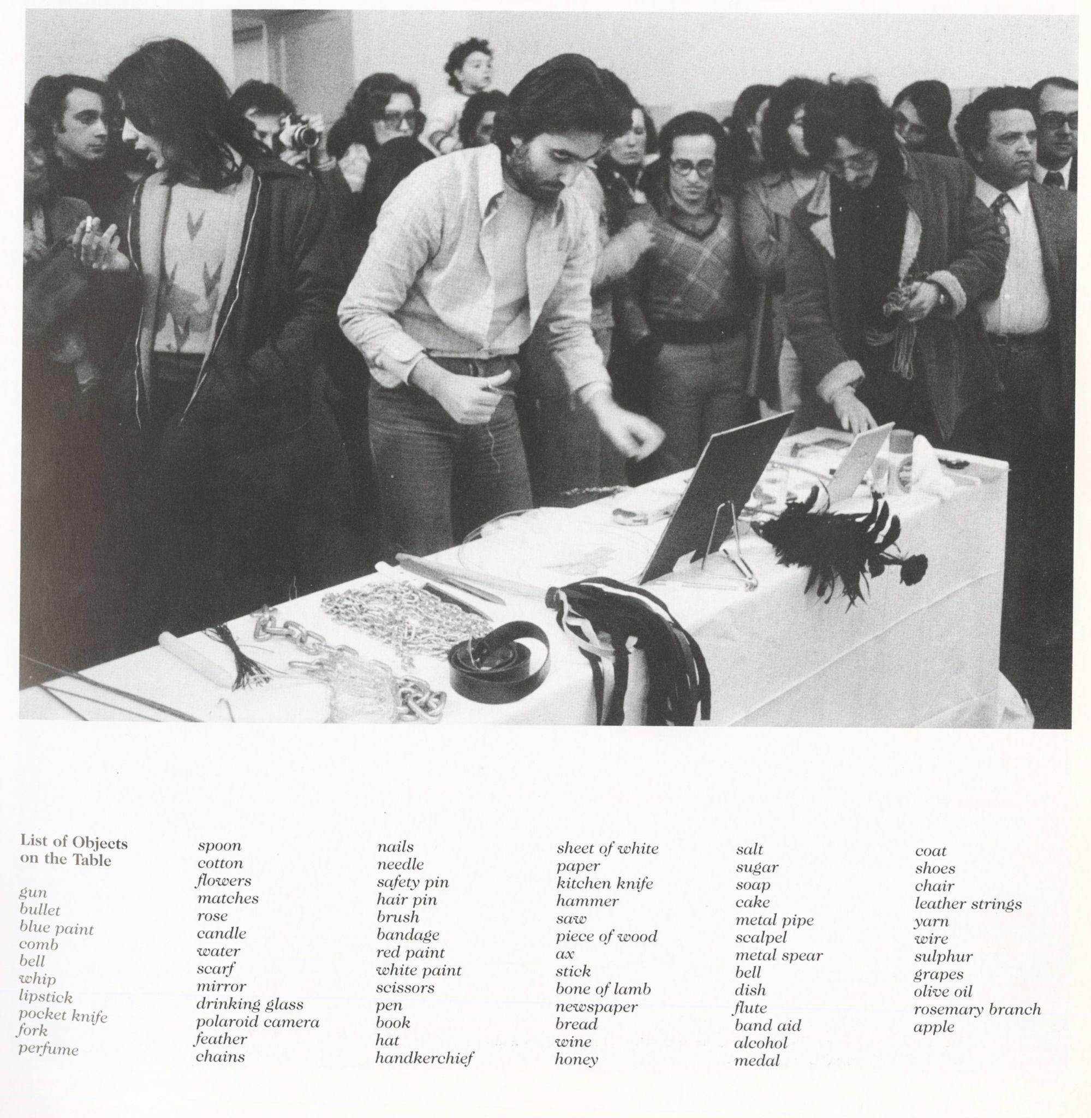
Figure 13 Marina Abramović, Rhythm 0, 1974, performance photograph, Studio Morra, Naples
© Marina Abramović
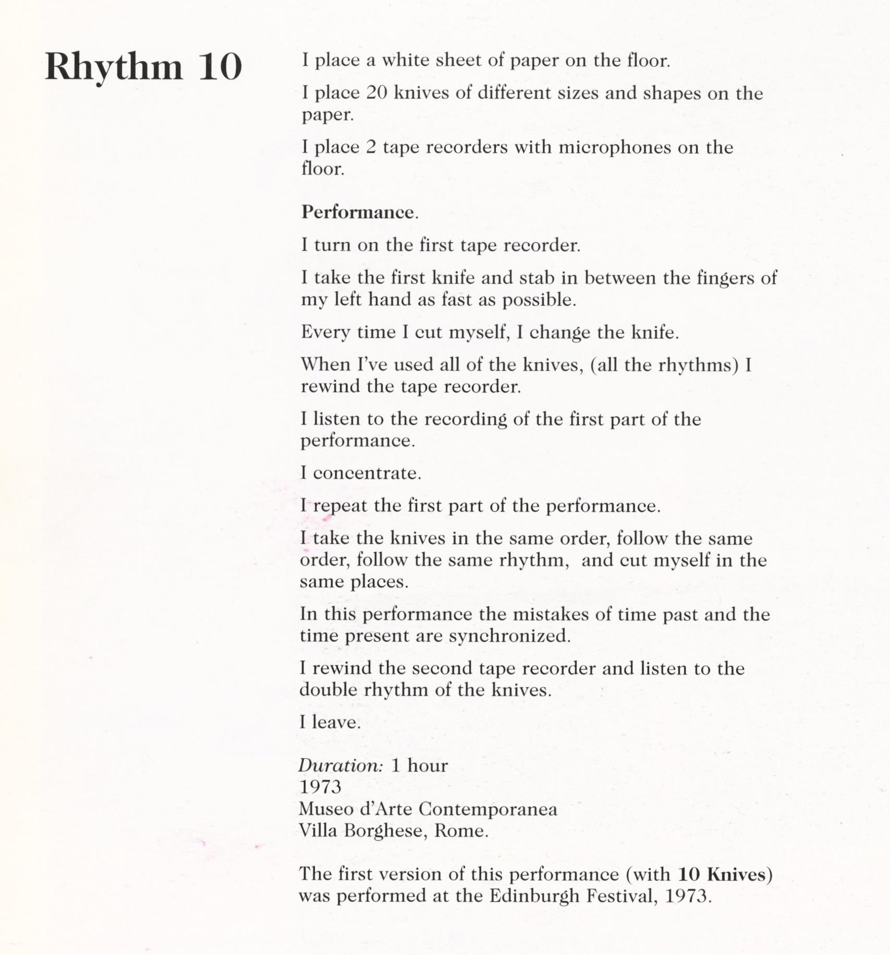
Figure 14 Marina Abramović, Rhythm 10, 1973, performance photograph
© Marina Abramović
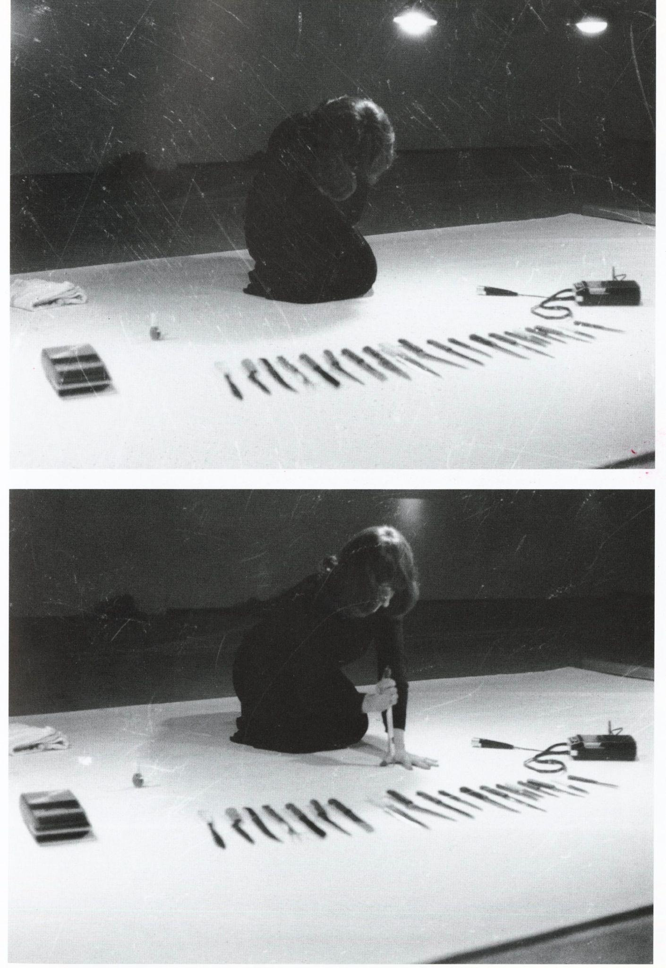
Figure 15 Marina Abramović, Rhythm 10, 1973, performance photograph
© Marina Abramović
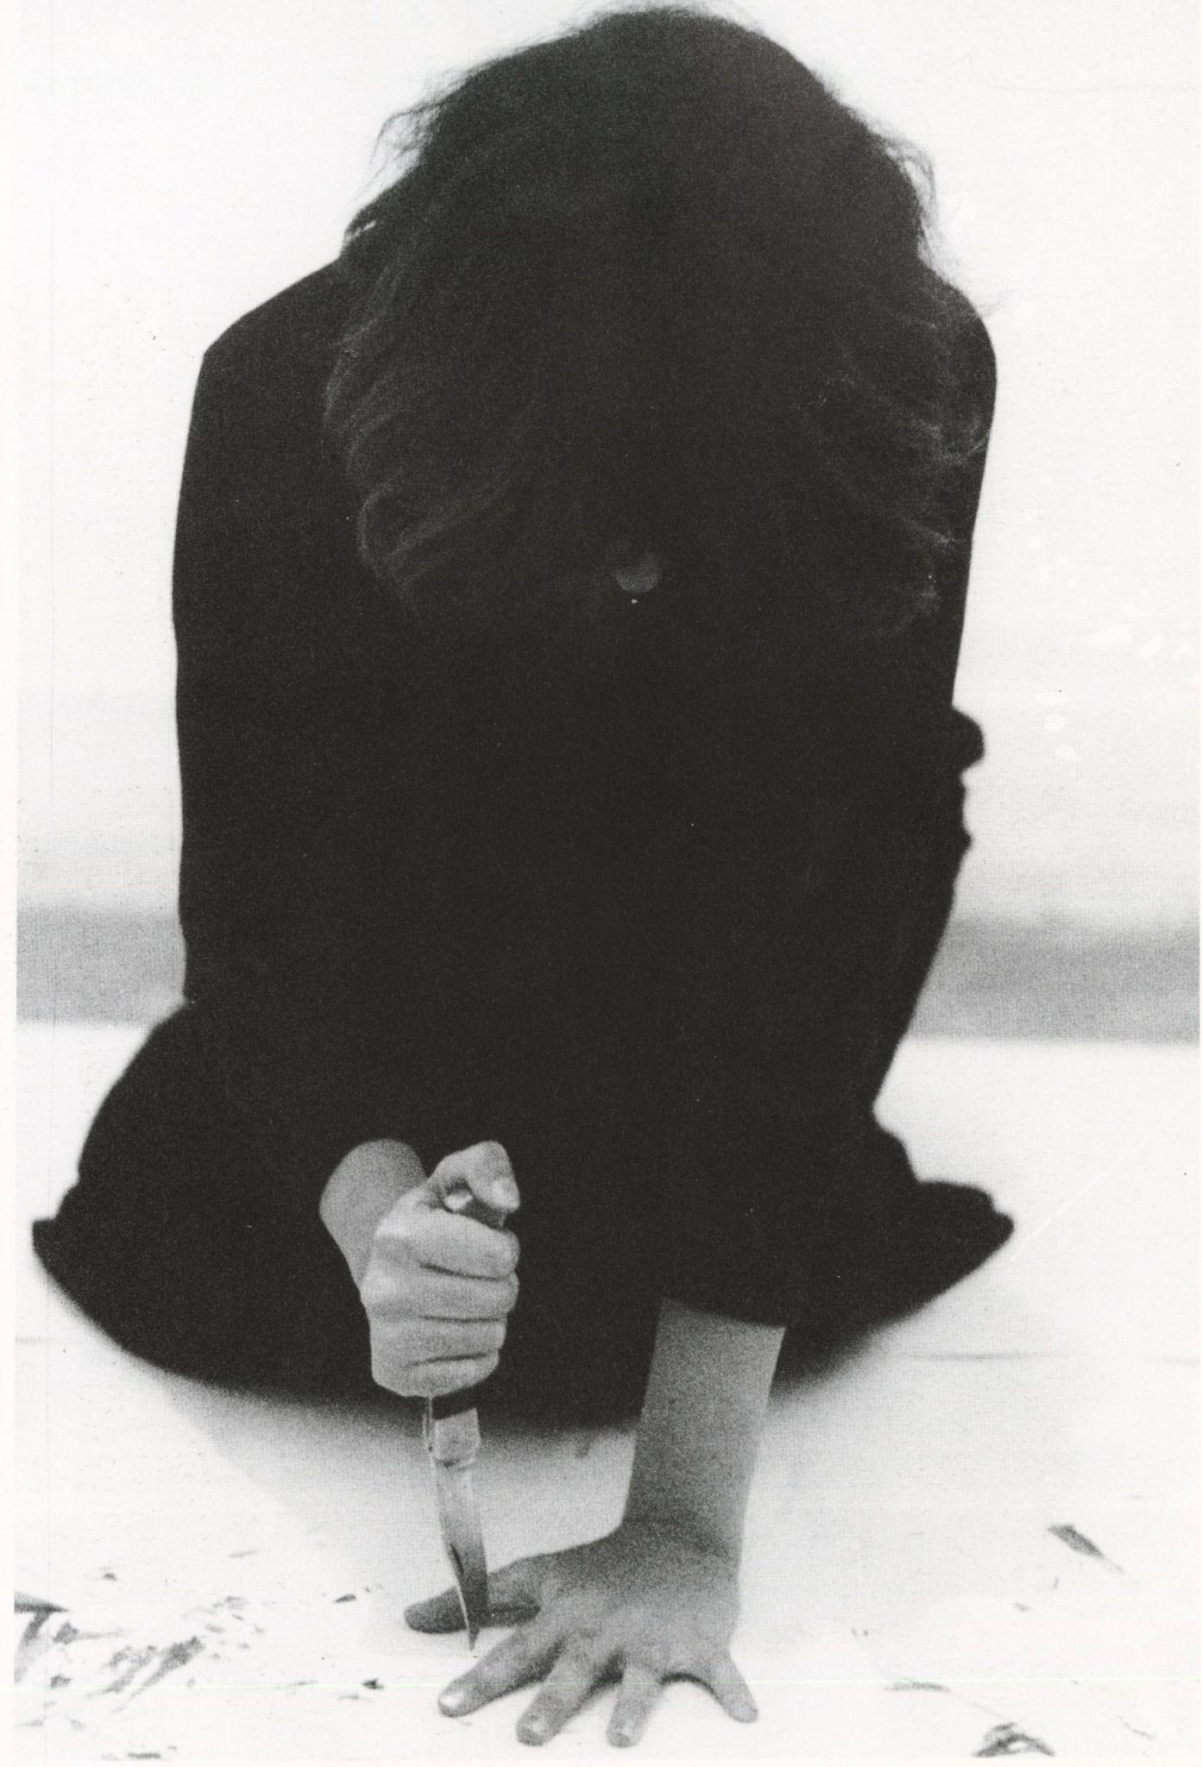
Figure 16 Marina Abramović, Rhythm 10, 1973, performance photograph
© Marina Abramović
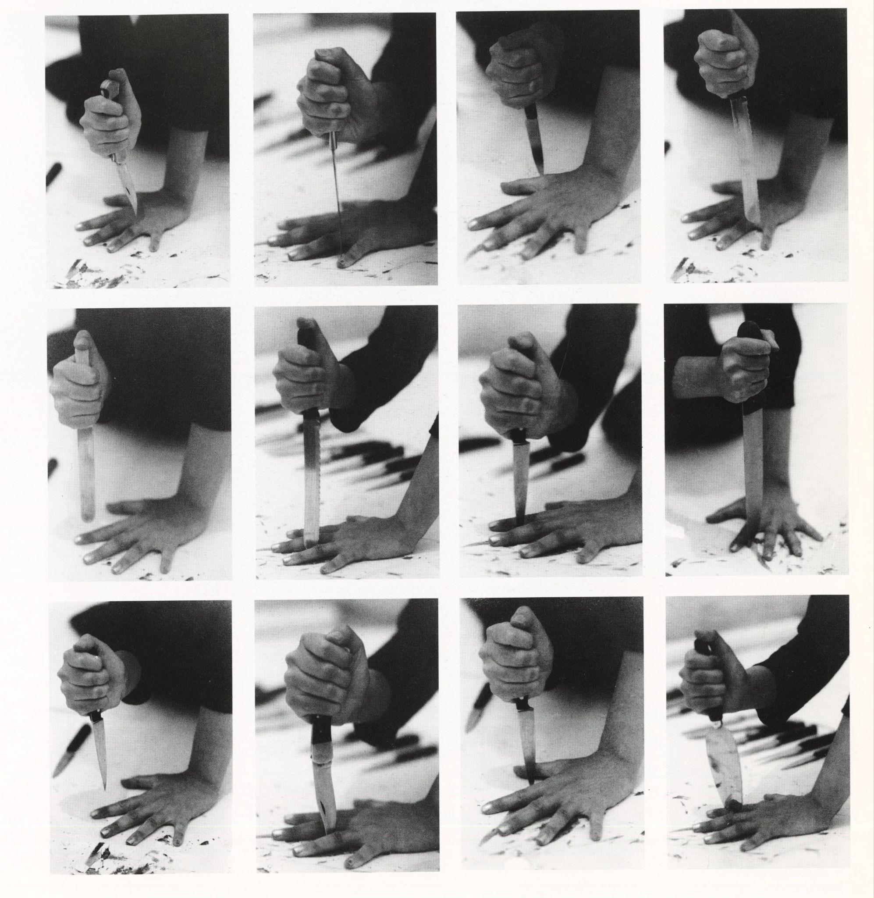
Figure 17 Marina Abramović, Rhythm 10, 1973, performance photograph
© Marina Abramović
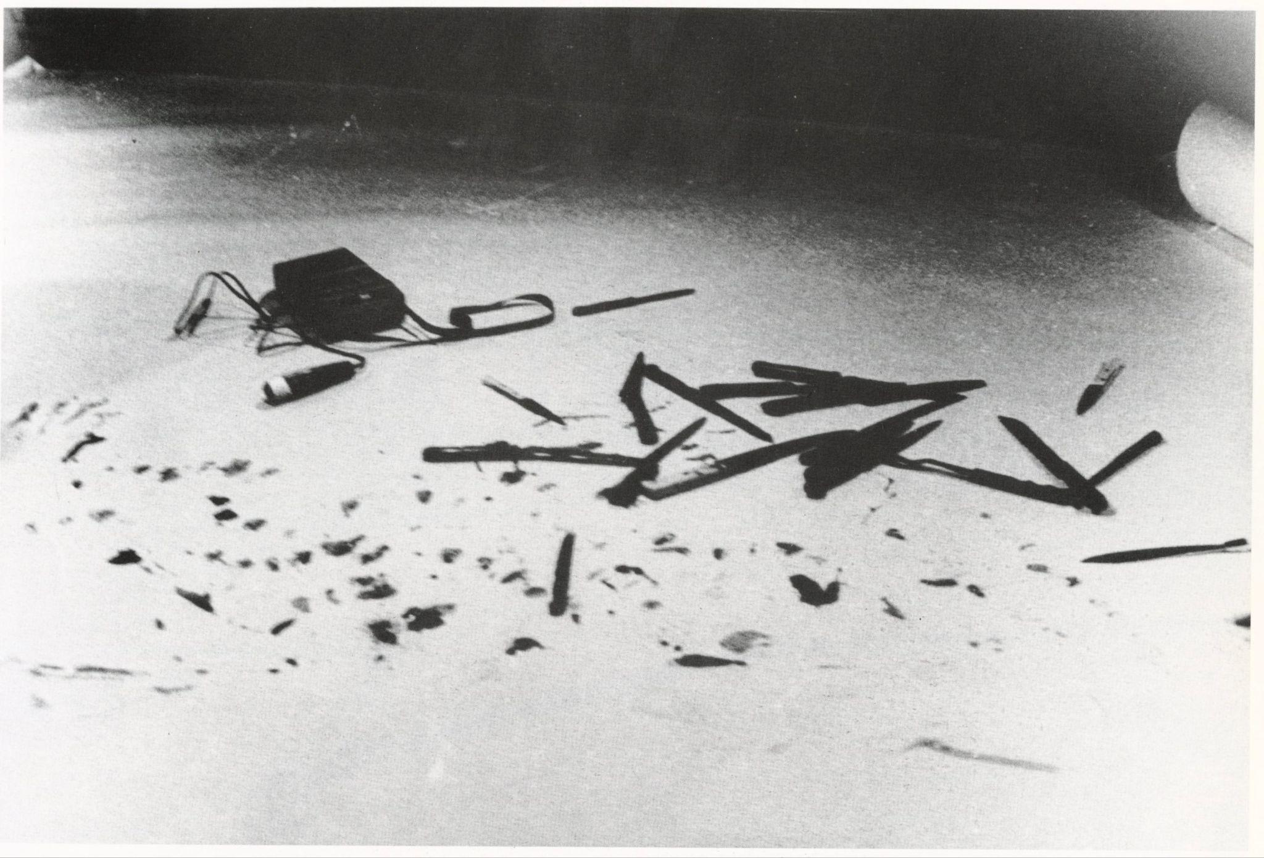
Figure 18 Marina Abramović, Rhythm 10, 1973, performance photograph
© Marina Abramović
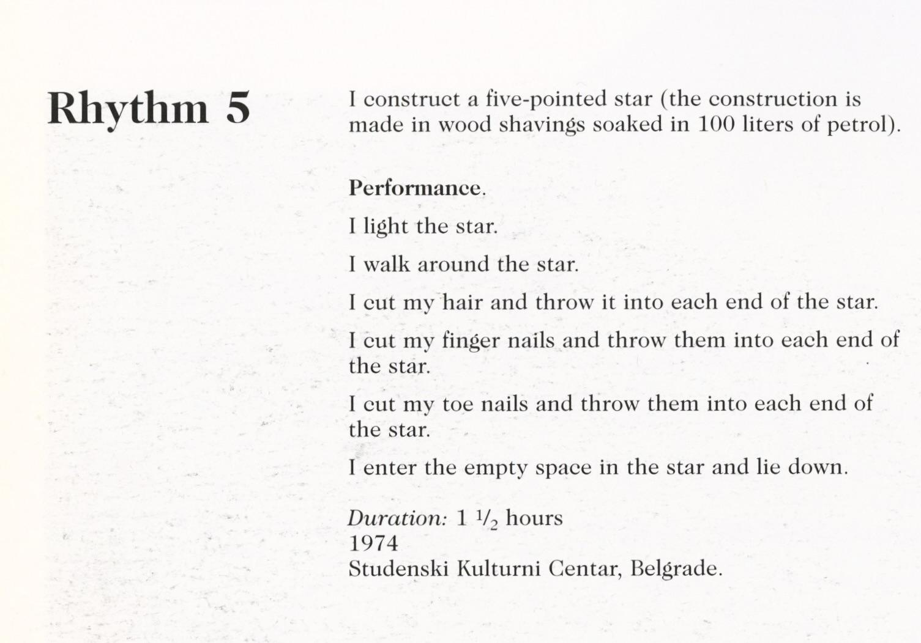
Figure 19 Marina Abramović, Rhythm 5, 1974, performance photograph
© Marina Abramović
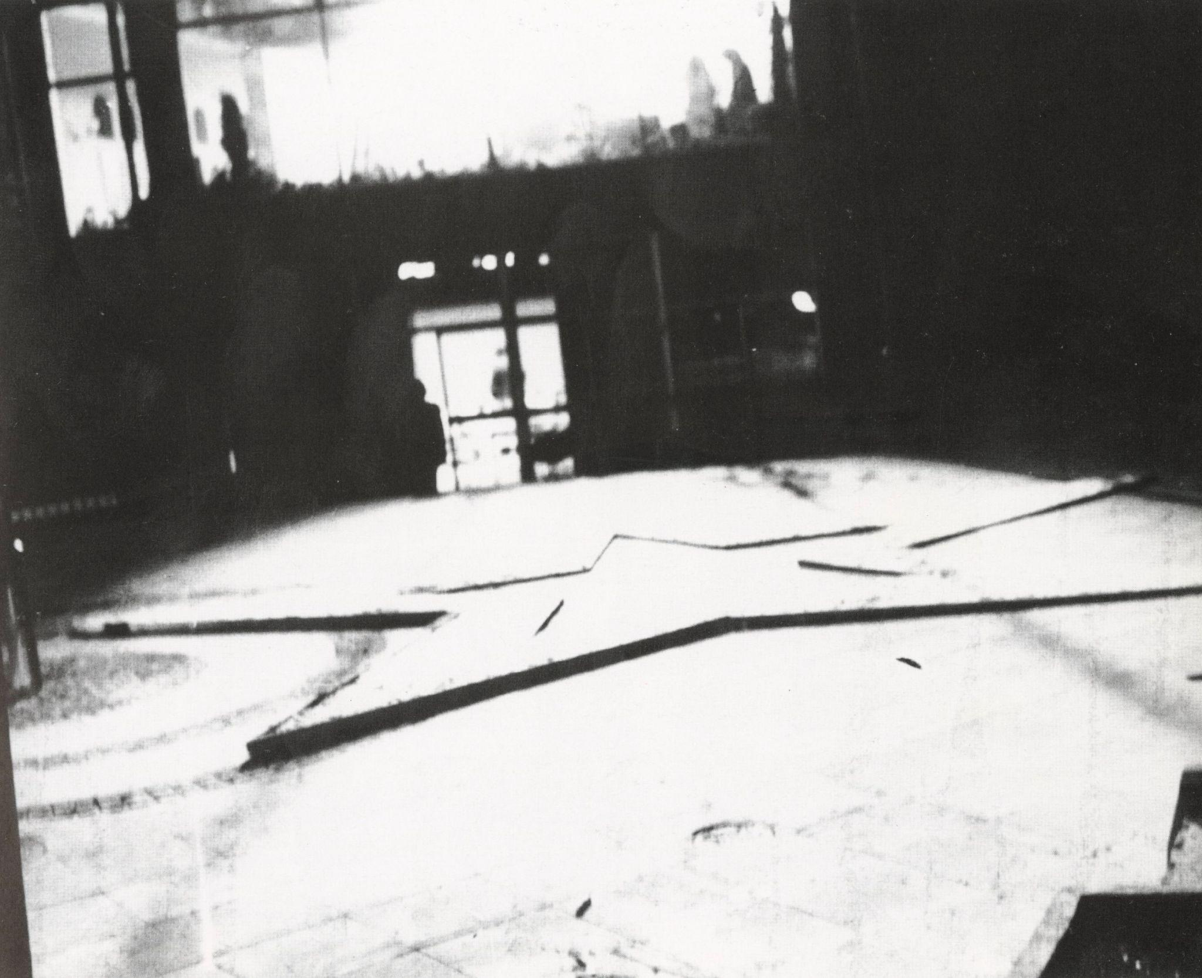
Figure 20 Marina Abramović, Rhythm 5, 1974, performance photograph
© Marina Abramović
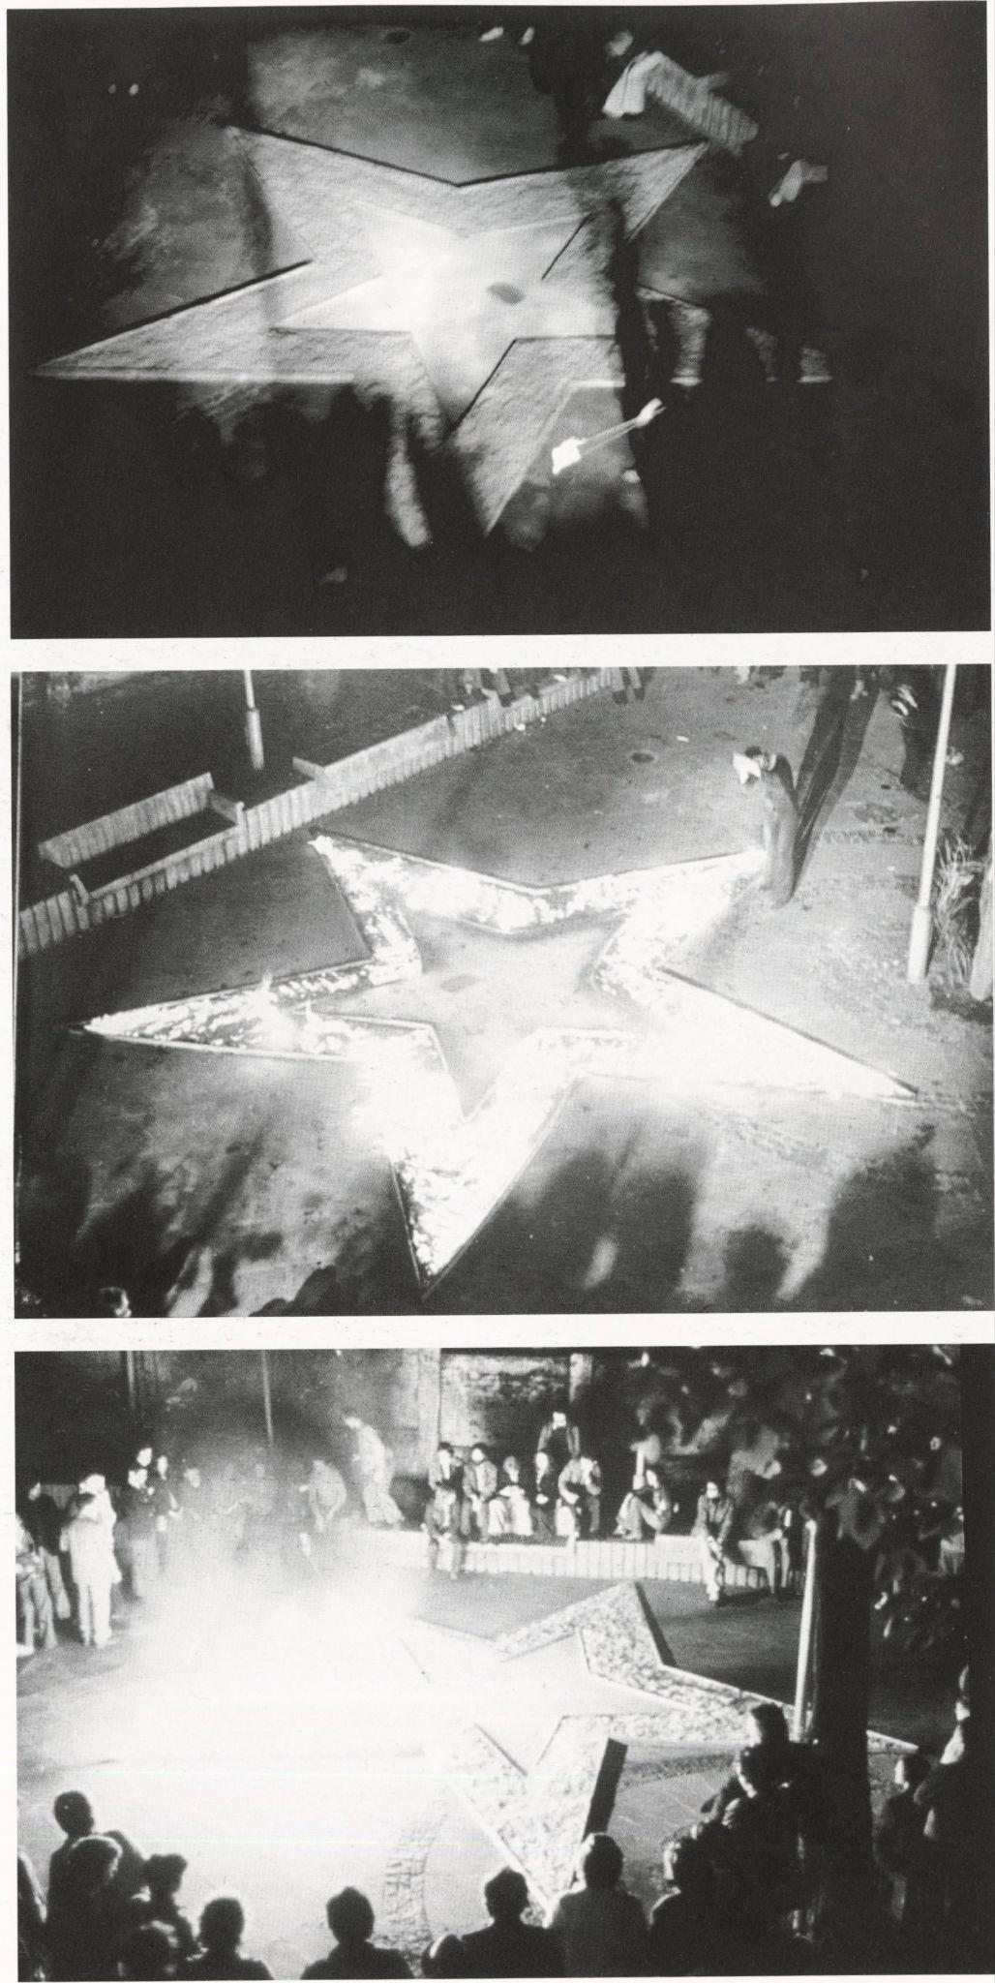
Figure 21 Marina Abramović, Rhythm 5, 1974, performance photograph
© Marina Abramović
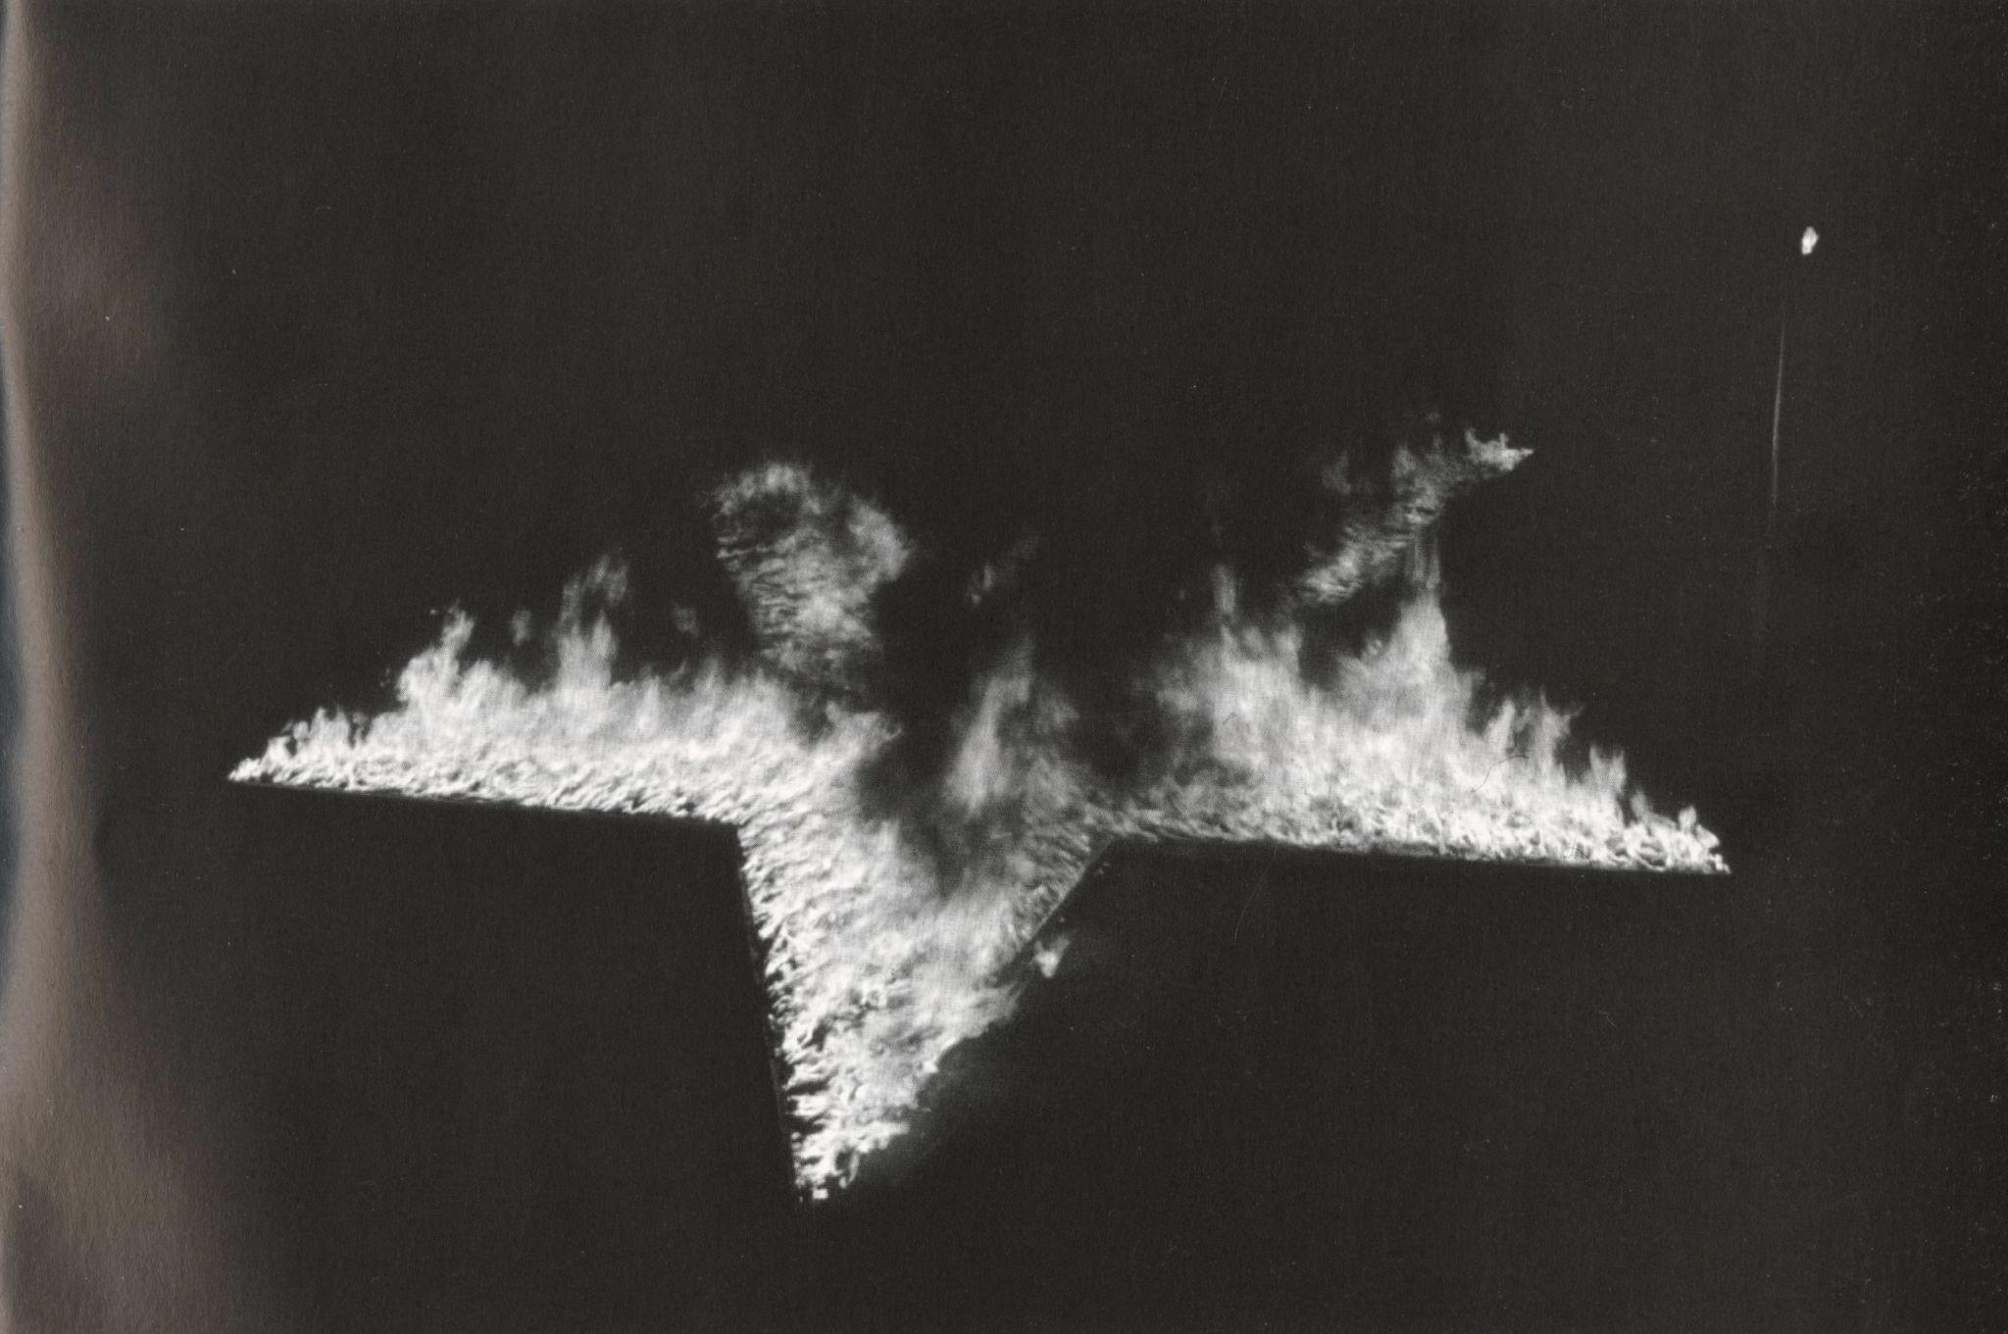
Figure 22 Marina Abramović, Rhythm 5, 1974, performance photograph
© Marina Abramović
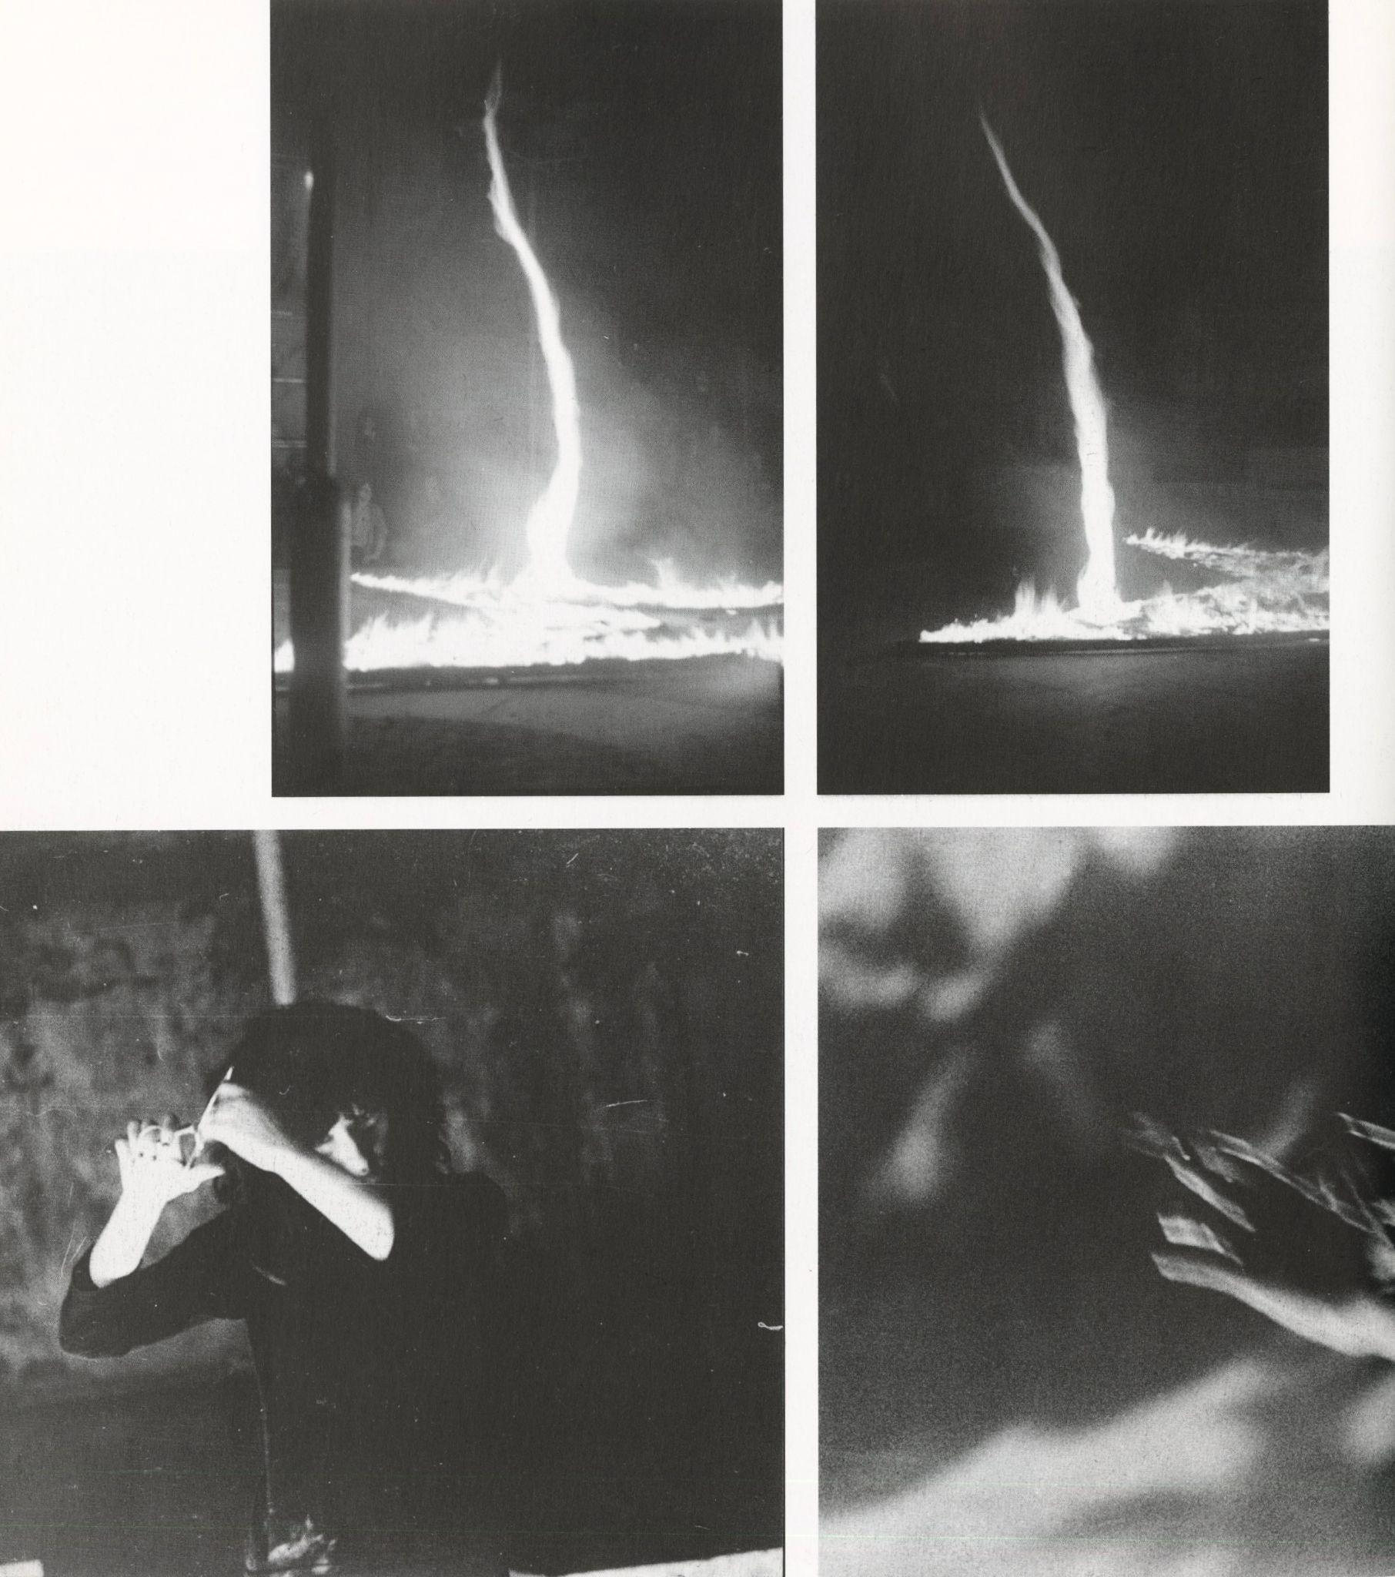
Figure 23 Marina Abramović, Rhythm 5, 1974, performance photograph
© Marina Abramović
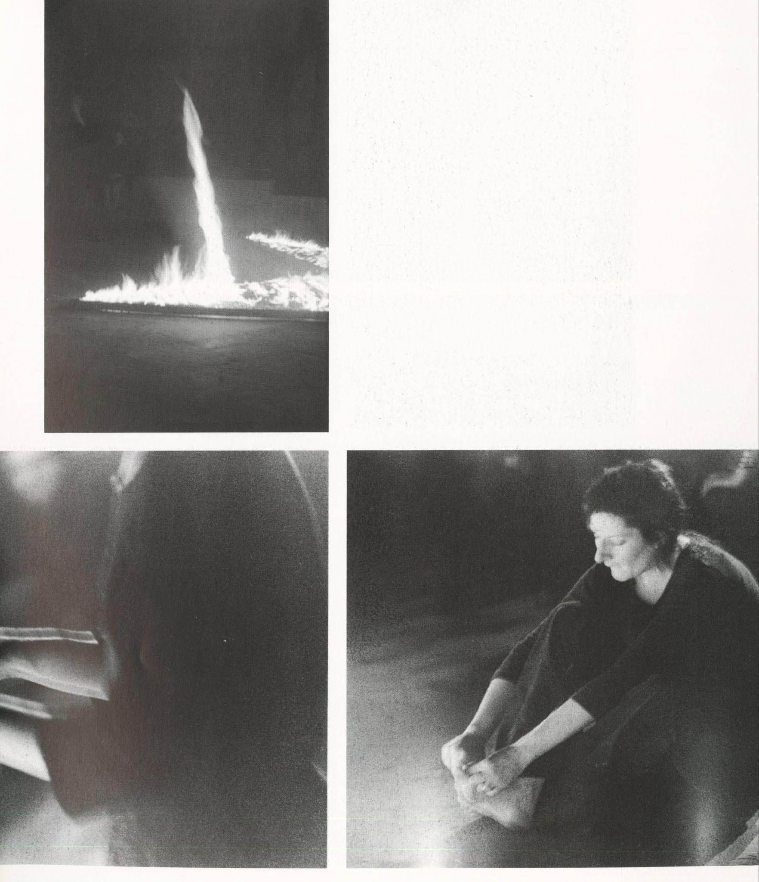
Figure 24 Marina Abramović, Rhythm 5, 1974, performance photograph
© Marina Abramović
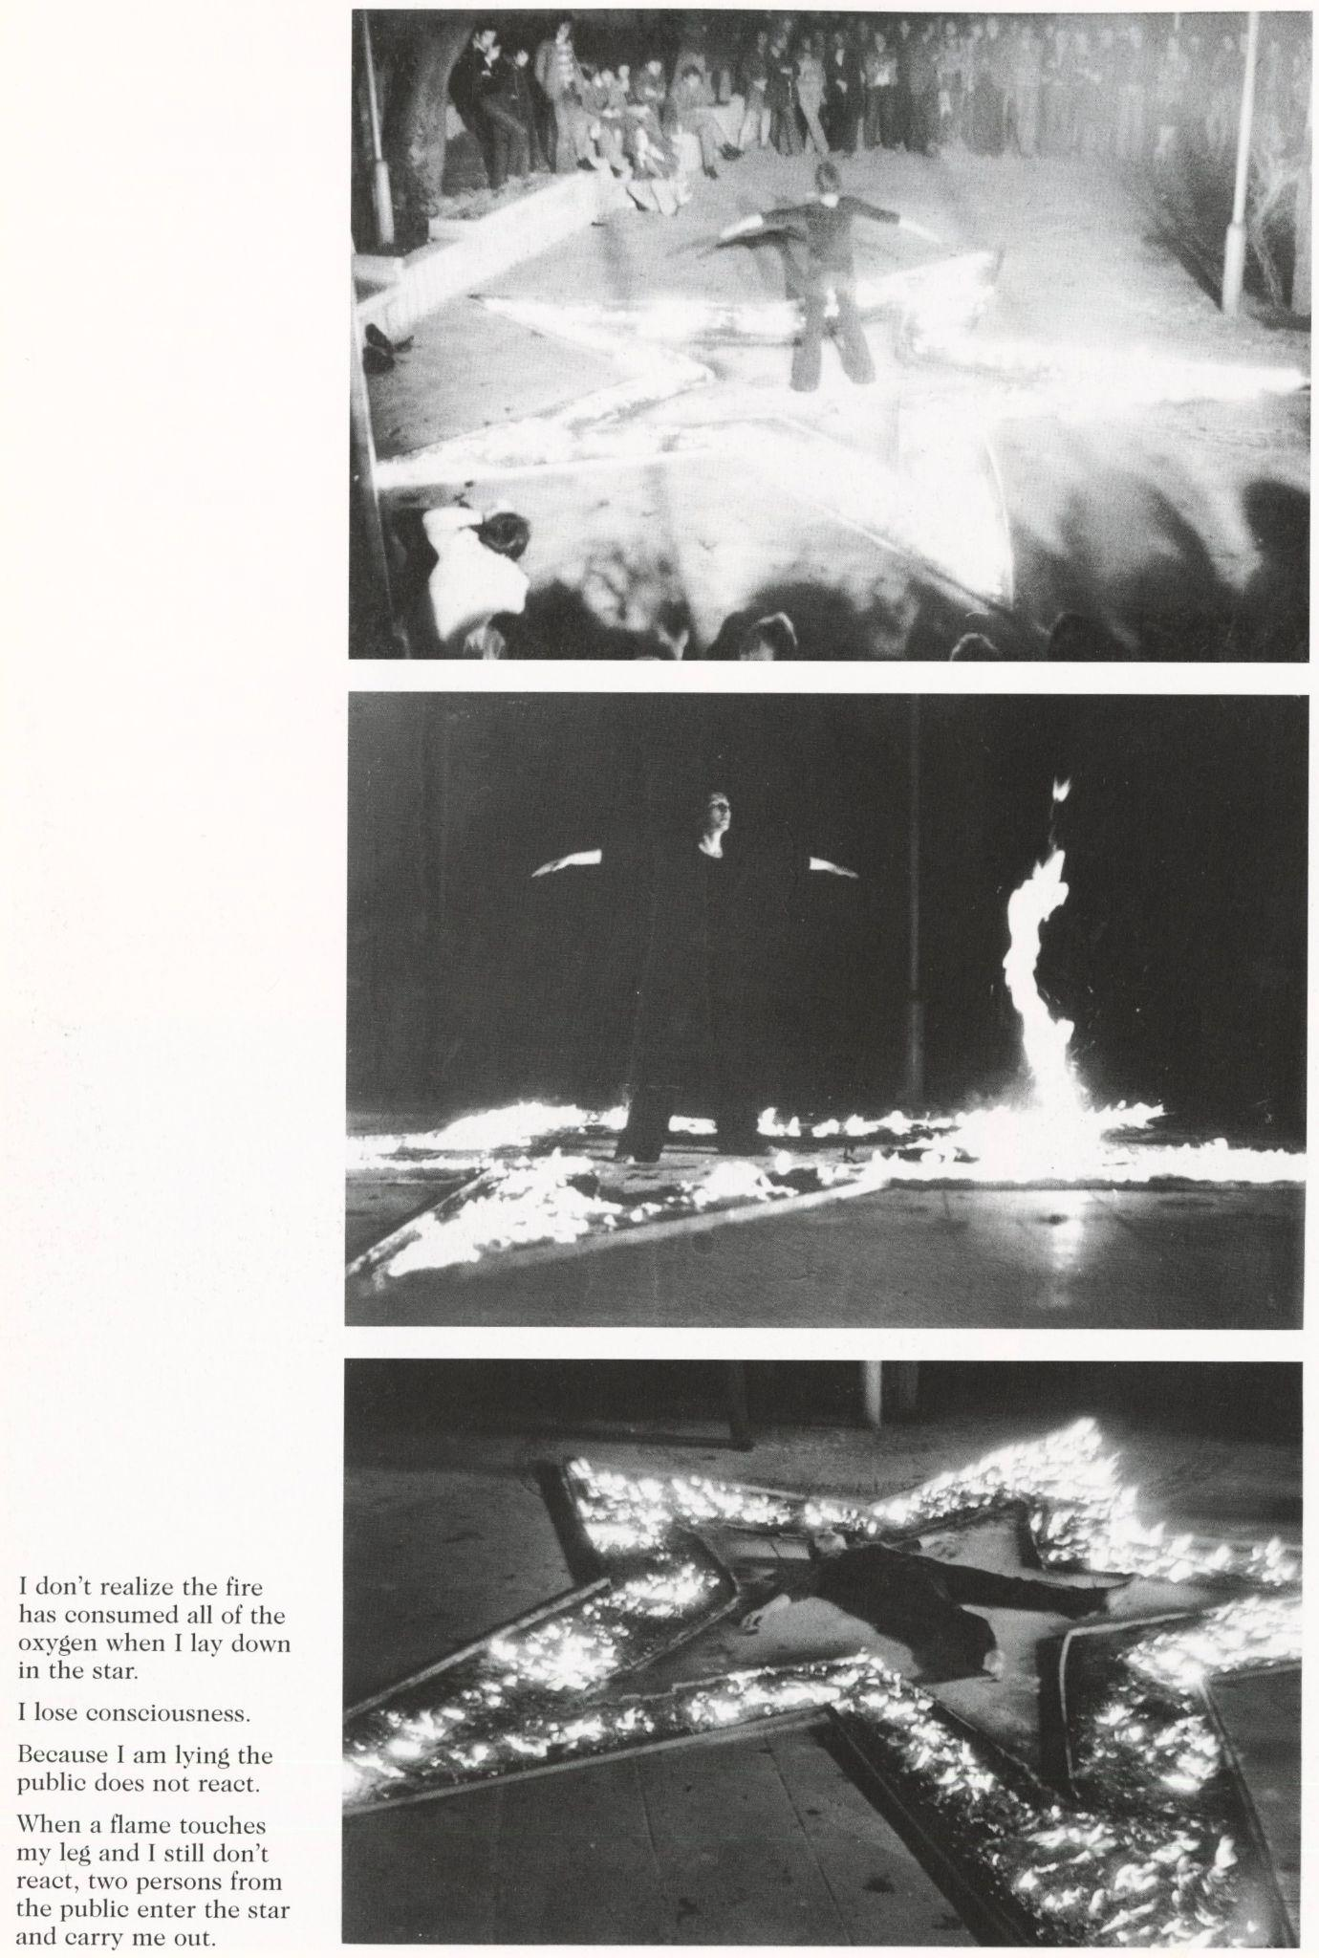
Figure 25 Marina Abramović, Rhythm 5, 1974, performance photograph
© Marina Abramović
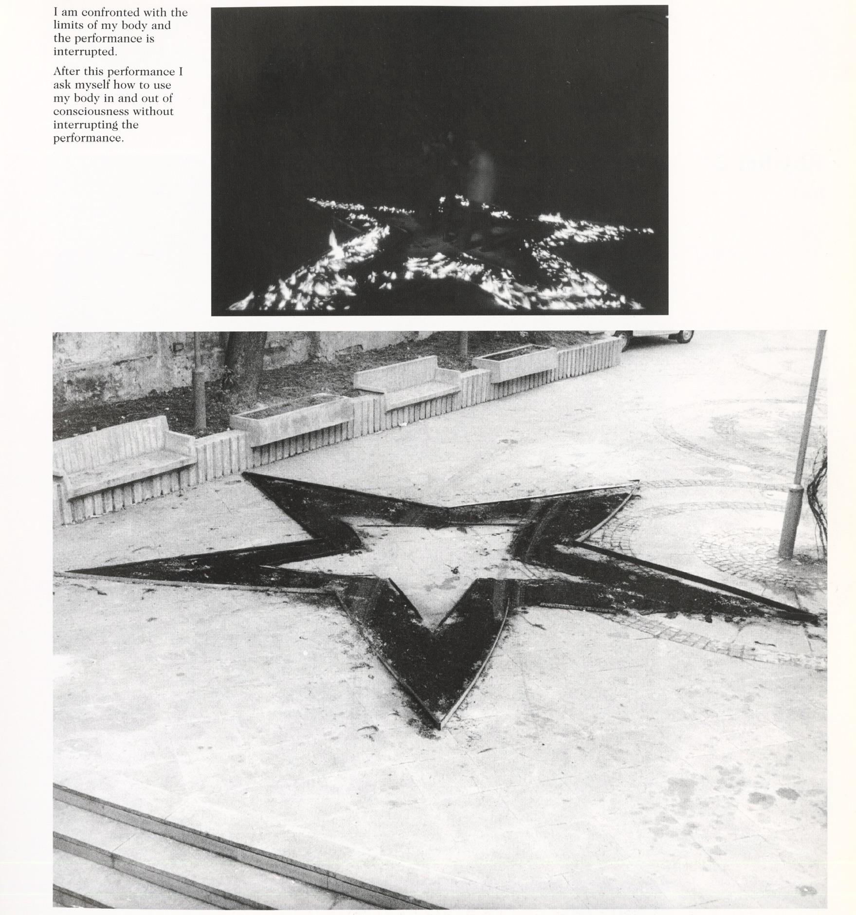
Figure 26 Marina Abramović, Rhythm 5, 1974, performance photograph
© Marina Abramović
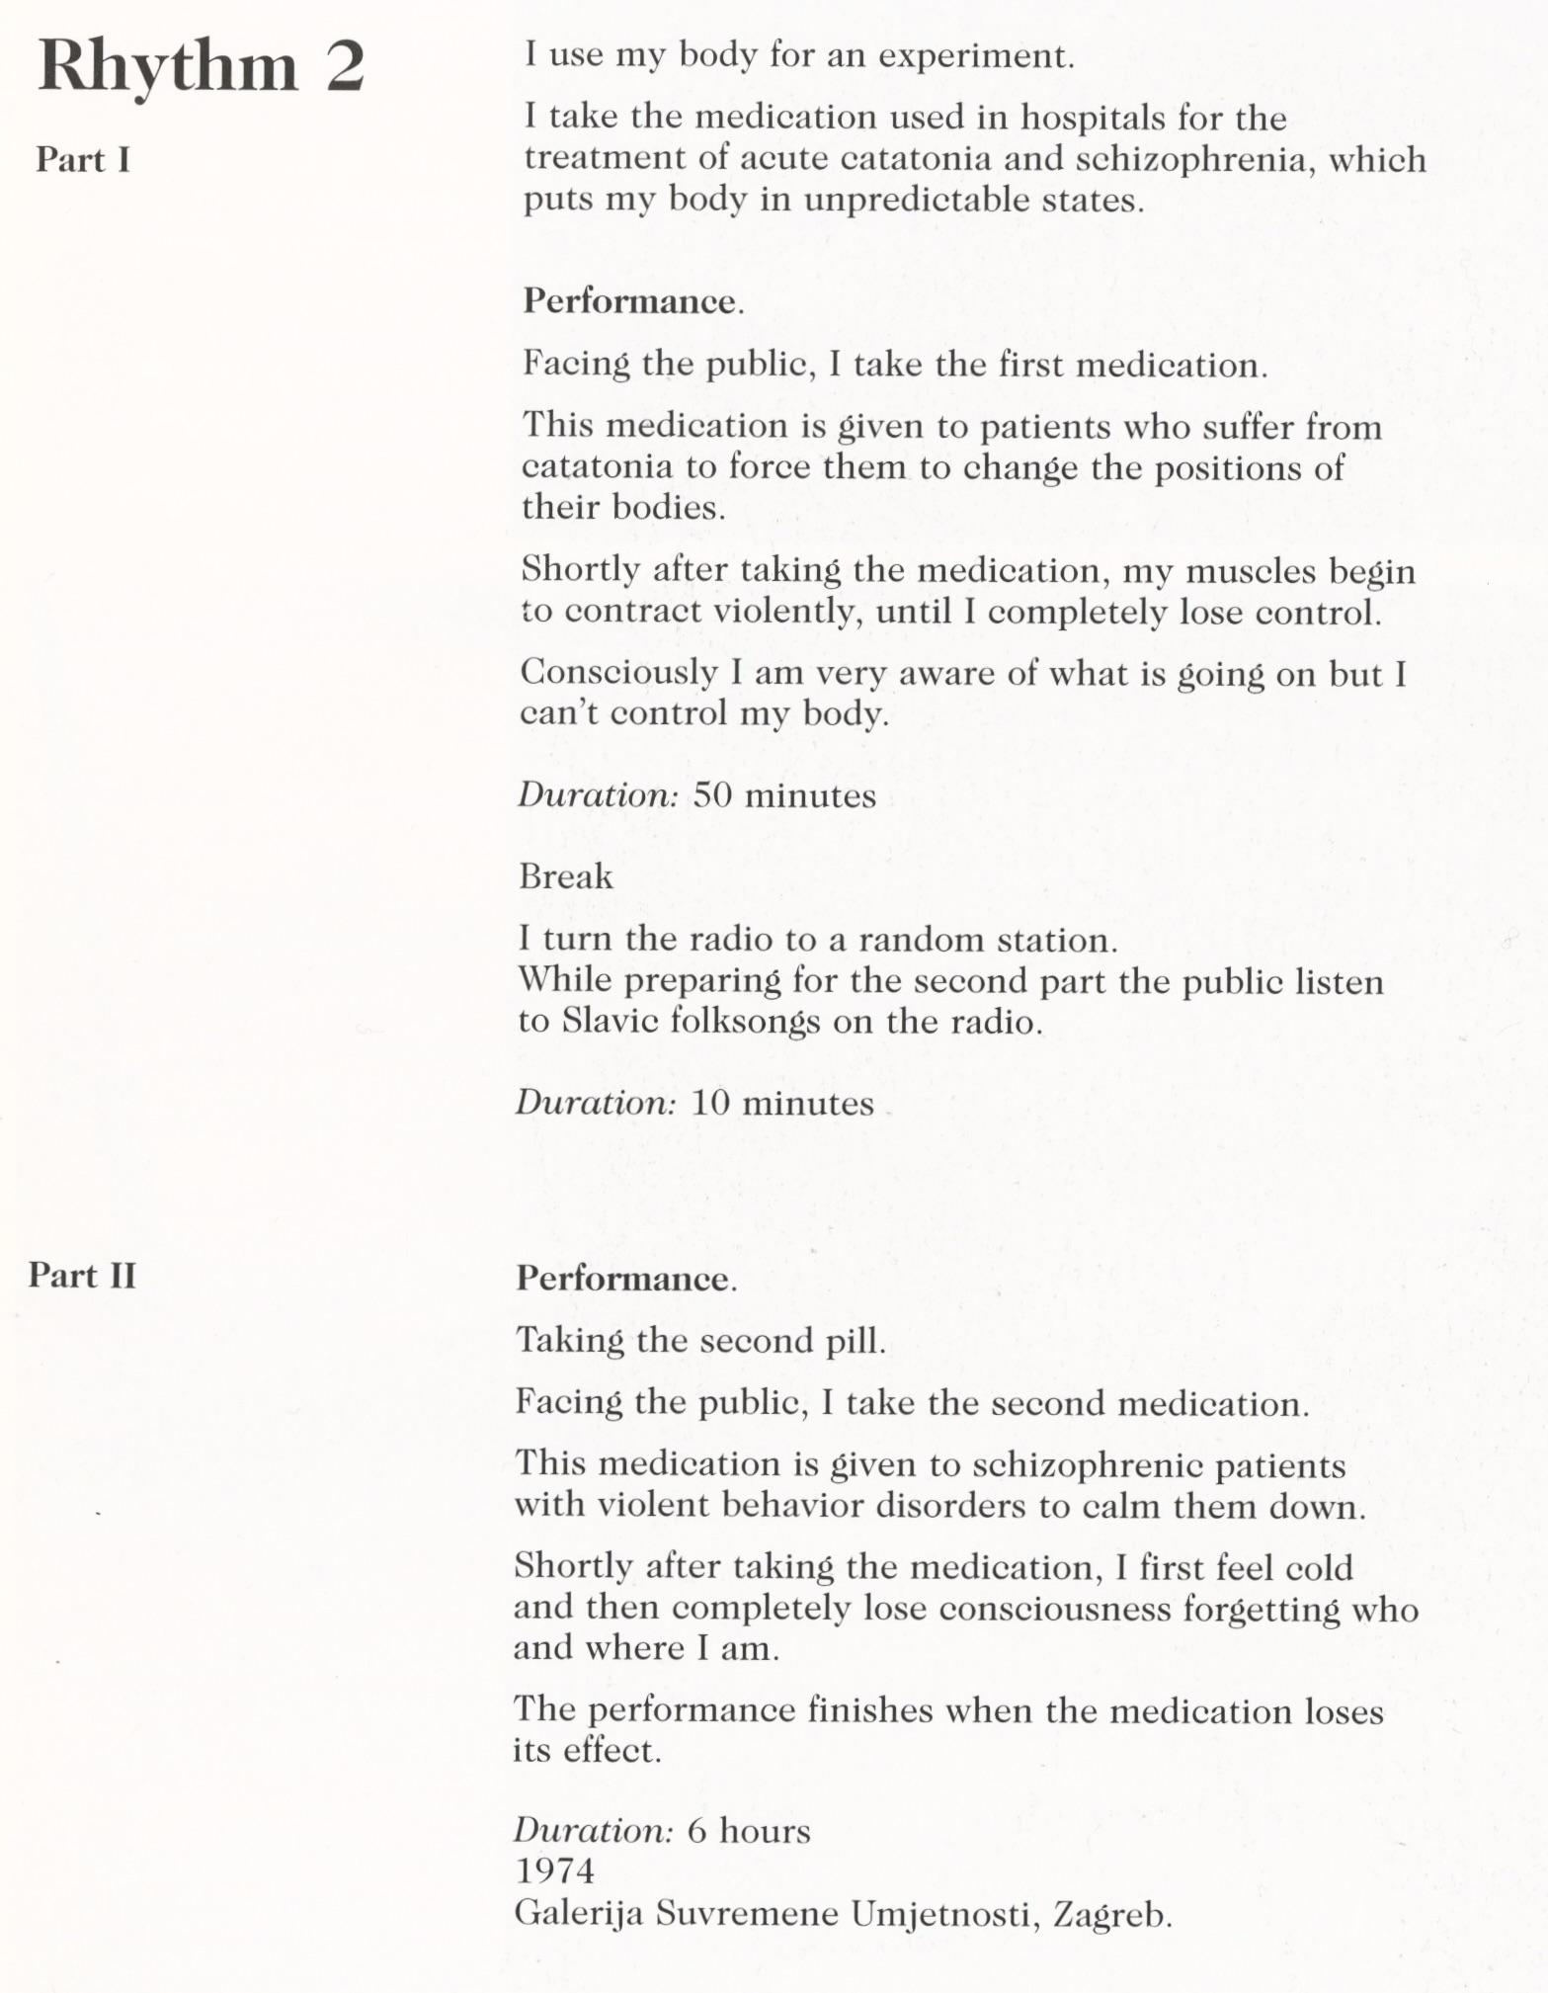
Figure 27 Marina Abramović, Rhythm 2, 1974, performance photograph
© Marina Abramović
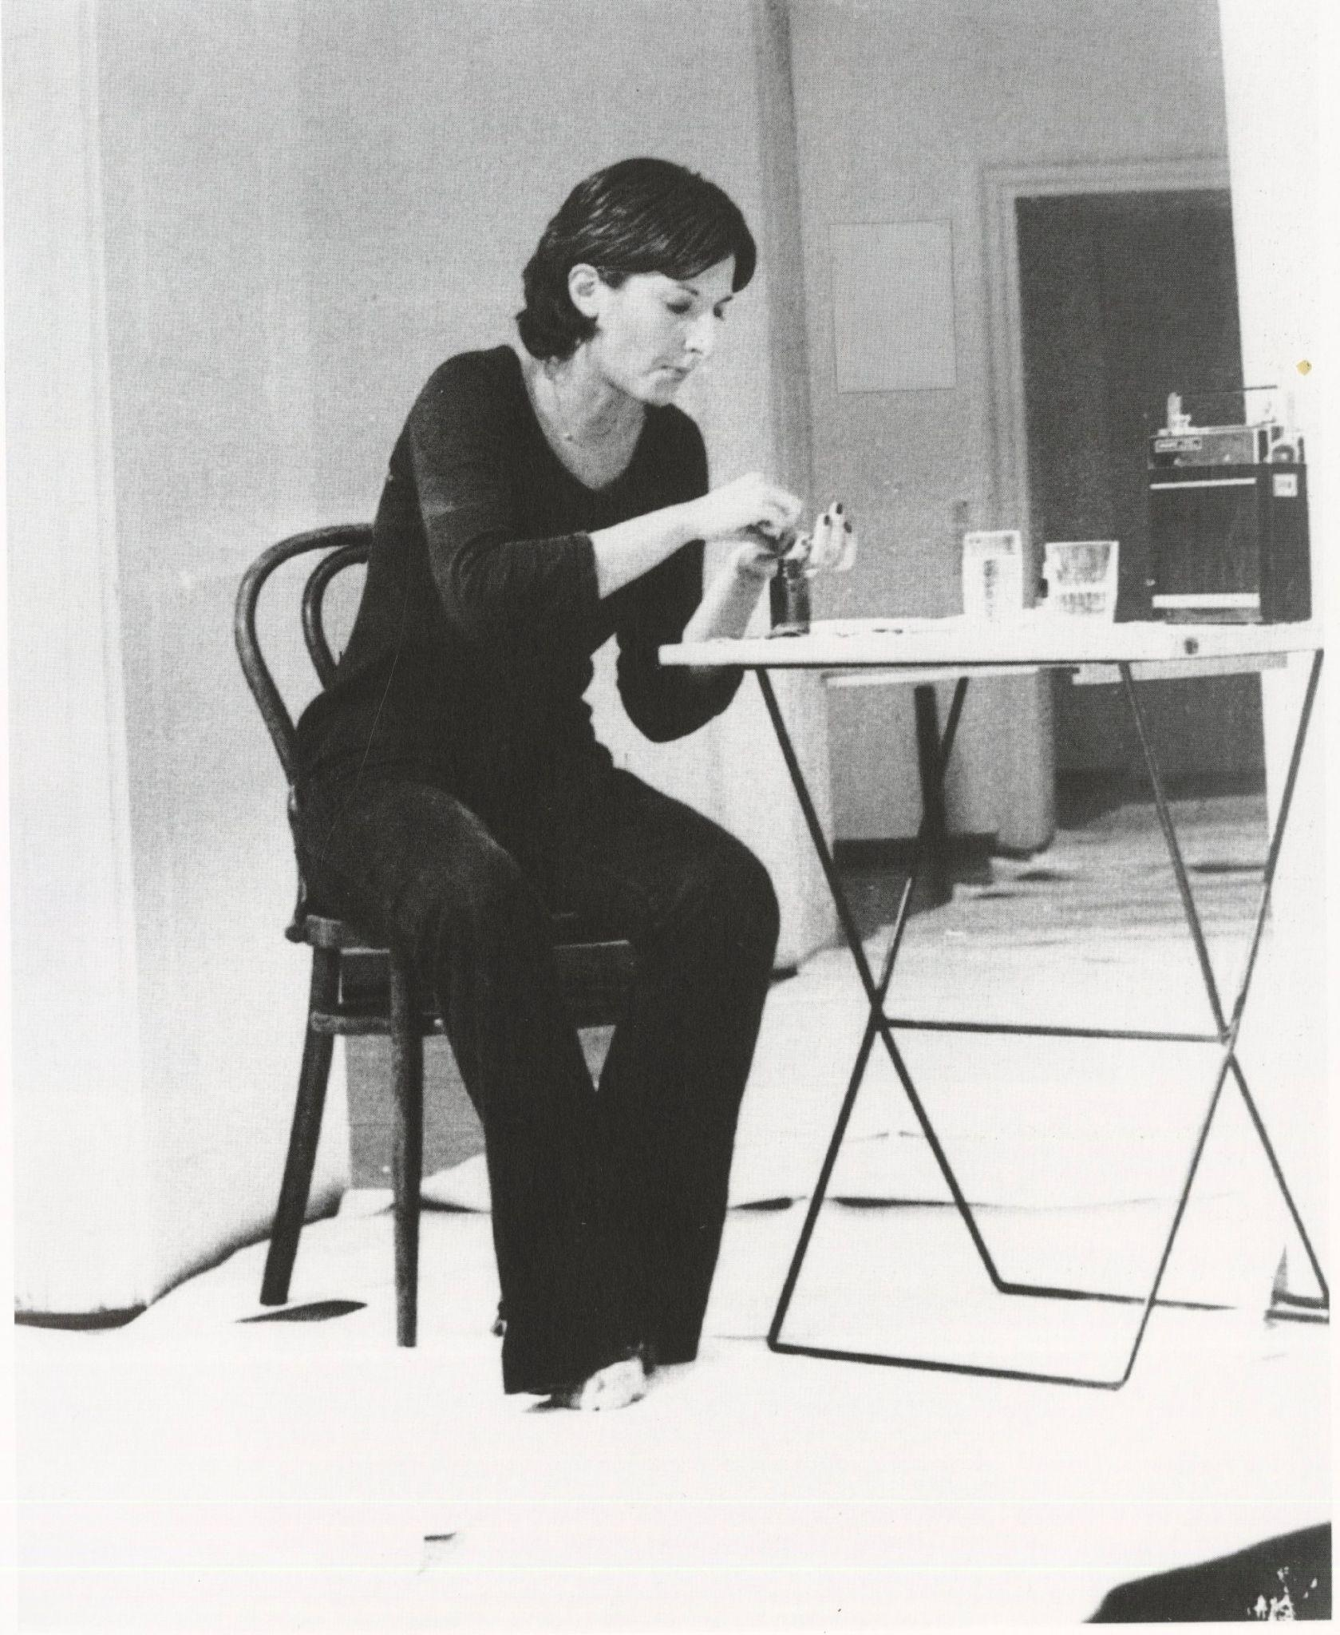
Figure 28 Marina Abramović, Rhythm 2, 1974, performance photograph
© Marina Abramović
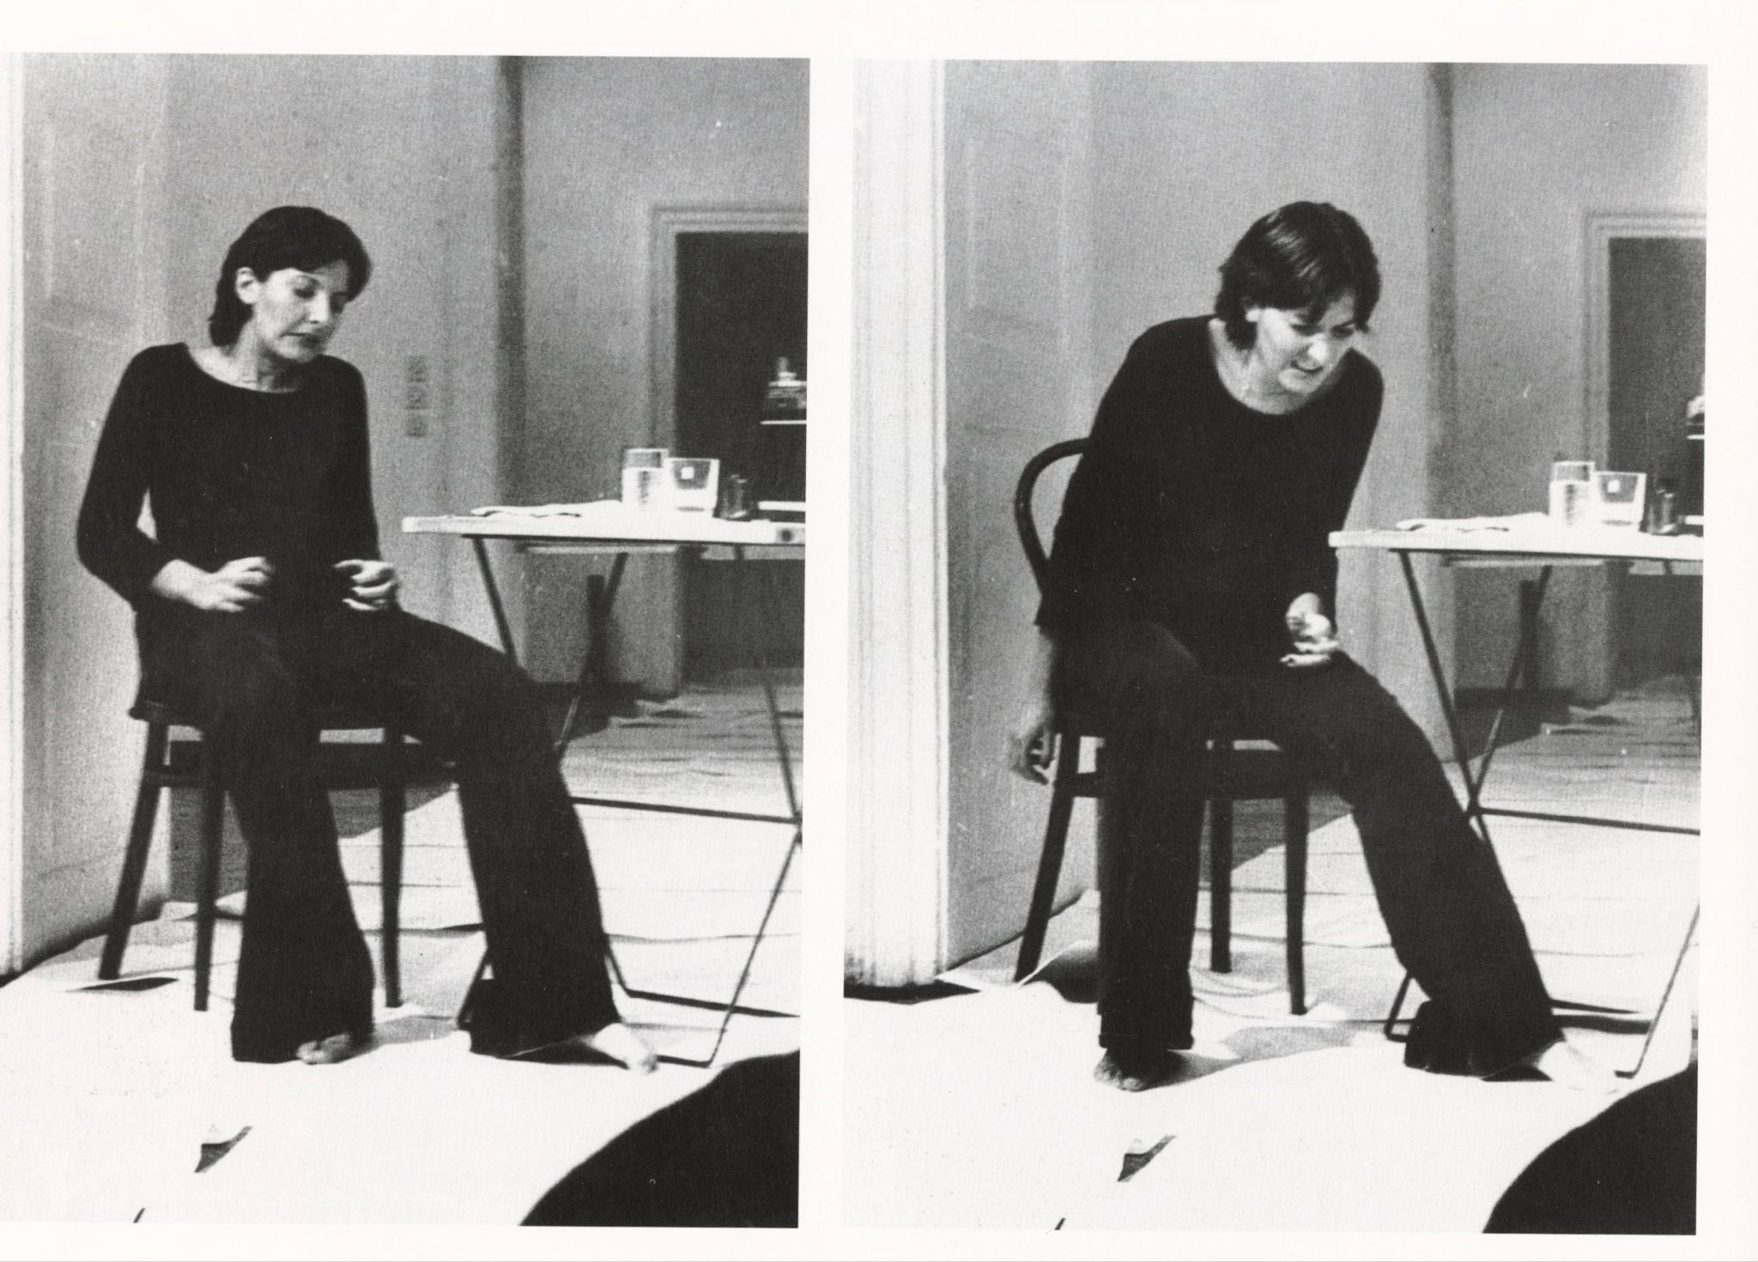
Figure 29 Marina Abramović, Rhythm 2, 1974, performance photograph
© Marina Abramović
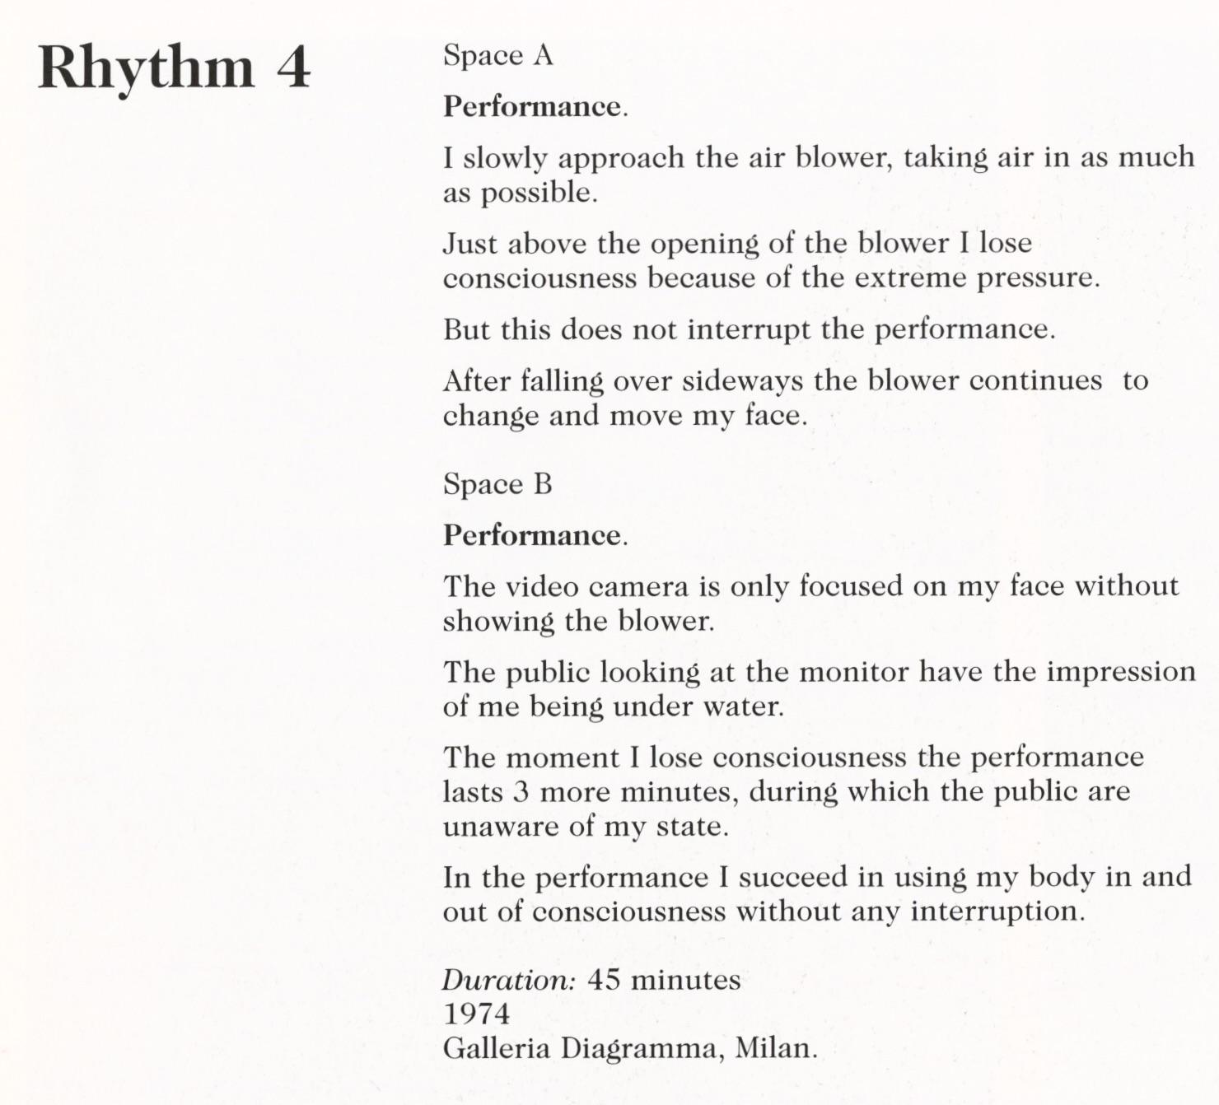
Figure 30 Marina Abramović, Rhythm 4, 1974, performance photograph
© Marina Abramović
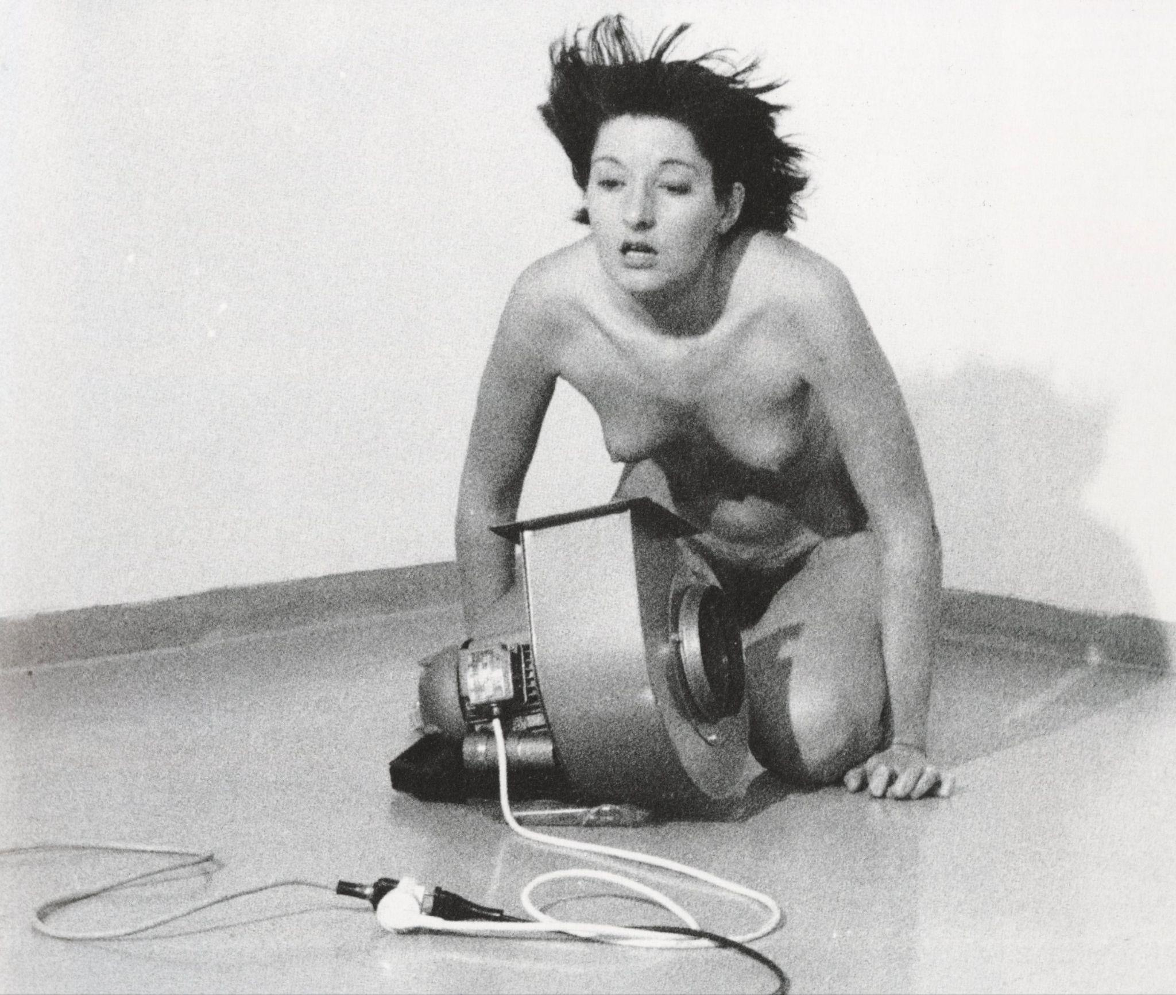
Figure 31 Marina Abramović, Rhythm 4, 1974, performance photograph
© Marina Abramović

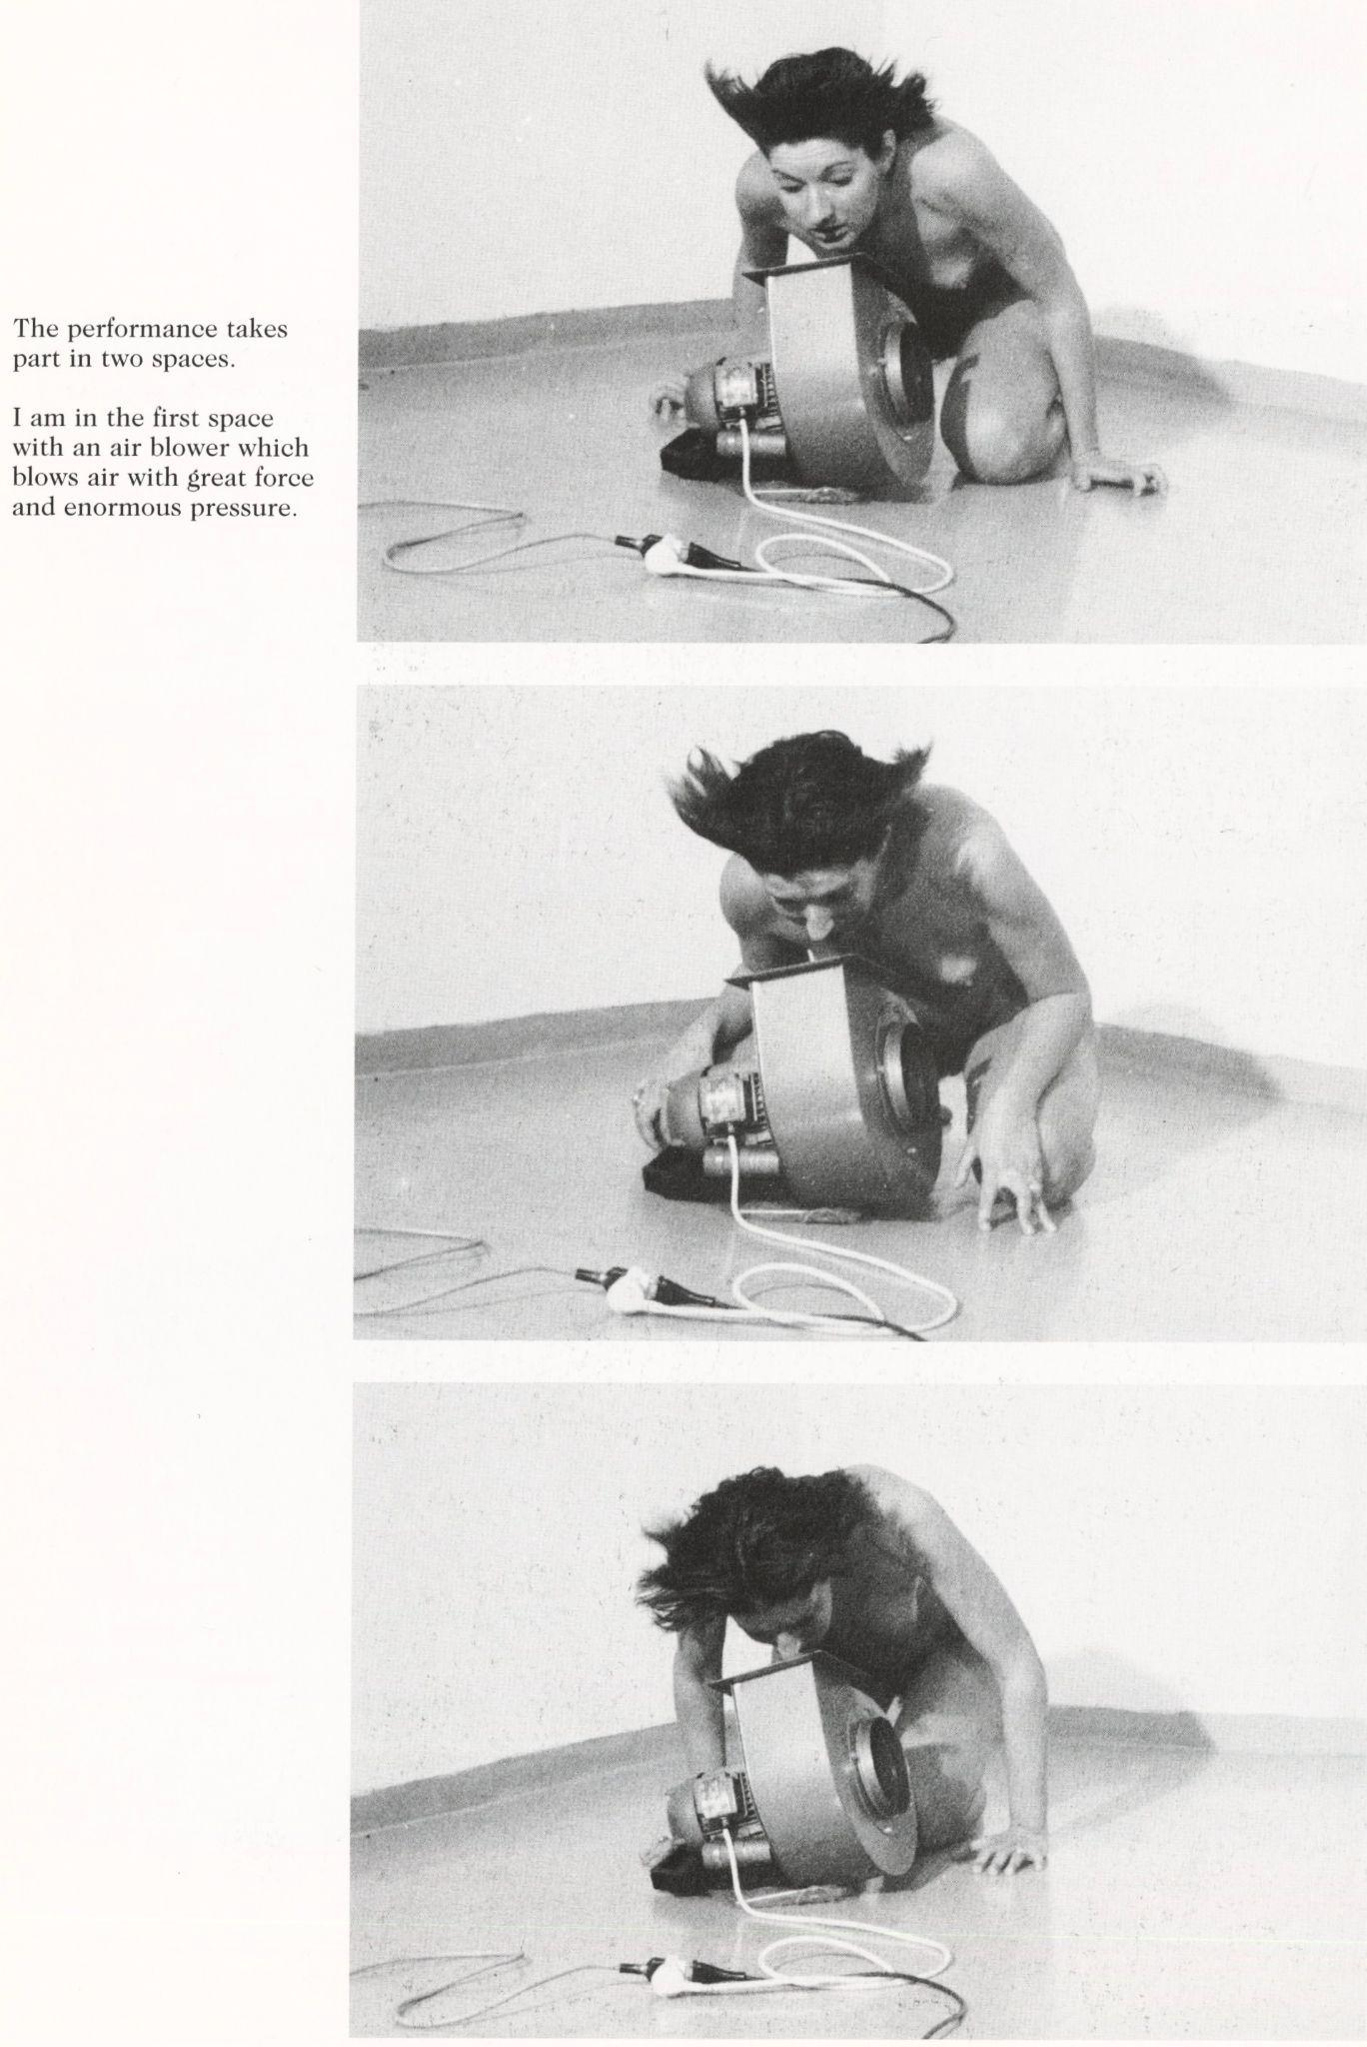
Figure 32 Marina Abramović, Rhythm 4, 1974, performance photograph
© Marina Abramović
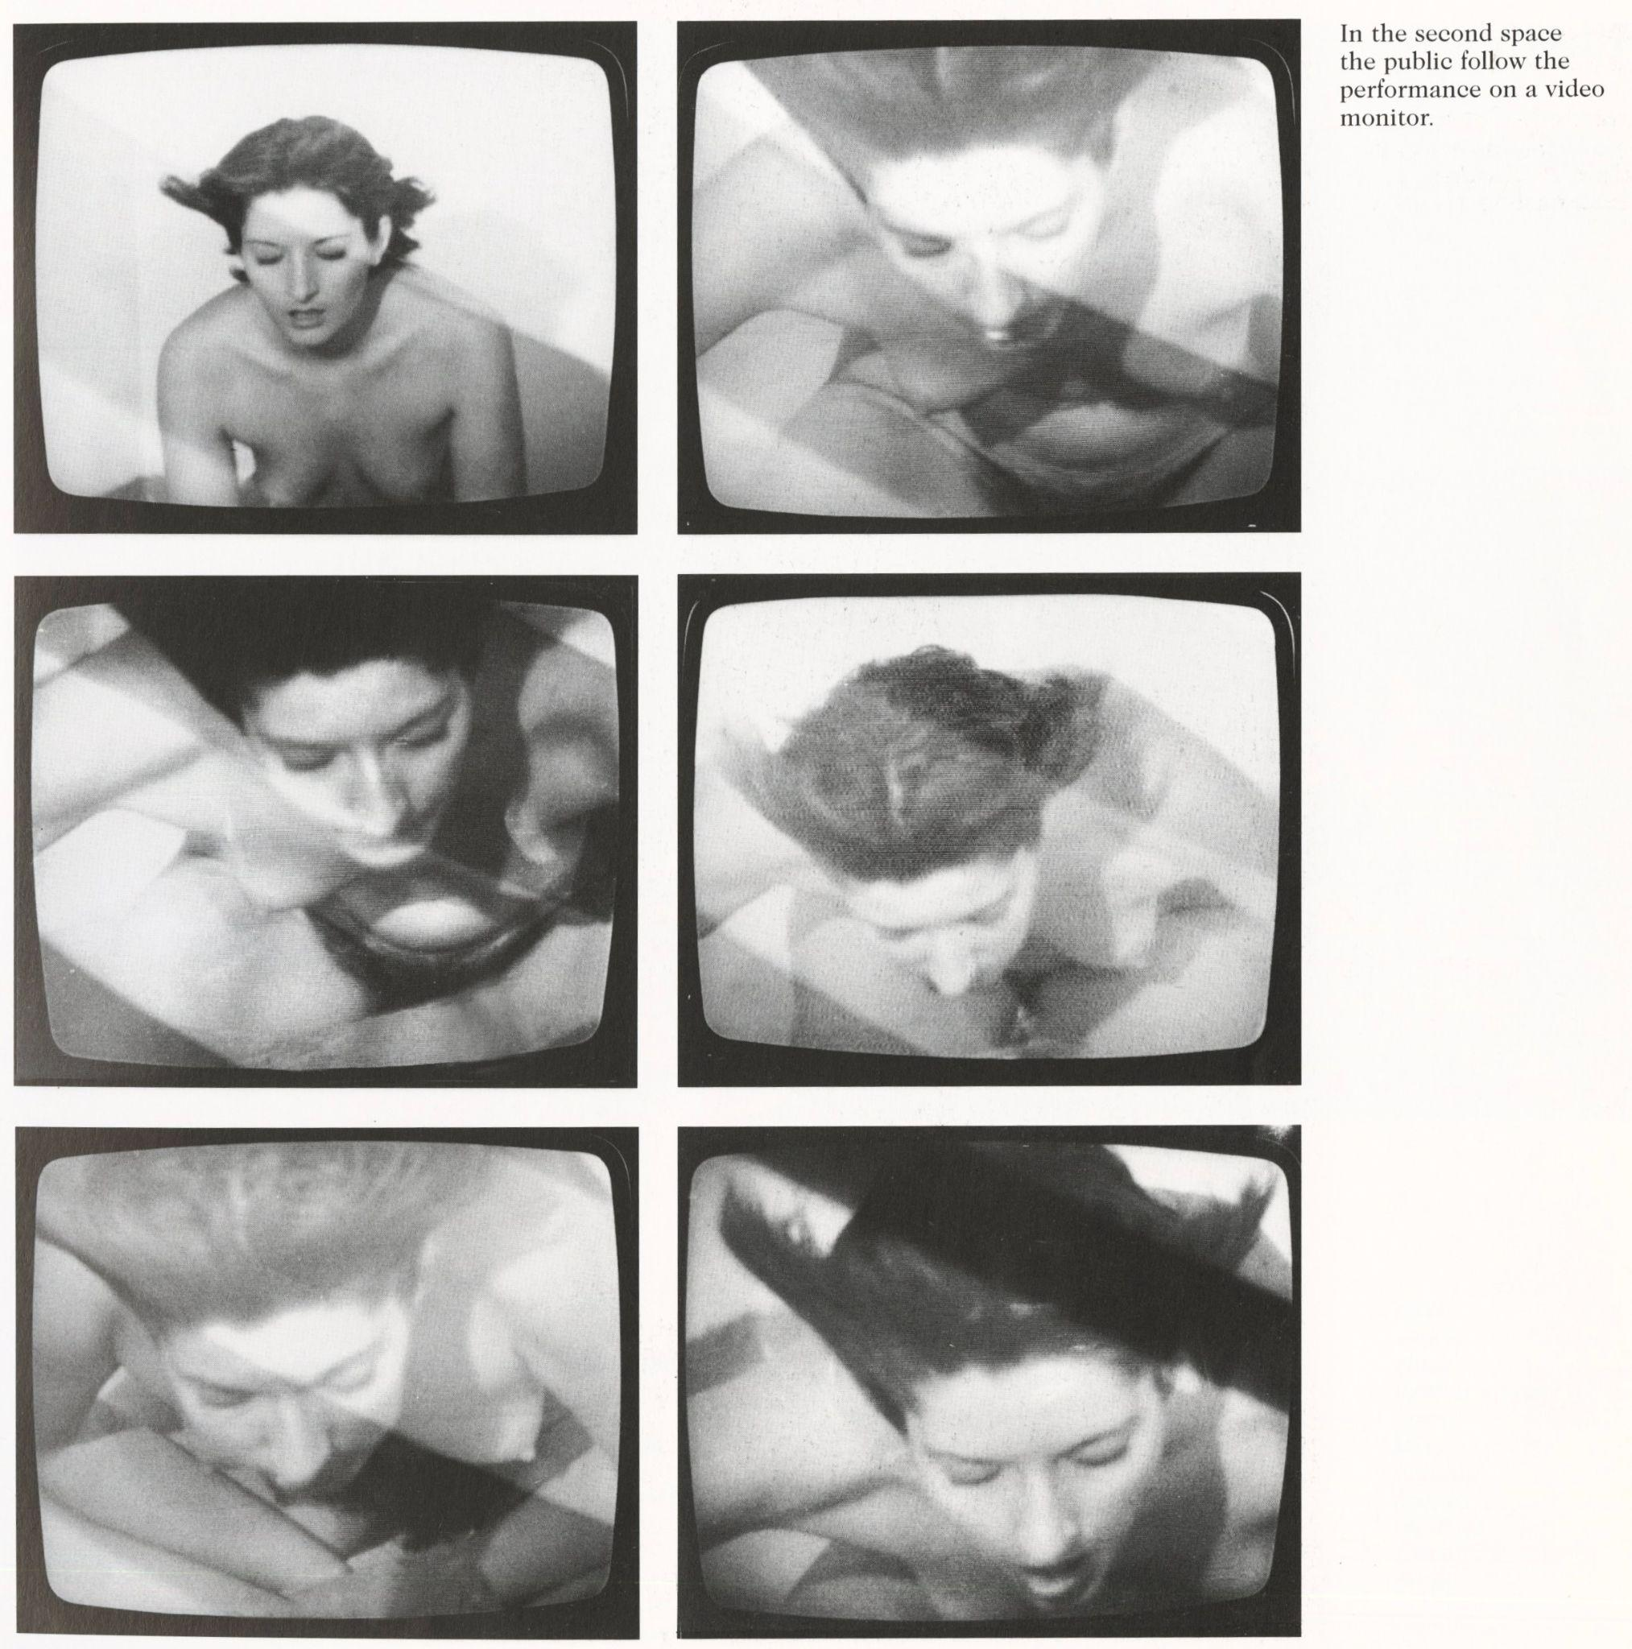
Figure 33 Marina Abramović, Rhythm 4, 1974, performance photograph
© Marina Abramović

Achille Bonito Oliva, Encyclopaedia of the Word: Artist Conversations, 1968-2008 (Skira, 2010), 290.
RoseLee Goldberg, Performance: Live Art since the 60s (Thames & Hudson, 2004), 13.
While lacking significant meaning for this performance, it is interesting to note Abramović’s frequent use of bones as an iconographical symbol in her later works, like Balkan Baroque (1997) and Carrying the Skeleton (2008).
Mary Richards, Marina Abramović (Routledge, 2010), 88-89.
Kristine Stiles, “Performance,” in Critical Terms for Art History, ed Robert S. Nelson and Richard Shiff (University of Chicago Press, 2003).
Richards, Marina Abramović, 83.
Richards, Marina Abramović, 83.
Anna Dezeuze, The “do-It-Yourself” Artwork: Participation from Fluxus to New Media (Manchester University Press, 2010), 132.
Lisson Gallery, “Rhythm 10, 1973.”
Richards, Marina Abramović, 83.
Richards, Marina Abramović, 84-85.
Dezeuze, The “do-It-Yourself” Artwork, 134.
Richards, Marina Abramović, 86.
Abramović, Marina, Velimir Abramović, and Kunstmuseum Bern, Marina Abramović: artist body: performances 1969-1998 (Charta, 1998), 29.
While no sources specify the pills, Abramović likely took “Lorazapem,” the most commonly prescribed benzodiazepine (prescription central nervous system depressant) to treat catatonia. The second pill for extreme aggression was likely another type of benzodiazepine, as they were among the top-selling prescription medications globally in the 1970s.
Richards, Marina Abramović, 87.
Stiles et al., Marina Abramović, 21-25.
Richards, Marina Abramović, 2-5.
Richards, Marina Abramović, 5-9.
Richards, Marina Abramović, 5-6.
Goldberg, Performance: Live Art since the 60s, 21.
Stiles, Kristine, Marina Abramovic, Klaus Biesenbach, and Chrissie Iles. Marina Abramović. (Phaidon, 2008), 19
Goldberg, Performance: Live Art since the 60s, 97.
Abramović et al., Marina Abramović: artist body, 27.
Richards, Marina Abramović, 88-91.
Richards, Marina Abramović, 88-89.
“Marina Abramović. Rhythm 0. 1974,” The Museum of Modern Art, accessed January 25, 2025, https://www.moma.org/audio/playlist/243/3118.
Richards, Marina Abramović, 88-89.
Richards, Marina Abramović, 88-89.
Stiles, “Performance,” 76-77.
Merriam-Webster, “Commissure.”
Stiles, “Performance,” 75-77.
Stiles, “Performance,” 75.
Gustave Le Bon, The Crowd & The Psychology of Revolution: Enriched edition. Two Classics on Understanding the Mob Mentality and Its Motivations, (Good Press, 2024), 6
Stiles, “Performance,” 82.
Abramovic, Marina, Chrissie Iles, RoseLee Goldberg, Thomas McEvilley, David Elliott, and Museum of Modern Art. Marina Abramović: Objects, Performance, Video, Sound (Museum of Modern Art Oxford, 1995), 14.
Stiles, “Performance,” 75-76.
Stiles, “Performance,” 83.
Abramović et al., Marina Abramović: artist body, 27.
Stiles, “Performance,” 83.
Richards, Marina Abramović, 91.
Abramović et al., Marina Abramović: artist body, 30.
Abramović et al., Marina Abramović: artist body, 30.
Abramović et al., Marina Abramović: artist body, 30.

