Charlotte Ogorek
Fragonard’s Reflections of Protofeminism in 18th Century France
The Rococo era in France, taking place in the middle to late 18th century, is sometimes regarded as an era of silly, frivolous art, and critics at the time would be inclined to agree. As a reactionary period to the excessive grandeur and solemn decadence seen in the previous Baroque period through works such as King Louis XIV’s Palace of Versailles, as well as a manifestation of the onset of the Enlightenment period in France, Rococo art often centered around scenes of leisure and play, disregarding previous tastes for historical or biblical scenes, and often displaying a much more relaxed moral code. While civil unrest that would soon lead to violent rioting, guillotine executions, and ultimately revolution grew within the proletariat class, the aristocracy at the time enjoyed a period of education, high culture, and philosophical ideals such as love and play as reflected in their art. This period also saw a rare but remarkable inclusion of women, not only in cultural and artistic realms, but also in the academic world. Many aristocratic women received extended education and were active contributors to philosophy and literature, writing works themselves and engaging in discourse with the leading male thinkers of the period. French Rococo painter Jean-Honoré Fragonard, who often included depictions of women in his works, did not shy away from these sociopolitical shifts, but instead supported them by subverting the typical male gaze and narratives that dominated the world of art prior to the period. Not only do Fragonard’s representations of women reflect Rococo’s interests of love, pleasure, and leisure, but also the freedom and even empowerment found by aristocratic women in France at this time.
Jean-Honoré Fragonard, born in Grasse, France in 1732, moved to Paris at the age of fifteen to pursue law, which he quickly abandoned for a career as a painter. After apprenticing with another great painter at the time, François Boucher, he would continue to make a vast number of paintings, almost all depicting scenes of love. However, these scenes differ greatly from other periods, specifically in their refusal to objectify women and their focus on sensuality and romance. Working mostly for private patrons after his departure from salon exhibitions, Jean-Honoré Fragonard’s paintings depict women in many types of scenes, including allegorical scenes, portraiture, and genre scenes, and he utilized a wide variety of stylistic tactics in order to portray them as individuals with agency as opposed to objects of male desire.
The concept of the gaze, introduced as part of a feminist approach to art history in the 1990s by Norma Broude and Mary Garrard. addresses how female subjects are depicted. The “male gaze” is often referred to when discussing these subjects, as they were often painted in a way that represented male-oriented ideals and fantasies of women, such as women reclining nude with their bodies on display or performing nude tasks such as bathing or dressing. Paintings such as Titian’s Venus of Urbino, 1534, or Édouard Manet’s later Olympia, 1863, often come to mind in such discussions. Many of Fragonard’s works offer a direct contradiction to such depictions by displaying female subjects fully clothed or with their backs turned to the viewer, reverting attention from their physiques and appearances and instead refocusing it on the actions being performed. This palpable shift in depiction and gaze seen in Fragonard’s works are perhaps the most poignant reflection of the newfound respect granted to women at the time, as well as their roles as tastemakers themselves.
In the beginning of the 18th century, France experienced the Baroque period, characterized by opulent architecture and grand manner paintings of historical and biblical scenes. The Palace of Versailles, renovated by Louis XIV to feature floor to ceiling windows, crystal chandeliers, elaborate murals, and gold in every detail, was not only a display of opulent Baroque architecture, but also power. During this time, the king wished to reinforce his position with the idea of divine ruling, in which God himself gifted the throne to those he wished to oversee France. Perhaps the crystal, gold, and perfectly manicured gardens were created to emulate heaven, but by the mid to late 18th century, the French had grown sick of such displays of wealth. For the proletariat class, the period only highlighted the enormous discrepancies between lifestyles; for the aristocratic class, the Baroque period was simply too uptight and rigid. As a result, the following period under the rule of Louis XV, nicknamed “The Well-Beloved” in his early years as king, erupted in light-hearted, playful sentiments and curiosity stemming from the coinciding era of enlightenment in Europe.
While this enlightenment brought about a newfound interest in academic areas such as science and philosophy, it also inspired much more liberal approaches to political and domestic realms. Ideas surrounding liberty, tolerance, and the separation of church and state began to bloom and flourish. As with most periods in history, Rococo art began to mirror such sociopolitical and ideological shifts in thinking, moving towards secular art. Portraiture and genre scenes gained widespread popularity, contrasting the previous Baroque period’s affinity for biblical and historical scenes. While the proletariat class embarked on a path of radical enlightenment that would lead to revolution, the aristocracy exercised liberal enlightenment, which nurtured literature, philosophy, theoretical thinking, relaxed moral codes, and the extension of higher education to women.
French aristocratic women in the Rococo period were not only permitted higher education; they were also allowed, and even welcomed, outside of the domestic sphere. With most being literate at the very least, they were often heavily involved in cultural and social circles revolving around discourse concerning art, philosophy, and literature. Such gatherings, referred to as Salons, saw women mingling and even maintaining close friendships with male scholars, philosophers, theorists, and artists, often offering their own opinions and input on a variety of matters. Madame de Pompadour, mistress and friend of King Louis XV, is considered one of the period’s primary tastemakers, a powerful patron of the arts and fashion icon whose example others were quick to follow. Many other women at the time hosted such salons in addition to attending them, such as Anne-Térèse de Marguenat de Corcelles, also known as the Marquis de Lambert. A talented writer and essayist herself, publishing a number of works concerning matters such as friendship, family, and femininity, she was known to hold salons on two nights a week for different academic circles, though her guests were able to freely attend either gathering as they saw fit. These two women are only examples of the vast number of others who participated in the formation of taste, style, and culture in the Rococo era, holding their place amongst even the most powerful and respected men in the French aristocracy.
Jean-Honoré Fragonard was not oblivious or adverse to the changes surrounding him in French society, and used a variety of formal strategies to uplift women within his paintings. One tactic, such as that used in The Swing (Figure 1) and The Musical Contest (Figure 2) is simple but remarkably effective: composition. The Swing, painted in oil on canvas by Jean-Honoré Fragonard in 1767, is perhaps the hallmark artwork of the period. Painted in pastel colors and set in a lush, overgrown garden featuring statues of mythological cherubs, or putti, the scene depicts a woman swinging and casting a knowing, flirtatious look down at the man lying below her in order to catch a glimpse up the skirt of her dress as her chaperone remains oblivious in the background. The Swing is an excellent example of using composition to uplift the woman in the scene, making her an active participant as opposed to passive. Three figures appear in the painting; two men, one holding the role of oblivious chaperone while the other, the suitor, hides in the underbrush, poised to receive a scandalous view of the third figure, a young woman on a swing. Placed in the center of the scene and illuminated by the sunlight filtering between the lush, green foliage, the woman is clearly intended to draw the immediate attention of the viewer as the other two figures remain in the shadows. She wears a beautiful, elaborate pink dress with lace detailing and a hat and choker as she swings upwards, away from her chaperone and into the view of her secret onlooker.
At first glance, after viewing the woman and then becoming aware of her company, the viewer may fear that she has fallen victim to a Peeping Tom. However, Fragonard is quick to assure his audience that this is not the case. Her expression reveals her knowing participation in the encounter: she gazes down directly upon the man below her with the corners of her mouth turned slightly upwards, giving her a quietly flirtatious look. She is also depicted kicking off one of her dainty pink slippers so that it should fall upon her suitor and leave her right foot revealed. Through these details, as well as the composition as a whole which demands the viewer focus on her, she is portrayed as not only an object of desire to be looked upon, but an individual with desires of her own which she wishes to express.
The Musical Contest, painted by Fragonard between 1754 and 1755 in oil on canvas, is another strong example of the artist’s use of composition to create a scene in which the woman holds the power. Once again placed in the center of the scene and above the other two figures, both men and potential suitors, the woman depicted stands tall and holds a parasol in her left hand, further adding to the height of her figure as the men fall below her on either side. Her right hand, holding a floral crown, is extended out from her body. The man on her left is positioned rather pathetically on his knees, clinging to her and looking up at her in anguish as she gazes away in the opposite direction. On her right, beneath her extended arm, the second man sits on the ground, staring up at her in admiration as he holds a musical instrument, which the title as well as the statues of putti in the background and symbolic fruit in the foreground suggest he is playing in hopes to win her love. From the extended arm holding the crown above one man while the other seems to be in disarray having lost his hat and coat, it appears she has chosen a winner between the two suitors. The contents of the scene depicted, further emphasized by the dramatic composition featuring considerable differences in heights, postures, and expressions, not only assign all control and agency to the woman over her own romantic endeavors, but also reduce the men to subdued figures, desperate for her approval.
This pattern of female agency depicted in Fragonard’s paintings extend to scenes of physicality between lovers as well, often depicted as soft moments of sensuality as opposed to lustful scenes in which the female subject is sexualized. In these scenes, he uses thoughtful composition as well, but also makes distinct visual choices in order to create empowering representations. The Desired Moment (Figure 3), painted between 1755 and 1765 in oil on canvas, shows a man and woman in bed sharing a passionate embrace. The woman reclines in her lover’s arms, wrapping herself around his neck as they share a kiss. Though pictured fully in the nude, Fragonard protects his subject’s modesty by depicting her turned away from the viewer so that only her back and a small sliver of her buttocks are visible. Both appear comfortable, fully absorbed by the moment and unaware of the viewer. By largely concealing the woman’s face and body, themes prevalent to the male gaze when depicting female nudes such as eroticism and voyeurism are largely removed from the scene, giving it qualities of genuine love and tenderness instead.
Similarly, The Kiss (Figure 4), painted in oil on canvas between 1763 and 1778, depicts a man and a woman embracing from the shoulders up. The woman, reclining against a pillow, wraps her arms around her lover, pressing his head beneath her chin into her bosom. He holds her equally tight as she plants a soft kiss on his cheek, slightly squishing his face against her own. Both of their eyes are closed, giving them a sense of mutual comfort and vulnerability devoid of lustfulness.
The last work to be included in this discussion, The Love Letter (Figure 5) , features a singular female subject and uses symbolism in addition to composition and intentionality behind visual representation. Painted in the early 1770s in oil on canvas, the genre scene depicts a woman in a blue dress with lace detailing and a pink and white cap seated at a desk facing a round window. On the desk sits a pile of papers, and the woman holds a folded letter and a bouquet of pink flowers close to her chest. The woman wears a coy expression on her powdered face, with the corner of her mouth turned upwards as she looks over her shoulder directly at the viewer as her slightly bedraggled dog lays behind her on the stool, making equally intense eye contact. The scene reiterates the themes seen throughout Fragonard’s work and offers markers of the status of women at the time. The desk at which she sits appears to be set up for writing, reenforcing the education and literacy of aristocratic women, and the flowers and letter, as well as the dog, often a symbol of fidelity, suggest some sort of social interaction taking place outside of the frame, most likely concerning a lover. The lack of suitor within the scene implies the woman’s own participation and agency in her romantic endeavors.
While women were often oppressed and disregarded throughout history, the Rococo period in France offered those in the aristocracy a small window of respite, permitting the education of women and including them in social and cultural realms free of gender discrimination. Women in this time did not take these freedoms lightly; many produced their own work, including art and written works, and participated in discussions regarding literature, philosophy, and art, which led to cultural tastes and trends heavily impacted by their opinions and preferences. Fragonard’s paintings offer tangible evidence of this impact, depicting women as active participants in French society as opposed to objects to be looked upon for personal enjoyment or people tethered only to the context of the domestic sphere. By avoiding unnecessary nudity and refusing to only depict women as passive participants in male-dominated scenes, instead often featuring them as leading protagonists, Fragonard reiterates the agency and individualism exercised by aristocratic women at the time. Through analyzing Fragonard’s paintings, one can see clearly that in this time in history in which women were granted a glimpse of freedom and equality, they did not squander it, but instead demonstrated their intellect, wit, and competence with grace and refinement.

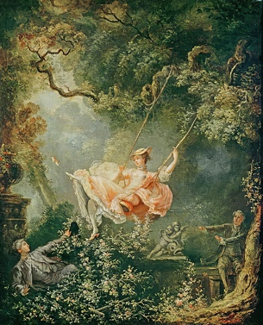
Figure 1. The Swing, Fragonard, 1767, oil on canvas.
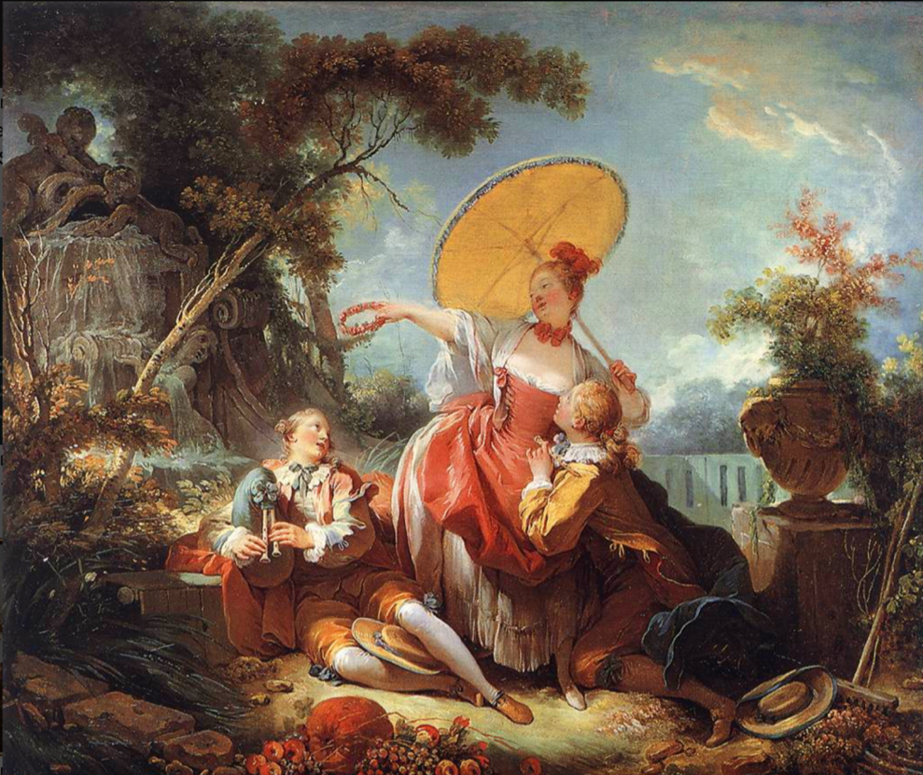
Figure 2. The Musical Contest, Fragonard, 1754-1755, oil on canvas.

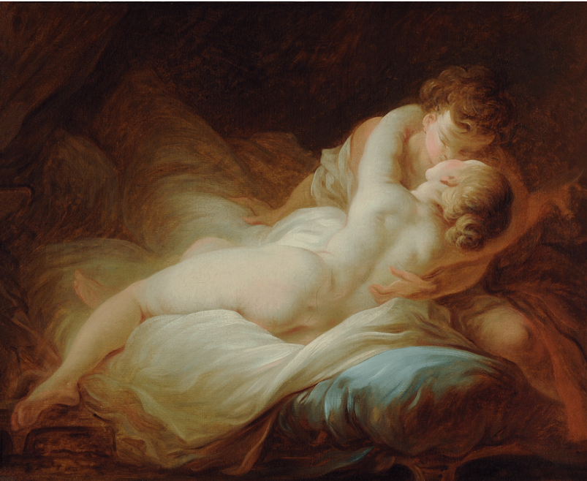
Figure 3. The Desired Moment, Fragonard, 1755-1765, oil on canvas.

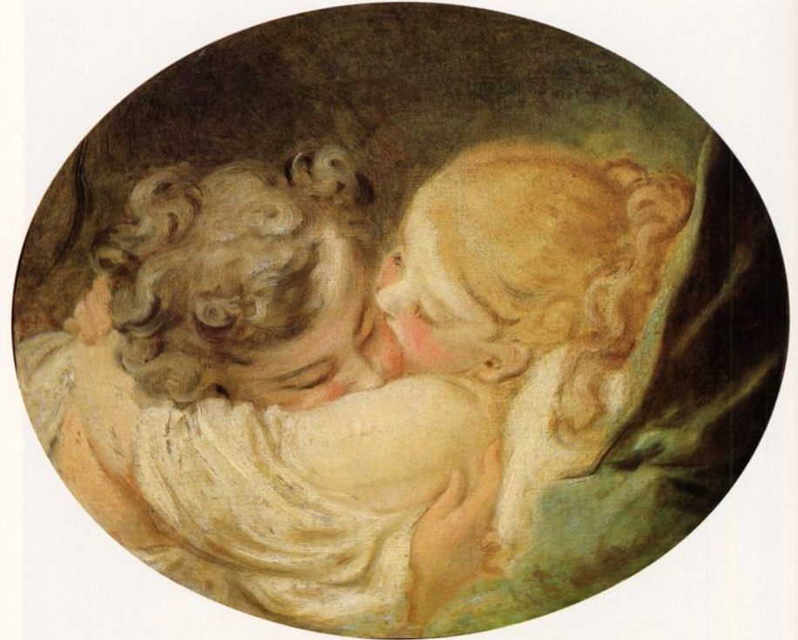
Figure 4. The Kiss, Fragonard, 1763-1778, oil on canvas.
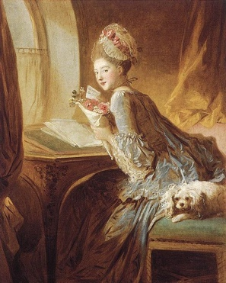
Figure 5. The Love Letter, Fragonard, 1770s, oil on canvas.

Works Cited
Andrei Molotiu, and Paul Getty. Fragonard’s Allegories of Love . Los Angeles: J. Paul Getty Museum, 2007.
D’alleva, Anne. Methods and Theories of Art History. London: Laurence King, 2005.
Gere Mason, Amelia. Women of the French Salons. Hardpress Ltd, 2013.
Miamioh.edu. “9/28 Enlightenment and Rococo – Art188,” 2021. https://art188.lib.miamioh.edu/18th-and-19th-century-art/1-enlightenment-and-rococo/.
Posner, Donald. “Mme. De Pompadour as a Patron of the Visual Arts.” The Art Bulletin 72, no. 1 (March 1990): 74. https://doi.org/10.2307/3045718.
Saisselin, Remy G. “The Rococo as a Dream of Happiness.” The Journal of Aesthetics and Art Criticism 19, no. 2 (December 1, 1960): 145–52. https://doi.org/10.1111/1540_6245.jaac19.2.0145.

Andrei Molotiu and Paul Getty, Fragonard’s Allegories of Love (Los Angeles: J. Paul Getty Museum, 2007).
Andrei Molotiu and Paul Getty, Fragonard’s Allegories of Love (Los Angeles: J. Paul Getty Museum, 2007).
Anne D’alleva, Methods and Theories of Art History (London: Laurence King, 2005).
“9/28 Enlightenment and Rococo – Art188,” Miamioh.edu, 2021, https://art188.lib.miamioh.edu/18th-and-19th-century-art/1-enlightenment-and-rococo/.
Remy G. Saisselin, “The Rococo as a Dream of Happiness,” The Journal of Aesthetics and Art Criticism 19, no. 2 (December 1, 1960): 145–52, https://doi.org/10.1111/1540_6245.jaac19.2.0145.
“9/28 Enlightenment and Rococo – Art188,” Miamioh.edu, 2021, https://art188.lib.miamioh.edu/18th-and-19th-century-art/1-enlightenment-and-rococo/.
Ibid.
Donald Posner, “Mme. De Pompadour as a Patron of the Visual Arts,” The Art Bulletin 72, no. 1 (March 1990): 74, https://doi.org/10.2307/3045718.
Amelia Gere Mason, Women of the French Salons. (Hardpress Ltd, 2013).

