Amanda Delgado
Senior Seminar
Christopher Platts
April 24, 2023
The Reality of Infinity: Reassessing Yayoi Kusama Through Disability Studies
Yayoi Kusama is, as of now, the most successful living female artist on the planet. Her career spans decades and has been geographically diverse, with early works in the United States and Europe in the late 1950s to '70s and in Japan, where she has remained since 1975. However, much like how Kusama's career continues to grow and expand, so does our understanding of the driving force behind her artwork: Obsessive Compulsive Disorder, more commonly known as OCD. Moreover, rather than seeing OCD as only a diagnostic factor of Kusama's process, her works must be viewed as also seeking to project and connect her embodied experience as a disabled person to a broad audience through immersive installation and humanist themes. Due to the ever-evolving nature of our knowledge of OCD and increased disability advocacy in the arts, there cannot be a reliance on scholarship that was written prior regarding Kusama's art and her disability. This is mostly because its goal was to reignite interest in a public and establishment that had cast her aside decades prior and had to conform to the then current, albeit flawed framework of "reframing" her art as a triumph over her illness instead of an extension of herself. Therefore, before going further, it is necessary to have a comprehensive understanding of what OCD is and how it can affect people like Kusama.
Obsessive-compulsive disorder, most commonly known as "OCD," is a neurological disorder defined as an individual having a singular or multiple "obsessions" that can lead to taking an action or series of actions known as "compulsions." These actions and thoughts lead to significant emotional distress and hinder function due to their perpetual repetition. Because of the all-consuming nature of the obsession or compulsion, people with this disorder feel there is no other option but to perform it or dwell on it. This leads to extreme anxiety in scenarios where these actions cannot be completed, causing individuals to engage in irrational behavior, such as possibly leaving work or school in the middle of the day to make sure their compulsion was acted on regardless of consequence. In the case of Kusama, her compulsion is described by herself as the act of placing her signature dots on objects, and her obsessions spring from the childhood trauma she received from her abusive mother and cheating father. She has also described notable hallucinative episodes throughout her life as coming from the anxiety surrounding this trauma and her illness. Kusama even goes so far as to not describe herself as an artist but instead say that she is "pursuing art in order to correct the disability which began in my childhood." Calling into question the choice made by scholars before analyzing Kusama's work "beyond" this framing of mental illness and disability.
As art educator and disability activist John Derby explains, "the art world's obsession with obsessed artists' has more to do with the workings of artists' minds and practices rather than their works." Citing the scholarship by L.J. Davis on outsider art, he concurs that denying the "embodied" experiences of disabled artists is a "mistake" as the way disabled artists are labeled by society has a direct impact on their material conditions and creative output in ways that do not affect abled artists such as institutionalization. Another factor that Derby highlights as an issue in art historical analysis is the archetype of the "mad artistic genius" that stems from 19th-century modernist notions of productivity. Essentially, the "mad genius " is an acceptable form of disability because their "madness" can produce something for society. However, when not viewed as a "mad genius," a disabled artist will often have their work and process simplified to just "treatment" and not be valued or analyzed to the degree that an abled artist would if they are considered an artist at all. Other disability studies scholars like Simone Muri, highlight how "obsession" is a characteristic often used to define "outsider art" or artists outside of the traditional art institution. Furthermore, Muri contends that these artists are left out of academic study often because their disabilities impact their cognitive abilities in ways that are not compatible with what is traditionally considered reasons for art making. Thus if the "mad artist" is considered to supersede their disability, these artists are so entrenched in it that they cannot be considered "genius" and are not contributing to the institution or canon of art. One of the most prevailing ableist beliefs is that disabled people are not productive members of society and do not contribute value as people. Derby elaborates on how this notion also feeds into the equally ableist idea of disability as rendering people "simple-minded" or infantile as a way for abled people to ease their guilt and justify providing accommodations.
It is this negative association of disability with infancy that scholars were likely attempting to avoid when planning the exhibitions and scholarship that would ultimately lead to the resurgence and success of Kusama in the international art scene. However, in doing so, they unintentionally reinforced the idea of her disability as this "mad genius" trope and framed her illness as a malignant force. Kusama herself has stated that her art-making directly results from her obsessive compulsions. In many interviews, she has stated that art-making is how she coped with these anxieties and hallucinations. However, despite this, there was the tendency to want to put her work in more "expanded" interpretations. Several schools of art history methodology allow for these different views on her work in relation to, for example, its modernist forms and mediums or its socio-political commentary. The reasoning seems to be stemming from the need not to have her disability and current state of self-institutionalization reflect on her work. Fueled by the fear that it would lead the public, they want to reintroduce her work to see her as just a patient performing part of her therapy. They begin framing her disability as an obstacle to overcome. Alexandra Munroe, one of the organizers of the first retrospective on Kusama for the Center for International Contemporary Arts in New York in 1989, refers to Kusama's mental illness as a "problem in assessing her work." Similarly, Frances Morris' work covering Kusama's shows at the Tate Modern in 2012 also references Yayoi's institutionalization as a "context" that has "framed much of the speculation around her work." In both publications, these scholars concede that her mental illness is vital to understanding her work. However, the argument that her disability is celebrated and regarded as her source of artistic triumph is not being honest about her status as a disabled individual. According to accounts by a Venice Biennale official, he had to lie about her residence in a ward to allow her to represent Japan in 1993, showing how much her institutionalization's knowledge impacted how her art was viewed and received.
Analysis of Kusama's work is still clearly affected by this idea that her art has to be separated or elevated away from the tangible and physical effects that her neurosis has on her daily activities in order to glean some "universal" truth from her works so that an abled audience can more easily digest it. Kusama's understanding and navigation of the world are regurgitated by scholars, where her physical reality of seeing dots on objects or having her sense of self "obliterated" by flowers, is explained as an abstract presentation of the ideas of infinity and space rather than a material experience that she is visually translating to an audience. Often using language that isolates Kusama into the more familiar trope of a reclusive and eclectic "mad genius”. An example of this is Munroe going as far as describing Kusama's art making as: "The insistence of her creative will over the degenerate forces of her illness is the fight to stay alert to what is happening in her unconscious.". This phrasing frames Kusama as a lone warrior within her mysterious mind battling rather than a person who lives a condition that many others do, which is what she's fighting to be perceived as. This concept of retreating into her world is contradicted by Kusama's history of participatory "happenings" and installation works beginning from her time in New York in the 1960s, where she actively invites others into her lived experience.
The first series of works by Kusama that marked this interest in bringing her experience to the world is the 1963 series Accumulation (see fig.1). Described by Kusama as an attempt to overcome her trauma and obsession surrounding sex, and in particular the penis. Accumulation consists of several pieces of furniture and objects, including armchairs, a boat, and a baby carriage, completely covered in soft phallic protrusions that render them unusable for their intended functions. The dense packing of these protrusions causes the physical boundaries of the object to become more amorphous. It creates an interesting silhouette where the object is still recognizable as a sofa or a boat but is also warped into an organic mass. When displayed all together, they create the sense of a space being overrun by these blobby masses. In Aggregation (see fig. 2), Kusama pairs the masses with her wall-to-wall installation of a print of the object, further adding to this overwhelming feeling of invasion and obsession. By conveying this in such a tangible manner, Kusama is giving the viewer a palpable and relatable representation of obsession and how it operates within the mind of someone like her. She would continue to explore this tangibility through her art work as her time in New York City went on.
The later 1960s were marked by considerable social change in the United States with the shifting public opinion towards the Vietnam War and the rise of conservatism with Richard Nixon's re-election to the presidency. Under these conditions, Kusama created her attention-grabbing happenings, which often employed nude figures in tandem with her signature polka dots to create performance pieces that also functioned as protests against the war in Vietnam. Happenings such as Anatomic Explosion (see fig. 3) and Homosexual Wedding (see fig. 4) have her among nude or semi-nude performers clad in specific elements like masks of political figures like Jackie Kennedy and Richard Nixon or a self-described "orgy wedding dress" made to be worn by to people at once. Along with these elements come placing several polka dots across their entire bodies. The ethos behind the use of nudity was that to Kusama, the human body was a beautiful thing that was being destroyed by sending it off to be destroyed in the war. The settings for these works were often public spaces like the Museum of Modern Art (MoMA) or, in the case of Anatomic Explosion, an Alice in Wonderland sculpture in Central Park in New York, gaining them more exposure in the press than a gallery would. In addition, Kusama also had her happenings very well documented in both video recordings and photography, further adding to their accessibility to the public.
Due to this access, however, these protest works came to be regarded in a more notorious sense by both the American and Japanese press, who saw them more as attention-seeking stunts than these genuine protests for change. Kusama was once again trying to get the world to understand her and her values through her lens as a person through these happenings. Bringing the performance to the public and out of the gallery in order to engage in her messages of equality and peace as she saw them through her mind. This urge to connect with people may be the result of the isolation that one might feel because of their disability and what value society has attached to them because of it. Unsurprisingly, Kusama's time in New York came to a bitter end, and her return to Japan was met with shame and ridicule because of this sensationalist view of her and her work. It was at this point in her life that she attempted suicide and afterward made the decision to check herself into a hospital that had an art therapy program. The subsequent treatment that followed and continues to this day would eventually set the stage for her rediscovery in the late 1980s and 90s. Her work, after rediscovery, became more ambitious and immersive regarding translating her experiences to an audience.
I’m Here But Nothing (see fig. 5) is a 2000 installation work that recreates Kusama's experience of seeing dots appear on random objects such as flowers. She chooses to do so by creating a room filled with furniture and household items like an electric fan and a television. This room is then subsequently lit under UV light, giving the entire environment a ghostly purple hue to the walls and a bright glow to particular light-colored objects like white shirts or paintings with light blue skies. This is accompanied by the small multi-colored dots that project onto every surface of the installation. The projection of these dots completely transforms the boundary of space in the work, making it appear at certain angles that the floor and walls lie on the same spatial plane. These dots and UV lights also change the appearance of those that enter the installation, morphing them to become a part of the environment, just like the rack of clothing or dining table. Through this clever use of lighting Kusuma is making the viewers participants in her inner world that travel and interact with it much like how she does in her everyday life. This idea of the audience as participants in her work would continue to evolve as Kusama continued her installation work in the 2000s.
Another work that encompasses Kusama’s preference towards participation is the 2002 work Obliteration Room (see fig. 6). In Obliteration Room, Kusama places the audience in a stark white environment filled with white furniture and objects, such as sculptural white flowers and books. The audience is then invited to place colorful dot stickers on parts of the environment, including the walls, floor, and ceiling. The culmination of the audience's participation is the transformation of the blank white space into a cacophony of color, where the intensity and density of the dots obliterate the delineation of space between the objects and the room itself. Depending on when the gallery chooses to "reset" the installation, the walls can look indistinguishable from the cabinets, bookshelves, or the flowers from the table and chairs. Through their participation, the audience molds the space into one of Kusama's hallucinations, where the single fixation has propagated and mutated beyond its border to become all-encompassing of its surrounding space. It is significant also given the nature of the stickers. It means that while the audience can easily place these dots in the space, they cannot easily remove them once placed. The permanence tied with this decision mimics how obsessive-compulsive disorder functions in individuals with it.
I'm Here But Nothing expresses the more obsessive elements of Yayoi's condition, while the compulsive element of her art-making process is represented in Obliteration Room. With the handing of the stickers to the participants of all ages, in Obliteration Room, Kusama is placing the audience within her mind, just as she did in I’m Here But Nothing, where the projected dots endlessly float around the space and on the visitors. Furthermore, just like her, they experience the obsession with polka dots and then the compulsion to cover an entire environment with them, engaging in "self-obliteration." A process that Kusama describes as the boundaries between herself and the world around her dissipating until they are indistinguishable. Thus these two works become less of an exercise on Kusama's part of creating specific episodes or memories of what she experienced and more of an effort on trying to convey to an audience an understanding of her unique way of being in the world . And, for a moment, it empathizes with what it must be like to be in her position and live her life as an institutionalized woman with OCD.
Technically, Kusama is participating in art therapy for her OCD, and obfuscating that fact leads to readings of her work that do not fully encompass her reality in the service of her appearing as a more legitimate artist and not an outsider due to disability. Due to the activism and research done since the publication of these scholarships surrounding those seminal retrospectives on Kusama, there is more knowledge available on OCD and the experiences of those living with it. Thus, there’s an expectation that we can begin moving beyond the previous, well-meaning yet ableist, notions of how to approach disabled artists and their disability in regards to their work. This does not mean that feminist or formalist readings of Kusama's work can no longer be applied because she is a disabled woman. But instead, there can be an acknowledgment that her works primarily stem from her disability, and there is nothing inherently diminishing about viewing her works from that viewpoint.

Bibliography

Bhupendra, Karia, and Alexandra Munroe. 1989. Yayoi Kusama : A Retrospective . The Center for International Contemporary Arts, Inc., New York: The Center for International Contemporary Arts.

Brianna Vargas, Kendall Baker, and Daniel Summer. Anxiety and Obsessive Compulsive Disorder Exploration Through a Sculptural Process. Documents, 2022. https://jstor.org/stable/community.33100288.

Hasegawa, Yuko, and Pamela Miki. “The Spell to Re-Integrate the Self: The Significance of the Work of Yayoi Kusama in the New Era.” Afterall: A Journal of Art, Context and Enquiry, no. 13 (2006): 46–53. http://www.jstor.org/stable/20711605.

Kusama, Yayoi. Yayoi Kusama Le Consortium, Contemporary Art Center, Dijon, November 2000 - January 2001 ... ; Artsonje Center, Seoul (Korea), Autumn/Winter 2002. Dijon: Les Presses du Réel/Janvier, 2000.

Derby, John. “Disability Studies and Art Education .” Studies in Art Education 52, no. 2 (2011): 94–111. http://www.jstor.org/stable/41407936.

Derby, John. “Nothing About Us Without Us: Art Education’s Disservice to Disabled People.” Studies in Art Education 54, no. 4 (2013): 376–80. http://www.jstor.org/stable/24465522.

Morris, Frances, and Yayoi. Kusama. "Yayoi Kusama" / Edited by Frances Morris ; with Contributions by Jo Applin, Juliet Mitchell, Frances Morris, Mignon Nixon, Rachel Taylor, Midori Yamamura. New York: DAP/Distributed Art Publishers, 2012.

Muri, Simone Alter. “Folk Art and Outsider Art: Acknowledging Social Justice Issues in Art Education.” Art Education 52, no. 4 (1999): 36–41. https://doi.org/10.2307/3193772.

Turner, Grady, and Yayoi Kusama. “Yayoi Kusama.” BOMB, no. 66 (1999): 62–69. http://www.jstor.org/stable/40425916.

Image List

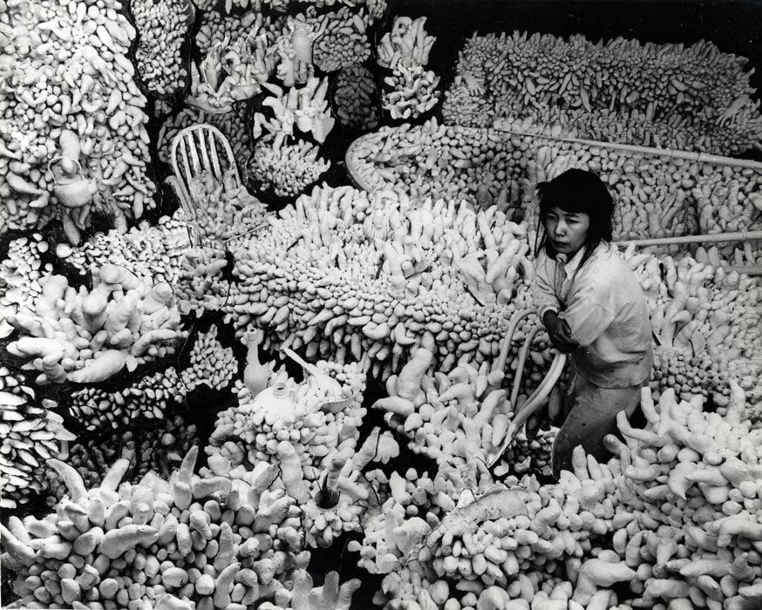
Figure 1. Yayoi Kusama, Accumulation (Compulsion Furniture), 1963

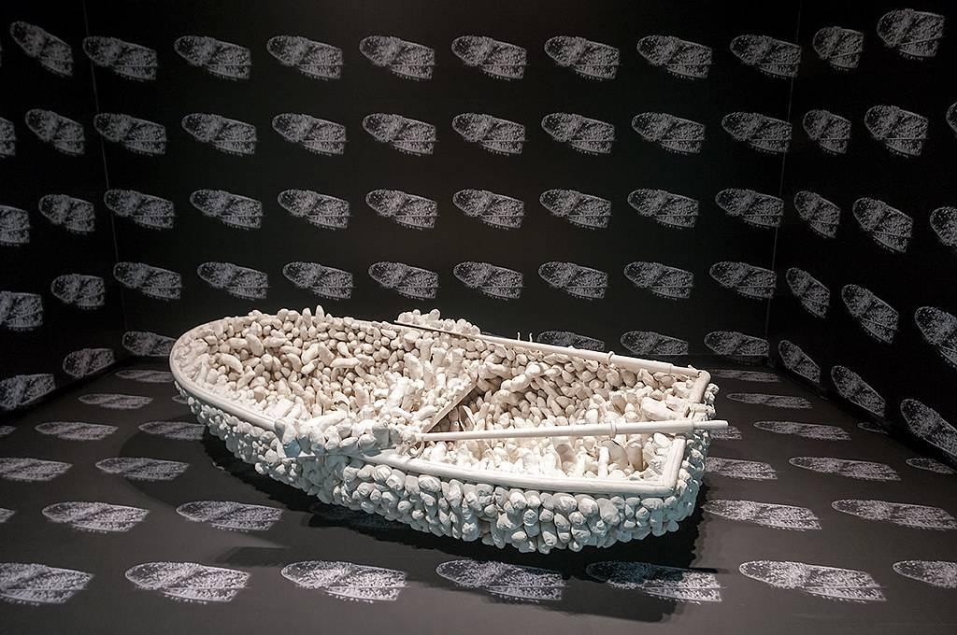
Figure 2. Yayoi Kusama, Aggregation: One Thousand Boats Show, 1963.

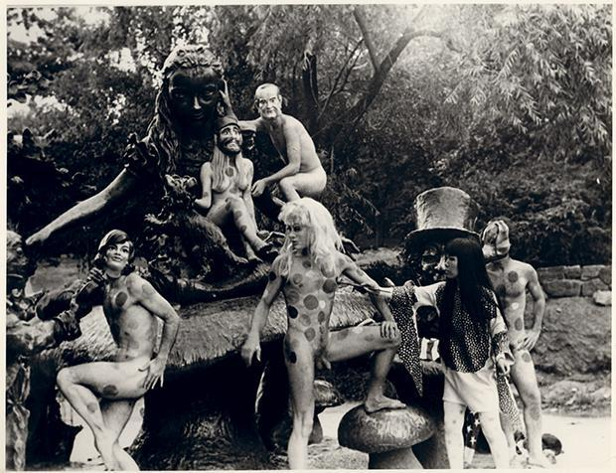
Figure 3. Yayoi Kusama, Anatomic Explosion, 1968 in Central Park, New York.
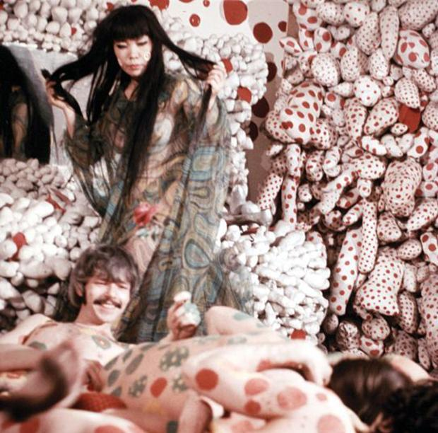
Figure 4. Yayoi Kusama, Homosexual Wedding, 1968.

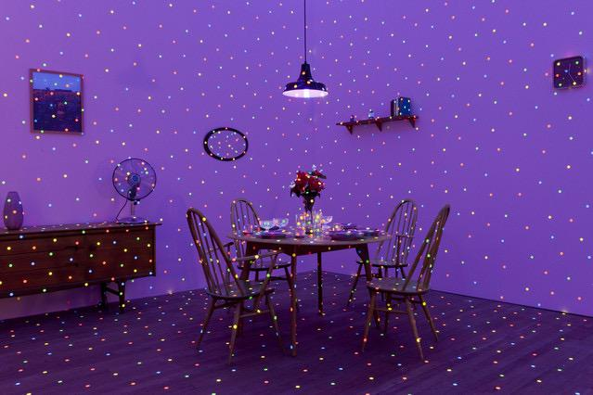
Figure 5. Yayoi Kusama, I’m Here But Nothing, 2000.

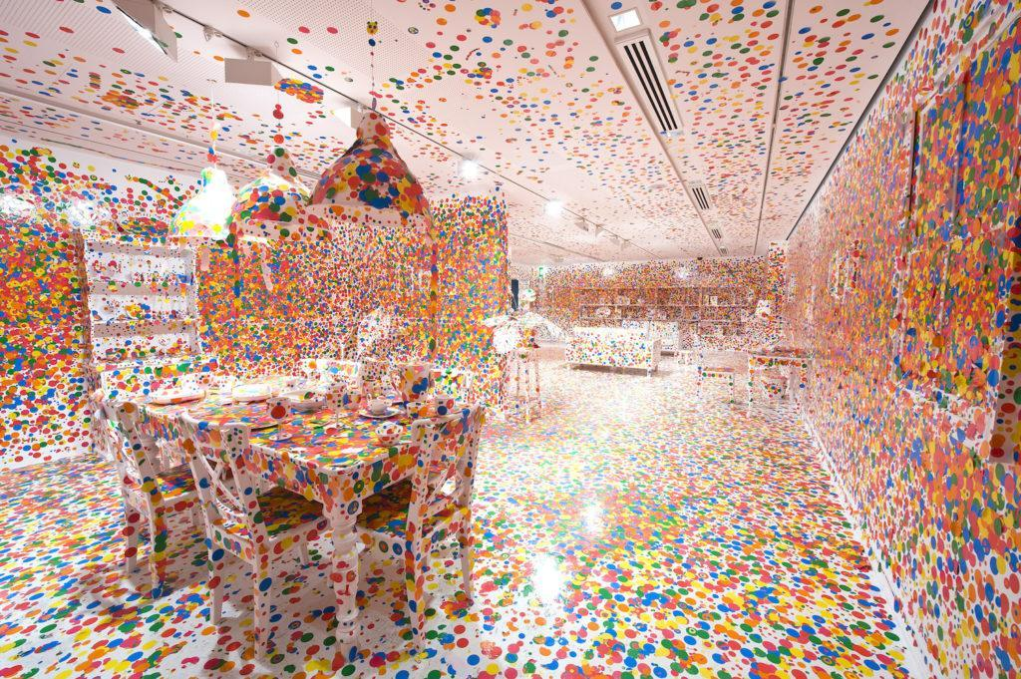
Figure 6. Yayoi Kusama, Obliteration Room, 2002.

Brianna Vargas, Kendall Baker, and Daniel Summer, Anxiety and Obsessive Compulsive Disorder Exploration Through a Sculptural Process, Documents, 2022, 3.
” An example of this could include someone having obsessive thoughts over their house burning down and their family being hurt. The compulsions could be constantly checking to see if flatten irons, ovens, or candles are turned off, or even avoiding using these things all together. In extreme cases, one could even drive all the way back home from work just to check if these things were turned off. Although this is clearly irrational, it is difficult for those with OCD to let go of this anxiety over causing something horrible to happen. This is disruptive to an adult’s daily routine, as constantly being in a state of panic as well as feeling the need to repeat certain actions can take up a large amount of time.” See Vargas, Baker, and Summer, Anxiety and Obsessive Compulsive Disorder Exploration Through a Sculptural Process, 3.
Yayoi Kusama, Yayoi Kusama Le Consortium, Contemporary Art Center, Dijon, November 2000 - January 2001 ... ; Artsonje Center, Seoul (Korea), Autumn/Winter 2002. Dijon: Les Presses du Réel/Janvier, 2000, 62.
Karia Bhupendra and Alexandra Munroe, Yayoi Kusama : A Retrospective, The Center for International Contemporary Arts, Inc., (New York: The Center for International Contemporary Arts, 1989), 12.
John Derby, “Disability Studies and Art Education .” Studies in Art Education 52, no. 2 (2011): 98. http://www.jstor.org/stable/41407936.
Derby, “Disability Studies and Art Education,” 98.
Derby, “Disability Studies and Art Education,” 97.
“MacGregor (1989) described the characteristics of outsider arts as markedly obsessional work that reveals unique creativity and intensity” see Simone Alter Muri,“Folk Art and Outsider Art: Acknowledging Social Justice Issues in Art Education,” Art Education 52, no. 4 (1999): 37. https://doi.org/10.2307/3193772.
Derby, “Disability Studies and Art Education,” 97.
“it is a poor representation of disability in general because it exemplifies the myth that disabled people and their work are incompetent;” see John Derby, “Nothing About Us Without Us: Art Education’s Disservice to Disabled People,” Studies in Art Education 54, no. 4 (2013): 378-9. http://www.jstor.org/stable/24465522.
Bhupendra and Munroe, Yayoi Kusama : A Retrospective, 11.
Frances Morris and Yayoi. Kusama, "Yayoi Kusama" / Edited by Frances Morris ; with Contributions by Jo Applin, Juliet Mitchell, Frances Morris, Mignon Nixon, Rachel Taylor, Midori Yamamura. (New York: DAP/Distributed Art Publishers, 2012.),14.
Bhupendra and Munroe, Yayoi Kusama : A Retrospective, 12.
“Kusama owns up to a deep-seated “obsession” with the phalli,” see Yayoi Kusama, Yayoi Kusama Le Consortium, 63.
Kusama: Infinity, 49:34 to 49:55.
“It was meant to glorify life. There is no reason why these beautiful bodies should be destroyed in the Vietnam War.” see Yayoi Kusama, Yayoi Kusama Le Consortium, 36.
Kusama: Infinity, 48:32 to 49:26 and 51:15 to 51:35.
“I was hospitalized at the mental hospital in Tokyo in 1975 where I have resided ever since. I chose to live here on the advice of a psychiatrist. He suggested I paint pictures in the hospital while undergoing medical treatment .” see Grady Turner and Yayoi Kusama. “Yayoi Kusama.” BOMB, no. 66 (1999): 63. http://www.jstor.org/stable/40425916.
Kusama: Infinity, directed by Heather Lenz (Magnolia Pictures, 2018), 59:19 to 59:45. https://www.hbomax.com/feature/urn:hbo:feature:GY5oOjQi2ysJtiQEAAAAC?_ga=2.5102131.1214981761.1682441091-716188505.1682441091
“At the heart of the concept of self-obliteration is the notion that the reduction of everything to polka dots or atoms, accumulation and collage are methods by which we can reunite our two separated selves (our physical reality and virtual reality).” see Yuko Hasegawa, and Pamela Miki. “The Spell to Re-Integrate the Self: The Significance of the Work of Yayoi Kusama in the New Era.” Afterall: A Journal of Art, Context and Enquiry, no. 13 (2006): 50. http://www.jstor.org/stable/20711605.
Muri,“Folk Art and Outsider Art: Acknowledging Social Justice Issues in Art Education,” 37.

