Hotel Helper

by

Awais Shoaib & Jonathan Harold

Submitted to
the Faculty of the School of Information Technology
in Partial Fulfillment of the Requirements for
the Degree of Bachelor of Science
in Information Technology

© Copyright 2021 Awais Shoaib, Jonathan Harold

The author grants to the School of Information Technology permission
to reproduce and distribute copies of this document in whole or in part.




___________________________________________________ __________________
Awais Shoaib Date
___________________________________________________ __________________
Jonathan Harold Date
__________________Yahya Gilany____________________ __________________
Yahya Gilany, Faculty Advisor Date

University of Cincinnati
College of
Education, Criminal Justice, and Human Services

April 2021
TABLE OF CONTENTS

List of Figures II
Abstract 1
Introduction 2-3
Problem 2
Solution 2-3
Project Goals 3
Overview 3
Discussion 3-15
Project Concept 3-4
Design Objectives 4
Methodology and Technical Approach 4-9
User Profile 9-10
Use Case Diagram 10-11
Testing 12-16
Budget 16-17
Project Timeline 17-20
Problems Encountered and Analysis of Problems Solved 20
Conclusion 20-21
Lessons Learned 21
Abilities and Skills Developed Throughout Project 21-22
Future Plans 22
Back Matter 23
References 23

LIST OF FIGURES

Figure 1. Web Application Snapshot 6
Figure 2. Database Diagram 8
Figure 3. Use Case Diagram 11
Figure 4. Administrator Unit Testing Results 14
Figure 5. Front Desk Unit Testing Results 14
Figure 6. Housekeeper Unit Testing Results 15

Table 1. User Profile 1 9
Table 2. User Profile 2 10
Table 3. User Profile 3 10
Table 4. Testing Plan 12-13
Table 5. UAT Testing Results 15-16
Table 6. Project Budget 17
Table 7. Project Timeline 18-20
ABSTRACT

Hotel Helper is an automated Housekeeping management system created using Node.JS and Angular to alleviate hotel staff of tedious and manual administrative tasks. The importance of minimizing labor costs is a generally a priority of hotel owners, but the impact COVID-19 has made on the hospitality industry makes it even more crucial for hotel owners to save money where they can. Housekeeping management software on the market is expensive and contains many unnecessary features for most hotels. As a result, many hotels prefer to use a manual pen and paper process, but this process is very inefficient. Hotel Helper serves as a cost friendly, simple web application alternative that allows managers and housekeeping staff to communicate in a two-way manner with updates on room cleaning progress, late checkouts, along with any other room related requests. Hotel Helper increases hotel staff efficiency, minimizes owner expenses, and streamlines the housekeeping process through the modernization of an outdated pen and paper procedure to an easy-to-use web application.

- INTRODUCTION

  - Problem
The COVID-19 Pandemic impacted many industries around the United States, including the hotel industry. Since the Pandemic, the average time to clean a room has increased by two minutes, which can lead to a $400,000 increase in expenses₄. Hotel owners are dealing with decreased occupancy but increased pressure to deliver an enhanced level of cleanliness. A study conducted by P&G mentioned 78 percent of hotel guests expect an “above average” level of cleanliness. In order to satisfy guests, housekeepers are unable to compromise any aspect of the cleaning process for efficiency_{1.} To satisfy guests and preserve revenues, housekeepers cannot compromise aspects of cleaning for efficiency. Hotel owners still need staff members to clean rooms, but also need ways to keep costs as low as possible while still maintaining guest satisfaction and high standards. The hospitality industry demonstrates that cleanliness and odor are top components of customer satisfaction and conversely, hotel profitability₃. Hotels deal with many cleanliness issues due to the lack of efficiency and communication with management during the cleaning process₃. This problem impacts guest experience, employee satisfaction, and the hotel revenue proportionately_{3.}
  - Solution
Hotel Helper is the web application allowing managers and housekeeping staff to communicate in a two-way manner with updates on room cleaning progress, status, and any related notes. Front desk workers are able to assign dirty rooms to housekeepers both automatically and manually. Housekeepers also have the ability to distinguish the condition of the room by indicating whether the room is dirty, in progress, cleaned, or waiting to be checked by a manager. The room data automatically updates allowing other members of the hotel staff to see the status of each room. Administrators are used to manage the users and view related reports. Modernizing the previously manual task helps keep the housekeeping process easy and free of communication issues. Hotel Helper allows all hotel staff to be in constant communication with real-time updates on room cleaning progress, status, and any other room related requests.
  - Project Goals
The main goal of Hotel Helper is to make the housekeeping process as efficient as possible and save hotels valuable time and money. Every year hotels spend significant amounts of money on housekeeping and it does not help the average time and cost to clean a room has gone up due to COVID-19₂. Hotel Helper is an easy to use web application aimed to decrease the amount of money spent on housekeeping labor by increasing the hotel staff efficiency leading to thoroughly cleaned rooms, happier employees, and increased customer satisfaction.
  - Overview
The remainder of this final report outlines in detail how the project was completed. The report includes the following sections: design objectives, methodology, testing, budget, timeline, problems encountered, and future recommendations.

- DISCUSSION

  - Project Concept

The main objective of hotels is to provide quality customer service and clean lodging facilities to their guests. Current housekeeping processes at many hotels are done through manual processes using pen and paper. This is inefficient and causes miscommunication issues leading to dirtier rooms and unsatisfied guests. Hotel Helper serves as a way to modernize the outdated pen and paper housekeeping process while increasing staff efficiency.
Awais and Jonathan knew they wanted to work together for Senior Design, but as the class moved closer, they did not have a project idea. Awais was at his family’s hotel and noticed the lack of modernization in the housekeeping process. Thinking more about the subject, Awais realized that most, if not all hotels he had been to have the same process. He wondered what the point of highly digital and modern processes for everything else if the housekeeping portion is still done through a pen and paper system. Awais also had a discussion with Dr. Said, who encouraged pursuing an idea in the hotel business because it will be solving a unique problem. The project began by going to the hotel and observing a normal day of how the housekeeping process works. Ultimately, it became clear to pursue Hotel Helper for Senior Design to help the hotel business become more efficient by implementing a cheap, easy to use, housekeeping management solution.

  - Design Objectives

The initial design objectives were to have an excel-like layout that would allow hotel staff to input data. Since then, the design objectives have evolved throughout the project. Intuitive dashboards are now used to display important information. Hotel Helper is designed as a simplified web application giving hotel owners and staff flexibility to carry out housekeeping tasks in a modern process, instead of pen and paper. Additionally, the user experience was kept simple to prevent the need of training.
Initially, Hotel Helper was set to have three separate log in portals for each type of user. Instead, it was decided to just route the users upon log in based off of the type of user they are. This saved time in the development process and made more sense once development started. The central login system allows for users to have a clean, seamless experience. A room matrix feature was part of the initial plan but became less of a priority as the project moved along and it was decided to not be a core function of Hotel Helper.
  - Methodology and Technical Approach
Throughout the development process of Hotel Helper, agile development was used to evolve the application as efficiently as possible. Large scale redesigns were not an ideal option being under a strict timeframe. Ultimately, a complete redesign occurred, and luckily it was early enough to where it did not significantly impact the project timeline.
Web App:
Node.JS and Angular were used to complete our project. The web application is being hosted on AWS. AWS was decided upon because of the relatively low cost compared to traditional server hosting options. Additionally, AWS Cloud is more reliable than third party server options.

Figure 1: Web Application Snapshot. The following diagram, Figure 1, shows the current table structure of the Hotel Helper web application

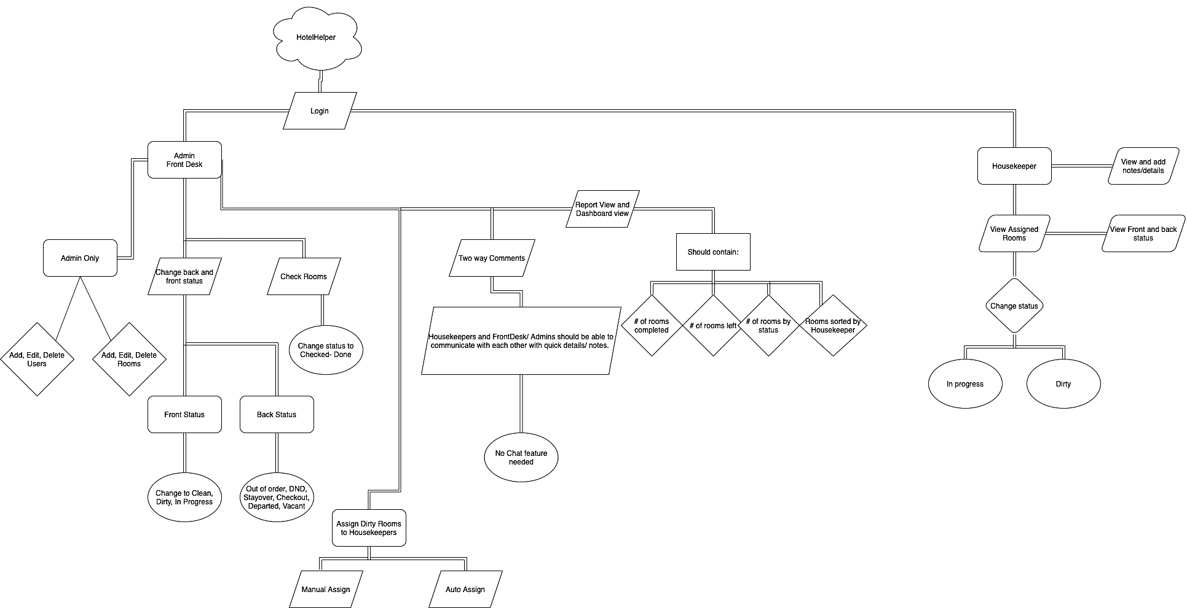
Figure 1: Web Application Snapshot

Since the housekeeping aspect is currently carried out via pen and paper, it was decided to create a custom application using Node.JS and Angular to be hosted on AWS. The central login system automatically detects the role of the person logging in and redirects them to the correct page. If they are an admin or front desk user, they will be redirected to the admin panel. The admin panel
allows for the management of users and rooms with the ability to communicate with housekeepers. Users in the admin panel have the ability to both manually and automatically assign housekeepers to rooms. In terms of the auto assign feature, front desk and admin users should be able to select the housekeepers that are present before automatically assigning rooms. The ability to select individual housekeepers during the auto assign process is important because there is not a fixed schedule for housekeepers. The housekeepers are contracted from a third party and can come on different days without notice.
If the user is a housekeeper, they will be redirected to the user page when logged on where they will see the rooms assigned to them to be cleaned. From there, housekeepers are able to select the status of the room. The housekeeping side of the application is designed to be as simple and as intuitive as possible in order to improve housekeeper productivity. Hotel Helper is mobile optimized to make it easier for housekeepers to perform their job on the go.
Database:
User information, room information, and the dates that will correspond to the room status on each date need to be stored. The user information includes the name, phone number, and role type. The room information has room number, room type, and room status (clean, dirty, checked).
For the Fall 2020 Semester, the database was hosted locally for development and testing purposes. Currently, Hotel Helper is hosted using AWS RDS. Rather than using an external database, it is more efficient to utilize Amazon Web Services to handle the database as well.

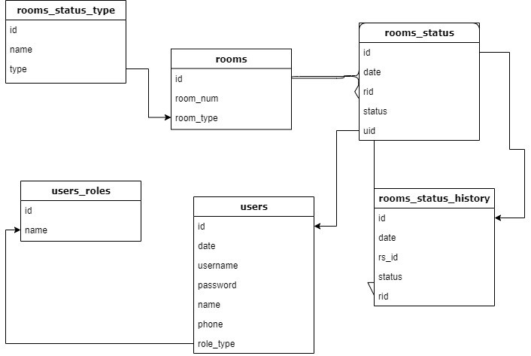
Figure 2: Database Diagram. The following diagram, Figure 1, shows the current table structure of the Hotel Helper database.

Figure 2: Database Diagram
As shown in Figure 1, Hotel Helper has an intricate database diagram. The structure consisting of these tables should not change moving forward, but more information may need to be recorded within some of the tables. This will ensure enough information is recorded to show very helpful performance dashboards to staff. The current database structure supports the main functionality of the application. The database used MariaDB and MySQL Workbench for development purposes, but has since transitioned to AWS RDS for the production app.
Security:
MD5 hashing is used for the database and AWS security protocols are also in effect for our site. The browser and cookies have AES security. Additionally, this web app is strictly private facing since it is only used on premise for hotel staff. MAC addresses or IP addresses could be limited through AWS to ensure that only authorized personnel are accessing the site rather than keeping it opened up to the public. This allows Administrators to still access the webapp off premises without compromising security.
  - User Profile
There are three types of users interacting with Hotel Helper. The first users described are the Administrators, who maintain the application. The second user group is made up of the Front Desk agents, who oversee the housekeepers alongside the Administrators. The third and final user group consists of the Housekeepers. They are the primary users of the application and use it on a day to day basis.
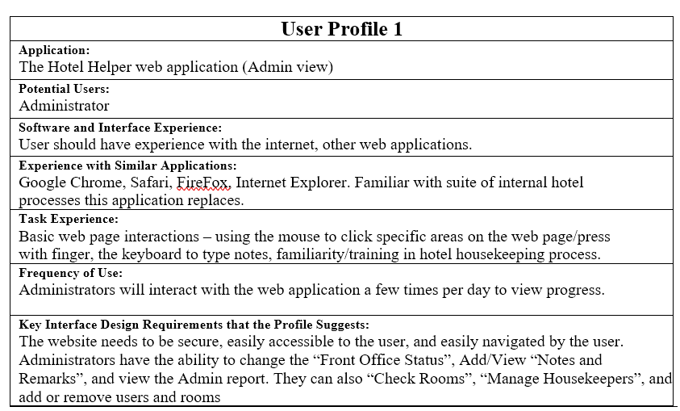
Table 1: User Profile 1: The table below displays the administrator user profile.
Table 1: User Profile 1
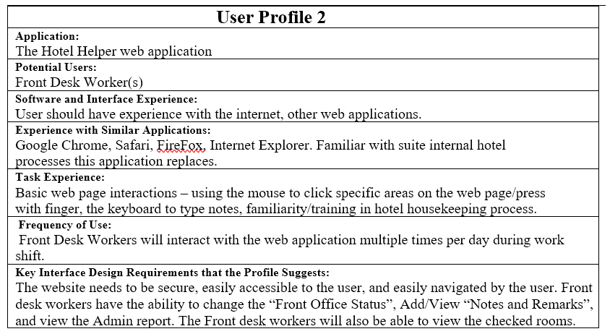
Table 2: User Profile 2: The table below displays the front desk worker user profile.
Table 2: User Profile 2
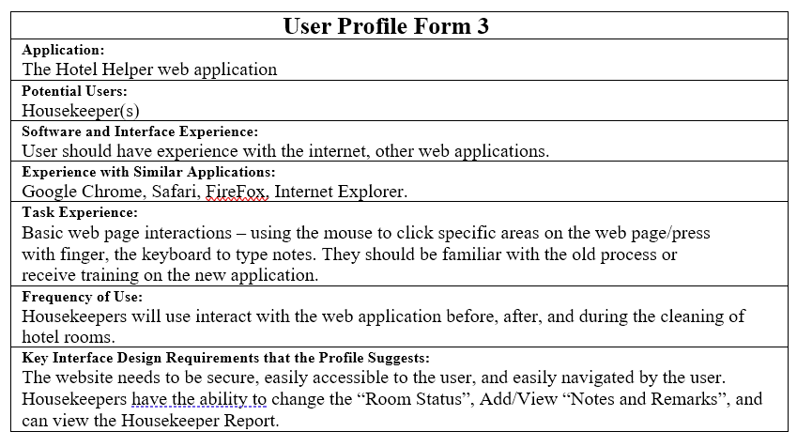
Table 3: User Profile 3: The table below displays the housekeeper user profile.
Table 3: User Profile 3
  - Use Case Diagram
Hotel Helper has three types of users, Admins, Front Desk, and housekeepers. All three use a central login system that automatically reroutes to the correct dashboard. The Admins are able to manage users and rooms. Front desk users are able to check the rooms and assign them to housekeepers.
Figure 3: Use Case Diagram The following diagram, Figure 1, demonstrates the use case for Hotel Helper. The diagram shows all possible users with corresponding tasks.
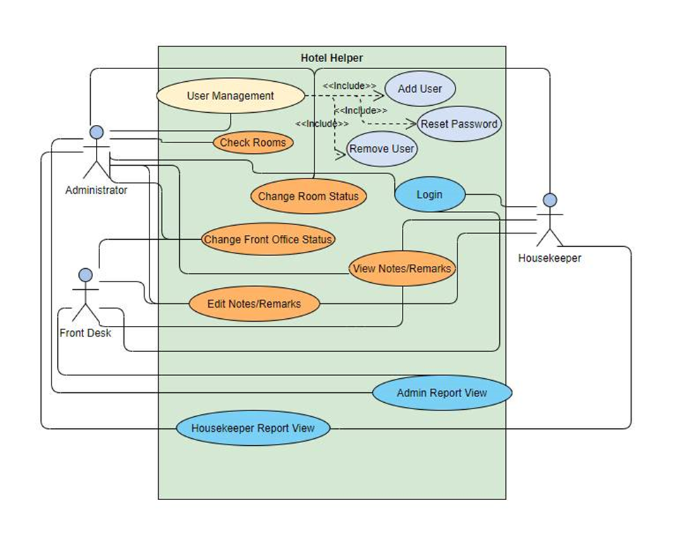
Figure 3: Use Case Diagram

  - Testing
Methodology and Approach:
The testing plan for Hotel Helper walks through the specific roles and use cases for each of the three application users: Admin, Front Desk, and Housekeepers. Multiple people, including our team, went through the use cases of the application to test the app as we worked through development. Automated unit testing was set up using Cypress to ensure issues were caught and code was fixed to work as intended. During this process we tested the functionality of Hotel Helper and made sure everything was working correctly from a technical perspective. UAT testing was then performed with hotel staff to ensure Hotel Helper worked exactly as intended and was up to their usability standards too.
Testing:
Scope: All of the features listed below are essential to the users of Hotel Helper and have been tested between utilizing unit testing and UAT. The use cases are broken down by common application tasks.
Table 4: Testing Plan: The table below displays the testing plan for Hotel Helper.

Test Case | User (s) | Use Case | Description
1 | All | Log In | Users can log in with correct credentials and correct role
2 | Admin/Front Desk | User Management | Users can add, delete, edit other users along with reset passwords
4 | Admin/Front Desk | Assign Room | -Manual Assign  -Auto Assign
5 | Admin/Front Desk | View Reports | Users are able to view both monthly and weekly reports.
5 | Admin/Front Desk | Room Management | Users can add, edit, delete, rooms accordingly
7 | Admin/Front Desk | Assign Rooms | Users are able to properly manually and automatically assign rooms
8 | Housekeeper | View/Check/Clean Assigned Rooms | Housekeepers are able to check room and put into proper status
9 | All | Log off | Users are able to log off of the application
Table 4: Testing Plan
Testing Results: The following sections display the Hotel Helper Unit Testing and UAT testing results for administrators, front desk workers, and housekeeper roles.
Unit Testing (Cypress):
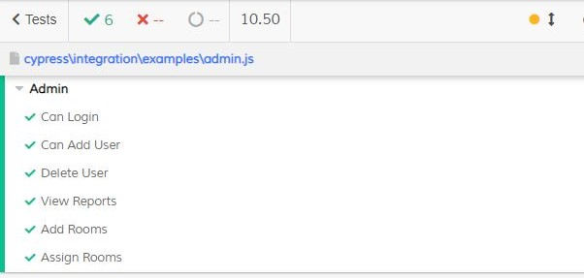
Figure 4: Administrator Unit Testing Results The following diagram, Figure 4, displays the unit testing results for the administrator role.
Figure 4: Administrator Unit Testing Results
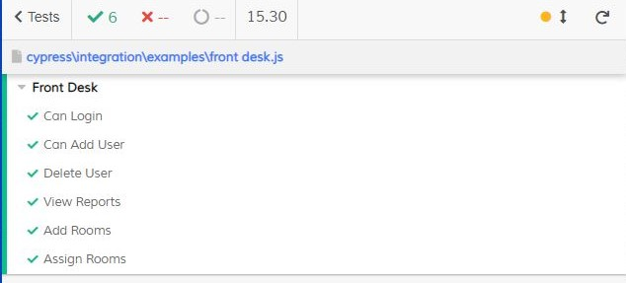
Figure 5: Front Desk Unit Testing Results The following diagram, Figure 4, displays the unit testing results for the front desk role.
Figure 5: Front Desk Unit Testing Results
Figure 6: Housekeeper Unit Testing Results The following diagram, Figure 4, displays the unit testing results for the housekeeper role.
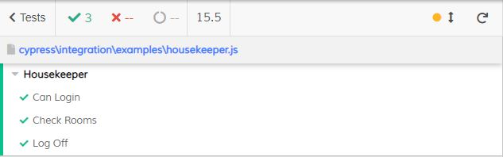
Figure 6: Housekeeper Unit Testing Results

UAT Testing
Table 5: UAT Testing: The table below displays the UAT testing results for Hotel Helper.

Test Case | User (s) | Use Case | Acceptance Requirement | Test Result
1 | All | Log In | Users can log in with correct credentials and correct role | Pass
2 | Admin/Front Desk | User Management | Users can add, delete, edit other users along with reset passwords | Pass
4 | Admin/Front Desk | Assign Room | -Manual Assign  -Auto Assign | Pass
5 | Admin/Front Desk | View Reports | Users are able to view both monthly and weekly reports. | Pass
5 | Admin/Front Desk | Room Management | Users can add, edit, delete, rooms accordingly | Pass
7 | Admin/Front Desk | Assign Rooms | Users are able to properly manually and automatically assign rooms | Pass
8 | Housekeeper | View/Check/Clean Assigned Rooms | Housekeepers are able to check room and put into proper status | Pass
9 | All | Log off | Users are able to log off of the application | Pass

Table 5: UAT Testing Results

  - Budget
Development time, average pay for young professionals, yearly cost to host and maintain Hotel Helper, and logo designs were factored in when calculating the total cost of the project.

Table 6: Project Budget The table below displays the budget for Hotel Helper. It is an estimation of real-world costs associated with the application development.
Hotel Helper Budget
NO. | ITEM | UNIT, HOURS | UNIT PRICE | TOTAL
SOFTWARE
1 | AWS | 1 | $156 (yearly) | $156
2 | Domain | 1 | $15 (yearly) | $15
 | Subtotal |  |  | $171
LABOR
4 | Logo Design | 1 | $100 (flat fee) | $100
5 | WebApp development | 1 | $3500 | $3500
6 | Database Build | 1 | $500 (flat fee) | $500
7 | Security Modifications | 1 | $150 (flat fee) | $150
 | Subtotal |  |  | $4250
 | Total |  |  | $4421

Table 6: Project Budget
2.8 Project Timeline

The timeline was malleable throughout the fall semester. Dates were narrowed down when development began in order to have an idea of anticipated progress on a weekly and monthly basis. Some hard deadlines were present within the Spring Semester, like IT Expo, but plans were still flexible overall.

Table 7: Project Timeline The following diagram, Figure 2, shows the Project Timeline for Hotel Helper. The Project Timeline shows the project schedule for fall and spring semester.

1. 0 Project Management and Deliverables | 232 | 08/24/20 | 4/14/21
1.2 Ideas and Brainstorming | 7 | 08/24/20 | 08/31/20
1.3 Fall Semester Assignment 0: Team Members & Project Name | 1 | 08/24/20 | 08/24/20
1.3.1 Project Name | 7 | 08/24/20 | 08/31/20
1.4 Fall Semester Assignment 1: Team Contract | 7 | 08/24/20 | 08/31/20
1.4.1 Project Approval | 7 | 08/31/20 | 09/07/20
1.4.3 Work Breakdown Structure | 14 | 08/31/20 | 09/14/20
1.5 Fall Semester Assignment 2: Project Abstract for Tech Expo | 21 | 09/21/20 | 10/12/20
1.6 Fall Semester Assignment 3: Team Contract Resubmission | 17 | 09/25/20 | 10/12/20
1.7 Fall Semester Assignment 4: User Profile | 14 | 10/05/20 | 10/19/20
1.8 Fall Semester Assignment 5: Use Case Diagram | 14 | 10/05/20 | 10/19/20
1.9 Fall Semester Assignment 6: Draft Report | 14 | 10/21/20 | 11/09/20
1.10 Fall Semester Assignment 7: Final Fall Semester Report | 28 | 11/2/20 | 11/30/20
1.11 Fall Semester Oral Presentation | 12 | 11/4/20 | 11/16/20
1.11.1 Presentation Practice | 18 | 10/30/20 | 11/16/20
1.12 Spring Semester Assignment 1: Testing Plan/Report | 28 | 01/13/20 | 02/10/20
1.13 Spring Semester Assignment 2: Abstract | 7 | 02/10/20 | 02/17/20
1.14 Spring Semester Assignment 3: Draft Tech Expo Poster | 14 | 02/17/20 | 03/2/20
1.15 Spring Semester Assignment 4: Final Poster | 7 | 03/2/20 | 03/9/20
1.16 Spring Semester Oral Presentation | 21 | 03/16/20 | 04/6/20
1.16.1 Presentation Practice | 21 | 03/16/20 | 04/6/20
1.17 Spring Semester Assignment 5: Final Report | 21 | 03/16/20 | 04/6/20
1.18 Spring Semester Assignment 6: Safe Assign Final Report | 21 | 03/16/20 | 04/6/20
1.19 IT Expo | 6 | 04/6/20 | 04/12/20
1.19.1 IT Expo Exhibit and Preparation | 6 | 04/6/20 | 04/12/20
1.20 Spring Semester Assignment 7: Final Library Copy | 9 | 04/20/20 | 04/29/20
2.0 Research | 36 | 08/31/20 | 09/19/20
2.1 Equipment Requirements | 10 | 08/31/20 | 09/10/20
2.1.1 Determine type of End user Device | 5 | 08/31/20 | 09/05/20
2.1.2 Hotel Walkthrough and Inspection | 5 | 09/05/20 | 09/10/20
2.2 Software Requirements | 2 | 09/11/20 | 09/13/20
2.2.1 Determine App Language | 1 | 09/11/20 | 09/11/20
2.2.6 Determine app notification settings | 1 | 09/12/20 | 09/12/20
2.4 Miscellaneous Research | 6 | 09/13/20 | 09/19/20
2.4.1 Determine Hotel needs | 2 | 09/13/20 | 09/15/20
2.4.3 Conduct Interviews with Housekeeping Staff | 2 | 09/15/20 | 09/17/20
2.4.4 Budget Analysis | 2 | 09/17/20 | 09/19/20
3.0 Design | 14 | 09/7/20 | 09/21/20
3.1 Create Prototype | 14 | 09/7/20 | 09/21/20
3.1.1 Layout Basic Feature set | 3 | 09/7/20 | 09/10/20
3.1.2 Create Wireframe | 4 | 09/8/20 | 09/12/20
3.1.3 Design Database | 4 | 09/12/20 | 09/16/20
3.1.4 Create Use Case Diagram | 2 | 09/17/20 | 09/19/20
3.1.5 Create User Profile | 2 | 09/19/20 | 09/21/20
4.0 Environment Set-Up | 7 | 09/14/20 | 09/21/20
4.1 Setup GitHub | 1 | 09/14/20 | 09/14/20
4.2 Install Visual Studio | 1 | 09/15/20 | 09/15/20
4.2.1 Set up Visual Studio | 1 | 09/16/20 | 09/16/20
4.3 AWS Setup | 1 | 09/17/20 | 09/17/20
4.3.1 Configure AWS account | 1 | 09/18/20 | 09/18/20
4.3.2 Import site domain | 1 | 09/19/20 | 09/19/20
4.3.3 RDS | 2 | 09/20/20 | 09/22/20
5.0 Development (Back End and Front End) | 132 | 09/22/20 | 2/1/21
5.1 Create Database | 2 | 09/22/20 | 09/24/20
5.2 Create Architect Layers | 1 | 09/24/20 | 09/24/20
5.3 Create Database Connection | 1 | 09/24/20 | 09/24/20
5.4 Create APIs | 20 | 09/24/20 | 10/25/20
5.4.1 Integrate SQL Server | 1 | 10/04/20 | 10/04/20
5.4.2 Buttons | 1 | 10/05/20 | 10/05/20
5.4.3 Pages | 1 | 10/06/20 | 10/06/20
5.4.4 Create Routing Modules | 7 | 10/07/20 | 10/14/20
5.4.5 Create backend functionality | 10 | 10/15/20 | 11/12/20
5.5 Login Page | 12 | 10/25/20 | 11/06/20
5.5.1 Create Login Front end | 6 | 10/25/20 | 10/31/20
5.5.2 Implement central Login system backend | 6 | 10/31/20 | 11/06/20
5.6 Implement MD5 and AES encryption | 5 | 11/07/20 | 11/12/20
5.7 Webapp Report views and Dashboards + Finishing touches | 70 | 11/30/20 | 2/1/21
6.0 Testing | 71 | 2/2/21 | 4/05/21
6.1 Functionality Test | 21 | 2/21/21 | 3/14/21
6.2 Penetration Testing | 6 | 3/22/21 | 3/28/21
6.2.1 SQL Injection Testing | 3 | 3/22/21 | 3/25/21
6.2.2 Regression Testing | 3 | 3/25/21 | 3/28/21
6.3 Data Testing | 2 | 3/29/21 | 3/31/21
6.2.3 Perform multi-device use case | 5 | 3/31/21 | 3/5/21
Table 7: Project Timeline

2.9 Problems Encountered and Analysis of Problems Solved

The plan was on using C# along with Asp.net, CSS and HTML, when the project first started, but as progress was made it was decided to go with Node.js and angular. C# is not easy to integrate with JSON, which causes issues to begin with. MVC, or the APIs for the database had to be integrated, so rather than try to overcome the major hurdle, it was decided to switch to a more familiar stack in order to have confidence moving forward. The project moved along smoothly once this was done. A clear plan from the start indicating what technology stack would help accomplish the goals of Hotel Helper would have saved time. Overall, it was a great learning experience, as this switch gave opportunity to feel pressure from making mistakes and the ability to push through while still learn from them.
Awais came down with the COVID-19 at the beginning of the spring semester. It took around three weeks or so to recover. In that time, Jonathan had to ensure development was going to stay on schedule. Awais was in the middle of some of his tasks, so Jonathan had to jump in and take responsibility. Jonathan was forced to put testing and other aspects on hold until Awais was feeling better. After three or four meetings, the team figured it out and we were able to proceed. This was arguably the biggest hurdle the team faced.

- CONCLUSION

3.0 Conclusion
Collectively, the inception, ideation, and creation of Hotel Helper has a tremendous impact on our group and how we evolved throughout the course of the semester. The development, layout, and feature set were constantly evaluated in order to accomplish the main goal of making a modern, user friendly application to replace the outdated housekeeping process.

3.1 Lessons Learned

Developing Hotel Helper teaches the importance of organization and effective communication. A large project with many moving makes it easy to get disorganized and miss key details. Staying organized with code and deliverables over time helps reduce stress and increase productivity. Effective communication helps make sure everyone is on the same page and prevents unnecessary work.

3.2 Abilities and Skills Developed Throughout Project

A lot was learned about development through the creation of Hotel Helper since both Awais and Jon are Cybersecurity students. Jon has previous Java and Python experience and Awais has previous experience with Java, PHP, Python, MySQL, and working knowledge of Node.js and Angular. Diving in with Node.js and Angular side of technology throughout the project taught both of us a lot about the similarities and differences compared to the languages previously used. Neither of us had any experience with AWS; however, with the dwindling time we had, we knew that uploading the webapp on a server would be the easy route to go. It was decided to spend the extra time and effort uploading our project to AWS rather than take the easy way out. Ultimately, being on AWS helps promote scalability and ensures reliability in Hotel Helper.
Project management and organizational skills were developed throughout the course of the semester by staying up to date with due dates and making sure deliverables were done accurately and turned in on time. Additionally, our skills of working under immense pressure improved through the experience dealing with Awais’ COVID battle that happened at a critical time for our project.
3.3 Future Plans

If it were the beginning of the semester, ensuring that we have a proper plan aligned with our stack prior to starting would be the only major change to implement. While we were able to make it up, the two-months of lost time switching from C# to Node.JS definitely hindered overall progress. If more time were available, Hotel Helper would incorporate more in-depth reports that would give managers further detailed looks into housekeeper metrics. Currently, administrators are able to print or export as a JPG file; however, we would love to offer PDF files. Suggestions from hotel staff have all been included and taken into consideration. While extra features could help, the hotel staff and management wanted a simple webapp with no unnecessary features. The plan is to implement Hotel Helper in at least one hotel by the end of 2021.

REFERENCES AND APPENDIX

4.1 References
₁“ECJ EUROPEAN Cleaning Journal.” ECJ, www.europeancleaningjournal.com/magazine/web-
articles/latest-news/cleanliness-key-to-hotel-ratings-reveals-research).
₂Fox, J. (2020, June 05). New study calculates cost of post-pandemic housekeeping. Retrieved
December 04, 2020, from https://www.hotelmanagement.net/housekeeping/new-study
calculates-cost-post-pandemic-housekeeping
₃O’Toole, J. (n.d.). As COVID-19 Crisis Unfolds, Hotel Cleanliness Becomes Even More Critical
to Customer Satisfaction. Retrieved December 04, 2020, from
https://hospitalitytech.com/covid-19-crisis-unfolds-hotel-cleanliness-becomes-even-more
critical-customer-satisfaction
₄Ross, Del. “Housekeeping Time, Costs Rise as Workforce Rebuilds.” HNNHousekeeping Time,
Costs Rise as Workforce Rebuilds, 7 July 2020, 7:10,
www.hotelnewsnow.com/Articles/303379/Housekeeping-time-costs-rise-as-workforce
rebuilds.

