INVITED SPEAKERS

Debra Sparrow
Debra Sparrow was born and raised on the Musqueam Indian Reserve and is self-taught in Salish design and jewellery-making. Her work can be seen in various museums and institutions.

Debra designed the logo for the Canadian Men’s Hockey Team for the 2010 Olympic and Paralympic Winter Games in Vancouver, B.C.

She also continues to work on pieces close to her heart at her home in Musqueam. It is Debra’s hope to educate others about the beauty and integrity of her people’s history through her art.

Debra is an acclaimed weaver who has been weaving for twenty years and is deeply involved with the revival of Musqueam weaving. Her Musqueam blankets are displayed at the Vancouver Airport, and at UBC.

James Hoggan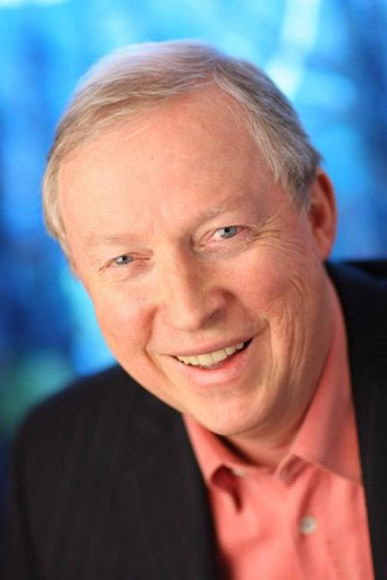
James Hoggan, JD, is a best-selling author and president of an award winning public relations firm.

Jim writes and speaks widely on public relations, communications and incivility in the public sphere, keying especially on lessons from his most recent book I’m Right and You’re an Idiot: The Toxic State of Public Discourse and How to Clean It Up.

Hoggan has spent more than a decade studying today’s warlike approach to public discourse, looking at how unyielding one-sidedness defeats our efforts to resolve global problems, and how self-awareness, empathy and pluralistic advocacy could help us cut through this toxic barrier to change.

He is seen as one of the gurus in his field, whether defending the reputations of civil society organizations, public institutions or prominent corporations, and the leaders who run them.

A tireless advocate for ethics in public discourse, he founded the influential online news site DeSmogBlog that reports on public relations trickery and that Time Magazine included in its 2011 list of the internet’s best blogs.

Hoggan is former Chair of the David Suzuki Foundation and Al Gore's Climate Project Canada. He has served on numerous national and international boards and advisory committees including Shell Global’s External Review Committee in The Hague, the Dalai Lama Centre for Peace and Education, and The Four Great Rivers Society.

He is the author of two other books, Do the Right Thing: PR Tips for a Skeptical Public and Climate Cover-Up: The Crusade to Deny Global Warming.

Karen Bakker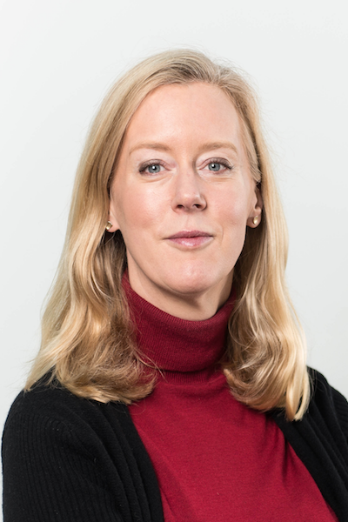
Dr. Karen Bakker is Professor and Canada Research Chair at the University of British Columbia.

The author of more than 100 academic publications Dr. Bakker is a Pierre Elliott Trudeau Foundation Fellow and member of the Royal Society of Canada’s College of New Scholars, Artists and Scientists.

She obtained her PhD from Oxford University, where she studied as a Rhodes Scholar.

She was the recipient of Stanford University's Annenberg Fellowship in Communication in 2015/2016.

Karen regularly acts as an advisor and consultant to national and international organizations, including the UNDP, OECD, and the International Institute of Sustainable Development.

Her public engagement has included teaching a MOOC on the Harvard edX platform, and extensive media contributions.

Karen is passionate about equity and diversity, and is currently focusing the majority of her research on issues of decolonization and technological innovation

Caleb Behn

Unfortunately, Caleb Behn is no longer able to attend the conference due to a scheduling conflict with his work.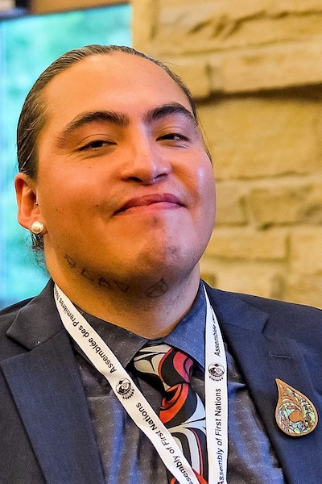
Caleb Behn is Eh-Cho Dene and Dunne-Za from Treaty #8 territory in northeastern BC.

He is a graduate of the University of Victoria Law Program and was called to the BC Bar in 2014.

Caleb’s work has focused on the intersection of water, energy and indigenous law.

A former ‘lands manager’ for the West Moberly First Nations and Saulteau First Nations and a former Senior Researcher at the Centre for International Governance Innovation, Caleb was also a founding member of the Decolonizing Water Research Collective and the subject of the documentary film ‘Fractured Land’.

Caleb now resides in Ottawa and is the Special Advisor on Water to the Housing, Infrastructure and Emergency Services Sector of the Assembly of First Nations.

Libby Lester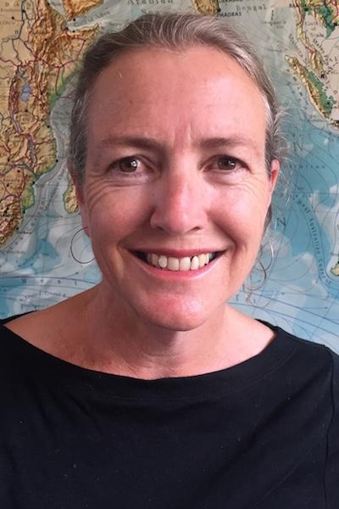
Libby Lester is Professor of Journalism, Media and Communications, and Associate Dean, Research for the College of Arts, Law and Education at the University of Tasmania, Australia.

She has authored, co-authored and co-edited six books, including Leadership and the Construction of Environmental Concerns (Palgrave Macmillan 2017), Environmental Pollution and the Media: Political Discourses of Risk and Responsibility in Australia, China and Japan (Routledge 2017), and Media and Environment: Conflict, Politics and the News (Polity 2010; Arabic ed 2013).

Her research has appeared in leading international journals, including Media, Culture & Society, Environmental Communication, International Communication Gazette, Journalism, Forestry, International Journal of Communication, Environmental Policy and Governance, and International Journal of Press/Politics.

She has been a Visiting Fellow at Oxford University's Reuters Institute for the Study of Journalism and at the National Graduate Institute for Policy Studies in Tokyo.

Her current research program, funded by the Australian Research Council, is focussed on trade, resource extraction and supply, and environmental communications.

Before joining the University of Tasmania, she worked as a journalist, reporting on social, political and environmental issues for major Australian newspapers and magazines.

