GRAP
by
R.J. Gehringer, Gina Hopper, Parneet Kang, Aida Musaeva

Submitted to
the Faculty of the School of Information Technology
in Partial Fulfillment of the Requirements for
the Degree of Bachelor of Science
in Information Technology

© Copyright 2020 R.J. Gehringer, Gina Hopper, Parneet Kang, Aida Musaeva

The author grants to the School of Information Technology permission
to reproduce and distribute copies of this document in whole or in part.

04/20/2021
___________________________________________________ __________________
R.J. Gehringer Date

04/20/2021
___________________________________________________ __________________
Gina Hopper Date

04/20/2021
___________________________________________________ __________________
Gina Hopper Date

04/20/2021
___________________________________________________ __________________
Aida Musaeva Date

Abdou Fall 04/20/2021
___________________________________________________ __________________
Abdou Fall, Faculty Advisor Date

University of Cincinnati
College of
Education, Criminal Justice, and Human Services
April 2021

Table of Contents

List of Illustrations II
Abstract III
Introduction IV
Introduction: IV
Problem: IV
Solution: V
Project Goals: VI
Discussion VII
Project Concept VII
Design Objectives/Deliverables VII
Methodology and Technical Approach VIII
User Profile IX
Use Case Diagram XII
Budget XIII
Project Schedule XIV
Work Breakdown Structure XVII
Problems Encountered and Analysis of Problems Solved XVII
Gantt Chart XVIII
Technical Elements XX
Conclusion XXI

List of Illustrations

Table 1 Major Project Milestones VII
Table 2 Project Schedule XIII
Table 3 Project Schedule Continued XIV
Table 4 Project Schedule Continued XV
Table 5 Work Breakdown Structure XVI

Figure 1 Use Case Diagram XI
Figure 2 Budget XII
Figure 3 Gantt Chart XVII
Figure 4 Gantt Chart continued XVIII

Abstract

GRAP is a web and mobile application for users to learn, customize, and simplify their shopping, cooking, and exercise needs. GRAP provides users with a fast and easy way to follow recipes depending on what they have at home and their cuisine preferences. Following what you have at home, GRAP can fill in certain ingredients you do not have at home and even provide the user with locations that carry the missing ingredients. While simplifying your time in the kitchen and grocery stores GRAP provides a service for tracking your health and fitness. With GRAP on the market shopping, cooking, and exercise needs will become easier to maintain through and after this troubling time.

Introduction

Introduction:
With the rise of COVID-19 has risen the demand of cooking at home, meticulous shopping, and monitoring your health. Across the globe people are looking for new recipes, cheaper groceries, and a way to stay healthy. GRAP has brought all these needs into one location for all their users to converge into one community across the globe. This application will bring people together in this unusual time, helping everyone work through to the other side.

Problem:
Every day people are looking up recipes, watching their calorie intake, and shopping for food. A couple of the top websites for this area have a couple of these features, but not all. Finding a place that can help you find where to buy the ingredients to cook the recipes is important. Sometimes your local area may not carry a certain ingredient and you will have to improvise, but you cannot share your modifications of the recipe to all the other users. Along with adding new recipes, the top websites also do not allow you to customize your ingredients to your favorite foods. They typically consist of a list like yogurt or grapes, but you always eat a specific yogurt or grape-like Yoplait or concord grapes. These features are primarily found through multiple areas, but not in just one.
One of the existing solutions is a website called https://myfridgefood.com/. It allows you to check the boxes of the ingredients you have and will suggest a recipe based off it. However, the site isn't very user friendly, and there is no easy way to search for an ingredient you have. It
makes you scroll through all the available ingredients and select which ones you want. Another issue is that the recipe's list will also include ingredients you may not have, there is no option to select saying you only want a recipe using those specific ingredients.
Another solution is https://www.supercook.com/, which allows you to add what ingredients you have and it has a search feature and a feature to keep track of what you already have in your pantry/shopping list. What it doesn't include is a way to scan the barcode of a product you already have to add it for searching recipes, or if you want to keep track of your pantry/shopping list. The app also doesn't allow you to buy groceries, but it does pull the recipes from several major recipe sites. Neither of these solutions allows you to track your daily nutritional intake, but they do advise the nutritional values.
The site https://cronometer.com is a solution for tracking all your nutritional/health/exercise data but it does not have the functionality to find recipes or the nutritional information from an item.
The Kroger's mobile app, https://www.kroger.com/i/ways-to-shop/mobile-app, allows you to search for ingredients and buy them online but it doesn't include any of the above features.

Solution:
GRAP is created for a one-stop-shop web application community for food shopping, health tracking, and cooking. Users will be able to find the ingredients for a recipe they enjoy or just fill in the ingredients that they already have and come up with the great recipe. Users will also be able to add ingredients by scanning their barcodes for a more intuitive feel. These recipes
can be customized to better reflect what each user prefers by adding your favorite brands of ingredients. Also, by adding your favorite brands you will be able to get a more accurate idea of the calories you will be consuming. Not only will you be able to customize ingredients, but you will be able to publish your recipes or modifications of other recipes. This will give the environment more of a community feel and allow users to get a better experience with cooking and health.

Project Goals:
The main purpose for GRAP is to simplify the user experience on figuring out what to make for food based off what the user already has in their pantry. This includes developing a web application, ensuring security measures, and integrating the application programming interface (API). Other features include tracking the user’s nutritional/health/exercise data.

Discussion

Project Concept
The concept of GRAP was inspired by our daily lives problem of using those ingredients in the pantry which we think are of no use. The group came up to the conclusion with this app because the problems solved by GRAP will be very helpful for the users, who are very busy in their daily lives. There were some bugs in some of the already designed apps and we decided to solve them and add some new features like scanning the barcode of the items in the pantry, providing the nearest location the Kroger store, providing nutrition values of the ingredients and providing recipes with the ingredients present in the pantry. Developing this app will not only help the users to use their unwanted ingredients but also learn some new recipes.

Design Objectives/Deliverables

Major Project Milestones (Deliverables)
Project Initiation | 07/31/2020 | Environments Set-up | 10/15/2020
Begin Research | 07/31/2020 | Presented 3 Minute Elevator Pitch | 10/19/2020
Team Contract Delivered | 09/01/2020 | Use Case/User Profile Complete | 10/19/2020
Completed Project Abstract | 10/12/2020
Table 1 Major Project Milestones

Our teams deign objective has changed with the change in the phase of the project. During our first meeting we decided the idea of the project. We decided the to go with GRAP application as our project. After finalizing the idea of the project, we started the to do research, so that we can reach to the expectations of the class. After doing the researching, our Team Contract was delivered.
After completing Ream Contract, we started working on our project Abstract, completed it and then submitted it. After completing Project Abstract, we decided to Set-up IntelliJ as the environment of our project. We decided to code our project in Kotlin language. We started coding with the DTO’s, DAO’s and Service Classes. Our professor kept on pointing where we need to improve and where he was impressed by us. We also delivered 3 Minute Elevator Pitch. During the end of the semester, we gave oral presentation.

Methodology and Technical Approach

Web Application
GRAP application is being developed with the goal of helping the users to use their leftover ingredients in the pantry. The team decided to code in IntelliJ. IntelliJ is an integrated development environment written in Java for developing computer software. We decided to code the project in Kotlin language. It also allows us to use HTML and CSS styling. The website includes:
- Recipe – Shows the recipes to the users with the ingredients they search for
- Pantry – Contains the ingredients that a user has
- User Profile – Keeps track of the user’s account
- Nutrition – Keeps track of the nutrients taken by the user

User Profile
Potential Users:
- College Students
- Families
- Web developers and administrators
Software, Interface, and Related Experience:
The target audience of this application will include anyone with the desire to learn, customize, and simplify their shopping, cooking, and exercise needs. During COVID-19 eating out has become limited and the need to cook and maintain a healthy lifestyle has grown substantially. Provided are among the highest prioritized users for this application.
Experience with similar applications:
College students these days are quite aware of what is available on the Internet and how to utilize them. These users have used a variety of applications to this date to separately track fitness like https://cronometer.com, or find new and fun recipes like https://www.supercook.com/. These applications in of themselves work fine, but with GRAP they can forget about separate accounts and locations and can centralize all their health, cooking, and shopping needs into one application across all their devices.
Web developers and administrators will need to have experience with web technologies, APIs, GitHub and Google Firestore.
Travelers / Businessmen are a similar user class to college students, and workers who are likely carrying many smart devices. These users will also have experience with the process of configuring an app to utilize its features. They can use the app wherever they want with the access of the internet. This will help them get new recipes to any part of the world they go to.
Fitness users may use some of the features that are more tailored to fitness and may not need the others that are tailored to the recipes. They will need to have experience with tracking their nutritional intake and workouts.

Task Experience:
The GRAP community can actively participate in a variety of health, cooking, and shopping desires. When considering our primary group of users, performing recipe searches, shopping ingredients, and tracking the daily health will be the target focus. The users of GRAP can also experience a variety of other features like: Sharing in app or through other social media applications, store locations, recipe and profile customization, will be provided cross platform on any device with a browser.
Frequency of use:
Upon reaching The GRAP home screen, setting up a user profile and personal configuration will be swift and easy. The user will be able to access their account on multiple devices and can be saved on desired devices. During our product demonstrations we will be able to display several different use cases like shown above to provide straightforward examples of our target audience. Providing demonstrations of customization will also provide clarity for unique user interests.
After production deployment occurs our developers and project managers will begin to monitor, test, and resolve any issue that may arise to provide an optimal user experience.
Key project design requirements that the profile suggests:
- Internet capable device
- User friendly interface
- Fast and consistent usability
- Easy and simple profile management
- Nationwide support
- Accommodates to a wide variety of users’ interests
- Provides a community of shared interests
- Top level security

Use Case Diagram
￼
Figure 1 Use Case Diagram

Budget
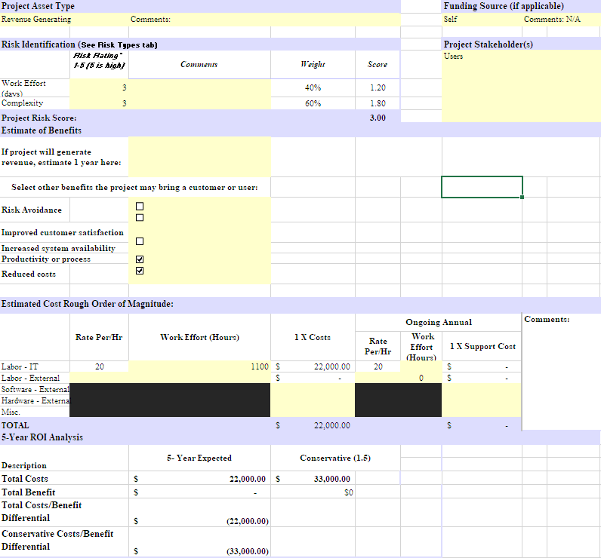
Figure 2 Budget

Project Schedule
Task Name | Duration | Start | Finish
Software Development | 128 days? | Tue 8/18/20 | Thu 2/11/21
Project Milestones/Deliverables | 60 days? | Tue 8/18/20 | Mon 11/9/20
Team Formation | 5 days? | Tue 8/18/20 | Mon 8/24/20
Brainstorming Ideas | 5 days? | Tue 8/18/20 | Mon 8/24/20
Fall Deliverable 0: Team Members and Project Title | 1 day? | Mon 8/24/20 | Mon 8/24/20
Fall Deliverable 1: Team Contract | 7 days? | Mon 8/24/20 | Tue 9/1/20
Fall Deliverable 2: Project Abstract for Tech Expo | 36 days? | Mon 8/24/20 | Mon 10/12/20
Fall Deliverable 3: Team Contract Resubmission | 9 days? | Tue 9/1/20 | Fri 9/11/20
Table 2 Project Schedule
Fall Deliverable 4: Use Case Diagram | 41 days? | Mon 8/24/20 | Mon 10/19/20
Fall Deliverable 5: Draft Report | 56 days? | Mon 8/24/20 | Mon 11/9/20
Research Phase | 2 days | Fri 8/21/20 | Mon 8/24/20
Select language and frameworks | 1 day | Mon 8/24/20 | Mon 8/24/20
Select APIs | 8 hrs | Fri 8/21/20 | Fri 8/21/20
Select Data Storage | 1 day | Fri 8/21/20 | Fri 8/21/20
Design | 43 days | Tue 8/18/20 | Thu 10/15/20
System Diagrams | 43 days | Tue 8/18/20 | Thu 10/15/20
Design Wireframes | 5 days | Tue 8/18/20 | Mon 8/24/20
Create Network and Database Diagrams | 4 days | Tue 8/18/20 | Fri 8/21/20
Development | 43 days? | Thu 10/15/20 | Mon 12/14/20
Setup Environment | 15 days | Thu 10/15/20 | Wed 11/4/20
Set-Up Environments | 1 day | Thu 10/15/20 | Thu 10/15/20
Setup Github Repo | 1 day | Thu 10/15/20 | Thu 10/15/20
Create project email | 1 day | Thu 10/15/20 | Thu 10/15/20
Sign up for API keys | 15 days | Thu 10/15/20 | Wed 11/4/20
Table 3 Project Schedule Continued
Commit initial base project to Github | 15 days | Thu 10/15/20 | Wed 11/4/20
Design Interface | 43 days? | Thu 10/15/20 | Mon 12/14/20
Design Backend Code | 43 days? | Thu 10/15/20 | Mon 12/14/20
Design Features | 1 day? | Thu 10/15/20 | Thu 10/15/20
Barcode Scanning | 1 day? | Thu 10/15/20 | Thu 10/15/20
Searchable Recipe | 1 day? | Thu 10/15/20 | Thu 10/15/20
Create Pantry | 1 day? | Thu 10/15/20 | Thu 10/15/20
Testing | 86 days | Thu 10/15/20 | Thu 2/11/21
User tests | 43 days | Thu 10/15/20 | Mon 12/14/20
Security Testing | 43 days | Tue 12/15/20 | Thu 2/11/21
Deployment | 44 days | Thu 10/15/20 | Tue 12/15/20
Deploy Website | 43 days | Thu 10/15/20 | Mon 12/14/20
Provide ongoing support for application | 1 day | Tue 12/15/20 | Tue 12/15/20
Table 4 Project Schedule Continued

Work Breakdown Structure
Task # | Task Name | Duration | Start Date | End Date1
1 | Project idea development | 3 weeks | 07/31/2020 | 08/24/2020
2 | Contract and software tools overview | 1 week | 08/25/2020 | 09/01/2020
3 | Scope development and WBS creation | 1 week | 09/02/2020 | 09/09/2020
4 | Research | 6 weeks | 09/09/2020 | 10/21/2020
5 | Design | 3 weeks | 10/21/2020 | 11/11/2020
6 | Development | 13 weeks | 11/11/2020 | 02/10/2021
7 | Testing and quality assurance | 8 weeks | 02/10/2021 | 04/07/2021
8 | IT Expo | 1 day | 04/13/2021 | 04/13/2021
Table 5 Work Breakdown Structure

Problems Encountered and Analysis of Problems Solved
Deciding what product, we want to create was the hardest problem for us. We did a lot of research and have a lot of discussions before we finally came up with GRAP. We all were feeling that cooking and food are what connects a lot of people.
The next problem was setting up our environment we want to work and what technologies we want to use. We were not able to use some of the technologies because of the fees they charge or some of us was not familiar with them. We were able to solve this problem by discussing what is best for us and how simple they are to use. We mostly use open-source software.
Picking the right APIs was another challenge because some of them do not provide the right or complete information. We did some research and was able to find suitable ones.

Gantt Chart
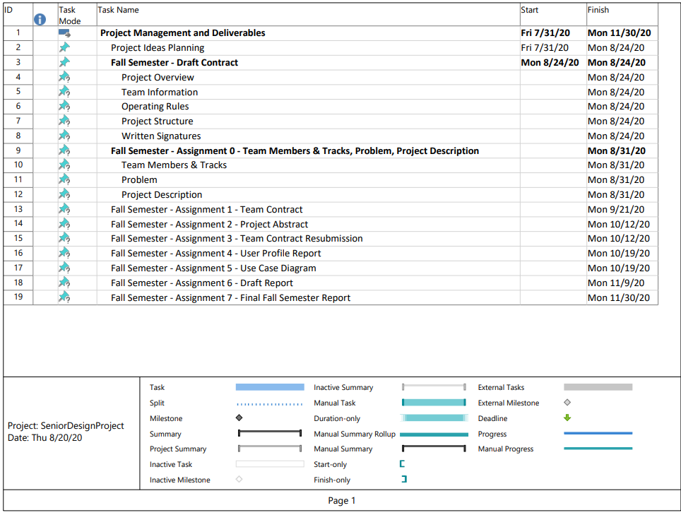
Figure 3 Gantt Chart

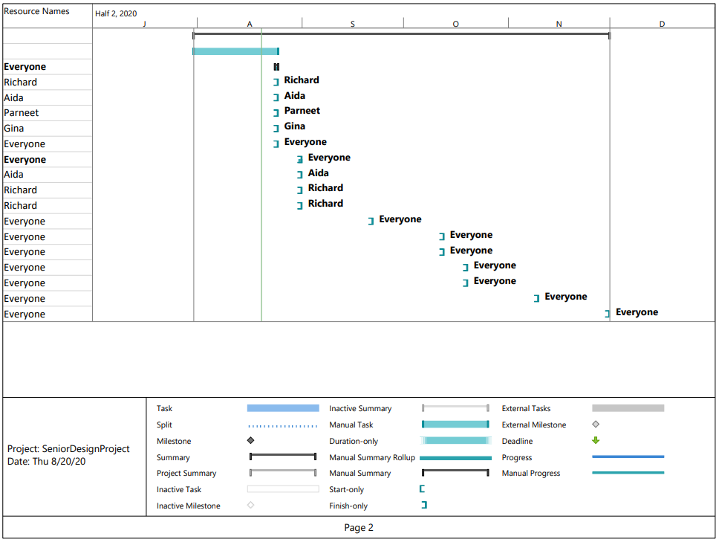
Figure 4 Gantt Chart continued

Technical Elements

The main purpose of GRAP application is to help those people who want to look for the recipe made with those ingredients that are available in their refrigerator. Our group concluded using IntelliJ. It helps to improve the code quality. We have decided to code the project in Java language. There will be five pages for the project and they are:
- Nutrition: Contains all the nutrition value of ingredients and recipes
- Recipe: allow the customers to have access to different recipes to those ingredients that are available in their refrigerator
- Pantry: It consist of the number and the ingredients present in the refrigerator
- Search: Search allows the customers to search for the recipe by entering ingredients in the search bar
- Profile: Helps the user to create their own Account

Conclusion

Fall 2020
Our goal for this semester was to further our knowledge of web applications in areas like APIs, MVVM architecture, and design as well as working in an agile team environment. From the start we put together a ton of ideas for features our application could provide. We began by getting into a schedule where we began to delegate tasks and planning out our project lifecycle. After a few weeks and a lot more, research into implementing features alongside each other we began to sniff out certain issues. Some of these issues we ran into were the amount of API requests we made between all of us and conflicting API information on pages. Issues like these are almost impossible to have seen coming, but when faced with issues like these we were able to pivot and move forward. We have currently arrived at the project lifecycle where we are fine tuning some of our more incremental features and designing the UI. In doing so we have made sure to implement Bootstrap to create a responsive application across all devices. As we look toward the end of this semester, we strive to produce the sharpest and most utilized demo for our target audience.

Spring 2021
We would like to add an API that can be used for scanning the products available in the pantry. This will help the users to add the ingredients in the pantry just by scanning their barcode without entering them manually. Another thing that we would like to add is Nutrition page. This will help the users to keep track of the calories that are taking. This feature will also attract the people who are interested in fitness.

References

Documentation | Firebase. (n.d.). Retrieved November 10, 2020, from https://firebase.google.com/docs
Edamam. (n.d.). Retrieved November 10, 2020, from https://developer.edamam.com/edamam-docs-recipe-api
Awaiken. (n.d.). Documentation. Retrieved November 10, 2020, from https://spoonacular.com/food-api/docs
Severson, K., & Yaffe-bellany, D. (2020, March 20). Independent Restaurants Brace for the Unknown. Retrieved November 10, 2020, from https://www.nytimes.com/2020/03/20/dining/local-restaurants-coronavirus.html

