UC Fit Fitness Application
by
Blake Schemine, Andrew Norton, Samuel Blaha

Submitted to
The Faculty of the School of Information Technology
in Partial Fulfillment of the Requirements for
the Degree of Bachelor of Science
in Information Technology

© Copyright 2021 Sam Blaha, Andrew Norton, Blake Schemine

The author grants to the School of Information Technology permission
to reproduce and distribute copies of this document in whole or in part.

Blake Schemine | Blake Schemine | 4/12/2021
Andrew Norton | Andrew Norton | 4/12/2021
Samula Blaha | Samuel Blaha | 4/12/2021

Abdou Fall | Abdou Fall | 4/12/2021

University of Cincinnati
College of Education, Criminal Justice, and Human Services
April 2021

Prepared by:

Blake Schemine - Database Architect
Andrew Norton - UX Designer
Samuel Blaha - Security Analyst

Students of
University of Cincinnati
College of Education, Criminal Justice, and Human Services
School of Information Technology
cech.uc.edu/it

April 2021

Table of Contents
Table of Contents 3
List of Illustrations 5
Tables: 5
Abstract 1
Introduction: 2
Problem: 2
Solution: 2
Project Description / Goals: 3
Overview: 4
Discussion: 4
Project Concepts: 4
Methodology: 4
Design Objectives / Deliverables: 5
Technical Elements 7
Database: 7
Application: 7
User Profile: 8
Use Case Diagram: 12
Project Management 13
Budget: 13
LINK TO BUDGET 13
Testing: 14
Project Schedule: 15
Work Breakdown Structure: 16
Problems Encountered: 20
Conclusion 22
Fall 2020: 22
Spring 2021: 23
References 25
Appendix A 26

List of Illustrations

Tables:
Table 1: Major Project Milestones. 10
Table 2: User Profile. 13-15
Table 3: Work Breakdown Structure. 20-23
Figures:
Figure 1: User Case Diagram. 16
Figure 2: Budget. 17
Figure 3: Login Page. 30
Figure 4: Homepage. 31
Figure 5: Dining Hall Page. 32
Figure 6: Workout Page. 33
Figure 7: History Page. 34

Abstract

Every year, freshmen across the US gain weight from the food courts on each college campus. Studies have found two thirds of freshmen gain weight during their first year while 70% of students gain weight and body fat before graduation. Our app UC FIT aims to reduce the overall weight gain and unhealthy lifestyle college students face every year. We are here to help college students navigate the weight room and the food courts. UC FIT will help them live out a healthy lifestyle by informing them of what food options are available, each day from the food courts. As well, UC FIT will provide a seamless way to track workouts and learn how to operate the gym equipment, using our guided workout animations of specific exercises. UC FIT will help college students and countless others from gaining excessive weight throughout their freshmen year.

Introduction:

Problem:
Last year roughly 8,000⁴ freshmen enrolled at UC. Each year many students and Rec Center members visit the gym, many not knowing how to properly use the workout equipment. Additionally, there are few signs promoting a healthy lifestyle, outside of the rec center. UC Rec Center members do not have access to a convenient mobile solution that details what is available, how to properly use gym equipment, logging workouts, and how to eat and live healthy while living on, off, or near campus. There needs to be a solution that brings these components together. A solution like this could be beneficial to UC Students, Faculty, and Rec Center Guests in promoting a healthier lifestyle and workout routine.

Solution:
Our web application, UC Fit, will allow UC Rec Center members to view what equipment is available at the gym, what exercises are possible per machine, and give a detailed list of what food options are available, each day, from the UC food courts. UC Fit will also highlight diet-restricted meal plates that people could consume at each food court. UC Fit will have a simple intuitive interface for UC Rec Center members to log what workouts they performed. UC Fit will make it simple to stay up to date on an individual's workout routine while allowing freshmen to avoid over-consuming food which leads to the dubbed “freshman 15”. UC Fit will give new-comers the ability to confidently learn what is possible at the gym, without fear of looking like a newbie.

Project Description / Goals:
UC Fit is a mobile web application that allows Students to easily navigate the UC Rec Center and UC dining halls. Students are not able to easily see what gym equipment is available for their workout, or how to use a specific machine. Students are also unable to easily see what dining options are available to them that will fit within their calorie needs, diet, and allergies.
UC Fit solves these problems students face by organizing this data in one location. Students can log in to UC Fit to view Dining options for that day, scan gym equipment to understand how it operates, and view their workout statistics.
This is a unique solution as there are no other web applications on the market that target UC Rec center and UC dining halls specifically. Currently students have to use Campus Dining to view foods available for the day. UC Rec Center doesn't even offer an application to help students when it comes to workout. UC Fit combines two things related to health to give students a great experience when on campus. Our app includes an all-in-one interface that allows UC students find these features in one central location. Saving time, energy, and offering convenience.

Overview:
The remainder of this report will cover the progress and development that our group experienced in order to design and lay the framework for our UC Fit Mobile application. We will discuss in depth our plan for developing the UC Fit Mobile application later in the report. This report will highlight our project goals and deliverables and the schedule for developing UC Fit. Finally, the functionality of our app will also be demonstrated using the user interface prototypes we designed.

Discussion:

Project Concepts:
UC Fit is a solution for students that connects the UC recreation center with UC dining to promote living a healthy lifestyle for college students. The idea of this app was to make it easy for students to navigate the UC rec center. We were all freshmen in college and we were all aware of the weight gain that freshman year provides. We noticed there wasn’t a solution provided by UC to promote a healthy lifestyle.

Methodology:
When designing our application we had to make sure that it worked on a mobile device and all of the functionality worked correctly. For each page of our application, we had to design and test each feature to make sure it worked as intended. This plan-and-procedure method allowed us to understand how the application should work before it was even built. This made testing and debugging easier because we knew what to look for.

Design Objectives / Deliverables:
We created a simple easy to use web application that encompasses all of the ideas and tools we found would be useful to college students. When we set out to create UC Fit we had a lot of concepts we wanted to implement, but we quickly realized that we would have to slim down our project to meet the minimum viable product for this class’s timeline. One idea we had to discard was a reward system for our app. The more a student works out and records their workout they would receive ‘points’. The more ‘points’ they accumulate the more rewards they could get. Another idea we scraped was a calorie tracking feature for the food courts. We originally intended for the user to be able to log what food they ate. Now one can only view what food is available. Finally, we wanted to make this a true mobile application. None of us had the skills and background to feasibly create the application. Thus, we resorted on making a mobile-responsive web application in place of a native mobile application.
The following table outlines the major project milestones for our project as well as the senior design assignment deadlines. The left column displays the specific project milestones. The right column displays the target dates for each major milestone which need to be completed across both fall and spring semester.
Table 1: Major Project Milestones
Major Project Milestones
Fall 2020
Team Members and Project Name | 24-Aug
Team Contract | 1-Sep
Project Abstract | 12-Oct
Team Contract Resubmission | 12-Oct
3-Minute Elevator Speech | 19-Oct
User Profile | 19-Oct
Use Case Diagram | 19-Oct
Draft Report | 9-Nov
Oral Presentation | 23-Nov
Final Fall Semester Report | 7-Dec

Technical Elements
These are the technical components we used when developing our website. We had to build a custom database to house our data. We used a front-end web design solution to create the custom interface. We used a UI-creation software to mock the user experience. Finally, we used html to build the layout of our webpages.

Database:
The database for our application was written using SQL in SQL Studio Management Studio. We developed a database structure that allows for the easy creation and retrieval of data pertaining to the UC dining halls and workouts a user chooses to log. The database has a list of stored procedures that allow the front end to automatically log and retrieve records. The front end will call these procedures with specific IDs and the stored procedures will return the subsequent records.

Application:
Our web application was designed and written using AngularJS and Bootstrap. Angular provides a framework to create web pages for both desktop and mobile. Using advanced CSS we will allow our web app to scale to the dimensions used when accessed. We can translate our webpage back and forth regardless of what device is used. The Bootstrap implemented into the HTML allows the components we use to have a modern colorful aesthetic while keeping the application light-weight and easy to use. We can build a custom experience for our application with minimal complexity.

User Profile:
Our User Profiles break down our intended audience. We layout what type of action(s) that user is expected to perform given the capabilities of our app. We highlight what each user is able to do within our app and what resources are needed in order to perform that action. As our app expands and we generate a big user base, more case studies will generate and our user profiles will have to update.
Table 2: User Profiles
User Profile – System Administrator
Application: UC Fit
Potential Users: Developer, Database admin
Software and Interface Experience: The user should be able to understand how the software interacts with different components of the application, like how to JavaScript calls to the database to retrieve information the end user is requesting. The user should also be familiar with web development and database creation/administration. The system admin should understand OWASP top 10 to keep the app secure.
Experience with Similar Applications: The user should be experienced with web application development using tools like GitHub, vscode, and angular. They should have some experience with JavaScript.
Task Experience: The user should be able to use JavaScript to maintain requests back to the database from the front-end. The user should also have experience updating angular components when needed to change design or function of the application. SQL experience is required.
Frequency of Use: The application will be created and published. The user will then just need to do regular maintenance such as ensuring the application is always available, ensure the database is up. Working with the angular and JavaScript will be less frequent but will need to be looked at routinely to ensure we are being efficient.
Key Interface Design Requirements that the Profile Suggests: The user will need to have experience with backend development and maintenance. They will need to understand how the database is designed, how to angular functions, and how the JavaScript requests work

User Profile – End User
Application: UC Fit
Potential Users: End User
Software and Interface Experience: The user should have experience operating a web browser on their mobile device.
Experience with Similar Applications: The user should have experience navigating websites that offer menus, log-in screens, and camera usage.
Task Experience: The user should have experience operating a camera to scan qr codes on workout equipment. They should know how to navigate menus to find dining hall information and workout statistics. They should understand how to log in to the application. They should understand how to record a workout and log that workout to their history page.
Frequency of Use: The user will use this application daily. They will use the application to view the food available to them at the dining halls for that day. They will also use the application when they go to the UC Rec Center to workout.
Key Interface Design Requirements that the Profile Suggests: The design requires that the user have available to them an easy to operate mobile web application. The application needs to be clean and intuitive. The application should make sense in how it operates. The design should be useful so that the user will want to continue using the web application in the future.

Use Case Diagram:
Our use case diagram is here to represent the user’s interaction with the application or system. This shows the relationship between the user and the different use cases in which the user will perform. Additionally, we have outlined which components are going to be utilized by the User and which components will be used by the Web Developer/ Administrator.
Figure 1: Use Case Diagram 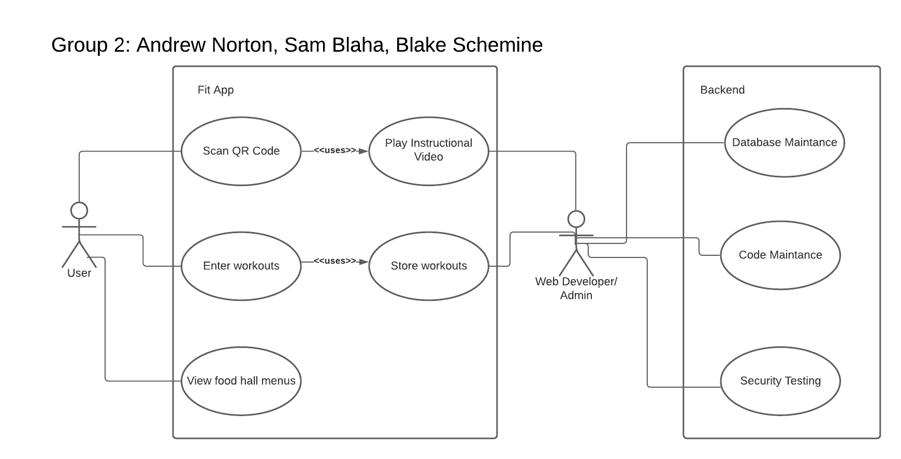

Project Management
This section describes the budget and planning that went into our project. We had to figure out how much this project would cost our team financially and logistically.

Budget:
The budget we have created outlines the financial aspects of the UC Fit web application. We thought through what it would cost for materials, and the pay someone might receive in our role. We also included a project risk score. The score is an important measure as it determines the risk of failure completing the project. This score is based on complexity and the time needed to complete the project.
Figure 2: Budget

LINK TO BUDGET
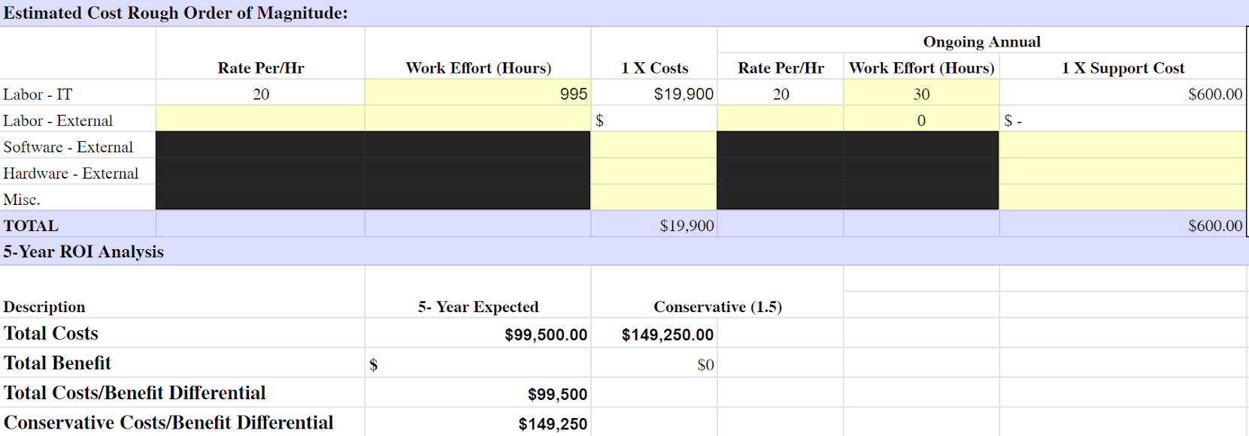

Testing:
In order to make sure our application was built correctly and runs properly we had to run multiple tests on each aspect of the application, thoroughly testing the extremes of what would be allowed and what was accessible. The following highlights each phase of our testing.
- Development
  - While developing the application we had to test for bugs and other issues causing the application not to run. These issues would prevent one part of the code or application from being complete so fixing an issue at the source was important to further development.
- Quality Assurance
  - Once we felt confident and comfortable with what we developed we ran tests on our application. We had to make sure we were able to find ways to break our application and once doing so: understand how to repair it. This process was iterative as we created more and more pages for our application.
- User Testing
  - We conducted user testing by putting our application in the hands of peers and other students. We had them use the application for a set amount of time, then asked specific questions such as, log a workout or look up how to do a certain exercise. The results were straightforward and honest. Many users intuitively navigated our application and had no issues figuring out how to do specified tasks. Most users discussed how they would like to see the user interface updated to a minimalistic clean style. Another criticism we encountered was on the logging workouts page. The users wanted a simpler way to select and enter the workouts, some users said they wanted slider bars for weight entry.
- Database
  - While designing and creating the database there were multiple stored procedures that had to be created. Not only did these relationships have to connect multiple tables together and do calculations based on the result set, there were also issues with pulling incorrect or incomplete data. While designing all of the statements it was important to test the extremes of what is allowed as an input and what will be accepted per the calculation. We had to make sure that each stored procedure ran as designed and pulled the correct information.

Project Schedule:
Work Breakdown Structure outlines the entire schedule for our project across both semesters. The proposed timeline is to help complete specific deliverables to achieve target milestones. We have to add additional features to our web application. We have to have accessibility to our database. Plus there are general security features that must be implemented. This section describes in more detail what was accomplished and what must be done.

Work Breakdown Structure:
Table 3: Work Breakdown Structure
Work Breakdown Structure
Task Name | Duration | Start | Finish
UC FIT | 232 days | 8/24/20 | 4/13/21
Project Milestones/Deliverables
Team Formation | 1 days | 8/1/2020 | 8/2/2020
Brainstorming | 7 days | 8/24/20202 | 8/28/2020
Deliverable 0: Team Members and Project Name | 7 days | 8/17/2020 | 8/24/2020
Deliverable 1: Team Contract | 7 days | 8/25/2020 | 9/1/2020
Deliverable 2: Project Abstract for IT Expo | 7 days | 10/5/2020 | 10/12/2020
Deliverable 3: Team Contract Resubmission | 7 days | 10/5/2020 | 10/12/2020
3-Minute Elevator Pitch | 7 days | 10/12/2020 | 10/19/2020
Deliverable 4: User Profile | 7 days | 10/12/2020 | 10/19/2020
Deliverable 5: Use Case Diagram | 7 days | 10/12/2020 | 10/19/2020
Deliverable 6: Draft Report | 14 days | 10/25/2020 | 11/9/2020
Deliverable 7: Final Fall Semester Report | 14 days | 11/23/2020 | 12/7/2020
Deliverable 8: Testing Plan/ Report | 14 | 1/25/2021 | 2/8/2021
Deliverable 9: Final IT Expo Abstract | 7 days | 2/8/2021 | 2/15/2021
Deliverable 10: Draft IT Expo Poster | 7 days | 2/22/2021 | 3/1/2021
Deliverable 11: FInal IT Expo Poster | 14 days | 3/1/2021 | 3/15/2021
Deliverable 12: Course FInal Presentation & Visual Aids | 7 days | 3/29/2021 | 4/5/2021
1.0 Environment Setup
1.1 Github | 14 days | 8/31/2020 | 9/14/2020
1.2 Visual Studio Code | 14 days | 8/31/2020 | 9/14/2020
1.3 Angular / Bootstrap | 14 days | 8/26/2020 | 9/25/2020
1.4 SQL Server Management Studio | 7 days | 9/11/2020 | 9/18/2020
1.5 Adobe XD | 7 days | 8/28/2020 | 9/4/2020
2.0 Architecture
2.1 Web Flow | 7 days | 8/24/2020 | 8/31/2020
2.2 UI Concepts | 21 days | 8/24/2020 | 9/14/2020
2.3 Database Design | 14 days | 8/26/2020 | 9/7/2020
3.0 Scripting
3.1 Database Environment | 1 day | 9/13/2020 | 9/14/2020
3.2 Database Tables | 7 days | 9/14/2020 | 9/21/2020
3.3 Database Procedures | 14 days | 9/14/2020 | 9/28/2020
4.0 Populate Database
4.1 Mock Data | 1 day | 9/20/2020 | 9/21/2020
4.2 Test Scripts | 14 days | 9/14/2020 | 9/28/2020
4.3 Autotomize Procedures | 14 days | 9/28/2020 | 10/12/2020
5.0 Code Development
5.1 Angular Shell | 7 days | 10/2/2020 | 10/9/2020
5.2 Web Skeleton | 7 days | 10/9/2020 | 10/16/2020
5.3 Page Navigation | 14 days | 10/9/2020 | 10/23/2020
5.4 Component Placing | 21 days | 10/26/2020 | 11/16/2020
5.5 Javascript Functionality | 21 days | 10/26/2020 | 11/16/2020
5.6 Database Connections | 21 days | 10/26/2020 | 11/16/2020
5.7 UI Scalability | 21 days | 10/26/2020 | 11/16/2020
5.8 Debugging | 21 days | 10/26/2020 | 11/16/2020
6.0 Functional Testing
6.1 Error Handling | 7 days | 11/9/2020 | 11/16/2020
6.2 CRUD Statements | 14 days | 11/2/2020 | 11/16/2020
6.3 Logging | 28 days | 10/19/2020 | 11/16/2020
7.0 Security Checks
7.1 Debugging | 14 days | 11/2/2020 | 11/16/2020
7.2 Error Handling | 14 days | 11/2/2020 | 11/16/2020
7.3 Connection Issues | 28 days | 10/19/2020 | 11/16/2020
7.4 Vulnerability Checking | 28 days | 10/19/2020 | 11/16/2020
8.0 Optimization
8.1 Web Flow | 14 days | 9/28/2020 | 10/12/2020
8.2 Polish Aesthetics | 14 days | 11/2/2020 | 11/16/2020
8.3 Page Scalability | 21 days | 10/26/2020 | 11/16/2020
8.4 Data Integrity | 21 days | 10/26/2020 | 11/16/2020
8.5 CSS Work | 30 days | 1/1/2021 | 1/31/2021
8.6 User Testing | 30 days | 2/1/2021 | 2/28/2021
9.0 Final
9.1 Oral Presentation | 1 day | 4/5/2021 | 4/5/2021
9.2 Final Report | 7 days | 4/1/2021 | 4/9/2021
9.3 IT Expo | 1 day | 4/13/2021 | 4/13/2021

Problems Encountered:
These are problems and errors our team encountered throughout our application development. We have errors and bugs on multiple fronts.

- Database connection
  - Connecting the SQL database to the angular web app turned out to be more difficult than we originally thought. To connect the database we need to create an api connection between the frontend and the backend. These api connections are unique for every project. We are still configuring these api connections to have it working by the Spring IT Expo.
- Environment setup
  - After researching how to connect VS code to github, we found a guide to help us connect them. This helped us push and pull code from our github server, allowing every member of the tea to have the latest version of our code.
- PrimeNG
  - PrimeNG is a collection of UI components for angular projects. We decided to not use primeNG after having countless failures in our code. We decided to use Bootstrap instead because it integrated nicely with our existing code.
- Proportional Scaling
  - We are still working on figuring out a way to make the web page proportionally scale to any size screen the end user uses.
- Security
  - Implementation of Content-Security-Policy HTTP header, regular Angular library updates, implementation of user security classes based off the Principle of Least Privilege, implement Google authentication or UC’s six plus two for secured login.
- QR Code Scanner
  - Creating a QR code scanner turned out to be more difficult than we planned. We originally wanted to use the native camera application on iPhone and Android. While we were able to open the native camera application from our web application we were not able to use the QR code scanning capability the native camera application provides. We also tried implementing a QR library online but encountered issues when trying to connect it to our web application.

Conclusion

Fall 2020:
Our goal for the fall semester has been to learn about the different technologies that we’ll be using for our project. We have spent time making sure each technology can integrate with the others. Initially we hoped to create a website that will tell the user how many people are in specific buildings, which could be very useful on campus when finding a place to study. After talking to advisors, our team decided to shift our idea to developing a mobile application that would help UC students live a healthier lifestyle. After we decided to pivot we immediately started researching how students could live a healthier lifestyle. We came up with an all in one solution called UC Fit. This mobile application will help students find healthy meals in the UC dining halls. UC Fit will also tell students how to use specific workout machines in the UC rec, eliminating the embarrassment some students get when working out. Lastly the UC Fit app will help students record their workouts. While developing the UC Fit app we discovered that some of our technologies were not compatible with each other, for example our Microsoft sql server database would not integrate with the angular version we are using causing us to find a new database host. These problems that we overcame helped us get our hands on new and unique technologies and sharpen some of our technical skills as well as our soft skills, more specifically our resilience as a team.

Spring 2021:
A lot was accomplished this spring semester. We completely redesigned the UI of our application, we pivoted from being able to scan QR codes to a seamless integration of gif files relating to the selected workout, finally we revamped the dining halls page making it more attractive to the end user. All of these tasks were designed to make the end user of our application feel a sense of ease and simplicity when using our app. We want to make an application that lets people feel stress free. These enhancements all had their own unique technical challenge. We had to discover new ideas and techniques that weren’t clear at first. The dining hall page required learning a ‘parallax’ effect. The guided workouts (gif) page required referencing different files using a single variable. Finally the UI overhaul required we validate each page and element to confirm it changed before commiting each change to github. There were a lot of technical challenges this semester but our team came together and completed what we originally sought after. We are pleased with the output of our application and think it will be beneficial to those who use it.
Throughout this whole year, a common challenge / theme was the research needed when integrating multiple systems together. At various points in our project we learned the difficulty of combining multiple technologies together. It’s easy to build a database. It’s easy to build a website. It’s easy to host a website on a server. And it’s easy to design a global css. What is difficult is combining all these features together. One can’t just connect a front end to a database. One can’t just write one css file and apply it globally. One can’t just pick a cloud provider and push your code. There are many technological barriers that have to be researched and throughout before committing to any one design or architecture. We learned very quickly how much we didn’t know and what we would have to improve on if we wanted to make this app the best it could be.

References
- Brissette, C. (2017, September 26). How to avoid the 'freshman 15'. Retrieved October 13, 2020, from https://www.washingtonpost.com/lifestyle/wellness/tips-to-avoid-the-freshman-15-which-may-be-a-myth-anyway/2017/09/25/8d368618-9cb3-11e7-8ea1-ed975285475e_story.html
- O'Connor, A. (2012, September 26). 70% of Students Gain Weight During College: Study. Retrieved October 13, 2020, from https://www.health.com/family/college-gain-weight
- Russell McMahon, personal communication, 10 October 2020
- Brownfield, A. (2019, September 16). University of Cincinnati smashes another record for 2019. Retrieved November 30, 2020, from https://www.bizjournals.com/cincinnati/news/2019/09/16/university-of-cincinnati-smashes-another-record.html

Appendix A: Visuals
Figure 3: Login page
Here is the login page or our web application. Users will be able to login or create an account from this screen.
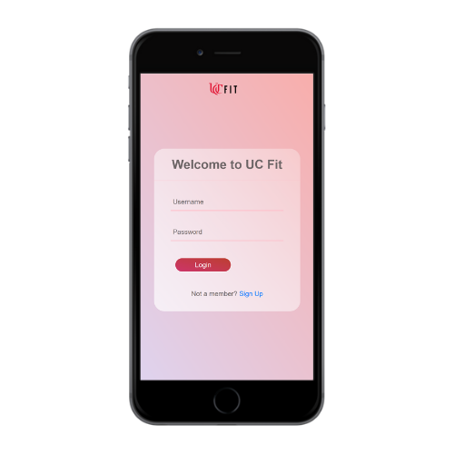

Figure 4: Homepage
The login page will take the user to the homepage where the user will be met with 3 different buttons. Food, Workout, and History. Each button will take the user to the respective pages.
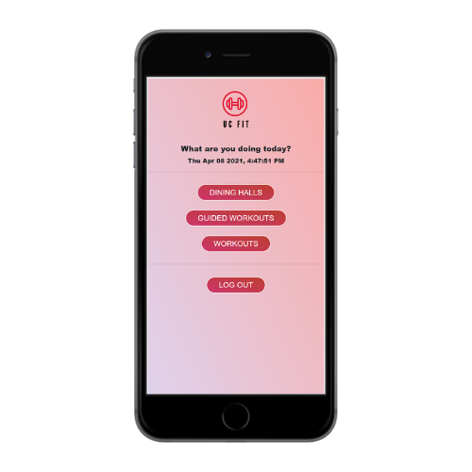

Figure 5: Dining Hall Page
This is the food page. First the user will be prompted to choose a food court. From there, the user is taken to that specific food halls menu.
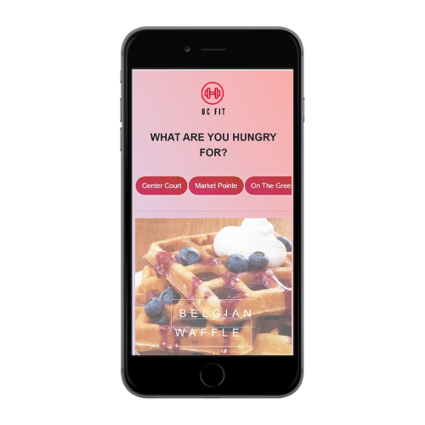

Figure 6: Workout Page
This is the workout page. This page will allow the user to Scan a Qr code (on a workout machine) to view how to do the specific workout. This page will also allow the user to record workouts to view later and track progress.
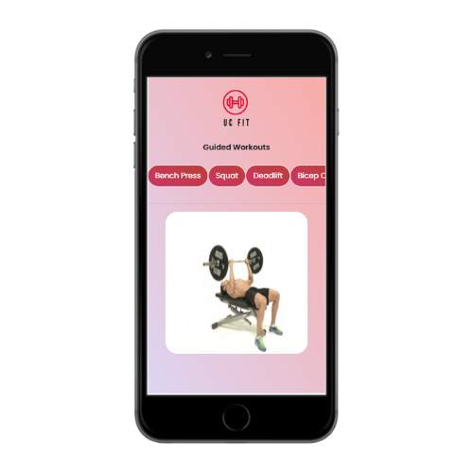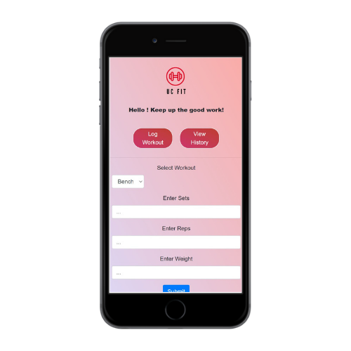

Figure 7: History Page
This is the History page. Here users can view their workout history.

