Hokusai’s Great Wave and its Impact on the Culture of Western Art
Joe Gray
Senior Seminar Research Paper
Prof. Christopher Platts
4/21/22

In the genre of classic Japanese art, one name stands above all others in its worldwide recognition in the 21st century, that being Katsushika Hokusai (1760-1849). Simply known as Hokusai, his contributions to the world of Japanese woodblock prints during the seventeenth and eighteenth centuries made him a household name during his life. In the aftermath of the Meiji Restoration in 1868, as Japan reopened its borders and to trade with the western world, Japanese art became a major inspiration to western artists working in many genres. Of his many woodblock prints, or ukiyo-e, one piece stands alone in the way in which it captivated its audience, both Japanese and Western. The Kanagawa-oki Nami Ura, or The Great Wave of Kanagawa, simply known as The Great Wave (Fig.1). The influence The Great Wave can be seen in the method in which it was utilized as inspiration for both classical Impressionist and Post-Impressionist artists, as well as modern influences on fashion, art, and technology.
Japan has a unique connection to the history of art. Of its many contributions, few prove more historically significant than the contribution of ukiyo-e, meaning “pictures of the floating world”, in reference to the hedonistic lifestyles led by the subjects of typical ukiyo-e prints. This genre of woodblock print, which became famous during the seventeenth through nineteenth centuries, provided ukiyo-e artists allowed their vision for the idealized form of beauty to be seen by the world. Through stylized images that exaggerated the proportions of beautiful women such as courtesans and geishas, professional companions for members of the Japanese upper class who were well versed in culture and the arts, as well as in the case of geishas, providing physical companionship, as well as portraits of actors from Kabuki and Noh theatre, a classical form of Japanese theatre (Watanabe 672).
Born Tokitarō, Hokusai later adopted the latter as a pen name, a custom generally shared amongst Japanese artists. Hokusai and his work in printmaking transformed the woodblock print genre from being generally focused on portraiture and exaggerations of the human form, to a broader art form that incorporated more natural elements such as sweeping landscapes, aerial views of cities and villages, and images of local flora and fauna. His broadening of the ukiyo-e genre led to perhaps his most well-known series of prints, the Fugaku Sanjūrokkei, or the Thirty-Six Views of Mount Fuji. This series, which depicted the highest mountain in all of Japan from various locations and vantage points, and in diverse weather conditions. What made The Great Wave so significant that countless other Japanese artists, as well as their Western contemporaries such as Vincent van Gogh came to recognize it as a work worthy of such praise? What caused it to become one of the most replicated images in the history of Japanese art and to be used as reference and inspiration for Western artists, many of whom had never seen Japanese art before?
The Great Wave represents the coastal region around Mt. Fuji during a specific weather event. The event is not clear, yet based on the size of the wave, it can be assumed this scene depicts a massive weather system. However, the notion of a devastating weather event can be disputed when we observe the background imagery of the sky between the wave and Mount Fuji itself. Despite the size of the wave and the suggestion of a massive storm system, there are no clouds in the sky nor any indication of rain in the scene. It is more likely the Great Wave represents an okinami, an ocean surface wave typical of Japanese coastal regions (Cartwright et al. 121).
In the foreground beneath the cresting wave are three boats known as oshiokuri-bune. Literally meaning “cargo boat”. These vessels were used as fishing trawlers, transporting fish from the Tokyo Bay and Sagami Bay, the waters just off the coast of Kanagwa, to the markets of Edo, modern day Tokyo (Screech 105). Each boat contains eight rowers, with an additional two rowers acting as navigators toward to front of each boat near the cresting wave. Assuming each boat to be full, this brings the number of human figures in the print to thirty. IN the foreground, the two boats are separated by a smaller wave. The Great Wave is often mistaken for having only two boats, with the foreground boats being mistaken for one continuous vessel being partially obscured by the foreground wave (Zaera-Polo 81).
This is of course an approximation, as two of the boats are partially obscured by a secondary wave in the foreground. Confirmation of these boats being oshiokuri is critical. Knowing this, we can approximate the size of the wave, as oshiokuri were between twelve and fifteen meters in length or thirty-night to forty-nine feet. (Screech 108). Given the approximate size of the oshiokuri in the foreground, even partially obscured by a secondary wave, we can approximate the crest of the wave reaching a size between eleven and twelve meters in height or thirty-three to thirty-nine feet.
Despite the wave taking up a majority of the composition and seemingly being the primary focus, the main figure of interest Hokusai intended for this print is Mount Fuji, as the eponymous series is named after the mountain itself, not the surrounding scenery that accompanies it. As the highest peak in Japan and a major cultural symbol that has come to represent Japan in modern media. Hokusai often uses perspective in the series to keep the focus on the mountain, while also emphasizing the importance of the scene depicted in the woodblock. With the great size of the wave dwarfing even that of Mt. Fuji, Hokusai symbolically places both the boats and the mountain itself under the Great Wave. This symbolizing both the power of nature and the importance of humility in the face of nature (Zaera-Polo 83).
This danger is also represented by the human figures as they sit precariously in the boats. Hokusai chooses to depict the wave reaching out toward the fisherman, like many hands reaching out to grab them and their boats. Despite the imminent danger the scene conveys, the faces of the fisherman in the doomed boats show no expressions of fear or distress. The figures seem not to even recognize the lurking danger they are in.
As they crouch in the boats, what little expression we see on their faces seem blank, betraying no fear or apprehension. This could be expressions of acceptance at the fate they will shortly face, or the stylistic leaning of Japanese art, where eyes and mouths are traditionally depicted with simple expressions (Thompson 17), fitting for a society that regards poise and reservedness as positive traits. This specific choice to convey the wave crashing down upon the fisherman allows the wave to also utilize the cresting and white-water portion of the wave to frame the image of Mt. Fuji, drawing the viewers attention to the mountain
Within his work, Hokusai not only shared the danger through the composition and the positioning of the wave in relation to the boats, but in his use of color and the representation of motion. Hokusai used traditionally cool colors such as blue, green and violet. While the print may suggest the idea of serenity to the audience with its lack of harsh colors or bright tones, the use of Prussian blue in the wave and light grey for the overcast sky portrays a sense of coldness and danger (Singer 65). However, while the deep blue of the ocean is the predominant color pallet, the churning water atop the wave is portrayed with a bright white. With the imagery of the cresting water mimicking small hands reaching out to grasp the fishermen, the white on top of the wave may symbolize hope for survival, as the color white in Japanese culture, as well as other cultures, symbolizes purity and the act of cleansing oneself (Guth, Society 470).
The movement of the water is represented by the abundance of white-water throughout the foreground and middle ground of the piece. The churning of the water as the wave begins to crash around the boat provide a break in the color scheme of the solid Prussian blue, a pigment ironically imported to Japan by Dutch traders in the early 1800’s. During this time, Japan still maintained a strong isolationist policy in relation to foreigners, making the use of Hokusai’s choice of color an outlier when the idea of using materials and colors imported to Japan was seen as a major breach of etiquette and protocol (Singer 65). We can see tiny droplets raining down from the wave on the left side of the composition as the wave reaches its peak above the boat, providing a sense of motion as the small drops of water suggests the larger wave that is soon to come crashing down. We also see the white water portrayed such that it seems to move off the left edge of the print. The motion of the water Hokusai created seems to pull the boats into frame from the left as the waves begin to pull water towards them while gathering strength
Prior to the Meiji Restoration, Japan had been closed to all but a select few western traders and merchants due to the Japanese fear of foreign invasion. Up until the late 1800s, Japan had a deep mistrust of foreigners, as previous influx of western culture and Christianity during the seventeenth and eighteenth centuries threatened the stability of the Daimyo system, the feudal system of warlords which had controlled the country from 1603 until 1868. The Great Wave may be seen as an allegory of the protection of Japan against these “foreign invaders” (Guth, Society 114). Japan closely associated natural phenomena with “kami”, meaning spirits. In essence, Hokusai may have been demonstrating the power of “kami” of the oceans that surround Japan as a way of symbolically protecting the nation from foreign influence (Singer 66).
As Hokusai experimented with linear perspective in his Mount Fuji series, he was able to achieve scenes rarely seen among his fellow artists. While his contemporaries focused on portraiture and idealizing the human form, Hokusai was able to transform the ukiyo-e genre into new mediums as he explored the power of nature in his prints (Guth, Culture 475). Hokusai could have created a tranquil scene of boats floating on calm seas, idealizing the natural beauty of the Japanese landscape., Instead, his choice in highlighting real weather conditions that Japan experiences by providing an allusion to the typhoons and monsoon rains that Japan experienced during its rainy season, Hokusai provided a wholly different subject in Japanese art. Hokusai left behind the traditional techniques of idealizing beauty, instead stylizing the natural beauty and danger found in the landscape of Japan.
The imagery Hokusai chose for his Great Wave has a stunning visual impact, yet one could argue this is true of many Japanese woodblock prints. The technique in creating such a work is a complicated process involving many steps and specialized artisans beyond the original artist. In creating a woodblock print, Hokusai followed the usual process of ukiyo-e artists. After developing their final sketch, known as a shita-e, the artists would take it to a horishi, or woodcarver (Thompson 18). When it comes to this step, Hokusai is unique as he carved his own woodblocks, demonstrating his carving skill and the many years required to master such a technique (Singer 66).
The woodcarver, in this case Hokusai himself, would painstakingly carve away the raised lines around the design as visible in the woodblock, destroying the initial drawing. The complexity of the carving steps was manifested in the fact that a single print may require several woodblocks for each layer of color, which had to match exactly to avoid misalignment in the final print (Thompson 19).
Once all the necessary woodblocks were carved, the surishi, or printer, took over by adding the appropriate pigments (Zaera-Polo 80). Each color and shade would be applied to a different woodblock. There are three shades of blue for the wave itself, including the Prussian blue that the Great Wave has become known for due to its scarcity in Japanese art. Two layers of yellow and pink, both for the boats and the subtle tonality of the sky around Mount Fuji, and a pale grey, not only for the boat in the foreground, but also the sky in the upper region around both the wave and Mount Fuji itself (Zaera-Polo 81). Hokusai’s work became widely recognized outside of Japan for its composition, use of color and novel subject matter, but Japan produced many artists who would go on to obtain great success and notoriety outside of Japan (Watanabe 680) What was it that made Hokusai’s work so recognizable across the world? I would argue it was due to a combination of timing and the political shift in Japan’s policy toward foreign traders (Thompson 4).
Hokusai’s fame in Japan came rapidly during his lifetime in the early nineteenth century. He created over thirty thousand drawings, paintings, woodblock prints and picture books (Guth Society, 113). His pioneering utilization of different perspectives and innovative landscapes made him a household name in Japan (Guth, Culture 468). Yet it was the Meiji Restoration in 1868 when Japan ended its longstanding practice of isolationism from the West, and a great deal of Japanese art found its way into Europe and the Americas through trade. Japanese art, particularly woodblock prints, became immensely popular in the West, which coined the term “Japonisme”. A French term which refers to the popularity and influence of Japanese art on western artists during the late nineteenth century (Screech 104).
Hokusai became the face of Japanese art to western audiences. His 36 Views of Mt. Fuji became a guide for Western collectors and fellow artists to view a genre of art to which they had previously not encountered (Watanabe, 668). His work, along with that of many other Japanese artists, became highly collectible to art traders, collectors and museums (Watanabe 667). Hokusai’s work helped to inspire the Impressionist and Post-Impressionist artists in the late 19th century, with artist such as Claude Monet, Edgar Degas and van Gogh (Watanabe 681).
Van Gogh in particular was impressed with Hokusai’s ability to tell a narrate in his work, the Frenchman praised the emotional impact of seeing The Great Wave and stating to his brother Theo in a letter dated September 8th, 1888, “Hokusai makes you cry out the same thing — but in his case with his lines, his drawing, since in your letter you say to yourself: these waves are claws, the boat is caught in them, you can feel it. Ah well, if we made the colour very correct or the drawing very correct, we wouldn’t create those emotions” (Watanabe 683). Van Gogh was so moved by Hokusai’s work that he believed were it made by a Western artist, it would not have had the same emotional impact upon viewing. Hokusai’s influence is felt even in our modern American conception of art. The Great Wave has been used as imagery for everything from currency, fashion, even technology, with the Great Wave being the basis for the wave emoji for Mac and iOS devices (Shea 2015).
Hokusai became the face of Japanese art to the west in the later 19th century. His contributions to ukiyo-e and his willingness to break tradition and explore new subjects in a highly traditionalist society and artistic culture became the basis for the West’s fascination with Japanese art. Arguably the most recognizable name in Japanese art, Hokusai’s influence can be felt in classical western artists to modern technology. The Great Wave is a symbol of Japan and its place in and contributions to the world in arts and culture. Much like how the Thirty-Six Views of Mount Fuji provided the means to view the varied landscapes of Japan under the guise of its most famous landmark, Hokusai’s The Great Wave off Kanagawa provided the means for Westerners to have their first look at Japanese art and has been inspiring Western artists and culture ever since.

Illustrations
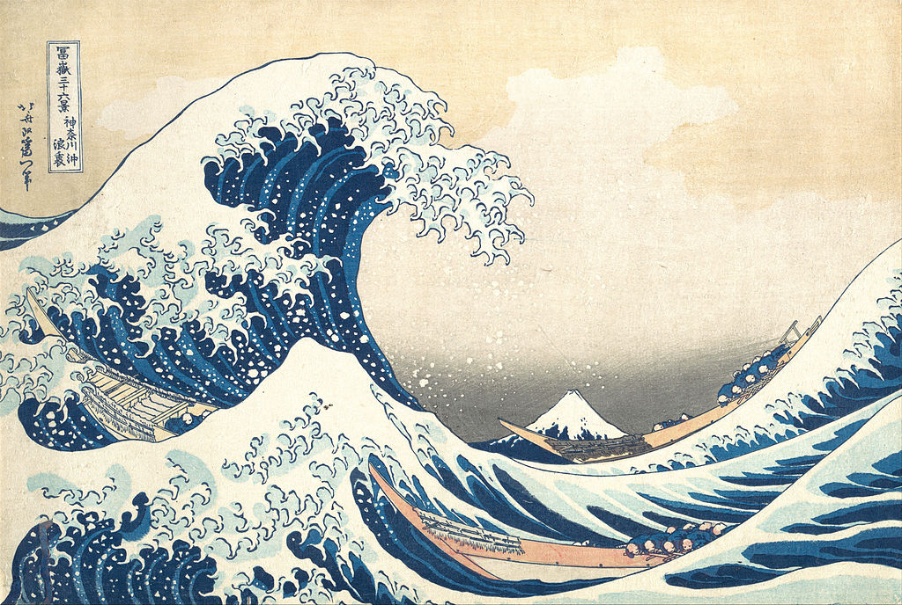
(Fig.1) Katsushika Hokusai, Kanagawa-oki Nami Ura (The Great Wave off Kanagawa), 1831,
25.7 cm × 37.8 cm, color woodblock print, The Metropolitan Museum of Art, New York.

Bibliography
Cartwright, Julyan H.E., and Hisami Nakamura. “What Kind of a Wave Is Hokusai's Great Wave off Kanagawa?” Notes and Records of the Royal Society of London, vol. 63, no. 2, 20 June 2009, pp. 119–135.
Guth, Christine M.E. “Hokusai's Geometry.” Review of Japanese Culture and Society, vol. 20, no. 46, Dec. 2008, pp. 112–132.
Guth, Christine M.E. “Hokusai's Great Waves in Nineteenth-Century Japanese Visual Culture.” The Art Bulletin, vol. 93, no. 4, 2011, pp. 468–485.
Screech, Timon. “Hokusai’s Lines of Sight.” Mechademia, vol. 7, no. 1, 2012, pp. 103–109.
Shea, Andrea. “Hokusai's 19th Century 'Great Wave,' so Iconic It's an Emoji, Comes Home to the MFA.” Hokusai's 19th Century 'Great Wave,' So Iconic It's An Emoji, Comes Home To The MFA | WBUR News, WBUR, 3 Apr. 2015, https://www.wbur.org/news/2015/04/03/hokusai-great-wave-mfa-boston
Singer, Robert T. “Japanese Painting of the Edo Period.” Archaeology, vol. 39, no. 2, 1986, pp. 64–67.
Thompson, Sarah. “The World of Japanese Prints.” Philidelphia Museum of Art Bulletin, vol. 82, no. 349/350, 1986, pp. 1–47.
Watanabe, Toshio. “The Western Image of Japanese Art in the Late Edo Period.” Modern Asian Studies, vol. 18, no. 4, 1984, pp. 667–684., https://doi.org/10.1017/s0026749x00016371.
Zaera-Polo, Alejandro. “The Hokusai Wave.” Perspecta, vol. 37, 2005, pp. 78–85.

