Mika Kumar
Senior Seminar
14 April 2022
Max Pechstein: Seeking Change Through Das Vater Unser
Along with his fellow German Expressionists, Max Pechstein lived during the late nineteenth and early twentieth centuries during a socio-politically tumultuous period consisting of colonialism, World Wars I and II, and the Cold War. Early in his life, he was a key contributor to Die Brücke (The Bridge) and advocated for social reform in Germany’s newly founded democracy in the late 1910s. With his woodblock print portfolio Das Vater Unser (The Lord’s Prayer), Pechstein combined religious subject matter with non-Western art influences to convey his disillusionment with the post-World War I politics of the Weimar Republic and his strong desire for reform through divine intervention.
Born on New Year’s Eve 1881, Hermann Max Pechstein grew up in the industrial town of Zwickau, Germany, which was known for mining and clothmaking. He had an affinity for the arts at a young age; this was nurtured by his uncle, an amateur artist. He studied at the Dresden Academy, where he eventually became a member of the German Expressionist group Die Brücke for six years; he became president of Neue Secession (New Secession) after impressing his peers with his talent and zeal for art. He studied at the Prussian Academy of Arts in Berlin until the Nazis deemed his art as “degenerate.” His breadth of work featured Fauvist-inspired paintings and over nine hundred prints. The stories of Christ’s life in the Bible were major sources of inspiration for Pechstein and the German Expressionists. Despite living in an era of intellectual skepticism and philosophical nihilism, Pechstein was frequently drawn to the Christian themes and symbols that had molded German life and culture for centuries. As a frequent churchgoer, he valued Christian liturgy highly. Pechstein recalled his first participation in Holy Communion, claiming that “all this lifted [him] up beyond [himself], and [his] entire being underwent a change.” Since religion and art entailed surrender to an inner, spiritual energy and a preoccupation with the human soul, he linked both concepts together in this work.
Das Vater Unser is a series consisting of twelve, hand-colored woodcut prints on wove paper. Throughout his career, Pechstein created works in intaglio, lithography, and woodcut. He preferred the latter because of its capability for bold outlines and flattened forms. With Das Vater Unser, the artist utilized his characteristic intensity of form and emotion by depicting religious imagery. Pechstein himself was a very religious person throughout his life. Through the religious themes that he grew up with, Pechstein refers to the agony of contemporary Germany recovering from war and plagued by political strife. Each sheet illustrates a single verse of the Lord’s Prayer, as taken from Martin Luther’s Small Catechism, which emphasizes the power of individual prayer. This particular work is the most widespread prayer in Christianity and the only one that Christ taught his disciples in the New Testament. Overall, the portfolio reflects Pechstein’s immense dissatisfaction with the politics that ended up inflicting postwar Germany with war guilt and financial insecurities. The prints juxtapose God's majesty and omnipotence with the lives of his poor followers.
The title print of the same name (Figure 1) depicts three figures seated and seemingly in deep prayer. Each figure has a different facial expression during this worship. The central figure has his hands clasped and his head pointed downward as he is focused on his prayer. The figures who flank him have their eyes open: one on the left is looking up toward the large text “Das Vater,” which both directly and indirectly represents the Lord; the other on the right has his head tilted downward while glancing over at the viewer. Together, the men create a triangular composition, which is the only traditional art historical element in the graphically linear series. This print sets the tone for the rest of the series by presenting a parallel between the biblical account and the artist's life. In the Lord’s Prayer, God comes off as harsh, the human being as a tragic hero, the human state as paradise lost and never regained, and human virtue is innocence humiliated and oppressed.
Unser Täglich Brot Gieb Uns Heute (Give Us This Day Our Daily Bread) (Figure 2) depicts four figures sitting around a rectangular table with a fish platter at the center; a subtle wash of red stains the table. They have small plates in front of them as their hands clasp together in prayer. The man on the left wears a workman's hat. The figures are looking up and are immersed in worship; only the man at the back of the composition has his head down while his eyes are closed, as if he is in introspection. In block letters, Unser täglich Brot is at the very top of the page while gieb uns heute is at the very bottom. There is an unrealistic sense of perspective, as indicated by the distorted scale of the table and the head of the figure in the foreground.
The “bread” in the title of this piece and the fish on the table refer to the feeding of 4,000. With only a few loaves of bread and some small fish, Christ could feed a large crowd. As a verse from The Lord’s Prayer, “Give Us This Day Our Daily Bread” translated to postwar Germany’s financial and political instability in the 1920s. The prayer itself is petitionary, in that it makes several requests to the Lord. Here, the men are asking God to take care of their prayer's physical needs, such as food and, by extension, other bodily requirements. Initially, the German Expressionists were in favor of World War I because they believed that it could “destroy the old, stultifying order and create a new, more spiritually guided world in its place.” However, as the catastrophic reality of the struggle dashed any hopes of a rapid, clean triumph, their early exhilaration swiftly faded. They would soon learn how untrue that would be: instead, all of the military apparatus at the Supreme Command's disposal could not defeat the nations aligned against Germany. Ultimately, all of the meticulously designed domestic propaganda efforts could not deflect the hard reality of the German population's hunger, shortages, and death.
Und Vergieb Uns Unsre Schuld (And Forgive Us Our Debts) (Figure 3) elaborates on the repercussions of the immense debt that Germany faced. At the top left of the print, a figure understood to represent the Lord is surrounded by kneeling worshippers. His right hand is outstretched and surrounded by an orb of light. The imagery evokes a heartrending emotional response — one that reflected what was within Pechstein’s being while dealing with the hardships of living in the Weimar Republic. The facial expressions, also rigid and geometric, on the figures present a non-Western influence; the most primal element comes from the figure with widened eyes and an agape mouth on the bottom right of the print. Straight lines create wrinkles and shadows on the faces. These features that develop the figures are simple in form; with woodblock printmaking, artists must make the most out of the carved block without being incredibly detailed for a successful print. The prints of German Expressionists were an attempt, in part, to reclaim German cultural heritage. This is especially true of their woodcuts, which rediscovered the inherent vigor of the medium in the fifteenth century. Prints, in particular, bolstered the argument that Expressionism was the victorious and unavoidable outcome of a long creative progression. The varied angles of the kneeling figures along with the puffy clouds form a border around the Lord, resulting in a dynamic piece which relies on its compositional components and contrasting forms.
The Lord’s majesty is also portrayed in Vater Unser, Der Du Bist Im Himmel (Our Father Which Art in Heaven) (Figure 4). As the only figure featured in the print, God’s form takes up most of the sheet. There is a stoic expression on his face as rays of light, indicated by repetitive lines, radiate from his entire body. These rays bring attention to the cloudlike forms that they are pushing away from God; interestingly, these clouds are similar to the configuration of circular forms that create His beard. Small flames rest in the palm of His left hand, and a cloud is pushed from His right hand. The organic quality of these complementary forms contrasts the overall linearity of the other prints in the portfolio. The result is a visually compelling composition that stresses the ascendancy of the Lord in a style inspired by non-Western cultures.
Pechstein was especially fascinated with the Orient in the 1920s because of his desire to escape from the political strife that followed World War I. Although Germany’s status as a colonial power ended well before the creation of Das Vater Unser, it still served as a way for Pechstein to gain access to a range of richly adorned material objects from around the world. The act of traveling had its roots in French Romanticism: artists such as Eugene Delacroix traveled to Africa and created works of art that reflected their impressions of the Orient (Figure 5). With such preconceived notions, it then became common for artists to travel abroad for inspiration, creating tension between preformed ideas of a culture and authentic experiences.
Influenced by this concept, Pechstein dressed the worshipping figures of his prints in the basic clothes of Baltic fisherman; he was familiar with this style due to his visits to Nida, Lithuania, which he viewed as a utopia untouched by industrialization. The masklike features and blocky, angular bodies of the figures combine old German woodcut techniques with shapes from the South Pacific and Africa, where Pechstein visited prior to World War I. Expressive distortion reacted against the materialism and positivism of bourgeois society as well as the basic naturalism of Impressionism. Expressionism was also inextricably linked to the political turbulence of early twentieth-century Germany. The recurrent Expressionist desire for a transfigured humanity on both the individual and communal levels was inextricably related, either directly or indirectly, to political conflicts against the established order.
Sondern Erlose Uns Von Dem Ubel (But Deliver Us from Evil) (Figure 6) depicts a scene of grief as the two figures in the foreground are lamenting the loss of the two men behind them. At the top of the composition, light is radiating from above onto the rather grim scene. On all of the figures’ faces, lines emphasize the creases on their foreheads. The theme of grief and even the composition of this print resemble Erich Heckel’s woodblock print Die Tote (The Dead Woman) (Figure 7). Heckel’s print emphasizes the psychological tension of the climax of Fyodor Dostoyevsky's novel The Idiot, as the two men mourn in front of the body of the woman whom they both loved. This conveys a universal facet that death is inevitable. After the First World War, especially, bereavement was more relevant for the German Expressionists. Both artists’ prints allude to the cataclysmic devastation of the war and its tragic aftermath.
Furthermore, the “evil,” as mentioned in the title of the print, refers to the corruption of the Weimar Republic, with which Pechstein was immensely dissatisfied. Along with fellow artist César Klein, Pechstein founded the Novembergruppe (November Group) in 1918. The artists in this group were radical and revolutionary; many created political posters to promote the Social Democratic Party, hoping for a socialist revolution and to unite the arts in Germany. Pechstein was among the most politically engaged artists postwar and created many posters during this time. In an advertisement (Figure 8) for the radical newspaper An die Laterne (To the Lamppost), he expressed concern for corruption by depicting a violent scene of flag-carrying protesters, assumed to be Communists, marching by a hanged man. This was a warning against the anarchy that the artist felt, and predicted, would destabilize the Weimar Republic. It sent an unclear message in both text and images by depicting the violence that afflicted the new regime. The subliminal message here was to join the hordes of outraged protestors who appear to be intent on in-kind retaliation for the lynchings of their comrades.
Demm Dein Ist Das Reich (For Thine is the Kingdom) (Figure 9) illustrates a small family of a mother, father, and son in the middle of worship. In the bottom left of the composition, a calf stands next to the child. The background features undulating lines, meant to resemble a stream of water, with fish and birds; this inclusion again pays homage to the Baltic fishermen who inspired Pechstein. The parents’ facial expressions showcase their despair as they gaze up at the sky. The boy and the calf, in contrast, have their eyes closed and heads bowed toward the ground, unaware of the tragedies that are assumably causing the adults’ grief. Calves were a common but special sacrifice in the Christian Bible the calf’s insertion in this print is most likely a representation of the virility and stability wished for Germany.
The last print of the series, titled Von Ewigkeit Zu Ewigkeit Amen (Forever and Ever Amen) (Figure 10) is arguably the most graphic of all due to how much ink saturates the paper. There are no stylized figures to set the tone of the work with their facial expressions. Instead, the only representational elements are the two hands at the top and bottom of the work. Behind each hand, there is a halo or some sort of illumination to highlight it. The artist’s choice for text placement is unlike the rest of the prints in the series because it is intentionally out of order. Rather than ordering it as von Ewigkeit zu Ewigkeit Amen, Pechstein chose to put von Ewigkeit Amen! zu Ewigkeit. The “Amen!” at the center of the print takes up about a fourth of the entire page, creating visual interest due to the disruption in word order and ultimately presenting a monumental finale to the series as an illustration for the final verse of The Lord’s Prayer.
Overall, the simplicity of these mostly monochromatic woodcuts presents an immediacy of experience and directness of expression in a manner which painting does not. The onset of World War I was a harrowing reminder of the intransigence of political and bureaucratic authority in the face of individual opposition. Distraught by this and the corruption of his government, Max Pechstein resorted to his spirituality to cope with the traumas associated with living in a postwar society. The Vater Unser series emulated the compressed angularity of African art and to the devotional quality of the earliest German woodcuts. [STILL WORKING ON CONCLUSION]
Figure 1.
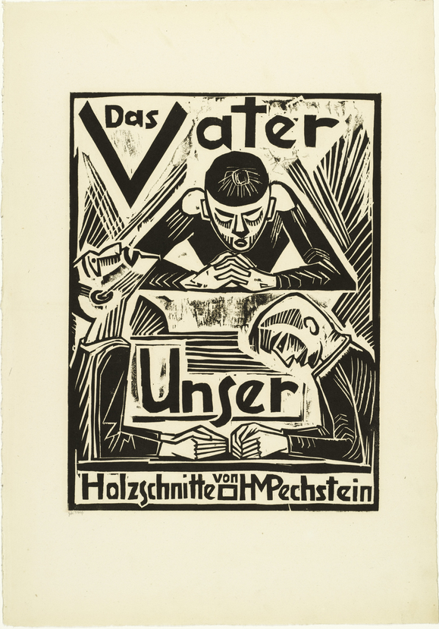
Das Vater Unser. Max Pechstein. 1921. 47.63 x 36.83 cm. Hand-colored woodcut on wove paper. University of Cincinnati Art Collection. Cincinnati, Ohio.
Figure 2.
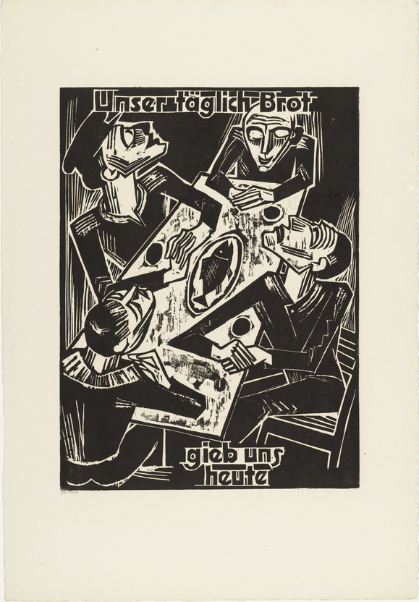
Max Pechstein. Unser Täglich Brot Gieb Uns Heute. 1921. 59.69 x 41.91 cm. Hand-colored woodcut on wove paper. University of Cincinnati Art Collection. Cincinnati, Ohio.
Figure 3.
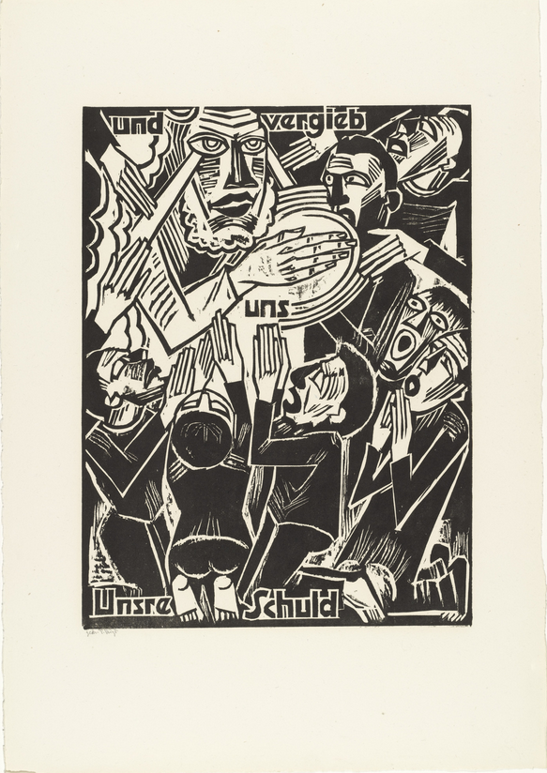
Max Pechstein. Und Vergieb Uns Unsre Schuld. 1921. 45.7 x 27.94 cm. Hand-colored woodcut on wove paper. University of Cincinnati Art Collection. Cincinnati, Ohio.
Figure 4.
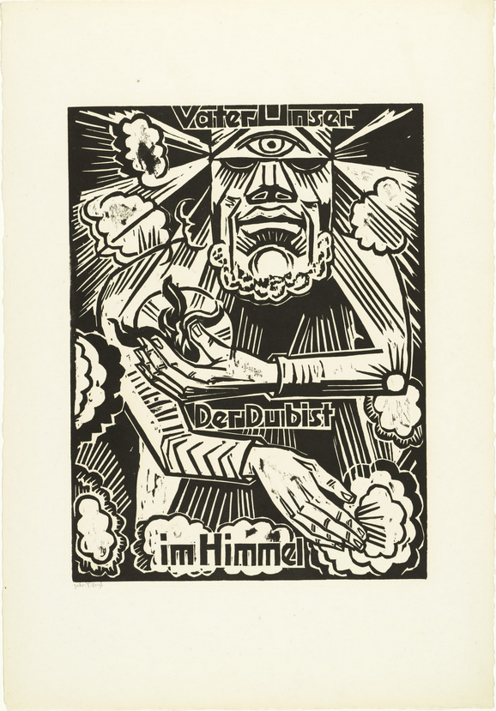
Max Pechstein. Vater Unser, Der Du Bist Im Himmel. 1921. 59.69 x 41.28 cm. Hand-colored woodcut on wove paper. University of Cincinnati Art Collection. Cincinnati, Ohio.
Figure 5.
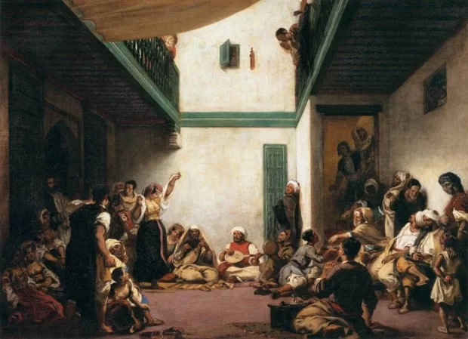
Eugene Delacroix. Jewish Wedding in Morocco. 1841. 105 x 140 cm. Oil painting on canvas. The Louvre. Paris, France.
Figure 6.
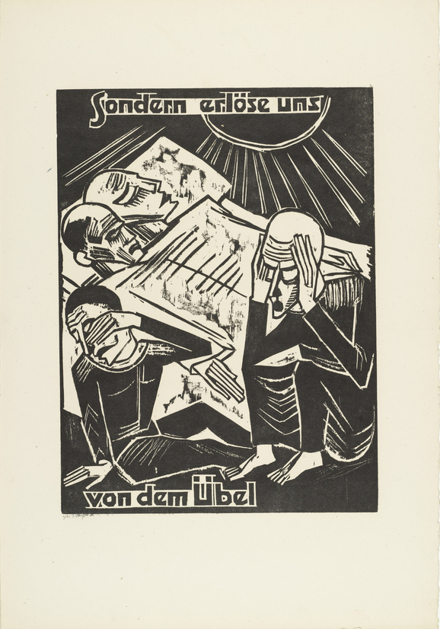
Max Pechstein. Sondern Erlose Uns Von Dem Ubel. 1921. 39.69 x 29.53 cm. Hand-colored woodcut on wove paper. University of Cincinnati Art Collection. Cincinnati, Ohio.
Figure 7.
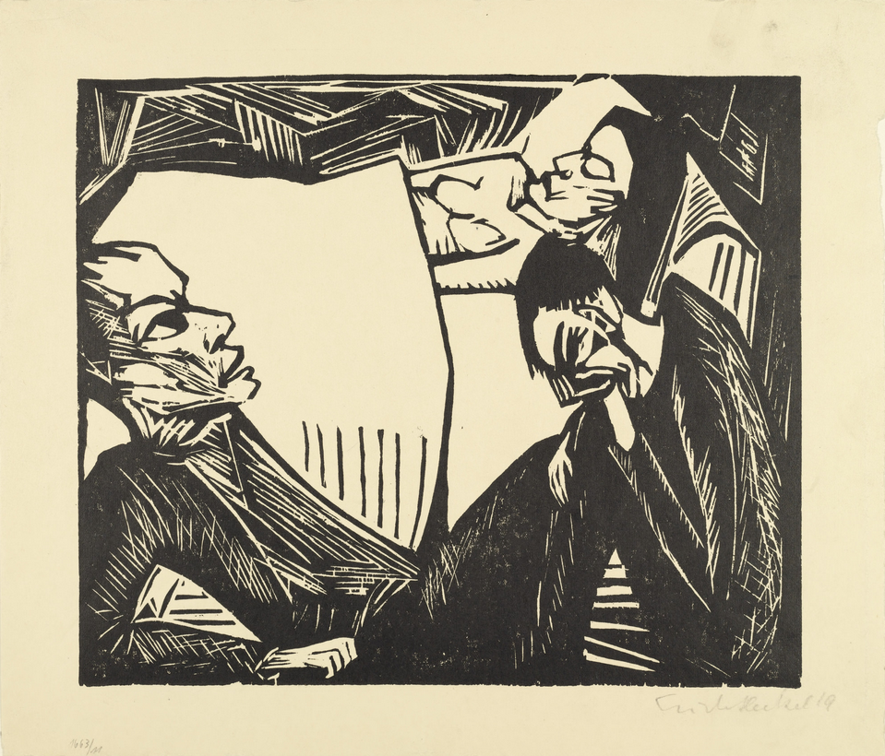
Erich Heckel. Die Tote. 1919. 31.3 x 36.5 cm. Woodcut on wove paper. Museum of Modern Art. Manhattan, New York.
Figure 8.
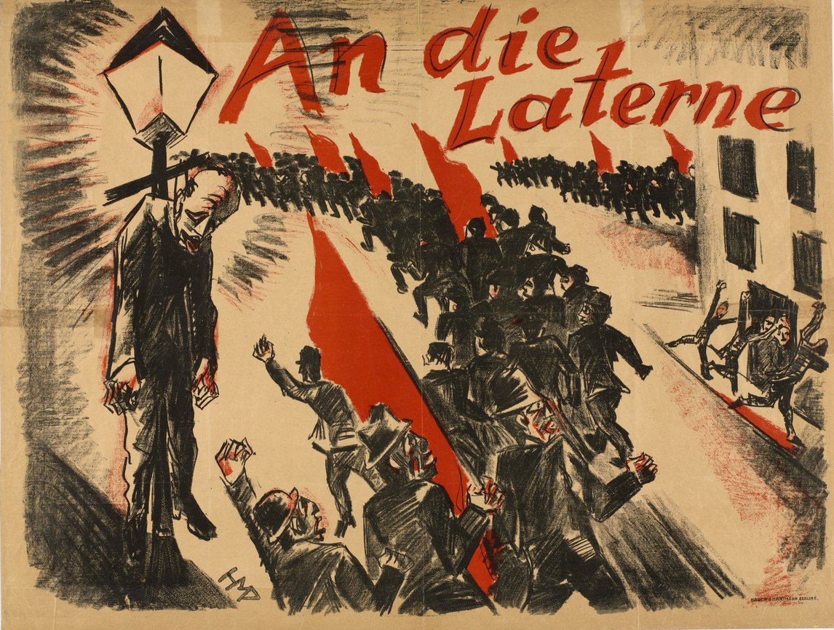
Max Pechstein. An die Laterne. 1919. 72 x 94.7 cm. Lithograph on wove paper. Museum of Modern Art. Manhattan, New York.
Figure 9.
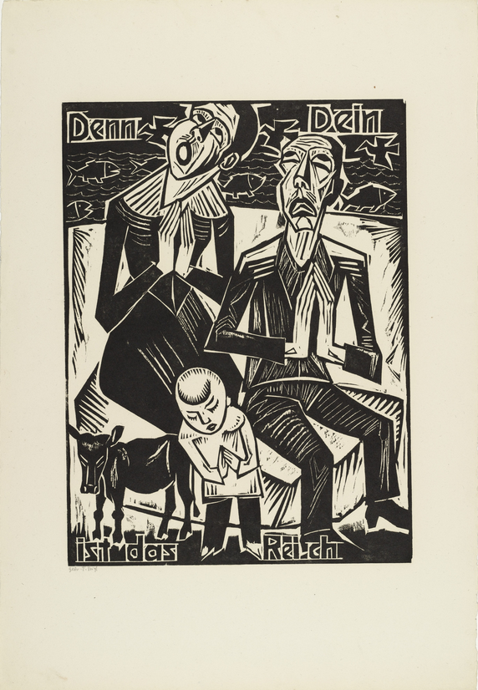
Max Pechstein. Demm Dein Ist Das Reich. 1921. 39.69 x 29.53 cm. Hand-colored woodcut on wove paper. University of Cincinnati Art Collection. Cincinnati, Ohio.
Figure 10.
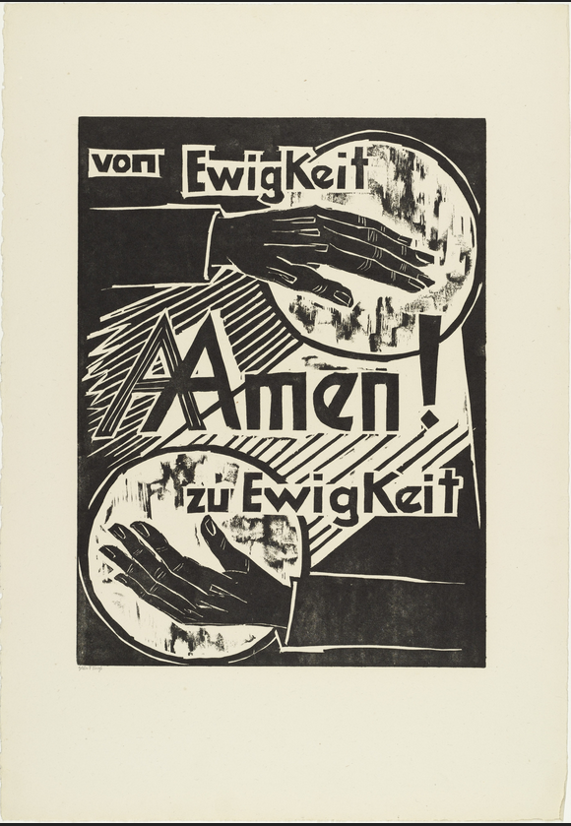
Max Pechstein. Von Ewigkeit Zu Ewigkeit Amen. 1921. 45.7 x 27.94 cm. Hand-colored woodcut on wove paper. University of Cincinnati Art Collection. Cincinnati, Ohio.
Bibliography
Bernhard, Fulda, and Aya Soika. Max Pechstein: The Rise and Fall of Expressionism. Berlin: De Gruyter, 2012.

Chapman, Kathleen G. “Chapter 4 From War to Revolution, from Propaganda to Art: Expressionism and Posters of the Revolutionary Period.” In Expressionism and Poster Design in Germany 1905–1922, (Leiden, The Netherlands: Brill, 2018). https://doi.org/10.1163/9789004380998_006.
Chilvers, Ian, and John Glaves-Smith. “Pechstein, Max.” In A Dictionary of Modern and Contemporary Art: Oxford University Press, 2009. https://www- oxfordreferencecom.uc.idm.oclc.org/view/10.1093/acref/9780199239665.001.0 001/acref-9780199239665-e-2073.
Faxon, Alicia. “German Expressionist Prints, A Persistent Tradition.” In The Print Collector’s Newsletter 14, no. 1 (1983): 3–4. http://www.jstor.org/stable/24552540.

Grigsby, Darcy Grimaldo. “Orients and Colonies: Delacroix’s Algerian Harem.” In The Cambridge Companion to Delacroix, ed. Beth S. Wright. London: Cambridge University Press, 2001.

Hults, Linda C. “German Expressionism.” The Print in the Western World: An Introductory History, 1996.

Pechstein, Max. Erinnerungen. Wiesbaden: Limes Verlag, 1960.

Rigby, Ida Katherine. “German Expressionist Political Posters 1918-1919: Art and Politics, a Failed Alliance.” Art Journal 44, no. 1 (1984): 33–39. https://doi.org/10.2307/776671.

Fulda Bernhard and Aya Soika, Max Pechstein: The Rise and Fall of Expressionism, (Berlin: De Gruyter, 2012), 2.
Ian Chilvers and John Glaves-Smith, “Pechstein, Max,” in A Dictionary of Modern and Contemporary Art, (Oxford University Press, 2009).
Alicia Faxon, “German Expressionist Prints, A Persistent Tradition,” The Print Collector’s Newsletter 14, no. 1 (1983), 4.
Max Pechstein, Erinnerungen, (Wiesbaden: Limes Verlag, 1960), 13.
Kathleen G. Chapman, “Chapter 4 From War to Revolution, from Propaganda to Art: Expressionism and Posters of the Revolutionary Period,” Expressionism and Poster Designs in Germany 1905-1922, (Leiden, The Netherlands: Brill, 2018), 197.
Darcy Grimaldo Grigsby, “Orients and Colonies: Delacroix's Algerian Harem,” in The Cambridge Companion to Delacroix, ed. Beth S. Wright (London: Cambridge University Press, 2001), 69-87.
Bernhard and Soika, 71.
Linda C. Hults, “German Expressionism,” The Print in the Western World: An Introductory History, 1996, 582.
Ida Katherine Rigby, “German Expressionist Political Posters 1918-1919: Art and Politics, a Failed Alliance,” Art Journal 44, no. 1, 1984, 33.
Ibid, 34.

