How can temperate forest settings add therapeutic value to Horticultural Therapy programs that serve participants of the adolescent population, experiencing difficult symptoms of post-traumatic stress?

Maggie Adams

Senior Project

Professor: Stevie Famulari, GDS

Bachelor of Science, Horticulture

DAAP School of Planning, Horticulture Program

April 2024

Table of Contents

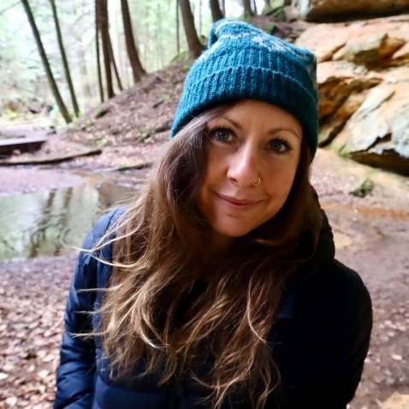

“Action on behalf of life transforms. Because the relationship between self and the world is reciprocal, it is not a question of first getting enlightened or saved and then acting. As we work to heal the earth, the earth heals us.”

Email: Meadams24@gmail.com

Senior Project- Horticulture 4092

Previous Course Experience

Fall semester 2022-2023

Native Plants I- HORT1030 Professor Donna McCollum and Professor David Gressley

Fall semester 2022-2023

Urban Landscape Forestry- HORT 3040 Professor David Gamstetter
FALL SEMESTER 2022-2023
Landscape History- HORT 3050 Professor Frederick Lutt

SPRING SEMESTER 2023
Woody Ornamentals II- HORT 2031 Professor Steve Foltz

SPRING SEMESTER 2023
Agriculture Ecology- HORT 2012 Professor Tania Burgos Hermandez

SPRING SEMESTER 2023
Horticulture Science II- HORT 1011 Professor Jim Hansel

SPRING SEMESTER 2023
Horticulture Chemistry- HORT 1011 Lab Professor Brian Grubb

SUMMER SEMESTER 2023
Herbaceous Ornamentals II- HORT 2033 Professor Jim Hansel

SUMMER SEMESTER 2023
Hops and Hemp Field Experiment Professor Dave Volkman

FALL SEMESTER 2023
Introduction to Nature Based Therapy- MED 2092 Professor Dr. Barbara Walker

FALL SEMESTER 2023
Introduction to Hemp and Medical Cannabis- HORT 4081 Professor Bonnie Rabin

FALL SEMESTER 2023
Plant Pathology and Microbiology- HORT 2020 Professor Brian Moody and Dan Peterson

Abstract
Temperate forest settings can add distinct therapeutic value to horticultural therapy programs whose adolescent participants struggle with post-traumatic stress symptoms. Observation and engagement with forest-based settings can enhance established programs serving those that are triggered by daily elements such as conversating about certain subject matters, noise pollution, and general confusion. Forest settings can provide emotional and physical stimulation that can effectively calm the nervous system and regulate responses to the effects of trauma. By exposing a program engaged population to a nearby temperate forest, measures can be made regarding the overall reaction to being in the presence of a forest specific environment. It is expected that the response to the experiences of forest engagement and exposure will present positive and increase the overall well-being of participants. Due to the depth of our available technology, challenges to create bonds and an increase of survival-based living, it is more common for the average adolescent to become detached from natural settings and become less engaged with our natural world. An article by Joachin Schummer states “As technicians are guided by aims and are concerned with both matter and form of their artifacts, so philosophers of nature should be concerned with aims of nature as well as with matter and form of natural things,” (Aristotle on Technology and Nature, pg. 3). This statement can further support the need for general nature-based focus within structural and sociological systems.

Keywords
Horticulture, Therapy, Forest, Temperate, Nature Well-being, Trauma, Adolescents, Post trauma, Stress, Cognitive, Physical, Emotional, Regulation, Skills, Calm, Nervous System, Regulation, Feeling, Green, Plants, Wildlife, Connection, Engagement, Interact, Outdoors, Programs

Problem Statement
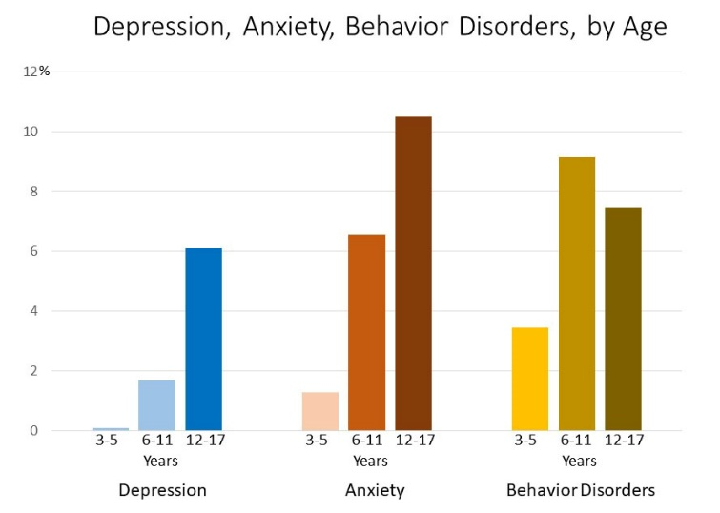
How can temperate forests add therapeutic value to horticultural therapy programs that serve participants of the adolescent population experiencing difficult symptoms of post-traumatic stress? Forest based settings can provide cognitive, emotional, and physical regulation to decrease the intensity of existing reactions to common interactions and daily elements.
Figure 1. Mental Health Statistics https://www.cdc.gov/childrensmentalhealth/data.html
Project Justification
Temperate forests can provide a sense of ease to the nervous system when actively engaged in the elements within it. Proposing horticultural therapy experiences that involve temperate forest characteristics can provide the diversity that adolescent populations may need to functionally live through a temperamental society as well as potentially threatening living situations. With mental health concerns developing rapidly within our society, the need for intentional focus on the drastic effects that come from personal experiences is also increasing. Due to the cognitively developing nature of adolescents, this population proves to be highly sensitive to the effects of personal experience and societal pressure. The feeling one often develops from being in nature and around various forms of life and landscape elements, can help regulate emotional intensities, reduce physical symptoms of post-traumatic stress, and diminish overstimulation.
Forest settings provide specific sensory stimulation that can create positive triggers throughout the body, as opposed to negative triggers, which can essentially improve the well being of adolescents actively participating in a horticultural therapy program. The interest of this topic developed from co facilitating a Horticultural Therapy Program at Cincinnati Children’s Hospital, located in Cincinnati, Ohio. While the program has a functional space to hold group and therapeutic activities, it lacks an area to hold programming near or in a more dense, temperate forest setting. Nearby the existing area where programming is held, sits a temperate forest area that has the potential to be utilized for therapeutic purposes.
User/Client Description
Priority Clients: The priority population that will be utilizing the presented space are adolescent clients between the ages of ten and eighteen, who are actively participating in the Horticultural Therapy Program in the residential Psychiatric Division at Cincinnati Children’s Hospital, College Hill campus in Cincinnati, Ohio. These individuals can hold a variety of diagnosis, such as:
- Schizophrenia, Bi-polar disorder, Clinical depression, Intermittent Explosive Disorder, Opposite Defiant Disorder, Borderline Personality, Clinical Anxiety, Substance Use, Developmental Disorder, eating disorders.
Most of these individuals have a history of various types of abuse such as:
- Emotional, physical, sexual, verbal, discriminatory, organizational/institutional, domestic, psychological, neglect, self-neglect

The nature of space will be used to make a therapeutic connection between humans and nature, and to gain the benefits of overlooking a temperate forest setting that includes other forms of life within it. Although most of the individuals may have a diagnosis, or a history of abuse, this does not disregard individuals from exploring the space, while accompanied by a staff member. Factors that would prevent an individual from utilizing the site would be on a strictly clinical basis and discussed amongst residential staff members on an individual’s clinical treatment team.

Secondary Users: Secondary users of the space include staff members who work within the facility. A portion of the space can be available to any staff member that has a need to debrief or find a calming environment away from the clinical setting during their own time. Specific roles of staff members that may utilize the space include:
- Nurses, Therapists, Environmental Services team, Building Maintenance and Operations, Dinning and Kitchen Services, Clinicians, Grounds Crew, Administration, Social Workers, Information Services, Behavioral Health Specialists.
To respect the privacy of the clients and staff, the space will not be open publicly to visitors. Accessible parking will be available to staff near the proposed space.

Address | City and State | County | Neighborhood | Business | Acreage
5642 Hamilton Ave. | Cincinnati, Ohio | Hamilton | North College Hill | Cincinnati Children’s Hospital, Psychiatric facility | 27 (total)  3 (proposed site)
Inventory and Analysis

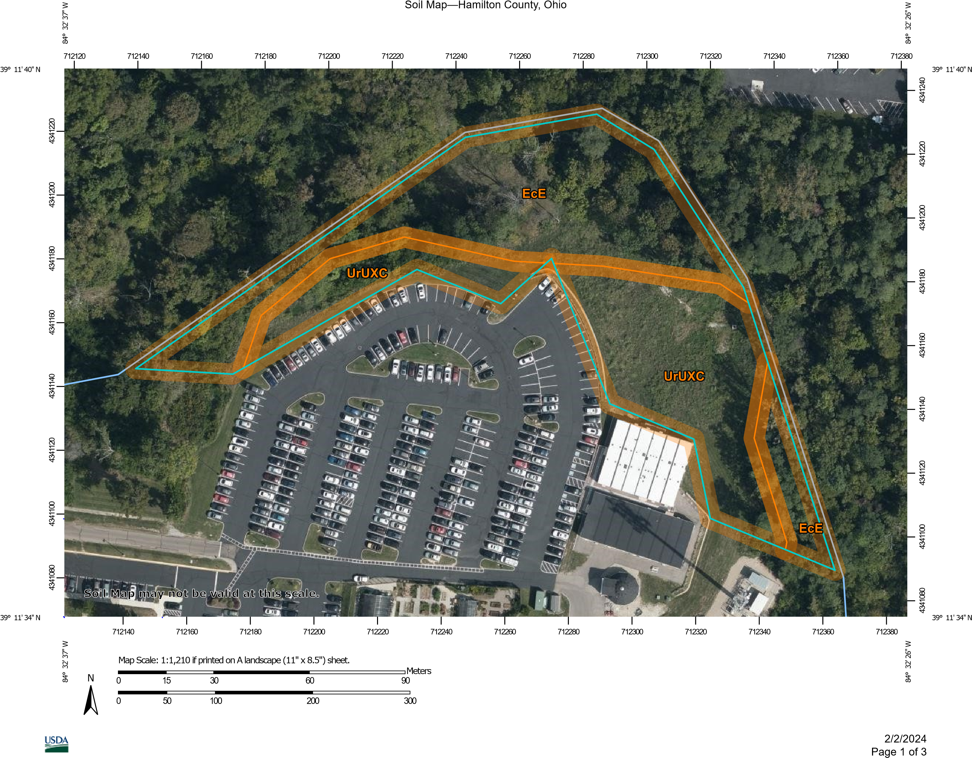
Figure 1, USDA Soil map, Cincinnati Children’s (College Hill)- proposed site

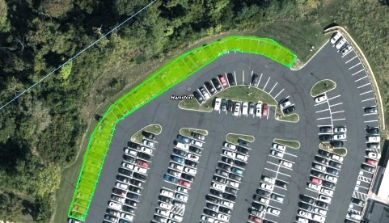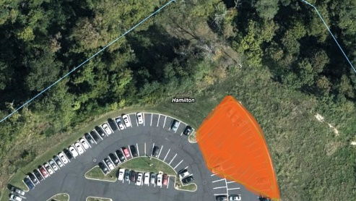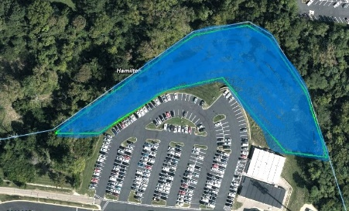
Zone 1- Forest Overlook Zone 2- Group Area Zone 3- Temperate Forest

Soil  Profile and Features  Class  Name | - 0-5 inches of silty clay loam, 5-28 inches of silty clay, 28-30 inches of weather bed rock,  - class 7, conditions restricted from cultivation, not restricted to grazing, forestland, and wildlife habitat.  - Eden (90%), Alfic udarents (30%), Rossmoyne (15%), Avonburg (2%), Cincinnati eroded (2%), Switzerland (1%)
Slope  Percentage  Shape  Geographic profile | - 25-40 %  - Linear  - Hills, till plains, linear back and side slopes made up of limestone and shale
Drainage and Runoff | - Group D- high run off potential when wet, high shrink well potential, high-water tables, claypan or layer, shallow and impervious (High surface runoff)
Land Capability / Management | - Moderate hazards to off trail and off-road erosion, low potential seedling mortality, severe soil rutting potential (low strength).
Pathway and Trail potential | - Very limited potential for paths and trails due to slope percentage
Vegetation  Species  Dominant species  Vegetation Health  Age of deciduous species | - Acer rubrum (Red maple), Platanus occidentalis (American sycamore), Juglans nigra (Black Walnut), Robinia pseudoacacia (Black locust), Catalpa speciosa (Catalpa), Nyssa sylvatica (Black gum), Quercus bicolor (Swamp White oak), Acer rubrum (Red maple)  - Platanus occidentalis (American sycamore)  - Deciduous health- moderate…Herbaceous health- high  - Older growth species at the bottom of slope, newer growth species on and at the top of slope
Existing Waterways | - Creek that sits at the bottom of a slope
Surrounding Facilities  Commercial  Residential | - Main hospital facility (south of site), Salt dome (southeast of site), Greenhouse (southeast), Group facility building (South)  - Residential housing surrounding (northern section of site, elevated above and slightly overlooking site)
Historical Use
Impact of Historical Use | - Slope increase, erosion increase,
Construction History
Views | - Views from existing parking facilities overlooking the forested area and desired site use, residential viewing of site from neighborhoods sitting on the northern upward slop on the opposite side of parking lots (see pictures for further details)
Solar exposure | - Partial exposure to afternoon sunlight, full exposure on slope sitting on the southeastern part of the site averaging 5-6 hours daily, the bottom wetland portion of the site slopes are shaded by older growth deciduous species, southeast sunrise
Observed Wildlife Habitat | - White tailed deer, Eastern gray squirrel, Red fox, Woodchuck/Groundhog, Eastern Cottontail Rabbit, various bird species (Robins, Black capped chickadee, Northern cardinals, Tufted titmouse, Starlings, Morning dove, American goldfinch, White breasted Nut hatch, Carolina wren Blue jay, Killdeer, Ruby throated hummingbird, Brown headed cowbird, House finch, Barn swallow, Woodpecker species, American crow)
Noise pollution | - Traffic noise coming from main roadways (Hamilton Ave.), residents from nearby neighborhoods, construction (on site and off site), grounds crew equipment
Light pollution | - N/A, site will mainly be used during the day
Environmental/Safety concerns | - Hill side erosion, construction runoff, water retention, insect population increase during wet periods, wind borne trash from nearby construction and residential areas, deciduous tree health, runoff from nearby residential sites, slight drop off from existing retaining wall outlining the parking lot and overlooking the site, structural dips in walkable areas, potential irritating plant species, high pollen rates from specific plant species (ragweed),
Sustainability Considerations  Sustainable  Non sustainable | - Sustaining wildlife area, land structure, recreational land use that sustains quality and health of site, soil health consideration, species health consideration, increase in nearby residential value, increase in property value, water filtration through on-site species existence.  - Increase in pollution due to on site construction , site shift as a result to use increase

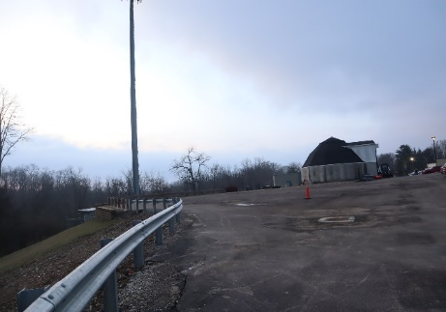
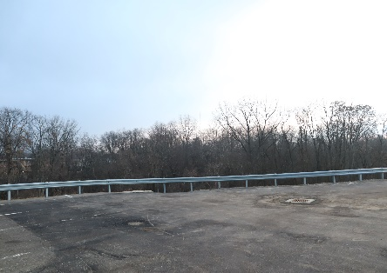
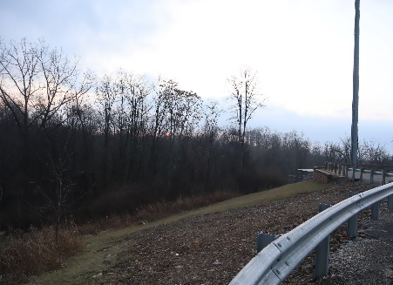

View from south side of current parking lot Photo from
Photo by Maggie Adams
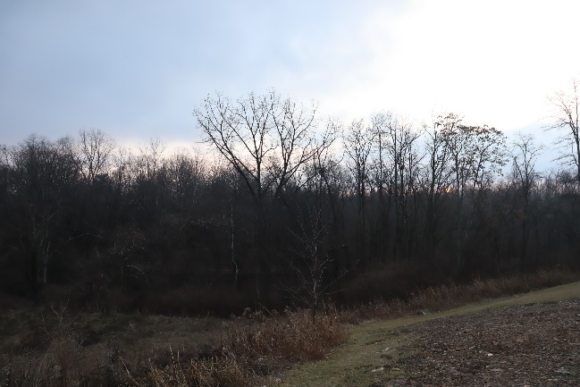
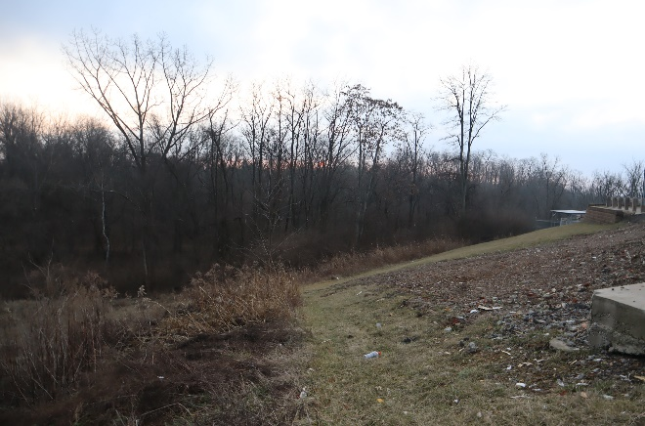

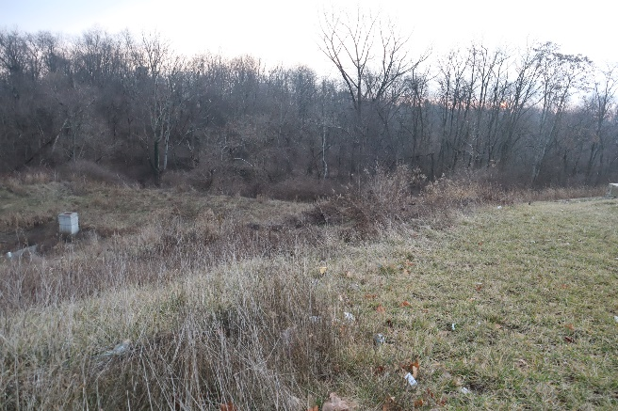
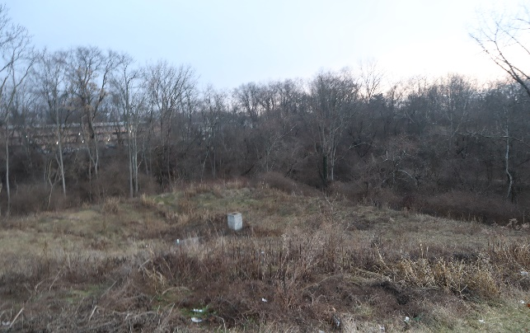

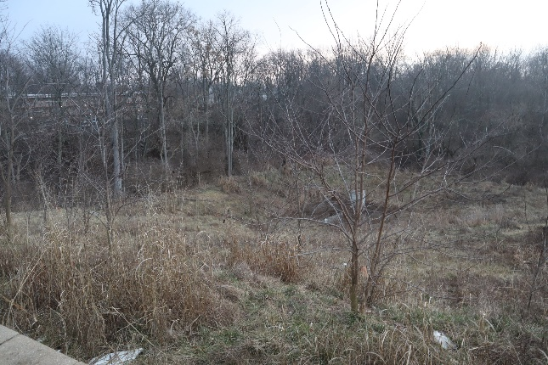
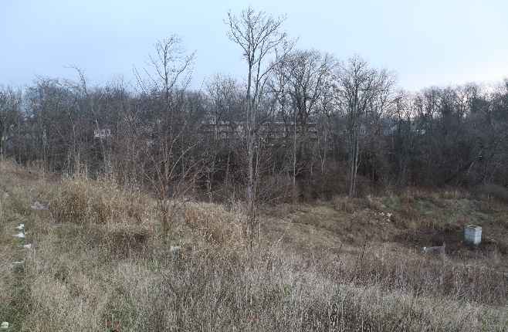

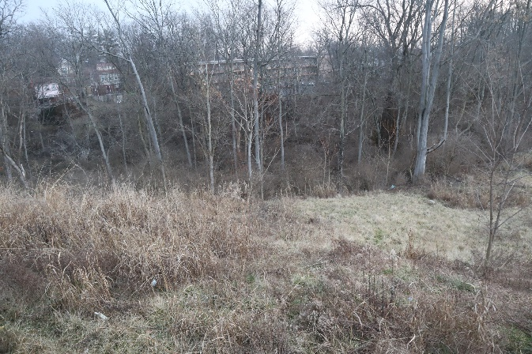
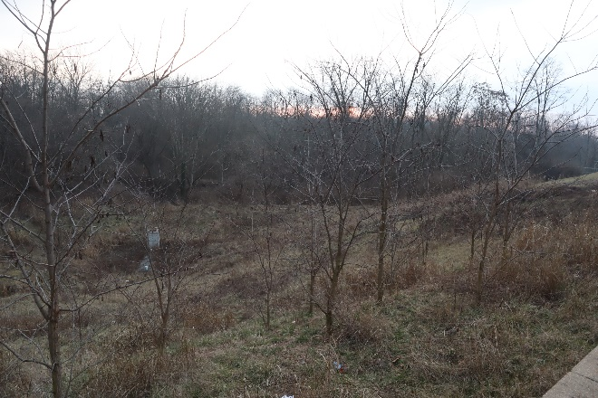

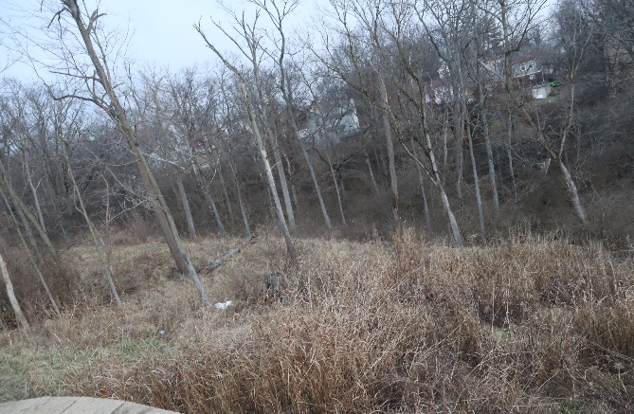
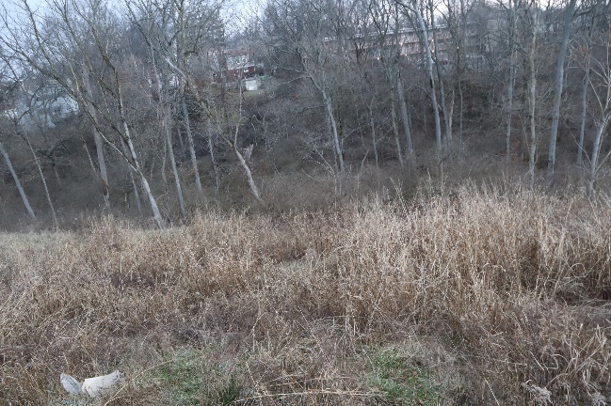

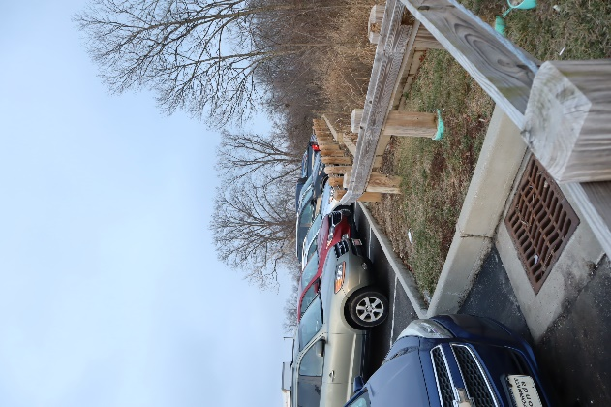
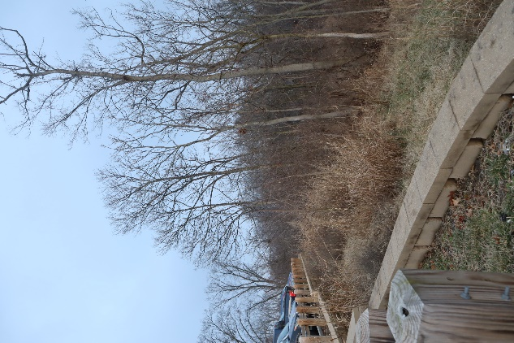
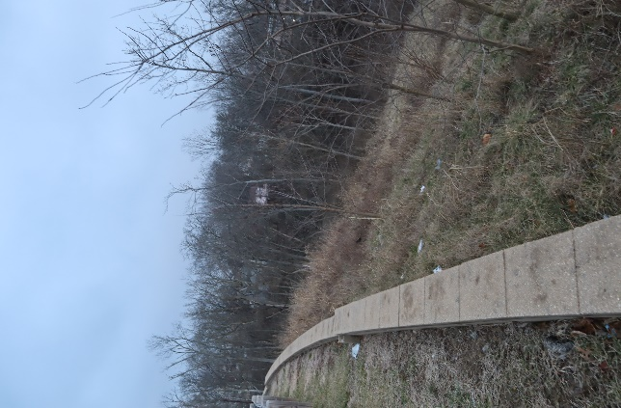

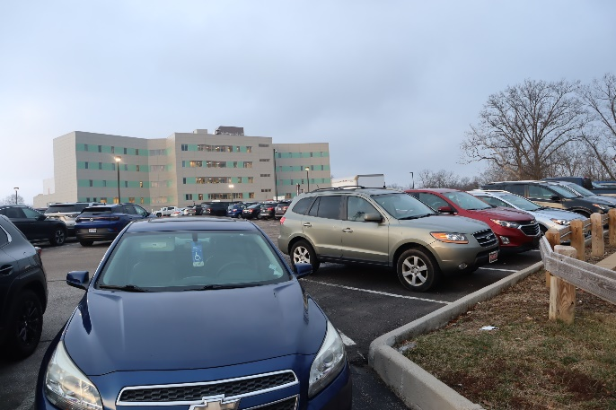


1
3
4
2

**This image is a Grid map of the proposed location that will be offered to staff and clients to utilize for decompression and therapeutic purposes. This map can also be used to help readers identify from what location the pictures were taken. Refer to picture labels

Site Summary and Considerations
The presented site serves as a steppingstone for not just adolescent participants but provides a natural area for staff members of the facility to enjoy the benefits. The site contains features and characteristics that may be suitable for a wide range of people with different interests and backgrounds. Because this is a naturalized area, all characteristics of the site mentioned above are important to consider when transforming the space into a naturalized overlook. When utilizing the site, safety is the highest priority. One concern with the safety of this area is the steep slope and hillsides, as well as the existing retaining wall where people would stand to overlook the area. Proper identification of plant species within the area is also of high priority, due to the possibility of allergy-related threats. In addition to safety, the surrounding areas are important to consider as well, specifically in the case of adding any additional features that may disrupt nearby residents from looking into their person backyard space or parking lot.

Case Studies and Literature Review:
Hypothesis: Forest settings can provide emotional, mental, and physical stimulation that can effectively calm the nervous system and regulate responses to the effects of trauma.
Research Questions and Studies Associated:
- How can temperate forests contribute to developing safe, trusting relationships for an adolescent with post-traumatic stress symptoms?
  - Forest Manners Exchange: Forest as a Place to Remedy Risky Behavior of Adolescents: Mixed Methods Approach
Citation: Machackova, K; Dudik,R; Zeleny, J.; Kolarova, D.; Vins, Z.; Riedl, M. Forest Manners Exchange: Forest as a Place to Remedy Risky Behaviour of Adolescents: Mixed Methods Approach. Int. J. Environ. Res. Public Health 2021, 18, 5725.
- Is a temperate forest a safe environment to hold Horticultural Therapy sessions for the adolescent population with post-traumatic stress symptoms?
  - An Integrated Approach to Assess the Potential of Forest Areas for Therapy Services
Citation: Dodev, Y; Zhiyanski, M.; Glushkova, M.; Borisova, B.; Semerdzhieva, L.; Ihtimanski, I.; Dimitrov, S.; Nedkov, S.; Nikolova, M.; Shin, W.-S. An integrated Approach to Assess the Potential of Forest Areas for Therapy Services. Land 2021, 10, 1354.
- How can we thoughtfully prepare for negative or heightened emotions from participants who may be unfamiliar with the elements within a temperate forest landscape?
  - Bird Songs Alleviate Anxiety and Paranoia in Healthy Participants
Citation: Stobbe, E.; Sundermann, J.; Ascone, L.; Kuhn, S. Bird Songs Alleviate Anxiety and Paranoia in Healthy Participants. Scientific Reports 2022, 12:16414.

Research Question #1:
The first proposed research question, “How can temperate forests contribute to developing safe, trusting relationships for an adolescent with post-traumatic stress symptoms,” is an important question to present in terms of proving specific value of forests integrated into existing programming. The case study titled Forest Manners Exchange: Forest as a Place to Remedy Risky Behavior of Adolescents: Mixed Methods Approach, a group of adolescent individuals, admitted into various psychiatric institutions, that have been diagnosed with various behavioral disorders, were brought together in a forest setting to participate in a series of tests that would ultimately determine if their levels of aggression would lower after spending time in a forest-based setting. The therapeutic approach that was used for these individuals is called Shinrin-yoku:
“ Shinrin-yoku, also known as forest bathing, is a practice or process of therapeutic relaxation where one spends time in a forest or natural atmosphere, focusing on sensory engagement to connect with nature, “ (“Shinrin-yoku”, 2024).
The question presented to portray this study is, “…is it possible to reduce aggressive behavior with forest therapies based on observing the social behavior of forest animals with the simultaneous therapeutic action of Shinrin-yoku and Outdoor Behavioral Therapy (OBH),” (Int. J. Environ. Res. Public Health 2021). To question a series of sensory tests were performed with approximately 68 participants between the ages of twelve and sixteen. Questi0ons were created around the relationships between animals within the forest and a therapeutic group was then formed to share participants answers to these questions, based on their current knowledge and mutual interaction with the site.
While the results of the study and take aways from the group activity proved to lower aggression levels of the individuals, it can also that in general, the practice of Shinrin-yoku and interaction with a forest setting can promote several other health benefits that will allow the adolescent community with post-traumatic stress, to build trusting relationships with their peers and community. Although these additional health benefits are not the focus of the study, they are mentioned as general benefits of forest immersion, or ‘forest bathing’. These benefits include: low anxiety, low depression, low blood pressure, decrease in stress hormones, increase in intracellular anti-cancer proteins and a boost overall, a boost in the parasympathetic nervous system.
Being in a psychiatric facility can often cause an increase in feeling isolated, and incapability of relating to those outside of the facility. Because humans and animals have a similar limbic system that enable the experience of feeling emotion and empathy, it can be effective to incorporate temperate forests into programming because of the commonly existing wildlife that a participant may be able to interact with and relate to. The dynamic of discussing animals’ life and observing it can also be used as an effective modality for the existing program at Cincinnati Children’s, as it has had positive results for similar populations that are mentioned in the study. This approach may need some restructuring based on the diagnosis and cognitive levels of each participant from the existing Horticultural Therapy program.
Research Question #2:
Is in fact, a temperate forest setting a safe environment to hold Horticultural Therapy session for adolescent population with post-traumatic stress? In the presented scholarly article, An Integrated Approach to Assess the Potential of Forest Areas for Therapy Services, an approach using scientific knowledge and available technology, was used to determine the potential use for therapeutic services in a subdivision-based forest area in Bulgaria. This study took place in the region of Smolyan municipality, near the Rhodopes Mountains. Although the geographical area of this study differs greatly from a temperate forest region, similar characteristics and features of the site were taken into consideration and measured to develop a percentage. Ultimately, a five-point system was used to represent the potential based off specified characteristics of the site. These include:
-Remoteness, transport accessibility, public transport, anthropogenic impact, age of the forest, bodies of water, cultural and historical landmarks, terrain slope, legal restrictions, altitude, ecological status, proximity of recreational facilities and subdivisions. In addition to these site features, other indicators for a therapeutic forest setting were considered, such as: social setting, physical setting, management setting.
This study is relevant to the proposed site at Cincinnati Childrens Hospital because both have or will be tested for therapeutic potential. Similar technology and scientific knowledge will come into play when testing takes place such as ecological knowledge of the site, or GIS system. Both the site in the study and the site proposed have features that develop the potential to be of therapeutic use. In contrast, the proposed site varies greatly as far as geographical location, and therefore altitude. With this information, cultural and ecological considerations may need to be approached differently with the Cincinnati site. One question that may be developed from measurements of the site in Bulgaria and measurements of the site in Cincinnati might be…how does the landscape culture and the ecological formation of each site differ? The answer to this question will ultimately offer considerations to create the proper approach to measure the Cincinnati site for therapeutic value. The proposed temperate site will also be used by a specific population, in which the case study does not mention a specific population that will utilize the area in Bulgaria. The study also mentions the measurement and significance of phytoncides, which is said to have a positive impact on the human immune system. Being that the study does not mention a specific population, and the proposed site does, the positive effects of phytoncides (if measured), could potentially have a reverse effect with participants. Measuring the phytoncide levels will also play a role in determining the therapeutic value of the site.
Research Question #3:
How can we thoughtfully prepare for negative or heightened emotions from individuals who are uneasy about an unfamiliar approach to Horticultural Therapy and temperate forest settings? While it is not uncommon for adolescents with post-traumatic stress symptoms to be fearful of elements in which they have not been exposed to, there is the possibility of these elements having the opposite effect of what is presumed by the client after engagement and interaction in a temperate forest setting. There is a scientific study that tests the hypothesis that birdsongs lead to a decrease in paranoia, a possible increase in cognitive performance, and regulates mood. This study initially was meant to test the effects of urban soundscapes vs natural soundscapes, specifically birdsongs. The study included a total of 295 participants with mental health states that were unspecified, but all participants completed a pre and post survey on levels of anxiety, depression, and overall mood. The main hypothesis of this study is: Birdsong soundscapes vs traffic soundscapes benefit mood, paranoia, and cognitive functioning.
Although this study was a randomized experimental design, it did prove that nature soundscapes vs urban soundscapes have a more positive effect on mood and can significantly decrease depression and anxiety. The effects of cognitive function appeared to be neutral and did not indicate any signs of improvement. The study did contain more men than women participants, so the results of the study based on gender are unclear.
Generally, this study points out the important effects that urban noise can have on individuals with specific mental health disorders such as schizophrenia, as mentioned in the introduction portion of this study.
“A meta-analysis shows a link between the increase of schizophrenia incidence and the increase in urbanicity, highlighting the fact that the risk for schizophrenia in the most urban environment was estimated to be 2.37 times higher than in the most rural environment,” (Scientific Reports, 2022).
This point in the study may apply to participants in the existing Horticulture Therapy program. Many participants in the program are from urban settings, in which they have experienced a large amount of urban noise and overstimulation as a result, prior to diagnosis and treatment. The significance of adding a temperate forest setting to the existing program can prove to be beneficial for alternative exposure noise that can have the opposite effect of urban noise, such as bird songs. There is a possibility that participants could be unfamiliar with the sounds that are present in a temperate forest, therefore it can cause uneasiness and even fearful reactions. While the study brings up clear points of the benefits, a clinical plan must be established in the case that an individual has a negative reaction to the bird songs heard in the forest setting. This would require the individuals and their treatment team to come together and discuss the appropriateness and interest level of an activity that may involve a potentially triggering noise. Furthermore, if the individual has committed to consistently coming to the Horticultural Therapy program but does not feel that this type of study or activity is appropriate for them, this should be understood and openly accepted by their team.

Case Study Summary:
The three case studies provide consistent evidence of incorporating a temperate forest setting into an existing horticulture therapy program that serves the adolescent community with post-traumatic stress. With careful consideration of safety and appropriate measuring to determine the suitability, the proposed site can provide additional therapeutic value. An integrative approach is necessary to structure the safety around the types of populations that will be using the site, as well as the surrounding residents who have an overlooking view of the area. Zoning and property lines is of importance as well when factoring in the level of use. In addition to measuring safety, observing the existing life that is living amongst the site will provide another important consideration when developing groups with participants. For individuals to make connections with their environment, they must be in a minimum of a baseline headspace and willingness to commit to the program. If this is in place, it allows a more open-minded approach to engaging with the elements of the site and connecting with other forms of life, which is presented as an effective modality in the second study mentioned above. The third study proves that bird songs are an effective soundscape for lowering observed diagnosis such as anxiety and depression. These diagnoses are common amongst the adolescent population, particularly those who have consistently been exposed to noise pollution and urban based soundscapes. This is an important factor to consider when we are putting into perspective the therapeutic effects of a temperate forest.

Historical Context
The location of current day Cincinnati Children’s Hospital, College Hill campus, was once the location of the Ohio Female College of Cincinnati in 1946. The main facility burned down in 1858, was rebuilt and then burned down for the second time in 1868. From there it was sold to a handful of businessmen and doctors in 1872, and then became the Cincinnati Sanitarium from the years 1873 to 1956. The facility was created by three doctors who saw the need for a private facility to treat individuals who had mental health and addiction challenges. Historical records state the acreage had beautiful gardens, peaceful grounds and comfortable living facilities for who were then referred to as patients. In honor of Dr. Emerson A. North, one of the founding fathers of the facility, the name was changed in his honor.
The location has been around since the mid 1800’s, in which the majority of its years have been dedicated to serving populations that are in need of mental health services. The grounds are noted to be peaceful, and vegetative, which can set the tone for the originality of the location. The addition of a temperate forest included in therapeutic programming could contribute to the originality of the acreage, as well as the originality of what diverse number of populations can gain from interacting with nature and plant-based settings. Like the originality of the location, horticulture is recognized as a calming, peaceful and stress reducing activity since as early as 500 BC, Ancient Persia, in which gardening was used to soothe senses.
The practice of using horticulture and nature as a therapeutic modality for many years can play a role in developing a progressive therapeutic program that can intentionally utilize the naturalized space that still exists this day. The character of the location that was once presented to be of benefit to staff and patients, can continue to serve that purpose in a different constructional form, one that is developed enough to safely serve the desired population. Addressing originality can support the cause of incorporating the desired site to the existence of a program that has been proven to serve well in the past.
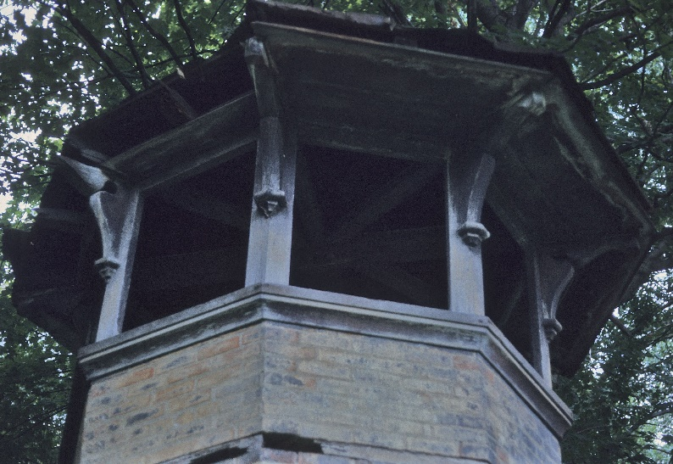
Emerson A. North Ventilation Tower

Bibliography and References

Machackova, K; Dudik, R; Zeleny, J.; Kolarova, D.; Vins, Z.; Riedl, M. Forest Manners Exchange: Forest as a Place to Remedy Risky Behaviour of Adolescents: Mixed Methods Approach. Int. J. Environ. Res. Public Health 2021, 18, 5725.
Dodev, Y; Zhiyanski, M.; Glushkova, M.; Borisova, B.; Semerdzhieva, L.; Ihtimanski, I.; Dimitrov, S.; Nedkov, S.; Nikolova, M.; Shin, W.-S. An integrated Approach to Assess the Potential of Forest Areas for Therapy Services. Land 2021, 10, 1354.
Stobbe, E.; Sundermann, J.; Ascone, L.; Kuhn, S. Bird Songs Alleviate Anxiety and Paranoia in Healthy Participants. Scientific Reports 2022, 12:16414.
United States Department of Agriculture. (2024, February 2). Custom Soil Resource Report of Hamilton County, Ohio. Natural Resources Conservation Service.
https://websoilsurvey.nrcs.usda.gov/app/HomePage.htm?TARGET_APP=Web_Soil_Survey_application_pujkrx o3hg5d0iiw3xmqhh4n
Soil Survey Staff, Natural Resources Conservation Service, United States Department of Agriculture. U.S. General Soil Map (STATSG02). Available online. Accessed 2/2/2024.
Wikipedia contributors. (2024, February 4). Shinrin-yoku. In Wikipedia, The Free Encyclopedia. Retrieved February 5, 2024 from https://en.wikipedia.org/wiki/Shinrin-yoku#References
Emerson A. North Hospital View of ventilation tower exterior view, Hamilton County 1846, digital photograph,
Cincinnati Preservation Association, accessed 7 February 2024 https://library.artstor.org/#/asset/35166783;prevRouteTS=1707362691247
Kimmerer, R. W. (2015). Braiding sweetgrass. Milkweed Editions.

