5/15/2026

AMERICAN HISTORY
Including key U.S. Supreme Court decisions
https://scholar.uc.edu/show/ks65hd707

Lawrence T. Bennett, Esq.
Professor Emeritus
University of Cincinnati
Former Program Chair, Fire Science & Emergency Management
Cell 513-470-2744
Lawrence.bennett@uc.edu

Landmark United States Supreme Court Cases:
- 6/13/1966 Miranda v. Arizona
- 1/16/1967 Garrity v. New Jersey
- 6/31/1968 Pickering v. Board of Education
- 2/19/1975 NLRB v. Weingarten
- 5/31/1978 Michigan v. Tyler
- 1/11/1984 Michigan v. Clifford
- 3/19/1985 Cleveland Board of Education v. Loudermill
- 6/29/2009 Frank Ricci v. DeStefano
- 6/15/2025 Ames v. Ohio Department of Youth Services

Deadliest fires in U.S. history:

- 10/8-9/1987 Great Chicago fire 250 deaths
- 12/30/1903 Iroquois Theater, Chicago, IL 602 deaths
- 10/12/1918 Forest Fire, MN 559 deaths
- 4/21/1930 Ohio Penitentiary 320 deaths
- 11/28/1942 Cocoanut Grove Night Club, MA 492 deaths
- 12/1/1958 Our Ladies of Angles, Chicago, IL 95 deaths
- 5/28/1977 Beverly Hills Nightclub, KY 165 deaths
- 9/11/2001 World Trade Center, NY 2,666 / 343 FDNY / 2 Medics / Chaplain / 71 PD
- 2/20/2003 The Station Nightclub, RI 100 dead
- 4/17/2013 West Fertilizer Company, TX 10 firefighters killed
- 6/13/2023 Granite Mountain Hotshots, AR 19 firefighters killed
- 1/7/2025 LA fires, CA 32 dead

See also: NFPA - Deadliest incidents resulting in the deaths of 8 or more firefighters https://www.nfpa.org/education-and-research/research/nfpa-research/fire-statistical-reports/fatal-firefighter-injuries/deadliest-incidents-resulting-in-the-deaths-of-8-or-more-firefighters

1490s: Christopher Columbus – First Slaves To Haiti And Dominican Republic
“America’s History of Slavery Began Long Before Jamestown. The arrival of the first captives to the Jamestown Colony, in 1619, is often seen as the beginning of slavery in America—but enslaved Africans arrived in North America as early as the 1500s…. Christopher Columbus likely transported the first Africans to the Americas in the late 1490s on his expeditions to the island of Hispaniola, now Haiti and the Dominican Republic. Their exact status, whether free or enslaved, remains disputed. But the timeline fits with what we know of the origins of the slave trade.” https://www.history.com/articles/american-slavery-before-jamestown-1619
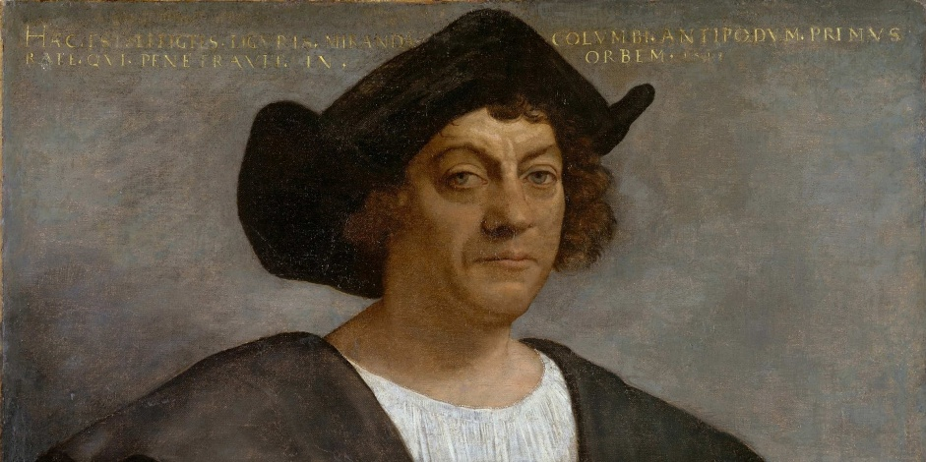

1607: Jamestown, VA

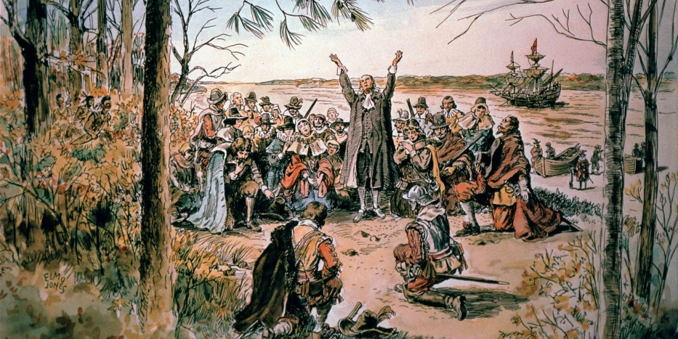
“Did Jamestown’s Settlers Drink Themselves to Death?
https://www.history.com/articles/did-jamestowns-settlers-drink-themselves-to-death
Geologists are investigating whether tainted drinking water killed most of Jamestown’s colonists during the “starving time” of 1609-1610.
Life was no picnic for the Jamestown colony’s earliest founders, but at least they had enough to eat. Evidence from waste pits suggests that the settlers, who first arrived on the island in May 1607, feasted on deer, turtles and sturgeon during their first year in the New World, said historian James Whittenburg, the director for instruction at the National Institute of American History and Democracy. (“The sturgeon in the James River were so large that colonists would wade out and harvest them with an axe,” he added.) Thanks to an uneasy truce brokered by their leader, Captain James Smith, they supplemented this high-protein diet with corn received from local Powhatans in exchange for goods.
But in the fall of 1609, shortly after the arrival of new ships packed with more mouths to feed, a disastrous sequence of events plunged Jamestown into famine, said Whittenburg. Faced with their own shortages because of a prolonged drought, the Powhatans cut off trade with their neighbors after Smith returned to England for medical treatment in October. The settlers began taking food by force, and the Powhatans retaliated by laying siege to Jamestown; confined to their fort, the colonists could no longer hunt, fish or seek fresh water. ‘We do see in the trash bins from the ‘starving time’ that they’re eating really small animals,” said Whittenburg.’ They eat up all of the domestic stock—the dogs and the horses. They get down to eating rats and even poisonous snakes.’”

Disease:
“Early Virginia (1607-24) was a nightmarish world of disease and death, perhaps unsurpassed in the annals of English colonization. Typhoid fever and dysentery visited Jamestown in recurrent epidemics killing 30 per cent or more of the colonists with each onslaught. Yet Jamestown endured because the leaders of the Virginia Company misapprehended the nexus between the estuarine environment and water-borne, non-immunizing diseases. Each summer, death stalked the town as invading salt water pushed up the estuary and concentrated pathogens in the town's water supply. The prevention of disease and death required the abandonment of Jamestown and relocation into healthier niches, which occurred with the dissolution of the Virginia Company in 1624.” https://www.sciencedirect.com/science/article/abs/pii/030574887990224X

1619: Jamestown - Slavery Comes To North America

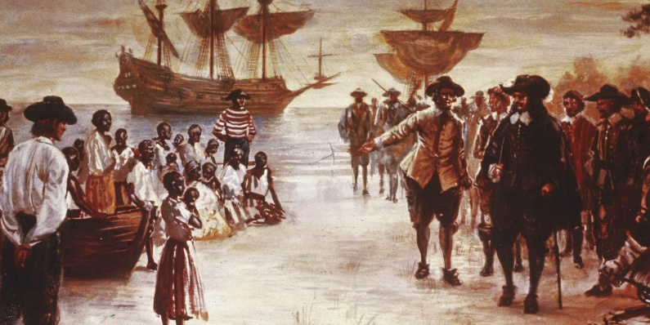

“To satisfy the labor needs of the rapidly growing North American colonies, white European settlers turned in the early 17th century from indentured servants (mostly poorer Europeans) to a cheaper, more plentiful labor source: enslaved Africans. After 1619, when a Dutch ship brought 20 Africans ashore at the British colony of Jamestown, Virginia, slavery spread quickly through the American colonies. Though it is impossible to give accurate figures, some historians have estimated that 6 to 7 million enslaved people were imported to the New World during the 18th century alone, depriving the African continent of its most valuable resource—its healthiest and ablest men and women.” https://www.history.com/articles/black-history-milestones

***
“In late August, 1619, 20-30 enslaved Africans landed at Point Comfort, today's Fort Monroe in Hampton, Va., aboard the English privateer ship White Lion. In Virginia, these Africans were traded in exchange for supplies. Several days later, a second ship (Treasurer) arrived in Virginia with additional enslaved Africans. Both groups had been captured by English privateers from the Spanish slave ship San Juan Bautista. They are the first recorded Africans to arrive in England's mainland American colonies. The landing of the first Africans in Virginia is one of the most significant events we interpret. Although English colonists in Virginia did not invent slavery, and the transition from a handful of bound African laborers to a legalized system of full-blown chattel slavery took many decades, 1619 marks the beginning of race-based bondage that defined the African American experience.” https://www.hampton.gov/3580/The-1619-Landing-Report-FAQs
***
“Arrival of ‘20 and odd’ Africans in late August 1619, not aboard a Dutch ship as reported by John Rolfe, but an English warship, White Lion, sailing with a letters of marque issued to the English Captain Jope by the Protestant Dutch Prince Maurice, son of William of Orange. A letters of marque legally permitted the White Lion to sail as a privateer attacking any Spanish or Portuguese ships it encountered. The 20 and odd Africans were captives removed from the Portuguese slave ship, San Juan Bautista, following an encounter the ship had with the White Lion and her consort, the Treasurer, another English ship, while attempting to deliver its African prisoners to Mexico. Rolfe's reporting the White Lion as a Dutch warship was a clever ruse to transfer blame away from the English for piracy of the slave ship to the Dutch.” https://www.nps.gov/jame/learn/historyculture/african-americans-at-jamestown.htm

1631: Fire Codes - Boston
“First fire prevention ordinance banned thatched roofs and wooden chimneys.” https://bostonfirehistory.org/boston-history-before-1859/

“Boston, Massachusetts, 1631, John Winthrop, Governor of Boston, outlawed the building of wooden chimneys and thatched roofs of homes as each of these were
found to cause more fires and dangerous fires throughout the community. This became the first American Building Code.” https://www.leg.state.nv.us/Session/79th2017/Exhibits/Senate/GA/SGA468G.pdf

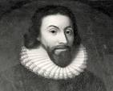

1648: NY – Fire Wardens
“Governor of New Amsterdam (New York City), appointed 4 fire wardens in 1648
which was the first organized fire prevention inspections in America. The Fire Wardens were allowed to inspect every home in the city for proper cleaning and construction of chimneys.
If fires were started due to negligent cleaning or construction of chimneys and fire places, the Fire Wardens could issue fines to the home owners.” https://www.leg.state.nv.us/Session/79th2017/Exhibits/Senate/GA/SGA468G.pdf

1653: Boston – Great Blaze
“Immediately following the first great blaze in 1653, officials decreed that each house be equipped with a ladder to reach the roof, poles with swabs to snuff out sparks, and other tools to fight fires. Boston became an early leader in firefighting regulations; it was later to pass the first fire-related building codes.
***
Volunteers also played a major role in fighting Boston's fires. Responding to a fire had always been a civic duty of all men in Boston; when the cry of ‘fire’ or the pealing of church bells signaled that flames had been spotted, every household was required to send a man with a leather bucket to help fight the fire. In September of 1718, Boston organized the ‘Boston Fire Society,’ the nation's first mutual aid organization. Members pledged to fight fires at each other's homes, rescue their property, and guard against looting.”
https://www.massmoments.org/moment-details/boston-burns.html

1676: Bacon’s Rebellion – Virginia
“In the summer of 1676, settlers in the colonies of both Virginia and Maryland were frenzied with suspicion over Indigenous tribes — partly because of a terrible mistake. A group of English militiamen had slaughtered more than a dozen Native villagers along the Potomac River the year before in retribution for the killing of a farmworker. But they got the wrong people. Those killed were Susquehannocks, allies of the royal government, and had nothing to do with the farmer’s death.
That touched off a cycle of back-and-forth revenge — Native people would attack a family on the frontier; settlers would hunt down more Natives — until a group of Virginians decided the only answer was to get rid of all the tribes by mass relocation, enslavement or death.
They rallied behind charismatic newcomer Nathaniel Bacon, who had been sent to the colonies by his father to escape prosecution for defrauding a legal client in England. He arrived with enough wealth to become instantly prominent and enough arrogance to cause trouble.
***
Historians know how Bacon’s Rebellion eventually played out, of course. The rebels did stumble onto a group of Native people, killing seven and enslaving about 45. Cockacoeske kept her pledge not to kill any Englishmen.
In October 1676, Bacon died of a disease much like typhus — possibly from parasites contracted outside Jamestown, historian Rice has written, or maybe even from his damp slogs through Dragon Run. The rebel was buried in an unmarked grave in Gloucester.
Berkeley returned to rebuild Jamestown, though the capital would shift to Williamsburg in 1699. Cockacoeske signed the Treaty of Middle Plantation in 1677 that made the Pamunkey and a handful of other tribes allies of the colony. To this day, they bring a tribute of wild game to the Virginia governor every fall.
But the effects of the insurrection lingered.
“After Bacon’s Rebellion, Virginia governors were really reluctant to go against this virulent, anti-Native sentiment among White Virginians,” Rice said. “What they were asking for was really just a broad, aggressive anti-Native policy wiping Native people off the face of whatever patch of Earth Virginia planters wanted.”
Enslavement of Native people surged; whole tribes were sometimes sold to plantations in the West Indies. By the early 1700s, Virginia’s Indigenous population was decimated.” https://www.washingtonpost.com/dc-md-va/2024/09/20/bacons-rebellion-virginia-native-americans-dragon-run/?utm_campaign=wp_todays_headlines&utm_medium=email&utm_source=newsletter&wpisrc=nl_headlines&carta-url=https%3A%2F%2Fs2.washingtonpost.com%2Fcar-ln-tr%2F3f0e801%2F66ee9953e1878f5a37ee5632%2F59731235ade4e21a848a56ed%2F22%2F65%2F66ee9953e1878f5a37ee5632

1705: Virginia Slave Codes
“But any question about the status of Black people in the colonies—free, enslaved or indentured servants—was made clear with the passage of the Virginia Slave Codes of 1705, a series of laws that stripped away legal rights and legalized the barbaric and dehumanizing nature of slavery.” https://www.history.com/articles/american-slavery-before-jamestown-1619

1732: George Washington is born in VA
George Washington (February 22, 1732 – December 14, 1799): https://www.history.com/topics/us-presidents/george-washington

1734: Daniel Boone born in PA
“Daniel Boone was born in 1734 to a family of Quakers in a one-room log cabin in present-day Pennsylvania. He was one of 11 children. Boone spent most of his early life in the borderlands between the 13 colonies and the Ohio Country. He quickly became known as an excellent hunter. In his teenage years, Boone’s family moved to North Carolina, and later Virginia. Boone experienced war firsthand when he enlisted with the Carolina militia in the French and Indian War. Later he fought in the Anglo-Cherokee War.

Boone married Rebecca Bryan and supported his family through long expeditions in the borderlands. There he hunted deer, beavers, and otters for their furs. His travels took him as far south as Florida and as far north as Kentucky.

By 1767, he had moved his family into Kentucky. This angered the Shawnee, Cherokee, and Delaware who claimed the territory. Fights between Boone, other colonists, and Natives directly led to Lord Dunmore’s War. The war ended with the Shawnee giving up their lands in Kentucky.

Through the American Revolution, Boone and his family continued to live in Kentucky. Boone was wounded in fighting against the Shawnee and saved by Simon Kenton, a fellow frontiersman. Later, Boone was captured by Chief Blackfish and taken to Oldtown. He survived by convincing Chief Blackfish that he and his men had switched sides. He was so convincing that his own men believed him! He was court-martialed for his ruse but found not guilty. He continued to fight in the war until its end, losing a brother and son to the conflict. After the war, Boone served as a local Virginian politician and merchant in present-day Kentucky and West Virginia, and later Missouri. It was there that he died in 1820.” https://ohiodnr.gov/go-and-do/see-the-sights/historic-places/great-council/explore-more-danielboone

OLD TOWN, OH (near Xenia):

“Long before the early settlers moved into the area, the Shawnee lived in the village they called Old Chillicothe. This was their principal home. There were other Chillicothesin Ohio, but this was the oldest of the settlements, hence the “Old.” They liked the area with its gently rolling hills and the proximity to the river which provided water, food, and of course transportation. It was near this site that the noted Shawnee warrior, Tecumseh, was born. It was here that Simon Kenton, having been captured by the Shawnee for stealing their horses, ran a gauntlet of men lined on both sides with tree limbs and other devices with which to flog him as he ran past. He was able to escape and tell of his adventures when he was an old man. Here, Daniel Boone and the salt makers were confined and so many more tales about the area are remembered.” https://www.xeniagazette.com/2023/07/14/oldtown-has-quite-a-history/

1736: Philadelphia – Benjamin Franklin [age 30] forms Union Fire Company
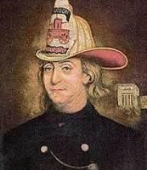

PHILADELPHIA: Modeled after Boston’s “Mutual Fire Societies.”
“On December 7, 1736 Benjamin Franklin co-founded the Union Fire Company, also known as the “Bucket Brigade”. It was the first formally organized all volunteer fire company in the colonies and was shaped after Boston’s Mutual Fire Societies. The difference between the fires societies of Boston and Franklin’s Union Fire Company was that the former protected its members only while the latter the entire community.” http://www.benjamin-franklinhistory.org/union-fire-company/

Jan. 18. 2023: MA – BUILDING CODES – Benjamin Franklin' - A Tribute To Firefighting [historical VIDEO]. https://www.youtube.com/watch?v=jYXVVNRqsFg

1742: Benjamin Franklin Stove
“In colonial America, homes were warmed by a fireplace. The Franklin stove, invented in 1742, is a metal-lined fireplace that stands in the middle of a room. It has rear baffles for improved airflow. It provides more heat and less smoke than an open fireplace and uses less wood. This cast-iron furnace would radiate heat from the middle of the room in all directions, and the iron walls even absorbed heat, providing warmth to the room long after the fire went out.” https://www.ushistory.org/franklin/science/stove.htm?srsltid=AfmBOorscceSsMe5OZj98bqukF_8nbHyHQsdGHSk_-w1x4zZBTINxug1

1754-63: French & Indian “Seven Years War”
“Also known as the Seven Years’ War, this New World conflict marked another chapter in the long imperial struggle between Britain and France. When France’s expansion into the Ohio River valley brought repeated conflict with the claims of the British colonies, a series of battles led to the official British declaration of war in 1756. Boosted by the financing of future Prime Minister William Pitt, the British turned the tide with victories at Louisbourg, Fort Frontenac and the French-Canadian stronghold of Quebec. At the 1763 peace conference, the British received the territories of Canada from France and Florida from Spain, opening the Mississippi Valley to westward expansion.” https://www.history.com/topics/native-american-history/french-and-indian-war

Nov. 12, 1758: George Washington – “friendly fire”
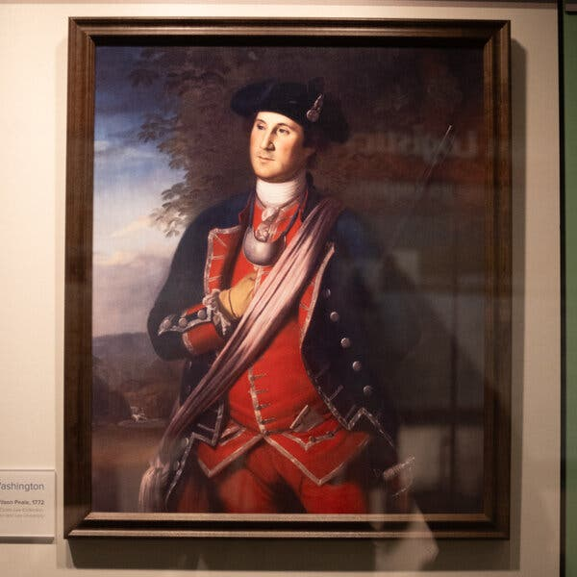
A reproduction of a 1772 portrait of George Washington, depicting him during the French and Indian War a decade earlier, when he was a colonel in the Virginia Regiment. Credit...Aaron Blum for The New York Times

“It was not all glory. In one passage, Washington recalled the terrible, foggy evening of Nov. 12, 1758. He and his men had ventured from Fort Ligonier, a British redoubt about 60 miles from present-day Pittsburgh, to help another group of Virginians push back a French raiding party but instead ignited a devastating volley of friendly fire. Several dozen were injured, and as many as 14 killed, before Washington, by his account, rode between the two groups of Virginians, knocking away their muskets.*** The friendly fire incident, as the episode is known, is a footnote in the history of the French and Indian War, and merits only a paragraph or two in most Washington biographies. But it has long been part of the lore in this part of western Pennsylvania, where a reconstruction of Fort Ligonier opened in 1953. *** The friendly fire incident may seem like a minor episode, and Washington himself was not eager to talk about it. The only record he left at the time was a terse entry in his orderly book later that night, noting that he was sending more than 400 men out with spades to bury the dead.https://www.nytimes.com/2025/07/15/arts/george-washington-battlefield-war.html

1736: Benjamin Franklin – Philadelphia Union Fire Company
“Boston’s firefighting clubs inspired Ben to create the first volunteer fire company in Philadelphia. He named it the Union Fire Company in 1736. The company consisted of all males dedicated to putting out fires and saving property. Their equipment included a leather bucket and linen bag. The firefighters used the linen bucket to put out fires and the linen bag held rescued valuables. Additionally, the Union Fire Company’s members including Ben Franklin and a few others established a fire insurance company.
The group founded The Contributionship for the Insuring of Houses from Loss by Fire in 1752. The board created a set of parameters for building’s to meet to receive insurance. Some of the constraints required buildings to be easily accessible for firemen, there couldn’t be any major interferences inside or on the property that would hinder firefighting, and that the building wasn’t a high risk for having fires. Only buildings that met these certain parameters received insurance. Some suspect that a few modern fire code requirements originated from the insurance company’s prerequisites for coverage.” https://kinetixfire.com/ben-franklins-pivotal-role-in-the-fire-life-safety-industry/

1752: Fire Marks – Signs On Houses Showing Insured For Fire
“American fire marks, also known as ‘badges’ and ‘house plates,’ are signs issued by insurance companies that were affixed to the front of a property to mark that the property was insured for fire. Fire marks carried the symbol or the name of the insurer and were made of cast iron, sheet brass, lead, tinned sheet iron, copper or zinc. They came in various sizes and shapes, sometimes attached to a wooden plaque.
Used primarily for advertising purposes, fire marks were used from 1752 to circa 1900. Going back to their early practices, the Philadelphia Contributionship and The Baltimore Equitable Society still issue fire marks.” https://www.firemanshallmuseum.org/fire-marks/

Dec. 11, 1753: Washington (age 21), Virginia Regiment, sent to Ohio Valley to confront French
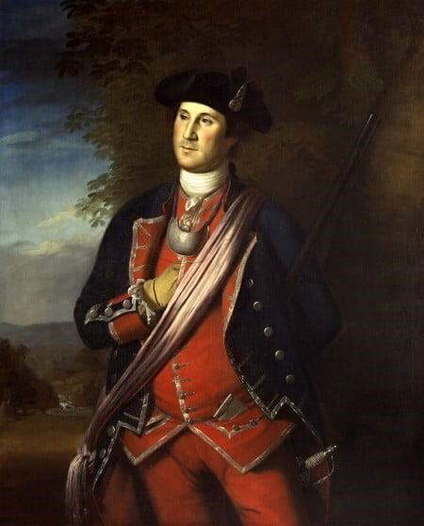 George Washington as a Colonel in Virginia Regiment
https://www.mountvernon.org/george-washington/artwork/life-portraits-of-george-washington/
“Control of the expansive Ohio Valley region, especially near the joining of the Monongahela and Allegheny rivers (modern day Pittsburgh), was of great interest to both the British and their French rivals. Rivers like the Ohio, which connected to the Mississippi, were essential transit corridors for goods produced in this fertile region.
Concerned by reports of French expansion into the Ohio Valley, Virginia Lt. Governor Robert Dinwiddie sent 21-year-old Major George Washington of the Virginia Regiment on a mission to confront the French forces. Washington was to deliver a message from the governor demanding that the French leave the region and halt their harassment of English traders. Washington departed Williamsburg, Virginia in October 1753 and made his way into the rugged trans- Appalachian region with Jacob Van Braam, a family friend and French speaker, and Christopher Gist, an Ohio company trader and guide. On December 11, 1753, amidst a raging snowstorm, Washington arrived and was politely received by Captain Jacques Legardeur de Saint-Pierre at Fort LeBoeuf. After reviewing Dinwiddie's letter, Legardeur de Saint-Pierre calmly wrote a reply stating that the French king's claim to the Ohio Valley was "incontestable.”
Washington's return to Virginia during the winter of 1753 was a perilous one, but the group safely returned to Williamsburg after traveling almost 900 miles in two and a half winter months.” https://www.mountvernon.org/george-washington/french-indianwar/ten-facts-about-george-washington-and-the-french-indian-war/

1754: French and Indian War (1754 - 1763)
“The French and Indian War (1754-1763) is the name given to the North American theatre of the Seven Years’ War (1756-1763), a global conflict involving the major powers of Europe. Though war was not formally declared until 1756, armed conflict began in 1754 as disputes over land claims in the Ohio Valley lead to a series of frontier battles between the French and British. Both received support from various Native American tribes, though the outnumbered French became far more dependent on these allies as the war progressed.
The French saw a number of early victories, most notably over George Washington and Edward Braddock in Western Pennsylvania. Washington quickly became a central figure in the conflict, maturing during his tenure in the Virginia militia from an inexperienced young major to the commander in chief of the colony’s regiment. Washington’s involvement during the war’s early stages provided the future President with invaluable military experience while also gaining him positive notoriety that helped to launch his future political career.”
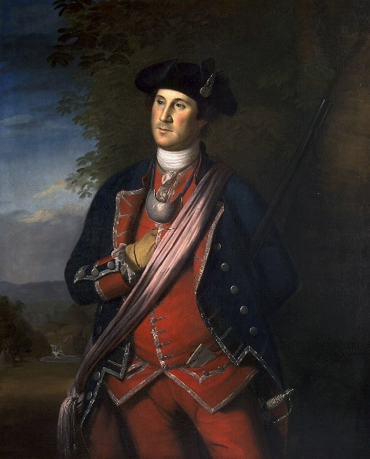1772 portrait of Washington by Charles Willson Peale.

March, 1754: Washington's very first battle for the British Government Against France
“George Washington was a raw and ambitious 21-year-old when he was first sent to the Ohio Valley to confront the growing French presence in the region. His actions sparked the French and Indian War … Responding to the defiant French. Lt. Governor Dinwiddie ordered the newly promoted Lt. Col. George Washington and approximately 160 Virginia militia to return to the Ohio country in March of 1754. Dinwiddie wanted Washington to ‘act on the defensive,’ but also clearly empowered Washington to ‘make Prisoners of or kill & destroy…’ all those who resisted British control of the region.
Eager to send their own diplomatic directive demanding an English withdrawal from the region, a French force of 35 soldiers commanded by Ensign Joseph Coulon de Villiers de Jumonville camped in a rocky ravine not far from Washington's encampment at the Great Meadows (now in Fayette County, Pennsylvania).
Accompanied by Tanacharison, a Seneca chief (also known as the Half-King) and 12 native warriors, Washington led a party of 40 militiamen on an all night march towards the French position. On May 28, 1754, Washington's party stealthily approached the French camp at dawn. Finally spotted at close range by the French, shots rang out and a vigorous firefight erupted in the wooded wilderness. Washington's forces quickly overwhelmed the surprised French force and killed 13 soldiers and captured another 21.” https://www.mountvernon.org/george-washington/french-indian-war/ten-facts-about-georgewashington-and-the-french-indian-war/
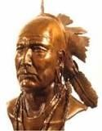Tanacharison

1754: George Washington (age 22) surrendered to the French at Fort Necessity
“After learning of the attack at Jumonville Glen, Claude-Pierre Pecaudy de Contrecoeur, the veteran French commander at Fort Duquesne, ordered Captain Louis Coulon de Villiers, Ensign Jumonville's brother, to assail Washington and his force near Great Meadows. De Villiers left Fort Duquesne with nearly 600 French soldiers and Canadian militiamen, accompanied by 100 native allies.
Aware of the onset of a powerful French column, Washington busily fortified his position at Great Meadows. Despite receiving additional reinforcements, Washington's bedraggled force of around 400 men remained outnumbered by the approaching French. Even more concerning, the small circular wooden fort – named Fort Necessity - built in the center of the meadow was poorly situated and vulnerable to fire from the nearby wooded hills that circled the position.
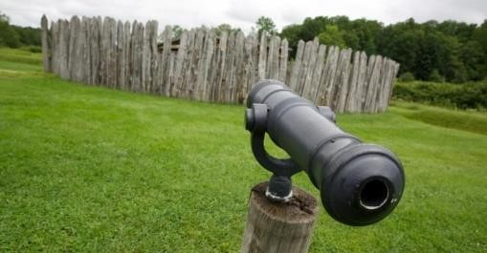
“On July 1, 1754, the large combined French and native forces reached the Great Meadows. Washington gathered his troops and retreated into Fort Necessity where on a rainy July 3rd the French began firing on the surrounded English. Sensing the hopelessness of his situation, Washington agreed to surrender to the French. The surrender terms, written in French, poorly translated, and soaking wet allowed
Washington and his troops to return to Virginia in peace, but one clause in the document had Washington admitting that he had ‘assassinated’ Ensign Jumonville – something that Washington hotly contested despite his signature on the document. *** The Battle of Great Meadows proved to be the only time that Washington surrendered to an enemy in battle.” https://www.mountvernon.org/george-washington/french-indian-war/ten-factsabout-george-washington-and-the-french-indian-war/

Spring, 1755: Daniel Boone volunteered – wagoner with British General Braddock

Watch video – “Boone At War”: https://cet.pbslearningmedia.org/resource/ket-history-danielboone0102/daniel-boone-at-war/

July 9, 1755 – Battle of Monongahela – British Major General Edward Braddock killed
“In the spring of 1755, a column of 2,100 British Regulars and 500 colonial militia commanded by Major General Edward Braddock, set out from Virginia to advance upon and take the French stronghold at Fort Duquesne. Braddock's column faced the daunting challenge of moving their men and material over the rough, densely wooded Allegheny Mountains. George Washington accompanied Braddock's column as an aide-de-camp to the general. Washington, who knew the terrain well, was recovering from a terrible case of dysentery as Braddock's force reached the Monongahela River ten miles from Fort Duquesne. In a wooded ravine on the far side of the river, Braddock's leading force of 1,300 men was suddenly attacked and defeated by a smaller French and native force on July 9, 1755 at the Battle of Monongahela. During the attack, most of the senior British officers, including Gen. Edward Braddock were killed [died July 13, 1755] or severely wounded. With panic in the air, George Washington quickly rode into the fray and helped to reestablish some amount of order. During the savage fight, Washington had two horses shot out from underneath him and his coat was pierced by four musket balls. Washington's cool leadership helped many of the surviving soldiers to effectively escape the onslaught. Despite the British loss of 977 killed or wounded, Washington was lauded as the ‘hero of Monongahela’ by Virginia Governor Robert Dinwiddie and was given the rank of colonel in command of the 1,200 man Virginia Regiment.”

1755: George Washington Denied British Commission
“During the 1755 Braddock expedition, Washington became an unpaid, volunteer aide-de-camp to Braddock rather than assume his militia rank and be subjected to the embarrassment of being subordinate to junior officers. Washington's interest in obtaining a royal commission became so strong that he traveled to Boston to meet with Governor William Shirley, who was the acting commander in chief after Gen. Braddock's death. Washington was unsuccessful in obtaining a royal commission, but Shirley did issue a decree that officers in the Virginia militia would outrank British officers of lower rank.” https://www.mountvernon.org/george-washington/french-indian-war/ten-facts-about-george-washington-and-the-french-indian-war

1756: Seven Years War (1756 – 1763)
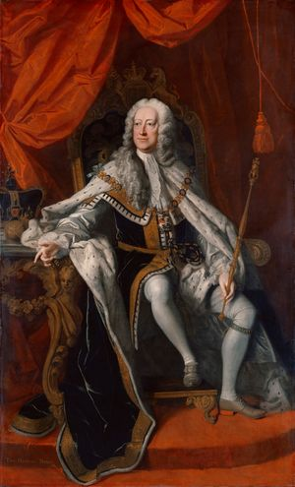British King George II
“Seven Years’ War, (1756–63), the last major conflict before the French Revolution to involve all the great powers of Europe. Generally, France, Austria, Saxony, Sweden, and Russia were aligned on one side against Prussia, Hanover, and Great Britain on the other.
***
The definitive Treaty of Paris was concluded on February 10, 1763, between Great Britain, Hanover, France, and Spain, with Portugal expressly understood to be included. By that treaty France renounced to Great Britain all of mainland North America east of the Mississippi River (excluding New Orleans and environs); the West Indian islands of Grenada, Saint Vincent, Dominica, and Tobago; and all French conquests made since 1749 in India or in the East Indies.” https://www.britannica.com/event/Seven-Years-War/1760

1758: George Washington finally occupies abandoned Fort Duquesne
“Operating from the recently established Fort Ligonier, Colonel Washington's Virginians participated in a number of operations in the area east of the French position. On November 24, 1758, Washington led his troops on an advance that occupied the smoking ruins of the abandoned Fort Duquesne. After almost five years of hard marching, combat, and countless setbacks, Washington was finally able to stand at the British controlled forks of the Ohio.” https://www.mountvernon.org/george-washington/french-indian-war/ten-facts-about-george-washington-and-the-french-indian-war

Jan. 6,1759: George Washington inherits Mount Vernon
“As a young, attractive, wealthy widow, Martha Dandridge Custis probably enjoyed more freedom to choose her own destiny than at any other point in her life. She was only 26 years old, owned nearly 300 enslaved individuals and had more than 17,500 acres of land—worth more than £40,000. Because her husband had died without a will, she was the executor of his estate. *** On January 6, 1759, Martha Dandridge Custis married George Washington at her home in New Kent County. For both Martha and George, a new era had dawn.” https://www.mountvernon.org/george-washington/martha-washington/george-marthas-courtship/
“Hidden Under George Washington’s Home: 35 Glass Bottles of Cherries. Archaeologists discovered the glass bottles in the cellar during a restoration project.” https://www.nytimes.com/2024/06/18/us/george-washington-mount-vernon-cherries.html?te=1&nl=the-morning&emc=edit_nn_20240619
“Washington inherited Mount Vernon in 1761. Hundreds of enslaved men, women and children lived there over the years. Initial findings show that the fruit was neatly cut using shears, allowing the trees to remain productive while protecting the cherries, Dr. Boroughs said. The fruit is also extremely clean, demonstrating the highly skilled process that went into picking, packing and storing it. The storage pits were probably used between the 1750s and 1770s, until they were paved over by brick flooring during the home’s expansion. At the time, an enslaved woman named Doll, who was brought to Mount Vernon by Martha Washington in 1759, was the family’s main cook, Dr. Boroughs said. Based on letters from Mrs. Washington to her niece in the late 1790s, it’s likely that Doll either prepared the bottles herself or had another enslaved person do it, Dr. Boroughs said.”

Aug. 1761: Slave Girl - Phillis Wheatley, Taught To Read And Write
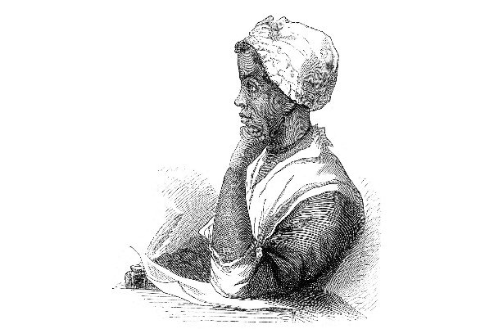
“Wheatley was seized from Senegal/Gambia, West Africa, when she was about seven years old. She was transported to the Boston docks with a shipment of ‘refugee’ slaves, who because of age or physical frailty were unsuited for rigorous labor in the West Indian and Southern colonies, the first ports of call after the Atlantic crossing. In the month of August 1761, ‘in want of a domestic,’ Susanna Wheatley, wife of prominent Boston tailor John Wheatley, purchased ‘a slender, frail female child ... for a trifle’ because the captain of the slave ship believed that the waif was terminally ill, and he wanted to gain at least a small profit before she died. A Wheatley relative later reported that the family surmised the girl—who was ‘of slender frame and evidently suffering from a change of climate,’ nearly naked, with ‘no other covering than a quantity of dirty carpet about her’—to be ‘about seven years old ... from the circumstances of shedding her front teeth.’

After discovering the girl’s precociousness, the Wheatleys, including their son Nathaniel and their daughter Mary, did not entirely excuse Wheatley from her domestic duties but taught her to read and write. Soon she was immersed in the Bible, astronomy, geography, history, British literature (particularly John Milton and Alexander Pope), and the Greek and Latin classics of Virgil, Ovid, Terence, and Homer. In ‘To the University of Cambridge in New England’ (probably the first poem she wrote but not published until 1773), Wheatley indicated that despite this exposure, rich and unusual for an American slave, her spirit yearned for the intellectual challenge of a more academic atmosphere.” https://www.poetryfoundation.org/poets/phillis-wheatley

1764: King George III (age 26) - Imposes Taxes On Colonies
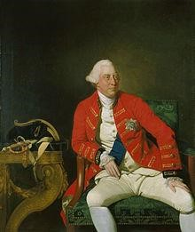 King George III

1764: Sugar Act [Colonists use sugar to make Rum]
“On April 5, 1764, Parliament passed a modified version of the Sugar and Molasses Act (1733), which was about to expire. Under the Molasses Act colonial merchants had been required to pay a tax of six pence per gallon on the importation of foreign molasses. But because of corruption, they mostly evaded the taxes and undercut the intention of the tax — that the English product would be cheaper than that from the French West Indies. This hurt the British West Indies market in molasses and sugar and the market for rum, which the colonies had been producing in quantity with the cheaper French molasses.” http://www.ushistory.org/declaration/related/sugaract.html

1765: Stamp Act
“The Stamp Act of 1765 was the first internal tax levied directly on American colonists by the British government. The act, which imposed a tax on all paper documents in the colonies, came at a time when the British Empire was deep in debt from the Seven Years’ War (1756-63) and looking to its North American colonies as a revenue source. Arguing that only their own representative assemblies could tax them, the colonists insisted that the act was unconstitutional, and they resorted to mob violence to intimidate stamp collectors into resigning. Parliament repealed the Stamp Act in 1766, but issued a Declaratory Act at the same time to reaffirm its authority to pass any colonial legislation it saw fit. The issues of taxation and representation raised by the Stamp Act strained relations with the colonies to the point that, 10 years later, the colonists rose in armed rebellion against the British.” https://www.history.com/topics/americanrevolution/stamp-act

“On March 22, 1765, the British Parliament passed the “Stamp Act” to help pay for British troops stationed in the colonies during the Seven Years’ War. The act required the colonists to pay a tax, represented by a stamp, on various forms of papers, documents, and playing cards….
- March 22, 1765: British Parliament passes the ‘Stamp Act.’
- October 1765: Delegates from nine colonies meet in New York City in what has become known as the Stamp Act Congress, the first united action by the colonies; the congress acknowledges that while Parliament has a right to regulate colonial trade, it does not have the power to tax the colonies since they were unrepresented in Parliament.
- November 1, 1765: The Stamp Act goes into effect in the colonies.
- March 1766: Colonial resistance to the Stamp Act and pressure from London merchants prompt Parliament to abolish the Stamp Act.
- March 1766: Parliament issues the Declaratory Act, which states that the king and Parliament have full legislative power over the colonies.” https://www.gilderlehrman.org/history-resources/spotlight-primary-source/stamp-act-1765

1767: Townshend Acts
“The Townshend Acts were a series of measures, passed by the British Parliament in 1767, that taxed goods imported to the American colonies. But American colonists, who had no representation in Parliament, saw it as an abuse of power. The British sent troops to America to enforce the unpopular new laws, further heightening tensions between Great Britain and the American colonies in the run-up to the American Revolutionary War.” https://www.history.com/topics/american-revolution/townshend-acts

March 5, 1770: “Boston Massacre”
“On March 5, 1770, a street brawl happened in Boston between American colonists and British soldiers. Later known as the Boston Massacre, the fight began after an unruly group of colonists – frustrated with the presence of British soldiers in their streets – flung snowballs at a British sentinel guarding the Boston Customs House. Reinforcements arrived and opened fire on the mob, killing five colonists and wounding six. The Boston Massacre and its fallout further incited the colonists’ rage towards Britain.” https://www.history.com/topics/american-revolution/boston-tea-party

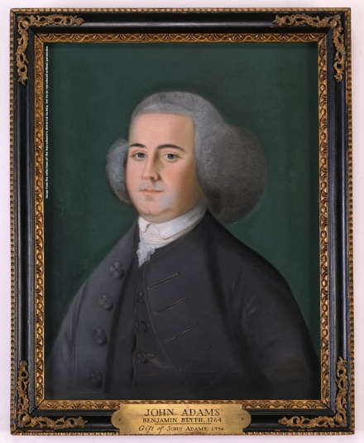Lawyer John Adams decided to serve on the defense of the Captain Preston and his soldiers.

“On March 5, 1770, British soldiers fired into a crowd of civilians, killing five people. Crispus Attucks, Samuel Gray, and James Caldwell died that night. Seventeen-year-old Samuel Maverick died the next morning. Patrick Carr died from his wounds nearly two weeks later. This event sparked outrage in Bostonians who later called this ‘the Boston Massacre.’

Shortly after the Massacre, the soldiers (William Wemms, Hugh White, Hugh Montgomery, James Hartigan, William McCauley, Mathew Kilroy, William Warren, and John Carroll) and their captain (Thomas Preston) were arrested and jailed. Royal government officials decided to delay the trial to let tensions in the town cool. Both sides doubted the soldiers would be given a fair trial. Loyalists feared that colonists would want vengeance; colonists feared that loyalists would arrange for charges to be dismissed….

Captain Preston's trial began on October 24, 1770. Lasting six days, this trial became the first in the American colonies with a duration longer than a single day. The prosecution argued that while Preston had not fired a single shot himself, if he had given the order to fire, Preston would have to take responsibility for the five civilian deaths. The defense argued that there was not sufficient evidence to prove that Preston had given the fatal order… On October 30, 1770, the jury delivered its verdict: Captain Thomas Preston was found not guilty….

On November 27, nearly a month after Preston's acquittal, the court moved forward with its trial of the soldiers. Since the prosecution had been unable to prove that Captain Preston had given the order to fire, the question remained: did the soldiers open fire of their own accord?... After a nine-day long trial, the decision rested with the jury. They deliberated for two and a half hours before returning with their verdict. The jury outright acquitted six of the eight soldiers present the night of March 5, 1770. For the remaining two soldiers, Hugh Montgomery and Matthew Kilroy, the jury found them guilty of manslaughter. By invoking the Benefit of Clergy, an antiquated piece of English law that reduced sentences for first time offenders and could only be used by literate citizens, the defense successfully commuted their sentences from capital punishment to having their right thumbs branded.” https://www.nps.gov/articles/000/boston-massacre-trial.htm

May 1773: Tea Act
“In May 1773, British Parliament passed the Tea Act which allowed British East India
Company to sell tea to the colonies duty-free and much cheaper than other tea companies – but still tax the tea when it reached colonial ports. Tea smuggling in the colonies increased, although the cost of the smuggled tea soon surpassed that of tea from British East India Company with the added tea tax.
Still, with the help of prominent tea smugglers such as John Hancock and Samuel Adams – who protested taxation without representation but also wanted to protect their tea smuggling operations – colonists continued to rail against the tea tax and Britain’s control over their interests.” https://www.history.com/topics/american-revolution/boston-teaparty
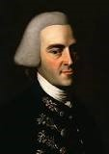John Hancock 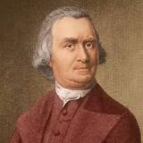 Samuel Adams

Dec. 16, 1773: “Boston Tea Party”
“On the evening of December 16, 1773, a few dozen men said to be ‘dressed in the Indian manner,” their faces darkened by lampblack or charcoal, descended with war whoops down Milk Street in Boston to board three merchant ships moored at Griffin’s Wharf. Prying open the hatches, they used block and tackle to hoist from the holds hundreds of heavy chests containing forty-five tones of Bohea, Congu, Singlo, Souchong, and Hyson tea. For three hours they methodically smashed the lids and scooped the leaves in the harbor.” The British Are Coming, by Rick Atkinson (2009) – Prologue, page 13.
“The event was the first major act of defiance to British rule over the colonists. It showed Great Britain that Americans wouldn’t take taxation and tyranny sitting down, andrallied
American patriots across the 13 colonies to fight for independence.” https://www.history.com/topics/american-revolution/boston-tea-party

1774: King George III [age 36] - Coercive Acts
“But despite the lack of violence, the Boston Tea Party didn’t go unanswered by King George III and British Parliament. In retribution, they passed the Coercive Acts (later known as the Intolerable Acts) which:
- closed Boston Harbor until the tea lost in the Boston Tea Party was paid for
- ended the Massachusetts Constitution and ended free elections of town officials
- moved judicial authority to Britain and British judges, basically creating martial law in Massachusetts
- required colonists to quarter British troops on demand, using their private homes if needed
- extended freedom of worship to French-Canadian Catholics under British rule, which angered the mostly Protestant colonists.” https://www.history.com/topics/americanrevolution/boston-tea-party

Sept. 5, 1774: First Continental Congress – Philadelphia
“From 1774 to 1789, the Continental Congress served as the government of the 13 American colonies and later the United States. The First Continental Congress, which was comprised of delegates from the colonies, met in 1774 in reaction to the Coercive Acts, a series of measures imposed by the British government on the colonies in response to their resistance to new taxes.” https://www.history.com/topics/americanrevolution/the-continental-congress

“In response to the British Parliament’s enactment of the Coercive Acts in the American colonies, the first session of the Continental Congress convenes at Carpenter’s Hall in Philadelphia. Fifty-six delegates from all the colonies except Georgia drafted a declaration of rights and grievances and elected Virginian Peyton Randolph as the first president of Congress. Patrick Henry, George Washington, John Adams, and John Jay were among the delegates.
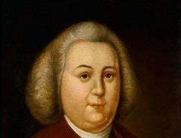
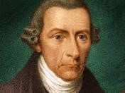
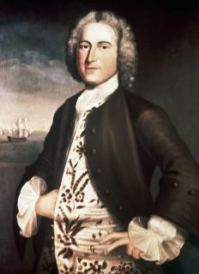
Peyton Randolph [age 53]
Patrick Henry [age 38]
John Adams [age 39]

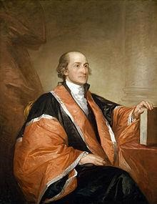

John Jay [age 29]; in 1789 was appointed by President Washington as the 1st Chief Justice of United States

1774: Non-Importation of British Goods
“On September 22, 1774, Charles Thomson, secretary to the Continental Congress in Philadelphia, entered into the minutes this resolution:
That the Congress request the Merchants and Others, in the several Colonies, not to send to Great Britain any Orders for Goods, and to direct the execution of all Orders already sent, to be delayed or suspended, until the sense of the Congress, on the means to be taken for the preservation of the Liberties of America, is made public.
On October 14, 1774 the Congress, chaired by President Peyton Randolph of
Williamsburg, announced the result of its deliberations: a set of Declarations and Resolves. The delegates adopted the detailed articles of a non-importation association on October 22, 1774.
DECLARATION AND RESOLVES OF THE FIRST CONTINENTAL CONGRESS:
October 14, 1774
“To obtain redress of these grievances, which threaten destruction to the lives, liberty, and property of his Majesty's subjects in North-America, we are of opinion, that a non-importation, non-consumption, and non-exportation agreement, faithfully adhered to, will prove the most speedy, effectual, and peaceable measure: and therefore we do, for ourselves, and the inhabitants of the several Colonies, whom we represent, firmly agree and associate under the sacred ties of virtue, honour, and love of our country, as follows:
- That from and after the first day of December next, we will not import into British America, from Great-Britain or Ireland, any goods, wares or merchandize whatsoever, or from any other place any such goods, wares or merchandize, as shall have been exported from Great-Britain or Ireland; nor will we, after that day, import any East India tea from any part of the world; nor any molasses, syrrups, paneles, coffee, or piemento, from the British plantations, or from Dominica; nor wines from Madeira, or the Western Islands; nor foreign Indigo.
- That we will neither import, nor purchase any slave imported, after the first day of December next; after which time, we will wholly discontinue the slave trade, and will neither be concerned in it ourselves, nor will we hire our vessels, nor sell our commodities or manufactures to those who are concerned in it. ***” http://www.history.org/almanack/life/politics/resolves.cfm
British Are Coming, by Rick Atkinson (2009) – Prologue, pages 25-26.

Oct. 26, 1774: Letter to Canadians to Join USA As 14th Colony

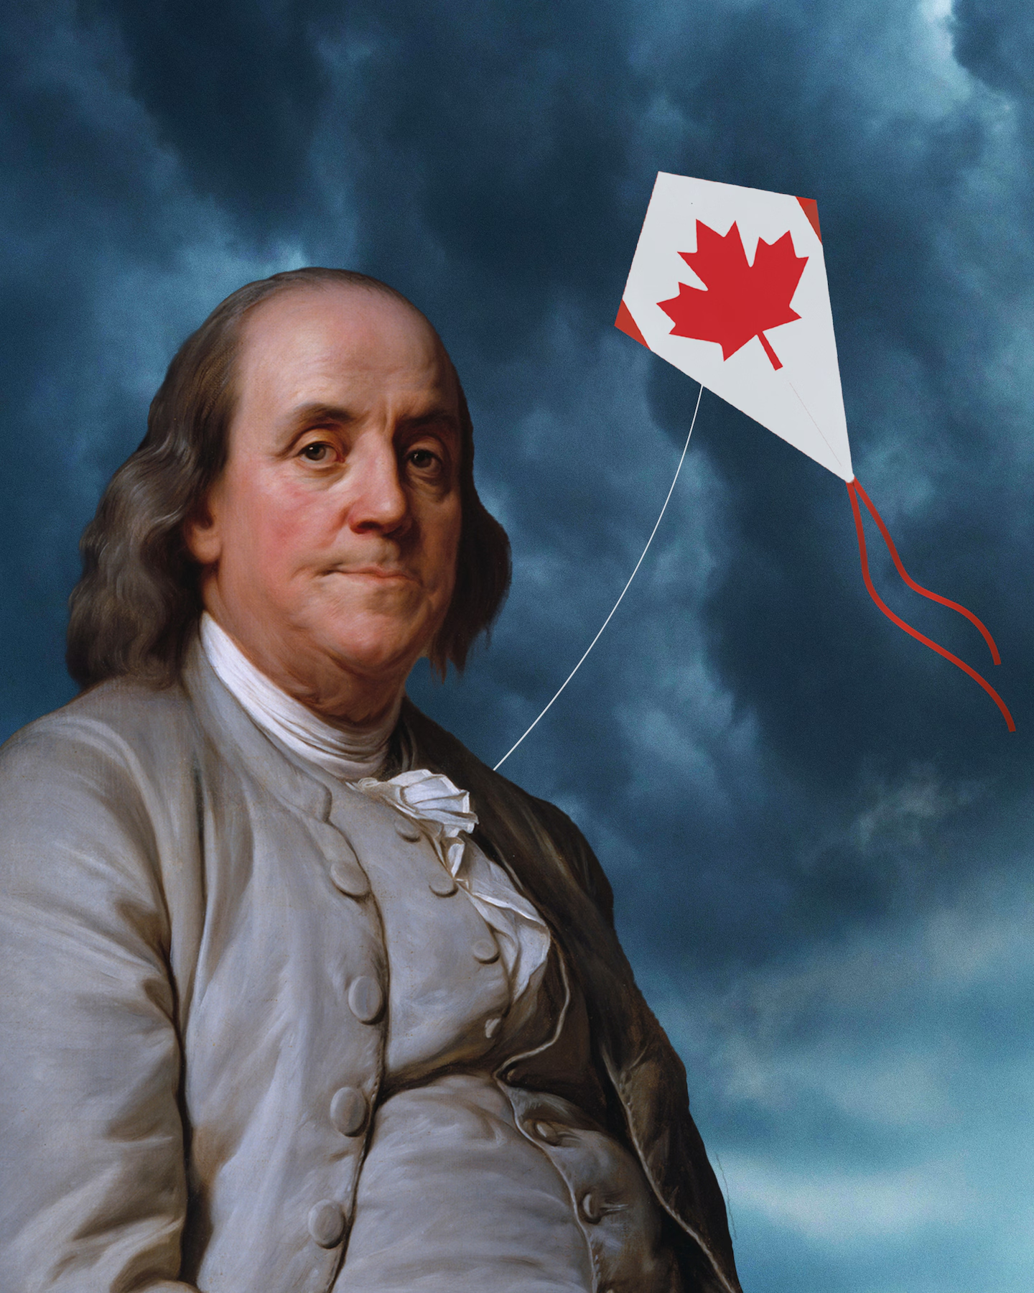
“When Benjamin Franklin failed to make Canada the 14th colony. Canadians weren’t enticed by the colonists’ noble goals. Why would they want to join now? For those of you scratching your heads — letter? what letter? — it was written in 1774, when Canadians and Americans were fellow British colonists. (Yes, some Americans have been eyeing Canada for that long.) It was sent to the Province of Quebec by delegates to the First Continental Congress, including Founding Fathers George Washington, John Adams and John Jay. In it, they described in glowing terms the country they sought to build and the values that would serve as its foundation. They thought — wrongly, as it turned out — that the Canadians of that era, who were overwhelmingly French-speaking and Catholic, could not help but see that it was in their best interests to join a group of English-speaking Protestants in their fight with the British government. (The Declaration of Independence was still on the horizon.)” https://www.washingtonpost.com/opinions/2025/03/25/canada-benjamin-franklin-trump/?utm_campaign=wp_post_most&utm_medium=email&utm_source=newsletter&carta-url=https%3A%2F%2Fs2.washingtonpost.com%2Fcar-ln-tr%2F41c4f6b%2F67e2d8686ef25d630e0a20f8%2F59731235ade4e21a848a56ed%2F22%2F63%2F67e2d8686ef25d630e0a20f8

1775: Daniel Boone Leave Home in NC heading West – 30 others
8 Things You Might Not Know About Daniel Boone: https://www.history.com/articles/8-things-you-might-not-know-about-daniel-boone
“In 1775, Boone and a group of some 30 woodsmen left to complete a 200-mile trail through the wilderness to the Cumberland Gap—a natural break in the rugged Appalachian Mountains—and into Kentucky. Boone had been hired for the job by Richard Henderson, a North Carolinian who along with a group of investors planned to establish a colony called Transylvania in an area comprising much of present-day Kentucky and part of present-day Tennessee.
After Boone blazed the trail, which became known as the Wilderness Road, he helped establish one of Kentucky’s earliest settlements, Boonesborough, which became Transylvania’s capital. The Transylvania colony was short-lived; in 1778, the Virginia General Assembly voided the deal Henderson had struck with the Cherokees for the land.
Nevertheless, the Wilderness Road became the gateway by which an estimated 200,000 settlers journeyed to the western frontier by the early 19th century. Among those emigrants was Abraham Lincoln’s grandfather, who in 1779 traveled the Wilderness Road from Virginia to Kentucky, where America’s 16th president was born in 1809.”

March 20, 1775: Ben Franklin [age 69] – Leaves England After 20 Years, Returns To America
“Except for a brief return visit to Philadelphia in 1763-64 … [Benjamin Franklin] had lived at No. 27 [Craven Street, London] since arriving in England as a colonial agent in 1757. Because he was widely deemed a ‘universal genius’ – the accolade did not displease him – his eccentricities were forgiven: chuffing up and down the nineteen oak stairs, dumbbells in hand, for exercise; sitting nude in the open window about the street, regardless of the season, for his morning ‘air bath’; playing his ‘harmonica,’ an improbable contraption constructed of thirty-seven glass hemispheres mounted on an iron spindle and rotated with a foot treadle so that he could elicit three ghostly octaves by touching the moving edges with his moistened fingers. (Mozart and Beethoven, among others, would compose for the instrument.) And Craven Street had also been his laboratory, the sire where he had launched inquiries into sunspots, magnetism, lead poisoning, the organic origins of coal, carriage wheel construction, and ocean salinity. At the foot of the street, in the Thames [River], he had repeated his celebrated kite-and-key demonstration; St. Paul’s Cathedral, nearby was Britain’s first structure to install a lightning rod.” The British Are Coming, by Rick Atkinson (2009) – Prologue, page 27.
Note: “In December 1772, Franklin sent letters to Boston [letters written by a Crown official in Massachusetts to a British undersecretary, which he had secretly received from a source] as confidential intelligence for patriot leaders, but six months later they were published, causing an uproar in New England, and then in Britain. Franklin eventually placed a notice in the London Chronicle, disclosing his responsibility. British newspapers vilified him as ‘this old snake,’ ‘old Doubleface,’ and a ‘base, ungrateful, cunning, upstart thing.’ On Jan. 29, 1774, he appeared before the king’s council. *** It was the greatest humiliation of his life, and a day later he was sacked as deputy post master general for North America.” The British Are Coming, by Rick Atkinson (2009) – Prologue, pages 29 - 30.

March 23, 1775: Patrick Henry – “Give me liberty or give me death”
“On April 18, 1775 - this day, 250 years ago - a 40-year-old Boston silversmith named Paul Revere borrowed a horse and sped west toward Lexington to warn his fellow colonists of an emerging threat: The British were coming.” The New York Times April 18, 2025; nytdirect@nytimes.com
***
“Step back in time to March 23, 1775! At the Second Virginia Convention, held within the hallowed walls of St. John’s Church in Richmond, Patrick Henry ignited the flames of revolution with his legendary speech. His words galvanized the Virginia delegation, leading to a resolution that committed Virginia troops to the Revolutionary War.” https://va250.org/patrick-henrys-speech/
Discover Patrick Henry’s Legacy, Beyond His Revolutionary ‘Give Me Liberty or Give Me Death’ Speech. https://www.smithsonianmag.com/history/discover-patrick-henrys-legacy-beyond-his-revolutionary-give-me-liberty-or-give-me-death-speech-180986266/
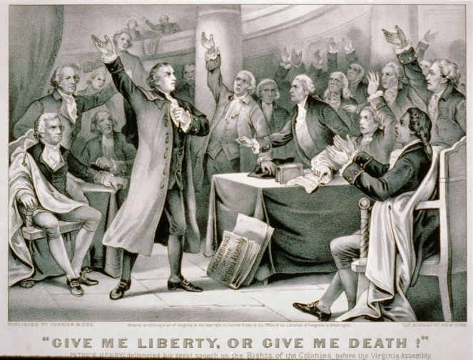

“With the other colonies watching intently, Massachusetts led the resistance to the British, forming a shadow revolutionary government and establishing militias to resist the increasing British military presence across the colony. In April 1775, Thomas Gage, the British governor of Massachusetts, ordered British troops to march to Concord,
Massachusetts, where a Patriot arsenal was known to be located. On April 19, 1775, the British regulars encountered a group of American militiamen at Lexington, and the first shots of the American Revolution were fired.” https://www.history.com/this-day-inhistory/first-continental-congress-convenes

April 18, 1775: Lexington, MA – Ride Of Paul Revere

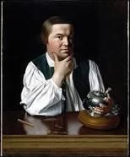 Paul Revere

William Dawes [age 30] – with Paul Revere, rode from Boston to warn them. The
“Midnight Ride”
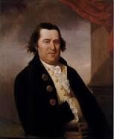 Williams Dawes

“After Revere conferred with Warren, he returned to his own neighborhood, where he contacted a “friend” (Revere was very careful not to identify anyone he did not need to, in case his deposition fell into the wrong hands) to climb up into the bell tower of Christ Church (today known as the Old North Church) to set the famous signals. The ‘friend’ hung two lanterns, meaning the British planned to leave Boston ‘by sea’ across the Charles River, as opposed to a single lantern, which would mean the troops planned to march entirely ‘by land,’ by the same route William Dawes had taken. *** Narrowly escaping capture by a British patrol just outside of Charlestown, Revere charged his planned route somewhat and arrived in Lexington just past midnight. We do not know what he said at each of the houses along the road. We do know exactly what he said when he got to Lexington, however, as there was a sentry on duty outside the house where Adams and Hancock lodged, and that sentry, a Sergeant Monroe, later wrote down what happened. As Revere approached the house, Monroe told him not to make so much noise, that everyone in the house had retired for the night. Revere cried ‘Noise! You’ll have noise enough before long! The regulars are coming out!’ Despite this, Revere still had trouble convincing the sentry to let him pass until John Hancock, who was still awake and heard the commotion, recognized Revere’s voice and said “Oh, you, Revere. We are not afraid of you” after which Revere was allowed to enter the house and deliver his news.

***
About 30 minutes later William Dawes arrived. The two messengers ‘refreshed themselves’ (probably got something to eat and drink) and then decided to continue on to the town of Concord, to verify that the military stores had been properly dispersed and hidden away. Along the road they were joined by a third man, a Dr. Samuel Prescott, who they recognized as a ‘High Son of Liberty.’ Soon afterwards they were all stopped by a British patrol. Dawes, who had probably turned aside to alarm a house, noticed what was going on and made his escape. The British herded Prescott and Revere into a nearby meadow, when Prescott suddenly said ‘Put on!’ (meaning scatter) and the two patriots suddenly rode off in different directions. Prescott, a local man, successfully eluded capture, and alarmed the militia in Lincoln and Concord; Revere chose the wrong patch of woods to head for and was recaptured by more British soldiers. Held for a while, questioned, and even threatened, Revere was eventually released, although his horse was confiscated. Making his way back into Lexington on foot, Revere assisted Adams and Hancock to leave for Woburn, Massachusetts.” https://www.biography.com/news/paulreveres-ride-facts

April 19, 1775: Lexington & Concord – “Shot Heard Round The World” - Start of Revolutionary War (Apr 19, 1775 – Sep 3, 1783)
“American victory. The British marched into Lexington and Concord intending to suppress the possibility of rebellion by seizing weapons from the colonists. Instead, their actions sparked the first battle of the Revolutionary War. The colonists’ intricate alarm system summoned local militia companies, enabling them to successfully counter the British threat.
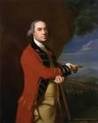British General Thomas Gage [age 57].

By April 1775, Gage was facing the threat of outright rebellion. He hoped to prevent violence by ordering the seizure of weapons and powder being stored in Concord, Massachusetts, twenty miles northwest of Boston. But he underestimated the courage and determination of the colonists. Patriot spies got wind of Gage’s plan. On the evening of April 18, Paul Revere and other riders raised the alarm that British regulars were on their way to Concord. Minute Men and militias rushed to confront them early on April 19. Though it is uncertain who actually fired the first shot that day, it reverberated throughout history. Eight years of war followed, and those who stood their ground against Gage’s troops eventually earned independence from Britain and became citizens of the democratic United States of America.
Forces Engaged:
- American: 3,960
- British: 1,500
Estimated Casualties:
- American: 93
- British: 300
https://www.battlefields.org/learn/revolutionary-war/battles/lexington-and-concord

“Blows would decide, as the king had predicted. Yet no one could forecast that the American War of Independence would last 3,059 days. Or that the struggle would be marked by more than 1,300 actions, mostly small and bloody, plus 241 naval engagements in a theater initially bounded by the Atlantic seaboard, the St. Lawrence and Mississippi Rivers, and the Gulf of Mexico, before expanding to other lands and other waters. Roughly a quarter million Americans would serve the cause in some military capacity. At least one in ten of them would die for that cause – 25,674 deaths by one tally, as many as 35,800 by another. Those deaths were divided with rough parity among battle, disease, and British prisons, a larger portion of the American population to perish in any conflict other than the Civil War.” The British Are Coming, by Rick Atkinson (2009) – Prologue, pages 25-26.

April 19, 1775: Prince Eastbrook – Slave – Shot In Shoulder By British Troops
American Revolution – Slaves
“Prince Estabrook was an enslaved man who stood with his white neighbors against the British Army on April 19, 1775… Though Provincial law prohibited “Indians and Negroes” from training as soldiers in the militia, they were still required to “turn out” armed during an emergency. During wartime the enlistment of black men was more common though still controversial. In 1775 Prince was a member of the Lexington militia, and mustered with that militia under the command of Colonel John Parker during the early morning hours of April 19. When the advance column of British troops decided to confront the militia gathered on Lexington Green, Prince was among the militiamen who had reassembled there. During the ensuing shooting, before the British officers regained control of their troops, Prince Estabrook was struck by a musket ball in his left shoulder. A document entitled ‘Appendix - Soldiers of Color on April 19, 1775’ states that a 35-year-old black slave from Lexington named Prince Estabrook serving in Colonel Parker’s militia was actively engaged in fighting and was wounded that day. A separate document titled ‘LIST of the Names of the PROVINCIALS who were Killed and Wounded in the late Engagement with His Majesty’s Troops at Concord, &c.’, under a heading listed as ‘Wounded Of Lexington’, the name ‘Prince Easterbrooks (a Negro Man)’ appears. Prince recovered from that wound and, over the course of the next eight years, he served several tours with the militia and with the Continental Army:
With Captain Parker’s company in Cambridge (1775)
With Colonel Jonathan Reed’s regiment at Fort Ticonderoga (1775 - 1776)
With Colonel Eleazer Brook’s regiment at Cambridge (1776 - 1777)
Part of a group of men raised to reinforce the Continental Army (1780 - 1781)
With Colonel John Greaton’s regiment (1782)
With Colonel Michael Jackson’s regiment (1783)
Following the dissolution of the Continental Army, Prince returned to Lexington. At that point he had earned his freedom.” https://www.nps.gov/people/prince-estabrook-of-lexington.htm

“Can Ken Burns Win the American Revolution? Burns’s 12-hour documentary about our national origin story…. The film notes that while roughly 5,000 Black people, free and enslaved, fought on the patriot side, an estimated 15,000 fought for the British, who promised them freedom (a promise that was largely betrayed).” https://www.nytimes.com/2025/10/23/arts/television/ken-burns-american-revolution.html?nl=The+Evening
Video: Ken Burns at West Point: https://www.pbs.org/video/unum-on-the-road-250west-point-fs0tds/

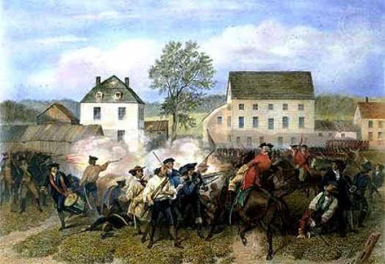Battle of Lexington, MA (4/19/1775);
https://www.landofthebrave.info/revolutionary-war-timeline.htm

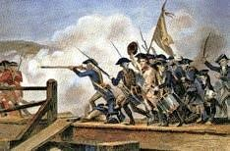
https://www.landofthebrave.info/revolutionary-war-timeline.htm

May 10, 1775 – Fort Ticonderoga Captured
“The capture of Fort Ticonderoga was the first offensive victory for American forces in the Revolutionary War. It secured the strategic passageway north to Canada and netted the patriots an important cache of artillery…. American victory. Ethan Allen and his Green Mountain Boys, together with Benedict Arnold, surprised and overtook a small British garrison at the fort, acquiring valuable weapons for the Continental Army. Arnold took command of Ticonderoga until he was relieved in June 1775…. Located at the confluence of Lake Champlain and Lake George, Fort Ticonderoga controlled access north and south between Albany and Montreal…. During the American War for Independence, several engagements were fought at the five-pointed star-shaped Fort Ticonderoga. The most famous of these occurred on May 10, 1775, when Ethan Allen and his band of Green Mountain Boys, accompanied by Benedict Arnold, who held a commission from Massachusetts, silently rowed across Lake Champlain from present-day Vermont and stormed the fort in a swift, late-night sneak attack. Months later, George Washington, commander of the Continental Army, sent one of his officers, Colonel Henry Knox, to gather the artillery left at Ticonderoga and bring it to Boston. Knox organized the transfer of the heavy guns over frozen rivers and the snow-covered Berkshire Mountains of western Massachusetts. Mounted on Dorchester Heights, the guns from Ticonderoga compelled the British to evacuate the city of Boston in March of 1776.” https://www.battlefields.org/learn/revolutionary-war/battles/fort-ticonderoga-1775
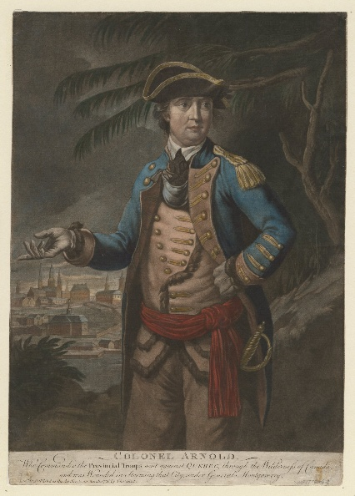Benedict Arnold

May 10, 1775: Second Continental Congress in Philadelphia – established the Continental Army
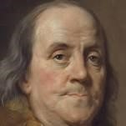Benjamin Franklin [age 69] returns from London
“Franklin returned [from London] to Philadelphia in May 1775, shortly after the
Revolutionary War (1775-83) had begun, and was selected to serve as a delegate to the Second Continental Congress, America’s governing body at the time. In 1776, he was part of the five-member committee that helped draft the Declaration of Independence, in which the 13 American colonies declared their freedom from British rule. That same year, Congress sent Franklin to France to enlist that nation’s help with the Revolutionary War. In February 1778, the French signed a military alliance with America and went on to provide soldiers, supplies and money that proved critical to America’s victory in the war.” https://www.history.com/topics/american-revolution/benjamin-franklin

“When the Second Continental Congress convened in Philadelphia, delegates–including new additions Benjamin Franklin and Thomas Jefferson–voted to form a Continental Army, with Washington as its commander in chief. On June 17, in the Revolution’s first major battle, colonial forces inflicted heavy casualties on the British regiment of General William Howe at Breed’s Hill in Boston. The engagement (known as the Battle of Bunker Hill) ended in British victory, but lent encouragement to the revolutionary cause. Throughout that fall and winter, Washington’s forces struggled to keep the British contained in Boston, but artillery captured at Fort Ticonderoga in New York helped shift the balance of that struggle in late winter. The British evacuated the city in March 1776, with Howe and his men retreating to Canada to prepare a major invasion of New York. https://www.history.com/topics/american-revolution/american-revolution-history

May 10, 1775: Ethan Allen and his Green Mountain Boys surprised British garrison at Fort Ticonderoga, NY – British surrendered. Ethan Allen [age 37] Benedict Arnold [age 34] – turned “Traitor” in 1780 [age 39], defected to British Army.
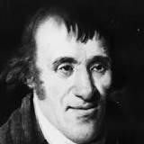
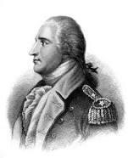
“By the end of 1779, Arnold had begun secret negotiations with the British to surrender the American fort at West Point, New York, in return for money and a command in the British army. Arnold’s chief intermediary was British Major John André (1750-80). André was captured in September 1780, while crossing between British and American lines, disguised in civilian clothes. Papers found on André incriminated Arnold in treason. Learning of André’s capture, Arnold fled to British lines before the Patriots could arrest him. West Point remained in American hands, and Arnold only received a portion of his promised bounty. André was hanged as a spy in October 1780.
***
After fleeing to the enemy side, Arnold received a commission with the British army and served in several minor engagements against the Americans. After the war, which ended in victory for the Americans with the Treaty of Paris in 1783, Arnold resided in England. He died in London on June 14, 1801, at age 60. The British regarded him with ambivalence, while his former countrymen despised him. Following his death, Arnold’s memory lived on in the land of his birth, where his name became synonymous with the word “traitor.” “ https://www.history.com/topics/american-revolution/benedict-arnold

June 16,1775: Colonel George Washington [age 43] accepts post of Commander In Chief of Continental Army

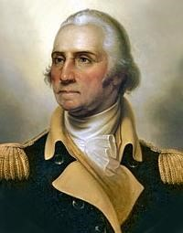
https://www.landofthebrave.info/revolutionary-war-timeline.htm

June 17, 1775: Battle of Bunker Hill, MA
“On June 17, 1775, early in the Revolutionary War (1775-83), the British defeated the Americans at the Battle of Bunker Hill in Massachusetts. Despite their loss, the inexperienced colonial forces inflicted significant casualties against the enemy, and the battle provided them with an important confidence boost. Although commonly referred to as the Battle of Bunker Hill, most of the fighting occurred on nearby Breed’s Hill.
https://www.history.com/topics/american-revolution/battle-of-bunker-hill

“It took more than a month for the letter to reach John Adams in Philadelphia, but on June 18, 1775, Abigail Adams wrote the following words about events unfolding in Charlestown, just north of Boston: “The Battle began upon our entrenchments upon Bunker Hill, a Saturday morning about 3 o’clock, and has not ceased yet and ’tis now 3 o’clock Sabbath afternoon. … How many have fallen we know not. The constant roar of the cannon is so distressing that we cannot Eat, Drink or Sleep.”
Abigail Adams had taken her eldest son, John Quincy, just shy of his eighth birthday, to view the distant battle from the top of Penn’s Hill near the family farm in Braintree (now Quincy). They had witnessed from afar the Pyrrhic British victory, achieved at the cost of more than 1,000 casualties, nearly half the British attack force. Back in London, one retired British officer would observe that with a few more victories like Bunker Hill, the British army would be annihilated.

Nor did Abigail Adams learn until later that Joseph Warren, the Adamses’ family physician and prominent leader of the colonial resistance group the Sons of Liberty, had been killed when the third wave of the British assault overran his redoubt; he was shot between the eyes after the American troops had run out of ammunition. ‘Our dear Friend Dr. Warren is no more,’ she wrote, ‘but fell gloriously fighting for his Country — saying better to die honorably in the field than ignominiously hang upon the Gallows.’”
https://www.washingtonpost.com/opinions/interactive/2025/bunker-hill-revolutionary-war/?utm_campaign=wp_post_most&utm_medium=email&utm_source=newsletter&carta-url=https%3A%2F%2Fs2.washingtonpost.com%2Fcar-ln-tr%2F432491c%2F68519494337c6a26b4be2374%2F59731235ade4e21a848a56ed%2F49%2F65%2F68519494337c6a26b4be2374

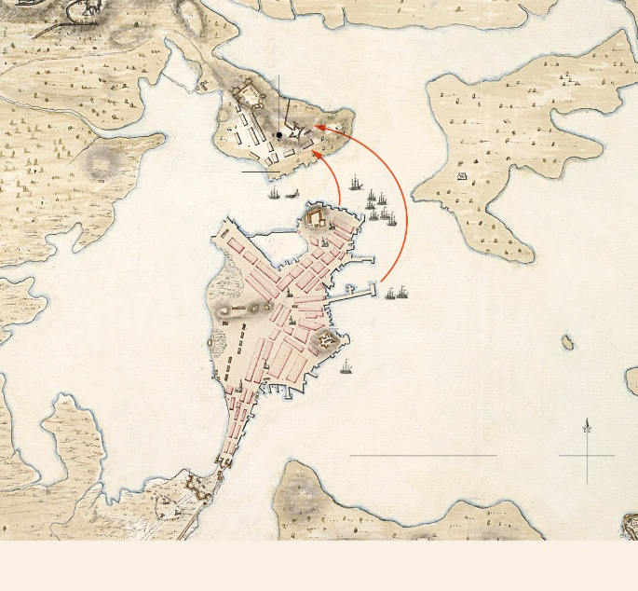

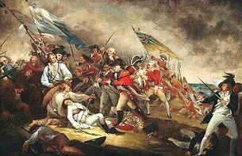 Death of General Warren at the Battle of Bunker Hill: https://www.landofthebrave.info/revolutionary-war-timeline.htm

August, 1775: King George III [age 37] issued proclamation that colonists were engaged in “rebellion” – British parliament passed American Prohibitory Act – American vessels / cargo can be seized

Aug. 21, 1775: George Washington – Enslaved Servant Will Lea
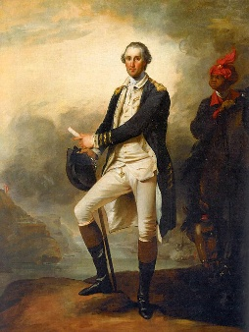
“From the time of his arrival on Boston’s outskirts, Washington would thereafter be constantly in the field or in camp with his troops, accompanied by his enslaved servant William Lee, who was also an excellent horseman. Washington regarded a disciplined and well-trained officer corps as crucial to victory. He also believed in the importance of winning by conventional warfare as necessary to demonstrate the civility of the new nation and earn the respect of Europe.” https://www.washingtonpost.com/opinions/interactive/2025/george-washington-revolutionary-war-commander/?utm_campaign=wp_week_in_ideas&utm_medium=email&utm_source=newsletter
***
William (Billy) Lee: https://www.washingtonpost.com/opinions/interactive/2025/george-washington-revolutionary-war-commander/?utm_campaign=wp_week_in_ideas&utm_medium=email&utm_source=newsletter
“William Lee arrived at Mount Vernon in 1768, after George Washington purchased him from Mary Lee, a wealthy Virginia widow, for £61.15s. Washington also bought William’s younger brother Frank, who went on to serve as a waiter and butler in the household. Both William and Frank were described as “mulatto,” or mixed race, meaning they were probably the sons of an enslaved mother and a white father. The name “Billy Lee” appears frequently in popular histories and is well known, Washington only referred to his valet by that diminutive until about 1771. *** Spending more than seven years in close proximity during the intensity of war seems to have made Washington and Lee’s relationship especially close. The former’s views on slavery shifted significantly during the war, and he emerged with a newfound abhorrence of slavery and a commitment to neither buy nor sell enslaved people and to avoid separating enslaved families. Many factors likely influenced Washington’s evolution, but his close relationship with William Lee may have helped him understand more fully the humanity of those he enslaved.”

Sept. 14, 1775: Address to the Inhabitants of Canada, 14 September 1775
Read letter signed by George Washington. “Generals of approved Experience, who boasted of subduing this great Continent, find themselves circumscribed within the Limits of a single City and its Suburbs, suffering all the Shame and Distress of a Siege. While the trueborn Sons of America, animated by the genuine Principles of Liberty and Love of their Country, with increasing Union, Firmness and Discipline repel every Attack, and despise every Danger. ** I have detached Colonel Arnold into your Country, with a Part of the Army under my Command—I have enjoined upon him, and I am certain that he will consider himself, and act as in the Country of his Patrons, and best Friends.” https://founders.archives.gov/documents/Washington/03-01-02-0358

Nov. 20, 1775 – British Artillery Recovered From Captured Fort Ticonderoga

“Henry Knox, a 25-year-old bookseller turned Continental Army colonel, departed from Boston on one of the most daring logistical missions of the American Revolution. His task was a near-impossible feat: travel to American-held Fort Ticonderoga, retrieve its captured British artillery, and haul the guns nearly 300 miles back to the American siege lines around Boston. Over the next two months, Knox and his men would engineer one of the great early triumphs of the war. Battling snow, ice, freezing rivers, and rugged wilderness, they successfully transported 59 pieces of heavy artillery—mortars, howitzers, and massive cannons—on sleds drawn by teams of oxen. Gen. George Washington called the achievement “a prodigious undertaking,” and it proved decisive. When the guns arrived in Boston in early 1776, they were emplaced on the heights surrounding the city, forcing the British to evacuate Boston in March. Knox’s successful journey was a testament to the ingenuity, endurance, and resolve of the fledgling Continental Army in the early stages of their fight for independence.”

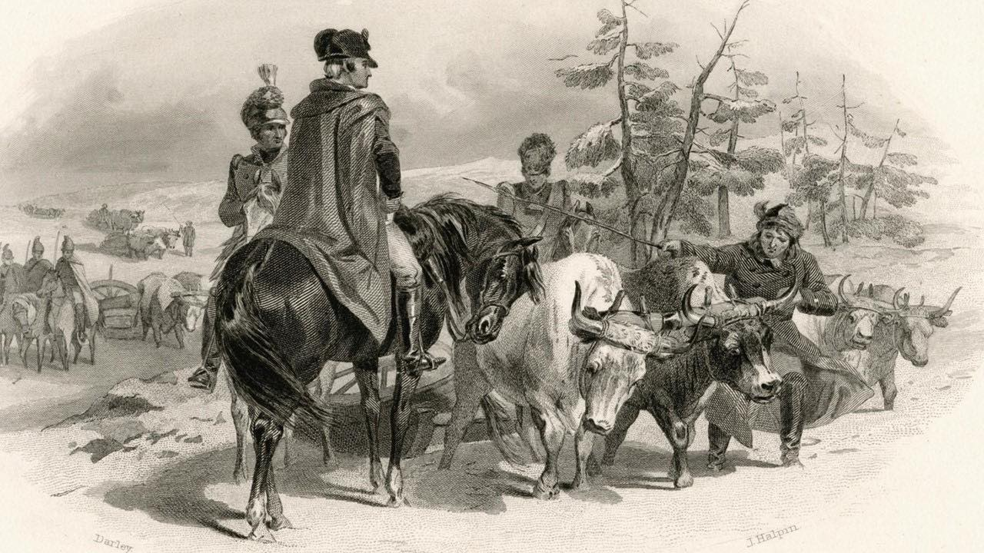

“Influenced by Boston's protests and revolution fever, Knox joined a local militia group called the Boston Grenadier Corps. In 1775, he served in the Siege of Boston. When General Washington arrived to take command in July of that year, Knox's command of artillery impressed the new commander. Though only about twenty five years old, Knox received a commission as a colonel who oversaw artillery and tasked with bringing cannons from the recently captured Fort Ticonderoga in New York state to Boston in the middle of winter. He and his men successfully brought sixty tons of cannon packed on sleds pulled by oxen over 300 miles of snow, ice covered rivers, and mountains to the Boston camps without losing a single cannon.” https://www.battlefields.org/learn/biographies/henry-knox

Dec. 31, 1775 - Failed Battle of Quebec
“On December 31, 1775, during the American Revolutionary War (1775-83), Patriot forces under Colonel Benedict Arnold (1741-1801) and General Richard Montgomery (1738-75) attempted to capture the British-occupied city of Quebec and with it win support for the American cause in Canada. The attack failed, and the effort cost Montgomery his life. The Battle of Quebec was the first major defeat of the Revolutionary War for the Americans.
***
Of the approximately 1,200 Americans who participated in the battle, more than 400 were captured, wounded or killed. British casualties were minor.” https://www.history.com/topics/american-revolution/battle-of-quebec-1775

Jan. 1776: Thomas Payne [age 39] publishes a pamphlet, “Common Sense” – calling for independence
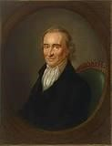Thomas Paine

March 17, 1776: British Evacuate Boston
“After the British evacuated Boston on March 17, 1776, General George Washington guessed correctly that their next target would be New York. By mid-April, Washington had marched his 19,000 soldiers to Lower Manhattan. He strengthened the batteries that guarded the harbor and constructed forts in northern Manhattan and on Brooklyn Heights across the East River on Long Island.
***
Washington waited throughout June for the British to appear, hoping that somehow his undisciplined troops could hold off an attack, which he was certain would come in Manhattan. In early July, 400 British ships with 32,000 men commanded by General
William Howe arrived at Staten Island. When Howe offered a pardon to the rebels, Washington answered, "Those who have committed no fault want no pardon." While he was still convinced that the British would attack Manhattan, he sent more troops to
Brooklyn.” https://www.mountvernon.org/library/digitalhistory/digitalencyclopedia/article/battle-of-long-island/

May 23, 1776: King George [age 38] - British hiring German mercenaries
King George arranged with German states to hire mercenaries – “Hessians” - to fight Americans.

June 12, 1776: The Virginia Declaration of Rights [format for “Bill of Rights”]
“Virginia's Declaration of Rights was drawn upon by Thomas Jefferson for the opening paragraphs of the Declaration of Independence. It was widely copied by the other colonies and became the basis of the Bill of Rights. Written by George Mason, it was adopted by the Virginia Constitutional Convention on June 12, 1776.
Section 1: Section 1. That all men are by nature equally free and independent and have certain inherent rights, of which, when they enter into a state of society, they cannot, by any compact, deprive or divest their posterity; namely, the enjoyment of life and liberty, with the means of acquiring and possessing property, and pursuing and obtaining happiness and safety.”
https://www.archives.gov/founding-docs/virginia-declaration-of-rights

6/1776: Second Continental Congress
Richard Henry Lee, from Virginia, proposed Resolution for Independence – but vote on Resolution was delayed.
Appointment of Committee of 5 to prepare Declaration of Independence:

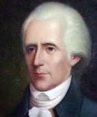
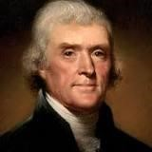
Richard Henry Lee – Virginia [age 44]
Thomas Jefferson – Virginia [age33] - principal draftsman

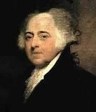
John Adams [age 41]

Benjamin Franklin [age 70] Note: During the beginning of the Revolutionary War (1775), Benjamin Franklin’s son, William, was the Royal Governor of New Jersey, and supported the “Loyalists” who fought against General George Washington’s Continental Army at Battle of Springfield, NJ (6/23/1780).
“In June of 1776, rebels in New Jersey exiled Gov. William Franklin to Connecticut, where Gov. Jonathan Trumbull sided with the patriots. The patriots placed him under guard at Wallingford and then Middletown. However, the stubborn governor-in-exile refused to submit to his captors. He continued gathering intelligence for loyalists and helping protect Connecticut Tories’ property by issuing them royal pardons. In May of 1777, armed guards took William Franklin to Litchfield. They placed him in solitary confinement in the cell reserved for prisoners condemned to death. His filthy room contained a straw mat on the floor and nothing else – no bed, no seat, no toilet facility.” https://www.newenglandhistoricalsociety.com/william-franklin-bens-son-spentrevolutionary-war-connecticut-jail/

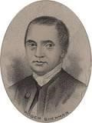 Roger Sherman [age 55]

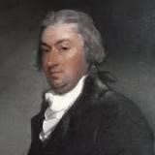 Robert Livingston [age 30]

July 4, 1776: Declaration of Independence - Benjamin Franklin – famous quote
Declaration of Independence fashioned after 1215 Magna Carta:
“Magna Carta Libertatum, or the Great Charter of Freedoms, has been described by scholars as one of the most important documents in the Western world. First penned for King John of England during an open revolt by his barons in 1215 — and offered as a kind of peace treaty — the charter famously declares that even the king must follow the rules. *** After it was first issued in 1215 by King John, the Great Charter was reissued in 1216, 1217 and 1225 by his son, King Henry III, and then reissued again by Henry’s son, Edward I, in 1297 and 1300.” https://www.washingtonpost.com/world/2025/05/15/magna-carta-harvard-great-charter/?utm_campaign=wp_todays_headlines&utm_medium=email&utm_source=newsletter&carta-url=https%3A%2F%2Fs2.washingtonpost.com%2Fcar-ln-tr%2F4291f51%2F6825bb2be4755d707b27b1eb%2F59731235ade4e21a848a56ed%2F26%2F62%2F6825bb2be4755d707b27b1eb

Benjamin Franklin supposedly gave this quote after signing the Declaration of Independence: “We must all hang together, or most assuredly we shall all hang separately.”

Presentation of the finished Declaration of Independence by Thomas Jefferson in Philadelphia, July 4, 1776. The Declaration was then signed and copies of the text were transported to key cities such as New York and Boston to be read aloud.” http://www.historyplace.com/unitedstates/revolution/decindep.htm

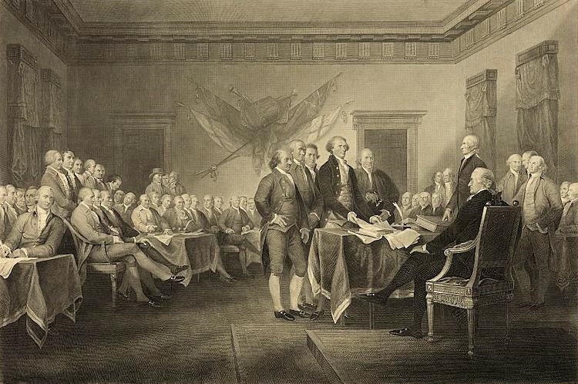
In Congress, July 4, 1776.
The unanimous Declaration of the thirteen united States of America, When in the Course of human events, it becomes necessary for one people to dissolve the political bands which have connected them with another, and to assume among the powers of the earth, the separate and equal station to which the Laws of Nature and of Nature's God entitle them, a decent respect to the opinions of mankind requires that they should declare the causes which impel them to the separation.
We hold these truths to be self-evident, that all men are created equal, that they are endowed by their Creator with certain unalienable Rights, that among these are Life, Liberty and the pursuit of Happiness.--That to secure these rights, Governments are instituted among Men, deriving their just powers from the consent of the governed, -That whenever any Form of Government becomes destructive of these ends, it is the Right of the People to alter or to abolish it, and to institute new Government, laying its foundation on such principles and organizing its powers in such form, as to them shall seem most likely to effect their Safety and Happiness. Prudence, indeed, will dictate that Governments long established should not be changed for light and transient causes; and accordingly all experience hath shewn, that mankind are more disposed to suffer, while evils are sufferable, than to right themselves by abolishing the forms to which they are accustomed. But when a long train of abuses and usurpations, pursuing invariably the same Object evinces a design to reduce them under absolute Despotism, it is their right, it is their duty, to throw off such Government, and to provide new Guards for their future security.--Such has been the patient sufferance of these Colonies; and such is now the necessity which constrains them to alter their former Systems of Government. The history of the present King of Great Britain is a history of repeated injuries and usurpations, all having in direct object the establishment of an absolute Tyranny over these States. To prove this, let Facts be submitted to a candid world.
He has refused his Assent to Laws, the most wholesome and necessary for the public good.
He has forbidden his Governors to pass Laws of immediate and pressing importance, unless suspended in their operation till his Assent should be obtained; and when so suspended, he has utterly neglected to attend to them.
He has refused to pass other Laws for the accommodation of large districts of people, unless those people would relinquish the right of Representation in the Legislature, a right inestimable to them and formidable to tyrants only.
He has called together legislative bodies at places unusual, uncomfortable, and distant from the depository of their public Records, for the sole purpose of fatiguing them into compliance with his measures.
He has dissolved Representative Houses repeatedly, for opposing with manly firmness his invasions on the rights of the people.
He has refused for a long time, after such dissolutions, to cause others to be elected; whereby the Legislative powers, incapable of Annihilation, have returned to the People at large for their exercise; the State remaining in the mean time exposed to all the dangers of invasion from without, and convulsions within.
He has endeavored to prevent the population of these States; for that purpose obstructing the Laws for Naturalization of Foreigners; refusing to pass others to encourage their migrations hither, and raising the conditions of new Appropriations of Lands.
He has obstructed the Administration of Justice, by refusing his Assent to Laws for establishing Judiciary powers.
He has made Judges dependent on his Will alone, for the tenure of their offices, and the amount and payment of their salaries.
He has erected a multitude of New Offices, and sent hither swarms of Officers to harass our people, and eat out their substance.
He has kept among us, in times of peace, Standing Armies without the Consent of our legislatures.
He has affected to render the Military independent of and superior to the Civil power.
He has combined with others to subject us to a jurisdiction foreign to our constitution, and unacknowledged by our laws; giving his Assent to their Acts of pretended Legislation:
For Quartering large bodies of armed troops among us:
For protecting them, by a mock Trial, from punishment for any Murders which they should commit on the Inhabitants of these States:
For cutting off our Trade with all parts of the world:
For imposing Taxes on us without our Consent:
For depriving us in many cases, of the benefits of Trial by Jury:
For transporting us beyond Seas to be tried for pretended offences
For abolishing the free System of English Laws in a neighboring Province, establishing therein an Arbitrary government, and enlarging its Boundaries so as to render it at once an example and fit instrument for introducing the same absolute rule into these Colonies:
For taking away our Charters, abolishing our most valuable Laws, and altering fundamentally the Forms of our Governments:
For suspending our own Legislatures, and declaring themselves invested with power to legislate for us in all cases whatsoever.
He has abdicated Government here, by declaring us out of his Protection and waging War against us.
He has plundered our seas, ravaged our Coasts, burnt our towns, and destroyed the lives of our people.
He is at this time transporting large Armies of foreign Mercenaries to complete the works of death, desolation and tyranny, already begun with circumstances of Cruelty & perfidy scarcely paralleled in the most barbarous ages, and totally unworthy the Head of a civilized nation.
He has constrained our fellow Citizens taken Captive on the high Seas to bear Arms against their Country, to become the executioners of their friends and Brethren, or to fall themselves by their Hands.
He has excited domestic insurrections amongst us, and has endeavored to bring on the inhabitants of our frontiers, the merciless Indian Savages, whose known rule of warfare, is an undistinguished destruction of all ages, sexes and conditions.
In every stage of these Oppressions We have Petitioned for Redress in the most humble terms: Our repeated Petitions have been answered only by repeated injury. A Prince whose character is thus marked by every act which may define a Tyrant, is unfit to be the ruler of a free people.
Nor have We been wanting in attentions to our British brethren. We have warned them from time to time of attempts by their legislature to extend an unwarrantable jurisdiction over us. We have reminded them of the circumstances of our emigration and settlement here. We have appealed to their native justice and magnanimity, and we have conjured them by the ties of our common kindred to disavow these usurpations, which, would inevitably interrupt our connections and correspondence. They too have been deaf to the voice of justice and of consanguinity. We must, therefore, acquiesce in the necessity, which denounces our Separation, and hold them, as we hold the rest of mankind, Enemies in War, in Peace Friends.
We, therefore, the Representatives of the united States of America, in General Congress, Assembled, appealing to the Supreme Judge of the world for the rectitude of our intentions, do, in the Name, and by Authority of the good People of these Colonies, solemnly publish and declare, That these United Colonies are, and of Right ought to be Free and Independent States; that they are Absolved from all Allegiance to the British Crown, and that all political connection between them and the State of Great Britain, is and ought to be totally dissolved; and that as Free and Independent States, they have full Power to levy War, conclude Peace, contract Alliances, establish Commerce, and to do all other Acts and Things which Independent States may of right do. And for the support of this Declaration, with a firm reliance on the protection of divine Providence, we mutually pledge to each other our Lives, our Fortunes and our sacred Honor.”
https://www.archives.gov/founding-docs/declaration-transcript [spelling corrected to modern English]

July 21, 1776: 12 Colonies voted for Independence; New York did not cast vote until NY Convention approved on July 9.

July 27, 1776: Benjamin Franklin Appointed Postmaster General
“Back on American soil [from England] in 1775, Franklin was part of the Second Continental Congress and served on many committees, including one to establish an independent postal system. On July 26, 1775, the Congress appointed Benjamin Franklin the first Postmaster General of the organization now known as the United States Postal Service. Franklin received an annual salary of $1,000 plus $340 for a secretary and comptroller. He was responsible for all Post Offices -- from Massachusetts to Georgia -- and had authority to hire as many postmasters as he saw fit.” https://about.usps.com/whowe-are/postal-history/pmg-franklin.pdf

Aug. 27, 1776: Battle of Long Island, NY
General Washington lost the battle and was almost killed. See videotaped interview of Joe Ellis, author of Revolutionary Summer. https://www.mountvernon.org/library/digitalhistory/digitalencyclopedia/article/battle-of-long-island/
“After the British evacuated Boston on March 17, 1776, General George Washington guessed correctly that their next target would be New York. By mid-April, Washington had marched his 19,000 soldiers to Lower Manhattan. He strengthened the batteries that guarded the harbor and constructed forts in northern Manhattan and on Brooklyn Heights across the East River on Long Island.
***
General Howe halted the fighting by the early afternoon and directed his men to dig trenches around the American position on the next day. Before they could be surrounded, Washington ordered his men to evacuate Long Island. From late in the evening of August 29 to dawn on the following morning, Washington watched as 9,000 Continentals were rowed back to Manhattan. As the sun came up, a fog miraculously descended on the remaining men crossing the river. According to eyewitnesses, George Washington was the last man to leave Brooklyn.”
https://www.mountvernon.org/library/digitalhistory/digital-encyclopedia/article/battle-oflong-island/

Aug. 29-30, 1776: George Washington – Brooklyn Heights,
Washington’s Ten Best Military Decisions (10/28/2025) https://allthingsliberty.com/2025/10/washingtons-ten-best-military-decisions/

“The evacuation of Washington’s army from Brooklyn Heights to Manhattan on the night of August 29-30, 1776. Done in small craft on difficult water without detection by a larger and more powerful enemy army and fleet, this represents one of the most skillful withdrawals in military history. By the time he called a council of war on the afternoon of August 29 to discuss whether to withdraw from Brooklyn, Washington had already begun to collect the boats, and he ordered the evacuation to begin immediately. The crossing began to unfold that evening. At that point, British officer Charles Stedman recalled, the American army ‘had been driven to the corner of an island, where they were hemmed in within the narrow space of two square miles’ and ‘lay almost entirely at the will of the English.’ While not undoing Washington’s litany of errors in connection with the Battle of Long Island two days before, this operation saved fully one-half of his army—9,500 men, their horses, and most of their equipment. Washington, who salvaged all but five of his cannon, left with the last of the troops. This action has been described by one historian as flawless and one of the greatest moments in the annals of warfare, given its impact. To another, it stands as one of the most brilliant tactical withdrawals in military history. And Lt. Benjamin Tallmadge, who did not ‘recollect a more fortunate retreat’ in ‘the history of warfare,’ opined that ‘Gen. Washington has never received the credit which was due to him for this wise and most fortunate measure.”’”

Sept. 16, 1776: Battle of Harlem Heights, NY
“The British understood Washington's strategy, and retreated as a result. Casualties were high with 150 men lost on both sides including Lieutenant Knowlton who was mortally wounded. With the skirmish concluded, Washington completed his letter to Congress. While he was disappointed that his men failed to execute his orders, he had actually won his first battlefield victory in the war. His soldiers were equally elated that they had forced the British to flee before them.”
https://www.mountvernon.org/library/digitalhistory/digital-encyclopedia/article/battle-ofharlem-heights/

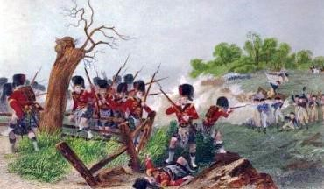
https://www.landofthebrave.info/revolutionary-war-timeline.htm

Dec. 25, 1776: George Washington – Incident Command

Christmas Day he crossed Delaware River: victory at Trenton [Age 44]
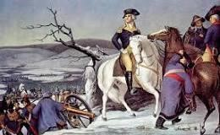
“General George Washington’s army crossed the icy Delaware on Christmas Day 1776 and, over the course of the next 10 days, won two crucial battles of the American Revolution. In the Battle of Trenton (December 26), Washington defeated a formidable garrison of Hessian mercenaries before withdrawing. A week later he returned to Trenton to lure British forces south, then executed a daring night march to capture Princeton on January 3. “https://www.history.com/topics/american-revolution/battles-of-trenton-andprinceton

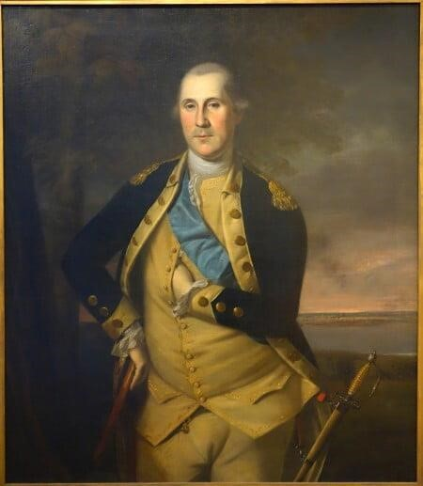 Portrait of George Washington (1776) by Charles Willson Peale: https://www.mountvernon.org/george-washington/artwork/life-portraits-of-georgewashington/

Jan. 13, 1777: Battle of Princeton (NJ)
“After crossing the Delaware on December 25, 1776, George Washington embarked on a ten day campaign that would change the course of the war. Culminating at the Battle of Princeton on January 3, 1777, Washington snatched victory from the jaws of defeat and proved his amateur army could defeat the British. ***
The Battle of Princeton was a classic meeting engagement, both sides stumbled into one another, and neither expected to fight on the ground where the battle raged. Initially, the British commander Charles Mawhood, marched his force south towards Trenton to meet the main British army, when he spotted the American column. Washington had stolen a march on Charles Lord Cornwallis, slipping away from the British forces along Assunpink Creek the night before.
When the American's spotted British troopers around William Clarke's farm, Washington detached Hugh Mercer's brigade to investigate. Mercer ran headlong into the 17th Foot, firmly stationed behind a fence at the end of Clarke's orchard. In the ensuing volleys, Mercer was wounded and his men routed by a bayonet charge. With the outnumbered
British on the verge of splitting his army, Washington quickly detached John Cadwalader's Philadelphia Associatiors to plug the gap. These green troops fought valiantly, but were also broken by British bayonets.
With the battle, and the war, hanging in the balance, Washington personally led fresh troops onto the field while grapeshot and canister from Joseph Moulder's artillery battery forced the British back towards William Clarke's farmhouse. Washington's counterattack broke the British line, which quickly turned into a rout.” https://www.battlefields.org/learn/revolutionary-war/battles/princeton

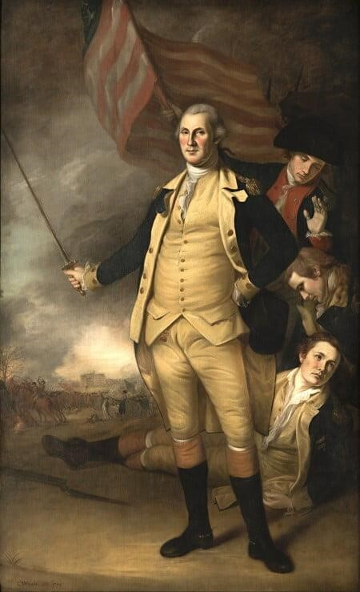 Portrait of George Washington after Battle of Princeton – by Charles Willson Peale https://www.mountvernon.org/george-washington/artwork/life-portraits-ofgeorge-washington/

June 13, 1777: Marquis de Lafayette [age 19] arrives from France
“He landed near Charleston, South Carolina, June 13, 1777, then travelled to
Philadelphia, where he was commissioned a Major General on July 31. This reflected his wealth and noble social station, rather than years of battlefield experience — he was only 19 years old. The newly commissioned young general was soon introduced to his commander-in-chief, General George Washington, who would become a lifelong friend. Lafayette was wounded during the September 11, 1777 Battle of the Brandywine. In December, 1777, he camped with Washington and the army at Valley Forge.
http://www.ushistory.org/valleyforge/served/lafayette.html

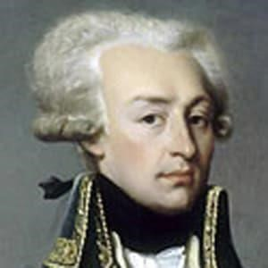 Marquis de Lafayette
.
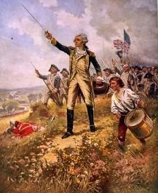
Lafayette's baptism of fire

Aug. 27, 1777 - Philadelphia
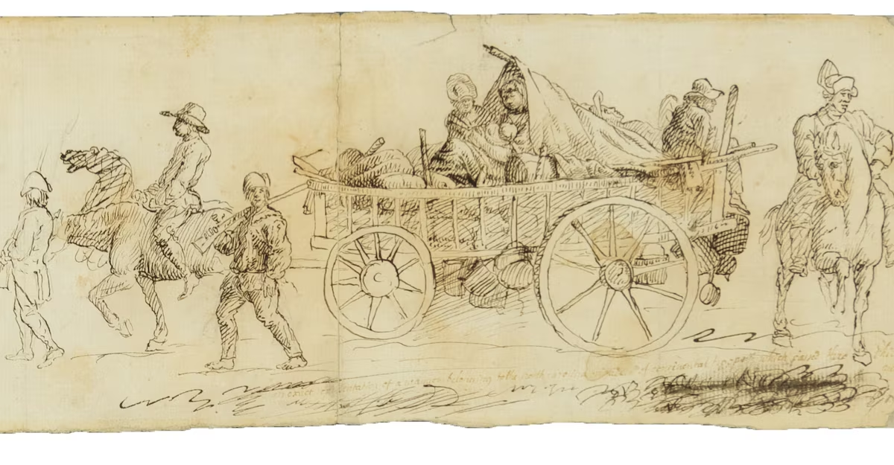Aug. 27, 1777, issue of the Pennsylvania Gazette. The newspaper included an account of “General Nash’s brigade of North-Carolina forces” marching through the city to join General Washington’s Continental Army just before the Battle of Brandywine. The illustration, measuring 15 by 5 inches, shows six men — two on horseback, two on foot and two riding in a wagon laden with supplies — along with two women and a baby in the wagon.
https://www.washingtonpost.com/history/2024/04/14/revolutionary-war-sketch-simitiere-museum/?utm_campaign=wp_evening_edition&utm_medium=email&utm_source=newsletter&carta-url=https%3A%2F%2Fs2.washingtonpost.com%2Fcar-ln-tr%2F3d656bd%2F661c43e5ab122c4fece814c3%2F59731235ade4e21a848a56ed%2F26%2F43%2F661c43e5ab122c4fece814c3

Sept. 11, 1777: Battle of Brandywine, PA
“On September 11, 1777, General Sir William Howe and General Charles Cornwallis launch a full-scale British attack on General George Washington and the Patriot outpost at Brandywine Creek near Chadds Ford, in Delaware County, Pennsylvania, on the road linking Baltimore and Philadelphia.
***
Surprised and outnumbered by the 18,000 British troops to his 11,000 Continentals,
Washington ordered his men to abandon their posts and retreat. Defeated, the Continental Army marched north and camped at Germantown, Pennsylvania. The British abandoned their pursuit of the Continentals and instead began the British occupation of Philadelphia.
***
The one-day battle at Brandywine cost the Americans more than 1,100 men killed or captured while the British lost approximately 600 men killed or injured. To make matters worse, the Patriots were also forced to abandon most of their cannon to the British victors after their artillery horses fell in battle.
***
Congress, which had been meeting in Philadelphia, fled first to Lancaster, then to York, Pennsylvania, and the British took control of the city without Patriot opposition.” https://www.history.com/this-day-in-history/the-battle-of-brandywine-begins

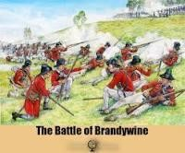

Sept. 19,1777: Battles of Saratoga, NY - British General John Burgoyne surrender on Oct. 17
“Fought eighteen days apart in the fall of 1777, the two Battles of Saratoga were a turning point in the American Revolution. On September 19th, British General John Burgoyne achieved a small, but costly victory over American forces led by Horatio Gates and Benedict Arnold. Though his troop strength had been weakened, Burgoyne again attacked the Americans at Bemis Heights on October 7th, but this time was defeated and forced to retreat. He surrendered ten days later, and the American victory convinced the
French government to formally recognize the colonist’s cause and enter the war as their ally.” https://www.history.com/topics/american-revolution/battle-of-saratoga

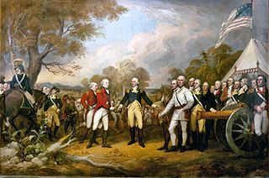
https://www.landofthebrave.info/revolutionary-war-timeline.htm

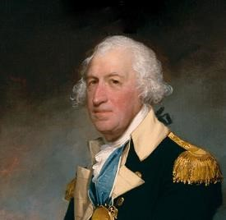Horatio Gates [age 50]

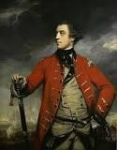General John Burgoyne [age 55]

Dec. 19, 1777: Valley Forge, PA - General George Washington [age 45]

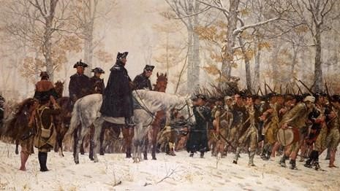
“On December 19, 1777, 11,000 Continental Army regulars marched into Valley Forge, Pennsylvania, to set up winter quarters during the Revolutionary War. By December 1777, Washington was well aware that some members of the Continental Congress were questioning his leadership abilities. The Valley Forge site—located along trade routes and near farm supplies—was an attempt to balance Congress’ demands for a winter campaign against Philadelphia with the needs of his troops. It was common for armies at the time to withdraw to fixed camps during the winter, as the harsh weather made transportation of troops, arms and supplies extremely difficult. The soldiers who marched to Valley Forge on December 19, 1777 were not downtrodden or desperate. Though they had been defeated in two key battles, and had lost Philadelphia to the British, Continental troops had often put themselves on the offensive, and proved themselves as skilled fighters against professional soldiers with superior numbers. They were certainly tired, and lacking in supplies, but these were not unusual circumstances in the life of a Continental soldier. Once the troops arrived at their winter camp site, military engineers directed the construction of some 2,000 huts laid out in parallel lines, forming a kind of city, along with miles of trenches, five earthen redoubts and a bridge over the Schuylkill River. Raw winter weather made things difficult for the tired troops, while a mismanaged commissary and Congress’ failure to provide the army with sufficient funds for fresh supplies led to widespread hunger and lack of clothing, shoes and other supplies among the men. Yet cold and starvation were not the most dangerous threats to soldiers at Valley Forge: Diseases like influenza, dysentery, typhoid and typhus killed two-thirds of the nearly 2,000 soldiers who died during the encampment. https://www.history.com/news/235-years-ago-washingtons-troops-made-camp-at-valleyforge

Feb. 1778: Daniel Boone captured by Shawnees
8 Things You Might Not Know About Daniel Boone: https://www.history.com/articles/8-things-you-might-not-know-about-daniel-boone
“Boone was held captive by Native Americans. In February 1778, while Boone was traveling with a group of Boonesborough men along Kentucky’s Licking River, he was captured by a group of Shawnees. The Shawnees took him to their village in Ohio, where he was adopted by Chief Blackfish to take the place of one of his sons who’d been killed. Boone, who was given the name Sheltowee, or Big Turtle, was treated relatively well by his captors—he was allowed to hunt and may have had a Shawnee wife—but they kept a close eye on him.

In June 1778 he managed to escape and make his way back to Boonesborough, where he warned residents that the natives, upset because settlers had moved onto their Kentucky hunting grounds, were planning to attack. That September, over the course of nine days and nights, a group of Shawnees and other Native Americans laid siege to Boonesborough, but the outnumbered settlers managed to hold them off. A new wave of emigrants then traveled to Kentucky, some of them personally recruited and led there by Boone.”

Feb. 6, 1778: France joins war - King Louis XVI - signed treaties with Americans
King Louis XVI [age 24] sends General Comte de Rochambeau [age 53] and Admiral François Joseph Paul de Grasse [age 56].

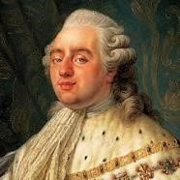
Louis XVI in French Revolution, guillotined [age 39] January 21, 1793, Place de la Concorde, Paris, France; Spouse: Marie Antoinette
Marie Antoinette [age 23] - in French Revolution, guillotined Oct. 16, 1793 [age 38], Place de la Concorde, Paris, France; Spouse: Marie Antoinette 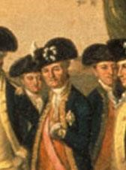
Jean-Baptiste-Donatien de Vimeur, Comte de Rochambeau [age 53]
“The Comte de Rochambeau was the commander of all French forces in America during the War for Independence. His most important contribution came during the Yorktown Campaign, in which he collaborated with George Washington to force the surrender of a major British army under Charles Cornwallis.”
http://www.ouramericanrevolution.org/index.cfm/people/view/pp0028

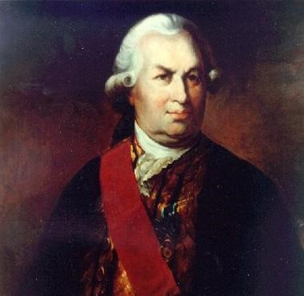 Admiral François Joseph Paul de Grasse [1781 - age 59]
“The most important strategic decision that set Gen. George Washington’s Continental Army on the path to victory in the Revolutionary War was not made by Washington, but by French Admiral François Joseph Paul de Grasse. When de Grasse was ordered to sail with his French fleet from the West Indies to America in 1781 to assist Washington and French General JeanBaptiste Donatien de Vimeur, comte de Rochambeau in the War for American Independence, the French navy commander was given a choice of specific destination. Washington was eager to attack the British stronghold in New York City. Rochambeau, who had arrived with a small army in 1780 to help the Americans, favored confronting Gen. Charles Cornwallis and his British army at Yorktown, Va. For either target, strong naval support from de Grasse’s fleet was essential. De Grasse sided with Rochambeau and chose Virginia. It was closer to his fleet’s base, and the mouth of the Chesapeake Bay was more navigable than New York harbor. His decision set in motion the course of events that would lead to America’s victory in the Revolutionary War.” https://www.battlefields.org/learn/biographies/comte-de-grasse

June 28, 1778: Battle of Monmouth (NJ)
“What began as a promising opportunity devolved into a potential disaster. As Washington approached the fighting, he encountered panic stricken troops fleeing the enemy. Enraged, he galloped ahead of his wing, In an angry confrontation on the field of battle, Washington removed Lee from command.
Rallying what troops he had, Washington continued the assault on the Britsh. The commanding general’s delaying action gave time for the rest of the Continental Army to come up and join the battle.
***
The fighting see-sawed back and forth under the brutal June sun for several hours. By 6:00 P.M., however, the British had had enough. While Wayne wanted to press the attack, Washington demurred, believing that his men were “beat out and with heat and fatigue.”
The British did not give Washington a chance to renew the fight in the morning, slipping away under the cover of darkness and resuming their withdrawal to New York City.” https://www.battlefields.org/learn/revolutionary-war/battles/monmouth
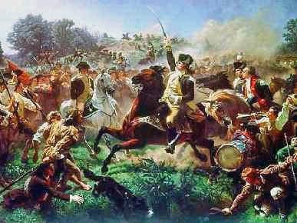
https://www.landofthebrave.info/revolutionary-war-timeline.htm

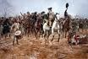

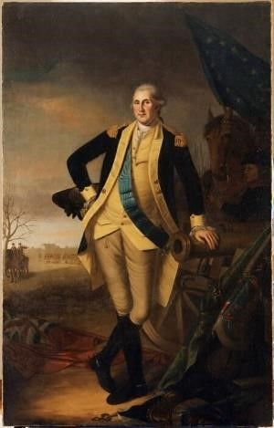Portrait of George Washington at Battle of Princeton (1779) by Charles Willson Peale: https://www.mountvernon.org/george-washington/artwork/life-portraits-ofgeorge-washington/

Aug. 28, 1778: Battle of Rhode Island
“The 1st Rhode Island, the first black regiment in America’s history, took part in the action… Located on the right (west) side of the American line, they defended their part of the hill against fierce attacks by German troops. Numbering 400 men, the 1st Rhode Island acquitted itself well, repulsing three separate and distinct charges from 1,500 Hessians under Count Donop.
***
After a siege of 12 days by the Americans dug in on Honeyman’s Hill in Middletown, a weary and disappointed Sullivan realized the land attack alone could not penetrate the English line. With extreme regret, Sullivan was obliged to order withdrawal.
On August 30, near midnight, the last of the Continentals was removed from Aquidneck. The regular troops were sent to rejoin Washington, the militia returned home, and only a small force was left to man the guns of Fort Barton. The Battle of Rhode Island was over.” https://revolutionarywar.us/year-1778/battle-rhode-island/

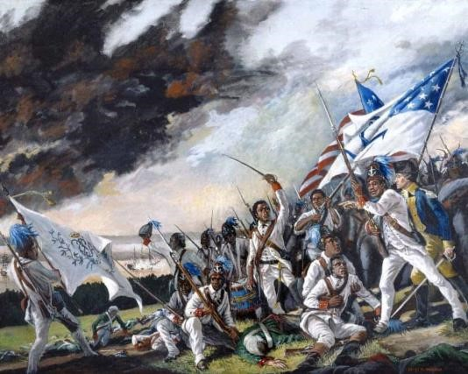
https://revolutionarywar.us/year-1778/battle-rhode-island/

1779: Col. John Bowman battle with Shawnee - Oldtown, Ohio (Xenia)
“A terrible battle was waged in 1779 to secure the land which was occupied by the Shawnee. Col. John Bowman with 264 men under his command marched against Old Chillicothe during the month of May. The troops arrived at night and were determined to wait until daylight to storm the village. Some of the soldiers took it upon themselves to scout the village before the troops could be assigned their various positions, so the Shawnee — alerted — were prepared to fight before daylight. The women and children sought shelter in one of the larger cabins while both sides continued firing. Bowman determined that it would be useless to continue the fight, but several cabins were burned to the ground after taking blankets and silver. The soldiers also rounded up a herd of horses which they took when they retreated. Old Chillicothe was attacked a total of three times before the Shawnee moved away. After the Shawnee left the area, the settlers moved into the fertile land, planting corn and other crops. When it was time to select a name for the village, in keeping with the Shawnee tradition of Old Chillicothe, the new village was named Oldtown.” https://www.xeniagazette.com/2023/07/14/oldtown-has-quite-a-history/

1779 – Sullivan Campaign
“It’s an acknowledgment that the colonists’ desire for unfettered access to Native lands was a primary cause of the break with Britain, which had forbidden any settlement west of the Appalachians.That theme is echoed throughout the documentary. One of the most chilling sequences describes the Sullivan campaign of 1779, in upstate New York, where Washington ordered the destruction of all villages, crops and orchards of the Seneca and Cayuga, who had allied with the British. “You will not by any means listen to any overture for peace, before the total ruin of their settlements is effected,” Washington declared.” https://www.nytimes.com/2025/10/23/arts/television/ken-burns-american-revolution.html?nl=The+Evening

June 23, 1780: Battle of Springfield (NJ)
“At Springfield a terrible battle ensued, involving the Continental regulars and militia against the British soldiers and New Jersey citizens who were loyal to the Crown. Some observers at the time said it was more like a Civil War than a Revolution against an outside power. This internecine battle cut deep, even in the family of Benjamin Franklin, whose own son William, Royal Governor of New Jersey, was a prominent force in organizing the Loyalists. ***
It was a losing battle, causing Lee and his men to retreat back towards the slopes of the Short Hills. But at a critical point, Major General Greene sent over two New England regiments with a cannon. The sight of another 400 soldiers advancing on the high ground while the militiamen covered the slopes of nearby Newark (South) Mountain caused the British to stop abruptly. They risked heavy casualties from the cannon on one side and musket fire on the other.
The British began to retreat back to Staten Island. It was the last time they would set foot in New Jersey.” https://www.durandhedden.org/archives/articles/the_battle_of_springfield

September 1780 – Benedict Arnold - Treason
“After being passed over for a promotion to Major General, Arnold attempted to resign his commission. Arnold resigned his post in Philadelphia and eventually gained command at West Point under the endorsement of Phillip Schuyler. It was in this role that he entered into secret negotiations with the British. He transferred money to British forces and passed on information that would aid the British in capturing West Point. At the same time, he weakened the fort's defenses and thinned out its supplies to make it easier to do so.
John Andre, the officer in charge of British intelligence in North America, was his contact. In late September of 1780, he was captured and ultimately executed for his role in the plot.⁶ The documents in his possession when he was arrested implicated Arnold and revealed Arnold’s betrayal. Before his execution, the Americans offered a prisoner exchange of Andre for Arnold, but it was refused by the British. Arnold narrowly avoided capture by the Americans and eventually fled to England with his family. Washington wrote of Arnold, ‘Treason of the blackest dye was yesterday discovered!.’” https://www.mountvernon.org/library/digitalhistory/digital-encyclopedia/article/benedict-arnold

Oct. 2, 1780 – British Spy John Andre Is Hung
“Washington ordered [Benedict] Arnold's arrest, but Arnold had already reached the safety of British lines. As for André, Washington organized a court of fourteen military generals led by Nathanael Greene to examine the case. After questioning the prisoner, the board decided that he should be executed as a spy. Some officers on the board such as the Marquis de Lafayette disagreed with the decision to execute him. Washington accepted this determination, though he offered the British the opportunity to save André's life by exchanging him for Arnold.
The British refused, believing it would dissuade others from deserting to the British cause. As a result, Washington ordered André's execution which took place on October 2, 1780 at Tappan, New York. The day before his execution, André wrote to Washington for ‘sympathy’ and to request a more honorable death by firing squad, writing, ‘Let me hope Sir, that if ought in my Character impresses you with Esteem towards me, if ought in my Misfortunes marks me as the Victim of policy and not of resentment.’ Ultimately, Washington denied this request and deferred to the decision made by the court marital, insisting that André hang for crime of espionage. News of his execution led to Anti-American sentiment in Britain.” https://www.mountvernon.org/library/digitalhistory/digital-encyclopedia/article/john-andre
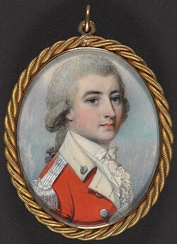

1781: Thomas Jefferson [age 38] on Slavery
Notes on the State of Virginia (1781-1782)
“The whole commerce between master and slave is a perpetual exercise of the most boisterous passions, the most unremitting despotism on the one part, and degrading submissions on the other…
And can the liberties of a nation be thought secure when we have removed their only firm basis, a conviction that these liberties are of the gift of God? That they are not to be violated but with his wrath? Indeed I tremble for my country when I reflect that God is just: That his justice cannot sleep for ever: that considering numbers, nature and natural means only, a revolution of the wheel of fortune, an exchange of situation, is among possible events: that it may become probable by supernatural interference!” http://socialenquiry.org/socialepistemics.com/AD_book_extracts/excerpts/jeffersons_mo numental_quote.html

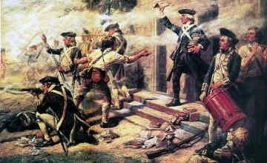
https://www.landofthebrave.info/revolutionary-war-timeline.htm

Sept. 5, 1781: Battle of the Chesapeake – victory for French / Americans
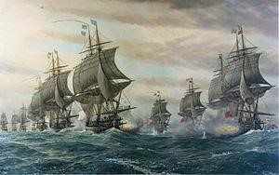
“Battle of the Chesapeake, also called the Battle of the Virginia Capes or the Battle of the
Capes, (5 September 1781), critical naval battle in the Chesapeake Bay (off the coast of Maryland and Virginia) and strategic French victory in the American Revolution. It prevented the British from reinforcing or evacuating the army of Charles Cornwallis the following month at the Siege of Yorktown, Virginia, the last major land battle of the war and the defeat that led the British to sue for peace.”
https://www.britannica.com/event/Battle-of-the-Chesapeake-1781

Sept. 17, 1781: Battle of Yorktown – Lord Cornwallis surrenders; General Washington, with help of Admiral deGrasse’s French fleet that blockaded Chesapeake Bay
“In the fall of 1781, a combined American force of Colonial and French troops laid seige to the British Army at Yorktown, Virginia. Led by George Washington and French General Comte de Rochambeau, they began their final attack on October 14th, capturing two British defenses and leading to the surrender, just days later, of British General Lord Corwallis and nearly 9,000 troops. Yorktown proved to be the final battle of the American Revolution, and the British began peace negotiations shortly after the American victory.” https://www.history.com/topics/american-revolution/siege-ofyorktown

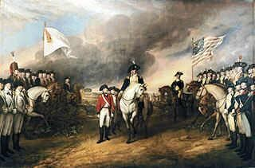
https://www.landofthebrave.info/revolutionary-war-timeline.htm
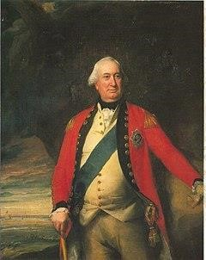General Charles Cornwallis [age 43]

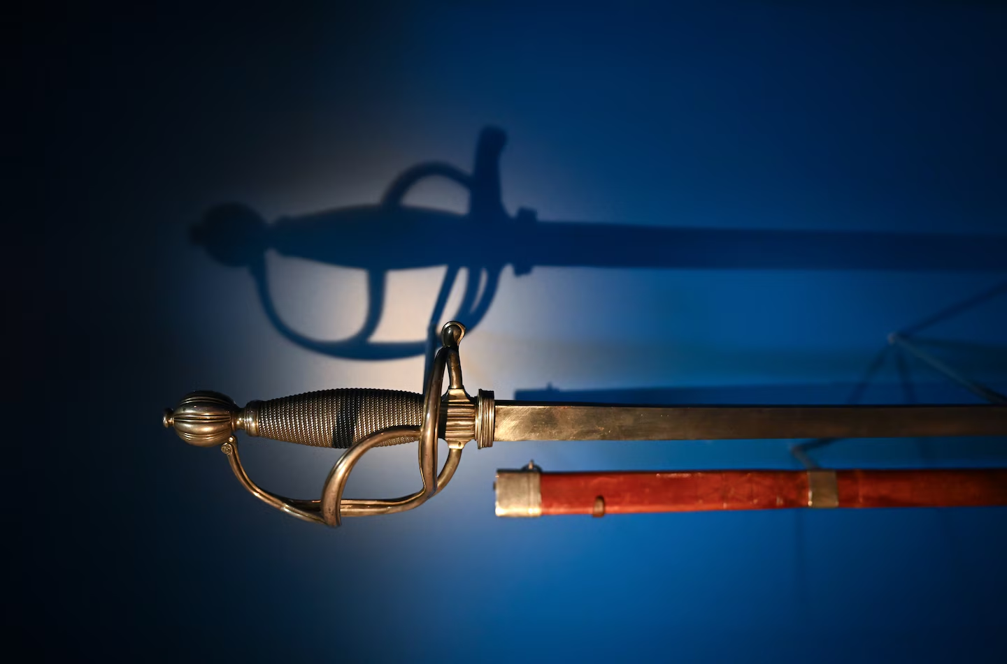
“[T]he sword of British Gen. Charles Cornwallis that, experts theorize, was presented to the Americans during the British surrender at Yorktown on Oct. 19, 1781. (Cornwallis himself never showed up.) *** Cornwallis instead sent one of his subordinates, Gen. Charles O’Hara. As the ceremony began, O’Hara tried to offer the sword to Rochambeau, even though O’Hara knew Washington was the allied commander, Greene recounted. Rochambeau pointed O’Hara to Washington. But when O’Hara tried to surrender the sword to Washington, the latter directed him to one of his subordinates, Gen. Benjamin Lincoln. If Cornwallis was sending a subordinate, he would surrender to a subordinate, Greene wrote. Lincoln took the sword, held it for a moment and gave it back. *** More than 2,000 hired German soldiers surrendered with the British. *** One of the faded flags is that of the 1st Rhode Island Regiment, which included a large contingent of Black soldiers, many of whom were enslaved and agreed to fight in exchange for their freedom. One of them was Cato Varnum, who is shown as a life-size figure wearing the regiment’s white uniform and black hat. He joined the regiment at age 16.”
https://www.washingtonpost.com/history/2025/06/13/cornwallis-sword-washington-revolutionary-war/?utm_campaign=wp_todays_headlines&utm_medium=email&utm_source=newsletter&carta-url=https%3A%2F%2Fs2.washingtonpost.com%2Fcar-ln-tr%2F4314f70%2F684d482bd0a89a00853d8272%2F59731235ade4e21a848a56ed%2F37%2F58%2F684d482bd0a89a00853d8272

Sept. 14, 1782: George Washington [age 50] reviewing Continental Army and French troops at Verplanck’s Point (NY) – in honor of departing French Commander in Chief Comte de Rochambeau [age 57]

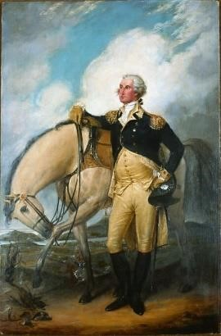Portrait by John Trumbull, former aide to General Washington:
https://www.mountvernon.org/george-washington/artwork/life-portraits-of-george-washington/
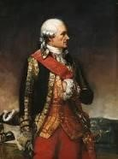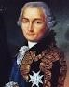

Jean-Baptiste Donatien de Vimeur, comte de Rochambeau

Sept. 1782 – “AIKEN BIBLE” - First Bible Published USA
“In September of 1782, a committee of the United States Congress (at that time the Congress of the Confederation) met in the capital city of Philadelphia to discuss the recent production of local printer Robert Aitken. The work, a 1452-page protestant Bible, was advertised on the title page as being a new translation into English from the ‘original tongues,’ as well as having been “diligently” compared to preceding translations. James Duane, committee chairman, noted its political significance in the minutes printed at the end of the work:
‘[Aitken] undertook this expensive work at a time when, from the circumstances of the war, an English edition of the Bible could not be imported, nor any opinion formed how long the obstruction might continue.’
The publication of the ‘Aitken Bible’ was a landmark moment in the book history of the United States. As the first complete Bible published in an independent America, the tome represents not only its publisher’s piety, but the country’s burgeoning cultural identity detached from that of Britain’s, as well as an intrepid side-stepping of the embargo affecting the importation of books. By decreeing it not just an American copy of a British publisher’s work, but as a brand new, comprehensive incarnation of the Bible for an American audience, the Aitken Bible became not just a devotional text, but a patriotic one as well. It remains the only edition of the Bible authorized by Congress.” https://blogs.loc.gov/bibliomania/2023/07/12/bible-of-the-revolution-the-aitken-bible-in-the-rare-book-and-special-collections-division/

Sept. 3, 1783: Treaty of Paris signed by Great Britain and Americans
U.S. gets all territory westward to Mississippi River, and south to Florida, and north to Canada [Britain also signed treaties ending their battles with Spain and Netherlands.]

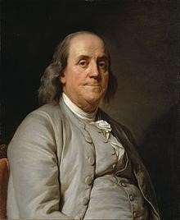
Benjamin Franklin [age 77]

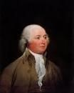 John Adams [age 48]

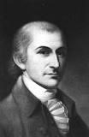
John Jay [age 38]
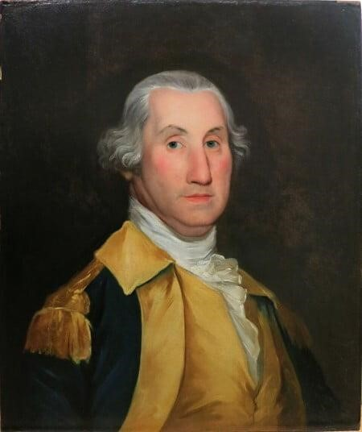

Portrait of George Washington (1783) at his headquarters,
Rocky Hill (NJ), by Joseph Wright: https://www.mountvernon.org/georgewashington/artwork/life-portraits-of-george-washington/
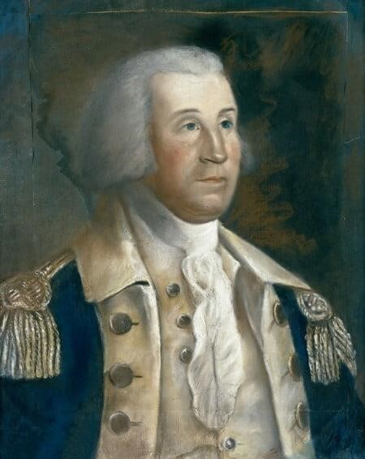
Sketch of George Washington at Rocky Hill, NJ – by 17-year-old William Dunlap: https://www.mountvernon.org/george-washington/artwork/life-portraits-ofgeorge-washington/

Sept. 14, 1783: Treaty of Paris ratified by Congress
“The Treaty of Paris of 1783 formally ended the American Revolutionary War. American statesmen Benjamin Franklin, John Adams and John Jay negotiated the peace treaty with representatives of King George III of Great Britain. In the Treaty of Paris, the British Crown formally recognized American independence and ceded most of its territory east of the Mississippi River to the United States, doubling the size of the new nation and paving the way for westward expansion.” https://www.history.com/topics/americanrevolution/treaty-of-paris

Nov. 25, 1783: New York City finally returned to American control as the last British troops departed after seven years of occupation.

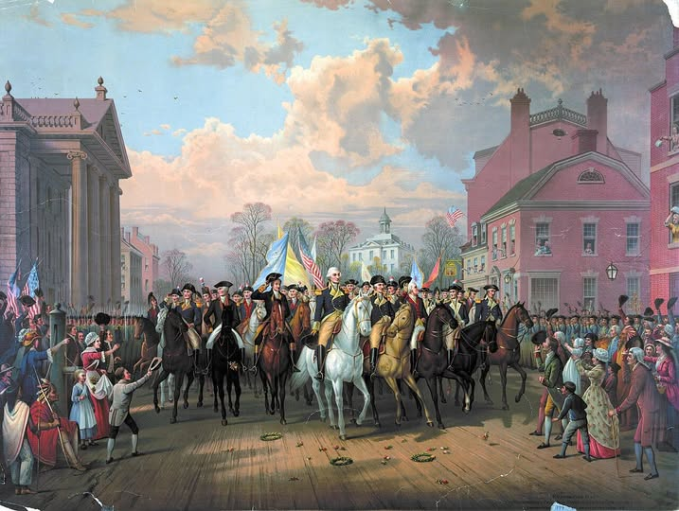
Evacuation Day and Washington’s Triumphal Entry in New York City, produced by Edmund P. Restein, ca. 1838. Collection of Library of Congress Prints and Photographs Division. Washington, D.C.

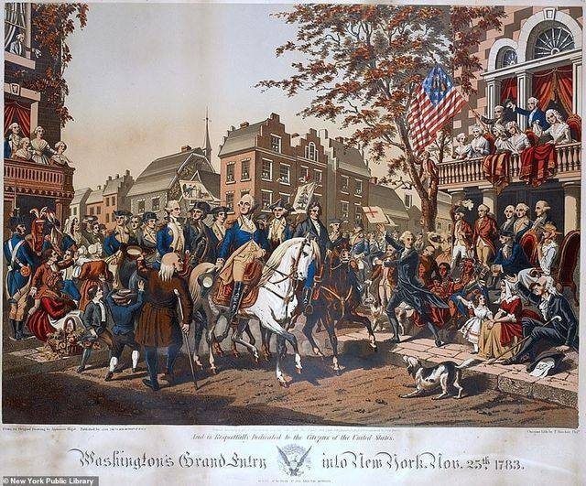

1784: Virginia gives up claims to western lands north of Ohio River – Northwest Territory
The Virginia Cession of Territory Northwest of the Ohio. https://founders.archives.gov/documents/Jefferson/01-06-02-0419-0001
“Thus, both in her own legislature and in Congress, Virginia placed the welfare of the nation above special interests in her effort to create a national domain. A few leaders, such as George Mason, James Madison, Thomas Jefferson, George Washington, Joseph Jones, Benjamin Harrison—some of whom were far from being disinterested themselves—led the three-year fight to yield in the national interest a vast tract of territory for which the state had a more defensible title than most other western claims.”

Note: See July 13, 1787 - Northwest Ordinance - A division of the Northwest Territory into "not less than three nor more than five States." https://www.archives.gov/milestone-documents/northwest-ordinance

Oct. 2, 1785: George Washington sits for a “Life Mask”

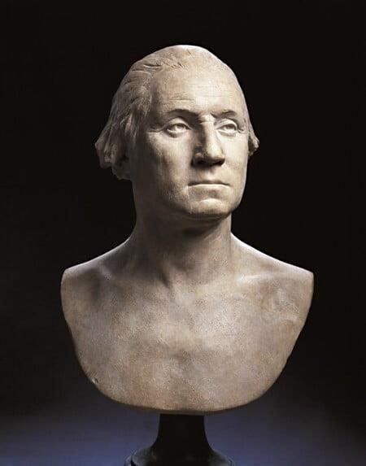
“Born at French court, famed sculptor Houdon was known for capturing the spirit and accurate likenesses of European heads of state. Insisting upon the need to sculpt Washington from life, Houdon and three assistants arrived at Mount Vernon on October 2, 1785. There, Houdon made a life mask, modeled a terracotta bust.” https://www.mountvernon.org/georgewashington/artwork/life-portraits-of-george-washington/

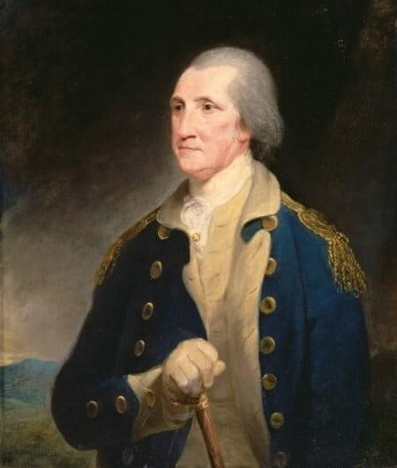
Portrait of George Washington (1785) by Robert Edge Pine: https://www.mountvernon.org/george-washington/artwork/life-portraits-of-george-washington

May 14, 1787: Constitutional Convention (Philadelphia)
George Washington [age 55] – elected President of the Convention; 12 states participated [Rhode Island refused]
“With George Washington presiding, the Constitutional Convention formally convenes on this day in 1787. The convention faced a daunting task: the peaceful overthrow of the new American government as it had been defined by the Article of Confederation. The process began with the proposal of James Madison’s Virginia Plan. Madison had dedicated the winter of 1787 to the study of confederacies throughout history and arrived in Philadelphia with a wealth of knowledge and an idea for a new American government. Virginia’s governor, Edmund Randolph, presented Madison’s plan to the convention. It featured a bicameral legislature, with representation in both houses apportioned to states based upon population; this was seen immediately as giving more power to large states, like Virginia. The two houses would in turn elect the executive and the judiciary and would possess veto power over the state legislatures. Madison’s conception strongly resembled Britain’s parliament. It omitted any discussion of taxation or regulation of trade, however; these items had been set aside in favor of outlining a new form of government altogether.” https://www.history.com/this-day-in-history/constitutionalconvention-convenes-in-philadelphia

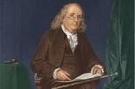Benjamin Franklin [age 81]

At the close of the Constitutional Convention of 1787, Franklin was queried as he left Independence Hall on the final day of deliberation. In the notes of Dr. James McHenry, one of Maryland’s delegates to the Convention, a lady asked Dr. Franklin “Well Doctor what have we got, a republic or a monarchy.” Franklin replied, “A republic . . . if you can keep it.”
http://www.whatwouldthefoundersthink.com/a-republic-if-you-can-keep-it

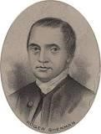Roger Sherman [age 66] – Connecticut [only delegate signed
Declaration of Independence, Articles of Confederation, and later the Constitution

July 13, 1787: Northwest Ordinance – banned slavery
“On July 13, 1787, Congress passed the Northwest Ordinance—an act that established a framework for governing the Northwest Territory, admitting new states, and protecting the civil liberties of settlers. It also banned slavery in the new territories. However, it granted slaveholders the power to recapture enslaved people alleged to have escaped into them. When crafting the Northwest Ordinance, Congress drew, in part, on the work of Thomas Jefferson from his time in Congress. The Northwest Territory covered a massive tract of land that would eventually become the states of Illinois, Indiana, Michigan, Ohio, Wisconsin, and a section of Minnesota. Following the Civil War, Reconstruction Republicans drew on the Northwest Ordinance’s text to craft the Thirteenth Amendment, which abolished slavery.” https://constitutioncenter.org/the-constitution/historic-document-library/detail/the-northwest-ordinance

Northwest Ordinance: https://www.archives.gov/milestone-documents/northwest-ordinance
“Three principal provisions were ordained in the document:
- A division of the Northwest Territory into "not less than three nor more than five States"
- A three-stage method for admitting a new state to the Union: a congressionally appointed governor, secretary, and three judges to rule in the first phase; an elected assembly and one non-voting delegate to Congress to be elected in the second phase when the population of the territory reached "five thousand free male inhabitants of full age"; and a state constitution to be drafted and membership to the Union to be requested in the third phase when the population reached 60,000
- A bill of rights protecting religious freedom, the right to a writ of habeas corpus, the benefit of trial by jury, and other individual rights; in addition the ordinance encouraged education and forbade slavery.”

Arthur St. Clair – Appointed Governor of Northwest Territory. https://www.mountvernon.org/library/digitalhistory/digital-encyclopedia/article/arthur-st-clair
“Arthur St. Clair was born in Caithness, Scotland in 1734…. In July 1777, Washington defended his colleague after he lost Fort Ticonderoga to the British during the Saratoga Campaign. Washington asked him to join his staff as an aide-de-camp after a court martial cleared him of any wrongdoing…. In 1787, St. Clair was appointed as the governor of the Northwest Territory. During his tenure, he lived in and name Cincinnati, Ohio after the Society of Cincinnati. He created written laws for the territory and attempted to resolve conflict with Native Americans groups such as the Shawnee, Delaware, and Ojibwe nations being displaced by American settlers…. St. Clair led men without proper military experience or training deep into the woods of western Ohio. On the morning of November 4, 1791, members of the Miami and Shawnee nations attacked, killing or wounding over 600 of St. Clair's soldiers, including most of his officers. St. Clair and a few hundred men escaped back to Fort Washington on the banks of the Ohio River. The loss was known as “St. Clair’s Defeat.” His failures in the Northwest Territory led to the first investigation of the executive branch by the legislature under the Constitution in January 1792. Amid the investigation, St. Clair wrote to Washington, “A Wish to rectify the public Opinion, and a Duty that, I conceive I owe to myself, induces me to request that an Enquiry into my Conduct may be instituted—When that is over I may hope to be permitted to resign the Commission of Major General which I now hold.” St. Clair was exonerated, but he was replaced from his military post. Washington allowed him to remain as the Governor of the Ohio Territory.

July 16, 1787: The Three-Fifths Compromise - Slaves
“The Three-Fifths Compromise was reached among state delegates during the 1787 Constitutional Convention. It determined that three out of every five slaves were counted when determining a state’s total population for legislative representation and taxation. Before the Civil War, the Three-Fifths Compromise gave a disproportionate representation of slave states in the House of Representatives.” https://perspectivesofchange.hms.harvard.edu/node/87

***
“After the American Revolution, many colonists (particularly in the North, where slavery was relatively unimportant to the economy) began to link the oppression of enslaved Africans to their own oppression by the British. Though leaders such as George Washington and Thomas Jefferson—both slaveholders from Virginia—took cautious steps towards limiting slavery in the newly independent nation, the Constitution tacitly acknowledged the institution, guaranteeing the right to repossess any “person held to service or labor” (an obvious euphemism for slavery). Many northern states had abolished slavery by the end of the 18th century, but the institution was absolutely vital to the South, where Black people constituted a large minority of the population and the economy relied on the production of crops like tobacco and cotton. Congress outlawed the import of new enslaved people in 1808, but the enslaved population in the U.S. nearly tripled over the next 50 years, and by 1860 it had reached nearly 4 million, with more than half living in the cotton–producing states of the South.” https://www.history.com/articles/black-history-milestones

Oct. 1787 – May 1788: Federalist Papers
“The Federalist, commonly referred to as the Federalist Papers, is a series of 85 essays written by Alexander Hamilton, John Jay, and James Madison between October 1787 and May 1788. The essays were published anonymously, under the pen name "Publius," in various New York state newspapers of the time. The Federalist Papers were written and published to urge New Yorkers to ratify the proposed United States Constitution, which was drafted in Philadelphia in the summer of 1787. In lobbying for adoption of the Constitution over the existing Articles of Confederation, the essays explain particular provisions of the Constitution in detail. For this reason, and because Hamilton and Madison were each members of the Constitutional Convention, the Federalist Papers are often used today to help interpret the intentions of those drafting the Constitution.” https://guides.loc.gov/federalist-papers/full-text
“In the spring of 1788, Alexander Hamilton published an essay titled The Federalist No.78 under the pseudonym “Publius.” The piece was one of a “Collection of Essays, written in favour of the New Constitution” and addressed to “the People of the State of New York.” *** The Constitution’s separation-of-powers principle, Hamilton argued, gave courts the power of “judgment” so that they could act as “an intermediate body between the people and the legislature, in order, among other things, to keep the latter within the limits assigned to their authority.” https://www.whitehouse.gov/wp-content/uploads/2021/12/SCOTUS-Report-Final-12.8.21-1.pdf (page 35).

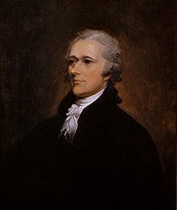Alexander Hamilton [age 32]
John Jay [age 42]
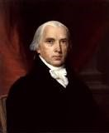James Madison [age 36]

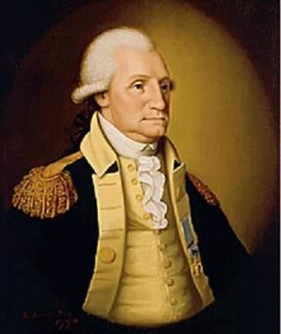Portrait of George Washington (1789) by Edward Savage:
https://www.mountvernon.org/george-washington/artwork/life-portraits-of-george-washington/

Nov. 22, 1787 – James Madison publishes Federalist No. 10 – Need A Republic, Not A Democracy

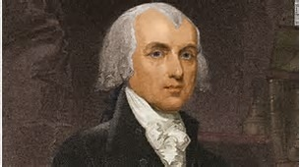

“To the People of the State of New York:
AMONG the numerous advantages promised by a well constructed Union, none deserves to be more accurately developed than its tendency to break and control the violence of faction…. Hence, it clearly appears, that the same advantage which a republic has over a democracy, in controlling the effects of faction, is enjoyed by a large over a small republic,--is enjoyed by the Union over the States composing it.”
https://avalon.law.yale.edu/18th_century/fed10.asp

Sept. 17, 1788: Constitution adopted by unanimous consent
The Constitution was adopted by a convention of the States on September 17, 1787, and was subsequently ratified by the several States, on the following dates: Delaware, December 7, 1787; Pennsylvania, December 12, 1787; New Jersey, December 18, 1787; Georgia, January 2, 1788; Connecticut, January 9, 1788; Massachusetts, February 6, 1788; Maryland, April 28, 1788; South Carolina, May 23, 1788; New Hampshire, June 21, 1788. Ratification was completed on June 21, 1788.

Feb. 4, 1789: First Presidential Election
The Electoral College: https://www.archives.gov/federal-register/electoralcollege/about.html
“The Electoral College is a process, not a place. The founding fathers established it in the Constitution as a compromise between election of the President by a vote in Congress and election of the President by a popular vote of qualified citizens.
The Electoral College process consists of the selection of the electors, the meeting of the electors where they vote for President and Vice President, and the counting of the electoral votes by Congress.
The Electoral College consists of 538 electors. A majority of 270 electoral votes is required to elect the President. Your state’s entitled allotment of electors equals the number of members in its Congressional delegation: one for each member in the House of Representatives plus two for your Senators. Read more about the allocation of electoral votes.
Under the 23rd Amendment of the Constitution, the District of Columbia is allocated 3 electors and treated like a state for purposes of the Electoral College. For this reason, in the following discussion, the word ‘state’ also refers to the District of Columbia.
Each candidate running for President in your state has his or her own group of electors. The electors are generally chosen by the candidate’s political party, but state laws vary on how the electors are selected and what their responsibilities are. Read more about the qualifications of the Electors and restrictions on who the Electors may vote for.
The presidential election is held every four years on the Tuesday after the first Monday in November. You help choose your state’s electors when you vote for President because when you vote for your candidate you are actually voting for your candidate’s electors.
Most states have a ‘winner-take-all’ system that awards all electors to the winning presidential candidate. However, Maine and Nebraska each have a variation of ‘proportional representation.’”

March 4, 1789: Fed. Government Begins Operating
“On March 4, 1789, the new government created by the Constitution began operating. Many elements of the system remained uncertain and disputed despite the preceding twenty-two months of discussion and drafting, first in the Constitutional Convention and then in the state ratifying conventions. The Constitution’s beginning raised a host of new questions, the stakes of which were understood to be tremendously high.” https://www.whitehouse.gov/wp-content/uploads/2021/12/SCOTUS-Report-Final-12.8.21-1.pdf (page 36).

April 30, 1789: George Washington [age 57] sworn in as 1st President

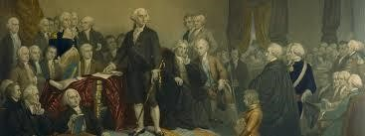
Congress met in New York City; unanimous (69 to 0) in Senate for George Washington as President – letter taken to Mount Vernon [took 7 days]; he later took Oath of Office on balcony of Federal Hall, Wall Street, New York City
John Adams [age 54] elected Vice President

June 8, 1789: Bill of Rights drafted
“Introducing the Bill of Rights in the First Congress. Few members of the First Congress wanted to make amending the new Constitution a priority. But James Madison, once the most vocal opponent of the Bill of Rights, introduced a list of amendments to the Constitution on June 8, 1789, and ‘hounded his colleagues relentlessly’ to secure its passage. Madison had come to appreciate the importance voters attached to these protections, the role that enshrining them in the Constitution could have in educating people about their rights, and the chance that adding them might prevent its opponents from making more drastic changes to it.” https://www.archives.gov/founding-docs/bill-of-rights/how-did-it-happen

Sept. 24, 1789: The Origins of the Supreme Court: Judiciary Act of 1789 – 6 Justices
“Article III of the Constitution established the Supreme Court. But the drafters of the Constitution had been unable to agree on key points—most importantly, whether to create inferior federal courts, what types of cases the federal courts would be able to hear, and what sort of relationship the Supreme Court would have with the state courts. The Constitution was also silent on the number of Justices who would sit on the Court. The drafters therefore left to Congress the task of addressing many of these questions as it saw fit, subject to the boundaries set forth in Article III. The drafters’ decision to postpone the question of the inferior federal courts has been termed by modern commentators the “Madisonian Compromise. When the First Congress convened in New York’s Federal Hall in April 1789, its members immediately began debating a bill to establish the federal courts. *** A Senate committee comprising ten members (one from each state that had both ratified
the Constitution and sent senators by that point) produced a first version of the Act. The
committee then sent its draft to leading lawyers, jurists, and officials around the nation,
requesting their comments. What resulted was a compromise bill that attempted to balance
competing interests, most notably the Federalists’ focus on establishing a strong federal
judiciary with the Anti-Federalists’ desire to preserve state autonomy. Following several
rounds of revisions and amendments, the bill won approval from the Senate and the House.
On September 24, the Judiciary Act of 1789 was signed into law by President George
Washington.
***
The Act provided for a six-justice Supreme Court: one Chief Justice and five associate
Justices. It established the Court’s jurisdiction, both original and appellate. It also placed the
Court at the top of the hierarchy of courts in the nation, state as well as federal. Section 25 of
the Act granted the Court the power to review certain decisions of the highest courts of the
states. This provision was viewed by some as particularly delicate, insofar as it placed the
Supreme Court in the position of overseeing —and potentially overruling—the decisions of
state court judges.”
***
The Act thus established a system of inferior federal courts, which it broke
down into two categories: district courts and circuit courts. The thirteen district courts, each
with a single district judge, were apportioned along state lines, including one each for Maine
and Kentucky, which had not yet become independent states.” https://www.whitehouse.gov/wp-content/uploads/2021/12/SCOTUS-Report-Final-12.8.21-1.pdf (p. 37 - 38).

1790: Naturalization Act – “free white people”
“The first major piece of U.S. legislation, the Naturalization Act, was signed in 1790, and it began the nation’s first naturalization process by providing access to U.S. citizenship to free white immigrants, mostly people from western Europe, who had lived in the U.S. for at least two years and their children. Early on, requirements for the Naturalization Act included two years of residence and good moral character reflecting the times. Later, the residency requirement was extended to five years in 1795, 14 years in 1798, and back to five years in 1802. Applicants were also required to be a ‘free white person.’” https://news.unm.edu/news/u-s-immigration-legislation-since-1776

Nov. 4, 1791 – Arthur St. Clair, Governor of Northwest Territory and Major General, defeated in battle with Miami and Shawnee Indians

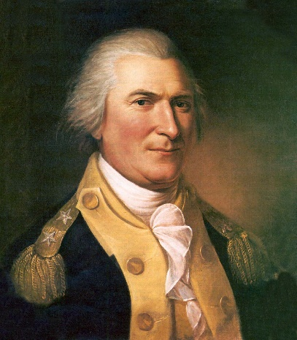
“As president, Washington appointed him as the commander of the American army assigned to conflicts with Native American conflicts north of the Ohio in 1791. St. Clair led men without proper military experience or training deep into the woods of western Ohio. On the morning of November 4, 1791, members of the Miami and Shawnee nations attacked, killing or wounding over 600 of St. Clair's soldiers, including most of his officers. St. Clair and a few hundred men escaped back to Fort Washington on the banks of the Ohio River. The loss was known as ‘St. Clair’s Defeat.’
His failures in the Northwest Territory led to the first investigation of the executive branch by the legislature under the Constitution in January 1792. Amid the investigation, St. Clair wrote to Washington, ‘A Wish to rectify the public Opinion, and a Duty that, I conceive I owe to myself, induces me to request that an Enquiry into my Conduct may be instituted—When that is over I may hope to be permitted to resign the Commission of Major General which I now hold.” St. Clair was exonerated, but he was replaced from his military post. Washington allowed him to remain as the Governor of the Ohio Territory.
In 1802, President Thomas Jefferson removed St. Clair from his territorial governorship, preferring a member of his own party rather than a Federalist. St. Clair spent the rest of his life in western Pennsylvania, struggling financially. He died in 1818 at 81 years of age.” https://www.mountvernon.org/library/digitalhistory/digital-encyclopedia/article/arthur-st-clair

Dec. 15, 1791: Bill of Rights ratified - becomes part of Constitution
“On this day in 1791, Virginia becomes the last state to ratify the Bill of Rights, making the first ten amendments to the Constitution law and completing the revolutionary reforms begun by the Declaration of Independence. Before the Massachusetts ratifying convention would accept the Constitution, which they finally did in February 1788, the document’s Federalist supporters had to promise to create a Bill of Rights to be amended to the Constitution immediately upon the creation of a new government under the document.”
https://www.history.com/this-day-in-history/the-bill-of-rights-becomes-law

The U.S. Bill of Rights
Note: The following text is a transcription of the first ten amendments to the Constitution in their original form. These amendments were ratified December 15, 1791, and form what is known as the "Bill of Rights." https://billofrightsinstitute.org/primary-sources/bill-of-rights

Amendment I
Congress shall make no law respecting an establishment of religion, or prohibiting the free exercise thereof; or abridging the freedom of speech, or of the press; or the right of the people peaceably to assemble, and to petition the Government for a redress of grievances.

Amendment II
A well regulated Militia, being necessary to the security of a free State, the right of the people to keep and bear Arms, shall not be infringed.

Amendment III
No Soldier shall, in time of peace be quartered in any house, without the consent of the Owner, nor in time of war, but in a manner to be prescribed by law.

Amendment IV
The right of the people to be secure in their persons, houses, papers, and effects, against unreasonable searches and seizures, shall not be violated, and no Warrants shall issue, but upon probable cause, supported by Oath or affirmation, and particularly describing the place to be searched, and the persons or things to be seized.

Amendment V
No person shall be held to answer for a capital, or otherwise infamous crime, unless on a presentment or indictment of a Grand Jury, except in cases arising in the land or naval forces, or in the Militia, when in actual service in time of War or public danger; nor shall any person be subject for the same offence to be twice put in jeopardy of life or limb; nor shall be compelled in any criminal case to be a witness against himself, nor be deprived of life, liberty, or property, without due process of law; nor shall private property be taken for public use, without just compensation.

Amendment VI
In all criminal prosecutions, the accused shall enjoy the right to a speedy and public trial, by an impartial jury of the State and district wherein the crime shall have been committed, which district shall have been previously ascertained by law, and to be informed of the nature and cause of the accusation; to be confronted with the witnesses against him; to have compulsory process for obtaining witnesses in his favor, and to have the Assistance of Counsel for his defence.

Amendment VII
In Suits at common law, where the value in controversy shall exceed twenty dollars, the right of trial by jury shall be preserved, and no fact tried by a jury, shall be otherwise re-examined in any Court of the United States, than according to the rules of the common law.

Amendment VIII
Excessive bail shall not be required, nor excessive fines imposed, nor cruel and unusual punishments inflicted.

Amendment IX
The enumeration in the Constitution, of certain rights, shall not be construed to deny or disparage others retained by the people.

Amendment X
The powers not delegated to the United States by the Constitution, nor prohibited by it to the States, are reserved to the States respectively, or to the people.

James Madison [age 36]

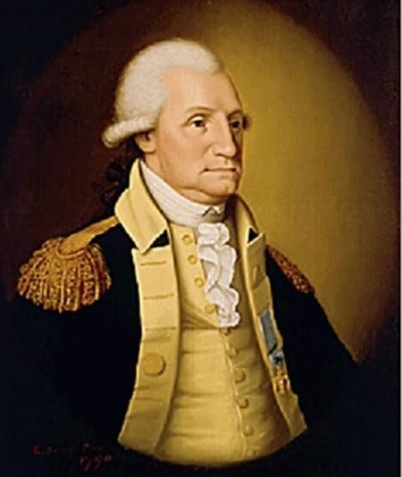

Portrait of George Washington (1789) by Edward Savage:
https://www.mountvernon.org/george-washington/artwork/life-portraits-of-george-washington/

May 2, 1792: Militia Act of 1792
“The Militia Act of 1792 allowed the President to temporarily take control of state militias in times of crises. This was later expanded in 1795, permanently allowing the President to call out the militia.
Transcript:
Section 1. Be it enacted by the Senate and House of Representatives of the United States of America in Congress assembled, That whenever the United States shall be invaded, or be in imminent danger of invasion from any foreign nation or Indian tribe, it shall be lawful for the President of the United States, to call forth such number of the militia of the state or states most convenient to the place of danger or scene of action as he may judge necessary to repel such invasion, and to issue his orders for that purpose, to such officer or officers of the militia as he shall think proper; and in case of an insurrection in any state, against the government thereof, it shall be lawful for the President of the United States, on application of the legislature of such state, or of the executive (when the legislature cannot be convened) to call forth such number of the militia of any other state or states, as may be applied for, or as he may judge sufficient to suppress such insurrection.” https://www.mountvernon.org/education/primary-source-collections/primary-source-collections/article/militia-act-of-1792

1793: Rise Of The Cotton Industry

Cotton Gin Invented
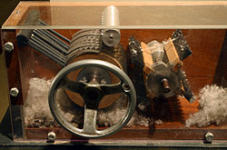
“In the years immediately following the Revolutionary War, the rural South—the region where slavery had taken the strongest hold in North America—faced an economic crisis. The soil used to grow tobacco, then the leading cash crop, was exhausted, while products such as rice and indigo failed to generate much profit. As a result, the price of enslaved people was dropping, and the continued growth of slavery seemed in doubt. Around the same time, the mechanization of spinning and weaving had revolutionized the textile industry in England, and the demand for American cotton soon became insatiable. Production was limited, however, by the laborious process of removing the seeds from raw cotton fibers, which had to be completed by hand.
In 1793, a young Yankee schoolteacher named Eli Whitney came up with a solution to the problem: The cotton gin, a simple mechanized device that efficiently removed the seeds, could be hand–powered or, on a large scale, harnessed to a horse or powered by water. The cotton gin was widely copied, and within a few years the South would transition from a dependence on the cultivation of tobacco to that of cotton.
As the growth of the cotton industry led inexorably to an increased demand for enslaved Africans, the prospect of slave rebellion—such as the one that triumphed in Haiti in 1791—drove slaveholders to make increased efforts to prevent a similar event from happening in the South. Also in 1793, Congress passed the Fugitive Slave Act, which made it a federal crime to assist an enslaved person trying to escape. Though it was difficult to enforce from state to state, especially with the growth of abolitionist feeling in the North, the law helped enshrine and legitimize slavery as an enduring American institution.” https://www.history.com/articles/black-history-milestones
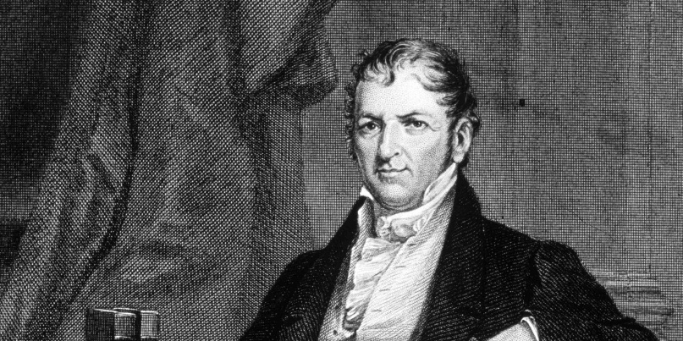 https://www.history.com/articles/cotton-gin-and-eli-whitney

Feb. 12, 1793: Fugitive Slave Act
“Fugitive slave laws provided enslavers and their agents with the legal right to reclaim runaways from other jurisdictions. Those states or jurisdictions were required to deliver the fugitives. As early as 1643, the United Colonies of New England had required the return of runaways, and, after the American Revolution (1775–1783), the Northwest Ordinance of 1787 contained similar protections for enslavers. The U.S. Constitution included a Fugitive Slave Clause, which was agreed to without dissent at the Constitutional Convention. Following a dispute between Pennsylvania and Virginia, Congress passed the Fugitive Slave Act of 1793 which clarified the processes by which enslavers could claim their property and was designed to balance the competing interests of free and slave states.

***
The Fugitive Slave Act of 1793, signed into law by President George Washington on February 12, 1793, allows slaveowners to seize and arrest fugitive slaves and present written or oral proof to an official in order to reclaim their property.” https://encyclopediavirginia.org/entries/fugitive-slave-laws/

August 7, 1794: George Washington puts down Whiskey Rebellion in Western PA
“In 1790, in order to solve a congressional deadlock over the permanent placement of the new nation’s capital, Alexander Hamilton, Thomas Jefferson, and James Madison reached a compromise that would result in an eventual shift of the capital to a location on the border of Maryland and Virginia, as well a promise that the federal government would assume the Revolutionary War debts of the thirteen states. The 1791 passage of the whiskey excise tax was an attempt to begin paying down that debt through a direct tax on the distillation of alcohol.
Unfortunately, this tax on production adversely impacted farmers on the western frontier. These small-scale farmers did not have ready cash to be able to pay the tax and were unable to easily pass on the burden to their customers, like the operators of large distilleries in the east.

***
Under the tenets of the Militia Act of 1792, after a judge notified the president that the laws could not be safely executed, the president could call forth a militia. Washington called up the state militias from Virginia, Pennsylvania, Maryland, and New Jersey, which ultimately amounted to close to 13,000 troops, to put down the rebellion by force if necessary. Divided into two wings that staged in Carlisle, Pennsylvania, and Cumberland, Maryland, Washington personally led a portion of the army as far west as Bedford, Pennsylvania.,,, When the army reached Western Pennsylvania, they did not find the population in open rebellion. The mere presence of such a large force of federalized militia was enough to send the rebel leaders into hiding. In the end, while a number of rebels were arrested and tried for treason, only a handful were found guilty, and all of these individuals would eventually be pardoned by either President Washington or, later, President John Adams.

In the end, the rebellion was put down and order restored. As Washington noted in a letter to the army's commander, General Henry (Lighthorse) Lee, written shortly before his departure from Bedford, his troops had preserved the ‘blessings of that Revolution which, at much expense of blood & treasure, constituted us a free and independent nation.’” https://www.mountvernon.org/george-washington/the-first-president/whiskey-rebellion

1795: George Washington – sat for portrait by Charles Willson Peale [his 7th and last portrait of George Washington]
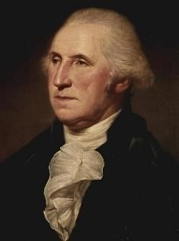
https://www.mountvernon.org/george-washington/artwork/life-portraits-of-george-washington/

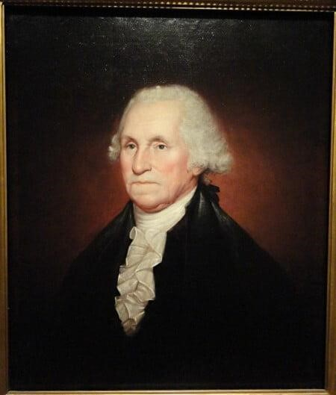George Washington – portrait by Rembrandt Peale (1795), son of Charles Willson Peale: https://www.mountvernon.org/george-washington/artwork/life-portraitsof-george-washington/

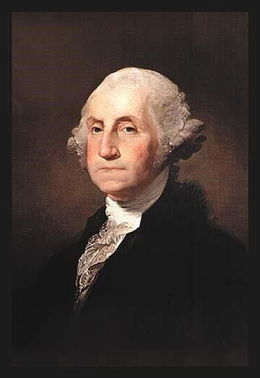 George Washington – portrait (1795) by Gilbert Stuart
https://www.mountvernon.org/george-washington/artwork/life-portraits-of-george-washington/

1795: 11th Amendment to U.S. Constitution – If Congress Upset With U.S. Supreme Court Decision, Can Pass Constitutional Amendment
“The judicial power of the United States shall not be construed to extend to any suit in law or equity, commenced or prosecuted against one of the United States by citizens of another state, or by citizens or subjects of any foreign state.” https://www.law.cornell.edu/constitution/amendmentxi
Explanation:
“In accepting a suit against a state by a citizen of another state in 1793, the Supreme Court [in Chisholm v. Georgia, 2 U.S. (2 Dall.) 419 (1793)] provoked such anger in Georgia and such anxiety in other states that, at the first meeting of Congress following the decision, the Eleventh Amendment was proposed by an overwhelming vote of both Houses and ratified with, what was for that day, ‘vehement speed.’ *** The Amendment proposed by Congress and ratified by the states was directed specifically toward overturning the result in Chisholm and preventing suits against states by citizens of other states or by citizens or subjects of foreign jurisdictions. It did not, as other possible versions of the Amendment would have done, altogether bar suits against states in the federal courts.” https://www.law.cornell.edu/constitution-conan/amendment-11/purpose-andearly-interpretation
1795: Treaty of Greenville [Ohio]
“The years between the Revolutionary War and the War of 1812 were not peaceful: the American army was dealt its worst defeat ever between tribal nations and American forces, at the hands of tribal warriors led by Little Turtle of the Miami and Blue Jacket of the Shawnee. St. Clair’s defeat in 1791 saw the American army lose approximately 1,000 men: three times the number lost during General Custer’s better-known defeat at Little Bighorn in 1876.
Between 1774 and 1794, Indian villages in New York, Pennsylvania, Indiana and Ohio were constantly attacked by the American army and militias. The Shawnee, Delaware, Iroquois, Miami, Odawa, Wyandot and Mingo saw unspeakable violence committed against their villages during this time period. Over 100 Indian villages were burned and destroyed, leaving an unknown number of civilian casualties. The most notorious frontier massacres occurred on March 8, 1782 on the Upper Sandusky River in Ohio, at a village known as Gnadenhutten. Over 90 Delaware Indians, the majority women and children, were returning to the village to gather food supplies. These Delaware, known as the Moravian town Indians, were Christian and pacifists. Upon reaching their village, the Delaware were rounded up by Colonel David Williamson and the Pennsylvania militia. Two outbuildings served as slaughter houses where the Indians were led, two at a time, to their execution.
In response to these tensions, the 1795 Treaty of Greenville aimed to end the hostilities that had engulfed the Great Lakes. It was an imperfect agreement not agreed upon by all the tribes, but it ended violence at least temporarily, and established Indian lands. But American expansion quickly nullified the agreement.” https://www.nps.gov/articles/a-long-legacy.htm
***
Two Shawnee brothers – Tecumseh (warrior chief) and Tenskwatawa (the “prophet”) –refused to sign Treaty of Greenville in 1795

Aug. 29, 1796: George Washington proposes treaty to the Cherokee Nation
https://founders.archives.gov/documents/Washington/05-20-02-0388

“Many years have passed since the White people first came to America. In that long space of time many good men have considered how the condition of the Indian natives of the country might be improved; and many attempts have been made to effect it. But, as we see at this day, all these attempts have been nearly fruitless. I also have thought much on this subject, and anxiously wished that the various Indian tribes, as well as their neighbours, the White people, might enjoy in abundance all the good things which make life comfortable and happy. I have considered how this could be done; and have discovered but one path that could lead them to that desirable situation. In this path I wish all the Indian nations to walk. From the information received concerning you, my beloved Cherokees, I am inclined to hope that you are prepared to take this path and disposed to pursue it. It may seem a little difficult to enter; but if you make the attempt, you will find every obstacle easy to be removed.
Mr. Dinsmoor, my beloved agent to your nation, being here, I send to you this talk by him. He will have it interpreted to you, and particularly explain my meaning.”

***

“My beloved Cherokees,
Some among you already experience the advantage of keeping cattle and hogs: let all keep them and increase their numbers, and you will ever have a plenty of meat. To these add sheep, and they will give you cloathing as well as food. Your lands are good and of great extent. By proper management you can raise live stock not only for your own wants, but to sell to the White people. By using the plow you can vastly increase your crops of corn. You can also grow Wheat, (which makes the best bread) as well as other useful grain. To these you will easily add flax and cotton, which you may dispose of to the White people, or have it made up by your own women into cloathing for yourselves. Your wives and daughters can soon learn to spin and weave; and to make this certain, I have directed Mr. Dinsmoor to procure all the necessary apparatus for spinning and weaving, and to hire a woman to teach the use of them. He will also procure some plows and other implements of husbandry, with which to begin the improved cultivation of the ground which I recommend, and employ a fit person to shew you how they are to be used. I have further directed him to procure some cattle and sheep for the most prudent and industrious men, who shall be willing to exert themselves in tilling the ground and raising those useful animals. He is often to talk with you on these subjects, and give you all necessary information to promote your success. I must therefore desire you to listen to him; and to follow his advice. I appointed him to dwell among you as the Agent of the United States, because I judged him to be a faithful man, ready to obey my instructions and to do you good.

But the cares of the United States are not confined to your single nation. They extend to all the Indians dwelling on their borders. For which reason other agents are appointed; and for the four southern nations there will be a general or principal agent who will visit all of them, for the purpose of maintaining peace and friendship among them and with the United States; to superintend all their affairs; and to assist the particular agents with each nation in doing the business assigned them. To such general or principal agent I must desire your careful attention. He will be one of our greatly beloved men. His whole time will be employed in contriving how to do you good, and you will therefore act wisely to follow his advice. The first general or principle agent will be Colonel Benjamin Hawkins, a man already known and respected by you. I have chosen him for this office because he is esteemed for a good man; has a knowledge of Indian customs, and a particular love and friendship for all the Southern tribes.”

1798: Alien Enemies Act of 1798
May 2, 2025: U.S. District Judge Fernando Rodriguez Jr., whom Trump nominated to the bench in 2017, ruled that the administration’s use of the Alien Enemies Act to quickly deport Venezuelan migrants to El Salvador was “unlawful.” He said this was because the migrants’ entry into the United States, as described by Trump’s proclamation, didn’t constitute the “invasion” or “predatory incursion” that the AEA requires. https://www.washingtonpost.com/politics/2025/05/01/trump-immigration-judicial-challenges/?utm_campaign=wp_post_most&utm_medium=email&utm_source=newsletter&carta-url=https%3A%2F%2Fs2.washingtonpost.com%2Fcar-ln-tr%2F425e867%2F6814f0b1b82e315dbf135a10%2F59731235ade4e21a848a56ed%2F47%2F61%2F6814f0b1b82e315dbf135a10

1799: Daniel Boone moves to Missouri (which was owned by Spain)

8 Things You Might Not Know About Daniel Boone: https://www.history.com/articles/8-things-you-might-not-know-about-daniel-boone

“In 1799, Boone, then in his mid-60s, moved with his extended family from Kentucky, which achieved statehood in 1792, to present-day Missouri, then under Spanish control and known as Upper Louisiana. The Spanish, who wanted to encourage settlement in the area, welcomed Boone with military honors and granted him 850 acres of land in the Femme Osage district, west of St. Louis. They also waived the requirement that all immigrants had to be Roman Catholic and made Boone a syndic, or magistrate, of the Femme Osage district, responsible for settling disputes among settlers.
In 1800, the Spanish ceded the Louisiana Territory to France, and three years later the U.S. gained control of it with the Louisiana Purchase. Boone subsequently lost his land claims because he hadn’t followed the proper procedures to gain permanent title to the land.
After the frontiersman petitioned Congress, President James Madison signed a bill into law in 1814 giving Boone his 850 acres; however, he soon had to sell the property to pay off Kentuckians who’d heard the news about the grant and traveled to Missouri to collect on old debts. Missouri became America’s 24th state in 1821, a year after Boone’s death.”

Dec. 14, 1799: At the time of George Washington’s death [age 67], Mount Vernon enslaved population consisted of 317 people.
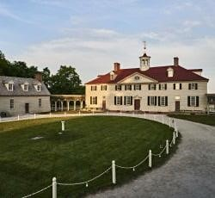
“Of the 317 enslaved people living at Mount Vernon in 1799, a little less than half (123 individuals) were owned by George Washington himself. Another 153 slaves at Mount Vernon in 1799 were dower slaves from the Custis estate. When Martha Washington's first husband, Daniel Parke Custis, died without a will in 1757, she received a life interest in one-third of his estate, including the slaves. Neither George nor Martha Washington could free these slaves by law and upon Martha’s death these individuals reverted to the Custis estate and were divided among her grandchildren.”
https://www.mountvernon.org/george-washington/slavery/ten-facts-aboutwashington-slavery/

1801: Thomas Jefferson – President (1801-1809)
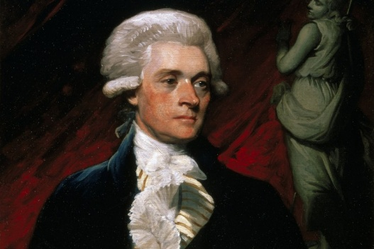 https://www.monticello.org/thomas-jefferson/brief-biography-of-jefferson/
“But when Jefferson went to Washington, the president called for enslaved teenage girls to come learn French cookery under George Washington's chef, Julien. Fossett’s sister-in-law Frances Hern was sent over as well in 1806…. When Jefferson left office in 1809, the cooks returned with him to Monticello, and Fossett became head chef there.

***
Peter Fossett was 11 years old when Jefferson died in 1826. Jefferson had freed only five enslaved workers in his will, Joseph Fossett among them. Jefferson had enormous debts, so the other 100 people were sold at an estate auction.
https://www.cincinnati.com/story/news/2025/02/23/thomas-jefferson-enslaved-cook-brought-french-cuisine-cincinnati/78208670007/?utm_source=enquirer-dailybriefing-strada&utm_medium=email&utm_campaign=dailybriefing-headline-stack&utm_term=Content%20List%20-%20Stacking%20-%20optimized&utm_content=pcin-cincinnati-nletter65

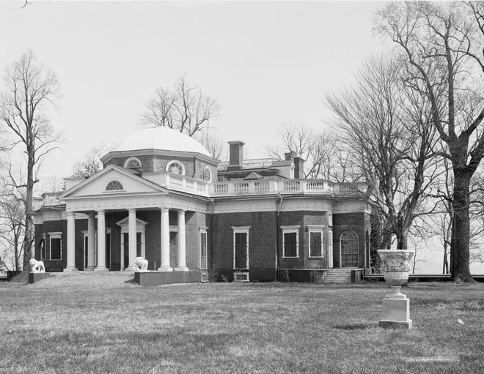

1801: Chief Justice John Marshall (1801-1835)
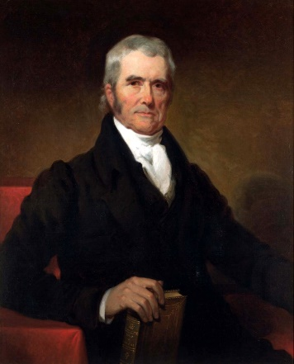
[Chief Justice John Roberts, in 2007 interview.] “Roberts believes that Marshall’s temperament and worldview came from his experiences as a soldier at Valley Forge, where he developed a commitment to the success of the nation. ‘Some have speculated that the real root of Marshall’s ill feeling to Jefferson was that Jefferson was not at Valley Forge, was not in the fight, and had what Marshall might regard as a somewhat precious attachment to ideas for the sake of ideas, while Marshall was more personally invested in the success of the American experiment.’ *** During Marshall’s thirty years as chief, “there weren’t a lot of concurring opinions. There weren’t a lot of dissents. And nowadays, you take a look at some of our opinions and you wonder if we’re reverting back to the English model, where everybody has to have their say. It’s more being concerned with the jurisprudence of the individual rather than working toward a jurisprudence of the Court.” Roberts praised justices who were willing to put the good of the Court above their own ideological agendas.” https://www.theatlantic.com/magazine/archive/2007/01/robertss-rules/305559/

2/24/1803: U.S. Supreme Court: Marbury v. Madison (5 US 137) JUDICIAL POWER TO REVIEW CONGRESSIONAL LEGISLATION

“Importance: This decision gave the Court the ability to strike down laws on the grounds that they are unconstitutional (a power called judicial review).” https://www.americanbar.org/groups/public_education/programs/constitution_day/landmark-cases/

Thomas Jefferson
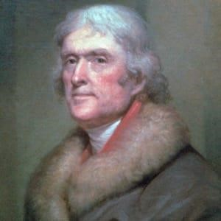

“Facts of the case
Thomas Jefferson defeated John Adams in the 1800 presidential election. Before
Jefferson took office on March 4, 1801, Adams and Congress passed the Judiciary Act of 1801, which created new courts, added judges, and gave the president more control over appointment of judges. The Act was essentially an attempt by Adams and his party to frustrate his successor, as he used the act to appoint 16 new circuit judges and 42 new justices of the peace. The appointees were approved by the Senate, but they would not be valid until their commissions were delivered by the Secretary of State.
William Marbury had been appointed Justice of the Peace in the District of Columbia, but his commission was not delivered. Marbury petitioned the Supreme Court to compel the new Secretary of State, James Madison, to deliver the documents. Marbury, joined by three other similarly situated appointees, petitioned for a writ of mandamus compelling the delivery of the commissions.

Question
- Do the plaintiffs have a right to receive their commissions?
- Can they sue for their commissions in court?
- Does the Supreme Court have the authority to order the delivery of their commissions?

Conclusion
The Court found that Madison’s refusal to deliver the commission was illegal, but did not order Madison to hand over Marbury’s commission via writ of mandamus. Instead, the Court held that the provision of the Judiciary Act of 1789 enabling Marbury to bring his claim to the Supreme Court was itself unconstitutional, since it purported to extend the Court’s original jurisdiction beyond that which Article III, Section 2, established. Marshall expanded that a writ of mandamus was the proper way to seek a remedy, but concluded the Court could not issue it. Marshall reasoned that the Judiciary Act of 1789 conflicted with the Constitution. Congress did not have power to modify the Constitution through regular legislation because Supremacy Clause places the Constitution before the laws. In so holding, Marshall established the principle of judicial review, i.e., the power to declare a law unconstitutional.” https://www.oyez.org/cases/1789-1850/5us137

May 21, 1803: Thomas Jefferson - The Louisiana Purchase
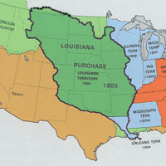
“The Louisiana Purchase of 1803 brought into the United States about 828,000 square miles of territory from France, thereby doubling the size of the young republic. What was known at the time as the Louisiana Territory stretched from the Mississippi River in the east to the Rocky Mountains in the west and from the Gulf of Mexico in the south to the Canadian border in the north. Part or all of 15 states were eventually created from the land deal, which is considered one of the most important achievements of Thomas Jefferson’s presidency. *** And in 1801, Spain signed a secret treaty with France to return the Louisiana Territory to France. Reports of the retrocession caused considerable unease in the United States. Since the late 1780s, Americans had been moving westward into the Ohio River and Tennessee River valleys, and these settlers were highly dependent on free access to the Mississippi River and the strategic port of New Orleans. U.S. officials feared that France, resurgent under the leadership of Napoleon Bonaparte, would soon seek to dominate the Mississippi River and access to the Gulf of Mexico. In a letter to U.S. minister to France Robert Livingston, President Thomas Jefferson stated, ‘The day that France takes possession of New Orleans…we must marry ourselves to the British fleet and nation.’” https://www.history.com/topics/westward-expansion/louisianapurchase

Napoleon - acquired Louisiana from Spain in 1800.
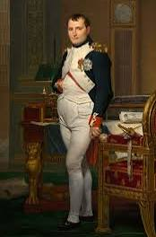
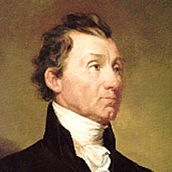James Monroe

“Napoleon Bonaparte’s plans to revive the French empire in the New World.

He planned to recapture the valuable sugar colony of St. Domingue from a slave rebellion, and then use Louisiana as the granary for his empire. France acquired Louisiana from Spain in 1800 and took possession in 1802, sending a large French army to St. Domingue [Haiti] and preparing to send another to New Orleans.

Westerners became very apprehensive about having the more-powerful French in control of New Orleans: President Thomas Jefferson noted, ‘There is on the globe one single spot, the possessor of which is our natural and habitual enemy. It is New Orleans.’

In addition to making military preparations for a conflict in the Mississippi Valley, Jefferson sent James Monroe to join Robert Livingston in France to try to purchase New Orleans and West Florida for as much as $10 million. Failing that, they were to attempt to create a military alliance with England. Meanwhile, the French Army in St. Domingue was being decimated by yellow fever, and war between France and England still threatened. Napoleon decided to give up his plans for Louisiana, and offered a surprised Monroe and Livingston the entire territory of Louisiana for $15 million. Although this far exceeded their instructions from President Jefferson, they agreed.

When news of the sale reached the United States, the West was elated. President Jefferson, however, was in a quandary. He had always advocated strict adherence to the letter of the Constitution, yet there was no provision empowering him to purchase territory. Given the public support for the purchase and the obvious value of Louisiana to the future growth of the United States, however, Jefferson decided to ignore the legalistic interpretation of the Constitution and forgo the passage of a Constitutional amendment to validate the purchase. This decision contributed to the principle of implied powers of the federal government.” https://history.state.gov/milestones/1801-1829/louisiana-purchase

June 15, 1804: 12th Amendment to U.S. Constitution ratified
“The electors shall meet in their respective states and vote by ballot for President and Vice-President, one of whom, at least, shall not be an inhabitant of the same state with themselves; they shall name in their ballots the person voted for as President, and in distinct ballots the person voted for as Vice-President, and they shall make distinct lists of all persons voted for as President, and of all persons voted for as Vice-President, and of the number of votes for each, which lists they shall sign and certify, and transmit sealed to the seat of the government of the United States, directed to the President of the Senate;--The President of the Senate shall, in the presence of the Senate and House of Representatives, open all the certificates and the votes shall then be counted;--the person having the greatest number of votes for President, shall be the President, if such number be a majority of the whole number of electors appointed; and if no person have such majority, then from the persons having the highest numbers not exceeding three on the list of those voted for as President, the House of Representatives shall choose immediately, by ballot, the President.” https://www.law.cornell.edu/constitution/amendmentxii

July 11, 1804: FAMOUS DUEL – AARON BURR KILLED ALEXANDER HAMILTON

“Hamilton-Burr Duel.” https://www.nps.gov/articles/000/hamilton-burr-duel.htm

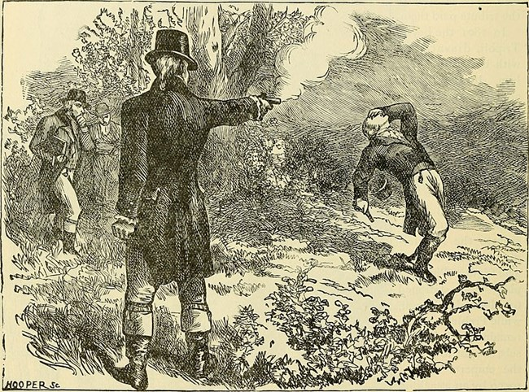

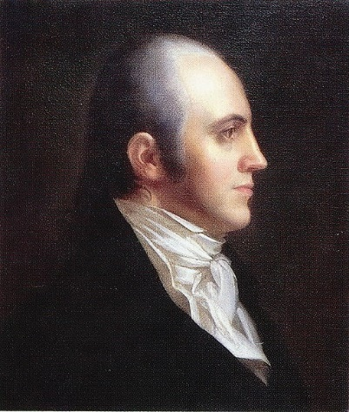Portrait of Aaron Burr
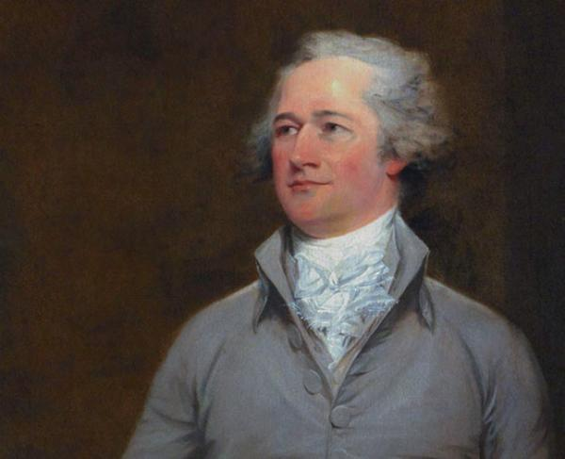Alexander Hamilton
“The specific event that led to the final duel began in the early months of 1804. A letter, written by Charles Cooper and published in the Albany Register in April 1804 referenced a conversation between Hamilton and other dinner guests in which Hamilton mentioned that Burr is a ‘dangerous man, and not to be trusted.’ The letter also references a ‘more despicable’ statement made by Hamilton about Burr.
***
Dueling was outlawed in both the states of New York and New Jersey, but the penalties for dueling were less harsh in New Jersey than in New York. Therefore, the site of Weehawken, New Jersey was chosen for this duel to take place on July 11th, 1804. It was the same site where, three years prior, Hamilton’s eldest son died in a duel defending his father’s honor.
***
Hamilton shot wide of Burr, hitting a nearby tree. Hamilton wrote days before that he had planned to do this before the duel. ‘I have resolved, ‘wrote Hamilton, ‘to reserve and throw away my first fire, and I have thoughts even of reserving my second fire.’ This statement was verbally confirmed in the moments before the duel, according to Hamilton’s second, Nathaniel Pendleton. If withholding a second shot was Hamilton’s plan that morning, it was never realized. Burr’s bullet hit Hamilton in the abdomen, entering the right side. Later accounts by the seconds of the two duelists agree that Hamilton instantly fell to the ground. A later account from Dr. David Hosack states that Hamilton was lying in the arms of Pendleton when Hosack ran to him. ‘This is a mortal wound, Doctor,’ Hosack recalls Hamilton saying.”

“Aaron Burr was on a mission to commit treason. And Cincinnati was a pit stop along the way.”https://www.cincinnati.com/story/news/2024/05/11/aaron-burr-mission-commit-treason-brief-stop-cincinnati/73534105007/?utm_source=enquirer-dailybriefing-strada&utm_medium=email&utm_campaign=dailybriefing-headline-stack&utm_term=hero&utm_content=pcin-cincinnati-nletter65

“Burr’s visits to Cincinnati
Burr made trips to the western country in spring 1805 and fall 1806. When passing through Cincinnati, he stayed at the home of Sen. John Smith in Terrace Park.
Elder Smith, as he was known, served as the minister of a Baptist church in the settlement of Columbia (now the Columbia Tusculum neighborhood of Cincinnati). He was also a politician in the Northwest Territory, advocating for Ohio’s statehood. In 1803, the Democratic-Republican was elected as one of the state’s first two U.S. senators.
***
Kentucky’s U.S. Attorney Joseph Hamilton Daveiss brought Burr before a grand jury in Frankfort three times in late 1806 to face charges that he had planned a military expedition to invade Spanish territory, which was in violation of the federal Neutrality Act. Burr, defended by the young attorney Henry Clay, was acquitted each time.
***

Jefferson finally did something about that pesky Burr. In November 1806, he issued a proclamation against the western insurgents, calling on state militias to help control the West. On Dec. 10, 1806, the Ohio militia intercepted the boats filled with weapons, supplies and soldiers at Blennerhassett Island, but Harman Blennerhassett escaped. The militia ransacked the island the next day. Burr was hundreds of miles away at the time, which was a key point. Blennerhassett and fewer than 100 men met up with Burr and they headed down the Ohio River toward New Orleans to enact their plot, not knowing Wilkinson double-crossed them. Upon hearing of the bounty out on them, Burr and his men surrendered to authorities at Bayou Pierre in Louisiana.
***
Burr went on trial in 1807 at the federal court in Richmond, Virginia, presided over by Chief Justice John Marshall. The president himself accused Burr of treason. The Constitution defines treason against the U.S. as “levying war against them.” Conviction requires “the testimony of two witnesses to the same overt act.” The act that was the basis for the charges against Burr occurred on Blennerhassett Island [Ohio] on Dec. 10, but Burr was not actually there, so there were no witnesses to his involvement.
The trial ended up narrowly defining what treason is according to the Constitution, and despite Jefferson’s fervent wishes, Burr’s case did not meet the standard. The verdict: ‘We of the jury say that Aaron Burr is not proved to be guilty under this indictment by any evidence submitted to us. We therefore find him not guilty.’”

1805: “The Shores of Tripoli” - Marine Corps Hymn
“In the early 1800s, the U.S. stood up to the Barbary States in North Africa that demanded protection payments for U.S. shipping. In 1805, Marine Lieutenant Presley O’Bannon and eight Marines led a force of mercenaries on a 500-mile trek across the desert. Their surprise attack on the city of Derna, on “the shores of Tripoli,” helped bring an end to the conflict.” https://www.kennedy-center.org/education/resources-for-educators/classroom-resources/media-and-interactives/media/music/story-behind-the-song/the-story-behind-the-song/the-marines-hymn/

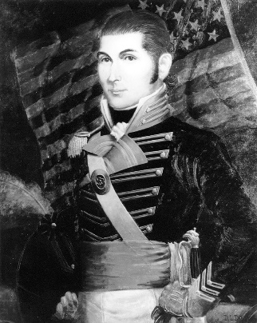

1806: Tecumseh - TENSKWATAW (“THE PROFIT)
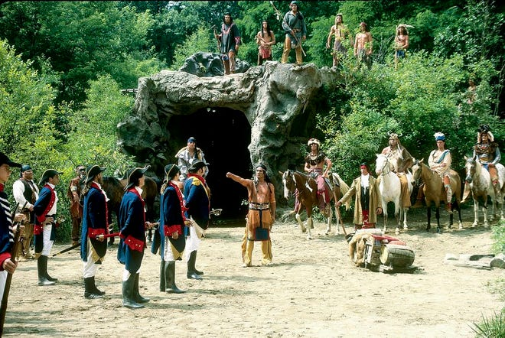
Two Shawnee brothers – Tecumseh (warrior chief) and Tenskwatawa (the “prophet”) – from 2003 enactment. Tecumseh refused to sign Treaty of Greenville in 1795, ceding most of Ohio to U.S. Government.
TOTAL ELICIPSE
“Tecumseh and younger brother Tenskwatawa used total eclipse to convey they had the power to control the sun, in disagreement with William Henry Harrison, would go on to become President.” https://www.dispatch.com/story/news/local/2024/04/04/how-tecumseh-used-the-1806-total-eclipse-in-ohio-to-his-advantage/72931327007/?utm_source=columbusdispatch-dailybriefing-strada&utm_medium=email&utm_campaign=dailybriefing-headline-stack&utm_term=hero&utm_content=ncod-columbus-nletter65

March 3, 1807: Insurrection Act of 1807

18 U.S. CODE § 2383 - REBELLION OR INSURRECTION
“Sec. 331. Federal aid for State governments Whenever there is an insurrections in any State against its government, the President may, upon the request of its legislature or of its governor if the legislature cannot be convened, call into Federal service such of the militia of the other States, in the number requested by that State, and use such of the armed forces, as he considers necessary to suppress the insurrection.”
Sec. 332. Use of militia and armed forces to enforce Federal authority Whenever the President considers that unlawful obstructions, combinations, or assemblages, or rebellion against the authority of the United States, make it impracticable to enforce the laws of the United States in any State by the ordinary course of judicial proceedings, he may call into Federal service such of the militia of any State, and use such of the armed forces, as he considers necessary to enforce those laws or to suppress the rebellion.” https://policy.defense.gov/portals/11/documents/hdasa/references/insurrection_act.pdf
“Any act of rebellion or insurrection against the U.S. government constitutes a serious federal crime punishable by serious jail time and fines. This crime is embodied under Title 18 U.S. Code 2383. *** It's important to note that 18 U.S. Code 2383 insurrection and rebellion charges are rarely filed by the United States Department of Justice (DOJ) because they recognize the First Amendment right to free speech. Still, specific unlawful behavior could result in criminal charges under this statute. For example, recall the events at the U.S. Capitol building on January 6, 2021, when a group of people stormed a government building to disrupt Congress' formal certification of presidential election results.” https://www.thefederalcriminalattorneys.com/rebellion-or-insurrection#:~:text=Rebellion%20or%20insurrection%20is%20a,violent%20resistance%20to%20government%20authority.

March 2, 1808: Congress Outlaws Importation Of Slaves
“Congress outlawed the import of new enslaved people in 1808, but the enslaved population in the U.S. nearly tripled over the next 50 years, and by 1860 it had reached nearly 4 million, with more than half living in the cotton–producing states of the South. https://www.history.com/articles/black-history-milestones

“On March 2, 1807, the U.S. Congress passes an act to ‘prohibit the importation of slaves into any port or place within the jurisdiction of the United States…from any foreign kingdom, place, or country.’ It would go into effect at the start of the following year.” https://www.history.com/this-day-in-history/march-2/congress-abolishes-the-african-slave-trade

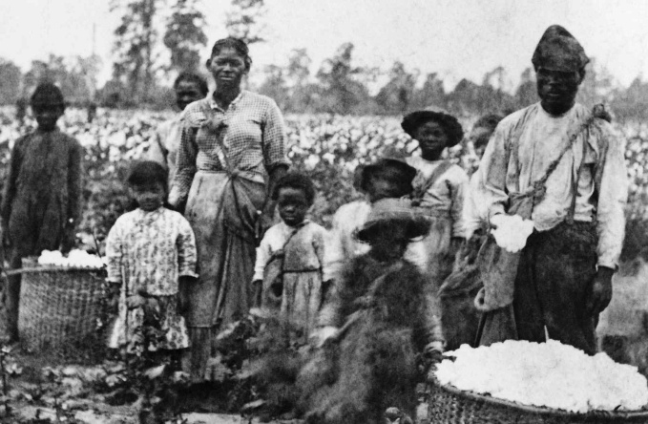

Feb. 12, 1809: ABRAHAM LINCOLN BORN
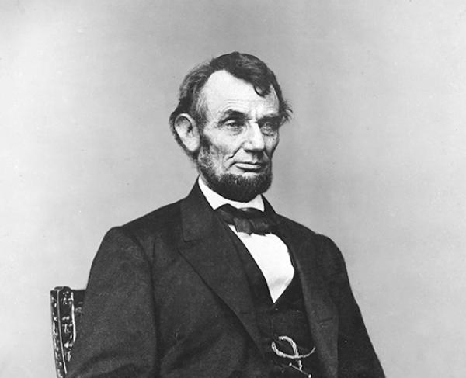
“Abraham Lincoln, sixteenth President of the United States, was born near Hodgenville, Kentucky on February 12, 1809. His family moved to Indiana when he was seven and he grew up on the edge of the frontier. He had very little formal education, but read voraciously when not working on his father’s farm. A childhood friend later recalled Lincoln's "manic" intellect, and the sight of him red-eyed and tousle-haired as he pored over books late into the night. In 1828, at the age of nineteen, he accompanied a produce-laden flatboat down the Mississippi River to New Orleans, Louisiana—his first visit to a large city--and then walked back home. Two years later, trying to avoid health and finance troubles, Lincoln's father moved the family moved to Illinois.” https://www.battlefields.org/learn/biographies/abraham-lincoln

Aug. 1810: Tecumseh Meets With William Henry Harrison
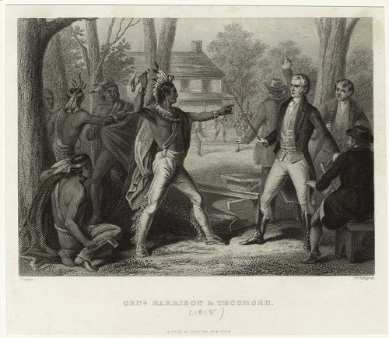
“Beginning in 1808, the Shawnee leader Tecumseh travelled throughout the United States gathering supporters and allies to form a native confederacy that could resist westward expansion by white settlers. In August 1811, Tecumseh met with Governor William Henry Harrison to discuss the recent treaties, land purchases, and violence throughout the Indiana territories. At their meeting, Tecumseh spoke for a large group of natives along the Great Lakes, and told Harrison, ‘that piece of land, we do not wish you to take it,’ indicating that his allies wanted ‘the present boundary line to continue.’ Should the whites continue their expansion into the region, Tecumseh warned, ‘I assure you it will be productive of bad consequences.’” https://www.nps.gov/articles/tecumseh.htm
***
“William Henry Harrison joined the army at eighteen in the early 1790s. He later became aide to Major General “Mad Anthony” Wayne, and participated in the decisive victory over the Western Indian Confederacy at the 1794 Battle of Fallen Timbers. After resigning from the army, Harrison became a territorial governor. A ruthless negotiator for Indian lands, Harrison procured some 3,000,000 acres for white settlement by negotiating with carefully-selected tribes.” https://www.nps.gov/articles/tippecanoe.htm?utm_source=article&utm_medium=website&utm_campaign=experience_more&utm_content=small
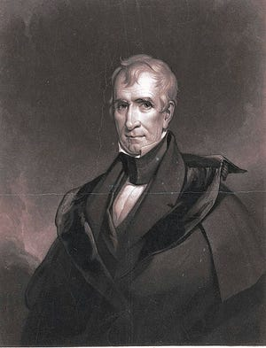William Henry Harrison, Governor of neighboring Indiana Territory (elected President in 1840).

Nov. 7, 1811: The Battle of Tippecanoe
:The Battle of Tippecanoe was fought between American soldiers and Native American warriors along the banks of the Keth-tip-pe-can-nunk, a river in the heart of central Indiana. Following the Treaty of Fort Wayne, an 1809 agreement requiring Indiana tribes to sell three million acres of land to the United States government, a Shawnee chief named Tecumseh, organized a confederation of Native American tribes to combat the horde of pioneers flooding into native lands.” https://www.battlefields.org/learn/war-1812/battles/tippecanoe
***
“Fought almost a year before the formal declaration of the War of 1812, ‘Tippecanoe’ became a rallying cry for many Americans as they denounced British support for the western Indian tribes. … [William Henry] Harrison recognized the threat Tecumseh’s movement posed for American settlement. Hoping to gain an advantage, Harrison launched a preemptive strike at the native headquarters at “Prophet’s Town,” located on Tippecanoe Creek in present-day Indiana. But his targets sprang their own surprise: on November 6, 1811, they launched a predawn attack. Harrison’s men eventually repulsed the attackers, but suffered significant casualties in the fighting.” https://www.nps.gov/articles/tippecanoe.htm?utm_source=article&utm_medium=website&utm_campaign=experience_more&utm_content=small
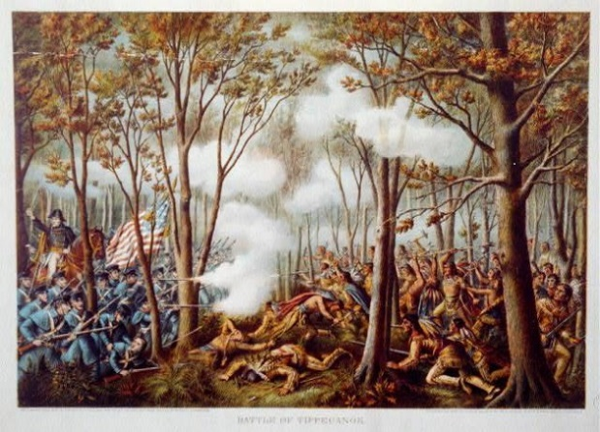

June 18, 1812 – “WAR OF 1812”

“War of 1812, (June 18, 1812–February 17, 1815), conflict fought between the United States and Great Britain over British violations of U.S. maritime rights. It ended with the exchange of ratifications of the Treaty of Ghent.
***
Michigan territorial governor William Hull led U.S. forces into Canada from Detroit, but Isaac Brock and Tecumseh’s warriors chased Hull back across the border and frightened him into surrendering Detroit on August 16, 1812, without firing a shot—behavior that Americans and even Brock’s officers found disgraceful. The Northwest subsequently fell prey to Indian raids and British incursions led by Maj. Gen. Henry Procter.
***
To the west, however, American Oliver Hazard Perry’s Lake Erie squadron won a great victory off Put-in-Bay on September 10, 1813, against Capt. Robert Barclay. The battle opened the way for Harrison to retake Detroit and defeat Procter’s British and Indian forces at the Battle of the Thames (October 5). Tecumseh was killed during the battle, shattering his confederation and the Anglo-Indian alliance.” https://www.britannica.com/event/War-of-1812/War
***
The British assault on Baltimore (September 12–14, 1814) foundered when Americans fended off an attack at Northpoint and withstood the naval bombardment of Fort McHenry, an action that inspired Francis Scott Key’s “The Star-Spangled Banner.”

Aug. 24, 1814: British Troops Burn White House
“During the War of 1812, British troops burned the White House. President James Madison and the First Lady were in Maryland at the time. British soldiers allegedly sat down, ate a meal and ransacked the house before setting it on fire.” https://www.firerescue1.com/history/articles/when-firefighting-crossed-paths-with-presidents-veeps-SbUtdRP4yHbhoFaI/

September 13, 1814 – Defense of Fort McHenry - Star Spangled Banner
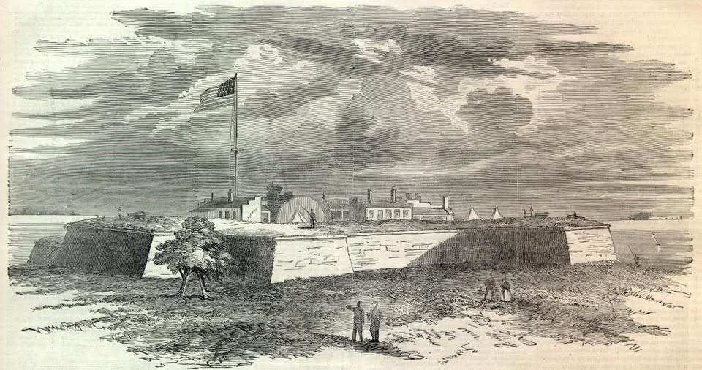1814, Francis Scott Key pens the poem "Defense of Fort McHenry". Later known as the "Star Spangled Banner."

“On September 13, 1814, Key and a U.S. official rowed over to a British warship at the mouth of the Patapsco River outside of Baltimore, Maryland. Their mission was to seek the release of some American prisoners.
The meeting with the British officers went well, and they even dined together. But when it came time for Key and his companions to paddle home, their hosts said hold your rowboats. The Americans had seen too much. British ships were moving into position to blast the daylights out of Fort McHenry, about eight miles away. Once they captured the fort, British troops would then raid the city, like they had in Washington. The British could not let Key and the others report on what they had seen.
Meanwhile, the Americans had very good seats for the fireworks. British ships let loose with their cannon as night fell. Hour after hour, they lobbed rockets and shells at the fort, more than 1,500 ka-booms in all.
As dawn neared, Key squinted through the gloom and smoke. He prepared himself to see his fears fulfilled: the British flag flying over Fort McHenry. But wait. Was that …? Was it …? It sure was. A huge American flag still waved there. The British attack had failed and Baltimore was saved.

The Poem
As soon as Key was released, he pulled an envelope from his pocket and began writing on the back. Out poured a poem about how the U.S. had withstood Great Britain’s armed might:

Oh say can you see by the dawn’s early light
What so proudly we hailed at the twilight’s last gleaming?
Whose broad stripes and bright stars through the perilous fight,
O’er the ramparts we watched were so gallantly streaming?
And the rockets’ red glare, the bombs bursting in air,
Gave proof through the night that our flag was still there.
O! say does that star-spangled banner yet wave
O'er the land of the free and the home of the brave?

Interestingly, Key put the words to a (gasp) familiar drinking so ng, ‘To Anacreon in Heaven,’ written by (gasp) British composer John Stafford Smith.”
https://www.kennedy-center.org/education/resources-for-educators/classroom-resources/media-and-interactives/media/music/story-behind-the-song/the-story-behind-the-song/the-star-spangled-banner/

1815 – NYFD – First African American Woman Firefighter
In 1815, Molly Williams became the first recorded woman, and one of the first African Americans, to serve as a firefighter in New York City. Her moment of heroism came during a brutal blizzard in 1818. While many male firefighters were sidelined by illness, Molly stepped in, fearlessly operating the fire pump through snow and freezing temperatures.
Her courage and determination left a lasting legacy in fire service history.

“History of Women in Firefighting
Women have been firefighters for longer than most people realize: in fact, for almost 200 years. The first woman firefighter we know of was Molly Williams, who was a slave in New York City and became a member of Oceanus Engine Company #11 in about 1815.” https://web.archive.org/web/20141014060453/http://i-women.org/firefighters/history-of-women-in-firefighting/

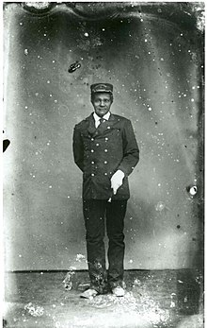

1815 – Napoleon’s Final Defeat – Cattle of Waterloo (Belgium)
“Battle of Waterloo, (June 18, 1815), Napoleon’s final defeat, ending 23 years of recurrent warfare between France and the other powers of Europe. It was fought during the Hundred Days of Napoleon’s restoration, 3 miles (5 km) south of Waterloo village (which is 9 miles [14.5 km] south of Brussels), between Napoleon’s 72,000 troops and the combined forces of the duke of Wellington’s allied army of 68,000 (with British, Dutch, Belgian, and German units) and about 45 https://www.britannica.com/event/Battle-of-Waterloo ,000 Prussians, the main force of Gebhard Leberecht von Blücher’s command.” https://www.britannica.com/event/Battle-of-Waterloo

March 4, 1817: JAMES MONROE - ELECTED PRESIDENT – MONROE DOCTRINE OF AMERICAN EXPANSION [March 4, 1817 – March 4, 1825]
“Along with his influential Secretary of State John Quincy Adams, Monroe issued the Monroe Doctrine, which forewarned the imperial European powers against interfering in the affairs of the newly independent Latin American states or potential U.S. territories in the Western hemisphere. Adhering to the intellectual underpinnings of the doctrine, Monroe granted diplomatic recognition to newly-independent Latin American republics.”
https://history.state.gov/departmenthistory/people/monroe-james

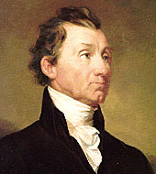

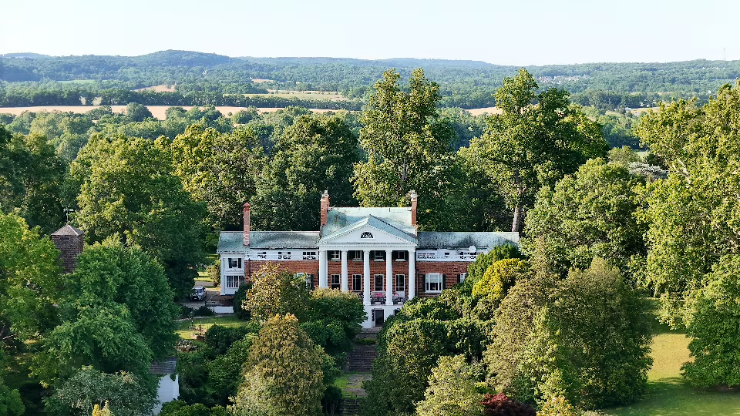
“President James Monroe is said to have written the American expansion policy known as the Monroe Doctrine in the dining room. The Marquis de Lafayette visited twice, and Dolley Madison was a regular guest. Monroe’s Loudoun County estate — the 200-year-old Oak Hill, built and maintained by enslaved African Americans — is considered the only home of a Founding Father still in private hands, and the aging owners want to sell the carefully preserved landmark and its 1,240 acres to Virginia at a discount to become a state park.” https://www.washingtonpost.com/dc-md-va/2025/02/21/virginia-oak-hill-park-james-monroe/?utm_campaign=wp_post_most&utm_medium=email&utm_source=newsletter&carta-url=https%3A%2F%2Fs2.washingtonpost.com%2Fcar-ln-tr%2F413e07f%2F67b8b571fcd029063f77cbae%2F59731235ade4e21a848a56ed%2F25%2F56%2F67b8b571fcd029063f77cbae

Oct. 5, 1818 – Abraham Lincoln’s mother died
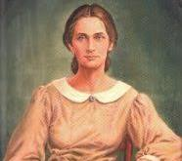
“On October 5, 1818, Nancy Hanks Lincoln died [age 34; Abraham was 9] from milk sickness. The disease resulted when cows ate the white snakeroot plant and the poison from the plant contaminated the milk. Nancy became ill when she went to help care for her sick neighbors.” https://www.nps.gov/places/grave-site-of-nancy-hanks-lincoln.htm

1819 – Indian Boarding Schools Established
“In the United States, forced removals to reservations were followed by policies of cultural assimilation, in which the government of the United States attempted to force Tribes to conform to the dominant American culture. Through its Bureau of Indian Affairs, the government established more than 4008 boarding schools across the United States and forced many Indigenous children to attend them. In these schools, Indigenous children were forced to abandon their traditional languages, dress, and customs. Boarding schools were seen as one expedient means to achieve this cultural assimilation because they separated Indigenous children from their families and Tribes and ‘Americanized’ them while they were still malleable.
***
Regardless of the individual experiences at boarding schools, however, the system itself left a legacy of community and individual trauma that broke down family and support systems among Indigenous communities.
***
Footnote 8: The total number of Native Boarding Schools in United States during the Boarding School Period (1819-1979) is estimated to be 408. During that period, there were a total of 84 Boarding Schools run by Catholic religious communities or Church entities, according to the website https://ctah.archivistsacwr.org/. Of those, the number of Boarding Schools that were entrusted by the federal government to Catholic church groups is estimated to be much lower, since a good number of them were created for assistance and educational purposes to poor and marginalized communities, outside of the government programs, and were funded by religious communities and their benefactors. Also, federal funding for Catholic Boarding Schools ended in the early 1900’s.” https://www.usccb.org/resources/Indigenous%20Pastoral%20Framework%20-June%202024-Final%20Text.pdf
***
“3,104 students died at boarding schools between 1828 and 1970, three times as many deaths as reported by the U.S. Interior Department earlier this year. The Post found that more than 800 of those students are buried in cemeteries at or near the schools they attended, underscoring how, in many cases, children’s bodies were never sent home to their families or tribes.” https://www.washingtonpost.com/investigations/interactive/2024/native-american-deaths-burial-sites-boarding-schools/?utm_campaign=wp_post_most&utm_medium=email&utm_source=newsletter&carta-url=https%3A%2F%2Fs2.washingtonpost.com%2Fcar-ln-tr%2F40102b7%2F67683d4f9965465237938c0f%2F59731235ade4e21a848a56ed%2F10%2F52%2F67683d4f9965465237938c0f
***
“More than 900 Native American children died at U.S. boarding schools. The U.S. government should apologize for policies that traumatized generations of children and their families, a new federal report urges. *** In the new report, Newland’s team of researchers said they identified 18,624 Native American children who were forced to attend the schools, but noted that the number of students was greater. The report also estimated that the federal government spent more than $23.3 billion in inflation-adjusted dollars over 98 years to implement the Indian boarding school system, similar institutions and associated assimilation policies.https://www.washingtonpost.com/investigations/2024/07/30/indian-boarding-schools-native-americans/

March 6, 1819: U.S. Supreme Court: McCulloch v. Maryland

“Issue: Can Congress establish a national bank, and if so, can a state tax this bank?
Result: The Court held that Congress had implied powers to establish a national bank under the "necessary and proper" clause of the U.S. Constitution. The Court also determined that United States laws trump state laws and consequently, a state could not tax the national bank.
Importance: The McCulloch decision established two important principles for constitutional law that continue today: implied powers and federal supremacy.” https://www.americanbar.org/groups/public_education/programs/constitution_day/landmark-cases/

1820: Missouri Compromise – Maine established as a “Free State”
“In the years leading up to the Missouri Compromise of 1820, tensions began to rise between pro-slavery and anti-slavery factions within the U.S. Congress and across the country. They reached a boiling point after Missouri’s 1819 request for admission to the Union as a slave state, which threatened to upset the delicate balance between slave states and free states. To keep the peace, Congress orchestrated a two-part compromise, granting Missouri’s request but also admitting Maine as a free state. It also passed an amendment that drew an imaginary line across the former Louisiana Territory, establishing a boundary between free and slave regions that remained the law of the land until it was negated by the Kansas-Nebraska Act of 1854.” https://www.history.com/topics/abolitionist-movement/missouri-compromise
***

“Maine statehood had national repercussions. The inhabitants of this northern part of Massachusetts had asked for statehood in 1819, but their petition was stopped dead by southerners who refused to permit a ‘free state’—one that did not permit slavery—to enter the Union without a corresponding ‘slave state.’ The explosive growth of the northern states had already given free states control of the House of Representatives, but the South held its own in the Senate, where each state got two votes. The admission of Maine would give the North the advantage, and southerners insisted that Maine’s admission be balanced with the admission of a southern slave state lest those opposed to slavery use their power in the federal government to restrict enslavement in the South.
They demanded the admission of Missouri to counteract Maine’s two ‘free’ Senate votes.
But this ‘Missouri Compromise’ infuriated northerners, especially those who lived in Maine. They swamped Congress with petitions against admitting Missouri as a slave state, resenting that slave owners in the Senate could hold the state of Maine hostage until they got their way. Tempers rose high enough that Thomas Jefferson wrote to Massachusetts—and later Maine—senator John Holmes that he had for a long time been content with the direction of the country, but that the Missouri question ‘like a fire bell in the night, awakened and filled me with terror. I considered it at once as the knell of the Union. It is hushed indeed for the moment, but this is a reprieve only, not a final sentence.’ Congress passed the Missouri Compromise, but Jefferson was right to see it as nothing more than a reprieve. The petition drive that had begun as an effort to keep the admission of Maine from being tied to the admission of Missouri continued as a movement to get Congress to whittle away at slavery where it could—by, for example, outlawing slave sales in the nation’s capital—and would become a key point of friction between the North and the South.” https://heathercoxrichardson.substack.com/p/march-15-2024

March 2, 1824 – U.S. Supreme Court - Gibbons v. Ogden

“Issue: Can states pass laws that challenge the power of Congress to regulate interstate commerce?
Result: The Court held that it is the role of the federal government to regulate commerce and that state governments cannot develop their own commerce-regulating laws. Further, the Court created a wide definition for “commerce,” reasoning that the term encompassed more than just selling and buying. In this case, the Court determined that regulating water navigation was in fact an act that regulated commerce.
Importance: The impact of Gibbons is still felt today as it gives the federal government a much-broader base to regulate economic transactions.” https://www.americanbar.org/groups/public_education/programs/constitution_day/landmark-cases/

July 4, 1826 – Thomas Jefferson Dies – Slaves Sold To Settle Debts

“A peculiar thing about Thomas Jefferson’s house servants was that we were all related to one another, and as a matter of fact, we did not know we were slaves,” Peter Fossett said in an 1898 lecture in Cincinnati. “I was dressed unlike plantation boys. My grandmother was free, and I remember the first suit I ever wore she gave me. It was of blue Nankeen cloth, red Morocco hat and red Morocco shoes. … “I had nice house servant work, got tips and all that sort of thing. Suddenly, at the death of my old master, Thomas Jefferson, I was put on the auction block and sold for $500 to strangers,” he said.
Peter Fossett was 11 years old when Jefferson died in 1826. Jefferson had freed only five enslaved workers in his will, Joseph Fossett among them. Jefferson had enormous debts, so the other 100 people were sold at an estate auction.” https://www.cincinnati.com/story/news/2025/02/23/thomas-jefferson-enslaved-cook-brought-french-cuisine-cincinnati/78208670007/?utm_source=enquirer-dailybriefing-strada&utm_medium=email&utm_campaign=dailybriefing-headline-stack&utm_term=Content%20List%20-%20Stacking%20-%20optimized&utm_content=pcin-cincinnati-nletter65

Oct. 26, 1825: Erie Canal
New York Gov. DeWitt Clinton opened the canal in 1825…. Backed by the New York state legislature, construction on the Erie Canal began in 1817. An army of subcontractors dug, blasted and dredged their way through the forests, mountains and swamps of the upstate landscape to create the 40-foot-wide, 4-foot-deep waterway, one of the country’s first major public-works projects, according to Brad L. Utter, author of “Enterprising Waters: The History and Art of New York’s Erie Canal.”… When the full waterway officially opened on Oct. 26, 1825, connecting the interior of the U.S. to the Atlantic Ocean via the Hudson River, the Erie Canal kicked off an unprecedented era of growth. Shipping and travel time were slashed in half. Cargo costs dropped from about $100 per ton to $4 per ton. In the waterway’s first year of operation, more than 40,000 passengers traveled it, according to the New York State Archives Partnership Trust.” https://www.washingtonpost.com/travel/2025/05/26/erie-canal-bicentennial-events/?utm_campaign=wp_post_most&utm_medium=email&utm_source=newsletter&carta-url=https%3A%2F%2Fs2.washingtonpost.com%2Fcar-ln-tr%2F42d7c37%2F683c7da4e4755d707b301c08%2F59731235ade4e21a848a56ed%2F41%2F52%2F683c7da4e4755d707b301c08

July 4, 1826: Thomas Jefferson and Samuel Adams died same day – 50th Anniversary of signing Declaration of Independence
“John Adams and Thomas Jefferson died on the same day, July 4, 1826. Both were old men—Adams was 90, and Jefferson was 83—and both were ill, though Adams had been in comparatively robust health until just a few months earlier and Jefferson had been ill for an extended period. They had been rivals, indeed enemies, for some time; Jefferson had defeated Adams in the presidential election of 1800. But they had repaired their differences and had pursued an active correspondence with each other in the years before their deaths. On that final day, the 50th anniversary of the signing of the Declaration of Independence, Adams died at his home in Quincy, Massachusetts, and Jefferson died at his home in Monticello, Virginia, the two separated by hundreds of miles and by many days of overland travel time.” https://www.bu.edu/historic/battin.htm

May 28, 1830 – Indian Removal Act
“The Indian Removal Act was signed into law by President Andrew Jackson on May 28, 1830, authorizing the president to grant lands west of the Mississippi in exchange for Indian lands within existing state borders. A few tribes went peacefully, but many resisted the relocation policy. During the fall and winter of 1838 and 1839, the Cherokees were forcibly moved west by the United States government. Approximately 4,000 Cherokees died on this forced march, which became known as the ‘Trail of Tears.’” https://guides.loc.gov/indian-removal-act
November 16, 1907: “Oklahoma entered the Union as the forty-sixth state on November 16, 1907. The history of Oklahoma is tied to the early nineteenth-century use of this land for relocating the Native American population from the settled portions of the United States.” https://guides.loc.gov/indian-removal-act/related-online-resources
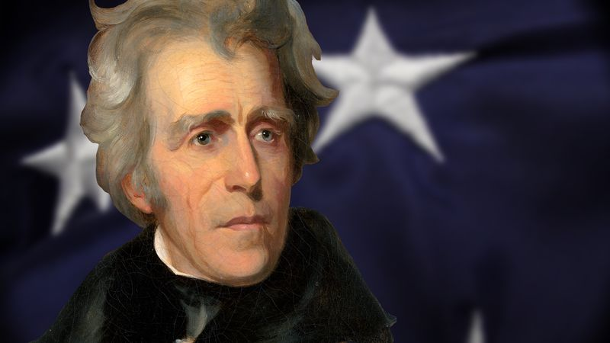
7th President of the United States (1829–1837)
“Served in the Creek War of 1813 as commander of Tennessee forces; his victory in the Creek War brought him a commission as major general in the United States Army in May 1814; led his army to victory over the British in the Battle of New Orleans in January 1815; received the thanks of Congress and a gold medal by resolution of February 27, 1815; commanded an expedition which captured Florida in 1817; served as Governor of the new territory in 1821; again elected to the United States Senate and served from March 4, 1823, to October 14, 1825, when he resigned; chairman, Committee on Military Affairs (Eighteenth Congress); unsuccessful candidate for President in 1824; elected as a Democrat as President of the United States in 1828; reelected in 1832 and served from March 4, 1829, to March 3, 1837; retired to his country home, the 'Hermitage,' near Nashville, Tenn., where he died June 8, 1845; interment in the garden on his estate.” https://bioguide.congress.gov/search/bio/j000005

Aug. 1831: Nat Turner’s Revolt
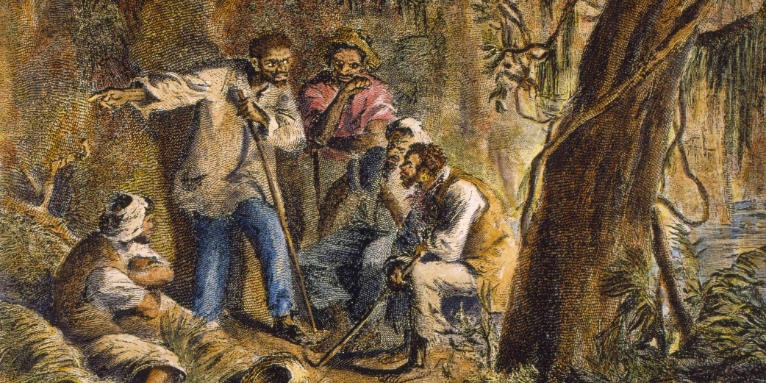 https://www.history.com/articles/nat-turner

“In August 1831, Nat Turner struck fear into the hearts of white Southerners by leading the only effective slave rebellion in U.S. history. Born on a small plantation in Southampton County, Virginia, Turner inherited a passionate hatred of slavery from his African–born mother and came to see himself as anointed by God to lead his people out of bondage…. In early 1831, Turner took a solar eclipse as a sign that the time for revolution was near, and on the night of August 21, he and a small band of followers killed his owners, the Travis family, and set off toward the town of Jerusalem [Virginia]where they planned to capture an armory and gather more recruits. The group, which eventually numbered around 75 Black people, killed some 60 white people in two days before armed resistance from local white people and the arrival of state militia forces overwhelmed them just outside Jerusalem. Some 100 enslaved people, including innocent bystanders, lost their lives in the struggle. Turner escaped and spent six weeks on the run before he was captured, tried and hanged.” https://www.history.com/articles/black-history-milestones

1831: Abolitionism And The Underground Railroad
“In the early 19th century, however, a new brand of radical abolitionism emerged in the North, partly in reaction to Congress’ passage of the Fugitive Slave Act of 1793 and the tightening of codes in most southern states. One of its most eloquent voices was William Lloyd Garrison, a crusading journalist from Massachusetts, who founded the abolitionist newspaper The Liberator in 1831 and became known as the most radical of America’s antislavery activists. Antislavery northerners—many of them free Black people—had begun helping enslaved people escape from southern plantations to the North via a loose network of safe houses as early as the 1780s called the Underground Railroad.” https://www.britannica.com/biography/William-Lloyd-Garrison
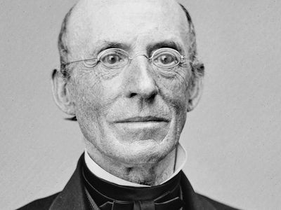
***
“A printer, newspaper publisher, radical abolitionist, suffragist, and civil rights activist, William Lloyd Garrison spent his life disturbing the peace of the nation in the cause of justice…. Contact with Black Americans in Boston and Baltimore led Garrison to reject gradualism and colonization. In 1831, back in Boston with his new newspaper The Liberator, Garrison publicly committed himself to Black abolitionists' demands for an immediate uncompensated end to slavery and for political and social equality. Despite threats, violence, and financial struggles Garrison continued to hammer away for freedom and equality. He published The Liberator every week for thirty-five years. He gave speeches and helped found antislavery societies. He worked with, inspired (and on occasion offended) activists such as Charles Lenox Remond, Frederick Douglass, Lucy Stone, Abby Kelley Foster, Wendell Phillips, and others. After slavery and The Liberator ended in 1865, he continued to demand equality for Blacks and for women. At a women's suffrage meeting in 1873, Garrison summed up his life's work: ‘I am still for immediate, unconditional, everlasting emancipation from oppression of everyone on the face of the earth.’” https://www.nps.gov/people/william-lloyd-garrison.htm

1832: President Andrew Jackson – Refuses To Enforce U.S. Supreme Court Decision / Cherokees Forced Migration - “TRAIL OF TEARS”
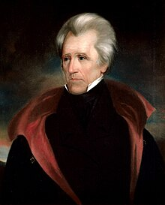
“In Worcester v. Georgia (1832), the Supreme Court overturned the conviction of a missionary living among the Cherokee Nation for refusing to take an oath to obey the laws of Georgia. In an opinion written by Chief Justice John Marshall, the Court held that the Cherokees constituted an independent political community to which the state of Georgia could not apply its laws. Accordingly, the Court ordered Worcester’s release from custody. Georgia’s governor refused to release the missionary, vowing to defy the Court’s decision. President Andrew Jackson refused to intervene, maintaining that Georgia had the right to apply its laws to any person living within its borders. Jackson also embraced the view that both the executive and legislative branches had as much right as the judicial branch to interpret the Constitution. While the story is likely apocryphal, Jackson supposedly remarked, ‘John Marshall has made his decision, now let him enforce it.’ (The quotation is believed to have first appeared in an 1864 book by newspaper publisher Horace Greeley.) Eventually, Jackson acted in direct contravention of the Court’s decision in Worcester. Ignoring the Court’s ruling that the Cherokees were an independent people entitled to the land on which they lived, Jackson sent federal troops to evict them. The result was the Cherokees’ forced and deadly migration west along the infamous Trail of Tears.” https://www.fjc.gov/history/administration/executive-enforcement-judicial-orders

1833 – Abolitionist: Lydia Maria Child
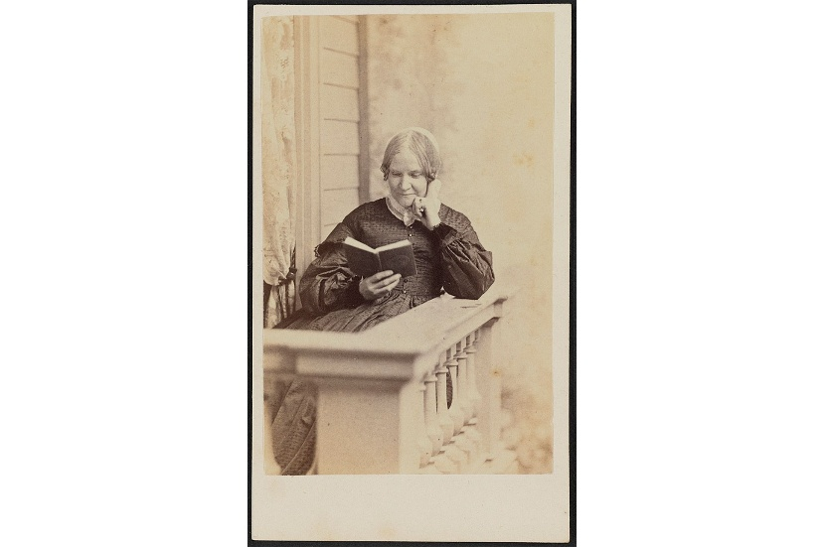

“An Appeal in Favor of That Class of Americans Called Africans (1833) is the first scholarly American overview of the history of slavery and the first major study of that institution in the United States. In this book Child blames the North as well as the South for the existence of the ‘peculiar institution.’ She calls for the immediate abolition of slavery and the eradication of all forms of racial discrimination, including laws of anti-miscegenation that forbade intermarriage between Black and white people. Once again she openly defended interracial marriage.
The abolitionists wasted little time in praising An Appeal in Favor of That Class of Americans Called Africans. In his review published in The Liberator on August 10, 1833, [William Lloyd] Garrison wrote that any “heart must be harder than the nether mill-stone which can remain unaffected by the solemn truths it contains.” Indeed, scholars credit this book with converting more men and women to abolition than any other publication.” https://www.poetryfoundation.org/poets/lydia-maria-child

1837: CINCINNATI – SALMON P. CHASE, ESQ.
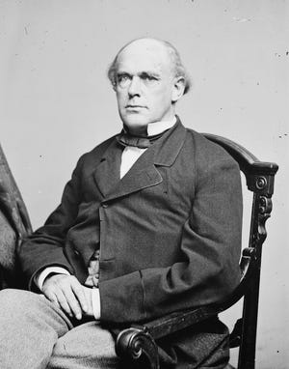
“Salmon P. Chase was one of the most complex and accomplished men in Cincinnati’s history. There is much to cover. His time as the Secretary of the Treasury − a member of Abraham Lincoln’s “team of rivals” in the Cabinet − during the Civil War, when he ran the federal finances and created our first system of paper currency. Or his era as chief justice on the Supreme Court, presiding over the impeachment trial of President Andrew Johnson. Or Chase’s great ambition to be president, even running for office while he sat on the Supreme Court.
***
Chase didn’t consider himself an abolitionist so much as an antislavery attorney. He took on numerous cases defending people apprehended as fugitive slaves, and defended James Birney, publisher of the abolitionist newspaper, The Philanthropist. Birney also enlisted Chase’s help with the case of his housekeeper, Mathilda. She had been enslaved and accompanied slaveholder Larkin Lawrence to Cincinnati in 1837. While docked at the Public Landing, she stepped off the boat and into the city, and soon found work with Birney. Lawrence had her arrested as a fugitive slave. Chase defended her and argued against the constitutionality of the Fugitive Slave Act of 1793. He also claimed that since Ohio was a free state, Mathilda ceased to be enslaved the moment Lawrence brought her within the city limits, including the Public Landing. When she walked off the boat, she didn’t escape, she just exercised her freedom to walk from one spot in the free territory to another. Though Chase lost the case and Mathilda returned to slavery, the case marked “the first major abolitionist challenge to fugitive recaptures,” according to historians. After the similar case of Samuel Watson in 1845, which Chase also lost, there was some hope as even the judge began to regret the existence of slavery. Chase’s arguments were starting to change a few minds.” https://www.cincinnati.com/story/news/2025/04/06/salmon-p-chase-prolific-political-career-started-cincinnati/82504216007/?utm_source=enquirer-dailybriefing-strada&utm_medium=email&utm_campaign=dailybriefing-headline-stack&utm_term=Content%20List%20-%20Stacking%20-%20optimized&utm_content=pcin-cincinnati-nletter65

April 28, 1845: Frederick Douglas [age 27] writes autobiography: “Narrative of the Life of Frederick Douglass, an American Slave”
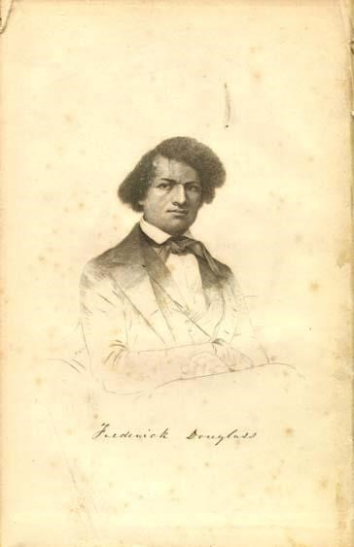Read his autobiography:
https://docsouth.unc.edu/neh/douglass/douglass.html
“Frederick Douglass was an escaped slave who became a prominent activist, author and public speaker. He became a leader in the abolitionist movement, which sought to end the practice of slavery, before and during the Civil War. After that conflict and the Emancipation Proclamation of 1862, he continued to push for equality and human rights until his death in 1895. *** Douglass’ 1845 autobiography, Narrative of the Life of Frederick Douglass, an American Slave, described his time as a slave in Maryland. It was one of five autobiographies he penned, along with dozens of noteworthy speeches, despite receiving minimal formal education. https://www.history.com/topics/blackhistory/frederick-douglass

1845 AUTOBIOGRAPHY:
“I WAS born in Tuckahoe, near Hillsborough, and about twelve miles from Easton, in Talbot county, Maryland. I have no accurate knowledge of my age, never having seen any authentic record containing it. By far the larger part of the slaves know as little of their ages as horses know of theirs, and it is the wish of most masters within my knowledge to keep their slaves thus ignorant. I do not remember to have ever met a slave who could tell of his birthday. They seldom come nearer to it than planting-time, harvest-time, cherry-time, spring-time, or fall-time. A want of information concerning my own was a source of unhappiness to me even during childhood. The white children could tell their ages. I could not tell why I ought to be deprived of the same privilege. I was not allowed to make any inquiries of my master concerning it. He deemed all such inquiries on the part of a slave improper and impertinent, and evidence of a restless spirit. The nearest estimate I can give makes me now between twenty-seven and twenty-eight years of age. I come to this, from hearing my master say, sometime during 1835, I was about seventeen years old. My mother was named Harriet Bailey. She was the daughter of Isaac and Betsey Bailey, both colored, and quite dark.
My mother was of a darker complexion than either my grandmother or grandfather.
My father was a white man. He was admitted to be such by all I ever heard speak of my parentage. The opinion was also whispered that my master was my father; but of the correctness of this opinion, I know nothing; the means of knowing was withheld from me. My mother and I were separated when I was but an infant-before I knew her as my mother. It is a common custom, in the part of Maryland from which I ran away, to part children from their mothers at a very early age. Frequently, before the child has reached its twelfth month, its mother is taken from it, and hired out on some farm a considerable distance off, and the child is placed under the care of an old woman, too old for field labor. For what this separation is done, I do not know, unless it be to hinder the development of the child's affection toward its mother, and to blunt and destroy the natural affection of the mother for the child. This is the inevitable result.” https://docsouth.unc.edu/neh/douglass/douglass.html

1849: Harriet Tubman – Freed Slaves / Civil War Hero
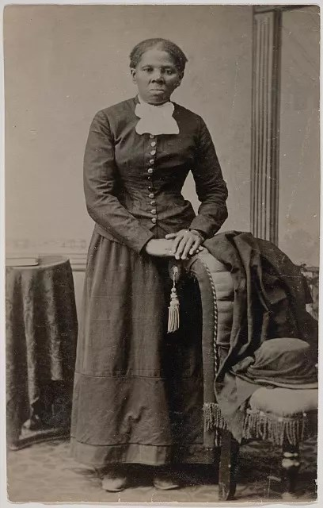Harriet Tubman (1822 – 1913)

“Tubman deserves to retain recognition of her immense contributions. As then-Secretary of the Navy Carlos Del Toro said upon announcing the ship’s name, “Our fleet benefits from having her name emblazoned on the hull of one of our great ships.” Often called the “Moses of her people,” Tubman was born enslaved on Maryland’s Eastern Shore; she escaped in 1849 and sought freedom in Philadelphia. She risked that freedom to return to Maryland more than a dozen times over the next 11 years and rescued 70 people, advising dozens more who freed themselves.

***

Often called the “Moses of her people,” Tubman was born enslaved on Maryland’s Eastern Shore; she escaped in 1849 and sought freedom in Philadelphia. She risked that freedom to return to Maryland more than a dozen times over the next 11 years and rescued 70 people, advising dozens more who freed themselves.

Yet Tubman’s service during the Civil War is perhaps her most consequential legacy. After the U.S. military reclaimed Port Royal Sound, South Carolina, from the Confederacy in 1861, Tubman was sent on a critical mission to gather intelligence from the 8,000 formerly enslaved people who had escaped to Union lines. She was attached to Gen. Isaac Stevens’s headquarters and worked for Gens. Rufus Saxton and David Hunter, commanding a ring of Black men as spies, scouts and river pilots.

Tubman’s little-known mission came to fruition on June 1, 1863, when she guided three U.S. Army boats loaded with 300 Black soldiers from Col. James Montgomery’s Second South Carolina Volunteers, and a battery of White soldiers from another regiment, up the Combahee River into Confederate-controlled territory. Earlier, Tubman and her men had infiltrated Confederate plantations and identified the enslaved men who were forced to plant mines along the Combahee River to prevent Union access. With their help, Tubman’s men and the U.S. Army officers defused the mines. Those soldiers also rooted out Confederate forces, burned seven plantations— including the owners’ homes, barns, stockpiles of rice, and stables— and cut Confederate supply lines by destroying a bridge.

From those burned lands, hundreds of enslaved people flocked to the soldiers’ rowboats at the river shore. Fearful that the rowboats might capsize, Montgomery asked Tubman to calm the crowds. Using her strong voice, she started singing and was met with a joyful response of clapping and shouting. Seven hundred and fifty-six people were liberated that day; the U.S. Army did not lose a single life. The Combahee Ferry Raid is now considered the largest and most successful slave rebellion in U.S. history.

That Tubman was prohibited from enlisting in the U.S. Army did not stop her from risking her life for the enslaved, or for a nation that hadn’t yet recognized her rights as a citizen. Though she was not paid for her work, which also included nursing the sick and cooking for officers — she took in laundry to scrape by — her service with the armed forces helped make the Combahee River Raid one of the most successful campaigns of the war.
Harriet Tubman was a civil rights leader, but she was also a military hero who risked her life fighting for freedom, our nation and the perfection of our democracy. She earned the honor of having the USNS Harriet Tubman named after her. It should remain part of her legacy — and ours.” https://www.washingtonpost.com/opinions/2025/07/02/tubman-hegseth-naval-ship-removal/?utm_campaign=wp_post_most&utm_medium=email&utm_source=newsletter&carta-url=https%3A%2F%2Fs2.washingtonpost.com%2Fcar-ln-tr%2F4369a44%2F68655c8d22827c5c302bbb00%2F59731235ade4e21a848a56ed%2F38%2F68%2F68655c8d22827c5c302bbb00

1850s – New York City Slave Trade
“In the 1850s, a quarter century after slavery was banned in New York State, the city grimly developed into a thriving center of trans-Atlantic human trafficking, with slave ships regularly being outfitted in Lower Manhattan and sent to West Africa. There, imprisoned Africans were forced aboard and shipped to Cuba for a life of servitude.
Mr. Emilio Sanchez [Cuban-born spy ] who was a commission merchant and ship broker in New York, sought to destroy this trade by secretly identifying and tracking slave ships leaving the city so British naval vessels could intercept them off the African coast. During the same period, Horace Greeley was the editor of the New York paper that most vigorously denounced the illegal slave trade in an era when it was rampant and few stood against it.” https://www.nytimes.com/2025/07/06/realestate/streetscapes-brooklyn-british-spy.html

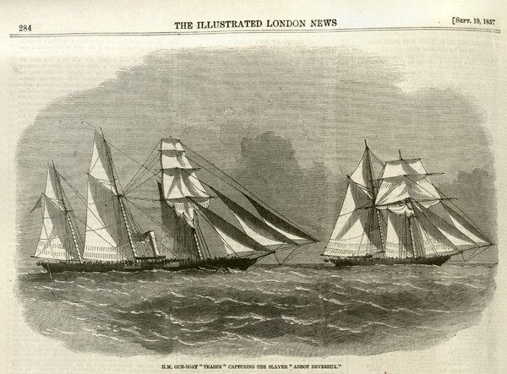
An American slave ship sought to bring enslaved Africans to Cuba in 1857 but was intercepted by the British Navy, above. Such captures became more common in 1859, when the British hired Emilio Sanchez to secretly identify slave ships before they left New York for the African coast. Credit...The Illustrated London News

Sept. 12, 1847: “From The Halls of Montezuma” – Marine Corps Hymn
“In 1845, the U.S. launched the Mexican-American War to seize Mexican lands. In September 1847, U.S. Marines and Army troops fought Mexican forces defending Mexico City. In the Battle of Chapultepec, the Americans captured Chapultepec Castle, a historic site also known as the Halls of Montezuma. The victory effectively ended the war.” https://www.kennedy-center.org/education/resources-for-educators/classroom-resources/media-and-interactives/media/music/story-behind-the-song/the-story-behind-the-song/the-marines-hymn/
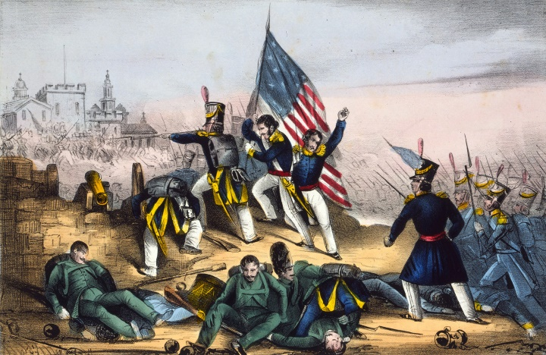

1850: Fugitive Slave Act / Underground Railroad
“What is the Underground Railroad?... The decision to assist a freedom seeker may have been spontaneous. However, in some places, especially after the Fugitive Slave Act of 1850, the Underground Railroad was deliberate and organized. Despite the illegality of their actions, people of all races, class and genders participated in this widespread form of civil disobedience. Freedom seekers went in many directions – Canada, Mexico, Spanish Florida, Indian territory, the West, Caribbean islands and Europe. “I was the conductor of the Underground Railroad for eight years, and I can say what most conductors can't say — I never ran my train off the track and I never lost a passenger.” https://www.nps.gov/subjects/undergroundrailroad/what-is-the-underground-railroad.htm

1853: Boston and Cincinnati each claim to be the oldest fire department; who is correct?

1853: “On April 1, 1853, Cincinnati, Ohio, established the first professional and fully paid fire department in the United States.” https://www.cincinnati-oh.gov/fire/about-fire/history/
1678: “The first paid (call) municipal fire department organized. Thomas Atkins is the first fire chief, aided by twelve assistants. The first fire engine purchased and a building provided to house fire engine. The engine, imported from England, was lodged in a shed on town land on Queen (now Court) St., near the (then) prison.” https://bostonfirehistory.org/boston-history-before-1859/

Oct. 16, 1854 – Lincoln opposed to slavery
“Abraham Lincoln said, ‘no man is good enough to govern another man, without that other's consent. I say this is the leading principle-the sheet anchor of American republicanism.... Now the relation of masters and slaves is, pro tanto, a total violation of this principle’ (Lincoln, Speech at Peoria, Ill. [October 16, 1854] [reprinted in 2 Collected Works of Lincon 266 [Basher ed 1953]).

May 22, 1856: The Caning of Senator Charles Sumner
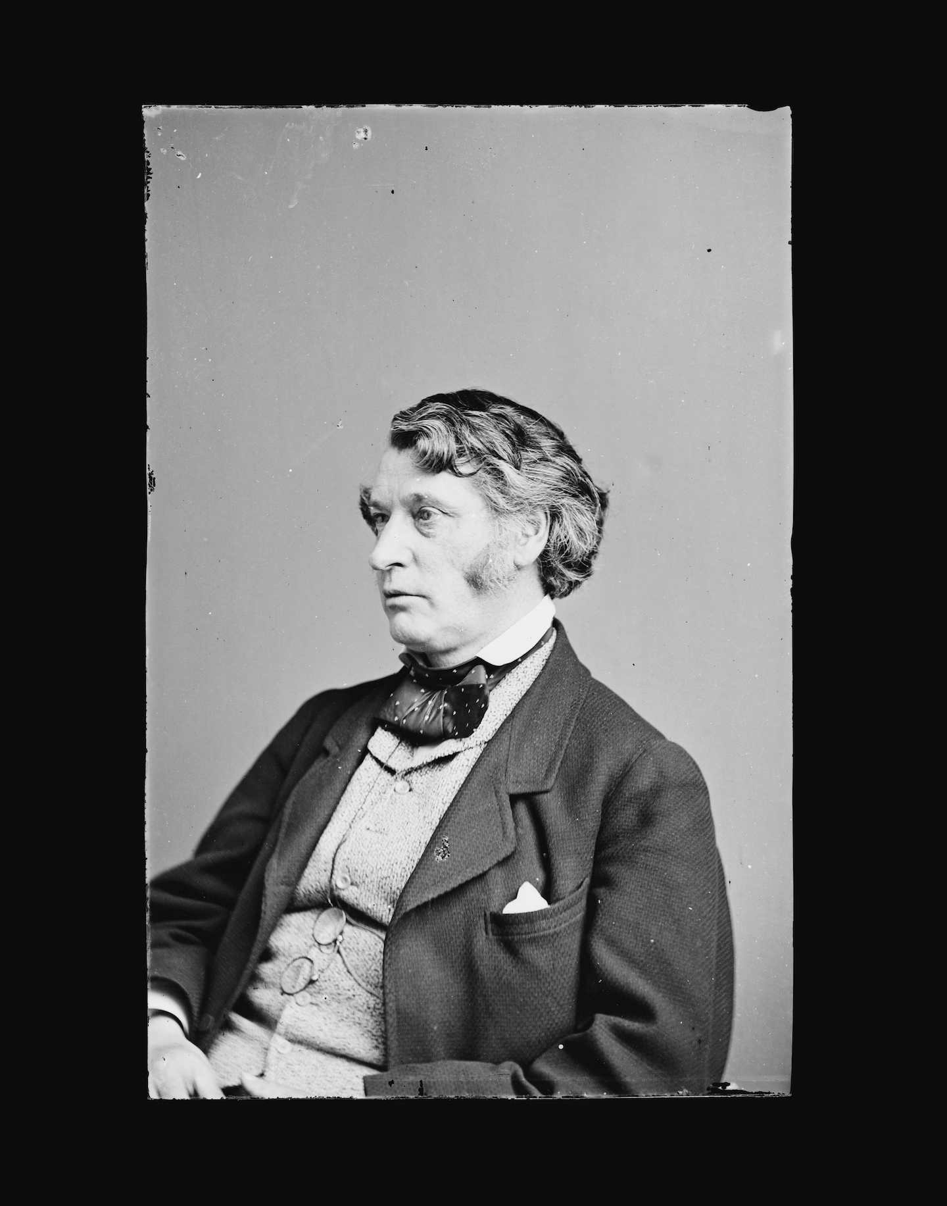
Former Massachusetts senator Charles Sumner (Library of Congress)

“On May 22, 1856, the ‘world's greatest deliberative body’ became a combat zone. In one of the most dramatic and deeply ominous moments in the Senate's entire history, a member of the House of Representatives entered the Senate Chamber and savagely beat a senator into unconsciousness.
The inspiration for this clash came three days earlier when Senator Charles Sumner, a Massachusetts antislavery Republican, addressed the Senate on the explosive issue of whether Kansas should be admitted to the Union as a slave state or a free state. In his ‘Crime Against Kansas’ speech, Sumner identified two Democratic senators as the principal culprits in this crime—Stephen Douglas of Illinois and Andrew Butler of South Carolina. He characterized Douglas to his face as a "noise-some, squat, and nameless animal . . . not a proper model for an American senator." Andrew Butler, who was not present, received more elaborate treatment. Mocking the South Carolina senator's stance as a man of chivalry, the Massachusetts senator charged him with taking ‘a mistress . . . who, though ugly to others, is always lovely to him; though polluted in the sight of the world, is chaste in his sight—I mean,’ added Sumner, ‘the harlot, Slavery.’
Representative Preston Brooks was Butler's South Carolina kinsman. If he had believed Sumner to be a gentleman, he might have challenged him to a duel. Instead, he chose a light cane of the type used to discipline unruly dogs. Shortly after the Senate had adjourned for the day, Brooks entered the old chamber, where he found Sumner busily attaching his postal frank to copies of his "Crime Against Kansas" speech.
Moving quickly, Brooks slammed his metal-topped cane onto the unsuspecting Sumner's head. As Brooks struck again and again, Sumner rose and lurched blindly about the chamber, futilely attempting to protect himself. After a very long minute, it ended.
Bleeding profusely, Sumner was carried away. Brooks walked calmly out of the chamber without being detained by the stunned onlookers. Overnight, both men became heroes in their respective regions.
Surviving a House censure resolution, Brooks resigned, was immediately reelected, and soon thereafter died at age 37. Sumner recovered slowly and returned to the Senate, where he remained for another 18 years. The nation, suffering from the breakdown of reasoned discourse that this event symbolized, tumbled onward toward the catastrophe of civil war.”
https://www.senate.gov/artandhistory/history/minute/The_Caning_of_Senator_Charles_S umner.htm

March 6, 1857: U.S. Supreme Court - Dred Scott v. Sandford (60 US 393)
https://www.oyez.org/cases/1850-1900/60us393

“Issue: In this pre-Civil War case, the question was whether Congress had the constitutional power to prohibit slavery in free territories. A second question was whether the Constitution gave African Americans the right to sue in federal court.
Result: The 1857 Court answered no on both accounts: Congress could not prohibit slavery in territories, and African Americans also had no right to sue in federal court. In reaching these answers, the Court, interpreting the Constitution as it existed before the Civil War Amendments (Constitutional Amendments 13, 14, and 15) abolished slavery, concluded that people of African descent had none of the rights of citizens. The Court further reasoned that slaves were "property" and therefore could not be taken from their owners without due process.
Importance: The Dred Scott case became a central issue in the debate surrounding the expansion of slavery and further fueled the flames leading to the Civil War.” https://www.americanbar.org/groups/public_education/programs/constitution_day/landmark-cases/

CALLED THE WORST DECISION IN HISTORY / DECLARING SLAVES “PROPERTY” [overturned by 13th Amendment in 1865]
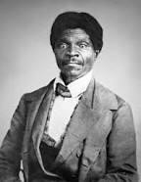
“On March 6, 1857, the U.S. Supreme Court handed down its decision in Scott v. Sanford, delivering a resounding victory to southern supporters of slavery and arousing the ire of northern abolitionists. During the 1830s, the owner of an enslaved man named Dred Scott had taken him from the slave state of Missouri to the Wisconsin territory and Illinois, where slavery was outlawed, according to the terms of the Missouri Compromise of 1820. Upon his return to Missouri, Scott sued for his freedom on the basis that his temporary removal to free soil had made him legally free. The case went to the Supreme Court, where Chief Justice Roger B. Taney and the majority eventually ruled that Scott was an enslaved person and not a citizen, and thus had no legal rights to sue.” https://www.history.com/articles/black-history-milestones

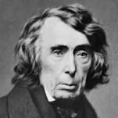Chief Justice Roger B. Taney
[See Washington Post article, July 22, 2020.] “The House voted Wednesday to remove statues of Confederate leaders from the Capitol and replace the bust of Roger B. Taney, the U.S. chief justice who wrote the Supreme Court decision that said people of African descent are not U.S. citizens. *** In 1857, Taney wrote the majority decision in the case of Scott, a black man born into slavery who used the courts to demand his freedom. Taney’s ruling, which defended slavery and declared that black people could never become U.S. citizens, came to be viewed as one of the worst Supreme Court decisions in U.S. history. Taney wrote that at the time of the Constitution’s ratification, black people ‘had for more than a century before been regarded as beings of an inferior order and altogether unfit to associate with the white race, either in social or political relations; and so far inferior that they had no rights which the white man was bound to respect; and that the Negro might justly and lawfully be reduced to slavery for his benefit.’” https://www.washingtonpost.com/powerpost/house-to-vote-on-removing-confederatestatues-from-the-capitol-and-replacing-bust-of-segregationist-chiefjustice/2020/07/22/72873a50-cba0-11ea-b0e3-
d55bda07d66a_story.html?utm_campaign=wp_evening_edition&utm_medium=email&u tm_source=newsletter&wpisrc=nl_evening
1858: Abraham Lincoln “House Divided”

“Why Lincoln’s ‘House Divided’ Speech Was So Important’”
”When Abraham Lincoln said “a house divided against itself cannot stand,” he wasn’t talking about the kind of political divisions common today. Americans may differ sharply on issues like immigration and abortion, but there is no single issue that geographically and economically divides the country in the same way that slavery did in the 1850s. Back then, the U.S. was so divided that many feared it would break out in civil war—a fear that Lincoln unwittingly stoked.
Lincoln’s now-famous “house divided” line, which is drawn from the Bible, was actually part of a campaign speech he delivered at the 1858 Illinois Republican State Convention. Lincoln, then a relatively unknown politician, had just won the nomination to run for U.S. Senate against one of the most important politicians in the country, Stephen A. Douglas.” https://www.history.com/news/abraham-lincoln-house-divided-speech

“In 1858, Lincoln made a mistake.” https://www.washingtonpost.com/opinions/2024/06/19/biden-lincoln-house-divided-lessons/?utm_campaign=wp_todays_headlines&utm_medium=email&utm_source=newsletter&wpisrc=nl_headlines&carta-url=https%3A%2F%2Fs2.washingtonpost.com%2Fcar-ln-tr%2F3e0af68%2F6673fdb61805fa57aecf48d1%2F59731235ade4e21a848a56ed%2F20%2F61%2F6673fdb61805fa57aecf48d1

“He was warning of what slavery’s supporters would attempt to do — legalize it everywhere — if they succeeded in spreading it into the territories, as allowed under the Kansas-Nebraska Act. Nearly every modern-day president has invoked Lincoln’s phrase, often as part of an appeal to national unity during election season. Usually forgotten, however, is that those words might have helped cost Lincoln the Senate race, as Lincoln scholar Allen Guelzo has noted. Although Lincoln aimed to inspire unity against the spread of slavery, Democrats turned the metaphor around on him, accusing him of inflaming tensions and pushing the country toward conflict — precisely what they themselves had been doing through their support of the Kansas-Nebraska Act and growing talk of secession.”

Oct. 16-18, 1859 - John Brown’s Raid – Happer’s Ferry
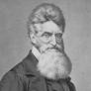
“A native of Connecticut, John Brown struggled to support his large family and moved restlessly from state to state throughout his life, becoming a passionate opponent of slavery along the way. After assisting in the Underground Railroad out of Missouri and engaging in the bloody struggle between pro- and anti-slavery forces in Kansas in the 1850s, Brown grew anxious to strike a more extreme blow for the cause. On the night of October 16, 1859, he led a small band of less than 50 men in a raid against the federal arsenal at Harper’s Ferry, Virginia. Their aim was to capture enough ammunition to lead a large operation against Virginia’s slaveholders. Brown’s men, including several Black people, captured and held the arsenal until federal and state governments sent troops and were able to overpower them. John Brown was hanged on December 2, 1859. His trial riveted the nation, and he emerged as an eloquent voice against the injustice of slavery and a martyr to the abolitionist cause. Just as Brown’s courage turned thousands of previously indifferent northerners against slavery, his violent actions convinced slave owners in the South beyond doubt that abolitionists would go to any lengths to destroy the "peculiar institution.” Rumors spread of other planned insurrections, and the South reverted to a semi-war status. Only the election of the anti–slavery Republican Abraham Lincoln as president in 1860 remained before the southern states would begin severing ties with the Union, sparking the bloodiest conflict in American history.” https://www.history.com/articles/black-history-milestones

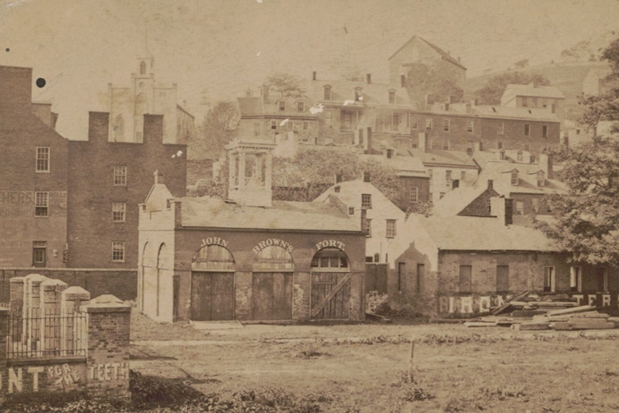

Colonel Robert E. Lee [later Confederate General]:

“After a botched attempt at taking over the town and inciting a slave rebellion, John Brown and his polyglot force had seized hostages and taken refuge inside a small brick engine house on federal property. The Marines marched to Harpers Ferry, entering the arsenal grounds through a back gate. About 11 pm, Lee ordered the various volunteer units out of the grounds, clearing space for the only regular troops at his disposal—the Marines under Greene. The following morning, Lee demanded that the terrorists surrender. When all attempts to negotiate with Brown failed, 27 Marines broke down the door with a battering ram, rushed into the building, killed or wounded the holdouts, and took Brown prisoner. Lee would later write, ‘I must also ask to express my entire commendation of the conduct of the detachment of Marines, who were at all times ready and prompt in the execution of any duty.’” https://warfarehistorynetwork.com/harpers-ferry-the-rise-of-robert-e-lee-and-j-e-b-stuart/

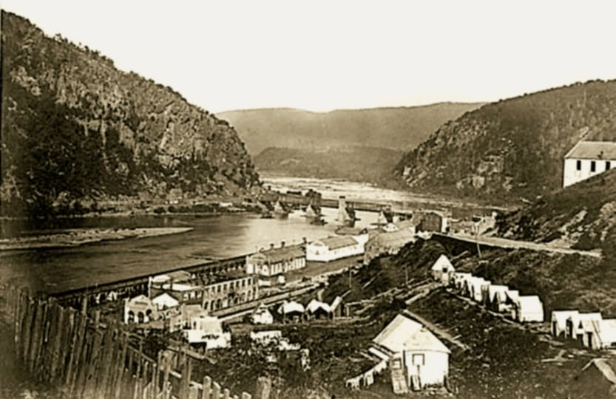

HARPER’S FERRY
Located where the Potomac and Shenandoah Rivers meet, Harper’s Ferry was in a critical strategic location and exchanged hands several times during the war. It is most famous for being the target of abolitionist John Brown’s unsuccessful raid on its armory in 1859. Most of the lower town was in ruins by the end of the war. It was rebuilt and is now a very popular destination for Civil War buffs, maintained by the National Park Service.

Feb. 12, 1861 – Lincoln In Cincinnati
“Abraham Lincoln spent his birthday in Cincinnati on Feb. 12, 1861, on his way from Springfield, Illinois, to the nation’s capital for his inauguration. *** Lincoln’s visit was just as the nation was falling apart. Yet, Lincoln narrowly won the presidency in 1860, despite not taking a single Southern state. In the first three months after the contentious election, seven states in the South seceded from the Union. There was a legitimate question whether Kentucky, a slave state, would soon follow. ***In his speech in Cincinnati two years earlier in [Sept. 17] 1859, he had said, ‘I think slavery is wrong, morally, and politically. I desire that it should be no further spread in these United States, and I should not object if it should gradually terminate in the whole Union.’ But he also said, ‘I say that we must not interfere with the institution of slavery in the states where it exists, because the Constitution forbids it, and the general welfare does not require us to do so.’ That was still his stance at the start of his presidency in 1861. Lincoln was mainly concerned with keeping the Union together as disgruntled states in the South were breaking away.” https://www.cincinnati.com/story/news/2025/02/09/what-abraham-lincoln-said-during-1861-visit-cincinnati/77722960007/?utm_source=enquirer-dailybriefing-strada&utm_medium=email&utm_campaign=dailybriefing-headline-stack&utm_term=Content%20List%20-%20Stacking%20-%20optimized&utm_content=pcin-cincinnati-nletter65

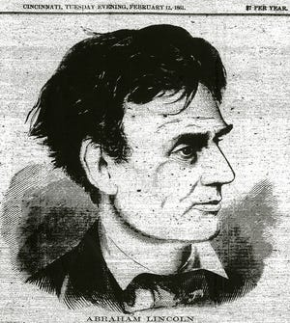

April 12, 1861: Civil War (April 12, 1861 – May 26, 1865)
“The Civil War is the central event in America's historical consciousness. While the Revolution of 1776-1783 created the United States, the Civil War of 1861-1865 determined what kind of nation it would be. The war resolved two fundamental questions left unresolved by the revolution: whether the United States was to be a dissolvable confederation of sovereign states or an indivisible nation with a sovereign national government; and whether this nation, born of a declaration that all men were created with an equal right to liberty, would continue to exist as the largest slaveholding country in the world.” https://www.battlefields.org/learn/articles/brief-overview-american-civil-war
***
“The Civil War was America's bloodiest conflict. The unprecedented violence of battles such as Shiloh, Antietam, Stones River, and Gettysburg shocked citizens and international observers alike. Nearly as many men died in captivity during the Civil War as were killed in the whole of the Vietnam War. Hundreds of thousands died of disease. Roughly 2% of the population, an estimated 620,000 men, lost their lives in the line of duty.” https://www.battlefields.org/learn/articles/civil-war-casualties
***

Ulysses S. Grant, General-in-Chief, Union Army:
https://www.battlefields.org/learn/biographies/ulysses-s-grant
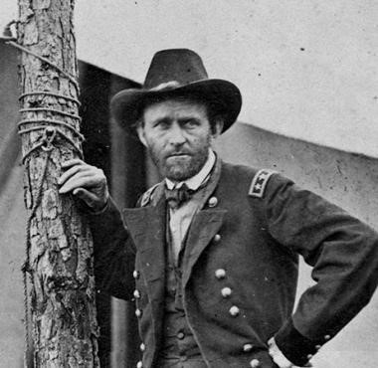
General Robert E. Lee, commander of the Confederate "Army of Northern Virginia":
https://www.nps.gov/gett/learn/historyculture/people.htm
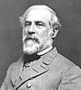

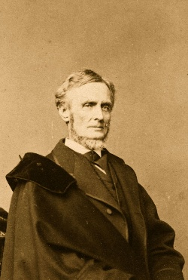Jefferson Davis

1861 – Mary Richards Bowser - Spy For The North
Domestic Servant Confederate President Jefferson Davis In Confederate White House, Richmond, VA / Northern Spy

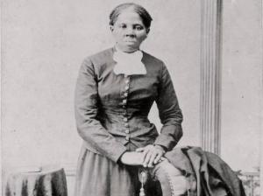

“Mary Richards Bowser was born into slavery and later became a missionary to Liberia, a Union spy in the Confederate White House during the American Civil War (1861–1865), and a teacher at freedmen’s schools. As a child, she was enslaved by the Van Lew family of Richmond; Elizabeth Van Lew, who had arranged for her to be educated in the North and provided her with de facto freedom prior to the war, ran a pro-Union intelligence ring in which Bowser played an important role.” https://encyclopediavirginia.org/entries/bowser-mary-richards-fl-1846-1867/

***

“Born a slave, Mary Elizabeth Bowser, worked as a domestic servant, cleaning and cooking for the family of Confederate President Jefferson Davis – simultaneously spying and reporting her findings to abolitionist Elizabeth Van Lew as part of an elaborate woman’s spy ring. Bowser worked on the John Van Lew plantation outside Richmond, Virginia. After her father’s death in 1851, Van Lew freed Ms. Bowser and other Van Lew family slaves. Recognizing her potential and intelligence, Van Lew sent Bowser north to attend school. During the Civil War, Van Lew organized the spy ring, eventually sending for Bowser after deciding to plant a spy in the home of Davis.” https://baltimoretimes-online.com/living-well/2025/02/21/mary-elizabeth-bowser-the-black-spy-who-infiltrated-the-home-of-a-c

April 17, 1861 – Lincoln suspends Writ of Habeas Corpus
“Lincoln's Suspension of the Writ of Habeas Corpus: An Historical and Constitutional Analysis” - https://quod.lib.umich.edu/j/jala/2629860.00

“The background is well known. After Virginia seceded from the Union on April 17, 1861, the only lines for overland supplies, troop movements, transportation, and communication to Washington, D.C., ran through Maryland, with the railroads running through Baltimore. Baltimore was a rough city for the Union, and Maryland an uncertain ally. In February, Baltimore rowdies had forced President-elect Lincoln to sneak through the city in disguise, and a mob attacked the Sixth Massachusetts Regiment as it marched through Baltimore on its way to Washington. Confederate sympathizers in Maryland were numerous, organized, and sometimes violent. The Maryland legislature was of questionable loyalty, prompting Lincoln to monitor its April 26 session and, later, to order the arrest of a number of its members.

Determined to keep the Maryland lines open, on April 27 Lincoln issued an order to General Winfield Scott authorizing him to suspend the writ of habeas corpus, at or near any military line between Philadelphia and Washington if the public safety required it. Lincoln issued his order pursuant to the provision in Article I, Section 9 of the Constitution stating that "the privilege of the writ of habeas corpus shall not be suspended, unless when in cases of rebellion and invasion the public safety may require it," generally called the suspension clause.

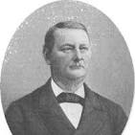

On May 25, federal troops arrested John Merryman in Cockeysville, Maryland, for recruiting, training, and leading a drill company for Confederate service. Merryman's lawyer promptly petitioned Chief Justice Roger Brooke Taney, sitting as a trial judge, for a writ of habeas corpus. This writ, sometimes called the Great Writ, is a judicial writ addressed to a jailer ordering him to come to court with his prisoner and explain why the prisoner is being held.

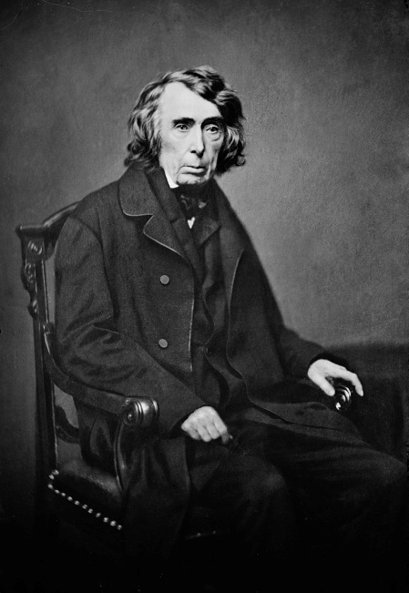

Following a hearing in the matter, Taney ordered delivery of a writ of habeas corpus to General George Cadwallader directing him to appear before Taney on May 28 with Merryman in tow. After Cadwallader refused service of the writ, Taney ruled on May 28 that the president did not have the power to suspend the writ, and Taney announced that he later would issue an opinion in support of his ruling.

Several days later, Taney issued his opinion. [Ex Parte Merryman, 17 F. Cas. 144 (1861).]

Only Congress, he said, could suspend the writ of habeas corpus. He observed that the limitation on suspension of the writ appeared in Article I of the Constitution, dealing with legislative powers, not in Article II, which established executive power. He explored the history of the writ of habeas corpus under English law, showing that the House of Commons had limited and then abolished the royal power to suspend the writ, leaving suspension in legislative hands. The Constitution, he said, embodied this English tradition. Article II, he asserted, gave the president very limited powers that were weakened further by the Bill of Rights. Finally, he cited eminent authority, noting that Chief Justice John Marshall, Thomas Jefferson, and Joseph Story, a luminary as both judge and scholar, had all acknowledged that the power to suspend was a congressional power.

Lincoln ignored Taney, and that was the end of the federal judiciary's involvement with the suspension of habeas corpus. Neither the Supreme Court nor the lower federal courts dealt with the issue again. The action now passed to the president and Congress.”

1862: The Homestead Act of 1862
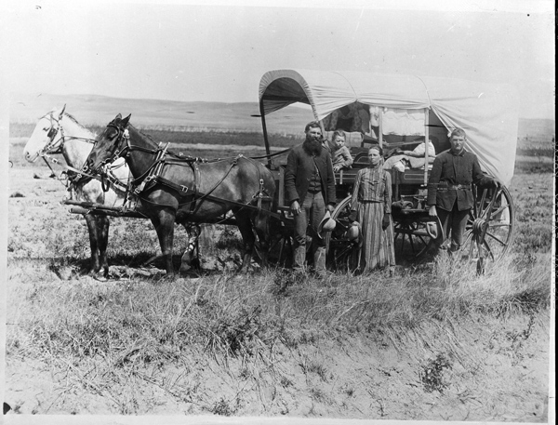
“President Abraham Lincoln signed the Homestead Act on May 20, 1862. On January 1, 1863, Daniel Freeman made the first claim under the Act, which gave citizens or future citizens up to 160 acres of public land provided they live on it, improve it, and pay a small registration fee. The Government granted more than 270 million acres of land while the law was in effect…. The Civil War removed the slavery issue because the Southern states had seceded from the Union. So finally, in 1862, the Homestead Act was passed and signed into law. The new law established a three-fold homestead acquisition process: file an application, improve the land, and file for deed of title. Any U.S. citizen, or intended citizen, who had never borne arms against the U.S. Government could file an application and lay claim to 160 acres of surveyed Government land. For the next 5 years, the General Land Office looked for a good faith effort by the homesteaders. This meant that the homestead was their primary residence and that they made improvements upon the land. After 5 years, the homesteader could file for his patent (or deed of title) by submitting proof of residency and the required improvements to a local land office.” https://www.archives.gov/education/lessons/homestead-act#background

Feb. 21, 1862 – Slave Trader Hung – U.S. Built Ships Taking Slaves From Africa To Brazil
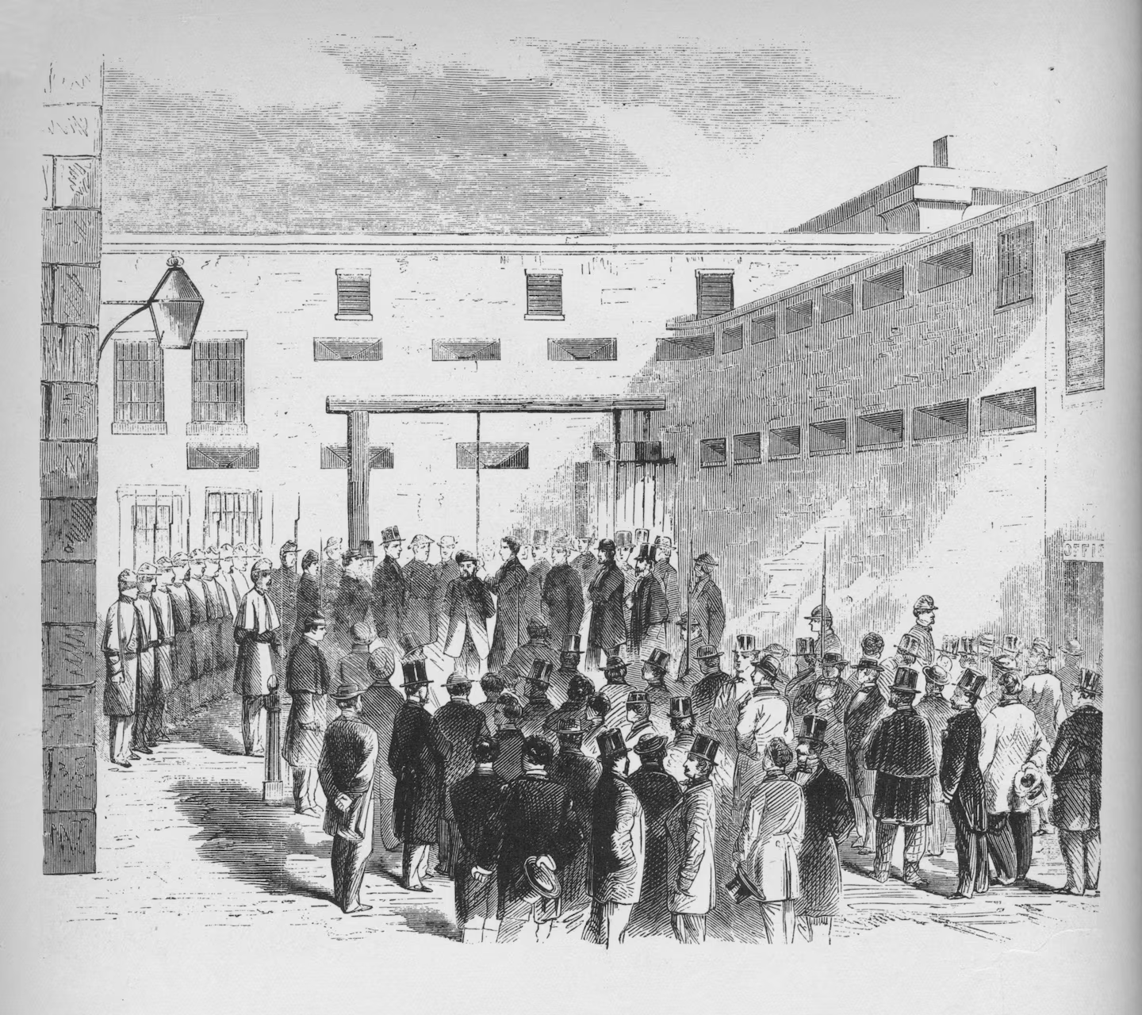Slave trader Nathaniel Gordon was hanged in the Tombs prison in New York in 1862. It was the only time an American was executed for violating the law against slave trading.
“’Any man, who, for paltry gain and stimulated only by avarice, can rob Africa of her children to sell into interminable bondage, I will never pardon,’ Abraham Lincoln said, according to author Ron Soodalter, denying Gordon’s pleas for clemency. https://www.washingtonpost.com/history/2024/03/31/camargo-us-slave-ship-brazil/?utm_campaign=wp_evening_edition&utm_medium=email&utm_source=newsletter&carta-url=https%3A%2F%2Fs2.washingtonpost.com%2Fcar-ln-tr%2F3d40f74%2F6609cee53f3b3130891acbfb%2F59731235ade4e21a848a56ed%2F11%2F40%2F6609cee53f3b3130891acbfb

June 28, 1862 – Richmond / Injured Soldiers
“A largely candid glimpse of men wounded at the Battle of Gaines' Mill resting and being treated at a field hospital at Savage Station the day after the battle, June 28, 1862, about 10 miles east of Richmond. In this detail you can see men caring for the wounded, who are fortunate to have some hay or straw for comfort. Hanging haversacks on the fence, musket, pouches, tents and more. Feel free to call out the straw hat unit!” Garry Adelman's Civil War Page, https://www.facebook.com/p/Garry-Adelmans-Civil-War-Page-100044534825272/

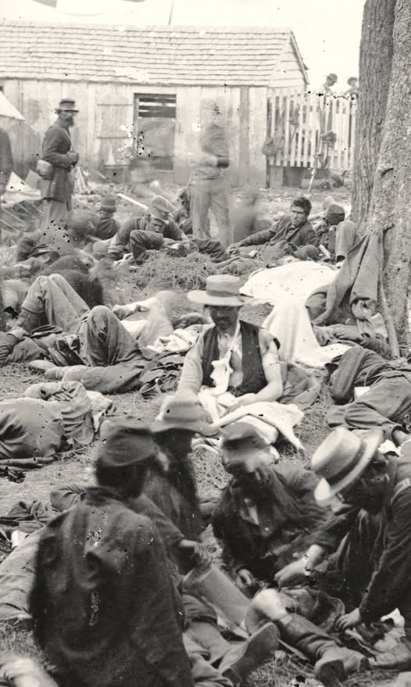

SEPT. 11, 1862 – CINCINNATI NOT INVADED BY CONFEDERATES – BLACK BRIGADE
“That Cincinnati did not fall was largely due to the leadership of Maj. Gen. Lew Wallace, a Union general who was dogged by controversy after the Battle of Shiloh a few months earlier. His defense of Cincinnati maybe only happened because he was trying to prove himself after Shiloh. *** Meanwhile, panicked Cincinnatians prepared for a siege. Wallace took command of Cincinnati, Newport and Covington and declared martial law on Sept. 1. *** Wallace ordered the organization of the Black Brigade, with abolitionist Col. William M. Dickson in command. The 300 kidnapped Black men were sent home and given the dignity of volunteering. The next day, 700 volunteers for the Black Brigade showed up. *** A force of some 70,000 soldiers – a mix of the regular army and volunteers – showed up to defend Cincinnati. That number included 15,000 backwoods fighters known as ‘Squirrel Hunters,’ armed with pistols, shotguns and sporting rifles. When the Confederate troops arrived, they found Cincinnati was prepared to defend itself. Realizing that invasion would not be easy, [General Henry] Heth and the Confederates pulled out during the night of Sept. 11.” https://www.cincinnati.com/story/news/2024/01/27/major-general-lew-wallace-saved-cincinnati-during-civil-war/72312546007/

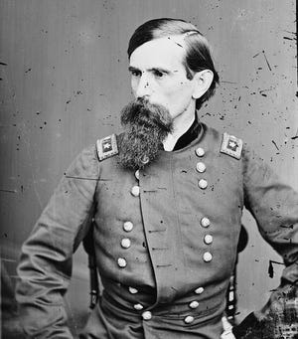
Union General Lew Wallace

Dec. 26, 1862: US – DAKOTA WAR - 38 SANTEE SIOUX HUNG
“On August 17, [1862] a Dakota hunting party stole eggs from settlers in Acton Township, located in Meeker County. The raid led to the deaths of five settlers. Little Crow, a chief of the Mdewakanton band of Dakota, decided to continue the raids. The day after the raid in Acton, Little Crow led another raid against the Lower Sioux Agency near Morton, MN in Renville County. A relief force, led by the Minnesota Militia, was routed by the Dakota. In the subsequent days, Dakota warriors led raids against New Ulm and Fort Ridgley, both of which had limited success. Because of the Civil War, the US government was slow to send troops to quell the uprising. Instead, military forces were primarily comprised of volunteer groups, led by former Governor Henry Sibley. On September 23, federal forces defeated the Dakota at the Battle of Wood Lake in Yellow Medicine County. Three days later, the Dakota surrendered, releasing nearly 300 captives. The Dakota who surrendered were held until military trials could take place that November. Hundreds of Dakota were held at Camp Release, near Montevideo.” https://cla.umn.edu/chgs/holocaust-genocide-education/resource-guides/us-dakota-war-1862
***
“At 10:00 am on December 26, 38 Dakota prisoners were led to a scaffold specially constructed for their execution. One had been given a reprieve at the last minute. An estimated 4,000 spectators crammed the streets of Mankato and surrounding land. Col. Stephen Miller, charged with keeping the peace in the days leading up to the hangings, had declared martial law and had banned the sale and consumption of alcohol within a ten-mile radius of the town. As the men took their assigned places on the scaffold, they sang a Dakota song as white muslin coverings were pulled over their faces. Drumbeats signaled the start of the execution. The men grasped each others’ hands. With a single blow from an ax, the rope that held the platform was cut. Capt. William Duley, who had lost several members of his family in the attack on the Lake Shetek settlement, cut the rope.” https://www.usdakotawar.org/history/aftermath/trials-hanging

LINCOLN SAVED 265
“In August 1862, starving Dakota families, whose annuity payments under a laxly enforced treaty had been delayed by the confusion of the Civil War, appealed to the owner of a reservation trading post for food on credit. The trader, Andrew Myrick, was reported to have answered, ‘Let them eat grass or their own dung.’ The next day, an outraged young tribesman murdered a family of settlers.
Chief Little Crow reluctantly agreed to expand the assault into a general war on settlers along the Upper Minnesota River, though he predicted the ultimate result. “The white men are like the locusts,” he said. No matter how many the Sioux killed, “ten times ten will come to kill you.” In the following weeks, as many as 800 settlers were killed in history’s largest uprising of Native Americans — including Myrick, whose corpse was recovered with grass stuffed in his mouth.
Some of the killings were even more brutal: A baby was nailed to a tree. Women and children hiding in a field of tall grass were burned alive. Panic was so widespread among the settlers that President Lincoln dispatched one of his private secretaries, John Nicolay, to go by train to Minnesota and render a reliable report.
The timing could not have been worse for Lincoln. A springtime of Union successes had sagged into a summer of demoralizing failures culminating in a two-pronged invasion of the North by Confederate armies. Union troops were deserting by the thousands. Lincoln’s Cabinet appeared to be splintering. And Queen Victoria’s government was preparing to intervene in the war to force a conclusion that would permanently divide the United States.
Assured by his secretary of the need for more troops, Lincoln dispatched sufficient forces to Minnesota to bring the war to an end. Gen. John Pope telegraphed the president in October that he intended to hold prompt trials for hundreds of Dakota prisoners, and was “anxious to execute a number of them.” The tribunals were an acknowledged sham: Pope wrote at the outset that he found it difficult to figure out which Dakota participated in the fighting and which ones actually tried to prevent it.
In early November, in the midst of a chastening off-year election, Pope forwarded a list of 303 prisoners he intended to hang. Minnesota Gov. Alexander Ramsey followed up with a plea to Lincoln that “the execution of every Sioux Indian condemned by the military court will be at once ordered.” Instead, the harried president demanded that all the files be sent to him for review. Lincoln rightly suspected that the public’s desire for revenge had tainted justice.
Ramsey and Pope both warned Lincoln that failure to kill the 303 would result in far worse bloodshed. “Private revenge” by lynch mobs would result in the “indiscriminate massacre of all the Indians — old men, women, and children,” the general wrote. But Lincoln began a careful review of each case. Exasperated, the governor offered to take control of the prisoners and execute them on state authority. Members of Congress arriving from Minnesota for the new session added their own warnings of mob violence if the Sioux were not sacrificed immediately.
Advised by a lawyer that he must personally decide each potential clemency, Lincoln tediously ground his way through 303 files — even as the Civil War dragged and pressure grew from opponents of his proposed Emancipation Proclamation. The easy and popular thing to do was to give Minnesota’s citizenry the executions they demanded, but as Lincoln explained afterward, “I could not hang men for votes.”
Ultimately, the president teased from records of the sham tribunals sufficient grounds to spare the lives of roughly seven out of every eight condemned Dakota. The hanging of 38 prisoners later in December was the largest mass execution in U.S. history, but on the same day, 265 lives were saved solely by the conscience of one man.”
Washington Post article: “Abraham Lincoln Didn’t Deserve Portland’s Wrath (Oct. 13, 2020):https://www.washingtonpost.com/opinions/abraham-lincoln-didnt-deserve-portlandswrath/2020/10/13/8973460e-0d73-11eb-8a35-
237ef1eb2ef7_story.html?utm_campaign=wp_week_in_ideas&utm_medium=email&utm_sourc e=newsletter&wpisrc=nl_ideas&carta-url=https%3A%2F%2Fs2.washingtonpost.com%2Fcar-lntr%2F2c2df81%2F5f8c20549d2fda0efb4d724e%2F59731235ade4e21a848a56ed%2F33%2F73 %2F8a8598bb10de0e3be66b5dbbdbcf9b41

Jan. 1, 1863: Emancipation Proclamation

Abraham Lincoln [age 54] sought to end slavery on New Year’s Day
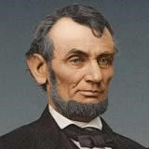
“By freeing some 3 million enslaved people in the rebel states, the Emancipation Proclamation deprived the Confederacy of the bulk of its labor forces and put international public opinion strongly on the Union side. Some 186,000 Black soldiers would join the Union Army by the time the war ended in 1865, and 38,000 lost their lives. The total number of dead at war’s end was 620,000 (out of a population of some 35 million), making it the costliest conflict in American history.” https://www.history.com/articles/black-history-milestones
***
“President Abraham Lincoln issued the Emancipation Proclamation on January 1, 1863, as the nation approached its third year of bloody civil war. The proclamation declared ‘that all persons held as slaves’ within the rebellious states ‘are, and henceforward shall be free.’ Despite this expansive wording, the Emancipation Proclamation was limited in many ways. It applied only to states that had seceded from the United States, leaving slavery untouched in the loyal border states. It also expressly exempted parts of the Confederacy (the Southern secessionist states) that had already come under Northern control. Most important, the freedom it promised depended upon Union (United States) military victory.” https://www.archives.gov/exhibits/featured-documents/emancipation-proclamation#:~:text=President%20Abraham%20Lincoln%20issued%20the,and%20henceforward%20shall%20be%20free.%22
***
https://www.archives.gov/exhibits/featured-documents/emancipation-proclamation
“On New Year’s morning of 1863, President Abraham Lincoln hosted a three-hour reception in the White House. That afternoon, Lincoln slipped into his office and — without fanfare — signed a document that changed America forever. It was the Emancipation Proclamation, decreeing “that all persons held as slaves” within the rebellious Southern states “are, and henceforward shall be, free.” However, the proclamation did not immediately free any of the nation’s nearly 4 million slaves. The biggest impact was that for the first time, ending slavery became a goal of the Union in the bloody civil war with the Confederacy.” On New Year’s morning of 1863, President Abraham Lincoln hosted a three-hour reception in the White House. That afternoon, Lincoln slipped into his office and — without fanfare — signed a document that changed America forever. *** By Jan. 31, 1865, both houses of Congress passed the 13th Amendment that “neither slavery or involuntary servitude … shall exist in the United States.” Slavery officially ended on Dec. 18, 1865 after 27, or two-thirds, of the 36 states ratified the amendment. *** Free African Americans in the North celebrated the news. “We are all liberated by this proclamation,” said the noted orator and former slave Frederick Douglass. “Everybody is liberated. The white man is liberated, the black man is liberated, the brave men now fighting the battles of their country against rebels and traitors are now liberated.” But Douglass cautioned that the proclamation was only a first step; slaves who celebrated the proclamation risked being beaten or hung.” https://www.washingtonpost.com/history/2019/01/01/lincoln-declared-an-end-slaverynew-years-day-it-went-two-moreyears/?utm_term=.41ddb2cefc8e&wpisrc=nl_most&wpmm=1

WATCH NIGHT SERVICES:
“On ‘Freedom’s Eve,’ or the eve of January 1, 1863, the first Watch Night services took place. On that night, enslaved and free African Americans gathered in churches and private homes all across the country awaiting news that the Emancipation Proclamation had taken effect. At the stroke of midnight, prayers were answered as all enslaved people in Confederate States were declared legally free. Union soldiers, many of whom were black, marched onto plantations and across cities in the south reading small copies of the Emancipation Proclamation spreading the news of freedom in Confederate States. Only through the Thirteenth Amendment [Dec. 6, 1865] did emancipation end slavery throughout the United States.” https://nmaahc.si.edu/explore/stories/historical-legacy-juneteenth

1863: Frederick Douglas – Post Civil War - “Father Of The Civil Right Movement”
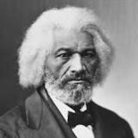Frederick Douglas [age 45]
“In his journey from enslaved young man to internationally renowned activist, Frederick Douglass (1818-1895) has been a source of inspiration and hope for millions. His brilliant words and brave actions continue to shape the ways that we think about race, democracy, and the meaning of freedom.
He became the most important leader of the movement for African American civil rights in the 19th century. After escaping from slavery in Maryland, Douglass became a national leader of the abolitionist movement in Massachusetts and New York, during which he gained fame for his oratory and incisive antislavery writings. He wrote three autobiographies, describing his experiences as an enslaved person in his first, Narrative of the Life of Frederick Douglass, an American Slave (1845), which became a bestseller and was influential in promoting the cause of abolition.
He also actively supported women's suffrage, and he held several public offices. Without his knowledge or consent, he became the first African American nominated for vice president of the United States, as the running mate of Victoria Woodhull on the Equal Rights Party ticket. He believed in dialogue and in making alliances across racial and ideological divides.” https://www.nps.gov/frdo/learn/historyculture/frederickdouglass.htm

March 2, 1863: False Claims Act
“The American colonies began using qui tam statutes in the 1600s as an extension of European practice, and the First Congress included qui tam provisions in the first framing of the Constitution. Congress enacted the FCA with its qui tam provision in 1863 as a means of redressing fraud perpetuated on Union troops. In 1986, Congress amended the FCA to expand liability for fraud to include all government contracts and claims, not just those submitted to the military, and, in 2009, Congress passed the Fraud Enforcement and Recovery Act (FERA), which further expanded the scope of liability for those fraudulently receiving money from the federal government.” https://www.taf.org/brief-history-fca-constitutionality/
See Dec. 21, 2018 Press Release:
“Justice Department Recovers Over $2.8 Billion from False Claims Act Cases in Fiscal Year 2018.” https://www.justice.gov/opa/pr/justice-department-recovers-over-28-billionfalse-claims-act-cases-fiscal-year-2018
“The False Claims Act was originally passed in response to rampant fraud perpetrated against the United States military during the Civil War. Back then, crooked contractors defrauded the Union Army by selling it sick mules, lame horses, sawdust instead of gunpowder, and rotted ships with fresh paint. Unfortunately, what we see today is just a modern version of the same thing — deceptive and fraudulent practices directed at the U.S. government and the American taxpayer,” said Assistant Attorney General Jody Hunt. “The Department of Justice has placed a high priority on rooting out and pursuing those who cheat government programs for their own gain. The recoveries announced today are a message that fraud and dishonesty will not be tolerated.”
In 1986, Congress strengthened the Act by increasing incentives for whistleblowers to file lawsuits alleging false claims on behalf of the government. These whistleblower, or qui tam, actions comprise a significant percentage of the False Claims Act cases that are filed. If the government prevails in a qui tam action, the whistleblower, also known as the relator, receives up to 30 percent of the recovery. Whistleblowers filed 645 qui tam suits in fiscal year 2018, and this past year the Department recovered over $2.1 billion in these and earlier filed suits.”

July 2, 1863: Gettysburg, 2nd Day - Col. Joshua Chamberlin, Maine – “Little Round Top”
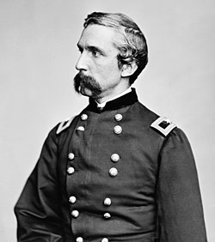
“On July 2, 1863, Chamberlain was posted on the extreme left of the Federal line at Little Round Top—just in time to face Confederate General John B. Hood’s attack on the Union flank. Exhausted after repulsing repeated assaults, the 20th Maine, out of ammunition, executed a bayonet charge, dislodging their attackers and securing General Meade’s embattled left. Though the exact origin of the charge is still the subject of debate, Congress awarded Chamberlain the Medal of Honor for “conspicuous gallantry.”
Shortly after Gettysburg, Chamberlain was given command of a brigade in the Fifth Corps and would retain it until the end of the war. Throughout the war, Chamberlain was wounded six times, most grievously at Petersburg in June 1864. Believing this wound to be mortal, Congress promoted Chamberlain to the rank of Brigadier General. Chamberlain, however, would survive the wound, and return to the front in time to play a pivotal role in the Appomattox Campaign. On April 12, 1865, Brigadier General Chamberlain received the Confederate surrender of arms. Rising to the occasion, the general ordered his men to salute their vanquished foes.
After the war, Chamberlain returned to Maine, where he served four terms as the state’s Governor. He later served as president of Bowdoin College alongside former general and Bowdoin alum, Oliver Otis Howard. Prolific and prosaic throughout his life, Chamberlain spent his twilight years writing and speaking about the war. His memoir of the Appomattox Campaign, The Passing of the Armies was published after his death in 1914.” https://www.battlefields.org/learn/biographies/joshua-lawrence-chamberlain

Nov. 19, 1863 – Gettysburg Address
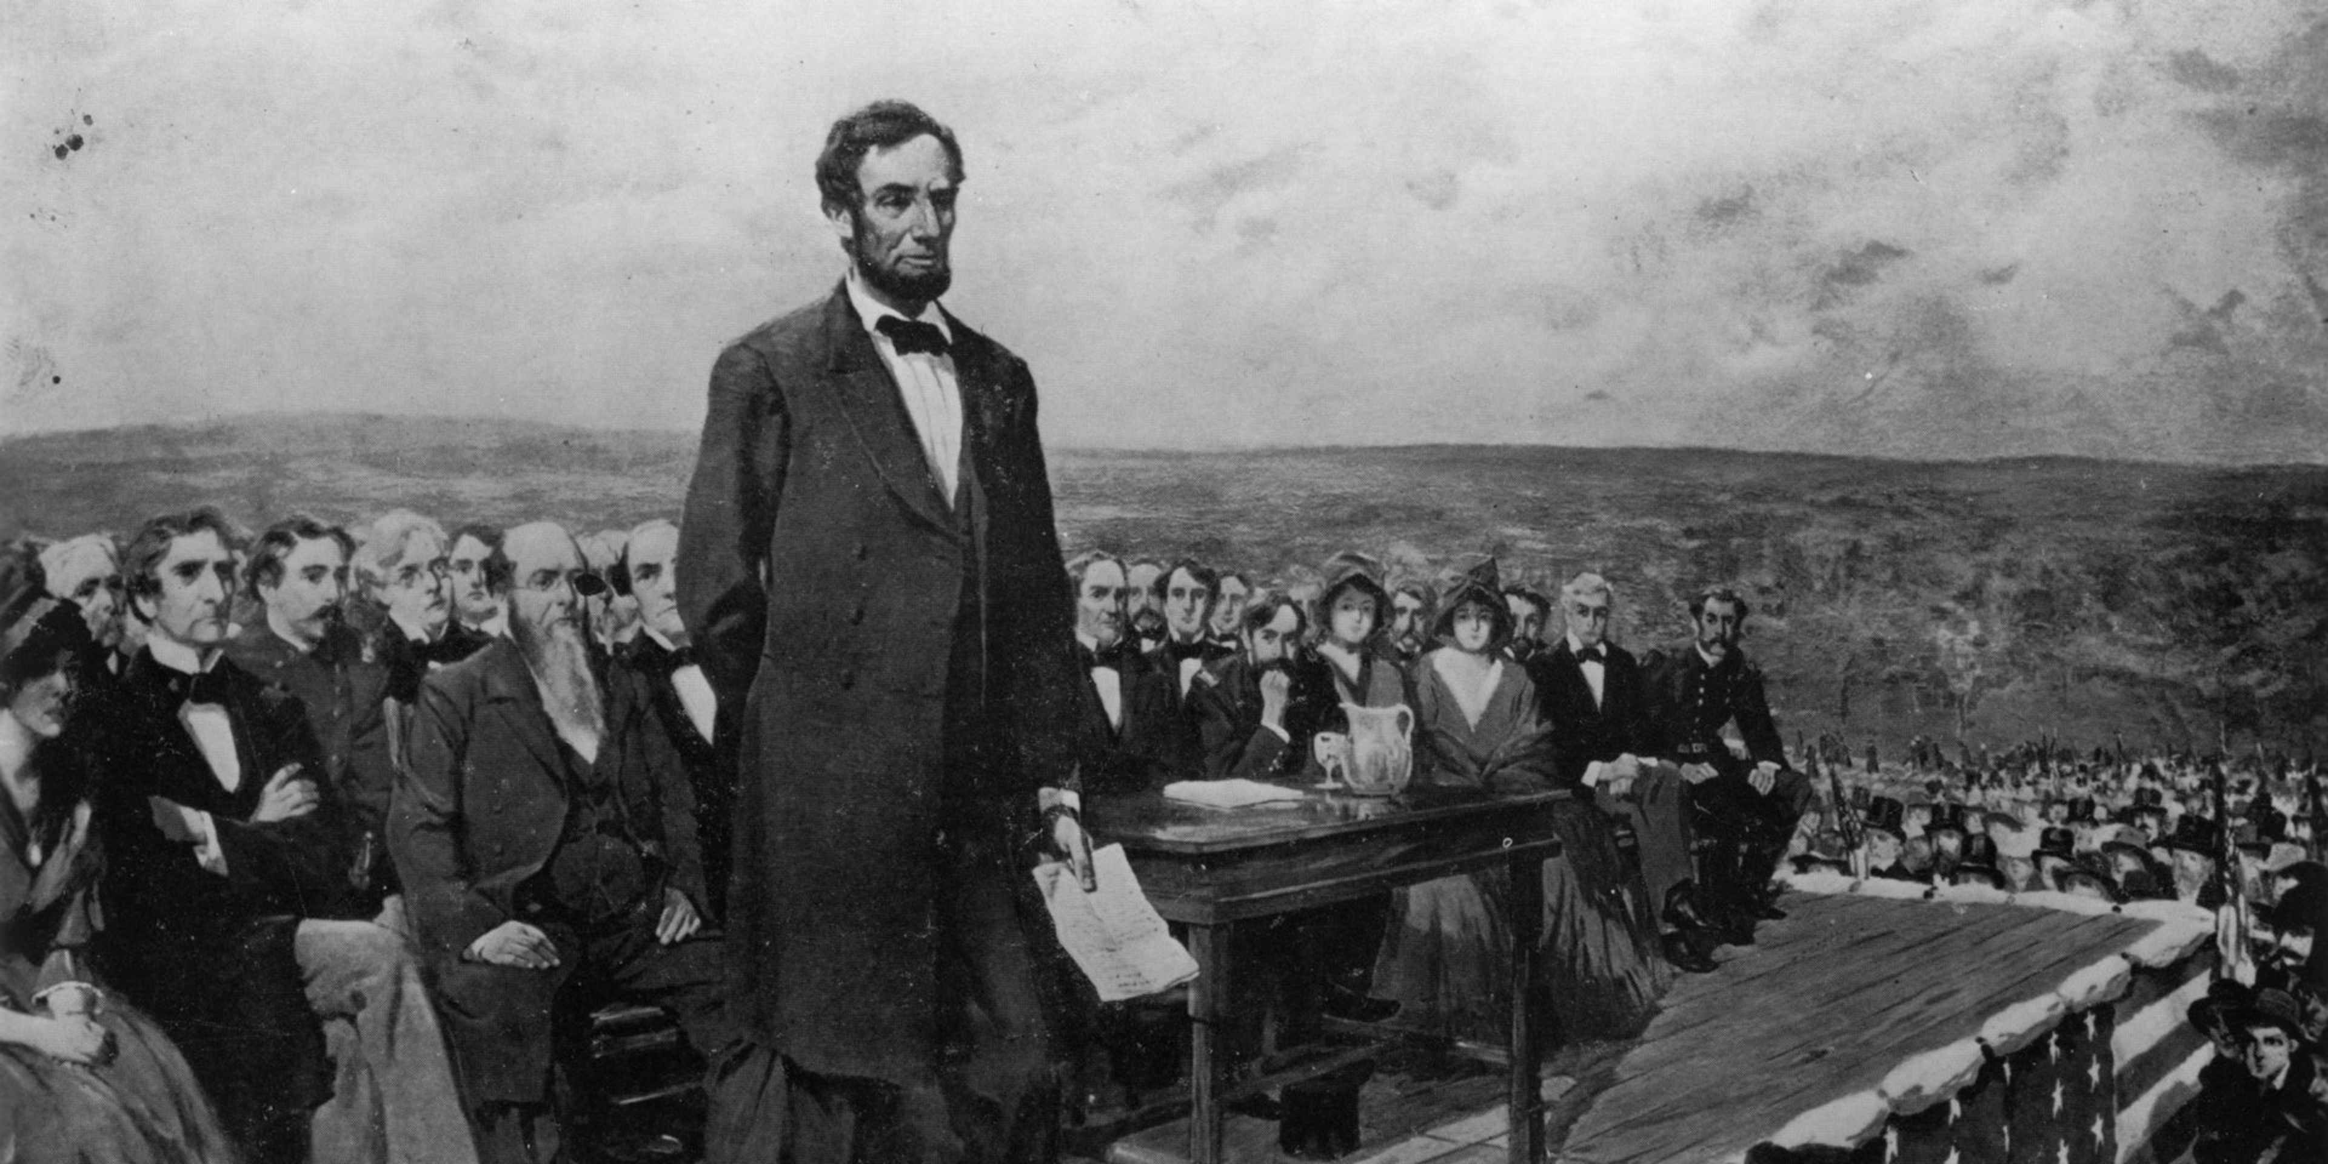 https://www.history.com/articles/gettysburg-address
“Four score and seven years ago our fathers brought forth on this continent, a new nation, conceived in Liberty, and dedicated to the proposition that all men are created equal.
Now we are engaged in a great civil war, testing whether that nation, or any nation so conceived and so dedicated, can long endure. We are met on a great battle-field of that war. We have come to dedicate a portion of that field, as a final resting place for those who here gave their lives that that nation might live. It is altogether fitting and proper that we should do this.
But, in a larger sense, we can not dedicate -- we can not consecrate -- we can not hallow -- this ground. The brave men, living and dead, who struggled here, have consecrated it, far above our poor power to add or detract. The world will little note, nor long remember what we say here, but it can never forget what they did here. It is for us the living, rather, to be dedicated here to the unfinished work which they who fought here have thus far so nobly advanced. It is rather for us to be here dedicated to the great task remaining before us -- that from these honored dead we take increased devotion to that cause for which they gave the last full measure of devotion -- that we here highly resolve that these dead shall not have died in vain -- that this nation, under God, shall have a new birth of freedom -- and that government of the people, by the people, for the people, shall not perish from the earth.
Abraham Lincoln
November 19, 1863”
https://www.history.com/articles/gettysburg-address

“On June 1, 1865, Senator Charles Sumner referred to the most famous speech ever given by President Abraham Lincoln. In his eulogy on the slain president, he called the Gettysburg Address a ‘monumental act.’ He said Lincoln was mistaken that ‘the world will little note, nor long remember what we say here.’ Rather, the Bostonian remarked, ‘The world noted at once what he said, and will never cease to remember it. The battle itself was less important than the speech.’

There are five known copies of the speech in Lincoln's handwriting, each with a slightly different text, and named for the people who first received them: Nicolay, Hay, Everett, Bancroft and Bliss. Two copies apparently were written before delivering the speech, one of which probably was the reading copy. The remaining ones were produced months later for soldier benefit events. Despite widely-circulated stories to the contrary, the president did not dash off a copy aboard a train to Gettysburg. Lincoln carefully prepared his major speeches in advance; his steady, even script in every manuscript is consistent with a firm writing surface, not the notoriously bumpy Civil War-era trains. Additional versions of the speech appeared in newspapers of the era, feeding modern-day confusion about the authoritative text.”
https://www.abrahamlincolnonline.org/lincoln/speeches/gettysburg.htm

1864 – General Ulysses S. Grant – Incident Command
War Fighting: The Case of Ulysses S. Grant (9/16/2025): https://publications.armywarcollege.edu/News/Display/Article/4305205/war-fighting-the-case-of-ulysses-s-grant/

“A review of all these studies of Grant would go beyond the scope of this article; instead, focusing on two aspects of Grant’s command in 1864 will illustrate the point. The first involves Grant’s role as the overall commanding general, including his involvement in the operations assigned to General William Tecumseh Sherman. The military professionals taught about Sherman’s March to the Sea as part of Grant’s broad, strategic approach for 1864, including at least five mutually supporting campaigns, all moving toward, in Grant’s earliest orders, ‘a common center.’ Three or four were in the Virginia theater: an advance up the Shenandoah Valley along with an attack over the mountains from West Virginia; an assault up the James River toward Richmond; and the ‘Overland Campaign,’ as it later became known, which was aimed directly at the Army of Northern Virginia, with the additional goal of linking up with the James River assault. The other two were to be in the American Southeast: one landing and attacking north from Mobile, Alabama, and one moving from Chattanooga, Tennessee, toward Atlanta, Georgia, and beyond under Sherman.”

March 4, 1865 – President Lincoln – Second Inaugural Address
“The speech was delivered on March 4, 1865, outside the grand, columned east entrance to the Capitol. Lincoln addressed a crowd of about 40,000 people on a blustery, rainy day that gave way to sunshine. The Civil War, in which more than 600,000 people died over almost four years, was soon to be over. American slavery was ending. And parts of the South were devastated. Lincoln wanted to address what had happened and why, and find some meaning in the tragedy that was still unfolding.”
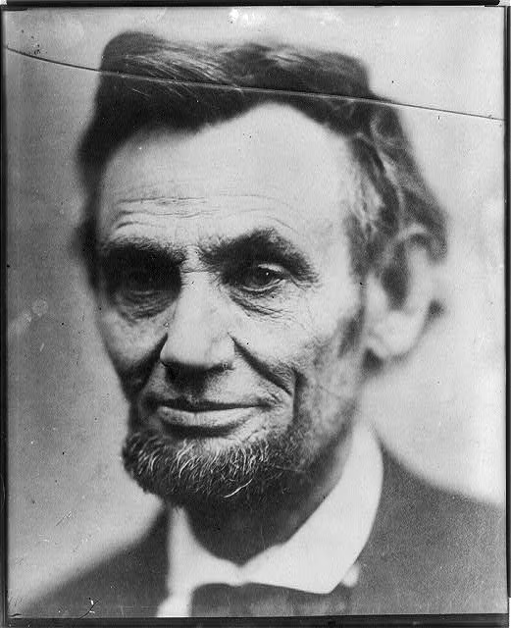
A photo of Abraham Lincoln taken shortly before his second inauguration in 1865. (Alexander Gardner/Library of Congress)
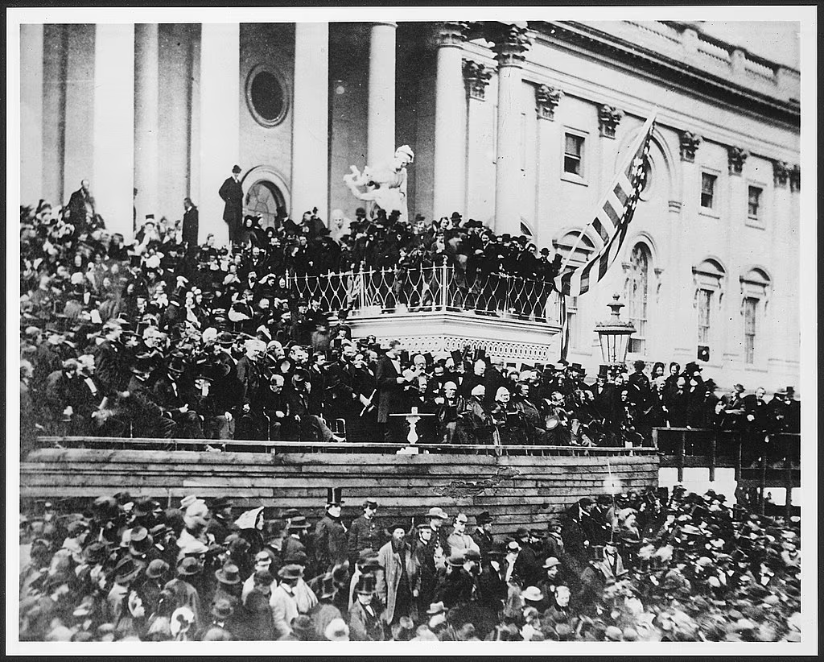
At his second inauguration, Lincoln stands before a white table, center, outside the U.S. Capitol. (Alexander Gardner/Library of Congress)
https://www.washingtonpost.com/history/2025/01/19/lincoln-speech-second-inaugural-trump-address/?utm_campaign=wp_post_most&utm_medium=email&utm_source=newsletter&carta-url=https%3A%2F%2Fs2.washingtonpost.com%2Fcar-ln-tr%2F41281a7%2F67b363a6eb3eba471afc37e7%2F59731235ade4e21a848a56ed%2F27%2F53%2F67b363a6eb3eba471afc37e7
***
“On March 4, 1865, only 41 days before his assassination, President Abraham Lincoln took the oath of office for the second time. Lincoln's second inaugural address previewed his plans for healing a once-divided nation. The speech is engraved on the north interior wall of the Lincoln Memorial. The speech was short — just over 700 words. Lincoln, who was 56, spoke slowly. Even so, the address probably lasted only six or seven minutes….

"Fellow countrymen: at this second appearing to take the oath of the presidential office there is less occasion for an extended address than there was at the first. Then a statement somewhat in detail of a course to be pursued seemed fitting and proper. Now, at the expiration of four years during which public declarations have been constantly called forth on every point and phase of the great contest which still absorbs the attention and engrosses the energies of the nation little that is new could be presented. The progress of our arms, upon which all else chiefly depends is as well known to the public as to myself and it is I trust reasonably satisfactory and encouraging to all. With high hope for the future no prediction in regard to it is ventured.
On the occasion corresponding to this four years ago all thoughts were anxiously directed to an impending civil war. All dreaded it ~ all sought to avert it. While the inaugural address was being delivered from this place devoted altogether to saving the Union without war insurgent agents were in the city seeking to destroy it without war ~ seeking to dissolve the Union and divide effects by negotiation. Both parties deprecated war but one of them would make war rather than let the nation survive, and the other would accept war rather than let it perish. And the war came.
One eighth of the whole population were colored slaves not distributed generally over the union but localized in the southern part of it. These slaves constituted a peculiar and powerful interest. All knew that this interest was somehow the cause of the war. To strengthen perpetuate and extend this interest was the object for which the insurgents would rend the Union even by war while the government claimed no right to do more than to restrict the territorial enlargement of it. Neither party expected for the war the magnitude or the duration which it has already attained. Neither anticipated that the cause of the conflict might cease with or even before the conflict itself should cease. Each looked for an easier triumph and a result less fundamental and astounding. Both read the same Bible and pray to the same God and each invokes His aid against the other. It may seem strange that any men should dare to ask a just God's assistance in wringing their bread from the sweat of other men's faces but let us judge not that we be not judged. The prayers of both could not be answered ~ that of neither has been answered fully. The Almighty has His own purposes. ‘Woe unto the world because of offenses for it must needs be that offenses come but woe to that man by whom the offense cometh.’ If we shall suppose that American slavery is one of those offenses which in the providence of God must needs come but which having continued through His appointed time He now wills to remove and that He gives to both North and South this terrible war as the woe due to those by whom the offense came shall we discern therein any departure from those divine attributes which the believers in a living God always ascribe to Him. Fondly do we hope ~ fervently do we pray ~ that this mighty scourge of war may speedily pass away. Yet, if God wills that it continue until all the wealth piled by the bondsman's two hundred and fifty years of unrequited toil shall be sunk and until every drop of blood drawn with the lash shall be paid by another drawn with the sword as was said three thousand years ago so still it must be said 'the judgments of the Lord are true and righteous altogether.'
With malice toward none with charity for all with firmness in the right as God gives us to see the right let us strive on to finish the work we are in to bind up the nation's wounds, to care for him who shall have borne the battle and for his widow and his orphan ~ to do all which may achieve and cherish a just and lasting peace among ourselves and with all nations." https://www.nps.gov/linc/learn/historyculture/lincoln-second-inaugural.htm

April 15, 1865: President Lincoln Assassinated
“On the evening of April 14, 1865, John Wilkes Booth, a famous actor and Confederate sympathizer, assassinated President Abraham Lincoln at Ford’s Theatre in Washington,
D.C. The attack came only five days after Confederate General Robert E. Lee surrendered his massive army at Appomattox Court House, Virginia, effectively ending the American Civil War.” https://www.history.com/topics/american-civil-war/abrahamlincoln-assassination
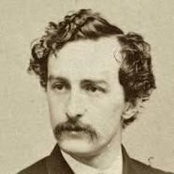John Wilkes Booth

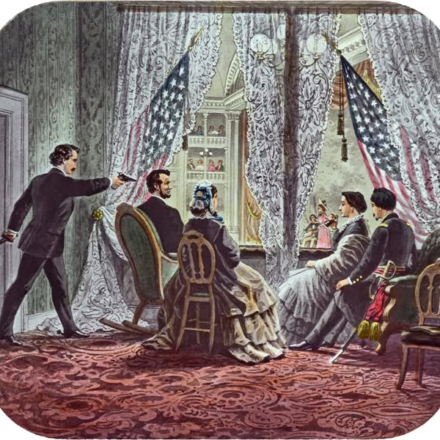

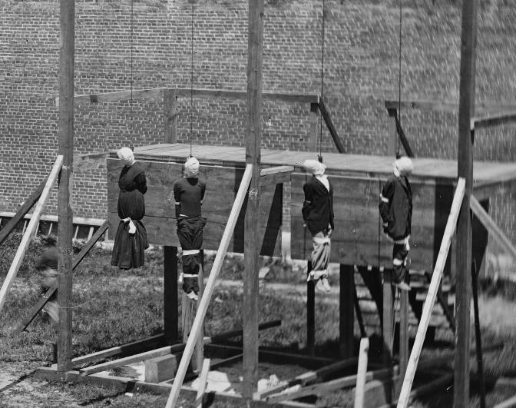
Execution of the four Lincoln conspirators: David Herold, Lewis Powell, George Atzerodt and Mary Surratt.
https://www.washingtonpost.com/local/four-people-were-hanged-for-lincolns-assassination-and-it-was-caught-on-camera/2015/07/03/377614d4-1905-11e5-ab92-c75ae6ab94b5_story.html

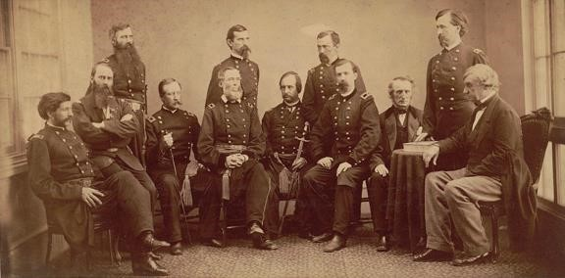
https://columbialawreview.org/content/the-law-of-the-lincoln-assassination/
“On May 1, 1865, President Andrew Johnson ordered the formation of a military commission to try the accused persons. The actual trial began on May 10th and lasted for about seven weeks. The defendants were allowed to have lawyers and witnesses, but they were not allowed to testify themselves. On June 29, 1865, the Military Commission met in secret session to begin its review of the evidence in the seven-week long trial. A guilty verdict could come with a majority vote of the nine-member commission; death sentences required the votes of six members. The next day, it reached its verdicts. The Commission found seven of the prisoners guilty of at least one of the conspiracy charges. Four of the prisoners: Mary Surratt, Lewis Powell, George Atzerodt, and David Herold were sentenced “to be hanged by the neck until he [or she] be dead”. Samuel Arnold, Dr. Samuel Mudd and Michael O’Laughlen were sentenced to “hard labor for life, at such place at the President shall direct”, Edman Spangler received a six-year sentence. The next day General Hartrandft informed the prisoners of their sentences. He told the four condemned prisoners that they would hang the next day.” https://rarehistoricalphotos.com/execution-lincoln-conspirators-1865/

June 19, 1865 – “Juneteenth” – Texas Emancipation
“On ‘Freedom’s Eve,’ or the eve of January 1, 1863, the first Watch Night services took place. On that night, enslaved and free African Americans gathered in churches and private homes all across the country awaiting news that the Emancipation Proclamation had taken effect. At the stroke of midnight, prayers were answered as all enslaved people in Confederate States were declared legally free. Union soldiers, many of whom were black, marched onto plantations and across cities in the south reading small copies of the Emancipation Proclamation spreading the news of freedom in Confederate States. Only through the Thirteenth Amendment did emancipation end slavery throughout the United States.
But not everyone in Confederate territory would immediately be free. Even though the Emancipation Proclamation was made effective in 1863, it could not be implemented in places still under Confederate control. As a result, in the westernmost Confederate state of Texas, enslaved people would not be free until much later. Freedom finally came on June 19, 1865, when some 2,000 Union troops arrived in Galveston Bay, Texas. The army announced that the more than 250,000 enslaved black people in the state, were free by executive decree. This day came to be known as "Juneteenth," by the newly freed people in Texas.” https://nmaahc.si.edu/explore/stories/historical-legacy-juneteenth

1865: Jim Crow Laws (1865 – 1877)
“The roots of Jim Crow laws began as early as 1865, immediately following the ratification of the 13th Amendment, which abolished slavery in the United States. Black codes were strict local and state laws that detailed when, where and how formerly enslaved people could work, and for how much compensation. The codes appeared throughout the South as a legal way to put Black citizens into indentured servitude, to take voting rights away, to control where they lived and how they traveled and to seize children for labor purposes.” https://www.history.com/topics/early-20th-century-us/jim-crow-laws
***
“However, starting in the 1870s, as the Southern economy continued its decline, Democrats took over power in Southern legislatures and used intimidation tactics to suppress black voters. Tactics included violence against blacks and those tactics continued well into the 1900s. Lynchings were a common form of terrorism practiced against blacks to intimidate them. It is important to remember that the Democrats and Republicans of the late 1800s were very different parties from their current iterations. Republicans in the time of the Civil War and directly after were literally the party of Lincoln and anathema to the South. As white, Southern Democrats took over legislatures in the former Confederate states, they began passing more restrictive voter registration and electoral laws, as well as passing legislation to segregate blacks and whites. *** And while segregation was literal law in the South, it was also practiced in the northern United States via housing patterns enforced by private covenants, bank lending practices, and job discrimination, including discriminatory labor union practices.” https://guides.ll.georgetown.edu/c.php?g=592919&p=4172697

___________________________________________________________________ “Jim Crow” named after Minstrel shows:
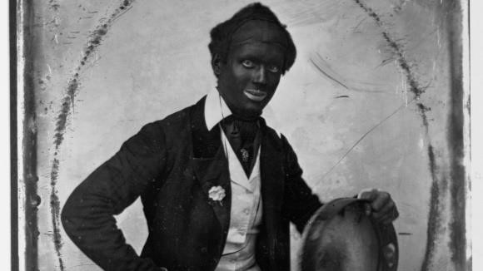Blackface performer, Dan Bryant, circa
1850. Library of Congress/Corbis/VCG via Getty Images
“Several characters in minstrel shows became archetypes, as described in the University of Florida’s digital exhibit, ‘History of Minstrels: From
‘Jump Jim Crow’ to ‘The Jazz Singer.’ Some of the most famous ones were Rice’s “Jim Crow,” a rural dancing fool in tattered clothing; the ‘Mammy,’ an overweight and loud mother figure; and ‘Zip Coon,’ a flamboyant-dressed man who used sophisticated words incorrectly.” https://www.history.com/news/blackface-history-racism-origins

July 5, 1865: Secret Service established
“Today [7/7/2025], the Department of Homeland Security honors the 160th anniversary since the founding of the United States Secret Service. One of our nation’s oldest and most recognized federal law enforcement agencies, the Secret Service was founded on July 5, 1865, to combat rampant counterfeiting that threatened the integrity of America’s economy at a time when nearly half of all U.S. currency in circulation was fake.” https://www.dhs.gov/news/2025/07/05/united-states-secret-service-celebrates-160th-birthday

Dec. 6, 1865: 13th Amendment Abolished Slavery
“Though the Union victory in the Civil War gave some 4 million enslaved people their freedom, significant challenges awaited during the Reconstruction period. The 13th Amendment, adopted late in 1865, officially abolished slavery, but the question of freed Black peoples’ status in the post–war South remained. As white southerners gradually reestablished civil authority in the former Confederate states in 1865 and 1866, they enacted a series of laws known as the Black Codes, which were designed to restrict freed Black peoples’ activity and ensure their availability as a labor force.” https://www.history.com/articles/black-history-milestones
***
Thirteenth Amendment - ratified by the required 27 of the then 36 states on December 6, 1865.
“Section 1
Neither slavery nor involuntary servitude, except as a punishment for crime whereof the party shall have been duly convicted, shall exist within the United States, or any place subject to their jurisdiction.
Section 2
Congress shall have power to enforce this article by appropriate legislation.” https://constitution.congress.gov/constitution/amendment-13/
***

“On January 31, 1865, the House of Representatives passed the proposed amendment with a vote of 119-56, just over the required two-thirds majority. The following day, Lincoln approved a joint resolution of Congress submitting it to the state legislatures for ratification. But he would not see final ratification: Lincoln was assassinated on April 14,
1865, and the necessary number of states did not ratify the 13th Amendment until December 6. While Section 1 of the 13th Amendment outlawed chattel slavery and involuntary servitude (except as punishment for a crime), Section 2 gave the U.S. Congress the power “to enforce this article by appropriate legislation.” https://www.history.com/topics/black-history/thirteenth-amendment

April 9, 1866: Civil Rights Act of 1866 – Overturned “Black
Codes”
On this date, the House overrode President Andrew Johnson’s veto of the Civil Rights Bill of 1866 with near unanimous Republican support, 122 to 41, marking the first time Congress legislated upon civil rights.
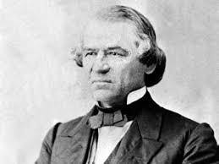
President Andrew Johnson – from Raleigh, NC
"All persons within the jurisdiction of the United States shall have the same right in every State and Territory to make and enforce contracts, to sue, be parties, give evidence, and to the full and equal benefit of all laws and proceedings for the security of persons and property as is enjoyed by white citizens, and shall be subject to like punishment, pains, penalties, taxes, licenses, and exactions of every kind, and to no other.” https://teachingamericanhistory.org/library/document/thecivil-rights-act-of-1866/
_____________________________________________________________________
“The year after the [13th] amendment’s passage, Congress used this power to pass the nation’s first civil rights bill, the Civil Rights Act of 1866. The law invalidated the socalled black codes, those laws put into place in the former Confederate states that governed the behavior of blacks, effectively keeping them dependent on their former owners. Congress also required the former Confederate states to ratify the 13th Amendment in order to regain representation in the federal government. Together with the 14th and 15th Amendments, also ratified during the Reconstruction era, the 13th Amendment sought to establish equality for black Americans. Despite these efforts, the struggle to achieve full equality and guarantee the civil rights of all Americans would continue well into the 20th century. https://www.history.com/topics/blackhistory/thirteenth-amendment
Black Codes: “Under black codes, many states required blacks to sign yearly labor contracts; if they refused, they risked being arrested, fined and forced into unpaid labor.
Outrage over black codes helped undermine support for President Andrew Johnson and the Republican Party.” https://www.history.com/topics/black-history/black-codes

April, 1866: Ohio Rep. John Bingham appointed to Joint Committee on Reconstruction – they drafted what became the 14th Amendment
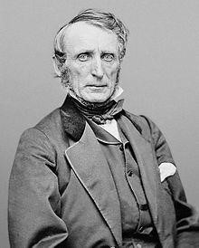
John Bingham (elected to Congress – four terms (March 4, 1865 – March 3, 1873) https://history.house.gov/People/Listing/B/BINGHAM,-John-Armor-(B000471)/

December 21, 1866 – Lakota War Party
Fort Phil Kearny Historic Site: Wyoming State Historic Site, National Historic Landmark and Interpretive Center. https://www.fortphilkearny.org/fetterman-battle-history
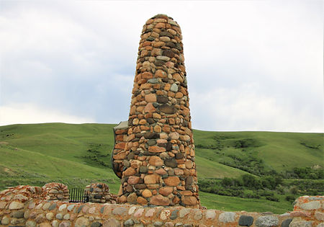
“It was one of only a few battles in U.S. history in which an entire command was wiped out. The Fetterman Fight, and its loss of the lives of 76 enlisted men, three officers and two civilians, shocked the nation, and influenced government policy and attitudes towards the Plains Indians for years to come.
***
Shortly after the cavalry and infantry left the fort, the signal came through that the wood train had broken free and was on its way to the pinery. Now the decoys, a group of about 10 with representatives from Lakota, Cheyenne and Arapaho tribes took over. Indian accounts from Judge Eli Ricker's early interviews mention Lakota warriors Crazy Horse, American Horse and others, as participants in the decoy. They goaded the troops, shouting insults, and staying just out of firing range. It was a temptation which Fetterman seemingly did not resist, and he followed the decoy, crossing the ridge. The troops had no idea of the ambush awaiting them. When the trap was set, with no chance of the troops escaping, mounted warriors crossed paths down on the flats across Peno creek at the north end of the ridge. This was the signal for large numbers of warriors to break out of ambush from the gullies to the north, east and west of Massacre Hill. By now the infantry and cavalry detachments were separated, the riders nearly to the creek and the foot soldiers on the ridge. The cavalry began to fall back up the hill.”
***
Like the Battle of the Little Bighorn a decade later, there will always be mysteries. Military records, even with their official reports, present puzzling questions, as do interviews with individual soldiers and civilians. Indian accounts, all coming down through oral traditions, and some through extensive interviews with Judge Eli Ricker of Nebraska and others, vary. Significantly, there were no soldiers left alive to tell the story.”

March, 1867 – US Buys Alaska - $7.2 Million

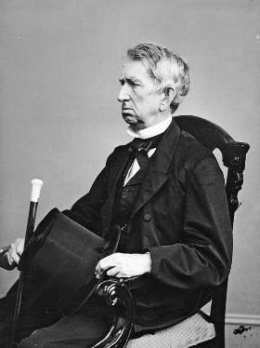

Secretary of State William Henry Seward negotiated with Russia over the purchase of Alaska.
“By the 1850s, the United States had acquired California, annexed Texas and fought a war with Mexico. There was talk of “Manifest Destiny,” the idea that the United States was destined to expand across North America. Russian officials, including the commander of its Pacific fleet, urged the ailing empire to offload Alaska while it could…. In March 1867, Secretary of State William Henry Seward opened the negotiations by offering $5 million for the territory to Eduard Stoeckl, the Russian minister to the United States. Two weeks later, they agreed on $7.2 million, or less than two cents an acre. A treaty was signed in Seward’s office at 4 a.m. after an all-night negotiating session, and later approved by Congress and Czar Alexander II.” https://www.nytimes.com/2025/08/15/world/europe/russia-alaska-purchase-ukraine.html

1868: Central Pacific Railroad, California
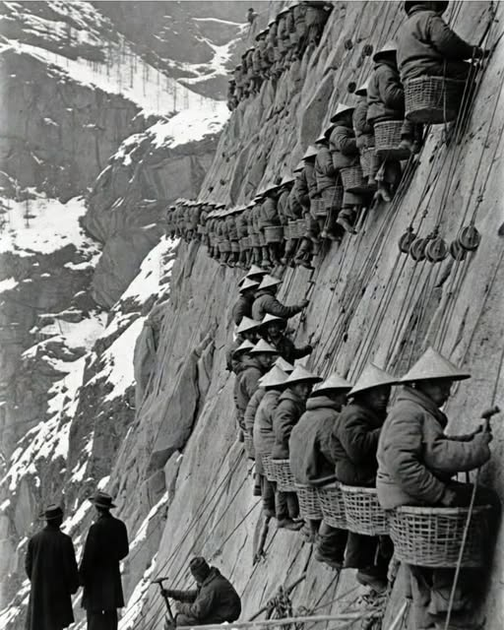

“The Central Pacific Railroad faced the impossible—crossing the towering Sierra Nevada.
White workers walked away. Too high. Too cold. Too dangerous. So the company turned to Chinese laborers already in California. Fifty men were hired. They stayed. By 1868, more than 12,000 Chinese workers made up nearly 90% of the workforce. They earned $28 a month. White workers received $35—plus food and shelter. The Chinese paid for their own meals, lived in tents, and endured brutal winters at elevations above 8,000 feet.” https://www.facebook.com/hashtag/chineserailroadworkers

March 5, 1868: Impeachment Trial of President Andrew Johnson
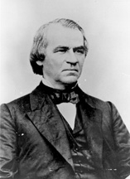
“During the years immediately following the Civil War, President Andrew Johnson [from TN] clashed repeatedly with the Republican-controlled Congress over reconstruction of the defeated South. Johnson vetoed legislation that Congress passed to protect the rights of those who had been freed from slavery. This clash culminated in the House of Representatives voting, on February 24, 1868, to impeach the president. On March 5, the trial began in the Senate, where Republicans held more seats than the two-thirds majority required to remove Johnson from office. When the trial concluded on May 16, however, the president had won acquittal, not because a majority of senators supported his policies but because a sufficient minority wished to protect the office of the president and preserve the constitutional balance of powers.” https://www.senate.gov/about/powers-procedures/impeachment/impeachment-johnson.htm
“[T]he trial before the Senate lasted three months, at the conclusion of which he was acquitted (May 26, 1868) by a vote of thirty-five for conviction to nineteen for acquittal, the necessary two-thirds vote for impeachment not having been obtained; retired to his home in Tennessee upon the expiration of the presidential term, March 3, 1869.” https://bioguide.congress.gov/search/bio/J000116

July 9, 1868: 14th Amendment – Due Process Clause / Birthright Citizenship
“Section 1.
All persons born or naturalized in the United States, and subject to the jurisdiction thereof, are citizens of the United States and of the State wherein they reside. No State shall make or enforce any law which shall abridge the privileges or immunities of citizens of the United States; nor shall any State deprive any person of life, liberty, or property, without due process of law; nor deny to any person within its jurisdiction the equal protection of the laws.
Section 2.
Representatives shall be apportioned among the several States according to their respective numbers, counting the whole number of persons in each State, excluding Indians not taxed. But when the right to vote at any election for the choice of electors for President and Vice-President of the United States, Representatives in Congress, the Executive and Judicial officers of a State, or the members of the Legislature thereof, is denied to any of the male inhabitants of such State, being twenty-one years of age, and citizens of the United States, or in any way abridged, except for participation in rebellion, or other crime, the basis of representation therein shall be reduced in the proportion which the number of such male citizens shall bear to the whole number of male citizens twenty-one years of age in such State.
Section 3.
No person shall be a Senator or Representative in Congress, or elector of President and Vice-President, or hold any office, civil or military, under the United States, or under any State, who, having previously taken an oath, as a member of Congress, or as an officer of the United States, or as a member of any State legislature, or as an executive or judicial officer of any State, to support the Constitution of the United States, shall have engaged in insurrection or rebellion against the same, or given aid or comfort to the enemies thereof. But Congress may by a vote of two-thirds of each House, remove such disability.
Section 4.
The validity of the public debt of the United States, authorized by law, including debts incurred for payment of pensions and bounties for services in suppressing insurrection or rebellion, shall not be questioned. But neither the United States nor any State shall assume or pay any debt or obligation incurred in aid of insurrection or rebellion against the United States, or any claim for the loss or emancipation of any slave; but all such debts, obligations and claims shall be held illegal and void.
Section 5.
The Congress shall have power to enforce, by appropriate legislation, the provisions of this article.” https://www.archives.gov/milestone-documents/14th-amendment

1868 - Impeachment Trial Of President Andrew Johnso

“During the years immediately following the Civil War, President Andrew Johnson clashed repeatedly with the Republican-controlled Congress over reconstruction of the defeated South. Johnson vetoed legislation that Congress passed to protect the rights of those who had been freed from slavery. This clash culminated in the House of Representatives voting, on February 24, 1868, to impeach the president. On March 5, the trial began in the Senate, where Republicans held more seats than the two-thirds majority required to remove Johnson from office. When the trial concluded on May 16, however, the president had won acquittal, not because a majority of senators supported his policies but because a sufficient minority wished to protect the office of the president and preserve the constitutional balance of powers.” https://www.senate.gov/about/powers-procedures/impeachment/impeachment-johnson.htm

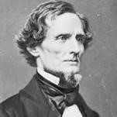

Jefferson Davis – President of Confederate States (1861 – 1865)

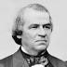Andrew Johnson – President (1829-1837)

March 30, 1870: 15th Amendment – Right to vote to not be denied based on race
“Section. 1. The right of citizens of the United States to vote shall not be denied or abridged by the United States or by any State on account of race, color, or previous condition of servitude.
Section. 2. The Congress shall have power to enforce this article by appropriate legislation.” https://constitution.findlaw.com/amendments.html

“Amendment Fifteen to the Constitution – the last of the Reconstruction Amendments – was ratified on February 3, 1870. It grants the right to vote for all male citizens regardless of their ethnicity or prior slave status. The official text is written as such:
The right of citizens of the United States to vote shall not be denied or abridged by the United States or by any State on account of race, color, or previous condition of servitude.
The Congress shall have the power to enforce this article by appropriate legislation.
Although the right to vote is commonly regarded in modern times to be one of the most important American freedoms, the ability to have a role in elections is something that has been contested since the nation’s founding. When the Constitution and the Bill of Rights was enacted into law in the late 18th century, the Founders’ approach to voting was that each of the states would determine the voter eligibility of their citizens. The most common measurement for voter eligibility in the first decades of the republic was that the prospective voter had to be a white male who owned property of a certain dollar value. Certain states and cities allowed free African Americans and women to vote, but these were few in number and scattered across the Northern states. It would not be until the Presidential Election of 1828 when the majority of the land-ownership requirements were eliminated, and it was twenty-eight years after that when every state removed them. With the passage of the Thirteenth and Fourteenth Amendments after the Civil War, the expansion of civil rights to the newly-freed African American population turned to the question of voting. After the election of Ulysses S. Grant to the presidency in 1868, Congress proposed a new amendment that would ban all restrictions on the right to vote regarding ethnicity and prior slave status. In spite of heavy opposition by the Southern delegations, Congress ratified the Fifteenth Amendment on February 3, 1870. At the start, the amendment did not extend the right to vote to any women in the United States. It would not be until the ratification of the Nineteenth Amendment in 1920 that allowed all women the right to vote.” https://www.reaganlibrary.gov/constitutional-amendments-amendment-15-right-vote

May 31, 1870: Civil Right Act of 1870 – Ku Klux Clan Act
“During Reconstruction, Congress enacted the Civil Rights Act of 1870, also known as the Enforcement Act or the First Ku Klux Klan Act, in order to enforce the terms of the Fifteenth Amendment, which prohibited the states from denying anyone the right to vote based on race. The act provided criminal penalties for those attempting to prevent African Americans from voting by using or threatening to use violence or engaging in other tactics, such as making threats to terminate a person’s employment or evict them from their home. As a result of the act, the criminal jurisdiction of the federal courts was expanded.” https://www.fjc.gov/history/timeline/civil-rights-act-1870
Now codified: 42 USC 1983; police officers often sued in “1983 Actions”
“Congress followed the Civil Rights Act of 1870 with an 1871 law “to enforce the
Provisions of the Fourteenth Amendment to the Constitution of the United States,” which came to be known as the Second Enforcement Act or the Second Ku Klux Klan Act. Like the prior year’s legislation, the act was designed in large part to protect African Americans from Klan violence during Reconstruction, giving those deprived of a constitutional right by someone acting under color of law the right to seek relief in a federal district or circuit court. This part of the legislation was later made a part of the United States Code as 42 U.S.C. §1983 and served as the basis for many federal court lawsuits against state and local officials.”
https://www.fjc.gov/history/timeline/civil-rights-act-1871
“While the Force acts and the publicity generated by the joint committee temporarily helped put an end to the violence and intimidation, the end of formal Reconstruction in 1877 allowed for a return of largescale disenfranchisement of African Americans.” https://www.senate.gov/artandhistory/history/common/generic/EnforcementActs.htm

Oct. 8-10, 1871 – Great Chicago Fire
What Los Angeles Can Learn From Another Great American City That Burned’ Jan. 23, 2025; https://www.nytimes.com/2025/01/23/opinion/los-angeles-fires-la-wildfires-chicago.html
“Chicago’s fire commissioners predicted the 1871 disaster, but the mayor and aldermen knew that raising taxes to bolster a department that was underequipped and understaffed would be unpopular, and did not press the issue. It was only because insurance companies threatened to withhold coverage after the second fire that Chicago finally began to act. The insurers demanded that new buildings be constructed of fireproof materials such as brick or stone (1871 Chicago was built largely out of wood); that warehouses and stores be equipped with iron shutters; and that the city reorganize the fire department, lay more and bigger water mains and pipes, install additional hydrants and remove all lumber yards from built-up areas.”

The Chicago Fire of 1871 and the 'Great Rebuilding'. https://education.nationalgeographic.org/resource/chicago-fire-1871-and-great-rebuilding/
“On October 8, 1871, a fire broke out in a barn on the southwest side of Chicago, Illinois. For more than 24 hours, the fire burned through the heart of Chicago, killing 300 people and leaving one-third of the city's population homeless. The ‘Great Rebuilding’ was the effort to construct a new, urban center. Big businesses, innovative buildings, and a new style of architecture were the results.”

Oct. 8, 1871 – Wisconsin Wildfire – 1,500 Killed
Peshtigo Fire: The deadliest wildfire in U.S. history. The conflagration claimed the lives of more than 1,500 people but still exists for many in the shadow of the Great Chicago Fire. ** The Peshtigo Fire burned over 1 million acres, destroyed thousands of buildings, and killed over 1,500 people, most in northeastern Wisconsin – the deadliest forest fire in U.S. history. By the end of the incident, 16 towns had been burned. Unless you’re from the area or are a fire science student, there’s a good chance you’ve never heard of this “other” major October fire. https://www.firerescue1.com/firefighting-history/articles/peshtigo-fire-the-deadliest-wildfire-in-us-history-Xe6TtkZVNuTix48C/?utm_source=delivra&utm_medium=email&utm_campaign=FR1-Daily-10-8-25&utm_id=9610378&dlv-emuid=fed355b8-46a2-4fa4-b55c-4d602dde33c4&dlv-mlid=9610378

1872: President Ulysses S. Grant [age 50] – D.C. Police Officer [African American] stopped him twice for speeding on a horse-drawn carriage
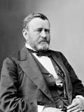Ulysses S. Grant – born, Point Pleasant, OH (April 27, 1822)
“The Police Officer Who Arrested A President”
“In 1872, while president, Grant was arrested at the corner of 13th and M streets in Washington. This was not a high crime, but it was — at least theoretically speaking — a misdemeanor. *** The man who led the North to victory in the Civil War was busted for speeding in his horse-drawn carriage. *** That policeman was William H. West, a black man who had fought in the Civil War. ‘Since his retirement,’ the story said, ‘he has decided to let the public know the true story of the arrest.’ It begins with Grant’s love of fast horses. ‘Gen. Grant was an ardent admirer of a good horse and loved nothing better than to sit behind a pair of spirited animals,’ the Star story said. ‘He was a good driver, and sometimes “let them out” to try their mettle.’ And that’s where Grant, as president, rode into the law. The police had been receiving complaints of speeding carriages. After a mother and child were run over and badly injured, Officer West was dispatched to investigate. As West spoke to witnesses, another group of speeding carriages headed toward him — including one driven by the president of the United States. ‘Policeman West held up his hand for them to stop,’ the story said. ‘Grant was driving a pair of fast steppers and he had some difficulty in halting them, but this he managed to do.’ Grant was a bit testy. ‘Well, officer,’ he said, ‘what do you want with me?’ West replied: ‘I want to inform you, Mr. President, that you are violating the law by speeding along this street. Your fast driving, sir, has set the example for a lot of other gentlemen.’ The president apologized, promised it wouldn’t happen again, and galloped away. But Grant could not curb his need for speed. The next evening, West was patrolling at the corner of 13th and M streets when the president came barreling through again, this time speeding so fast that it took him an entire block to stop. Now Grant was cocky and had a ‘smile on his face,’ the Star article said, that made him look like ‘a schoolboy who had been caught in a guilty act by a teacher.’ He said, ‘Do you think, officer, that I was violating the speed laws?’ ‘I do, Mr. President,’ West said. Grant had an excuse for his speeding, not unlike one no doubt being given somewhere right now: He had no idea he had been going so fast. West was sympathetic but firm. ‘I am very sorry, Mr. President, to have to do it,’ he said, ‘for you are the chief of the nation, and I am nothing but a policeman, but duty is duty, sir, and I will have to place you under arrest.’ *** Anyway, Grant and several of his speeding buddies also arrested went with West to the police station. The president of the United States was ordered to put up 20 bucks as collateral. A trial was held the next day. ‘Thirty-two ladies of the most refined character and surroundings voluntarily came into the court and testified against the drivers,’ the Star story said. ‘The cases were contested bitterly.’ The judge imposed ‘heavy fines’ and a ‘scathing rebuke’ to the speeding drivers, who didn’t include the president. He didn’t show up for court.’” Washington Post article: Dec. 16, 2018: https://www.washingtonpost.com/history/2018/12/16/police-officer-who-arrestedpresident/?utm_term=.9f22b60ea0f1

1873 – Susan B. Anthony – Women’s Right To Vote

In the 1800s, women in the United States had few legal rights and did not have the right to vote. This speech was given by Susan B. Anthony after her arrest for casting an illegal vote in the presidential election of 1872. She was tried and then fined $100 but refused to pay.  https://www.historyplace.com/speeches/anthony.htm | 
Friends and fellow citizens: I stand before you tonight under indictment for the alleged crime of having voted at the last presidential election, without having a lawful right to vote. It shall be my work this evening to prove to you that in thus voting, I not only committed no crime, but, instead, simply exercised my citizen's rights, guaranteed to me and all United States citizens by the National Constitution, beyond the power of any state to deny.
The preamble of the Federal Constitution says:
"We, the people of the United States, in order to form a more perfect union, establish justice, insure domestic tranquillity, provide for the common defense, promote the general welfare, and secure the blessings of liberty to ourselves and our posterity, do ordain and establish this Constitution for the United States of America."
It was we, the people; not we, the white male citizens; nor yet we, the male citizens; but we, the whole people, who formed the Union. And we formed it, not to give the blessings of liberty, but to secure them; not to the half of ourselves and the half of our posterity, but to the whole people - women as well as men. And it is a downright mockery to talk to women of their enjoyment of the blessings of liberty while they are denied the use of the only means of securing them provided by this democratic-republican government - the ballot.
For any state to make sex a qualification that must ever result in the disfranchisement of one entire half of the people, is to pass a bill of attainder, or, an ex post facto law, and is therefore a violation of the supreme law of the land. By it the blessings of liberty are forever withheld from women and their female posterity.
To them this government has no just powers derived from the consent of the governed. To them this government is not a democracy. It is not a republic. It is an odious aristocracy; a hateful oligarchy of sex; the most hateful aristocracy ever established on the face of the globe; an oligarchy of wealth, where the rich govern the poor. An oligarchy of learning, where the educated govern the ignorant, or even an oligarchy of race, where the Saxon rules the African, might be endured; but this oligarchy of sex, which makes father, brothers, husband, sons, the oligarchs over the mother and sisters, the wife and daughters, of every household - which ordains all men sovereigns, all women subjects, carries dissension, discord, and rebellion into every home of the nation.
Webster, Worcester, and Bouvier all define a citizen to be a person in the United States, entitled to vote and hold office.
The only question left to be settled now is: Are women persons? And I hardly believe any of our opponents will have the hardihood to say they are not. Being persons, then, women are citizens; and no state has a right to make any law, or to enforce any old law, that shall abridge their privileges or immunities. Hence, every discrimination against women in the constitutions and laws of the several states is today null and void, precisely as is every one against Negroes.
Susan B. Anthony - 1873

1873: U.S. Cavalry Defend Surveyors – Northern Pacific Railroad

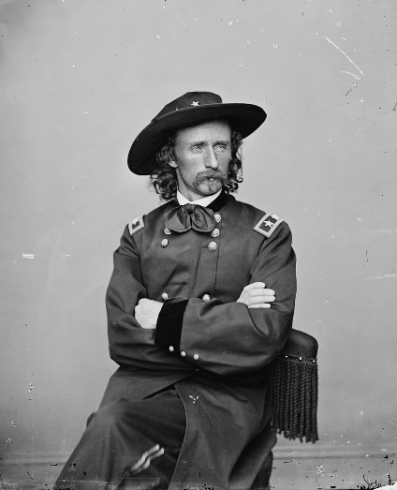Lt. Colonel George A. Custer

“The Yellowstone Expedition of 1873 was an expedition of the United States Army in August, 1873 along the Yellowstone River in Montana to survey a route for the Northern Pacific Railroad. The main escort for the expedition were companies of the 7th United States Cavalry Regiment under the command of Lieutenant Colonel George A. Custer, although the expedition was under the overall command of Colonel David S. Stanley. *** U.S. Army forces. Custer and units of the 7th Cavalry were part of the military column commanded by Col. David S. Stanley accompanying the 1873 Northern Pacific Railway survey party surveying the north side of the Yellowstone River west of the Powder River in eastern Montana. Stanley's column consisted of a 1,530 man force of cavalry, infantry, and two artillery pieces (3" rifled Rodman guns), and 60 days' rations. It traveled out of Dakota Territory in June, 1873 with the 1,530 soldiers, 275 mule-drawn wagons, 353 civilians involved in the survey, and 27 Indian and mixed-blood scouts supporting the column. *** Native American forces. The Native American forces that fought against the expedition in Montana Territory were from the village of Sitting Bull, estimated at anywhere from 400 to 500 lodges with over 1000 Warriors.^{[3]} It included Hunkpapa Sioux under Gall accompanied by the war chief Rain in the Face, Oglala Sioux under Crazy Horse, and Miniconjou and Cheyenne. *** The Battle of Honsinger Bluff. On Sunday, August 3, 1873, Stanley's column camped near the mouth of Sunday Creek, a tributary to the Yellowstone on the northeasterly end of Yellowstone Hill in present-day Custer County, Montana…. Shots were exchanged with Sioux Warriors near the Yellowstone River early in the Battle, and George Custer's men formed a skirmish line. A volley from the line distracted the pursuing Indians enough to halt the warriors' charge. Custer had Captain Moylan pull back his Company A to a wooded area previously occupied by Company A. After reaching the wooded area, the cavalrymen dismounted, forming a semicircular perimeter along a former channel of the Yellowstone River. The usual configuration for dismounted cavalry was every fourth man holding horses, however, due to the length of the semicircular perimeter, only every eighth man was detailed to hold horses. The bank of the dry channel served as a natural parapet.
The warriors siege on the detachment of the 7th Cavalry continued for about three hours in reported 110 °F (43 °C) heat, when Custer's mounted soldiers burst from their wooded river position in a charge that scattered the Lakota Sioux forces, who fled upriver with Custer's men in pursuit. The soldiers pursued them for nearly four miles but were never able to close on them sufficiently to engage them.” https://military-history.fandom.com/wiki/Yellowstone_Expedition_of_1873

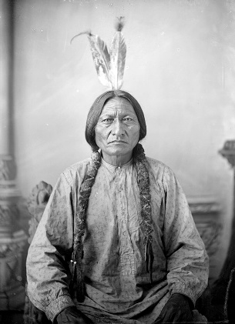Sitting Bull

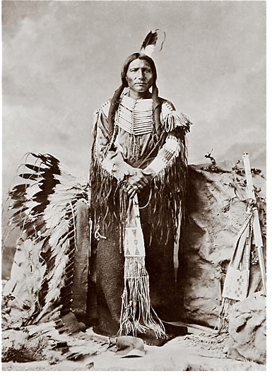Crazy Horse

March 3, 1875: Nation’s first Immigration Law

“The Page Act was primarily enforced against Chinese immigrants. It marked the beginning of a shift in anti-Asian prejudice from a Western issue to a national concern. Seven years later, the Chinese Exclusion Act of 1882 banned Chinese men from immigrating as well.” https://wams.nyhistory.org/industry-and-empire/expansion-and-empire/page-act-1875/

June 25, 1876: Battle of Little Bighorn – Lt. Col. George Armstrong Custer

“The Battle of the Little Bighorn, fought on June 25, 1876, near the Little Bighorn River in Montana Territory, pitted federal troops led by Lieutenant Colonel George Armstrong Custer (1839-76) against a band of Lakota Sioux and Cheyenne warriors. Tensions between the two groups had been rising since the discovery of gold on Native American lands. When a number of tribes missed a federal deadline to move to reservations, the U.S. Army, including Custer and his 7th Cavalry, was dispatched to confront them. Custer was unaware of the number of Indians fighting under the command of Sitting Bull (c.1831-90) at Little Bighorn, and his forces were outnumbered and quickly overwhelmed in what became known as Custer’s Last Stand.” https://www.history.com/articles/battle-of-the-little-bighorn
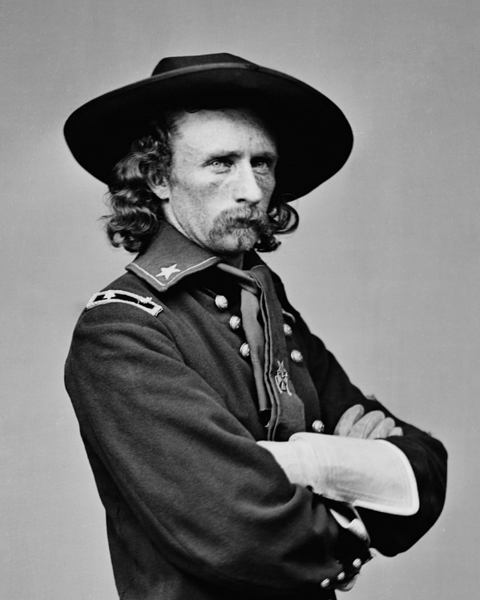

Lt Col George Armstrong Custer (died June 25, 1876; age 36)
“In 1874, an Army expedition led by Lt. Col. George Armstrong Custer found gold in the Black Hills, in present-day South Dakota. At the time, the United States recognized the hills as property of the Sioux Nation, under a treaty the two parties had signed six years before. The Grant administration tried to buy the hills, but the Sioux, considering them sacred ground, refused to sell; in 1876, federal troops were dispatched to force the Sioux onto reservations and pacify the Great Plains. That June, Custer attacked an encampment of Sioux, Cheyenne and Arapaho on the Little Bighorn River, in what is now Montana. The Battle of the Little Bighorn is one of the most studied actions in U.S. military history, and the immense literature on the subject is devoted primarily to answering questions about Custer’s generalship during the fighting. But neither he nor the 209 men in his immediate command survived the day, and an Indian counterattack would pin down seven companies of their fellow 7th Cavalrymen on a hilltop over four miles away. (Of about 400 soldiers on the hilltop, 53 were killed and 60 were wounded before the Indians ended their siege the next day.) The experience of Custer and his men can be reconstructed only by inference.” https://www.smithsonianmag.com/history/how-the-battle-of-little-bighorn-was-won-63880188/

June 18, 1878: POSSE COMITAS ACT
“The Posse Comitatus Act bars federal troops from participating in civilian law enforcement except when expressly authorized by law. This 143-year-old law embodies an American tradition that sees military interference in civilian affairs as a threat to both democracy and personal liberty. *** In British and American law, a posse comitatus is a group of people who are mobilized by the sheriff to suppress lawlessness in the county. In any classic Western film, when a lawman gathers a ‘posse’ to pursue the outlaws, they are forming a posse comitatus. The Posse Comitatus Act is so named because one of the things it prohibits is using soldiers rather than civilians as a posse comitatus.”
https://www.brennancenter.org/our-work/research-reports/posse-comitatus-act-explained

***

“The Constitution permits Congress to authorize the use of the militia "to execute the Laws of the Union, suppress Insurrections and repel Invasions." And it guarantees the states protection against invasion or usurpation of their "republican form of government," and, upon the request of the state legislature, against "domestic violence." These constitutional provisions are reflected in the Insurrection Acts, which have been invoked numerous times both before and after passage of the Posse Comitatus Act, 18 U.S.C. Section 1385, in 1878. Congress has also enacted a number of statutes that authorize the use of land and naval forces to execute their objective. The Posse Comitatus Act outlaws the willful use of any part of the Army or Air Force to execute the law unless expressly authorized by the Constitution or an act of Congress. History supplies the grist for an argument that the Constitution prohibits military involvement in civilian affairs subject to only limited alterations by Congress or the President, but the courts do not appear to have ever accepted the argument unless violation of more explicit constitutional command could also be shown. The express statutory exceptions include the legislation that allows the President to use military force to suppress insurrection or to enforce federal authority, 10 U.S.C. Sections 251-255, and laws that permit the Department of Defense to provide federal, state and local police with information, equipment, and personnel, 10 U.S.C. §§ 271-284.” https://www.congress.gov/crs-product/R42659

March 19, 2025: “Trump team makes plans for military to hold migrants at border.
If enacted, miles of buffer zone would become a temporary military installation, giving U.S. troops their most direct role yet in the president’s enforcement mission. *** The effort would enable the most significant use yet of active-duty forces at the border under Trump, though any move to militarize the southern border’s buffer zone is certain to raise questions about whether employing the military in this way runs afoul of the Posse Comitatus Act, a federal law that prohibits active-duty troops from most law enforcement missions. To date, the Trump administration has addressed such legal considerations by having Customs and Border Protection or Immigration and Customs Enforcement detain people and move them once in custody, including on U.S. military flights involved in its deportation efforts.” https://www.washingtonpost.com/national-security/2025/03/19/trump-border-military-buffer-zone/?utm_campaign=wp_todays_headlines&utm_medium=email&utm_source=newsletter&carta-url=https%3A%2F%2Fs2.washingtonpost.com%2Fcar-ln-tr%2F41af9f1%2F67dbe72b97fc0f25850ac3d2%2F59731235ade4e21a848a56ed%2F18%2F64%2F67dbe72b97fc0f25850ac3d2

1881 – Booker T. Washington – Tuskegee Institute

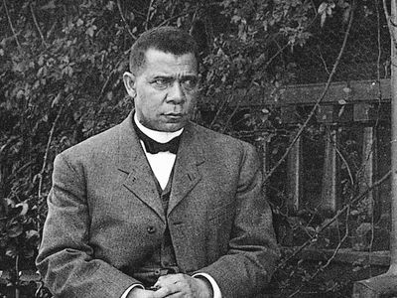https://www.britannica.com/biography/Booker-T-Washington

“In 1881 Washington was selected to head a newly established normal school for African Americans at Tuskegee, an institution with two small converted buildings, no equipment, and very little money. Tuskegee Normal and Industrial Institute became a monument to his life’s work. At his death 34 years later, it had more than 100 well-equipped buildings, some 1,500 students, a faculty of nearly 200 teaching 38 trades and professions, and an endowment of approximately $2 million. Washington believed that the best interests of Black people in the post-Reconstruction era could be realized through education in the crafts and industrial skills and the cultivation of the virtues of patience, enterprise, and thrift. He urged his fellow Blacks, most of whom were impoverished and illiterate farm laborers, to temporarily abandon their efforts to win full civil rights and political power and instead to cultivate their industrial and farming skills so as to attain economic security. Blacks would thus accept segregation and discrimination, but their eventual acquisition of wealth and culture would gradually win for them the respect and acceptance of the white community. This would break down the divisions between the two races and lead to equal citizenship for Blacks in the end. In his epochal speech (September 18, 1895) to a racially mixed audience at the Atlanta Exposition, Washington summed up his pragmatic approach in the famous phrase:
‘In all things that are purely social we can be separate as the fingers, yet one as the hand in all things essential to mutual progress.’” https://www.britannica.com/biography/Booker-T-Washington

Oct. 14, 1883: U.S. Supreme Court: Civil Rights Cases, 109

U.S. 3 (1883) – CONGRESS LACKED POWER TO STOP HOTELS, THEATERS FROM PRACTICING SEGREGATION [later overturned]
“[I]n this set of five cases that were consolidated into one issue, a majority of the court held the Civil Rights Act of 1875 unconstitutional against the lone famous dissent of Justice Harlan. The majority argued that Congress lacked authority to regulate private affairs under the 14th Amendment and that the 13th Amendment ‘merely abolishe[d] slavery’. Segregation in public accommodations would not be declared illegal after these cases until the Civil Rights Act of 1964.” https://guides.ll.georgetown.edu/c.php?g=592919&p=4172697
“Two of the cases, those against Stanley and Nichols, were indictments for denying to persons of color the accommodations and privileges of an inn or hotel; two of them, those against Ryan and Singleton, were, one on information, the other an indictment, for denying to individuals the privileges and accommodations of a theatre, the information against Ryan being for refusing a colored person a seat in the dress circle of Maguire's theatre in San Francisco, and the indictment against Singleton was for denying to another person, whose color was not stated, the full enjoyment of the accommodations of the theatre known as the Grand Opera House in New York, ‘said denial not being made for any reasons by law applicable to citizens of every race and color, and regardless of any previous condition of servitude.’” https://supreme.justia.com/cases/federal/us/109/3/

MR. JUSTICE JOHN HARLAN dissenting.
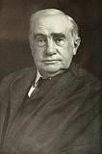
“The opinion in these cases proceeds, it seems to me, upon grounds entirely too narrow and artificial. I cannot resist the conclusion that the substance and spirit of the recent amendments of the Constitution have been sacrificed by a subtle and ingenious verbal criticism. *** The purpose of the first section of the act of Congress of March 1, 1875, was to prevent race discrimination in respect of the accommodations and facilities of inns, public conveyances, and places of public amusement.” https://supreme.justia.com/cases/federal/us/109/3/
1884 – Haskell Indian Nations University

“Well, Haskell [Haskell Indian Nations University, Lawrence, Kansas] is one of at least 35 TCUs, or tribal colleges and universities. https://collegefund.org/tribal-colleges-and-universities/

They are not unlike HBCUs, historically Black colleges and universities. They, too, were born out of refusal by this land’s settler colonial class to provide any meaningful education to the progeny of the millions of indigenous people it really preferred to eradicate, or the progeny of the millions of humans it trafficked from Africa to exploit.

Haskell was founded by the U.S. government in 1884 — it was one of those U.S. Indian Industrial Training Schools that came to be called, extremely inappropriately, Indian boarding schools. They had little to nothing in common with boarding schools such as Andover or Exeter.

The mission of TCUs and HBCUs is to educate the marginalized ethnic and racial students referenced in their titles. And Haskell is even more pointed. As part of a treaty and trust signed between American Indians and this country, Haskell’s mission is specifically to lift up those who are members of federally recognized tribes, or can prove Native ancestry through blood. Last fall, Haskell enrolled 978 students from 146 tribes.”
https://www.washingtonpost.com/sports/2025/02/23/haskell-womens-basketball-coach-cut/?utm_campaign=wp_post_most&utm_medium=email&utm_source=newsletter&carta-url=https%3A%2F%2Fs2.washingtonpost.com%2Fcar-ln-tr%2F4147d59%2F67bb4bcefe9d672c2a35f390%2F59731235ade4e21a848a56ed%2F35%2F52%2F67bb4bcefe9d672c2a35f390

Dec. 29, 1890: Wounded Knee Massacre

“Wounded Knee Massacre [South Dakota], the slaughter of approximately 150–300 Lakota Indians by United States Army troops in the area of Wounded Knee Creek in southwestern South Dakota. The massacre was the climax of the U.S. Army’s late 19th-century efforts to repress the Plains Indians. It broke any organized resistance to reservation life and assimilation to white American culture, although American Indian activists renewed public attention to the massacre during a 1973 occupation of the site.” https://www.britannica.com/event/Wounded-Knee-Massacre
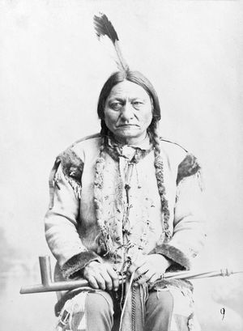
“In November [1890] the U.S. Army arrived on Lakota reservations with the goal of stopping the rise of the Ghost Dance. One source indicates that it was the largest deployment of federal troops since the end of the Civil War in 1865. Near the Standing Rock Agency lived Sitting Bull, a powerful Hunkpapa Lakota chief and spiritual leader who had led the Lakota and Northern Cheyenne to victory in 1876 against the U.S. Army at the Little Bighorn. Many of his 250 followers were Dancers, and, though he personally was not a practitioner, he refused to let the federal government repress them any further. Maj. James McLaughlin, the reservation’s agent, resolved to arrest Sitting Bull for his role in permitting the spread of the religion. Maj. Gen. Nelson A. Miles commanded U.S. Army forces on the Lakota lands and hoped to take a peaceful approach to removing the Hunkpapa leader from the reservation. McLaughlin chose to undermine that plan, instead dispatching 43 tribal policemen to Sitting Bull’s cabin on December 15. Sitting Bull was compliant, but his followers would not relinquish him without protest. A vicious struggle ensued, and roughly nine Hunkpapa were killed; among the dead was Sitting Bull.” https://www.britannica.com/event/Wounded-Knee-Massacre

May 18, 1896: U.S. Supreme Court: Plessy v. Ferguson (7 to 1) https://www.law.cornell.edu/wex/plessy_v_ferguson_(1896)

“SEPARATE BUT EQUAL” – STATE SEGREGATION LAWS UPHELD [OVERTURNED IN 1954]

[T]his is the case which gave us the phrase ‘separate but equal’ and upheld state racial segregation laws for public facilities. Justice Harlan again offered a lone dissent. These laws would remain in play until 1954.”
https://guides.ll.georgetown.edu/c.php?g=592919&p=4172697

“The statute of Louisiana, acts of 1890, c. 111, requiring railway companies carrying passengers in their coaches in that State, to provide equal, but separate, accommodations for the white and colored races, by providing two or more passenger coaches for each passenger train, or by dividing the passenger coaches by a partition so as to secure separate accommodations; and providing that no person shall be permitted to occupy seats in coaches other than the ones assigned to them, on account of the race they belong to; and requiring the officer of the passenger train to assign each passenger to the coach or compartment assigned for the race to which he or she belong; and imposing fines or imprisonment upon passengers insisting on going into a coach or compartment other than the one set aide for the race to which he or she belongs; and conferring upon officers of the train power to refuse to carry on the train passengers refusing to occupy the coach or compartment assigned to them, and exempting the railway company from liability for such refusal, are not in conflict with the provisions either of the Thirteenth Amendment or of the Fourteenth Amendment to the Constitution of the United States.” https://supreme.justia.com/cases/federal/us/163/537/

MR. JUSTICE JOHN HARLAN, dissenting.
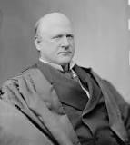
“By the Louisiana statute the validity of which is here involved, all railway companies (other than street railroad companies) carrying passengers in that State are required to have separate but equal accommodations for white and colored persons ‘by providing two or more passenger coaches for each passenger train, or by dividing the passenger coaches by a partition so as to secure separate accommodations.’ Under this statute, no colored person is permitted to occupy a seat in a coach assigned to white persons, nor any white person to occupy a seat in a coach assigned to colored persons. The managers of the railroad are not allowed to exercise any discretion in the premises, but are required to assign each passenger to some coach or compartment set apart for the exclusive use of his race. If a passenger insists upon going into a coach or compartment not set apart for persons of his race, he is subject to be fined or to be imprisoned in the parish jail. Penalties are prescribed for the refusal or neglect of the officers, directors, conductors and employees of railroad companies to comply with the provisions of the act. *** Thus, the State regulates the use of a public highway by citizens of the United States solely upon the basis of race. However apparent the injustice of such legislation may be, we have only to consider whether it is consistent with the Constitution of the United States.” https://supreme.justia.com/cases/federal/us/163/537/

Aug. 1896 - Klondike Gold Rush

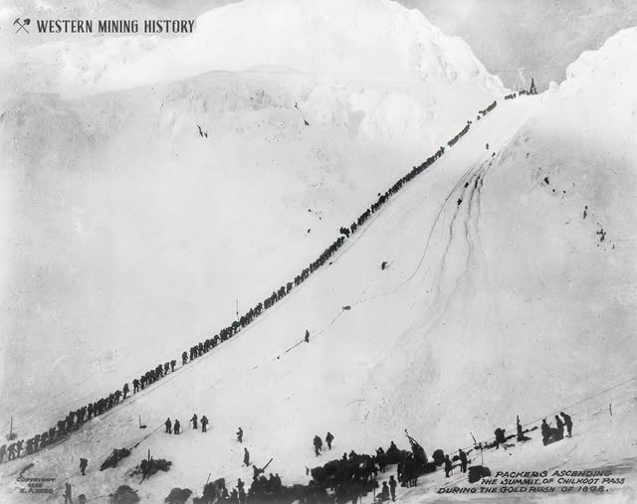
This 1898 photo depicts Chilkoot Pass, Alaska on the trail to the Klondike goldfields. The Klondike Gold Rush began in late 1896.

“’Cries of "Gold! Gold! Gold in the Klondike!’ started a race. 100,000 hopeful miners sprinted toward Alaska and the Yukon with their eyes on riches. Alaska Native and First Nations communities adapted to hold onto another kind of wealth: their culture, land, and way of life. In August, 1896, Skookum Jim and his family found gold near the Klondike River in Canada's Yukon Territory. Their discovery sparked one of the most frantic gold rushes in history. Nearby miners immediately flocked to the Klondike to stake the rest of the good claims. Almost a year later, news ignited the outside world. A wave of gold seekers bought supplies and boarded ships in Seattle and other west coast port cities. They headed north thinking they would strike it rich. *** By midsummer of 1898 there were 18,000 people at Dawson, with more than 5,000 working the diggings. By August many of the stampeders had started for home, most of them broke. The next year saw a still larger exodus of miners when gold was discovered at Nome, Alaska. The great Klondike Gold Rush ended as suddenly as it had begun. Towns such as Dawson City and Skagway began to decline. Others, including Dyea, disappeared altogether, leaving only memories of what many consider to be the last grand adventure of the 19th century.”
https://www.nps.gov/klgo/learn/goldrush.htm

Nov. 6, 1896 – NFPA Formed – Installation of Sprinkler Systems
“So, in 1895, a number of insurance and property protection professionals met for the first time in Boston to discuss how to address this challenge. They discussed how, at the time, nine different standards for fire sprinkler piping size and spacing were being used within a 100-mile radius of Boston, as well as evidence and research that was beginning to mount regarding which installation methods worked best.
The group continued meeting, and following one such meeting in March 1896 released the “Report of Committee on Automatic Sprinkler Protection,” which would eventually become NFPA 13, Standard for the Installation of Sprinkler Systems. At a subsequent meeting on November 6, 1896, the group voted to start an entire organization dedicated to advancing fire safety. “This organization shall be known as the National Fire Protection Association,” the approved article stated, and NFPA was officially born.” https://www.nfpa.org/news-blogs-and-articles/blogs/2024/11/06/history-of-nfpa

Feb. 15, 1898: “Remember The Maine” - Cuba
“On February 15, 1898, the battleship USS Maine exploded in Havana’s harbor in Cuba, killing nearly two-thirds of her crew. The tragedy occurred after years of escalating tensions between the United States and Spain, and the ‘yellow press’ and public opinion were quick to blame Spain. While the sinking of the Maine was not a direct cause of the Spanish-American War, it did accelerate the breakdown in diplomatic relations between the US and Spain. ‘Remember the Maine, to Hell with Spain!’ became a rallying cry.”
https://www.gilderlehrman.org/history-resources/spotlight-primary-source/remember-maine-1898
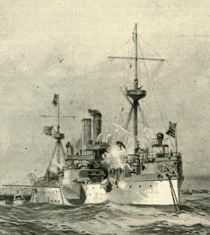

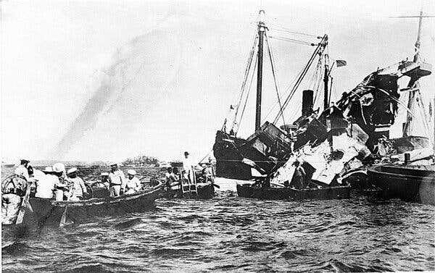Lifeboats rescuing surviving crew members after a mysterious explosion sank the U.S.S. Maine in Havana Harbor in February 1898.Credit...Associated Press
“The Spanish-American War in 1898 led to a number of U.S. interventions in Latin America, particularly in Cuba. The U.S.S. Maine was sent to Havana that January on a stated mission of protecting American citizens. After a mysterious explosion sank the battleship a month later, the United States began a naval blockade of Cuba and went to war with Spain. That campaign expanded to Puerto Rico, and then reached the Pacific to include the Philippines and Guam. The war ended with the 1898 Treaty of Paris, signed in December, which ceded ownership of Puerto Rico, Guam and the Philippines to the United States. Spain also relinquished control of Cuba.” https://www.nytimes.com/2025/12/09/us/politics/military-history-latin-america-strikes.html?nl=Breaking+News&segment_id=212078

May 1, 1898: Manila Bay – Commodore George Dewey
“The first battle was fought on May 1, in Manila Bay, where Commodore George Dewey’s Asiatic Squadron defeated the Spanish naval force defending the Philippines. On June 10, U.S. troops landed at Guantanamo Bay in Cuba and additional forces landed near the harbor city of Santiago on June 22 and 24. After isolating and defeating the Spanish Army garrisons in Cuba, the U.S. Navy destroyed the Spanish Caribbean squadron on July 3 as it attempted to escape the U.S. naval blockade of Santiago.” https://history.state.gov/milestones/1866-1898/spanish-american-war#:~:text=U.S.%20victory%20in%20the%20war,of%20Hawaii%20during%20the%20conflict
June 10, 1898: U.S. Marines, Guantánamo Bay, Cuba
“Marines had landed in Guantánamo Bay, Cuba, in June 1898 and moved swiftly through the island. It was the start of a long period of Marine involvement in conflicts in Central America and the Caribbean, which came to be known as the Banana Wars. ‘Before the Second World War, this is what the Marine Corps did,’ said Mark F. Cancian, a senior adviser with the Center for Strategic and International Studies and a retired Marine Corps colonel. ‘Their bread and butter was destabilizing and overthrowing governments in Latin America.’” https://www.nytimes.com/2025/12/09/us/politics/military-history-latin-america-strikes.html?nl=Breaking+News&segment_id=212078

1898: President McKinley – Spanish-American War - Annexing Philippines
“The Spanish-American War of 1898 ended Spain’s colonial empire in the Western Hemisphere and secured the position of the United States as a Pacific power. U.S. victory in the war produced a peace treaty that compelled the Spanish to relinquish claims on Cuba, and to cede sovereignty over Guam, Puerto Rico, and the Philippines to the United States. The United States also annexed the independent state of Hawaii during the conflict. Thus, the war enabled the United States to establish its predominance in the Caribbean region and to pursue its strategic and economic interests in Asia.” https://history.state.gov/milestones/1866-1898/spanish-american-war

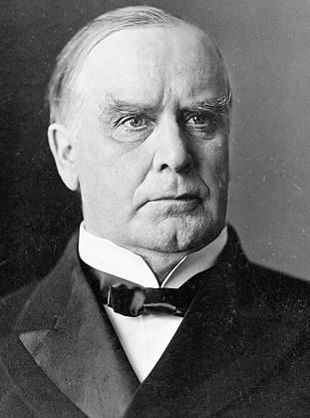
“So, too, McKinley’s embrace of American imperialism proved fleeting, for very good reason. The Spanish-American War — a conflict triggered by hysteria over the (likely accidental) explosion of a U.S. battleship in Havana harbor in 1898 (“Remember the Maine!”) — cost the lives of more than 2,000 U.S. service members. Then, by foolishly annexing the Philippines in 1899, McKinley embroiled America in another conflict that cost the lives of more than 4,200 U.S. soldiers and 20,000 Filipino combatants. More than 200,000 Filipino civilians also died from violence, famine and disease, and U.S. soldiers committed war crimes that shamed the nation. The United States eventually won the conflict but secured no real strategic or economic advantage; the U.S. bases in the Philippines were easily overrun by the Japanese in 1942.

***

The United States did not annex Cuba but did dominate it in cooperation with corrupt local elites. The last U.S.-backed dictator, Fulgencio Batista, was overthrown by Fidel Castro in 1959, and the island has been a thorn in America’s side ever since.”

https://www.washingtonpost.com/opinions/2025/01/26/donald-trump-william-mckinley-president-panama-canal/?utm_campaign=wp_post_most&utm_medium=email&utm_source=newsletter&carta-url=https%3A%2F%2Fs2.washingtonpost.com%2Fcar-ln-tr%2F40ac55f%2F6796645b927b326945a87499%2F59731235ade4e21a848a56ed%2F27%2F56%2F6796645b927b326945a87499

September 14, 1901 – President McKinley Assassination
“President William McKinley (1843-1901) dies on September 14, 1901 of complications from bullet wounds inflicted by Leon Czolgosz. Czolgosz, an anarchist, shot the President during one of his public appearances at the Pan-American Exposition in Buffalo, New York. Initially doctors believed that President McKinley would survive the assassination attempt even though only one bullet was able to be removed.” https://guides.loc.gov/chronicling-america-william-mckinley-assassination

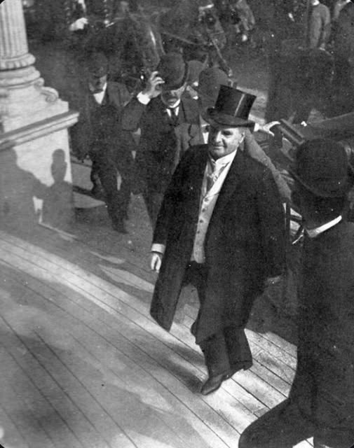

1903 – Mark Twain and “Jim”
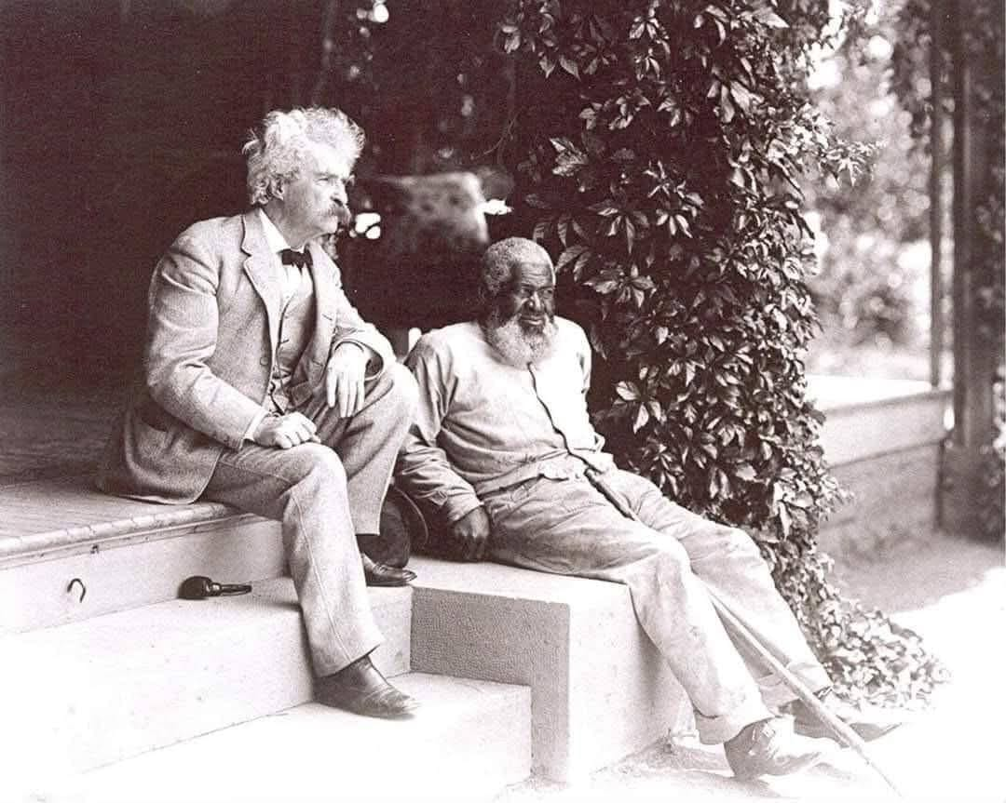
“Huck and Jim in Their Final Years”
“In 1903, on his last visit to his in-laws at Quarry Farm in Elmira, New York, Mark Twain (1835-1910) posed for this photograph with his friend, John T. Lewis (1835-1906), who was born a free man in Maryland and who had migrated to upstate New York. They met in 1877 after Lewis saved the lives of Twain’s sister-in-law and her daughter by courageously stopping their runaway carriage at no small risk to his own safety…. When Twain returned to writing Huckleberry Finn, in 1879 while at Elmira, Lewis was one of the real-life people upon whom he based the character of Jim, and it is even possible that his acquaintance with Lewis caused Twain to continue working on the novel after having earlier set it aside.”https://www.facebook.com/goldenageglamours/posts/huck-and-jim-in-their-final-yearsin-1903-on-his-last-visit-to-his-in-laws-at-qua/122186827790032905/

Dec. 17, 1903: First Flight - Kitty Hawk, NC

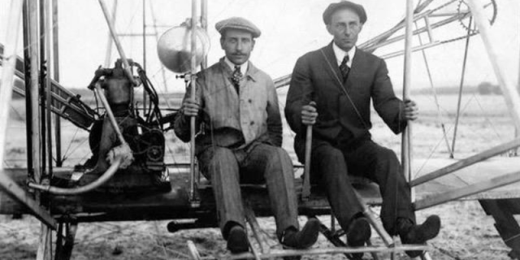
“They Taught the World to Fly! Wind, sand, and a dream of flight brought Wilbur and Orville Wright to Kitty Hawk, North Carolina where, after four years of scientific experimentation, they achieved the first successful airplane flights on December 17, 1903. With courage and perseverance, these self-taught engineers relied on teamwork and application of the scientific process. What they achieved changed our world forever.” https://www.nps.gov/wrbr/index.htm

Brazil claims first flight:
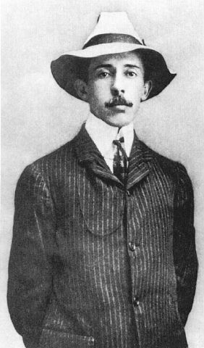
“It's difficult for citizens of the United States to understand why Brazilians are so insistent that he was the first to fly when the very sources they cite seem to prove just the opposite. Brazilians point proudly to the records of the Federation Aeronautique Internationale that show Santos Dumont made his record 722-foot flight in 1906, without disputing the eyewitness accounts that corroborate the Wright brothers report of 852 feet in 1903. To help explain why this is so, perhaps it would be best to let a Brazilian make the case for Santos Dumont. This is one of the better-written and less strident letters that we have received from Brazil:
Dear Sirs,
I recognize the importance of Wright Brothers to the progress of aviation, to people of USA. But I'll never recognize any kind of primacy in flight from that Gentlemen, first because they were working in absolute "secret", until 1908, when they presented their ground device dependant flying machine in Europe for the first time. Considering the alleged date for the first flight event, I cannot understand why 5 years later they were still using a catapult…. “ https://www.wright-brothers.org/History_Wing/History_of_the_Airplane/Who_Was_First/Santos_Dumont/Santos_Dumont.htm

March 25, 1911: NY City – Triangle Shirtwaist Factory Fire
“On March 25, 1911, the Triangle Shirtwaist Company factory in New York City burned, killing 146 workers. It is remembered as one of the most infamous incidents in American industrial history, as the deaths were largely preventable–most of the victims died as a result of neglected safety features and locked doors within the factory building. The tragedy brought widespread attention to the dangerous sweatshop conditions of factories, and led to the development of a series of laws and regulations that better protected the safety of workers.” https://www.history.com/topics/early-20th-century-us/triangle-shirtwaist-fire

1912: Nicaragua
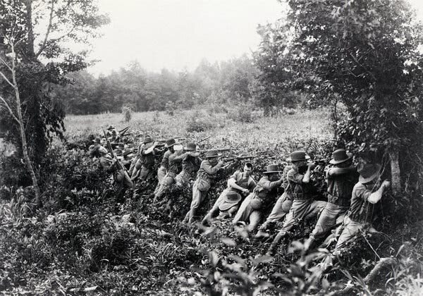A contingent of U.S. Marines landed in Nicaragua in 1912, beginning 21 years of occupation. Credit...Bettmann, via Getty Images
“Nicaragua was in the middle of a revolt against its right-leaning and pro-American president when Marines landed in the country on a stated mission to preserve U.S. interests. This quickly turned into a direct military intervention and began 21 years of occupation of Nicaragua as part of the Banana Wars.” https://www.nytimes.com/2025/12/09/us/politics/military-history-latin-america-strikes.html?nl=Breaking+News&segment_id=212078

Oct. 14, 1912 – Theodore Roosevelt Shot – Still Gave Speech

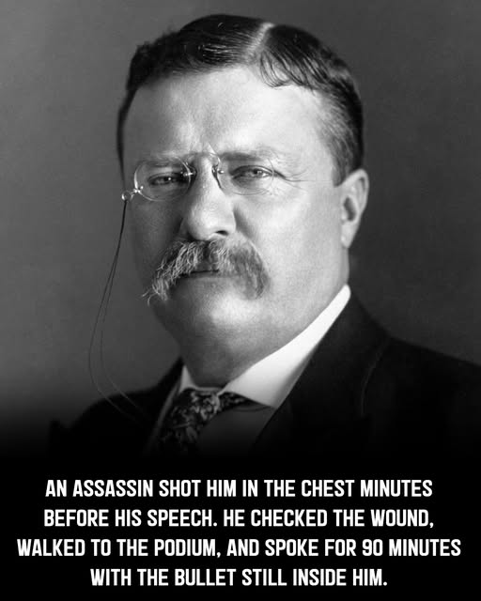
“It Takes More Than That To Kill A Bull Moose. Before a campaign speech in Milwaukee, Wisconsin, presidential candidate Theodore Roosevelt is shot at close range by saloonkeeper John Schrank while greeting the public in front of the Gilpatrick Hotel. Schrank’s .32-caliber bullet, aimed directly at Roosevelt’s heart, failed to mortally wound the former president because its force was slowed by a glasses case and a bundle of manuscript in the breast pocket of Roosevelt’s heavy coat—a manuscript containing Roosevelt’s evening speech. Schrank was immediately detained and reportedly offered as his motive that “any man looking for a third term ought to be shot.” Roosevelt, who suffered only a flesh wound from the attack, went on to deliver his scheduled speech with the bullet still in his body. After a few words, the former “Rough Rider” pulled the torn and bloodstained manuscript from his breast pocket and declared, “You see, it takes more than one bullet to kill a Bull Moose.” He spoke for nearly an hour and then was rushed to the hospital. Despite his vigorous campaign, Roosevelt, who served as the 26th U.S. president from 1901 to 1909, was defeated by Democrat Woodrow Wilson in November. Shrank was deemed insane and committed to a mental hospital, where he died in 1943.” https://www.history.com/this-day-in-history/october-14/theodore-roosevelt-shot-in-milwaukee

April 1914 – Mexico

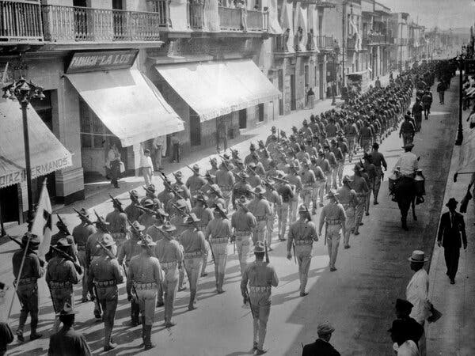U.S. troops in Veracruz, Mexico, in April 1914, as part of a blockade of the city’s port.

“Tensions were high between the United States and Mexico in 1914, as the latter underwent political upheaval fomented by the former. The year before, the United States had worked to overthrow a Mexican president in favor of another who was viewed as more pro-American, leading to a coup d’état, only to turn around and withdraw support for the new president, backing the bandit and revolutionary leader Pancho Villa to depose him.
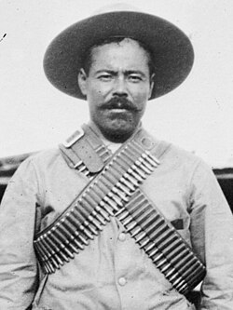 Pancho Villa
Then came the I’m-sorry-I’m-not-sorry squabble. The Mexican government arrested nine American sailors in April 1914 for entering an off-limits fuel-loading station in Tampico, on the country’s east coast. Mexico released the sailors, but the United States demanded an apology and a 21-gun salute. Mexico agreed to the apology but not the salute.
President Woodrow Wilson ordered a naval blockade of the Port of Veracruz, to the south. But before that could be carried out, he discovered an arms shipment heading to Mexico in violation of an American arms embargo. The U.S. Navy seized the Port of Veracruz, occupying it for seven months.” https://www.nytimes.com/2025/12/09/us/politics/military-history-latin-america-strikes.html?nl=Breaking+News&segment_id=212078

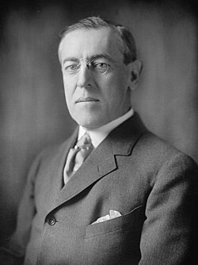

1914 – World War I Begins (1914-1918)
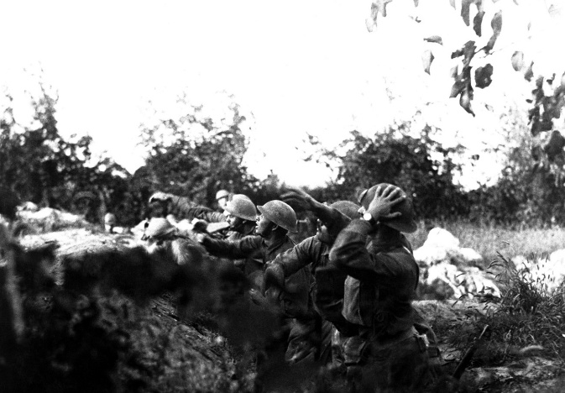

“In the summer of 1914, the assassination of Archduke Franz Ferdinand, heir to the Austro-Hungarian Empire, ignited a continental war between the Central Powers of Germany, Austria-Hungary, and the Ottoman Empire and the Allies of France, Great Britain, Russia, and Italy. By the war’s end in 1918, the war would span the globe, claim more than 16 million lives, and change the world forever…. The United States initially remained neutral. But reports of German atrocities and submarine attacks on shipping bound for Britain and France – most infamously the 1915 sinking of the Lusitania, which killed 128 Americans – began to change American opinion. In 1916 President Woodrow Wilson won re-election on the slogan ‘He kept us out of war.’ But in April 1917, Germany’s resumption of unrestricted submarine warfare, along with its offer to help Mexico recover territories lost to the United States in 1848, led Wilson to ask Congress to declare war on Germany…. Although the first American soldiers landed in France in June 1917, it would take a year to create, train and equip an army and ship it across the Atlantic. The outcome of the war would turn on whether Germany could defeat Britain and France before the Americans arrived in force…. American troops conducted their first major action on May 28, 1918, when the 1st Division rolled back a German salient at Cantigny. Soon after, American forces were deployed along the Western Front, fighting in battles that have become part of American military lore. In early June, the 2nd Division, including a brigade of U.S. Marines, drove German forces out of Belleau Wood after weeks of savage fighting. At Chateau Thierry the 3rd Division won the name ‘Rock of the Marne’ for its stand on the Marne River…. The United States suffered 53,402 battle deaths in World War I, in less than six months of fighting. Another 63,114 died from accidents and disease.” https://www.nps.gov/wwim/wwioverview.htm

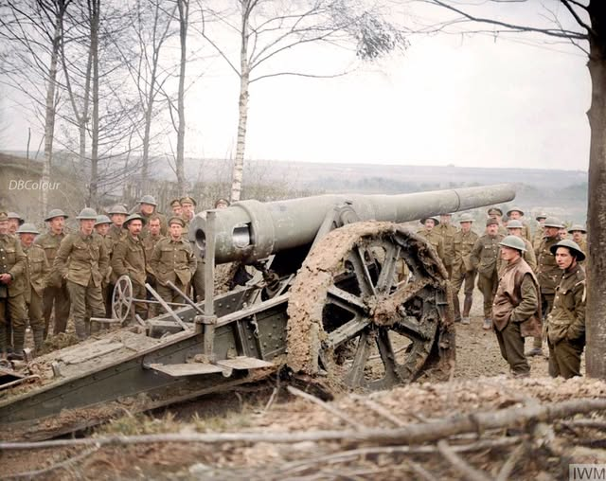
Nov. 29, 1917 - A captured German 15 cm naval gun, northern France

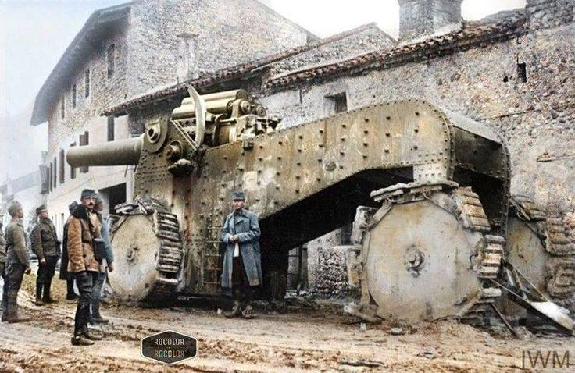Austro-Hungarian soldiers inspecting an Italian 305mm howitzer captured during the battle of Caporetto, November 1917

1915 – Haiti
“After President Vilbrun Guillaume Sam of Haiti was assassinated (shortly after ordering the execution of 167 political prisoners), Wilson sent Marines to the country. The stated mission was to restore order and stabilize Haiti’s turbulence, which had been fueled in part by U.S. actions such as the seizure of its gold reserves over debts. The Marines stayed almost 20 years, finally withdrawing in 1934.” https://www.nytimes.com/2025/12/09/us/politics/military-history-latin-america-strikes.html?nl=Breaking+News&segment_id=212078

September, 1915: Ohio – African American Auto Maker
“The Little-Known Tale of the Only African American Automaker. Patterson-Greenfield only built cars from 1915–1918 but found time to innovate, even patenting a door design that presaged those on modern-day vans. *** Patterson-Greenfield was an early 20th-century automaker headquartered in Greenfield, Ohio, a small town roughly midway between Columbus and Cincinnati. Like a number of early brands, including Buick, Pontiac, and Studebaker, it was founded as a successful 19th-century maker of horse-drawn carriages. But unlike any of those contemporaries or any other U.S. automobile company before or since, it was founded and run entirely by African American owners, providing it with a particular prominence in vehicular history. *** In 1929, according to Nelson, nearly half of the school buses in Ohio were made by Patterson.”
https://www.caranddriver.com/features/a26360175/african-american-automaker/

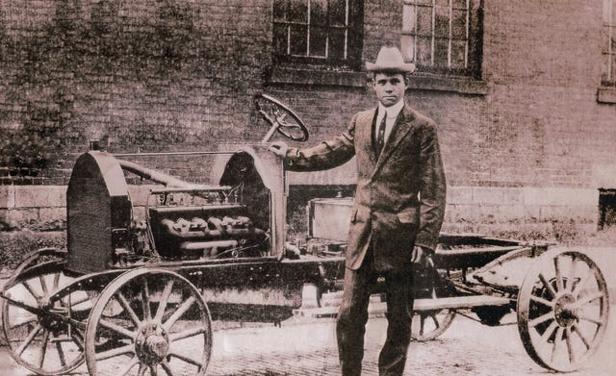

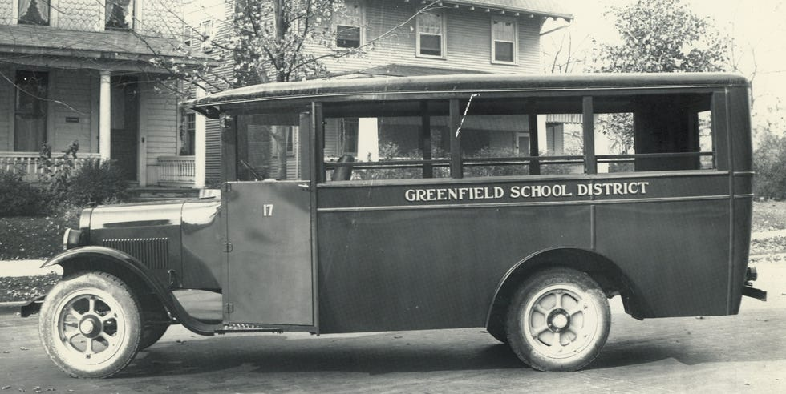

Oct. 27, 1915 – Antarctica - Ernest Shackleton – “The Endurance”
On Oct. 27, 1915, after being caught and crushed by packed ice for nine months in the Weddell Sea off Antarctica, Ernest Shackleton and his crew abandoned the Endurance and their quest to traverse the frozen continent by land. The doomed ship drifted atop the ice for three more weeks before finally sinking. https://www.nytimes.com/2025/10/06/science/shackleton-endurance-antarctica.html?nl=From+The+Times
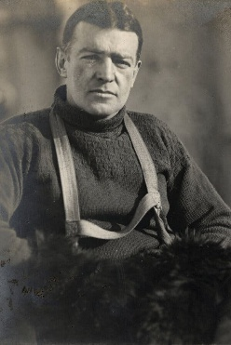
Ernest Shackleton during the Imperial Trans-Antarctic Expedition, 1914 to 1917.
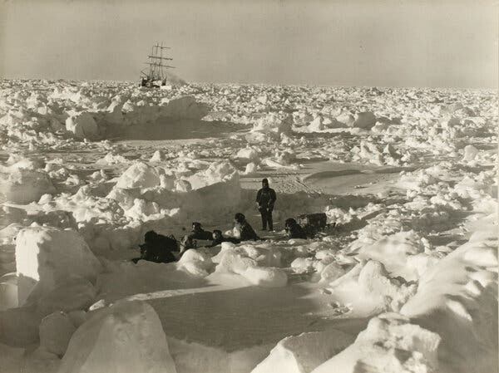

1918: General John J. Pershing – Incident Command / WW I
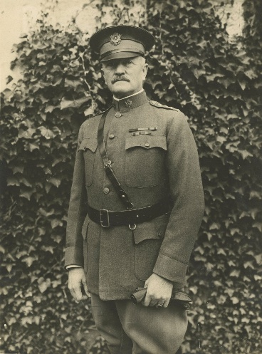
War Fighting: The Case of Ulysses S. Grant (9/16/2025): https://publications.armywarcollege.edu/News/Display/Article/4305205/war-fighting-the-case-of-ulysses-s-grant/

“When the Americans began moving into France in 1917 and 1918, unity of command and effort was lacking among the Allies on the Western Front. General John J. Pershing and his staff suggested unified command, but they had to figure out how to fight under the existing arrangement. One of the first tasks for Pershing and his staff was to identify where on the front an American field army could operate under its own command and have the greatest effect on the war. They selected the Alsace-Lorraine region and prepared for an offensive east from the Saint-Mihiel area toward German lines of communications and resources around Metz. This planned campaign was isolated from the rest of the Allies’ efforts on the front, both physically and in intent.

The German 1918 Spring Offensive forced the Allies to appoint a supreme commander in Ferdinand Foch. The Americans were happy to accede to Foch’s requests for American troops (as divisions) to stem and push back the Germans in the summer of 1918. In the meantime, Pershing kept building First Army with the intent of attacking toward Metz. In the late summer, Foch saw an opportunity for a unified strategy to end the war that called for multiple concentric campaigns aimed at the center of the great German salient in northeastern France and Belgium. The Americans would attack north into the southern face of the salient.

Pershing and his staff agreed—as long as First Army remained a coherent force under American command. Why would they so readily abandon their previous planning for an attack east toward Metz? Put simply, Foch’s overall strategy for 1918 looked like Grant’s successful strategy of 1864. First Army and earlier I Corps commander General Hunter Liggett directly compared prior allied disunity to the Civil War, quoting Grant: ‘As Grant said of the Union Armies before he took command, they had acted ‘without concert, like a balky team, no two ever pulling together.’ ”

April 1918 – WWI – Red Baron
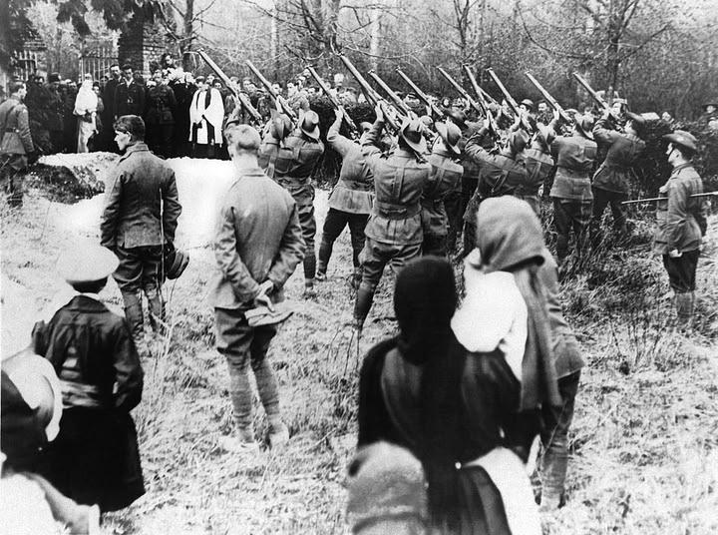
Australian troops fire a final volley over the grave of Manfred von Richthofen, the German ace pilot know as the Red Baron, Amiens, France, May 22, 1918. He was shot down on the Western Front, and his body fell behind the British lines. He was buried with full military honors.
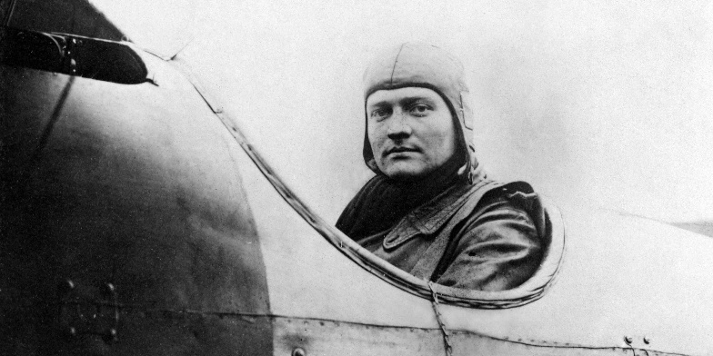
“The Red Baron was the name applied to Manfred von Richthofen, a German fighter pilot who was the deadliest flying ace of World War I. During a 19-month period between 1916 and 1918, the Prussian aristocrat shot down 80 Allied aircraft and won widespread fame for his scarlet-colored airplanes and ruthlessly effective flying style. Richthofen’s legend only grew after he took command of a German fighter wing known as the Flying Circus, but his career in the cockpit was cut short in April 1918, when he was killed in a dogfight over France.” https://www.history.com/articles/manfred-baron-von-richthofen

June 1, 1918: U.S. Army & Marines – Victorius in Battle of Belleau Wood
“The Allies’ victory at the Battle of Belleau Wood, which occurred in France from June 1 to June 26, 1918, greatly boosted morale amid the Germans’ Spring Offensive. The battle was the first major engagement of the U.S. army in World War I, and, only 39 miles from Paris, marked the closest the Germans came to the French capital during the war.” https://www.britannica.com/event/Battle-of-Belleau-Wood

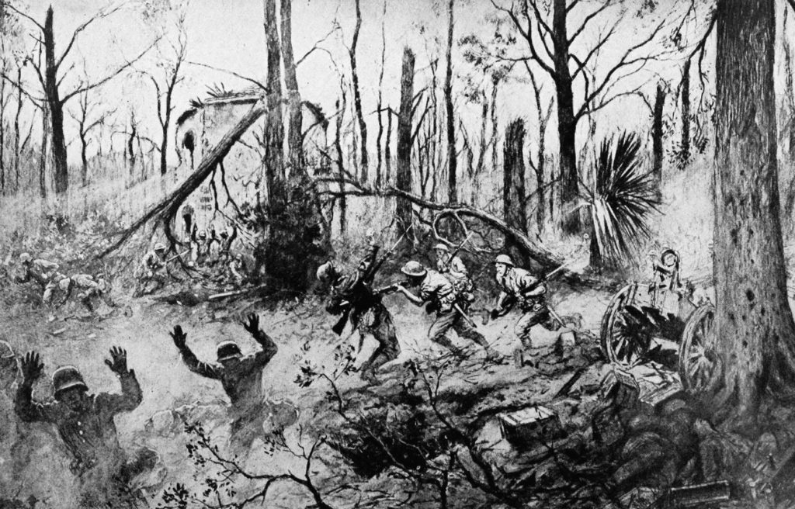

“Every U.S. marine knows the famous quotes from their comrades fighting in 1918 in the Battle of Belleau Wood: ‘Retreat, hell we just got here!’ by Capt. Lloyd Williams, and ‘C’mon you sons-of-bitches, do you want to live forever?’ by Gunnery Sgt. Dan Daley. Every marine proudly claims the ‘Devil dogs’ moniker because of their ferocity in combat. Alongside the Battles of Fallujah, Khe Sanh, Chosin, and Iwo Jima, Belleau Wood occupies a hallowed place in U.S. Marine Corps lore and history. These battles are ingrained in the Marines’ collective consciousness from the first days of boot camp, during ceremonies at birthday balls, on walls in museums, and on pages of publications.” https://warontherocks.com/2018/06/the-importance-of-the-battle-of-belleau-wood/

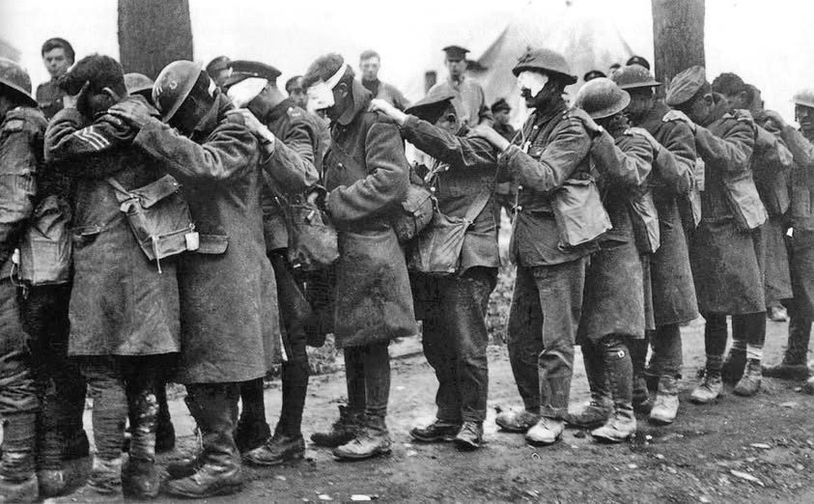
Blinded by gas, British soldiers of the 55th division hold onto each other at an advanced dressing station, April 1918.

1919 – Cincinnati Fire Department strike

“The fire department suffered through two major events that created serious staffing problems. World War 1 caused many firefighters to leave the department for military service. As the war ended the Spanish Flu epidemic swept the nation. Firefighters suffered some of the highest rates of infection. At least 17 were killed hundreds took ill. This stress helped to draw firefighters together to push for better working conditions. A weeklong strike in mid-April was ultimately broken by the city. Firefighters would not be permitted to organize until 1936.” https://www.cincyfiremuseum.com/exhibits/firefighting-history/

March 3, 1919: U.S. Supreme Court - Schenck v. United States (249 US 47) – PROSECUTION FOR CREATING CLEAR & PRESENT DANGER

“Issue: Is certain speech, including sending antiwar pamphlets to drafted men, made in wartime and deemed in violation of the Espionage Act, protected by the First Amendment?
Result: No. Although the defendant would have been able to state his views during ordinary times, the Court held that in certain circumstances, like this case the nation being at war, justify such limits on the First Amendment.
Importance: The Schenck decision is best known for creating the ‘clear and present danger’ test meaning that speech could be restricted if it presented a clear and present danger. The decision was also the first to explain the metaphor of falsely yelling ‘Fire!’ in a crowded theater. Schenck was later modified by Brandenburg v. Ohio, which said that speech could be restricted if it would provoke an ‘imminent lawless action.’” https://www.americanbar.org/groups/public_education/programs/constitution_day/landmark-cases/

“Charles T. Schenck was general secretary of the U.S. Socialist Party, which opposed the implementation of a military draft in the country. The party printed and distributed some 15,000 leaflets that called for men who were drafted to resist military service. Schenck was subsequently arrested for having violated the Espionage Act; he was convicted on three counts.” https://www.britannica.com/event/Schenck-v-United-States MR. JUSTICE HOLMES delivered the opinion of the court.
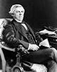
Justice Oliver Homes
“Incriminating document seized under a search warrant directed against a Socialist headquarters, held admissible in evidence, consistently with the Fourth and Fifth Amendment, in a criminal prosecution against the general secretary of a Socialist party, who had charge of the office. Words which, ordinarily and in many places, would be within the freedom of speech protected by the First Amendment may become subject to prohibition when of such a nature and used in such circumstances a to create a clear and present danger that they will bring about the substantive evils which Congress has a right to prevent. The character of every act depends upon the circumstances in which it is done. A conspiracy to circulate among men called and accepted for military service under the Selective Service Act of May 18, 1917, a circular tending to influence them to obstruct the draft, with the intent to effect that result, and followed by the sending of such circulars, is within the power of Congress to punish, and is punishable under the Espionage Act, § 4….” https://supreme.justia.com/cases/federal/us/249/47/

1920s: Great Migration North / KKK
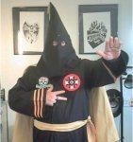
“The era of Jim Crow laws saw a dramatic reduction in the number of blacks registered to vote within the South. This time period brought about the Great Migration of blacks to northern and western cities like New York City, Chicago, and Los Angeles. In the 1920s, the Ku Klux Klan experienced a resurgence and spread all over the country, finding a significant popularity that has lingered to this day in the Midwest. It was claimed at the height of the second incarnation of the KKK that its membership exceeded 4 million people nationwide. The Klan didn't shy away from using burning crosses and other intimidation tools to strike fear into their opponents, who included not just blacks, but also Catholics, Jews, and anyone who wasn't a white Protestant.” https://guides.ll.georgetown.edu/c.php?g=592919&p=4172697

Jan. 26, 1920 - Silverthorne Lumber Co., Inc. v. United States, 251 U.S. 385 (1920)
https://supreme.justia.com/cases/federal/us/251/385/

ILLEGAL SEARCH COMPANY BOOKS & RECORDS
“The facts are simple. An indictment upon a single specific charge having been brought against the two Silverthornes mentioned, they both were arrested at their homes early in the morning of February 25, and were detained in custody a number of hours. While they were thus detained, representatives of the Department of Justice and the United States marshal, without a shadow of authority, went to the office of their company and made a clean sweep of all the books, papers and documents found there. All the employes were taken or directed to go to the office of the District Attorney of the United States, to which also the books, &c., were taken at once. An application, was made as soon as might be to the District Court for a return of what thus had been taken unlawfully…. But the rights of a corporation against unlawful search and seizure are to be protected even if the same result might have been achieved in a lawful way.”

Aug. 18, 1920: 19th Amendment Ratified – Women Right To Vote
“Passed by Congress June 4, 1919, and ratified on August 18, 1920, the 19th amendment guarantees all American women the right to vote. Achieving this milestone required a lengthy and difficult struggle; victory took decades of agitation and protest. Beginning in the mid-19th century, several generations of woman suffrage supporters lectured, wrote, marched, lobbied, and practiced civil disobedience to achieve what many Americans considered a radical change of the Constitution. Few early supporters lived to see final victory in 1920.” https://www.archives.gov/historical-docs/19th-amendment

Sept. 7, 1920: President Woodrow Wilson - Fire Prevention Day
“President Wilson issued the first National Fire Prevention Day proclamation in 1920. And since 1922, Fire Prevention Week has been observed each October.” https://www.firerescue1.com/history/articles/when-firefighting-crossed-paths-with-presidents-veeps-SbUtdRP4yHbhoFaI/
***
”By the President of the United States of America
A Proclamation
Whereas, the destruction by fires in the United States involves an annual loss of life of 15,000 men, women and children, and over $250,-000,000 in buildings, foodstuffs and other created resources, and
Whereas, the need of the civilized world for American products to replace the ravages of the Great War is especially great at this time, and
Whereas, the present serious shortage of home and business structures makes the daily destruction of buildings by fire an especially serious matter, and
Whereas, a large percentage of the fires causing the annual American fire waste may be easily prevented by increased care and vigilance on the part of citizens:
Therefore, I, Woodrow Wilson, President of the United States, do urge upon the Governors of the various States to designate and set apart Saturday, October 9, 1920, as Fire Prevention Day, and to request the citizens of, their States to plan for that day such instructive and educational exercises as shall bring before the people the serious and unhappy effects of the present unnecessary fire waste, and the need of their individual and collective efforts in conserving the natural and created resources of America.
In witness whereof, I have hereunto set my hand and caused the seal of the United States to be affixed.
Done in the District of Columbia this seventh day of September, in the year of our Lord One Thousand Nine Hundred and Twenty and of the Independence of the United States, the One Hundred and Forty-fifth.
WOODROW WILSON
By the President: . .
Bainbridge Colby, Secretary of State.” https://www.presidency.ucsb.edu/documents/proclamation-1573-fire-prevention-day-1920

1921: William Howard Taft – from President to Chief Justice of U.S. Supreme Court
“A century ago, in the summer of 1921, President Warren G. Harding appointed former President William Howard Taft as Chief Justice of the United States. Taft had spent a lifetime in public service, ultimately reaching the White House. Yet he expressed trepidation in taking on this new and different challenge. Taft told Harding that he was gratified by the appointment but ‘trembled to think whether I can worthily fill the position and be useful to the country.’ He voiced a concern that might cross the mind of any good judge when first donning a judicial robe.” https://www.supremecourt.gov/publicinfo/year-end/2021year-endreport.pdf

Aug. 26, 1920 – 19th Amendment – Women’s Suffrage Rights
“The right of citizens of the United States to vote shall not be denied or abridged by the United States or by any State on account of sex. Congress shall have power to enforce this article by appropriate legislation.” https://constitution.findlaw.com/amendments.html 1926

May 31, 1921 – Tulsa, OK Race Massacre
Justice Department Announces Results of Review and Evaluation of the Tulsa Race Massacre (1/10/2025): https://www.justice.gov/opa/pr/justice-department-announces-results-review-and-evaluation-tulsa-race-massacre
“The review revealed that, on the night of May 31, 1921, a violent attack by as many as 10,000 white Tulsans destroyed Greenwood, a uniquely prosperous Black community. The attack was so systematic and coordinated that it transcended mere mob violence. The review found that the trigger for the violence of the Tulsa Race Massacre was the kind of unfounded condemnation that, at the time, was commonly employed to justify unspeakable treatment of Black men; a white man alleged that a Black man, 19-year-old Dick Rowland, assaulted a white woman who operated an elevator he used. After Rowland’s arrest, a local newspaper then sensationalized the story and, soon, a mob of white Tulsans gathered outside the courthouse, demanding a lynching.
The local sheriff called on Black men from Greenwood, many recently returned from service during World War I, to come to the courthouse to prevent a lynching. The white mob saw this effort to protect Rowland as an unacceptable challenge to the social order. The mob grew. A confrontation broke out, and when someone fired a shot, horrific violence erupted. The Tulsa police deputized hundreds of white residents, many of whom — immediately before being awarded a badge — had been drinking and agitating for Rowland’s murder. Law enforcement officers helped organize these special deputies — as well as other white Tulsans — into the forces that would eventually ravage the Greenwood community.
Violence was initially unorganized and opportunistic. But at daybreak on June 1, a whistle blew, and the violence and arsons that had been chaotic became systematic. White Tulsans, many of whom had recently drilled together as the “Home Guard,” formed to replace members of the National Guard who had gone overseas during the Great War, became organized and efficient in their destruction. They looted, burned and destroyed 35 city blocks while Greenwood’s residents tried desperately to defend their homes. As the fires consumed Greenwood, many Black families fled for their lives, leaving behind their homes and valuable items. White residents chased them across and beyond the city, taking into custody men, women, children, the elderly and the infirm, and looting the homes they left behind. The destruction of the district was total. The survivors were left with little to nothing.
Law enforcement officers (both from the Tulsa Police and the National Guard) disarmed Black residents, confiscated their weapons and detained many in makeshift camps under armed guard. In addition, there are credible reports that at least some law enforcement officers did more than arrest and detain Black men; some participated in murder, arson and looting. After the devastation, city officials promised to help Greenwood rebuild, but the government of Tulsa not only failed to do so, it put up obstacles to residential reconstruction. White local leaders rejected outside aid, claiming they could handle the recovery, but then provided little to no financial support. Instead, claiming the area was best suited for industrial use, they imposed harsh new fire codes that priced residents out of the area.”
See also: https://www.tulsahistory.org/exhibit/1921-tulsa-race-massacre/
May 30, 1922 – Lincoln Memorial dedication
“Ground was broken in 1914. The statue of the seated Lincoln was made from 28 blocks of Georgia marble carved by sculptor Daniel Chester French in the New York studio of the Piccirilli brothers, a team of renowned Italian stonecutters. The blocks were then shipped to Washington and assembled inside the memorial in 1919. The memorial was dedicated in 1922 [President Warren G. Harding] ,in the presence of Lincoln’s son, Robert, then 78. About 50,000 people attended. African Americans, as was the cruel custom in then-segregated Washington, were shunted off to the rear.” https://www.washingtonpost.com/dc-md-va/2024/12/11/lincoln-memorial-undercroft-national-park-service-visitor-area-musem/?utm_campaign=wp_todays_headlines&utm_medium=email&utm_source=newsletter&carta-url=https%3A%2F%2Fs2.washingtonpost.com%2Fcar-ln-tr%2F3fe8fc4%2F675ac231357387190b4ebd70%2F59731235ade4e21a848a56ed%2F22%2F61%2F675ac231357387190b4ebd70

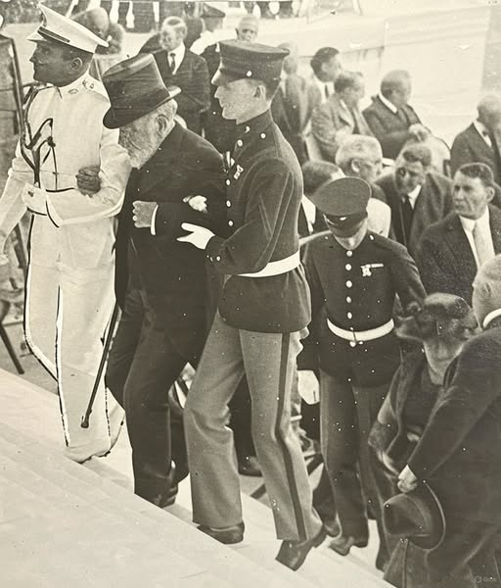
78-year-old Robert T. Lincoln (son of Abraham Lincoln) is helped up the steps at the dedication of the Lincoln Memorial in Washington D.C.

June 2, 1924 – Native Americans become U.S. Citizens
“Indian Citizenship Act. On June 2, 1924, Congress enacted the Indian Citizenship Act, which granted citizenship to all Native Americans born in the U.S. The right to vote, however, was governed by state law; until 1957, some states barred Native Americans from voting.” https://www.loc.gov/item/today-in-history/june-02/

July 10, 1925: Scopes Trial
“The Scopes Trial, also known as the Scopes Monkey Trial, was the 1925 prosecution of science teacher John Scopes for teaching evolution in a Tennessee public school, which a recent bill had made illegal. The trial featured two of the best-known orators of the era, William Jennings Bryan and Clarence Darrow, as opposing attorneys. The trial was viewed as an opportunity to challenge the constitutionality of the bill, to publicly advocate for the legitimacy of Darwin’s theory of evolution, and to enhance the profile of the American Civil Liberties Union (ACLU).” https://www.history.com/articles/scopes-trial

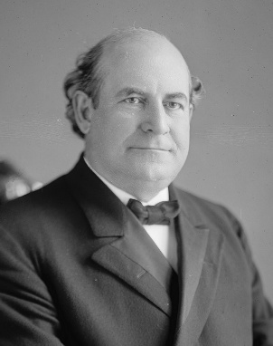 William Jennings Bryan (March 19, 1860 – July 26, 1925)
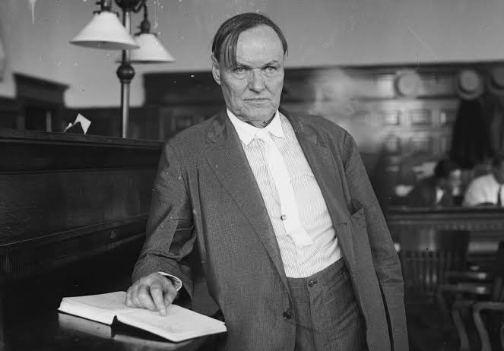 Clarence Seward Darrow (April 18, 1857 – March 13, 1938)
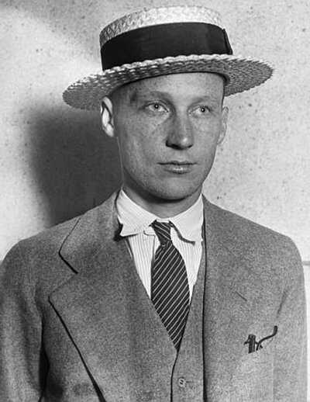John T. Scopes
“Scopes Trial, (July 10–21, 1925, Dayton, Tennessee, U.S.), highly publicized trial known as the ‘Monkey Trial’) of a Dayton, TN school teacher, John T. Scopes, charged with violating state law by teaching Charles Darwin’s theory of evolution. The trial’s proceedings helped to bring the scientific evidence for evolution into the public sphere while also stoking a national debate over the veracity of evolution that continues to the present day.

In March 1925 the Tennessee legislature had passed the Butler Act, which declared unlawful the teaching of any doctrine denying the divine creation of man as taught by the Bible. World attention focused on the trial proceedings, which promised and delivered confrontation between fundamentalist literal belief and liberal interpretation of the Scriptures. William Jennings Bryan led for the prosecution and Clarence Darrow for the defense.

The trial’s climax came on July 20, when Darrow called on Bryan to testify as an expert witness for the prosecution on the Bible. Raulston moved the trial to the courthouse lawn, citing the swell of spectators and stifling heat inside. Darrow’s cross-examination challenged Bryan on various biblical stories and the validity and practicality of their literal interpretation. Bryan responded by claiming that Darrow’s “only aim was to cast slurs on the Bible.” With Raulston limiting the trial to the single question of whether Scopes had taught evolution, which he admittedly had, Scopes was convicted and fined $100 on July 21. On appeal, the state Supreme Court upheld the constitutionality of the 1925 law but acquitted Scopes on the technicality that he had been fined excessively.

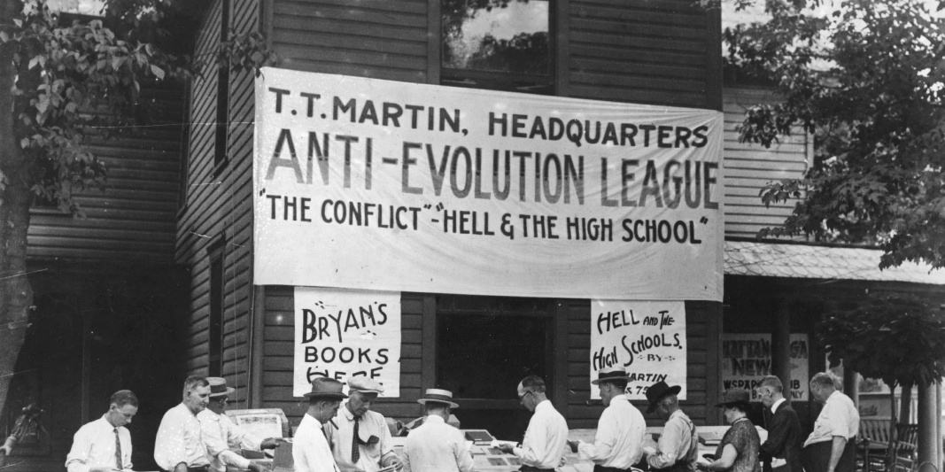

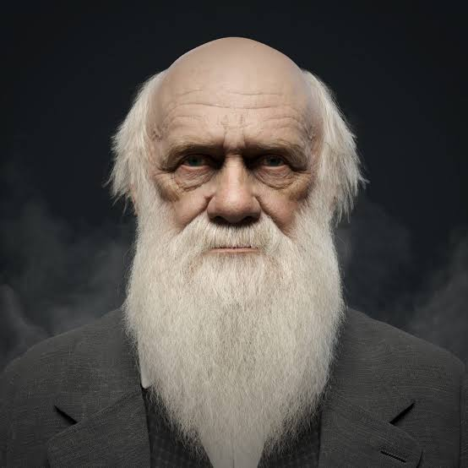”Charles Darwin: History’s most famous biologist. (1809-1882) transformed the way we understand the natural world with ideas that, in his day, were nothing short of revolutionary. He and his fellow pioneers in the field of biology gave us insight into the fantastic diversity of life on Earth and its origins, including our own as a species.” https://www.nhm.ac.uk/discover/charles-darwin-most-famous-biologist.html

1926 – American Indian Children, 83% forcibly sent to Boarding Schools

Opinion: Deb Haaland: My grandparents were stolen from their families as children. We must learn about this history. Deb Haaland, the U.S. interior secretary, is the first Native American to serve as a Cabinet secretary. (June 11, 2021)
“Over nearly 100 years, tens of thousands of Indigenous children were taken from their communities and forced into scores of boarding schools run by religious institutions and the U.S. government. Some studies suggest that by 1926, nearly 83 percent of Native American school-age children were in the system. Many children were doused with DDT upon arrival, and as their coerced re-education got underway, they endured physical abuse for speaking their tribal languages or practicing traditions that didn’t fit into what the government believed was the American ideal.
My great-grandfather was taken to Carlisle Indian School in Pennsylvania. Its founder coined the phrase ‘kill the Indian, and save the man,’ which genuinely reflects the influences that framed these policies at the time.”
https://www.washingtonpost.com/opinions/2021/06/11/deb-haaland-indigenous-boarding-schools/?utm_campaign=wp_week_in_ideas&utm_medium=email&utm_source=newsletter&wpisrc=nl_ideas

1925: Leonard “Kip” Rhinelander Trial – White’s Family Sought Annulment When He Married “Black”
“The Rhinelander Trial held the public in its grip for the better part of 1925, with both black and white press weighing in with varying opinions. Ultimately, on December 6, 1925, the jury ruled in Mrs. Rhinelander’s favor. Playing on the notion that race can be visually established, the defense attorney successfully ‘showed’ Mrs. Rhinelander to be ‘colored,’ argued that she could not have deceived her husband, and therefore his claims for annulment were invalid. The couple never reunited, and legally separated in 1930. Leonard Rhinelander died in 1936, and Alice died in 1989.” https://blackpast.org/african-american-history/leonard-kip-rhinelander-trial-1925/

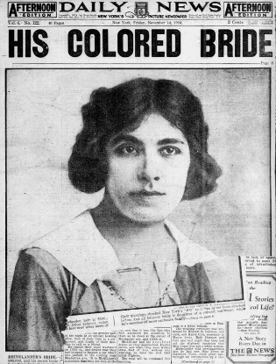
“If Alice and Leonard had married in one of the 29 states that outlawed interracial marriage at the time, the presentation of Alice’s birth certificate to a judge would have invalidated their union. In New York, however, interracial marriage was legal, and divorce was typically permitted only in cases of adultery — which left an annulment on the basis of racial fraud as Leonard’s only state-sanctioned means of dissolving the marriage.” https://www.nytimes.com/2025/12/17/magazine/rhinelander-trial-interracial-marriage.html?nl=From+The+Times&segment_id=212712

March 4, 1929: President Herbert Hoover – Inauguration
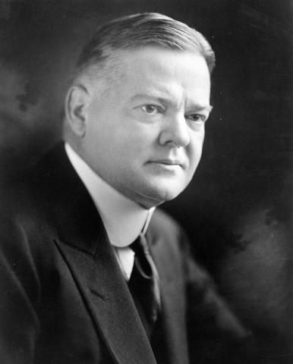
https://hoover.archives.gov/hoovers/president-herbert-hoover

Oct. 24, 1929: Stock Market Crash - “Black Thursday” – Great Depression Started
“Stock market crash of 1929, a sharp decline in U.S. stock market values in 1929 that contributed to the Great Depression of the 1930s. The Great Depression lasted approximately 10 years and affected both industrialized and non industrialized countries in many parts of the world. *** On October 18 the market went into a free fall, and the wild rush to buy stocks gave way to an equally wild rush to sell. The first day of real panic, October 24, is known as Black Thursday; on that day a record 12.9 million shares were traded as investors rushed to salvage their losses. Still, the Dow closed down only six points after a number of major banks and investment companies bought up great blocks of stock in a successful effort to stem the panic that day. Their attempts, however, ultimately failed to shore up the market. The panic began again on Black Monday (October 28), with the market closing down 12.8 percent. On Black Tuesday (October 29) more than 16 million shares were traded. The Dow lost another 12 percent and closed at 198—a drop of 183 points in less than two months. Prime securities tumbled like the issues of bogus gold mines. General Electric fell from 396 on September 3 to 210 on October 29. American Telephone and Telegraph dropped 100 points. DuPont fell from a summer high of 217 to 80, United States Steel from 261 to 166, Delaware and Hudson from 224 to 141, and Radio Corporation of America (RCA) common stock from 505 to 26.” https://www.britannica.com/event/stock-market-crash-of-1929
1930s – Prohibition (ending Dec. 5, 1933 – 21st Amendment)
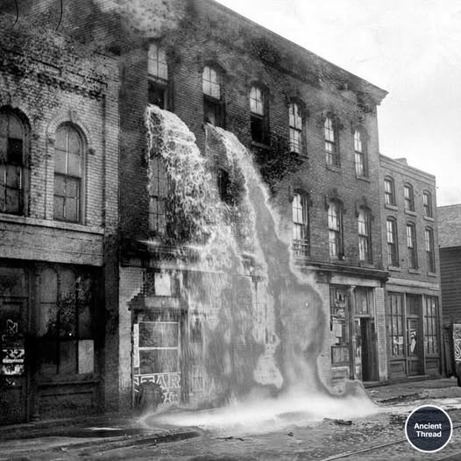Agents dump seized liquor during the Prohibition in the 1930s.
“In 1929—the year of the stock market crash, which seemingly increased the country’s desire for illegal liquor—Eliot Ness was hired as a special agent of the U.S. Department of Justice to head the Prohibition bureau in Chicago, with the express purpose of investigating and harassing Capone. Because the men whom Ness hired to help him were extremely dedicated and unbribable, they were nicknamed the Untouchables. The public learned of them when big raids on breweries, speakeasies, and other places of outlawry attracted newspaper headlines. The Untouchables’ infiltration of the underworld secured evidence that helped send Capone to prison for income-tax evasion in 1932.” https://www.britannica.com/event/Prohibition-United-States-history-1920-1933
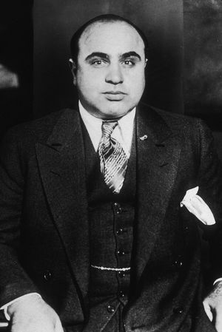Al Capone – 1935
“The Prohibition Era began in 1920 when the 18th Amendment to the U.S. Constitution, which banned the manufacture, transportation and sale of intoxicating liquors, went into effect with the passage of the Volstead Act. Despite the new legislation, Prohibition was difficult to enforce. The increase of the illegal production and sale of liquor (known as “bootlegging”), the proliferation of speakeasies (illegal drinking spots) and the accompanying rise in gang violence and organized crime led to waning support for Prohibition by the end of the 1920s. In early 1933, Congress adopted a resolution proposing a 21st Amendment to the Constitution that would repeal the 18th. The 21st Amendment was ratified on December 5, 1933, ending Prohibition.” https://www.history.com/articles/prohibition

1932: 116 Lynchings In Virginia (1866-1832)
“While communities in the South have reckoned with the legacy of lynching in recent years, including establishment of the National Memorial for Peace and Justice in Alabama, Virginia localities have done relatively little to address the legal record. The Racial Terror: Lynching in Virginia project at James Madison University has identified some 116 lynchings across the state from 1866 to 1932. In a groundbreaking case last year, a prosecutor in Albemarle County dismissed an indictment against John Henry James, a Black man lynched in 1898 after being accused of raping a White woman.” https://www.washingtonpost.com/dc-md-va/2024/12/20/virginia-lynching-judge-culpeper/?utm_campaign=wp_evening_edition&utm_medium=email&utm_source=newsletter&carta-url=https%3A%2F%2Fs2.washingtonpost.com%2Fcar-ln-tr%2F4009b51%2F6765e8e264c0860cbc19978d%2F59731235ade4e21a848a56ed%2F24%2F45%2F6765e8e264c0860cbc19978d

1933: Bonnie & Clyde

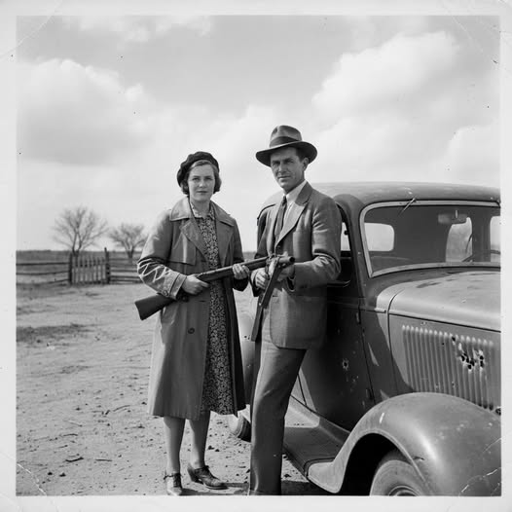
Bonnie and Clyde: Defiance (1933): "Bonnie Parker, with her signature bob haircut, and Clyde Barrow, leaning against a stolen car, both holding firearms. Their expressions are defiant and confident, capturing their notorious public image. The background is a nondescript rural landscape, a common backdrop for their exploits."

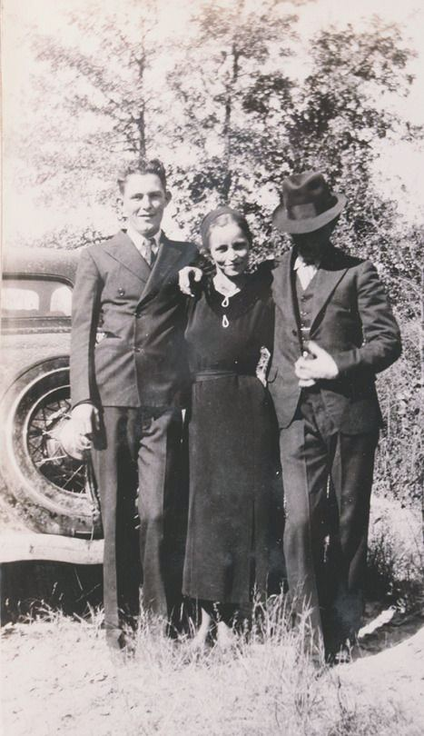

History Pictures:

“Beyond the daring robberies and dramatic headlines, the lives of Bonnie and Clyde were riddled with bizarre, desperate, and often tragic episodes that the legend tends to overshadow. In January 1932, while imprisoned at the notoriously harsh Eastham Prison Farm [Texas]. Clyde became so desperate to escape the grueling labor that he chopped off his left big toe and part of another with an axe. Ironically, his mother had successfully petitioned for his parole, and he was released just six days later—leaving him with a permanent limp that would mark him for life.
Their life on the run was equally perilous and unpredictable. In June 1933, a high-speed escape in their Ford V-8 ended with the car flipping into a ravine. Battery acid from the car’s engine poured onto Bonnie’s leg, burning through flesh to the bone in places. For the rest of her life, she struggled to walk, often relying on Clyde’s support or hopping on one leg. Even in small details, their story was punctuated by irony and unintended notoriety: a few weeks before their deaths, Clyde sent a fan letter to Henry Ford, praising the V-8 as the ultimate getaway car, demonstrating a mix of admiration and dark humor amid their crime spree.
The public image of Bonnie and Clyde was shaped as much by accident as intention. Iconic photos of Bonnie with a cigar and guns were never meant for public consumption; left behind in a Joplin, Missouri, shootout, the undeveloped film was seized by a newspaper, creating the “cigar-smoking outlaw” myth—Bonnie herself didn’t even smoke cigars. Their lives ended abruptly on May 23, 1934, in a deadly ambush, but even in death, the small, human details remained: Bonnie was found clutching a half-eaten fried bologna sandwich, a quiet, ordinary moment frozen at the very end of a life defined by chaos, speed, and relentless danger.”

March 4, 1933: President Franklin D. Roosevelt – Inauguration
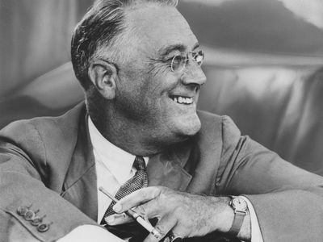
https://www.britannica.com/biography/Franklin-D-Roosevelt

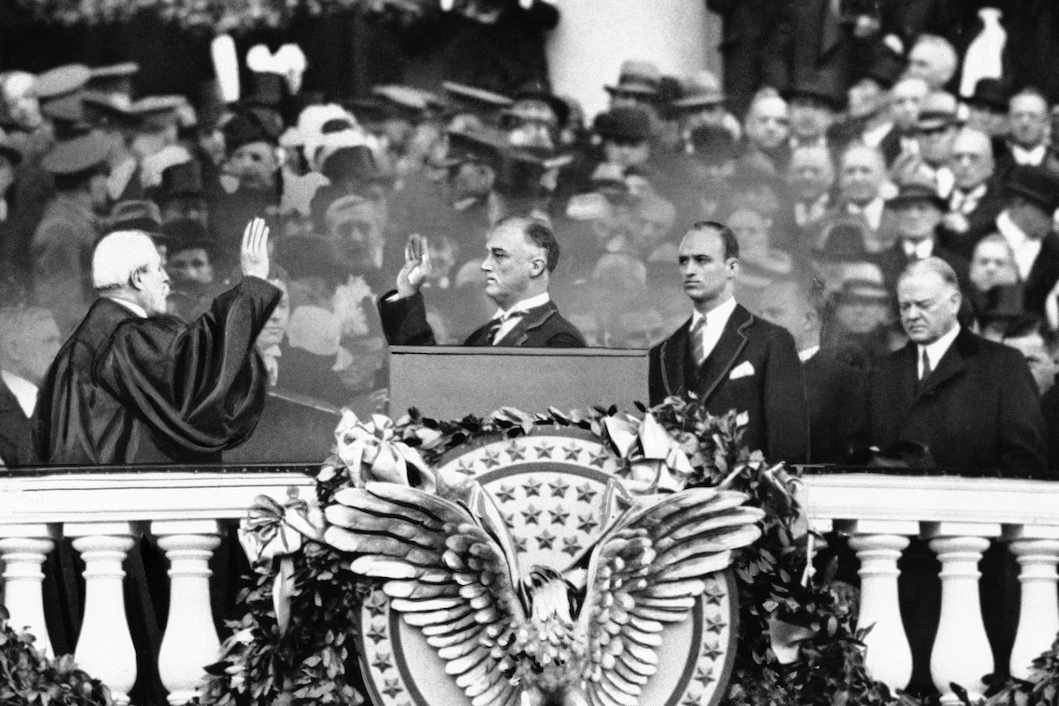 Outgoing President Herbert Hoover, far right, gazes down as President-elect Franklin D. Roosevelt, accompanied by his eldest son James, takes the oath of office from Chief Justice Charles E. Hughes, in Washington on March 4, 1933. (AP)

1933 – Machine Gun Kelly
Machine gun Kelly arrested in Memphis TN 1933 being led down the steps of the Shelby County Courthouse by officers.
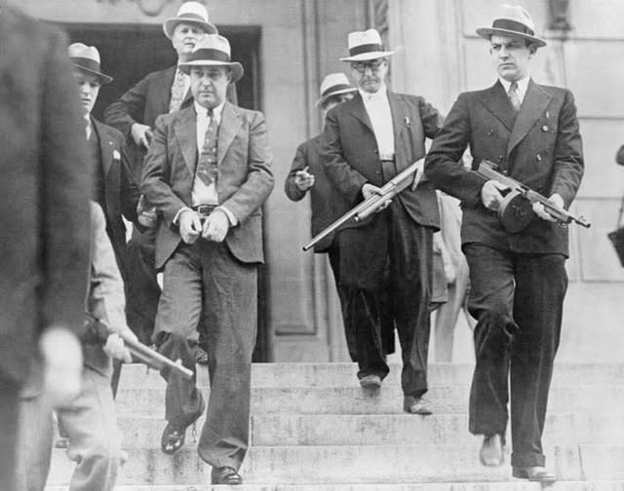
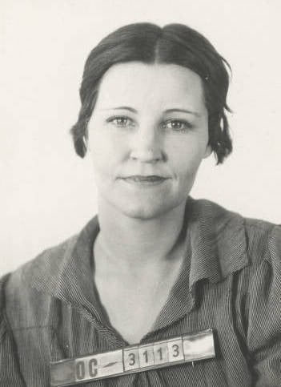
A 1933 mug shot of Kathryn Kelly, wife of gangster George "Machine Gun" Kelly, from the Oklahoma City Police Department.
“He probably never uttered those now famous words, ‘Don’t Shoot G-Men, Don’t Shoot.’
But George ‘Machine Gun’ Kelly—really, George Kelly Barnes—earned a notorious place in FBI history after kidnapping a wealthy oil magnate in 1933 and being associated with that phrase. Following the abduction, the Bureau coordinated a multi-state investigation, drawing investigative information from its own field offices as well as from other police sources, as it identified and tracked down the gangster, his wife, and their criminal colleagues across the country.” https://www.fbi.gov/history/famous-cases/machine-gun-kelly

1935: NLRB
“The National Labor Relations Board enforces the National Labor Relations Act by investigating allegations of wrong-doing brought by workers, unions, or employers, conducting elections, and deciding and resolving cases.” https://www.usa.gov/federalagencies/national-labor-relations-board

May 6, 1937: Lakehurst, New Jersey, the German passenger airship Hindenburg

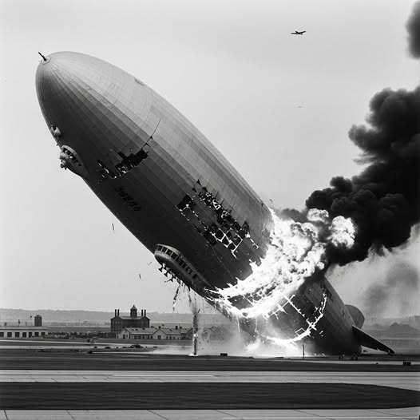
A total of 36 people died in the Hindenburg disaster on May 6, 1937, including 13 passengers and 22 crew members on board, plus one member of the ground crew. Of the 97 people aboard (36 passengers and 61 crew), 62 survived, often with severe burns, after the airship caught fire at Lakehurst, New Jersey.

1938: FLSA enacted: 29 USC 207k
Fair Labor Standards Act of 1938: Maximum Struggle for a Minimum Wage
“When he felt the time was ripe, President Roosevelt asked Secretary of Labor Perkins, 'What happened to that nice unconstitutional bill you had tucked away?'
On Saturday, June 25, 1938, to avoid pocket vetoes 9 days after Congress had adjourned, President Franklin D. Roosevelt signed 121 bills. Among these bills was a landmark law in the Nation's social and economic development -- Fair Labor Standards Act of 1938 (FLSA). Against a history of judicial opposition, the depression-born FLSA had survived, not unscathed, more than a year of Congressional altercation. In its final form, the act applied to industries whose combined employment represented only about one-fifth of the labor force. In these industries, it banned oppressive child labor and set the minimum hourly wage at 25 cents, and the maximum workweek at 44 hours.” https://www.dol.gov/general/aboutdol/history/flsa1938
Note: Cross-Trained EMS Payed Overtime Same As Firefighters (29 U.S.C. 203), https://www.law.cornell.edu/uscode/text/29/203
(y) “Employee in fire protection activities” means an employee, including a firefighter, paramedic, emergency medical technician, rescue worker, ambulance personnel, or hazardous materials worker, who—
- is trained in fire suppression, has the legal authority and responsibility to engage in fire suppression, and is employed by a fire department of a municipality, county, fire district, or State; and
- is engaged in the prevention, control, and extinguishment of fires or response to emergency situations where life, property, or the environment is at risk.

June 1933: FBI - Authorized to make arrests . carry firearms
“How’d we end up at Quantico? It began with the so-called “Kansas City Massacre.” In June 1933, three police officers and one Bureau agent escorting a prisoner through a Missouri train station were killed when “Pretty Boy” Floyd and other criminals opened fire on them. Following the public outcry, FBI agents were given the authority to make arrests and to carry weapons for the first time.” https://www.fbi.gov/how-we-can-help-you/outreach/alumni-e-brief/alumni-e-brief-march-2024

Jan. 20, 1937: President Franklin D. Roosevelt – Second Inauguration
“This year marks the one hundred and fiftieth anniversary of the Constitutional Convention which made us a nation. At that Convention our forefathers found the way out of the chaos which followed the Revolutionary War; they created a strong government with powers of united action sufficient then and now to solve problems utterly beyond individual or local solution. A century and a half ago they established the Federal Government in order to promote the general welfare and secure the blessings of liberty to the American people. Today we invoke those same powers of government to achieve the same objectives.” https://avalon.law.yale.edu/20th_century/froos2.asp

July 2, 1937: Amelia Earhardt – Never Found
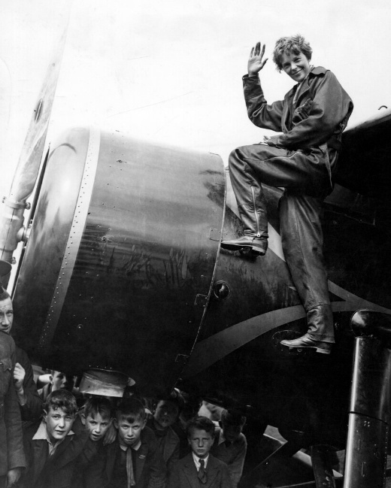Amelia Earhart in 1932
“The documents include a July 1937 radio log from Itasca, a U.S. Coast Guard cutter that was deployed to support Earhart's flight around the world. Itasca was the last ship to have radio contact with Earhart and Noonan before their aircraft disappeared. The phrase ‘Earhart Unheard’ appears numerous times in the log. According to the National Archives, the last communication from Earhart's plane came at about 8:43 a.m. on Jul 2, 1937: ‘We are on the line 157 337 wl rept msg we wl rept…’” https://www.cbsnews.com/news/amelia-earhart-records-declassified-released-missing-aviator/

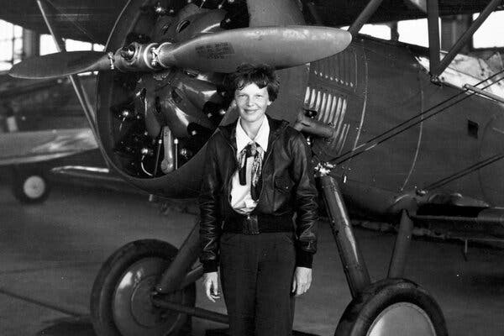
“The Trump administration recently released more than 4,600 pages of documents related to Amelia Earhart, the aviator who vanished in 1937 while trying to become the first woman to circumnavigate the world.” https://www.nytimes.com/2025/11/17/us/politics/trump-amelia-earhart-flight-records.html?ae=oa&context=newsletter-quiz&nl=On+Politics&q=w&showDialog=1

Dec. 11, 1939 - Nardone v. United States, 308 U.S. 338 (1939)
https://supreme.justia.com/cases/federal/us/308/338/

FRUIT OF POISONOUS TREE - ILLEGAL WIRETAP

“We are called upon for the second time to review affirmance by the Circuit Court of Appeals for the Second Circuit of petitioners' convictions under an indictment for frauds on the revenue. In Nardone v. United States, 302 U. S. 379, this Court reversed the convictions on the first trial because they were procured by evidence secured in violation of § 605 of the Communications Act of 1934 (c. 652, 48 Stat. 1064, 1103; 47 U.S.C. § 605). For details of the facts reference is made to that case. Suffice it here to say that this evidence consisted of intercepted telephone messages, constituting ‘a vital part of the prosecution's proof.’ … The burden is, of course, on the accused in the first instance to prove to the trial court's satisfaction that wiretapping was unlawfully employed. Once that is established -- as was plainly done here -- the trial judge must give opportunity, however closely confined, to the accused to prove that a substantial portion of the case against him was a fruit of the poisonous tree.”

1940: UC Black Students Not allowed To Live In Dorms On Campus
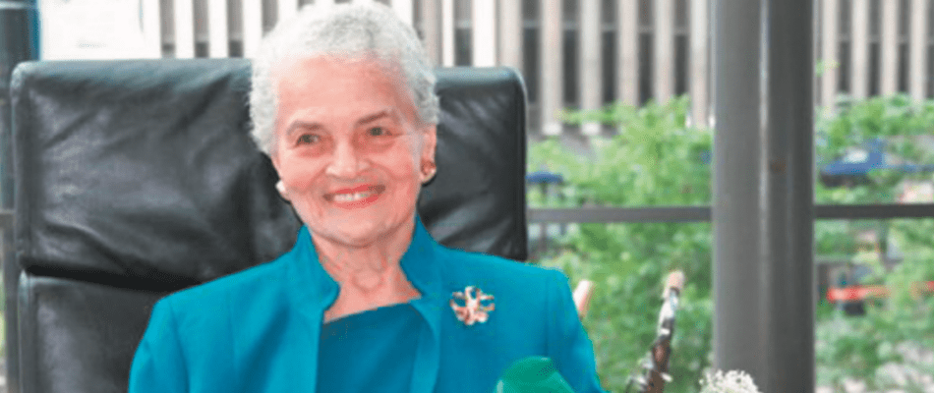
“Marian Spencer, a civil rights icon, was instrumental in desegregating Cincinnati’s Coney Island as well as Cincinnati Public Schools. She went on to become the first African American woman elected to Cincinnati City Council in 1983. As a Black student in the late 1930s and early 1940s, Marian Spencer wasn't permitted to live in a dorm on UC’s campus. Today, there is a residence hall that bears her name, opened in 2018. The Marian Spencer Scholars form a living-learning community housed together in the residence hall for their first year.” Dec. 4, 2024. https://www.uc.edu/news/articles/2024/12/wlwt-segment-features-ucs-marian-spencer-scholarship-program.html?utm_source=cerkl&utm_medium=email&utm_campaign=newsletter-12042024&cerkl_id=20299800&cerkl_ue=A8mLsDEGP2lba17JhuRw0M5uibPpXE21SoiEibe3xak%3D

May 1940: FBI Investigated German Spies In US

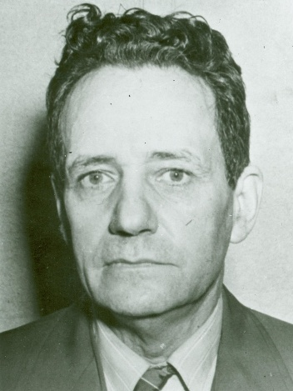
Frederick Joubert Duquesne –“Duquesne Spy Ring”

“First, FBI Lab engineers built a secret shortwave radio transmitting station on Long Island. In May 1940, Bureau agents established contact with the German shortwave station abroad. Our Long Island radio station served as a main channel of communication between German spies in New York City and their superiors in Germany for 16 straight months. Pretending to be Sebold, FBI agents sent more than 300 authentic-sounding messages and received another 200 messages from the Nazis. *** Once we had enough information to pinpoint the members of the ring and enough evidence for an airtight case, the 33 spies were arrested. Nineteen quickly pled guilty. The remaining 14 spies were brought to trial in Brooklyn, New York, on September 3, 1941; they were all found guilty by jury on December 13, 1941. On January 2, 1942, the 33 members of the Nazi spy ring headed by Duquesne were sentenced to serve a total of over 300 years in prison.” https://www.fbi.gov/history/famous-cases/duquesne-spy-ring

September 1940: Lend-Lease Program
“Lend-Lease and Military Aid to the Allies in the Early Years of World War II
During World War II, the United States began to provide significant military supplies and other assistance to the Allies in September 1940, even though the United States did not enter the war until December 1941. Much of this aid flowed to the United Kingdom and other nations already at war with Germany and Japan through an innovative program known as Lend-Lease.” https://history.state.gov/milestones/1937-1945/lend-lease
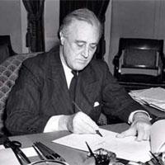
FDR signing Lend-Lease Bill

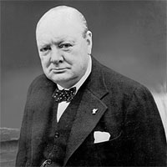Winston Churchill

September 2, 1940: Britain Gets U.S. Destroyers, US Gets Military Bases In Newfoundland And Caribbean
“On September 2, 1940, President Roosevelt signed a “Destroyers for Bases” agreement. Under the terms of the agreement, the United States gave the British more than 50 obsolete destroyers, in exchange for 99-year leases to territory in Newfoundland and the Caribbean, which would be used as U.S. air and naval bases. British Prime Minister Winston Churchill had originally requested that Roosevelt provide the destroyers as a gift, but the President knew that the American public and Congress would oppose such a deal. He therefore decided that a deal that gave the United States long-term access to British bases could be justified as essential to the security of the Western Hemisphere—thereby assuaging the concerns of the public and the U.S. military.” https://history.state.gov/milestones/1937-1945/lend-lease

Caribbean bases:
Eastern side of the Bahamas
Southern coast of Jamaica
Western coast of Saint Lucia
West coast of Trinidad (Gulf of Paria)
Antigua
British Guiana (now Guyana) within fifty miles of Georgetown

Dec. 1, 1940: Attorney General Robert H. Jackson – “Fair Play” By Prosecutors
“Nothing better can come out of this meeting of law enforcement officers than a rededication to the spirit of fair play and decency that should animate the federal prosecutor. Your positions are of such independence and importance that while you are being diligent, strict, and vigorous in law enforcement you can also afford to be just. Although the government technically loses its case, it has really won if justice has been done.”
https://www.roberthjackson.org/speech-and-writing/the-federal-prosecutor/

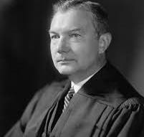

“He rose from IRS legal counsel to Assistant Attorney General, to Solicitor General, and finally, to Attorney General. Roosevelt appointed Jackson to the Supreme Court in 1941 after years of loyal and effective advocacy. While on the Court, Jackson served as chief U.S. prosecutor at the Nuremberg war crimes trials at the conclusion of World War II.” https://www.oyez.org/justices/robert_h_jackson

Jan. 20, 1941: President Franklin D. Roosevelt – Third Inauguration
Dec. 7, 1941 – Pearl Harbor, Hawaii – 4 Battleships Sunk – 4 Damaged
“Many U.S. ships were sunk or damaged and more than 2,400 sailors, Marines, soldiers and civilians were killed.”
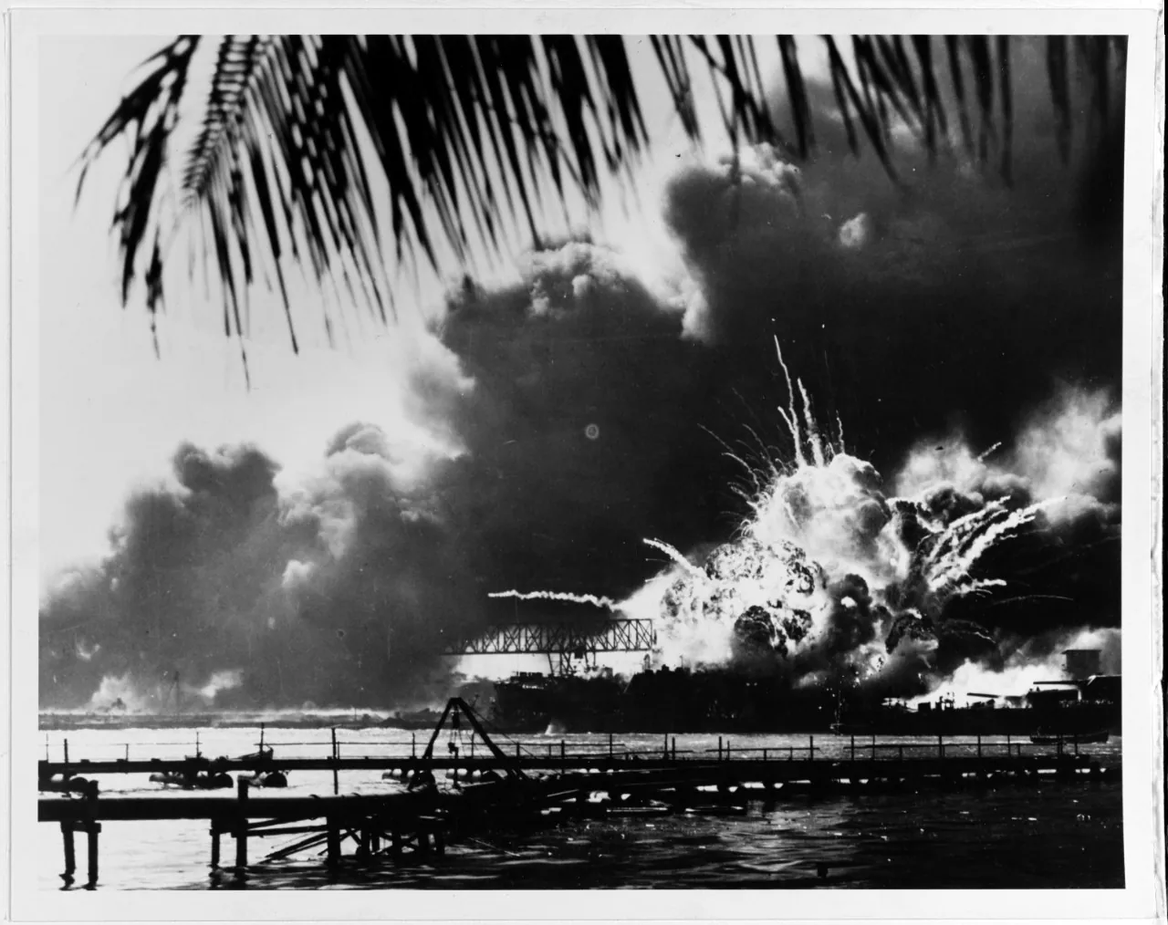
“An explosion occurs the USS Shaw during the Japanese attack on Pearl Harbor on Dec. 7, 1941.”
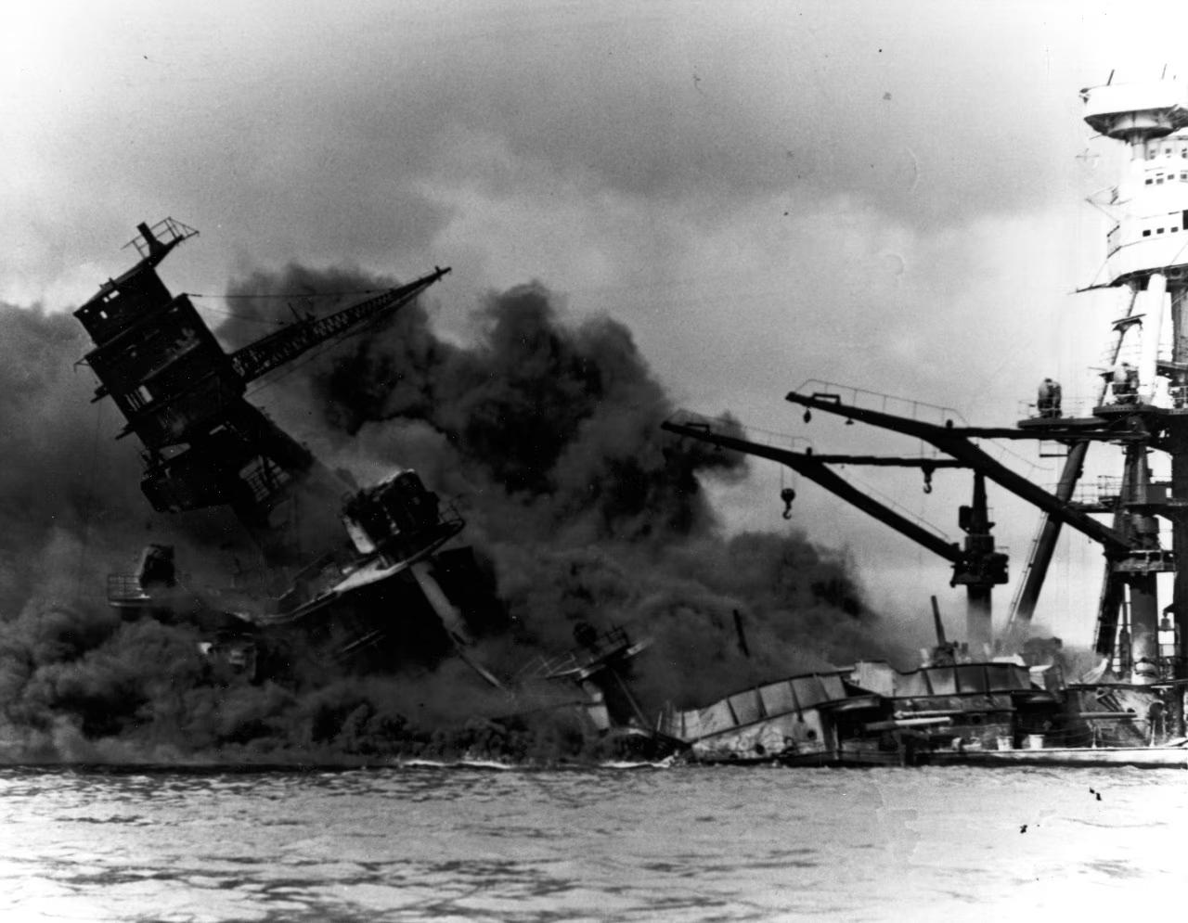 T
“The USS Arizona arrived at Pearl Harbor on Dec. 5, 1941. It was sunk two days later.”

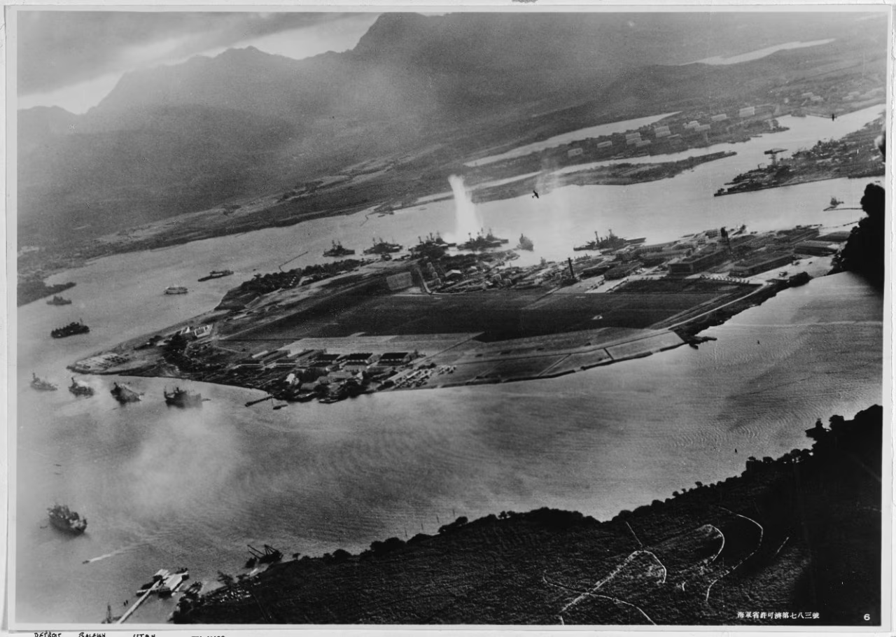
“This photo was taken from a Japanese plane during the attack on Pearl Harbor on Dec. 7, 1941.”
https://www.washingtonpost.com/history/2025/08/18/pearl-harbor-navy-attack-book-lost-archives-found/?utm_campaign=wp_post_most&utm_medium=email&utm_source=newsletter&carta-url=https%3A%2F%2Fs2.washingtonpost.com%2Fcar-ln-tr%2F4438f7a%2F68a350eef256107aad6bd6a1%2F59731235ade4e21a848a56ed%2F28%2F66%2F68a350eef256107aad6bd6a1

Dec. 8, 1941 – Japanese 10 Hours After Pear Harbor Attacked Philippines – Also Guam, Midway Island, Wake Island (and British colonies of Malaya, Singapore and Hong Kong)
“The first wave of Japanese bombers approached Clark Field undetected on Dec. 8, 1941. By the time US airmen realized they were under attack, the bombs were already falling. Almost all of the American airplanes at Clark—45 miles north of Manila and the main operational base of the Far East Air Force in the Philippines—were lined up neatly on the ground when the strike came at 12:40 p.m. Japanese A6M Zero fighters followed the bombers, dropping down to strafe the ramp. The fighter base at Iba on the western coast of Luzon, 42 miles from Clark, was struck almost simultaneously.

By end of the first day, the strength of Far East Air Force was reduced by half, and it was eliminated as an effective fighting force. The FEAF response was scattered and ineffective. Of approximately 200 aircraft in the Japanese strike force, all but eight returned to their bases on Formosa.” https://www.afpaaa.org/resources/link-only-pages/correll-articles/disaster-in-the-philippines.pdf

Dec. 8, 1941 – President Roosevelt – “Day in Infamy’ Address to Congress
Address to the Congress Asking That a State of War Be Declared Between the United States and Japan. https://www.loc.gov/resource/afc1986022.afc1986022_ms2201/?st=text
“Mr. Vice President, and Mr. Speaker, and Members of the Senate and House of Representatives:

YESTERDAY, December 7, 1941 a date which will live in infamy the United States of America was suddenly and deliberately attacked by naval and air forces of the Empire of Japan.

The United States was at peace with that Nation and, at the solicitation of Japan, was still in conversation with its Government and its Emperor looking toward the maintenance of peace in the Pacific. Indeed, one hour after Japanese air squadrons had commenced bombing in the American Island of Oahu, the Japanese Ambassador to the United States and his colleague delivered to our Secretary of State a formal reply to a recent American message. And while this reply stated that it seemed useless to continue the existing diplomatic negotiations, it contained no threat or hint of war or of armed attack.

It will be recorded that the distance of Hawaii from Japan makes it obvious that the attack was deliberately planned many days or even weeks ago. During the intervening time the Japanese Government has deliberately sought to deceive the United States by false statements and expressions of hope for continued peace.

The attack yesterday on the Hawaiian Islands has caused severe damage to American naval and military forces. I regret to tell you that very many American lives have been lost. In addition American ships have been reported torpedoed on the high seas between San Francisco and Honolulu.

Yesterday the Japanese Government also launched an attack against Malaya. Last night Japanese forces attacked Hong Kong: Last night Japanese forces attacked Guam. Last night Japanese forces attacked the Philippine Islands. Last night the Japanese attacked Wake Island. And this morning the Japanese attacked Midway Island.

Japan has, therefore, undertaken a surprise offensive extending throughout the Pacific area. The facts of yesterday and today speak for themselves. The people of the United States have already formed their opinions and well understand the implications to the very life and safety of our Nation.

As Commander in Chief of the Army and Navy I have directed that all measures be taken for our defense.

But always will our whole Nation remember the character of the onslaught against us.
No matter how long it may take us to overcome this premeditated invasion, the American people in their righteous might will win through to absolute victory.
I believe that I interpret the will of the Congress and of the people when I assert that we will not only defend ourselves to the uttermost but will make it very certain that this form of treachery shall never again endanger us.

Hostilities exist. There is no blinking at the fact that our people, our territory, and our interests are in grave danger.

With confidence in our armed forces with the unbounding determination of our people we will gain the inevitable triumph so help us God.
I ask that the Congress declare that since the unprovoked and dastardly attack by Japan on Sunday, December 7, 1941, a state of war has existed between the United States and the Japanese Empire

Feb. 21, 1942 – Pearl Harbor Spy
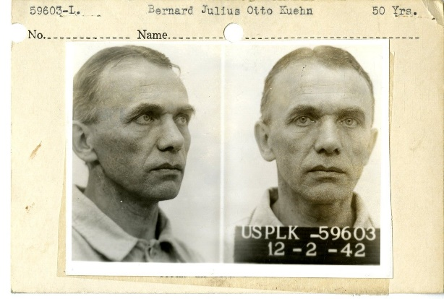
On February 21, 1942, just 76 days after the tragic attack on Pearl Harbor, Bernard Julius Otto Kuehn was found guilty of spying and sentenced to be shot “by musketry” in Honolulu.
What was a German national doing in Hawaii in the days leading up to the attack? What exactly did Kuehn do to warrant such a sentence? Here’s the story.

Bed sheets on clothes lines. Lights in dormer windows. Car headlights. A boat with a star on its sail.
Otto Kuehn had a complex system of signals all worked out. A light shining in the dormer window of his Oahu house from 9 to 10 p.m., for example, meant that U.S. aircraft carriers had sailed. A linen sheet hanging on a clothes line at his home on Lanikai beach between 10 and 11 a.m. meant the battle force had left the harbor. There were eight codes in all, used in varying combinations with the different signals.
In November 1941, Kuehn had offered to sell intelligence on U.S. warships in Hawaiian waters to the Japanese consulate in Hawaii. On December 2, he provided specific—and highly accurate—details on the fleet in writing. That same day, he gave the consulate the set of signals that could be picked up by nearby Japanese subs.
Kuehn—a member of the Nazi party—had arrived in Hawaii in 1935. By 1939, the Bureau was suspicious of him. He had questionable contacts with the Germans and Japanese. He'd lavishly entertained U.S. military officials and expressed interest in their work. He had two houses in Hawaii, lots of dough, but no real job. Investigations by the Bureau and the Army, though, never turned up definite proof of his spying.
Not until the fateful attack of December 7, 1941. Honolulu Special Agent in Charge Robert Shivers﻿ immediately began coordinating homeland security in Hawaii and tasked local police with guarding the Japanese consulate. They found its officials trying to burn reams of paper. These documents—once decoded—included a set of signals for U.S. fleet movements.
All fingers pointed at Kuehn. He had the dormer window, the sailboat, and big bank accounts.
Kuehn was arrested the next day and confessed, though he denied ever sending coded signals. His sentence was commuted—50 years of hard labor instead of death “by musketry”—and he was later deported.
https://www.fbi.gov/history/famous-cases/pearl-harbor-spy

April 18, 1942 - Doolittle Raid
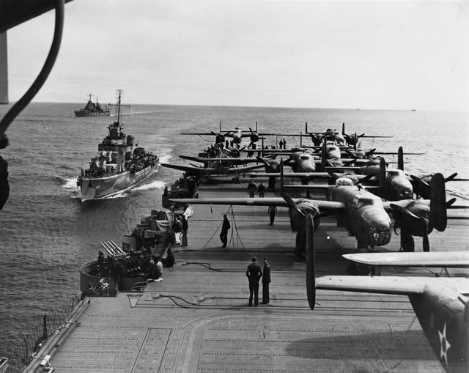
“James H. Doolittle - Leading the attack was Army Lt. Col. James H. Doolittle. Jimmie Doolittle was an aviation pioneer and daredevil racer. He pioneered instrument flying. He won the Schneider Race for the Army in 1925. He pushed for higher octane gasoline for aircraft in the 1930s, when he was an employee of Shell. Doolittle trained the volunteer crews to take off their B-25B Mitchell bombers in only 450 feet instead of the usual 1,200. The planes were loaded aboard the USS Hornet in March 1942. The plan was to launch the bombers within 400 miles of the Japanese coast. They would then bomb their targets and continue to airfields in China. But Japanese picket boats discovered the task force about 800 miles off the coast, and the Army planes were launched immediately. The 16 bombers struck Tokyo, Kobe, Nagoya and Yokohama. Because of the added distance, no plane was able to make the Chinese airfields. Most of the planes crash landed in China with one plane landing in the Soviet Union. Of the 75 fliers who landed in China three died in accidents and eight were captured by the Japanese. The rest returned to the United States.” https://www.afhistory.af.mil/FAQs/Fact-Sheets/Article/458984/1942-doolittles-raid/

“Of the 16 B-25s, 15 crashed in occupied China, where the Japanese inflicted brutal reprisals against the Chinese populace who had sheltered the American airmen. The Japanese also managed to capture the survivors of two crews, later executing three of them. One B-25 landed intact at Vladivostok, where the Soviets interned the aircraft and its crew.” https://www.history.navy.mil/browse-by-topic/wars-conflicts-and-operations/world-war-ii/1942/halsey-doolittle-raid.html

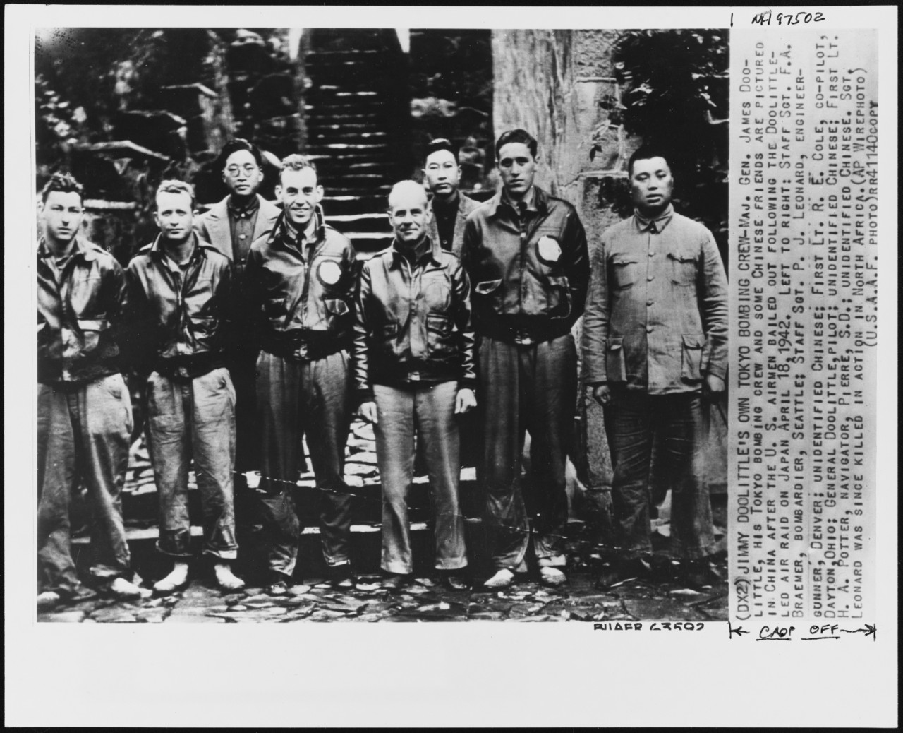
Doolittle and crew in China.

1942: Japanese Internment Camps
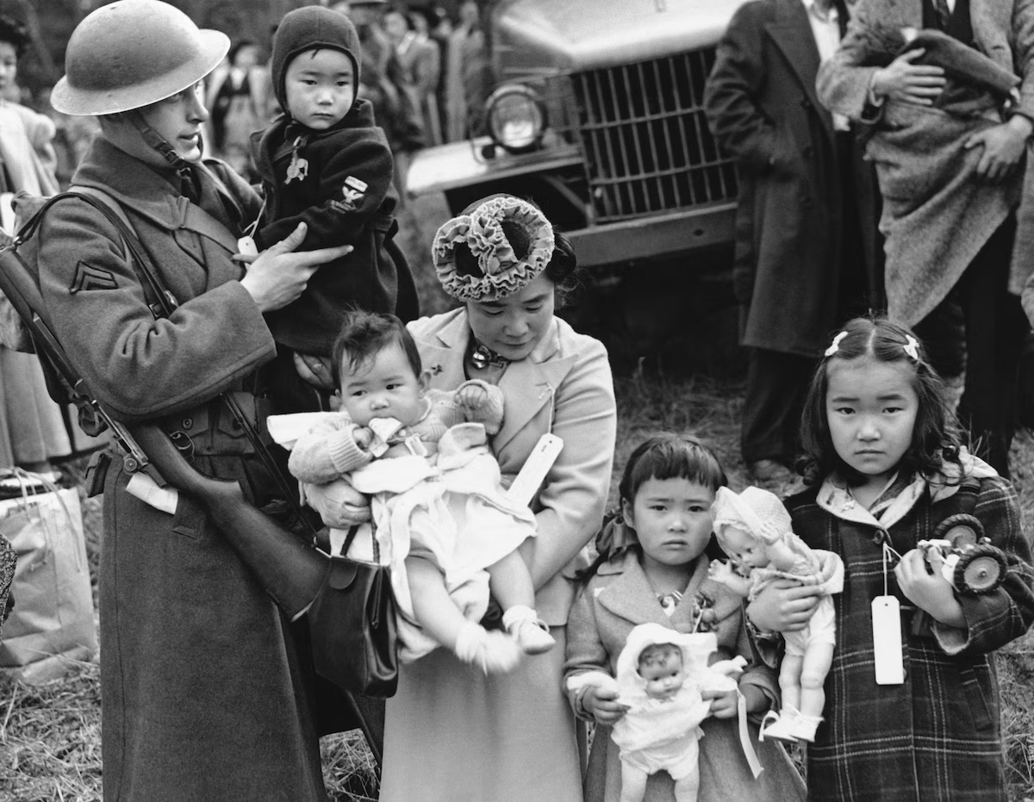March 30, 1942

March 19, 2025: “‘Very dangerous’: Japanese Americans warn of Trump’s use of Alien Enemies Act. Some fear Trump’s invocation of a 1798 wartime authority could lead to abuses similar to those that took place during one of the darkest chapters of U.S. history *** President Franklin D. Roosevelt’s use of the law, in the immediate aftermath of the Japanese military’s bombing of Pearl Harbor on Dec. 7, 1941, led to the arrest of 31,000 Japanese, German and Italian nationals in the United States and Latin America. Many were later found to have been improperly arrested, jailed and, in some cases, repatriated.” https://www.washingtonpost.com/immigration/2025/03/19/japanese-americans-alien-enemies-trump-deportations/?utm_campaign=wp_post_most&utm_medium=email&utm_source=newsletter&carta-url=https%3A%2F%2Fs2.washingtonpost.com%2Fcar-ln-tr%2F41bce12%2F67e028bae630c35b0faa13e7%2F59731235ade4e21a848a56ed%2F38%2F54%2F67e028bae630c35b0faa13e7
***
“Japanese internment camps were established during World War II by President Franklin Roosevelt through his Executive Order 9066. From 1942 to 1945, it was the policy of the U.S. government that people of Japanese descent would be interred in isolated camps. Enacted in reaction to Pearl Harbor and the ensuing war, the Japanese internment camps are now considered one of the most atrocious violations of American civil rights in the 20th century.” https://www.history.com/topics/world-war-ii/japanese-american-relocation
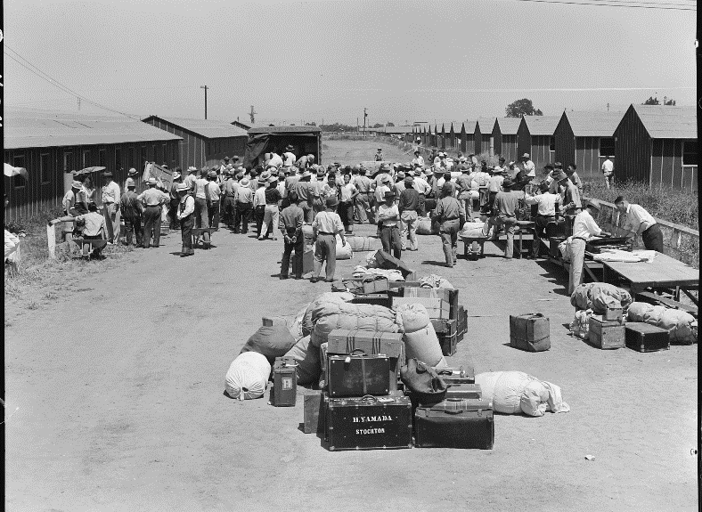
https://www.nationalww2museum.org/war/articles/japanese-american-incarceration

June 6, 1942: USS Yorktown sunk

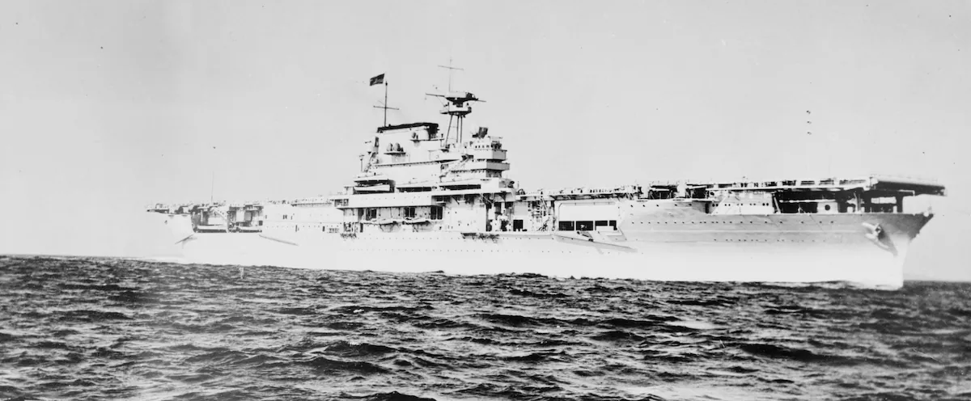
The USS Yorktown at sea in 1939. A Japanese attack on the aircraft carrier in 1942 caused it to sink during the Battle of Midway. (U.S. Navy/Library of Congress)
“Yorktown took part in several operations during World War II (WWII), including the Battle of the Coral Sea from May 4-8, 1942, and the Battle of Midway from June 4-7, 1942. During the Battle of Midway, Japanese Aichi D3A bombers successfully attacked Yorktown. Three bombs hit their targets: the first at the midship elevator on the starboard side; the second inside the starboard side exhaust stack, which crippled five of the nine boilers; and the third at the aft elevator on the starboard side. Despite this, Yorktown was able to recover and continue to launch aircraft. Later in the battle, Japanese Nakajima B5N torpedo bombers delivered two torpedo hits along the port side of the carrier, destroying its rudder system. Unable to move, Yorktown was towed by destroyer USS Hammann for transit back to Pearl Harbor for repairs. On the morning of June 7, 1942, while under tow, the Imperial Japanese Navy submarine I-168 attacked both vessels, sinking Hammann and striking Yorktown twice on the starboard side, causing the carrier to capsize and sink.” https://oceanexplorer.noaa.gov/news/exploration-extras/photogrammetry/yorktown/yorktown.html

June 20, 1942 – Japanese pilot drops bomb on Oregon
“On June 20, 1942, the Imperial Japanese Navy I-25 torpedoed a Canadian lumber schooner, the S.S. Camosun near Cape Flattery, followed by the shelling of the Estevan Point lighthouse and Canadian radio station on Vancouver Island by the I-26 submarine. In the late night and early morning of June 21-22, the I-25 submarine fired multiple 14-cm [5.5-inch] shells at Battery Russell on Fort Stevens, which defended the Oregon side of the Columbia River. It was later assessed that 17 rounds had been fired, yet no loss of life occurred during the attack. Most of the damage was done to the baseball field and telephone cables, but the bombardment only heightened the tension of more attacks. The shelling of Fort Stevens was historic, marking the first foreign attack on a military installation on U.S. soil since the War of 1812.” https://www.dvidshub.net/news/435846/bombing-oregon-80th-anniversary-japanese-attacks-state

Nov. 28, 1942: Boston - Cocoanut Grove fire
“The deadliest nightclub fire in U.S. history, the Cocoanut Grove nightclub burned on November 28, 1942, killing 492 people.*** It was the Saturday after Thanksgiving, and the night of the highly anticipated football game between rivals Boston College and Holy Cross. Nearly a year after Pearl Harbor, men and women were looking for ways to forget about the war for a few hours. Crowds pushed night clubs and theaters beyond their limits. The Cocoanut Grove night club was no exception. Already a very popular venue, a new bar, the New Broadway Lounge, had recently opened within the night club. The night club was very crowded, with some estimates as high as a thousand people. The fire was first noticed around 10:15 p.m. in the Melody Lounge, which was located in the basement. According to witnesses, it immediately spread throughout the Melody Lounge between the false cloth ceiling and the plywood ceiling above it, then ascended the stairway.” https://sites.google.com/view/cocoanutgrove-fire
See also: https://www.nfpa.org/Public-Education/Staying-safe/Safety-in-living-and-entertainment-spaces/Nightclubs-assembly-occupancies/The-Cocoanut-Grove-fire

1943 - FDNY
Chief, the dalmatian of FDNY Engine Co. 20, rides a sidecar on the fire truck, 1943.
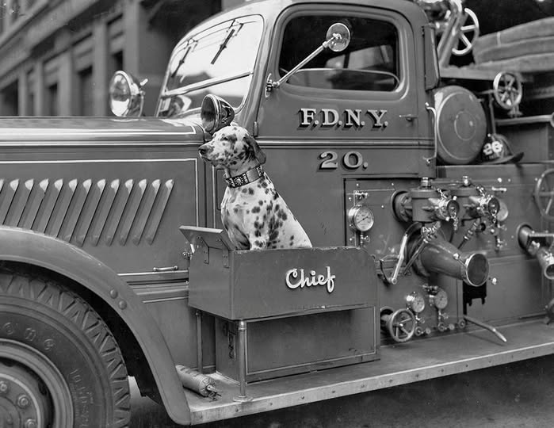

May, 1943 – The Tuskegee Airmen - African American Pilots of WWII
“Before the Tuskegee Airmen, no African American had ever been a United
States military pilot. The Jim Crow laws, a series of racist laws that enforced
the ‘separate but equal’ treatment of African Americans, were used as
justification for blocking previous attempts by African American soldiers to
become pilots. African Americans served bravely and with distinction in every
theater of World War II, while simultaneously struggling for their own civil
rights from ‘the world’s greatest democracy.’ Although the United States
Armed Forces were officially segregated until 1948, WWII laid the foundation
for post-war integration of the military. In 1941 fewer than 4,000 African
Americans were serving in the military and only twelve African Americans had
become officers. By 1945, more than 1.2 million African Americans would be
serving in uniform on the Home Front, in Europe, and the Pacific (including
thousands of African American women in the Women’s auxiliaries).
The Army Air Forces established several African American organizations, including fighter and bombardment groups and squadrons. Between 1941 and 1946, roughly 1,000 black pilots were trained at a segregated air base in Tuskegee, AL. The Tuskegee Airmen flew hundreds of patrol and attack missions for the Twelfth Air Force, flying P-40 and P-39 airplanes, before they were reassigned to the 15th Air Force to escort B-17 and B-24 heavy bombers, using P-47 and P-51 airplanes. The famous ‘Tuskegee Airmen’ of the 332nd Fighter Group became part of the 15th Air Force, escorting American
bombers as they flew over Italy. As escorts, flying P-47s and later P-51s, they were responsible for protecting larger bombers from German fighter planes. The Tuskegee Airmen flew more than 15,000 sorties between May 1943 and June 1945. Bomber crews often requested to be escorted by these ‘Red Tails,’ a nicknamed acquired from the painted tails of Tuskegee fighter planes, which were a distinctive deep red. Sixty-six Tuskegee Airmen died in combat. They had one of the lowest loss records of any escort fighter group.” https://www.nationalww2museum.org/sites/default/files/2017-07/tuskegee-airmen.pdf
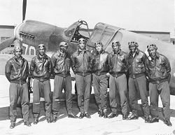

Jan. 1944 General George S. Patton and Major General Geoffrey Keyes – In Italy - Patton commanding the Seventh Army in the Mediterranean Theater
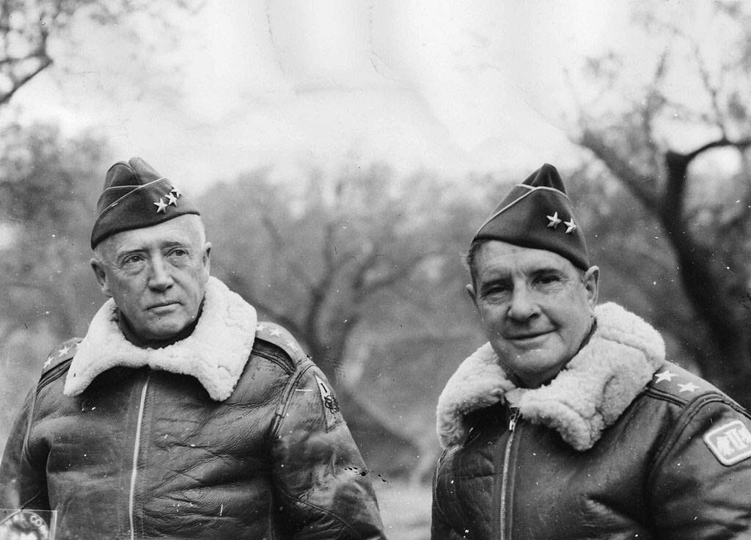

May 14, 1944: Winston Churchill
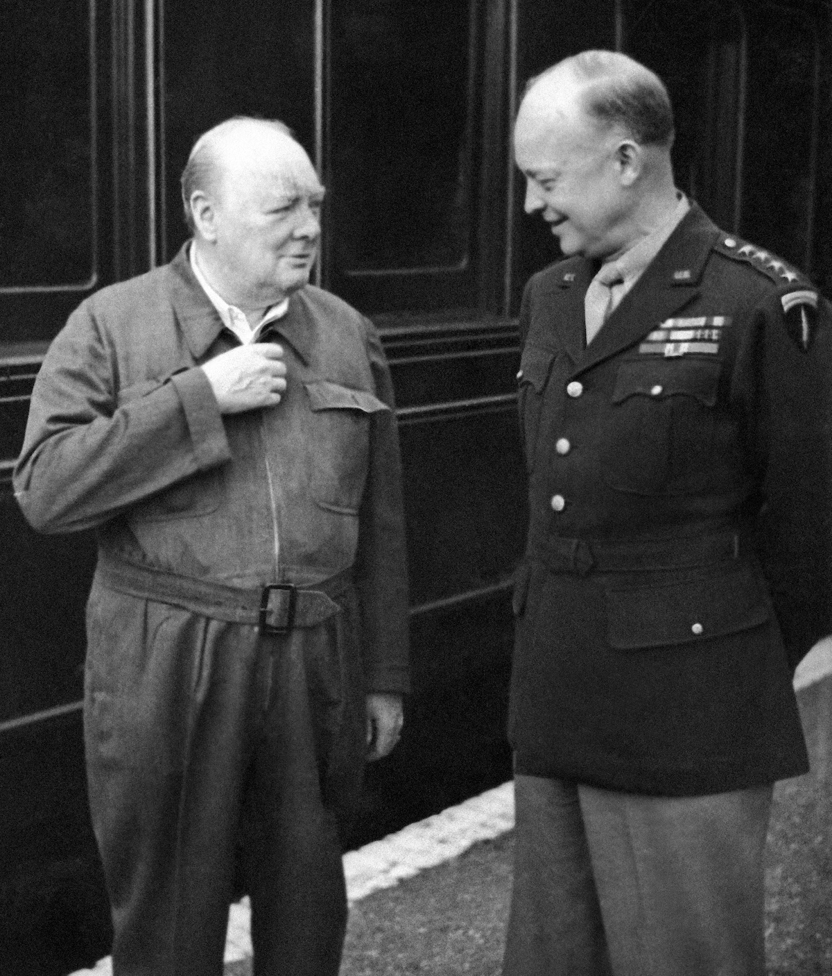
Britain’s Prime Minister Winston Churchill demonstrates the zipper on his “siren suit” to Gen. Dwight D. Eisenhower in England on May 14, 1944. (AP). https://www.washingtonpost.com/history/2025/03/03/winston-churchill-siren-suit-onesie/?utm_campaign=wp_post_most&utm_medium=email&utm_source=newsletter&carta-url=https%3A%2F%2Fs2.washingtonpost.com%2Fcar-ln-tr%2F416b32f%2F67c73431fcd029063f7f8b58%2F59731235ade4e21a848a56ed%2F44%2F55%2F67c73431fcd029063f7f8b58

June 5, 1944
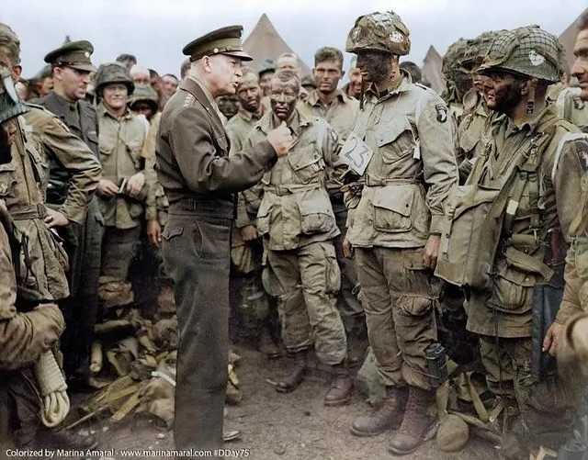
General Eisenhower briefs the paratroopers on the crucial role for D-Day. He tells them “You are about to embark upon the Great Crusade, toward which we have striven these many months. The eyes of the world are upon you”.

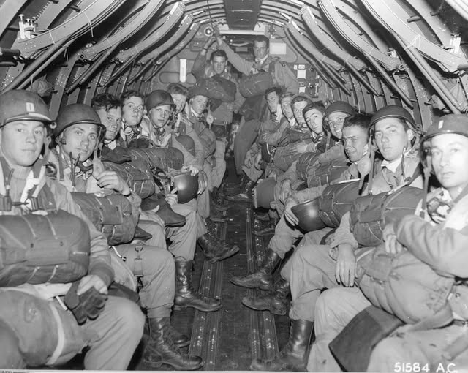

June 6, 1944 – D-DAY
“Success demanded a very specific set of conditions:
Before the landings, the weather needed to be calm for 48 hours.
For the three days following, the wind needed to stay below Beaufort Force 4, equivalent to a moderate breeze.
Parachutists and other air support needed less than 30 percent cloud cover below 8,000 feet, with a cloud base no lower than 2,500 feet and visibility of over three miles.
A low tide at dawn was needed to expose German defenses.
The invasion had to occur one day before or four days after a full moon for nighttime operations.
Furthermore, the invasion had to align with the Soviet summer offensive in the East, to maximize pressure on German forces.
The Allies identified a window: between June 5 and June 7.” https://www.nytimes.com/2025/06/05/weather/d-day-forecast-history-wwii.html

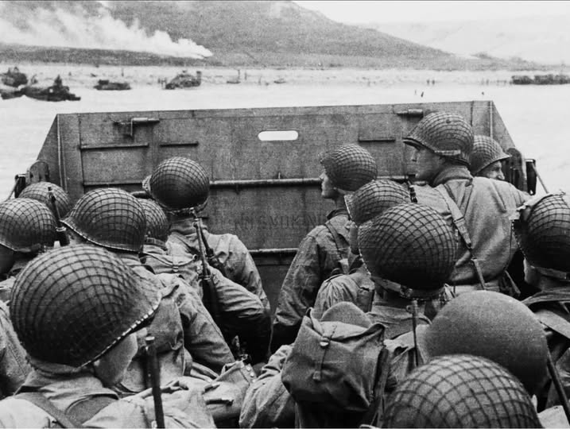

June 1944 – The Ghost Army
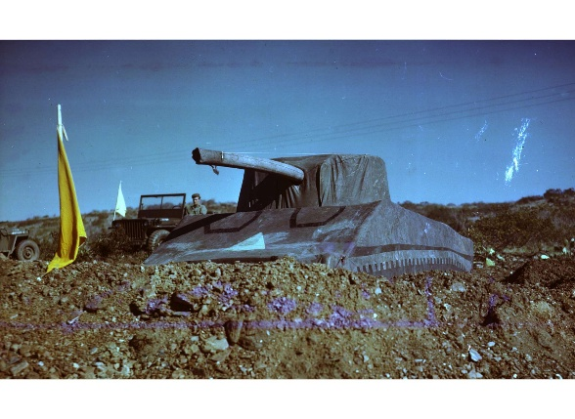 https://www.nationalww2museum.org/visit/exhibits/traveling-exhibits/ghost-army-combat-con-artists-world-war-ii
“In June 1944, a secret U.S. Army unit went into action in Normandy. The weapons they deployed were decidedly unusual: hundreds of inflatable tanks and a one-of-a-kind collection of sound effects records. Their mission was to use bluff, deception, and trickery to save lives. Many were artists, some of who would become famous, including a budding fashion designer named Bill Blass. They painted and sketched their way across Europe, creating a unique visual record of their journey. The story of what these men accomplished was hushed up by the Pentagon for more than forty years.” https://rickbeyer.net/about/films/

June 1944 – U.S. Military – All Japanese Unit
“The 522nd was part of the famed 442nd Regimental Combat Team, the all-nisei unit that lived up to its motto ‘Go For Broke,’ taking heavy casualties in bloody battles in Italy and France. The 442nd remains the most decorated unit for its size and length of combat service in the history of the U.S. military. The 522nd arrived in Italy as part of the 442nd in June 1944. The unit fought with distinction in several pivotal battles, including in the storied rescue of the Lost Battalion in the Vosges Mountains of France. In that battle, eight forward observers from C Battery, including George Oiye, found themselves pinned down by German machine-gun fire. After five days of continuous fighting, the soldiers found the Texas National Guard’s 1st Battalion of the 141st Regiment, which had been surrounded by German soldiers for nearly a week. Miraculously, all eight artillerymen from the 522nd survived.” https://www.washingtonpost.com/history/2025/05/09/eighty-years-ago-they-liberated-prisoners-dachau-death-march-this-month-they-remembered/?utm_campaign=wp_post_most&utm_medium=email&utm_source=newsletter&carta-url=https%3A%2F%2Fs2.washingtonpost.com%2Fcar-ln-tr%2F427b763%2F681e297766b7286f0ec392e9%2F59731235ade4e21a848a56ed%2F31%2F58%2F681e297766b7286f0ec392e9

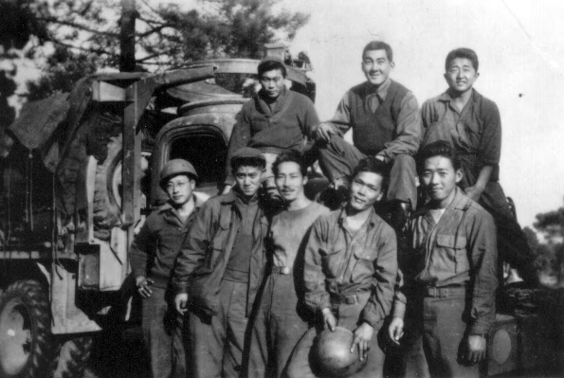

Japanese Relocation Camps
“In response to the Japanese attack on Pearl Harbor during World War II, the U.S. government decided to require Japanese-Americans to move into relocation camps as a matter of national security. President Franklin Roosevelt signed Executive Order 9066 in February 1942, two months after Pearl Harbor. A Japanese-American man living in San Leandro, Fred Korematsu, chose to stay at his residence rather than obey the order to relocate. Korematsu was arrested and convicted of violating the order. He responded by arguing that Executive Order 9066 violated the Fifth Amendment. The Ninth Circuit affirmed Korematsu's conviction.
***
The petitioner, an American citizen of Japanese descent, was convicted in a federal district court for remaining in San Leandro, California, a ‘Military Area,’ contrary to Civilian Exclusion Order No. 34 of the Commanding General of the Western Command, U.S. Army, which directed that, after May 9, 1942, all persons of Japanese ancestry should be excluded from that area.” https://supreme.justia.com/cases/federal/us/323/214/#tab-opinion-1938225

July 6, 1944: Jackie Robinson – U.S. Army Bus / Arrest & Found Not Guilty At Court Marshal
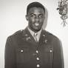
“As detailed in the masterful Jackie Robinson: A Biography by Arnold Rampersad, on July 6, 1944, Robinson ‘became entangled in a dispute that threatened to end his military service in disgrace.’ While riding on a military bus returning to a hospital from ‘the colored officers club,’ Robinson sat next to Virginia Jones, the wife of one of his fellow officers. Jones looked white — at least the white bus driver thought so. After a few blocks, the driver abruptly ordered Robinson ‘to move to the back of the bus.’ Robinson, justifiably outraged, refused. Among other things, he had read that segregation was no longer allowed on military buses (pdf) and proceeded to engage in a form of protest prefiguring a similar action by Rosa Parks 11 years later.

Rampersad reprints Robinson’s statement about what happened next: ‘The bus driver asked me for my identification card. I refused to give it to him. He then went to the Dispatcher and told him something. What he told him I don’t know. He then comes back and tells the people that this nigger is making trouble. I told the driver to stop f—in with me, so he gets the rest of the men around there and starts blowing his top and someone calls the MP’s.’ Robinson was placed under ‘arrest in quarters,’ which meant that ‘he would be considered under arrest at the hospital, although without a guard. Robinson was then taken to the hospital in a police pickup truck.’ A white officer would recall that Robinson ‘was handcuffed, and there were shackles on his legs. Robinson’s face was angry, the muscles on his face tight, his eyes half closed.’

Robinson was transferred to the 758th Tank Battalion on July 24, ‘where the commander signed orders to prosecute him.’ On that day, he was arrested. Rampersad says that ‘At 1:45 in the afternoon on August 2, the case of The United States v. 2nd Lieutenant Jack R. Robinson, 0-10315861, Cavalry, Company C, 758th Tank Battalion, began.’ Robinson’s fate was in the hands of nine men, eight of them white: ‘One was black; another had been a UCLA student [where Robinson had been an undergraduate]. Six votes were needed for conviction.’
Robinson faced two charges: ‘The first, a violation of Article of War No. 63, accused him of “behaving with disrespect toward Capt. Gerald M. Bear, CMP, his superior officer” … The second charge was a violation of Article No. 64, in this case “willful disobedience of lawful command of Gerald M. Bear, CMP, his superior.” Three other charges were dropped before the trial began. Testimony reveals how bravely Robinson had fought to defend himself on the evening of the incident, including reportedly saying quite heroically, ‘Look here, you son-of-a-bitch, don’t you call me no nigger!’ After a four-hour trial, Robinson was exonerated: Robinson secured at least the four votes (secret and written) needed for his acquittal. He was found ‘not guilty of all specifications and charges.'” https://www.pbs.org/wnet/african-americans-many-rivers-to-cross/history/was-jackie-robinson-court-martialed/

Dec. 18, 1944: U.S. Supreme Court - Korematsu v. United States (6 to 3) https://www.oyez.org/cases/1940-1955/323us214
RELOCATION CAMPS LAWFUL
“In response to the Japanese attack on Pearl Harbor during World War II, the U.S. government decided to require Japanese-Americans to move into relocation camps as a matter of national security. President Franklin Roosevelt signed Executive Order 9066 in February 1942, two months after Pearl Harbor. A Japanese-American man living in San Leandro, Fred Korematsu, chose to stay at his residence rather than obey the order to relocate. Korematsu was arrested and convicted of violating the order. He responded by arguing that Executive Order 9066 violated the Fifth Amendment. The Ninth Circuit affirmed Korematsu's conviction…. In an opinion written by Justice Black, the Court ruled that the evacuation order violated by Korematsu was valid. The majority found that the Executive Order did not show racial prejudice but rather responded to the strategic imperative of keeping the U.S. and particularly the West Coast (the region nearest Japan) secure from invasion. The Court relied heavily on a 1943 decision, Hirabayashi v. U.S., which addressed similar issues. Black argued that the validation of the military's decision by Congress merited even more deference.” https://www.oyez.org/cases/1940-1955/323us214

July 7, 1944 – Senior Officers
General Montgomery with Generals Patton (left) and Bradley (center) at 21st Army Group HQ, Normandy, 7 July 1944.

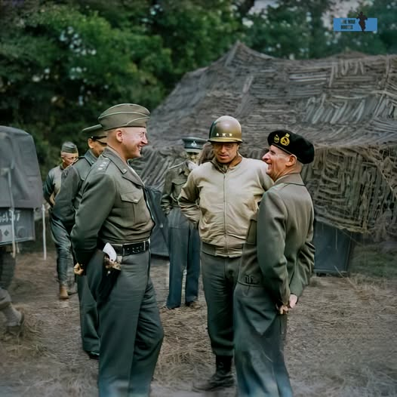

July 21, 1945
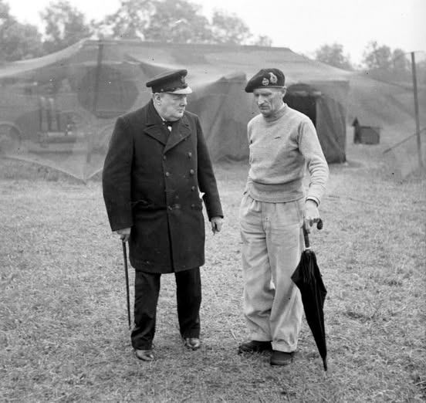
Winston Churchill with General Montgomery at his HQ in Normandy - 21 July 1944

September 1944
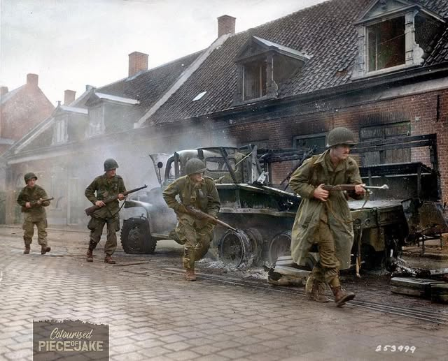
American soldiers of the 101st Airborne Division rush past a burned-out truck in Veghel, the Netherlands in September 1944

Dec. 1944 – General George Patton – Incident Command / Battle of the Bulge
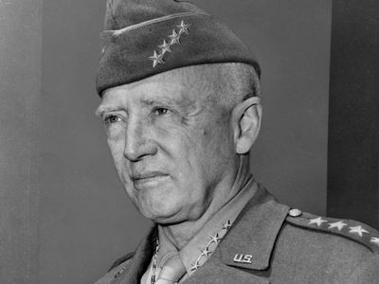
“In December 1944 the Germans launched a massive surprise counterattack in the Ardennes Forest, encircling the U.S. 101st Airborne Division at Bastogne, Belgium. Supreme Allied Commander Gen. Dwight D. Eisenhower ordered the Third Army to relieve Bastogne, and Patton repositioned his force with astonishing speed. Such a feat was made possible in large part by Patton’s intelligence officer, Col. Oscar Koch, who had predicted the German offensive on the basis of a shrewd analysis of enemy troop strength and disposition. Advance elements of the Third Army reached Bastogne’s tenacious defenders on December 26, and additional reinforcements followed over subsequent days. Patton’s forces continued to push the Germans back, and by the end of January 1945, the Third Army had reached the German frontier. On March 1 those forces took Trier, precipitating one of the most famous exchanges of the war. When Patton received a message instructing him to bypass the city because it would take four divisions to capture it, Patton replied, “Have taken Trier with two divisions. Do you want me to give it back?” Over the next 10 days, they cleared the entire region north of the Moselle River, trapping thousands of Germans. They then joined the Seventh Army in sweeping the Saar and the Palatinate, where they took 100,000 prisoners.” https://www.britannica.com/biography/George-Smith-Patton

***
‘Early on the misty winter morning of Dec. 16, 1944, more than 200,000 German troops and nearly 1,000 tanks launched Adolf Hitler's last bid to reverse the ebb in his fortunes that had begun when Allied troops landed in France on D-Day. Seeking to drive to the coast of the English Channel and split the Allied armies as they had done in May 1940, the Germans struck in the Ardennes Forest, a 75-mile stretch of the front characterized by dense woods and few roads, held by four inexperienced and battle-worn American divisions stationed there for rest and seasoning.” https://www.army.mil/botb/
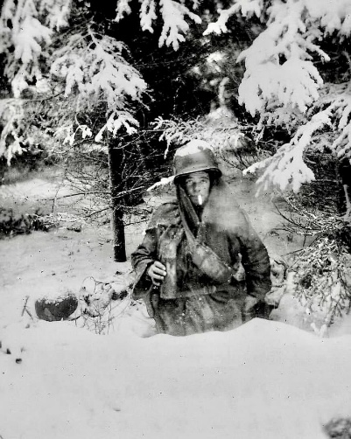
Pfc George A Guckenberger, D Company, 2nd Battalion, 506 Parachute Infantry Regiment, 101st Airborne Division in his foxhole near Bastogne in January, 1945.

Jan. 20, 1945: President Franklin D. Roosevelt – Fourth Inauguration
“Franklin Roosevelt’s fourth inauguration in 1945 was by all accounts a small and serious event. In January 1945, the nation was entering its last year of the war and President Roosevelt had a lot on his mind. Roosevelt just won a tough election marked by accusations against the President and his family (famously including his dog Fala) and questions about the President’s health. In early January the administration fought with Congress in an attempt to address severe shortages of men for military service and in critical manufacturing sectors. In Europe, US and British forces had beaten back the German Wehrmacht in the Battle of the Bulge. In what turned out to be the largest battle in the history of the US Army, more than 600,000 soldiers fought desperately in horrific conditions to break the determined German assault.” https://www.nationalww2museum.org/war/articles/fdr-inauguration-ceremony-1945

Feb. 22, 1945 – U.S. Marines, Iwo Jima
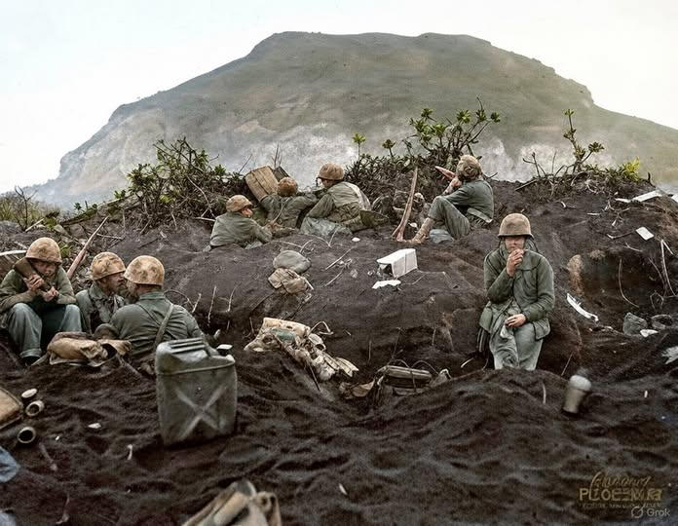US Marines dig in on a forward position, facing entrenched Japanese troops on the slopes of Mount Suribachi, Iwo Jima, on 22 February 1945.

April 12, 1945: President Harry S. Truman – First Inauguration
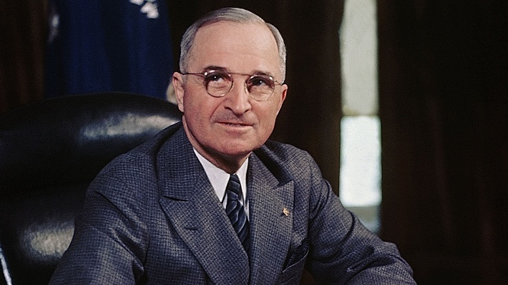

“Truman’s inauguration reflected the recent Allied victory in World War II and the beginning of the Cold War with the Soviet Union. The celebratory events featured hundreds of war planes flying overhead and armed soldiers marching in the streets, demonstrating victory, confidence, and prosperity. Truman referred to communism as the ‘false prophecy’ in his address, reinforcing contemporary views of the ideology’s threat to the United States. He outlined four major courses of action to navigate World War II’s aftermath while addressing public concern for democracy’s growing ideological opponent.” https://evolutiondc.museum.gwu.edu/admit-one-trumans-inauguration/

Feb. 1945: The Assault on IWO JIMA
“The conquest of Iwo Jima had taken a heavy toll of the Marines—17,372 wounded and 5,931 killed— but the island had to be taken. An inkling of its importance in the aerial war against Japan may be gained from the fact that by the war's end, 2,251 heavy
bombers carrying 24,761 Americans had found refuge at Iwo Jima during the course of raids on Japan. The courage and heroism displayed by all those who fought and died on Iwo Jima, including those who proudly raised their nation's colors atop Mt. Suribachi, inspired a war-weary nation to push for final victory. The Japanese defenders led by General Kuribayashi had proved a formidable foe but were beaten. They were overwhelmed by a skillfully led band of Ameri cans among whom, in the words of Fleet Admiral Chester W. Nimitz, ‘Uncommon valor was a common virtue.’” https://www.marines.mil/Portals/1/Publications/The%20United%20States%20marines%20On%20Iwo%20Jima_The%20Battle%20and%20the%20Flag%20Raisings%20%20PCN%2019000316600.pdf

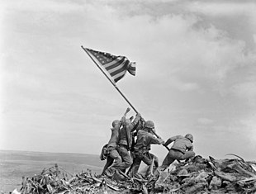
The most famous battle photograph ever taken, the second flag-raising on Mount Suribachi on Iwo Jima. Pictured from left are 1-PFC Ira H. Hayes; 2-PFC Franklin R. Sousley, KIA; 3-Sgt Michael Strank, KIA; 4-PM2/C John H. Bradley; 5-PFC Rene A. Gagnon; and 6-Cpl Harlon H. Block, KIA.

July 16, 1945 – First Atomic Bomb test, Los Alamos, Nevada
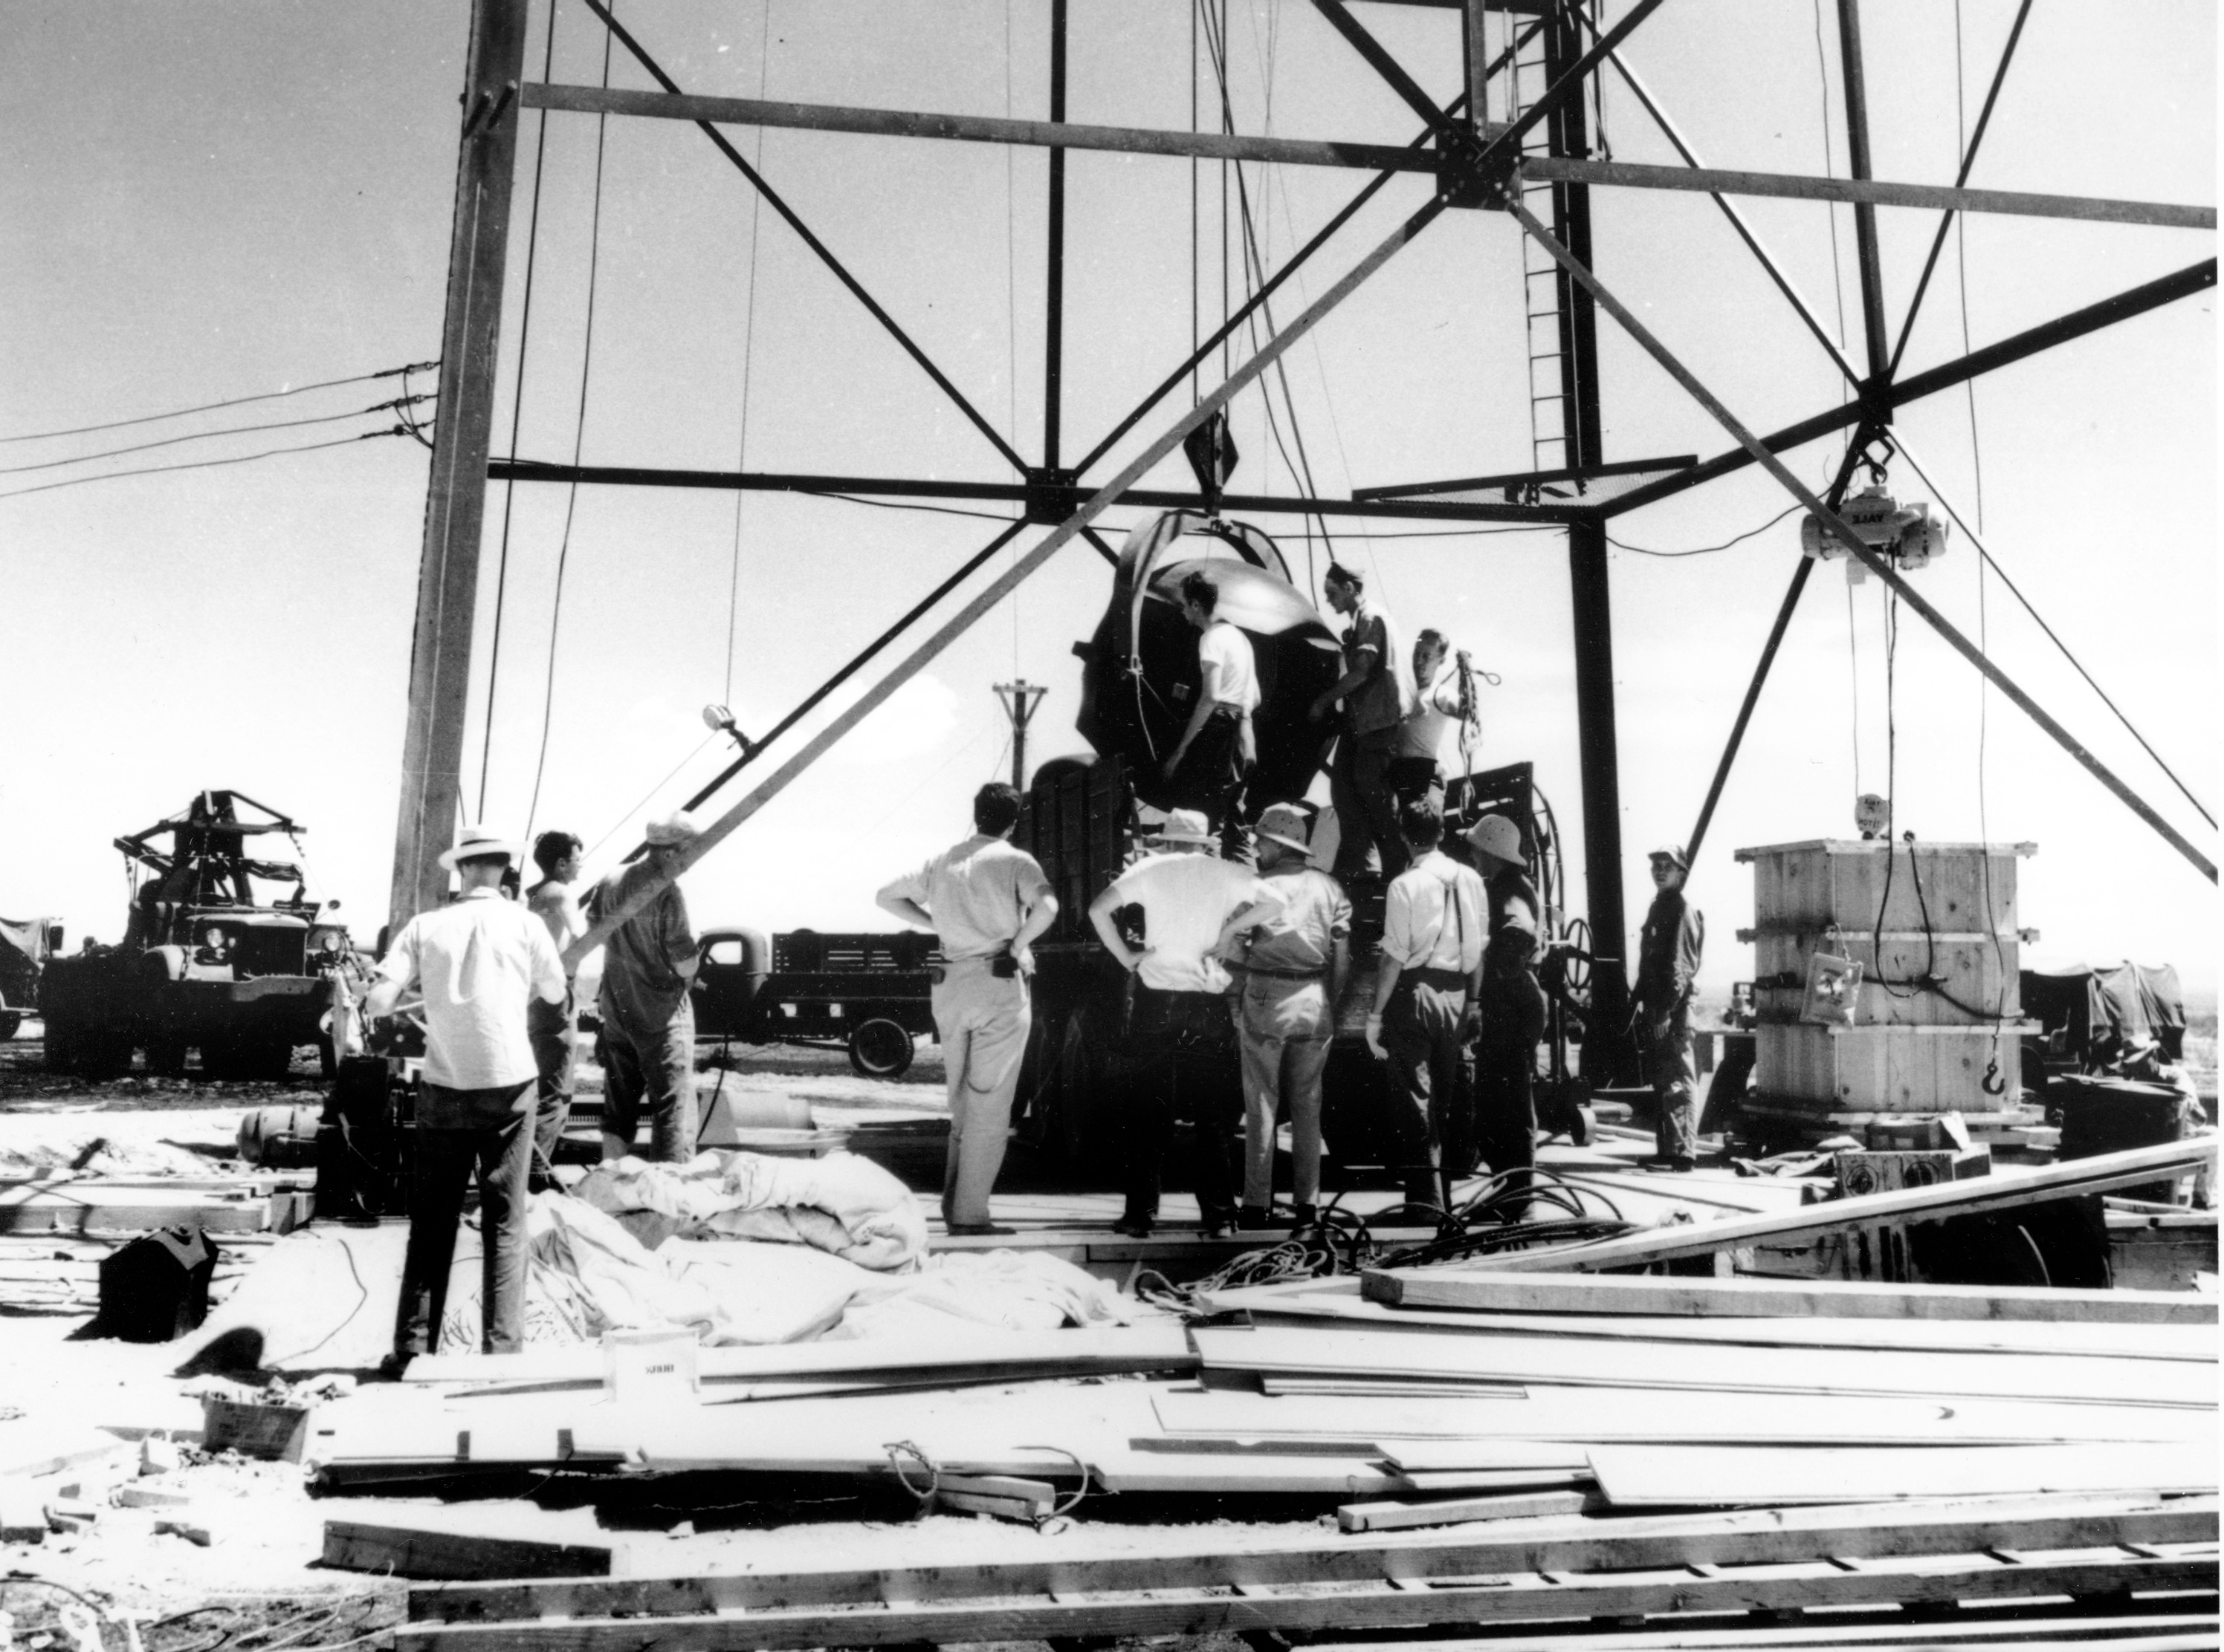
Scientists and workers rig the world's first atomic bomb at the Trinity nuclear test site in New Mexico in July 1945. (AP)
“[N]amed “Trinity” by J. Robert Oppenheimer, director of the Manhattan Project’s Los Alamos National Laboratory.*** July 16 is the 80th anniversary of the world’s first atomic bomb test. At 5:30 a.m. on that date in 1945, 12 young girls attending a summer camp in Ruidoso, New Mexico, were jolted out of their bunks by a thunderous noise. *** As the years went by, the truth began to sink in. The former campers developed terrible cancers. Kent suffered from skin and endometrial cancer and ultimately had to have her thyroid removed. She was one of the lucky ones. Only she and one other of that group of 12 would live past the age of 40.” https://www.washingtonpost.com/opinions/2025/07/15/atom-bomb-trinity-victims-survivors/?utm_campaign=wp_todays_headlines&utm_medium=email&utm_source=newsletter&carta-url=https%3A%2F%2Fs2.washingtonpost.com%2Fcar-ln-tr%2F43a44dc%2F68777825c2bee70ac1f4d563%2F59731235ade4e21a848a56ed%2F34%2F66%2F68777825c2bee70ac1f4d563

Aug. 6, 1945: Atomic Bomb dropped on Hiroshima

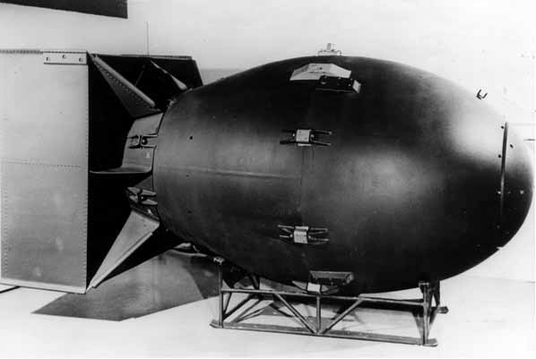

Decision to Drop the Atomic Bomb
“Upon becoming president, Harry Truman learned of the Manhattan Project, a secret scientific effort to create an atomic bomb. After a successful test of the weapon, Truman issued the Potsdam Declaration demanding the unconditional surrender of the Japanese government, warning of “prompt and utter destruction.” Eleven days later, on August 6, 1945, having received no reply, an American bomber called the Enola Gay left the Tinian Island in route toward Japan. In the belly of the bomber was “Little Boy,” an atomic bomb. At 8:15 am Hiroshima time, “Little Boy” was dropped. The result was approximately 80,000 deaths in just the first few minutes. Thousands died later from radiation sickness. On August 9, 1945, another bomber was in route to Japan, only this time they were heading for Nagasaki with “Fat Man,” another atomic bomb. After the first minute of dropping “Fat Man,” 39,000 men, women and children were killed. 25,000 more were injured. Both cities were leveled from the bombs and this, in turn, forced Japan to surrender to the United States. The war was finally over.” https://www.trumanlibrary.gov/education/presidential-inquiries/decision-drop-atomic-bomb
Aug. 9, 1945 - Nagasaki, Japan
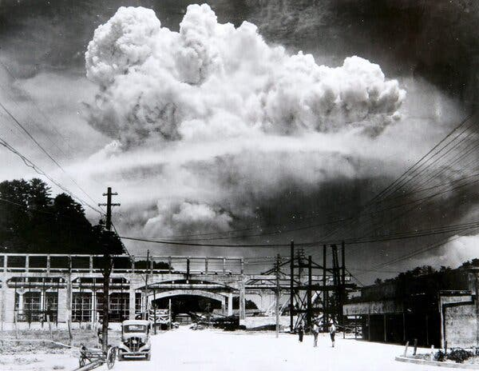 The mushroom cloud over Nagasaki, Japan, on Aug. 9, 1945.

Sept. 2, 1945: World War II Ends
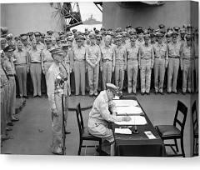
Gen. Douglas MacArthur signs the Instrument of Surrender onboard the U.S. Navy battleship USS Missouri in Tokyo Bay on Sept. 2, 1945. (U.S. Army Signal Corps/U.S. National Archives via Reuters) (Us Army/Via Reuters)

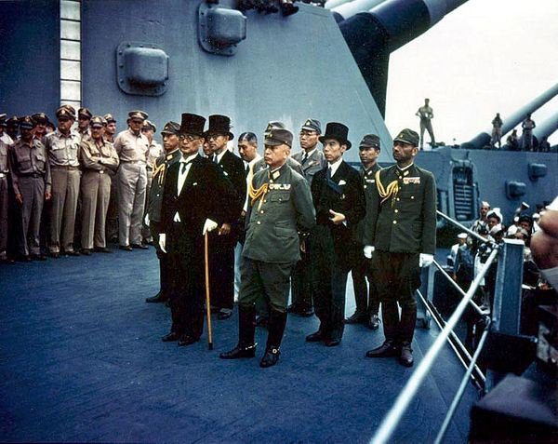

Nov. 20, 1945: Nuremberg trials begin
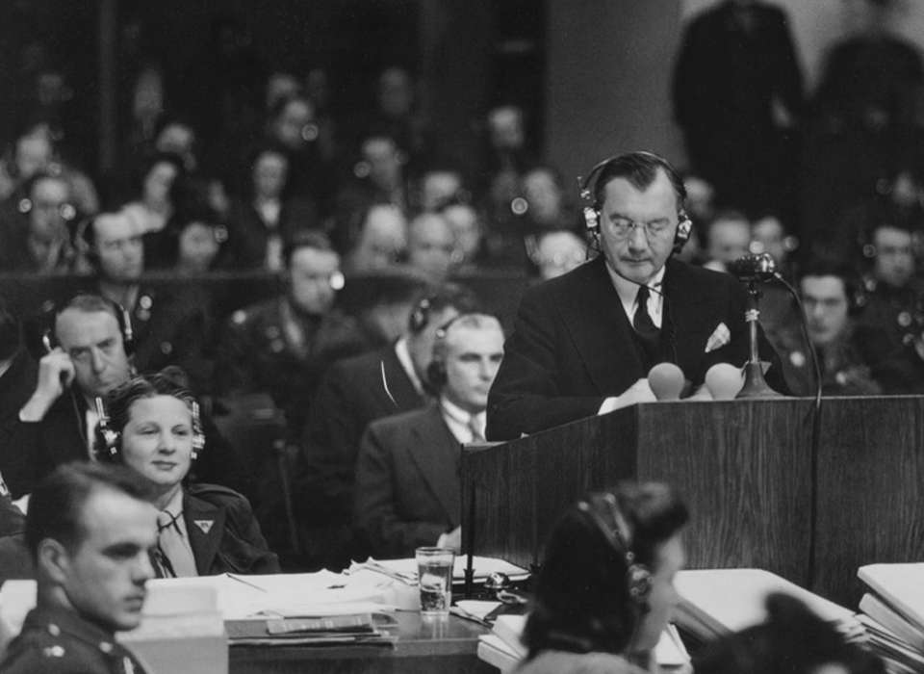
Robert H. Jackson

“In the days before Germany surrendered on May 8, 1945, President Harry S Truman appointed Associate Supreme Court Justice Robert H Jackson to be the chief prosecutor representing the United States in the proposed trials for the European Axis powers. Jackson helped lead the Allies—American, British, French, and Soviet governments—to an agreement called the London Charter, setting the procedures for the Nuremberg Trials. The London Agreement [https://www.un.org/en/genocideprevention/documents/atrocity-crimes/Doc.2_Charter%20of%20IMT%201945.pdf ] created the International Military Tribunal (IMT) on August 8, 1945, where each of the four Allied nations appointed a judge and a prosecution team.” https://www.nationalww2museum.org/war/topics/nuremberg-trials

“Held for the purpose of bringing Nazi war criminals to justice, the Nuremberg trials were a series of 13 trials carried out in Nuremberg, Germany, between 1945 and 1949. The defendants, who included Nazi Party officials and high-ranking military officers along with German industrialists, lawyers and doctors, were indicted on such charges as crimes against peace and crimes against humanity.
• 3 acquitted (Fritzsche, von Papen, Schacht)
• 7 prison terms (Doenitz, Konstantin von Neurath, Speer, von Schirach, Hess, Funk, Raeder)
• 12 death sentences (Goering suicide)
• 2 No Decision (Krupp medical illness and Ley suicide).” https://www.history.com/topics/world-war-ii/nuremberg-trials

Watch Opening Statement by U.S. Supreme Court Justice Robert H. Jackson, on leave from court to be chief prosecutor: https://www.youtube.com/watch?v=EJj6NcWHkDE
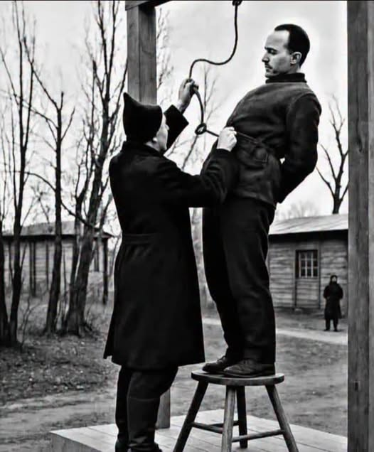In 1947, Rudolf Höss, the former commandant of the Auschwitz concentration camp, faced the final judgment for the atrocities committed under his command.

June 11, 1946: Administrative Procedure Act

“5 USC §551 et seq. (1946): The Administrative Procedure Act (APA) governs the process by which federal agencies develop and issue regulations. It includes requirements for publishing notices of proposed and final rulemaking in the Federal Register, and provides opportunities for the public to comment on notices of proposed rulemaking. The APA requires most rules to have a 30-day delayed effective date. In addition to setting forth rulemaking procedures, the APA addresses other agency actions such as issuance of policy statements, licenses, and permits. It also provides standards for judicial review if a person has been adversely affected or aggrieved by an agency action.” https://www.epa.gov/laws-regulations/summary-administrative-procedure-act

***
“Why the government built only 58 EV charging stations in three years. February 10, 2025…. In the nearly 80 years since its passage, the APA has become the Magna Carta of bureaucratic governance, ensuring that agencies are fair and transparent. The attendant checks and balances, designed explicitly to prevent the bureaucracy from steamrolling opponents, almost inevitably slow things down.” https://www.washingtonpost.com/opinions/2025/02/10/ev-chargers-government-infrastructure/?utm_campaign=wp_week_in_ideas&utm_medium=email&utm_source=newsletter

April 15, 1947: Jackie Robinson – enters Major League
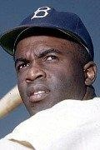https://www.baseball-reference.com/players/r/robinja02.shtml

AN UNPRECEDENTED CAREER IN THE MAJOR LEAGUES https://www.jackierobinsonmuseum.org/about/jackie-robinson/
“On April 15, 1947, Jackie Robinson stepped onto Ebbets Field for his first game with the Brooklyn Dodgers. It was the beginning of an unparalleled career in baseball. At the end of his explosive ten years as a Dodger, his record included a .311 batting average, 137 home runs, 734 runs batted in, and 197 stolen bases. In 1955, he helped the Dodgers beat the New York Yankees to win their first World Series Championship. Robinson took home the Rookie of the Year Award in 1947, the Most Valuable Player Award in 1949, and in 1962 became the first African American inducted into the Baseball Hall of Fame.”
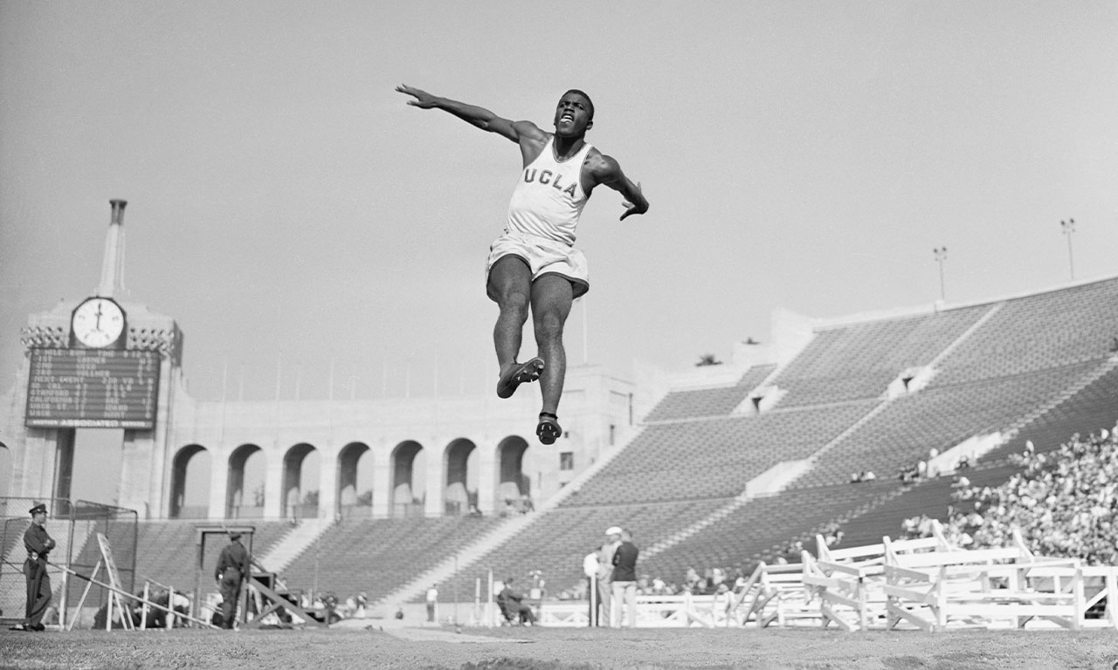

January 31, 1919 – October 24, 1972
“Jackie Robinson, who made history in 1947 by becoming the first black baseball player in the major leagues, suffered a heart attack in his home in Stamford, Conn., yesterday morning and died at Stamford Hospital at 7:10 A.M. He was 53 years old.” https://www.google.com/search?channel=cus2&client=firefox-b-1d&q=Jackie+Robinson
Note:
“But the first African American to play regularly in the big leagues wasn’t the Brooklyn Dodgers second baseman, it was Moses Fleetwood “Fleet” Walker.On
May 1, 1884, the 26-year-old Walker was the catcher for the Toledo Blue
Stockings in their opening game in the then-major league American Association. Six decades later, while Robinson was hailed as a pioneer, Walker was seen more as a curiosity.” But the first African American to play regularly in the big leagues wasn’t the Brooklyn Dodgers second baseman, it was Moses Fleetwood “Fleet” Walker.
On May 1, 1884, the 26-year-old Walker was the catcher for the Toledo Blue Stockings in their opening game in the then-major league American Association. Six decades later, while Robinson was hailed as a pioneer, Walker was seen more as a curiosity.” https://www.washingtonpost.com/history/2019/04/15/first-africanamerican-major-leaguer-wasnt-who-you-think/

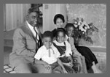
Jackie Robinson, Rachel Robinson, and their three children (David, Sharon, and Jackie, Jr.) at home in Stamford, Connecticut. Photograph by Arthur Rothstein, 1956. https://www.loc.gov/collections/jackie-robinson-baseball/articles-and-essays/baseball-the-color-line-and-jackie-robinson/1957-to-1961/
Note from Prof. Bennett: I was born in Stamford, CT, and grew up seeing Jackie Robinson playing golf at our public golf course, Hubbard Heights. I now can better appreciate why he played at a public golf course, and not at any of the private clubs.

Branch Rickey - American baseball executive
https://www.britannica.com/biography/Branch-Rickey
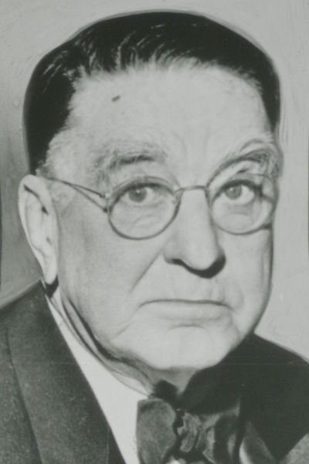

“In the spring of 1945, Rickey founded the United States League for Black players, whom unwritten law excluded from organized baseball, and he was criticized for encouraging continued segregation in sports. There are no records indicating that the league ever played any games; however, it served as a front that allowed Rickey to quietly scout Black ballplayers for one who could lead the desegregation of the major leagues. In October 1945 he signed infielder Jackie Robinson for the Dodgers’ minor league organization. Robinson’s success with the Dodgers from 1947 led other owners to seek Black talent. Rickey later was vice president, general manager. (1950–55), and chairman of the board (1955–59) of the Pittsburgh Pirates.”

Oct. 14, 1947 – Chuck Yeager - Sound Barrier
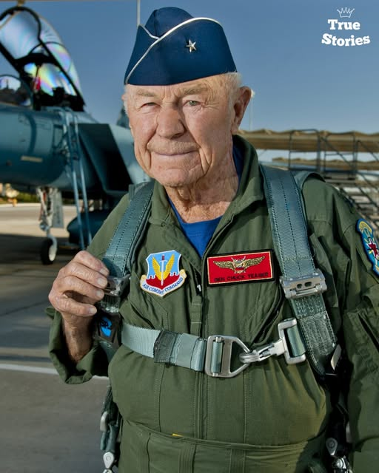
“Chuck Yeager broke the sound barrier — and then lied about it for nine months because no one believed it was possible. It was October 14, 1947. The war was over, the future was uncertain, and a 24-year-old test pilot from West Virginia was climbing into a rocket-shaped plane called the Bell X-1. He’d named it Glamorous Glennis after his wife. Two nights earlier, he’d broken two ribs after falling off a horse — and hid it from the Air Force.” https://chuckyeager.com/history

May 3, 1948: U.S. Supreme Court - Hurd v. Hodge (6 to 0)
https://supreme.justia.com/cases/federal/us/334/24/

FEDERAL COURTS CAN NOT ENFORCE LAND DEEDS PROHBITING SALE TO AFRICAN AMERICANS
Note: After this decision, 42 U.S.C. 1983 lawsuits started to be filed against police officers and their municipal employers.
MR. CHIEF JUSTICE VINSON delivered the opinion of the Court.
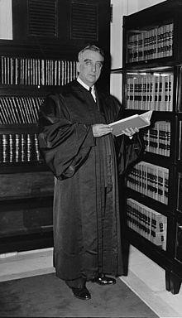Justice Fred M. Vinson
“In 1906, twenty of thirty-one lots in the 100 block of Bryant Street, Northwest, in the City of Washington, were sold subject to the following covenant:
‘. . . that said lot shall never be rented, leased, sold, transferred or conveyed unto any Negro or colored person, under a penalty of Two Thousand Dollars ($2,000), which shall be a lien against said property.’
The covenant imposes no time limitation on the restriction.
***
The Negro petitioners entered into contracts of sale with willing sellers for the purchase of properties upon which they desired to establish homes. Solely because of their race and color, they are confronted with orders of court divesting their titles in the properties and ordering that the premises be vacated. White sellers, one of whom is a petitioner here, have been enjoined from selling the properties to any Negro or colored person. Under such circumstances, to suggest that the Negro petitioners have been accorded the same rights as white citizens to purchase, hold, and convey real property is to reject the plain meaning of language. We hold that the action of the District Court directed against the Negro purchasers and the white sellers denies rights intended by Congress to be protected by the Civil Rights Act, and that, consequently, the action cannot stand.” https://supreme.justia.com/cases/federal/us/334/24/

June 13, 1948 – Babe Ruth
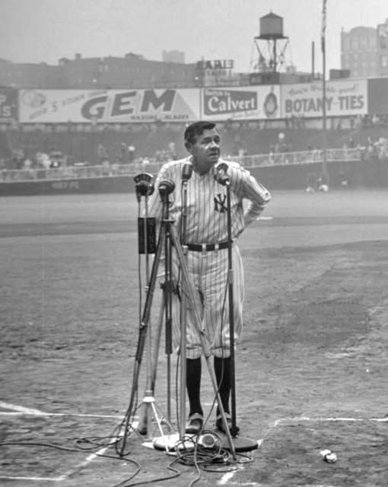
On June 13, 1948, Babe Ruth, battling terminal cancer, made his final appearance at Yankee Stadium during its 25th anniversary celebration.

Jan. 20, 1949: President Harry S. Truman – Second Inauguration

1950 – FDNY
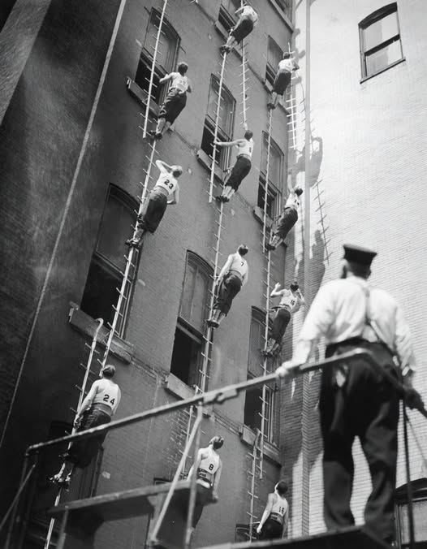

1950: Korean War (1950-1953)
“The Korean War (1950-1953), was fought between forces of the United States, South Korea and their allies, and forces of communist North Korea and China. It was a bitter, back-and-forth struggle that killed people on the ground and in the air. It claimed more than half as many Americans in three years as the Vietnam War killed in over a decade. Thousands fell during fighting in subzero temperatures around the Chosin Reservoir, in what is now North Korea. And U.S. pilots were shot down in many forbidding places, like MiG Alley near the Chinese border. Seven thousand Americans are still missing in action.” https://www.washingtonpost.com/dc-md-va/2021/12/23/korean-war-memorial-names-washington-dean-shot-down-granite-tons-crane-43000/?utm_campaign=wp_evening_edition&utm_medium=email&utm_source=newsletter&wpisrc=nl_evening&carta-url=https%3A%2F%2Fs2.washingtonpost.com%2Fcar-ln-tr%2F359843c%2F61c4f1799d2fdab56bda3692%2F59731235ade4e21a848a56ed%2F52%2F64%2F61c4f1799d2fdab56bda3692

Feb. 9, 1950: Communist Scare – Senator Joseph McCarthy

Joseph R. McCarthy: A Featured Biography
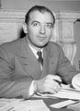
“Elected to the Senate in 1946, Joseph McCarthy (1908-1957) did not draw major national attention until 1950. On February 9th of that year, he delivered a Lincoln Day address in Wheeling, West Virginia, blaming failures in American foreign policy on Communist infiltration of the U.S. government. The Wisconsin Republican claimed to have a list of known Communists still working in the Department of State. A special subcommittee investigated McCarthy's charges and rejected them as “a fraud and a hoax,” but the outbreak of the Korean War and the highly publicized conviction of Alger Hiss lent credibility to the charges. When McCarthy became chairman of the Permanent Subcommittee on Investigations in 1953, he launched a series of investigations into alleged subversion and espionage. In 1954 a confrontation with the army led to the nationally televised Army-McCarthy hearings, which tarnished McCarthy's public image, undermined his charges, and prompted his censure by the U.S. Senate.” https://www.senate.gov/senators/FeaturedBios/Featured_Bio_McCarthy.htm

House Un-American Activities Committee:
“HUAC was created in 1938 to investigate alleged disloyalty and rebel activities on the part of private citizens, public employees and organizations suspected of having Communist ties. Citizens suspected of having ties to the communist party would be tried in a court of law. Also during this time, Senator Joseph McCarthy began a campaign against alleged communists in the U.S. government and other institutions. From 1950-1954 “McCarthyism” described the practice of accusing Federal Government employees of having affiliations with communism and leaking information. Government employees could be blacklisted (viewed as untrustworthy or someone to avoid) and could lose their jobs. The threat of Communism was a driving force that created a wedge between society and the United States government.” https://www.trumanlibrary.gov/education/presidential-inquiries/house-un-american-activities-committee

Nov. 1, 1950 – Presidential Assassination Attempt / Police Officer Kiled
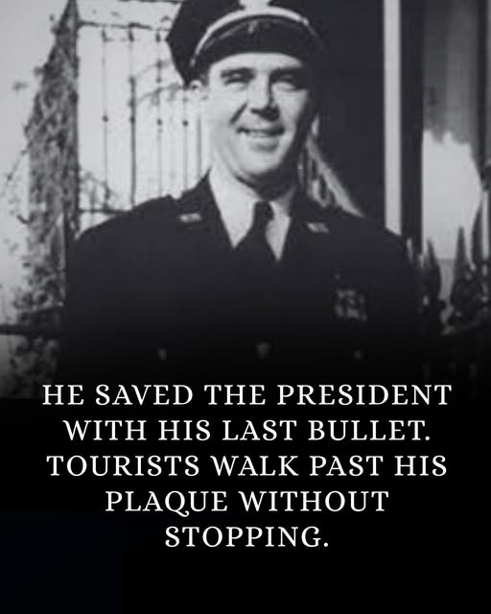
https://behindbadge.substack.com/p/heroes-live-forever-the-story-of-d5d
He was already dying when he fired the shot.
Three bullets in his body. Blood spreading across his uniform. His guard booth at Blair House splintered around him.
And the man trying to reach the President was still moving.
It was November 1, 1950. A Tuesday afternoon in Washington, D.C. President Harry Truman was upstairs at Blair House taking a nap, living there temporarily while the White House underwent its first major structural renovation since it was built. The executive mansion had been deemed structurally unsound. So the President of the United States was sleeping in a townhouse across Pennsylvania Avenue, protected by a small detail of White House Police officers.
One of them was Leslie Coffelt.
He was 39 years old. A veteran officer who had spent years in the quiet, invisible work of protecting presidents. Not glamorous work. Not celebrated work. Standing posts. Running checks. Being present so that nothing happened.
That afternoon, something happened.
At approximately 2:20 PM, two men approached Blair House from different directions. Oscar Collazo and Griselio Torresola, Puerto Rican nationalists, armed and coordinated. No warning. No demands. They opened fire the moment they were in range.
The assault lasted less than three minutes.
In those three minutes, multiple officers were hit. The street outside Blair House became a gunfight, sudden and close and brutal, in a neighborhood that had been quiet an hour before.
Torresola was the more lethal of the two. He moved along the Pennsylvania Avenue side of the building with precision, firing at officers, advancing toward the entrance. He had already wounded several men. He was still moving. Still armed. The entrance to Blair House was within reach.
Coffelt was inside his guard booth on the lower west side of the building when Torresola's bullets came through it.
The first round hit him in the chest. Then his abdomen. Then a third shot. He went down inside the booth, bleeding severely, his body already in the process of shutting down from wounds that doctors would later confirm were not survivable.
He did not stay down.
What happened next is the part of this story that the brief plaque on Blair House's wall cannot fully hold. Coffelt dragged himself out of the booth. Mortally wounded. Moving on training and something that is harder to name than training. He gripped his .38 caliber revolver. He steadied himself.
Torresola was twenty feet away.
Still advancing.
Coffelt raised his weapon and fired once.
The bullet struck Torresola in the head. He was dead before he hit the ground.
The attack was over.
Coffelt collapsed and did not rise again.
An ambulance came. Officers applied pressure to his wounds. They worked on him at the hospital for hours. He died approximately four hours after being shot, never regaining full consciousness. His last coherent action, the last thing his body performed before it gave out entirely, was raising a weapon and firing with enough precision to drop an armed man from twenty feet.
Upstairs, President Truman had heard the gunfire and gone to the window. His agents physically pulled him back from the glass. He was resistant. He wanted to see. They held him away from any possible line of fire until the shooting stopped.
He was alive because of what had just happened below his window.
Oscar Collazo was wounded, captured, tried, and sentenced to death. Two years later, in 1952, Truman commuted the sentence to life imprisonment. Jimmy Carter pardoned Collazo in 1979. He returned to Puerto Rico and lived until 1994.
Griselio Torresola, the man Coffelt killed, was buried in Puerto Rico.
Leslie Coffelt was buried in Arlington National Cemetery, Section 8.
Truman wrote personally to Coffelt's widow. He attended memorial services. He made sure the officer was honored in the ways available to him. But there is a particular arithmetic to that situation that no letter resolves. A man Truman had likely exchanged nothing more than a nod with on his way in and out of Blair House had just given his life so that Truman could continue living his.

Feb. 27,1951: 22nd Amendment - Two-Term Limit on Presidency
“The 22nd Amendment to the United States Constitution was passed in an era when Americans were concerned about the rising power of dictators overseas. After Adolf Hilter and Mussolini both gained power in their respective countries, there was a concern that the same could happen in the United States. This concern was only exacerbated by the rise of Franklin D. Roosevelt, who was elected to an unprecedented four terms in a row. This continual re-election of FDR was more concerning when he died not long into his fourth term. FDR’s actions were in contravention of a norm that had held until then in American politics that no one would run for a third term. Presidents had considered running for the unprecedented third term several times, and in the few instances where someone did seek a third term, such as in the case of Theodore Roosevelt, they failed in their re-election bids. Accordingly, after FDR died, at the urging of then-president Harry S. Truman, Congress decided it was time to act. Congress created what is now the 22nd Amendment, which was reviewed by the States and passed with overwhelming support from the American people.” https://cornerstonelaw.us/22nd-amendment-doesnt-say-think-says/

May 1951: Willie Mays – “the Say Hey Kid”
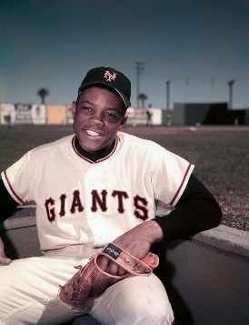
“Mays was batting .477 for the Minneapolis Millers of the American Association when he was called up by the Giants in May 1951. It was only four years after Robinson had become a Dodger, and there were few Black players in the majors, although the Giants had four when Mays joined them: Monte Irvin, the star outfielder; Hank Thompson, their third baseman; Ray Noble, a backup catcher; and Artie Wilson, an infielder, who was sent to the minors to make room for Mays. Black and white teammates remained apart early in Mays’s career. “For a while we couldn’t stay in the same hotels,” he said. “We’d get to Chicago, we’d get off on the South Side, they’d get off on the North Side.” https://www.nytimes.com/2024/06/18/sports/willie-mays-dead.html?emc=edit_na_20240618&ref=headline&nl=breaking-news

“But this combination of physical assets was not Mays’s most valuable or endearing asset. Rather, he rarely complained about anything and took time to play stickball with and sign autographs for his adoring fans. Most importantly, he almost always had a broad smile on his face. He was such a joyful presence that one imagines he would have played baseball without receiving a salary. That is what made this athlete into a role model for people like me who grew up in the 1950s and ’60s. *** Just after his career had started ascending, Mays served his country in the U.S. Army from 1952 to 1953. As the 1954 National League most valuable player, he led the Giants to victory in the World Series, in which he made one of the most memorable plays ever with ‘The Catch’ in deep center field of the Polo Grounds. In addition to the awards Mays collected during his playing career, Major League Baseball selected him as one of the greatest living players in 2015, and he was a recipient of the Presidential Medal of Freedom later that year.” https://www.washingtonpost.com/opinions/2024/06/21/willie-mays-bryson-dechambeau-trans-athletes/?utm_campaign=wp_todays_headlines&utm_medium=email&utm_source=newsletter&wpisrc=nl_headlines&carta-url=https%3A%2F%2Fs2.washingtonpost.com%2Fcar-ln-tr%2F3e0eba3%2F6676a0a7abab932d285edfc6%2F59731235ade4e21a848a56ed%2F29%2F60%2F6676a0a7abab932d285edfc6

1952: The Immigration and Nationality Act of 1952 (The McCarran-Walter Act)
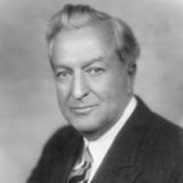
Patrick McCarran

“The Immigration and Nationality Act of 1952 upheld the national origins quota system established by the Immigration Act of 1924, reinforcing this controversial system of immigrant selection. It also ended Asian exclusion from immigrating to the United States and introduced a system of preferences based on skill sets and family reunification. Situated in the early years of the Cold War, the debate over the revision of U.S. immigration law demonstrated a division between those interested in the relationship between immigration and foreign policy, and those linking immigration to concerns over national security. The former group, led by individuals like Democrat Congressman from New York Emanuel Celler, favored the liberalization of immigration laws. Celler expressed concerns that the restrictive quota system heavily favored immigration from Northern and Western Europe and therefore created resentment against the United States in other parts of the world. He felt the law created the sense that Americans thought people from Eastern Europe as less desirable and people from Asia inferior to those of European descent. The latter group, led by Democratic Senator from Nevada Pat McCarran and Democratic Congressman from Pennsylvania Francis Walter, expressed concerns that the United States could face communist infiltration through immigration and that unassimilated aliens could threaten the foundations of American life. To these individuals, limited and selective immigration was the best way to ensure the preservation of national security and national interests.” https://history.state.gov/milestones/1945-1952/immigration-act

2/25/2025: “Trump administration says undocumented immigrants must register.
But lawyers and immigrant advocates warned that the administration’s plan was on shaky legal ground and that some immigrants may be afraid to comply. The Trump administration will require all unauthorized immigrants in the United States who are 14 and older to register with the federal government or face civil and criminal penalties, including up to $1,000 in fines and up to six months in prison. Homeland Security Secretary Kristi L. Noem, who announced the plan Tuesday, has argued that the administration should know who is here illegally so that it can deport them or give them the chance to leave voluntarily. She has warned immigrants in recent days that they “will be hunted down and deported” if they fail to register and has cited a provision of the 1952 Immigration and Nationality Act as justification for the requirement.” https://www.washingtonpost.com/immigration/2025/02/25/trump-administration-undocumented-immigrants-register/?utm_campaign=wp_todays_headlines&utm_medium=email&utm_source=newsletter&carta-url=https%3A%2F%2Fs2.washingtonpost.com%2Fcar-ln-tr%2F414fa96%2F67bef437a211644b43526728%2F59731235ade4e21a848a56ed%2F17%2F66%2F67bef437a211644b43526728

Jan. 21, 1953: President Dwight D. Eisenhower – First Inauguration
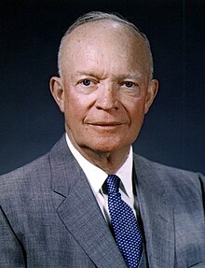

Oct. 1, 1953: Ohio Outlaws Wearing Masks – KKK rallies
“In the late 1880s, a group of vigilantes called the White Caps terrorized abusers, gamblers, alcoholics and "fast women." The outlaws would wear disguises (and white caps) as they burned down saloons and whipped anyone who didn't abide by their moral code.
***
Ohio's law went into effect on Oct. 1, 1953. Sixteen U.S. states have a form of anti-mask laws, some of which were ratified around the same time to prevent Ku Klux Klan rallies, whose members typically wore white hoods to conceal their identities.” https://www.dispatch.com/story/news/education/2024/05/06/some-student-protesters-could-face-felonies-because-of-an-old-ohio-law/73588920007/?utm_source=enquirer-dailybriefing-strada&utm_medium=email&utm_campaign=dailybriefing-headline-stack&utm_term=newsletter-greeting&utm_content=pcin-cincinnati-nletter65

May 15, 1954: U.S. Supreme Court - Brown v. Board of Education of Topeka (9 to 0) https://supreme.justia.com/cases/federal/us/347/483/

PUBLIC SCHOOL SEGREGATION ILLEGAL
“Issue: Do racially segregated public schools violate the Equal Protection Clause?
Result: Yes. A unanimous Court overturned Plessy v. Ferguson and held that state laws requiring or allowing racially segregated schools violate the Equal Protection Clause of the Fourteenth Amendment. The Court famously stated ‘separate educational facilities are inherently unequal.’
Importance: The Brown decision is heralded as a landmark decision in Supreme Court history, overturning Plessy v. Ferguson (1896) which had created the ‘separate but equal’ doctrine. In Plessy, The Court held that even though a Louisiana law required rail passengers to be segregated based on race, there was no violation of the Fourteenth Amendment's Equal Protection Clause so long as the accommodations at issue were ‘separate, but equal.’ By overturning this doctrine, the Brown Court helped lay the ground for the civil rights movement and integration across the country.” https://www.americanbar.org/groups/public_education/programs/constitution_day/landmark-cases/

Thurgood Marshall - Special Counsel, NAACP - finally got the case he had been hoping for, and in 1952 argued Brown v. Board of Education.
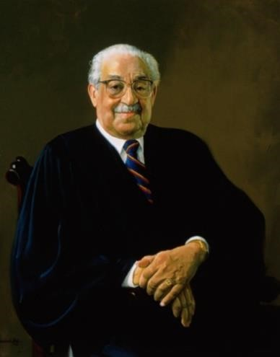Thurgood Marshall
“The case was reargued in 1953, and after 5 months of waiting, the Supreme Court delivered its opinion that invalidated the separate but equal doctrine. In 1961, President Kennedy appointed Marshall as federal judge to the Second Circuit Court of Appeals in New York City. Marshall spent four years on the court, and none of his opinions were reversed on appeal to the Supreme
Court. In 1965, President Johnson called upon Marshall to be the country’s next Solicitor General. Marshall was sworn into office, but only spent two years in the position. In 1967, the President appointed him as the first African-American to be an Associate Justice on the U.S. Supreme Court.” https://www.oyez.org/justices/thurgood_marshall

MR. CHIEF JUSTICE WARREN delivered the opinion of the Court.
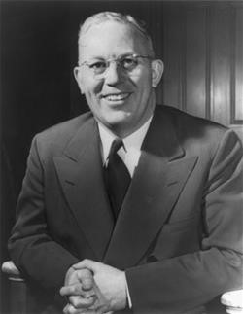 Chief Justice Earl Warren: https://www.landmarkcases.org/brown-v-
board-of-education/earl-warren

“Facts of the case
This case was the consolidation of cases arising in Kansas, South Carolina, Virginia, Delaware, and Washington D.C. relating to the segregation of public schools on the basis of race. In each of the cases, African American students had been denied admittance to certain public schools based on laws allowing public education to be segregated by race. They argued that such segregation violated the Equal Protection Clause of the Fourteenth Amendment. The plaintiffs were denied relief in the lower courts based on Plessy v. Ferguson, which held that racially segregated public facilities were legal so long as the facilities for blacks and whites were equal. (This was known as the ‘separate but equal’ doctrine.)

Question
Does the segregation of public education based solely on race violate the Equal Protection Clause of the Fourteenth Amendment?

Conclusion
Separate but equal educational facilities for racial minorities is inherently unequal, violating the Equal Protection Clause of the Fourteenth Amendment. Chief Justice Earl Warren delivered the opinion of the unanimous Court. The Supreme Court held that “separate but equal” facilities are inherently unequal and violate the protections of the Equal Protection Clause of the Fourteenth Amendment. The Court reasoned that the segregation of public education based on race instilled a sense of inferiority that had a hugely detrimental effect on the education and personal growth of African American children. Warren based much of his opinion on information from social science studies rather than court precedent. The decision also used language that was relatively accessible to non-lawyers because Warren felt it was necessary for all Americans to understand its logic.”
https://www.oyez.org/cases/1940-1955/347us483

July 17, 1955 – Nuclear testing
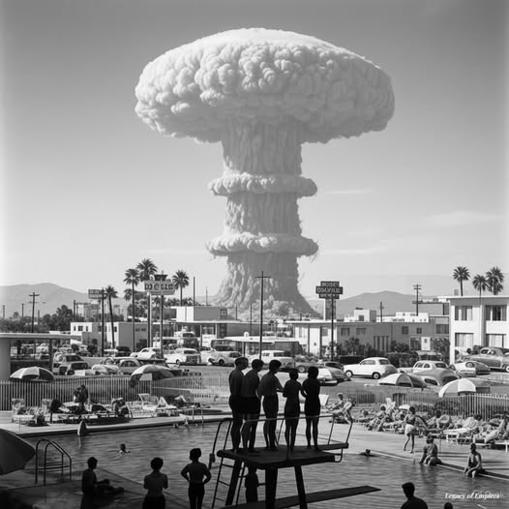On July 17, 1955, at precisely 5:30 a.m., swimmers at the Desert Inn pool in Las Vegas paused mid-dive. A mushroom cloud rose in the distance—65 miles away at the Nevada Test Site. The atomic blast, part of Operation Teapot, was visible from the Strip, and locals had gathered with lawn chairs and sunglasses to witness the spectacle.

Operation Teapot - 1955 - Nevada Test Site
“This series of fourteen shots proof tested a broad variety of fission devices with low to moderate yields. As a group these devices combined several innovations - some previously tested, some introduced during this test series - to create a new pattern of fission device that would dominate the design of all later weapons. These devices used new compact, efficient, light weight spherical implosion systems; beryllium tampers; hollow cores; deuterium-tritium boosting; and the use of neutron pulse tubes as initiators to create light, compact, efficient, and reliable fission explosive systems…. UCRL (University of California Radiation Laboratory, now the Lawrence Livermore National Laboratory - LLNL) had its first successful test shots after two and a half years of trying. UCRL demonstrated linear implosion - a non-lensed implosion approach used in artillery shells and other applications where very small diameter systems are required. Approximately 8,000 DOD personnel participated in the Desert Rock VI exercise which was intended to familiarize troops with the capabilities of nuclear weapons, and the conditions of atomic combat.” https://www.atomicarchive.com/media/photographs/testing/us/teapot.html

December 1955: Montgomery Bus Boycott - Rosa Parks
“December 5, 1955 to December 20, 1956. Sparked by the arrest of Rosa Parks on 1 December 1955, the Montgomery bus boycott was a 13-month mass protest that ended with the U.S. Supreme Court ruling that segregation on public buses is unconstitutional. The Montgomery Improvement Association (MIA) coordinated the boycott, and its president, Martin Luther King, Jr., became a prominent civil rights leader as international attention focused on Montgomery. The bus boycott demonstrated the potential for nonviolent mass protest to successfully challenge racial segregation and served as an example for other southern campaigns that followed. In Stride Toward Freedom, King’s 1958 memoir of the boycott, he declared the real meaning of the Montgomery bus boycott to be the power of a growing self-respect to animate the struggle for civil rights.” https://kinginstitute.stanford.edu/montgomery-bus-boycott
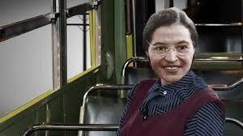

“Rosa Parks (1913—2005) helped initiate the civil rights movement in the United States when she refused to give up her seat to a white man on a Montgomery, Alabama bus in 1955. Her actions inspired the leaders of the local Black community to organize the Montgomery Bus Boycott. Led by a young Rev. Dr. Martin Luther King Jr., the boycott lasted more than a year— during which Parks not coincidentally lost her job—and ended only when the U.S. Supreme Court ruled that bus segregation was unconstitutional. Over the next half-century, Parks became a nationally recognized symbol of dignity and strength in the struggle to end entrenched racial segregation.” https://www.history.com/topics/black-history/rosa-parks

1956 – FBI – J. Edgar Hoover - J. EDGAR HOOVER STARTS “COINTTELPRO” - including Surveillance Of Martin Luther King (1967-71)
“The term "COINTELPRO" is a generic term used by the FBI to describe seven separate ‘counterintelligenc’" programs which the Bureau implemented at different times during· the period .from ~-1956 to 1971, when all were discontinued. Five of these programs were directed at domestic based groups and individuals -- Communist Party, USA, the forerunner of all other COINTELPROS (1956-1971); Socialist Workers Party (1961-1970); White Hate Grou~s (1964-1971); Black Extremists (1967-1971); and New Left (1968-1971). The documents authorizing these five programs define their objective as being either simply the disruption of the group's activities; or the disruption, exposure and neutralization thereof.´ https://www.fordlibrarymuseum.gov/sites/default/files/pdf_documents/library/document/0204/1511708.pdf

Jan. 21, 1957: President Eisenhower – Second Inauguration
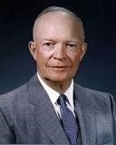
President Dwight D. Eisenhower

Sept. 4, 1957: Little Rock Nine
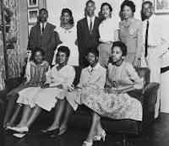
“The Little Rock Nine were a group of nine black students who enrolled at formerly all white Central High School in Little Rock, Arkansas, in September 1957. Their attendance at the school was a test of Brown v. Board of Education, a landmark 1954 Supreme Court ruling that declared segregation in public schools unconstitutional. On September 4, 1957, the first day of classes at Central High, Governor Orval Faubus called in the Arkansas National Guard to block the black students’ entry into the high school. Later
that month, President Dwight D. Eisenhower sent in federal troops to escort the Little Rock Nine into the school. It drew national attention to the civil rights movement.” https://www.history.com/topics/black-history/central-high-school-integration
President Dwight D. Eisenhower

Executive Order 10730: Desegregation of Central High School (1957)
https://www.archives.gov/milestone-documents/executive-order-10730
“On September 4, the nine Black students attempted to enter Central High. The students had planned to meet and enter as a group; though one student, Elizabeth Eckford, did not receive this news and attempted to enter the school by herself, only to be threatened and harassed by an angry mob of segregationists. The students were turned away and denied entry by the Arkansas National Guard. That evening, Governor Faubus revealed that he had ordered the National Guard to prevent the Black students from entering.
President Eisenhower, who was vacationing in Newport, RI, invited Governor Faubus to meet him at the Naval Base at Newport to discuss the tense situation. In the meeting, Faubus indicated that he would respect the desegregation order. Eisenhower therefore suggested that Faubus not necessarily withdraw the National Guard troops, but instruct them to preserve order and allow the Black students to attend Central High.
However, once back in Little Rock, Governor Faubus withdrew the National Guard. A few days later, when the Black students entered the school, a full-scale riot erupted. The situation was quickly out of control, as Governor Faubus failed to stop the violence. Finally, Congressman Brooks Hays and Little Rock Mayor Woodrow Mann asked the federal government for help, first in the form of U.S. marshals.
President Dwight D. Eisenhower, as the chief law enforcement officer of the United States, was presented with a difficult problem. He was required to uphold the Constitution and the laws, but he also wanted to avoid a bloody confrontation in Arkansas. With Executive Order 10730, the President placed the Arkansas National Guard under federal control and sent 1,000 U.S. Army paratroopers from the 101st Airborne Division to assist them in restoring order in Little Rock.”

Billy Graham: Pastor to Presidents
https://billygraham.org/story/billy-graham-pastor-to-presidents-2/
“Every U.S. President since World War II met with Billy Graham. Both Johnson and Nixon, the two who probably sought him the most, offered him high positions in government—which he quickly and politely refused.
Here are short snippets of their stories:
Dwight D. Eisenhower — “Eisenhower was the first President that really asked my counsel in depth when he was sending troops into Little Rock,” said Mr. Graham. Just before Eisenhower died, Billy was invited to see him at Walter Reed Hospital. After talking again about assurance of salvation, the two men prayed. Eisenhower then said he was ready to die.
‘Billy Graham is one of the best ambassadors our country has but he told me, ‘I am an ambassador of heaven.' — Dwight D. Eisenhower.”

Aug. 28, 1957 – Sen. Strom Thurmond (D- South Carolina) filibuster – 24 hours, 18 minutes
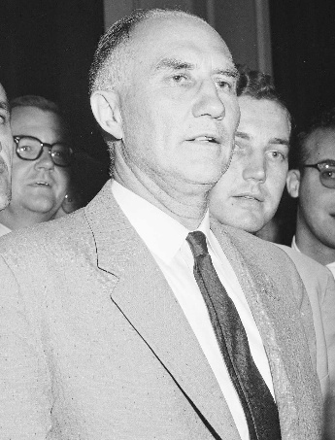
The record-long filibuster against proposed Civil Rights Act is the 1957 talkfest by then-Democratic Sen. Strom Thurmond of South Carolina. He lasted for 24 hours, 18 minutes.
“[H]e conducted what is still the longest live filibuster in history — 24 hours, 18 minutes — in opposition to President Dwight D. Eisenhower's modest civil rights bill (PL 85–315)…. The filibuster was unsuccessful, but Thurmond took his opposition to the stump, using the federal government's actions to integrate Little Rock's high school as an occasion to vent his criticism. “We in the South are not about to surrender, not now or in the future,” he said. He reserved a special blast for the Supreme Court, whom he called “nine puppets of the NAACP” for refusing to give Arkansas authorities more time to work out a compromise. He promised that Southerners would “maintain an adequate system of mass education for all people — either public or private — and that we will maintain it segregated.” https://library.cqpress.com/cqalmanac/document.php?id=cqal02-236-10381-664576#_=_

Dec. 1, 1958: Chicago - Our Lady of the Angels School fire

“60 Years Later: Our Lady of the Angels School Fire. Alex Burkholder reflects on the tragic fire that took the lives of 92 students and three nuns in Chicago on Dec. 1, 1958. ***The fire had started in the basement and quickly spread up a stairwell. Fire doors on the first floor stopped the smoke and flames, and students on that floor fled the building. Things were much different on the second floor where there were no fire doors and the smoke and flames spread down a hallway, trapping students in five classrooms. The students’ only way out was through the windows. Ironically, a fire department inspector at the school a couple of months before the fire had noted the lack of fire doors upstairs, but because of the building codes and grandfather clauses, he could not demand their installation.” https://www.firehouse.com/operations-training/article/21028868/60-years-later-our-lady-of-the-angels-school-fire

Jan. 20, 1961: President John F. Kennedy Inauguration
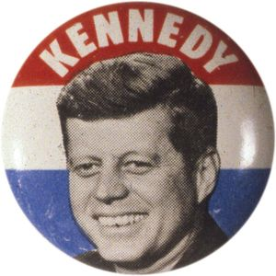

June 19, 1961: U.S. Supreme Court - Mapp v. Ohio (6 to 3) https://supreme.justia.com/cases/federal/us/367/643/

EVIDENCE ILLEGALLY OBTAINED WILL BE EXCLUDED FROM TRIAL
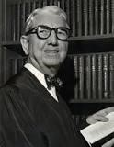
Justice Tom C. Clark: https://www.oyez.org/justices/tom_c_clark

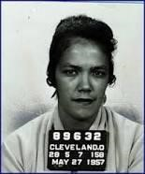Dollree Mapp

“Facts of the case
Dollree Mapp was convicted of possessing obscene materials after an admittedly illegal police search of her home for a fugitive. She appealed her conviction on the basis of freedom of expression.
Question
Were the confiscated materials protected from seizure by the Fourth Amendment?

Conclusion
In an opinion authored by Justice Tom C. Clark, the majority brushed aside First Amendment issues and declared that all evidence obtained by searches and seizures in violation of the Fourth Amendment is inadmissible in a state court. The decision launched the Court on a troubled course of determining how and when to apply the exclusionary rule.” https://www.oyez.org/cases/1960/236
Sept. 30, 1962: James Meredith – Riot at University of Mississippi

“UM History of Integration - About James Meredith.” https://50years.olemiss.edu/james-meredith/
“After a protracted court battle, the U.S. Supreme Court ruled on Sept. 10, 1962, that Meredith was to be admitted to the university. Mississippi Gov. Ross Barnett tried to prevent Meredith’s enrollment by assuming the position of registrar and blocking his admission.
On Sept. 30, 1962, when a deal was reached between Barnett and U.S. Attorney General Robert Kennedy to allow Meredith to enroll, a riot broke out on campus. A mob of angry whites confronted U.S. marshals stationed on campus to protect Meredith. The crowd assaulted the marshals with bricks and bullets outside the Lyceum, the university’s administration building, until the arrival of federal troops quelled the violence in the early morning hours. Two bystanders died in the confrontation, 206 marshals and soldiers were wounded, and 200 individuals were arrested. Meredith was finally allowed to register for courses on Oct. 1, 1962.”
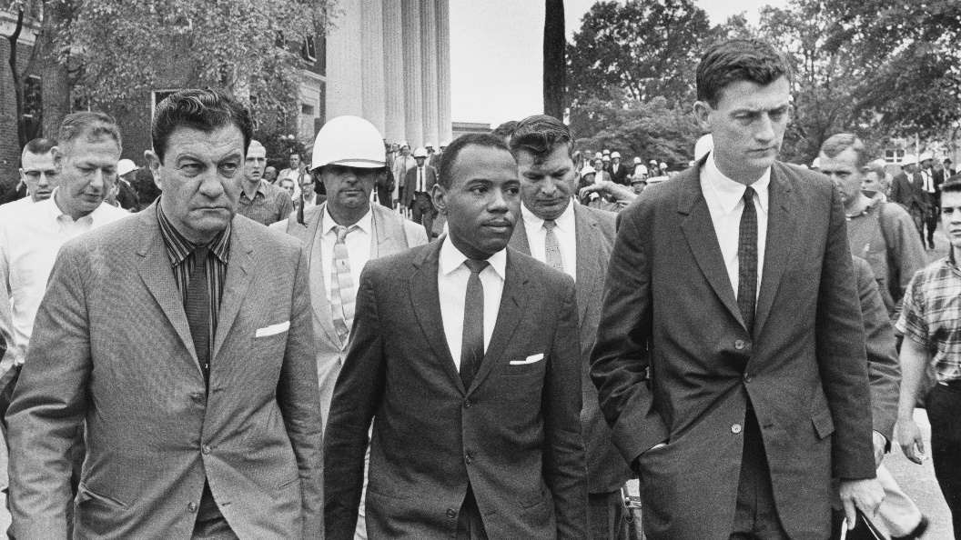
https://www.google.com/search?client=firefox-b-1-d&q=Justice+Black+and+Meridth#vhid=vor84z8NhpT68M&vssid=l

WASHINGTON, Oct. 8, 1962 (UPI) -- The Supreme Court today refused to review the court order which forced the admission of James H. Meredith to the University of Mississippi. It also upheld two lower court decisions which struck down racial barriers in bus and railroad terminals in Louisiana and Georgia. https://www.upi.com/Archives/1962/10/08/Supreme-Court-allows-Meredith-to-enter-U-of-Mississippi/5528434544180/
“The court's action in the Mississippi case had been anticipated. Justice Hugo L. Black early last month vacated several stays granted by Fifth Circuit Judge Ben F. Cameron. Black, after consulting with the other justices, said the lower court orders to admit Meredith should be carried out.”
Supreme Court of the United States; James H. MEREDITH, Movant, v.
Charles Dickson FAIR et al. Sept. 10, 1962. https://clearinghouse.net/doc/87075/

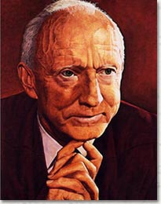

“Despite the Fifth Circuit's July 1962 opinion, [5th Circuit] Judge Cameron continued to issue stays to block Meredith's admission to Ole Miss. In total, he issued three stays after the July 1962 Fifth Circuit decision and before the September 1962 Supreme Court decision. Justice Black of the Supreme Court reviewed Judge Cameron's actions and vacated his orders. The Supreme Court held that continuing to stay the Fifth Circuit mandates would cause further harm to Meredith and enforcing the mandates would not cause appreciable harm to Ole Miss. 83 S. Ct. 10.”https://clearinghouse.net/case/11088/

April 16, 1963: Martin Luther King – Letter From Birmingham Jail
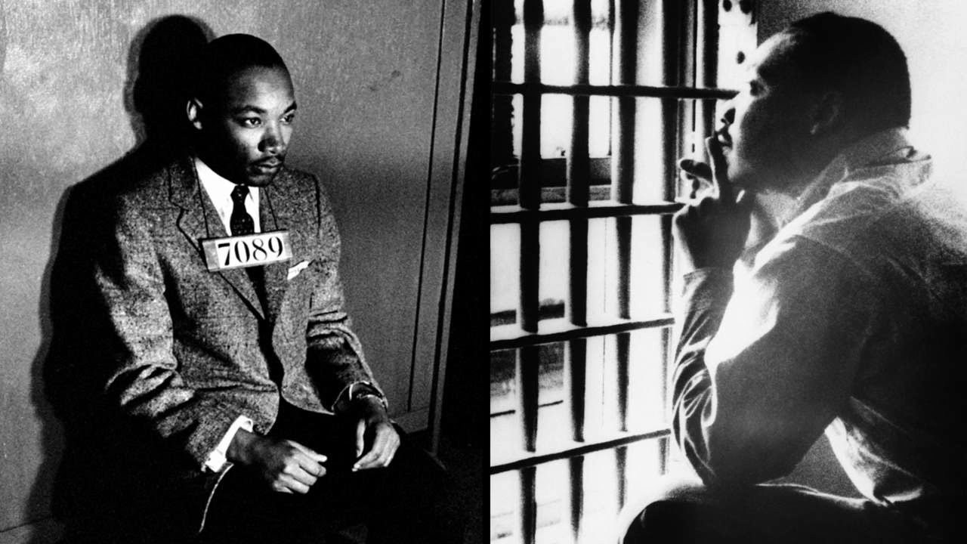
“WHILE confined here in the Birmingham city jail, I came across your recent statement calling our present activities "unwise and untimely." Seldom, if ever, do I pause to answer criticism of my work and ideas. If I sought to answer all of the criticisms that cross my desk, my secretaries would be engaged in little else in the course of the day, and I would have no time for constructive work. But since I feel that you are men of genuine good will and your criticisms are sincerely set forth, I would like to answer your statement in what I hope will be patient and reasonable terms. I think I should give the reason for my being in Birmingham, since you have been influenced by the argument of "outsiders coming in." I have the honor of serving as president of the Southern Christian Leadership Conference, an organization operating in every Southern state, with headquarters in Atlanta, Georgia. We have some eighty-five affiliate organizations all across the South, one being the Alabama Christian Movement for Human Rights. Whenever necessary and possible, we share staff, educational and financial resources with our affiliates. Several months ago our local affiliate here in Birmingham invited us to be on call to engage in a nonviolent direct-action program if such were deemed necessary. We readily consented, and when the hour came we lived up to our promises. So I am here, along with several members of my staff, because we were invited here. I am here because I have basic organizational ties here. Beyond this, I am in Birmingham because injustice is here. Just as the eighth-century prophets left their little villages and carried their "thus saith the Lord" far beyond the boundaries of their hometowns; and just as the Apostle Paul left his little village of Tarsus and carried the gospel of Jesus Christ to practically every hamlet and city of the Greco-Roman world, I too am compelled to carry the gospel of freedom beyond my particular hometown. Like Paul, I must constantly respond to the Macedonian call for aid.” https://www.africa.upenn.edu/Articles_Gen/Letter_Birmingham.html

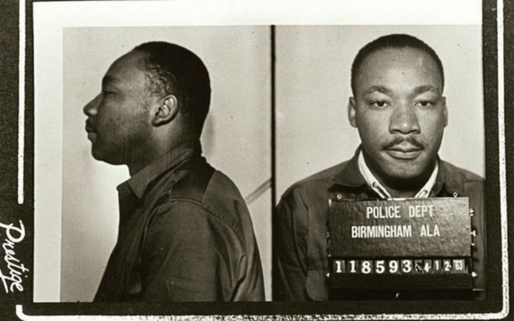

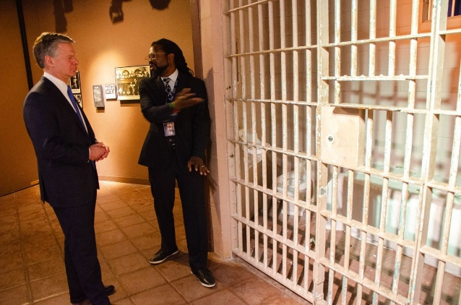
FBI Director Wray is shown the jail cell bars that held Dr. Martin Luther King Jr. when he wrote "Letter from Birmingham Jail" during a tour of the Birmingham Civil Rights Institute on April 15, 2024. https://www.fbi.gov/news/stories/director-wray-recalls-fbis-journey-toward-justice-in-speech-at-civil-rights-landmark-in-alabama?utm_campaign=email-Immediate&utm_medium=email&utm_source=stories&utm_content=%5B1820060%5D-%2Fnews%2Fstories%2Fdirector-wray-recalls-fbis-journey-toward-justice-in-speech-at-civil-rights-landmark-in-alabama

May 3, 1963 – Birmingham, AL – Fire Hoses Used On Protestors
“With an estimated 40 percent of the student body at the all-black Parker High School skipping class to protest and the Birmingham City Jail filled beyond capacity, Birmingham Public Safety Commissioner Bull Connor ordered the use of fire hoses and police dogs on the protestors.” https://www.al.com/birmingham-news-stories/2013/05/bull_connor_used_fire_hoses_po.html
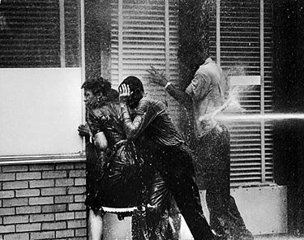

June 12, 1963 – MEDGAR EVANS MURDERED
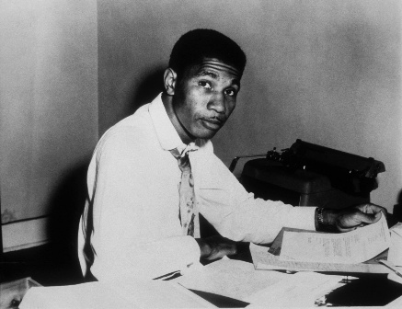

FBI: “It took more than three decades, but justice was finally served in the 1963 murder of a pioneering civil rights leader in Jackson, Mississippi. About half past midnight, a shot rang out. It was June 12, 1963, in a suburban neighborhood of Jackson, Mississippi. A 37-year-old civil rights activist named Medgar Evers had just come home after a meeting of the NAACP. As he began the short walk up to his single-story rambler, the bullet struck Evers in the back. He staggered up to the steps of the house, then collapsed. Across the street on a lightly wooded hill, another man jumped up in pain. The recoil from the Enfield rifle he had just fired drove the scope into his eye, badly bruising him. He dropped the weapon and fled. *** The FBI connected it to a man named Byron De La Beckwith based on its similarity to his military service prints. He was arrested several days later. Beckwith, a known white supremacist and segregationist, had been asking around to find out the location of Evers’ home for some time prior to the shooting. With the obvious motive, his fingerprint on the weapon, the injury around his eye, his planning, and other factors, Beckwith clearly appeared to be the killer. In two separate trials, local prosecutors presented a strong case. A number of police, FBI experts, and others testified on different parts of the evidence against Beckwith.
But this was the 1960s, and in both trials, all-white juries did not reach a verdict. Beckwith went free. By the early 1990s, however, the time was ripe to revisit the case. Evers’ widow, Myrlie—a formidable civil rights organizer in her own right—asked local prosecutors to reopen the investigation and see if other evidence could be found. The FBI again provided its assistance. In December 1990, a new grand jury returned an indictment against Beckwith based on witnesses finally willing to tell their stories, including hearing the white supremacist brag how he had killed Medgar Evers. This time, justice was done. Beckwith was convicted in 1994 and sentenced to life in prison.” https://www.fbi.gov/history/famous-cases/medgar-evers

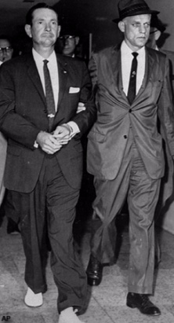 Byron De La Beckwith (left) is escorted to the Jackson police station by FBI agents on June 23, 1963. AP photograph.

May 13, 1963: U.S. Supreme Court - Brady v. Maryland (7 to 2) https://supreme.justia.com/cases/federal/us/373/83/
DEFENSE ENTITLED TO EXCULPATORY EVIDENCE PRIOR TO TRIAL
“Ruling:
The suppression by the prosecution of evidence favorable to an accused upon request violates due process where the evidence is material either to guilt or to punishment, irrespective of the good faith or bad faith of the prosecution.
Facts:
In separate trials in a Maryland state court, where the jury was the judge of both the law and the facts but the court passed on the admissibility of the evidence, petitioner Brady and a companion, Boblit, were convicted of first-degree murder and sentenced to death. At his trial, Brady admitted participating in the crime but claimed that Boblit did the actual killing. In his summation to the jury, Brady's counsel conceded that Brady was guilty of murder in the first degree and asked only that the jury return that verdict ‘without capital punishment.’ Prior to the trial, Brady's counsel had requested the prosecution to allow him to examine Boblit’s extrajudicial statements. Several of these were shown to him. However, one in which Boblit admitted to the actual killing was withheld by the prosecution, and it did not come to Brady's notice until after he had been tried, convicted and sentenced and after his conviction had been affirmed by the Court of Appeals of Maryland. In a post-conviction proceeding, the appellate court held that suppression of the evidence by the prosecutor denied Brady due process of law, and it remanded the case for a new trial of the question of punishment, but not the question of guilt, since it was of the opinion that nothing in the suppressed confession could have reduced Brady's offense below murder in the first degree.”
https://www.lexisnexis.com/community/casebrief/p/casebrief-brady-v-maryland
See April 8, 2025: STANDING ORDERS FOR CRIMINAL CASES The Honorable Sarah D. Morrison United States District Court for the Southern District of Ohio Eastern Division

E. BRADY MATERIAL
Counsel for the government must produce to a defendant, in a timely manner, any evidence in its possession that is favorable to defendant and material to defendant’s guilt or punishment. See Brady v. Maryland, 373 U.S. 83 (1963). This obligation is a continuing one. If counsel identifies any information which is favorable to defendant but which it believes not to be material, counsel for the government must submit such information to the Court for in camera review. https://www.ohsd.uscourts.gov/sites/ohsd/files//Standing%20Orders%20for%20Criminal%20Cases%20%28Updated%20April%207%2C%202025%29.pdf

May 18, 1963: U.S. Supreme Court - Gideon v. Wainwright (9 to 0) https://supreme.justia.com/cases/federal/us/372/335/
INDIGENT DEFENDANTS ENTITLED TO APPOINTMENT OF DEFENSE ATTORNEY

“Issue: Does the Constitution require that any individual charged with a felony, but unable to pay for a lawyer, be guaranteed the free assistance of legal counsel?
Result: Yes, according to a unanimous Supreme Court. The Court held that the Sixth Amendment right to assistance of counsel applies to criminal state trials and that ‘lawyers in criminal court are necessities, not luxuries.’
Importance: Along with the right to assistance for state criminal defendants, the Gideon decision had the effect of expanding public defender systems across the country.” https://www.americanbar.org/groups/public_education/programs/constitution_day/landmark-cases/

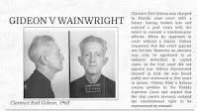

“Facts of the case
Clarence Earl Gideon was charged in Florida state court with felony breaking and entering. When he appeared in court without a lawyer, Gideon requested that the court appoint one for him. According to Florida state law, however, an attorney may only be appointed to an indigent defendant in capital cases, so the trial court did not appoint one.
Gideon represented himself in trial. He was found guilty and sentenced to five years in prison. Gideon filed a habeas corpus petition in the Florida Supreme Court, arguing that the trial court's decision violated his constitutional right to be represented by counsel. The Florida Supreme Court denied habeas corpus relief.

Question
Does the Sixth Amendment's right to counsel in criminal cases extend to felony defendants in state courts?

Conclusion
The Sixth Amendment's guarantee of a right to assistance of counsel applies to criminal defendants in state court by way of the Fourteenth Amendment. In a unanimous opinion authored by Justice Hugo L. Black, the Court held that it was consistent with the Constitution to require state courts to appoint attorneys for defendants who could not afford to retain counsel on their own. The Court reasoned that the Sixth Amendment's guarantee of counsel is a fundamental and essential right made obligatory upon the states by the Fourteenth Amendment. The Sixth Amendment guarantees the accused the right to the assistance of counsel in all criminal prosecutions and requires courts to provide counsel for defendants unable to hire counsel unless the right was competently and intelligently waived.” https://www.oyez.org/cases/1962/155

Aug. 28, 1963: Martin Luther King – “I Have A Dream” Speech, Lincoln Memorial, Washington, DC
Watch video: https://www.youtube.com/watch?v=smEqnnklfYs https://www.archives.gov/files/press/exhibits/dream-speech.pdf
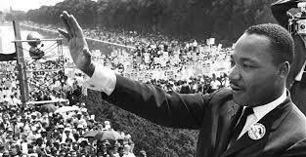

Sept. 15, 1963 – Birmingham Bombing – 4 Children Killed
September 15, 1963, church bombing that killed Carole Robertson, Addie Mae Collins, Cynthia Wesley, and Denise McNair.
“It was a quiet Sunday morning in Birmingham, Alabama—around 10:24 on September 15, 1963—when a dynamite bomb exploded in the back stairwell of the downtown Sixteenth Street Baptist Church. The violent blast ripped through the wall, killing four African-American girls on the other side and injuring more than 20 inside the church. *** By 1965, we [FBI] had serious suspects—namely, Robert E. Chambliss, Bobby Frank Cherry, Herman Frank Cash, and Thomas E. Blanton, Jr., all KKK members—but witnesses were reluctant to talk and physical evidence was lacking. Also, at that time, information from our surveillances was not admissible in court. As a result, no federal charges were filed in the ‘60s. It has been claimed that Director Hoover held back evidence from prosecutors in the ‘60s or even tried to block prosecution. But it’s simply not true. His concern was to prevent leaks, not to stifle justice. In one memo concerning a Justice Department prosecutor seeking information, he wrote, “Haven’t these reports already been furnished to the Dept.?” In 1966, Hoover overruled his staff and made transcripts of wiretaps available to Justice. And he couldn’t have blocked the prosecution and didn’t—he simply didn’t think the evidence was there to convict. *** Chambliss received life in prison in 1977 following a case led by Alabama Attorney General Robert Baxley. And eventually the fear, prejudice, and reticence that kept witnesses from coming forward began to subside. We re-opened our case in the mid-1990s, and Blanton and Cherry were indicted in May 2000. Both were convicted at trial and sentenced to life in prison. The fourth man, Herman Frank Cash, had died in 1994.”
https://www.fbi.gov/history/famous-cases/baptist-street-church-bombing

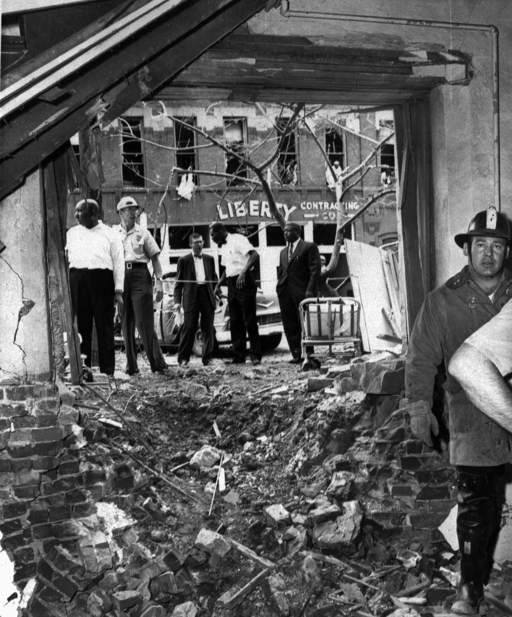

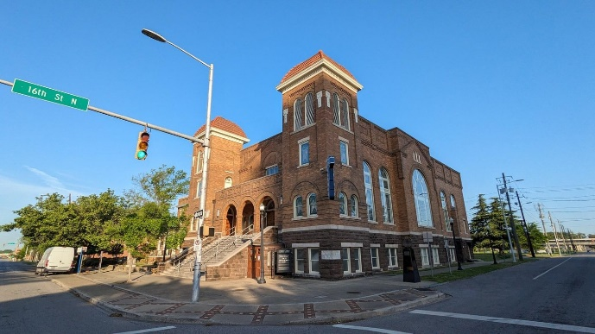

Oct. 1963: FBI search warrant
March 19, 2023: Investigations and Oversight: Director Wray Discusses FBI’s Commitment to Government Accountability: FBI Director Wray also acknowledged the FBI’s missteps with respect to Dr. Martin Luther King Jr.—including an October 1963 wiretap request against the civil rights leader that failed to “present a shred of evidence.” He also reflected on the psychological toll FBI surveillance took on Dr. King. https://www.fbi.gov/news/stories/investigations-and-oversight-director-wray-discusses-fbi-s-commitment-to-government-accountability?utm_campaign=email-Immediate&utm_medium=email&utm_source=stories&utm_content=%5B1806007%5D-%2Fnews%2Fstories%2Finvestigations-and-oversight-director-wray-discusses-fbi-s-commitment-to-government-accountability

Nov. 22, 1963: President Kennedy assassinated, Dallas, TX
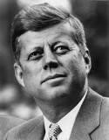John Fitzgerald "Jack" Kennedy

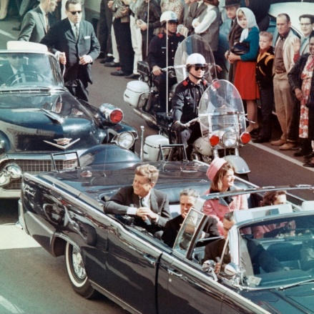
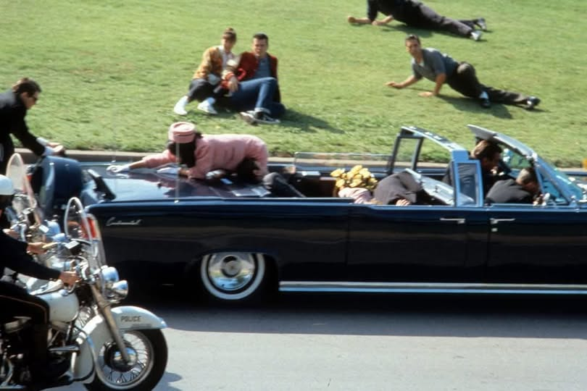

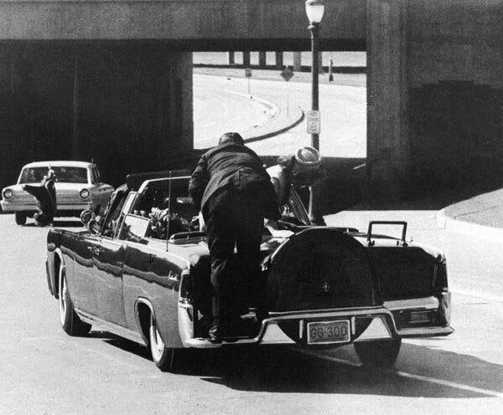
The Secret Service agent Clint Hill clambered onto the trunk of President John F. Kennedy’s limousine in Dallas on Nov. 22, 1963, moments after shots were fired. As the first lady, Jacqueline Kennedy, tried to climb out of her seat, he pushed her back, preventing her from falling to the ground. He was credited with saving her life. [Clint Hill passed away 2/23/2025, age 93.] https://www.nytimes.com/2025/02/24/us/clint-hill-dead.html

November 22, 1963: Death of the President https://www.jfklibrary.org/learn/about-jfk/jfk-in-history/november-22-1963-death-of-the-president

“Shortly after noon on November 22, 1963, President John F. Kennedy was assassinated as he rode in a motorcade through Dealey Plaza in downtown Dallas, Texas.
***
The president's body was brought to Love Field and placed on Air Force One. Before the plane took off, a grim-faced Lyndon B. Johnson stood in the tight, crowded compartment and took the oath of office, administered by US District Court Judge Sarah Hughes. The brief ceremony took place at 2:38 p.m.
Less than an hour earlier, police had arrested Lee Harvey Oswald, a recently hired employee at the Texas School Book Depository. He was being held for the assassination of President Kennedy and the fatal shooting, shortly afterward, of Patrolman J. D. Tippit on a Dallas street.
On Sunday morning, November 24, Oswald was scheduled to be transferred from police headquarters to the county jail. Viewers across America watching the live television coverage suddenly saw a man aim a pistol and fire at point blank range. The assailant was identified as Jack Ruby, a local nightclub owner. Oswald died two hours later at Parkland Hospital.
***
The Warren Commission
On November 29, 1963 President Lyndon B. Johnson appointed the President's Commission on the Assassination of President Kennedy. It came to be known as the Warren Commission after its chairman, Earl Warren, Chief Justice of the United States. President Johnson directed the commission to evaluate matters relating to the assassination and the subsequent killing of the alleged assassin, and to report its findings and conclusions to him.
.

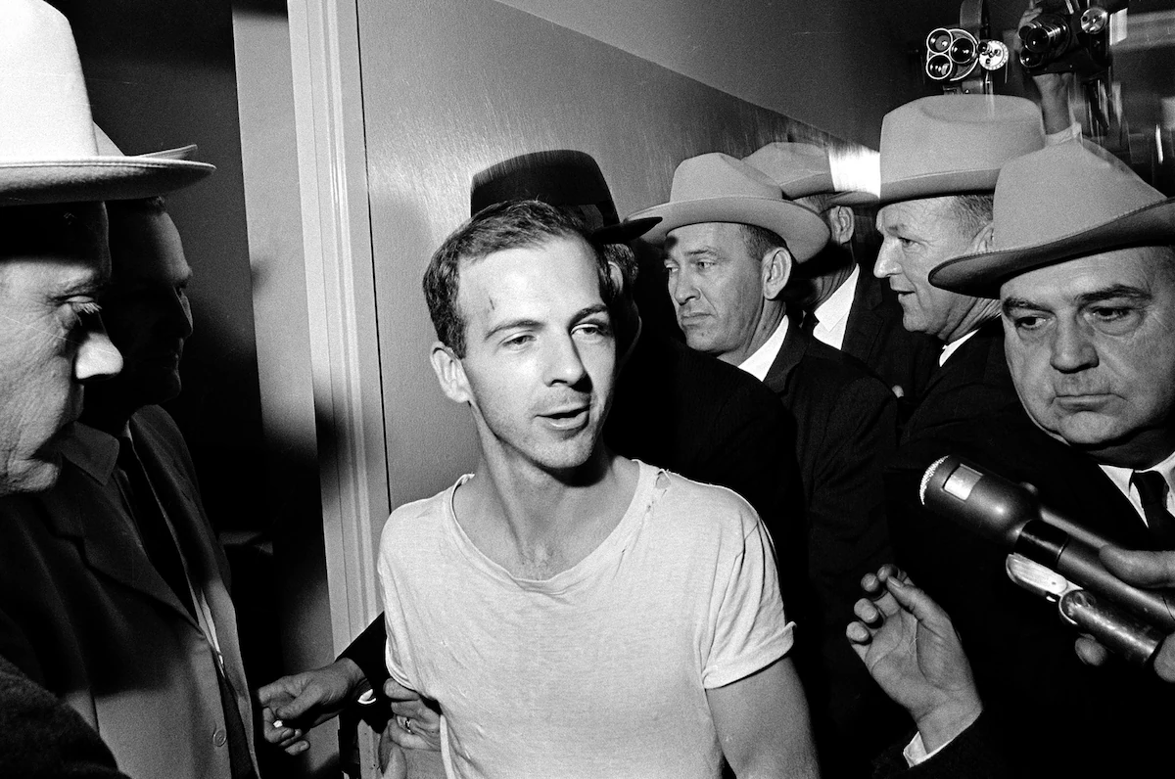
Lee Harvey Oswald talks to the media as he is led down a corridor of the Dallas police station on Nov. 23, 1963, for a round of questioning in connection with the assassination of U.S. President John F. Kennedy. He told reporters he was “a patsy,” but didn't say for whom. (AP).

Lee Harvey Oswald - killed Nov. 24, 1963; shot at Dallas County Jail.
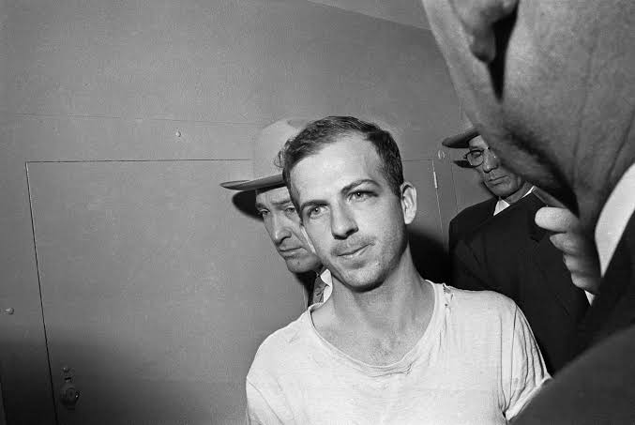
3/18/2025:
JFK Assassination Records - 2025 Documents Release: “In accordance with President Donald Trump’s directive of March 17, 2025, all records previously withheld for classification that are part of the President John F. Kennedy Assassination Records Collection are released. The National Archives has partnered with agencies across the federal government to comply with the President’s directive in support of Executive Order 14176. As of March 18, 2025, the records are available to access either online at this page or in person, via hard copy or on analog media formats, at the National Archives at College Park, Maryland. As the records continue to be digitized, they will be posted to this page.” https://www.archives.gov/research/jfk/release-2025
7/14/2025
The CIA reveals more of its connections to Lee Harvey Oswald. New documents show an officer known only as Howard managed a Cuban group that interacted with Oswald in the months before the JFK assassination. For more than 60 years, the CIA claimed it had little or no knowledge of Lee Harvey Oswald’s activities before the assassination of President John F. Kennedy in November 1963. That wasn’t true, new documents unearthed by a House task force prove. The revelation raises further questions about the agency’s awareness of — or involvement in — the plot to murder the president. The documents confirm that George Joannides, a CIA officer based in Miami in 1963, was helping finance and oversee a group of Cuban students opposed to the ascension of Fidel Castro. Joannides had a covert assignment to manage anti-Castro propaganda and disrupt pro-Castro groups, even as the CIA was prohibited from domestic spying. The CIA-backed group known as DRE was aware of Oswald as he publicly promoted a pro-Castro policy for the U.S., and its members physically clashed with him three months before the assassination. And then, a DRE member said, Oswald approached them and offered his help, possibly to work as a mole within his pro-Castro group, the Fair Play for Cuba Committee.
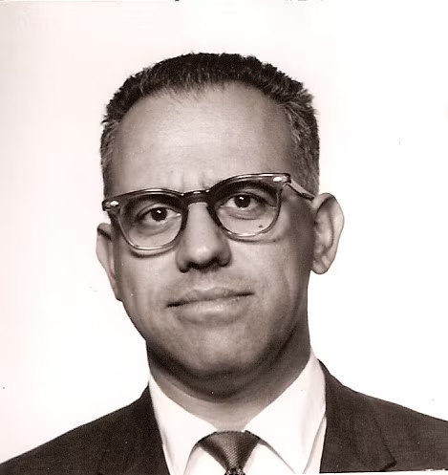
George Joannides, a career CIA agent, was posted in Miami when an anti-Castro group he oversaw was in contact with Lee Harvey Oswald. The CIA resisted revealing Joannides's identity until this month. (National Archives and Records Administration) https://www.washingtonpost.com/national-security/2025/07/14/cia-oswald-jfk-assassination-joannides/?utm_campaign=wp_post_most&utm_medium=email&utm_source=newsletter&carta-url=https%3A%2F%2Fs2.washingtonpost.com%2Fcar-ln-tr%2F439bcaa%2F687528c77867926b76393613%2F59731235ade4e21a848a56ed%2F15%2F67%2F687528c77867926b76393613

Nov. 22, 1963: President Lyndon B. Johnson – First Inauguration
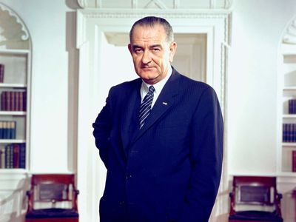
https://www.britannica.com/biography/Lyndon-B-Johnson

Martin Luther King and President Lyndon Johnson – at White House (1963)
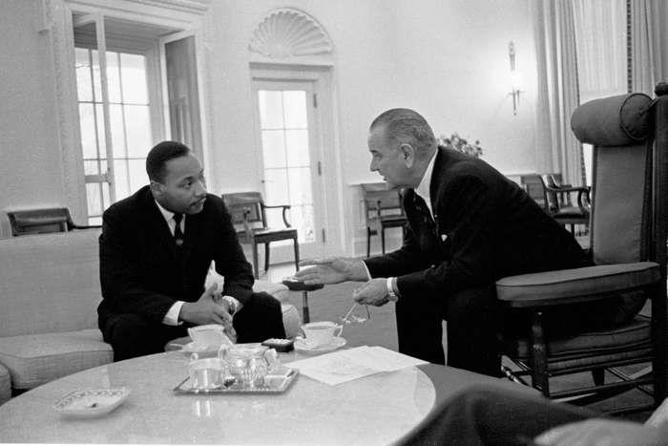
July 2, 1964: Video of President Lyndon B. Johnson signing the bill. https://www.lbjlibrary.org/object/video/signing-civil-rights-act-1964

Radio and television remarks on signing the Civil Rights Bill.
https://www.senate.gov/artandhistory/history/resources/pdf/JohnsonSpeechJuly21964.pdf

Feb. 4, 1964: 24th Amendment – Abolition Poll Tax Qualification in Federal Elections
“Section. 1. The right of citizens of the United States to vote in any primary or other election for President or Vice President, for electors for President or Vice President, or for Senator or Representative in Congress, shall not be denied or abridged by the United States or any State by reason of failure to pay any poll tax or other tax.
Section. 2. The Congress shall have power to enforce this article by appropriate legislation.” https://constitution.findlaw.com/amendments.html

March 9, 1964: U.S. Supreme Court - New York Times v. Sullivan (9 to 0) https://supreme.justia.com/cases/federal/us/376/254/
PUBLIC FIGURES MUST PROVE “MALICE” TO SUE NEWSPAPERS OR OTHER PRESS FOR LIBEL / SLANDER
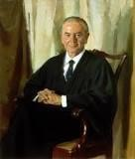Justice William J. Brennan
MR. JUSTICE BRENNAN delivered the opinion of the Court.

“Facts of the case
During the Civil Rights movement of the 1960s, the New York Times published an ad for contributing donations to defend Martin Luther King, Jr., on perjury charges. The ad contained several minor factual inaccuracies. The city Public Safety Commissioner, L.B.
Sullivan, felt that the criticism of his subordinates reflected on him, even though he was not mentioned in the ad. Sullivan sent a written request to the Times to publicly retract the information, as required for a public figure to seek punitive damages in a libel action under Alabama law.
When the Times refused and claimed that they were puzzled by the request, Sullivan filed a libel action against the Times and a group of African American ministers mentioned in the ad. A jury in state court awarded him $500,000 in damages. The state supreme court affirmed and the Times appealed.

Question
Did Alabama's libel law unconstitutionally infringe on the First Amendment's freedom of speech and freedom of press protections?

Conclusion
To sustain a claim of defamation or libel, the First Amendment requires that the plaintiff show that the defendant knew that a statement was false or was reckless in deciding to publish the information without investigating whether it was accurate. In a unanimous opinion authored by Justice Brennan, the Court ruled for the Times. When a statement concerns a public figure, the Court held, it is not enough to show that it is false for the press to be liable for libel. Instead, the target of the statement must show that it was made with knowledge of or reckless disregard for its falsity. Brennan used the term ‘actual malice’ to summarize this standard, although he did not intend the usual meaning of a malicious purpose. In libel law, ‘malice’ had meant knowledge or gross recklessness rather than intent, since courts found it difficult to imagine that someone would knowingly disseminate false information without a bad intent.” https://www.oyez.org/cases/1963/39

June 16, 1964: KKK – Killers of 3 Civil Rights Activists

“In 1964, the Klan killed three young activists and shocked the nation.”
“In 1964, the Klan killed three young activists and shocked the nation. A Mississippi town still grapples with that violent civil rights history.” The three activists had arrived to check on the latest church burning. But before the sun rose the next morning, Mickey Schwerner, James Chaney and Andrew Goodman would all be dead, ambushed by the Ku Klux Klan as they were heading out of Neshoba County. It took a massive FBI mobilization 44 days to find the brutalized bodies. It took years for even a modicum of justice.
***
1967: With only the state able to bring murder charges — and Mississippi refusing to do so — the U.S. Justice Department put 18 men on trial for allegedly violating the civil rights of Schwerner, Chaney and Goodman. One defendant pleaded guilty. Seven, including a deputy sheriff, were convicted. None spent more than six years behind bars.” https://www.washingtonpost.com/nation/interactive/2024/mississippi-klan-killings-1964-impact-history/?utm_campaign=wp_post_most&utm_medium=email&utm_source=newsletter&wpisrc=nl_most&carta-url=https%3A%2F%2Fs2.washingtonpost.com%2Fcar-ln-tr%2F3e0b883%2F66745280065ad23d7ff1dd36%2F59731235ade4e21a848a56ed%2F8%2F53%2F66745280065ad23d7ff1dd36

“DoJ Case Document: Michael Schwerner - James Chaney - Andrew Goodman”
“As previously noted, seven defendants – Price, Roberts, H.D. Barnette, Posey, Arledge, Snowden, and Bowers – were convicted of the federal criminal civil rights conspiracy. Eight defendants – Burrage and Harris, as well as Bernard Akin, Travis Barnette, Herndon, Rainey, Tucker, and Willis – were found not guilty. Mistrials were entered by the court after the jury could not agree as to three defendants, Killen, Sharpe and “Hop” Barnette.” https://www.justice.gov/crt/case-document/micheal-schwerner-james-chaney-andrew-goodman

Trial Transcripts In The Case - United States V. Price, Et Al. (also Known As The "Mississippi Burning" Incident) 1967.
‘On June 21, 1964, several individuals conspired to murder civil rights workers James Chaney, Andrew Goodman, and Michael Schwerner in Philadelphia, Mississippi, one day after the three had arrived in Mississippi to assist in efforts to register African-American voters. Deputy Sheriff Cecil Price approached the civil rights workers while they changed a tire on the car by the side of the road. The Deputy Sheriff alleged that the car had been speeding, arrested the workers, and placed them all in jail – holding the two passengers for “investigation.” Deputy Sheriff Price fined the car’s driver James Chaney $20.00 and then released the trio at 10:00 P.M. ordering them to leave Neshoba County. Deputy Sheriff Price escorted the civil rights workers to the edge of town on the road towards Meridian, Mississippi. The civil rights workers never arrived in Meridian. On June 23, 1964, on information provided by residents of a nearby Choctaw community, Special Agents of the Federal Bureau of Investigation (FBI) found the charred remains of the civil rights workers’ Ford station wagon eighty feet off the highway on an abandoned logging track. After an extensive investigation in which the FBI offered a reward for locating the victims, on August 4, 1964, investigators discovered all three civil rights workers’ bodies buried in an earthen dam on a farm six miles southwest of Philadelphia, Mississippi” https://www.justice.gov/crt/trial-transcripts-caseunited-states-v-price-et-al-also-known-mississippi-burning-incident-1967?itid=lk_inline_enhanced-template

July 2, 1964: CIVIL RIGHTS ACT OF 1964 – TITLE VII is key provision in sex, race, age litigation
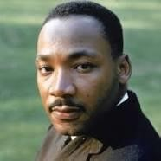
Civil rights leader Martin Luther King Jr. said that the Civil Rights Act of 1964 was nothing less than a “second emancipation.” https://kinginstitute.stanford.edu/king-papers/documents/facingchallenge-new-age-address-delivered-naacp-emancipation-day-rally

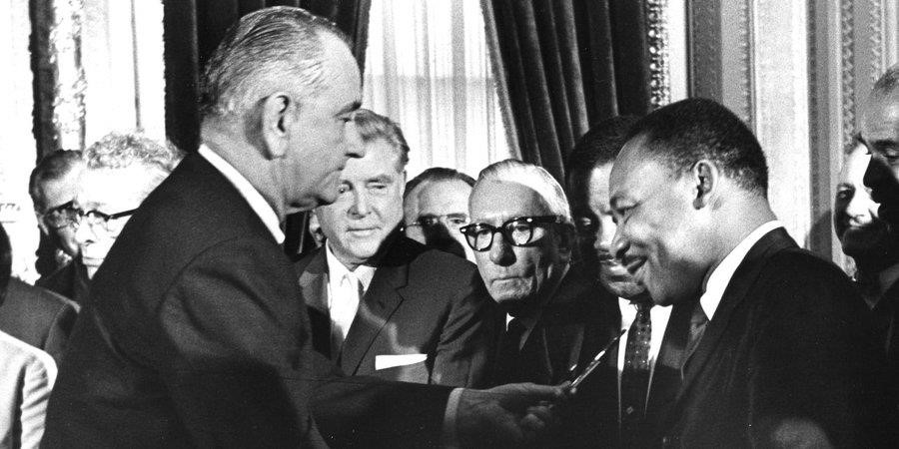
President Lyndon Baines Johnson and Martin Luther King
EDITOR'S NOTE: The following is the text of Title VII of the Civil Rights Act of 1964 (Pub. L. 88-352) (Title VII), as amended, as it appears in volume 42 of the United States Code, beginning at section 2000e. Title VII prohibits employment discrimination based on race, color, religion, sex and national origin. The Civil Rights Act of 1991 (Pub. L. 102-166) (CRA) and the Lily Ledbetter Fair Pay Act of 2009 (Pub. L. 111-2) amend several sections of Title VII. https://www.eeoc.gov/statutes/title-vii-civil-rights-act-1964

UNLAWFUL EMPLOYMENT PRACTICES
SEC. 2000e-2. [Section 703]
(a) Employer practices
It shall be an unlawful employment practice for an employer -(1) to fail or refuse to hire or to discharge any individual, or otherwise to discriminate against any individual with respect to his compensation, terms, conditions, or privileges of employment, because of such individual's race, color, religion, sex, or national origin; or
(2) to limit, segregate, or classify his employees or applicants for employment in any way which would deprive or tend to deprive any individual of employment opportunities or otherwise adversely affect his status as an employee, because of such individual's race, color, religion, sex, or national origin.

“The Civil Rights Act of 1964, which ended segregation in public places and banned employment discrimination on the basis of race, color, religion, sex or national origin, is considered one of the crowning legislative achievements of the civil rights movement. First proposed by President John F. Kennedy, it survived strong opposition from southern members of Congress and was then signed into law by Kennedy’s successor, Lyndon B. Johnson. In subsequent years, Congress expanded the act and passed additional civil rights legislation such as the Voting Rights Act of 1965.” https://www.history.com/topics/black-history/civil-rights-act

August 1964 – USS Maddox - Vietnam
“An unexpected development in August 1964 altered that timetable. On August 2 the destroyer USS Maddox was attacked by North Vietnamese torpedo boats while on electronic surveillance patrol in the Gulf of Tonkin. The preceding day, patrol boats of the South Vietnamese navy had carried out clandestine raids on the islands of Hon Me and Hon Nieu just off the coast of North Vietnam, and the North Vietnamese may have assumed that the Maddox was involved. In any case, the U.S. destroyer suffered no damage, and the North Vietnamese boats were driven off by gunfire from the Maddox and from aircraft based on a nearby carrier. President Johnson reacted to news of the attack by announcing that the U.S. Navy would continue patrols in the gulf and by sending a second destroyer, the Turner Joy, to join the Maddox. On the night of August 4 the two ships reported a second attack by torpedo boats. Although the captain of the Maddox soon cautioned that evidence for the second incident was inconclusive, Johnson and his advisers chose to believe those who insisted that a second attack had indeed taken place. The president ordered retaliatory air strikes against North Vietnamese naval bases, and he requested congressional support for a broad resolution authorizing him to take whatever action he deemed necessary to deal with future threats to U.S. forces or U.S. allies in Southeast Asia. The measure, soon dubbed the Gulf of Tonkin Resolution, passed the Senate and House overwhelmingly on August 7. Few who voted for the resolution were aware of the doubts concerning the second attack, and even fewer knew of the connection between the North Vietnamese attacks and U.S.-sponsored raids in the North or that the Maddox was on an intelligence mission. Although what many came to see as Johnson’s deceptions would cause problems later, the immediate result of the president’s actions was to remove Vietnam as an issue from the election campaign. In November Johnson was reelected by a landslide.” https://www.britannica.com/event/Vietnam-War/The-Gulf-of-Tonkin

Jan. 20, 1965: PRESIDENT LYNDON B. JOHNSON - SECOND INAGURATION

March 7, 1965 – Bloody Sunday - Selma, Alabama
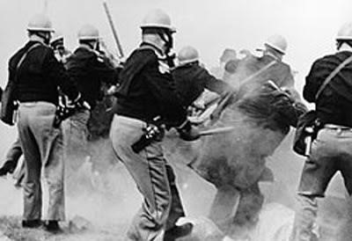

Alabama State Troopers attack civil rights demonstrators
outside Selma, Alabama, on Bloody Sunday, March 7, 1965
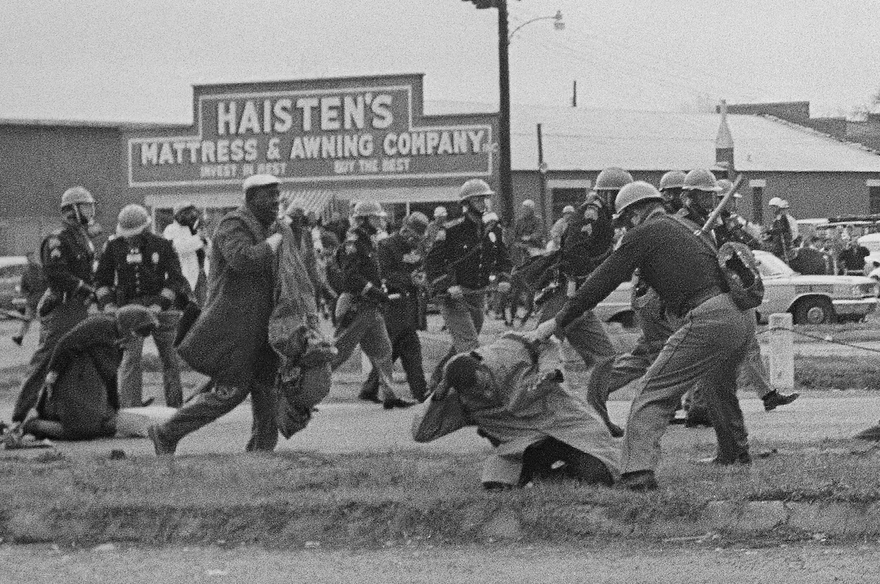
State troopers swing billy clubs to break up a civil rights voting march in Selma on March 7, 1965. https://www.washingtonpost.com/nation/2025/03/09/selmas-civil-rights-anniversary-fears-rise-about-way-forward/?utm_campaign=wp_evening_edition&utm_medium=email&utm_source=newsletter&carta-url=https%3A%2F%2Fs2.washingtonpost.com%2Fcar-ln-tr%2F4182230%2F67ce015b2204985819893f1f%2F59731235ade4e21a848a56ed%2F23%2F46%2F67ce015b2204985819893f1f

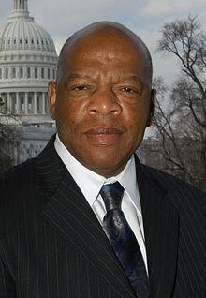 John Lewis: https://johnlewis.house.gov/john-lewis/biography
“John Lewis [age 25] was prepared to get arrested on Sunday, March 7, 1965. ‘I wanted to have something to eat,’ he said, so in his backpack he stored ‘one apple and one orange. I had two books. I had toothpaste and a toothbrush.’ Yet the 25-year-old civil rights leader carried something far more crucial inside as he led some 600 protesters over the Edmund Pettus Bridge in Selma to agitate for the right of African Americans to vote. While most people must move through fear to find courage, Lewis said ‘I never felt fear, not once.’
Lewis was the first to be beaten in the clash with state troopers, who cracked his skull with a billy club on the date that became known as ‘Bloody Sunday.’ The televised images of the bravery shown by Lewis and other protesters in the face of state violence inspired the passage of the 1965 Voting Rights Act just two months later.”
https://www.washingtonpost.com/history/2020/07/26/john-lewis-bloody-sunday-edmundpettus-
bridge/?utm_campaign=wp_post_most&utm_medium=email&utm_source=newsletter& wpisrc=nl_most

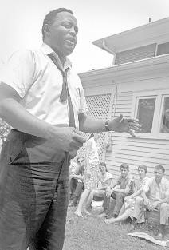

Hosea Williams: https://kinginstitute.stanford.edu/encyclopedia/williams-hosea

“Hosea Williams, another notable Civil Rights leader, and John Lewis led over 600 peaceful, orderly protestors across the Edmund Pettus Bridge in Selma, Alabama on March 7, 1965. They intended to march from Selma to Montgomery to demonstrate the need for voting rights in the state. The marchers were attacked by Alabama state troopers in a brutal confrontation that became known as ‘Bloody Sunday.’ News broadcasts and photographs revealing the senseless cruelty of the segregated South helped hasten the passage of the Voting Rights Act of 1965.” https://johnlewis.house.gov/johnlewis/biography

Oct. 3, 1965 - Immigration and Nationality Act
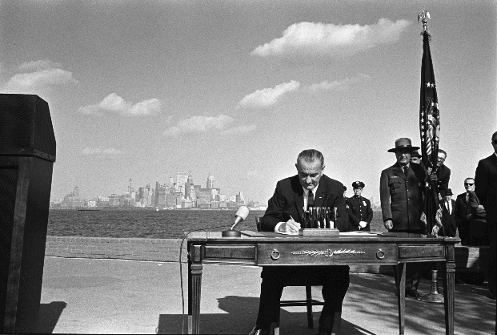
“On Oct. 3, 1965, at the base of the Statue of Liberty and with the island of Manhattan gleaming in the background, President Lyndon B. Johnson signed the Immigration and Nationality Act, also known as the Hart-Celler Act. In the previous 40 years before the act was signed, those who wanted to come to America were subject to a quota system. Immigration law favored immigrants from northern Europe and the British Isles, discriminated against those from southern and eastern Europe, and barred those from Asia and non-whites from entering the country. The Immigration and Nationality Act abolished quotas, opening the doors to "those who can contribute most to this country – to its growth, to its strength, to its spirit." The new law created a preference system that focused on immigrants' skills and family relations with citizens or U. S. residents. President John F. Kennedy, whose Irish ancestors had faced prejudice, wanted immigration reform. As president, Johnson turned to Kennedy's brother, Ted, to help steer the bill through Congress. In a March 8, 1965 telephone conversation, the two men talked about strengthening their working relationship and dispelling rumors about a strain between Johnson and Kennedy supporters. The conversation can be heard below. For historical perspective, the LBJ Presidential Library has collected related photos, videos, audio, and text from the bill signing. All are public domain.” https://www.lbjlibrary.org/news-and-press/media-kits/immigration-and-nationality-act

June 13, 1966: U.S. Supreme Court - Miranda v. Arizona (5 to 4) https://supreme.justia.com/cases/federal/us/384/436/
“MIRANDA OF RIGHTS” WHEN IN CUSTODY

“Issue: Are police constitutionally required to inform people in custody of their rights to remain silent and to an attorney?
Result: Yes, the Court found that the Fifth and Sixth Amendments require police to inform individuals in custody that they have a right to remain silent and to be assisted by an attorney. According to the Court, if the police fail to do so, a criminal court judge may rule that any statements made by the accused cannot be admitted as evidence during trial.
Importance: The now famous ‘Miranda warnings’ are required before any police custodial interrogation can begin if any of the evidence obtained during the interrogation is going to be used during a trial; the Court has limited and narrowed these warnings over the years.” https://www.americanbar.org/groups/public_education/programs/constitution_day/landmark-cases/

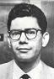 Ernesto Miranda

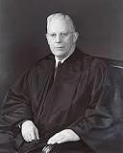Chief Justice Earl Warren
MR. CHIEF JUSTICE WARREN delivered the opinion of the Court

“Facts of the case
This case represents the consolidation of four cases, in each of which the defendant confessed guilt after being subjected to a variety of interrogation techniques without being informed of his Fifth Amendment rights during an interrogation.
On March 13, 1963, Ernesto Miranda was arrested in his house and brought to the police station where he was questioned by police officers in connection with a kidnapping and rape. After two hours of interrogation, the police obtained a written confession from Miranda. The written confession was admitted into evidence at trial despite the objection of the defense attorney and the fact that the police officers admitted that they had not advised Miranda of his right to have an attorney present during the interrogation. The jury found Miranda guilty. On appeal, the Supreme Court of Arizona affirmed and held that Miranda’s constitutional rights were not violated because he did not specifically request counsel.

Question
Does the Fifth Amendment’s protection against self-incrimination extend to the police interrogation of a suspect?

Conclusion
The Fifth Amendment requires that law enforcement officials advise suspects of their right to remain silent and to obtain an attorney during interrogations while in police custody. Chief Justice Earl Warren delivered the opinion of the 5-4 majority, concluding that defendant’s interrogation violated the Fifth Amendment. To protect the privilege, the Court reasoned, procedural safeguards were required. A defendant was required to be warned before questioning that he had the right to remain silent, and that anything he said can be used against him in a court of law. A defendant was required to be told that he had the right to an attorney, and if he could not afford an attorney, one was to be appointed for him prior to any questioning if he so desired. After these warnings were given, a defendant could knowingly and intelligently waive these rights and agree to answer questions or make a statement. Evidence obtained as a result of interrogation was not to be used against a defendant at trial unless the prosecution demonstrated the warnings were given, and knowingly and intelligently waived.” https://www.oyez.org/cases/1965/759

1967 – San Francisco Music
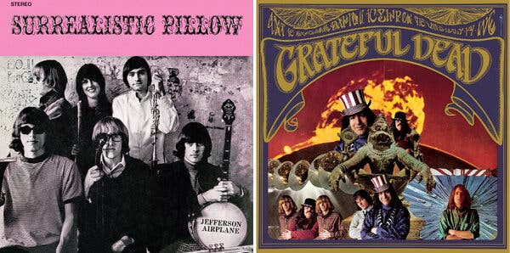
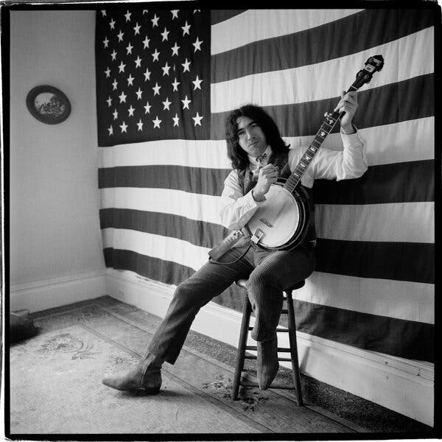Mr. Greene’s many pictures of the Grateful Dead, a favorite subject, include a well-known one of Jerry Garcia against a wall-sized American flag.
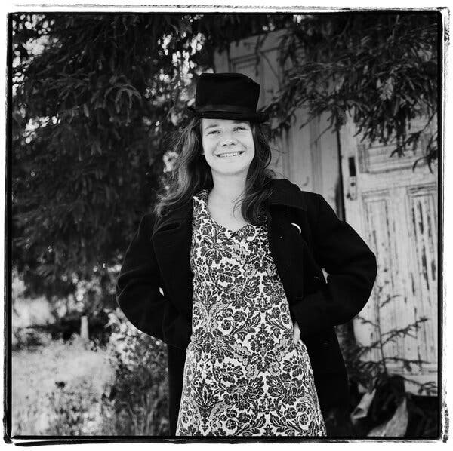Mr. Greene photographed Janis Joplin during a walk in his neighborhood in San Francisco in 1966.
https://www.nytimes.com/2025/03/26/arts/music/herb-greene-dead.html

Jan. 16, 1967: U.S. Supreme Court - Garrity v. New Jersey 5 to 4) – https://supreme.justia.com/cases/federal/us/385/493/
INTERNAL INVESTIGATIONS AND ORDERED TO ANSWER QUESTIONS - PROTECTION FROM PROSECUTION [BUT NOT DISCIPLINE]
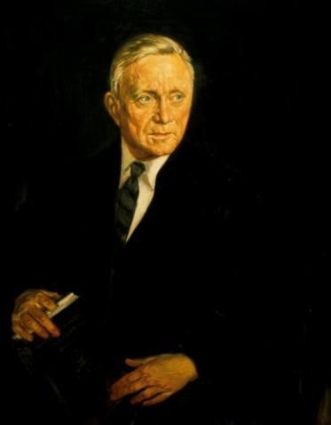Justice William O. Douglas
MR. JUSTICE DOUGLAS delivered the opinion of the Court.
“Syllabus
Appellants, police officers in certain New Jersey boroughs, were questioned during the course of a state investigation concerning alleged traffic ticket ‘fixing.’ Each officer was first warned that: anything he said might be used against him in a state criminal proceeding; he could refuse to answer if the disclosure would tend to incriminate him; if he refused to answer, he would be subject to removal from office. The officers' answers to the questions were used over their objections in subsequent prosecutions, which resulted in their convictions. The State Supreme Court, on appeal, upheld the convictions despite the claim that the statements of the officers were coerced by reason of the fact that, if they refused to answer, they could, under the New Jersey forfeiture of office statute, lose their positions. That statute provides that a public employee shall be removed from office if he refuses to testify or answer any material question before any commission or body which has the right to inquire about matters relating to his office or employment on the ground that his answer may incriminate him. On the ground that the only real issue in the case was the voluntariness of the statements, the State Supreme Court declined to pass upon the constitutionality of the statute, though the statute was considered relevant for the bearing it had on the voluntary character of the statements used to convict the officers. The officers appealed to this Court under 28 U.S.C. § 1257(2), and the question of jurisdiction was postponed to a hearing on the merits.
Held:
- The forfeiture of office statute is too tangentially involved to satisfy the requirements of 28 U.S. C. § 1257(2). The only bearing it had was whether, valid or not, the choice between being discharged under it for refusal to answer and self-incrimination rendered the statements products of coercion. The appeal is dismissed, the papers are treated as a petition for certiorari, and certiorari is granted.
- The threat of removal from public office under the forfeiture of office statute to induce the petitioners to forgo the privilege against self-incrimination secured by the Fourteenth Amendment rendered the resulting statements involuntary, and therefore inadmissible in the state criminal proceedings.”
https://supreme.justia.com/cases/federal/us/385/493/

Feb. 23, 1967: 25Th Amendment – Presidential Vacancy
“Section. 1. In case of the removal of the President from office or of his death or resignation, the Vice President shall become President.
Section. 2. Whenever there is a vacancy in the office of the Vice President, the President shall nominate a Vice President who shall take office upon confirmation by a majority vote of both Houses of Congress.
Section. 3. Whenever the President transmits to the President pro tempore of the Senate and the Speaker of the House of Representatives his written declaration that he is unable to discharge the powers and duties of his office, and until he transmits to them a written declaration to the contrary, such powers and duties shall be discharged by the Vice President as Acting President….” https://constitution.findlaw.com/amendments.html

March 25, 1967 – Vietnam War (1965 – 1973)
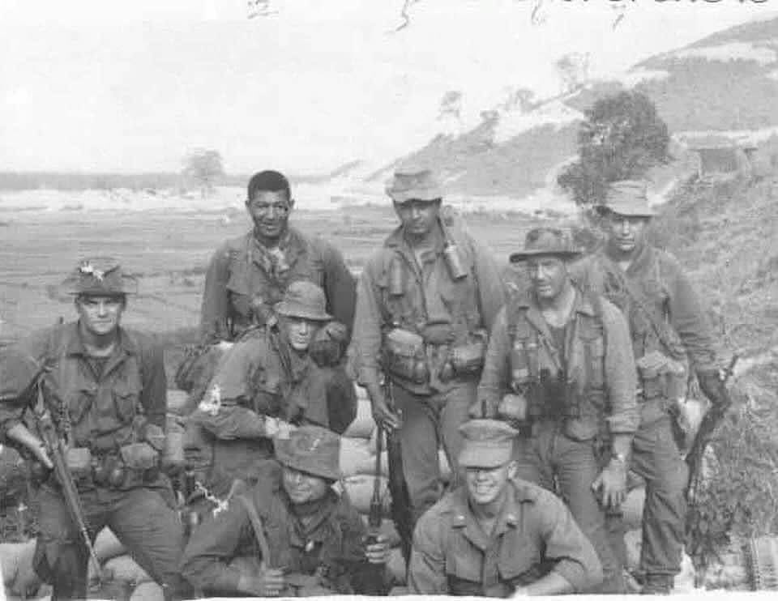
Today we remember our teammate Captain Eric Barnes (front right) who was Killed In Action leading 1st Force Reconnaissance Co. Team COUNTERSIGN on March 25th 1967.
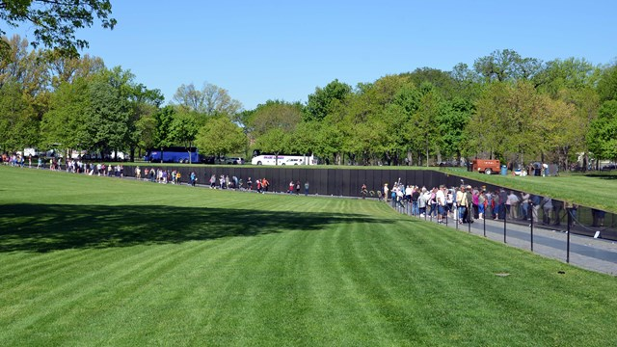Honoring the men and women who served in the controversial Vietnam War, the Vietnam Veterans Memorial chronologically lists the names of 58,318 Americans who gave their lives in service to their country. https://www.nps.gov/vive/index.htm

April 10, 1967 – Sen. Robert F. Kennedy
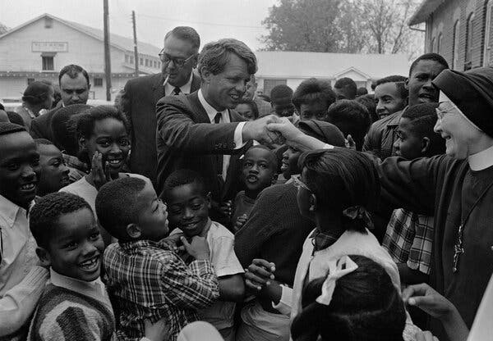
Senator Robert F. Kennedy visiting Greenville, Miss., in 1967.
“At the behest of Marian Wright, then a Mississippi civil rights attorney, Senator Robert F. Kennedy and the delegation of the U.S. Senate Subcommittee on Employment Manpower and Poverty, traveled the day after the hearings in Jackson to the Mississippi Delta where they saw firsthand the extent of the poverty and malnutrition that the poor in Mississippi endured. As civil rights attorney, Marian Wright had testified the day before: ‘the poverty program has done nothing to change the basic economic structure which needs to be changed.’” https://www.jimlucasphotography.com/civil-rights-movement-in-mississippi-1964-1968/1967-robert-f-kennedys-visit-to-the-mississippi-delta/

Oct. 8, 1967: Federal Trial KKK Murder 3 Civil Rights Activists

“Case Document: Michael Schwerner - James Chaney - Andrew Goodman.” https://www.justice.gov/crt/case-document/micheal-schwerner-james-chaney-andrew-goodman
“The trial of United States v. Price was held in Meridian in the Southern District of Mississippi, commencing on October 9, 1967. One hundred and fifty-one witnesses testified. Approximately twenty percent of the witnesses presented the government’s evidence of the crime, while the remaining eighty percent of the witnesses offered character and alibi evidence for the defendants. The jury returned its verdicts on October 20, 1967.
The 1967 federal prosecution trial team focused its evidentiary presentation on those defendants who participated in the shooting deaths of the three victims and on the top Klan leadership, Mississippi Klan leader Bowers and Philadelphia Klan leader Killen. All of the primary targeted defendants were convicted except for Killen. Accordingly, the prosecution team concentrated less on the secondary defendants, who had helped arrange, facilitate, and organize the murders and the burials, but had not actually participated in the killing. Given the available evidence and the political climate surrounding the trial, this strategy can hardly be faulted and proved largely successful.
***
As previously noted, seven defendants – Price, Roberts, H.D. Barnette, Posey, Arledge, Snowden, and Bowers – were convicted of the federal criminal civil rights conspiracy. Eight defendants – Burrage and Harris, as well as Bernard Akin, Travis Barnette, Herndon, Rainey, Tucker, and Willis – were found not guilty. Mistrials were entered by the court after the jury could not agree as to three defendants, Killen, Sharpe and “Hop” Barnette.”

Trial Transcripts In The Case - United States V. Price, Et Al. (also Known As The "Mississippi Burning" Incident) 1967.
“These trial transcripts were created as a result of the Civil Rights Division’s 1967 prosecution of individuals charged with the violation of the civil rights of James Chaney, Andrew Goodman, and Michael Schwerner in the United States v. Price, et al. (also known as the “Mississippi Burning” incident).” https://www.justice.gov/crt/trial-transcripts-caseunited-states-v-price-et-al-also-known-mississippi-burning-incident-1967?itid=lk_inline_enhanced-template

“In 1964, the Klan killed three young activists and shocked the nation.”
“With only the state able to bring murder charges — and Mississippi refusing to do so — the U.S. Justice Department put 18 men on trial for allegedly violating the civil rights of Schwerner, Chaney and Goodman. One defendant pleaded guilty. Seven, including a deputy sheriff, were convicted. None spent more than six years behind bars.” https://www.washingtonpost.com/nation/interactive/2024/mississippi-klan-killings-1964-impact-history/?utm_campaign=wp_post_most&utm_medium=email&utm_source=newsletter&wpisrc=nl_most&carta-url=https%3A%2F%2Fs2.washingtonpost.com%2Fcar-ln-tr%2F3e0b883%2F66745280065ad23d7ff1dd36%2F59731235ade4e21a848a56ed%2F8%2F53%2F66745280065ad23d7ff1dd36

Dec. 18, 1967: U.S. Supreme Court - Katz v. United States (8 to 0) https://supreme.justia.com/cases/federal/us/389/347/
FBI RECORDING DEVICE ON PHONE BOTH – BREACH EXPECTATION OF PRIVACY

“The petitioner was convicted in the District Court for the Southern District of California under an eight-count indictment charging him with transmitting wagering information by telephone from Los Angeles to Miami and Boston, in violation of a federal statute. At trial, the Government was permitted, over the petitioner's objection, to introduce evidence of the petitioner's end of telephone conversations, overheard by FBI agents who had attached an electronic listening and recording device to the outside of the public telephone booth from which he had placed his calls…. But what he sought to exclude when he entered the booth was not the intruding eye -- it was the uninvited ear. He did not shed his right to do so simply because he made his calls from a place where he might be seen.”

Jan. 30-31, 1968: Tet Offensive, Viet Nam
“By 1968 there were nearly 500,000 U.S. service personnel in the Republic of Vietnam (South Vietnam), under the overall command of Commander, U.S. Military Assistance Command, Vietnam (COMUSMACV) General William C. Westmoreland. Aided by 650,000 Army of the Republic of Vietnam (ARVN) personnel, the United States’ mission since 1965 had consisted of Rolling Thunder bombing campaigns against the Democratic Republic of Vietnam (North Vietnam), interdiction attempts along the Ho Chi Minh trail, and search and destroy missions against enemy forces throughout the South Vietnamese countryside. Optimism was high among U.S. military and planning personnel that these combined efforts were steadily degrading North Vietnam’s combat capabilities; within the near future, the U.S. intended to turn more and more of South Vietnam’s internal defense over to the ARVN.
A massive communist offensive, beginning in late January 1968, demonstrated that North Vietnam and its allies were still able to put up a fight. Throughout the evening of January 30-31, 1968, during the Vietnamese New Year holiday of Tet, more than 84,000 communist soldiers launched assaults on various U.S. and South Vietnamese military installations, cities, and hamlets. Enemy forces were a mix of North Vietnamese Army (NVA) troops and Viet Cong (VC) guerillas, with the former predominating towards the North – South Vietnamese border. Together they attacked more than 100 South Vietnamese targets, including most large cities, the capital of Saigon, and major U.S. bases.” https://dpaa-mil.sites.crmforce.mil/dpaaFamWebInTetOffensive#:~:text=In%20late%20January%201968%2C%20during,against%20the%20South%20Vietnamese%20government.

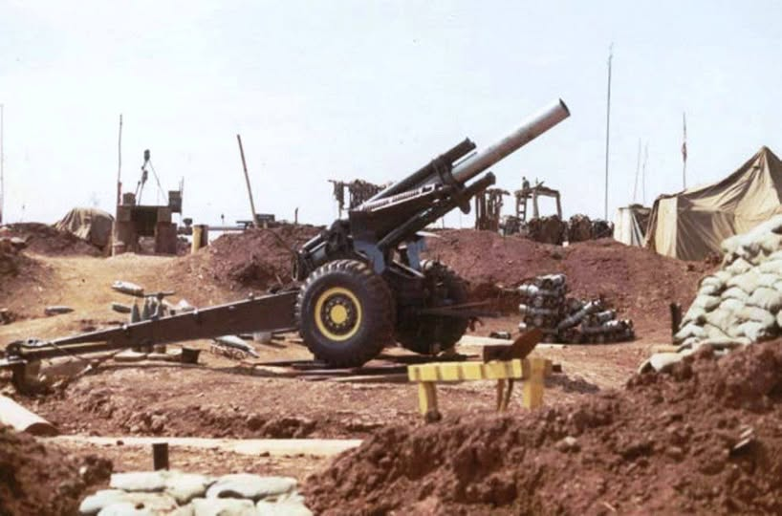
155mm Howitzer.

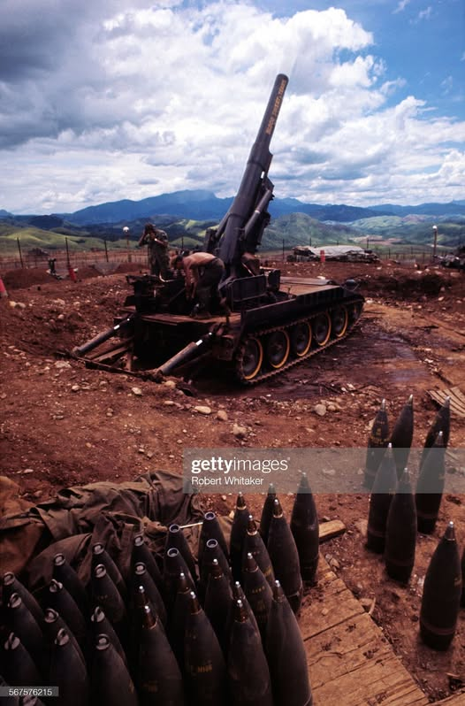

March 13, 1968 – Nerve Agent Testing
“On March 13, 1968, a military plane released a nerve agent during a covert open-air chemical test in Utah at the Army’s Dugway Proving Ground, the main weapons-testing center for America’s chemical and biological warfare. More than 6,000 sheep on nearby ranches died or had to be put down. The Army denied responsibility but its role was confirmed in a report released in 1997.” https://www.nytimes.com/2025/12/18/movies/cover-up-review-seymour-hersh.html?nl=The+Evening&segment_id=212532

March 16, 1968 – My Lai

“On March 16, 1968 the angry and frustrated men of Charlie Company, 11th Brigade, Americal Division entered the Vietnamese village of My Lai. ‘This is what you've been waiting for -- search and destroy -- and you've got it,’ said their superior officers. A short time later the killing began. When news of the atrocities surfaced, it sent shockwaves through the U.S. political establishment, the military's chain of command, and an already divided American public. Poised for Conflict. My Lai lay in the South Vietnamese district of Son My, a heavily mined area where the Vietcong were deeply entrenched. Numerous members of Charlie Company had been maimed or killed in the area during the preceding weeks. The agitated troops, under the command of Lt. William Calley, entered the village poised for engagement with their elusive enemy. Massacre As the "search and destroy" mission unfolded, it soon degenerated into the massacre of over 300 apparently unarmed civilians including women, children, and the elderly. Calley ordered his men to enter the village firing, though there had been no report of opposing fire. According to eyewitness reports offered after the event, several old men were bayoneted, praying women and children were shot in the back of the head, and at least one girl was raped and then killed. For his part, Calley was said to have rounded up a group of the villagers, ordered them into a ditch, and mowed them down in a fury of machine gun fire.” https://www.pbs.org/wgbh/americanexperience/features/vietnam-my-lai-massacre/

1968 - VIETNAM – PROTESTS
“Students, government officials, labor unions, church groups and middle class families increasingly opposed the war as it climaxed in 1968, forcing a gradual withdrawal of U.S. forces. Anti-war activities, particularly large-scale resistance to military conscription, forced an end U.S. combat operations in Vietnam and a suspension of the draft by January 1973.” https://www.nonviolent-conflict.org/us-anti-vietnam-war-movement-1964-1973/

April 4, 1968: Martin Luther King assassinated in Memphis, TN
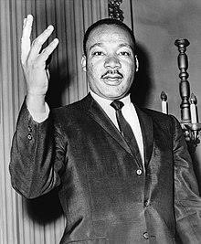

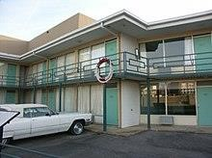
“Martin Luther King, Jr. was assassinated in Memphis, Tennessee, on April 4, 1968, an event that sent shock waves reverberating around the world. A Baptist minister and founder of the Southern Christian Leadership Conference (SCLC), King had led the civil rights movement since the mid-1950s, using a combination of impassioned speeches and nonviolent protests to fight segregation and achieve significant civil rights advances for African Americans. His assassination led to an outpouring of anger among black Americans, as well as a period of national mourning that helped speed the way for an equal housing bill that would be the last significant legislative achievement of the civil rights era.” https://www.history.com/topics/black-history/martin-luther-king-jr-assassination

James Earl Ray: pled guilty in 1969 to the assassination to avoid death penalty – died in prison after serving 29 years.
https://www.britannica.com/event/assassination-of-Martin-Luther-King-Jr
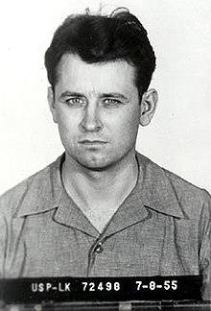

June 6, 1968: Robert F. Kennedy assassinated at Ambassador Hotel in Los Angeles: https://www.biography.com/political-figure/robert-kennedy
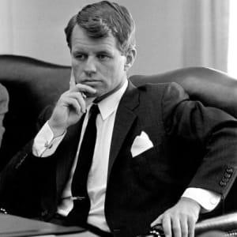

June 10, 1968: U.S. Supreme Court - Terry v. Ohio
(8 to 1) https://supreme.justia.com/cases/federal/us/392/1/
“STOP & FRISK” UPHELD
Chief Justice Earl Warren
MR. CHIEF JUSTICE WARREN delivered the opinion of the Court.

“Facts of the case
Terry and two other men were observed by a plain clothes policeman in what the officer believed to be ‘casing a job, a stick-up.’ The officer stopped and frisked the three men and found weapons on two of them. Terry was convicted of carrying a concealed weapon and sentenced to three years in jail.

Question
Was the search and seizure of Terry and the other men in violation of the Fourth Amendment?

Conclusion
In an 8-to-1 decision, the Court held that the search undertaken by the officer was reasonable under the Fourth Amendment and that the weapons seized could be introduced into evidence against Terry. Attempting to focus narrowly on the facts of this particular case, the Court found that the officer acted on more than a ‘hunch’ and that ‘a reasonably prudent man would have been warranted in believing [Terry] was armed and thus presented a threat to the officer's safety while he was investigating his suspicious behavior.’ The Court found that the searches undertaken were limited in scope and designed to protect the officer's safety incident to the investigation.

1968: PSOB – Public Safety Officers Benefits Program
“The Public Safety Officers’ Benefits (PSOB) program is authorized in statute at Part L of Title I of the Omnibus Crime Control and Safe Streets Act of 1968 (34 U.S.C. §§10281-10288).” https://fas.org/sgp/crs/misc/R45327.pdf
It is administered by the U.S. Department of Justice, Bureau of Justice Assistance. https://psob.bja.ojp.gov/PSOB_FactSheet2019.pdf
Note: On Aug. 14, 2020, President signed into law the “Safeguarding America's First Responders Act of 2020.”
“This bill extends death and disability benefits under the Public Safety Officers' Benefits Program (PSOB) to public safety officers (e.g., law enforcement officers) and survivors of public safety officers who die or become injured as a result of COVID-19 (i.e., coronavirus disease 2019). The PSOB program provides death, disability, and education benefits to public safety officers and survivors of public safety officers who are killed or injured in the line of duty.For purposes of death benefits, this bill creates a general presumption that a public safety officer who dies from COVID-19 or related complications sustained a personal injury in the line of duty. For purposes of disability benefits, the bill creates a general presumption that COVID-19 or related complications suffered by a public safety
officer constitutes a personal injury sustained in the line of duty.” https://www.congress.gov/bill/116th-congress/senate-bill/3607
July 21, 2020: House passes bill to ensure COVID-19 death, disability benefits for first responders
“Their “Safeguarding America’s First Responders Act” creates a presumption that if a first responder is diagnosed with the coronavirus within 45 days of their last day on the job, the Department of Justice will treat it as a line of duty incident and provide the payments.” https://www.firerescue1.com/legislation-
funding/articles/house-passes-bill-to-ensure-covid-19-death-disability-benefitsfor-first-responders-
deBCm2kVdUMy5ATc/?utm_source=FireRescue1+Member+Newsletter&utm_c ampaign=7d3689028a-
EMAIL_CAMPAIGN_2020_07_21_07_03&utm_medium=email&utm_term=0_ 758bdbeffe-7d3689028a-41607823

June 12, 1968: Age Discrimination in Employment Act
Mandatory retirement age may be imposed by Fire & Police Departments.
29 U.S. Code § 623. Prohibition of age discrimination: https://www.law.cornell.edu/uscode/text/29/623

(j) Employment as firefighter or law enforcement officer. It shall not be unlawful for an employer which is a State, a political subdivision of a State, an agency or instrumentality of a State or a political subdivision of a State, or an interstate agency to fail or refuse to hire or to discharge any individual because of such individual’s age if such action is taken—
(1) with respect to the employment of an individual as a firefighter or as a law enforcement officer, the employer has complied with section 3(d)(2) of the Age Discrimination in Employment Amendments of 1996 ² if the individual was discharged after the date described in such section, and the individual has attained—
(A)
the age of hiring or retirement, respectively, in effect under applicable State or local law on March 3, 1983; or
(B)
(i)
if the individual was not hired, the age of hiring in effect on the date of such failure or refusal to hire under applicable State or local law enacted after September 30, 1996; or
(ii) if applicable State or local law was enacted after September 30, 1996, and the individual was discharged, the higher of—
(I)
the age of retirement in effect on the date of such discharge under such law; and
(II)
age 55; and
(2)
pursuant to a bona fide hiring or retirement plan that is not a subterfuge to evade the purposes of this chapter.

June 31, 1968: U.S. Supreme Court - Pickering v. Board of Ed. (8 to 1) https://law.justia.com/cases/illinois/supreme-court/1967/40038-5.html
LIMITED FREE SPEECH RIGHTS OF PUBLIC EMPLOYEES – “BALANCING TEST”
Justice Thurgood Marshall: https://www.oyez.org/justices/thurgood_marshall
MR. JUSTICE MARSHALL delivered the opinion of the Court.

“Facts of the case
Marvin Pickering, a school teacher, wrote a letter to the editor at the Lockport Herald complaining about a recently defeated school board proposal to increase school taxes. The letter complained about the board’s handling of past proposals and allocation of funds favoring athletics over academics. The school board felt the letter was ‘detrimental to the efficient operation and administration of the schools’ and opted to terminate Pickering’s employment. Pickering sued in the Circuit Court of Will County alleging his letter was speech protected under the First Amendment. The court ruled in favor of the school board and the Supreme Court of Illinois affirmed.
Question
Was Pickering’s letter constitutionally protected free speech?

Conclusion
Yes. Justice Thurgood Marshall wrote the 8-1 majority opinion holding that Pickering’s dismissal violated his First Amendment right to free speech. The Supreme Court noted that similar speech is not protected if it contains false statements knowingly or recklessly made. There was no evidence that Pickering’s statements were knowingly false or reckless.
Justice William O. Douglas concurred, but took an even broader view of protected free speech. Justice Hugo L. Black joined in the concurrence. Justice Byron R. White wrote a dissent, agreeing that the letter may be protected speech, but preferring to remand the case for further proceedings to decide whether the statements in the letter were knowingly or recklessly false.” https://www.oyez.org/cases/1967/510

May 14, 2024: “Attorney General Merrick B. Garland Delivers Remarks Celebrating 70th Anniversary of Brown v. Board Decision.” https://www.justice.gov/opa/speech/attorney-general-merrick-b-garland-delivers-remarks-celebrating-70th-anniversary-brown-v
“Seventy years ago this Friday, on May 17, 1954, the United States Supreme Court unanimously concluded “that, in the field of public education, the doctrine of ‘separate, but equal’ has no place.”

On that day, the Court ruled in favor of the more than 200 people from across the country who had joined as plaintiffs in Brown v. Board of Education.
Those plaintiffs included parents like Mrs. Lena Carper, who believed her 10-year-old daughter deserved better than to have to walk and wait in the wind, rain, snow, and mud to catch the bus that would take her to the school designated for Black children. And they included students like 16-year-old Barbara Johns, who led hundreds of fellow students in a strike to protest the terrible conditions at her segregated school. Barbara received deaths threats, her family home was burned to the ground, and a cross was burned on the grounds of her high school by white supremacists. For those students, and for our country, the decision in Brown represented a promise. A promise that this would be a nation where students of all races and backgrounds could learn together in the same classrooms and the same schools. And a promise that our schools would not only teach students about the principle that underlies our democracy — that we are all equal under the law — but that they would embody it.

But in the wake of the Court’s decision, it became clear that the words of the Justices would not be sufficient to ensure the integration of our nation’s schools.
As members of Congress urged states to ‘resist forced integration by any lawful means,’ and governors barred schoolhouse doors, the task primarily fell to Black children — some no more than five or six years old, whose only wish was to go to school. Among those students were three six-year-old girls — who, together Ruby Bridges, would later become part of a group known as the New Orleans Four. In November of 196[0], three members of the New Orleans Four integrated the previously all-white McDonogh 19 Elementary School in New Orleans. Each day, U.S. Marshals escorted them to school. On their way, they had to face down the mobs of white residents who lined the streets to heckle, threaten, and harass them.
On the girls’ very first day of school, parents of their white classmates removed their children from the school, rather than have them sit in the same classrooms with their Black peers.”

Aug. 26-29, 1968: Democratic National Convention - Chicago
“Over 650 protesters were arrested during the convention. The total number of injured protesters is unknown but over 100 were treated at area hospitals. It was reported that 192 police officers were injured and 49 required medical treatment.” https://www.history.com/topics/1960s/1968-democratic-convention
_____________________________________________________________________________
“Using media cover, military counterintelligence special agents infiltrated the 1968 Democratic National Convention in Chicago. There was no legitimate Defense investigative purpose for this action. Information collected by Defense elements was routinely transferred to civilian law enforcement authorities without evidence of criminal activity or relevance to the law enforcement missions of the receiving authorities. This activity was improper.” https://dodsioo.defense.gov/About-DOD-SIOO/

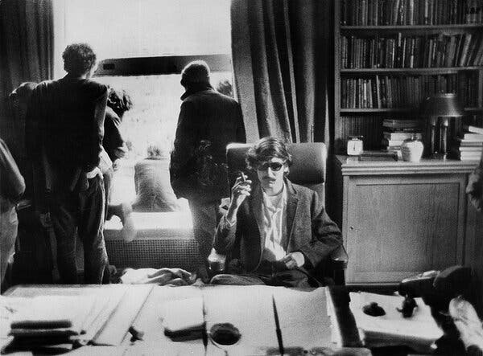
“Mr. [David] Shapiro first tasted fame, albeit unwittingly, when he was photographed in the office of Columbia University’s president during the student uprising of 1968. https://www.nytimes.com/2024/05/10/books/david-shapiro-dead.html?te=1&nl=the-morning&emc=edit_nn_20240511

Oct. 22, 1968: Gun Control Act effective
”Gun Control Act of 1968
This Legislation regulated interstate and foreign commerce in firearms, including importation, "prohibited persons", and licensing provisions. Assassinations and Gun Control
After the assassinations of President John Kennedy, Attorney General Robert Kennedy and Dr. Martin Luther King, Jr., the Gun Control Act is passed and imposes stricter licensing and regulation on the firearms industry, establishes new categories of firearms offenses, and prohibits the sale of firearms and ammunition to felons and certain other prohibited persons. It also imposes the first Federal jurisdiction over "destructive devices," including bombs, mines, grenades and other similar devices. Congress reorganizes ATU into the Alcohol and Tobacco Tax Division (ATTD) and delegates to them the enforcement of the Gun Control Act.” https://www.atf.gov/rules-and-regulations/laws-alcohol-tobacco-firearms-and-explosives/gun-control-act

March 27, 2024:
‘Ghost Guns’: What They Are and Why There Has Been a Fight Over Them. A rule regulating the firearm kits was a centerpiece of President Joseph R. Biden Jr.’s gun control initiative. The Supreme Court has upheld the regulation, issued in 2022. The Supreme Court on Wednesday [March 26, 2024] upheld federal restrictions the Biden administration placed on “ghost guns,” drawing a spotlight to the kits that can be assembled into home.” https://www.nytimes.com/2025/03/26/us/politics/what-are-ghost-guns.html
U.S. Supreme Court opinion: https://www.supremecourt.gov/opinions/24pdf/23-852_c07d.pdf

Jan. 20, 1969: President Richard Nixon – First Inauguration

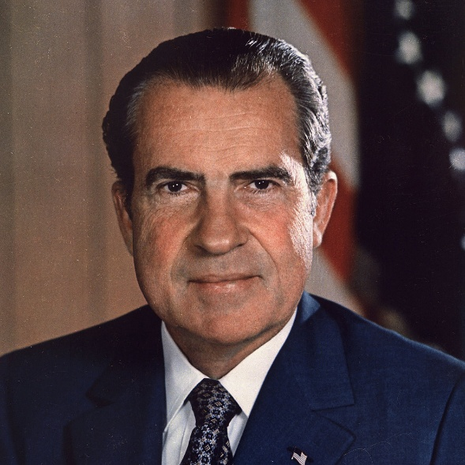
https://bidenwhitehouse.archives.gov/about-the-white-house/presidents/richard-m-nixon/

May 1, 1969 – Fred Rogers testifies before Congress to save PBS budget
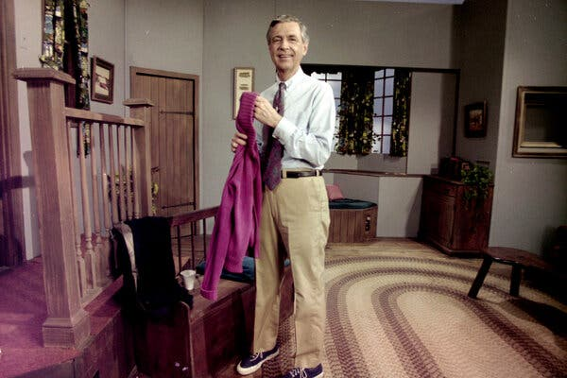Fred Rogers, the star of “Mister Rogers’ Neighborhood” testified before Congress in 1969 to protest proposed cuts to public media. https://www.nytimes.com/2025/03/26/business/media/pbs-npr-congress-funding.html

February 24, 1969: U.S. Supreme Court - Tinker v. Des Moines
“Issue: Does the First Amendment prohibit public school officials from barring students' from wearing black armbands to symbolize anti-war political protest?
Result: According to the Court, yes. The Supreme Court held that students do not ‘shed their constitutional rights to freedom of speech…at the schoolhouse gate.’ Consequently, the Court found that the students' speech could only be prohibited if it actually disrupted the educational process. Because there was no evidence of such a disruption, the school was in violation of the First Amendment freedom of speech.
Importance: Tinker has become the central case for any challenges to school-based First Amendment rights.” https://www.americanbar.org/groups/public_education/programs/constitution_day/landmark-cases/

June 28, 1969 – NYPD Raid On Gay Bar
“Stonewall riots, series of violent confrontations that began in the early hours of June 28, 1969, between police and gay rights activists outside the Stonewall Inn, a gay bar in the Greenwich Village section of New York City. As the riots progressed, an international gay rights movement was born. *** In 1969 the solicitation of homosexual relations was an illegal act in New York City (and indeed virtually all other urban centres). Gay bars were places of refuge where gay men and lesbians and other individuals who were considered sexually suspect could socialize in relative safety from public harassment. Many of those bars were, however, subject to regular police harassment. The riots outside the Stonewall Inn waxed and waned for the next five days. Many historians characterized the uprising as a spontaneous protest against the perpetual police harassment and social discrimination suffered by a variety of sexual minorities in the 1960s. Although there had been other protests by gay groups, the Stonewall incident was perhaps the first time lesbians, gays, and transgender people saw the value in uniting behind a common cause. Occurring as it did in the context of the civil rights and feminist movements, the Stonewall riots became a galvanizing force.” https://www.britannica.com/event/Stonewall-riots
June 28, 2024: National Park Service - Stonewall National Monument Visitor Center in NYC. https://stonewallvisitorcenter.org/

May 4, 1970 – Kent State University – 4 Students Killed By Ohio National Guard
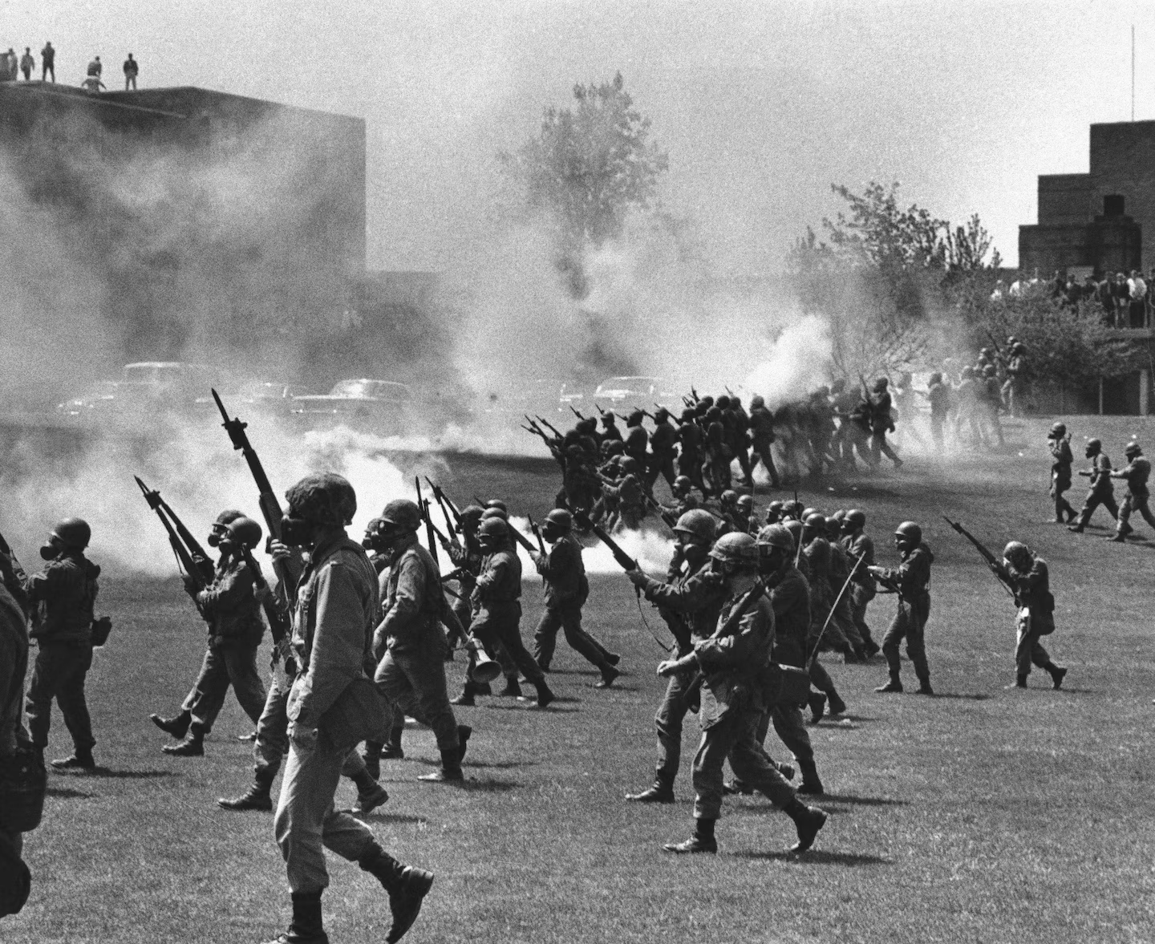
“The commander of National Guard forces on the scene, Assistant Adjutant General Robert Canterbury, decided to disperse the protesters. As Kane and others had feared, the presence of armed troops inflamed the students; what had been planned as a protest against the war became a protest of a different sort. ‘It wasn’t an antiwar rally,’ said a student. ‘It was now a National Guard get-the-hell-off our campus rally.’ *** The reckless Canterbury also failed to warn protesters — as required by Ohio National Guard regulations for crowd control — that his men were armed with loaded rifles containing high-velocity bullets that could kill at a range of 1,000 yards and at 200 yards could pierce a steel helmet and pass straight through a human head. Unaware of the risk, students advanced toward the nervous Guardsmen, and at 12:24 p.m., several of the troops opened fire. Four Kent State students were killed, and nine were wounded, one of them paralyzed for life.” https://www.washingtonpost.com/opinions/2024/04/26/kent-state-killings-lesson-protests/?utm_campaign=wp_todays_headlines&utm_medium=email&utm_source=newsletter&wpisrc=nl_headlines&carta-url=https%3A%2F%2Fs2.washingtonpost.com%2Fcar-ln-tr%2F3d879cb%2F662cccb6a460347163ea193e%2F59731235ade4e21a848a56ed%2F30%2F67%2F662cccb6a460347163ea193e

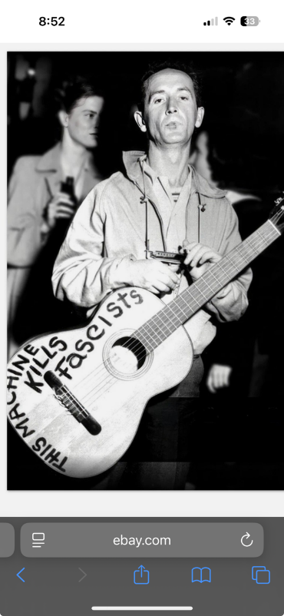
Woody Guthrie – protest songs

April 21,1971: OSHA Effective Date
“The Occupational Safety and Health Administration was established in 1971. Since then, OSHA and our state partners, coupled with the efforts of employers, safety and health professionals, unions and advocates, have had a dramatic effect on workplace safety. Fatality and injury rates have dropped markedly. Although accurate statistics were not kept at the time, it is estimated that in 1970 around 14,000 workers were killed on the job. That number fell to approximately 4,340 in 2009. At the same time, U.S.
employment has almost doubled and now includes over 130 million workers at more than 7.2 million worksites. Since the passage of the OSH Act, the rate of reported serious workplace injuries and illnesses has declined from 11 per 100 workers in 1972 to 3.6 per 100 workers in 2009. OSHA safety and health standards, including those for trenching, machine guarding, asbestos, benzene, lead, and bloodborne pathogens have prevented countless work-related injuries, illnesses and deaths. This timeline highlights key milestones in occupational safety and health history since the creation of OSHA.” https://www.osha.gov/osha40/timeline.html
Federal OSHA neither has regulations, nor jurisdiction, over State, municipal, or volunteer fire departments: https://www.osha.gov/lawsregs/standardinterpretations/2006-10-11-1
“Please be advised that Federal OSHA neither has regulations, nor jurisdiction, over State, municipal, or volunteer fire departments. Section (3)(5) of the Occupational Safety and Health Act of 1970 specifically excludes Federal OSHA's authority over employees of State and local government. The Act provides for States to assume responsibility for occupational safety and health programs under the State's own plan, which must be approved by the U.S. Department of Labor. Each State-plan must include coverage of public employees of the State, and it must be "at least as effective" as Federal OSHA's protection of private sector employees.

As you may know, the State of New York administers its own occupational safety and health program for public sector employees (Public Employee Safety & Health (PESH)) under a plan approved and monitored by Federal OSHA. States are required to have regulations that are, at least as effective as the federal standards, although they may be more stringent. Also, private sector employees in the State of New York are covered by Federal OSHA.
***
Richard E. Fairfax, Director
Directorate of Enforcement Programs
22 STATE OSHA PLANS
“State Plans are OSHA-approved workplace safety and health programs operated by individual states or U.S. territories. There are currently 22 State Plans covering both private sector and state and local government workers, and there are six State Plans covering only state and local government workers. State Plans are monitored by OSHA and must be at least as effective as OSHA in protecting workers and in preventing work-related injuries, illnesses and deaths.” https://www.osha.gov/stateplans

May 8, 1971: DC Fire Chief Jerry Wilson
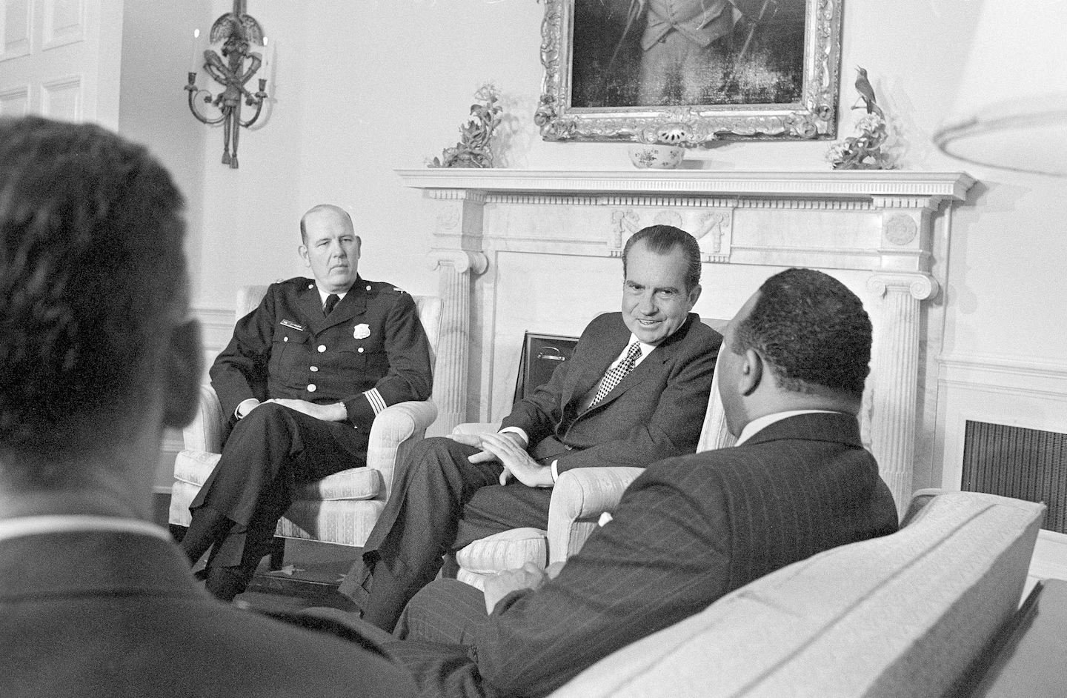 President Richard M. Nixon talks with D.C. Police Chief Jerry Wilson and Mayor Walter E. Washington in the White House on May 8, 1971. (Charles Tasnadi/AP)

“How Jerry Wilson transformed the D.C. police. This consequential police chief was one of the best managers of a government agency I ever knew.*** In April 1968, the District had gone through a three-day riot that started the day the Rev. Martin Luther King Jr. was assassinated. A few people were killed, and fires burned up entire blocks on Seventh and 14th Streets NW and H Street NE. *** Wilson had two great opportunities presented to him and took full advantage of both, to the lasting benefit of the city. I joined a department [in 1969] with about 2,600 sworn officers and an authorized strength of 3,100. But in those pre-home-rule days, two successive presidents, Lyndon B. Johnson and Richard M. Nixon, worried that they might be blamed for rising crime in Washington. And each came up with the same solution: Add 1,000 police officers to the force. Our authorized strength went from 3,100 to 5,100! *** No department in the United States was regularly putting women on patrol, but Wilson thought they ought to be able to do the work. He decided on an experiment: The city would hire 100 female officers, assign them to patrol beats and see how their work compared with that of 100 male rookies. Looking for a woman to oversee this experiment, Wilson was turned down by all the department’s top-ranking women. Women had a different status from male officers: They were all college graduates, all in the Youth Division, all in civilian clothes, none working the midnight to 8 a.m. shift. There was little enthusiasm for making women into patrol officers. Wilson worked his way from the highest-ranking woman in the department all the way down to Pvt. Mary Ellen Abrecht, another true hero of the city, who said, “I’ll do it.” *** Mrs. Abrecht, who helped manage and coordinate a pilot program of 100 female police officers on the beat in 1972 and later became a prosecutor with the U.S. attorney’s office in Washington and a Superior Court judge, died Aug. 16 at her home in Washington. She was 72, and the cause was metastatic breast cancer, said her husband, Gary L. Abrecht, a former D.C. police deputy chief who retired as chief of the U.S. Capitol Police.https://www.washingtonpost.com/local/obituaries/mary-ellen-abrecht-early-female-beat-cop-who-became-a-dc-superior-court-judge-dies-at-72/2018/08/22/0fde5920-a4c8-11e8-8fac-12e98c13528d_story.html 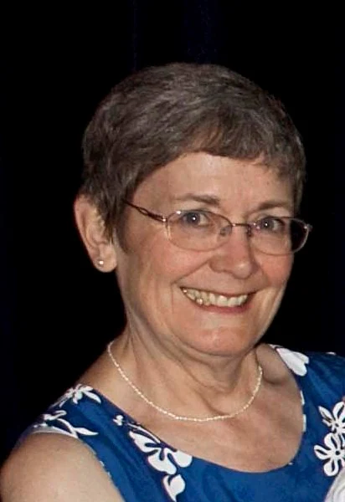
By Donald E. Graham. Donald E. Graham, former publisher of The Washington Post, was a patrolman with the Metropolitan Police Department from January 1969 to June 1970. https://www.washingtonpost.com/opinions/2025/03/24/jerry-wilson-dc-police-donald-graham/?utm_campaign=wp_todays_headlines&utm_medium=email&utm_source=newsletter&carta-url=https%3A%2F%2Fs2.washingtonpost.com%2Fcar-ln-tr%2F41c3aa9%2F67e27eaaa658864abd1a266a%2F59731235ade4e21a848a56ed%2F29%2F66%2F67e27eaaa658864abd1a266a

June 21, 1971: U.S. Supreme Court - Bivens v. Six Unknown Agents of Federal Bureau of Narcotics (6 to 3) https://supreme.justia.com/cases/federal/us/403/388/
FEDERAL AGENTS CAN BE PERSONALLY SUED FOR ILLEGAL SEARCH & SEIZURES
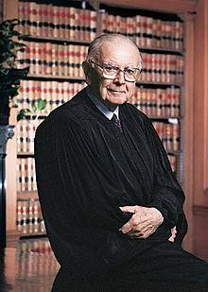
Justice William J. Brennan Jr.: https://www.oyez.org/justices/william_j_brennan_jr

“Facts of the case
In 1965, six agents of the Federal Bureau of Narcotics forced their way into Webster Bivens’ home without a warrant and searched the premises. The agents handcuffed Bivens in front of his wife and children and arrested him on narcotics charges. Later, the agents interrogated Bivens and subjected him to a visual strip search. Bivens sued the agents for $15,000 in damages each for humiliation and mental suffering. The district court dismissed the complaint for failure to state a cause of action. The U.S. Court of Appeals for the Second Circuit affirmed.

Question
- Does violation of an individual’s Fourth Amendment protection against unreasonable search and seizure give rise to a federal claim for damages?
- Does governmental privilege extend to federal agents who clearly violate constitutional rights and act outside their authority?

Conclusion
Yes, No answer. Justice William J. Brennan Jr., writing for a 6-3 majority, reversed the Second Circuit and remanded. The Supreme Court held that Bivens does have a cause of action for damages arising from the federal agents Fourth Amendment violations. Bivens must provide proof of his injuries in order to recover. The Court did not reach the privilege question because the Court of Appeals did not consider the question. Justice John M. Harlan concurred in the judgment, writing that federal courts have the power to award damages for constitutional violations.
Chief Justice Warren E. Burger dissented, arguing that the doctrine of separation of powers is better served by leaving the question to Congress. He also argued that the doctrine of suppressing evidence obtained in illegal searches is insufficient to deter law enforcement. Justice Hugo L. Black also dissented, arguing that Congress could create the cause of action Bivens stated, but has not, so the majority’s decision is an unconstitutional extension of judicial power. Justice Harry A. Blackmun dissented, supporting the idea that the question in this case is better left to Congress.” https://www.oyez.org/cases/1970/301

June 30, 1971: U.S. Supreme Court – New York Times Company v. United States (9 to 0) https://supreme.justia.com/cases/federal/us/403/713/

The First Amendment overrides the federal government’s interest in keeping certain documents, such as the Pentagon Papers, classified.

https://scholar.google.com/scholar_case?case=17571244799664973711&q=New+York+Times+v.+United+States&hl=en&as_sdt=6,36&as_vis=1

Pentagon Papers case, New York Times Co. v. United States, in which the government sought to prevent the Times and The Post from printing classified documents. “These disclosures may have a serious impact,” Justice Hugo Black wrote in rejecting that effort. “But that is no basis for sanctioning a previous restraint on the press.”

July 5, 1971: 26th Amendment – Voting Age 18
“Section. 1. The right of citizens of the United States, who are eighteen years of age or older, to vote shall not be denied or abridged by the United States or by any State on account of age.
Section. 2. The Congress shall have power to enforce this article by appropriate legislation.” https://constitution.findlaw.com/amendments.html
***
“For most of American history, people had to be 21 to vote in federal elections. That changed when 18-year-olds started being shipped abroad to fight in the Vietnam War. They protested; they staged sit-ins; they burned their draft cards. If they could die for their country, why couldn’t they vote for its leaders? So, in 1971, states ratified the 26th Amendment, which lowered the voting age to 18.” The New York Times - July 18, 2025: nytdirect@nytimes.com

July 5, 1971: 27th Amendment – Congressional Pay Limitation
“No law varying the compensation for the services of the Senators and Representatives shall take effect, until an election of Representatives shall have intervened.” https://constitution.findlaw.com/amendments.html

June 17, 1972: Watergate Burglary
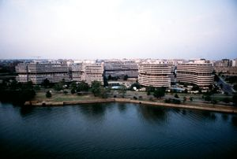
Watergate complex, Washington, D.C.

“Burglary, arrest, and limited immediate political effect. Early on June 17, 1972, police apprehended five burglars at the office of the DNC in the Watergate complex. Four of them formerly had been active in Central Intelligence Agency (CIA) activities against Fidel Castro in Cuba. (Though often referred to in the press as ‘Cubans,’ only three of the four were of Cuban heritage.) The fifth, James W. McCord, Jr., was the security chief of the Committee to Re-elect the President (later known popularly as CREEP), which was presided over by John Mitchell, Nixon’s former attorney general. The arrest was reported in the next morning’s Washington Post in an article written by Alfred E. Lewis, Carl Bernstein, and Bob Woodward, the latter two a pair of relatively undistinguished young reporters relegated to unglamorous beats—Bernstein to roving coverage of Virginia politics and Woodward, still new to the Post, to covering minor criminal activities. Soon after, Woodward and Bernstein and Federal Bureau of Investigation (FBI) investigators identified two coconspirators in the burglary: E. Howard Hunt, Jr., a former high-ranking CIA officer only recently appointed to the staff of the White House, and G. Gordon Liddy, a former FBI agent working as a counsel for CREEP. At the time of the break-in, Liddy had been overseeing a similar, though uncompleted, attempt to break into and surveil the headquarters of George S. McGovern, soon to become the Democratic nominee in the 1972 U.S. presidential election.” https://www.britannica.com/event/Watergate-Scandal

Attorney General John Mitchell:

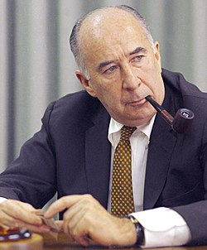

“In 1974 he was indicted on charges that he had conspired to plan the break-in and that he had obstructed justice and perjured himself during the subsequent cover-up of the affair. He was convicted in 1975 and sentenced to 2 1/2 to 8 years in prison; he entered prison in 1977 and was released on parole in 1979.” https://www.britannica.com/biography/John-Mitchell-attorney-general-of-United-States

Deputy Attorney General Richard Kleindienst

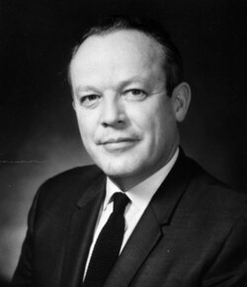

“On the morning of the burglars' court appearance, Kleindienst was playing golf near Washington, when a frantic Gordon Liddy, one of those who had helped organize the break-in, tracked him down to warn him that the burglars were in the pay of the re-election committee. He was almost certainly asked to block further FBI investigations. In the event, he rang a senior official in the US justice department to order that campaign officials should be investigated as vigorously as any other suspect.” https://www.theguardian.com/news/2000/feb/05/guardianobituaries

“In 1974, he was censured after he was convicted of giving false testimony to a U.S. Senate committee in connection with an International Telephone and Telegraph payoff scandal.”https://www.upi.com/Archives/1981/04/14/Former-Attorney-General-Richard-Kleindienst-who-resigned-from-office/9126356072400/

HERE’S OTHERS INVOLVED

G. Gordon Liddy

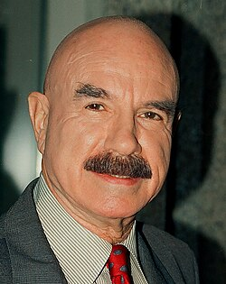

“In 1957 he joined the FBI. He quit the FBI in 1962, and three years later he became an assistant district attorney in Poughkeepsie, New York…. In 1971 Liddy and former Central Intelligence Agency (CIA) agent E. Howard Hunt, the future Watergate mastermind, led a group that broke into the Beverly Hills, California, office of the psychiatrist of military analyst Daniel Ellsberg, who had infuriated Nixon with his leak of the Pentagon Papers. They came up empty in their search for compromising information. Following the disbandment of the Plumbers, Liddy went to work for the Committee to Reelect the President (also known as CREEP), for which he organized “dirty tricks” aimed primarily at undermining the Democratic Party…. Liddy and Hunt oversaw a team that included six burglars and James W. McCord, Jr., the head of security of Nixon’s reelection campaign, which planted bugs and took photos at the DNC office on May 28, 1972. A few weeks later, on June 17, McCord and four burglars broke in again, but this time they were caught by police. Liddy and Hunt were quarterbacking the operation from a Watergate hotel room, and they too were arrested and charged with burglary, wiretapping, and conspiracy…. In March 1973 Liddy was sentenced to 20 years in prison, but he was freed in 1977 after just four years and four months when U.S. Pres. Jimmy Carter commuted his sentence. https://www.britannica.com/biography/G-Gordon-Liddy

James McCord:
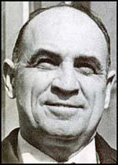
“The Watergate Burglar Who Cracked.” But after Washington police were summoned to investigate a reported burglary at the Watergate office building on that spring night in 1972, one of those arrested at the scene, and taken away in handcuffs, was James W. McCord Jr., the head of security for Nixon’s fundraising organization, the Committee for the Re-Election of the President, better known as CREEP. The Oklahoma-born McCord was 48, a veteran aviator of World War II, and a longtime CIA counterintelligence operative who had retired from the agency in 1971 to start his own security firm…. It was only in March 1973, when the burglars were threatened by District Judge John Sirica with lengthy prison terms if they didn’t tell all they knew, that McCord cracked. He wrote a letter to the court and, as Sirica said, ‘broke the case wide open.’ On March 23, 1973, Sirica read McCord’s letter aloud in court: ‘There was political pressure applied to the defendants to plead guilty and remain silent. … Perjury occurred during the trial. … Others involved in the Watergate operation were not identified.’” https://www.politico.com/news/magazine/2019/12/29/james-mccord-watergate-burglar-obituary-086480
President Trump on March 19, 2025 released many JFK assassination classified documents, including Aug. 4, 1966 CIA document. “An award recommendation for James W. McCord Jr. — a longtime, high-level CIA employee who was later convicted in the Watergate burglary says he was instrumental in developing “fluoroscopic scanning” that enabled the CIA to ‘detect hidden technical listening devices’ for the first time. Intelligence agencies spent ‘large sums of money’ to develop such a capability, the document states, adding that McCord — who died in 2017 — and others had ‘contributed significantly to the future clandestine use of this technique on a world-wide basis.’” https://www.washingtonpost.com/investigations/interactive/2025/jfk-files-assassination-documents/?utm_campaign=wp_todays_headlines&utm_medium=email&utm_source=newsletter&carta-url=https%3A%2F%2Fs2.washingtonpost.com%2Fcar-ln-tr%2F41af9f0%2F67dbe72b97fc0f25850ac3d2%2F59731235ade4e21a848a56ed%2F17%2F64%2F67dbe72b97fc0f25850ac3d2

Jan. 20, 1973: President Nixon – Second Inauguration
“As America's longest and most difficult war comes to an end, let us again learn to debate our differences with civility and decency. And let each of us reach out for that one precious quality government cannot provide--a new level of respect for the rights and feelings of one another, a new level of respect for the individual human dignity which is the cherished birthright of every American.” https://avalon.law.yale.edu/20th_century/nixon2.asp

1973: Watergate Committee

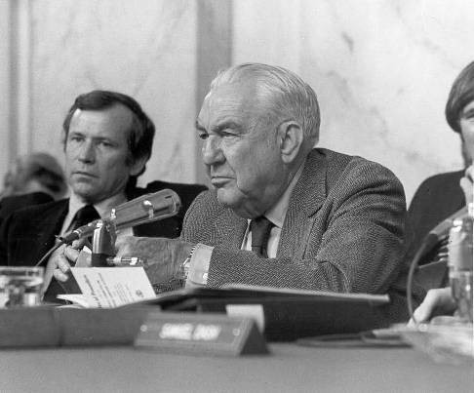
Senator Sam Ervin (NC) – Chair of Watergate Committee:
“The House Judiciary Committee used information uncovered by the Senate Watergate Committee to draft articles of impeachment against President Richard Nixon, who resigned on August 9, 1974. Ervin retired from the Senate in December 1974, returning to his hometown of Morganton, North Carolina.” https://www.senate.gov/senators/FeaturedBios/Featured_Bio_ErvinSam.htm
***
“In 1973, he Senate Watergate Committee investigation revealed that the executive branch had directed national intelligence agencies to carry out constitutionally questionable domestic security operations. In 1974 Pulitzer Prize–winning journalist Seymour Hersh published a front-page New York Times article claiming that the CIA had been spying on anti-war activists for more than a decade, violating the agency’s charter. Former CIA officials and some lawmakers, including Senators William Proxmire and Stuart Symington, called for a congressional inquiry.

***
The Senator Frank] Church Committee investigated and identified a wide range of intelligence abuses by federal agencies, including the CIA, FBI, Internal Revenue Service, and National Security Agency. In the course of their work, investigators identified programs that had never before been known to the American public, including NSA’s Projects SHAMROCK and MINARET, programs which monitored wire communications to and from the United States and shared some of that data with other intelligence agencies. Committee staff researched the FBI’s long-running program of ‘covert action designed to disrupt and discredit the activities of groups and individuals deemed a threat to the social order,’ known as COINTELPRO. The FBI included among the program’s many targets organizations such as the Southern Christian Leadership Conference, the anti-Vietnam War movement, and individuals such as Martin Luther King, Jr., as well as local, state, and federal elected officials.
***
In 1976 the Senate approved Senate Resolution 400, establishing the Senate Select Committee on Intelligence, to provide ‘vigilant legislative oversight over the intelligence activities of the United States to assure that such activities are in conformity with the Constitution and laws of the United States.’ In 1978 Congress approved and President Jimmy Carter signed into law the Foreign Intelligence Surveillance Act (FISA), requiring the executive branch to request warrants for wiretapping and surveillance purposes from a newly formed FISA Court.” https://www.senate.gov/about/powersprocedures/investigations/church-committee.htm

January 22, 1973: U.S. Supreme Court - Roe v. Wade
“Issue: Does the Constitution prohibit laws that severely restrict or deny a woman's access to abortion?
Result: Yes. The Court concluded that such laws violate the Constitution's right to privacy. The Court held that, under the Fourteenth Amendment Due Process Clause, states may only restrict abortions toward the end of a pregnancy, in order to protect the life of the woman or the fetus.
Importance: Roe has become a center-piece in the battle over abortion-rights, both in the public and in front of the Court.” https://www.americanbar.org/groups/public_education/programs/constitution_day/landmark-cases/

May 14, 1973: McDonnell Douglas Corp. v. Green (9 to 0) https://supreme.justia.com/cases/federal/us/411/792/
DISCRIMINATION – THREE-STEPS (1) PLANTIFF PRIMA FACIE CASE; (2) EMPLOYER SHOWS REASON FOR ACTION; (3) PLAINTIFF MUST SHOW “PRETEXT”
“Petitioner, McDonnell Douglas Cop., is an aerospace and aircraft manufacturer headquartered in St. Louis, Missouri, where it employs over 30,000 people. Respondent, a black citizen of St. Louis, worked for petitioner as a mechanic and laboratory technician from 1956 until August 28, 1964, when he was laid off in the course of a general reduction in petitioner's workforce. Respondent, a long-time activist in the civil rights movement, protested vigorously that his discharge and the general hiring practices of petitioner were racially motivated. As part of this protest, respondent and other members of the Congress on Racial Equality illegally stalled their cars on the main roads leading to petitioner's plant for the purpose of blocking access to it at the time of the morning shift change.”
[Note: U.S. District Court dismissed his lawsuit; 8th Cir. reversed; U.S. Supreme Court remanded case for a bench trial – following the three-step process. First the plaintiff ‘must carry the initial burden’ of ‘establishing a prima facie case of racial discrimination.’… A plaintiff can make this showing with evidence that (1) ‘he belongs to a racial minority,’ (2) ‘he applied and was qualified for a job for which the employer was seeking applicants,’ (3) ‘despite his qualifications, he was rejected,’ and (4) ‘after his rejection, the position remained open and the employer continued to seek applicants from persons of complainant's qualifications.’ If the plaintiff succeeds in establishing a prima facie case, the burden then shifts to the defendant ‘to articulate some legitimate, nondiscriminatory reason for the employee's rejection.’ If the defendant carries that burden, then the plaintiff must have an ‘opportunity to show that [the employer's] stated reason for [rejecting him] was in fact pretext.’”]

March 10, 2025: Two U.S. Supreme Court Justices - Decision Caused Confusion
“JUSTICE THOMAS, with whom JUSTICE GORSUCH joins, dissenting from the denial of certiorari. To prevail on a Title VII disparate-treatment claim, a plaintiff must prove that the defendant intentionally discriminated against him because of a protected trait…. This case squarely presents the question whether McDonnell Douglas should be overruled. Given the widespread confusion caused by McDonnell Douglas, and given the frequency with which courts encounter Title VII cases, it behooves us to revisit McDonnell Douglas and offer clear guidance on how to determine whether a Title VII claim survives summary judgment.” https://www.supremecourt.gov/opinions/24pdf/24-427_l5gm.pdf

FALL 1973: FBI “COINTELPRO” Disclosed – Surveillance Of Martin Luther King, Others
“In Fall, 1973 the Department of Justice disclosed certain documents relating to a ‘counterintelligence’ program of the Federal Bureau of Investigation entitled ‘COINTELPRO New Left.’ Among the documents disclosed was a directive indicating that the FBI had also instituted six other counter intelligence programs ("COINTELPRO"), to wit: Espionage; White Hate Groups; Communist Party, USA; Special Operations; Black Extremists and the Socialist Workers Party. Based on these disclosures, additional requests have been made for numerous other documents relating to these FBI COINTELPRO activities. This paper is in response to those requests. In January, 1974 Attorney General William Saxbe requested Assistant Attorney General Henry Petersen to form a committee to review these FBI COINTELPRO activities.” https://www.fordlibrarymuseum.gov/sites/default/files/pdf_documents/library/document/0204/1511708.pdf

“Did the FBI bug the Rev. Martin Luther King’s hotel rooms? Yes. Did it record intimate moments within? Yes. Did it threaten him and try to slime him in the media? Yes.
***
Under Cointelpro, the FBI:
- Sent anonymous fictitious materials to targeted groups, designed to “create dissention and cause disruption.”
- Leaked informant-based or investigative materials to friendly media sources for the purpose of exposing the nature, aims and membership of those groups.
- Deployed informants to disrupt such groups’ activities by sowing dissension and exploiting disputes.
- Informed employers, prospective employers, credit bureaus and creditors of targeted people’s “illegal, immoral, radical and Communist Party activities,” aiming to damage their financial or employment status.
- Told people that the FBI was “aware” of their activity, with the goal of developing them as informants.
- Attempted to persuade religious and civic leaders to exert pressure on state and local governments, employers and landlords to the “detriment” of the targeted groups.
- Sent anonymous letters, including one to a political candidate alerting him that a targeted group’s members were active in his campaign and warning him not to be a “tool,” and another to a school board official, “purporting to be from a concerned parent,” pointing out that some candidates for the school board were members of a certain group.
- Furnished background on a candidate for public office, including arrests and questionable marital status, to news media contacts; furnished information concerning arrests of an individual to a court that had earlier given him a suspended sentence and furnished this same information to his employer, which later fired him.
- Made “an anonymous telephone call to a defense attorney, after a federal prosecution had resulted in a mistrial, advising him (apparently falsely) that one of the defendants and another well-known group individual were FBI informants.”
- Put out disinformation over “citizens band” radio, using the same frequency as demonstrators.
- Obtained tax returns of suspect group members, reproduced a group leader’s signature stamp and investigated a group leader’s love life.
https://www.washingtonpost.com/opinions/2024/12/20/patel-hoover-cointelpro-fbi/?utm_campaign=wp_todays_headlines&utm_medium=email&utm_source=newsletter&carta-url=https%3A%2F%2Fs2.washingtonpost.com%2Fcar-ln-tr%2F400c34a%2F67669fb3bd400b4064d76741%2F59731235ade4e21a848a56ed%2F27%2F60%2F67669fb3bd400b4064d76741

Nov. 7, 1973 – WAR POWERS RESOLUTION / CONSULTATION
50 U.S. Code § 1542 - Consultation; initial and regular consultations
The President in every possible instance shall consult with Congress before introducing United States Armed Forces into hostilities or into situations where imminent involvement in hostilities is clearly indicated by the circumstances, and after every such introduction shall consult regularly with the Congress until United States Armed Forces are no longer engaged in hostilities or have been removed from such situations. (Pub. L. 93–148, § 3, Nov. 7, 1973, 87 Stat. 555.) https://www.law.cornell.edu/uscode/text/50/1542
Jan. 9, 2026:
“President Trump and Vice President Vance declared this week that all presidents have considered the War Powers Resolution to be unconstitutional. The comments were in response to a Senate vote to take up a measure that would limit further military action in and against Venezuela…. What is the War Powers Resolution? It is a set of statutes Congress enacted in 1974 — and tweaked in 1983 — in an effort to reclaim its constitutionally intended role of deciding whether the United States would go to war. That role had eroded during the Cold War as presidents used the standing armies left in place after World War II to unilaterally dispatch troops into combat…. The 1974 legislation said Congress could terminate a military operation through a concurrent resolution — one the president does not sign or veto. But in 1983, the Supreme Court ruled that, for a resolution to have legal effect, it must be presented to the president for signature or veto, just like a bill. Later that year, Congress enacted legislation, which President Ronald Reagan signed without complaint, saying that it could terminate hostilities using a joint resolution — the kind presidents can veto.” https://www.nytimes.com/2026/01/09/us/politics/trump-war-powers-resolution.html?algo=combo_lda_unique_triton_clicks_decay_96_50_ranks&fellback=false&imp_id=6506414311456368&nl=On+Politics&pool=programmingnode%2F0dc6538b-a831-51be-a980-5597993fb6e2&req_id=6646913288529833&segment_id=213475&surface=more-politics-news&variant=0_only_variant

Jan. 20, 1974: President Gerald Ford – Inauguration

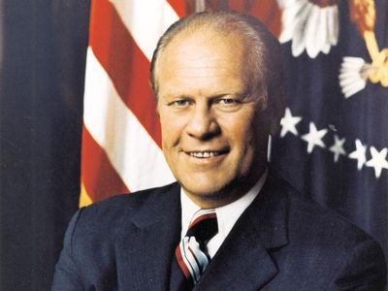
https://www.britannica.com/biography/Gerald-Ford

1974: National Fire Academy Opens
“The National Fire Academy opened in 1974 as part of the National Fire Prevention and Control Administration, now known as the U.S. Fire Administration, which is the lead federal agency for fire data and training, particularly for state, local and tribal fire departments.” https://www.washingtonpost.com/nation/2025/03/09/national-fire-academy-fema-casses-canceled-trump/?utm_campaign=wp_todays_headlines&utm_medium=email&utm_source=newsletter&carta-url=https%3A%2F%2Fs2.washingtonpost.com%2Fcar-ln-tr%2F41839f4%2F67ceb82b12829321d7739d9a%2F59731235ade4e21a848a56ed%2F40%2F65%2F67ceb82b12829321d7739d9a

1974: FLSA Amended – for first time it applies to states and local communities (7k exemption – firefighters & police)
“In 1974 the FLSA was amended to apply to state and local governments for the first time. At that time, Congress enacted the 207k exemption (usually referred to as 7k exemption) to allow firefighters (who commonly worked an average of 48-56 hours a week) and police officers (many of whom worked 45-48 hour schedules) to continue working those hours with minimal impact to taxpayers. In addition, to address the inherent variation in weekly hours that firefighters and police officers had due to their rotating schedules, the 7k exemption extended the 7 day work week applicable to everyone else, to a work period that could be between 7 and 28 days long.” http://www.firelawblog.com/2018/05/31/origins-of-the-7k-firefighter-overtimeexemption/

July 24, 1974: U.S. Supreme Court - United States v. Nixon (9 to 0) https://supreme.justia.com/cases/federal/us/418/683/

SUBPOENA OF PRESIDENT FOR AUDIO TAPES ENFORCEABLE

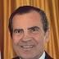

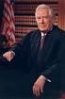Justice Warren E. Burger
MR. CHIEF JUSTICE BURGER delivered the opinion of the Court.

“Facts of the case
A grand jury returned indictments against seven of President Richard Nixon's closest aides in the Watergate affair. The special prosecutor appointed by Nixon and the defendants sought audio tapes of conversations recorded by Nixon in the Oval Office.
Nixon asserted that he was immune from the subpoena claiming ‘executive privilege,’ which is the right to withhold information from other government branches to preserve confidential communications within the executive branch or to secure the national interest. Decided together with Nixon v. United States.

Question
Is the President's right to safeguard certain information, using his ‘executive privilege’ confidentiality power, entirely immune from judicial review?

Conclusion
No. The Court held that neither the doctrine of separation of powers, nor the generalized need for confidentiality of high-level communications, without more, can sustain an absolute, unqualified, presidential privilege. The Court granted that there was a limited executive privilege in areas of military or diplomatic affairs, but gave preference to ‘the fundamental demands of due process of law in the fair administration of justice.’ Therefore, the president must obey the subpoena and produce the tapes and documents. Nixon resigned shortly after the release of the tapes.” https://www.oyez.org/cases/1973/73-1766

Aug. 9, 1974: Nixon Resigns
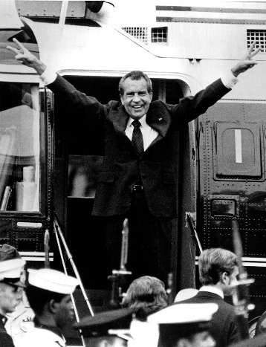
In this Aug. 9, 1974 photo, Richard Nixon waves goodbye as he boards a helicopter after resigning the presidency earlier that day.

Feb. 19, 1975: U.S. Supreme Court - NLRB v. J. Weingarten, Inc. (7 to 2)
https://supreme.justia.com/cases/federal/us/420/251/
RIGHT TO UNION REP. DURING INVESTIGATION INTERVIEW

June 26, 1975: Two FBI Agents Killed – Pine Ridge Indian Reservation
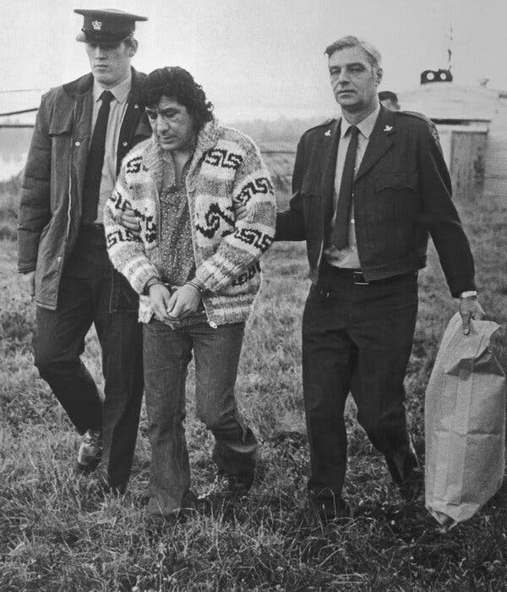
[Note: Jan. 20, 2025 – President Joe Biden: “I am also commuting the life sentence imposed on Leonard Peltier so that he serves the remainder of his sentence in home confinement.” https://bidenwhitehouse.archives.gov/briefing-room/statements-releases/2025/01/20/statement-from-president-joe-biden-16/ ]
“On June 26, 1975, FBI Agents Jack Coler and Ronald Williams were murdered by Leonard Peltier at Pine Ridge Indian Reservation in South Dakota. In 1977, Peltier was found guilty of first-degree murder and sentenced to two consecutive life terms in prison. He has since made numerous appeals for parole or a commutation of his sentence.
Quick Facts
- Unknown to Agents Williams and Coler, Leonard Peltier was present on Pine Ridge. Peltier had an outstanding warrant for his arrest, which had been issued in the Eastern District of Wisconsin, for Unlawful Flight to Avoid Prosecution (UFAP) - Attempted Murder (of an off-duty police officer). Peltier and his supporters allege they had traveled to Pine Ridge from Farmington, New Mexico, with a contingent of American Indian Movement (AIM) members.
- At approximately 11:50 a.m. on June 26, 1975, Agent Williams indicated over his car radio that he had spotted a red and white vehicle. (Agent personnel who overheard the radio transmission have differing opinions of the vehicle description, but it was clearly established that there was only one operable vehicle in the area.) One of the occupants of the red and white vehicle was later determined to be an individual who had been interviewed by Agent Williams and another agent in Williams’ FBI vehicle the previous day.
- Soon after Williams’ initial transmission, he radioed information that the subject vehicle had stopped and that he and Coler had come under fire. Williams began transmitting directions to Agent Gary Adams, who was approximately 12 miles away. Adams could not reach the vicinity of Williams and Coler due to gunfire directed at him as he approached.
  - Contrary to some media reports that gunfire lasted four hours, trial testimony described the gunfight directed at Williams and Coler as lasting approximately 10 minutes. During this ordeal, a combined total of five rounds had been fired from both Williams’ and Coler’s weapons. The agents’ vehicles alone had 125 bullet holes. This total does not take into account those rounds that hit the agents, glass, or were not recovered.
- At approximately 4:25 p.m., agents discovered the bodies of Williams and Coler lying beside Agent Coler’s vehicle. Agent Williams received bullet wounds to his left arm and side, foot, right hand, and head. Agent Coler received bullet wounds to the arm and head.
- An examination of the physical evidence concluded that Agents Williams and Coler had been killed at close range by a .223 type bullet. According to witnesses, Peltier was identified as the only person in possession of a weapon that would fire a .223 type bullet at the time of the murders. The weapon was an AR-15 rifle.
Peltier’s AR-15, Agent Coler’s .308 rifle, and an arsenal of other weapons were recovered from associates of Peltier on September 10, 1975, when a car exploded on the Kansas Turnpike near Wichita, Kansas. An examination by the FBI Laboratory made a positive match with a .223 shell casing found in the trunk of Agent Coler’s car and marks produced by the extractor of Peltier’s AR-15. No match could be made with the firing pin, because it was too smooth.
  - On September 11, 1986, Federal Appeals Judge Gerald R. Heaney concluded, “When all is said and done, however, a few simple but very important facts remain. The casing introduced into evidence had in fact been extracted from the Wichita AR-15.”
- Peltier was captured in February 1976 by the Royal Canadian Mounted Police (RCMP) and was in possession of several loaded weapons. Upon arrest, he advised the RCMP that two FBI agents were shot when they came to a house to serve a warrant on him.
- On April 18, 1977, Leonard Peltier was found guilty of the first-degree murders of Williams and Coler. On June 1, 1977, Chief U.S. District Judge Paul Benson sentenced Peltier to two consecutive life terms. During an interview on the television show ‘60 Minutes’ that aired on September 22, 1991, Peltier admitted firing at Agents Williams and Coler.” https://www.fbi.gov/history/famous-cases/resmurs-case-reservation-murders

Note: Feb. 18, 2025. Native American Activist Leonard Peltier Released From Prison
“Mr. Peltier was convicted in the killing of two F.B.I. agents. An order from former President Joseph R. Biden Jr. will allow him to serve his remaining time under home confinement. Leonard Peltier, a Native American rights activist held for nearly half a century for the killing of two F.B.I. agents, was released from a federal prison in Central Florida on Tuesday morning. Mr. Peltier, 80, will serve the remainder of his two life sentences in home confinement in North Dakota, where he is a member of the Turtle Mountain Band of Chippewa.” https://www.nytimes.com/2025/02/18/us/leonard-peltier-released-prison.html ]

April 5, 1975: Operation Babylift
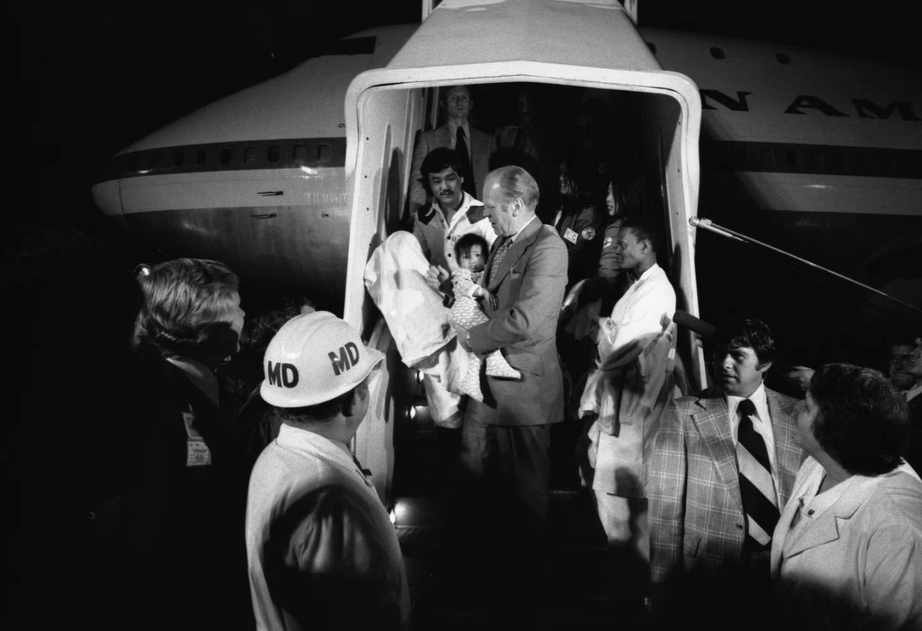

President Gerald Ford carries a Vietnamese baby from Clipper 1742, an Operation Babylift plane that transported about 325 adoptees, after it landed in San Francisco from Saigon on April 5, 1975. (Gerald R. Ford Presidential Library and Museum), https://www.washingtonpost.com/history/2025/04/27/operation-babylift-saigon-vietnam-war/?utm_campaign=wp_post_most&utm_medium=email&utm_source=newsletter&carta-url=https%3A%2F%2Fs2.washingtonpost.com%2Fcar-ln-tr%2F424d400%2F680fa548fa0b8c6760393ca2%2F59731235ade4e21a848a56ed%2F37%2F60%2F680fa548fa0b8c6760393ca2
“Fifty years ago, the American military launched "Operation Babylift" to airlift Vietnamese adoptees ahead of the fall of Saigon during the Vietnam War. But the first transport plane crashed shortly after takeoff. Among those killed was Air Force Capt. Mary T. Klinker. She is one of the few women whose name is inscribed on the Vietnam Veterans Memorial in Washington.”https://www.instagram.com/reel/DIzPN2EBDhn/?utm_source=ig_embed&ig_rid=4746481e-a585-4f1d-9a90-11d79af463fb

July 1, 1975: Watergate Convictions
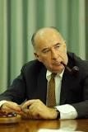John Mitchell
[Former Attorney General John N. Mitchell] “was one of four Nixon Administration officials who were convicted on Jan. 1, 1975, of all counts in the Watergate cover‐up trial. The others were H. R. Haldeman, John D. Ehrlichman and Robert C. Mardian. The three‐month trial culminated the principal investigation and prosecution of persons responsible for the biggest political scandal in the nation's history. A Federal grand jury named the then President, Richard M. Nixon, on March 1, 1974, as an unindicted coconspirator in the case.” https://www.nytimes.com/1975/07/04/archives/mitchelldisbarred-as-lawyer-in-state-mitchell-is-disbarred-in.html
Mitchell was sentenced to 2 ½ to 8 years in prison; he entered prison in 1977 and was released on parole in 1979. https://www.britannica.com/biography/John-Mitchellattorney-general-of-United-States

Sept. 5, 1975: President Gerald Ford – Assassination Attempt, Sacramento, CA
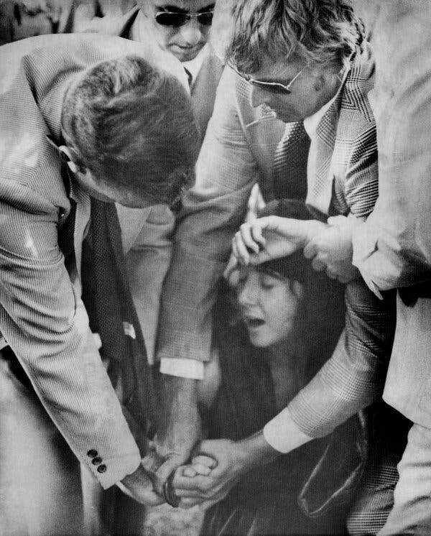
“On Sept. 5, 1975, President Ford spurned his limousine, which was idling outside the Senator Hotel in Sacramento, and, flanked by Secret Service agents, strode across the street to greet a throng of well-wishers on his way to the State Capitol to meet with Gov. Edmund G. Brown Jr. “My position was right at his shoulder,” [Secret Service Agent Larry] Buendorf recalled in 2010 in an interview [https://geraldrfordfoundation.org/centennial/oralhistory/larry-buendorf/ ] for the President Gerald R. Ford Oral History Project. “Squeaky was back in the crowd, maybe one person back, and she had an ankle holster on with a .45,” he said, referring to a .45-caliber semiautomatic pistol. “That’s a big gun to have on your ankle. So, when it came up, it came up low, and I happened to be looking in that direction, I see it coming, and I step in front of him, not sure what it was other than that it was coming up pretty fast, and yelled out ‘Gun!’ When I yelled out ‘Gun!’ I popped that .45 out of her hand.”
He added: “I got a hold of her fingers, and she’s screaming — the crowd is screaming — and I’m thinking, ‘I don’t have a vest on, I don’t know where the next shot is coming from,’ and that I don’t think she’s alone. All of this is going on while I’m trying to control her.” “She turns around, and I pulled her arm back and dropped her to the ground, and agents and police come from the back of the crowd” as Ms. Fromme shrieked in disbelief, he said.
“She’s screaming, ‘It didn’t go off!’” he continued. “I had it in my hand. I knew what she was doing, she was pulling back on the slide, and I hit the slide before she could chamber a round. If she’d had a round chambered, I couldn’t have been there in time. It would’ve gone through me and the president.” Ms. Fromme, who was nicknamed Squeaky because of her high-pitched voice, was a 26-year-old disciple of the cult leader Charles Manson, whose gang’s brutal killing spree in 1969 claimed the lives of the actress Sharon Tate and eight others. Cloaked in a full-length red robe and matching turban, Ms. Fromme had cocked the hammer, but none of the four bullets that the gun was armed with had entered the chamber yet.
Testifying for the prosecution at Ms. Fromme’s trial, Mr. Buendorf said she jerked the gun when he grabbed it “as though she was trying to pull it away or fire it.” Other agents hustled Mr. Ford to safety. “I was in the right place at the right time,” Mr. Buendorf, who was 37 at the time and had been an agent for five years, said. “If I had been looking someplace else, who knows how history would have changed.” Ms. Fromme was convicted of attempted assassination and sentenced to life in prison. She was paroled in 2009. https://www.nytimes.com/2025/03/13/us/politics/larry-buendorf-dead.html

1976 – Apple Company formed



“When Steve Jobs and Steve Wozniak signed the documents to start Apple in 1976, Silicon Valley’s fruit orchards hadn’t yet been taken over by office parks. ,,, In half a century, Apple has risen, fallen and risen again. A mythology has developed around the company as it has become one of the most valuable outfits in the world. Mr. Jobs, who died in 2011, has become so idolized that he was the subject of at least two movies, one of which was nominated for two Oscars. Apple is now worth roughly $4 trillion, makes more than $100 billion in profit every year and has 2.5 billion of its phones, tablets, computers, earphones and smart watches in use around the world. Those devices have shaped the industries of computing and entertainment. Between its supply chain and its retail business, Apple has come to define how to be a global technology company.”
https://www.nytimes.com/2026/04/01/technology/apple-employee-50-years.html?nl=the-evening&segment_id=217600



The Apple, a personal computer with color graphics and easy-to-use software, was introduced in 1977. Here, the Apple IIe, which was released in 1983.

June 24, 1976: U.S. Supreme Court held that FLSA does not apply to state and local communities.
June 24, 1976: National League of Cities v. Usery, 426 U.S. 833 (1976). https://supreme.justia.com/cases/federal/us/426/833/
“The original Fair Labor Standards Act passed in 1938 specifically excluded the States and their political subdivisions from its coverage. In 1974, however, Congress enacted the most recent of a series of broadening amendments to the Act. By these amendments, Congress has extended the minimum wage and maximum hour provisions to almost all public employees employed by the States and by their various political subdivisions. Appellants in these cases include individual cities and States, the National League of Cities, and the National Governors' Conference; they brought an action in the District Court for the District of Columbia which challenged the validity of the 1974 amendments. They asserted, in effect, that, when Congress sought to apply the Fair Labor Standards Act provisions virtually across the board to employees of state and municipal governments it ‘infringed a constitutional prohibition’ running in favor of the States as states. *** This exercise of congressional authority does not comport with the federal system of government embodied in the Constitution. We hold that, insofar as the challenged amendments operate to directly displace the States' freedom to structure integral operations in areas of traditional governmental functions, they are not within the authority granted Congress by Art. I, § 8, cl. 3.”
Note: In 1985, the U.S. Supreme Court reversed that decision in Garcia v. San Antonio Metropolitan Transit Authority, 469 U.S. 528 (1985) https://supreme.justia.com/cases/federal/us/469/528/

Feb. 18, 1976: President Gerald Ford – Executive Order to stop domestic spying by U.S. Military
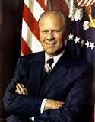

“In the early and mid1970s several Congressional committees, including the Church [April 29, 1976 - first report of Sen. Frank Church Commission, Pike, and Ervin committees, conducted investigations and public hearings. After three and a half years of investigation, these committees determined that what had occurred was a classic example of what we would today call ‘mission creep.’ What had begun as a simple requirement to provide basic intelligence to commanders charged with assisting in the maintenance and restoration of order, had become a monumentally intrusive effort. This resulted in the monitoring of activities of innocent persons involved in the constitutionally protected expression of their views on civil rights or anti-war activities. The information collected on the persons targeted by Defense intelligence personnel was entered into a national data bank and made available to civilian law enforcement authorities. This produced a chilling effect on political expression by those who were legally working for political change in domestic and foreign policies. Senator Ervin concluded ‘the collection and computerization of information by government must be tempered with an appreciation of the basic rights of the individual, of his right to privacy, to express himself freely and associate with whom he chooses.’ As a result of these investigations, DoD imposed severe restrictions on future surveillance of U.S. persons, required that information already in DoD files be destroyed, and established a structure to regulate future DoD intelligence collection. [On Feb. 18, 1976], President Ford issued an Executive Order placing significant controls on the conduct of all intelligence activities. Executive Order (EO) 11905, as the charter for the Intelligence Community, included provisions for an intelligence oversight mechanism.” https://dodsioo.defense.gov/About-DOD-SIOO/

1976: Public Safety Officers Benefits (PSOB) Act

“The Public Safety Officers Benefits (PSOB) Act, (42 USC 3796, Public Law 94-430) became law on September 29, 1976. The legislation provided for a $50,000 death benefit for fire fighters (paid and volunteer) and law enforcement officers that died in the line-of-duty (emergency or non-emergency) from a traumatic injury.

On December 15, 2003, the Act was amended (Hometown Heroes Act) to cover deaths from heart attack and stroke occurring in the line-of-duty. The Act does not cover deaths resulting from occupational illness or pulmonary disease unless a traumatic injury is a substantial factor to the death.” https://www.iaff.org/psob/

***
“2026 Benefits: The amount of the PSOB benefit is $461,656.00 for eligible deaths and disabilities occurring on or after October 1, 2025. The amount of the PSOB educational assistance benefit for one month of full-time assistance on or after October 1, 2025 is $1,574.00.” https://bja.ojp.gov/program/psob/resources/benefits-by-year

Jan. 20, 1977: President Jimmy Carter – Inauguration

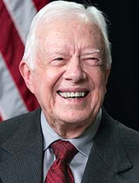

https://www.cartercenter.org/about/experts/jimmy_carter.html

May 28, 1977: Southgate, KY - Beverly Hills Supper Club fire
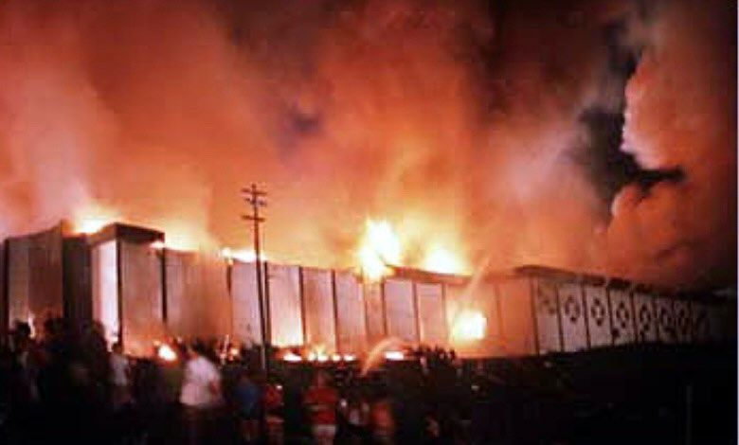
“One of the deadliest nightclub fires happened nearly 40 years ago—but it resulted in changes to fire safety regulations that protect the public to this day.” https://blog.qrfs.com/278-the-deadliest-fires-in-u-s-history-lessons-learned-from-the-beverly-hills-supper-club-fire/
“The May 28, 1977 fire killed 165 people and changed Kentucky fire regulations forever. The fire injured more than 200 people, including five firefighters.” https://www.fox19.com/2021/05/28/th-anniversary-deadly-beverly-hills-supper-club-fire/
Opinion: History says the Supper Club fire was no accident (May 28, 2021): “The ‘aluminum wiring’ civil settlement proved nothing but the greed of lawyers. Repeated investigations reached the same dead-end: ‘undetermined cause.’ But the past refuses to stay buried.” https://www.cincinnati.com/story/opinion/2021/05/28/opinion-history-says-supper-club-fire-no-accident/7427554002/

Forbidden Fruit’ book explores underworld connections to Beverly Hills Supper Club fire (Dec. 4, 2020): https://www.cincinnati.com/story/news/2020/12/03/forbidden-fruit-beverly-hills-supper-club-fire-peter-bronson/3782061001/

“Inside the Beverly Hills Supper Club Fire” - Paperback – Illustrated, June 1, 2010: https://www.amazon.com/Inside-Beverly-Hills-Supper-Club/dp/159652751X

Attorney Stanley Chesley dies at 89 (Nov. 4, 2025)
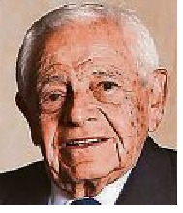
Legal ground breaker in fire case later disbarred.
“Stanley M. Chesley, a former trial lawyer from Cincinnati who rose to prominence after representing victims of the Beverly Hills Supper Club fire but was later disbarred for defrauding millions of dollars from his clients, has died, sources confirmed to The Enquirer.
He was 89.
Chesley’s legal career skyrocketed when he served as the plaintiffs’ attorney after the Beverly Hills Supper Club fire in 1977, which killed 165 people in the Northern Kentucky town of Southgate. He made a rare move to sue the entire aluminum electrical wire industry and won a $49 million settlement ($207 million adjusted for inflation). His success in the case made him a legal trailblazer and coined the term ‘enterprise liability.’ “ https://enewspaper.cincinnati.com/?token=650bca96048768615440b11fb674f972&cnum=eb834637-2c6d-4424-a2d5-903e8f89f711&fod=1111111STD-0&selDate=20251104&licenseType=paid_subscriber&for-guid=c3d67b6e-6174-11ef-b801-c2f230e29541&utm_source=cincinnati-enewspaper-strada&utm_medium=email&utm_campaign=enewspaper&utm_term=body&utm_content=pcin-cincinnati-nletter95

Jan. 11,1978 – Federal Service Labor-Management Relations Act
April 28, 2025. U.S. District Court Judge Paul L, Friedman, D.C. National Treasury Employees v. Donald J. Trump – Preliminary Injunction issued.
https://cases.justia.com/federal/district-courts/district-of-columbia/dcdce/1:2025cv00935/279006/34/0.pdf?ts=1745920374

“In 1978, Congress passed the Federal Service Labor-Management Relations Statute (effective Jan. 11, 1979), This landmark piece of legislation codified the rights of federal employees to collectively bargain and “participate through labor organizations of their own choosing in decisions which affect them.” 5 U.S.C. § 7101(a)(1). In passing the statute, Congress spoke unequivocally: “labor organizations and collective bargaining in the civil service are in the public interest.” 5 U.S.C. § 7101(a). Congress's determination that these rights should apply broadly – and that those rights “contribute[ ] to the effective conduct of public business,” 5 U.S.C. § 7101(a)(1)(B) – was undisturbed for decades, governing the state of the federal workforce despite changes in the composition of Congress and presidential administrations.

***

This all changed on March 27, 2025. On that day, President Trump issued an Executive Order invoking 5 U.S.C. § 7103(b) (1), which permits the President to “issue an order excluding any agency or subdivision thereof from coverage” of the Federal Service Labor-Management Relations Statute if the President determines that “the agency or subdivision has as a primary function intelligence, counterintelligence, investigative, or national security work,” and that the statute's provisions “cannot be National Treasury Employees Union v. Trump, --- F.Supp.3d ---- (2025) © 2025 Thomson Reuters. No claim to original U.S. Government Works. applied to that agency or subdivision in a manner consistent with national security requirements and considerations.” The effect of the Executive Order was substantial: it removed collective bargaining rights from approximately two-thirds of the federal workforce. In response to this sweeping Executive Order, the National Treasury Employees Union (“NTEU”) filed the instant action challenging the Executive Order, arguing that the President exceeded his power when issuing the order. *** The Court therefore concludes that the balance of the equities and assessment of the public interest weigh in favor of granting a preliminary injunction. Indeed, each of the preliminary injunction factors weighs in favor of granting NTEU’s motion.”

May 31, 1978: U.S. Supreme Court - Michigan v. Tyler (7 to 1) https://supreme.justia.com/cases/federal/us/436/499/
ARSON INVESTIGATIONS / RE-ENTRY AFTER GIVING UP CONTROL OF BUILDING REQUIRES SEARCH WARRANT
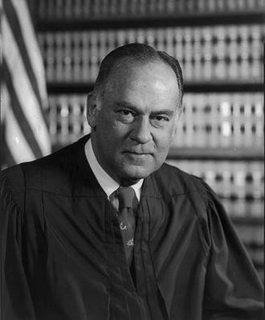Justice Potter Stewart
MR. JUSTICE STEWART delivered the opinion of the Court

“Facts of the case
On January 21, 1970, Tyler’s Auction, a furniture store in Oakland County, Michigan, caught fire shortly before midnight. The building was leased to Loren Tyler, who ran the business with Robert Tompkins. When Fire Chief See arrived on the scene, he was informed that two plastic containers of flammable liquid were found in the building. After determining that arson possibly caused the fire, See called Police Detective Webb. Webb arrived and took pictures, but the smoke and steam forced him to postpone his investigation. Around 4 a.m., the fire was extinguished, and the personnel left the premises. The containers were turned over to Webb. Webb did not have a warrant for any of the entries into the building or the removal of the containers.
The next morning, See returned to the scene with Assistant Chief Somerville, whose job was to determine the ‘origin of all fires that occur in the Township.’ They conducted a cursory examination and left. An hour later, Somerville returned with Webb, and the two discovered evidence of arson. The men did not have warrants for these entrances or seizures of evidence. Over the course of multiple visits beginning on February 16, Sergeant Hoffman of the Michigan State Police Arson Section conducted an investigation and secured further evidence of arson that played an important role in the trial.
At trial, the respondents objected to the introduction of this evidence, but the judge admitted it, and they were convicted. The Court of Appeals of the State of Michigan held that the constitutional protections against illegal searches and seizures did not pertain to arson investigations of burned premises and affirmed the conviction. The Supreme Court of Michigan held that the illegal searches and seizures had violated the Fourth and Fourteenth Amendments. The court reversed the convictions and ordered a new trial.

Question
Does the Fourth Amendment protection against illegal searches and seizures extend to investigations of burned premises for evidence of arson?

Conclusion
Yes. Justice Potter Stewart delivered the opinion of the 7-1 majority. The Court held that any search for administrative purposes, such as to find evidence of a crime, requires a warrant. There are circumstances that require law enforcement agents to act without a warrant, such as when firemen enter a burning building. Once in the building for that purpose, the firemen may seize evidence of arson that is in plain view without obtaining a warrant. The Court also held that determining the cause of the fire is part of a fireman’s job, so firemen may remain in a building without a warrant after a fire has been extinguished for ‘a reasonable amount of time’ to investigate. The Court held that the initial entry and the investigation on the following morning were constitutional, but the subsequent entries and seizures of evidence were not.” https://www.oyez.org/cases/1977/76-1608

Justice William Stewart

MR. JUSTICE BRENNAN delivered the opinion of the Court.

“Facts of the case
The petitioners, a class of female employees of the Department of Social Services and the Board of Education of the City of New York, sued their employers for depriving them of their constitutional rights. The employers required pregnant women to take unpaid leaves of absence before there was any medical reason to do so. The plaintiffs sought an injunction against the forced leaves of absence in the future, as well as back pay for those that had already occurred.
The district court found that such policies were unconstitutional but held that the city had immunity from paying the back wages. The district court also held that the motion for an injunction was moot because the organizations removed the policy in the intervening time. The Court of Appeals affirmed.

Question
If sued in their official capacity, are local government officials and organizations such as a school board considered ‘persons’ for the purpose of liability for back wages?

Conclusion
Yes. Justice William J. Brennan, Jr. delivered the opinion of the 7-2 majority. The Court held that the legislative history of the Civil Rights Act of 1871, and specifically the Sherman Amendment, indicated that municipalities could be liable for the infringement of constitutional rights. Additionally, by 1871 there was a clear legislative and precedentbased history for municipal corporations — such as a school board — to be considered a “person” for the purpose of lawsuits and liability. The Court held that this liability only existed when the constitutional infringement was the direct result of an official policy.
https://www.oyez.org/cases/1977/75-1914
June 6, 1978: U.S. Supreme Court - Monell v. New York Dept. of Social Services (7 to 2) https://supreme.justia.com/cases/federal/us/436/658/

MUNICIPALTY LIABLE FOR FAILURE TO TRAIN OR SUPERVISE ITS OFFICIALS OR EMPLOYEES

“In the case of Monell v. Dep’t of Soc. Servs., the United States Supreme Court expressly held that governmental entities, as opposed to governmental officials or employees, could not be held liable for violating Section 1983 based on the doctrine of respondeat superior, or in other words, automatically liable for the actions of its officials or agents. 436 U.S. 658, 691-694 (1978). A governmental entity cannot be held liable under Section 1983 solely because it employs a tortfeasor. The elements of a Monell claim are: (1) deprivation of a federal right; (2) some governmental action can be traced to the deprivation, i.e., policy or custom; (3) policy or custom demonstrating the governmental entity’s fault, i.e., deliberate indifference; and (4) municipal action that was the moving force behind the federal violation. Dean v. Wexford Health Service, Inc., 18 F.4th 214, 235 (7th Cir. 2021).
Since the Monell decision, case law has developed specific types of “policy or customs” that are actionable. First, a governmental entity may be liable for an express policy that causes a constitutional deprivation when enforced. McTigue v. City of Chicago, 60 F.3d 381, 382 (7th Cir. 2009). Second, liability may arise from a widespread practice that, “although not authorized by written law or an express policy, is so permanent and well settled as to constitute a custom or usage with the force of law.” Id. Additional high levels of proof are required for liability to attach to a widespread practice. Plaintiff must show that the policymakers were deliberately indifferent to the known or obvious consequence of the custom: in other words, turned a blind eye to the custom. Thomas v. Cook Cnty. Sheriff’s Dept., 604 F. 3d 773, 790 (7th Cir. 2006). There also must be evidence demonstrating that the practice was persuasive. Id. One or two missteps are insufficient. Rather, evidence of systemic and gross deficiencies is mandatory. Hildreth v. Butler, 960 F.3d 420, 426 (7th Cir. 2020). A governmental entity may be held liable for its inaction by a failure to train or supervise its officials or employees. Orozco v. Dart, 64 F.4th 806, 824 (7th Cir. 2023). Importantly, this path to Monell is steep. Id. Rigorous standards of culpability and causation are applied. Id. Lastly, Section 1983 liability may be imposed on a governmental authority when the final decision-making authority is directly responsible for the deprivation. Gernetzke v. Kenosha Unified School District No. 1, 274 F.3d 464 (7th Cir. 2001). Under this type of Monell claim, the official or employee who commits the violation must have authority that is final in a special sense: that there is no higher authority. Id. at 469. “Delegation is not direction; authorization is not command: permission does not make the permittee the final policy maker.” Id.” https://mwhlawgroup.com/taming-the-monell-monster/

June 26, 1978: U.S. Supreme Court - Regents of the University of California v. Bakke (5 to 4) https://supreme.justia.com/cases/federal/us/438/265/
AFFIRMATIVE ACTION IN ADMISSIONS TO MEDICAL SCHOOL LAWFUL
“Issue: Can an institution of higher learning use race as a factor when making admissions decisions?
Result: The Court held that universities may use race as part of an admissions process so long as ‘fixed quotas’ are not used. The Court determined that the specific system in place at the University of California Medical School was ‘unnecessary’ to achieve the goal of creating a diverse student body and was merely a ‘fixed quota’ and therefore, was unconstitutional.
Importance: The decision started a line of cases in which the Court upheld affirmative action programs. In 2003, such academic affirmative action programs were again directly challenged in Gratz v. Bollinger and Grutter v. Bollinger. In these cases, the Court clarified that admission programs that include race as a factor can pass constitutional muster so long as the policy is narrowly tailored and does not create an automatic preference based on race. The Court asserted that a system that created an automatic race-based preference would in fact violate the Equal Protection Clause.” https://www.americanbar.org/groups/public_education/programs/constitution_day/landmark-cases/

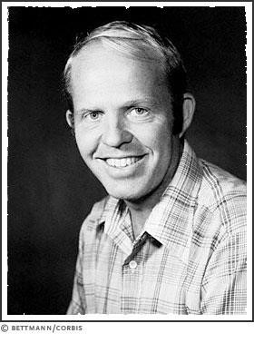 Allan Paul Bakke: https://www.s9.com/Biography/bakke-allan-paul/
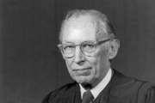 Justice Lewis F. Powell, Jr.

“Facts of the case
Allan Bakke, a thirty-five-year-old white man, had twice applied for admission to the University of California Medical School at Davis. He was rejected both times. The school reserved sixteen places in each entering class of one hundred for ‘qualified’ minorities, as part of the university's affirmative action program, in an effort to redress longstanding, unfair minority exclusions from the medical profession. Bakke's qualifications (college GPA and test scores) exceeded those of any of the minority students admitted in the two years Bakke's applications were rejected. Bakke contended, first in the California courts, then in the Supreme Court, that he was excluded from admission solely on the basis of race.

Question
Did the University of California violate the Fourteenth Amendment's equal protection clause, and the Civil Rights Act of 1964, by practicing an affirmative action policy that resulted in the repeated rejection of Bakke's application for admission to its medical school?

Conclusion
No and yes. There was no single majority opinion. Four of the justices contended that any racial quota system supported by government violated the Civil Rights Act of 1964. Justice Lewis F. Powell, Jr., agreed, casting the deciding vote ordering the medical school to admit Bakke. However, in his opinion, Powell argued that the rigid use of racial quotas as employed at the school violated the Equal Protection Clause of the Fourteenth Amendment. The remaining four justices held that the use of race as a criterion in admissions decisions in higher education was constitutionally permissible. Powell joined that opinion as well, contending that the use of race was permissible as one of several admission criteria. So, the Court managed to minimize white opposition to the goal of equality (by finding for Bakke) while extending gains for racial minorities through affirmative action.” https://www.oyez.org/cases/1979/76-811

Oct. 25,1978: Foreign Intelligence Surveillance Act (FISA)
“The Foreign Intelligence Surveillance Act (FISA)1 was enacted in 1978 (effective Oct. 25. 1978). . This legislation was the Congressional response to the exposure during multiple Committee hearings of previous abuses of U.S. persons’ privacy rights by certain components of the United States government. Those abuses had occurred, according to the government, as part of its efforts to counter purported threats to national security. Unquestionably, such threats existed in and before 1978; beyond peradventure, however, they pale in comparison to the threats to national security that the United States currently faces. Those threats bear the face of terrorism, primarily foreign but domestic as well. Though FISA is not a legally usable tool for combating domestic terrorism, its electronic surveillance and physical search authority are legal and very effective methods for monitoring the activities of foreign powers and agents of foreign powers while they operate within the United States. Increasingly, indeed, overwhelmingly, the current objective of such operational activities is to thwart terrorist acts.”
https://www.fletc.gov/sites/default/files/imported_files/training/programs/legaldivision/downloads-articles-and-faqs/research-bysubject/miscellaneous/ForeignIntelligenceSurveillanceAct.pdf
Aug. 3, 2020: Statement of Assistant Attorney General for National Security John
C. Demers on the Public Release of the Department’s Findings with Respect to the 29 FISA Applications that Were the Subject of the March 2020 OIG Preliminary Report

“The Department of Justice has completed its review of the 29 FISA applications that were the subject of preliminary findings by the DOJ Inspector General (OIG) in March 2020. We are pleased that our review of these applications concluded that all contained sufficient basis for probable cause and uncovered only two material errors, neither of which invalidated the authorizations granted by the FISA Court. These findings, together with the more than 40 corrective actions undertaken by the Federal Bureau of Investigation and the National Security
Division, should instill confidence in the FBI’s use of FISA authorities. We would like to express our appreciation to the OIG for their focus on the Department’s use of its national security authority. We remain committed to improving the FISA process to ensure that we use these tools consistent with the law and our obligations to the FISA Court. The ability to surveil and to investigate using FISA authorities remains critical to confronting current national security threats, including election interference, Chinese espionage and terrorism.”
https://www.justice.gov/opa/pr/statement-assistant-attorneygeneral-national-security-john-c-demers-public-release
Jan. 20, 1981: President Ronald Regan – First Inauguration
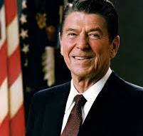

https://governors.library.ca.gov/33-reagan.html

March 30, 1981: Assassination Attempt – President Regan
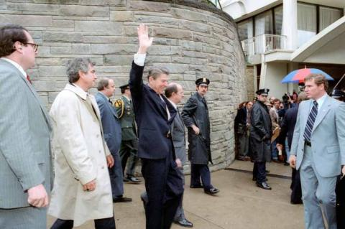
“On March 30, 1981, President Reagan was leaving the Hilton Hotel in Washington, D.C., where he had been talking to 5,000 members of the AFL-CIO when several shots were fired. John Hinckley, Jr., fired his .22 caliber revolver with “devastator” bullets at the President and his security team. Reagan was wounded when one of the bullets ricocheted off of the limousine, striking him under the left armpit. Press Secretary James Brady, Secret Service Agent Timothy McCarthy, and policeman Thomas Delahanty were also wounded during the shooting. President Reagan’s wounds were not noticed until he began to cough up blood. He was then taken to the George Washington University Hospital. After twelve days in the hospital, he was able to return to the White House with a new commitment to changing the relationship between the United States and the Soviet Union.” https://www.reaganlibrary.gov/permanent-exhibits/assassination-attempt

July 17, 1981: Kansas City Walkway Collapse
On July 17, 1981, two suspended walkways collapsed inside Kansas City’s Hyatt Regency Hotel. The event became one of the worst man-made disasters in American history, and the shockwaves are still being felt four decades later. It happened at the worst possible time. The room was packed for a Friday night dance, and 114 people died, 216 were hurt and thousands more were affected. VIDEO: https://www.kmbc.com/article/kmbc-9-chronicle-the-skywalk-tapes-the-night-the-hyatt-regency-hotel-skywalks-fell-forever-changing-kansas-city-missouri/36942895#

Sept. 25, 1981: First Woman On U.S. Supreme Court - Justice Sandra Day O’Connor
Justice Sandra Day O’Connor was appointed to the Supreme Court by President Ronald Reagan, and served from 1981 until 2006. https://www.supremecourt.gov/visiting/sandradayoconnor.aspx
“Very little could happen without Justice O’Connor’s support when it came to the polarizing issues on the court’s docket, and the law regarding affirmative action, abortion, voting rights, religion, federalism, sex discrimination and other hot-button subjects was basically what Sandra Day O’Connor thought it should be.” https://www.nytimes.com/2023/12/01/us/sandra-day-oconnor-dead.html
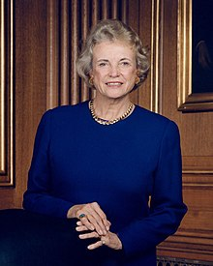

March 8, 1981: U.S. Supreme Court - Griggs v. Duke Power (8 to 0) https://supreme.justia.com/cases/federal/us/401/424/

RACE - APPLICANT TESTS MUST BE JOB RELATED
MR. CHIEF JUSTICE BURGER delivered the opinion of the Court.
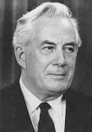Chief Justice Warren E. Burger

“The Company added a further requirement for new employees on July 2, 1965, the date on which Title VII became effective. To qualify for placement in any but the Labor Department, it became necessary to register satisfactory scores on two professionally prepared aptitude tests, as well as to have a high school education.
***
On the record before us, neither the high school completion requirement nor the general intelligence test is shown to bear a demonstrable relationship to successful performance of the jobs for which it was used. Both were adopted, as the Court of Appeals noted, without meaningful study of their relationship to job performance ability. Rather, a vice-president of the Company testified, the requirements were instituted on the Company's judgment that they generally would improve the overall quality of the workforce. The evidence, however, shows that employees who have not completed high school or taken the tests have continued to perform satisfactorily, and make progress in departments for which the high school and test criteria are now used.
***
The Company contends that its general intelligence tests are specifically permitted by § 703(h) of the [Civil Rights Act of 1964]. That section authorizes the use of ‘any professionally developed ability test’ that is not ‘designed, intended or used to discriminate because of race. . . .’
(Emphasis added.) The Equal Employment Opportunity Commission, having enforcement responsibility, has issued guidelines interpreting § 703(h) to permit only the use of job-related tests.
***
Nothing in the Act precludes the use of testing or measuring procedures; obviously they are useful. What Congress has forbidden is giving these devices and mechanisms controlling force unless they are demonstrably a reasonable measure of job performance. Congress has not commanded that the less qualified be preferred over the better qualified simply because of minority origins. Far from disparaging job qualifications as such, Congress has made such qualifications the controlling factor, so that race, religion, nationality, and sex become irrelevant. What Congress has commanded is that any tests used must measure the person for the job, and not the person in the abstract.” https://supreme.justia.com/cases/federal/us/401/424/#tab-opinion1949187
Jan. 13, 1982 – Air Florida Crash
In 1982, Air Florida flight 90, a 737 crashed into Washington, D.C.'s 14th Street Bridge and fell into the Potomac River while trying to take off during a snowstorm. 78 people lost their lives. Four passengers and a flight attendant survived. During the rescue, one of the survivors, a woman, was too weak to hold onto the ring to grab the line when the helicopter returned to her. As she began to sink below the Potomac River her savior was coming. A young office assistant for a government agency, Lenny Skutnik, stripped off his coat and boots and in short sleeves, dove into the icy water and swam out to her. She survived, as did Lenny.
Number of deaths: 74
Location: Potomac River, 14th Street Bridge
Start date: January 13, 1982
Injuries (nonfatal): 10
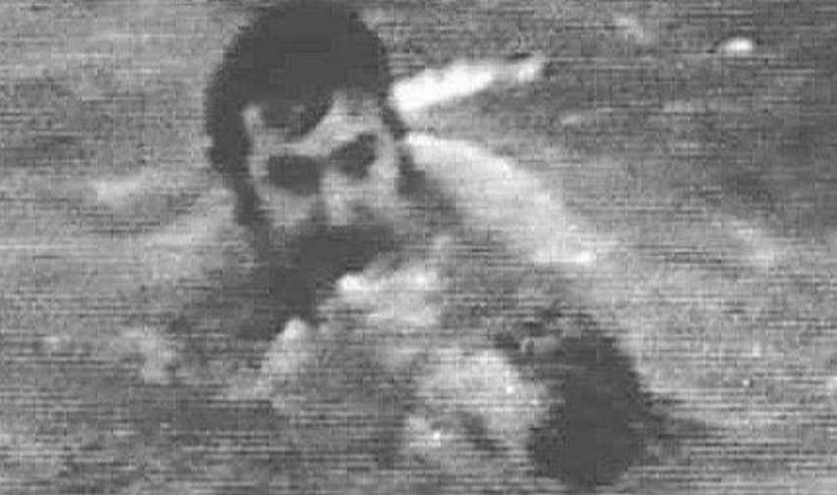

June 24, 1982 – U.S. Supreme Court - Harlow v. Fitzgerald (8 to 0) https://supreme.justia.com/cases/federal/us/457/800/
QUALIFIED IMMUNITY FOR GOV’T OFFICIALS - unless “clearly established” statute or case decision
“Henceforth, government officials performing discretionary functions generally are shielded from liability for civil damages insofar as their conduct does not violate ‘clearly established’ statutory or constitutional rights of which a reasonable person would have known.”

President Nixon ordered in Jan. 1970 the firing of a senior Air Force member – whistleblower. U.S. Supreme Court held Nixon staff members have qualified immunity.
“The issue in this case is the scope of the immunity available to the senior aides and advisers of the President of the United States in a suit for damages based upon their official acts. IIn this suit for civil damages, petitioners Bryce Harlow and Alexander Butterfield are alleged to have participated in a conspiracy to violate the constitutional and statutory rights of the respondent A. Ernest Fitzgerald. Respondent avers that petitioners entered the conspiracy in their capacities as senior White House aides to former President Richard M. Nixon. As the alleged conspiracy is the same as that involved in Nixon v. Fitzgerald, ante p. 457 U. S. 731, the facts need not be repeated in detail.” https://supreme.justia.com/cases/federal/us/457/800/

Plaintiff in case – told Congress about C-5A cost overruns.
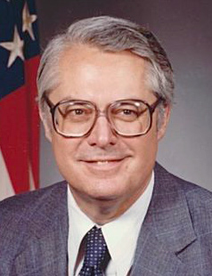
“A. Ernest Fitzgerald (1926–2019) was an American engineer, a member of the Senior Executive Service in the United States Air Force, and a prominent U.S. government whistleblower. Following service in the U.S. Navy, Fitzgerald earned a bachelor of science degree in industrial engineering from the University of Alabama. After working for a number of years as an engineer and in management, Fitzgerald was employed by the U.S. Air Force as Deputy for Management Systems in 1965. While employed at the Pentagon Fitzgerald testified to Congress in 1968 and 1969 about the concealed cost overruns and the technical problems of the Lockheed C-5A transport plane. He was accused of revealing classified information and was fired on order of President Richard M. Nixon.” https://www.independent.org/aboutus/person_detail.asp?id=373

“A Tribute to Pentagon Whistleblower Ernie Fitzgerald:
Less than a year later, the Air Force said Fitzgerald would be losing his job in January 1970 as part of a wholesale trimming of civilian personnel that had nothing to do with his testimony. Fitzgerald fought his dismissal, and in 1973 won his case before the Civil Service Commission, which ordered him reinstated with $80,000 in back pay. He went back to work, but he grumbled that the Air Force assigned him to minor-league matters. So in 1974 he sued the US government again, this time to regain his original responsibilities, and after eight years he won again, along with $200,000 in legal fees, according to People.” https://www.pogo.org/analysis/remembering-ernie-fitzgerald

Dec. 16, 1982 – FBI Plane Crash into Bookstore, Montgomery, OH
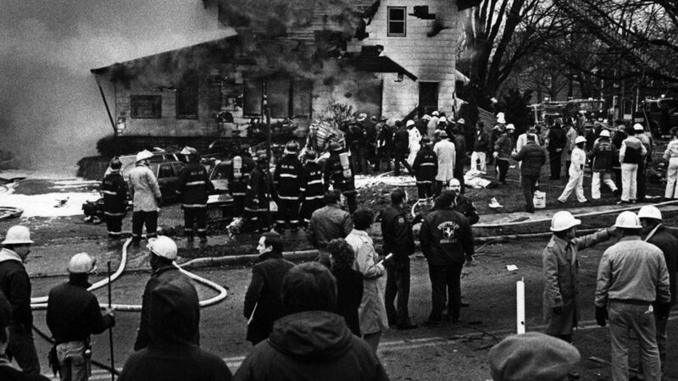
DECEMBER 16, 1982: A small plane carrying four FBI agents, an accused embezzler and a retired Chicago cop crashed into Sheppard's Book Store in downtown Montgomery in 1982. Still missing is $55,000 the embezzler allegedly stashed somewhere. https://www.fox19.com/2022/12/16/new-podcast-looks-into-1982-plane-crash-that-killed-fbi-agents-accused-embezzler/

“On December 16, 1982, Special Agents Terry Burnett Hereford, Charles L. Ellington, Robert W. Conners, and Michael James Lynch were killed in a Bureau airplane accident near Montgomery, Ohio. The agents were accompanying a bank fraud and embezzlement subject, Carl Henry Johnson, and an individual from the law firm representing Johnson to Cincinnati. They were attempting to locate $50,000 in embezzled money, which Johnson had hidden in that area. The plane, piloted by special agents Hereford and Conners, crashed on approach to Cincinnati's Lunken Airport near Montgomery, and all aboard were killed. There were indications that the aircraft encountered altitude read-out problems, was flying at a low altitude, and hit some wires before it went down.” https://www.fbi.gov/history/wall-of-honor/michael-james-lynch

April 20, 1983 – U.S. Supreme Court – Connick v. Myers (5 to 4) https://supreme.justia.com/cases/federal/us/461/138/
Free Speech Rights of Public Officials / Only If Matter of “Public Concern”
Free Speech Center – Connick v. Myers
https://firstamendment.mtsu.edu/article/connick-v-myers/
“In Connick v. Myers 461 U.S. 138 (1983), the Supreme Court clarified the level of First Amendment protection for public employees in the workplace by explaining how courts should balance an employee’s right to speak on matters of public importance against an employer’s interests in a disruptive-free workplace. Sheila Myers, an assistant district attorney in New Orleans, had objected to being transferred to another section of her office. After receiving notice of the transfer, she prepared and distributed a questionnaire to the office staff that in part raised the issue of whether their office was poorly run. Harry Connick Sr., the district attorney and Myers’s supervisor, terminated her for refusing the transfer and for undermining his authority with the questionnaire. Myers challenged her dismissal, reasoning that she was fired because she had expressed her opinion of how Connick ran the office and that such termination violated her First Amendment political speech rights. In a 5-4 vote, a divided Supreme Court held Myers’s dismissal to be constitutional. In the majority opinion of the Court, Justice Byron R. White stated, per the Court’s ruling in Pickering v. Board of Education (1968), that the Court must balance the First Amendment right of government employees to comment upon matters of public concern versus the interest of government to provide its services efficiently. In applying the Pickering test to the New Orleans case, White found that Myers in general was not speaking about matters of public concern, because in the main, her questionnaire focused on internal office workings. White determined, however, that at least one question — concerning whether Connick forced office staff to perform political campaign work — should be considered of public concern.”
1982 – GARMENT WORKER’S STRIKE - NYC
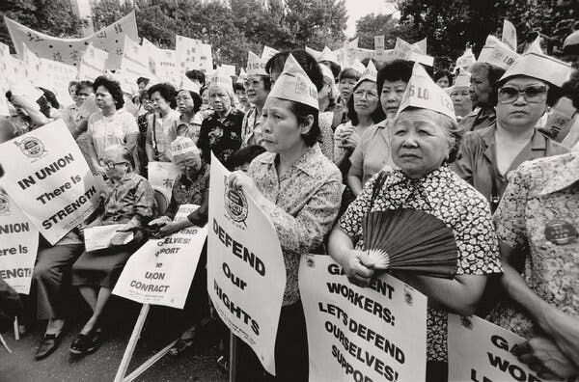
“A garment workers’ strike gathered nearly 20,000 workers for a mass walkout in New York in 1982, including this crowd in Columbus Park.Credit...Estate of Corky Lee.”
https://www.nytimes.com/2024/05/10/books/review/corky-lee-asian-america-fifty-years-photographic-justice.html?te=1&nl=the-morning&emc=edit_nn_20240512

Oct. 25, 1983 – Grenada

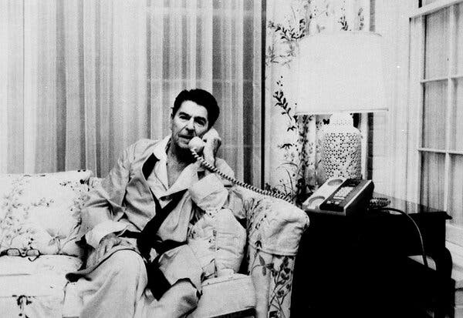 President Ronald Reagan, in his pajamas and robe, speaking to Vice President George H.W. Bush about Grenada from the White House in 1983.
“The United States accused the government of Grenada of building an airport that would project Soviet power in the region, claiming that its long runway could enable the Soviet Union to land giant transport planes capable of moving weapons.
A political leadership crisis in Grenada that fall eventually led to the execution of its prime minister. The military announced a curfew and said anyone on the streets in violation of the order would be shot on sight.
At dawn on Oct. 25, President Ronald Reagan sent 7,600 troops, including two Army Ranger battalions, the 82nd Airborne, the Marines, Delta commandos and Navy SEALs, supported by American warplanes and Army helicopters. His stated reason was to protect 600 American medical students in the island country.
The U.S. troops made quick work of 1,500 Grenadian soldiers involved in the initial defense of the country, and within a few days most of the resistance was gone. Grenada’s military government was overthrown, and an interim one was installed. On Nov. 3, Reagan announced the mission was successfully completed.” https://www.nytimes.com/2025/12/09/us/politics/military-history-latin-america-strikes.html?nl=Breaking+News&segment_id=212078

January 11, 1984: U.S. Supreme Court - Michigan v. Clifford (5 to 4) https://supreme.justia.com/cases/federal/us/464/287/
UNLESS “EXIGENT CIRCUMSTANCES” – WHEN ARSON INVESTIGATORS SHOW UP 6 HRS AFTER FIRE PUT OUT AND FD LEFT, NEED WARRANT

“In the early morning hours of October 18, 1980, a fire erupted at the Clifford home. The Cliffords were out of town on a camping trip at the time. The fire was reported to the Detroit Fire Department, and fire units arrived on the scene about 5:40 a.m. The fire was extinguished and all fire officials and police left the premises at 7:04 a.m.
At 8 o'clock on the morning of the fire, Lieutenant Beyer, a fire investigator with the arson section of the Detroit Fire Department, received instructions to investigate the Clifford fire. He was informed that the Fire Department suspected arson. Because he had other assignments, Lieutenant Beyer did not proceed immediately to the Clifford residence. He and his partner finally arrived at the scene of the fire about 1 p.m. on October 18. When they arrived, they found a work crew on the scene. The crew was boarding up the house and pumping some six inches of water out of the basement. A neighbor told the investigators that he had called Mr. Clifford and had been instructed to request the Cliffords' insurance agent to send a boarding crew out to secure the house. The neighbor also advised that the Cliffords did not plan to return that day. While the investigators waited for the water to be pumped out, they found a Coleman fuel can in the driveway that was seized and marked as evidence. By 1:30 p.m., the water had been pumped out of the basement and Lieutenant Beyer and his partner, without obtaining consent or an administrative warrant, entered the Clifford residence and began their investigation into the cause of the fire. *** The aftermath of a fire often presents exigencies that will not tolerate the delay necessary to obtain a warrant or to secure the owner's consent to inspect fire-damaged premises. Because determining the cause and origin of a fire serves a compelling public interest, the warrant requirement does not apply in such cases…. Because the cause of the fire was then known, the search of the upper portions of the house, described above, could only have been a search to gather evidence of the crime of arson. Absent exigent circumstances, such a search requires a criminal warrant.”

June 12, 1984 U.S. Supreme Court - New York v. Quarles (6 to 3) https://supreme.justia.com/cases/federal/us/467/649/

PUBLIC SAFETY QUESTIONING OF SUSPECT - “where’s the gun: - no Miranda violation. Also questioning police officer after a shooting or emergency responder after serious on duty MVA.
“Respondent was charged in a New York state court with criminal possession of a weapon. The record showed that a woman approached two police officers who were on road patrol, told them that she had just been raped, described her assailant, and told them that the man had just entered a nearby supermarket and was carrying a gun. While one of the officers radioed for assistance, the other (Officer Kraft) entered the store and spotted respondent, who matched the description given by the woman. Respondent ran toward the rear of the store, and Officer Kraft pursued him with a drawn gun, but lost sight of him for several seconds. Upon regaining sight of respondent, Officer Kraft ordered him to stop and put his hands over his head; frisked him and discovered that he was wearing an empty shoulder holster; and, after handcuffing him, asked him where the gun was. Respondent nodded toward some empty cartons and responded that "the gun is over there." Officer Kraft then retrieved the gun from one of the cartons, formally arrested respondent, and read him his rights under Miranda v. Arizona, 384 U. S. 436. Respondent indicated that he would answer questions without an attorney being present and admitted that he owned the gun and had purchased it in Florida. The trial court excluded respondent's initial statement and the gun because the respondent had not yet been given the Miranda warnings, and also excluded respondent's other statements as evidence tainted by the Miranda violation. Both the Appellate Division of the New York Supreme Court and the New York Court of Appeals affirmed.
Held: The Court of Appeals erred in affirming the exclusion of respondent's initial statement and the gun because of Officer Kraft's failure to read respondent his Miranda rights before attempting to locate the weapon. Accordingly, it also erred in affirming the exclusion of respondent's subsequent statements as illegal fruits of the Miranda violation. This case presents a situation where concern for public safety must be paramount to adherence to the literal language of the prophylactic rules enunciated in Miranda.”
***
Read this April 10, 2025 article about legal issues - interviewing police officers involved in shooting – including public safety interview, investigator interview and Garrity compelled interview.
“I Just Got In A Shooting, What Happens Next? You have been on the job for some time but have never had to use deadly force. Then, in a split second, you just shot someone; what happens next? *** The supervisor verified you were involved and asked some precise questions. There are usually two types of interviews that can be conducted with a sworn officer following an officer-involved shooting: a voluntary or compelled statement (we will discuss compelled statements in greater detail further along in this paper).
However, this (the sergeant’s questioning of the involved officers) is referred to as a public safety statement and is neither compelled nor voluntary—the public safety statement derives from the US Supreme Court decision of New York v. Quarles in 1984. The Quarles decision established an exception to the Miranda rule, allowing law enforcement to prioritize public safety in certain situations (New York v. Quarles, 467 U.S. 649 (1984). In short, the Quarles decision enables a supervisor to ask specific questions of the involved officers following an incident, like an officer-involved shooting. The questions must be designed to ensure the public’s safety if there is a possible immediate threat to the public. The generally accepted practices call for the following public safety questions:
- Did you use force, and what type of force?
- What direction did you fire?
- How many rounds did you fire?
- Outstanding suspects, last known location of travel?
- Evidence location and location of the injured person/suspect(s)?

It is important to remember that the public safety questions are outside of the Miranda warning and are meant for the public’s safety. You cannot refuse to provide the answers to these specific questions, and you will not be compelled to answer them. During the public safety statement questions, you will not have a representative/ or attorney to guide you. The public safety statement requirement does not allow the sergeant to ask questions regarding the shooting, such as why you shot, whether you were in fear for your life, etc. Additionally, the public safety questions must be contemporaneous with the shooting incident. Departments cannot use the public safety statement to obtain shooting information outside Miranda or the Garrity warning (voluntary or compelled).

***
Under the administrative portion of the shooting investigation, the administrative investigators can and, more likely than not, will compel you to provide them with a walk-through. Remember, a walk-through is not an interview and is only designed to obtain your position(s) during the shooting in relation to the suspect. Any information received from you from such a compulsion under Garity cannot be used against you in any criminal proceedings.
Regarding the interview, the general practice is to allow the involved officer two sleep cycles before obtaining an official statement of the shooting. The initial investigators wanting to get a statement from you will be the criminal investigators, who cannot compel you and only get a statement if you volunteer one. Lastly, the administrative investigators will want to interview you once the criminal case is completed. Once completed, the criminal investigation will be provided to the prosecutors’ office for review and criminal considerations surrounding your use of lethal force. For this reason, you cannot be compelled, as the Garity warning assures that any statement obtained under Garrity cannot be used against you criminally. Therefore, the criminal investigators must get a voluntary statement from you or no statement at all. Your counsel will guide you on whether you should provide a voluntary statement. Attorneys who practice this area of law are very experienced in these matters and will be able to advise you properly.”
https://www.llrmi.com/articles/legal_updates/2025_what-happens-next/

Jan. 20, 1985: President Ronald Regan – Second Inauguration

Feb. 19, 1985: U.S. Supreme Court - Garcia v. San Antonio Metropolitan Transit Authority https://supreme.justia.com/cases/federal/us/469/528/

FLSA APPLIES TO STATE AND LOCAL GOVERNMENTS – INCLUDING FIRE & EMS EMPLOYEES
“The FLSA obligations of public mass transit systems like SATS were expanded in 1974 when Congress provided for the progressive repeal of the surviving overtime exemption for mass transit employees. Fair Labor Standards Amendments of 1974, § 21(b), 88 Stat. 68. Congress simultaneously brought the States and their subdivisions further within the ambit of the FLSA by extending FLSA coverage to virtually all state and local government employees. §§ 6(a)(1) and (6), 88 Stat. 58, 60, 29 U.S.C. §§ 203(d) and (x). SATS complied with the FLSA's overtime requirements until 1976, when this Court, in National League of Cities, overruled Maryland v. Wirtz and held that the FLSA could not be applied constitutionally to the "traditional governmental functions" of state and local governments. Four months after National League of Cities was handed down, SATS informed its employees that the decision relieved SATS of its overtime obligations under the FLSA. Matters rested there until September 17, 1979, when the Wage and Hour Administration of the Department of Labor issued an opinion that SAMTA's operations "are not constitutionally immune from the application of the Fair Labor Standards Act" under National League of Cities. Opinion WH-499, 6 LRR 91:1138. *** This analysis makes clear that Congress' action in affording SAMTA employees the protections of the wage and hour provisions of the FLSA contravened no affirmative limit on Congress' power under the Commerce Clause. The judgment of the District Court therefore must be reversed.”
U.S. Department of Labor, Wage & Hour Division (Fact Sheet #8)
“Section 7(k) of the FLSA provides that employees engaged in fire protection or law enforcement may be paid overtime on a "work period" basis. A "work period" may be from 7 consecutive days to 28 consecutive days in length. For work periods of at least 7 but less than 28 days, overtime pay is required when the number of hours worked exceeds the number of hours that bears the same relationship to 212 (fire) or 171 (police) as the number of days in the work period bears to 28. For example, fire protection personnel are due overtime under such a plan after 106 hours worked during a 14-day work period, while law enforcement personnel must receive overtime after 86 hours worked during a 14-day work period.” https://www.dol.gov/agencies/whd/fact-sheets/8-flsa-policefirefighters

Feb. 19, 1985: Garcia v. San Antonio Metropolitan Transit Authority, 469 U.S. 528 (1985) https://supreme.justia.com/cases/federal/us/469/528/ “The FLSA obligations of public mass transit systems like SATS were expanded in 1974 when Congress provided for the progressive repeal of the surviving overtime exemption for mass transit employees. Fair Labor Standards Amendments of 1974, § 21(b), 88 Stat. 68. Congress simultaneously brought the States and their subdivisions further within the ambit of the FLSA by extending FLSA coverage to virtually all state and local government employees. §§ 6(a)(1) and (6), 88 Stat. 58, 60, 29 U.S.C. §§ 203(d) and (x). SATS complied with the FLSA's overtime requirements until 1976, when this Court, in National League of Cities, overruled Maryland v. Wirtz and held that the FLSA could not be applied constitutionally to the "traditional governmental functions" of state and local governments. Four months after National League of Cities was handed down, SATS informed its employees that the decision relieved SATS of its overtime obligations under the FLSA. Matters rested there until September 17, 1979, when the Wage and Hour Administration of the Department of Labor issued an opinion that SAMTA's operations "are not constitutionally immune from the application of the Fair Labor Standards Act" under National League of Cities. Opinion WH-499, 6 LRR 91:1138. *** This analysis makes clear that Congress' action in affording SAMTA employees the protections of the wage and hour provisions of the FLSA contravened no affirmative limit on Congress' power under the Commerce Clause. The judgment of the District Court therefore must be reversed.”

March 19, 1985: U.S. Supreme Court - Cleveland Board of Education v. Loudermill (8 to 1) https://supreme.justia.com/cases/federal/us/470/532/
PRE-TERMINATION HEARING BY PUBLIC EMPLOYERS

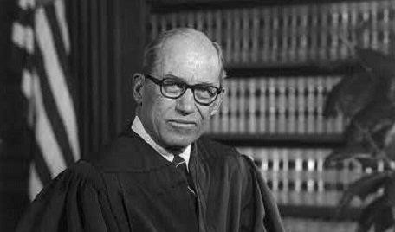Justice Byron White

JUSTICE WHITE delivered the opinion of the Court.

“Facts of the case
James Loudermill stated on his application for employment with the Cleveland Board of Education that he had never been convicted for a felony. After hiring him as a security guard, the board discovered that he had been convicted for grand larceny and without further consideration fired him for providing false information on his application. Since Loudermill qualified as a ‘classified civil servant’ under Ohio law, he obtained a property right to his employment. This meant he could only be dismissed for cause and could obtain an administrative review of the causes for his termination. The Cleveland Civil Service Commission granted him an administrative review after his termination and found it valid. Loudermill filed suit in District Court alleging that the review system was unconstitutional because it only allowed him to respond to the charges against him after his termination. He argued that the board removed his property without giving him a chance to defend himself in violation of his right to Due Process under the Fourteenth Amendment. The District Court agreed that the Ohio statute gave Loudermill a property right to his job, but ruled that the board did not violate his due process rights because it followed the procedures specified by the same statute for removing the property right. In a similar case, Richard Donnelly alleged that post-dismissal hearings violated his due process rights. The Court of Appeals for the Sixth Circuit heard both cases together and ruled that the board violated both defendants' due process rights by removing their property rights to employment before providing an opportunity for them to respond to charges against them.

Question
Can a state remove a civil servant's property rights to employment before providing an opportunity for that worker to respond to the charges offered for his termination?

Conclusion
No. Justice Byron White authored the opinion for an 8-1 court. The Ohio statute clearly grants civil servants property rights to their employment. In order to lawfully remove this property, the Due Process Clause requires a procedure that carefully weighs the interests of the government in removing the property against the interests of the private party in retaining the property. This procedure must incorporate the ‘essential requirements of due process,’ which ‘are notice and an opportunity to respond.’ There was no strong reason to delay the opportunity to respond until after termination. The Court found that ‘affording the employee an opportunity to respond prior to termination would impose neither a significant administrative burden nor intolerable delays.’ Accordingly, the significant interests of the employees to retain their jobs outweighed the interests of the state to remove employees quickly.” https://www.oyez.org/cases/1984/83-1362

March 25, 1986 – U.S. Supreme Court - Pembaur v. City of Cincinnati & Hamilton County (6 t0 3) https://supreme.justia.com/cases/federal/us/475/469/
COUNTY PROSECUTOR TELLS POLICE TO BREAK DOWN DOOR – SEEKING TWO WITNESSES BEFORE GRAND JURY – COUNTY CAN BE SUED VIOL. 4th AMENDMENT
“Applying this standard to the case before us, we have little difficulty concluding that the Court of Appeals erred in dismissing petitioner's claim against the county. The Deputy Sheriffs who attempted to serve the capiases at petitioner's clinic found themselves in a difficult situation. Unsure of the proper course of action to follow, they sought instructions from their supervisors. The instructions they received were to follow the orders of the County Prosecutor. The Prosecutor made a considered decision based on his understanding of the law, and commanded the officers forcibly to enter petitioner's clinic. That decision directly caused the violation of petitioner's Fourth Amendment rights.”

March 25, 1986 – U.S. Supreme Court - Meritor Savings Bank, FSB v. Vinson (9 to 0) https://www.oyez.org/cases/1985/84-1979
SEXUAL HARASSMENT VIOLATION OF TITLE VII OF CIVIL RIGHTS ACT OF 1964

EEOC (4/29/2024): Enforcement Guidance on Harassment in the Workplace. https://www.eeoc.gov/laws/guidance/enforcement-guidance-harassment-workplace
“In 1986, the U.S. Supreme Court held in the landmark case of Meritor Savings Bank, FSB v. Vinson that workplace harassment can constitute unlawful discrimination under Title VII of the Civil Rights Act of 1964 (Title VII). Decades later, harassing conduct remains a serious workplace problem. For the five fiscal years (FY) ending with FY 2023, over one-third of the charges of employment discrimination received by the Equal Employment Opportunity Commission (‘the Commission’ or ‘the EEO’”) included an allegation of unlawful harassment based on race, sex, disability, or another statutorily protected characteristic. The actual cases behind these numbers reveal that many people experience harassing conduct at work that may be unlawful.”

Oct. 5, 1986 – IRAN-CONTRA AFFAIR
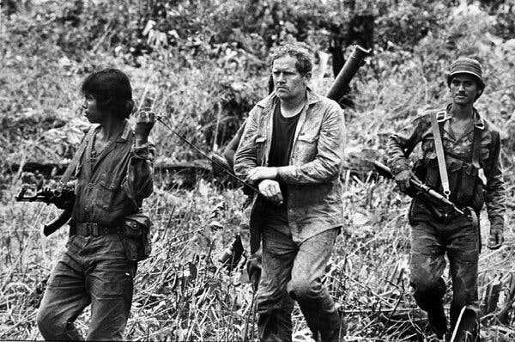

“Eugene Hasenfus, who as a 45-year-old former Marine and laid-off construction worker was thrust into the national spotlight in 1986 when, on a covert mission sponsored by the C.I.A., his gunrunning cargo plane was shot down over Nicaragua, setting off what would become known as the Iran-contra affair, died on Wednesday at his home in Menominee, Mich. He was 84…. President Ronald Reagan’s administration initially denied any American involvement in the flight. Those denials began unraveling when it was reported that the cargo plane belonged to Southern Air Transport, a charter carrier based in Miami that was formerly owned by the C.I.A. Mr. Hasenfus’s capture led to investigations by Congress and by an independent counsel, Lawrence E. Walsh, and ultimately to revelations that the administration, defying Congress, had illegally sold arms to Iran and used some of the proceeds to secretly support the contras. The scandal shadowed the Reagan administration and later the presidency of George H.W. Bush, who was Mr. Reagan’s vice president before succeeding him in 1989.” https://www.nytimes.com/2025/12/02/us/eugene-hasenfus-dead.html?nl=Breaking+News

June 29, 1988: Morrison v. Olson, 487 U.S. 654 (1988) (7 to 1)
Upheld power of Congress to appoint independent counsel.
“Primary Holding: Congress may grant authority to the judicial branch to appoint independent counsel without violating the separation of powers, even though the independent counsel are members of the executive branch. Congress also may place restrictions on the removal of agency officials unless this would interfere with the President’s exercise of executive power.”
“This case presents us with a challenge to the independent counsel provisions of the Ethics in Government Act of 1978, 28 U.S.C. §§ 49, 591 et seq. (1982 ed., Supp. V). We hold
today that these provisions of the Act do not violate the Appointments Clause of the Constitution, Art. II, § 2, cl. 2, or the limitations of Article III, nor do they impermissibly interfere with the President's authority under Article II in violation of the constitutional principle of separation of powers…. In 1982, two Subcommittees of the House of Representatives issued subpoenas directing the Environmental Protection Agency (EPA) to produce certain documents relating to the efforts of the EPA and the Land and Natural Resources Division of the Justice Department to enforce the "Superfund Law." At that time, appellee [Ted] Olson was the Assistant Attorney General for the Office of Legal Counsel (OLC), appellee [Edward C.] Schmults was Deputy Attorney General, and appellee [Caol E.] Dinkins was the Assistant Attorney General for the Land and Natural Resources Division. Acting on the advice of the Justice Department, the President ordered the Administrator of EPA to invoke executive privilege to withhold certain of the documents on the ground that they contained ‘enforcement-sensitive information.’ … In 1985, the majority members of the Judiciary Committee published a lengthy report…not only criticized various officials in the Department of Justice for their role in the EPA executive privilege dispute, but it also suggested that appellee [Assistant Attorney General Ted] Olson had given false and misleading testimony to the Subcommittee on March 10, 1983, and that appellees Schmults and Dinkins had wrongfully withheld certain documents from the Committee, thus obstructing the Committee's investigation…. On July 20, 1987, the District Court upheld the constitutionality of the Act and denied the motions to quash. In re Sealed Case, 665 F. Supp. 56 (DC). The court subsequently ordered that appellees be held in contempt pursuant to 28 U.S.C. § 1826(a) for continuing to refuse to comply with the subpoenas…. The court stayed the effect of its contempt orders pending expedited appeal. A divided Court of Appeals reversed. In re Sealed Case, 267 U.S.App.D.C. 178, 838 F.2d 476 (1988).
https://supreme.justia.com/cases/federal/us/487/654/

Dissent by Justice Scalia – NEED A “UNITARY EXECUTIVE” – PRESIDENT CAN HIRE / FIRE INDEPENDENT COUNSEL. “As I indicated earlier, the basic separation of powers principles I have discussed are what give life and content to our jurisprudence concerning the President's power to appoint and remove officers. The same result of unconstitutionality is therefore plainly indicated by our case law in these areas. *** It is, in other words, an additional advantage of the unitary Executive that it can achieve a more uniform application of the law. Perhaps that is not always achieved, but the mechanism to achieve it is there. The mini-Executive that is the independent counsel, however, operating in an area where so little is law and so much is discretion, is intentionally cut off from the unifying influence of the Justice Department, and from the perspective that multiple responsibilities provide. What would normally be regarded as a technical violation (there are no rules defining such things), may in his or her small world assume the proportions of an indictable offense. What would normally be regarded as an investigation that has reached the level of pursuing such picayune matters that it should be concluded, may to him or her be an investigation that ought to go on for another year. How frightening it must be to have your own independent counsel and staff appointed, with nothing else to do but to investigate you until investigation is no longer worthwhile -- with whether it is worthwhile not depending upon what such judgments usually hinge on, competing responsibilities. And to have that counsel and staff decide, with no basis for comparison, whether what you have done is bad enough, willful enough, and provable enough, to warrant an indictment. How admirable the constitutional system that provides the means to avoid such a distortion. And how unfortunate the judicial decision that has permitted it.”

March 21, 1989: U.S. Supreme Court - National Treasury Employees Union v. Von Raab (5 to 4) https://supreme.justia.com/cases/federal/us/489/656/

RANDOM DRUG TESTING LAWFUL FOR CUSTOMS ENFORCEMENT OFFICERS
“We granted certiorari to decide whether it violates the Fourth Amendment for the United States Customs Service to require a urinalysis test from employees who seek transfer or promotion to certain positions…. We think Customs employees who are directly involved in the interdiction of illegal drugs or who are required to carry firearms in the line of duty likewise have a diminished expectation of privacy in respect to the intrusions occasioned by a urine test.”

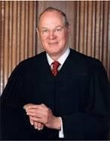Justice Anthony Kennedy
JUSTICE KENNEDY delivered the opinion of the Court.

“Facts of the case
In 1986, the United States Customs Service implemented a drug testing program for certain employees who either carry firearms, are involved in intercepting drugs as they enter the country, or are in high level positions involving classified information.
Question
Did the regulations violate the Fourth Amendment?

Conclusion
No. The Court held that the ‘substantial interests’ of the government in stifling the drug trade justified ‘departure from the ordinary warrant and probable cause requirements’ associated with searches. The fact that customs personnel are the country's ‘first line of defense’ against drug smugglers and they are exposed to a sometimes aggressive criminal element, places them in a unique and important position in which they have a
"diminished expectation of privacy.’” https://www.oyez.org/cases/1988/86-1879

Jan. 20, 1989: President George H. W. Bush – First Inauguration
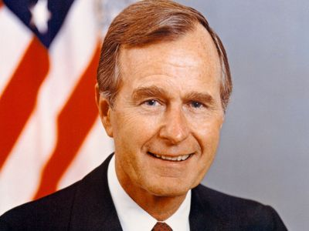
https://www.britannica.com/biography/George-H-W-Bush

Jan. 20, 1989: Ronald Regan – Leaving Office, Personal Note To President George H.W. Bush
“In 1989, Reagan scribbled a note to his successor and former vice president on a silly illustration of an elephant — the animal mascot of the Republican Party — overcome by turkeys.
‘Don’t let the turkeys get you down,’ read the caption.
Dear George
You’ll have moments when you want to use this particular stationery. Well go to it.
George I treasure the memories we share and wish you all the very best. You’ll be in my prayers. God Bless You & Barbara. I’ll miss our Thursday lunches.
Ron
https://www.washingtonpost.com/history/2025/01/20/inauguration-letter-president-trump-biden-tradition/?utm_campaign=wp_post_most&utm_medium=email&utm_source=newsletter&carta-url=https%3A%2F%2Fs2.washingtonpost.com%2Fcar-ln-tr%2F41281a4%2F67b363a6eb3eba471afc37e7%2F59731235ade4e21a848a56ed%2F23%2F53%2F67b363a6eb3eba471afc37e7

May 21, 1989: U.S. Supreme Court - Skinner v. Railway Labor Executives’ Association (7 to 2) https://supreme.justia.com/cases/federal/us/489/602/

RANDOM DRUG TESTING RAILROAD EMPLOYEES PERFORMING SAFETY SENSITIVE WORK
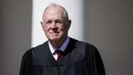Justice Anthony Kennedy
JUSTICE KENNEDY delivered the opinion of the Court.

“Facts of the case
Recognizing the dangers of drug and alcohol abuse by railroad employees, the Federal Railroad Administration (FRA) implemented regulations requiring mandatory blood and urine tests of employees involved in certain train accidents. Other FRA rules allowed railroads to administer breath and urine tests to employees who violate certain safety rules.
Question
Did the regulations violate the Fourth Amendment?

Conclusion
No. The Court held that the government's interest in assuring safety on the nation's railroads constituted a ‘special need’" which justified a departure from standard warrant and probablecause requirements in searches. Preventing accidents, the goal of most railroad regulations including the one in this case, argued Justice Kennedy, was such a significant concern that it warranted reduced ‘expectations of privacy’ for railroad employees.” https://www.oyez.org/cases/1988/87-1555

Aug. 23, 1989 – Pet Rose Banned From Baseball
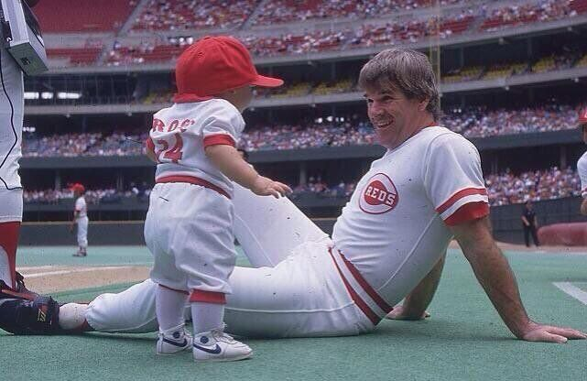
Pete Rose & his son, Tyler– 1985
“On August 23, 1989, as punishment for betting on baseball, Cincinnati Reds manager Pete Rose accepts a settlement that includes a lifetime ban from the game. The ban is publicly announced the following morning. A heated debate continues to rage as to whether Rose, a former player who remains the game’s all-time hits leader, should be given a second chance.” https://www.history.com/this-day-in-history/august-23/pete-rose-gets-booted-from-baseball

December 1989: Panama
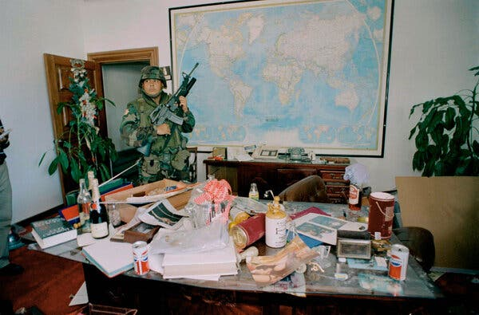 A U.S. Army soldier standing guard in Gen. Manuel Noriega’s office in Panama City in December 1989.
Gen. Manuel Noriega, the military leader of Panama, had longstanding ties to the C.I.A. and to its director, George H.W. Bush, who would be elected president. From the 1960s to the 1980s, the United States paid General Noriega to help sabotage the left-wing Sandinistas in Nicaragua and the F.M.L.N. revolutionaries in El Salvador. He also worked with the Drug Enforcement Administration to restrict illegal drug shipments — and laundered drug money as a side hustle.
But around 1986, news reports surfaced in the American media about the criminal activities of General Noriega, who was now the military dictator of Panama. Mr. Reagan asked the general to step down; he refused. American courts indicted him on drug-related charges. General Noriega soured on the United States and started asking for and receiving military aid from Cuba, Nicaragua and Libya, which were Soviet-bloc countries.
The general survived attempted coups and a disputed election. On Dec. 15, 1989, Panama’s General Assembly passed a resolution declaring a state of war with the United States.
The next night, four U.S. service members were stopped at a roadblock in Panama; one was shot and killed. Mr. Bush ordered in U.S. troops to remove General Noriega.
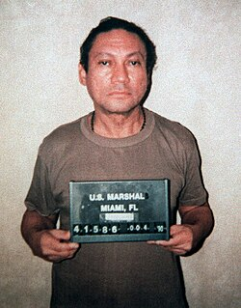 Noriega's mug shot after his surrender to U.S. forces in 1990

July 26, 1990: ADA - Americans With Disability Act
https://www.eeoc.gov/eeoc/history/35th/1990s/ada.html
“Passed by Congress in 1990, the Americans with Disabilities Act (ADA) is the nation's first comprehensive civil rights law addressing the needs of people with disabilities, prohibiting discrimination in employment, public services, public accommodations, and telecommunications. EEOC was given enforcement authority for Title I of the Act, the employment discrimination provisions. Congress provided that Title I would not take effect for two years in order to allow the Commission time to develop regulations and technical assistance, time to conduct comprehensive public education programs on the new disability law, and time for employers to adjust to the new requirements.”
(July 31, 2020) Joint Statement by the U.S. Equal Employment Opportunity
Commission, Department of Justice, and Department of Labor Commemorating the
30th Anniversary of the Americans with Disabilities Act and its Impact on the American Workforce https://www.justice.gov/opa/pr/joint-statement-us-equalemployment-opportunity-commission-department-justice-and-department
“Through its enforcement efforts, DOJ works to ensure that people with disabilities are judged for their skills and what they are able to contribute, rather than having their employment opportunities limited by stereotypes and assumptions about their disability. For example, DOJ recently settled a case involving a Georgia paramedic, who also worked part-time as an emergency medical technician teaching assistant at a technical college, after the college unlawfully terminated her because she had multiple sclerosis.”
(Nov. 7, 2019) SETTLEMENT AGREEMENT BETWEEN
THE UNITED STATES OF AMERICA AND
LANIER TECHNICAL COLLEGE https://www.ada.gov/lanier_sa.html
“Specifically, the United States alleges that Defendant removed Complainant from the work schedule for an entire school semester, thus reducing her hours and compensation to zero, because of her multiple sclerosis. In doing so, the United
States alleges that Defendant terminated Complainant’s employment because of her disability.”

1991: General H. Norman Schwarzkopf – Incident Command / Desert Storm

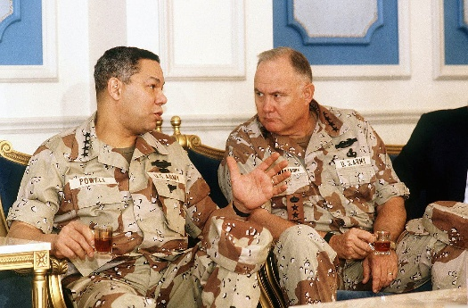

“There's nothing wrong with being afraid. And true courage is not not being afraid. True courage is being afraid, and going ahead and doing your job anyhow, that's what courage is.

***
Allied forces carried out a six-week aerial bombardment of Iraq, to disrupt or destroy enemy communications, supply lines and infrastructure. Schwarzkopf feigned an amphibious landing on Kuwait, drawing the bulk of Iraqi forces and exposing their west flank to the Allied advance. Allied troops advanced quickly through Kuwait and into Iraq. With their communications destroyed, their supply lines cut and the Allies within 150 miles of Baghdad, the Iraqis began to surrender in massive numbers. Iraq accepted a cease-fire and, after only 100 hours, the ground fighting was over. Total casualties of the Allied forces were 115 killed in action, 330 wounded in action.” https://achievement.org/achiever/general-h-norman-schwarzkopf/

1991 - Persian Gulf War

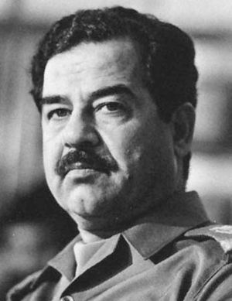
Saddam Hussein

“In August 1990 the Iraqi army overran neighboring Kuwait. Saddam apparently intended to use that nation’s vast oil revenues to bolster Iraq’s economy, but his occupation of Kuwait quickly triggered a worldwide trade embargo against Iraq. He ignored appeals to withdraw his forces from Kuwait, despite the buildup of a large U.S.-led military force in Saudi Arabia and the passage of United Nations (UN) resolutions condemning the occupation and authorizing the use of force to end it. The Persian Gulf War began on January 16, 1991, and ended six weeks later when the allied military coalition drove Iraq’s armies out of Kuwait. Iraq’s crushing defeat triggered internal rebellions by both Shiʿis and Kurds, but Saddam suppressed their uprisings, causing thousands to flee to refugee camps along the country’s northern border. Untold thousands more were tortured and murdered, many simply disappearing into the regime’s prisons, such as the notorious Abu Ghraib.” https://www.britannica.com/biography/Saddam-Hussein
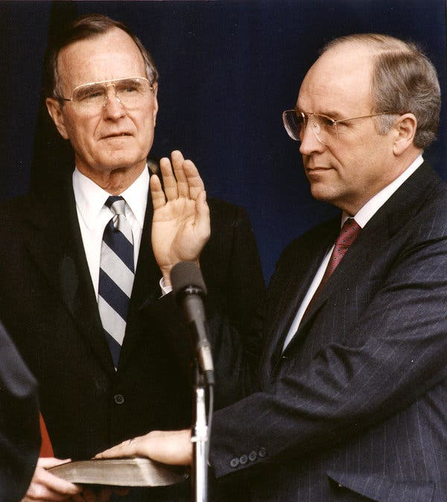
Dick Cheney
“But it was the national security arena where he had the most profound impact. As defense secretary, he helped engineer the gulf war that successfully evicted Iraqi invaders from Kuwait in 1991, then took a leading role a decade later in responding to the terrorist attacks of Sept. 11, 2001. To prevent future attacks, he advocated aggressive policies including warrantless surveillance, indefinite detention and brutal interrogation tactics. And he pushed for the invasion of Iraq to topple Saddam Hussein in 2003, completing the unfinished job of his previous stint in power but leading to years of bloody warfare.” https://www.nytimes.com/2025/11/04/us/politics/dick-cheney-dead.html?nl=The+Morning

June 21, 1971: Bivens v. Six Unknown Named Agents of Federal Bureau of Narcotics (6 to 3)
https://supreme.justia.com/cases/federal/us/403/388/
If federal agents unlawfully search your home, can sue U.S. and the agents for damages.
“While there is no explicit right to file a civil lawsuit against federal government officials who have violated the Fourth Amendment, this right can be inferred. This is because a constitutional protection would not be meaningful if there were no way to seek a remedy for a violation of it.
***
This case has its origin in an arrest and search carried out on the morning of November 26, 1965. Petitioner's complaint alleged that, on that day, respondents, agents of the Federal Bureau of Narcotics acting under claim of federal authority, entered his apartment and arrested him for alleged narcotics violations. The agents manacled petitioner in front of his wife and children, and threatened to arrest the entire family. They searched the apartment from stem to stern. Thereafter, petitioner was taken to the federal courthouse in Brooklyn, where he was interrogated, booked, and subjected to a visual strip search.
***
“Facts of the case
In 1965, six agents of the Federal Bureau of Narcotics forced their way into Webster Bivens’ home without a warrant and searched the premises. The agents handcuffed Bivens in front of his wife and children and arrested him on narcotics charges. Later, the agents interrogated Bivens and subjected him to a visual strip search. Bivens sued the agents for $15,000 in damages each for humiliation and mental suffering. The district court dismissed the complaint for failure to state a cause of action. The U.S. Court of Appeals for the Second Circuit affirmed.
Question
- Does violation of an individual’s Fourth Amendment protection against unreasonable search and seizure give rise to a federal claim for damages?
YES
- Does governmental privilege extend to federal agents who clearly violate constitutional rights and act outside their authority?
NO.” https://www.oyez.org/cases/1970/301

Nov. 21, 1991: CIVIL RIGHTS ACT OF 1991

“On November 21, 1991, Congress enacted the Civil Rights Act of 1991. Congress acted to address a series of no fewer than seven decisions by the Supreme Court, some of which were regarded as changing the well-established landscape of discrimination law, and calling into doubt existing precedent.
***
In addition, the 1991 Act added a new subsection to Title VII, codifying the disparate impact theory of discrimination, essentially putting the law back as it had been prior to Wards Cove. And in response to Price-Waterhouse, the Act provided that where the plaintiff shows that discrimination was a motivating factor for an employment decision, the employer is liable for injunctive relief, attorney's fees, and costs (but not individual monetary or affirmative relief) even though it proves it would have made the same decision in the absence of a discriminatory motive. The Act also provided employment discrimination protection to employees of Congress and some high-level political appointees. Lastly, Title VII and ADA coverage was extended to include American and American-controlled employers operating abroad.” https://www.eeoc.gov/eeoc/history/35th/1990s/civilrights.html
Civil Rights Act of 1991: https://www.eeoc.gov/civil-rights-act-1991-original-text
An Act
To amend the Civil Rights Act of 1964 to strengthen and improve Federal civil rights laws, to provide for damages in cases of intentional employment discrimination, to clarify provisions regarding disparate impact actions, and for other purposes.
Be it enacted by the Senate and House of Representatives of the United States of America in Congress assembled,
SECTION 1. SHORT TITLE.
This Act may be cited as the `Civil Rights Act of 1991'.
SEC. 3. PURPOSES.
The purposes of this Act are--
(1) to provide appropriate remedies for intentional discrimination and unlawful harassment in the workplace;
(2) to codify the concepts of `business necessity' and `job related' enunciated by the Supreme Court in Griggs v. Duke Power Co., 401 U.S. 424 (1971), and in the other Supreme Court decisions prior to Wards Cove Packing Co. v. Atonio, 490 U.S. 642 (1989);
(3) to confirm statutory authority and provide statutory guidelines for the adjudication of disparate impact suits under title VII of the Civil Rights Act of 1964 (42 U.S.C. 2000e et seq.); and
(4) to respond to recent decisions of the Supreme Court by expanding the scope of relevant civil rights statutes in order to provide adequate protection to victims of discrimination.
***
(3) REASONABLE ACCOMMODATION AND GOOD FAITH EFFORT- In cases where a discriminatory practice involves the provision of a reasonable accommodation pursuant to section 102(b)(5) of the Americans with Disabilities Act of 1990 or regulations implementing section 501 of the Rehabilitation Act of 1973, damages may not be awarded under this section where the covered entity demonstrates good faith efforts, in consultation with the person with the disability who has informed the covered entity that accommodation is needed, to identify and make a reasonable accommodation that would provide such individual with an equally effective opportunity and would not cause an undue hardship on the operation of the business.
***
(b) COMPENSATORY AND PUNITIVE DAMAGES-
(1) DETERMINATION OF PUNITIVE DAMAGES- A complaining party may recover punitive damages under this section against a respondent (other than a government, government agency or political subdivision) if the complaining party demonstrates that the respondent engaged in a discriminatory practice or discriminatory practices with malice or with reckless indifference to the federally protected rights of an aggrieved individual.
***
SEC. 105. BURDEN OF PROOF IN DISPARATE IMPACT CASES.
(a) Section 703 of the Civil Rights Act of 1964 (42 U.S.C. 2000e-2) is amended by adding at the end the following new subsection:
`(k)(1)(A) An unlawful employment practice based on disparate impact is established under this title only if--
`(i) a complaining party demonstrates that a respondent uses a particular employment practice that causes a disparate impact on the basis of race, color, religion, sex, or national origin and the respondent fails to demonstrate that the challenged practice is job related for the position in question and consistent with business necessity; or
`(ii) the complaining party makes the demonstration described in subparagraph (C) with respect to an alternative employment practice and the respondent refuses to adopt such alternative employment practice.”

Jan. 20, 1993: PRESIDENT WILLIAM CINTON - FIRST INAGURATION
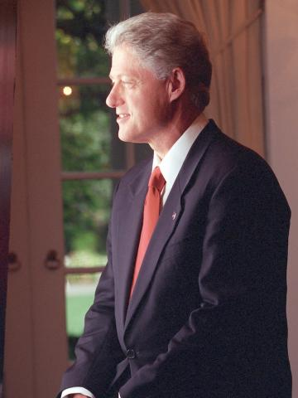
https://www.clintonlibrary.gov/research/clinton-biographies
Jan. 20, 1993: GEORGE H.W. BUSH – LEAVING OFFICE – PERSONAL NOTE TO BILL CLINTON
“Dear Bill,
When I walked into this office just now I felt the same sense of wonder and respect that I felt four years ago. I know you will feel that, too.
I wish you great happiness here. I never felt the loneliness some Presidents have described.
There will be very tough times, made even more difficult by criticism you may not think is fair. I’m not a very good one to give advice; but just don’t let the critics discourage you or push you off course.
You will be our President when you read this note. I wish you well. I wish your family well.
Your success now is our country’s success. I am rooting hard for you.
Good luck —
George”
https://www.washingtonpost.com/history/2025/01/20/inauguration-letter-president-trump-biden-tradition/?utm_campaign=wp_post_most&utm_medium=email&utm_source=newsletter&carta-url=https%3A%2F%2Fs2.washingtonpost.com%2Fcar-ln-tr%2F41281a4%2F67b363a6eb3eba471afc37e7%2F59731235ade4e21a848a56ed%2F23%2F53%2F67b363a6eb3eba471afc37e7

Jan. 20, 1993: PRESIDENT WILLIAM CLINTON - INAGURATION

Feb. 6, 1993: FIRST ATTACK ON WORLD TRADE CENTER

“FBI - World Trade Center Bombing 1993.” https://www.fbi.gov/history/famous-cases/world-trade-center-bombing-1993
“One clue led to another and we soon had in custody three more suspects—Nidal Ayyad, Mahmoud Abouhalima, and Ahmed Ajaj. We’d also found the apartment where the bomb was built and a storage locker containing dangerous chemicals, including enough cyanide gas to wipe out a town. All four men were tried, convicted, and sentenced to life in prison.
***
Meanwhile, the mastermind of the World Trade Center bombing was still on the run—and up to no good. We’d learned his name—Ramzi Yousef—within weeks after the attack and discovered he was planning more attacks, including the simultaneous bombing of a dozen U.S. international flights. Yousef was captured in Pakistan in February 1995, returned to America, and convicted along with the van driver, Eyad Ismoil. A seventh plotter, Abdul Yasin, remains at large.We later learned from Yousef that his Trade Center plot was far more sinister. He wanted the bomb to topple one tower, with the collapsing debris knocking down the second. The attack turned out to be something of a deadly dress rehearsal for 9/11; with the help of Yousef’s uncle Khalid Sheikh Mohammed, al Qaeda would later return to realize Yousef’s nightmarish vision.”

Oct. 13, 1994: Uniformed Services Employment and Re-employment Rights Act (USERRA) of 1994

Oct. 13, 1994: President Bill Clinton signed into law the Uniformed Services Employment and Reemployment Rights Act (USERRA). https://osc.gov/Services/Pages/USERRA.aspx

***

“President Bush's war on terrorism in response to the Sept. 11 terrorist attacks has led to the mobilization of 50,000 National Guard and Reserve troops. Those called to military service are making real sacrifices, as they leave both jobs and families. Some are firefighters. Following the Persian Gulf War, when more than 265,000 reservists and national guardsmen were activated, Congress enacted the Uniformed Services Employment and Re-employment Rights Act of 1994 (USERRA) to assist those who are mobilized.” https://www.firehouse.com/leadership/article/10545356/law-protects-members-called-to-military-duty

***
​“The Uniformed Services Employment and Reemployment Rights Act (USERRA) is a federal law, passed in 1994, that protects military service members and veterans from employment discrimination on the basis of their service, and allows them to regain their civilian jobs following a period of uniformed service.
USERRA a​pplies to members of the Armed Forces, Reserves, National Guard, and other “Uniformed Services” (including the National Disaster Medical System and the Commissioned Corps of the Public Health Service). The law ensures that service members:
- Are not disadvantaged in their civilian careers because of their military service;
- Are promptly re-employed in their civilian jobs upon return from duty;
- Are not discriminated against by employers because of past, present, or future military service.
USERRA applies to both public and private employers. The Office of Special Counsel, in conjunction with the Department of Labor, investigates and enforces USERRA claims involving federal government employers. The Department of Labor and the Department of Justice handle USERRA claims involving private employers as well as state and local governments.” https://osc.gov/Services/Pages/USERRA.aspx

See also: https://webapps.dol.gov/elaws/vets/userra/

***

March 24. 2025:
“USERRA Protections Broadened by Dole Act. On January 2, 2025, then-President Biden signed into law the Senator Elizabeth Dole 21st Century Veterans Healthcare and Benefits Improvement Act (Dole Act), a bipartisan bill that expands healthcare and other benefits for veterans. Among its various pro-veteran measures, the Dole Act introduced noteworthy amendments to the Uniformed Services Employment and Reemployment Rights Act (USERRA). USERRA, enacted in 1994, prohibits employers from discriminating and retaliating against veterans and service members because of their military status or service. USERRA also provides reemployment rights and other rights and benefits to workers whose civilian jobs are voluntarily or involuntarily interrupted by military obligations.

1. Retaliation Protections Broadened:
The Dole Act significantly expands USERRA’s anti-retaliation protections. Previously, the law only prohibited “discrimination in employment” and “adverse employment actions” against individuals who exercised their USERRA rights, sought enforcement of those rights, or participated in related proceedings. Now, employers are barred from taking any form of retaliatory action, eliminating the need to debate whether a retaliatory act meets the threshold of an “adverse employment action.” Courts had previously required proof of a material change in employment conditions or significant harm—those requirements are now gone. Additionally, retaliation no longer needs to be employment-related, broadening the scope of prohibited reprisals and bolstering protections for service members.

2. Increased Liquidated Damages: Before the Dole Act, USERRA authorized liquidated damages awards that were equal to the employee’s lost wages and benefits if a private or state or local government employer’s USERRA violation was “willful.” “Willful” violations occurred when an employer acted with reckless disregard for whether its conduct violated USERRA.
The Dole Act strengthens liquidated damages under USERRA by allowing awards even when no lost wages or benefits are recovered and establishes a minimum award of $50,000. Now, courts can require an employer to pay the greater of $50,000 or the total sum of lost wages, benefits, and prejudgment interest.” https://www.littler.com/news-analysis/asap/userra-protections-broadened-dole-act

***
“On September 29, 2022, President Biden signed S. 2293 the “Civilian Reservist Emergency Workforce Act of 2021” or the “CREW Act,” into law. The “CREW Act” extends employment protections under the Uniformed Services Employment and Reemployment Rights Act (USERRA) to Federal Emergency Management Agency (FEMA) reservists who deploy to major disaster sites. For questions or technical assistance with respect to the “CREW Act,” the U.S. Department of Defense Employer Support of the Guard and Reserve (ESGR) and VETS staff are available to assist.” https://www.dol.gov/agencies/vets/programs/userra

Nov. 30, 1993 – BRADY HANDGUN ACT
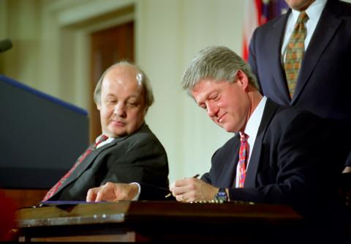
“The Brady Handgun Violence Prevention Act of 1993 amended the federal Gun Control Act of 1968 to provide a method for preventing firearms transfers to prohibited persons.1 Under the Brady Act, every firearm dealer, known as a federal firearms licensee (FFL), must request a background check on any potential purchaser or firearm transferee. To aid in fulfilling that
mandate, the Brady Act required creation of the National Instant Criminal Background Check System (NICS), a computerized system that stores records on persons who may be disqualified from receiving firearms. Each state determines its form of interaction with NICS, and each state may use its own background check system, thus becoming a full point-of-contact (POC) state, by designating a local or state law enforcement authority to serve as intermediary between its FFLs and NICS.” https://www.pacourts.us/assets/opinions/Supreme/out/Affirmed-Reversed-Remanded.pdf?cb=2

“After Jim Brady survived a bullet to the head during the 1981 assassination attempt of President Reagan, he and his wife, Sarah Brady, knew our country urgently needed common-sense solutions to prevent guns from falling into the hands of those who intend to cause harm.
The path to pass the Brady Bill was neither easy nor short. It took Jim and Sarah seven years, six votes, and three presidents to finally pass the Brady Bill.” https://www.bradyunited.org/resources/research/how-brady-background-checks-became-law

September 1994 - Haiti
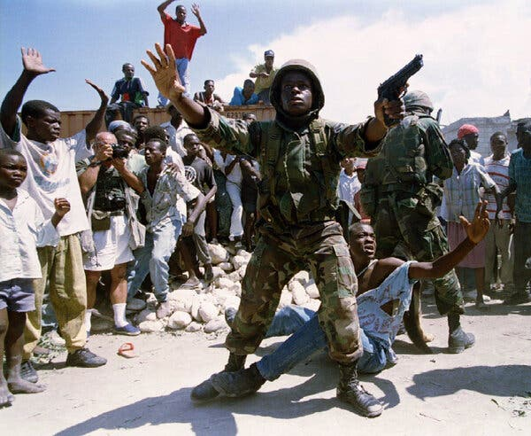 A U.S. soldier in Port-au-Prince, Haiti, after an explosive device was thrown at a pro-Aristide march in September 1994.
“Sixty years after their first trip to Haiti, the Marines were back, this time with Army troops, after President Bill Clinton ordered the U.S. military to restore to power President Jean-Bertrand Aristide, who had been democratically elected and quickly overthrown.
Ten years later, Mr. Aristide was out of favor with Washington and ousted in a coup orchestrated by the United States and France, which had colonized the country.” https://www.nytimes.com/2025/12/09/us/politics/military-history-latin-america-strikes.html?nl=Breaking+News&segment_id=212078

April 19, 1995: OKLAHIOMA CITY BOMBING – ALFRED P. MURRAH FEDERAL BUILDING
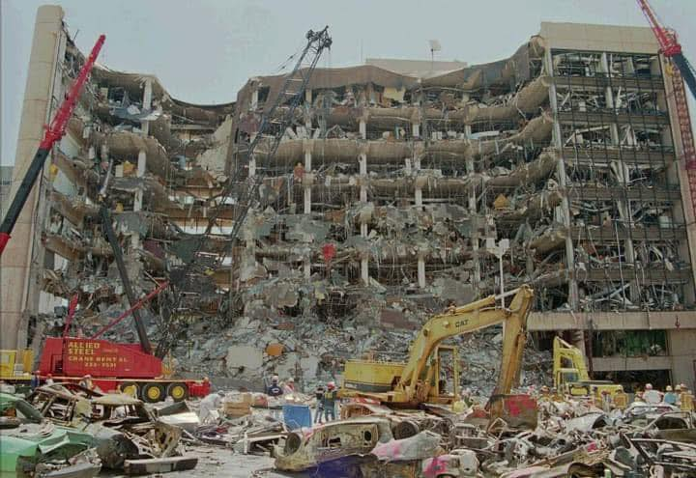
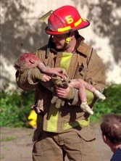Oklahoma City Fire Captain Chris Fields carries 1-yr old Baylee Almon. https://www.usatoday.com/story/news/2015/04/18/oklahoma-city-photo/25957831/
Tim McVeigh was executed by lethal injection on June 11, 2001, at the U.S. federal penitentiary in Terre Haute, Indiana. Terry Nichols was sentenced to life in prison.
Antiterrorism and Effective Death Penalty Act of 1996:

“The [1995] Oklahoma City bombing, a tragedy that claimed the lives of 168 people, 19 of whom were children,' brought the issue of domestic terrorism to the forefront of American social concerns and created the political impetus to address and eliminate this new threat to the United States' national security. In response, the legislature has strived to combat the force of domestic terrorism through legislation aimed at deterring and preventing these senseless acts of violence. Consequently, the United States Senate passed the Comprehensive Terrorism Prevention Act of 1995 shortly after the Oklahoma City Bombing. Following the Comprehensive Terrorism Prevention Act of 1995, the House of Representatives, in March 1996, passed a similar resolution titled the Effective Death Penalty and Public Safety Act of 1996.' The United States Senate sought to temper the more stringent provisions of the proposed Effective Death Penalty and Public Safety Act and ultimately passed the Antiterrorism and Effective Death Penalty Act of 1996 (‘AEDPA’) on April 17, 1996. President Clinton signed the AEDPA into law on April 24, 1996,’ in commemoration of the Oklahoma City Bombing that occurred one year and five days earlier.” https://scholarship.law.nd.edu/cgi/viewcontent.cgi?article=1218&context=jleg

Attorney General Merrick B. Garland Statement on the 29th Anniversary of the Oklahoma City Bombing (April 19, 2024).
“The Justice Department issued the following statement from Attorney General Merrick B. Garland in recognition of the 29th anniversary of the Oklahoma City Bombing, which took place on April 19, 1995, in Oklahoma City, Oklahoma: “Twenty-nine years after the bombing of the Alfred P. Murrah Federal Building, we continue to remember the 168 people, including 19 children, who were stolen from their loved ones, as well as the hundreds who were injured and forever changed. We continue to mourn alongside the families and the entire Oklahoma City community devastated by the attack. “On this day, twenty-nine years ago, I watched in horror from my desk at the Justice Department as reports came in that there had been an explosion at the Murrah building in Oklahoma City. My colleagues and I gathered in front of a TV in my office and saw our first glimpse of the aftermath of the horrific attack. Forty-eight hours later, I traveled to Oklahoma to represent the United States in the first court hearing of the perpetrator, Timothy McVeigh.” https://www.justice.gov/opa/pr/attorney-general-merrick-b-garland-statement-29th-anniversary-oklahoma-city-bombing

1996: HIPAA https://www.hhs.gov/hipaa/for-professionals/privacy/index.html
“The Health Insurance Portability and Accountability Act of 1996 (HIPAA) required the Secretary of the U.S. Department of Health and Human Services (HHS) to develop regulations protecting the privacy and security of certain health information.¹ To fulfill this requirement, HHS published what are commonly known as the HIPAA Privacy Rule and the HIPAA Security Rule. [Nov. 3, 1999].
The Privacy Rule, or Standards for Privacy of Individually Identifiable Health Information, establishes national standards for the protection of certain health information. The Security Standards for the Protection of Electronic Protected Health Information (the Security Rule) establish a national set of security standards for protecting certain health information that is held or transferred in electronic form. The Security Rule operationalizes the protections contained in the Privacy Rule by addressing the technical and non-technical safeguards that organizations called “covered entities” must put in place to secure individuals’ “electronic protected health information” (e-PHI).
Within HHS, the Office for Civil Rights (OCR) has responsibility for enforcing the Privacy and Security Rules with voluntary compliance activities and civil money penalties.”
https://www.hhs.gov/hipaa/for-professionals/security/lawsregulations/index.html

April 1996: Unabomber Arrested
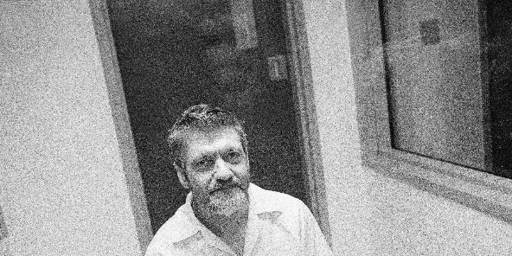
In April 1996, the FBI arrested Ted Kaczynski at his cabin in Montana. When they searched the cabin, they found bomb-making materials…. Kaczynski graduated from Harvard with a degree in mathematics in 1962 and went on to the University of Michigan, where he completed a Ph.D. He then went to work at the University of California, Berkeley, as a tenured professor. But he left UC Berkeley suddenly, and, in 1971, he moved to Lincoln, Montana, where he built a one-room cabin with no electricity or running water. He lived on game he hunted, the produce of a garden he tended, and the money his family members sent him. And it was in this period that Kaczynski started building the explosive devices that won him the moniker “Unabomber.” He sent them to people he had never met, although they were individuals whom he believed were furthering the expansion of technology, which he thought would lead to the ruination of society. His first bomb injured a security guard at Northwestern University in Evanston, Illinois, in May 1978. About a year later, in May 1979, another bomb exploded at Northwestern, injuring a student. But in November of that year, Kaczynski’s third bomb went off in the cargo hold of American Airlines Flight 444 from Chicago to Washington, D.C., forcing the plane to land and injuring 12 people. Because bombing a commercial airliner is a federal offense, the FBI investigated the crime. It was at this point that the unknown perpetrator was dubbed the “Unabomber,” for “university and airline bomber.” https://archivesfoundation.org/newsletter/the-unabomber/

April 24, 1996: Antiterrorism and Effective Death Penalty Act of 1996 (AEDPA)
“The Antiterrorism and Effective Death Penalty Act of 1996 gave the Secretary of State authority to designate foreign terrorist organizations whose terrorist activity threatens the security of United States nationals or the national defense, foreign relations or economic interests of the United States.
The Antiterrorism Act also created 18 U.S.C. § 2339B, which makes it unlawful, within the United States, or for any person who is subject to the jurisdiction of the United States anywhere, to knowingly provide material support to a foreign terrorist organization that has been designated by the Secretary of State. See Pub. L. 104-132, § 303, 110 Stat. 1214, 1250.” https://www.justice.gov/archives/jm/criminal-resource-manual-16-providing-material-support-designated-terrorist-organizations

Criminal defendants convicted in state court now have very limited rights to appeal to federal judges for habeas corpus relief.
“A § 2254 habeas petition is governed by the heightened standard of review outlined in the Anti-Terrorism and Effective Death Penalty Act (‘AEDPA’). 28 U.S.C. § 2254. To obtain relief, habeas petitioners who raise claims adjudicated by state courts must ‘show that the relevant state-court decision (1) was contrary to, or involved an unreasonable application of, clearly established Federal law, or (2) was based on an unreasonable determination of the facts in light of the evidence presented in the State court proceedings.’ Wilson v. Sellers, 584 U.S. 122, 125 (2018) (quoting 28 U.S.C. § 2254(d)). The focus of this standard ‘is not whether a federal court believes the state court's determination was incorrect but whether that determination was unreasonable-a substantially higher threshold.’ Schriro v. Landrigan, 550 U.S. 465, 473 (2007). ‘AEDPA thus imposes a highly deferential standard for evaluating state-court rulings and demands that state-court decisions be given the benefit of the doubt.’ Renico v. Lett, 559 U.S. 766, 773 (2010) (internal citations and quotation marks omitted). Ultimately, ‘[a] state court's determination that a claim lacks merit precludes federal habeas relief so long as ‘fair-minded jurists could disagree' on the correctness of the state court's decision.’ Harrington v. Richter, 562 U.S. 86, 101 (2011) (quoting Yarborough v. Alvarado, 541 U.S. 652, 664 (2004)). Additionally, a state court's factual determinations are presumed correct on federal habeas review, 28 U.S.C. § 2254(e)(1), and review is ‘limited to the record that was before the state court.’ Cullen v. Pinholster, 563 U.S. 170, 181 (2011). https://law.justia.com/cases/federal/district-courts/michigan/miedce/2:2014cv14849/297471/5/

September, 1996 - Comprehensive Test Ban Treaty
“These tests [hydronuclear tests] are permitted under the Comprehensive Nuclear Test Ban Treaty, which the United States signed in 1996 but has never ratified.” https://www.nytimes.com/2025/11/24/science/hydro-nuclear-testing-trump.html?algo=combo_lda_unique_triton_clicks_decay_96_50_ranks&fellback=false&imp_id=5656603060179752&nl=On+Politics&pool=programmingnode%2F0dc6538b-a831-51be-a980-5597993fb6e2&req_id=4969101602534021&surface=more-politics-news&variant=0_only_variant
***
“The Comprehensive Test Ban Treaty (CTBT) prohibits “any nuclear weapon test explosion or any other nuclear explosion” anywhere in the world. The treaty was opened for signature in September 1996, and has been signed by 187 nations and ratified by 178. The treaty cannot formally enter into force until it is ratified by 44 specific nations, nine of which must still do so: China, India, Pakistan, North Korea, Israel, Iran, Egypt, Russia and the United States. Although Russia ratified the CTBT in 2000, it withdrew its ratification of the CTBT in 2023 to "mirror" the posture of the United States; as a treaty signatory, Russia remains obligated not to take any action contrary to the object or purpose of the treaty.” https://www.armscontrol.org/factsheets/comprehensive-test-ban-treaty-glance

Jan. 20, 1997: PRESIDENT WILLIAM CINTON – SECOND INAGURATION

Jan. 1, 1998: OSHA Two In / Two Out Regulation
“The respiratory protection standard requires that workers engaged in fighting interior structural fires work in a buddy system; at least two workers must enter the building together, so that they can monitor each other's whereabouts as well as the work environment. There must also be at least two standby personnel outside the fire area prepared to rescue the inside firefighters should the need arise. One of these outside firefighters must actively monitor the status of the inside fighters but the second outside firefighter may perform a variety of other duties, such as pump operations, incident commander or outside hose line operation. There are no provisions in the standard to waive the requirements for either the ‘two-inside firefighters’ or the ‘two-outside firefighters’, although the circumstances under which this provision applies are more limited than generally understood.” https://www.osha.gov/laws-regs/standardinterpretations/1998-12-15

May 26, 1998: U.S. Supreme Court - County of Sacramento v. Lewis (9 to 0) https://supreme.justia.com/cases/federal/us/523/833/

HIGH SPEED PURSUITS – POLICE LIABILITY ONLY IF “SHOCKS THE CONSCIENCE”
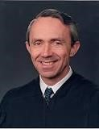Justice David Souter
JUSTICE SOUTER delivered the opinion of the Court.

“Facts of the case
Philip Lewis was a passenger on a motorcycle that was involved in a high-speed police chase. The chase ended when the motorcycle's driver lost control and tipped the bike over, hurling both riders to the pavement. James Smith, one of two pursuing Sacramento county sheriff's deputies, was unable to stop his car in time and skidded into Philip, causing fatal injuries. Philip's parents, Teri and Thomas Lewis, accused Smith and the Sacramento county police department of deliberate and reckless conduct which ultimately deprived their son of his due process right to life and his protection against unconstitutional seizure. On appeal from an appellate court's reversal of a district court decision favoring Smith, the Supreme Court granted certiorari.

Question
Are the Fourteenth Amendment's substantive due process protection, or the Fourth Amendment's guarantee against illegal seizure, violated by a police officer who, in the course of pursuing a subject, causes their death through deliberate or reckless indifference?

Conclusion
No. In a unanimous decision the Court first ruled that the Fourth Amendment's reasonableness standards prevented its illegal seizure protections from applying to highspeed police chases. Such incidents are merely pursuits and do not constitute actual seizures, especially if they fail due to the death of the subject. Moreover, addressing the Fourteenth Amendment challenge, the Court held that Smith's actions, while perhaps unwise, were not intended to injure or kill those pursued. As such, the negligent infliction of harm during a police chase does not violate due process since it is not an unexpectedly shocking or egregious result under the circumstances.” https://www.oyez.org/cases/1997/96-1337

June 26, 1998: U.S. Supreme Court - Faragher v. City of Boca Raton (7 to 2) https://supreme.justia.com/cases/federal/us/524/775/

SEXUAL HARASSMENT - CITY’S FAILURE TO EDUCATE / ENFORCE SEXUAL HARASSMENT POLICY
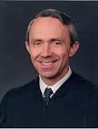Justice David H. Souter
JUSTICE SOUTER delivered the opinion of the Court.

“Facts of the case
After resigning as a lifeguard, Beth Ann Faragher brought an action against the City of Boca Raton and her immediate supervisors, alleging that the supervisors had created a sexually hostile atmosphere by touching, remarking, and commenting. Faragher asserted that this conduct constituted discrimination in violation of Title VII of the Civil Rights Act of 1964. The District Court concluded that Faragher's supervisors' conduct was sufficiently serious to alter the conditions of her employment and constitute an abusive working environment. The court then held that the city could be held liable. In reversing, the en banc Court of Appeals held that Faragher's supervisors were not acting within the scope of their employment when they engaged in the harassing conduct, that knowledge of the harassment could not be imputed to the City, and that the City could not be held liable for negligence in failing to prevent it.

Question
May an employer be held liable under Title VII of the Civil Rights Act of 1964 for the acts of an employee whose sexual harassment of subordinates has created a hostile work environment amounting to employment discrimination?

Conclusion
Yes. In a 7-2 opinion delivered by Justice David H. Souter, the Court held that an employer is vicariously liable under Title VII of the Civil Rights Act of 1964 for actionable discrimination caused by a supervisor. The Court also held that such liability is subject to an affirmative defense looking to the reasonableness of the employer's conduct as well as that of the plaintiff victim. ‘The City had entirely failed to disseminate its policy against sexual harassment among the beach employees and that its officials made no attempt to keep track of the conduct of supervisors like [Faragher's],’ wrote Justice Souter, ‘[u]nder such circumstances, we hold as a matter of law that the City could not be found to have exercised reasonable care to prevent the supervisors' harassing conduct.’” https://www.oyez.org/cases/1997/97-282

August 7, 1998 – Al-Qaega Attacks U.S. Embassies in Nairobi, Kenya and Dar es Salam, Tanzania
FBI - East African Embassy Bombings: https://www.fbi.gov/history/famous-cases/east-african-embassy-bombings
“On August 7, 1998, nearly simultaneous bombs blew up in front of the American embassies in Nairobi, Kenya, and Dar es Salaam, Tanzania, in Africa. Two hundred and twenty-four people died in the blasts, including 12 Americans, and more than 4,500 people were wounded. In the aftermath of the attacks, over 900 FBI agents alone—and many more FBI employees—traveled overseas to assist in the recovery of evidence and the identification of victims at the bomb sites and to track down the perpetrators.
These attacks were soon directly linked to al Qaeda﻿. Extraordinary efforts from our federal and international partners led to the identification, arrest, and extradition to the United States of several members of the al Qaeda terrorist network for their role in the bombings.
Mohammed Sadeek Odeh and Mohammed Rashed Daoud al-Owhali were arrested in Kenya within 20 days of the bombings and rendered to the U.S. shortly thereafter. Both were convicted for their roles in the bombing and sentenced to life in prison in October 2001.
In September 1998, Mamdouh Mahmud Salim was arrested in Germany. He is currently serving a life sentence for stabbing a federal corrections officer in the eye while in prison after being charged in the embassy attacks.
Also in September 1998, Wadih el-Hage—a naturalized American citizen who had been living in Arlington, Texas—was arrested by the FBI for making false statements during questioning. After being indicted for his role in the bombings, he was convicted and sentenced to life in prison in 2001.
On November 4, 1998, Osama Bin Laden and several members of his network, including his military commander Muhammad Atef, were named in an indictment based on the investigation. Both have since been killed.
All told, more than 20 people have been charged in connection with the bombings. Seven are serving life sentences in U.S. prison.”

Feb. 5, 1999: Family Medical Leave Act
U.S. Department of Labor: https://www.dol.gov/agencies/whd/fmla
“The FMLA entitles eligible employees of covered employers to take unpaid, job-protected leave for specified family and medical reasons with continuation of group health insurance coverage under the same terms and conditions as if the employee had not taken leave. Eligible employees are entitled to:
- Twelve workweeks of leave in a 12-month period for:
  - the birth of a child and to care for the newborn child within one year of birth; o the placement with the employee of a child for adoption or foster care and to care for the newly placed child within one year of placement;
  - to care for the employee’s spouse, child, or parent who has a serious health condition;
  - a serious health condition that makes the employee unable to perform the essential functions of his or her job;
  - any qualifying exigency arising out of the fact that the employee’s spouse, son, daughter, or parent is a covered military member on “covered active duty;” or
- Twenty-six workweeks of leave during a single 12-month period to care for a covered servicemember with a serious injury or illness if the eligible employee is the servicemember’s spouse, son, daughter, parent, or next of kin (military caregiver leave).”
Two types of recovery in lawsuits:
The FMLA provides: “It shall be unlawful for any employer to interfere with, restrain, or deny the exercise of or the attempt to exercise, any right provided under this subchapter.” 29 U.S.C. § 2615(a)(1). The FMLA further provides: “It shall be unlawful for any employer to discharge or in any other manner discriminate against any individual for opposing any practice made unlawful by this subchapter.” 29 U.S.C. § 2615(a)(2). Thus, two separate theories of recovery are available under the FMLA: interference with the exercise of FMLA rights, and retaliation against an employee's opposition to an unlawful FMLA practice. Id. at § 2615(a)(1) and (2).

April 20, 1999: COLUMBINE HIGH SCHOOL, COLORADO – MASS SHOOTING
“The Columbine shooting on April 20, 1999 at Columbine High School in Littleton, Colorado, occurred when two teens [12-graders Eric Harris and Dylan Klebold] went on a shooting spree, killing 13 people and wounding more than 20 others, before turning their guns on themselves and committing suicide.”
https://www.history.com/topics/1990s/columbine-high-school-shootings

***

“On April 20, 1999, Eric Davis Harris (1981-1999) and Dylan Bennet Klebold (1981-1999) killed 12 students and one teacher at Columbine High School in Littleton, Colorado before committing suicide. The tragedy sparked national debates about school safety. The FBI assisted local law enforcement by investigating additional threats and Internet leads, conducting witness interviews, and processing physical evidence. The FBI’s file details the initial investigation and contains witness interviews between April 21, 1999 and May 5, 1999.” https://vault.fbi.gov/Columbine%20High%20School%20

***

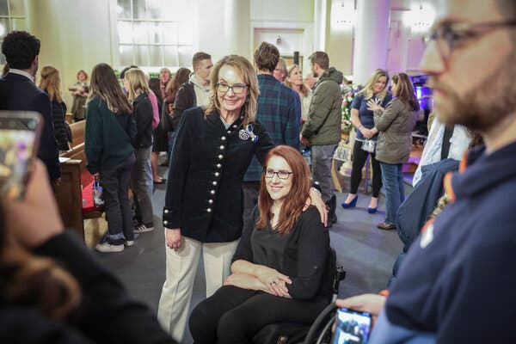

“Feb. 18, 2025: Anne Marie Hochhalter, Paralyzed in Columbine Shooting, Dies at 43.
Fiercely independent, she publicly discussed the long-term effects of gun violence and spoke of forgiveness…. Sue Townsend, who became close to Ms. Hochhalter after her stepdaughter, Lauren Townsend, was killed in the shooting, said that Ms. Hochhalter had been dealing with lingering effects from her injuries, including a pressure sore and an infection…. Ms. Hochhalter, a junior who was 17, was shot twice — once in the chest and once in the back — and was paralyzed from the waist down. Her brother, Nathan Hochhalter, who was a freshman at Columbine, was trapped in the school for hours until a SWAT team arrived.” https://www.nytimes.com/2025/02/18/us/anne-marie-hochhalter-columbine-shooting-dies.html

June 22, 1999: U.S. Supreme Court - Olmstead v. L.C. (6 to 3) https://supreme.justia.com/cases/federal/us/527/581/

MENTAL DISABILITIES – INSTITUTIONALIZING PEOPLE WITH DISABILITIES IS DISCRIMINATION
https://www.oyez.org/cases/1998/98-536
“[T]wo female patients with mental disabilities, challenged Tommy Olmstead, the Commissioner of Georgia's Department of Human Resources, for the Georgia Regional Hospital's (GRH) decision to keep the two women in psychiatric isolation. [Their attorney] argued that under Title II of the 1990 Americans with Disabilities Act (ADA), the women had to be moved to the most communally integrated setting possible. Defending GRH's decision, Olmstead argued that although the women were medically cleared for a more integrated treatment setting, financial constraints and the need to fundamentally alter treatment programs prevented this from happening.”

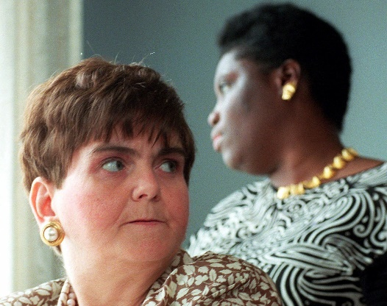
Photograph of Lois Curtis and Elaine Wilson.

U.S. Department of Labor (June 20, 2024). https://blog.dol.gov/2024/06/20/the-olmstead-effect-celebrating-25-years-of-positive-change
“Twenty-five years ago this month, a landmark U.S. Supreme Court ruling ushered in an era of profound and positive change for people with disabilities in America—as well as the agencies that serve and support them, including the department. The case was Olmstead v. L.C., and the plaintiffs were two disabled women, Lois Curtis and Elaine Wilson. Even though Curtis and Wilson desired to reside and receive care in a community-based setting and were declared able to do so by doctors, they were both confined to a state-run hospital for several years. Their attorney argued that such unjust institutionalization amounted to discrimination under the Americans with Disabilities Act, and the nation’s highest court agreed.
In the years since it was handed down, the Olmstead ruling has had a resounding ripple effect, setting in motion policy innovations across numerous federal agencies. This month, in honor of Olmstead’s 25th anniversary, our National Center on Leadership for the Employment and Economic Advancement of People with Disabilities (LEAD Center) published a retrospective of the 25 most impactful developments in disability rights and protections since the decision.
Olmstead affirmed that people with disabilities have the right to receive publicly funded services in the most integrated settings possible based on the individual’s requirements. One of the most notable public services is employment services. Olmstead has served as the bedrock of one of ODEP’s major policy priorities since our inception in 2001: advancing competitive integrated employment (CIE), a key pillar of which is people with disabilities working in the community alongside people without disabilities.”

May 1, 2000: U.S. Supreme Court - Christensen v. Harris County (6 to 3) https://supreme.justia.com/cases/federal/us/529/576/

PUBLIC EMPLOYERS MAY IMPLEMENT COMP TIME POLICY

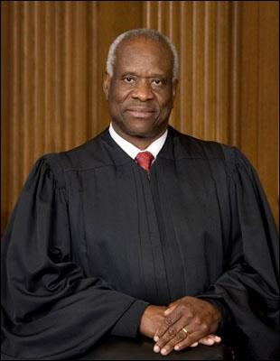 Justice Clarence Thomas
JUSTICE THOMAS delivered the opinion of the Court.

“Facts of the case
The Fair Labor Standards Act of 1938 (FLSA) permits governmental entities to compensate their employees for overtime work by granting them compensatory time in lieu of cash payment. If the employees do not use their accumulated compensatory time, the employer must pay cash compensation under certain circumstances. Harris County, Texas, found that too many of its deputy sheriffs had too many hours of accrued compensatory time. Fearing a budget crisis, the county adopted a policy under which its employees could be ordered to schedule compensatory time at specified times in order to reduce the amount of accrued time that would otherwise require cash payment. Edward Christensen and 128 other deputy sheriffs in Harris County believed they had the right to use their compensatory time when they saw fit. The sheriffs sued, claiming that the FLSA does not permit an employer to compel an employee to use compensatory time in the absence of an agreement permitting the employer to do so. The District Court ruled in favor of the sheriffs, concluding that the policy violated the FLSA. In reversing, the Court of Appeals held that the FLSA did not address the issue in question and thus did not prohibit the county from implementing a compensatory time policy.

Question
Does the Fair Labor Standards Act of 1938 prohibit a public employer from compelling its employees to use their compensatory time without a preexisting agreement?

Conclusion
No. In an opinion delivered by Justice Clarence Thomas, the Court held 6-3 that ‘[n]othing in the FLSA or its implementing regulations prohibits a public employer from compelling the use of compensatory time.’ Justice Thomas wrote for the Court that, ‘under the FLSA, an employer is free to require an employee to take time off work, and an employer is also free to use the money it would have paid in wages to cash out accrued compensatory time. The compelled use of compensatory time challenged in this case merely involves doing both of these steps at once.’” https://www.oyez.org/cases/1999/98-1167

OCT. 30, 2000 – AFG GRANT PROGRAM
[Oct. 30, 2025]: “It’s hard to believe that the Assistance to Firefighters Grant (AFG) Program was signed into law on this day 25 years ago. Passage of the legislation was an uphill battle with many obstacles encountered along the way. At the time, a federal grant program for the fire service seemed like a pipedream. Few in Congress supported the idea, asserting that the federal government should not have a role in funding local fire departments -- that was the role of local and state governments. But a core group of members of Congress – including the leaders of the Congressional Fire Services Caucus – recognized the need for the federal government to provide support to address the growing needs and challenges of local fire departments. They refused to capitulate to the notion that the federal government had no business in supporting local fire departments, affirming that the nation’s safety demands federal investment in the fire service. For two years, they were relentless in advocating for the passage of the authorizing legislation, called the FIRE Act, until President Bill Clinton signed it into law on October 30, 2000 as part of the fiscal year (FY) 2001 National Defense Authorization Act (NDAA).” Congressional Fire Services Institute update@cfsi.ccsend.com

See YouTube summary: https://www.youtube.com/watch?v=CQ6AQ7rsC8U

See Oct. 2000 article:

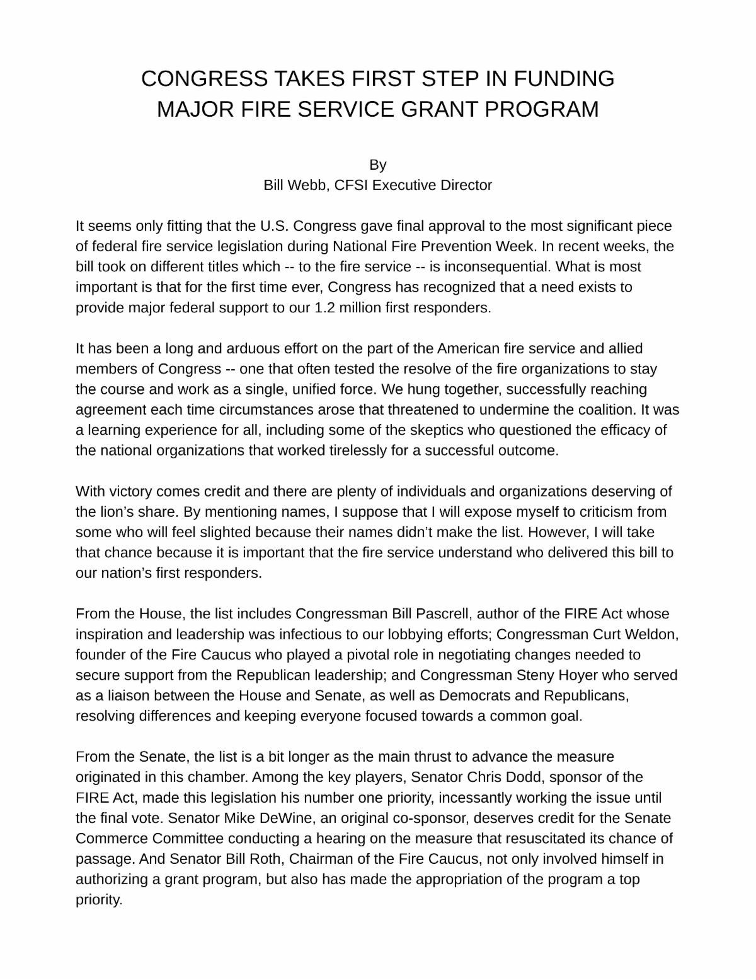

Jan. 20, 2001: PRESIDENT GEORGE W. BUSH – INAURATION
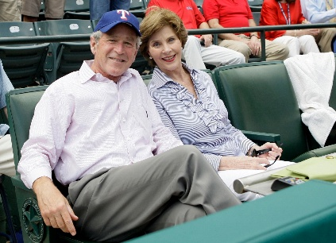
https://georgewbush.com/

Jan. 20, 2001: Bill Blinton – Leaving Office, Personal Note To George W. Bush

“Dear George,

Today you embark on the greatest venture, with the greatest honor, that can come to an American citizen.

Like me, you are especially fortunate to lead our country in a time of profound and largely positive change, when old questions, not just about the role of government, but about the very nature of our nation, must be answered anew.

You lead a proud, decent, good people. And from this day you are President of all of us. I salute you and wish you success and much happiness.

The burdens you now shoulder are great but often exaggerated. The sheer joy of doing what you believe is right is inexpressible.

My prayers are with you and your family. Godspeed.

Sincerely,

Bill”
https://www.washingtonpost.com/history/2025/01/20/inauguration-letter-president-trump-biden-tradition/?utm_campaign=wp_post_most&utm_medium=email&utm_source=newsletter&carta-url=https%3A%2F%2Fs2.washingtonpost.com%2Fcar-ln-tr%2F41281a4%2F67b363a6eb3eba471afc37e7%2F59731235ade4e21a848a56ed%2F23%2F53%2F67b363a6eb3eba471afc37e7

Feb. 18, 2001- Dale Ernhart (age 49) killed at Daytona 500

“That was at least 20 years ago, he says, around the same time NASCAR was issuing sweeping changes in the wake of Dale Sr.’s death. Drivers complained about having to wear head and neck restraints, and cars had to be outfitted with stronger roll bars and carbon fiber seats. Speedway walls were updated with upgraded barriers that dissipated energy during a crash.” https://www.washingtonpost.com/sports/2025/05/22/dale-earnhardt-jr-dad-nascar-death/?utm_campaign=wp_post_most&utm_medium=email&utm_source=newsletter&carta-url=https%3A%2F%2Fs2.washingtonpost.com%2Fcar-ln-tr%2F42afa07%2F682f4d1495e93627b9f1fe1c%2F59731235ade4e21a848a56ed%2F14%2F58%2F682f4d1495e93627b9f1fe1c
https://www.youtube.com/watch?v=qQZPBFI5cc4
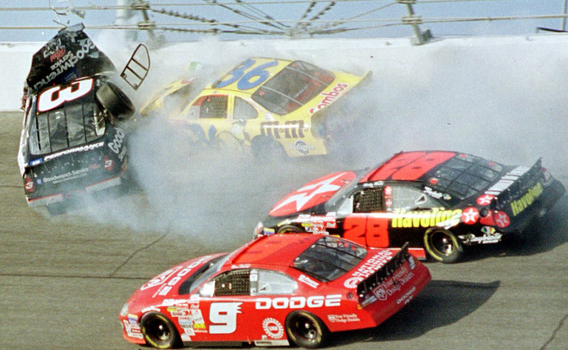

June 11, 2001: United States of America Executed Timothy McVeigh
Tim McVeigh was executed by lethal injection on June 11, 2001, at the U.S. federal penitentiary in Terre Haute, Indiana.
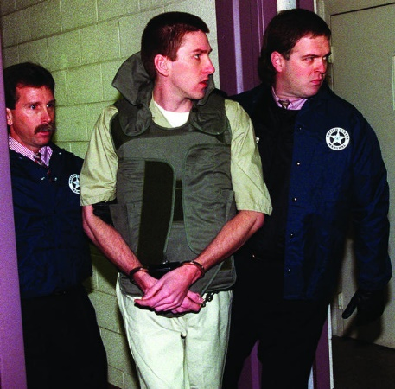
“The execution of Timothy McVeigh: must see TV?”
https://www.ncbi.nlm.nih.gov/pmc/articles/PMC1120354/
“On 19 April 1995, 7000 lbs of explosives detonated alongside the Alfred P Murrah Federal Office Building in Oklahoma City. Without warning the bomb punched a gaping hole through offices and a daycare centre, killing adults and children; 163 died inside the building, four more died outside, and a final victim was killed entering the scene to help the wounded.

Timothy McVeigh, despite his earplugs, heard the deafening roar of the blast and felt the thump of air lift him an inch off the ground. Falling bricks hit him in the leg and a snapped live wire threatened his life. McVeigh, who lit the fuse creating the bloody, horrifying, hideous scene behind him, did not look back. He first saw the devastation via CNN and was momentarily irritated at the sight of the building still standing.”

June 11, 2001: U.S. Supreme Court - Kyllo v. United States (5 to 4) https://supreme.justia.com/cases/federal/us/533/27/

THERMAL IMAGING CAMERA – HEAT FROM MJ LAMPS – ILLEGAL SEARCH

“In 1991 Agent William Elliott of the United States Department of the Interior came to suspect that marijuana was being grown in the home belonging to petitioner Danny Kyllo, part of a triplex on Rhododendron Drive in Florence, Oregon. Indoor marijuana growth typically requires high intensity lamps. In order to determine whether an amount of heat was emanating from petitioner's home consistent with the use of such lamps, at 3:20 a.m. on January 16, 1992, Agent Elliott and Dan Haas used an Agema Thermovision 210 thermal imager to scan the triplex. Thermal imagers detect infrared radiation, which virtually all objects emit but which is not visible to the naked eye. The imager converts radiation into images based on relative warmth-black. *** Where, as here, the Government uses a device that is not in general public use, to explore details of the home that would previously have been unknowable without physical intrusion, the surveillance is a "search" and is presumptively unreasonable without a warrant.
Since we hold the Thermovision imaging to have been an unlawful search, it will remain for the District Court to determine whether, without the evidence it provided, the search warrant issued in this case was supported by probable cause-and if not, whether there is any other basis for supporting admission of the evidence that the search pursuant to the warrant produced.”

Sept. 11, 2001 – Attacks On World Trade Center and Pentagon
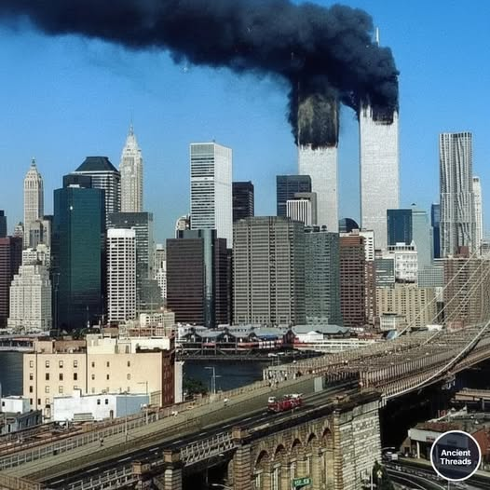
“On September 11, 2001, 2,977 people were killed in the deadliest terrorist attacks in American history.” https://millercenter.org/remembering-september-11/september-11-terrorist-attacks

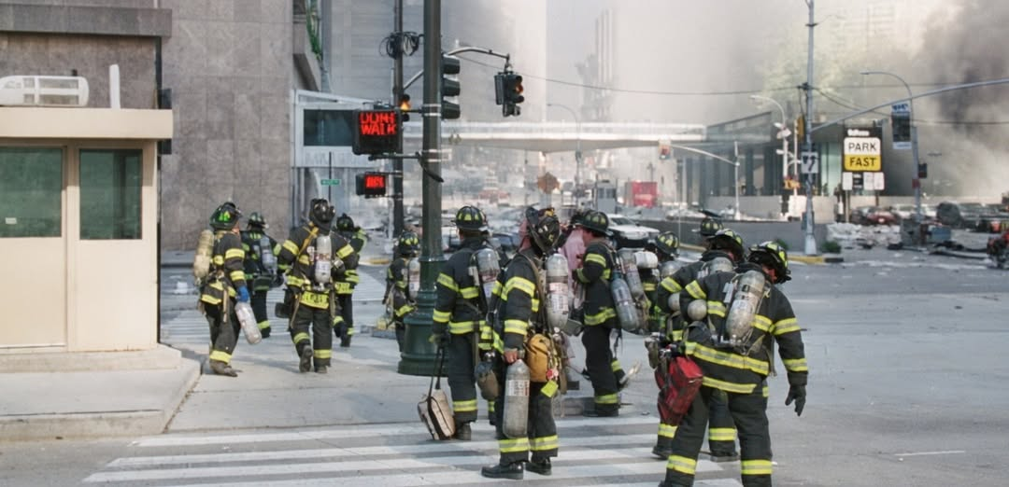
This is the last known photograph of these brave firefighters from Ladder 7 and Ladder 118.
September 11, 2021: Attacks on World Trade Center and Pentagon
FBI Director Christopher Wray: “Hard-Earned Lessons from 9/11 Offer a Playbook for Combating Today’s Threats.” September 10, 2021. https://www.fbi.gov/news/press-releases/hard-earned-lessons-from-911-offer-a-playbook-for-combating-todays-threats-wray-op-ed-091021

September 16, 2001 – Sermon – First Sunday After Attack on World Trade Center and Pentagon
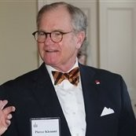
Sermon given on the first Sunday after 911, by Episcopal Minister Pierce Klemmt, Rector of Christ Church [George Washington’ parish church], Alexandria, VA. He was Rector from 1994-2014 and is now retired and living in Alexandria. Posted with his written approval. pklemmt@gmail.com

9/11 Memorial & Museum: https://www.911memorial.org/911-faqs
What happened on 9/11?
“9/11” is shorthand for four coordinated terrorist attacks carried out by al-Qaeda, an Islamist extremist group, that occurred on the morning of September 11, 2001.
Nineteen terrorists from al-Qaeda hijacked four commercial airplanes, deliberately crashing two of the planes into the upper floors of the North and South Towers of the World Trade Center complex and a third plane into the Pentagon in Arlington, Virginia. The Twin Towers ultimately collapsed because of the damage sustained from the impacts and the resulting fires. After learning about the other attacks, passengers on the fourth hijacked plane, Flight 93, fought back, and the plane was crashed into an empty field in western Pennsylvania about 20 minutes by air from Washington, D.C.
The attacks killed 2,977 people from 90 nations: 2,753 people were killed in New York; 184 people were killed at the Pentagon; and 40 people were killed on Flight 93.

9/11 Commission Report: https://www.9-11commission.gov/report/911Report.pdf
“The Terrorism Warning Lights Are Blinking Red Again. Echoes of the run-up to 9/11.” June 10, 2024. https://www.foreignaffairs.com/united-states/terrorism-warning-lights-are-blinking-red-again
“From his confirmation hearing to become director of Central Intelligence in May 1997 until September 11, 2001, George Tenet was sounding an alarm about Osama bin Laden and al Qaeda. In those four years before al Qaeda operatives attacked the World Trade Center and the Pentagon, Tenet testified publicly no fewer than ten times about the threat the group posed to U.S. interests at home and abroad. In February 1999, six months after the group bombed the U.S. embassies in Kenya and Tanzania, he claimed, ‘there is not the slightest doubt that Osama bin Laden . . . [is] planning further attacks against us.’ In early 2000, he warned Congress again that bin Laden was ‘foremost among these terrorists, because of the immediacy and seriousness of the threat he poses’ and because of his ability to strike ‘without additional warning.’ Al Qaeda’s next attacks, Tenet said, could be ‘simultaneous’ and ‘spectacular.’ In private, Tenet was even more assertive. Breaking with standard protocols, he wrote personal letters to President Bill Clinton expressing his deep conviction about the gravity of the threat. And several times in 2001, he personally discussed his concerns about al Qaeda’s plans with President George W. Bush and National Security Adviser Condoleezza Rice. e CIA and the FBI may not have uncovered the time, place, or method of the 9/11 plot, but Tenet’s warnings were prophetic.”

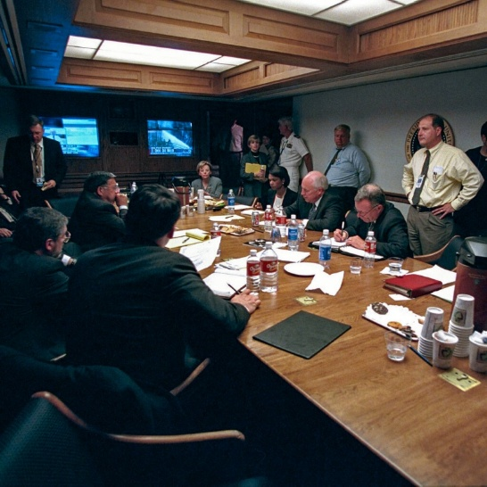

On Sept. 11, 2001, Secret Service agents grabbed Vice President Dick Cheney from his West Wing office and rushed him into a bunker below the East Wing, which had been built as a shelter for Roosevelt during World War II. Cheney headed underground the moment that American Airlines Flight 77 crashed into the Pentagon. The New York Times nytdirect@nytimes.com (10/24/2025)

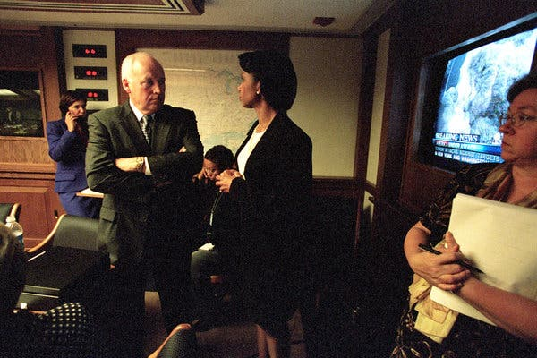
Mr. Cheney with Condoleezza Rice, the national security adviser, on Sept. 11, 2001. With the president traveling and sent to secure locations after the terrorist attacks that morning, it was Mr. Cheney who took charge of the response from the White House.

Oct. 26, 2001 – USA Patriot Act
“Six weeks after the attacks, Mr. Cheney helped engineer a swift, lopsided passage of the USA Patriot Act, a sweeping law that greatly expanded the government’s powers of investigation, surveillance and detention to fight terrorism. With the wounded nation still seething over Sept. 11, public opposition to the law was muted, though civil libertarians warned that it authorized the government to spy on ordinary Americans. Later, it became clear that the act was being used to underpin secret courts, wiretaps without warrants, the unlimited detention of suspects without hearings or charges, and interrogation methods that skirted bans on torture in the Geneva Conventions. There were wide protests and even constitutional challenges. But Mr. Cheney strongly defended the law and its expansion of presidential power, and it remained in force.” https://www.nytimes.com/2025/11/04/us/politics/dick-cheney-dead.html?nl=Breaking+News
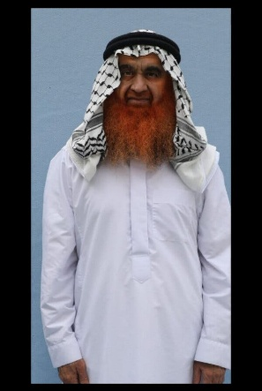
All 15 prisoners at Guantánamo have had access to the program, which began allowing photos in 2009. Khalid Shaikh Mohammed, who is accused of hatching the 9/11 plot that killed nearly 3,000 people, appears in a recent photo in a pressed white robe, his beard dyed.
https://www.nytimes.com/2025/10/23/us/politics/guantanamo-prisoners-portraits.html?nl=The+Evening

2002 – President Bush / Secret NSA Domestic Spying
[See March 11, 2004: President Bush / Reauthorized Secret NSA Domestic Spying Program – “Stellarwind”] https://www.nytimes.com/2026/03/21/us/politics/robert-s-mueller-dead.html?nl=breaking-news&segment_id=217034
Dec. 16, 2005: N.Y. Times: Bush Lets U.S. Spy on Callers Without Courts
Months after the Sept. 11 attacks. https://www.nytimes.com/2005/12/16/politics/bush-lets-us-spy-on-callers-without-courts.html

President Bush secretly authorized the National Security Agency to eavesdrop on Americans and others inside the United States to search for evidence of terrorist activity without the court-approved warrants ordinarily required for domestic spying, according to government officials.
Under a presidential order signed in 2002, the intelligence agency has monitored the international telephone calls and international e-mail messages of hundreds, perhaps thousands, of people inside the United States without warrants over the past three years in an effort to track possible "dirty numbers" linked to Al Qaeda, the officials said. The agency, they said, still seeks warrants to monitor entirely domestic communications.
The previously undisclosed decision to permit some eavesdropping inside the country without court approval was a major shift in American intelligence-gathering practices, particularly for the National Security Agency, whose mission is to spy on communications abroad. As a result, some officials familiar with the continuing operation have questioned whether the surveillance has stretched, if not crossed, constitutional limits on legal searches.

***

In mid-2004, concerns about the program expressed by national security officials, government lawyers and a judge prompted the Bush administration to suspend elements of the program and revamp it.

For the first time, the Justice Department audited the N.S.A. program, several officials said. And to provide more guidance, the Justice Department and the agency expanded and refined a checklist to follow in deciding whether probable cause existed to start monitoring someone's communications, several officials said.

A complaint from Judge Colleen Kollar-Kotelly, the federal judge who oversees the Federal Intelligence Surveillance Court, helped spur the suspension, officials said. The judge questioned whether information obtained under the N.S.A. program was being improperly used as the basis for F.I.S.A. wiretap warrant requests from the Justice Department, according to senior government officials. While not knowing all the details of the exchange, several government lawyers said there appeared to be concerns that the Justice Department, by trying to shield the existence of the N.S.A. program, was in danger of misleading the court about the origins of the information cited to justify the warrants.

June 8, 2002: U.S. Supreme Court - Toyota Motor Mfg. Kentucky, Inc. v. Williams (9 to 0) https://supreme.justia.com/cases/federal/us/534/184/

ADA / DISABILITY MUST BE PERMANENT [CONGRESS PASSED STATUTE IN 2008 WHICH OVERTURNS THIS DECISION - ADA Amendments Act of 2008]

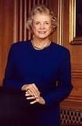 Justice Sandra Day O'Connor
JUSTICE O'CONNOR delivered the opinion of the Court.

“Facts of the case
In 1997, Toyota Motor Manufacturing, Kentucky, Inc. terminated Ella Williams, citing her poor attendance record. Subsequently, claiming to be disabled from performing her automobile assembly line job by carpal tunnel syndrome and related impairments, Williams sued Toyota for failing to provide her with a reasonable accommodation as required by the Americans with Disabilities Act of 1990 (ADA). Granting Toyota summary judgment, the District Court held that Williams's impairment did not qualify as a disability under the ADA because it had not substantially limited any major life activity and that there was no evidence that Williams had had a record of a substantially limiting impairment. In reversing, the Court of Appeals found that the impairments substantially limited Williams in the major life activity of performing manual tasks. Because her ailments prevented her from doing the tasks associated with certain types of manual jobs that require the gripping of tools and repetitive work with hands and arms extended at or above shoulder levels for extended periods of time, the appellate court concluded that Williams demonstrated that her manual disability involved a class of manual activities affecting the ability to perform tasks at work.

Question
Did the Court of Appeals use the proper standard in determining whether an employee was disabled under the ADA due to carpel tunnel syndrome by showing that her manual disability involved a class of manual activities affecting the ability to perform tasks at work?

Conclusion
No. In a unanimous opinion delivered by Justice Sandra Day O'Connor, the Court held that the Court of Appeals did not apply the proper standard in making its determination because it analyzed only a limited class of manual tasks and failed to ask whether Williams's impairments prevented or restricted her from performing tasks that are of central importance to most people's daily lives. The Court also reasoned that for the purposes of the ADA, an impairment's impact must also be permanent or long-term. ‘Given large potential differences in the severity and duration of the effects of carpal tunnel syndrome, an individual's carpal tunnel syndrome diagnosis, on its own, does not indicate whether the individual has a disability within the meaning of the ADA,’ wrote Justice O'Connor for the Court.” https://www.oyez.org/cases/2001/00-1089
[Note: Congress later amended the ADA, in effect overturning this decision.]

Nov. 25, 2002: U.S. Department of Homeland Security formed
“Eleven days after the September 11, 2001, terrorist attacks, Pennsylvania Governor
Tom Ridge was appointed as the first Director of the Office of Homeland Security in the White House. The office oversaw and coordinated a comprehensive national strategy to safeguard the country against terrorism and respond to any future attacks. With the passage of the Homeland Security Act by Congress in November 2002, the Department of Homeland Security formally came into being as a stand-alone, Cabinet-level department to further coordinate and unify national homeland security efforts, opening its doors on March 1, 2003 [22 Departments].” https://www.dhs.gov/creation-departmenthomeland-security

Feb. 20, 2003: West Warwick, RI - The Station Nightclub Fire

“The fourth deadliest nightclub fire in U.S. history, a blaze at The Station nightclub in W. Warwick, RI, on February 20, 2003, claimed 100 lives. After the fire, NFPA enacted tough new code provisions for fire sprinklers and crowd management in nightclub-type venues. Those provisions mark sweeping changes to the codes and standards governing safety in assembly occupancies.” https://www.nfpa.org/Public-Education/Staying-safe/Safety-in-living-and-entertainment-spaces/Nightclubs-assembly-occupancies/The-Station-nightclub-fire

“For many Station survivors and relatives of dead, fire inspector Larocque culpable for not spotting flammable insulation (Feb. 19, 2013).

“They point to the club owners, Michael and Jeffrey Derderian, who had glued flammable foam to the club’s walls to muffle the music and neighbors’ complaints; the band Great White, whose illegal use of pyrotechnics in a wooden building with 8-foot ceilings ignited the foam; and town officials, most notably Larocque, who inspected the club at least three times in the months before the fire and never cited the foam as a fire hazard. Larocque, a broad man with a thick, graying moustache, had a reputation for being a tough fire inspector. A career firefighter who became the local fire marshal five years earlier, he noticed code infractions and didn’t hesitate to report them, even in businesses owned by friends like Laboissonniere. When investigators first questioned Larocque about the foam, days after the Feb. 20, 2003, fire, he said he didn’t see it because he had been blinded by anger after seeing that an illegal door he had ordered removed had been reinstalled. That door, which swung inward instead of outward -- a potential safety impediment in an emergency -- had the flammable gray, egg-crate-shaped foam glued to its interior side.” https://www.providencejournal.com/article/20130219/SPECIAL-REPORTS/302199997

Graphic Video from scene: https://www.youtube.com/watch?v=rO0ioCCiEe8
NIST re-creation: https://www.youtube.com/watch?v=IxiOXZ55hbc

March 2003 – Stat of Iraq War (until 2011)

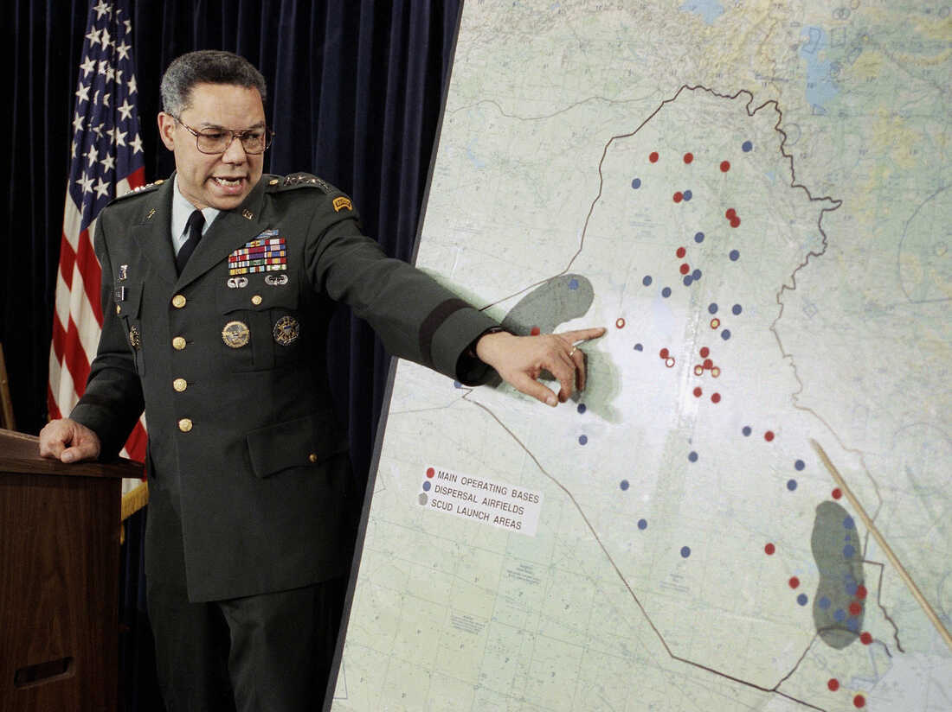
General Colin Powell

“In March 2003, U.S. forces invaded Iraq vowing to destroy Iraqi weapons of mass destruction (WMD) and end the dictatorial rule of Saddam Hussein. When WMD intelligence proved illusory and a violent insurgency arose, the war lost public support. Saddam was captured, tried, and hanged and democratic elections were held. In the years since, there have been over 4,700 U.S. and allied troop deaths, and more than one hundred thousand Iraqi civilians have been killed. Meanwhile, questions linger over Iraq’s fractious political situation.” https://www.cfr.org/timeline/iraq-war

May 27, 2003: U.S. Supreme Court - Nevada Department of Human Resources v. Hibbs (6 to 3) https://supreme.justia.com/cases/federal/us/538/721/

FMLA ALSO COVERS STATE EMPLOYEES

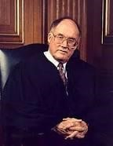Justice William Rehnquist
CHIEF JUSTICE REHNQUIST delivered the opinion of the Court.

“Facts of the case
William Hibbs, an employee of the Nevada Department of Human Resources, sought leave to care for his wife under the Family and Medical Leave Act of 1993 (FMLA). The FMLA entitles an eligible employee to take up to 12 workweeks of unpaid leave annually for the onset of a ‘serious health condition’ in the employee's spouse. The Department granted Hibbs's request for the full 12 weeks of FMLA leave and, after he had exhausted that leave, informed him that he must report to work by a certain date. When Hibbs failed to do so, he was fired. Pursuant to FMLA provisions creating a private right of action ‘against any employer’ that ‘interfered with, restrained, or denied the exercise of’ FMLA rights, Hibbs sued in Federal District Court, seeking money damages for FMLA violations. The District Court concluded that the Eleventh Amendment barred the FMLA claim. The Court of Appeals reversed.

Question
May an individual sue a State for money damages in federal court for violation of the Family and Medical Leave Act of 1993?

Conclusion
Yes. In a 6-3 opinion delivered by Chief Justice William H. Rehnquist, the Court held that State employees may recover money damages in federal court in the event of the State's failure to comply with the FMLA's family-care provision. The Court reasoned that Congress both clearly stated its intention to abrogate the States' Eleventh Amendment immunity from suit in federal court under the FMLA and acted within its authority under section 5 of the Fourteenth Amendment by enacting prophylactic, rather than substantively redefining, legislation. ‘In sum, the States' record of unconstitutional participation in, and fostering of, gender-based discrimination in the administration of leave benefits is weighty enough to justify the enactment of prophylactic [section] 5 legislation,’ wrote Chief Justice Rehnquist. Justices Antonin Scalia and Anthony M. Kennedy, who was joined by Justices Clarence Thomas and Scalia, filed dissents.” https://www.oyez.org/cases/2002/01-1368

Oct. 18, 2003 – Secretary of State Colin Powell – Address UN Security Council - Iraq has weapons of mass destruction. Watch video. https://www.youtube.com/watch?v=DhWlPo3qxak

Feb. 12, 2004: Ohio Public Records Act
149.43 Availability of public records for inspection and copying: http://codes.ohio.gov/orc/149.43
Records not public – firefighter, EMT home address, etc.
(A) As used in this section:
(1) “Public record" does not mean any of the following:
(7) "Designated public service worker" means a peace officer, parole officer, probation officer, bailiff, prosecuting attorney, assistant prosecuting attorney, correctional employee, county or multicounty corrections officer, community-based correctional facility employee, youth services employee, firefighter, EMT, medical director or member of a cooperating physician advisory board of an emergency medical service organization, state board of pharmacy employee, investigator of the bureau of criminal identification and investigation, judge, magistrate, or federal law enforcement officer.
***
(f) The name, the residential address, the name of the employer, the address of the employer, the social security number, the residential telephone number, any bank account, debit card, charge card, or credit card number, or the emergency telephone number of the spouse, a former spouse, or any child of a designated public service worker….
Note: Journalists Exception – Disclose Personal Address
“(9) (a) Upon written request made and signed by a journalist, a public office, or person responsible for public records, having custody of the records of the agency employing a specified designated public service worker shall disclose to the journalist the address of the actual personal residence of the designated public service worker and, if the designated public service worker's spouse, former spouse, or child is employed by a public office, the name and address of the employer of the designated public service worker's spouse, former spouse, or child. The request shall include the journalist's name and title and the name and address of the journalist's employer and shall state that disclosure of the information sought would be in the public interest.
***
(c) As used in division (B)(9) of this section, "journalist" means a person engaged in, connected with, or employed by any news medium, including a newspaper, magazine, press association, news agency, or wire service, a radio or television station, or a similar medium, for the purpose of gathering, processing, transmitting, compiling, editing, or disseminating information for the general public.”
See also: Ohio Attorney General – 2020 Ohio Sunshine Laws: https://www.ohioattorneygeneral.gov/yellowbook
Note: July 23, 2020: New York: “Judge blocks release of NY FF, police discipline records Unions argued that posting unproven or false complaints could sully first responders' reputations and compromise their safety. NEW YORK — A federal judge has halted the public release of police officer disciplinary records in New York, temporarily turning back a state transparency reform enacted in the wake of the police killing of George Floyd. Judge Katherine Polk Failla granted a temporary restraining order late Wednesday barring police departments and other entities in the state from disclosing discipline records until at least Aug. 18, when she'll hear arguments in a union lawsuit challenging their release.” https://www.firerescue1.com/legal/articles/judge-blocksrelease-of-ny-ff-police-discipline-records-
7rj16mVBBulSb3oo/?utm_source=FireRescue1+Member+Newsletter&utm_campaign=4 b0f0b6849-
EMAIL_CAMPAIGN_2020_07_24_08_10&utm_medium=email&utm_term=0_758bdb effe-4b0f0b6849-41607823
See also: June 10, 2020: New York – “The New York state Senate and Assembly passed the 50-a repeal Tuesday night largely along party lines, as Republicans argued the law would allow the release of unsubstantiated or false complaints against officers. *** June
9, 2020: ALBANY, N.Y. — A decades-old law that kept law enforcement officers’ disciplinary records secret in New York appeared to be headed for an overhaul this week as state lawmakers moved to act on a number of police accountability measures prompted by street demonstrations over the death of George Floyd. The state law, known by its section title, 50-a, was passed in the 1970s to prevent criminal defense attorneys from subjecting officers to cross-examinations about irrelevant information in their personnel file. The law applies to jail guards and firefighters, as well.”
https://www.gov1.com/legal/articles/ny-poised-to-overhaul-law-concealing-policedisciplinary-files-we2ftqJQKSrjDE9g/

March 11, 2004: President Bush / Reauthorized Secret NSA Domestic Spying Program – “Stellarwind”
March 21, 2026: Robert S. Mueller III, 81, Dies; Rebuilt F.B.I. and Led Trump Inquiry.
https://www.nytimes.com/2026/03/21/us/politics/robert-s-mueller-dead.html?nl=breaking-news&segment_id=217034

Early in 2004, Mr. Mueller [FBI Director] and his immediate superior at the Justice Department, the deputy attorney general, Mr. Comey, learned that Mr. Bush had authorized the N.S.A. to spy on Americans. The program, code-named Stellarwind, was so secret that very few people were aware of how it worked.

The N.S.A., created to gather foreign intelligence abroad, was eavesdropping freely in the United States, without search warrants, collecting electronic records of millions of telephone conversations, emails and internet addresses. Then it sent the raw data to the bureau. The F.B.I. found that dealing with this deluge was like trying to drink from a fire hose. And the surveillance program had never saved a life, stopped an imminent attack or unveiled a member of Al Qaeda in the United States.

Of greater concern to Mr. Mueller and Mr. Comey was their determination that the program violated the Constitution’s protections against illegal searches and seizures. They convinced Attorney General John Ashcroft that he could not reauthorize Stellarwind. But Mr. Bush did so, unilaterally, on the morning of March 11, 2004, asserting in effect that his power overrode the Constitution.

Mr. Mueller took meticulous notes. He recorded that the president was “trying to do an end run around the law.” At 1:30 a.m. on March 12, he sat at his kitchen table and drafted a letter of resignation. “I am forced to withdraw the F.B.I. from participation in the program,” he wrote; if the president did not back down, he would resign. Both Mr. Comey and Mr. Ashcroft were determined to go with him.
Eight hours later, with the resignation letter in the breast pocket of his suit, Mr. Mueller sat alone with Mr. Bush in the White House.
“I had to make a big decision, and fast,” Mr. Bush wrote in his memoirs. “I thought about the Saturday Night Massacre” — the 1973 Watergate debacle in which President Nixon forced the attorney general and his deputy to resign to protect his secret White House tapes, a desperate move that in time destroyed his presidency.
“That was not,” Mr. Bush observed, “a historical crisis I was eager to replicate.” He could stand his ground “while my administration imploded.” Or he could bow to Mr. Mueller and let the secret programs be scaled back and placed on a legal footing. He chose the second path, though it took years.

Dec. 16, 2005: N.Y. Times: Bush Lets U.S. Spy on Callers Without Courts
Months after the Sept. 11 attacks. https://www.nytimes.com/2005/12/16/politics/bush-lets-us-spy-on-callers-without-courts.html

President Bush secretly authorized the National Security Agency to eavesdrop on Americans and others inside the United States to search for evidence of terrorist activity without the court-approved warrants ordinarily required for domestic spying, according to government officials.
Under a presidential order signed in 2002, the intelligence agency has monitored the international telephone calls and international e-mail messages of hundreds, perhaps thousands, of people inside the United States without warrants over the past three years in an effort to track possible "dirty numbers" linked to Al Qaeda, the officials said. The agency, they said, still seeks warrants to monitor entirely domestic communications.
The previously undisclosed decision to permit some eavesdropping inside the country without court approval was a major shift in American intelligence-gathering practices, particularly for the National Security Agency, whose mission is to spy on communications abroad. As a result, some officials familiar with the continuing operation have questioned whether the surveillance has stretched, if not crossed, constitutional limits on legal searches.

***

In mid-2004, concerns about the program expressed by national security officials, government lawyers and a judge prompted the Bush administration to suspend elements of the program and revamp it.

For the first time, the Justice Department audited the N.S.A. program, several officials said. And to provide more guidance, the Justice Department and the agency expanded and refined a checklist to follow in deciding whether probable cause existed to start monitoring someone's communications, several officials said.

A complaint from Judge Colleen Kollar-Kotelly, the federal judge who oversees the Federal Intelligence Surveillance Court, helped spur the suspension, officials said. The judge questioned whether information obtained under the N.S.A. program was being improperly used as the basis for F.I.S.A. wiretap warrant requests from the Justice Department, according to senior government officials. While not knowing all the details of the exchange, several government lawyers said there appeared to be concerns that the Justice Department, by trying to shield the existence of the N.S.A. program, was in danger of misleading the court about the origins of the information cited to justify the warrants.

April 4 – Sept. 2004: Fallujah, Iraq
“On the night of April 4, 2004, Marines launched their assault on the city, and by sunrise the following morning, Fallujah was surrounded by U.S. Marines. Throughout the next five days, Marines engaged in fierce urban combat with a level of intensity not seen since the Battle of Hue City.” https://www.marines.mil/News/News-Display/Article/3350301/operation-vigilant-resolve/

May 17, 2004: U.S. Supreme Court - Tennessee v. Lane (5 to 4) https://supreme.justia.com/cases/federal/us/541/509/

ELEVATORS FOR DISABELED, COURTHOUSES AND OTHER PUBLIC INVITED LOCATIONS

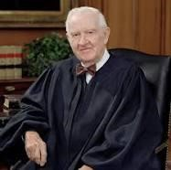 Justice John Paul Stevens
Justice Stevens delivered the opinion of the Court.

“Facts of the case
George Lane and Beverly Jones were disabled and could not access upper floors in Tennessee state courthouses. Lane, Jones, and several others sued Tennessee in federal district court, alleging that by denying them public services based on their disabilities, Tennessee was in violation of Title II of the Americans with Disabilities Act (1990).
According to Title II, no person may be denied access to ‘services, programs, or activities’ on the basis of his disability. The act allows alleged victims of discrimination to sue states for damages.
Tennessee asked that the case be dismissed, claiming that it was barred by the 11th Amendment's prohibition of suits against states in federal courts (the sovereign immunity doctrine). The state cited Alabama v. Garrett (2001), in which the U.S. Supreme Court ruled that Congress had acted unconstitutionally in granting citizens the right to sue states for disability discrimination (such as the denial of employment) under the 14th Amendment's equal protection clause. In that case the Supreme Court reasoned that Congress did not have enough evidence of disability discrimination by states to justify the waiver of sovereign immunity.
The district court rejected the state's argument and denied the motion to dismiss. The Sixth Circuit Court of Appeals panel affirmed. The courts reasoned that because Title II of the ADA dealt with the Due process Clause of the 14th Amendment, not the equal protection clause, the ruling in Garrett did not apply. The court found that while Congress may not have had enough evidence of disability discrimination to waive sovereign immunity for equal protection claims, it did have enough evidence of Due Process violations (such as non-handicap-accessible courthouses) to waive the sovereign immunity doctrine for Due Process claims.

Question
Did the Americans with Disabilities Act violate the sovereign immunity doctrine of the
11th Amendment when, based on Congress's 14th Amendment enforcement powers of
the Due Process clause, it allowed individuals to sue states for denying them services based on their disabilities?

Conclusion
No. In a 5-to-4 opinion written by Justice John Paul Stevens, the Court held that Congress had sufficiently demonstrated the problems faced by disabled persons who sought to exercise fundamental rights protected by the Due Process clause of the 14th Amendment (such as access to a court). The Court also emphasized that the remedies required from the states were not unreasonable - they just had to make reasonable accommodations to allow disabled persons to exercise their fundamental rights. Because Title II was a ‘reasonable prophylactic measure, reasonably targeted to a legitimate end,’ and because Congress had the authority under the 14th Amendment to regulate the actions of the states to accomplish that end, the law was constitutional.” https://www.oyez.org/cases/2003/02-1667

June 14, 2004: U.S. Supreme Court - Pennsylvania State Police v. Nancy Drew Suders (8 to 1) https://supreme.justia.com/cases/federal/us/542/129/

HOSTILE WORK AMOSPHERE, BUT MUST INFORM EMPLOYER
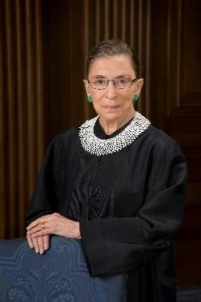Justice Ruth Bader Ginsburg
Justice GINSBURG delivered the opinion of the Court.

“Facts of the case
Nancy Drew Suders quit her job as a dispatcher for the Pennsylvania State Police in August 1998. She claimed that she had been sexually harassed by her supervisors since she got the job in March of that year, and that she had finally decided to quit after she was accused of theft, handcuffed, photographed and questioned. Two days before quitting, she had contacted the state police equal opportunity officer about the harassment, but did not file a report because, Suders claimed, the woman was unhelpful and unsympathetic.
Suders then filed suit in federal district court, charging that the harassment had forced her to quit. The district court judge, however, granted summary judgment to the state police before the case went to trial. He found that Suders had failed to use the internal procedures set up by the state police to deal with sexual harassment, and that she therefore could not bring suit unless the police had taken a ‘tangible employment action’ that substantially changed her employment status. On appeal, a Third Circuit Court of Appeals panel overturned the district judge's decision, ruling that the harassment had been so bad that Suders had no choice but to quit. While the police had not fired Suders, they had been directly responsible for her resignation and therefore could not use her failure to file a report as a defense.

Question
When a supervisor makes a workplace environment so hostile (through sexual harassment) that an employee has no choice but to quit, may the employee bring suit even if she did not use the internal procedures established by the employer to report sexual harassment claims?

Conclusion
Yes. In an 8-to-1 decision written by Justice Ruth Bader Ginsburg, the Court ruled that an employee faced with a situation in which a ‘reasonable person ... would have felt compelled to resign’ could bring suit even if she had not filed a report with the employer before resigning. Her employer, however, could use her failure to file a report, along with evidence of the safeguards it had in place to prevent harassment, in its defense. If it could prove that she had not attempted to prevent the harassment, and that the safeguards in place would have prevented it if she had, the employer would not be liable.” https://www.oyez.org/cases/2003/03-95

Dec. 6, 2004: U.S. Supreme Court - City of San Diego v. John Roe (9 to 0) https://supreme.justia.com/cases/federal/us/543/77/

POLICE OFFICER PROPERLY FIRED, VIDEO OF HIM STRIPPING OFF POLICE UNIFORM
Per Curiam decision – opinion not authored by one Justice.

“Facts of the case
John Roe, a San Diego police officer, was fired for selling a video on eBay that showed him stripping off a police uniform and masturbating. He then sued the city in federal district court and alleged his firing violated his First Amendment right to freedom of speech. The district court ruled against the officer; the Ninth Circuit reversed.

Question
San Diego fired John Roe from the city police force after he made and sold online a video showing him engaging in sexually explicit acts. Did this violate John Roe's First Amendment right to free speech?

Conclusion
No. In a unanimous per curiam opinion, the Court held that firing Roe for his behavior and ‘speech’ did not violate the First Amendment. Government employers, the Court wrote, could restrict their employees' speech in ways that would be unconstitutional if applied to the general public. But government employees had the right to speak on matters of public concern, such as on government policies of interest to the public. In this case, however, Roe's activities did not inform the public about the police department and were also detrimental to the force.” https://www.oyez.org/cases/2004/03-1669

Jan. 20, 2005: President George W. Bush – Secon Inauguration

June 28, 2004: U.S. Supreme Court - Hamdi v. Rumsfeld (8 to 1)
https://supreme.justia.com/cases/federal/us/542/507/

Enemy Combatant – Right To Challenge Detention

“Declaring that ‘a state of war is not a blank check for the president,’ the Supreme Court ruled on Monday that those deemed enemy combatants by the Bush administration, both in the United States and at Guantanamo Bay, Cuba, must be given the ability to challenge their detention before a judge or other "neutral decision-maker." *** Eight justices, all but Justice Clarence Thomas, said the two-year-long detention of an American citizen, Yaser Esam Hamdi, had either been invalid from the beginning or had become so, for constitutional or statutory reasons. The controlling opinion, by Justice Sandra Day O'Connor, said that Mr. Hamdi's detention was permissible if designation as an enemy combatant proved to be correct, but that his inability so far to appear before a judge, challenge the government's evidence, and tell his side of the story had deprived him of his constitutional right to due process.” https://www.nytimes.com/2004/06/29/politics/justices-affirm-legal-rights-of-enemy-combatants.html
May 11, 2005: REAL ID ACT
The REAL ID Act, passed by Congress in 2005, enacted the 9/11 Commission’s recommendation that the Federal Government “set standards for the issuance of sources of identification, such as driver's licenses and identification cards.” The Act and implementing regulations establish minimum security standards for license issuance and production and prohibit federal agencies from accepting for certain official purposes noncompliant driver’s licenses and identification cards, both physical and digital (also known as Mobile Driver’s Licenses, or “mDLs”). The official purposes covered by the Act and regulations are:
Accessing certain federal facilities;
Boarding Federally regulated commercial aircraft; and
Entering nuclear power plants. https://www.tsa.gov/realid/about-realid

May 30, 2005: U.S. Supreme Court - Garcetti et al v. Ceballos (5 to 4) https://scholar.google.com/scholar_case?case=6711908971660042297&q=Garcetti+et+al+v.+Ceballos&hl=en&as_sdt=6,36&as_vis=1

LIMITED THE FIRST AMENDMENT RIGHTS PUBLIC EMPLOYEES IN PUBLIC COMMENTS
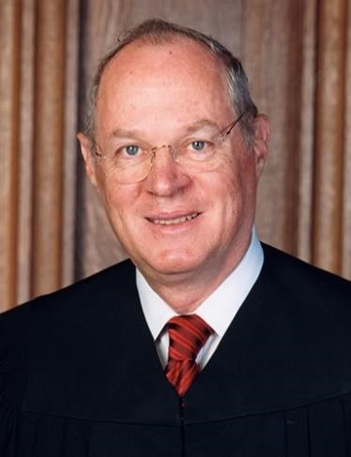 Justice Anthony Kennedy (nominated by President Ronald Regan,
served from 1988 until retired 2018).
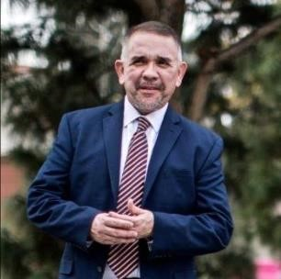 Richard Ceballos, Esq.
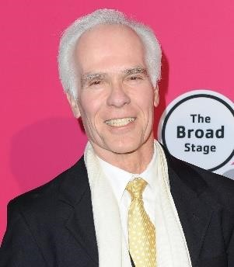Gill Garcetti (LA County Prosecutor, 1992 – 2000)

“Facts of the case
Richard Ceballos, an employee of the Los Angeles District Attorney's office, found that a sheriff misrepresented facts in a search warrant affidavit. Ceballos notified the attorneys prosecuting the case stemming from that arrest and all agreed that the affidavit was questionable, but the D.A.'s office refused to dismiss the case.
Ceballos then told the defense he believed the affidavit contained false statements, and defense counsel subpoenaed him to testify. Seeking damages in federal district court, Ceballos alleged that D.A.s in the office retaliated against him for his cooperation with the defense, which he argued was protected by the First Amendment. The district court ruled that the district attorneys were protected by qualified immunity, but the Ninth Circuit reversed and ruled for Ceballos, holding that qualified immunity was not available to the defendants because Ceballos had been engaged in speech that addressed matters of public concern and was thus protected by the First Amendment.

Question
Should a public employee's purely job-related speech, expressed strictly pursuant to the duties of employment, be protected by the First Amendment simply because it touched on a matter of public concern, or must the speech also be engaged in ‘as a citizen?’

Conclusion
In a 5-to-4 decision authored by Justice Anthony Kennedy, the Supreme Court held that speech by a public official is only protected if it is engaged in as a private citizen, not if it is expressed as part of the official's public duties. Ceballos's employers were justified in taking action against him based on his testimony and cooperation with the defense, therefore, because it happened as part of his official duties. ‘The fact that his duties sometimes required him to speak or write,’ Justice Kennedy wrote, ‘does not mean his supervisors were prohibited from evaluating his performance.’ Justices Stevens, Souter, Ginsburg and Breyer dissented.
https://www.oyez.org/cases/2005/04-473

See article (Dec. 11, 2019): “Tuesday, Deputy District Attorney Richard Ceballos withdrew his candidacy for L.A. County District Attorney. In response, Rachel Rossi issued the following statement.”
“I wish Richard Ceballos all the best as he made a difficult choice to end his race for Los Angeles County District Attorney. Richard was the first candidate to take a stand and challenge the status quo in our District Attorney’s Office eight months ago. I am grateful for his fight in this race and for his career in fighting for reform. I know this won’t be the last we hear from him.” https://rachel4da.com/2019/12/11/statement-on-the-withdrawalof-richard-ceballos-for-district-attorney/

Oct. 2005 - Saddam Hussein executed
“In October 2005 Saddam went on trial before the Iraqi High Tribunal, a panel court established to try officials of the former Iraqi government. He and several codefendants were charged with the killing of 148 townspeople in Al-Dujayl, a mainly Shiʿi town, in 1982. Throughout the nine-month trial, Saddam interrupted the proceedings with angry outbursts, claiming that the tribunal was a sham and that U.S. interests were behind it. The tribunal finally adjourned in July 2006 and handed down its verdicts in November. Saddam was convicted of crimes against humanity—including willful killing, illegal imprisonment, deportation, and torture—and was sentenced to death by hanging. Saddam’s half brother (an intelligence officer) and Iraq’s former chief judge were also sentenced to death. Days after an Iraqi court upheld his sentence in December 2006, Saddam was executed.” https://www.britannica.com/biography/Saddam-Hussein

Oct. 6, 2005: S.397 - Protection of Lawful Commerce in Arms Act https://www.congress.gov/bill/109th-congress/senate-bill/397/text
“Mexico first sued multiple gun companies in 2021, arguing that the cartel bloodshed was “the foreseeable result of the defendants’ deliberate actions and business practices.”
A trial court judge dismissed the case, finding it was barred by a 2005 federal law that limits litigation against gun manufacturers and distributors and has provided immunity from actions brought by the families of people killed and injured by their weapons.”
March 3, 2025: At Supreme Court, Mexico to Offer Culprit for Cartel Violence: Gun Makers. The dispute focuses on whether Mexico can hold U.S. manufacturers liable for gun violence and comes amid rising tensions between the countries. https://www.nytimes.com/2025/03/03/us/politics/supreme-court-mexico-gunmakers.html

Dec. 16, 2005: N.Y. Times: Bush Lets U.S. Spy on Callers Without Courts
Months after the Sept. 11 attacks. https://www.nytimes.com/2005/12/16/politics/bush-lets-us-spy-on-callers-without-courts.html

President Bush secretly authorized the National Security Agency to eavesdrop on Americans and others inside the United States to search for evidence of terrorist activity without the court-approved warrants ordinarily required for domestic spying, according to government officials.
Under a presidential order signed in 2002, the intelligence agency has monitored the international telephone calls and international e-mail messages of hundreds, perhaps thousands, of people inside the United States without warrants over the past three years in an effort to track possible "dirty numbers" linked to Al Qaeda, the officials said. The agency, they said, still seeks warrants to monitor entirely domestic communications.
The previously undisclosed decision to permit some eavesdropping inside the country without court approval was a major shift in American intelligence-gathering practices, particularly for the National Security Agency, whose mission is to spy on communications abroad. As a result, some officials familiar with the continuing operation have questioned whether the surveillance has stretched, if not crossed, constitutional limits on legal searches.

Nov. 8, 2005: U.S. Supreme Court - IBP, Inc. v. Alvarez (9 to 0) https://supreme.justia.com/cases/federal/us/546/21/
FLSA, TIME PUTTING ON SAFETY EQUIPMENT BY BEEF BUTCHERS “ON THE CLOCK”
Justice John Paul Stevens (nominated by President Gerald Ford in 1975, retired 2010)

“Facts of the case
In two separate cases, employees sued Barber Foods and IBP [Iowa Beef Producers] in federal district court. The employees alleged the companies violated the Fair Labor Standards Act by not paying them for time spent walking to the worksite after putting on required equipment. The district court and later the First Circuit ruled against the Barber employees. A separate district court ruled IBP must compensate its employees for the disputed time. The Ninth Circuit agreed. The U.S. Supreme Court consolidated the cases.

Question
Did the Fair Labor Standards Act require employers to pay employees for time spent walking to and from stations that distributed required safety equipment?

Conclusion
Yes. Justice John Paul Stevens, for a unanimous Court, wrote that putting on required safety equipment qualified as a ‘principal activity’ under the FLSA. The workday began when employees started that activity and therefore included the subsequent time spent walking to the worksite. The time spent waiting to put on safety equipment before that, however, was not included in the workday because it was a "preliminary" activity under the Portal-to-Portal Act.” https://www.oyez.org/cases/2005/03-1238

2007: Volunteer Responder Incentive Protection Act (VRIPA)
National Volunteer Fire Council (December 20, 2019): https://www.nvfc.org/volunteerresponder-incentive-protection-act-restored-for-2020-tax-year/
“On December 20, President Trump signed into law appropriations legislation (H.R.
1865), which includes language restoring the Volunteer Responder Incentive Protection Act (VRIPA) in the 2020 tax year. VRIPA exempts nominal volunteer recruitment and retention incentives from being subject to federal income tax and reporting requirements for the 2020 tax year. Specifically, H.R. 1865 exempts property tax benefits and up to $600 per year in other incentives, such as stipends, that volunteer fire and EMS personnel receive as a reward for their service.
***
VRIPA was first enacted in 2007 and was in effect from 2008-2010. Originally, VRIPA exempted property tax benefits and up to $360 per year of other incentives. VRIPA expired in 2011 and 2020 will be the first year that it is back in effect since then. In addition to restoring VRIPA for the 2020 tax year, H.R. 1865 raises the maximum exempted benefits amount for non-property tax benefits from $360 to $600 per year.”

May 29, 2007: U.S. Supreme Court - Ledbetter v. Goodyear Tire & Rubber Co., Inc. (5 to 4) https://supreme.justia.com/cases/federal/us/550/618/

PAY DISCRIMINATION, BUT EEOC CHARGE NOT FILED TIMELY - [DECISION OVERTURNED IN 2009 BY CONGRESS AMENDING TITLE VII – Lilly Ledbetter Fair Pay Act]

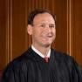Justice Samuel Alito (nominated by President George W. Bush in
2006),
“During most of the time that petitioner [Lilly]Ledbetter was employed by respondent Goodyear, salaried employees at the plant where she worked were given or denied raises based on performance evaluations. Ledbetter submitted a questionnaire to the Equal Employment Opportunity Commission (EEOC) in March 1998 and a formal EEOC charge in July 1998. After her November 1998 retirement, she filed suit, asserting, among other things, a sex discrimination claim under Title VII of the Civil Rights Act of 1964.
The District Court allowed her Title VII pay discrimination claim to proceed to trial. There, Ledbetter alleged that several supervisors had in the past given her poor evaluations because of her sex; that as a result, her pay had not increased as much as it would have if she had been evaluated fairly; that those past pay decisions affected the amount of her pay through-out her employment; and that by the end of her employment, she was earning significantly less than her male colleagues. Goodyear maintained that the evaluations had been nondiscriminatory, but the jury found for Ledbetter, awarding backpay and damages. On appeal, Goodyear contended that the pay discrimination claim was time barred with regard to all pay decisions made before September 26,1997—180 days before Ledbetter filed her EEOC questionnaire—and that no discriminatory act relating to her pay occurred after that date.*** Held: Because the later effects of past discrimination do not restart the clock for filing an EEOC charge, Ledbetter’s claim is untimely.” https://www.supremecourt.gov/opinions/06pdf/05-1074.pdf
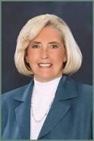 Lilly Ledbetter: https://www.aauw.org/article/a-qa-with-lilly-ledbetter-
fierce-champion-of-equal-pay/

June 18, 2007: Charleston, South Carolina FD – 9 FF LODDs
Watch this video: 9 Charleston Firefighters were killed at the infamous Sofa Super Store Fire. They are Captain Louis Mulkey, Captain Mike Benke, FF Melvin Champaign, Captain Billy Hutchingson, Engineer Brad Baity, FF Earl Drayton, Engineer Mark Kelsey, Engineer Michael French, and FF Brandon Thompson. https://www.youtube.com/watch?v=mqiRN9rygoI

Nov. 15, 2007 – Bary Bonds Indicted – Steroids / Case Later Dropped
“A federal grand jury in San Francisco indicts Bonds on four counts of perjury and one count of obstruction of justice. He is accused of lying when he said he didn't knowingly take steroids given to him by Anderson. He's also is accused of lying that Anderson never injected him with steroids. He is scheduled to appear in U.S. District Court in San Francisco on Dec. 7. Anderson, who had been imprisoned for refusing to testify against Bonds, was ordered released.” Barry Bonds steroids timeline; https://www.espn.com/mlb/news/story?id=3113127
July 21, 2015: “Barry Bonds Steroid Case Is Officially Over. Federal prosecutors' long, long legal pursuit of former San Francisco Giants slugger Barry Bonds is officially over. Melinda Haag, the U.S. attorney for Northern California, filed a brief notice with the 9th U.S. Circuit Court of Appeals on Tuesday morning that the government won't attempt to take its case to the Supreme Court. Bonds was convicted in 2011 of obstruction of justice in connection with a probe into his alleged use of performance-enhancing drugs. The conviction was first upheld by a three-judge 9th Circuit panel, then struck down by an en banc panel of 11 judges. It's that last decision the Justice Department has decided not to appeal to the high court. Prosecutors investigating BALCO, a Peninsula sports lab that had distributed banned substances to elite athletes, had charged Major League Baseball's all-time home-run record holder with perjury and obstruction in connection with his 2003 testimony to a federal grand jury in San Francisco. They said Bonds had lied when he denied using steroids and had tried to mislead the grand jury with an evasive answer about his drug use. The jury failed to reach a verdict on three perjury counts, but convicted him on the obstruction charge because of his ‘I was a celebrity child’ response to a question about whether he'd used injected substances.” https://www.kqed.org/news/10609736/barry-bonds-steroid-case-is-officially-over

June 26, 2008: U.S. Supreme Court – District of Columbia v. Heller (5 to 4) https://supreme.justia.com/cases/federal/us/554/570/
Right to own firearms
“Respondent Dick Heller is a D. C. special police officer authorized to carry a handgun while on duty at the Federal Judicial Center. He applied for a registration certificate for a handgun that he wished to keep at home, but the District refused. He thereafter filed a lawsuit in the Federal District Court for the District of Columbia seeking, on Second Amendment grounds, to enjoin the city from enforcing the bar on the registration of handguns, the licensing requirement insofar as it prohibits the carrying of a firearm in the home without a license, and the trigger-lock requirement insofar as it prohibits the use of “functional firearms within the home.
***
In sum, we hold that the District’s ban on handgun possession in the home violates the Second Amendment, as does its prohibition against rendering any lawful firearm in the home operable for the purpose of immediate self-defense. Assuming that Heller is not disqualified from the exercise of Second Amendment rights, the District must permit him to register his handgun and must issue him a license to carry it in the home.”

Jan. 20, 2009: George W. Bush – Leaving Office, Perdsonal Note To Barack Obama

“Dear Barack,

Congratulations on becoming our President. You have just begun a fantastic chapter in your life.

Very few have had the honor of knowing the responsibility you now feel. Very few know the excitement of the moment and the challenges you will face.

There will be trying moments. The critics will rage. Your ‘friends’ will disappoint you. But, you will have an Almighty God to comfort you, a family who loves you, and a country that is pulling for you, including me. No matter what comes, you will be inspired by the character and compassion of the people you now lead.

God bless you.

Sincerely,

GW”
https://www.washingtonpost.com/history/2025/01/20/inauguration-letter-president-trump-biden-tradition/?utm_campaign=wp_post_most&utm_medium=email&utm_source=newsletter&carta-url=https%3A%2F%2Fs2.washingtonpost.com%2Fcar-ln-tr%2F41281a4%2F67b363a6eb3eba471afc37e7%2F59731235ade4e21a848a56ed%2F23%2F53%2F67b363a6eb3eba471afc37e7

Jan. 20, 2009: President Barack Obama – Inauguration
https://obamawhitehouse.archives.gov/administration/president-obama

May 28, 2009: Lilly Ledbetter Fair Pay Act of 2009
“On January 29, 2009, President Obama signed the first piece of legislation of his Administration: the Lilly Ledbetter Fair Pay Act of 2009 (‘Act’). This law overturned the Supreme Court's decision in Ledbetter v. Goodyear Tire & Rubber Co., Inc., 550 U.S. 618 (2007), which severely restricted the time period for filing complaints of employment discrimination concerning compensation [180 days].
The Act states the EEOC's longstanding position that each paycheck that contains discriminatory compensation is a separate violation regardless of when the discrimination began. The Ledbetter Act recognizes the ‘reality of wage discrimination’ and restores ‘bedrock principles of American law.’ Particularly important for the victims of discrimination, the Act contains an explicit retroactivity provision.
People challenging a wide variety of practices that resulted in discriminatory compensation can benefit from the Act's passage. These practices may include employer decisions about base pay or wages, job classifications, career ladder or other noncompetitive promotion denials, tenure denials, and failure to respond to requests for raises.” https://www.eeoc.gov/eeoc/publications/brochureequal_pay_and_ledbetter_act.cfm

June 29, 2009: U.S. Supreme Court - Frank Ricci v. DeStefano (5 to 4) – https://supreme.justia.com/cases/federal/us/557/557/
NEW HAVEN FIRE DEPARTMENT PROMOTIONS TO PROCEED; TEST WAS PROFESSIONALLY PREPARED
Justice Anthony Kennedy (nominated by President Ronald Regan, served
from 1988 until retired 2018).

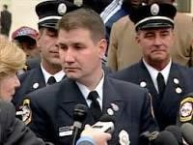Frank Ricci, New Haven Fire Department:
https://www.nhregister.com/news/article/Frank-Ricci-re-elected-fire-union-president13452262.php

“Facts of the case
White and Hispanic candidates for promotion in the New Haven, CT fire department sued various city officials in the United States District Court for the District of Connecticut when the New Haven Civil Service Board (CSB) failed to certify two exams needed for the plaintiffs' promotion to Lieutenant and Captain. The CSB did not certify because the results of the test would have promoted a disproportionate number of white candidates in comparison to minority candidates. The plaintiffs argued that their rights under Title VII of the Civil Rights Act of 1964, 42 U.S.C. Section 2000e, and the 14th Amendment Equal Protection Clause were violated. The federal district court granted the defendants' motion for summary judgment.
On appeal, the United States Court of Appeals for the Second Circuit affirmed. It reasoned that the CSB, by refusing to certify the results of the promotional exam, was trying to fulfill its obligations under the rules utilized by the plaintiffs in their argument and therefore was protected in its actions.

Question
- Can a municipality reject results from an otherwise valid civil service exam when the results unintentionally prevent the promotion of minority candidates?
- Does 42 U.S.C. Section 2000e permit federal courts to relieve municipalities from having to comply with local laws that require strict compliance with race-blind merit selection procedures?

Conclusion
Maybe; fact dependent. Not answered. The Supreme Court held that by discarding the exams, the City of New Haven violated Title VII of the Civil Rights Act of 1964. Justice Anthony M. Kennedy wrote the majority joined by Chief Justice John G. Roberts, and Justices Antonin G. Scalia, Clarence Thomas, and Samuel A. Alito. Before an employer can engage in intentional discrimination for the purpose of avoiding a "disparate impact" on a protected trait (race, color, religion, national origin), the employer must have a "strong basis in evidence" that it will be subject to "disparate impact liability" if it fails to take the discriminatory action. Here, the Court reasoned that New Haven failed to prove it had a ‘strong basis in evidence’ that failing to discard the results of the exam would have subjected it to liability, as the exams were job-related, consistent with business necessity, and there was no evidence that an equally-valid, less-discriminatory alternative was available.”
https://www.oyez.org/cases/2008/07-1428

Jan. 21, 2010: U.S. Supreme Court – Citizens United v.
Federal Election Commission (5 to 4) https://supreme.justia.com/cases/federal/us/558/310/

Limiting independent expenditure on political campaigns by groups such as corporations, labor unions, or other collective entities violates the First Amendment because limitations constitute a prior restraint on speech.
https://www.scotusblog.com/case-files/cases/citizens-united-v-federal-electioncommission/
Justice Anthony Kennedy
“In January 2008, Citizens United released a film entitled Hillary: The Movie. We refer to the film as Hillary. It is a 90–minute documentary about then-Senator Hillary Clinton, who was a candidate in the Democratic Party's 2008 Presidential primary elections. Hillary mentions Senator Clinton by name and depicts interviews with political commentators and other persons, most of them quite critical of Senator Clinton. Hillary was released in theaters and on DVD, but Citizens United wanted to increase distribution by making it available through video-on-demand. *** The law before us is an outright ban, backed by criminal sanctions. Section 441b makes it a felony for all corporations— including nonprofit advocacy corporations—either to expressly advocate the election or defeat of candidates or to broadcast electioneering communications within 30 days of a primary election and 60 days of a general election. Thus, the following acts would all be felonies under § 441b: The Sierra Club runs an ad, within the crucial phase of 60 days before the general election, that exhorts the public to disapprove of a Congressman who favors logging in national forests; the National Rifle Association publishes a book urging the public to vote for the challenger because the incumbent U.S. Senator supports a handgun ban; and the American Civil Liberties Union creates a Web site telling the public to vote for a Presidential candidate in light of that candidate's defense of free speech. These prohibitions are classic examples of censorship. *** Modern day movies, television comedies, or skits on Youtube.com might portray public officials or public policies in unflattering ways. Yet if a covered transmission during the blackout period creates the background for candidate endorsement or opposition, a felony occurs solely because a corporation, other than an exempt media corporation, has made the ‘purchase, payment, distribution, loan, advance, deposit, or gift of money or anything of value’ in order to engage in political speech. 2 U.S.C. § 431(9)(A)(i). Speech would be suppressed in the realm where its necessity is most evident: in the public dialogue preceding a real election. Governments are often hostile to speech, but under our law and our tradition it seems stranger than fiction for our Government to make this political speech a crime. Yet this is the statute's purpose and design. *** Some members of the public might consider Hillary to be insightful and instructive; some might find it to be neither high art nor a fair discussion on how to set the Nation's course; still others simply might suspend judgment on these points but decide to think more about issues and candidates. Those choices and assessments, however, are not for the Government to make. The First Amendment underwrites the freedom to experiment and to create in the realm of thought and speech. Citizens must be free to use new forms, and new forums, for the expression of ideas.”
Note: see comments on the impact of this decision.
“The Supreme Court's 2010 decision in Citizens United v. Federal Election Commission helped unleash unprecedented amounts of outside spending in the 2010 and 2012 election cycles. The case, along with other legal developments, spawned the creation of super PACs, which can accept unlimited contributions from corporate and union treasuries, as well as from individuals; these groups spent more than $800 million in the 2012 election cycle. It also triggered a boom in political activity by tax-exempt ‘dark money’ organizations that don't have to disclose their donors.” https://www.opensecrets.org/news/reports//citizens_united.php
___________________________________________________________________
“Political spending is a form of protected speech under the First Amendment, and the government may not keep corporations or unions from spending money to support or denounce individual candidates in elections. While corporations or unions may not give money directly to campaigns, they may seek to persuade the voting public through other means, including ads, especially where these ads were not broadcast.” https://www.scotusblog.com/case-files/cases/citizens-united-v-federal-electioncommission/

2011: Florida Abolishes “Fireman’s Rule”
https://flsenate.gov/Laws/Statutes/2011/112.182
112.182 “Firefighter rule” abolished.—
- A firefighter or properly identified law enforcement officer who lawfully enters upon the premises of another in the discharge of his or her duty occupies the status of an invitee. The common-law rule that such a firefighter or law enforcement officer occupies the status of a licensee is hereby abolished.
- It is not the intent of this section to increase or diminish the duty of care owed by property owners to invitees. Property owners shall be liable to invitees pursuant to this section only when the property owner negligently fails to maintain the premises in a reasonably safe condition or negligently fails to correct a dangerous condition of which the property owner either knew or should have known by the use of reasonable care or negligently fails to warn the invitee of a dangerous condition about which the property owner had, or should have had, knowledge greater than that of the invitee. History.—s. 1, ch. 90-308; s. 693, ch. 95-147.

September 11, 2012 – Attack On U.S. Mission in Benghazi, Libya

Feb. 6, 2026: “Third Coconspirator in Fatal Benghazi Attacks in U.S. Custody, Charged in Washington D.C. with Murder and Terrorism Counts. Zubayar Al-Bakoush, an armed coconspirator in the 2012 attack on U.S. facilities in Benghazi, Libya, that killed U.S. Ambassador J. Christopher Stevens and three other Americans, was charged in an eight-count indictment unsealed today in U.S. District Court on multiple terrorism and murder counts. *** ‘The FBI and our U.S. government partners have worked tirelessly to hold accountable those responsible for the heinous terrorist attacks in Benghazi, Libya that resulted in the deaths of the U.S. Ambassador, J. Christopher Stevens and U.S. government personnel Sean Smith, Tyrone Woods, and Glen Doherty,’ said FBI Director Kash Patel. ‘The latest result of our efforts is bringing Zubayar Al-Bakoush to the U.S. to face charges for his alleged role in the attacks against our citizens and our facilities in Libya. You can be assured that no matter how long it takes, or where you are located, the FBI remains steadfast in our duty to see justice served against those who harm our citizens. I’m grateful to the men and women of the FBI for their unrelenting efforts to bring us to where we stand today – this defendant will be prosecuted on U.S. soil.’” https://www.justice.gov/opa/pr/third-coconspirator-fatal-benghazi-attacks-us-custody-charged-washington-dc-murder-and

Attorney General Bondi, Director Patel, U.S. Attorney Pirro Make Press Announcement: https://www.justice.gov/opa/video/attorney-general-bondi-director-patel-us-attorney-pirro-make-press-announcement

Jan. 21, 2013: President Barack Obama – Second Inauguration
“Through blood drawn by lash and blood drawn by sword, we learned that no union founded on the principles of liberty and equality could survive half-slave and half-free. We made ourselves anew, and vowed to move forward together.” https://obamawhitehouse.archives.gov/the-press-office/2013/01/21/inaugural-address-president-barack-obama
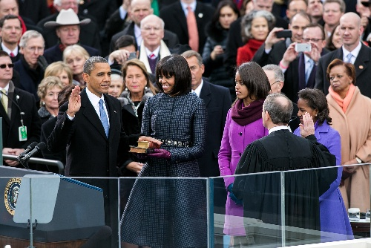

March 26, 2013: U.S. Supreme Court - Florida v. Jardines (6 to 3) https://supreme.justia.com/cases/federal/us/569/1/
DRUG DOG – FRONT PORCH – ILLEGAL SEARCH
“Here, however, the question before the court is precisely whether the officer’s conduct was an objectively reasonable search. As we have described, that depends upon whether the officers had an implied license to enter the porch, which in turn depends upon the purpose for which they entered. Here, their behavior objectively reveals a purpose to conduct a search, which is not what anyone would think he had license to do.

***

Dissent (Justice Alito): For these reasons, I would hold that no search within the meaning of the Fourth Amendment took place in this case, and I would reverse the decision below.”

April 17, 2013 – TX: 10 Firefighters Killed, West Fertilizer Company

“The City of West is a small rural town in central Texas, approximately 20 miles north of Waco and 75 miles south of Dallas. On the evening of April 17, 2013, the weather in central Texas was typical for spring, with temperatures hovering around 80 degrees F, low humidity, scattered clouds, and winds blowing from the SSE at 20 mph. Everything changed around 19:30, when a devastating explosion at the West Fertilizer Company plant rocked the city. The blast was so powerful that it was felt 80 miles away and registered as a 2.1-magnitude earthquake. The explosion destroyed or damaged more than 500 buildings, including homes, schools and a nursing home; left a massive crater where the plant once stood; and hit the community with an economic loss of over $230 million. The explosion killed 15 and injured more than 280 people. Except for one, all fatalities occurred due to fractures, blunt force trauma, or blast force injuries sustained during the explosion. Among those killed were 10 firefighters ranging in age from 26 to 52:
- Five West volunteer firefighters;
- Four volunteer firefighters attending an EMS class in the city (two from Abbott VFD, one from Bruceville-Eddy VFD, and one from Mertens/Navarro Mills VFD); and
- One off-duty Dallas fire captain who became aware of the incident and responded to the scene to assist.” https://www.firerescue1.com/west-fertilizer-plant-explosion/articles/west-texas-the-fertilizer-plant-explosion-that-killed-10-firefighters-7tdcjYownNurVVFN/?utm_source=Sailthru&utm_medium=email&utm_campaign=FR1-Daily-4-17-26&utm_term=FR1%20Daily

June 13, 2013 – 19 Granite Mountain Hot Shots killed

On June 30, 2013, 19 of the 20 members of the group perished fighting the Yarnell Hill Fire.

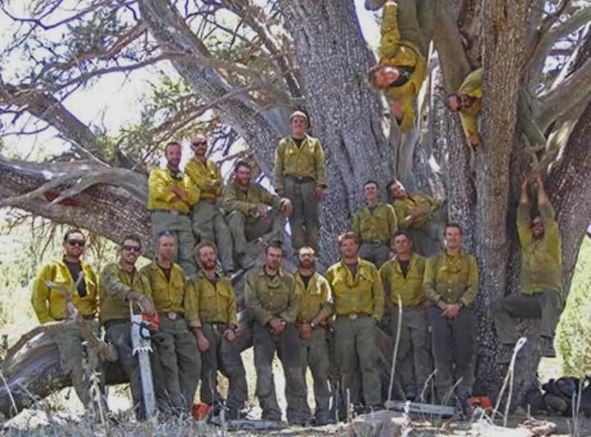
https://azstateparks.com/hotshots/the-hotshots/about-the-hotshots

”The Granite Mountain Interagency Hotshot Crew was a crew within the Prescott Fire Department whose mission was to fight wildfires and when not doing so, engaged in work to reduce growth of fire-prone vegetation. Originally founded in 2001 as a fuels mitigation crew, they were later formed into Crew 7, a Type II IA hand-crew in 2004, and eventually transitioned into a Type I Inter-agency hotshot crew in 2008.”
https://prescottfire.org/who-we-are/granite-mountain-hotshots/

Oct. 22, 2014: White House – Secret Service Canine Stops Intruder
“On Oct. 22, 2014, Hurricane was 6 years old when he spotted a man jumping the White House fence. The intruder fought off another Secret Service canine, Jordan, when he was about halfway across the North Lawn. But then Hurricane, who weighed more than 60 pounds, charged in for a brawl that lasted a few seconds before Hurricane knocked the man to the ground. The suspect, 23-year-old Dominic Adesanya, was taken to a hospital with injuries from a dog bite. Hurricane’s body was covered in bruises, bumps and blood, Mirarchi said, and he was taken to a veterinarian. Mirarchi said he worried Hurricane would die of his injuries.”

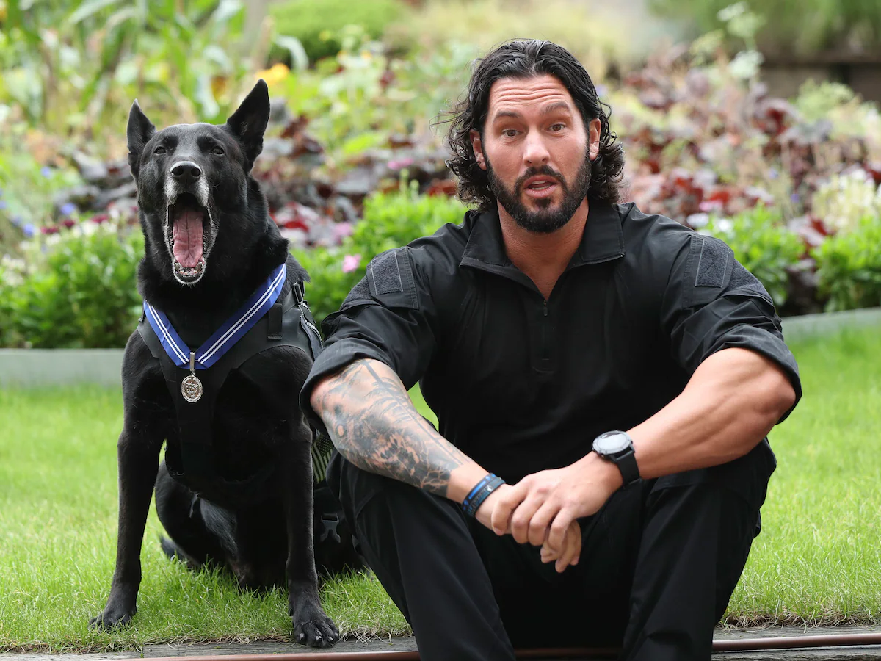
Secret Service Agent Marshall Mirarchi with former Secret Service dog Hurricane. (Yui Mok/AP)
Feb. 19, 2025: Hurricane, the most decorated K-9 in White House history, dies at 15, The Belgian Malinois was lauded for protecting President Barack Obama and his family after an intruder hopped the White House fence in 2014. https://www.washingtonpost.com/nation/2025/02/19/hurricane-dog-white-house-dies/?utm_campaign=wp_post_most&utm_medium=email&utm_source=newsletter&carta-url=https%3A%2F%2Fs2.washingtonpost.com%2Fcar-ln-tr%2F41388bf%2F67b7634333779f2c4a7b7360%2F59731235ade4e21a848a56ed%2F33%2F57%2F67b7634333779f2c4a7b7360

Jan. 19, 2016: U.S. Supreme Court - Hefferman v. City of Patterson (8 to 1) https://supreme.justia.com/cases/federal/us/578/14-1280/
POLICE OFFICER WITH POLITICAL SIGN FOR MAYOR’S OPPONENT MAY SUE FOR RETALIATION

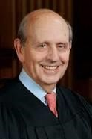Justice Steven Breyer (nominated by President Clinton in 1994)

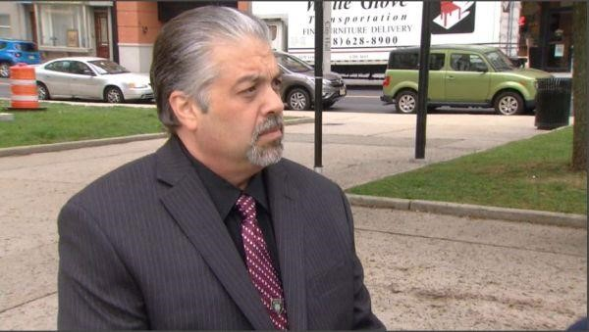 Officer Jeffery Heffernan: https://www.mtsu.edu/first-
amendment/article/1457/heffernan-v-city-of-paterson

“Facts of the case
Jeffrey Heffernan was a police officer for the City of Paterson, New Jersey. A fellow police officer observed Heffernan picking up a campaign sign for the mayoral candidate running against the incumbent. When a supervisor confronted him, Heffernan claimed that he was not politically involved, could not vote in the city of Paterson, and was picking up the sign on behalf of his mother. Heffernan was demoted to a walking post because his actions were considered to be ‘overt involvement in political activities.’
Heffernan sued the city of Paterson and claimed that the city had violated his First Amendment rights to freedom of speech and association. The city filed a motion for summary judgment and argued that, since Heffernan had not actually engaged in constitutionally protected speech, the City’s actions had not violated his First Amendment rights. The district court granted the city’s motion for summary judgment because there was no evidence Heffernan associated himself with the political candidate at issue. Heffernan admitted himself that he was not associated with the candidate, and therefore there is no evidence of a violation of his right to freedom of association. The U.S. Court of Appeals for the Third Circuit affirmed.

Question
Does the First Amendment prohibit the government from demoting a public employee based on a supervisor’s perception that the employee supports a political candidate?

Conclusion
A government employee who is demoted because of perceived involvement in protected political activity is entitled to challenge his demotion under the First Amendment even if the demotion was based on a factual mistake. Justice Stephen G. Breyer delivered the opinion for the 6-2 majority. The Court held that, although there was no First
Amendment case that specifically addressed this issue, there was at least one precedential case in which the employer’s motive was what determined whether the action violated the employee’s First Amendment rights. Therefore, when an employer demotes an employee out of a desire the prevent or punish the employee for engaging in protected speech, that action violates the First Amendment, even if the employer made a factual mistake and no protected speech occurred. The Court also held that this rule tracks the language of the First Amendment because it focuses on the harm the government actor committed, which is the same whether or not the employer made a factual mistake, and does not alter the burden that an employee claiming a First Amendment violation must meet, which is to prove that the defendant had an improper motive.” https://www.oyez.org/cases/2015/14-1280

Jan. 2017: Barack Obama – Leaving Office, Personal Note To Donald Trump
“Dear Mr. President -
Congratulations on a remarkable run. Millions have placed their hopes in you, and all of us, regardless of party, should hope for expanded prosperity and security during your tenure.
This is a unique office, without a clear blueprint for success, so I don’t know that any advice from me will be particularly helpful. Still, let me offer a few reflections from the past 8 years.
First, we’ve both been blessed, in different ways, with great good fortune. Not everyone is so lucky. It’s up to us to do everything we can (to) build more ladders of success for every child and family that’s willing to work hard.
Second, American leadership in this world really is indispensable. It’s up to us, through action and example, to sustain the international order that’s expanded steadily since the end of the Cold War, and upon which our own wealth and safety depend.
Third, we are just temporary occupants of this office. That makes us guardians of those democratic institutions and traditions — like rule of law, separation of powers, equal protection and civil liberties — that our forebears fought and bled for. Regardless of the push and pull of daily politics, it’s up to us to leave those instruments of our democracy at least as strong as we found them.
And finally, take time, in the rush of events and responsibilities, for friends and family. They’ll get you through the inevitable rough patches.
Michelle and I wish you and Melania the very best as you embark on this great adventure, and know that we stand ready to help in any ways which we can.
Good luck and Godspeed,
BO”
https://www.washingtonpost.com/history/2025/01/20/inauguration-letter-president-trump-biden-tradition/?utm_campaign=wp_post_most&utm_medium=email&utm_source=newsletter&carta-url=https%3A%2F%2Fs2.washingtonpost.com%2Fcar-ln-tr%2F41281a4%2F67b363a6eb3eba471afc37e7%2F59731235ade4e21a848a56ed%2F23%2F53%2F67b363a6eb3eba471afc37e7

Jan. 20, 2017: President Donald Trump – First Inauguration

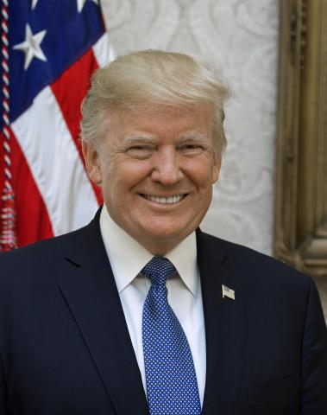

https://www.trumplibrary.gov/trumps/president-donald-j-trump

April 6, 2017: Ohio – Firefighter Cancer - Statutory Presumption Expanded From Cardiovascular, Pulmonary and Respiratory Diseases
https://www.legislature.ohio.gov/legislation/legislation-summary?id=GA131-SB-27

4123.68 Schedule of compensable occupational diseases. http://codes.ohio.gov/orc/4123.68
The following diseases are occupational diseases and compensable as such when contracted by an employee in the course of the employment in which such employee was engaged and due to the nature of any process described in this section.
***
(W) Cardiovascular, pulmonary, or respiratory diseases incurred by firefighters or police officers following exposure to heat, smoke, toxic gases, chemical fumes and other toxic substances: Any cardiovascular, pulmonary, or respiratory disease of a firefighter or police officer caused or induced by the cumulative effect of exposure to heat, the inhalation of smoke, toxic gases, chemical fumes and other toxic substances in the performance of the firefighter's or police officer's duty constitutes a presumption, which may be refuted by affirmative evidence, that such occurred in the course of and arising out of the firefighter's or police officer's employment. For the purpose of this section, "firefighter" means any regular member of a lawfully constituted fire department of a municipal corporation or township, whether paid or volunteer, and "police officer" means any regular member of a lawfully constituted police department of a municipal corporation, township or county, whether paid or volunteer. ***
(X)
- Cancer contracted by a firefighter: Cancer contracted by a firefighter who has been assigned to at least six years of hazardous duty as a firefighter constitutes a presumption that the cancer was contracted in the course of and arising out of the firefighter's employment if the firefighter was exposed to an agent classified by the international agency for research on cancer or its successor organization as a group 1 or 2A carcinogen.
- The presumption described in division (X)(1) of this section is rebuttable in any of the following situations:
  - There is evidence that the firefighter's exposure, outside the scope of the firefighter's official duties, to cigarettes, tobacco products, or other conditions presenting an extremely high risk for the development of the cancer alleged, was probably a significant factor in the cause or progression of the cancer.
  - There is evidence that shows, by a preponderance of competent scientific evidence, that exposure to the type of carcinogen alleged did not or could not have caused the cancer being alleged.
  - There is evidence that the firefighter was not exposed to an agent classified by the international agency for research on cancer as a group 1 or 2A carcinogen.
  - There is evidence that the firefighter incurred the type of cancer alleged before becoming a member of the fire department.
  - The firefighter is seventy years of age or older.
"Michael Louis Palumbo, Jr. Act."- Sub. S.B. 27, 131stGeneral Assembly: https://www.legislature.ohio.gov/download?key=6094&format=pdf
Local firefighter Michael Louis Palumbo Jr. receives hero’s burial (June 3, 2017): https://www.news-herald.com/news/ohio/local-firefighter-michael-louis-palumbo-jrreceives-hero-s-burial/article_e26ca425-9c33-5c68-91b3-e8a9dc2f68ec.html

Oct. 1, 2017 – Las Vegas Mass Shooting – 58 Dead, 800 Injured

FEMA Releases After-Action Report on Las Vegas Shooting.
On Friday, August 24, 2018, the Federal Emergency Management Agency (FEMA) released the “1 October After-Action Report” which details the findings and lessons learned from the October 1, 2017 shooting that left more than 800 people injured and resulted in 58 fatalities. The 13 responding agencies, including the Clark County Fire Department (CCFD) and Las Vegas Metropolitan Police Department (LVMPD), have all been praised for their concerted and efficient response. According to the report, “The cooperation between local fire departments, law enforcement agencies, and local private ambulance companies at the scene was exceptional.” In particular, FEMA notes that “heavy local investment in Multi-Assault Counter-Terrorism Action Capabilities (MACTAC) and Hostile Mass Casualty Incident (MCI) training, as well as other formal training investments by CCFD, LVMPD, and surrounding jurisdictions, also proved especially valuable.” Even though the responding agencies and organizations used strong collaboration to execute a quick and effective response, “when responders encountered communication barriers, these barriers hindered some aspects of their response coordination.” FEMA makes 72 observations in the report, all of which are accompanied by a corresponding recommendation. In sum, all responders met this incident with “courage and knowledge”, and the value of training and exercises is incalculable. FEMA summarizes the key conclusions as:
- Strong cross-agency collaboration is critical for a quick and effective response.
- Response training that is tailored to address an incident of mass violence is an especially valuable preparedness investment.
- Coordinated, cross-agency planning for an incident of mass violence is necessary for successful outcomes. https://www.hsdl.org/c/fema-releases-after-action-report-on-las-vegas-shooting/
Read the report: https://www.hsdl.org/c/abstract/?docid=814668

April 10, 2028 – Kyle Plush / Cincinnati 911
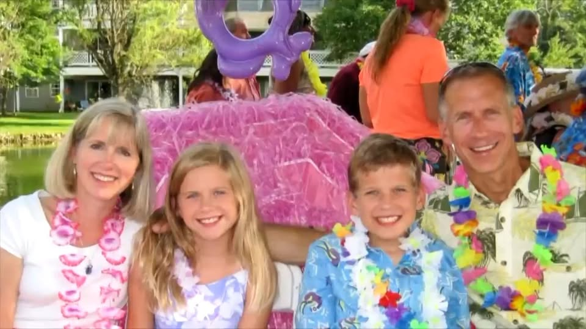
4/9/2021: Family of Kyle Plush reaches $6 million settlement in wrongful death lawsuit…. The 16-year-old Seven Hills student died on April 10, 2018, when he was trapped by a folding seat in the back of a minivan parked in a lot across from his school. The boy was headed to the tennis court but never arrived. Instead, he was pinned by a folding seat in the back of his parked minivan. Plush managed to use the voice activation on his phone to call 911. However, operators and police were unable to locate his van. The teenager was found six hours later by his father. He was unresponsive in the van and pronounced dead a short time later…. The settlement establishes a team of 911 experts from around the country who will work with the director of the ECC to further enhance the city's 911 system. "The scope of the work that these experts will engage in includes fully, thoroughly exploring all the actions that everyone took that failed Kyle, identifying the systemic issues: the training, the quality assurance, the protocol issues and making sure that every one of them gets fixed," Gerhardstein said. "Reports every six months. They will be public. The public will be able to talk directly to the expert team. And they'll be a public hearing at various points whenever any of us want one, in order to bring everybody up to date with what's been done." https://www.wlwt.com/article/family-of-kyle-plush-reaches-settlement-in-wrongful-death-lawsuit/36079929
4/18/2026: CINCINNATI (WKRC) - Eight years after 16-year-old Kyle Plush died after becoming trapped in his family’s car outside a Madisonville school, his parents are continuing to honor his memory by supporting the people who answer 911 calls and by sharing safety tips aimed at helping first responders find callers faster. Ron and Jill Plush, along with volunteers from their organization, the Kyle Plush Answer the Call Foundation, are visiting nearly 30 911 call centers during National Public Safety Telecommunicators Week. They are dropping off items as a way to thank dispatchers and other telecommunicators. https://local12.com/news/local/family-marks-years-since-sons-death-by-visiting-supporting-911-call-centers-dispatch-dispatchers-cops-police-officers-madisonville-kyle-plush-answer-the-call-foundation-telecommunicators-week-public-safety-honoring-memory-cincinnati

June 4, 2018 – U.S. Supreme Court - Masterpiece Cakeshop v. Colorado Civil Rights Commission (7 to 2) https://www.oyez.org/cases/2017/16-111
WEEDING CAKE BAKER – CAN REFUSE TO SELL TO GAY
“In 2018, the court sided with a Colorado baker who had refused to create a wedding cake for a same-sex couple. The result looked like a loss for gay rights. But Justices Kagan and Breyer had helped persuade Justice Kennedy to rule on grounds so narrow they neutered the decision, according to people familiar with the proceedings. The baker won — but the results could not be applied to any other case.
On Monday, Justice Kennedy chose a third path, one that seemed to apply only to the case before the court. Writing for the majority in the 7-to-2 decision, he said the Civil Rights Commission’s ruling against the baker, Jack Phillips, had been infected by religious animus. He cited what he said were “inappropriate and dismissive comments” from one commissioner in saying that the panel had acted inappropriately and that its decision should be overturned.
‘The neutral and respectful consideration to which Phillips was entitled was compromised here,’ Justice Kennedy wrote. ‘The Civil Rights Commission’s treatment of his case has some elements of a clear and impermissible hostility toward the sincere religious beliefs that motivated his objection.’” https://www.nytimes.com/2018/06/04/us/politics/supreme-court-sides-with-baker-who-turned-away-gay-couple.html

June 22, 2018: U.S. Supreme Court – Carpenter v. United States (5 to 4) https://www.supremecourt.gov/opinions/17pdf/16-402_h315.pdf
CELL PHONE LOCATION DATA REQUIRES SEARCH WARRANT UNLESS “EXIGENT CIRCUMSTANCES”
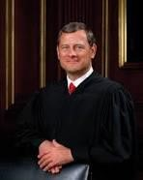Chief Justice John Roberts
“Cell phones perform their wide and growing variety of functions by continuously connecting to a set of radio antennas called ‘cell sites.’ Each time a phone connects to a cell site, it generates a time-stamped record known as cell-site location information (CSLI). Wireless carriers collect and store this information for their own business purposes. Here, after the FBI identified the cell phone numbers of several robbery suspects, prosecutors were granted court orders to obtain the suspects’ cell phone records under the Stored Communications Act. Wireless carriers produced CSLI for petitioner
Timothy Carpenter’s phone, and the Government was able to obtain 12,898 location points cataloging Carpenter’s movements over 127 days—an average of 101 data points per day. Carpenter moved to suppress the data, arguing that the Government’s seizure of the records without obtaining a warrant supported by probable cause violated the Fourth Amendment. The District Court denied the motion, and prosecutors used the records at trial to show that Carpenter’s phone was near four of the robbery locations at the time those robberies occurred. Carpenter was convicted. The Sixth Circuit affirmed, holding that Carpenter lacked a reasonable expectation of privacy in the location information collected by the FBI because he had shared that information with his wireless carriers.
Held:
The Government did not obtain a warrant supported by probable cause before acquiring Carpenter’s cell-site records. It acquired those records pursuant to a court order under the Stored Communications Act, which required the Government to show ‘reasonable grounds’ for believing that the records were ‘relevant and material to an ongoing investigation.’ 18 U. S. C. §2703(d). That showing falls well short of the probable cause required for a warrant. Consequently, an order issued under §2703(d) is not a permissible mechanism for accessing historical cell-site records. Not all orders compelling the production of documents will require a showing of probable cause. A warrant is required only in the rare case where the suspect has a legitimate privacy interest in records held by a third party. And even though the Government will generally need a warrant to access CSLI, case-specific exceptions—e.g., exigent circumstances—may support a warrantless search.” https://www.supremecourt.gov/opinions/17pdf/16-402_h315.pdf

See article: “He Won a Landmark Case for Privacy Rights. He’s Going to Prison
Anyway.” (June 13, 2019). “This week, a federal appeals court [6th Circuit] decided that Mr. Carpenter’s big victory at the Supreme Court won’t spare him from going to prison for the rest of his life. *** But under the good-faith exception to violations of the Fourth Amendment, the court said the agents acted reasonably and in “good faith” — and so whatever they gathered could still be used at trial. The F.B.I. merely followed the law and the rules that applied at the time of the violation. https://www.nytimes.com/2019/06/13/opinion/timothy-carpenter-prison-privacy.html

6th Circuit decision (June 11, 2019):
https://www.opn.ca6.uscourts.gov/opinions.pdf/19a0126p-06.pdf

“This case returns on remand from the Supreme Court. In our prior opinion, the majority held that the Government’s warrantless collection of Timothy Ivory Carpenter’s cell-site location information (CSLI) did not violate the Fourth Amendment. The Supreme Court disagreed. The unconstitutionality of the Government’s search was not clear until after the Supreme Court reversed our decision, which leads us to the question of whether the FBI agents who obtained Carpenter’s CSLI acted in good faith. Because these agents reasonably relied on the Stored Communications Act (SCA), we AFFIRM the judgment of the district court.”
See also: Cell Phone Store Robber Sentenced to 116 Years (April 16, 2014): https://archives.fbi.gov/archives/detroit/press-releases/2014/cell-phone-store-robbersentenced-to-116-years

December 21, 2018: First Step Act [releasing federal prisoners]
On December 21, 2018, President Trump signed into law the First Step Act of 2018 (P.L. 115-391). The act was the culmination of several years of congressional debate about what Congress might do to reduce the size of the federal prison population while also creating mechanisms to maintain public safety. This report provides an overview of the provisions of the act. The act has three major components: (1) correctional reform via the establishment of a risk and needs assessment system at the Bureau of Prisons (BOP), (2) sentencing reform via changes to penalties for some federal offenses, and (3) the reauthorization of the Second Chance Act of 2007 (P.L. 110-199). The act also contains a series of other criminal justice-related provisions. https://crsreports.congress.gov/product/pdf/R/R45558
July 19, 2019: Justice Department officials on Friday announced that 3,100 inmates are being released from federal prisons across the country because of a change in how their good-behavior time is calculated — a significant step, they said, in the implementation of a new criminal justice reform law. https://www.washingtonpost.com/national-security/3100-inmates-to-be-released-as-trump-administration-implements-criminal-justice-reform/2019/07/19/7ed0daf6-a9a4-11e9-a3a6-ab670962db05_story.html

July 25, 2021: The First Step Act aimed to correct the disparities in sentencing of defendants convicted of crack offenses, who were mostly Black, compared to powder cocaine. It contains six provisions that address reducing recidivism, incentivizing rehabilitation, improving where an inmate is confined in relation to their primary residence, correctional reforms such as prohibiting the use of restraints on pregnant inmates, government oversight and sentencing reforms. https://www.washingtonpost.com/nation/2021/07/25/first-step-act/?utm_campaign=wp_evening_edition&utm_medium=email&utm_source=newsletter&wpisrc=nl_evening&carta-url=https%3A%2F%2Fs2.washingtonpost.com%2Fcar-ln-tr%2F343c18f%2F60fdd0e69d2fda945a17bbac%2F59731235ade4e21a848a56ed%2F35%2F48%2F60fdd0e69d2fda945a17bbac

August. 10, 2019 – Jeffrey Epstein Suicide
https://www.brennancenter.org/our-work/analysis-opinion/completely-predictable-death-jeffrey-epstein
“The reported suicide on Saturday of disgraced financier Jeffrey Epstein in a federal jail cell in the heart of Manhattan was both utterly shocking and completely predictable. It’s shocking that the Bureau of Prisons was unable to keep Epstein alive pending his federal sex trafficking trial and that jail officials, knowing the world was watching this case so closely, allowed his death even after Epstein’s apparent failed attempt to take his own life three weeks ago. That’s negligence by definition, whether the celebrity defendant was placed on or taken off ‘suicide watch.’ But inmate suicides are such a regular part of life in American prisons and jails that none of us should be surprised whenever they occur. They are the leading cause of death in jails, and have been for many years, and the problem seems to be getting worse. The latest statistics, from 2014, tell us the rate of suicides in jails was the highest it’s been since at least 2000. This even though there is more public awareness surrounding the phenomenon and a cry for better records (and details) about the number of suicides that take place each year.”

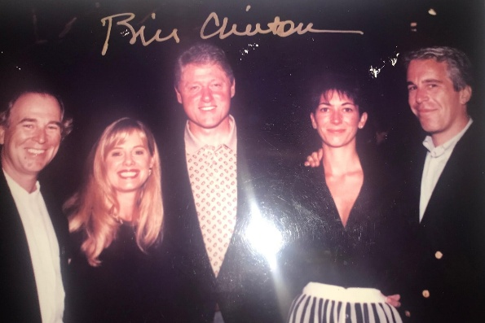
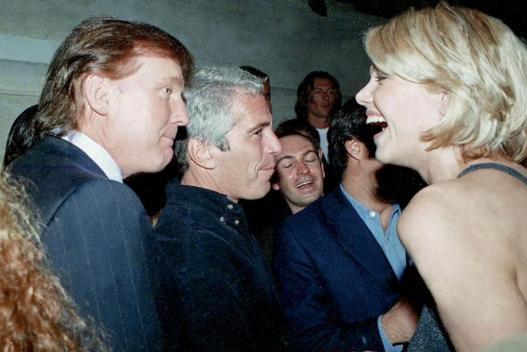
Dec. 12, 2025: “Democrats Release Photos Showing Epstein Ties to Powerful Men. The images, released without context by Democrats on the House Oversight Committee, revealed little new about the deceased sex offender’s ties to prominent men in politics, entertainment and finance.” https://www.nytimes.com/2025/12/12/us/politics/jeffrey-epstein-photos-estate.html

Dec. 14, 2025:
“Mr. Clinton was acquainted with Mr. Epstein — an association the former president described in his memoir — but never visited his private island and cut off contact with him two decades ago. Mr. Clinton took four international trips on Mr. Epstein’s private jet in 2002 and 2003, according to flight logs, and an undated photograph of Mr. Clinton and Mr. Epstein signed by the former president was part of a batch of images released by House Democrats last week highlighting Mr. Epstein’s ties to powerful men.” https://www.nytimes.com/2025/12/14/us/politics/clintons-epstein-inquiry.html?nl=On+Politics&segment_id=212324

Nov. 15, 2019: President Trump Pardons First Lieutenant Clint Lorance
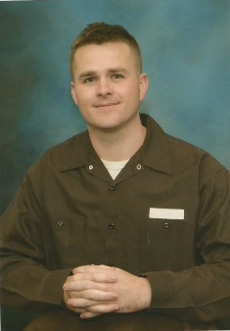Clint Lorance

“One of the pardoned soldiers was First Lt. Clint Lorance, who was turned in by his own troops after he ordered them to fire on unarmed Afghans over 100 yards away from his platoon, killing them. The soldier then radioed a false report claiming the bodies had been removed and couldn’t be searched for weapons. The Army convicted Lieutenant Lorance of second-degree murder and other charges and sentenced him to 19 years in prison.

***

The legal and ethical challenges he will have to overcome to realize his dream of becoming a lawyer are formidable, despite a pardon from President Donald Trump last November that let him out of the U.S. Disciplinary Barracks at Fort Leavenworth, Kansas, after serving six years of a 19-year sentence.” https://www.nytimes.com/2025/02/22/us/politics/hegseth-firings-military-lawyers-jag.html

“His crime: ordering his subordinates to fire on three Afghans riding a motorcycle while on patrol in Kandahar in July 2012…. Lorance, I soon discovered, had been on the ground with his platoon in Afghanistan for only three days when the shooting that landed him in prison occurred. He had replaced another lieutenant, who’d been wounded in a bombing. Lorance, who had previously served in Iraq as an enlisted soldier, was freshly commissioned and 28 years old…. Reading that interview, I started to lose faith in Lorance. Nine members of his platoon testified against him at his trial. Together, they described a man who arrived in Afghanistan determined to get his hands bloody. Fair enough. Combat soldiers are, by nature, hungry for a fight. As a result, a platoon leader who is willing to loosen the reins a little and allow his subordinates to aggressively pursue the enemy will generally be a pretty popular guy. Which is why I was surprised to discover that not a single soldier from Lorance’s platoon testified on his behalf. Even more surprising is the wide discrepancy between the accounts of the incident provided by the soldiers who testified against Lorance and the narrative he and his supporters — none of whom actually witnessed the shooting — have vehemently pressed since the murder investigation began.”
https://taskandpurpose.com/news/think-lt-clint-lorance-murderer/

Jan. 15, 2020: FLSA - U.S. Department of Labor issues its “Final Rule” on benefits that can be given employees, without increasing their overtime “regular rate of pay”
https://www.dol.gov/agencies/whd/overtime/2019-regular-rate/faqs
“The Final Rule focuses primarily on clarifying whether certain kinds of benefits or perks and other miscellaneous payments must be included in the regular rate. In relevant part, the Department revises the current regulations to confirm the following:
- the cost of providing certain parking benefits, wellness programs, onsite specialist treatment, gym access and fitness classes, employee discounts on retail goods and services, certain tuition benefits (whether paid to an employee, an education provider, or a student-loan program), and adoption assistance;
- payments for unused paid leave, including paid sick leave or paid time off;
- payments of certain penalties required under state and local scheduling laws;
- reimbursed expenses including cellphone plans, credentialing exam fees, organization membership dues, and travel, even if not incurred “solely” for the employer’s benefit; and clarifies that reimbursements that do not exceed the maximum travel reimbursement under the Federal Travel Regulation System or the optional IRS substantiation amounts for travel expenses are per se “reasonable payments”;
- certain sign-on bonuses and certain longevity bonuses;
- the cost of office coffee and snacks to employees as gifts;
- discretionary bonuses, by clarifying that the label given a bonus does not determine whether it is discretionary and providing additional examples and;
- contributions to benefit plans for accident, unemployment, legal services, or other events that could cause future financial hardship or expense.”

March 27, 2020: Coronavirus Aid, Relief, and Economics

Security Act (“CARES”)

U.S. Department of Treasury: “The Coronavirus Aid, Relief, and Economic Security (CARES) Act was passed by Congress with overwhelming, bipartisan support and signed into law by President Trump on March 27th, 2020. This over $2 trillion economic relief package delivers on the Trump Administration’s commitment to protecting the American people from the public health and economic impacts of COVID-19.” https://home.treasury.gov/policy-issues/cares

July 30, 2020: The $150k reporting threshold plummets to $10k
“The reporting, which will begin in January of 2021 for all funds received and spent in 2020, will be required of all who have received a total of $10,000 or more. The Terms state that this includes any funds received from HHS under the Coronavirus Aid, Relief, and Economics Security Act (“CARES”), the Coronavirus Preparedness and Response Supplemental Appropriations Act, the Families First Coronavirus Response Act, or any other Act primarily making appropriations for the coronavirus response. Therefore, this lowered threshold will likely mean that almost every EMS and ambulance agency will have to follow the reporting requirements.” Page, Wolfberg & Wirth info@pwwemslaw.com

May 25, 2020: George Floyd death
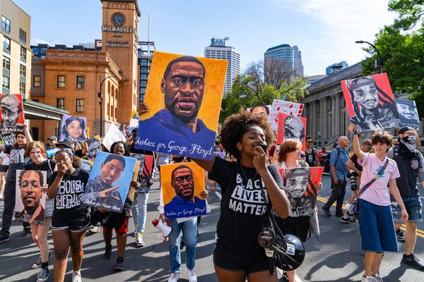
The murder of George Floyd in 2020 set off protests in Minneapolis and across the country. Credit...Aaron Nesheim for The New York Times https://www.nytimes.com/2024/04/14/us/minneapolis-prosecutor-george-floyd-moriarty.html?te=1&nl=the-morning&emc=edit_nn_20240415
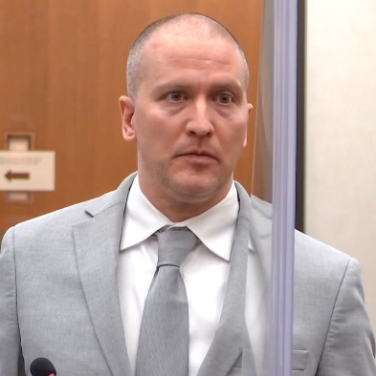
Nov. 24, 2023: Derek Chauvin, the former Minneapolis police officer convicted of murdering George Floyd, was stabbed by another inmate and seriously injured Friday at a federal prison in Arizona, a person familiar with the matter told The Associated Press. The attack happened at the Federal Correctional Institution, Tucson, a medium-security prison that has been plagued by security lapses and staffing shortages. The person was not authorized to publicly discuss details of the attack and spoke to the AP on the condition of anonymity. https://apnews.com/article/derek-chauvin-george-floyd-prison-stabbing-f24cde6aa28877d034530c2dc40ef7ea
March 5, 2025: Chauvin was found guilty of murder and is serving two concurrent sentences for federal and state convictions. If Trump pardoned him on the federal charges, Chauvin would still have to serve the remainder of his 22½-year sentence in a state facility, a prison official told The Minnesota Star Tribune. The New York Times nytdirect@nytimes.com

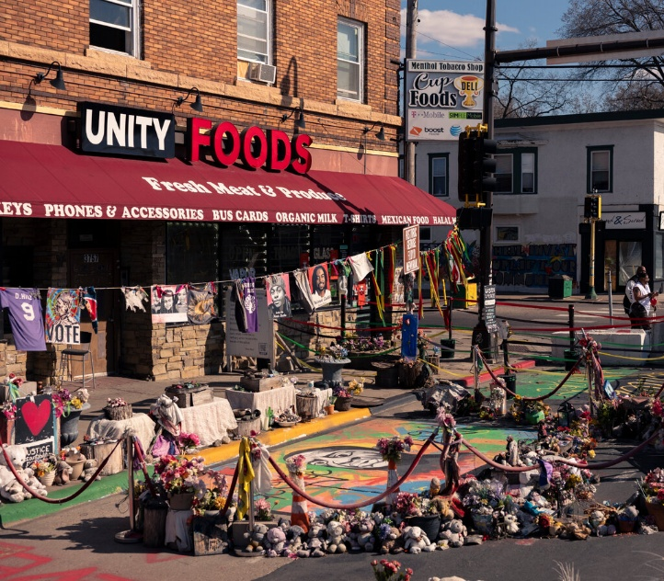

June 15, 2020: U.S. Supreme Court – Bostock v. Clayton County, Georgia (6 to 3) https://www.supremecourt.gov/opinions/19pdf/17-1618_hfci.pdf

TITLE VII PROTECTS TRANSGENDERS
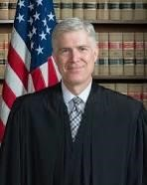 Justice Neil Gorsuch (nominated by President Donald Trump, sworn in
April 10, 2017)
“In each of these cases, an employer allegedly fired a long-time employee simply for being homosexual or transgender. Clayton County, Georgia, fired Gerald Bostock for conduct ‘unbecoming’ a county employee shortly after he began participating in a gay recreational softball league.”
Gerald Bostock

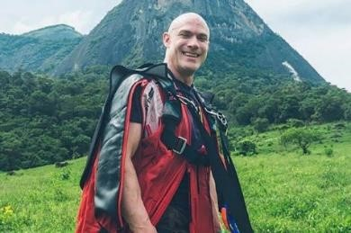
“Altitude Express fired Donald Zarda days after he mentioned being gay.”
Donald Zarda – died in base jumping accident in 2014:
https://nypost.com/2020/06/15/mom-of-late-gay-supreme-court-plaintiff-he-would-bedelighted/
Aimee Stephens
“And R. G. & G. R. Harris Funeral Homes fired Aimee Stephens, who presented as a male when she was hired, after she in-formed her employer that she planned to ‘live and work full-time as a woman.’”
Each employee sued, alleging sex discrimination under Title VII of the Civil Rights Act of 1964. The Eleventh Circuit held that Title VII does not prohibit employers from firing employees for being gay and so Mr. Bostock’s suit could be dismissed as a matter of law. The Second and Sixth Circuits, however, allowed the claims of Mr. Zarda and Ms. Stephens, respectively, to proceed.
Held: An employer who fires an individual merely for being gay or transgender violates Title VII.” https://www.supremecourt.gov/opinions/19pdf/17-1618_hfci.pdf

July 17, 2020: Congressman John Lewis dies – Civil Rights Leader
“John Lewis [and Hosea Williams] led over 600 peaceful, orderly protestors across the Edmund Pettus Bridge in Selma, Alabama on March 7, 1965. They intended to march from Selma to Montgomery to demonstrate the need for voting rights in the state. The marchers were attacked by Alabama state troopers in a brutal confrontation that became known as ‘Bloody Sunday.’ News broadcasts and photographs revealing the senseless cruelty of the segregated South helped hasten the passage of the Voting Rights Act of 1965.” https://johnlewis.house.gov/john-lewis/biography

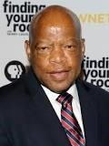

NEW YORK TIMES: Mr. Lewis, the civil rights leader who died on July 17, wrote this essay shortly before his death, to be published upon the day of his funeral. https://www.nytimes.com/2020/07/30/opinion/john-lewis-civil-rights-america.html
6/30/2020: By John Lewis:
“While my time here has now come to an end, I want you to know that in the last days and hours of my life you inspired me. You filled me with hope about the next chapter of the great American story when you used your power to make a difference in our society. Millions of people motivated simply by human compassion laid down the burdens of division. Around the country and the world you set aside race, class, age, language and nationality to demand respect for human dignity.
That is why I had to visit Black Lives Matter Plaza in Washington, though I was admitted to the hospital the following day. I just had to see and feel it for myself that, after many years of silent witness, the truth is still marching on.
Emmett Till was my George Floyd. He was my Rayshard Brooks, Sandra Bland and Breonna Taylor. He was 14 when he was killed, and I was only 15 years old at the time. I will never ever forget the moment when it became so clear that he could easily have been me. In those days, fear constrained us like an imaginary prison, and troubling thoughts of potential brutality committed for no understandable reason were the bars.
Though I was surrounded by two loving parents, plenty of brothers, sisters and cousins, their love could not protect me from the unholy oppression waiting just outside that family circle. Unchecked, unrestrained violence and government sanctioned terror had the power to turn a simple stroll to the store for some Skittles or an innocent morning jog down a lonesome country road into a nightmare. If we are to survive as one unified nation, we must discover what so readily takes root in our hearts that could rob Mother Emanuel Church in South Carolina of her brightest and best, shoot unwitting concertgoers in Las Vegas and choke to death the hopes and dreams of a gifted violinist like Elijah McClain.
Like so many young people today, I was searching for a way out, or some might say a way in, and then I heard the voice of Dr. Martin Luther King Jr. on an old radio. He was talking about the philosophy and discipline of nonviolence. He said we are all complicit when we tolerate injustice. He said it is not enough to say it will get better by and by. He said each of us has a moral obligation to stand up, speak up and speak out. When you see something that is not right, you must say something. You must do something. Democracy is not a state. It is an act, and each generation must do its part to help build what we called the Beloved Community, a nation and world society at peace with itself.
Ordinary people with extraordinary vision can redeem the soul of America by getting in what I call good trouble, necessary trouble. Voting and participating in the democratic process are key. The vote is the most powerful nonviolent change agent you have in a democratic society. You must use it because it is not guaranteed. You can lose it.
You must also study and learn the lessons of history because humanity has been involved in this soul-wrenching, existential struggle for a very long time. People on every continent have stood in your shoes, through decades and centuries before you. The truth does not change, and that is why the answers worked out long ago can help you find solutions to the challenges of our time. Continue to build union between movements stretching across the globe because we must put away our willingness to profit from the exploitation of others.
Though I may not be here with you, I urge you to answer the highest calling of your heart and stand up for what you truly believe. In my life I have done all I can to demonstrate that the way of peace, the way of love and nonviolence is the more excellent way. Now it is your turn to let freedom ring.
When historians pick up their pens to write the story of the 21st century, let them say that it was your generation who laid down the heavy burdens of hate at last and that peace finally triumphed over violence, aggression and war. So I say to you, walk with the wind, brothers and sisters, and let the spirit of peace and the power of everlasting love be your guide.”

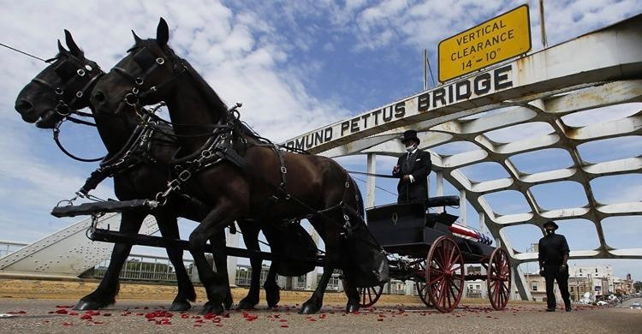

July 30, 2020: Obama speech - call to action in eulogy for Lewis … along with
Presidents Clinton and Bush.
”Standing before Lewis’s flag-draped casket, [President] Obama told the story of Lewis’s courage on his first ‘freedom’ ride on a bus, an unofficial test taken with a Black friend to set the stage for the broader Freedom Ride protests on segregated buses in the South. ‘Imagine the courage of two people Malia’s age, younger than my oldest daughter, on their own,’ the former president said. ‘John was only 20 years old. But he pushed all 20 of those years to the center of the table, betting everything — all of it — that his example could challenge centuries of convention and generations of brutal violence.’”
https://www.politico.com/news/2020/07/30/clinton-bush-obama-john-lewis-funeral-388050

April 14, 2020: PSOB Amended – Public Safety Officers - COVID-19 deaths / injuries
SEC. 3. Public Safety Officer Benefits: https://www.congress.gov/bill/116th-congress/senatebill/3607/text
- Death benefits.—As determined by the Bureau of Justice Assistance, unless competent medical evidence establishes that the death of a public safety officer (as defined in section 1204 of title I of the Omnibus Crime Control and Safe Streets Act of 1968 (34 U.S.C. 10284)) was directly and proximately caused by something other than COVID–19, COVID–19 (or complications therefrom) suffered by the public safety officer shall be presumed to constitute a personal injury within the meaning of section
1201(a) of title I of the Omnibus Crime Control and Safe Streets Act of 1968 (34 U.S.C. 10281(a)), sustained in the line of duty by the officer and directly and proximately resulting in death, if—
  - the officer engaged in a line of duty action or activity between January 1, 2020, and December 31, 2021;
  - the officer was diagnosed with COVID–19 (or evidence indicates that the officer had COVID–19) during the 45-day period beginning on the last day of duty of the officer; and
  - evidence indicates that the officer had COVID–19 (or complications therefrom) at the time of the officer's death.
- Disability benefits.—As determined by the Bureau of Justice Assistance, COVID–19 (or complications therefrom) suffered by a public safety officer shall be presumed to constitute a personal injury within the meaning of section 1201(b) of title I of the Omnibus Crime Control and Safe Streets Act of 1968 (34 U.S.C. 10281(b)), sustained in the line of duty by the officer, if—
  - the officer engaged in a line of duty action or activity between January 1, 2020, and December 31, 2021; and
  - the officer was diagnosed with COVID–19 (or evidence indicates that the officer had COVID–19) during the 45-day period beginning on the last day of duty of the officer.”

Jan. 20, 2021: President Joe Biden – Inauguration

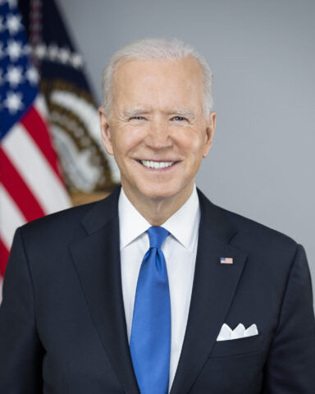
https://www.whitehousehistory.org/bios/joseph-r-biden-jr
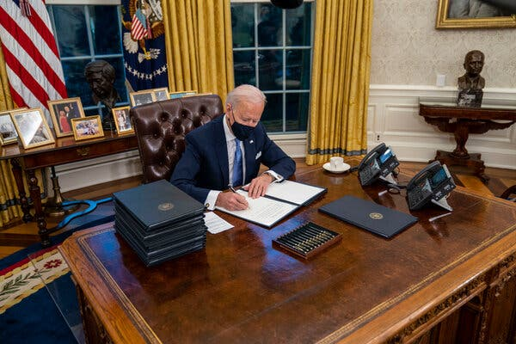President Joseph R. Biden Jr. signing executive orders on his first day in office. https://www.nytimes.com/2025/12/07/us/politics/biden-immigration-trump.html?nl=Breaking+News

June 8, 2021 – Trump Rally - Mob Attacks U.S. Capitol
“More than 140 officers were wounded and three people died as a result of medical emergencies suffered during the riot. Four police officers who worked that day later died by suicide.” https://www.washingtonpost.com/dc-md-va/2025/02/21/enrique-tarrio-proud-boys-arrested-dc-capitol-police/?utm_campaign=wp_post_most&utm_medium=email&utm_source=newsletter&carta-url=https%3A%2F%2Fs2.washingtonpost.com%2Fcar-ln-tr%2F41436f6%2F67b9fa8b99aedb3a29da0fd3%2F59731235ade4e21a848a56ed%2F29%2F56%2F67b9fa8b99aedb3a29da0fd3
***
“The 2020 presidential election was held on November 3, 2020. On December 14, 2020,
the Electoral College met, and a majority of the electors cast their votes for Joseph R. Biden and Kamala D. Harris…. On January 6, 2021, a mob attacked the U.S. Capitol, where the House and Senate were set to count and certify the Electoral College vote. According to the RNC, “[m]any in the mob intended to interfere” with Congress’s counting and certification… And some “attacked Capitol police officers, vandalized portions of the Capitol itself, and forced their way into the Senate chamber.”
Republican National Committee v. Nancy Pelosi, et al., May 1, 2022. https://storage.courtlistener.com/recap/gov.uscourts.dcd.241102/gov.uscourts.dcd.241102.33.0.pdf

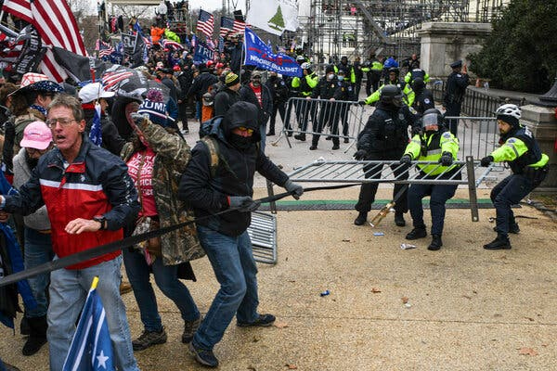

‘You’re a Go’: How Miscues and Confusion Delayed the National Guard on Jan. 6. {May 7, 2024.]
The picture is far from a flattering one: A miscommunication between Christopher C. Miller, the secretary of defense at the time, and Ryan D. McCarthy, the secretary of the Army, resulted in each man leaving a critical exchange on the afternoon of Jan. 6 with a different understanding of how quickly the Guard would be deployed — and who would give word that it was authorized. *** The testimony highlighted a still-simmering feud inside the military over who is to blame for the more than four-hour delay in deploying the National Guard. The pro-Trump mob began assaulting police officers at the Capitol just before 1 p.m. But it took until 5:40 p.m. for the National Guard to arrive on the Capitol grounds, after the Capitol Police and the Metropolitan Police Department had largely put down the riot. https://www.nytimes.com/2024/05/07/us/politics/miscues-confusion-national-guard-delay-jan-6.html?te=1&nl=the-morning&emc=edit_nn_20240509

***
Feb. 20, 2025: Justice Department broadens Trump’s Jan. 6 clemency as it moves to drop gun cases.
“In court papers, DOJ revealed a newly expansive interpretation of the president’s Jan. 6 pardons. The Justice Department now says that President Donald Trump’s clemency for Jan. 6 rioters covers unrelated crimes that were discovered during FBI searches stemming from the attack on the Capitol. Federal prosecutors revealed the new legal position this week in court papers seeking to drop gun charges against two former Jan. 6 defendants. The guns in question were found at the two men’s homes during the Jan. 6 investigation, but the alleged gun crimes themselves were not connected to the riot. Nonetheless, prosecutors moved to dismiss the gun cases by invoking Trump’s Day 1 executive order granting mass clemency to Jan. 6 defendants. That order issued pardons to roughly 1,500 people who had been convicted of “offenses related to events that occurred at or near the United States Capitol” on Jan. 6, 2021. It also directed the attorney general to dismiss all pending prosecutions for “conduct related to” those events. *** A day after Trump ordered Ball released from his Jan. 6 assault case, he was rearrested and returned to Florida where he was charged with being a felon in possession of a firearm. (Ball had prior felonies on his record from 2017 and 2021, according to the indictment.) *** Costianes, for his part, pleaded guilty in 2023 to possessing a firearm while being a user of illegal drugs. He recently began serving his two-year prison sentence — a sentence that the Justice Department sought Wednesday to end immediately.” https://www.politico.com/news/2025/02/20/justice-department-january-6-clemency-guns-00205357

March 3, 2022: SEXUAL HARASSMENT / NO FORCED ARBITRATIONS
“President Biden Signs Bill Prohibiting Mandatory Arbitration and Class Action Waivers for Sexual Harassment and Sexual Assault Claims. President Biden signed the bill into law on March 3, 2022. The law takes effect immediately.*** Today, the Senate passed H. 4445, the Ending Forced Arbitration of Sexual Assault and Sexual Harassment Act (the ‘Act’), by a voice vote. The bill had previously passed the House of Representatives by a vote of 335-97. The White House has indicated President Biden will sign the bill. [The Act amends] the Federal Arbitration Act to prohibit enforcement of mandatory pre-dispute arbitration agreements, as well as agreements prohibiting participation in a joint, class or collective action in any forum, ‘at the election of the person alleging conduct constituting a sexual harassment dispute or sexual assault dispute, or the named representative of a class or in a collective action alleging such conduct.’ The Act also provides that any dispute concerning whether a claim falls within the scope of the Act’s prohibitions will be decided by a court and not an arbitrator, irrespective of whether the arbitration agreement at issue purports to delegate such determinations to an arbitrator. A ‘sexual assault dispute’ is defined as one ‘involving a nonconsensual sexual act or sexual contact, as such terms are defined in section 2246 of title 18 or similar applicable Tribal or State law, including when the victim lacks capacity to consent.’ A ‘sexual harassment dispute’ is defined as one ‘relating to conduct that is alleged to constitute sexual harassment under applicable Federal, Tribal, or State law.’
The new restrictions would apply ‘with respect to any dispute or claim that arises or accrues on or after the date of enactment of this Act,’ meaning that once enacted, millions of American workers could elect to be released from existing arbitration agreements and/or class and collective action waivers as relating to sexual harassment and sexual assault claims that arise after the law goes into effect. However, because the law only addresses pre-dispute arbitration and class/collection action waiver agreements, any agreement to arbitrate claims entered into by the parties after the claims arise remains enforceable.” https://www.lawandtheworkplace.com/2022/02/congress-passes-bill-prohibiting-mandatory-arbitration-and-class-action-waivers-for-sexual-harassment-and-sexual-assault-claims/

June 8, 2022: Armed man went to Justice Kavanaugh’s home to kill him
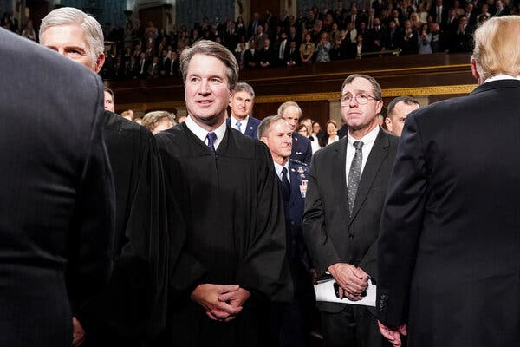
“A man armed with a pistol, a knife and other weapons was arrested near the Maryland home of Justice Brett M. Kavanaugh early Wednesday after he said he traveled from California to kill the Supreme Court justice, federal officials said. Nicholas John Roske, 26, of Simi Valley, Calif., was charged with attempted murder after two U.S. deputy marshals saw him step out of a taxicab in front of the justice’s house in Chevy Chase, Md., early Wednesday morning, federal prosecutors said. Mr. Roske was dressed in black and carrying a suitcase and a backpack, according to a federal affidavit. Inside the suitcase and backpack, the authorities later discovered a “black tactical chest rig and tactical knife,” a pistol with two magazines and ammunition, pepper spray, zip ties, a hammer, a screwdriver, a nail punch, a crowbar, a pistol light and duct tape, in addition to other items, according to the affidavit. His plan was to break into the house, kill the justice and then kill himself, according to the affidavit.”
May 11, 2024 – Comments on security by Justice Kavanaugh: “After the leak of the Dobbs draft, a man with a gun and a knife was detained by police near Kavanaugh’s Maryland home and charged with attempted murder. Nicholas John Roske of Simi Valley, Calif., was upset by the leaked draft as well as the recent school shooting in Uvalde, Tex., according to an affidavit. Kavanaugh called the heightened security measures that are now in place for the justices ‘night and day’ from when he clerked for then-Justice Anthony M. Kennedy in the early 1990s.” https://www.washingtonpost.com/politics/2024/05/10/kavanaugh-thomas-alito-supreme-court-speeches/?utm_campaign=wp_todays_headlines&utm_medium=email&utm_source=newsletter&wpisrc=nl_headlines&carta-url=https%3A%2F%2Fs2.washingtonpost.com%2Fcar-ln-tr%2F3dae9d3%2F663f41a7e01322169e863076%2F59731235ade4e21a848a56ed%2F11%2F54%2F663f41a7e01322169e863076

June 24, 2022: U.S. Supreme Court: Dobbs, State Health Officer of the Mississippi Department of Health v. Jackson Women’s Health Organization (6 to 3)

https://www.supremecourt.gov/opinions/21pdf/19-1392_6j37.pdf

U.S. SUPREME COURT OVERTURNS ROE v. WADE - ABORTION
“The Supreme Court on Friday struck down Roe v. Wade, eliminating the nearly 50-year-old constitutional right to abortion and handing states authority to drastically limit or ban the procedure. The 6-3 decision by a majority of conservative justices to fundamentally reshape American society by overturning the landmark 1973 precedent is certain to ignite a political firestorm and yield a complex patchwork of state laws that will effectively block large swathes of the population from terminating unwanted pregnancies. The ruling upholds Mississippi’s 15-week abortion ban, which directly clashed with Roe’s requirement that states permit abortion up to the point of fetal viability, around 24 weeks, as well as Planned Parenthood v. Casey, a 1992 decision that reaffirmed Roe’s core holding.” https://thehill.com/regulation/court-battles/3523884-supreme-court-strikes-down-roe-v-wade/
6/24/2022: ALITO , J., delivered the opinion of the Court, in which THOMAS, GORSUCH, KAVANAUGH, and BARRETT , JJ., joined. THOMAS , J., and KAVANAUGH, J., filed concurring opinions. ROBERTS , C. J., filed an opinion concurring in the judgment. BREYER, SOTOMAYOR, and KAGAN, JJ., filed a dissenting opinion.

Abortion presents a profound moral question. The Constitution does not prohibit the citizens of each State from regulating or prohibiting abortion. Roe and Casey arrogated that authority. The Court overrules those decisions and returns that authority to the people and their elected representatives. https://www.supremecourt.gov/opinions/21pdf/19-1392_6j37.pdf

June 29, 2022: Pregnant Workers Fairness Act
“This bill prohibits employment practices that discriminate against making reasonable accommodations for qualified employees affected by pregnancy, childbirth, or related medical conditions. A qualified employee is an employee or applicant who, with or without reasonable accommodation, can perform the essential functions of the position, with specified exceptions.
Specifically, the bill declares that it is an unlawful employment practice to
- fail to make reasonable accommodations to known limitations of such employees unless the accommodation would impose an undue hardship on an entity's business operation;
- require a qualified employee affected by such condition to accept an accommodation other than any reasonable accommodation arrived at through an interactive process;
- deny employment opportunities based on the need of the entity to make such reasonable accommodations to a qualified employee;
- require such employees to take paid or unpaid leave if another reasonable accommodation can be provided; or
- take adverse action in terms, conditions, or privileges of employment against a qualified employee requesting or using such reasonable accommodations.
The bill sets forth enforcement procedures and remedies that cover different types of employees in relation to such unlawful employment practices.
The Equal Employment Opportunity Commission must provide examples of reasonable accommodations that shall be provided to affected employees unless the employer can demonstrate that doing so would impose an undue hardship.
The bill prohibits state immunity under the Eleventh Amendment to the Constitution from an action for a violation of this bill.” https://www.congress.gov/bill/117th-congress/senate-bill/1486

June 30, 2022 –Justice Ketanji Brown Jackson - First Female Black Justice
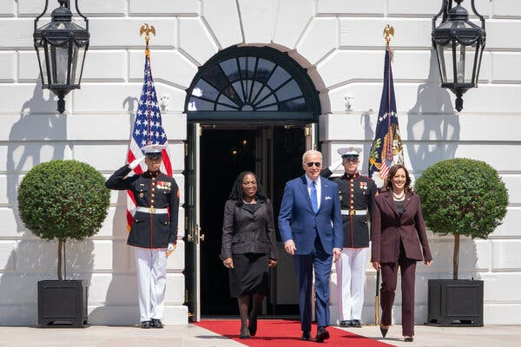
Justice Ketanji Brown Jackson was nominated to the Supreme Court by President Joseph R. Biden Jr. in 2022.

“Her appointment as the first Black female justice was ‘a refutation of past ignominies, a long-anticipated and highly celebrated national achievement,’ she wrote in her memoir. But inside the court, she was the junior justice, assigned to tasks like serving on the cafeteria committee and answering the door to the justices’ private conference room in case of a knock. In those meetings, Justice Jackson spoke only after the others, meaning that unless there was a tie, she had the least influence.” https://www.nytimes.com/2025/10/31/us/politics/supreme-court-kagan-jackson-liberal-justices.html?nl=The+Morning
2023: President Biden – Border Policies
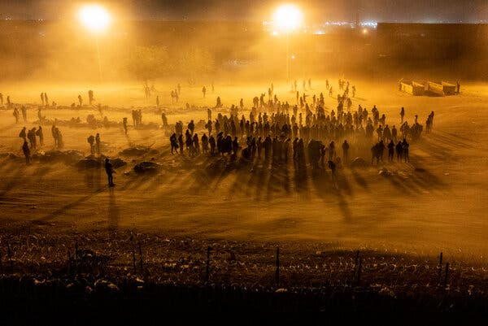Migrants waiting to be processed by Border Patrol agents at a makeshift camp in El Paso, Texas, in 2023.

“Mr. Biden created new legal pathways for migration to ease pressure at the border, under which more than one million people were allowed into the United States, fueling public resistance. And he failed to convince Congress to change immigration laws, dragging his feet on a crucial Senate border deal, according to the lead Republican negotiator, who said the effort might have otherwise succeeded.” https://www.nytimes.com/2025/12/07/us/politics/biden-immigration-trump.html?nl=Breaking+News

April 11, 2023: DC - EEOC – Draft Regulations To Implement the Pregnant Workers Fairness Act.

“On December 29, 2022, President Biden signed the Pregnant Workers Fairness Act (PWFA) into law.^{[1]} The PWFA requires a covered entity to provide reasonable accommodations to a qualified employee's or applicant's known limitation related to, affected by, or arising out of pregnancy, childbirth, or related medical conditions, absent undue hardship on the operation of the business of the covered entity. 42 U.S.C. 2000gg–3 requires the Equal Employment Opportunity Commission (EEOC or Commission) to promulgate regulations to implement the PWFA. *** Example 1636.3 #4: An employee's spouse, on the employee's behalf, requests light duty for the employee because the employee has a lifting restriction related to pregnancy; the employee's spouse uses the employer's established process for requesting a reasonable accommodation or light duty for the employee. The lifting restriction is a physical condition related to the employee's pregnancy, and the employee's representative (their spouse) has identified a change needed at work (light duty). This is a request for a reasonable accommodation under the PWFA.” https://www.federalregister.gov/documents/2023/08/11/2023-17041/regulations-to-implement-the-pregnant-workers-fairness-act

June 29, 2023: U.S. Supreme Court – Students for Fair Admissions, Inc. v. President and Fellows of Harvard College (6 to 3) https://www.supremecourt.gov/opinions/22pdf/20-1199_hgdj.pdf
HARVARD AND UNIVERSITY OF NORTH CAROLINA – RACIAL ADMISSION PROGRAMS VIOLATE 14th AMENDDMENT (EQUAL PROTECTION)
“A benefit to a student who overcame racial discrimination, for example, must be tied to that student’s courage and determination. Or a benefit to a student whose heritage or culture motivated him or her to assume a leadership role or attain a particular goal must be tied to that student’s unique ability to contribute to the university. In other words, the student must be treated based on his or her experiences as an individual—not on the basis of race.” https://www.supremecourt.gov/opinions/22pdf/20-1199_hgdj.pdf

April 17, 2024: U.S. Supreme Court – Jatonya Clayborn Muldrow v. City of St. Louis, Missouri (9 to 0). https://www.supremecourt.gov/opinions/23pdf/22-193_q86b.pdf
FEMALE POLICE OFFICER – JOB TRANSFER “SOME HARM”
On April 17, 2024, in Jatonya Clayborn Muldrow v. City of St. Louis, Missouri, et al., the United States Supreme Court held (9 to 0) that trial court should not have granted summary judgment to the city, and 8th Circuit Court of Appeals had applied too tough a standard for employees claiming job transfer was because of sexual harassment (“materially significant disadvantage”). Sergeant Jatonya Clayborn Muldrow maintains that her employer, the St. Louis Police Department, transferred her from one job to another because she is a woman. Sergeant Muldrow was in Intelligence Division, worked M-F, vehicle, FBI cases, and her new male boss moved her out (back to street patrol) because wanted male sergeant. Under new standard, she must only that that the job transfer brought about some harm with respect to an identifiable term or condition of employment, but that harm need not be significant. https://www.supremecourt.gov/opinions/23pdf/22-193_q86b.pdf

The new “some harm” standard will be widely applied not only in job transfer cases but also a wide variety of other employment decisions.

Note: Justice Michael Kavanaugh in his concurring decision focused on impact of this decision

“All of that said, the Court’s new some-harm requirement appears to be a relatively low bar. Importantly, the Court emphasizes that ‘some harm’ is less than significant harm,
serious harm, or substantial harm. Ante, at 6. Therefore, anyone who has been transferred because of race, color, religion, sex, or national origin should easily be able to show
some additional harm—whether in money, time, satisfaction, schedule, convenience, commuting costs or time, prestige, status, career prospects, interest level, perks, professional relationships, networking opportunities, effects on family obligations, or the like.”

April 26, 2024 – Colorado Paramedics – One Sentenced Prison, One Probation
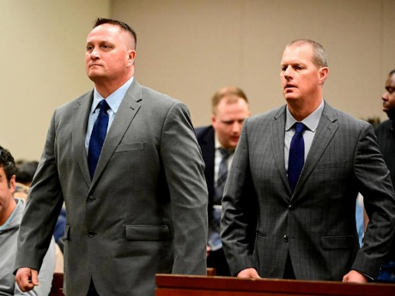
Paramedics Jeremy Cooper, left, and Peter Cichuniec, right, at an arraignment in the Adams County district court at the Adams County Justice Center Jan. 20, 2023.© Andy Cross/MediaNews Group/The Denver Post via Getty Images, FILE
“Former paramedic Jeremy Cooper has been sentenced to a four-year probationary sentence Friday after being found guilty of criminally negligent homicide in the final case connected to Elijah McClain's 2019 death. Prosecutors accused the Aurora, Colorado, paramedic and his co-defendant Peter Cichuniec of administering an excessive amount of ketamine to sedate the 23-year-old McClain after an encounter with police on August 24, 2019. According to department policy, administering ketamine to sedate a suspect is intended ‘to minimize time struggling.’ *** The judge added that Cichuniec was sentenced to five years in prison with a three-year period of parole for assault in the second-degree unlawful administration of drugs and criminally negligent homicide.” https://www.msn.com/en-us/news/crime/paramedic-sentenced-to-4-years-probation-in-connection-with-elijah-mcclain-s-death/ar-AA1nIZU5?ocid=socialshare&pc=U531&cvid=b7f71de9bce545aa9f520c8d0d60b030&ei=22
September 13, 2024:

Paramedic convicted in Elijah McClain's death freed after judge reduces sentence. Peter Cichuniec was serving a five-year prison sentence.
https://abcnews.go.com/US/paramedic-convicted-elijah-mcclain-death-freed-from-prison/story?id=113678258
***

Paramedic convicted in Elijah McClain's death freed after judge reduces sentence. Peter Cichuniec was serving a five-year prison sentence. [TV video.] https://abcnews.go.com/US/paramedic-convicted-elijah-mcclain-death-freed-from-prison/story?id=113678258

April 3, 2024 – Ohio Still Has No Anti-SLAPP Legislation – Protecting Public Speech

“Ohio Looks To Slapp Frivolous Lawsuits Silly
https://www.ficlaw.com/blog/ohio-looks-to-slapp-frivolous-lawsuits-silly
“State Senators Therese Gavarone and Nathan Manning recently introduced a bill in the Ohio Senate whereby Ohio would adopt the ‘Unifor’ Public Expression Protection Act.’ The Act is commonly referred to as an ‘Anti-SLAPP" bill. Whatever it's called, it is high time to adopt it.
***
The bill is an ‘Anti-SLAPP’ law because it seeks to limit the use of ‘Strategic Lawsuits Against Public Participation.’ A ‘SLAPP’ occurs when someone files a lawsuit – regardless of the merits – to bully a speaker on a public issue into shutting up. Even a frivolous lawsuit can force a speaker to shell out thousands of dollars to defend it. And the money is only part of the problem, as the lawsuit can be a drain on time and other resources. Of course, that is exactly why a plaintiff would file the suit.
So, what does an ‘Anti-SLAPP’ bill do exactly? It does several things. First, it allows a defendant named in such a suit to file a motion asking the court to hold an expedited hearing on the case. Once the defendant makes that request, the court must "stay" the case. This means that with limited exceptions, there's no discovery in the case while the motion is pending. In other words, a plaintiff can't send document requests or take depositions. Within sixty days of the filing of the motion for expedited relief, the court must hold a hearing and determine whether the plaintiff ‘stated a claim upon which relief may be granted.’ This could mean that the plaintiff failed to show that the statement was false, or that it was defamatory.
If the court finds that the complaint fails to state a claim for relief, the court shall award reasonable attorney fees and costs to the defendant. But note that this is a two-way street. If the court finds that the motion for expedited review was frivolous, the court must award the plaintiff's reasonable fees and court costs. If the court denies the motion for expedited relief, the defendant may immediately appeal that finding, and the stay remains in place pending the appeal.”

Anti-Slapp Legal Guide
https://www.rcfp.org/anti-slapp-legal-guide/
“Anti-SLAPP laws provide defendants a way to quickly dismiss meritless lawsuits — known as SLAPPs or strategic lawsuits against public participation — filed against them for exercising speech, press, assembly, petition, or association rights. These laws aim to discourage the filing of SLAPP suits and prevent them from imposing significant litigation costs and chilling protected speech.
In recent years, several states have adopted or amended their anti-SLAPP laws. As of September 2023, 33 states and the District of Columbia have anti-SLAPP laws, including Arizona, Arkansas, California, Colorado, Connecticut, Delaware, Florida, Georgia, Hawaii, Illinois, Indiana, Kansas, Kentucky, Louisiana, Maine, Maryland, Massachusetts, Missouri, Nebraska, Nevada, New Jersey, New Mexico, New York, Oklahoma, Oregon, Pennsylvania, Rhode Island, Tennessee, Texas, Utah, Vermont, Virginia, and Washington. Minnesota previously passed an anti-SLAPP law, but it was struck down as unconstitutional, as discussed below.”

April 11, 2024: “Red Flag” Laws

“Citing Constitutional Concerns, Yost Urges DOJ to Scrap ‘Red Flag’ Gun-Confiscation Program.” 4/11/2024
https://www.ohioattorneygeneral.gov/Media/News-Releases/April-2024/Citing-Constitutional-Concerns-Yost-Urges-DOJ-to-S
“(COLUMBUS, Ohio) — Ohio Attorney General Dave Yost and 18 other state attorneys general are opposing a new federal program that promotes aggressive enforcement of ‘red flag’ gun-confiscation laws.
Yost and his counterparts argue in a letter to U.S. Attorney General Merrick Garland that the National Extreme Risk Protection Order (ERPO) Resource Center, launched in March by the Department of Justice, undermines the Second Amendment and other fundamental rights in a flawed attempt to reduce gun violence.
‘The solution to gun violence is not more bureaucracy, and it is certainly not parting otherwise law-abiding men and women from their right to self-defense,’ Yost said.
The state attorneys general raise several concerns with the ERPO Resource Center, most notably how the program advocates for laws that allow government officials to ‘suspend fundamental rights under the Second Amendment with no genuine due process.’
So-called ‘red flag’ laws permit authorities to seek court orders authorizing the confiscation of firearms from people thought to pose a danger. Twenty-one states have enacted such laws; Ohio is not among them.
See April 11, 2024 letter to Attorney General: https://www.ohioattorneygeneral.gov/Files/Briefing-Room/News-Releases/4-11-24-ERPO-Letter-to-AG-Garland.aspx
“And it’s not just the Second Amendment that’s at risk. How can officers enter a home and seize a gun without a warrant in a way that’s consistent with the Fourth Amendment? How can ex parte proceedings unconnected to any criminal wrongdoing or criminal investigation be good enough
under the Fifth and Fourteenth Amendments when they lead to firearms seizures? Both questions have the same answer: They can’t. ‘By depriving individuals of their property and rights without having been formally charged, arraigned, or convicted of a crime, red flag laws violate these constitutional rights.’ … No wonder that Congress has already called out your Department for funding state-level red-flag programs that fail to meet basic statutory and constitutional requirements.”

May 23, 2024: Late Rev. Billy Graham Immortalized In Capitol Hill Statue
https://www.youtube.com/watch?v=h42Ez9DYn6Q

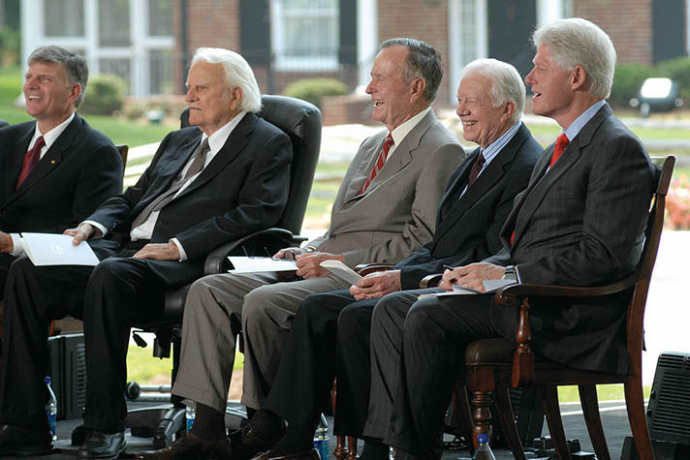

Billy Graham: Pastor to Presidents
https://billygraham.org/story/billy-graham-pastor-to-presidents-2/
Every U.S. President since World War II met with Billy Graham. Both Johnson and Nixon, the two who probably sought him the most, offered him high positions in government—which he quickly and politely refused.
Here are short snippets of their stories:
Harry S. Truman — In 1950 a congressman called Billy and asked, “Would you like to meet the President?” Without any briefing on protocol, he agreed and went in with three colleagues and spoke with President Truman, who told Billy he lived by the Sermon on the Mount. Before he left, the two prayed together. Years later, Truman warmly received Billy at his home in Independence, Missouri.
Dwight D. Eisenhower — “Eisenhower was the first President that really asked my counsel in depth when he was sending troops into Little Rock,” said Mr. Graham. Just before Eisenhower died, Billy was invited to see him at Walter Reed Hospital. After talking again about assurance of salvation, the two men prayed. Eisenhower then said he was ready to die.
“Billy Graham is one of the best ambassadors our country has but he told me, ‘I am an ambassador of heaven.'” — Dwight D. Eisenhower
John F. Kennedy — Four days before he was inaugurated as President, John Kennedy invited Mr. Graham to spend the day with him in Palm Beach. “We drove around in JFK’s white Lincoln convertible,” said Billy. “During our conversations, I became aware that he was concerned about the moral and spiritual condition of the nation.” During Kennedy’s funeral service in the Capitol rotunda, Billy stood about 30 feet from Mrs. Kennedy and the family, and thought about the brevity of life and how people must prepare to meet God.
Lyndon B. Johnson — There was a spiritual side to Lyndon Johnson that many people did not know. Billy was probably closer to Johnson than to any other President. He was invited to the family ranch several times and spent more than 20 nights at the White House during Johnson’s administration. Every time Billy would say to him, “Let’s have a prayer,” the President would get on his knees to pray.
“My mind went back to those lonely occasions at the White House when your friendship helped to sustain a President in an hour of trial.” — Lyndon Johnson in a letter to Billy Graham
Richard M. Nixon — President Nixon and Billy had been personal friends since 1950. Nixon was a private and complex person, but beneath the surface, Billy found him to be warm and compassionate, quite different from popular caricatures. He was rooted in the teachings and prayers of his Quaker faith. Often he asked Billy to pray with him and read the Bible when he would visit. In the last year of Nixon’s presidency, Billy did not get to see him. Someone on the White House later relayed that Nixon said, “Don’t let Billy Graham near me, I don’t want him tarred with Watergate.”
Gerald R. Ford — Answering critics of his relationship with Billy, Gerald Ford said, “I’ve heard the comments from some sources that Billy mixes politics with religion. I never felt that and I don’t think that thousands and thousands of people who listen to him felt that. Billy dropped by the Oval Office on several occasions while I was President. They were get-togethers of old friends. They had no political or other significance.”
Jimmy Carter — “Billy and Ruth Graham have been to visit us both in the governor’s mansion in Georgia and in the White House,” said Jimmy Carter. “His reputation is above reproach or suspicion.” Back in 1966, Carter chaired a BGEA film crusade in Americus, Ga., and when he was governor, served as an honorary chairman of the Atlanta Crusade.
Ronald W. Reagan — Billy met Ronald Reagan a year after he married Nancy. The two remained close friends. “I remember when Reagan was president of the Screen Actors Guild, a union leader, and a very strong Democrat,” Billy said. On March 30, 1981, after the assassination attempt on President Reagan’s life, Billy flew immediately to Washington, D.C., to comfort and pray with Mrs. Reagan, and do anything he could for the President.
“It was through Billy Graham that I found myself praying even more than on a daily basis … and that in the position I held, that my prayers more and more were to give me the wisdom to make decisions that would serve God and be pleasing to Him.” — Ronald Reagan
George H. W. Bush — Mr. Graham has said he found George H.W. Bush easy to talk to about spiritual issues, “easier than other Presidents I have met. He says straight out that he has received Christ as his Savior and that he is a born-again believer.” Billy was with President and Barbara Bush at the White House in 1991, the night that the Gulf War began. “Billy Graham has been an inspiration in my life,” said Bush. “It is my firm belief that no one can be President … without understanding the power of prayer, without faith. And Billy Graham helped me understand that.”
William J. Clinton — President Bill Clinton once recalled, “When I was a small boy, about 12 years old, Billy Graham came to Little Rock, Arkansas, to preach a Crusade.” Mr. Graham would not agree to segregate the audience racially, which made an impression on the young boy. When he was governor of Arkansas, Bill Clinton joined Billy Graham at a Little Rock Crusade in 1989. Mr. Graham also visited Clinton in the Oval Office after he became President.
“Billy and Ruth Graham have practiced the ministry of … being friends with Presidents of both parties … always completely private, always completely genuine.” — William J. Clinton
George W. Bush — In his 1999 campaign autobiography, “A Charge to Keep,” George W. Bush said a turning point in his faith came during a private talk with Billy Graham along the coast of Maine in 1985. Graham’s words planted the “mustard seed in my soul” that eventually led to a decision to “recommit my heart to Jesus Christ,” he wrote.
Barack Obama — President Barack Obama visited Billy Graham at his Montreat, N.C. home at the end of his weekend mountain vacation in April 2010. He is the first sitting president to meet with Graham at his home, where the two of them had a private prayer time and some conversation. A White House spokesman said that the president was “extraordinarily gratified that he (Mr. Graham) took the time to meet with him.” Mr. Graham said he was pleased to have had the president visit his home.
Donald J. Trump — Billy Graham met Donald Trump at the evangelist’s 95th birthday celebration on November 7, 2013. Trump and his wife, Melania, joined hundreds of guests at the event in watching a showing of “The Cross,” a short evangelistic film featuring a message of hope and redemption from Billy Graham, interwoven with life-changing testimonies.

May 20, 2024 – Ohio has no “Red Flag” law, but it does have a “Stand Your Ground” law
“How Gun Violence Spread Across One American City – Columbus, OH had only 100 homicides a year. Then came a pandemic surge. With more guns and loser laws, can the city find its way back to the new normal?”
https://www.nytimes.com/2024/05/20/us/gun-violence-shootings-columbus-ohio.html?te=1&nl=the-morning&emc=edit_nn_20240520
“For more than a decade, the Ohio legislature had been scaling back gun regulations. In 2006, lawmakers pre-empted cities from passing their own gun statutes. In 2014, they rescinded a ban on high-capacity magazines. Then, in 2019, a gunman in Dayton used one to fire 41 rounds in under 30 seconds, killing nine people and wounding 17. The outcry that followed prompted Gov. Mike DeWine, a Republican, to promise changes that included expanded background checks and a ‘red flag’ law allowing for the temporary removal of guns from people deemed dangerous to themselves or others. The proposals went nowhere.
Instead, in 2020 the state enacted a “stand your ground” law supported by gun rights organizations, expanding established limits on when a shooting can be deemed self-defense.
In 2022, Ohio lawmakers allowed school boards to arm teachers who completed 24 hours of training, eliminated permit and training requirements for concealed weapons, and barred cities from prohibiting gun sales during riots. Proponents of expansive gun rights argue that increased regulation only makes it harder for lawful buyers to obtain guns for legitimate reasons, and that criminals will always find ways to skirt stricter laws.

In Ohio, Republican supporters of the permit-less carry bill said that there was little difference between openly carrying a gun, which Ohioans are permitted to do, and concealing that same weapon.
“Killers, rapists, kidnappers and other violent criminals don’t obey this law anyway,” said state Representatives Tom Brinkman and Kris Jordan, the bill’s sponsors, in their written testimony.

Ohio Revised Code: Section 2901.09 | No duty to retreat in residence or vehicle. https://codes.ohio.gov/ohio-revised-code/section-2901.09 Effective:
April 6, 2021
(A) As used in this section, "residence" has the same meaning as in section 2901.05 of the Revised Code.
(B) For purposes of any section of the Revised Code that sets forth a criminal offense, a person has no duty to retreat before using force in self-defense, defense of another, or defense of that person's residence if that person is in a place in which the person lawfully has a right to be.
(C) A trier of fact shall not consider the possibility of retreat as a factor in determining whether or not a person who used force in self-defense, defense of another, or defense of that person's residence reasonably believed that the force was necessary to prevent injury, loss, or risk to life or safety….
Facing a mounting body count in 2021 and 2022, Columbus tried to test the state ban on local lawmaking. The city enacted legislation requiring guns to be safely stored around children and banning high-capacity magazines. But the measures were stalled by court challenges, one by the state attorney general, a Republican, and the other by private citizens. Columbus, in turn, has challenged the 2023 state law that prohibits cities from halting the sale of guns and ammunition during riots.

“I feel like at times we have one or two arms tied behind our back trying to fight gun violence,” said Mayor Ginther, a Democrat who just began his third term. “And it can be very frustrating because the people are angry. They want more to be done.”

June 19, 2024 - AFG and SAFER Reauthorization Bill Passes Senate, Sent to President to Become Law

“On June 18, by a vote of 88 to 2, the Senate passed the Fire Grants and Safety Act (S.870), a bill to reauthorize the Assistance to Firefighters Grant (AFG) and Staffing for Adequate Fire and Emergency Response (SAFER) grant programs, as well as the U.S. Fire Administration (USFA) through fiscal year (FY) 2028. The legislation also extended the sunset date for AFG and SAFER to September 30, 2030. The bill has been sent to the President to be signed into law. Once signed, these programs will be protected for the next several years, ensuring that the fire and emergency services can continue to access vital federal support.” https://www.cfsi.org/

June 21, 2024 – U.S. Supreme Court - United States v. Rahimi (8 to 1) https://www.supremecourt.gov/opinions/23pdf/22-915_8o6b.pdf DISARMING DOMESTIC ABUSERS - UPHELD
“The Supreme Court ruled on Friday that the government can take guns away from people subject to restraining orders for domestic violence, limiting the sweep of a blockbuster decision in 2022 that had vastly expanded Second Amendment rights. Indeed, Friday’s decision amounted to a retreat from what had been an unbroken series of major rulings favoring gun rights that started in 2008, when the court first recognized an individual constitutional right to keep firearms in the home for self-defense. In the 2022 decision, the court established a right to carry guns outside the home and announced a new test to assess all sorts of gun control laws, one that looked to historical practices to judge their constitutionality. That new test has sown confusion in the lower courts, with some judges striking down laws that had been on the books for decades. The case decided Friday, United States v. Rahimi, asked whether a Texas man could be prosecuted under federal law making it a crime for people subject to domestic violence restraining orders to possess guns. Chief Justice John G. Roberts Jr., writing for the majority in the 8-to-1 decision, said that the answer was yes and that Second Amendment rights have limits. The decision amounted to a retreat from what had been an unbroken series of major decisions expanding gun rights that started in 2008.” https://www.nytimes.com/2024/06/21/us/politics/supreme-court-guns-domestic-violence.html?te=1&nl=the-evening&emc=edit_ne_20240621
U.S. Supreme Court decision: https://www.supremecourt.gov/opinions/23pdf/22-915_8o6b.pdf

July 1, 2024 – U.S. Supreme Court – Donald J. Trump v. United States (6 to 3)
BROAD PRESIDENTIAL IMMUNITY
Syllabus: “A federal grand jury indicted former President Donald J. Trump on four counts for conduct that occurred during his Presidency following the November 2020 election. The indictment alleged that after losing that election, Trump conspired to overturn it by spreading knowingly false claims of election fraud to obstruct the collecting, counting, and certifying of the election results. Trump moved to dismiss the indictment based on Presidential immunity, arguing that a President has absolute immunity from criminal prosecution for actions performed within the outer perimeter of his official responsibilities, and that the indictment’s allegations fell within the core of his official duties.”

Chief Justice Roberts – Majority: “The President therefore may not be prosecuted for exercising his core constitutional powers, and he is entitled, at a minimum, to a presumptive immunity from prosecution for all his official acts. That immunity applies equally to all occupants of the Oval Office, regardless of politics, policy, or party.

Justice Sotomayor - Dissent: “Today’s decision to grant former Presidents criminal
immunity reshapes the institution of the Presidency. It makes a mockery of the principle, foundational to our Constitution and system of Government, that no man is above the law.
Relying on little more than its own misguided wisdom about the need for “bold and unhesitating action” by the President, ante, at 3, 13, the Court gives former President Trump
all the immunity he asked for and more. Because our Constitution does not shield a former President from answering for criminal and treasonous acts, I dissent.
https://www.supremecourt.gov/opinions/23pdf/23-939_e2pg.pdf

Sept. 10, 2024: More members of FDNY have died from 9/11-related illness than were killed on day of attack
“Illnesses linked to the September 11 terror attack on the World Trade Center have now killed more members of the New York City Fire Department than were killed on the day of the attack itself. ‘Those insurmountable losses did not end at the World Trade Center site,’ Fire Commissioner Robert Tucker said Monday. ‘Instead, we have seen our members become sick because of time they spent working in the rescue and recovery.’ There were 343 members of the FDNY that died on 9/11. In the 23 years since, more than 370 have died of World Trade Center-related illnesses, the department said.” https://abc7ny.com/post/september-11-more-members-fdny-have-died-911-related-illness-were-killed-day-attack/15282126/

Jan. 17, 2025 – U.S. Supreme Court – TikTok Inc. v. Merrick B. Garland, Attorney General (9 to 0) https://www.supremecourt.gov/opinions/24pdf/24-656_ca7d.pdf
CONGRESS CAN ORDER SALE OF TIKTOK
https://www.supremecourt.gov/opinions/24pdf/24-656_ca7d.pdf
“As of January 19, the Protecting Americans from Foreign Adversary Controlled Applications Act will make it unlawful for companies in the United States to provide services to distribute, maintain, or update the social media platform TikTok, unless U. S. operation of the platform is severed from Chinese control. Petitioners are two TikTok operating entities and a group of U. S. TikTok users. We consider whether the Act, as applied to petitioners, violates the First Amendment. *** There is no doubt that, for more than 170 million Americans, TikTok offers a distinctive and expansive outlet for
expression, means of engagement, and source of community. But Congress has determined that divestiture is necessary to address its well-supported national security concerns regarding TikTok’s data collection practices and relationship with a foreign adversary. For the foregoing reasons, we conclude that the challenged provisions do not
violate petitioners’ First Amendment rights.”

Jan. 20, 2025: President Trump – Second Inauguration

Inaugural address: https://www.whitehouse.gov/remarks/2025/01/the-inaugural-address/

“We now have a government that cannot manage even a simple crisis at home while, at the same time, stumbling into a continuing catalogue of catastrophic events abroad.”

Jan. 29, 2025: President Trump Signs “Laken Riley” Act

“President Trump signed his first piece of legislation into law, the Laken Riley Act on January 29, 2025. This law mandates the federal detention of illegal immigrants who are accused of theft, burglary, assaulting a law enforcement officer, and any crime that causes death or serious bodily injury. A statement from Secretary Noem on the signing of the bill is below: “Thank you, President Trump, for signing the Laken Riley Act. This law restores commonsense to our broken immigration system. Under President Trump, violent criminals and vicious gang members will no longer be released into American communities.” The Laken Riley Act is named after a Georgia nursing student who was killed by a Venezuelan alien who was previously arrested and paroled into the U.S. under the previous administration.” https://www.hstoday.us/subject-matter-areas/border-security/president-trump-signs-the-laken-riley-act-into-law/
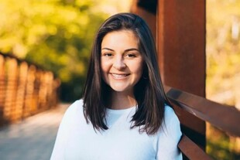

Jan. 22, 2025: Stuart Rhodes, Convicted and Pardoned – Visits U.S. Capitol

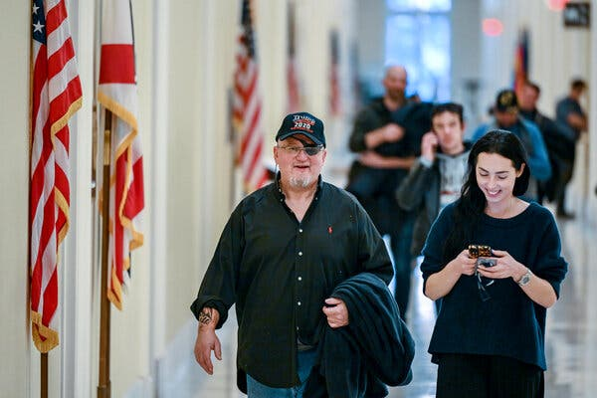

“Stewart Rhodes, convicted of seditious conspiracy and released by Trump, visits Capitol Hill. Stewart Rhodes, the far-right Oath Keepers extremist group founder convicted of seditious conspiracy in the Jan. 6, 2021 attack visited Capitol Hill Wednesday after he was released from prison [18 year sentence] as part of the President

Donald Trump’s sweeping clemency order for the more than 1,500 people charged in the riot. Rhodes was convicted of seditious conspiracy in one of the serious cases brought by the Justice Department in the siege that halted the certification of President Joe Biden’s victory and left more than 100 police officers injured. Rhodes was found guilty of orchestrating a weekslong plot that culminated in his followers attacking the U.S. Capitol in a desperate bid to keep Trump in power.” https://www.pbs.org/newshour/politics/stewart-rhodes-convicted-of-seditious-conspiracy-and-released-by-trump-visits-capitol-hill

***

Among those granted clemency were:
- Mark Ponder, who was prosecuted by Mr. Romano and sentenced to more than five years in prison for repeatedly attacking officers with wooden poles.
- Benjamen Burlew, who was prosecuted by Ms. Levine and pleaded guilty to grabbing an officer and trying to drag him into a crowd of rioters.
- Richard Barnett, who, in a case overseen by Mr. Gordon, was sentenced to more than four years in prison after being convicted of taking a stun gun to the Capitol and propping his feet on a desk in the office of then-Speaker Nancy Pelosi.
- Steven Cappuccio, who was sentenced to seven years in prison for tearing off the gas mask of Officer Hodges and hitting him in the face with his own baton — one of the scenes from Jan. 6 that Mr. Rosen said he would never forget.
https://www.nytimes.com/2025/08/24/nyregion/january-6-capitol-riot-prosecutors.html

Jan. 27, 2025 – Prosecutors Who Investigate Trump Fired

Justice Dept. Fires Prosecutors Who Worked on Trump Investigations
The termination of more than a dozen lawyers who worked with the special counsel, Jack Smith, came hours after the department’s most senior career official was reassigned. https://www.nytimes.com/2025/01/27/us/politics/justice-department-firings-trump-jack-smith.html

***

“One week after Inauguration Day, more than a dozen prosecutors were abruptly fired. The common thread: All had helped the special counsel, Mr. Smith, pursue two criminal cases against Mr. Trump — one examining his role in the efforts to reverse his defeat in the 2020 election, the other his mishandling of classified documents. Their dismissal letters claimed they could no longer be trusted to ‘faithfully implement’ the president’s agenda.” https://www.nytimes.com/2025/08/24/nyregion/january-6-capitol-riot-prosecutors.html

Feb. 25, 2025 – Ohio Bathroom Law – Student Restrooms / birth gender

“Importantly, Ohio Revised Code 3345.90 went into effect on Tuesday, February 25, requiring institutions of higher education to designate multi-occupant student restrooms, student locker rooms, student shower rooms, and student changing rooms, “for the exclusive use by students of the male biological sex only or by students of the female biological sex only.”

ORC 3345.90 - Single-sex facilities and accommodations
(2) No institution of higher education shall knowingly permit a member of the female biological sex to use a student restroom, locker room, changing room, or shower room that has been designated by the school for the exclusive use of the male biological sex. No institution of higher education shall knowingly permit a member of the male biological sex to use a student restroom, locker room, changing room, or shower room that has been designated by the school for the exclusive use of the female biological sex.
https://codes.ohio.gov/ohio-revised-code/section-3345.90#:~:text=male%20biological%20sex.-,No%20institution%20of%20higher%20education%20shall%20knowingly%20permit%20a%20member,of%20the%20female%20biological%20sex.

March 14, 2025: 100 Former D.C. Prosecutors – Letter Against Acting U.S. Attorney Ed Martin

“In 1801, John Thomson Mason, whose uncle was George Mason, a delegate to the
Constitutional Convention and the Father of the Bill of Rights, was nominated by President Thomas Jefferson to serve as the first United States Attorney for the District of Columbia. We are John Thomson Mason’s heirs and the heirs of 51 other men and women who have honorably and faithfully held that position for the past 224 years.
We speak in opposition to Edward Martin to be the next United States Attorney for the
District of Columbia.”
https://www.washingtonpost.com/documents/2ffee413-488d-49cc-9eac-93676f80aa19.pdf?itid=lk_inline_manual_16

May 8, 2025: Trump pulls the nomination of Ed Martin for DC US Attorney after concerns of partisanship. https://apnews.com/article/donald-trump-ed-martin-white-house-justice-department-thom-tillis-cecf801799faa2b56fd1bb4fac48379e

April 7, 2025: U.S. Supreme Court – Donald J. Trump v. J.G.G., et al. (5 to 4) https://www.supremecourt.gov/opinions/24pdf/24a931_2c83.pdf
DEPORTEES ENTITLED NOTICE / OPPORTUNITY TO CHALLENGE REMOVAL
“This matter concerns the detention and removal of Venezuelan nationals believed to be members of Tren de Aragua (TdA), an entity that the State Department has designated as a foreign terrorist organization. *** For all the rhetoric of the dissents, today’s order and per curiam confirm that the detainees subject to removal orders under the AEA are entitled to notice and an opportunity to challenge their removal. The only question is which court will resolve that challenge. For the reasons set forth, we hold that venue lies in the district of confinement. The dissents would have the Court delay resolving that issue, requiring—given our decision today—that the process begin anew down the road. We see no benefit in such wasteful delay.”

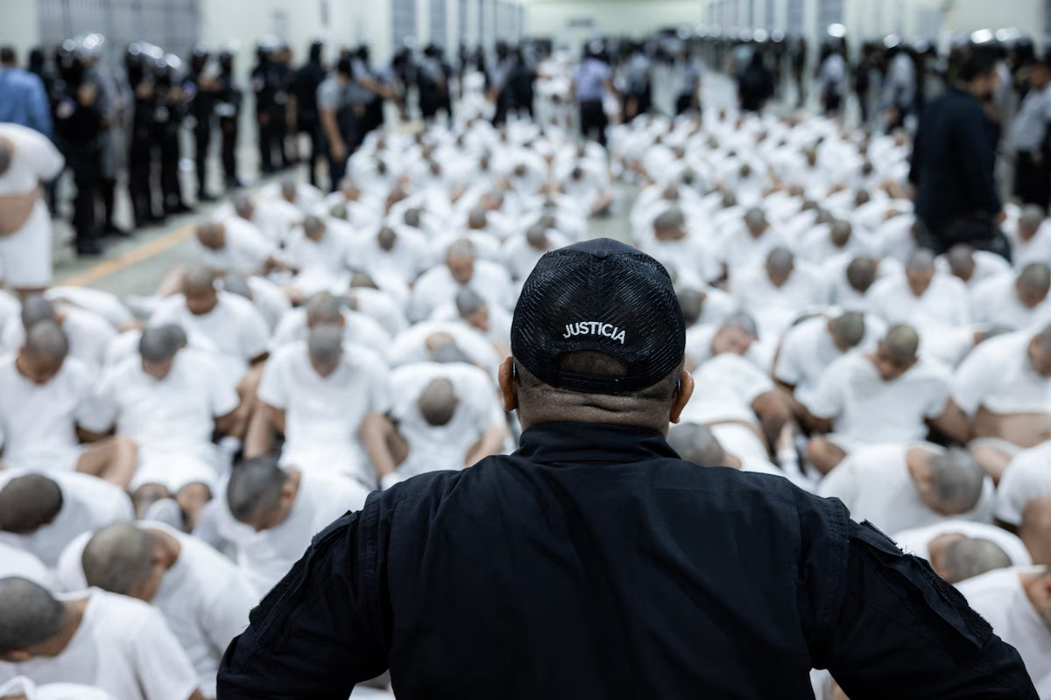Alleged members of the Venezuelan criminal organization Tren de Aragua are assembled at the Terrorism Confinement Center in Tecoluca, El Salvador. (El Salvador Presidential Press Office/AFP/Getty Images)

June 5, 2025: U.S. Supreme Court – Ames v. Ohio Department of Youth Services (9 to 0)

Discrimination against a “majority” plaintiff is also violation Title VII.

“The question in this case is whether, to satisfy that prima facie burden, a plaintiff who is a member of a majority group must also show’ ‘background circumstances to support the suspicion that the defendant is that unusual employer who discriminates against the majority.’ ” 87 F. 4th 822, 825 (CA6 2023) (per curiam). We hold that this additional ‘background circumstances’ requirement is not consistent with Title VII’s text or our case law construing the statute.” https://www.supremecourt.gov/opinions/24pdf/23-1039_c0n2.pdf

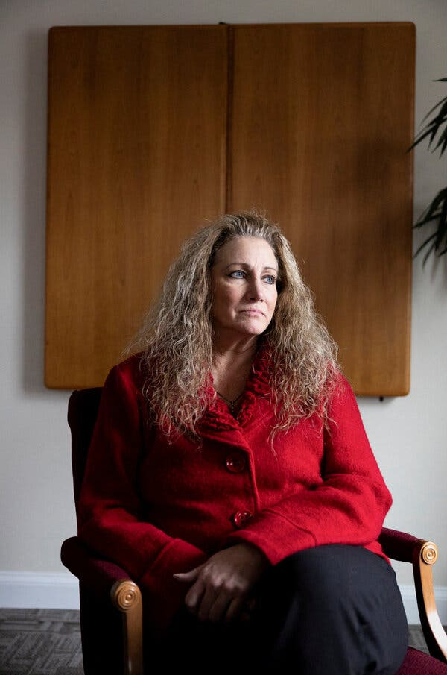 Marlean A. Ames

“Supreme Court Rules for Straight Woman in Job Discrimination Suit
The justices rejected an appeals court’s requirement that members of majority groups meet a heightened standard to win employment discrimination cases. *** The case was brought by Marlean A. Ames, who had worked for the Ohio Department of Youth Services, which oversees parts of the state’s juvenile corrections system. After a decade there, in 2014 she became the administrator of a program addressing prison rape. Five years later, she applied for a promotion. Her supervisors turned her down, saying she lacked vision and leadership skills. They eventually gave the position to a gay woman who had been at the department for a shorter time and, unlike Ms. Ames, lacked a college degree. Not long after denying her the new position, her supervisors removed her from her existing job, telling her that they had concerns about her leadership and offering her a demotion that came with a substantial pay cut. She was replaced by a gay man with less seniority.” https://www.nytimes.com/2025/06/05/us/politics/supreme-court-straight-woman-workplace-discrimination.html?algo=combo_lda_unique_triton_clicks_decay_96_50_ranks&fellback=false&imp_id=3537081671040738&pool=programmingnode%2F0dc6538b-a831-51be-a980-5597993fb6e2&req_id=230724380790231&surface=more-politics-news&variant=0_only_variant

June 20, 2025: U.S. SUPREME COURT – Stanley v. City of Sanford, Florida (6 to 3)
https://www.supremecourt.gov/opinions/24pdf/23-997_6579.pdf
Ms. Stanley sued, claiming the City violated the Americans with
Disabilities Act by providing different health-insurance benefits to
those who retire with 25 years of service and those who retire due to
disability. The district court dismissed her ADA claim, reasoning that
the alleged discrimination occurred after she retired, when she was not
a “qualified individual” under Title I of the ADA, 42 U. S. C. §12112(a),
because she no longer held or sought a job with the defendant. The
Eleventh Circuit affirmed.

June 23, 2025: U.S. SUP. CT – Department of Homeland Security v. D.V.D., et al. (7 to 2)
DEPORTATION INJUNCTION STAYED
On June 23, 2025, in Department of Homeland Security, et al. v. D.V.D., et al, the U.S. Supreme Court (7 to 2; Court Order – no Opinion) has set aside orders by U.S. District Court Judge Brian E. Murphy, Boston, of March 28, 2025 (temporary restraining order) and April 18, 2025 (preliminary injunction) against deporting some illegal aliens to South Sedan, since their home countries refused to accept them. THE COURT HELD: “The April 18, 2025, preliminary injunction of the United States District Court for the District of Massachusetts, case No. 25–cv–10676, is stayed pending the disposition of the appeal in the United States Court of Appeals for the First Circuit and disposition of a petition for a writ of certiorari, if such writ is timely sought. Should certiorari be denied, this stay shall terminate automatically. In the event certiorari is granted, the stay shall terminate upon the sending down of the judgment of the Court.” https://www.supremecourt.gov/opinions/24pdf/24a1153_l5gm.pdf

Two Dissenting Justices - Justice Sonia Sotomayor opinion, joined by Justice Elena Kagan:

“In matters of life and death, it is best to proceed with caution. In this case, the Government took the opposite approach. It wrongfully deported one plaintiff to Guatemala, even though an Immigration Judge found he was likely to face torture there. Then, in clear violation of a court order, it deported six more to South Sudan, a nation the State Department considers too unsafe for all but its most critical personnel. An attentive District Court’s timely intervention only narrowly prevented a third set of unlawful removals to Libya.

***
The Government thus openly flouted two court orders, including the one from which it now seeks relief. Even if the orders in question had been mistaken, the Government had
a duty to obey them until they were ‘reversed by orderly and proper proceedings.’ Maness, 419 U. S., at 459 (quoting United States v. Mine Workers, 330 U. S. 258, 293
(1947)). That principle is a bedrock of the rule of law. The Government’s misconduct threatens it to its core.

***
By rewarding lawlessness, the Court once again undermines that foundational principle. Apparently, the Court finds the idea that thousands will suffer violence in far flung locales more palatable than the remote possibility that a District Court exceeded its remedial powers when it ordered the Government to provide notice and process to which the plaintiffs are constitutionally and statutorily entitled. That use of discretion is as incomprehensible as it is inexcusable. Respectfully, but regretfully, I dissent.”

Note:

Here is the Injunction that was set aside in this case. On May 21, 2025, Judge Murphy issued an ORDER ON REMEDY FOR VIOLATION OF PRELIMINARY INJUNCTION.

“Each of the six individuals must be given a reasonable fear interview in private, with the opportunity for the individual to have counsel of their choosing present during the interview, either in-person or remotely, at the individual’s choosing. Each individual must be afforded access to counsel that is commensurate with the access that they would have received had these procedures occurred within the United States prior to their deportation, including remote access where in-person access would otherwise be available. Each individual must also be afforded the name and telephone number of class counsel, as well as access to a phone, interpreter, and technology for the confidential transfer of documents that is commensurate with the access they would receive were they in DHS custody within United States borders.” https://storage.courtlistener.com/recap/gov.uscourts.mad.282404/gov.uscourts.mad.282404.119.0_1.pdf

See also the June 23, 2025 Press Release: The U.S. Department of Homeland Security announcement it will immediately resume deportation flights – “Fire up the deportation planes.” https://www.supremecourt.gov/opinions/24pdf/24a1153_l5gm.pdf

BREAKING NEWS: “Universal injunctions” by Federal District Court judges have now been struck down by U.S. Supreme Court. The U.S. Supreme Court on June 26, 2025 stayed national-wide so-called “universal injunctions by three Federal District Court judges in MA, WA, MA in a case challenging President Trump’s executive order on citizenship by birth in United States. TRUMP, PRESIDENT OF THE UNITED STATES, ET AL. v. CASA, INC., ET AL. The Court (6 to 3) held that “These injunctions—known as ‘universal injunctions’—likely exceed the equitable authority that Congress has granted to federal courts. We therefore grant the Government’s applications to partially stay the injunctions entered below.” https://www.supremecourt.gov/opinions/24pdf/24a884_8n59.pdf

June 27, 2025 – Invasion of U.S. Capitol - Lead Prosecutor / Others Fired

“Michael Gordon, left, was dismissed as a federal prosecutor after he investigated the storming of the Capitol on Jan. 6, 2021, right…. Greg Rosen led the Justice Department’s Capitol Siege Section, the large task force that prosecuted the Jan. 6 rioters.”

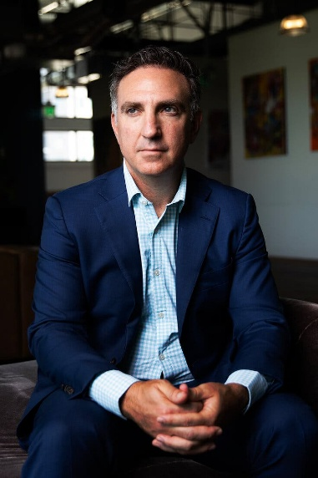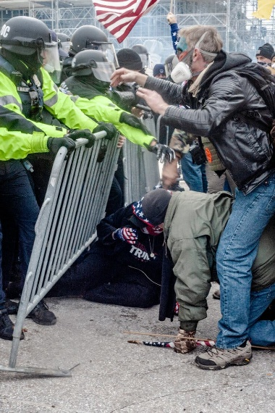

“Reframing Jan. 6: After the Pardons, the Purge

“In its campaign of “uprooting the foot soldiers,” the Trump Justice Department has fired or demoted more than two dozen Jan. 6 prosecutors, even as those they sent to prison walk free.

***

One week after Inauguration Day, more than a dozen prosecutors were abruptly fired. The common thread: All had helped the special counsel, Mr. Smith, pursue two criminal cases against Mr. Trump — one examining his role in the efforts to reverse his defeat in the 2020 election, the other his mishandling of classified documents. Their dismissal letters claimed they could no longer be trusted to “faithfully implement” the president’s agenda. Four days later, about 15 junior prosecutors who had worked on Jan. 6 cases, including Ms. Levine, were also fired. Mr. Trump’s former personal lawyer, Emil Bove III, handpicked to help remold the Justice Department to the president’s liking, informed the fired lawyers that their employment “hindered” Mr. Martin from fulfilling his ‘obligation to faithfully implement the agenda that the American people elected President Trump to execute.’ (Mr. Trump has since appointed Mr. Bove to a lifetime seat as a federal appeals court judge.)

***

To date, the Justice Department has fired or demoted more than two dozen prosecutors who were assigned to hold the rioters accountable — roughly a quarter of the complement. Some were junior prosecutors, like Sara Levine, who had secured a guilty plea from a rioter who had grabbed a police officer. Others were veterans, including Greg Rosen, who had led the department’s Jan. 6 task force. Scores more prosecutors, involved in these and other cases, have left, either in fear of where the ax might next fall or out of sheer disgust.” https://www.nytimes.com/2025/08/24/nyregion/january-6-capitol-riot-prosecutors.html

June 27, 2025: Donald J. Trump v. Casa, Inc. et al. (6 t0 3)
https://www.courthousenews.com/wp-content/uploads/2025/06/trump-casa-opinion-scotus.pdf

Universal Injunctions – Congress has not granted federal courts authority to universally enjoin the enforcement of an executive order [including Trump birthright citizenship order].

“The injunctions before us today reflect a more recent development: district courts
asserting the power to prohibit enforcement of a law or policy against anyone. These injunctions—known as ‘universal injunctions’—likely exceed the equitable authority that Congress has granted to federal courts. Footnote 1: 1 Such injunctions are sometimes called ‘nationwide injunctions,’ reflecting their use by a single district court to bar the enforcement of a law anywhere in the Nation. But the term ‘universal’ better captures
how these injunctions work. …. The plaintiffs—individuals, organizations, and States—sought to enjoin the implementation and enforcement of President Trump’s Executive Order No. 14160.2 See Protecting the Meaning and Value of American Citizenship, 90 Fed. Reg. 8449 (2025). The Executive Order identifies circumstances in which a person born in the United States is not ‘subject to the jurisdiction thereof ‘ and is thus not recognized as an American citizen. See ibid. Specifically, it sets forth the ‘policy of the United States’ to no longer issue or accept documentation of citizenship in two scenarios: ‘(1) when [a] person’s mother was unlawfully present in the United States and the person’s father was not a United States citizen or lawful permanent resident at the time of said person’s birth, or (2) when [a] person’s mother’s presence in the United States was lawful but temporary, and the person’s father was not a United States citizen or lawful permanent resident at the time of said person’s birth.’ Ibid.”

***

“Trump asks Supreme Court to step in on birthright citizenship…. Birthright citizenship was explicitly added to the Constitution in 1868 when the 14th Amendment was adopted following the Civil War. That amendment provides that ‘[a]ll persons born or naturalized in the United States, and subject to the jurisdiction thereof, are citizens of the United States and of the State wherein they reside.’ The United States is one of roughly 30 countries, including neighboring Canada and Mexico, that offer automatic citizenship to everyone born there.” https://www.scotusblog.com/2025/03/trump-asks-supreme-court-to-step-in-on-birthright-citizenship/

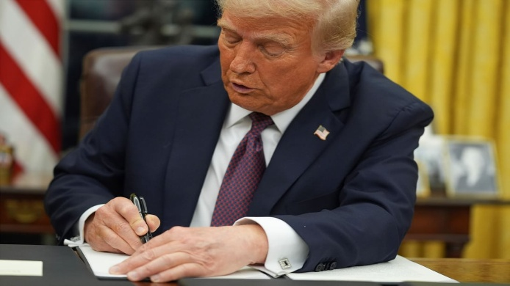 President Donald Trump signs an executive order on birthright citizenship in the Oval Office of the White House in Washington, Jan. 20, 2025.

Nov. 20, 2025: “Trump’s fight to redefine 'American citizen' returns to Supreme Court
After winning round one, President Trump wants the justices to tee up a final showdown on birthright citizenship. In a private session Friday, the Supreme Court will consider putting President Donald Trump’s bid to limit birthright citizenship back on the docket in 2026.
Last term, the policy was postscript to the conservative majority’s blockbuster ruling on universal injunctions — court orders that blocked limits on birthright citizenship nationwide. But if the justices give in to Trump’s updated request, they’ll be forced to confront the administration’s battle to recast citizenship and 150 years of history standing behind the core tenets of what it means to be an American….

The road to round two
After the justices’ 6-3 ruling in late June, a lower court kept Trump’s order from being enforced by certifying children who would be subjected to the policy into a class — a legal process that assesses the commonality between a group of people within a class action. Another court blocked the order within the states that have challenged the policy as unlawful.
An appeals court then ruled that Trump’s executive order unconstitutionally stripped the children of some individuals without legal status of their citizenship rights. The court noted that for over 150 years, the 14th Amendment has guaranteed citizenship to individuals born in the United States with very few exceptions.” https://courthousenews.com/trumps-fight-to-redefine-american-citizen-returns-to-supreme-court/

Opinion: Memo to Trump: Birthright citizenship is a constitutional right. Period. Trump and others argue against birthright citizenship. They’re mistaken.
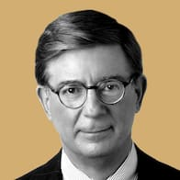
By George F. Will
August 23, 2024
“In 1868, the Republican Party, then just 14 years old, produced what remains, 156 years later, its greatest accomplishment: the 14th Amendment. *** The issue is birthright citizenship. The amendment’s first sentence says: ‘All persons born or naturalized in the United States, and subject to the jurisdiction thereof, are citizens of the United States and of the state wherein they reside.’ The question is whether birthright citizenship is a constitutional mandate or a mere policy, albeit one sanctified by more than a century of practice. The correct answer is: a mandate. *** This endorsement was primarily for the benefit of African Americans: The citizenship clause repudiated the Supreme Court’s worst decision, Dred Scott v. Sandford, which in 1857 held that African Americans could not be citizens. The clause should, however, also be construed in the context of the American premise, which rejects the pre-modern politics of blood and tribalism. The premise is: Rights-bearing individuals are society’s molecular units. Their natural rights precede governments, which, as the Declaration of Independence proclaims, are instituted to ‘secure’ those rights. Individuals are endowed with a right to recognition of these rights regardless of where birth occurs. Birth on U.S. soil is entry into the community of persons subject to U.S. laws. The citizenship clause’s “subject to the jurisdiction” language was intended to exclude only a few categories of people — e.g., the children of foreign diplomats and tribal Native Americans (to whom Congress extended citizenship in 1924). Congress in 1868 could not, in expected application of the phrase, have contemplated the exclusion of children of illegal immigrants. This is because in 1868 there were none: Until 1875, there were no national immigration laws to violate.”
https://www.washingtonpost.com/opinions/2024/08/23/trump-birthright-citizenship-constitutional/

July 3, 2025: Deportation to South Sudan

DHS Releases Statement on SCOTUS Victory on Criminal Illegal Alien Deportations to South Sudan
https://www.dhs.gov/news/2025/07/03/dhs-releases-statement-scotus-victory-criminal-illegal-alien-deportations-south
These barbaric criminal illegal aliens will be in South Sudan by Independence Day
WASHINGTON – The Department of Homeland Security today released the following statement on the United States Supreme Court Decision to allow U.S. Immigration and Customs Enforcement (ICE) to remove eight barbaric, violent criminal illegal aliens to South Sudan.
“These sickos will be in South Sudan by Independence Day,” said Assistant Secretary Tricia McLaughlin. “A win for the rule of law, safety and security of the American people. We thank our brave ICE law enforcement for their sacrifice to defend our freedoms.”

Oct. 31, 2025: The Debate Dividing the Supreme Court’s Liberal Justices

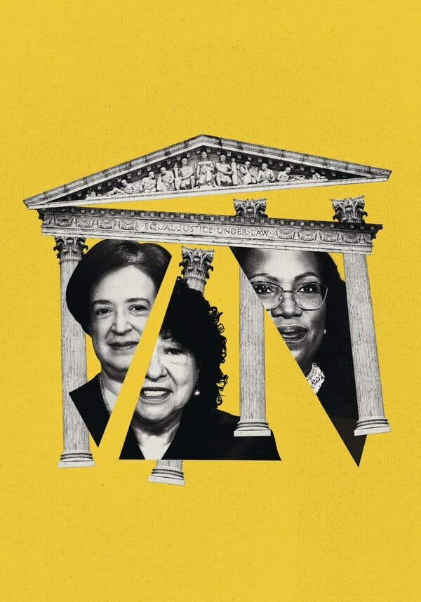

“Outnumbered and facing vast stakes, Justices Kagan and Jackson are split over the best approach: investing in diplomacy inside the court or sounding the alarm outside…. For years, as the court has moved right, Justice Kagan has agonized over whether to be more confrontational, confidantes say, and has mostly concluded that to be effective, she must be careful about rocking the boat. But in recent months, Justice Kagan’s liberal colleague, Justice Ketanji Brown Jackson, has started warning the public that the boat is sinking. In one opinion after another, Justice Jackson has accused the right side of the court of favoring “moneyed interests,” and of “complicity” that enables “our collective demise.” At oral arguments, she has taken up far more speaking time than her colleagues, even though the court several years ago tucked timers into the justices’ imposing wood table to tally each of their ticking minutes, according to several people familiar with the devices.” https://www.nytimes.com/2025/10/31/us/politics/supreme-court-kagan-jackson-liberal-justices.html?nl=The+Morning

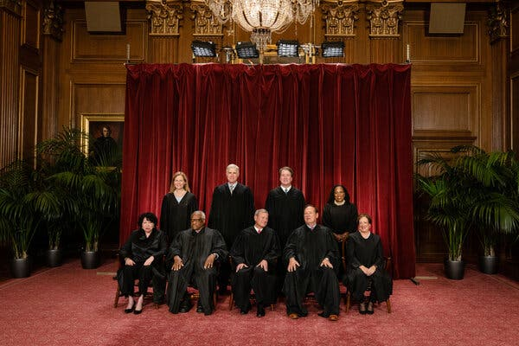

Justice Ketanji Brown Jackson, at the far right of the back row, joined the Supreme Court in 2022 as the third liberal justice.

Nov. 6, 2025: U.S. Supreme Court – Donald J. Trump v. Ashton Orr (6 to 3)

GOVERNMENT CAN REQUIRE PASSPORTS TO LIST SEX AT BIRTH

DONALD J. TRUMP, PRESIDENT OF THE UNITED
STATES, ET AL . v. ASHTON ORR, ET AL.
ON APPLICATION FOR STAY
“This case concerns an Executive Branch policy requiring all new passports to display an individual’s biological sex at birth. The United States District Court for the District of
Massachusetts preliminarily enjoined the Government from enforcing the policy, and the First Circuit declined to stay the injunction pending appeal. The Government then filed this stay application. Applying our familiar stay factors at this preliminary stage, we grant the application. Displaying passport holders’ sex at birth no more offends equal protection principles than displaying their country of birth—in both cases, the Government is merely attesting to a historical fact without subjecting anyone to differential treatment.”

***
Dissent: J USTICE J ACKSON, with whom JUSTICE SOTOMAYOR and
J USTICE KAGAN join, dissenting from the grant of application for stay….
For the past 33 years, across six Presidential administrations, transgender Americans have been able to obtain U. S. passports with sex markers that match their gender identity. From 1992 to 2010, passport applicants who wished to obtain passports with sex markers that were different from the sex assigned to them at birth had to submit
evidence of surgical reassignment. In 2010, the State Department began allowing passport applicants to submit a doctor’s certification avowing that they had undergone clinical treatment for gender transition. Beginning in 2021, the State Department allowed applicants to self-select the sex marker that matched their gender identity…. On January 22, 2025, the agency overhauled the rules for sex markers on passports, reverting to its pre-1992 practices. Its Passport Policy now requires that all new passports reflect the holders’ sex assigned at birth. Why? Because two days earlier, on January 20, President
Trump issued Executive Order No. 14168, characterizing transgender identity as ‘false’ and ‘corrosive’ to American society. 90 Fed. Reg. 8615 (2025).” … Thus, by preventing transgender Americans from obtaining gender-congruent passports, the Government is doing more than just making a statement about its belief that transgender identity is ‘false.’ The Passport Policy also invites the probing, and at times humiliating, additional scrutiny these plaintiffs have experienced. Given this, it is no surprise that each of the plaintiffs credibly testified that they would experience significant anxiety and fear for their safety if required to use passports that reflect their sex assigned at birth rather than their gender identity. https://www.supremecourt.gov/opinions/25pdf/25a319_i4dj.pdf

Nov. 9, 2025

“Why I Am Resigning.”
A federal judge explains his reasoning for leaving the bench.

By Mark L. Wolf
https://www.theatlantic.com/ideas/2025/11/federal-judge-resignation-trump/684845/?gift=vf1DGKhD1xBHQ3siCRuAVcz-qxehhrT47kEa20qvhPE&utm_source=copy-link&utm_medium=social&utm_campaign=share

About the Author
Mark L. Wolf is a retired senior United States district judge in Massachusetts.
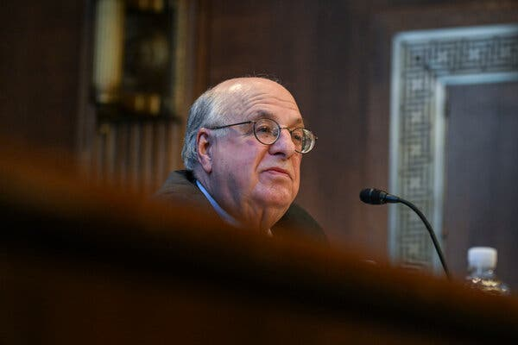

I was 38 years old. At the time, I looked forward to serving for the rest of my life. However, I resigned Friday, relinquishing that lifetime appointment and giving up the opportunity for public service that I have loved.
My reason is simple: I no longer can bear to be restrained by what judges can say publicly or do outside the courtroom. President Donald Trump is using the law for partisan purposes, targeting his adversaries while sparing his friends and donors from investigation, prosecution, and possible punishment. This is contrary to everything that I have stood for in my more than 50 years in the Department of Justice and on the bench. The White House’s assault on the rule of law is so deeply disturbing to me that I feel compelled to speak out. Silence, for me, is now intolerable.

When I accepted the nomination to serve on the U.S. District Court in Massachusetts, I took pride in becoming part of a federal judiciary that works to make our country’s ideal of equal justice under law a reality. A judiciary that helps protect our democracy. That has the authority and responsibility to hold elected officials to the limits of the power delegated to them by the people. That strives to ensure that the rights of minority groups, no matter how they are viewed by others, are not violated. That can serve as a check on corruption to prevent public officials from unlawfully enriching themselves. Becoming a federal judge was an ideal opportunity to extend a noble tradition that I had been educated by experience to treasure.

My public service began in 1974, near the end of Richard Nixon’s presidency, at a time of dishonor for the Department of Justice. Nixon’s first attorney general, John Mitchell, who had also been the president’s campaign manager, later went to prison for his role in the break-in at the Democratic headquarters at the Watergate complex and for perjury in attempting to cover up that crime. His successor, Richard Kleindienst, was convicted of contempt of Congress for lying about the fact that, as instructed by the president, he’d ended an antitrust investigation of a major company after it pledged to make a $400,000 contribution to the Republican National Convention. The Justice Department was also discredited by revelations that FBI Director J. Edgar Hoover had obtained and disseminated derogatory information about political adversaries, including Martin Luther King Jr.

I joined the Department of Justice as a special assistant to the honest and able Deputy Attorney General Laurence Silberman. Soon after, in 1975, President Gerald Ford named Edward Levi as attorney general to restore confidence in the integrity of the department. Levi, then the president of the University of Chicago, had a well-deserved reputation for brilliance, honesty, and nonpartisanship. Ford told Levi that he wanted the attorney general to “protect the rights of American citizens, not the President who appointed him.”

I organized Levi’s induction ceremony and was there when he declared that “nothing can more weaken the quality of life or more imperil the realization of the goals we all hold dear than our failure to make clear by word and deed that our law is not an instrument of partisan purpose.” For the next two years I served as one of Levi’s special assistants, working closely with a man who was always faithful to this principle.

With Levi as my model, in 1981 I became the deputy United States attorney and chief federal prosecutor of public corruption in Massachusetts. In about four years, my assistants and I won more than 40 consecutive corruption cases.
Many convictions were of defendants close to the powerful mayor of Boston at the time. As a result, I received the Attorney General’s Distinguished Service Award and was appointed a federal judge.

Some of the cases over which I presided as judge involved corruption and were highly publicized. Most notable was the prosecution of the notorious Boston mobsters James “Whitey” Bulger and Stephen “the Rifleman” Flemmi. Both, it turned out, were also FBI informants. Agents in the bureau, I discovered, were involved in crimes and egregious misconduct, including murders committed by Bulger and Flemmi. I wrote a 661-page decision detailing my findings. This led to orders that the government pay more than $100 million to the families of people murdered by informants whom the FBI had improperly protected. Their FBI handler was convicted twice and sentenced to serve a total of 50 years in prison.

I also presided over a six-week trial of a former speaker of the Massachusetts House of Representatives. After he was convicted of demanding and accepting bribes, I sentenced him to serve eight years in prison.
I decided all of my cases based on the facts and the law, without regard to politics, popularity, or my personal preferences. That is how justice is supposed to be administered—equally for everyone, without fear or favor. This is the opposite of what is happening now.

As I watched in dismay and disgust from my position on the bench, I came to feel deeply uncomfortable operating under the necessary ethical rules that muzzle judges’ public statements and restrict their activities. Day after day, I observed in silence as President Trump, his aides, and his allies dismantled so much of what I dedicated my life to.

When I became a senior judge in 2013, my successor was appointed, so my resignation will not create a vacancy to be filled by the president. My colleagues on the United States District Court in Massachusetts and judges on the lower federal courts throughout the country are admirably deciding a variety of cases generated by Trump’s many executive orders and other unprecedented actions. However, the Supreme Court has repeatedly removed the temporary restraints imposed on those actions by lower courts in deciding emergency motions on its “shadow docket” with little, if any, explanation. I doubt that if I remained a judge I would fare any better than my colleagues.

Others who have held positions of authority, including former federal judges and ambassadors, have been opposing this government’s efforts to undermine the principled, impartial administration of justice and distort the free and fair functioning of American democracy. They have urged me to work with them. As much as I have treasured being a judge, I can now think of nothing more important than joining them, and doing everything in my power to combat today’s existential threat to democracy and the rule of law.

What Nixon did episodically and covertly, knowing it was illegal or improper, Trump now does routinely and overtly. Prosecutorial decisions during this administration are a prime example. Because even a prosecution that ends in an acquittal can have devastating consequences for the defendant, as a matter of fairness Justice Department guidelines instruct prosecutors not to seek an indictment unless they believe there is sufficient admissible evidence to prove guilt beyond a reasonable doubt.

Trump has utterly ignored this principle. In a social-media post, he instructed Attorney General Pam Bondi to seek indictments against three political adversaries even though the officials in charge of the investigations at the time saw no proper basis for doing so. It has been reported that New York Attorney General Letitia James was prosecuted for mortgage fraud after Deputy Attorney General Todd Blanche, one of Donald Trump’s former criminal-defense lawyers, questioned the legal viability of bringing charges against James. Former FBI Director James Comey was charged after the interim U.S. attorney who had been appointed by Trump refused to seek an indictment and was forced to resign. Senator Adam Schiff, the third target of Trump’s social-media post, has yet to be charged.

Trump is also dismantling the offices that could and should investigate possible corruption by him and those in his orbit. Soon after he was inaugurated, Trump fired, possibly unlawfully, 18 inspectors general who were responsible for detecting and deterring fraud and misconduct in major federal agencies. The FBI’s public-corruption squad also has been eliminated. The Department of Justice’s public-integrity section has been eviscerated, reduced from 30 lawyers to only five, and its authority to investigate election fraud has been revoked.

The Department of Justice has evidently chosen to ignore matters it would in the past have likely investigated. Some directly involve the president. It has been reported that at a lavish April 2024 dinner at Mar-a-Lago, after executives from major oil companies complained about how the Biden administration’s environmental regulations were hurting their businesses, Trump said that if they raised $1 billion for his campaign he would promptly reverse those rules and policies. The executives raised the money, and Trump delivered on his promise. The law may be unclear concerning whether Trump himself could have been charged with conspiracy to bribe a public official or honest-services fraud. In addition, Trump himself may have immunity from prosecution if similar payments for his benefit continued after he became president. However, the companies that made the payments, and the individuals acting for them, could possibly be prosecuted. There is no public indication that this matter has been investigated by Trump’s Department of Justice.

As a prosecutor and judge I dealt seriously with the unlawful influence of money on official decisions. However, Trump and his administration evidently do not share this approach. After Trump launched his own cryptocurrency, $TRUMP, his Department of Justice disbanded its cryptocurrency-enforcement unit. The top 220 buyers of Trump’s cryptocurrency were invited to a dinner with Trump. Sixty-seven of them had invested more than $1 million. The top spender, Justin Sun, who was born in China and is a foreign national, reportedly spent more than $10 million. Sun also reportedly spent $75 million on investments issued by a crypto company controlled by Trump’s family. It is illegal for people who are not U.S. citizens to donate to American political candidates, and the most that anyone can donate directly to one candidate is $3,500. Ordinarily, the Department of Justice would investigate this sort of situation. There is, however, no indication that any investigation has occurred. Rather, a few months after Sun started purchasing tokens from the Trump-family cryptocurrency company, the Securities and Exchange Commission paused its fraud suit against Sun and his companies pending the outcome of settlement negotiations. (Sun and his companies have denied any wrongdoing.)

Trump is not the only member of his administration whose conduct is apparently shielded from investigation. In September of last year, Tom Homan, who became Trump’s “border czar,” reportedly was recorded accepting $50,000 in cash in return for a promise to use his potential future public position to benefit a company seeking government contracts. The FBI had created the fictitious company as part of an undercover investigation. Typically, an investigation of that sort would have continued after Homan became a Department of Homeland Security official, with the FBI seeking any additional evidence of bribery. However, after Trump took office, the investigation was shut down, with the White House claiming there was no “credible evidence” of criminal wrongdoing. Weeks after the FBI investigation was reported, Homan denied taking $50,000 “from anybody” and has said he did “nothing criminal.” An honest investigation could reveal who is telling the truth.

There is also the matter of Trump’s executive orders. A good number are, in my opinion, unconstitutional or otherwise illegal. For example, contrary to the express language of the Fourteenth Amendment, one order declares that not everyone born in this country is a U.S. citizen. Trump’s administration also has deported undocumented immigrants without due process, in many cases to countries where they have no connections and will be in great danger. Although many federal judges have issued orders restraining the government’s effort to implement those executive orders, some appear to have been disobeyed by members of the Trump administration. Trump has responded by calling for federal judges to be impeached, even though the Constitution permits impeachment only for “high crimes and misdemeanors,” such as treason and bribery.

Trump’s angry attacks on the courts have coincided with an unprecedented number of serious threats against judges. There were nearly 200 from March to late May 2025 alone. These included credible death threats, hundreds of vitriolic phone calls, and anonymous, unsolicited pizza deliveries falsely made in the name of the son of a federal judge, who was murdered in the judge’s home in 2020 by a disgruntled lawyer.

Over the past 35 years I have spoken in many countries about the role of American judges in safeguarding democracy, protecting human rights, and combatting corruption. Many of these countries—including Russia, China, and Turkey—are ruled by corrupt leaders who rank among the worst abusers of human rights. These kleptocrats jail their political opponents, suppress independent media that could expose their wrongdoing, forbid free speech, punish peaceful protests, and frustrate every effort to establish an independent, impartial judiciary that could constrain these abuses. These kleptocrats have impunity in their countries because they control the police, prosecutors, and courts.

In my work around the world, I have made many friends, young and old, who have been inspired by the example of American judges, lawyers, and citizens. They have suffered greatly for trying to make their countries more like ours. Among them are impartial judges who have been imprisoned in Turkey, a brilliant young Russian lawyer who was alleged to be a spy and forced into exile, and a Venezuelan law student who almost lost sight in one eye while protesting his country’s oppressive government. They courageously share what have historically been our nation’s convictions. These brave people inspire me.

I resigned in order to speak out, support litigation, and work with other individuals and organizations dedicated to protecting the rule of law and American democracy. I also intend to advocate for the judges who cannot speak publicly for themselves.

I cannot be confident that I will make a difference. I am reminded, however, of what Senator Robert F. Kennedy said in 1966 about ending apartheid in South Africa: “Each time a man stands up for an ideal, or acts to improve the lot of others, or strikes out against injustice, he sends forth a tiny ripple of hope.” Enough of these ripples can become a tidal wave.
And as Nobel Laureate Seamus Heaney wrote, sometimes the “longed-for tidal wave of justice can rise up, and hope and history rhyme.” I want to do all that I can to make this such a time.

Nov. 19, 2025 – National Guard – Injunctions – Chicago; Portland, Oregon

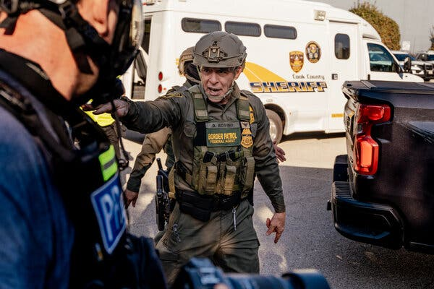Gregory Bovino, a senior official with the Border Patrol, telling demonstrators to clear a driveway used to transport detainees outside an immigration processing center in Broadview, Ill.

“The federal crackdown on illegal immigration that began in the Chicago area in early September goes on, though it has been tamped down somewhat by the courts. Before he departed, Mr. Bovino and federal agents that included Border Patrol personnel had in recent weeks taken some of the most aggressive actions yet. A federal judge condemned agents for using unnecessary force that included using tear gas and pepper spray against Chicago residents without giving them proper warning, and for pointing guns at civilians who were not a physical threat. The judge also said Mr. Bovino had lied to her about his tactics. The Justice Department argued that the tactics were justified because some protesters had become violent.
President Trump has sought to deploy National Guard troops from Illinois and Texas to the city, too, but that effort remains tied up in the courts. Last weekend, the federal government said it was sending 200 Texas National Guard troops back home who had yet to be deployed on Chicago streets….

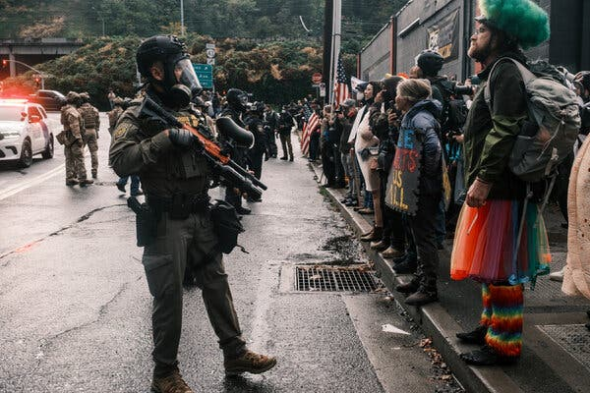Federal agents facing protesters in front of an ICE facility in Portland, Ore., in October.

The Trump administration ramped up its immigration enforcement in the city around June, and a small but persistent group of protesters has held daily demonstrations outside Portland’s ICE building ever since. Skirmishes with the authorities led to the closing of that building for more than three weeks at one point, according to the Department of Homeland Security, but protests had largely fizzled by September. Late that month, however, Mr. Trump tried to send National Guard troops to the city, saying that the ICE building and federal workers there needed to be protected from ‘war-ravaged Portland.’ Portland and Oregon sued, and a federal judge this month issued a permanent block on the deployment. The administration is appealing. Over the weekend, the Pentagon said that it was going to send home about 200 California National Guard troops who had been sent to Portland but never deployed on the streets. About 100 Oregon National Guard troops remain under federal control and on standby.
https://www.nytimes.com/2025/11/18/us/trump-immigration-raids.html?nl=The+Morning

Dec. 10, 2025: “Judge blocks Trump's National Guard deployment in LA with sharp rebuke. The Trump Administration must end its deployment of the National Guard to Los Angeles and return control of the troops to the state, according to a ruling by U.S. District Judge Charles Breyer in San Francisco. Judge Breyer granted a preliminary injunction to California officials who opposed President Trump's use of state troops since June, when the administration seized control of the guard — against Governor Gavin Newsom's wishes — to confront protests against immigration enforcement operations in Los Angeles. The Trump administration filed an appeal on Thursday.” https://www.npr.org/2025/12/10/nx-s1-5639822/national-guard-la-court-judge-trump

Dec. 10, 2025: FEMA
“Exclusive: Trump’s FEMA council to recommend dramatic downsizing and overhaul – but not elimination – of the agency.” https://www.cnn.com/2025/12/10/politics/fema-council-report-recommend-downsizing-overhaul

Dec. 30, 2025: 15 Prisoners From 9/11 Still At Guantanamo Bay, Cuba

“It is part of a Red Cross program that allows detainees in the war against terrorism to communicate with their families through prison-reviewed letters and cards. These protections are outlined in the Geneva Conventions, the international law governing warfare. All 15 prisoners at Guantánamo have had access to the program, which began allowing photos in 2009…. The collection of photos offers a curated view of life today in detention at the Navy outpost where the United States has held about 780 men and boys in the war against terrorism since 2002. Just 15 prisoners remain.”
https://www.nytimes.com/2025/10/23/us/politics/guantanamo-prisoners-portraits.html?nl=The+Morning&segment_id=212909

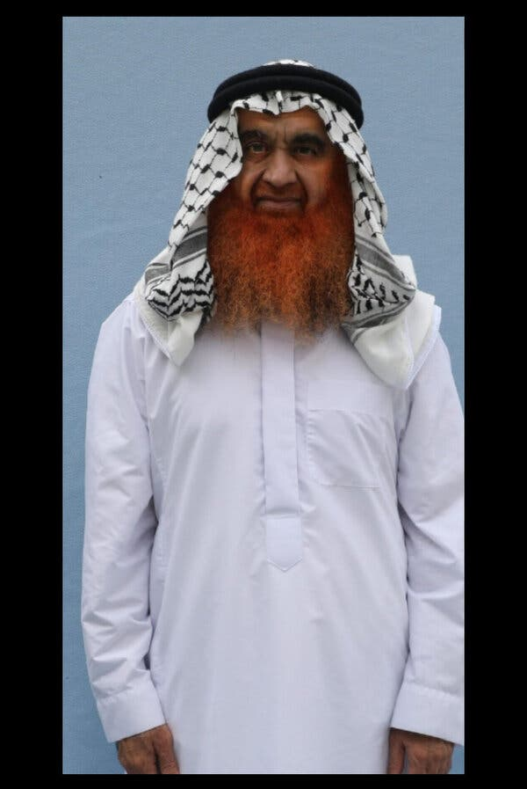
Khalid Shaikh Mohammed, who is accused of hatching the 9/11 plot that killed nearly 3,000 people, appears in a recent photo in a pressed white robe, his beard dyed.

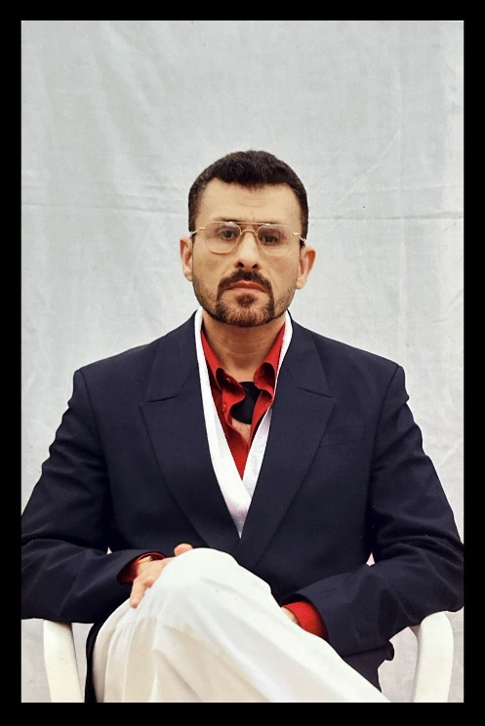

“In one photo taken in 2024, Abu Zubaydah looks as if he walked out of a yachting magazine, not a prison cell. A black patch he sometimes wears over a false eye, worn around his neck, suggests a cravat…. Abu Zubaydah was the first person to be waterboarded by the C.I.A. and the first prisoner to be held in a secret overseas detention program that was set up by the Bush administration to interrogate prisoners after the Sept. 11 attacks. He has never been tied to the Sept. 11 plot, but he claimed to run a jihadist movement that rivaled Al Qaeda and has been assessed by a U.S. national security panel as too dangerous to release.”

Dec. 31, 2025: Trump Abandons Efforts to Deploy National Guard to 3 Major Cities

“The troops had nearly no presence in two of the cities, Portland and Chicago. But the decision signaled a retreat, at least for now, in one of the president’s most audacious attempts to test his power…. President Trump said on Wednesday that he would abandon, for now, efforts to deploy the National Guard in Chicago, Los Angeles and Portland, Ore.
The decision comes after the Supreme Court ruled last week that Mr. Trump could not deploy troops in the Chicago area over the objections of Illinois officials. The president’s announcement made no mention of the ruling, but he suggested his administration would not hesitate to deploy troops in the future.” https://www.nytimes.com/2025/12/31/us/politics/trump-national-guard.html?nl=The+Morning&segment_id=212982

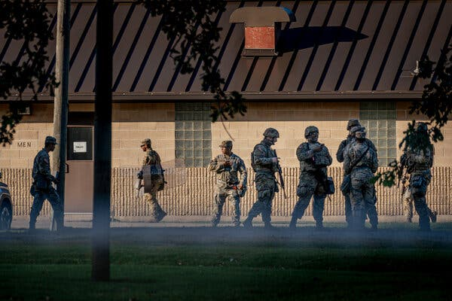Members of the Texas National Guard at a U.S. Army Reserve Training Center in Elwood, Ill., a suburb of Chicago, in October.

See also Professor Bennett’s Dec. 28. 2025 article.

HOMELAND SECURITY TODAY - COLUMN: Supreme Court Blocks National Guard Deployment to Chicago, Restricts Presidential Power Under Title 10
Landmark ruling reshapes federal authority and strengthens governors’ control over National Guard deployments. https://www.hstoday.us/us-national-guard/column-supreme-court-blocks-national-guard-deployment-to-chicago-restricts-presidential-power-under-title-10/

January 3, 2026 – Venezuela - Nicolás Maduro Captured, Flown To NYC

“In 2025, President Donald Trump began a military buildup against Venezuela, accusing Maduro of supporting drug traffickers, which the Venezuelan president denied. In the early hours of January 3, 2026, U.S. forces attacked Venezuela’s capital city of Caracas in a large scale operation to capture Maduro and his wife, Cilia Flores. The two were swiftly flown out of the country, with Maduro facing charges in the Southern District of New York of narco-terrorism, cocaine trafficking, and conspiracy to possess machine guns and destructive devices against the U.S.” https://www.britannica.com/biography/Nicolas-Maduro/Attempts-to-remove-Maduro-from-office

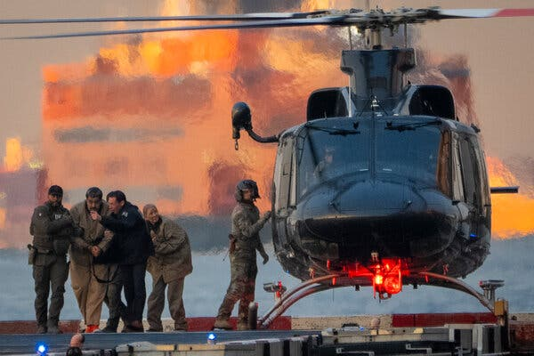
Nicolás Maduro, the ousted leader of Venezuela, and his wife, Cilia Flores, before their arraignment in New York City in January. The New York Times

April 5, 2026: U.S. Air Force Officer – Shot Down Over IRAN – RESCUED

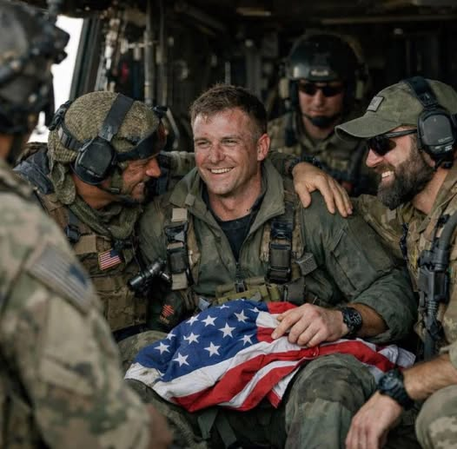

April 6, 2026 – U.S. Supreme Court - Former Cincinnati Councilman PG Sittenfeld Conviction Set Aside

Public corruption – must prove money was for “official acts”

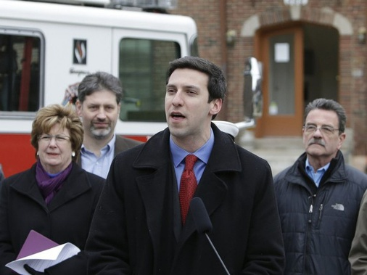

Watch this TV VIDEO: In 2018, FBI agents secretly record former Cincinnati city councilman P.G. Sittenfeld, recordings released
https://www.youtube.com/watch?v=dUyEke_XyPA

U.S. Supreme Court – Orders List - April 6, 2026
https://www.supremecourt.gov/orders/courtorders/040626zor_5iek.pdf

SITTENFELD, ALEXANDER V. UNITED STATES
The petition for a writ of certiorari is granted. The
judgment is vacated, and the case is remanded to the United
States Court of Appeals for the Sixth Circuit for further
consideration in light of the pending motion to dismiss the
indictment.

April 7, 2026: U.S. Supreme Court Overturns PG Sittenfeld Corruption Conviction. https://www.cleveland.com/news/2026/04/us-supreme-court-overturns-pg-sittenfeld-corruption-conviction.html
“The U.S. Supreme Court on Monday granted federal prosecutors’ request to overturn ex-Cincinnati City Councilman PG Sittenfeld’s corruption conviction, opening the door for a lower court to dismiss his case given that President Donald Trump pardoned him last year.
The ruling marks what could be the first time in U.S. Supreme Court history that the nation’s high court accepted an appeal from a defendant who had already received a presidential pardon for a criminal conviction….

Sittenfeld, a 2016 Democratic U.S. Senate candidate, was convicted in 2023 of bribery and attempted extortion after accepting $20,000 from undercover FBI agents in exchange for lining up votes for a Cincinnati development project.
Sittenfeld pleaded innocent, arguing – among other things – that the $20,000 was a political contribution that he had a right to accept under the First Amendment.”

Discuss when an elected official can accept campaign contributions from individuals seeking to do business with that official’s political subdivision. Before you answer, read the below note.

Note: In 2016, the Supreme Court clarified the boundaries of federal political corruption statutes in McDonnell v. United States, in which it examined which actions taken by public officials could be considered “official acts.” The federal bribery statute, 18 U.S.C. § 201, makes it a crime for a public official to "receive or accept anything of value" in exchange for being "influenced in the performance of any official act."

McDonnell v. United States:
Facts of the case.
https://www.oyez.org/cases/2015/15-474
On November 3, 2009, Robert F. McDonnell was elected Governor of Virginia. At the time of his election, he and his family were experiencing economic difficulties; by September 2010, he and his wife had a combined credit card balance of $90,000, and by 2012 the business he and his sister operated had a loan balance of $2.5 million. Shortly after his election, McDonnell met with Jonnie Williams, the founder and CEO of Star Scientific, Inc. (Star), which was trying to market a product called Anatabloc that could be used to treat chronic inflammation. Star wanted the Food and Drug Administration to classify Anatabloc as a pharmaceutical, which would be more profitable than the alternative classification of nutraceutical. However, such a classification would require expensive testing, clinical trials and studies, and Star lacked the funds. Between 2009 and 2012, Williams and McDonnell met several times and agreed that “independent testing [of Anatabloc] in Virginia was a good idea.” Williams also provided expensive gifts to the McDonnells and “was willing to help” with their financial troubles. A launch event for Anatabloc was held at the Governor’s Mansion, and Mrs. McDonnell facilitated meetings between Star officials and officials at the University of Virginia and Virginia Commonwealth University to get the studies started. Mrs. McDonnell also purchased, sold, and gifted Star stock in such as way as to avoid reporting requirements, and McDonnell spoke to various government officials about the benefits of Anatabloc.

The McDonnells were eventually arrested and charged for corruption, under federal statutes that make it a felony to take “official action” in exchange for money, campaign contributions, or any other thing of value. On September 4, 2014, McDonnell was found guilty on 11 counts of corruption. McDonnell appealed his conviction and argued that the jury instructions given at trial did not properly define the term “official action.” The U.S. Court of Appeals for the Fourth Circuit affirmed his conviction and held that the jury instructions in question were adequate.

Conclusion

An “official act” is a decision or action on a question, matter, cause, suit, proceeding, or controversy that involves a specific exercise of formal governmental power. Chief Justice John G. Roberts, Jr. delivered the opinion for the unanimous Court. The Court held that arranging a meeting, contacting another official, or hosting an event -- on its own -- is not sufficient to rise to the level of an “official act” for the purpose of federal bribery statutes. This more limited reading of the statutory text gives each word a meaning that is proper in context and not superfluous, which is the best reading of the statute. Additionally, previous Supreme Court precedent has established that the existence of matters pending before a government official was not sufficient to find that any action related to those matters constituted an “official act.” Adopting a broader reading of the statutory language would likely chill public officials’ interactions with their constituents due to fears of prosecution and therefore make it more difficult for them to do their jobs. Based on this interpretation of the statutory language, the jury instructions at issue were impermissibly broad and did not provide enough guidance to the jury regarding whether the actions in question needed to be formal exercises of governmental power. Therefore, the conviction was vacated.

