Dock Talk

by

Tek Dhital, Tyler Jones, Kyler Miller

Submitted to
the Faculty of the School of Information Technology
in Partial Fulfillment of the Requirements for
the Degree of Bachelor of Science
in Information Technology

© Copyright 2019 Tek Dhital, Tyler Jones Kyle Miller

The author grants to the School of Information Technology permission
to reproduce and distribute copies of this document in whole or in part.

Tyler Jones  Tyler Jones – Project Manager/Developer | 4/27/2019_  Date
Kyle Miller  Kyle Miller – Security Analyst | 4/27/2019_  Date
Tek Dhital  Tek Dhital – Security Analyst | 4/27/2019_  Date
Bo Vykhovanyuk  Bo Vykhovanyuk– Faculty Advisor | 4/27/2019_  Date

University of Cincinnati
College of
Education, Criminal Justice, and Human Services

April 2019

Dock Talk

Prepared by:

Tek Dhital, Security Analyst and Developer
Tyler Jones Project Manager and Developer
Kyle Miller Security Analyst and Developer

Students of
University of Cincinnati
College of Education, Criminal Justice, and Human Services
School of Information Technology
Cech.uc.edu/it

April 2019

Table of Contents
Table of Contents i
List of Illustrations ii
Abstract 1
1 Problem Statement 2
1.1 Problem: 2
1.2 Solution: 2
1.3 Project Goals: 3
1.4 Overview: 3
2 Discussion 4
2.1 Project concept: 4
2.2 Design Objectives: 4
2.3 Methodology: 4
2.4 User Profile: 5
2.5 Use Case Diagram: 7
2.6 Project Schedule and Gantt Chart 8
2.7 Budget: 10
2.8 Problems Encountered: 10
3 Technical Elements 12
3.1 Hardware 12
3.2 Software 12
3.3 Security 12
4 Testing 13
4.1 Overview 13
4.2 Scope 13
4.3 Objective 13
4.4 Entry and Exit Criteria 13
4.5 Logging Test and Procedures 14
5 User Interface 15
5.1 Login Page 15
5.2 Dock Talk 16
6 Conclusion 17
Appendix A. Additional Information a
Appendix B. References e

List of Illustrations
Table 1. User Profile 6
Figure 1. Use Case Diagram 7
Figure 2. Project schedule 8
Figure 3. Gantt Chart 9
Figure 4. Gantt Chart 10
Figure 5. Login Page 15
Figure 6. Dock Talk 16
Figure 7. Wireshark Scan a
Figure 8. Nikto Scan b

Abstract
Today we constantly use our phones to act as another form of verification. Unfortunately, this requires us to jump from device to device to prove that we have our phones. Dock Talk is a product that will communicate authentication codes, so the end user does not have to. This way, a user can set their phone down to charge and not have to worry about pesky authentication codes. By using NFC technology our dock will be able to receive authentication codes from the phone. If you are traveling and did not bring your dock with you, you will still be able to use old verification methods.

1 Problem Statement

1.1 Problem:
Multi-factor is a great way to ensure that the correct person is the one signing into their account. However, this adds extra time for the user to get logged in. In our experience, it takes around 15-30 seconds to receive and respond to a Multi-factor request. If you are responding to a Multi-factor request 10-20 times a day you can easily spend 5 minutes a day on these requests. This adds up to around 21 hours a year wasted on Multi-factor requests.
Security measures in IT are becoming an inconvenience. You must type in a password on your computer, then go to your phone to either type in another code or hit a button. During the day this process might be repeated up to a dozen times. Depending on a company’s security procedures there are many processes that require multi-authentication; connecting to a machine remotely, physically, pulling from a web-server, connecting to a Virtual Private Network (VPN), or connecting to a firewall.
In our team’s experience we go through these processes daily and with logging out due to breaks, sessions timing out or various other reasons the need to use multiple forms of authentication can add up greatly and take up time as well as be an annoyance.

1.2 Solution:
Dock Talk is a device that authenticates for you. The dock is able to do this by utilizing Near Field Communication (NFC) Technology. While the phone is sitting on the dock, the phone can automatically pass its private key to the dock. This eliminates the excessive need of typing in additional codes throughout the day with the simple and quick method of setting down your phone a jumping into your work. If the phone is not on the dock, then the authenticator should be able to default back to either sending a text or using push notifications. The dock also has a built-in wireless charger. This way users do not have to worry about their phone’s battery.

1.3 Project Goals:
Deliver a working prototype of the dock. It should be able to read information from the phone, as well as charge the phone.
Design and 3D print the prototype.
Develop an android application for storing authentication information.
Develop a website that uses our authentication.

1.4 Overview:
Dock Talk is something that people don’t have to worry about carrying around as it sits on your desk. Our dock makes multi-factor authentication a faster and easier process. Unlike other multi-authentication applications, Dock Talk does not require you to type in your passwords more than once to prove that you are the person trying to login, instead, it gets your information without you even have to worry about getting any confirmation or having to press multiple buttons. Having Dock Talk on your desk also means that your phone will not run out of battery as it also has wireless charging capability.

2 Discussion

2.1 Project concept:
The idea for this project came about from an interest in NFC technology. We wanted to take this technology and use it for Multi-factor purposes. We then took the technology we were interested in and looked at a current problem we were all facing, Multi-factor. The time and effort of jumping from computer to phone, then back to computer frustrated us. Since NFC is built into most modern cell phones, we decided this would be the perfect issue for us to solve.

2.2 Design Objectives:
The physical design we would have liked to have made as thin as possible. Since this would require a manufacturer and a computer engineers design for the board, we had to leave the dock rather bulky.
The software design we wanted to make it as unobtrusive as possible for the end users. We wanted an easy to use, User Interface (UI) for the systems administrator. The UI for the systems administrator is something we were unable to get in depth into due to time constraints.

2.3 Methodology:
Dock Talk will communicate with a user’s phone using NFC Protocol. NFC enables the phone to transfer files to other devices through physical contact. Dock Talk Servers will produce dynamic authentication keys that will be sent to the users’ phone. The user will then be able to place the phone on the dock which will pass the authentication key from the phone to the computer via an NFC session.

2.4 User Profile:
Table 1. User Profile Table: Shows the roles we expect our users and Information Technology (IT) Administrators to follow.

2.4.1 Project Title: Dock Talk
2.4.2 Potential End Users:
→ The primary users will be employees in a business environment that are going to have to have several different authentications applications or use an authentication application several times.
→ Our secondary user will be our IT Administrator. Their role will be to
setup and maintain the back end of the system. The will also oversee account creation, and redistributing authentication keys if needed

2.4.3 Software, Interface, and Related Experience:
→ Our goal is to target corporate environments seeking to enhance their employees' experience when using multi-factor authentication. Unlike other two-factor authentication applications, our product does not require the user to check their phone authenticate against their computer. The dock will automatically read your phone when placed on the dock and the phone itself will act as an NFC token.
→Our IT Administrator would need some administration and troubleshooting experience.
2.4.4 Frequency of use:
→ The dock would be used every time a user would need to log into a portal that requires multi-factor authentication.
→The IT Administration will only need to use the application when onboarding a new user, troubleshooting a user’s account, or during a cyber-attack when keys may need to be changed.

2.4.5 Key Project Design Requirements that the Profile Suggests:
→ A wireless charging port with NFC chips attached to it
→ The dock that can gain access to your phone for authentication purposes
→ Streamlined authentication process

Table 1. User Profile

2.5 Use Case Diagram:
Figure 1. Use Case Diagram: illustrates the role that each person has in implementing Dock Talk. Our end users will have very little required on their part, while our administrator will have the ability to manage accounts with ease.
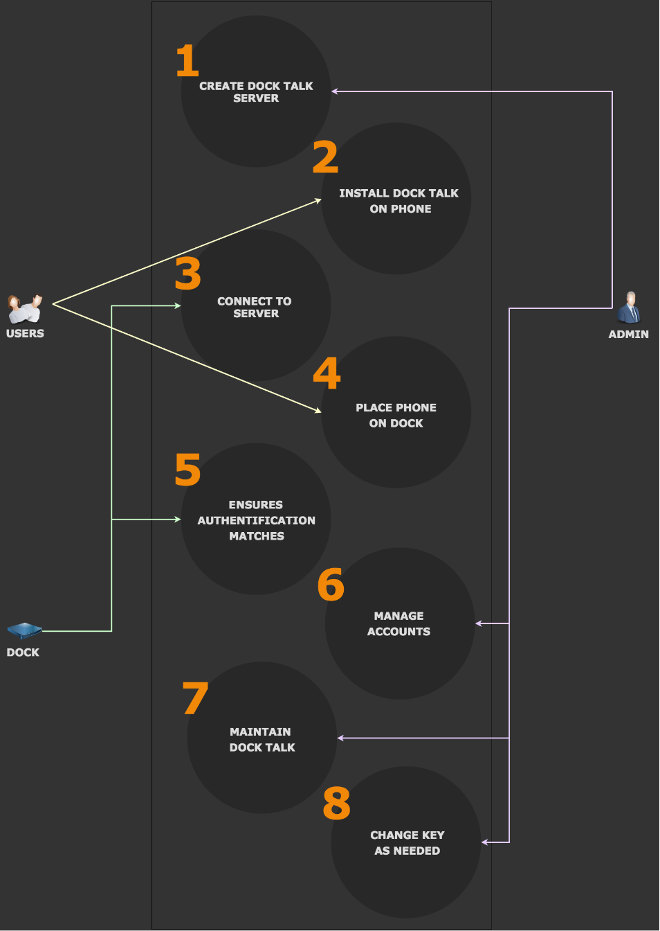

Figure 1. Use Case Diagram

2.6 Project Schedule and Gantt Chart
Figure 2. Project schedule: Shows a list our major tasks and features to accomplish.
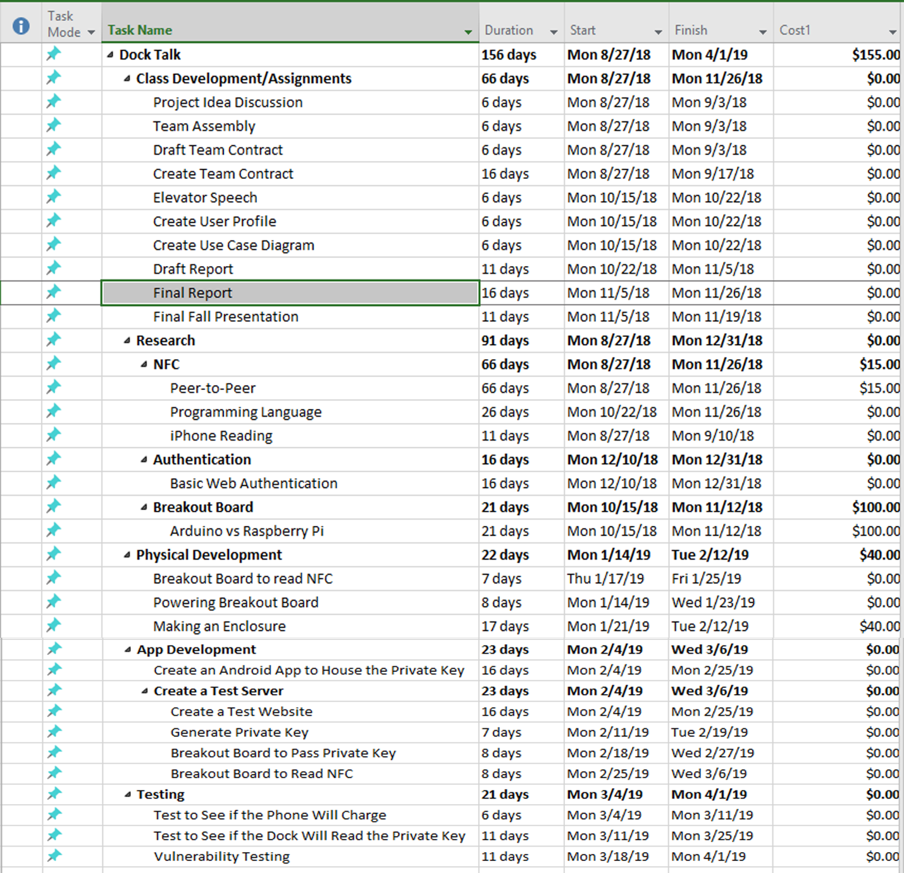

Figure 2. Project schedule

Figure 3. Gantt Chart: Shows a timeline of when we are working towards each milestone.
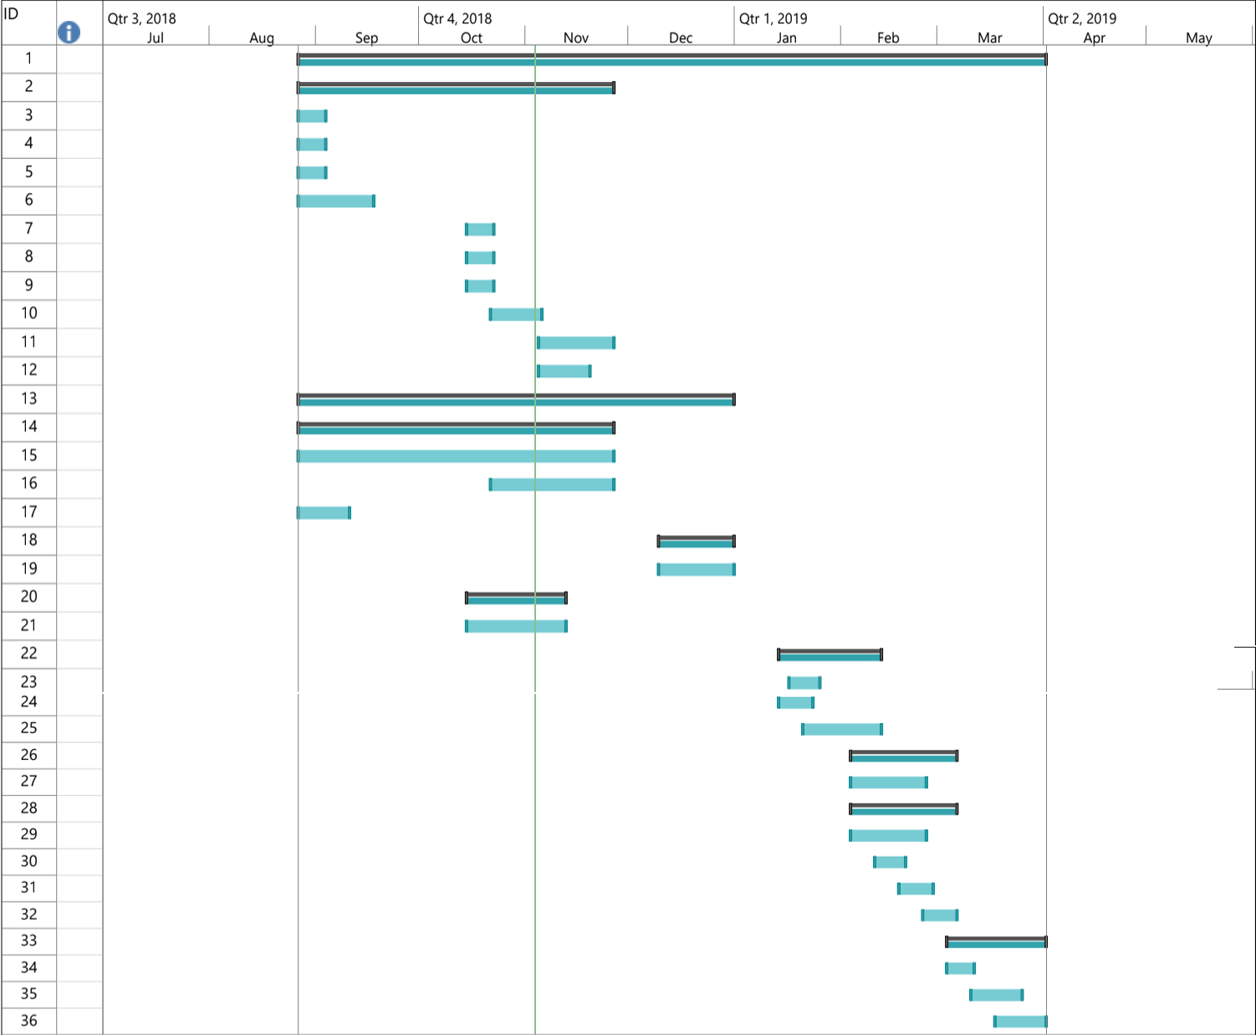

Figure 3. Gantt Chart

2.7 Budget:
Figure 4. Budget: Shows an estimated budget of our project.
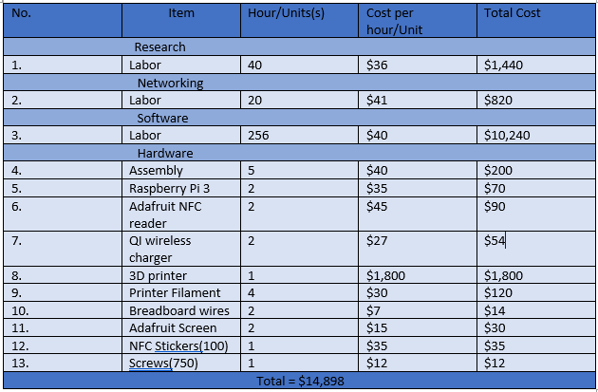

Figure 4. Gantt Chart

2.8 Problems Encountered:
Throughout the development of Dock Talk, we have run into several issues. One of our earliest issues was power. With both the wireless charger and the Raspberry Pi connected to a single AC supply, the charger would pull too much causing the Pi to reboot. Our solution, for the time being, is to keep them on separate circuits. If time permits, we would like to be able to research more into how to power both devices off a single cable
A major issue our project faces is with older phones. Currently, only one phone between all of us uses a static UID while the other phones change per NFC interaction. This means our project is at the whim of phone manufacturers. Currently, we have been using static tags, and the one Samsung Galaxy S8 Active to run our tests. Since we have had to resort to static tags for testing, this also means we cannot use the ATS code found on phones to filter out NFC tags. Ideally, we would like for the phone to send our own code using an application so that it can be changed and work on older phones.
Another issue we have encountered is with iPhones NFC capabilities. Currently iPhones block NFC signals unless it is with a credit card reader. After researching the issue, we found out that IOS 12 has unlocked NFC capabilities for the iPhone X (1, p. 1). Unfortunately, it took some time to acquire an iPhone X. At that point it was too close to IT Expo and did not have time to create something in Swift.
The last issue we had was with a Python module called Paramiko. Paramiko allows the server to Secure Shell (SSH) into the raspberry pi. Our goal was to use SSH keys instead of using passwords. We were unable to accomplish this due to an issue with Paramiko and one of its dependencies (3, p 1). We ended up using passwords when IT Expo came around.

3 Technical Elements

3.1 Hardware
The prototype for the dock used a Raspberry Pi Three Model B with an Adafruit PN532 NFC breakout board connected to it. The breakout board allowed the Raspberry Pi to pull NFC information off the phone. This is how we obtained our devices code for multifactor authentication. Once the Raspberry Pi has the code it submitted the code across the network to our authentication server.
We did add an Adafruit PIOLED to display the Internet Protocol (IP) address. This saved us from having to hook up a monitor to the Raspberry Pi, or log into the local network.

3.2 Software
We wrote are test website using a Python microframework called Flask. This allowed us to setup a quick and easy blog website to test our authentication against. Once the website was completed, we added a step to use Paramiko to SSH into our Raspberry Pi and run the LibNFC code. The results returned to the website and this could be compared to the user database.

3.3 Security
For security we focused on a couple of programs to test our project. The first program was Wireshark. We used Wireshark to confirm that the dock was able to send information to the website, without making the user’s information public.
The second software we focused on was Nikto (vulnerability scanner). We wanted to make sure our website was free of vulnerabilities. Especially since this was our first time writing a website in Python.

4 Testing

4.1 Overview
This section will explain the testing methodology we used for the Dock Talk hardware and application. We will also be covering the security behind both. The following individuals will use this section as test guidance:
- End Users
- Developers
- Information Security Analyst

4.2 Scope
The scope of testing is to see the reliability and security of an android phone communicating with the dock and a server and to test the penetrability and accessibility of devices included in the process (Phone, Dock; Pi, Wireless Charger). The test will be organized based on the application’s requirements

4.3 Objective
The objective of testing is to confirm that devices are communicating as intended. Our group is more security oriented, so the greater focus is put to confirming communications are secure. We want to ensure that our solution is just as secure as current two-factor authentication methods while having consistent user login times. We want to make sure that the product we’ve created has a simpler user interaction (users will just need to place their phone on the dock for authentication and it will check, automatically, if that phone belongs to the correct user and logs in the user).

4.4 Entry and Exit Criteria
Entry Criteria:
- Complete building the product and application
- Testing the design process is written and validated (self-tested)
Exit criteria:
- The application and the device are tested and are working in an acceptable manner
- Bugs and issues are documented and fixed
- Fixes are approved by a security analyst
- Make sure the solution proposed for the project is fulfilled

4.5 Logging Test and Procedures
If an issue or bug is found during testing or for some other reasons the application and the device do not perform well, the occurrence and duplication steps will be documented by the tester. If there is a bug then it will be fixed and if there is a feature not yet designed, the team’s developer will work towards adding the feature to the application as well as the device, after discussion with the team members.

5 User Interface

5.1 Login Page
Figure 5. Login Page: Shows our login page for our test website. The user must enter in their email and password correctly. They will also need to have their phone on the dock. Once the three requirements are met the website will either log the user in or present them with an error message. The error messages vary. If the email or password are incorrect then the website will notify the user, it’s one of those two things. If the dock is not available or the UID is incorrect then it will notify the user as to which issue they are running into.
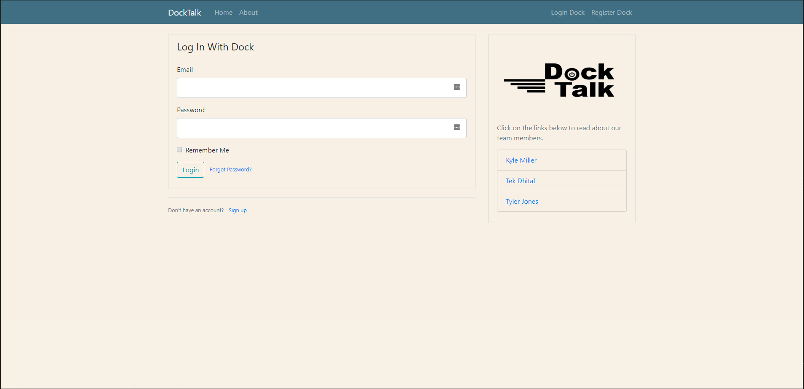

Figure 5. Login Page

5.2 Dock Talk
Figure 6. Dock Talk: Shows a what the dock looks like. The mobile phone sits on the right side of the dock where the wireless charger and NFC reader are housed. Once the website requests the UID from the Dock then it will scan the phone and return the information. Users will only need to remember their passwords, and to place their phone on the dock.
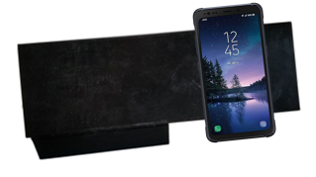

Figure 6. Dock Talk

6 Conclusion

6.1 Fall
We are still learning some very valuable lessons with this project. One of the most important lessons is teamwork. Being able to properly work with everyone can save a time and effort. This lesson is one that we are constantly trying to figure out. Some areas we all work perfectly in sync and some we end up putting in double the effort to fix.
We are all expanding our technically skills as well. Learning how to use GitHub to manage changes between each person is a great asset. We can put our classroom skills to the test by having so many different components communicate between each other.
We plan on furthering our development in the spring and having our project truly work between phone, dock, and server. From there we want to refine everything before expo.

6.2 Spring
We were able to create a working prototype of our dock, something we were unsure of in the fall. We managed to create a 3D design, print it out, and build an actual product. The website was also a great addition to the project. This allowed us to deepen our knowledge of Python and have something nice to display at IT Expo.
We learned some very valuable lessons from this project. Since the beginning, our project had very interesting and conflicting opinions. This continued all the way to IT Expo. Some people really enjoyed the idea, the time save, and the ease of use. Others disliked the idea and thought about it like leaving your keys in the ignition of an open car. This is something we could not argue, but we failed to see how that expression couldn’t include other forms of Multi-factor authentication. Overall, we learned that you cannot please everyone.

Appendix A. Additional Information
The team contacted the following professionals for clarification and additional insight.
- Bo Vykhovanyuk, Advisor – University of Cincinnati

Security Reports:

The following tables show the results of our tests.
Figure 7. Wireshark Scan: Shows that the traffic to the dock from the website is an encrypted packet. This means that Paramiko did its job and used an SSH connection to run the program and received the results.
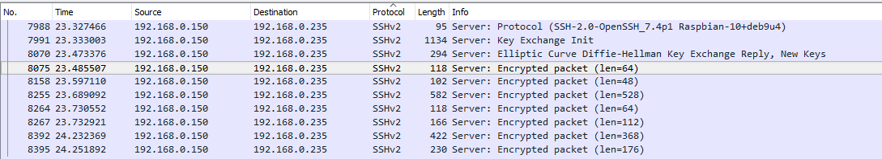

Figure 7. Wireshark Scan

Figure 8. Nikto Scan: Shows the errors that Nikto has found from its vast database. Some of the errors are due to use using Ngrok to host our website locally while we scan.
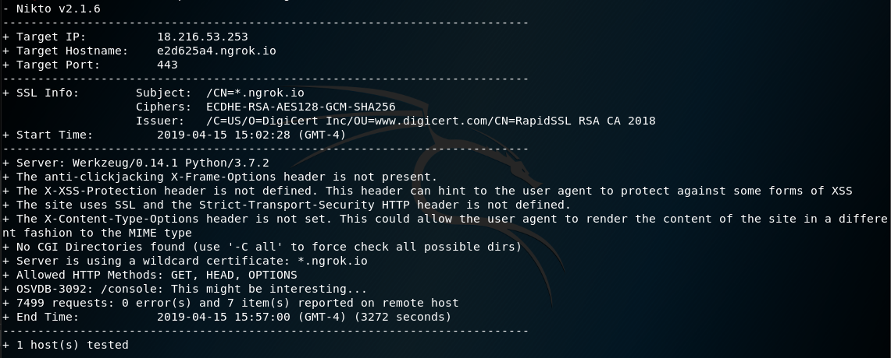

Figure 8. Nikto Scan
Hardware Testing:
Tester Category | Item Tested | Expected Outcome | Actual Outcome | Bug Reported
Developer | Qi Charger | Phone should be charging | Phone was Charging | The new Dock material PLA makes the Qi charger not work.
Developer | NFC reader | NFC can pull information from the phone | Pi displays phone information | N/A
Developer | Qi charger and NFC reader | Qi charger should not interfere with the NFC reader, nor should the NFC reader interfere with the Qi Charger | The two do not interfere with each other. | N/A

Software Testing:

Tester Category | Item Tested | Expected Outcome | Actual Outcome | Bug Reported
Developer | Website login | When a user logs in the website should require, username, password, and phone | Login works as expected | Sometimes throws a Jinja error. Does not appear to be an issue with the hardware.
Developer | Website login - incorrect password | the site should display an error related to password | Site displays an error related to password | N/A
Developer | Website login - incorrect phone | the site should display an error related to phone | Site displays an error related to phone | N/A
Developer | Website login - incorrect | the site should display an error related to username | Site displays an error related to username | N/A
Developer | Website login - dock cannot be found | the site should display an error related to issues where it could not find the dock | Site displays an error related to the dock not being found | N/A
Developer | Account Creation | Users should be able to register an account | Users can create an account | N/A
Developer | Account Creation - Password | passwords should be stored using a salted hash | passwords are stored using a salted hash | N/A
Developer | Account Creation- Phone registration | Users should be able to register a "phone” an account | Users can register a phone to an account | Most phones change UID's per NFC transaction. Developer’s phone and NFC stickers do not change.
Developer | Account Creation - username/email | Users should be able to register with a certain username and email address. | Users can register a username and email address, as long as it is not taken. | N/A

Appendix B. References
1. Campbell, Mikey. "Apple to Unlock IPhone's NFC Chip Capabilities in June, Report Says." AppleInsider. May 26, 2018. Accessed April 14, 2019. https://appleinsider.com/articles/18/05/25/apple-to-reportedly-unlock-iphone-nfc-chip-capabilities-in-june.
2. Fried, Limor. "Adafruit PiOLED - 128x32 Mini OLED for Raspberry Pi." Overview | Adafruit PiOLED - 128x32 Mini OLED for Raspberry Pi | Adafruit Learning System. Accessed April 15, 2019. https://learn.adafruit.com/adafruit-pioled-128x32-mini-oled-for-raspberry-pi/overview.
3. Igoe, Tom, Don Coleman, and Brian Jepson. Beginning NFC: Near Field Communication with Arduino, Android, and Phonegap. Beijing: OReilly, 2014.
Richardson, Matt, and Shawn P. Wallace. Getting Started with Raspberry Pi:. San Francisco, CA: Maker Media, 2016.
4. Sleeper, Josh. "CryptographyDeprecationWarnings with Cryptography 2.5 Release · Issue #1369 · Paramiko/paramiko." GitHub. Accessed April 14, 2019. https://github.com/paramiko/paramiko/issues/1369.
5. Townsend, Kevin. "Adafruit NFC/RFID on Raspberry Pi." Memory Architectures | Memories of an Arduino | Adafruit Learning System. July 29, 2012. Accessed November 11, 2018. https://learn.adafruit.com/adafruit-nfc-rfid-on-raspberry-pi.

