INVITED SPEAKERS
Re-MEDIAting the Wild features four invited speakers. Subhankar Banerjee will provide a keynote address. He will also participate in a thematic plenary panel with Claire G. Coleman, Erik Hoffner, and Maria Isabel Torres.

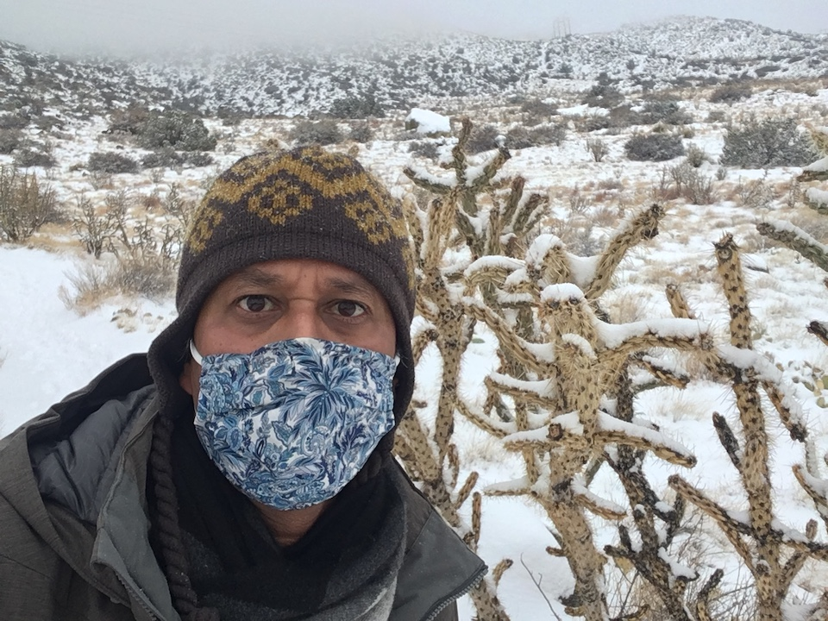Subhankar Banerjee
Subhankar Banerjee is a photographer, writer, conservationist and public scholar. His practice is place–based and community–engaged and focuses on biological annihilation and climate breakdown, the two most consequential planetary crises of human history. He works closely with Indigenous Gwich’in and Iñupiat community members and environmental organizations to protect critical biological nurseries and culturally significant places in Arctic Alaska, including the Arctic National Wildlife Refuge. His work is currently situated in three places: the Arctic in the U.S.–Canada borderlands; the desert in the U.S.–Mexico borderlands; and the tropical forests of India, including the mangrove forest of the Sundarban in the India–Bangladesh borderlands. He was most recently co-editor (with T.J. Demos and Emily Eliza Scott) of the Routledge Companion to Contemporary Art, Visual Culture, and Climate Change (Routledge, February 2021); co-host (with then U.S. Senator Tom Udall) of the UNM Biodiversity Webinar Series (Fall 2020); and co-curator (with Josie Lopez) of Species in Peril Along the Rio Grande (Fall 2019). He is currently writing a book Species in Peril to bring attention to the intensifying human-caused biodiversity crisis (Seven Stories Press, 2022). Subhankar is the Lannan Foundation Endowed Chair and a professor of Art & Ecology at the University of New Mexico where he serves as the founding director of both the Species in Peril project and the Center for Environmental Arts and Humanities.
Website
Keynote Talk: Have you seen a species go extinct?
We can say with high confidence that there is global acknowledgement of the climate crisis—among the general public, and also the policy makers, as is evident with the Paris Agreement. Additionally, U.S. President Joe Biden has adopted a whole-of-government approach to develop mitigation measures and Madam Secretary Deb Haaland has established a Climate Task Force at the U.S. Department of the Interior that would prioritize department-wide climate action. A bit late but encouraging, nevertheless.
At the historic 1992 Earth Summit in Rio de Janeiro, the United Nations had established two separate institutions, one to address the climate crisis (UNFCCC) and the other to address the biodiversity crisis (CBD). While there is now meaningful progress with addressing the climate crisis in which communication has played a significant role, the biodiversity crisis continues to fester from public inattention and alludes the radar of policy makers.
Is the biodiversity crisis less significant than the climate crisis? Far from it. The intensifying biodiversity crisis is just as consequential, just as severe in scale and scope, and just as challenging to mitigate as the climate crisis, if not more. Take for exemple, the no-end-in-sight coronavirus pandemic that has been causing so much death and suffering around the world. The root causes of the pandemic, scientists inform us, are situated in the biodiversity crisis, specifically the destruction of wildlife habitats and trade of wildlife.
In a May 2019 assessment, the United Nations projected that one million animal and plant species face extinction due to human activity. And according to the 2020 Living Planet Report, monitored populations of vertebrate species (amphibians, birds, fishes, mammals, and reptiles) declined in abundance by an average of 68% globally, with the most pronounced loss of 94% in Central and South America, and 84% for freshwater species globally. All to say that our nonhuman relatives face a grim future.
The question before us this: How can we, environmental communicators and scholars of environmental communication help speed up the process so that the biodiversity crisis will finally get the attention from the public and the policy makers that it deserves?
Drawing on more than two decades of engagement with and witnessing the biodiversity and the climate crises in multiple geographies, in this talk, I’ll reflect on that question and offer some analysis and suggestions to open up a long overdue and crucially needed conversation. I have personally witnessed and addressed in my writing and/or photography four mass species die-offs in North America, but I have never seen a species go extinct.

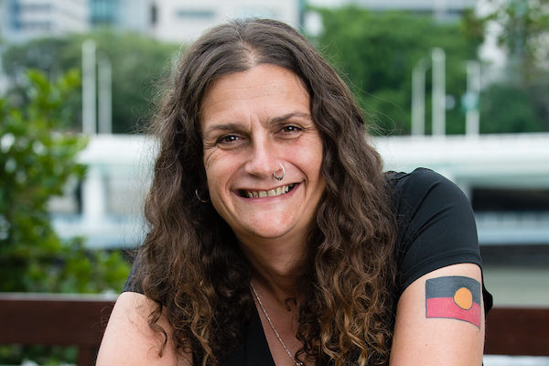Claire G. Coleman
Claire G. Coleman is a Noongar woman whose family have belonged to the south coast of Western Australia since long before history started being recorded. She writes fiction, essays, poetry and art writing while either living in Naarm (Melbourne) or on the road. Born in Perth, away from her ancestral country she has lived most of her life in Victoria and most of that in and around Melbourne. During an extended circuit of the continent she wrote a novel, influenced by certain experiences gained on the road. She has since won a Black&Write! Indigenous Writing Fellowship for that novel ,"Terra Nullius". Terra Nullius was published in Australia by Hachette Australia and in North America by Small Beer Press. Since mid 2020 Claire has been a member of the cultural advisory committee for Agency, a Not-for-profit Indigenous arts consultancy.
Website

Erik Hoffner
Erik Hoffner is a photojournalist, editor, content strategist and podcast producer for the global environmental news outlet Mongabay.com. His work also appears in publications like The Guardian, Yale Environment 360, The Washington Post, National Geographic, The Sun, Northern Woodlands, and Earth Island Journal. He's a member of the Society of Environmental Journalists and an exhibiting member of the Vermont Center for Photography. See examples of his work at erikhoffner.com and connect via @erikhoffner on Twitter and Instagram.
Website

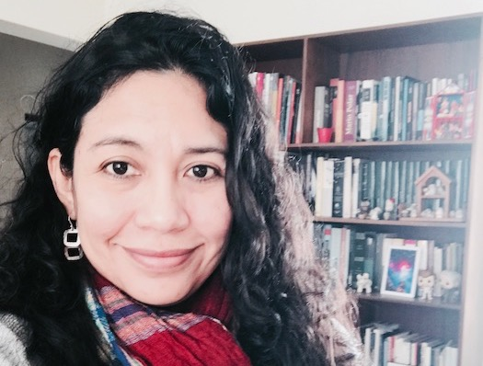Maria Isabel Torres
Maria Isabel Torres lives in Peru and is the Project Manager at Mongabay Latam, Mongabay´s bureau for covering Latin America and producing original content in Spanish. She has been an investigative journalist for mainstream and online media for 12 years specialising in politics and economics. She has also worked as Communications Director of the Ministry of Environment and was part of the team who organized the COP 20 in Lima. In the last few years, Mongabay Latam has won the «Rey de España» International Journalism Award, two honorable mentions granted by the Inter-American Press Association (IAPA), and has been finalist for national journalism awards in Peru and Bolivia.
Website

