KEYNOTE SPEAKERS
COCE 2017 will feature several keynote speakers all of whom will address themes of the conference.
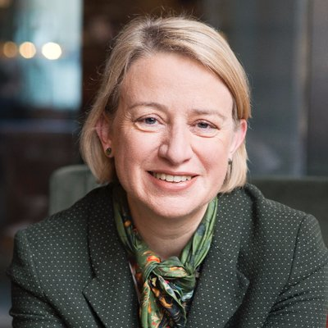 | Natalie Bennett  Natalie Bennett was the leader of the Green Party of England and Wales from 2012 to 2016. A native of Australia, she began her career as a journalist with regional newspapers in New South Wales before leaving in 1995 for Thailand. There she worked for Australian Volunteers International and the Bangkok Post newspaper over the next four years. Since settling in Britain in 1999 she has contributed to the Guardian, Independent and Times newspapers. Her election as leader of the Greens came six years after she joined the party in January 2006.  She holds a Bachelor of Agricultural Science (BAgrSc Hons) from the University of Sydney, a Bachelor of Arts (BA Hons) in Asian Studies from the University of New England and a Master of Arts (MA) in Mass Communication from the University of Leicester, graduating from the latter in 2001.  She will contest the Sheffield Central constituency for the Green Party in the next election.  Source: Wikipedia
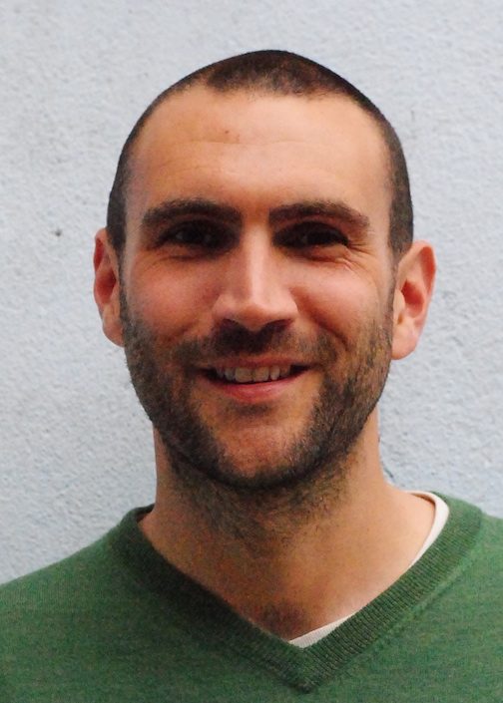 | Adam Corner  Adam Corner is the Research Director at Climate Outreach, a charitable think tank that specialises in public engagement with climate change. Adam manages the Climate Outreach research portfolio and directs collaborations with academic partners. Receiving his PhD in 2008 from Cardiff University, Adam also holds an Honorary Research Fellow position in Cardiff's School of Psychology.  Publishing widely in leading academic journals, through commissioned reports and briefings, and writing regularly for international media such as the New Scientist and The Guardian, Adam recently authored a book (with his colleague Jamie Clarke) titled Talking Climate: From Research to Practice in Public Engagement. Published through Palgrave Macmillan in late 2016, the book describes five principles for shifting public engagement with climate change out of the margins and into the mainstream.  Adam also manages the Climate Visuals programme for Climate Outreach, aimed at transforming the visual language of climate change.
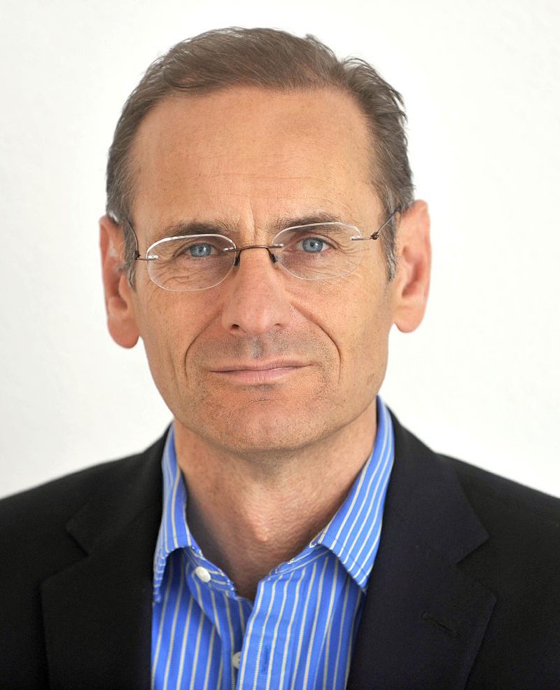 | Roger Harrabin  Roger Harrabin is the BBC's Environment Analyst, and one of their senior journalists on the environment and energy. He has broadcast on environmental issues since the 1980s and has won many awards in print, TV and radio. Aside from his speciality he has covered many major general news stories. He is a Visiting Fellow at Green Templeton College, Oxford and an Associate Press Fellow at Wolfson College, Cambridge.  Harrabin joined BBC radio's The World at One, where he won a succession of Media Natura Environment Awards for reports on issues related to the environment and development. He also won the One World Media award after revealing how changes in trade rules would affect sugar workers in Guyana, and a Sony Silver Award for reports on development dilemmas in Africa. He was shortlisted for Sony Reporter of the Year.  The Today Programme created a roving role for him, and he spent a decade there travelling widely, reporting and organising series on issues like globalisation, health and the role of women. He won an award for an investigation into flower-growing in Kenya which showed that multi-national companies tended to take better care of their workers than local firms. He won another award for a feature on child labour in Bangladesh which demonstrated that for many girls, work in a "sweatshop" was preferable to the other alternatives of prostitution or working as a domestic servant in the Persian Gulf..  Source: Wikipedia  Photo of Roger Harrabin by Cls14 at English Wikipedia, CC BY-SA 3.0, Link
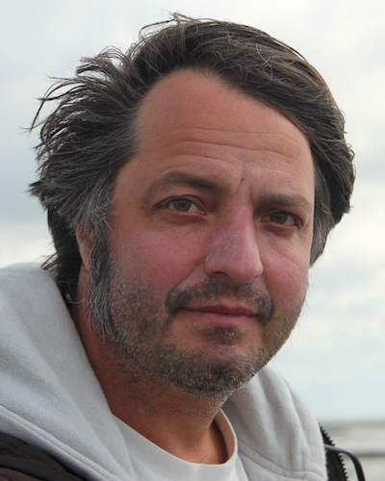 | Sönke Lorenzen  Sönke Lorenzen is the Research Manager for Global Engagement at Greenpeace International. He is also the outgoing Chair of the Board of Directors of the International Environmental Communication Association (IECA). He helped lauch the IECA in 2011 and has been a Board Member ever since.  Originally from Hannover, Germany, he grew up in the Middle East and Asia. He graduated from Albert-Ludwigs-Universität in Freiburg Germany with an M.A. in Cultural Anthropology and Applied Geography. His thesis was based on fieldwork in Indonesia. In 1995 He started working in sales and documentation at the award winning photographers agency Lookat in Zürich. The same year he began PhD research on alternative media under the title 'Zine-culture - the textualization of the everyday" at the department of Popular Cultures at the University of Zürich. Two years later he joined the international business intelligence company Cision as a senior media analyst.  In 2005 he started working as media analyst for Greenpeace International. In 2015 he was a visiting scholar at the Department of Media Studies working with the New Media & Digital Culture program at the University of Amsterdam. While there, he conducted research on the topic of New Media Monitoring and Data Analytics as Critical Practice. Later that year he took up his current position with Greenpeace International. Part of his job is to build stronger ties to academia and initiate collaborations between NGOs and researchers.
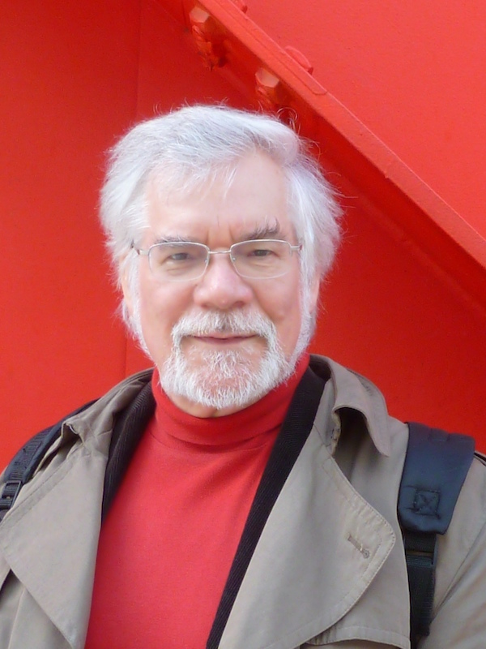 | Graham Murdock  Graham Murdock is Professor of Culture and Economy at the Department of Social Sciences at Loughborough University and Visiting Fellow in Media and Communication at Goldsmiths London University. He is well known for developing a critical approach to the analysis of culture and communication and the politics of risk that combines insights from across the humanities and social sciences.  He has held the Bonnier Chair at the University of Stockholm and the Teaching Chair at the Free University of Brussels and been a Visiting Professor at the Universities of Auckland, Bergen, California, Curtin Western Australia, and Wuhan.  His writings have been translated into twenty one languages. His recent books include as co-editor, The Idea of the Public Sphere (Lexington 2010) , The Blackwell Handbook of Political Economy of Communication (2011), Money Talks: Media, Markets, Crisis (2014), and in Mandarin, New Media and Metropolitan Life: Connecting, Consuming, Creating (2015). His next book, Communication and Carbon Capitalism: Confronting Climate Crisis, with Benedetta Brevini, brings together researchers and activists to explore the multiple ways that communication systems are implicated in global warming and the struggle for feasible alternatives.
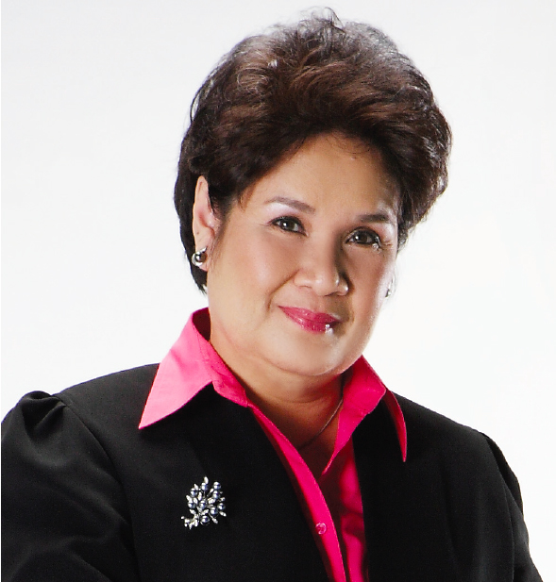 | Amanda Katili Niode  Amanda Katili Niode, a founding member of the International Environmental Communication Association, is the Manager of The Climate Reality Project Indonesia, a climate change leadership program with a mission to educate the public about the harmful effects of climate change and to work toward solutions at a grassroots.  At present, she is the Head of the Expert Team at the Office of President’s Special Envoy on Climate Change in Indonesia. She previously held a position as Head of Secretariat at the Indonesian National Council on Climate Change and a former Special Assistant to the Indonesian Minister of Environment.  As there is a dual relationship between climate action and sustainable development, Amanda is also active in campaigning for sustainable development goals and was recently invited by the UNDP to be one of its Sustainable Development Goals Movers in Indonesia.  An environmental management specialist, educator and writer, she holds a Ph.D from the School of Natural Resources and Environment, University of Michigan, Ann Arbor, USA. She received her undergraduate degree from the School of Natural Science and Technology, Institut Teknologi Bandung (ITB), Indonesia. Her continuing education includes: environmental communication, environmental policy and regulations, environmental crime investigations, entrepreneurship, and media communications.  She completed an Executive Leadership Program at the School of Foreign Service, Georgetown University, USA; a Leadership and Campaign Management Program at Yale University, USA; and an Asia Leadership Program on Climate Change and Sustainable Development in Seoul, Korea. She received a prestigious award from the Rockefeller Foundation as a Resident Policy Fellow at the Rockefeller Foundation’s Bellagio Center in Italy.  As an environmental specialist Amanda is often invited as a professional speaker by universities in Indonesia and abroad. She has been a member of the Indonesian Delegation to Conference of Parties (COP) of the United Nations Framework Convention on Climate Change (UNFCCC) since 2007, including the recent COP 22 – Marrakech Climate Change Conference.  Her 35 years working experiences cover Indonesian government institutions, multinational corporations, environmental consulting companies, academic Institutions, civil societies and international organizations.

