5/6/2026

FIRE & EMS LAW – CURRENT EVENTS and Appendix:
American History, including U.S. Supreme Court opinions

(Current Events – 2025 / 2026)

2026: FIRE & EMS - CURRENT EVENTS & AMERICAN HISTORY: https://doi.org/10.7945/0dwx-fc52

NOT PROVIDING LEGAL ADVICE.

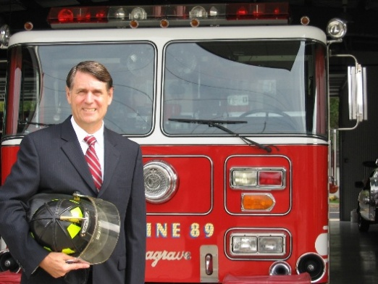 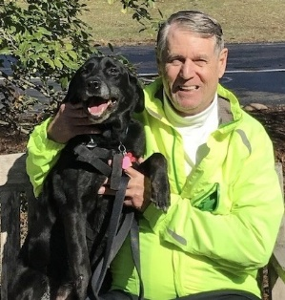Pet Therapy dog FRYE

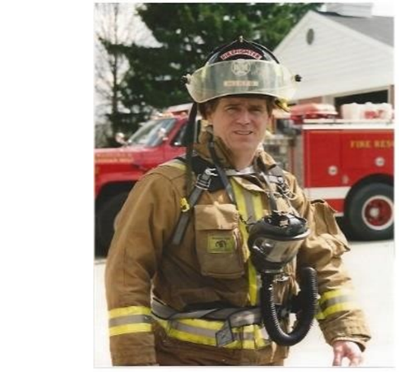
https://www.waveland.com/browse.php?t=708

Lawrence T. Bennett, Esq.
Professor / Educator Emeritus
Former Program Chair, Fire Science & Emergency Mgt.
University of Cincinnati
Cell 513-470-2744
Lawrence.bennett@uc.edu

Chap. 1 – American Legal System, incl. Fire Codes, Investigations, Arson Page 3
Chap. 2 – Line Of Duty Death / Safety Page 40
Chap. 3 – Homeland Security, incl. Active Shooter, Cybersecurity, Immigration Page 79
Chap. 4 – Incident Command, incl. Training, Drones, Communications Page 85
Chap. 5 – Emergency Vehicle Operations Page 116
Chap. 6 – Employment Litigation, incl. Work Comp., Age, Vet Rights Page 134
Chap. 7 – Sexual Harassment, incl. Pregnancy Discrim., Gay Rights Page 138
Chap. 8 – Race / National Origin Discrimination Page 154
Chap. 9 – Americans With Disabilities Act Page 173
Chap. 10 – Family Medical Leave Act Page 176
Chap. 11 – Fair Labor Standards Act and Military Leave Page 179
Chap. 12 – Drug-Free Workplace, inc. Recovery Page 187
Chap. 13 – EMS, incl. Community Paramedicine, COVID-19 Page 198
Chap. 14 – Physical Fitness, incl. Heart Health Page 211
Chap. 15 – Mental Health, incl. CISM, Peer Support, Pet Therapy Page 213
Chap. 16 – Discipline, incl. Code of Ethics, Social Media, Hazing Page 225
Chap. 17 – Arbitration, incl. Mediation, Labor Relations Page 260
Chap. 18 – Legislation, incl. Public Records Page 274

APPENDIX: AMERICAN HISTORY, including U.S. Supreme Court opinions Page 294

- Landmark United States Supreme Court Cases
- Deadliest fires in U.S. history

Textbooks / Other Publications
- 2026: FIRE & EMS - LIBRARY RECENT CASE SUMMARIES: Over 1,600 case summaries since 2018 from monthly newsletters (supplement my 2017 Textbook, Fire Service Law): https://doi.org/10.7945/j6c2-q930

- 2026: FIRE & EMS - POLITICAL & LEGAL APPLICATIONS FOR EMERGENCY SERVICES (3 Author text for National Fire Academy / FESHE online course): https://doi.org/10.7945/av8d-c920

- 2026: Fire & EMS - EMS POLITICAL & LEGAL APPLICATIONS FOR EMERGENCY MEDICAL SERVICES (4 Author text for National Fire Academy / FESHE online course): https://scholar.uc.edu/concern/documents/ht24wm15r?locale=en

- 2026: INTERDISCIPLINARY STUDIES: Fire Service, Legal Issues, American History (new UC course starting Fall 2026)
https://scholar.uc.edu/show/ks65hd707

- 2017: TEXTBOOK: FIRE SERVICE LAW (Second Edition) (ISBN 978-1-4786-3397-6); Waveland Press: http://www.waveland.com/browse.php?t=708 (First Edition – Prentice Hall, 2008).

- 2006: CHIEF FIRE OFFICER’S DESK REFERENCE: Jones & Bartlett, Chap. 4: U.S. Legal System.

- 2005: FIRE & EMS LAW FOR OFFICERS: Fire Protection Publications, Okla. State: Employment Best Practices (2005); Safety (2004).

CHAPTER 1 – AMERICAN LEGAL SYSTEM, including Fire Codes, Fire Investigations, Arson

May 5, 2026: NY - NYC Filed Legal Claim Against Owner Of Building Where Fire Killed Three Over Hazards Next Door. The owners of an apartment building in Manhattan where three people were killed in a fast-moving fire early Monday are being sued by the city for neglecting fire hazards at a neighboring property, court documents show.
The fire broke out around 12:30 a.m. in a second-floor apartment at 207 Dyckman St. near Broadway in Inwood, FDNY officials said. About a week earlier, the NYC Department of Housing Preservation and Development filed a legal petition accusing Jan Jan Realty Corp., which buildings records list as also the owner of the fire-ravaged building, of neglecting hundreds of unsafe code violations at another property located next door. The April 27 legal filing cites obstructions to egress, broken flame-retardant in a common area of 209 Dyckman St., along with missing smoke and carbon monoxide detectors among numerous fire hazards found at the property. Also noted in the suit were incidents of peeling lead paint, collapsing ceilings, lack of gas service, vermin and “rampant” water leaks causing “cracks, holes, and broken paint and plaster,” in addition to hazardous mold, broken faucets and missing window guards. All told, there are 219 open code violations at the property, which the city is accusing Jan Jan Realty Corp. and its president, Jack Bick, of neglecting “as part of an intentional and aggressive campaign to harass and displace rent stabilized tenants,” according to the suit. Messages left for an attorney for Jan Jan Realty Corp. were not immediately returned. Monday’s fire resulted in 14 injuries, including a firefighter with minor injuries. Three residents died at the scene, while five more were hospitalized with critical injuries, FDNY officials said. Four more residents were taken to local hospitals with moderate or minor injuries. The building where the fire broke out has 107 housing code violations, including 39 that are considered immediately hazardous, building records show.
Fire officials said that open doors near a central staircase allowed the flames to intensify and shoot upstairs to other apartments. https://www.fireengineering.com/news/nyc-filed-legal-claim-against-owner-of-building-where-fire-killed-three-over-hazards-next-door/?utm_source=fe_daily_newsletter&utm_medium=email&utm_campaign=2026-5-5&oly_enc_id=0573H1103045H2E

See the Verified Petition / photos: https://iapps.courts.state.ny.us/nyscef/ViewDocument?docIndex=rvf/3fZjjOEWbHS6AY7jDw== DEPARTMENT OF HOUSING PRESERVATION AND DEVELOPMENT OF THE CITY OF NEW YORK, Petitioner brings this proceeding to enjoin Respondents and impose civil penalties against them for failing to repair dangerous conditions at the premises, like those depicted above, for months or years beyond the time required by law.

May 4, 2026: CA – U.S. Department of Justice - Justice Department Files Statement Of Interest In California Fire Insurance Case. Today, the Department of Justice announced that it has filed a Statement of Interest in the case of Ferrier v. State Farm Fire and Casualty Company, which is currently pending in the state Superior Court of Los Angeles County, California. This case was brought by 60 homeowners who lost their homes in the devastating wildfires that occurred in southern California in January 2025. The homeowners allege that the defendants, 16 homeowner insurance companies, jointly conspired to cancel the homeowners’ fire insurance policies in the years leading up to the January 2025 fires. As a result, the homeowners claim that they were forced to obtain insurance from a state-run program that offers less protective coverage, resulting in much higher out-of-pocket expenses for rebuilding their homes. “Nearly 16 months after the Eaton and Palisades Fires, the homeowners who lost everything are still trying to rebuild their lives,” said Deputy Assistant Attorney General Charlie Beller of the Justice Department’s Antitrust Division. “The last thing the fire victims need is the improper use of certain legal doctrines to deprive Angelenos of their day in court. The DOJ Antitrust Division is monitoring insurer conduct across the country to ensure that an improper understanding of federal law does not preclude state or federal antitrust claims.” https://www.justice.gov/opa/pr/justice-department-files-statement-interest-california-fire-insurance-case

April 30, 2026: CT - CT Lawmakers Reject New Fire, Building Code, Saying It Would Hinder New Housing. The state building and fire code failed to gain legislative approval Tuesday, as the proposal from the Department of Administrative Services came under fire for changes advocates said would make it harder to build new housing. The Regulation Review Committee voted down the proposals, which have been years in the making, along party lines Tuesday. Housing advocates and lawmakers were concerned about provisions that would have required wider access roads for fire trucks, allowed local fire officials to decide which side of the building should be adjacent to an access road and limited developments to sites located closer to access roads. *** But housing advocates and lawmakers took issue with the new version because of three major policy changes. One would have required wider access roads for fire trucks — 26 instead of 20 feet at certain locations such as near a fire hydrant — for new multifamily developments. DAS officials said this would help improve safety and bring the state into compliance with international code. Osten said she was worried about roads where that wasn’t possible, such as Route 138 which is bordered by a river and a ledge. Advocates wrote letters saying there was a lack of evidence that the 20-foot roads had caused safety problems. “In the midst of an ongoing state housing crisis, where affordable housing units are in ever-higher demand, we must scrutinize potential regulations that appear well-intentioned but would in fact have a harmful effect on the state and its residents,” said a letter from the Open Communities Alliance. Another would leave it up to local fire officials to decide which side of the building should have road access. State Fire Marshal Lauri Volkert offered the example of a building that might have inoperable windows on one side and balconies on the other. The fire officials would likely want the access road to be on the balcony side, Volkert said. *** The single stair legislation was another push from housing advocates. They said that, paired with modern fire prevention technology, the single stairs would have been safe and made it easier to build housing.
https://www.fireengineering.com/fire-safety/building-construction/ct-lawmakers-reject-new-fire-building-code-saying-it-would-hinder-new-housing/?utm_medium=email&utm_source=fe_daily_newsletter&utm_campaign=2026-4-30&oly_enc_id=0573H1103045H2E

April 30, 2026: CA - CA City Files Class Action Lawsuit Against Fire Apparatus Manufacturers, Alleges Antitrust Violations. The city of Fullerton has filed a federal class action lawsuit against three major fire apparatus manufacturers in the United States and dozens of their dealers, alleging they are violating antitrust laws to monopolize the market, which has pushed up the cost of firefighting equipment and slowed delivery.
The complaint, filed April 21 against Oshkosh Corp., REV Group, Inc., Boise Mobile Equipment Inc. and others, seeks restitution of profits the companies may have reaped through unlawful business practices, reimbursing Fullerton and other class members for the overcharges. The lawsuit opens by painting the image of Altadena resident Victor Shaw, who was found dead with his fingers curled around a garden hose outside his home during the January 2025 Eaton fire. His death, the suit alleges, was preventable: Shaw’s neighborhood did not lack water or firefighters, but fire apparatus. More than 100 of the Los Angeles Fire Department’s 183 fire trucks were out of service during the fires, with many kept past their prime because the cost of replacing them was “astronomic.” https://www.fireengineering.com/fire-apparatus/ca-city-files-class-action-lawsuit-against-fire-apparatus-manufacturers-alleges-antitrust-violations/?utm_medium=email&utm_source=fe_daily_newsletter&utm_campaign=2026-4-30&oly_enc_id=0573H1103045H2E

See also: April 28, 2026: PA - Pa. City Is Latest To Join Others In Lawsuit Over Alleged Fire Truck Monopoly. Allentown’s federal lawsuit claims American Industrial Partners and manufacturers drove up costs, closed plants and created long delivery backlogs that impact fire departments. ALLENTOWN, Pa. — Allentown has joined a growing list of cities suing a private equity firm, its subsidiaries and a select few fire truck manufacturers for creating a monopoly on custom fire trucks and chassis.
The lawsuit filed Wednesday in federal court accuses American Industrial Partners of buying up struggling fire truck makers and eliminating competitors to create a monopoly.
https://www.firerescue1.com/legal/pa-city-is-latest-to-join-others-in-lawsuit-over-alleged-fire-truck-monopoly?utm_source=Sailthru&utm_medium=email&utm_campaign=FR1-Rewind-5-3-26&utm_term=FR1%20Daily

April 16, 2026: OR - Portland Torches Fire Truck Giants In Price-Gouge Court Fight. Portland is hauling a group of fire truck heavyweights into federal court, accusing them of quietly building a monopoly that jacked up prices and dragged out delivery times for the city’s rigs. n a new antitrust lawsuit filed Thursday, the city says roughly a dozen fire-apparatus manufacturers and their private-equity backers created a dominant corporate web that left departments waiting years for new trucks. Portland points to four engines it ordered at about $1 million each and singles out a Pierce “Enforcer” pumper it bought in 2025 as a prime example of what it calls inflated pricing. City attorneys want money damages and court orders to unwind that consolidated structure. According to The Oregonian/OregonLive, the complaint names REV Group and a New York private-equity firm as defendants. Portland alleges the companies scooped up multiple manufacturers and folded them into a single, market-controlling enterprise that backlogged orders through mid-2024. The suit says manufacturers slapped buyers with floating or post-order price hikes that drove up final bills and asks a federal judge to break up the conglomerate, restore independent competition and award unspecified damages. Part of a national wave Portland is not swinging alone. Its lawsuit lands in the middle of a growing batch of municipal cases that already includes Los Angeles County and Milwaukee, all accusing the fire-truck industry of consolidation, price spikes and long waits for replacement rigs. As Los Angeles County outlines in its own filing, city and county buyers say consolidation shrank their pool of suppliers and helped create long backlogs. Coverage by CBS58 highlights complaints that those conditions opened the door to price terms that push extra costs onto already stretched municipal budgets. Courts and lawmakers have spent the past year scrutinizing the sector through hearings and consolidated filings. https://hoodline.com/2026/04/portland-torches-fire-truck-giants-in-price-gouge-court-fight/

April 17, 2026: NM - N.M. Becomes First State To Classify Firefighting Foam As Hazardous Waste. A unanimous vote allows regulators to mandate cleanup of PFAS-containing foam, require reporting and restrict its use as concerns grow over “forever chemical” contamination. [TV VIDEO.] SANTA FE, N.M. — New Mexico is the first state to classify aqueous film-forming foam as a hazardous waste. Monday’s unanimous Environmental Improvement Board vote will allow the state Environment Department to mandate cleanup of the forever chemical-containing fire suppressant, according to a Wednesday release from the agency. https://www.firerescue1.com/firefighting-foam/n-m-becomes-first-state-to-classify-firefighting-foam-as-hazardous-waste?utm_source=Sailthru&utm_medium=email&utm_campaign=FR1-Rewind-4-26-26&utm_term=FR1%20Daily

April 9, 2026: CA - ‘There goes your inventory': Arson Suspect Filmed Himself Igniting Massive Calif. Warehouse Fire. Authorities say a warehouse worker recorded video of himself setting paper products ablaze at a Kimberly-Clark distribution center in Ontario. … The video, posted to Instagram, appears to have been filmed by 29-year-old Chamel A. Abdulkarim of Highland, said Cpl. Emily Williams, a spokeswoman for the Ontario Police Department…. Abdulkarim is an employee of NFI Industries, which operated the warehouse where the Kimberly-Clark products were stored. Kimberly-Clark makes diapers, wipes, facial tissue, toilet paper and feminine hygiene items. https://www.firerescue1.com/Arson-Investigation/there-goes-your-inventory-arson-suspect-filmed-himself-igniting-massive-calif-warehouse-fire?utm_source=Sailthru&utm_medium=email&utm_campaign=FR1-Daily-4-9-26&utm_term=FR1%20Daily

April 2, 2026: CA - Grand Jury: CA County Failed To Act For Years Before Deadly Fireworks Explosion That Killed Seven. [TV VIDEO.] A California grand jury concluded that Yolo County officials failed to act on known safety risks before a deadly fireworks facility explosion that killed seven people last year. The 32-page report concludes that multiple agencies including the sheriff’s office, fire officials, and county leaders were aware for years of an illegal fireworks storage operation in Esparto but did not take action to prevent the July 1 explosion, according to KCRA 3. Investigators say the site, located on agriculturally zoned land, contained thousands of pounds of fireworks and was known to county employees as early as 2022. The grand jury determined the explosion was preventable, but the county did not enforce the codes that would have prevented it. It also concluded insufficient training and inadequate resources for code compliance contributed. The report also criticizes the Yolo County Board of Supervisors, alleging it fostered a culture tolerant of code violations and failed to support enforcement efforts. https://www.fireengineering.com/news/grand-jury-ca-county-failed-to-act-for-years-before-deadly-fireworks-explosion-that-killed-seven/?utm_source=fe_daily_newsletter&utm_medium=email&utm_campaign=2026-4-2&oly_enc_id=0573H1103045H2E

March 31, 2026: TX - West, Texas: The fertilizer Plant Explosion That Killed 10 Firefighters. Detailing the tragedy from the initial response to the final investigation…. Despite the potential hazards, zoning restrictions did not limit residential or commercial occupancies from encroaching on the facility. As a result, a park was located within 150 feet, an apartment complex at 370 feet, West Intermediate School just over 200 feet, and the local high school about 500 feet from the plant…. Around 19:51, about 12 minutes after the first WVFD unit arrived or 22 minutes after the initial 911 call, a massive explosion occurred. A 911 call was received by dispatch shortly after the explosion, confirming the explosion and reporting multiple firefighters down…. In the aftermath of the explosion, many questions were raised about the safety of the West Fertilizer Company plant and the handling of hazardous materials in the United States, specifically ammonium nitrate (AN). The incident highlighted the need for stronger regulations and oversight to ensure the safety of workers and the public in handling dangerous chemicals and materials…. The cause of the fire that led to the explosion was never officially determined, but one investigation agency believes it to be the result of a criminal act. In 2016, the ATF announced that it had concluded their investigation and found the fire was deliberately set. However, no arrests have been made in connection with the incident…. Additionally, legislative action occurred shortly after the incident. The White House issued an executive order in August 2013 aimed at improving the safety and security of chemical facilities. However, the order was rescinded upon recommendations by the EPA in 2017, partly due to the investigative findings shared by the ATF. The possibility of restoring elements of the original executive order is currently being considered. [Also filed, Chap. 2.] https://www.firerescue1.com/west-fertilizer-plant-explosion/articles/west-texas-the-fertilizer-plant-explosion-that-killed-10-firefighters-7tdcjYownNurVVFN/?utm_source=Sailthru&utm_medium=email&utm_campaign=FR1-Daily-4-17-26&utm_term=FR1%20Daily

See 2017 Ohio Fire Code: Bureau of Testing & Registration - Important Update on Ammonium Nitrate…. Per Ohio Administrative Code 1301:7-7-01(E)(3)(d), OFC 105.1.1.1.4, an annual explosives permit must be obtained from the State Fire Marshal (SFM) for the storage, use, manufacture, processing or handling of ammonium nitrate in either solid form or prill form for any facility that will at any time have an aggregate quantity of ammonium nitrate on-site in excess of 5,000 pounds. This explosives permit expires annually on July 1. https://butler.osu.edu/sites/butler/files/imce/Program_Pages/ANR/Ammonium%20Nitrate%20Memo.pdf

March 23, 2026: CA - Single-Stair Reformers, Safety Advocates Clash Over Building Codes. Fire officials and pro-density urbanists are often at loggerheads…. One area of tension for fire safety advocates and density advocates is the requirement that most new apartment buildings have more than one stairway to facilitate resident evacuation and emergency responders’ access. In nearly all American cities, unlike in other parts of the world, developers are required to build double staircases into four- to six-story residential buildings. (Though definitions vary, these are often considered mid-rise buildings.) This extra staircase takes up about 7% of floor space and drives up costs by 6% to 13%, according to the Pew Charitable Trusts. That extra cost could be enough to kill a project to build housing, says Stephen Smith, the executive director of the Center for Building in North America, a nonprofit organization focused on building code reform. Largely due to advocates like Smith and Flaherty, a movement is sweeping across North America, from Texas to Toronto, to relax restrictions on residential stairways. Over 30 locations have now considered such measures. The possibility of relatively rapid changes to local building codes, outside the national three-year cycle, is raising urgent conversations about density and safety as cities grapple with housing shortages. https://www.fireengineering.com/news/single-stair-reformers-safety-advocates-clash-over-building-codes/?utm_source=fe_daily_newsletter&utm_medium=email&utm_campaign=2026-3-24&oly_enc_id=0573H1103045H2E

March 23, 2026: Criminal Grand Jury Investigating CA Explosion. A Yolo County criminal grand jury is investigating the deadly explosion in Esparto, which left seven workers dead just before the Fourth of July last year. While grand jury proceedings are held in secret until an indictment is brought, sources familiar with the matter told Sacramento Bee reporters that the grand jury is looking into possible criminal conduct leading up to the July incident.
The explosion happened on July 1, 2025, leaving seven workers at the warehouse dead and a community questioning how such a tragedy could happen. In February, Cal Fire concluded its investigation into the explosion, uncovering what the agency believes to be evidence of “illegal activity,” according to the California’s Office of the State Fire Marshal…. The company Devastating Pyrotechnics, however, lacked required California licenses to manufacture or sell fireworks. The county’s hazardous waste coordinator had determined the operation needed a detailed hazardous materials plan and inspection — neither happened.
When asked why the county didn’t act on early warnings, county spokesperson Laura Galindo told the Bee time had clouded staff recollections and offered no clear answer, adding that a single code enforcement officer was handling a backlog of complaints.
https://www.fireengineering.com/fire-safety/criminal-grand-jury-investigating-ca-explosion/?utm_medium=email&utm_source=fe_daily_newsletter&utm_campaign=2026-3-23&oly_enc_id=0573H1103045H2E

March 19, 2026: PA - PA Regulators Seek $2.6 Million In Penalties For Deadly 2023 Chocolate Factory Explosion…. Pennsylvania regulators asked an administrative law judge on Wednesday to make a gas utility pay $2.6 million in civil penalties for a chocolate factory explosion three years ago that killed seven workers and sent flames shooting into the air. The Public Utility Commission filed a formal complaint against the UGI Utilities Inc. gas division, alleging the company’s distribution facilities serving the R.M. Palmer Company in West Reading violated state and federal standards and regulations…. A woman pulled alive from the rubble told The Associated Press in 2023 that flames had engulfed the building and her arm when the floor gave way beneath her. Patricia Borges fell into vat of liquid chocolate, which extinguished her blazing arm. Borges broke her collarbone and both of her heels and spent nine hours screaming for help and waiting for rescue as firefighters battled the inferno…. The state utility regulator wants Denver, Pennsylvania-based UGI to expand the use of remote methane detectors, inspect older plastic pipe fittings more often and bolster emergency response procedures. The explosion was traced to a plastic service part in the street near the factory, located about 60 miles (96 kilometers) northwest of Philadelphia. Gas went underground into the factory building and was somehow ignited. The National Transportation Safety Board had previously concluded the plant lacked natural gas emergency procedures in place that could have resulted in an immediate evacuation. Workers reported they smelled gas before it ignited. https://www.fireengineering.com/news/pa-regulators-seek-2-6-million-in-penalties-for-deadly-2023-chocolate-factory-explosion/?utm_source=fe_daily_newsletter&utm_medium=email&utm_campaign=2026-3-19&oly_enc_id=0573H1103045H2E

March 3, 2026: IL - Volunteer Firefighter Accused Of Arson In IL Wildfire That Burned 700 Acres…. Trent W. Schafer, 21, of Kasbeer — a small, rural, unincorporated community — was taken into custody at the scene. According to police, there are additional counts of arson pending against Schafer for several other fires previously set in Lee and Bureau counties. A class 2 felony, arson is punishable by three to seven years in prison. Police said Schafer is a volunteer firefighter with the fire department of Ohio, Illinois, a small village some 60 miles southwest of the city of Rockford. https://www.wildlandfirefighter.com/2026/03/02/volunteer-firefighter-accused-of-arson-in-il-wildfire-that-burned-700-acres/?utm_medium=email&utm_source=fe_daily_newsletter&utm_campaign=2026-3-3&oly_enc_id=0573H1103045H2E

March 2, 2026: MO - Federal Judge Grants Compassionate Release To Man Sentenced To Life For 1988 deaths Of Mo. Firefighters. [TV Video.] A U.S. district judge vacated Richared Brown’s life sentence nearly 30 years after his conviction in a deadly Kansas City arson that killed six firefighters…. vacating a life sentence he received nearly three decades ago for his role in a 1988 arson that led to the deaths of six Kansas City firefighters.
The order handed down Friday in U.S. District Court for the Western District of Missouri granted Brown’s amended motion for compassionate release. The order credited him for the nearly 29 years he was incarcerated. https://www.firerescue1.com/legal/federal-judge-grants-compassionate-release-to-man-sentenced-to-life-for-1988-deaths-of-mo-firefighters?utm_source=Sailthru&utm_medium=email&utm_campaign=FR1-Daily-3-2-26&utm_term=FR1%20Daily

Feb. 12, 2026: U.S. Department of Justice: Mississippi Man Indicted for Arson of Beth Israel Synagogue and the Goldring/Woldenberg Institute of Southern Jewish Life. Stephen Spencer Pittman, 19, of Madison, Mississippi, was charged by superseding indictment Tuesday, Feb. 10, with civil rights and arson offenses related to the burning of the Beth Israel Congregation and the Goldring/Woldenberg Institute of Southern Jewish Life building. According to court documents from his arrest, Pittman is alleged to have used gasoline to set fire to the religious building in the early morning hours of Saturday, Jan. 10. The fire resulted in extensive damage to a significant portion of the building and rendered it inoperable for an indefinite period time. https://www.justice.gov/opa/pr/mississippi-man-indicted-arson-beth-israel-synagogue-and-goldringwoldenberg-institute

Dec. 9, 2025: MA - Fire Inspectors Say Their Warnings Were Ignored Ahead Of MA’s Deadliest Fire In 40 Years. [TV VIDEO.] In September 2024, when Fire Systems Inc. notified Fall River’s Gabriel House assisted living facility of long-recalled sprinkler heads in the building, the company offered a free, full survey and warned of potential failure should a fire break out. The notices went ignored by Gabriel House management. That’s according to new details filed in Bristol County Superior Court Monday as part of cross-claims submitted by Fire Systems Inc. (FSI) — the North Dartmouth-based company contracted to perform fire inspections at the now-embattled facility. FSI contends Gabriel House owner Dennis Etzkorn and his staff knew about the presence of recalled sprinkler heads 10 months prior to the fatal blaze that ultimately killed 10 people on July 13, the deadliest fire in Massachusetts in more than 40 years. FSI is named as a defendant, alongside Etzkorn, in several ongoing personal injury and wrongful death lawsuits stemming from the fire. But in its new filing, FSI claims it shouldn’t be, because Gabriel House, or Gabriel Care Inc., “is responsible for the failure to replace the recalled sprinkler heads at the facility,” according to a statement from an FSI spokesperson. https://www.fireengineering.com/news/fire-inspectors-say-their-warnings-were-ignored-ahead-of-mas-deadliest-fire-in-40-years/?utm_source=fe_daily_newsletter&utm_medium=email&utm_campaign=2025-12-9&oly_enc_id=0573H1103045H2E

Dec. 3: Ohio – Ohio Ethics Commission VOICE OF ETHICS: https://ethics.ohio.gov/education/newsletters/VOE_25Q4.pdf
“The office manager for a factory that I regularly inspect offered me four tickets to The Nutcracker Suite. Can I accept them? Yes, if you pay for the tickets. The Ethics Commission has advised that when a public official or employee is offered tickets to sporting events, concerts, theater performances, or any similarly valued event, the public official or employee must pay either the face value for the tickets or the amount the giver paid for the tickets - whichever is higher.” https://ethics.ohio.gov/education/factsheets/GiftsandOtherThingsofValue.pdf#page=11

Dec. 1, 2025: Hong Kong - Hong Kong Authorities Say Netting On Buildings That Caught Fire, Killing 151, Did Not Meet Code. Hong Kong authorities say the death toll from a deadly apartment complex blaze has risen to 151 after more bodies were found….
Initial tests of the netting showed it was up to code, but subsequently investigators collected 20 samples from all areas, including higher floors, and found seven failed safety standards, suggesting contractors skimped to make greater profits, said Eric Chan, Hong Kong’s Chief Secretary…. The complex’s buildings were all clad in bamboo scaffolding draped with nylon netting for external renovations. Windows were covered with polystyrene panels, and authorities are investigating if fire codes had been violated.
Residents had complained for almost a year about the netting that covered the scaffolding, Hong Kong’s Labor Department said. It confirmed officials had carried out 16 inspections of the renovation project since July 2024 and had warned contractors multiple times in writing that they had to meet fire safety requirements. The latest inspection was just a week before the fire. https://www.fireengineering.com/firefighting/hong-kong-authorities-say-netting-on-buildings-that-caught-fire-killing-151-did-not-meet-code/?utm_source=fe_daily_newsletter&utm_medium=email&utm_campaign=2025-12-1&oly_enc_id=0573H1103045H2E

Nov. 20, 2025: AZ - Arizona Man Charged With Hate Crime For Synagogue Fire. On Nov. 18, a federal grand jury in Phoenix returned a one-count indictment against Everardo Gregorio, 31, of Casa Grande, Arizona for the Obstruction of the Free Exercise of Religious Beliefs by Fire. The indictment alleges that Gregorio burned down Khal Chasidim, a synagogue in Casa Grande, on March 3. The portion of the synagogue that was destroyed in the fire included the place where the Jewish community worshipped, as well as a kosher grocery store and restaurant that operated out of the building. Gregorio has also been charged with arson by the Pinal County Attorney’s Office and is currently pending trial in that case. A conviction for Obstruction of Free Exercise of Religious Beliefs by Fire carries a maximum penalty of 20 years in prison, a $250,000 fine, or both. https://www.justice.gov/opa/pr/arizona-man-charged-hate-crime-synagogue-fire

Nov. 20, 2025: OH - Fire Safety Made Easier, State Marshal Revises Ohio Fire Code. the Ohio Department of Commerce and the Division of State Fire Marshal announced the updated 2025 Ohio Fire Code (OFC) with revisions to make fire safety easier to understand. The State Fire Marshal cut almost 300,000 words to simplify fire safety regulations and remove outdated language, redundant and obsolete provisions to make the code more user-friendly. The update incorporated the 2021 International Fire Code to allow the division to reduce the word count in fire-related portions of the Ohio Administrative Code and Ohio Fire Code by 29%.... Several additions were made to the 2025 code:
A new chapter was added for energy storage systems. The chapter addresses safe installation and operation, reflecting advances in renewable energy technology
Mobile food preparation vehicles received updated terminology and safety provisions. The changes ensure compliance with modern standards
A new chapter introduces specific safety requirements for laboratories at colleges and universities
Additional updates include provisions for outdoor pallet storage, on-demand mobile fueling and enhanced safety measures for fireworks and solar energy systems
The 2025 Ohio Fire Code took effect Thursday, Nov. 20, 2025. https://spectrumnews1.com/oh/dayton/news/2025/11/20/marshal-revises-ohio-fire-code

Note: The 2025 Ohio Fire Code became effective on November 20, 2025. In accordance with OAC 4765-20-12(G), please note the following:
If a new fire code is adopted by the state of Ohio, a fire safety inspector and hazard recognition officer shall attend continuing education of not less than four hours related to the new fire code. The continuing education shall be completed within six months of the adoption of the new fire code. The fire safety inspector and hazard recognition officer shall maintain documentation of completion of this update.
(1) The four hours shall be completed in accordance with paragraphs (E) and (F) of this rule; and
(2) The four hours may be counted towards the requirements set forth in paragraphs (A) and (C) of this rule. Ohio EMS OhioEMS@info.dps.ohio.gov

Nov. 17, 2025: MD - Man Charged In 2022 Baltimore Rowhome Fire That Killed 3 Firefighters. Prosecutors say an external ignition source started the blaze, which led to a collapse that killed three Baltimore City firefighters and injured three others. [TV VIDEO.] A man has been arrested and charged in connection with the 2022 Stricker Street fire that killed three Baltimore City firefighters and critically injured another, according to court documents.
WBFF reported James Barnett, 57, was taken into custody on Nov. 14 and is facing multiple charges, including second-degree murder, second-degree arson, involuntary manslaughter and reckless endangerment. According to court documents, a 911 caller reported a building fire with people trapped inside. When crews arrived, they found the three-story rowhome heavily involved, but based on the report of occupants, firefighters attempted an interior attack. While they were inside, the structure collapsed, trapping six firefighters and killing three of them. Surveillance video shows a man, now identified as James Barnett, entering the rowhome, creating “several flashes” inside and leaving minutes later, according to court documents. Intermittent smoke was later seen coming from the rear of the rowhome, and no one else entered the building before the fire broke out around 5 a.m., the documents state. https://www.firerescue1.com/arson-investigation/man-charged-in-2022-baltimore-rowhome-fire-that-killed-3-firefighters?utm_source=delivra&utm_medium=email&utm_campaign=FR1-Daily-11-17-25&utm_id=9827556&dlv-emuid=fed355b8-46a2-4fa4-b55c-4d602dde33c4&dlv-mlid=9827556

Oct. 28, 2025: MI - Fire Marshal: MI Senior Facility Wasn’t Required to Have Sprinklers in Attic, Decks. Southgate’s fire marshal said there weren’t sprinklers in the attic or decks of a senior living facility that caught fire last weekend, and the building wasn’t required to have the equipment in those areas under fire codes. A fire broke out at American House Southgate on Allen Road at about 10 p.m. Friday. Police said there were 87 residents and staff in the building at the time. All of them are accounted for, authorities said. Two people, including a firefighter, were treated for injuries. *** Niemann said he believes nursing homes generally are required to have sprinklers in the attic, but senior living facilities aren’t. He said the attics in apartment buildings generally aren’t required to be sprinkled. Their decks also don’t need to have sprinklers. Niemann said he would like to see attics sprinkled “where possible,” and he thinks apartments’ exterior decks should have sprinklers. https://www.fireengineering.com/fire-safety/building-construction/fire-marshal-mi-senior-facility-wasnt-required-to-have-sprinklers-in-attic-decks/?utm_medium=email&utm_source=fe_daily_newsletter&utm_campaign=2025-10-28&oly_enc_id=0573H1103045H2E

Oct. 23, 2025: PA - Two Men Who Set Fire That Killed Philadelphia Fire Lieutenant Sentenced To Prison. [TV VIDEO.] Two men who set a Fairhill building on fire in 2022 in hopes of collecting a six-figure insurance payout — but who instead caused the structure to collapse, killing a responding Philadelphia Fire Department lieutenant — were each sentenced Wednesday to decades in federal prison. U.S. District Judge Cynthia M. Rufe said the actions by Al-Ashraf Khalil and Isaam Jaghama, which led to the death of Lt. Sean Williamson and left five other first responders injured, were made “out of pure self-interest” and displayed “depraved indifference to human life.” “Neither of the defendants considered at all the consequences of their actions, which proved to be far-reaching, devastating, and deadly,” she said. She sentenced Khalil — who owned the building on the 300 block of West Indiana Avenue that he set ablaze — to serve 40 years in prison. And she said Jaghama, who participated in the arson alongside Khalil, would serve a term of 25 years behind bars. Both men are 32. Both men had faced the potential of life sentences. And both apologized for their actions before being sentenced. *** The fire was set early in the morning of June 18, 2022. Khalil, who co-owned a pizza shop in Juniata Park, had bought the Indiana Avenue building months earlier and was hoping to renovate it and turn a quick profit. But when that plan appeared destined to fail, prosecutors said, he began plotting to set it ablaze, hoping that he could instead collect on an insurance policy worth nearly $500,000. Surveillance footage discovered after the crime showed Khalil and Jaghama entering the building’s basement shortly before the blaze began, around 1:30 a.m., then leaving not long after flames erupted. https://www.fireengineering.com/firefighting/two-men-who-set-fire-that-killed-philadelphia-fire-lieutenant-sentenced-to-prison/?utm_source=fe_daily_newsletter&utm_medium=email&utm_campaign=2025-10-23&oly_enc_id=0573H1103045H2E

Oct. 8, 2025: CA – Man Charged With Starting Deadly Palisades Fire In CA. A 29-year-old man has been charged with sparking California’s deadly Palisades Fire, one of the most destructive wildfires in its history, authorities said Wednesday. Federal officials said Jonathan Rinderknecht, who lived in the area, started a small fire on New Year’s Day that smoldered underground before reigniting nearly a week later and roaring through Pacific Palisades, home to many of Los Angeles’ rich and famous. The fire that left 12 dead in the hillside neighborhoods across Pacific Palisades and Malibu was one of two blazes that broke out on Jan. 7, killing more than 30 people in all and destroying over 17,000 homes and buildings while burning for days in Los Angeles County. https://www.fireengineering.com/firefighting/man-charged-with-starting-deadly-palisades-fire-in-ca/?utm_source=fe_daily_newsletter&utm_medium=email&utm_campaign=2025-10-9&oly_enc_id=0573H1103045H2E

Oct. 8, 2025: MA - Four Takeaways From Investigation That Found Safety Flaws After MA Assisted Living Fire. *** The July fire at Gabriel House in Fall River serves as a tragic case study of the system’s weaknesses. Sources with knowledge of the ongoing investigation told MassLive that a sprinkler failed to activate in the room where the fire started. A comprehensive five-year internal inspection of the system was overdue, they also said, and several lawsuits allege the sprinklers contained parts that had been recalled decades ago. Despite these issues, the building had repeatedly passed annual inspections conducted by the Fall River Fire Department. Fall River’s fire chief admitted that inspectors rely on licensed contractors and would not necessarily notice a missing five-year inspection tag, for example, underscoring how easily critical deficiencies can be overlooked. https://www.fireengineering.com/news/four-takeaways-from-investigation-that-found-safety-flaws-after-ma-assisted-living-fire/?utm_source=fe_daily_newsletter&utm_medium=email&utm_campaign=2025-10-8&oly_enc_id=0573H1103045H2E

Sept. 30, 2025: MA - After Deadly MA Fire, Chief Warns Recalled Sprinklers Could Be In Other Buildings. Following reports that the sprinkler system at Gabriel House contained recalled parts when the assisted living facility went up in flames this summer, the Fall River Fire Department recently discovered recalled sprinklers inside four additional residential buildings in the city. The findings underscore the disconcerting reality that recalled sprinklers likely exist in buildings across the state. The sprinkler heads in question — recalled more than two decades ago — were discovered earlier this month during routine inspections at one group home, two boarding houses and one shelter, according to Fall River Fire Chief Jeffrey Bacon. *** The recalled sprinklers, approximately 35 million of them, were manufactured by Central Sprinkler Company between the mid-1970s until 2001. They were subject to nationwide recalls in the late 1990s and early 2000s because of their “O-ring seals,” a component that can corrode and cause the sprinkler heads not to activate in a fire. https://www.fireengineering.com/news/after-deadly-ma-fire-chief-warns-recalled-sprinklers-could-be-in-other-buildings/?utm_source=fe_daily_newsletter&utm_medium=email&utm_campaign=2025-9-30&oly_enc_id=0573H1103045H2E

Sept. 27, 2025: MA - Report Details Critical Failures In MA Fire Sprinkler Inspections. The inspection process for fire sprinklers in Massachusetts relies on a haphazard honor system that can fail the very people it’s meant to protect. A MassLive investigation following the July fatal fire at Gabriel House — a Fall River assisted living facility where 10 people were killed by a five-alarm blaze — revealed a chain of problems with the state’s oversight of sprinkler systems in buildings:
Inspections of sprinkler systems depend on an honor code, where fire departments rely on building owners to maintain these critical safety components. This reality extends beyond Massachusetts and is codified in the standards published by the National Fire Protection Association, which are adopted across the country.
At Gabriel House, a sprinkler failed to activate in a second-story room where the fire started, sources with knowledge of the investigation have told MassLive. A mandated, five-year internal inspection of the sprinkler system was overdue, and several lawsuits claim the system also contained parts that were recalled decades ago.
There is no centralized tracking of fire code violations in the state, and enforcement is arduous due to strained fire department staffing.
Meaningful changes to fire safety regulations often only follow tragedy, experts said, such as the fire at Gabriel House, the deadliest in the state in over 40 years. “Fire safety regulations are written in blood,” said Chris Nelson, senior fire protection engineer in the Boston Fire Department’s Fire Prevention Division. “Someone has died because of an incident, and the code is written because someone died.”
Nearly every fire department in Massachusetts reports being understaffed, undermining public trust and expectations that they can ensure fire safety in buildings across their communities. https://www.fireengineering.com/news/report-details-critical-failures-in-ma-fire-sprinkler-inspections/?utm_source=fe_daily_newsletter&utm_medium=email&utm_campaign=2025-9-29&oly_enc_id=0573H1103045H2E

Sept. 25, 2025: ‘Technology is the lure’: Kirk McKinzie Talks FF Recruitment, Engagement. [VIDEO.} The fire service technologist offers insights for capturing the interest of digital natives. “If it doesn’t have a touchscreen on it, I’m not using it.” That’s the message from some digital natives unsure about whether a traditionally tactile profession like the fire service is right for them. But as tech-expert Captain Kirk McKinzie explains, with the current pace of technology, there are countless opportunities for more tech-minded individuals in the fire service, and quite frankly, we must connect with them to keep up. In this way, technology can be the carrot for the next generation. We geek out about how to make this happen, plus AI, drones, VTOL EMS aircraft, predictive analytics, zero-visibility decision-making, gamification, extended reality training, even fire suppression catapults. https://www.firerescue1.com/recruitment/technology-is-the-lure-kirk-mckinzie-talks-ff-recruitment-engagement?utm_source=ed_note&utm_medium=email&utm_campaign=FR1-Daily-9-25-25&utm_id=9548986&dlv-emuid=fed355b8-46a2-4fa4-b55c-4d602dde33c4&dlv-mlid=9548986

Sept. 12, 2025: DC - Apparatus Manufacturers On Defense At Senate Hearing. [C-SPAN VIDEO.] Fire service leaders and representatives from REV Group and Pierce testified about apparatus costs, delivery lead times and alleged anti-competitive practices. Congressional committees have never held a hearing focused solely on fire apparatus, in at least the last 30 years, and very likely ever. That changed on Sept. 10 when the Senate Subcommittee on Disaster Management, District of Columbia and Census heard from witnesses representing the fire service, two major manufacturers as well as an attorney who testified about the effects of consolidation within the industry. The hearing, “Sounding the Alarm: America’s Fire Apparatus Crisis,” was led by Subcommittee Chairman Sen. Josh Hawley (R-Mo.), with additional questioning from Sen. Andy Kim (D-N.J.), Sen. Elizabeth Warren (D-Mass.) and others. The senators pressed two apparatus manufacturer representatives on issues related to apparatus cost and delayed deliveries, which they argue have left departments nationwide using older, worn-down trucks or more desperate measures. The senators also alleged that anti-competitive practices by three apparatus manufacturers — REV Group and Oshkosh Corp. (owner of Pierce Manufacturing), which, along with Rosenbauer, comprise up to 80% of the market — may have enabled price manipulation. [Also filed, Chap. 18.] https://www.firerescue1.com/fire-apparatus/apparatus-manufacturers-on-defense-at-senate-hearing?utm_source=delivra&utm_medium=email&utm_campaign=FR1-Daily-9-12-25&utm_id=9488949&dlv-emuid=fed355b8-46a2-4fa4-b55c-4d602dde33c4&dlv-mlid=9488949

Sept. 11, 2025: MA - Despite Recent Fires, MA City Council Rebuffs Fire Chief, Kills New Sprinkler Law. The Worcester City Council went against the recommendations of its city manager and fire chief by opting out of a state law requiring automatic sprinklers in new or significantly renovated residential buildings with four or more units. On Tuesday, the public safety committee made a recommendation to lay aside a communication from City Manager Eric D. Batista recommending the adoption of the law. The council voted 6-4 in favor of the subcommittee’s recommendation, choosing not to opt into the law. *** Fire Chief Martin Dyer attended the meeting on Tuesday and told the council that he supports the measure. “As a fire chief I always support installation of sprinklers wherever possible,” he said. https://www.fireengineering.com/news/despite-recent-fires-ma-city-council-rebuffs-fire-chief-kills-new-sprinkler-law/?utm_source=fe_daily_newsletter&utm_medium=email&utm_campaign=2025-9-11&oly_enc_id=0573H1103045H2E

Sept. 5, 2025: CA - Deadly Eaton Fire Ignited By CA Utility, Feds Claim. Federal prosecutors on Thursday sued Southern California Edison over its alleged role in the deadly Eaton fire, a blaze that killed 19 people and destroyed more than 9,000 homes and other structures in Altadena and the surrounding area. In a civil complaint, prosecutors allege that the Eaton fire ignited “from faulty power infrastructure or by sparks from faulty power infrastructure owned, maintained, and operated” by Edison. The results of the official investigation into the fire by the Los Angeles County Fire Department and California Department of Forestry and Fire Protection have not yet been announced. The government’s lawsuit notes that the investigation into the fire remains ongoing. *** In April, Pedro Pizarro, chief executive of Edison International, the utility’s parent company, said that “a leading hypothesis” of Eaton fire investigators was that a century-old transmission line, last used during the Vietnam War, somehow became re-energized and sparked the fire. https://www.fireengineering.com/firefighting/wildland-firefighting/deadly-eaton-fire-ignited-by-ca-utility-feds-claim/?utm_source=fe_daily_newsletter&utm_medium=email&utm_campaign=2025-9-5&oly_enc_id=0573H1103045H2E

Aug. 5, 2025: NJ – U.S. Department of Justice Press Release - New Jersey Company Pleads Guilty And Agrees To Restitution And Civil Penalty For Failing To Report Dangerous Air Conditioners. Royal Sovereign International Inc. (Royal Sovereign), a New Jersey corporation that sold office and home appliances, pleaded guilty today to a criminal information charging it under the Consumer Product Safety Act (CPSA) with failing to report immediately to the U.S. Consumer Product Safety Commission (CPSC) information concerning portable air conditioners allegedly linked to more than 40 fires and one death. Additionally, Royal Sovereign agreed to a civil settlement with the United States that included a $16,025,000 civil penalty, the maximum civil penalty authorized by the CPSA. According to court documents, Royal Sovereign, which also did business as Royal Centurian Inc., imported and sold more than 33,000 defective air conditioners between 2008 and 2014. The air conditioners were defective due to a faulty drain motor that could electrically short and cause them to catch fire and burn uncontrollably. The company’s CEO, Takwan Lim, previously signed a settlement agreement with CPSC stemming from allegations that a related entity, Royal Sovereign Corporation, sold certain portable ceramic heaters that posed a fire risk. Royal Sovereign recalled the defective air conditioner models in 2021. https://www.justice.gov/opa/pr/new-jersey-company-pleads-guilty-and-agrees-restitution-and-civil-penalty-failing-report

July 29, 2025: TN - Tenn. City Approves Single-Stair Apartment Buildings With Fire Service Input. Chattanooga city leaders say new rules allowing up to five-story single-stair buildings will include required sprinklers and stair pressurization, after consulting with fire officials. Chattanooga will allow multifamily buildings to be built with just one staircase, rather than two. Council members voted Tuesday to take advantage of a state law passed last year that creates an exception to the International Building Code. https://www.firerescue1.com/tenn-city-approves-single-stair-apartment-buildings-with-fire-service-input?utm_source=delivra&utm_medium=email&utm_campaign=FR1-Daily-7-29-25&utm_id=9274393&dlv-emuid=fed355b8-46a2-4fa4-b55c-4d602dde33c4&dlv-mlid=9274393

July 23, 2025: MI - Exonerated Detroit Man Sues FD Over Fatal Arson Conviction. [TV VIDEO.] Duane Williams, exonerated in 2024 after serving 11 years for a deadly fire he didn’t commit, has filed a $100M federal lawsuit against Detroit police, fire officials and the city. DETROIT — Duane Williams said even though he’s been out of prison for months, serving 11 years for a crime he didn’t commit continues to haunt him. The Detroit resident recalled he was out of town recently and walking down a street where there was some construction. Choking back tears and emotions, he explained it was like walking through a cave, and it made him feel like he was back in prison. In 2009, Williams was accused of setting a house on fire that left two people dead. At the time, he was 27. Four years later, Williams was charged with two counts of felony murder, a count of second-degree murder, and arson, according to court records.
In September 2013, a Wayne County Circuit Court jury found Williams guilty, and he was sentenced to life in prison without the possibility of parole, court documents said.
His attorneys said the conviction was primarily based on false, perjured testimony and manipulated evidence. After a new investigation uncovered suppressed evidence — including photos of a lighter and smoking materials near the fire’s point of origin — Williams’ conviction was vacated in June 2024. The state dismissed the case entirely four months later. https://www.firerescue1.com/legal/exonerated-detroit-man-sues-fd-over-fatal-arson-conviction?utm_source=delivra&utm_medium=email&utm_campaign=FR1-Daily-7-23-25&utm_id=9251872&dlv-emuid=fed355b8-46a2-4fa4-b55c-4d602dde33c4&dlv-mlid=9251872

July 22, 2025: MA - Smoking Or Oxygen Machine May Have Caused Deadly Fire At MA Assisted-Living Home. FALL RIVER, Mass. (AP) — A fire that killed 10 people at a Massachusetts assisted-living facility was unintentionally caused by someone smoking or an electrical issue with an oxygen machine, investigators said Tuesday. The state’s deadliest blaze in more than four decades has highlighted the lack of regulations governing assisted-living facilities that often care for low-income or disabled residents. The state fire marshal, Jon Davine, said the presence of medical oxygen contributed to the spread of the July 13 fire at Gabriel House in Fall River. The blaze left some residents of hanging out windows of the three-story building screaming for help. *** The governor said last week that a state agency that ensures assisted-living residences comply with regulations will investigate all 273 such facilities in Massachusetts to make sure they are prepared to protect residents during emergencies. She said Tuesday that work has begun.https://www.fireengineering.com/firefighting/smoking-or-oxygen-machine-may-have-caused-deadly-fire-at-ma-assisted-living-home/?utm_medium=email&utm_source=fe_daily_newsletter&utm_campaign=2025-7-23&oly_enc_id=0573H1103045H2E

See also: July 14, 2025: MA - 9 Killed, 30 Injured In Fire At Mass. Assisted Living Facility. [TV VIDEO.] More than 50 Fall River firefighters, including 30 who were off-duty, responded as residents were trapped inside Gabriel House. FALL RIVER, Mass. — A fire tore through an assisted living facility in Massachusetts, trapping residents inside, including some who were hanging out of windows screaming for help, authorities said Monday. Nine people died and at least 30 were injured in the blaze, which has been put out. Firefighters responded to the Gabriel House assisted living facility in Fall River at about 9:50 p.m. Sunday and were met with heavy smoke and flames at the front of the building, the state Department of Fire Services said in a news release. About 70 people live in the house. https://www.firerescue1.com/fatal-incident/9-killed-30-injured-in-fire-at-mass-assisted-living-facility?utm_source=delivra&utm_medium=email&utm_campaign=FR1-Daily-7-14-25&utm_id=9211158&dlv-emuid=fed355b8-46a2-4fa4-b55c-4d602dde33c4&dlv-mlid=9211158

July 22, 2025: VA - Propane Worker Found Guilty In VA Explosion That Killed Firefighter. A jury convicted a propane company tech of involuntary manslaughter in connection with a 2024 house explosion that killed a firefighter and injured 13 others in Northern Virginia. Roger Bentley, previously a technician with Southern States Cooperative, was found guilty Monday after a week-long trial, NBC 4 reports.
The February 2024 blast in Sterling destroyed a home and killed Trevor Brown, a 45-year-old father of three, and fourth-generation volunteer firefighter. Firefighters were called to investigate an odor of gas at 7:50 p.m. on Feb. 16, 2024. Technicians had been investigating a gas leak at the property earlier in the day, and had pumped 130 gallons of propane into the tank. Bentley was the last technician on-site before the blast. At 8:15 p.m., as firefighters were in the home investigating the source of the odors, an explosion occurred, killing Brown. Jurors deliberated for three days before convicting Bentley of involuntary manslaughter and three hazardous materials misdemeanors. Prosecutors argued Bentley was negligent in dealing with a leaking underground propane tank. His defense claimed he was unfairly blamed for the tragedy. https://www.fireengineering.com/news/propane-worker-found-guilty-in-va-explosion-that-killed-firefighter/?utm_source=fe_daily_newsletter&utm_medium=email&utm_campaign=2025-7-22&oly_enc_id=0573H1103045H2E

July 15, 2025: CA – Report: CA ‘Loophole’ Helped Fireworks Facility CEO Obtain Licenses. [TV VIDEO.] *** Fireworks industry specialists found this activity unusual, considering the company’s official role as a wholesaler and provider of public displays. Despite a felony conviction that disqualified him from obtaining federal licenses from the Bureau of Alcohol, Tobacco, Firearms and Explosives, Kenneth Chee — the company’s registered owner and CEO — was still able to secure state explosives licenses due to what appears to be a gap in California’s explosives regulations. According to Cal Fire laws and regulations, most felony convictions make a person ineligible for a federal explosives license. However, at the state level, only felonies specifically related to explosives, fireworks, or arson prevent someone from obtaining an explosives license issued by the state fire marshal. https://www.fireengineering.com/news/report-ca-loophole-helped-fireworks-facility-ceo-obtain-licenses/?utm_source=fe_daily_newsletter&utm_medium=email&utm_campaign=2025-7-15&oly_enc_id=0573H1103045H2E

July 10, 2025: CA - Attempted Coverup Among Many Missteps n Palisades (CA) Fire, Suit Alleges. A Los Angeles Department of Water and Power worker took nearly five hours to respond to an order to de-energize electrical circuits during the catastrophic Palisades fire, then attempted to change a computer log to make it appear he had arrived much sooner, according to an amended lawsuit filed Wednesday, July 9. The suit, which blames LADWP for damages caused by the devastating fire, amends a complaint filed in March and contains new allegations of city mismanagement and various attempts by LADWP to cover up its part in stoking the fire that destroyed nearly 7,000 homes and businesses and killed 12 people. The California Parks and Recreation Department also was added Wednesday to the suit, filed under the name “Grigsby et al,” for allegedly allowing a smaller blaze extinguished days earlier on state property to smolder and rekindle Jan. 7 as the most destructive fire in Los Angeles history. *** Lawyers contend that energized power lines throughout the area triggered scattered fires that contributed to the rapid spread of the main blaze. The suit also portrays the attempt to alter computer records as part of a larger campaign by LADWP to cover up its part in the unprecedented destruction of the community.
https://www.fireengineering.com/firefighting/wildland-firefighting/attempted-coverup-among-many-missteps-in-palisades-ca-fire-suit-alleges/?utm_source=fe_daily_newsletter&utm_medium=email&utm_campaign=2025-7-10&oly_enc_id=0573H1103045H2E

June 16, 2025: OH - Just Askin': Blue, Red Or Green. What's The Color Of My Cincinnati Fire Hydrant Mean?*** City officials announced in April they're painting up to 1,000 fire hydrants in 2025, starting in the Avondale neighborhood. What might stick out is the distinct color on the fire hydrant's front steamer port: either light blue, green, orange or red. As you could've guessed, the colors mean something. It has to do with the flow rate of that fire hydrant. Here's what the colors mean, from best to worst:
Light blue (Class AA): 1,500 gallons per minute (GPM) or greater, indicating very good flow.
Green (Class A): 1,000 to 1,499 GPM, good for residential areas.
Orange (Class B): 500 to 999 GPM, marginally adequate flow.
Red (Class C) Less than 500 GPM, indicating inadequate flow.
Greater Cincinnati Water Works is also painting the top bonnet black of hydrants located in areas with system pressures of 100 pounds per square inch (PSI) or higher. This high level of pressure requires special equipment by firefighters to use. City officials say the colors, in alignment with National Fire Prevention Association standards, can help firefighters make decisions quicker during emergencies. https://www.cincinnati.com/story/news/2025/06/16/what-the-blue-green-orange-or-red-color-of-your-fire-hydrant-means/83710930007/?utm_source=enquirer-dailybriefing-strada&utm_medium=email&utm_campaign=dailybriefing-headline-stack&utm_term=Content%20List%20-%20Stacking%20-%20optimized&utm_content=pcin-cincinnati-nletter65

June 16, 2025: WV - WV Fire Department Renews Focus On Certificates of Occupancy. BECKLEY — A renewed initiative at the Beckley Fire Prevention Bureau aims to prevent future tragedies and ensure all businesses meet modern safety standards. While commercial businesses in Beckley have long been required to have a Certificate of Occupancy, Beckley Fire Marshal Christopher R. Graham said the bureau is getting ready to “begin actively enforcing” the city’s code. Graham has prepared a letter he is going to give business owners that explains why having an up-to-date Certificate of Occupancy is important. “This effort is aimed at ensuring the health and safety of all individuals who live in or visit buildings open to the public,” states the letter. https://www.fireengineering.com/fire-safety/fire-prevention/wv-fire-department-renews-focus-on-certificates-of-occupancy/?oly_enc_id=0573H1103045H2E

June 6, 2025: RI - Rhode Island Man Sentenced For Setting Fires Around The Exterior Of A Church And Assaulting Federal Officers. Kevin Colantonio, 36, pleaded guilty in February 2025 to malicious damage by means of fire, obstruction of free exercise of religious beliefs, and two counts of assault on a federal officer. He was sentenced yesterday by U.S. District Court Chief Judge John J. McConnell Jr., to more than six years in federal prison. He intentionally set multiple fires around the exterior of a predominantly black church in North Providence, RI, in February 2024, and assaulted two federal correctional officers while detained at a federal detention center following his arrest. *** Colantonio previously admitted to a federal judge that on Feb. 11, 2024, he used gasoline and a lighter he purchased minutes earlier at a gas station within walking distance of Shiloh Gospel Temple Ministries, to ignite five fires around the exterior of the church. The fires were quickly extinguished by North Providence officers, but not before the church sustained some damage. During a Feb. 15, 2024, court-authorized search of Colantonio’s residence, an accelerant detection canine indicated a positive reaction on several items of seized clothing. These items matched the clothing Colantonio was wearing on the night of the arson, based upon surveillance footage. Colantonio admitted to setting the fires and assaulting the corrections officers. https://www.justice.gov/opa/pr/rhode-island-man-sentenced-setting-fires-around-exterior-church-and-assaulting-federal

May 19, 2025: CA - Thousands Of Buildings In San Diego Are Long Overdue For Fire Inspections — And That’s Just What The City Knows About. Thousands of San Diego apartment or condo buildings and schools are overdue for an annual fire safety inspection as required by state law. More than 2,700 properties that are supposed to be inspected by San Diego Fire-Rescue every year have not been inspected since at least 2023, The San Diego Union-Tribune found after reviewing inspection data obtained via a public record request. There are roughly another 880 for which Fire-Rescue has no inspection date on record — meaning the department doesn’t know if or when it last inspected the property, data show. *** Fire-Rescue shut down its hazmat inspection program completely because of the pandemic, Tosca said, and it left the program shuttered for years because it has still been behind on the state-mandated annual inspections. The department has only recently been able to restart the program. https://www.fireengineering.com/fire-safety/thousands-of-buildings-in-san-diego-are-long-overdue-for-fire-inspections-and-thats-just-what-the-city-knows-about/?utm_medium=email&utm_source=fe_daily_newsletter&utm_campaign=2025-5-19&oly_enc_id=0573H1103045H2E

May 15, 2025: NY - Ex-FDNY Chief Gets Three Years In Prison For Taking Bribes To Fast-Track Safety Inspections. A former New York City Fire Department chief was sentenced to three years in prison Wednesday for accepting tens of thousands of dollars in bribes to fast-track fire safety inspections at restaurants, hotels and other city businesses.
Anthony Saccavino, 61, pleaded guilty in January to running the scheme while heading the department’s Bureau of Fire Prevention, which regulates the installation of fire safety and suppression systems in New York City. With the help of another chief, Brian Cordasco, Saccavino solicited and received $190,000 in bribe payments between 2021 and 2023, prosecutors said. “Chief Saccavino led a pay-to-play bribery scheme that would offend the sensibilities of every hard-working New Yorker,” Manhattan U.S. Attorney Jay Clayton said in a statement. *** Saccavino was arrested in September alongside Cordasco, who also pleaded guilty and was sentenced in March to 20 months in prison. https://www.fireengineering.com/news/ex-fdny-chief-gets-three-years-in-prison-for-taking-bribes-to-fast-track-safety-inspections/?utm_source=fe_daily_newsletter&utm_medium=email&utm_campaign=2025-5-15&oly_enc_id=0573H1103045H2E

May 13, 2025: MO - MO Attorney General Sues Utility In Deadly Explosion. The Missouri Attorney General on Monday filed suit against Liberty Utilities for last month’s natural gas explosion in Lexington, Missouri, that killed a 5-year-old boy, sent his sister and father to the hospital with serious burns, destroyed three homes and damaged multiple others. Attorney General Andrew Bailey claims Liberty Utilities (Midstates Natural Gas) Corp was “reckless” and violated the Missouri Underground Facility Safety and Damages Prevention Act after failing to properly mark a gas line in early April. That, Bailey said, ultimately caused the explosion. *** Bailey’s suit comes a week after the National Transportation Safety Board released its preliminary report showing that days before the digging began, Liberty Utilities sent a locator to mark all buried utilities in that area. But the section of the line involved in the explosion “was not identified or marked during this process,” according to the preliminary report released May 5. Just after 4 p.m. on April 9, the subcontractor who was among the crew helping install fiber optic cable in the area of Franklin Avenue and 17th Street began drilling into the “unmarked section of a capped underground gas distribution main,” the report said. More than three hours later, after neighbors had repeatedly reported smelling gas, the explosion occurred inside Cunningham’s rented home along Franklin Avenue near 17th Street. https://www.fireengineering.com/fire-safety/mo-attorney-general-sues-utility-in-deadly-explosion/?utm_medium=email&utm_source=fe_daily_newsletter&utm_campaign=2025-5-13&oly_enc_id=0573H1103045H2E

May 13, 2025: As Fire Truck Prices Hit $2 million, US Firefighters Demand An Antitrust Probe. The largest firefighters' labor union in the U.S. is demanding antitrust authorities investigate the companies that make fire trucks, saying industry consolidation has led to skyrocketing costs and years-long wait times, endangering firefighters and the public.
The U.S. Department of Justice and Federal Trade Commission should probe the fire and emergency vehicle industry, where three companies — REV Group (REVG.N), opens new tab, Oshkosh (OSK.N), opens new tab, and Rosenbauer (RBAV.VI), opens new tab — together make up around two-thirds of the market, the International Association of Fire Fighters said in a letter, opens new tab. https://www.reuters.com/sustainability/boards-policy-regulation/fire-truck-prices-hit-2-million-us-firefighters-demand-an-antitrust-probe-2025-05-13/?mc_cid=7b75d2b565&mc_eid=cbaa4ade01

See also: DC - IAFF Enters Fire Apparatus Conversation With Letter to FTC. The American Economic Liberties Project (AELP) and International Association of Fire Fighters (IAFF) have written a letter to Federal Trade Commission (FTC) Chair Andrew Ferguson; Pam Bondi, Attorney General; and Gail Slater, Assistant Attorney General, Antitrust Division, requesting that the FTC “investigate and take action against consolidation in fire and emergency vehicle manufacturers.” The letter also asks the FTC to look into other fire service products it claims have been impacted by consolidation trends, citing costs for self-contained breathing apparatus (SCBA) and dispatching software.
The letter suggests that the FTC investigate topics including:
National and regional consolidation trends.
National and regional market shares of the top firms in each industry.
If transactions have been followed by an increased rate of price increases.
If transactions have been followed by reduction in production capacity or longer delivery delays.
https://www.fireapparatusmagazine.com/fire-apparatus/iaff-enters-fire-apparatus-conversation-with-letter-to-ftc/?utm_medium=email&utm_source=fe_daily_newsletter&utm_campaign=2025-5-14&oly_enc_id=0573H1103045H2E

See also May 13, 2925 the letter:

Over the past decade, private equity firms such as American Industrial Partners (AIP) have aggressively consolidated an industry that had been competitively diversified across at least two-dozen companies2 by rolling up various fire apparatus and emergency vehicle manufacturers into the holding company conglomerate REV Group.3 Today, there are just three dominant manufacturers: REV Group, Oshkosh (itself a serial acquirer), and Rosenbauer. REV Group is the most dominant, capturing about a third of the $3 billion in annual U.S. fire truck sales, while Oshkosh takes around a quarter, and Rosenbauer takes 8%.4 Together, these firms dominate two-thirds of the national market– which may translate into even higher market shares in some regional markets. https://www.economicliberties.us/wp-content/uploads/2025/05/FINAL-2025-5-13-Letter-to-FTC-and-DOJ-re-Firetrucks.pdf

May 8, 2025: TN - Tennessee Man Indicted On Arson And Explosive Charges For Setting Fire To Nonprofit Organization. A federal grand jury in Knoxville, Tennessee returned an indictment on May 7, charging Regan Darby Prater, 27, with arson for firebombing the Highlander Center, a nonprofit research and education center in New Market, Tennessee; and with carrying an explosive device during the commission of the arson. Prater appeared in court today before U.S. Magistrate Judge Jill E. McCook and entered a plea of not guilty to the charges in the indictment. He was held pending trial, which has been set for July 15 in United States District Court, in Knoxville, Tennessee. According to court documents, on March 29, 2019, Prater used an explosive to firebomb the Highlander Center’s administrative building, resulting in a fire that consumed the entire structure. Court documents also allege that Prater was inspired by the March 15, 2019, mass shootings in Christchurch, New Zealand, and left a symbol of the Iron Guard, a World War II-era Romanian Nazi organization, spraypainted in the Highlander Center’s parking lot. The same symbol appeared on the Christchurch gunman’s rifle as he livestreamed his attacks. https://www.justice.gov/opa/pr/tennessee-man-indicted-arson-and-explosive-charges-setting-fire-nonprofit-organization

HIGHLANDER’S MISSION AND WORK
https://highlandercenter.org/about-us/
Martin Luther King, Pete Seeger, Rosa Parks, Ralph Abernathy, and Charis Horton at Highlander Institute, 1957. Highlander serves as a catalyst for grassroots organizing and movement building in Appalachia and the U.S. South. Through popular education, participatory research, and cultural work, we help to create spaces — at Highlander and in local communities — where people gain knowledge, hope and courage, expanding their ideas of what is possible. Highlander is a place where leaders, networks, and movement strands come together to interact, build friendships, craft joint strategy and develop the tools and mechanisms needed to advance a multi-racial, inter-generational movement for social and economic justice in our region. Highlander is also a source of political continuity, across both geography and history, linking current movement efforts to movements across the globe and to the history of movements across multiple generations. Highlander’s work – convening workshops; scouting for emerging leadership and political action; ‘relationship-building’; connecting across difference; documentation; cultural engagement – marks, shapes and forms the trajectory of political action by helping to create a common understanding of the work to be done by supporting and connecting actual and potential doers of that work.

May 6, 2025: OH – TRAINING: The May 21st meeting of SWOFSC will take place at 204 Garver Road, Monroe, OH 45050.*** In this presentation, we will explore SB112—The Ohio Childhood Safety Act, and discuss what this legislation means for inspectors, schools, and the Authorities Having Jurisdiction (AHJs). Attendees will learn about how SB112 increases inspection requirements to ensure greater door and egress compliance and readiness for educational institutions and strengthens oversight by the AHJ to foster a safer environment for students, faculty, and visitors. We will also explore Ohio code regarding fire door inspections and the responsibilities of business owners and AHJs (Authority Having Jurisdiction). As stewards of public safety, understanding the nuances of egress and fire doors is paramount. Join us as we delve into the critical role these elements play in safeguarding lives, ensuring compliance, and fortifying our communities against emergencies. [Also filed, Chap. 18.] Carroll, Randy rcarroll@beavercreektownship.org

OH SB112
Enact Ohio Childhood Safety Act
https://www.billtrack50.com/billdetail/1623545
Introduced Session
135th General Assembly (2023-2024)
Bill Summary
To enact sections 3737.74 and 3781.50 of the Revised Code to require school buildings to comply with national life safety standards and to name this act the Ohio Childhood Safety Act.
AI Summary
This bill, the Ohio Childhood Safety Act, requires school buildings in Ohio to comply with national life safety standards. Specifically, it mandates that school governing authorities (such as school districts and charter schools) inspect and test all protective door assemblies (e.g., doors with panic hardware, fire exit doors) in school buildings every 12 months to ensure compliance with the applicable fire safety code standards. If a door assembly is found to be non-compliant, the school must take steps to make it compliant. The bill also empowers the fire marshal's office to inspect school records and issue citations for non-compliance, though it prohibits fines or penalties if the school is actively working to achieve compliance.
Effective (on 10/24/2024)

May 2, 2025: OH – A Violent Chain Of Events: Man Accused Of Killing Deputy Day After Police Shot His Son. *** Police said the driver of the car, Rodney Hinton Jr., is the father of a man who was shot and killed by Cincinnati Police in East Price Hill on May 1. Authorities have not identified the police officers involved in the shooting or the deputy who was struck at UC, citing Marsy’s Law, legislation meant to protect victims of crimes. https://www.cincinnati.com/story/news/2025/05/02/man-accused-of-killing-deputy-a-day-after-cincinnati-police-shot-his-son/83418787007/?utm_source=enquirer-dailybriefing-strada&utm_medium=email&utm_campaign=dailybriefing-headline-stack&utm_term=hero&utm_content=pcin-cincinnati-nletter65

MARSY’S LAW. C. Right to be Heard [R.C. 2930.09] Marsy’s Law is designed to give victims a voice. The victim, victim’s representative, and victim’s attorney have the right to be heard orally, in writing, or both, at any public proceeding other than a grand jury proceeding, in which any right of the victim is implicated. The victim or victim’s representative do not have to be present in order for the victim’s statements to be read. See R.C. 2930.09 for specific provisions. https://www.supremecourt.ohio.gov/docs/JCS/courtSvcs/MarsysLaw/Toolkit.pdf

See also: Feb. 11, 2025: Ohio Supreme Court hears arguments on whether cops get crime victim protections. The Ohio Supreme Court heard arguments Tuesday on what could be a landmark government transparency case. https://www.cincinnati.com/story/news/courts/2025/02/11/ohio-supreme-court-to-decide-marsys-law-case-involving-police/78410084007/https://www.cincinnati.com/story/news/courts/2025/02/11/ohio-supreme-court-to-decide-marsys-law-case-involving-police/78410084007/

April 30, 2025: AR - Mesa Man Indicted For Torching Tesla Property. Today, a federal grand jury in Phoenix returned a five-count indictment against Ian William Moses, 35, of Mesa, Arizona for Maliciously Damaging Property and Vehicles in Interstate Commerce by Means of Fire. The charging documents filed in the case allege that Moses was at the Tesla dealership in Mesa shortly before 2 a.m. on Monday, April 28, wearing a dark hooded sweatshirt, tan ballcap, grey pants, black boots, and a black mask. He also carried a red plastic gas can and a black backpack. While in the Tesla parking lot, Moses was captured on video as he placed fire starter logs next to the dealership building. Moses then poured gasoline onto the starter logs, the building, and three Tesla vehicles. At around 1:38 a.m., Moses ignited the starter logs, causing a fire that destroyed a silver Tesla Cybertruck. Video shows Moses leaving the dealership on a dark colored bicycle shortly thereafter. Mesa police officers arrested Moses approximately a quarter mile from the Tesla dealership at around 3 a.m., still dressed in the same clothes as he was seen wearing at the scene. After his arrest, officers found a hand drawn map of the area in Moses’ pocket, which included a box with the letter “T” marking the dealership’s location. *** Each count of conviction for Malicious Damage to Property in Interstate Commerce carries a minimum penalty of five years and up to a maximum penalty of 20 years in prison and a fine of $250,000. https://www.justice.gov/opa/pr/mesa-man-indicted-torching-tesla-property

April 28, 2025: OH – Sugarcreek Township FD – Self-Inspectiuon Program. When Covid started, our Prevention Bureau created a self-inspection program for our local businesses. In order to be a part of this program, the business had to be assessed as a low-risk business and show compliance with annual fire safety inspections for the preceding two years. I have attached the letter and the survey to this email.

Jordan Ewing
Fire Marshal
Sugarcreek Township Fire Department
4398 Clyo Rd.
Dayton, OH 45459
W: 937.848.7344
C: 937.760.8333
jewing@sugarcreekoh.us


April 19, 2025: NY - More Than 400,000 Wireless Phone Chargers Recalled Over Fire Hazard.
Casely, a company in Brooklyn, received 51 reports of lithium-ion batteries overheating, expanding or catching fire, resulting in six minor burn injuries. https://www.nytimes.com/2025/04/19/business/casely-power-banks-charger-recall.html

April 9, 2025: GA - U.S. Cites Georgia Firm After Chemical Cloud Disrupted Life In Atlanta’s Suburbs. CONYERS, Ga. (AP) — Federal authorities have found that a Georgia company improperly stored hazardous chemicals before a fire southeast of Atlanta last year that produced a toxic chemical cloud over the area. The Sept. 29 blaze at the plant in Conyers led to the closure of a major interstate, classes canceled for schoolchildren and forced thousands of residents to shelter in place as the chemical cloud moved around Atlanta’s suburbs. BioLab Inc. was cited for six violations, including four serious violations, and now faces more than $60,000 in proposed penalties, the U.S. Department of Labor said in a statement this week. The Department of Labor’s investigation found that improperly stored hazardous chemicals were the cause of the fire, which was investigated by the agency’s Occupational Safety and Health Administration (OSHA). https://www.fireengineering.com/firefighting/us-cites-georgia-firm-after-chemical-cloud-disrupted-life-in-atlantas-suburbs/?oly_enc_id=0573H1103045H2E

April 4, 2025: CA - L.A. Code Proposes Allowing Single-Exit, Single Stairway In Midrise Apartment Buildings. A nationwide push for single-staircase buildings to ease the housing crisis is raising alarms from NFPA and fire safety experts, who warn the shift could compromise emergency access and evacuation. In a move to make it easier to build more affordable, family-sized units, the Los Angeles City Council on Wednesday, April 2, laid the groundwork for allowing single staircases in six-story apartment buildings. *** “Now that we have extensive sprinkler rules and new kinds of building materials that are far more fire resistant than they were a century ago, the regulations for dual staircases really are not necessary to guarantee the level of fire safety that we currently require in our buildings,” Raman said. https://www.firerescue1.com/building-construction/l-a-code-proposes-allowing-single-exit-single-stairway-in-midrise-apartment-buildings?utm_source=delivra&utm_medium=email&utm_campaign=FR1-Daily-4-4-25&utm_id=8739047&dlv-emuid=fed355b8-46a2-4fa4-b55c-4d602dde33c4&dlv-mlid=8739047

April 2, 2025: NY - Former FDNY Chief Sentenced To prison For Expedited inspection Bribery Scheme. [TV VIDEO.] Former FDNY chief Brian Cordasco was sentenced to 20 months in prison for accepting $190K in bribes to fast-track inspections. NEW YORK — Staten Islander and former FDNY chief Brian Cordasco was sentenced to 20 months in prison for his part in a “pay-to-play” bribery scheme where building owners and developers in New York City paid nearly $190,000 for expedited inspections and other preferential treatment. *** Cordasco’s accomplice, former Assistant Chief Anthony Saccavino of Manhattan, pleaded guilty to one count of conspiracy to solicit and receive a bribe in January and is awaiting sentencing. Saccavino was head of the Bureau of Fire Prevention and former Deputy Assistant Chief Cordasco worked for him. [Also filed, Chap. 16.] https://www.firerescue1.com/legal/former-fdny-chief-sentenced-to-prison-for-expedited-inspection-bribery-scheme?utm_source=delivra&utm_medium=email&utm_campaign=FR1-Daily-4-2-25&utm_id=8728348&dlv-emuid=fed355b8-46a2-4fa4-b55c-4d602dde33c4&dlv-mlid=8728348

March 27, 2025: NV – Nevada Resident Arrested And Charged In Connection With Violent Tesla Arson In Las Vegas. *** According to allegations in the complaint, on March 18, Las Vegas Metropolitan Police Department patrol officers responded to an emergency call about a person setting vehicles on fire and hearing gunshots at a Tesla collision business. The Clark County Fire Department arrived to suppress the fires. During the investigation, it was determined that Molotov cocktails and a .30 caliber AR-style firearm were used to damage and destroy five Tesla vehicles, and graffiti was sprayed to write “Resist” on the front of the building. https://www.justice.gov/opa/pr/nevada-resident-arrested-and-charged-connection-violent-tesla-arson-las-vegas

March 20, 2025: DC - Attorney General Pamela Bondi Announces Severe Charges Against Violent Tesla Arsonists. Today, Attorney General Pamela Bondi announced charges against three individuals responsible for the violent destruction of Tesla properties. All three defendants will face the full force of the law for using Molotov cocktails to set fire to Tesla cars and charging stations. “The days of committing crimes without consequence have ended,” said Attorney General Pamela Bondi. “Let this be a warning: if you join this wave of domestic terrorism against Tesla properties, the Department of Justice will put you behind bars.”
One defendant, also armed with a suppressed AR-15 rifle, was arrested after throwing approximately eight Molotov cocktails at a Tesla dealership located in Salem, Oregon.
Another was arrested in Loveland, Colorado after attempting to light Teslas on fire with Molotov cocktails. The defendant was later found in possession of materials used to produce additional incendiary weapons.
In Charleston, South Carolina, a third defendant wrote profane messages against President Trump around Tesla charging stations before lighting the charging stations on fire with Molotov cocktails.
Each defendant faces serious charges carrying a minimum penalty of five years and up to 20 years in prison.
The Department of Justice is committed to ending all acts of violence and arson directed at Tesla properties and otherwise. https://www.justice.gov/opa/pr/attorney-general-pamela-bondi-announces-severe-charges-against-violent-tesla-arsonists

March 19, 2025: NY - Homeowners Charged With Manslaughter Following Fatal Fire At Illegal Airbnb. POUGHKEEPSIE – The owners of a home in the Town of Clinton that caught fire and killed a mother and daughter from Cape Cod who had rented the house through Airbnb in October were arrested on Tuesday, March 18, under a sealed indictment. They were arraigned before Acting Dutchess County Court Judge Michael Hayes Wednesday afternoon, following the unsealing of the indictment charging Meredith Darcy, 55, and her husband, Dennis Darcy Jr., 57, on the charge of manslaughter.*** First responders who battled the inferno that killed Shannon Hubbard, 35, and her one-year-old daughter did not have any smoke detectors in the three-story home. https://midhudsonnews.com/2025/03/19/breaking-homeowners-charged-with-manslaughter-following-fatal-fire-at-illegal-airbnb/

March 19, 2025: GA - Mississippi Man Indicted For Federal Civil Rights And Arson Charges For Setting Fire To Mormon Church. A federal grand jury in Gulfport, Mississippi, returned a six-count superseding indictment today charging Stefan Day, also known as Stefan Pete Day Rowold, with federal civil rights and arson violations for vandalizing and setting fire to a house of worship. According to the superseding indictment, on July 5, 2024, and July 7, 2024, Day set fire to The Church of Jesus Christ of Latter-Day Saints in Wiggins, Mississippi. Counts one and four of the superseding indictment charge Day with arson for setting fire to the church. Counts two and five of the superseding indictment charge Day with intentionally damaging, defacing, and destroying religious real property because of the religious character of the property. Counts three and six of the superseding indictment charge Day with using fire to commit a federal felony offense. If convicted, Day faces a minimum penalty of five years in prison and a maximum penalty of 20 years in prison on each of the arson charges, a maximum penalty of 20 years in prison for each of the civil rights charges, and a minimum penalty of ten years in prison for the use of fire to commit a federal felony offense. https://www.justice.gov/opa/pr/mississippi-man-indicted-federal-civil-rights-and-arson-charges-setting-fire-mormon-church

March 6, 2025: NJ - NJ City Unveils Tough New E-Bike Rules With $2,000 Fines. Under Hoboken’s ordinance, the use, sale and repair of second-hand batteries are banned. E-bike and e-scooter riders will also be prohibited from charging or storing their devices in the common areas of residential properties with three or more units. Anyone found to be violating the ordinance will be issued a warning. If the problem continues, violators can be slapped with fines of up to $2,000 per violation, per day. E-bikes are a fast and convenient way to zip around a city, and have skyrocketed in popularity since the pandemic. But they have also become associated with a fast-moving kind of fire that can ignite if their batteries overheat or explode. As of January 2024, there had been 445 recorded incidents of lithium battery-related fires in the U.S., resulting in 38 deaths and 214 injuries. Hoboken’s new ordinance may seem simple, but Mike Fritz, who worked with the city to craft it, believes it to be “the finest, in terms of ensuring safe use of these products, of any city in America right now.” https://www.fireengineering.com/news/nj-city-unveils-tough-new-e-bike-rules-with-2000-fines/?utm_source=fe_daily_newsletter&utm_medium=email&utm_campaign=2025-3-6&oly_enc_id=0573H1103045H2E

March 6, 2025: CA - Los Angeles County Sues Southern California Edison, Alleging Utility’s Equipment Sparked Wildfire. Los Angeles County said Wednesday that it’s suing Southern California Edison, alleging the utility’s equipment sparked January’s Eaton Fire, which destroyed more than 9,400 structures and killed 17 people in the Altadena area. The lawsuit seeks to recover costs and damages sustained from the blaze that damaged “essential community infrastructure” and “massively impacted the County’s natural resources, harmed the environment and wildlife, and threatened public health,” LA County said in a statement. Costs and damage estimates were expected to total hundreds of millions of dollars, the county said, adding that assessments were ongoing. https://www.fireengineering.com/firefighting/wildland-firefighting/los-angeles-county-sues-southern-california-edison-alleging-utilitys-equipment-sparked-wildfire/?utm_source=fe_daily_newsletter&utm_medium=email&utm_campaign=2025-3-6&oly_enc_id=0573H1103045H2E

March 4, 2025: CA - Report: LAFD Didn’t Raise Alarm Over More Than 1,000 Fire Hydrants Needing Repair. The Los Angeles Fire Department did not inform the city’s Department of Water and Power until mid-February that more than 1,000 fire hydrants needed repairs, despite being aware of the issues months before. According to city records and officials, the Fire Department discovered the damage to the hydrants during inspections in the months prior to the Jan. 7 Palisades fire, which destroyed thousands of homes. While firefighters struggled with low water pressure during the blaze, it’s unclear whether the damaged hydrants played a role. https://www.fireengineering.com/fire-safety/fire-suppression-systems/report-lafd-alarm-fire-hydrants-repair/?utm_medium=email&utm_source=fe_daily_newsletter&utm_campaign=2025-3-4&oly_enc_id=0573H1103045H2E

March 3, 2025: NY - Driver Who Blocked Hydrant At Fatal Bronx 3-Alarm Fire Gets $4K Fine. A parked car blocked the nearest hydrant during a fire, leading to the first-ever criminal court summons for violating the 15-foot hydrant rule. A brazen 27-year-old woman who left her car parked next to a fire hydrant as a fatal fire tore through a Bronx Buddhist temple — then defiantly complained about parking in the area to reporters — has been slapped with a $4,000 fine, the Daily News has learned. The FDNY issued the criminal court summons to Quinaysa Arnold following the Feb. 12 blaze on Anthony Ave. near E. Burnside Ave. that killed a monk and a visitor to the USA Buddhayaram Temple. *** On the afternoon of the fire, Arnold showed up with her 6-year-old child at her side. She said the city had booted her tire the day before the blaze but she couldn’t deal with getting the boot removed because she had to go to work.
https://www.firerescue1.com/fire-safety-codes/driver-who-blocked-hydrant-at-fatal-bronx-3-alarm-fire-gets-4k-fine?utm_source=delivra&utm_medium=email&utm_campaign=FR1-Daily-3-3-25&utm_id=8584456&dlv-emuid=fed355b8-46a2-4fa4-b55c-4d602dde33c4&dlv-mlid=8584456

Feb. 20, 2025: PA – 3 Pa. Firefighters Charged With Setting 5 fires. Hempfield Fire Chief John Kottmyer said the firefighters have been suspended during the investigation and the department is working to reinstill public confidence. https://www.firerescue1.com/arson-investigation/3-pa-firefighters-charged-with-setting-5-fires?utm_source=delivra&utm_medium=email&utm_campaign=FR1-Daily-2-20-25&utm_id=8534871&dlv-emuid=fed355b8-46a2-4fa4-b55c-4d602dde33c4&dlv-mlid=8534871

See also: Feb. 19, 2025:PA Firefighters Facing Arson Charges. [TV Video.] The three Hempfield volunteer firefighters arraigned on arson charges Tuesday fought the fires they are now charged with intentionally starting with a lighter, according to a criminal complaint filed by East Hempfield Township police. Joshua Lightcap, 23, of Columbia; Mason Howard, 21, of Akron; and a 16-year-old from East Petersburg face multiple arson charges in connection with five fires started in East Hempfield and Penn Township in October and November. According to an affidavit filed Friday by police, investigators had suspicions about the fires shortly after they began. https://www.fireengineering.com/fire-safety/fire-prevention/pa-firefighters-facing-arson-charges/?oly_enc_id=0573H1103045H2E

Feb. 18, 2025: DC – Man Tried To Shield Child From Fire In Final Act, Official Testifies
The owner of the rowhouse in Northwest D.C. that caught fire in 2019, killing two renters, blamed one for the blaze. Authorities say the cause is undetermined. *** It took the firefighters who responded to the burning Kennedy Street rowhouse 15 minutes to cut through a metal door sealing off the basement and iron bars on the windows — safety concerns District authorities said the home’s owner had been warned months earlier to address. The officer, prosecutors said in court, was trained to spot code violations and told Walker the home needed smoke detectors in the bedrooms and improvements to doors and windows, among other fixes. The officer then alerted D.C. housing agencies to investigate further, noting the height of the ceilings and small size of rooms did not appear to meet residential zoning requirements. *** Testimony in a trial for the homeowner, James Walker, will enter its third and final week Tuesday. In a rare partnership, federal and local prosecutors in D.C. have teamed to bring a case against Walker, 66, who they say failed to ensure his Brightwood Park neighborhood rowhouse was safe for the low-income tenants who lived there. Prosecutors charged Walker with second-degree murder, manslaughter and numerous District civil and criminal violations in the Aug. 18, 2019 fire, which they say erupted five months after a D.C. police officer warned Walker of building issues. *** The family shared a windowless room in the basement that cost $450 a month, she testified; she and Yafet needed a key to get in and out of the metal gate that was on each door to the outside.
https://www.washingtonpost.com/dc-md-va/2025/02/17/fire-james-walker-landlord-ethopian-deaths-murder/?utm_campaign=wp_evening_edition&utm_medium=email&utm_source=newsletter&carta-url=https%3A%2F%2Fs2.washingtonpost.com%2Fcar-ln-tr%2F412e6bd%2F67b502e478d65f3ab7cde047%2F59731235ade4e21a848a56ed%2F31%2F46%2F67b502e478d65f3ab7cde047

Feb. 17, 2025: NY - As Wall Street Chases Profits, Fire Departments Have Paid the Price.
Fire engine manufacturing is now largely controlled by three companies. Around the country, prices have soared, and orders can take years to fulfill. *** Edward Kelly, general president of the International Association of Fire Fighters, said it was clear that the pandemic brought on problems. “But in hindsight, it was masking what ends up being a main driver of higher cost and lag time in production: the monopolizing of fire truck and ambulance manufacturing in the United States,” Mr. Kelly said. “At the end of the day, absent competition, monopoly capitalism is a shakedown.” *** The fire engine industry was once made up of small, local manufacturers, many of whom built dozens or hundreds of trucks per year. By the late 1990s and early 2000s, some of those companies were struggling to stay afloat. Wall Street investment firms saw an opportunity to buy these troubled firms for low prices and combine them. In 2006, a midsize private-equity firm, American Industrial Partners, decided to create one large company out of a collection of small specialty vehicle businesses. They bought up fire truck companies, as well as those making ambulances, school buses, street sweepers and recreation vehicles and combined them into a company called Rev Group. They took it public in 2017 but retained control over all operating decisions and who would serve on the board. After going public, Rev Group bought up two more key fire truck makers, Spartan and Ferrara, but found it hard to find streamlining efficiencies. *** Other companies were adopting a similar model, Mr. Sullivan said, including Pierce Manufacturing, a division of Oshkosh Corporation that has recently sold many vehicles to the Los Angeles Fire Department. Rev Group now controls as much as 30 percent of the fire truck market, according to industry estimates the company cites. Together, the industry’s three largest companies — Rev Group, Oshkosh and Rosenbauer — control about 70 to 80 percent of the market. https://www.nytimes.com/2025/02/17/us/fire-engines-shortage-private-equity.html

Feb. 12, 2025: OH - Former Ohio Fire Official Set 26 fires To ‘Give The Boys Something To Do.’ [TV VIDEO.] The former Greenfield Township Volunteer Fire Department official faces 18 months in prison. PERRY COUNTY, Ohio — A former Ohio fire department administrator was sentenced to prison after officials said he intentionally set 26 fires. James Bartels, 52, pleaded guilty to one count of timber set afire, according to court documents. In February, he was sentenced to one and a half years in prison, according to a Feb. 10 news release from the U.S. Attorney’s Office for the Southern District of Ohio. *** On Nov. 8, 2022, 17 fires were set, officials said. This was days after Bartels resigned from the Galia County 911 dispatch center, according to court documents. A witness reported that Bartels’ Ford truck was seen near two of the fire sites “within minutes of their ignition,” the complaint said. In December, investigators spoke with Bartels and he admitted to starting 26 fires in the Wayne National Forest using a lighter, officials said. He told authorities he started the fires to “give the boys something to do” and to distract himself from his depression, according to the complaint.
https://www.firerescue1.com/arson-investigation/former-ohio-fire-official-set-26-fires-to-give-the-boys-something-to-do?utm_source=delivra&utm_medium=email&utm_campaign=FR1-Daily-2-12-25&utm_id=8499042&dlv-emuid=fed355b8-46a2-4fa4-b55c-4d602dde33c4&dlv-mlid=8499042

Feb. 7, 2025: MD - MD Advocates Push For More Regulation Of Tubing Product Linked To LODD. ANNAPOLIS — The widow of Frederick County Battalion Chief Joshua Laird and elected officials from Frederick County are continuing their push for stronger regulations on a common building material linked to the local firefighter’s death in the line of duty. Corrugated stainless steel tubing (CSST) is a thin flexible piping material that is used to carry fuel gases such as liquid petroleum and propane through residences and commercial buildings. When lightning strikes a building containing CSST, electricity can sometimes flow between the material and nearby metal objects, creating sparks or “arcing.” This can lead to perforations in the tubing that allow gas to escape, adding fuel to a potential fire. When it comes to fire protection, some kinds of CSST are safer than others.
A 2022 Maryland law named for Joshua Laird and Nathan Flynn — another firefighter from Howard County who died fighting a CSST-related fire — required the use of arc-resistant CSST in the construction of a new gas piping system, the replacement of an existing gas line or a renovation of more than half a property. With arc-resistant CSST, the inner layer of tubing is covered with a conductive jacket that can help diffuse the energy generated by a lightning strike, making failures less likely. https://www.fireengineering.com/news/md-advocates-push-for-more-regulation-of-tubing-product-linked-to-lodd/?utm_medium=email&utm_source=fe_daily_newsletter&utm_campaign=2025-2-10&oly_enc_id=0573H1103045H2E

Feb. 6, 2025: NY - NY Charter School Cited Again For Tampering With Fire Safety Equipment. Syracuse, N.Y. — A Syracuse charter school recently forced to close for nearly two weeks after high carbon monoxide levels has been hit with a new set of code violations, including for tampering with fire safety equipment. The Syracuse Academy of Science High School at 1001 Park Ave. was cited Wednesday for tampering with a combination smoke and carbon monoxide detector, according to Capt. Phillip Vogt, a fire department spokesperson. Firefighters made the discovery when they were called to the school at about 3 p.m. Tuesday for a carbon monoxide detector that was ringing, Vogt said. Crews quickly determined there was no carbon monoxide issue, he said. The detector may have been activated by burning food. Crews found the detector had several pieces of tape covering openings that lead to its sensors, Vogt said. School staff had taken it off its spot on the wall in the school kitchen and put it on a desk, he said. A different detector had been placed on the wall. The school was cited twice under two separate New York state building codes for tampering with a life-safety device and failing to maintain a life-safety system, Vogt said. It was also cited for violating Syracuse’s property conservation code.
School officials said in a statement Wednesday that the person who tampered with the detector was a food service contractor, acting “contrary to earlier directives.” https://www.fireengineering.com/fire-safety/ny-charter-school-cited-again-for-tampering-with-fire-safety-equipment/?utm_medium=email&utm_source=fe_daily_newsletter&utm_campaign=2025-2-6&oly_enc_id=0573H1103045H2E

Jan. 30, 2025: NY - Former FDNY Chief Pleads Guilty In $190K Inspection Bribery Case.
A former New York City Fire Department chief pleaded guilty Wednesday to a conspiracy charge, admitting that he and others agreed to accept $190,000 in bribes to speed up safety inspections for customers of a former city firefighter.Anthony Saccavino, who at the time of the crimes headed the department’s Bureau of Fire Prevention, entered the plea in Manhattan federal court, where sentencing was set for May 14. When Saccavino was charged in September, he was arrested along with Brian Cordasco, another former city fire chief who pleaded guilty in October to a conspiracy charge. Cordasco will be sentenced in March. *** Anthony Saccavino was one of two former chiefs in the FDNYs Bureau of Fire Prevention charged with rushing improper requests to expedite inspections. ***A plea agreement signed with the government recommended Saccavino serve five years in prison. It also called for Saccavino to give up the $57,000 in bribes he received before the scheme was discovered. Authorities said Saccavino carried out the scheme from 2021 to 2023. [Also filed, Chap. 16.] https://www.firerescue1.com/legal/former-fdny-chief-pleads-guilty-in-190k-inspection-bribery-case?utm_source=delivra&utm_medium=email&utm_campaign=FR1-Daily-1-30-25&utm_id=8434919&dlv-emuid=fed355b8-46a2-4fa4-b55c-4d602dde33c4&dlv-mlid=8434919

Jan. 17, 2025: CA – CA Is Years Behind i]In Implementing A Law To Make Homes More Fire Resistant. SACRAMENTO, Calif. (AP) — Reeling from destructive wildfires, including the deadliest in California history, state lawmakers in 2020 passed new requirements for clearing combustible materials like dead plants and wooden furniture within 5 feet (1.5 meters) of homes in risky areas. The rules were set to take effect on Jan. 1, 2023. But as Los Angeles grapples with blazes that have destroyed thousands of homes in what could be the costliest natural disaster in U.S. history, the regulations still haven’t been written. The state Board of Forestry and Fire Protection has no firm timeline for completing them. *** So-called defensible space laws require homeowners in fire-prone places to keep the area immediately around their homes free of landscaping and other materials that could catch fire. California already enforces some of the most stringent defensible space laws in the West. The state began requiring homeowners in high-risk areas to clear flammable materials within 30 feet (9 meters) of their houses in the 1960s and then expanded the rules to include areas within 100 feet (30.5 meters) of structures in 2006. The latest measure creates a new “ember-resistant” zone, dubbed “zone zero,” that bars things like brush, wooden fencing, furniture, sheds and mulch within 5 feet (1.5 meters) of homes. The idea is to clear all materials that could catch fire from flying embers carried by winds and spread to the structure. State officials and researchers said embers are responsible for 90% of structures destroyed by wildfire. https://www.fireengineering.com/news/ca-is-years-behind-in-implementing-a-law-to-make-homes-more-fire-resistant/?utm_medium=email&utm_source=fe_daily_newsletter&utm_campaign=2025-1-21&oly_enc_id=0573H1103045H2E

Jan. 16, 2025: CA - Inside The Getty Museums’ Defense Against The L.A. Wildfires.
The Getty — with its multibillion-dollar endowment — has emerged as a beacon of fire preparedness as deadly blazes have razed swaths of Los Angeles. As wildfires ravaged greater Los Angeles last week, the J. Paul Getty Museum faced encroaching flames on two fronts. Blazes nearly surrounded the Getty Villa in Pacific Palisades, coming within six feet of its walls. Days later, ominous red clouds were visible from the Getty Center in Brentwood, hovering on the horizon like a warning. *** High on a hilltop, the campus has sprawling plazas made of fire-resistant travertine imported from Italy. Open spaces surround imposing, elevated buildings that boast walls constructed from reinforced concrete or fire-protected steel. The roofs are covered with stone aggregate, which is fire-resistant. Inside, the buildings are equipped with special doors that prevent flames from traveling. Temperature and humidity are closely monitored during red-flag warnings. Outside, the grounds are routinely cleared; the plants, selected for their drought-resistant qualities, are pruned regularly to prevent them from becoming fuel. *** While the Getty stresses that it does not hire private firefighters or seek special treatment, it maintains its own water tanks — including a 1 million gallon tank at the Center — year-round. https://www.washingtonpost.com/weather/2025/01/16/getty-museum-villa-center-fire-preparedness/?utm_campaign=wp_post_most&utm_medium=email&utm_source=newsletter&carta-url=https%3A%2F%2Fs2.washingtonpost.com%2Fcar-ln-tr%2F4078925%2F678a8d7af77fd623ad392a5c%2F59731235ade4e21a848a56ed%2F23%2F58%2F678a8d7af77fd623ad392a5c

Jan. 8, 2025: CA – PRESS RELEASE. The Getty Villa in Pacific Palisades remains safe and intact this morning, January 8, and will be closed at least through early next week.
While trees and vegetation on the property have burned, Getty structures have been unaffected, and thankfully, both staff and the collections are safe. Out of caution and to help alleviate traffic in the area, the Getty Center in Brentwood will be closed at least through Sunday, January 12. We deeply appreciate the tireless work and dedication of the Los Angeles Fire Department, Los Angeles County Fire Department, and other agencies, and also the small team of Getty staff who have remained on-site at the Villa supporting emergency response efforts. We again express our heartfelt concern to our neighbors in the Pacific Palisades, Malibu, and surrounding areas affected by the fires.
Again, on Tuesday morning, the Villa was swiftly closed to non-emergency staff and, in any case, was closed to the public on Tuesdays. Fortunately, Getty had made extensive efforts to clear brush from the surrounding area as part of its fire mitigation efforts throughout the year. Additional fire prevention measures in place at the Villa include water storage on-site. Irrigation was immediately deployed in parts of the grounds Tuesday morning. Museum galleries and library archives were sealed off from smoke by state-of-the-art air handling systems. The double-walled construction of the galleries also provides significant protection for the collections. https://www.getty.edu/news/updated-statement-from-getty-president-and-ceo-katherine-e-fleming-regarding-palisades-fire/

Jan. 10, 2025: NY - Report: Fire Inspection Failed To Catch NY School’s Missing Carbon Monoxide Detector. [TV VIDEO.] Syracuse, N.Y. — Six weeks ago, the Syracuse fire marshal gave the Syracuse Academy of Science High School passing marks during an annual safety inspection. The marshal is tasked with ensuring schools have working carbon monoxide detectors, among other things. But this week, firefighters chanced upon a carbon monoxide leak in the same school’s kitchen while tending to a custodian found dead in the building. Five other staffers were sent to the hospital with symptoms of carbon monoxide poisoning. The custodian’s cause of death is under investigation. School officials initially said there was a carbon monoxide detector in the kitchen. Wednesday afternoon, they reversed course, and said there was a smoke detector only.
https://www.fireengineering.com/firefighting/fire-ems/fire-inspection-syracuse-schools-carbon-monoxide/?utm_medium=email&utm_source=fe_daily_newsletter&utm_campaign=2025-1-13&oly_enc_id=0573H1103045H2E

CHAPTER 2 – LINE OF DUTY DEATH / SAFETY

May 5, 2026: PA - Report On Pa. FF’s Mayday, Fall Highlights Importance Of Survival Training And Inspections. [TV VIDEO.] A NIOSH investigation into a boarding house fire shows why departments must train for emergency egress and competing strategies. EASTON, Pa. — A career firefighter was seriously injured after falling from a ground ladder while attempting to self-extricate during a multi-occupancy boarding house fire in Pennsylvania. The Feb. 20, 2026, incident began as a reported basement electrical fire but quickly escalated, with fire extending to upper floors and multiple occupants requiring rescue.
Crews advanced lines and initiated searches amid worsening smoke conditions and reports of trapped occupants. As conditions deteriorated, firefighters operating on an upper floor attempted to exit via ground ladders placed for rescue. During this high-stress, rapidly evolving phase, one firefighter fell from a ladder while escaping the structure, sustaining serious injuries. https://www.firerescue1.com/niosh/report-on-pa-ffs-mayday-fall-highlights-importance-of-survival-training-and-inspections?utm_source=Sailthru&utm_medium=email&utm_campaign=FR1-Daily-5-5-26&utm_term=FR1%20Daily

May 4, 2026: NY - Firefighter Bails Out Of Window To Escape Queens (NY) Fire; 14 Firefighters Injured. [TV VIDEO.] A wind-driven four-alarm fire tore through multiple homes in Queens on Sunday, injuring 14 firefighters and damaging at least two residences, according to ABC 7. The fire was reported just before 3 p.m. on 93rd Street in the Jackson Heights area and quickly spread amid strong winds, sending thick black smoke into the air.
More than 200 firefighters responded as flames rapidly extended between neighboring homes. Fire conditions changed rapidly as firefighters searched two homes and left firefighters trapped above the fire. One firefighter was forced to deploy personal safety ropes to escape, officials said. Three firefighters suffered serious injuries, while the remaining sustained minor injuries. Two residents were also treated for minor injuries, and all occupants were able to escape safely. https://www.fireengineering.com/firefighting/firefighter-bails-out-of-window-to-escape-queens-ny-fire-14-firefighters-injured/?utm_source=fe_daily_newsletter&utm_medium=email&utm_campaign=2026-5-4&oly_enc_id=0573H1103045H2E

April 15, 2026: DC- NFPA 1700, Guide for Structural Fire Fighting: What’s New for 2026….
It is well understood that in a majority of Mayday and line-of-duty-death (LODD) incidents, the appropriate selection of incident strategy (offensive or defensive) was done poorly or not done at all. Firefighters working in offensive positions during defensive fire conditions create a recipe for disaster, defined as a “strategic level” Mayday. This means that this situation has direct connection to the incident commander’s (IC’s) choice of strategy.
To prevent poor or absent choices and improve strategic decision making, a defined standard and process are critical in the incident command system. The greatest advancement of the 2026 version of Chapter 9 is the description of size-up in defining the critical fireground factors at any incident. Size-up is an ongoing process until all tactical objectives have been met and the incident is under control.
As a part of the ongoing process of size-up and effective strategy decisions, this chapter emphasizes the importance of a standard process for conducting a 360° assessment at every incident. This process allows the IC to challenge or validate the initial (A side) incident size-up to better support or change an initial IAP in executing the tactical objectives. This process includes the following:
- Size-up for the location, volume, and extent of smoke and fire.
- Presence and type of basement.
- Ventilation profile.
- Location of potentially tenable or searchable spaces.
- Structural integrity.
Each of these elements is critical to developing a plan that executes the work in the best possible manner and manages the safety of the firefighters conducting it.
Chapter 9 is designed to improve the initial, critical decisions of ICs through a defined process of selecting the most appropriate incident strategy. This is meant to ensure effective fireground operations while protecting the firefighters, so they can minimize the harm to their communities to the best of their abilities. https://www.fireengineering.com/firefighting/structural-firefighting/nfpa-1700-guide-for-structural-fire-fighting-whats-new-for-2026/

April 10, 2026: MD - Report: Baltimore 2023 LODDs exposed training, staffing gaps.
An internal report into a 2023 blaze that killed two firefighters found equipment failures, extreme heat and a lack of modern tactics…. The roughly 300-page report, dated Feb. 19, described a “catastrophic failure” involving breathing equipment and said the department had been teaching tactics that were out of step with the modern fire environment, according to The Banner. The report also said some changes had already been made, while other fixes were still in progress…. The report found that Rinaldo and Pitts were likely exposed to temperatures above 1,000 degrees, according to The Banner. Investigators said their entry through the front door appeared to increase ventilation and intensify conditions inside, and evidence showed the nozzle was not opened as they moved forward. The report noted the firefighters had not been trained on using water flow to cool gases and reduce flashover risk. “They were not exposed to or instructed on the tactic of flowing water while advancing to the seat of the fire necessary for the modern fire environment,” the report said. The Banner reported that Baltimore began training on “flow-and-move” techniques in September 2024. Firefighters interviewed during the inquiry described the blaze as one of the hottest they had ever encountered, and investigators found the heat contributed to catastrophic failures in the two men’s breathing equipment. The board said the department should send more firefighters to fire scenes so supervisors can focus on command instead of frontline tasks. It also found that thermal imaging cameras were underused, and many newer officers lacked formal training on the equipment. https://www.firerescue1.com/firefighter-training/report-baltimore-2023-lodds-exposed-training-staffing-gaps?utm_source=Sailthru&utm_medium=email&utm_campaign=FR1-Daily-4-10-26&utm_term=FR1%20Daily

April 9, 2026: DC - Public Safety Officers’ Benefits (PSOB). Within the Department of Justice, the Public Safety Officers’ Benefits (PSOB) Program is proposed to be funded at $238.8 million, an increase of $2 million compared to FY 2026 funding levels. However, there is no proposed increase in staffing levels, notwithstanding the Department of Justice’s understanding that “From FY 2021 to FY 2025, the number of PSOB death claims increased over 70%, from 293 to nearly 500 claims”. CFSI will be asking Congress to appropriately fund and staff the PSOB office to help limit the number of delayed benefit approvals. Congressional Fire Services Institute update@cfsi.ccsend.com

March 26, 2026: GA - NIOSH Report Reveals Critical Failures In GA Warehouse Fire LODD. A federal review off a 2025 warehouse fire in DeKalb County found that a raft of problems, ranging from a lack of sprinklers to questionable tactics and task saturation, contributed to the death of a firefighter. NIOSH Fire Fighter Fatality Investigation and Prevention Program examined the September 8, 2025, line-of-duty death of a DeKalb County Fire Rescue Master Firefighter Preston Fant, 53. The incident began as a reported business fire at a warehouse. The first in crew encountered heavy smoke from the eaves and made an offensive interior attack. The fire, initially ventilation-limited, exploded when crews began cutting garage doors for ventilation before a sustainable water supply was established.
What followed were two Mayday calls. The first occurred when a firefighter got knocked down by a hose stream and became disoriented trying to exit the building. His exit was further hindered by other firefighters leaving the building and removing the hose line as they went, leaving him without a hose to guide him out. The second Mayday occurred when a firefighter sent in to respond to the first Mayday became disoriented. Fant, a 21-year veteran firefighter, was pulled from the fire building about 20 minutes after he entered to search, but was pronounced dead at the hospital due to smoke inhalation. [Also filed, Chap. 4.]
https://www.fireengineering.com/firefighting/niosh-report-reveals-critical-failures-in-ga-warehouse-fire-lodd/?utm_source=fe_daily_newsletter&utm_medium=email&utm_campaign=2026-3-26&oly_enc_id=0573H1103045H2E

March 31, 2026: TX - West, Texas: The fertilizer Plant Explosion That Killed 10 Firefighters. Detailing the tragedy from the initial response to the final investigation…. Despite the potential hazards, zoning restrictions did not limit residential or commercial occupancies from encroaching on the facility. As a result, a park was located within 150 feet, an apartment complex at 370 feet, West Intermediate School just over 200 feet, and the local high school about 500 feet from the plant…. Around 19:51, about 12 minutes after the first WVFD unit arrived or 22 minutes after the initial 911 call, a massive explosion occurred. A 911 call was received by dispatch shortly after the explosion, confirming the explosion and reporting multiple firefighters down…. In the aftermath of the explosion, many questions were raised about the safety of the West Fertilizer Company plant and the handling of hazardous materials in the United States, specifically ammonium nitrate (AN). The incident highlighted the need for stronger regulations and oversight to ensure the safety of workers and the public in handling dangerous chemicals and materials…. The cause of the fire that led to the explosion was never officially determined, but one investigation agency believes it to be the result of a criminal act. In 2016, the ATF announced that it had concluded their investigation and found the fire was deliberately set. However, no arrests have been made in connection with the incident…. Additionally, legislative action occurred shortly after the incident. The White House issued an executive order in August 2013 aimed at improving the safety and security of chemical facilities. However, the order was rescinded upon recommendations by the EPA in 2017, partly due to the investigative findings shared by the ATF. The possibility of restoring elements of the original executive order is currently being considered. [Also filed, Chap. 1.] https://www.firerescue1.com/west-fertilizer-plant-explosion/articles/west-texas-the-fertilizer-plant-explosion-that-killed-10-firefighters-7tdcjYownNurVVFN/?utm_source=Sailthru&utm_medium=email&utm_campaign=FR1-Daily-4-17-26&utm_term=FR1%20Daily

See 2017 Ohio Fire Code: Bureau of Testing & Registration - Important Update on Ammonium Nitrate…. Per Ohio Administrative Code 1301:7-7-01(E)(3)(d), OFC 105.1.1.1.4, an annual explosives permit must be obtained from the State Fire Marshal (SFM) for the storage, use, manufacture, processing or handling of ammonium nitrate in either solid form or prill form for any facility that will at any time have an aggregate quantity of ammonium nitrate on-site in excess of 5,000 pounds. This explosives permit expires annually on July 1. https://butler.osu.edu/sites/butler/files/imce/Program_Pages/ANR/Ammonium%20Nitrate%20Memo.pdf

March 24, 2026: MD - City Firefighter Union Urges Mental Health Checks After Recruit Allegedly Made Threats…. Matthew Coster, President of the Baltimore City Firefighters IAFF Local 734 union, expressed concern after a recruit allegedly sent text messages on Dec. 3 threatening to shoot others and himself. "You don't want somebody that's going to ultimately shoot somebody (with the department), that's not what we're looking for," Coster said. The alarming messages prompted recruits to alert fire department officials, who then contacted police. Officers discovered loaded weapons in the recruit's vehicle, though no one was injured. The recruit was taken to a hospital for evaluation. Coster is advocating for mental health screenings during recruitment, saying, "As far as I know, there is no mental health screening process." He added, Coster has been in discussions with Fire Chief James Wallace and the administration to implement mental health evaluations, but Coster said financial constraints appear to remain a hurdle. BCFD spokesperson John Marsh confirmed that recruits are not required to undergo psychological evaluations, but must pass a thorough background check. [Also filed, Chap. 15.] https://www.msn.com/en-us/news/us/city-firefighter-union-urges-mental-health-checks-after-recruit-allegedly-made-threats/ar-AA1RFzFP?apiversion=v2&domshim=1&noservercache=1&noservertelemetry=1&batchservertelemetry=1&renderwebcomponents=1&wcseo=1

March 20, 2026: IL - Man Charged With Murder In Chicago Firefighter LODD. An arrest has been made in the line-of-duty death of Chicago Firefighter/EMT Michael Altman of Truck Co. 47, who died after sustaining severe injuries in a fall at a fire earlier this week. The suspect, Sheaves Slate, 27, has been charged with first-degree murder, according to a statement from the Chicago (IL) Fire Department (CFD). https://www.fireengineering.com/firefighting/arrest-chicago-firefighter-lodd/?utm_source=fe_daily_newsletter&utm_medium=email&utm_campaign=2026-3-23&oly_enc_id=0573H1103045H2E

Note: March 20, 2026: Slate has been arrested at least three times since July 2025, according to Cook County court records. In October, he was placed under court supervision for a year after pleading guilty to retail theft. The warrant was issued in January after he failed to appear in court to face charges of retail theft and possession of methamphetamine and drug paraphernalia. He previously had the same list of charges dropped in another case, records show. https://chicago.suntimes.com/crime/2026/03/20/man-charged-firefighter-death-michael-altman

March 16, 2026: MD - NIOSH report finds missed return-to-duty evaluation in Md. LODD investigation Federal investigators say the officer had recently returned to duty after a stroke and heart failure diagnosis, highlighting gaps in return-to-work medical clearance. MONTGOMERY COUNTY, Md. — A NIOSH LODD investigation highlights how gaps in medical clearance policies and communication procedures can intersect with the already high physical demands of fireground operations. The 46-year-old lieutenant had recently returned to duty after a serious medical event that included hospitalization, a stroke diagnosis and newly identified congestive heart failure. He was back on shift and serving as a driver/engineer when he collapsed during exterior operations at the scene. The report makes clear that this was not only a medical emergency that unfolded in front of crews. It was also a department systems issue involving return-to-duty procedures, shift coverage practices and fireground communication. For fire service leaders, the death is a stark reminder that administrative gaps can carry operational consequences. When a firefighter returns after a significant illness or injury without a formal evaluation tied to the actual demands of the job, departments may be exposing that member and everyone around them to preventable risk. [Also filed, Chap. 14.] https://www.firerescue1.com/niosh/niosh-report-finds-missed-return-to-duty-evaluation-in-md-lodd-investigation?utm_source=Sailthru&utm_medium=email&utm_campaign=FR1-Rewind-3-22-26&utm_term=FR1%20Daily

March 16, 2026: Elected Officials Guide – Firefighter Medical Evaluations. https://files.constantcontact.com/bf8abd7a001/6a9fefa4-16b2-4256-a209-8729f1b2d3ee.pdf?rdr=true

March 12, 2026: Study: Used Turnout Gear During Training Not A Source Of PFAS ‘Forever Chemicals. ’ Amid growing concern about PFAS “forever chemicals,” a pilot study suggests turnout gear used during training may not be a major airborne exposure source…. At Portland Fire & Rescue (PFR) in Oregon, this raised concerns that use of old gear could cause increased occupational exposure to PFAS. PFR reached out to the Department of Environmental and Molecular Toxicology at Oregon State University (OSU) to conduct a pilot study. The team consisted of two firefighters (PFR) and three toxicologists (OSU). https://www.firerescue1.com/fire-products/personal-protective-equipment-ppe/study-used-turnout-gear-during-training-not-a-source-of-pfas-forever-chemicals?utm_source=Sailthru&utm_medium=email&utm_campaign=FR1-Rewind-3-15-26&utm_term=FR1%20Daily

March 5, 2026: TX – NIOH Serious Injury Report - Senior Captain and Two Firefighters of Ladder Company Burned During Primary Search in Garden Apartment Fire – Texas. On January 7, 2025, a senior captain and two firefighters were injured while performing a primary search in a garden apartment building. At 05:28 hours, the office of emergency communications (OEC) received the first call reporting an apartment fire and subsequently dispatched the first alarm assignment.
https://www.cdc.gov/niosh/firefighters/programs/pdfs/f202501.pdf

Feb. 21, 2026: MO - Parents Of MO Firefighter Settle Suit Claiming Faulty Equipment Caused His Death. [TV VIDEO] ST. LOUIS — The parents of a St. Louis firefighter who died of smoke inhalation while trapped under rubble during a fire have reached a settlement over claims that a faulty alert and breathing system caused his death. The terms of the agreement between Ben Polson’s family and the manufacturer, 3M and Scott Technologies, are not public. But Patrick Bader, a lawyer for the Polson family, said the parents are “thrilled” with the terms of the agreement and hope it sparks change. “They wanted to play their role in pushing 3M and the industry as a whole into making these (alert) devices safe,” he said. Spokespeople for 3M did not respond to requests for comment. The company denied any wrongdoing throughout the case. Fire department spokesman Capt. Garon Mosby said last month that firefighters are still using breathing and safety devices manufactured by 3M. Polson, 33, died Jan. 13, 2022, while he and a colleague were searching for survivors in a vacant brick home on Cote Brilliante Avenue. Court documents say the building partially collapsed, and Polson was pinned down in the rubble on the second floor. His colleague and other firefighters searched for him for several minutes but were still unable to locate him. That day, Polson was wearing a personal safety device that was supposed to sound within 20 seconds of the wearer becoming immobile. It should’ve been so loud, Bader said, that other firefighters could hear it throughout the house. But court records say those devices are prone to fail, particularly when exposed to high heat or when the wearer is immobilized on an uneven surface. https://www.firefighternation.com/firefighting/parents-of-mo-firefighter-settle-suit-claiming-faulty-equipment-caused-his-death/?utm_medium=email&utm_source=fe_daily_newsletter&utm_campaign=2026-2-23&oly_enc_id=0573H1103045H2E

Feb. 18, 2026: When The Job Follows You Home. Modern fire apparatus may meet emissions standards, but diesel exhaust can still linger inside stations – and firefighters’ lungs. They remembered Brandy Allinience on what would have been her 40th birthday. “Everybody doesn’t have that heart,” her friend Javonte Brown told those who gathered. “She looked at everything with joy, even in the face of adversity.” Allinience, a Houston firefighter since 2014, died in December 2025 of cancer attributed to her job. Local station KHOU reported she was the fourth known area first responder to succumb to the disease that month. It’s not news that firefighters face a cancer risk that’s elevated by their jobs. A major NIOSH analysis published in 2013 found they had a rate of cancer diagnosis 9% higher than the general population and a rate of cancer-related deaths 14% higher. More recently, long-term follow-up research by the American Cancer Society reinforced an increased mortality risk for most kinds of cancer, including skin (58% higher for firefighters) and kidney (40% higher). “Our findings support the growing body of research linking firefighter exposures to cancer risk,” wrote lead author Lauren Teras, Ph.D., senior scientific director for the ACS’ epidemiology research. Continued efforts to protect firefighter health are vital, Teras added, through measures like screening, early detection and prevention. https://www.firerescue1.com/fire-products/vehicle-equipment/exhaust-removal-systems/when-the-job-follows-you-home

Feb. 10, 2026: CDC's National Firefighter Registry for Cancer is Now the Largest in the Nation. More than 40,000 firefighters nationwide have now joined the National Firefighter Registry (NFR) for Cancer, an effort by CDC's National Institute for Occupational Safety and Health (NIOSH) to study and reduce cancer risk in the fire service. With this level of participation, the NFR is now the largest firefighter cohort in the nation dedicated to understanding occupational cancer risks and advancing prevention efforts to protect firefighters' health. https://www.cdc.gov/media/releases/2026/2026-cdcs-national-firefighter-registry-for-cancer-is-now-the-largest-in-the-nation.html

Jan. 8, 2026: MD - MD Firefighters Eligible For Cancer Screenings Under New Law. [TV VIDEO.] Maryland firefighters covered by county self-insured health benefit plans no longer have to pay out-of-pocket for cancer prevention screenings under a new law that took effect this year. According to WMAR, House Bill 459 and Senate Bill 374 (known as the James “Jimmy” Malone Act) eliminate co-pays for comprehensive cancer screenings for career firefighters. The law is named after former Maryland state delegate and lifelong firefighter James “Jimmy” Malone, who died of cancer in 2024. It aims to promote early detection among firefighters, who face elevated cancer risks due to exposure to toxic byproducts of combustion, as well as some workplace chemicals. Howard County Deputy Fire Chief Gordon Wallace told WMAR early detection is critical to improving survival rates, noting the screenings include ultrasound testing for several cancers commonly linked to firefighting, including stomach, pancreatic, prostate, colon, liver, and testicular cancers. [Also filed, Chap. 18.] https://www.firefighternation.com/health-wellness/physical-health/md-firefighters-eligible-for-cancer-screenings-under-new-law/?utm_medium=email&utm_source=fe_daily_newsletter&utm_campaign=2026-1-8&oly_enc_id=0573H1103045H2E

Dec. 17, 2025: DC - CFSI is pleased that the Honoring Our Fallen Heroes Act (S.237/H.R.1269) has become law as part of the Fiscal Year 2026 National Defense Authorization Act. The Honoring Our Fallen Heroes Act expands eligible conditions under the federal Public Safety Officers’ Benefits (PSOB) Program to include certain cancers that result in death or permanent disability and are linked to service as a firefighter or other first responder. While cancer is a leading cause of death among firefighters, the PSOB Program did not reflect that reality until now. This bipartisan, CFSI-supported legislation represents a significant step forward in ensuring that federal law more accurately aligns with the risks faced by firefighters and other public safety officers in the line of duty. https://www.canva.com/design/DAGz7CUAy9o/HO6ROl3yaqWLz5c24fRXlA/view?utm_content=DAGz7CUAy9o&utm_campaign=designshare&utm_medium=link2&utm_source=uniquelinks&utlId=hb679b8e332#10

Dec. 22, 2025: MN - St. Paul Fire Captain Remembered As Federal Law Expands Cancer Benefits For First Responders…. Mike Paidar, a captain in the St. Paul Fire Department, died in August 2020, six months after being diagnosed with an aggressive form of leukemia, a rare cancer affecting bone marrow and blood. His diagnosis was linked to exposure to toxic chemicals encountered during his work. Last week, the U.S. Senate passed the Honoring Our Fallen Heroes Act, which was included as part of the National Defense Authorization Act for Fiscal Year 2026. It was signed into law by President Trump on Dec. 18. This new legislation expands access to federal benefits for the families of firefighters and other first responders who have died or become permanently disabled due to cancers related to occupational exposure.
Introduced by U.S. Senators Amy Klobuchar (D-MN) and Kevin Cramer (R-ND) in honor of Captain Mike Paidar, the bill garnered strong bipartisan support. Currently, firefighters and other first responders are only eligible for support through the Public Safety Officers’ Benefits program, which provides cash benefits for physical injuries incurred while on duty. This support also extends to deaths resulting from duty-related heart attacks, strokes, mental health conditions like post-traumatic stress disorder and illnesses related to the events of Sept. 11, 2001. [Also filed, Chap. 18.] https://www.mprnews.org/story/2025/12/22/honoring-fallen-heroes-act-cancer-benefits-st-paul-fire-captain-remembered

See also: Dec. 19, 2025: DC - U.S. Will Pay $450,000 to Wildfire Fighters With Cancer. They will be eligible for a one-time payment as well as college tuition for their children. The effort is part of a legislative push to address the dangers of working in toxic smoke. The federal government has known for years that wildfire fighters, who spend weeks at a time in poisonous smoke, can develop deadly cancers from the exposure. Now, they will be eligible for a payment of nearly $450,000 and college tuition for their family if they die or become debilitated from a smoke-related cancer, under a law signed by President Trump on Thursday. The measure is part of a bipartisan push in Congress to overhaul how the government protects and compensates firefighters who work in toxic wildfire smoke — with multiple bills pending that would enforce the use of masks, expand benefits and recognize smoke exposure as a major occupational hazard. https://www.nytimes.com/2025/12/19/us/wildfire-fighters-cancer.html

Dec. 17, 2025: DC - CFSI is pleased that the Honoring Our Fallen Heroes Act (S.237/H.R.1269) has become law as part of the Fiscal Year 2026 National Defense Authorization Act. The Honoring Our Fallen Heroes Act expands eligible conditions under the federal Public Safety Officers’ Benefits (PSOB) Program to include certain cancers that result in death or permanent disability and are linked to service as a firefighter or other first responder. While cancer is a leading cause of death among firefighters, the PSOB Program did not reflect that reality until now. This bipartisan, CFSI-supported legislation represents a significant step forward in ensuring that federal law more accurately aligns with the risks faced by firefighters and other public safety officers in the line of duty. https://www.canva.com/design/DAGz7CUAy9o/HO6ROl3yaqWLz5c24fRXlA/view?utm_content=DAGz7CUAy9o&utm_campaign=designshare&utm_medium=link2&utm_source=uniquelinks&utlId=hb679b8e332#10

Dec. 12, 2025: CA - San Francisco FD To Switch Entirely To PFAS-Free Turnout Gear.
Backed by a $2.35M FEMA grant, the department is rolling out 1,100 sets of UL-certified, PFAS-free ensembles. The San Francisco Fire Department is preparing to outfit its entire firefighting force with non-PFAS turnout gear, a move the agency says will make it the largest department in the country to fully transition away from PFAS-containing ensembles.
The department is using a $2.35 million FEMA Assistance to Firefighters Grant, along with matching city funds, to purchase about 1,100 sets of non-PFAS turnout gear, one per suppression member. SFFD partnered with Milliken & Company and Fire-Dex to outfit all frontline firefighters, with the rollout expected to be completed by Dec. 31, 2025…. The rollout follows a May 2024 city ordinance that made San Francisco the first U.S. city to ban PFAS in turnout gear, setting a June 30, 2026, deadline for full replacement. In response, the department accelerated procurement and testing, including a 90-day wear trial with 50 firefighters during live-fire training. The gear is UL-certified and meets NFPA 1971-2018 and 1971-2025 standards.
While non-fluorinated outer shells and thermal liners were already on the market, a PFAS-free moisture barrier had remained a gap. That changed in October 2024, when Milliken introduced its Assure barrier, allowing Fire-Dex to produce a fully compliant, non-PFAS turnout gear ensemble for SFFD.
https://www.firerescue1.com/personal-protective-equipment-ppe/san-francisco-fd-to-switch-entirely-to-pfas-free-turnout-gear?utm_source=delivra&utm_medium=email&utm_campaign=FR1-Daily-12-15-25&utm_id=9991220&dlv-emuid=fed355b8-46a2-4fa4-b55c-4d602dde33c4&dlv-mlid=9991220

Dec. 9, 2025: MI - Judge Tosses MI PFAS Lawsuit Over Firefighting Foam Contamination. GRAND RAPIDS, MI — A Kent County judge has dismissed a lawsuit brought against the Gerald R. Ford International Airport by the state of Michigan, which sought cleanup and recovery of costs related to PFAS contamination from the facility’s use of firefighting foam. In a Nov. 24 order, Kent County Circuit Judge George J. Quist ruled in favor of the airport, writing that the state’s claims are preempted by former federal requirements that commercial airports use a chemical based aqueous film-forming foam known as AFFF.
The lawsuit, filed in September 2023 by Attorney General Dana Nessel and the Michigan Department of Environment, Great Lakes and Energy (EGLE), sought damages and costs tied to the discovery of PFAS in residential drinking water near the airport in 2018. “This appears to be a case of first impression as neither party cited to any cases on point where a state sued an airport for its use of AFFF,” Quist wrote. “To that end, the court believes that federal preemption applies.” Quist also cited the airport’s aviation license from the Michigan Department of Transportation certifying its compliance with state rules as supporting his conclusion that the state lacks authority to sue the airport over conduct governed by federal requirements. https://www.firefighternation.com/health-wellness/physical-health/judge-tosses-mi-pfas-lawsuit-over-firefighting-foam-contamination/?utm_medium=email&utm_source=fe_daily_newsletter&utm_campaign=2025-12-10&oly_enc_id=0573H1103045H2E

Dec. 8, 2025: Ill. Fire Chiefs, Officials Challenge $31.5M LODD Lawsuit Verdict.
Rock Falls and two fire officials are asking a judge to pause enforcement of the judgment awarded to the family of Sterling Lt. Garrett Ramos. ROCK FALLS, Ill. — The city of Rock Falls and two fire officials are taking steps that could pave the way for an appeal of a $31.5 million verdict issued against them a little over three weeks ago in connection with Sterling Fire Lt. Garrett Ramos’ 2021 line-of-duty death. Court documents filed Nov. 24 in Whiteside County Circuit Court indicate that former Rock Falls Fire Chief Chris Bouwens, Rock Falls Fire Chief Ken Wolf and the city of Rock Falls have retained appellate counsel and are asking to extend the deadline to file a post-trial motion in the wake of the verdict delivered Nov. 14 at the conclusion of a nine-day civil trial. https://www.firerescue1.com/legal/ill-fire-chiefs-officials-challenge-31-5m-lodd-lawsuit-verdict?utm_source=delivra&utm_medium=email&utm_campaign=FR1-Rewind-12-14-25&utm_id=9984229&dlv-emuid=fed355b8-46a2-4fa4-b55c-4d602dde33c4&dlv-mlid=9984229

Dec. 8, 2025: IL Judge Puts Stay On $31.5M Verdict In LODD Case; Appeal Underway. A Whiteside County judge has granted a request from a Chicago attorney asking for more time to file a post-trial motion in the wake of a $31.5 million wrongful death verdict issued in November against the city of Rock Falls and two Rock Falls fire officials. Judge James Heuerman on Monday, Dec. 8, agreed to give the city of Rock Falls, former Rock Falls Fire Chief Cris Bouwens, and Rock Falls Fire Chief Ken Wolf until Jan. 12 to file the post-trial motion that could put them on the path to appealing the verdict issued in connection with the 2021 line-of-duty death of Sterling Fire Lt. Garrett Ramos. In making the request in Whiteside County Circuit Court in Morrison, attorney Joseph A. Culig of firm Hinshaw and Culbertson LLP, serving as appellate counsel, asked that the original deadline of Dec. 15 be extended by 30 days. Heuerman moved the deadline to Jan. 12. https://www.fireengineering.com/firefighting/il-judge-puts-stay-on-31-5m-verdict-in-lodd-case-appeal-underway/?utm_medium=email&utm_source=fe_daily_newsletter&utm_campaign=2025-12-9&oly_enc_id=0573H1103045H2E

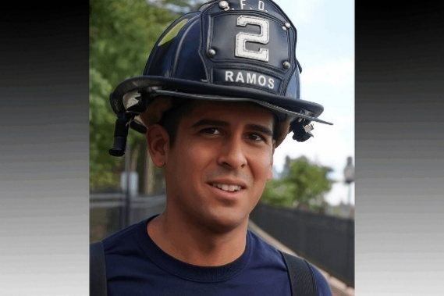

See also: Nov. 17, 2025: IL - IL Firefighter’s Widow Awarded $31.5M; Jury Says Command Lapses Contributed to Death. A Whiteside County jury has awarded $31.5 million to the widow and two young daughters of a Sterling firefighter killed in the line of duty four years ago. The verdict in favor of Brittney Ramos, suing in connection with the December 2021 death of her husband, Lt. Garrett Ramos, found that former Rock Falls Fire Chief Cris Bouwens and Rock Falls Fire Chief Ken Wolf, who was a deputy chief at the time of the fire, were each 50% to blame for Ramos’ death…. During closing statements on Friday morning, Ramos’ attorney Michael Gallagher asked the jury to consider a string of failures as it weighed the evidence:
—Bouwens’ failure to ask the residents of the home, who were on scene, if there was a basement. Firefighters did not learn the home had a basement until after receiving mayday calls from a fallen firefighter at 12:03 a.m. Not knowing there was a basement put firefighters who were working the interior of the burning structure at risk because of potential floor collapse and holes developing.
—Bouwens’ failure to appoint a safety officer, as soon as a senior trained official was available, to oversee the scene. Ramos’ attorneys have said former Dixon Rural Fire Chief Sid Aurand arrived at the scene at 11:40 p.m., but Bouwens didn’t appoint Aurand as safety officer until three minutes after two mayday calls were heard at 12:03 a.m.
—Failure to withdraw interior firefighters from the burning home in a timely manner as fire conditions worsened. The fire initially began in the unattached garage. Throughout the next hour, firefighters battled a blaze that had spread into and across the home’s attic, with fire apparent to firefighters as they used tools to pull down ceilings as they worked to save the property. All residents were out of the home safely, yet firefighters were sent back into the burning structure as trusses were falling and holes were developing in the floor.
—Failed to initiate a personnel accountability report in a timely manner so that all firefighters were accounted for.
—Failure to administer PAR properly.
—Failure to properly train for mayday calls and PAR response. [Also filed, Chapter 4.]
https://www.fireengineering.com/firefighting/il-firefighters-widow-awarded-31-5m-jury-says-command-lapses-contributed-to-death/?utm_source=fe_daily_newsletter&utm_medium=email&utm_campaign=2025-11-17&oly_enc_id=0573H1103045H2E

See also: Nov. 14, 2025: IL - Attorneys Clash Over Basement, Go/No-go And Mayday In Ill. LODD Trial..
https://www.firerescue1.com/fireground-operations/attorneys-clash-over-basement-go-no-go-and-mayday-in-ill-lodd-trial?utm_source=delivra&utm_medium=email&utm_campaign=FR1-Daily-11-14-25&utm_id=9812847&dlv-emuid=fed355b8-46a2-4fa4-b55c-4d602dde33c4&dlv-mlid=9812847

See also: Nov. 7, 2025: IL - ‘Chief, we have a mayday': Incident Command Scrutinized In Ill. LODD Trial. [TV VIDEO.} https://www.firerescue1.com/legal/chief-we-have-a-mayday-incident-command-scrutinized-in-ill-lodd-trial

See also: March 8, 2022 - Illinois OSHA report: INSPECTION #: 1567974 REPORT The Ridge Incident: Firefighter Dies in House Fire After First Floor Collapse and Loss of Accountability. https://labor.illinois.gov/content/dam/soi/en/web/idol/laws-rules/safety/documents/ridge-incident-report.pdf
CONTRIBUTING FACTORS Key contributing factors identified in this investigation include: • Basement was not identified during size up. • Interior firefighter teams did not always stay together. • Mayday call was received but caller was not identified or located.
State OSHA poster: https://labor.illinois.gov/content/dam/soi/en/web/idol/documents/Ridge%20Incident%20Poster.pdf

Oct. 29, 2025: MI - Mich. Fire Chief Reinstated After Warning Of Staffing Gaps Weeks Before Fatal Church Attack. [TV VIDEO.] The Grand Blanc Township board reinstated Fire Chief Jamie Jent following controversy over fire department staffing and budget cuts raised before the Sept. 28 church attack. GRAND BLANC TOWNSHIP, Mich. — The Grand Blanc Township board announced Tuesday at its board meeting that it had reinstated the fire chief, who had been on administrative leave, after leaders were considering firing him.
Fire Chief Jamie Jent was placed on administrative leave this month after a discussion with township Superintendent Dennis Liimatta, according to the Grand Blanc Professional Firefighters Local 4962. Liimatta oversees the township’s day-to-day operations. The discussion followed a fire union letter to the township board on Oct. 14 that requested meetings to discuss operations and challenges in the Fire Department. It is unclear why Jent was placed on leave.
The union’s letter alleged Liimatta cut four full-time fire positions from the township’s proposed 2026 budget weeks before the Sept. 28 gunman’s attack on the Church of Jesus Christ of Latter-day Saints, which killed four people and destroyed the building in a fire. The department has six full-time and 28 part-time firefighters, according to township staff. https://www.firerescue1.com/fire-chief/mich-fire-chief-reinstated-after-dispute-over-fire-department-staffing-following-church-attack?utm_source=delivra&utm_medium=email&utm_campaign=FR1-Daily-10-29-25&utm_id=9704598&dlv-emuid=fed355b8-46a2-4fa4-b55c-4d602dde33c4&dlv-mlid=9704598

Oct. 28, 2024: NY Times – 12 Hours In The Smoke. One longtime member died last year after being diagnosed at 40 with brain cancer. A former crew leader is being treated for both leukemia and lymphoma diagnosed in his 40s. Another colleague was recently told that he has the lungs of a lifelong chainsmoker. Wildfire fighters nationwide are getting sick and dying at young ages, The New York Times has reported. The federal government acknowledges that the job is linked to lung disease, heart damage and more than a dozen kinds of cancer. *** To find out how harmful the air gets on an average-size wildfire, Times reporters brought sensors to the Green fire this summer. We tracked levels of some of the most lethal particles in the air, called PM2.5, which are so tiny that they can enter the bloodstream and cause lasting damage.
Readings above 225.5 micrograms per cubic meter are considered hazardous. On the fire line, levels regularly exceeded 500. https://www.nytimes.com/interactive/2025/10/28/us/wildfire-smoke-firefighter-deaths.html?nl=The+Morning

See also: ‘If I Live to 25, I’ve Lived a Good Life’
He started fighting wildfires as a teenager. After inhaling smoke on the front lines for six seasons, he faced an impossible choice. https://www.nytimes.com/2025/09/07/us/wildfire-firefighter-cancer.html?unlocked_article_code=1.uE8.0S-u.DJw8uGK9hIoH&smid=url-share

Oct. 25, 2025: VA - Significant Incident Investigations Team – Live Fire Training Burn Injury
On October 13, 2024, a Fairfax County (VA) firefighter sustained burn injuries during a live fire training evolution at the Fire & Rescue Academy. In response, Fire Chief John Butler activated a Significant Incident Investigation Team (SIIT) tasked with examining the circumstances surrounding the injury, identifying contributing factors, and recommending corrective actions. The investigation began with extensive interviews with participants and instructors, a review of operational and training policies, and an analysis of the training event’s planning and execution. This phase identified multiple operational, procedural, and cultural factors that contributed to the incident. The investigation concluded with the help of the Fire Safety Research Institute (FSRI) performing live fire training experiments to recreate the fire behavior to learn what occurred to help guide policy, procedural, and training changes to prevent it from happening in the future.
https://www.fairfaxcounty.gov/fire-ems/siit

FINAL REPORT: https://online.fliphtml5.com/murtp/vowj/#p=4
VIDEO: https://www.youtube.com/watch?v=jMKYTiZvMPU

Oct. 14, 2025: CA - CA Passes Ban On PFAS in Turnout Gear. [TV VIDEO.] A new California law bans perfluoroalkyl and polyfluoroalkyl substances, known as PFAS, from firefighting equipment, CBS 8 reports. PFAS do not easily break down in the environment or the human body, and have been linked to cancerfand other health risks. Firefighters face heightened exposure to PFAS because it is in their protective gear, and it’s also found in burning materials at fire scenes. Cal Fire San Diego County Captain Robert Johnson told CBS 8 the department is committed to finding safer gear and promoting a “clean gear culture” to reduce contamination.
Under the new law, Cal/OSHA must develop safety standards and phase out PFAS-containing gear statewide by 2028. [Also filed, Chap. 18.] https://www.firefighternation.com/health-wellness/physical-health/ca-passes-ban-on-pfas-in-turnout-gear/?utm_medium=email&utm_source=fe_daily_newsletter&utm_campaign=2025-10-15&oly_enc_id=0573H1103045H2E

Oct. 7, 2025: DC - IAFF Asks Court To Dismiss Lawsuits Against NFPA Over PPE Standards Related To PFAS. [PODCAST.] The firefighters’ union moved to dismiss with prejudice its PFAS-related lawsuit over NFPA’s firefighter gear standard. WASHINGTON — The International Association of Fire Fighters (IAFF) has asked the Boston Superior Court to dismiss, with prejudice, all remaining claims against the National Fire Protection Association (NFPA) from its March 2023 lawsuit concerning standards for firefighter protective gear.
“As NFPA stated from the very beginning, the IAFF’s legal strategy was misguided and not supported by the facts. A portion of the lawsuit was dismissed in March 2024, and it was clear from the discovery process that remaining claims had no basis,” The NFPA said in a statement attributed to NFPA President and CEO Jim Pauley. “We are pleased that they have asked the court to dismiss all claims.” *** The IAFF sued the NFPA in Norfolk County Superior Court in Dedham, arguing NFPA’s gear standard effectively requires PFAS and seeking to eliminate the cancer-linked chemicals from firefighter gear. Occupational cancer is the leading cause of firefighter deaths; nearly 75% of those honored at the 2022 Fallen Fire Fighter Memorial died from it.
https://www.firerescue1.com/legal/iaff-asks-court-to-dismiss-lawsuits-against-nfpa-over-ppe-standards-related-to-pfas?utm_source=delivra&utm_medium=email&utm_campaign=FR1-Daily-10-7-25&utm_id=9603645&dlv-emuid=fed355b8-46a2-4fa4-b55c-4d602dde33c4&dlv-mlid=9603645

Oct. 3, 2025: MO - Wristband Technology Wakes Up MO FFs Without the Jolt. [TV VIDEO.] Firefighters in Blue Springs are testing a new device designed to make middle-of-the-night emergency calls less stressful on their bodies. The Ease Alert band vibrates on firefighters’ wrists to wake them for calls, replacing loud alarms and bright lights, KCTV reports. Experts say the technology helps reduce the sudden cardiovascular strain that can put firefighters at higher risk for heart attacks. https://www.fireapparatusmagazine.com/fire-technology-innovation/wristband-technology-wakes-up-mo-firefighters-without-the-jolt/?utm_medium=email&utm_source=fe_daily_newsletter&utm_campaign=2025-10-7&oly_enc_id=0573H1103045H2E

Sept. 30, 2025: CA - Civil Rights Division Files The First Department Of Justice Affirmative Lawsuit In Support of Gun Owners. The Civil Rights Division today filed a lawsuit against the Los Angeles County Sheriff’s Department due to their pattern or practice of infringing the Second Amendment rights of law-abiding citizens seeking concealed carry weapons (CCW) permits. This lawsuit is the first affirmative lawsuit in support of gun owners filed by the U.S. Department of Justice. On March 27, 2025, the Division initiated the first-of-its-kind Second Amendment investigation due to numerous complaints of unreasonable delays in CCW permitting decisions by the Los Angeles County Sheriff’s Department. After analysis of data and documents spanning over 8,000 CCW permit applications, the Division today filed suit seeking relief on behalf of law-abiding applicants. https://www.justice.gov/opa/pr/civil-rights-division-files-first-department-justice-affirmative-lawsuit-support-gun-owners

Sept. 17. 2025: MD - Complaint Filed Over Beard Policy After Baltimore Paramedic Suspended. A Muslim civil rights group alleges the Baltimore Fire Department denied religious accommodation, selectively enforced its grooming policy and suspended him without offering a respirator fit test. The Council on American-Islamic Relations (CAIR) has filed a federal discrimination complaint against the Baltimore City Fire Department on behalf of a Muslim paramedic who was suspended for keeping a beard as part of his religious practice. According to a statement, the suspension followed the employer’s refusal to grant a religious accommodation to the agency’s grooming policy. The complaint asks the EEOC to investigate, reinstate the paramedic with back pay and mandate policy changes and staff training. Othmane El Omari sought to maintain his facial hair in accordance with his religious beliefs since beginning his employment with the fire department. The complaint alleges that the department has repeatedly denied his accommodation requests, enforcing grooming policies in a discriminatory manner that has hindered his ability to work free from harassment and unequal treatment. The department says its grooming policy is needed to ensure a proper respirator seal. The OSHA standard states “The test shall not be conducted if there is any hair growth between the skin and the facepiece sealing surface, such as stubble beard growth, beard, mustache or sideburns which cross the respirator sealing surface.” The department has not administered a fit test to Omari and has instead enforced the policy against him. The complaint states: “Mr. El Omari expressly seeks a narrow accommodation from BCFD that OSHA itself contemplates, shaving only the sealing area and submitting to fit testing. Refusing even to conduct a fit test underscores that BCFD’s obstacle is its own rigid policy, not federal law. Any alleged difficulty arises solely from BCFD’s own policies and inaction.” CAIR alleges that the department has allowed other EMS personnel and firefighters, including some supervisors, to keep facial hair without consequence and continue working safely. [Also filed, Chap. 8.] https://www.firerescue1.com/legal/complaint-filed-over-beard-policy-after-baltimore-paramedic-suspended?utm_source=delivra&utm_medium=email&utm_campaign=FR1-Daily-9-17-25&utm_id=9510973&dlv-emuid=fed355b8-46a2-4fa4-b55c-4d602dde33c4&dlv-mlid=9510973

Sept. 11, 2025: MT - U.S. Forest Service Reverses Course, Issues Masks To Wildland Firefighters But Keeps Ban In Place. [TV VIDEO.] After reporting on smoke-linked illnesses and pressure from lawmakers, the agency will stock and provide N95s for light use, while still barring masks during arduous work. The U.S. Forest Service will begin providing wildfire crews with masks to protect against smoke, reversing a decades-long policy banning protective gear after The New York Times spotlighted severe health impacts from smoke exposure, including a case involving a young Oregon firefighter now battling cancer. For decades, federal wildland firefighters were not given masks, even as researchers and labor groups warned of the long-term risks, the Times found. The Forest Service said masks could cause firefighters to overheat. https://www.firerescue1.com/wildfire-and-wildland-urban-interface/u-s-forest-service-reverses-course-issues-masks-to-wildland-firefighters-but-keeps-ban-in-place?utm_source=delivra&utm_medium=email&utm_campaign=FR1-Daily-9-11-25&utm_id=9480874&dlv-emuid=fed355b8-46a2-4fa4-b55c-4d602dde33c4&dlv-mlid=9480874

See also Aug. 17, 2025 NY Times article - Wildfire Fighters, Unmasked in Toxic Smoke, Are Getting Sick and Dying. The U.S. Forest Service has fought decades of efforts to better protect its crews — sending them into smoke without masks or warnings about the risks. https://www.nytimes.com/2025/08/17/us/wildfire-firefighters-masks-smoke.html

Aug. 19, 2025: GA - ACS Study: Firefighters Face Higher Cancer Mortality, With Sharp Rises In Skin, Kidney Cancers. Researchers found higher cancer mortality overall, with prostate and colorectal risks rising with tenure and lung cancer emerging only after 30 years of follow-up. ATLANTA — After tracking firefighters for more than 30 years, a new study reports increased mortality from skin, kidney and other cancers. The findings build on the 2022 International Agency for Research on Cancer (IARC) conclusion that firefighting causes mesothelioma and bladder cancer, according to the American Cancer Society. The study appeared in the International Journal of Epidemiology…. Researchers analyzed over 470,000 firefighters in the ACS CPS-II cohort, comparing their mortality to that of other employed men over 36 years (1982–2018). Jobs were coded using 1980 Census categories and cancer deaths were classified by ICD. Firefighting was linked to higher cancer mortality overall, with the strongest increases for skin (+58%) and kidney (+40%). Prostate and colorectal risks rose with longer tenure, and a lung cancer signal appeared only after over 30 years of follow-up. https://www.firerescue1.com/cancer/acs-study-firefighters-face-higher-cancer-mortality-with-sharp-rises-in-skin-kidney-cancers?utm_source=delivra&utm_medium=email&utm_campaign=FR1-Daily-8-19-25&utm_id=9368807&dlv-emuid=fed355b8-46a2-4fa4-b55c-4d602dde33c4&dlv-mlid=9368807

Aug. 15, 2025: NY - 4 Missed Maydays, Safety Lapses Flagged In N.Y. LODD. State and Buffalo Fire Department reports cite accountability lapses, interior ops failures, an untrained acting officer and delays in defensive ops in death of Firefighter Jason Arno. … Excessive radio traffic drowned out four of Arno’s maydays as evacuation orders went out; no one radioed him after he went down, and no emergency headcount (PAR) was conducted after crews exited. https://www.firerescue1.com/fireground-operations/4-missed-maydays-safety-lapses-flagged-in-n-y-lodd?utm_source=delivra&utm_medium=email&utm_campaign=FR1-Daily-8-15-25&utm_id=9353841&dlv-emuid=fed355b8-46a2-4fa4-b55c-4d602dde33c4&dlv-mlid=9353841

See also: Aug. 13, 2025: NY - Investigation Exposes Buffalo Fire Failures In Firefighter's Death. [TV VIDEO.] State and city reports filed recently in widow's lawsuit. BUFFALO, N.Y. — Two newly filed investigative reports obtained by 2 On Your Side Investigates into the 2023 death of Buffalo Firefighter Jason Arno reveal multiple errors and safety violations on the day Arno died inside a burning costume shop on Main Street. The findings, which include multiple state-issued citations to the Buffalo Fire Department for safety violations, are part of an ongoing lawsuit over Arno’s death. They provide a new accounting of the split-second decisions, dangerous conditions, missed signals and long-standing safety gaps that appear to have turned a routine commercial fire into a tragedy. *** The reports, which were filed this week in State Supreme Court as part of a lawsuit against the city by Arno’s widow, reveal that Buffalo Fire officials missed four mayday calls Arno made using his radio, something the fire department’s report attributed to “excessive radio traffic” in the chaotic moments firefighters were told to evacuate the burning building. Additionally, the State Department of Labor concluded that Buffalo Fire “had inadequate accountability, nonfunctioning firefighting equipment, failure to follow interior firefighting procedures, and other factors unrelated to occupational safety and health standards,” contributing to the death of Arno. https://www.wgrz.com/article/news/investigations/2-investigates/report-buffalo-firefighters-mayday-calls-missed-amid-deadly-fire/71-32e7af94-47dd-4575-96da-b686464edbef

Aug. 12, 2025: CT - OSHA Fines Conn. FD For ‘Serious’ Yiolation In Firefighter’s Tatal UTV Rollover. [TV VIDEO – No seatbelt / no helmet.] The agency levied a $640 penalty after determining safety lapses contributed to the death of a Wethersfield firefighter when a utility terrain vehicle flipped during a brush fire…. At 5:30 p.m. on Oct. 22, the report said, a firefighter was operating a utility terrain vehicle during response efforts at a brush fire on Lamentation Mountain in Meriden. While driving over uneven terrain, it said, the UTV rolled over and struck the firefighter in the head and neck. [Also filed, Chap. 5.]
https://www.firerescue1.com/risk-management/osha-fines-conn-fd-for-serious-violation-in-firefighters-fatal-utv-rollover?utm_source=delivra&utm_medium=email&utm_campaign=FR1-Daily-8-12-25&utm_id=9337739&dlv-emuid=fed355b8-46a2-4fa4-b55c-4d602dde33c4&dlv-mlid=9337739

Aug. 13, 2025: TheSecretList - FirefighterCloseCalls.com <thesecretlist@firefighterclosecalls.ccsend.com>
During the brush fire on Lamentation Mountain, the report said, FF Sharkevich and three other Firefighters were using an Arctic Cat UTV with a Kimtek fire suppression unit, essentially a mini fire apparatus for work on rough terrain. Sharkevich was driving, according to the report. "While driving the UTV on an incline to change locations, the unit began to slide on loose shale," the report says. "The unit then became unstable and began to roll from side to side. "Two Firefighters sitting on the suppression unit were thrown from the UTV. The two firefighters sitting in the cab were thrown about the cab," the report says. "The driver then was ejected from the cab, struck by the UTV, and sustained fatal injuries." The state Office of the Chief Medical Examiner found the cause of the former Hartford firefighter's death was impact injury of the head and neck, and the manner accidental. The other firefighters suffered non-life-threatening injuries, officials said at the time.

Aug. 11, 2025: PA: NIOSH: Lieutenant Killed During Post-Fire Collapse At Mixed-Use Building. Investigation highlights the risks of post-suppression overhaul and origin-and-cause operations. PHILADELPHIA — NIOSH Report F2022-02 details a June 2022 fire in which a three-story mixed-use building collapsed during post-fire overhaul, killing a lieutenant and injuring five other personnel. Investigators cite arson, undocumented structural alterations, infrequent inspections, and the building’s age and condition as key factors, and recommend stricter change-of-occupancy reviews, timely hazard communication, and enhanced risk-management training for fireground operations. https://www.firerescue1.com/niosh/niosh-lieutenant-killed-during-post-fire-collapse-at-mixed-use-building?utm_source=delivra&utm_medium=email&utm_campaign=FR1-Daily-8-11-25&utm_id=9332400&dlv-emuid=fed355b8-46a2-4fa4-b55c-4d602dde33c4&dlv-mlid=9332400

Read NIOSH Report: https://www.cdc.gov/niosh/firefighters/programs/pdfs/face202202.pdf
The fire was officially placed under control at 02:18 hours, and units began clearing the scene…. Approximately 90 minutes after the initial dispatch, at 03:23 hours, the structure collapsed, trapping multiple firefighters inside…. At approximately 04:09 hours, IC
confirmed contact with three trapped firefighters, while a fourth trapped firefighter could not be accounted for. Over the next several hours, intensive rescue operations occurred, with four firefighters successfully extricated between 05:01 and 05:14 hours and transported to local hospitals. By 07:05 hours, IC reported that all personnel had been removed, and the final firefighter was transported at 07:11 hours.

Aug. 7, 2025: MO - Widow Of Mo. Firefighter/Paramedic Who Died In Training Receives $1M Settlement. The city council awarded nearly $1.1 million to the wife of Kyle Brinker, a Kansas City Fire Department paramedic who died during a training exercise in 2024. The wife of the Kansas City Fire Department paramedic who died during a training exercise last year has been awarded just under $1.1 million to resolve a workers’ compensation claim filed against the city. The City Council approved the award to Rebecca Ann Brinker without comment near the end of Thursday’s regular meeting. Her husband, 33-year-old Kyle Brinker, died after suffering an undisclosed medical emergency during a fire department training event on Sept. 17, 2024. [Also filed, Chap. 6.] https://www.firerescue1.com/legal/widow-of-mo-firefighter-paramedic-who-died-in-training-receives-1m-settlement?utm_source=delivra&utm_medium=email&utm_campaign=FR1-Daily-8-7-25&utm_id=9315710&dlv-emuid=fed355b8-46a2-4fa4-b55c-4d602dde33c4&dlv-mlid=9315710

See: Aug. 14, 2025: ‘Not mandatory’: Mo. FD skipped formal AARs after two recent LODDs…. The department confirmed on Tuesday that it conducted no internal review after the drowning death last September of 33-year-old Kyle Brinker. It confirmed a day later that it also did not conduct a review after paramedic Graham Hoffman, 29, was stabbed to death by a patient in the back of an ambulance in April. https://www.firerescue1.com/firefighter-training/not-mandatory-mo-fd-skipped-formal-aars-after-two-recent-lodds

See also: FD Press Release about pool swim: https://www.scribd.com/document/899223136/Statement-From-KCFD

See also: Sept. 19, 2024 TV VIDEO: https://www.firerescue1.com/line-of-duty-death-lodd/fallen-mo-firefighter-paramedic-was-known-as-a-mentor-role-model-for-many

Aug. 7, 2025: MN - Minneapolis Firehouses Add Saunas To Help Reduce Cancer Risk In Firefighters. With support from the Minneapolis Fire Foundation, five stations have installed saunas aimed at flushing out toxins after fires. *** Some firefighters say using a sauna helps remove the smoky smell from their skin after a fire. That anecdotal evidence has led some researchers and doctors to explore whether saunas might also help flush out harmful toxins and carcinogens through sweat and urination. The Minneapolis Fire Foundation hopes to install saunas in the city’s remaining 14 fire stations and is actively seeking donations to support the effort.
https://www.firerescue1.com/cancer/minneapolis-firehouses-add-saunas-to-help-reduce-cancer-risk-in-firefighters?utm_source=delivra&utm_medium=email&utm_campaign=FR1-Daily-8-7-25&utm_id=9315710&dlv-emuid=fed355b8-46a2-4fa4-b55c-4d602dde33c4&dlv-mlid=9315710

July 30, 2025: CT - Family Of Fallen Conn. Firefighter First To Receive Expanded Death Benefit Under New Law. The family of Plainville Firefighter Raymond Moreau will be the first to receive an immediate $100,000 for fallen first responders. he family of fallen Plainville volunteer firefighter Raymond Moreau will be the first to receive an expanded state death benefit for first responders signed into law by Gov. Ned Lamont in late June, according to a spokesperson for state Comptroller Sean Scanlon, who pressed for the legislation. Moreau, 60, died Sunday after being struck by a piece of equipment that dislodged from a fire engine at the scene of a residential house fire on Maria Road, police have said. He was a 35-year veteran of the Plainville Fire Department, officials said. The expanded law, which went into effect July 1, provides a $100,000 immediate benefit to the survivors of Connecticut police, firefighters, emergency medical technicians and paramedics who died in the line of duty, after the proper paperwork has been filed, said Madi Csejka, communications director for Scanlon’s office, which administers the fund. The money is exempt from state tax, Csejka said. The previous version of the law, which passed in 2023, gave the families of fallen police officers the $100,000 benefit. Under that law, the families of Hartford police Officer Bobby Garten Jr. and Connecticut State Trooper Aaron Pelletier received the benefit, Csejka said. [Also filed, Chap. 18.] https://www.firerescue1.com/legislation-funding/family-of-fallen-conn-firefighter-first-to-receive-expanded-death-benefit-under-new-law?utm_source=delivra&utm_medium=email&utm_campaign=FR1-Daily-7-30-25&utm_id=9279916&dlv-emuid=fed355b8-46a2-4fa4-b55c-4d602dde33c4&dlv-mlid=9279916

July 17, 2025: Firefighter Fatality Notification

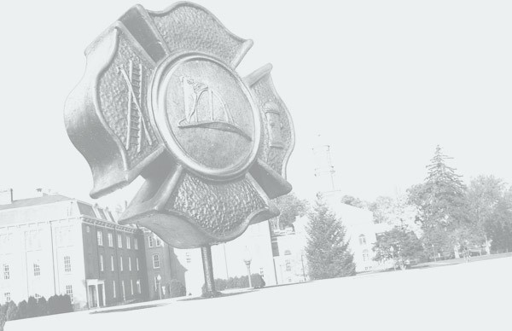
Assistant Chief Jason McGlone
East Branch Fire Department
East Branch, New York
Assistant Chief Jason McGlone arrived at the scene of a crash involving a motor vehicle and a utility pole at approximately 9:30 p.m. on July 17, 2025. Shortly after arriving, Assistant Chief McGlone repositioned the pumper rescue truck he was driving to distance his vehicle from sagging electrical wires. However, he was unaware that the wires had become entangled with the apparatus and were in contact with the vehicle’s roof. Assistant Chief McGlone was electrocuted when he exited the rescue pumper. Personnel on-scene immediately began attempts to resuscitate Assistant Chief McGlone with CPR and the use of an automatic external defibrillator (AED). Despite these efforts, Assistant Chief McGlone could not be revived and was pronounced deceased.
Age: 51
Sex: Male
Classification: Volunteer
Years of service: 25
Date of incident: July 17, 2025
Date of death: July 17, 2025
https://apps.usfa.fema.gov/firefighter-fatalities/details?id=7590

July 1, 2025: ID - Idaho Wildfire Gunman Identified As A Transient Who Once Aspired To Be A Firefighter. [TV VIDEO.] Authorities say Wess Roley, a 20-year-old living out of his car, set a fire on Canfield Mountain before fatally shooting two battalion chiefs and injuring a third.*** Roley had once aspired to be a firefighter and had only a handful of minor contacts with area police, Norris said. A motive was still unknown, he said. https://www.firerescue1.com/violence-against-first-responders/idaho-wildfire-gunman-identified-as-a-transient-who-once-aspired-to-be-a-firefighter?utm_source=delivra&utm_medium=email&utm_campaign=FR1-Daily-7-1-25&utm_id=9153202&dlv-emuid=fed355b8-46a2-4fa4-b55c-4d602dde33c4&dlv-mlid=9153202

See also: June 30, 2025: ID - 2 Firefighters Killed, 1 ‘fighting for his life’ After Ambush At Idaho Wildfire. [TV VIDEO.] Authorities say a man set a wildfire and ambushed firefighters in Coeur d’Alene, killing two and critically injuring another before being found dead. BOISE, Idaho — A man armed with a rifle started a wildfire Sunday and then began shooting at first responders in a northern Idaho mountain community, killing two firefighters and wounding a third during a barrage of gunfire over several hours, authorities said. A shelter-in-place order was lifted Sunday night after a tactical response team used cell phone data to “hone in” on a wooded area where they found the suspect’s body with a firearm nearby as flames rapidly approached, Kootenai County Sheriff Bob Norris said. https://www.firerescue1.com/line-of-duty-death-lodd/2-firefighters-killed-1-fighting-for-his-life-after-ambush-at-idaho-wildfire?utm_source=delivra&utm_medium=email&utm_campaign=FR1-Daily-6-30-25&utm_id=9148819&dlv-emuid=fed355b8-46a2-4fa4-b55c-4d602dde33c4&dlv-mlid=9148819

June 24, 2025: SC - Columbia (SC) Accuses Irmo Of Lying About Firefighter’s Death In Apartment Fire. The legal fallout of an Irmo firefighter’s death two years ago is growing, with the city of Columbia accusing the Irmo Fire District of lying about events at an apartment complex fire that killed James Michael Muller. Muller was killed on May 26, 2023, when a ceiling collapsed on him while he fought a fire at the Tropical Ridge Apartments. At the time, the Irmo Fire District was assisting the Columbia-Richland Fire District at the fire just off of Greystone Boulevard near Riverbanks zoo. Two people had been rescued from the burning building, and the highly flammable structure was beginning to buckle when firetrucks from the Columbia-Richland Fire District trained their powerful “deck guns” on the roof. Shortly after, the top floor crashed down, trapping four firefighters. *** It was just one of the many miscommunications that NIOSH said led to Muller’s death. The federal investigators said in their report that leadership at the scene appeared to be unaware that Muller and another Irmo firefighter were trapped in the building. Muller’s mayday call was not picked up until more than 20 minutes after it went out. https://www.fireengineering.com/firefighting/structural-firefighting/columbia-sc-accuses-irmo-of-lying-about-firefighters-death-in-apartment-fire/?utm_source=fe_daily_newsletter&utm_medium=email&utm_campaign=2025-6-24&oly_enc_id=0573H1103045H2E

See NIOSH Final Report 202307: https://www.scribd.com/document/857781278/Niosh-Final-Report-202307

June 14, 2025: DC - Takeaways From AP’s Investigation Of US Death Benefits Program For Public Safety Officers. A federal program that provides benefits to families of police officers and firefighters who die and become disabled on duty is rapidly growing while facing criticism for increasing delays in deciding claims. Congress created the Public Safety Officers’ Benefits program in 1976 to guarantee that the spouses and children of officers who put their lives on the line would receive financial support. But repeated expansions in eligibility approved by Congress, including three passed in the last five years, have made the program more popular and complex to administer. Critics say the program fails some families by taking too long to grant or deny benefits and making inconsistent rulings. An Associated Press analysis found that hundreds of families are waiting years to learn whether they qualify for payments, and more are ultimately being denied. *** As of late April, more than 120 claims by surviving relatives or disabled first responders have been awaiting initial determinations or rulings on their appeals for more than five years, according AP’s findings. About a dozen have waited over a decade for an answer.
https://apnews.com/article/public-safety-officers-death-benefits-program-backlog-6fb357a85bf3d66202d20599302594cf

June 10, 2025: MN - Minn. Fire Departments Test Soy-Based, PFAS-Free Firefighting Foam. Murray County fire departments are testing SoyFoam, a PFAS-free foam made from soy flour and distributed by the state’s soybean research council. Several fire departments in Murray County are preparing to test a soy-based firefighting foam that could serve as an alternative to conventional products containing PFAS chemicals. Soybean growers in the region donated pails of SoyFoam — a product developed by Cross Plains Solutions — to departments in Currie, Dovray, Fulda, Iona, Lake Wilson and Slayton, the Marshall Independent reported. The initiative is part of a broader campaign by the Minnesota Soybean Research & Promotion Council to distribute the foam to more than 40 fire departments across the state. Murray County Mutual Aid Association President and Slayton Fire Chief Chris Letendre said the departments will test the foam’s performance in various fire scenarios. SoyFoam is made from soy flour and contains no intentionally added forever chemicals like PFAS, according to the council. Council Chair and Dumont firefighter Tom Frisch described the effort as a way to support both local agriculture and firefighter safety, stating the foam offers a renewable, PFAS-free option for departments. https://www.firerescue1.com/firefighting-foam/minn-fire-departments-test-soy-based-pfas-free-firefighting-foam?utm_source=delivra&utm_medium=email&utm_campaign=FR1-Daily-6-10-25&utm_id=9046557&dlv-emuid=fed355b8-46a2-4fa4-b55c-4d602dde33c4&dlv-mlid=9046557

June 9, 2025: CA - Firefighter’s Death Leads Calif. FD To Partner With Biotech For Early Cancer Detection. To fight firefighter cancer risks, the Hayward Fire Department has partnered with Prenuvo to offer full-body MRI scans for early detection, inspired by the legacy of late Captain Steve Holt. HAYWARD, Calif. — Every day, firefighters are exposed to cancer-causing chemicals from the scorched aftermath of forest fires, the melting pot of kitchen cleaning supplies in burning homes, and abandoned polyurethane appliances and bags in homeless encampment blazes. Cancer has jumped to the leading cause of death among firefighters; they have a 9% greater risk of being diagnosed with the disease, and a 14% higher risk of dying from it than the general population, according to a study published by the National Institutes of Health on the occupational hazards of firefighting. According to the International Association of Fire Fighters, 66% of line-of-duty firefighter deaths from 2002 to 2019 were caused by cancer. To combat this endemic threat of cancer, the Hayward Fire Department has partnered with the Redwood City-based biotech company Prenuvo to offer full-body MRI scans to firefighters and identify cancer early on, when effective treatment options have a better chance of eliminating the disease and keeping it in remission. The inspiration for this early-detection effort was HFD Captain Steve Holt, who died of cancer on Nov. 29, 2017. Holt had worked at the Hayward Fire Department since 1987; he responded to the Loma Prieta earthquake in 1989 and the Oakland Hills fire in 1991, receiving accolades for his work. “At his daughter’s cheerleading camp, (Holt) passed out, woke up in the hospital, and was diagnosed with lung cancer that spread to his brain and spinal cord,” Hayward Firefighters Union President Andrew Ghali said. *** The Hayward Fire Department signed a $100,000 contract with Prenuvo on Jan. 1, funded through the city of Hayward, to provide head and torso MRI scans. https://www.firerescue1.com/cancer/firefighters-death-leads-calif-fd-to-partner-with-biotech-for-early-cancer-detection?utm_source=delivra&utm_medium=email&utm_campaign=FR1-Daily-6-9-25&utm_id=9040348&dlv-emuid=fed355b8-46a2-4fa4-b55c-4d602dde33c4&dlv-mlid=9040348

June 5, 2025: FL - Florida Legislation Recommends FDs Limit Standard Firefighter Shifts To 42 Hours Per Week. [TV VIDEO.} House Bill 929 also directs fire departments to purchase gear free of hazardous chemicals and requires mental health monitoring of firefighters. Florida Governor Ron DeSantis signed House Bill 929 on June 5, legislation that addresses firefighter health and safety related to chemicals in gear, mental health monitoring and shift schedules. *** According to a press release from the governor’s office, HB 929 updates the Florida Firefighters Occupational Safety and Health Act by expanding its scope to include occupational diseases and suicide prevention. The bill directs the Department of Financial Services’ Division of the State Fire Marshal to adopt clear rules to mitigate health risks, including mental health impacts and exposure to toxic substances.
Under the new law:
Fire departments must purchase gear free of hazardous chemicals once it becomes commercially available.
Employers must notify firefighters if current gear contains toxic substances.
The Division is required to monitor mental health impacts, including suicide risks, and establish prevention protocols.
Employers are encouraged to limit standard firefighter shifts to 42 hours per week to reduce burnout. [Also filed, Chap. 18.] https://www.firerescue1.com/health-wellness/florida-governor-signs-legislation-limiting-firefighter-shifts-to-42-hours-per-week?utm_source=delivra&utm_medium=email&utm_campaign=FR1-Daily-6-6-25&utm_id=9030459&dlv-emuid=fed355b8-46a2-4fa4-b55c-4d602dde33c4&dlv-mlid=9030459

June 4, 2025: NJ – NJ Firefighter Wins Court Battle Over Growing Beard On Religious Grounds. Atlantic City officials violated a firefigher’s religious freedom by forcing him to shave his beard, a federal appeals court ruled. Alexander Smith is an ordained Christian minister who works as a firefighter and air mask technician in Atlantic City. The case originated in early 2019 after Smith’s request for religious accommodation was denied and he was threatened with suspension. It did not issue a final ruling on whether he can keep the beard permanently. That decision now goes back to the lower court. However, the federal appeals court said that Atlantic City’s rule banning beards wasn’t applied fairly across the board. The opinion noted that while the city claimed the rule was about safety — specifically ensuring air masks fit tightly during fires — it made exceptions for some people. For example, administrative staff weren’t required to take the same mask-fitting tests, and fire captains had the power to make case-by-case exceptions to the rule. Because the fire department allowed other kinds of exceptions, the court said it couldn’t turn around and deny an exception to someone who needed one for religious reasons. In legal terms, that meant the rule wasn’t “generally applicable,” which triggered a much tougher legal standard. Under that standard, the city had to prove it had no other way to meet its safety goals without burdening the firefighter’s religious belief. The court said the city failed to do that. It also ruled that the city failed to show that allowing Smith to keep his beard for religious reasons would significantly disrupt operations or create major difficulties under federal civil rights law. https://www.firefighternation.com/news/nj-firefighter-wins-court-battle-over-growing-beard-on-religious-grounds/?utm_medium=email&utm_source=fe_daily_newsletter&utm_campaign=2025-6-4&oly_enc_id=0573H1103045H2E

May 30, 2025: MD – EV FIRES – FIRE BLANKETS EXPLOSION RISK
The Fire Protection Research Foundation (FPRF), the research affiliate of NFPA, and the Fire Safety Research Institute (FSRI), part of UL Research Institutes, today issued a notice about a potential explosion hazard when fire blankets are used during electric vehicle fire suppression efforts with battery involvement.
During experiments involving the use of electric vehicle fire blankets to suppress an EV fire with battery involvement, it was observed that the deployment of a fire blanket eliminated flaming by denying oxygen to the vehicle and the battery fire.
While the flaming was eliminated, battery thermal runaway propagation continued after blanket deployment, which resulted in the continued release and accumulation of flammable battery gases into the volume under the blanket
In some of the experiments, this accumulation of flammable gases under the blankets presented an explosion risk to firefighters operating near the vehicle.
The risk of an explosion can be increased when re-introducing air into an oxygen-depleted accumulation of unburned flammable battery gases. https://fsri.org/news/potential-hazard-involving-ev-fire-blankets

May 30, 2025: OH - Ohio Fire Chief Recognized For Squeezing Into Basement To Rescue Woman Trapped In House Fire. [Watch PD Video.} Video shows Medina Fire Chief Larry Walters entering a burning basement to save a trapped woman, using a Halligan bar to get her, and himself, out. MEDINA, Ohio — Medina Fire Chief Larry Walters is being honored by the state of Ohio for rescuing a woman trapped in the basement of her burning home during a house fire in October 2024.Fire crews responded to a blaze on Branch Road in York Township and located the trapped woman at a basement window, but the opening was too small for her to escape, and their initial rescue attempt failed, FOX8 WJW reported. With flames closing in, body-camera video from the Medina County Sheriff’s Office showed Walters taking action, entering the basement without SCBA, and reassuring the woman that he would get her out safely. Using a Halligan bar, he was able to boost the woman up through the narrow window and into the arms of waiting firefighters. After ensuring the woman’s safety, Walters stayed behind in an attempt to save the victim’s dog, but the fire spread rapidly. Realizing he was running out of time, he used the Halligan bar to lift himself toward the window. Fellow firefighters pulled him out moments before the house was fully engulfed. https://www.firerescue1.com/search-rescue/ohio-fire-chief-recognized-for-squeezing-into-basement-to-rescue-woman-trapped-in-house-fire?utm_source=delivra&utm_medium=email&utm_campaign=FR1-Daily-5-30-25&utm_id=8996147&dlv-emuid=fed355b8-46a2-4fa4-b55c-4d602dde33c4&dlv-mlid=8996147

May 30, 2025: MA - The Fire Protection Research Foundation And The Fire Safety Research Institute Issue Notice Around Potential Hazard Involving Fire Blankets Used For Electric Vehicle Fire Suppression Efforts with Battery Involvement. The Fire Protection Research Foundation (FPRF), the research affiliate of NFPA, and the Fire Safety Research Institute (FSRI), part of UL Research Institutes, today issued a notice about a potential explosion hazard when fire blankets are used during electric vehicle fire suppression efforts with battery involvement.
During experiments involving the use of electric vehicle fire blankets to suppress an EV fire with battery involvement, it was observed that the deployment of a fire blanket eliminated flaming by denying oxygen to the vehicle and the battery fire.
While the flaming was eliminated, battery thermal runaway propagation continued after blanket deployment, which resulted in the continued release and accumulation of flammable battery gases into the volume under the blanket
In some of the experiments, this accumulation of flammable gases under the blankets presented an explosion risk to firefighters operating near the vehicle.
The risk of an explosion can be increased when re-introducing air into an oxygen-depleted accumulation of unburned flammable battery gases.
https://fsri.org/news/potential-hazard-involving-ev-fire-blankets

May 28, 2025: DC – NIOSH - Reporting Adverse Conditions Involving Self-Contained Breathing Apparatus – Thermal Degradation and Failure of Facepiece Lens. NIOSH continues to identify instances where certain facepiece lens materials on self-contained breathing apparatus (SCBA) fail before other components of the firefighter’s SCBA and personal protective equipment ensemble. *** What issues have been identified involving SCBA facepiece lenses? Since 2009, several NIOSH Fire Fighter Fatality Investigation and Prevention Program reports suggest that: • Certain SCBA facepiece lens materials may be failing before other components of the firefighter’s SCBA and personal protective equipment ensemble. • SCBA facepiece lenses certified to the 2007 NFPA 1981 standard, or earlier editions, may undergo thermal degradation when exposed to intense heat and energy while operating in the modern flow path. This may include bubbling, crazing, holes, or other severe deformation developing in the lens. A 2012 NFPA Safety Alert, along with research by the National Institute of Standards and Technology and other entities, helped establish the Lens Radiant Heat Test and the Elevated Temperature Heat and Flame Resistance Test. NFPA added these tests in 2013 to its testing procedures to reduce future occurrences of these severe failures. What actions can fire departments take? Fire departments can upgrade or replace their current SCBA to meet the 2013 or more recent edition of the NFPA 1981 standard. Testing by organizations such as the Fire Safety Research Institute has shown that SCBA models manufactured with more radiant heat and flame-resistant materials that are compliant with at least the 2013 edition of NFPA 1981 have improved thermal performance when exposed to radiant heating. https://www.cdc.gov/niosh/docs/2025-116/pdfs/2

May 23, 2025: SC - S.C. Fire Department Tests ‘1323' Shift To Improve Work-Life Balance. {TV VIDEO.] With the new “1323" schedule, the Charleston Fire Department addressed health concerns with maintaining the 56-hour workweek. CHARLESTON, S.C. — A new shift schedule known as the “1323" is being tested by the Charleston Fire Department to promote better work-life balance for firefighters. Charleston firefighters typically work 24-hour shifts totaling 56 hours per week. Previously, they followed a 24/48 schedule. However, fire officials say that the system did not provide enough recovery time between shifts, WCSC reported. The department began piloting the new 1323 schedule on May 10. Under this model, firefighters work one day on, three days off, then two days on, followed by another three days off. [Also posted, Chap. 15.] https://www.firerescue1.com/health-wellness/s-c-fire-department-tests-1323-shift-to-improve-work-life-balance?utm_source=delivra&utm_medium=email&utm_campaign=FR1-Daily-5-23-25&utm_id=8966091&dlv-emuid=fed355b8-46a2-4fa4-b55c-4d602dde33c4&dlv-mlid=8966091

May 22, 2025: NIOSH- LODD Death Reports released: https://wwwn.cdc.gov/NIOSH-fire-fighter-face/

12/7/2022: Two Volunteer Firefighters Die while Conducting Fire Attack at a Single-Family Residence – Pennsylvania. https://www.cdc.gov/niosh/firefighters/programs/pdfs/face202210.pdf

12/4/2021: Lieutenant Dies from a Floor Collapse in Residential Structure Fire with Unpermitted Renovations – Illinois. https://www.cdc.gov/niosh/firefighters/programs/pdfs/face202209.pdf

7/4/2021: Volunteer Firefighter Dies after Becoming Lost during a Residential Structure Fire – Pennsylvania. https://www.cdc.gov/niosh/firefighters/programs/pdfs/face202112.pdf

5/12/2021: Firefighter Dies and Lieutenant Seriously Injured at a Multi-Family Residential Structure Fire – Connecticut. https://www.cdc.gov/niosh/firefighters/programs/pdfs/face202111.pdf

See also this article / TV VIDEO.
‘Lack of experience and knowledge’ highlighted in Conn. LODD report
Following a four-year investigation into the death of New Haven firefighter Ricardo Torres Jr., federal officials say missed communication and command inexperience contributed to his death.
https://www.firerescue1.com/firefighter-training/lack-of-experience-and-knowledge-highlighted-in-conn-lodd-report?utm_source=delivra&utm_medium=email&utm_campaign=FR1-Daily-5-28-25&utm_id=8984337&dlv-emuid=fed355b8-46a2-4fa4-b55c-4d602dde33c4&dlv-mlid=8984337

May 21, 2025: DC - Congressional Fire Services Institute
Some NIOSH Staff Restored - More Work to Be Done. Last week, following advocacy from CFSI and many other fire service and outside organizations, some staff at the Department of Health and Human Services National Institute for Occupational Safety and Health (NIOSH) were returned to work and their Reduction in Force (RIF) notices were cancelled. This included staff at the following programs:
﻿
The National Firefighter Registry (NFR) for Cancer
The NFR is a crucial program for collecting data on cancer in the fire service and identifying trends, with the goal of informing policies that enhance firefighter health protections.

The Firefighter Fatality Investigation and Prevention Program (FFFIPP)
A program that conducts independent investigations of select career and volunteer firefighter line-of-duty deaths to formulate recommendations for preventing future deaths and injuries.

The National Personal Protective Technology Laboratory (NPPTL)
NPPTL conducts research on all types of PPE effectiveness and innovation, develops best practices and recommendations for PPE, and creates guidance and tools to help employers best use PPE.
NPPTL is particularly known for its work with respirators, including testing and approving respirators used in U.S. workplaces.

The World Trade Center Health Program (WTCHP)
This program provides medical monitoring and treatment services for 9/11 first responders and survivors.
https://cfsi.org/cfsi-washington-watch-national-fire-academy-closed-government-shutdown-averted-agency-staffing-changes-and-more/

May 14, 2025: NJ - NJ Fire Captain Falsified Safety Records, Officials Say. A 45-year-old senior fire captain in Emerson is facing charges after authorities say he improperly conducted respirator fit tests for firefighters and lied about it. Richard A. Solimando, is charged with forgery and tampering with records, the Bergen County Prosecutor’s Office said Friday. Solimando signed reports stating the tests had been completed when they had not been finished between Jan. 7 and Jan. 27, officials said. Fit testing is the method for finding the respirator that fits the face of emergency responders and ensuring it provides a tight seal to help keep you protected, according to the Agency for Healthcare Research and Quality. It’s more involved than a seal check, which is only used to check if a respirator is properly positioned on a face. [Also filed, Chap. 16.] https://www.fireengineering.com/firefighting-equipment/firefighter-scba/nj-fire-captain-falsified-safety-records-officials-say/?utm_medium=email&utm_source=fe_daily_newsletter&utm_campaign=2025-5-19&oly_enc_id=0573H1103045H2E

May 14 2025: DC – Recently Released NIOSH Firefighter Line of Duty Critical Injury and Death reports

Hawaii: One Firefighter Dies During Unprotected Search in Nine Apartment Building that was Originally Constructed to be a Single-Family House –
https://www.cdc.gov/niosh/firefighters/programs/pdfs/face202502.pdf

Texas: Career firefighter dies and another injured while performing rapid intervention team tasks at vacant warehouse fire https://www.cdc.gov/niosh/firefighters/programs/pdfs/face202406.pdf

Oregon: Career Firefighter Seriously Injured During Search Operations in a Residential Structure Fire
https://www.cdc.gov/niosh/firefighters/programs/pdfs/face202403.pdf

New Jersey: Two Career Land-Based Firefighters Die After Becoming Lost and Running Out of Air During a Marine Vessel Fire in Port
https://www.cdc.gov/niosh/firefighters/programs/pdfs/face202310.pdf
NTSB report: https://www.youtube.com/watch?v=V8njyRIRKnk

South Carolina: Career Firefighter Dies in Collapse involving Lightweight Construction with Two separate Maydays
https://www.cdc.gov/niosh/firefighters/programs/pdfs/face202307.pdf

Florida: Career Firefighter Dies from Crush Injuries During Sand Trailer Operations
https://www.cdc.gov/niosh/firefighters/programs/pdfs/face202207.pdf

Maryland: Three Firefighters Die and another Seriously Injured During the Collapse of an Abandoned, Derelict, 3-story Row House Fire
https://www.cdc.gov/niosh/firefighters/programs/pdfs/face202201.pdf

West Virginia: A Military Firefighter Killed and Two Firefighters Injured by a Wall Collapse at a Barn Fire
https://www.cdc.gov/niosh/firefighters/programs/pdfs/face202109.pdf

May 5, 2025: SC - Lawsuit Accuses SC Fire Department Of Fatal Mistakes In Irmo Firefighter’s Death. The fatal blaze was started by a grease fire inside of a kitchen located at the back of a second floor apartment. Muller and other firefighters from the Irmo Fire District were responding to the two alarm fire as part of an automatic aid agreement. While the fire was in the Columbia Fire Department’s jurisdiction, the agreement allows the closest fire department to respond to an emergency. *** While fighting the fire at its source inside of a second floor kitchen, Muller and three other Irmo firefighters were buried by debris when the two floors above collapsed on top of them. According to a lawsuit filed by Muller’s widow, the collapse was caused when the Columbia Fire Department had turned their powerful “deck guns” on the roof, unleashing “enormous” amounts of water on the fire-weakened building. Once trapped, Muller’s Mayday call was lost amid busy radio traffic and simple misunderstandings. Muller died of “mechanical asphyxiation” after remaining trapped under debris for at least 45 minutes, according to the lawsuit. https://www.thestate.com/news/local/article305725176.html

May 5, 2025: “Investigation into death of Irmo firefighter reveals departmental mishaps.” https://www.thestate.com/news/local/article305386346.html
As jets of water from hoses and powerful cannons mounted on fire trucks pounded the apartment building consumed by flames, a Mayday call went out. The lightweight wooden construction, weakened by water and flame, had given way. Two floors of the burning building had collapsed, trapping four Irmo firefighters on the second floor of the burning building. Three would make it out. But James Michael Muller, 25, would later be pronounced dead at an area hospital.

VIDEO: https://www.youtube.com/watch?v=ng20W7V1i-M

NIOSH report: https://www.cdc.gov/niosh/firefighters/programs/pdfs/face202307RS.pdf

April 29, 2025: DC - NIOSH Firefighter Programs To Be Temporarily Restored Following ‘Misinterpreted Executive Order.’ IAFF President Ed Kelly says talks with HHS Secretary Robert F. Kennedy Jr. have heightened attention on saving some firefighter health and safety programs. *** The International Association of Fire Fighters (IAFF) announced Tuesday that some NIOSH programs focused on firefighter health and safety will be restored following a “misinterpreted executive order” that resulted in dozens of layoffs to programs like the Fire Fighter Fatality Investigation and Prevention Program, the National Firefighter Registry for Cancer, and the World Trade Center Health Program.
The IAFF media advisory indicated that IAFF President Ed Kelly has been working with the Trump administration to protect these programs. Kelly shared the following message with IAFF members: “This past Saturday, I spoke with both the White House and U.S. Health and Human Services Secretary Robert F. Kennedy Jr. to discuss these programs. Yesterday, I was notified that HHS had begun restoring these programs, and staff would be returning to their roles as early as today. It was explained to me that the Reduction in Force (RIF) ordered by a White House Executive Order was misinterpreted by ‘mid-level bureaucrats,’ and our programs – which Secretary Kennedy assured me were ‘critical’ – would continue. Secretary Kennedy and I also discussed meaningful ways to improve the programs to better serve our members. Thanks to our advocacy, these programs will continue. I am confident that the IAFF’s voice will continue to be heard as we work together to improve these programs and make our dangerous jobs as safe as possible.” https://www.firerescue1.com/niosh/iaff-niosh-firefighter-programs-to-be-temporarily-restored-following-misinterpreted-executive-order?utm_source=delivra&utm_medium=email&utm_campaign=FR1-Daily-4-29-25&utm_id=8848699&dlv-emuid=fed355b8-46a2-4fa4-b55c-4d602dde33c4&dlv-mlid=8848699

April 28, 2025: MO - Firefighter-Paramedic Dies After Being Stabbed In Ambulance. A Kansas City firefighter-paramedic has died after being stabbed by a patient he was transporting to a hospital on Sunday morning. According to the Kansas City Police Department, KCFD crews were dispatched on a “routine medical call” just before 1 a.m. KCPD said the call was for a welfare check after a woman was seen walking along the westbound lanes of 152 Highway. When KCFD emergency responders arrived, they reportedly took the woman into the ambulance, but while en route to the hospital, the woman stabbed the firefighter-paramedic, later identified as Graham Hoffman, in the chest with an “edged weapon or sharp object.” Hoffman’s partner stopped to help and take the woman into custody but was also assaulted by the patient. *** At this time, the woman, identified as Shanetta Bossell, is in custody. She was charged with first-degree murder, armed criminal action, assault and resisting arrest. She was being held on a $1 million bond. Bossell was also in custody at the Clay County Detention Center earlier this week on April 23 and 24, and was out on bond when Hoffman was killed. She was charged in that incident with assaulting an officer, records show. [Also filed, Chap. 13.]
https://myfox8.com/news/firefighter-paramedic-dies-after-being-stabbed-in-ambulance/

4/30/2025: https://www.firefighterclosecalls.com/
Shanetta Bossell, walking in the area of State Highway 152 and was bleeding from a cut on the hand, and reluctantly agreed to be taken to a hospital. During that trip, Bossell stabbed Hoffman in the heart. She then jumped into the driver’s seat of the ambulance and attempted to put the vehicle in gear as the other paramedic was treating Hoffman. She also bit a police officer during a struggle as he tried to take her into custody. More officers arrived, and they arrested her.

“SHE WAS A DANGER TO THE PUBLIC”..BUT YET:

Bossell has been charged with first-degree murder, armed criminal action, third-degree assault of a law enforcement officer and resisting arrest in Clay County. Last week, in another case, Bossell was charged with biting an off-duty police officer and deemed “a danger to the public.” She bonded out of jail on Friday, less than two days before she murdered FF-PM Hoffman.

See also:

U.S. Fire Administration – Fire Fighter Fatality Notification

Patient With Knife Kills Paramedic

Firefighter/Medic Graham Hoffman
Kansas City Missouri Fire Department
Kansas City, Missouri
Firefighter/Medic Graham Hoffman was stabbed in the chest by a patient he was transporting to a local hospital. Immediately after the stabbing, additional personnel from the Kansas City Missouri Fire and Police Departments were dispatched to the scene. Kansas City Missouri Fire Department crews worked to save Firefighter/Medic Hoffman’s life while they transported him to North Kansas City Hospital. Lifesaving efforts continued in the hospital emergency room before Firefighter/Medic Hoffman was moved into surgery. Despite all these lifesaving efforts, Firefighter/Medic Hoffman passed away from the injuries he sustained. The patient who stabbed Firefighter/Medic Hoffman was taken into custody.
Age: 29
Sex: Male
Classification: Career
Years of service: 3
Date of incident: April 27, 2025
Date of death: April 27, 2025
U.S. Fire Administration usfa@service.govdelivery.com

April 24, 2025: OH - Investigation Continues Tnto Death Of Wayne County firefighter Killed In The Line Of Duty. [TV VIDEO.] WAYNE COUNTY, Ohio (WOIO) - Town and County Firefighters held a news conference Thursday morning regarding their firefighter killed last week in the line of duty. Lt. Paul Charles Mickolick, 43, was struck and killed while helping a man whose truck got stuck in a ditch. Wayne County Fire Chief Adam Hory was emotional as he spoke about the loss of his friend. “It is a terrible loss for us. I mean it is two fireman that we have lost. Two fathers that are not going home,” said Chief Hory.
https://www.cleveland19.com/2025/04/24/news-conference-wayne-county-firefighter-killed-line-duty/

April 17, 2025: CT - Conn. Offers Free, Full-Body Scans To Hundreds Of Firefighters In Fight Against Cancer. Free cancer screening in response to recent legislation will help detect cancer in approximately 900 firefighters every two years. As of May 1 , the state will add free enhanced cancer screenings to firefighters enrolled in the state employee health plan and partnership plan, Gov. Ned Lamont recently announced. The new benefits will provide about 900 firefighters out of about 27,000 statewide with free access to a full-body scan once every two years. The screenings are designed to detect cancers early— often before symptoms appear —when treatment is more effective, and outcomes are significantly better, according to a news conference with Lamont and Comptroller Sean Scanlon. The screening is in response to bills introduced in the legislative session that brought attention to the increased risk of cancers for firefighters and requests for a pilot program for regular screenings in paid and volunteer departments. https://www.firerescue1.com/cancer/conn-offers-free-full-body-scans-to-hundreds-of-firefighters-in-fight-against-cancer?utm_source=delivra&utm_medium=email&utm_campaign=FR1-Daily-4-17-25&utm_id=8801694&dlv-emuid=fed355b8-46a2-4fa4-b55c-4d602dde33c4&dlv-mlid=8801694

April 5, 2025: DC - Layoffs Threaten U.S. Firefighter Cancer Registry, Other Programs. Government staffing cuts have gutted a small U.S. health agency that aims to protect workers — drawing rebukes from firefighters, coal miners, medical equipment manufacturers and a range of others. The National Institute for Occupational Safety and Health, a Cincinnati-based agency that is part of the Centers for Disease Control and Prevention, is losing about 850 of its approximately 1,000 employees, according to estimates from a union and affected employees. Among those ousted were its director, Dr. John Howard, who had been in the job through three previous presidential administrations. The layoffs are stalling — and perhaps ending — many programs, including a firefighter cancer registry and a lab that is key to certifying respirators for many industries. https://www.fireengineering.com/firefighting/firefighter-health/layoffs-threaten-u-s-firefighter-cancer-registry-other-programs/

See also April 3, 2025 Congressional Fire Services Institute mewsletter. https://cfsi.org/

The National Firefighter Registry (NFR) for Cancer
The NFR is a crucial program for collecting data on cancer in the fire service and identifying trends, with the goal of informing policies that enhance firefighter health protections. The website for enrollment in the registry has already been shut down.

The Firefighter Fatality Investigation and Prevention Program (FFFIPP)
A program that conducts independent investigations of select career and volunteer firefighter line-of-duty deaths to formulate recommendations for preventing future deaths and injuries.

The National Personal Protective Technology Laboratory (NPPTL)
NPPTL conducts research on all types of PPE effectiveness and innovation, develops best practices and recommendations for PPE, and creates guidance and tools to help employers best use PPE. NPPTL is particularly known for its work with respirators, including testing and approving respirators used in U.S. workplaces.

See also:

April 3, 2025: The IAFF is reportedly taking the lead here to advocate for restoring these programs. IAFF President Ed Kelly shared these comments on X, highlighting some hope for what’s ahead: “I spoke with the White House yesterday to express our concerns about HHS’s actions this week and urged the Administration to fully restore these vital programs. The call was productive, and they assured me that efforts are underway to reverse these cuts. I appreciate the Administration’s willingness to engage in this important conversation.” https://www.firerescue1.com/cancer/the-firefighter-cancer-registry-is-it-waste-fraud-or-abuse-im-listening?utm_source=delivra&utm_medium=email&utm_campaign=FR1-Daily-4-3-25&utm_id=8734523&dlv-emuid=fed355b8-46a2-4fa4-b55c-4d602dde33c4&dlv-mlid=8734523

March 24, 2025: NH - NH Firefighters Replacing Gear Contaminated With PFAS. ***
Now, as the human and financial costs of using PFAS-laden gear have emerged, legislators and fire departments in New Hampshire are trying to replace contaminated sets. In recent town meetings and elections, voters throughout the Monadnock Region approved thousands of dollars in public funds for departments to replace contaminated gear. At the same time, New Hampshire tightened laws surrounding the use and purchase of this gear by departments in 2024. The state did not require departments to replace all contaminated gear, instead requiring departments to give preference to PFAS-free gear when purchasing new sets. *** State legislation. Under previously existing New Hampshire law, manufacturers of firefighting equipment were required to provide written notices at the time of sale if the gear contains PFAS, as of Jan. 1, 2020. But in May 2024, following pressure from the Professional Fire Fighters of New Hampshire — the state’s largest union of firefighters — then-governor Chris Sununu signed HB 1352, which creates new guidelines for PFAS-contaminated gear. The law, which took effect Jan. 1, requires that departments give preference to turnout gear without PFAS when purchasing new gear. Under HB 1352, departments also must “have in place a policy that limits the unnecessary exposure to firefighting personal protective equipment.” *** Concord’s legislative changes regarding turnout gear are coming during a larger reckoning surrounding the danger of PFAS in turnout gear. In 2024, Massachusetts and Connecticut banned PFAS in new firefighting gear, which will take effect in 2027 and 2028 respectively. On July 1, departments in the Granite State will be prohibited from allowing firefighters to wear new gear with PFAS. [Also filed, Chap. 18.] https://www.fireengineering.com/firefighting/firefighter-health/nh-firefighters-replacing-gear-contaminated-with-pfas/?utm_medium=email&utm_source=fe_daily_newsletter&utm_campaign=2025-3-24&oly_enc_id=0573H1103045H2E

March 13, 2025: CA - San Jose Firefighters Take Part In Cancer Research After Initial Denial. San Jose said no to letting its firefighters participate in a state-funded cancer prevention and research program — until pressure forced the city to reverse course. Thirteen state legislators advocated for San Jose firefighters in a Feb. 14 letter to participate in the program that wouldn’t cost the city a dime. San Jose was awarded a full grant under Assembly Bill 700 — a recently-passed law allowing the University of California to oversee the California Firefighter Cancer Prevention and Research Program. But the city manager’s office refused to authorize the request, labor groups and lawmakers told San José Spotlight. Jerry May, president of San Jose Fire Fighters Local Union 230, was stunned by the initial denial. He said the union received a $750,000 grant last December to collaborate with UC Berkeley and Lawrence Livermore Laboratory on a study to determine the effects of secondhand smoke from fire vehicle turnouts and within the engines and trucks. In addition to not allowing firefighters to participate, May said the city also declined allowing them to swab city property, a critical component of the research. *** “A majority of firefighters now, including retirees, are now dying of cancer, mostly leukemia. It’s a staggering statistic,” he told San José Spotlight. “This program will use the science that we have available now to create an opportunity to take corrective action in the future, and our local government should want to do that.” https://sanjosespotlight.com/san-jose-firefighters-take-part-in-california-cancer-research-after-initial-denial/?mc_cid=402768cb96&mc_eid=cbaa4ade01

Feb. 21, 2025: NY - NYC To Pay $3.5M To Family Of Belgian FF Killed In FDNY Fireboat Crash. The Coast Guard determined the FDNY was at fault, finding excessive speed and inadequate lookout. New York City will pay $3.5 million to the family of a visiting Belgian firefighter who was killed in a FDNY boat crash in the East River in 2022.
Victim Johnny Beernaert, 54, was aboard the FDNY craft Marine 1 Bravo on June 17, 2022, on a sightseeing trip with three other civilians, including his wife and one on-duty firefighter, when it collided with the chartered harbor cruise boat Honcho. On Thursday, a Brooklyn Federal Court judge dismissed the lawsuit filed by Beernaert’s estate and his wife, Heidi Vermandel, after she and the city came to terms in the case. https://www.firerescue1.com/legal/nyc-to-pay-3-5m-to-family-of-belgian-ff-killed-in-fdny-fireboat-crash?utm_source=delivra&utm_medium=email&utm_campaign=FR1-Daily-2-21-25&utm_id=8541257&dlv-emuid=fed355b8-46a2-4fa4-b55c-4d602dde33c4&dlv-mlid=8541257

Feb. 20, 2025: FL - ‘We’ve asked every month’: Tampa Firefighters Union Pushes City, Fire Dept. For Backup Gear. [TV VIDEO.] TAMPA, Fla. (WFLA) — More than 500 sets of much needed gear for firefighters is just sitting in city storage, according to the Tampa Firefighters Union. They are demanding that the city and fire department distribute the gear immediately, as wearing contaminated gear increases cancer risks, which they said is the leading cause of firefighter deaths in the nation. Union President Nick Stocco said it’s dangerous for firefighters not to have a second set of gear due to all the toxins they carry from the hazardous atmospheres they go into. *** We understand the critical importance of providing our team with the best protective gear available. While we are currently awaiting the second set of gear for every sworn firefighter due to manufacturer delays, we want to assure the public that we are still within the timeline outlined in our contract. No employee has been affected by not having replacement gear and everyone will receive their 2nd set of gear by end of summer. https://www.wfla.com/news/hillsborough-county/weve-asked-every-month-tampa-firefighters-union-pushes-city-fire-dept-for-backup-gear/

Feb. 6, 2025: DC - The Department of Homeland Security (DHS) Science and Technology Directorate (S&T) recently announced progress toward changing the National Fire Protection Association’s National Electric Code (NFPA 70) to add requirements for emergency disconnects on EV charging stations. A task group comprised of experts from S&T’s Big City Fire Working Group (BCF) and its National Urban Security Technology Laboratory (NUSTL) was formed in 2023 to recommend language to address the need and propose changes to the code. The final step in the process to revise the National Electrical Code will take place in June 2025, when a Technical Committee will vote to approve the language for inclusion in the 2026 version of NFPA 70. https://www.dhs.gov/science-and-technology/news/2025/01/16/feature-article-enhancing-safety-firefighters-and-public

Jan. 28, 2025: Families Of Firefighters Killed In Stricker Street Fire File New Lawsuit Against Baltimore Officials. [TV VIDEO.] Attorneys representing the families of three Baltimore firefighters who died battling a Stricker Street blaze filed a new lawsuit against the city after their federal suit was dropped last month. Firefighter John McMaster, who was injured but not killed in the early 2022 blaze, was also named as a plaintiff in the lawsuit filed last week in Baltimore Circuit Court. Like its federal counterpart, the lawsuit alleges that the city failed to inform firefighters that it had discontinued a program called “Code X-Ray” that marked vacant residences with an “X.” That program never formally ended, but the use of the marks was halted amid complaints that the signs were tarnishing the reputations of certain communities. McMaster, as well as Fire Lt. Paul Butrim, Lt. Kelsey Sadler, EMT and firefighter Kenny Lacayo, had been injured while battling a fire from the inside of a vacant rowhome in Southwest Baltimore’s Mount Clare neighborhood. Butrim, Sadler and Lacayo died after the structure partially collapsed. A report on the deadly Jan. 24, 2022, blaze found that firefighters were unaware of the building’s lengthy vacancy and blamed the city for failing to notify firefighters of the structural deficiency. https://www.fireengineering.com/firefighting/families-of-firefighters-killed-in-stricker-street-fire-file-new-lawsuit-against-baltimore-officials/?utm_source=fe_daily_newsletter&utm_medium=email&utm_campaign=2025-1-28&oly_enc_id=0573H1103045H2E

Jan. 27, 2025: DC - A New Age Of PPE: PFAS, Restricted Substances And Turnout Gear.
Understanding how NFPA 1970 addresses PFAS in fire gear. Likely the most controversial of all changes that went into the new NFPA 1970: Standard on Protective Ensembles for Structural and Proximity Firefighting, Work Apparel, Open-Circuit Self-Contained Breathing Apparatus (SCBA) for Emergency Services, and Personal Alert Safety Systems (PASS) involves per- and polyfluorinated alky substances (PFAS) and restricted substances. PFAS became a serious topic related to firefighter protective clothing beginning in 2018, following the approval of the 2018 edition of NFPA 1971 – the original standard on protective ensembles for structural and proximity firefighting. At that time, PFAS in turnout clothing was an emerging issue, as individual states were ramping up legislation to mandate at least the disclosure of PFAS in PPE. ***
PFAS requirements in NFPA 1970
NFPA 1970 handles PFAS in two ways:
An optional labeling requirement permits manufacturers of turnout clothing products to make a claim about limited PFAS in their product. This claim is based on independent testing of key materials used in the construction of the item.
Separate requirements mandate that manufacturer suppliers have their materials and components independently tested for certain PFAS chemicals. The respective materials and components can only be used in the manufacturer of the clothing item when the respective materials and components are shown to be absent or at very low levels of PFAS. https://www.firerescue1.com/fire-products/personal-protective-equipment-ppe/a-new-age-of-ppe-pfas-restricted-substances-and-turnout-gear?utm_source=delivra&utm_medium=email&utm_campaign=FR1-Daily-1-27-25&utm_id=8417492&dlv-emuid=fed355b8-46a2-4fa4-b55c-4d602dde33c4&dlv-mlid=8417492

Jan. 16, 2025: DC – U.S. Dept. Homeland Security - Changes To the National Electrical Code Will Enhance the Safety of Firefighters and the Public. The Science and Technology Directorate’s (S&T) National Urban Security Technology Laboratory (NUSTL) and the Big City Fire Working Group (BCF) have reached a major milestone toward introducing electric vehicle-related safety improvements to the National Electrical Code. *** A task group comprised of BCF and NUSTL experts representing the U.S. fire service and members of the National Electrical Manufacturers Association (NEMA) representing industry was formed to recommend language to address the need and propose changes to the code—specifically to Article 625. “The proposed requirements from the fire service were fairly simple. They requested an emergency disconnect that is easily seen, labeled appropriately, readily accessible, and operable without the use of specialized tooling. Matching the distance requirements for fueling stations, they asked to specify a 20-ft minimum distance from the EV supply equipment to the disconnect as a safety gap in case of an EV fire and a 100-ft maximum distance to ensure that the disconnect can be seen from the EV supply equipment,” said NUSTL BCF program manager Casandra Robinson. “Industry representatives helped to write the requirements so they are applicable for any EV charging station configuration and expanded the labeling requirement to make it clear that the emergency disconnect only deenergizes the EV supply equipment and that the EV is still energized.” *** The final step, which will take place in June 2025, is a National Electric Code Technical Committee ballot to approve the language for inclusion in the 2026 version of NFPA 70. The recent approval by the panel is a victory for BCF, and subsequent approval by the NFPA Technical Committee will finalize the new language and enhance the safety of all U.S. firefighters, as well as the public. https://www.dhs.gov/science-and-technology/news/2025/01/16/feature-article-enhancing-safety-firefighters-and-public

Jan. 15, 2025: CA - Data Spotlights LAFD Staffing Crisis, With Firefighters Pushed ‘Beyond The Brink.’ Los Angeles has one of the lowest firefighter-to-resident ratios in the nation, falling behind cities like Chicago, Dallas and Houston. *** LAFD’s 3,500 firefighters are responsible for nearly 4 million residents, a ratio that challenges the department’s ability to respond effectively to emergencies, according to CNN. By contrast, San Francisco employs more than 1,800 firefighters for a population of 1.5 million. *** Los Angeles Fire Chief Kristin Crowley echoed these concerns in a memo last year, highlighting how the city’s population has grown significantly since 1960, while the number of fire stations has declined. Crowley noted that the department would need 62 new fire stations and hundreds more firefighters to align with benchmarks recommended by the NFPA. https://www.firerescue1.com/fire-department-management/data-spotlights-lafd-staffing-crisis-with-firefighters-pushed-beyond-the-brink?utm_source=delivra&utm_medium=email&utm_campaign=FR1-Rewind-1-19-25&utm_id=8374671&dlv-emuid=fed355b8-46a2-4fa4-b55c-4d602dde33c4&dlv-mlid=8374671

Jan. 5, 2023: LA Fire Chief Kristen M. Crowley memo – LAFD PAID WILDLAND HANDCREW PROGRAM https://ens.lacity.org/lafd/lafdreportarchv/lafdlafdreport1864168105_01112023.pdf

Jan. 6, 2025: DC – U.S. Dept. of Labor - Updating Procedures To Protect Female Federal Firefighters And Their Families. Under my leadership, the Department of Labor's Office of Workers' Compensation Programs (OWCP) has just taken a transformative step forward in addressing the unique challenges faced by female federal firefighters. These brave individuals, especially those serving as Wildland Firefighters, put their lives and health on the line each year to protect communities from dangerous wildfires. Recognizing the gender-specific health risks they face, this week OWCP has introduced groundbreaking changes to the Federal Employees’ Compensation Act (FECA), setting a new standard for inclusivity and equity in workers’ compensation policies. *** After consultation, Dr. Moffatt has now concluded that female firefighters, more likely than not, face heightened risks for breast, uterine and ovarian cancers – conditions not previously covered by the FAA provision – due to the toxic exposures they face in their work. Additionally, he confirmed that basal cell carcinoma presents an increased risk for all firefighters. As one of my final acts as OWCP’s director, I have administered the issuance of a new FECA Bulletin expanding the list of presumptive conditions to include these new cancers. This policy change acknowledges the unique occupational hazards faced by women firefighters and ensures they receive the care and support they deserve. This advancement represents a transformative shift toward equity and recognition of women’s contributions and the protections they deserve given the risks they take and the exposures they face. [Also filed, Chap. 6.] https://blog.dol.gov/2025/01/06/updating-procedures-to-protect-female-federal-firefighters-and-their-families

CHAPTER 3 – HOMELAND SECURITY

April 20, 2026: Homeland Security Today Magazine - Lawrence T. Bennett, Contributor (with an Editor). 9/11 Litigation Is Building A New Legal Framework For Foreign Terrorist Accountability https://www.hstoday.us/subject-matter-areas/counterterrorism/9-11-litigation-is-building-a-new-legal-framework-for-foreign-terrorist-accountability/

See also:

Dec. 28, 2025: Supreme Court Blocks National Guard Deployment to Chicago, Restricts Presidential Power Under Title 10
https://www.hstoday.us/us-national-guard/column-supreme-court-blocks-national-guard-deployment-to-chicago-restricts-presidential-power-under-title-10/

Dec. 19, 2025: Federal Courts Continue to Block DHS and FEMA DEI Grant Conditions
Twin injunctions protect billions in emergency preparedness funding from diversity program compliance mandates
https://www.hstoday.us/fema-dhs-federal-pages/column-federal-courts-block-dhs-and-fema-dei-grant-conditions/

Oct. 7, 2025: Federal Courts Block FEMA & DHS Immigration Grant Conditions, Safeguarding Billions in Emergency Preparedness Funds.
https://www.hstoday.us/perspective/eyes-on-preparedness-federal-courts-block-fema-dhs-immigration-grant-conditions-safeguarding-billions-in-emergency-preparedness-funds/

September 24, 2025: EYES IN THE SKY: Do Cities Need Warrants for Drones?
https://www.hstoday.us/subject-matter-areas/unmanned-vehicles/eyes-in-the-sky-do-cities-need-warrants-for-drones/

April 13, 2026: TN – U.S. Department of Justice - Tennessee Man Pleads Guilty To Arson And Attempting to Provide Material Support to a Foreign Terrorist Organization. White Supremacist Destroyed Nonprofit with a Napalm-Based Device and Attempted to Provide Support to Hezbollah Today, Regan Darby Prater, 28, currently of Tullahoma, Tennessee, entered a guilty plea to one count of arson and one count of attempting to provide material support to a foreign terrorist organization. Prater pleaded guilty in the U.S. District Court for the Eastern District of Tennessee at Knoxville. Sentencing has been set before U.S. District Judge Thomas A. Varlan for Sept. 9, in Knoxville…. Court documents establish that Prater used a so-called “sparkler bomb,” i.e., a napalm-based incendiary device ignited by a common sparkler, to destroy facilities maintained by the Highlander Center, a school for grassroots leaders and social movements in New Market, Tennessee. As part of his guilty plea, Prater admitted that he drove from his home in Tullahoma to the Highlander Center, ignited the sparkler bomb, and destroyed a building, ultimately causing over $1.2 million in damage. Before he detonated the bomb, Prater spray-painted the symbol of the Iron Guard, a 1930s-era paramilitary arm of the Romanian Nazi Party, in the Highlander Center parking lot. This same symbol was engraved on the rifle used in the terrorist attacks in Christchurch, New Zealand, just two weeks prior to the arson. Prater acknowledged that he committed the arson at the Highland Center due to his white-supremacist ideology and as a response to the Highlander Center’s faith-based educational priorities and its association with the Civil Rights Movement. https://www.justice.gov/opa/pr/tennessee-man-pleads-guilty-arson-and-attempting-provide-material-support-foreign-terrorist

March 30, 2026: DC - Reporting Voluntary Self-Disclosures of Violations of National Security Laws Under the Department-wide Corporate Enforcement Policy. The mission of the Department of Justice’s National Security Division (NSD) is to protect and defend the United States against the full range of national security threats, consistent with the rule of law. Business organizations and their employees are at the forefront of protecting the national security of the United States by preventing the unlawful export of sensitive commodities, technologies, and services, as well as unlawful transactions with sanctioned countries and designated individuals and entities. Enforcing our export control and sanctions laws, and holding accountable those who violate them, is a top priority for NSD.
On March 10, 2026, the Department released its first-ever Department-wide corporate enforcement policy (CEP) for criminal matters, promoting uniformity, predictability, and fairness in how it pursues white-collar cases to protect the American people.
As the announcement explains, the “Department-wide CEP provides concrete benefits to incentivize companies to voluntarily disclose discovered misconduct, cooperate with our investigations, and timely and appropriately remediate the wrongdoing. For companies that do, absent certain limited aggravating circumstances, the Department will decline to prosecute the company. Incentivizing corporate self-disclosures — while still permitting prosecutions in appropriate circumstances — allows the Department to quickly pursue culpable individuals, secure justice for victims, and deter white-collar crime, all while not unduly burdening American businesses.” https://www.justice.gov/opa/pr/reporting-voluntary-self-disclosures-violations-national-security-laws-under-department-wide

March 11, 2026: US Medical Equipment Company Stryker Says Cyberattack Disrupted Its Global Networks. PORTAGE, Mich. (AP) — Stryker, a major U.S. medical equipment company, said a cyberattack disrupted its global networks Wednesday.
“We have no indication of ransomware or malware and believe the incident is contained. Our teams are working rapidly to understand the impact of the attack on our systems,” Stryker said in a statement on its website. The logo of Handala, a hacking group linked to Iran, has appeared on company login pages, The Wall Street Journal reported. Stryker’s statement said the cyberattack hit its Microsoft programs. Emails seeking additional information were not immediately answered. But in a filing with the Securities and Exchange Commission, Stryker said the timeline for a full restoration, as well as the “full scope” of the impact on business, were not yet known. Stryker is based in Portage, Michigan, and makes a variety of medical products, from artificial joints to hospital beds. It had revenue of more than $25 billion in 2025. The company says it has 56,000 employees around the world. https://apnews.com/article/stryker-cyberattack-iran-medical-equipment-products-8dd418618a3bd4fa4c97caf7978c11ee

March 5, 2026: CT - Connecticut Lawmakers Consider Reining In Use Of License Plate Readers. The debate is over law enforcement tool vs. personal privacy data…. It is that technology and the ability to share such data with third parties and the Department of Homeland Security that worries some lawmakers, especially in light of the Trump administration’s crackdown on migrants. https://westfaironline.com/fairfield/connecticut-lawmakers-consider-reining-in-use-of-license-plate-readers/

March 4, 2026: MI - MI City Implements Full-Scale Drone Response Unit. [TV Video.] Warren first-responders now get an almost-immediate first-look at crime or emergency scenes thanks to a newly fully implemented video-drone program. A partnership between the city police and fire departments will “revolutionize public safety efforts” by providing officials with a view of a crime or emergency scene within a minute or two, and could help save lives of those involved in the incident, first responders and anyone else potentially impacted. “This is truly special, this is going to revolutionize what we’re doing in Warren,” police Commissioner Eric Hawkins said Tuesday at a press conference at the police station. Camera- and-sensor-equipped drones have been placed in six locations on the rooftops of the city’s five fire stations and the police station to take off within 20 seconds to respond to “high priority” 911 calls, officials explained. https://www.fireengineering.com/fire-apparatus/fire-drones/mi-city-implements-full-scale-drone-response-unit/?utm_medium=email&utm_source=fe_daily_newsletter&utm_campaign=2026-3-4&oly_enc_id=0573H1103045H2E

Feb. 27, 2026: TX - Pentagon Shoots Down US Customs And Border Protection Drone With Laser System, Lawmakers Say. The US military used an anti-drone laser system to shoot down a unmanned aircraft operated by US Customs and Border Protection in Texas, according to congressional representatives. The incident comes just weeks after use of a laser system near El Paso led to confusion and exposed communication lapses among several US agencies. … The top Democrat on the House committee Rick Larsen, along with Reps. André Carson and Bennie Thompson were notified of the shoot down Thursday through official channels, a congressional source tells CNN. “We said MONTHS ago that the White House’s decision to sidestep a bipartisan, tri-committee bill to appropriately train C-UAS (counter unmanned aerial system) operators and address the lack of coordination between the Pentagon, DHS and the FAA was a short-sighted idea. Now, we’re seeing the result of its incompetence,” the statement said.
https://www.cnn.com/2026/02/26/us/pentagon-shoots-down-cbp-drone

Feb. 14, 2026: ATF Seizes Thousands of Illegal Firearms Bound for Cartels in Mexico. The Bureau of Alcohol, Tobacco, Firearms and Explosives (ATF) today announced that since January 20, 2025, it has seized 36,277 illegal crime guns and 2,317,999 rounds of ammunition from prohibited persons, gang members, and suppliers for transnational criminal organizations.
4,359 of these seized firearms were bound for Mexico, where they would have been used by violent drug cartels and gangs. 648,975 rounds of the seized ammunition were bound for Mexico, which averages to over 1,600 rounds per day…. Through advanced Crime Gun Intelligence (NIBIN, firearms tracing, and touch DNA), ATF partners with state and local law enforcement to investigate, identify, and prosecute violent offenders. At the same time, we safeguard lawful commerce and uphold the Constitution. https://www.justice.gov/opa/pr/atf-seizes-thousands-illegal-firearms-bound-cartels-mexico

Feb. 13, 2026: TX - What To Know About The Counter Drone Technology That Triggered The Closure Of The El Paso Sirspace. The government’s ability to deal with drones that pose a threat on American soil has been questioned this week after the use of a laser designed to shoot down drones near the border in Texas led to the abrupt closure of the airspace over El Paso, sources familiar with the situation told The Associated Press. The details of exactly what happened before the Federal Aviation Administration shut down the busy airport in the Mexican border city on Wednesday aren’t entirely clear, but a source familiar with the situation told AP that the laser was deployed by U.S. Customs and Border Protection without coordinating with the FAA. Two months ago, Congress agreed to give more law enforcement agencies the authority to take down rogue drones as long as they are properly trained. That could make situations like the one in El Paso more likely. Previously, only a select few federal agencies had that power. https://apnews.com/article/el-paso-flights-airspace-drone-restrictions-laser-a9474193eb96500c14db54aa9003d2ce

HOMELAND SECURITY MAGAZINE: Articles by Professor Bennett as contributor with Homeland Security Today:

December 28, 2025: Supreme Court Blocks National Guard Deployment to Chicago, Restricts Presidential Power Under Title 10
https://www.hstoday.us/us-national-guard/column-supreme-court-blocks-national-guard-deployment-to-chicago-restricts-presidential-power-under-title-10/

December 19, 2025: Federal Courts Continue to Block DHS and FEMA DEI Grant Conditions
https://www.hstoday.us/fema-dhs-federal-pages/column-federal-courts-block-dhs-and-fema-dei-grant-conditions/

October 7, 2025: Federal Courts Block FEMA & DHS Immigration Grant Conditions, Safeguarding Billions in Emergency Preparedness Funds
https://www.hstoday.us/perspective/eyes-on-preparedness-federal-courts-block-fema-dhs-immigration-grant-conditions-safeguarding-billions-in-emergency-preparedness-funds/

September 24, 2025: EYES IN THE SKY: Do Cities Need Warrants for Drones?
https://www.hstoday.us/subject-matter-areas/unmanned-vehicles/eyes-in-the-sky-do-cities-need-warrants-for-drones/

CHAPTER 4 – INCIDENT COMMAND, including Training, Drones, Communications, High Tech

April 24, 2026: OH – Cincinnati Fire / Signal 99 – FACEBOOK POST

How long does it take to burn down a Fire Department that’s been doing this job longer than most of City Hall has been alive? Less than three years.
January 17, 2026—North Edgewood Avenue.
Mary Ann Schwartz.
Sol Archambault.
Aislynne Coffaro.
They didn’t die quietly. They called 911.
19:08:02—first call enters CAD. Structure fire. People trapped.
19:08:20—units are paged. Routine tone-out.
19:09–19:10—more calls stack. Same message. People inside. Second floor. Whole house burning.
Seven minutes in, a woman is still on the phone from inside that house, telling dispatch where they are and that they don’t want to die.
Ten minutes in, Command has to ask the question that should never need to be asked—do we have anyone on the phone inside?
Dispatch answers yes. Second floor. Open line. No longer responsive.
Three minutes earlier, she was.
That’s the window.
That’s the difference between a slim chance of survival and none—and that information never went out over the radio.
It sat buried in CAD notes while firefighters made entry blind.
The CFD did its job. Crews pushed into a fully involved structure, zero visibility, high heat, collapsing conditions, searching for lives they were never told were still reachable. They risked it all—that’s what Firefighters do.
But the information they were given was incomplete.
Now listen to the response from leadership.
The ECC claims no policy was broken.
The City says no discipline is warranted.
Chief Frank McKinley says the outcome wouldn’t have changed.
“Wouldn’t have changed.”
Seven minutes of a live victim on the phone. Location known. Floor known. Conditions known.
And we’re supposed to accept that it wouldn’t matter whether that was broadcast to the firefighters going inside?
That’s not analysis—that’s damage control.
Because there is policy. CFD Radio Procedures—Section 703. Emergency traffic gets priority. It gets broadcast. It gets repeated until acknowledged back. It doesn’t get buried in a screen full of CAD notes while crews are too busy to stop and read.
So which is it? Either policy exists and wasn’t followed…or leadership is pretending it doesn’t exist to protect the system that failed…I guess the third option could be that they are all just too freaking stupid to know what policies the CFD and the ECC actually have in place.
While that call was still active—while a human voice was still coming from inside that house—where was leadership?
At a Sentinels dinner. City Manager Sheryl Long and CFD Fire Chief Frank McKinley.
Long fired CFD Chief Mike Washington for failing to respond to a high-rise fire—with no fatalities…but McKinley gets several passes on multiple fires with fatalities that he never responded to? Chief Washington never received the callout for the high-rise fire he missed—McKinley the Holograph Chief simply ignores them.
Then comes the part nobody wants to talk about out loud.
SharePoint uploads that should be routine—missing.
Records delayed.
An “Excellence” award for the ECC circulating right as questions start surfacing.
And right on cue, the Enquirer shows up with a soft-focus piece that treats a systemic failure like a scheduling hiccup and a few crossed wires. (Lobbing softballs at the City in your article will never restore your credibility as an actual news source with integrity.)
This isn’t just incomplete reporting—this is narrative management. This is why your liberal rag of a “news source” can’t pull the subscriptions to be profitable.
When a news outlet downplays a failure like this—when it leans on official talking points instead of pressing the only question that matters—it stops informing the public and starts insulating the people in charge.
Three people died while critical information sat in a CAD screen instead of going over a radio. They weren’t wealthy, Caucasian people, though, so you’ll just re-write your narrative and take the flames off of the CFD Chief, the ECC, and the City, right?
That is not a “bad day.”
That is not “multiple callers.”
That is not “mapping limitations.”
That is an epic failure that resulted in the loss of three lives.
And the follow-up has been just as telling as the incident itself.
No policy violation.
No discipline.
No accountability.
No urgency to explain why that information wasn’t broadcast when it mattered most.
Just reassurance that everything worked as intended. Nothing to see here, folks, move along.
If this is what “working as intended” looks like, every resident in this City should be paying attention.
Because the next time someone calls from inside a burning house, the only question that matters is the one nobody has answered:
Why wasn’t it said over the radio? Until that question is answered—clearly, directly, and without deflection—nothing will ever get fixed.
We broke this story back in January. The Enquirer broke it today. Being the first to, “break the story” is never our objective—getting it right with actual facts…no matter who it pisses off—that’s the point. We had it right in January and we still have it right. We don’t even charge subscriptions…but we do have integrity.
Try that. Perhaps one day, you could actually develop credibility within the First Responder Community and have phenomenal sources as well. (Don’t hold your breath.)
So say their names and tell their truths—because their lives actually mattered and they can longer speak for themselves.
Mary Ann Schwartz.
Sol Archambault.
Aislynne Coffaro.
Once again, prayers to the families of the victims and to the First Responders that worked that critical incident.
#fyp #signal99 #share #cincinnati

April 23, 2026: OH - 911 Caller Said They Were Trapped. Firefighters Didn't Know. 3 Died. https://www.cincinnati.com/story/news/2026/04/22/fire-north-edgewood-avenue-spring-grove-village-schwartz-archambault-dispatch/89596461007/?utm_source=enquirer-dailybriefing-strada&utm_medium=email&utm_campaign=dailybriefing-headline-stack&utm_term=hero&utm_content=pcin-cincinnati-nletter65

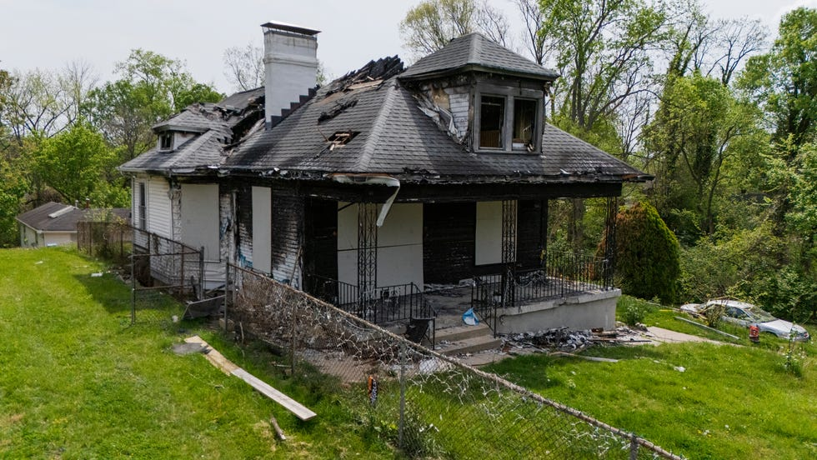

As Cincinnati firefighters battled flames tearing through a century-old home in Spring Grove Village, three people were trapped inside. One was on the phone with 911.
For 10 minutes, as firefighters searched the house from the basement up, an emergency call taker was on the phone with 32-year-old Sol Archambault, who said they were trapped in an upstairs attic-turned-bedroom while their sister and mother were trapped downstairs. Recently released reports and radio traffic reviewed by The Enquirer show that information was not relayed to firefighters at the North Edgewood Avenue home until it was too late. By the time firefighters found the trapped people, two were already dead, and Archambault was unconscious and later died from smoke inhalation. From the first minutes after an initial 911 call came in – when 68-year-old Mary Ann Schwartz ran back inside her home to rescue her two adult children, Sol and 22-year-old Aislynne, who had Down syndrome – there were discrepancies in what information was shared on the radio the night of Jan. 17.

When citizens call 911, they are connected with a trained call taker who gathers basic information and passes it along to a dispatcher. The dispatcher uses that information to decide how many firefighters, police or emergency medical services personnel to send.
Call takers stay on the line with callers, relaying new information to dispatchers as it becomes available, using a computer-aided dispatch system, or CAD. Dispatchers decide what information to relay to firefighters and incident commanders over the radio. In response to questions from The Enquirer, city spokeswoman Mollie Lair said dispatchers did not fail to relay information about Archambault's call. However, Lair admitted there was a delay, attributing it to heavy radio traffic and the volume of information dispatchers were processing that night. The fire chief said it was unclear whether firefighters receiving that information would have changed the outcome. Lair said the investigation confirmed it wouldn’t have. A 911 expert and the fire union president, however, said the information pinpointing the location of people trapped in any fire is crucial.

Records show that once firefighters learned Archambault was on the phone with 911 and trapped in the attic, they located them unconscious four minutes later. They later died.

Dylan Archambault, the sibling who was not home when the fire began, said he was unaware of the communication lapse and he wants to understand exactly what happened. "This is a terrible tragedy," Dylan Archambault said in a statement through his attorney Derek Phipps. "It is deeply concerning that someone could be on the phone with 911 asking for help, while at the same time, responders on the scene are never provided that critical information."

Firefighters pulled back while people were inside

Schwartz called 911 at 7:06 p.m. Jan. 17 and said her children were trapped inside her North Edgewood Avenue home.

Seconds later, the fire was dispatched as a "one alarm," with eight firetrucks and other emergency medical services sent out all at once. Many fires are dispatched as “still alarms,” when the extent is unknown. A one-alarm fire immediately assigns additional resources due to reported severity.

After making the call, Schwartz ran to get neighbors to help rescue her kids and cats, neighbors said. The heat and smoke were too much and they could not follow her inside, according to the fire report.
No smoke detectors were in the home, which was built in 1908, and there were a number of void spaces between the walls, which firefighters say accelerated the flames.

More neighbors called 911 to report that people were trapped in the home. It was not until firetrucks were en route that dispatchers gave an update that there were "possibly two to three victims still inside the residence," according to the fire report.
A minute-and-a-half after the first ladder arrived, Sol Archambault called for help, reporting being alone in the second-floor bedroom.

The 911 call taker stayed on the line with Archambault for 6 minutes until they became unresponsive, making notes in the electronic dispatch file. A dispatcher never relayed the information over the radio. During that time, the fire department pulled back and took a more defensive approach to the fire, citing extreme heat, live downed electrical wires and fire conditions.

Another minute passed. A dispatcher asked on the radio whether anyone was still inside the home. The incident commander responded that it had not been confirmed.
It had been 7 minutes since Archambault first said they were trapped inside.
Three minutes later, a commander with access to dispatch notes asked the dispatcher for clarification.

"Are you getting calls from potential occupants inside this building on floor 2?" the commander asked.

"Command, getting ready to relay, 4684 North Edgewood Avenue has someone calling that they're stuck on the second-floor bedroom," a dispatcher replied.
Four minutes later, and 14 minutes after Archambault called 911, firefighters pulled them out of the building, unresponsive, and transported them to the hospital. Archambault later died of acute carbon monoxide poisoning, according to the Hamilton County Coroner's Office.

Timeline: Spring Grove Valley fire

Three people were killed in a fire on North Edgewood Avenue the night of Jan. 17.

There is a 10 minute period when a 911 dispatcher did not relay to firefighters on scene that a person was on 911 telling them they were trapped inside the home.

Four minutes after firefighters learned of the call, one person was taken out of the home unconscious, and later died.

7:06:29 p.m.
First 911 call comes in.

7:08:02 p.m.
Firefighters are first told people possibly are trapped inside the home.

7:11:31 p.m.
The first ladder arrives at the home.

7:12:25 p.m.
Sol Archambault calls 911 and says they are trapped in the home.
7:15:06 p.m.
The fire department retreats from the home because of heavy fire conditions and begins attacking the fire from the outside.

7:18:14 p.m.
The calltaker on the phone with Sol reports they have gone unresponsive.

7:19:17 p.m.
Firefighters report that it's unconfirmed whether anyone is still inside the home.

7:22:06 p.m.
A commander on scene asks whether a dispatcher is on the phone with Sol. Dispatch confirms they are.

7:26:21 p.m.
Firefighters retrieve Sol, unconscious, from a second floor window.

7:43:29 p.m.
Still searching for Mary Ann and Aislynne.

7:56:00 p.m.
All firefighters retreat from the home again and return to fighting the fire from the outside.

8:38:41 p.m.
Firefighters locate both Mary Ann and Aislynne inside the home, already dead.
Source: Cincinnati Computer Aided Dispatch (CAD) reports

The fire continued to spread. Firefighters retreated and resumed a defensive approach, putting out the fire from the outside. About an hour-and-a-half after the fire was called in, firefighters found Schwartz and Aislynne Coffaro dead on the first floor.

Fire chief: Cannot assume info 'could've changed the outcome'

Cincinnati Fire Chief Frank McKinley said after a February meeting that it's the department's standard operating procedure to search for victims inside a burning building, regardless of if they are informed someone is inside.

"I think it's unfair to just assume that because the information wasn't relayed that contributed to the cause of death or could've changed the outcome," McKinley said in response to a question about whether firefighters knew someone was trapped in the building when they arrived. "I don't feel like any of us are in a position to say for certain if it did or if it didn't."

Lair said in an April statement that the call taker on the phone with Archambault followed the city's protocols. She praised the call taker's actions, saying they "did an exemplary job in providing the caller with instructions appropriate for a person trapped in a fire."
The Enquirer requested recordings of all 911 calls related to the fire in February but did not receive them prior to publication.

Joe Elliott, fire union president, said that even though immediately searching for trapped people is part of firefighters' training, information about where a person might be is crucial.
Firefighters rely on call takers to relay information to dispatchers so they can decide what emergency personnel on scene need to know, he said.

The communication lapse bears similarities to those in the 2018 death of 16-year-old Kyle Plush after he was trapped inside his parked minivan. In Plush's case, the family alleged the 911 call taker failed to share critical information with police about his need for immediate help, which contributed to his death.
The city eventually settled with Plush's family for $6 million and pledged to make improvements to the 911 center.

Lair said dispatch procedures state that dispatchers should read "all pertinent incident text, such as information concerning persons trapped in a fire or life safety information."

Knowing a trapped person’s exact location inside a building is "incredibly pertinent," said John Melcher, a former CEO of the largest 911 program in North America and an expert hired in the Plush case.

"Basic 911 standards state that's valuable information," Melcher said. "First responders can only act with the information that they're given."

'Time is always of the essence.'

Three months after the fire, a collection of candles, flowers and Christian statutes memorializing Mary Ann, Aislynne and Sol rest in front of the burned home.

Lair said no changes to protocol had been made because of the fire and no disciplinary action was taken against the call taker, dispatcher or dispatch supervisor, all of whom have been employed by the city for multiple years.
McKinley said in February the department is always looking to improve communication between dispatchers and firefighters.

"As a firefighter, as someone who's come up through the system, I love to have as much information as possible as quickly as possible," McKinley said.
Elliott, the union president, said that while dispatchers often process a surge of information through the system and over the radio, reports of trapped occupants stand apart in importance and should always be relayed as an urgent message.

Melcher said that busy radio traffic is not an excuse for not relaying information. Radio traffic tends to be busy during an emergency, he said.

"Time is always of the essence," Melcher said. "That's what 911 is all about."

See Feb. 24, 2026 article: Fire Chief Addresses Concerns After Triple Fatal Fire In Spring Grove Village. [TV VIDEO.] https://www.fox19.com/2026/02/24/fire-chief-addresses-concerns-after-triple-fatal-fire-spring-grove-village/

CINCINNATI (WXIX) - Cincinnati Fire Chief Frank McKinley addressed City Council Tuesday about a troubling trend: a 500% increase in deadly fires this year.
One of those fires happened on North Edgewood Avenue Jan. 17, killing Mary Ann Schwartz and her two children, Sol Archambault and Aislynne Coffaro.
After that meeting, McKinley addressed internet rumors that dispatch failed to relay critical information to firefighters arriving on scene, saying conversations are being held about communication between crews and dispatch.

“We’ve had conversations of what was said, what wasn’t said, and when it was said,” McKinley explained. “We’ve had conversations with ECC. Would it have changed the outcome? The response I’ve provided is we have standard operating procedure.”

Chief McKinley said they approach every fire scene by assuming that someone is trapped inside

He said crews immediately do a primary rapid search of the building and have a standard response model regardless of whether there is a known victim.

“I think it’s unfair to assume because the information wasn’t relayed, it contributed to the cause of death or could’ve changed the outcome. I don’t think any of us are in a position to say if it did or didn’t,” he said.

Chief McKinley said after the switch from fire dispatch to the 311 system, they are working on communication differences, but he can’t say if any changes had an impact on the fatal fire.

“The more information we can get, the better, but there hasn’t been any changes in the dispatch that could surely change the outcome of a structure fire that we responded to,” he explained.
The city continues its investigation into the fire as the fire department and dispatch continue their dialogue.
.
Copyright 2026 WXIX. All rights reserved.

April 16, 2026: MD - Md. County Budget Adds 12 Battalion Chiefs To Boost Fireground Command, Safety. Baltimore County’s $3M investment would more than double battalion chief staffing. Baltimore County Executive Kathy Klausmeier’s proposed budget will include more than $3 million to add 12 battalion chiefs to the county fire department — a move she says will speed command response and improve safety as call volumes surge. Baltimore County Executive Kathy Klausmeier’s proposed budget will include more than $3 million to add 12 battalion chiefs to the county fire department — a move she says will speed command response and improve safety as call volumes surge. The county fire department has long been shorthanded on battalion chiefs, who are responsible for overseeing operations at the scene of a fire, directing crews, and making decisions to keep firefighters and the public safe. Klausmeier said the number of battalion chiefs has been reduced since 2000, leaving fewer leaders across one of Maryland’s largest counties.
That year, Baltimore County slashed its number of fire districts from five to three, leaving only three field battalion chiefs on duty at any time, according to previous reporting in The Baltimore Sun. At the time, fire officials criticized the staffing changes and raised safety concerns, while higher-ranking officials contended that the time to respond to incidents would not be significant. https://www.firerescue1.com/incident-command/md-county-budget-adds-12-battalion-chiefs-to-boost-fireground-command-safety?utm_source=Sailthru&utm_medium=email&utm_campaign=FR1-Daily-4-16-26&utm_term=FR1%20Daily

April 14, 2026: MI - Mich. Firefighters Sue, Allege Retaliation After Backing Fire Chief After Church Attack. [TV VIDEO] Four part-time Grand Blanc firefighters say township officials blocked them from full-time jobs after they supported Fire Chief Jamie Jent following the deadly September 2025 attack on a Mormon church. GRAND BLANC TOWNSHIP, Mich. — Four part-time Grand Blanc Township firefighters are suing the township and its superintendent, alleging they were retaliated against after they advocated for the fire chief to keep his job following the September 2025 attack on a Mormon church.
Fire Chief Jamie Jent was placed on administrative leave and briefly considered for termination in the month after a gunman on Sept. 28 drove into the township’s Church of Jesus Christ of Latter-Day Saints, killing four and burning the building to the ground. Jent said he was placed on leave after he refused to take part in a “unified front” with the township’s Board of Trustees about fire department staffing and response. https://www.firerescue1.com/legal/mich-firefighters-sue-allege-retaliation-after-backing-fire-chief-after-church-attack?utm_source=Sailthru&utm_medium=email&utm_campaign=FR1-Daily-4-14-26&utm_term=FR1%20Daily

April 7, 2026: WA - WA Fire Department Sued For Using Positive Pressure Ventilation In ’23 Ship Fire. [TV VIDEO.] A commercial fishing ship moored at the Port of Tacoma burned for over a week in April 2023, prompting fears of fuel and oil spills and temporarily requiring northeast Tacoma neighborhoods to shelter in place.
Ultimately, there was no spillage, according to the U.S. Coast Guard, but the Kodiak Enterprise was a total loss. Its owner, Trident Seafoods Corp., thanked the agencies that responded to the fire and subsequent environmental hazard. Three years later, Trident is casting blame for the blaze’s spread, which it claims led to damages likely north of $100 million. https://www.fireengineering.com/firefighting/tacoma-wa-fire-department-sued-for-ppv-in-23-ship-fire/

April 3, 2026: CT – “We look forward to making our case in court”: Conn. Volunteer FDs End Mediation, Say Lawsuits Against City Will Continue. The Yantic, Taftville, Laurel Hill and Occum volunteer departments say Norwich officials did not negotiate in good faith over the city’s unified command policy…. The statement said despite the departments’ best efforts, the city, led by City Manager John Salomone and City Fire Chief Sam Wilson, has not come to the table in good faith, and has not presented any meaningful solutions for the volunteer departments and Norwich taxpayers.” One month ago, attorneys for the departments and the city agreed to enter the mediation in an attempt to resolve their ongoing feud rooted in the city’s August 2025 establishment of Unified Command policy. This led to separate lawsuits filed on behalf of the four departments by Attorney Mark Kovack.
The policy established a single command structure with Wilson at the top, and standardized training, communications and emergency response protocols for both paid and volunteer fire services in the city. https://www.firerescue1.com/legal/we-look-forward-to-making-our-case-in-court-conn-volunteer-fds-end-mediation-say-lawsuits-against-city-will-continue?utm_source=Sailthru&utm_medium=email&utm_campaign=FR1-Daily-4-3-26&utm_term=FR1%20Daily

April 3, 2026: MO - Mo. Fire Chief To Implement New Search Guidelines After Family Finds Body Days After Fire. [TV VIDEO.] Mid County Fire Chief Randell Sanders says new search protocols are coming after firefighters failed to find Wayne Vann in his burned home. WELLSTON, Mo. — Firefighters searching a burned Wellston home failed to locate a victim during two seperate search operations, leaving the family to later find his remains, according to KSDK. For nearly 48 hours after the Feb. 24 fire, Wayne Vann’s family was told no one had been found. Mid County Fire Protection District Chief Randell Sanders said the department has since launched an internal review and is implementing changes to its search procedures. In an April 1 interview with KSDK, Sanders discussed the department’s search efforts and their limitations. https://www.firerescue1.com/sogs/mo-fire-chief-to-implement-new-search-guidelines-after-family-finds-body-days-after-fire?utm_source=Sailthru&utm_medium=email&utm_campaign=FR1-Daily-4-3-26&utm_term=FR1%20Daily

March 27, 2026: CA – Getting Out In 4 Minutes: Audit finds San Diego FD Response Delays After 2019 Dispatch Change. SAN DIEGO — San Diego firefighters failed to meet emergency response time goals for three years straight in part because of a new dispatch protocol established in 2019 without City Council review, a troubling new city audit finds.
A new city audit says a 2019 triage protocol helped slow firefighter turnout, contributing to missed emergency response goals across San Diego for three years in a row…. From 2012 to 2018, city fire crews began prepping for dispatch almost immediately after an emergency call came in. But in 2019, fire officials shifted the protocol to waiting until a call went through a triage analysis. After dispatchers evaluate calls, they divide them into three categories: Level 1 calls like heart attacks and gunshot victims, less urgent Level 2 calls that don’t include imminent threats to life and even less serious Level 3 calls that often don’t require immediate attention at all. Ambulances, which are operated by private contractors Falck USA and American Medical Response but dispatched by the city, travel to all emergencies. Firefighters go only to Level 1 calls. From 2012 to 2018, fire crews would prepare for all calls and often head out and then get called back if the call was eventually deemed Level 2 or Level 3. https://www.firerescue1.com/fire-department-management/getting-out-in-4-minutes-audit-finds-san-diego-fd-response-delays-after-2019-dispatch-change?utm_source=Sailthru&utm_medium=email&utm_campaign=FR1-Daily-3-27-26&utm_term=FR1%20Daily

March 26, 2026: LA - Video: Delays, Missed Rescue Under Scrutiny In La. Fire That Killed 4. Shreveport fireground video and interviews detail response issues, delayed search and communication breakdowns, as lawsuits allege firefighter actions and dispatch errors contributed to four deaths…. Kennedy acknowledged he was not fully geared up when the crew arrived, saying he put on only the lower portion of his bunker gear while en route and did not finish dressing until they reached the scene. He also said he realized at the front of the house that he did not have his helmet and noted that the mistake had happened before…. One lawsuit, filed by Shereka Garner, alleges she told 911 dispatchers that four people were inside the home, but that information was not immediately relayed to responding crews. The complaint says a supervisor later acknowledged the dispatcher made a mistake and added the information only after a delay. [Also filed, Chap. 16.]
https://www.firerescue1.com/fireground-operations/video-delays-missed-rescue-under-scrutiny-in-la-fire-that-killed-4?utm_source=Sailthru&utm_medium=email&utm_campaign=FR1-Daily-3-26-26&utm_term=FR1%20Daily

YouTube: Fatal Fire Lawsuits - https://www.youtube.com/watch?v=KBAWG_eNEwo

March 26, 2026: GA - NIOSH Report Reveals Critical Failures In GA Warehouse Fire LODD. A federal review off a 2025 warehouse fire in DeKalb County found that a raft of problems, ranging from a lack of sprinklers to questionable tactics and task saturation, contributed to the death of a firefighter. NIOSH Fire Fighter Fatality Investigation and Prevention Program examined the September 8, 2025, line-of-duty death of a DeKalb County Fire Rescue Master Firefighter Preston Fant, 53. The incident began as a reported business fire at a warehouse. The first in crew encountered heavy smoke from the eaves and made an offensive interior attack. The fire, initially ventilation-limited, exploded when crews began cutting garage doors for ventilation before a sustainable water supply was established.
What followed were two Mayday calls. The first occurred when a firefighter got knocked down by a hose stream and became disoriented trying to exit the building. His exit was further hindered by other firefighters leaving the building and removing the hose line as they went, leaving him without a hose to guide him out. The second Mayday occurred when a firefighter sent in to respond to the first Mayday became disoriented. Fant, a 21-year veteran firefighter, was pulled from the fire building about 20 minutes after he entered to search, but was pronounced dead at the hospital due to smoke inhalation. [Also filed, Chap. 2.]
https://www.fireengineering.com/firefighting/niosh-report-reveals-critical-failures-in-ga-warehouse-fire-lodd/?utm_source=fe_daily_newsletter&utm_medium=email&utm_campaign=2026-3-26&oly_enc_id=0573H1103045H2E

March 24, 2026: CA - Officials Considered Warning Altadena (CA) Before Eaton Fire, but No Alert Was Sent. Almost two hours before the Eaton fire broke out in the San Gabriel foothills Jan. 7, 2025, Los Angeles County emergency management officials had been pushed to send out an emergency alert to warn residents that increasingly high winds would pose a significant risk. But no such alert was sent. The residents of est Altadena did not receive an emergency alert until 3:30 a.m. the next day, nine hours after the fire started — and almost 12 hours after an emergency management employee urged a prefire alert. All but one of the Eaton fire’s 19 deaths occurred in west Altadena…. In a statement, L.A. County’s Office of Emergency Management defended its decision not to send out a prefire wireless emergency alert, saying it was not warranted before the fire started because the wind event was not a “specific life-safety incident requiring an immediate protective action,” for which such alerts are reserved. https://www.fireengineering.com/fire-safety/officials-considered-warning-altadena-ca-before-eaton-fire-but-no-alert-was-sent/?utm_medium=email&utm_source=fe_daily_newsletter&utm_campaign=2026-3-24&oly_enc_id=0573H1103045H2E

March 16, 2026: LA - Lawsuit Alleges Communication Failures, Delayed Rescue In Deadly LA House Fire. [TV VIDEO.] A new lawsuit filed in connection with a deadly 2025 house fire in Shreveport alleges critical communication failures and delays in rescue efforts by emergency responders. The fire on Kemp Lane killed 56-year-old Eureka Garner, 84-year-old Mildred Carter-Rawls, 7-year-old Tayona Robinson, and 5-year-old Ne’vaeh Garner.
The lawsuit, filed in Caddo District Court by the sons of Carter-Rawls, names the City of Shreveport and the Shreveport Fire Department. It claims a breakdown in communication led to a delayed rescue attempt, KSLA reports. According to the suit, the children’s mother called 911 and told dispatchers her children were inside the burning home. However, the initial dispatch reportedly described the incident as a “possible” house fire without indicating that occupants were trapped inside. https://www.fireengineering.com/firefighting/lawsuit-alleges-communication-failures-delayed-rescue-in-deadly-la-house-fire/?utm_source=fe_daily_newsletter&utm_medium=email&utm_campaign=2026-3-18&oly_enc_id=0573H1103045H2E

Feb. 19, 2026: 4 Conn. FDs file lawsuit after officials close volunteer fire department.
Yantic, Taftville, Occum and Laurel Hill departments allege the Norwich city manager and fire chief exceeded their authority by imposing a unified command policy. NORWICH, Conn. — Four of the city’s five volunteer fire departments are suing the city, charging that City Manager John Salomone and City Fire Chief Sam Wilson exceeded their authority last August by establishing the Unified Command policy last summer…. Among other things, it alleges that Wilson does not possess the blanket power, authority, or right to order, direct, command, suspend, remove, eliminate, supersede, subordinate or otherwise control” the city’s five volunteer departments. https://www.firerescue1.com/legal/4-conn-fds-file-lawsuit-after-officials-close-volunteer-fire-department?utm_source=Sailthru&utm_medium=email&utm_campaign=FR1-Daily-2-19-26&utm_term=FR1%20Daily

Feb. 17, 2026: CA - LAPD Oversight Board Approves $2.1M Donation To Expand Drone Program. The Los Angeles Police Department’s civilian oversight board has given the green light to a $2.1 million donation to expand the force’s fleet of aerial drones.
The department’s “Drone as First Responder” pilot — which sends drones to 911 calls before officers arrive — was bolstered by the $2.1 million gift from the LA Police Foundation. The money approved by the Board of Police Commissioners would pay for additional drones, docking stations and installation costs at police facilities across the city. The Los Angeles City Council must still vote to formally accept the money before the LAPD can spend it. In a report to the Police Commission, Assistant Chief Emada Tingirides wrote that the department plans to combine the private donation with a separate $1.8 million retail theft grant. https://nypost.com/2026/02/17/us-news/lapd-oversight-board-approves-2-1m-donation-to-expand-drone-program/

Feb. 6, 2026: WHITE HOUSE - PROTECTING THE NATIONAL SECURITY AND WELFARE OF THE UNITED STATES AND ITS CITIZENS FROM CRIMINAL ACTORS
AND OTHER PUBLIC SAFETY THREATS. By the authority vested in me as President by the Constitution and the laws of the United States of America, including 6 U.S.C. 122(a)(2), it is hereby ordered:
Section 1. Policy. It is the policy of the United States to protect its welfare and security, and the welfare and security of its citizens, from criminal actors. Such criminal actors may include foreign nationals with criminal histories who have entered or remained in the United States in violation of the immigration laws of the United States or who otherwise seek to violate the criminal laws of the United States. It is also the policy of the United States to cooperate with trusted foreign governments by sharing information concerning convicted felons on a reciprocal basis for border security and immigration purposes. *** Sec. 3. Exchanging Felony Conviction Records with Visa Waiver Program and Other Countries for Border Security and Immigration Purposes. (a) The Secretary of Homeland Security may exchange, to the maximum extent permitted by law, CHRI with the border security and immigration authorities of Visa Waiver Program (VWP) countries, countries that have entered into a Preventing and Combating Serious Crime or similar agreement with the United States, and other trusted allies, under an agreement or arrangement described in subsection (b) of this section. The Secretary of Homeland Security may provide this information to these countries for the sole purpose of screening travelers and immigrants seeking to enter or stay in the VWP or other country. https://www.whitehouse.gov/presidential-actions/2026/02/protecting-the-national-security-and-welfare-of-the-united-states-and-its-citizens-from-criminal-actors-and-other-public-safety-threats/

Jan. 7, 2026: Can You Still Use Your DJI or Autel Drone in 2026? There's been a lot of online noise suggesting that Chinese-made drones are now completely banned and grounded in the United States. In reality, the regulatory landscape is much more specific and nuanced…. What Still Remains Legal
Contrary to some alarmist headlines, the FCC's action does not retroactively force existing drones out of the sky.
You can continue to use drones you already own. The FCC's fact sheet explicitly states that this decision does not impact a consumer's ability to continue using drones they previously purchased or acquired.
Retailers may still sell or import models approved before the Covered List update. Existing FCC-authorized models can still be legally marketed and sold.
If you were flying DJI or Autel drones before December 22, 2025, nothing about the FCC's Covered List action prevents you from continuing to operate them. That includes both recreational flying and commercial use under FAA Part 107 rules.
So What Does "No New FCC Authorization" Really Mean?
Future hardware, new releases, and next-generation drones from foreign producers won't be entering the U.S. market unless the Department of Defense or Department of Homeland Security specifically determines they pose no national security risk.
https://www.terrestrialimaging.com/blogs/news/can-you-still-use-your-dji-or-autel-drone-in-2026?srsltid=AfmBOoqI_d0QLMzLFm1T5YukWmbzHCIZXncjd7b7fS5PZpqWsY2ifHl2

Jan. 7, 2026: TX - TX County Terminates Contract With Department After Failure o Go Interior In Fatal House Fire. [TV VIDEO.] Hunt County has terminated its contract with the Quinlan Volunteer Fire Department after two incidents in 2025. In one case, firefighters were ordered not to go interior and search for victims at a fatal house fire in March. In a second incident, the department lost a rig in a rollover accident that injured two firefighters. The decision affects fire response in unincorporated areas of the county, where the volunteer department has served under contract. County commissioners voted 3-2 to terminate the contract after hearing from a number of members of the department and other first responders who asked that the contract remain in force, as well as critics of the department. The decision comes against a backdrop of county efforts to establish a regional fire district. https://www.fireengineering.com/firefighting/tx-county-terminates-contract-with-department-after-failure-to-go-interior-in-fatal-house-fire/?utm_source=fe_daily_newsletter&utm_medium=email&utm_campaign=2026-1-7&oly_enc_id=0573H1103045H2E

Dec. 30, 2025: FEMA – In a Historic Announcement, FEMA Rapidly Awards $250 Million to Secure U.S. Skies Ahead of the FIFA World Cup 2026.
Today, the Federal Emergency Management Agency (FEMA) awarded $250 million to the 11 states hosting FIFA World Cup 2026 matches and to the National Capital Region through the new Counter Unmanned Aircraft Systems (C-UAS) Grant Program. Recipients can use this money to strengthen their ability to detect, identify, track, or mitigate unmanned aircraft systems, also known as “drones.” This program aligns with the Trump-Vance Administration’s initiative to protect the public from hostile drones during mass gathering events, as outlined in the Executive Order on Restoring American Airspace Sovereignty. https://www.dhs.gov/news/2025/12/30/historic-announcement-fema-rapidly-awards-250-million-secure-us-skies-ahead-fifa

Dec. 18, 2025: CA - Failed Emergency Alerts During L.A. Firestorms Eroded Public Trust. How To Fix A Broken System? During the first days of the January firestorms, Los Angeles became a case study in what can go wrong with emergency alerts and evacuations.
In Pacific Palisades there was chaos Jan. 7 as people in the foothills tried to flee, only to hit traffic gridlock. Then when the Eaton fire erupted in Altadena, evacuation orders did not go out to residents of the west side until five hours after flames began to threaten homes in the area. All but one of the 19 people confirmed dead in the Eaton blaze were on the west side. Two days later a wireless evacuation warning intended for residents near a new fire near Malibu Canyon mistakenly was blasted out across a metropolitan area of 10 million people. Officials sent out a correction about 20 minutes later, but a stream of erroneous alerts continued to buzz phones throughout the night and following morning, stoking confusion and panic in communities 40 miles from any active fire. https://www.fireengineering.com/firefighting/wildland-firefighting/failed-emergency-alerts-during-l-a-firestorms-eroded-public-trust-how-to-fix-a-broken-system/?utm_source=fe_daily_newsletter&utm_medium=email&utm_campaign=2025-12-18&oly_enc_id=0573H1103045H2E

Dec. 17, 2025: CA - ‘Both Sides Botched It.’ L.A. Mayor, In Unguarded Moment, Rips Responses To Palisades, Eaton Fires. The setting looked almost cozy: Los Angeles Mayor Karen Bass and a podcast host seated inside her home in two comfy chairs, talking about President Trump, ICE raids, public schools and the Palisades fire.
The recording session inside the library at Getty House, the official mayor’s residence, lasted an hour. Once it ended, the two shook hands and the room broke into applause.
Then, the mayor kept talking — and let it rip. Bass gave a blunt assessment of the emergency response to the Palisades and Eaton fires. “Both sides botched it,” she said.
She didn’t offer specifics on the Palisades. But on the Eaton fire, she pointed to the lack of evacuation alerts in west Altadena, where all but one of the 19 deaths occurred.
“They didn’t tell people they were on fire,” she said to Matt Welch, host of “The Fifth Column” podcast. The mayor’s informal remarks, which lasted around four minutes, came at the tail end of a 66-minute video added to “The Fifth Column’s” YouTube channel last month. In recent weeks, it was replaced by a shorter, 62-minute version — one that omits her more freewheeling final thoughts. https://www.fireengineering.com/firefighting/wildland-firefighting/both-sides-botched-it-l-a-mayor-in-unguarded-moment-rips-responses-to-palisades-eaton-fires/?utm_source=fe_daily_newsletter&utm_medium=email&utm_campaign=2025-12-16&oly_enc_id=0573H1103045H2E

Dec. 14, 2025: NY - Private Equity Finds A New Source of Profit: Volunteer Fire Departments
Rural departments have long relied on cheap software solutions to keep their operations running. But fire chiefs report sharp price increases as investors have entered the market. The Norfolk Volunteer Fire Department operates on an annual budget of $132,000, barely enough to sustain its aging rigs, train unpaid crews and keep the lights on at the station in the hills of northern Connecticut. Not long ago, it faced a different kind of emergency: The software system it relied on to track detailed incident information was no longer going to be usable. A company backed by private equity investors, ESO Solutions, had acquired the platform and planned to shut it down. The alternative software it was offering would raise the community’s costs from $795 per year to more than $5,000…. Much of the software used by firefighters and other emergency responders was initially created by people who worked in those fields and felt a calling to keep prices affordable. But now fire chiefs around the country are scrambling to manage shrinking options and soaring costs as corporations flush with cash from Wall Street have raced to dominate the market…. The federal government is poised to transition in the next few weeks from a data reporting standard known as the National Fire Incident Reporting System (NFIRS) to a new system known as the National Emergency Response Information System (NERIS). https://www.nytimes.com/2025/12/14/us/fire-department-software-private-equity.html?nl=The+Morning&segment_id=212385

Dec. 12, 2025: CA - Officials Reveal Mistakes That Impacted CA Refinery Fire Response. New details emerged this week about the massive February fire that erupted at the Martinez Refinery Company and released more than 7,000 gallons of hydrocarbon materials into the air, as officials revealed that oil crews had been using incompatible radio systems that prevented immediate contact with local public safety agencies. While county firefighters arrived on the scene 14 minutes after being notified of a fire at MRC, crews were stalled outside, unable to contact the refinery operators on site – a communication gap that delayed the establishment of a unified command center by nearly two hours. Internal breakdowns like those add to the chronic terror neighbors and businesses face downwind of the refinery, said Heidi Taylor, who lives along its fence line in downtown Martinez. She said she’s seen level-one alerts and “enormous” flaring almost every day for the past month, which was confirmed by Contra Costa County officials. https://www.fireengineering.com/firefighting/officials-reveal-mistakes-that-impacted-ca-refinery-fire-response/?utm_medium=email&utm_source=fe_daily_newsletter&utm_campaign=2025-12-15&oly_enc_id=0573H1103045H2E

Dec. 8, 2025: CA - From Shelter Dogs To Disaster Search Specialists. Through the National Disaster Search Dog Foundation, rescued dogs with extraordinary drive are trained, paired with firefighter handlers and prepared for complex search environments…. She committed to changing that reality through the creation of the National Disaster Search Dog Foundation (SDF) the following year. Today, SDF trains disaster response dogs and their handlers at a 145-acre facility in Santa Paula, California. Teams trained through SDF have deployed to disasters around the world, including most recently to Jamaica after Hurricane Melissa and to Central Texas after the flooding disaster last summer…. Over the years, the foundation has grown and expanded and now includes many individual and corporate donors that support the facility and a paid staff of 35 full-time employees. https://www.firerescue1.com/search-rescue/from-shelter-dogs-to-disaster-search-specialists?utm_source=delivra&utm_medium=email&utm_campaign=FR1-Daily-12-8-25&utm_id=9952943&dlv-emuid=fed355b8-46a2-4fa4-b55c-4d602dde33c4&dlv-mlid=9952943

National Disaster Search Dog Foundation
6800 Wheeler Canyon Road
Santa Paula, CA 93060
(888) 4K9-HERO
(888) 459-4376
https://www.searchdogfoundation.org/

Dec. 4, 2025: CA - Cal Fire Drones Take Flight In Emergency Prevention And Response. When a photographer donated two drones to Cal Fire’s San Benito-Monterey Unit in 2021, the act of generosity launched a drone program that would break records and save lives. A team of Cal Fire drone pilots uses specialized technology to conduct prescribed burns, search for missing or injured individuals and keep emergency responders safe. … The program now boasts 19 aircraft, ranging from drones that cost a couple hundred dollars to the team’s five $100,000 specialized drones. The fleet of flying Swiss Army knives provides the team with high-zoom and wide-angle cameras, thermal imaging, aerial ignition capabilities and 88-pound cargo capacity. These tools aid in wildfire management, search and rescue, crowd management and risk reduction for first responders. When it comes to fighting fire, drones serve several functions. Pilots monitor thermal cameras to help crews battle wildfires through real-time fire hot spot detection. Meanwhile, high-resolution aerial mapping can identify areas of highly flammable material and complete pre- and post-fire surveys of land to inform future fire prevention efforts, including those recently conducted in the Del Monte Forest. One of the program’s most innovative uses of drones is aerial ignition. The team uses combustible balls known as Dragon Eggs to strategically start small fires to slow the spread of larger fires, particularly in areas not safely accessible by fire crews. “We’re able to alleviate a lot of that risk using the technology,” says Silveira. Specialized drones carry up to 450 Dragon Eggs, which resemble Ping-Pong balls and ignite through a chemical reaction between potassium permanganate and glycol. The team also hosts the National Aerial Ignition Academy in the Santa Lucia reserve, providing aerial ignition training. https://www.fireengineering.com/firefighting/wildland-firefighting/cal-fire-drones-take-flight-in-emergency-prevention-and-response/?utm_source=fe_daily_newsletter&utm_medium=email&utm_campaign=2025-12-4&oly_enc_id=0573H1103045H2E

See also: Dec. 9, 2025. “This Is The Future Of War…. In November a smaller start-up, Anduril, founded by the Oculus inventor Palmer Luckey, won an Army contract to provide the service with an A.I.-powered drone defense program. The company’s software is designed to organize information from radars and other detection systems so that humans can target and destroy enemy drones faster and more effectively. On Oct. 31 over the Mojave Desert, the firm flew a dart-shaped drone, called Fury, in a first test of its A.I.-controlled flight. The Pentagon hopes eventually to field a fleet of 1,000 robotic wingmen that will fly alongside traditional fighter jets into battle with the ability to dogfight with other aircraft, perform reconnaissance and conduct electronic warfare.” https://www.nytimes.com/interactive/2025/12/09/opinion/editorials/us-china-military-ai-tech.html?nl=Breaking+News

Dec. 2, 2025: DC – U.S. Department of Homeland Security – Science & Technology Directorate - Feature Article: Taking Nefarious Drones Out of the Fight. The Science and Technology Directorate (S&T) continues to collaborate with government, industry, and academic partners to study the effects of kinetic Counter-Unmanned Aircraft Systems (C-UAS) mitigation methods. A test team was deployed to North Dakota over the summer to evaluate the capabilities of several systems that can deny and defeat the UAS threat…. During the event, 10 companies demonstrated capabilities across four categories: Global Navigation Satellite System jamming, handheld weapon-fired munitions, directed energy weapons, and drone-on-drone counter systems, including keynote demonstration of the Epirus High Power Microwave system. Testing the potential for domestic usage is critical because, “Keeping the public safe many times means that the systems and methodologies used by the military in a war zone are not going to be appropriate for us to use domestically or in a law enforcement situation,” said S&T Project Manager Andy Myers…. Engineers from private sector partners engaged drones with lasers and other capabilities. Participants included CACI, DroneShield, the Naval Surface Warfare Center, Crane Division (NSWC Crane), Plumb Precision Products, Lockheed Martin & IPG Photonics, Epirus, Skyborne Technologies, Transcend Air, Askari Defense, and BlueHalo. https://www.dhs.gov/science-and-technology/news/2025/12/02/feature-article-taking-nefarious-drones-out-fight

Nov. 17, 2025: IL - IL Firefighter’s Widow Awarded $31.5M; Jury Says Command Lapses Contributed to Death. A Whiteside County jury has awarded $31.5 million to the widow and two young daughters of a Sterling firefighter killed in the line of duty four years ago.
The verdict in favor of Brittney Ramos, suing in connection with the December 2021 death of her husband, Lt. Garrett Ramos, found that former Rock Falls Fire Chief Cris Bouwens and Rock Falls Fire Chief Ken Wolf, who was a deputy chief at the time of the fire, were each 50% to blame for Ramos’ death. The city of Rock Falls also was a defendant in the case. The verdict came in about 4:20 p.m., just three hours after the jury began its deliberations. Over seven days of testimony, the jury listened to evidence to determine if the two Rock Falls fire officials should be found liable for on-scene decisions they made in the hours after the fire broke out late Dec. 3, 2021, at 10031 Ridge Road in Rock Fall. The fire, which started in the one-story home’s garage, was called in to dispatchers at 11:04 p.m. Dec. 3, with Ramos arriving at the scene with a Sterling fire crew to assist the Rock Falls department. Ramos, who had been fighting the fire from inside the burning home, was heading out of the home to get his air supply replenished when he fell through a hole in the floor and into the basement about midnight Dec. 4, about an hour after the fire began. He was able to issue two mayday calls from the basement — a basement that fire officials did not know existed at the time. Command officers heard the mayday calls, but did not know who was issuing them, where the firefighter was located, or what the problem was. They initially identified another firefighter as being the one they thought was missing; when he was found, no further work was done to make sure no one else had made the call, according to testimony.

***

During closing statements on Friday morning, Ramos’ attorney Michael Gallagher asked the jury to consider a string of failures as it weighed the evidence:
—Bouwens’ failure to ask the residents of the home, who were on scene, if there was a basement. Firefighters did not learn the home had a basement until after receiving mayday calls from a fallen firefighter at 12:03 a.m. Not knowing there was a basement put firefighters who were working the interior of the burning structure at risk because of potential floor collapse and holes developing.
—Bouwens’ failure to appoint a safety officer, as soon as a senior trained official was available, to oversee the scene. Ramos’ attorneys have said former Dixon Rural Fire Chief Sid Aurand arrived at the scene at 11:40 p.m., but Bouwens didn’t appoint Aurand as safety officer until three minutes after two mayday calls were heard at 12:03 a.m.
—Failure to withdraw interior firefighters from the burning home in a timely manner as fire conditions worsened. The fire initially began in the unattached garage. Throughout the next hour, firefighters battled a blaze that had spread into and across the home’s attic, with fire apparent to firefighters as they used tools to pull down ceilings as they worked to save the property. All residents were out of the home safely, yet firefighters were sent back into the burning structure as trusses were falling and holes were developing in the floor.
—Failed to initiate a personnel accountability report in a timely manner so that all firefighters were accounted for.
—Failure to administer PAR properly.
—Failure to properly train for mayday calls and PAR response. [Also filed, Chapter 2.]
https://www.fireengineering.com/firefighting/il-firefighters-widow-awarded-31-5m-jury-says-command-lapses-contributed-to-death/?utm_source=fe_daily_newsletter&utm_medium=email&utm_campaign=2025-11-17&oly_enc_id=0573H1103045H2E

See also: Nov. 14, 2025: IL - Attorneys Clash Over Basement, Go/No-go And Mayday In Ill. LODD Trial..
https://www.firerescue1.com/fireground-operations/attorneys-clash-over-basement-go-no-go-and-mayday-in-ill-lodd-trial?utm_source=delivra&utm_medium=email&utm_campaign=FR1-Daily-11-14-25&utm_id=9812847&dlv-emuid=fed355b8-46a2-4fa4-b55c-4d602dde33c4&dlv-mlid=9812847

See also: Nov. 7, 2025: IL - ‘Chief, we have a mayday': Incident Command Scrutinized In Ill. LODD Trial. [TV VIDEO.} https://www.firerescue1.com/legal/chief-we-have-a-mayday-incident-command-scrutinized-in-ill-lodd-trial

See also: March 8, 2022 - Illinois OSHA report: INSPECTION #: 1567974 REPORT The Ridge Incident: Firefighter Dies in House Fire After First Floor Collapse and Loss of Accountability. https://labor.illinois.gov/content/dam/soi/en/web/idol/laws-rules/safety/documents/ridge-incident-report.pdf
CONTRIBUTING FACTORS Key contributing factors identified in this investigation include: • Basement was not identified during size up. • Interior firefighter teams did not always stay together. • Mayday call was received but caller was not identified or located.
State OSHA poster: https://labor.illinois.gov/content/dam/soi/en/web/idol/documents/Ridge%20Incident%20Poster.pdf

Nov. 12, 2025: CA - Report: LAFD Knew of Firefighter Complaints About Lachman Fire Mop-up And Said Nothing. For months, as victims pleaded for information, the Los Angeles Fire Department kept secret that its firefighters were ordered to stop mop-up operations on a small brushfire that continued to smolder and reignited days later into the massive Palisades fire. At least one department official learned that a battalion chief had directed the firefighters to pack up their hoses and leave the scene of the Lachman fire Jan. 2, even though they complained that the ground was still smoking in places and rocks remained hot to the touch, according to a source who was briefed on the matter in June. But the department did not include that finding, or any detailed examination of the reignition, in its after-action report on the Jan. 7 Palisades fire — or otherwise make the information public — despite victims demanding answers for months about how the blaze started and whether more could have been done to prevent it. https://www.fireengineering.com/firefighting/wildland-firefighting/report-lafd-knew-of-firefighter-complaints-about-lachman-fire-mop-up-and-said-nothing/?utm_source=fe_daily_newsletter&utm_medium=email&utm_campaign=2025-11-12&oly_enc_id=0573H1103045H2E

Nov. 7, 2025: MD – LODD REPORT – Bryce Trossbach, St. Mary’s County Volunteer Fire Service. On June 27, 2023, units from the St. Mary’s County Volunteer Fire Service, along with units from Naval Air Station Patuxent River Air Station Fire Department, were dispatched to a reported house fire at 20521 Deer Wood Park Drive in Leonardtown, Maryland. Recommendation #1: St. Mary’s County must have a defined and accepted policy for completing a 360, which includes physically assessing the basement for evidence of smoke/fire. *** While Chief 1 did not see “obvious” signs of a basement fire from the exterior, he failed to take the time himself or follow up by assigning a specific company to physically assess the basement space, even though there was a working fire in the structure. This was a critical failure. In the interview with Chief 1 noted there was a window on Side Bravo that was intact and was pitch black. The walkout slider on Side Charlie had the same conditions as the Side Bravo window. *** While entering the first floor for fire attack, and shortly after crossing the threshold of the front door, there was a series of catastrophic collapses that led to the first floor collapsing into the basement, leaving Firefighter Trossbach deeply entrapped in the debris. During the initial collapse, at least two individuals were able to quickly grab hold of Firefighter Trossbach for a few seconds before losing their grip on him. https://www.lvfd1.org/files/news/252/Brice%20Trossbach%20LODD%20Final%20Report.pdf

Nov. 5, 2025: CA - Lack Of Coordination Led To Evacuation Delays And Chaos During L.A. Fires: Report. A lack of coordination between the Los Angeles Police Department and the Los Angeles Fire Department contributed to evacuation delays and chaos during the Palisades fire, according to a new after-action report from the LAPD. The Los Angeles Police Department had difficulties coordinating with other agencies during the blaze – namely the Los Angeles Fire Department – and a lack of stable communication channels and technology, according to the report, released Tuesday, Nov. 4. Spanning 92 pages, the report identifies areas for the department to improve “before the next major incident impacts the City of Los Angeles.” https://www.fireengineering.com/firefighting/wildland-firefighting/lack-of-coordination-led-to-evacuation-delays-and-chaos-during-l-a-fires-report/?utm_source=fe_daily_newsletter&utm_medium=email&utm_campaign=2025-11-5&oly_enc_id=0573H1103045H2E

Nov. 2, 2025: CA - Report: Days Before Palisades Fire, Firefighters Were Ordered To Leave Smoldering Burn Site. [TV VIDEO.] LOS ANGELES — Firefighters mopping up a small brush fire that authorities say reignited as the Palisades fire five days later were ordered to leave the original burn scene even though they complained the ground was still smoldering and rocks remained hot to the touch, according to firefighter text messages reviewed by the Los Angeles Times. To the firefighters’ surprise, their battalion chief ordered them to roll up their hoses and pull out of the area on Jan. 2 — the day after the 8-acre blaze was declared contained — rather than stay and make sure there were no hidden embers that could spark a new fire, the text messages said. On the morning of Jan. 7, according to federal authorities, strong winds stoked the remnants of the New Year’s Day blaze into the firestorm that killed 12 people and destroyed thousands of homes in Pacific Palisades, Malibu and Topanga. https://www.fireengineering.com/firefighting/wildland-firefighting/report-palisades-fire-smoldering-lafd/?utm_source=fe_daily_newsletter&utm_medium=email&utm_campaign=2025-11-3&oly_enc_id=0573H1103045H2E

Sept. 15, 2025: MI - Report Cites Delayed Incident Command, Fire Crew Dispatch In MI Shooting. [TV VIDEO.] The Oakland County Sheriff’s Office failed to establish a timely incident command and was late to dispatch fire crews in response to the Oxford High School shooting, according to an independent investigative report released Monday. The office did not create a formal incident command at Oxford High School until 25 minutes after a teenage gunman who went on a murderous rampage was in custody, according to an after-action review of the emergency response to the November 2021 school shooting. The 275-page report by Guidepost Solutions found no evidence of neglect or dereliction of duty by individual responders, but noted that failing to quickly establish an initial command and promptly integrate with other public safety agencies can lead to severe consequences. *** “During this review numerous fire department members indicated that, when on scene at OHS, they did not feel that they were adequately prepared to deal with the chaos and pressures of an active assailant situation,” the report said. “Departmental training was limited to mass casualty scenarios within EMS continuing education programs. There was insufficient or even non-existent training on the use of ballistic protective gear at the fire department, which was frequently stored away and never utilized by personnel,” the report says. “For many OFD members, the day of the shooting was the first time they donned ballistic vests and helmets.” https://www.fireengineering.com/news/report-cites-delayed-incident-command-fire-crew-dispatch-in-mi-shooting/?utm_source=fe_daily_newsletter&utm_medium=email&utm_campaign=2025-9-16&oly_enc_id=0573H1103045H2E

Aug. 6, 2025: MS - Miss. Firefighters Injured In Crowd Assault At Fatal Crash. [TV VIDEO; drag racing location.] Firefighters were attacked by a crowd of hundreds while at a crash scene in Copiah County, forcing them to abandon their equipment and retreat. A fatal crash scene in Copiah County escalated into chaos when volunteer firefighters were assaulted while responding to the scene, according to police. An angry crowd of 200 to 300 people gathered at the intersection of Lilly and Allen Roads on Aug. 3, assaulting the firefighters and forcing them to abandon their equipment and retreat. WLBT reported that authorities are now searching for those responsible. “They were in the process of using the Jaws of Life,” Copiah County Emergency Management Director Darryl Hilliard said. “Firefighters had to leave some equipment.” Four volunteer firefighters were injured during rescue efforts, including one who was hospitalized after being slammed to the ground. Others reported being pushed or struck by debris. https://www.firerescue1.com/violence-against-first-responders/miss-firefighters-hospitalized-assaulted-by-crowd-of-hundreds-at-fatal-crash?utm_source=delivra&utm_medium=email&utm_campaign=FR1-Daily-8-6-25&utm_id=9309446&dlv-emuid=fed355b8-46a2-4fa4-b55c-4d602dde33c4&dlv-mlid=9309446

July 17, 2025: NC - Former NC Fire Chief Accused Of Training Records Fraud. [TV VIDEO.] DAVIDSON COUNTY – The town of Denton’s former fire chief has been arrested and accused of falsifying the Denton Fire Department’s records, the N.C. Department of Insurance announced Wednesday afternoon. Brandon Allen Dorsett, 37, was charged with misusing government computers and two counts of fraud, all felonies. Dorsett is accused of using the town’s computers to falsely report the Denton Fire Department’s training records and certified rosters between March 1, 2021, and July 10, 2025. No other information about the charges or the investigation was released. In past cases involving similar allegations at other fire departments, the reported motive for falsifying the records was an effort to get a higher fire insurance protection rating for the fire department. [Also filed, Chap. 16.] https://www.fireengineering.com/news/former-nc-fire-chief-accused-of-training-records-fraud/?utm_source=fe_daily_newsletter&utm_medium=email&utm_campaign=2025-7-17&oly_enc_id=0573H1103045H2E

June 24, 2025: DC – US Dept of Transportation - Real-Time Train Consist Information. The Real-Time Train Consist Information Rule requires railroads that carry hazardous materials to generate and maintain certain information regarding hazardous materials in rail transportation in electronic form and provide to authorized first responders, emergency response officials, and law enforcement personnel to enhance emergency response and investigative efforts. These requirements go into effect for the major Class I railroads on June 24, 2025, while smaller Class II and III railroads have until June 24, 2026. What is Real-Time Train Consist Information? Real Time Train Consist information is accurate, up-to-date information on the position within a train and contents of railcars containing hazardous materials. https://www.phmsa.dot.gov/standards-rulemaking/hazmat/real-time-train-consist-information?fbclid=IwY2xjawI0FkdleHRuA2FlbQIxMAABHcBdwqCOlxTFSEN1jvcuo99esdlduoYvNf7XgGRP6UIr731aO6epkGFvIA_aem_St32HCi5XZfRc5vk7X8WNg

June 20, 2025: IL - New Order For Chicago Firefighters: Start In Defensive Mode. A new general order from the Chicago (IL) Fire Department indicates that firefighters must start any non-high-rise fire in a defensive mode, according an anonymous source who shared the document with Fire Engineering. The document - https://www.fireengineering.com/wp-content/uploads/2025/06/Initial-Incident-Command-for-Non-High-Rise-Fires-GO-25-002.pdf
has been making its way around social media, and is shared below in full. It says that the fire attack in such circumstances will begin with defensive operations, and that interior attack and search/rescue operations is only to be started if there are clearly visible victims who are in imminent danger, or if information is received from the Fire Alarm Office or from persons on scene that there are victims trapped inside the structure. This appears to be in response to Illinois Department of Labor concerns over recent incidents within the department. https://www.fireengineering.com/news/new-order-for-chicago-firefighters-start-in-defensive-mode/?utm_source=fe_daily_newsletter&utm_medium=email&utm_campaign=2025-6-20

See TV VIDEO: ‘Buildings burning down and potential death': New Chicago fireground SOP draws criticism from union, aldermen. hicago firefighters and city leaders are raising alarms over new guidelines requiring four-person engine crews to delay entry unless victims are visibly trapped.

https://www.firerescue1.com/risk-management/buildings-burning-down-and-potential-death-new-chicago-fireground-sop-draws-criticism-from-union-aldermen?utm_source=delivra&utm_medium=email&utm_campaign=FR1-Daily-6-24-25&utm_id=9115941&dlv-emuid=fed355b8-46a2-4fa4-b55c-4d602dde33c4&dlv-mlid=9115941

May 28, 2025: PA – Pa. FD Responds To Public Criticism For Not Responding To House Fire. [TV VIDEO.] Citing a no-bid response protocol, Springdale firefighters say they were following rules when they didn’t respond, despite being just minutes away. SPRINGDALE, Pa. — The Springdale Volunteer Fire Department is responding to criticism and answering questions about why its firefighters did not respond to a Memorial Day fire despite being one of the closest fire departments. On May 26, a house fire on Melzina Street prompted a response from 50 firefighters across seven different departments. One person was injured in the fire and hospitalized. Fire department officials explained to WTAE and on social media why they didn’t respond to the fire, addressing growing concerns from the community. They cited a new response protocol as the reason for their absence. *** An Allegheny County spokesperson said that the Springdale Volunteer Fire Department was only listed on the run card for a second alarm, and the fire never escalated beyond a first alarm. https://www.firerescue1.com/911-and-dispatch/pa-fd-responds-to-public-criticism-for-not-responding-to-house-fire?utm_source=delivra&utm_medium=email&utm_campaign=FR1-Daily-5-28-25&utm_id=8984337&dlv-emuid=fed355b8-46a2-4fa4-b55c-4d602dde33c4&dlv-mlid=8984337

May 25, 2025: AZ – Tucson Fire Department – VIDEO of backdraft smoke explosion: https://www.youtube.com/watch?v=_wg9oNLLpwM

May 23, 2025: MI - Mich. FD Uses Facebook To Be Lifeline For Community During Tornado. Amid storm damage and power outages, Tri-Township firefighters used Facebook to keep residents informed, coordinate wellness checks and manage emergency calls. ST. CHARLES, Mic. — In the early hours of what should have been a festive Beautification Day in St. Charles, an EF-0 tornado suddenly tore through the small village, uprooting trees, damaging homes and leaving roads impassable. The tornado, with a wind speed of 85 mph, touched down at about 12:05 a.m. Friday, May 16, near Dempsey Road and Walnut Street, southwest of the Kimberly Oaks Golf Club, according to the National Weather Service. It was on the ground for 1.6 miles as it continued to track northeast, crossing the Bad River and Coal Miners’ Park and ending in the vicinity of the neighborhood north of the park. But what followed was not just cleanup—it was a great example of leadership and the power of community-driven communication. Amid the ongoing cleanup effort, Village of St. Charles officials shared a message of gratitude on the village Facebook page: “It takes a Village…. And a township, and a county, and a state.” https://www.firerescue1.com/social-media-for-firefighters/mich-fd-uses-facebook-to-be-lifeline-for-community-during-tornado?utm_source=delivra&utm_medium=email&utm_campaign=FR1-Daily-5-23-25&utm_id=8966091&dlv-emuid=fed355b8-46a2-4fa4-b55c-4d602dde33c4&dlv-mlid=8966091

May 22, 2025: GA - NIOSH: Ga. Battalion Chief’s Death Highlights Need To Review SOPs, Risk/Benefit And Hazard Recognition. In September 2024, a Greene County Fire Rescue battalion chief was killed in an explosion while investigating cargo during a tractor-trailer fire. On Sept. 4, 2024, a Greene County Fire Rescue battalion chief (Battalion 1) died while commanding a tractor-trailer fire response. While investigating the cargo in a burning refrigerated trailer, an explosion occurred, fatally injuring him. *** While investigating the rear of the trailer around 0933 hours, Battalion 1 attempted to open the doors when the trailer exploded. *** ICs should establish an IMS on all incidents. At times, conditions may require the first arriving officer to engage in operations rather than assume a command role — such as during low staffing, imminent rescues or the need to investigate scene conditions. While investigation may be necessary, department policies should prioritize ICs performing command functions. If an IC takes on an investigative role, command should be transferred to the next qualified officer as soon as possible. https://www.firerescue1.com/niosh/niosh-ga-battalion-chiefs-death-highlights-need-to-review-sops-risk-benefit-and-hazard-recognition?utm_source=delivra&utm_medium=email&utm_campaign=FR1-Daily-5-2-25&utm_id=8864792&dlv-emuid=fed355b8-46a2-4fa4-b55c-4d602dde33c4&dlv-mlid=8864792
NIOSH Line Of Duty Death Report: https://www.cdc.gov/niosh/firefighters/programs/pdfs/face202405.pdf

May 21, 2024: CO – How The Proposed Federal Wildland Fire Service Could Change The Wildfire Game. The President’s Budget proposal takes a new, but not unexpected, approach to consolidating several wildland firefighting systems. *** Specifically, the President’s Budget proposes a new Federal Wildland Fire Service (FWFS) that would be “distinct in command and appropriation from existing wildland firefighting agencies and would streamline Federal wildfire suppression response, risk mitigation efforts, and coordination with non-Federal partners to combat the wildfire crisis.” *** National mutual-aid system. While the FWFS will be an important component of the wildland firefighting system, it is worth noting that federal wildland firefighters represent just a fraction of the current wildland firefighting resources. To truly build the nation’s wildland firefighting capability, there is an urgent need to tap into the underutilized resource that our Nation’s 1.1 million local government firefighters represent. The current mobilization systems are effective at mobilizing federal resources but fail at rapidly mobilizing local government firefighters. As such, the creation of the FWFS should be accompanied by a national mutual-aid system that can rapidly deploy firefighters across the nation, regardless of the land ownership of the fire. https://www.firerescue1.com/wildfire-and-wildland-urban-interface/how-the-proposed-federal-wildland-fire-service-could-change-the-wildfire-game?utm_source=delivra&utm_medium=email&utm_campaign=FR1-Rewind-5-25-25&utm_id=8969933&dlv-emuid=fed355b8-46a2-4fa4-b55c-4d602dde33c4&dlv-mlid=8969933

May 15, 2025: MI - Lawsuit Against MI Firefighters Who Issued All-Clear At Fatal Fire Can Continue. FLINT, MI — A lawsuit filed by the mother and estates of two Flint children against the city, the Flint Fire Department, and two former city firefighters can continue in Genesee Circuit Court, the Michigan Court of Appeals has ruled. In an unpublished decision issued on Wednesday, May 14, a three-judge Appeals Court panel affirmed a Circuit Court ruling that firefighters Daniel Sniegocki and Michael Zlotek are not entitled to have the case against them dismissed. Sniegocki and Zlotek issued an all-clear after responding to a May 28, 2022, fatal house fire on Pulaski Street where Lamar D. and Zyaire Mitchell lived, but never searched a room where the two children were later found, according to an internal investigation by the city. https://www.fireengineering.com/firefighting/lawsuit-against-mi-firefighters-who-issued-all-clear-at-fatal-fire-can-continue/?utm_source=fe_daily_newsletter&utm_medium=email&utm_campaign=2025-5-15&oly_enc_id=0573H1103045H2E

See Court decision:
UNPUBLISHED
May 14, 2025
CITY OF FLINT and FLINT FIRE DEPARTMENT
https://cases.justia.com/michigan/court-of-appeals-unpublished/2025-368583.pdf?ts=1747314007

April 16, 2025: MD - NTSB Finds ‘Failure’ In Training Before Deadly Newark Cargo Ship Fire. The Newark fire department’s lack of training and familiarity with marine firefighting during a deadly cargo ship fire at the East Coast’s largest port in July 2023 amounted to a “failure of leadership,” the head of the National Transportation Safety Board said Tuesday. The board met publicly in Washington to unveil its findings about the inferno inside the Italian-flagged Grande Costa D’Avorio, which smoldered for nearly a week and resulted in the deaths of two Newark firefighters. In addition to singling out Newark’s fire department for criticism, the board also found that the fire ignited when cargo loaders used a Jeep that wasn’t designed for such work to push vehicles into position. It also found that a carbon dioxide fire suppression system was ineffective because a large hydraulic door had to be closed for it to operate correctly, and could only be shut from inside, where the fire was raging in cramped conditions, with vehicles parked as narrowly as 4 inches (10 centimeters) apart. *** Newark firefighters Augusto “Augie” Acabou and Wayne “Bear” Brooks Jr. were killed. Firefighting boats ultimately blasted water cannons at the ship for days to extinguish the blaze. Board members noted that relatives of the fallen firefighters were present at the meeting and expressed condolences to them. The Port Authority of New York and New Jersey, which operates Newark’s port, relies on local fire departments to assist with fires since it doesn’t have its own firefighting agency. Authorities earlier declined to answer whether firefighters should have gone into harm’s way to put the blaze out when no lives appeared to be at risk, with the ship’s 28 crew members safe and accounted for. Fritz Frage, who was Newark’s public safety director at the time, said the city and port authority have continuing conversations about training. He didn’t offer specifics. https://www.fireengineering.com/firefighting/ntsb-finds-failure-in-training-before-deadly-newark-cargo-ship-fire/?utm_source=fe_daily_newsletter&utm_medium=email&utm_campaign=2025-4-16&oly_enc_id=0573H1103045H2E
See IAFF article - NTSB video: https://www.iaff.org/news/ntsb-report-reveals-deadly-failures-in-newark-ship-fire-tragedy/

April 1, 2025: DC Firefighters Used Tech To Find Plane Crash Debris Fast. Its Funding Is Now Under Review. [TV VIDEO.] Using a sonar mapping tool after the Potomac midair disaster, D.C. Fire and EMS turned what could have been a weekslong operation into just days. https://www.nbcwashington.com/investigations/dc-firefighters-used-tech-to-find-plane-crash-debris-fast-its-funding-is-now-under-review/3881121/

April 3, 2025: CA - The Orange County Fire Authority Chief Traveled To Altadena, Where He Grew Up, As Fires Tore Through The Community In January. [VIDEO.] https://www.firerescue1.com/wildfire-and-wildland-urban-interface/chief-brian-fennessy-talks-mind-blowing-l-a-urban-conflagration?utm_source=ed_note&utm_medium=email&utm_campaign=FR1-Daily-4-4-25&utm_id=8739047&dlv-emuid=fed355b8-46a2-4fa4-b55c-4d602dde33c4&dlv-mlid=8739047

March 19, 2025: DC - The U.S. Department of Transportation’s Pipeline and Hazardous Materials Safety Administration (PHMSA) has established a new rule requiring railroads carrying hazardous materials to provide real-time train consist information to 911 centers and emergency responders starting June 24, 2025. What This Means for 911 Centers
Railroads must send train consist information to a 911 center in a form it is capable of readily accessing.
911 centers can instruct railroads to provide the information via their preferred medium, such as email, fax or a software application. https://www.phmsa.dot.gov/standards-rulemaking/hazmat/real-time-train-consist-information?fbclid=IwY2xjawI0FkdleHRuA2FlbQIxMAABHcBdwqCOlxTFSEN1jvcuo99esdlduoYvNf7XgGRP6UIr731aO6epkGFvIA_aem_St32HCi5XZfRc5vk7X8WNg

Feb. 24, 2025: FL - Former Miami-Dade (FL) Firefighters Arrested In Deadly Training Exercise. Two former Miami-Dade County firefighters were arrested Friday in connection with a fatal training exercise that took place last June in Virginia Gardens. Rafael Fernandez, 52, and Francisco Camero, 48, both face charges of manslaughter and culpable negligence following an incident that claimed the life of 28-year-old Fabian Camero, Francisco’s son, during an unauthorized live fire training exercise. According to a 15-page warrant, the training exercise was conducted at a three-story building in Virginia Gardens without proper authorization. Fabian, who was not a firefighter, was given inadequate gear, the warrant charges. He died from smoke inhalation after his breathing apparatus failed. Camero was invited to gain experience in firefighting. https://www.fireengineering.com/firefighter-training/former-miami-dade-firefighters-arrested-in-deadly-training-M25&oly_enc_id=0573H1103045H2E

Feb. 12, 2025: DC Fire Chief John Donnelly. address on Unified Command at Helicopter / American Airlines crash and Congressional Fire Service Institute annual dinner. It is an honor for CFSI to host the annual National Fire and Emergency Services Dinner. This year's program featured District of Columbia Fire Chief John Donnelly as our keynote speaker. He delivered a compelling presentation on the recent aviation disaster involving an American Airlines jet and a military helicopter over the Potomac River on January 29th. The theme of his remarks focused on how all disasters require a local response.
https://www.youtube.com/watch?v=Ois4XCNOVL8

Feb. 21, 2025: CA - Los Angeles Mayor Removes Fire Chief, Blaming Her for Lack of Preparation. Mayor Karen Bass criticized Kristin Crowley for sending firefighters home before a blaze devastated the Pacific Palisades neighborhood. *** Ms. Crowley was the first female chief in the history of the department, and the first openly gay one. But the choice was opposed by many department veterans, who called for a national search and charged that she was insufficiently experienced. Fire chiefs are mayoral appointees in Los Angeles, and can be replaced by new administrations, but Ms. Bass kept Ms. Crowley on when she entered office in 2022. https://www.nytimes.com/2025/02/21/us/los-angeles-fire-chief-removed.html

See also: Jan. 17, 2025: CA – Los Angeles Fire Chief Faces Calls For Resignation. As a disastrous fire continues to burn on the city’s west side, some are calling Chief Kristin Crowley to account: Why wasn’t the city better prepared? *** At a news conference, she struggled to explain why an outgoing shift of about 1,000 firefighters was not ordered to remain at work last Tuesday as a precaution amid extreme red-flag conditions. “We surged where we could surge,” she said. A Jan. 13 letter signed by unnamed “retired and active L.A.F.D. chief officers” accused her of a host of management failures and called for her to step down. “A large number of chief officers do not believe you are up to the task,” the five-page letter read in part. https://www.nytimes.com/2025/01/17/us/los-angeles-fire-chief-kristin-crowley.html

Jan. 18, 2025: CA - A Key ‘Weakness’ In L.A.’s Wildfire Strategy Went Unaddressed For Years, Post Probe Shows. In a memo that has not been previously reported, chief told city fire commissioners that L.A. relied almost entirely on overburdened “hand crews” from other jurisdictions to handle its brush fire emergencies. Two years before wildfires incinerated swaths of Los Angeles, the city’s Fire Chief Kristin M. Crowley identified “one significant area of weakness” in her department’s ability to contain wildfires. L.A. had no specialized wildland unit to respond to daily brush fires and scrape vegetation, dig ditches and do the other labor to ensure blazes did not spread or rekindle, she wrote on Jan. 5, 2023, asking for $7 million to assemble its own squad. In a memo that has not been previously reported, she told city fire commissioners that L.A. relied almost entirely on overburdened “hand crews” from other jurisdictions to bring such muscle to its brush fire emergencies. Hand crews, the most elite of which are sometimes called “hotshots,” fight wildfires with chain saws, axes and shovels, setting containment lines and then sticking around to meticulously monitor smoldering fires, feeling by hand for heat and digging out live spots to make sure fires don’t relight.
The city staffed its own team — made up of unpaid, mostly teenage volunteers — only on Tuesdays and Thursdays after school. Crowley warned the commission that there would inevitably come a day when L.A. would need the important grunt work of a “hand crew” and one would not be available, which could “mean the difference in containment or out of control spread.” https://www.washingtonpost.com/weather/2025/01/18/2023-memo-la-fire-chief-warned-significant-gap-wildfire-defense/?utm_source=alert&utm_medium=email&utm_campaign=wp_news_alert_revere&location=alert

Jan. 5, 2023: LA Fire Chief KristenM. Crowley memo – LAFD PAID WILDLAND HANDCREW PROGRAM https://ens.lacity.org/lafd/lafdreportarchv/lafdlafdreport1864168105_01112023.pdf

Jan. 12, 2025: NY - Central Square, N.Y. — A Former Central New York Fire Chief Was Arrested This Week On Charges He Forged An FAA License To Operate His Department’s Drone, Troopers Said. Michael J. Leonelli, 46, of Central Square, was arrested Wednesday following a complaint from the Caughdenoy Fire Department this summer, troopers said Friday. While working at the fire department, Leonelli operated the fire department’s drone, troopers said. Leonelli was asked by the department to provide them with his FAA Part 107 UAS Certificate, or drone license, troopers said. Leonelli gave the fire department a forged document that represented himself as having a Part 107 certificate, troopers said. He was charged with second-and-third-degree forgery and criminal possession of a forged Instrument. https://www.firefighternation.com/fire-leadership/former-central-ny-fire-chief-is-charged-with-forging-faa-drone-license/?utm_medium=email&utm_source=fe_daily_newsletter&utm_campaign=2025-1-14&oly_enc_id=0573H1103045H2E

CHAPTER 5 – EMERGENCY VEHICLE OPERATIONS

May 3, 2026: NY - N.Y. Airports To Install Transponders On Ground Vehicles Following Fatal ARFF crash. The Port Authority says transponders will be installed on vehicles after a LaGuardia collision involving a fire truck and an Air Canada jet. N.Y. airports to install transponders on ground vehicles following fatal ARFF crash. The Port Authority says transponders will be installed on vehicles after a LaGuardia collision involving a fire truck and an Air Canada jet. NEW YORK — Transponders that might have helped pinpoint the location of a fire truck that collided with a landing Air Canada jet in New York will soon be installed on ground vehicles at the region’s three major airports.
The trackers will be put on fire trucks and other rescue vehicles, the Port Authority of New York and New Jersey said Tuesday. The transponders can provide air traffic controllers with more precise information about the vehicles and their locations by constantly sending signals to the control tower. https://www.firerescue1.com/aviation-incidents-airports-and-arff/n-y-airports-to-install-transponders-on-ground-vehicles-following-fatal-arff-crash?utm_source=Sailthru&utm_medium=email&utm_campaign=FR1-Daily-5-4-26&utm_term=FR1%20Daily

April 16, 2026: MD - Baltimore Approves $225K Settlement To Man Struck By Fire Department Vehicle. Almost five years after he was struck by a city vehicle, a Baltimore man will receive a nearly quarter-million-dollar settlement from the city on Monday. The Baltimore Board of Estimates approved a $225,000 settlement for Daryl Bailey, who sued the city after he was struck by a Baltimore City Fire Department vehicle in 2021.
On Nov. 2, 2021, Bailey was crossing the street at the intersection of Saratoga Street and Holliday Street in downtown Baltimore. As he was crossing the street, a BCFD sedan struck him. Bailey suffered multiple injuries, including a torn rotator cuff that will require surgery to fix. A CitiWatch camera in the area confirmed that the pedestrian walk light was green when Bailey crossed the street. Matthew Bradford, Chief of Staff for the Baltimore Law Department, said the city driver made a left turn onto Holliday when they struck Bailey. “Given its likelihood for an adverse jury verdict, the law department negotiated and recommends an approval of a settlement,” Bradford said. “Our understanding is that the city driver has not been disciplined, but information was pretty limited here, given the age of the incident.”… Bradford clarified that Bailey’s case took nearly five years due to the suit being filed at the end of the three-year deadline plaintiffs are given to file a lawsuit against the city. “Though there was not much dispute here,” Bradford said. “We do sometimes have to go to the discovery process, even when somebody is injured, just so we can know the nature of what we’re going to spend.” https://www.fireengineering.com/firefighting/baltimore-approves-225k-settlement-to-man-struck-by-fire-department-vehicle/?utm_source=fe_daily_newsletter&utm_medium=email&utm_campaign=2026-4-16&oly_enc_id=0573H1103045H2E

April 15, 2026: NY - N.Y. To Mandate Dash Cameras In All ‘Emergency Ambulance Service Vehicles’ Other Than Ambulances. [TV VIDEO.] A state requirement will force ambulance services to install dash cameras, with smaller agencies facing added costs as larger providers say the technology improves safety, training and accountability. ALBANY, N.Y. — New York EMS agencies will soon need to equip “emergency ambulance service vehicles in a certified ambulance service,” with dash cameras under a statewide mandate aimed at improving safety, accountability and post-incident review. WROC reported that under the mandate, published in October 2025, EMS providers must purchase dash cameras equipped with the following capabilities at a minimum:
- Records from the driver’s perspective at least towards the front of the vehicle
- Activated by “g” force change
- Capable of recording pre- and post-activation
- Capable of recording sounds and video and retain such recording for a period of no less than 10 days
*** Newark-Arcadia EMS has gone a step further by outfitting its EMTs with body-worn cameras in addition to dash cameras. Chief Timothy Wood said the footage helps supervisors review calls, coach providers and recognize strong performance. All new EMS vehicles must be equipped with dash cameras starting in April, while existing vehicles must be retrofitted with the technology by this fall. [Also filed, Chap. 13.] https://www.firerescue1.com/fire-based-ems/n-y-to-mandate-dash-cameras-in-all-ambulances?utm_source=Sailthru&utm_medium=email&utm_campaign=FR1-Daily-4-15-26&utm_term=FR1%20Daily

March 24, 2026: NY - NTSB: NYC Runway Warning System Failed As ARFF Rig Lacked Transponder. NTSB investigators have not yet interviewed the firefighters or determined whether they braked or turned to avoid a collision. NEW YORK — A runway warning system failed to sound an alarm moments before an Air Canada jet and a fire truck collided while the plane was landing at New York’s LaGuardia Airport, federal investigators said Tuesday.
National Transportation Safety Board chairwoman Jennifer Homendy said during a news conference that the system didn’t work as intended because the fire truck did not have a transponder. While the NTSB hasn’t recommended that vehicles on airport grounds have transponders, they should, Homendy said…. The plane carrying more than 70 people slammed into the fire truck while landing late Sunday night, killing the two pilots and injuring several passengers. Most, though, were able to escape the mangled aircraft, and a flight attendant still strapped in her seat survived after being thrown onto the tarmac.
Investigators don’t know yet whether the two people in the fire truck heard the control tower’s frantic, last-second warnings to stop before pulling into the plane’s path, Homendy said. https://www.firerescue1.com/aviation-incidents-airports-and-arff/ntsb-nyc-runway-warning-system-failed-as-arff-rig-lacked-transponder?utm_source=Sailthru&utm_medium=email&utm_campaign=FR1-Daily-3-25-26&utm_term=FR1%20Daily

Feb. 23, 2026: CA - Man Sleeping Outside Calif. Firehouse Is Struck By Fire Apparatus While Crews Respond To Blaze. An unhoused man was critically injured after being hit by a fire department pickup exiting Oakland Fire Station 20 with lights and siren activated for a structure fire. OAKLAND — A man who may have been sleeping outside an East Oakland fire station was injured Monday evening when he was struck by a fire department vehicle responding to a structure blaze, authorities said. The man, believed to be in his 30s and unhoused, was initially listed in critical condition but was later upgraded to stable, authorities said. The collision happened about 6:24 p.m. Monday in the driveway outside Fire Station 20 at 1401 98th Ave. According to initial reports, the man apparently had been laying on the ground against a large roll-up garage door to the station. A firefighter about to respond to a structure fire got into a department crew cab pickup truck, opened the roll-up door, activated the vehicle’s siren and emergency lights and started driving outside, authorities said. The firefighter apparently did not see the man before striking him. https://www.firerescue1.com/fire-apparatus/man-sleeping-outside-calif-firehouse-is-struck-by-fire-apparatus-while-crews-respond-to-blaze?utm_source=Sailthru&utm_medium=email&utm_campaign=FR1-Daily-2-23-26&utm_term=FR1%20Daily

Jan. 8, 2026: OH Fire Chief Announces Retirement As Disciplinary Hearing Loomed, [TV VIDEO.] Columbus Fire Chief Jeff Happ has announced his retirement after more than 30 years of service, including four years as chief, according to WBNS. The announcement came the same day Happ was scheduled to appear at a director’s hearing examining his handling of a 2023 fatal crash involving a fire engine on Interstate 270. The incident involved a fire engine turning across multiple lanes of traffic, triggering two crashes. While the driver was disciplined through the court system, no internal fire department discipline was imposed. WBNS reports the city hired an outside law firm to investigate the incident, and Happ faced departmental charges related to neglect of duty and supervisory standards. In a statement, Happ said it had been an honor to serve and that he hopes to assist with the transition. https://www.fireengineering.com/firefighting/oh-fire-chief-announces-retirement-as-disciplinary-hearing-loomed/?utm_source=fe_daily_newsletter&utm_medium=email&utm_campaign=2026-1-8&oly_enc_id=0573H1103045H2E

Dec. 19, 2025: MI - Mich. FF Suspended After Fatal POV-Response Crash. [VIDEO – Billy Goldfedder]. A crash in Boyne City killed one person and led to the suspension of a firefighter who was driving a personal vehicle to a call. BOYNE CITY, Mich. – One person is dead, and a firefighter is suspended after a crash in Northern Michigan on Monday, WPBN/WGTU reports.
A member of Boyne Valley Fire & Rescue was driving their personal vehicle to a call when the crash happened Monday afternoon on M-75 near Air Industrial Parkway Drive in Boyne City, the report said. Another driver pulled out onto the road into the path of the firefighter, resulting in the crash, Fire Chief Darren Eaton told the TV station. Firefighters responded to the crash scene and used the jaws of life to extricate the deceased person from their vehicle, the report said. Their identity has not been released. https://www.firerescue1.com/fatal-incident/mich-ff-suspended-after-fatal-pov-response-crash?utm_source=Sailthru&utm_medium=email&utm_campaign=FR1-Daily-12-19-25&utm_term=FR1%20Daily

Dec. 19, 2025: DC - U.S. DOT OFFICE OF DRUG AND ALCOHOL POLICY AND COMPLIANCE NOTICE. On December 18, 2025, the President of the United States issued an Executive Order directing the Department of Justice to complete the rescheduling process of marijuana from a Schedule I to a Schedule III drug of the Controlled Substances Act (CSA). We have had inquiries about what impact this Executive Order will have on the Department of Transportation’s longstanding regulation about the use of marijuana by safety‐sensitive transportation employees – pilots, school bus drivers, truck drivers, train engineers, subway operators, aircraft maintenance personnel, transit fire‐armed security personnel, ship captains, and pipeline emergency response personnel, among others.
First – marijuana is still a Schedule I drug under the CSA until any rescheduling is complete. It remains unacceptable for any safety‐sensitive employee subject to drug testing under the Department of Transportation’s drug testing regulations to use marijuana.
Second – until the rescheduling process is complete, the Department of Transportation’s drug testing process and regulations will not change. Transportation employees in safety-sensitive positions will still be subject to testing for marijuana. Furthermore, the Department’s guidance on medical and recreational marijuana and CBD are still in effect. [Also filed, Chap. 12.] https://www.transportation.gov/odapc

Dec. 8, 2025: OH - Columbus Fire Chief Could Face Discipline After Independent Review In Firefighter's Crash. [TV VIDEO - https://www.youtube.com/watch?v=ZWpg_Kc1Y-U .] An independent investigation into a 2023 crash involving a Columbus probationary firefighter has led to disciplinary charges against Columbus Fire Chief Jeffrey Happ. The City of Columbus hired law firm Barnes & Thornburg to review Columbus Fire's handling of a crash that resulted in the conviction of then firefighter Tyler Conners on misdemeanor first-degree aggravated vehicular homicide. Conners was driving a fire engine on I-270 NB, nearly a mile from Exit 37 to OH-317/Hamilton Road, on July 23, 2023, around 9:45 p.m. The independent report says Connors made a left turn into an emergency turnaround at night on a wet road, causing a sedan to strike the front end of the fire engine. A pickup truck, driven by 63-year-old Timothy Wiggins, then struck the fire engine in the rear. Wiggins was killed in the crash. The city spent $2.2 million on legal settlements and replacing the totaled fire engine, Columbus Public Safety said. The firefighter was not responding to an emergency at the time, and the report states he could have changed lanes to the right and taken exit 37 instead of the emergency turnaround. Multiple witnesses reportedly told the law firm that the next exit was under construction, though the firm's review found that there was no closed exit. Gahanna police charged Conners in October, months after the crash, and he pleaded no contest in April 2024. He was ordered to complete community service, and his jail sentence was suspended. Despite being charged and later convicted, CFD did not discipline Conners, who was within his probationary period when the crash happened, and found no fault. The law firm's review, though, found "multiple failures" in CFD's review process. The report found that Conners "clearly violated multiple provisions" of the CFD Standard Operating Procedures and the Columbus Central Work Rules. *** CFD's AIU collected evidence and submitted a report to an assistant fire chief, who then referred the matter to a chief's hearing. Despite the criminal case, Chief Happ had already decided before the hearing that he would not find Conners guilty of violating policy, the report said…. In the wake of the report, Columbus Public Safety Director Kate McSweeney-Pishotti announced disciplinary charges would be filed against Happ that could result in suspension, demotion, or termination.
https://abc6onyourside.com/news/local/columbus-fire-chief-jeffrey-happ-could-face-discipline-after-independent-review-firefighters-crash-tyler-conners-gahanna

Dec. 2, 2025: FL - Fla. Firefighter Ejected, Critically Injured In Fire Engine Rollover. [Seatbelt?] A Blackman Fire Department firefighter was ejected and seriously injured in a crash while responding to a brush fire. OKALOOSA COUNTY, Fla. — A Blackman Fire Department engine responding to a brush fire in northern Okaloosa County crashed on Nov. 28, according to the Florida Highway Patrol. Firefighters were en route to a fire on Creston Barrow Road when Engine 70 — a 2010 Kenworth pumper-tanker carrying 1,500 gallons of water — was involved in a motor vehicle crash, WEAR reported. https://www.firerescue1.com/apparatus-crash/fla-firefighter-ejected-critically-injured-in-fire-engine-rollover?utm_source=delivra&utm_medium=email&utm_campaign=FR1-Daily-12-3-25&utm_id=9926157&dlv-emuid=fed355b8-46a2-4fa4-b55c-4d602dde33c4&dlv-mlid=9926157

Dec. 1, 2025: DC - Trump’s Transportation Secretary Sean P. Duffy Cracks Down On Illegal Providers Of Commercial Driver’s License Test Training Centers. U.S. Transportation Secretary Sean P. Duffy has announced the removal of nearly 3,000 commercial driver’s license (CDL) training providers from the Federal Motor Carrier Safety Administration’s (FMCSA) Training Provider Registry (TPR) for failing to equip trainees with the Trump Administration’s standards of readiness. Another 4,500 training providers were placed on notice due to potential noncompliance…. The Training Provider Registry lists all providers authorized to offer federally required Entry-Level Driver Training for CDL students. This is the first step in FMCSA’s review of the 16,000 training providers listed on the TPR to identify and remove noncompliant providers. CDL Training Providers are being removed from the TPR due to:
Falsifying or manipulating training data
Neglecting to meet required curriculum standards, facility conditions, or instructor qualifications
Failing to maintain accurate, complete documentation or refusing to provide records during federal audits or investigations
“If you are unwilling to follow the rules, you have no place training America’s commercial drivers. We will not tolerate negligence,” added FMCSA Administrator Derek D. Barrs. https://www.transportation.gov/briefing-room/trumps-transportation-secretary-sean-p-duffy-cracks-down-illegal-providers-commercial

Nov. 26, 2025: NH - Records Show Derry Fire Chief Was Driving Emergency Vehicle When Arrested For DUI In Bow. Derry Fire Chief Shawn Haggart was driving an emergency vehicle with government license plates when he was arrested in Bow in October on suspicion of driving under the influence, according to police records. Bow police stopped Haggart shortly after midnight near the intersection of Route 3A and Eastview Road. He was behind the wheel of a grey SUV that had been swerving in and out of its lane and crossing the double-yellow center line on the road multiple times, according to police records obtained by the Monitor through a right-to-know request…. Haggart was driving home to Chester from a funeral in Vermont when he was pulled over around 12:30 a.m. on Oct. 18, according to the report. He was taken into custody after being given a series of sobriety tests. He was also observed to have slurred speech. The following morning, Charles Tinkham, dispatch supervisor for the Derry Fire Department, went to the Bow Police Department to take custody of the vehicle, which had been towed there, according to the documents. [Also filed, Chapter 12.] https://www.concordmonitor.com/2025/11/26/derry-fire-chief-arrested-bow/

See also: Nov. 22, 2025: NH - Derry Fire Chief Pleads No Contest To DWI First Offense Charge. A New Hampshire fire chief who was arrested on a DUI charge has entered a no contest plea to the charge, according to court documents. Derry Fire Chief Shawn Haggart was arrested on Oct. 18 in Bow for driving under the influence. According to court documents, Haggart entered no contest to a DWI first offense. Haggart was fined $500 and his privilege to drive was revoked for nine months, according to court documents. He also has a $120 penalty assessment, and the state will also withdraw the administrative license suspension, according to court documents. https://www.wmur.com/article/derry-fire-chief-no-contest-dwi-first-offense-charge/69518321

See: TV VIDEO: https://www.wmur.com/article/derry-nh-fire-chief-shawn-haggart-dui-arrest-111525/69446628

Nov. 30, 2025: MO - Lawsuit: Mo. Fire District Alleges Speed Bumps Damaged Apparatus, Street Closures Delayed Response. The North County Fire Protection District lawsuit says Riverview made the changes without consulting the district as required by law. RIVERVIEW, Mo. — This north St. Louis County suburb delayed first responders by closing streets without warning and damaged emergency vehicles with speed bumps that weren’t built to code, a lawsuit says. Riverview made the changes without consulting the North County Fire Protection District as required by law and ignored the district’s protests afterward, the district said in a lawsuit filed last week in St. Louis County Circuit Court. The city also has failed to notify that district about buildings that need to be inspected for fire hazards or occupancy permits, the suit says.
Riverview Mayor Mike Cornell, whose administration installed the speed bumps, did not respond to requests for comment…. The bumps weren’t built to the standards recommended by the International Fire Code and the National Fire Protection Association to accommodate emergency vehicles, which caused damage to North County emergency vehicles, the suit said. https://www.firerescue1.com/legal/lawsuit-mo-fire-district-alleges-speed-bumps-damaged-apparatus-street-closures-delayed-response?utm_source=delivra&utm_medium=email&utm_campaign=FR1-Rewind-12-7-25&utm_id=9945904&dlv-emuid=fed355b8-46a2-4fa4-b55c-4d602dde33c4&dlv-mlid=9945904
See also: NFPA 1141, Standard for Fire Protection Infrastructure for Land Development in Wildland, Rural, and Suburban Areas outlines requirements for traffic calming in relation to fire department access. Section A.5.2.18 states that “prior to installation of traffic calming, the authority having jurisdiction should work with the emergency response department(s) to ensure traffic calming devices can be negotiated by emergency response vehicles in a safe and timely manner without damage to those vehicles”. This requirement is echoed in 527 CMR 1.00, requiring AHJ approval for any traffic calming devices. https://coderedconsultants.com/insights/fire-department-access-part-4-traffic-calming-devices/

Oct. 31, 2025: VA - Virginia Beach EMS Will Limit Use Of Lights, Sirens On Responses Outside Of Priority 1 Classification. About 25% of incidents fall under the Priority 1 designation, officials said, meaning 75% of incidents would no longer require lights or sirens. This week, an operational change went into effect for Virginia Beach EMS in which first responders will limit the utilization of lights and sirens for calls under their Priority 2 designation. The change, confirmed by Chief Jason Stroud, is amid a nationwide shift by localities to rethink whether those signals should be deployed for every single instance that requires an EMS response…. Stroud emphasized that lights and sirens will still be utilized for critical responses and high-priority calls, or incidents designated by dispatch under Priority 1 classification. “Breathing difficulty, reports of someone unresponsive, someone actively having a seizure or traumatic accident. Those types of things get scored at a higher acuity level, they are a Priority 1, and we’ll still use red lights or sirens for those calls,” he says.
[Also filed, Chap. 13.] https://www.13newsnow.com/article/news/local/mycity/virginia-beach/virginia-beach-ems-will-limit-use-of-lights-sirens-on-responses-outside-of-priority-1-classification/291-99b5908c-8efb-4c68-8271-1a6dc3ee0973

Oct. 14, 2021: MN - Alcohol Not Involved In Fatal MN Apparatus Crash, State Patrol Says. Blood test results show that alcohol was not involved in a fatal crash involving a Wood Lake (MN) Volunteer Fire Department fire apparatus, a Minnesota State Patrol spokesperson said Monday, Oct. 13, 2025, marshallindependent.com reported. After receiving blood test results, the state patrol updated its online incident page to say that alcohol was not involved in the crash, the report said. The state patrol and the Yellow Medicine County Sheriff’s Office are investigating a rollover crash that involved a Wood Lake fire apparatus Sept. 26, 2025. Patrick Remiger, 43, of rural Wood Lake, was killed in the crash. Andrew Vanhecke, 37, and Beaux Vanhecke, 6, both of Wood Lake, were injured. At the time of the crash, the rig was returning from homecoming festivities at Lakeview School. Celebrations included a tradition where members of the Lakeview cross country team run the homecoming game football from the city of Wood Lake to the city of Cottonwood. https://www.fireapparatusmagazine.com/fire-apparatus/alcohol-not-involved-in-fatal-mn-apparatus-crash-state-patrol-says/?utm_medium=email&utm_source=fe_daily_newsletter&utm_campaign=2025-10-15&oly_enc_id=0573H1103045H2E

Oct. 1, 2025: MN - Drunk Driving Suspected In Fire Truck Crash That Killed Minn. FF. [TV VIDEO.} Police believe a Wood Lake firefighter was driving under the influence of alcohol when the fire engine overturned after leaving school homecoming festivities. WOOD LAKE, Minn. — Several beer cans were found near the scene where a firetruck “rolled several times” with a suspected drunken driver behind the wheel, according to a newly released court document filed by police. The crash occurred Friday in Wood Lake while the town’s Fire Department was participating in Lakeview High School’s annual homecoming festivities.
Rescue crews found Patrick Steven Remiger, 43, trapped beneath the truck when they arrived. He died at the scene. [NO SEAT BELTS.] https://www.firerescue1.com/apparatus-crash/drunk-driving-suspected-in-fire-truck-crash-that-killed-minn-ff?utm_source=delivra&utm_medium=email&utm_campaign=FR1-Daily-10-1-25&utm_id=9575415&dlv-emuid=fed355b8-46a2-4fa4-b55c-4d602dde33c4&dlv-mlid=9575415

Sept. 17, 2025: MO - Arbitrator Orders Kansas City (MO) Firefighter Involved In Deadly Crash Reinstated. A Kansas City firefighter involved in the 2021 Westport fire truck crash that killed three people will get his job back and be allowed to drive again if a court affirms an arbitrator’s ruling. Arbitrator Leland Shurin ordered that firefighter Dominic Biscari be reinstated with full back pay and benefits, and that his personnel file reflect only a three-day suspension without pay, KMBC and The Kansas City Star report. The ruling also allows Biscari to operate fire apparatus again. Biscari pleaded guilty in 2023 to three counts of involuntary manslaughter and was sentenced to probation and community service. Following his plea, the city suspended him without pay and moved to fire him, but the firefighters union filed a grievance, arguing the city violated due process. Shurin said the city’s disciplinary actions were more severe than in comparable cases and that Biscari had been denied a fair process. The ruling is awaiting confirmation in Jackson County Circuit Court.[Also filed, Chap. 17.] https://www.fireengineering.com/news/arbitrator-orders-kansas-city-mo-firefighter-involved-in-deadly-crash-reinstated/?utm_source=fe_daily_newsletter&utm_medium=email&utm_campaign=2025-9-17&oly_enc_id=0573H1103045H2E

Aug. 25, 2025: KY – NO SEAT BELT - Firefighter Fatality Notification
U.S. Fire Administration usfa@service.govdelivery.com

Lieutenant Brian Hatt
Raywick Fire Department
Raywick, Kentucky
On August 22, 2025, Lieutenant Brian Hatt was driving a fire department pumper as he was responding to a mutual aid call. During the response, the vehicle veered out of control, hit an embankment, and overturned. Lieutenant Hatt was ejected from the vehicle as it rolled. Lieutenant Hatt was flown by helicopter from the scene and transported to a hospital where he passed away on August 25, 2025, from the injuries sustained in the accident. Another firefighter who was a passenger in the vehicle was also flown by helicopter to a hospital with serious but non-life-threatening injuries.
Age: 51
Sex: Male
Classification: Volunteer
Years of service: 12
Date of incident: Aug. 22, 2025
Date of death: Aug. 25, 2025

Aug. 12, 2025: CT - OSHA Fines Conn. FD For ‘Serious’ Yiolation In Firefighter’s Tatal UTV Rollover. [TV VIDEO – No seatbelt / no helmet.] The agency levied a $640 penalty after determining safety lapses contributed to the death of a Wethersfield firefighter when a utility terrain vehicle flipped during a brush fire…. At 5:30 p.m. on Oct. 22, the report said, a firefighter was operating a utility terrain vehicle during response efforts at a brush fire on Lamentation Mountain in Meriden. While driving over uneven terrain, it said, the UTV rolled over and struck the firefighter in the head and neck. [Also filed, Chap. 2.]
https://www.firerescue1.com/risk-management/osha-fines-conn-fd-for-serious-violation-in-firefighters-fatal-utv-rollover?utm_source=delivra&utm_medium=email&utm_campaign=FR1-Daily-8-12-25&utm_id=9337739&dlv-emuid=fed355b8-46a2-4fa4-b55c-4d602dde33c4&dlv-mlid=9337739

Aug. 13, 2025: TheSecretList - FirefighterCloseCalls.com <thesecretlist@firefighterclosecalls.ccsend.com>
During the brush fire on Lamentation Mountain, the report said, FF Sharkevich and three other Firefighters were using an Arctic Cat UTV with a Kimtek fire suppression unit, essentially a mini fire apparatus for work on rough terrain. Sharkevich was driving, according to the report. "While driving the UTV on an incline to change locations, the unit began to slide on loose shale," the report says. "The unit then became unstable and began to roll from side to side. "Two Firefighters sitting on the suppression unit were thrown from the UTV. The two firefighters sitting in the cab were thrown about the cab," the report says. "The driver then was ejected from the cab, struck by the UTV, and sustained fatal injuries." The state Office of the Chief Medical Examiner found the cause of the former Hartford firefighter's death was impact injury of the head and neck, and the manner accidental. The other firefighters suffered non-life-threatening injuries, officials said at the time.

July 22, 2025: MD - Md. Firefighter Disciplined After Driving $500K Fire Engine Into Floodwater. [TV VIDEO.] A Montgomery County fire engine is likely totaled after being driven into floodwaters during a rescue, prompting an internal review and placing the firefighter behind the wheel on non-driving status. SILVER SPRING, Md. — A fire engine worth more than $500,000 was likely destroyed in weekend floodwaters, and the firefighter who drove it is now under investigation. According to Montgomery County Fire and Rescue Service, the incident occurred on July 19, in Silver Spring as firefighters responded to rescue occupants from a partially submerged vehicle, NBC Washington reported. As rising waters surrounded the car, bystanders stepped in to help, pulling one person through a passenger window and assisting others still trapped inside. Video showed firefighters driving the engine into deep floodwaters, causing water to surge over the windshield and sending a wake that rocked the already submerged vehicle. *** Fire Chief Corey Smedley told News4 the engine is likely a total loss. The firefighter behind the wheel has been placed on non-driving status while the incident is under review, though they have not been put on administrative leave. Mechanics are assessing whether the engine can be salvaged, but Smedley said that outcome is unlikely. https://www.firerescue1.com/fire-apparatus/md-firefighter-disciplined-after-driving-500k-fire-engine-into-floodwater?utm_source=delivra&utm_medium=email&utm_campaign=FR1-Daily-7-22-25&utm_id=9246992&dlv-emuid=fed355b8-46a2-4fa4-b55c-4d602dde33c4&dlv-mlid=9246992

See also: July 1, 2025: OH – Columbus To Pay Over $1M In Deadly Fire Truck Crash, Launches Probe Into Fire Division. In light of a deadly 2023 Columbus fire truck crash in Gahanna costing Columbus more than $1 million in settlements and repairs, the city is investigating how the Division of Fire handled disciplining the firefighters involved. Columbus Fire Chief Jeffrey M. Happ did not discipline him, but the driver of the fire truck was convicted of vehicular manslaughter. The Columbus City Council voted June 30 to settle a lawsuit with Patricia Hesson, who was injured in the crash, for $191,000. She brought a personal injury lawsuit against the city in Franklin County Common Pleas Court. The damage to Fire Engine 5 in the July 2023 crash cost about $191,000 to repair. A $750,000 settlement with the estate of 63-year-old Timothy Wiggins, Hesson's fiancé, who died in the crash, is pending approval in the Franklin County Probate Court and then will come to the council for a vote. At the Columbus Department of Public Safety's request, the city council also voted June 30 to approve $60,000 for Barnes & Thornburg LLP to conduct an independent investigation into the crash and the review process by the Division of Fire. The Department of Public Safety oversees the divisions of fire and police. ***The crash happened around 10 p.m. on July 23, 2023, on Interstate 270 North in Gahanna. The fire engine's lights and sirens were not on as it had just been called off an emergency run. To head south toward the fire station, Conners attempted to slow down and merge from the far-right lane of the interstate to the far left lane to make a turn into an emergency vehicle turnaround, according to legislation before the council. While the fire truck, mostly in the left lane, continued to slow and began to turn into the turnaround, a sedan tried to pass the fire truck on the shoulder, but collided with the fire truck. The fire truck came to a stop while still partly in the left lane and a pickup truck driven by Wiggins collided with the back of the fire truck. The crash report said Wiggins was going more than 70 mph while the fire engine was traveling at about 23 mph. https://www.dispatch.com/story/news/local/2025/06/30/columbus-ohio-fire-truck-crash-gahanna-cost-firefighters/84419473007/?utm_source=columbusdispatch-dailybriefing-strada&utm_medium=email&utm_campaign=dailybriefing-headline-stack&utm_term=Content%20List%20-%20Stacking%20-%20optimized&utm_content=ncod-columbus-nletter65

July 17, 2025: OH - Columbus Firefighters Union Thankful For Proposed $15M Investment Amid 'Apparatus Crisis.' [TV VIDEO.] A multi-million dollar investment could soon stop the alarm on what the Columbus firefighters' union is calling an apparatus crisis. Columbus Mayor Andrew Ginther's proposed 2025 Capital Budget includes $15 million for fire apparatus. The budget will soon be voted on by the Columbus City Council. "We're one of the busiest agencies in the United States, and with our population continuing to grow, that demand for service is only going to go up," said Steve Stein, President of the International Association of Firefighters Local 67. https://abc6onyourside.com/news/local/columbus-firefighters-union-thankful-for-proposed-15m-investment-amid-apparatus-crisis

June 27, 2025: CO - Colo. Fire Lieutenant, Engineer Demoted After Incident With Police Vehicle. [TV VIDEO.] The Aurora firefighters used a spotlight on a marked patrol car and forced the officer to swerve, leading to disciplinary action and transfers. Two Aurora Fire Rescue members, a lieutenant and an engineer, have been demoted following an incident in February involving a marked police vehicle. According to disciplinary documents obtained by CBS Colorado, the firefighters used the engine’s spotlight to illuminate an Aurora police officer’s patrol car and moved into the officer’s lane, prompting the officer to swerve onto the shoulder to avoid a collision. No injuries or vehicle damage were reported. The incident occurred on Feb. 25 near the city’s south satellite facilities. Surveillance video reportedly captured the interaction, but city officials have declined to release the footage or related reports, citing personnel privacy. In a written statement, Aurora Fire Chief Alec Oughton described the leadership team as “alarmed” by the firefighters’ actions, emphasizing the department’s commitment to safety and professionalism. [Also filed, Chap. 16.] https://www.firerescue1.com/legal/colo-fire-lieutenant-engineer-demoted-after-incident-with-police-vehicle?utm_source=delivra&utm_medium=email&utm_campaign=FR1-Daily-6-27-25&utm_id=9137946&dlv-emuid=fed355b8-46a2-4fa4-b55c-4d602dde33c4&dlv-mlid=9137946

June 16, 2025: Our Decades-Long Struggle To Change The Seatbelt Culture Drives Forward. Dr. Burt Clark. More than 150,000 firefighters have signed the Seatbelt Pledge, but we must do better. I understand the cognitive dissonance of enforcing seatbelt standards. Seatbelt use and enforcement by drivers, officers and chiefs seems to contradict our need for speed, risk-taking, and even some members’ glorification of firefighter injury and death as heroic. But it’s time we accept that firefighter injury and death related to failure to buckle-up is not just a technical issue; it is a psychological, cultural, adaptive, leadership and moral issue. We can do better! Chiefs’ worst nightmares In recent months, I read about the vehicle crash resulting in the occupational fatality of 16-year-old volunteer Firefighter Chevy Gall. Gall was responding in his POV to the fire station for a water rescue alarm, and according to media reports, he was not wearing his seatbelt. I also read about the eight firefighters from Orange County (California) Fire Authority who were injured in a September 2024 vehicle crash, with rollover, returning from the Airport Fire. The first recommendation for immediate corrective action listed in the OCFA Blue Sheet was to, “Ensure all personnel are wearing seatbelts while vehicles are in motion.” Both cases must be classified as examples of a fire chief’s worst nightmare. *** The national campaign began with the 2005 occupational death of Firefighter Brian Hunton from Amarillo, Texas — a National Fire Academy graduate — which I wrote about in my article, “We Killed Firefighter Brian Hunton.” https://www.firerescue1.com/safety/our-decades-long-struggle-to-change-the-seatbelt-culture-drives-forward?utm_source=delivra&utm_medium=email&utm_campaign=FR1-Rewind-6-22-25&utm_id=9098426&dlv-emuid=fed355b8-46a2-4fa4-b55c-4d602dde33c4&dlv-mlid=9098426

See also: Christopher Brian Hunton, Firefighter. Deceased: April 25, 2005
Nicknamed: ‘Shrek’ April 25, 2005 Christopher Brian Hunton aka “Shrek” passed away after falling from a fire truck while responding to a structure fire. He was putting on his turnout gear without a seatbelt as they turned the corner, the door came open and he fell out. https://fire.amarillo.gov/team/christopher-brian-hunton/

May 12, 2025: MO - Mo. Firefighter Behind Fatal Crash Into Building Could Get $915K Settlement From City. Kansas City Firefighter Dominic Biscari may receive nearly $1 million to settle a grievance filed by the firefighters’ union after the city suspended him without pay. The Kansas City firefighter responsible for the deaths of three people in a December 2021 traffic crash in Westport that cost taxpayers more than $3 million in damages could receive $915,000 from the city to settle a grievance case filed on his behalf by his union. According to the agenda for its regular meeting on Thursday afternoon, the City Council was set to consider approving the settlement, which would appear to end two years of litigation between the firefighters union and the city that began when the Fire Department suspended Dominic Biscari without pay and announced its intention to fire him. The department announced the disciplinary actions when Biscari pleaded guilty in February 2023 to three counts of involuntary manslaughter. In exchange for his plea, Biscari avoided a jury trial in which he faced the the possibility of conviction on the charges and being sentenced to up to 12 years in prison, as each count carried a maximum sentence of four years. Instead, he got three years probation and was ordered to perform 40 hours of community service. The firefighters union, International Association of Firefighters, Local 42, filed a grievance to block Biscari’s termination soon after that guilty plea. The grievance process led to a hearing before an arbitrator last year and then a lawsuit that the city will most likely drop as part of the settlement. https://www.firerescue1.com/labor-and-union-issues/mo-firefighter-behind-fatal-crash-into-building-could-get-915k-settlement-from-city?utm_source=delivra&utm_medium=email&utm_campaign=FR1-Daily-5-12-25&utm_id=8911049&dlv-emuid=fed355b8-46a2-4fa4-b55c-4d602dde33c4&dlv-mlid=8911049

April 15, 2025: DC - Sens. Warren, Banks Open Bipartisan Investigation Into Harms of Private Equity in Fire Truck Manufacturing. Private equity roll-ups of fire truck manufacturers create sky-high prices and manufacturing backlogs, putting firefighters and communities in danger. “While CEOs and shareholders pad their pockets, consolidation in the industry impedes fire fighters’ ability to do their jobs safely and effectively, squeezes fire departments’ budgets, and forces taxpayers to bear the consequences.” *** In 2006, private equity group American Industrial Partners (AIP) began rolling up independent fire equipment manufacturers, eventually consolidating four smaller companies into REV Group. Today, as a result of additional acquisitions, REV Group owns about a third of the fire truck manufacturing market, the largest share of any company. Meanwhile, independent companies account for only about 20 percent of the market. Large fire truck manufacturers may be exploiting their market power to raise fire truck prices and restrict the supply of fire trucks. In 2013, a pumper truck cost $500,000, and a ladder truck cost $900,000. Today, these prices have skyrocketed to nearly $1 million and $2 million, respectively, far outpacing inflation for heavy-duty truck manufacturing over that time period. Some manufacturers also use “floating” prices, increasing the final price of a truck after it goes into production and even withholding the delivery of the vehicles if fire departments do not agree to the price increases. At the same time, companies like REV have permanently shut down their own manufacturers’ plants, reducing manufacturing capabilities and leading to a nationwide backlog in fire truck delivery. https://www.warren.senate.gov/newsroom/press-releases/sens-warren-banks-open-bipartisan-investigation-into-harms-of-private-equity-in-fire-truck-manufacturing#:~:text=Washington%2C%20D.C.%20

April 11, 2025: FL - Fla. Firefighter Fired After Driving Into Path Of Brightline Train. [TRAIN VIDEO.] A Delray Beach firefigher was terminated following a city investigation into the crash that injured 15 people, including firefighters and train passengers, and destroyed a fire truck. ***On their way to a call of a fire at an apartment building, Wyatt drove over the tracks, despite the lowered gates and flashing red warnings lights, with the Brightline train barreling toward them at nearly 80 mph. https://www.firerescue1.com/apparatus-crash/fla-firefighter-fired-after-driving-into-path-of-brightline-train?utm_source=delivra&utm_medium=email&utm_campaign=FR1-Daily-4-11-25&utm_id=8775294&dlv-emuid=fed355b8-46a2-4fa4-b55c-4d602dde33c4&dlv-mlid=8775294

See also: April 10, 2025: FL - Delray Beach Says It Has Terminated Fire Truck Driver Who Crashed Into Brightline Train. [VIDEO.] The city of Delray Beach announced Thursday that the person who was driving a fire truck that crashed into a Brightline train was terminated. *** “As a dedicated public servant for more than three decades, I hold the public’s trust as paramount. It is with that responsibility in mind I have determined that Driver-Engineer David Wyatt will no longer serve the City of Delray Beach," Moore said in a statement. "The train collision on December 28 was more than a traffic incident. It was a moment that tested the integrity of our public safety systems and shook the confidence of the community we serve. From the outset, I understood the gravity of what occurred—not only in terms of the immediate damage but in how it could undermine our residents' faith in the men and women entrusted with protecting them. https://www.wpbf.com/article/florida-delray-beach-terminates-fire-truck-driver-crashed-brightline-train-david-wyatt/64446644

March 12, 2025: IN - Ind. Chief Arrested For Intoxicated Driving After Crashing During Emergency Call. [TV VIDEO.] The Elizabethtown assistant chief was trapped inside the department vehicle after it overturned while he was responding to a fire. BARTHOLOMEW COUNTY, Ind. — Elizabethtown Volunteer Fire Department Assistant Chief Thomas Nienaber was arrested on March 9 for operating a vehicle while intoxicated after overturning a department vehicle while responding to a structure fire.Deputies found the vehicle on its side in a residential driveway, with Nienaber trapped inside. Witnesses reported that the truck had its lights and sirens activated before leaving the roadway and rolling over, FOX 59 reported. https://www.firerescue1.com/apparatus-crash/ind-chief-arrested-for-intoxicated-driving-after-crashing-during-emergency-call?utm_source=delivra&utm_medium=email&utm_campaign=FR1-Daily-3-12-25&utm_id=8629636&dlv-emuid=fed355b8-46a2-4fa4-b55c-4d602dde33c4&dlv-mlid=8629636

Feb. 27, 2025: FL - Some Delray Beach Fire Department employees do not have valid driver's licenses. https://www.youtube.com/watch?v=APsql1LlMnc
The review of the driver’s license status was typically managed by the Assistant Chief of Operations. During the time pertinent to this investigation, Chief Giaccone wasresponsible for overseeing this process. In 2024, Chief Giaconne delegated the duty toChief Todd Lynch, who had not ever been asked nor trained on how to conduct suchreview in the past.Chief Lynch received PDF document that was approximately 400 pages, listing the status of licenses. He was instructed to check for validity and expirationdates for all personnel as of the date of the report (May 10, 2024). If a license wascurrently suspended, pending suspension, or revoked, he was to notify his supervisor,Chief Giaccone. During his review, Chief Lynch identified only two concerns -- thatCapt. David Garcia had a pending suspension and D/E Eric Verano's license was shownas suspended for a year.In response to these findings, Chief Lynch took the following actions:1. Upon discovering the issues with Capt. Garcia and D/E Verano, Chief Lynch immediately notified Chief Giaccone via email. He also informed Capt. Garciaand D/E Verano about their license status. Capt. Garcia corrected his pendingsuspension the same day, and D/E Verano provided proof of correction, stating itwas an insurance issue. https://www.scribd.com/document/832775257/FILE-2694

Feb. 21, 2025: FL - Fla. FF Driving Fire Truck Struck By Train Cited For Failure To Use ‘Due Care’. Three firefighters and 12 passengers were injured when the Brightline train struck a Delray Beach fire truck responding to an apartment fire. *** The crash injured 15 people, including 12 train passengers and 3 firefighters transported as trauma alerts. Nine of the train passengers, including the engineer and conductor, were hospitalized, according to the report. One of the two firefighter passengers, Captain Brian Fiorey, suffered serious injury to his leg, requiring him to get a metal rod implanted into his bone. The other firefighter, Joseph Fiumara III, had non-incapacitating injuries.The citation Wyatt received requires a court appearance. A pre-trial hearing is set for March 12.*** In addition to the Sheriff’s Office’s investigation, the Delray Beach Police Department is investigating its handling of a previous crash involving Wyatt, who was off-duty at the time and received a citation for careless driving. The fire department also launched an internal investigation related to the status of fire department personnel’s driver’s licenses, placing four staff members, including Wyatt, on leave. https://www.firerescue1.com/apparatus-crash/fla-ff-driving-fire-truck-struck-by-train-cited-for-failure-to-use-due-care?utm_source=delivra&utm_medium=email&utm_campaign=FR1-Daily-2-21-25&utm_id=8541257&dlv-emuid=fed355b8-46a2-4fa4-b55c-4d602dde33c4&dlv-mlid=8541257

Jan. 15, 2025: NY - N.Y.P.D. Bans High-Speed Chases For Low-Level Offenses.A quarter of the nearly 2,300 vehicle pursuits last year led to crashes, property damage or physical harm, the police said. Most chases will no longer be allowed. New York City police officers will no longer engage in high-speed chases of drivers who break traffic laws or commit other low-level offenses, the Police Department said, in an effort to stop the crashes that have led to serious injuries and deaths in America’s most densely populated major city. A new policy will prohibit officers from chasing vehicles at their discretion, unless the drivers have committed the “most serious and violent crimes,” meaning felonies or violent misdemeanors, according to a statement released by the police on Wednesday. *** The policy is in line with recommendations outlined in a 2023 study by the Police Executive Research Forum, which researched the issue with support from the Department of Justice. That study warned that “pursuits are high-risk events that put the lives of officers, suspects and the public at risk.” https://www.nytimes.com/2025/01/15/nyregion/nypd-bans-high-speed-chases-for-low-level-offenses.html

Jan. 8, 2025: FL - Questions Emerge About Status of Delray Beach (FL) Firefighters’ Driver’s Licenses After Brightline Crash. A violent crash between a Delray Beach Fire Rescue ladder truck and a Brightline train prompted an investigation into the status of firefighters’ driver’s licenses and has led to growing tension among city officials about transparency. *** City Attorney Lynn Gelin responded there were 10 people within the department without valid licenses, but it was not clarified in the brief discussion whether the 10 people are firefighters or other personnel, whether they had suspended licenses in the past or currently or what the circumstances surrounding any of those status changes may have been. https://www.fireapparatusmagazine.com/fire-apparatus/ladder-trucks/questions-emerge-about-status-of-delray-beach-fl-firefighters-drivers-licenses-after-brightline-crash/?utm_medium=email&utm_source=fe_daily_newsletter&utm_campaign=2025-1-8&oly_enc_id=0573H1103045H2E

See also: Dec. 30, 2024: FL - Video: Fla. Fire Truck Passes Crossing Barrier Before Collision With Train. A Delray Beach spokesperson said three firefighters are in stable condition after their ladder truck was struck by a train while responding to a call. https://www.firerescue1.com/apparatus-crash/video-fla-fire-truck-passes-crossing-barrier-before-collision-with-train?utm_source=delivra&utm_medium=email&utm_campaign=FR1-Rewind-1-5-25&utm_id=8305936&dlv-emuid=fed355b8-46a2-4fa4-b55c-4d602dde33c4&dlv-mlid=8305936

Jan. 3, 2025: 4 Delray Beach Fire Rescue employees placed on leave after Brightline crash, chief says. [TV VIDEO.] Martin said the decision was made 'pending the results of an internal administrative investigation.’ https://www.wptv.com/news/region-s-palm-beach-county/delray-beach/4-delray-beach-fire-rescue-employees-placed-on-leave-after-brightline-crash-chief-says

The Delray Beach Fire Chief said in a “Facebook post” this evening that Assistant Chief Kevin Green, Division Chief Todd Lynch, Captain Brian Fiorey and Driver Engineer David Wyatt are being placed on administrative leave with pay, "pending the results of an internal administrative investigation to determine if City and Fire Rescue policies and procedures were followed."
TheSecretList - FirefighterCloseCalls.com thesecretlist@firefighterclosecalls.ccsend.com

Mayor and Commissioners:
As the voice of the dedicated men and women who serve Delray Beach with resolute commitment and courage, IAFF Local 1842 condemns Fire Chief Martin’s reckless and irresponsible decision to publicly release the names of our members involved in an ongoing investigation. This thoughtless action demonstrates a troubling lack of leadership and disregard for the well-being of individuals who risk their lives daily to protect this City.
Chief Martin’s decision to prematurely name individuals, without the conclusion of a thorough investigation, not only undermines fundamental principles of due process but signals a dangerous erosion in leadership and integrity. In doing so, Chief Martin risks the creation of a culture of selfishness and skepticism at Delray Beach Fire Rescue, a Department that relies on unity and trust to function effectively during emergencies.
Accountability and transparency are essential to public trust, but Chief Martin’s actions show a clear prioritization of optics and appearances over the rights and protections of his own personnel. His disregard for due process sends a chilling message to every firefighter: we are expendable and will have blame laid on our doorstep without inquiry or exploration. Instead of standing with his personnel during a time of question and uncertainty, Chief Martin has chosen to throw his own to the wolves in favor of political expediency and self-righteous public relations.
Publicly naming our members before the investigation has started, let alone concluded, is not a demonstration of accountability or transparency, it is an impulsive display of poor leadership that jeopardizes the safety of those involved, exposes them and their families to potential harassment, and causes undue emotional and professional harm. While there is no doubt that the events of December 28 should be carefully examined, our members, like all City employees and any other person, deserve a fair, unbiased process that is free from undue public scrutiny and premature judgment. Chief Martin’s decision has compromised that process.
IAFF Local 1842 will not tolerate defamation of our members by rash and careless leadership. We will aggressively defend the reputation and rights of our members and all affected personnel. We will do our best to ensure they are treated with fairness and respect, something Chief Martin has failed to do.
We call upon the City of Delray Beach to hold Chief Martin accountable for this disgraceful failure in leadership. If the Fire Chief cannot set the example of integrity, fairness, and respect for the individuals who make up the City’s Fire Department, then he will lose the trust and confidence of those he is charged with leading.
To our Commission and community, we thank you for your continued support of the brave firefighters and paramedics who serve you. We urge you to stand with us in demanding that Chief Martin’s actions be addressed and that our members be afforded the protections and respect they deserve.
﻿
Respectfully,
Craig Mahoney
President
Professional Fire Fighters of Delray Beach

CHAPTER 6 – EMPLOYMENT LITIGATION, including Worker’s Comp., Age, Veterans’ Rights

April 10, 2026: TX - Austin Firefighter's Union Rallying Behind Firefighter Battling Terminal Cancer Who Was Denied Workers' Compensation. [TV VIDEO.] In February, the city of Austin refused to accept Suzanne LaFollette's workers' compensation claim, saying that her cancer diagnosis was not caused by her work. AUSTIN, Texas — The Austin Firefighters Association is rallying behind a lieutenant who was denied workers' compensation despite battling terminal cancer. Suzanne LaFollette, a 19-year veteran of the Austin Fire Department, was diagnosed with Stage 4 ovarian and endometrial cancer in May 2025, but the city of Austin denied her workers' compensation claim. According to her attorney, the city's reasoning for the denial was because "the disease is considered an ordinary disease of life, and there is insufficient evidence connecting it to her employment with the city of Austin." A formal hearing was held on Thursday over LaFollette's claim. Leaders with the firefighters' union said they believe the science is clear that her cancer is work-related, and that they're currently appealing the city's ruling and hope to get a new decision within the next 10 to 30 days. "Along with the formal process of appeal through this workers' compensation, it is our desire, our hope and our belief that through this formal process, Suzanne will get the coverage that she deserves," Austin Firefighters Association President David Girouard said Thursday. Union leaders confirmed that they will be pushing for changes during the next Texas legislative session, calling on the state to expand the list of covered cancers to match federal standards, which already recognizes ovarian cancer as work-related for firefighters. LaFollette is still going through chemotherapy. She said she hopes her case will pave the way for future female firefighters. Under law passed in 2019 by the Texas Legislature, only 11 cancers are eligible for workers' compensation:
- Stomach
- Colon
- Rectal
- Skin
- Prostate
- Testicular
- Brain
- Non-Hodgkin’s lymphoma
- Multiple myeloma
- Malignant melanoma
- Renal cell carcinoma. https://www.kvue.com/article/news/local/austin-firefighters-union-sarah-lafollette-terminal-cancer-compensation/269-dffadaec-24d0-46a4-9479-c0e73158e9d1?mc_cid=56c66b73d9&mc_eid=cbaa4ade01

See Ohio law: Jan. 6, 2017: Governor Kasich Signs Legislation Providing Workers' Compensation Eligibility for Firefighters at Risk for Cancer. “Under the new law, all types of cancers and their treatments would be covered under the Ohio Bureau of Workers’ Compensation and the Ohio Police and Fire Pension Fund for any firefighter, full-time or volunteer, who has worked for at least six years on hazardous duty. A firefighter's cancer will be presumed to be work-related unless the employer can demonstrate otherwise, making it easier for firefighters to receive the treatment they need.” https://ohiohouse.gov/news/republican/governor-kasich-signs-legislation-providing-workers-compensation-eligibility-for-firefighters-at-risk-for-cancer-87012

Ohio Revised Code: Section 4123.68 | Schedule of compensable occupational diseases. https://codes.ohio.gov/ohio-revised-code/section-4123.68

(W) Cardiovascular, pulmonary, or respiratory diseases incurred by firefighters or police officers following exposure to heat, smoke, toxic gases, chemical fumes and other toxic substances: Any cardiovascular, pulmonary, or respiratory disease of a firefighter or police officer caused or induced by the cumulative effect of exposure to heat, the inhalation of smoke, toxic gases, chemical fumes and other toxic substances in the performance of the firefighter's or police officer's duty constitutes a presumption, which may be refuted by affirmative evidence, that such occurred in the course of and arising out of the firefighter's or police officer's employment.

***

(X)(1) Cancer contracted by a firefighter: Cancer contracted by a firefighter who has been assigned to at least six years of hazardous duty as a firefighter constitutes a presumption that the cancer was contracted in the course of and arising out of the firefighter's employment if the firefighter was exposed to an agent classified by the international agency for research on cancer or its successor organization as a group 1 or 2A carcinogen.

Jan. 20, 2026: TX - Backlash prompts Texas workers’ comp provider to cover injured firefighter’s care. [TV VIDEO.] Public backlash and political pressure led the city’s workers’ comp provider to reverse course and approve care for a Fort Worth firefighter severely injured in a collapse. FORT WORTH, Texas — The workers’ compensation company used by the City of Fort Worth will pay for an injured firefighter’s surgeries and medical devices, the firefighter said Friday. The company’s reversal comes after widespread backlash from government officials and the public. City council member Charles Lauersdorf ripped into the company on social media Thursday night, saying he was “declaring war” on it. “Fort Worth doesn’t abandon the people who run toward danger,” Lauersdorf wrote on Facebook. https://www.firerescue1.com/legislation-funding/backlash-prompts-texas-workers-comp-provider-to-cover-injured-firefighters-care

Nov. 25, 2025: OH - Ohio Bill Would Fine Cities $50K For Losing Firefighter Cancer Claim Appeals. Senate Bill 241 would penalize municipalities that unsuccessfully challenge Palumbo Act cancer claims. COLUMBUS, Ohio — Ohio lawmakers are weighing a proposal that would fine municipalities if they challenge firefighters’ cancer claims and lose on appeal.
State Sen. Tom Patton (R–District 24), who introduced Senate Bill 241 in July, delivered sponsor testimony on Nov. 18, during the bill’s first hearing before the Ohio Financial Institutions, Insurance and Technology Committee, News 5 Cleveland reported. Patton’s bill would impose a mandatory $50,000 fine on any city, town or municipality that appeals a firefighter’s cancer claim approved under the Michael Louis Palumbo Jr. Act and then loses. The money would be paid directly to the firefighter.The measure would also allow firefighters to keep receiving compensation and medical benefits while their claims are under appeal…. Between April 6, 2017, and April 2, 2025, Ohio’s Bureau of Workers’ Compensation approved 327 of 422 Palumbo Act cancer claims. Of the approved claims, 264 were appealed, forcing firefighters and their families to fight their own employers for benefits the state had already granted. https://www.firerescue1.com/cancer/ohio-bill-would-fine-cities-50k-for-losing-firefighter-cancer-claim-appeals?utm_source=delivra&utm_medium=email&utm_campaign=FR1-Daily-11-25-25&utm_id=9872898&dlv-emuid=fed355b8-46a2-4fa4-b55c-4d602dde33c4&dlv-mlid=9872898

Aug. 7, 2025: MO - Widow Of Mo. Firefighter/Paramedic Who Died In Training Receives $1M Settlement. The city council awarded nearly $1.1 million to the wife of Kyle Brinker, a Kansas City Fire Department paramedic who died during a training exercise in 2024. The wife of the Kansas City Fire Department paramedic who died during a training exercise last year has been awarded just under $1.1 million to resolve a workers’ compensation claim filed against the city. The City Council approved the award to Rebecca Ann Brinker without comment near the end of Thursday’s regular meeting. Her husband, 33-year-old Kyle Brinker, died after suffering an undisclosed medical emergency during a fire department training event on Sept. 17, 2024. [Also filed, Chap. 2.] https://www.firerescue1.com/legal/widow-of-mo-firefighter-paramedic-who-died-in-training-receives-1m-settlement?utm_source=delivra&utm_medium=email&utm_campaign=FR1-Daily-8-7-25&utm_id=9315710&dlv-emuid=fed355b8-46a2-4fa4-b55c-4d602dde33c4&dlv-mlid=9315710

See: Aug. 14, 2025: ‘Not mandatory’: Mo. FD skipped formal AARs after two recent LODDs…. The department confirmed on Tuesday that it conducted no internal review after the drowning death last September of 33-year-old Kyle Brinker. It confirmed a day later that it also did not conduct a review after paramedic Graham Hoffman, 29, was stabbed to death by a patient in the back of an ambulance in April. https://www.firerescue1.com/firefighter-training/not-mandatory-mo-fd-skipped-formal-aars-after-two-recent-lodds

See also: FD Press Release about pool swim: https://www.scribd.com/document/899223136/Statement-From-KCFD

See also: Sept. 19, 2024 TV VIDEO: https://www.firerescue1.com/line-of-duty-death-lodd/fallen-mo-firefighter-paramedic-was-known-as-a-mentor-role-model-for-many

March 26, 2025: AR - Arizona Supreme Court Sides With Insurance To Deny Firefighter’s Worker Comp Claim. An Arizona Supreme Court ruling on Wednesday could make it more difficult for firefighters to get medical care for work-related illnesses. The decision surrounds Robert Vande Krol’s claim filed in January 2021, a few months after being diagnosed with brain cancer he says was caused by his line of work. The insurance company denied the claim. Since then, he’s been trying to get his coverage approved, but the decision sends him back to square one. “The laws have been written to protect firefighters from this exact thing, and they keep having to be rewritten and corrected because insurance companies find loopholes to not cover us,” said Vande Krol. *** Vande Krol hoped the court would rule in his favor and decide that his claim should be applied to a 2021 law that makes getting coverage easier. However, the justices concluded the new law was not retroactive. Since Vande Krol filed his claim before the new law was passed, the court said a 2017 version applies to his case. The older law makes it more difficult for firefighters to prove they were injured on the job. https://www.azfamily.com/2025/03/27/arizona-supreme-court-sides-with-insurance-deny-firefighters-worker-comp-claim/?mc_cid=c619b8fbea&mc_eid=cbaa4ade01

Arizona Supreme Court – March 26, 2025 decision. https://cases.justia.com/arizona/supreme-court/2025-cv-23-0211-pr.pdf?ts=1743008459
“Put differently, the 2017 statute required firefighters to prove the cancer was job-related (that through their work they were exposed to a known carcinogen that is reasonably related to the cancer), whereas the 2021 statute eliminated that burden and required respondents to prove the cancer was not job-related (that there is a specific cause of the cancer other than an occupational exposure). *** But applying the 2021 statute
would incorrectly divest Respondents of a vested substantive right conferred by the 2017 statute.”

Jan. 8, 2025: TX - Dallas Settles Lawsuit Over Firefighter Who Died After Toxic Exposures For $600,000. The Dallas City Council on Wednesday approved allowing a $600,000 settlement to resolve a lawsuit filed by the family of a city firefighter denied workers’ compensation benefits after his death. The wife and three sons of David Walters asserted in a June 2021 lawsuit that chemicals — like carbon monoxide and fine particulate matter — he inhaled and was exposed to during his 19 years as a Dallas firefighter led to heart-related diseases that contributed to his sudden cardiac death in November 2018 while on vacation with his family. He was 49 when he died. The lawsuit challenged a January 2021 administrative law judge’s decision that Walters didn’t sustain a compensable injury from an “occupational disease” that killed him. An appeal panel of the Texas Department of Insurance Division of Workers’ Compensation upheld the administrative law judge’s decision in April 2021. A notice related to the lawsuit was filed in December, saying representatives from the city and the Walters family anticipated settling within 60 days. A dismissal hearing in the case is scheduled for Jan. 24, online Dallas County court records show. *** The family was referred to COBRA health insurance, more than doubling David’s health insurance premium. If he had died while on the job, then his family would have qualified for line-of-duty death benefits through the city, and it would have included continuing their health insurance benefits. According to the lawsuit, a medical examiner determined four months after Walters’ death that he died of atherosclerotic cardiovascular disease and coronary artery disease along with narrowed coronary arteries, pulmonary congestion and edema.
https://www.firefighternation.com/health-wellness/physical-health/dallas-settles-lawsuit-over-firefighter-who-died-after-toxic-exposures-for-600000/?utm_medium=email&utm_source=fe_daily_newsletter&utm_campaign=2025-1-9&oly_enc_id=0573H1103045H2E

Jan. 6, 2025: DC – U.S. Dept. of Labor - Updating Procedures To Protect Female Federal Firefighters And Their Families. Under my leadership, the Department of Labor's Office of Workers' Compensation Programs (OWCP) has just taken a transformative step forward in addressing the unique challenges faced by female federal firefighters. These brave individuals, especially those serving as Wildland Firefighters, put their lives and health on the line each year to protect communities from dangerous wildfires. Recognizing the gender-specific health risks they face, this week OWCP has introduced groundbreaking changes to the Federal Employees’ Compensation Act (FECA), setting a new standard for inclusivity and equity in workers’ compensation policies. *** After consultation, Dr. Moffatt has now concluded that female firefighters, more likely than not, face heightened risks for breast, uterine and ovarian cancers – conditions not previously covered by the FAA provision – due to the toxic exposures they face in their work. Additionally, he confirmed that basal cell carcinoma presents an increased risk for all firefighters. As one of my final acts as OWCP’s director, I have administered the issuance of a new FECA Bulletin expanding the list of presumptive conditions to include these new cancers. This policy change acknowledges the unique occupational hazards faced by women firefighters and ensures they receive the care and support they deserve. This advancement represents a transformative shift toward equity and recognition of women’s contributions and the protections they deserve given the risks they take and the exposures they face. [Also filed, Chap. 2.] https://blog.dol.gov/2025/01/06/updating-procedures-to-protect-female-federal-firefighters-and-their-families

CHAPTER 7 – SEXUAL HARASSMENT, including Pregnancy Discrimination, Gay Rights

April 12, 2026: KS - Wichita Firefighters’ Battle For Paid Parental Leave. [TV VIDEO.] WICHITA, Kan. (KSNW)— The issue of paid parental leave has boiled to the forefront of public discussion around the Wichita Fire Department’s contract negotiations.
Despite Sedgwick County Fire and the Wichita Police Department both receiving paid parental leave within the last two years, WFD has to rely on accrued sick and vacation days. Longtime firefighter for WFD Marci Pearson’s post on Facebook Sunday brought the issue to the top of discussion…. According to WFD leadership, just 10 of their 488 firefighters are women, or roughly two percent. That number, Pearson argues, is partially due to her department’s lack of paid parental leave. She says that for any mother, recovering after giving birth is a physically challenging process. But for firefighters like her, going back to work means hopping back on a rig. “It’s especially difficult trying to get back into firefighting afterwards,” she said. “I made sure my husband set up a camera right by the crib so when we’d get up in the middle of the night to go on calls, I could get up to make sure my baby was okay.” A mother of three, she gave birth to her youngest son eight years ago while firmly entrenched in her career as a firefighter. To get time off, she says she had to use almost all of her sick and vacation days. https://www.msn.com/en-us/news/us/wichita-firefighters-battle-for-paid-parental-leave/ar-AA1MjeXf?apiversion=v2&domshim=1&noservercache=1&noservertelemetry=1&batchservertelemetry=1&renderwebcomponents=1&wcseo=1&mc_cid=56c66b73d9&mc_eid=cbaa4ade01

Cincinnati IAFF Contract: Section 28.2 Parental Leave: Members covered under this Agreement shall be eligible for Parental Leave under the City’s Parental Leave Policy 4.7 (Revised 1/1/23). If the City’s Parental Leave Policy is terminated at any time, the parties will revert back to the language above. If the City’s Parental leave Policy is amended at any time, the union may elect to retain the amended policy or revert back to the language above. Under no circumstances will a member receive the Parental leave benefit and the forty-eight (48) hours off under SWP-M above. https://www.cincinnati-oh.gov/hr/labor-relations/fire-contract-2023-2026/

Jan. 13, 2025: City Manager Sheryl Long Announces Updated Parental Leave Policy for City of Cincinnati Employees. Jan 13, 2023. https://www.cincinnati-oh.gov/cityofcincinnati/news/city-manager-sheryl-long-announces-updated-parental-leave-policy-for-city-of-cincinnati-employees/
City Manager Sheryl M. M. Long has announced an updated, more generous parental leave policy for City of Cincinnati employees.
The new policy applies to all non-seasonal, full-time employees of the City of Cincinnati. It:
- Extends parental leave to 12 weeks paid at 100% of the employee’s salary (up from 6 weeks, 2 of which were a “waiting period” during which the employee could use accrued time or remain unpaid, followed by 4 weeks paid at 70%).
- Broadens eligibility to employees who seek parental leave for the birth, adoption, fostering, or legal guardianship of a child (previously only birth and adoptive parents were eligible).
- Adds 20 hours of paid prenatal/pre-adoption leave that can be used for appointments prior to the birth or adoption of a child (no such leave was available under the previous policy).
- Allows employees taking parental leave to receive regular holiday pay while on leave (under the previous policy, employees on parental leave did not receive holiday pay in all circumstances).

March 31, 2026: TX - Affidavits Detail Allegations Against Texas FFs In Junior Firefighter Sexual Abuse Case. The documents outline claims of repeated abuse, threats and ignored complaints involving a 16-year-old female junior firefighter at the Howe Volunteer Fire Department. HOWE, Texas — Three North Texas firefighters were arrested on child sex crime charges tied to allegations they abused a 16-year-old junior firefighter over several months in 2022 at the Howe Volunteer Fire Department, according to an arrest affidavit.
Two were placed on leave from the Allen and Irving fire departments, while the third resigned from the Melissa Fire Department the day of his arrest at the end of March, WFAA reported. The girl, whose name was redacted in documents obtained by WFAA, told police in May 2025 that multiple members of the department abused her during her time as a junior firefighter in 2022. The girl told investigators that Howe firefighter David Perez-Glass, 33, assaulted her more than two dozen times between January 2022 and January 2023, when she was underage, including encounters at the fire station and a storage facility in Van Alstyne, according to arrest documents. [Also filed, Chap. 6.] https://www.firerescue1.com/legal/affidavits-detail-allegations-against-texas-ffs-in-female-junior-firefighter-sexual-abuse-case?utm_source=Sailthru&utm_medium=email&utm_campaign=FR1-Daily-3-31-26&utm_term=FR1%20Daily

See also: March 30, 2026: TX - 3 Texas Firefighters Arrested On Child Sex Crime Charges [firefighter cadet under age 18]. The arrests followed a Texas Rangers investigation into allegations involving members of the Howe Volunteer Fire Department. HOWE, Texas — Three Texas firefighters have been arrested on child sex crime charges following an investigation. Howe police asked the Texas Department of Public Safety to investigate allegations of inappropriate conduct involving members of the Howe Volunteer Fire Department, KXII reported. Following an investigation by the Texas Rangers, David Perez and Dalton McCaslin were each arrested on three counts of sexual assault of a child, while Joshua Ryals was arrested on two counts of indecency with a child by sexual contact, according to KXII. All three were booked into the Grayson County Jail on March 26…. These matters did not involve any patient. Upon learning of the allegations, there was immediate attention and response. https://www.firerescue1.com/legal/3-texas-firefighters-arrested-on-child-sex-crime-charges?utm_source=Sailthru&utm_medium=email&utm_campaign=FR1-Daily-3-30-26&utm_term=FR1%20Daily

Dec. 17, 2025: MI - Mich. Fire Chief Out As Lawsuit Alleges Discrimination Over Bra Inquiry.[TV VIDEO.] Lansing will not renew Fire Chief Brian Sturdivant’s contract as the city faces a civil rights lawsuit accusing him of discriminatory conduct toward a female firefighter. LANSING, Mich. — The city of Lansing will not renew Fire Chief Brian Sturdivant’s contract when it expires at the end of the year. WILX reported the decision comes as the city and fire department face a lawsuit alleging Sturdivant violated the Elliott-Larsen Civil Rights Act after he asked two male firefighters to confirm that a female firefighter was wearing a bra…. City officials did not say whether the decision was related to the lawsuit. The lawsuit says Firefighter/Paramedic Cecilia Major, the only woman assigned to her Lansing firehouse, works 24-hour shifts there. It alleges that in June she was summoned to an assistant chief’s office and told the chief had ordered a meeting about why she was not wearing a bra at all times while at work. https://www.firerescue1.com/fire-chief/mich-fire-chief-out-as-lawsuit-alleges-discrimination-over-bra-inquiry?utm_source=Sailthru&utm_medium=email&utm_campaign=FR1-Daily-12-17-25&utm_term=FR1%20Daily

Dec. 10, 2025: PA - Philadelphia Fire Official Demoted In Harassment, Overtime Probes. A former top-ranking deputy with the Philadelphia Fire Department has been demoted amid two ongoing investigations into sexual harassment and overtime abuse, The Inquirer has learned. Former Deputy Commissioner for Operations Anthony Hudgins — who had been the second-highest ranking official in the 2,800-member department — was recently downgraded to deputy fire chief and reassigned to the Incident Safety Office, according to spokespeople with the city and fire department. The demotion cut his annual salary by nearly 25%, from $202,550 to $155,106, payroll records show. Hudgins was the subject of an array of sexual harassment allegations, which led the city to hire an outside law firm to investigate the claims and interview department personnel. In a May interview with The Inquirer, Hudgins called the probe baseless and claimed he was targeted with false allegations after uncovering rampant overtime fraud. He acknowledged that as many as 10 employees had lodged complaints against him. The city inked a $35,000 contract with the law firm Campbell Durrant to investigate the allegations. https://www.fireengineering.com/news/philadelphia-fire-department-harassment-overtime-fraud-probes/?utm_source=fe_daily_newsletter&utm_medium=email&utm_campaign=2025-12-10&oly_enc_id=0573H1103045H2E

Dec. 9, 2025: MI - Mich. Fire Chief, City Sued Over Alleged Bra Checks Of Female Firefighter. A Lansing firefighter/paramedic has filed a lawsuit alleging she was singled out over her undergarments. LANSING, Mich. — The city of Lansing and its fire chief are facing a lawsuit that alleges Fire Chief Brian Sturdivant directed two male employees to check whether a female employee was wearing a bra while on duty. The suit, filed Nov. 20 in Ingham County Circuit Court by Firefighter/Paramedic Cecilia Major, accuses the city and Sturdivant of violating Michigan’s Elliott-Larsen Civil Rights Act through disparate treatment, retaliation and creating a hostile work environment, USA Today reported. *** On June 17, Assistant Chief Carrie Edwards-Clemmons called Major into a meeting and, at Sturdivant’s direction, questioned her about not “wearing a bra at all times while at work,” the lawsuit says. Major, who had not previously been told of any issue, objected that she was being singled out and asked whether any complaints had been filed, while also raising concerns about uniform support garments and the need for feminine hygiene stations in women’s restrooms, concerns Edwards-Clemmons could not directly address, according to the complaint. On June 24, Sturdivant met with Major, two male officers and her union representative, where he allegedly opened by saying the meeting was about her not wearing a bra and directly asked if she was wearing one, despite no policy requiring it, the lawsuit says. According to the lawsuit, Sturdivant told Major that bra-wearing was mandatory under his interpretation of policy, claimed there were complaints but refused to describe them, then ordered her to wear a bra on duty and directed two male officers to check that she complied. After she reported her concerns, the city updated related policies but did not investigate her discrimination claims, the suit alleges. https://www.firerescue1.com/legal/mich-fire-chief-city-sued-over-alleged-bra-checks-of-female-firefighter?utm_source=delivra&utm_medium=email&utm_campaign=FR1-Daily-12-9-25&utm_id=9959618&dlv-emuid=fed355b8-46a2-4fa4-b55c-4d602dde33c4&dlv-mlid=9959618

Dec. 9, 2025: DC - Department Of Justice Rule Restores Equal Protection For All In Civil Rights Enforcement. Today, the Justice Department issued a final rule updating its regulations under Title VI of the Civil Rights of 1964. This rule ensures that our nation’s federal civil rights laws are firmly grounded in the principle of equal treatment under the law by eliminating disparate-impact liability from its Title VI regulations…. “The prior ‘disparate impact’ regulations encouraged people to file lawsuits challenging racially neutral policies, without evidence of intentional discrimination,” said Assistant Attorney General Harmeet K. Dhillon of the Justice Department’s Civil Rights Division. “Our rejection of this theory will restore true equality under the law by requiring proof of actual discrimination, rather than enforcing race- or sex-based quotas or assumptions.” “For over 50 years, the prior disparate-impact rule fostered the very thing the Civil Rights Act of 1964 prohibited — discrimination on the basis of race, color, or national origin. But with today’s rule,” said Chief of Staff and Supervisory Official for the Office of Legal Policy Nicholas Schilling. “The Department reaffirms Congress’ commitment to measure all Americans by merit.” [Also filed, Chap. 8.] https://www.justice.gov/opa/pr/department-justice-rule-restores-equal-protection-all-civil-rights-enforcement

Nov. 12, 2025: CA - Calif. City To Pay $1.7M To Settle Gender Discrimination Suit. Fairfield Battalion Chief Jessica Fleshman, a 20-year veteran and former Marine, alleged she faced harassment and retaliation after her promotion, claims the city denied but agreed to settle. [TV VIDEO]. The city of Fairfield will pay more than $1.7 million to settle a gender discrimination and harassment suit filed by Battalion Chief Jessica Fleshman, the first woman to hold that rank in the Fairfield Fire Department. The agreement, reached in October, includes no admission of liability. Fleshman, a 20-year department veteran, alleged in a 2023 lawsuit that her historic promotion was met with internal resistance, NBC Bay Area reported. Fleshman’s lawsuit claims she endured harassment and retaliation that fostered a hostile work environment, one that “undermined her authority, disrupted her duties and derailed her career.” Fleshman, a former U.S. Marine, rose through the ranks to become battalion chief in 2021 and lead department training, a promotion she says soon sparked turmoil. Fleshman’s lawsuit claims she endured harassment and retaliation that fostered a hostile work environment, one that “undermined her authority, disrupted her duties and derailed her career.” Fleshman, a former U.S. Marine, rose through the ranks to become battalion chief in 2021 and lead department training, a promotion she says soon sparked turmoil. In 2022, Fleshman reported the harassment to the chief, but city records show the complaint wasn’t sustained and no one was disciplined. A second complaint in 2024 was also deemed unfounded, according to city records…. Fairfield Fire Chief John Sturdee told NBC Bay Area that independent investigators reviewed Fleshman’s complaints and found no evidence of discrimination or a hostile work environment, adding her claims “were never proven in court.” https://www.firerescue1.com/legal/calif-city-to-pay-1-7m-to-settle-gender-discrimination-suit?utm_source=delivra&utm_medium=email&utm_campaign=FR1-Daily-11-12-25&utm_id=9800159&dlv-emuid=fed355b8-46a2-4fa4-b55c-4d602dde33c4&dlv-mlid=9800159

Nov. 6, 2025: CA - Fairfield's First Female Battalion Chief Settles $1.7 Million Lawsuit Against City. The City of Fairfield has agreed to pay more than $1.7 million to settle a gender discrimination and harassment lawsuit brought by Battalion Chief Jessica Fleshman, the first woman ever to reach that rank in the Fairfield Fire Department. The settlement was reached last month without any admission of liability by either party.
Fleshman, a 20-year veteran of the department, alleged in her 2023 lawsuit that her historic promotion to battalion chief was met with resistance by some in the department. According to Fleshman’s lawsuit, the battalion chief faced harassment and retaliation, creating a hostile work environment that “undermined her authority, interfered with her job, and derailed her career.” Fleshman, who oversaw training for the department, said she joined Fairfield Fire after serving in the U.S. Marine Corps, then rose through the ranks until her promotion to battalion chief in 2021.
But Fleshman alleges the promotion quickly became a source of turmoil. https://www.nbcbayarea.com/news/local/fairfield-female-battalion-chief-lawsuit/3976191/?fbclid=IwY2xjawN5dO5leHRuA2FlbQIxMQBicmlkETFwOE5VcDdSYTdsRkZDT1ZMc3J0YwZhcHBfaWQQMjIyMDM5MTc4ODIwMDg5MgABHvTSR-BaU6BdtYrBa4L7MsAH3C30gXka8CIyVHkGfgvzZSwXP9SRzJmRDeOs_aem__gw7FbPvtKhcCSITW5LoVA

Aug. 13, 2025: VA - Federal Court Grants Justice Department’s Motion to Terminate 47-Year-Old Consent Decree Governing Employment by City of Norfolk’s Police and Fire Departments. This week, the Justice Department announced that the U.S. District Court for the Eastern District of Virginia granted its motion to terminate a 1978 consent decree governing police and firefighter employment in Norfolk, Virginia. The consent decree settled the Department’s lawsuit, filed the same year, that alleged the City’s Police and Fire Departments unlawfully discriminated against blacks and females in its employment practices, in violation of Title VII of the Civil Rights Act of 1964. The City did not oppose the Justice Department’s motion. “Local communities must be able to choose firefighters and police officers based on skill and dedication to public safety – not to meet DEI quotas imposed by federal courts and the federal government,” said Attorney General Pamela Bondi. “Thanks to this Department of Justice, the City of Norfolk’s first responder hiring will finally be free from federal micromanagement for the first time in almost 50 years.” “Nearly half a century after it was entered, the Decree is no longer necessary or legally justifiable as a temporary measure to remedy employment discrimination that may have occurred long ago,” said Assistant Attorney General Harmeet K. Dhillon of the Justice Department’s Civil Rights Division. “The City fully complied with the decree in its hiring, recruitment, and other employment matters, and the federal government should release supervision and return control to local authorities.” [Also filed, Chap. 8.]
https://www.justice.gov/opa/pr/federal-court-grants-justice-departments-motion-terminate-47-year-old-consent-decree

June 5, 2025: U.S. Supreme Court - Supreme Court Rules for Straight Woman in Job Discrimination Suit. The justices rejected an appeals court’s requirement that members of majority groups meet a heightened standard to win employment discrimination cases. The Supreme Court on Thursday unanimously ruled in favor of a straight woman who twice lost positions to gay workers, saying an appeals court had been wrong to require her to meet a heightened burden in seeking to prove workplace discrimination because she was a member of a majority group. *** The case was brought by Marlean A. Ames, who had worked for the Ohio Department of Youth Services, which oversees parts of the state’s juvenile corrections system. After a decade there, in 2014 she became the administrator of a program addressing prison rape. Five years later, she applied for a promotion. Her supervisors turned her down, saying she lacked vision and leadership skills. They eventually gave the position to a gay woman who had been at the department for a shorter time and, unlike Ms. Ames, lacked a college degree. Not long after denying her the new position, her supervisors removed her from her existing job, telling her that they had concerns about her leadership and offering her a demotion that came with a substantial pay cut. She was replaced by a gay man with less seniority. Lower courts ruled against Ms. Ames on those grounds. The U.S. Court of Appeals for the Sixth Circuit, in Cincinnati, said she could have satisfied the “background circumstances” requirement by showing that decisions about her employment were made by “a member of the relevant minority group (here, gay people)” or with statistical evidence. But the appeals court said Ms. Ames had provided neither kind of proof. (In the trial court, she said the two supervisors who took negative employment actions against her were straight. On appeal, she said a gay supervisor had also played a role. The appeals court ruled that she had forfeited that argument by not making it sooner.) Justice Jackson wrote that the text of the civil rights law “draws no distinctions between majority-group plaintiffs and minority-group plaintiffs.” https://www.nytimes.com/2025/06/05/us/politics/supreme-court-straight-woman-workplace-discrimination.html?unlocked_article_code=1.Mk8.au1v.KNk64_kxHER8&smid=url-share&mc_cid=66cd089199&mc_eid=cbaa4ade01

See decision: AMES v. OHIO DEPT. OF YOUTH SERVICES (9 to 0)
“The question in this case is whether, to satisfy that prima facie burden, a plaintiff who is a member of a majority group must also show’ ‘background circumstances to support the suspicion that the defendant is that unusual employer who discriminates against the majority.’ ” 87 F. 4th 822, 825 (CA6 2023) (per curiam). We hold that this additional ‘background circumstances’ requirement is not consistent with Title VII’s text or our case law construing the statute.” https://www.supremecourt.gov/opinions/24pdf/23-1039_c0n2.pdf

March 26, 2025: FL - District Fire Chief Suing City Of Orlando. ​Orlando District Fire Chief Alissa Baussan has initiated legal action against the City of Orlando, alleging workplace discrimination and retaliation. Baussan has been with the Fire Department for more than two decades and worked her way up to the District Fire Chief position. She contends that after requesting a transition to a 40-hour workweek—a schedule less common in the fire service, where 48-hour workweeks are standard -she faced adverse treatment from the Orlando Fire Department’s administration. The City of Orlando has responded, noting that the Equal Employment Opportunity Commission did not find evidence of discrimination in this case. ​ This lawsuit is part of a broader pattern of legal challenges within the Orlando Fire Department. In August 2023, approximately two dozen current and former District Fire Chiefs filed a lawsuit against the city, seeking compensation for unpaid overtime. Following this, many of these chiefs were reassigned to different shifts and stations, leading to claims of retaliation. The city, however, maintains that these transfers were intended to provide the chiefs with broader experience and enhance customer service. ​https://bungalower.com/2025/03/26/district-fire-chief-suing-city-of-orlando/?mc_cid=a4042c8336&mc_eid=cbaa4ade01

See TV VIDEO: https://www.youtube.com/watch?v=AOho4ueeK_c

May 7, 2025: PA - Harassment, Overtime Fraud Probes At Top Levels Of Philly Fire Department. A top-ranking commander at the Philadelphia Fire Department is under investigation for harassment — while at least two employees who made complaints against him have been questioned in a separate investigation into overtime abuse.
Both sides claim they are being targeted in retaliation for exposing misconduct within the 2,800-member department, raising questions about accountability and the waste of tax dollars in one of the city’s critical public-safety agencies.
In December, the city hired the Campbell Durrant law firm to investigate “complaints of sexual harassment against an individual in the fire department,” according to the $35,000 contract. The harassment probe is focused on Deputy Commissioner for Operations Anthony Hudgins — the department’s second-in-command, known as Car 2. *** One accuser alleged that Hudgins demanded hugs, pulled her hair, and unbuttoned his pants in her cubicle, telling her he needed to adjust his shirt. She also claimed he’d used intimidation tactics to pressure her to adjust timesheets for an aide and pushed her to help him investigate about 10 people he suspected of overtime abuse, including a woman who had accused him of harassment. She said she quit her job to avoid him but feared speaking on the record now because she may seek to return to work in the department at some point. ***Hudgins denied most of those allegations in an interview with The Inquirer. He acknowledged that he has sometimes hugged employees, either to comfort those who were struggling or by way of greeting. “We call it dapping up in my community,” he said.
https://www.fireengineering.com/news/harassment-overtime-fraud-probes-at-top-levels-of-philly-fire-department/?utm_source=fe_daily_newsletter&utm_medium=email&utm_campaign=2025-5-7&oly_enc_id=0573H1103045H2E

April 28, 2025: CA - ‘No way of knowing who to trust': Hidden Camera Found Inside Women’s Bunkroom In Calif. Firehouse. A hidden spy camera disguised as a phone charger was discovered in the bunkroom of an El Cajon fire station, leaving female EMS personnel feeling violated and unsafe. It looked just like a phone charger, like someone took the cord but left the brick plugged into a wall outlet in a bunkroom at an El Cajon fire station. But it was at such a strange location for a phone charger, nearer the foot of a bed. One woman who uses the room wondered: Why not just charge the phone in the power strip on the bedside table?
Later, a closer look by a colleague at that out-of-place phone charger revealed it was actually a camouflaged spy camera, according to a legal claim four women who work at Fire Station 8 filed with the city of El Cajon. All four worked on ambulances based out of the location on East Madison Avenue near East Main Street. “This is the one place I always felt safe,” said Bella Mason , an emergency medical technician. She said she was immediately “sick to my stomach” on learning of the hidden camera in the room where she slept and changed clothes. “This is so big and so violating.” *** The camera was discovered Feb. 2, the claim states. *** The bunkrooms serve as a bedroom while at work. It’s where the women — and any firefighters, medics or EMTs working at the station — dress and sleep with an expectation of privacy.The claim, filed in March, alleged that no workplace investigation was done. It sought unspecified damages in excess of $10,000 each for “psychological treatment, emotional distress, humiliation, anxiety, and mental anguish, as well as punitive damages against the unknown public employees.” *** A second spy camera was later found disguised in a clock in a different bunkroom also used by women, they said. https://www.firerescue1.com/legal/no-way-of-knowing-who-to-trust-hidden-camera-found-inside-female-bunkroom-in-calif-firehouse?utm_source=delivra&utm_medium=email&utm_campaign=FR1-Daily-4-28-25&utm_id=8843396&dlv-emuid=fed355b8-46a2-4fa4-b55c-4d602dde33c4&dlv-mlid=8843396

April 17, 2025: RI - Lesbian Firefighter Wins $1.75 million Victory After Years-Long Discrimination Battle: “You can win. ” Lori Franchina, a lesbian and retired firefighter, was awarded $1.75 million in her second lawsuit against the city of Providence, Rhode Island. She sued the city after it denied her an accidental disability pension for post-traumatic stress disorder (PTSD) she developed in response to years of homophobic discrimination she faced while working for the city’s fire department. Franchina worked for the department from 2002 until PTSD forced her into early retirement in 2013. She initially filed a gender discrimination and retaliation lawsuit against the city in 2012. She said coworkers repeatedly called her b**ch, c**t, and lesbo; pushed and spit on her; deliberately splattered a victim’s blood and brains onto her; caused her food poisoning; forced her to work with an aggressive coworker who she had gotten a protection order against; ignored her official complaints; and refused to follow her commands, which resulted in the death of a fire victim. [Also filed, Chap. 15.] https://www.lgbtqnation.com/2025/04/lesbian-firefighter-wins-1-75-million-victory-after-years-long-discrimination-battle-you-can-win/

March 25, 2025: NJ - Lawsuit Alleges N.J. Assistant Chief Sexually Abused FFs While Others Watched. The lawsuit accuses the Silverton and Toms River fire departments, and local officials of negligence, civil rights violations and covering up decades of alleged abuse against young volunteers. TOMS RIVER, N.J. — Three current and former volunteer firefighters in Toms River have filed a lawsuit alleging they were sexually abused by a senior fire official with the Silverton Volunteer Fire Company #1 — abuse they say was ignored and enabled by fire department leadership. *** The alleged victims accuse Sinnott of using his authority and close ties within the Toms River Fire District 2 to groom, assault and intimidate young men under the guise of training exercises or mentorship. *** According to the lawsuit, Sinnott subjected the men to sexual assault, harassment, and manipulation, which included forced handcuffing, groping, and simulated police demonstrations that allegedly turned violent and sexually explicit.
The complaint alleges much of the abuse occurred at the firehouse and in full view of other members, pointing to a culture of complicity and institutional failure. https://www.firerescue1.com/legal/lawsuit-alleges-n-j-assistant-chief-sexually-assaulted-ffs-while-others-watched?utm_source=delivra&utm_medium=email&utm_campaign=FR1-Rewind-3-30-25&utm_id=8705498&dlv-emuid=fed355b8-46a2-4fa4-b55c-4d602dde33c4&dlv-mlid=8705498

March 8, 2025: NY - FDNY Issues Policy Barring Bosses From Dating Underlings After String Of Sexual Harassment Scandals — Including One Involving ‘Jersey Shore’ Star. FDNY bosses will be barred from dating their underlings under a new, long-overdue policy on job-related relationships, officials told The Post. “Managers and supervisors are prohibited from engaging in any romantic or intimate relationship with a subordinate they routinely supervise,” says the directive issued this week. Under the policy, such couplings must be disclosed to higher-ups, so that one of the persons can be transferred. If anyone “anticipates” starting a romantic relationship with a subordinate or someone likely to come under their supervision, “both parties are obligated to confidentially notify the Deputy Commissioner of Human Capital,” it states. It’s the FDNY’s first such policy, and it comes as the legion of female firefighters has steadily increased to 177, but still less than 2 percent of the 11,030 total.*** The city paid $350,000 to Angelina Pivarnick, a reality TV star and Staten Island EMT, who complained that one supervisor badgered her for sex and another groped her. *** One impetus for the ban arose when a drill instructor at the Fire Academy started dating a probie firefighter, and it became an open secret. “It made people uncomfortable – but there was no written rule against it,” an official said. The drill instructor was moved to work with other probies. After Robert Tucker became fire commissioner last August, the issue came up again after The Post exposed explosive allegations that NYPD Chief of Department Jeffrey Maddrey had demanded sex from a subordinate in exchange for massive overtime. https://nypost.com/2025/03/08/us-news/fdny-forbids-romance-between-bosses-and-underlings/

March 5, 2025: MO - Mo. Police, Fire Chaplains Dismissed In Fallout From Church Sexual Abuse Investigation. Grandview fire and police chiefs confirmed that chaplains who worked with the International House of Prayer-Kansas City have been removed from their programs. *** The chaplain dismissals came after the Feb. 3 release of the findings of the third-party investigation into sex abuse allegations against IHOPKC founder Mike Bickle and others associated with the night-and-day prayer ministry. Conducted by Firefly Independent Sexual Abuse Investigations, it found that Bickle committed sexual abuse or misconduct against 17 women — some when they were minors — over decades, amid a thriving culture of systemic abuse and cover-up. In addition to the Bickle incidents, the report said the investigation uncovered 16 cases of sexual abuse and misconduct perpetrated by people associated with IHOPKC but not directly related to Bickle. *** According to Missouri law, ministers and others responsible for the care of children are mandatory reporters of suspected child abuse and neglect, and failure to report is a Class A misdemeanor. The statute of limitations for prosecuting such an offense is one year. https://www.firerescue1.com/legal/mo-police-fire-chaplains-dismissed-in-fallout-from-church-sexual-abuse-investigation?utm_source=delivra&utm_medium=email&utm_campaign=FR1-Daily-3-5-25&utm_id=8597231&dlv-emuid=fed355b8-46a2-4fa4-b55c-4d602dde33c4&dlv-mlid=8597231

Feb. 28, 2025: DC - ‘It’s all been scrapped’: Women In Wildland FirefightingBbootcamps Canceled After DEI Cuts. Women already had an intimidating entry point to the male-dominated field. Trump's orders to dismantle DEI in the federal government could hurt years of progress. *** The same training that changed the trajectory of Balkind’s life has now been canceled as part of a government-wide effort to rid agencies of programs that focused on diversity, equity and inclusion under the Trump administration. Descriptions of the trainings on the U.S. Forest Service website have been taken down. And though announcements about the bootcamps are still up on the websites for the Bureau of Land Management and the National Park Service, they now have this language at the top: “Any previously issued diversity, equity, inclusion or gender-related guidance on this webpage should be considered rescinded.” And, the U.S. Forest Service Women in Wildland Fire Advisory Council, which was launched last year to help women in the field convene and find policy solutions for things like parental leave and child care, no longer has support from the Forest Service, said Riva Duncan, vice president of the advocacy group Grassroots Wildland Fire. https://19thnews.org/2025/02/dei-women-wildland-firefighting-bootcamps-canceled/

Feb. 26, 2025: MD – Justice Department Abandoning Cases Alleging Discriminatory Police And Firefighter Hiring. *** In the Maryland case, the Biden administration announced in October that it had reached an agreement with state police to change the ways applicants are tested after the department alleged police used a written test that discriminated against Black candidates and a physical fitness test that discriminated against female applicants. [Also filed, Chap. 8.] https://apnews.com/article/justice-department-police-firefighters-hiring-dei-cd39b931fdfa1fec74a25861755d8a51?mc_cid=a3610d88d3&mc_eid=cbaa4ade01

Feb. 26, 2025: OH - UC President Calls 'Biological' Bathroom Signs Error As Students, Faculty Protest. To an impassioned group of students at the trustees meeting Tuesday, President Neville Pinto said the signs were an "error." It is unclear when or if the signs will be changed back. https://www.cincinnati.com/story/news/politics/2023/05/23/ohio-republicans-introduce-transgender-bathroom-bill/70249189007/

FEB. 25, 2025 – OHIO BATHROOM LAW
Ohio Revised Code 3345.90 went into effect on Tuesday, February 25, requiring institutions of higher education to designate multi-occupant student restrooms, student locker rooms, student shower rooms, and student changing rooms, “for the exclusive use by students of the male biological sex only or by students of the female biological sex only.”
ORC 3345.90 - Single-sex facilities and accommodations
(2) No institution of higher education shall knowingly permit a member of the female biological sex to use a student restroom, locker room, changing room, or shower room that has been designated by the school for the exclusive use of the male biological sex. No institution of higher education shall knowingly permit a member of the male biological sex to use a student restroom, locker room, changing room, or shower room that has been designated by the school for the exclusive use of the female biological sex.
https://codes.ohio.gov/ohio-revised-code/section-3345.90#:~:text=male%20biological%20sex.-,No%20institution%20of%20higher%20education%20shall%20knowingly%20permit%20a%20member,of%20the%20female%20biological%20sex.
Nov. 27, 2024: Ohio Gov. Mike DeWine signs transgender bathroom ban bill into law. https://ohiocapitaljournal.com/2024/11/27/ohio-gov-mike-dewine-signs-transgender-bathroom-ban-bill-into-law/

Feb. 14, 2025: NY - FDNY Makes History With First Female Deputy Chief. Battalion Chief Fitzsimmons joined the FDNY and was assigned to Engine 289 in Queens, just four months before the 9/11 terror attacks. An FDNY officer who was told by her grandfather that “women shouldn’t be firefighters” is poised to become the highest-ranked woman uniformed firefighter in FDNY history, the Daily News has learned. FDNY Battalion Chief Michele Fitzsimmons will be promoted to deputy chief on Friday, becoming the first woman in the department to achieve the rank. Women in the city’s Emergency Medical Service have already reached this milestone.*** Fitzsimmons joined the FDNY in 2001 at 31 years old after working for a company that dealt with HIV and AIDS patients. She had always wanted to become a firefighter but hesitated when she was younger after a conversation with her grandfather Michael Fitzsimmons — an FDNY battalion chief who retired in 1968. Her great-grandfather, Charles Roth, was also an FDNY firefighter. “When I was 13, the first women were going into the FDNY. I found that so exciting,” she recalled. “I remember telling my grandfather that I wanted to be a firefighter and he told me, ‘Women shouldn’t be firefighters.’” That old-school thinking may have delayed her, but didn’t deter her. https://www.firerescue1.com/women-in-firefighting/fdny-makes-history-with-first-female-deputy-chief?utm_source=delivra&utm_medium=email&utm_campaign=FR1-Daily-2-14-25&utm_id=8509017&dlv-emuid=fed355b8-46a2-4fa4-b55c-4d602dde33c4&dlv-mlid=8509017

Feb. 11, 2025: NJ - Rookie N.J. Firefighter Sexually Harassed In First Weeks On The Job Files Lawsuit. The firefighter’s lawsuit also alleges that Hamilton Township officials mishandled her complaints and still lack door locks in bathrooms and changing areas in firehouses used by women. *** The 33-page filing says the female firefighter was the target of “severe, disgusting and ongoing sexual harassment” by Roldan, a senior firefighter on her shift. He allegedly told her she was a “probie,” a term for a rookie firefighter, who would be fired if she complained. The female firefighter started with the department about two years ago, but Roldan was not on her first shifts at Station 15, formerly known as DeCou Fire Co. They met a week later and four days later after that he started to make comments about her “body, her rear end, and her clothing,” the suit says. Over the next few months, Roldan unleashed a number of sexually inappropriate comments, walked in on her in the shower, listened to her urinate in the bathroom and once texted her that he’d sucked her toes while she slept, the suit says. When the female firefighter texted Roldan about a regular matter, he responded, “You gotta send sexies first,” and then repeatedly asked her via text to send nude or “spicy” photos, the lawsuit says. *** Roldan eventually resigned, “with a clean record,” and was hired in Ewing , according to the lawsuit. https://www.firerescue1.com/legal/rookie-n-j-firefighter-sexually-harassed-in-first-weeks-on-the-job-files-lawsuit?utm_source=delivra&utm_medium=email&utm_campaign=FR1-Daily-2-11-25&utm_id=8493505&dlv-emuid=fed355b8-46a2-4fa4-b55c-4d602dde33c4&dlv-mlid=8493505

Feb. 10, 2025: DC - Judge OKs $2.7M In Atty Fees From $23M FBI Sex Bias Deal. A D.C. federal judge on Friday approved $2.7 million in fees for attorneys representing a class of women accusing the Federal Bureau of Investigation of holding them to sexist double standards, part of a $22.6 million settlement resolving the lawsuit. Employment Law360 news-alt@law360.com
See also: Sept. 30, 2024: DOJ And Former Female FBI Agent Trainees Reach $22.6M Settlement In Sex Discrimination Lawsuit. The U.S. Department of Justice today agreed to a $22.6 million settlement, resolving a class action sex discrimination lawsuit on behalf of 34 women who were wrongfully dismissed from the FBI’s agent training academy. In addition to monetary relief, DOJ has committed to working with identified experts to undertake review and reform of the FBI training policies and programs challenged as discriminatory in the lawsuit. Central to today’s settlement are allegations of a systemic practice of sex discrimination at the FBI training academy in Quantico, Virginia, that led to the disproportionate dismissal of female FBI agent trainees as compared to their male counterparts. The former female trainees noted instructors perceived them as being “weak and prone to failure” and consistently gave them lower performance ratings for mistakes that were ignored when made by their male counterparts. In the underlying complaint, female FBI intelligence analyst trainees also detailed their experiences with pervasive sex harassment by their instructors, field counselors, and male classmates that included sexual jokes, invasive comments about physical appearance and pressure to engage in sexual activity. The sex harassment claims were not part of the class-wide issues addressed in today’s settlement. The Time’s Up Legal Defense Fund, housed at the National Women’s Law Center, financially supported attorney David J. Shaffer, who first filed this class action and later brought on the law firm Cohen Milstein as co-counsel. The Fund assists survivors of workplace sex harassment and retaliation. “The FBI’s perpetuation of the myth that women are less capable than men to become agents is emblematic of the sex discrimination that persists in many male-dominated professions and sends a dangerous message that sex discrimination is permissible,” said Jennifer Mondino, senior director of the Time’s Up Legal Defense Fund. “For years, qualified women training to become FBI agents were undervalued and forced out simply because of their sex. But now, because this group of brave women exposed the FBI’s toxic culture of discrimination, the FBI will finally be required to start leveling the playing field for women. We’re proud that we could support this group of women in bringing this groundbreaking class action lawsuit.” The women in the lawsuit underwent training at the FBI’s academy between 2015-2024 and were discharged just weeks before they were scheduled to graduate. Pending court approval, the settlement allows the plaintiffs to seek reinstatement into the FBI training program. Although the FBI has not admitted responsibility, the settlement requires the FBI to pay for and cooperate with outside, independent expert review of its policies, procedures, and methods for evaluating its trainees. https://nwlc.org/press-release/doj-and-former-female-fbi-agent-trainees-reach-22-6m-settlement-in-sex-discrimination-lawsuit/

Jan. 31, 2025: UT - Salt Lake City Fire Captain Charged With Sexually Abusing EMS Students. [TV VIDEO.] Authorities say the fire captain used his role as an EMT instructor to inappropriately touch students under the guise of medical assessments. SALT LAKE CITY, Utah — A captain with the Salt Lake City Fire Department and paramedic instructor at a local community college has been arrested and charged with sexually abusing two of his students. Christopher David Burk is accused of using his position of authority to assault the victims under the pretense of demonstrating medical assessments, some of which were reportedly not part of the curriculum, according to charging documents obtained by KSL.com. Burk was taken into custody by Sandy police on Jan. 29. He faces six counts of forcible sexual abuse, a second-degree felony and one count of attempted forcible sexual abuse, a third-degree felony. Prosecutors allege that Burk exploited his roles as both a paramedic instructor and firefighter to target the victims, violating their trust during classroom training sessions. Police began investigating Burk in October after a student reported he had inappropriately touched her under her shirt during an EMT class, claiming to demonstrate medical assessments, according to the charging documents. She said she was too scared to report the incident, fearing retaliation, the documents stated. During the investigation, a second woman came forward, alleging Burk repeatedly targeted her for assessments in class, touching her inappropriately multiple times, the documents state. She also reported an assault during an August ride-along. [Also filed, Chap. 16.] https://www.firerescue1.com/legal/salt-lake-city-fire-captain-charged-with-sexually-abusing-ems-students?utm_source=delivra&utm_medium=email&utm_campaign=FR1-Daily-1-31-25&utm_id=8440130&dlv-emuid=fed355b8-46a2-4fa4-b55c-4d602dde33c4&dlv-mlid=8440130

Jan. 20, 2025: DC – President Trump Executive Order. DEFENDING WOMEN FROM GENDER IDEOLOGY EXTREMISM AND RESTORING BIOLOGICAL TRUTH TO THE FEDERAL GOVERNMENT. Section 1. Purpose. Across the country, ideologues who deny the biological reality of sex have increasingly used legal and other socially coercive means to permit men to self-identify as women and gain access to intimate single-sex spaces and activities designed for women, from women’s domestic abuse shelters to women’s workplace showers. This is wrong. Efforts to eradicate the biological reality of sex fundamentally attack women by depriving them of their dignity, safety, and well-being. The erasure of sex in language and policy has a corrosive impact not just on women but on the validity of the entire American system. Basing Federal policy on truth is critical to scientific inquiry, public safety, morale, and trust in government itself. *** The prior Administration argued that the Supreme Court’s decision in Bostock v. Clayton County (2020), which addressed Title VII of the Civil Rights Act of 1964, requires gender identity-based access to single-sex spaces under, for example, Title IX of the Educational Amendments Act. This position is legally untenable and has harmed women. The Attorney General shall therefore immediately issue guidance to agencies to correct the misapplication of the Supreme Court’s decision in Bostock v. Clayton County (2020) to sex-based distinctions in agency activities. In addition, the Attorney General shall issue guidance and assist agencies in protecting sex-based distinctions, which are explicitly permitted under Constitutional and statutory precedent. https://www.whitehouse.gov/presidential-actions/2025/01/defending-women-from-gender-ideology-extremism-and-restoring-biological-truth-to-the-federal-government/?utm_medium=email&utm_source=web_app&utm_campaign=digest

CHAPTER 8 – RACIAL
DISCRIMINATION

April 10, 2026: DC – U.S. Department of Justice - IBM Pays $17 Million to Resolve Allegations of Discrimination Through Illegal DEI Practices…. The United States alleged that IBM took race, color, national origin, or sex into account when making employment decisions, including by using a diversity modifier that tied bonus compensation to achieving demographic targets. The government further alleged that IBM altered interview criteria based on race or sex through the use of “diverse interview slates” and other related employment practices in connection with identifying “diverse” candidates for hiring, transfer, or promotion. Additionally, the government alleged that IBM developed race and sex demographic goals for business units and took race and sex into account when making employment decisions to achieve progress towards those demographic goals. Finally, the United States alleged that IBM offered certain training, partnerships, mentoring, leadership development programs and educational opportunities only to certain employees, with eligibility, participation, access or admission limited on the basis of race or sex. https://www.justice.gov/opa/pr/ibm-pays-17-million-resolve-allegations-discrimination-through-illegal-dei-practices

April 8, 2026: CT - Ex-CT Fire Lieutenant Files $3.5M Lawsuit Alleging He Was Fired Based On Color of Skin. A former New Haven fire lieutenant who was fired after being charged with sexual assault — a case that was later dismissed — has filed a multimillion dollar federal lawsuit alleging city officials violated his civil rights and terminated him based on the color of his skin. Keith Norfleet, a 36-year-old Black man, was fired from the New Haven Fire Department in August 2024 before a jury later acquitted him on a sexual assault charge, according to a lawsuit filed by Watertown-based attorney Eric R. Brown on Norfleet’s behalf…. The arrest was tied to a complaint filed by a woman who told police she had met Norfleet in a bar in New Haven in late 2022 and that they had consensual sex at his apartment, the arrest warrant affidavit said. She alleged that Norfleet did not allow her leave the apartment when she refused to have sex with him again, police wrote in the warrant affidavit. She alleged that she was sexually assaulted and eventually allowed to leave.
Norfleet contested the accusations and took the matter to trial. A jury acquitted him in late 2024, the lawsuit states. About 2 ½ months earlier, city officials fired Norfleet after the city’s internal investigation was completed. The lawsuit contends that the city’s treatment of Norfleet was vastly different than its treatment of other fire officials who had been previously arrested, including one who was charged with sexual assault. The complaint cites four other fire officials who were placed on leave. The man who was charged with sexual assault, who is described in the complaint as a “white” male, was allowed to return to work after he was found not guilty, the lawsuit states. Another firefighter, only described as a “white male,” allegedly was arrested on two separate occasions on one felony and six misdemeanors, the lawsuit said. He was given two hearings before the Board of Fire Commissioners and was allowed to resign rather than be fired, the complaint states. Two other firefighters allegedly were arrested on domestic violence charges, including one who was accused of pulling a gun on his wife, and they were each given “last chance deals” that allowed them to continue working for the fire department, the lawsuit alleges. The complaint also contends that none of the firefighters who were arrested had their charges announced by city officials via a press release the way Norfleet’s arrest was publicized in statements from the police and fire departments…. The lawsuit also alleges that part of the basis for Norfleet’s firing was a flawed internal affairs investigation that included the disclosure of his previous arrests. Those charges were ultimately dropped and were supposed to be erased from public disclosure, the lawsuit said. The arrests were made by the Hamden Police Department in 2021 and 2022 on negligent storage of a firearm, interfering with a 911 call and disorderly conduct charges, the complaint said. Despite the charges being dismissed in early 2023, the arrests were referenced in the city’s internal affairs report and used as evidence to support a “pattern of misconduct” and the decision to fire Norfleet, the lawsuit alleges. [Also filed, Chap. 16.]
https://www.firefighternation.com/fire-leadership/management/ex-ct-fire-lieutenant-files-3-5m-lawsuit-alleging-he-was-fired-based-on-color-of-skin/?utm_medium=email&utm_source=fe_daily_newsletter&utm_campaign=2026-4-8&oly_enc_id=0573H1103045H2E

Feb. 3, 2026: Black History Month: Lessons from Frederick Douglass for Today’s Challenges.
“The conversation also gets into the broader vision of progress that spans generations. The conversation links historic civil rights struggles to the ongoing pursuit of an equitable society, framing it as a movement that requires collaboration, endurance, and mutual benefit. They remind listeners that meaningful change isn’t a zero-sum game; instead, it arises when communities and individuals work toward shared victories that uplift all involved.
This perspective has strong relevance for fire departments where diversity, equity, and inclusion efforts remain critical. The episode encourages reflection on how today’s efforts to build a supportive culture and expand opportunities are foundational for the future. Leaders are urged to inspire not only their immediate teams but also future generations by modeling dedication and fostering systems that encourage growth and resilience.” https://www.fireengineering.com/firefighting/black-history-month-lessons-from-frederick-douglass-for-todays-challenges/?utm_source=fe_daily_newsletter&utm_medium=email&utm_campaign=2026-2-3&oly_enc_id=0573H1103045H2E

Dec. 9, 2025: DC - Department Of Justice Rule Restores Equal Protection For All In Civil Rights Enforcement. Today, the Justice Department issued a final rule updating its regulations under Title VI of the Civil Rights of 1964. This rule ensures that our nation’s federal civil rights laws are firmly grounded in the principle of equal treatment under the law by eliminating disparate-impact liability from its Title VI regulations…. “The prior ‘disparate impact’ regulations encouraged people to file lawsuits challenging racially neutral policies, without evidence of intentional discrimination,” said Assistant Attorney General Harmeet K. Dhillon of the Justice Department’s Civil Rights Division. “Our rejection of this theory will restore true equality under the law by requiring proof of actual discrimination, rather than enforcing race- or sex-based quotas or assumptions.” “For over 50 years, the prior disparate-impact rule fostered the very thing the Civil Rights Act of 1964 prohibited — discrimination on the basis of race, color, or national origin. But with today’s rule,” said Chief of Staff and Supervisory Official for the Office of Legal Policy Nicholas Schilling. “The Department reaffirms Congress’ commitment to measure all Americans by merit.” [Also filed, Chap. 7.] https://www.justice.gov/opa/pr/department-justice-rule-restores-equal-protection-all-civil-rights-enforcement

Dec. 8, 2025: DC - A Dozen F.B.I. Agents Sue Patel After Being Fired Over Kneeling At Protest. A five-year-old photo of agents kneeling at a D.C. protest after George Floyd’s killing led to the firing of about 16 agents. A dozen F.B.I. agents fired this year for having knelt during a racial justice protest in 2020 sued the bureau’s director, Kash Patel, and the Trump administration on Monday, arguing that they had been unjustly punished for de-escalating a potentially dangerous situation. The suit involves one of the largest groups of former law enforcement officials to challenge the Trump administration in court over its continuing purge of personnel at the Justice Department and F.B.I. Mr. Patel and Attorney General Pam Bondi have vowed to end what they call weaponization of government, which they define as Democratic officials pursuing criminal investigations of President Trump and conservatives. So far, that has meant firing many senior career officials, as well as lower-level agents and prosecutors who worked on investigations related to Mr. Trump…. The fired agents, who filed suit anonymously, worked at the bureau’s Washington field office when they were deployed on June 4, 2020, downtown in response to growing protests after the killing of George Floyd, a Black man in Minneapolis, by a police officer. Despite their experience as investigators, the agents had never had F.B.I. training that “included law enforcement tactics for crowd control,” were not equipped with riot gear and were “vastly outnumbered by the crowds they encountered,” according to the lawsuit. At one point, the agents were standing near the National Archives building when a large crowd gathered around them, forming what the lawsuit described as “a mob.” The filing describes “members of the chaotic scene yelling, chanting, waving banners or closed fists, and throwing objects.” Complicating the situation, according to the lawsuit, was that agents were “backed up against a wall” of the archives building. Some in the crowd began shouting for the agents to “take a knee,” and those closest to the crowd did so. They knelt “to prevent a dangerous situation in which confrontational or unwitting civilians might make physical contact with agents,” the lawsuit said, adding that the moves were also meant to “demonstrate a level-headed law enforcement presence that avoided the use of unnecessary force against civilians.”
They made the decision “for apolitical tactical reasons to defuse a volatile situation, not as an expressive political act,” after which the crowd moved on, the lawsuit said. At the time, conservatives on social media criticized the agents, but F.B.I. leadership cleared them of wrongdoing. Shortly after, the F.B.I. director at the time, Christopher A. Wray, met with the group and said he understood they had “de-escalated a dangerous situation” and was glad they had come back safely, the lawsuit said. Mr. Wray’s deputy director, David Bowdich, also reviewed the agents’ actions, assuring them that they “would not be penalized” for acting to de-escalate any tension, according to the suit. https://www.nytimes.com/2025/12/08/us/politics/kash-patel-fbi-lawsuit-george-floyd-protest.html?nl=Breaking+News

Nov. 4, 2025: NC - Charlotte (NC) Settled Ex-Battalion Chief’s Lawsuit Before Naming His Wife Police Chief. The city of Charlotte settled a longstanding racial discrimination suit filed by a former fire department battalion chief last week — just days before announcing his wife would lead the Charlotte-Mecklenburg Police Department. Lance Patterson and co-plaintiff Sylivia Smith-Phifer, a captain with the department, alleged in a 2018 lawsuit against the city that they were denied promotions and other opportunities because of their race. They were among several Charlotte Fire Department officials who accused former chief Jon Hannan of discriminating against Black and female employees during promotion decisions. Hannan retired from the department in 2017. Patterson, then a 20-year department veteran, entered settlement talks with the city several years after filing the lawsuit. Negotiations broke down, however, and the dispute continued in the courts, according to documents filed in the Western District Court of North Carolina. An Oct. 27 settlement notice was filed in federal court less than a week before Charlotte publicly named Patterson’s wife, former Raleigh police chief Estella Patterson, to lead the police department. She previously worked for the department from 1996 to 2021. The racial discrimination lawsuit. https://www.firefighternation.com/fire-leadership/charlotte-nc-settled-ex-battalion-chiefs-lawsuit-before-naming-his-wife-police-chief/?utm_medium=email&utm_source=fe_daily_newsletter&utm_campaign=2025-11-4&oly_enc_id=0573H1103045H2E

Sept. 17. 2025: MD - Complaint Filed Over Beard Policy After Baltimore Paramedic Suspended. A Muslim civil rights group alleges the Baltimore Fire Department denied religious accommodation, selectively enforced its grooming policy and suspended him without offering a respirator fit test. The Council on American-Islamic Relations (CAIR) has filed a federal discrimination complaint against the Baltimore City Fire Department on behalf of a Muslim paramedic who was suspended for keeping a beard as part of his religious practice. According to a statement, the suspension followed the employer’s refusal to grant a religious accommodation to the agency’s grooming policy. The complaint asks the EEOC to investigate, reinstate the paramedic with back pay and mandate policy changes and staff training. Othmane El Omari sought to maintain his facial hair in accordance with his religious beliefs since beginning his employment with the fire department. The complaint alleges that the department has repeatedly denied his accommodation requests, enforcing grooming policies in a discriminatory manner that has hindered his ability to work free from harassment and unequal treatment. The department says its grooming policy is needed to ensure a proper respirator seal. The OSHA standard states “The test shall not be conducted if there is any hair growth between the skin and the facepiece sealing surface, such as stubble beard growth, beard, mustache or sideburns which cross the respirator sealing surface.” The department has not administered a fit test to Omari and has instead enforced the policy against him. The complaint states: “Mr. El Omari expressly seeks a narrow accommodation from BCFD that OSHA itself contemplates, shaving only the sealing area and submitting to fit testing. Refusing even to conduct a fit test underscores that BCFD’s obstacle is its own rigid policy, not federal law. Any alleged difficulty arises solely from BCFD’s own policies and inaction.” CAIR alleges that the department has allowed other EMS personnel and firefighters, including some supervisors, to keep facial hair without consequence and continue working safely. [Also filed, Chap. 2.] https://www.firerescue1.com/legal/complaint-filed-over-beard-policy-after-baltimore-paramedic-suspended?utm_source=delivra&utm_medium=email&utm_campaign=FR1-Daily-9-17-25&utm_id=9510973&dlv-emuid=fed355b8-46a2-4fa4-b55c-4d602dde33c4&dlv-mlid=9510973

Aug. 13, 2025: VA - Federal Court Grants Justice Department’s Motion to Terminate 47-Year-Old Consent Decree Governing Employment by City of Norfolk’s Police and Fire Departments. This week, the Justice Department announced that the U.S. District Court for the Eastern District of Virginia granted its motion to terminate a 1978 consent decree governing police and firefighter employment in Norfolk, Virginia. The consent decree settled the Department’s lawsuit, filed the same year, that alleged the City’s Police and Fire Departments unlawfully discriminated against blacks and females in its employment practices, in violation of Title VII of the Civil Rights Act of 1964. The City did not oppose the Justice Department’s motion. “Local communities must be able to choose firefighters and police officers based on skill and dedication to public safety – not to meet DEI quotas imposed by federal courts and the federal government,” said Attorney General Pamela Bondi. “Thanks to this Department of Justice, the City of Norfolk’s first responder hiring will finally be free from federal micromanagement for the first time in almost 50 years.” “Nearly half a century after it was entered, the Decree is no longer necessary or legally justifiable as a temporary measure to remedy employment discrimination that may have occurred long ago,” said Assistant Attorney General Harmeet K. Dhillon of the Justice Department’s Civil Rights Division. “The City fully complied with the decree in its hiring, recruitment, and other employment matters, and the federal government should release supervision and return control to local authorities.” [Also filed, Chap. 7.]
https://www.justice.gov/opa/pr/federal-court-grants-justice-departments-motion-terminate-47-year-old-consent-decree

July 29, 2025 – Attorney General Bondi – Memo on Race Discrimination
IV. UNLAWFUL DISCRIMINATORY POLICIES AND PRACTICES
The following is a non-exhaustive list of unlawful practices that could result in revocation of grant funding. Federal funding recipients may also be liable for discrimination ifthey knowingly fund the unlawful practices of contractors, grantees, and other third parties.
A. Granting Preferential Treatment Based on Protected Characteristics 1. What Constitutes Unlawful Preferential Treatment? Preferential treatment occurs when a federally funded entity provides opportunities, benefits, or advantages to individuals or groups based on protected characteristics in a way that disadvantages other qualified persons, including such practices portrayed as "preferential" to certain groups. Such practices violate federal law unless they meet very n¿urow exceptions. 2. Examples of Unlawful Practices Race-Based Scholarships or Programs: A university's DEI program establishes a scholarship fund exclusively for students of a specific racial group (e.g., "Black Student Excellence Scholarship") and excludes otherwise qualified applicants of other races, even if they meet academic or financial need criteria. This extends to any race-exclusive opportunities, such as internships, mentorship programs, or leadership initiatives that reserve spots for specific racial groups, regardless of intent to promote diversity. Such race-exclusive programs violate federal civil rights law by discriminating against individuals based solely on their race or treating people differently based on a protected characteristic without meeting the strict legal standards required for race-conscious programs. Preferential Hiring or Promotion Practices: A federally funded entity's DEI policy prioritizes candidates from "underrepresented groups" for admission, hiring, or promotion, bypassing qualified candidates who do not belong to those groups, where the preferred 'ounderrepresented groups" are determined on the basis of a protected characteristic like race. Access to Facitities or Resources Based on Race or Ethnicity: A university's DEI initiative designates a "safe space" or lounge exclusively for students of a specific racial or ethnic group. https://www.justice.gov/ag/media/1409486/dl

June 27, 2025: MN - St. Paul Fire Department Reaches Milestone With Black Firefighters. [TV VIDEO.] Diversity within the St. Paul Fire Department is more prevalent than ever. The department has the highest number of Black firefighters in promoted positions in department history [30%]. This is a testament to how far the department has come and the hard work of local organizations dedicated to equal opportunity. *** Khaliq retired from the department in the early 2000s after suing St. Paul and the fire department for racial discrimination multiple times. A few other Black firefighters were a part of this lawsuit. Khaliq describes his time with the St. Paul Fire Department as stressful. He worked for the department for decades and shared some of his experiences with FOX9. *** Since Chief Inks leadership, at least 15 Black firefighters are sent to train [at National Fire Academy] every year and most who have, have been promoted. This includes Deputy Chief Jamie Smith. https://www.fox9.com/news/st-paul-fire-department-reaches-milestone-black-firefighters?mc_cid=cc9f32116f&mc_eid=cbaa4ade01

June 24, 2025: OH – UC President Neville Pinto Announcement.
These changes are part of UC’s strategic and necessary response to the requirements within the Enhance Ohio Higher Education Act that Governor Mike DeWine signed into law on March 28. To comply with the new state law, our Board of Trustees finalized required policy changes this morning that will close DEI-focused areas of UC effective June 25.

Among the changes:
﻿
UC’s central Equity & Inclusion office will close. Dr. Bleuzette Marshall will lead a new unit focused on ethics, compliance and community impact. In addition, the Office of the University Ombuds will report to her. I want to thank Vice President Marshall and her team for their many years dedicated to building belonging at UC. I have full confidence that she will provide equally impactful leadership in her new role.
All four of UC’s identity centers will close, and spaces will be repurposed to support the success of all students. I’m pleased to share that all identity center employees have been given an opportunity to transition into new roles within Student Affairs.
The Center for Student Involvement will relocate to the space currently occupied by Ethnic Programs & Services, the LGBTQ Center and the Women’s Center. As a hub for student activities, this expanded space will allow students to connect to our vibrant campus community in new and meaningful ways that support their personal growth, experiential learning and community building. Additionally, this space will provide a collaborative environment for student organization leaders.
The African American Cultural & Resource Center building will be renamed “The Cultural Center” and will function as a general connection space with new programming for all students and student organizations.

June 16, 2025: DC - Justice Department Addresses Racial Discrimination In Lawsuit Challenging Race-Based Admissions at United States Naval Academy. The Justice Department today announced a joint filing with the plaintiff challenging former race-based admissions practices at the U.S. Naval Academy to dismiss the lawsuit based on the federal government’s commitments to end those practices permanently. The lawsuit challenged race-based admissions at the Academy as unconstitutional under the Fifth Amendment. *** The joint filing in the U.S. Court of Appeals for the Fourth Circuit also asks that court to vacate the district court decision on appeal, which upheld race-based admissions, because the appeal has become moot. As explained in the filing, the “Naval Academy changed its admissions policy so that race and ethnicity are no longer considered in any way at any point” and those changes “are intended to be permanent.” And the policy “changes reflect the judgment of the United States—based on the military’s experience and expertise, and after reviewing the record in this case—that the consideration of race and ethnicity in admissions at the Naval Academy does not promote military cohesiveness, lethality, recruitment, retention, or legitimacy; national security; or any other governmental interest.” https://www.justice.gov/opa/pr/justice-department-addresses-racial-discrimination-lawsuit-challenging-race-based-admissions

June 5, 2025: RI - Justice Department Launches Investigation Into Rhode Island For Race-Based Employment Preferences In Violation Of Title VII Of The Civil Rights Act. The Justice Department’s Civil Rights Division has opened an investigation into the State of Rhode Island (“Rhode Island”) concerning potential race-based discrimination in state employment practices. The state of Rhode Island mandates state agencies set hiring targets that are effectively race-based employment quotas.[1]These statutorily mandated goals pressure state agencies to engage in discriminatory, and potentially unlawful, hiring practices. The Civil Rights Division’s Employment Litigation Section opened the investigation under Title VII of the Civil Rights Act of 1964, which prohibits employment discrimination based on race, national origin, and other protected characteristics.“The state of Rhode Island’s official hiring policy embraces racial discrimination, something the Supreme Court has long held to be unlawful,” said Assistant Attorney General Harmeet K. Dhillon of the Justice Department's Civil Rights Division. “Discrimination in the name of ‘diversity’ is not only fundamentally unjust, but it also violates federal law. The Civil Rights Division will investigate Rhode Island’s discriminatory policy and take appropriate action if warranted.” [1] Rhode Island General Law, §28-5.1-3(b) (“Each state department or agency, excluding the legislative branch of state government, shall annually prepare an affirmative action plan.”); see also Guidelines for State of Rhode Island Government Affirmative Action Plans. https://www.justice.gov/opa/pr/justice-department-launches-investigation-rhode-island-race-based-employment-preferences

June 3, 2025: OH - 'Our house is on fire.' Cincinnati Firefighters Give Bleak Picture Of Their Jobs. Cincinnati firefighters gave a grim assessment of their department and its leaders last year when they took part in a “culture survey” that asked how they felt about their jobs. Large majorities of those who responded to the survey described a lack of trust between firefighters and management, poor communication from the top down and widespread suspicion about how the city imposes discipline and handles promotions. When asked to expand on their concerns in written responses, many firefighters didn’t mince words. “We are miserable,” one wrote. “It is so stressful out here and NO ONE CARES!” “Our house is on fire,” wrote another. Morale a concern for years.The survey, which has not been made public but was obtained by The Enquirer, indicates that concerns about work conditions and morale in the fire department have continued in the two years since city officials fired former Fire Chief Michael Washington. At the time of Washington’s dismissal, City Manager Sheryl Long blamed him for creating a hostile work environment for female firefighters and for failing to take steps to improve the fire department’s workplace culture. The 73-page survey, which was conducted last fall by a private firm, found those concerns continue to be an issue for some firefighters, with roughly 65% saying they had witnessed discrimination and believe race and gender play a role in promotions. [Also filed, Chap. 16.] https://www.cincinnati.com/story/news/politics/2025/06/03/cincinnati-firefighters-slam-the-department-in-survey/83824412007/?utm_source=enquirer-dailybriefing-strada&utm_medium=email&utm_campaign=dailybriefing-headline-stack&utm_term=Content%20List%20-%20Stacking%20-%20optimized&utm_content=pcin-cincinnati-nletter65

May 23, 2025: OH - Cincinnati Police Officers Sue City, Chief Alleging Bias Against White Lieutenants. Several high-ranking Cincinnati police officers are suing the city and Police Chief Teresa Theetge on claims the department's leadership is discriminating against White lieutenants in making assignment decisions. The lawsuit, filed on May 19 in federal court in Cincinnati, alleges the city and Theetge discriminated against Capt. Robert Wilson and lieutenants Patrick Caton, Gerald Hodges and Andrew Mitchell by favoring women and persons of color for preferred assignments. The officers say they were skipped over for such assignments, which are generally regarded within the department as career-enhancing and include benefits like take-home cars and additional overtime opportunities.
https://www.cincinnati.com/story/news/2025/05/23/white-cincinnati-police-officers-sue-city-chief-alleging-racial-bias/83819538007/

May 21, 2025: DC – Trump Administration Pulls Back From Local Police Oversight Across U.S. The Justice Department said that it would abandon efforts to overhaul local policing in Minneapolis and other cities with histories of civil rights violations. The Trump administration moved on Wednesday to scrap proposed agreements for federal oversight of police departments in Minneapolis and Louisville, Ky., as part of a broader abandonment of efforts by previous administrations to overhaul local law enforcement across the United States. Justice Department officials said they planned to drop cases filed after incidents of police violence against Black people in Minneapolis and Louisville, and to close investigations into departments in Memphis; Phoenix; Oklahoma City; Trenton, N.J.; and Mount Vernon, N.Y., as well as a case against the Louisiana State Police. *** It also resulted in a withering federal report that found that the Minneapolis Police Department had routinely discriminated against Black and Native American people and had used deadly force without justification. After nearly two years of negotiations, the Justice Department and the city submitted an agreement to the court in January calling for federal oversight of the Police Department’s efforts to address the issues.That arrangement, known as a consent decree, was similar to court-approved agreements between the federal government and at least 13 other cities whose police forces have been accused of widespread civil rights abuses, including Los Angeles, Newark and Ferguson, Mo. https://www.nytimes.com/2025/05/21/us/trump-police-consent-decrees.html

May 19, 2025: DC - Justice Department Establishes Civil Rights Fraud Initiative. Today, the Department of Justice announced the establishment of the Civil Rights Fraud Initiative, which will utilize the False Claims Act to investigate and, as appropriate, pursue claims against any recipient of federal funds that knowingly violates federal civil rights laws. Violations of the False Claims Act can result in treble damages and significant penalties. “Institutions that take federal money only to allow anti-Semitism and promote divisive DEI policies are putting their access to federal funds at risk,” said Attorney General Pamela Bondi. “This Department of Justice will not tolerate these violations of civil rights – inaction is not an option.” “America has watched a tidal wave of anti-Semitism sweep our universities and seen public institutions codify inherently divisive policies like DEI at an unprecedented rate,” said Deputy Attorney General Todd Blanche. “In advancing the initiative, the Department of Justice’s Civil Fraud Section and Civil Rights Division will work in concert – alongside other Department components and government agencies – to identify and root out instances in which recipients of federal funds fail to uphold their basic obligations under federal civil rights laws. The days of using federal funds to further discrimination are over.” The Department strongly encourages anyone with knowledge of discrimination by federal funding recipients to consider filing a qui tam action under the False Claims Act. See 31 U.S.C. § 3730. When a qui tam action is successful, the whistleblower typically receives a portion of the monetary recovery. The Department also encourages the public to report instances of such discrimination to the appropriate federal authorities. https://www.justice.gov/opa/pr/justice-department-establishes-civil-rights-fraud-initiative

May 17, 2025: TX - Beaumont Residents Speak Out Against Firefighters' Union. Some Beaumont residents seem to have their own issues with the city's firefighters' union after multiple people took the public comment period at a recent City Council meeting to express concerns regarding a vote of no confidence in Fire Chief Earl White. *** “Chief Earl White is one of the most respected men in this community,” Martin said. “He is a man of integrity and substance. We, the National Association for the Advancement of Colored People Beaumont Branch are here to speak up for the first Black fire chief who not only works in Beaumont, but also lives in Beaumont.” Residents also took issue with the seemingly small number of Beaumont firefighters that live in the city. “Chief Earl White is one of the most respected men in this community,” Martin said. “He is a man of integrity and substance. We, the National Association for the Advancement of Colored People Beaumont Branch are here to speak up for the first Black fire chief who not only works in Beaumont, but also lives in Beaumont.” Residents also took issue with the seemingly small number of Beaumont firefighters that live in the city. https://www.beaumontenterprise.com/news/article/beaumont-citizens-oppose-firefighters-union-20294259.php?mc_cid=567016b8df&mc_eid=cbaa4ade01

May 9, 2025: NM - Justice Department And City Of Albuquerque Seek Termination Of Consent Decree Covering the Albuquerque Police Department. The Justice Department and the City of Albuquerque filed a joint motion today seeking U.S. District Court approval to terminate the federal consent decree covering the Albuquerque Police Department (APD) since 2015. The joint motion follows a long record of findings that APD has maintained full compliance with the decree. “This consent decree has run its course successfully,” said Assistant Attorney General Harmeet K. Dhillon of the Justice Department’s Civil Rights Division. “We are proud to stand by the men and women of the Albuquerque Police Department and ask the court to terminate this consent decree. Albuquerque Police operates constitutionally. It is now appropriate to end federal oversight and return full control of local law enforcement to the city.” “The Albuquerque Police Department has made meaningful progress toward constitutional policing and a culture of accountability,” said U.S. Attorney Ryan Ellison for the District of New Mexico. “This progress builds on nearly a decade of hard work and partnership with the community, laying a strong foundation for the future and opening the door to a new chapter. This chapter demands leadership that listens, a community that stays engaged, and a department committed to doing what is right, even when it is difficult, in service of a safer, more just Albuquerque for all.” https://www.justice.gov/opa/pr/justice-department-and-city-albuquerque-seek-termination-consent-decree-covering-albuquerque

Note: Cincinnati FD – 1974 Consent Decree

See Nov. 6, 2019 article. “Cincinnati’s Black firefighters Integration of Cincinnati Fire Department required lengthy process.” The Cincinnati Fire Department (CFD) was established in 1853. However, unfortunately the first African American was not employed by the CFD until 1955. The first Black firefighter on the CFD is known as a trailblazer and a source of great pride with-in the Black firefighter ranks. Twenty-two-year-old Herbert Bane, of Avondale, entered the CFD in 1955. He was later joined by two other Black firefighters, who entered the force in 1956 (Charles Fowler) and 1962 (Oliver McGee) respectively…. As a result of the City’s efforts, three Blacks were hired in the CFD in September of 1968. These firefighters were Bennie Shepard, Richard Childs and Bernard Blakey. The city and the fire department would only hire another three Black firefighters from 1969 and 1972…. Tilford Youngblood, of Avondale, and Ralph Nichols, of Fairmount, two former Black recruit applicants, file a suit, with the Legal Aid Society of Cincinnati as their advocate, in the United States District Court. More importantly, the Ohio Civil Rights Commission partnered with Youngblood, Nichols and Legal Aid in the lawsuit…. Although the Tilford Youngblood lawsuit never went to trail, it was the basis for which the City of Cincinnati entered into a Consent Decree. The Consent Decree was signed on May 7, 1974. At that time, there were 14 African Americans on the CFD. The Consent Decree required that each recruit class be made up of 40% African Americans until the number of Black firefighters in the department was at least 18%. The fire department was well on its way to racially integrating the Department.
https://thecincinnatiherald.com/2019/11/06/cincinnatis-black-firefighters-integration-of-cincinnati-fire-department-required-lengthy-process/

March 18, 1991 – Consent Decree 18% has been met, U.S. District Court Judge Carl Rubin orders three white applicants to Cincinnati FD be added to list of successful candidates; Fire Chief still has discretion on hiring them under “Rule of Threes” (can select any from top three). 758 F. Supp. 451 (1991), Timothy JANSEN, et al., Plaintiffs, v. CITY OF CINCINNATI, Defendants. Civ. Nos. C-1-89-079, C-1-89-479 and C-1-90-151. United States District Court, S.D. Ohio, W.D.
https://law.justia.com/cases/federal/district-courts/FSupp/758/451/1809462/

May 9, 2025: DC – Trump Seeks To Strip Away Legal Tool Key To Civil Rights Enforcement.
President Trump has ordered federal agencies to halt their use of “disparate-impact liability,” which has been used to assess whether policies discriminate against different groups. ***
One of the largest settlements involved Walmart, which in 2020 agreed to a $20 million settlement in a case brought by the Equal Employment Opportunity Commission that claimed the company’s practice of giving physical ability tests to applicants for certain grocery warehouse jobs made it more difficult for women to get the positions. [Also filed, Chap. 14.] https://www.nytimes.com/2025/05/09/us/politics/trump-civil-rights.html

Case: EEOC v. Walmart
6:20-cv-00163 | U.S. District Court for the Eastern District of Kentucky
Filed Date: Aug. 3, 2020
Case Ongoing
Clearinghouse coding complete
https://clearinghouse.net/case/17761/

Case Summary
On August 3, 2020, the EEOC brought a class action lawsuit in the U.S. District Court for the Eastern District of Kentucky against Walmart alleging sex discrimination. Specifically, the complaint alleges that Walmart subjected two named plaintiffs and a class of female grocery workers to a physical ability test that disproportionately impacted female applications by denying them employment opportunities on the basis of their sex in violation of Title VII of the Civil Rights Act of 1964. The lawsuit, though brought against Walmart, Inc., specifically references the conduct of the Walmart store located in London, Kentucky.
Prior to the filing of this lawsuit, the plaintiffs filed their charges of discrimination with the EEOC. The EEOC found reasonable cause to determine that Walmart’s actions subjected a class of women to sex-based discrimination based on Walmart’s use of a physical ability test. The EEOC then issued Letters of Determination to Walmart with this finding and invited Walmart to join the EEOC in informal methods of resolution to remedy the discriminatory practices and provide appropriate relief to the plaintiffs. However, Walmart did not provide a resolution that the EEOC found acceptable, and the EEOC issued a Notice of Failure of Conciliation advising Walmart of the failed resolution. The EEOC then filed suit against Walmart.
The complaint alleged that since 2010, Walmart used a selection procedure in grocery distribution centers nationwide that required grocery orderfiller applicants to achieve a competitive score on a physical abilities test. The physical abilities test was not necessary to the performance of the grocery orderfiller job function. Because women tended to receive lower scores on the physical abilities test, Walmart’s use of this physical abilities test disparately and negatively affected women in the hiring process for grocery orderfillers.

May 8, 2025: NY - DOJ Ends Bias Case Against NYFD. DOJ Ends Bias Case Against NYFD. *** The case, originally launched in 2007, alleged that FDNY’s firefighter entrance exams disproportionately excluded Black and Hispanic applicants. The Vulcan Society, representing Black firefighters, later intervened, also asserting claims of intentional discrimination. A federal judge found evidence of disparate impact and implemented a remedial order, monitored by the court, to reform the hiring process. In 2013 and 2014, the City agreed to a settlement that included a $98 million payout and the establishment of a Chief Diversity and Inclusion Officer within the FDNY. Recruitment reforms also pledged to improve outreach to minority candidates, particularly African American applicants. Despite the DOJ’s withdrawal, remedial efforts continue. The Vulcan Society, which initially triggered the DOJ’s involvement, will maintain its role in ensuring ongoing compliance with court-ordered reforms. Attorney Dana Lossia, representing the Society and individual firefighter plaintiffs, emphasized that the DOJ’s move does not impact their continuing claims or the oversight currently in place. “The improvements made are substantial, but this work is far from over,” said Lossia. “Our focus remains on making sure the City continues to comply with the remedial order and builds an equitable hiring process.” City officials confirmed that all provisions under the settlement, including diversity recruitment efforts and oversight, will proceed as planned. A recent status report detailed efforts such as targeted outreach to Black and Hispanic exam-takers and increased transparency in test preparation resources. The DOJ’s decision aligns with the administration’s April 23 executive order, “Restoring Equality of Opportunity and Meritocracy,” which instructs federal agencies to deprioritize disparate impact cases and review existing investigations.The case, U.S. v. City of New York, case number 1:07-cv-02067, remains active with ongoing monitoring, though federal involvement has officially concluded. https://usaherald.com/doj-ends-bias-case-against-nyfd/

March 28, 2025: OH - Governor DeWine Signs Bill Into Law [also filed, Chap. 18]. https://governor.ohio.gov/media/news-and-media/governor-dewine-signs-bill-into-law-3-28-2025#:~:text=(COLUMBUS%2C%20Ohio)%E2%80%94Ohio,state%20institutions%20of%20higher%20education.
(1)(a) Prohibit all of the following: (i) Any orientation or training course regarding diversity, equity, and inclusion, unless the institution submits a written request for an exception to the chancellor of higher education because the institution determines the orientation or training course is exempt from that prohibition because all aspects of the orientation or course are required to do any of the following: (I) Comply with state and federal laws or regulations; (II) Comply with state or federal professional licensure requirements; (III) Obtain or retain accreditation. The exception request shall include an explanation of the circumstances and the effort made by the institution to comply with division (B)(1)(a)(i) of this section. https://search-prod.lis.state.oh.us/api/v2/general_assembly_136/legislation/sb1/05_EN/pdf/

See March 31, 2025 interview: 'Great day for higher education': Ohio Republican praises state for banning DEI practices at public colleges. Ohio State Sen. Jerry Cirino weighs in on Democratic opposition on the Buckeye State banning DEI practices at public colleges. https://www.foxnews.com/video/6370820699112

March 19, 2025: DC - EEOC And Justice Department Warn Against Unlawful DEI-Related Discrimination. Employers’ DEI Policies, Programs, and Practices Can Violate Title VII Of The Civil Rights Act Of 1964. Today, the U.S. Equal Employment Opportunity Commission (EEOC) and the U.S. Department of Justice (DOJ) released two technical assistance documents focused on educating the public about unlawful discrimination related to “diversity, equity, and inclusion” (DEI) in the workplace. DEI is a broad term that is not defined in Title VII of the Civil Rights Act of 1964. Title VII prohibits employment discrimination based on protected characteristics such as race and sex. Under Title VII, DEI initiatives, policies, programs, or practices may be unlawful if they involve an employer or other covered entity taking an employment action motivated—in whole or in part—by an employee’s or applicant’s race, sex, or another protected characteristic. In the past five years, DEI policies, programs, and practices have become increasingly prevalent in many of our nation’s largest and most prominent businesses, universities, and cultural institutions. The widespread adoption of DEI, however, does not change longstanding legal prohibitions against the use of race, sex, and other protected characteristics in employment. https://www.justice.gov/opa/pr/eeoc-and-justice-department-warn-against-unlawful-dei-related-discrimination
See also: What To Do If You Experience Discrimination Related to DEI at Work.
What can DEI-related discrimination look like? Diversity, Equity and Inclusion (DEI) is a broad term that is not defined in the statute. Under Title VII, DEI policies, programs, or practices may be unlawful if they involve an employer or other covered entity taking an employment action motivated—in whole or in part—by an employee’s race, sex, or another protected characteristic. https://www.eeoc.gov/what-do-if-you-experience-discrimination-related-dei-work?utm_medium=email&utm_source=govdelivery

What You Should Know About DEI-Related Discrimination at Work.

Can an employer’s DEI training create a hostile work environment? Depending on the facts, an employee may be able to plausibly allege or prove that a diversity or other DEI-related training created a hostile work environment by pleading or showing that the training was discriminatory in content, application, or context. In cases alleging that diversity trainings created hostile work environments, courts have ruled in favor of plaintiffs who present evidence of how the training was discriminatory (for example, in the training’s design, content, or execution) or, at the motion-to-dismiss stage, who make plausible allegations that explain how the training was discriminatory. https://www.eeoc.gov/wysk/what-you-should-know-about-dei-related-discrimination-work?utm_medium=email&utm_source=govdelivery

March 6, 2025: MA - Holyoke (MA) Fire Department Exits 1970s Diversity Hiring Consent Decree. After 53 years, Holyoke’s fire and police departments no longer have to follow a federal rule that aimed to boost the ranks of officers of color. The court order said that the fire and police departments that were still under federal control could stop using the policy by Dec. 31, 2024. Both departments were among the last five of more than 100 communities, including Springfield until 2022, in the state that were ordered to follow hiring ratios to prioritize Black and Hispanic candidates under the 1972 federal decree. *** The decree required departments to follow a one-to-one hiring policy. For each white person hired, the department also had to hire a minority until the number of whites and minorities hired was equal, Mettui said. Although the court order said that fire and police departments still under federal control could stop using the policy by Dec. 31, 2024, Mettui said the Holyoke Fire Department reached its goal much earlier. https://www.fireengineering.com/firefighting/fire-leadership/holyoke-ma-fire-department-exits-1970s-diversity-hiring-consent-decree/?utm_medium=email&utm_source=fe_daily_newsletter&utm_campaign=2025-3-6&oly_enc_id=0573H1103045H2E

March 3, 2025: NC - N.C. FD Applicants Lose Nearly $1M Settlement After DOJ Reverses On Lawsuit. Durham will no longer pay a settlement for a firefighter hiring test deemed unfair to Black applicants after the Department of Justice dropped its civil rights case against the city. The city of Durham will no longer pay a nearly $1 million settlement it agreed to last fall to compensate firefighter applicants for an unintentionally racist test, the city attorney said Friday. The reversal comes after the U.S. Department of Justice dismissed its action against the Durham Fire Department that had alleged the hiring test unfairly disqualified 16 Black applicants from becoming firefighters. The city settled with the Department of Justice in the civil rights lawsuit in October, agreeing to pay $980,000 in compensation and to offer the applicants other hiring opportunities subject to approval by a federal judge. But with the dismissal of the suit under the Trump administration, the city no longer has to pay the money or offer any hiring relief to the affected job candidates. https://www.firerescue1.com/legal/n-c-fd-applicants-lose-nearly-1m-settlement-after-doj-reverses-on-lawsuit?utm_source=delivra&utm_medium=email&utm_campaign=FR1-Daily-3-3-25&utm_id=8584456&dlv-emuid=fed355b8-46a2-4fa4-b55c-4d602dde33c4&dlv-mlid=8584456

Feb. 28, 2025: DC - Justice Department Abandoning Cases Alleging Discriminatory Firefighter Hiring. The Justice Department is abandoning cases that sought to force police and fire departments to end what the Biden administration alleged were discriminatory hiring processes, Attorney General Pam Bondi said Wednesday in the latest move by the Trump administration to end government support for efforts to increase diversity. A Justice Department official said the administration is walking away from four cases, including one that led to a settlement agreement resolving an investigation into discriminatory hiring practices affecting Black and female applicants to the Maryland State Police. It’s part of a broader effort by President Donald Trump’s administration to roll back initiatives and programs promoting diversity, equity and inclusion, which Republicans contend threaten merit-based hiring. “American communities deserve firefighters and police officers to be chosen for their skill and dedication to public safety – not to meet DEI quotas,” the attorney general said in an emailed statement. In the Maryland case, the Biden administration announced in October that it had reached an agreement with state police to change the ways applicants are tested after the department alleged police used a written test that discriminated against Black candidates and a physical fitness test that discriminated against female applicants. The Biden administration found the tests disqualified Black and female applicants from the hiring process at significantly disproportionate rates, concluding that the tests violated a federal statute that prohibits employment discrimination based on race, sex, color, national origin, and religion. Bondi’s chief of staff, Chad Mizelle, said in a social media post that the Biden administration had sought to punish police and fire departments “for using race-neutral hiring tools,” even though he said there is “no evidence that the departments engaged in intentional discrimination.” Maryland State Police did not immediately respond to a request for comment Wednesday evening. Other cases were related to fire or police departments in North Carolina, Georgia, and Indiana, Mizelle said. Trump signed an order on his first day in office directing federal agencies to terminate all “equity-related” grants or contracts. He signed a follow-up order requiring federal contractors to certify that they don’t promote DEI. https://www.fireengineering.com/news/justice-department-abandoning-cases-alleging-discriminatory-firefighter-hiring/?utm_medium=email&utm_source=fe_daily_newsletter&utm_campaign=2025-3-3&oly_enc_id=0573H1103045H2E

Feb. 26, 2025: MD – Justice Department Abandoning Cases Alleging Discriminatory Police And Firefighter Hiring. *** In the Maryland case, the Biden administration announced in October that it had reached an agreement with state police to change the ways applicants are tested after the department alleged police used a written test that discriminated against Black candidates and a physical fitness test that discriminated against female applicants. [Also filed, Chap. 7.] https://apnews.com/article/justice-department-police-firefighters-hiring-dei-cd39b931fdfa1fec74a25861755d8a51?mc_cid=a3610d88d3&mc_eid=cbaa4ade01

Feb. 14, 2025: DC – “Dear Colleague” Letter - Craig Trainor Acting Assistant Secretary for Civil Rights United States Department of Education. Dear Colleague: Discrimination on the basis of race, color, or national origin is illegal and morally reprehensible. Accordingly, I write to clarify and reaffirm the nondiscrimination obligations of schools and other entities that receive federal financial assistance from the United States Department of Education (Department). *** Educational institutions have toxically indoctrinated students with the false premise that the United States is built upon “systemic and structural racism” and advanced discriminatory policies and practices. Proponents of these discriminatory practices have attempted to further justify them—particularly during the last four years—under the banner of “diversity, equity, and inclusion” (“DEI”), smuggling racial stereotypes and explicit race-consciousness into everyday training, programming, and discipline. But under any banner, discrimination on the basis of race, color, or national origin is, has been, and will continue to be illegal…. And race-based decision-making, no matter the form, remains impermissible. For example, a school may not use students’ personal essays, writing samples, participation in extracurriculars, or other cues as a means of determining or predicting a student’s race and favoring or disfavoring such students…. Institutions that fail to comply with federal civil rights law may, consistent with applicable law, face potential loss of federal funding. Anyone who believes that a covered entity has unlawfully discriminated may file a complaint with OCR. Information about filing a complaint with OCR, including a link to the online complaint form, is available here. Thank you in advance for your commitment to providing our Nation’s students with an educational environment that is free of race, color, or national origin discrimination. https://www.ed.gov/media/document/dear-colleague-letter-sffa-v-harvard-109506.pdf

Feb. 10, 2025: TN - Metro To Pay $1.8M To White Firefighter Who Was Demoted For Controversial Facebook Posts. Metro Council's decision to reject a proposed settlement with a fire department employee, who was demoted for criticizing Black Lives Matter protesters, tremendously backfired. By the numbers: The Metro Legal Department wanted to settle the case for $105,000, but needed Metro Council approval. In March 2024, council unanimously rejected the legal department's advice, and sent the case to trial. A federal jury voted on Friday to award demoted captain Tracy Turner just under $1.8 million. Catch up quick: The controversy in 2020 began when Turner bashed BLM protestors on his Facebook page, according to Fox 17.
In one post, Turner wrote "These protesters are the stupidest people on the planet, other than the arsonist and looters that hang out with them." He used terms like "thugs" and "animals" to describe the protesters.
"I am not or ever have been a Slave Owner or a Bad Cop. Me or anyone else I know have never even spoke to the White Privilege office. (If you have their number please share) So quit looting and trying to burn down my city. If I offend you or you offend me, get over it," Turner wrote in another post.
In response to his Facebook posts, Turner was placed on leave and later demoted. He also received rebukes from public officials such as state Rep. Vincent Dixie and Metro Councilmember Emily Benedict. He later apologized for the posts.
[Also filed, Chap. 16.] https://www.axios.com/local/nashville/2025/02/10/metro-payout-firefighter-lawsuit-facebook-posts

Jan. 24, 2025: MO - DOJ Ends Kansas City (MO) Fire Department Discrimination Investigation. The U.S Department of Justice has ended its investigation into discriminatory employment practices at the Kansas City Fire Department three and a half years after it began in response to a Kansas City Star series outlining longstanding discrimination within department ranks. The city legal department was notified of the decision in a letter dated Jan. 21, a day after President Donald Trump was sworn in to his second non-consecutive term. It’s unclear whether the timing was coincidental. The letter ave no indication what the investigation found or why it was dropped, but that is typical department practice. “The Department of Justice has concluded its investigation and decided to close the matter without further action,” read the letter, which was signed by Karen D. Woodard, chief of the employment litigation with the justice department’s civil rights division. She was promoted to that job during the Biden administration and was acting chief when the city was notified on July 2, 2021 that an investigation had begun.
New leadership at the Justice Department put a freeze on civil rights litigation this week and suggested that it might reconsider existing agreements with police departments negotiated by the Biden administration, the Associated Press reported. *** The Justice Department said at the the outset of its fire department investigation that it was focused on “publicly available information that suggests the KCFD may be engaged in hiring practices that discriminate against Black applicants for the position of entry-level firefighter, in promotional and assignment practices that discriminate against Black firefighters throughout the ranks and in maintaining a hostile work environment for Black firefighters throughout the ranks.” Those were among the findings of The Star’s investigation and were the partial focus of a cultural assessment report funded by the City of Kansas City. City and fire department officials have said they have taken a number of steps in recent years to address hiring and promotion practices within the department since The Star’s series was first published in December 2020.
https://www.firefighternation.com/fire-leadership/doj-ends-kansas-city-mo-fire-department-discrimination-investigation/?oly_enc_id=0573H1103045H2E

CHAPTER 9 – AMERICANS WITH DISABILITIES ACT

Feb. 23, 2026: CA - Calif. Firefighter Chooses Greater Leg Amputation To Return To Duty After Crash. [TV VIDEO.] After a 2025 motorcycle crash led to the amputation of his left leg, Merced Firefighter Rhett Avant chose a below-the-knee amputation to improve his prosthetic options. MERCED, Calif. — A Merced firefighter is sharing his story after losing his left leg in a motorcycle crash nearly a year ago, describing the experience as a life-changing journey. “No matter what you go through, whatever cards you are dealt in your life, if you want it bad enough, you can get back to whatever it is that you want to do,” Merced Firefighter Rhett Avant told KFSN. Firefighter Rhett Avant leaned on a determined mindset to overcome an unexpected life-changing injury. In April 2025, he was involved in a motorcycle crash on the way to work and doctors amputated his left foot. Avant then requested a higher amputation, believing it would give him better prosthetic options and a greater chance to return to firefighting. “Once hearing and talking to the professionals, and finding out that yeah, I can do it with just the ankle, but to take it up below the knee, it opens up opportunities and is kind of a no-brainer,” Avant said. https://www.firerescue1.com/health-wellness/calif-firefighter-chooses-greater-leg-amputation-to-return-to-duty-after-crash?utm_source=Sailthru&utm_medium=email&utm_campaign=FR1-Daily-2-24-26&utm_term=FR1%20Daily

Dec. 8, 2025: DC - Supreme Court Declines To Revive Denver Firefighter’s ADA Suit. In a move that landed with the finality of a closed firehouse door, the U.S. Supreme Court on Monday refused to reopen the case of a former Denver firefighter who claimed the city forced him into retirement by assigning work that worsened a serious hand injury. The justices’ decision leaves untouched a Tenth Circuit ruling that extinguished his lawsuit before it ever reached trial…. In its latest order list, the Supreme Court rejected a certiorari petition from David Perez, who brought claims under Title VII and the Americans with Disabilities Act. Without offering commentary—typical of such denials—the justices allowed a February Tenth Circuit opinion to stand. That ruling held Perez had blown past the deadline for filing his bias charge with the U.S. Equal Employment Opportunity Commission. According to the appellate court, Perez resigned on Feb. 27, 2020, placing his departure outside the 300-day filing window required to keep his claims alive. Perez had insisted the clock didn’t start ticking until March 2, 2020, arguing that the real end of his employment fell within the permissible period. https://usaherald.com/supreme-court-declines-to-revive-denver-firefighters-ada-suit/

See Feb. 7, 2025 decision of 10th Circuit: https://cases.justia.com/federal/appellate-courts/ca10/24-1243/24-1243-2025-02-07.pdf?ts=1738945892
“Mr. Perez was injured in the line of duty in March 2019. He alleged that
between March 2019 and December 2019, the City failed to accommodate his injury
and passed him over for other more appropriate positions for which he was qualified.
Based on his belief that the City had failed to accommodate his injury and forced him
to quit, Mr. Perez resigned by emailing his chain of command on February 27, 2020.
The email advised that he intended to take disability retirement as of March 2, 2020…. The district court held that Mr. Perez’s resignation email triggered the 300-day deadline
for filing an EEOC charge, and that he missed the deadline by several days. This
court affirmed on appeal. See Perez v. City & Cnty. of Denver, No. 23-1057, 2023
WL 7486461 (10th Cir. Nov. 13, 2023)…. The question of Mr. Perez’s last day of work, however, is unrelated to the question of when he gave notice of his resignation for purposes of the 300-day deadline. See Green v. Brennan, 578 U.S. 547, 564 (2016) (“[A] constructive discharge claim accrues—and the limitations period begins to run—when the employee gives notice of his resignation, not on the effective date of that
resignation.”). The district court acted within its discretion in holding the FPPA
email is immaterial to the district court’s finding of futility based on Mr. Perez’s
February 27, 2020, notice of resignation.”

Jan. 7, 2025: DC - Supreme Court To Hear Retired Firefighter’s Bid To Sue Ex-Employer Over Benefits. In 2003, the city changed its policy on insurance subsidies. Under the new policy, firefighters who retire after 25 years of service continue to receive the subsidy until they reach the age of 65. But firefighters who retire as a result of a disability receive the subsidy for 24 months or until they become eligible for Medicare, whichever comes first. Stanley was diagnosed with Parkinson’s disease in 2016. She took disability retirement two years later, at the age of 47. The change in the city’s subsidy policy meant that in 2020 Stanley became responsible for the entire cost of her health insurance for the next 15 years, until she reaches the age of 65. https://www.scotusblog.com/2025/01/supreme-court-to-hear-retired-firefighters-bid-to-sue-ex-employer-over-benefits/?mc_cid=1c24639661&mc_eid=cbaa4ade01

CHAPTER 10 – FAMILY MEDICAL LEAVE ACT

January 5, 2026: U.S. Department of Labor – Opinion Letter – TEACHER ON LEAVE / SCHOOL CLOSES BAD WEATHER. FMLA2026-1. Therefore, when an employee is approved to take FMLA leave for less than a full work week, and the school closes for less than a week such that the employee would no longer be expected to report to work during that time, such time during the school closure should not be deducted from the employee’s FMLA leave entitlement. https://www.dol.gov/sites/dolgov/files/WHD/opinion-letters/FMLA/FMLA2026-1.pdf

September 30, 2025: DC – U.S. Department of Labor – Opinion Letter FMLA2025-02-A. Calculating number of FMLA leave available.
https://www.dol.gov/sites/dolgov/files/WHD/opinion-letters/FMLA/FMLA-2025-02-A.pdf
This letter responds to your request for an opinion concerning how to calculate the number of hours of Family and Medical Leave Act (FMLA) leave available to correctional law enforcement employees who work a fixed “Pitman Schedule” requiring 12-hour shifts over a 2-week cycle that includes mandatory overtime. Your letter also states that employees may volunteer for additional hours that are not part of the fixed schedule. It is our opinion that, under the circumstances presented, an employer seeking to calculate the hourly equivalent of FMLA leave available to an employee should do so based on the employee’s actual, normally scheduled workweek. Accordingly, you should include in the entitlement calculation any work time comprising the employee’s normal, actual workweek—including mandatory hours. In contrast, additional voluntary hours that the employee may work should not be counted in his or her FMLA entitlement calculation. Similarly, employers cannot require employees to use their FMLA leave when employees do not work these voluntary hours. This opinion is based exclusively on the facts as presented below that you provided to the Department and may not apply to different facts in this or other situations.

***
You indicate the employer calculates the 12-workweek FMLA leave entitlement as equivalent to 504 hours. This calculation is based on the number of hours employees are required to work under the employer’s published schedule which mandates 84 hours of work every two weeks. You ask whether such an approach is correct, including whether it is appropriate to exclude from the FMLA leave entitlement calculation additional hours that an employee may volunteer to work, but that are not part of the published schedule.

***
We further confirm that additional voluntary overtime hours should not be added to the calculation of an employee’s FMLA leave entitlement, and likewise any voluntary hours an employee is not required to work and does not work due to an FMLA-qualifying reason should not be counted against the employee’s FMLA leave entitlement.

March 7, 2025: DC - DHS Ends Collective Bargaining For TSA’s Transportation Security Officers, Enhancing Safety, Efficiency, And Organizational Agility. *** Gaps in benefit programs, including non-verifiable Family and Medical Leave, are being exploited by a select few poor performers, placing greater burden on TSOs at the expense of American travelers and taxpayers. https://www.dhs.gov/news/2025/03/07/dhs-ends-collective-bargaining-tsas-transportation-security-officers-enhancing

CHAPTER 11 – FAIR LABOR STANDARDS ACT and MILITARY LEAVE

May 1, 2026: MD – IAFF: Maryland fire fighters secure 42-hour work week thanks to union advocacy. After years of effort, bipartisan legislation to strike a better work-life balance for fire fighters across the state has been signed into law. Maryland now has a standardized 42-hour work week for all fire fighters across the state…. While some fire fighters across Maryland have 42-hour weeks, in areas like Baltimore City or Montgomery County – the state’s most populous county – fire fighters are forced to work 48 hours a week before they qualify for overtime pay. This complex system not only punishes first responders in high-population areas, but actively contributes to Maryland’s ongoing fire fighter shortage. https://www.iaff.org/news/maryland-fire-fighters-secure-42-hour-work-week-thanks-to-union-advocacy/ [Also filed; Chap. 18.]

Senate Bill 445: THE WAGE FOR OVERTIME FOR A FIREFIGHTER EMPLOYED BY A GOVERNMENTAL UNIT SHALL BE COMPUTED ON THE BASIS OF EACH HOUR OVER 16826 HOURS THAT THE FIREFIGHTER WORKS DURING A 28–DAY WORK PERIOD. https://mgaleg.maryland.gov/2026RS/bills/sb/sb0445T.pdf

***

Maryland State Legislature Passes Firefighter 42-Hour Overtime Bill. Maryland firefighters may soon see drastic changes to how their overtime is calculated. Senate Bill 445, which recently passed both legislative chambers with wide bi-partisan support does two big things for Maryland firefighters. First, it creates a uniform statewide overtime standard of 42 hours per week for public agency firefighters throughout the state. Second, the bill requires public agency employers provide firefighters with clearer more defined pay data on paystubs. If the governor signs this pending legislation into law, the new rules would take effect October 1, 2028. More specifically, the bill would establish firefighter overtime paid for all hours worked in excess of 168 in a 28-day period. The bill also includes some paid leave when determining overtime eligibility. This new overtime threshold exceeds the FLSA’s §207(k) partial overtime exemption for employees engaged in fire protection activities in two critical areas: Maximum Hours and Hours Worked. Maximum Hours: The FLSA 207(k) exemption allows local governments to avoid paying overtime until a firefighter exceeds 212 hours in a 28-day work period. The Maryland bill drops this mandate to 168 hours, meaning Maryland firefighters will earn overtime pay 44 hours sooner than the federal minimum requirement. https://www.firefighterovertime.org/2026/04/12/maryland-state-legislature-passes-firefighter-42-hour-overtime-bill/

April 8, 2026: IL - Wood River (IL) Firefighters Shift To 48-Hour Schedule In Trial Run. WOOD RIVER — Wood River firefighters will be working a different schedule for at least the next year after the Wood River City Council approved a change in the department’s contract. The Council approved amending the contract with the International Association of Fire Fighters Local 2371 to allow a different schedule for a one-year trial period starting April 19. Fire Chief Wade Stahlhut said union officials approached the administration about the schedule. “It’s a one-year trial period,” he said. “We’ll start evaluating how it went in November this year.” The department currently operates on a nine-day modified “Kelly Schedule” used by many fire departments. Firefighters alternate between three 24-hour shifts, with 24 hours off in between, then are off for 96 hours, working a total of 2,756 hours per year. Under the new schedule, firefighters would work a 48-hour shift, then be off for 96 hours. “It shortens the pattern but elongates the off time to allow the firefighters to recover,” Stahlhut said. He added that firefighters would work the same number of hours, but that the revised schedule allows more “peak-level performance.” He said one concern is that the department’s call volume has been going up “exponentially.” From 2021 to 2025, call volume increased by approximately 50%, averaging about 7.5 calls per day. “You take that into consideration with all the other requirements, whether it’s training or inspections or daily activities and maintenance, we have to look for some opportunity to improve the overall well-being of our guys and their work-life balance,” Stahlhut said. [Also filed, Chap. 15.] https://www.firefighternation.com/health-wellness/physical-health/wood-river-il-firefighters-shift-to-48-hour-schedule-in-trial-run/?utm_source=fe_daily_newsletter&utm_medium=email&utm_campaign=2026-4-9&oly_enc_id=0573H1103045H2E

March 22, 2026: SC - Federal Judge Rejects County’s Bid to Dismiss Paramedic Overtime Lawsuit. A federal judge in South Carolina has denied Clarendon County’s motion for summary judgment in a Fair Labor Standards Act (FLSA) overtime lawsuit brought by paramedic Abbey Beemer, allowing the case to move forward toward trial. Beemer, a paramedic formerly employed by Clarendon County’s Fire Rescue Department, alleges the county improperly classified herself and other EMS employees as firefighters under the FLSA’s §207(k) partial overtime exemption for employees engaged in fire protection activities [a.k.a. §207(k) firefighter]…. But the sole remaining question was whether she also had the “responsibility to engage in fire suppression” — and on that issue, the judge found there is a genuine issue of material fact, meaning the evidence is not clear enough to rule for the county absent a trial. https://www.firefighterovertime.org/2026/03/22/federal-judge-rejects-countys-bid-to-dismiss-paramedic-overtime-lawsuit/

Jan. 5, 2026: U.S. Department of Labor – Opinion Letter FLSA 2026-3: 15 MINUTE ROLL CALL Your request states that the county and union are considering a CBA proposal that would establish a mandatory 15-minute roll call prior to each scheduled shift to bring employees closer to 2,080 hours per year. Under the terms of the proposal, the mandatory 15-minute roll call would be considered “hours worked” under the FLSA but would be excluded from being counted toward the calculation of overtime. https://www.dol.gov/sites/dolgov/files/WHD/opinion-letters/FLSA/FLSA2026-3.pdf

Jan. 5, 2026: U.S. Department of Labor – Opinion Letter FMLA2026-2: TRAVEL TIME FOR TREATMENT. As a result, when an eligible employee travels to or from a health care provider for a medical appointment regarding the employee’s serious health condition, he or she may take FMLA leave not only for the actual appointment, but also the time traveling to or from the appointment. Id.; cf. Hodgens v. General Dynamics Corp., 144 F.3d 151, 165 (1st Cir. 1998) (“The FMLA protected [the employee’s] absences whenever his health condition required him to visit his physician rendering him unable to work during the time it took to accomplish those visits.”). By contrast, travel time that is not related to the employee’s own serious medical condition is not protected by the FMLA. Cf. Hodgens, 144 F.3d at 172 (holding that time was “not protected by the FMLA” when the employee, released by his doctor for half-days or light-duty after medical appointments, failed to return to work). https://www.dol.gov/sites/dolgov/files/WHD/opinion-letters/FMLA/FMLA2026-2.pdf

Dec. 31, 2025: VA - Fourth Circuit Rules Against Battalion Chiefs in Virginia FLSA Lawsuit. On December 31, 2025, the U.S. Court of Appeals for the Fourth Circuit upheld a lower court’s ruling that found a group of current and former Alexandria battalion chiefs were ineligible for FLSA overtime. The chiefs had challenged the City of Alexandria’s pay practices as unlawful under both federal and state wage and hour laws. In 2023, a federal district court found that the city’s pay practices were compliant with the FLSA’s “white-collar” overtime exemptions and as a result, both operational and administrative battalion chiefs were ineligible for any FLSA overtime. Shortly after that decision this appeal followed.” https://www.firefighterovertime.org/2026/01/04/fourth-circuit-rules-against-battalion-chiefs-in-virginia-flsa-lawsuit/

Read the opinion: https://www.ca4.uscourts.gov/opinions/231752.P.pdf

Oct. 29, 2025: KY - Louisville Battalion Chiefs File FLSA Lawsuit For Unpaid OT.
A group of Louisville Fire Department Battalion Chiefs has filed a lawsuit in federal court alleging that the Louisville/Jefferson County Metro Government has been denying them legally required overtime pay for years. The suit, filed on October 29, 2025, includes 21 current and former Battalion Chiefs who claim the city misclassified them as overtime-exempt employees, despite the nature of their job duties and the way they are paid.
https://www.firefighterovertime.org/2025/11/01/louisville-battalion-chiefs-file-flsa-lawsuit-for-unpaid-ot/

Sept. 30, 2025 –DISASTER / EMERGENCY DECLARATION - BONUS PAYMENTS
https://www.dol.gov/sites/dolgov/files/WHD/opinion-letters/FLSA/FLSA-2025-04.pdf
U.S. DEPARTMENT OF LABOR – OPINION LETTER - FLSA2025-04

This letter responds to your request for an opinion addressing whether “emergency pay” provided to you and other firefighters in your city can be excluded from the regular rate of pay when calculating overtime premiums under section 7(e) of the Fair Labor Standards Act (FLSA) or, alternatively, how to include this payment in the regular rate. It is our opinion that, under the circumstances presented and limited to the specific facts set forth in the request, the “emergency pay” is not excludable from the regular rate of pay because the fact and amount of the payment are not within the sole discretion of the employer at or near the end of the work period, and the pay does not otherwise fit within a statutory exclusion. Accordingly, the employer at issue should include “emergency pay” earned for hours worked within the regular rate for purposes of overtime premium calculations using the method described below. This opinion is based exclusively on the facts as presented below that you provided to the Department and may not apply to different facts in this or other situations.

***
You describe yourself as a firefighter/paramedic employed by a city government in Texas. The city has a written policy for emergency pay through which—in relevant part—firefighters and certain other non-exempt employees are paid a premium payment of one half the employee’s regular hourly rate of pay, which we assume means an employee’s base or usual hourly rate, for every hour worked during an “emergency period.” The city’s policy defines emergency periods as periods when, due to a disaster or emergency declaration as defined by the city, only some “designated emergency employees” must work. You state that although employee job duties “substantially remain the same” during certain emergency pay periods, “the extreme weather environment makes those duties more likely to cause physical hardship” for firefighters.

Sept. 16, 2025: NC - N.C. FD Switches To 24/72 Shift For Better Work-Life Schedule. [TV VIDEO.] Greenville City Council approves a 24/72 schedule to boost recruitment and work-life balance. The Greenville City Council approved moving the Fire Department to a 24/72 shift schedule, 24 hours on, followed by 72 hours off, making it the first metro department in the state to do so. City and department leaders say the change is designed to improve recruitment, retention and long-term workforce stability, WNCT reported. “What it does is it creates more of that work-life balance, provides more hours to replenish the mind, and also improves service care,” City Manager Michael Cowin said. On social media, the department said it currently operates on a 24/48 schedule. The new shift schedule will give crews more time to recover, physically and mentally, from the high fire and EMS call volume. https://www.firerescue1.com/fire-department-management/n-c-fd-switches-to-24-72-shift-for-better-work-life-schedule?utm_source=delivra&utm_medium=email&utm_campaign=FR1-Daily-9-16-25&utm_id=9505721&dlv-emuid=fed355b8-46a2-4fa4-b55c-4d602dde33c4&dlv-mlid=9505721

June 25, 2025: IW - West Des Moines Firefighters Sue City, Say Pay Cuts Followed Years Of Unpaid Overtime. Fifteen West Des Moines fire-rescue captains and lieutenants have sued the city, claiming it misclassified them as salaried managers, withheld overtime against the Fair Labor Standards Act (FLSA) guarantees and, when confronted, cut their hourly pay to blunt the cost. The petition, filed June 10 in Polk County District Court, centers on a specific section of the FLSA that governs overtime for emergency personnel. For firefighters working a 14-day schedule, the law requires time-and-a-half pay after 106 hours. The plaintiffs allege they routinely passed that mark without compensation, even after the city formally acknowledged the error, and accuse city leaders of violating federal labor law not once, but twice. “The Captains have been seeking a resolution to this matter for quite some time now,” the plaintiff’s attorney Andrew LeGrant said in a statement to the Des Moines Register. “The City's previous misclassification of them as exempt from the FLSA's overtime provisions has impacted their livelihoods not just in the short-term when it comes to their paychecks, but also in the long term with the ripple effect associated with the City's reduction of their hourly rates as a sort of cost-cutting device.” https://www.desmoinesregister.com/story/news/local/west-des-moines/2025/06/25/west-des-moines-withheld-overtime-cut-pay-firefighters-allege-in-lawsuit/84292166007/

June 4, 2025: FL – Fla. FD To Move To 24/72 Shift, Add 49 Firefighters To Boost Morale. [See TV VIDEO – reduce firefighters’ average workweek from 56 to 42 hours. https://www.fox35orlando.com/news/kissimmee-approves-firefighter-schedule-overhaul-adds-property-fee-fund-plan ] Kissimmee’s transition from 24/48 shifts includes a two-phase hiring plan for 49 firefighters by April 2026, funded by a new property-based fire assessment. To fund the shift change and hire 49 new firefighters, Kissimmee city commissioners approved a new fire assessment. Starting on Oct. 1, property owners will pay a base fee of $105 per property, plus 56 cents per $1,000 of structural improvements, FOX 35 Orlando reported. *** The city says the new assessment will fund the hiring of 49 additional firefighters to enhance public safety and transition to a 24/72 shift schedule. By moving from the current 24-on/48-off model to 24-on/72-off, officials hope to improve morale, strengthen recruitment and support long-term retention. https://www.firerescue1.com/health-wellness/fla-fd-to-move-to-24-72-shift-add-49-firefighters-to-boost-morale?utm_source=delivra&utm_medium=email&utm_campaign=FR1-Daily-6-4-25&utm_id=9018817&dlv-emuid=fed355b8-46a2-4fa4-b55c-4d602dde33c4&dlv-mlid=9018817

June 3, 2025: DC – DOL OPINION LETTERS

Greetings,
It is the duty of responsive government to provide clear and consistent guidance to the public we serve. In that spirit, the Wage and Hour Division is relaunching its opinion letter program and encourages submissions from the public. The division will increase official guidance on how wage and hour laws apply to specific workplace situations. Opinion letters offer practical, common-sense answers to help employers, workers, and legal professionals understand their obligations and rights. We are committed to providing compliance assistance and meaningful outreach to job creators, workers, industry leaders, and the public at large. https://www.dol.gov/agencies/whd/opinion-letters/request

For example:
FLSA2020-9 (June 25, 2020)
The employer is a county government that employs a Director of Emergency Management who is responsible for the county’s response to emergencies such as fires and floods, furnishing services and assistance to residents, and mitigation activities to prevent or lessen the impact of disasters. The director is assisted by two Emergency Management Coordinators. *** You represent that if the coordinators’ duties qualify as exempt, you would change their compensation so that they would be paid on a salary basis of at least the standard salary level. You also represent that the coordinators exercise a high level of independent judgment and discretion with regard to matters of significance. *** CONCLUSION. For these reasons, we conclude that the coordinators, depending on which duty is their primary duty, may be exempt administrative employees. https://www.dol.gov/sites/dolgov/files/WHD/opinion-letters/FLSA/2020_06_25_09_FLSA.pdf

May 9, 2025: IN - Indiana Town Hit With FLSA Lawsuit From Current And Former Firefighters. Sixty-seven current and former firefighters from Brownsburg, Indiana have filed suit in federal court alleging the town’s pay practices violate the FLSA. The firefighters’ claim the town failed to pay overtime when required and improperly calculated the firefighters’ regular and overtime rates of pay. *** [Complaint.] Defendant has failed to include certain premium payments in Plaintiffs’ regular rate of pay for purposes of computing overtime pay entitlements of Plaintiffs, resulting in Defendant paying Plaintiffs for overtime work at a rate that is below the rate mandated by the FLSA. Defendant’s failure to include these forms of additional compensation in Plaintiffs’ regular rate of pay violates section 7(a) of the FLSA. 29 U.S.C. § 207(a); 29 C.F.R. § 778.207(b). https://www.firefighterovertime.org/2025/05/11/in-town-flsa-suit/

April 23, 2025: NC - Settlement Reached In North Carolina FLSA Misclassification Lawsuit. A North Carolina Volunteer Fire Department and a group of five firefighters have agreed to settle a 2024 lawsuit for a total of $86,573. The lawsuit, which was initially filed by a lone firefighter in federal court in 2024, expanded to include four additional firefighters. The main allegation made by the firefighters was that the department misclassified them as employees in fire protection activities, often referred to as §207(k) firefighters in violation of the FLSA. The FLSA’s §207(k) exemptions allows “public agency” fire departments avoid the FLSA’s traditional overtime requirement of overtime pay after working 40 hours in a 7-day workweek. The firefighters claimed this department is a privately held corporation, and not a public agency, and therefore cannot classify its firefighters as §207(k) firefighters and must pay overtime for all hours worked over 40 every 7 days. The terms of the settlement require the department pay the five plaintiffs one hundred percent of the unpaid overtime they claimed to be owed for the two years leading up to the filing of the lawsuit and their attorneys’ fees. However, the settlement reduces the standard award of liquidated damages from 100 percent to only 60 percent of the total back wages. The Memorandum in Support of Plaintiffs’ Consent Motion for Approval of FLSA Settlement is found below along with a link to past coverage of the suit. For the FLSA junkies out there, the memo is likely an interesting read. The attorneys that drafted the memo did a very good job (IMHO) explaining how several key factors impacted the negotiation process that eventually led to the settlement. In particular, how valuable a “good faith” defense can be for any fire department that finds itself afoul of the FLSA’s maximum hour and overtime requirements. Here, the parties agreed to reduce the statute of limitations to two-years, as opposed to a maximum of three and reduce the liquidated damages award from the norm of 100 percent of back wages to only 60 percent of back wages. This is a bit unusual in FLSA litigation and is worth the read. https://www.firefighterovertime.org/2025/04/22/settlement-reached-in-north-carolina-flsa-misclassification-lawsuit/

March 28. 2025: CA – LA Faces $9.5M Payout For Unpaid Firefighter OT — On Top Of $1.2 Billion Already Spent. The city of Los Angeles has reached a deal with firefighters and paramedics to pay up to $9.5 million to settle a legal dispute about unpaid overtime from 2020 to 2024. That money comes on top of $1.2 billion in overtime already paid out to fire department employees over those same four years, according to an LAist analysis of city payroll data. The settlement was approved by L.A. Mayor Karen Bass on March 3 and now goes to a U.S. District Court judge for final approval, scheduled for next month. *** Department officials acknowledge that while 24-hour shifts start at 8 a.m., there is a long-standing practice of reporting at 6:30 a.m. ahead of that handoff. That represents the 1.5 hours over the 24-hour standard shift that’s at the center of the 2023 lawsuit. https://laist.com/news/la-fire-department-overtime-payroll-lafd

March 2, 2025: CA: CA Firefighters File FLSA Lawsuit Over Regular Rate Calculations. More than three dozen firefighters have filed an FLSA lawsuit against their employer, the City of Haywood, California alleging that the city improperly calculated their regular rate of pay in violation of the FLSA. The lawsuit was filed by thirty-seven named plaintiffs and other “similarly situated individuals.” This likely means that additional current and former firefighters will join in on the lawsuit over the next few months. https://www.firefighterovertime.org/2025/03/02/ca-ffs-flsa-suit-regular-rate-calculations/

COMPLAINT: 31. Defendant Failed to Include Cash-in-Lieu of Health Care in the Regular Rate. As part of the compensation it provided Plaintiffs, Defendant paid Plaintiffs and other similarly situated individuals monetary compensation in lieu of contributing towards Defendant-provided health benefits coverage. 36. 9 U.S.C. section 207(e)(2), which allows employers to exclude from the regular rate payments for periods where no work is performed, reasonable payments for traveling expenses or other expenses incurred by employees, and other similar payments which are not made as
compensation for employees' work, does not allow Defendant to exclude monetary
compensation paid to Plaintiffs, and similarly situated individuals, in lieu of contributions for medical benefits. https://www.firefighterovertime.org/wp-content/uploads/2025/03/US_DIS_CAND_4_25cv1116_d53602075e2546_COMPLAINT_for_Violations_of_the_Fair_Labor_Standar-2.pdf

CHAPTER 12 – DRUG-FREE WORKPLACE & RECOVERY

April 23, 2026: DC - Justice Department Places FDA-Approved Marijuana Products and Products Containing Marijuana Subject to a Qualifying State-issued License in Schedule III, Strengthening Medical Research While Maintaining Strict Federal Controls. In accordance with President Trump’s December 18, 2025, Executive Order on Increasing Medical Marijuana and Cannabidiol Research, the Justice Department and the Drug Enforcement Administration (DEA) today announced the issuance of an order immediately placing both FDA-approved products containing marijuana and marijuana products regulated by a state medical marijuana license in Schedule III of the Controlled Substances Act, as well as the initiation of an expedited administrative hearing process to consider the broader rescheduling of marijuana from Schedule I to Schedule III. The new hearing, beginning June 29, 2026, will provide a timely and legally compliant pathway to evaluate broader changes to marijuana’s status under federal law. Together, these actions provide immediate and long-term clarity to researchers, patients, and providers alike while still maintaining strict federal controls against illicit drug trafficking. https://www.justice.gov/opa/pr/justice-department-places-fda-approved-marijuana-products-and-products-containing-marijuana

March 4, 2026: MD - Md. Bill Would Protect Off-Duty Medical Marijuana Use For Firefighters. The bill would shield registered fire and rescue employees from employer penalties for legal, off-duty medical cannabis use, while opponents warn the lack of an impairment test could create public safety risks…. With no state law offering guidance, first responders’ use of medical cannabis has been the responsibility of local jurisdictions. Unions and activists have pushed for change at both levels. Last December, Howard County voted to allow fire and rescue personnel to use cannabis off-duty with a valid medical authorization. The change became effective on Jan. 31.
https://www.firerescue1.com/legal/md-senate-bill-would-protect-off-duty-medical-marijuana-use-for-firefighters?utm_source=Sailthru&utm_medium=email&utm_campaign=FR1-Daily-3-4-26&utm_term=FR1%20Daily

March 4, 2026: DC – U.S. DEPARTMENT OF TRANSPORTATION Office of the Secretary 49 CFR Part 40 Procedures for Transportation Workplace Drug and Alcohol Testing Programs: Substance Abuse Professional and the Return-to-Duty Process…. Today, the Department of Transportation (DOT) published a Federal Register Notification regarding “The Do’s and Don’ts for the Substance Abuse Professional and the Return-to-Duty Process in the U.S. DOT Drug and Alcohol Testing Program.” This notification addresses several Substance Abuse Professional (SAP)/Return-to-Duty (RTD) issues the DOT has become aware of, to remind DOT-qualified SAPs to follow all RTD process procedures in Part 40, and to remind DOT-regulated employers of the SAP responsibilities and the RTD process.
https://www.govinfo.gov/content/pkg/FR-2026-03-04/pdf/2026-04337.pdf

Jan. 2, 2026: NM - N.M. Firefighters Removed From Sheriff’s Helicopter Unit Over Off-Duty Marijuana Policy. After more than a decade of joint rescues and wildfire response, Bernalillo County firefighters were ousted from the Metro Air Support Unit following a policy change allowing off-duty cannabis use. https://www.firerescue1.com/legal/n-m-firefighters-removed-from-sheriffs-helicopter-unit-over-off-duty-marijuana-policy?utm_source=Sailthru&utm_medium=email&utm_campaign=FR1-Rewind-1-4-26&utm_term=FR1%20Daily

Dec. 22, 2025: MD - Md. Firefighters Get Green Light For Off-Duty Medical Cannabis. https://www.firerescue1.com/labor-and-union-issues/md-firefighters-get-green-light-for-off-duty-medical-cannabis?utm_source=Sailthru&utm_medium=email&utm_campaign=FR1-Daily-12-22-25&utm_term=FR1%20Daily

A newly updated policy will allow Howard County firefighters to use medical cannabis while off duty in 2026, with safeguards in place to address safety, testing and fitness for duty. HOWARD COUNTY, Md. — Howard County firefighters will be permitted to use medical cannabis while off duty under an updated Fire and Rescue Services Substance Abuse Policy, County Executive Calvin Ball announced on Dec. 19. The agreement between the county and Howard County IAFF Local 2000 is the first major revision to the policy since 1991. The revised policy takes effect Jan. 31, 2026, and permits uniformed members of the county Department of Fire and Rescue Services to use medical marijuana while off duty, CBS Baltimore reported…. Under the new rules, firefighters may not use cannabis within 12 hours of a shift and must submit a valid medical cannabis authorization form to the county Office of Human Resources. The update also adds new reasonable-suspicion testing standards, expands post-accident testing and revises existing alcohol testing guidelines. Union leaders say medical cannabis could help firefighters manage chronic pain, sleep disorders, PTSD and other health conditions.
The change follows President Donald Trump’s decision to reclassify marijuana from Schedule I to Schedule III, as both medical and recreational cannabis are legal in Maryland. https://www.firerescue1.com/labor-and-union-issues/md-firefighters-get-green-light-for-off-duty-medical-cannabis?utm_source=Sailthru&utm_medium=email&utm_campaign=FR1-Daily-12-22-25&utm_term=FR1%20Daily

Dec. 19, 2025: DC - U.S. DOT OFFICE OF DRUG AND ALCOHOL POLICY AND COMPLIANCE NOTICE. On December 18, 2025, the President of the United States issued an Executive Order directing the Department of Justice to complete the rescheduling process of marijuana from a Schedule I to a Schedule III drug of the Controlled Substances Act (CSA). We have had inquiries about what impact this Executive Order will have on the Department of Transportation’s longstanding regulation about the use of marijuana by safety‐sensitive transportation employees – pilots, school bus drivers, truck drivers, train engineers, subway operators, aircraft maintenance personnel, transit fire‐armed security personnel, ship captains, and pipeline emergency response personnel, among others.
First – marijuana is still a Schedule I drug under the CSA until any rescheduling is complete. It remains unacceptable for any safety‐sensitive employee subject to drug testing under the Department of Transportation’s drug testing regulations to use marijuana.
Second – until the rescheduling process is complete, the Department of Transportation’s drug testing process and regulations will not change. Transportation employees in safety-sensitive positions will still be subject to testing for marijuana. Furthermore, the Department’s guidance on medical and recreational marijuana and CBD are still in effect. [Also filed, Chap. 5.] https://www.transportation.gov/odapc

Dec. 17, 2025: MO - MO Firefighter With Six DWIs Gets Five Years in Prison. Saying “enough is enough,” a Clay County judge on Tuesday revoked the probation of a longtime Kansas City firefighter who has had six DWI cases and sentenced him to five years in prison. Clay County Circuit Court Judge Shane Alexander said it was crystal clear that John Speer had struggled to follow the rules of his probation. And the judge noted that he’d warned Speer at the last violation hearing that he wasn’t getting another chance. “Less than a week after that conversation, here we go again,” Alexander said. “No compliance. https://www.fireengineering.com/news/mo-firefighter-with-six-dwis-gets-five-years-in-prison/?utm_source=fe_daily_newsletter&utm_medium=email&utm_campaign=2025-12-17&oly_enc_id=0573H1103045H2E

See also: Dec. 15, 2025: MO - Longtime Kansas City (MO) Firefighter With Six DWIs In Four Counties Remains On The Job. John Speer has spent much of his adult life working for the Kansas City Fire Department. Indeed, the 48-year-old firefighter has been with KCFD for nearly two decades. But in addition to battling his share of blazes over the years, Speer has been putting out fires on another front as well. A string of DWI cases. Six of them, court documents reveal, spanning four counties. Three of the cases were charged as felonies, the records show. In a July 2023 arrest — just five months after a previous arrest — his minor children were riding with him when his speed was clocked at 87 mph. And he’s violated his probation nearly a dozen times since February in a case that remains ongoing. But Speer has avoided serious prison time and is still on the job, drawing a 2025 salary of $91,814, according to the city. At the time he was hired in October 2006, he had three DWIs on his record. In May, the judge handling his divorce case issued a ruling on his ex-wife’s request to modify their child custody agreement. In it, he noted that “there exists a history of DWI” cases against Speer. https://www.firefighternation.com/health-wellness/firefighter-mental-health/longtime-kansas-city-mo-firefighter-with-six-dwis-in-four-counties-remains-on-the-job/?utm_medium=email&utm_source=fe_daily_newsletter&utm_campaign=2025-12-16&oly_enc_id=0573H1103045H2E

Dec. 4, 2025: NH - NH Chief’s Retirement Averts Discipline Decision After DWI Charge.
DERRY — Shawn Haggart’s retirement from the Derry Fire Department after 23 years spares town officials from deciding his fate following an October arrest and months on paid administrative leave. “He has chosen to resign relative to action we would have taken,” said Town Administrator Michael Fowler. Haggart, 48, of Chester, was put on leave Oct. 20, just two days after he was stopped by police in Bow and arrested on suspicion of driving while intoxicated, Bow police confirmed to news outlets. At the time of his arrest, Haggart was driving a department-owned emergency vehicle. The following day, Haggart notified the town of the incident and was immediately put on paid leave, Fowler said. On Monday, he retired from his position as chief, effective immediately. “In general, (Haggart) had the opportunity to take the option to retire based on the number of years he’d worked for the town,” Fowler said. “Since he has retired, that now allows the town to go forward and reset with an interim fire chief.”
As part of any employee’s rights, Haggart remained on the payroll with no decrease to his salary or access to his benefits when he was put on paid leave, Fowler said. At the time of his retirement, he was making around $155,000 a year and is now eligible to collect his pension. https://www.fireengineering.com/firefighting/fire-leadership/nh-chiefs-retirement-averts-discipline-decision-after-dwi-charge/?utm_medium=email&utm_source=fe_daily_newsletter&utm_campaign=2025-12-4&oly_enc_id=0573H1103045H2E

See also: Nov. 26, 2025: NH - Records Show Derry Fire Chief Was Driving Emergency Vehicle When Arrested For DUI In Bow. Derry Fire Chief Shawn Haggart was driving an emergency vehicle with government license plates when he was arrested in Bow in October on suspicion of driving under the influence, according to police records. Bow police stopped Haggart shortly after midnight near the intersection of Route 3A and Eastview Road. He was behind the wheel of a grey SUV that had been swerving in and out of its lane and crossing the double-yellow center line on the road multiple times, according to police records obtained by the Monitor through a right-to-know request…. Haggart was driving home to Chester from a funeral in Vermont when he was pulled over around 12:30 a.m. on Oct. 18, according to the report. He was taken into custody after being given a series of sobriety tests. He was also observed to have slurred speech. The following morning, Charles Tinkham, dispatch supervisor for the Derry Fire Department, went to the Bow Police Department to take custody of the vehicle, which had been towed there, according to the documents. [Also filed, Chapter 5.] https://www.concordmonitor.com/2025/11/26/derry-fire-chief-arrested-bow/

See also: Nov. 22, 2025: NH - Derry Fire Chief Pleads No Contest To DWI First Offense Charge. A New Hampshire fire chief who was arrested on a DUI charge has entered a no contest plea to the charge, according to court documents. Derry Fire Chief Shawn Haggart was arrested on Oct. 18 in Bow for driving under the influence. According to court documents, Haggart entered no contest to a DWI first offense. Haggart was fined $500 and his privilege to drive was revoked for nine months, according to court documents. He also has a $120 penalty assessment, and the state will also withdraw the administrative license suspension, according to court documents. https://www.wmur.com/article/derry-fire-chief-no-contest-dwi-first-offense-charge/69518321

See: TV VIDEO: https://www.wmur.com/article/derry-nh-fire-chief-shawn-haggart-dui-arrest-111525/69446628

Nov. 29, 2025: DC - Trump Announces Pardon for Honduran Ex-President Convicted in Drug Case.Juan Orlando Hernández was accused of receiving millions in bribes and partnering with cocaine traffickers. He was convicted in Manhattan in 2024 and sentenced to 45 years in prison. President Trump announced on Friday afternoon that he would grant “a Full and Complete Pardon” to a former president of Honduras, Juan Orlando Hernández, who, as the center of a sweeping drug case, was found guilty by an American jury last year of conspiring to import cocaine into the United States. The news came as a shock not only to Hondurans, but also to the authorities in the United States who had built a major case and won a conviction against Mr. Hernández. They had accused him of taking bribes during his campaign from Joaquín Guzmán, the notorious former leader of the Sinaloa cartel in Mexico known as “El Chapo,” and of running his Central American country like a narco state…. Less than a month after leaving office, in 2022, Mr. Hernández was arrested and later extradited to the United States to face drug-trafficking and weapons charges. During the trial, prosecutors asserted that Mr. Hernández had received millions in bribes from drug traffickers, including $1 million from Mr. Guzmán, the former Sinaloa cartel leader who is imprisoned in the United States. Mr. Hernández denied that he had trafficked narcotics, offered police protection to drug cartels or taken bribes. But in the end, he was convicted in March 2024 of the drug charges and of possessing and conspiring to possess “destructive devices,” including machine guns…. As word spread on Friday about Mr. Hernández’s pardon, Todd Robinson, who served as the U.S. assistant secretary of state for international narcotics and law enforcement affairs at the State Department, said online: “We blow up ‘alleged’ drug boats in the Caribbean but pardon actually convicted drug traffickers in the U.S. Someone help me make sense of this.” https://www.nytimes.com/2025/11/28/world/americas/trump-pardon-honduras-hernandez.html?nl=The+Morning

Oct. 30, 2025: CT - ‘Just like Charlie Kirk': Former Conn. FF Charged With Threatening Officials. The former Waterbury lieutenant, dismissed over medical marijuana use, was arraigned after prosecutors said he referenced Charlie Kirk and threats to shoot local political officials. WATERBURY, Conn. — A former Waterbury fire lieutenant, who spent years fighting a legal battle with the city over his dismissal for using medical marijuana, mentioned Charlie Kirk and shooting political officials in Waterbury, according to prosecutors. Thomas Eccleston was arraigned Wednesday and held on $400,000 bond. He is charged with second-degree harassment, first-degree threatening with a firearm, second-degree threatening with physical threat, first-degree harassment with physical threats and second-degree harassment, according to the clerk’s office. His next court date is Nov. 24. Conservative activist Charlie Kirk was shot and killed Sept. 10 while speaking at a college in Utah. Therkildsen said the threats were made against Mayor Paul Pernerewski, Waterbury Police Chief Fernando Spagnolo, other members of the police and fire departments and City Hall staff. Eccleston was arrested in California where he now lives and extradited to Waterbury, Therkildsen said. [Also filed, Chapter 12.] https://www.firerescue1.com/police/just-like-charlie-kirk-former-conn-ff-charged-with-threatening-officials?utm_source=delivra&utm_medium=email&utm_campaign=FR1-Daily-10-30-25&utm_id=9709386&dlv-emuid=fed355b8-46a2-4fa4-b55c-4d602dde33c4&dlv-mlid=9709386

See also: June 30, 2025: Judge Considers Contempt Request Against Former Conn. Firefighter In Marijuana Firing Case. A former Waterbury firefighter contesting his firing for medical marijuana use could be held in contempt after allegedly violating court orders, including sending a defiant email to the mayor. WATERBURY, Conn. — A state judge is considering the city’s request to cite a former city firefighter contesting his 2018 firing for using medical marijuana for contempt. Attorney James A. Mengacci told Judge John L. Cordani during a hearing Wednesday conducted remotely in state Superior Court in Waterbury that former Fire Department Lt. Thomas Eccelston has engaged in a pattern of flouting court orders and harassing Mengacci, including accusing him of unprofessional conduct and criminal activity. The self-represented Eccelston appearing remotely from his South Carolina home acknowledged that he violated a court order when he sent an email to Mayor Paul K. Pernerewski Jr. on May 14, but argued he decided to defy the order to report criminal and unprofessional conduct on the part of Mengacci. Cordani made no ruling Wednesday. He asked Mengacci to provide the court a copy of the May 14 email. He told both Mengacci and Eccelston that he would review the communication and then make a decision, but did not indicate how long that will take. Eccleston was fired after a random drug screen in March 2018 tested positive for marijuana in violation of a “last-chance agreement” he signed in November 2015 to avoid termination then following an arrest for domestic violence two months earlier. He had obtained a state-issued medical marijuana card for treatment of post-traumatic stress disorder two weeks before his positive drug test. The last-chance agreement required that Eccelston submit to random drug testing and stipulated he would be fired if he failed a drug test. After his dismissal, he subsequently filed federal and state lawsuits alleging workplace discrimination that were both dismissed. https://www.firerescue1.com/legal/judge-considers-contempt-request-against-former-conn-firefighter-in-marijuana-firing-case

Oct. 13, 2025: NC - First Responders On Ketamine? Largely Unregulated Mental Health Treatment Faces Hurdles. ASHEVILLE, N.C. — A few months ago, Waynesville Police Sgt. Paige Shell was about to give up hope of getting better. The daily drip of violence, death, and misery from almost 20 years in law enforcement had left a mark. Her sleep was poor, depression was a stubborn companion, and thoughts of suicide had taken root.
Shell, who works in a rural community about 30 miles west of Asheville, tried talk therapy, but it didn’t work. When her counselor suggested ketamine-assisted psychotherapy, she was skeptical. “I didn’t know what to expect. I’m a cop. It’s a trust thing,” she said with a thin smile. https://www.firefighternation.com/health-wellness/firefighter-mental-health/first-responders-on-ketamine-largely-unregulated-mental-health-treatment-faces-hurdles/?utm_medium=email&utm_source=fe_daily_newsletter&utm_campaign=2025-10-14&oly_enc_id=0573H1103045H2E

Oct. 2, 2025: The U.S. Department of Transportation’s Office of Drug and Alcohol Policy and Compliance (ODAPC) has updated the “What Employers Need to Know About DOT Drug and Alcohol Testing” guidelines, also known as the 'Employer Handbook'. Last revised in June 2015, this new version can be viewed at http://www.dot.gov/odapc/employer_handbook. A summary of the changes made to the 'Employer Handbook' can be found on the last page of the booklet.
What Employers Need to Know About DOT Drug and Alcohol Testing. https://www.transportation.gov/odapc/employer_handbook

June 23, 2025: VA - Va. Firefighter’s Appeal Over Medical Marijuana Use Denied By Grievance Panel. A Norfolk grievance panel upheld the firing of a firefighter over medical marijuana use, despite state law now protecting such use. NORFOLK, Va. — A city grievance panel has denied an appeal from a former Norfolk firefighter seeking to get his job back after being fired for medical marijuana use. A three-member panel upheld the termination of firefighter Brandon Beltaine in a June 9 decision after he was fired in 2023 for medical marijuana use. Beltaine has said he was unfairly targeted by the city and was protected by a drug policy the city changed after he informed them of his cannabis use. The firing is also now illegal under state law, which forbids discharging or discriminating against an employee for medical cannabis use. In its decision, the grievance panel upheld the firing by citing the entirety of the city’s substance abuse policy, which at the time of Beltaine’s firing forbid the use of medical marijuana. The policy cited federal drug laws and the possibility of losing federal grant money as reasons for not allowing the practice. Beltaine said the grievance panel ultimately did not review whether the policy itself was legal, but rather whether it was correctly used in the firing. “They were like, ‘We’re not here to interpret state law,’” Beltaine said. Beltaine said his next steps include appealing the decision in Circuit Court and filing a civil suit against the city.
Beltaine said he began using medical marijuana off the clock to help relieve anxiety, depression and other symptoms. In 2022, in accordance with city policy, he told the human resources department he had received a medical marijuana card from a doctor. He was later fired in 2023 after disclosing his medical marijuana usage during a yearly physical.
https://www.firerescue1.com/legal/grievance-panel-denies-fired-va-firefighters-appeal-over-medical-marijuana-use?utm_source=delivra&utm_medium=email&utm_campaign=FR1-Daily-6-23-25&utm_id=9105727&dlv-emuid=fed355b8-46a2-4fa4-b55c-4d602dde33c4&dlv-mlid=9105727

See also: June 3. 2025: VA - VA Firefighter Who Lost His Job Over Medical Marijuana Use Challenges Firing. https://www.fireengineering.com/news/norfolk-va-firefighter-who-lost-his-job-over-medical-marijuana-use-challenges-firing-after-change-in-va-law/?utm_source=fe_daily_newsletter&utm_medium=email&utm_campaign=2025-6-3&oly_enc_id=0573H1103045H2E

May 20, 2025: CA - Fire Captain Stole Narcotics Set For Emergency Patients, CA Officials Say. A fire captain faces charges that he stole painkillers and sedatives meant for emergency patients from a fire station lockbox, California prosecutors reported. Mark Moalem, 45, of Gilroy, is a 22-year veteran of the San Jose Fire Department, the Santa Clara County District Attorney’s Office said in a Monday, May 19, news release. His arraignment was scheduled for 1:30 p.m. Monday. “These controlled medical drugs, which are kept secured inside fire engines, are used by paramedics to treat the ill or injured,” prosecutors said in the release. An audit after a paramedic reported morphine administered to a patient had no effect found vials of morphine and midazolam, a benzodiazepine, had been tampered with at 17 stations, prosecutors said. “Further investigation by the San Jose Police Department using a license plate reader system tracked Moalem’s vehicle in the vicinity of the fire station during the time frame the narcotics box is alleged to have been stolen from Station 4,” prosecutors said. “The driver in the images matched Moalem’s description.” On April 8, he was seen “in between two fire trucks near where a narcotics box is kept” at a fire station where he does not work, prosecutors said.
A search of his home found San Jose Fire Department vial caps for morphine and midazolam, vials of midazolam and four bags of saline, prosecutors said.
Moalem has been placed on leave, prosecutors said. [Also filed, Chap. 16.] https://www.fireengineering.com/firefighting/fire-captain-stole-narcotics-set-for-emergency-patients-ca-officials-say/?utm_medium=email&utm_source=fe_daily_newsletter&utm_campaign=2025-5-20&oly_enc_id=0573H1103045H2E

Feb. 26, 2024: NM - BernCo Commission Finalizes Firefighter Cannabis Rules. Union pledges good-faith discussion should state sanction department. Bernalillo County firefighters now have a therapeutic option available to many other county employees. County commissioners Tuesday night approved a change to the memorandum of agreement between the county and the local firefighters union that removes cannabis from the list of substances tested for in random drug screenings. Union leaders and County Manager Cindy Chavez said they will work together in good faith should the new policy run afoul of the New Mexico Department of Transportation. https://nmpoliticalreport.com/2025/02/26/bernco-commission-finalizes-firefighter-cannabis-rules/

Feb. 3, 2025: OH - Former Clark County (OH) EMS Leader Sentenced To 12 Months For Drug Thefts. The Pleasant Twp. Fire Department’s former assistant chief of EMS operations was sentenced to 12 months in prison for two drug theft incidents that occurred when he worked at the Madison County Emergency Medical District. Justin Whitehead, 38, was sentenced recently to two concurrent 12-month sentences for two fourth-degree felony counts of theft of drugs. He must also pay more than $2,000 in court costs. He was ordered conveyed to the Ohio Department of Rehabilitation and orrections facility in Orient. [Also filed, Chap. 16.] https://www.jems.com/news/former-clark-county-oh-ems-leader-sentenced-to-12-months-for-drug-thefts/?utm_medium=email&utm_source=fe_daily_newsletter&utm_campaign=2025-2-4&oly_enc_id=0573H1103045H2E

Jan. 17, 2025: IL – Justice Department Files Nationwide Lawsuit Alleging Walgreens Knowingly Filled Millions Of Prescriptions That Lacked A Legitimate Medical Purpose. In a civil complaint filed yesterday in the U.S. District Court for the Northern District of Illinois, the Justice Department alleges that Walgreens Boots Alliance, Walgreen Co. and various subsidiaries (collectively, Walgreens) dispensed millions of unlawful prescriptions in violation of the Controlled Substances Act (CSA) and then sought reimbursement for many of these prescriptions from various federal health care programs in violation the False Claims Act (FCA). Walgreens is one of the country’s largest pharmacy chains, with over 8,000 pharmacies across the United States. *** The complaint further alleges that Walgreens systematically pressured its pharmacists to fill prescriptions quickly without taking the time needed to confirm each prescription’s validity. Walgreens also allegedly deprived its pharmacists of crucial information, including by preventing pharmacists from warning one another about certain prescribers. *** Four different whistleblowers who previously worked for Walgreens in various parts of the country filed whistleblower actions under the qui tam provisions of the FCA. Those provisions authorize private parties to sue on behalf of the United States for false claims and share in any recovery. The Act permits the United States to intervene and take over such lawsuits, as it has done here. The four cases have been consolidated and are captioned United States ex rel. Novak v. Walgreens Boots Alliance Inc. No. 18 C 5452 (NDIL). https://www.justice.gov/opa/pr/justice-department-files-nationwide-lawsuit-alleging-walgreens-knowingly-filled-millions

Jan. 17, 2025: Biden to Commute Sentences of Nearly 2,500 Drug Offenders. The action, aimed at inmates who received harsher sentences based on old disparities in drug laws, will be the broadest commutation of individual sentences ever issued by a U.S. president. ***
Some of Mr. Biden’s closest allies, such as Representative James E. Clyburn, Democrat of South Carolina, have made the case to the White House that crack cocaine was more widespread among the Black community, while powder cocaine tended to be used by white people. https://www.nytimes.com/2025/01/17/us/politics/biden-commute-sentences-drug-offenders.html

Jan. 16, 2025: KY - Louisville Firefighters File Lawsuit Against Metro Government For Right To Use Medical Marijuana. [TV VIDEO.] Louisville firefighters want to be able to use medical marijuana. A lawsuit filed this week against Louisville Metro states, according to their Collective Bargaining Agreement, firefighters wouldn't be disciplined for using medical marijuana as long as they didn't come to work while using the drug. Also according to the lawsuit, the current contract states medical marijuana would be treated like other prescription drugs. However, the lawsuit states Chief Brian O'Neill sent an email to staff saying the department would continue to prohibit all use of marijuana by employees. https://www.wdrb.com/news/louisville-firefighters-file-lawsuit-against-metro-government-for-right-to-use-medical-marijuana/article_f798cce6-d487-11ef-af9b-333e77d7be8a.html?mc_cid=2e7f25069e&mc_eid=cbaa4ade01

Jan. 15, 2025: DC – U.S. Department of Transportation. The Office of Drug and Alcohol Policy and Compliance (ODAPC) is pleased to announce the release of the “DOT Oral Fluid Specimen Collection Procedures Guidelines.” On May 2, 2023, The Department of Transportation (DOT) published a final rule that authorizes employers to use oral fluid drug testing as an alternative methodology to urine drug testing. As part of that rule, DOT requires that to be permitted to act as an oral fluid collector in the DOT drug testing program, an individual must (among other things) be knowledgeable about the current “DOT Oral Fluid Specimen Collection Procedures Guidelines.” https://content.govdelivery.com/accounts/USDOT/bulletins/3ccd067

See the Guidelines: https://www.transportation.gov/odapc/oral_fluid_collector

Chapter 13 – EMS

April 16, 2026: NV - Nev. Man Sues City Over Misplaced Severed Finger. A lawsuit claims Henderson firefighters failed to preserve and deliver a severed finger to hospital staff, leaving doctors unable to reattach it after more than 12 hours without proper care. HENDERSON, Nev. — A man who claims that his severed finger was mishandled after police and firefighters were called to his home in 2024 has sued the city of Henderson.
Kyle Adams, according to a lawsuit filed in Clark County District Court on April 7, alleges that Henderson Fire Department personnel failed to properly identify, preserve and deliver one of his severed fingers to treating physicians and hospital officials at Sunrise Hospital and Medical Center in Las Vegas. According to the eight-page complaint, filed through The 702 Firm, Henderson police officers and firefighters were called to Adams’ home in southeast Henderson the night of June 2, 2024 . While at the home, the complaint said, police officers found a severed finger from Adams’ right hand, which they passed along to fire department personnel, who were in the process of taking Adams to Sunrise Hospital. The lawsuit did not state how Adams was injured. Medical providers at Sunrise, according to the lawsuit, didn’t know about the severed finger until June 3. Adams “found it among his personal belongings” at the hospital, the complaint said. By the time Adams discovered the finger, it had been without “proper medical preservation” for over 12 hours, which made surgical reattachment impossible, according to the suit. https://www.firerescue1.com/legal/nev-man-sues-city-over-misplaced-severed-finger?utm_source=Sailthru&utm_medium=email&utm_campaign=FR1-Daily-4-16-26&utm_term=FR1%20Daily

April 15, 2026: NY - N.Y. To Mandate Dash Cameras In All ‘Emergency Ambulance Service Vehicles’ Other Than Ambulances. [TV VIDEO.] A state requirement will force ambulance services to install dash cameras, with smaller agencies facing added costs as larger providers say the technology improves safety, training and accountability. ALBANY, N.Y. — New York EMS agencies will soon need to equip “emergency ambulance service vehicles in a certified ambulance service,” with dash cameras under a statewide mandate aimed at improving safety, accountability and post-incident review. WROC reported that under the mandate, published in October 2025, EMS providers must purchase dash cameras equipped with the following capabilities at a minimum:
- Records from the driver’s perspective at least towards the front of the vehicle
- Activated by “g” force change
- Capable of recording pre- and post-activation
- Capable of recording sounds and video and retain such recording for a period of no less than 10 days
*** Newark-Arcadia EMS has gone a step further by outfitting its EMTs with body-worn cameras in addition to dash cameras. Chief Timothy Wood said the footage helps supervisors review calls, coach providers and recognize strong performance. All new EMS vehicles must be equipped with dash cameras starting in April, while existing vehicles must be retrofitted with the technology by this fall. [Also filed, Chap. 5.] https://www.firerescue1.com/fire-based-ems/n-y-to-mandate-dash-cameras-in-all-ambulances?utm_source=Sailthru&utm_medium=email&utm_campaign=FR1-Daily-4-15-26&utm_term=FR1%20Daily

April 1, 2026: IN - Judge Orders Reinstatement Of IN Fire Captain’s Credentials In Cheating Case Appeal. A judge has ordered the reinstatement of firefighting credentials for Muncie Fire Captain Troy Dulaney, ruling that state regulators overstepped their authority when they revoked his certifications. Dulaney, a 20-year veteran of the Muncie Fire Department, had been accused of helping firefighters cheat to pass EMT exams, WTHR reports. Dulaney was accused of collecting exam questions so he could pass them to future test-takers, a practice some argued was simply a test-preparation tactic. The Indiana Department of Homeland Security and the Indiana Board of Firefighting Personnel Standards and Education determined the claims were substantiated and revoked his certifications. An administrative law judge found that investigators failed to prove misconduct warranting such punishment and recommended reinstatement. State regulators moved forward with revocation despite that recommendation. In his ruling, Marion County Superior Court Judge Clayton Graham called the board’s actions arbitrary and capricious, citing a lack of evidence and failure to justify rejecting the administrative law judge’s findings. He ordered the immediate reinstatement of Dulaney’s certifications and the removal of any record of revocation or suspension, though the state may still bar him from serving as a certification exam proctor. The state now will decide whether to appeal the ruling.
[Also filed, Chap. 16.] https://www.fireengineering.com/firefighter-training/judge-orders-reinstatement-of-in-fire-captains-credentials-in-cheating-case-appeal/?utm_medium=email&utm_source=fe_daily_newsletter&utm_campaign=2026-4-1&oly_enc_id=0573H1103045H2E

March 31, 2026: GA – U.S. Department of Justice - Justice Department and U.S. Attorneys’ Offices Reach $3 Million Settlement with Georgia Professional Licensing Boards for Alleged Violations of the Servicemembers Civil Relief Act. The Justice Department announced today that it has entered into an agreement with 42 Georgia state licensing boards (“Georgia Boards”) to resolve allegations that the Georgia Boards failed to recognize the out-of-state professional licenses of servicemembers and their spouses, in violation of the Servicemembers Civil Relief Act (“SCRA”). This settlement is the first of its kind and will provide up to $3 million in compensation to servicemembers and military spouses whose applications for licensure were improperly denied or delayed. The settlement also requires the Georgia Boards to adopt new policies that comply with the SCRA and provide a streamlined application process for servicemembers and military spouses who are already licensed in another state…. Since January 2023, the SCRA has required state licensing authorities to recognize the out-of-state professional licenses of servicemembers and military spouses who relocate to a new state due to military orders. The law is intended to remove barriers to employment and improve the financial readiness of military families. Many military spouses work in fields that require licenses and must move across state lines every two to three years due to their spouses’ military orders. The SCRA provides that if a servicemember or military spouse holds a covered license, the new state must recognize the license as valid and may not impose requirements beyond those set forth in the statute. [Also filed, Chap. 18.] https://www.justice.gov/opa/pr/justice-department-and-us-attorneys-offices-reach-3-million-settlement-georgia-professional

March 27, 2026: FL – U.S. Department of Justice - Telemedicine Company Owner Pleads Guilty To $46M Medicare Fraud Scheme. The owner of a telemedicine company pleaded guilty today to organizing and leading a $46.2 million Medicare fraud conspiracy that spanned more than six years. According to court documents, Christopher Harwood, 43, of Fort Lauderdale, Florida, admitted that he owned and operated a telemedicine company called TelevisitMD. Harwood and his co-conspirators targeted Medicare patients through aggressive telemarketing campaigns, inducing them to accept orthotic braces and genetic tests that they did not need. Harwood paid doctors to approve orders for these braces and genetic tests. These doctors did not follow Medicare’s rules for telemedicine visits, did not have real medical relationships with the Medicare patients, and often signed orders for orthotic braces and genetic tests without any meaningful interaction with the Medicare patients. Harwood then sold the signed doctors’ orders to durable medical equipment (DME) supply companies, laboratories, and marketers who were part of the scheme. Harwood also owned and operated multiple DME supply companies based in Florida that he used to bill Medicare millions of dollars for orthotic braces that Medicare patients did not want or need. In total, at least $46.2 million in false and fraudulent claims were submitted to Medicare as part of Harwood’s scheme. Medicare paid $17.9 million based on these claims, and Harwood personally received more than $10.4 million from the fraud scheme. Harwood pleaded guilty to conspiracy to commit health care fraud and wire fraud and agreed to pay $17.9 million in restitution. Sentencing will be scheduled at a later date. Harwood faces a maximum sentence of 20 years in prison. A federal district court judge will determine any sentence after considering the U.S. Sentencing Guidelines and other statutory factors. https://www.justice.gov/opa/pr/telemedicine-company-owner-pleads-guilty-46m-medicare-fraud-scheme

March 26, 2026: GA - Ga. County Approves $100 Fee For Treated, Non-Transport EMS Calls. Commissioners unanimously approved the new fee as Douglas County Fire-EMS looks to recover supply and medication costs from 911 medical calls that do not result in a billable ambulance transport. DOUGLAS COUNTY, Ga. — Douglas County commissioners voted unanimously to impose a $100 fee on 911 medical calls when the patient is treated but not transported to a hospital. The measure, proposed by Fire Chief Miles Allen, appeared on the March 17 Board of Commissioners consent agenda. Chief Allen said the proposal is a cost-recovery measure for EMS calls that use resources but don’t result in a billable transport.
Allen offered two hypothetical examples to show the problem. In one, EMS responds to a patient found unresponsive with critically low blood sugar, administers a $250 dose of glucagon, and the patient regains consciousness but refuses transport. In the other, EMS responds to a cardiac arrest, performs resuscitation using airway devices, IV/IO supplies and defibrillation pads — about $500 in expenses — but no ambulance transport occurs because the patient does not survive. The chief estimates that roughly one-third of EMS calls, about 5,600 in 2025, do not result in a patient transport. Assuming a 60% collection rate, he said the department could recover about $336,000 in revenue to help offset the cost of pharmaceuticals and disposable EMS supplies now paid through the operating budget. https://www.firerescue1.com/legislation-funding/ga-county-approves-100-fee-for-treated-non-transport-ems-calls?utm_source=Sailthru&utm_medium=email&utm_campaign=FR1-Daily-3-26-26&utm_term=FR1%20Daily

March 23, 2026: NM City And Firefighters Union Quietly End Paramedic Staffing Feud…. The issue stems from the controversial decision by Albuquerque Fire Rescue Chief Emily Jaramillo to split paramedics between firetrucks and ambulances. Under that policy, paramedics on ambulances were reduced from two to one in order to place a paramedic on each firetruck. Under this change, the lone ambulance paramedic is accompanied by an emergency medical technician, or EMT, while firetrucks are staffed with one paramedic and three EMTs. Currently, the change is being piloted at five stations and has not been rolled out departmentwide. https://www.firefighternation.com/news/nm-city-and-firefighters-union-quietly-end-paramedic-staffing-feud/?utm_medium=email&utm_source=fe_daily_newsletter&utm_campaign=2026-3-23&oly_enc_id=0573H1103045H2E

March 9, 2026: DC – EMS AGENCIES NOT OWNED OR OPERATED BY HOSPITAL TO REGISTER WITH DEA. Registering Emergency Medical Services Agencies Under the Protecting Patient Access to Emergency Medications Act of 2017…. The Act established uniform EMS agency requirements for the administration of controlled substances while ensuring adequate safeguards against theft and diversion. The Act added a new subsection to the CSA, 21 U.S.C. 823(k). The new 21 U.S.C. 823(k) makes several notable changes to the CSA. First, the Act creates a new registration category under the CSA for EMS agencies, directing the Attorney General (and thus the Administrator of DEA by delegation) to register such an agency under the CSA if the agency submits an application demonstrating that it is authorized to conduct emergency medical services under the laws of each State in which the agency practices. 21 U.S.C. 823(k)(1)(A). https://www.federalregister.gov/documents/2026/02/05/2026-02288/registering-emergency-medical-services-agencies-under-the-protecting-patient-access-to-emergency

March 7, 2026: TX - Grapevine Firefighter Union Is Fighting City’s Plan To Reorganize Department…. If implemented this summer, the city would take Engine 1 out of service and add a “squad,” which is specialized unit used for high-risk fire rescue operations that also has the ability to provide EMS care. “Moving forward, we’ll have four ambulances in service every day to make this happen with in our current budget, it will mean taking one fire company out of service,” Fire Chief Darrell Brown told the City Council at a Feb. 17 meeting. “Four ambulances will be stationed at stations 2 through 5 and, and we’ll introduce a squad company in Station 1.” The Grapevine Professional Firefighters Association believes the plan is flawed. “If implemented, this plan would eliminate the city’s only double-company firehouse,” the association posted on social media. “Engine 1 would be permanently shut down, and it would be replaced with a two-person squad operating out of a pickup-truck, while other personnel are reassigned to place a fourth medic in service.” [Also filed, Chapter 17.] https://www.star-telegram.com/news/local/community/northeast-tarrant/article314840078.html#storylink=cpy

March 4, 2026: CO - Ambulance Services Would Get Funding Boost While Saving Colorado Millions Under New Bill…. Currently, ambulance services in Colorado must be reimbursed only when they transport a patient to an emergency room. Under the bill, they could also be reimbursed for treating someone on-site without transporting them, a practice commonly called treatment in place. https://www.kunc.org/politics/2026-03-04/ambulance-services-could-get-funding-boost-while-saving-the-state-millions-under-new-bill?_amp=true

March 4, 2026: NM - N.M. City Council Backs FD Paramedic Staffing Model, Restoring Chief’s Authority. After a year of dispute over moving paramedics onto engines and reducing ambulance medic staffing, the Albuquerque City Council unanimously approved a resolution supporting the pilot and ending its fight with the mayor’s office…. The resolution revisited the controversial decision by AFR leadership to split paramedics between fire trucks and ambulances. Under this policy, paramedics on ambulances were reduced from two to one in order to place a paramedic on each firetruck. Under this change, the lone ambulance paramedic is accompanied by an emergency medical technician, while firetrucks are staffed with one paramedic and three emergency medical technicians. Leadership at the local firefighters’ union staunchly opposed the change, calling it unsafe and burdensome. https://www.firerescue1.com/n-m-city-council-backs-fd-paramedic-staffing-model-restoring-chiefs-authority?utm_source=Sailthru&utm_medium=email&utm_campaign=FR1-Daily-3-5-26&utm_term=FR1%20Daily

March 3, 2026: MI - Mich. FD Rolls Out Peak-Demand EMS Units To Fight Paramedic Burnout. In Sterling Heights, new weekday EMT units and a color-coded dispatch system are easing paramedic burnout and targeting rising EMS calls…. Under one of two new initiatives aimed at lightening the load on paramedics as medical service calls are increasing, Sterling Heights has what it calls a peak demand unit to handle less severe 911 calls. Four emergency medical technicians, or EMTs, handle low-acuity calls such as stomach pain and lift assists on most weekdays. They are also firefighters and sometimes respond to fire calls. Under one of two new initiatives aimed at lightening the load on paramedics as medical service calls are increasing, Sterling Heights has what it calls a peak demand unit to handle less severe 911 calls. Four emergency medical technicians, or EMTs, handle low-acuity calls such as stomach pain and lift assists on most weekdays. They are also firefighters and sometimes respond to fire calls. https://www.firerescue1.com/fire-based-ems/mich-fd-rolls-out-peak-demand-ems-units-to-fight-paramedic-burnout?utm_source=Sailthru&utm_medium=email&utm_campaign=FR1-Daily-3-3-26&utm_term=FR1%20Daily

Feb. 25, 2026: DC – NIST - Emergency Responder Alert: Fatal Injuries Linked To Faulty Air Bag Inflators. What EMS Should Look For and How to Report Suspected Ruptures
The National Highway Traffic Safety Administration (NHTSA) has issued an urgent warning regarding dangerous, substandard air bag inflators that have ruptured in motor vehicle crashes—resulting in eight deaths and two serious injuries.
WHAT TO LOOK FOR: When these faulty inflators deploy, they can explode and send large metal fragments into the vehicle cabin. Resulting injuries may include:
- Penetrating wounds to the chest, neck, eyes or face
- Severe lacerations or embedded metal fragments
- Injuries resembling gunshot wounds
If injuries appear disproportionate to the crash damage, a ruptured inflator may be a factor…. To report a suspected incident, submit information to NHTSA online or call the Vehicle Safety Hotline at 888-327-4236 (Mon–Fri, 8 a.m.–8 p.m. ET). https://ems.ohio.gov/about-us/newsroom/all-news/emergency-responder-alert-fatal-injuries-linked-to-faulty-air-bag-inflators

Feb. 24, 2026: Coast Guard Reinstates 56 Members Who Were Dismissed For Refusing COVID Vaccines Under Biden Administration. WASHINGTON – The Department of Homeland Security (DHS) announced Monday that 56 members of the United States Coast Guard who were kicked out of the service over the COVID-19 vaccine have finally been reinstated with back pay. “56 members of the United States Coast Guard who were kicked out of the service over the COVID-19 vaccine have finally been reinstated with back pay—this is a victory for religious, personal, and medical freedom for all Americans — both in and out of uniform. The last administration’s vaccine mandates were unconstitutional, un-American, and a gross violation of personal freedom. It was no way to treat the men and women who put everything on the line to keep our country safe,” said Secretary Kristi Noem. “President Trump is righting these wrongs and returning those unjustly removed members to service. This decision to reinstate these members of the Coast Guard is a major step in the right direction.” On August 21, 2021, Joe Biden’s Secretary of Defense, Lloyd Austin, issued a mandate forcing all service members to take a COVID-19 vaccine. The mandate was rescinded on January 10, 2023. The Coast Guard implemented a similar mandate which was rescinded on January 11, 2023. On January 27, 2025, President Donald Trump issued Executive Order 14184, which made reinstatement available for all service members who were discharged for refusing the vaccine. As a result of that Executive Order, a three-member panel of the Board for Correction of Military Records of the Coast Guard voted upon Secretary Noem’s recommendation to reinstate 56 members of the Coast Guard who were discharged because of their refusal to take the COVID vaccine.
The Coast Guard will now retroactively reinstate these 56 members effective upon the date of their discharge. https://www.dhs.gov/news/2026/02/24/coast-guard-reinstates-56-members-who-were-dismissed-refusing-covid-vaccines-under

Feb. 17, 2026: Doing More With Less: How Dispatch Automation Benefits EMS Operations. The current personnel shortages in the emergency services don’t spare public safety answering points (PSAPs) and call centers – telecommunicators like call-takers and dispatchers are in short supply too. A 2023 survey by the International Academies of Emergency Dispatch revealed an average vacancy rate of around 25% in U.S. 911 centers from 2019–2022,¹ and another a year later by the National Emergency Number Association (NENA) found 75% of emergency communications centers lacked the funds to expand their workforce.² Even worse, in NENA’s findings: Of centers with the means to hire, 82% still had trouble filling vacancies, and half of trainees didn’t complete their probationary periods….From unit assignment to nonemergent scheduling, this software solution can help call centers and EMS agencies manage staffing shortages and growing demand. https://www.ems1.com/911-and-dispatch/doing-more-with-less-how-dispatch-automation-benefits-ems-operations

Feb. 17, 2026: Results of First Comprehensive Assessment of Pediatric Capabilities of EMS and Fire-Rescue Agencies Published. New Study Describes Nationwide Baseline of Prehospital Pediatric Readiness. A new national study, published today in Annals of Emergency Medicine, provides the first comprehensive understanding of pediatric capabilities of emergency medical services (EMS) and fire-rescue agencies across the United States. The results, which reflect the participation of 7,000 agencies, indicate strengths and opportunities to improve prehospital care for the 3 million children who seek it annually. https://emscimprovement.center/news/results-of-first-comprehensive-assessment-of-pediatric-capabilities-of-ems-and-fire-rescue-agencies-published/

Feb. 13, 2026: Pediatric ED readiness guidance could save thousands of lives — and EMS has a role to play. Here’s what EMS providers should know about the updated standards, national assessments and opportunities to improve pediatric care together. A joint statement recently published by the American Academy of Pediatrics (AAP), American College of Emergency Physicians (ACEP), the Emergency Nurses Association (ENA) and the American College of Surgeons (ACS) highlights the steps all emergency departments (ED) should take to be more prepared to care for pediatric patients. *** https://www.firerescue1.com/fire-based-ems/pediatric-ed-readiness-guidance-could-save-thousands-of-lives-and-ems-has-a-role-to-play?utm_source=Sailthru&utm_medium=email&utm_campaign=FR1-Daily-2-17-26&utm_term=FR1%20Daily

Feb. 5, 2026: DEA Releases Rule: Protecting Patient Access to Emergency Medications Act of 2017 (PPAEMA).
Security & Storage, Including Jump Bags (21 CFR 1301.80)
Controlled substances may be stored only at: (1) a registered EMS location; (2) a designated location; (3) an EMS vehicle at a registered or designated location; or (4) an EMS vehicle traveling from/to such a location while responding to an emergency or otherwise “actively in use.”
Vehicle locking. An EMS vehicle storing controlled substances must be locked when: Parked outside an enclosed registered/designated location, or actively in use but unattended during non-emergency stops (e.g., meals, breaks). The vehicle need not be locked when it is parked within an enclosed registered or designated location, at the scene of an emergency, or attended by EMS personnel (e.g., in transit, public demonstrations).
Storage components. Except when drugs are being carried in a jump bag/on person during an emergency (below), controlled substances must be stored in either: a securely locked, substantially constructed cabinet or safe that cannot be readily removed, located at a permitted storage site; or an automated dispensing system (ADS) at a registered or designated location, installed and operated by the EMS agency, not used to dispense directly to patients, and compliant with state law.
Jump bags / on-person carriage. EMS personnel may carry controlled substances on their person or in a jump bag while responding to an emergency. Once not actively engaged in an emergency, those drugs must be returned to an approved storage component in the vehicle or at a registered/designated location.
The rule therefore permits true scene-side access (jump bags) but insists on locked, fixed storage when the unit is not actively working a call. https://naemsp.org/news/dea-releases-rule-protecting-patient-access-to-emergency-medications-act-of-2017-ppaema-2/

Dec. 17, 2025: DC - The Honoring Our Fallen Heroes Act expands eligible conditions under the federal Public Safety Officers’ Benefits (PSOB) Program to include certain cancers that result in death or permanent disability and are linked to service as a firefighter or other first responder.. https://www.canva.com/design/DAGz7CUAy9o/HO6ROl3yaqWLz5c24fRXlA/view?utm_content=DAGz7CUAy9o&utm_campaign=designshare&utm_medium=link2&utm_source=uniquelinks&utlId=hb679b8e332#10

Dec. 16, 2025: MI - Mich. Firefighters First In County To Administer Cyanide Antidote To Rescue Victim. https://www.firerescue1.com/fire-based-ems/mich-firefighters-first-in-county-to-administer-cyanide-antidote-to-rescue-victim?utm_source=delivra&utm_medium=email&utm_campaign=FR1-Daily-12-16-25&utm_id=9997157&dlv-emuid=fed355b8-46a2-4fa4-b55c-4d602dde33c4&dlv-mlid=9997157

Oct. 31, 2025: VA - Virginia Beach EMS Will Limit Use Of Lights, Sirens On Responses Outside Of Priority 1 Classification. https://www.13newsnow.com/article/news/local/mycity/virginia-beach/virginia-beach-ems-will-limit-use-of-lights-sirens-on-responses-outside-of-priority-1-classification/291-99b5908c-8efb-4c68-8271-1a6dc3ee0973

Oct. 29, 2025: Mechanical CPR, Stay And Play, Epi And More: Top Takeaways From The 2025 AHA CPR/ECC Guidelines. Michael Fraley breaks down what paramedics need to know about what’s changed — and what hasn’t — in the new resuscitation guidance. As expected, the 2025 American Heart Association (AHA) Guidelines for Cardiopulmonary Resuscitation (CPR) and Emergency Cardiovascular Care (ECC) was recently released and it contains a wealth of information about caring for cardiac emergencies…. Mechanical CPR. There is no doubt that the biggest news from the BLS section is the lack of a recommendation for mechanical CPR. The guidelines actually note that “routine” use of mechanical CPR devices provides no documented benefit to patients and is not recommended. This is not a change from the 2020 Guidelines, but still a topic of great debate among EMS providers…. Choking guidance. Another highlight in the BLS section includes switching to administering back blows first for foreign body airway obstruction in both adults and pediatric victims. Back blows are thought to be slightly more effective, so why not try them first? For infants, chest compressions are substituted for abdominal thrusts, but the back blows are still first in the sequence as they are in adults and children. The two-finger technique for infant chest compressions has been eliminated as it was found to be ineffective. Rescuers may use either the heel of one hand or the 2-thumb encircling hands technique.. Community CPR training. Additionally, the Guidelines note efforts must be continued to improve lay rescuer response in our communities. AHA notes that only 41.7% of adult out-of-hospital cardiac arrest (OHCA) patients received bystander CPR. Only 12.6% of patients who suffered their OHCA in a public place had an AED applied. Certainly there is work to be done to train lay rescuers on CPR but to also place and encourage the use of public access AEDs…. Stay and play vs. load and go. The Systems of Care section also reinforces a previous recommendation that cardiac arrest be treated where the patient is found unless extenuating circumstances dictate moving them. This means transport with ongoing CPR should be a rare exception. It is well documented that CPR and other care during transport are less effective and the practice generally involves more risk than benefit. ALS and BLS providers should follow termination of resuscitation guidelines and be trained in death notification. https://www.ems1.com/ems-training-and-education/mechanical-cpr-stay-and-play-epi-and-more-top-takeaways-from-the-2025-aha-cpr-ecc-guidelines?utm_medium=email&utm_content=1R-79AqTzd4ygokeUWUdvvGlQEpVAymRbzpEX5quajFRHiAU-f5_k_l5Eq0DJsRY

Oct. 23, 2025: NY - N.Y. Governor Vetoes NYC EMS Staffing Bill Inspired By Slain FDNY EMS Lieutenant. [TV VIDEO.] Gov. Kathy Hochul cited $25 million in annual costs as the reason for rejecting it, sparking backlash from EMS unions. NEW YORK — Gov. Kathy Hochul vetoed a bill on Oct. 22 that would have required two-person staffing on EMS ambulances and supervisor units responding to patients in cities with over one million residents. The measure, Emergency Response Staffing Bill (S. 6698/A. 7356), passed unanimously by the Assembly and Senate, was introduced in memory of FDNY Lt. Allison Russo-Elling, who was fatally stabbed while on a break in 2022. Russo was working alone when she was killed, which is what inspired the bill’s introduction by lawmakers…. Current law sets the minimum EMS staffing at just one responder. Union officials argue New York City prioritizes other spending over public safety, leaving EMS crews vulnerable to assaults. [Also filed, Chapter 18.] https://www.ems1.com/legislation-funding/n-y-governor-vetoes-nyc-ems-staffing-bill-inspired-by-slain-fdny-emt

Aug. 5, 2025: The Wages Of Upcoding. “Upcoding” is the term used in EMS for instances where an individual provider or his employer falsely documents the patient condition in order to increase the amount of money paid for ambulance transport. https://emsartifact.com/2025/08/the-wages-of-upcoding/

July 13, 2025: CO - Former Paramedic Faces Manslaughter Charge In In-Custody Death. BOULDER, Colo. — A former paramedic has been charged with manslaughter in connection with the death of a man in police custody. https://www.9news.com/article/news/crime/paramedic-charged-manslaughter-boulder/73-ec096b3f-4d1f-4993-8b50-79a7a4498184

June 20, 2025: AZ - Phoenix To Pay $2M Over Toddler’s Death After Firefighters Advised Against Transport. [TV VIDEO.] https://www.firerescue1.com/legal/phoenix-to-pay-2m-over-toddlers-death-after-firefighters-advised-against-transport?utm_source=delivra&utm_medium=email&utm_campaign=FR1-Daily-6-20-25&utm_id=9093030&dlv-emuid=fed355b8-46a2-4fa4-b55c-4d602dde33c4&dlv-mlid=9093030

June 5, 2025: CO Man Indicted For Treating Over 100 Patients As Paramedic With No License. [TV VIDEO.] https://www.jems.com/ems-management/legal-issues/co-man-indicted-for-treating-over-100-patients-as-paramedic-with-no-

June 3, 2025: CMS Statement on Emergency Medical Treatment and Labor Act (EMTALA). The Department of Health and Human Services and Centers for Medicare & Medicaid Services (“CMS”) are rescinding July 2022 guidance from CMS with the subject “Reinforcement of EMTALA Obligations specific to Patients who are Pregnant or are Experiencing Pregnancy Loss” (QSO-22-22-Hospitals) and (QSO-21-22-Hospitals) and the accompanying Letter from the former Secretary of Health and Human Services, which do not reflect the policy of this Administration. https://www.cms.gov/newsroom/press-releases/cms-statement-emergency-medical-treatment-and-labor-act-emtala

May 29, 2025: MI – Detroit Pushes To Reduce EMS Response Times Even More With Nurse ‘Navigators.’ https://www.jems.com/ems-operations/detroit-pushes-to-reduce-ems-response-times-even-more-with-nurse-navigators/?utm_medium=email&utm_source=fe_daily_newsletter&utm_campaign=2025-5-29&oly_enc_id=0573H1103045H2E

May 17, 2025: OH - Troy Firefighters Union Argues With City Leadership Over Changes In EMS Service. https://www.daytondailynews.com/local/troy-firefighters-union-argues-with-city-leadership-over-changes-in-ems-service/RW3DPTUY2REMTCUHSEU3IJ35LY/?mc_cid=567016b8df&mc_eid=cbaa4ade01

Feb. 2, 2025: St. Luke’s Health System. A large health system in Idaho alleges that part of Idaho’s abortion ban is preempted by the federal Emergency Medical Treatment and Active Labor Act (EMTALA), which requires certain health care providers to offer stabilizing treatment to patients in emergency situations.
https://litigationtracker.law.georgetown.edu/litigation/st-lukes-health-system-ltd-v-labrador/

Jan. 8, 2025: NV - Nev. FD Shows Crisis Response Teams Reduce ED Transports And Mental Health Holds. A six-month Clark County Fire Department pilot using a paramedic, EMT, and social worker diverted 70% of behavioral health patients from emergency rooms and de-escalated 94% of crisis calls. https://www.firerescue1.com/fire-based-ems/nev-fd-shows-crisis-response-teams-reduce-ed-transports-and-mental-health-holds?utm_source=Sailthru&utm_medium=email&utm_campaign=FR1-Daily-1-8-26&utm_term=FR1%20Daily

Sept. 19, 2024: CT - Fmr. Conn. Fire Chief Allegedly Had Firefighter Impersonate Him For EMS Training. https://www.firerescue1.com/fire-chief/fmr-conn-fire-chief-allegedly-had-firefighter-impersonate-him-for-ems-training?utm_source=delivra&utm_medium=email&utm_campaign=FR1-Daily-9-19-24&utm_id=7602888

September 13, 2024: Paramedic Convicted In Elijah McClain's Death Freed After Judge Reduces sentence [TV VIDEO.] https://abcnews.go.com/US/paramedic-convicted-elijah-mcclain-death-freed-from-prison/story?id=113678258

March 1, 2024: CO - Aurora Paramedic Gets 5 years In Prison For Elijah McClain’s Death. https://sentinelcolorado.com/orecent-headlines/aurora-paramedic-gets-5-years-in-prison-for-elijah-mcclains-death/

Jan. 20, 2023: 2 Illinois EMS workers charged with murder in death of patient strapped to stretcher appear in court.
https://www.nbcnews.com/news/us-news/2-illinois-ems-workers-charged-murder-death-patient-strapped-stretcher-rcna66715 . Watch this TV video, including PD body camera. https://www.youtube.com/watch?v=GHO2Qjk4XIo

CHAPTER 14 – PHYSICAL FITNESS AND HEART HEALTH

March 16, 2026: MD - NIOSH report finds missed return-to-duty evaluation in Md. LODD investigation Federal investigators say the officer had recently returned to duty after a stroke and heart failure diagnosis, highlighting gaps in return-to-work medical clearance. MONTGOMERY COUNTY, Md. — A NIOSH LODD investigation highlights how gaps in medical clearance policies and communication procedures can intersect with the already high physical demands of fireground operations. The 46-year-old lieutenant had recently returned to duty after a serious medical event that included hospitalization, a stroke diagnosis and newly identified congestive heart failure. He was back on shift and serving as a driver/engineer when he collapsed during exterior operations at the scene. The report makes clear that this was not only a medical emergency that unfolded in front of crews. It was also a department systems issue involving return-to-duty procedures, shift coverage practices and fireground communication. For fire service leaders, the death is a stark reminder that administrative gaps can carry operational consequences. When a firefighter returns after a significant illness or injury without a formal evaluation tied to the actual demands of the job, departments may be exposing that member and everyone around them to preventable risk. [Also filed, Chap. 2.] https://www.firerescue1.com/niosh/niosh-report-finds-missed-return-to-duty-evaluation-in-md-lodd-investigation?utm_source=Sailthru&utm_medium=email&utm_campaign=FR1-Rewind-3-22-26&utm_term=FR1%20Daily

March 2, 2026: FL - Fla. FD Breaks Ground On Health And Wellness Center For Firefighters. The Jacksonville Fire and Rescue Department broke ground on Feb. 23 on a new Health and Wellness Center aimed at expanding medical support for firefighters. Officials said the facility will provide services including annual physicals, pulmonary testing, cardiac stress tests and ultrasound screenings, Action News JAX reported. The department has offered the services since 2018, but has not had a permanent facility until now. https://www.firerescue1.com/station-design/fla-fd-breaks-ground-on-health-and-wellness-center-for-firefighters?utm_source=Sailthru&utm_medium=email&utm_campaign=FR1-Daily-3-2-26&utm_term=FR1%20Daily

Dec. 18, 2025: NY - Hero NY fire commissioner dies while rescuing hiker stranded in Catskill Mountains: ‘Ultimate sacrifice.’ A veteran cop whose “retirement” included taking up the mantle as his town’s resident fire commissioner suffered a fatal heart attack Saturday while rescuing a young hiker stranded in the Catskill Mountains. https://nypost.com/2025/12/18/us-news/hero-ny-fire-commissioner-suffers-fatal-heart-attack-while-rescuing-hiker-stranded-in-catskills-mountains/

Nov. 9, 2025: NY - NYC firefighter dies from 'medical episode' while battling 'all-hands' Brooklyn fire. https://abcnews.com/US/nyc-firefighter-dies-battling-5-alarm-brooklyn-fire/story?id=127348718

CHAPTER 15 – Mental Health, including CISM, Peer Support, Employee Assistance, Pet Therapy

April 8, 2026: IL - Wood River (IL) Firefighters Shift To 48-Hour Schedule In Trial Run. WOOD RIVER — Wood River firefighters will be working a different schedule for at least the next year after the Wood River City Council approved a change in the department’s contract. The Council approved amending the contract with the International Association of Fire Fighters Local 2371 to allow a different schedule for a one-year trial period starting April 19. Fire Chief Wade Stahlhut said union officials approached the administration about the schedule. “It’s a one-year trial period,” he said. “We’ll start evaluating how it went in November this year.” The department currently operates on a nine-day modified “Kelly Schedule” used by many fire departments. Firefighters alternate between three 24-hour shifts, with 24 hours off in between, then are off for 96 hours, working a total of 2,756 hours per year. Under the new schedule, firefighters would work a 48-hour shift, then be off for 96 hours. “It shortens the pattern but elongates the off time to allow the firefighters to recover,” Stahlhut said. He added that firefighters would work the same number of hours, but that the revised schedule allows more “peak-level performance.” He said one concern is that the department’s call volume has been going up “exponentially.” From 2021 to 2025, call volume increased by approximately 50%, averaging about 7.5 calls per day. “You take that into consideration with all the other requirements, whether it’s training or inspections or daily activities and maintenance, we have to look for some opportunity to improve the overall well-being of our guys and their work-life balance,” Stahlhut said. [Also filed, Chap. 11.] https://www.firefighternation.com/health-wellness/physical-health/wood-river-il-firefighters-shift-to-48-hour-schedule-in-trial-run/?utm_source=fe_daily_newsletter&utm_medium=email&utm_campaign=2026-4-9&oly_enc_id=0573H1103045H2E

March 24, 2026: MD - City Firefighter Union Urges Mental Health Checks After Recruit Allegedly Made Threats…. Matthew Coster, President of the Baltimore City Firefighters IAFF Local 734 union, expressed concern after a recruit allegedly sent text messages on Dec. 3 threatening to shoot others and himself. "You don't want somebody that's going to ultimately shoot somebody (with the department), that's not what we're looking for," Coster said. The alarming messages prompted recruits to alert fire department officials, who then contacted police. Officers discovered loaded weapons in the recruit's vehicle, though no one was injured. The recruit was taken to a hospital for evaluation. Coster is advocating for mental health screenings during recruitment, saying, "As far as I know, there is no mental health screening process." He added, Coster has been in discussions with Fire Chief James Wallace and the administration to implement mental health evaluations, but Coster said financial constraints appear to remain a hurdle. BCFD spokesperson John Marsh confirmed that recruits are not required to undergo psychological evaluations, but must pass a thorough background check. [Also filed, Chap. 2.] https://www.msn.com/en-us/news/us/city-firefighter-union-urges-mental-health-checks-after-recruit-allegedly-made-threats/ar-AA1RFzFP?apiversion=v2&domshim=1&noservercache=1&noservertelemetry=1&batchservertelemetry=1&renderwebcomponents=1&wcseo=1

Dec. 22, 2025: OH - Ohio Approves $40 million PTSD Fund In Major Win For First Responders. Governor Mike DeWine signed HB 184 into law, marking a key first step as the Ohio Association of Professional Fire Fighters works to secure long-term mental health support for Ohio fire fighters…. “Ohio was one of the last handful of states that didn’t provide treatment for responders without an associated physical injury,” said Harvey. “We’ve been battling this for years, and partnerships with the Fraternal Order of Police played a huge part in being able to secure $40 million out of the general revenue side for treatment for first responders.” https://www.iaff.org/news/ohio-approves-40-million-ptsd-fund-in-major-win-for-first-responders/

Dec. 16, 2025: CO - Colo. Firefighters To Start Shifts Later After Study Shows Early Hours Cut Sleep. [TV VIDEO.] Data showing reduced sleep during 7 a.m. starts prompted West Metro to delay firefighter shift times by two hours. LAKEWOOD, Colo. — West Metro Fire Rescue is changing the start time for firefighter shifts after a months-long sleep study found that early start times significantly reduced rest, the department said. For decades, West Metro firefighters have worked 48-hour shifts that begin at 7 a.m. and end two days later. During those shifts, crews respond to calls around the clock, often with little uninterrupted sleep, 9 News reported…. Starting in January, West Metro will adjust firefighter shift start times from 7 a.m. to 9 a.m. to provide crews with more natural rest before duty. The change was approved by union members in a vote that passed by a wide margin. https://www.firerescue1.com/health-wellness/colo-firefighters-to-start-shifts-later-after-study-shows-early-hours-cut-sleep?utm_source=delivra&utm_medium=email&utm_campaign=FR1-Daily-12-16-25&utm_id=9997157&dlv-emuid=fed355b8-46a2-4fa4-b55c-4d602dde33c4&dlv-mlid=9997157

Dec. 12, 2025: MD - Disease Risk Low In Md. Firehouse Contamination Case, But Psychological Impact Looms Large, Experts Say. Medical experts say the disease risk from a Baltimore County paramedic’s alleged contamination of co-workers’ food and items is minimal, but firefighters report significant anxiety and uncertainty. After a Baltimore County paramedic was accused of masturbating with and urinating on coworkers’ food and personal items, officials say the risk of disease transmission appears low. But the psychological toll on fire personnel could prove more significant. Captions on pornographic videos allegedly posted by the paramedic on subscription sites — since deleted but recovered by The Baltimore Sun through the Internet Archive’s Wayback Machine — appear to show bodily fluids being placed at work into items labeled as a “coworker’s lemonade,” “coworker’s dressing” and “job’s ranch.” Other videos depict a man performing sex acts with what captions describe as a “coworker’s chapstick” and a “stranger’s toothbrush at work.” https://www.firerescue1.com/health-wellness/experts-say-disease-risk-low-in-md-firehouse-contamination-case-but-psychological-impact-looms-large?utm_source=delivra&utm_medium=email&utm_campaign=FR1-Daily-12-12-25&utm_id=9979205&dlv-emuid=fed355b8-46a2-4fa4-b55c-4d602dde33c4&dlv-mlid=9979205

Dec. 8, 2025: OH - Ohio Approves $40M Fund To Support First Responders With Job-Related PTSD. Ohio lawmakers have set aside $40 million to launch a Post-Traumatic Stress Fund that will help firefighters, police officers and EMS personnel cover lost wages and medical costs tied to duty-related PTSD…. The funding is included in House Bill 184, a wide-ranging spending measure that is awaiting Gov. Mike DeWine’s signature. Section 12 of the bill directs the state to transfer money from the General Revenue Fund into the State Post-Traumatic Stress Fund on July 1, 2026, or as soon as possible thereafter, WCPO reported. Lawmakers noted the fund was created in 2020 but has remained idle and unfunded until now. The fund is intended to help cover lost wages and medical costs for first responders who become disabled by job-related PTSD. https://www.firerescue1.com/legislation-funding/ohio-approves-40m-fund-to-support-first-responders-with-job-related-ptsd?utm_source=delivra&utm_medium=email&utm_campaign=FR1-Daily-12-8-25&utm_id=9952943&dlv-emuid=fed355b8-46a2-4fa4-b55c-4d602dde33c4&dlv-mlid=9952943

Dec. 4, 2025: MD - Firearms Found In Baltimore FD Trainee’s Car After Police Respond To Threats Made Against Classmates. [TV VIDEO.} Police say a Baltimore City Fire Academy trainee threatened to “stack bodies” before classmates alerted instructors, leading officers to seize multiple firearms from his vehicle. Baltimore police responded on Dec. 2 to the city fire academy after a trainee allegedly threatened to harm classmates, and investigators later found multiple weapons in his vehicle, according to CBS Baltimore. A trainee at Baltimore City’s Fire Academy on Pulaski Highway threatened to harm fellow recruits, reportedly saying he would be “stacking bodies” and “taking himself out,” sources told CBS Baltimore. Classmates alerted instructors to the threats, prompting them to contact police, according to CBS Baltimore. Officers reportedly found several weapons in the trainee’s vehicle, including 10 semi-automatic firearms and a handgun…. Baltimore police said they responded to a report of an individual in crisis after fire officials raised concerns about a trainee’s messages. A Crisis Response Team took the trainee to a hospital for evaluation under an emergency petition, and the fire department says the incident remains under active investigation. [Also filed, Chap. 16.] https://www.firerescue1.com/police/firearms-found-in-baltimore-fd-trainees-car-after-police-respond-to-threats-made-against-classmates?utm_source=delivra&utm_medium=email&utm_campaign=FR1-Daily-12-4-25&utm_id=9932663&dlv-emuid=fed355b8-46a2-4fa4-b55c-4d602dde33c4&dlv-mlid=9932663

Nov. 30, 2025: OH - Ohio Legislature Puts $40M Toward PTSD Assistance For First Responders. Lawmakers say more needs to be done to actually get that money to afflicted firefighters, police and EMS. The Ohio legislature is putting $40 million in cash into a state fund that promises direct financial help for firefighters, police and EMS first responders who suffer from a post-traumatic stress injury. The measure was included in a broad spending bill known as House Bill 184, which awaits a signature from Gov. Mike DeWine before it’s confirmed into law. Section 12 of the bill mandates the state, on July 1, 2026, or as soon as possible thereafter, to “transfer $40,000,000 cash from the General Revenue Fund to the State Post-Traumatic Stress Fund,” which lawmakers said was created in 2020 but has sat idle and unfunded ever since.
The fund, which H.B 184 will move under the Ohio Department of Public Safety, is designed to help cover wages for responders who become “disabled by post-traumatic stress disorder” incurred on the job, and to help cover the medical expenses incurred over the course of treatment. Still, despite passing the appropriation, legislators on both sides of the aisle say there’s plenty more work to do to actually get that assistance to afflicted first responders, given that there’s no formal instruction in either administrative code or Ohio law that dictates how first responders can apply for help, or for how the fund should determine claims.
“We are finally getting money into that fund, and this is important. But it’s also important that we don’t go out and send out press releases saying that we fixed this problem,” Rep. Bride Rose Sweeney, D-Westlake, said on the House floor before the vote. Volunteer firefighter and local state Rep. Thomas Hall, R-Madison Twp., told this outlet he agreed with Sweeney’s characterization on the floor. Still, he called the step “a huge deal.”
“First responders see a lot of trauma, almost on a daily basis in some communities,” Hall said in an interview. “A lot of the stress and a lot of the trauma goes untreated.”
He said the fund, once operational, will fill a gap present in Ohio’s Bureau of Workers Compensation program, which financially supplements employees physically injured on the job, but doesn’t offer relief for mental trauma. “Ohio was one of the few states that didn’t recognize the post-traumatic stress injury part of it for first responders,” Hall said. “So, these $40 million will go towards that, towards these traumatic scenes and situations these first responders respond to and have to leave there and deal with what they’ve just seen.” Hall, who is one of a bipartisan group of lawmakers to recently champion the cause, said the “next logical step” is to hold discussions with first responders and their advocacy groups to determine how to set up a framework for the fund. “This was a huge step getting the funds, and after we got the funds it’s now, ‘How do we actually see this working?’” Hall said, adding that he hopes to start discussions in the next few weeks and have a framework up “within a year, year and a half, that’s my goal.” Most pressingly, lawmakers will have to nullify a provision in the law that states “there shall be no payments made from the state post-traumatic stress fund” and that “no person is eligible for any claims.”
“It is disturbing that we’re going to let this issue continue to go on, and I want to commend this body for moving this forward,” Sweeney told her peers, “but I urge all of us to give that commitment that we’re not just funding this, it’s not just another (instance of) moving-the-goal-line.” https://www.wcpo.com/news/state/state-ohio/ohio-legislature-puts-40m-toward-ptsd-assistance-for-first-responders?fbclid=IwY2xjawObwNBleHRuA2FlbQIxMQBzcnRjBmFwcF9pZBAyMjIwMzkxNzg4MjAwODkyAAEeYpnGkql704f8-Ro-UVfBCUVqFYIRIcJyoAHu-57q5_hC3iGVlgVtHzqQkg4_aem_-k9nymvWrMQDSEpdQdPOsw

Oct. 31, 2025 - Do Men And Women Recover From Trauma Differently? By Jessica K. Spicer, MPH, and Dr. Derrick Edwards. A new study explores gender differences in PTSD and post-traumatic growth among firefighters, EMTs and medics…. The results from this checklist were eye-opening. Female responders reported significantly higher PTSD symptoms than their male peers. On average, women scored nearly 40 on the PTSD scale compared to 25 for men. This pattern is consistent with broader research indicating higher PTSD vulnerability among women in both the general population and emergency services. While the current study does not address the underlying reasons for the increased vulnerability, prior literature has found limited female peer support models, exposure to harassment and exclusion, and broader psychosocial differences all contribute. https://www.firerescue1.com/health-wellness/do-men-and-women-recover-from-trauma-differently?utm_source=delivra&utm_medium=email&utm_campaign=FR1-Daily-10-31-25&utm_id=9715571&dlv-emuid=fed355b8-46a2-4fa4-b55c-4d602dde33c4&dlv-mlid=9715571

Oct. 15, 2025: TN - Tenn. Supreme Court Reinstates Denial Of PTSD Benefits For Former Firefighter. The court reinstated a pension board’s rejection, ruling the traumatic events behind the PTSD were expected within firefighting duties and thus didn’t meet the fund’s “unexpected event” standard. Matthew Long was a Chattanooga firefighter for 15 years before being diagnosed with PTSD, according to the Monday opinion by the state’s highest court. “While he may not have expected to experience PTSD, that does not make the events themselves unexpected within his normal course of duties,” the opinion said. “There is little evidence that the events causing Mr. Long’s PTSD were ‘unexpected,’ and there is significant evidence that the events were expected.” Long submitted a claim in June 2020 to the Chattanooga Fire and Police Pension Fund for disability benefits but was refused, the opinion said. Fund administrators claimed Long failed to prove “the graphic nature of the accidents, injuries and death he encountered as a firefighter” were unexpected, as required by the fund’s policy. https://www.firerescue1.com/legal/tenn-supreme-court-reinstates-denial-of-ptsd-benefits-for-former-firefighter?utm_source=delivra&utm_medium=email&utm_campaign=FR1-Daily-10-15-25&utm_id=9641961&dlv-emuid=fed355b8-46a2-4fa4-b55c-4d602dde33c4&dlv-mlid=9641961

Read Oct. 13, 2025 decision: https://www.tncourts.gov/sites/default/files/OpinionsPDFVersion/Majority%20Opinion%20-%20E2022-01151-SC-R11-CV.pdf

Sept. 2, 2025: Why ‘Therapy Dog’ Is The Wrong Term For Critical Incident Response K9s. Rachel Engel. Mislabeling public safety K9s creates confusion, liability and access issues during high-stakes deployments. In public safety, language matters. While the term “therapy dog” is common in other fields, it can create confusion in EMS, fire and law enforcement. Janeen Baggette, founder of K9’s for Freedom & Independence and a Texas law enforcement officer, notes that the label is often misunderstood, suggesting a purpose that doesn’t align with the needs of first responders. Beyond perception, the terminology also has operational consequences. Mislabeling dogs as therapy, emotional support or service animals can lead to legal and policy issues, compromise crime scene integrity and conflict with FBI Criminal Justice Information System (CJIS) security protocols. That’s why Baggette created a Critical Incident Response Team (CIRT) K9 program specifically tailored to first responder deployments. https://www.firerescue1.com/legal/why-therapy-dog-is-the-wrong-term-for-critical-incident-response-k9s?utm_source=delivra&utm_medium=email&utm_campaign=FR1-Rewind-9-7-25&utm_id=9456179&dlv-emuid=fed355b8-46a2-4fa4-b55c-4d602dde33c4&dlv-mlid=9456179

June 24, 2025: TX - TX Police, Fire Chiefs Pushing For Public Safety Psychologist. Waco Police Chief Sheryl Victorian and Fire Chief Robby Bergerson have requested a staff psychologist dedicated to the well-being of the city’s public safety personnel.
Victorian listed the $177,000 personnel request as her top budget priority for the coming year, and City Manager Bradley Ford said it is a top priority for city administrators as well. *** Victorian and Bergerson both acknowledged the untimely deaths of two Waco police officers who ended their own lives within the past year. Both officers also served in the military before joining the Waco Police Department. *** According to Firefighter Behavioral Health Alliance data reported by the National Fire Protection Association, 110 firefighters, 17 emergency medical technicians and four dispatchers died by suicide last year. *** The city also is seeking a two-year $200,000 federal grant under the Law Enforcement Mental Health Wellness Act. The grant would not pay for the public safety psychologist but would support other mental health wellness efforts in the department. The money could be spent for the implementation of peer support, training, family resources, suicide prevention, stress reduction, clinical support and other wellness programs to benefit police personnel and their families, city council documents say. The services will improve efficiency, decision-making, training and crisis management of police personnel by enhancing their mental health, wellness and resilience, supporting peak performance, fostering a culture of support and safety, and improving staff retention, according to council documents.
https://www.firefighternation.com/health-wellness/firefighter-mental-health/tx-police-fire-chiefs-pushing-for-public-safety-psychologist/?utm_medium=email&utm_source=fe_daily_newsletter&utm_campaign=2025-6-26&oly_enc_id=0573H1103045H2E

June 24, 2025: DC - Jan. 6 Rioter Ordered To Pay $500K To Widow Of Officer Who Killed Himself. A federal jury held David Walls-Kaufman liable for assaulting police officer Jeffrey Smith during the U.S. Capitol riot and ordered him to pay damages to widow Erin Smith. A federal jury ordered a Jan. 6 rioter to pay $500,000 in damages for assaulting a police officer who died by suicide nine days later. The jury on Monday awarded $380,000 in punitive damages and $60,000 in compensatory damages to Erin Smith, the widow of D.C. police officer Jeffrey Smith, in her civil lawsuit against David Walls-Kaufman, 69. The jury also ordered Walls-Kaufman to pay a further $60,000 to Smith’s estate for his pain and suffering. The damages were first reported by the Associated Press and confirmed to The Washington Post by Erin Smith’s attorney, David P. Weber. Walls-Kaufman, a chiropractor who lived and worked on Capitol Hill, was sentenced in 2023 to two months in jail for a misdemeanor offense over his role in the Capitol riot in 2021. The judge at the time said she was unable to include Smith’s death in her sentencing decision because Walls-Kaufman had only pleaded guilty to illegally protesting in a Capitol building. Within hours of taking office for his second term, President Donald Trump pardoned or commuted the sentences of all of those charged and convicted over the riot, though Trump’s decision did not affect the civil suit brought by Erin Smith. *** Smith’s lawsuit said that footage from Jan. 6, 2021 showed Walls-Kaufman grabbing and “violently” swinging Officer Smith’s baton, hitting him in the head. Officer Smith was vulnerable because his visor was in the upright position, the lawsuit said, and argued that Smith suffered from post-concussive syndrome, which was to blame for the depression he suffered and his suicide.https://www.washingtonpost.com/politics/2025/06/24/capitol-police-jan-6-jeffrey-smith-david-kaufman/?utm_campaign=wp_evening_edition&utm_medium=email&utm_source=newsletter&carta-url=https%3A%2F%2Fs2.washingtonpost.com%2Fcar-ln-tr%2F43461f8%2F685b11d92b51f26b0082bdd3%2F59731235ade4e21a848a56ed%2F33%2F47%2F685b11d92b51f26b0082bdd3

May 23, 2025: SC - S.C. Fire Department Tests ‘1323' Shift To Improve Work-Life Balance. {TV VIDEO.] With the new “1323" schedule, the Charleston Fire Department addressed health concerns with maintaining the 56-hour workweek. CHARLESTON, S.C. — A new shift schedule known as the “1323" is being tested by the Charleston Fire Department to promote better work-life balance for firefighters. Charleston firefighters typically work 24-hour shifts totaling 56 hours per week. Previously, they followed a 24/48 schedule. However, fire officials say that the system did not provide enough recovery time between shifts, WCSC reported. The department began piloting the new 1323 schedule on May 10. Under this model, firefighters work one day on, three days off, then two days on, followed by another three days off. [Also posted, Chap. 2.] https://www.firerescue1.com/health-wellness/s-c-fire-department-tests-1323-shift-to-improve-work-life-balance?utm_source=delivra&utm_medium=email&utm_campaign=FR1-Daily-5-23-25&utm_id=8966091&dlv-emuid=fed355b8-46a2-4fa4-b55c-4d602dde33c4&dlv-mlid=8966091

May 6, 2025: SC - NIOSH: Activation Of Mental Health Crisis Team Beneficial In S.C. LODD. One of 13 NIOSH recommendations highlights the department’s proactive mental health response, including mandatory check-ins and peer-led crisis support. COLUMBIA, S.C. — Nearly two years after Irmo Fire District Firefighter James Muller died when a floor collapsed beneath him during an apartment fire, a NIOSH investigation has identified a series of tactical and command breakdowns that contributed to his death — and commended the department’s post-incident mental health response. *** A state fire mental health crisis team was activated, offering free counseling to firefighters and their families. Leadership ensured all members were aware of the resources and required everyone to meet with a mental health professional at least once before returning to duty. Members were encouraged to monitor each other and report concerns. Given the high risk of trauma exposure in public safety roles, programs like this are essential to support long-term mental health and well-being, NIOSH said.Command staff utilized telephone calls, emails, text threads and meetings with members and their spouses to ensure knowledge of and ease of access to the resources for their members and families. Although the resources were voluntary at first, the fire department required every member to check in with a mental health professional at least once prior to returning to duty. Upon return to duty, members were encouraged to look out for each other, to access mental health services whenever needed and to report concerns about fellow firefighters through the chain of command. [See Chap. 2 – wife of FF files lawsuit.] https://www.firerescue1.com/niosh/niosh-activation-of-mental-health-crisis-team-beneficial-in-s-c-lodd?utm_source=delivra&utm_medium=email&utm_campaign=FR1-Daily-5-6-25&utm_id=8880916&dlv-emuid=fed355b8-46a2-4fa4-b55c-4d602dde33c4&dlv-mlid=8880916

NIOSH Report: https://www.cdc.gov/niosh/firefighters/programs/pdfs/face202307RS.pdf

April 17, 2025: RI - Lesbian Firefighter Wins $1.75 million Victory After Years-Long Discrimination Battle: “You can win. ” Lori Franchina, a lesbian and retired firefighter, was awarded $1.75 million in her second lawsuit against the city of Providence, Rhode Island. She sued the city after it denied her an accidental disability pension for post-traumatic stress disorder (PTSD) she developed in response to years of homophobic discrimination she faced while working for the city’s fire department. Franchina worked for the department from 2002 until PTSD forced her into early retirement in 2013. She initially filed a gender discrimination and retaliation lawsuit against the city in 2012. She said coworkers repeatedly called her b**ch, c**t, and lesbo; pushed and spit on her; deliberately splattered a victim’s blood and brains onto her; caused her food poisoning; forced her to work with an aggressive coworker who she had gotten a protection order against; ignored her official complaints; and refused to follow her commands, which resulted in the death of a fire victim. [Also filed, Chap. 7.] https://www.lgbtqnation.com/2025/04/lesbian-firefighter-wins-1-75-million-victory-after-years-long-discrimination-battle-you-can-win/

April 9, 2025: The Science Of Pets As Mental Health Therapy: A Guide For First Responders. Learn how to choose the right pet for your shift schedule, energy level and emotional needs. *** nteracting with animals — especially in moments of personal distress — triggers a neurochemical response in the body that is both calming and emotionally beneficial. Petting a dog or cat can increase oxytocin (the bonding hormone), while decreasing cortisol (a stress hormone) and boosting serotonin and dopamine levels, which are associated with mood regulation and emotional stability. This effect is particularly important for first responders, who operate under intense pressure and may have limited opportunities to decompress. https://www.firerescue1.com/health-wellness/the-science-of-pets-as-mental-health-therapy-a-guide-for-first-responders?utm_source=delivra&utm_medium=email&utm_campaign=FR1-Daily-4-21-25&utm_id=8813089&dlv-emuid=fed355b8-46a2-4fa4-b55c-4d602dde33c4&dlv-mlid=8813089

March 5, 2025: TN - UPDATE: TN Supreme Court Hears Arguments In Disability Benefits Dispute Involving Former Chattanooga Firefighter. [TV VIDEO.] The Tennessee Supreme Court heard arguments on Wednesday regarding disability benefits for first responders, which could affect who decides if they are awarded. Matthew Long, who was a Chattanooga firefighter for 15 years, was diagnosed with post-traumatic stress disorder, or PTSD, as a result of being a firefighter and responding to emergencies involving severe injuries or death. Long applied to the Chattanooga Fire and Police Pension Fund for disability benefits under the Fund's policy. The Fund’s board of trustees denied Long's application after an administrative hearing, saying that he failed to show the cause of his PTSD was “unexpected" events, which is required under the Fund’s policy. Long filed a petition in Hamilton County Chancery Court to challenge the decision as "arbitrary" and “capricious”. The Chancery Court determined the word "unexpected" was ambiguous and the language in the disability policy should be interpreted in Long's favor, overturning the Fund’s decision by awarding benefits to the former firefighter. The Court of Appeals upheld the Chancery Court’s ruling that the policy must be interpreted in Long’s favor but found that the board's interpretation was entitled to deference under the Tennessee Uniform Administrative Procedures Act. https://www.local3news.com/local-news/update-tn-supreme-court-hears-arguments-in-disability-benefits-dispute-involving-former-chattanooga-firefighter/article_0119943e-c94e-11ef-a2e0-7b74cb579db5.html

See also: Dec. 19, 2023: Appeals Court Rules In Favor Of Chattanooga Firefighter Who Was Denied Benefits Related To PTSD. https://www.chattanoogan.com/2023/12/19/479964/Appeals-Court-Rules-In-Favor-Of.aspx

Jan. 23, 2025: KY - Jo Terry: ‘PTSD does not have to end in tragedy’ [BROADCAST INTERVIEW.] After Kentucky Assistant Chief Chip Terry died by suicide, his widow made it her mission to help first responders get the help they need for PTSD. https://www.firerescue1.com/health-wellness/jo-terry-ptsd-does-not-have-to-end-in-tragedy?utm_source=delivra&utm_medium=email&utm_campaign=FR1-Daily-1-23-25&utm_id=8399178&dlv-emuid=fed355b8-46a2-4fa4-b55c-4d602dde33c4&dlv-mlid=8399178

Jan. 14, 2025: VA –Loudoun County Combined Fire And Rescue System’s (LC-CFRS) Significant Incident Report (SIR) is complete for the 2024 explosion in Sterling that resulted in the Line of Duty Death of Firefighter Trevor Brown and injured thirteen others. TheSecretList - FirefighterCloseCalls.com thesecretlist@firefighterclosecalls.ccsend.com . *** On February 16, 2024, a significant and catastrophic event occurred in a single-family home at 347 Silver Ridge Drive in Sterling, Virginia. Over the course of the incident, several members of the Loudoun County Combined Fire and Rescue System (LC-CFRS) were severely injured as well as two residents, a mutual aid firefighter, and a member of the Loudoun County Sheriff’s Office (LCSO). In addition, the incident resulted in the line of duty death (LODD) of Firefighter Trevor Brown, of the Sterling Volunteer Fire Company. *** Observation #1: The emotional and mental well-being of LC-CFRS members was a high priority during and after the Silver Ridge Drive Incident. As responders were released from the scene, they were directed to a central location where peer support team members, clinicians, and canines were available for support. This central location allowed incident responders to gather and receive or provide various forms of emotional support. https://www.loudoun.gov/DocumentCenter/View/212354/Silver-Ridge-Drive-Significant-Incident-Report-SIR

Bottom of Form
Jan. 13, 2025: CA - Families, firefighters in shock as California wildfires continue | 60 Minutes [VIDEO]. https://www.google.com/search?client=firefox-b-1-d&q=Biran+Fnnessy%2C+60+Minutes#fpstate=ive&vld=cid:60f7720d,vid:MxcvVGtoYZE,st:0

Jan. 6, 2025: TX - Houston Firefighters’ Mental Health Risks Exacerbated By Long-Standing Problems. Firefighters are three times more likely to die by suicide than to die in the line of duty, according to the National Fallen Firefighters Foundation. Locally, among Houston’s 3,600 firefighters, around 300 contacted the department’s clinical psychologists this year. ***
"When they initially come in, it's depression, it's PTSD, it's anxiety," she added. "But the more we start talking, we find out that you've been having some suicidal thoughts as well."
Belsches estimates that a quarter of the firefighters she saw this year struggle with suicidal ideation, and even then, "it's probably much higher than what our firefighters are sharing with us or open to sharing.'" https://www.houstonpublicmedia.org/articles/news/city-of-houston/2025/01/06/509256/houston-firefighters-mental-health-risks-exacerbated-by-long-standing-problems/?mc_cid=1c24639661&mc_eid=cbaa4ade01

CHAPTER 16 – DISCIPLINE, including CODE OF ETHICS, SOCIAL MEDIA, HAZING

May 4, 2026: FL - 3 Former Fla. Firefighters Avoid Jail In Waterboarding, Hazing Plea Deal. [TV VIDEO.] Three former Marion County firefighters who admitted to attacking a rookie firefighter will serve probation under a plea deal, while charges against a paramedic were dropped. MARION COUNTY, Fla. — Three former Marion County firefighters arrested for waterboarding an employee during a hazing incident took a plea deal. In court on April 30, the former firefighters admitted to attacking 19-year-old Kayne Stuart. Though a judge seemed hesitant to accept the state’s offer, ultimately the victim, Stuart, was satisfied with the plea agreement, FOX 35 reported. Kayne Stuart, a 19-year-old rookie firefighter at Marion County Fire Rescue’s Station 21, was assaulted Nov. 16 in what the department described as a hazing incident, according to the Marion County Sheriff’s Office. Investigators said several firefighters restrained Stuart, beat him with his own belt, dragged him across a parking lot and waterboarded him three times with a towel while trying to get access to his cellphone to view a video he had posted on social media. https://www.firerescue1.com/legal/3-former-fla-firefighters-avoid-jail-in-waterboarding-hazing-plea-deal?utm_source=Sailthru&utm_medium=email&utm_campaign=FR1-Daily-5-4-26&utm_term=FR1%20Daily

April 30, 2026: NY - Former NY Firefighter Charged After Cat Dies; Used Hose To Knock It Out Of Tree. A former Upstate New York firefighter has been charged after a cat died during a reported rescue attempt. WHEC reports Douglas McPherson faces animal cruelty charges after a pet owner called 911 in October to get help from the Spencerport Fire Department. A video posted on social media showed a high-powered fire hose stream pointed at a tree, spraying water at a cat to knock it out of a high branch. According to the Lollypop Farm in Fairport, investigators said the cat was euthanized a few days later after a vet said its injuries were too severe. McPherson, described as a “former member” of the fire department, allegedly tried other ways to get the cat out of the tree, including using a ladder, but it kept climbing higher in the tree. Spencerport Fire Chief Jake Bromage later condemned McPherson’s actions and conducted an internal review.
Reno DiDomenico, vice president of Lollypop Farm Humane Law Enforcement, said a three-month investigation led to a charge of Torturing and Injuring Animal under section 353 of New York State Agriculture and Markets law. The charge is a lesser misdemeanor because the Human Society can’t prove McPherson intended to seriously harm the cat, but investigators said McPherson still took careless action and showed neglect. https://www.fireengineering.com/news/former-ny-firefighter-charged-after-cat-dies-used-hose-to-knock-it-out-of-tree/?utm_source=fe_daily_newsletter&utm_medium=email&utm_campaign=2026-4-30&oly_enc_id=0573H1103045H2E

April 27, 2026: FL - Fla. Fire Lieutenant Gouged Patient’s Eyes, Struck Head Against Stretcher During Call. [TV VIDEO.] The Broward County Fire Rescue lieutenant was arrested and fired after deputies said he assaulted a 65-year-old man during a medical call. BROWARD COUNTY, Fla. — A Broward Sheriff Fire Rescue lieutenant is behind bars and relieved of duty after he allegedly slammed a 65-year-old man’s head and gouged his eyes while on a rescue call to help him, deputies say. Carlos Lewin, a 43-year-old nearly 11-year veteran of BSO Fire Rescue, is facing two counts of battery on a person 65 years old or older. On January 31, Lt. Lewin and other rescue-crew members rushed to a medical call near the intersection of Northwest First Street and 31st Avenue to assist Alan MacPhee , 65, the sheriff’s office said. They moved MacPhee from his wheelchair to a stretcher. Lewin began arguing with him during an evaluation shortly after. He told the two firefighters with him to put MacPhee in the ambulance, where there are no cameras. While the pair of firefighters were trying to get his vital signs, Lewin slammed MacPhee’s head against the stretcher for about 30 seconds, detectives said. Lewin then “used his fingers to press into MacPhee’s eyes and struck his head against the stretcher again,” deputies said. After the medical call was over, the firefighters reported what happened. Some time after, Lewin was relieved of duty and placed on administrative leave with pay while an investigation was started. On Thursday, Lewin was arrested at the BSO Public Safety Building and suspended without pay. https://www.firerescue1.com/legal/fla-fire-lieutenant-gouged-patients-eyes-struck-head-against-stretcher-during-call?utm_source=Sailthru&utm_medium=email&utm_campaign=FR1-Daily-4-27-26&utm_term=FR1%20Daily

April 13, 2026: CT - Conn. Firefighter Suspended Over Derogatory Facebook Comment About Mayor. A firefighter in Taftville was placed on a 90-day suspension after making a comment about Norwich’s mayor, prompting a response from department leaders and the mayor…. Though the comment has since been deleted, Tom Jencks responded to a post in the Norwich Community Forum Facebook group on April 5 that asked, “Which town in Connecticut has the worst mayor?” In screenshots of the post, Tom Jencks said it was Norwich and made a comment about the faith of Mayor Swarnjit Singh, who is Sikh. https://www.firerescue1.com/social-media-for-firefighters/conn-deputy-chief-suspended-over-derogatory-facebook-comment-about-mayor?utm_source=Sailthru&utm_medium=email&utm_campaign=FR1-Daily-4-13-26&utm_term=FR1%20Daily

April 8, 2026: CT - Ex-CT Fire Lieutenant Files $3.5M Lawsuit Alleging He Was Fired Based On Color of Skin. A former New Haven fire lieutenant who was fired after being charged with sexual assault — a case that was later dismissed — has filed a multimillion dollar federal lawsuit alleging city officials violated his civil rights and terminated him based on the color of his skin. Keith Norfleet, a 36-year-old Black man, was fired from the New Haven Fire Department in August 2024 before a jury later acquitted him on a sexual assault charge, according to a lawsuit filed by Watertown-based attorney Eric R. Brown on Norfleet’s behalf…. The arrest was tied to a complaint filed by a woman who told police she had met Norfleet in a bar in New Haven in late 2022 and that they had consensual sex at his apartment, the arrest warrant affidavit said. She alleged that Norfleet did not allow her leave the apartment when she refused to have sex with him again, police wrote in the warrant affidavit. She alleged that she was sexually assaulted and eventually allowed to leave.
Norfleet contested the accusations and took the matter to trial. A jury acquitted him in late 2024, the lawsuit states. About 2 ½ months earlier, city officials fired Norfleet after the city’s internal investigation was completed. The lawsuit contends that the city’s treatment of Norfleet was vastly different than its treatment of other fire officials who had been previously arrested, including one who was charged with sexual assault. The complaint cites four other fire officials who were placed on leave. The man who was charged with sexual assault, who is described in the complaint as a “white” male, was allowed to return to work after he was found not guilty, the lawsuit states. Another firefighter, only described as a “white male,” allegedly was arrested on two separate occasions on one felony and six misdemeanors, the lawsuit said. He was given two hearings before the Board of Fire Commissioners and was allowed to resign rather than be fired, the complaint states. Two other firefighters allegedly were arrested on domestic violence charges, including one who was accused of pulling a gun on his wife, and they were each given “last chance deals” that allowed them to continue working for the fire department, the lawsuit alleges. The complaint also contends that none of the firefighters who were arrested had their charges announced by city officials via a press release the way Norfleet’s arrest was publicized in statements from the police and fire departments…. The lawsuit also alleges that part of the basis for Norfleet’s firing was a flawed internal affairs investigation that included the disclosure of his previous arrests. Those charges were ultimately dropped and were supposed to be erased from public disclosure, the lawsuit said. The arrests were made by the Hamden Police Department in 2021 and 2022 on negligent storage of a firearm, interfering with a 911 call and disorderly conduct charges, the complaint said. Despite the charges being dismissed in early 2023, the arrests were referenced in the city’s internal affairs report and used as evidence to support a “pattern of misconduct” and the decision to fire Norfleet, the lawsuit alleges. [Also filed, Chap. 8.]
https://www.firefighternation.com/fire-leadership/management/ex-ct-fire-lieutenant-files-3-5m-lawsuit-alleging-he-was-fired-based-on-color-of-skin/?utm_medium=email&utm_source=fe_daily_newsletter&utm_campaign=2026-4-8&oly_enc_id=0573H1103045H2E

April 1, 2026: IN - Judge Orders Reinstatement Of IN Fire Captain’s Credentials In Cheating Case Appeal. A judge has ordered the reinstatement of firefighting credentials for Muncie Fire Captain Troy Dulaney, ruling that state regulators overstepped their authority when they revoked his certifications. Dulaney, a 20-year veteran of the Muncie Fire Department, had been accused of helping firefighters cheat to pass EMT exams, WTHR reports. Dulaney was accused of collecting exam questions so he could pass them to future test-takers, a practice some argued was simply a test-preparation tactic. The Indiana Department of Homeland Security and the Indiana Board of Firefighting Personnel Standards and Education determined the claims were substantiated and revoked his certifications. An administrative law judge found that investigators failed to prove misconduct warranting such punishment and recommended reinstatement. State regulators moved forward with revocation despite that recommendation. In his ruling, Marion County Superior Court Judge Clayton Graham called the board’s actions arbitrary and capricious, citing a lack of evidence and failure to justify rejecting the administrative law judge’s findings. He ordered the immediate reinstatement of Dulaney’s certifications and the removal of any record of revocation or suspension, though the state may still bar him from serving as a certification exam proctor. The state now will decide whether to appeal the ruling.
[Also filed, Chap. 13.] https://www.fireengineering.com/firefighter-training/judge-orders-reinstatement-of-in-fire-captains-credentials-in-cheating-case-appeal/?utm_medium=email&utm_source=fe_daily_newsletter&utm_campaign=2026-4-1&oly_enc_id=0573H1103045H2E

March 31, 2026: TX - Affidavits Detail Allegations Against Texas FFs In Junior Firefighter Sexual Abuse Case. The documents outline claims of repeated abuse, threats and ignored complaints involving a 16-year-old female junior firefighter at the Howe Volunteer Fire Department. HOWE, Texas — Three North Texas firefighters were arrested on child sex crime charges tied to allegations they abused a 16-year-old junior firefighter over several months in 2022 at the Howe Volunteer Fire Department, according to an arrest affidavit.
Two were placed on leave from the Allen and Irving fire departments, while the third resigned from the Melissa Fire Department the day of his arrest at the end of March, WFAA reported. The girl, whose name was redacted in documents obtained by WFAA, told police in May 2025 that multiple members of the department abused her during her time as a junior firefighter in 2022. The girl told investigators that Howe firefighter David Perez-Glass, 33, assaulted her more than two dozen times between January 2022 and January 2023, when she was underage, including encounters at the fire station and a storage facility in Van Alstyne, according to arrest documents. [Also filed, Chap. 7.] https://www.firerescue1.com/legal/affidavits-detail-allegations-against-texas-ffs-in-female-junior-firefighter-sexual-abuse-case?utm_source=Sailthru&utm_medium=email&utm_campaign=FR1-Daily-3-31-26&utm_term=FR1%20Daily

See also: March 30, 2026: TX - 3 Texas Firefighters Arrested On Child Sex Crime Charges [firefighter cadet under age 18]. The arrests followed a Texas Rangers investigation into allegations involving members of the Howe Volunteer Fire Department. HOWE, Texas — Three Texas firefighters have been arrested on child sex crime charges following an investigation. Howe police asked the Texas Department of Public Safety to investigate allegations of inappropriate conduct involving members of the Howe Volunteer Fire Department, KXII reported. Following an investigation by the Texas Rangers, David Perez and Dalton McCaslin were each arrested on three counts of sexual assault of a child, while Joshua Ryals was arrested on two counts of indecency with a child by sexual contact, according to KXII. All three were booked into the Grayson County Jail on March 26…. These matters did not involve any patient. Upon learning of the allegations, there was immediate attention and response. https://www.firerescue1.com/legal/3-texas-firefighters-arrested-on-child-sex-crime-charges?utm_source=Sailthru&utm_medium=email&utm_campaign=FR1-Daily-3-30-26&utm_term=FR1%20Daily

March 26, 2026: LA - Video: Delays, Missed Rescue Under Scrutiny In La. Fire That Killed 4. Shreveport fireground video and interviews detail response issues, delayed search and communication breakdowns, as lawsuits allege firefighter actions and dispatch errors contributed to four deaths…. Kennedy acknowledged he was not fully geared up when the crew arrived, saying he put on only the lower portion of his bunker gear while en route and did not finish dressing until they reached the scene. He also said he realized at the front of the house that he did not have his helmet and noted that the mistake had happened before…. One lawsuit, filed by Shereka Garner, alleges she told 911 dispatchers that four people were inside the home, but that information was not immediately relayed to responding crews. The complaint says a supervisor later acknowledged the dispatcher made a mistake and added the information only after a delay. [Also filed, Chap. 4.]
https://www.firerescue1.com/fireground-operations/video-delays-missed-rescue-under-scrutiny-in-la-fire-that-killed-4?utm_source=Sailthru&utm_medium=email&utm_campaign=FR1-Daily-3-26-26&utm_term=FR1%20Daily

YouTube: Fatal Fire Lawsuits - https://www.youtube.com/watch?v=KBAWG_eNEwo

March 25, 2026: WI - Former WI Fire Chief Charged With Stealing More Than $100K From Village. [TV VIDEO.] Plainfield’s former fire chief has been charged with stealing more than $100,000 from the central Wisconsin village, the Wisconsin Department of Justice Division of Criminal Investigation said Monday. Jeffrey M. Kessenich was arrested Wednesday and charged Friday with two felony counts of theft in a business setting and one count of misdemeanor theft for allegedly stealing $112,157 from the village when he was Plainfield fire chief, DCI said in a statement. According to the criminal complaint, Kessenich used the stolen village funds for personal purchases, making unauthorized purchases and unauthorized reimbursements to himself, misappropriating funds, and moving funds between different Plainfield Fire Department accounts to cover up the alleged fraud. https://www.fireengineering.com/firefighting/fire-leadership/former-wi-fire-chief-charged-with-stealing-more-than-100k-from-village/?utm_medium=email&utm_source=fe_daily_newsletter&utm_campaign=2026-3-25&oly_enc_id=0573H1103045H2E

Feb. 25, 2026: CO - CO Authority Board Cites Lack Of Transparency, Misleading Information In Fire Chief Termination. The Loveland Fire Rescue Authority Board laid out its reasons for pursuing termination of Fire Chief Tim Sendelbach in a notice of intent to terminate his employment agreement, which was obtained by the Loveland Reporter-Herald. In the notice sent to the fire chief, the authority board stated that it believes Sendelbach failed to be transparent with the board, created division between the board and related councils or groups, and provided information that was “at best inaccurate and at worst intentionally misleading.” Sendelbach was placed on paid administrative leave Jan. 28 after a regularly scheduled board meeting where Chairman Jeff Swanty and Loveland City Manager Jim Thompson were appointed to a committee to handle a personnel issue. The board has not publicly stated its reasons for pursuing termination and refused to answer questions about what it refers to as confidential personnel matter. Those reasons, however, were laid out in a letter sent to the chief, which is part of the process laid out in his contract. The Reporter-Herald received the notice from the board’s attorney through an open records request. https://www.firefighternation.com/fire-leadership/management/co-authority-board-cites-lack-of-transparency-misleading-information-in-co-fire-chief-termination/?utm_medium=email&utm_source=fe_daily_newsletter&utm_campaign=2026-2-26&oly_enc_id=0573H1103045H2E

Feb. 24, 2026: CA - Ousted LAFD Chief Accuses Mayor Of Retaliation In Palisades Fire Whistleblower Lawsuit. Former Los Angeles Fire Chief Kristin Crowley is suing the city, claiming in a whistleblower lawsuit that Mayor Karen Bass “orchestrated a campaign of retaliation” to protect her own political future and paper over her failures during the most destructive fire in city history. In the lawsuit, filed Monday in Los Angeles County Superior Court, Crowley and her attorneys allege Bass sought to shift blame for the way the city handled the catastrophic Palisades fire to Crowley amid mounting criticism of the mayor’s decision to attend a ceremony in Ghana on Jan. 7, the day the fire erupted. Bass, the suit alleges, left L.A. despite knowing of the potential severe winds and fire danger. “She sought to avoid accountability by shifting blame and lying –- including falsely claiming that she was not aware of the nationally anticipated weather event, falsely claiming that that the LAFD’s budget was not cut, and falsely claiming that LAFD’s resources would have supported an additional 1,000 firefighters to fight the blaze — claims contradicted by public records and Bass’ own prior statements,” the lawsuit alleges. “These false statements were not mistakes but part of a deliberate strategy to divert scrutiny from Bass’ decisions and to avoid accountability.” https://www.fireengineering.com/news/ousted-lafd-chief-accuses-mayor-of-retaliation-in-palisades-fire-whistleblower-lawsuit/?utm_source=fe_daily_newsletter&utm_medium=email&utm_campaign=2026-2-25&oly_enc_id=0573H1103045H2E

Feb. 24, 2026: CT - Former CT Fire Chief Sues Town, Saying He Was Forced To Resign After ‘Sham’ Investigation. EAST LYME — The former chief of the Flanders Volunteer Fire Department is suing the town of East Lyme and its first selectman in federal court on claims he was “constructively terminated” after a “sham” investigation into his behavior as a part-time town employee. Attorney Jon Fries, representing former Fire Chief Chris Taylor, said in the lawsuit that East Lyme First Selectman Dan Cunningham, former Deputy Fire Marshal Erik Quinn, who was fired last year, and others conspired to get rid of his client’s volunteer position to make way for an all-career fire department. Taylor claims in the lawsuit that in January 2024 he found two firefighters in his office, which he had locked, and told them to leave. He then was placed on administrative leave by Cunningham while the town investigated a complaint that he had harassed an employee and used “foul language.” He later was told he could not be on town property, respond to fires or act with the fire service and couldn’t talk to town employees — which Taylor said in the lawsuit included his own daughters.
Town officials and Taylor’s attorney did not respond to requests for information on whether Taylor was terminated from his role as fire chief, as well as whether he worked for the town in any other capacity and was terminated in that role as well. https://www.firefighternation.com/fire-leadership/former-ct-fire-chief-sues-town-saying-he-was-forced-to-resign-after-sham-investigation/?utm_medium=email&utm_source=fe_daily_newsletter&utm_campaign=2026-2-24&oly_enc_id=0573H1103045H2E

Feb. 19, 2026: IN Fire Chief Removed. Mike Weitzel has been removed as Portland’s fire chief. Weitzel confirmed Wednesday afternoon that Portland Mayor Jeff Westlake had informed him that he would no longer be chief of the city’s fire department…. Weitzel said he was asked to stop by the mayor’s office at Portland City Hall on Wednesday and was informed of the change in leadership about 12:30 p.m. He said the mayor told him the reason for his removal was that “we didn’t connect.”… The mayor has the authority under city ordinance to replace department heads as he sees fit. Since taking office in January 2024, he has made changes to leadership with the police, wastewater and street and parks departments as well. https://www.fireengineering.com/firefighting/fire-leadership/in-fire-chief-removed/?utm_medium=email&utm_source=fe_daily_newsletter&utm_campaign=2026-2-19&oly_enc_id=0573H1103045H2E

Feb. 13. 2026: NY - Ex-NYPD Official Charged With Taking Bribes From Company Selling ‘Panic Button’ To City Schools. Federal prosecutors alleged Kevin Taylor attempted to steer an $11 million contract toward SaferWatch while serving as the commanding officer of the NYPD’s School Safety Division…. In an indictment Thursday, federal prosecutors said Kevin Taylor attempted to steer an $11 million contract toward the company, SaferWatch, while serving as the commanding officer of the NYPD’s School Safety Division. The company markets its product as a “mobile panic alert system” used for mass shootings and other emergencies. In exchange, the company’s founder, Gene Roefaro, showered Taylor and his romantic partner with gifts — including luxury hotels and airfare to the Bahamas and Las Vegas, helicopter tours, tickets to Broadway musicals and a “medieval-themed dinner theater” — along with multiple cash payments, prosecutors said. https://www.police1.com/ex-nypd-official-charged-with-taking-bribes-from-company-selling-panic-button-to-city-schools

Dec. 31, 2025: FL – “That went way too far”: Details Released In Fla. FD Hazing, Waterboarding. A 19-year-old Marion County rookie says co-workers restrained, beat and waterboarded him during his second shift while trying to force his phone passcode, prompting firings and criminal charges. https://www.firerescue1.com/legal/that-went-way-too-far-details-released-in-fla-fd-hazing-waterboarding?utm_source=Sailthru&utm_medium=email&utm_campaign=FR1-Daily-12-31-25&utm_term=FR1%20Daily

Dec. 22, 2025: FL - 6 More Fla. FD Employees Fired In Wake Of Hazing, Waterboarding Allegation…. MARION COUNTY, Fla. — Six more Marion County Fire Rescue employees have been fired in connection with an alleged violent hazing incident at a fire station, raising the total number of terminations in the case to 10, county officials said.
All personnel on duty at Fire Station 21 during the alleged incident have now been dismissed. Three firefighters and one paramedic were previously fired and arrested in late November and face criminal charges, FOX 35 reported…. Fire Chief James Banta said the department opened an internal investigation after the arrests, leading to further administrative action, while two other employees were cleared to return to work. He said the alleged conduct is unacceptable and does not reflect the department’s values or mission.
https://www.firerescue1.com/legal/6-more-fla-fd-employees-fired-in-wake-of-hazing-waterboarding-allegations?utm_source=Sailthru&utm_medium=email&utm_campaign=FR1-Daily-12-22-25&utm_term=FR1%20Daily

See also: Dec. 12, 2025: FL - Stop Hazing: Firefighters, Fire Officers Have A Duty To Intervene. “Set the standard": Turn a Florida hazing incident into a training and a culture-reset moment for your crew. A violent hazing at a Florida firehouse is a criminal case and a leadership failure. In the latest Wellness Brief, Emily Hitchings and Greg Friese dissect how three firefighters and a paramedic allegedly stripped, beat and waterboarded a co-worker after a dispute over a phone. The discussion confronts the mob mentality that lets misconduct snowball and the importance of senior members drawing the line. “Somebody should have said something,” Hitchings said, underscoring every firefighter’s duty to intervene. https://www.firerescue1.com/leadership/stop-hazing-firefighters-fire-officers-have-a-duty-to-intervene?utm_source=delivra&utm_medium=email&utm_campaign=FR1-Daily-12-15-25&utm_id=9991220&dlv-emuid=fed355b8-46a2-4fa4-b55c-4d602dde33c4&dlv-mlid=9991220

See Oct. 1, 2025 article & TV VIDEO: Fla. Firefighters, Paramedic Accused Of Beating, Waterboarding Co-Worker In Hazing Incident. Three Marion County firefighters and one paramedic face felony charges after allegedly stripping, beating and waterboarding a 19-year-old co-worker at Fire Station 21 in Ocala. https://www.firerescue1.com/legal/fla-firefighters-paramedic-charged-with-beating-waterboarding-coworker

Dec. 5, 2025: MD - Hazmat Cleaning Ordered After Alleged Lewd Acts By Md. Paramedic Inside Firehouses. Baltimore County officials have removed a paramedic from the workplace after allegations that he filmed himself masturbating in public areas of multiple firehouses. BALTIMORE COUNTY, Md. — Allegations described as “disgusting” and “nauseating” have surfaced within the Baltimore County Fire Department, prompting a police investigation and major public health concerns. A paramedic is under investigation after allegedly masturbating and urinating in shared areas inside county fire stations, according to the Baltimore Banner. The paramedic is also accused of posting videos of the acts on subscriber-only sites, including OnlyFans, as well as on public social media pages. https://www.firerescue1.com/hazards-hazmat/hazmat-cleaning-ordered-after-alleged-lewd-acts-by-md-firefighter-inside-firehouses?utm_source=delivra&utm_medium=email&utm_campaign=FR1-Daily-12-5-25&utm_id=9939495&dlv-emuid=fed355b8-46a2-4fa4-b55c-4d602dde33c4&dlv-mlid=9939495

Dec. 4, 2025: MD - Firearms Found In Baltimore FD Trainee’s Car After Police Respond To Threats Made Against Classmates. [TV VIDEO.} Police say a Baltimore City Fire Academy trainee threatened to “stack bodies” before classmates alerted instructors, leading officers to seize multiple firearms from his vehicle. Baltimore police responded on Dec. 2 to the city fire academy after a trainee allegedly threatened to harm classmates, and investigators later found multiple weapons in his vehicle, according to CBS Baltimore. A trainee at Baltimore City’s Fire Academy on Pulaski Highway threatened to harm fellow recruits, reportedly saying he would be “stacking bodies” and “taking himself out,” sources told CBS Baltimore. Classmates alerted instructors to the threats, prompting them to contact police, according to CBS Baltimore. Officers reportedly found several weapons in the trainee’s vehicle, including 10 semi-automatic firearms and a handgun…. Baltimore police said they responded to a report of an individual in crisis after fire officials raised concerns about a trainee’s messages. A Crisis Response Team took the trainee to a hospital for evaluation under an emergency petition, and the fire department says the incident remains under active investigation. [Also filed, Chap. 15.] [Ahttps://www.firerescue1.com/police/firearms-found-in-baltimore-fd-trainees-car-after-police-respond-to-threats-made-against-classmates?utm_source=delivra&utm_medium=email&utm_campaign=FR1-Daily-12-4-25&utm_id=9932663&dlv-emuid=fed355b8-46a2-4fa4-b55c-4d602dde33c4&dlv-mlid=9932663

Dec. 1, 2025: FL - Fla. Firefighters, Paramedic Accused Of Beating, Waterboarding Co-Worker In Hazing Incident. [TV VIDEO.] Three Marion County firefighters and one paramedic face felony charges after allegedly stripping, beating and waterboarding a 19-year-old co-worker at Fire Station 21 in Ocala. MARION COUNTY, Fla. — Three firefighters and one paramedic in north-central Florida are facing criminal charges after the “violent hazing” of a co-worker, authorities announced Wednesday. The four Marion County Fire Rescue employees are accused of chasing down a 19-year-old co-worker and removing his pants, before beating him with his belt and even waterboarding him — all over a TikTok video. The shocking incident unfolded on Nov. 16 at Fire Station 21 in Ocala, about 80 miles northwest of Orlando. According to Marion County Sheriff Billy Woods, the four individuals — three men and a woman — wanted to see a TikTok video the victim had on his phone, but he refused to share it. They began smearing grease on the victim before chasing him down in the parking lot, Woods said at a press conference Wednesday afternoon. Once they caught him, they removed his pants, took his belt and used it to strike him “on the backside.” With the victim still refusing to hand over his phone, the group took it by force and demanded his passcode, which he again refused to provide.
While still trying to get into the phone, the four individuals escalated the situation by removing the victim’s underwear and beating him again “on his bare skin,” Woods said.
At some point, they decided to get a bottle of water and a towel and waterboarded him three times, the victim told police. *** Firefighters Tate Trauthwein, 19, Edward Kenny III and Seth Day, both 22, were arrested for kidnapping, robbery and battery. Kaylee Bradley, a 25-year-old paramedic who had been with the department for two years, was charged with robbery and as a principal accessory to robbery, officials said. https://www.firerescue1.com/legal/fla-firefighters-paramedic-charged-with-beating-waterboarding-coworker?utm_source=delivra&utm_medium=email&utm_campaign=FR1-Daily-12-1-25&utm_id=9909087&dlv-emuid=fed355b8-46a2-4fa4-b55c-4d602dde33c4&dlv-mlid=9909087

Dec. 1, 2025: CT - CT Firefighters Union Votes ‘No Confidence’ In Chief Over Ethics Violation. NEW CANAAN — The union that represents local firefighters has issued a vote of no confidence in Fire Chief Albert Bassett after an internal investigation found he violated the town’s ethics code. “We demand department leadership that models integrity, not leadership that erodes it,” the International Association of Fire Fighters Local 3224 said in a statement Monday that also accused Bassett of “a profound breach of trust.” The vote came after an ethics probe found Bassett failed to disclose to town officials that he co-owns a consulting business that some firefighters within the department used to prepare for promotional exams. The investigation found no evidence Bassett skewed test results or improperly rewarded firefighters who used his company, but prompted the New Canaan Fire Commission to suspend him for five days without pay last month. *** The ethics investigation was launched in August after the firefighters union filed a grievance alleging Bassett’s company Promotional Opportunities LLC was directly profiting from the department’s promotional process. The private business, which Bassett co-owns with Norwalk’s deputy fire chief, provides “preparatory services” for firefighters hoping to climb the ranks, including interview coaching and simulation training, according to the company’s website. Attorneys who investigated the complaint learned Bassett was involved in creating the department’s promotional exams and determined he violated the town’s ethics code by not reporting his role in the business to town officials. [Also filed, Chap. 17.]https://www.fireengineering.com/news/ct-firefighters-union-votes-no-confidence-in-chief-over-ethics-violation/?utm_source=fe_daily_newsletter&utm_medium=email&utm_campaign=2025-12-2&oly_enc_id=0573H1103045H2E

Nov. 14, 2025: NJ - NJ Fire Chief Fined After Trying To Start Business with His Firefighters [starting a bar]. A fire chief in Essex County has been fined $2,500 after state officials determined his involvement in a business venture with firefighters he supervised was a conflict of interest. Andre Williams, chief of the East Orange Fire Department, is fighting the ruling and fine brought by the Local Finance Board, a regulatory body within the Division of Local Government Services of the New Jersey Department of Community Affairs…. Williams testified before the finance board earlier this year that he held a 9% interest in the company. The intent of the LLC was to establish and operate a restaurant and bar on North Park Street, according to the notice.
The City of East Orange sold the property to the firefighters for $200,000 on May 22, 2018. Williams began paying $400 a month toward the monthly $2,000 mortgage, the notice claims.
But the chief abruptly stopped making payments after seven months, leaving the other four firefighters to pitch in an extra $100 each a month to cover Williams’ share, according to the notice. The notice alleges Williams was “very nonchalant about getting out of the situation and payments,” and that the other firefighters were “scared to speak with him” about having to cover his costs because he was their supervisor. Williams testified before the finance board that he voluntarily removed himself from the LLC, which eventually folded in May 2021. At issue was whether Williams violated New Jersey laws, which state in part that no government officer shall have a business interest that presents a direct or indirect conflict. The finance board determined that Williams’ involvement in the business alongside the four firefighters presented a “substantial conflict.” https://www.fireengineering.com/firefighting/fire-leadership/nj-fire-chief-fined-after-trying-to-start-business-with-his-firefighters/?utm_medium=email&utm_source=fe_daily_newsletter&utm_campaign=2025-11-14&oly_enc_id=0573H1103045H2E

Nov. 13, 2025: OH - Ohio Firefighter Fired After Charlie Kirk Social Media Post Investigation. The Toledo Fire and Rescue Department found the lieutenant guilty on three policy charges, including conduct unbecoming and social media violation. [TV VIDEO.] The Toledo Fire and Rescue Department has fired Lieutenant Jeffery Schroeder for conduct violations following an internal investigation into a social media post he allegedly made in September after the assassination of conservative influencer Charlie Kirk…. The department said Schroeder was found guilty of the final three charges and was fired immediately “based on the severity of the infractions,” a move consistent with its commitment to accountability and its zero-tolerance policy for conduct that promotes violence, disrupts operations or harms the department’s reputation. Schroeder faced intense backlash over a social media post that claimed Charlie Kirk’s killing stemmed from his political views and appeared to laud the gunman’s aim. The post referenced 22-year-old Tyler Robinson, who was arrested after a day-and-a-half manhunt following the shooting at a Utah Valley University event. https://www.firerescue1.com/social-media-for-firefighters/ohio-firefighter-fired-after-charlie-kirk-social-media-post-investigation?utm_source=delivra&utm_medium=email&utm_campaign=FR1-Daily-11-13-25&utm_id=9806987&dlv-emuid=fed355b8-46a2-4fa4-b55c-4d602dde33c4&dlv-mlid=9806987
See also September 15, 2025: Ohio FD Places Firehouses On Lockdown After Backlash Related To Post About Charlie Kirk Killing. Toledo Fire & Rescue put all firehouses on precautionary lockdown amid backlash to a firefighter’s post about the fatal shooting of Charlie Kirk’ [TV VIDEO.] https://www.firerescue1.com/safety/ohio-fd-places-firehouses-on-lockdown-after-backlash-related-to-post-about-charlie-kirk-killing

See also: Schroeder came under significant public backlash for the post, which alleged the fatal shooting of Kirk was a direct result of his political beliefs and affiliations. It also said "Wish the guy was a better shot," in an apparent reference to the shooter, 22-year-old Tyler Robinson, who was arrested in a day-and-a-half-long manhunt after the shooting at a public speaking event at Utah Valley University. https://www.wtol.com/article/news/local/toledo-fire-lieutenant-fired-investigation-social-media-post-about-charlie-kirk/512-599961fb-9233-4ebc-8628-cfa2b96c7722

Nov. 10, 2025: MD - Md. Firefighters Acquitted In Baseball Field Flooding Case. A district judge dismissed charges against two Montgomery County firefighters, finding insufficient evidence the soaked Montgomery Blair High School field was damaged. [TV VIDEO.] https://www.firerescue1.com/legal/md-firefighters-acquitted-in-baseball-field-flooding-case?utm_source=delivra&utm_medium=email&utm_campaign=FR1-Daily-11-10-25&utm_id=9781227&dlv-emuid=fed355b8-46a2-4fa4-b55c-4d602dde33c4&dlv-mlid=9781227

Nov. 7, 2025: NC - Three Former NC Firefighters Accused of Sabotaging Fire Department Systems. [TV VIDEO.] Three former firefighters in the town Stanley were indicted by a grand jury on charges of sabotaging several of the fire department’s operations systems and technologies. Former Chief Michael Hullett, former Deputy Chief Eric Withers and former Capt. Ashley Price were charged with multiple felonies, a press release from the Stanley Police Department said. “Critical public safety files were deleted, mapping systems vital to emergency response were erased, and multiple computers and electronic devices were intentionally wiped clean,” the press release said. “These actions were designed to undermine new leadership and compromise essential public safety systems.” https://www.fireengineering.com/firefighting-equipment/former-nc-firefighters-accused-of-sabotaging-fire-department-systems/?utm_medium=email&utm_source=fe_daily_newsletter&utm_campaign=2025-11-10&oly_enc_id=0573H1103045H2E

Nov. 6, 2025: OH - Cincinnati Assistant Fire Chief Fired For Helping Former Chief In Lawsuit. Assistant Cincinnati Fire Chief Sherman Smith has been fired for helping former fire chief Michael Washington in a lawsuit, sources confirm to Alexis Martin and Tricia Macke. Members of the Cincinnati Firefighters Union Local 48 express concerns with Smith’s recent termination, as he is a “respected member of the Cincinnati Fire Department.” Smith, a 31-year veteran member of the Cincinnati Fire Department, was put on paid administrative leave on July 2 pending the outcome of the probe, Joe Elliot, president of Cincinnati Fire Fighters, previously said. The union says the circumstances surrounding Smith’s termination will receive “careful review.” Local 48 has also initiated the grievance process. “Chief Smith has served this department and community with professionalism, compassion, and commitment,” said Joseph Elliott, President of Cincinnati Fire Fighters Union Local 48. “After more than three decades of honorable service, he deserves a fair and impartial review of the circumstances leading to this action. We will continue to stand by him and ensure his rights are fully protected.” Smith was sworn in as one of the fire department’s assistant chiefs on Sept. 11, 2017, according to a city of Cincinnati social media post about the ceremony. https://www.fox19.com/2025/11/06/cincinnati-assistant-fire-chief-fired-helping-former-chief-lawsuit-sources/

Oct. 30, 2025: CT - ‘Just like Charlie Kirk': Former Conn. FF Charged With Threatening Officials. The former Waterbury lieutenant, dismissed over medical marijuana use, was arraigned after prosecutors said he referenced Charlie Kirk and threats to shoot local political officials. WATERBURY, Conn. — A former Waterbury fire lieutenant, who spent years fighting a legal battle with the city over his dismissal for using medical marijuana, mentioned Charlie Kirk and shooting political officials in Waterbury, according to prosecutors. Thomas Eccleston was arraigned Wednesday and held on $400,000 bond. He is charged with second-degree harassment, first-degree threatening with a firearm, second-degree threatening with physical threat, first-degree harassment with physical threats and second-degree harassment, according to the clerk’s office. His next court date is Nov. 24. Conservative activist Charlie Kirk was shot and killed Sept. 10 while speaking at a college in Utah. Therkildsen said the threats were made against Mayor Paul Pernerewski, Waterbury Police Chief Fernando Spagnolo, other members of the police and fire departments and City Hall staff. Eccleston was arrested in California where he now lives and extradited to Waterbury, Therkildsen said. [Also filed, Chapter 12.] https://www.firerescue1.com/police/just-like-charlie-kirk-former-conn-ff-charged-with-threatening-officials?utm_source=delivra&utm_medium=email&utm_campaign=FR1-Daily-10-30-25&utm_id=9709386&dlv-emuid=fed355b8-46a2-4fa4-b55c-4d602dde33c4&dlv-mlid=9709386

See also: June 30, 2025: Judge Considers Contempt Request Against Former Conn. Firefighter In Marijuana Firing Case. A former Waterbury firefighter contesting his firing for medical marijuana use could be held in contempt after allegedly violating court orders, including sending a defiant email to the mayor. WATERBURY, Conn. — A state judge is considering the city’s request to cite a former city firefighter contesting his 2018 firing for using medical marijuana for contempt. Attorney James A. Mengacci told Judge John L. Cordani during a hearing Wednesday conducted remotely in state Superior Court in Waterbury that former Fire Department Lt. Thomas Eccelston has engaged in a pattern of flouting court orders and harassing Mengacci, including accusing him of unprofessional conduct and criminal activity. The self-represented Eccelston appearing remotely from his South Carolina home acknowledged that he violated a court order when he sent an email to Mayor Paul K. Pernerewski Jr. on May 14, but argued he decided to defy the order to report criminal and unprofessional conduct on the part of Mengacci. Cordani made no ruling Wednesday. He asked Mengacci to provide the court a copy of the May 14 email. He told both Mengacci and Eccelston that he would review the communication and then make a decision, but did not indicate how long that will take. Eccleston was fired after a random drug screen in March 2018 tested positive for marijuana in violation of a “last-chance agreement” he signed in November 2015 to avoid termination then following an arrest for domestic violence two months earlier. He had obtained a state-issued medical marijuana card for treatment of post-traumatic stress disorder two weeks before his positive drug test. The last-chance agreement required that Eccelston submit to random drug testing and stipulated he would be fired if he failed a drug test. After his dismissal, he subsequently filed federal and state lawsuits alleging workplace discrimination that were both dismissed. https://www.firerescue1.com/legal/judge-considers-contempt-request-against-former-conn-firefighter-in-marijuana-firing-case

Oct. 20, 2025: TX – Texas Fire Chief Resigns After Union Dispute, EMS Merger Controversy. [TV VIDEO.] Fort Worth Fire Chief Jim Davis steps down after being placed on administrative leave amid firefighter union concerns over the MedStar merger and ambulance duty requirements. *** Sources said tensions grew after Davis announced in late August that all firefighters would be required to undergo driver training to serve on ambulances. Members of the association have long advocated for keeping firefighting duties separate from EMS. Outside experts say assigning firefighters to ambulance duty greatly increases workload. The medical division fields 500–600 calls a day; on Oct. 15, the combined department handled 576. [Also filed, Chap. 13.] https://www.firerescue1.com/labor-and-union-issues/texas-fire-chief-resigns-after-union-dispute-ems-merger-controversy?utm_source=delivra&utm_medium=email&utm_campaign=FR1-Rewind-10-26-25&utm_id=9688981&dlv-emuid=fed355b8-46a2-4fa4-b55c-4d602dde33c4&dlv-mlid=9688981

See also: Oct. 29, 2025 - TX City to Pay Fire Chief $99,999 to Drop Claims. Soon to be former Fort Worth fire Chief Jim Davis had some complaints about his time as a city of Fort Worth employee, according to a separation agreement shared with the Star-Telegram. Rather than hash out those claims in court, the city agreed to pay Davis $99,999.00 and Davis agreed to drop all claims against the city, according to the agreement. The specifics weren’t immediately available, but they include dropping claims against the city under laws covering age discrimination, the American Disabilities Act, family medical leave, Texas labor code and Texas Whistleblower Act, according to the agreement. https://www.fireengineering.com/firefighting/fire-leadership/tx-city-to-pay-fire-chief-99999-to-drop-claims/?utm_medium=email&utm_source=fe_daily_newsletter&utm_campaign=2025-10-29&oly_enc_id=0573H1103045H2E

See also: Oct. 27, 2025 - Fire Chief resigned over safety disputes with Fort Worth’s firefighters union, attorney says. Former Fort Worth Fire Chief Jim Davis resigned over disagreements with the firefighters’ union about reviewing the fire department’s safety standards, an attorney representing Davis said. Before Davis was placed on leave in mid-September, he had pushed for the National Institute for Occupational Safety and Health to launch an external investigation into a recent firefighter’s injury, said Davis’s attorney, Stephen Kennedy. Davis ultimately submitted his letter of resignation, which will take effect Oct. 31. The Fort Worth Professional Firefighters Association, or Local 440, opposed the external investigation, Kennedy said. The attorney argued union officials worried the investigation’s findings would reflect poorly on the union’s leadership and positions they had taken. *** About two weeks before Davis was placed on leave, Fort Worth firefighter Caleb Halvorson was nearly killed by a collapsing garage roof during a house fire. He was hospitalized for 34 days after sustaining third-degree burns and a dislocated knee.

Oct. 29, 2025: MD - Md. FF Allegedly Used Firehouse Wi-Fi To Upload Child Pornography. [TV VIDEO.] The Prince George’s County lieutenant is being held without bond and faces multiple charges. PRINCE GEORGE’S COUNTY, Md. — A Prince George’s County firefighter has been arrested after investigators say he used his fire station’s Wi-Fi to upload child pornography. Charging documents identify the suspect as Joshua Edmund Murphy, 35, of Brunswick, according to WJLA. The investigation began after the National Center for Missing and Exploited Children alerted authorities to an upload of child sexual abuse material to the platform KiK, according to charging documents. Investigators traced the upload to an internet account registered to the Chillum firehouse and to a phone belonging to Murphy. Murphy was confronted and arrested at the firehouse last week, according to charging documents. Investigators said Murphy admitted to having additional images on his phone. https://www.firerescue1.com/legal/md-ff-allegedly-used-firehouse-wi-fi-to-upload-child-pornography?utm_source=delivra&utm_medium=email&utm_campaign=FR1-Daily-10-29-25&utm_id=9704598&dlv-emuid=fed355b8-46a2-4fa4-b55c-4d602dde33c4&dlv-mlid=9704598

Oct. 1, 2025: NY - FDNY Suspends 11 Firefighters, Three Captains Over Hazing Videos; Transfers Nine Others. [TV VIDEO.] The FDNY has transferred nine firefighters and suspended 11 more plus three captains over videos of probationary firefighters being hazed, the New York Daily News has learned. The two separate Bronx hazing incidents involved new FDNY members doing push-ups face-first into cakes and hugging naked men. The FDNY has transferred nine firefighters from Engine 38/Ladder 51 on Eastchester Road in Williamsbridge and suspended and transferred an FDNY officer, officials said. And Engine 43/Ladder 59 on Sedgwick Ave. in Morris Heights, 11 firefighters have been suspended and transferred and two officers suspended and transferred. The transferred FDNY members have been reassigned to stationhouses scattered throughout the city. An FDNY source close to the matter said the department came down hard on its members believed to be involved in the incidents “to show everyone we’re not kidding” about the FDNY’s anti-hazing policy. The investigation is continuing. Videos of the hazing of probationary firefighters made the rounds on social media late last week. In one of the videos, three firefighters were recorded doing push-ups face-first into cakes laid out in front of them on the floor as an off-camera voice counts up to 20. That video was recorded at Engine 38/Ladder 51, sources said. The second video, which appears to show three uniformed rookie firefighters lined up against the wall of a paddleball court awkwardly shaking hands and hugging two naked men wearing only shoes, involved members of Engine 43/Ladder 59, sources said. The videos were recorded just hours after 344 probationary firefighters graduated from the FDNY Fire Academy on Thursday. https://www.fireengineering.com/news/fdny-suspends-11-firefighters-three-captains-over-hazing-videos-transfers-nine-others/?utm_source=fe_daily_newsletter&utm_medium=email&utm_campaign=2025-10-1&oly_enc_id=0573H1103045H2E

Sept. 30, 2025: MD - Md. Firefighters Charged After Deliberately Flooding Baseball Field. [TV VIDEO.} Two Montgomery County firefighters face malicious destruction and disorderly conduct charges after spraying engine water onto the field. MONTGOMERY COUNTY, Md. — Two Montgomery County firefighters face malicious destruction and disorderly conduct charges after one admitted to flooding a local baseball field on July 17. Police say thousands of gallons of water was sprayed from a fire engine, a scene captured in a viral video showing a high plume drenching the diamond, NBC Washington reported. A charging document says Fire Captain Christopher Reilly told two players who came to the station to object, “I wanted to get your attention.” He later explained to police that he flooded the field out of frustration after baseballs repeatedly hit personal vehicles and equipment at the adjacent fire station. A second firefighter, Alan Barnes, is also charged. The charging document says Barnes backed the fire engine out of the firehouse and removed hose, after which the video shows Reilly atop the fire engine spraying the field for about three minutes. https://www.firerescue1.com/legal/md-firefighters-charged-face-prison-after-deliberately-flooding-baseball-field?utm_source=delivra&utm_medium=email&utm_campaign=FR1-Daily-9-30-25&utm_id=9569923&dlv-emuid=fed355b8-46a2-4fa4-b55c-4d602dde33c4&dlv-mlid=9569923

Sept. 29, 2025: NY - FDNY Investigates Hazing Of Probationary Firefighters Inside Bronx Firehouse. Videos allegedly shot at Engine 38/Ladder 51 show rookies doing cake-face pushups and hugging naked men. The FDNY is investigating two videos shared with the Daily News that show incidents of apparent hazing of new firefighters by veterans, including making them do pushups face-first into cake, and forcing them to hug naked men. In one of the videos, three firefighters are seen doing pushups, repeatedly smashing their faces into cakes on the floor as an off-camera voice counts up to 20. The video was filmed last Thursday or Friday at Engine 38, Ladder 51, in the Bronx, according to a source. The second video appears to show three uniformed rookie firefighters lined up against the wall of a paddleball court, awkwardly shaking hands and hugging two naked men wearing only shoes. The video was also filmed last Thursday or Friday, a source recounted. *** The fire chief had reposted a video from Slyngstad Cartoons on Facebook. It shows an elephant, dressed in a white robe and standing beside a giant golden assault rifle atop an altar. On the stairs leading up are seven people shot dead. The elephant shouts to the crowd: “Bring out the next sacrifice!!” Elephants in suits surround the altar, bowing down to the rifle. Above the cartoon is a direct quote from Kirk: “I think it’s worth it to have a cost of, unfortunately, a few gun deaths every single year so that we can have the 2nd amendment.” Kirk’s quote from 2023 had resurfaced and has been widely used to criticize him after his death. https://www.firerescue1.com/fdny/fdny-investigates-hazing-of-probationary-firefighters-inside-bronx-firehouse?utm_source=delivra&utm_medium=email&utm_campaign=FR1-Daily-9-29-25&utm_id=9564876&dlv-emuid=fed355b8-46a2-4fa4-b55c-4d602dde33c4&dlv-mlid=9564876

Sept. 18, 2025: OR - Judge Dismisses Former OR Fire Chief’s $999,999 Lawsuit Against City. A judge has dismissed former Baker City Fire Chief Todd Jaynes’ $999,999 civil suit against the city. Senior Judge Thomas Bradford of Newport, who presided in place of Judge Matt Shirtcliff, issued a ruling Tuesday, Sept. 16, on the city’s motion for summary judgment. Branford heard oral arguments on that motion during a 45-minute hearing July 25 in Baker County Circuit Court. *** Although Murphy didn’t say publicly why he fired Jaynes, in a memo dated March 6 that was included as an exhibit with the city’s June 20 motion to dismiss the lawsuit, Murphy, who started as city manager in January 2024, wrote that he was not satisfied with Jaynes’ answers to several questions Murphy had about the fire department budget and other matters, and that Jaynes lacked certain firefighter certifications. *** During the July 25 hearing, the city’s attorney, Luke Reese, told the judge that an evidence rule, known as the parol evidence rule, prevents Jaynes from arguing that France, in negotiating the contract in 2023, misrepresented terms of the contract that Jaynes signed. The city’s initial attorney in the case, Kirk Mylander, wrote in his motion for summary judgment that the parol evidence rule “prohibits introduction of prior oral statements that contract an unambiguous written agreement.” The written agreement is the contract Jaynes signed. Reese said during the hearing that the city’s “position is that the language is clear” in the contract — that it not ambiguous. https://www.fireengineering.com/firefighting/fire-leadership/judge-dismisses-former-or-fire-chiefs-999999-lawsuit-against-city/?utm_medium=email&utm_source=fe_daily_newsletter&utm_campaign=2025-9-18&oly_enc_id=0573H1103045H2E

Sept. 17, 2025: OH - Cleveland Fire Chief Placed On Leave After Social Media Post On Charlie Kirk Death. [TV VIDEO.] CLEVELAND, Ohio — Cleveland Fire Chief Anthony Luke is on paid leave pending an investigation after he reposted a political cartoon that criticized Charlie Kirk and Republicans, just two days after Kirk was shot and killed in Utah. Luke’s now-deleted post, which was made on Friday and stayed up until Monday night, criticized Republicans and suggested conservatives were responsible for gun deaths. It also included a quote from Kirk defending the Second amendment. Kirk, the 31-year-old co-founder of Turning Point USA, was fatally shot on the campus of Utah Valley University on Wednesday afternoon. Tyler James Robinson, 22, of Washington, Utah, has been arrested on suspicion of aggravated murder and other charges. https://www.fireengineering.com/news/cleveland-fire-chief-placed-on-leave-after-social-media-post-on-charlie-kirk-death/?utm_source=fe_daily_newsletter&utm_medium=email&utm_campaign=2025-9-17&oly_enc_id=0573H1103045H2E

Sept. 5, 2025: CO - Pueblo Firefighters Union Official Pleads Guilty To Embezzling Over $130,000 Of Union Funds. A former leader of the Pueblo firefighters union has pleaded guilty to embezzling more than $131,000 in union funds, according to IAFF Local 3. In a statement released Thursday, the union said that its former secretary-treasurer, Doug Martin, had admitted to misusing approximately $131,000 collected from members’ dues. https://krdo.com/news/2025/09/05/pueblo-firefighters-union-official-pleads-guilty-to-embezzling-over-130000-of-union-funds/

Sept. 2, 2025: DC – Secretary Noem Fires FEMA Employees Who Used Government Devices to Consume Racially Charged Porn During Work Hours. U.S. Department of Homeland Security (DHS) Secretary Kristi Noem today terminated multiple Federal Emergency Management Agency (FEMA) employees for consuming pornographic content during work hours while on government issued devices. During the investigation into FEMA employees’ conduct, DHS discovered that almost half of FEMA’s employees regularly log into social media platforms while performing their taxpayer funded duties. *** On July 12, 2025, The DHS’s Insider Threat Operations Center (ITOC) identified that one employee typed explicit and sexually charged phrases into a chatbot website from his government devices for the purpose of having the comments read back to him in an accent. On August 1, 2025, another individual, a government contracted employee also stationed at the command center was identified by the ITOC as accessing Reddit.com 578 times over a 30-day period. It was revealed that he was engaged in extensive interactions with individuals online, viewing explicit sexual content while on his work devices. He accessed content that included graphic photographs and videos. On several occasions, he used his government computer to chat online with members presenting explicit content. https://www.dhs.gov/news/2025/09/02/secretary-noem-fires-fema-employees-who-used-government-devices-consume-racially

Aug. 14, 2025: NY - FDNY Firefighter Arrested For Punching, Hitting Another Firefighter With Chair. Police say the firefighter was charged with assault, harassment and weapons possession and released without bail…. Firefighter Christopher Mullin, 53, was busted Monday for the Friday night firefighter-on-firefighter attack in Rescue 5 headquarters on Clove Road near Targee St. in Concord, cops said. During an argument with the 62-year-old firefighter, Mullin allegedly pulled the other man’s chair out from under him, causing him to fall to the floor and “hit his left arm and head to the ground,” according to court documents…. Mullin surrendered to authorities Monday and was charged with second-degree assault, harassment and weapons possession. At his arraignment later that day, the Staten Island district attorney’s office asked that Mullin be held on $10,000 bail, but a judge ordered him released without bail. He’s currently suspended without pay as the case is being investigated, an FDNY spokeswoman said. https://www.firerescue1.com/legal/fdny-firefighter-arrested-for-punching-hitting-another-firefighter-with-chair?utm_source=delivra&utm_medium=email&utm_campaign=FR1-Rewind-8-17-25&utm_id=9358043&dlv-emuid=fed355b8-46a2-4fa4-b55c-4d602dde33c4&dlv-mlid=9358043

Aug. 13, 2025: IO - Civil Service Commission Confirms Firing Of Marion Firefighter After Appeal Filed. [TV VIDEO.] MARION, Iowa (KCRG) - The Marion Civil Service Commission confirmed the firing of a Marion firefighter after a workplace incident last year. William Zamastil, a Marion firefighter, was fired after he reportedly pressured coworkers not to report an incident of workplace violence. According to the Marion Civil Service Commission, Zamastil violated sections of the employee handbook related to retaliation and dishonesty. On November 10, 2024, Zamastil appealed his termination to the Civil Service Commission. He has been employed with the city as a firefighter and acting lieutenant since 2015. According to documents from Chief Tom Fagan, Zamastil witnessed a workplace violence incident and pressured coworkers not to report it to management. Fagan said when Zamastil learned the victim reported the incident, he created an uncomfortable work environment for the victim. https://www.kcrg.com/2025/08/13/civil-service-commission-confirms-firing-marion-firefighter-after-appeal-filed/

August 4, 2025: OH – Ohio Ethics Commission.
INFORMATION SHEET: ADVISORY OPINION NO. 2025-02 FREQUENT FLYER MILES AND REWARDS POINTS What is the question in the opinion? Can public officials and employees use frequent flyer miles or other rewards points accrued during official travel for their personal use? What is the brief answer in this opinion? Yes. Public officials or employees can use frequent flyer miles, credit card rewards, hotel points, or other rewards earned during official business for their personal use, provided that (1) these rewards are earned the same way as members of the public would earn them; and (2) they do not impose additional costs to the public agency. However, a public official or employee is prohibited from choosing an airline, vendor, or service just to get rewards points for themselves. https://ethics.ohio.gov/advice/opinions/2025-02.pdf

July 17, 2025: NC - Former NC Fire Chief Accused Of Training Records Fraud. [TV VIDEO.] DAVIDSON COUNTY – The town of Denton’s former fire chief has been arrested and accused of falsifying the Denton Fire Department’s records, the N.C. Department of Insurance announced Wednesday afternoon. Brandon Allen Dorsett, 37, was charged with misusing government computers and two counts of fraud, all felonies. Dorsett is accused of using the town’s computers to falsely report the Denton Fire Department’s training records and certified rosters between March 1, 2021, and July 10, 2025. No other information about the charges or the investigation was released. In past cases involving similar allegations at other fire departments, the reported motive for falsifying the records was an effort to get a higher fire insurance protection rating for the fire department. [Also filed, Chap. 4.] https://www.fireengineering.com/news/former-nc-fire-chief-accused-of-training-records-fraud/?utm_source=fe_daily_newsletter&utm_medium=email&utm_campaign=2025-7-17&oly_enc_id=0573H1103045H2E

July 14, 2025: AL - Ala. Fire Chief Terminated Over Allegations Of Workplace Harassment. The Tarrant City Council voted to remove Chief Jason Rickels after multiple firefighters described a toxic work environment under his leadership. TARRANT, Ala. — The fire chief in a small town near Birmingham has been fired after an investigation into workplace harassment. Chief Jason Rickels was accused of swatting at a firefighter’s groin, using demeaning language and trying to stop the employee from filing a complaint, according to an investigative report prepared by J.W. Furman, a lawyer in Birmingham. “…all the interviewees offered that they or some of their coworkers were uncomfortable or fearful around Chief Rickels,“ according to the report. ”All said he is constantly offensive in his speech and demeanor. More mentioned his anger and their concern over retaliation.” Rickels has said the allegations are unfounded. He also called the public hearings inappropriate. https://www.firerescue1.com/legal/ala-fire-chief-terminated-over-allegations-of-workplace-harassment?utm_source=delivra&utm_medium=email&utm_campaign=FR1-Daily-7-14-25&utm_id=9211158&dlv-emuid=fed355b8-46a2-4fa4-b55c-4d602dde33c4&dlv-mlid=9211158

July 9. 2025: NM - Former N.M. firefighters Acquitted In High-Profile Rape Trial. [TV VIDEO.] A jury found former Albuquerque fireifghters Aden Heyman and Anthony Martin not guilty on all counts after just two hours of deliberation. ALBUQUERQUE, N.M. — Jurors acquitted two former Albuquerque firefighters Tuesday in a trial that hinged on the testimony of a woman who accused the men of raping her in 2023. Aden Heyman, 48, and Anthony Martin, 46, wept and hugged supporters and family members after a judge read verdicts finding both men not guilty on all counts. The 2nd Judicial District Court jury of four men and eight women deliberated only two hours following a trial that began June 23. The verdicts end a high-profile case that rocked the city in July 2023 when a woman told police she was raped by three former Albuquerque Fire and Rescue personnel following a charity golf tournament. *** The alleged victim testified during the first two days of trial, describing how she drank alcohol until she blacked out, then found herself in Martin’s dark bedroom where two of the men raped her.
The woman told jurors she ran to a downstairs bathroom and fled the apartment through a bathroom window. Prosecutors argued that the woman had no incentive to lie about the encounter. https://www.firerescue1.com/former-n-m-firefighters-acquitted-in-high-profile-rape-trial?utm_source=delivra&utm_medium=email&utm_campaign=FR1-Daily-7-9-25&utm_id=9189584&dlv-emuid=fed355b8-46a2-4fa4-b55c-4d602dde33c4&dlv-mlid=9189584

July 9, 2025: FL - Miami-Dade Fire Lieutenant Accused Of Secretly Filming Colleagues In Station Bathrooms. [TV VIDEO.] A former Miami-Dade Fire Rescue lieutenant was arrested Monday on charges he secretly videoed his colleagues inside two fire station bathrooms over several months, according to his warrant. Manuel “Manny” Fernandez, 55, faces 11 counts of video voyeurism stemming from the more than 600 clips detectives found on a clandestine camera disguised as a wall charger his colleagues found in the bathroom, his arrest warrant states. Miami-Dade Fire Rescue said Fernandez is no longer employed at the department, but did not specify whether he was fired or he resigned. *** Herrera also determined that the device was used on March 12, 2023, inside a women’s bathroom at Station 66, located at 3100 SE Eighth St. in Homestead, according to the warrant.
https://www.fireengineering.com/news/miami-dade-fire-lieutenant-accused-of-secretly-filming-colleagues-in-station-bathrooms/?utm_source=fe_daily_newsletter&utm_medium=email&utm_campaign=2025-7-9&oly_enc_id=0573H1103045H2E

July 7, 2025: KY - Former KY Fire Chief Charged With Stealing Thousands From Department. [TV VIDEO.] The former fire chief of a small, Western Kentucky town was indicted Thursday after prosecutors say he stole thousands of dollars from his department.
Chad Cullen, 41, was indicted on one count of abuse of public trust for pocketing more than $50,000 from the Sturgis Fire Department between January 2022 and December 2024.
His indictment comes five months after he resigned as chief of the department, according to Evansville, Indiana, TV station Eyewitness News. https://www.fireengineering.com/firefighting/fire-leadership/former-ky-fire-chief-charged-with-stealing-thousands-from-department/?utm_medium=email&utm_source=fe_daily_newsletter&utm_campaign=2025-7-7&oly_enc_id=0573H1103045H2E

June 27, 2025: CO - Colo. Fire Lieutenant, Engineer Demoted After Incident With Police Vehicle. [TV VIDEO.] The Aurora firefighters used a spotlight on a marked patrol car and forced the officer to swerve, leading to disciplinary action and transfers. Two Aurora Fire Rescue members, a lieutenant and an engineer, have been demoted following an incident in February involving a marked police vehicle. According to disciplinary documents obtained by CBS Colorado, the firefighters used the engine’s spotlight to illuminate an Aurora police officer’s patrol car and moved into the officer’s lane, prompting the officer to swerve onto the shoulder to avoid a collision. No injuries or vehicle damage were reported. The incident occurred on Feb. 25 near the city’s south satellite facilities. Surveillance video reportedly captured the interaction, but city officials have declined to release the footage or related reports, citing personnel privacy. In a written statement, Aurora Fire Chief Alec Oughton described the leadership team as “alarmed” by the firefighters’ actions, emphasizing the department’s commitment to safety and professionalism. [Also filed, Chap. 5.] https://www.firerescue1.com/legal/colo-fire-lieutenant-engineer-demoted-after-incident-with-police-vehicle?utm_source=delivra&utm_medium=email&utm_campaign=FR1-Daily-6-27-25&utm_id=9137946&dlv-emuid=fed355b8-46a2-4fa4-b55c-4d602dde33c4&dlv-mlid=9137946

June 26, 2025: MI - Former Mich. Fire Chief Nears $225K Settlement In Firing Tied To False Statements About Search In Fatal Fire. [TV VIDEO.] Former Flint Fire Chief Raymond Barton claims he was fired for refusing to alter findings after a house fire where firefighters allegedly failed to search a room where two children later died. *** But Barton said in an internal investigation that the firefighters never searched a room where two brothers – Zyaire Mitchell, 12, and Lamar Mitchell, 9 – were found roughly six minutes after they called off the search. Barton’s lawsuit claims Neeley told him he and his wife, state Rep. Cynthia Neeley, needed the support of the Flint firefighters’ union in their campaigns later that year. https://www.firerescue1.com/legal/former-mich-fire-chief-nears-225k-settlement-in-firing-tied-to-false-statements-about-search-in-fatal-fire?utm_source=delivra&utm_medium=email&utm_campaign=FR1-Daily-6-26-25&utm_id=9130243&dlv-emuid=fed355b8-46a2-4fa4-b55c-4d602dde33c4&dlv-mlid=9130243

June 9, 2025: MN - St. Paul Fire Inspector Charged With Kidnapping, Attempted Sexual Assault Of 13-Year-Old. [TV VIDEO.] A St. Paul fire inspector is charged with kidnapping and child solicitation after allegedly trying to sexually assault a 13-year-old who needed a ride to school. James Allen Thomas, 73, of Woodbury, is accused of picking up a middle school girl who had missed the bus and was walking to school in late May. He allegedly took her to his apartment where he tried to assault her and offered her money for sex. Thomas is facing felony charges of kidnapping, attempted criminal sexual conduct and solicitation of a child, according to documents filed in Ramsey County District Court on Friday. He is due in court for a first appearance at 9 a.m. Monday. A city spokesperson on Sunday said Thomas is a fire safety inspector for St. Paul’s Department of Safety and Inspections (DSI). The middle schooler told police she was walking on Phalen Boulevard in the rain to try to get to school when she stopped at a medical clinic for help. Near the entrance, she said Thomas was sitting in an SUV and asked if she needed assistance. Noticing the man’s uniform and radio, the girl said she thought he was a security officer, so she accepted a ride to school. She told police Thomas drove her to his apartment instead. According to court documents, Thomas tried to force the girl to perform sexual acts. She refused. He allegedly offered her $50 to take her clothes off and let him touch her. Thomas allegedly grabbed the child’s iPad and asked if she had her location on. She told police he eventually drove her to school, while asking her questions about sex and her home address. A school staffer told police that when the girl arrived at school, she was shaking and visibly upset. The school employee said the driver of the vehicle that dropped the student off exited his car and introduced himself as working for the St. Paul Fire Department. https://www.fireengineering.com/news/st-paul-fire-inspector-charged-kidnapping/?utm_medium=email&utm_source=fe_daily_newsletter&utm_campaign=2025-6-10&oly_enc_id=0573H1103045H2E

June 8, 2025: MI - Photo Of Warren Firefighters Inside Burned Home Sparks Outrage.
Young firefighter’s social media post stirs controversy. A young firefighter in Warren is facing scrutiny after posting a photo on social media following a house fire. In the picture, he is seen standing inside a burned home alongside his lieutenant and teammates. The fire commissioner stated that the actions were unacceptable and that consequences would follow. However, he also emphasized that it serves as a teachable moment regarding young workers and their use of social media. The photo, which was intended to honor the team with the caption “good work boys,” has drawn criticism for its lack of sensitivity toward the homeowner. The first-alarm fire on Dominic Drive occurred Thursday, June 5, and was contained within 20 minutes, with no injuries reported. The photo was taken two hours after crews first arrived on the scene. The fire commissioner noted that many veteran firefighters might view a photo taken at the scene as something to be framed and displayed, but posting it on social media reflects a different mindset, particularly among younger workers. https://www.clickondetroit.com/news/local/2025/06/06/photo-of-warren-firefighters-inside-burned-home-sparks-outrage/

May 27, 2025: VA - Va. County Bans FD From Responding To Calls, Citing ‘Operational Deficiencies.’ [SEE TV VIDEO.] Greene County officials revealed internal issues ranging from missed training and pending criminal charges, which led to the sudden closure of the Ruckersville Volunteer Fire Company. GREENE COUNTY, Va. — Greene County officials have released new information explaining their abrupt decision to shut down the Ruckersville Volunteer Fire Company, leaving many residents confused and concerned about emergency coverage in the area. On May 23, the Greene County Board of Supervisors disclosed some details, offering more clarity on the controversial decision to ban the department from responding to any emergency calls. According to a letter from the county, the closure stemmed from a range of internal issues within the department, WVIR reported.
The letter included the following issues:
Pending criminal charges against Assistant Chief Cameron Hord
Alleged operational deficiencies
Questions about command roles
Missed active threat training events
Concerns about responding to emergency calls
How money was spent
https://www.firerescue1.com/fire-department-management/va-county-bans-fd-from-responding-to-calls-citing-operational-deficiencies?utm_source=delivra&utm_medium=email&utm_campaign=FR1-Daily-5-27-25&utm_id=8978887&dlv-emuid=fed355b8-46a2-4fa4-b55c-4d602dde33c4&dlv-mlid=8978887

May 20, 2025: CA - Fire Captain Stole Narcotics Set For Emergency Patients, CA Officials Say.
A fire captain faces charges that he stole painkillers and sedatives meant for emergency patients from a fire station lockbox, California prosecutors reported.
Mark Moalem, 45, of Gilroy, is a 22-year veteran of the San Jose Fire Department, the Santa Clara County District Attorney’s Office said in a Monday, May 19, news release.
His arraignment was scheduled for 1:30 p.m. Monday. “These controlled medical drugs, which are kept secured inside fire engines, are used by paramedics to treat the ill or injured,” prosecutors said in the release. An audit after a paramedic reported morphine administered to a patient had no effect found vials of morphine and midazolam, a benzodiazepine, had been tampered with at 17 stations, prosecutors said. “Further investigation by the San Jose Police Department using a license plate reader system tracked Moalem’s vehicle in the vicinity of the fire station during the time frame the narcotics box is alleged to have been stolen from Station 4,” prosecutors said. “The driver in the images matched Moalem’s description.” On April 8, he was seen “in between two fire trucks near where a narcotics box is kept” at a fire station where he does not work, prosecutors said.
A search of his home found San Jose Fire Department vial caps for morphine and midazolam, vials of midazolam and four bags of saline, prosecutors said.
Moalem has been placed on leave, prosecutors said. [Also filed, Chap. 16.] https://www.fireengineering.com/firefighting/fire-captain-stole-narcotics-set-for-emergency-patients-ca-officials-say/?utm_medium=email&utm_source=fe_daily_newsletter&utm_campaign=2025-5-20&oly_enc_id=0573H1103045H2E

May 14, 2025: NJ - NJ Fire Captain Falsified Safety Records, Officials Say. A 45-year-old senior fire captain in Emerson is facing charges after authorities say he improperly conducted respirator fit tests for firefighters and lied about it. Richard A. Solimando, is charged with forgery and tampering with records, the Bergen County Prosecutor’s Office said Friday. Solimando signed reports stating the tests had been completed when they had not been finished between Jan. 7 and Jan. 27, officials said. Fit testing is the method for finding the respirator that fits the face of emergency responders and ensuring it provides a tight seal to help keep you protected, according to the Agency for Healthcare Research and Quality. It’s more involved than a seal check, which is only used to check if a respirator is properly positioned on a face. [Also filed, Chap. 2.] https://www.fireengineering.com/firefighting-equipment/firefighter-scba/nj-fire-captain-falsified-safety-records-officials-say/?utm_medium=email&utm_source=fe_daily_newsletter&utm_campaign=2025-5-19&oly_enc_id=0573H1103045H2E

May 12, 2025: CA - Suspended LAFD Union President Disputes Allegations Of Missing Receipts: ‘I’ve Been Unjustly Accused.’ Freddy Escobar stood on the sidewalk outside his former workplace waving a green thumb drive and a stack of papers that he said would clear his name. The suspended president of the United Firefighters of Los Angeles City said he couldn’t get into the office where he’s worked since 2018. He said the union’s parent organization had changed the locks to the building and the gate code to the parking garage.
He rang the doorbell to deliver his evidence, including photos of receipts, to counter allegations that he hadn’t documented many of his credit card purchases. But there was no answer. *** The IAFF also placed UFLAC under conservatorship, a first for any of the local firefighter unions overseen by the Washington, D.C.-based organization, a spokesperson said. The unprecedented move followed Times reports about the IAFF’s financial audit as well as massive overtime payments to Escobar and other union officials.
IAFF General President Edward Kelly disclosed the audit’s findings in a letter to UFLAC members Monday. From July 2018 through November 2024, Escobar initiated 1,957 transactions on his UFLAC credit card, totaling $311,498, the letter said. More than 70% of those transactions — amounting to $230,466 — had no supporting documentation.
“The auditors could not ascertain the purpose of these transactions,” Kelly wrote in the letter. He added that an additional 157 transactions — amounting to $35,397 — were only partially supported by required documentation. https://www.fireengineering.com/news/suspended-lafd-union-president-disputes-allegations-of-missing-receipts-ive-been-unjustly-accused/?utm_medium=email&utm_source=fe_daily_newsletter&utm_campaign=2025-5-12&oly_enc_id=0573H1103045H2E

See also:

May 6, 2025 CA - IAFF Suspends L.A. Firefighters Union Leaders After Audit Finds $800,000 In Undocumented Spending. Top officials at the Los Angeles firefighters labor union were suspended Monday after an audit conducted by its parent organization found over $800,000 in credit card spending, some of it by the union’s president, could not be accounted for. The International Association of Fire Fighters, which oversees firefighter unions across the country, wrote in a letter to the United Firefighters of Los Angeles City that it would be placing the union under a conservatorship to properly manage its finances. The union represents more than 3,600 members of the Los Angeles Fire Department, according to its LinkedIn. According to the letter from IAFF President Edward Kelly, the organization voted to suspend union President Freddy Escobar and two other officials who made thousands of credit card transactions with no receipts or other documentation justifying them. https://www.fireengineering.com/news/iaff-suspends-l-a-firefighters-union-leaders-after-audit-finds-800000-in-undocumented-spending/?utm_source=fe_daily_newsletter&utm_medium=email&utm_campaign=2025-5-6&oly_enc_id=0573H1103045H2E

May 7. 2025: TN- 3 Former Officers Acquitted Of All State Charges In Tyre Nichols’s Death.
The former Memphis officers had been charged with second-degree murder and other crimes in the beating death of Mr. Nichols. *** Surveillance and body camera footage from Jan. 7, 2023, showed five officers restraining, kicking and pummeling Mr. Nichols after a traffic stop, despite his efforts to comply with their aggressive commands. None of the officers reported the violence. At one point they left Mr. Nichols bruised and slumped against a police car.
He died three days later, leaving behind a young child.
The assault was widely criticized as another example of a Black man facing excessive force at the hands of law enforcement. All of the officers were also Black.
Memphis officials quickly fired them, and disciplined or fired a number of other deputies, paramedics and police officials. They also dissolved the elite policing unit that the five officers belonged to.[Also filed, Chap. 8.] https://www.nytimes.com/2025/05/07/us/politics/tyre-nichols-state-trial-officers-acquitted.html

See also: Feb. 2, 2023: 7th Memphis Officer Disciplined, EMTs Fired In Nichols death.
Two more Memphis police officers have been disciplined and three emergency responders fired in connection with the death of Tyre Nichols, officials said Monday, widening the circle of punishment for the shocking display of police brutality after video showed many more people failed to help him beyond the five officers accused of beating him to death. *** Also Monday, Memphis Fire Department officials announced the dismissal of emergency medical technicians Robert Long and JaMichael Sandridge and Lt. Michelle Whitaker. The EMTs had previously been suspended. Fire Chief Gina Sweat said in a statement that the department received a call from police to respond to a report of a person who had been pepper-sprayed. The workers arrived at 8:41 p.m. as Nichols was handcuffed on the ground and slumped against a squad car, the statement said. Long and Sandridge, based on the nature of the call and information they were told by police, “failed to conduct an adequate patient assessment of Mr. Nichols,” the statement said. Whitaker and the driver remained in the engine. An ambulance was called, and it arrived at 8:55 p.m., the statement said. An emergency unit cared for Nichols and left for a hospital with him at 9:08 p.m. — 27 minutes after Long, Sandridge and Whitaker arrived, officials said. An investigation determined that all three violated “multiple” policies and protocols, the statement said, adding that “their actions or inactions on the scene that night do not meet the expectations of the Memphis Fire Department.” https://apnews.com/article/tyre-nichols-memphis-police-officer-suspended-179a49b0e8b1c6494af2e6408581d47f

May 2, 2025: MD - Former Fallston (MD) Volunteer Fire Chief Indicted On Felony Theft Charges. The former chief of the Fallston Volunteer Fire and Ambulance Company has been indicted on five felony theft charges for allegedly stealing thousands from the department. Daniel McKinney, 37, was arrested Wednesday and faces five felony theft charges ranging from theft of $1,500, to $100,000 as well as one misdemeanor embezzlement charge, according to court documents. The documents indicate that after his arrest, McKinney posted an unsecured bond of $25,000. According to an emailed statement from fire company president Christopher Gibbons, the Board of Directors “discovered some irregular purchases on an issued company credit card” and an investigation revealed “possible criminal activity.” The company turned over evidence to the Harford County Sheriff’s Office detectives who then turned over their findings to the Harford County State’s Attorney’s Office. https://www.fireengineering.com/firefighting/fire-leadership/former-fallston-md-volunteer-fire-chief-indicted-on-felony-theft-charges/?utm_medium=email&utm_source=fe_daily_newsletter&utm_campaign=2025-5-5&oly_enc_id=0573H1103045H2E

April 3, 2025: IL - Chicago FFs Sue City, FD Over Violation Of Constitutional Rights In Search For Guns, Weapons. CHICAGO — A group of Chicago firefighters have accused the city and the Chicago Fire Department of violating their Fourth and 14th Amendment rights during a set of vehicle searches in late February. 23 Chicago firefighters allege the city and fire department violated their constitutional rights by searching personal vehicles for weapons after an anonymous tip. In a federal lawsuit filed Friday, 23 firefighters alleged that Fire Department investigators went through firefighters’ personal vehicles for guns and weapons on Feb. 27 and 28 at Engine 86’s fire station in the Dunning neighborhood on the Northwest Side. The firefighters, engineers, paramedics and lieutenants were being represented in court by attorneys from their union, the International Association of Firefighters. The lawsuit alleges that fire officials called all firefighters working to the floor of the Dunning fire station, located at 3918 N. Harlem Ave., told them of the search and encouraged them to speak up if they had a gun or a weapon in their vehicles. Officials searched vehicles at that station because they’d received an anonymous tip, the complaint stated. The plaintiffs allegedly had to stand next to their cars with their keys as officials searched the vehicles. Two sets of searches occurred over two days, according to the complaint. *** According to the complaint, no firearms were found in the searches. No hearing dates have been set in the case. https://www.firerescue1.com/legal/chicago-ffs-sue-city-fd-over-violation-of-constitutional-rights-in-search-for-guns-weapons?utm_source=delivra&utm_medium=email&utm_campaign=FR1-Daily-4-3-25&utm_id=8734523&dlv-emuid=fed355b8-46a2-4fa4-b55c-4d602dde33c4&dlv-mlid=8734523

April 2, 2025: NY - Former FDNY Chief Sentenced To prison For Expedited inspection Bribery Scheme. [TV VIDEO.] Former FDNY chief Brian Cordasco was sentenced to 20 months in prison for accepting $190K in bribes to fast-track inspections. NEW YORK — Staten Islander and former FDNY chief Brian Cordasco was sentenced to 20 months in prison for his part in a “pay-to-play” bribery scheme where building owners and developers in New York City paid nearly $190,000 for expedited inspections and other preferential treatment. *** Cordasco’s accomplice, former Assistant Chief Anthony Saccavino of Manhattan, pleaded guilty to one count of conspiracy to solicit and receive a bribe in January and is awaiting sentencing. Saccavino was head of the Bureau of Fire Prevention and former Deputy Assistant Chief Cordasco worked for him. [Also filed, Chap. 1.] https://www.firerescue1.com/legal/former-fdny-chief-sentenced-to-prison-for-expedited-inspection-bribery-scheme?utm_source=delivra&utm_medium=email&utm_campaign=FR1-Daily-4-2-25&utm_id=8728348&dlv-emuid=fed355b8-46a2-4fa4-b55c-4d602dde33c4&dlv-mlid=8728348

March 26, 2025: ID - Executive Pleads Guilty to a Seven-Count Indictment Two Weeks Before Trial, Admits to Longstanding Antitrust and Wire Fraud Conspiracies Affecting Wildfire Services. The owner of a contractor company that provided fuel truck services to the U.S. Forest Service’s wildfire fighters pleaded guilty to a seven-count indictment yesterday for his role in schemes to rig bids, allocate territories, and commit wire fraud over an eight-year period. Kris Bird, 62, pleaded guilty to all charges against him two weeks before trial, with no assurances from the government as to the sentence prosecutors will recommend to the judge. The plea follows a judicially authorized wiretap investigation that led to the indictment of two executives in December 2023. Both executives pleaded guilty and are now scheduled to be sentenced in June 2025. https://www.justice.gov/opa/pr/executive-pleads-guilty-seven-count-indictment-two-weeks-trial-admits-longstanding-antitrust

March 19, 2025: GA - Ga. FF Charged With Publicly Sharing Crime Scene Photos. [TV VIDEO.] A Towns County firefighter is facing an obstruction charge for allegedly sharing crime scene photos of the Lewis twins’ deaths. TOWNS COUNTY, Ga. — A volunteer firefighter is accused of publicly sharing photos of the scene where twin brothers from metro Atlanta were found dead atop a northeast Georgia mountain this month. The bodies of 19-year-old Qaadir Malik Lewis and Naazir Rahim Lewis were found on Bell Mountain on the morning of March 8. The firefighter, whose Facebook page says he works for the Towns County Fire Rescue Department, allegedly “took photos of the Lewis twins’ death scene and shared them publicly,” according to the GBI. He does not face charges in connection with the twins’ deaths, only a misdemeanor charge of obstruction. The Atlanta Journal-Constitution is not identifying him because he is not charged with a felony. https://www.firerescue1.com/legal/ga-ff-charged-with-publicly-sharing-crime-scene-photos?utm_source=delivra&utm_medium=email&utm_campaign=FR1-Daily-3-19-25&utm_id=8659326&dlv-emuid=fed355b8-46a2-4fa4-b55c-4d602dde33c4&dlv-mlid=8659326

March 18, 2025: NY - N.Y. FDs To Pay Fines For Displaying Confederate Flag, Discriminatory Policies. [TV VIDEO.] The departments faced complaints over alleged Confederate flag displays and unlawful applications asking about citizenship and felony history. ALBANY, N.Y. — The New York State Division of Human Rights has resolved complaints against the Brookhaven, Levittown and Holbrook Fire Departments over allegations of displaying Confederate flags and enforcing discriminatory membership policies. The settlements, finalized between July 2024 and January 2025, require the departments to pay $28,000 in civil fines and implement policy changes to prevent future discrimination, WRGB reported.
The complaints, originally filed in 2021, accused the Brookhaven Fire Department of displaying a Confederate flag on a fire truck during an event in August 2020 and the Levittown Fire Department’s drill team, known as the “Rebels,” of using equipment featuring a cartoon character holding a Confederate flag, both in violation of the New York State Human Rights Law. https://www.firerescue1.com/legal/n-y-fds-to-pay-fines-for-displaying-confederate-flag-discriminatory-policies?utm_source=delivra&utm_medium=email&utm_campaign=FR1-Daily-3-18-25&utm_id=8654554&dlv-emuid=fed355b8-46a2-4fa4-b55c-4d602dde33c4&dlv-mlid=8654554

March 4, 2025: CA - Former Los Angeles Fire Chief Fails To Get Job Back After Ouster Following Historic Deadly Wildfire. The former Los Angeles fire chief who was ousted by Mayor Karen Bass after the most destructive wildfire in city history failed to win back her job Tuesday, falling short with her argument that her dismissal was based on false accusations about her conduct and decision-making. Former Chief Kristin Crowley appealed to the City Council to reverse Bass’ decision, which followed finger-pointing between Crowley and City Hall over the wildfire devastation and the fire department’s funding. The council voted 13-2 to shelve the proposal in what amounted to a show of support for Bass, a first-term Democrat who has been criticized for being in Africa as part of a presidential delegation on the day the fires started, even though weather reports had warned of dangerous wind and wildfire conditions in the days before she left. https://apnews.com/article/los-angeles-wildfire-mayor-karen-bass-firefighters-ad56f6f47991e90b5ebde2b890e3699e

Feb. 7, 2025: TN - Former Nashville Fireman Awarded Nearly $1.8 Million In Civil Rights Case Following Demotion From Social Media Posts. In March 2024, the Metro Council voted to refuse a proposed settlement of $105K with Turner for what he posted on social media in 2020. NASHVILLE, Tenn. (WSMV) - The attorney for former Nashville firefighter Tracy Turner has announced a victory in his civil rights case against the Metropolitan Government of Nashville and Davidson County. Turner, who was demoted following posts made on his personal Facebook page, was awarded nearly $1.8 million by a federal jury on Friday.
His attorney says that the $1,775,513 in damages comes from the retaliation against Turner based on his exercise of free speech. “He was demoted from his position as Captain to the lowest rank in the department based on his political comments regarding such issues as violent protests by Black Lives Matter, the COVID-19 mask mandate and global warming,” Larry L. Crain, Esq. said. The court found that Turner was within his First Amendment right to free speech with his Facebook comments. “This is an important vindication of a public employee’s freedom to exercise their right of free speech,” Crain said. “We should never tolerate government retaliation against an employee for speaking out on a matters of inherent public concern.” n March 2024, the Metro Council voted to refuse a proposed settlement with Turner for what he posted on social media in 2020. The Council voted 31-0 with three abstentions to reject the settlement to pay him $105,000 after he filed a lawsuit against the city after he was demoted for posting what the city said were a series of racially inflammatory posts on his Facebook page. Metro Legal Director Wally Dietz told WSMV4 that he did not have a comment on this case. https://www.wsmv.com/2025/02/07/former-nashville-fireman-awarded-nearly-18-million-civil-rights-case-following-demotion-social-media-posts/

See also: Feb. 10, 2025: TN - Metro To Pay $1.8M To Firefighter Who Was Demoted For Controversial Facebook Posts. Metro Council's decision to reject a proposed settlement with a fire department employee, who was demoted for criticizing Black Lives Matter protesters, tremendously backfired. By the numbers: The Metro Legal Department wanted to settle the case for $105,000, but needed Metro Council approval. In March 2024, council unanimously rejected the legal department's advice, and sent the case to trial. A federal jury voted on Friday to award demoted captain Tracy Turner just under $1.8 million. Catch up quick: The controversy in 2020 began when Turner bashed BLM protestors on his Facebook page, according to Fox 17.
In one post, Turner wrote "These protesters are the stupidest people on the planet, other than the arsonist and looters that hang out with them." He used terms like "thugs" and "animals" to describe the protesters.
"I am not or ever have been a Slave Owner or a Bad Cop. Me or anyone else I know have never even spoke to the White Privilege office. (If you have their number please share) So quit looting and trying to burn down my city. If I offend you or you offend me, get over it," Turner wrote in another post.
In response to his Facebook posts, Turner was placed on leave and later demoted. He also received rebukes from public officials such as state Rep. Vincent Dixie and Metro Councilmember Emily Benedict. He later apologized for the posts.
[Also filed, Chap. 16.] https://www.axios.com/local/nashville/2025/02/10/metro-payout-firefighter-lawsuit-facebook-posts

Jan. 22, 2025: CA - CA University Fire Department Executive Assistant Accused of Embezzlement. A former executive assistant at UC Davis accused of embezzlement while working for the campus fire department made her first appearance Tuesday in Yolo Superior Court. Meagan Emily McFadden faces felony charges of misappropriating public money, embezzlement, along with an enhancement alleging aggravating circumstances. She also is accused of perjury. Thomas Johnson, McFadden’s attorney, entered not guilty pleas on behalf of his client. McFadden, 34, worked for more than four years as an executive assistant for Nathan Jon Trauernicht, the former UC Davis fire chief who also is accused of misappropriating public money while working for the campus. https://www.fireengineering.com/news/ca-university-fire-department-executive-assistant-accused-of-embezzlement/?utm_source=fe_daily_newsletter&utm_medium=email&utm_campaign=2025-1-22&oly_enc_id=0573H1103045H2E

See also: Former UC Davis Fire Chief Arraigned on Felony Indictment
Dec 12, 2024
Press Release
(Woodland, CA) – December 12, 2024 – On December 9, 2024, former UC Davis Fire Chief Nathan J. Trauernicht, 45, was arraigned on a felony Indictment in Department 1 of the Yolo County Superior Court. The Indictment alleged a violation of Penal Code section 424(a)1, Misappropriation of Public Moneys. Mr. Trauernicht, of Sacramento, was indicted by a Yolo County Grand Jury on December 5, 2024. Meagan McFadden, 34, of Sacramento, also formerly employed by the UC Davis Fire Department has been charged with Misappropriation of Public Moneys in a separately filed Complaint.
Trauernicht’s next court date is January 21, 2025, in Dept. 7 of the Yolo County Superior Court, for a trial setting conference. Trauernicht is out of custody on his own recognizance. McFadden is scheduled to be arraigned in Dept. 1 of the Yolo County Superior Court on January 21, 2025. https://yoloda.org/former-uc-davis-fire-chief-arraigned-on-felony-indictment/

Jan. 21, 2025: CA - He Pulled Up To Palisades Fire With A Fire Engine And An Offer To Help. It Was Fake, Police Say. [TV VIDEO.] The fire truck pulled up to a checkpoint Saturday morning near where emergency workers were sifting through the wreckage caused by the Palisades fire. The driver told the National Guard troops manning the perimeter that he was a volunteer firefighter, a law enforcement source with knowledge of the incident told The Times. They had little reason to believe otherwise, said the official, who wasn’t authorized to speak with the media and requested anonymity. The man was wearing a yellow firefighter uniform — and he was driving a full-size red fire engine outfitted with emergency lights, California license plates and an American flag. But a firefighter at the checkpoint noticed something off about the decals on the truck, which had markings from the “Roaring River Fire Department,” the official said. He told Los Angeles County sheriff’s deputies to check the man’s ID. According to the law enforcement official, the man presented an Oregon driver’s license with the name of Dustin Nehl. A search of Nehl’s criminal history revealed he had served five years in prison for arson, the official said. KATU, a Portland TV station, reported that Nehl pleaded guilty in 2017 to setting a series of fires at a golf course, a park and a water facility in Woodburn, Ore., a city about 30 miles south of Portland. Nehl, 31, and his wife, 44-year-old Jennifer Nehl — who was with him — were arrested on suspicion of impersonating firefighters and unauthorized entry of an evacuation zone, Los Angeles County Sheriff’s Department officials said Sunday. Sheriff’s officials said they planned to ask the Los Angeles County district attorney’s office to charge the couple on Tuesday. Dustin Nehl isn’t the first to be accused of impersonating emergency personnel to gain access to an evacuation zone. Last week, Los Angeles Police Chief Jim McDonnell said his officers caught a burglary suspect in the Palisades fire zone who was dressed as a firefighter. Ivan Cedric Reed, 34, was wearing a yellow firefighter’s uniform and carrying a radio when police found him on Clifftop Way in Malibu on Tuesday evening, prosecutors said in announcing that Reed was charged with receiving stolen property, impersonating a firefighter, unlawful use of a badge and unauthorized entry of a closed disaster area. https://www.fireengineering.com/firefighting/he-pulled-up-to-palisades-fire-with-a-fire-engine-and-an-offer-to-help-it-was-fake-police-say/?utm_source=fe_daily_newsletter&utm_medium=email&utm_campaign=2025-1-21&oly_enc_id=0573H1103045H2E

Feb. 3, 2025: OH - Former Clark County (OH) EMS Leader Sentenced To 12 Months For Drug Thefts. The Pleasant Twp. Fire Department’s former assistant chief of EMS operations was sentenced to 12 months in prison for two drug theft incidents that occurred when he worked at the Madison County Emergency Medical District. Justin Whitehead, 38, was sentenced recently to two concurrent 12-month sentences for two fourth-degree felony counts of theft of drugs. He must also pay more than $2,000 in court costs. He was ordered conveyed to the Ohio Department of Rehabilitation and orrections facility in Orient. [Also filed, Chap. 12.] https://www.jems.com/news/former-clark-county-oh-ems-leader-sentenced-to-12-months-for-drug-thefts/?utm_medium=email&utm_source=fe_daily_newsletter&utm_campaign=2025-2-4&oly_enc_id=0573H1103045H2E

Jan. 31, 2025: UT - Salt Lake City Fire Captain Charged With Sexually Abusing EMS Students. [TV VIDEO.] https://www.firerescue1.com/legal/salt-lake-city-fire-captain-charged-with-sexually-abusing-ems-students?utm_source=delivra&utm_medium=email&utm_campaign=FR1-Daily-1-31-25&utm_id=8440130&dlv-emuid=fed355b8-46a2-4fa4-b55c-4d602dde33c4&dlv-mlid=8440130

Authorities say the fire captain used his role as an EMT instructor to inappropriately touch students under the guise of medical assessments. SALT LAKE CITY, Utah — A captain with the Salt Lake City Fire Department and paramedic instructor at a local community college has been arrested and charged with sexually abusing two of his students. Christopher David Burk is accused of using his position of authority to assault the victims under the pretense of demonstrating medical assessments, some of which were reportedly not part of the curriculum, according to charging documents obtained by KSL.com. Burk was taken into custody by Sandy police on Jan. 29. He faces six counts of forcible sexual abuse, a second-degree felony and one count of attempted forcible sexual abuse, a third-degree felony. Prosecutors allege that Burk exploited his roles as both a paramedic instructor and firefighter to target the victims, violating their trust during classroom training sessions. Police began investigating Burk in October after a student reported he had inappropriately touched her under her shirt during an EMT class, claiming to demonstrate medical assessments, according to the charging documents. She said she was too scared to report the incident, fearing retaliation, the documents stated. During the investigation, a second woman came forward, alleging Burk repeatedly targeted her for assessments in class, touching her inappropriately multiple times, the documents state. She also reported an assault during an August ride-along. [Also filed, Chap. 7.] https://www.firerescue1.com/legal/salt-lake-city-fire-captain-charged-with-sexually-abusing-ems-students?utm_source=delivra&utm_medium=email&utm_campaign=FR1-Daily-1-31-25&utm_id=8440130&dlv-emuid=fed355b8-46a2-4fa4-b55c-4d602dde33c4&dlv-mlid=8440130

Jan. 30, 2025: NY - Former FDNY Chief Pleads Guilty In $190K Inspection Bribery Case.
A former New York City Fire Department chief pleaded guilty Wednesday to a conspiracy charge, admitting that he and others agreed to accept $190,000 in bribes to speed up safety inspections for customers of a former city firefighter.Anthony Saccavino, who at the time of the crimes headed the department’s Bureau of Fire Prevention, entered the plea in Manhattan federal court, where sentencing was set for May 14. When Saccavino was charged in September, he was arrested along with Brian Cordasco, another former city fire chief who pleaded guilty in October to a conspiracy charge. Cordasco will be sentenced in March. *** Anthony Saccavino was one of two former chiefs in the FDNYs Bureau of Fire Prevention charged with rushing improper requests to expedite inspections. ***A plea agreement signed with the government recommended Saccavino serve five years in prison. It also called for Saccavino to give up the $57,000 in bribes he received before the scheme was discovered. Authorities said Saccavino carried out the scheme from 2021 to 2023. [Also filed, Chap. 1.] https://www.firerescue1.com/legal/former-fdny-chief-pleads-guilty-in-190k-inspection-bribery-case?utm_source=delivra&utm_medium=email&utm_campaign=FR1-Daily-1-30-25&utm_id=8434919&dlv-emuid=fed355b8-46a2-4fa4-b55c-4d602dde33c4&dlv-mlid=8434919

CHAPTER 17 – ARBITRATION; MEDIATION, including Labor Relations

April 9, 2026: TX - Houston Must Pay Firefighters $10M To $12M After Arbitrator Sides With Union In Contract Dispute. The city of Houston must pay $10 million to $12 million in additional raises to its firefighters after an arbitrator ruled in the union's favor in a contract dispute, Controller Chris Hollins said Wednesday. The city's 2024 contract with the Houston Professional Fire Fighters Association gave the firefighters $650 million in back pay for the more than seven years they worked without a contract. It also gave the firefighters a 10% raise in 2025, as well as smaller annual raises over the 5-year life of the contract. Those annual raises increase, the contract states, if the city or union find "additional new revenue" for public safety. At issue in the arbitration case was a state law that went into effect on Sept. 1, 2025, that resulted in the city collecting more ambulance fees. Houston expected to collect an additional $13 million in fees in the current budget year. City Attorney Arturo Michel said the city read the "additional new revenue" clause as requiring a different source of money, while the union argued "new" and "additional" were interchangeable. The arbitrator sided with the union Feb. 27, requiring the city to pay all firefighters additional 3% raises dating back to Sept. 1, when the bill took effect. https://www.msn.com/en-us/news/us/houston-must-pay-firefighters-10m-to-12m-after-arbitrator-sides-with-union-in-contract-dispute/ar-AA1ZVNyo?apiversion=v2&domshim=1&noservercache=1&noservertelemetry=1&batchservertelemetry=1&renderwebcomponents=1&wcseo=1

See also: 'I'm hearing rumors': Arbitrator sides with firefighters union to enforce contractual obligations [TV VIDEO.]
https://abc13.com/post/arbitrator-sides-houston-firefighters-union-enforce-contractual-obligations/18824482/

April 3, 2026: MO - Firefighters Union Sues City Over Failed Contract Negotiations; Kinder Says Suit Timed To Affect Mayoral Race. Firefighters union sues City of Cape Girardeau, alleging bad-faith contract talks and unlawful pay changes, as mayoral race enters final days and Mayor Kinder blasts the suit as political…. [Mayor] said the suit came as no surprise. "The local fire union has been threatening this politically motivated lawsuit since the City has refused to concede to the expensive provisions of their previous contract. Since the old contract expired in 2022, we have filled vacant positions, significantly increased salaries and benefits across departments, improved services, and paid down $50 million in city debt. Conceding to many of the union’s current demands would halt that progress. As mayor, I will continue to oppose these excessive demands, as well as this lawsuit," she wrote in a statement. "We have seen what the fire union's demands have done in recent years. Severe budget overruns in the Cape Fire Department have occurred since that contract was signed. Cape firefighters were not required to clock in and out, they were paid time-and-a-half in over 30 different ways, and were allowed unlimited trade days that often resulted in massive payments in overtime wages — even when overtime hours weren't legally reached. These are things the fire union is still demanding, in the name of 'fairness'." https://www.semissourian.com/news/firefighters-union-lawsuit-comes-in-final-days-of-mayoral-contest-66c7fd6e

March 14, 2026: Article - When the labor contract becomes the culture. Progressive departments cannot grievance their way into greatness. Walk into almost any fire station and you can sense the department’s culture before you can describe it. You feel whether the environment is mission-driven and improvement-minded or grievance-centered and change-resistant. You hear whether conversations are framed around service outcomes or around contractual limits. Over time, many departments drift toward a reality in which the labor agreement is not merely a document that governs employment conditions but rather a lens through which nearly all organizational life is interpreted. When that happens, a hard question emerges for leaders and members alike: Does the organization possess a shared culture or has it allowed the contract to become the culture?
https://www.firerescue1.com/fire-service-culture/when-the-labor-contract-becomes-the-culture?utm_source=Sailthru&utm_medium=email&utm_campaign=FR1-Rewind-3-22-26&utm_term=FR1%20Daily

March 7, 2026: TX - Grapevine Firefighter Union Is Fighting City’s Plan To Reorganize Department…. If implemented this summer, the city would take Engine 1 out of service and add a “squad,” which is specialized unit used for high-risk fire rescue operations that also has the ability to provide EMS care. “Moving forward, we’ll have four ambulances in service every day to make this happen with in our current budget, it will mean taking one fire company out of service,” Fire Chief Darrell Brown told the City Council at a Feb. 17 meeting. “Four ambulances will be stationed at stations 2 through 5 and, and we’ll introduce a squad company in Station 1.” The Grapevine Professional Firefighters Association believes the plan is flawed. “If implemented, this plan would eliminate the city’s only double-company firehouse,” the association posted on social media. “Engine 1 would be permanently shut down, and it would be replaced with a two-person squad operating out of a pickup-truck, while other personnel are reassigned to place a fourth medic in service.” [Also filed, Chapter 13.] https://www.star-telegram.com/news/local/community/northeast-tarrant/article314840078.html#storylink=cpy

Feb. 23, 2026: NY – Two Cohoes (NY) Firefighters File Lawsuit Claiming Discrimination For Union Activities. COHOES, N.Y. — Two Cohoes firefighters brought forth a lawsuit alleging they were denied promotions to captain due to being outspoken concerning staffing and public safety issues. The 18-page document, which names the city, Mayor Bill Keeler, and Fire Chief Joseph Fahd as defendants, was filed on Feb. 2 by Cohoes Fire Lieutenants George Primeau and Robert Johnson. According to the filing, the lawsuit is intended to address “years of hostility” from Keeler and Fahd. “Lt. Primeau and Lt. Johnson also are filing this action to pursue meaningful change within the CFD and Cohoes so that members of IAFF Local 97 can continue working in Cohoes without fear of reprisal whenever they raise awareness about matters of public concern within the CFD,” the lawsuit reads. https://www.firefighternation.com/fire-leadership/management/two-cohoes-ny-firefighters-file-lawsuit-claiming-discrimination-for-union-activities/?utm_medium=email&utm_source=fe_daily_newsletter&utm_campaign=2026-2-23&oly_enc_id=0573H1103045H2E

January 15, 2026: LA - Firefighters Union Accuses Jefferson Parish President Of Misusing Public Funds For Personal Litigation. [TV Video.] The long-standing battle between Jefferson Parish leadership and its firefighters has moved from council chambers to the courtroom, as a newly filed taxpayer lawsuit accuses Parish President Cynthia Lee Sheng of illegally using public funds to finance a personal legal vendetta.
The lawsuit, filed on Jan. 5, marks a sharp escalation in a feud that has simmered for five years over pay raises and departmental funding. At the heart of the new legal challenge is a "stalking" petition filed by Sheng against Stephen Orkus Jr., a member of the Jefferson Fire Fighters Association Local 1374. https://www.wwltv.com/article/news/local/jefferson/firefighters-union-accuses-jefferson-parish-president-of-misusing-public-funds-for-personal-litigation/289-93b7f3bf-1b0c-4bd7-bf19-59778e5add91

Dec. 15, 2025: UT - UT Repeals Ban On Collective Bargaining For Firefighters, Other Public Servants. SALT LAKE CITY (AP) — Utah has repealed a collective bargaining ban passed earlier this year that prevented labor unions serving teachers, firefighters, police and other public employees from negotiating on behalf of their workers. Republican Gov. Spencer Cox on Thursday approved the repeal of a policy that experts had called one of the most restrictive labor laws in the country. The state’s Republican-controlled Legislature originally approved the policy in February, saying it was needed to allow employers to engage directly with all employees, instead of communicating through a union representative. Thousands of union members from the public and private sector rallied outside Cox’s office for a week, urging him to veto the bill, which he decided to sign. Pushback continued in the months after it became law, with the Legislature ultimately deciding on a reversal during a special session this month. Republican state Rep. Jordan Teuscher, the original House sponsor, said the repeal “allows us to step back, to lower the temperature and to create space for a clearer and more constructive conversation.”
He maintained that it was a “good policy” that has been “overshadowed by misinformation and unnecessary division.” https://www.firefighternation.com/fire-leadership/management/ut-repeals-ban-on-collective-bargaining-for-firefighters-other-public-servants/?utm_medium=email&utm_source=fe_daily_newsletter&utm_campaign=2025-12-16&oly_enc_id=0573H1103045H2E

December 10, 2025: UT - Utah Legislature Repeals Anti-Bargaining Legislation After Backlash From Workers And Communities. A bill to strip collective bargaining rights from fire fighters, police officers, teachers, and other workers has been reversed – ending a long fight between Utah’s workers and lawmakers…. The PFFU, alongside 18 other labor groups, formed Protect Utah Workers – a new organization dedicated to securing a ballot measure to repeal the law during the 2026 elections. The group collected more than 320,000 valid signatures in support of putting a repeal of H.B. 267 before the voters – far exceeding the 140,000-signature requirement. Given the unified opposition from Utah’s workers, the public outrage, and the looming referendum vote on the bill, [Governor] Cox called a special session of the legislature to address H.B. 267. In a post on social media, Cox expressed support for ending H.B. 267 – signaling he’ll sign the repeal following overwhelming bipartisan votes to do so in both chambers. [Also filed, Chap. 18.] https://www.iaff.org/news/utah-legislature-repeals-anti-bargaining-legislation-after-backlash-from-workers-and-communities/

Dec. 2, 2025: TX - Texas Firefighter Exam Draws Over 300 Applicants After Dropping Dual-Certification Requirement. [TV VIDEO.] Beaumont Fire Department’s entrance exam attracted a record number of applicants after the city opened testing to candidates without prior certification. BEAUMONT, Texas — The Beaumont Fire Department’s entrance exam drew a record 347 applicants, with 162 candidates sitting for the firefighter test on Dec. 1 at the Beaumont Event Centre. Officials say the surge in interest follows the city’s decision to drop its dual-certification requirement, which previously limited applicants to those who were already certified as both firefighters and EMTs. Now, candidates only need a high school diploma and to be at least 18 years old to apply, KFDM reported. With nearly 30 vacancies to fill, the department can now be more selective in hiring. Applicants with both firefighter and EMT certifications will be considered first, followed by those with one certification, while uncertified candidates will be hired into training slots. Union President Jeff Nesom said the new approach is not only boosting interest but also shows the staffing shortage could have been addressed earlier without heavily relying on overtime and extra taxpayer spending. https://www.firerescue1.com/recruitment/texas-firefighter-exam-draws-over-300-applicants-after-dropping-dual-certification-requirement?utm_source=delivra&utm_medium=email&utm_campaign=FR1-Daily-12-2-25&utm_id=9918508&dlv-emuid=fed355b8-46a2-4fa4-b55c-4d602dde33c4&dlv-mlid=9918508

Dec. 1, 2025: CT - CT Firefighters Union Votes ‘No Confidence’ In Chief Over Ethics Violation. NEW CANAAN — The union that represents local firefighters has issued a vote of no confidence in Fire Chief Albert Bassett after an internal investigation found he violated the town’s ethics code. “We demand department leadership that models integrity, not leadership that erodes it,” the International Association of Fire Fighters Local 3224 said in a statement Monday that also accused Bassett of “a profound breach of trust.” The vote came after an ethics probe found Bassett failed to disclose to town officials that he co-owns a consulting business that some firefighters within the department used to prepare for promotional exams. The investigation found no evidence Bassett skewed test results or improperly rewarded firefighters who used his company, but prompted the New Canaan Fire Commission to suspend him for five days without pay last month. *** The ethics investigation was launched in August after the firefighters union filed a grievance alleging Bassett’s company Promotional Opportunities LLC was directly profiting from the department’s promotional process. The private business, which Bassett co-owns with Norwalk’s deputy fire chief, provides “preparatory services” for firefighters hoping to climb the ranks, including interview coaching and simulation training, according to the company’s website. Attorneys who investigated the complaint learned Bassett was involved in creating the department’s promotional exams and determined he violated the town’s ethics code by not reporting his role in the business to town officials. [Also filed, Chap. 16.]https://www.fireengineering.com/news/ct-firefighters-union-votes-no-confidence-in-chief-over-ethics-violation/?utm_source=fe_daily_newsletter&utm_medium=email&utm_campaign=2025-12-2&oly_enc_id=0573H1103045H2E

Nov. 20, 2025: MA - Union Questions New Hiring System For Fall River Firefighters. [TV VIDEO.] FALL RIVER, Mass. (WJAR) — The Fall River Fire Department is trying to bring in more firefighters. The department has been struggling with staffing for quite some time, but the Gabriel House fire highlighted how much the department was understaffed.
"When Gabriel House fire happened, and especially once we upped our manpower to 38 per shift, we were already running low for a number of the manpower we already had," said Fall River Fire Chief Jeffrey Bacon. "So we realized we needed a way to quickly increase our staffing so we could eliminate the need to rely on overtime."… "Starting early this year, the state's civil service department offered a new program called the local register, that allows the appointing authority to establish a hiring list based on whatever credentials he or she deems fit," he said. "It's going to allow us to hire with the credentials that we set, which is already firefighter one or two certified, already EMT basic minimum and the experience of already being a working firefighter, and what it allows us to do is eliminate the six to 9 months of training required to get fresh candidates off the street to those levels of certification. We would anticipate that being six to eight weeks from the time we interview to the time we can get them into the company."
Although everyone is on board with wanting to get more people to join the department, some still have their reservations around the new process. https://turnto10.com/news/local/union-questions-new-hiring-system-fall-river-firefighters-gabriel-house-emergencies-rescues-understaffed-november-20-2025

Nov. 14, 2025: OH - Cincinnati Fire Fighters Win On Pay Parity And Job-Related Illness Leave. Cincinnati Local 48 fire fighters refused to back down on the two most critical issues for the membership. And they won. Two outstanding issues have been resolved by unanimous motions in the Cincinnati City Council, delivering a hard-fought victory for Cincinnati Local 48.
Effective immediately, paid time off for medical treatment and fair pay through the “me too” clause settlement have been secured for members. “Local 48 fought hard on both of these issues, and it has finally paid off,” Local 48 President Joe Elliott said. “We are very pleased with the actions the mayor and the city council have taken to reach resolution.” One motion creates a new leave benefit so fire fighters with occupational illnesses like cancer won’t have to use paid time off for appointments. Ohio has a cancer presumption law, but Cincinnati fire fighters were regularly denied workers’ compensation benefits, such as paid time off, forcing members to rely on personal leave for treatment and follow-up care. “Dozens of our members are currently fighting for their lives because they contracted cancer from on-the-job exposures. Most are treated at the James Cancer Center or the Cleveland Clinic,” Elliott said. “Neither facility is very flexible about appointment times. You come when they tell you. Our members need to be able to attend those lifesaving appointments without worrying about whether they have enough leave.”
In the second motion, the council agreed to settle the lawsuit filed by Local 48 after the city failed to comply with a contract clause that calls for pay parity with the police. https://www.iaff.org/news/cincinnati-fire-fighters-win-on-pay-parity-and-job-related-illness-leave/?fbclid=IwY2xjawOSkOxleHRuA2FlbQIxMQBzcnRjBmFwcF9pZBAyMjIwMzkxNzg4MjAwODkyAAEeHc4UcMgrojZAqRmoRjbPlbHy9i2kk7916_CGgttUoRtICaHHwspWOO_oNu4_aem_AFr4fp3VmFZQTW-DyRjN_g

Oct. 20, 2025: TX - Texas Fire Chief Resigns After Union Dispute, EMS Merger Controversy. [TV VIDEO.] Fort Worth Fire Chief Jim Davis steps down after being placed on administrative leave amid firefighter union concerns over the MedStar merger and ambulance duty requirements. Fort Worth Fire Chief Jim Davis has resigned, just weeks after being placed on paid administrative leave. Multiple sources told CBS News Texas the move followed threats by the city’s firefighters association to hold a vote of no confidence in his leadership. Sources within the fire department said that the Fort Worth Professional Firefighters Association’s concerns focused on how the MedStar merger was handled. One source described the process as rushed, saying, “We made it happen, but it wasn’t easy.” Before the change, MedStar served Fort Worth and nearby communities as the EMS provider, overseeing ambulance and paramedic operations. It was incorporated into the Fort Worth Fire Department on July 1. Sources said tensions grew after Davis announced in late August that all firefighters would be required to undergo driver training to serve on ambulances. Members of the association have long advocated for keeping firefighting duties separate from EMS. Outside experts say assigning firefighters to ambulance duty greatly increases workload. The medical division fields 500–600 calls a day; on Oct. 15, the combined department handled 576. [Also filed, Chap. 13.] https://www.firerescue1.com/labor-and-union-issues/texas-fire-chief-resigns-after-union-dispute-ems-merger-controversy?utm_source=delivra&utm_medium=email&utm_campaign=FR1-Daily-10-20-25&utm_id=9663344&dlv-emuid=fed355b8-46a2-4fa4-b55c-4d602dde33c4&dlv-mlid=9663344

Sept. 17, 2025: MO - Arbitrator Orders Kansas City (MO) Firefighter Involved In Deadly Crash Reinstated. A Kansas City firefighter involved in the 2021 Westport fire truck crash that killed three people will get his job back and be allowed to drive again if a court affirms an arbitrator’s ruling. Arbitrator Leland Shurin ordered that firefighter Dominic Biscari be reinstated with full back pay and benefits, and that his personnel file reflect only a three-day suspension without pay, KMBC and The Kansas City Star report. The ruling also allows Biscari to operate fire apparatus again. Biscari pleaded guilty in 2023 to three counts of involuntary manslaughter and was sentenced to probation and community service. Following his plea, the city suspended him without pay and moved to fire him, but the firefighters union filed a grievance, arguing the city violated due process. Shurin said the city’s disciplinary actions were more severe than in comparable cases and that Biscari had been denied a fair process. The ruling is awaiting confirmation in Jackson County Circuit Court.[Also filed, Chap. 5.] https://www.fireengineering.com/news/arbitrator-orders-kansas-city-mo-firefighter-involved-in-deadly-crash-reinstated/?utm_source=fe_daily_newsletter&utm_medium=email&utm_campaign=2025-9-17&oly_enc_id=0573H1103045H2E

July 24, 2025: KY - Jury Awards KY Firefighters $1M For Unlawful Firing After Unionization. A federal jury recently awarded two former Kentucky firefighters $1 million after they were fired for forming a union. Jamie Bottom and Derrick Steele received the award July 18 after a Lexington jury determined they were unlawfully fired from the Harrodsburg Fire Department in 2023. Soon before they were fired, Steele, a captain, and Bottom, a lieutenant, were elected to leadership positions of a newly formed union that represented the department. “This verdict sends a clear message: Workers have a fundamental right to union representation,” said Edward Kelly, general president for the International Association of Fire Fighters, a union that represents firefighters nationwide. “This was a tremendous win for our members and families.” https://www.yahoo.com/news/articles/jury-awards-ky-firefighters-1m-090000534.html?mc_cid=2792ee0224&mc_eid=cbaa4ade01&guccounter=1

June 22, 2025: CT – Stratford (CT) Firefighters Terminated While On Leave For Injuries Sustained In Line of Duty, Union Says. The local firefighter union and town officials are at odds over two firefighters terminated by the town while on leave for injuries they sustained in the line of duty, letters issued by both sides said. *** “Let me be clear: neither of these members has reached maximum medical improvement, and there has been no medical consensus indicating that either of them will be permanently unable to return to duty,” Michalovic said. “To put it bluntly, these firefighters showed up, did their jobs, were injured while protecting the citizens of Stratford — and were subsequently fired for getting hurt on the job.” *** However, Stratford Mayor Laura Hoydick contended in a statement issued on June 20, that the two firefighters have been unable to work for two to three years and have been receiving workers’ compensation while on leave. “I would like to thank both William Hertzog and Scot Sanford for their years of service with the Town of Stratford Fire Department as firefighters,” Hoydick said. “Scot was injured in April of 2022 and William in February of 2023,” she continued. “The Town has paid them the difference in their salary and the workers’ compensation benefit for this time period while waiting for them to be released to return to full duty.”Since neither employee can provide return-to-work date, the town told the employees and their union that they had the options to retire or terminate their position, Hoydick said in the statement. “They chose not to retire so the Town terminated their employment,” she said. “They remain eligible to retire and receive a pension and paid retiree medical insurance.” https://www.firefighternation.com/fire-leadership/stratford-ct-firefighters-terminated-while-on-leave-for-injuries-sustained-in-line-of-duty-union-says/?utm_medium=email&utm_source=fe_daily_newsletter&utm_campaign=2025-6-23&oly_enc_id=0573H1103045H2E

June 6, 2025: MA - Town And Firefighters Clash Over Plan To Cut Minimum Staffing, Reduce Overtime. *** The escalation of the dispute began when the town’s Select Board voted to reduce the minimum number of firefighters required to be on duty on any given day from 29 to 23. Citing “management rights” to set staffing levels following the expiration of the contract, the town is moving to institute the new “flexible staffing” plan starting on July 1. The town says the change is necessary to ease strain on the under-pressure municipal budget by saving at least $1.5 million a year in fire department overtime costs, which have ballooned in recent years. Currently, the department schedules 36 firefighters to cover each 24-hour shift. If more than seven are absent or request leave, the department must cover those positions with other firefighters earning overtime, according to the expired contract. Under the new plan, which the town calls “flexible staffing,” the fire chief would have the discretion to accommodate up to 13 absences – effectively lowering the minimum number of firefighters required to be on duty. https://brookline.news/town-and-firefighters-clash-over-plan-to-cut-minimum-staffing-reduce-overtime/?mc_cid=a1583e1195&mc_eid=cbaa4ade01

June 3, 2025: OH - 'Our house is on fire.' Cincinnati Firefighters Give Bleak Picture Of Their Jobs. Cincinnati firefighters gave a grim assessment of their department and its leaders last year when they took part in a “culture survey” that asked how they felt about their jobs. Large majorities of those who responded to the survey described a lack of trust between firefighters and management, poor communication from the top down and widespread suspicion about how the city imposes discipline and handles promotions. When asked to expand on their concerns in written responses, many firefighters didn’t mince words. “We are miserable,” one wrote. “It is so stressful out here and NO ONE CARES!” “Our house is on fire,” wrote another. Morale a concern for years.The survey, which has not been made public but was obtained by The Enquirer, indicates that concerns about work conditions and morale in the fire department have continued in the two years since city officials fired former Fire Chief Michael Washington. At the time of Washington’s dismissal, City Manager Sheryl Long blamed him for creating a hostile work environment for female firefighters and for failing to take steps to improve the fire department’s workplace culture. The 73-page survey, which was conducted last fall by a private firm, found those concerns continue to be an issue for some firefighters, with roughly 65% saying they had witnessed discrimination and believe race and gender play a role in promotions. [Also filed, Chap. 8.] https://www.cincinnati.com/story/news/politics/2025/06/03/cincinnati-firefighters-slam-the-department-in-survey/83824412007/?utm_source=enquirer-dailybriefing-strada&utm_medium=email&utm_campaign=dailybriefing-headline-stack&utm_term=Content%20List%20-%20Stacking%20-%20optimized&utm_content=pcin-cincinnati-nletter65

May 20, 2025: OH - Columbus Council Approves Firetruck Purchase With Sutphen A Week After Rejecting It. A week after a divided Columbus City Council rejected buying an essential firetruck over a dispute between the local supplier and its union, the council approved the purchase on May 19. All eight present members voted to authorize the negotiation of a $2.5 million contract for a ladder truck with The Sutphen Corp., a Dublin-based manufacturer that supplies most of Columbus' firetrucks. Councilmember Lourdes Barroso De Padilla was absent.
The passed ordinance includes new provisions allowing the city to cancel or impose fees if Sutphen cannot deliver the truck on time. The legislation also asks city staff to negotiate so that the use of nonunion workers, or scabs, would constitute a breach of contract. *** Last week, five members voted against a similar ordinance at the request of Mark Vandak, president of Teamsters Local 284, which represents Sutphen employees. He told the council that the ongoing labor dispute could lead to a strike and, thus, delays in fulfilling contracts. Already, firetrucks often take over a year to build. Sutphen employees have filed seven unfair labor practice charges against Sutphen since August 2023 and have been working without a contract since October 2024. The company settled with the National Labor Relations Board in April. *** This City Hall fight with Sutphen came about a month after Steven Stein, president of the Columbus Local 67 chapter of the International Association of Fire Fighters, went to the media to accuse the city of inadequately funding firetrucks for years. "Our needs are clear," he told The Dispatch before the meeting. "I generally expect the Columbus City Council to make sure our firefighters have the tools they need to deliver vital services to the citizens of Columbus, who we're privileged to serve."
https://www.dispatch.com/story/news/politics/government/2025/05/19/columbus-city-council-approves-firetruck-after-teamsters-dispute/83678512007/?utm_source=columbusdispatch-dailybriefing-strada&utm_medium=email&utm_campaign=dailybriefing-headline-stack&utm_term=Content%20List%20-%20Stacking%20-%20optimized&utm_content=ncod-columbus-nletter65

May 10, 2025: NH - Keene Pays Ousted Fire Captain More Than $300K In Settlement Agreement. Keene recently settled with a former fire captain who’d alleged he was wrongfully terminated, an agreement between him and the city shows. The city agreed to pay Steven J. Dumont Sr. more than $200,000 in lost wages, which covers two years of pay, and Dumont Sr. agreed to resign, the March 26 document shows. *** In this ruling, Gary E. Hicks, a retired N.H. Supreme Court judge who served as the arbitrator, said there was no evidence Dumont Sr. reprimanded his subordinate publicly. The city’s complaint that Dumont Sr. had discussed department matters with unauthorized personnel stemmed from Dumont Sr. communicating with his lawyer, according to Hicks, who did not elaborate on why Dumont Sr. sought legal advice. https://www.keenesentinel.com/news/local/keene-pays-ousted-fire-captain-more-than-300k-in-settlement-agreement/article_a1da001c-b0a9-45c8-a181-51d77fbf1f46.html

May 9, 2025: IL - Mayor Johnson's Bid To Reshape Chicago Fire Department Explains 4-Year Wait For New Contract. Changes to the nature of first-responder work reflect a bigger need for more emergency medical care than for traditional fire trucks, the mayor said. *** Cleary has said he won’t settle for less than 20 more ambulances — in addition to the 80 now on the street — and the paramedics to staff them. *** Former Mayors Lori Lightfoot and Rahm Emanuel talked about eliminating the minimum staffing requirement and reconciling the number of firehouses with the fact the fire departmentt now spends two-thirds of its time responding to medical emergencies. Neither ultimately made those cuts. Determined to avoid the political heat, Lightfoot negotiated a short-term contract that cost taxpayers $95 million in back pay in exchange for increased health care contributions. That contract expired in 2021. On May 21, a process known as interest arbitration will begin. A mediator will bring the two sides together and try to find middle ground on unresolved issues. If that doesn’t work, binding arbitration is next. Both sides would submit their best and last offers, and the mediator would then decide between the two proposals. https://chicago.suntimes.com/city-hall/2025/05/09/brandon-johnson-chicago-fire-department-overhaul-contract-talks?mc_cid=665456dcde&mc_eid=cbaa4ade01

May 6, 2025: CA – City Of Santa Maria Approves Labor Agreement With Firefighters. ***
The new agreement starts at the end of this May and ends on June 25, 2027 and includes a 14% base salary raise, equity adjustments, a $2,000 increase for members working for the City on the date of Council approval, increased health insurance, a holiday for Cesar Chavez Day on March 31, standby pay for the Fire Investigation On Call Program and increased availability of hours by Local 2020 for Association Business, according to the City of Santa Maria. https://keyt.com/news/top-stories/2025/05/06/city-of-santa-maria-approves-labor-agreement-with-firefighters/

April 17, 2025: NC - City Manager's Office Seeks To Cut Winston-Salem Firefighter Leave Time, Citing Equity And Budget Strain. Winston-Salem firefighters could lose more than half of their annual time off under a proposal from the City Manager’s Office, triggering strong pushback from the firefighters’ union and raising new concerns about staffing, recruitment and retirement benefits. Currently, firefighters working 24-hour shifts earn 288 hours of sick time and 240 hours of vacation annually, equal to 12 and 10 days, respectively. That’s a total of 22 days off per year. The new proposal would reduce that to just 10.25 days, or 246 hours. *** The city is also reviewing firefighter pay following a 2024 compensation study that found Winston-Salem’s entry-level salaries were 4% to 7% below those of comparable cities. While Winston-Salem offers military and education pay incentives that many departments don’t—5% for military service, 5% for a 2-year degree, and 10% for a 4-year degree—Parrinello said cutting time off to fund raises is unacceptable. https://www.wfmynews2.com/article/news/local/city-managers-office-seeks-to-cut-winston-salem-firefighter-leave-time-citing-equity-and-budget-strain-retirement/83-cd2272ac-a133-4614-8296-4275f59b40df

April 16, 2025: RI - Eight Pawtucket (RI) Firefighters Out Amid Criminal Investigation.
The City of Pawtucket said eight Pawtucket firefighters are no longer with the department after an investigation into violations of rules and regulations. According to the City of Pawtucket, the firefighters were engaged in “possible criminal activity resulting in violations of the public trust.” In response to an internal investigation, four firefighters were fired and four decided to resign or file for retirement. The Rhode Island Attorney General’s Office and the City of Pawtucket are conducting a criminal investigation into the matter. The City of Pawtucket said it is unable to give additional information due to the ongoing investigation. ***
Reached for comment, Local 1261, the Pawtucket firefighters’ union said: Late yesterday afternoon, the City of Pawtucket unjustly terminated four fire fighters without just cause. All four fire fighters in question had impeccable and unblemished service records with the department. During their pre-deprivation hearings the city’s hired attorney Vincent Ragosta, willingly expressed he withheld evidence that the city was using to support their ill-guided terminations. Furthermore, the sole evidence that was presented was in the form of text messages from three years ago. For Mr. Ragosta to make such a ridiculous statement like “I have seen cases that are very atrocious in terms of behavior, but I haven’t seen anything to this degree or this extent” is beyond comprehension. Luckily for the members of this union, we have binding arbitration. The binding arbitration process protects our membership from this form of ill-advised and unjust terminations. The Union will vigorously defend the wrongfully terminated fire fighters in the arbitration arena, we will most certainly not present our case, unlike Mr. Ragosta, in the court of public opinion. Pawtucket Fire Fighters have always and without question will continue to provide the residents of the city with the professionalism and expertise they deserve. Our unwavering commitment to public safety is second to none. https://www.abc6.com/pawtucket-4-firefighters-fired-4-quit-or-retire-after-internal-investigation-union-to-exercise-arbitration/

March 25, 2025: ME - Lewiston Firefighters Local 1773 Applauds Court Decision To Enforce Mediation-Arbitration. Lewiston Firefighters Local 1773 welcomes the recent ruling by the District Court of the Second Judicial District, which mandates that the City of Lewiston enter into mediation-arbitration as outlined in the firefighters' collective labor agreement. The union had called for this process months ago as a fair and cost-effective way to resolve the ongoing labor dispute. In November 2024, Local 1773 formally proposed mediation-arbitration, as defined in their labor agreement, emphasizing that it would save taxpayer dollars and allow both sides to work toward a cooperative resolution in an ongoing contract dispute. Instead, the City chose to pursue a lawsuit seeking a Declaratory Judgment, a legal maneuver that unnecessarily prolonged the dispute and wasted public resources. The court's decision to compel arbitration and stay the City's lawsuit confirms that legally binding agreements must be honored. This decision supports Lewiston's firefighters and anyone who relies on the City to honor contracts. https://www.bigcountrynewsconnection.com/idaho/lewiston-firefighters-local-1773-applauds-court-decision-to-enforce-mediation-arbitration/article_807e7f2c-1776-4801-a511-bb5bd60c4b8b.html

Feb. 17, 2025: OH - Cincinnati FOP, Firefighters Union File Complaints Over City Initiative. Cincinnati’s Fraternal Order of Police (FOP) and the Cincinnati Fire Fighters Union Local 48 have filed complaints against the city’s community responder initiative.
The unions allege that the City of Cincinnati’s Community Responder program violates their collective bargaining agreement. “It’s a danger to the public,” Cincinnati FOP President Ken Kober told FOX19 NOW Monday. “These folks clearly don’t have the training police officers do, but they have them going out and trying to engage in those activities.” The Cincinnati FOP and Cincinnati Fire Fighters Union are opposing the Cincinnati Emergency Communications Center’s (ECC) Community Responder program. According to the City of Cincinnati, Community Responders would be responsible for "non-emergency issues reported to 311 and 911 that do not require a police officer’s response." In August 2024, the Cincinnati FOP said a cease and desist order was sent to the city. Kober explained that this was to let city officials know that if they wanted to go through with the initiative, they would have to negotiate with the police and firefighter unions. “They didn’t do that,” Kober said. The city went ahead with the program, allowing a Community Responder, a city employee, to respond instead of a police officer to non-emergency calls for service. https://www.fox19.com/2025/02/18/cincinnati-fop-firefighters-union-file-complaints-over-city-initiative/

Alternative Response to Crisis (ARC) Response Team: Sending a City of Cincinnati ARC Response Team, in lieu of a traditional police response, to a low-risk crisis (e.g., check someone's welfare, address basic needs issues, or provide connection to services). This is a two-person, non-police team, which includes a licensed behavioral health clinician. This City program is a partnership between the Cincinnati Emergency Communications Center, Cincinnati Health Department, Cincinnati Fire Department, and Greater Cincinnati Behavioral Health Service. https://www.cincinnati-oh.gov/ecc/arc/#CR

Feb. 14, 2025: UT - Utah Public Unions Banned From Collective Bargaining After Gov. Cox Signs Controversial Bill. “Looks like Utah will become the most anti-labor state in America,” said Jack Tidrow, president of the Professional Firefighters of Utah. “Pathetic.” Utah Gov. Spencer Cox signed into law late Friday a bill that will prohibit government entities from negotiating contracts with unions representing public employees — including teachers, firefighters and police.“Utah has long been known as a state that can work together to solve difficult issues. I’m disappointed that in this case, the process did not ultimately deliver the compromise that at one point was on the table and that some stakeholders had accepted,” Cox said in a statement after signing the legislation. Union leaders were shocked by Cox’s sudden decision. [Also filed, Chap. 18.] https://www.sltrib.com/news/politics/2025/02/14/public-union-collective-bargaining/

CHAPTER 18 – LEGISLATION AND PUBLIC RECORDS

May 1, 2026: MD – IAFF: Maryland fire fighters secure 42-hour work week thanks to union advocacy. After years of effort, bipartisan legislation to strike a better work-life balance for fire fighters across the state has been signed into law. Maryland now has a standardized 42-hour work week for all fire fighters across the state…. While some fire fighters across Maryland have 42-hour weeks, in areas like Baltimore City or Montgomery County – the state’s most populous county – fire fighters are forced to work 48 hours a week before they qualify for overtime pay. This complex system not only punishes first responders in high-population areas, but actively contributes to Maryland’s ongoing fire fighter shortage. https://www.iaff.org/news/maryland-fire-fighters-secure-42-hour-work-week-thanks-to-union-advocacy/ [Also filed; Chap. 11.]

Senate Bill 445: THE WAGE FOR OVERTIME FOR A FIREFIGHTER EMPLOYED BY A GOVERNMENTAL UNIT SHALL BE COMPUTED ON THE BASIS OF EACH HOUR OVER 16826 HOURS THAT THE FIREFIGHTER WORKS DURING A 28–DAY WORK PERIOD. https://mgaleg.maryland.gov/2026RS/bills/sb/sb0445T.pdf

***

Maryland State Legislature Passes Firefighter 42-Hour Overtime Bill. Maryland firefighters may soon see drastic changes to how their overtime is calculated. Senate Bill 445, which recently passed both legislative chambers with wide bi-partisan support does two big things for Maryland firefighters. First, it creates a uniform statewide overtime standard of 42 hours per week for public agency firefighters throughout the state. Second, the bill requires public agency employers provide firefighters with clearer more defined pay data on paystubs. If the governor signs this pending legislation into law, the new rules would take effect October 1, 2028. More specifically, the bill would establish firefighter overtime paid for all hours worked in excess of 168 in a 28-day period. The bill also includes some paid leave when determining overtime eligibility. This new overtime threshold exceeds the FLSA’s §207(k) partial overtime exemption for employees engaged in fire protection activities in two critical areas: Maximum Hours and Hours Worked. Maximum Hours: The FLSA 207(k) exemption allows local governments to avoid paying overtime until a firefighter exceeds 212 hours in a 28-day work period. The Maryland bill drops this mandate to 168 hours, meaning Maryland firefighters will earn overtime pay 44 hours sooner than the federal minimum requirement. https://www.firefighterovertime.org/2026/04/12/maryland-state-legislature-passes-firefighter-42-hour-overtime-bill/

March 31, 2026: GA – U.S. Department of Justice - Justice Department and U.S. Attorneys’ Offices Reach $3 Million Settlement with Georgia Professional Licensing Boards for Alleged Violations of the Servicemembers Civil Relief Act. The Justice Department announced today that it has entered into an agreement with 42 Georgia state licensing boards (“Georgia Boards”) to resolve allegations that the Georgia Boards failed to recognize the out-of-state professional licenses of servicemembers and their spouses, in violation of the Servicemembers Civil Relief Act (“SCRA”). This settlement is the first of its kind and will provide up to $3 million in compensation to servicemembers and military spouses whose applications for licensure were improperly denied or delayed. The settlement also requires the Georgia Boards to adopt new policies that comply with the SCRA and provide a streamlined application process for servicemembers and military spouses who are already licensed in another state…. Since January 2023, the SCRA has required state licensing authorities to recognize the out-of-state professional licenses of servicemembers and military spouses who relocate to a new state due to military orders. The law is intended to remove barriers to employment and improve the financial readiness of military families. Many military spouses work in fields that require licenses and must move across state lines every two to three years due to their spouses’ military orders. The SCRA provides that if a servicemember or military spouse holds a covered license, the new state must recognize the license as valid and may not impose requirements beyond those set forth in the statute. [Also filed, Chap. 13.] https://www.justice.gov/opa/pr/justice-department-and-us-attorneys-offices-reach-3-million-settlement-georgia-professional

March 26, 2026: KY - KY House Passes Bill Criminalizing Harassment Of First Responders, Including ICE. A Kentucky bill to criminalize harassing or obstructing the work of a first responder, including police, EMTs, federal immigration agents and firefighters, took another step toward becoming law Wednesday. Senate Bill 104, known as the Halo Act, passed the state House of Representatives 79-16 March 25, with three Democrats joining Republicans in casting yes votes. The bill creates a 25-foot “buffer zone” around first responders, making it illegal to interfere, threaten or harass them after being given a warning. https://www.fireengineering.com/firefighting/ky-house-passes-bill-criminalizing-harassment-of-first-responders-including-ice/?utm_medium=email&utm_source=fe_daily_newsletter&utm_campaign=2026-3-26&oly_enc_id=0573H1103045H2E

March 21, 2026: Article - 1 Big Thing: The Surprises In The No Surprises Act. Congress may have protected patients from certain surprise medical bills, but it didn't end the fight between insurers and providers over out-of-network bills — and providers are winning.
Why it matters: The dispute resolution process that lawmakers created to settle billing disputes may be so skewed in favor of providers that it encourages them — and third-party vendors — to view arbitration as a lucrative option.
- Providers, for their part, are complaining that insurers aren't promptly paying up after they lose.
Catch up quick: The No Surprises Act was signed into law more than five years ago to address the medical bills patients received when they unintentionally received care from an out-of-network provider.
- The practice of "balance billing" was not only hard on patients, it also had an inflationary effect on in-network prices paid to the types of providers likely to generate balance bills, some experts said.
- A classic scenario went like this: A patient brought to the nearest hospital during an emergency was seen by an emergency room physician who didn't contract with their insurer. When the patient's insurer refused to cover what was charged, the doctor billed the patient.
- That gave ER doctors and other providers an upper hand in contract negotiations, critics said, because they could argue for higher payment rates as an alternative to balance billing.
Congress successfully took patients out of the middle of such billing disputes. But the arbitration system it set up for when insurers and providers couldn't agree on a payment rate isn't exactly working out….The bottom line: CMS data tells a clear story: A lot of bills are being taken to arbitration, where the provider is very likely to win.
- And the winning payment bid is extremely likely to be higher than the benchmark rate designed to reflect market prices.
https://www.axios.com/newsletters/axios-vitals-b639e1a0-247b-11f1-bd5e-39463c345215.html

Feb. 23, 2026: CT - Conn. Governor Proposes Mortgage, Tuition Incentives To Boost Police, Firefighter Recruitment. Gov. Ned Lamont wants to create a mortgage assistance program and offer public college tuition waivers to police officers and firefighters with at least five years of service. HARTFORD, Conn. — Gov. Ned Lamont is proposing two bill amendments aimed at recruiting more police and firefighters in the state by making home purchases and college more affordable for them. One of the proposed amendments to House Bill 5046, An Act Supporting Firefighter and Police Officer Recruitment and Retention, would develop a mortgage assistance program for police officers and members of career or volunteer fire departments. The other would allow those who put in five or more years of service to seek a waiver of tuition and fees at public colleges and universities. https://www.firerescue1.com/legislation-funding/conn-governor-proposes-mortgage-tuition-incentives-to-boost-police-firefighter-recruitment?utm_source=Sailthru&utm_medium=email&utm_campaign=FR1-Daily-2-24-26&utm_term=FR1%20Daily

Feb. 20, 2026: CA - CA Proposal Would Guarantee Insurance for Fire-Hardened Properties. A bill requiring insurers to offer coverage to California homeowners who make their property resistant to wildfires was introduced Wednesday in the Legislature.
SB 1076, by state Sen. Sasha Renée Pérez (D-Alhambra), would require insurers to offer and renew coverage for any home that meets wildfire-safety standards adopted by the insurance commissioner starting Jan. 1, 2028. https://www.wildlandfirefighter.com/2026/02/19/ca-proposal-would-guarantee-insurance-for-fire-hardened-properties/?utm_medium=email&utm_source=fe_daily_newsletter&utm_campaign=2026-2-20&oly_enc_id=0573H1103045H2E

Jan. 8, 2026: MD - MD Firefighters Eligible For Cancer Screenings Under New Law. [TV VIDEO.] Maryland firefighters covered by county self-insured health benefit plans no longer have to pay out-of-pocket for cancer prevention screenings under a new law that took effect this year. According to WMAR, House Bill 459 and Senate Bill 374 (known as the James “Jimmy” Malone Act) eliminate co-pays for comprehensive cancer screenings for career firefighters. The law is named after former Maryland state delegate and lifelong firefighter James “Jimmy” Malone, who died of cancer in 2024. It aims to promote early detection among firefighters, who face elevated cancer risks due to exposure to toxic byproducts of combustion, as well as some workplace chemicals. Howard County Deputy Fire Chief Gordon Wallace told WMAR early detection is critical to improving survival rates, noting the screenings include ultrasound testing for several cancers commonly linked to firefighting, including stomach, pancreatic, prostate, colon, liver, and testicular cancers. [Also filed, Chap. 2.] https://www.firefighternation.com/health-wellness/physical-health/md-firefighters-eligible-for-cancer-screenings-under-new-law/?utm_medium=email&utm_source=fe_daily_newsletter&utm_campaign=2026-1-8&oly_enc_id=0573H1103045H2E

Dec. 22, 2025: MN - St. Paul Fire Captain Remembered As Federal Law Expands Cancer Benefits For First Responders…. Mike Paidar, a captain in the St. Paul Fire Department, died in August 2020, six months after being diagnosed with an aggressive form of leukemia, a rare cancer affecting bone marrow and blood. His diagnosis was linked to exposure to toxic chemicals encountered during his work. Last week, the U.S. Senate passed the Honoring Our Fallen Heroes Act, which was included as part of the National Defense Authorization Act for Fiscal Year 2026. It was signed into law by President Trump on Dec. 18. This new legislation expands access to federal benefits for the families of firefighters and other first responders who have died or become permanently disabled due to cancers related to occupational exposure.
Introduced by U.S. Senators Amy Klobuchar (D-MN) and Kevin Cramer (R-ND) in honor of Captain Mike Paidar, the bill garnered strong bipartisan support. Currently, firefighters and other first responders are only eligible for support through the Public Safety Officers’ Benefits program, which provides cash benefits for physical injuries incurred while on duty. This support also extends to deaths resulting from duty-related heart attacks, strokes, mental health conditions like post-traumatic stress disorder and illnesses related to the events of Sept. 11, 2001. [Also filed, Chap. 2.] https://www.mprnews.org/story/2025/12/22/honoring-fallen-heroes-act-cancer-benefits-st-paul-fire-captain-remembered

Honoring Our Fallen Heroes Act. Dec. 18, 2025: Klobuchar and Cramer’s Honoring Our Fallen Heroes Act Signed into Law. https://www.klobuchar.senate.gov/public/index.cfm/news-releases?ID=77BDFBC4-95FA-4A09-B36C-59CD53B58D4D

December 10, 2025: UT - Utah Legislature Repeals Anti-Bargaining Legislation After Backlash From Workers And Communities. A bill to strip collective bargaining rights from fire fighters, police officers, teachers, and other workers has been reversed – ending a long fight between Utah’s workers and lawmakers…. The PFFU, alongside 18 other labor groups, formed Protect Utah Workers – a new organization dedicated to securing a ballot measure to repeal the law during the 2026 elections. The group collected more than 320,000 valid signatures in support of putting a repeal of H.B. 267 before the voters – far exceeding the 140,000-signature requirement. Given the unified opposition from Utah’s workers, the public outrage, and the looming referendum vote on the bill, [Governor] Cox called a special session of the legislature to address H.B. 267. In a post on social media, Cox expressed support for ending H.B. 267 – signaling he’ll sign the repeal following overwhelming bipartisan votes to do so in both chambers. [Also filed, Chap. 17.] https://www.iaff.org/news/utah-legislature-repeals-anti-bargaining-legislation-after-backlash-from-workers-and-communities/

Nov. 25, 2025: OH - Ohio Supreme Court: Police Officers’ Names Can Be Withheld If They’re Crime Victims. In a case that sets statewide precedent, the Ohio Supreme Court ruled Tuesday that police are crime victims if attacked in the line of duty and entitled to privacy under Marsy’s Law. That means their names can be redacted from public records about the incident. The case stems from a 2023 police-involved fatal shooting on Interstate 70 near Columbus. One of the officers was shot five times and critically hurt. One suspect died at the scene, and the other two are in federal prisons for their roles. The Columbus Dispatch has now lost its fight for unredacted dashboard and body camera footage of the two officers who were shot at by an armed robbery suspect. Marsy’s Law defines a victim as any person against whom a criminal offense is committed or who is directly harmed by a criminal offense, Justice Pat DeWine wrote in the court’s majority opinion. “Applying the plain text of the amendment, we have no difficulty concluding that an ordinary understanding of Marsy’s Law’s definition of victim encompasses the officers in this case,” DeWine’s opinion states. https://www.fox19.com/2025/11/25/ohio-supreme-court-police-officers-names-can-be-withheld-if-theyre-crime-victims/
See Court’s opinion: GateHouse Media Ohio Holdings II, Inc. v. Columbus Police Dept., Slip Opinion No. 2025-Ohio-5243 – Nov. 25, 2025. https://www.supremecourt.ohio.gov/rod/docs/pdf/0/2025/2025-Ohio-5243.pdf
Nov. 26, 2025: Ohio Supreme Court rules police officers’ identities can be withheld under Marsy’s Law. https://www.nbc4i.com/news/local-news/columbus/ohio-supreme-court-rules-police-officers-identities-can-be-withheld-under-marsys-law/

Nov. 7, 2025: DC - Senators Collins, Welch Introduce Bipartisan Bill To Expand Treat-in-Place Emergency Medical Services. U.S. Senators Susan Collins (R-ME) and Peter Welch (D-VT) introduced the bipartisan Comprehensive Alternative Response to Emergencies (CARE) Act. This bill would require the Centers for Medicare and Medicaid Services to test a five-year “treatment-in-place” model in which Medicare reimburses emergency medical service (EMS) providers when they treat a patient outside of the hospital, such as for minor medical incidents, rather than transporting them to a hospital for care…. The CARE Act would build on the success of a temporary treatment-in-place model implemented during the COVID-19 pandemic, which demonstrated savings of more than $500 to Medicare per patient encounter. In Maine, about 35 percent of EMS calls conclude without transport to a hospital, leaving providers to absorb those costs. By reimbursing EMS for care delivered in place, this legislation would strengthen local emergency response and better ensure that more patients receive appropriate, timely care. The bill is supported by the American Ambulance Association, the Maine Ambulance Association, North East Mobile Health Services, the National Association of Emergency Medical Technicians, the International Association of Fire Chiefs, the National Rural Healthcare Association, the National EMS Quality Alliance, and many local EMS organizations across the country. [Also filed, Chap. 13.] https://www.collins.senate.gov/newsroom/senators-collins-welch-introduce-bipartisan-bill-to-expand-treat-in-place-emergency-medical-services

Oct. 31, 2025: LA - Alabama Joins Other States With Law Allowing EMS Treatment And Transport of Injured Law Enforcement Dogs. Police K9s play a critical role in law enforcement activities such as detecting narcotics, locating missing persons, and assisting their human counterparts in high-risk operations. Unlike their human counterparts, however, police K9s haven’t always been entitled to emergency medical care, primarily due to legal concerns. Police K9s in Alabama will now be eligible for emergency medical services thanks to a new state law. The Lakyn Canine Act was enacted in May 2025 and allows emergency responders to administer care and transport injured K9 officers without fear of legal liability. The law is named for K9 Lakyn, a military K9, who passed due to health issues after discharge. The act was presented in the Alabama House on behalf of Abby Smith, who was Lakyn’s handler. In essence, the law authorizes EMS personnel to provide emergency medical care to injured police dogs and to transport them to a veterinary clinic or veterinary hospital and provides immunity from liability arising from providing such medical care. Key aspects of the law include: Allowing K9 transportation to a veterinarian facility if there is no human requiring medical attention or transport at that time.
EMS personnel acting in good faith to provide emergency medical care to a police dog are immune from criminal or civil liability as it relates to any injury or harm caused to the injured police dog.
EMS personnel are also immune from criminal or civil liability for refusing to treat or transport an injured police dog.
Law Provides Legal Protection for EMS. Alabama joins several other U.S. states with similar laws, including Arizona, Delaware, Florida, Illinois, Massachusetts, Michigan, Nebraska, New York, and Rhode Island. A common restriction among the laws is that care and transport transpires only when no human requires EMS transport. [Also filed, Chapter 13.] https://www.hmpgloballearningnetwork.com/site/emsworld/feature/alabama-joins-other-states-law-allowing-ems-treatment-and-transport-injured

Oct. 30, 2025: DC - It’s hard to believe that the Assistance to Firefighters Grant (AFG) Program was signed into law on this day 25 years ago. Passage of the legislation was an uphill battle with many obstacles encountered along the way. At the time, a federal grant program for the fire service seemed like a pipedream. Few in Congress supported the idea, asserting that the federal government should not have a role in funding local fire departments -- that was the role of local and state governments. But a core group of members of Congress – including the leaders of the Congressional Fire Services Caucus – recognized the need for the federal government to provide support to address the growing needs and challenges of local fire departments. They refused to capitulate to the notion that the federal government had no business in supporting local fire departments, affirming that the nation’s safety demands federal investment in the fire service. For two years, they were relentless in advocating for the passage of the authorizing legislation, called the FIRE Act, until President Bill Clinton signed it into law on October 30, 2000 as part of the fiscal year (FY) 2001 National Defense Authorization Act (NDAA). Congressional Fire Services Institute update@cfsi.ccsend.com

See YouTube summary: https://www.youtube.com/watch?v=CQ6AQ7rsC8U

Oct. 23, 2025: NY - N.Y. Governor Vetoes NYC EMS Staffing Bill Inspired By Slain FDNY EMS Lieutenant. [TV VIDEO.] Gov. Kathy Hochul cited $25 million in annual costs as the reason for rejecting it, sparking backlash from EMS unions. NEW YORK — Gov. Kathy Hochul vetoed a bill on Oct. 22 that would have required two-person staffing on EMS ambulances and supervisor units responding to patients in cities with over one million residents. The measure, Emergency Response Staffing Bill (S. 6698/A. 7356), passed unanimously by the Assembly and Senate, was introduced in memory of FDNY Lt. Allison Russo-Elling, who was fatally stabbed while on a break in 2022. Russo was working alone when she was killed, which is what inspired the bill’s introduction by lawmakers…. Current law sets the minimum EMS staffing at just one responder. Union officials argue New York City prioritizes other spending over public safety, leaving EMS crews vulnerable to assaults. [Also filed, Chapter 13.] https://www.ems1.com/legislation-funding/n-y-governor-vetoes-nyc-ems-staffing-bill-inspired-by-slain-fdny-emt

Oct. 14, 2025: CA - CA Passes Ban On PFAS in Turnout Gear. [TV VIDEO.] A new California law bans perfluoroalkyl and polyfluoroalkyl substances, known as PFAS, from firefighting equipment, CBS 8 reports. PFAS do not easily break down in the environment or the human body, and have been linked to cancerfand other health risks. Firefighters face heightened exposure to PFAS because it is in their protective gear, and it’s also found in burning materials at fire scenes. Cal Fire San Diego County Captain Robert Johnson told CBS 8 the department is committed to finding safer gear and promoting a “clean gear culture” to reduce contamination.
Under the new law, Cal/OSHA must develop safety standards and phase out PFAS-containing gear statewide by 2028. [Also filed, Chap. 2.] https://www.firefighternation.com/health-wellness/physical-health/ca-passes-ban-on-pfas-in-turnout-gear/?utm_medium=email&utm_source=fe_daily_newsletter&utm_campaign=2025-10-15&oly_enc_id=0573H1103045H2E

Sept. 12, 2025: DC - Apparatus Manufacturers On Defense At Senate Hearing. [C-SPAN VIDEO.] Fire service leaders and representatives from REV Group and Pierce testified about apparatus costs, delivery lead times and alleged anti-competitive practices. Congressional committees have never held a hearing focused solely on fire apparatus, in at least the last 30 years, and very likely ever. That changed on Sept. 10 when the Senate Subcommittee on Disaster Management, District of Columbia and Census heard from witnesses representing the fire service, two major manufacturers as well as an attorney who testified about the effects of consolidation within the industry. The hearing, “Sounding the Alarm: America’s Fire Apparatus Crisis,” was led by Subcommittee Chairman Sen. Josh Hawley (R-Mo.), with additional questioning from Sen. Andy Kim (D-N.J.), Sen. Elizabeth Warren (D-Mass.) and others. The senators pressed two apparatus manufacturer representatives on issues related to apparatus cost and delayed deliveries, which they argue have left departments nationwide using older, worn-down trucks or more desperate measures. The senators also alleged that anti-competitive practices by three apparatus manufacturers — REV Group and Oshkosh Corp. (owner of Pierce Manufacturing), which, along with Rosenbauer, comprise up to 80% of the market — may have enabled price manipulation. [Also filed, Chap. 1.] https://www.firerescue1.com/fire-apparatus/apparatus-manufacturers-on-defense-at-senate-hearing?utm_source=delivra&utm_medium=email&utm_campaign=FR1-Daily-9-12-25&utm_id=9488949&dlv-emuid=fed355b8-46a2-4fa4-b55c-4d602dde33c4&dlv-mlid=9488949

Aug. 31, 2025: AK - Fayetteville First City In Arkansas To Adopt Firefighters Bill Of Rights. City officials hope a recently adopted Firefighters Bill of Rights will help the Fire Department retain employees and keep morale high. Fayetteville became the first city in the state to adopt the Firefighters Bill of Rights, following City Council approval last month.
Arkansas state legislators passed Act 686 of 2025 in April. The law acts as a template for a Firefighters Bill of Rights, laying out basic employment protections for firefighters, said Rep. Andrew Collins, D-Little Rock, a sponsor of the law. *** The bill of rights sets a standard for how complaints against firefighters should be handled and what steps should be taken before disciplinary action and prevents discrimination in firing and promotion decisions.
For example, the law lays out where and how any interrogations of firefighters should be conducted and their rights during the interrogation, as well as how they should be notified of any charges that may be brought against them. https://www.arkansasonline.com/news/2025/aug/31/fayetteville-first-city-in-arkansas-to-adopt/

See Act 686, including: https://arkleg.state.ar.us/Home/FTPDocument?path=%2FACTS%2F2025R%2FPublic%2FACT686.pdf

14-53-201. Purpose.
(a) The purpose of this subchapter is to recommend a basic Bill of
Rights for firefighters of municipalities in Arkansas.
***
(7)(A) An interrogation of a firefighter in connection with an
investigation against him or her shall be recorded in full.
(B) The firefighter may make his or her own independent
recording of the interrogation and have one (1) witness of his or her
choosing present who shall be:
(i) An attorney; or
(ii) A member of the fire department who is not
related in any way to the matter under investigation;

July 30, 2025: CT - Family Of Fallen Conn. Firefighter First To Receive Expanded Death Benefit Under New Law. The family of Plainville Firefighter Raymond Moreau will be the first to receive an immediate $100,000 for fallen first responders. he family of fallen Plainville volunteer firefighter Raymond Moreau will be the first to receive an expanded state death benefit for first responders signed into law by Gov. Ned Lamont in late June, according to a spokesperson for state Comptroller Sean Scanlon, who pressed for the legislation. Moreau, 60, died Sunday after being struck by a piece of equipment that dislodged from a fire engine at the scene of a residential house fire on Maria Road, police have said. He was a 35-year veteran of the Plainville Fire Department, officials said. The expanded law, which went into effect July 1, provides a $100,000 immediate benefit to the survivors of Connecticut police, firefighters, emergency medical technicians and paramedics who died in the line of duty, after the proper paperwork has been filed, said Madi Csejka, communications director for Scanlon’s office, which administers the fund. The money is exempt from state tax, Csejka said. The previous version of the law, which passed in 2023, gave the families of fallen police officers the $100,000 benefit. Under that law, the families of Hartford police Officer Bobby Garten Jr. and Connecticut State Trooper Aaron Pelletier received the benefit, Csejka said. [Also filed, Chap. 2.] https://www.firerescue1.com/legislation-funding/family-of-fallen-conn-firefighter-first-to-receive-expanded-death-benefit-under-new-law?utm_source=delivra&utm_medium=email&utm_campaign=FR1-Daily-7-30-25&utm_id=9279916&dlv-emuid=fed355b8-46a2-4fa4-b55c-4d602dde33c4&dlv-mlid=9279916

July 22, 2025: MO - New Mo. Law Offers Free College Tuition To First Responders And Their Dependents. Under the new Public Safety Retention and Recruitment Act, Missouri firefighters, EMTs, police, and other first responders with six years of service can now receive full in-state tuition for degree programs related to public safety. ST. JOSEPH, Mo. — Missouri is pioneering new opportunities for a wide range of public safety personnel to further their education with free tuition awards for eligible members and their dependents. Public safety personnel with at least six years of service will now be eligible for free college tuition awards worth up to 100% of their resident tuition charges under a new law signed this July by Missouri Gov. Mike Kehoe, called the Public Safety Retention and Recruitment Act. The new law applies to a wide range of positions, including firefighters, EMTs, police, sheriff’s officers, advanced EMTs, paramedics and telecommunicator first responders residing in Missouri and requires them to commit to a university or community college within the state to receive an award. https://www.firerescue1.com/legislation-funding/new-mo-law-offers-free-college-tuition-to-first-responders-and-their-dependents?utm_source=delivra&utm_medium=email&utm_campaign=FR1-Daily-7-22-25&utm_id=9246992&dlv-emuid=fed355b8-46a2-4fa4-b55c-4d602dde33c4&dlv-mlid=9246992

July 8, 2025: OH – Defamation Suit Offers Early Test Of Ohio’s New Anti-SLAPP Statute.
The new legal procedure aims to protect free speech from lawsuits filed to stifle expression. In Cambridge, Ohio attorneys have filed what may be the state’s first anti-SLAPP motion. The newly established legal procedure gives defendants a tool to dismiss frivolous lawsuits filed suppress their protected speech. According to the Institute for Free Speech, 38 states have now passed laws protecting against strategic lawsuits against public participation, or SLAPP. *** Ohio’s law - State lawmakers approved Ohio’s anti-SLAPP statute, Senate Bill 237, in the final days of the last legislative session. In both chambers, the measure passed without a single ‘no’ vote. The bill’s co-sponsors, state Sens. Nathan Manning, R-North Ridgeville, and Theresa Gavarone, R-Bowling Green, explained SLAPP suits can take several different forms, including defamation or nuisance lawsuits. What holds them together, though, is their aim — to “silence or intimidate an individual for exercising their rights to free speech.”
“Such lawsuits,” Gavarone explained in committee, “send a message to potential critics that those who speak out will face stress, time commitments, and expensive legal bills over a period of months or even years that many defendants cannot endure.”
The proposal had the backing of a wide array of interest groups, from the ACLU and news organizations to domestic violence groups and the state bar. Ohio’s measure adopts language drafted by the Uniform Law Commission, a non-partisan group of lawyers, judges and professors who develop draft legislation that states can adopt.
The law establishes a fast-track review process, where defendants can argue the lawsuit is frivolous or related to their protected speech. Filing that motion halts other proceedings like discovery, which limits costs and so-called fishing expedition tactics. Both parties have opportunities to appeal along the way, but if the judge determines the lawsuit is meant to stifle speech, it gets dismissed.
The engine driving SLAPP suits, ACLU chief lobbyist Gary Daniels explained, is a power or financial imbalance between the two parties.
“A well-known scenario is grassroots activists speaking out about environmental, safety, or other concerns only to be sued or countersued for their advocacy,” Daniels said. The person filing a SLAPP suit against them doesn’t care if they win or lose in court. “Instead, they know the massive costs of litigation and legal defense act as a barrier against those without adequate financial resources to fight back and defend themselves.”
Monica Nieporte from the Ohio News Media Association explained news outlets are a frequent target of the SLAPP playbook.
“Newspapers in Ohio have been sued for defamation simply for running an article, editorial, or even a political cartoon,” she told state lawmakers. “The goal of these suits is not to prevail and receive damages, but to stifle and suppress protected expression.”
More troubling, Bridget Mahoney explained, without anti-SLAPP legislation on the books, abusers can turn the court system against their victims. Mahoney is the former board chair of the Ohio Domestic Violence Network. Divorcing her abusive ex-husband started a 20-year court battle. When Mahoney and her daughter began advocating for other survivors, Mahoney’s ex-husband filed a defamation case. She described depositions and discovery stretching on for years, forcing her to relive some of her worst experiences and costing her more than $100,000.
“Anyone in Ohio who comes forward to tell their story or report a sexual assault are vulnerable to the same debilitating frivolous lawsuit that we endured,” Mahoney said. She stressed that the law wouldn’t limit her ex-husband or anyone else’s right to sue. “What it will do is give us and others like us a tool so that we are safer to exercise our freedom of speech.”

June 10, 2025: IA - Expanded Cancer Coverage For IA Firefighters Signed Into Law. [TV VIDEO.] DES MOINES — Firefighters and emergency responders have enough to worry about, Iowa Sen. Scott Webster said. Whether cancer treatment will be covered by their insurance, he said, should not be one of them. All forms of cancer will be covered by firefighters’ disability insurance coverage — rather than only the 14 forms previously covered — under legislation signed into law Friday by Iowa Gov. Kim Reynolds. Dozens of firefighters watched as Reynolds signed the bill into law during a public ceremony Friday in downtown Des Moines. Under the new law, all forms of cancer will be included in disability and death benefits to Iowa firefighters, city, county and state police officers, and other first responders. Workers will pay slightly more into the state retirement systems that funds the coverage to help share any added costs that otherwise would fall on local governments. *** Under the new law, state workers who contribute to multiple state retirement programs will increase their contribution rate by 0.125 percent. https://www.firefighternation.com/health-wellness/physical-health/expanded-cancer-coverage-for-ia-firefighters-signed-into-law/?utm_medium=email&utm_source=fe_daily_newsletter&utm_campaign=2025-6-10&oly_enc_id=0573H1103045H2E

June 5, 2025: FL - Florida Legislation Recommends FDs Limit Standard Firefighter Shifts To 42 Hours Per Week. [TV VIDEO.} House Bill 929 also directs fire departments to purchase gear free of hazardous chemicals and requires mental health monitoring of firefighters. Florida Governor Ron DeSantis signed House Bill 929 on June 5, legislation that addresses firefighter health and safety related to chemicals in gear, mental health monitoring and shift schedules. *** According to a press release from the governor’s office, HB 929 updates the Florida Firefighters Occupational Safety and Health Act by expanding its scope to include occupational diseases and suicide prevention. The bill directs the Department of Financial Services’ Division of the State Fire Marshal to adopt clear rules to mitigate health risks, including mental health impacts and exposure to toxic substances.
Under the new law:
Fire departments must purchase gear free of hazardous chemicals once it becomes commercially available.
Employers must notify firefighters if current gear contains toxic substances.
The Division is required to monitor mental health impacts, including suicide risks, and establish prevention protocols.
Employers are encouraged to limit standard firefighter shifts to 42 hours per week to reduce burnout. [Also filed, Chap. 2.] https://www.firerescue1.com/health-wellness/florida-governor-signs-legislation-limiting-firefighter-shifts-to-42-hours-per-week?utm_source=delivra&utm_medium=email&utm_campaign=FR1-Daily-6-6-25&utm_id=9030459&dlv-emuid=fed355b8-46a2-4fa4-b55c-4d602dde33c4&dlv-mlid=9030459

May 20, 2025: DC – FEMA Opens $396M In Grants To Support Fire Service Staffing, Fire Prevention Programs. SAFER and FP&S grant programs will fund new hires, fire prevention campaigns and firefighter health research for FY 2024.To help departments bolster firefighter staffing levels and enhance safety initiatives, FEMA has announced the availability of $396 million through two fire service grant programs for fiscal year 2024. The agency is offering $360 million through the Staffing for Adequate Fire and Emergency Response (SAFER) grant program, which provides funding directly to fire departments and volunteer firefighter interest organizations. The goal: help departments increase or maintain the number of trained firefighters in their communities. An additional $36 million is available through the Fire Prevention and Safety (FP&S) grant program, which supports fire prevention efforts and research to improve firefighter safety, health and wellness. The application period for both programs opens on May 23, 2025, at 9 a.m. ET and closes on July 3, 2025, at 5 p.m. ET. https://www.firerescue1.com/fire-grant-center/fema-opens-396m-in-grants-to-support-fire-service-staffing-fire-prevention-programs?utm_source=delivra&utm_medium=email&utm_campaign=FR1-Rewind-5-25-25&utm_id=8969933&dlv-emuid=fed355b8-46a2-4fa4-b55c-4d602dde33c4&dlv-mlid=8969933

May 7, 2025: MO – Tuition-Free College For Mo. First Responders Advances To Governor’s Desk. The bill would cover tuition for firefighters, paramedics and other first responders after six years of service and their dependents after 10 years. ***
The measure, which earlier was approved in the House, would apply to any police officer, firefighter, paramedic, telecommunicator first responder, emergency medical technician or advanced emergency medical technician. The 100% tuition waivers to the state’s colleges and universities would be available to any of those workers after six years of service and waivers would be available to their dependents after 10 years of service. https://www.firerescue1.com/legislation-funding/tuition-free-college-for-mo-first-responders-advances-to-governors-desk?utm_source=delivra&utm_medium=email&utm_campaign=FR1-Rewind-5-11-25&utm_id=8905925&dlv-emuid=fed355b8-46a2-4fa4-b55c-4d602dde33c4&dlv-mlid=8905925

May 6, 2025: OH – TRAINING: The May 21st meeting of SWOFSC will take place at 204 Garver Road, Monroe, OH 45050.*** In this presentation, we will explore SB112—The Ohio Childhood Safety Act, and discuss what this legislation means for inspectors, schools, and the Authorities Having Jurisdiction (AHJs). Attendees will learn about how SB112 increases inspection requirements to ensure greater door and egress compliance and readiness for educational institutions and strengthens oversight by the AHJ to foster a safer environment for students, faculty, and visitors. We will also explore Ohio code regarding fire door inspections and the responsibilities of business owners and AHJs (Authority Having Jurisdiction). As stewards of public safety, understanding the nuances of egress and fire doors is paramount. Join us as we delve into the critical role these elements play in safeguarding lives, ensuring compliance, and fortifying our communities against emergencies. [Also filed, Chap. 1.] Carroll, Randy rcarroll@beavercreektownship.org

OH SB112
Enact Ohio Childhood Safety Act
https://www.billtrack50.com/billdetail/1623545
Introduced Session
135th General Assembly (2023-2024)
Bill Summary
To enact sections 3737.74 and 3781.50 of the Revised Code to require school buildings to comply with national life safety standards and to name this act the Ohio Childhood Safety Act.
AI Summary
This bill, the Ohio Childhood Safety Act, requires school buildings in Ohio to comply with national life safety standards. Specifically, it mandates that school governing authorities (such as school districts and charter schools) inspect and test all protective door assemblies (e.g., doors with panic hardware, fire exit doors) in school buildings every 12 months to ensure compliance with the applicable fire safety code standards. If a door assembly is found to be non-compliant, the school must take steps to make it compliant. The bill also empowers the fire marshal's office to inspect school records and issue citations for non-compliance, though it prohibits fines or penalties if the school is actively working to achieve compliance.
Effective (on 10/24/2024)

April 16, 2025: PA - Pittsburgh (PA) EMS Union Sues To Overturn Residency Requirement. The union that represents Pittsburgh’s emergency medical services (EMS) employees has sued the city to overturn a requirement that paramedics live in the city. The city has pledged not to challenge the suit, a key element to the most recent contract that EMS workers sign with the city, Triblive reports. The residency requirement can be changed only through a lawsuit or a referendum because it is written into Pittsburgh’s Home Rule Charter. City leaders can’t modify the charter through legislative actions or contract negotiations. Similar lawsuits have resulted in the residency requirements for police and firefighters being struck down. The lawsuit was filed in Allegheny County Common Pleas Court by the Fraternal Association of Professional Paramedics Local 1. The union and city leaders hope that eliminating the requirement will make it easier to attract and retain paramedics. [Also filed, Chap. 13.] https://www.jems.com/ems-management/ems-recruitment-retention/pittsburgh-pa-ems-union-sues-to-overturn-residency-requirement/?oly_enc_id=0573H1103045H2E

April 7, 2025: DC - This Bill Aims To Help Firefighters With Cancer. Getting It Passed Is Just the Beginning. As firefighters battled the catastrophic blazes in Los Angeles County in January, California’s U.S. senators, Adam Schiff and Alex Padilla, signed onto legislation with a simple aim: Provide federal assistance to first responders diagnosed with service-related cancer. The Honoring Our Fallen Heroes Act is considered crucial by its supporters, with climate change fueling an increase in wildfire frequency and firefighting deemed carcinogenic by the World Health Organization. Firefighters have a 14% higher chance of dying from cancer than the general population, according to a 2024 study, and the disease was responsible for 66% of career firefighter line-of-duty deaths from 2002 to 2019. *** As the Public Safety Officers’ Benefits Program is currently implemented, firefighters and other first responders are eligible for support for physical injuries they incur in the line of duty or for deaths from duty-related heart attacks, strokes, mental health conditions, and 9/11-related illnesses. The bill would add provisions for those who die or become permanently disabled from other service-related cancers. https://californiahealthline.org/news/article/firefighter-cancer-death-disability-education-benefits-health-california-fires/?mc_cid=5eeb936525&mc_eid=cbaa4ade01
See the Jan. 23, 2025 Bill: https://www.congress.gov/bill/119th-congress/senate-bill/237

March 28, 2025: OH - Governor DeWine Signs Bill Into Law [also filed, Chap. 8]. https://governor.ohio.gov/media/news-and-media/governor-dewine-signs-bill-into-law-3-28-2025#:~:text=(COLUMBUS%2C%20Ohio)%E2%80%94Ohio,state%20institutions%20of%20higher%20education.
(1)(a) Prohibit all of the following: (i) Any orientation or training course regarding diversity, equity, and inclusion, unless the institution submits a written request for an exception to the chancellor of higher education because the institution determines the orientation or training course is exempt from that prohibition because all aspects of the orientation or course are required to do any of the following: (I) Comply with state and federal laws or regulations; (II) Comply with state or federal professional licensure requirements; (III) Obtain or retain accreditation. The exception request shall include an explanation of the circumstances and the effort made by the institution to comply with division (B)(1)(a)(i) of this section. https://search-prod.lis.state.oh.us/api/v2/general_assembly_136/legislation/sb1/05_EN/pdf/

See March 31, 2025 interview: 'Great day for higher education': Ohio Republican praises state for banning DEI practices at public colleges. Ohio State Sen. Jerry Cirino weighs in on Democratic opposition on the Buckeye State banning DEI practices at public colleges. https://www.foxnews.com/video/6370820699112

March 24, 2025: NH - NH Firefighters Replacing Gear Contaminated With PFAS. ***
Now, as the human and financial costs of using PFAS-laden gear have emerged, legislators and fire departments in New Hampshire are trying to replace contaminated sets. In recent town meetings and elections, voters throughout the Monadnock Region approved thousands of dollars in public funds for departments to replace contaminated gear. At the same time, New Hampshire tightened laws surrounding the use and purchase of this gear by departments in 2024. The state did not require departments to replace all contaminated gear, instead requiring departments to give preference to PFAS-free gear when purchasing new sets. *** State legislation. Under previously existing New Hampshire law, manufacturers of firefighting equipment were required to provide written notices at the time of sale if the gear contains PFAS, as of Jan. 1, 2020. But in May 2024, following pressure from the Professional Fire Fighters of New Hampshire — the state’s largest union of firefighters — then-governor Chris Sununu signed HB 1352, which creates new guidelines for PFAS-contaminated gear. The law, which took effect Jan. 1, requires that departments give preference to turnout gear without PFAS when purchasing new gear. Under HB 1352, departments also must “have in place a policy that limits the unnecessary exposure to firefighting personal protective equipment.” *** Concord’s legislative changes regarding turnout gear are coming during a larger reckoning surrounding the danger of PFAS in turnout gear. In 2024, Massachusetts and Connecticut banned PFAS in new firefighting gear, which will take effect in 2027 and 2028 respectively. On July 1, departments in the Granite State will be prohibited from allowing firefighters to wear new gear with PFAS. [Also filed, Chap. 2.] https://www.fireengineering.com/firefighting/firefighter-health/nh-firefighters-replacing-gear-contaminated-with-pfas/?utm_medium=email&utm_source=fe_daily_newsletter&utm_campaign=2025-3-24&oly_enc_id=0573H1103045H2E

Feb. 14, 2025: UT - Utah Public Unions Banned From Collective Bargaining After Gov. Cox Signs Controversial Bill. “Looks like Utah will become the most anti-labor state in America,” said Jack Tidrow, president of the Professional Firefighters of Utah. “Pathetic.” Utah Gov. Spencer Cox signed into law late Friday a bill that will prohibit government entities from negotiating contracts with unions representing public employees — including teachers, firefighters and police.“Utah has long been known as a state that can work together to solve difficult issues. I’m disappointed that in this case, the process did not ultimately deliver the compromise that at one point was on the table and that some stakeholders had accepted,” Cox said in a statement after signing the legislation. Union leaders were shocked by Cox’s sudden decision. [Also filed, Chap. 17.] https://www.sltrib.com/news/politics/2025/02/14/public-union-collective-bargaining/

Jan. 29, 2025: DC - President Trump Signs the Laken Riley Act into Law - Today, President Trump signed his first piece of legislation into law, the Laken Riley Act. This law mandates the federal detention of illegal immigrants who are accused of theft, burglary, assaulting a law enforcement officer, and any crime that causes death or serious bodily injury.
A statement from Secretary Noem on the signing of the bill is below:
“Thank you, President Trump, for signing the Laken Riley Act. This law restores commonsense to our broken immigration system. Under President Trump, violent criminals and vicious gang members will no longer be released into American communities.”
The Laken Riley Act is named after a Georgia nursing student who was killed by a Venezuelan alien who was previously arrested and paroled into the U.S. under the previous administration. [Also filed, Chap. 3.] https://www.dhs.gov/news/2025/01/29/president-trump-signs-laken-riley-act-law

Jan. 9, 2025: NY - NYPD Union Asks State Appeals Court To Exempt Police Officers’ Old Disciplinary Records From Public Disclosure. Two lower courts granted the New York Post’s petition to compel the nation’s largest police department to release formerly classified misconduct records under the state’s Freedom of Information Law — but a powerful New York police union argues that records from 1976 to June 2020 should remain sealed. *** Such officer disciplinary records were previously shielded from public disclosure by the state civil rights law section 50-a, until the state repealed it in June 2020, as part of set of major accountability reforms responding to widespread local and national civil rights protests sparked by the police-involved killing of George Floyd in Minneapolis. Shortly after 50-a — which previously required the concealment of disciplinary records of police officers, firefighters and prison officers from the public — was officially struck down, then-Mayor Bill de Blasio ordered a massive database of disciplinary records on NYPD police officers to be published online. https://www.courthousenews.com/nypd-union-asks-state-appeals-court-to-exempt-police-officers-old-disciplinary-records-from-public-disclosure/?mc_cid=088ba16808&mc_eid=cbaa4ade01

Jan. 5, 2025: DC - Social Security Fairness Act Signed Into Law, Boosting Retirement Benefits For Firefighters, Police. [WATCH VIDEO.] The new law eliminates provisions that reduced benefits for retired police officers, firefighters, teachers and other public servants, offering retroactive and future payment increases. President Joe Biden on Sunday signed into law a measure that boosts Social Security payments for current and former public employees, affecting nearly 3 million people who receive pensions from their time as teachers, firefighters, police officers and in other public service jobs. Advocates say the Social Security Fairness Act rights a decades-old disparity, though it will also put strain on Social Security Trust Funds, which face a looming insolvency crisis. The bill rescinds two provisions — the Windfall Elimination Provision and the Government Pension Offset — that limit Social Security benefits for recipients if they get retirement payments from other sources, including public retirement programs from a state or local government. https://www.firerescue1.com/retirement-planning-resources/social-security-fairness-act-signed-into-law-boosting-retirement-benefits-for-firefighters-police?utm_source=delivra&utm_medium=email&utm_campaign=FR1-Rewind-1-12-25&utm_id=8336478&dlv-emuid=fed355b8-46a2-4fa4-b55c-4d602dde33c4&dlv-mlid=8336478

APPENDIX:

AMERICAN HISTORY
Including key U.S. Supreme Court decisions

Landmark United States Supreme Court Cases:
- 6/13/1966 Miranda v. Arizona
- 1/16/1967 Garrity v. New Jersey
- 6/31/1968 Pickering v. Board of Education
- 2/19/1975 NLRB v. Weingarten
- 5/31/1978 Michigan v. Tyler
- 1/11/1984 Michigan v. Clifford
- 3/19/1985 Cleveland Board of Education v. Loudermill
- 6/29/2009 Frank Ricci v. DeStefano
- 6/15/2025 Ames v. Ohio Department of Youth Services

Deadliest fires in U.S. history:

- 10/8-9/1987 Great Chicago fire 250 deaths
- 12/30/1903 Iroquois Theater, Chicago, IL 602 deaths
- 10/12/1918 Forest Fire, MN 559 deaths
- 4/21/1930 Ohio Penitentiary 320 deaths
- 11/28/1942 Cocoanut Grove Night Club, MA 492 deaths
- 12/1/1958 Our Ladies of Angles, Chicago, IL 95 deaths
- 5/28/1977 Beverly Hills Nightclub, KY 165 deaths
- 9/11/2001 World Trade Center, NY 2,666 / 343 FDNY / 2 Medics / Chaplain / 71 PD
- 2/20/2003 The Station Nightclub, RI 100 dead
- 4/17/2013 West Fertilizer Company, TX 10 firefighters killed
- 6/13/2023 Granite Mountain Hotshots, AR 19 firefighters killed
- 1/7/2025 LA fires, CA 32 dead

See also: NFPA - Deadliest incidents resulting in the deaths of 8 or more firefighters https://www.nfpa.org/education-and-research/research/nfpa-research/fire-statistical-reports/fatal-firefighter-injuries/deadliest-incidents-resulting-in-the-deaths-of-8-or-more-firefighters

1490s: Christopher Columbus – First Slaves To Haiti And Dominican Republic
“America’s History of Slavery Began Long Before Jamestown. The arrival of the first captives to the Jamestown Colony, in 1619, is often seen as the beginning of slavery in America—but enslaved Africans arrived in North America as early as the 1500s…. Christopher Columbus likely transported the first Africans to the Americas in the late 1490s on his expeditions to the island of Hispaniola, now Haiti and the Dominican Republic. Their exact status, whether free or enslaved, remains disputed. But the timeline fits with what we know of the origins of the slave trade.” https://www.history.com/articles/american-slavery-before-jamestown-1619


1607: Jamestown, VA

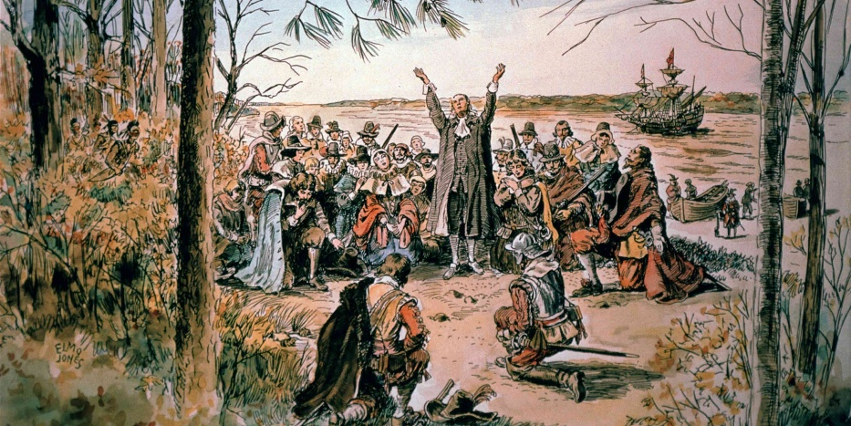
“Did Jamestown’s Settlers Drink Themselves to Death?
https://www.history.com/articles/did-jamestowns-settlers-drink-themselves-to-death
Geologists are investigating whether tainted drinking water killed most of Jamestown’s colonists during the “starving time” of 1609-1610.
Life was no picnic for the Jamestown colony’s earliest founders, but at least they had enough to eat. Evidence from waste pits suggests that the settlers, who first arrived on the island in May 1607, feasted on deer, turtles and sturgeon during their first year in the New World, said historian James Whittenburg, the director for instruction at the National Institute of American History and Democracy. (“The sturgeon in the James River were so large that colonists would wade out and harvest them with an axe,” he added.) Thanks to an uneasy truce brokered by their leader, Captain James Smith, they supplemented this high-protein diet with corn received from local Powhatans in exchange for goods.
But in the fall of 1609, shortly after the arrival of new ships packed with more mouths to feed, a disastrous sequence of events plunged Jamestown into famine, said Whittenburg. Faced with their own shortages because of a prolonged drought, the Powhatans cut off trade with their neighbors after Smith returned to England for medical treatment in October. The settlers began taking food by force, and the Powhatans retaliated by laying siege to Jamestown; confined to their fort, the colonists could no longer hunt, fish or seek fresh water. ‘We do see in the trash bins from the ‘starving time’ that they’re eating really small animals,” said Whittenburg.’ They eat up all of the domestic stock—the dogs and the horses. They get down to eating rats and even poisonous snakes.’”

Disease:
“Early Virginia (1607-24) was a nightmarish world of disease and death, perhaps unsurpassed in the annals of English colonization. Typhoid fever and dysentery visited Jamestown in recurrent epidemics killing 30 per cent or more of the colonists with each onslaught. Yet Jamestown endured because the leaders of the Virginia Company misapprehended the nexus between the estuarine environment and water-borne, non-immunizing diseases. Each summer, death stalked the town as invading salt water pushed up the estuary and concentrated pathogens in the town's water supply. The prevention of disease and death required the abandonment of Jamestown and relocation into healthier niches, which occurred with the dissolution of the Virginia Company in 1624.” https://www.sciencedirect.com/science/article/abs/pii/030574887990224X

1619: Jamestown - Slavery Comes To North America

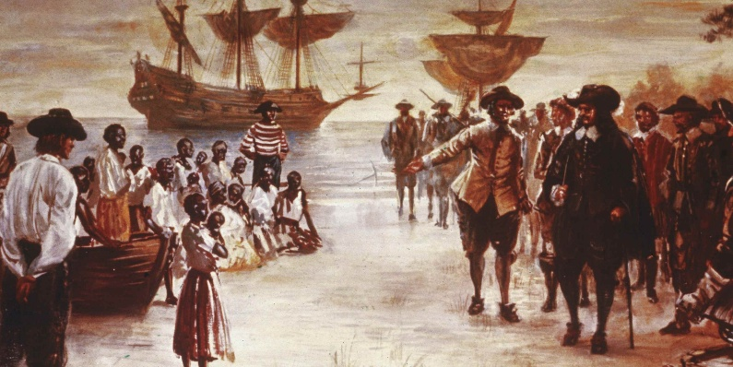

“To satisfy the labor needs of the rapidly growing North American colonies, white European settlers turned in the early 17th century from indentured servants (mostly poorer Europeans) to a cheaper, more plentiful labor source: enslaved Africans. After 1619, when a Dutch ship brought 20 Africans ashore at the British colony of Jamestown, Virginia, slavery spread quickly through the American colonies. Though it is impossible to give accurate figures, some historians have estimated that 6 to 7 million enslaved people were imported to the New World during the 18th century alone, depriving the African continent of its most valuable resource—its healthiest and ablest men and women.” https://www.history.com/articles/black-history-milestones

***
“In late August, 1619, 20-30 enslaved Africans landed at Point Comfort, today's Fort Monroe in Hampton, Va., aboard the English privateer ship White Lion. In Virginia, these Africans were traded in exchange for supplies. Several days later, a second ship (Treasurer) arrived in Virginia with additional enslaved Africans. Both groups had been captured by English privateers from the Spanish slave ship San Juan Bautista. They are the first recorded Africans to arrive in England's mainland American colonies. The landing of the first Africans in Virginia is one of the most significant events we interpret. Although English colonists in Virginia did not invent slavery, and the transition from a handful of bound African laborers to a legalized system of full-blown chattel slavery took many decades, 1619 marks the beginning of race-based bondage that defined the African American experience.” https://www.hampton.gov/3580/The-1619-Landing-Report-FAQs
***
“Arrival of ‘20 and odd’ Africans in late August 1619, not aboard a Dutch ship as reported by John Rolfe, but an English warship, White Lion, sailing with a letters of marque issued to the English Captain Jope by the Protestant Dutch Prince Maurice, son of William of Orange. A letters of marque legally permitted the White Lion to sail as a privateer attacking any Spanish or Portuguese ships it encountered. The 20 and odd Africans were captives removed from the Portuguese slave ship, San Juan Bautista, following an encounter the ship had with the White Lion and her consort, the Treasurer, another English ship, while attempting to deliver its African prisoners to Mexico. Rolfe's reporting the White Lion as a Dutch warship was a clever ruse to transfer blame away from the English for piracy of the slave ship to the Dutch.” https://www.nps.gov/jame/learn/historyculture/african-americans-at-jamestown.htm

1631: Fire Codes - Boston
“First fire prevention ordinance banned thatched roofs and wooden chimneys.” https://bostonfirehistory.org/boston-history-before-1859/

“Boston, Massachusetts, 1631, John Winthrop, Governor of Boston, outlawed the building of wooden chimneys and thatched roofs of homes as each of these were
found to cause more fires and dangerous fires throughout the community. This became the first American Building Code.” https://www.leg.state.nv.us/Session/79th2017/Exhibits/Senate/GA/SGA468G.pdf



1648: NY – Fire Wardens
“Governor of New Amsterdam (New York City), appointed 4 fire wardens in 1648
which was the first organized fire prevention inspections in America. The Fire Wardens were allowed to inspect every home in the city for proper cleaning and construction of chimneys.
If fires were started due to negligent cleaning or construction of chimneys and fire places, the Fire Wardens could issue fines to the home owners.” https://www.leg.state.nv.us/Session/79th2017/Exhibits/Senate/GA/SGA468G.pdf

1653: Boston – Great Blaze
“Immediately following the first great blaze in 1653, officials decreed that each house be equipped with a ladder to reach the roof, poles with swabs to snuff out sparks, and other tools to fight fires. Boston became an early leader in firefighting regulations; it was later to pass the first fire-related building codes.
***
Volunteers also played a major role in fighting Boston's fires. Responding to a fire had always been a civic duty of all men in Boston; when the cry of ‘fire’ or the pealing of church bells signaled that flames had been spotted, every household was required to send a man with a leather bucket to help fight the fire. In September of 1718, Boston organized the ‘Boston Fire Society,’ the nation's first mutual aid organization. Members pledged to fight fires at each other's homes, rescue their property, and guard against looting.”
https://www.massmoments.org/moment-details/boston-burns.html

1676: Bacon’s Rebellion – Virginia
“In the summer of 1676, settlers in the colonies of both Virginia and Maryland were frenzied with suspicion over Indigenous tribes — partly because of a terrible mistake. A group of English militiamen had slaughtered more than a dozen Native villagers along the Potomac River the year before in retribution for the killing of a farmworker. But they got the wrong people. Those killed were Susquehannocks, allies of the royal government, and had nothing to do with the farmer’s death.
That touched off a cycle of back-and-forth revenge — Native people would attack a family on the frontier; settlers would hunt down more Natives — until a group of Virginians decided the only answer was to get rid of all the tribes by mass relocation, enslavement or death.
They rallied behind charismatic newcomer Nathaniel Bacon, who had been sent to the colonies by his father to escape prosecution for defrauding a legal client in England. He arrived with enough wealth to become instantly prominent and enough arrogance to cause trouble.
***
Historians know how Bacon’s Rebellion eventually played out, of course. The rebels did stumble onto a group of Native people, killing seven and enslaving about 45. Cockacoeske kept her pledge not to kill any Englishmen.
In October 1676, Bacon died of a disease much like typhus — possibly from parasites contracted outside Jamestown, historian Rice has written, or maybe even from his damp slogs through Dragon Run. The rebel was buried in an unmarked grave in Gloucester.
Berkeley returned to rebuild Jamestown, though the capital would shift to Williamsburg in 1699. Cockacoeske signed the Treaty of Middle Plantation in 1677 that made the Pamunkey and a handful of other tribes allies of the colony. To this day, they bring a tribute of wild game to the Virginia governor every fall.
But the effects of the insurrection lingered.
“After Bacon’s Rebellion, Virginia governors were really reluctant to go against this virulent, anti-Native sentiment among White Virginians,” Rice said. “What they were asking for was really just a broad, aggressive anti-Native policy wiping Native people off the face of whatever patch of Earth Virginia planters wanted.”
Enslavement of Native people surged; whole tribes were sometimes sold to plantations in the West Indies. By the early 1700s, Virginia’s Indigenous population was decimated.” https://www.washingtonpost.com/dc-md-va/2024/09/20/bacons-rebellion-virginia-native-americans-dragon-run/?utm_campaign=wp_todays_headlines&utm_medium=email&utm_source=newsletter&wpisrc=nl_headlines&carta-url=https%3A%2F%2Fs2.washingtonpost.com%2Fcar-ln-tr%2F3f0e801%2F66ee9953e1878f5a37ee5632%2F59731235ade4e21a848a56ed%2F22%2F65%2F66ee9953e1878f5a37ee5632

1705: Virginia Slave Codes
“But any question about the status of Black people in the colonies—free, enslaved or indentured servants—was made clear with the passage of the Virginia Slave Codes of 1705, a series of laws that stripped away legal rights and legalized the barbaric and dehumanizing nature of slavery.” https://www.history.com/articles/american-slavery-before-jamestown-1619

1732: George Washington is born in VA
George Washington (February 22, 1732 – December 14, 1799): https://www.history.com/topics/us-presidents/george-washington

1734: Daniel Boone born in PA
“Daniel Boone was born in 1734 to a family of Quakers in a one-room log cabin in present-day Pennsylvania. He was one of 11 children. Boone spent most of his early life in the borderlands between the 13 colonies and the Ohio Country. He quickly became known as an excellent hunter. In his teenage years, Boone’s family moved to North Carolina, and later Virginia. Boone experienced war firsthand when he enlisted with the Carolina militia in the French and Indian War. Later he fought in the Anglo-Cherokee War.

Boone married Rebecca Bryan and supported his family through long expeditions in the borderlands. There he hunted deer, beavers, and otters for their furs. His travels took him as far south as Florida and as far north as Kentucky.

By 1767, he had moved his family into Kentucky. This angered the Shawnee, Cherokee, and Delaware who claimed the territory. Fights between Boone, other colonists, and Natives directly led to Lord Dunmore’s War. The war ended with the Shawnee giving up their lands in Kentucky.

Through the American Revolution, Boone and his family continued to live in Kentucky. Boone was wounded in fighting against the Shawnee and saved by Simon Kenton, a fellow frontiersman. Later, Boone was captured by Chief Blackfish and taken to Oldtown. He survived by convincing Chief Blackfish that he and his men had switched sides. He was so convincing that his own men believed him! He was court-martialed for his ruse but found not guilty. He continued to fight in the war until its end, losing a brother and son to the conflict. After the war, Boone served as a local Virginian politician and merchant in present-day Kentucky and West Virginia, and later Missouri. It was there that he died in 1820.” https://ohiodnr.gov/go-and-do/see-the-sights/historic-places/great-council/explore-more-danielboone

OLD TOWN, OH (near Xenia):

“Long before the early settlers moved into the area, the Shawnee lived in the village they called Old Chillicothe. This was their principal home. There were other Chillicothesin Ohio, but this was the oldest of the settlements, hence the “Old.” They liked the area with its gently rolling hills and the proximity to the river which provided water, food, and of course transportation. It was near this site that the noted Shawnee warrior, Tecumseh, was born. It was here that Simon Kenton, having been captured by the Shawnee for stealing their horses, ran a gauntlet of men lined on both sides with tree limbs and other devices with which to flog him as he ran past. He was able to escape and tell of his adventures when he was an old man. Here, Daniel Boone and the salt makers were confined and so many more tales about the area are remembered.” https://www.xeniagazette.com/2023/07/14/oldtown-has-quite-a-history/

1736: Philadelphia – Benjamin Franklin [age 30] forms Union Fire Company
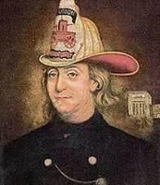

PHILADELPHIA: Modeled after Boston’s “Mutual Fire Societies.”
“On December 7, 1736 Benjamin Franklin co-founded the Union Fire Company, also known as the “Bucket Brigade”. It was the first formally organized all volunteer fire company in the colonies and was shaped after Boston’s Mutual Fire Societies. The difference between the fires societies of Boston and Franklin’s Union Fire Company was that the former protected its members only while the latter the entire community.” http://www.benjamin-franklinhistory.org/union-fire-company/

Jan. 18. 2023: MA – BUILDING CODES – Benjamin Franklin' - A Tribute To Firefighting [historical VIDEO]. https://www.youtube.com/watch?v=jYXVVNRqsFg

1742: Benjamin Franklin Stove
“In colonial America, homes were warmed by a fireplace. The Franklin stove, invented in 1742, is a metal-lined fireplace that stands in the middle of a room. It has rear baffles for improved airflow. It provides more heat and less smoke than an open fireplace and uses less wood. This cast-iron furnace would radiate heat from the middle of the room in all directions, and the iron walls even absorbed heat, providing warmth to the room long after the fire went out.” https://www.ushistory.org/franklin/science/stove.htm?srsltid=AfmBOorscceSsMe5OZj98bqukF_8nbHyHQsdGHSk_-w1x4zZBTINxug1

1754-63: French & Indian “Seven Years War”
“Also known as the Seven Years’ War, this New World conflict marked another chapter in the long imperial struggle between Britain and France. When France’s expansion into the Ohio River valley brought repeated conflict with the claims of the British colonies, a series of battles led to the official British declaration of war in 1756. Boosted by the financing of future Prime Minister William Pitt, the British turned the tide with victories at Louisbourg, Fort Frontenac and the French-Canadian stronghold of Quebec. At the 1763 peace conference, the British received the territories of Canada from France and Florida from Spain, opening the Mississippi Valley to westward expansion.” https://www.history.com/topics/native-american-history/french-and-indian-war

Nov. 12, 1758: George Washington – “friendly fire”
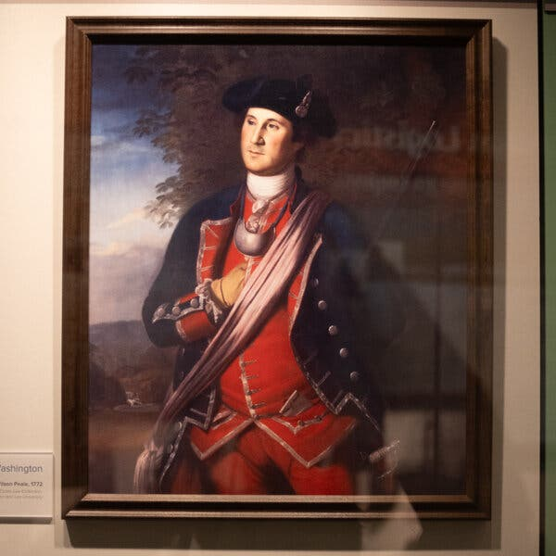
A reproduction of a 1772 portrait of George Washington, depicting him during the French and Indian War a decade earlier, when he was a colonel in the Virginia Regiment. Credit...Aaron Blum for The New York Times

“It was not all glory. In one passage, Washington recalled the terrible, foggy evening of Nov. 12, 1758. He and his men had ventured from Fort Ligonier, a British redoubt about 60 miles from present-day Pittsburgh, to help another group of Virginians push back a French raiding party but instead ignited a devastating volley of friendly fire. Several dozen were injured, and as many as 14 killed, before Washington, by his account, rode between the two groups of Virginians, knocking away their muskets.*** The friendly fire incident, as the episode is known, is a footnote in the history of the French and Indian War, and merits only a paragraph or two in most Washington biographies. But it has long been part of the lore in this part of western Pennsylvania, where a reconstruction of Fort Ligonier opened in 1953. *** The friendly fire incident may seem like a minor episode, and Washington himself was not eager to talk about it. The only record he left at the time was a terse entry in his orderly book later that night, noting that he was sending more than 400 men out with spades to bury the dead.https://www.nytimes.com/2025/07/15/arts/george-washington-battlefield-war.html

1736: Benjamin Franklin – Philadelphia Union Fire Company
“Boston’s firefighting clubs inspired Ben to create the first volunteer fire company in Philadelphia. He named it the Union Fire Company in 1736. The company consisted of all males dedicated to putting out fires and saving property. Their equipment included a leather bucket and linen bag. The firefighters used the linen bucket to put out fires and the linen bag held rescued valuables. Additionally, the Union Fire Company’s members including Ben Franklin and a few others established a fire insurance company.
The group founded The Contributionship for the Insuring of Houses from Loss by Fire in 1752. The board created a set of parameters for building’s to meet to receive insurance. Some of the constraints required buildings to be easily accessible for firemen, there couldn’t be any major interferences inside or on the property that would hinder firefighting, and that the building wasn’t a high risk for having fires. Only buildings that met these certain parameters received insurance. Some suspect that a few modern fire code requirements originated from the insurance company’s prerequisites for coverage.” https://kinetixfire.com/ben-franklins-pivotal-role-in-the-fire-life-safety-industry/

1752: Fire Marks – Signs On Houses Showing Insured For Fire
“American fire marks, also known as ‘badges’ and ‘house plates,’ are signs issued by insurance companies that were affixed to the front of a property to mark that the property was insured for fire. Fire marks carried the symbol or the name of the insurer and were made of cast iron, sheet brass, lead, tinned sheet iron, copper or zinc. They came in various sizes and shapes, sometimes attached to a wooden plaque.
Used primarily for advertising purposes, fire marks were used from 1752 to circa 1900. Going back to their early practices, the Philadelphia Contributionship and The Baltimore Equitable Society still issue fire marks.” https://www.firemanshallmuseum.org/fire-marks/

Dec. 11, 1753: Washington (age 21), Virginia Regiment, sent to Ohio Valley to confront French
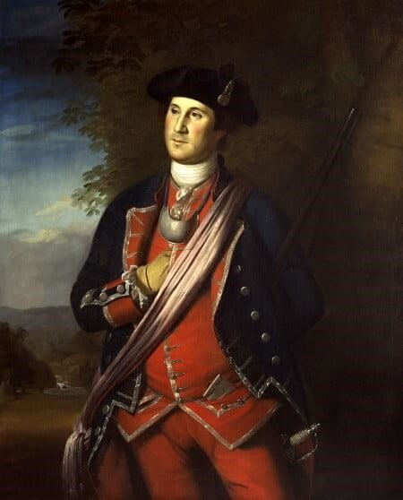 George Washington as a Colonel in Virginia Regiment
https://www.mountvernon.org/george-washington/artwork/life-portraits-of-george-washington/
“Control of the expansive Ohio Valley region, especially near the joining of the Monongahela and Allegheny rivers (modern day Pittsburgh), was of great interest to both the British and their French rivals. Rivers like the Ohio, which connected to the Mississippi, were essential transit corridors for goods produced in this fertile region.
Concerned by reports of French expansion into the Ohio Valley, Virginia Lt. Governor Robert Dinwiddie sent 21-year-old Major George Washington of the Virginia Regiment on a mission to confront the French forces. Washington was to deliver a message from the governor demanding that the French leave the region and halt their harassment of English traders. Washington departed Williamsburg, Virginia in October 1753 and made his way into the rugged trans- Appalachian region with Jacob Van Braam, a family friend and French speaker, and Christopher Gist, an Ohio company trader and guide. On December 11, 1753, amidst a raging snowstorm, Washington arrived and was politely received by Captain Jacques Legardeur de Saint-Pierre at Fort LeBoeuf. After reviewing Dinwiddie's letter, Legardeur de Saint-Pierre calmly wrote a reply stating that the French king's claim to the Ohio Valley was "incontestable.”
Washington's return to Virginia during the winter of 1753 was a perilous one, but the group safely returned to Williamsburg after traveling almost 900 miles in two and a half winter months.” https://www.mountvernon.org/george-washington/french-indianwar/ten-facts-about-george-washington-and-the-french-indian-war/

1754: French and Indian War (1754 - 1763)
“The French and Indian War (1754-1763) is the name given to the North American theatre of the Seven Years’ War (1756-1763), a global conflict involving the major powers of Europe. Though war was not formally declared until 1756, armed conflict began in 1754 as disputes over land claims in the Ohio Valley lead to a series of frontier battles between the French and British. Both received support from various Native American tribes, though the outnumbered French became far more dependent on these allies as the war progressed.
The French saw a number of early victories, most notably over George Washington and Edward Braddock in Western Pennsylvania. Washington quickly became a central figure in the conflict, maturing during his tenure in the Virginia militia from an inexperienced young major to the commander in chief of the colony’s regiment. Washington’s involvement during the war’s early stages provided the future President with invaluable military experience while also gaining him positive notoriety that helped to launch his future political career.”
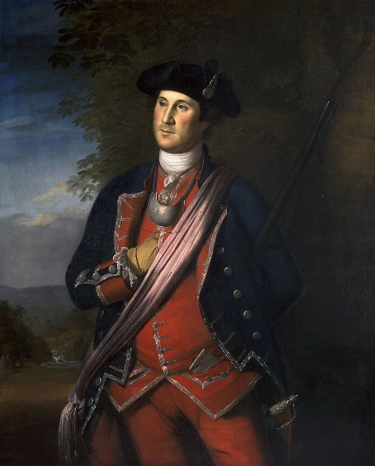1772 portrait of Washington by Charles Willson Peale.

March, 1754: Washington's very first battle for the British Government Against France
“George Washington was a raw and ambitious 21-year-old when he was first sent to the Ohio Valley to confront the growing French presence in the region. His actions sparked the French and Indian War … Responding to the defiant French. Lt. Governor Dinwiddie ordered the newly promoted Lt. Col. George Washington and approximately 160 Virginia militia to return to the Ohio country in March of 1754. Dinwiddie wanted Washington to ‘act on the defensive,’ but also clearly empowered Washington to ‘make Prisoners of or kill & destroy…’ all those who resisted British control of the region.
Eager to send their own diplomatic directive demanding an English withdrawal from the region, a French force of 35 soldiers commanded by Ensign Joseph Coulon de Villiers de Jumonville camped in a rocky ravine not far from Washington's encampment at the Great Meadows (now in Fayette County, Pennsylvania).
Accompanied by Tanacharison, a Seneca chief (also known as the Half-King) and 12 native warriors, Washington led a party of 40 militiamen on an all night march towards the French position. On May 28, 1754, Washington's party stealthily approached the French camp at dawn. Finally spotted at close range by the French, shots rang out and a vigorous firefight erupted in the wooded wilderness. Washington's forces quickly overwhelmed the surprised French force and killed 13 soldiers and captured another 21.” https://www.mountvernon.org/george-washington/french-indian-war/ten-facts-about-georgewashington-and-the-french-indian-war/
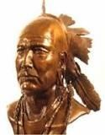Tanacharison

1754: George Washington (age 22) surrendered to the French at Fort Necessity
“After learning of the attack at Jumonville Glen, Claude-Pierre Pecaudy de Contrecoeur, the veteran French commander at Fort Duquesne, ordered Captain Louis Coulon de Villiers, Ensign Jumonville's brother, to assail Washington and his force near Great Meadows. De Villiers left Fort Duquesne with nearly 600 French soldiers and Canadian militiamen, accompanied by 100 native allies.
Aware of the onset of a powerful French column, Washington busily fortified his position at Great Meadows. Despite receiving additional reinforcements, Washington's bedraggled force of around 400 men remained outnumbered by the approaching French. Even more concerning, the small circular wooden fort – named Fort Necessity - built in the center of the meadow was poorly situated and vulnerable to fire from the nearby wooded hills that circled the position.

“On July 1, 1754, the large combined French and native forces reached the Great Meadows. Washington gathered his troops and retreated into Fort Necessity where on a rainy July 3rd the French began firing on the surrounded English. Sensing the hopelessness of his situation, Washington agreed to surrender to the French. The surrender terms, written in French, poorly translated, and soaking wet allowed
Washington and his troops to return to Virginia in peace, but one clause in the document had Washington admitting that he had ‘assassinated’ Ensign Jumonville – something that Washington hotly contested despite his signature on the document. *** The Battle of Great Meadows proved to be the only time that Washington surrendered to an enemy in battle.” https://www.mountvernon.org/george-washington/french-indian-war/ten-factsabout-george-washington-and-the-french-indian-war/

Spring, 1755: Daniel Boone volunteered – wagoner with British General Braddock

Watch video – “Boone At War”: https://cet.pbslearningmedia.org/resource/ket-history-danielboone0102/daniel-boone-at-war/

July 9, 1755 – Battle of Monongahela – British Major General Edward Braddock killed
“In the spring of 1755, a column of 2,100 British Regulars and 500 colonial militia commanded by Major General Edward Braddock, set out from Virginia to advance upon and take the French stronghold at Fort Duquesne. Braddock's column faced the daunting challenge of moving their men and material over the rough, densely wooded Allegheny Mountains. George Washington accompanied Braddock's column as an aide-de-camp to the general. Washington, who knew the terrain well, was recovering from a terrible case of dysentery as Braddock's force reached the Monongahela River ten miles from Fort Duquesne. In a wooded ravine on the far side of the river, Braddock's leading force of 1,300 men was suddenly attacked and defeated by a smaller French and native force on July 9, 1755 at the Battle of Monongahela. During the attack, most of the senior British officers, including Gen. Edward Braddock were killed [died July 13, 1755] or severely wounded. With panic in the air, George Washington quickly rode into the fray and helped to reestablish some amount of order. During the savage fight, Washington had two horses shot out from underneath him and his coat was pierced by four musket balls. Washington's cool leadership helped many of the surviving soldiers to effectively escape the onslaught. Despite the British loss of 977 killed or wounded, Washington was lauded as the ‘hero of Monongahela’ by Virginia Governor Robert Dinwiddie and was given the rank of colonel in command of the 1,200 man Virginia Regiment.”

1755: George Washington Denied British Commission
“During the 1755 Braddock expedition, Washington became an unpaid, volunteer aide-de-camp to Braddock rather than assume his militia rank and be subjected to the embarrassment of being subordinate to junior officers. Washington's interest in obtaining a royal commission became so strong that he traveled to Boston to meet with Governor William Shirley, who was the acting commander in chief after Gen. Braddock's death. Washington was unsuccessful in obtaining a royal commission, but Shirley did issue a decree that officers in the Virginia militia would outrank British officers of lower rank.” https://www.mountvernon.org/george-washington/french-indian-war/ten-facts-about-george-washington-and-the-french-indian-war

1756: Seven Years War (1756 – 1763)
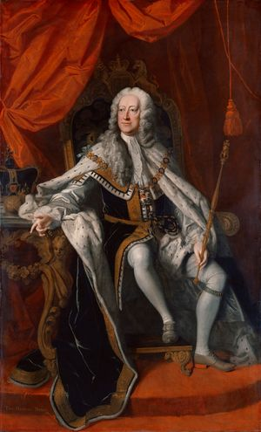British King George II
“Seven Years’ War, (1756–63), the last major conflict before the French Revolution to involve all the great powers of Europe. Generally, France, Austria, Saxony, Sweden, and Russia were aligned on one side against Prussia, Hanover, and Great Britain on the other.
***
The definitive Treaty of Paris was concluded on February 10, 1763, between Great Britain, Hanover, France, and Spain, with Portugal expressly understood to be included. By that treaty France renounced to Great Britain all of mainland North America east of the Mississippi River (excluding New Orleans and environs); the West Indian islands of Grenada, Saint Vincent, Dominica, and Tobago; and all French conquests made since 1749 in India or in the East Indies.” https://www.britannica.com/event/Seven-Years-War/1760

1758: George Washington finally occupies abandoned Fort Duquesne
“Operating from the recently established Fort Ligonier, Colonel Washington's Virginians participated in a number of operations in the area east of the French position. On November 24, 1758, Washington led his troops on an advance that occupied the smoking ruins of the abandoned Fort Duquesne. After almost five years of hard marching, combat, and countless setbacks, Washington was finally able to stand at the British controlled forks of the Ohio.” https://www.mountvernon.org/george-washington/french-indian-war/ten-facts-about-george-washington-and-the-french-indian-war

Jan. 6,1759: George Washington inherits Mount Vernon
“As a young, attractive, wealthy widow, Martha Dandridge Custis probably enjoyed more freedom to choose her own destiny than at any other point in her life. She was only 26 years old, owned nearly 300 enslaved individuals and had more than 17,500 acres of land—worth more than £40,000. Because her husband had died without a will, she was the executor of his estate. *** On January 6, 1759, Martha Dandridge Custis married George Washington at her home in New Kent County. For both Martha and George, a new era had dawn.” https://www.mountvernon.org/george-washington/martha-washington/george-marthas-courtship/
“Hidden Under George Washington’s Home: 35 Glass Bottles of Cherries. Archaeologists discovered the glass bottles in the cellar during a restoration project.” https://www.nytimes.com/2024/06/18/us/george-washington-mount-vernon-cherries.html?te=1&nl=the-morning&emc=edit_nn_20240619
“Washington inherited Mount Vernon in 1761. Hundreds of enslaved men, women and children lived there over the years. Initial findings show that the fruit was neatly cut using shears, allowing the trees to remain productive while protecting the cherries, Dr. Boroughs said. The fruit is also extremely clean, demonstrating the highly skilled process that went into picking, packing and storing it. The storage pits were probably used between the 1750s and 1770s, until they were paved over by brick flooring during the home’s expansion. At the time, an enslaved woman named Doll, who was brought to Mount Vernon by Martha Washington in 1759, was the family’s main cook, Dr. Boroughs said. Based on letters from Mrs. Washington to her niece in the late 1790s, it’s likely that Doll either prepared the bottles herself or had another enslaved person do it, Dr. Boroughs said.”

Aug. 1761: Slave Girl - Phillis Wheatley, Taught To Read And Write
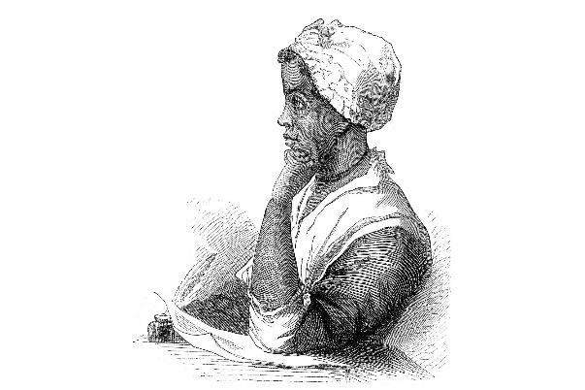
“Wheatley was seized from Senegal/Gambia, West Africa, when she was about seven years old. She was transported to the Boston docks with a shipment of ‘refugee’ slaves, who because of age or physical frailty were unsuited for rigorous labor in the West Indian and Southern colonies, the first ports of call after the Atlantic crossing. In the month of August 1761, ‘in want of a domestic,’ Susanna Wheatley, wife of prominent Boston tailor John Wheatley, purchased ‘a slender, frail female child ... for a trifle’ because the captain of the slave ship believed that the waif was terminally ill, and he wanted to gain at least a small profit before she died. A Wheatley relative later reported that the family surmised the girl—who was ‘of slender frame and evidently suffering from a change of climate,’ nearly naked, with ‘no other covering than a quantity of dirty carpet about her’—to be ‘about seven years old ... from the circumstances of shedding her front teeth.’

After discovering the girl’s precociousness, the Wheatleys, including their son Nathaniel and their daughter Mary, did not entirely excuse Wheatley from her domestic duties but taught her to read and write. Soon she was immersed in the Bible, astronomy, geography, history, British literature (particularly John Milton and Alexander Pope), and the Greek and Latin classics of Virgil, Ovid, Terence, and Homer. In ‘To the University of Cambridge in New England’ (probably the first poem she wrote but not published until 1773), Wheatley indicated that despite this exposure, rich and unusual for an American slave, her spirit yearned for the intellectual challenge of a more academic atmosphere.” https://www.poetryfoundation.org/poets/phillis-wheatley

1764: King George III (age 26) - Imposes Taxes On Colonies
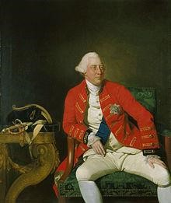 King George III

1764: Sugar Act [Colonists use sugar to make Rum]
“On April 5, 1764, Parliament passed a modified version of the Sugar and Molasses Act (1733), which was about to expire. Under the Molasses Act colonial merchants had been required to pay a tax of six pence per gallon on the importation of foreign molasses. But because of corruption, they mostly evaded the taxes and undercut the intention of the tax — that the English product would be cheaper than that from the French West Indies. This hurt the British West Indies market in molasses and sugar and the market for rum, which the colonies had been producing in quantity with the cheaper French molasses.” http://www.ushistory.org/declaration/related/sugaract.html

1765: Stamp Act
“The Stamp Act of 1765 was the first internal tax levied directly on American colonists by the British government. The act, which imposed a tax on all paper documents in the colonies, came at a time when the British Empire was deep in debt from the Seven Years’ War (1756-63) and looking to its North American colonies as a revenue source. Arguing that only their own representative assemblies could tax them, the colonists insisted that the act was unconstitutional, and they resorted to mob violence to intimidate stamp collectors into resigning. Parliament repealed the Stamp Act in 1766, but issued a Declaratory Act at the same time to reaffirm its authority to pass any colonial legislation it saw fit. The issues of taxation and representation raised by the Stamp Act strained relations with the colonies to the point that, 10 years later, the colonists rose in armed rebellion against the British.” https://www.history.com/topics/americanrevolution/stamp-act

“On March 22, 1765, the British Parliament passed the “Stamp Act” to help pay for British troops stationed in the colonies during the Seven Years’ War. The act required the colonists to pay a tax, represented by a stamp, on various forms of papers, documents, and playing cards….
- March 22, 1765: British Parliament passes the ‘Stamp Act.’
- October 1765: Delegates from nine colonies meet in New York City in what has become known as the Stamp Act Congress, the first united action by the colonies; the congress acknowledges that while Parliament has a right to regulate colonial trade, it does not have the power to tax the colonies since they were unrepresented in Parliament.
- November 1, 1765: The Stamp Act goes into effect in the colonies.
- March 1766: Colonial resistance to the Stamp Act and pressure from London merchants prompt Parliament to abolish the Stamp Act.
- March 1766: Parliament issues the Declaratory Act, which states that the king and Parliament have full legislative power over the colonies.” https://www.gilderlehrman.org/history-resources/spotlight-primary-source/stamp-act-1765

1767: Townshend Acts
“The Townshend Acts were a series of measures, passed by the British Parliament in 1767, that taxed goods imported to the American colonies. But American colonists, who had no representation in Parliament, saw it as an abuse of power. The British sent troops to America to enforce the unpopular new laws, further heightening tensions between Great Britain and the American colonies in the run-up to the American Revolutionary War.” https://www.history.com/topics/american-revolution/townshend-acts

March 5, 1770: “Boston Massacre”
“On March 5, 1770, a street brawl happened in Boston between American colonists and British soldiers. Later known as the Boston Massacre, the fight began after an unruly group of colonists – frustrated with the presence of British soldiers in their streets – flung snowballs at a British sentinel guarding the Boston Customs House. Reinforcements arrived and opened fire on the mob, killing five colonists and wounding six. The Boston Massacre and its fallout further incited the colonists’ rage towards Britain.” https://www.history.com/topics/american-revolution/boston-tea-party

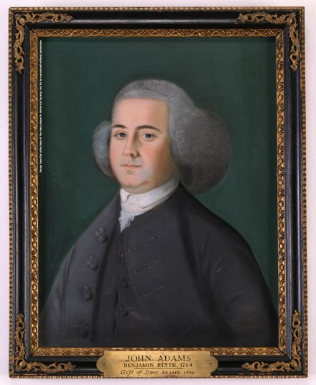Lawyer John Adams decided to serve on the defense of the Captain Preston and his soldiers.

“On March 5, 1770, British soldiers fired into a crowd of civilians, killing five people. Crispus Attucks, Samuel Gray, and James Caldwell died that night. Seventeen-year-old Samuel Maverick died the next morning. Patrick Carr died from his wounds nearly two weeks later. This event sparked outrage in Bostonians who later called this ‘the Boston Massacre.’

Shortly after the Massacre, the soldiers (William Wemms, Hugh White, Hugh Montgomery, James Hartigan, William McCauley, Mathew Kilroy, William Warren, and John Carroll) and their captain (Thomas Preston) were arrested and jailed. Royal government officials decided to delay the trial to let tensions in the town cool. Both sides doubted the soldiers would be given a fair trial. Loyalists feared that colonists would want vengeance; colonists feared that loyalists would arrange for charges to be dismissed….

Captain Preston's trial began on October 24, 1770. Lasting six days, this trial became the first in the American colonies with a duration longer than a single day. The prosecution argued that while Preston had not fired a single shot himself, if he had given the order to fire, Preston would have to take responsibility for the five civilian deaths. The defense argued that there was not sufficient evidence to prove that Preston had given the fatal order… On October 30, 1770, the jury delivered its verdict: Captain Thomas Preston was found not guilty….

On November 27, nearly a month after Preston's acquittal, the court moved forward with its trial of the soldiers. Since the prosecution had been unable to prove that Captain Preston had given the order to fire, the question remained: did the soldiers open fire of their own accord?... After a nine-day long trial, the decision rested with the jury. They deliberated for two and a half hours before returning with their verdict. The jury outright acquitted six of the eight soldiers present the night of March 5, 1770. For the remaining two soldiers, Hugh Montgomery and Matthew Kilroy, the jury found them guilty of manslaughter. By invoking the Benefit of Clergy, an antiquated piece of English law that reduced sentences for first time offenders and could only be used by literate citizens, the defense successfully commuted their sentences from capital punishment to having their right thumbs branded.” https://www.nps.gov/articles/000/boston-massacre-trial.htm

May 1773: Tea Act
“In May 1773, British Parliament passed the Tea Act which allowed British East India
Company to sell tea to the colonies duty-free and much cheaper than other tea companies – but still tax the tea when it reached colonial ports. Tea smuggling in the colonies increased, although the cost of the smuggled tea soon surpassed that of tea from British East India Company with the added tea tax.
Still, with the help of prominent tea smugglers such as John Hancock and Samuel Adams – who protested taxation without representation but also wanted to protect their tea smuggling operations – colonists continued to rail against the tea tax and Britain’s control over their interests.” https://www.history.com/topics/american-revolution/boston-teaparty
John Hancock  Samuel Adams

Dec. 16, 1773: “Boston Tea Party”
“On the evening of December 16, 1773, a few dozen men said to be ‘dressed in the Indian manner,” their faces darkened by lampblack or charcoal, descended with war whoops down Milk Street in Boston to board three merchant ships moored at Griffin’s Wharf. Prying open the hatches, they used block and tackle to hoist from the holds hundreds of heavy chests containing forty-five tones of Bohea, Congu, Singlo, Souchong, and Hyson tea. For three hours they methodically smashed the lids and scooped the leaves in the harbor.” The British Are Coming, by Rick Atkinson (2009) – Prologue, page 13.
“The event was the first major act of defiance to British rule over the colonists. It showed Great Britain that Americans wouldn’t take taxation and tyranny sitting down, andrallied
American patriots across the 13 colonies to fight for independence.” https://www.history.com/topics/american-revolution/boston-tea-party

1774: King George III [age 36] - Coercive Acts
“But despite the lack of violence, the Boston Tea Party didn’t go unanswered by King George III and British Parliament. In retribution, they passed the Coercive Acts (later known as the Intolerable Acts) which:
- closed Boston Harbor until the tea lost in the Boston Tea Party was paid for
- ended the Massachusetts Constitution and ended free elections of town officials
- moved judicial authority to Britain and British judges, basically creating martial law in Massachusetts
- required colonists to quarter British troops on demand, using their private homes if needed
- extended freedom of worship to French-Canadian Catholics under British rule, which angered the mostly Protestant colonists.” https://www.history.com/topics/americanrevolution/boston-tea-party

Sept. 5, 1774: First Continental Congress – Philadelphia
“From 1774 to 1789, the Continental Congress served as the government of the 13 American colonies and later the United States. The First Continental Congress, which was comprised of delegates from the colonies, met in 1774 in reaction to the Coercive Acts, a series of measures imposed by the British government on the colonies in response to their resistance to new taxes.” https://www.history.com/topics/americanrevolution/the-continental-congress

“In response to the British Parliament’s enactment of the Coercive Acts in the American colonies, the first session of the Continental Congress convenes at Carpenter’s Hall in Philadelphia. Fifty-six delegates from all the colonies except Georgia drafted a declaration of rights and grievances and elected Virginian Peyton Randolph as the first president of Congress. Patrick Henry, George Washington, John Adams, and John Jay were among the delegates.


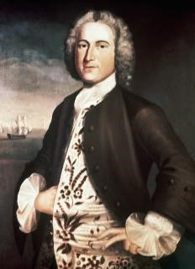
Peyton Randolph [age 53]
Patrick Henry [age 38]
John Adams [age 39]

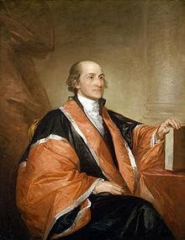

John Jay [age 29]; in 1789 was appointed by President Washington as the 1st Chief Justice of United States

1774: Non-Importation of British Goods
“On September 22, 1774, Charles Thomson, secretary to the Continental Congress in Philadelphia, entered into the minutes this resolution:
That the Congress request the Merchants and Others, in the several Colonies, not to send to Great Britain any Orders for Goods, and to direct the execution of all Orders already sent, to be delayed or suspended, until the sense of the Congress, on the means to be taken for the preservation of the Liberties of America, is made public.
On October 14, 1774 the Congress, chaired by President Peyton Randolph of
Williamsburg, announced the result of its deliberations: a set of Declarations and Resolves. The delegates adopted the detailed articles of a non-importation association on October 22, 1774.
DECLARATION AND RESOLVES OF THE FIRST CONTINENTAL CONGRESS:
October 14, 1774
“To obtain redress of these grievances, which threaten destruction to the lives, liberty, and property of his Majesty's subjects in North-America, we are of opinion, that a non-importation, non-consumption, and non-exportation agreement, faithfully adhered to, will prove the most speedy, effectual, and peaceable measure: and therefore we do, for ourselves, and the inhabitants of the several Colonies, whom we represent, firmly agree and associate under the sacred ties of virtue, honour, and love of our country, as follows:
- That from and after the first day of December next, we will not import into British America, from Great-Britain or Ireland, any goods, wares or merchandize whatsoever, or from any other place any such goods, wares or merchandize, as shall have been exported from Great-Britain or Ireland; nor will we, after that day, import any East India tea from any part of the world; nor any molasses, syrrups, paneles, coffee, or piemento, from the British plantations, or from Dominica; nor wines from Madeira, or the Western Islands; nor foreign Indigo.
- That we will neither import, nor purchase any slave imported, after the first day of December next; after which time, we will wholly discontinue the slave trade, and will neither be concerned in it ourselves, nor will we hire our vessels, nor sell our commodities or manufactures to those who are concerned in it. ***” http://www.history.org/almanack/life/politics/resolves.cfm
British Are Coming, by Rick Atkinson (2009) – Prologue, pages 25-26.

Oct. 26, 1774: Letter to Canadians to Join USA As 14th Colony


“When Benjamin Franklin failed to make Canada the 14th colony. Canadians weren’t enticed by the colonists’ noble goals. Why would they want to join now? For those of you scratching your heads — letter? what letter? — it was written in 1774, when Canadians and Americans were fellow British colonists. (Yes, some Americans have been eyeing Canada for that long.) It was sent to the Province of Quebec by delegates to the First Continental Congress, including Founding Fathers George Washington, John Adams and John Jay. In it, they described in glowing terms the country they sought to build and the values that would serve as its foundation. They thought — wrongly, as it turned out — that the Canadians of that era, who were overwhelmingly French-speaking and Catholic, could not help but see that it was in their best interests to join a group of English-speaking Protestants in their fight with the British government. (The Declaration of Independence was still on the horizon.)” https://www.washingtonpost.com/opinions/2025/03/25/canada-benjamin-franklin-trump/?utm_campaign=wp_post_most&utm_medium=email&utm_source=newsletter&carta-url=https%3A%2F%2Fs2.washingtonpost.com%2Fcar-ln-tr%2F41c4f6b%2F67e2d8686ef25d630e0a20f8%2F59731235ade4e21a848a56ed%2F22%2F63%2F67e2d8686ef25d630e0a20f8

1775: Daniel Boone Leave Home in NC heading West – 30 others
8 Things You Might Not Know About Daniel Boone: https://www.history.com/articles/8-things-you-might-not-know-about-daniel-boone
“In 1775, Boone and a group of some 30 woodsmen left to complete a 200-mile trail through the wilderness to the Cumberland Gap—a natural break in the rugged Appalachian Mountains—and into Kentucky. Boone had been hired for the job by Richard Henderson, a North Carolinian who along with a group of investors planned to establish a colony called Transylvania in an area comprising much of present-day Kentucky and part of present-day Tennessee.
After Boone blazed the trail, which became known as the Wilderness Road, he helped establish one of Kentucky’s earliest settlements, Boonesborough, which became Transylvania’s capital. The Transylvania colony was short-lived; in 1778, the Virginia General Assembly voided the deal Henderson had struck with the Cherokees for the land.
Nevertheless, the Wilderness Road became the gateway by which an estimated 200,000 settlers journeyed to the western frontier by the early 19th century. Among those emigrants was Abraham Lincoln’s grandfather, who in 1779 traveled the Wilderness Road from Virginia to Kentucky, where America’s 16th president was born in 1809.”

March 20, 1775: Ben Franklin [age 69] – Leaves England After 20 Years, Returns To America
“Except for a brief return visit to Philadelphia in 1763-64 … [Benjamin Franklin] had lived at No. 27 [Craven Street, London] since arriving in England as a colonial agent in 1757. Because he was widely deemed a ‘universal genius’ – the accolade did not displease him – his eccentricities were forgiven: chuffing up and down the nineteen oak stairs, dumbbells in hand, for exercise; sitting nude in the open window about the street, regardless of the season, for his morning ‘air bath’; playing his ‘harmonica,’ an improbable contraption constructed of thirty-seven glass hemispheres mounted on an iron spindle and rotated with a foot treadle so that he could elicit three ghostly octaves by touching the moving edges with his moistened fingers. (Mozart and Beethoven, among others, would compose for the instrument.) And Craven Street had also been his laboratory, the sire where he had launched inquiries into sunspots, magnetism, lead poisoning, the organic origins of coal, carriage wheel construction, and ocean salinity. At the foot of the street, in the Thames [River], he had repeated his celebrated kite-and-key demonstration; St. Paul’s Cathedral, nearby was Britain’s first structure to install a lightning rod.” The British Are Coming, by Rick Atkinson (2009) – Prologue, page 27.
Note: “In December 1772, Franklin sent letters to Boston [letters written by a Crown official in Massachusetts to a British undersecretary, which he had secretly received from a source] as confidential intelligence for patriot leaders, but six months later they were published, causing an uproar in New England, and then in Britain. Franklin eventually placed a notice in the London Chronicle, disclosing his responsibility. British newspapers vilified him as ‘this old snake,’ ‘old Doubleface,’ and a ‘base, ungrateful, cunning, upstart thing.’ On Jan. 29, 1774, he appeared before the king’s council. *** It was the greatest humiliation of his life, and a day later he was sacked as deputy post master general for North America.” The British Are Coming, by Rick Atkinson (2009) – Prologue, pages 29 - 30.

March 23, 1775: Patrick Henry – “Give me liberty or give me death”
“On April 18, 1775 - this day, 250 years ago - a 40-year-old Boston silversmith named Paul Revere borrowed a horse and sped west toward Lexington to warn his fellow colonists of an emerging threat: The British were coming.” The New York Times April 18, 2025; nytdirect@nytimes.com
***
“Step back in time to March 23, 1775! At the Second Virginia Convention, held within the hallowed walls of St. John’s Church in Richmond, Patrick Henry ignited the flames of revolution with his legendary speech. His words galvanized the Virginia delegation, leading to a resolution that committed Virginia troops to the Revolutionary War.” https://va250.org/patrick-henrys-speech/
Discover Patrick Henry’s Legacy, Beyond His Revolutionary ‘Give Me Liberty or Give Me Death’ Speech. https://www.smithsonianmag.com/history/discover-patrick-henrys-legacy-beyond-his-revolutionary-give-me-liberty-or-give-me-death-speech-180986266/
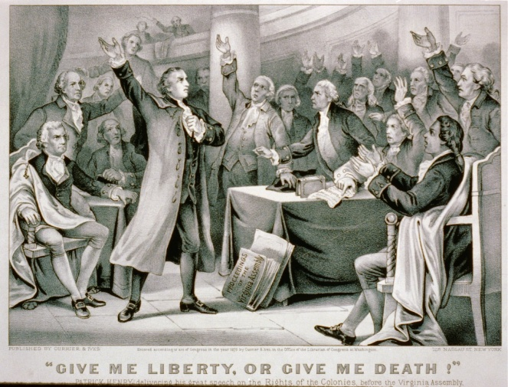

“With the other colonies watching intently, Massachusetts led the resistance to the British, forming a shadow revolutionary government and establishing militias to resist the increasing British military presence across the colony. In April 1775, Thomas Gage, the British governor of Massachusetts, ordered British troops to march to Concord,
Massachusetts, where a Patriot arsenal was known to be located. On April 19, 1775, the British regulars encountered a group of American militiamen at Lexington, and the first shots of the American Revolution were fired.” https://www.history.com/this-day-inhistory/first-continental-congress-convenes

April 18, 1775: Lexington, MA – Ride Of Paul Revere

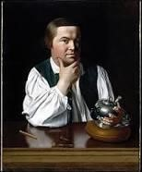 Paul Revere

William Dawes [age 30] – with Paul Revere, rode from Boston to warn them. The
“Midnight Ride”
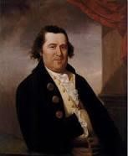 Williams Dawes

“After Revere conferred with Warren, he returned to his own neighborhood, where he contacted a “friend” (Revere was very careful not to identify anyone he did not need to, in case his deposition fell into the wrong hands) to climb up into the bell tower of Christ Church (today known as the Old North Church) to set the famous signals. The ‘friend’ hung two lanterns, meaning the British planned to leave Boston ‘by sea’ across the Charles River, as opposed to a single lantern, which would mean the troops planned to march entirely ‘by land,’ by the same route William Dawes had taken. *** Narrowly escaping capture by a British patrol just outside of Charlestown, Revere charged his planned route somewhat and arrived in Lexington just past midnight. We do not know what he said at each of the houses along the road. We do know exactly what he said when he got to Lexington, however, as there was a sentry on duty outside the house where Adams and Hancock lodged, and that sentry, a Sergeant Monroe, later wrote down what happened. As Revere approached the house, Monroe told him not to make so much noise, that everyone in the house had retired for the night. Revere cried ‘Noise! You’ll have noise enough before long! The regulars are coming out!’ Despite this, Revere still had trouble convincing the sentry to let him pass until John Hancock, who was still awake and heard the commotion, recognized Revere’s voice and said “Oh, you, Revere. We are not afraid of you” after which Revere was allowed to enter the house and deliver his news.

***
About 30 minutes later William Dawes arrived. The two messengers ‘refreshed themselves’ (probably got something to eat and drink) and then decided to continue on to the town of Concord, to verify that the military stores had been properly dispersed and hidden away. Along the road they were joined by a third man, a Dr. Samuel Prescott, who they recognized as a ‘High Son of Liberty.’ Soon afterwards they were all stopped by a British patrol. Dawes, who had probably turned aside to alarm a house, noticed what was going on and made his escape. The British herded Prescott and Revere into a nearby meadow, when Prescott suddenly said ‘Put on!’ (meaning scatter) and the two patriots suddenly rode off in different directions. Prescott, a local man, successfully eluded capture, and alarmed the militia in Lincoln and Concord; Revere chose the wrong patch of woods to head for and was recaptured by more British soldiers. Held for a while, questioned, and even threatened, Revere was eventually released, although his horse was confiscated. Making his way back into Lexington on foot, Revere assisted Adams and Hancock to leave for Woburn, Massachusetts.” https://www.biography.com/news/paulreveres-ride-facts

April 19, 1775: Lexington & Concord – “Shot Heard Round The World” - Start of Revolutionary War (Apr 19, 1775 – Sep 3, 1783)
“American victory. The British marched into Lexington and Concord intending to suppress the possibility of rebellion by seizing weapons from the colonists. Instead, their actions sparked the first battle of the Revolutionary War. The colonists’ intricate alarm system summoned local militia companies, enabling them to successfully counter the British threat.
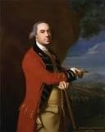British General Thomas Gage [age 57].

By April 1775, Gage was facing the threat of outright rebellion. He hoped to prevent violence by ordering the seizure of weapons and powder being stored in Concord, Massachusetts, twenty miles northwest of Boston. But he underestimated the courage and determination of the colonists. Patriot spies got wind of Gage’s plan. On the evening of April 18, Paul Revere and other riders raised the alarm that British regulars were on their way to Concord. Minute Men and militias rushed to confront them early on April 19. Though it is uncertain who actually fired the first shot that day, it reverberated throughout history. Eight years of war followed, and those who stood their ground against Gage’s troops eventually earned independence from Britain and became citizens of the democratic United States of America.
Forces Engaged:
- American: 3,960
- British: 1,500
Estimated Casualties:
- American: 93
- British: 300
https://www.battlefields.org/learn/revolutionary-war/battles/lexington-and-concord

“Blows would decide, as the king had predicted. Yet no one could forecast that the American War of Independence would last 3,059 days. Or that the struggle would be marked by more than 1,300 actions, mostly small and bloody, plus 241 naval engagements in a theater initially bounded by the Atlantic seaboard, the St. Lawrence and Mississippi Rivers, and the Gulf of Mexico, before expanding to other lands and other waters. Roughly a quarter million Americans would serve the cause in some military capacity. At least one in ten of them would die for that cause – 25,674 deaths by one tally, as many as 35,800 by another. Those deaths were divided with rough parity among battle, disease, and British prisons, a larger portion of the American population to perish in any conflict other than the Civil War.” The British Are Coming, by Rick Atkinson (2009) – Prologue, pages 25-26.

April 19, 1775: Prince Eastbrook – Slave – Shot In Shoulder By British Troops
American Revolution – Slaves
“Prince Estabrook was an enslaved man who stood with his white neighbors against the British Army on April 19, 1775… Though Provincial law prohibited “Indians and Negroes” from training as soldiers in the militia, they were still required to “turn out” armed during an emergency. During wartime the enlistment of black men was more common though still controversial. In 1775 Prince was a member of the Lexington militia, and mustered with that militia under the command of Colonel John Parker during the early morning hours of April 19. When the advance column of British troops decided to confront the militia gathered on Lexington Green, Prince was among the militiamen who had reassembled there. During the ensuing shooting, before the British officers regained control of their troops, Prince Estabrook was struck by a musket ball in his left shoulder. A document entitled ‘Appendix - Soldiers of Color on April 19, 1775’ states that a 35-year-old black slave from Lexington named Prince Estabrook serving in Colonel Parker’s militia was actively engaged in fighting and was wounded that day. A separate document titled ‘LIST of the Names of the PROVINCIALS who were Killed and Wounded in the late Engagement with His Majesty’s Troops at Concord, &c.’, under a heading listed as ‘Wounded Of Lexington’, the name ‘Prince Easterbrooks (a Negro Man)’ appears. Prince recovered from that wound and, over the course of the next eight years, he served several tours with the militia and with the Continental Army:
With Captain Parker’s company in Cambridge (1775)
With Colonel Jonathan Reed’s regiment at Fort Ticonderoga (1775 - 1776)
With Colonel Eleazer Brook’s regiment at Cambridge (1776 - 1777)
Part of a group of men raised to reinforce the Continental Army (1780 - 1781)
With Colonel John Greaton’s regiment (1782)
With Colonel Michael Jackson’s regiment (1783)
Following the dissolution of the Continental Army, Prince returned to Lexington. At that point he had earned his freedom.” https://www.nps.gov/people/prince-estabrook-of-lexington.htm

“Can Ken Burns Win the American Revolution? Burns’s 12-hour documentary about our national origin story…. The film notes that while roughly 5,000 Black people, free and enslaved, fought on the patriot side, an estimated 15,000 fought for the British, who promised them freedom (a promise that was largely betrayed).” https://www.nytimes.com/2025/10/23/arts/television/ken-burns-american-revolution.html?nl=The+Evening
Video: Ken Burns at West Point: https://www.pbs.org/video/unum-on-the-road-250west-point-fs0tds/

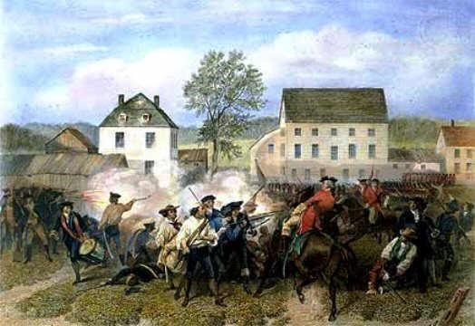Battle of Lexington, MA (4/19/1775);
https://www.landofthebrave.info/revolutionary-war-timeline.htm

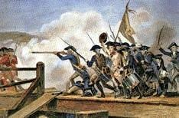
https://www.landofthebrave.info/revolutionary-war-timeline.htm

May 10, 1775 – Fort Ticonderoga Captured
“The capture of Fort Ticonderoga was the first offensive victory for American forces in the Revolutionary War. It secured the strategic passageway north to Canada and netted the patriots an important cache of artillery…. American victory. Ethan Allen and his Green Mountain Boys, together with Benedict Arnold, surprised and overtook a small British garrison at the fort, acquiring valuable weapons for the Continental Army. Arnold took command of Ticonderoga until he was relieved in June 1775…. Located at the confluence of Lake Champlain and Lake George, Fort Ticonderoga controlled access north and south between Albany and Montreal…. During the American War for Independence, several engagements were fought at the five-pointed star-shaped Fort Ticonderoga. The most famous of these occurred on May 10, 1775, when Ethan Allen and his band of Green Mountain Boys, accompanied by Benedict Arnold, who held a commission from Massachusetts, silently rowed across Lake Champlain from present-day Vermont and stormed the fort in a swift, late-night sneak attack. Months later, George Washington, commander of the Continental Army, sent one of his officers, Colonel Henry Knox, to gather the artillery left at Ticonderoga and bring it to Boston. Knox organized the transfer of the heavy guns over frozen rivers and the snow-covered Berkshire Mountains of western Massachusetts. Mounted on Dorchester Heights, the guns from Ticonderoga compelled the British to evacuate the city of Boston in March of 1776.” https://www.battlefields.org/learn/revolutionary-war/battles/fort-ticonderoga-1775
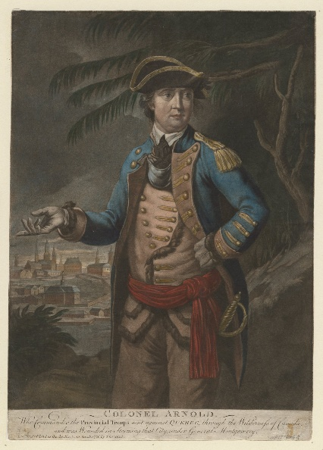Benedict Arnold

May 10, 1775: Second Continental Congress in Philadelphia – established the Continental Army
Benjamin Franklin [age 69] returns from London
“Franklin returned [from London] to Philadelphia in May 1775, shortly after the
Revolutionary War (1775-83) had begun, and was selected to serve as a delegate to the Second Continental Congress, America’s governing body at the time. In 1776, he was part of the five-member committee that helped draft the Declaration of Independence, in which the 13 American colonies declared their freedom from British rule. That same year, Congress sent Franklin to France to enlist that nation’s help with the Revolutionary War. In February 1778, the French signed a military alliance with America and went on to provide soldiers, supplies and money that proved critical to America’s victory in the war.” https://www.history.com/topics/american-revolution/benjamin-franklin

“When the Second Continental Congress convened in Philadelphia, delegates–including new additions Benjamin Franklin and Thomas Jefferson–voted to form a Continental Army, with Washington as its commander in chief. On June 17, in the Revolution’s first major battle, colonial forces inflicted heavy casualties on the British regiment of General William Howe at Breed’s Hill in Boston. The engagement (known as the Battle of Bunker Hill) ended in British victory, but lent encouragement to the revolutionary cause. Throughout that fall and winter, Washington’s forces struggled to keep the British contained in Boston, but artillery captured at Fort Ticonderoga in New York helped shift the balance of that struggle in late winter. The British evacuated the city in March 1776, with Howe and his men retreating to Canada to prepare a major invasion of New York. https://www.history.com/topics/american-revolution/american-revolution-history

May 10, 1775: Ethan Allen and his Green Mountain Boys surprised British garrison at Fort Ticonderoga, NY – British surrendered. Ethan Allen [age 37] Benedict Arnold [age 34] – turned “Traitor” in 1780 [age 39], defected to British Army.
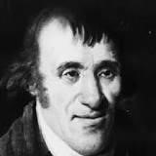
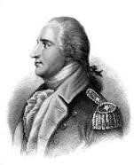
“By the end of 1779, Arnold had begun secret negotiations with the British to surrender the American fort at West Point, New York, in return for money and a command in the British army. Arnold’s chief intermediary was British Major John André (1750-80). André was captured in September 1780, while crossing between British and American lines, disguised in civilian clothes. Papers found on André incriminated Arnold in treason. Learning of André’s capture, Arnold fled to British lines before the Patriots could arrest him. West Point remained in American hands, and Arnold only received a portion of his promised bounty. André was hanged as a spy in October 1780.
***
After fleeing to the enemy side, Arnold received a commission with the British army and served in several minor engagements against the Americans. After the war, which ended in victory for the Americans with the Treaty of Paris in 1783, Arnold resided in England. He died in London on June 14, 1801, at age 60. The British regarded him with ambivalence, while his former countrymen despised him. Following his death, Arnold’s memory lived on in the land of his birth, where his name became synonymous with the word “traitor.” “ https://www.history.com/topics/american-revolution/benedict-arnold

June 16,1775: Colonel George Washington [age 43] accepts post of Commander In Chief of Continental Army

https://www.landofthebrave.info/revolutionary-war-timeline.htm

June 17, 1775: Battle of Bunker Hill, MA
“On June 17, 1775, early in the Revolutionary War (1775-83), the British defeated the Americans at the Battle of Bunker Hill in Massachusetts. Despite their loss, the inexperienced colonial forces inflicted significant casualties against the enemy, and the battle provided them with an important confidence boost. Although commonly referred to as the Battle of Bunker Hill, most of the fighting occurred on nearby Breed’s Hill.
https://www.history.com/topics/american-revolution/battle-of-bunker-hill

“It took more than a month for the letter to reach John Adams in Philadelphia, but on June 18, 1775, Abigail Adams wrote the following words about events unfolding in Charlestown, just north of Boston: “The Battle began upon our entrenchments upon Bunker Hill, a Saturday morning about 3 o’clock, and has not ceased yet and ’tis now 3 o’clock Sabbath afternoon. … How many have fallen we know not. The constant roar of the cannon is so distressing that we cannot Eat, Drink or Sleep.”
Abigail Adams had taken her eldest son, John Quincy, just shy of his eighth birthday, to view the distant battle from the top of Penn’s Hill near the family farm in Braintree (now Quincy). They had witnessed from afar the Pyrrhic British victory, achieved at the cost of more than 1,000 casualties, nearly half the British attack force. Back in London, one retired British officer would observe that with a few more victories like Bunker Hill, the British army would be annihilated.

Nor did Abigail Adams learn until later that Joseph Warren, the Adamses’ family physician and prominent leader of the colonial resistance group the Sons of Liberty, had been killed when the third wave of the British assault overran his redoubt; he was shot between the eyes after the American troops had run out of ammunition. ‘Our dear Friend Dr. Warren is no more,’ she wrote, ‘but fell gloriously fighting for his Country — saying better to die honorably in the field than ignominiously hang upon the Gallows.’”
https://www.washingtonpost.com/opinions/interactive/2025/bunker-hill-revolutionary-war/?utm_campaign=wp_post_most&utm_medium=email&utm_source=newsletter&carta-url=https%3A%2F%2Fs2.washingtonpost.com%2Fcar-ln-tr%2F432491c%2F68519494337c6a26b4be2374%2F59731235ade4e21a848a56ed%2F49%2F65%2F68519494337c6a26b4be2374

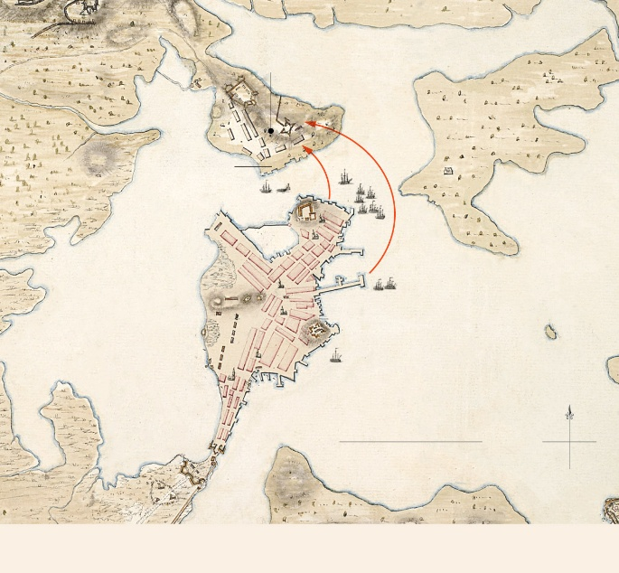

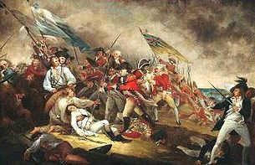 Death of General Warren at the Battle of Bunker Hill: https://www.landofthebrave.info/revolutionary-war-timeline.htm

August, 1775: King George III [age 37] issued proclamation that colonists were engaged in “rebellion” – British parliament passed American Prohibitory Act – American vessels / cargo can be seized

Aug. 21, 1775: George Washington – Enslaved Servant Will Lea
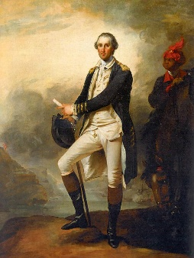
“From the time of his arrival on Boston’s outskirts, Washington would thereafter be constantly in the field or in camp with his troops, accompanied by his enslaved servant William Lee, who was also an excellent horseman. Washington regarded a disciplined and well-trained officer corps as crucial to victory. He also believed in the importance of winning by conventional warfare as necessary to demonstrate the civility of the new nation and earn the respect of Europe.” https://www.washingtonpost.com/opinions/interactive/2025/george-washington-revolutionary-war-commander/?utm_campaign=wp_week_in_ideas&utm_medium=email&utm_source=newsletter
***
William (Billy) Lee: https://www.washingtonpost.com/opinions/interactive/2025/george-washington-revolutionary-war-commander/?utm_campaign=wp_week_in_ideas&utm_medium=email&utm_source=newsletter
“William Lee arrived at Mount Vernon in 1768, after George Washington purchased him from Mary Lee, a wealthy Virginia widow, for £61.15s. Washington also bought William’s younger brother Frank, who went on to serve as a waiter and butler in the household. Both William and Frank were described as “mulatto,” or mixed race, meaning they were probably the sons of an enslaved mother and a white father. The name “Billy Lee” appears frequently in popular histories and is well known, Washington only referred to his valet by that diminutive until about 1771. *** Spending more than seven years in close proximity during the intensity of war seems to have made Washington and Lee’s relationship especially close. The former’s views on slavery shifted significantly during the war, and he emerged with a newfound abhorrence of slavery and a commitment to neither buy nor sell enslaved people and to avoid separating enslaved families. Many factors likely influenced Washington’s evolution, but his close relationship with William Lee may have helped him understand more fully the humanity of those he enslaved.”

Sept. 14, 1775: Address to the Inhabitants of Canada, 14 September 1775
Read letter signed by George Washington. “Generals of approved Experience, who boasted of subduing this great Continent, find themselves circumscribed within the Limits of a single City and its Suburbs, suffering all the Shame and Distress of a Siege. While the trueborn Sons of America, animated by the genuine Principles of Liberty and Love of their Country, with increasing Union, Firmness and Discipline repel every Attack, and despise every Danger. ** I have detached Colonel Arnold into your Country, with a Part of the Army under my Command—I have enjoined upon him, and I am certain that he will consider himself, and act as in the Country of his Patrons, and best Friends.” https://founders.archives.gov/documents/Washington/03-01-02-0358

Nov. 20, 1775 – British Artillery Recovered From Captured Fort Ticonderoga

“Henry Knox, a 25-year-old bookseller turned Continental Army colonel, departed from Boston on one of the most daring logistical missions of the American Revolution. His task was a near-impossible feat: travel to American-held Fort Ticonderoga, retrieve its captured British artillery, and haul the guns nearly 300 miles back to the American siege lines around Boston. Over the next two months, Knox and his men would engineer one of the great early triumphs of the war. Battling snow, ice, freezing rivers, and rugged wilderness, they successfully transported 59 pieces of heavy artillery—mortars, howitzers, and massive cannons—on sleds drawn by teams of oxen. Gen. George Washington called the achievement “a prodigious undertaking,” and it proved decisive. When the guns arrived in Boston in early 1776, they were emplaced on the heights surrounding the city, forcing the British to evacuate Boston in March. Knox’s successful journey was a testament to the ingenuity, endurance, and resolve of the fledgling Continental Army in the early stages of their fight for independence.”

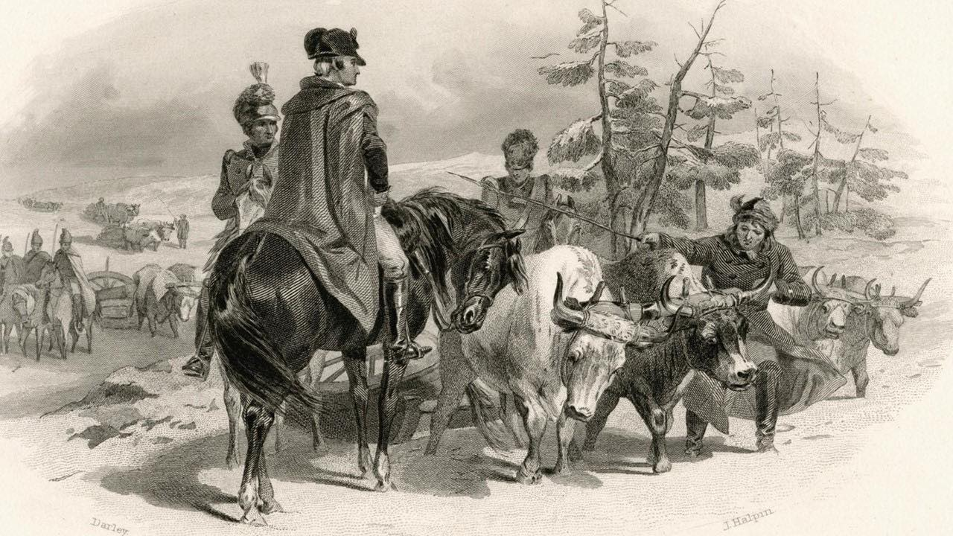

“Influenced by Boston's protests and revolution fever, Knox joined a local militia group called the Boston Grenadier Corps. In 1775, he served in the Siege of Boston. When General Washington arrived to take command in July of that year, Knox's command of artillery impressed the new commander. Though only about twenty five years old, Knox received a commission as a colonel who oversaw artillery and tasked with bringing cannons from the recently captured Fort Ticonderoga in New York state to Boston in the middle of winter. He and his men successfully brought sixty tons of cannon packed on sleds pulled by oxen over 300 miles of snow, ice covered rivers, and mountains to the Boston camps without losing a single cannon.” https://www.battlefields.org/learn/biographies/henry-knox

Dec. 31, 1775 - Failed Battle of Quebec
“On December 31, 1775, during the American Revolutionary War (1775-83), Patriot forces under Colonel Benedict Arnold (1741-1801) and General Richard Montgomery (1738-75) attempted to capture the British-occupied city of Quebec and with it win support for the American cause in Canada. The attack failed, and the effort cost Montgomery his life. The Battle of Quebec was the first major defeat of the Revolutionary War for the Americans.
***
Of the approximately 1,200 Americans who participated in the battle, more than 400 were captured, wounded or killed. British casualties were minor.” https://www.history.com/topics/american-revolution/battle-of-quebec-1775

Jan. 1776: Thomas Payne [age 39] publishes a pamphlet, “Common Sense” – calling for independence
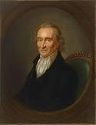Thomas Paine

March 17, 1776: British Evacuate Boston
“After the British evacuated Boston on March 17, 1776, General George Washington guessed correctly that their next target would be New York. By mid-April, Washington had marched his 19,000 soldiers to Lower Manhattan. He strengthened the batteries that guarded the harbor and constructed forts in northern Manhattan and on Brooklyn Heights across the East River on Long Island.
***
Washington waited throughout June for the British to appear, hoping that somehow his undisciplined troops could hold off an attack, which he was certain would come in Manhattan. In early July, 400 British ships with 32,000 men commanded by General
William Howe arrived at Staten Island. When Howe offered a pardon to the rebels, Washington answered, "Those who have committed no fault want no pardon." While he was still convinced that the British would attack Manhattan, he sent more troops to
Brooklyn.” https://www.mountvernon.org/library/digitalhistory/digitalencyclopedia/article/battle-of-long-island/

May 23, 1776: King George [age 38] - British hiring German mercenaries
King George arranged with German states to hire mercenaries – “Hessians” - to fight Americans.

June 12, 1776: The Virginia Declaration of Rights [format for “Bill of Rights”]
“Virginia's Declaration of Rights was drawn upon by Thomas Jefferson for the opening paragraphs of the Declaration of Independence. It was widely copied by the other colonies and became the basis of the Bill of Rights. Written by George Mason, it was adopted by the Virginia Constitutional Convention on June 12, 1776.
Section 1: Section 1. That all men are by nature equally free and independent and have certain inherent rights, of which, when they enter into a state of society, they cannot, by any compact, deprive or divest their posterity; namely, the enjoyment of life and liberty, with the means of acquiring and possessing property, and pursuing and obtaining happiness and safety.”
https://www.archives.gov/founding-docs/virginia-declaration-of-rights

6/1776: Second Continental Congress
Richard Henry Lee, from Virginia, proposed Resolution for Independence – but vote on Resolution was delayed.
Appointment of Committee of 5 to prepare Declaration of Independence:

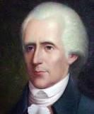
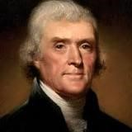
Richard Henry Lee – Virginia [age 44]
Thomas Jefferson – Virginia [age33] - principal draftsman

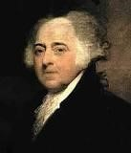
John Adams [age 41]

Benjamin Franklin [age 70] Note: During the beginning of the Revolutionary War (1775), Benjamin Franklin’s son, William, was the Royal Governor of New Jersey, and supported the “Loyalists” who fought against General George Washington’s Continental Army at Battle of Springfield, NJ (6/23/1780).
“In June of 1776, rebels in New Jersey exiled Gov. William Franklin to Connecticut, where Gov. Jonathan Trumbull sided with the patriots. The patriots placed him under guard at Wallingford and then Middletown. However, the stubborn governor-in-exile refused to submit to his captors. He continued gathering intelligence for loyalists and helping protect Connecticut Tories’ property by issuing them royal pardons. In May of 1777, armed guards took William Franklin to Litchfield. They placed him in solitary confinement in the cell reserved for prisoners condemned to death. His filthy room contained a straw mat on the floor and nothing else – no bed, no seat, no toilet facility.” https://www.newenglandhistoricalsociety.com/william-franklin-bens-son-spentrevolutionary-war-connecticut-jail/

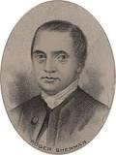 Roger Sherman [age 55]

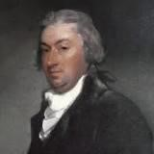 Robert Livingston [age 30]

July 4, 1776: Declaration of Independence - Benjamin Franklin – famous quote
Declaration of Independence fashioned after 1215 Magna Carta:
“Magna Carta Libertatum, or the Great Charter of Freedoms, has been described by scholars as one of the most important documents in the Western world. First penned for King John of England during an open revolt by his barons in 1215 — and offered as a kind of peace treaty — the charter famously declares that even the king must follow the rules. *** After it was first issued in 1215 by King John, the Great Charter was reissued in 1216, 1217 and 1225 by his son, King Henry III, and then reissued again by Henry’s son, Edward I, in 1297 and 1300.” https://www.washingtonpost.com/world/2025/05/15/magna-carta-harvard-great-charter/?utm_campaign=wp_todays_headlines&utm_medium=email&utm_source=newsletter&carta-url=https%3A%2F%2Fs2.washingtonpost.com%2Fcar-ln-tr%2F4291f51%2F6825bb2be4755d707b27b1eb%2F59731235ade4e21a848a56ed%2F26%2F62%2F6825bb2be4755d707b27b1eb

Benjamin Franklin supposedly gave this quote after signing the Declaration of Independence: “We must all hang together, or most assuredly we shall all hang separately.”

Presentation of the finished Declaration of Independence by Thomas Jefferson in Philadelphia, July 4, 1776. The Declaration was then signed and copies of the text were transported to key cities such as New York and Boston to be read aloud.” http://www.historyplace.com/unitedstates/revolution/decindep.htm

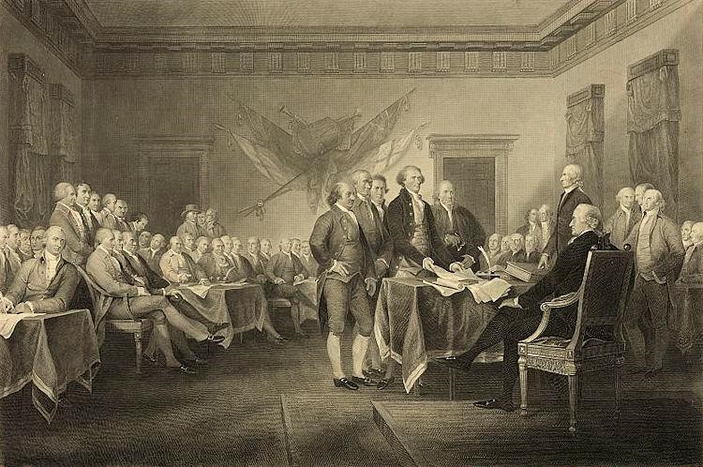
In Congress, July 4, 1776.
The unanimous Declaration of the thirteen united States of America, When in the Course of human events, it becomes necessary for one people to dissolve the political bands which have connected them with another, and to assume among the powers of the earth, the separate and equal station to which the Laws of Nature and of Nature's God entitle them, a decent respect to the opinions of mankind requires that they should declare the causes which impel them to the separation.
We hold these truths to be self-evident, that all men are created equal, that they are endowed by their Creator with certain unalienable Rights, that among these are Life, Liberty and the pursuit of Happiness.--That to secure these rights, Governments are instituted among Men, deriving their just powers from the consent of the governed, -That whenever any Form of Government becomes destructive of these ends, it is the Right of the People to alter or to abolish it, and to institute new Government, laying its foundation on such principles and organizing its powers in such form, as to them shall seem most likely to effect their Safety and Happiness. Prudence, indeed, will dictate that Governments long established should not be changed for light and transient causes; and accordingly all experience hath shewn, that mankind are more disposed to suffer, while evils are sufferable, than to right themselves by abolishing the forms to which they are accustomed. But when a long train of abuses and usurpations, pursuing invariably the same Object evinces a design to reduce them under absolute Despotism, it is their right, it is their duty, to throw off such Government, and to provide new Guards for their future security.--Such has been the patient sufferance of these Colonies; and such is now the necessity which constrains them to alter their former Systems of Government. The history of the present King of Great Britain is a history of repeated injuries and usurpations, all having in direct object the establishment of an absolute Tyranny over these States. To prove this, let Facts be submitted to a candid world.
He has refused his Assent to Laws, the most wholesome and necessary for the public good.
He has forbidden his Governors to pass Laws of immediate and pressing importance, unless suspended in their operation till his Assent should be obtained; and when so suspended, he has utterly neglected to attend to them.
He has refused to pass other Laws for the accommodation of large districts of people, unless those people would relinquish the right of Representation in the Legislature, a right inestimable to them and formidable to tyrants only.
He has called together legislative bodies at places unusual, uncomfortable, and distant from the depository of their public Records, for the sole purpose of fatiguing them into compliance with his measures.
He has dissolved Representative Houses repeatedly, for opposing with manly firmness his invasions on the rights of the people.
He has refused for a long time, after such dissolutions, to cause others to be elected; whereby the Legislative powers, incapable of Annihilation, have returned to the People at large for their exercise; the State remaining in the mean time exposed to all the dangers of invasion from without, and convulsions within.
He has endeavored to prevent the population of these States; for that purpose obstructing the Laws for Naturalization of Foreigners; refusing to pass others to encourage their migrations hither, and raising the conditions of new Appropriations of Lands.
He has obstructed the Administration of Justice, by refusing his Assent to Laws for establishing Judiciary powers.
He has made Judges dependent on his Will alone, for the tenure of their offices, and the amount and payment of their salaries.
He has erected a multitude of New Offices, and sent hither swarms of Officers to harass our people, and eat out their substance.
He has kept among us, in times of peace, Standing Armies without the Consent of our legislatures.
He has affected to render the Military independent of and superior to the Civil power.
He has combined with others to subject us to a jurisdiction foreign to our constitution, and unacknowledged by our laws; giving his Assent to their Acts of pretended Legislation:
For Quartering large bodies of armed troops among us:
For protecting them, by a mock Trial, from punishment for any Murders which they should commit on the Inhabitants of these States:
For cutting off our Trade with all parts of the world:
For imposing Taxes on us without our Consent:
For depriving us in many cases, of the benefits of Trial by Jury:
For transporting us beyond Seas to be tried for pretended offences
For abolishing the free System of English Laws in a neighboring Province, establishing therein an Arbitrary government, and enlarging its Boundaries so as to render it at once an example and fit instrument for introducing the same absolute rule into these Colonies:
For taking away our Charters, abolishing our most valuable Laws, and altering fundamentally the Forms of our Governments:
For suspending our own Legislatures, and declaring themselves invested with power to legislate for us in all cases whatsoever.
He has abdicated Government here, by declaring us out of his Protection and waging War against us.
He has plundered our seas, ravaged our Coasts, burnt our towns, and destroyed the lives of our people.
He is at this time transporting large Armies of foreign Mercenaries to complete the works of death, desolation and tyranny, already begun with circumstances of Cruelty & perfidy scarcely paralleled in the most barbarous ages, and totally unworthy the Head of a civilized nation.
He has constrained our fellow Citizens taken Captive on the high Seas to bear Arms against their Country, to become the executioners of their friends and Brethren, or to fall themselves by their Hands.
He has excited domestic insurrections amongst us, and has endeavored to bring on the inhabitants of our frontiers, the merciless Indian Savages, whose known rule of warfare, is an undistinguished destruction of all ages, sexes and conditions.
In every stage of these Oppressions We have Petitioned for Redress in the most humble terms: Our repeated Petitions have been answered only by repeated injury. A Prince whose character is thus marked by every act which may define a Tyrant, is unfit to be the ruler of a free people.
Nor have We been wanting in attentions to our British brethren. We have warned them from time to time of attempts by their legislature to extend an unwarrantable jurisdiction over us. We have reminded them of the circumstances of our emigration and settlement here. We have appealed to their native justice and magnanimity, and we have conjured them by the ties of our common kindred to disavow these usurpations, which, would inevitably interrupt our connections and correspondence. They too have been deaf to the voice of justice and of consanguinity. We must, therefore, acquiesce in the necessity, which denounces our Separation, and hold them, as we hold the rest of mankind, Enemies in War, in Peace Friends.
We, therefore, the Representatives of the united States of America, in General Congress, Assembled, appealing to the Supreme Judge of the world for the rectitude of our intentions, do, in the Name, and by Authority of the good People of these Colonies, solemnly publish and declare, That these United Colonies are, and of Right ought to be Free and Independent States; that they are Absolved from all Allegiance to the British Crown, and that all political connection between them and the State of Great Britain, is and ought to be totally dissolved; and that as Free and Independent States, they have full Power to levy War, conclude Peace, contract Alliances, establish Commerce, and to do all other Acts and Things which Independent States may of right do. And for the support of this Declaration, with a firm reliance on the protection of divine Providence, we mutually pledge to each other our Lives, our Fortunes and our sacred Honor.”
https://www.archives.gov/founding-docs/declaration-transcript [spelling corrected to modern English]

July 21, 1776: 12 Colonies voted for Independence; New York did not cast vote until NY Convention approved on July 9.

July 27, 1776: Benjamin Franklin Appointed Postmaster General
“Back on American soil [from England] in 1775, Franklin was part of the Second Continental Congress and served on many committees, including one to establish an independent postal system. On July 26, 1775, the Congress appointed Benjamin Franklin the first Postmaster General of the organization now known as the United States Postal Service. Franklin received an annual salary of $1,000 plus $340 for a secretary and comptroller. He was responsible for all Post Offices -- from Massachusetts to Georgia -- and had authority to hire as many postmasters as he saw fit.” https://about.usps.com/whowe-are/postal-history/pmg-franklin.pdf

Aug. 27, 1776: Battle of Long Island, NY
General Washington lost the battle and was almost killed. See videotaped interview of Joe Ellis, author of Revolutionary Summer. https://www.mountvernon.org/library/digitalhistory/digitalencyclopedia/article/battle-of-long-island/
“After the British evacuated Boston on March 17, 1776, General George Washington guessed correctly that their next target would be New York. By mid-April, Washington had marched his 19,000 soldiers to Lower Manhattan. He strengthened the batteries that guarded the harbor and constructed forts in northern Manhattan and on Brooklyn Heights across the East River on Long Island.
***
General Howe halted the fighting by the early afternoon and directed his men to dig trenches around the American position on the next day. Before they could be surrounded, Washington ordered his men to evacuate Long Island. From late in the evening of August 29 to dawn on the following morning, Washington watched as 9,000 Continentals were rowed back to Manhattan. As the sun came up, a fog miraculously descended on the remaining men crossing the river. According to eyewitnesses, George Washington was the last man to leave Brooklyn.”
https://www.mountvernon.org/library/digitalhistory/digital-encyclopedia/article/battle-oflong-island/

Aug. 29-30, 1776: George Washington – Brooklyn Heights,
Washington’s Ten Best Military Decisions (10/28/2025) https://allthingsliberty.com/2025/10/washingtons-ten-best-military-decisions/

“The evacuation of Washington’s army from Brooklyn Heights to Manhattan on the night of August 29-30, 1776. Done in small craft on difficult water without detection by a larger and more powerful enemy army and fleet, this represents one of the most skillful withdrawals in military history. By the time he called a council of war on the afternoon of August 29 to discuss whether to withdraw from Brooklyn, Washington had already begun to collect the boats, and he ordered the evacuation to begin immediately. The crossing began to unfold that evening. At that point, British officer Charles Stedman recalled, the American army ‘had been driven to the corner of an island, where they were hemmed in within the narrow space of two square miles’ and ‘lay almost entirely at the will of the English.’ While not undoing Washington’s litany of errors in connection with the Battle of Long Island two days before, this operation saved fully one-half of his army—9,500 men, their horses, and most of their equipment. Washington, who salvaged all but five of his cannon, left with the last of the troops. This action has been described by one historian as flawless and one of the greatest moments in the annals of warfare, given its impact. To another, it stands as one of the most brilliant tactical withdrawals in military history. And Lt. Benjamin Tallmadge, who did not ‘recollect a more fortunate retreat’ in ‘the history of warfare,’ opined that ‘Gen. Washington has never received the credit which was due to him for this wise and most fortunate measure.”’”

Sept. 16, 1776: Battle of Harlem Heights, NY
“The British understood Washington's strategy, and retreated as a result. Casualties were high with 150 men lost on both sides including Lieutenant Knowlton who was mortally wounded. With the skirmish concluded, Washington completed his letter to Congress. While he was disappointed that his men failed to execute his orders, he had actually won his first battlefield victory in the war. His soldiers were equally elated that they had forced the British to flee before them.”
https://www.mountvernon.org/library/digitalhistory/digital-encyclopedia/article/battle-ofharlem-heights/

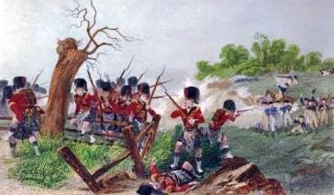
https://www.landofthebrave.info/revolutionary-war-timeline.htm

Dec. 25, 1776: George Washington – Incident Command

Christmas Day he crossed Delaware River: victory at Trenton [Age 44]

“General George Washington’s army crossed the icy Delaware on Christmas Day 1776 and, over the course of the next 10 days, won two crucial battles of the American Revolution. In the Battle of Trenton (December 26), Washington defeated a formidable garrison of Hessian mercenaries before withdrawing. A week later he returned to Trenton to lure British forces south, then executed a daring night march to capture Princeton on January 3. “https://www.history.com/topics/american-revolution/battles-of-trenton-andprinceton

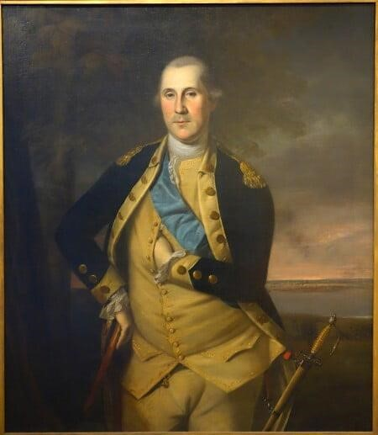 Portrait of George Washington (1776) by Charles Willson Peale: https://www.mountvernon.org/george-washington/artwork/life-portraits-of-georgewashington/

Jan. 13, 1777: Battle of Princeton (NJ)
“After crossing the Delaware on December 25, 1776, George Washington embarked on a ten day campaign that would change the course of the war. Culminating at the Battle of Princeton on January 3, 1777, Washington snatched victory from the jaws of defeat and proved his amateur army could defeat the British. ***
The Battle of Princeton was a classic meeting engagement, both sides stumbled into one another, and neither expected to fight on the ground where the battle raged. Initially, the British commander Charles Mawhood, marched his force south towards Trenton to meet the main British army, when he spotted the American column. Washington had stolen a march on Charles Lord Cornwallis, slipping away from the British forces along Assunpink Creek the night before.
When the American's spotted British troopers around William Clarke's farm, Washington detached Hugh Mercer's brigade to investigate. Mercer ran headlong into the 17th Foot, firmly stationed behind a fence at the end of Clarke's orchard. In the ensuing volleys, Mercer was wounded and his men routed by a bayonet charge. With the outnumbered
British on the verge of splitting his army, Washington quickly detached John Cadwalader's Philadelphia Associatiors to plug the gap. These green troops fought valiantly, but were also broken by British bayonets.
With the battle, and the war, hanging in the balance, Washington personally led fresh troops onto the field while grapeshot and canister from Joseph Moulder's artillery battery forced the British back towards William Clarke's farmhouse. Washington's counterattack broke the British line, which quickly turned into a rout.” https://www.battlefields.org/learn/revolutionary-war/battles/princeton

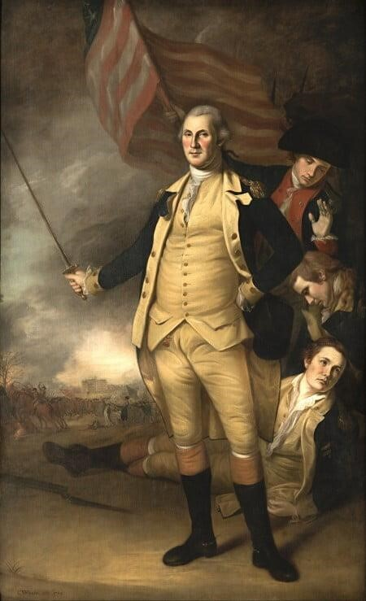 Portrait of George Washington after Battle of Princeton – by Charles Willson Peale https://www.mountvernon.org/george-washington/artwork/life-portraits-ofgeorge-washington/

June 13, 1777: Marquis de Lafayette [age 19] arrives from France
“He landed near Charleston, South Carolina, June 13, 1777, then travelled to
Philadelphia, where he was commissioned a Major General on July 31. This reflected his wealth and noble social station, rather than years of battlefield experience — he was only 19 years old. The newly commissioned young general was soon introduced to his commander-in-chief, General George Washington, who would become a lifelong friend. Lafayette was wounded during the September 11, 1777 Battle of the Brandywine. In December, 1777, he camped with Washington and the army at Valley Forge.
http://www.ushistory.org/valleyforge/served/lafayette.html

 Marquis de Lafayette
.
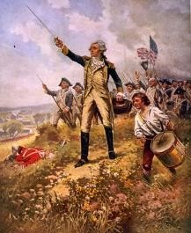
Lafayette's baptism of fire

Aug. 27, 1777 - Philadelphia
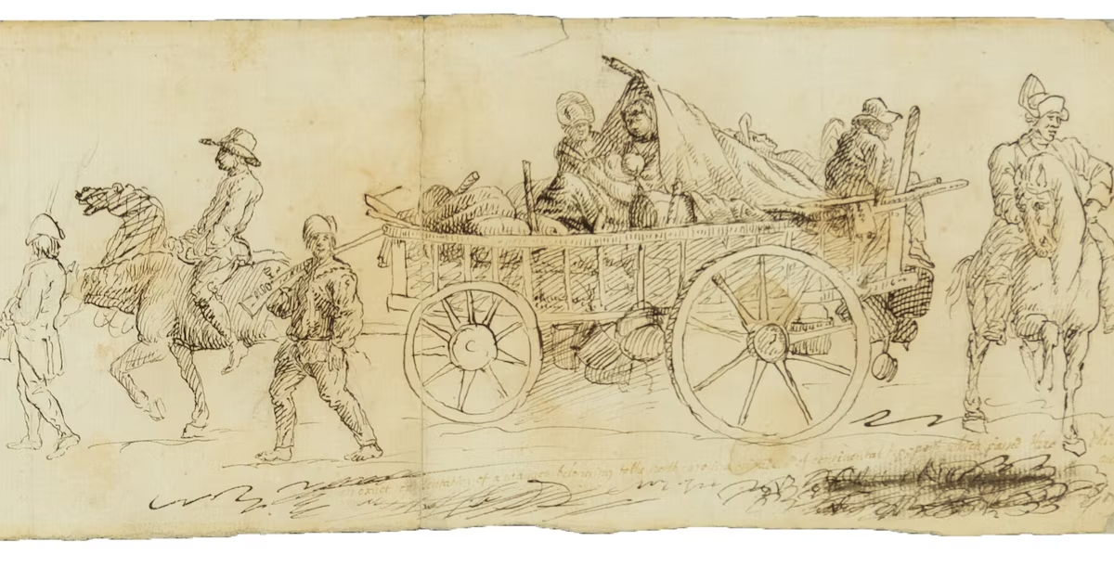Aug. 27, 1777, issue of the Pennsylvania Gazette. The newspaper included an account of “General Nash’s brigade of North-Carolina forces” marching through the city to join General Washington’s Continental Army just before the Battle of Brandywine. The illustration, measuring 15 by 5 inches, shows six men — two on horseback, two on foot and two riding in a wagon laden with supplies — along with two women and a baby in the wagon.
https://www.washingtonpost.com/history/2024/04/14/revolutionary-war-sketch-simitiere-museum/?utm_campaign=wp_evening_edition&utm_medium=email&utm_source=newsletter&carta-url=https%3A%2F%2Fs2.washingtonpost.com%2Fcar-ln-tr%2F3d656bd%2F661c43e5ab122c4fece814c3%2F59731235ade4e21a848a56ed%2F26%2F43%2F661c43e5ab122c4fece814c3

Sept. 11, 1777: Battle of Brandywine, PA
“On September 11, 1777, General Sir William Howe and General Charles Cornwallis launch a full-scale British attack on General George Washington and the Patriot outpost at Brandywine Creek near Chadds Ford, in Delaware County, Pennsylvania, on the road linking Baltimore and Philadelphia.
***
Surprised and outnumbered by the 18,000 British troops to his 11,000 Continentals,
Washington ordered his men to abandon their posts and retreat. Defeated, the Continental Army marched north and camped at Germantown, Pennsylvania. The British abandoned their pursuit of the Continentals and instead began the British occupation of Philadelphia.
***
The one-day battle at Brandywine cost the Americans more than 1,100 men killed or captured while the British lost approximately 600 men killed or injured. To make matters worse, the Patriots were also forced to abandon most of their cannon to the British victors after their artillery horses fell in battle.
***
Congress, which had been meeting in Philadelphia, fled first to Lancaster, then to York, Pennsylvania, and the British took control of the city without Patriot opposition.” https://www.history.com/this-day-in-history/the-battle-of-brandywine-begins

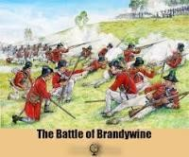

Sept. 19,1777: Battles of Saratoga, NY - British General John Burgoyne surrender on Oct. 17
“Fought eighteen days apart in the fall of 1777, the two Battles of Saratoga were a turning point in the American Revolution. On September 19th, British General John Burgoyne achieved a small, but costly victory over American forces led by Horatio Gates and Benedict Arnold. Though his troop strength had been weakened, Burgoyne again attacked the Americans at Bemis Heights on October 7th, but this time was defeated and forced to retreat. He surrendered ten days later, and the American victory convinced the
French government to formally recognize the colonist’s cause and enter the war as their ally.” https://www.history.com/topics/american-revolution/battle-of-saratoga

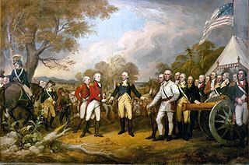
https://www.landofthebrave.info/revolutionary-war-timeline.htm

Horatio Gates [age 50]

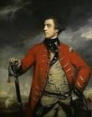General John Burgoyne [age 55]

Dec. 19, 1777: Valley Forge, PA - General George Washington [age 45]

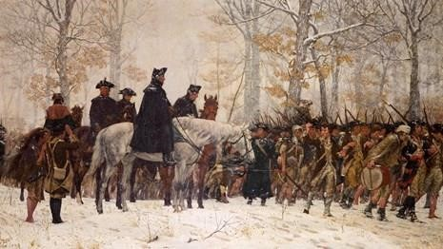
“On December 19, 1777, 11,000 Continental Army regulars marched into Valley Forge, Pennsylvania, to set up winter quarters during the Revolutionary War. By December 1777, Washington was well aware that some members of the Continental Congress were questioning his leadership abilities. The Valley Forge site—located along trade routes and near farm supplies—was an attempt to balance Congress’ demands for a winter campaign against Philadelphia with the needs of his troops. It was common for armies at the time to withdraw to fixed camps during the winter, as the harsh weather made transportation of troops, arms and supplies extremely difficult. The soldiers who marched to Valley Forge on December 19, 1777 were not downtrodden or desperate. Though they had been defeated in two key battles, and had lost Philadelphia to the British, Continental troops had often put themselves on the offensive, and proved themselves as skilled fighters against professional soldiers with superior numbers. They were certainly tired, and lacking in supplies, but these were not unusual circumstances in the life of a Continental soldier. Once the troops arrived at their winter camp site, military engineers directed the construction of some 2,000 huts laid out in parallel lines, forming a kind of city, along with miles of trenches, five earthen redoubts and a bridge over the Schuylkill River. Raw winter weather made things difficult for the tired troops, while a mismanaged commissary and Congress’ failure to provide the army with sufficient funds for fresh supplies led to widespread hunger and lack of clothing, shoes and other supplies among the men. Yet cold and starvation were not the most dangerous threats to soldiers at Valley Forge: Diseases like influenza, dysentery, typhoid and typhus killed two-thirds of the nearly 2,000 soldiers who died during the encampment. https://www.history.com/news/235-years-ago-washingtons-troops-made-camp-at-valleyforge

Feb. 1778: Daniel Boone captured by Shawnees
8 Things You Might Not Know About Daniel Boone: https://www.history.com/articles/8-things-you-might-not-know-about-daniel-boone
“Boone was held captive by Native Americans. In February 1778, while Boone was traveling with a group of Boonesborough men along Kentucky’s Licking River, he was captured by a group of Shawnees. The Shawnees took him to their village in Ohio, where he was adopted by Chief Blackfish to take the place of one of his sons who’d been killed. Boone, who was given the name Sheltowee, or Big Turtle, was treated relatively well by his captors—he was allowed to hunt and may have had a Shawnee wife—but they kept a close eye on him.

In June 1778 he managed to escape and make his way back to Boonesborough, where he warned residents that the natives, upset because settlers had moved onto their Kentucky hunting grounds, were planning to attack. That September, over the course of nine days and nights, a group of Shawnees and other Native Americans laid siege to Boonesborough, but the outnumbered settlers managed to hold them off. A new wave of emigrants then traveled to Kentucky, some of them personally recruited and led there by Boone.”

Feb. 6, 1778: France joins war - King Louis XVI - signed treaties with Americans
King Louis XVI [age 24] sends General Comte de Rochambeau [age 53] and Admiral François Joseph Paul de Grasse [age 56].


Louis XVI in French Revolution, guillotined [age 39] January 21, 1793, Place de la Concorde, Paris, France; Spouse: Marie Antoinette
Marie Antoinette [age 23] - in French Revolution, guillotined Oct. 16, 1793 [age 38], Place de la Concorde, Paris, France; Spouse: Marie Antoinette 
Jean-Baptiste-Donatien de Vimeur, Comte de Rochambeau [age 53]
“The Comte de Rochambeau was the commander of all French forces in America during the War for Independence. His most important contribution came during the Yorktown Campaign, in which he collaborated with George Washington to force the surrender of a major British army under Charles Cornwallis.”
http://www.ouramericanrevolution.org/index.cfm/people/view/pp0028

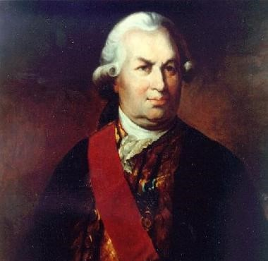 Admiral François Joseph Paul de Grasse [1781 - age 59]
“The most important strategic decision that set Gen. George Washington’s Continental Army on the path to victory in the Revolutionary War was not made by Washington, but by French Admiral François Joseph Paul de Grasse. When de Grasse was ordered to sail with his French fleet from the West Indies to America in 1781 to assist Washington and French General JeanBaptiste Donatien de Vimeur, comte de Rochambeau in the War for American Independence, the French navy commander was given a choice of specific destination. Washington was eager to attack the British stronghold in New York City. Rochambeau, who had arrived with a small army in 1780 to help the Americans, favored confronting Gen. Charles Cornwallis and his British army at Yorktown, Va. For either target, strong naval support from de Grasse’s fleet was essential. De Grasse sided with Rochambeau and chose Virginia. It was closer to his fleet’s base, and the mouth of the Chesapeake Bay was more navigable than New York harbor. His decision set in motion the course of events that would lead to America’s victory in the Revolutionary War.” https://www.battlefields.org/learn/biographies/comte-de-grasse

June 28, 1778: Battle of Monmouth (NJ)
“What began as a promising opportunity devolved into a potential disaster. As Washington approached the fighting, he encountered panic stricken troops fleeing the enemy. Enraged, he galloped ahead of his wing, In an angry confrontation on the field of battle, Washington removed Lee from command.
Rallying what troops he had, Washington continued the assault on the Britsh. The commanding general’s delaying action gave time for the rest of the Continental Army to come up and join the battle.
***
The fighting see-sawed back and forth under the brutal June sun for several hours. By 6:00 P.M., however, the British had had enough. While Wayne wanted to press the attack, Washington demurred, believing that his men were “beat out and with heat and fatigue.”
The British did not give Washington a chance to renew the fight in the morning, slipping away under the cover of darkness and resuming their withdrawal to New York City.” https://www.battlefields.org/learn/revolutionary-war/battles/monmouth
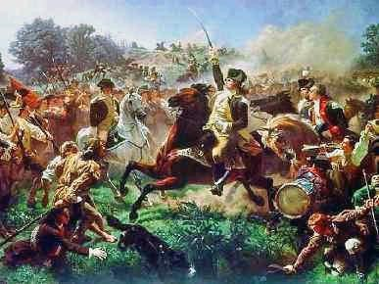
https://www.landofthebrave.info/revolutionary-war-timeline.htm



Portrait of George Washington at Battle of Princeton (1779) by Charles Willson Peale: https://www.mountvernon.org/george-washington/artwork/life-portraits-ofgeorge-washington/

Aug. 28, 1778: Battle of Rhode Island
“The 1st Rhode Island, the first black regiment in America’s history, took part in the action… Located on the right (west) side of the American line, they defended their part of the hill against fierce attacks by German troops. Numbering 400 men, the 1st Rhode Island acquitted itself well, repulsing three separate and distinct charges from 1,500 Hessians under Count Donop.
***
After a siege of 12 days by the Americans dug in on Honeyman’s Hill in Middletown, a weary and disappointed Sullivan realized the land attack alone could not penetrate the English line. With extreme regret, Sullivan was obliged to order withdrawal.
On August 30, near midnight, the last of the Continentals was removed from Aquidneck. The regular troops were sent to rejoin Washington, the militia returned home, and only a small force was left to man the guns of Fort Barton. The Battle of Rhode Island was over.” https://revolutionarywar.us/year-1778/battle-rhode-island/

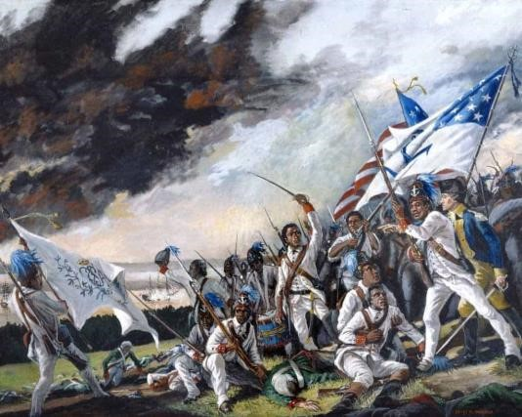
https://revolutionarywar.us/year-1778/battle-rhode-island/

1779: Col. John Bowman battle with Shawnee - Oldtown, Ohio (Xenia)
“A terrible battle was waged in 1779 to secure the land which was occupied by the Shawnee. Col. John Bowman with 264 men under his command marched against Old Chillicothe during the month of May. The troops arrived at night and were determined to wait until daylight to storm the village. Some of the soldiers took it upon themselves to scout the village before the troops could be assigned their various positions, so the Shawnee — alerted — were prepared to fight before daylight. The women and children sought shelter in one of the larger cabins while both sides continued firing. Bowman determined that it would be useless to continue the fight, but several cabins were burned to the ground after taking blankets and silver. The soldiers also rounded up a herd of horses which they took when they retreated. Old Chillicothe was attacked a total of three times before the Shawnee moved away. After the Shawnee left the area, the settlers moved into the fertile land, planting corn and other crops. When it was time to select a name for the village, in keeping with the Shawnee tradition of Old Chillicothe, the new village was named Oldtown.” https://www.xeniagazette.com/2023/07/14/oldtown-has-quite-a-history/

1779 – Sullivan Campaign
“It’s an acknowledgment that the colonists’ desire for unfettered access to Native lands was a primary cause of the break with Britain, which had forbidden any settlement west of the Appalachians.That theme is echoed throughout the documentary. One of the most chilling sequences describes the Sullivan campaign of 1779, in upstate New York, where Washington ordered the destruction of all villages, crops and orchards of the Seneca and Cayuga, who had allied with the British. “You will not by any means listen to any overture for peace, before the total ruin of their settlements is effected,” Washington declared.” https://www.nytimes.com/2025/10/23/arts/television/ken-burns-american-revolution.html?nl=The+Evening

June 23, 1780: Battle of Springfield (NJ)
“At Springfield a terrible battle ensued, involving the Continental regulars and militia against the British soldiers and New Jersey citizens who were loyal to the Crown. Some observers at the time said it was more like a Civil War than a Revolution against an outside power. This internecine battle cut deep, even in the family of Benjamin Franklin, whose own son William, Royal Governor of New Jersey, was a prominent force in organizing the Loyalists. ***
It was a losing battle, causing Lee and his men to retreat back towards the slopes of the Short Hills. But at a critical point, Major General Greene sent over two New England regiments with a cannon. The sight of another 400 soldiers advancing on the high ground while the militiamen covered the slopes of nearby Newark (South) Mountain caused the British to stop abruptly. They risked heavy casualties from the cannon on one side and musket fire on the other.
The British began to retreat back to Staten Island. It was the last time they would set foot in New Jersey.” https://www.durandhedden.org/archives/articles/the_battle_of_springfield

September 1780 – Benedict Arnold - Treason
“After being passed over for a promotion to Major General, Arnold attempted to resign his commission. Arnold resigned his post in Philadelphia and eventually gained command at West Point under the endorsement of Phillip Schuyler. It was in this role that he entered into secret negotiations with the British. He transferred money to British forces and passed on information that would aid the British in capturing West Point. At the same time, he weakened the fort's defenses and thinned out its supplies to make it easier to do so.
John Andre, the officer in charge of British intelligence in North America, was his contact. In late September of 1780, he was captured and ultimately executed for his role in the plot.⁶ The documents in his possession when he was arrested implicated Arnold and revealed Arnold’s betrayal. Before his execution, the Americans offered a prisoner exchange of Andre for Arnold, but it was refused by the British. Arnold narrowly avoided capture by the Americans and eventually fled to England with his family. Washington wrote of Arnold, ‘Treason of the blackest dye was yesterday discovered!.’” https://www.mountvernon.org/library/digitalhistory/digital-encyclopedia/article/benedict-arnold

Oct. 2, 1780 – British Spy John Andre Is Hung
“Washington ordered [Benedict] Arnold's arrest, but Arnold had already reached the safety of British lines. As for André, Washington organized a court of fourteen military generals led by Nathanael Greene to examine the case. After questioning the prisoner, the board decided that he should be executed as a spy. Some officers on the board such as the Marquis de Lafayette disagreed with the decision to execute him. Washington accepted this determination, though he offered the British the opportunity to save André's life by exchanging him for Arnold.
The British refused, believing it would dissuade others from deserting to the British cause. As a result, Washington ordered André's execution which took place on October 2, 1780 at Tappan, New York. The day before his execution, André wrote to Washington for ‘sympathy’ and to request a more honorable death by firing squad, writing, ‘Let me hope Sir, that if ought in my Character impresses you with Esteem towards me, if ought in my Misfortunes marks me as the Victim of policy and not of resentment.’ Ultimately, Washington denied this request and deferred to the decision made by the court marital, insisting that André hang for crime of espionage. News of his execution led to Anti-American sentiment in Britain.” https://www.mountvernon.org/library/digitalhistory/digital-encyclopedia/article/john-andre
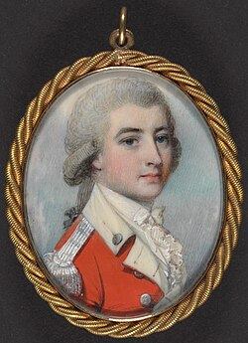

1781: Thomas Jefferson [age 38] on Slavery
Notes on the State of Virginia (1781-1782)
“The whole commerce between master and slave is a perpetual exercise of the most boisterous passions, the most unremitting despotism on the one part, and degrading submissions on the other…
And can the liberties of a nation be thought secure when we have removed their only firm basis, a conviction that these liberties are of the gift of God? That they are not to be violated but with his wrath? Indeed I tremble for my country when I reflect that God is just: That his justice cannot sleep for ever: that considering numbers, nature and natural means only, a revolution of the wheel of fortune, an exchange of situation, is among possible events: that it may become probable by supernatural interference!” http://socialenquiry.org/socialepistemics.com/AD_book_extracts/excerpts/jeffersons_mo numental_quote.html

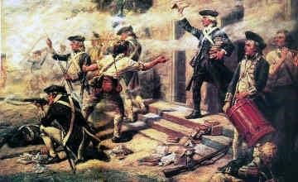
https://www.landofthebrave.info/revolutionary-war-timeline.htm

Sept. 5, 1781: Battle of the Chesapeake – victory for French / Americans

“Battle of the Chesapeake, also called the Battle of the Virginia Capes or the Battle of the
Capes, (5 September 1781), critical naval battle in the Chesapeake Bay (off the coast of Maryland and Virginia) and strategic French victory in the American Revolution. It prevented the British from reinforcing or evacuating the army of Charles Cornwallis the following month at the Siege of Yorktown, Virginia, the last major land battle of the war and the defeat that led the British to sue for peace.”
https://www.britannica.com/event/Battle-of-the-Chesapeake-1781

Sept. 17, 1781: Battle of Yorktown – Lord Cornwallis surrenders; General Washington, with help of Admiral deGrasse’s French fleet that blockaded Chesapeake Bay
“In the fall of 1781, a combined American force of Colonial and French troops laid seige to the British Army at Yorktown, Virginia. Led by George Washington and French General Comte de Rochambeau, they began their final attack on October 14th, capturing two British defenses and leading to the surrender, just days later, of British General Lord Corwallis and nearly 9,000 troops. Yorktown proved to be the final battle of the American Revolution, and the British began peace negotiations shortly after the American victory.” https://www.history.com/topics/american-revolution/siege-ofyorktown

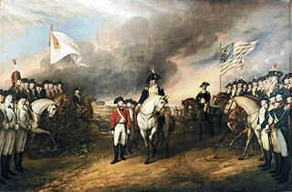
https://www.landofthebrave.info/revolutionary-war-timeline.htm
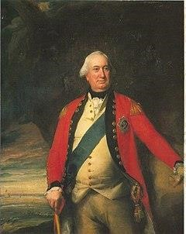General Charles Cornwallis [age 43]


“[T]he sword of British Gen. Charles Cornwallis that, experts theorize, was presented to the Americans during the British surrender at Yorktown on Oct. 19, 1781. (Cornwallis himself never showed up.) *** Cornwallis instead sent one of his subordinates, Gen. Charles O’Hara. As the ceremony began, O’Hara tried to offer the sword to Rochambeau, even though O’Hara knew Washington was the allied commander, Greene recounted. Rochambeau pointed O’Hara to Washington. But when O’Hara tried to surrender the sword to Washington, the latter directed him to one of his subordinates, Gen. Benjamin Lincoln. If Cornwallis was sending a subordinate, he would surrender to a subordinate, Greene wrote. Lincoln took the sword, held it for a moment and gave it back. *** More than 2,000 hired German soldiers surrendered with the British. *** One of the faded flags is that of the 1st Rhode Island Regiment, which included a large contingent of Black soldiers, many of whom were enslaved and agreed to fight in exchange for their freedom. One of them was Cato Varnum, who is shown as a life-size figure wearing the regiment’s white uniform and black hat. He joined the regiment at age 16.”
https://www.washingtonpost.com/history/2025/06/13/cornwallis-sword-washington-revolutionary-war/?utm_campaign=wp_todays_headlines&utm_medium=email&utm_source=newsletter&carta-url=https%3A%2F%2Fs2.washingtonpost.com%2Fcar-ln-tr%2F4314f70%2F684d482bd0a89a00853d8272%2F59731235ade4e21a848a56ed%2F37%2F58%2F684d482bd0a89a00853d8272

Sept. 14, 1782: George Washington [age 50] reviewing Continental Army and French troops at Verplanck’s Point (NY) – in honor of departing French Commander in Chief Comte de Rochambeau [age 57]

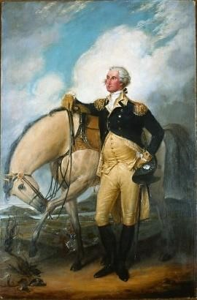Portrait by John Trumbull, former aide to General Washington:
https://www.mountvernon.org/george-washington/artwork/life-portraits-of-george-washington/
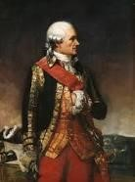

Jean-Baptiste Donatien de Vimeur, comte de Rochambeau

Sept. 1782 – “AIKEN BIBLE” - First Bible Published USA
“In September of 1782, a committee of the United States Congress (at that time the Congress of the Confederation) met in the capital city of Philadelphia to discuss the recent production of local printer Robert Aitken. The work, a 1452-page protestant Bible, was advertised on the title page as being a new translation into English from the ‘original tongues,’ as well as having been “diligently” compared to preceding translations. James Duane, committee chairman, noted its political significance in the minutes printed at the end of the work:
‘[Aitken] undertook this expensive work at a time when, from the circumstances of the war, an English edition of the Bible could not be imported, nor any opinion formed how long the obstruction might continue.’
The publication of the ‘Aitken Bible’ was a landmark moment in the book history of the United States. As the first complete Bible published in an independent America, the tome represents not only its publisher’s piety, but the country’s burgeoning cultural identity detached from that of Britain’s, as well as an intrepid side-stepping of the embargo affecting the importation of books. By decreeing it not just an American copy of a British publisher’s work, but as a brand new, comprehensive incarnation of the Bible for an American audience, the Aitken Bible became not just a devotional text, but a patriotic one as well. It remains the only edition of the Bible authorized by Congress.” https://blogs.loc.gov/bibliomania/2023/07/12/bible-of-the-revolution-the-aitken-bible-in-the-rare-book-and-special-collections-division/

Sept. 3, 1783: Treaty of Paris signed by Great Britain and Americans
U.S. gets all territory westward to Mississippi River, and south to Florida, and north to Canada [Britain also signed treaties ending their battles with Spain and Netherlands.]

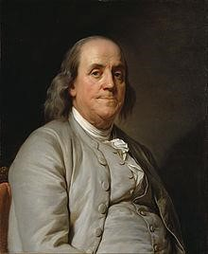
Benjamin Franklin [age 77]

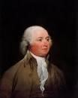 John Adams [age 48]

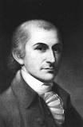
John Jay [age 38]
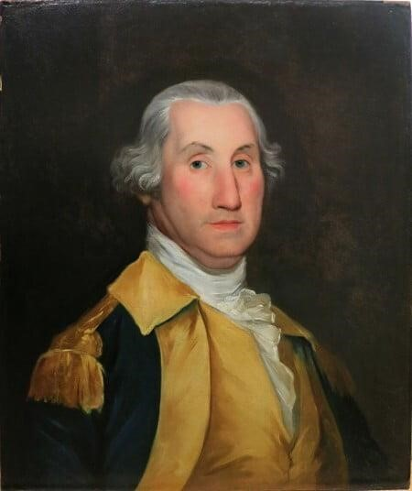

Portrait of George Washington (1783) at his headquarters,
Rocky Hill (NJ), by Joseph Wright: https://www.mountvernon.org/georgewashington/artwork/life-portraits-of-george-washington/
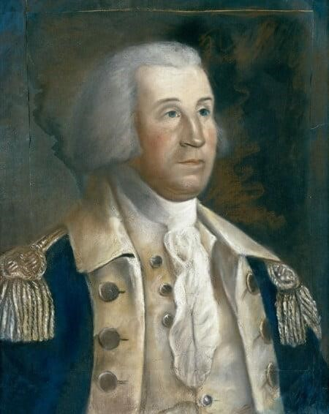
Sketch of George Washington at Rocky Hill, NJ – by 17-year-old William Dunlap: https://www.mountvernon.org/george-washington/artwork/life-portraits-ofgeorge-washington/

Sept. 14, 1783: Treaty of Paris ratified by Congress
“The Treaty of Paris of 1783 formally ended the American Revolutionary War. American statesmen Benjamin Franklin, John Adams and John Jay negotiated the peace treaty with representatives of King George III of Great Britain. In the Treaty of Paris, the British Crown formally recognized American independence and ceded most of its territory east of the Mississippi River to the United States, doubling the size of the new nation and paving the way for westward expansion.” https://www.history.com/topics/americanrevolution/treaty-of-paris

Nov. 25, 1783: New York City finally returned to American control as the last British troops departed after seven years of occupation.

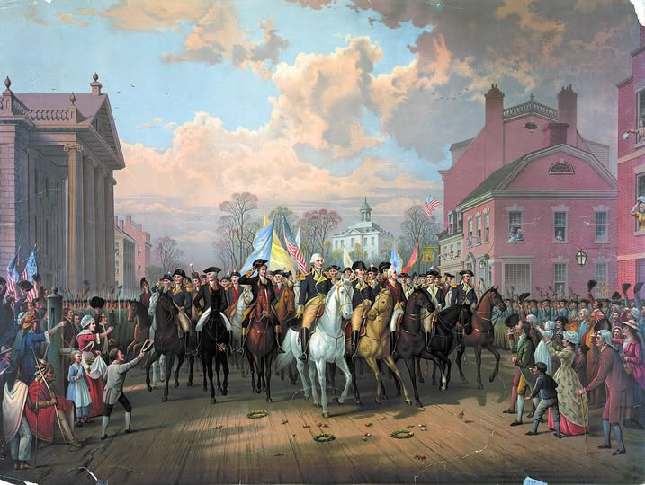
Evacuation Day and Washington’s Triumphal Entry in New York City, produced by Edmund P. Restein, ca. 1838. Collection of Library of Congress Prints and Photographs Division. Washington, D.C.

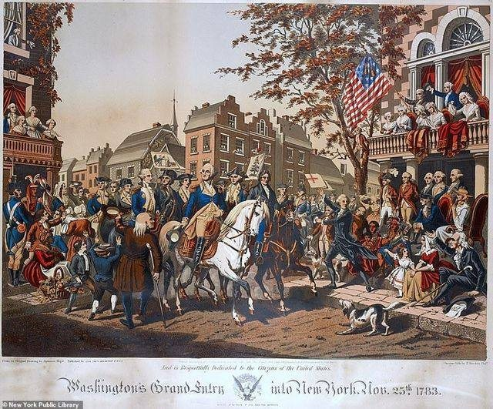

1784: Virginia gives up claims to western lands north of Ohio River – Northwest Territory
The Virginia Cession of Territory Northwest of the Ohio. https://founders.archives.gov/documents/Jefferson/01-06-02-0419-0001
“Thus, both in her own legislature and in Congress, Virginia placed the welfare of the nation above special interests in her effort to create a national domain. A few leaders, such as George Mason, James Madison, Thomas Jefferson, George Washington, Joseph Jones, Benjamin Harrison—some of whom were far from being disinterested themselves—led the three-year fight to yield in the national interest a vast tract of territory for which the state had a more defensible title than most other western claims.”

Note: See July 13, 1787 - Northwest Ordinance - A division of the Northwest Territory into "not less than three nor more than five States." https://www.archives.gov/milestone-documents/northwest-ordinance

Oct. 2, 1785: George Washington sits for a “Life Mask”


“Born at French court, famed sculptor Houdon was known for capturing the spirit and accurate likenesses of European heads of state. Insisting upon the need to sculpt Washington from life, Houdon and three assistants arrived at Mount Vernon on October 2, 1785. There, Houdon made a life mask, modeled a terracotta bust.” https://www.mountvernon.org/georgewashington/artwork/life-portraits-of-george-washington/

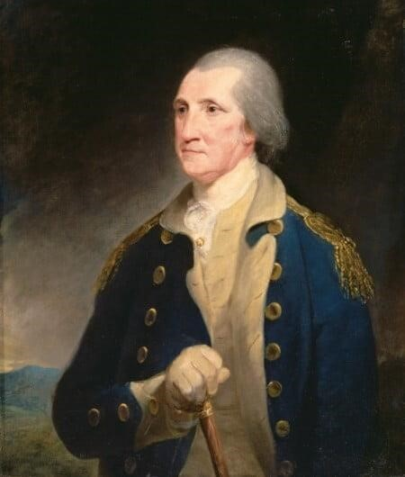
Portrait of George Washington (1785) by Robert Edge Pine: https://www.mountvernon.org/george-washington/artwork/life-portraits-of-george-washington

May 14, 1787: Constitutional Convention (Philadelphia)
George Washington [age 55] – elected President of the Convention; 12 states participated [Rhode Island refused]
“With George Washington presiding, the Constitutional Convention formally convenes on this day in 1787. The convention faced a daunting task: the peaceful overthrow of the new American government as it had been defined by the Article of Confederation. The process began with the proposal of James Madison’s Virginia Plan. Madison had dedicated the winter of 1787 to the study of confederacies throughout history and arrived in Philadelphia with a wealth of knowledge and an idea for a new American government. Virginia’s governor, Edmund Randolph, presented Madison’s plan to the convention. It featured a bicameral legislature, with representation in both houses apportioned to states based upon population; this was seen immediately as giving more power to large states, like Virginia. The two houses would in turn elect the executive and the judiciary and would possess veto power over the state legislatures. Madison’s conception strongly resembled Britain’s parliament. It omitted any discussion of taxation or regulation of trade, however; these items had been set aside in favor of outlining a new form of government altogether.” https://www.history.com/this-day-in-history/constitutionalconvention-convenes-in-philadelphia

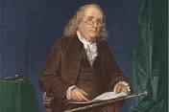Benjamin Franklin [age 81]

At the close of the Constitutional Convention of 1787, Franklin was queried as he left Independence Hall on the final day of deliberation. In the notes of Dr. James McHenry, one of Maryland’s delegates to the Convention, a lady asked Dr. Franklin “Well Doctor what have we got, a republic or a monarchy.” Franklin replied, “A republic . . . if you can keep it.”
http://www.whatwouldthefoundersthink.com/a-republic-if-you-can-keep-it

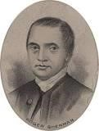Roger Sherman [age 66] – Connecticut [only delegate signed
Declaration of Independence, Articles of Confederation, and later the Constitution

July 13, 1787: Northwest Ordinance – banned slavery
“On July 13, 1787, Congress passed the Northwest Ordinance—an act that established a framework for governing the Northwest Territory, admitting new states, and protecting the civil liberties of settlers. It also banned slavery in the new territories. However, it granted slaveholders the power to recapture enslaved people alleged to have escaped into them. When crafting the Northwest Ordinance, Congress drew, in part, on the work of Thomas Jefferson from his time in Congress. The Northwest Territory covered a massive tract of land that would eventually become the states of Illinois, Indiana, Michigan, Ohio, Wisconsin, and a section of Minnesota. Following the Civil War, Reconstruction Republicans drew on the Northwest Ordinance’s text to craft the Thirteenth Amendment, which abolished slavery.” https://constitutioncenter.org/the-constitution/historic-document-library/detail/the-northwest-ordinance

Northwest Ordinance: https://www.archives.gov/milestone-documents/northwest-ordinance
“Three principal provisions were ordained in the document:
- A division of the Northwest Territory into "not less than three nor more than five States"
- A three-stage method for admitting a new state to the Union: a congressionally appointed governor, secretary, and three judges to rule in the first phase; an elected assembly and one non-voting delegate to Congress to be elected in the second phase when the population of the territory reached "five thousand free male inhabitants of full age"; and a state constitution to be drafted and membership to the Union to be requested in the third phase when the population reached 60,000
- A bill of rights protecting religious freedom, the right to a writ of habeas corpus, the benefit of trial by jury, and other individual rights; in addition the ordinance encouraged education and forbade slavery.”

Arthur St. Clair – Appointed Governor of Northwest Territory. https://www.mountvernon.org/library/digitalhistory/digital-encyclopedia/article/arthur-st-clair
“Arthur St. Clair was born in Caithness, Scotland in 1734…. In July 1777, Washington defended his colleague after he lost Fort Ticonderoga to the British during the Saratoga Campaign. Washington asked him to join his staff as an aide-de-camp after a court martial cleared him of any wrongdoing…. In 1787, St. Clair was appointed as the governor of the Northwest Territory. During his tenure, he lived in and name Cincinnati, Ohio after the Society of Cincinnati. He created written laws for the territory and attempted to resolve conflict with Native Americans groups such as the Shawnee, Delaware, and Ojibwe nations being displaced by American settlers…. St. Clair led men without proper military experience or training deep into the woods of western Ohio. On the morning of November 4, 1791, members of the Miami and Shawnee nations attacked, killing or wounding over 600 of St. Clair's soldiers, including most of his officers. St. Clair and a few hundred men escaped back to Fort Washington on the banks of the Ohio River. The loss was known as “St. Clair’s Defeat.” His failures in the Northwest Territory led to the first investigation of the executive branch by the legislature under the Constitution in January 1792. Amid the investigation, St. Clair wrote to Washington, “A Wish to rectify the public Opinion, and a Duty that, I conceive I owe to myself, induces me to request that an Enquiry into my Conduct may be instituted—When that is over I may hope to be permitted to resign the Commission of Major General which I now hold.” St. Clair was exonerated, but he was replaced from his military post. Washington allowed him to remain as the Governor of the Ohio Territory.

July 16, 1787: The Three-Fifths Compromise - Slaves
“The Three-Fifths Compromise was reached among state delegates during the 1787 Constitutional Convention. It determined that three out of every five slaves were counted when determining a state’s total population for legislative representation and taxation. Before the Civil War, the Three-Fifths Compromise gave a disproportionate representation of slave states in the House of Representatives.” https://perspectivesofchange.hms.harvard.edu/node/87

***
“After the American Revolution, many colonists (particularly in the North, where slavery was relatively unimportant to the economy) began to link the oppression of enslaved Africans to their own oppression by the British. Though leaders such as George Washington and Thomas Jefferson—both slaveholders from Virginia—took cautious steps towards limiting slavery in the newly independent nation, the Constitution tacitly acknowledged the institution, guaranteeing the right to repossess any “person held to service or labor” (an obvious euphemism for slavery). Many northern states had abolished slavery by the end of the 18th century, but the institution was absolutely vital to the South, where Black people constituted a large minority of the population and the economy relied on the production of crops like tobacco and cotton. Congress outlawed the import of new enslaved people in 1808, but the enslaved population in the U.S. nearly tripled over the next 50 years, and by 1860 it had reached nearly 4 million, with more than half living in the cotton–producing states of the South.” https://www.history.com/articles/black-history-milestones

Oct. 1787 – May 1788: Federalist Papers
“The Federalist, commonly referred to as the Federalist Papers, is a series of 85 essays written by Alexander Hamilton, John Jay, and James Madison between October 1787 and May 1788. The essays were published anonymously, under the pen name "Publius," in various New York state newspapers of the time. The Federalist Papers were written and published to urge New Yorkers to ratify the proposed United States Constitution, which was drafted in Philadelphia in the summer of 1787. In lobbying for adoption of the Constitution over the existing Articles of Confederation, the essays explain particular provisions of the Constitution in detail. For this reason, and because Hamilton and Madison were each members of the Constitutional Convention, the Federalist Papers are often used today to help interpret the intentions of those drafting the Constitution.” https://guides.loc.gov/federalist-papers/full-text
“In the spring of 1788, Alexander Hamilton published an essay titled The Federalist No.78 under the pseudonym “Publius.” The piece was one of a “Collection of Essays, written in favour of the New Constitution” and addressed to “the People of the State of New York.” *** The Constitution’s separation-of-powers principle, Hamilton argued, gave courts the power of “judgment” so that they could act as “an intermediate body between the people and the legislature, in order, among other things, to keep the latter within the limits assigned to their authority.” https://www.whitehouse.gov/wp-content/uploads/2021/12/SCOTUS-Report-Final-12.8.21-1.pdf (page 35).

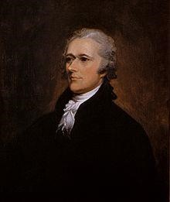Alexander Hamilton [age 32]
John Jay [age 42]
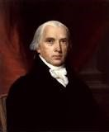James Madison [age 36]

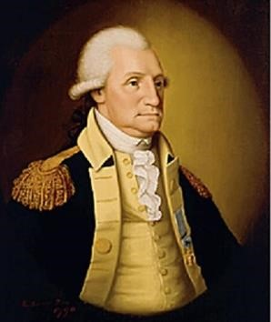Portrait of George Washington (1789) by Edward Savage:
https://www.mountvernon.org/george-washington/artwork/life-portraits-of-george-washington/

Nov. 22, 1787 – James Madison publishes Federalist No. 10 – Need A Republic, Not A Democracy

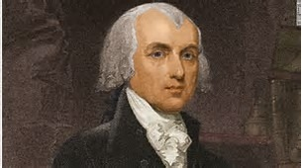

“To the People of the State of New York:
AMONG the numerous advantages promised by a well constructed Union, none deserves to be more accurately developed than its tendency to break and control the violence of faction…. Hence, it clearly appears, that the same advantage which a republic has over a democracy, in controlling the effects of faction, is enjoyed by a large over a small republic,--is enjoyed by the Union over the States composing it.”
https://avalon.law.yale.edu/18th_century/fed10.asp

Sept. 17, 1788: Constitution adopted by unanimous consent
The Constitution was adopted by a convention of the States on September 17, 1787, and was subsequently ratified by the several States, on the following dates: Delaware, December 7, 1787; Pennsylvania, December 12, 1787; New Jersey, December 18, 1787; Georgia, January 2, 1788; Connecticut, January 9, 1788; Massachusetts, February 6, 1788; Maryland, April 28, 1788; South Carolina, May 23, 1788; New Hampshire, June 21, 1788. Ratification was completed on June 21, 1788.

Feb. 4, 1789: First Presidential Election
The Electoral College: https://www.archives.gov/federal-register/electoralcollege/about.html
“The Electoral College is a process, not a place. The founding fathers established it in the Constitution as a compromise between election of the President by a vote in Congress and election of the President by a popular vote of qualified citizens.
The Electoral College process consists of the selection of the electors, the meeting of the electors where they vote for President and Vice President, and the counting of the electoral votes by Congress.
The Electoral College consists of 538 electors. A majority of 270 electoral votes is required to elect the President. Your state’s entitled allotment of electors equals the number of members in its Congressional delegation: one for each member in the House of Representatives plus two for your Senators. Read more about the allocation of electoral votes.
Under the 23rd Amendment of the Constitution, the District of Columbia is allocated 3 electors and treated like a state for purposes of the Electoral College. For this reason, in the following discussion, the word ‘state’ also refers to the District of Columbia.
Each candidate running for President in your state has his or her own group of electors. The electors are generally chosen by the candidate’s political party, but state laws vary on how the electors are selected and what their responsibilities are. Read more about the qualifications of the Electors and restrictions on who the Electors may vote for.
The presidential election is held every four years on the Tuesday after the first Monday in November. You help choose your state’s electors when you vote for President because when you vote for your candidate you are actually voting for your candidate’s electors.
Most states have a ‘winner-take-all’ system that awards all electors to the winning presidential candidate. However, Maine and Nebraska each have a variation of ‘proportional representation.’”

March 4, 1789: Fed. Government Begins Operating
“On March 4, 1789, the new government created by the Constitution began operating. Many elements of the system remained uncertain and disputed despite the preceding twenty-two months of discussion and drafting, first in the Constitutional Convention and then in the state ratifying conventions. The Constitution’s beginning raised a host of new questions, the stakes of which were understood to be tremendously high.” https://www.whitehouse.gov/wp-content/uploads/2021/12/SCOTUS-Report-Final-12.8.21-1.pdf (page 36).

April 30, 1789: George Washington [age 57] sworn in as 1st President

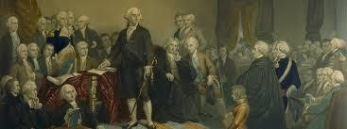
Congress met in New York City; unanimous (69 to 0) in Senate for George Washington as President – letter taken to Mount Vernon [took 7 days]; he later took Oath of Office on balcony of Federal Hall, Wall Street, New York City
John Adams [age 54] elected Vice President

June 8, 1789: Bill of Rights drafted
“Introducing the Bill of Rights in the First Congress. Few members of the First Congress wanted to make amending the new Constitution a priority. But James Madison, once the most vocal opponent of the Bill of Rights, introduced a list of amendments to the Constitution on June 8, 1789, and ‘hounded his colleagues relentlessly’ to secure its passage. Madison had come to appreciate the importance voters attached to these protections, the role that enshrining them in the Constitution could have in educating people about their rights, and the chance that adding them might prevent its opponents from making more drastic changes to it.” https://www.archives.gov/founding-docs/bill-of-rights/how-did-it-happen

Sept. 24, 1789: The Origins of the Supreme Court: Judiciary Act of 1789 – 6 Justices
“Article III of the Constitution established the Supreme Court. But the drafters of the Constitution had been unable to agree on key points—most importantly, whether to create inferior federal courts, what types of cases the federal courts would be able to hear, and what sort of relationship the Supreme Court would have with the state courts. The Constitution was also silent on the number of Justices who would sit on the Court. The drafters therefore left to Congress the task of addressing many of these questions as it saw fit, subject to the boundaries set forth in Article III. The drafters’ decision to postpone the question of the inferior federal courts has been termed by modern commentators the “Madisonian Compromise. When the First Congress convened in New York’s Federal Hall in April 1789, its members immediately began debating a bill to establish the federal courts. *** A Senate committee comprising ten members (one from each state that had both ratified
the Constitution and sent senators by that point) produced a first version of the Act. The
committee then sent its draft to leading lawyers, jurists, and officials around the nation,
requesting their comments. What resulted was a compromise bill that attempted to balance
competing interests, most notably the Federalists’ focus on establishing a strong federal
judiciary with the Anti-Federalists’ desire to preserve state autonomy. Following several
rounds of revisions and amendments, the bill won approval from the Senate and the House.
On September 24, the Judiciary Act of 1789 was signed into law by President George
Washington.
***
The Act provided for a six-justice Supreme Court: one Chief Justice and five associate
Justices. It established the Court’s jurisdiction, both original and appellate. It also placed the
Court at the top of the hierarchy of courts in the nation, state as well as federal. Section 25 of
the Act granted the Court the power to review certain decisions of the highest courts of the
states. This provision was viewed by some as particularly delicate, insofar as it placed the
Supreme Court in the position of overseeing —and potentially overruling—the decisions of
state court judges.”
***
The Act thus established a system of inferior federal courts, which it broke
down into two categories: district courts and circuit courts. The thirteen district courts, each
with a single district judge, were apportioned along state lines, including one each for Maine
and Kentucky, which had not yet become independent states.” https://www.whitehouse.gov/wp-content/uploads/2021/12/SCOTUS-Report-Final-12.8.21-1.pdf (p. 37 - 38).

1790: Naturalization Act – “free white people”
“The first major piece of U.S. legislation, the Naturalization Act, was signed in 1790, and it began the nation’s first naturalization process by providing access to U.S. citizenship to free white immigrants, mostly people from western Europe, who had lived in the U.S. for at least two years and their children. Early on, requirements for the Naturalization Act included two years of residence and good moral character reflecting the times. Later, the residency requirement was extended to five years in 1795, 14 years in 1798, and back to five years in 1802. Applicants were also required to be a ‘free white person.’” https://news.unm.edu/news/u-s-immigration-legislation-since-1776

Nov. 4, 1791 – Arthur St. Clair, Governor of Northwest Territory and Major General, defeated in battle with Miami and Shawnee Indians

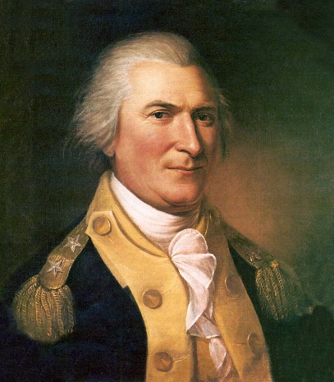
“As president, Washington appointed him as the commander of the American army assigned to conflicts with Native American conflicts north of the Ohio in 1791. St. Clair led men without proper military experience or training deep into the woods of western Ohio. On the morning of November 4, 1791, members of the Miami and Shawnee nations attacked, killing or wounding over 600 of St. Clair's soldiers, including most of his officers. St. Clair and a few hundred men escaped back to Fort Washington on the banks of the Ohio River. The loss was known as ‘St. Clair’s Defeat.’
His failures in the Northwest Territory led to the first investigation of the executive branch by the legislature under the Constitution in January 1792. Amid the investigation, St. Clair wrote to Washington, ‘A Wish to rectify the public Opinion, and a Duty that, I conceive I owe to myself, induces me to request that an Enquiry into my Conduct may be instituted—When that is over I may hope to be permitted to resign the Commission of Major General which I now hold.” St. Clair was exonerated, but he was replaced from his military post. Washington allowed him to remain as the Governor of the Ohio Territory.
In 1802, President Thomas Jefferson removed St. Clair from his territorial governorship, preferring a member of his own party rather than a Federalist. St. Clair spent the rest of his life in western Pennsylvania, struggling financially. He died in 1818 at 81 years of age.” https://www.mountvernon.org/library/digitalhistory/digital-encyclopedia/article/arthur-st-clair

Dec. 15, 1791: Bill of Rights ratified - becomes part of Constitution
“On this day in 1791, Virginia becomes the last state to ratify the Bill of Rights, making the first ten amendments to the Constitution law and completing the revolutionary reforms begun by the Declaration of Independence. Before the Massachusetts ratifying convention would accept the Constitution, which they finally did in February 1788, the document’s Federalist supporters had to promise to create a Bill of Rights to be amended to the Constitution immediately upon the creation of a new government under the document.”
https://www.history.com/this-day-in-history/the-bill-of-rights-becomes-law

The U.S. Bill of Rights
Note: The following text is a transcription of the first ten amendments to the Constitution in their original form. These amendments were ratified December 15, 1791, and form what is known as the "Bill of Rights." https://billofrightsinstitute.org/primary-sources/bill-of-rights

Amendment I
Congress shall make no law respecting an establishment of religion, or prohibiting the free exercise thereof; or abridging the freedom of speech, or of the press; or the right of the people peaceably to assemble, and to petition the Government for a redress of grievances.

Amendment II
A well regulated Militia, being necessary to the security of a free State, the right of the people to keep and bear Arms, shall not be infringed.

Amendment III
No Soldier shall, in time of peace be quartered in any house, without the consent of the Owner, nor in time of war, but in a manner to be prescribed by law.

Amendment IV
The right of the people to be secure in their persons, houses, papers, and effects, against unreasonable searches and seizures, shall not be violated, and no Warrants shall issue, but upon probable cause, supported by Oath or affirmation, and particularly describing the place to be searched, and the persons or things to be seized.

Amendment V
No person shall be held to answer for a capital, or otherwise infamous crime, unless on a presentment or indictment of a Grand Jury, except in cases arising in the land or naval forces, or in the Militia, when in actual service in time of War or public danger; nor shall any person be subject for the same offence to be twice put in jeopardy of life or limb; nor shall be compelled in any criminal case to be a witness against himself, nor be deprived of life, liberty, or property, without due process of law; nor shall private property be taken for public use, without just compensation.

Amendment VI
In all criminal prosecutions, the accused shall enjoy the right to a speedy and public trial, by an impartial jury of the State and district wherein the crime shall have been committed, which district shall have been previously ascertained by law, and to be informed of the nature and cause of the accusation; to be confronted with the witnesses against him; to have compulsory process for obtaining witnesses in his favor, and to have the Assistance of Counsel for his defence.

Amendment VII
In Suits at common law, where the value in controversy shall exceed twenty dollars, the right of trial by jury shall be preserved, and no fact tried by a jury, shall be otherwise re-examined in any Court of the United States, than according to the rules of the common law.

Amendment VIII
Excessive bail shall not be required, nor excessive fines imposed, nor cruel and unusual punishments inflicted.

Amendment IX
The enumeration in the Constitution, of certain rights, shall not be construed to deny or disparage others retained by the people.

Amendment X
The powers not delegated to the United States by the Constitution, nor prohibited by it to the States, are reserved to the States respectively, or to the people.

James Madison [age 36]

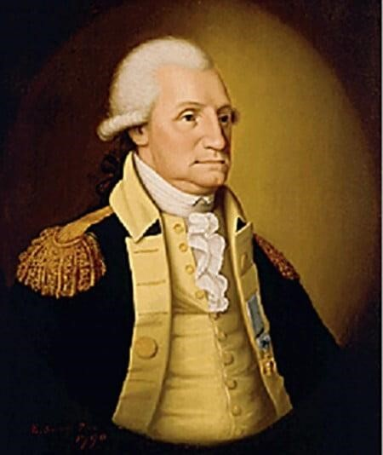

Portrait of George Washington (1789) by Edward Savage:
https://www.mountvernon.org/george-washington/artwork/life-portraits-of-george-washington/

May 2, 1792: Militia Act of 1792
“The Militia Act of 1792 allowed the President to temporarily take control of state militias in times of crises. This was later expanded in 1795, permanently allowing the President to call out the militia.
Transcript:
Section 1. Be it enacted by the Senate and House of Representatives of the United States of America in Congress assembled, That whenever the United States shall be invaded, or be in imminent danger of invasion from any foreign nation or Indian tribe, it shall be lawful for the President of the United States, to call forth such number of the militia of the state or states most convenient to the place of danger or scene of action as he may judge necessary to repel such invasion, and to issue his orders for that purpose, to such officer or officers of the militia as he shall think proper; and in case of an insurrection in any state, against the government thereof, it shall be lawful for the President of the United States, on application of the legislature of such state, or of the executive (when the legislature cannot be convened) to call forth such number of the militia of any other state or states, as may be applied for, or as he may judge sufficient to suppress such insurrection.” https://www.mountvernon.org/education/primary-source-collections/primary-source-collections/article/militia-act-of-1792

1793: Rise Of The Cotton Industry

Cotton Gin Invented
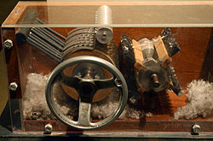
“In the years immediately following the Revolutionary War, the rural South—the region where slavery had taken the strongest hold in North America—faced an economic crisis. The soil used to grow tobacco, then the leading cash crop, was exhausted, while products such as rice and indigo failed to generate much profit. As a result, the price of enslaved people was dropping, and the continued growth of slavery seemed in doubt. Around the same time, the mechanization of spinning and weaving had revolutionized the textile industry in England, and the demand for American cotton soon became insatiable. Production was limited, however, by the laborious process of removing the seeds from raw cotton fibers, which had to be completed by hand.
In 1793, a young Yankee schoolteacher named Eli Whitney came up with a solution to the problem: The cotton gin, a simple mechanized device that efficiently removed the seeds, could be hand–powered or, on a large scale, harnessed to a horse or powered by water. The cotton gin was widely copied, and within a few years the South would transition from a dependence on the cultivation of tobacco to that of cotton.
As the growth of the cotton industry led inexorably to an increased demand for enslaved Africans, the prospect of slave rebellion—such as the one that triumphed in Haiti in 1791—drove slaveholders to make increased efforts to prevent a similar event from happening in the South. Also in 1793, Congress passed the Fugitive Slave Act, which made it a federal crime to assist an enslaved person trying to escape. Though it was difficult to enforce from state to state, especially with the growth of abolitionist feeling in the North, the law helped enshrine and legitimize slavery as an enduring American institution.” https://www.history.com/articles/black-history-milestones
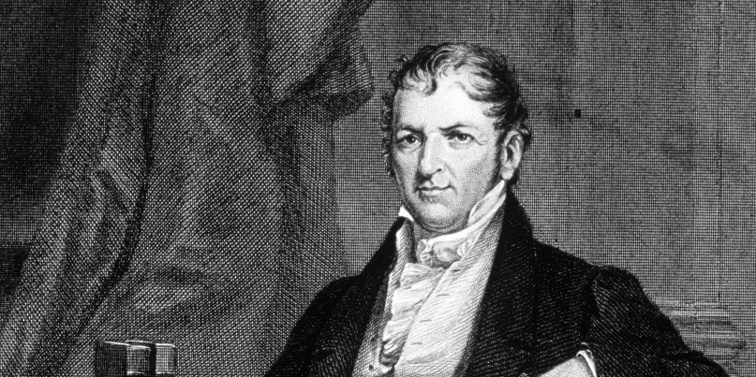 https://www.history.com/articles/cotton-gin-and-eli-whitney

Feb. 12, 1793: Fugitive Slave Act
“Fugitive slave laws provided enslavers and their agents with the legal right to reclaim runaways from other jurisdictions. Those states or jurisdictions were required to deliver the fugitives. As early as 1643, the United Colonies of New England had required the return of runaways, and, after the American Revolution (1775–1783), the Northwest Ordinance of 1787 contained similar protections for enslavers. The U.S. Constitution included a Fugitive Slave Clause, which was agreed to without dissent at the Constitutional Convention. Following a dispute between Pennsylvania and Virginia, Congress passed the Fugitive Slave Act of 1793 which clarified the processes by which enslavers could claim their property and was designed to balance the competing interests of free and slave states.

***
The Fugitive Slave Act of 1793, signed into law by President George Washington on February 12, 1793, allows slaveowners to seize and arrest fugitive slaves and present written or oral proof to an official in order to reclaim their property.” https://encyclopediavirginia.org/entries/fugitive-slave-laws/

August 7, 1794: George Washington puts down Whiskey Rebellion in Western PA
“In 1790, in order to solve a congressional deadlock over the permanent placement of the new nation’s capital, Alexander Hamilton, Thomas Jefferson, and James Madison reached a compromise that would result in an eventual shift of the capital to a location on the border of Maryland and Virginia, as well a promise that the federal government would assume the Revolutionary War debts of the thirteen states. The 1791 passage of the whiskey excise tax was an attempt to begin paying down that debt through a direct tax on the distillation of alcohol.
Unfortunately, this tax on production adversely impacted farmers on the western frontier. These small-scale farmers did not have ready cash to be able to pay the tax and were unable to easily pass on the burden to their customers, like the operators of large distilleries in the east.

***
Under the tenets of the Militia Act of 1792, after a judge notified the president that the laws could not be safely executed, the president could call forth a militia. Washington called up the state militias from Virginia, Pennsylvania, Maryland, and New Jersey, which ultimately amounted to close to 13,000 troops, to put down the rebellion by force if necessary. Divided into two wings that staged in Carlisle, Pennsylvania, and Cumberland, Maryland, Washington personally led a portion of the army as far west as Bedford, Pennsylvania.,,, When the army reached Western Pennsylvania, they did not find the population in open rebellion. The mere presence of such a large force of federalized militia was enough to send the rebel leaders into hiding. In the end, while a number of rebels were arrested and tried for treason, only a handful were found guilty, and all of these individuals would eventually be pardoned by either President Washington or, later, President John Adams.

In the end, the rebellion was put down and order restored. As Washington noted in a letter to the army's commander, General Henry (Lighthorse) Lee, written shortly before his departure from Bedford, his troops had preserved the ‘blessings of that Revolution which, at much expense of blood & treasure, constituted us a free and independent nation.’” https://www.mountvernon.org/george-washington/the-first-president/whiskey-rebellion

1795: George Washington – sat for portrait by Charles Willson Peale [his 7th and last portrait of George Washington]
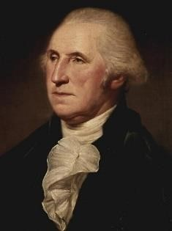
https://www.mountvernon.org/george-washington/artwork/life-portraits-of-george-washington/

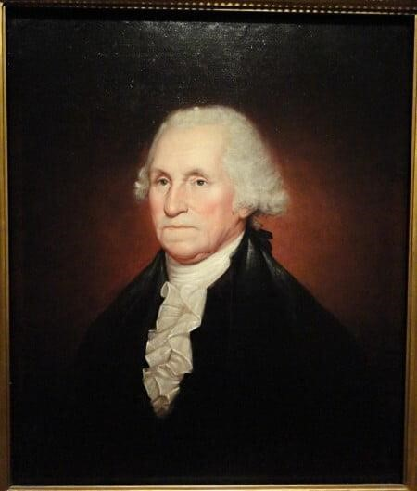George Washington – portrait by Rembrandt Peale (1795), son of Charles Willson Peale: https://www.mountvernon.org/george-washington/artwork/life-portraitsof-george-washington/

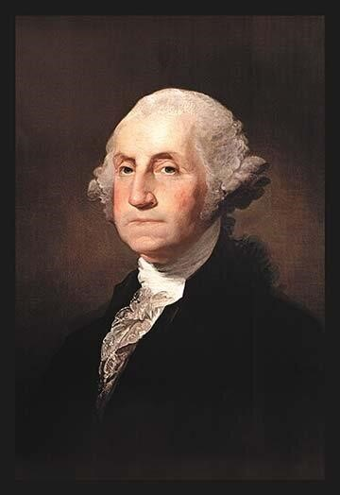 George Washington – portrait (1795) by Gilbert Stuart
https://www.mountvernon.org/george-washington/artwork/life-portraits-of-george-washington/

1795: 11th Amendment to U.S. Constitution – If Congress Upset With U.S. Supreme Court Decision, Can Pass Constitutional Amendment
“The judicial power of the United States shall not be construed to extend to any suit in law or equity, commenced or prosecuted against one of the United States by citizens of another state, or by citizens or subjects of any foreign state.” https://www.law.cornell.edu/constitution/amendmentxi
Explanation:
“In accepting a suit against a state by a citizen of another state in 1793, the Supreme Court [in Chisholm v. Georgia, 2 U.S. (2 Dall.) 419 (1793)] provoked such anger in Georgia and such anxiety in other states that, at the first meeting of Congress following the decision, the Eleventh Amendment was proposed by an overwhelming vote of both Houses and ratified with, what was for that day, ‘vehement speed.’ *** The Amendment proposed by Congress and ratified by the states was directed specifically toward overturning the result in Chisholm and preventing suits against states by citizens of other states or by citizens or subjects of foreign jurisdictions. It did not, as other possible versions of the Amendment would have done, altogether bar suits against states in the federal courts.” https://www.law.cornell.edu/constitution-conan/amendment-11/purpose-andearly-interpretation
1795: Treaty of Greenville [Ohio]
“The years between the Revolutionary War and the War of 1812 were not peaceful: the American army was dealt its worst defeat ever between tribal nations and American forces, at the hands of tribal warriors led by Little Turtle of the Miami and Blue Jacket of the Shawnee. St. Clair’s defeat in 1791 saw the American army lose approximately 1,000 men: three times the number lost during General Custer’s better-known defeat at Little Bighorn in 1876.
Between 1774 and 1794, Indian villages in New York, Pennsylvania, Indiana and Ohio were constantly attacked by the American army and militias. The Shawnee, Delaware, Iroquois, Miami, Odawa, Wyandot and Mingo saw unspeakable violence committed against their villages during this time period. Over 100 Indian villages were burned and destroyed, leaving an unknown number of civilian casualties. The most notorious frontier massacres occurred on March 8, 1782 on the Upper Sandusky River in Ohio, at a village known as Gnadenhutten. Over 90 Delaware Indians, the majority women and children, were returning to the village to gather food supplies. These Delaware, known as the Moravian town Indians, were Christian and pacifists. Upon reaching their village, the Delaware were rounded up by Colonel David Williamson and the Pennsylvania militia. Two outbuildings served as slaughter houses where the Indians were led, two at a time, to their execution.
In response to these tensions, the 1795 Treaty of Greenville aimed to end the hostilities that had engulfed the Great Lakes. It was an imperfect agreement not agreed upon by all the tribes, but it ended violence at least temporarily, and established Indian lands. But American expansion quickly nullified the agreement.” https://www.nps.gov/articles/a-long-legacy.htm
***
Two Shawnee brothers – Tecumseh (warrior chief) and Tenskwatawa (the “prophet”) –refused to sign Treaty of Greenville in 1795

Aug. 29, 1796: George Washington proposes treaty to the Cherokee Nation
https://founders.archives.gov/documents/Washington/05-20-02-0388

“Many years have passed since the White people first came to America. In that long space of time many good men have considered how the condition of the Indian natives of the country might be improved; and many attempts have been made to effect it. But, as we see at this day, all these attempts have been nearly fruitless. I also have thought much on this subject, and anxiously wished that the various Indian tribes, as well as their neighbours, the White people, might enjoy in abundance all the good things which make life comfortable and happy. I have considered how this could be done; and have discovered but one path that could lead them to that desirable situation. In this path I wish all the Indian nations to walk. From the information received concerning you, my beloved Cherokees, I am inclined to hope that you are prepared to take this path and disposed to pursue it. It may seem a little difficult to enter; but if you make the attempt, you will find every obstacle easy to be removed.
Mr. Dinsmoor, my beloved agent to your nation, being here, I send to you this talk by him. He will have it interpreted to you, and particularly explain my meaning.”

***

“My beloved Cherokees,
Some among you already experience the advantage of keeping cattle and hogs: let all keep them and increase their numbers, and you will ever have a plenty of meat. To these add sheep, and they will give you cloathing as well as food. Your lands are good and of great extent. By proper management you can raise live stock not only for your own wants, but to sell to the White people. By using the plow you can vastly increase your crops of corn. You can also grow Wheat, (which makes the best bread) as well as other useful grain. To these you will easily add flax and cotton, which you may dispose of to the White people, or have it made up by your own women into cloathing for yourselves. Your wives and daughters can soon learn to spin and weave; and to make this certain, I have directed Mr. Dinsmoor to procure all the necessary apparatus for spinning and weaving, and to hire a woman to teach the use of them. He will also procure some plows and other implements of husbandry, with which to begin the improved cultivation of the ground which I recommend, and employ a fit person to shew you how they are to be used. I have further directed him to procure some cattle and sheep for the most prudent and industrious men, who shall be willing to exert themselves in tilling the ground and raising those useful animals. He is often to talk with you on these subjects, and give you all necessary information to promote your success. I must therefore desire you to listen to him; and to follow his advice. I appointed him to dwell among you as the Agent of the United States, because I judged him to be a faithful man, ready to obey my instructions and to do you good.

But the cares of the United States are not confined to your single nation. They extend to all the Indians dwelling on their borders. For which reason other agents are appointed; and for the four southern nations there will be a general or principal agent who will visit all of them, for the purpose of maintaining peace and friendship among them and with the United States; to superintend all their affairs; and to assist the particular agents with each nation in doing the business assigned them. To such general or principal agent I must desire your careful attention. He will be one of our greatly beloved men. His whole time will be employed in contriving how to do you good, and you will therefore act wisely to follow his advice. The first general or principle agent will be Colonel Benjamin Hawkins, a man already known and respected by you. I have chosen him for this office because he is esteemed for a good man; has a knowledge of Indian customs, and a particular love and friendship for all the Southern tribes.”

1798: Alien Enemies Act of 1798
May 2, 2025: U.S. District Judge Fernando Rodriguez Jr., whom Trump nominated to the bench in 2017, ruled that the administration’s use of the Alien Enemies Act to quickly deport Venezuelan migrants to El Salvador was “unlawful.” He said this was because the migrants’ entry into the United States, as described by Trump’s proclamation, didn’t constitute the “invasion” or “predatory incursion” that the AEA requires. https://www.washingtonpost.com/politics/2025/05/01/trump-immigration-judicial-challenges/?utm_campaign=wp_post_most&utm_medium=email&utm_source=newsletter&carta-url=https%3A%2F%2Fs2.washingtonpost.com%2Fcar-ln-tr%2F425e867%2F6814f0b1b82e315dbf135a10%2F59731235ade4e21a848a56ed%2F47%2F61%2F6814f0b1b82e315dbf135a10

1799: Daniel Boone moves to Missouri (which was owned by Spain)

8 Things You Might Not Know About Daniel Boone: https://www.history.com/articles/8-things-you-might-not-know-about-daniel-boone

“In 1799, Boone, then in his mid-60s, moved with his extended family from Kentucky, which achieved statehood in 1792, to present-day Missouri, then under Spanish control and known as Upper Louisiana. The Spanish, who wanted to encourage settlement in the area, welcomed Boone with military honors and granted him 850 acres of land in the Femme Osage district, west of St. Louis. They also waived the requirement that all immigrants had to be Roman Catholic and made Boone a syndic, or magistrate, of the Femme Osage district, responsible for settling disputes among settlers.
In 1800, the Spanish ceded the Louisiana Territory to France, and three years later the U.S. gained control of it with the Louisiana Purchase. Boone subsequently lost his land claims because he hadn’t followed the proper procedures to gain permanent title to the land.
After the frontiersman petitioned Congress, President James Madison signed a bill into law in 1814 giving Boone his 850 acres; however, he soon had to sell the property to pay off Kentuckians who’d heard the news about the grant and traveled to Missouri to collect on old debts. Missouri became America’s 24th state in 1821, a year after Boone’s death.”

Dec. 14, 1799: At the time of George Washington’s death [age 67], Mount Vernon enslaved population consisted of 317 people.

“Of the 317 enslaved people living at Mount Vernon in 1799, a little less than half (123 individuals) were owned by George Washington himself. Another 153 slaves at Mount Vernon in 1799 were dower slaves from the Custis estate. When Martha Washington's first husband, Daniel Parke Custis, died without a will in 1757, she received a life interest in one-third of his estate, including the slaves. Neither George nor Martha Washington could free these slaves by law and upon Martha’s death these individuals reverted to the Custis estate and were divided among her grandchildren.”
https://www.mountvernon.org/george-washington/slavery/ten-facts-aboutwashington-slavery/

1801: Thomas Jefferson – President (1801-1809)
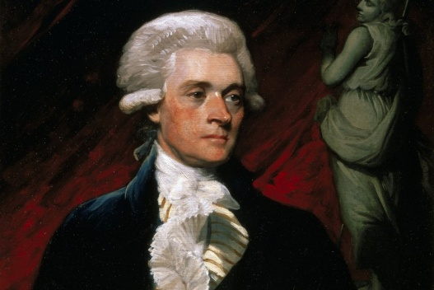 https://www.monticello.org/thomas-jefferson/brief-biography-of-jefferson/
“But when Jefferson went to Washington, the president called for enslaved teenage girls to come learn French cookery under George Washington's chef, Julien. Fossett’s sister-in-law Frances Hern was sent over as well in 1806…. When Jefferson left office in 1809, the cooks returned with him to Monticello, and Fossett became head chef there.

***
Peter Fossett was 11 years old when Jefferson died in 1826. Jefferson had freed only five enslaved workers in his will, Joseph Fossett among them. Jefferson had enormous debts, so the other 100 people were sold at an estate auction.
https://www.cincinnati.com/story/news/2025/02/23/thomas-jefferson-enslaved-cook-brought-french-cuisine-cincinnati/78208670007/?utm_source=enquirer-dailybriefing-strada&utm_medium=email&utm_campaign=dailybriefing-headline-stack&utm_term=Content%20List%20-%20Stacking%20-%20optimized&utm_content=pcin-cincinnati-nletter65

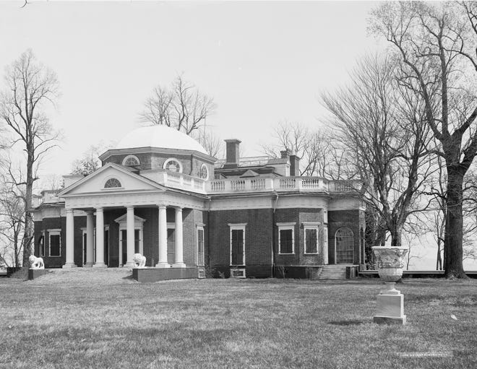

1801: Chief Justice John Marshall (1801-1835)
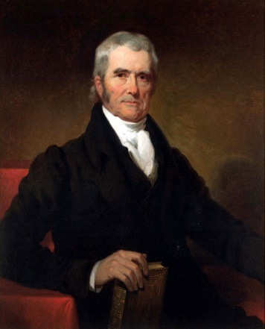
[Chief Justice John Roberts, in 2007 interview.] “Roberts believes that Marshall’s temperament and worldview came from his experiences as a soldier at Valley Forge, where he developed a commitment to the success of the nation. ‘Some have speculated that the real root of Marshall’s ill feeling to Jefferson was that Jefferson was not at Valley Forge, was not in the fight, and had what Marshall might regard as a somewhat precious attachment to ideas for the sake of ideas, while Marshall was more personally invested in the success of the American experiment.’ *** During Marshall’s thirty years as chief, “there weren’t a lot of concurring opinions. There weren’t a lot of dissents. And nowadays, you take a look at some of our opinions and you wonder if we’re reverting back to the English model, where everybody has to have their say. It’s more being concerned with the jurisprudence of the individual rather than working toward a jurisprudence of the Court.” Roberts praised justices who were willing to put the good of the Court above their own ideological agendas.” https://www.theatlantic.com/magazine/archive/2007/01/robertss-rules/305559/

2/24/1803: U.S. Supreme Court: Marbury v. Madison (5 US 137) JUDICIAL POWER TO REVIEW CONGRESSIONAL LEGISLATION

“Importance: This decision gave the Court the ability to strike down laws on the grounds that they are unconstitutional (a power called judicial review).” https://www.americanbar.org/groups/public_education/programs/constitution_day/landmark-cases/

Thomas Jefferson
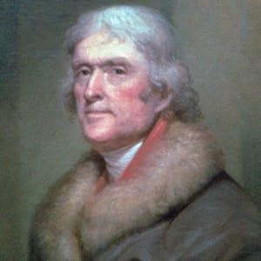

“Facts of the case
Thomas Jefferson defeated John Adams in the 1800 presidential election. Before
Jefferson took office on March 4, 1801, Adams and Congress passed the Judiciary Act of 1801, which created new courts, added judges, and gave the president more control over appointment of judges. The Act was essentially an attempt by Adams and his party to frustrate his successor, as he used the act to appoint 16 new circuit judges and 42 new justices of the peace. The appointees were approved by the Senate, but they would not be valid until their commissions were delivered by the Secretary of State.
William Marbury had been appointed Justice of the Peace in the District of Columbia, but his commission was not delivered. Marbury petitioned the Supreme Court to compel the new Secretary of State, James Madison, to deliver the documents. Marbury, joined by three other similarly situated appointees, petitioned for a writ of mandamus compelling the delivery of the commissions.

Question
- Do the plaintiffs have a right to receive their commissions?
- Can they sue for their commissions in court?
- Does the Supreme Court have the authority to order the delivery of their commissions?

Conclusion
The Court found that Madison’s refusal to deliver the commission was illegal, but did not order Madison to hand over Marbury’s commission via writ of mandamus. Instead, the Court held that the provision of the Judiciary Act of 1789 enabling Marbury to bring his claim to the Supreme Court was itself unconstitutional, since it purported to extend the Court’s original jurisdiction beyond that which Article III, Section 2, established. Marshall expanded that a writ of mandamus was the proper way to seek a remedy, but concluded the Court could not issue it. Marshall reasoned that the Judiciary Act of 1789 conflicted with the Constitution. Congress did not have power to modify the Constitution through regular legislation because Supremacy Clause places the Constitution before the laws. In so holding, Marshall established the principle of judicial review, i.e., the power to declare a law unconstitutional.” https://www.oyez.org/cases/1789-1850/5us137

May 21, 1803: Thomas Jefferson - The Louisiana Purchase
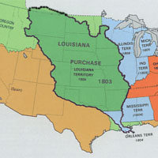
“The Louisiana Purchase of 1803 brought into the United States about 828,000 square miles of territory from France, thereby doubling the size of the young republic. What was known at the time as the Louisiana Territory stretched from the Mississippi River in the east to the Rocky Mountains in the west and from the Gulf of Mexico in the south to the Canadian border in the north. Part or all of 15 states were eventually created from the land deal, which is considered one of the most important achievements of Thomas Jefferson’s presidency. *** And in 1801, Spain signed a secret treaty with France to return the Louisiana Territory to France. Reports of the retrocession caused considerable unease in the United States. Since the late 1780s, Americans had been moving westward into the Ohio River and Tennessee River valleys, and these settlers were highly dependent on free access to the Mississippi River and the strategic port of New Orleans. U.S. officials feared that France, resurgent under the leadership of Napoleon Bonaparte, would soon seek to dominate the Mississippi River and access to the Gulf of Mexico. In a letter to U.S. minister to France Robert Livingston, President Thomas Jefferson stated, ‘The day that France takes possession of New Orleans…we must marry ourselves to the British fleet and nation.’” https://www.history.com/topics/westward-expansion/louisianapurchase

Napoleon - acquired Louisiana from Spain in 1800.

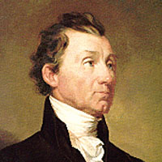James Monroe

“Napoleon Bonaparte’s plans to revive the French empire in the New World.

He planned to recapture the valuable sugar colony of St. Domingue from a slave rebellion, and then use Louisiana as the granary for his empire. France acquired Louisiana from Spain in 1800 and took possession in 1802, sending a large French army to St. Domingue [Haiti] and preparing to send another to New Orleans.

Westerners became very apprehensive about having the more-powerful French in control of New Orleans: President Thomas Jefferson noted, ‘There is on the globe one single spot, the possessor of which is our natural and habitual enemy. It is New Orleans.’

In addition to making military preparations for a conflict in the Mississippi Valley, Jefferson sent James Monroe to join Robert Livingston in France to try to purchase New Orleans and West Florida for as much as $10 million. Failing that, they were to attempt to create a military alliance with England. Meanwhile, the French Army in St. Domingue was being decimated by yellow fever, and war between France and England still threatened. Napoleon decided to give up his plans for Louisiana, and offered a surprised Monroe and Livingston the entire territory of Louisiana for $15 million. Although this far exceeded their instructions from President Jefferson, they agreed.

When news of the sale reached the United States, the West was elated. President Jefferson, however, was in a quandary. He had always advocated strict adherence to the letter of the Constitution, yet there was no provision empowering him to purchase territory. Given the public support for the purchase and the obvious value of Louisiana to the future growth of the United States, however, Jefferson decided to ignore the legalistic interpretation of the Constitution and forgo the passage of a Constitutional amendment to validate the purchase. This decision contributed to the principle of implied powers of the federal government.” https://history.state.gov/milestones/1801-1829/louisiana-purchase

June 15, 1804: 12th Amendment to U.S. Constitution ratified
“The electors shall meet in their respective states and vote by ballot for President and Vice-President, one of whom, at least, shall not be an inhabitant of the same state with themselves; they shall name in their ballots the person voted for as President, and in distinct ballots the person voted for as Vice-President, and they shall make distinct lists of all persons voted for as President, and of all persons voted for as Vice-President, and of the number of votes for each, which lists they shall sign and certify, and transmit sealed to the seat of the government of the United States, directed to the President of the Senate;--The President of the Senate shall, in the presence of the Senate and House of Representatives, open all the certificates and the votes shall then be counted;--the person having the greatest number of votes for President, shall be the President, if such number be a majority of the whole number of electors appointed; and if no person have such majority, then from the persons having the highest numbers not exceeding three on the list of those voted for as President, the House of Representatives shall choose immediately, by ballot, the President.” https://www.law.cornell.edu/constitution/amendmentxii

July 11, 1804: FAMOUS DUEL – AARON BURR KILLED ALEXANDER HAMILTON

“Hamilton-Burr Duel.” https://www.nps.gov/articles/000/hamilton-burr-duel.htm

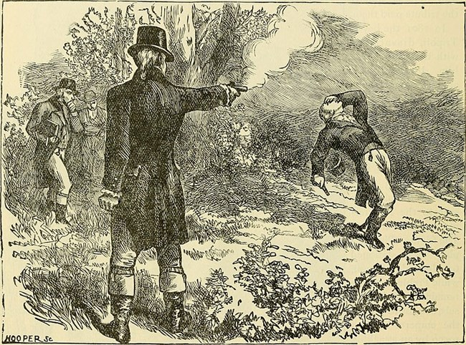

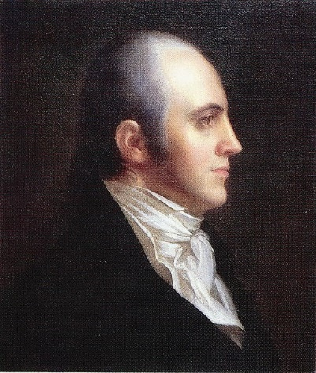Portrait of Aaron Burr
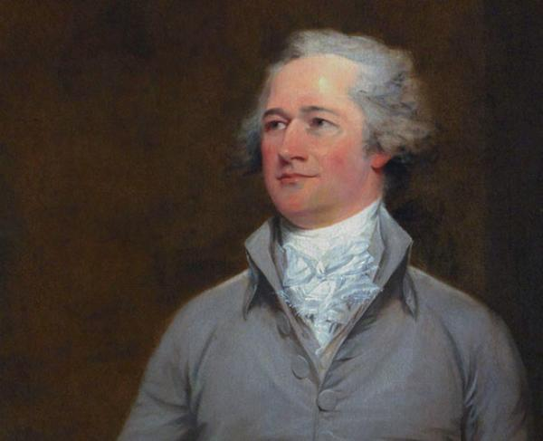Alexander Hamilton
“The specific event that led to the final duel began in the early months of 1804. A letter, written by Charles Cooper and published in the Albany Register in April 1804 referenced a conversation between Hamilton and other dinner guests in which Hamilton mentioned that Burr is a ‘dangerous man, and not to be trusted.’ The letter also references a ‘more despicable’ statement made by Hamilton about Burr.
***
Dueling was outlawed in both the states of New York and New Jersey, but the penalties for dueling were less harsh in New Jersey than in New York. Therefore, the site of Weehawken, New Jersey was chosen for this duel to take place on July 11th, 1804. It was the same site where, three years prior, Hamilton’s eldest son died in a duel defending his father’s honor.
***
Hamilton shot wide of Burr, hitting a nearby tree. Hamilton wrote days before that he had planned to do this before the duel. ‘I have resolved, ‘wrote Hamilton, ‘to reserve and throw away my first fire, and I have thoughts even of reserving my second fire.’ This statement was verbally confirmed in the moments before the duel, according to Hamilton’s second, Nathaniel Pendleton. If withholding a second shot was Hamilton’s plan that morning, it was never realized. Burr’s bullet hit Hamilton in the abdomen, entering the right side. Later accounts by the seconds of the two duelists agree that Hamilton instantly fell to the ground. A later account from Dr. David Hosack states that Hamilton was lying in the arms of Pendleton when Hosack ran to him. ‘This is a mortal wound, Doctor,’ Hosack recalls Hamilton saying.”

“Aaron Burr was on a mission to commit treason. And Cincinnati was a pit stop along the way.”https://www.cincinnati.com/story/news/2024/05/11/aaron-burr-mission-commit-treason-brief-stop-cincinnati/73534105007/?utm_source=enquirer-dailybriefing-strada&utm_medium=email&utm_campaign=dailybriefing-headline-stack&utm_term=hero&utm_content=pcin-cincinnati-nletter65

“Burr’s visits to Cincinnati
Burr made trips to the western country in spring 1805 and fall 1806. When passing through Cincinnati, he stayed at the home of Sen. John Smith in Terrace Park.
Elder Smith, as he was known, served as the minister of a Baptist church in the settlement of Columbia (now the Columbia Tusculum neighborhood of Cincinnati). He was also a politician in the Northwest Territory, advocating for Ohio’s statehood. In 1803, the Democratic-Republican was elected as one of the state’s first two U.S. senators.
***
Kentucky’s U.S. Attorney Joseph Hamilton Daveiss brought Burr before a grand jury in Frankfort three times in late 1806 to face charges that he had planned a military expedition to invade Spanish territory, which was in violation of the federal Neutrality Act. Burr, defended by the young attorney Henry Clay, was acquitted each time.
***

Jefferson finally did something about that pesky Burr. In November 1806, he issued a proclamation against the western insurgents, calling on state militias to help control the West. On Dec. 10, 1806, the Ohio militia intercepted the boats filled with weapons, supplies and soldiers at Blennerhassett Island, but Harman Blennerhassett escaped. The militia ransacked the island the next day. Burr was hundreds of miles away at the time, which was a key point. Blennerhassett and fewer than 100 men met up with Burr and they headed down the Ohio River toward New Orleans to enact their plot, not knowing Wilkinson double-crossed them. Upon hearing of the bounty out on them, Burr and his men surrendered to authorities at Bayou Pierre in Louisiana.
***
Burr went on trial in 1807 at the federal court in Richmond, Virginia, presided over by Chief Justice John Marshall. The president himself accused Burr of treason. The Constitution defines treason against the U.S. as “levying war against them.” Conviction requires “the testimony of two witnesses to the same overt act.” The act that was the basis for the charges against Burr occurred on Blennerhassett Island [Ohio] on Dec. 10, but Burr was not actually there, so there were no witnesses to his involvement.
The trial ended up narrowly defining what treason is according to the Constitution, and despite Jefferson’s fervent wishes, Burr’s case did not meet the standard. The verdict: ‘We of the jury say that Aaron Burr is not proved to be guilty under this indictment by any evidence submitted to us. We therefore find him not guilty.’”

1805: “The Shores of Tripoli” - Marine Corps Hymn
“In the early 1800s, the U.S. stood up to the Barbary States in North Africa that demanded protection payments for U.S. shipping. In 1805, Marine Lieutenant Presley O’Bannon and eight Marines led a force of mercenaries on a 500-mile trek across the desert. Their surprise attack on the city of Derna, on “the shores of Tripoli,” helped bring an end to the conflict.” https://www.kennedy-center.org/education/resources-for-educators/classroom-resources/media-and-interactives/media/music/story-behind-the-song/the-story-behind-the-song/the-marines-hymn/

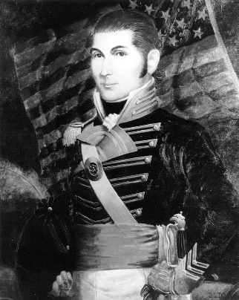

1806: Tecumseh - TENSKWATAW (“THE PROFIT)
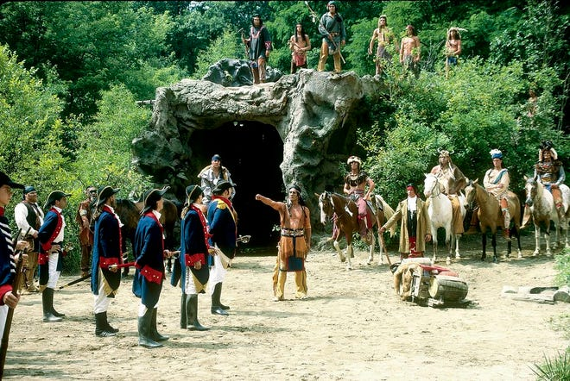
Two Shawnee brothers – Tecumseh (warrior chief) and Tenskwatawa (the “prophet”) – from 2003 enactment. Tecumseh refused to sign Treaty of Greenville in 1795, ceding most of Ohio to U.S. Government.
TOTAL ELICIPSE
“Tecumseh and younger brother Tenskwatawa used total eclipse to convey they had the power to control the sun, in disagreement with William Henry Harrison, would go on to become President.” https://www.dispatch.com/story/news/local/2024/04/04/how-tecumseh-used-the-1806-total-eclipse-in-ohio-to-his-advantage/72931327007/?utm_source=columbusdispatch-dailybriefing-strada&utm_medium=email&utm_campaign=dailybriefing-headline-stack&utm_term=hero&utm_content=ncod-columbus-nletter65

March 3, 1807: Insurrection Act of 1807

18 U.S. CODE § 2383 - REBELLION OR INSURRECTION
“Sec. 331. Federal aid for State governments Whenever there is an insurrections in any State against its government, the President may, upon the request of its legislature or of its governor if the legislature cannot be convened, call into Federal service such of the militia of the other States, in the number requested by that State, and use such of the armed forces, as he considers necessary to suppress the insurrection.”
Sec. 332. Use of militia and armed forces to enforce Federal authority Whenever the President considers that unlawful obstructions, combinations, or assemblages, or rebellion against the authority of the United States, make it impracticable to enforce the laws of the United States in any State by the ordinary course of judicial proceedings, he may call into Federal service such of the militia of any State, and use such of the armed forces, as he considers necessary to enforce those laws or to suppress the rebellion.” https://policy.defense.gov/portals/11/documents/hdasa/references/insurrection_act.pdf
“Any act of rebellion or insurrection against the U.S. government constitutes a serious federal crime punishable by serious jail time and fines. This crime is embodied under Title 18 U.S. Code 2383. *** It's important to note that 18 U.S. Code 2383 insurrection and rebellion charges are rarely filed by the United States Department of Justice (DOJ) because they recognize the First Amendment right to free speech. Still, specific unlawful behavior could result in criminal charges under this statute. For example, recall the events at the U.S. Capitol building on January 6, 2021, when a group of people stormed a government building to disrupt Congress' formal certification of presidential election results.” https://www.thefederalcriminalattorneys.com/rebellion-or-insurrection#:~:text=Rebellion%20or%20insurrection%20is%20a,violent%20resistance%20to%20government%20authority.

March 2, 1808: Congress Outlaws Importation Of Slaves
“Congress outlawed the import of new enslaved people in 1808, but the enslaved population in the U.S. nearly tripled over the next 50 years, and by 1860 it had reached nearly 4 million, with more than half living in the cotton–producing states of the South. https://www.history.com/articles/black-history-milestones

“On March 2, 1807, the U.S. Congress passes an act to ‘prohibit the importation of slaves into any port or place within the jurisdiction of the United States…from any foreign kingdom, place, or country.’ It would go into effect at the start of the following year.” https://www.history.com/this-day-in-history/march-2/congress-abolishes-the-african-slave-trade

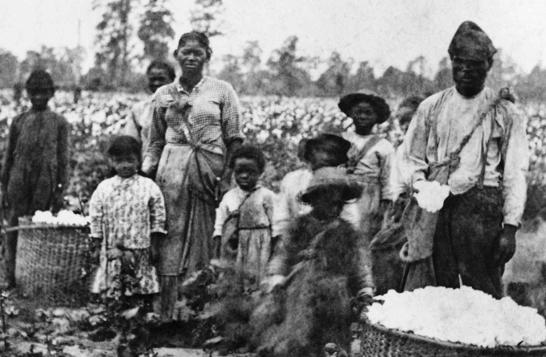

Feb. 12, 1809: ABRAHAM LINCOLN BORN
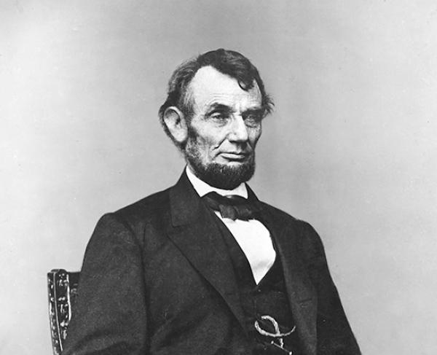
“Abraham Lincoln, sixteenth President of the United States, was born near Hodgenville, Kentucky on February 12, 1809. His family moved to Indiana when he was seven and he grew up on the edge of the frontier. He had very little formal education, but read voraciously when not working on his father’s farm. A childhood friend later recalled Lincoln's "manic" intellect, and the sight of him red-eyed and tousle-haired as he pored over books late into the night. In 1828, at the age of nineteen, he accompanied a produce-laden flatboat down the Mississippi River to New Orleans, Louisiana—his first visit to a large city--and then walked back home. Two years later, trying to avoid health and finance troubles, Lincoln's father moved the family moved to Illinois.” https://www.battlefields.org/learn/biographies/abraham-lincoln

Aug. 1810: Tecumseh Meets With William Henry Harrison
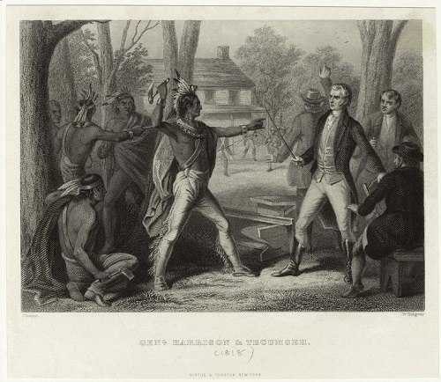
“Beginning in 1808, the Shawnee leader Tecumseh travelled throughout the United States gathering supporters and allies to form a native confederacy that could resist westward expansion by white settlers. In August 1811, Tecumseh met with Governor William Henry Harrison to discuss the recent treaties, land purchases, and violence throughout the Indiana territories. At their meeting, Tecumseh spoke for a large group of natives along the Great Lakes, and told Harrison, ‘that piece of land, we do not wish you to take it,’ indicating that his allies wanted ‘the present boundary line to continue.’ Should the whites continue their expansion into the region, Tecumseh warned, ‘I assure you it will be productive of bad consequences.’” https://www.nps.gov/articles/tecumseh.htm
***
“William Henry Harrison joined the army at eighteen in the early 1790s. He later became aide to Major General “Mad Anthony” Wayne, and participated in the decisive victory over the Western Indian Confederacy at the 1794 Battle of Fallen Timbers. After resigning from the army, Harrison became a territorial governor. A ruthless negotiator for Indian lands, Harrison procured some 3,000,000 acres for white settlement by negotiating with carefully-selected tribes.” https://www.nps.gov/articles/tippecanoe.htm?utm_source=article&utm_medium=website&utm_campaign=experience_more&utm_content=small
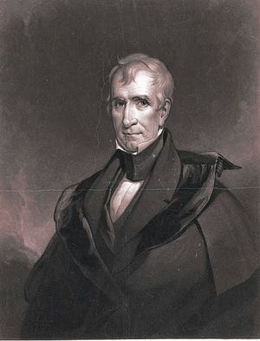William Henry Harrison, Governor of neighboring Indiana Territory (elected President in 1840).

Nov. 7, 1811: The Battle of Tippecanoe
:The Battle of Tippecanoe was fought between American soldiers and Native American warriors along the banks of the Keth-tip-pe-can-nunk, a river in the heart of central Indiana. Following the Treaty of Fort Wayne, an 1809 agreement requiring Indiana tribes to sell three million acres of land to the United States government, a Shawnee chief named Tecumseh, organized a confederation of Native American tribes to combat the horde of pioneers flooding into native lands.” https://www.battlefields.org/learn/war-1812/battles/tippecanoe
***
“Fought almost a year before the formal declaration of the War of 1812, ‘Tippecanoe’ became a rallying cry for many Americans as they denounced British support for the western Indian tribes. … [William Henry] Harrison recognized the threat Tecumseh’s movement posed for American settlement. Hoping to gain an advantage, Harrison launched a preemptive strike at the native headquarters at “Prophet’s Town,” located on Tippecanoe Creek in present-day Indiana. But his targets sprang their own surprise: on November 6, 1811, they launched a predawn attack. Harrison’s men eventually repulsed the attackers, but suffered significant casualties in the fighting.” https://www.nps.gov/articles/tippecanoe.htm?utm_source=article&utm_medium=website&utm_campaign=experience_more&utm_content=small
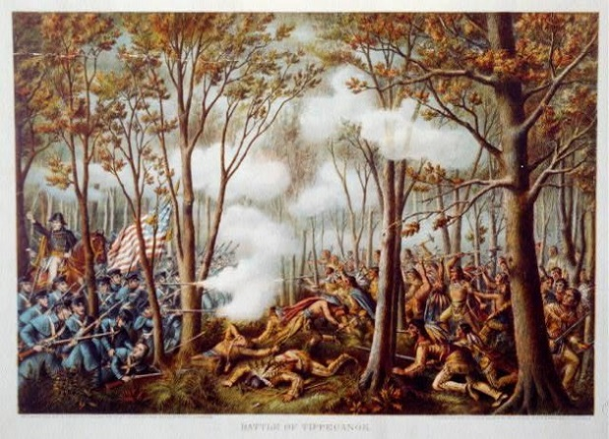

June 18, 1812 – “WAR OF 1812”

“War of 1812, (June 18, 1812–February 17, 1815), conflict fought between the United States and Great Britain over British violations of U.S. maritime rights. It ended with the exchange of ratifications of the Treaty of Ghent.
***
Michigan territorial governor William Hull led U.S. forces into Canada from Detroit, but Isaac Brock and Tecumseh’s warriors chased Hull back across the border and frightened him into surrendering Detroit on August 16, 1812, without firing a shot—behavior that Americans and even Brock’s officers found disgraceful. The Northwest subsequently fell prey to Indian raids and British incursions led by Maj. Gen. Henry Procter.
***
To the west, however, American Oliver Hazard Perry’s Lake Erie squadron won a great victory off Put-in-Bay on September 10, 1813, against Capt. Robert Barclay. The battle opened the way for Harrison to retake Detroit and defeat Procter’s British and Indian forces at the Battle of the Thames (October 5). Tecumseh was killed during the battle, shattering his confederation and the Anglo-Indian alliance.” https://www.britannica.com/event/War-of-1812/War
***
The British assault on Baltimore (September 12–14, 1814) foundered when Americans fended off an attack at Northpoint and withstood the naval bombardment of Fort McHenry, an action that inspired Francis Scott Key’s “The Star-Spangled Banner.”

Aug. 24, 1814: British Troops Burn White House
“During the War of 1812, British troops burned the White House. President James Madison and the First Lady were in Maryland at the time. British soldiers allegedly sat down, ate a meal and ransacked the house before setting it on fire.” https://www.firerescue1.com/history/articles/when-firefighting-crossed-paths-with-presidents-veeps-SbUtdRP4yHbhoFaI/

September 13, 1814 – Defense of Fort McHenry - Star Spangled Banner
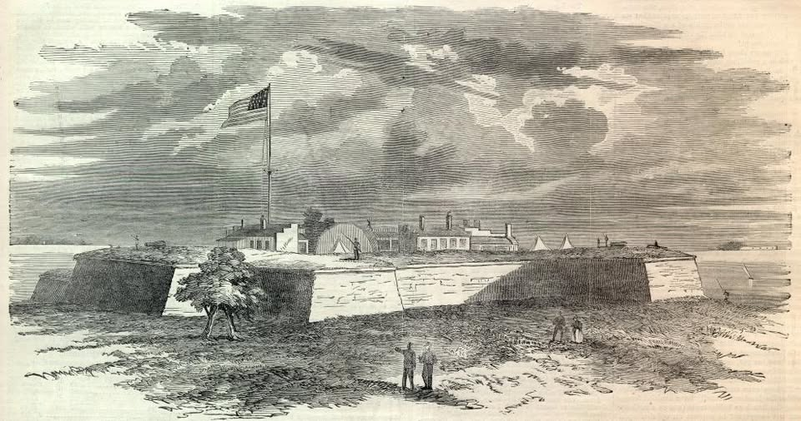1814, Francis Scott Key pens the poem "Defense of Fort McHenry". Later known as the "Star Spangled Banner."

“On September 13, 1814, Key and a U.S. official rowed over to a British warship at the mouth of the Patapsco River outside of Baltimore, Maryland. Their mission was to seek the release of some American prisoners.
The meeting with the British officers went well, and they even dined together. But when it came time for Key and his companions to paddle home, their hosts said hold your rowboats. The Americans had seen too much. British ships were moving into position to blast the daylights out of Fort McHenry, about eight miles away. Once they captured the fort, British troops would then raid the city, like they had in Washington. The British could not let Key and the others report on what they had seen.
Meanwhile, the Americans had very good seats for the fireworks. British ships let loose with their cannon as night fell. Hour after hour, they lobbed rockets and shells at the fort, more than 1,500 ka-booms in all.
As dawn neared, Key squinted through the gloom and smoke. He prepared himself to see his fears fulfilled: the British flag flying over Fort McHenry. But wait. Was that …? Was it …? It sure was. A huge American flag still waved there. The British attack had failed and Baltimore was saved.

The Poem
As soon as Key was released, he pulled an envelope from his pocket and began writing on the back. Out poured a poem about how the U.S. had withstood Great Britain’s armed might:

Oh say can you see by the dawn’s early light
What so proudly we hailed at the twilight’s last gleaming?
Whose broad stripes and bright stars through the perilous fight,
O’er the ramparts we watched were so gallantly streaming?
And the rockets’ red glare, the bombs bursting in air,
Gave proof through the night that our flag was still there.
O! say does that star-spangled banner yet wave
O'er the land of the free and the home of the brave?

Interestingly, Key put the words to a (gasp) familiar drinking so ng, ‘To Anacreon in Heaven,’ written by (gasp) British composer John Stafford Smith.”
https://www.kennedy-center.org/education/resources-for-educators/classroom-resources/media-and-interactives/media/music/story-behind-the-song/the-story-behind-the-song/the-star-spangled-banner/

1815 – NYFD – First African American Woman Firefighter
In 1815, Molly Williams became the first recorded woman, and one of the first African Americans, to serve as a firefighter in New York City. Her moment of heroism came during a brutal blizzard in 1818. While many male firefighters were sidelined by illness, Molly stepped in, fearlessly operating the fire pump through snow and freezing temperatures.
Her courage and determination left a lasting legacy in fire service history.

“History of Women in Firefighting
Women have been firefighters for longer than most people realize: in fact, for almost 200 years. The first woman firefighter we know of was Molly Williams, who was a slave in New York City and became a member of Oceanus Engine Company #11 in about 1815.” https://web.archive.org/web/20141014060453/http://i-women.org/firefighters/history-of-women-in-firefighting/

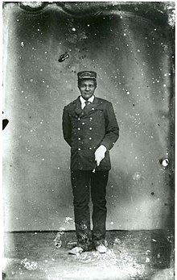

1815 – Napoleon’s Final Defeat – Cattle of Waterloo (Belgium)
“Battle of Waterloo, (June 18, 1815), Napoleon’s final defeat, ending 23 years of recurrent warfare between France and the other powers of Europe. It was fought during the Hundred Days of Napoleon’s restoration, 3 miles (5 km) south of Waterloo village (which is 9 miles [14.5 km] south of Brussels), between Napoleon’s 72,000 troops and the combined forces of the duke of Wellington’s allied army of 68,000 (with British, Dutch, Belgian, and German units) and about 45 https://www.britannica.com/event/Battle-of-Waterloo ,000 Prussians, the main force of Gebhard Leberecht von Blücher’s command.” https://www.britannica.com/event/Battle-of-Waterloo

March 4, 1817: JAMES MONROE - ELECTED PRESIDENT – MONROE DOCTRINE OF AMERICAN EXPANSION [March 4, 1817 – March 4, 1825]
“Along with his influential Secretary of State John Quincy Adams, Monroe issued the Monroe Doctrine, which forewarned the imperial European powers against interfering in the affairs of the newly independent Latin American states or potential U.S. territories in the Western hemisphere. Adhering to the intellectual underpinnings of the doctrine, Monroe granted diplomatic recognition to newly-independent Latin American republics.”
https://history.state.gov/departmenthistory/people/monroe-james

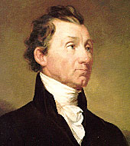


“President James Monroe is said to have written the American expansion policy known as the Monroe Doctrine in the dining room. The Marquis de Lafayette visited twice, and Dolley Madison was a regular guest. Monroe’s Loudoun County estate — the 200-year-old Oak Hill, built and maintained by enslaved African Americans — is considered the only home of a Founding Father still in private hands, and the aging owners want to sell the carefully preserved landmark and its 1,240 acres to Virginia at a discount to become a state park.” https://www.washingtonpost.com/dc-md-va/2025/02/21/virginia-oak-hill-park-james-monroe/?utm_campaign=wp_post_most&utm_medium=email&utm_source=newsletter&carta-url=https%3A%2F%2Fs2.washingtonpost.com%2Fcar-ln-tr%2F413e07f%2F67b8b571fcd029063f77cbae%2F59731235ade4e21a848a56ed%2F25%2F56%2F67b8b571fcd029063f77cbae

Oct. 5, 1818 – Abraham Lincoln’s mother died

“On October 5, 1818, Nancy Hanks Lincoln died [age 34; Abraham was 9] from milk sickness. The disease resulted when cows ate the white snakeroot plant and the poison from the plant contaminated the milk. Nancy became ill when she went to help care for her sick neighbors.” https://www.nps.gov/places/grave-site-of-nancy-hanks-lincoln.htm

1819 – Indian Boarding Schools Established
“In the United States, forced removals to reservations were followed by policies of cultural assimilation, in which the government of the United States attempted to force Tribes to conform to the dominant American culture. Through its Bureau of Indian Affairs, the government established more than 4008 boarding schools across the United States and forced many Indigenous children to attend them. In these schools, Indigenous children were forced to abandon their traditional languages, dress, and customs. Boarding schools were seen as one expedient means to achieve this cultural assimilation because they separated Indigenous children from their families and Tribes and ‘Americanized’ them while they were still malleable.
***
Regardless of the individual experiences at boarding schools, however, the system itself left a legacy of community and individual trauma that broke down family and support systems among Indigenous communities.
***
Footnote 8: The total number of Native Boarding Schools in United States during the Boarding School Period (1819-1979) is estimated to be 408. During that period, there were a total of 84 Boarding Schools run by Catholic religious communities or Church entities, according to the website https://ctah.archivistsacwr.org/. Of those, the number of Boarding Schools that were entrusted by the federal government to Catholic church groups is estimated to be much lower, since a good number of them were created for assistance and educational purposes to poor and marginalized communities, outside of the government programs, and were funded by religious communities and their benefactors. Also, federal funding for Catholic Boarding Schools ended in the early 1900’s.” https://www.usccb.org/resources/Indigenous%20Pastoral%20Framework%20-June%202024-Final%20Text.pdf
***
“3,104 students died at boarding schools between 1828 and 1970, three times as many deaths as reported by the U.S. Interior Department earlier this year. The Post found that more than 800 of those students are buried in cemeteries at or near the schools they attended, underscoring how, in many cases, children’s bodies were never sent home to their families or tribes.” https://www.washingtonpost.com/investigations/interactive/2024/native-american-deaths-burial-sites-boarding-schools/?utm_campaign=wp_post_most&utm_medium=email&utm_source=newsletter&carta-url=https%3A%2F%2Fs2.washingtonpost.com%2Fcar-ln-tr%2F40102b7%2F67683d4f9965465237938c0f%2F59731235ade4e21a848a56ed%2F10%2F52%2F67683d4f9965465237938c0f
***
“More than 900 Native American children died at U.S. boarding schools. The U.S. government should apologize for policies that traumatized generations of children and their families, a new federal report urges. *** In the new report, Newland’s team of researchers said they identified 18,624 Native American children who were forced to attend the schools, but noted that the number of students was greater. The report also estimated that the federal government spent more than $23.3 billion in inflation-adjusted dollars over 98 years to implement the Indian boarding school system, similar institutions and associated assimilation policies.https://www.washingtonpost.com/investigations/2024/07/30/indian-boarding-schools-native-americans/

March 6, 1819: U.S. Supreme Court: McCulloch v. Maryland

“Issue: Can Congress establish a national bank, and if so, can a state tax this bank?
Result: The Court held that Congress had implied powers to establish a national bank under the "necessary and proper" clause of the U.S. Constitution. The Court also determined that United States laws trump state laws and consequently, a state could not tax the national bank.
Importance: The McCulloch decision established two important principles for constitutional law that continue today: implied powers and federal supremacy.” https://www.americanbar.org/groups/public_education/programs/constitution_day/landmark-cases/

1820: Missouri Compromise – Maine established as a “Free State”
“In the years leading up to the Missouri Compromise of 1820, tensions began to rise between pro-slavery and anti-slavery factions within the U.S. Congress and across the country. They reached a boiling point after Missouri’s 1819 request for admission to the Union as a slave state, which threatened to upset the delicate balance between slave states and free states. To keep the peace, Congress orchestrated a two-part compromise, granting Missouri’s request but also admitting Maine as a free state. It also passed an amendment that drew an imaginary line across the former Louisiana Territory, establishing a boundary between free and slave regions that remained the law of the land until it was negated by the Kansas-Nebraska Act of 1854.” https://www.history.com/topics/abolitionist-movement/missouri-compromise
***

“Maine statehood had national repercussions. The inhabitants of this northern part of Massachusetts had asked for statehood in 1819, but their petition was stopped dead by southerners who refused to permit a ‘free state’—one that did not permit slavery—to enter the Union without a corresponding ‘slave state.’ The explosive growth of the northern states had already given free states control of the House of Representatives, but the South held its own in the Senate, where each state got two votes. The admission of Maine would give the North the advantage, and southerners insisted that Maine’s admission be balanced with the admission of a southern slave state lest those opposed to slavery use their power in the federal government to restrict enslavement in the South.
They demanded the admission of Missouri to counteract Maine’s two ‘free’ Senate votes.
But this ‘Missouri Compromise’ infuriated northerners, especially those who lived in Maine. They swamped Congress with petitions against admitting Missouri as a slave state, resenting that slave owners in the Senate could hold the state of Maine hostage until they got their way. Tempers rose high enough that Thomas Jefferson wrote to Massachusetts—and later Maine—senator John Holmes that he had for a long time been content with the direction of the country, but that the Missouri question ‘like a fire bell in the night, awakened and filled me with terror. I considered it at once as the knell of the Union. It is hushed indeed for the moment, but this is a reprieve only, not a final sentence.’ Congress passed the Missouri Compromise, but Jefferson was right to see it as nothing more than a reprieve. The petition drive that had begun as an effort to keep the admission of Maine from being tied to the admission of Missouri continued as a movement to get Congress to whittle away at slavery where it could—by, for example, outlawing slave sales in the nation’s capital—and would become a key point of friction between the North and the South.” https://heathercoxrichardson.substack.com/p/march-15-2024

March 2, 1824 – U.S. Supreme Court - Gibbons v. Ogden

“Issue: Can states pass laws that challenge the power of Congress to regulate interstate commerce?
Result: The Court held that it is the role of the federal government to regulate commerce and that state governments cannot develop their own commerce-regulating laws. Further, the Court created a wide definition for “commerce,” reasoning that the term encompassed more than just selling and buying. In this case, the Court determined that regulating water navigation was in fact an act that regulated commerce.
Importance: The impact of Gibbons is still felt today as it gives the federal government a much-broader base to regulate economic transactions.” https://www.americanbar.org/groups/public_education/programs/constitution_day/landmark-cases/

July 4, 1826 – Thomas Jefferson Dies – Slaves Sold To Settle Debts

“A peculiar thing about Thomas Jefferson’s house servants was that we were all related to one another, and as a matter of fact, we did not know we were slaves,” Peter Fossett said in an 1898 lecture in Cincinnati. “I was dressed unlike plantation boys. My grandmother was free, and I remember the first suit I ever wore she gave me. It was of blue Nankeen cloth, red Morocco hat and red Morocco shoes. … “I had nice house servant work, got tips and all that sort of thing. Suddenly, at the death of my old master, Thomas Jefferson, I was put on the auction block and sold for $500 to strangers,” he said.
Peter Fossett was 11 years old when Jefferson died in 1826. Jefferson had freed only five enslaved workers in his will, Joseph Fossett among them. Jefferson had enormous debts, so the other 100 people were sold at an estate auction.” https://www.cincinnati.com/story/news/2025/02/23/thomas-jefferson-enslaved-cook-brought-french-cuisine-cincinnati/78208670007/?utm_source=enquirer-dailybriefing-strada&utm_medium=email&utm_campaign=dailybriefing-headline-stack&utm_term=Content%20List%20-%20Stacking%20-%20optimized&utm_content=pcin-cincinnati-nletter65

Oct. 26, 1825: Erie Canal
New York Gov. DeWitt Clinton opened the canal in 1825…. Backed by the New York state legislature, construction on the Erie Canal began in 1817. An army of subcontractors dug, blasted and dredged their way through the forests, mountains and swamps of the upstate landscape to create the 40-foot-wide, 4-foot-deep waterway, one of the country’s first major public-works projects, according to Brad L. Utter, author of “Enterprising Waters: The History and Art of New York’s Erie Canal.”… When the full waterway officially opened on Oct. 26, 1825, connecting the interior of the U.S. to the Atlantic Ocean via the Hudson River, the Erie Canal kicked off an unprecedented era of growth. Shipping and travel time were slashed in half. Cargo costs dropped from about $100 per ton to $4 per ton. In the waterway’s first year of operation, more than 40,000 passengers traveled it, according to the New York State Archives Partnership Trust.” https://www.washingtonpost.com/travel/2025/05/26/erie-canal-bicentennial-events/?utm_campaign=wp_post_most&utm_medium=email&utm_source=newsletter&carta-url=https%3A%2F%2Fs2.washingtonpost.com%2Fcar-ln-tr%2F42d7c37%2F683c7da4e4755d707b301c08%2F59731235ade4e21a848a56ed%2F41%2F52%2F683c7da4e4755d707b301c08

July 4, 1826: Thomas Jefferson and Samuel Adams died same day – 50th Anniversary of signing Declaration of Independence
“John Adams and Thomas Jefferson died on the same day, July 4, 1826. Both were old men—Adams was 90, and Jefferson was 83—and both were ill, though Adams had been in comparatively robust health until just a few months earlier and Jefferson had been ill for an extended period. They had been rivals, indeed enemies, for some time; Jefferson had defeated Adams in the presidential election of 1800. But they had repaired their differences and had pursued an active correspondence with each other in the years before their deaths. On that final day, the 50th anniversary of the signing of the Declaration of Independence, Adams died at his home in Quincy, Massachusetts, and Jefferson died at his home in Monticello, Virginia, the two separated by hundreds of miles and by many days of overland travel time.” https://www.bu.edu/historic/battin.htm

May 28, 1830 – Indian Removal Act
“The Indian Removal Act was signed into law by President Andrew Jackson on May 28, 1830, authorizing the president to grant lands west of the Mississippi in exchange for Indian lands within existing state borders. A few tribes went peacefully, but many resisted the relocation policy. During the fall and winter of 1838 and 1839, the Cherokees were forcibly moved west by the United States government. Approximately 4,000 Cherokees died on this forced march, which became known as the ‘Trail of Tears.’” https://guides.loc.gov/indian-removal-act
November 16, 1907: “Oklahoma entered the Union as the forty-sixth state on November 16, 1907. The history of Oklahoma is tied to the early nineteenth-century use of this land for relocating the Native American population from the settled portions of the United States.” https://guides.loc.gov/indian-removal-act/related-online-resources
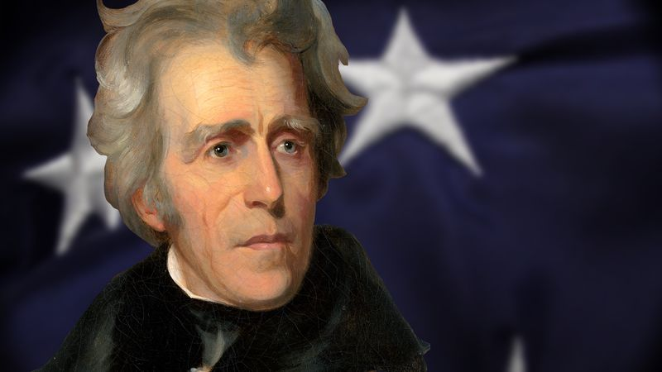
7th President of the United States (1829–1837)
“Served in the Creek War of 1813 as commander of Tennessee forces; his victory in the Creek War brought him a commission as major general in the United States Army in May 1814; led his army to victory over the British in the Battle of New Orleans in January 1815; received the thanks of Congress and a gold medal by resolution of February 27, 1815; commanded an expedition which captured Florida in 1817; served as Governor of the new territory in 1821; again elected to the United States Senate and served from March 4, 1823, to October 14, 1825, when he resigned; chairman, Committee on Military Affairs (Eighteenth Congress); unsuccessful candidate for President in 1824; elected as a Democrat as President of the United States in 1828; reelected in 1832 and served from March 4, 1829, to March 3, 1837; retired to his country home, the 'Hermitage,' near Nashville, Tenn., where he died June 8, 1845; interment in the garden on his estate.” https://bioguide.congress.gov/search/bio/j000005

Aug. 1831: Nat Turner’s Revolt
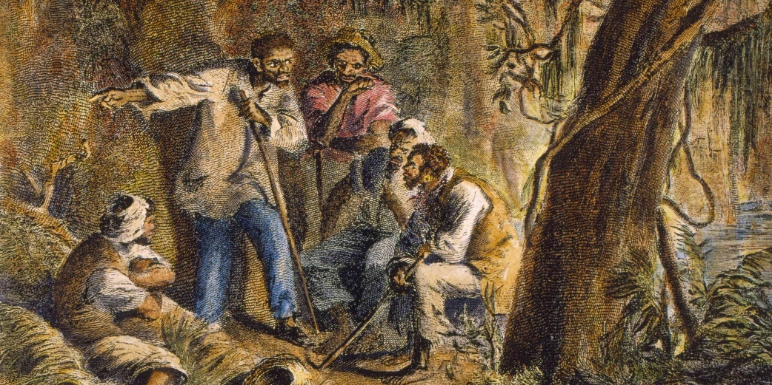 https://www.history.com/articles/nat-turner

“In August 1831, Nat Turner struck fear into the hearts of white Southerners by leading the only effective slave rebellion in U.S. history. Born on a small plantation in Southampton County, Virginia, Turner inherited a passionate hatred of slavery from his African–born mother and came to see himself as anointed by God to lead his people out of bondage…. In early 1831, Turner took a solar eclipse as a sign that the time for revolution was near, and on the night of August 21, he and a small band of followers killed his owners, the Travis family, and set off toward the town of Jerusalem [Virginia]where they planned to capture an armory and gather more recruits. The group, which eventually numbered around 75 Black people, killed some 60 white people in two days before armed resistance from local white people and the arrival of state militia forces overwhelmed them just outside Jerusalem. Some 100 enslaved people, including innocent bystanders, lost their lives in the struggle. Turner escaped and spent six weeks on the run before he was captured, tried and hanged.” https://www.history.com/articles/black-history-milestones

1831: Abolitionism And The Underground Railroad
“In the early 19th century, however, a new brand of radical abolitionism emerged in the North, partly in reaction to Congress’ passage of the Fugitive Slave Act of 1793 and the tightening of codes in most southern states. One of its most eloquent voices was William Lloyd Garrison, a crusading journalist from Massachusetts, who founded the abolitionist newspaper The Liberator in 1831 and became known as the most radical of America’s antislavery activists. Antislavery northerners—many of them free Black people—had begun helping enslaved people escape from southern plantations to the North via a loose network of safe houses as early as the 1780s called the Underground Railroad.” https://www.britannica.com/biography/William-Lloyd-Garrison
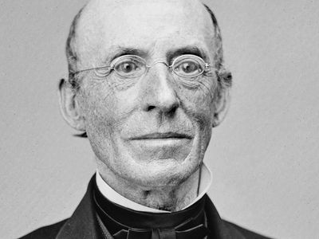
***
“A printer, newspaper publisher, radical abolitionist, suffragist, and civil rights activist, William Lloyd Garrison spent his life disturbing the peace of the nation in the cause of justice…. Contact with Black Americans in Boston and Baltimore led Garrison to reject gradualism and colonization. In 1831, back in Boston with his new newspaper The Liberator, Garrison publicly committed himself to Black abolitionists' demands for an immediate uncompensated end to slavery and for political and social equality. Despite threats, violence, and financial struggles Garrison continued to hammer away for freedom and equality. He published The Liberator every week for thirty-five years. He gave speeches and helped found antislavery societies. He worked with, inspired (and on occasion offended) activists such as Charles Lenox Remond, Frederick Douglass, Lucy Stone, Abby Kelley Foster, Wendell Phillips, and others. After slavery and The Liberator ended in 1865, he continued to demand equality for Blacks and for women. At a women's suffrage meeting in 1873, Garrison summed up his life's work: ‘I am still for immediate, unconditional, everlasting emancipation from oppression of everyone on the face of the earth.’” https://www.nps.gov/people/william-lloyd-garrison.htm

1832: President Andrew Jackson – Refuses To Enforce U.S. Supreme Court Decision / Cherokees Forced Migration - “TRAIL OF TEARS”
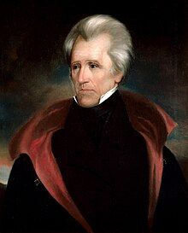
“In Worcester v. Georgia (1832), the Supreme Court overturned the conviction of a missionary living among the Cherokee Nation for refusing to take an oath to obey the laws of Georgia. In an opinion written by Chief Justice John Marshall, the Court held that the Cherokees constituted an independent political community to which the state of Georgia could not apply its laws. Accordingly, the Court ordered Worcester’s release from custody. Georgia’s governor refused to release the missionary, vowing to defy the Court’s decision. President Andrew Jackson refused to intervene, maintaining that Georgia had the right to apply its laws to any person living within its borders. Jackson also embraced the view that both the executive and legislative branches had as much right as the judicial branch to interpret the Constitution. While the story is likely apocryphal, Jackson supposedly remarked, ‘John Marshall has made his decision, now let him enforce it.’ (The quotation is believed to have first appeared in an 1864 book by newspaper publisher Horace Greeley.) Eventually, Jackson acted in direct contravention of the Court’s decision in Worcester. Ignoring the Court’s ruling that the Cherokees were an independent people entitled to the land on which they lived, Jackson sent federal troops to evict them. The result was the Cherokees’ forced and deadly migration west along the infamous Trail of Tears.” https://www.fjc.gov/history/administration/executive-enforcement-judicial-orders

1833 – Abolitionist: Lydia Maria Child
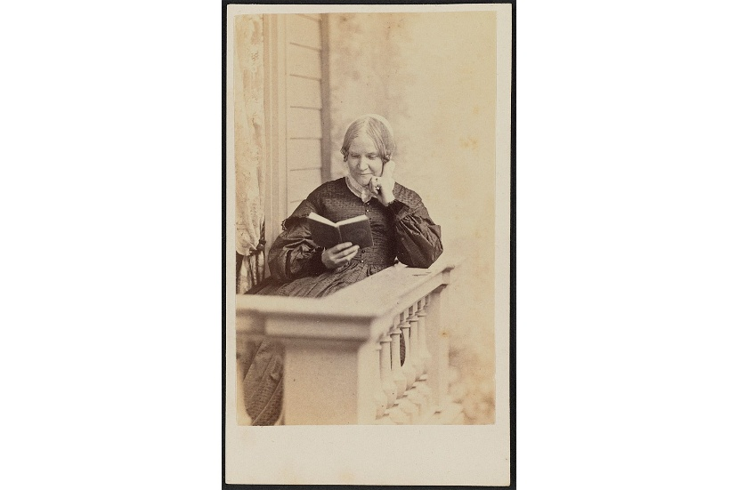

“An Appeal in Favor of That Class of Americans Called Africans (1833) is the first scholarly American overview of the history of slavery and the first major study of that institution in the United States. In this book Child blames the North as well as the South for the existence of the ‘peculiar institution.’ She calls for the immediate abolition of slavery and the eradication of all forms of racial discrimination, including laws of anti-miscegenation that forbade intermarriage between Black and white people. Once again she openly defended interracial marriage.
The abolitionists wasted little time in praising An Appeal in Favor of That Class of Americans Called Africans. In his review published in The Liberator on August 10, 1833, [William Lloyd] Garrison wrote that any “heart must be harder than the nether mill-stone which can remain unaffected by the solemn truths it contains.” Indeed, scholars credit this book with converting more men and women to abolition than any other publication.” https://www.poetryfoundation.org/poets/lydia-maria-child

1837: CINCINNATI – SALMON P. CHASE, ESQ.
“Salmon P. Chase was one of the most complex and accomplished men in Cincinnati’s history. There is much to cover. His time as the Secretary of the Treasury − a member of Abraham Lincoln’s “team of rivals” in the Cabinet − during the Civil War, when he ran the federal finances and created our first system of paper currency. Or his era as chief justice on the Supreme Court, presiding over the impeachment trial of President Andrew Johnson. Or Chase’s great ambition to be president, even running for office while he sat on the Supreme Court.
***
Chase didn’t consider himself an abolitionist so much as an antislavery attorney. He took on numerous cases defending people apprehended as fugitive slaves, and defended James Birney, publisher of the abolitionist newspaper, The Philanthropist. Birney also enlisted Chase’s help with the case of his housekeeper, Mathilda. She had been enslaved and accompanied slaveholder Larkin Lawrence to Cincinnati in 1837. While docked at the Public Landing, she stepped off the boat and into the city, and soon found work with Birney. Lawrence had her arrested as a fugitive slave. Chase defended her and argued against the constitutionality of the Fugitive Slave Act of 1793. He also claimed that since Ohio was a free state, Mathilda ceased to be enslaved the moment Lawrence brought her within the city limits, including the Public Landing. When she walked off the boat, she didn’t escape, she just exercised her freedom to walk from one spot in the free territory to another. Though Chase lost the case and Mathilda returned to slavery, the case marked “the first major abolitionist challenge to fugitive recaptures,” according to historians. After the similar case of Samuel Watson in 1845, which Chase also lost, there was some hope as even the judge began to regret the existence of slavery. Chase’s arguments were starting to change a few minds.” https://www.cincinnati.com/story/news/2025/04/06/salmon-p-chase-prolific-political-career-started-cincinnati/82504216007/?utm_source=enquirer-dailybriefing-strada&utm_medium=email&utm_campaign=dailybriefing-headline-stack&utm_term=Content%20List%20-%20Stacking%20-%20optimized&utm_content=pcin-cincinnati-nletter65

April 28, 1845: Frederick Douglas [age 27] writes autobiography: “Narrative of the Life of Frederick Douglass, an American Slave”
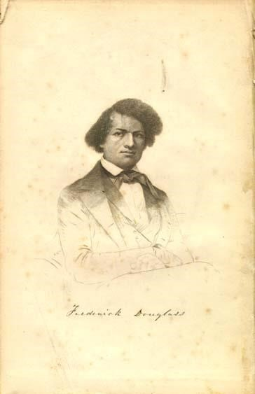Read his autobiography:
https://docsouth.unc.edu/neh/douglass/douglass.html
“Frederick Douglass was an escaped slave who became a prominent activist, author and public speaker. He became a leader in the abolitionist movement, which sought to end the practice of slavery, before and during the Civil War. After that conflict and the Emancipation Proclamation of 1862, he continued to push for equality and human rights until his death in 1895. *** Douglass’ 1845 autobiography, Narrative of the Life of Frederick Douglass, an American Slave, described his time as a slave in Maryland. It was one of five autobiographies he penned, along with dozens of noteworthy speeches, despite receiving minimal formal education. https://www.history.com/topics/blackhistory/frederick-douglass

1845 AUTOBIOGRAPHY:
“I WAS born in Tuckahoe, near Hillsborough, and about twelve miles from Easton, in Talbot county, Maryland. I have no accurate knowledge of my age, never having seen any authentic record containing it. By far the larger part of the slaves know as little of their ages as horses know of theirs, and it is the wish of most masters within my knowledge to keep their slaves thus ignorant. I do not remember to have ever met a slave who could tell of his birthday. They seldom come nearer to it than planting-time, harvest-time, cherry-time, spring-time, or fall-time. A want of information concerning my own was a source of unhappiness to me even during childhood. The white children could tell their ages. I could not tell why I ought to be deprived of the same privilege. I was not allowed to make any inquiries of my master concerning it. He deemed all such inquiries on the part of a slave improper and impertinent, and evidence of a restless spirit. The nearest estimate I can give makes me now between twenty-seven and twenty-eight years of age. I come to this, from hearing my master say, sometime during 1835, I was about seventeen years old. My mother was named Harriet Bailey. She was the daughter of Isaac and Betsey Bailey, both colored, and quite dark.
My mother was of a darker complexion than either my grandmother or grandfather.
My father was a white man. He was admitted to be such by all I ever heard speak of my parentage. The opinion was also whispered that my master was my father; but of the correctness of this opinion, I know nothing; the means of knowing was withheld from me. My mother and I were separated when I was but an infant-before I knew her as my mother. It is a common custom, in the part of Maryland from which I ran away, to part children from their mothers at a very early age. Frequently, before the child has reached its twelfth month, its mother is taken from it, and hired out on some farm a considerable distance off, and the child is placed under the care of an old woman, too old for field labor. For what this separation is done, I do not know, unless it be to hinder the development of the child's affection toward its mother, and to blunt and destroy the natural affection of the mother for the child. This is the inevitable result.” https://docsouth.unc.edu/neh/douglass/douglass.html

1849: Harriet Tubman – Freed Slaves / Civil War Hero
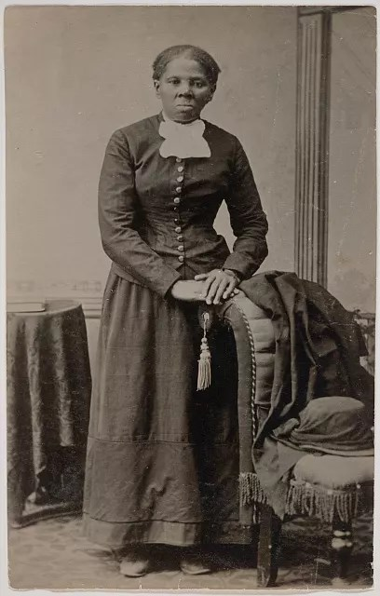Harriet Tubman (1822 – 1913)

“Tubman deserves to retain recognition of her immense contributions. As then-Secretary of the Navy Carlos Del Toro said upon announcing the ship’s name, “Our fleet benefits from having her name emblazoned on the hull of one of our great ships.” Often called the “Moses of her people,” Tubman was born enslaved on Maryland’s Eastern Shore; she escaped in 1849 and sought freedom in Philadelphia. She risked that freedom to return to Maryland more than a dozen times over the next 11 years and rescued 70 people, advising dozens more who freed themselves.

***

Often called the “Moses of her people,” Tubman was born enslaved on Maryland’s Eastern Shore; she escaped in 1849 and sought freedom in Philadelphia. She risked that freedom to return to Maryland more than a dozen times over the next 11 years and rescued 70 people, advising dozens more who freed themselves.

Yet Tubman’s service during the Civil War is perhaps her most consequential legacy. After the U.S. military reclaimed Port Royal Sound, South Carolina, from the Confederacy in 1861, Tubman was sent on a critical mission to gather intelligence from the 8,000 formerly enslaved people who had escaped to Union lines. She was attached to Gen. Isaac Stevens’s headquarters and worked for Gens. Rufus Saxton and David Hunter, commanding a ring of Black men as spies, scouts and river pilots.

Tubman’s little-known mission came to fruition on June 1, 1863, when she guided three U.S. Army boats loaded with 300 Black soldiers from Col. James Montgomery’s Second South Carolina Volunteers, and a battery of White soldiers from another regiment, up the Combahee River into Confederate-controlled territory. Earlier, Tubman and her men had infiltrated Confederate plantations and identified the enslaved men who were forced to plant mines along the Combahee River to prevent Union access. With their help, Tubman’s men and the U.S. Army officers defused the mines. Those soldiers also rooted out Confederate forces, burned seven plantations— including the owners’ homes, barns, stockpiles of rice, and stables— and cut Confederate supply lines by destroying a bridge.

From those burned lands, hundreds of enslaved people flocked to the soldiers’ rowboats at the river shore. Fearful that the rowboats might capsize, Montgomery asked Tubman to calm the crowds. Using her strong voice, she started singing and was met with a joyful response of clapping and shouting. Seven hundred and fifty-six people were liberated that day; the U.S. Army did not lose a single life. The Combahee Ferry Raid is now considered the largest and most successful slave rebellion in U.S. history.

That Tubman was prohibited from enlisting in the U.S. Army did not stop her from risking her life for the enslaved, or for a nation that hadn’t yet recognized her rights as a citizen. Though she was not paid for her work, which also included nursing the sick and cooking for officers — she took in laundry to scrape by — her service with the armed forces helped make the Combahee River Raid one of the most successful campaigns of the war.
Harriet Tubman was a civil rights leader, but she was also a military hero who risked her life fighting for freedom, our nation and the perfection of our democracy. She earned the honor of having the USNS Harriet Tubman named after her. It should remain part of her legacy — and ours.” https://www.washingtonpost.com/opinions/2025/07/02/tubman-hegseth-naval-ship-removal/?utm_campaign=wp_post_most&utm_medium=email&utm_source=newsletter&carta-url=https%3A%2F%2Fs2.washingtonpost.com%2Fcar-ln-tr%2F4369a44%2F68655c8d22827c5c302bbb00%2F59731235ade4e21a848a56ed%2F38%2F68%2F68655c8d22827c5c302bbb00

1850s – New York City Slave Trade
“In the 1850s, a quarter century after slavery was banned in New York State, the city grimly developed into a thriving center of trans-Atlantic human trafficking, with slave ships regularly being outfitted in Lower Manhattan and sent to West Africa. There, imprisoned Africans were forced aboard and shipped to Cuba for a life of servitude.
Mr. Emilio Sanchez [Cuban-born spy ] who was a commission merchant and ship broker in New York, sought to destroy this trade by secretly identifying and tracking slave ships leaving the city so British naval vessels could intercept them off the African coast. During the same period, Horace Greeley was the editor of the New York paper that most vigorously denounced the illegal slave trade in an era when it was rampant and few stood against it.” https://www.nytimes.com/2025/07/06/realestate/streetscapes-brooklyn-british-spy.html

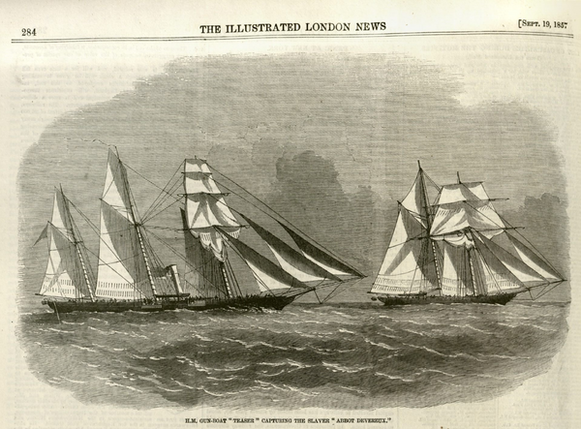
An American slave ship sought to bring enslaved Africans to Cuba in 1857 but was intercepted by the British Navy, above. Such captures became more common in 1859, when the British hired Emilio Sanchez to secretly identify slave ships before they left New York for the African coast. Credit...The Illustrated London News

Sept. 12, 1847: “From The Halls of Montezuma” – Marine Corps Hymn
“In 1845, the U.S. launched the Mexican-American War to seize Mexican lands. In September 1847, U.S. Marines and Army troops fought Mexican forces defending Mexico City. In the Battle of Chapultepec, the Americans captured Chapultepec Castle, a historic site also known as the Halls of Montezuma. The victory effectively ended the war.” https://www.kennedy-center.org/education/resources-for-educators/classroom-resources/media-and-interactives/media/music/story-behind-the-song/the-story-behind-the-song/the-marines-hymn/
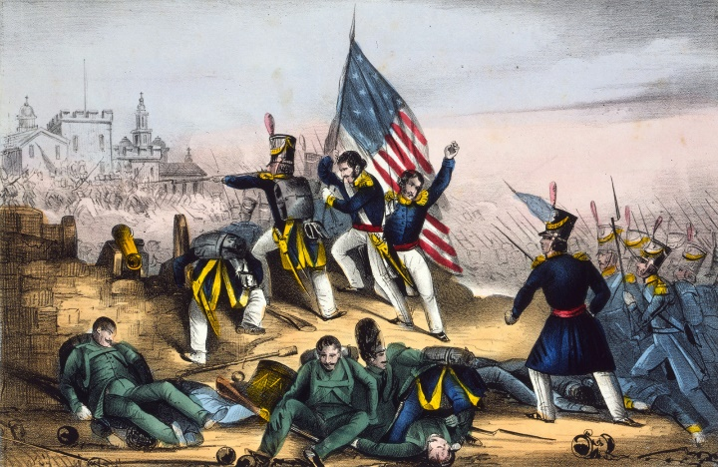

1850: Fugitive Slave Act / Underground Railroad
“What is the Underground Railroad?... The decision to assist a freedom seeker may have been spontaneous. However, in some places, especially after the Fugitive Slave Act of 1850, the Underground Railroad was deliberate and organized. Despite the illegality of their actions, people of all races, class and genders participated in this widespread form of civil disobedience. Freedom seekers went in many directions – Canada, Mexico, Spanish Florida, Indian territory, the West, Caribbean islands and Europe. “I was the conductor of the Underground Railroad for eight years, and I can say what most conductors can't say — I never ran my train off the track and I never lost a passenger.” https://www.nps.gov/subjects/undergroundrailroad/what-is-the-underground-railroad.htm

1853: Boston and Cincinnati each claim to be the oldest fire department; who is correct?

1853: “On April 1, 1853, Cincinnati, Ohio, established the first professional and fully paid fire department in the United States.” https://www.cincinnati-oh.gov/fire/about-fire/history/
1678: “The first paid (call) municipal fire department organized. Thomas Atkins is the first fire chief, aided by twelve assistants. The first fire engine purchased and a building provided to house fire engine. The engine, imported from England, was lodged in a shed on town land on Queen (now Court) St., near the (then) prison.” https://bostonfirehistory.org/boston-history-before-1859/

Oct. 16, 1854 – Lincoln opposed to slavery
“Abraham Lincoln said, ‘no man is good enough to govern another man, without that other's consent. I say this is the leading principle-the sheet anchor of American republicanism.... Now the relation of masters and slaves is, pro tanto, a total violation of this principle’ (Lincoln, Speech at Peoria, Ill. [October 16, 1854] [reprinted in 2 Collected Works of Lincon 266 [Basher ed 1953]).

May 22, 1856: The Caning of Senator Charles Sumner
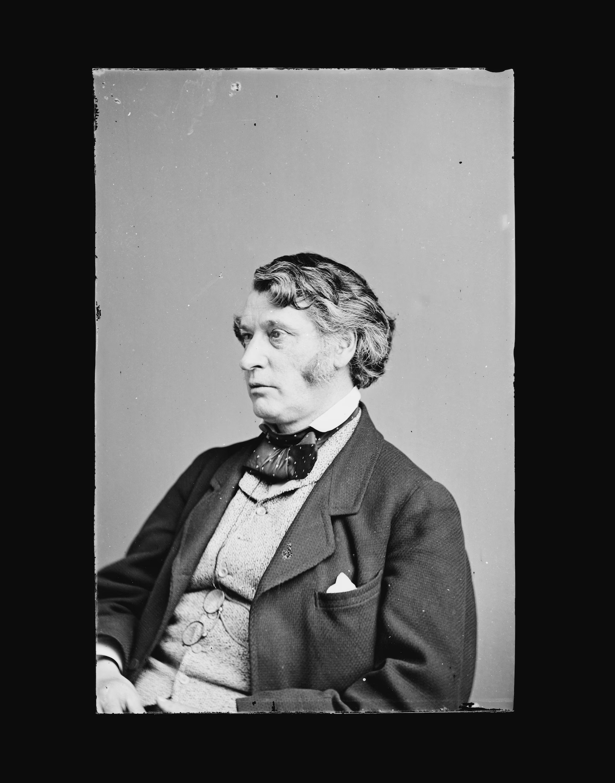
Former Massachusetts senator Charles Sumner (Library of Congress)

“On May 22, 1856, the ‘world's greatest deliberative body’ became a combat zone. In one of the most dramatic and deeply ominous moments in the Senate's entire history, a member of the House of Representatives entered the Senate Chamber and savagely beat a senator into unconsciousness.
The inspiration for this clash came three days earlier when Senator Charles Sumner, a Massachusetts antislavery Republican, addressed the Senate on the explosive issue of whether Kansas should be admitted to the Union as a slave state or a free state. In his ‘Crime Against Kansas’ speech, Sumner identified two Democratic senators as the principal culprits in this crime—Stephen Douglas of Illinois and Andrew Butler of South Carolina. He characterized Douglas to his face as a "noise-some, squat, and nameless animal . . . not a proper model for an American senator." Andrew Butler, who was not present, received more elaborate treatment. Mocking the South Carolina senator's stance as a man of chivalry, the Massachusetts senator charged him with taking ‘a mistress . . . who, though ugly to others, is always lovely to him; though polluted in the sight of the world, is chaste in his sight—I mean,’ added Sumner, ‘the harlot, Slavery.’
Representative Preston Brooks was Butler's South Carolina kinsman. If he had believed Sumner to be a gentleman, he might have challenged him to a duel. Instead, he chose a light cane of the type used to discipline unruly dogs. Shortly after the Senate had adjourned for the day, Brooks entered the old chamber, where he found Sumner busily attaching his postal frank to copies of his "Crime Against Kansas" speech.
Moving quickly, Brooks slammed his metal-topped cane onto the unsuspecting Sumner's head. As Brooks struck again and again, Sumner rose and lurched blindly about the chamber, futilely attempting to protect himself. After a very long minute, it ended.
Bleeding profusely, Sumner was carried away. Brooks walked calmly out of the chamber without being detained by the stunned onlookers. Overnight, both men became heroes in their respective regions.
Surviving a House censure resolution, Brooks resigned, was immediately reelected, and soon thereafter died at age 37. Sumner recovered slowly and returned to the Senate, where he remained for another 18 years. The nation, suffering from the breakdown of reasoned discourse that this event symbolized, tumbled onward toward the catastrophe of civil war.”
https://www.senate.gov/artandhistory/history/minute/The_Caning_of_Senator_Charles_S umner.htm

March 6, 1857: U.S. Supreme Court - Dred Scott v. Sandford (60 US 393)
https://www.oyez.org/cases/1850-1900/60us393

“Issue: In this pre-Civil War case, the question was whether Congress had the constitutional power to prohibit slavery in free territories. A second question was whether the Constitution gave African Americans the right to sue in federal court.
Result: The 1857 Court answered no on both accounts: Congress could not prohibit slavery in territories, and African Americans also had no right to sue in federal court. In reaching these answers, the Court, interpreting the Constitution as it existed before the Civil War Amendments (Constitutional Amendments 13, 14, and 15) abolished slavery, concluded that people of African descent had none of the rights of citizens. The Court further reasoned that slaves were "property" and therefore could not be taken from their owners without due process.
Importance: The Dred Scott case became a central issue in the debate surrounding the expansion of slavery and further fueled the flames leading to the Civil War.” https://www.americanbar.org/groups/public_education/programs/constitution_day/landmark-cases/

CALLED THE WORST DECISION IN HISTORY / DECLARING SLAVES “PROPERTY” [overturned by 13th Amendment in 1865]
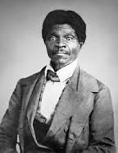
“On March 6, 1857, the U.S. Supreme Court handed down its decision in Scott v. Sanford, delivering a resounding victory to southern supporters of slavery and arousing the ire of northern abolitionists. During the 1830s, the owner of an enslaved man named Dred Scott had taken him from the slave state of Missouri to the Wisconsin territory and Illinois, where slavery was outlawed, according to the terms of the Missouri Compromise of 1820. Upon his return to Missouri, Scott sued for his freedom on the basis that his temporary removal to free soil had made him legally free. The case went to the Supreme Court, where Chief Justice Roger B. Taney and the majority eventually ruled that Scott was an enslaved person and not a citizen, and thus had no legal rights to sue.” https://www.history.com/articles/black-history-milestones

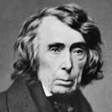Chief Justice Roger B. Taney
[See Washington Post article, July 22, 2020.] “The House voted Wednesday to remove statues of Confederate leaders from the Capitol and replace the bust of Roger B. Taney, the U.S. chief justice who wrote the Supreme Court decision that said people of African descent are not U.S. citizens. *** In 1857, Taney wrote the majority decision in the case of Scott, a black man born into slavery who used the courts to demand his freedom. Taney’s ruling, which defended slavery and declared that black people could never become U.S. citizens, came to be viewed as one of the worst Supreme Court decisions in U.S. history. Taney wrote that at the time of the Constitution’s ratification, black people ‘had for more than a century before been regarded as beings of an inferior order and altogether unfit to associate with the white race, either in social or political relations; and so far inferior that they had no rights which the white man was bound to respect; and that the Negro might justly and lawfully be reduced to slavery for his benefit.’” https://www.washingtonpost.com/powerpost/house-to-vote-on-removing-confederatestatues-from-the-capitol-and-replacing-bust-of-segregationist-chiefjustice/2020/07/22/72873a50-cba0-11ea-b0e3-
d55bda07d66a_story.html?utm_campaign=wp_evening_edition&utm_medium=email&u tm_source=newsletter&wpisrc=nl_evening
1858: Abraham Lincoln “House Divided”

“Why Lincoln’s ‘House Divided’ Speech Was So Important’”
”When Abraham Lincoln said “a house divided against itself cannot stand,” he wasn’t talking about the kind of political divisions common today. Americans may differ sharply on issues like immigration and abortion, but there is no single issue that geographically and economically divides the country in the same way that slavery did in the 1850s. Back then, the U.S. was so divided that many feared it would break out in civil war—a fear that Lincoln unwittingly stoked.
Lincoln’s now-famous “house divided” line, which is drawn from the Bible, was actually part of a campaign speech he delivered at the 1858 Illinois Republican State Convention. Lincoln, then a relatively unknown politician, had just won the nomination to run for U.S. Senate against one of the most important politicians in the country, Stephen A. Douglas.” https://www.history.com/news/abraham-lincoln-house-divided-speech

“In 1858, Lincoln made a mistake.” https://www.washingtonpost.com/opinions/2024/06/19/biden-lincoln-house-divided-lessons/?utm_campaign=wp_todays_headlines&utm_medium=email&utm_source=newsletter&wpisrc=nl_headlines&carta-url=https%3A%2F%2Fs2.washingtonpost.com%2Fcar-ln-tr%2F3e0af68%2F6673fdb61805fa57aecf48d1%2F59731235ade4e21a848a56ed%2F20%2F61%2F6673fdb61805fa57aecf48d1

“He was warning of what slavery’s supporters would attempt to do — legalize it everywhere — if they succeeded in spreading it into the territories, as allowed under the Kansas-Nebraska Act. Nearly every modern-day president has invoked Lincoln’s phrase, often as part of an appeal to national unity during election season. Usually forgotten, however, is that those words might have helped cost Lincoln the Senate race, as Lincoln scholar Allen Guelzo has noted. Although Lincoln aimed to inspire unity against the spread of slavery, Democrats turned the metaphor around on him, accusing him of inflaming tensions and pushing the country toward conflict — precisely what they themselves had been doing through their support of the Kansas-Nebraska Act and growing talk of secession.”

Oct. 16-18, 1859 - John Brown’s Raid – Happer’s Ferry

“A native of Connecticut, John Brown struggled to support his large family and moved restlessly from state to state throughout his life, becoming a passionate opponent of slavery along the way. After assisting in the Underground Railroad out of Missouri and engaging in the bloody struggle between pro- and anti-slavery forces in Kansas in the 1850s, Brown grew anxious to strike a more extreme blow for the cause. On the night of October 16, 1859, he led a small band of less than 50 men in a raid against the federal arsenal at Harper’s Ferry, Virginia. Their aim was to capture enough ammunition to lead a large operation against Virginia’s slaveholders. Brown’s men, including several Black people, captured and held the arsenal until federal and state governments sent troops and were able to overpower them. John Brown was hanged on December 2, 1859. His trial riveted the nation, and he emerged as an eloquent voice against the injustice of slavery and a martyr to the abolitionist cause. Just as Brown’s courage turned thousands of previously indifferent northerners against slavery, his violent actions convinced slave owners in the South beyond doubt that abolitionists would go to any lengths to destroy the "peculiar institution.” Rumors spread of other planned insurrections, and the South reverted to a semi-war status. Only the election of the anti–slavery Republican Abraham Lincoln as president in 1860 remained before the southern states would begin severing ties with the Union, sparking the bloodiest conflict in American history.” https://www.history.com/articles/black-history-milestones

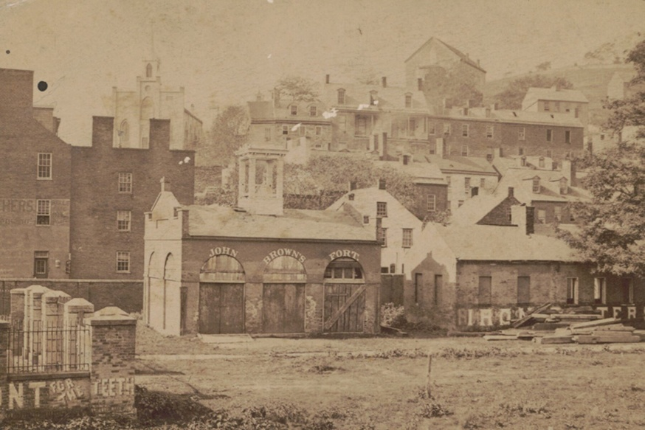

Colonel Robert E. Lee [later Confederate General]:

“After a botched attempt at taking over the town and inciting a slave rebellion, John Brown and his polyglot force had seized hostages and taken refuge inside a small brick engine house on federal property. The Marines marched to Harpers Ferry, entering the arsenal grounds through a back gate. About 11 pm, Lee ordered the various volunteer units out of the grounds, clearing space for the only regular troops at his disposal—the Marines under Greene. The following morning, Lee demanded that the terrorists surrender. When all attempts to negotiate with Brown failed, 27 Marines broke down the door with a battering ram, rushed into the building, killed or wounded the holdouts, and took Brown prisoner. Lee would later write, ‘I must also ask to express my entire commendation of the conduct of the detachment of Marines, who were at all times ready and prompt in the execution of any duty.’” https://warfarehistorynetwork.com/harpers-ferry-the-rise-of-robert-e-lee-and-j-e-b-stuart/

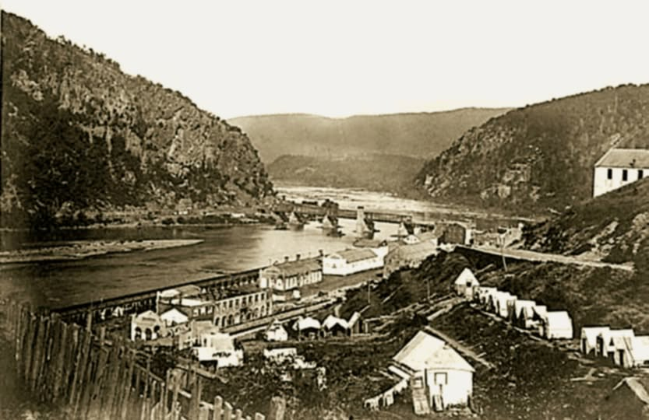

HARPER’S FERRY
Located where the Potomac and Shenandoah Rivers meet, Harper’s Ferry was in a critical strategic location and exchanged hands several times during the war. It is most famous for being the target of abolitionist John Brown’s unsuccessful raid on its armory in 1859. Most of the lower town was in ruins by the end of the war. It was rebuilt and is now a very popular destination for Civil War buffs, maintained by the National Park Service.

Feb. 12, 1861 – Lincoln In Cincinnati
“Abraham Lincoln spent his birthday in Cincinnati on Feb. 12, 1861, on his way from Springfield, Illinois, to the nation’s capital for his inauguration. *** Lincoln’s visit was just as the nation was falling apart. Yet, Lincoln narrowly won the presidency in 1860, despite not taking a single Southern state. In the first three months after the contentious election, seven states in the South seceded from the Union. There was a legitimate question whether Kentucky, a slave state, would soon follow. ***In his speech in Cincinnati two years earlier in [Sept. 17] 1859, he had said, ‘I think slavery is wrong, morally, and politically. I desire that it should be no further spread in these United States, and I should not object if it should gradually terminate in the whole Union.’ But he also said, ‘I say that we must not interfere with the institution of slavery in the states where it exists, because the Constitution forbids it, and the general welfare does not require us to do so.’ That was still his stance at the start of his presidency in 1861. Lincoln was mainly concerned with keeping the Union together as disgruntled states in the South were breaking away.” https://www.cincinnati.com/story/news/2025/02/09/what-abraham-lincoln-said-during-1861-visit-cincinnati/77722960007/?utm_source=enquirer-dailybriefing-strada&utm_medium=email&utm_campaign=dailybriefing-headline-stack&utm_term=Content%20List%20-%20Stacking%20-%20optimized&utm_content=pcin-cincinnati-nletter65

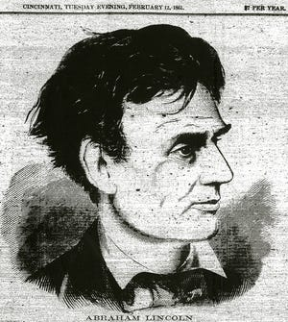

April 12, 1861: Civil War (April 12, 1861 – May 26, 1865)
“The Civil War is the central event in America's historical consciousness. While the Revolution of 1776-1783 created the United States, the Civil War of 1861-1865 determined what kind of nation it would be. The war resolved two fundamental questions left unresolved by the revolution: whether the United States was to be a dissolvable confederation of sovereign states or an indivisible nation with a sovereign national government; and whether this nation, born of a declaration that all men were created with an equal right to liberty, would continue to exist as the largest slaveholding country in the world.” https://www.battlefields.org/learn/articles/brief-overview-american-civil-war
***
“The Civil War was America's bloodiest conflict. The unprecedented violence of battles such as Shiloh, Antietam, Stones River, and Gettysburg shocked citizens and international observers alike. Nearly as many men died in captivity during the Civil War as were killed in the whole of the Vietnam War. Hundreds of thousands died of disease. Roughly 2% of the population, an estimated 620,000 men, lost their lives in the line of duty.” https://www.battlefields.org/learn/articles/civil-war-casualties
***

Ulysses S. Grant, General-in-Chief, Union Army:
https://www.battlefields.org/learn/biographies/ulysses-s-grant
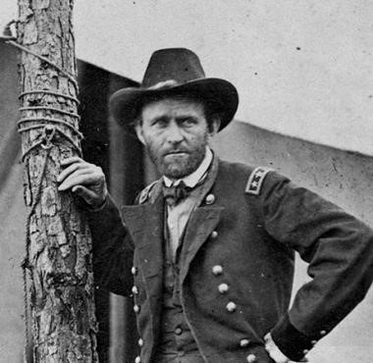
General Robert E. Lee, commander of the Confederate "Army of Northern Virginia":
https://www.nps.gov/gett/learn/historyculture/people.htm
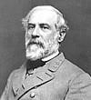

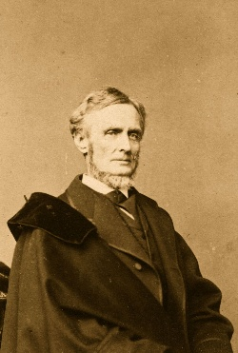Jefferson Davis

1861 – Mary Richards Bowser - Spy For The North
Domestic Servant Confederate President Jefferson Davis In Confederate White House, Richmond, VA / Northern Spy

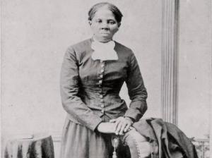

“Mary Richards Bowser was born into slavery and later became a missionary to Liberia, a Union spy in the Confederate White House during the American Civil War (1861–1865), and a teacher at freedmen’s schools. As a child, she was enslaved by the Van Lew family of Richmond; Elizabeth Van Lew, who had arranged for her to be educated in the North and provided her with de facto freedom prior to the war, ran a pro-Union intelligence ring in which Bowser played an important role.” https://encyclopediavirginia.org/entries/bowser-mary-richards-fl-1846-1867/

***

“Born a slave, Mary Elizabeth Bowser, worked as a domestic servant, cleaning and cooking for the family of Confederate President Jefferson Davis – simultaneously spying and reporting her findings to abolitionist Elizabeth Van Lew as part of an elaborate woman’s spy ring. Bowser worked on the John Van Lew plantation outside Richmond, Virginia. After her father’s death in 1851, Van Lew freed Ms. Bowser and other Van Lew family slaves. Recognizing her potential and intelligence, Van Lew sent Bowser north to attend school. During the Civil War, Van Lew organized the spy ring, eventually sending for Bowser after deciding to plant a spy in the home of Davis.” https://baltimoretimes-online.com/living-well/2025/02/21/mary-elizabeth-bowser-the-black-spy-who-infiltrated-the-home-of-a-c

April 17, 1861 – Lincoln suspends Writ of Habeas Corpus
“Lincoln's Suspension of the Writ of Habeas Corpus: An Historical and Constitutional Analysis” - https://quod.lib.umich.edu/j/jala/2629860.00

“The background is well known. After Virginia seceded from the Union on April 17, 1861, the only lines for overland supplies, troop movements, transportation, and communication to Washington, D.C., ran through Maryland, with the railroads running through Baltimore. Baltimore was a rough city for the Union, and Maryland an uncertain ally. In February, Baltimore rowdies had forced President-elect Lincoln to sneak through the city in disguise, and a mob attacked the Sixth Massachusetts Regiment as it marched through Baltimore on its way to Washington. Confederate sympathizers in Maryland were numerous, organized, and sometimes violent. The Maryland legislature was of questionable loyalty, prompting Lincoln to monitor its April 26 session and, later, to order the arrest of a number of its members.

Determined to keep the Maryland lines open, on April 27 Lincoln issued an order to General Winfield Scott authorizing him to suspend the writ of habeas corpus, at or near any military line between Philadelphia and Washington if the public safety required it. Lincoln issued his order pursuant to the provision in Article I, Section 9 of the Constitution stating that "the privilege of the writ of habeas corpus shall not be suspended, unless when in cases of rebellion and invasion the public safety may require it," generally called the suspension clause.

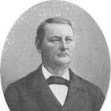

On May 25, federal troops arrested John Merryman in Cockeysville, Maryland, for recruiting, training, and leading a drill company for Confederate service. Merryman's lawyer promptly petitioned Chief Justice Roger Brooke Taney, sitting as a trial judge, for a writ of habeas corpus. This writ, sometimes called the Great Writ, is a judicial writ addressed to a jailer ordering him to come to court with his prisoner and explain why the prisoner is being held.

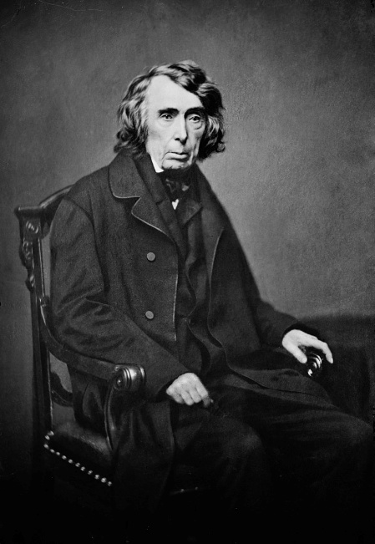

Following a hearing in the matter, Taney ordered delivery of a writ of habeas corpus to General George Cadwallader directing him to appear before Taney on May 28 with Merryman in tow. After Cadwallader refused service of the writ, Taney ruled on May 28 that the president did not have the power to suspend the writ, and Taney announced that he later would issue an opinion in support of his ruling.

Several days later, Taney issued his opinion. [Ex Parte Merryman, 17 F. Cas. 144 (1861).]

Only Congress, he said, could suspend the writ of habeas corpus. He observed that the limitation on suspension of the writ appeared in Article I of the Constitution, dealing with legislative powers, not in Article II, which established executive power. He explored the history of the writ of habeas corpus under English law, showing that the House of Commons had limited and then abolished the royal power to suspend the writ, leaving suspension in legislative hands. The Constitution, he said, embodied this English tradition. Article II, he asserted, gave the president very limited powers that were weakened further by the Bill of Rights. Finally, he cited eminent authority, noting that Chief Justice John Marshall, Thomas Jefferson, and Joseph Story, a luminary as both judge and scholar, had all acknowledged that the power to suspend was a congressional power.

Lincoln ignored Taney, and that was the end of the federal judiciary's involvement with the suspension of habeas corpus. Neither the Supreme Court nor the lower federal courts dealt with the issue again. The action now passed to the president and Congress.”

1862: The Homestead Act of 1862
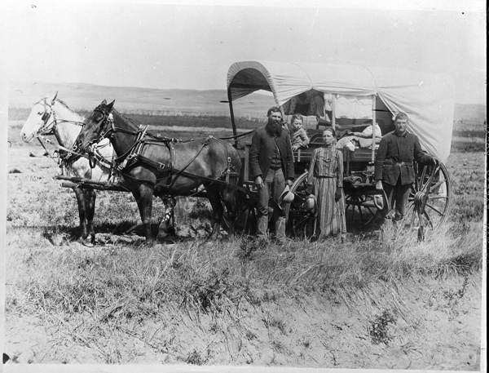
“President Abraham Lincoln signed the Homestead Act on May 20, 1862. On January 1, 1863, Daniel Freeman made the first claim under the Act, which gave citizens or future citizens up to 160 acres of public land provided they live on it, improve it, and pay a small registration fee. The Government granted more than 270 million acres of land while the law was in effect…. The Civil War removed the slavery issue because the Southern states had seceded from the Union. So finally, in 1862, the Homestead Act was passed and signed into law. The new law established a three-fold homestead acquisition process: file an application, improve the land, and file for deed of title. Any U.S. citizen, or intended citizen, who had never borne arms against the U.S. Government could file an application and lay claim to 160 acres of surveyed Government land. For the next 5 years, the General Land Office looked for a good faith effort by the homesteaders. This meant that the homestead was their primary residence and that they made improvements upon the land. After 5 years, the homesteader could file for his patent (or deed of title) by submitting proof of residency and the required improvements to a local land office.” https://www.archives.gov/education/lessons/homestead-act#background

Feb. 21, 1862 – Slave Trader Hung – U.S. Built Ships Taking Slaves From Africa To Brazil
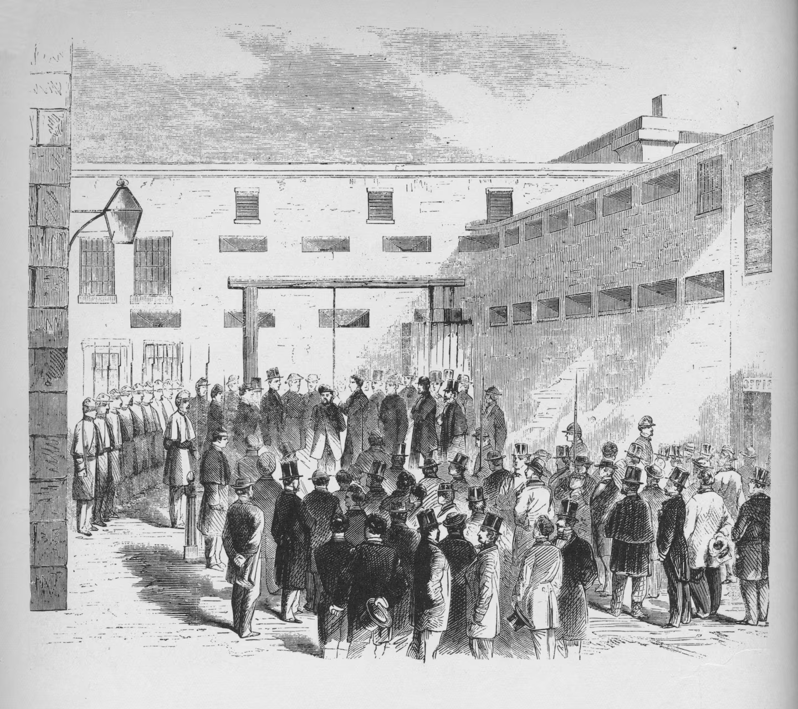Slave trader Nathaniel Gordon was hanged in the Tombs prison in New York in 1862. It was the only time an American was executed for violating the law against slave trading.
“’Any man, who, for paltry gain and stimulated only by avarice, can rob Africa of her children to sell into interminable bondage, I will never pardon,’ Abraham Lincoln said, according to author Ron Soodalter, denying Gordon’s pleas for clemency. https://www.washingtonpost.com/history/2024/03/31/camargo-us-slave-ship-brazil/?utm_campaign=wp_evening_edition&utm_medium=email&utm_source=newsletter&carta-url=https%3A%2F%2Fs2.washingtonpost.com%2Fcar-ln-tr%2F3d40f74%2F6609cee53f3b3130891acbfb%2F59731235ade4e21a848a56ed%2F11%2F40%2F6609cee53f3b3130891acbfb

June 28, 1862 – Richmond / Injured Soldiers
“A largely candid glimpse of men wounded at the Battle of Gaines' Mill resting and being treated at a field hospital at Savage Station the day after the battle, June 28, 1862, about 10 miles east of Richmond. In this detail you can see men caring for the wounded, who are fortunate to have some hay or straw for comfort. Hanging haversacks on the fence, musket, pouches, tents and more. Feel free to call out the straw hat unit!” Garry Adelman's Civil War Page, https://www.facebook.com/p/Garry-Adelmans-Civil-War-Page-100044534825272/

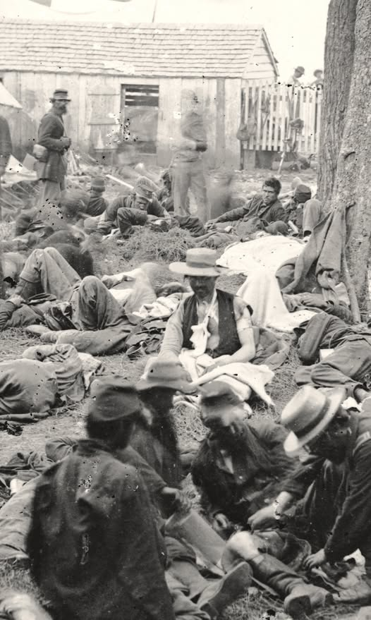

SEPT. 11, 1862 – CINCINNATI NOT INVADED BY CONFEDERATES – BLACK BRIGADE
“That Cincinnati did not fall was largely due to the leadership of Maj. Gen. Lew Wallace, a Union general who was dogged by controversy after the Battle of Shiloh a few months earlier. His defense of Cincinnati maybe only happened because he was trying to prove himself after Shiloh. *** Meanwhile, panicked Cincinnatians prepared for a siege. Wallace took command of Cincinnati, Newport and Covington and declared martial law on Sept. 1. *** Wallace ordered the organization of the Black Brigade, with abolitionist Col. William M. Dickson in command. The 300 kidnapped Black men were sent home and given the dignity of volunteering. The next day, 700 volunteers for the Black Brigade showed up. *** A force of some 70,000 soldiers – a mix of the regular army and volunteers – showed up to defend Cincinnati. That number included 15,000 backwoods fighters known as ‘Squirrel Hunters,’ armed with pistols, shotguns and sporting rifles. When the Confederate troops arrived, they found Cincinnati was prepared to defend itself. Realizing that invasion would not be easy, [General Henry] Heth and the Confederates pulled out during the night of Sept. 11.” https://www.cincinnati.com/story/news/2024/01/27/major-general-lew-wallace-saved-cincinnati-during-civil-war/72312546007/

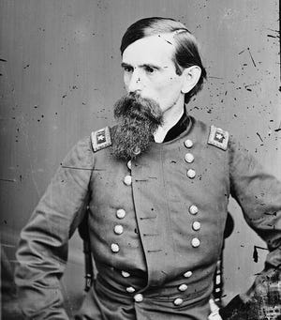
Union General Lew Wallace

Dec. 26, 1862: US – DAKOTA WAR - 38 SANTEE SIOUX HUNG
“On August 17, [1862] a Dakota hunting party stole eggs from settlers in Acton Township, located in Meeker County. The raid led to the deaths of five settlers. Little Crow, a chief of the Mdewakanton band of Dakota, decided to continue the raids. The day after the raid in Acton, Little Crow led another raid against the Lower Sioux Agency near Morton, MN in Renville County. A relief force, led by the Minnesota Militia, was routed by the Dakota. In the subsequent days, Dakota warriors led raids against New Ulm and Fort Ridgley, both of which had limited success. Because of the Civil War, the US government was slow to send troops to quell the uprising. Instead, military forces were primarily comprised of volunteer groups, led by former Governor Henry Sibley. On September 23, federal forces defeated the Dakota at the Battle of Wood Lake in Yellow Medicine County. Three days later, the Dakota surrendered, releasing nearly 300 captives. The Dakota who surrendered were held until military trials could take place that November. Hundreds of Dakota were held at Camp Release, near Montevideo.” https://cla.umn.edu/chgs/holocaust-genocide-education/resource-guides/us-dakota-war-1862
***
“At 10:00 am on December 26, 38 Dakota prisoners were led to a scaffold specially constructed for their execution. One had been given a reprieve at the last minute. An estimated 4,000 spectators crammed the streets of Mankato and surrounding land. Col. Stephen Miller, charged with keeping the peace in the days leading up to the hangings, had declared martial law and had banned the sale and consumption of alcohol within a ten-mile radius of the town. As the men took their assigned places on the scaffold, they sang a Dakota song as white muslin coverings were pulled over their faces. Drumbeats signaled the start of the execution. The men grasped each others’ hands. With a single blow from an ax, the rope that held the platform was cut. Capt. William Duley, who had lost several members of his family in the attack on the Lake Shetek settlement, cut the rope.” https://www.usdakotawar.org/history/aftermath/trials-hanging

LINCOLN SAVED 265
“In August 1862, starving Dakota families, whose annuity payments under a laxly enforced treaty had been delayed by the confusion of the Civil War, appealed to the owner of a reservation trading post for food on credit. The trader, Andrew Myrick, was reported to have answered, ‘Let them eat grass or their own dung.’ The next day, an outraged young tribesman murdered a family of settlers.
Chief Little Crow reluctantly agreed to expand the assault into a general war on settlers along the Upper Minnesota River, though he predicted the ultimate result. “The white men are like the locusts,” he said. No matter how many the Sioux killed, “ten times ten will come to kill you.” In the following weeks, as many as 800 settlers were killed in history’s largest uprising of Native Americans — including Myrick, whose corpse was recovered with grass stuffed in his mouth.
Some of the killings were even more brutal: A baby was nailed to a tree. Women and children hiding in a field of tall grass were burned alive. Panic was so widespread among the settlers that President Lincoln dispatched one of his private secretaries, John Nicolay, to go by train to Minnesota and render a reliable report.
The timing could not have been worse for Lincoln. A springtime of Union successes had sagged into a summer of demoralizing failures culminating in a two-pronged invasion of the North by Confederate armies. Union troops were deserting by the thousands. Lincoln’s Cabinet appeared to be splintering. And Queen Victoria’s government was preparing to intervene in the war to force a conclusion that would permanently divide the United States.
Assured by his secretary of the need for more troops, Lincoln dispatched sufficient forces to Minnesota to bring the war to an end. Gen. John Pope telegraphed the president in October that he intended to hold prompt trials for hundreds of Dakota prisoners, and was “anxious to execute a number of them.” The tribunals were an acknowledged sham: Pope wrote at the outset that he found it difficult to figure out which Dakota participated in the fighting and which ones actually tried to prevent it.
In early November, in the midst of a chastening off-year election, Pope forwarded a list of 303 prisoners he intended to hang. Minnesota Gov. Alexander Ramsey followed up with a plea to Lincoln that “the execution of every Sioux Indian condemned by the military court will be at once ordered.” Instead, the harried president demanded that all the files be sent to him for review. Lincoln rightly suspected that the public’s desire for revenge had tainted justice.
Ramsey and Pope both warned Lincoln that failure to kill the 303 would result in far worse bloodshed. “Private revenge” by lynch mobs would result in the “indiscriminate massacre of all the Indians — old men, women, and children,” the general wrote. But Lincoln began a careful review of each case. Exasperated, the governor offered to take control of the prisoners and execute them on state authority. Members of Congress arriving from Minnesota for the new session added their own warnings of mob violence if the Sioux were not sacrificed immediately.
Advised by a lawyer that he must personally decide each potential clemency, Lincoln tediously ground his way through 303 files — even as the Civil War dragged and pressure grew from opponents of his proposed Emancipation Proclamation. The easy and popular thing to do was to give Minnesota’s citizenry the executions they demanded, but as Lincoln explained afterward, “I could not hang men for votes.”
Ultimately, the president teased from records of the sham tribunals sufficient grounds to spare the lives of roughly seven out of every eight condemned Dakota. The hanging of 38 prisoners later in December was the largest mass execution in U.S. history, but on the same day, 265 lives were saved solely by the conscience of one man.”
Washington Post article: “Abraham Lincoln Didn’t Deserve Portland’s Wrath (Oct. 13, 2020):https://www.washingtonpost.com/opinions/abraham-lincoln-didnt-deserve-portlandswrath/2020/10/13/8973460e-0d73-11eb-8a35-
237ef1eb2ef7_story.html?utm_campaign=wp_week_in_ideas&utm_medium=email&utm_sourc e=newsletter&wpisrc=nl_ideas&carta-url=https%3A%2F%2Fs2.washingtonpost.com%2Fcar-lntr%2F2c2df81%2F5f8c20549d2fda0efb4d724e%2F59731235ade4e21a848a56ed%2F33%2F73 %2F8a8598bb10de0e3be66b5dbbdbcf9b41

Jan. 1, 1863: Emancipation Proclamation

Abraham Lincoln [age 54] sought to end slavery on New Year’s Day
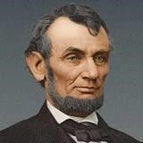
“By freeing some 3 million enslaved people in the rebel states, the Emancipation Proclamation deprived the Confederacy of the bulk of its labor forces and put international public opinion strongly on the Union side. Some 186,000 Black soldiers would join the Union Army by the time the war ended in 1865, and 38,000 lost their lives. The total number of dead at war’s end was 620,000 (out of a population of some 35 million), making it the costliest conflict in American history.” https://www.history.com/articles/black-history-milestones
***
“President Abraham Lincoln issued the Emancipation Proclamation on January 1, 1863, as the nation approached its third year of bloody civil war. The proclamation declared ‘that all persons held as slaves’ within the rebellious states ‘are, and henceforward shall be free.’ Despite this expansive wording, the Emancipation Proclamation was limited in many ways. It applied only to states that had seceded from the United States, leaving slavery untouched in the loyal border states. It also expressly exempted parts of the Confederacy (the Southern secessionist states) that had already come under Northern control. Most important, the freedom it promised depended upon Union (United States) military victory.” https://www.archives.gov/exhibits/featured-documents/emancipation-proclamation#:~:text=President%20Abraham%20Lincoln%20issued%20the,and%20henceforward%20shall%20be%20free.%22
***
https://www.archives.gov/exhibits/featured-documents/emancipation-proclamation
“On New Year’s morning of 1863, President Abraham Lincoln hosted a three-hour reception in the White House. That afternoon, Lincoln slipped into his office and — without fanfare — signed a document that changed America forever. It was the Emancipation Proclamation, decreeing “that all persons held as slaves” within the rebellious Southern states “are, and henceforward shall be, free.” However, the proclamation did not immediately free any of the nation’s nearly 4 million slaves. The biggest impact was that for the first time, ending slavery became a goal of the Union in the bloody civil war with the Confederacy.” On New Year’s morning of 1863, President Abraham Lincoln hosted a three-hour reception in the White House. That afternoon, Lincoln slipped into his office and — without fanfare — signed a document that changed America forever. *** By Jan. 31, 1865, both houses of Congress passed the 13th Amendment that “neither slavery or involuntary servitude … shall exist in the United States.” Slavery officially ended on Dec. 18, 1865 after 27, or two-thirds, of the 36 states ratified the amendment. *** Free African Americans in the North celebrated the news. “We are all liberated by this proclamation,” said the noted orator and former slave Frederick Douglass. “Everybody is liberated. The white man is liberated, the black man is liberated, the brave men now fighting the battles of their country against rebels and traitors are now liberated.” But Douglass cautioned that the proclamation was only a first step; slaves who celebrated the proclamation risked being beaten or hung.” https://www.washingtonpost.com/history/2019/01/01/lincoln-declared-an-end-slaverynew-years-day-it-went-two-moreyears/?utm_term=.41ddb2cefc8e&wpisrc=nl_most&wpmm=1

WATCH NIGHT SERVICES:
“On ‘Freedom’s Eve,’ or the eve of January 1, 1863, the first Watch Night services took place. On that night, enslaved and free African Americans gathered in churches and private homes all across the country awaiting news that the Emancipation Proclamation had taken effect. At the stroke of midnight, prayers were answered as all enslaved people in Confederate States were declared legally free. Union soldiers, many of whom were black, marched onto plantations and across cities in the south reading small copies of the Emancipation Proclamation spreading the news of freedom in Confederate States. Only through the Thirteenth Amendment [Dec. 6, 1865] did emancipation end slavery throughout the United States.” https://nmaahc.si.edu/explore/stories/historical-legacy-juneteenth

1863: Frederick Douglas – Post Civil War - “Father Of The Civil Right Movement”
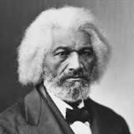Frederick Douglas [age 45]
“In his journey from enslaved young man to internationally renowned activist, Frederick Douglass (1818-1895) has been a source of inspiration and hope for millions. His brilliant words and brave actions continue to shape the ways that we think about race, democracy, and the meaning of freedom.
He became the most important leader of the movement for African American civil rights in the 19th century. After escaping from slavery in Maryland, Douglass became a national leader of the abolitionist movement in Massachusetts and New York, during which he gained fame for his oratory and incisive antislavery writings. He wrote three autobiographies, describing his experiences as an enslaved person in his first, Narrative of the Life of Frederick Douglass, an American Slave (1845), which became a bestseller and was influential in promoting the cause of abolition.
He also actively supported women's suffrage, and he held several public offices. Without his knowledge or consent, he became the first African American nominated for vice president of the United States, as the running mate of Victoria Woodhull on the Equal Rights Party ticket. He believed in dialogue and in making alliances across racial and ideological divides.” https://www.nps.gov/frdo/learn/historyculture/frederickdouglass.htm

March 2, 1863: False Claims Act
“The American colonies began using qui tam statutes in the 1600s as an extension of European practice, and the First Congress included qui tam provisions in the first framing of the Constitution. Congress enacted the FCA with its qui tam provision in 1863 as a means of redressing fraud perpetuated on Union troops. In 1986, Congress amended the FCA to expand liability for fraud to include all government contracts and claims, not just those submitted to the military, and, in 2009, Congress passed the Fraud Enforcement and Recovery Act (FERA), which further expanded the scope of liability for those fraudulently receiving money from the federal government.” https://www.taf.org/brief-history-fca-constitutionality/
See Dec. 21, 2018 Press Release:
“Justice Department Recovers Over $2.8 Billion from False Claims Act Cases in Fiscal Year 2018.” https://www.justice.gov/opa/pr/justice-department-recovers-over-28-billionfalse-claims-act-cases-fiscal-year-2018
“The False Claims Act was originally passed in response to rampant fraud perpetrated against the United States military during the Civil War. Back then, crooked contractors defrauded the Union Army by selling it sick mules, lame horses, sawdust instead of gunpowder, and rotted ships with fresh paint. Unfortunately, what we see today is just a modern version of the same thing — deceptive and fraudulent practices directed at the U.S. government and the American taxpayer,” said Assistant Attorney General Jody Hunt. “The Department of Justice has placed a high priority on rooting out and pursuing those who cheat government programs for their own gain. The recoveries announced today are a message that fraud and dishonesty will not be tolerated.”
In 1986, Congress strengthened the Act by increasing incentives for whistleblowers to file lawsuits alleging false claims on behalf of the government. These whistleblower, or qui tam, actions comprise a significant percentage of the False Claims Act cases that are filed. If the government prevails in a qui tam action, the whistleblower, also known as the relator, receives up to 30 percent of the recovery. Whistleblowers filed 645 qui tam suits in fiscal year 2018, and this past year the Department recovered over $2.1 billion in these and earlier filed suits.”

July 2, 1863: Gettysburg, 2nd Day - Col. Joshua Chamberlin, Maine – “Little Round Top”
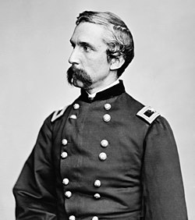
“On July 2, 1863, Chamberlain was posted on the extreme left of the Federal line at Little Round Top—just in time to face Confederate General John B. Hood’s attack on the Union flank. Exhausted after repulsing repeated assaults, the 20th Maine, out of ammunition, executed a bayonet charge, dislodging their attackers and securing General Meade’s embattled left. Though the exact origin of the charge is still the subject of debate, Congress awarded Chamberlain the Medal of Honor for “conspicuous gallantry.”
Shortly after Gettysburg, Chamberlain was given command of a brigade in the Fifth Corps and would retain it until the end of the war. Throughout the war, Chamberlain was wounded six times, most grievously at Petersburg in June 1864. Believing this wound to be mortal, Congress promoted Chamberlain to the rank of Brigadier General. Chamberlain, however, would survive the wound, and return to the front in time to play a pivotal role in the Appomattox Campaign. On April 12, 1865, Brigadier General Chamberlain received the Confederate surrender of arms. Rising to the occasion, the general ordered his men to salute their vanquished foes.
After the war, Chamberlain returned to Maine, where he served four terms as the state’s Governor. He later served as president of Bowdoin College alongside former general and Bowdoin alum, Oliver Otis Howard. Prolific and prosaic throughout his life, Chamberlain spent his twilight years writing and speaking about the war. His memoir of the Appomattox Campaign, The Passing of the Armies was published after his death in 1914.” https://www.battlefields.org/learn/biographies/joshua-lawrence-chamberlain

Nov. 19, 1863 – Gettysburg Address
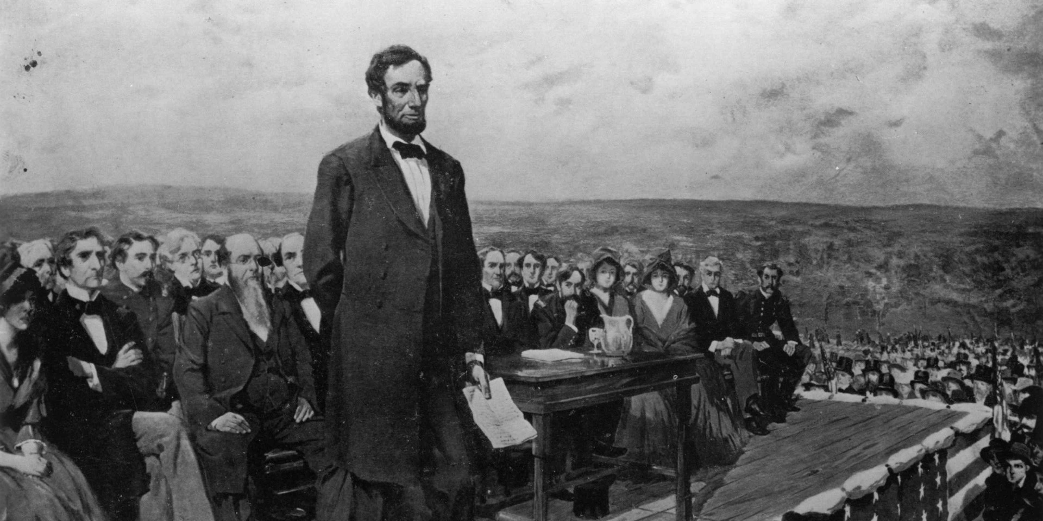 https://www.history.com/articles/gettysburg-address
“Four score and seven years ago our fathers brought forth on this continent, a new nation, conceived in Liberty, and dedicated to the proposition that all men are created equal.
Now we are engaged in a great civil war, testing whether that nation, or any nation so conceived and so dedicated, can long endure. We are met on a great battle-field of that war. We have come to dedicate a portion of that field, as a final resting place for those who here gave their lives that that nation might live. It is altogether fitting and proper that we should do this.
But, in a larger sense, we can not dedicate -- we can not consecrate -- we can not hallow -- this ground. The brave men, living and dead, who struggled here, have consecrated it, far above our poor power to add or detract. The world will little note, nor long remember what we say here, but it can never forget what they did here. It is for us the living, rather, to be dedicated here to the unfinished work which they who fought here have thus far so nobly advanced. It is rather for us to be here dedicated to the great task remaining before us -- that from these honored dead we take increased devotion to that cause for which they gave the last full measure of devotion -- that we here highly resolve that these dead shall not have died in vain -- that this nation, under God, shall have a new birth of freedom -- and that government of the people, by the people, for the people, shall not perish from the earth.
Abraham Lincoln
November 19, 1863”
https://www.history.com/articles/gettysburg-address

“On June 1, 1865, Senator Charles Sumner referred to the most famous speech ever given by President Abraham Lincoln. In his eulogy on the slain president, he called the Gettysburg Address a ‘monumental act.’ He said Lincoln was mistaken that ‘the world will little note, nor long remember what we say here.’ Rather, the Bostonian remarked, ‘The world noted at once what he said, and will never cease to remember it. The battle itself was less important than the speech.’

There are five known copies of the speech in Lincoln's handwriting, each with a slightly different text, and named for the people who first received them: Nicolay, Hay, Everett, Bancroft and Bliss. Two copies apparently were written before delivering the speech, one of which probably was the reading copy. The remaining ones were produced months later for soldier benefit events. Despite widely-circulated stories to the contrary, the president did not dash off a copy aboard a train to Gettysburg. Lincoln carefully prepared his major speeches in advance; his steady, even script in every manuscript is consistent with a firm writing surface, not the notoriously bumpy Civil War-era trains. Additional versions of the speech appeared in newspapers of the era, feeding modern-day confusion about the authoritative text.”
https://www.abrahamlincolnonline.org/lincoln/speeches/gettysburg.htm

1864 – General Ulysses S. Grant – Incident Command
War Fighting: The Case of Ulysses S. Grant (9/16/2025): https://publications.armywarcollege.edu/News/Display/Article/4305205/war-fighting-the-case-of-ulysses-s-grant/

“A review of all these studies of Grant would go beyond the scope of this article; instead, focusing on two aspects of Grant’s command in 1864 will illustrate the point. The first involves Grant’s role as the overall commanding general, including his involvement in the operations assigned to General William Tecumseh Sherman. The military professionals taught about Sherman’s March to the Sea as part of Grant’s broad, strategic approach for 1864, including at least five mutually supporting campaigns, all moving toward, in Grant’s earliest orders, ‘a common center.’ Three or four were in the Virginia theater: an advance up the Shenandoah Valley along with an attack over the mountains from West Virginia; an assault up the James River toward Richmond; and the ‘Overland Campaign,’ as it later became known, which was aimed directly at the Army of Northern Virginia, with the additional goal of linking up with the James River assault. The other two were to be in the American Southeast: one landing and attacking north from Mobile, Alabama, and one moving from Chattanooga, Tennessee, toward Atlanta, Georgia, and beyond under Sherman.”

March 4, 1865 – President Lincoln – Second Inaugural Address
“The speech was delivered on March 4, 1865, outside the grand, columned east entrance to the Capitol. Lincoln addressed a crowd of about 40,000 people on a blustery, rainy day that gave way to sunshine. The Civil War, in which more than 600,000 people died over almost four years, was soon to be over. American slavery was ending. And parts of the South were devastated. Lincoln wanted to address what had happened and why, and find some meaning in the tragedy that was still unfolding.”
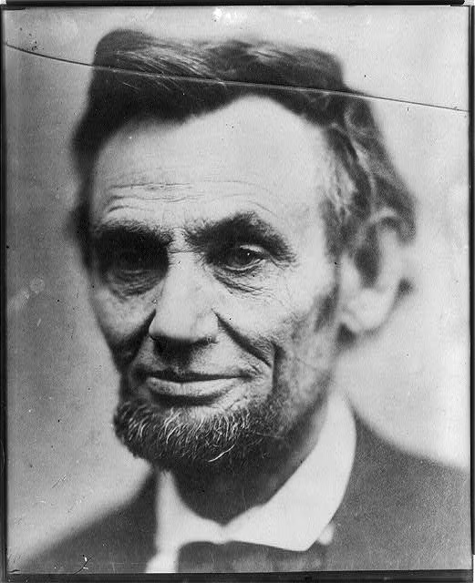
A photo of Abraham Lincoln taken shortly before his second inauguration in 1865. (Alexander Gardner/Library of Congress)
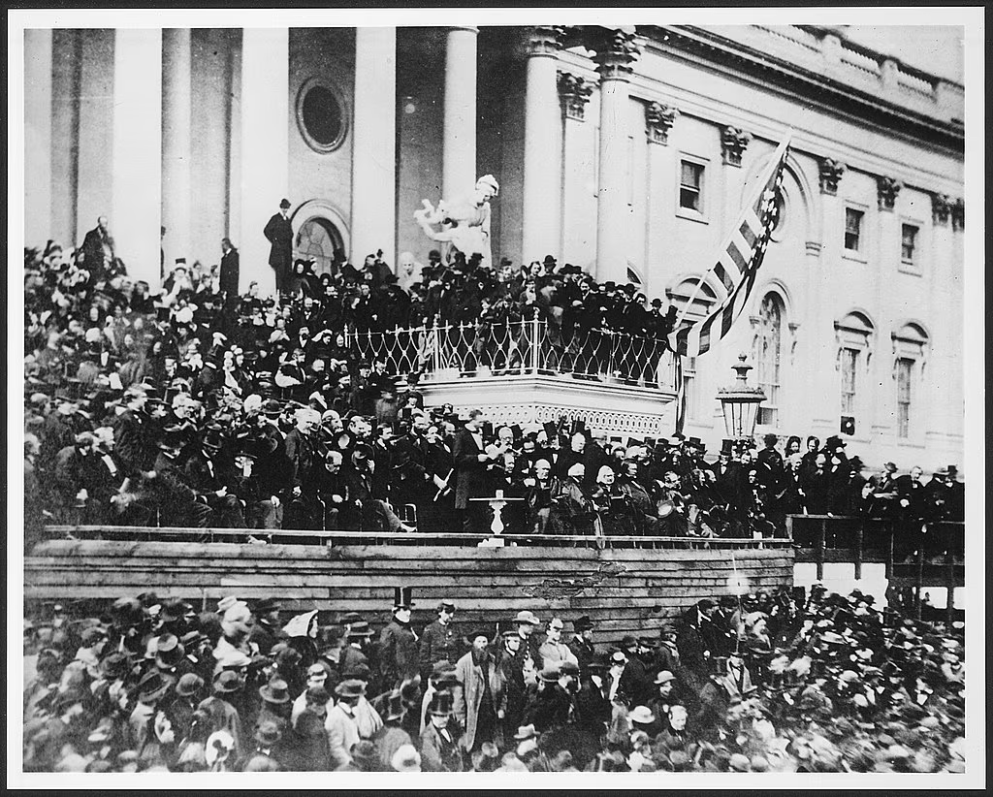
At his second inauguration, Lincoln stands before a white table, center, outside the U.S. Capitol. (Alexander Gardner/Library of Congress)
https://www.washingtonpost.com/history/2025/01/19/lincoln-speech-second-inaugural-trump-address/?utm_campaign=wp_post_most&utm_medium=email&utm_source=newsletter&carta-url=https%3A%2F%2Fs2.washingtonpost.com%2Fcar-ln-tr%2F41281a7%2F67b363a6eb3eba471afc37e7%2F59731235ade4e21a848a56ed%2F27%2F53%2F67b363a6eb3eba471afc37e7
***
“On March 4, 1865, only 41 days before his assassination, President Abraham Lincoln took the oath of office for the second time. Lincoln's second inaugural address previewed his plans for healing a once-divided nation. The speech is engraved on the north interior wall of the Lincoln Memorial. The speech was short — just over 700 words. Lincoln, who was 56, spoke slowly. Even so, the address probably lasted only six or seven minutes….

"Fellow countrymen: at this second appearing to take the oath of the presidential office there is less occasion for an extended address than there was at the first. Then a statement somewhat in detail of a course to be pursued seemed fitting and proper. Now, at the expiration of four years during which public declarations have been constantly called forth on every point and phase of the great contest which still absorbs the attention and engrosses the energies of the nation little that is new could be presented. The progress of our arms, upon which all else chiefly depends is as well known to the public as to myself and it is I trust reasonably satisfactory and encouraging to all. With high hope for the future no prediction in regard to it is ventured.
On the occasion corresponding to this four years ago all thoughts were anxiously directed to an impending civil war. All dreaded it ~ all sought to avert it. While the inaugural address was being delivered from this place devoted altogether to saving the Union without war insurgent agents were in the city seeking to destroy it without war ~ seeking to dissolve the Union and divide effects by negotiation. Both parties deprecated war but one of them would make war rather than let the nation survive, and the other would accept war rather than let it perish. And the war came.
One eighth of the whole population were colored slaves not distributed generally over the union but localized in the southern part of it. These slaves constituted a peculiar and powerful interest. All knew that this interest was somehow the cause of the war. To strengthen perpetuate and extend this interest was the object for which the insurgents would rend the Union even by war while the government claimed no right to do more than to restrict the territorial enlargement of it. Neither party expected for the war the magnitude or the duration which it has already attained. Neither anticipated that the cause of the conflict might cease with or even before the conflict itself should cease. Each looked for an easier triumph and a result less fundamental and astounding. Both read the same Bible and pray to the same God and each invokes His aid against the other. It may seem strange that any men should dare to ask a just God's assistance in wringing their bread from the sweat of other men's faces but let us judge not that we be not judged. The prayers of both could not be answered ~ that of neither has been answered fully. The Almighty has His own purposes. ‘Woe unto the world because of offenses for it must needs be that offenses come but woe to that man by whom the offense cometh.’ If we shall suppose that American slavery is one of those offenses which in the providence of God must needs come but which having continued through His appointed time He now wills to remove and that He gives to both North and South this terrible war as the woe due to those by whom the offense came shall we discern therein any departure from those divine attributes which the believers in a living God always ascribe to Him. Fondly do we hope ~ fervently do we pray ~ that this mighty scourge of war may speedily pass away. Yet, if God wills that it continue until all the wealth piled by the bondsman's two hundred and fifty years of unrequited toil shall be sunk and until every drop of blood drawn with the lash shall be paid by another drawn with the sword as was said three thousand years ago so still it must be said 'the judgments of the Lord are true and righteous altogether.'
With malice toward none with charity for all with firmness in the right as God gives us to see the right let us strive on to finish the work we are in to bind up the nation's wounds, to care for him who shall have borne the battle and for his widow and his orphan ~ to do all which may achieve and cherish a just and lasting peace among ourselves and with all nations." https://www.nps.gov/linc/learn/historyculture/lincoln-second-inaugural.htm

April 15, 1865: President Lincoln Assassinated
“On the evening of April 14, 1865, John Wilkes Booth, a famous actor and Confederate sympathizer, assassinated President Abraham Lincoln at Ford’s Theatre in Washington,
D.C. The attack came only five days after Confederate General Robert E. Lee surrendered his massive army at Appomattox Court House, Virginia, effectively ending the American Civil War.” https://www.history.com/topics/american-civil-war/abrahamlincoln-assassination
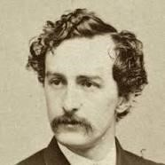John Wilkes Booth

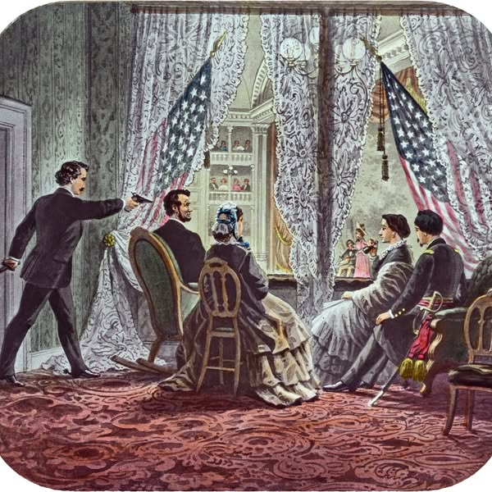

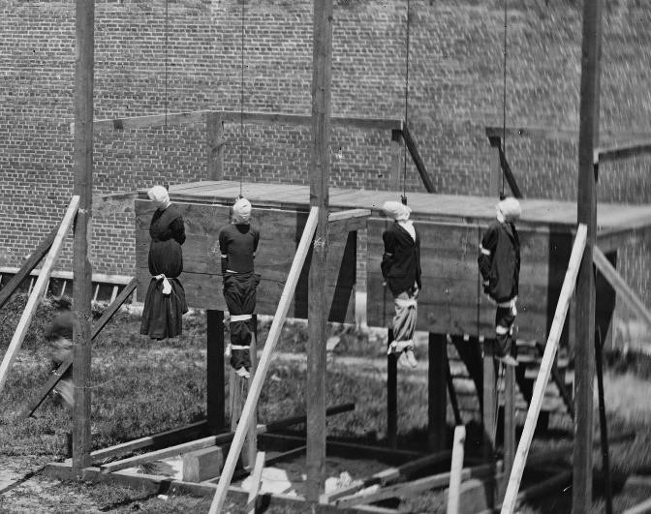
Execution of the four Lincoln conspirators: David Herold, Lewis Powell, George Atzerodt and Mary Surratt.
https://www.washingtonpost.com/local/four-people-were-hanged-for-lincolns-assassination-and-it-was-caught-on-camera/2015/07/03/377614d4-1905-11e5-ab92-c75ae6ab94b5_story.html

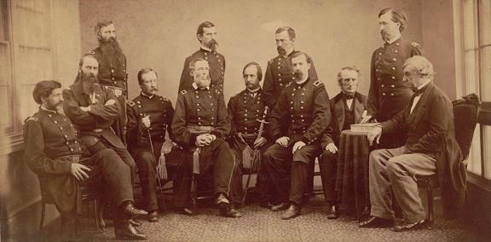
https://columbialawreview.org/content/the-law-of-the-lincoln-assassination/
“On May 1, 1865, President Andrew Johnson ordered the formation of a military commission to try the accused persons. The actual trial began on May 10th and lasted for about seven weeks. The defendants were allowed to have lawyers and witnesses, but they were not allowed to testify themselves. On June 29, 1865, the Military Commission met in secret session to begin its review of the evidence in the seven-week long trial. A guilty verdict could come with a majority vote of the nine-member commission; death sentences required the votes of six members. The next day, it reached its verdicts. The Commission found seven of the prisoners guilty of at least one of the conspiracy charges. Four of the prisoners: Mary Surratt, Lewis Powell, George Atzerodt, and David Herold were sentenced “to be hanged by the neck until he [or she] be dead”. Samuel Arnold, Dr. Samuel Mudd and Michael O’Laughlen were sentenced to “hard labor for life, at such place at the President shall direct”, Edman Spangler received a six-year sentence. The next day General Hartrandft informed the prisoners of their sentences. He told the four condemned prisoners that they would hang the next day.” https://rarehistoricalphotos.com/execution-lincoln-conspirators-1865/

June 19, 1865 – “Juneteenth” – Texas Emancipation
“On ‘Freedom’s Eve,’ or the eve of January 1, 1863, the first Watch Night services took place. On that night, enslaved and free African Americans gathered in churches and private homes all across the country awaiting news that the Emancipation Proclamation had taken effect. At the stroke of midnight, prayers were answered as all enslaved people in Confederate States were declared legally free. Union soldiers, many of whom were black, marched onto plantations and across cities in the south reading small copies of the Emancipation Proclamation spreading the news of freedom in Confederate States. Only through the Thirteenth Amendment did emancipation end slavery throughout the United States.
But not everyone in Confederate territory would immediately be free. Even though the Emancipation Proclamation was made effective in 1863, it could not be implemented in places still under Confederate control. As a result, in the westernmost Confederate state of Texas, enslaved people would not be free until much later. Freedom finally came on June 19, 1865, when some 2,000 Union troops arrived in Galveston Bay, Texas. The army announced that the more than 250,000 enslaved black people in the state, were free by executive decree. This day came to be known as "Juneteenth," by the newly freed people in Texas.” https://nmaahc.si.edu/explore/stories/historical-legacy-juneteenth

1865: Jim Crow Laws (1865 – 1877)
“The roots of Jim Crow laws began as early as 1865, immediately following the ratification of the 13th Amendment, which abolished slavery in the United States. Black codes were strict local and state laws that detailed when, where and how formerly enslaved people could work, and for how much compensation. The codes appeared throughout the South as a legal way to put Black citizens into indentured servitude, to take voting rights away, to control where they lived and how they traveled and to seize children for labor purposes.” https://www.history.com/topics/early-20th-century-us/jim-crow-laws
***
“However, starting in the 1870s, as the Southern economy continued its decline, Democrats took over power in Southern legislatures and used intimidation tactics to suppress black voters. Tactics included violence against blacks and those tactics continued well into the 1900s. Lynchings were a common form of terrorism practiced against blacks to intimidate them. It is important to remember that the Democrats and Republicans of the late 1800s were very different parties from their current iterations. Republicans in the time of the Civil War and directly after were literally the party of Lincoln and anathema to the South. As white, Southern Democrats took over legislatures in the former Confederate states, they began passing more restrictive voter registration and electoral laws, as well as passing legislation to segregate blacks and whites. *** And while segregation was literal law in the South, it was also practiced in the northern United States via housing patterns enforced by private covenants, bank lending practices, and job discrimination, including discriminatory labor union practices.” https://guides.ll.georgetown.edu/c.php?g=592919&p=4172697

___________________________________________________________________ “Jim Crow” named after Minstrel shows:
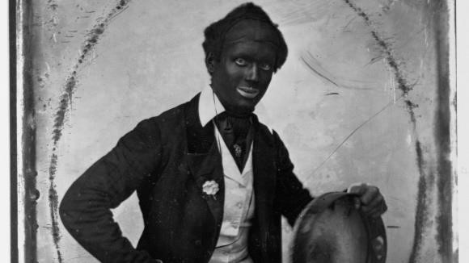Blackface performer, Dan Bryant, circa
1850. Library of Congress/Corbis/VCG via Getty Images
“Several characters in minstrel shows became archetypes, as described in the University of Florida’s digital exhibit, ‘History of Minstrels: From
‘Jump Jim Crow’ to ‘The Jazz Singer.’ Some of the most famous ones were Rice’s “Jim Crow,” a rural dancing fool in tattered clothing; the ‘Mammy,’ an overweight and loud mother figure; and ‘Zip Coon,’ a flamboyant-dressed man who used sophisticated words incorrectly.” https://www.history.com/news/blackface-history-racism-origins

July 5, 1865: Secret Service established
“Today [7/7/2025], the Department of Homeland Security honors the 160th anniversary since the founding of the United States Secret Service. One of our nation’s oldest and most recognized federal law enforcement agencies, the Secret Service was founded on July 5, 1865, to combat rampant counterfeiting that threatened the integrity of America’s economy at a time when nearly half of all U.S. currency in circulation was fake.” https://www.dhs.gov/news/2025/07/05/united-states-secret-service-celebrates-160th-birthday

Dec. 6, 1865: 13th Amendment Abolished Slavery
“Though the Union victory in the Civil War gave some 4 million enslaved people their freedom, significant challenges awaited during the Reconstruction period. The 13th Amendment, adopted late in 1865, officially abolished slavery, but the question of freed Black peoples’ status in the post–war South remained. As white southerners gradually reestablished civil authority in the former Confederate states in 1865 and 1866, they enacted a series of laws known as the Black Codes, which were designed to restrict freed Black peoples’ activity and ensure their availability as a labor force.” https://www.history.com/articles/black-history-milestones
***
Thirteenth Amendment - ratified by the required 27 of the then 36 states on December 6, 1865.
“Section 1
Neither slavery nor involuntary servitude, except as a punishment for crime whereof the party shall have been duly convicted, shall exist within the United States, or any place subject to their jurisdiction.
Section 2
Congress shall have power to enforce this article by appropriate legislation.” https://constitution.congress.gov/constitution/amendment-13/
***

“On January 31, 1865, the House of Representatives passed the proposed amendment with a vote of 119-56, just over the required two-thirds majority. The following day, Lincoln approved a joint resolution of Congress submitting it to the state legislatures for ratification. But he would not see final ratification: Lincoln was assassinated on April 14,
1865, and the necessary number of states did not ratify the 13th Amendment until December 6. While Section 1 of the 13th Amendment outlawed chattel slavery and involuntary servitude (except as punishment for a crime), Section 2 gave the U.S. Congress the power “to enforce this article by appropriate legislation.” https://www.history.com/topics/black-history/thirteenth-amendment

April 9, 1866: Civil Rights Act of 1866 – Overturned “Black
Codes”
On this date, the House overrode President Andrew Johnson’s veto of the Civil Rights Bill of 1866 with near unanimous Republican support, 122 to 41, marking the first time Congress legislated upon civil rights.
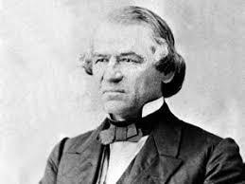
President Andrew Johnson – from Raleigh, NC
"All persons within the jurisdiction of the United States shall have the same right in every State and Territory to make and enforce contracts, to sue, be parties, give evidence, and to the full and equal benefit of all laws and proceedings for the security of persons and property as is enjoyed by white citizens, and shall be subject to like punishment, pains, penalties, taxes, licenses, and exactions of every kind, and to no other.” https://teachingamericanhistory.org/library/document/thecivil-rights-act-of-1866/
_____________________________________________________________________
“The year after the [13th] amendment’s passage, Congress used this power to pass the nation’s first civil rights bill, the Civil Rights Act of 1866. The law invalidated the socalled black codes, those laws put into place in the former Confederate states that governed the behavior of blacks, effectively keeping them dependent on their former owners. Congress also required the former Confederate states to ratify the 13th Amendment in order to regain representation in the federal government. Together with the 14th and 15th Amendments, also ratified during the Reconstruction era, the 13th Amendment sought to establish equality for black Americans. Despite these efforts, the struggle to achieve full equality and guarantee the civil rights of all Americans would continue well into the 20th century. https://www.history.com/topics/blackhistory/thirteenth-amendment
Black Codes: “Under black codes, many states required blacks to sign yearly labor contracts; if they refused, they risked being arrested, fined and forced into unpaid labor.
Outrage over black codes helped undermine support for President Andrew Johnson and the Republican Party.” https://www.history.com/topics/black-history/black-codes

April, 1866: Ohio Rep. John Bingham appointed to Joint Committee on Reconstruction – they drafted what became the 14th Amendment
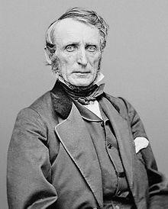
John Bingham (elected to Congress – four terms (March 4, 1865 – March 3, 1873) https://history.house.gov/People/Listing/B/BINGHAM,-John-Armor-(B000471)/

December 21, 1866 – Lakota War Party
Fort Phil Kearny Historic Site: Wyoming State Historic Site, National Historic Landmark and Interpretive Center. https://www.fortphilkearny.org/fetterman-battle-history

“It was one of only a few battles in U.S. history in which an entire command was wiped out. The Fetterman Fight, and its loss of the lives of 76 enlisted men, three officers and two civilians, shocked the nation, and influenced government policy and attitudes towards the Plains Indians for years to come.
***
Shortly after the cavalry and infantry left the fort, the signal came through that the wood train had broken free and was on its way to the pinery. Now the decoys, a group of about 10 with representatives from Lakota, Cheyenne and Arapaho tribes took over. Indian accounts from Judge Eli Ricker's early interviews mention Lakota warriors Crazy Horse, American Horse and others, as participants in the decoy. They goaded the troops, shouting insults, and staying just out of firing range. It was a temptation which Fetterman seemingly did not resist, and he followed the decoy, crossing the ridge. The troops had no idea of the ambush awaiting them. When the trap was set, with no chance of the troops escaping, mounted warriors crossed paths down on the flats across Peno creek at the north end of the ridge. This was the signal for large numbers of warriors to break out of ambush from the gullies to the north, east and west of Massacre Hill. By now the infantry and cavalry detachments were separated, the riders nearly to the creek and the foot soldiers on the ridge. The cavalry began to fall back up the hill.”
***
Like the Battle of the Little Bighorn a decade later, there will always be mysteries. Military records, even with their official reports, present puzzling questions, as do interviews with individual soldiers and civilians. Indian accounts, all coming down through oral traditions, and some through extensive interviews with Judge Eli Ricker of Nebraska and others, vary. Significantly, there were no soldiers left alive to tell the story.”

March, 1867 – US Buys Alaska - $7.2 Million

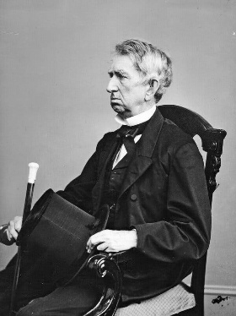

Secretary of State William Henry Seward negotiated with Russia over the purchase of Alaska.
“By the 1850s, the United States had acquired California, annexed Texas and fought a war with Mexico. There was talk of “Manifest Destiny,” the idea that the United States was destined to expand across North America. Russian officials, including the commander of its Pacific fleet, urged the ailing empire to offload Alaska while it could…. In March 1867, Secretary of State William Henry Seward opened the negotiations by offering $5 million for the territory to Eduard Stoeckl, the Russian minister to the United States. Two weeks later, they agreed on $7.2 million, or less than two cents an acre. A treaty was signed in Seward’s office at 4 a.m. after an all-night negotiating session, and later approved by Congress and Czar Alexander II.” https://www.nytimes.com/2025/08/15/world/europe/russia-alaska-purchase-ukraine.html

1868: Central Pacific Railroad, California
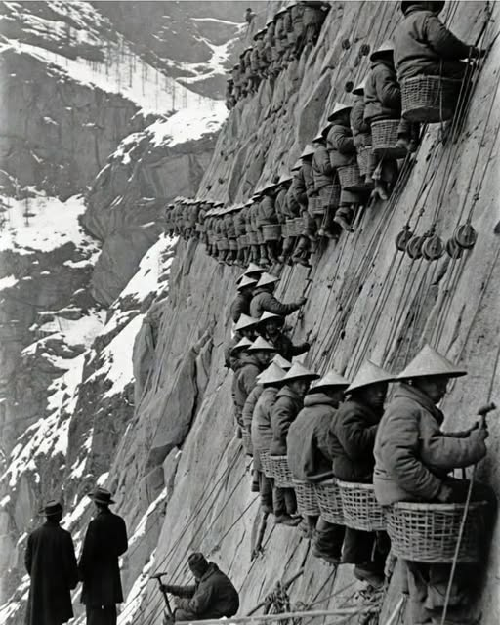

“The Central Pacific Railroad faced the impossible—crossing the towering Sierra Nevada.
White workers walked away. Too high. Too cold. Too dangerous. So the company turned to Chinese laborers already in California. Fifty men were hired. They stayed. By 1868, more than 12,000 Chinese workers made up nearly 90% of the workforce. They earned $28 a month. White workers received $35—plus food and shelter. The Chinese paid for their own meals, lived in tents, and endured brutal winters at elevations above 8,000 feet.” https://www.facebook.com/hashtag/chineserailroadworkers

March 5, 1868: Impeachment Trial of President Andrew Johnson
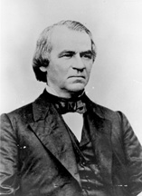
“During the years immediately following the Civil War, President Andrew Johnson [from TN] clashed repeatedly with the Republican-controlled Congress over reconstruction of the defeated South. Johnson vetoed legislation that Congress passed to protect the rights of those who had been freed from slavery. This clash culminated in the House of Representatives voting, on February 24, 1868, to impeach the president. On March 5, the trial began in the Senate, where Republicans held more seats than the two-thirds majority required to remove Johnson from office. When the trial concluded on May 16, however, the president had won acquittal, not because a majority of senators supported his policies but because a sufficient minority wished to protect the office of the president and preserve the constitutional balance of powers.” https://www.senate.gov/about/powers-procedures/impeachment/impeachment-johnson.htm
“[T]he trial before the Senate lasted three months, at the conclusion of which he was acquitted (May 26, 1868) by a vote of thirty-five for conviction to nineteen for acquittal, the necessary two-thirds vote for impeachment not having been obtained; retired to his home in Tennessee upon the expiration of the presidential term, March 3, 1869.” https://bioguide.congress.gov/search/bio/J000116

July 9, 1868: 14th Amendment – Due Process Clause / Birthright Citizenship
“Section 1.
All persons born or naturalized in the United States, and subject to the jurisdiction thereof, are citizens of the United States and of the State wherein they reside. No State shall make or enforce any law which shall abridge the privileges or immunities of citizens of the United States; nor shall any State deprive any person of life, liberty, or property, without due process of law; nor deny to any person within its jurisdiction the equal protection of the laws.
Section 2.
Representatives shall be apportioned among the several States according to their respective numbers, counting the whole number of persons in each State, excluding Indians not taxed. But when the right to vote at any election for the choice of electors for President and Vice-President of the United States, Representatives in Congress, the Executive and Judicial officers of a State, or the members of the Legislature thereof, is denied to any of the male inhabitants of such State, being twenty-one years of age, and citizens of the United States, or in any way abridged, except for participation in rebellion, or other crime, the basis of representation therein shall be reduced in the proportion which the number of such male citizens shall bear to the whole number of male citizens twenty-one years of age in such State.
Section 3.
No person shall be a Senator or Representative in Congress, or elector of President and Vice-President, or hold any office, civil or military, under the United States, or under any State, who, having previously taken an oath, as a member of Congress, or as an officer of the United States, or as a member of any State legislature, or as an executive or judicial officer of any State, to support the Constitution of the United States, shall have engaged in insurrection or rebellion against the same, or given aid or comfort to the enemies thereof. But Congress may by a vote of two-thirds of each House, remove such disability.
Section 4.
The validity of the public debt of the United States, authorized by law, including debts incurred for payment of pensions and bounties for services in suppressing insurrection or rebellion, shall not be questioned. But neither the United States nor any State shall assume or pay any debt or obligation incurred in aid of insurrection or rebellion against the United States, or any claim for the loss or emancipation of any slave; but all such debts, obligations and claims shall be held illegal and void.
Section 5.
The Congress shall have power to enforce, by appropriate legislation, the provisions of this article.” https://www.archives.gov/milestone-documents/14th-amendment

1868 - Impeachment Trial Of President Andrew Johnso

“During the years immediately following the Civil War, President Andrew Johnson clashed repeatedly with the Republican-controlled Congress over reconstruction of the defeated South. Johnson vetoed legislation that Congress passed to protect the rights of those who had been freed from slavery. This clash culminated in the House of Representatives voting, on February 24, 1868, to impeach the president. On March 5, the trial began in the Senate, where Republicans held more seats than the two-thirds majority required to remove Johnson from office. When the trial concluded on May 16, however, the president had won acquittal, not because a majority of senators supported his policies but because a sufficient minority wished to protect the office of the president and preserve the constitutional balance of powers.” https://www.senate.gov/about/powers-procedures/impeachment/impeachment-johnson.htm

Jefferson Davis – President of Confederate States (1861 – 1865)

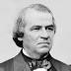Andrew Johnson – President (1829-1837)

March 30, 1870: 15th Amendment – Right to vote to not be denied based on race
“Section. 1. The right of citizens of the United States to vote shall not be denied or abridged by the United States or by any State on account of race, color, or previous condition of servitude.
Section. 2. The Congress shall have power to enforce this article by appropriate legislation.” https://constitution.findlaw.com/amendments.html

“Amendment Fifteen to the Constitution – the last of the Reconstruction Amendments – was ratified on February 3, 1870. It grants the right to vote for all male citizens regardless of their ethnicity or prior slave status. The official text is written as such:
The right of citizens of the United States to vote shall not be denied or abridged by the United States or by any State on account of race, color, or previous condition of servitude.
The Congress shall have the power to enforce this article by appropriate legislation.
Although the right to vote is commonly regarded in modern times to be one of the most important American freedoms, the ability to have a role in elections is something that has been contested since the nation’s founding. When the Constitution and the Bill of Rights was enacted into law in the late 18th century, the Founders’ approach to voting was that each of the states would determine the voter eligibility of their citizens. The most common measurement for voter eligibility in the first decades of the republic was that the prospective voter had to be a white male who owned property of a certain dollar value. Certain states and cities allowed free African Americans and women to vote, but these were few in number and scattered across the Northern states. It would not be until the Presidential Election of 1828 when the majority of the land-ownership requirements were eliminated, and it was twenty-eight years after that when every state removed them. With the passage of the Thirteenth and Fourteenth Amendments after the Civil War, the expansion of civil rights to the newly-freed African American population turned to the question of voting. After the election of Ulysses S. Grant to the presidency in 1868, Congress proposed a new amendment that would ban all restrictions on the right to vote regarding ethnicity and prior slave status. In spite of heavy opposition by the Southern delegations, Congress ratified the Fifteenth Amendment on February 3, 1870. At the start, the amendment did not extend the right to vote to any women in the United States. It would not be until the ratification of the Nineteenth Amendment in 1920 that allowed all women the right to vote.” https://www.reaganlibrary.gov/constitutional-amendments-amendment-15-right-vote

May 31, 1870: Civil Right Act of 1870 – Ku Klux Clan Act
“During Reconstruction, Congress enacted the Civil Rights Act of 1870, also known as the Enforcement Act or the First Ku Klux Klan Act, in order to enforce the terms of the Fifteenth Amendment, which prohibited the states from denying anyone the right to vote based on race. The act provided criminal penalties for those attempting to prevent African Americans from voting by using or threatening to use violence or engaging in other tactics, such as making threats to terminate a person’s employment or evict them from their home. As a result of the act, the criminal jurisdiction of the federal courts was expanded.” https://www.fjc.gov/history/timeline/civil-rights-act-1870
Now codified: 42 USC 1983; police officers often sued in “1983 Actions”
“Congress followed the Civil Rights Act of 1870 with an 1871 law “to enforce the
Provisions of the Fourteenth Amendment to the Constitution of the United States,” which came to be known as the Second Enforcement Act or the Second Ku Klux Klan Act. Like the prior year’s legislation, the act was designed in large part to protect African Americans from Klan violence during Reconstruction, giving those deprived of a constitutional right by someone acting under color of law the right to seek relief in a federal district or circuit court. This part of the legislation was later made a part of the United States Code as 42 U.S.C. §1983 and served as the basis for many federal court lawsuits against state and local officials.”
https://www.fjc.gov/history/timeline/civil-rights-act-1871
“While the Force acts and the publicity generated by the joint committee temporarily helped put an end to the violence and intimidation, the end of formal Reconstruction in 1877 allowed for a return of largescale disenfranchisement of African Americans.” https://www.senate.gov/artandhistory/history/common/generic/EnforcementActs.htm

Oct. 8-10, 1871 – Great Chicago Fire
What Los Angeles Can Learn From Another Great American City That Burned’ Jan. 23, 2025; https://www.nytimes.com/2025/01/23/opinion/los-angeles-fires-la-wildfires-chicago.html
“Chicago’s fire commissioners predicted the 1871 disaster, but the mayor and aldermen knew that raising taxes to bolster a department that was underequipped and understaffed would be unpopular, and did not press the issue. It was only because insurance companies threatened to withhold coverage after the second fire that Chicago finally began to act. The insurers demanded that new buildings be constructed of fireproof materials such as brick or stone (1871 Chicago was built largely out of wood); that warehouses and stores be equipped with iron shutters; and that the city reorganize the fire department, lay more and bigger water mains and pipes, install additional hydrants and remove all lumber yards from built-up areas.”

The Chicago Fire of 1871 and the 'Great Rebuilding'. https://education.nationalgeographic.org/resource/chicago-fire-1871-and-great-rebuilding/
“On October 8, 1871, a fire broke out in a barn on the southwest side of Chicago, Illinois. For more than 24 hours, the fire burned through the heart of Chicago, killing 300 people and leaving one-third of the city's population homeless. The ‘Great Rebuilding’ was the effort to construct a new, urban center. Big businesses, innovative buildings, and a new style of architecture were the results.”

Oct. 8, 1871 – Wisconsin Wildfire – 1,500 Killed
Peshtigo Fire: The deadliest wildfire in U.S. history. The conflagration claimed the lives of more than 1,500 people but still exists for many in the shadow of the Great Chicago Fire. ** The Peshtigo Fire burned over 1 million acres, destroyed thousands of buildings, and killed over 1,500 people, most in northeastern Wisconsin – the deadliest forest fire in U.S. history. By the end of the incident, 16 towns had been burned. Unless you’re from the area or are a fire science student, there’s a good chance you’ve never heard of this “other” major October fire. https://www.firerescue1.com/firefighting-history/articles/peshtigo-fire-the-deadliest-wildfire-in-us-history-Xe6TtkZVNuTix48C/?utm_source=delivra&utm_medium=email&utm_campaign=FR1-Daily-10-8-25&utm_id=9610378&dlv-emuid=fed355b8-46a2-4fa4-b55c-4d602dde33c4&dlv-mlid=9610378

1872: President Ulysses S. Grant [age 50] – D.C. Police Officer [African American] stopped him twice for speeding on a horse-drawn carriage
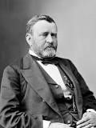Ulysses S. Grant – born, Point Pleasant, OH (April 27, 1822)
“The Police Officer Who Arrested A President”
“In 1872, while president, Grant was arrested at the corner of 13th and M streets in Washington. This was not a high crime, but it was — at least theoretically speaking — a misdemeanor. *** The man who led the North to victory in the Civil War was busted for speeding in his horse-drawn carriage. *** That policeman was William H. West, a black man who had fought in the Civil War. ‘Since his retirement,’ the story said, ‘he has decided to let the public know the true story of the arrest.’ It begins with Grant’s love of fast horses. ‘Gen. Grant was an ardent admirer of a good horse and loved nothing better than to sit behind a pair of spirited animals,’ the Star story said. ‘He was a good driver, and sometimes “let them out” to try their mettle.’ And that’s where Grant, as president, rode into the law. The police had been receiving complaints of speeding carriages. After a mother and child were run over and badly injured, Officer West was dispatched to investigate. As West spoke to witnesses, another group of speeding carriages headed toward him — including one driven by the president of the United States. ‘Policeman West held up his hand for them to stop,’ the story said. ‘Grant was driving a pair of fast steppers and he had some difficulty in halting them, but this he managed to do.’ Grant was a bit testy. ‘Well, officer,’ he said, ‘what do you want with me?’ West replied: ‘I want to inform you, Mr. President, that you are violating the law by speeding along this street. Your fast driving, sir, has set the example for a lot of other gentlemen.’ The president apologized, promised it wouldn’t happen again, and galloped away. But Grant could not curb his need for speed. The next evening, West was patrolling at the corner of 13th and M streets when the president came barreling through again, this time speeding so fast that it took him an entire block to stop. Now Grant was cocky and had a ‘smile on his face,’ the Star article said, that made him look like ‘a schoolboy who had been caught in a guilty act by a teacher.’ He said, ‘Do you think, officer, that I was violating the speed laws?’ ‘I do, Mr. President,’ West said. Grant had an excuse for his speeding, not unlike one no doubt being given somewhere right now: He had no idea he had been going so fast. West was sympathetic but firm. ‘I am very sorry, Mr. President, to have to do it,’ he said, ‘for you are the chief of the nation, and I am nothing but a policeman, but duty is duty, sir, and I will have to place you under arrest.’ *** Anyway, Grant and several of his speeding buddies also arrested went with West to the police station. The president of the United States was ordered to put up 20 bucks as collateral. A trial was held the next day. ‘Thirty-two ladies of the most refined character and surroundings voluntarily came into the court and testified against the drivers,’ the Star story said. ‘The cases were contested bitterly.’ The judge imposed ‘heavy fines’ and a ‘scathing rebuke’ to the speeding drivers, who didn’t include the president. He didn’t show up for court.’” Washington Post article: Dec. 16, 2018: https://www.washingtonpost.com/history/2018/12/16/police-officer-who-arrestedpresident/?utm_term=.9f22b60ea0f1

1873 – Susan B. Anthony – Women’s Right To Vote

In the 1800s, women in the United States had few legal rights and did not have the right to vote. This speech was given by Susan B. Anthony after her arrest for casting an illegal vote in the presidential election of 1872. She was tried and then fined $100 but refused to pay.  https://www.historyplace.com/speeches/anthony.htm | 
Friends and fellow citizens: I stand before you tonight under indictment for the alleged crime of having voted at the last presidential election, without having a lawful right to vote. It shall be my work this evening to prove to you that in thus voting, I not only committed no crime, but, instead, simply exercised my citizen's rights, guaranteed to me and all United States citizens by the National Constitution, beyond the power of any state to deny.
The preamble of the Federal Constitution says:
"We, the people of the United States, in order to form a more perfect union, establish justice, insure domestic tranquillity, provide for the common defense, promote the general welfare, and secure the blessings of liberty to ourselves and our posterity, do ordain and establish this Constitution for the United States of America."
It was we, the people; not we, the white male citizens; nor yet we, the male citizens; but we, the whole people, who formed the Union. And we formed it, not to give the blessings of liberty, but to secure them; not to the half of ourselves and the half of our posterity, but to the whole people - women as well as men. And it is a downright mockery to talk to women of their enjoyment of the blessings of liberty while they are denied the use of the only means of securing them provided by this democratic-republican government - the ballot.
For any state to make sex a qualification that must ever result in the disfranchisement of one entire half of the people, is to pass a bill of attainder, or, an ex post facto law, and is therefore a violation of the supreme law of the land. By it the blessings of liberty are forever withheld from women and their female posterity.
To them this government has no just powers derived from the consent of the governed. To them this government is not a democracy. It is not a republic. It is an odious aristocracy; a hateful oligarchy of sex; the most hateful aristocracy ever established on the face of the globe; an oligarchy of wealth, where the rich govern the poor. An oligarchy of learning, where the educated govern the ignorant, or even an oligarchy of race, where the Saxon rules the African, might be endured; but this oligarchy of sex, which makes father, brothers, husband, sons, the oligarchs over the mother and sisters, the wife and daughters, of every household - which ordains all men sovereigns, all women subjects, carries dissension, discord, and rebellion into every home of the nation.
Webster, Worcester, and Bouvier all define a citizen to be a person in the United States, entitled to vote and hold office.
The only question left to be settled now is: Are women persons? And I hardly believe any of our opponents will have the hardihood to say they are not. Being persons, then, women are citizens; and no state has a right to make any law, or to enforce any old law, that shall abridge their privileges or immunities. Hence, every discrimination against women in the constitutions and laws of the several states is today null and void, precisely as is every one against Negroes.
Susan B. Anthony - 1873

1873: U.S. Cavalry Defend Surveyors – Northern Pacific Railroad

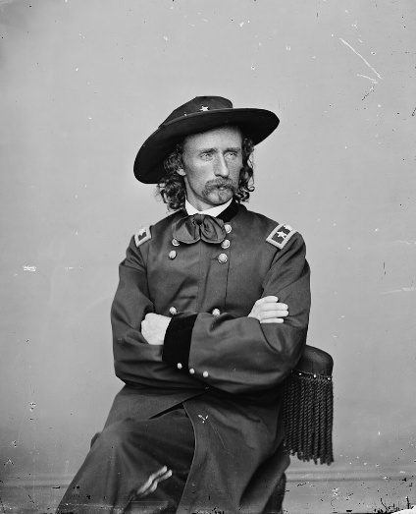Lt. Colonel George A. Custer

“The Yellowstone Expedition of 1873 was an expedition of the United States Army in August, 1873 along the Yellowstone River in Montana to survey a route for the Northern Pacific Railroad. The main escort for the expedition were companies of the 7th United States Cavalry Regiment under the command of Lieutenant Colonel George A. Custer, although the expedition was under the overall command of Colonel David S. Stanley. *** U.S. Army forces. Custer and units of the 7th Cavalry were part of the military column commanded by Col. David S. Stanley accompanying the 1873 Northern Pacific Railway survey party surveying the north side of the Yellowstone River west of the Powder River in eastern Montana. Stanley's column consisted of a 1,530 man force of cavalry, infantry, and two artillery pieces (3" rifled Rodman guns), and 60 days' rations. It traveled out of Dakota Territory in June, 1873 with the 1,530 soldiers, 275 mule-drawn wagons, 353 civilians involved in the survey, and 27 Indian and mixed-blood scouts supporting the column. *** Native American forces. The Native American forces that fought against the expedition in Montana Territory were from the village of Sitting Bull, estimated at anywhere from 400 to 500 lodges with over 1000 Warriors.^{[3]} It included Hunkpapa Sioux under Gall accompanied by the war chief Rain in the Face, Oglala Sioux under Crazy Horse, and Miniconjou and Cheyenne. *** The Battle of Honsinger Bluff. On Sunday, August 3, 1873, Stanley's column camped near the mouth of Sunday Creek, a tributary to the Yellowstone on the northeasterly end of Yellowstone Hill in present-day Custer County, Montana…. Shots were exchanged with Sioux Warriors near the Yellowstone River early in the Battle, and George Custer's men formed a skirmish line. A volley from the line distracted the pursuing Indians enough to halt the warriors' charge. Custer had Captain Moylan pull back his Company A to a wooded area previously occupied by Company A. After reaching the wooded area, the cavalrymen dismounted, forming a semicircular perimeter along a former channel of the Yellowstone River. The usual configuration for dismounted cavalry was every fourth man holding horses, however, due to the length of the semicircular perimeter, only every eighth man was detailed to hold horses. The bank of the dry channel served as a natural parapet.
The warriors siege on the detachment of the 7th Cavalry continued for about three hours in reported 110 °F (43 °C) heat, when Custer's mounted soldiers burst from their wooded river position in a charge that scattered the Lakota Sioux forces, who fled upriver with Custer's men in pursuit. The soldiers pursued them for nearly four miles but were never able to close on them sufficiently to engage them.” https://military-history.fandom.com/wiki/Yellowstone_Expedition_of_1873

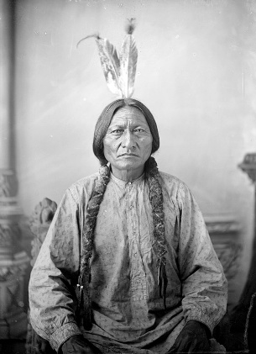Sitting Bull

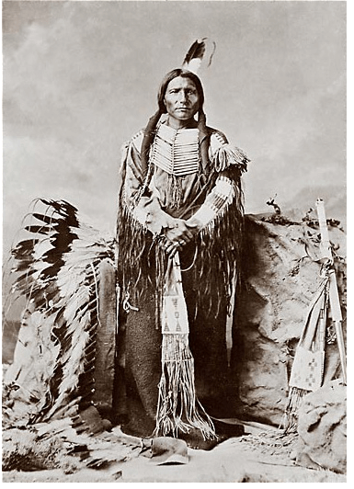Crazy Horse

March 3, 1875: Nation’s first Immigration Law

“The Page Act was primarily enforced against Chinese immigrants. It marked the beginning of a shift in anti-Asian prejudice from a Western issue to a national concern. Seven years later, the Chinese Exclusion Act of 1882 banned Chinese men from immigrating as well.” https://wams.nyhistory.org/industry-and-empire/expansion-and-empire/page-act-1875/

June 25, 1876: Battle of Little Bighorn – Lt. Col. George Armstrong Custer

“The Battle of the Little Bighorn, fought on June 25, 1876, near the Little Bighorn River in Montana Territory, pitted federal troops led by Lieutenant Colonel George Armstrong Custer (1839-76) against a band of Lakota Sioux and Cheyenne warriors. Tensions between the two groups had been rising since the discovery of gold on Native American lands. When a number of tribes missed a federal deadline to move to reservations, the U.S. Army, including Custer and his 7th Cavalry, was dispatched to confront them. Custer was unaware of the number of Indians fighting under the command of Sitting Bull (c.1831-90) at Little Bighorn, and his forces were outnumbered and quickly overwhelmed in what became known as Custer’s Last Stand.” https://www.history.com/articles/battle-of-the-little-bighorn
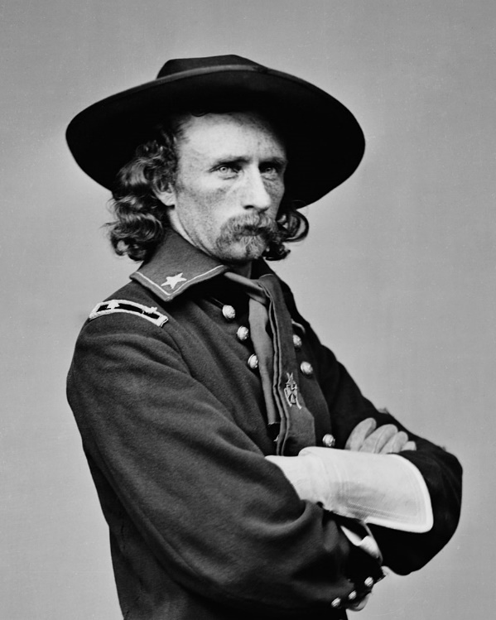

Lt Col George Armstrong Custer (died June 25, 1876; age 36)
“In 1874, an Army expedition led by Lt. Col. George Armstrong Custer found gold in the Black Hills, in present-day South Dakota. At the time, the United States recognized the hills as property of the Sioux Nation, under a treaty the two parties had signed six years before. The Grant administration tried to buy the hills, but the Sioux, considering them sacred ground, refused to sell; in 1876, federal troops were dispatched to force the Sioux onto reservations and pacify the Great Plains. That June, Custer attacked an encampment of Sioux, Cheyenne and Arapaho on the Little Bighorn River, in what is now Montana. The Battle of the Little Bighorn is one of the most studied actions in U.S. military history, and the immense literature on the subject is devoted primarily to answering questions about Custer’s generalship during the fighting. But neither he nor the 209 men in his immediate command survived the day, and an Indian counterattack would pin down seven companies of their fellow 7th Cavalrymen on a hilltop over four miles away. (Of about 400 soldiers on the hilltop, 53 were killed and 60 were wounded before the Indians ended their siege the next day.) The experience of Custer and his men can be reconstructed only by inference.” https://www.smithsonianmag.com/history/how-the-battle-of-little-bighorn-was-won-63880188/

June 18, 1878: POSSE COMITAS ACT
“The Posse Comitatus Act bars federal troops from participating in civilian law enforcement except when expressly authorized by law. This 143-year-old law embodies an American tradition that sees military interference in civilian affairs as a threat to both democracy and personal liberty. *** In British and American law, a posse comitatus is a group of people who are mobilized by the sheriff to suppress lawlessness in the county. In any classic Western film, when a lawman gathers a ‘posse’ to pursue the outlaws, they are forming a posse comitatus. The Posse Comitatus Act is so named because one of the things it prohibits is using soldiers rather than civilians as a posse comitatus.”
https://www.brennancenter.org/our-work/research-reports/posse-comitatus-act-explained

***

“The Constitution permits Congress to authorize the use of the militia "to execute the Laws of the Union, suppress Insurrections and repel Invasions." And it guarantees the states protection against invasion or usurpation of their "republican form of government," and, upon the request of the state legislature, against "domestic violence." These constitutional provisions are reflected in the Insurrection Acts, which have been invoked numerous times both before and after passage of the Posse Comitatus Act, 18 U.S.C. Section 1385, in 1878. Congress has also enacted a number of statutes that authorize the use of land and naval forces to execute their objective. The Posse Comitatus Act outlaws the willful use of any part of the Army or Air Force to execute the law unless expressly authorized by the Constitution or an act of Congress. History supplies the grist for an argument that the Constitution prohibits military involvement in civilian affairs subject to only limited alterations by Congress or the President, but the courts do not appear to have ever accepted the argument unless violation of more explicit constitutional command could also be shown. The express statutory exceptions include the legislation that allows the President to use military force to suppress insurrection or to enforce federal authority, 10 U.S.C. Sections 251-255, and laws that permit the Department of Defense to provide federal, state and local police with information, equipment, and personnel, 10 U.S.C. §§ 271-284.” https://www.congress.gov/crs-product/R42659

March 19, 2025: “Trump team makes plans for military to hold migrants at border.
If enacted, miles of buffer zone would become a temporary military installation, giving U.S. troops their most direct role yet in the president’s enforcement mission. *** The effort would enable the most significant use yet of active-duty forces at the border under Trump, though any move to militarize the southern border’s buffer zone is certain to raise questions about whether employing the military in this way runs afoul of the Posse Comitatus Act, a federal law that prohibits active-duty troops from most law enforcement missions. To date, the Trump administration has addressed such legal considerations by having Customs and Border Protection or Immigration and Customs Enforcement detain people and move them once in custody, including on U.S. military flights involved in its deportation efforts.” https://www.washingtonpost.com/national-security/2025/03/19/trump-border-military-buffer-zone/?utm_campaign=wp_todays_headlines&utm_medium=email&utm_source=newsletter&carta-url=https%3A%2F%2Fs2.washingtonpost.com%2Fcar-ln-tr%2F41af9f1%2F67dbe72b97fc0f25850ac3d2%2F59731235ade4e21a848a56ed%2F18%2F64%2F67dbe72b97fc0f25850ac3d2

1881 – Booker T. Washington – Tuskegee Institute

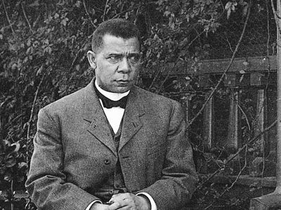https://www.britannica.com/biography/Booker-T-Washington

“In 1881 Washington was selected to head a newly established normal school for African Americans at Tuskegee, an institution with two small converted buildings, no equipment, and very little money. Tuskegee Normal and Industrial Institute became a monument to his life’s work. At his death 34 years later, it had more than 100 well-equipped buildings, some 1,500 students, a faculty of nearly 200 teaching 38 trades and professions, and an endowment of approximately $2 million. Washington believed that the best interests of Black people in the post-Reconstruction era could be realized through education in the crafts and industrial skills and the cultivation of the virtues of patience, enterprise, and thrift. He urged his fellow Blacks, most of whom were impoverished and illiterate farm laborers, to temporarily abandon their efforts to win full civil rights and political power and instead to cultivate their industrial and farming skills so as to attain economic security. Blacks would thus accept segregation and discrimination, but their eventual acquisition of wealth and culture would gradually win for them the respect and acceptance of the white community. This would break down the divisions between the two races and lead to equal citizenship for Blacks in the end. In his epochal speech (September 18, 1895) to a racially mixed audience at the Atlanta Exposition, Washington summed up his pragmatic approach in the famous phrase:
‘In all things that are purely social we can be separate as the fingers, yet one as the hand in all things essential to mutual progress.’” https://www.britannica.com/biography/Booker-T-Washington

Oct. 14, 1883: U.S. Supreme Court: Civil Rights Cases, 109

U.S. 3 (1883) – CONGRESS LACKED POWER TO STOP HOTELS, THEATERS FROM PRACTICING SEGREGATION [later overturned]
“[I]n this set of five cases that were consolidated into one issue, a majority of the court held the Civil Rights Act of 1875 unconstitutional against the lone famous dissent of Justice Harlan. The majority argued that Congress lacked authority to regulate private affairs under the 14th Amendment and that the 13th Amendment ‘merely abolishe[d] slavery’. Segregation in public accommodations would not be declared illegal after these cases until the Civil Rights Act of 1964.” https://guides.ll.georgetown.edu/c.php?g=592919&p=4172697
“Two of the cases, those against Stanley and Nichols, were indictments for denying to persons of color the accommodations and privileges of an inn or hotel; two of them, those against Ryan and Singleton, were, one on information, the other an indictment, for denying to individuals the privileges and accommodations of a theatre, the information against Ryan being for refusing a colored person a seat in the dress circle of Maguire's theatre in San Francisco, and the indictment against Singleton was for denying to another person, whose color was not stated, the full enjoyment of the accommodations of the theatre known as the Grand Opera House in New York, ‘said denial not being made for any reasons by law applicable to citizens of every race and color, and regardless of any previous condition of servitude.’” https://supreme.justia.com/cases/federal/us/109/3/

MR. JUSTICE JOHN HARLAN dissenting.
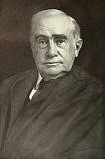
“The opinion in these cases proceeds, it seems to me, upon grounds entirely too narrow and artificial. I cannot resist the conclusion that the substance and spirit of the recent amendments of the Constitution have been sacrificed by a subtle and ingenious verbal criticism. *** The purpose of the first section of the act of Congress of March 1, 1875, was to prevent race discrimination in respect of the accommodations and facilities of inns, public conveyances, and places of public amusement.” https://supreme.justia.com/cases/federal/us/109/3/
1884 – Haskell Indian Nations University

“Well, Haskell [Haskell Indian Nations University, Lawrence, Kansas] is one of at least 35 TCUs, or tribal colleges and universities. https://collegefund.org/tribal-colleges-and-universities/

They are not unlike HBCUs, historically Black colleges and universities. They, too, were born out of refusal by this land’s settler colonial class to provide any meaningful education to the progeny of the millions of indigenous people it really preferred to eradicate, or the progeny of the millions of humans it trafficked from Africa to exploit.

Haskell was founded by the U.S. government in 1884 — it was one of those U.S. Indian Industrial Training Schools that came to be called, extremely inappropriately, Indian boarding schools. They had little to nothing in common with boarding schools such as Andover or Exeter.

The mission of TCUs and HBCUs is to educate the marginalized ethnic and racial students referenced in their titles. And Haskell is even more pointed. As part of a treaty and trust signed between American Indians and this country, Haskell’s mission is specifically to lift up those who are members of federally recognized tribes, or can prove Native ancestry through blood. Last fall, Haskell enrolled 978 students from 146 tribes.”
https://www.washingtonpost.com/sports/2025/02/23/haskell-womens-basketball-coach-cut/?utm_campaign=wp_post_most&utm_medium=email&utm_source=newsletter&carta-url=https%3A%2F%2Fs2.washingtonpost.com%2Fcar-ln-tr%2F4147d59%2F67bb4bcefe9d672c2a35f390%2F59731235ade4e21a848a56ed%2F35%2F52%2F67bb4bcefe9d672c2a35f390

Dec. 29, 1890: Wounded Knee Massacre

“Wounded Knee Massacre [South Dakota], the slaughter of approximately 150–300 Lakota Indians by United States Army troops in the area of Wounded Knee Creek in southwestern South Dakota. The massacre was the climax of the U.S. Army’s late 19th-century efforts to repress the Plains Indians. It broke any organized resistance to reservation life and assimilation to white American culture, although American Indian activists renewed public attention to the massacre during a 1973 occupation of the site.” https://www.britannica.com/event/Wounded-Knee-Massacre
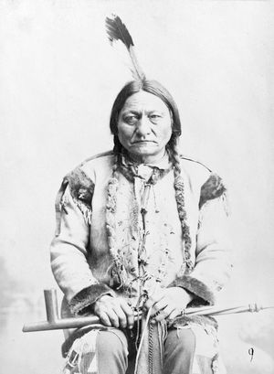
“In November [1890] the U.S. Army arrived on Lakota reservations with the goal of stopping the rise of the Ghost Dance. One source indicates that it was the largest deployment of federal troops since the end of the Civil War in 1865. Near the Standing Rock Agency lived Sitting Bull, a powerful Hunkpapa Lakota chief and spiritual leader who had led the Lakota and Northern Cheyenne to victory in 1876 against the U.S. Army at the Little Bighorn. Many of his 250 followers were Dancers, and, though he personally was not a practitioner, he refused to let the federal government repress them any further. Maj. James McLaughlin, the reservation’s agent, resolved to arrest Sitting Bull for his role in permitting the spread of the religion. Maj. Gen. Nelson A. Miles commanded U.S. Army forces on the Lakota lands and hoped to take a peaceful approach to removing the Hunkpapa leader from the reservation. McLaughlin chose to undermine that plan, instead dispatching 43 tribal policemen to Sitting Bull’s cabin on December 15. Sitting Bull was compliant, but his followers would not relinquish him without protest. A vicious struggle ensued, and roughly nine Hunkpapa were killed; among the dead was Sitting Bull.” https://www.britannica.com/event/Wounded-Knee-Massacre

May 18, 1896: U.S. Supreme Court: Plessy v. Ferguson (7 to 1) https://www.law.cornell.edu/wex/plessy_v_ferguson_(1896)

“SEPARATE BUT EQUAL” – STATE SEGREGATION LAWS UPHELD [OVERTURNED IN 1954]

[T]his is the case which gave us the phrase ‘separate but equal’ and upheld state racial segregation laws for public facilities. Justice Harlan again offered a lone dissent. These laws would remain in play until 1954.”
https://guides.ll.georgetown.edu/c.php?g=592919&p=4172697

“The statute of Louisiana, acts of 1890, c. 111, requiring railway companies carrying passengers in their coaches in that State, to provide equal, but separate, accommodations for the white and colored races, by providing two or more passenger coaches for each passenger train, or by dividing the passenger coaches by a partition so as to secure separate accommodations; and providing that no person shall be permitted to occupy seats in coaches other than the ones assigned to them, on account of the race they belong to; and requiring the officer of the passenger train to assign each passenger to the coach or compartment assigned for the race to which he or she belong; and imposing fines or imprisonment upon passengers insisting on going into a coach or compartment other than the one set aide for the race to which he or she belongs; and conferring upon officers of the train power to refuse to carry on the train passengers refusing to occupy the coach or compartment assigned to them, and exempting the railway company from liability for such refusal, are not in conflict with the provisions either of the Thirteenth Amendment or of the Fourteenth Amendment to the Constitution of the United States.” https://supreme.justia.com/cases/federal/us/163/537/

MR. JUSTICE JOHN HARLAN, dissenting.
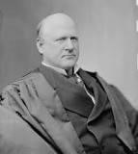
“By the Louisiana statute the validity of which is here involved, all railway companies (other than street railroad companies) carrying passengers in that State are required to have separate but equal accommodations for white and colored persons ‘by providing two or more passenger coaches for each passenger train, or by dividing the passenger coaches by a partition so as to secure separate accommodations.’ Under this statute, no colored person is permitted to occupy a seat in a coach assigned to white persons, nor any white person to occupy a seat in a coach assigned to colored persons. The managers of the railroad are not allowed to exercise any discretion in the premises, but are required to assign each passenger to some coach or compartment set apart for the exclusive use of his race. If a passenger insists upon going into a coach or compartment not set apart for persons of his race, he is subject to be fined or to be imprisoned in the parish jail. Penalties are prescribed for the refusal or neglect of the officers, directors, conductors and employees of railroad companies to comply with the provisions of the act. *** Thus, the State regulates the use of a public highway by citizens of the United States solely upon the basis of race. However apparent the injustice of such legislation may be, we have only to consider whether it is consistent with the Constitution of the United States.” https://supreme.justia.com/cases/federal/us/163/537/

Aug. 1896 - Klondike Gold Rush

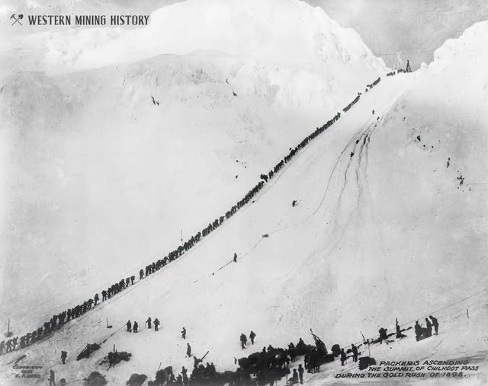
This 1898 photo depicts Chilkoot Pass, Alaska on the trail to the Klondike goldfields. The Klondike Gold Rush began in late 1896.

“’Cries of "Gold! Gold! Gold in the Klondike!’ started a race. 100,000 hopeful miners sprinted toward Alaska and the Yukon with their eyes on riches. Alaska Native and First Nations communities adapted to hold onto another kind of wealth: their culture, land, and way of life. In August, 1896, Skookum Jim and his family found gold near the Klondike River in Canada's Yukon Territory. Their discovery sparked one of the most frantic gold rushes in history. Nearby miners immediately flocked to the Klondike to stake the rest of the good claims. Almost a year later, news ignited the outside world. A wave of gold seekers bought supplies and boarded ships in Seattle and other west coast port cities. They headed north thinking they would strike it rich. *** By midsummer of 1898 there were 18,000 people at Dawson, with more than 5,000 working the diggings. By August many of the stampeders had started for home, most of them broke. The next year saw a still larger exodus of miners when gold was discovered at Nome, Alaska. The great Klondike Gold Rush ended as suddenly as it had begun. Towns such as Dawson City and Skagway began to decline. Others, including Dyea, disappeared altogether, leaving only memories of what many consider to be the last grand adventure of the 19th century.”
https://www.nps.gov/klgo/learn/goldrush.htm

Nov. 6, 1896 – NFPA Formed – Installation of Sprinkler Systems
“So, in 1895, a number of insurance and property protection professionals met for the first time in Boston to discuss how to address this challenge. They discussed how, at the time, nine different standards for fire sprinkler piping size and spacing were being used within a 100-mile radius of Boston, as well as evidence and research that was beginning to mount regarding which installation methods worked best.
The group continued meeting, and following one such meeting in March 1896 released the “Report of Committee on Automatic Sprinkler Protection,” which would eventually become NFPA 13, Standard for the Installation of Sprinkler Systems. At a subsequent meeting on November 6, 1896, the group voted to start an entire organization dedicated to advancing fire safety. “This organization shall be known as the National Fire Protection Association,” the approved article stated, and NFPA was officially born.” https://www.nfpa.org/news-blogs-and-articles/blogs/2024/11/06/history-of-nfpa

Feb. 15, 1898: “Remember The Maine” - Cuba
“On February 15, 1898, the battleship USS Maine exploded in Havana’s harbor in Cuba, killing nearly two-thirds of her crew. The tragedy occurred after years of escalating tensions between the United States and Spain, and the ‘yellow press’ and public opinion were quick to blame Spain. While the sinking of the Maine was not a direct cause of the Spanish-American War, it did accelerate the breakdown in diplomatic relations between the US and Spain. ‘Remember the Maine, to Hell with Spain!’ became a rallying cry.”
https://www.gilderlehrman.org/history-resources/spotlight-primary-source/remember-maine-1898
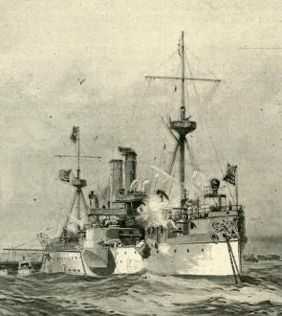

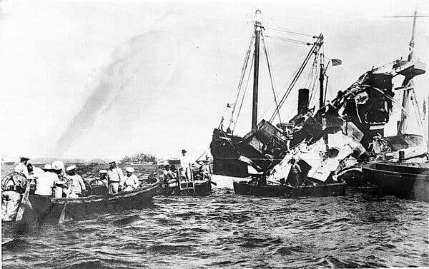Lifeboats rescuing surviving crew members after a mysterious explosion sank the U.S.S. Maine in Havana Harbor in February 1898.Credit...Associated Press
“The Spanish-American War in 1898 led to a number of U.S. interventions in Latin America, particularly in Cuba. The U.S.S. Maine was sent to Havana that January on a stated mission of protecting American citizens. After a mysterious explosion sank the battleship a month later, the United States began a naval blockade of Cuba and went to war with Spain. That campaign expanded to Puerto Rico, and then reached the Pacific to include the Philippines and Guam. The war ended with the 1898 Treaty of Paris, signed in December, which ceded ownership of Puerto Rico, Guam and the Philippines to the United States. Spain also relinquished control of Cuba.” https://www.nytimes.com/2025/12/09/us/politics/military-history-latin-america-strikes.html?nl=Breaking+News&segment_id=212078

May 1, 1898: Manila Bay – Commodore George Dewey
“The first battle was fought on May 1, in Manila Bay, where Commodore George Dewey’s Asiatic Squadron defeated the Spanish naval force defending the Philippines. On June 10, U.S. troops landed at Guantanamo Bay in Cuba and additional forces landed near the harbor city of Santiago on June 22 and 24. After isolating and defeating the Spanish Army garrisons in Cuba, the U.S. Navy destroyed the Spanish Caribbean squadron on July 3 as it attempted to escape the U.S. naval blockade of Santiago.” https://history.state.gov/milestones/1866-1898/spanish-american-war#:~:text=U.S.%20victory%20in%20the%20war,of%20Hawaii%20during%20the%20conflict
June 10, 1898: U.S. Marines, Guantánamo Bay, Cuba
“Marines had landed in Guantánamo Bay, Cuba, in June 1898 and moved swiftly through the island. It was the start of a long period of Marine involvement in conflicts in Central America and the Caribbean, which came to be known as the Banana Wars. ‘Before the Second World War, this is what the Marine Corps did,’ said Mark F. Cancian, a senior adviser with the Center for Strategic and International Studies and a retired Marine Corps colonel. ‘Their bread and butter was destabilizing and overthrowing governments in Latin America.’” https://www.nytimes.com/2025/12/09/us/politics/military-history-latin-america-strikes.html?nl=Breaking+News&segment_id=212078

1898: President McKinley – Spanish-American War - Annexing Philippines
“The Spanish-American War of 1898 ended Spain’s colonial empire in the Western Hemisphere and secured the position of the United States as a Pacific power. U.S. victory in the war produced a peace treaty that compelled the Spanish to relinquish claims on Cuba, and to cede sovereignty over Guam, Puerto Rico, and the Philippines to the United States. The United States also annexed the independent state of Hawaii during the conflict. Thus, the war enabled the United States to establish its predominance in the Caribbean region and to pursue its strategic and economic interests in Asia.” https://history.state.gov/milestones/1866-1898/spanish-american-war

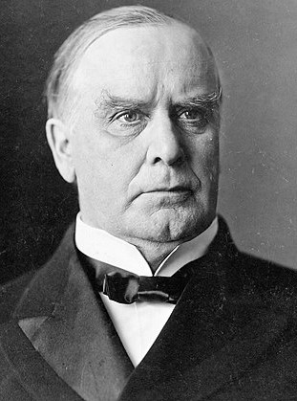
“So, too, McKinley’s embrace of American imperialism proved fleeting, for very good reason. The Spanish-American War — a conflict triggered by hysteria over the (likely accidental) explosion of a U.S. battleship in Havana harbor in 1898 (“Remember the Maine!”) — cost the lives of more than 2,000 U.S. service members. Then, by foolishly annexing the Philippines in 1899, McKinley embroiled America in another conflict that cost the lives of more than 4,200 U.S. soldiers and 20,000 Filipino combatants. More than 200,000 Filipino civilians also died from violence, famine and disease, and U.S. soldiers committed war crimes that shamed the nation. The United States eventually won the conflict but secured no real strategic or economic advantage; the U.S. bases in the Philippines were easily overrun by the Japanese in 1942.

***

The United States did not annex Cuba but did dominate it in cooperation with corrupt local elites. The last U.S.-backed dictator, Fulgencio Batista, was overthrown by Fidel Castro in 1959, and the island has been a thorn in America’s side ever since.”

https://www.washingtonpost.com/opinions/2025/01/26/donald-trump-william-mckinley-president-panama-canal/?utm_campaign=wp_post_most&utm_medium=email&utm_source=newsletter&carta-url=https%3A%2F%2Fs2.washingtonpost.com%2Fcar-ln-tr%2F40ac55f%2F6796645b927b326945a87499%2F59731235ade4e21a848a56ed%2F27%2F56%2F6796645b927b326945a87499

September 14, 1901 – President McKinley Assassination
“President William McKinley (1843-1901) dies on September 14, 1901 of complications from bullet wounds inflicted by Leon Czolgosz. Czolgosz, an anarchist, shot the President during one of his public appearances at the Pan-American Exposition in Buffalo, New York. Initially doctors believed that President McKinley would survive the assassination attempt even though only one bullet was able to be removed.” https://guides.loc.gov/chronicling-america-william-mckinley-assassination

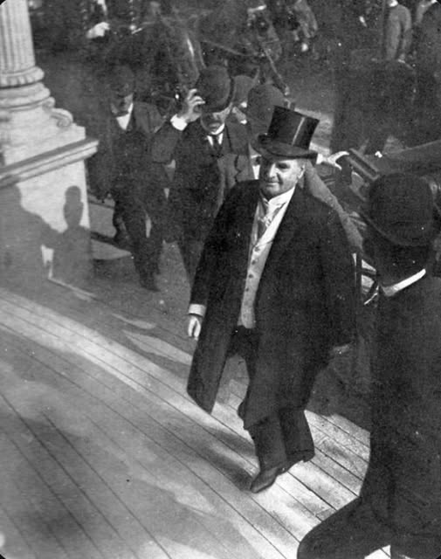

1903 – Mark Twain and “Jim”
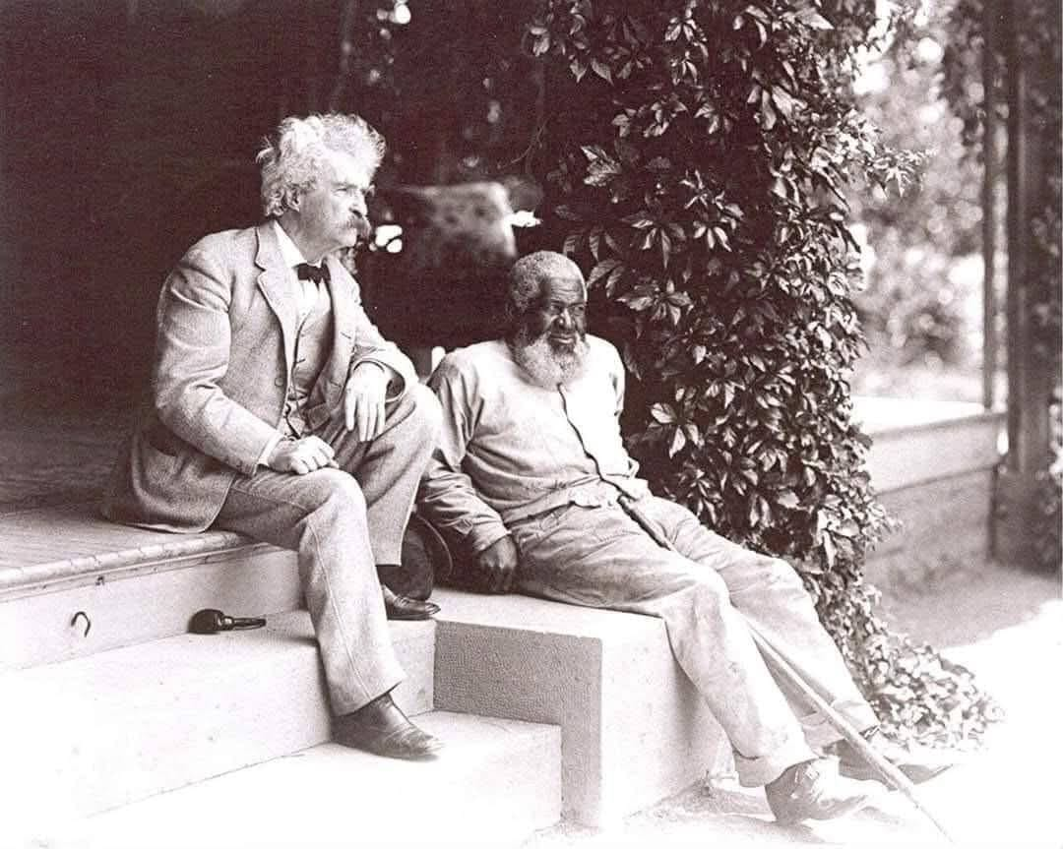
“Huck and Jim in Their Final Years”
“In 1903, on his last visit to his in-laws at Quarry Farm in Elmira, New York, Mark Twain (1835-1910) posed for this photograph with his friend, John T. Lewis (1835-1906), who was born a free man in Maryland and who had migrated to upstate New York. They met in 1877 after Lewis saved the lives of Twain’s sister-in-law and her daughter by courageously stopping their runaway carriage at no small risk to his own safety…. When Twain returned to writing Huckleberry Finn, in 1879 while at Elmira, Lewis was one of the real-life people upon whom he based the character of Jim, and it is even possible that his acquaintance with Lewis caused Twain to continue working on the novel after having earlier set it aside.”https://www.facebook.com/goldenageglamours/posts/huck-and-jim-in-their-final-yearsin-1903-on-his-last-visit-to-his-in-laws-at-qua/122186827790032905/

Dec. 17, 1903: First Flight - Kitty Hawk, NC


“They Taught the World to Fly! Wind, sand, and a dream of flight brought Wilbur and Orville Wright to Kitty Hawk, North Carolina where, after four years of scientific experimentation, they achieved the first successful airplane flights on December 17, 1903. With courage and perseverance, these self-taught engineers relied on teamwork and application of the scientific process. What they achieved changed our world forever.” https://www.nps.gov/wrbr/index.htm

Brazil claims first flight:
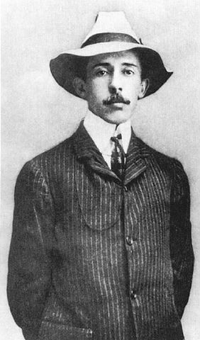
“It's difficult for citizens of the United States to understand why Brazilians are so insistent that he was the first to fly when the very sources they cite seem to prove just the opposite. Brazilians point proudly to the records of the Federation Aeronautique Internationale that show Santos Dumont made his record 722-foot flight in 1906, without disputing the eyewitness accounts that corroborate the Wright brothers report of 852 feet in 1903. To help explain why this is so, perhaps it would be best to let a Brazilian make the case for Santos Dumont. This is one of the better-written and less strident letters that we have received from Brazil:
Dear Sirs,
I recognize the importance of Wright Brothers to the progress of aviation, to people of USA. But I'll never recognize any kind of primacy in flight from that Gentlemen, first because they were working in absolute "secret", until 1908, when they presented their ground device dependant flying machine in Europe for the first time. Considering the alleged date for the first flight event, I cannot understand why 5 years later they were still using a catapult…. “ https://www.wright-brothers.org/History_Wing/History_of_the_Airplane/Who_Was_First/Santos_Dumont/Santos_Dumont.htm

March 25, 1911: NY City – Triangle Shirtwaist Factory Fire
“On March 25, 1911, the Triangle Shirtwaist Company factory in New York City burned, killing 146 workers. It is remembered as one of the most infamous incidents in American industrial history, as the deaths were largely preventable–most of the victims died as a result of neglected safety features and locked doors within the factory building. The tragedy brought widespread attention to the dangerous sweatshop conditions of factories, and led to the development of a series of laws and regulations that better protected the safety of workers.” https://www.history.com/topics/early-20th-century-us/triangle-shirtwaist-fire

1912: Nicaragua
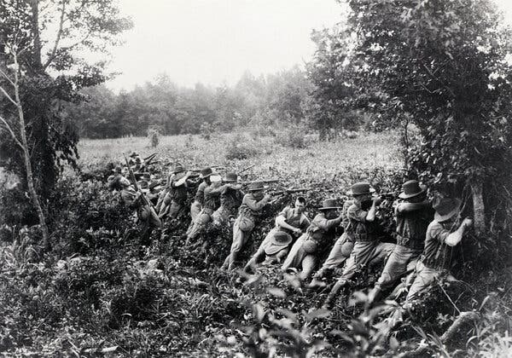A contingent of U.S. Marines landed in Nicaragua in 1912, beginning 21 years of occupation. Credit...Bettmann, via Getty Images
“Nicaragua was in the middle of a revolt against its right-leaning and pro-American president when Marines landed in the country on a stated mission to preserve U.S. interests. This quickly turned into a direct military intervention and began 21 years of occupation of Nicaragua as part of the Banana Wars.” https://www.nytimes.com/2025/12/09/us/politics/military-history-latin-america-strikes.html?nl=Breaking+News&segment_id=212078

Oct. 14, 1912 – Theodore Roosevelt Shot – Still Gave Speech

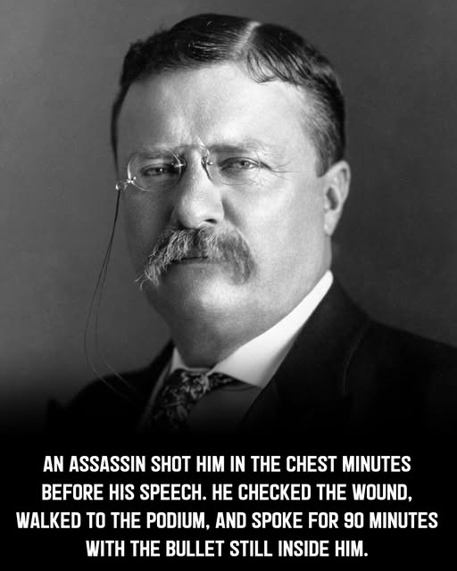
“It Takes More Than That To Kill A Bull Moose. Before a campaign speech in Milwaukee, Wisconsin, presidential candidate Theodore Roosevelt is shot at close range by saloonkeeper John Schrank while greeting the public in front of the Gilpatrick Hotel. Schrank’s .32-caliber bullet, aimed directly at Roosevelt’s heart, failed to mortally wound the former president because its force was slowed by a glasses case and a bundle of manuscript in the breast pocket of Roosevelt’s heavy coat—a manuscript containing Roosevelt’s evening speech. Schrank was immediately detained and reportedly offered as his motive that “any man looking for a third term ought to be shot.” Roosevelt, who suffered only a flesh wound from the attack, went on to deliver his scheduled speech with the bullet still in his body. After a few words, the former “Rough Rider” pulled the torn and bloodstained manuscript from his breast pocket and declared, “You see, it takes more than one bullet to kill a Bull Moose.” He spoke for nearly an hour and then was rushed to the hospital. Despite his vigorous campaign, Roosevelt, who served as the 26th U.S. president from 1901 to 1909, was defeated by Democrat Woodrow Wilson in November. Shrank was deemed insane and committed to a mental hospital, where he died in 1943.” https://www.history.com/this-day-in-history/october-14/theodore-roosevelt-shot-in-milwaukee

April 1914 – Mexico

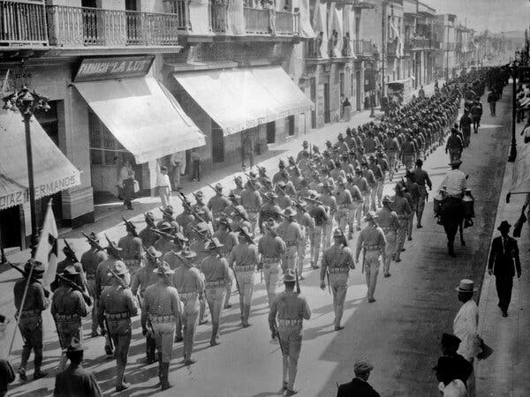U.S. troops in Veracruz, Mexico, in April 1914, as part of a blockade of the city’s port.

“Tensions were high between the United States and Mexico in 1914, as the latter underwent political upheaval fomented by the former. The year before, the United States had worked to overthrow a Mexican president in favor of another who was viewed as more pro-American, leading to a coup d’état, only to turn around and withdraw support for the new president, backing the bandit and revolutionary leader Pancho Villa to depose him.
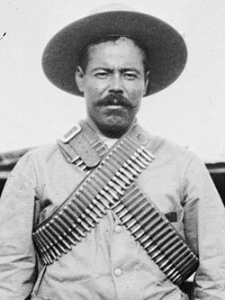 Pancho Villa
Then came the I’m-sorry-I’m-not-sorry squabble. The Mexican government arrested nine American sailors in April 1914 for entering an off-limits fuel-loading station in Tampico, on the country’s east coast. Mexico released the sailors, but the United States demanded an apology and a 21-gun salute. Mexico agreed to the apology but not the salute.
President Woodrow Wilson ordered a naval blockade of the Port of Veracruz, to the south. But before that could be carried out, he discovered an arms shipment heading to Mexico in violation of an American arms embargo. The U.S. Navy seized the Port of Veracruz, occupying it for seven months.” https://www.nytimes.com/2025/12/09/us/politics/military-history-latin-america-strikes.html?nl=Breaking+News&segment_id=212078

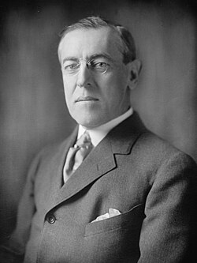

1914 – World War I Begins (1914-1918)
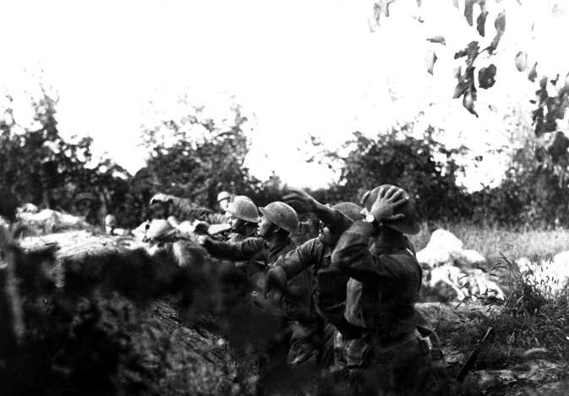

“In the summer of 1914, the assassination of Archduke Franz Ferdinand, heir to the Austro-Hungarian Empire, ignited a continental war between the Central Powers of Germany, Austria-Hungary, and the Ottoman Empire and the Allies of France, Great Britain, Russia, and Italy. By the war’s end in 1918, the war would span the globe, claim more than 16 million lives, and change the world forever…. The United States initially remained neutral. But reports of German atrocities and submarine attacks on shipping bound for Britain and France – most infamously the 1915 sinking of the Lusitania, which killed 128 Americans – began to change American opinion. In 1916 President Woodrow Wilson won re-election on the slogan ‘He kept us out of war.’ But in April 1917, Germany’s resumption of unrestricted submarine warfare, along with its offer to help Mexico recover territories lost to the United States in 1848, led Wilson to ask Congress to declare war on Germany…. Although the first American soldiers landed in France in June 1917, it would take a year to create, train and equip an army and ship it across the Atlantic. The outcome of the war would turn on whether Germany could defeat Britain and France before the Americans arrived in force…. American troops conducted their first major action on May 28, 1918, when the 1st Division rolled back a German salient at Cantigny. Soon after, American forces were deployed along the Western Front, fighting in battles that have become part of American military lore. In early June, the 2nd Division, including a brigade of U.S. Marines, drove German forces out of Belleau Wood after weeks of savage fighting. At Chateau Thierry the 3rd Division won the name ‘Rock of the Marne’ for its stand on the Marne River…. The United States suffered 53,402 battle deaths in World War I, in less than six months of fighting. Another 63,114 died from accidents and disease.” https://www.nps.gov/wwim/wwioverview.htm


Nov. 29, 1917 - A captured German 15 cm naval gun, northern France

Austro-Hungarian soldiers inspecting an Italian 305mm howitzer captured during the battle of Caporetto, November 1917

1915 – Haiti
“After President Vilbrun Guillaume Sam of Haiti was assassinated (shortly after ordering the execution of 167 political prisoners), Wilson sent Marines to the country. The stated mission was to restore order and stabilize Haiti’s turbulence, which had been fueled in part by U.S. actions such as the seizure of its gold reserves over debts. The Marines stayed almost 20 years, finally withdrawing in 1934.” https://www.nytimes.com/2025/12/09/us/politics/military-history-latin-america-strikes.html?nl=Breaking+News&segment_id=212078

September, 1915: Ohio – African American Auto Maker
“The Little-Known Tale of the Only African American Automaker. Patterson-Greenfield only built cars from 1915–1918 but found time to innovate, even patenting a door design that presaged those on modern-day vans. *** Patterson-Greenfield was an early 20th-century automaker headquartered in Greenfield, Ohio, a small town roughly midway between Columbus and Cincinnati. Like a number of early brands, including Buick, Pontiac, and Studebaker, it was founded as a successful 19th-century maker of horse-drawn carriages. But unlike any of those contemporaries or any other U.S. automobile company before or since, it was founded and run entirely by African American owners, providing it with a particular prominence in vehicular history. *** In 1929, according to Nelson, nearly half of the school buses in Ohio were made by Patterson.”
https://www.caranddriver.com/features/a26360175/african-american-automaker/

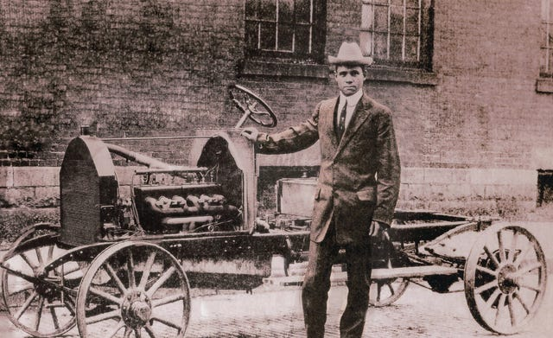

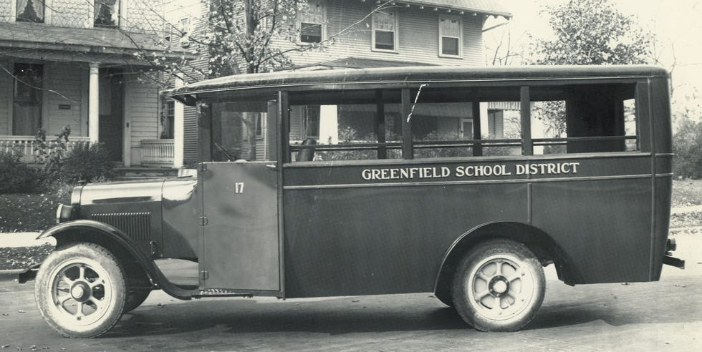

Oct. 27, 1915 – Antarctica - Ernest Shackleton – “The Endurance”
On Oct. 27, 1915, after being caught and crushed by packed ice for nine months in the Weddell Sea off Antarctica, Ernest Shackleton and his crew abandoned the Endurance and their quest to traverse the frozen continent by land. The doomed ship drifted atop the ice for three more weeks before finally sinking. https://www.nytimes.com/2025/10/06/science/shackleton-endurance-antarctica.html?nl=From+The+Times
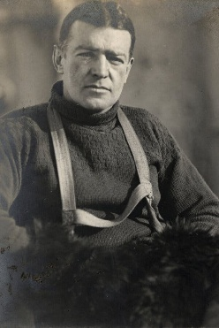
Ernest Shackleton during the Imperial Trans-Antarctic Expedition, 1914 to 1917.
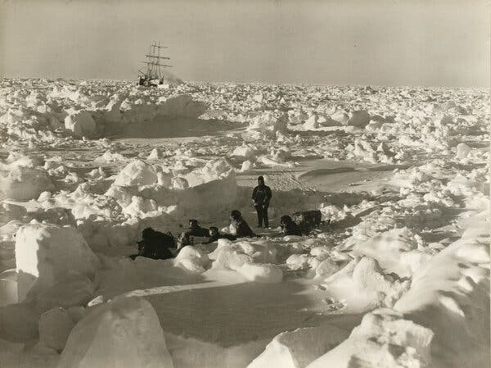

1918: General John J. Pershing – Incident Command / WW I
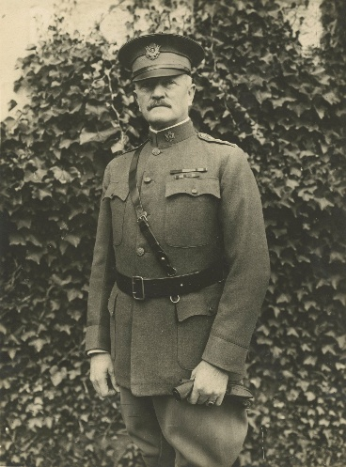
War Fighting: The Case of Ulysses S. Grant (9/16/2025): https://publications.armywarcollege.edu/News/Display/Article/4305205/war-fighting-the-case-of-ulysses-s-grant/

“When the Americans began moving into France in 1917 and 1918, unity of command and effort was lacking among the Allies on the Western Front. General John J. Pershing and his staff suggested unified command, but they had to figure out how to fight under the existing arrangement. One of the first tasks for Pershing and his staff was to identify where on the front an American field army could operate under its own command and have the greatest effect on the war. They selected the Alsace-Lorraine region and prepared for an offensive east from the Saint-Mihiel area toward German lines of communications and resources around Metz. This planned campaign was isolated from the rest of the Allies’ efforts on the front, both physically and in intent.

The German 1918 Spring Offensive forced the Allies to appoint a supreme commander in Ferdinand Foch. The Americans were happy to accede to Foch’s requests for American troops (as divisions) to stem and push back the Germans in the summer of 1918. In the meantime, Pershing kept building First Army with the intent of attacking toward Metz. In the late summer, Foch saw an opportunity for a unified strategy to end the war that called for multiple concentric campaigns aimed at the center of the great German salient in northeastern France and Belgium. The Americans would attack north into the southern face of the salient.

Pershing and his staff agreed—as long as First Army remained a coherent force under American command. Why would they so readily abandon their previous planning for an attack east toward Metz? Put simply, Foch’s overall strategy for 1918 looked like Grant’s successful strategy of 1864. First Army and earlier I Corps commander General Hunter Liggett directly compared prior allied disunity to the Civil War, quoting Grant: ‘As Grant said of the Union Armies before he took command, they had acted ‘without concert, like a balky team, no two ever pulling together.’ ”

April 1918 – WWI – Red Baron
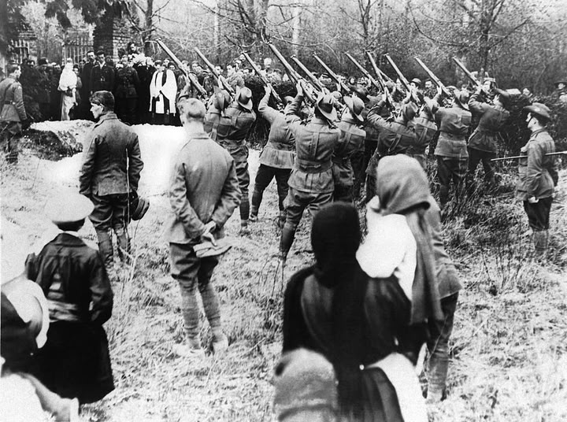
Australian troops fire a final volley over the grave of Manfred von Richthofen, the German ace pilot know as the Red Baron, Amiens, France, May 22, 1918. He was shot down on the Western Front, and his body fell behind the British lines. He was buried with full military honors.

“The Red Baron was the name applied to Manfred von Richthofen, a German fighter pilot who was the deadliest flying ace of World War I. During a 19-month period between 1916 and 1918, the Prussian aristocrat shot down 80 Allied aircraft and won widespread fame for his scarlet-colored airplanes and ruthlessly effective flying style. Richthofen’s legend only grew after he took command of a German fighter wing known as the Flying Circus, but his career in the cockpit was cut short in April 1918, when he was killed in a dogfight over France.” https://www.history.com/articles/manfred-baron-von-richthofen

June 1, 1918: U.S. Army & Marines – Victorius in Battle of Belleau Wood
“The Allies’ victory at the Battle of Belleau Wood, which occurred in France from June 1 to June 26, 1918, greatly boosted morale amid the Germans’ Spring Offensive. The battle was the first major engagement of the U.S. army in World War I, and, only 39 miles from Paris, marked the closest the Germans came to the French capital during the war.” https://www.britannica.com/event/Battle-of-Belleau-Wood

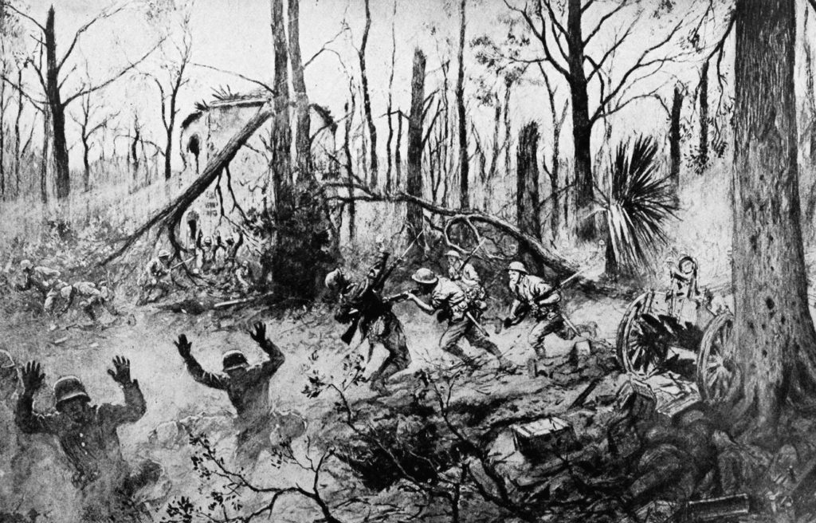

“Every U.S. marine knows the famous quotes from their comrades fighting in 1918 in the Battle of Belleau Wood: ‘Retreat, hell we just got here!’ by Capt. Lloyd Williams, and ‘C’mon you sons-of-bitches, do you want to live forever?’ by Gunnery Sgt. Dan Daley. Every marine proudly claims the ‘Devil dogs’ moniker because of their ferocity in combat. Alongside the Battles of Fallujah, Khe Sanh, Chosin, and Iwo Jima, Belleau Wood occupies a hallowed place in U.S. Marine Corps lore and history. These battles are ingrained in the Marines’ collective consciousness from the first days of boot camp, during ceremonies at birthday balls, on walls in museums, and on pages of publications.” https://warontherocks.com/2018/06/the-importance-of-the-battle-of-belleau-wood/

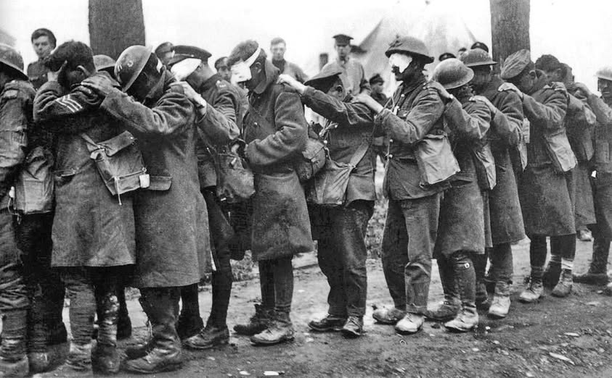
Blinded by gas, British soldiers of the 55th division hold onto each other at an advanced dressing station, April 1918.

1919 – Cincinnati Fire Department strike

“The fire department suffered through two major events that created serious staffing problems. World War 1 caused many firefighters to leave the department for military service. As the war ended the Spanish Flu epidemic swept the nation. Firefighters suffered some of the highest rates of infection. At least 17 were killed hundreds took ill. This stress helped to draw firefighters together to push for better working conditions. A weeklong strike in mid-April was ultimately broken by the city. Firefighters would not be permitted to organize until 1936.” https://www.cincyfiremuseum.com/exhibits/firefighting-history/

March 3, 1919: U.S. Supreme Court - Schenck v. United States (249 US 47) – PROSECUTION FOR CREATING CLEAR & PRESENT DANGER

“Issue: Is certain speech, including sending antiwar pamphlets to drafted men, made in wartime and deemed in violation of the Espionage Act, protected by the First Amendment?
Result: No. Although the defendant would have been able to state his views during ordinary times, the Court held that in certain circumstances, like this case the nation being at war, justify such limits on the First Amendment.
Importance: The Schenck decision is best known for creating the ‘clear and present danger’ test meaning that speech could be restricted if it presented a clear and present danger. The decision was also the first to explain the metaphor of falsely yelling ‘Fire!’ in a crowded theater. Schenck was later modified by Brandenburg v. Ohio, which said that speech could be restricted if it would provoke an ‘imminent lawless action.’” https://www.americanbar.org/groups/public_education/programs/constitution_day/landmark-cases/

“Charles T. Schenck was general secretary of the U.S. Socialist Party, which opposed the implementation of a military draft in the country. The party printed and distributed some 15,000 leaflets that called for men who were drafted to resist military service. Schenck was subsequently arrested for having violated the Espionage Act; he was convicted on three counts.” https://www.britannica.com/event/Schenck-v-United-States MR. JUSTICE HOLMES delivered the opinion of the court.
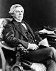
Justice Oliver Homes
“Incriminating document seized under a search warrant directed against a Socialist headquarters, held admissible in evidence, consistently with the Fourth and Fifth Amendment, in a criminal prosecution against the general secretary of a Socialist party, who had charge of the office. Words which, ordinarily and in many places, would be within the freedom of speech protected by the First Amendment may become subject to prohibition when of such a nature and used in such circumstances a to create a clear and present danger that they will bring about the substantive evils which Congress has a right to prevent. The character of every act depends upon the circumstances in which it is done. A conspiracy to circulate among men called and accepted for military service under the Selective Service Act of May 18, 1917, a circular tending to influence them to obstruct the draft, with the intent to effect that result, and followed by the sending of such circulars, is within the power of Congress to punish, and is punishable under the Espionage Act, § 4….” https://supreme.justia.com/cases/federal/us/249/47/

1920s: Great Migration North / KKK

“The era of Jim Crow laws saw a dramatic reduction in the number of blacks registered to vote within the South. This time period brought about the Great Migration of blacks to northern and western cities like New York City, Chicago, and Los Angeles. In the 1920s, the Ku Klux Klan experienced a resurgence and spread all over the country, finding a significant popularity that has lingered to this day in the Midwest. It was claimed at the height of the second incarnation of the KKK that its membership exceeded 4 million people nationwide. The Klan didn't shy away from using burning crosses and other intimidation tools to strike fear into their opponents, who included not just blacks, but also Catholics, Jews, and anyone who wasn't a white Protestant.” https://guides.ll.georgetown.edu/c.php?g=592919&p=4172697

Jan. 26, 1920 - Silverthorne Lumber Co., Inc. v. United States, 251 U.S. 385 (1920)
https://supreme.justia.com/cases/federal/us/251/385/

ILLEGAL SEARCH COMPANY BOOKS & RECORDS
“The facts are simple. An indictment upon a single specific charge having been brought against the two Silverthornes mentioned, they both were arrested at their homes early in the morning of February 25, and were detained in custody a number of hours. While they were thus detained, representatives of the Department of Justice and the United States marshal, without a shadow of authority, went to the office of their company and made a clean sweep of all the books, papers and documents found there. All the employes were taken or directed to go to the office of the District Attorney of the United States, to which also the books, &c., were taken at once. An application, was made as soon as might be to the District Court for a return of what thus had been taken unlawfully…. But the rights of a corporation against unlawful search and seizure are to be protected even if the same result might have been achieved in a lawful way.”

Aug. 18, 1920: 19th Amendment Ratified – Women Right To Vote
“Passed by Congress June 4, 1919, and ratified on August 18, 1920, the 19th amendment guarantees all American women the right to vote. Achieving this milestone required a lengthy and difficult struggle; victory took decades of agitation and protest. Beginning in the mid-19th century, several generations of woman suffrage supporters lectured, wrote, marched, lobbied, and practiced civil disobedience to achieve what many Americans considered a radical change of the Constitution. Few early supporters lived to see final victory in 1920.” https://www.archives.gov/historical-docs/19th-amendment

Sept. 7, 1920: President Woodrow Wilson - Fire Prevention Day
“President Wilson issued the first National Fire Prevention Day proclamation in 1920. And since 1922, Fire Prevention Week has been observed each October.” https://www.firerescue1.com/history/articles/when-firefighting-crossed-paths-with-presidents-veeps-SbUtdRP4yHbhoFaI/
***
”By the President of the United States of America
A Proclamation
Whereas, the destruction by fires in the United States involves an annual loss of life of 15,000 men, women and children, and over $250,-000,000 in buildings, foodstuffs and other created resources, and
Whereas, the need of the civilized world for American products to replace the ravages of the Great War is especially great at this time, and
Whereas, the present serious shortage of home and business structures makes the daily destruction of buildings by fire an especially serious matter, and
Whereas, a large percentage of the fires causing the annual American fire waste may be easily prevented by increased care and vigilance on the part of citizens:
Therefore, I, Woodrow Wilson, President of the United States, do urge upon the Governors of the various States to designate and set apart Saturday, October 9, 1920, as Fire Prevention Day, and to request the citizens of, their States to plan for that day such instructive and educational exercises as shall bring before the people the serious and unhappy effects of the present unnecessary fire waste, and the need of their individual and collective efforts in conserving the natural and created resources of America.
In witness whereof, I have hereunto set my hand and caused the seal of the United States to be affixed.
Done in the District of Columbia this seventh day of September, in the year of our Lord One Thousand Nine Hundred and Twenty and of the Independence of the United States, the One Hundred and Forty-fifth.
WOODROW WILSON
By the President: . .
Bainbridge Colby, Secretary of State.” https://www.presidency.ucsb.edu/documents/proclamation-1573-fire-prevention-day-1920

1921: William Howard Taft – from President to Chief Justice of U.S. Supreme Court
“A century ago, in the summer of 1921, President Warren G. Harding appointed former President William Howard Taft as Chief Justice of the United States. Taft had spent a lifetime in public service, ultimately reaching the White House. Yet he expressed trepidation in taking on this new and different challenge. Taft told Harding that he was gratified by the appointment but ‘trembled to think whether I can worthily fill the position and be useful to the country.’ He voiced a concern that might cross the mind of any good judge when first donning a judicial robe.” https://www.supremecourt.gov/publicinfo/year-end/2021year-endreport.pdf

Aug. 26, 1920 – 19th Amendment – Women’s Suffrage Rights
“The right of citizens of the United States to vote shall not be denied or abridged by the United States or by any State on account of sex. Congress shall have power to enforce this article by appropriate legislation.” https://constitution.findlaw.com/amendments.html 1926

May 31, 1921 – Tulsa, OK Race Massacre
Justice Department Announces Results of Review and Evaluation of the Tulsa Race Massacre (1/10/2025): https://www.justice.gov/opa/pr/justice-department-announces-results-review-and-evaluation-tulsa-race-massacre
“The review revealed that, on the night of May 31, 1921, a violent attack by as many as 10,000 white Tulsans destroyed Greenwood, a uniquely prosperous Black community. The attack was so systematic and coordinated that it transcended mere mob violence. The review found that the trigger for the violence of the Tulsa Race Massacre was the kind of unfounded condemnation that, at the time, was commonly employed to justify unspeakable treatment of Black men; a white man alleged that a Black man, 19-year-old Dick Rowland, assaulted a white woman who operated an elevator he used. After Rowland’s arrest, a local newspaper then sensationalized the story and, soon, a mob of white Tulsans gathered outside the courthouse, demanding a lynching.
The local sheriff called on Black men from Greenwood, many recently returned from service during World War I, to come to the courthouse to prevent a lynching. The white mob saw this effort to protect Rowland as an unacceptable challenge to the social order. The mob grew. A confrontation broke out, and when someone fired a shot, horrific violence erupted. The Tulsa police deputized hundreds of white residents, many of whom — immediately before being awarded a badge — had been drinking and agitating for Rowland’s murder. Law enforcement officers helped organize these special deputies — as well as other white Tulsans — into the forces that would eventually ravage the Greenwood community.
Violence was initially unorganized and opportunistic. But at daybreak on June 1, a whistle blew, and the violence and arsons that had been chaotic became systematic. White Tulsans, many of whom had recently drilled together as the “Home Guard,” formed to replace members of the National Guard who had gone overseas during the Great War, became organized and efficient in their destruction. They looted, burned and destroyed 35 city blocks while Greenwood’s residents tried desperately to defend their homes. As the fires consumed Greenwood, many Black families fled for their lives, leaving behind their homes and valuable items. White residents chased them across and beyond the city, taking into custody men, women, children, the elderly and the infirm, and looting the homes they left behind. The destruction of the district was total. The survivors were left with little to nothing.
Law enforcement officers (both from the Tulsa Police and the National Guard) disarmed Black residents, confiscated their weapons and detained many in makeshift camps under armed guard. In addition, there are credible reports that at least some law enforcement officers did more than arrest and detain Black men; some participated in murder, arson and looting. After the devastation, city officials promised to help Greenwood rebuild, but the government of Tulsa not only failed to do so, it put up obstacles to residential reconstruction. White local leaders rejected outside aid, claiming they could handle the recovery, but then provided little to no financial support. Instead, claiming the area was best suited for industrial use, they imposed harsh new fire codes that priced residents out of the area.”
See also: https://www.tulsahistory.org/exhibit/1921-tulsa-race-massacre/
May 30, 1922 – Lincoln Memorial dedication
“Ground was broken in 1914. The statue of the seated Lincoln was made from 28 blocks of Georgia marble carved by sculptor Daniel Chester French in the New York studio of the Piccirilli brothers, a team of renowned Italian stonecutters. The blocks were then shipped to Washington and assembled inside the memorial in 1919. The memorial was dedicated in 1922 [President Warren G. Harding] ,in the presence of Lincoln’s son, Robert, then 78. About 50,000 people attended. African Americans, as was the cruel custom in then-segregated Washington, were shunted off to the rear.” https://www.washingtonpost.com/dc-md-va/2024/12/11/lincoln-memorial-undercroft-national-park-service-visitor-area-musem/?utm_campaign=wp_todays_headlines&utm_medium=email&utm_source=newsletter&carta-url=https%3A%2F%2Fs2.washingtonpost.com%2Fcar-ln-tr%2F3fe8fc4%2F675ac231357387190b4ebd70%2F59731235ade4e21a848a56ed%2F22%2F61%2F675ac231357387190b4ebd70

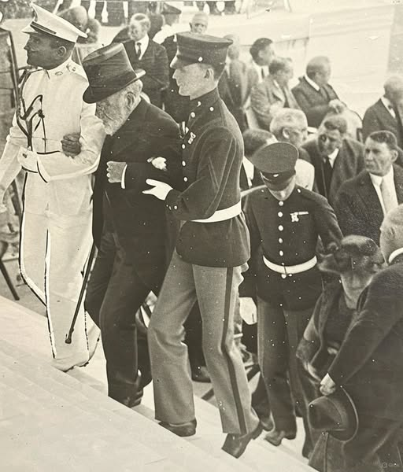
78-year-old Robert T. Lincoln (son of Abraham Lincoln) is helped up the steps at the dedication of the Lincoln Memorial in Washington D.C.

June 2, 1924 – Native Americans become U.S. Citizens
“Indian Citizenship Act. On June 2, 1924, Congress enacted the Indian Citizenship Act, which granted citizenship to all Native Americans born in the U.S. The right to vote, however, was governed by state law; until 1957, some states barred Native Americans from voting.” https://www.loc.gov/item/today-in-history/june-02/

July 10, 1925: Scopes Trial
“The Scopes Trial, also known as the Scopes Monkey Trial, was the 1925 prosecution of science teacher John Scopes for teaching evolution in a Tennessee public school, which a recent bill had made illegal. The trial featured two of the best-known orators of the era, William Jennings Bryan and Clarence Darrow, as opposing attorneys. The trial was viewed as an opportunity to challenge the constitutionality of the bill, to publicly advocate for the legitimacy of Darwin’s theory of evolution, and to enhance the profile of the American Civil Liberties Union (ACLU).” https://www.history.com/articles/scopes-trial

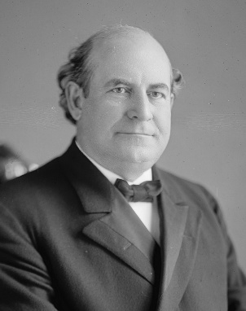 William Jennings Bryan (March 19, 1860 – July 26, 1925)
Clarence Seward Darrow (April 18, 1857 – March 13, 1938)
John T. Scopes
“Scopes Trial, (July 10–21, 1925, Dayton, Tennessee, U.S.), highly publicized trial known as the ‘Monkey Trial’) of a Dayton, TN school teacher, John T. Scopes, charged with violating state law by teaching Charles Darwin’s theory of evolution. The trial’s proceedings helped to bring the scientific evidence for evolution into the public sphere while also stoking a national debate over the veracity of evolution that continues to the present day.

In March 1925 the Tennessee legislature had passed the Butler Act, which declared unlawful the teaching of any doctrine denying the divine creation of man as taught by the Bible. World attention focused on the trial proceedings, which promised and delivered confrontation between fundamentalist literal belief and liberal interpretation of the Scriptures. William Jennings Bryan led for the prosecution and Clarence Darrow for the defense.

The trial’s climax came on July 20, when Darrow called on Bryan to testify as an expert witness for the prosecution on the Bible. Raulston moved the trial to the courthouse lawn, citing the swell of spectators and stifling heat inside. Darrow’s cross-examination challenged Bryan on various biblical stories and the validity and practicality of their literal interpretation. Bryan responded by claiming that Darrow’s “only aim was to cast slurs on the Bible.” With Raulston limiting the trial to the single question of whether Scopes had taught evolution, which he admittedly had, Scopes was convicted and fined $100 on July 21. On appeal, the state Supreme Court upheld the constitutionality of the 1925 law but acquitted Scopes on the technicality that he had been fined excessively.

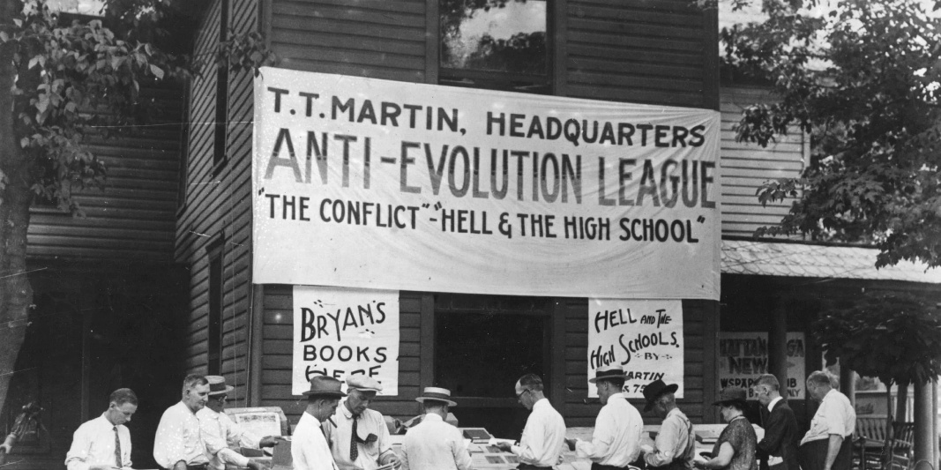

”Charles Darwin: History’s most famous biologist. (1809-1882) transformed the way we understand the natural world with ideas that, in his day, were nothing short of revolutionary. He and his fellow pioneers in the field of biology gave us insight into the fantastic diversity of life on Earth and its origins, including our own as a species.” https://www.nhm.ac.uk/discover/charles-darwin-most-famous-biologist.html

1926 – American Indian Children, 83% forcibly sent to Boarding Schools

Opinion: Deb Haaland: My grandparents were stolen from their families as children. We must learn about this history. Deb Haaland, the U.S. interior secretary, is the first Native American to serve as a Cabinet secretary. (June 11, 2021)
“Over nearly 100 years, tens of thousands of Indigenous children were taken from their communities and forced into scores of boarding schools run by religious institutions and the U.S. government. Some studies suggest that by 1926, nearly 83 percent of Native American school-age children were in the system. Many children were doused with DDT upon arrival, and as their coerced re-education got underway, they endured physical abuse for speaking their tribal languages or practicing traditions that didn’t fit into what the government believed was the American ideal.
My great-grandfather was taken to Carlisle Indian School in Pennsylvania. Its founder coined the phrase ‘kill the Indian, and save the man,’ which genuinely reflects the influences that framed these policies at the time.”
https://www.washingtonpost.com/opinions/2021/06/11/deb-haaland-indigenous-boarding-schools/?utm_campaign=wp_week_in_ideas&utm_medium=email&utm_source=newsletter&wpisrc=nl_ideas

1925: Leonard “Kip” Rhinelander Trial – White’s Family Sought Annulment When He Married “Black”
“The Rhinelander Trial held the public in its grip for the better part of 1925, with both black and white press weighing in with varying opinions. Ultimately, on December 6, 1925, the jury ruled in Mrs. Rhinelander’s favor. Playing on the notion that race can be visually established, the defense attorney successfully ‘showed’ Mrs. Rhinelander to be ‘colored,’ argued that she could not have deceived her husband, and therefore his claims for annulment were invalid. The couple never reunited, and legally separated in 1930. Leonard Rhinelander died in 1936, and Alice died in 1989.” https://blackpast.org/african-american-history/leonard-kip-rhinelander-trial-1925/

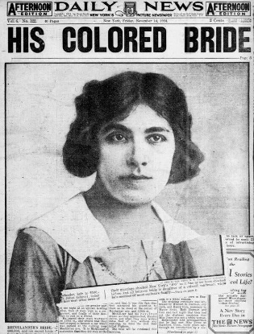
“If Alice and Leonard had married in one of the 29 states that outlawed interracial marriage at the time, the presentation of Alice’s birth certificate to a judge would have invalidated their union. In New York, however, interracial marriage was legal, and divorce was typically permitted only in cases of adultery — which left an annulment on the basis of racial fraud as Leonard’s only state-sanctioned means of dissolving the marriage.” https://www.nytimes.com/2025/12/17/magazine/rhinelander-trial-interracial-marriage.html?nl=From+The+Times&segment_id=212712

March 4, 1929: President Herbert Hoover – Inauguration
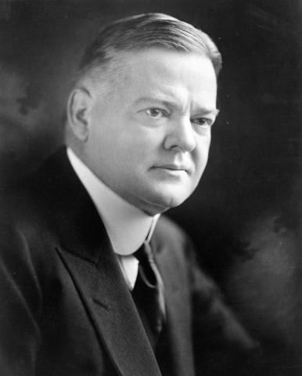
https://hoover.archives.gov/hoovers/president-herbert-hoover

Oct. 24, 1929: Stock Market Crash - “Black Thursday” – Great Depression Started
“Stock market crash of 1929, a sharp decline in U.S. stock market values in 1929 that contributed to the Great Depression of the 1930s. The Great Depression lasted approximately 10 years and affected both industrialized and non industrialized countries in many parts of the world. *** On October 18 the market went into a free fall, and the wild rush to buy stocks gave way to an equally wild rush to sell. The first day of real panic, October 24, is known as Black Thursday; on that day a record 12.9 million shares were traded as investors rushed to salvage their losses. Still, the Dow closed down only six points after a number of major banks and investment companies bought up great blocks of stock in a successful effort to stem the panic that day. Their attempts, however, ultimately failed to shore up the market. The panic began again on Black Monday (October 28), with the market closing down 12.8 percent. On Black Tuesday (October 29) more than 16 million shares were traded. The Dow lost another 12 percent and closed at 198—a drop of 183 points in less than two months. Prime securities tumbled like the issues of bogus gold mines. General Electric fell from 396 on September 3 to 210 on October 29. American Telephone and Telegraph dropped 100 points. DuPont fell from a summer high of 217 to 80, United States Steel from 261 to 166, Delaware and Hudson from 224 to 141, and Radio Corporation of America (RCA) common stock from 505 to 26.” https://www.britannica.com/event/stock-market-crash-of-1929
1930s – Prohibition (ending Dec. 5, 1933 – 21st Amendment)
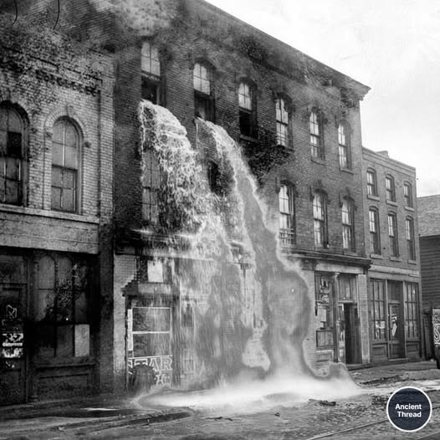Agents dump seized liquor during the Prohibition in the 1930s.
“In 1929—the year of the stock market crash, which seemingly increased the country’s desire for illegal liquor—Eliot Ness was hired as a special agent of the U.S. Department of Justice to head the Prohibition bureau in Chicago, with the express purpose of investigating and harassing Capone. Because the men whom Ness hired to help him were extremely dedicated and unbribable, they were nicknamed the Untouchables. The public learned of them when big raids on breweries, speakeasies, and other places of outlawry attracted newspaper headlines. The Untouchables’ infiltration of the underworld secured evidence that helped send Capone to prison for income-tax evasion in 1932.” https://www.britannica.com/event/Prohibition-United-States-history-1920-1933
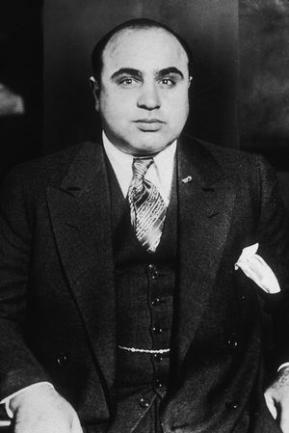Al Capone – 1935
“The Prohibition Era began in 1920 when the 18th Amendment to the U.S. Constitution, which banned the manufacture, transportation and sale of intoxicating liquors, went into effect with the passage of the Volstead Act. Despite the new legislation, Prohibition was difficult to enforce. The increase of the illegal production and sale of liquor (known as “bootlegging”), the proliferation of speakeasies (illegal drinking spots) and the accompanying rise in gang violence and organized crime led to waning support for Prohibition by the end of the 1920s. In early 1933, Congress adopted a resolution proposing a 21st Amendment to the Constitution that would repeal the 18th. The 21st Amendment was ratified on December 5, 1933, ending Prohibition.” https://www.history.com/articles/prohibition

1932: 116 Lynchings In Virginia (1866-1832)
“While communities in the South have reckoned with the legacy of lynching in recent years, including establishment of the National Memorial for Peace and Justice in Alabama, Virginia localities have done relatively little to address the legal record. The Racial Terror: Lynching in Virginia project at James Madison University has identified some 116 lynchings across the state from 1866 to 1932. In a groundbreaking case last year, a prosecutor in Albemarle County dismissed an indictment against John Henry James, a Black man lynched in 1898 after being accused of raping a White woman.” https://www.washingtonpost.com/dc-md-va/2024/12/20/virginia-lynching-judge-culpeper/?utm_campaign=wp_evening_edition&utm_medium=email&utm_source=newsletter&carta-url=https%3A%2F%2Fs2.washingtonpost.com%2Fcar-ln-tr%2F4009b51%2F6765e8e264c0860cbc19978d%2F59731235ade4e21a848a56ed%2F24%2F45%2F6765e8e264c0860cbc19978d

1933: Bonnie & Clyde

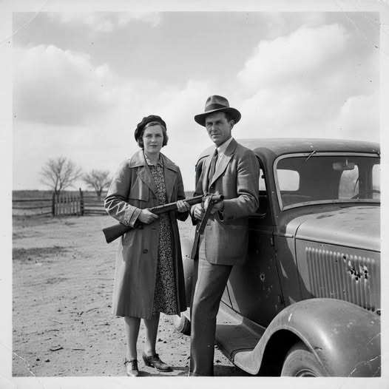
Bonnie and Clyde: Defiance (1933): "Bonnie Parker, with her signature bob haircut, and Clyde Barrow, leaning against a stolen car, both holding firearms. Their expressions are defiant and confident, capturing their notorious public image. The background is a nondescript rural landscape, a common backdrop for their exploits."

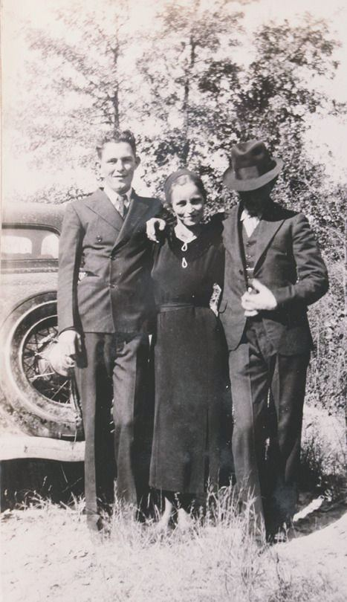

History Pictures:

“Beyond the daring robberies and dramatic headlines, the lives of Bonnie and Clyde were riddled with bizarre, desperate, and often tragic episodes that the legend tends to overshadow. In January 1932, while imprisoned at the notoriously harsh Eastham Prison Farm [Texas]. Clyde became so desperate to escape the grueling labor that he chopped off his left big toe and part of another with an axe. Ironically, his mother had successfully petitioned for his parole, and he was released just six days later—leaving him with a permanent limp that would mark him for life.
Their life on the run was equally perilous and unpredictable. In June 1933, a high-speed escape in their Ford V-8 ended with the car flipping into a ravine. Battery acid from the car’s engine poured onto Bonnie’s leg, burning through flesh to the bone in places. For the rest of her life, she struggled to walk, often relying on Clyde’s support or hopping on one leg. Even in small details, their story was punctuated by irony and unintended notoriety: a few weeks before their deaths, Clyde sent a fan letter to Henry Ford, praising the V-8 as the ultimate getaway car, demonstrating a mix of admiration and dark humor amid their crime spree.
The public image of Bonnie and Clyde was shaped as much by accident as intention. Iconic photos of Bonnie with a cigar and guns were never meant for public consumption; left behind in a Joplin, Missouri, shootout, the undeveloped film was seized by a newspaper, creating the “cigar-smoking outlaw” myth—Bonnie herself didn’t even smoke cigars. Their lives ended abruptly on May 23, 1934, in a deadly ambush, but even in death, the small, human details remained: Bonnie was found clutching a half-eaten fried bologna sandwich, a quiet, ordinary moment frozen at the very end of a life defined by chaos, speed, and relentless danger.”

March 4, 1933: President Franklin D. Roosevelt – Inauguration
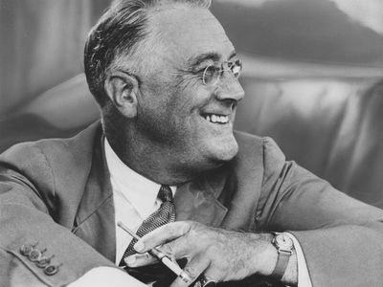
https://www.britannica.com/biography/Franklin-D-Roosevelt

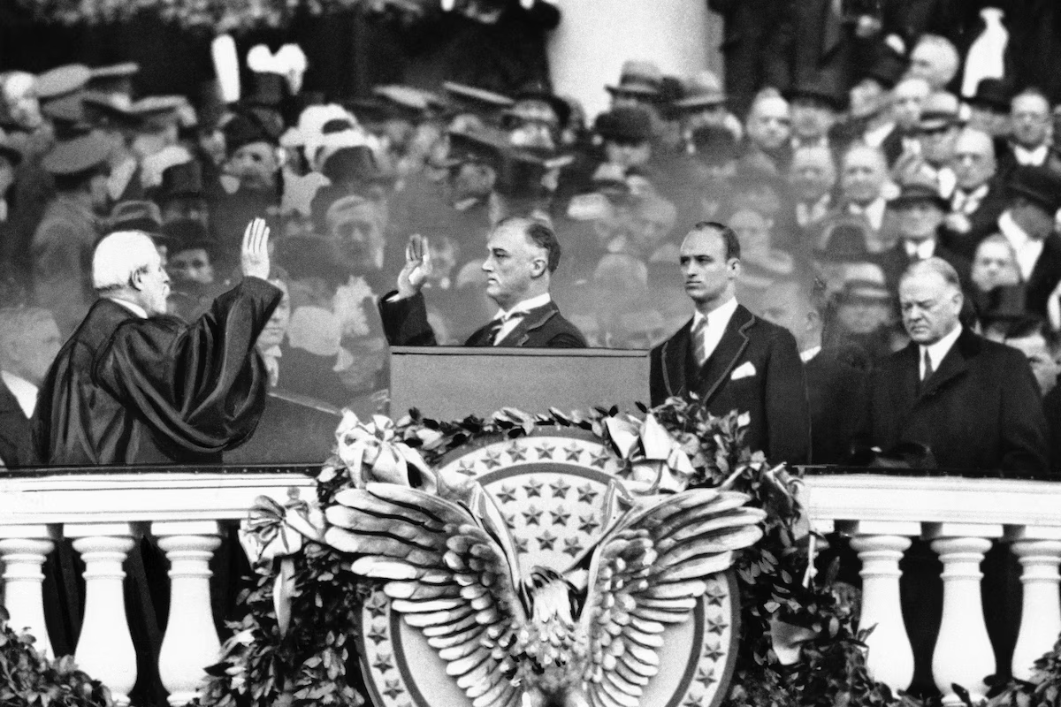 Outgoing President Herbert Hoover, far right, gazes down as President-elect Franklin D. Roosevelt, accompanied by his eldest son James, takes the oath of office from Chief Justice Charles E. Hughes, in Washington on March 4, 1933. (AP)

1933 – Machine Gun Kelly
Machine gun Kelly arrested in Memphis TN 1933 being led down the steps of the Shelby County Courthouse by officers.
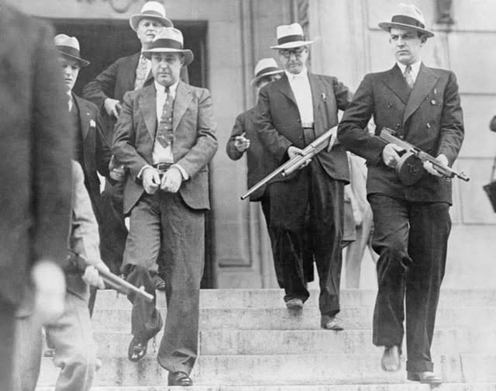
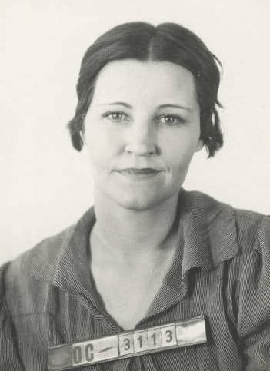
A 1933 mug shot of Kathryn Kelly, wife of gangster George "Machine Gun" Kelly, from the Oklahoma City Police Department.
“He probably never uttered those now famous words, ‘Don’t Shoot G-Men, Don’t Shoot.’
But George ‘Machine Gun’ Kelly—really, George Kelly Barnes—earned a notorious place in FBI history after kidnapping a wealthy oil magnate in 1933 and being associated with that phrase. Following the abduction, the Bureau coordinated a multi-state investigation, drawing investigative information from its own field offices as well as from other police sources, as it identified and tracked down the gangster, his wife, and their criminal colleagues across the country.” https://www.fbi.gov/history/famous-cases/machine-gun-kelly

1935: NLRB
“The National Labor Relations Board enforces the National Labor Relations Act by investigating allegations of wrong-doing brought by workers, unions, or employers, conducting elections, and deciding and resolving cases.” https://www.usa.gov/federalagencies/national-labor-relations-board

May 6, 1937: Lakehurst, New Jersey, the German passenger airship Hindenburg

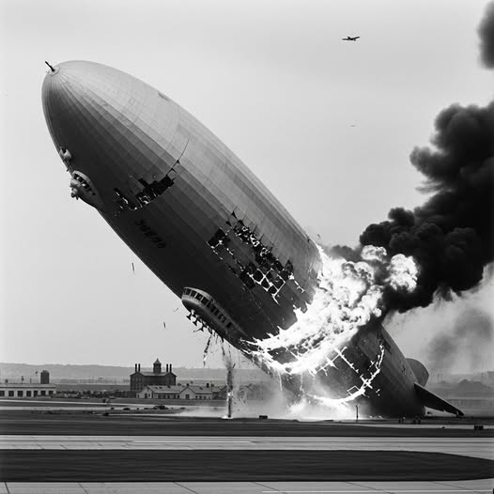
A total of 36 people died in the Hindenburg disaster on May 6, 1937, including 13 passengers and 22 crew members on board, plus one member of the ground crew. Of the 97 people aboard (36 passengers and 61 crew), 62 survived, often with severe burns, after the airship caught fire at Lakehurst, New Jersey.

1938: FLSA enacted: 29 USC 207k
Fair Labor Standards Act of 1938: Maximum Struggle for a Minimum Wage
“When he felt the time was ripe, President Roosevelt asked Secretary of Labor Perkins, 'What happened to that nice unconstitutional bill you had tucked away?'
On Saturday, June 25, 1938, to avoid pocket vetoes 9 days after Congress had adjourned, President Franklin D. Roosevelt signed 121 bills. Among these bills was a landmark law in the Nation's social and economic development -- Fair Labor Standards Act of 1938 (FLSA). Against a history of judicial opposition, the depression-born FLSA had survived, not unscathed, more than a year of Congressional altercation. In its final form, the act applied to industries whose combined employment represented only about one-fifth of the labor force. In these industries, it banned oppressive child labor and set the minimum hourly wage at 25 cents, and the maximum workweek at 44 hours.” https://www.dol.gov/general/aboutdol/history/flsa1938
Note: Cross-Trained EMS Payed Overtime Same As Firefighters (29 U.S.C. 203), https://www.law.cornell.edu/uscode/text/29/203
(y) “Employee in fire protection activities” means an employee, including a firefighter, paramedic, emergency medical technician, rescue worker, ambulance personnel, or hazardous materials worker, who—
- is trained in fire suppression, has the legal authority and responsibility to engage in fire suppression, and is employed by a fire department of a municipality, county, fire district, or State; and
- is engaged in the prevention, control, and extinguishment of fires or response to emergency situations where life, property, or the environment is at risk.

June 1933: FBI - Authorized to make arrests . carry firearms
“How’d we end up at Quantico? It began with the so-called “Kansas City Massacre.” In June 1933, three police officers and one Bureau agent escorting a prisoner through a Missouri train station were killed when “Pretty Boy” Floyd and other criminals opened fire on them. Following the public outcry, FBI agents were given the authority to make arrests and to carry weapons for the first time.” https://www.fbi.gov/how-we-can-help-you/outreach/alumni-e-brief/alumni-e-brief-march-2024

Jan. 20, 1937: President Franklin D. Roosevelt – Second Inauguration
“This year marks the one hundred and fiftieth anniversary of the Constitutional Convention which made us a nation. At that Convention our forefathers found the way out of the chaos which followed the Revolutionary War; they created a strong government with powers of united action sufficient then and now to solve problems utterly beyond individual or local solution. A century and a half ago they established the Federal Government in order to promote the general welfare and secure the blessings of liberty to the American people. Today we invoke those same powers of government to achieve the same objectives.” https://avalon.law.yale.edu/20th_century/froos2.asp

July 2, 1937: Amelia Earhardt – Never Found
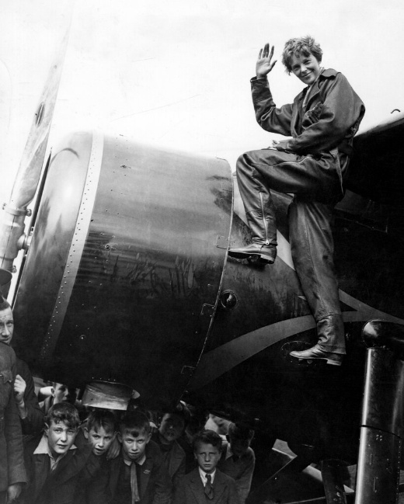Amelia Earhart in 1932
“The documents include a July 1937 radio log from Itasca, a U.S. Coast Guard cutter that was deployed to support Earhart's flight around the world. Itasca was the last ship to have radio contact with Earhart and Noonan before their aircraft disappeared. The phrase ‘Earhart Unheard’ appears numerous times in the log. According to the National Archives, the last communication from Earhart's plane came at about 8:43 a.m. on Jul 2, 1937: ‘We are on the line 157 337 wl rept msg we wl rept…’” https://www.cbsnews.com/news/amelia-earhart-records-declassified-released-missing-aviator/


“The Trump administration recently released more than 4,600 pages of documents related to Amelia Earhart, the aviator who vanished in 1937 while trying to become the first woman to circumnavigate the world.” https://www.nytimes.com/2025/11/17/us/politics/trump-amelia-earhart-flight-records.html?ae=oa&context=newsletter-quiz&nl=On+Politics&q=w&showDialog=1

Dec. 11, 1939 - Nardone v. United States, 308 U.S. 338 (1939)
https://supreme.justia.com/cases/federal/us/308/338/

FRUIT OF POISONOUS TREE - ILLEGAL WIRETAP

“We are called upon for the second time to review affirmance by the Circuit Court of Appeals for the Second Circuit of petitioners' convictions under an indictment for frauds on the revenue. In Nardone v. United States, 302 U. S. 379, this Court reversed the convictions on the first trial because they were procured by evidence secured in violation of § 605 of the Communications Act of 1934 (c. 652, 48 Stat. 1064, 1103; 47 U.S.C. § 605). For details of the facts reference is made to that case. Suffice it here to say that this evidence consisted of intercepted telephone messages, constituting ‘a vital part of the prosecution's proof.’ … The burden is, of course, on the accused in the first instance to prove to the trial court's satisfaction that wiretapping was unlawfully employed. Once that is established -- as was plainly done here -- the trial judge must give opportunity, however closely confined, to the accused to prove that a substantial portion of the case against him was a fruit of the poisonous tree.”

1940: UC Black Students Not allowed To Live In Dorms On Campus

“Marian Spencer, a civil rights icon, was instrumental in desegregating Cincinnati’s Coney Island as well as Cincinnati Public Schools. She went on to become the first African American woman elected to Cincinnati City Council in 1983. As a Black student in the late 1930s and early 1940s, Marian Spencer wasn't permitted to live in a dorm on UC’s campus. Today, there is a residence hall that bears her name, opened in 2018. The Marian Spencer Scholars form a living-learning community housed together in the residence hall for their first year.” Dec. 4, 2024. https://www.uc.edu/news/articles/2024/12/wlwt-segment-features-ucs-marian-spencer-scholarship-program.html?utm_source=cerkl&utm_medium=email&utm_campaign=newsletter-12042024&cerkl_id=20299800&cerkl_ue=A8mLsDEGP2lba17JhuRw0M5uibPpXE21SoiEibe3xak%3D

May 1940: FBI Investigated German Spies In US

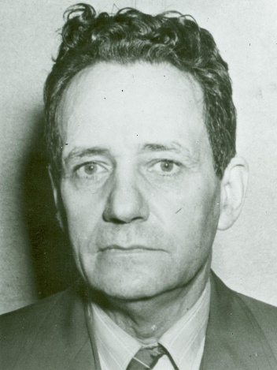
Frederick Joubert Duquesne –“Duquesne Spy Ring”

“First, FBI Lab engineers built a secret shortwave radio transmitting station on Long Island. In May 1940, Bureau agents established contact with the German shortwave station abroad. Our Long Island radio station served as a main channel of communication between German spies in New York City and their superiors in Germany for 16 straight months. Pretending to be Sebold, FBI agents sent more than 300 authentic-sounding messages and received another 200 messages from the Nazis. *** Once we had enough information to pinpoint the members of the ring and enough evidence for an airtight case, the 33 spies were arrested. Nineteen quickly pled guilty. The remaining 14 spies were brought to trial in Brooklyn, New York, on September 3, 1941; they were all found guilty by jury on December 13, 1941. On January 2, 1942, the 33 members of the Nazi spy ring headed by Duquesne were sentenced to serve a total of over 300 years in prison.” https://www.fbi.gov/history/famous-cases/duquesne-spy-ring

September 1940: Lend-Lease Program
“Lend-Lease and Military Aid to the Allies in the Early Years of World War II
During World War II, the United States began to provide significant military supplies and other assistance to the Allies in September 1940, even though the United States did not enter the war until December 1941. Much of this aid flowed to the United Kingdom and other nations already at war with Germany and Japan through an innovative program known as Lend-Lease.” https://history.state.gov/milestones/1937-1945/lend-lease
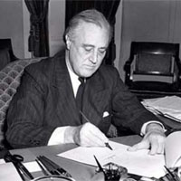
FDR signing Lend-Lease Bill

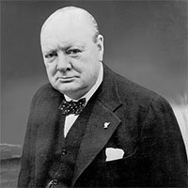Winston Churchill

September 2, 1940: Britain Gets U.S. Destroyers, US Gets Military Bases In Newfoundland And Caribbean
“On September 2, 1940, President Roosevelt signed a “Destroyers for Bases” agreement. Under the terms of the agreement, the United States gave the British more than 50 obsolete destroyers, in exchange for 99-year leases to territory in Newfoundland and the Caribbean, which would be used as U.S. air and naval bases. British Prime Minister Winston Churchill had originally requested that Roosevelt provide the destroyers as a gift, but the President knew that the American public and Congress would oppose such a deal. He therefore decided that a deal that gave the United States long-term access to British bases could be justified as essential to the security of the Western Hemisphere—thereby assuaging the concerns of the public and the U.S. military.” https://history.state.gov/milestones/1937-1945/lend-lease

Caribbean bases:
Eastern side of the Bahamas
Southern coast of Jamaica
Western coast of Saint Lucia
West coast of Trinidad (Gulf of Paria)
Antigua
British Guiana (now Guyana) within fifty miles of Georgetown

Dec. 1, 1940: Attorney General Robert H. Jackson – “Fair Play” By Prosecutors
“Nothing better can come out of this meeting of law enforcement officers than a rededication to the spirit of fair play and decency that should animate the federal prosecutor. Your positions are of such independence and importance that while you are being diligent, strict, and vigorous in law enforcement you can also afford to be just. Although the government technically loses its case, it has really won if justice has been done.”
https://www.roberthjackson.org/speech-and-writing/the-federal-prosecutor/

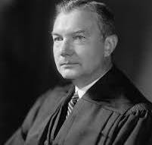

“He rose from IRS legal counsel to Assistant Attorney General, to Solicitor General, and finally, to Attorney General. Roosevelt appointed Jackson to the Supreme Court in 1941 after years of loyal and effective advocacy. While on the Court, Jackson served as chief U.S. prosecutor at the Nuremberg war crimes trials at the conclusion of World War II.” https://www.oyez.org/justices/robert_h_jackson

Jan. 20, 1941: President Franklin D. Roosevelt – Third Inauguration
Dec. 7, 1941 – Pearl Harbor, Hawaii – 4 Battleships Sunk – 4 Damaged
“Many U.S. ships were sunk or damaged and more than 2,400 sailors, Marines, soldiers and civilians were killed.”
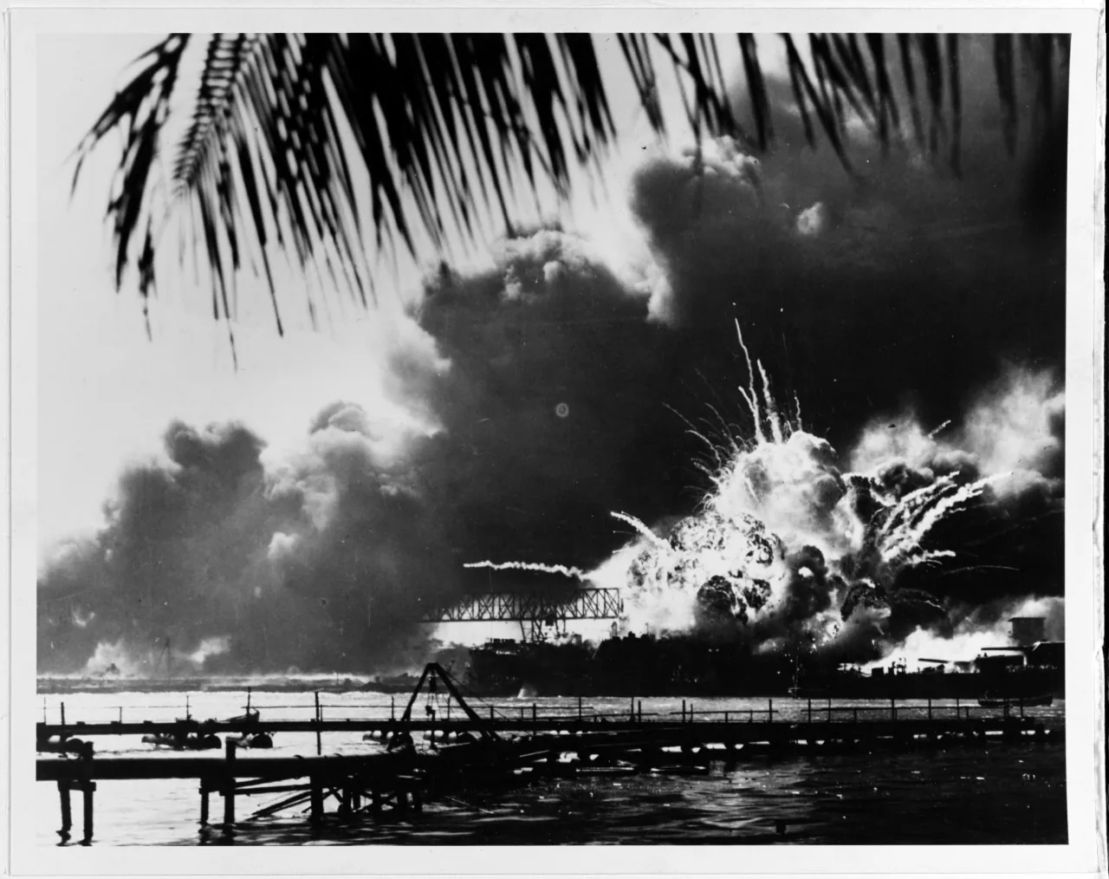
“An explosion occurs the USS Shaw during the Japanese attack on Pearl Harbor on Dec. 7, 1941.”
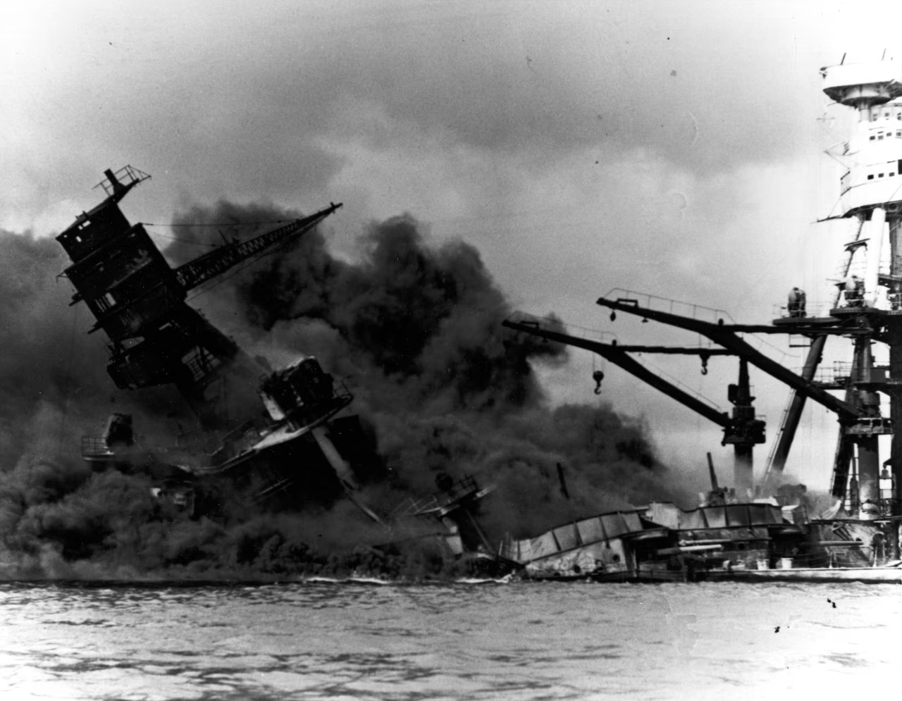 T
“The USS Arizona arrived at Pearl Harbor on Dec. 5, 1941. It was sunk two days later.”

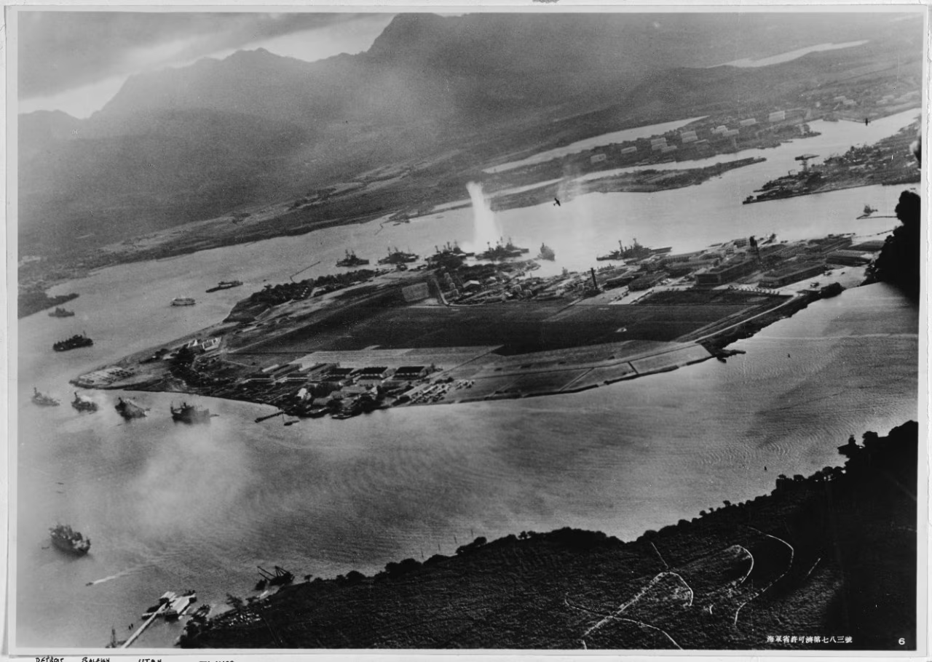
“This photo was taken from a Japanese plane during the attack on Pearl Harbor on Dec. 7, 1941.”
https://www.washingtonpost.com/history/2025/08/18/pearl-harbor-navy-attack-book-lost-archives-found/?utm_campaign=wp_post_most&utm_medium=email&utm_source=newsletter&carta-url=https%3A%2F%2Fs2.washingtonpost.com%2Fcar-ln-tr%2F4438f7a%2F68a350eef256107aad6bd6a1%2F59731235ade4e21a848a56ed%2F28%2F66%2F68a350eef256107aad6bd6a1

Dec. 8, 1941 – Japanese 10 Hours After Pear Harbor Attacked Philippines – Also Guam, Midway Island, Wake Island (and British colonies of Malaya, Singapore and Hong Kong)
“The first wave of Japanese bombers approached Clark Field undetected on Dec. 8, 1941. By the time US airmen realized they were under attack, the bombs were already falling. Almost all of the American airplanes at Clark—45 miles north of Manila and the main operational base of the Far East Air Force in the Philippines—were lined up neatly on the ground when the strike came at 12:40 p.m. Japanese A6M Zero fighters followed the bombers, dropping down to strafe the ramp. The fighter base at Iba on the western coast of Luzon, 42 miles from Clark, was struck almost simultaneously.

By end of the first day, the strength of Far East Air Force was reduced by half, and it was eliminated as an effective fighting force. The FEAF response was scattered and ineffective. Of approximately 200 aircraft in the Japanese strike force, all but eight returned to their bases on Formosa.” https://www.afpaaa.org/resources/link-only-pages/correll-articles/disaster-in-the-philippines.pdf

Dec. 8, 1941 – President Roosevelt – “Day in Infamy’ Address to Congress
Address to the Congress Asking That a State of War Be Declared Between the United States and Japan. https://www.loc.gov/resource/afc1986022.afc1986022_ms2201/?st=text
“Mr. Vice President, and Mr. Speaker, and Members of the Senate and House of Representatives:

YESTERDAY, December 7, 1941 a date which will live in infamy the United States of America was suddenly and deliberately attacked by naval and air forces of the Empire of Japan.

The United States was at peace with that Nation and, at the solicitation of Japan, was still in conversation with its Government and its Emperor looking toward the maintenance of peace in the Pacific. Indeed, one hour after Japanese air squadrons had commenced bombing in the American Island of Oahu, the Japanese Ambassador to the United States and his colleague delivered to our Secretary of State a formal reply to a recent American message. And while this reply stated that it seemed useless to continue the existing diplomatic negotiations, it contained no threat or hint of war or of armed attack.

It will be recorded that the distance of Hawaii from Japan makes it obvious that the attack was deliberately planned many days or even weeks ago. During the intervening time the Japanese Government has deliberately sought to deceive the United States by false statements and expressions of hope for continued peace.

The attack yesterday on the Hawaiian Islands has caused severe damage to American naval and military forces. I regret to tell you that very many American lives have been lost. In addition American ships have been reported torpedoed on the high seas between San Francisco and Honolulu.

Yesterday the Japanese Government also launched an attack against Malaya. Last night Japanese forces attacked Hong Kong: Last night Japanese forces attacked Guam. Last night Japanese forces attacked the Philippine Islands. Last night the Japanese attacked Wake Island. And this morning the Japanese attacked Midway Island.

Japan has, therefore, undertaken a surprise offensive extending throughout the Pacific area. The facts of yesterday and today speak for themselves. The people of the United States have already formed their opinions and well understand the implications to the very life and safety of our Nation.

As Commander in Chief of the Army and Navy I have directed that all measures be taken for our defense.

But always will our whole Nation remember the character of the onslaught against us.
No matter how long it may take us to overcome this premeditated invasion, the American people in their righteous might will win through to absolute victory.
I believe that I interpret the will of the Congress and of the people when I assert that we will not only defend ourselves to the uttermost but will make it very certain that this form of treachery shall never again endanger us.

Hostilities exist. There is no blinking at the fact that our people, our territory, and our interests are in grave danger.

With confidence in our armed forces with the unbounding determination of our people we will gain the inevitable triumph so help us God.
I ask that the Congress declare that since the unprovoked and dastardly attack by Japan on Sunday, December 7, 1941, a state of war has existed between the United States and the Japanese Empire

Feb. 21, 1942 – Pearl Harbor Spy
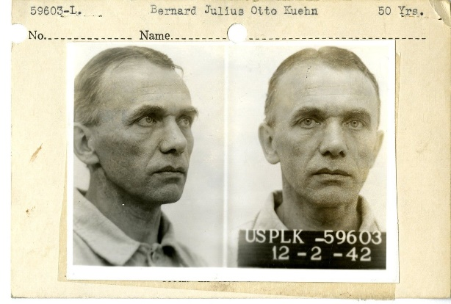
On February 21, 1942, just 76 days after the tragic attack on Pearl Harbor, Bernard Julius Otto Kuehn was found guilty of spying and sentenced to be shot “by musketry” in Honolulu.
What was a German national doing in Hawaii in the days leading up to the attack? What exactly did Kuehn do to warrant such a sentence? Here’s the story.

Bed sheets on clothes lines. Lights in dormer windows. Car headlights. A boat with a star on its sail.
Otto Kuehn had a complex system of signals all worked out. A light shining in the dormer window of his Oahu house from 9 to 10 p.m., for example, meant that U.S. aircraft carriers had sailed. A linen sheet hanging on a clothes line at his home on Lanikai beach between 10 and 11 a.m. meant the battle force had left the harbor. There were eight codes in all, used in varying combinations with the different signals.
In November 1941, Kuehn had offered to sell intelligence on U.S. warships in Hawaiian waters to the Japanese consulate in Hawaii. On December 2, he provided specific—and highly accurate—details on the fleet in writing. That same day, he gave the consulate the set of signals that could be picked up by nearby Japanese subs.
Kuehn—a member of the Nazi party—had arrived in Hawaii in 1935. By 1939, the Bureau was suspicious of him. He had questionable contacts with the Germans and Japanese. He'd lavishly entertained U.S. military officials and expressed interest in their work. He had two houses in Hawaii, lots of dough, but no real job. Investigations by the Bureau and the Army, though, never turned up definite proof of his spying.
Not until the fateful attack of December 7, 1941. Honolulu Special Agent in Charge Robert Shivers﻿ immediately began coordinating homeland security in Hawaii and tasked local police with guarding the Japanese consulate. They found its officials trying to burn reams of paper. These documents—once decoded—included a set of signals for U.S. fleet movements.
All fingers pointed at Kuehn. He had the dormer window, the sailboat, and big bank accounts.
Kuehn was arrested the next day and confessed, though he denied ever sending coded signals. His sentence was commuted—50 years of hard labor instead of death “by musketry”—and he was later deported.
https://www.fbi.gov/history/famous-cases/pearl-harbor-spy

April 18, 1942 - Doolittle Raid
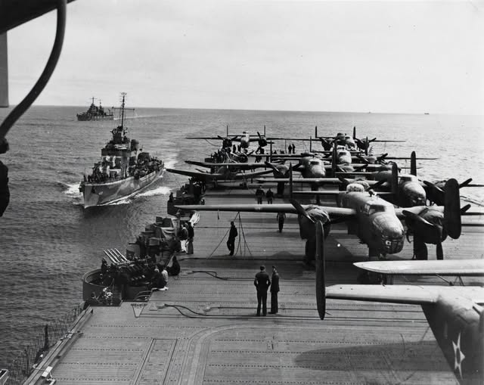
“James H. Doolittle - Leading the attack was Army Lt. Col. James H. Doolittle. Jimmie Doolittle was an aviation pioneer and daredevil racer. He pioneered instrument flying. He won the Schneider Race for the Army in 1925. He pushed for higher octane gasoline for aircraft in the 1930s, when he was an employee of Shell. Doolittle trained the volunteer crews to take off their B-25B Mitchell bombers in only 450 feet instead of the usual 1,200. The planes were loaded aboard the USS Hornet in March 1942. The plan was to launch the bombers within 400 miles of the Japanese coast. They would then bomb their targets and continue to airfields in China. But Japanese picket boats discovered the task force about 800 miles off the coast, and the Army planes were launched immediately. The 16 bombers struck Tokyo, Kobe, Nagoya and Yokohama. Because of the added distance, no plane was able to make the Chinese airfields. Most of the planes crash landed in China with one plane landing in the Soviet Union. Of the 75 fliers who landed in China three died in accidents and eight were captured by the Japanese. The rest returned to the United States.” https://www.afhistory.af.mil/FAQs/Fact-Sheets/Article/458984/1942-doolittles-raid/

“Of the 16 B-25s, 15 crashed in occupied China, where the Japanese inflicted brutal reprisals against the Chinese populace who had sheltered the American airmen. The Japanese also managed to capture the survivors of two crews, later executing three of them. One B-25 landed intact at Vladivostok, where the Soviets interned the aircraft and its crew.” https://www.history.navy.mil/browse-by-topic/wars-conflicts-and-operations/world-war-ii/1942/halsey-doolittle-raid.html

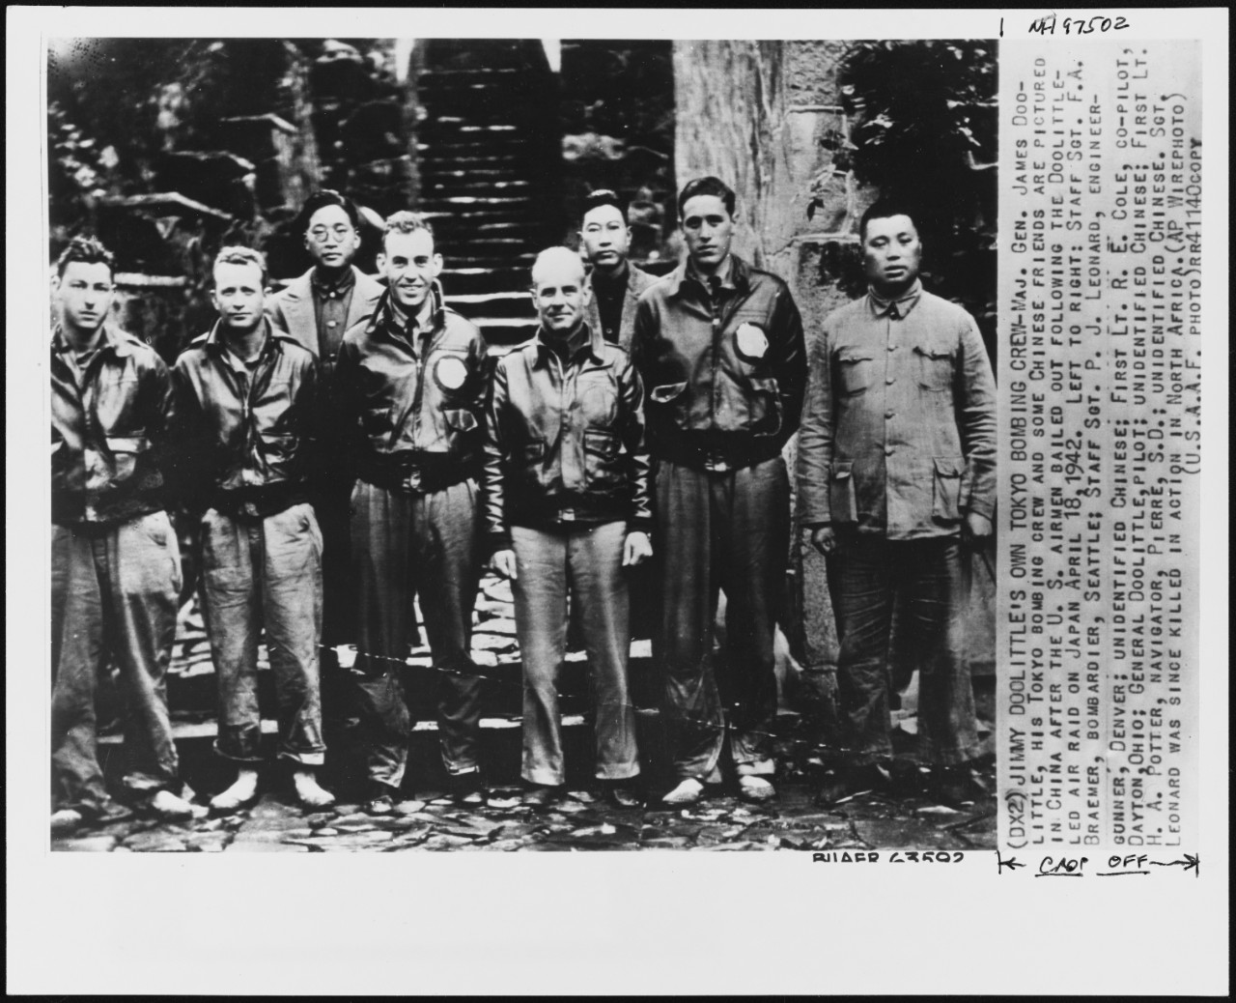
Doolittle and crew in China.

1942: Japanese Internment Camps
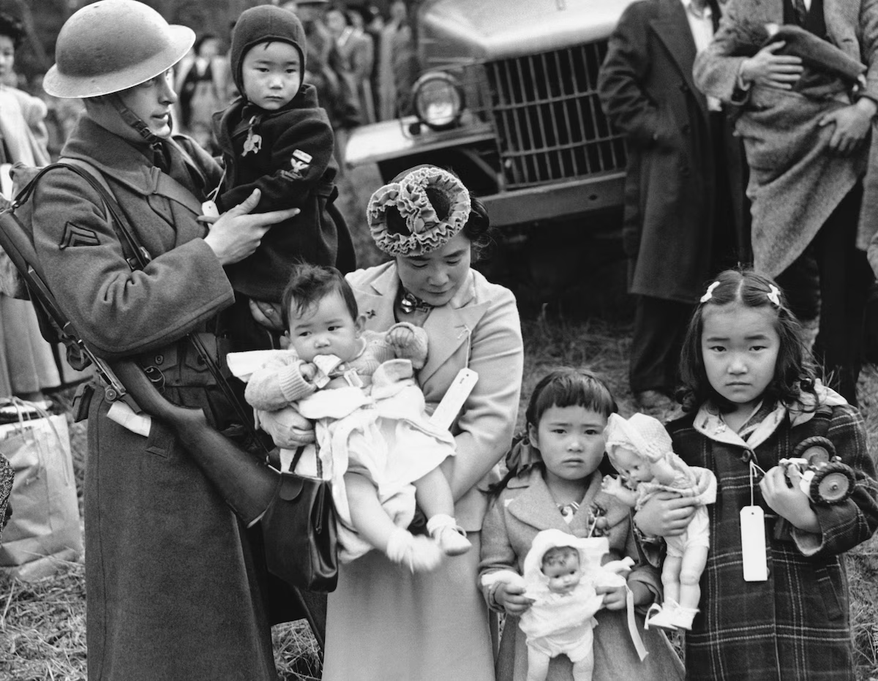March 30, 1942

March 19, 2025: “‘Very dangerous’: Japanese Americans warn of Trump’s use of Alien Enemies Act. Some fear Trump’s invocation of a 1798 wartime authority could lead to abuses similar to those that took place during one of the darkest chapters of U.S. history *** President Franklin D. Roosevelt’s use of the law, in the immediate aftermath of the Japanese military’s bombing of Pearl Harbor on Dec. 7, 1941, led to the arrest of 31,000 Japanese, German and Italian nationals in the United States and Latin America. Many were later found to have been improperly arrested, jailed and, in some cases, repatriated.” https://www.washingtonpost.com/immigration/2025/03/19/japanese-americans-alien-enemies-trump-deportations/?utm_campaign=wp_post_most&utm_medium=email&utm_source=newsletter&carta-url=https%3A%2F%2Fs2.washingtonpost.com%2Fcar-ln-tr%2F41bce12%2F67e028bae630c35b0faa13e7%2F59731235ade4e21a848a56ed%2F38%2F54%2F67e028bae630c35b0faa13e7
***
“Japanese internment camps were established during World War II by President Franklin Roosevelt through his Executive Order 9066. From 1942 to 1945, it was the policy of the U.S. government that people of Japanese descent would be interred in isolated camps. Enacted in reaction to Pearl Harbor and the ensuing war, the Japanese internment camps are now considered one of the most atrocious violations of American civil rights in the 20th century.” https://www.history.com/topics/world-war-ii/japanese-american-relocation
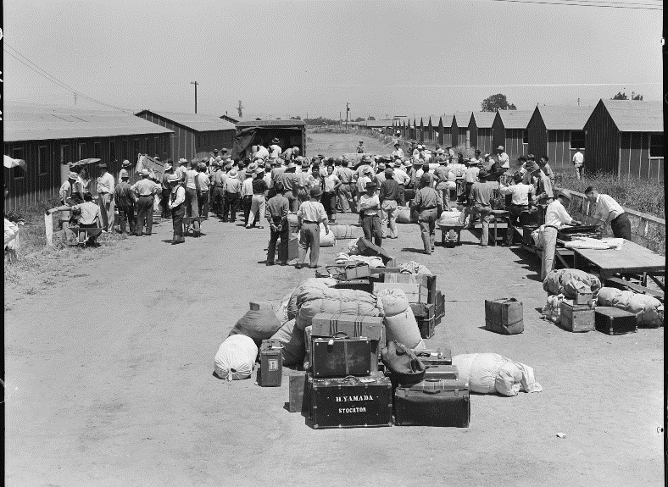
https://www.nationalww2museum.org/war/articles/japanese-american-incarceration

June 6, 1942: USS Yorktown sunk


The USS Yorktown at sea in 1939. A Japanese attack on the aircraft carrier in 1942 caused it to sink during the Battle of Midway. (U.S. Navy/Library of Congress)
“Yorktown took part in several operations during World War II (WWII), including the Battle of the Coral Sea from May 4-8, 1942, and the Battle of Midway from June 4-7, 1942. During the Battle of Midway, Japanese Aichi D3A bombers successfully attacked Yorktown. Three bombs hit their targets: the first at the midship elevator on the starboard side; the second inside the starboard side exhaust stack, which crippled five of the nine boilers; and the third at the aft elevator on the starboard side. Despite this, Yorktown was able to recover and continue to launch aircraft. Later in the battle, Japanese Nakajima B5N torpedo bombers delivered two torpedo hits along the port side of the carrier, destroying its rudder system. Unable to move, Yorktown was towed by destroyer USS Hammann for transit back to Pearl Harbor for repairs. On the morning of June 7, 1942, while under tow, the Imperial Japanese Navy submarine I-168 attacked both vessels, sinking Hammann and striking Yorktown twice on the starboard side, causing the carrier to capsize and sink.” https://oceanexplorer.noaa.gov/news/exploration-extras/photogrammetry/yorktown/yorktown.html

June 20, 1942 – Japanese pilot drops bomb on Oregon
“On June 20, 1942, the Imperial Japanese Navy I-25 torpedoed a Canadian lumber schooner, the S.S. Camosun near Cape Flattery, followed by the shelling of the Estevan Point lighthouse and Canadian radio station on Vancouver Island by the I-26 submarine. In the late night and early morning of June 21-22, the I-25 submarine fired multiple 14-cm [5.5-inch] shells at Battery Russell on Fort Stevens, which defended the Oregon side of the Columbia River. It was later assessed that 17 rounds had been fired, yet no loss of life occurred during the attack. Most of the damage was done to the baseball field and telephone cables, but the bombardment only heightened the tension of more attacks. The shelling of Fort Stevens was historic, marking the first foreign attack on a military installation on U.S. soil since the War of 1812.” https://www.dvidshub.net/news/435846/bombing-oregon-80th-anniversary-japanese-attacks-state

Nov. 28, 1942: Boston - Cocoanut Grove fire
“The deadliest nightclub fire in U.S. history, the Cocoanut Grove nightclub burned on November 28, 1942, killing 492 people.*** It was the Saturday after Thanksgiving, and the night of the highly anticipated football game between rivals Boston College and Holy Cross. Nearly a year after Pearl Harbor, men and women were looking for ways to forget about the war for a few hours. Crowds pushed night clubs and theaters beyond their limits. The Cocoanut Grove night club was no exception. Already a very popular venue, a new bar, the New Broadway Lounge, had recently opened within the night club. The night club was very crowded, with some estimates as high as a thousand people. The fire was first noticed around 10:15 p.m. in the Melody Lounge, which was located in the basement. According to witnesses, it immediately spread throughout the Melody Lounge between the false cloth ceiling and the plywood ceiling above it, then ascended the stairway.” https://sites.google.com/view/cocoanutgrove-fire
See also: https://www.nfpa.org/Public-Education/Staying-safe/Safety-in-living-and-entertainment-spaces/Nightclubs-assembly-occupancies/The-Cocoanut-Grove-fire

1943 - FDNY
Chief, the dalmatian of FDNY Engine Co. 20, rides a sidecar on the fire truck, 1943.
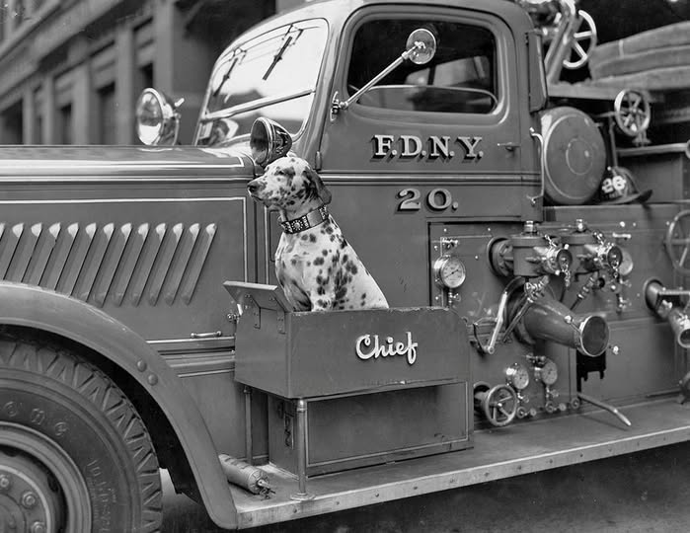

May, 1943 – The Tuskegee Airmen - African American Pilots of WWII
“Before the Tuskegee Airmen, no African American had ever been a United
States military pilot. The Jim Crow laws, a series of racist laws that enforced
the ‘separate but equal’ treatment of African Americans, were used as
justification for blocking previous attempts by African American soldiers to
become pilots. African Americans served bravely and with distinction in every
theater of World War II, while simultaneously struggling for their own civil
rights from ‘the world’s greatest democracy.’ Although the United States
Armed Forces were officially segregated until 1948, WWII laid the foundation
for post-war integration of the military. In 1941 fewer than 4,000 African
Americans were serving in the military and only twelve African Americans had
become officers. By 1945, more than 1.2 million African Americans would be
serving in uniform on the Home Front, in Europe, and the Pacific (including
thousands of African American women in the Women’s auxiliaries).
The Army Air Forces established several African American organizations, including fighter and bombardment groups and squadrons. Between 1941 and 1946, roughly 1,000 black pilots were trained at a segregated air base in Tuskegee, AL. The Tuskegee Airmen flew hundreds of patrol and attack missions for the Twelfth Air Force, flying P-40 and P-39 airplanes, before they were reassigned to the 15th Air Force to escort B-17 and B-24 heavy bombers, using P-47 and P-51 airplanes. The famous ‘Tuskegee Airmen’ of the 332nd Fighter Group became part of the 15th Air Force, escorting American
bombers as they flew over Italy. As escorts, flying P-47s and later P-51s, they were responsible for protecting larger bombers from German fighter planes. The Tuskegee Airmen flew more than 15,000 sorties between May 1943 and June 1945. Bomber crews often requested to be escorted by these ‘Red Tails,’ a nicknamed acquired from the painted tails of Tuskegee fighter planes, which were a distinctive deep red. Sixty-six Tuskegee Airmen died in combat. They had one of the lowest loss records of any escort fighter group.” https://www.nationalww2museum.org/sites/default/files/2017-07/tuskegee-airmen.pdf
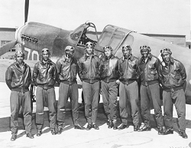

Jan. 1944 General George S. Patton and Major General Geoffrey Keyes – In Italy - Patton commanding the Seventh Army in the Mediterranean Theater
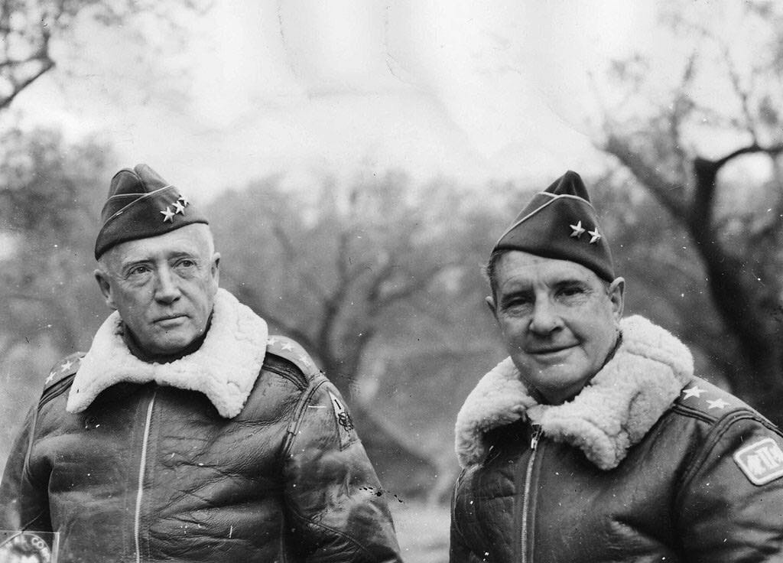

May 14, 1944: Winston Churchill
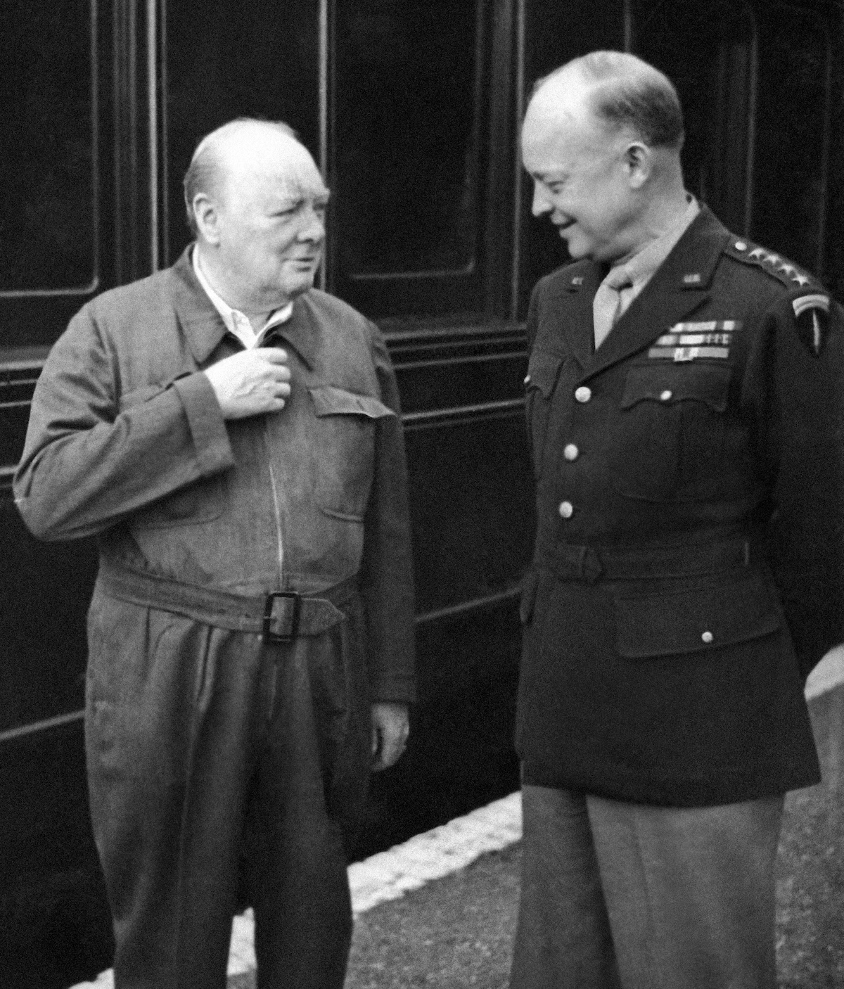
Britain’s Prime Minister Winston Churchill demonstrates the zipper on his “siren suit” to Gen. Dwight D. Eisenhower in England on May 14, 1944. (AP). https://www.washingtonpost.com/history/2025/03/03/winston-churchill-siren-suit-onesie/?utm_campaign=wp_post_most&utm_medium=email&utm_source=newsletter&carta-url=https%3A%2F%2Fs2.washingtonpost.com%2Fcar-ln-tr%2F416b32f%2F67c73431fcd029063f7f8b58%2F59731235ade4e21a848a56ed%2F44%2F55%2F67c73431fcd029063f7f8b58

June 5, 1944
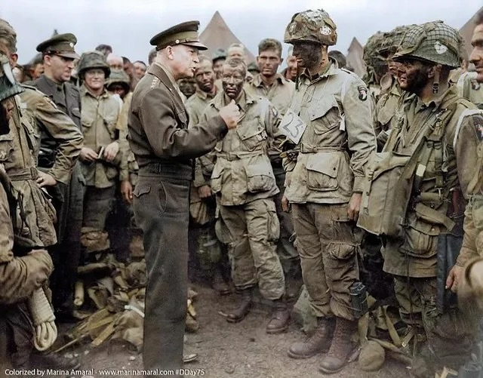
General Eisenhower briefs the paratroopers on the crucial role for D-Day. He tells them “You are about to embark upon the Great Crusade, toward which we have striven these many months. The eyes of the world are upon you”.

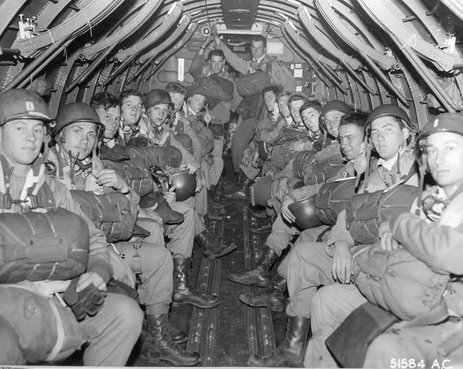

June 6, 1944 – D-DAY
“Success demanded a very specific set of conditions:
Before the landings, the weather needed to be calm for 48 hours.
For the three days following, the wind needed to stay below Beaufort Force 4, equivalent to a moderate breeze.
Parachutists and other air support needed less than 30 percent cloud cover below 8,000 feet, with a cloud base no lower than 2,500 feet and visibility of over three miles.
A low tide at dawn was needed to expose German defenses.
The invasion had to occur one day before or four days after a full moon for nighttime operations.
Furthermore, the invasion had to align with the Soviet summer offensive in the East, to maximize pressure on German forces.
The Allies identified a window: between June 5 and June 7.” https://www.nytimes.com/2025/06/05/weather/d-day-forecast-history-wwii.html

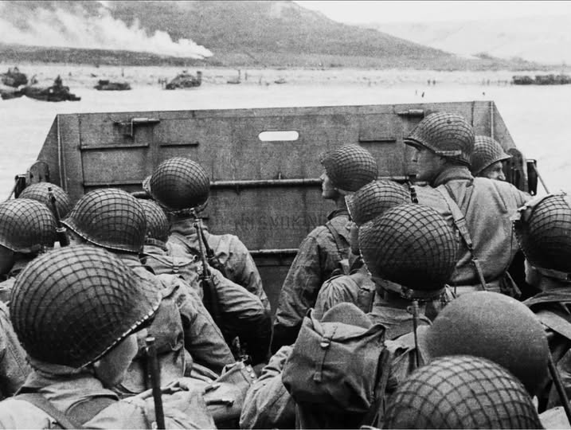

June 1944 – The Ghost Army
 https://www.nationalww2museum.org/visit/exhibits/traveling-exhibits/ghost-army-combat-con-artists-world-war-ii
“In June 1944, a secret U.S. Army unit went into action in Normandy. The weapons they deployed were decidedly unusual: hundreds of inflatable tanks and a one-of-a-kind collection of sound effects records. Their mission was to use bluff, deception, and trickery to save lives. Many were artists, some of who would become famous, including a budding fashion designer named Bill Blass. They painted and sketched their way across Europe, creating a unique visual record of their journey. The story of what these men accomplished was hushed up by the Pentagon for more than forty years.” https://rickbeyer.net/about/films/

June 1944 – U.S. Military – All Japanese Unit
“The 522nd was part of the famed 442nd Regimental Combat Team, the all-nisei unit that lived up to its motto ‘Go For Broke,’ taking heavy casualties in bloody battles in Italy and France. The 442nd remains the most decorated unit for its size and length of combat service in the history of the U.S. military. The 522nd arrived in Italy as part of the 442nd in June 1944. The unit fought with distinction in several pivotal battles, including in the storied rescue of the Lost Battalion in the Vosges Mountains of France. In that battle, eight forward observers from C Battery, including George Oiye, found themselves pinned down by German machine-gun fire. After five days of continuous fighting, the soldiers found the Texas National Guard’s 1st Battalion of the 141st Regiment, which had been surrounded by German soldiers for nearly a week. Miraculously, all eight artillerymen from the 522nd survived.” https://www.washingtonpost.com/history/2025/05/09/eighty-years-ago-they-liberated-prisoners-dachau-death-march-this-month-they-remembered/?utm_campaign=wp_post_most&utm_medium=email&utm_source=newsletter&carta-url=https%3A%2F%2Fs2.washingtonpost.com%2Fcar-ln-tr%2F427b763%2F681e297766b7286f0ec392e9%2F59731235ade4e21a848a56ed%2F31%2F58%2F681e297766b7286f0ec392e9

Japanese Relocation Camps
“In response to the Japanese attack on Pearl Harbor during World War II, the U.S. government decided to require Japanese-Americans to move into relocation camps as a matter of national security. President Franklin Roosevelt signed Executive Order 9066 in February 1942, two months after Pearl Harbor. A Japanese-American man living in San Leandro, Fred Korematsu, chose to stay at his residence rather than obey the order to relocate. Korematsu was arrested and convicted of violating the order. He responded by arguing that Executive Order 9066 violated the Fifth Amendment. The Ninth Circuit affirmed Korematsu's conviction.
***
The petitioner, an American citizen of Japanese descent, was convicted in a federal district court for remaining in San Leandro, California, a ‘Military Area,’ contrary to Civilian Exclusion Order No. 34 of the Commanding General of the Western Command, U.S. Army, which directed that, after May 9, 1942, all persons of Japanese ancestry should be excluded from that area.” https://supreme.justia.com/cases/federal/us/323/214/#tab-opinion-1938225

July 6, 1944: Jackie Robinson – U.S. Army Bus / Arrest & Found Not Guilty At Court Marshal
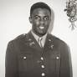
“As detailed in the masterful Jackie Robinson: A Biography by Arnold Rampersad, on July 6, 1944, Robinson ‘became entangled in a dispute that threatened to end his military service in disgrace.’ While riding on a military bus returning to a hospital from ‘the colored officers club,’ Robinson sat next to Virginia Jones, the wife of one of his fellow officers. Jones looked white — at least the white bus driver thought so. After a few blocks, the driver abruptly ordered Robinson ‘to move to the back of the bus.’ Robinson, justifiably outraged, refused. Among other things, he had read that segregation was no longer allowed on military buses (pdf) and proceeded to engage in a form of protest prefiguring a similar action by Rosa Parks 11 years later.

Rampersad reprints Robinson’s statement about what happened next: ‘The bus driver asked me for my identification card. I refused to give it to him. He then went to the Dispatcher and told him something. What he told him I don’t know. He then comes back and tells the people that this nigger is making trouble. I told the driver to stop f—in with me, so he gets the rest of the men around there and starts blowing his top and someone calls the MP’s.’ Robinson was placed under ‘arrest in quarters,’ which meant that ‘he would be considered under arrest at the hospital, although without a guard. Robinson was then taken to the hospital in a police pickup truck.’ A white officer would recall that Robinson ‘was handcuffed, and there were shackles on his legs. Robinson’s face was angry, the muscles on his face tight, his eyes half closed.’

Robinson was transferred to the 758th Tank Battalion on July 24, ‘where the commander signed orders to prosecute him.’ On that day, he was arrested. Rampersad says that ‘At 1:45 in the afternoon on August 2, the case of The United States v. 2nd Lieutenant Jack R. Robinson, 0-10315861, Cavalry, Company C, 758th Tank Battalion, began.’ Robinson’s fate was in the hands of nine men, eight of them white: ‘One was black; another had been a UCLA student [where Robinson had been an undergraduate]. Six votes were needed for conviction.’
Robinson faced two charges: ‘The first, a violation of Article of War No. 63, accused him of “behaving with disrespect toward Capt. Gerald M. Bear, CMP, his superior officer” … The second charge was a violation of Article No. 64, in this case “willful disobedience of lawful command of Gerald M. Bear, CMP, his superior.” Three other charges were dropped before the trial began. Testimony reveals how bravely Robinson had fought to defend himself on the evening of the incident, including reportedly saying quite heroically, ‘Look here, you son-of-a-bitch, don’t you call me no nigger!’ After a four-hour trial, Robinson was exonerated: Robinson secured at least the four votes (secret and written) needed for his acquittal. He was found ‘not guilty of all specifications and charges.'” https://www.pbs.org/wnet/african-americans-many-rivers-to-cross/history/was-jackie-robinson-court-martialed/

Dec. 18, 1944: U.S. Supreme Court - Korematsu v. United States (6 to 3) https://www.oyez.org/cases/1940-1955/323us214
RELOCATION CAMPS LAWFUL
“In response to the Japanese attack on Pearl Harbor during World War II, the U.S. government decided to require Japanese-Americans to move into relocation camps as a matter of national security. President Franklin Roosevelt signed Executive Order 9066 in February 1942, two months after Pearl Harbor. A Japanese-American man living in San Leandro, Fred Korematsu, chose to stay at his residence rather than obey the order to relocate. Korematsu was arrested and convicted of violating the order. He responded by arguing that Executive Order 9066 violated the Fifth Amendment. The Ninth Circuit affirmed Korematsu's conviction…. In an opinion written by Justice Black, the Court ruled that the evacuation order violated by Korematsu was valid. The majority found that the Executive Order did not show racial prejudice but rather responded to the strategic imperative of keeping the U.S. and particularly the West Coast (the region nearest Japan) secure from invasion. The Court relied heavily on a 1943 decision, Hirabayashi v. U.S., which addressed similar issues. Black argued that the validation of the military's decision by Congress merited even more deference.” https://www.oyez.org/cases/1940-1955/323us214

July 7, 1944 – Senior Officers
General Montgomery with Generals Patton (left) and Bradley (center) at 21st Army Group HQ, Normandy, 7 July 1944.



July 21, 1945
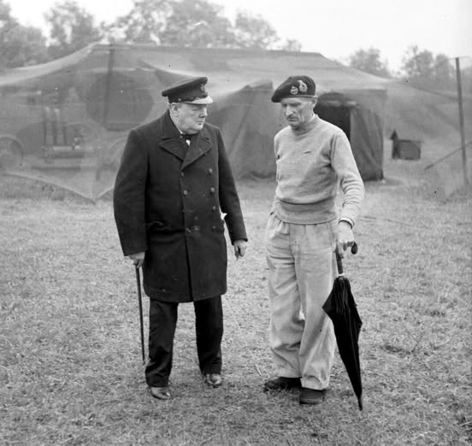
Winston Churchill with General Montgomery at his HQ in Normandy - 21 July 1944

September 1944
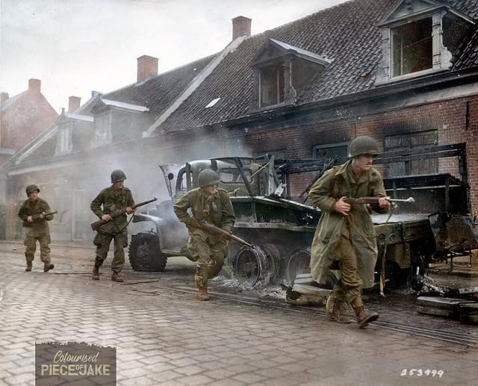
American soldiers of the 101st Airborne Division rush past a burned-out truck in Veghel, the Netherlands in September 1944

Dec. 1944 – General George Patton – Incident Command / Battle of the Bulge
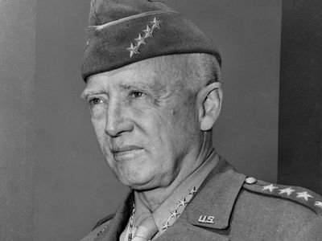
“In December 1944 the Germans launched a massive surprise counterattack in the Ardennes Forest, encircling the U.S. 101st Airborne Division at Bastogne, Belgium. Supreme Allied Commander Gen. Dwight D. Eisenhower ordered the Third Army to relieve Bastogne, and Patton repositioned his force with astonishing speed. Such a feat was made possible in large part by Patton’s intelligence officer, Col. Oscar Koch, who had predicted the German offensive on the basis of a shrewd analysis of enemy troop strength and disposition. Advance elements of the Third Army reached Bastogne’s tenacious defenders on December 26, and additional reinforcements followed over subsequent days. Patton’s forces continued to push the Germans back, and by the end of January 1945, the Third Army had reached the German frontier. On March 1 those forces took Trier, precipitating one of the most famous exchanges of the war. When Patton received a message instructing him to bypass the city because it would take four divisions to capture it, Patton replied, “Have taken Trier with two divisions. Do you want me to give it back?” Over the next 10 days, they cleared the entire region north of the Moselle River, trapping thousands of Germans. They then joined the Seventh Army in sweeping the Saar and the Palatinate, where they took 100,000 prisoners.” https://www.britannica.com/biography/George-Smith-Patton

***
‘Early on the misty winter morning of Dec. 16, 1944, more than 200,000 German troops and nearly 1,000 tanks launched Adolf Hitler's last bid to reverse the ebb in his fortunes that had begun when Allied troops landed in France on D-Day. Seeking to drive to the coast of the English Channel and split the Allied armies as they had done in May 1940, the Germans struck in the Ardennes Forest, a 75-mile stretch of the front characterized by dense woods and few roads, held by four inexperienced and battle-worn American divisions stationed there for rest and seasoning.” https://www.army.mil/botb/
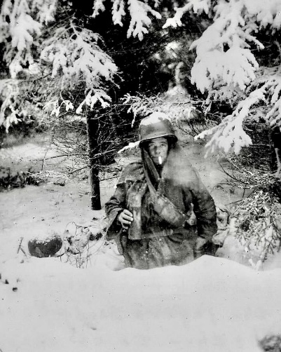
Pfc George A Guckenberger, D Company, 2nd Battalion, 506 Parachute Infantry Regiment, 101st Airborne Division in his foxhole near Bastogne in January, 1945.

Jan. 20, 1945: President Franklin D. Roosevelt – Fourth Inauguration
“Franklin Roosevelt’s fourth inauguration in 1945 was by all accounts a small and serious event. In January 1945, the nation was entering its last year of the war and President Roosevelt had a lot on his mind. Roosevelt just won a tough election marked by accusations against the President and his family (famously including his dog Fala) and questions about the President’s health. In early January the administration fought with Congress in an attempt to address severe shortages of men for military service and in critical manufacturing sectors. In Europe, US and British forces had beaten back the German Wehrmacht in the Battle of the Bulge. In what turned out to be the largest battle in the history of the US Army, more than 600,000 soldiers fought desperately in horrific conditions to break the determined German assault.” https://www.nationalww2museum.org/war/articles/fdr-inauguration-ceremony-1945

Feb. 22, 1945 – U.S. Marines, Iwo Jima
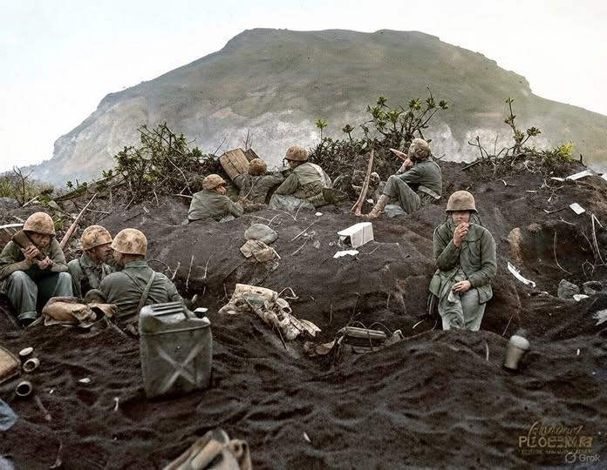US Marines dig in on a forward position, facing entrenched Japanese troops on the slopes of Mount Suribachi, Iwo Jima, on 22 February 1945.

April 12, 1945: President Harry S. Truman – First Inauguration
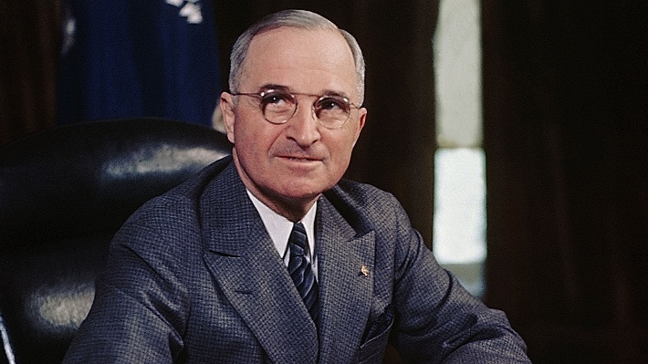

“Truman’s inauguration reflected the recent Allied victory in World War II and the beginning of the Cold War with the Soviet Union. The celebratory events featured hundreds of war planes flying overhead and armed soldiers marching in the streets, demonstrating victory, confidence, and prosperity. Truman referred to communism as the ‘false prophecy’ in his address, reinforcing contemporary views of the ideology’s threat to the United States. He outlined four major courses of action to navigate World War II’s aftermath while addressing public concern for democracy’s growing ideological opponent.” https://evolutiondc.museum.gwu.edu/admit-one-trumans-inauguration/

Feb. 1945: The Assault on IWO JIMA
“The conquest of Iwo Jima had taken a heavy toll of the Marines—17,372 wounded and 5,931 killed— but the island had to be taken. An inkling of its importance in the aerial war against Japan may be gained from the fact that by the war's end, 2,251 heavy
bombers carrying 24,761 Americans had found refuge at Iwo Jima during the course of raids on Japan. The courage and heroism displayed by all those who fought and died on Iwo Jima, including those who proudly raised their nation's colors atop Mt. Suribachi, inspired a war-weary nation to push for final victory. The Japanese defenders led by General Kuribayashi had proved a formidable foe but were beaten. They were overwhelmed by a skillfully led band of Ameri cans among whom, in the words of Fleet Admiral Chester W. Nimitz, ‘Uncommon valor was a common virtue.’” https://www.marines.mil/Portals/1/Publications/The%20United%20States%20marines%20On%20Iwo%20Jima_The%20Battle%20and%20the%20Flag%20Raisings%20%20PCN%2019000316600.pdf

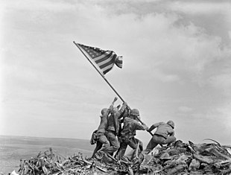
The most famous battle photograph ever taken, the second flag-raising on Mount Suribachi on Iwo Jima. Pictured from left are 1-PFC Ira H. Hayes; 2-PFC Franklin R. Sousley, KIA; 3-Sgt Michael Strank, KIA; 4-PM2/C John H. Bradley; 5-PFC Rene A. Gagnon; and 6-Cpl Harlon H. Block, KIA.

July 16, 1945 – First Atomic Bomb test, Los Alamos, Nevada
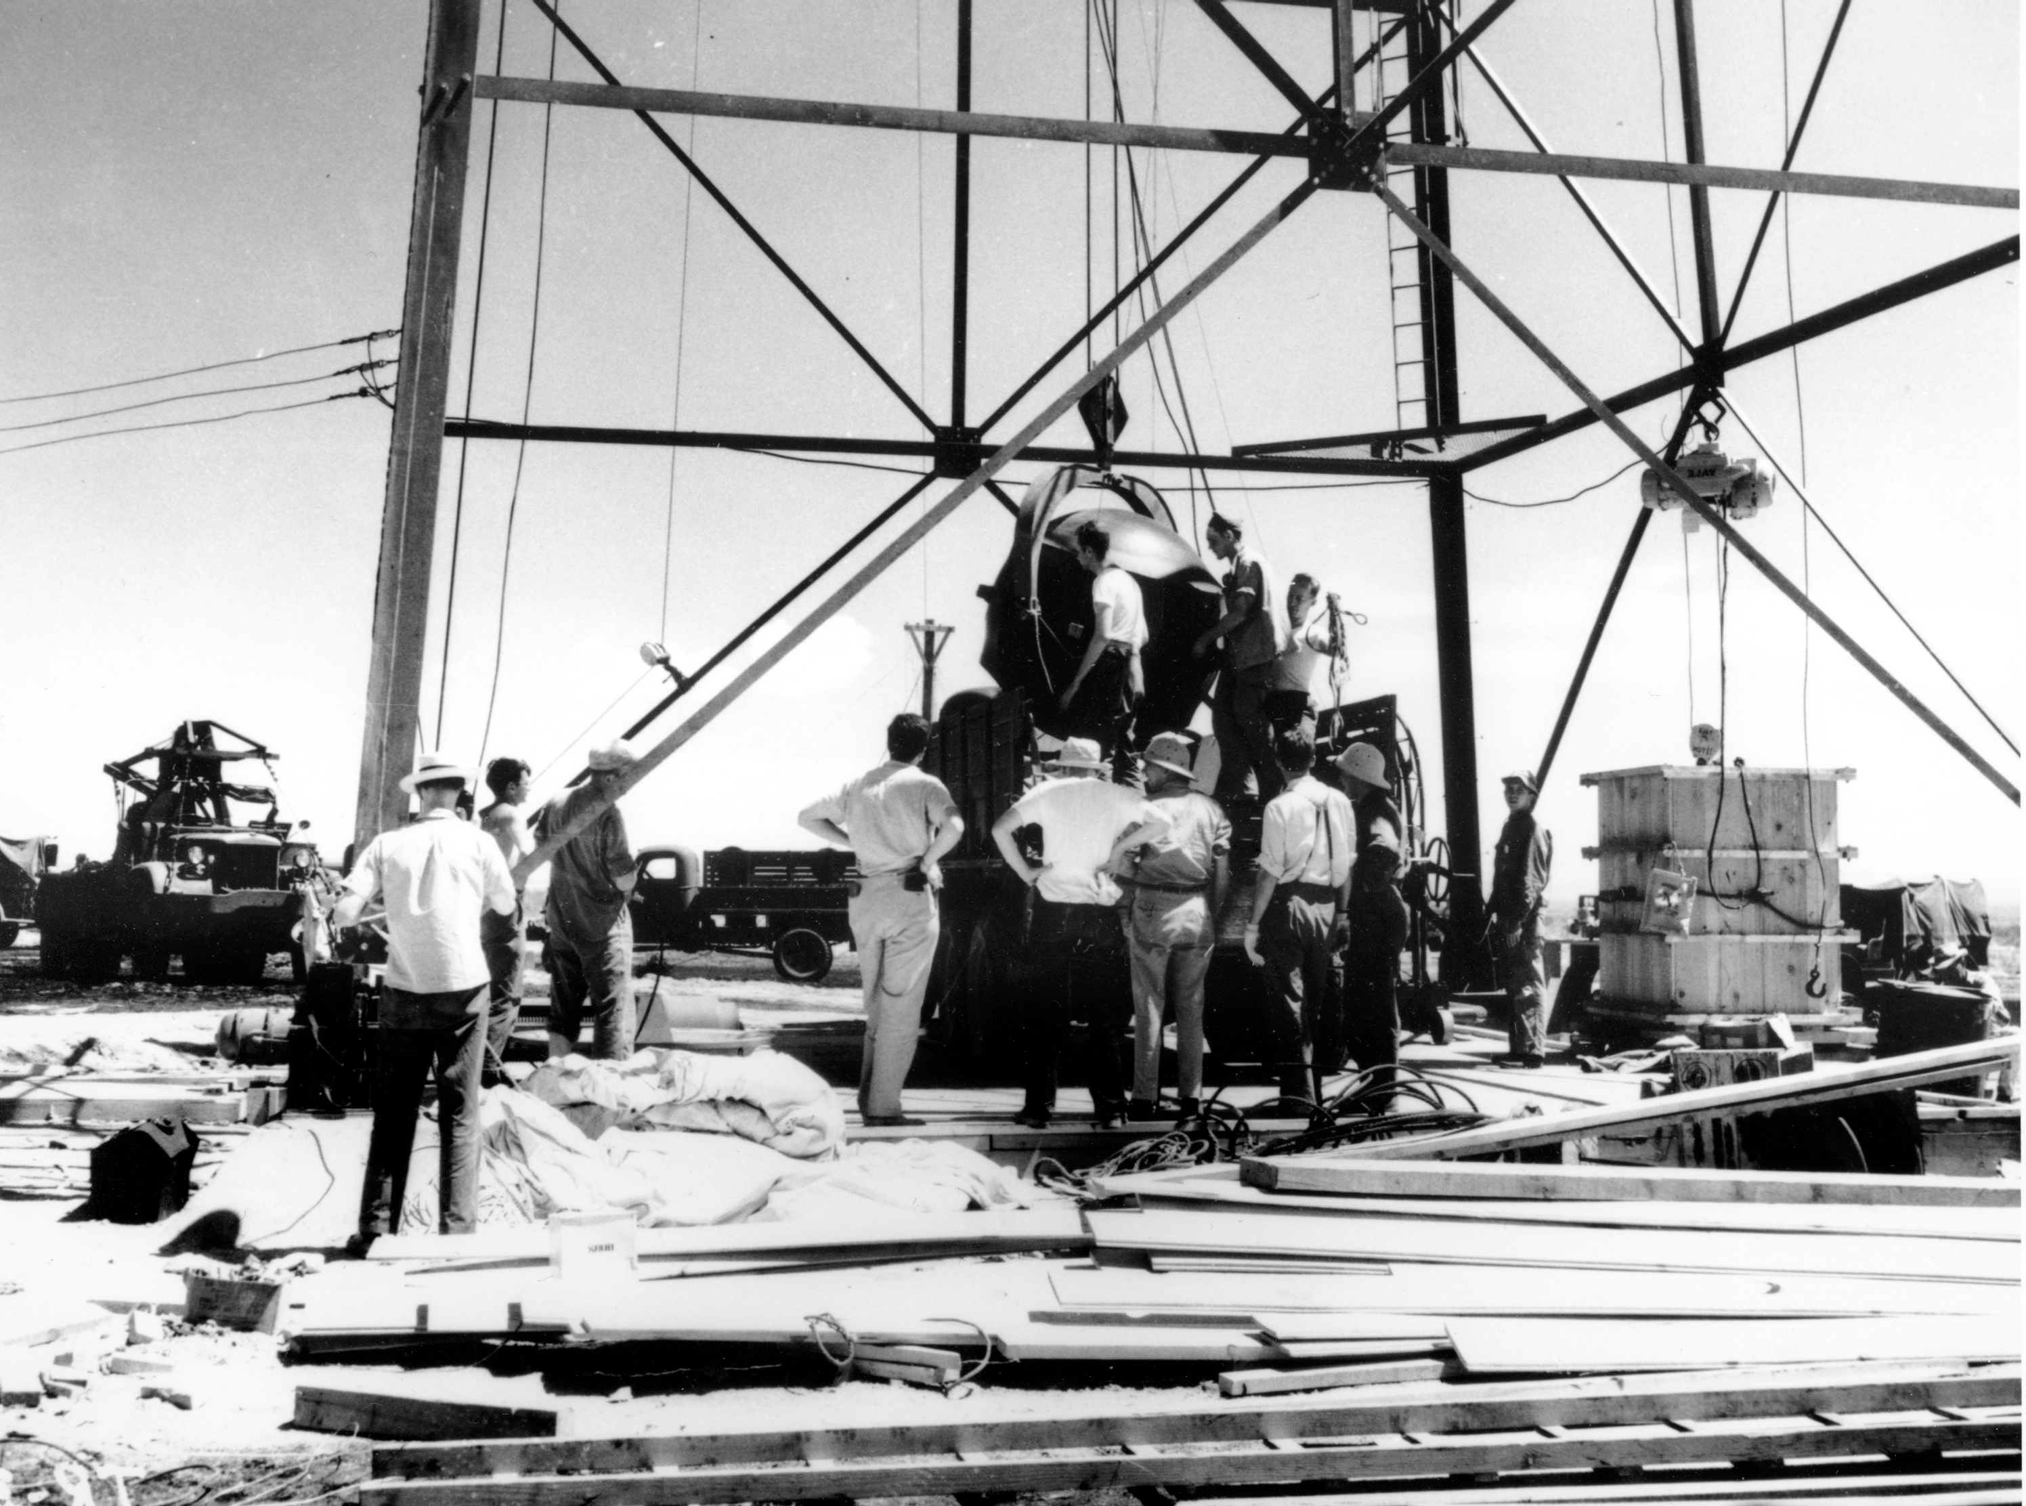
Scientists and workers rig the world's first atomic bomb at the Trinity nuclear test site in New Mexico in July 1945. (AP)
“[N]amed “Trinity” by J. Robert Oppenheimer, director of the Manhattan Project’s Los Alamos National Laboratory.*** July 16 is the 80th anniversary of the world’s first atomic bomb test. At 5:30 a.m. on that date in 1945, 12 young girls attending a summer camp in Ruidoso, New Mexico, were jolted out of their bunks by a thunderous noise. *** As the years went by, the truth began to sink in. The former campers developed terrible cancers. Kent suffered from skin and endometrial cancer and ultimately had to have her thyroid removed. She was one of the lucky ones. Only she and one other of that group of 12 would live past the age of 40.” https://www.washingtonpost.com/opinions/2025/07/15/atom-bomb-trinity-victims-survivors/?utm_campaign=wp_todays_headlines&utm_medium=email&utm_source=newsletter&carta-url=https%3A%2F%2Fs2.washingtonpost.com%2Fcar-ln-tr%2F43a44dc%2F68777825c2bee70ac1f4d563%2F59731235ade4e21a848a56ed%2F34%2F66%2F68777825c2bee70ac1f4d563

Aug. 6, 1945: Atomic Bomb dropped on Hiroshima



Decision to Drop the Atomic Bomb
“Upon becoming president, Harry Truman learned of the Manhattan Project, a secret scientific effort to create an atomic bomb. After a successful test of the weapon, Truman issued the Potsdam Declaration demanding the unconditional surrender of the Japanese government, warning of “prompt and utter destruction.” Eleven days later, on August 6, 1945, having received no reply, an American bomber called the Enola Gay left the Tinian Island in route toward Japan. In the belly of the bomber was “Little Boy,” an atomic bomb. At 8:15 am Hiroshima time, “Little Boy” was dropped. The result was approximately 80,000 deaths in just the first few minutes. Thousands died later from radiation sickness. On August 9, 1945, another bomber was in route to Japan, only this time they were heading for Nagasaki with “Fat Man,” another atomic bomb. After the first minute of dropping “Fat Man,” 39,000 men, women and children were killed. 25,000 more were injured. Both cities were leveled from the bombs and this, in turn, forced Japan to surrender to the United States. The war was finally over.” https://www.trumanlibrary.gov/education/presidential-inquiries/decision-drop-atomic-bomb
Aug. 9, 1945 - Nagasaki, Japan
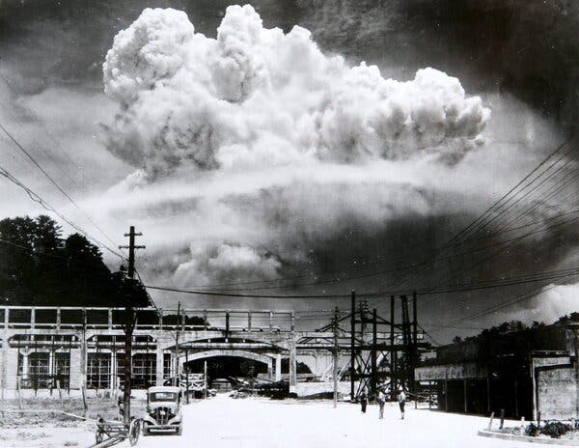 The mushroom cloud over Nagasaki, Japan, on Aug. 9, 1945.

Sept. 2, 1945: World War II Ends
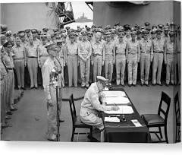
Gen. Douglas MacArthur signs the Instrument of Surrender onboard the U.S. Navy battleship USS Missouri in Tokyo Bay on Sept. 2, 1945. (U.S. Army Signal Corps/U.S. National Archives via Reuters) (Us Army/Via Reuters)

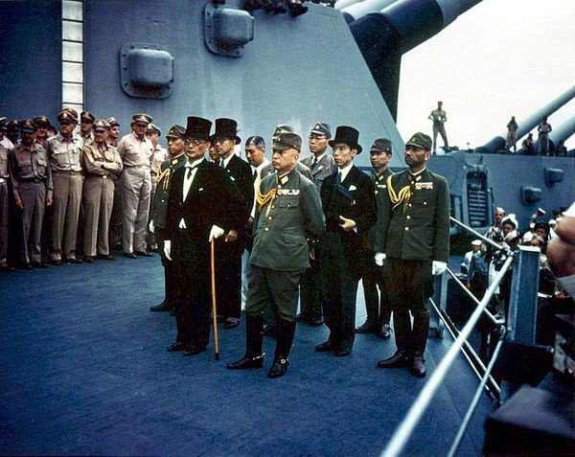

Nov. 20, 1945: Nuremberg trials begin
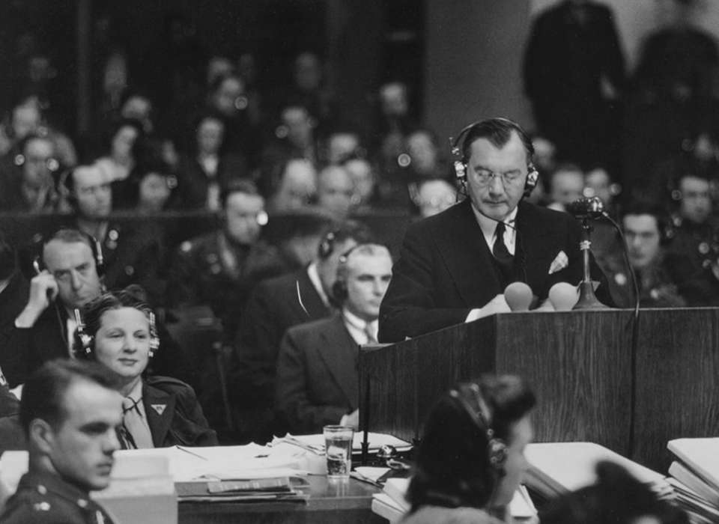
Robert H. Jackson

“In the days before Germany surrendered on May 8, 1945, President Harry S Truman appointed Associate Supreme Court Justice Robert H Jackson to be the chief prosecutor representing the United States in the proposed trials for the European Axis powers. Jackson helped lead the Allies—American, British, French, and Soviet governments—to an agreement called the London Charter, setting the procedures for the Nuremberg Trials. The London Agreement [https://www.un.org/en/genocideprevention/documents/atrocity-crimes/Doc.2_Charter%20of%20IMT%201945.pdf ] created the International Military Tribunal (IMT) on August 8, 1945, where each of the four Allied nations appointed a judge and a prosecution team.” https://www.nationalww2museum.org/war/topics/nuremberg-trials

“Held for the purpose of bringing Nazi war criminals to justice, the Nuremberg trials were a series of 13 trials carried out in Nuremberg, Germany, between 1945 and 1949. The defendants, who included Nazi Party officials and high-ranking military officers along with German industrialists, lawyers and doctors, were indicted on such charges as crimes against peace and crimes against humanity.
• 3 acquitted (Fritzsche, von Papen, Schacht)
• 7 prison terms (Doenitz, Konstantin von Neurath, Speer, von Schirach, Hess, Funk, Raeder)
• 12 death sentences (Goering suicide)
• 2 No Decision (Krupp medical illness and Ley suicide).” https://www.history.com/topics/world-war-ii/nuremberg-trials

Watch Opening Statement by U.S. Supreme Court Justice Robert H. Jackson, on leave from court to be chief prosecutor: https://www.youtube.com/watch?v=EJj6NcWHkDE
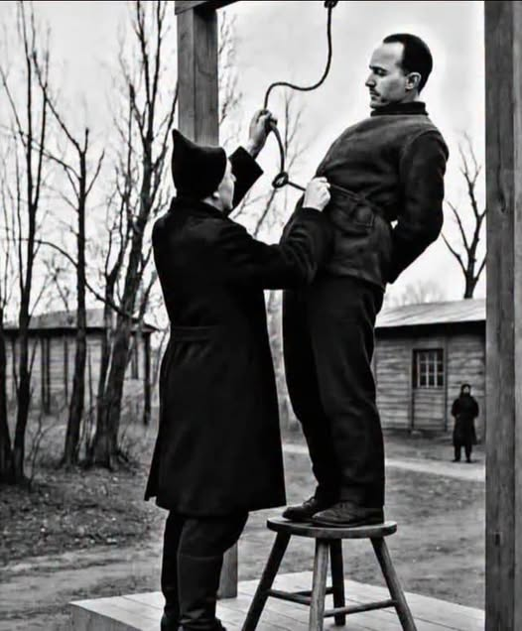In 1947, Rudolf Höss, the former commandant of the Auschwitz concentration camp, faced the final judgment for the atrocities committed under his command.

June 11, 1946: Administrative Procedure Act

“5 USC §551 et seq. (1946): The Administrative Procedure Act (APA) governs the process by which federal agencies develop and issue regulations. It includes requirements for publishing notices of proposed and final rulemaking in the Federal Register, and provides opportunities for the public to comment on notices of proposed rulemaking. The APA requires most rules to have a 30-day delayed effective date. In addition to setting forth rulemaking procedures, the APA addresses other agency actions such as issuance of policy statements, licenses, and permits. It also provides standards for judicial review if a person has been adversely affected or aggrieved by an agency action.” https://www.epa.gov/laws-regulations/summary-administrative-procedure-act

***
“Why the government built only 58 EV charging stations in three years. February 10, 2025…. In the nearly 80 years since its passage, the APA has become the Magna Carta of bureaucratic governance, ensuring that agencies are fair and transparent. The attendant checks and balances, designed explicitly to prevent the bureaucracy from steamrolling opponents, almost inevitably slow things down.” https://www.washingtonpost.com/opinions/2025/02/10/ev-chargers-government-infrastructure/?utm_campaign=wp_week_in_ideas&utm_medium=email&utm_source=newsletter

April 15, 1947: Jackie Robinson – enters Major League
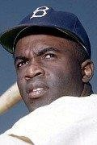https://www.baseball-reference.com/players/r/robinja02.shtml

AN UNPRECEDENTED CAREER IN THE MAJOR LEAGUES https://www.jackierobinsonmuseum.org/about/jackie-robinson/
“On April 15, 1947, Jackie Robinson stepped onto Ebbets Field for his first game with the Brooklyn Dodgers. It was the beginning of an unparalleled career in baseball. At the end of his explosive ten years as a Dodger, his record included a .311 batting average, 137 home runs, 734 runs batted in, and 197 stolen bases. In 1955, he helped the Dodgers beat the New York Yankees to win their first World Series Championship. Robinson took home the Rookie of the Year Award in 1947, the Most Valuable Player Award in 1949, and in 1962 became the first African American inducted into the Baseball Hall of Fame.”
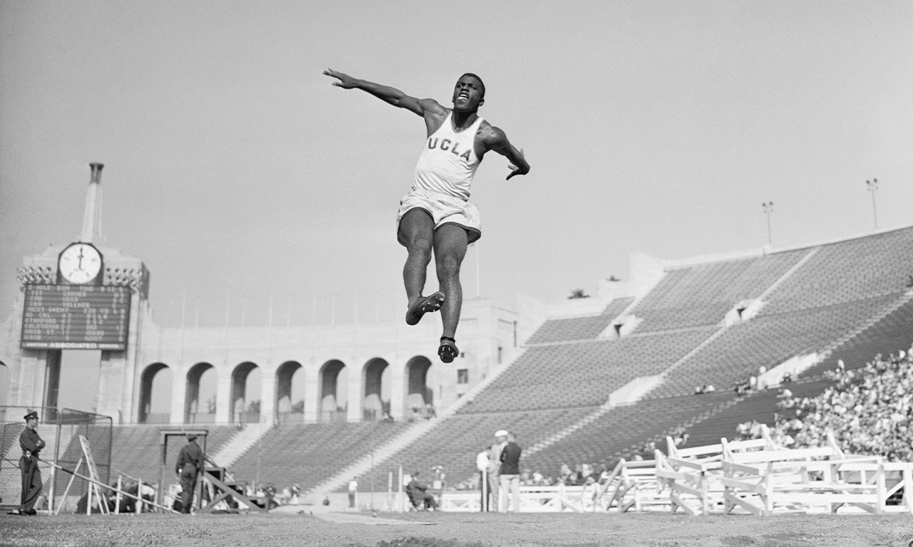

January 31, 1919 – October 24, 1972
“Jackie Robinson, who made history in 1947 by becoming the first black baseball player in the major leagues, suffered a heart attack in his home in Stamford, Conn., yesterday morning and died at Stamford Hospital at 7:10 A.M. He was 53 years old.” https://www.google.com/search?channel=cus2&client=firefox-b-1d&q=Jackie+Robinson
Note:
“But the first African American to play regularly in the big leagues wasn’t the Brooklyn Dodgers second baseman, it was Moses Fleetwood “Fleet” Walker.On
May 1, 1884, the 26-year-old Walker was the catcher for the Toledo Blue
Stockings in their opening game in the then-major league American Association. Six decades later, while Robinson was hailed as a pioneer, Walker was seen more as a curiosity.” But the first African American to play regularly in the big leagues wasn’t the Brooklyn Dodgers second baseman, it was Moses Fleetwood “Fleet” Walker.
On May 1, 1884, the 26-year-old Walker was the catcher for the Toledo Blue Stockings in their opening game in the then-major league American Association. Six decades later, while Robinson was hailed as a pioneer, Walker was seen more as a curiosity.” https://www.washingtonpost.com/history/2019/04/15/first-africanamerican-major-leaguer-wasnt-who-you-think/

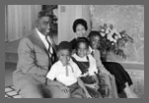
Jackie Robinson, Rachel Robinson, and their three children (David, Sharon, and Jackie, Jr.) at home in Stamford, Connecticut. Photograph by Arthur Rothstein, 1956. https://www.loc.gov/collections/jackie-robinson-baseball/articles-and-essays/baseball-the-color-line-and-jackie-robinson/1957-to-1961/
Note from Prof. Bennett: I was born in Stamford, CT, and grew up seeing Jackie Robinson playing golf at our public golf course, Hubbard Heights. I now can better appreciate why he played at a public golf course, and not at any of the private clubs.

Branch Rickey - American baseball executive
https://www.britannica.com/biography/Branch-Rickey
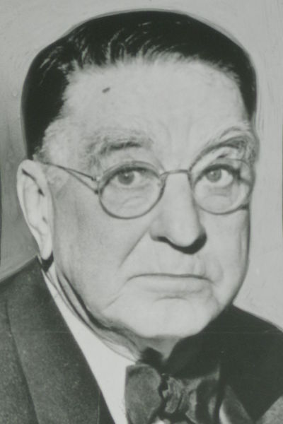

“In the spring of 1945, Rickey founded the United States League for Black players, whom unwritten law excluded from organized baseball, and he was criticized for encouraging continued segregation in sports. There are no records indicating that the league ever played any games; however, it served as a front that allowed Rickey to quietly scout Black ballplayers for one who could lead the desegregation of the major leagues. In October 1945 he signed infielder Jackie Robinson for the Dodgers’ minor league organization. Robinson’s success with the Dodgers from 1947 led other owners to seek Black talent. Rickey later was vice president, general manager. (1950–55), and chairman of the board (1955–59) of the Pittsburgh Pirates.”

Oct. 14, 1947 – Chuck Yeager - Sound Barrier

“Chuck Yeager broke the sound barrier — and then lied about it for nine months because no one believed it was possible. It was October 14, 1947. The war was over, the future was uncertain, and a 24-year-old test pilot from West Virginia was climbing into a rocket-shaped plane called the Bell X-1. He’d named it Glamorous Glennis after his wife. Two nights earlier, he’d broken two ribs after falling off a horse — and hid it from the Air Force.” https://chuckyeager.com/history

May 3, 1948: U.S. Supreme Court - Hurd v. Hodge (6 to 0)
https://supreme.justia.com/cases/federal/us/334/24/

FEDERAL COURTS CAN NOT ENFORCE LAND DEEDS PROHBITING SALE TO AFRICAN AMERICANS
Note: After this decision, 42 U.S.C. 1983 lawsuits started to be filed against police officers and their municipal employers.
MR. CHIEF JUSTICE VINSON delivered the opinion of the Court.
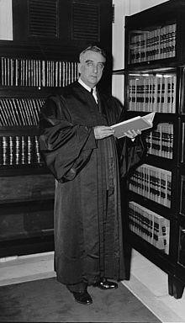Justice Fred M. Vinson
“In 1906, twenty of thirty-one lots in the 100 block of Bryant Street, Northwest, in the City of Washington, were sold subject to the following covenant:
‘. . . that said lot shall never be rented, leased, sold, transferred or conveyed unto any Negro or colored person, under a penalty of Two Thousand Dollars ($2,000), which shall be a lien against said property.’
The covenant imposes no time limitation on the restriction.
***
The Negro petitioners entered into contracts of sale with willing sellers for the purchase of properties upon which they desired to establish homes. Solely because of their race and color, they are confronted with orders of court divesting their titles in the properties and ordering that the premises be vacated. White sellers, one of whom is a petitioner here, have been enjoined from selling the properties to any Negro or colored person. Under such circumstances, to suggest that the Negro petitioners have been accorded the same rights as white citizens to purchase, hold, and convey real property is to reject the plain meaning of language. We hold that the action of the District Court directed against the Negro purchasers and the white sellers denies rights intended by Congress to be protected by the Civil Rights Act, and that, consequently, the action cannot stand.” https://supreme.justia.com/cases/federal/us/334/24/

June 13, 1948 – Babe Ruth
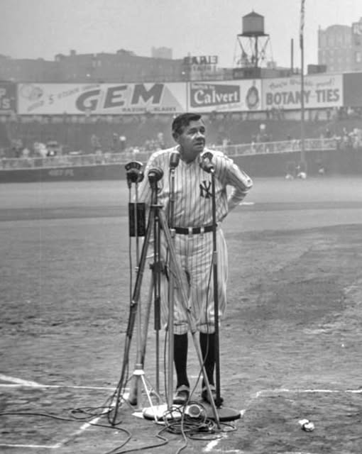
On June 13, 1948, Babe Ruth, battling terminal cancer, made his final appearance at Yankee Stadium during its 25th anniversary celebration.

Jan. 20, 1949: President Harry S. Truman – Second Inauguration

1950 – FDNY
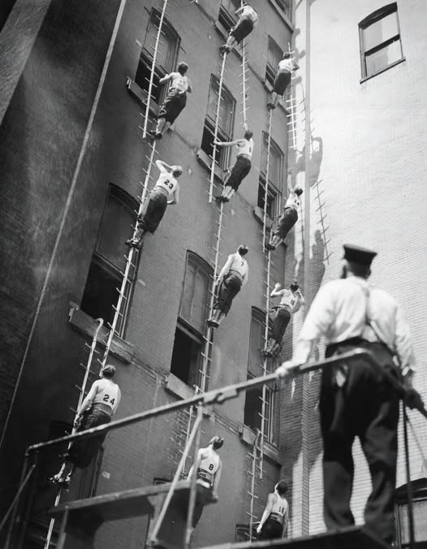

1950: Korean War (1950-1953)
“The Korean War (1950-1953), was fought between forces of the United States, South Korea and their allies, and forces of communist North Korea and China. It was a bitter, back-and-forth struggle that killed people on the ground and in the air. It claimed more than half as many Americans in three years as the Vietnam War killed in over a decade. Thousands fell during fighting in subzero temperatures around the Chosin Reservoir, in what is now North Korea. And U.S. pilots were shot down in many forbidding places, like MiG Alley near the Chinese border. Seven thousand Americans are still missing in action.” https://www.washingtonpost.com/dc-md-va/2021/12/23/korean-war-memorial-names-washington-dean-shot-down-granite-tons-crane-43000/?utm_campaign=wp_evening_edition&utm_medium=email&utm_source=newsletter&wpisrc=nl_evening&carta-url=https%3A%2F%2Fs2.washingtonpost.com%2Fcar-ln-tr%2F359843c%2F61c4f1799d2fdab56bda3692%2F59731235ade4e21a848a56ed%2F52%2F64%2F61c4f1799d2fdab56bda3692

Feb. 9, 1950: Communist Scare – Senator Joseph McCarthy

Joseph R. McCarthy: A Featured Biography
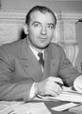
“Elected to the Senate in 1946, Joseph McCarthy (1908-1957) did not draw major national attention until 1950. On February 9th of that year, he delivered a Lincoln Day address in Wheeling, West Virginia, blaming failures in American foreign policy on Communist infiltration of the U.S. government. The Wisconsin Republican claimed to have a list of known Communists still working in the Department of State. A special subcommittee investigated McCarthy's charges and rejected them as “a fraud and a hoax,” but the outbreak of the Korean War and the highly publicized conviction of Alger Hiss lent credibility to the charges. When McCarthy became chairman of the Permanent Subcommittee on Investigations in 1953, he launched a series of investigations into alleged subversion and espionage. In 1954 a confrontation with the army led to the nationally televised Army-McCarthy hearings, which tarnished McCarthy's public image, undermined his charges, and prompted his censure by the U.S. Senate.” https://www.senate.gov/senators/FeaturedBios/Featured_Bio_McCarthy.htm

House Un-American Activities Committee:
“HUAC was created in 1938 to investigate alleged disloyalty and rebel activities on the part of private citizens, public employees and organizations suspected of having Communist ties. Citizens suspected of having ties to the communist party would be tried in a court of law. Also during this time, Senator Joseph McCarthy began a campaign against alleged communists in the U.S. government and other institutions. From 1950-1954 “McCarthyism” described the practice of accusing Federal Government employees of having affiliations with communism and leaking information. Government employees could be blacklisted (viewed as untrustworthy or someone to avoid) and could lose their jobs. The threat of Communism was a driving force that created a wedge between society and the United States government.” https://www.trumanlibrary.gov/education/presidential-inquiries/house-un-american-activities-committee

Nov. 1, 1950 – Presidential Assassination Attempt / Police Officer Kiled
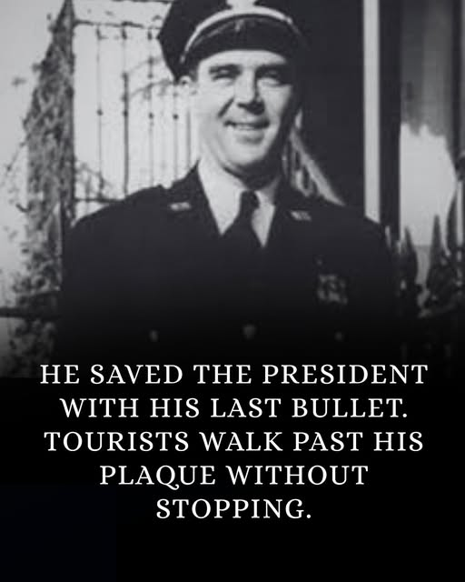
https://behindbadge.substack.com/p/heroes-live-forever-the-story-of-d5d
He was already dying when he fired the shot.
Three bullets in his body. Blood spreading across his uniform. His guard booth at Blair House splintered around him.
And the man trying to reach the President was still moving.
It was November 1, 1950. A Tuesday afternoon in Washington, D.C. President Harry Truman was upstairs at Blair House taking a nap, living there temporarily while the White House underwent its first major structural renovation since it was built. The executive mansion had been deemed structurally unsound. So the President of the United States was sleeping in a townhouse across Pennsylvania Avenue, protected by a small detail of White House Police officers.
One of them was Leslie Coffelt.
He was 39 years old. A veteran officer who had spent years in the quiet, invisible work of protecting presidents. Not glamorous work. Not celebrated work. Standing posts. Running checks. Being present so that nothing happened.
That afternoon, something happened.
At approximately 2:20 PM, two men approached Blair House from different directions. Oscar Collazo and Griselio Torresola, Puerto Rican nationalists, armed and coordinated. No warning. No demands. They opened fire the moment they were in range.
The assault lasted less than three minutes.
In those three minutes, multiple officers were hit. The street outside Blair House became a gunfight, sudden and close and brutal, in a neighborhood that had been quiet an hour before.
Torresola was the more lethal of the two. He moved along the Pennsylvania Avenue side of the building with precision, firing at officers, advancing toward the entrance. He had already wounded several men. He was still moving. Still armed. The entrance to Blair House was within reach.
Coffelt was inside his guard booth on the lower west side of the building when Torresola's bullets came through it.
The first round hit him in the chest. Then his abdomen. Then a third shot. He went down inside the booth, bleeding severely, his body already in the process of shutting down from wounds that doctors would later confirm were not survivable.
He did not stay down.
What happened next is the part of this story that the brief plaque on Blair House's wall cannot fully hold. Coffelt dragged himself out of the booth. Mortally wounded. Moving on training and something that is harder to name than training. He gripped his .38 caliber revolver. He steadied himself.
Torresola was twenty feet away.
Still advancing.
Coffelt raised his weapon and fired once.
The bullet struck Torresola in the head. He was dead before he hit the ground.
The attack was over.
Coffelt collapsed and did not rise again.
An ambulance came. Officers applied pressure to his wounds. They worked on him at the hospital for hours. He died approximately four hours after being shot, never regaining full consciousness. His last coherent action, the last thing his body performed before it gave out entirely, was raising a weapon and firing with enough precision to drop an armed man from twenty feet.
Upstairs, President Truman had heard the gunfire and gone to the window. His agents physically pulled him back from the glass. He was resistant. He wanted to see. They held him away from any possible line of fire until the shooting stopped.
He was alive because of what had just happened below his window.
Oscar Collazo was wounded, captured, tried, and sentenced to death. Two years later, in 1952, Truman commuted the sentence to life imprisonment. Jimmy Carter pardoned Collazo in 1979. He returned to Puerto Rico and lived until 1994.
Griselio Torresola, the man Coffelt killed, was buried in Puerto Rico.
Leslie Coffelt was buried in Arlington National Cemetery, Section 8.
Truman wrote personally to Coffelt's widow. He attended memorial services. He made sure the officer was honored in the ways available to him. But there is a particular arithmetic to that situation that no letter resolves. A man Truman had likely exchanged nothing more than a nod with on his way in and out of Blair House had just given his life so that Truman could continue living his.

Feb. 27,1951: 22nd Amendment - Two-Term Limit on Presidency
“The 22nd Amendment to the United States Constitution was passed in an era when Americans were concerned about the rising power of dictators overseas. After Adolf Hilter and Mussolini both gained power in their respective countries, there was a concern that the same could happen in the United States. This concern was only exacerbated by the rise of Franklin D. Roosevelt, who was elected to an unprecedented four terms in a row. This continual re-election of FDR was more concerning when he died not long into his fourth term. FDR’s actions were in contravention of a norm that had held until then in American politics that no one would run for a third term. Presidents had considered running for the unprecedented third term several times, and in the few instances where someone did seek a third term, such as in the case of Theodore Roosevelt, they failed in their re-election bids. Accordingly, after FDR died, at the urging of then-president Harry S. Truman, Congress decided it was time to act. Congress created what is now the 22nd Amendment, which was reviewed by the States and passed with overwhelming support from the American people.” https://cornerstonelaw.us/22nd-amendment-doesnt-say-think-says/

May 1951: Willie Mays – “the Say Hey Kid”
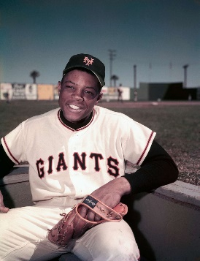
“Mays was batting .477 for the Minneapolis Millers of the American Association when he was called up by the Giants in May 1951. It was only four years after Robinson had become a Dodger, and there were few Black players in the majors, although the Giants had four when Mays joined them: Monte Irvin, the star outfielder; Hank Thompson, their third baseman; Ray Noble, a backup catcher; and Artie Wilson, an infielder, who was sent to the minors to make room for Mays. Black and white teammates remained apart early in Mays’s career. “For a while we couldn’t stay in the same hotels,” he said. “We’d get to Chicago, we’d get off on the South Side, they’d get off on the North Side.” https://www.nytimes.com/2024/06/18/sports/willie-mays-dead.html?emc=edit_na_20240618&ref=headline&nl=breaking-news

“But this combination of physical assets was not Mays’s most valuable or endearing asset. Rather, he rarely complained about anything and took time to play stickball with and sign autographs for his adoring fans. Most importantly, he almost always had a broad smile on his face. He was such a joyful presence that one imagines he would have played baseball without receiving a salary. That is what made this athlete into a role model for people like me who grew up in the 1950s and ’60s. *** Just after his career had started ascending, Mays served his country in the U.S. Army from 1952 to 1953. As the 1954 National League most valuable player, he led the Giants to victory in the World Series, in which he made one of the most memorable plays ever with ‘The Catch’ in deep center field of the Polo Grounds. In addition to the awards Mays collected during his playing career, Major League Baseball selected him as one of the greatest living players in 2015, and he was a recipient of the Presidential Medal of Freedom later that year.” https://www.washingtonpost.com/opinions/2024/06/21/willie-mays-bryson-dechambeau-trans-athletes/?utm_campaign=wp_todays_headlines&utm_medium=email&utm_source=newsletter&wpisrc=nl_headlines&carta-url=https%3A%2F%2Fs2.washingtonpost.com%2Fcar-ln-tr%2F3e0eba3%2F6676a0a7abab932d285edfc6%2F59731235ade4e21a848a56ed%2F29%2F60%2F6676a0a7abab932d285edfc6

1952: The Immigration and Nationality Act of 1952 (The McCarran-Walter Act)
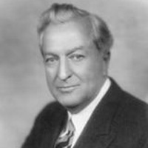
Patrick McCarran

“The Immigration and Nationality Act of 1952 upheld the national origins quota system established by the Immigration Act of 1924, reinforcing this controversial system of immigrant selection. It also ended Asian exclusion from immigrating to the United States and introduced a system of preferences based on skill sets and family reunification. Situated in the early years of the Cold War, the debate over the revision of U.S. immigration law demonstrated a division between those interested in the relationship between immigration and foreign policy, and those linking immigration to concerns over national security. The former group, led by individuals like Democrat Congressman from New York Emanuel Celler, favored the liberalization of immigration laws. Celler expressed concerns that the restrictive quota system heavily favored immigration from Northern and Western Europe and therefore created resentment against the United States in other parts of the world. He felt the law created the sense that Americans thought people from Eastern Europe as less desirable and people from Asia inferior to those of European descent. The latter group, led by Democratic Senator from Nevada Pat McCarran and Democratic Congressman from Pennsylvania Francis Walter, expressed concerns that the United States could face communist infiltration through immigration and that unassimilated aliens could threaten the foundations of American life. To these individuals, limited and selective immigration was the best way to ensure the preservation of national security and national interests.” https://history.state.gov/milestones/1945-1952/immigration-act

2/25/2025: “Trump administration says undocumented immigrants must register.
But lawyers and immigrant advocates warned that the administration’s plan was on shaky legal ground and that some immigrants may be afraid to comply. The Trump administration will require all unauthorized immigrants in the United States who are 14 and older to register with the federal government or face civil and criminal penalties, including up to $1,000 in fines and up to six months in prison. Homeland Security Secretary Kristi L. Noem, who announced the plan Tuesday, has argued that the administration should know who is here illegally so that it can deport them or give them the chance to leave voluntarily. She has warned immigrants in recent days that they “will be hunted down and deported” if they fail to register and has cited a provision of the 1952 Immigration and Nationality Act as justification for the requirement.” https://www.washingtonpost.com/immigration/2025/02/25/trump-administration-undocumented-immigrants-register/?utm_campaign=wp_todays_headlines&utm_medium=email&utm_source=newsletter&carta-url=https%3A%2F%2Fs2.washingtonpost.com%2Fcar-ln-tr%2F414fa96%2F67bef437a211644b43526728%2F59731235ade4e21a848a56ed%2F17%2F66%2F67bef437a211644b43526728

Jan. 21, 1953: President Dwight D. Eisenhower – First Inauguration
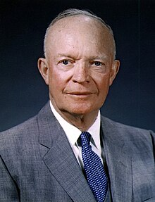

Oct. 1, 1953: Ohio Outlaws Wearing Masks – KKK rallies
“In the late 1880s, a group of vigilantes called the White Caps terrorized abusers, gamblers, alcoholics and "fast women." The outlaws would wear disguises (and white caps) as they burned down saloons and whipped anyone who didn't abide by their moral code.
***
Ohio's law went into effect on Oct. 1, 1953. Sixteen U.S. states have a form of anti-mask laws, some of which were ratified around the same time to prevent Ku Klux Klan rallies, whose members typically wore white hoods to conceal their identities.” https://www.dispatch.com/story/news/education/2024/05/06/some-student-protesters-could-face-felonies-because-of-an-old-ohio-law/73588920007/?utm_source=enquirer-dailybriefing-strada&utm_medium=email&utm_campaign=dailybriefing-headline-stack&utm_term=newsletter-greeting&utm_content=pcin-cincinnati-nletter65

May 15, 1954: U.S. Supreme Court - Brown v. Board of Education of Topeka (9 to 0) https://supreme.justia.com/cases/federal/us/347/483/

PUBLIC SCHOOL SEGREGATION ILLEGAL
“Issue: Do racially segregated public schools violate the Equal Protection Clause?
Result: Yes. A unanimous Court overturned Plessy v. Ferguson and held that state laws requiring or allowing racially segregated schools violate the Equal Protection Clause of the Fourteenth Amendment. The Court famously stated ‘separate educational facilities are inherently unequal.’
Importance: The Brown decision is heralded as a landmark decision in Supreme Court history, overturning Plessy v. Ferguson (1896) which had created the ‘separate but equal’ doctrine. In Plessy, The Court held that even though a Louisiana law required rail passengers to be segregated based on race, there was no violation of the Fourteenth Amendment's Equal Protection Clause so long as the accommodations at issue were ‘separate, but equal.’ By overturning this doctrine, the Brown Court helped lay the ground for the civil rights movement and integration across the country.” https://www.americanbar.org/groups/public_education/programs/constitution_day/landmark-cases/

Thurgood Marshall - Special Counsel, NAACP - finally got the case he had been hoping for, and in 1952 argued Brown v. Board of Education.
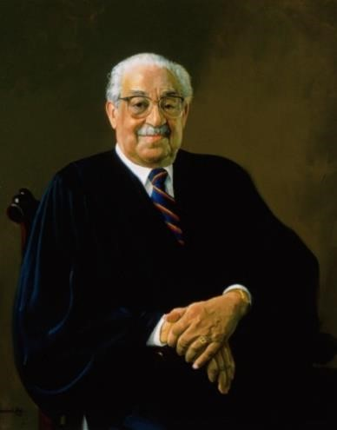Thurgood Marshall
“The case was reargued in 1953, and after 5 months of waiting, the Supreme Court delivered its opinion that invalidated the separate but equal doctrine. In 1961, President Kennedy appointed Marshall as federal judge to the Second Circuit Court of Appeals in New York City. Marshall spent four years on the court, and none of his opinions were reversed on appeal to the Supreme
Court. In 1965, President Johnson called upon Marshall to be the country’s next Solicitor General. Marshall was sworn into office, but only spent two years in the position. In 1967, the President appointed him as the first African-American to be an Associate Justice on the U.S. Supreme Court.” https://www.oyez.org/justices/thurgood_marshall

MR. CHIEF JUSTICE WARREN delivered the opinion of the Court.
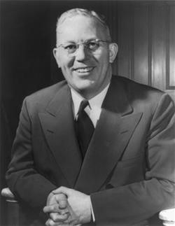 Chief Justice Earl Warren: https://www.landmarkcases.org/brown-v-
board-of-education/earl-warren

“Facts of the case
This case was the consolidation of cases arising in Kansas, South Carolina, Virginia, Delaware, and Washington D.C. relating to the segregation of public schools on the basis of race. In each of the cases, African American students had been denied admittance to certain public schools based on laws allowing public education to be segregated by race. They argued that such segregation violated the Equal Protection Clause of the Fourteenth Amendment. The plaintiffs were denied relief in the lower courts based on Plessy v. Ferguson, which held that racially segregated public facilities were legal so long as the facilities for blacks and whites were equal. (This was known as the ‘separate but equal’ doctrine.)

Question
Does the segregation of public education based solely on race violate the Equal Protection Clause of the Fourteenth Amendment?

Conclusion
Separate but equal educational facilities for racial minorities is inherently unequal, violating the Equal Protection Clause of the Fourteenth Amendment. Chief Justice Earl Warren delivered the opinion of the unanimous Court. The Supreme Court held that “separate but equal” facilities are inherently unequal and violate the protections of the Equal Protection Clause of the Fourteenth Amendment. The Court reasoned that the segregation of public education based on race instilled a sense of inferiority that had a hugely detrimental effect on the education and personal growth of African American children. Warren based much of his opinion on information from social science studies rather than court precedent. The decision also used language that was relatively accessible to non-lawyers because Warren felt it was necessary for all Americans to understand its logic.”
https://www.oyez.org/cases/1940-1955/347us483

July 17, 1955 – Nuclear testing
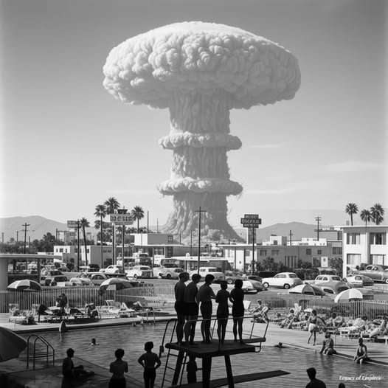On July 17, 1955, at precisely 5:30 a.m., swimmers at the Desert Inn pool in Las Vegas paused mid-dive. A mushroom cloud rose in the distance—65 miles away at the Nevada Test Site. The atomic blast, part of Operation Teapot, was visible from the Strip, and locals had gathered with lawn chairs and sunglasses to witness the spectacle.

Operation Teapot - 1955 - Nevada Test Site
“This series of fourteen shots proof tested a broad variety of fission devices with low to moderate yields. As a group these devices combined several innovations - some previously tested, some introduced during this test series - to create a new pattern of fission device that would dominate the design of all later weapons. These devices used new compact, efficient, light weight spherical implosion systems; beryllium tampers; hollow cores; deuterium-tritium boosting; and the use of neutron pulse tubes as initiators to create light, compact, efficient, and reliable fission explosive systems…. UCRL (University of California Radiation Laboratory, now the Lawrence Livermore National Laboratory - LLNL) had its first successful test shots after two and a half years of trying. UCRL demonstrated linear implosion - a non-lensed implosion approach used in artillery shells and other applications where very small diameter systems are required. Approximately 8,000 DOD personnel participated in the Desert Rock VI exercise which was intended to familiarize troops with the capabilities of nuclear weapons, and the conditions of atomic combat.” https://www.atomicarchive.com/media/photographs/testing/us/teapot.html

December 1955: Montgomery Bus Boycott - Rosa Parks
“December 5, 1955 to December 20, 1956. Sparked by the arrest of Rosa Parks on 1 December 1955, the Montgomery bus boycott was a 13-month mass protest that ended with the U.S. Supreme Court ruling that segregation on public buses is unconstitutional. The Montgomery Improvement Association (MIA) coordinated the boycott, and its president, Martin Luther King, Jr., became a prominent civil rights leader as international attention focused on Montgomery. The bus boycott demonstrated the potential for nonviolent mass protest to successfully challenge racial segregation and served as an example for other southern campaigns that followed. In Stride Toward Freedom, King’s 1958 memoir of the boycott, he declared the real meaning of the Montgomery bus boycott to be the power of a growing self-respect to animate the struggle for civil rights.” https://kinginstitute.stanford.edu/montgomery-bus-boycott


“Rosa Parks (1913—2005) helped initiate the civil rights movement in the United States when she refused to give up her seat to a white man on a Montgomery, Alabama bus in 1955. Her actions inspired the leaders of the local Black community to organize the Montgomery Bus Boycott. Led by a young Rev. Dr. Martin Luther King Jr., the boycott lasted more than a year— during which Parks not coincidentally lost her job—and ended only when the U.S. Supreme Court ruled that bus segregation was unconstitutional. Over the next half-century, Parks became a nationally recognized symbol of dignity and strength in the struggle to end entrenched racial segregation.” https://www.history.com/topics/black-history/rosa-parks

1956 – FBI – J. Edgar Hoover - J. EDGAR HOOVER STARTS “COINTTELPRO” - including Surveillance Of Martin Luther King (1967-71)
“The term "COINTELPRO" is a generic term used by the FBI to describe seven separate ‘counterintelligenc’" programs which the Bureau implemented at different times during· the period .from ~-1956 to 1971, when all were discontinued. Five of these programs were directed at domestic based groups and individuals -- Communist Party, USA, the forerunner of all other COINTELPROS (1956-1971); Socialist Workers Party (1961-1970); White Hate Grou~s (1964-1971); Black Extremists (1967-1971); and New Left (1968-1971). The documents authorizing these five programs define their objective as being either simply the disruption of the group's activities; or the disruption, exposure and neutralization thereof.´ https://www.fordlibrarymuseum.gov/sites/default/files/pdf_documents/library/document/0204/1511708.pdf

Jan. 21, 1957: President Eisenhower – Second Inauguration
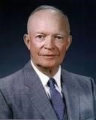
President Dwight D. Eisenhower

Sept. 4, 1957: Little Rock Nine
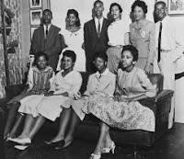
“The Little Rock Nine were a group of nine black students who enrolled at formerly all white Central High School in Little Rock, Arkansas, in September 1957. Their attendance at the school was a test of Brown v. Board of Education, a landmark 1954 Supreme Court ruling that declared segregation in public schools unconstitutional. On September 4, 1957, the first day of classes at Central High, Governor Orval Faubus called in the Arkansas National Guard to block the black students’ entry into the high school. Later
that month, President Dwight D. Eisenhower sent in federal troops to escort the Little Rock Nine into the school. It drew national attention to the civil rights movement.” https://www.history.com/topics/black-history/central-high-school-integration
President Dwight D. Eisenhower

Executive Order 10730: Desegregation of Central High School (1957)
https://www.archives.gov/milestone-documents/executive-order-10730
“On September 4, the nine Black students attempted to enter Central High. The students had planned to meet and enter as a group; though one student, Elizabeth Eckford, did not receive this news and attempted to enter the school by herself, only to be threatened and harassed by an angry mob of segregationists. The students were turned away and denied entry by the Arkansas National Guard. That evening, Governor Faubus revealed that he had ordered the National Guard to prevent the Black students from entering.
President Eisenhower, who was vacationing in Newport, RI, invited Governor Faubus to meet him at the Naval Base at Newport to discuss the tense situation. In the meeting, Faubus indicated that he would respect the desegregation order. Eisenhower therefore suggested that Faubus not necessarily withdraw the National Guard troops, but instruct them to preserve order and allow the Black students to attend Central High.
However, once back in Little Rock, Governor Faubus withdrew the National Guard. A few days later, when the Black students entered the school, a full-scale riot erupted. The situation was quickly out of control, as Governor Faubus failed to stop the violence. Finally, Congressman Brooks Hays and Little Rock Mayor Woodrow Mann asked the federal government for help, first in the form of U.S. marshals.
President Dwight D. Eisenhower, as the chief law enforcement officer of the United States, was presented with a difficult problem. He was required to uphold the Constitution and the laws, but he also wanted to avoid a bloody confrontation in Arkansas. With Executive Order 10730, the President placed the Arkansas National Guard under federal control and sent 1,000 U.S. Army paratroopers from the 101st Airborne Division to assist them in restoring order in Little Rock.”

Billy Graham: Pastor to Presidents
https://billygraham.org/story/billy-graham-pastor-to-presidents-2/
“Every U.S. President since World War II met with Billy Graham. Both Johnson and Nixon, the two who probably sought him the most, offered him high positions in government—which he quickly and politely refused.
Here are short snippets of their stories:
Dwight D. Eisenhower — “Eisenhower was the first President that really asked my counsel in depth when he was sending troops into Little Rock,” said Mr. Graham. Just before Eisenhower died, Billy was invited to see him at Walter Reed Hospital. After talking again about assurance of salvation, the two men prayed. Eisenhower then said he was ready to die.
‘Billy Graham is one of the best ambassadors our country has but he told me, ‘I am an ambassador of heaven.' — Dwight D. Eisenhower.”

Aug. 28, 1957 – Sen. Strom Thurmond (D- South Carolina) filibuster – 24 hours, 18 minutes
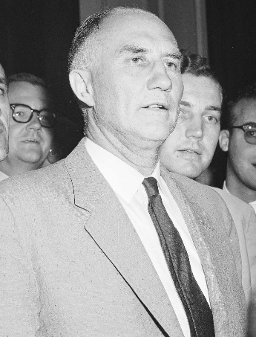
The record-long filibuster against proposed Civil Rights Act is the 1957 talkfest by then-Democratic Sen. Strom Thurmond of South Carolina. He lasted for 24 hours, 18 minutes.
“[H]e conducted what is still the longest live filibuster in history — 24 hours, 18 minutes — in opposition to President Dwight D. Eisenhower's modest civil rights bill (PL 85–315)…. The filibuster was unsuccessful, but Thurmond took his opposition to the stump, using the federal government's actions to integrate Little Rock's high school as an occasion to vent his criticism. “We in the South are not about to surrender, not now or in the future,” he said. He reserved a special blast for the Supreme Court, whom he called “nine puppets of the NAACP” for refusing to give Arkansas authorities more time to work out a compromise. He promised that Southerners would “maintain an adequate system of mass education for all people — either public or private — and that we will maintain it segregated.” https://library.cqpress.com/cqalmanac/document.php?id=cqal02-236-10381-664576#_=_

Dec. 1, 1958: Chicago - Our Lady of the Angels School fire

“60 Years Later: Our Lady of the Angels School Fire. Alex Burkholder reflects on the tragic fire that took the lives of 92 students and three nuns in Chicago on Dec. 1, 1958. ***The fire had started in the basement and quickly spread up a stairwell. Fire doors on the first floor stopped the smoke and flames, and students on that floor fled the building. Things were much different on the second floor where there were no fire doors and the smoke and flames spread down a hallway, trapping students in five classrooms. The students’ only way out was through the windows. Ironically, a fire department inspector at the school a couple of months before the fire had noted the lack of fire doors upstairs, but because of the building codes and grandfather clauses, he could not demand their installation.” https://www.firehouse.com/operations-training/article/21028868/60-years-later-our-lady-of-the-angels-school-fire

Jan. 20, 1961: President John F. Kennedy Inauguration
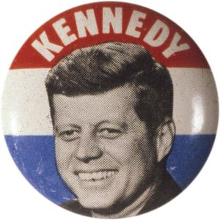

June 19, 1961: U.S. Supreme Court - Mapp v. Ohio (6 to 3) https://supreme.justia.com/cases/federal/us/367/643/

EVIDENCE ILLEGALLY OBTAINED WILL BE EXCLUDED FROM TRIAL
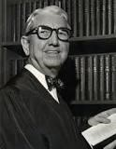
Justice Tom C. Clark: https://www.oyez.org/justices/tom_c_clark

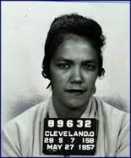Dollree Mapp

“Facts of the case
Dollree Mapp was convicted of possessing obscene materials after an admittedly illegal police search of her home for a fugitive. She appealed her conviction on the basis of freedom of expression.
Question
Were the confiscated materials protected from seizure by the Fourth Amendment?

Conclusion
In an opinion authored by Justice Tom C. Clark, the majority brushed aside First Amendment issues and declared that all evidence obtained by searches and seizures in violation of the Fourth Amendment is inadmissible in a state court. The decision launched the Court on a troubled course of determining how and when to apply the exclusionary rule.” https://www.oyez.org/cases/1960/236
Sept. 30, 1962: James Meredith – Riot at University of Mississippi

“UM History of Integration - About James Meredith.” https://50years.olemiss.edu/james-meredith/
“After a protracted court battle, the U.S. Supreme Court ruled on Sept. 10, 1962, that Meredith was to be admitted to the university. Mississippi Gov. Ross Barnett tried to prevent Meredith’s enrollment by assuming the position of registrar and blocking his admission.
On Sept. 30, 1962, when a deal was reached between Barnett and U.S. Attorney General Robert Kennedy to allow Meredith to enroll, a riot broke out on campus. A mob of angry whites confronted U.S. marshals stationed on campus to protect Meredith. The crowd assaulted the marshals with bricks and bullets outside the Lyceum, the university’s administration building, until the arrival of federal troops quelled the violence in the early morning hours. Two bystanders died in the confrontation, 206 marshals and soldiers were wounded, and 200 individuals were arrested. Meredith was finally allowed to register for courses on Oct. 1, 1962.”
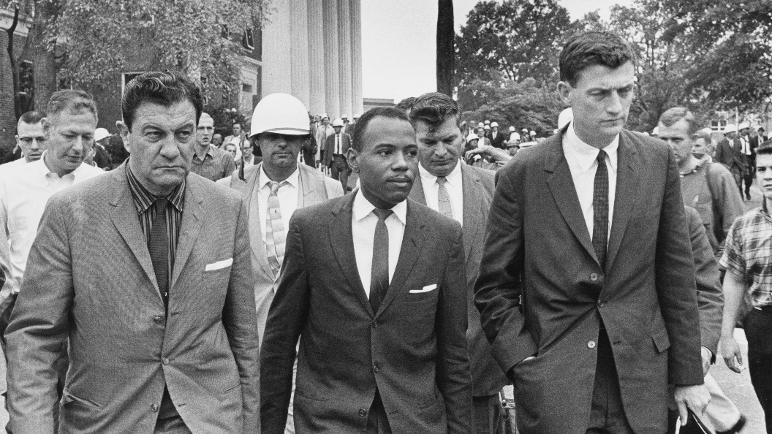
https://www.google.com/search?client=firefox-b-1-d&q=Justice+Black+and+Meridth#vhid=vor84z8NhpT68M&vssid=l

WASHINGTON, Oct. 8, 1962 (UPI) -- The Supreme Court today refused to review the court order which forced the admission of James H. Meredith to the University of Mississippi. It also upheld two lower court decisions which struck down racial barriers in bus and railroad terminals in Louisiana and Georgia. https://www.upi.com/Archives/1962/10/08/Supreme-Court-allows-Meredith-to-enter-U-of-Mississippi/5528434544180/
“The court's action in the Mississippi case had been anticipated. Justice Hugo L. Black early last month vacated several stays granted by Fifth Circuit Judge Ben F. Cameron. Black, after consulting with the other justices, said the lower court orders to admit Meredith should be carried out.”
Supreme Court of the United States; James H. MEREDITH, Movant, v.
Charles Dickson FAIR et al. Sept. 10, 1962. https://clearinghouse.net/doc/87075/

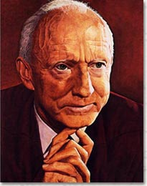

“Despite the Fifth Circuit's July 1962 opinion, [5th Circuit] Judge Cameron continued to issue stays to block Meredith's admission to Ole Miss. In total, he issued three stays after the July 1962 Fifth Circuit decision and before the September 1962 Supreme Court decision. Justice Black of the Supreme Court reviewed Judge Cameron's actions and vacated his orders. The Supreme Court held that continuing to stay the Fifth Circuit mandates would cause further harm to Meredith and enforcing the mandates would not cause appreciable harm to Ole Miss. 83 S. Ct. 10.”https://clearinghouse.net/case/11088/

April 16, 1963: Martin Luther King – Letter From Birmingham Jail
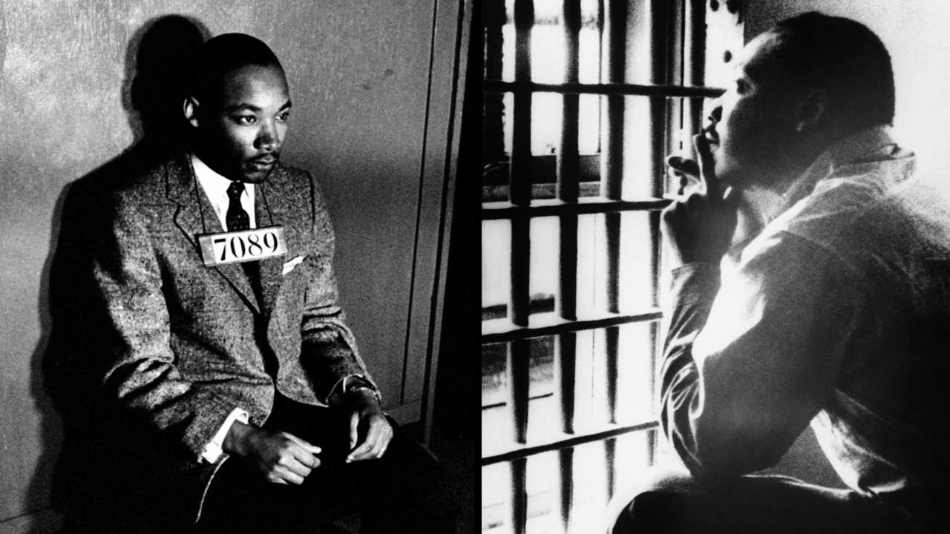
“WHILE confined here in the Birmingham city jail, I came across your recent statement calling our present activities "unwise and untimely." Seldom, if ever, do I pause to answer criticism of my work and ideas. If I sought to answer all of the criticisms that cross my desk, my secretaries would be engaged in little else in the course of the day, and I would have no time for constructive work. But since I feel that you are men of genuine good will and your criticisms are sincerely set forth, I would like to answer your statement in what I hope will be patient and reasonable terms. I think I should give the reason for my being in Birmingham, since you have been influenced by the argument of "outsiders coming in." I have the honor of serving as president of the Southern Christian Leadership Conference, an organization operating in every Southern state, with headquarters in Atlanta, Georgia. We have some eighty-five affiliate organizations all across the South, one being the Alabama Christian Movement for Human Rights. Whenever necessary and possible, we share staff, educational and financial resources with our affiliates. Several months ago our local affiliate here in Birmingham invited us to be on call to engage in a nonviolent direct-action program if such were deemed necessary. We readily consented, and when the hour came we lived up to our promises. So I am here, along with several members of my staff, because we were invited here. I am here because I have basic organizational ties here. Beyond this, I am in Birmingham because injustice is here. Just as the eighth-century prophets left their little villages and carried their "thus saith the Lord" far beyond the boundaries of their hometowns; and just as the Apostle Paul left his little village of Tarsus and carried the gospel of Jesus Christ to practically every hamlet and city of the Greco-Roman world, I too am compelled to carry the gospel of freedom beyond my particular hometown. Like Paul, I must constantly respond to the Macedonian call for aid.” https://www.africa.upenn.edu/Articles_Gen/Letter_Birmingham.html

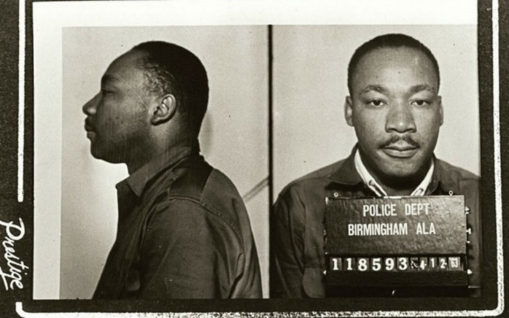

FBI Director Wray is shown the jail cell bars that held Dr. Martin Luther King Jr. when he wrote "Letter from Birmingham Jail" during a tour of the Birmingham Civil Rights Institute on April 15, 2024. https://www.fbi.gov/news/stories/director-wray-recalls-fbis-journey-toward-justice-in-speech-at-civil-rights-landmark-in-alabama?utm_campaign=email-Immediate&utm_medium=email&utm_source=stories&utm_content=%5B1820060%5D-%2Fnews%2Fstories%2Fdirector-wray-recalls-fbis-journey-toward-justice-in-speech-at-civil-rights-landmark-in-alabama

May 3, 1963 – Birmingham, AL – Fire Hoses Used On Protestors
“With an estimated 40 percent of the student body at the all-black Parker High School skipping class to protest and the Birmingham City Jail filled beyond capacity, Birmingham Public Safety Commissioner Bull Connor ordered the use of fire hoses and police dogs on the protestors.” https://www.al.com/birmingham-news-stories/2013/05/bull_connor_used_fire_hoses_po.html
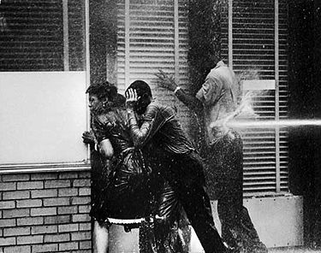

June 12, 1963 – MEDGAR EVANS MURDERED
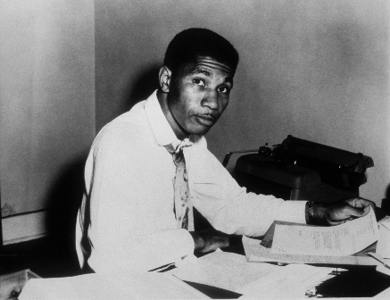

FBI: “It took more than three decades, but justice was finally served in the 1963 murder of a pioneering civil rights leader in Jackson, Mississippi. About half past midnight, a shot rang out. It was June 12, 1963, in a suburban neighborhood of Jackson, Mississippi. A 37-year-old civil rights activist named Medgar Evers had just come home after a meeting of the NAACP. As he began the short walk up to his single-story rambler, the bullet struck Evers in the back. He staggered up to the steps of the house, then collapsed. Across the street on a lightly wooded hill, another man jumped up in pain. The recoil from the Enfield rifle he had just fired drove the scope into his eye, badly bruising him. He dropped the weapon and fled. *** The FBI connected it to a man named Byron De La Beckwith based on its similarity to his military service prints. He was arrested several days later. Beckwith, a known white supremacist and segregationist, had been asking around to find out the location of Evers’ home for some time prior to the shooting. With the obvious motive, his fingerprint on the weapon, the injury around his eye, his planning, and other factors, Beckwith clearly appeared to be the killer. In two separate trials, local prosecutors presented a strong case. A number of police, FBI experts, and others testified on different parts of the evidence against Beckwith.
But this was the 1960s, and in both trials, all-white juries did not reach a verdict. Beckwith went free. By the early 1990s, however, the time was ripe to revisit the case. Evers’ widow, Myrlie—a formidable civil rights organizer in her own right—asked local prosecutors to reopen the investigation and see if other evidence could be found. The FBI again provided its assistance. In December 1990, a new grand jury returned an indictment against Beckwith based on witnesses finally willing to tell their stories, including hearing the white supremacist brag how he had killed Medgar Evers. This time, justice was done. Beckwith was convicted in 1994 and sentenced to life in prison.” https://www.fbi.gov/history/famous-cases/medgar-evers

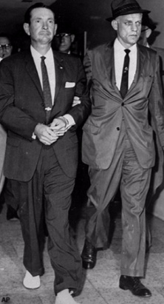 Byron De La Beckwith (left) is escorted to the Jackson police station by FBI agents on June 23, 1963. AP photograph.

May 13, 1963: U.S. Supreme Court - Brady v. Maryland (7 to 2) https://supreme.justia.com/cases/federal/us/373/83/
DEFENSE ENTITLED TO EXCULPATORY EVIDENCE PRIOR TO TRIAL
“Ruling:
The suppression by the prosecution of evidence favorable to an accused upon request violates due process where the evidence is material either to guilt or to punishment, irrespective of the good faith or bad faith of the prosecution.
Facts:
In separate trials in a Maryland state court, where the jury was the judge of both the law and the facts but the court passed on the admissibility of the evidence, petitioner Brady and a companion, Boblit, were convicted of first-degree murder and sentenced to death. At his trial, Brady admitted participating in the crime but claimed that Boblit did the actual killing. In his summation to the jury, Brady's counsel conceded that Brady was guilty of murder in the first degree and asked only that the jury return that verdict ‘without capital punishment.’ Prior to the trial, Brady's counsel had requested the prosecution to allow him to examine Boblit’s extrajudicial statements. Several of these were shown to him. However, one in which Boblit admitted to the actual killing was withheld by the prosecution, and it did not come to Brady's notice until after he had been tried, convicted and sentenced and after his conviction had been affirmed by the Court of Appeals of Maryland. In a post-conviction proceeding, the appellate court held that suppression of the evidence by the prosecutor denied Brady due process of law, and it remanded the case for a new trial of the question of punishment, but not the question of guilt, since it was of the opinion that nothing in the suppressed confession could have reduced Brady's offense below murder in the first degree.”
https://www.lexisnexis.com/community/casebrief/p/casebrief-brady-v-maryland
See April 8, 2025: STANDING ORDERS FOR CRIMINAL CASES The Honorable Sarah D. Morrison United States District Court for the Southern District of Ohio Eastern Division

E. BRADY MATERIAL
Counsel for the government must produce to a defendant, in a timely manner, any evidence in its possession that is favorable to defendant and material to defendant’s guilt or punishment. See Brady v. Maryland, 373 U.S. 83 (1963). This obligation is a continuing one. If counsel identifies any information which is favorable to defendant but which it believes not to be material, counsel for the government must submit such information to the Court for in camera review. https://www.ohsd.uscourts.gov/sites/ohsd/files//Standing%20Orders%20for%20Criminal%20Cases%20%28Updated%20April%207%2C%202025%29.pdf

May 18, 1963: U.S. Supreme Court - Gideon v. Wainwright (9 to 0) https://supreme.justia.com/cases/federal/us/372/335/
INDIGENT DEFENDANTS ENTITLED TO APPOINTMENT OF DEFENSE ATTORNEY

“Issue: Does the Constitution require that any individual charged with a felony, but unable to pay for a lawyer, be guaranteed the free assistance of legal counsel?
Result: Yes, according to a unanimous Supreme Court. The Court held that the Sixth Amendment right to assistance of counsel applies to criminal state trials and that ‘lawyers in criminal court are necessities, not luxuries.’
Importance: Along with the right to assistance for state criminal defendants, the Gideon decision had the effect of expanding public defender systems across the country.” https://www.americanbar.org/groups/public_education/programs/constitution_day/landmark-cases/

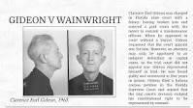

“Facts of the case
Clarence Earl Gideon was charged in Florida state court with felony breaking and entering. When he appeared in court without a lawyer, Gideon requested that the court appoint one for him. According to Florida state law, however, an attorney may only be appointed to an indigent defendant in capital cases, so the trial court did not appoint one.
Gideon represented himself in trial. He was found guilty and sentenced to five years in prison. Gideon filed a habeas corpus petition in the Florida Supreme Court, arguing that the trial court's decision violated his constitutional right to be represented by counsel. The Florida Supreme Court denied habeas corpus relief.

Question
Does the Sixth Amendment's right to counsel in criminal cases extend to felony defendants in state courts?

Conclusion
The Sixth Amendment's guarantee of a right to assistance of counsel applies to criminal defendants in state court by way of the Fourteenth Amendment. In a unanimous opinion authored by Justice Hugo L. Black, the Court held that it was consistent with the Constitution to require state courts to appoint attorneys for defendants who could not afford to retain counsel on their own. The Court reasoned that the Sixth Amendment's guarantee of counsel is a fundamental and essential right made obligatory upon the states by the Fourteenth Amendment. The Sixth Amendment guarantees the accused the right to the assistance of counsel in all criminal prosecutions and requires courts to provide counsel for defendants unable to hire counsel unless the right was competently and intelligently waived.” https://www.oyez.org/cases/1962/155

Aug. 28, 1963: Martin Luther King – “I Have A Dream” Speech, Lincoln Memorial, Washington, DC
Watch video: https://www.youtube.com/watch?v=smEqnnklfYs https://www.archives.gov/files/press/exhibits/dream-speech.pdf
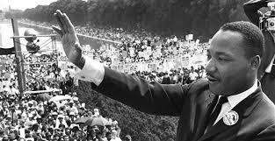

Sept. 15, 1963 – Birmingham Bombing – 4 Children Killed
September 15, 1963, church bombing that killed Carole Robertson, Addie Mae Collins, Cynthia Wesley, and Denise McNair.
“It was a quiet Sunday morning in Birmingham, Alabama—around 10:24 on September 15, 1963—when a dynamite bomb exploded in the back stairwell of the downtown Sixteenth Street Baptist Church. The violent blast ripped through the wall, killing four African-American girls on the other side and injuring more than 20 inside the church. *** By 1965, we [FBI] had serious suspects—namely, Robert E. Chambliss, Bobby Frank Cherry, Herman Frank Cash, and Thomas E. Blanton, Jr., all KKK members—but witnesses were reluctant to talk and physical evidence was lacking. Also, at that time, information from our surveillances was not admissible in court. As a result, no federal charges were filed in the ‘60s. It has been claimed that Director Hoover held back evidence from prosecutors in the ‘60s or even tried to block prosecution. But it’s simply not true. His concern was to prevent leaks, not to stifle justice. In one memo concerning a Justice Department prosecutor seeking information, he wrote, “Haven’t these reports already been furnished to the Dept.?” In 1966, Hoover overruled his staff and made transcripts of wiretaps available to Justice. And he couldn’t have blocked the prosecution and didn’t—he simply didn’t think the evidence was there to convict. *** Chambliss received life in prison in 1977 following a case led by Alabama Attorney General Robert Baxley. And eventually the fear, prejudice, and reticence that kept witnesses from coming forward began to subside. We re-opened our case in the mid-1990s, and Blanton and Cherry were indicted in May 2000. Both were convicted at trial and sentenced to life in prison. The fourth man, Herman Frank Cash, had died in 1994.”
https://www.fbi.gov/history/famous-cases/baptist-street-church-bombing

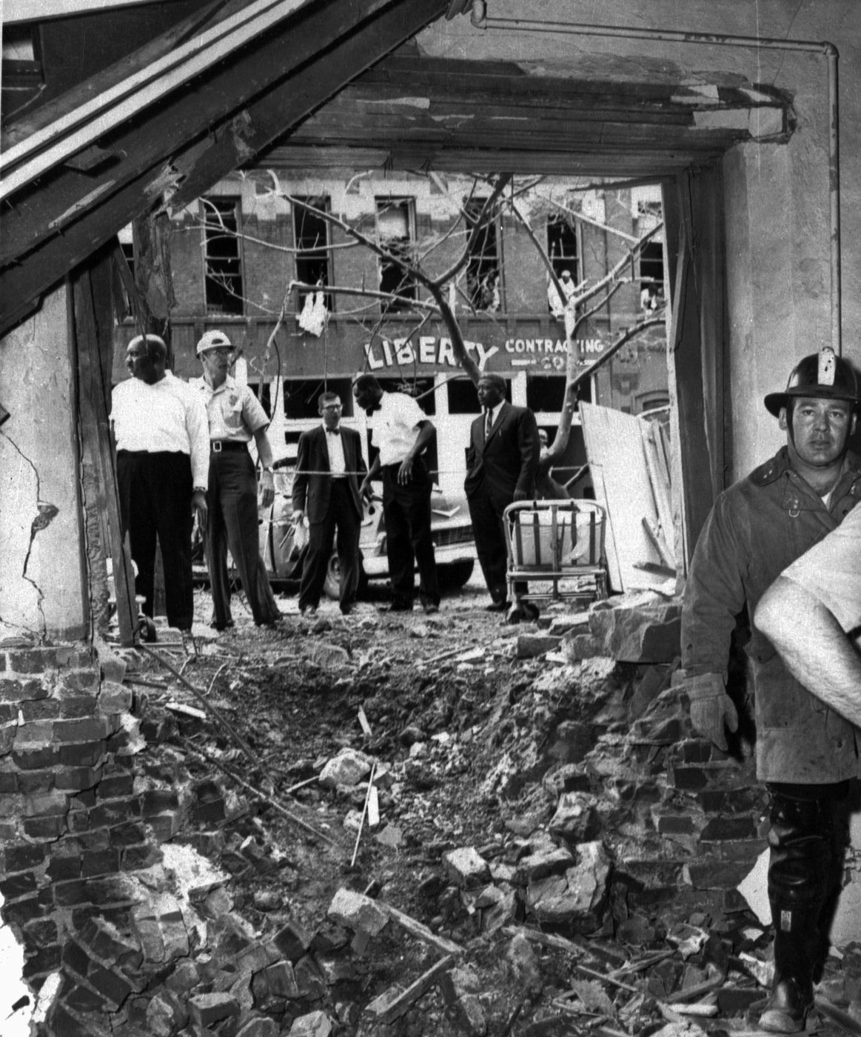

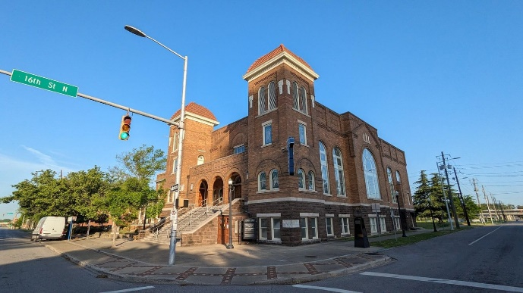

Oct. 1963: FBI search warrant
March 19, 2023: Investigations and Oversight: Director Wray Discusses FBI’s Commitment to Government Accountability: FBI Director Wray also acknowledged the FBI’s missteps with respect to Dr. Martin Luther King Jr.—including an October 1963 wiretap request against the civil rights leader that failed to “present a shred of evidence.” He also reflected on the psychological toll FBI surveillance took on Dr. King. https://www.fbi.gov/news/stories/investigations-and-oversight-director-wray-discusses-fbi-s-commitment-to-government-accountability?utm_campaign=email-Immediate&utm_medium=email&utm_source=stories&utm_content=%5B1806007%5D-%2Fnews%2Fstories%2Finvestigations-and-oversight-director-wray-discusses-fbi-s-commitment-to-government-accountability

Nov. 22, 1963: President Kennedy assassinated, Dallas, TX
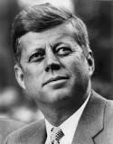John Fitzgerald "Jack" Kennedy

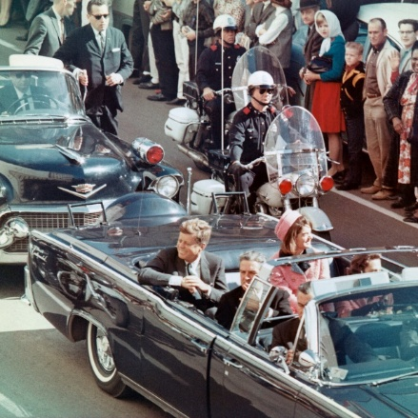
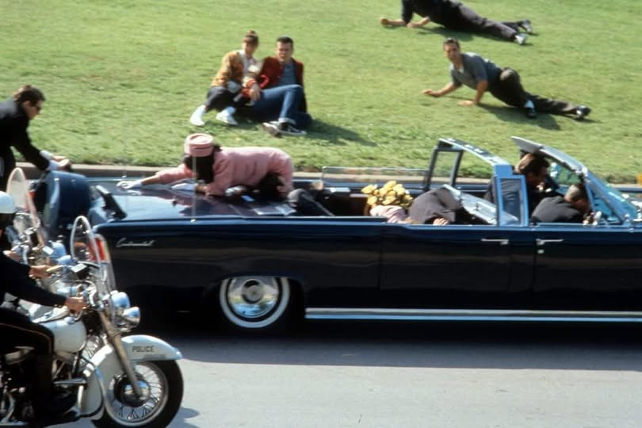

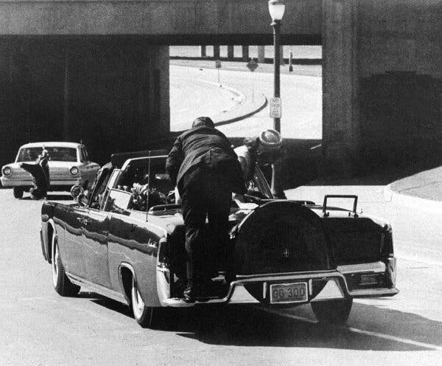
The Secret Service agent Clint Hill clambered onto the trunk of President John F. Kennedy’s limousine in Dallas on Nov. 22, 1963, moments after shots were fired. As the first lady, Jacqueline Kennedy, tried to climb out of her seat, he pushed her back, preventing her from falling to the ground. He was credited with saving her life. [Clint Hill passed away 2/23/2025, age 93.] https://www.nytimes.com/2025/02/24/us/clint-hill-dead.html

November 22, 1963: Death of the President https://www.jfklibrary.org/learn/about-jfk/jfk-in-history/november-22-1963-death-of-the-president

“Shortly after noon on November 22, 1963, President John F. Kennedy was assassinated as he rode in a motorcade through Dealey Plaza in downtown Dallas, Texas.
***
The president's body was brought to Love Field and placed on Air Force One. Before the plane took off, a grim-faced Lyndon B. Johnson stood in the tight, crowded compartment and took the oath of office, administered by US District Court Judge Sarah Hughes. The brief ceremony took place at 2:38 p.m.
Less than an hour earlier, police had arrested Lee Harvey Oswald, a recently hired employee at the Texas School Book Depository. He was being held for the assassination of President Kennedy and the fatal shooting, shortly afterward, of Patrolman J. D. Tippit on a Dallas street.
On Sunday morning, November 24, Oswald was scheduled to be transferred from police headquarters to the county jail. Viewers across America watching the live television coverage suddenly saw a man aim a pistol and fire at point blank range. The assailant was identified as Jack Ruby, a local nightclub owner. Oswald died two hours later at Parkland Hospital.
***
The Warren Commission
On November 29, 1963 President Lyndon B. Johnson appointed the President's Commission on the Assassination of President Kennedy. It came to be known as the Warren Commission after its chairman, Earl Warren, Chief Justice of the United States. President Johnson directed the commission to evaluate matters relating to the assassination and the subsequent killing of the alleged assassin, and to report its findings and conclusions to him.
.

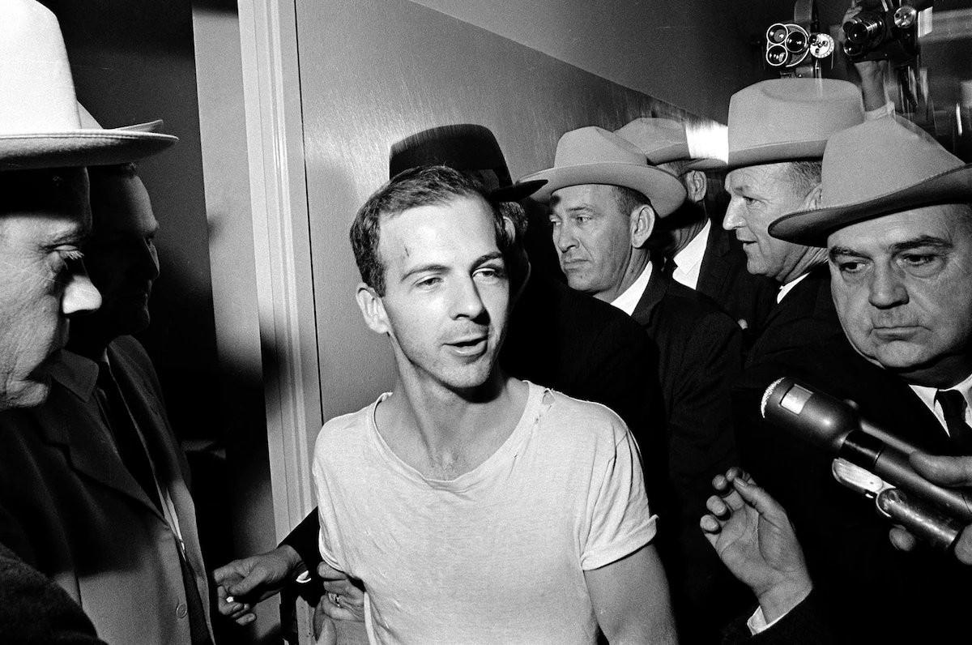
Lee Harvey Oswald talks to the media as he is led down a corridor of the Dallas police station on Nov. 23, 1963, for a round of questioning in connection with the assassination of U.S. President John F. Kennedy. He told reporters he was “a patsy,” but didn't say for whom. (AP).

Lee Harvey Oswald - killed Nov. 24, 1963; shot at Dallas County Jail.
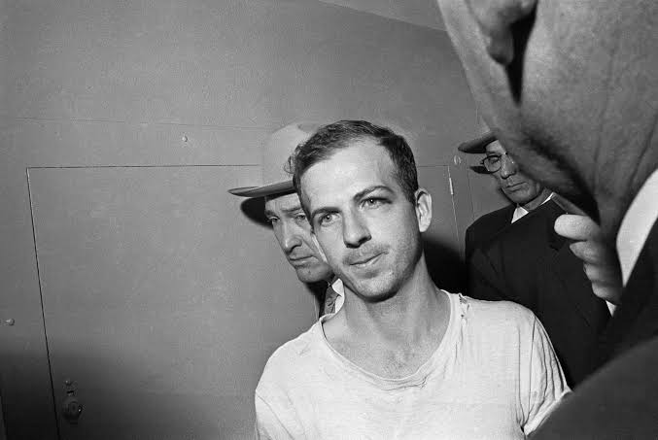
3/18/2025:
JFK Assassination Records - 2025 Documents Release: “In accordance with President Donald Trump’s directive of March 17, 2025, all records previously withheld for classification that are part of the President John F. Kennedy Assassination Records Collection are released. The National Archives has partnered with agencies across the federal government to comply with the President’s directive in support of Executive Order 14176. As of March 18, 2025, the records are available to access either online at this page or in person, via hard copy or on analog media formats, at the National Archives at College Park, Maryland. As the records continue to be digitized, they will be posted to this page.” https://www.archives.gov/research/jfk/release-2025
7/14/2025
The CIA reveals more of its connections to Lee Harvey Oswald. New documents show an officer known only as Howard managed a Cuban group that interacted with Oswald in the months before the JFK assassination. For more than 60 years, the CIA claimed it had little or no knowledge of Lee Harvey Oswald’s activities before the assassination of President John F. Kennedy in November 1963. That wasn’t true, new documents unearthed by a House task force prove. The revelation raises further questions about the agency’s awareness of — or involvement in — the plot to murder the president. The documents confirm that George Joannides, a CIA officer based in Miami in 1963, was helping finance and oversee a group of Cuban students opposed to the ascension of Fidel Castro. Joannides had a covert assignment to manage anti-Castro propaganda and disrupt pro-Castro groups, even as the CIA was prohibited from domestic spying. The CIA-backed group known as DRE was aware of Oswald as he publicly promoted a pro-Castro policy for the U.S., and its members physically clashed with him three months before the assassination. And then, a DRE member said, Oswald approached them and offered his help, possibly to work as a mole within his pro-Castro group, the Fair Play for Cuba Committee.
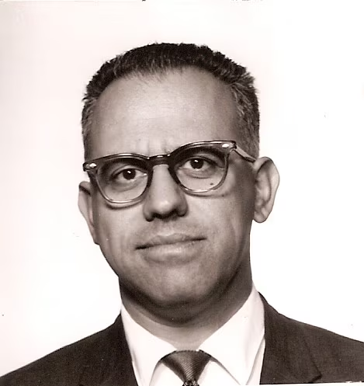
George Joannides, a career CIA agent, was posted in Miami when an anti-Castro group he oversaw was in contact with Lee Harvey Oswald. The CIA resisted revealing Joannides's identity until this month. (National Archives and Records Administration) https://www.washingtonpost.com/national-security/2025/07/14/cia-oswald-jfk-assassination-joannides/?utm_campaign=wp_post_most&utm_medium=email&utm_source=newsletter&carta-url=https%3A%2F%2Fs2.washingtonpost.com%2Fcar-ln-tr%2F439bcaa%2F687528c77867926b76393613%2F59731235ade4e21a848a56ed%2F15%2F67%2F687528c77867926b76393613

Nov. 22, 1963: President Lyndon B. Johnson – First Inauguration
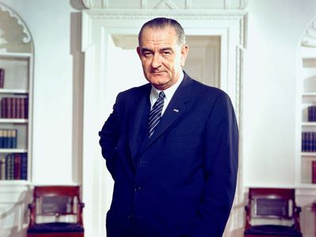
https://www.britannica.com/biography/Lyndon-B-Johnson

Martin Luther King and President Lyndon Johnson – at White House (1963)
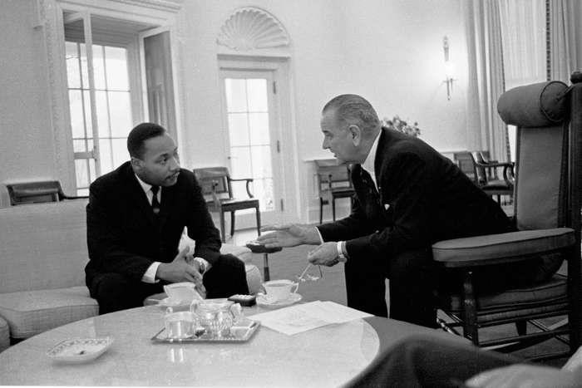
July 2, 1964: Video of President Lyndon B. Johnson signing the bill. https://www.lbjlibrary.org/object/video/signing-civil-rights-act-1964

Radio and television remarks on signing the Civil Rights Bill.
https://www.senate.gov/artandhistory/history/resources/pdf/JohnsonSpeechJuly21964.pdf

Feb. 4, 1964: 24th Amendment – Abolition Poll Tax Qualification in Federal Elections
“Section. 1. The right of citizens of the United States to vote in any primary or other election for President or Vice President, for electors for President or Vice President, or for Senator or Representative in Congress, shall not be denied or abridged by the United States or any State by reason of failure to pay any poll tax or other tax.
Section. 2. The Congress shall have power to enforce this article by appropriate legislation.” https://constitution.findlaw.com/amendments.html

March 9, 1964: U.S. Supreme Court - New York Times v. Sullivan (9 to 0) https://supreme.justia.com/cases/federal/us/376/254/
PUBLIC FIGURES MUST PROVE “MALICE” TO SUE NEWSPAPERS OR OTHER PRESS FOR LIBEL / SLANDER
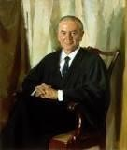Justice William J. Brennan
MR. JUSTICE BRENNAN delivered the opinion of the Court.

“Facts of the case
During the Civil Rights movement of the 1960s, the New York Times published an ad for contributing donations to defend Martin Luther King, Jr., on perjury charges. The ad contained several minor factual inaccuracies. The city Public Safety Commissioner, L.B.
Sullivan, felt that the criticism of his subordinates reflected on him, even though he was not mentioned in the ad. Sullivan sent a written request to the Times to publicly retract the information, as required for a public figure to seek punitive damages in a libel action under Alabama law.
When the Times refused and claimed that they were puzzled by the request, Sullivan filed a libel action against the Times and a group of African American ministers mentioned in the ad. A jury in state court awarded him $500,000 in damages. The state supreme court affirmed and the Times appealed.

Question
Did Alabama's libel law unconstitutionally infringe on the First Amendment's freedom of speech and freedom of press protections?

Conclusion
To sustain a claim of defamation or libel, the First Amendment requires that the plaintiff show that the defendant knew that a statement was false or was reckless in deciding to publish the information without investigating whether it was accurate. In a unanimous opinion authored by Justice Brennan, the Court ruled for the Times. When a statement concerns a public figure, the Court held, it is not enough to show that it is false for the press to be liable for libel. Instead, the target of the statement must show that it was made with knowledge of or reckless disregard for its falsity. Brennan used the term ‘actual malice’ to summarize this standard, although he did not intend the usual meaning of a malicious purpose. In libel law, ‘malice’ had meant knowledge or gross recklessness rather than intent, since courts found it difficult to imagine that someone would knowingly disseminate false information without a bad intent.” https://www.oyez.org/cases/1963/39

June 16, 1964: KKK – Killers of 3 Civil Rights Activists

“In 1964, the Klan killed three young activists and shocked the nation.”
“In 1964, the Klan killed three young activists and shocked the nation. A Mississippi town still grapples with that violent civil rights history.” The three activists had arrived to check on the latest church burning. But before the sun rose the next morning, Mickey Schwerner, James Chaney and Andrew Goodman would all be dead, ambushed by the Ku Klux Klan as they were heading out of Neshoba County. It took a massive FBI mobilization 44 days to find the brutalized bodies. It took years for even a modicum of justice.
***
1967: With only the state able to bring murder charges — and Mississippi refusing to do so — the U.S. Justice Department put 18 men on trial for allegedly violating the civil rights of Schwerner, Chaney and Goodman. One defendant pleaded guilty. Seven, including a deputy sheriff, were convicted. None spent more than six years behind bars.” https://www.washingtonpost.com/nation/interactive/2024/mississippi-klan-killings-1964-impact-history/?utm_campaign=wp_post_most&utm_medium=email&utm_source=newsletter&wpisrc=nl_most&carta-url=https%3A%2F%2Fs2.washingtonpost.com%2Fcar-ln-tr%2F3e0b883%2F66745280065ad23d7ff1dd36%2F59731235ade4e21a848a56ed%2F8%2F53%2F66745280065ad23d7ff1dd36

“DoJ Case Document: Michael Schwerner - James Chaney - Andrew Goodman”
“As previously noted, seven defendants – Price, Roberts, H.D. Barnette, Posey, Arledge, Snowden, and Bowers – were convicted of the federal criminal civil rights conspiracy. Eight defendants – Burrage and Harris, as well as Bernard Akin, Travis Barnette, Herndon, Rainey, Tucker, and Willis – were found not guilty. Mistrials were entered by the court after the jury could not agree as to three defendants, Killen, Sharpe and “Hop” Barnette.” https://www.justice.gov/crt/case-document/micheal-schwerner-james-chaney-andrew-goodman

Trial Transcripts In The Case - United States V. Price, Et Al. (also Known As The "Mississippi Burning" Incident) 1967.
‘On June 21, 1964, several individuals conspired to murder civil rights workers James Chaney, Andrew Goodman, and Michael Schwerner in Philadelphia, Mississippi, one day after the three had arrived in Mississippi to assist in efforts to register African-American voters. Deputy Sheriff Cecil Price approached the civil rights workers while they changed a tire on the car by the side of the road. The Deputy Sheriff alleged that the car had been speeding, arrested the workers, and placed them all in jail – holding the two passengers for “investigation.” Deputy Sheriff Price fined the car’s driver James Chaney $20.00 and then released the trio at 10:00 P.M. ordering them to leave Neshoba County. Deputy Sheriff Price escorted the civil rights workers to the edge of town on the road towards Meridian, Mississippi. The civil rights workers never arrived in Meridian. On June 23, 1964, on information provided by residents of a nearby Choctaw community, Special Agents of the Federal Bureau of Investigation (FBI) found the charred remains of the civil rights workers’ Ford station wagon eighty feet off the highway on an abandoned logging track. After an extensive investigation in which the FBI offered a reward for locating the victims, on August 4, 1964, investigators discovered all three civil rights workers’ bodies buried in an earthen dam on a farm six miles southwest of Philadelphia, Mississippi” https://www.justice.gov/crt/trial-transcripts-caseunited-states-v-price-et-al-also-known-mississippi-burning-incident-1967?itid=lk_inline_enhanced-template

July 2, 1964: CIVIL RIGHTS ACT OF 1964 – TITLE VII is key provision in sex, race, age litigation
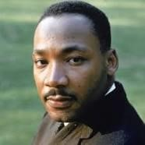
Civil rights leader Martin Luther King Jr. said that the Civil Rights Act of 1964 was nothing less than a “second emancipation.” https://kinginstitute.stanford.edu/king-papers/documents/facingchallenge-new-age-address-delivered-naacp-emancipation-day-rally

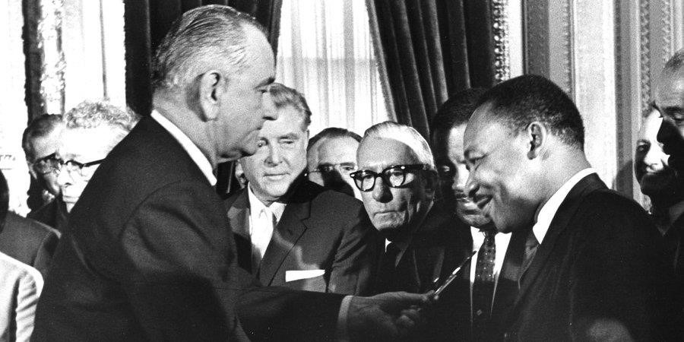
President Lyndon Baines Johnson and Martin Luther King
EDITOR'S NOTE: The following is the text of Title VII of the Civil Rights Act of 1964 (Pub. L. 88-352) (Title VII), as amended, as it appears in volume 42 of the United States Code, beginning at section 2000e. Title VII prohibits employment discrimination based on race, color, religion, sex and national origin. The Civil Rights Act of 1991 (Pub. L. 102-166) (CRA) and the Lily Ledbetter Fair Pay Act of 2009 (Pub. L. 111-2) amend several sections of Title VII. https://www.eeoc.gov/statutes/title-vii-civil-rights-act-1964

UNLAWFUL EMPLOYMENT PRACTICES
SEC. 2000e-2. [Section 703]
(a) Employer practices
It shall be an unlawful employment practice for an employer -(1) to fail or refuse to hire or to discharge any individual, or otherwise to discriminate against any individual with respect to his compensation, terms, conditions, or privileges of employment, because of such individual's race, color, religion, sex, or national origin; or
(2) to limit, segregate, or classify his employees or applicants for employment in any way which would deprive or tend to deprive any individual of employment opportunities or otherwise adversely affect his status as an employee, because of such individual's race, color, religion, sex, or national origin.

“The Civil Rights Act of 1964, which ended segregation in public places and banned employment discrimination on the basis of race, color, religion, sex or national origin, is considered one of the crowning legislative achievements of the civil rights movement. First proposed by President John F. Kennedy, it survived strong opposition from southern members of Congress and was then signed into law by Kennedy’s successor, Lyndon B. Johnson. In subsequent years, Congress expanded the act and passed additional civil rights legislation such as the Voting Rights Act of 1965.” https://www.history.com/topics/black-history/civil-rights-act

August 1964 – USS Maddox - Vietnam
“An unexpected development in August 1964 altered that timetable. On August 2 the destroyer USS Maddox was attacked by North Vietnamese torpedo boats while on electronic surveillance patrol in the Gulf of Tonkin. The preceding day, patrol boats of the South Vietnamese navy had carried out clandestine raids on the islands of Hon Me and Hon Nieu just off the coast of North Vietnam, and the North Vietnamese may have assumed that the Maddox was involved. In any case, the U.S. destroyer suffered no damage, and the North Vietnamese boats were driven off by gunfire from the Maddox and from aircraft based on a nearby carrier. President Johnson reacted to news of the attack by announcing that the U.S. Navy would continue patrols in the gulf and by sending a second destroyer, the Turner Joy, to join the Maddox. On the night of August 4 the two ships reported a second attack by torpedo boats. Although the captain of the Maddox soon cautioned that evidence for the second incident was inconclusive, Johnson and his advisers chose to believe those who insisted that a second attack had indeed taken place. The president ordered retaliatory air strikes against North Vietnamese naval bases, and he requested congressional support for a broad resolution authorizing him to take whatever action he deemed necessary to deal with future threats to U.S. forces or U.S. allies in Southeast Asia. The measure, soon dubbed the Gulf of Tonkin Resolution, passed the Senate and House overwhelmingly on August 7. Few who voted for the resolution were aware of the doubts concerning the second attack, and even fewer knew of the connection between the North Vietnamese attacks and U.S.-sponsored raids in the North or that the Maddox was on an intelligence mission. Although what many came to see as Johnson’s deceptions would cause problems later, the immediate result of the president’s actions was to remove Vietnam as an issue from the election campaign. In November Johnson was reelected by a landslide.” https://www.britannica.com/event/Vietnam-War/The-Gulf-of-Tonkin

Jan. 20, 1965: PRESIDENT LYNDON B. JOHNSON - SECOND INAGURATION

March 7, 1965 – Bloody Sunday - Selma, Alabama
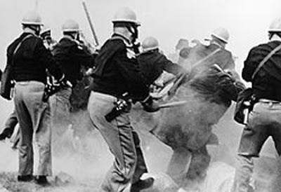

Alabama State Troopers attack civil rights demonstrators
outside Selma, Alabama, on Bloody Sunday, March 7, 1965
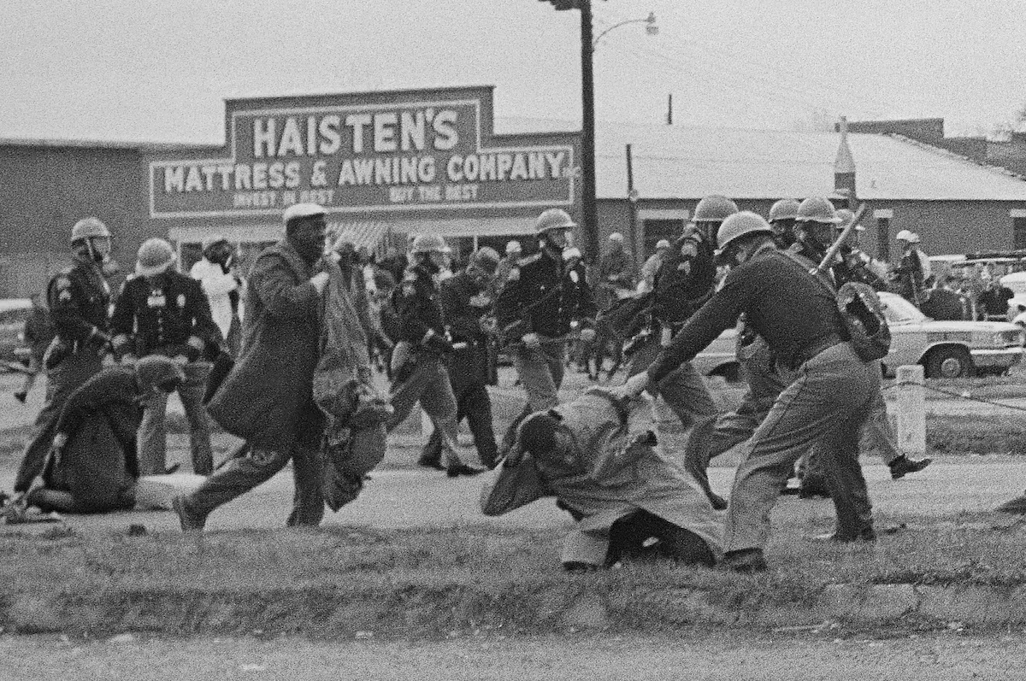
State troopers swing billy clubs to break up a civil rights voting march in Selma on March 7, 1965. https://www.washingtonpost.com/nation/2025/03/09/selmas-civil-rights-anniversary-fears-rise-about-way-forward/?utm_campaign=wp_evening_edition&utm_medium=email&utm_source=newsletter&carta-url=https%3A%2F%2Fs2.washingtonpost.com%2Fcar-ln-tr%2F4182230%2F67ce015b2204985819893f1f%2F59731235ade4e21a848a56ed%2F23%2F46%2F67ce015b2204985819893f1f

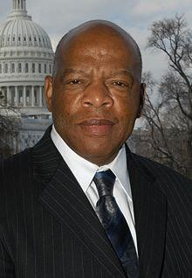 John Lewis: https://johnlewis.house.gov/john-lewis/biography
“John Lewis [age 25] was prepared to get arrested on Sunday, March 7, 1965. ‘I wanted to have something to eat,’ he said, so in his backpack he stored ‘one apple and one orange. I had two books. I had toothpaste and a toothbrush.’ Yet the 25-year-old civil rights leader carried something far more crucial inside as he led some 600 protesters over the Edmund Pettus Bridge in Selma to agitate for the right of African Americans to vote. While most people must move through fear to find courage, Lewis said ‘I never felt fear, not once.’
Lewis was the first to be beaten in the clash with state troopers, who cracked his skull with a billy club on the date that became known as ‘Bloody Sunday.’ The televised images of the bravery shown by Lewis and other protesters in the face of state violence inspired the passage of the 1965 Voting Rights Act just two months later.”
https://www.washingtonpost.com/history/2020/07/26/john-lewis-bloody-sunday-edmundpettus-
bridge/?utm_campaign=wp_post_most&utm_medium=email&utm_source=newsletter& wpisrc=nl_most

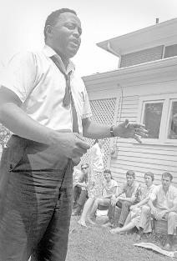

Hosea Williams: https://kinginstitute.stanford.edu/encyclopedia/williams-hosea

“Hosea Williams, another notable Civil Rights leader, and John Lewis led over 600 peaceful, orderly protestors across the Edmund Pettus Bridge in Selma, Alabama on March 7, 1965. They intended to march from Selma to Montgomery to demonstrate the need for voting rights in the state. The marchers were attacked by Alabama state troopers in a brutal confrontation that became known as ‘Bloody Sunday.’ News broadcasts and photographs revealing the senseless cruelty of the segregated South helped hasten the passage of the Voting Rights Act of 1965.” https://johnlewis.house.gov/johnlewis/biography

Oct. 3, 1965 - Immigration and Nationality Act
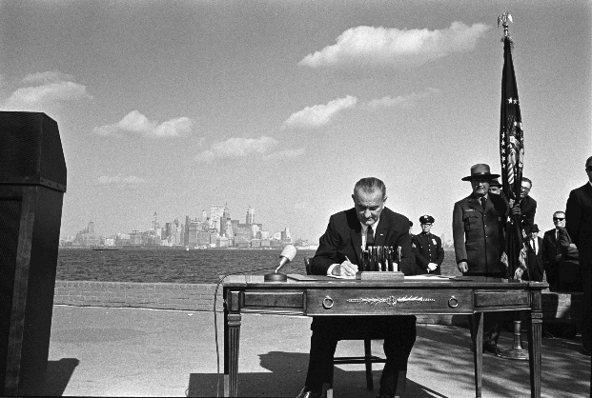
“On Oct. 3, 1965, at the base of the Statue of Liberty and with the island of Manhattan gleaming in the background, President Lyndon B. Johnson signed the Immigration and Nationality Act, also known as the Hart-Celler Act. In the previous 40 years before the act was signed, those who wanted to come to America were subject to a quota system. Immigration law favored immigrants from northern Europe and the British Isles, discriminated against those from southern and eastern Europe, and barred those from Asia and non-whites from entering the country. The Immigration and Nationality Act abolished quotas, opening the doors to "those who can contribute most to this country – to its growth, to its strength, to its spirit." The new law created a preference system that focused on immigrants' skills and family relations with citizens or U. S. residents. President John F. Kennedy, whose Irish ancestors had faced prejudice, wanted immigration reform. As president, Johnson turned to Kennedy's brother, Ted, to help steer the bill through Congress. In a March 8, 1965 telephone conversation, the two men talked about strengthening their working relationship and dispelling rumors about a strain between Johnson and Kennedy supporters. The conversation can be heard below. For historical perspective, the LBJ Presidential Library has collected related photos, videos, audio, and text from the bill signing. All are public domain.” https://www.lbjlibrary.org/news-and-press/media-kits/immigration-and-nationality-act

June 13, 1966: U.S. Supreme Court - Miranda v. Arizona (5 to 4) https://supreme.justia.com/cases/federal/us/384/436/
“MIRANDA OF RIGHTS” WHEN IN CUSTODY

“Issue: Are police constitutionally required to inform people in custody of their rights to remain silent and to an attorney?
Result: Yes, the Court found that the Fifth and Sixth Amendments require police to inform individuals in custody that they have a right to remain silent and to be assisted by an attorney. According to the Court, if the police fail to do so, a criminal court judge may rule that any statements made by the accused cannot be admitted as evidence during trial.
Importance: The now famous ‘Miranda warnings’ are required before any police custodial interrogation can begin if any of the evidence obtained during the interrogation is going to be used during a trial; the Court has limited and narrowed these warnings over the years.” https://www.americanbar.org/groups/public_education/programs/constitution_day/landmark-cases/

 Ernesto Miranda

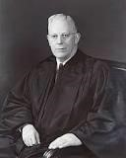Chief Justice Earl Warren
MR. CHIEF JUSTICE WARREN delivered the opinion of the Court

“Facts of the case
This case represents the consolidation of four cases, in each of which the defendant confessed guilt after being subjected to a variety of interrogation techniques without being informed of his Fifth Amendment rights during an interrogation.
On March 13, 1963, Ernesto Miranda was arrested in his house and brought to the police station where he was questioned by police officers in connection with a kidnapping and rape. After two hours of interrogation, the police obtained a written confession from Miranda. The written confession was admitted into evidence at trial despite the objection of the defense attorney and the fact that the police officers admitted that they had not advised Miranda of his right to have an attorney present during the interrogation. The jury found Miranda guilty. On appeal, the Supreme Court of Arizona affirmed and held that Miranda’s constitutional rights were not violated because he did not specifically request counsel.

Question
Does the Fifth Amendment’s protection against self-incrimination extend to the police interrogation of a suspect?

Conclusion
The Fifth Amendment requires that law enforcement officials advise suspects of their right to remain silent and to obtain an attorney during interrogations while in police custody. Chief Justice Earl Warren delivered the opinion of the 5-4 majority, concluding that defendant’s interrogation violated the Fifth Amendment. To protect the privilege, the Court reasoned, procedural safeguards were required. A defendant was required to be warned before questioning that he had the right to remain silent, and that anything he said can be used against him in a court of law. A defendant was required to be told that he had the right to an attorney, and if he could not afford an attorney, one was to be appointed for him prior to any questioning if he so desired. After these warnings were given, a defendant could knowingly and intelligently waive these rights and agree to answer questions or make a statement. Evidence obtained as a result of interrogation was not to be used against a defendant at trial unless the prosecution demonstrated the warnings were given, and knowingly and intelligently waived.” https://www.oyez.org/cases/1965/759

1967 – San Francisco Music

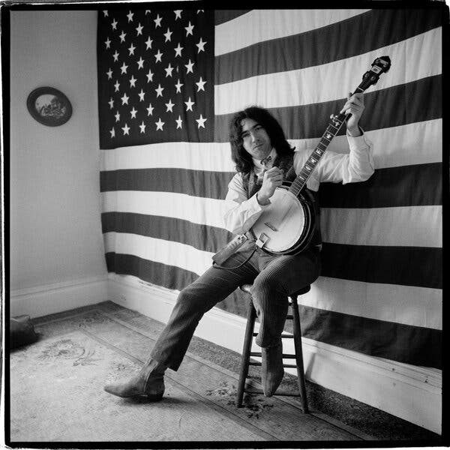Mr. Greene’s many pictures of the Grateful Dead, a favorite subject, include a well-known one of Jerry Garcia against a wall-sized American flag.
Mr. Greene photographed Janis Joplin during a walk in his neighborhood in San Francisco in 1966.
https://www.nytimes.com/2025/03/26/arts/music/herb-greene-dead.html

Jan. 16, 1967: U.S. Supreme Court - Garrity v. New Jersey 5 to 4) – https://supreme.justia.com/cases/federal/us/385/493/
INTERNAL INVESTIGATIONS AND ORDERED TO ANSWER QUESTIONS - PROTECTION FROM PROSECUTION [BUT NOT DISCIPLINE]
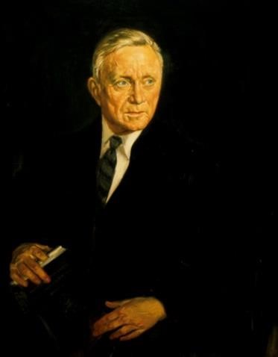Justice William O. Douglas
MR. JUSTICE DOUGLAS delivered the opinion of the Court.
“Syllabus
Appellants, police officers in certain New Jersey boroughs, were questioned during the course of a state investigation concerning alleged traffic ticket ‘fixing.’ Each officer was first warned that: anything he said might be used against him in a state criminal proceeding; he could refuse to answer if the disclosure would tend to incriminate him; if he refused to answer, he would be subject to removal from office. The officers' answers to the questions were used over their objections in subsequent prosecutions, which resulted in their convictions. The State Supreme Court, on appeal, upheld the convictions despite the claim that the statements of the officers were coerced by reason of the fact that, if they refused to answer, they could, under the New Jersey forfeiture of office statute, lose their positions. That statute provides that a public employee shall be removed from office if he refuses to testify or answer any material question before any commission or body which has the right to inquire about matters relating to his office or employment on the ground that his answer may incriminate him. On the ground that the only real issue in the case was the voluntariness of the statements, the State Supreme Court declined to pass upon the constitutionality of the statute, though the statute was considered relevant for the bearing it had on the voluntary character of the statements used to convict the officers. The officers appealed to this Court under 28 U.S.C. § 1257(2), and the question of jurisdiction was postponed to a hearing on the merits.
Held:
- The forfeiture of office statute is too tangentially involved to satisfy the requirements of 28 U.S. C. § 1257(2). The only bearing it had was whether, valid or not, the choice between being discharged under it for refusal to answer and self-incrimination rendered the statements products of coercion. The appeal is dismissed, the papers are treated as a petition for certiorari, and certiorari is granted.
- The threat of removal from public office under the forfeiture of office statute to induce the petitioners to forgo the privilege against self-incrimination secured by the Fourteenth Amendment rendered the resulting statements involuntary, and therefore inadmissible in the state criminal proceedings.”
https://supreme.justia.com/cases/federal/us/385/493/

Feb. 23, 1967: 25Th Amendment – Presidential Vacancy
“Section. 1. In case of the removal of the President from office or of his death or resignation, the Vice President shall become President.
Section. 2. Whenever there is a vacancy in the office of the Vice President, the President shall nominate a Vice President who shall take office upon confirmation by a majority vote of both Houses of Congress.
Section. 3. Whenever the President transmits to the President pro tempore of the Senate and the Speaker of the House of Representatives his written declaration that he is unable to discharge the powers and duties of his office, and until he transmits to them a written declaration to the contrary, such powers and duties shall be discharged by the Vice President as Acting President….” https://constitution.findlaw.com/amendments.html

March 25, 1967 – Vietnam War (1965 – 1973)
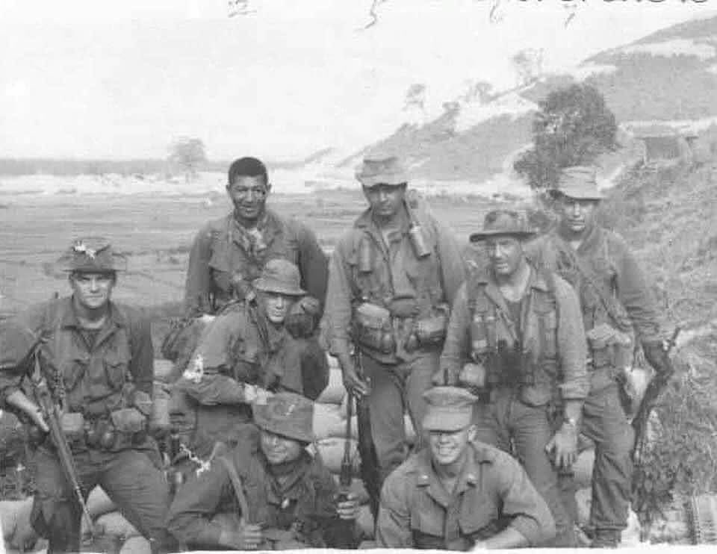
Today we remember our teammate Captain Eric Barnes (front right) who was Killed In Action leading 1st Force Reconnaissance Co. Team COUNTERSIGN on March 25th 1967.
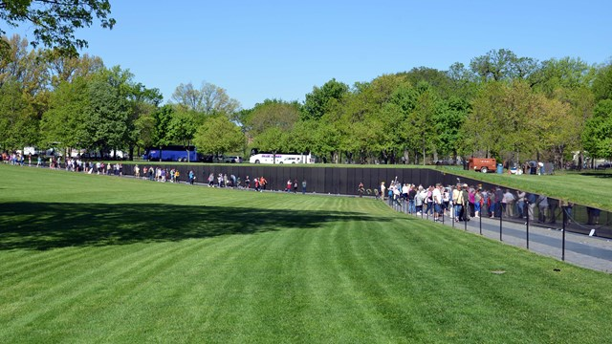Honoring the men and women who served in the controversial Vietnam War, the Vietnam Veterans Memorial chronologically lists the names of 58,318 Americans who gave their lives in service to their country. https://www.nps.gov/vive/index.htm

April 10, 1967 – Sen. Robert F. Kennedy
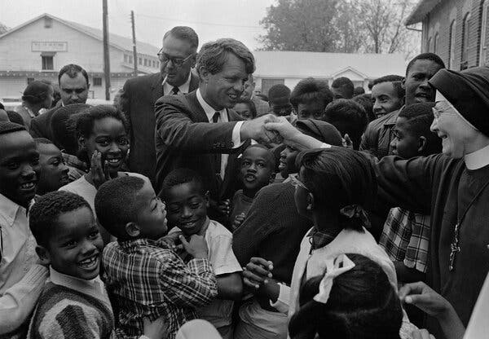
Senator Robert F. Kennedy visiting Greenville, Miss., in 1967.
“At the behest of Marian Wright, then a Mississippi civil rights attorney, Senator Robert F. Kennedy and the delegation of the U.S. Senate Subcommittee on Employment Manpower and Poverty, traveled the day after the hearings in Jackson to the Mississippi Delta where they saw firsthand the extent of the poverty and malnutrition that the poor in Mississippi endured. As civil rights attorney, Marian Wright had testified the day before: ‘the poverty program has done nothing to change the basic economic structure which needs to be changed.’” https://www.jimlucasphotography.com/civil-rights-movement-in-mississippi-1964-1968/1967-robert-f-kennedys-visit-to-the-mississippi-delta/

Oct. 8, 1967: Federal Trial KKK Murder 3 Civil Rights Activists

“Case Document: Michael Schwerner - James Chaney - Andrew Goodman.” https://www.justice.gov/crt/case-document/micheal-schwerner-james-chaney-andrew-goodman
“The trial of United States v. Price was held in Meridian in the Southern District of Mississippi, commencing on October 9, 1967. One hundred and fifty-one witnesses testified. Approximately twenty percent of the witnesses presented the government’s evidence of the crime, while the remaining eighty percent of the witnesses offered character and alibi evidence for the defendants. The jury returned its verdicts on October 20, 1967.
The 1967 federal prosecution trial team focused its evidentiary presentation on those defendants who participated in the shooting deaths of the three victims and on the top Klan leadership, Mississippi Klan leader Bowers and Philadelphia Klan leader Killen. All of the primary targeted defendants were convicted except for Killen. Accordingly, the prosecution team concentrated less on the secondary defendants, who had helped arrange, facilitate, and organize the murders and the burials, but had not actually participated in the killing. Given the available evidence and the political climate surrounding the trial, this strategy can hardly be faulted and proved largely successful.
***
As previously noted, seven defendants – Price, Roberts, H.D. Barnette, Posey, Arledge, Snowden, and Bowers – were convicted of the federal criminal civil rights conspiracy. Eight defendants – Burrage and Harris, as well as Bernard Akin, Travis Barnette, Herndon, Rainey, Tucker, and Willis – were found not guilty. Mistrials were entered by the court after the jury could not agree as to three defendants, Killen, Sharpe and “Hop” Barnette.”

Trial Transcripts In The Case - United States V. Price, Et Al. (also Known As The "Mississippi Burning" Incident) 1967.
“These trial transcripts were created as a result of the Civil Rights Division’s 1967 prosecution of individuals charged with the violation of the civil rights of James Chaney, Andrew Goodman, and Michael Schwerner in the United States v. Price, et al. (also known as the “Mississippi Burning” incident).” https://www.justice.gov/crt/trial-transcripts-caseunited-states-v-price-et-al-also-known-mississippi-burning-incident-1967?itid=lk_inline_enhanced-template

“In 1964, the Klan killed three young activists and shocked the nation.”
“With only the state able to bring murder charges — and Mississippi refusing to do so — the U.S. Justice Department put 18 men on trial for allegedly violating the civil rights of Schwerner, Chaney and Goodman. One defendant pleaded guilty. Seven, including a deputy sheriff, were convicted. None spent more than six years behind bars.” https://www.washingtonpost.com/nation/interactive/2024/mississippi-klan-killings-1964-impact-history/?utm_campaign=wp_post_most&utm_medium=email&utm_source=newsletter&wpisrc=nl_most&carta-url=https%3A%2F%2Fs2.washingtonpost.com%2Fcar-ln-tr%2F3e0b883%2F66745280065ad23d7ff1dd36%2F59731235ade4e21a848a56ed%2F8%2F53%2F66745280065ad23d7ff1dd36

Dec. 18, 1967: U.S. Supreme Court - Katz v. United States (8 to 0) https://supreme.justia.com/cases/federal/us/389/347/
FBI RECORDING DEVICE ON PHONE BOTH – BREACH EXPECTATION OF PRIVACY

“The petitioner was convicted in the District Court for the Southern District of California under an eight-count indictment charging him with transmitting wagering information by telephone from Los Angeles to Miami and Boston, in violation of a federal statute. At trial, the Government was permitted, over the petitioner's objection, to introduce evidence of the petitioner's end of telephone conversations, overheard by FBI agents who had attached an electronic listening and recording device to the outside of the public telephone booth from which he had placed his calls…. But what he sought to exclude when he entered the booth was not the intruding eye -- it was the uninvited ear. He did not shed his right to do so simply because he made his calls from a place where he might be seen.”

Jan. 30-31, 1968: Tet Offensive, Viet Nam
“By 1968 there were nearly 500,000 U.S. service personnel in the Republic of Vietnam (South Vietnam), under the overall command of Commander, U.S. Military Assistance Command, Vietnam (COMUSMACV) General William C. Westmoreland. Aided by 650,000 Army of the Republic of Vietnam (ARVN) personnel, the United States’ mission since 1965 had consisted of Rolling Thunder bombing campaigns against the Democratic Republic of Vietnam (North Vietnam), interdiction attempts along the Ho Chi Minh trail, and search and destroy missions against enemy forces throughout the South Vietnamese countryside. Optimism was high among U.S. military and planning personnel that these combined efforts were steadily degrading North Vietnam’s combat capabilities; within the near future, the U.S. intended to turn more and more of South Vietnam’s internal defense over to the ARVN.
A massive communist offensive, beginning in late January 1968, demonstrated that North Vietnam and its allies were still able to put up a fight. Throughout the evening of January 30-31, 1968, during the Vietnamese New Year holiday of Tet, more than 84,000 communist soldiers launched assaults on various U.S. and South Vietnamese military installations, cities, and hamlets. Enemy forces were a mix of North Vietnamese Army (NVA) troops and Viet Cong (VC) guerillas, with the former predominating towards the North – South Vietnamese border. Together they attacked more than 100 South Vietnamese targets, including most large cities, the capital of Saigon, and major U.S. bases.” https://dpaa-mil.sites.crmforce.mil/dpaaFamWebInTetOffensive#:~:text=In%20late%20January%201968%2C%20during,against%20the%20South%20Vietnamese%20government.


155mm Howitzer.

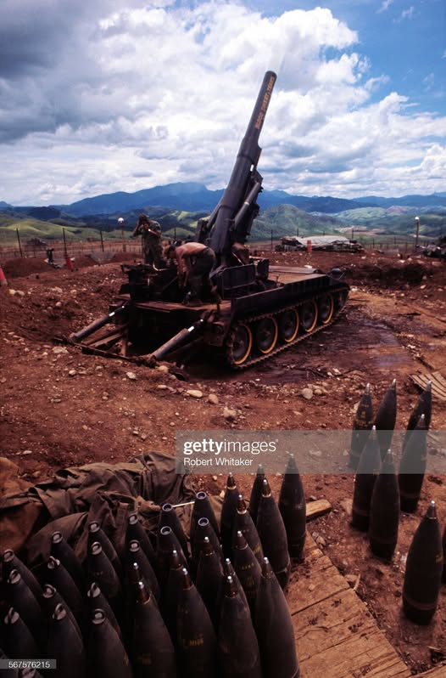

March 13, 1968 – Nerve Agent Testing
“On March 13, 1968, a military plane released a nerve agent during a covert open-air chemical test in Utah at the Army’s Dugway Proving Ground, the main weapons-testing center for America’s chemical and biological warfare. More than 6,000 sheep on nearby ranches died or had to be put down. The Army denied responsibility but its role was confirmed in a report released in 1997.” https://www.nytimes.com/2025/12/18/movies/cover-up-review-seymour-hersh.html?nl=The+Evening&segment_id=212532

March 16, 1968 – My Lai

“On March 16, 1968 the angry and frustrated men of Charlie Company, 11th Brigade, Americal Division entered the Vietnamese village of My Lai. ‘This is what you've been waiting for -- search and destroy -- and you've got it,’ said their superior officers. A short time later the killing began. When news of the atrocities surfaced, it sent shockwaves through the U.S. political establishment, the military's chain of command, and an already divided American public. Poised for Conflict. My Lai lay in the South Vietnamese district of Son My, a heavily mined area where the Vietcong were deeply entrenched. Numerous members of Charlie Company had been maimed or killed in the area during the preceding weeks. The agitated troops, under the command of Lt. William Calley, entered the village poised for engagement with their elusive enemy. Massacre As the "search and destroy" mission unfolded, it soon degenerated into the massacre of over 300 apparently unarmed civilians including women, children, and the elderly. Calley ordered his men to enter the village firing, though there had been no report of opposing fire. According to eyewitness reports offered after the event, several old men were bayoneted, praying women and children were shot in the back of the head, and at least one girl was raped and then killed. For his part, Calley was said to have rounded up a group of the villagers, ordered them into a ditch, and mowed them down in a fury of machine gun fire.” https://www.pbs.org/wgbh/americanexperience/features/vietnam-my-lai-massacre/

1968 - VIETNAM – PROTESTS
“Students, government officials, labor unions, church groups and middle class families increasingly opposed the war as it climaxed in 1968, forcing a gradual withdrawal of U.S. forces. Anti-war activities, particularly large-scale resistance to military conscription, forced an end U.S. combat operations in Vietnam and a suspension of the draft by January 1973.” https://www.nonviolent-conflict.org/us-anti-vietnam-war-movement-1964-1973/

April 4, 1968: Martin Luther King assassinated in Memphis, TN
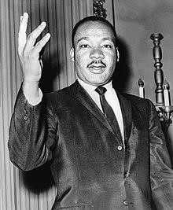

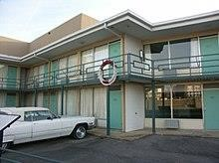
“Martin Luther King, Jr. was assassinated in Memphis, Tennessee, on April 4, 1968, an event that sent shock waves reverberating around the world. A Baptist minister and founder of the Southern Christian Leadership Conference (SCLC), King had led the civil rights movement since the mid-1950s, using a combination of impassioned speeches and nonviolent protests to fight segregation and achieve significant civil rights advances for African Americans. His assassination led to an outpouring of anger among black Americans, as well as a period of national mourning that helped speed the way for an equal housing bill that would be the last significant legislative achievement of the civil rights era.” https://www.history.com/topics/black-history/martin-luther-king-jr-assassination

James Earl Ray: pled guilty in 1969 to the assassination to avoid death penalty – died in prison after serving 29 years.
https://www.britannica.com/event/assassination-of-Martin-Luther-King-Jr
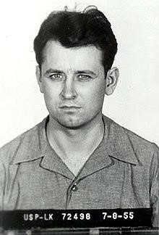

June 6, 1968: Robert F. Kennedy assassinated at Ambassador Hotel in Los Angeles: https://www.biography.com/political-figure/robert-kennedy


June 10, 1968: U.S. Supreme Court - Terry v. Ohio
(8 to 1) https://supreme.justia.com/cases/federal/us/392/1/
“STOP & FRISK” UPHELD
Chief Justice Earl Warren
MR. CHIEF JUSTICE WARREN delivered the opinion of the Court.

“Facts of the case
Terry and two other men were observed by a plain clothes policeman in what the officer believed to be ‘casing a job, a stick-up.’ The officer stopped and frisked the three men and found weapons on two of them. Terry was convicted of carrying a concealed weapon and sentenced to three years in jail.

Question
Was the search and seizure of Terry and the other men in violation of the Fourth Amendment?

Conclusion
In an 8-to-1 decision, the Court held that the search undertaken by the officer was reasonable under the Fourth Amendment and that the weapons seized could be introduced into evidence against Terry. Attempting to focus narrowly on the facts of this particular case, the Court found that the officer acted on more than a ‘hunch’ and that ‘a reasonably prudent man would have been warranted in believing [Terry] was armed and thus presented a threat to the officer's safety while he was investigating his suspicious behavior.’ The Court found that the searches undertaken were limited in scope and designed to protect the officer's safety incident to the investigation.

1968: PSOB – Public Safety Officers Benefits Program
“The Public Safety Officers’ Benefits (PSOB) program is authorized in statute at Part L of Title I of the Omnibus Crime Control and Safe Streets Act of 1968 (34 U.S.C. §§10281-10288).” https://fas.org/sgp/crs/misc/R45327.pdf
It is administered by the U.S. Department of Justice, Bureau of Justice Assistance. https://psob.bja.ojp.gov/PSOB_FactSheet2019.pdf
Note: On Aug. 14, 2020, President signed into law the “Safeguarding America's First Responders Act of 2020.”
“This bill extends death and disability benefits under the Public Safety Officers' Benefits Program (PSOB) to public safety officers (e.g., law enforcement officers) and survivors of public safety officers who die or become injured as a result of COVID-19 (i.e., coronavirus disease 2019). The PSOB program provides death, disability, and education benefits to public safety officers and survivors of public safety officers who are killed or injured in the line of duty.For purposes of death benefits, this bill creates a general presumption that a public safety officer who dies from COVID-19 or related complications sustained a personal injury in the line of duty. For purposes of disability benefits, the bill creates a general presumption that COVID-19 or related complications suffered by a public safety
officer constitutes a personal injury sustained in the line of duty.” https://www.congress.gov/bill/116th-congress/senate-bill/3607
July 21, 2020: House passes bill to ensure COVID-19 death, disability benefits for first responders
“Their “Safeguarding America’s First Responders Act” creates a presumption that if a first responder is diagnosed with the coronavirus within 45 days of their last day on the job, the Department of Justice will treat it as a line of duty incident and provide the payments.” https://www.firerescue1.com/legislation-
funding/articles/house-passes-bill-to-ensure-covid-19-death-disability-benefitsfor-first-responders-
deBCm2kVdUMy5ATc/?utm_source=FireRescue1+Member+Newsletter&utm_c ampaign=7d3689028a-
EMAIL_CAMPAIGN_2020_07_21_07_03&utm_medium=email&utm_term=0_ 758bdbeffe-7d3689028a-41607823

June 12, 1968: Age Discrimination in Employment Act
Mandatory retirement age may be imposed by Fire & Police Departments.
29 U.S. Code § 623. Prohibition of age discrimination: https://www.law.cornell.edu/uscode/text/29/623

(j) Employment as firefighter or law enforcement officer. It shall not be unlawful for an employer which is a State, a political subdivision of a State, an agency or instrumentality of a State or a political subdivision of a State, or an interstate agency to fail or refuse to hire or to discharge any individual because of such individual’s age if such action is taken—
(1) with respect to the employment of an individual as a firefighter or as a law enforcement officer, the employer has complied with section 3(d)(2) of the Age Discrimination in Employment Amendments of 1996 ² if the individual was discharged after the date described in such section, and the individual has attained—
(A)
the age of hiring or retirement, respectively, in effect under applicable State or local law on March 3, 1983; or
(B)
(i)
if the individual was not hired, the age of hiring in effect on the date of such failure or refusal to hire under applicable State or local law enacted after September 30, 1996; or
(ii) if applicable State or local law was enacted after September 30, 1996, and the individual was discharged, the higher of—
(I)
the age of retirement in effect on the date of such discharge under such law; and
(II)
age 55; and
(2)
pursuant to a bona fide hiring or retirement plan that is not a subterfuge to evade the purposes of this chapter.

June 31, 1968: U.S. Supreme Court - Pickering v. Board of Ed. (8 to 1) https://law.justia.com/cases/illinois/supreme-court/1967/40038-5.html
LIMITED FREE SPEECH RIGHTS OF PUBLIC EMPLOYEES – “BALANCING TEST”
Justice Thurgood Marshall: https://www.oyez.org/justices/thurgood_marshall
MR. JUSTICE MARSHALL delivered the opinion of the Court.

“Facts of the case
Marvin Pickering, a school teacher, wrote a letter to the editor at the Lockport Herald complaining about a recently defeated school board proposal to increase school taxes. The letter complained about the board’s handling of past proposals and allocation of funds favoring athletics over academics. The school board felt the letter was ‘detrimental to the efficient operation and administration of the schools’ and opted to terminate Pickering’s employment. Pickering sued in the Circuit Court of Will County alleging his letter was speech protected under the First Amendment. The court ruled in favor of the school board and the Supreme Court of Illinois affirmed.
Question
Was Pickering’s letter constitutionally protected free speech?

Conclusion
Yes. Justice Thurgood Marshall wrote the 8-1 majority opinion holding that Pickering’s dismissal violated his First Amendment right to free speech. The Supreme Court noted that similar speech is not protected if it contains false statements knowingly or recklessly made. There was no evidence that Pickering’s statements were knowingly false or reckless.
Justice William O. Douglas concurred, but took an even broader view of protected free speech. Justice Hugo L. Black joined in the concurrence. Justice Byron R. White wrote a dissent, agreeing that the letter may be protected speech, but preferring to remand the case for further proceedings to decide whether the statements in the letter were knowingly or recklessly false.” https://www.oyez.org/cases/1967/510

May 14, 2024: “Attorney General Merrick B. Garland Delivers Remarks Celebrating 70th Anniversary of Brown v. Board Decision.” https://www.justice.gov/opa/speech/attorney-general-merrick-b-garland-delivers-remarks-celebrating-70th-anniversary-brown-v
“Seventy years ago this Friday, on May 17, 1954, the United States Supreme Court unanimously concluded “that, in the field of public education, the doctrine of ‘separate, but equal’ has no place.”

On that day, the Court ruled in favor of the more than 200 people from across the country who had joined as plaintiffs in Brown v. Board of Education.
Those plaintiffs included parents like Mrs. Lena Carper, who believed her 10-year-old daughter deserved better than to have to walk and wait in the wind, rain, snow, and mud to catch the bus that would take her to the school designated for Black children. And they included students like 16-year-old Barbara Johns, who led hundreds of fellow students in a strike to protest the terrible conditions at her segregated school. Barbara received deaths threats, her family home was burned to the ground, and a cross was burned on the grounds of her high school by white supremacists. For those students, and for our country, the decision in Brown represented a promise. A promise that this would be a nation where students of all races and backgrounds could learn together in the same classrooms and the same schools. And a promise that our schools would not only teach students about the principle that underlies our democracy — that we are all equal under the law — but that they would embody it.

But in the wake of the Court’s decision, it became clear that the words of the Justices would not be sufficient to ensure the integration of our nation’s schools.
As members of Congress urged states to ‘resist forced integration by any lawful means,’ and governors barred schoolhouse doors, the task primarily fell to Black children — some no more than five or six years old, whose only wish was to go to school. Among those students were three six-year-old girls — who, together Ruby Bridges, would later become part of a group known as the New Orleans Four. In November of 196[0], three members of the New Orleans Four integrated the previously all-white McDonogh 19 Elementary School in New Orleans. Each day, U.S. Marshals escorted them to school. On their way, they had to face down the mobs of white residents who lined the streets to heckle, threaten, and harass them.
On the girls’ very first day of school, parents of their white classmates removed their children from the school, rather than have them sit in the same classrooms with their Black peers.”

Aug. 26-29, 1968: Democratic National Convention - Chicago
“Over 650 protesters were arrested during the convention. The total number of injured protesters is unknown but over 100 were treated at area hospitals. It was reported that 192 police officers were injured and 49 required medical treatment.” https://www.history.com/topics/1960s/1968-democratic-convention
_____________________________________________________________________________
“Using media cover, military counterintelligence special agents infiltrated the 1968 Democratic National Convention in Chicago. There was no legitimate Defense investigative purpose for this action. Information collected by Defense elements was routinely transferred to civilian law enforcement authorities without evidence of criminal activity or relevance to the law enforcement missions of the receiving authorities. This activity was improper.” https://dodsioo.defense.gov/About-DOD-SIOO/

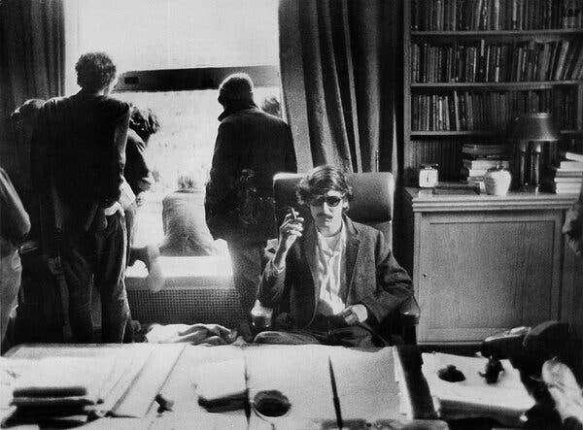
“Mr. [David] Shapiro first tasted fame, albeit unwittingly, when he was photographed in the office of Columbia University’s president during the student uprising of 1968. https://www.nytimes.com/2024/05/10/books/david-shapiro-dead.html?te=1&nl=the-morning&emc=edit_nn_20240511

Oct. 22, 1968: Gun Control Act effective
”Gun Control Act of 1968
This Legislation regulated interstate and foreign commerce in firearms, including importation, "prohibited persons", and licensing provisions. Assassinations and Gun Control
After the assassinations of President John Kennedy, Attorney General Robert Kennedy and Dr. Martin Luther King, Jr., the Gun Control Act is passed and imposes stricter licensing and regulation on the firearms industry, establishes new categories of firearms offenses, and prohibits the sale of firearms and ammunition to felons and certain other prohibited persons. It also imposes the first Federal jurisdiction over "destructive devices," including bombs, mines, grenades and other similar devices. Congress reorganizes ATU into the Alcohol and Tobacco Tax Division (ATTD) and delegates to them the enforcement of the Gun Control Act.” https://www.atf.gov/rules-and-regulations/laws-alcohol-tobacco-firearms-and-explosives/gun-control-act

March 27, 2024:
‘Ghost Guns’: What They Are and Why There Has Been a Fight Over Them. A rule regulating the firearm kits was a centerpiece of President Joseph R. Biden Jr.’s gun control initiative. The Supreme Court has upheld the regulation, issued in 2022. The Supreme Court on Wednesday [March 26, 2024] upheld federal restrictions the Biden administration placed on “ghost guns,” drawing a spotlight to the kits that can be assembled into home.” https://www.nytimes.com/2025/03/26/us/politics/what-are-ghost-guns.html
U.S. Supreme Court opinion: https://www.supremecourt.gov/opinions/24pdf/23-852_c07d.pdf

Jan. 20, 1969: President Richard Nixon – First Inauguration

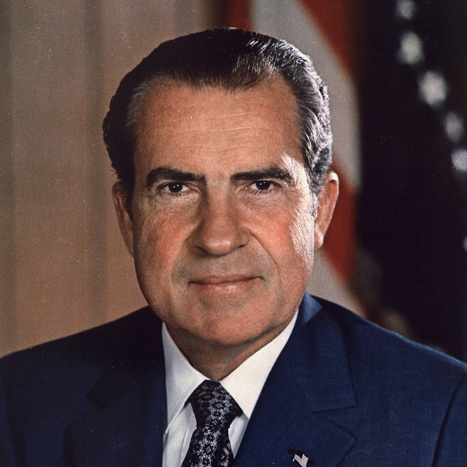
https://bidenwhitehouse.archives.gov/about-the-white-house/presidents/richard-m-nixon/

May 1, 1969 – Fred Rogers testifies before Congress to save PBS budget
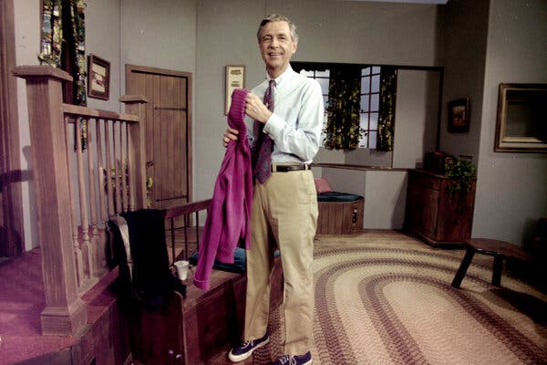Fred Rogers, the star of “Mister Rogers’ Neighborhood” testified before Congress in 1969 to protest proposed cuts to public media. https://www.nytimes.com/2025/03/26/business/media/pbs-npr-congress-funding.html

February 24, 1969: U.S. Supreme Court - Tinker v. Des Moines
“Issue: Does the First Amendment prohibit public school officials from barring students' from wearing black armbands to symbolize anti-war political protest?
Result: According to the Court, yes. The Supreme Court held that students do not ‘shed their constitutional rights to freedom of speech…at the schoolhouse gate.’ Consequently, the Court found that the students' speech could only be prohibited if it actually disrupted the educational process. Because there was no evidence of such a disruption, the school was in violation of the First Amendment freedom of speech.
Importance: Tinker has become the central case for any challenges to school-based First Amendment rights.” https://www.americanbar.org/groups/public_education/programs/constitution_day/landmark-cases/

June 28, 1969 – NYPD Raid On Gay Bar
“Stonewall riots, series of violent confrontations that began in the early hours of June 28, 1969, between police and gay rights activists outside the Stonewall Inn, a gay bar in the Greenwich Village section of New York City. As the riots progressed, an international gay rights movement was born. *** In 1969 the solicitation of homosexual relations was an illegal act in New York City (and indeed virtually all other urban centres). Gay bars were places of refuge where gay men and lesbians and other individuals who were considered sexually suspect could socialize in relative safety from public harassment. Many of those bars were, however, subject to regular police harassment. The riots outside the Stonewall Inn waxed and waned for the next five days. Many historians characterized the uprising as a spontaneous protest against the perpetual police harassment and social discrimination suffered by a variety of sexual minorities in the 1960s. Although there had been other protests by gay groups, the Stonewall incident was perhaps the first time lesbians, gays, and transgender people saw the value in uniting behind a common cause. Occurring as it did in the context of the civil rights and feminist movements, the Stonewall riots became a galvanizing force.” https://www.britannica.com/event/Stonewall-riots
June 28, 2024: National Park Service - Stonewall National Monument Visitor Center in NYC. https://stonewallvisitorcenter.org/

May 4, 1970 – Kent State University – 4 Students Killed By Ohio National Guard
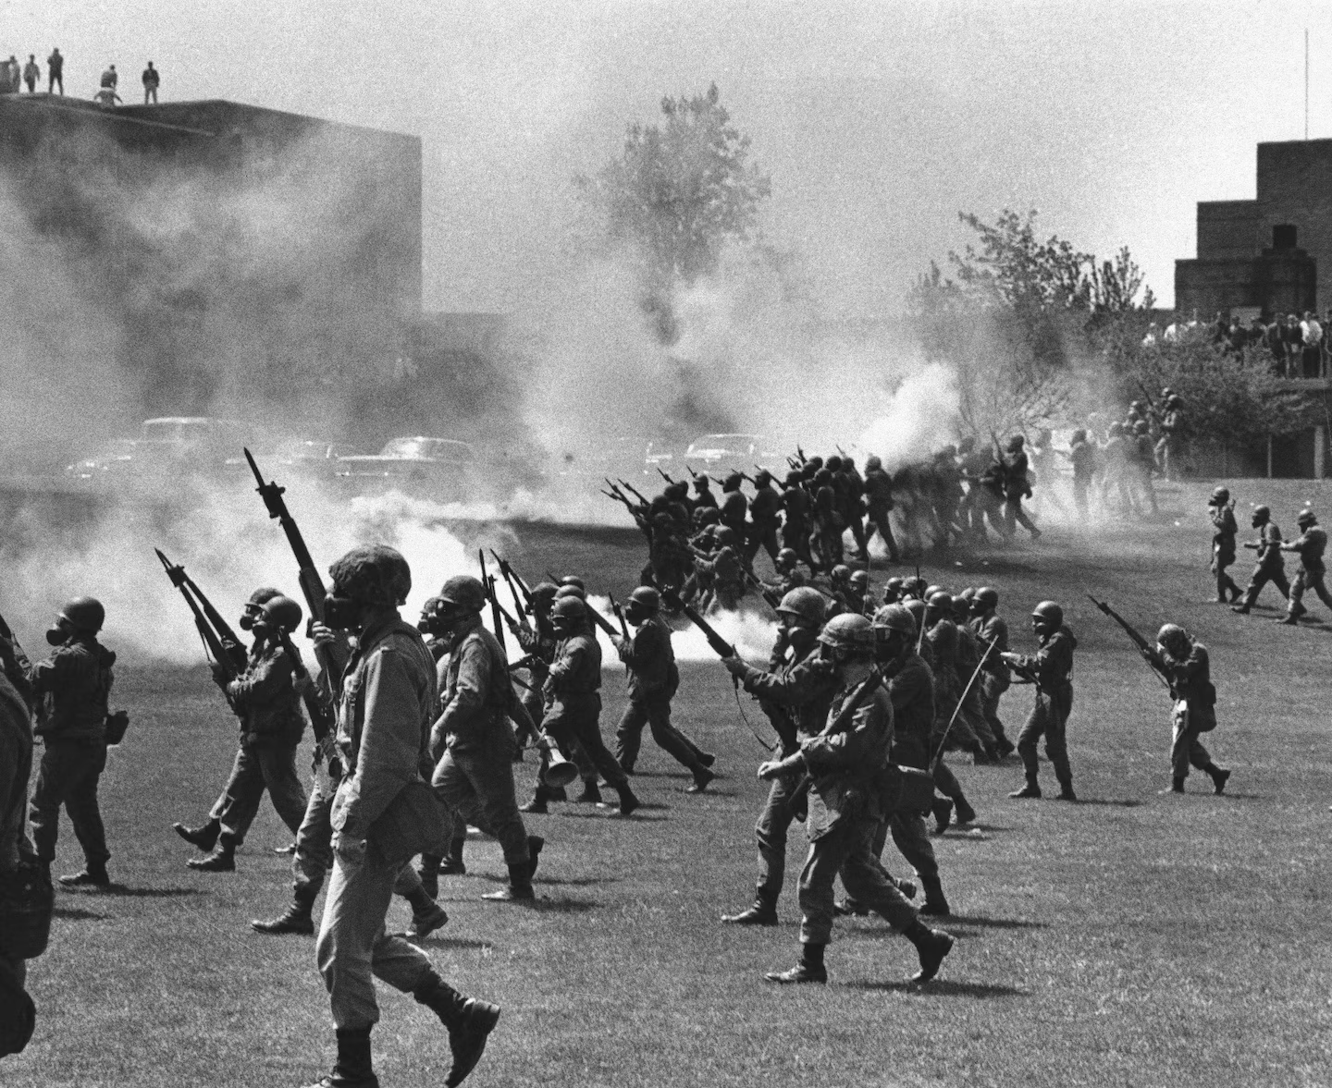
“The commander of National Guard forces on the scene, Assistant Adjutant General Robert Canterbury, decided to disperse the protesters. As Kane and others had feared, the presence of armed troops inflamed the students; what had been planned as a protest against the war became a protest of a different sort. ‘It wasn’t an antiwar rally,’ said a student. ‘It was now a National Guard get-the-hell-off our campus rally.’ *** The reckless Canterbury also failed to warn protesters — as required by Ohio National Guard regulations for crowd control — that his men were armed with loaded rifles containing high-velocity bullets that could kill at a range of 1,000 yards and at 200 yards could pierce a steel helmet and pass straight through a human head. Unaware of the risk, students advanced toward the nervous Guardsmen, and at 12:24 p.m., several of the troops opened fire. Four Kent State students were killed, and nine were wounded, one of them paralyzed for life.” https://www.washingtonpost.com/opinions/2024/04/26/kent-state-killings-lesson-protests/?utm_campaign=wp_todays_headlines&utm_medium=email&utm_source=newsletter&wpisrc=nl_headlines&carta-url=https%3A%2F%2Fs2.washingtonpost.com%2Fcar-ln-tr%2F3d879cb%2F662cccb6a460347163ea193e%2F59731235ade4e21a848a56ed%2F30%2F67%2F662cccb6a460347163ea193e


Woody Guthrie – protest songs

April 21,1971: OSHA Effective Date
“The Occupational Safety and Health Administration was established in 1971. Since then, OSHA and our state partners, coupled with the efforts of employers, safety and health professionals, unions and advocates, have had a dramatic effect on workplace safety. Fatality and injury rates have dropped markedly. Although accurate statistics were not kept at the time, it is estimated that in 1970 around 14,000 workers were killed on the job. That number fell to approximately 4,340 in 2009. At the same time, U.S.
employment has almost doubled and now includes over 130 million workers at more than 7.2 million worksites. Since the passage of the OSH Act, the rate of reported serious workplace injuries and illnesses has declined from 11 per 100 workers in 1972 to 3.6 per 100 workers in 2009. OSHA safety and health standards, including those for trenching, machine guarding, asbestos, benzene, lead, and bloodborne pathogens have prevented countless work-related injuries, illnesses and deaths. This timeline highlights key milestones in occupational safety and health history since the creation of OSHA.” https://www.osha.gov/osha40/timeline.html
Federal OSHA neither has regulations, nor jurisdiction, over State, municipal, or volunteer fire departments: https://www.osha.gov/lawsregs/standardinterpretations/2006-10-11-1
“Please be advised that Federal OSHA neither has regulations, nor jurisdiction, over State, municipal, or volunteer fire departments. Section (3)(5) of the Occupational Safety and Health Act of 1970 specifically excludes Federal OSHA's authority over employees of State and local government. The Act provides for States to assume responsibility for occupational safety and health programs under the State's own plan, which must be approved by the U.S. Department of Labor. Each State-plan must include coverage of public employees of the State, and it must be "at least as effective" as Federal OSHA's protection of private sector employees.

As you may know, the State of New York administers its own occupational safety and health program for public sector employees (Public Employee Safety & Health (PESH)) under a plan approved and monitored by Federal OSHA. States are required to have regulations that are, at least as effective as the federal standards, although they may be more stringent. Also, private sector employees in the State of New York are covered by Federal OSHA.
***
Richard E. Fairfax, Director
Directorate of Enforcement Programs
22 STATE OSHA PLANS
“State Plans are OSHA-approved workplace safety and health programs operated by individual states or U.S. territories. There are currently 22 State Plans covering both private sector and state and local government workers, and there are six State Plans covering only state and local government workers. State Plans are monitored by OSHA and must be at least as effective as OSHA in protecting workers and in preventing work-related injuries, illnesses and deaths.” https://www.osha.gov/stateplans

May 8, 1971: DC Fire Chief Jerry Wilson
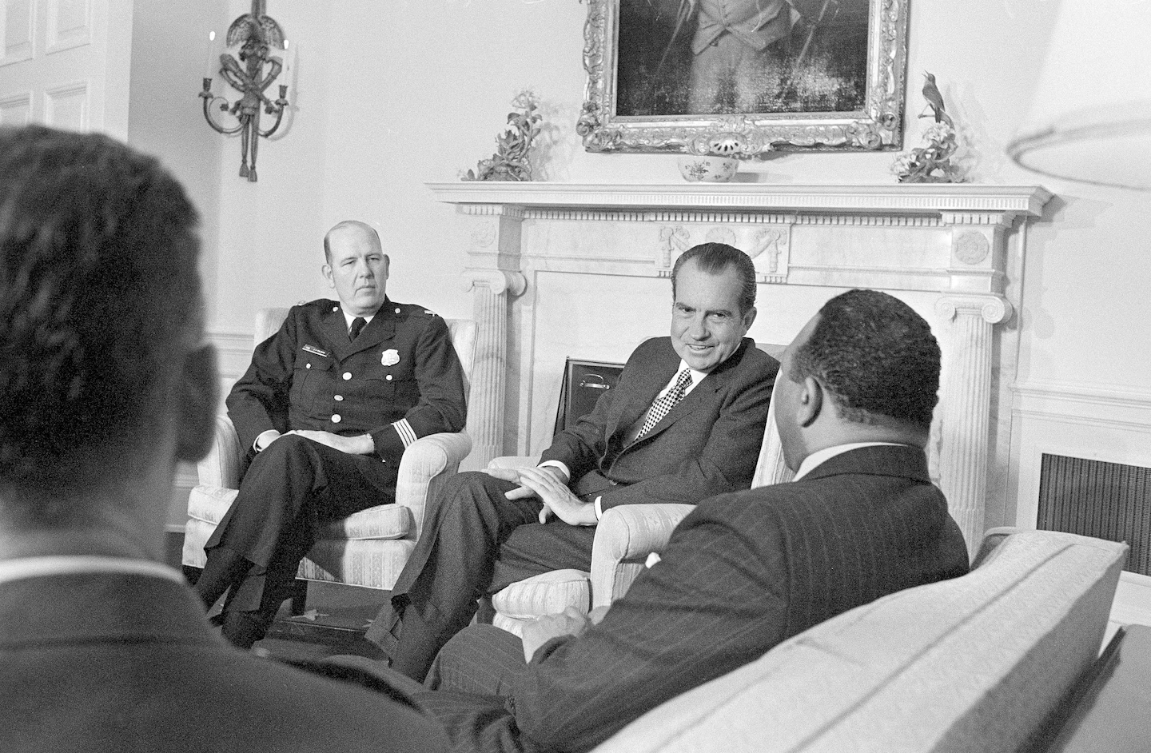 President Richard M. Nixon talks with D.C. Police Chief Jerry Wilson and Mayor Walter E. Washington in the White House on May 8, 1971. (Charles Tasnadi/AP)

“How Jerry Wilson transformed the D.C. police. This consequential police chief was one of the best managers of a government agency I ever knew.*** In April 1968, the District had gone through a three-day riot that started the day the Rev. Martin Luther King Jr. was assassinated. A few people were killed, and fires burned up entire blocks on Seventh and 14th Streets NW and H Street NE. *** Wilson had two great opportunities presented to him and took full advantage of both, to the lasting benefit of the city. I joined a department [in 1969] with about 2,600 sworn officers and an authorized strength of 3,100. But in those pre-home-rule days, two successive presidents, Lyndon B. Johnson and Richard M. Nixon, worried that they might be blamed for rising crime in Washington. And each came up with the same solution: Add 1,000 police officers to the force. Our authorized strength went from 3,100 to 5,100! *** No department in the United States was regularly putting women on patrol, but Wilson thought they ought to be able to do the work. He decided on an experiment: The city would hire 100 female officers, assign them to patrol beats and see how their work compared with that of 100 male rookies. Looking for a woman to oversee this experiment, Wilson was turned down by all the department’s top-ranking women. Women had a different status from male officers: They were all college graduates, all in the Youth Division, all in civilian clothes, none working the midnight to 8 a.m. shift. There was little enthusiasm for making women into patrol officers. Wilson worked his way from the highest-ranking woman in the department all the way down to Pvt. Mary Ellen Abrecht, another true hero of the city, who said, “I’ll do it.” *** Mrs. Abrecht, who helped manage and coordinate a pilot program of 100 female police officers on the beat in 1972 and later became a prosecutor with the U.S. attorney’s office in Washington and a Superior Court judge, died Aug. 16 at her home in Washington. She was 72, and the cause was metastatic breast cancer, said her husband, Gary L. Abrecht, a former D.C. police deputy chief who retired as chief of the U.S. Capitol Police.https://www.washingtonpost.com/local/obituaries/mary-ellen-abrecht-early-female-beat-cop-who-became-a-dc-superior-court-judge-dies-at-72/2018/08/22/0fde5920-a4c8-11e8-8fac-12e98c13528d_story.html 
By Donald E. Graham. Donald E. Graham, former publisher of The Washington Post, was a patrolman with the Metropolitan Police Department from January 1969 to June 1970. https://www.washingtonpost.com/opinions/2025/03/24/jerry-wilson-dc-police-donald-graham/?utm_campaign=wp_todays_headlines&utm_medium=email&utm_source=newsletter&carta-url=https%3A%2F%2Fs2.washingtonpost.com%2Fcar-ln-tr%2F41c3aa9%2F67e27eaaa658864abd1a266a%2F59731235ade4e21a848a56ed%2F29%2F66%2F67e27eaaa658864abd1a266a

June 21, 1971: U.S. Supreme Court - Bivens v. Six Unknown Agents of Federal Bureau of Narcotics (6 to 3) https://supreme.justia.com/cases/federal/us/403/388/
FEDERAL AGENTS CAN BE PERSONALLY SUED FOR ILLEGAL SEARCH & SEIZURES
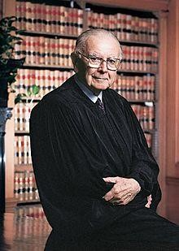
Justice William J. Brennan Jr.: https://www.oyez.org/justices/william_j_brennan_jr

“Facts of the case
In 1965, six agents of the Federal Bureau of Narcotics forced their way into Webster Bivens’ home without a warrant and searched the premises. The agents handcuffed Bivens in front of his wife and children and arrested him on narcotics charges. Later, the agents interrogated Bivens and subjected him to a visual strip search. Bivens sued the agents for $15,000 in damages each for humiliation and mental suffering. The district court dismissed the complaint for failure to state a cause of action. The U.S. Court of Appeals for the Second Circuit affirmed.

Question
- Does violation of an individual’s Fourth Amendment protection against unreasonable search and seizure give rise to a federal claim for damages?
- Does governmental privilege extend to federal agents who clearly violate constitutional rights and act outside their authority?

Conclusion
Yes, No answer. Justice William J. Brennan Jr., writing for a 6-3 majority, reversed the Second Circuit and remanded. The Supreme Court held that Bivens does have a cause of action for damages arising from the federal agents Fourth Amendment violations. Bivens must provide proof of his injuries in order to recover. The Court did not reach the privilege question because the Court of Appeals did not consider the question. Justice John M. Harlan concurred in the judgment, writing that federal courts have the power to award damages for constitutional violations.
Chief Justice Warren E. Burger dissented, arguing that the doctrine of separation of powers is better served by leaving the question to Congress. He also argued that the doctrine of suppressing evidence obtained in illegal searches is insufficient to deter law enforcement. Justice Hugo L. Black also dissented, arguing that Congress could create the cause of action Bivens stated, but has not, so the majority’s decision is an unconstitutional extension of judicial power. Justice Harry A. Blackmun dissented, supporting the idea that the question in this case is better left to Congress.” https://www.oyez.org/cases/1970/301

June 30, 1971: U.S. Supreme Court – New York Times Company v. United States (9 to 0) https://supreme.justia.com/cases/federal/us/403/713/

The First Amendment overrides the federal government’s interest in keeping certain documents, such as the Pentagon Papers, classified.

https://scholar.google.com/scholar_case?case=17571244799664973711&q=New+York+Times+v.+United+States&hl=en&as_sdt=6,36&as_vis=1

Pentagon Papers case, New York Times Co. v. United States, in which the government sought to prevent the Times and The Post from printing classified documents. “These disclosures may have a serious impact,” Justice Hugo Black wrote in rejecting that effort. “But that is no basis for sanctioning a previous restraint on the press.”

July 5, 1971: 26th Amendment – Voting Age 18
“Section. 1. The right of citizens of the United States, who are eighteen years of age or older, to vote shall not be denied or abridged by the United States or by any State on account of age.
Section. 2. The Congress shall have power to enforce this article by appropriate legislation.” https://constitution.findlaw.com/amendments.html
***
“For most of American history, people had to be 21 to vote in federal elections. That changed when 18-year-olds started being shipped abroad to fight in the Vietnam War. They protested; they staged sit-ins; they burned their draft cards. If they could die for their country, why couldn’t they vote for its leaders? So, in 1971, states ratified the 26th Amendment, which lowered the voting age to 18.” The New York Times - July 18, 2025: nytdirect@nytimes.com

July 5, 1971: 27th Amendment – Congressional Pay Limitation
“No law varying the compensation for the services of the Senators and Representatives shall take effect, until an election of Representatives shall have intervened.” https://constitution.findlaw.com/amendments.html

June 17, 1972: Watergate Burglary

Watergate complex, Washington, D.C.

“Burglary, arrest, and limited immediate political effect. Early on June 17, 1972, police apprehended five burglars at the office of the DNC in the Watergate complex. Four of them formerly had been active in Central Intelligence Agency (CIA) activities against Fidel Castro in Cuba. (Though often referred to in the press as ‘Cubans,’ only three of the four were of Cuban heritage.) The fifth, James W. McCord, Jr., was the security chief of the Committee to Re-elect the President (later known popularly as CREEP), which was presided over by John Mitchell, Nixon’s former attorney general. The arrest was reported in the next morning’s Washington Post in an article written by Alfred E. Lewis, Carl Bernstein, and Bob Woodward, the latter two a pair of relatively undistinguished young reporters relegated to unglamorous beats—Bernstein to roving coverage of Virginia politics and Woodward, still new to the Post, to covering minor criminal activities. Soon after, Woodward and Bernstein and Federal Bureau of Investigation (FBI) investigators identified two coconspirators in the burglary: E. Howard Hunt, Jr., a former high-ranking CIA officer only recently appointed to the staff of the White House, and G. Gordon Liddy, a former FBI agent working as a counsel for CREEP. At the time of the break-in, Liddy had been overseeing a similar, though uncompleted, attempt to break into and surveil the headquarters of George S. McGovern, soon to become the Democratic nominee in the 1972 U.S. presidential election.” https://www.britannica.com/event/Watergate-Scandal

Attorney General John Mitchell:

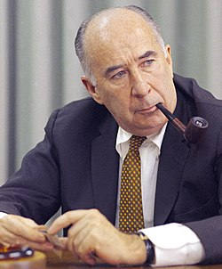

“In 1974 he was indicted on charges that he had conspired to plan the break-in and that he had obstructed justice and perjured himself during the subsequent cover-up of the affair. He was convicted in 1975 and sentenced to 2 1/2 to 8 years in prison; he entered prison in 1977 and was released on parole in 1979.” https://www.britannica.com/biography/John-Mitchell-attorney-general-of-United-States

Deputy Attorney General Richard Kleindienst

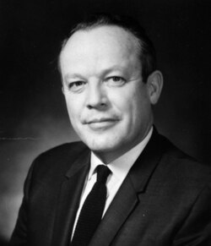

“On the morning of the burglars' court appearance, Kleindienst was playing golf near Washington, when a frantic Gordon Liddy, one of those who had helped organize the break-in, tracked him down to warn him that the burglars were in the pay of the re-election committee. He was almost certainly asked to block further FBI investigations. In the event, he rang a senior official in the US justice department to order that campaign officials should be investigated as vigorously as any other suspect.” https://www.theguardian.com/news/2000/feb/05/guardianobituaries

“In 1974, he was censured after he was convicted of giving false testimony to a U.S. Senate committee in connection with an International Telephone and Telegraph payoff scandal.”https://www.upi.com/Archives/1981/04/14/Former-Attorney-General-Richard-Kleindienst-who-resigned-from-office/9126356072400/

HERE’S OTHERS INVOLVED

G. Gordon Liddy

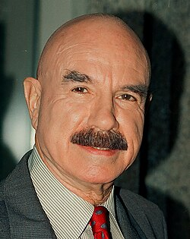

“In 1957 he joined the FBI. He quit the FBI in 1962, and three years later he became an assistant district attorney in Poughkeepsie, New York…. In 1971 Liddy and former Central Intelligence Agency (CIA) agent E. Howard Hunt, the future Watergate mastermind, led a group that broke into the Beverly Hills, California, office of the psychiatrist of military analyst Daniel Ellsberg, who had infuriated Nixon with his leak of the Pentagon Papers. They came up empty in their search for compromising information. Following the disbandment of the Plumbers, Liddy went to work for the Committee to Reelect the President (also known as CREEP), for which he organized “dirty tricks” aimed primarily at undermining the Democratic Party…. Liddy and Hunt oversaw a team that included six burglars and James W. McCord, Jr., the head of security of Nixon’s reelection campaign, which planted bugs and took photos at the DNC office on May 28, 1972. A few weeks later, on June 17, McCord and four burglars broke in again, but this time they were caught by police. Liddy and Hunt were quarterbacking the operation from a Watergate hotel room, and they too were arrested and charged with burglary, wiretapping, and conspiracy…. In March 1973 Liddy was sentenced to 20 years in prison, but he was freed in 1977 after just four years and four months when U.S. Pres. Jimmy Carter commuted his sentence. https://www.britannica.com/biography/G-Gordon-Liddy

James McCord:
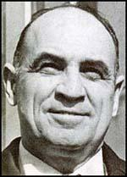
“The Watergate Burglar Who Cracked.” But after Washington police were summoned to investigate a reported burglary at the Watergate office building on that spring night in 1972, one of those arrested at the scene, and taken away in handcuffs, was James W. McCord Jr., the head of security for Nixon’s fundraising organization, the Committee for the Re-Election of the President, better known as CREEP. The Oklahoma-born McCord was 48, a veteran aviator of World War II, and a longtime CIA counterintelligence operative who had retired from the agency in 1971 to start his own security firm…. It was only in March 1973, when the burglars were threatened by District Judge John Sirica with lengthy prison terms if they didn’t tell all they knew, that McCord cracked. He wrote a letter to the court and, as Sirica said, ‘broke the case wide open.’ On March 23, 1973, Sirica read McCord’s letter aloud in court: ‘There was political pressure applied to the defendants to plead guilty and remain silent. … Perjury occurred during the trial. … Others involved in the Watergate operation were not identified.’” https://www.politico.com/news/magazine/2019/12/29/james-mccord-watergate-burglar-obituary-086480
President Trump on March 19, 2025 released many JFK assassination classified documents, including Aug. 4, 1966 CIA document. “An award recommendation for James W. McCord Jr. — a longtime, high-level CIA employee who was later convicted in the Watergate burglary says he was instrumental in developing “fluoroscopic scanning” that enabled the CIA to ‘detect hidden technical listening devices’ for the first time. Intelligence agencies spent ‘large sums of money’ to develop such a capability, the document states, adding that McCord — who died in 2017 — and others had ‘contributed significantly to the future clandestine use of this technique on a world-wide basis.’” https://www.washingtonpost.com/investigations/interactive/2025/jfk-files-assassination-documents/?utm_campaign=wp_todays_headlines&utm_medium=email&utm_source=newsletter&carta-url=https%3A%2F%2Fs2.washingtonpost.com%2Fcar-ln-tr%2F41af9f0%2F67dbe72b97fc0f25850ac3d2%2F59731235ade4e21a848a56ed%2F17%2F64%2F67dbe72b97fc0f25850ac3d2

Jan. 20, 1973: President Nixon – Second Inauguration
“As America's longest and most difficult war comes to an end, let us again learn to debate our differences with civility and decency. And let each of us reach out for that one precious quality government cannot provide--a new level of respect for the rights and feelings of one another, a new level of respect for the individual human dignity which is the cherished birthright of every American.” https://avalon.law.yale.edu/20th_century/nixon2.asp

1973: Watergate Committee

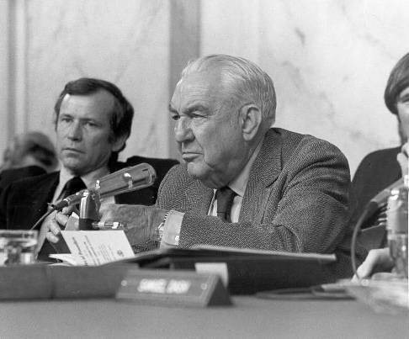
Senator Sam Ervin (NC) – Chair of Watergate Committee:
“The House Judiciary Committee used information uncovered by the Senate Watergate Committee to draft articles of impeachment against President Richard Nixon, who resigned on August 9, 1974. Ervin retired from the Senate in December 1974, returning to his hometown of Morganton, North Carolina.” https://www.senate.gov/senators/FeaturedBios/Featured_Bio_ErvinSam.htm
***
“In 1973, he Senate Watergate Committee investigation revealed that the executive branch had directed national intelligence agencies to carry out constitutionally questionable domestic security operations. In 1974 Pulitzer Prize–winning journalist Seymour Hersh published a front-page New York Times article claiming that the CIA had been spying on anti-war activists for more than a decade, violating the agency’s charter. Former CIA officials and some lawmakers, including Senators William Proxmire and Stuart Symington, called for a congressional inquiry.

***
The Senator Frank] Church Committee investigated and identified a wide range of intelligence abuses by federal agencies, including the CIA, FBI, Internal Revenue Service, and National Security Agency. In the course of their work, investigators identified programs that had never before been known to the American public, including NSA’s Projects SHAMROCK and MINARET, programs which monitored wire communications to and from the United States and shared some of that data with other intelligence agencies. Committee staff researched the FBI’s long-running program of ‘covert action designed to disrupt and discredit the activities of groups and individuals deemed a threat to the social order,’ known as COINTELPRO. The FBI included among the program’s many targets organizations such as the Southern Christian Leadership Conference, the anti-Vietnam War movement, and individuals such as Martin Luther King, Jr., as well as local, state, and federal elected officials.
***
In 1976 the Senate approved Senate Resolution 400, establishing the Senate Select Committee on Intelligence, to provide ‘vigilant legislative oversight over the intelligence activities of the United States to assure that such activities are in conformity with the Constitution and laws of the United States.’ In 1978 Congress approved and President Jimmy Carter signed into law the Foreign Intelligence Surveillance Act (FISA), requiring the executive branch to request warrants for wiretapping and surveillance purposes from a newly formed FISA Court.” https://www.senate.gov/about/powersprocedures/investigations/church-committee.htm

January 22, 1973: U.S. Supreme Court - Roe v. Wade
“Issue: Does the Constitution prohibit laws that severely restrict or deny a woman's access to abortion?
Result: Yes. The Court concluded that such laws violate the Constitution's right to privacy. The Court held that, under the Fourteenth Amendment Due Process Clause, states may only restrict abortions toward the end of a pregnancy, in order to protect the life of the woman or the fetus.
Importance: Roe has become a center-piece in the battle over abortion-rights, both in the public and in front of the Court.” https://www.americanbar.org/groups/public_education/programs/constitution_day/landmark-cases/

May 14, 1973: McDonnell Douglas Corp. v. Green (9 to 0) https://supreme.justia.com/cases/federal/us/411/792/
DISCRIMINATION – THREE-STEPS (1) PLANTIFF PRIMA FACIE CASE; (2) EMPLOYER SHOWS REASON FOR ACTION; (3) PLAINTIFF MUST SHOW “PRETEXT”
“Petitioner, McDonnell Douglas Cop., is an aerospace and aircraft manufacturer headquartered in St. Louis, Missouri, where it employs over 30,000 people. Respondent, a black citizen of St. Louis, worked for petitioner as a mechanic and laboratory technician from 1956 until August 28, 1964, when he was laid off in the course of a general reduction in petitioner's workforce. Respondent, a long-time activist in the civil rights movement, protested vigorously that his discharge and the general hiring practices of petitioner were racially motivated. As part of this protest, respondent and other members of the Congress on Racial Equality illegally stalled their cars on the main roads leading to petitioner's plant for the purpose of blocking access to it at the time of the morning shift change.”
[Note: U.S. District Court dismissed his lawsuit; 8th Cir. reversed; U.S. Supreme Court remanded case for a bench trial – following the three-step process. First the plaintiff ‘must carry the initial burden’ of ‘establishing a prima facie case of racial discrimination.’… A plaintiff can make this showing with evidence that (1) ‘he belongs to a racial minority,’ (2) ‘he applied and was qualified for a job for which the employer was seeking applicants,’ (3) ‘despite his qualifications, he was rejected,’ and (4) ‘after his rejection, the position remained open and the employer continued to seek applicants from persons of complainant's qualifications.’ If the plaintiff succeeds in establishing a prima facie case, the burden then shifts to the defendant ‘to articulate some legitimate, nondiscriminatory reason for the employee's rejection.’ If the defendant carries that burden, then the plaintiff must have an ‘opportunity to show that [the employer's] stated reason for [rejecting him] was in fact pretext.’”]

March 10, 2025: Two U.S. Supreme Court Justices - Decision Caused Confusion
“JUSTICE THOMAS, with whom JUSTICE GORSUCH joins, dissenting from the denial of certiorari. To prevail on a Title VII disparate-treatment claim, a plaintiff must prove that the defendant intentionally discriminated against him because of a protected trait…. This case squarely presents the question whether McDonnell Douglas should be overruled. Given the widespread confusion caused by McDonnell Douglas, and given the frequency with which courts encounter Title VII cases, it behooves us to revisit McDonnell Douglas and offer clear guidance on how to determine whether a Title VII claim survives summary judgment.” https://www.supremecourt.gov/opinions/24pdf/24-427_l5gm.pdf

FALL 1973: FBI “COINTELPRO” Disclosed – Surveillance Of Martin Luther King, Others
“In Fall, 1973 the Department of Justice disclosed certain documents relating to a ‘counterintelligence’ program of the Federal Bureau of Investigation entitled ‘COINTELPRO New Left.’ Among the documents disclosed was a directive indicating that the FBI had also instituted six other counter intelligence programs ("COINTELPRO"), to wit: Espionage; White Hate Groups; Communist Party, USA; Special Operations; Black Extremists and the Socialist Workers Party. Based on these disclosures, additional requests have been made for numerous other documents relating to these FBI COINTELPRO activities. This paper is in response to those requests. In January, 1974 Attorney General William Saxbe requested Assistant Attorney General Henry Petersen to form a committee to review these FBI COINTELPRO activities.” https://www.fordlibrarymuseum.gov/sites/default/files/pdf_documents/library/document/0204/1511708.pdf

“Did the FBI bug the Rev. Martin Luther King’s hotel rooms? Yes. Did it record intimate moments within? Yes. Did it threaten him and try to slime him in the media? Yes.
***
Under Cointelpro, the FBI:
- Sent anonymous fictitious materials to targeted groups, designed to “create dissention and cause disruption.”
- Leaked informant-based or investigative materials to friendly media sources for the purpose of exposing the nature, aims and membership of those groups.
- Deployed informants to disrupt such groups’ activities by sowing dissension and exploiting disputes.
- Informed employers, prospective employers, credit bureaus and creditors of targeted people’s “illegal, immoral, radical and Communist Party activities,” aiming to damage their financial or employment status.
- Told people that the FBI was “aware” of their activity, with the goal of developing them as informants.
- Attempted to persuade religious and civic leaders to exert pressure on state and local governments, employers and landlords to the “detriment” of the targeted groups.
- Sent anonymous letters, including one to a political candidate alerting him that a targeted group’s members were active in his campaign and warning him not to be a “tool,” and another to a school board official, “purporting to be from a concerned parent,” pointing out that some candidates for the school board were members of a certain group.
- Furnished background on a candidate for public office, including arrests and questionable marital status, to news media contacts; furnished information concerning arrests of an individual to a court that had earlier given him a suspended sentence and furnished this same information to his employer, which later fired him.
- Made “an anonymous telephone call to a defense attorney, after a federal prosecution had resulted in a mistrial, advising him (apparently falsely) that one of the defendants and another well-known group individual were FBI informants.”
- Put out disinformation over “citizens band” radio, using the same frequency as demonstrators.
- Obtained tax returns of suspect group members, reproduced a group leader’s signature stamp and investigated a group leader’s love life.
https://www.washingtonpost.com/opinions/2024/12/20/patel-hoover-cointelpro-fbi/?utm_campaign=wp_todays_headlines&utm_medium=email&utm_source=newsletter&carta-url=https%3A%2F%2Fs2.washingtonpost.com%2Fcar-ln-tr%2F400c34a%2F67669fb3bd400b4064d76741%2F59731235ade4e21a848a56ed%2F27%2F60%2F67669fb3bd400b4064d76741

Nov. 7, 1973 – WAR POWERS RESOLUTION / CONSULTATION
50 U.S. Code § 1542 - Consultation; initial and regular consultations
The President in every possible instance shall consult with Congress before introducing United States Armed Forces into hostilities or into situations where imminent involvement in hostilities is clearly indicated by the circumstances, and after every such introduction shall consult regularly with the Congress until United States Armed Forces are no longer engaged in hostilities or have been removed from such situations. (Pub. L. 93–148, § 3, Nov. 7, 1973, 87 Stat. 555.) https://www.law.cornell.edu/uscode/text/50/1542
Jan. 9, 2026:
“President Trump and Vice President Vance declared this week that all presidents have considered the War Powers Resolution to be unconstitutional. The comments were in response to a Senate vote to take up a measure that would limit further military action in and against Venezuela…. What is the War Powers Resolution? It is a set of statutes Congress enacted in 1974 — and tweaked in 1983 — in an effort to reclaim its constitutionally intended role of deciding whether the United States would go to war. That role had eroded during the Cold War as presidents used the standing armies left in place after World War II to unilaterally dispatch troops into combat…. The 1974 legislation said Congress could terminate a military operation through a concurrent resolution — one the president does not sign or veto. But in 1983, the Supreme Court ruled that, for a resolution to have legal effect, it must be presented to the president for signature or veto, just like a bill. Later that year, Congress enacted legislation, which President Ronald Reagan signed without complaint, saying that it could terminate hostilities using a joint resolution — the kind presidents can veto.” https://www.nytimes.com/2026/01/09/us/politics/trump-war-powers-resolution.html?algo=combo_lda_unique_triton_clicks_decay_96_50_ranks&fellback=false&imp_id=6506414311456368&nl=On+Politics&pool=programmingnode%2F0dc6538b-a831-51be-a980-5597993fb6e2&req_id=6646913288529833&segment_id=213475&surface=more-politics-news&variant=0_only_variant

Jan. 20, 1974: President Gerald Ford – Inauguration

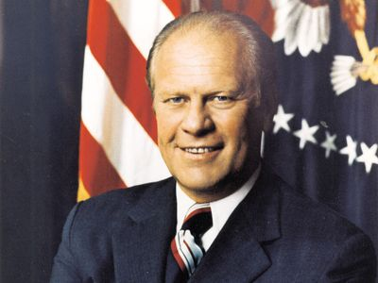
https://www.britannica.com/biography/Gerald-Ford

1974: National Fire Academy Opens
“The National Fire Academy opened in 1974 as part of the National Fire Prevention and Control Administration, now known as the U.S. Fire Administration, which is the lead federal agency for fire data and training, particularly for state, local and tribal fire departments.” https://www.washingtonpost.com/nation/2025/03/09/national-fire-academy-fema-casses-canceled-trump/?utm_campaign=wp_todays_headlines&utm_medium=email&utm_source=newsletter&carta-url=https%3A%2F%2Fs2.washingtonpost.com%2Fcar-ln-tr%2F41839f4%2F67ceb82b12829321d7739d9a%2F59731235ade4e21a848a56ed%2F40%2F65%2F67ceb82b12829321d7739d9a

1974: FLSA Amended – for first time it applies to states and local communities (7k exemption – firefighters & police)
“In 1974 the FLSA was amended to apply to state and local governments for the first time. At that time, Congress enacted the 207k exemption (usually referred to as 7k exemption) to allow firefighters (who commonly worked an average of 48-56 hours a week) and police officers (many of whom worked 45-48 hour schedules) to continue working those hours with minimal impact to taxpayers. In addition, to address the inherent variation in weekly hours that firefighters and police officers had due to their rotating schedules, the 7k exemption extended the 7 day work week applicable to everyone else, to a work period that could be between 7 and 28 days long.” http://www.firelawblog.com/2018/05/31/origins-of-the-7k-firefighter-overtimeexemption/

July 24, 1974: U.S. Supreme Court - United States v. Nixon (9 to 0) https://supreme.justia.com/cases/federal/us/418/683/

SUBPOENA OF PRESIDENT FOR AUDIO TAPES ENFORCEABLE

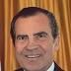

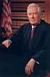Justice Warren E. Burger
MR. CHIEF JUSTICE BURGER delivered the opinion of the Court.

“Facts of the case
A grand jury returned indictments against seven of President Richard Nixon's closest aides in the Watergate affair. The special prosecutor appointed by Nixon and the defendants sought audio tapes of conversations recorded by Nixon in the Oval Office.
Nixon asserted that he was immune from the subpoena claiming ‘executive privilege,’ which is the right to withhold information from other government branches to preserve confidential communications within the executive branch or to secure the national interest. Decided together with Nixon v. United States.

Question
Is the President's right to safeguard certain information, using his ‘executive privilege’ confidentiality power, entirely immune from judicial review?

Conclusion
No. The Court held that neither the doctrine of separation of powers, nor the generalized need for confidentiality of high-level communications, without more, can sustain an absolute, unqualified, presidential privilege. The Court granted that there was a limited executive privilege in areas of military or diplomatic affairs, but gave preference to ‘the fundamental demands of due process of law in the fair administration of justice.’ Therefore, the president must obey the subpoena and produce the tapes and documents. Nixon resigned shortly after the release of the tapes.” https://www.oyez.org/cases/1973/73-1766

Aug. 9, 1974: Nixon Resigns
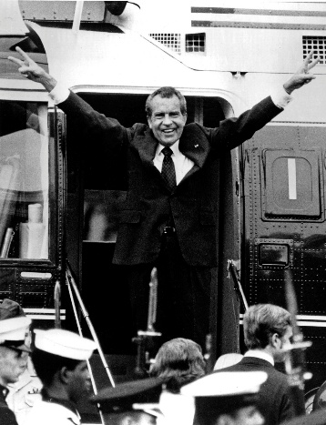
In this Aug. 9, 1974 photo, Richard Nixon waves goodbye as he boards a helicopter after resigning the presidency earlier that day.

Feb. 19, 1975: U.S. Supreme Court - NLRB v. J. Weingarten, Inc. (7 to 2)
https://supreme.justia.com/cases/federal/us/420/251/
RIGHT TO UNION REP. DURING INVESTIGATION INTERVIEW

June 26, 1975: Two FBI Agents Killed – Pine Ridge Indian Reservation
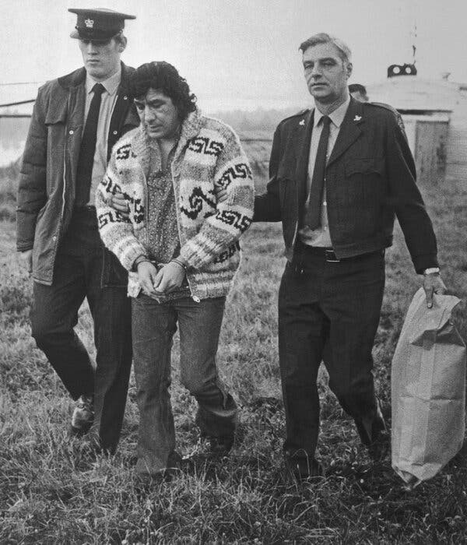
[Note: Jan. 20, 2025 – President Joe Biden: “I am also commuting the life sentence imposed on Leonard Peltier so that he serves the remainder of his sentence in home confinement.” https://bidenwhitehouse.archives.gov/briefing-room/statements-releases/2025/01/20/statement-from-president-joe-biden-16/ ]
“On June 26, 1975, FBI Agents Jack Coler and Ronald Williams were murdered by Leonard Peltier at Pine Ridge Indian Reservation in South Dakota. In 1977, Peltier was found guilty of first-degree murder and sentenced to two consecutive life terms in prison. He has since made numerous appeals for parole or a commutation of his sentence.
Quick Facts
- Unknown to Agents Williams and Coler, Leonard Peltier was present on Pine Ridge. Peltier had an outstanding warrant for his arrest, which had been issued in the Eastern District of Wisconsin, for Unlawful Flight to Avoid Prosecution (UFAP) - Attempted Murder (of an off-duty police officer). Peltier and his supporters allege they had traveled to Pine Ridge from Farmington, New Mexico, with a contingent of American Indian Movement (AIM) members.
- At approximately 11:50 a.m. on June 26, 1975, Agent Williams indicated over his car radio that he had spotted a red and white vehicle. (Agent personnel who overheard the radio transmission have differing opinions of the vehicle description, but it was clearly established that there was only one operable vehicle in the area.) One of the occupants of the red and white vehicle was later determined to be an individual who had been interviewed by Agent Williams and another agent in Williams’ FBI vehicle the previous day.
- Soon after Williams’ initial transmission, he radioed information that the subject vehicle had stopped and that he and Coler had come under fire. Williams began transmitting directions to Agent Gary Adams, who was approximately 12 miles away. Adams could not reach the vicinity of Williams and Coler due to gunfire directed at him as he approached.
  - Contrary to some media reports that gunfire lasted four hours, trial testimony described the gunfight directed at Williams and Coler as lasting approximately 10 minutes. During this ordeal, a combined total of five rounds had been fired from both Williams’ and Coler’s weapons. The agents’ vehicles alone had 125 bullet holes. This total does not take into account those rounds that hit the agents, glass, or were not recovered.
- At approximately 4:25 p.m., agents discovered the bodies of Williams and Coler lying beside Agent Coler’s vehicle. Agent Williams received bullet wounds to his left arm and side, foot, right hand, and head. Agent Coler received bullet wounds to the arm and head.
- An examination of the physical evidence concluded that Agents Williams and Coler had been killed at close range by a .223 type bullet. According to witnesses, Peltier was identified as the only person in possession of a weapon that would fire a .223 type bullet at the time of the murders. The weapon was an AR-15 rifle.
Peltier’s AR-15, Agent Coler’s .308 rifle, and an arsenal of other weapons were recovered from associates of Peltier on September 10, 1975, when a car exploded on the Kansas Turnpike near Wichita, Kansas. An examination by the FBI Laboratory made a positive match with a .223 shell casing found in the trunk of Agent Coler’s car and marks produced by the extractor of Peltier’s AR-15. No match could be made with the firing pin, because it was too smooth.
  - On September 11, 1986, Federal Appeals Judge Gerald R. Heaney concluded, “When all is said and done, however, a few simple but very important facts remain. The casing introduced into evidence had in fact been extracted from the Wichita AR-15.”
- Peltier was captured in February 1976 by the Royal Canadian Mounted Police (RCMP) and was in possession of several loaded weapons. Upon arrest, he advised the RCMP that two FBI agents were shot when they came to a house to serve a warrant on him.
- On April 18, 1977, Leonard Peltier was found guilty of the first-degree murders of Williams and Coler. On June 1, 1977, Chief U.S. District Judge Paul Benson sentenced Peltier to two consecutive life terms. During an interview on the television show ‘60 Minutes’ that aired on September 22, 1991, Peltier admitted firing at Agents Williams and Coler.” https://www.fbi.gov/history/famous-cases/resmurs-case-reservation-murders

Note: Feb. 18, 2025. Native American Activist Leonard Peltier Released From Prison
“Mr. Peltier was convicted in the killing of two F.B.I. agents. An order from former President Joseph R. Biden Jr. will allow him to serve his remaining time under home confinement. Leonard Peltier, a Native American rights activist held for nearly half a century for the killing of two F.B.I. agents, was released from a federal prison in Central Florida on Tuesday morning. Mr. Peltier, 80, will serve the remainder of his two life sentences in home confinement in North Dakota, where he is a member of the Turtle Mountain Band of Chippewa.” https://www.nytimes.com/2025/02/18/us/leonard-peltier-released-prison.html ]

April 5, 1975: Operation Babylift
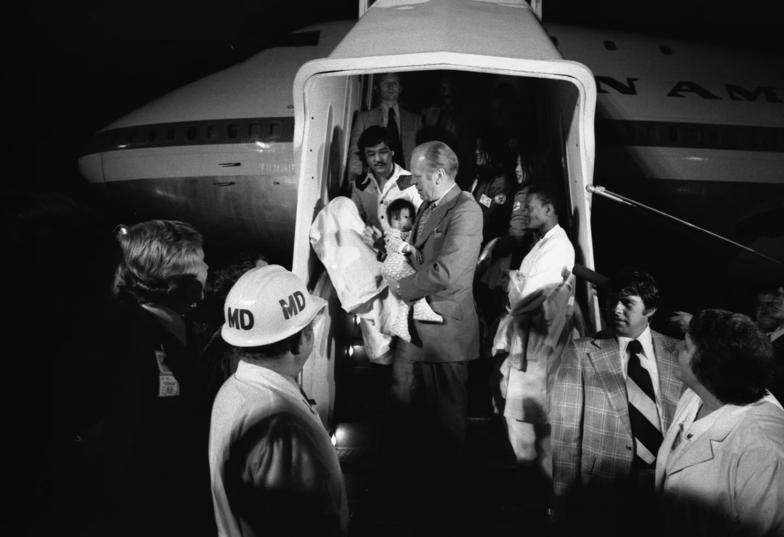

President Gerald Ford carries a Vietnamese baby from Clipper 1742, an Operation Babylift plane that transported about 325 adoptees, after it landed in San Francisco from Saigon on April 5, 1975. (Gerald R. Ford Presidential Library and Museum), https://www.washingtonpost.com/history/2025/04/27/operation-babylift-saigon-vietnam-war/?utm_campaign=wp_post_most&utm_medium=email&utm_source=newsletter&carta-url=https%3A%2F%2Fs2.washingtonpost.com%2Fcar-ln-tr%2F424d400%2F680fa548fa0b8c6760393ca2%2F59731235ade4e21a848a56ed%2F37%2F60%2F680fa548fa0b8c6760393ca2
“Fifty years ago, the American military launched "Operation Babylift" to airlift Vietnamese adoptees ahead of the fall of Saigon during the Vietnam War. But the first transport plane crashed shortly after takeoff. Among those killed was Air Force Capt. Mary T. Klinker. She is one of the few women whose name is inscribed on the Vietnam Veterans Memorial in Washington.”https://www.instagram.com/reel/DIzPN2EBDhn/?utm_source=ig_embed&ig_rid=4746481e-a585-4f1d-9a90-11d79af463fb

July 1, 1975: Watergate Convictions
John Mitchell
[Former Attorney General John N. Mitchell] “was one of four Nixon Administration officials who were convicted on Jan. 1, 1975, of all counts in the Watergate cover‐up trial. The others were H. R. Haldeman, John D. Ehrlichman and Robert C. Mardian. The three‐month trial culminated the principal investigation and prosecution of persons responsible for the biggest political scandal in the nation's history. A Federal grand jury named the then President, Richard M. Nixon, on March 1, 1974, as an unindicted coconspirator in the case.” https://www.nytimes.com/1975/07/04/archives/mitchelldisbarred-as-lawyer-in-state-mitchell-is-disbarred-in.html
Mitchell was sentenced to 2 ½ to 8 years in prison; he entered prison in 1977 and was released on parole in 1979. https://www.britannica.com/biography/John-Mitchellattorney-general-of-United-States

Sept. 5, 1975: President Gerald Ford – Assassination Attempt, Sacramento, CA
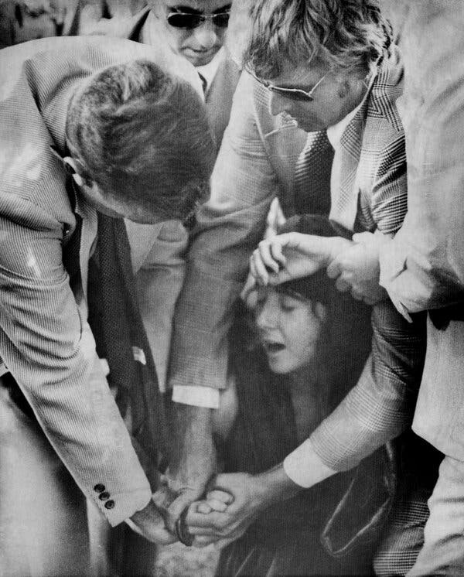
“On Sept. 5, 1975, President Ford spurned his limousine, which was idling outside the Senator Hotel in Sacramento, and, flanked by Secret Service agents, strode across the street to greet a throng of well-wishers on his way to the State Capitol to meet with Gov. Edmund G. Brown Jr. “My position was right at his shoulder,” [Secret Service Agent Larry] Buendorf recalled in 2010 in an interview [https://geraldrfordfoundation.org/centennial/oralhistory/larry-buendorf/ ] for the President Gerald R. Ford Oral History Project. “Squeaky was back in the crowd, maybe one person back, and she had an ankle holster on with a .45,” he said, referring to a .45-caliber semiautomatic pistol. “That’s a big gun to have on your ankle. So, when it came up, it came up low, and I happened to be looking in that direction, I see it coming, and I step in front of him, not sure what it was other than that it was coming up pretty fast, and yelled out ‘Gun!’ When I yelled out ‘Gun!’ I popped that .45 out of her hand.”
He added: “I got a hold of her fingers, and she’s screaming — the crowd is screaming — and I’m thinking, ‘I don’t have a vest on, I don’t know where the next shot is coming from,’ and that I don’t think she’s alone. All of this is going on while I’m trying to control her.” “She turns around, and I pulled her arm back and dropped her to the ground, and agents and police come from the back of the crowd” as Ms. Fromme shrieked in disbelief, he said.
“She’s screaming, ‘It didn’t go off!’” he continued. “I had it in my hand. I knew what she was doing, she was pulling back on the slide, and I hit the slide before she could chamber a round. If she’d had a round chambered, I couldn’t have been there in time. It would’ve gone through me and the president.” Ms. Fromme, who was nicknamed Squeaky because of her high-pitched voice, was a 26-year-old disciple of the cult leader Charles Manson, whose gang’s brutal killing spree in 1969 claimed the lives of the actress Sharon Tate and eight others. Cloaked in a full-length red robe and matching turban, Ms. Fromme had cocked the hammer, but none of the four bullets that the gun was armed with had entered the chamber yet.
Testifying for the prosecution at Ms. Fromme’s trial, Mr. Buendorf said she jerked the gun when he grabbed it “as though she was trying to pull it away or fire it.” Other agents hustled Mr. Ford to safety. “I was in the right place at the right time,” Mr. Buendorf, who was 37 at the time and had been an agent for five years, said. “If I had been looking someplace else, who knows how history would have changed.” Ms. Fromme was convicted of attempted assassination and sentenced to life in prison. She was paroled in 2009. https://www.nytimes.com/2025/03/13/us/politics/larry-buendorf-dead.html

1976 – Apple Company formed



“When Steve Jobs and Steve Wozniak signed the documents to start Apple in 1976, Silicon Valley’s fruit orchards hadn’t yet been taken over by office parks. ,,, In half a century, Apple has risen, fallen and risen again. A mythology has developed around the company as it has become one of the most valuable outfits in the world. Mr. Jobs, who died in 2011, has become so idolized that he was the subject of at least two movies, one of which was nominated for two Oscars. Apple is now worth roughly $4 trillion, makes more than $100 billion in profit every year and has 2.5 billion of its phones, tablets, computers, earphones and smart watches in use around the world. Those devices have shaped the industries of computing and entertainment. Between its supply chain and its retail business, Apple has come to define how to be a global technology company.”
https://www.nytimes.com/2026/04/01/technology/apple-employee-50-years.html?nl=the-evening&segment_id=217600



The Apple, a personal computer with color graphics and easy-to-use software, was introduced in 1977. Here, the Apple IIe, which was released in 1983.

June 24, 1976: U.S. Supreme Court held that FLSA does not apply to state and local communities.
June 24, 1976: National League of Cities v. Usery, 426 U.S. 833 (1976). https://supreme.justia.com/cases/federal/us/426/833/
“The original Fair Labor Standards Act passed in 1938 specifically excluded the States and their political subdivisions from its coverage. In 1974, however, Congress enacted the most recent of a series of broadening amendments to the Act. By these amendments, Congress has extended the minimum wage and maximum hour provisions to almost all public employees employed by the States and by their various political subdivisions. Appellants in these cases include individual cities and States, the National League of Cities, and the National Governors' Conference; they brought an action in the District Court for the District of Columbia which challenged the validity of the 1974 amendments. They asserted, in effect, that, when Congress sought to apply the Fair Labor Standards Act provisions virtually across the board to employees of state and municipal governments it ‘infringed a constitutional prohibition’ running in favor of the States as states. *** This exercise of congressional authority does not comport with the federal system of government embodied in the Constitution. We hold that, insofar as the challenged amendments operate to directly displace the States' freedom to structure integral operations in areas of traditional governmental functions, they are not within the authority granted Congress by Art. I, § 8, cl. 3.”
Note: In 1985, the U.S. Supreme Court reversed that decision in Garcia v. San Antonio Metropolitan Transit Authority, 469 U.S. 528 (1985) https://supreme.justia.com/cases/federal/us/469/528/

Feb. 18, 1976: President Gerald Ford – Executive Order to stop domestic spying by U.S. Military
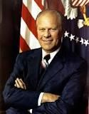

“In the early and mid1970s several Congressional committees, including the Church [April 29, 1976 - first report of Sen. Frank Church Commission, Pike, and Ervin committees, conducted investigations and public hearings. After three and a half years of investigation, these committees determined that what had occurred was a classic example of what we would today call ‘mission creep.’ What had begun as a simple requirement to provide basic intelligence to commanders charged with assisting in the maintenance and restoration of order, had become a monumentally intrusive effort. This resulted in the monitoring of activities of innocent persons involved in the constitutionally protected expression of their views on civil rights or anti-war activities. The information collected on the persons targeted by Defense intelligence personnel was entered into a national data bank and made available to civilian law enforcement authorities. This produced a chilling effect on political expression by those who were legally working for political change in domestic and foreign policies. Senator Ervin concluded ‘the collection and computerization of information by government must be tempered with an appreciation of the basic rights of the individual, of his right to privacy, to express himself freely and associate with whom he chooses.’ As a result of these investigations, DoD imposed severe restrictions on future surveillance of U.S. persons, required that information already in DoD files be destroyed, and established a structure to regulate future DoD intelligence collection. [On Feb. 18, 1976], President Ford issued an Executive Order placing significant controls on the conduct of all intelligence activities. Executive Order (EO) 11905, as the charter for the Intelligence Community, included provisions for an intelligence oversight mechanism.” https://dodsioo.defense.gov/About-DOD-SIOO/

1976: Public Safety Officers Benefits (PSOB) Act

“The Public Safety Officers Benefits (PSOB) Act, (42 USC 3796, Public Law 94-430) became law on September 29, 1976. The legislation provided for a $50,000 death benefit for fire fighters (paid and volunteer) and law enforcement officers that died in the line-of-duty (emergency or non-emergency) from a traumatic injury.

On December 15, 2003, the Act was amended (Hometown Heroes Act) to cover deaths from heart attack and stroke occurring in the line-of-duty. The Act does not cover deaths resulting from occupational illness or pulmonary disease unless a traumatic injury is a substantial factor to the death.” https://www.iaff.org/psob/

***
“2026 Benefits: The amount of the PSOB benefit is $461,656.00 for eligible deaths and disabilities occurring on or after October 1, 2025. The amount of the PSOB educational assistance benefit for one month of full-time assistance on or after October 1, 2025 is $1,574.00.” https://bja.ojp.gov/program/psob/resources/benefits-by-year

Jan. 20, 1977: President Jimmy Carter – Inauguration

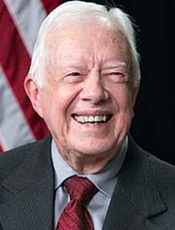

https://www.cartercenter.org/about/experts/jimmy_carter.html

May 28, 1977: Southgate, KY - Beverly Hills Supper Club fire
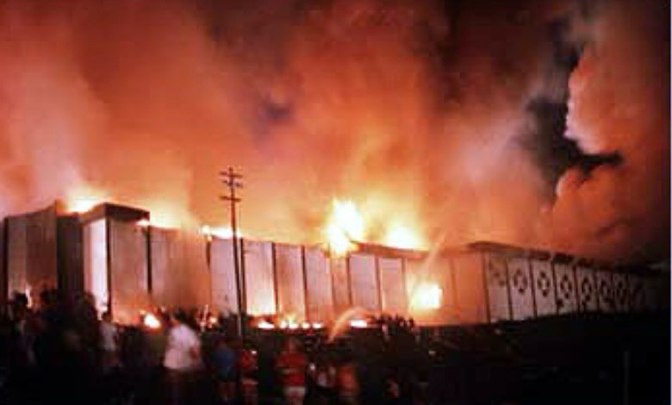
“One of the deadliest nightclub fires happened nearly 40 years ago—but it resulted in changes to fire safety regulations that protect the public to this day.” https://blog.qrfs.com/278-the-deadliest-fires-in-u-s-history-lessons-learned-from-the-beverly-hills-supper-club-fire/
“The May 28, 1977 fire killed 165 people and changed Kentucky fire regulations forever. The fire injured more than 200 people, including five firefighters.” https://www.fox19.com/2021/05/28/th-anniversary-deadly-beverly-hills-supper-club-fire/
Opinion: History says the Supper Club fire was no accident (May 28, 2021): “The ‘aluminum wiring’ civil settlement proved nothing but the greed of lawyers. Repeated investigations reached the same dead-end: ‘undetermined cause.’ But the past refuses to stay buried.” https://www.cincinnati.com/story/opinion/2021/05/28/opinion-history-says-supper-club-fire-no-accident/7427554002/

Forbidden Fruit’ book explores underworld connections to Beverly Hills Supper Club fire (Dec. 4, 2020): https://www.cincinnati.com/story/news/2020/12/03/forbidden-fruit-beverly-hills-supper-club-fire-peter-bronson/3782061001/

“Inside the Beverly Hills Supper Club Fire” - Paperback – Illustrated, June 1, 2010: https://www.amazon.com/Inside-Beverly-Hills-Supper-Club/dp/159652751X

Attorney Stanley Chesley dies at 89 (Nov. 4, 2025)
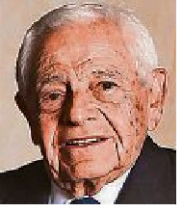
Legal ground breaker in fire case later disbarred.
“Stanley M. Chesley, a former trial lawyer from Cincinnati who rose to prominence after representing victims of the Beverly Hills Supper Club fire but was later disbarred for defrauding millions of dollars from his clients, has died, sources confirmed to The Enquirer.
He was 89.
Chesley’s legal career skyrocketed when he served as the plaintiffs’ attorney after the Beverly Hills Supper Club fire in 1977, which killed 165 people in the Northern Kentucky town of Southgate. He made a rare move to sue the entire aluminum electrical wire industry and won a $49 million settlement ($207 million adjusted for inflation). His success in the case made him a legal trailblazer and coined the term ‘enterprise liability.’ “ https://enewspaper.cincinnati.com/?token=650bca96048768615440b11fb674f972&cnum=eb834637-2c6d-4424-a2d5-903e8f89f711&fod=1111111STD-0&selDate=20251104&licenseType=paid_subscriber&for-guid=c3d67b6e-6174-11ef-b801-c2f230e29541&utm_source=cincinnati-enewspaper-strada&utm_medium=email&utm_campaign=enewspaper&utm_term=body&utm_content=pcin-cincinnati-nletter95

Jan. 11,1978 – Federal Service Labor-Management Relations Act
April 28, 2025. U.S. District Court Judge Paul L, Friedman, D.C. National Treasury Employees v. Donald J. Trump – Preliminary Injunction issued.
https://cases.justia.com/federal/district-courts/district-of-columbia/dcdce/1:2025cv00935/279006/34/0.pdf?ts=1745920374

“In 1978, Congress passed the Federal Service Labor-Management Relations Statute (effective Jan. 11, 1979), This landmark piece of legislation codified the rights of federal employees to collectively bargain and “participate through labor organizations of their own choosing in decisions which affect them.” 5 U.S.C. § 7101(a)(1). In passing the statute, Congress spoke unequivocally: “labor organizations and collective bargaining in the civil service are in the public interest.” 5 U.S.C. § 7101(a). Congress's determination that these rights should apply broadly – and that those rights “contribute[ ] to the effective conduct of public business,” 5 U.S.C. § 7101(a)(1)(B) – was undisturbed for decades, governing the state of the federal workforce despite changes in the composition of Congress and presidential administrations.

***

This all changed on March 27, 2025. On that day, President Trump issued an Executive Order invoking 5 U.S.C. § 7103(b) (1), which permits the President to “issue an order excluding any agency or subdivision thereof from coverage” of the Federal Service Labor-Management Relations Statute if the President determines that “the agency or subdivision has as a primary function intelligence, counterintelligence, investigative, or national security work,” and that the statute's provisions “cannot be National Treasury Employees Union v. Trump, --- F.Supp.3d ---- (2025) © 2025 Thomson Reuters. No claim to original U.S. Government Works. applied to that agency or subdivision in a manner consistent with national security requirements and considerations.” The effect of the Executive Order was substantial: it removed collective bargaining rights from approximately two-thirds of the federal workforce. In response to this sweeping Executive Order, the National Treasury Employees Union (“NTEU”) filed the instant action challenging the Executive Order, arguing that the President exceeded his power when issuing the order. *** The Court therefore concludes that the balance of the equities and assessment of the public interest weigh in favor of granting a preliminary injunction. Indeed, each of the preliminary injunction factors weighs in favor of granting NTEU’s motion.”

May 31, 1978: U.S. Supreme Court - Michigan v. Tyler (7 to 1) https://supreme.justia.com/cases/federal/us/436/499/
ARSON INVESTIGATIONS / RE-ENTRY AFTER GIVING UP CONTROL OF BUILDING REQUIRES SEARCH WARRANT
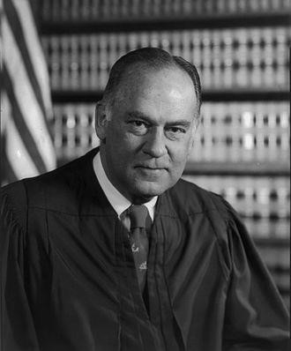Justice Potter Stewart
MR. JUSTICE STEWART delivered the opinion of the Court

“Facts of the case
On January 21, 1970, Tyler’s Auction, a furniture store in Oakland County, Michigan, caught fire shortly before midnight. The building was leased to Loren Tyler, who ran the business with Robert Tompkins. When Fire Chief See arrived on the scene, he was informed that two plastic containers of flammable liquid were found in the building. After determining that arson possibly caused the fire, See called Police Detective Webb. Webb arrived and took pictures, but the smoke and steam forced him to postpone his investigation. Around 4 a.m., the fire was extinguished, and the personnel left the premises. The containers were turned over to Webb. Webb did not have a warrant for any of the entries into the building or the removal of the containers.
The next morning, See returned to the scene with Assistant Chief Somerville, whose job was to determine the ‘origin of all fires that occur in the Township.’ They conducted a cursory examination and left. An hour later, Somerville returned with Webb, and the two discovered evidence of arson. The men did not have warrants for these entrances or seizures of evidence. Over the course of multiple visits beginning on February 16, Sergeant Hoffman of the Michigan State Police Arson Section conducted an investigation and secured further evidence of arson that played an important role in the trial.
At trial, the respondents objected to the introduction of this evidence, but the judge admitted it, and they were convicted. The Court of Appeals of the State of Michigan held that the constitutional protections against illegal searches and seizures did not pertain to arson investigations of burned premises and affirmed the conviction. The Supreme Court of Michigan held that the illegal searches and seizures had violated the Fourth and Fourteenth Amendments. The court reversed the convictions and ordered a new trial.

Question
Does the Fourth Amendment protection against illegal searches and seizures extend to investigations of burned premises for evidence of arson?

Conclusion
Yes. Justice Potter Stewart delivered the opinion of the 7-1 majority. The Court held that any search for administrative purposes, such as to find evidence of a crime, requires a warrant. There are circumstances that require law enforcement agents to act without a warrant, such as when firemen enter a burning building. Once in the building for that purpose, the firemen may seize evidence of arson that is in plain view without obtaining a warrant. The Court also held that determining the cause of the fire is part of a fireman’s job, so firemen may remain in a building without a warrant after a fire has been extinguished for ‘a reasonable amount of time’ to investigate. The Court held that the initial entry and the investigation on the following morning were constitutional, but the subsequent entries and seizures of evidence were not.” https://www.oyez.org/cases/1977/76-1608

Justice William Stewart

MR. JUSTICE BRENNAN delivered the opinion of the Court.

“Facts of the case
The petitioners, a class of female employees of the Department of Social Services and the Board of Education of the City of New York, sued their employers for depriving them of their constitutional rights. The employers required pregnant women to take unpaid leaves of absence before there was any medical reason to do so. The plaintiffs sought an injunction against the forced leaves of absence in the future, as well as back pay for those that had already occurred.
The district court found that such policies were unconstitutional but held that the city had immunity from paying the back wages. The district court also held that the motion for an injunction was moot because the organizations removed the policy in the intervening time. The Court of Appeals affirmed.

Question
If sued in their official capacity, are local government officials and organizations such as a school board considered ‘persons’ for the purpose of liability for back wages?

Conclusion
Yes. Justice William J. Brennan, Jr. delivered the opinion of the 7-2 majority. The Court held that the legislative history of the Civil Rights Act of 1871, and specifically the Sherman Amendment, indicated that municipalities could be liable for the infringement of constitutional rights. Additionally, by 1871 there was a clear legislative and precedentbased history for municipal corporations — such as a school board — to be considered a “person” for the purpose of lawsuits and liability. The Court held that this liability only existed when the constitutional infringement was the direct result of an official policy.
https://www.oyez.org/cases/1977/75-1914
June 6, 1978: U.S. Supreme Court - Monell v. New York Dept. of Social Services (7 to 2) https://supreme.justia.com/cases/federal/us/436/658/

MUNICIPALTY LIABLE FOR FAILURE TO TRAIN OR SUPERVISE ITS OFFICIALS OR EMPLOYEES

“In the case of Monell v. Dep’t of Soc. Servs., the United States Supreme Court expressly held that governmental entities, as opposed to governmental officials or employees, could not be held liable for violating Section 1983 based on the doctrine of respondeat superior, or in other words, automatically liable for the actions of its officials or agents. 436 U.S. 658, 691-694 (1978). A governmental entity cannot be held liable under Section 1983 solely because it employs a tortfeasor. The elements of a Monell claim are: (1) deprivation of a federal right; (2) some governmental action can be traced to the deprivation, i.e., policy or custom; (3) policy or custom demonstrating the governmental entity’s fault, i.e., deliberate indifference; and (4) municipal action that was the moving force behind the federal violation. Dean v. Wexford Health Service, Inc., 18 F.4th 214, 235 (7th Cir. 2021).
Since the Monell decision, case law has developed specific types of “policy or customs” that are actionable. First, a governmental entity may be liable for an express policy that causes a constitutional deprivation when enforced. McTigue v. City of Chicago, 60 F.3d 381, 382 (7th Cir. 2009). Second, liability may arise from a widespread practice that, “although not authorized by written law or an express policy, is so permanent and well settled as to constitute a custom or usage with the force of law.” Id. Additional high levels of proof are required for liability to attach to a widespread practice. Plaintiff must show that the policymakers were deliberately indifferent to the known or obvious consequence of the custom: in other words, turned a blind eye to the custom. Thomas v. Cook Cnty. Sheriff’s Dept., 604 F. 3d 773, 790 (7th Cir. 2006). There also must be evidence demonstrating that the practice was persuasive. Id. One or two missteps are insufficient. Rather, evidence of systemic and gross deficiencies is mandatory. Hildreth v. Butler, 960 F.3d 420, 426 (7th Cir. 2020). A governmental entity may be held liable for its inaction by a failure to train or supervise its officials or employees. Orozco v. Dart, 64 F.4th 806, 824 (7th Cir. 2023). Importantly, this path to Monell is steep. Id. Rigorous standards of culpability and causation are applied. Id. Lastly, Section 1983 liability may be imposed on a governmental authority when the final decision-making authority is directly responsible for the deprivation. Gernetzke v. Kenosha Unified School District No. 1, 274 F.3d 464 (7th Cir. 2001). Under this type of Monell claim, the official or employee who commits the violation must have authority that is final in a special sense: that there is no higher authority. Id. at 469. “Delegation is not direction; authorization is not command: permission does not make the permittee the final policy maker.” Id.” https://mwhlawgroup.com/taming-the-monell-monster/

June 26, 1978: U.S. Supreme Court - Regents of the University of California v. Bakke (5 to 4) https://supreme.justia.com/cases/federal/us/438/265/
AFFIRMATIVE ACTION IN ADMISSIONS TO MEDICAL SCHOOL LAWFUL
“Issue: Can an institution of higher learning use race as a factor when making admissions decisions?
Result: The Court held that universities may use race as part of an admissions process so long as ‘fixed quotas’ are not used. The Court determined that the specific system in place at the University of California Medical School was ‘unnecessary’ to achieve the goal of creating a diverse student body and was merely a ‘fixed quota’ and therefore, was unconstitutional.
Importance: The decision started a line of cases in which the Court upheld affirmative action programs. In 2003, such academic affirmative action programs were again directly challenged in Gratz v. Bollinger and Grutter v. Bollinger. In these cases, the Court clarified that admission programs that include race as a factor can pass constitutional muster so long as the policy is narrowly tailored and does not create an automatic preference based on race. The Court asserted that a system that created an automatic race-based preference would in fact violate the Equal Protection Clause.” https://www.americanbar.org/groups/public_education/programs/constitution_day/landmark-cases/

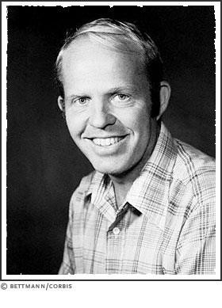 Allan Paul Bakke: https://www.s9.com/Biography/bakke-allan-paul/
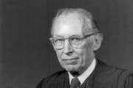 Justice Lewis F. Powell, Jr.

“Facts of the case
Allan Bakke, a thirty-five-year-old white man, had twice applied for admission to the University of California Medical School at Davis. He was rejected both times. The school reserved sixteen places in each entering class of one hundred for ‘qualified’ minorities, as part of the university's affirmative action program, in an effort to redress longstanding, unfair minority exclusions from the medical profession. Bakke's qualifications (college GPA and test scores) exceeded those of any of the minority students admitted in the two years Bakke's applications were rejected. Bakke contended, first in the California courts, then in the Supreme Court, that he was excluded from admission solely on the basis of race.

Question
Did the University of California violate the Fourteenth Amendment's equal protection clause, and the Civil Rights Act of 1964, by practicing an affirmative action policy that resulted in the repeated rejection of Bakke's application for admission to its medical school?

Conclusion
No and yes. There was no single majority opinion. Four of the justices contended that any racial quota system supported by government violated the Civil Rights Act of 1964. Justice Lewis F. Powell, Jr., agreed, casting the deciding vote ordering the medical school to admit Bakke. However, in his opinion, Powell argued that the rigid use of racial quotas as employed at the school violated the Equal Protection Clause of the Fourteenth Amendment. The remaining four justices held that the use of race as a criterion in admissions decisions in higher education was constitutionally permissible. Powell joined that opinion as well, contending that the use of race was permissible as one of several admission criteria. So, the Court managed to minimize white opposition to the goal of equality (by finding for Bakke) while extending gains for racial minorities through affirmative action.” https://www.oyez.org/cases/1979/76-811

Oct. 25,1978: Foreign Intelligence Surveillance Act (FISA)
“The Foreign Intelligence Surveillance Act (FISA)1 was enacted in 1978 (effective Oct. 25. 1978). . This legislation was the Congressional response to the exposure during multiple Committee hearings of previous abuses of U.S. persons’ privacy rights by certain components of the United States government. Those abuses had occurred, according to the government, as part of its efforts to counter purported threats to national security. Unquestionably, such threats existed in and before 1978; beyond peradventure, however, they pale in comparison to the threats to national security that the United States currently faces. Those threats bear the face of terrorism, primarily foreign but domestic as well. Though FISA is not a legally usable tool for combating domestic terrorism, its electronic surveillance and physical search authority are legal and very effective methods for monitoring the activities of foreign powers and agents of foreign powers while they operate within the United States. Increasingly, indeed, overwhelmingly, the current objective of such operational activities is to thwart terrorist acts.”
https://www.fletc.gov/sites/default/files/imported_files/training/programs/legaldivision/downloads-articles-and-faqs/research-bysubject/miscellaneous/ForeignIntelligenceSurveillanceAct.pdf
Aug. 3, 2020: Statement of Assistant Attorney General for National Security John
C. Demers on the Public Release of the Department’s Findings with Respect to the 29 FISA Applications that Were the Subject of the March 2020 OIG Preliminary Report

“The Department of Justice has completed its review of the 29 FISA applications that were the subject of preliminary findings by the DOJ Inspector General (OIG) in March 2020. We are pleased that our review of these applications concluded that all contained sufficient basis for probable cause and uncovered only two material errors, neither of which invalidated the authorizations granted by the FISA Court. These findings, together with the more than 40 corrective actions undertaken by the Federal Bureau of Investigation and the National Security
Division, should instill confidence in the FBI’s use of FISA authorities. We would like to express our appreciation to the OIG for their focus on the Department’s use of its national security authority. We remain committed to improving the FISA process to ensure that we use these tools consistent with the law and our obligations to the FISA Court. The ability to surveil and to investigate using FISA authorities remains critical to confronting current national security threats, including election interference, Chinese espionage and terrorism.”
https://www.justice.gov/opa/pr/statement-assistant-attorneygeneral-national-security-john-c-demers-public-release
Jan. 20, 1981: President Ronald Regan – First Inauguration


https://governors.library.ca.gov/33-reagan.html

March 30, 1981: Assassination Attempt – President Regan
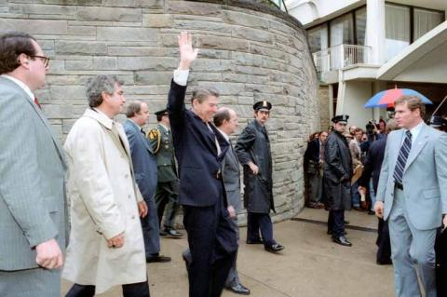
“On March 30, 1981, President Reagan was leaving the Hilton Hotel in Washington, D.C., where he had been talking to 5,000 members of the AFL-CIO when several shots were fired. John Hinckley, Jr., fired his .22 caliber revolver with “devastator” bullets at the President and his security team. Reagan was wounded when one of the bullets ricocheted off of the limousine, striking him under the left armpit. Press Secretary James Brady, Secret Service Agent Timothy McCarthy, and policeman Thomas Delahanty were also wounded during the shooting. President Reagan’s wounds were not noticed until he began to cough up blood. He was then taken to the George Washington University Hospital. After twelve days in the hospital, he was able to return to the White House with a new commitment to changing the relationship between the United States and the Soviet Union.” https://www.reaganlibrary.gov/permanent-exhibits/assassination-attempt

July 17, 1981: Kansas City Walkway Collapse
On July 17, 1981, two suspended walkways collapsed inside Kansas City’s Hyatt Regency Hotel. The event became one of the worst man-made disasters in American history, and the shockwaves are still being felt four decades later. It happened at the worst possible time. The room was packed for a Friday night dance, and 114 people died, 216 were hurt and thousands more were affected. VIDEO: https://www.kmbc.com/article/kmbc-9-chronicle-the-skywalk-tapes-the-night-the-hyatt-regency-hotel-skywalks-fell-forever-changing-kansas-city-missouri/36942895#

Sept. 25, 1981: First Woman On U.S. Supreme Court - Justice Sandra Day O’Connor
Justice Sandra Day O’Connor was appointed to the Supreme Court by President Ronald Reagan, and served from 1981 until 2006. https://www.supremecourt.gov/visiting/sandradayoconnor.aspx
“Very little could happen without Justice O’Connor’s support when it came to the polarizing issues on the court’s docket, and the law regarding affirmative action, abortion, voting rights, religion, federalism, sex discrimination and other hot-button subjects was basically what Sandra Day O’Connor thought it should be.” https://www.nytimes.com/2023/12/01/us/sandra-day-oconnor-dead.html
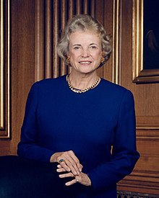

March 8, 1981: U.S. Supreme Court - Griggs v. Duke Power (8 to 0) https://supreme.justia.com/cases/federal/us/401/424/

RACE - APPLICANT TESTS MUST BE JOB RELATED
MR. CHIEF JUSTICE BURGER delivered the opinion of the Court.
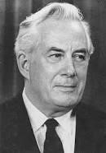Chief Justice Warren E. Burger

“The Company added a further requirement for new employees on July 2, 1965, the date on which Title VII became effective. To qualify for placement in any but the Labor Department, it became necessary to register satisfactory scores on two professionally prepared aptitude tests, as well as to have a high school education.
***
On the record before us, neither the high school completion requirement nor the general intelligence test is shown to bear a demonstrable relationship to successful performance of the jobs for which it was used. Both were adopted, as the Court of Appeals noted, without meaningful study of their relationship to job performance ability. Rather, a vice-president of the Company testified, the requirements were instituted on the Company's judgment that they generally would improve the overall quality of the workforce. The evidence, however, shows that employees who have not completed high school or taken the tests have continued to perform satisfactorily, and make progress in departments for which the high school and test criteria are now used.
***
The Company contends that its general intelligence tests are specifically permitted by § 703(h) of the [Civil Rights Act of 1964]. That section authorizes the use of ‘any professionally developed ability test’ that is not ‘designed, intended or used to discriminate because of race. . . .’
(Emphasis added.) The Equal Employment Opportunity Commission, having enforcement responsibility, has issued guidelines interpreting § 703(h) to permit only the use of job-related tests.
***
Nothing in the Act precludes the use of testing or measuring procedures; obviously they are useful. What Congress has forbidden is giving these devices and mechanisms controlling force unless they are demonstrably a reasonable measure of job performance. Congress has not commanded that the less qualified be preferred over the better qualified simply because of minority origins. Far from disparaging job qualifications as such, Congress has made such qualifications the controlling factor, so that race, religion, nationality, and sex become irrelevant. What Congress has commanded is that any tests used must measure the person for the job, and not the person in the abstract.” https://supreme.justia.com/cases/federal/us/401/424/#tab-opinion1949187
Jan. 13, 1982 – Air Florida Crash
In 1982, Air Florida flight 90, a 737 crashed into Washington, D.C.'s 14th Street Bridge and fell into the Potomac River while trying to take off during a snowstorm. 78 people lost their lives. Four passengers and a flight attendant survived. During the rescue, one of the survivors, a woman, was too weak to hold onto the ring to grab the line when the helicopter returned to her. As she began to sink below the Potomac River her savior was coming. A young office assistant for a government agency, Lenny Skutnik, stripped off his coat and boots and in short sleeves, dove into the icy water and swam out to her. She survived, as did Lenny.
Number of deaths: 74
Location: Potomac River, 14th Street Bridge
Start date: January 13, 1982
Injuries (nonfatal): 10
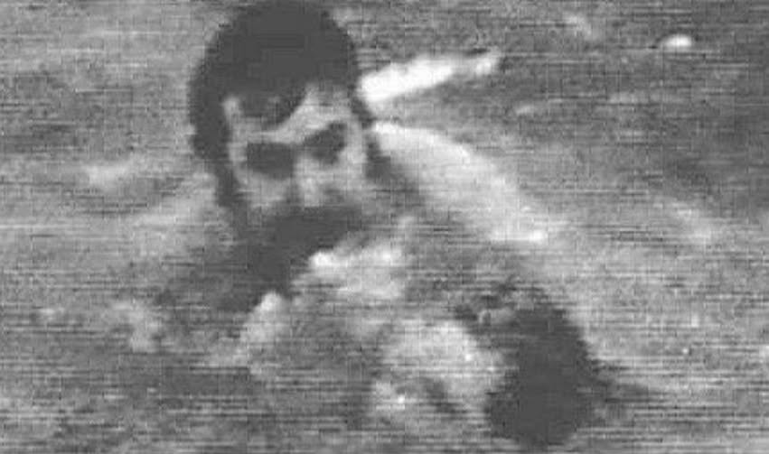

June 24, 1982 – U.S. Supreme Court - Harlow v. Fitzgerald (8 to 0) https://supreme.justia.com/cases/federal/us/457/800/
QUALIFIED IMMUNITY FOR GOV’T OFFICIALS - unless “clearly established” statute or case decision
“Henceforth, government officials performing discretionary functions generally are shielded from liability for civil damages insofar as their conduct does not violate ‘clearly established’ statutory or constitutional rights of which a reasonable person would have known.”

President Nixon ordered in Jan. 1970 the firing of a senior Air Force member – whistleblower. U.S. Supreme Court held Nixon staff members have qualified immunity.
“The issue in this case is the scope of the immunity available to the senior aides and advisers of the President of the United States in a suit for damages based upon their official acts. IIn this suit for civil damages, petitioners Bryce Harlow and Alexander Butterfield are alleged to have participated in a conspiracy to violate the constitutional and statutory rights of the respondent A. Ernest Fitzgerald. Respondent avers that petitioners entered the conspiracy in their capacities as senior White House aides to former President Richard M. Nixon. As the alleged conspiracy is the same as that involved in Nixon v. Fitzgerald, ante p. 457 U. S. 731, the facts need not be repeated in detail.” https://supreme.justia.com/cases/federal/us/457/800/

Plaintiff in case – told Congress about C-5A cost overruns.
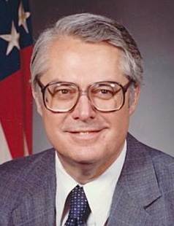
“A. Ernest Fitzgerald (1926–2019) was an American engineer, a member of the Senior Executive Service in the United States Air Force, and a prominent U.S. government whistleblower. Following service in the U.S. Navy, Fitzgerald earned a bachelor of science degree in industrial engineering from the University of Alabama. After working for a number of years as an engineer and in management, Fitzgerald was employed by the U.S. Air Force as Deputy for Management Systems in 1965. While employed at the Pentagon Fitzgerald testified to Congress in 1968 and 1969 about the concealed cost overruns and the technical problems of the Lockheed C-5A transport plane. He was accused of revealing classified information and was fired on order of President Richard M. Nixon.” https://www.independent.org/aboutus/person_detail.asp?id=373

“A Tribute to Pentagon Whistleblower Ernie Fitzgerald:
Less than a year later, the Air Force said Fitzgerald would be losing his job in January 1970 as part of a wholesale trimming of civilian personnel that had nothing to do with his testimony. Fitzgerald fought his dismissal, and in 1973 won his case before the Civil Service Commission, which ordered him reinstated with $80,000 in back pay. He went back to work, but he grumbled that the Air Force assigned him to minor-league matters. So in 1974 he sued the US government again, this time to regain his original responsibilities, and after eight years he won again, along with $200,000 in legal fees, according to People.” https://www.pogo.org/analysis/remembering-ernie-fitzgerald

Dec. 16, 1982 – FBI Plane Crash into Bookstore, Montgomery, OH
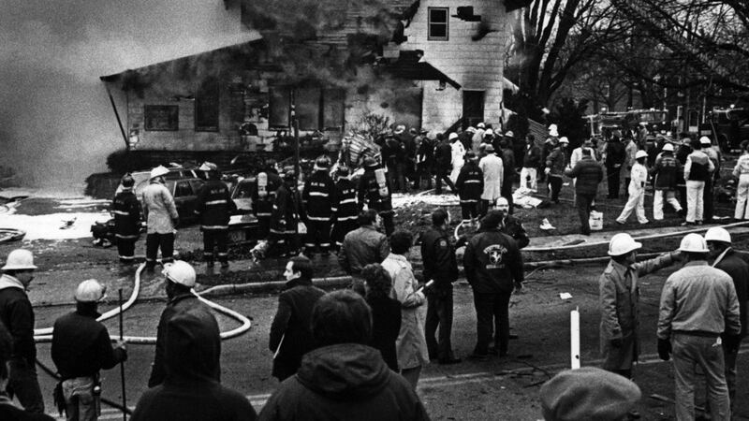
DECEMBER 16, 1982: A small plane carrying four FBI agents, an accused embezzler and a retired Chicago cop crashed into Sheppard's Book Store in downtown Montgomery in 1982. Still missing is $55,000 the embezzler allegedly stashed somewhere. https://www.fox19.com/2022/12/16/new-podcast-looks-into-1982-plane-crash-that-killed-fbi-agents-accused-embezzler/

“On December 16, 1982, Special Agents Terry Burnett Hereford, Charles L. Ellington, Robert W. Conners, and Michael James Lynch were killed in a Bureau airplane accident near Montgomery, Ohio. The agents were accompanying a bank fraud and embezzlement subject, Carl Henry Johnson, and an individual from the law firm representing Johnson to Cincinnati. They were attempting to locate $50,000 in embezzled money, which Johnson had hidden in that area. The plane, piloted by special agents Hereford and Conners, crashed on approach to Cincinnati's Lunken Airport near Montgomery, and all aboard were killed. There were indications that the aircraft encountered altitude read-out problems, was flying at a low altitude, and hit some wires before it went down.” https://www.fbi.gov/history/wall-of-honor/michael-james-lynch

April 20, 1983 – U.S. Supreme Court – Connick v. Myers (5 to 4) https://supreme.justia.com/cases/federal/us/461/138/
Free Speech Rights of Public Officials / Only If Matter of “Public Concern”
Free Speech Center – Connick v. Myers
https://firstamendment.mtsu.edu/article/connick-v-myers/
“In Connick v. Myers 461 U.S. 138 (1983), the Supreme Court clarified the level of First Amendment protection for public employees in the workplace by explaining how courts should balance an employee’s right to speak on matters of public importance against an employer’s interests in a disruptive-free workplace. Sheila Myers, an assistant district attorney in New Orleans, had objected to being transferred to another section of her office. After receiving notice of the transfer, she prepared and distributed a questionnaire to the office staff that in part raised the issue of whether their office was poorly run. Harry Connick Sr., the district attorney and Myers’s supervisor, terminated her for refusing the transfer and for undermining his authority with the questionnaire. Myers challenged her dismissal, reasoning that she was fired because she had expressed her opinion of how Connick ran the office and that such termination violated her First Amendment political speech rights. In a 5-4 vote, a divided Supreme Court held Myers’s dismissal to be constitutional. In the majority opinion of the Court, Justice Byron R. White stated, per the Court’s ruling in Pickering v. Board of Education (1968), that the Court must balance the First Amendment right of government employees to comment upon matters of public concern versus the interest of government to provide its services efficiently. In applying the Pickering test to the New Orleans case, White found that Myers in general was not speaking about matters of public concern, because in the main, her questionnaire focused on internal office workings. White determined, however, that at least one question — concerning whether Connick forced office staff to perform political campaign work — should be considered of public concern.”
1982 – GARMENT WORKER’S STRIKE - NYC
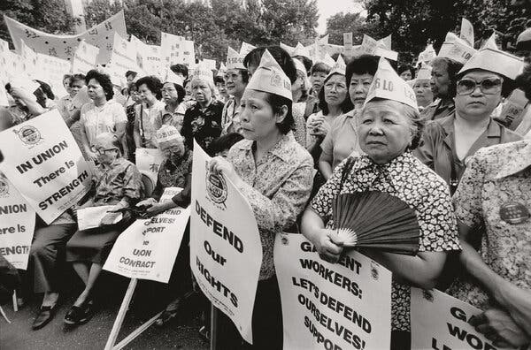
“A garment workers’ strike gathered nearly 20,000 workers for a mass walkout in New York in 1982, including this crowd in Columbus Park.Credit...Estate of Corky Lee.”
https://www.nytimes.com/2024/05/10/books/review/corky-lee-asian-america-fifty-years-photographic-justice.html?te=1&nl=the-morning&emc=edit_nn_20240512

Oct. 25, 1983 – Grenada

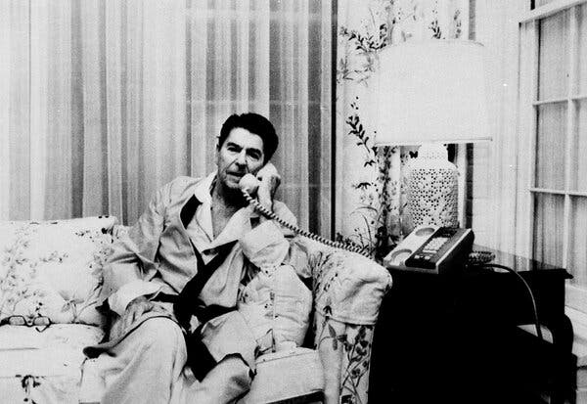 President Ronald Reagan, in his pajamas and robe, speaking to Vice President George H.W. Bush about Grenada from the White House in 1983.
“The United States accused the government of Grenada of building an airport that would project Soviet power in the region, claiming that its long runway could enable the Soviet Union to land giant transport planes capable of moving weapons.
A political leadership crisis in Grenada that fall eventually led to the execution of its prime minister. The military announced a curfew and said anyone on the streets in violation of the order would be shot on sight.
At dawn on Oct. 25, President Ronald Reagan sent 7,600 troops, including two Army Ranger battalions, the 82nd Airborne, the Marines, Delta commandos and Navy SEALs, supported by American warplanes and Army helicopters. His stated reason was to protect 600 American medical students in the island country.
The U.S. troops made quick work of 1,500 Grenadian soldiers involved in the initial defense of the country, and within a few days most of the resistance was gone. Grenada’s military government was overthrown, and an interim one was installed. On Nov. 3, Reagan announced the mission was successfully completed.” https://www.nytimes.com/2025/12/09/us/politics/military-history-latin-america-strikes.html?nl=Breaking+News&segment_id=212078

January 11, 1984: U.S. Supreme Court - Michigan v. Clifford (5 to 4) https://supreme.justia.com/cases/federal/us/464/287/
UNLESS “EXIGENT CIRCUMSTANCES” – WHEN ARSON INVESTIGATORS SHOW UP 6 HRS AFTER FIRE PUT OUT AND FD LEFT, NEED WARRANT

“In the early morning hours of October 18, 1980, a fire erupted at the Clifford home. The Cliffords were out of town on a camping trip at the time. The fire was reported to the Detroit Fire Department, and fire units arrived on the scene about 5:40 a.m. The fire was extinguished and all fire officials and police left the premises at 7:04 a.m.
At 8 o'clock on the morning of the fire, Lieutenant Beyer, a fire investigator with the arson section of the Detroit Fire Department, received instructions to investigate the Clifford fire. He was informed that the Fire Department suspected arson. Because he had other assignments, Lieutenant Beyer did not proceed immediately to the Clifford residence. He and his partner finally arrived at the scene of the fire about 1 p.m. on October 18. When they arrived, they found a work crew on the scene. The crew was boarding up the house and pumping some six inches of water out of the basement. A neighbor told the investigators that he had called Mr. Clifford and had been instructed to request the Cliffords' insurance agent to send a boarding crew out to secure the house. The neighbor also advised that the Cliffords did not plan to return that day. While the investigators waited for the water to be pumped out, they found a Coleman fuel can in the driveway that was seized and marked as evidence. By 1:30 p.m., the water had been pumped out of the basement and Lieutenant Beyer and his partner, without obtaining consent or an administrative warrant, entered the Clifford residence and began their investigation into the cause of the fire. *** The aftermath of a fire often presents exigencies that will not tolerate the delay necessary to obtain a warrant or to secure the owner's consent to inspect fire-damaged premises. Because determining the cause and origin of a fire serves a compelling public interest, the warrant requirement does not apply in such cases…. Because the cause of the fire was then known, the search of the upper portions of the house, described above, could only have been a search to gather evidence of the crime of arson. Absent exigent circumstances, such a search requires a criminal warrant.”

June 12, 1984 U.S. Supreme Court - New York v. Quarles (6 to 3) https://supreme.justia.com/cases/federal/us/467/649/

PUBLIC SAFETY QUESTIONING OF SUSPECT - “where’s the gun: - no Miranda violation. Also questioning police officer after a shooting or emergency responder after serious on duty MVA.
“Respondent was charged in a New York state court with criminal possession of a weapon. The record showed that a woman approached two police officers who were on road patrol, told them that she had just been raped, described her assailant, and told them that the man had just entered a nearby supermarket and was carrying a gun. While one of the officers radioed for assistance, the other (Officer Kraft) entered the store and spotted respondent, who matched the description given by the woman. Respondent ran toward the rear of the store, and Officer Kraft pursued him with a drawn gun, but lost sight of him for several seconds. Upon regaining sight of respondent, Officer Kraft ordered him to stop and put his hands over his head; frisked him and discovered that he was wearing an empty shoulder holster; and, after handcuffing him, asked him where the gun was. Respondent nodded toward some empty cartons and responded that "the gun is over there." Officer Kraft then retrieved the gun from one of the cartons, formally arrested respondent, and read him his rights under Miranda v. Arizona, 384 U. S. 436. Respondent indicated that he would answer questions without an attorney being present and admitted that he owned the gun and had purchased it in Florida. The trial court excluded respondent's initial statement and the gun because the respondent had not yet been given the Miranda warnings, and also excluded respondent's other statements as evidence tainted by the Miranda violation. Both the Appellate Division of the New York Supreme Court and the New York Court of Appeals affirmed.
Held: The Court of Appeals erred in affirming the exclusion of respondent's initial statement and the gun because of Officer Kraft's failure to read respondent his Miranda rights before attempting to locate the weapon. Accordingly, it also erred in affirming the exclusion of respondent's subsequent statements as illegal fruits of the Miranda violation. This case presents a situation where concern for public safety must be paramount to adherence to the literal language of the prophylactic rules enunciated in Miranda.”
***
Read this April 10, 2025 article about legal issues - interviewing police officers involved in shooting – including public safety interview, investigator interview and Garrity compelled interview.
“I Just Got In A Shooting, What Happens Next? You have been on the job for some time but have never had to use deadly force. Then, in a split second, you just shot someone; what happens next? *** The supervisor verified you were involved and asked some precise questions. There are usually two types of interviews that can be conducted with a sworn officer following an officer-involved shooting: a voluntary or compelled statement (we will discuss compelled statements in greater detail further along in this paper).
However, this (the sergeant’s questioning of the involved officers) is referred to as a public safety statement and is neither compelled nor voluntary—the public safety statement derives from the US Supreme Court decision of New York v. Quarles in 1984. The Quarles decision established an exception to the Miranda rule, allowing law enforcement to prioritize public safety in certain situations (New York v. Quarles, 467 U.S. 649 (1984). In short, the Quarles decision enables a supervisor to ask specific questions of the involved officers following an incident, like an officer-involved shooting. The questions must be designed to ensure the public’s safety if there is a possible immediate threat to the public. The generally accepted practices call for the following public safety questions:
- Did you use force, and what type of force?
- What direction did you fire?
- How many rounds did you fire?
- Outstanding suspects, last known location of travel?
- Evidence location and location of the injured person/suspect(s)?

It is important to remember that the public safety questions are outside of the Miranda warning and are meant for the public’s safety. You cannot refuse to provide the answers to these specific questions, and you will not be compelled to answer them. During the public safety statement questions, you will not have a representative/ or attorney to guide you. The public safety statement requirement does not allow the sergeant to ask questions regarding the shooting, such as why you shot, whether you were in fear for your life, etc. Additionally, the public safety questions must be contemporaneous with the shooting incident. Departments cannot use the public safety statement to obtain shooting information outside Miranda or the Garrity warning (voluntary or compelled).

***
Under the administrative portion of the shooting investigation, the administrative investigators can and, more likely than not, will compel you to provide them with a walk-through. Remember, a walk-through is not an interview and is only designed to obtain your position(s) during the shooting in relation to the suspect. Any information received from you from such a compulsion under Garity cannot be used against you in any criminal proceedings.
Regarding the interview, the general practice is to allow the involved officer two sleep cycles before obtaining an official statement of the shooting. The initial investigators wanting to get a statement from you will be the criminal investigators, who cannot compel you and only get a statement if you volunteer one. Lastly, the administrative investigators will want to interview you once the criminal case is completed. Once completed, the criminal investigation will be provided to the prosecutors’ office for review and criminal considerations surrounding your use of lethal force. For this reason, you cannot be compelled, as the Garity warning assures that any statement obtained under Garrity cannot be used against you criminally. Therefore, the criminal investigators must get a voluntary statement from you or no statement at all. Your counsel will guide you on whether you should provide a voluntary statement. Attorneys who practice this area of law are very experienced in these matters and will be able to advise you properly.”
https://www.llrmi.com/articles/legal_updates/2025_what-happens-next/

Jan. 20, 1985: President Ronald Regan – Second Inauguration

Feb. 19, 1985: U.S. Supreme Court - Garcia v. San Antonio Metropolitan Transit Authority https://supreme.justia.com/cases/federal/us/469/528/

FLSA APPLIES TO STATE AND LOCAL GOVERNMENTS – INCLUDING FIRE & EMS EMPLOYEES
“The FLSA obligations of public mass transit systems like SATS were expanded in 1974 when Congress provided for the progressive repeal of the surviving overtime exemption for mass transit employees. Fair Labor Standards Amendments of 1974, § 21(b), 88 Stat. 68. Congress simultaneously brought the States and their subdivisions further within the ambit of the FLSA by extending FLSA coverage to virtually all state and local government employees. §§ 6(a)(1) and (6), 88 Stat. 58, 60, 29 U.S.C. §§ 203(d) and (x). SATS complied with the FLSA's overtime requirements until 1976, when this Court, in National League of Cities, overruled Maryland v. Wirtz and held that the FLSA could not be applied constitutionally to the "traditional governmental functions" of state and local governments. Four months after National League of Cities was handed down, SATS informed its employees that the decision relieved SATS of its overtime obligations under the FLSA. Matters rested there until September 17, 1979, when the Wage and Hour Administration of the Department of Labor issued an opinion that SAMTA's operations "are not constitutionally immune from the application of the Fair Labor Standards Act" under National League of Cities. Opinion WH-499, 6 LRR 91:1138. *** This analysis makes clear that Congress' action in affording SAMTA employees the protections of the wage and hour provisions of the FLSA contravened no affirmative limit on Congress' power under the Commerce Clause. The judgment of the District Court therefore must be reversed.”
U.S. Department of Labor, Wage & Hour Division (Fact Sheet #8)
“Section 7(k) of the FLSA provides that employees engaged in fire protection or law enforcement may be paid overtime on a "work period" basis. A "work period" may be from 7 consecutive days to 28 consecutive days in length. For work periods of at least 7 but less than 28 days, overtime pay is required when the number of hours worked exceeds the number of hours that bears the same relationship to 212 (fire) or 171 (police) as the number of days in the work period bears to 28. For example, fire protection personnel are due overtime under such a plan after 106 hours worked during a 14-day work period, while law enforcement personnel must receive overtime after 86 hours worked during a 14-day work period.” https://www.dol.gov/agencies/whd/fact-sheets/8-flsa-policefirefighters

Feb. 19, 1985: Garcia v. San Antonio Metropolitan Transit Authority, 469 U.S. 528 (1985) https://supreme.justia.com/cases/federal/us/469/528/ “The FLSA obligations of public mass transit systems like SATS were expanded in 1974 when Congress provided for the progressive repeal of the surviving overtime exemption for mass transit employees. Fair Labor Standards Amendments of 1974, § 21(b), 88 Stat. 68. Congress simultaneously brought the States and their subdivisions further within the ambit of the FLSA by extending FLSA coverage to virtually all state and local government employees. §§ 6(a)(1) and (6), 88 Stat. 58, 60, 29 U.S.C. §§ 203(d) and (x). SATS complied with the FLSA's overtime requirements until 1976, when this Court, in National League of Cities, overruled Maryland v. Wirtz and held that the FLSA could not be applied constitutionally to the "traditional governmental functions" of state and local governments. Four months after National League of Cities was handed down, SATS informed its employees that the decision relieved SATS of its overtime obligations under the FLSA. Matters rested there until September 17, 1979, when the Wage and Hour Administration of the Department of Labor issued an opinion that SAMTA's operations "are not constitutionally immune from the application of the Fair Labor Standards Act" under National League of Cities. Opinion WH-499, 6 LRR 91:1138. *** This analysis makes clear that Congress' action in affording SAMTA employees the protections of the wage and hour provisions of the FLSA contravened no affirmative limit on Congress' power under the Commerce Clause. The judgment of the District Court therefore must be reversed.”

March 19, 1985: U.S. Supreme Court - Cleveland Board of Education v. Loudermill (8 to 1) https://supreme.justia.com/cases/federal/us/470/532/
PRE-TERMINATION HEARING BY PUBLIC EMPLOYERS

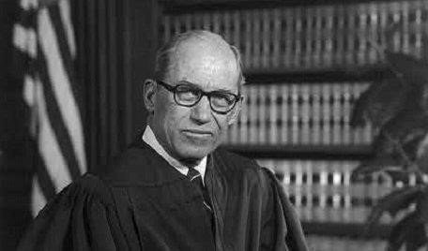Justice Byron White

JUSTICE WHITE delivered the opinion of the Court.

“Facts of the case
James Loudermill stated on his application for employment with the Cleveland Board of Education that he had never been convicted for a felony. After hiring him as a security guard, the board discovered that he had been convicted for grand larceny and without further consideration fired him for providing false information on his application. Since Loudermill qualified as a ‘classified civil servant’ under Ohio law, he obtained a property right to his employment. This meant he could only be dismissed for cause and could obtain an administrative review of the causes for his termination. The Cleveland Civil Service Commission granted him an administrative review after his termination and found it valid. Loudermill filed suit in District Court alleging that the review system was unconstitutional because it only allowed him to respond to the charges against him after his termination. He argued that the board removed his property without giving him a chance to defend himself in violation of his right to Due Process under the Fourteenth Amendment. The District Court agreed that the Ohio statute gave Loudermill a property right to his job, but ruled that the board did not violate his due process rights because it followed the procedures specified by the same statute for removing the property right. In a similar case, Richard Donnelly alleged that post-dismissal hearings violated his due process rights. The Court of Appeals for the Sixth Circuit heard both cases together and ruled that the board violated both defendants' due process rights by removing their property rights to employment before providing an opportunity for them to respond to charges against them.

Question
Can a state remove a civil servant's property rights to employment before providing an opportunity for that worker to respond to the charges offered for his termination?

Conclusion
No. Justice Byron White authored the opinion for an 8-1 court. The Ohio statute clearly grants civil servants property rights to their employment. In order to lawfully remove this property, the Due Process Clause requires a procedure that carefully weighs the interests of the government in removing the property against the interests of the private party in retaining the property. This procedure must incorporate the ‘essential requirements of due process,’ which ‘are notice and an opportunity to respond.’ There was no strong reason to delay the opportunity to respond until after termination. The Court found that ‘affording the employee an opportunity to respond prior to termination would impose neither a significant administrative burden nor intolerable delays.’ Accordingly, the significant interests of the employees to retain their jobs outweighed the interests of the state to remove employees quickly.” https://www.oyez.org/cases/1984/83-1362

March 25, 1986 – U.S. Supreme Court - Pembaur v. City of Cincinnati & Hamilton County (6 t0 3) https://supreme.justia.com/cases/federal/us/475/469/
COUNTY PROSECUTOR TELLS POLICE TO BREAK DOWN DOOR – SEEKING TWO WITNESSES BEFORE GRAND JURY – COUNTY CAN BE SUED VIOL. 4th AMENDMENT
“Applying this standard to the case before us, we have little difficulty concluding that the Court of Appeals erred in dismissing petitioner's claim against the county. The Deputy Sheriffs who attempted to serve the capiases at petitioner's clinic found themselves in a difficult situation. Unsure of the proper course of action to follow, they sought instructions from their supervisors. The instructions they received were to follow the orders of the County Prosecutor. The Prosecutor made a considered decision based on his understanding of the law, and commanded the officers forcibly to enter petitioner's clinic. That decision directly caused the violation of petitioner's Fourth Amendment rights.”

March 25, 1986 – U.S. Supreme Court - Meritor Savings Bank, FSB v. Vinson (9 to 0) https://www.oyez.org/cases/1985/84-1979
SEXUAL HARASSMENT VIOLATION OF TITLE VII OF CIVIL RIGHTS ACT OF 1964

EEOC (4/29/2024): Enforcement Guidance on Harassment in the Workplace. https://www.eeoc.gov/laws/guidance/enforcement-guidance-harassment-workplace
“In 1986, the U.S. Supreme Court held in the landmark case of Meritor Savings Bank, FSB v. Vinson that workplace harassment can constitute unlawful discrimination under Title VII of the Civil Rights Act of 1964 (Title VII). Decades later, harassing conduct remains a serious workplace problem. For the five fiscal years (FY) ending with FY 2023, over one-third of the charges of employment discrimination received by the Equal Employment Opportunity Commission (‘the Commission’ or ‘the EEO’”) included an allegation of unlawful harassment based on race, sex, disability, or another statutorily protected characteristic. The actual cases behind these numbers reveal that many people experience harassing conduct at work that may be unlawful.”

Oct. 5, 1986 – IRAN-CONTRA AFFAIR
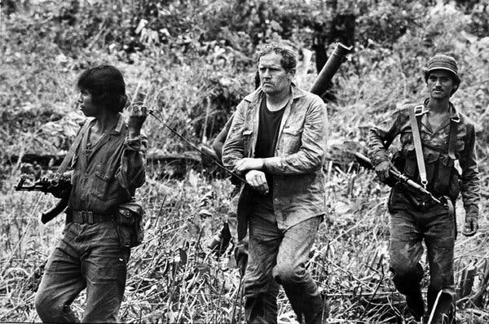

“Eugene Hasenfus, who as a 45-year-old former Marine and laid-off construction worker was thrust into the national spotlight in 1986 when, on a covert mission sponsored by the C.I.A., his gunrunning cargo plane was shot down over Nicaragua, setting off what would become known as the Iran-contra affair, died on Wednesday at his home in Menominee, Mich. He was 84…. President Ronald Reagan’s administration initially denied any American involvement in the flight. Those denials began unraveling when it was reported that the cargo plane belonged to Southern Air Transport, a charter carrier based in Miami that was formerly owned by the C.I.A. Mr. Hasenfus’s capture led to investigations by Congress and by an independent counsel, Lawrence E. Walsh, and ultimately to revelations that the administration, defying Congress, had illegally sold arms to Iran and used some of the proceeds to secretly support the contras. The scandal shadowed the Reagan administration and later the presidency of George H.W. Bush, who was Mr. Reagan’s vice president before succeeding him in 1989.” https://www.nytimes.com/2025/12/02/us/eugene-hasenfus-dead.html?nl=Breaking+News

June 29, 1988: Morrison v. Olson, 487 U.S. 654 (1988) (7 to 1)
Upheld power of Congress to appoint independent counsel.
“Primary Holding: Congress may grant authority to the judicial branch to appoint independent counsel without violating the separation of powers, even though the independent counsel are members of the executive branch. Congress also may place restrictions on the removal of agency officials unless this would interfere with the President’s exercise of executive power.”
“This case presents us with a challenge to the independent counsel provisions of the Ethics in Government Act of 1978, 28 U.S.C. §§ 49, 591 et seq. (1982 ed., Supp. V). We hold
today that these provisions of the Act do not violate the Appointments Clause of the Constitution, Art. II, § 2, cl. 2, or the limitations of Article III, nor do they impermissibly interfere with the President's authority under Article II in violation of the constitutional principle of separation of powers…. In 1982, two Subcommittees of the House of Representatives issued subpoenas directing the Environmental Protection Agency (EPA) to produce certain documents relating to the efforts of the EPA and the Land and Natural Resources Division of the Justice Department to enforce the "Superfund Law." At that time, appellee [Ted] Olson was the Assistant Attorney General for the Office of Legal Counsel (OLC), appellee [Edward C.] Schmults was Deputy Attorney General, and appellee [Caol E.] Dinkins was the Assistant Attorney General for the Land and Natural Resources Division. Acting on the advice of the Justice Department, the President ordered the Administrator of EPA to invoke executive privilege to withhold certain of the documents on the ground that they contained ‘enforcement-sensitive information.’ … In 1985, the majority members of the Judiciary Committee published a lengthy report…not only criticized various officials in the Department of Justice for their role in the EPA executive privilege dispute, but it also suggested that appellee [Assistant Attorney General Ted] Olson had given false and misleading testimony to the Subcommittee on March 10, 1983, and that appellees Schmults and Dinkins had wrongfully withheld certain documents from the Committee, thus obstructing the Committee's investigation…. On July 20, 1987, the District Court upheld the constitutionality of the Act and denied the motions to quash. In re Sealed Case, 665 F. Supp. 56 (DC). The court subsequently ordered that appellees be held in contempt pursuant to 28 U.S.C. § 1826(a) for continuing to refuse to comply with the subpoenas…. The court stayed the effect of its contempt orders pending expedited appeal. A divided Court of Appeals reversed. In re Sealed Case, 267 U.S.App.D.C. 178, 838 F.2d 476 (1988).
https://supreme.justia.com/cases/federal/us/487/654/

Dissent by Justice Scalia – NEED A “UNITARY EXECUTIVE” – PRESIDENT CAN HIRE / FIRE INDEPENDENT COUNSEL. “As I indicated earlier, the basic separation of powers principles I have discussed are what give life and content to our jurisprudence concerning the President's power to appoint and remove officers. The same result of unconstitutionality is therefore plainly indicated by our case law in these areas. *** It is, in other words, an additional advantage of the unitary Executive that it can achieve a more uniform application of the law. Perhaps that is not always achieved, but the mechanism to achieve it is there. The mini-Executive that is the independent counsel, however, operating in an area where so little is law and so much is discretion, is intentionally cut off from the unifying influence of the Justice Department, and from the perspective that multiple responsibilities provide. What would normally be regarded as a technical violation (there are no rules defining such things), may in his or her small world assume the proportions of an indictable offense. What would normally be regarded as an investigation that has reached the level of pursuing such picayune matters that it should be concluded, may to him or her be an investigation that ought to go on for another year. How frightening it must be to have your own independent counsel and staff appointed, with nothing else to do but to investigate you until investigation is no longer worthwhile -- with whether it is worthwhile not depending upon what such judgments usually hinge on, competing responsibilities. And to have that counsel and staff decide, with no basis for comparison, whether what you have done is bad enough, willful enough, and provable enough, to warrant an indictment. How admirable the constitutional system that provides the means to avoid such a distortion. And how unfortunate the judicial decision that has permitted it.”

March 21, 1989: U.S. Supreme Court - National Treasury Employees Union v. Von Raab (5 to 4) https://supreme.justia.com/cases/federal/us/489/656/

RANDOM DRUG TESTING LAWFUL FOR CUSTOMS ENFORCEMENT OFFICERS
“We granted certiorari to decide whether it violates the Fourth Amendment for the United States Customs Service to require a urinalysis test from employees who seek transfer or promotion to certain positions…. We think Customs employees who are directly involved in the interdiction of illegal drugs or who are required to carry firearms in the line of duty likewise have a diminished expectation of privacy in respect to the intrusions occasioned by a urine test.”

Justice Anthony Kennedy
JUSTICE KENNEDY delivered the opinion of the Court.

“Facts of the case
In 1986, the United States Customs Service implemented a drug testing program for certain employees who either carry firearms, are involved in intercepting drugs as they enter the country, or are in high level positions involving classified information.
Question
Did the regulations violate the Fourth Amendment?

Conclusion
No. The Court held that the ‘substantial interests’ of the government in stifling the drug trade justified ‘departure from the ordinary warrant and probable cause requirements’ associated with searches. The fact that customs personnel are the country's ‘first line of defense’ against drug smugglers and they are exposed to a sometimes aggressive criminal element, places them in a unique and important position in which they have a
"diminished expectation of privacy.’” https://www.oyez.org/cases/1988/86-1879

Jan. 20, 1989: President George H. W. Bush – First Inauguration
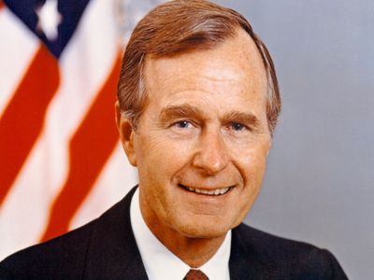
https://www.britannica.com/biography/George-H-W-Bush

Jan. 20, 1989: Ronald Regan – Leaving Office, Personal Note To President George H.W. Bush
“In 1989, Reagan scribbled a note to his successor and former vice president on a silly illustration of an elephant — the animal mascot of the Republican Party — overcome by turkeys.
‘Don’t let the turkeys get you down,’ read the caption.
Dear George
You’ll have moments when you want to use this particular stationery. Well go to it.
George I treasure the memories we share and wish you all the very best. You’ll be in my prayers. God Bless You & Barbara. I’ll miss our Thursday lunches.
Ron
https://www.washingtonpost.com/history/2025/01/20/inauguration-letter-president-trump-biden-tradition/?utm_campaign=wp_post_most&utm_medium=email&utm_source=newsletter&carta-url=https%3A%2F%2Fs2.washingtonpost.com%2Fcar-ln-tr%2F41281a4%2F67b363a6eb3eba471afc37e7%2F59731235ade4e21a848a56ed%2F23%2F53%2F67b363a6eb3eba471afc37e7

May 21, 1989: U.S. Supreme Court - Skinner v. Railway Labor Executives’ Association (7 to 2) https://supreme.justia.com/cases/federal/us/489/602/

RANDOM DRUG TESTING RAILROAD EMPLOYEES PERFORMING SAFETY SENSITIVE WORK
Justice Anthony Kennedy
JUSTICE KENNEDY delivered the opinion of the Court.

“Facts of the case
Recognizing the dangers of drug and alcohol abuse by railroad employees, the Federal Railroad Administration (FRA) implemented regulations requiring mandatory blood and urine tests of employees involved in certain train accidents. Other FRA rules allowed railroads to administer breath and urine tests to employees who violate certain safety rules.
Question
Did the regulations violate the Fourth Amendment?

Conclusion
No. The Court held that the government's interest in assuring safety on the nation's railroads constituted a ‘special need’" which justified a departure from standard warrant and probablecause requirements in searches. Preventing accidents, the goal of most railroad regulations including the one in this case, argued Justice Kennedy, was such a significant concern that it warranted reduced ‘expectations of privacy’ for railroad employees.” https://www.oyez.org/cases/1988/87-1555

Aug. 23, 1989 – Pet Rose Banned From Baseball
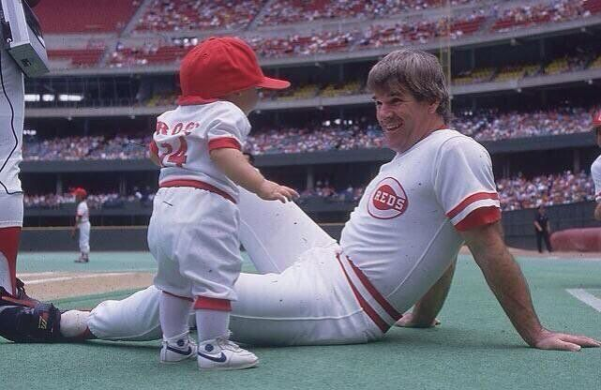
Pete Rose & his son, Tyler– 1985
“On August 23, 1989, as punishment for betting on baseball, Cincinnati Reds manager Pete Rose accepts a settlement that includes a lifetime ban from the game. The ban is publicly announced the following morning. A heated debate continues to rage as to whether Rose, a former player who remains the game’s all-time hits leader, should be given a second chance.” https://www.history.com/this-day-in-history/august-23/pete-rose-gets-booted-from-baseball

December 1989: Panama
 A U.S. Army soldier standing guard in Gen. Manuel Noriega’s office in Panama City in December 1989.
Gen. Manuel Noriega, the military leader of Panama, had longstanding ties to the C.I.A. and to its director, George H.W. Bush, who would be elected president. From the 1960s to the 1980s, the United States paid General Noriega to help sabotage the left-wing Sandinistas in Nicaragua and the F.M.L.N. revolutionaries in El Salvador. He also worked with the Drug Enforcement Administration to restrict illegal drug shipments — and laundered drug money as a side hustle.
But around 1986, news reports surfaced in the American media about the criminal activities of General Noriega, who was now the military dictator of Panama. Mr. Reagan asked the general to step down; he refused. American courts indicted him on drug-related charges. General Noriega soured on the United States and started asking for and receiving military aid from Cuba, Nicaragua and Libya, which were Soviet-bloc countries.
The general survived attempted coups and a disputed election. On Dec. 15, 1989, Panama’s General Assembly passed a resolution declaring a state of war with the United States.
The next night, four U.S. service members were stopped at a roadblock in Panama; one was shot and killed. Mr. Bush ordered in U.S. troops to remove General Noriega.
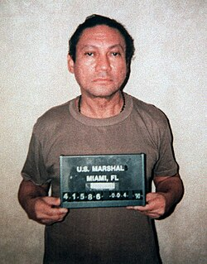 Noriega's mug shot after his surrender to U.S. forces in 1990

July 26, 1990: ADA - Americans With Disability Act
https://www.eeoc.gov/eeoc/history/35th/1990s/ada.html
“Passed by Congress in 1990, the Americans with Disabilities Act (ADA) is the nation's first comprehensive civil rights law addressing the needs of people with disabilities, prohibiting discrimination in employment, public services, public accommodations, and telecommunications. EEOC was given enforcement authority for Title I of the Act, the employment discrimination provisions. Congress provided that Title I would not take effect for two years in order to allow the Commission time to develop regulations and technical assistance, time to conduct comprehensive public education programs on the new disability law, and time for employers to adjust to the new requirements.”
(July 31, 2020) Joint Statement by the U.S. Equal Employment Opportunity
Commission, Department of Justice, and Department of Labor Commemorating the
30th Anniversary of the Americans with Disabilities Act and its Impact on the American Workforce https://www.justice.gov/opa/pr/joint-statement-us-equalemployment-opportunity-commission-department-justice-and-department
“Through its enforcement efforts, DOJ works to ensure that people with disabilities are judged for their skills and what they are able to contribute, rather than having their employment opportunities limited by stereotypes and assumptions about their disability. For example, DOJ recently settled a case involving a Georgia paramedic, who also worked part-time as an emergency medical technician teaching assistant at a technical college, after the college unlawfully terminated her because she had multiple sclerosis.”
(Nov. 7, 2019) SETTLEMENT AGREEMENT BETWEEN
THE UNITED STATES OF AMERICA AND
LANIER TECHNICAL COLLEGE https://www.ada.gov/lanier_sa.html
“Specifically, the United States alleges that Defendant removed Complainant from the work schedule for an entire school semester, thus reducing her hours and compensation to zero, because of her multiple sclerosis. In doing so, the United
States alleges that Defendant terminated Complainant’s employment because of her disability.”

1991: General H. Norman Schwarzkopf – Incident Command / Desert Storm



“There's nothing wrong with being afraid. And true courage is not not being afraid. True courage is being afraid, and going ahead and doing your job anyhow, that's what courage is.

***
Allied forces carried out a six-week aerial bombardment of Iraq, to disrupt or destroy enemy communications, supply lines and infrastructure. Schwarzkopf feigned an amphibious landing on Kuwait, drawing the bulk of Iraqi forces and exposing their west flank to the Allied advance. Allied troops advanced quickly through Kuwait and into Iraq. With their communications destroyed, their supply lines cut and the Allies within 150 miles of Baghdad, the Iraqis began to surrender in massive numbers. Iraq accepted a cease-fire and, after only 100 hours, the ground fighting was over. Total casualties of the Allied forces were 115 killed in action, 330 wounded in action.” https://achievement.org/achiever/general-h-norman-schwarzkopf/

1991 - Persian Gulf War

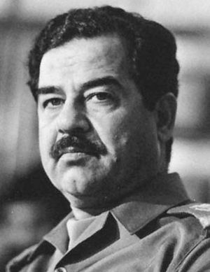
Saddam Hussein

“In August 1990 the Iraqi army overran neighboring Kuwait. Saddam apparently intended to use that nation’s vast oil revenues to bolster Iraq’s economy, but his occupation of Kuwait quickly triggered a worldwide trade embargo against Iraq. He ignored appeals to withdraw his forces from Kuwait, despite the buildup of a large U.S.-led military force in Saudi Arabia and the passage of United Nations (UN) resolutions condemning the occupation and authorizing the use of force to end it. The Persian Gulf War began on January 16, 1991, and ended six weeks later when the allied military coalition drove Iraq’s armies out of Kuwait. Iraq’s crushing defeat triggered internal rebellions by both Shiʿis and Kurds, but Saddam suppressed their uprisings, causing thousands to flee to refugee camps along the country’s northern border. Untold thousands more were tortured and murdered, many simply disappearing into the regime’s prisons, such as the notorious Abu Ghraib.” https://www.britannica.com/biography/Saddam-Hussein
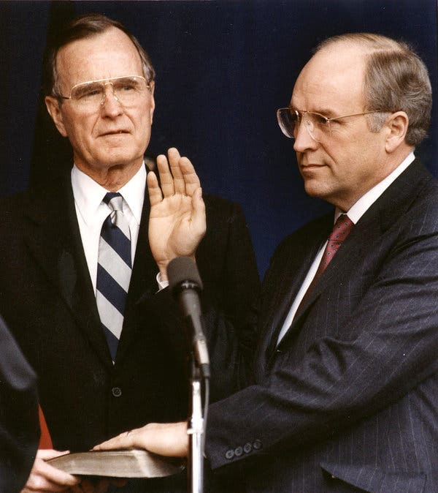
Dick Cheney
“But it was the national security arena where he had the most profound impact. As defense secretary, he helped engineer the gulf war that successfully evicted Iraqi invaders from Kuwait in 1991, then took a leading role a decade later in responding to the terrorist attacks of Sept. 11, 2001. To prevent future attacks, he advocated aggressive policies including warrantless surveillance, indefinite detention and brutal interrogation tactics. And he pushed for the invasion of Iraq to topple Saddam Hussein in 2003, completing the unfinished job of his previous stint in power but leading to years of bloody warfare.” https://www.nytimes.com/2025/11/04/us/politics/dick-cheney-dead.html?nl=The+Morning

June 21, 1971: Bivens v. Six Unknown Named Agents of Federal Bureau of Narcotics (6 to 3)
https://supreme.justia.com/cases/federal/us/403/388/
If federal agents unlawfully search your home, can sue U.S. and the agents for damages.
“While there is no explicit right to file a civil lawsuit against federal government officials who have violated the Fourth Amendment, this right can be inferred. This is because a constitutional protection would not be meaningful if there were no way to seek a remedy for a violation of it.
***
This case has its origin in an arrest and search carried out on the morning of November 26, 1965. Petitioner's complaint alleged that, on that day, respondents, agents of the Federal Bureau of Narcotics acting under claim of federal authority, entered his apartment and arrested him for alleged narcotics violations. The agents manacled petitioner in front of his wife and children, and threatened to arrest the entire family. They searched the apartment from stem to stern. Thereafter, petitioner was taken to the federal courthouse in Brooklyn, where he was interrogated, booked, and subjected to a visual strip search.
***
“Facts of the case
In 1965, six agents of the Federal Bureau of Narcotics forced their way into Webster Bivens’ home without a warrant and searched the premises. The agents handcuffed Bivens in front of his wife and children and arrested him on narcotics charges. Later, the agents interrogated Bivens and subjected him to a visual strip search. Bivens sued the agents for $15,000 in damages each for humiliation and mental suffering. The district court dismissed the complaint for failure to state a cause of action. The U.S. Court of Appeals for the Second Circuit affirmed.
Question
- Does violation of an individual’s Fourth Amendment protection against unreasonable search and seizure give rise to a federal claim for damages?
YES
- Does governmental privilege extend to federal agents who clearly violate constitutional rights and act outside their authority?
NO.” https://www.oyez.org/cases/1970/301

Nov. 21, 1991: CIVIL RIGHTS ACT OF 1991

“On November 21, 1991, Congress enacted the Civil Rights Act of 1991. Congress acted to address a series of no fewer than seven decisions by the Supreme Court, some of which were regarded as changing the well-established landscape of discrimination law, and calling into doubt existing precedent.
***
In addition, the 1991 Act added a new subsection to Title VII, codifying the disparate impact theory of discrimination, essentially putting the law back as it had been prior to Wards Cove. And in response to Price-Waterhouse, the Act provided that where the plaintiff shows that discrimination was a motivating factor for an employment decision, the employer is liable for injunctive relief, attorney's fees, and costs (but not individual monetary or affirmative relief) even though it proves it would have made the same decision in the absence of a discriminatory motive. The Act also provided employment discrimination protection to employees of Congress and some high-level political appointees. Lastly, Title VII and ADA coverage was extended to include American and American-controlled employers operating abroad.” https://www.eeoc.gov/eeoc/history/35th/1990s/civilrights.html
Civil Rights Act of 1991: https://www.eeoc.gov/civil-rights-act-1991-original-text
An Act
To amend the Civil Rights Act of 1964 to strengthen and improve Federal civil rights laws, to provide for damages in cases of intentional employment discrimination, to clarify provisions regarding disparate impact actions, and for other purposes.
Be it enacted by the Senate and House of Representatives of the United States of America in Congress assembled,
SECTION 1. SHORT TITLE.
This Act may be cited as the `Civil Rights Act of 1991'.
SEC. 3. PURPOSES.
The purposes of this Act are--
(1) to provide appropriate remedies for intentional discrimination and unlawful harassment in the workplace;
(2) to codify the concepts of `business necessity' and `job related' enunciated by the Supreme Court in Griggs v. Duke Power Co., 401 U.S. 424 (1971), and in the other Supreme Court decisions prior to Wards Cove Packing Co. v. Atonio, 490 U.S. 642 (1989);
(3) to confirm statutory authority and provide statutory guidelines for the adjudication of disparate impact suits under title VII of the Civil Rights Act of 1964 (42 U.S.C. 2000e et seq.); and
(4) to respond to recent decisions of the Supreme Court by expanding the scope of relevant civil rights statutes in order to provide adequate protection to victims of discrimination.
***
(3) REASONABLE ACCOMMODATION AND GOOD FAITH EFFORT- In cases where a discriminatory practice involves the provision of a reasonable accommodation pursuant to section 102(b)(5) of the Americans with Disabilities Act of 1990 or regulations implementing section 501 of the Rehabilitation Act of 1973, damages may not be awarded under this section where the covered entity demonstrates good faith efforts, in consultation with the person with the disability who has informed the covered entity that accommodation is needed, to identify and make a reasonable accommodation that would provide such individual with an equally effective opportunity and would not cause an undue hardship on the operation of the business.
***
(b) COMPENSATORY AND PUNITIVE DAMAGES-
(1) DETERMINATION OF PUNITIVE DAMAGES- A complaining party may recover punitive damages under this section against a respondent (other than a government, government agency or political subdivision) if the complaining party demonstrates that the respondent engaged in a discriminatory practice or discriminatory practices with malice or with reckless indifference to the federally protected rights of an aggrieved individual.
***
SEC. 105. BURDEN OF PROOF IN DISPARATE IMPACT CASES.
(a) Section 703 of the Civil Rights Act of 1964 (42 U.S.C. 2000e-2) is amended by adding at the end the following new subsection:
`(k)(1)(A) An unlawful employment practice based on disparate impact is established under this title only if--
`(i) a complaining party demonstrates that a respondent uses a particular employment practice that causes a disparate impact on the basis of race, color, religion, sex, or national origin and the respondent fails to demonstrate that the challenged practice is job related for the position in question and consistent with business necessity; or
`(ii) the complaining party makes the demonstration described in subparagraph (C) with respect to an alternative employment practice and the respondent refuses to adopt such alternative employment practice.”

Jan. 20, 1993: PRESIDENT WILLIAM CINTON - FIRST INAGURATION
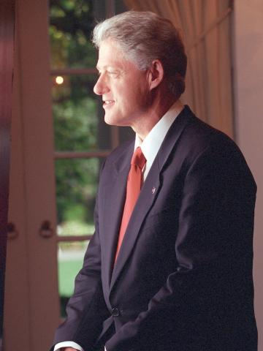
https://www.clintonlibrary.gov/research/clinton-biographies
Jan. 20, 1993: GEORGE H.W. BUSH – LEAVING OFFICE – PERSONAL NOTE TO BILL CLINTON
“Dear Bill,
When I walked into this office just now I felt the same sense of wonder and respect that I felt four years ago. I know you will feel that, too.
I wish you great happiness here. I never felt the loneliness some Presidents have described.
There will be very tough times, made even more difficult by criticism you may not think is fair. I’m not a very good one to give advice; but just don’t let the critics discourage you or push you off course.
You will be our President when you read this note. I wish you well. I wish your family well.
Your success now is our country’s success. I am rooting hard for you.
Good luck —
George”
https://www.washingtonpost.com/history/2025/01/20/inauguration-letter-president-trump-biden-tradition/?utm_campaign=wp_post_most&utm_medium=email&utm_source=newsletter&carta-url=https%3A%2F%2Fs2.washingtonpost.com%2Fcar-ln-tr%2F41281a4%2F67b363a6eb3eba471afc37e7%2F59731235ade4e21a848a56ed%2F23%2F53%2F67b363a6eb3eba471afc37e7

Jan. 20, 1993: PRESIDENT WILLIAM CLINTON - INAGURATION

Feb. 6, 1993: FIRST ATTACK ON WORLD TRADE CENTER

“FBI - World Trade Center Bombing 1993.” https://www.fbi.gov/history/famous-cases/world-trade-center-bombing-1993
“One clue led to another and we soon had in custody three more suspects—Nidal Ayyad, Mahmoud Abouhalima, and Ahmed Ajaj. We’d also found the apartment where the bomb was built and a storage locker containing dangerous chemicals, including enough cyanide gas to wipe out a town. All four men were tried, convicted, and sentenced to life in prison.
***
Meanwhile, the mastermind of the World Trade Center bombing was still on the run—and up to no good. We’d learned his name—Ramzi Yousef—within weeks after the attack and discovered he was planning more attacks, including the simultaneous bombing of a dozen U.S. international flights. Yousef was captured in Pakistan in February 1995, returned to America, and convicted along with the van driver, Eyad Ismoil. A seventh plotter, Abdul Yasin, remains at large.We later learned from Yousef that his Trade Center plot was far more sinister. He wanted the bomb to topple one tower, with the collapsing debris knocking down the second. The attack turned out to be something of a deadly dress rehearsal for 9/11; with the help of Yousef’s uncle Khalid Sheikh Mohammed, al Qaeda would later return to realize Yousef’s nightmarish vision.”

Oct. 13, 1994: Uniformed Services Employment and Re-employment Rights Act (USERRA) of 1994

Oct. 13, 1994: President Bill Clinton signed into law the Uniformed Services Employment and Reemployment Rights Act (USERRA). https://osc.gov/Services/Pages/USERRA.aspx

***

“President Bush's war on terrorism in response to the Sept. 11 terrorist attacks has led to the mobilization of 50,000 National Guard and Reserve troops. Those called to military service are making real sacrifices, as they leave both jobs and families. Some are firefighters. Following the Persian Gulf War, when more than 265,000 reservists and national guardsmen were activated, Congress enacted the Uniformed Services Employment and Re-employment Rights Act of 1994 (USERRA) to assist those who are mobilized.” https://www.firehouse.com/leadership/article/10545356/law-protects-members-called-to-military-duty

***
​“The Uniformed Services Employment and Reemployment Rights Act (USERRA) is a federal law, passed in 1994, that protects military service members and veterans from employment discrimination on the basis of their service, and allows them to regain their civilian jobs following a period of uniformed service.
USERRA a​pplies to members of the Armed Forces, Reserves, National Guard, and other “Uniformed Services” (including the National Disaster Medical System and the Commissioned Corps of the Public Health Service). The law ensures that service members:
- Are not disadvantaged in their civilian careers because of their military service;
- Are promptly re-employed in their civilian jobs upon return from duty;
- Are not discriminated against by employers because of past, present, or future military service.
USERRA applies to both public and private employers. The Office of Special Counsel, in conjunction with the Department of Labor, investigates and enforces USERRA claims involving federal government employers. The Department of Labor and the Department of Justice handle USERRA claims involving private employers as well as state and local governments.” https://osc.gov/Services/Pages/USERRA.aspx

See also: https://webapps.dol.gov/elaws/vets/userra/

***

March 24. 2025:
“USERRA Protections Broadened by Dole Act. On January 2, 2025, then-President Biden signed into law the Senator Elizabeth Dole 21st Century Veterans Healthcare and Benefits Improvement Act (Dole Act), a bipartisan bill that expands healthcare and other benefits for veterans. Among its various pro-veteran measures, the Dole Act introduced noteworthy amendments to the Uniformed Services Employment and Reemployment Rights Act (USERRA). USERRA, enacted in 1994, prohibits employers from discriminating and retaliating against veterans and service members because of their military status or service. USERRA also provides reemployment rights and other rights and benefits to workers whose civilian jobs are voluntarily or involuntarily interrupted by military obligations.

1. Retaliation Protections Broadened:
The Dole Act significantly expands USERRA’s anti-retaliation protections. Previously, the law only prohibited “discrimination in employment” and “adverse employment actions” against individuals who exercised their USERRA rights, sought enforcement of those rights, or participated in related proceedings. Now, employers are barred from taking any form of retaliatory action, eliminating the need to debate whether a retaliatory act meets the threshold of an “adverse employment action.” Courts had previously required proof of a material change in employment conditions or significant harm—those requirements are now gone. Additionally, retaliation no longer needs to be employment-related, broadening the scope of prohibited reprisals and bolstering protections for service members.

2. Increased Liquidated Damages: Before the Dole Act, USERRA authorized liquidated damages awards that were equal to the employee’s lost wages and benefits if a private or state or local government employer’s USERRA violation was “willful.” “Willful” violations occurred when an employer acted with reckless disregard for whether its conduct violated USERRA.
The Dole Act strengthens liquidated damages under USERRA by allowing awards even when no lost wages or benefits are recovered and establishes a minimum award of $50,000. Now, courts can require an employer to pay the greater of $50,000 or the total sum of lost wages, benefits, and prejudgment interest.” https://www.littler.com/news-analysis/asap/userra-protections-broadened-dole-act

***
“On September 29, 2022, President Biden signed S. 2293 the “Civilian Reservist Emergency Workforce Act of 2021” or the “CREW Act,” into law. The “CREW Act” extends employment protections under the Uniformed Services Employment and Reemployment Rights Act (USERRA) to Federal Emergency Management Agency (FEMA) reservists who deploy to major disaster sites. For questions or technical assistance with respect to the “CREW Act,” the U.S. Department of Defense Employer Support of the Guard and Reserve (ESGR) and VETS staff are available to assist.” https://www.dol.gov/agencies/vets/programs/userra

Nov. 30, 1993 – BRADY HANDGUN ACT
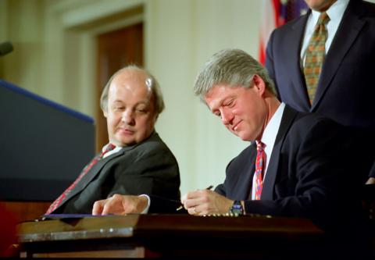
“The Brady Handgun Violence Prevention Act of 1993 amended the federal Gun Control Act of 1968 to provide a method for preventing firearms transfers to prohibited persons.1 Under the Brady Act, every firearm dealer, known as a federal firearms licensee (FFL), must request a background check on any potential purchaser or firearm transferee. To aid in fulfilling that
mandate, the Brady Act required creation of the National Instant Criminal Background Check System (NICS), a computerized system that stores records on persons who may be disqualified from receiving firearms. Each state determines its form of interaction with NICS, and each state may use its own background check system, thus becoming a full point-of-contact (POC) state, by designating a local or state law enforcement authority to serve as intermediary between its FFLs and NICS.” https://www.pacourts.us/assets/opinions/Supreme/out/Affirmed-Reversed-Remanded.pdf?cb=2

“After Jim Brady survived a bullet to the head during the 1981 assassination attempt of President Reagan, he and his wife, Sarah Brady, knew our country urgently needed common-sense solutions to prevent guns from falling into the hands of those who intend to cause harm.
The path to pass the Brady Bill was neither easy nor short. It took Jim and Sarah seven years, six votes, and three presidents to finally pass the Brady Bill.” https://www.bradyunited.org/resources/research/how-brady-background-checks-became-law

September 1994 - Haiti
 A U.S. soldier in Port-au-Prince, Haiti, after an explosive device was thrown at a pro-Aristide march in September 1994.
“Sixty years after their first trip to Haiti, the Marines were back, this time with Army troops, after President Bill Clinton ordered the U.S. military to restore to power President Jean-Bertrand Aristide, who had been democratically elected and quickly overthrown.
Ten years later, Mr. Aristide was out of favor with Washington and ousted in a coup orchestrated by the United States and France, which had colonized the country.” https://www.nytimes.com/2025/12/09/us/politics/military-history-latin-america-strikes.html?nl=Breaking+News&segment_id=212078

April 19, 1995: OKLAHIOMA CITY BOMBING – ALFRED P. MURRAH FEDERAL BUILDING
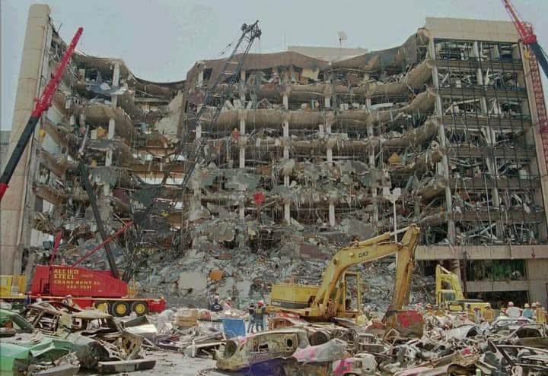
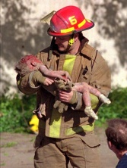Oklahoma City Fire Captain Chris Fields carries 1-yr old Baylee Almon. https://www.usatoday.com/story/news/2015/04/18/oklahoma-city-photo/25957831/
Tim McVeigh was executed by lethal injection on June 11, 2001, at the U.S. federal penitentiary in Terre Haute, Indiana. Terry Nichols was sentenced to life in prison.
Antiterrorism and Effective Death Penalty Act of 1996:

“The [1995] Oklahoma City bombing, a tragedy that claimed the lives of 168 people, 19 of whom were children,' brought the issue of domestic terrorism to the forefront of American social concerns and created the political impetus to address and eliminate this new threat to the United States' national security. In response, the legislature has strived to combat the force of domestic terrorism through legislation aimed at deterring and preventing these senseless acts of violence. Consequently, the United States Senate passed the Comprehensive Terrorism Prevention Act of 1995 shortly after the Oklahoma City Bombing. Following the Comprehensive Terrorism Prevention Act of 1995, the House of Representatives, in March 1996, passed a similar resolution titled the Effective Death Penalty and Public Safety Act of 1996.' The United States Senate sought to temper the more stringent provisions of the proposed Effective Death Penalty and Public Safety Act and ultimately passed the Antiterrorism and Effective Death Penalty Act of 1996 (‘AEDPA’) on April 17, 1996. President Clinton signed the AEDPA into law on April 24, 1996,’ in commemoration of the Oklahoma City Bombing that occurred one year and five days earlier.” https://scholarship.law.nd.edu/cgi/viewcontent.cgi?article=1218&context=jleg

Attorney General Merrick B. Garland Statement on the 29th Anniversary of the Oklahoma City Bombing (April 19, 2024).
“The Justice Department issued the following statement from Attorney General Merrick B. Garland in recognition of the 29th anniversary of the Oklahoma City Bombing, which took place on April 19, 1995, in Oklahoma City, Oklahoma: “Twenty-nine years after the bombing of the Alfred P. Murrah Federal Building, we continue to remember the 168 people, including 19 children, who were stolen from their loved ones, as well as the hundreds who were injured and forever changed. We continue to mourn alongside the families and the entire Oklahoma City community devastated by the attack. “On this day, twenty-nine years ago, I watched in horror from my desk at the Justice Department as reports came in that there had been an explosion at the Murrah building in Oklahoma City. My colleagues and I gathered in front of a TV in my office and saw our first glimpse of the aftermath of the horrific attack. Forty-eight hours later, I traveled to Oklahoma to represent the United States in the first court hearing of the perpetrator, Timothy McVeigh.” https://www.justice.gov/opa/pr/attorney-general-merrick-b-garland-statement-29th-anniversary-oklahoma-city-bombing

1996: HIPAA https://www.hhs.gov/hipaa/for-professionals/privacy/index.html
“The Health Insurance Portability and Accountability Act of 1996 (HIPAA) required the Secretary of the U.S. Department of Health and Human Services (HHS) to develop regulations protecting the privacy and security of certain health information.¹ To fulfill this requirement, HHS published what are commonly known as the HIPAA Privacy Rule and the HIPAA Security Rule. [Nov. 3, 1999].
The Privacy Rule, or Standards for Privacy of Individually Identifiable Health Information, establishes national standards for the protection of certain health information. The Security Standards for the Protection of Electronic Protected Health Information (the Security Rule) establish a national set of security standards for protecting certain health information that is held or transferred in electronic form. The Security Rule operationalizes the protections contained in the Privacy Rule by addressing the technical and non-technical safeguards that organizations called “covered entities” must put in place to secure individuals’ “electronic protected health information” (e-PHI).
Within HHS, the Office for Civil Rights (OCR) has responsibility for enforcing the Privacy and Security Rules with voluntary compliance activities and civil money penalties.”
https://www.hhs.gov/hipaa/for-professionals/security/lawsregulations/index.html

April 1996: Unabomber Arrested

In April 1996, the FBI arrested Ted Kaczynski at his cabin in Montana. When they searched the cabin, they found bomb-making materials…. Kaczynski graduated from Harvard with a degree in mathematics in 1962 and went on to the University of Michigan, where he completed a Ph.D. He then went to work at the University of California, Berkeley, as a tenured professor. But he left UC Berkeley suddenly, and, in 1971, he moved to Lincoln, Montana, where he built a one-room cabin with no electricity or running water. He lived on game he hunted, the produce of a garden he tended, and the money his family members sent him. And it was in this period that Kaczynski started building the explosive devices that won him the moniker “Unabomber.” He sent them to people he had never met, although they were individuals whom he believed were furthering the expansion of technology, which he thought would lead to the ruination of society. His first bomb injured a security guard at Northwestern University in Evanston, Illinois, in May 1978. About a year later, in May 1979, another bomb exploded at Northwestern, injuring a student. But in November of that year, Kaczynski’s third bomb went off in the cargo hold of American Airlines Flight 444 from Chicago to Washington, D.C., forcing the plane to land and injuring 12 people. Because bombing a commercial airliner is a federal offense, the FBI investigated the crime. It was at this point that the unknown perpetrator was dubbed the “Unabomber,” for “university and airline bomber.” https://archivesfoundation.org/newsletter/the-unabomber/

April 24, 1996: Antiterrorism and Effective Death Penalty Act of 1996 (AEDPA)
“The Antiterrorism and Effective Death Penalty Act of 1996 gave the Secretary of State authority to designate foreign terrorist organizations whose terrorist activity threatens the security of United States nationals or the national defense, foreign relations or economic interests of the United States.
The Antiterrorism Act also created 18 U.S.C. § 2339B, which makes it unlawful, within the United States, or for any person who is subject to the jurisdiction of the United States anywhere, to knowingly provide material support to a foreign terrorist organization that has been designated by the Secretary of State. See Pub. L. 104-132, § 303, 110 Stat. 1214, 1250.” https://www.justice.gov/archives/jm/criminal-resource-manual-16-providing-material-support-designated-terrorist-organizations

Criminal defendants convicted in state court now have very limited rights to appeal to federal judges for habeas corpus relief.
“A § 2254 habeas petition is governed by the heightened standard of review outlined in the Anti-Terrorism and Effective Death Penalty Act (‘AEDPA’). 28 U.S.C. § 2254. To obtain relief, habeas petitioners who raise claims adjudicated by state courts must ‘show that the relevant state-court decision (1) was contrary to, or involved an unreasonable application of, clearly established Federal law, or (2) was based on an unreasonable determination of the facts in light of the evidence presented in the State court proceedings.’ Wilson v. Sellers, 584 U.S. 122, 125 (2018) (quoting 28 U.S.C. § 2254(d)). The focus of this standard ‘is not whether a federal court believes the state court's determination was incorrect but whether that determination was unreasonable-a substantially higher threshold.’ Schriro v. Landrigan, 550 U.S. 465, 473 (2007). ‘AEDPA thus imposes a highly deferential standard for evaluating state-court rulings and demands that state-court decisions be given the benefit of the doubt.’ Renico v. Lett, 559 U.S. 766, 773 (2010) (internal citations and quotation marks omitted). Ultimately, ‘[a] state court's determination that a claim lacks merit precludes federal habeas relief so long as ‘fair-minded jurists could disagree' on the correctness of the state court's decision.’ Harrington v. Richter, 562 U.S. 86, 101 (2011) (quoting Yarborough v. Alvarado, 541 U.S. 652, 664 (2004)). Additionally, a state court's factual determinations are presumed correct on federal habeas review, 28 U.S.C. § 2254(e)(1), and review is ‘limited to the record that was before the state court.’ Cullen v. Pinholster, 563 U.S. 170, 181 (2011). https://law.justia.com/cases/federal/district-courts/michigan/miedce/2:2014cv14849/297471/5/

September, 1996 - Comprehensive Test Ban Treaty
“These tests [hydronuclear tests] are permitted under the Comprehensive Nuclear Test Ban Treaty, which the United States signed in 1996 but has never ratified.” https://www.nytimes.com/2025/11/24/science/hydro-nuclear-testing-trump.html?algo=combo_lda_unique_triton_clicks_decay_96_50_ranks&fellback=false&imp_id=5656603060179752&nl=On+Politics&pool=programmingnode%2F0dc6538b-a831-51be-a980-5597993fb6e2&req_id=4969101602534021&surface=more-politics-news&variant=0_only_variant
***
“The Comprehensive Test Ban Treaty (CTBT) prohibits “any nuclear weapon test explosion or any other nuclear explosion” anywhere in the world. The treaty was opened for signature in September 1996, and has been signed by 187 nations and ratified by 178. The treaty cannot formally enter into force until it is ratified by 44 specific nations, nine of which must still do so: China, India, Pakistan, North Korea, Israel, Iran, Egypt, Russia and the United States. Although Russia ratified the CTBT in 2000, it withdrew its ratification of the CTBT in 2023 to "mirror" the posture of the United States; as a treaty signatory, Russia remains obligated not to take any action contrary to the object or purpose of the treaty.” https://www.armscontrol.org/factsheets/comprehensive-test-ban-treaty-glance

Jan. 20, 1997: PRESIDENT WILLIAM CINTON – SECOND INAGURATION

Jan. 1, 1998: OSHA Two In / Two Out Regulation
“The respiratory protection standard requires that workers engaged in fighting interior structural fires work in a buddy system; at least two workers must enter the building together, so that they can monitor each other's whereabouts as well as the work environment. There must also be at least two standby personnel outside the fire area prepared to rescue the inside firefighters should the need arise. One of these outside firefighters must actively monitor the status of the inside fighters but the second outside firefighter may perform a variety of other duties, such as pump operations, incident commander or outside hose line operation. There are no provisions in the standard to waive the requirements for either the ‘two-inside firefighters’ or the ‘two-outside firefighters’, although the circumstances under which this provision applies are more limited than generally understood.” https://www.osha.gov/laws-regs/standardinterpretations/1998-12-15

May 26, 1998: U.S. Supreme Court - County of Sacramento v. Lewis (9 to 0) https://supreme.justia.com/cases/federal/us/523/833/

HIGH SPEED PURSUITS – POLICE LIABILITY ONLY IF “SHOCKS THE CONSCIENCE”
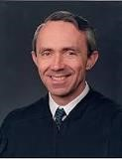Justice David Souter
JUSTICE SOUTER delivered the opinion of the Court.

“Facts of the case
Philip Lewis was a passenger on a motorcycle that was involved in a high-speed police chase. The chase ended when the motorcycle's driver lost control and tipped the bike over, hurling both riders to the pavement. James Smith, one of two pursuing Sacramento county sheriff's deputies, was unable to stop his car in time and skidded into Philip, causing fatal injuries. Philip's parents, Teri and Thomas Lewis, accused Smith and the Sacramento county police department of deliberate and reckless conduct which ultimately deprived their son of his due process right to life and his protection against unconstitutional seizure. On appeal from an appellate court's reversal of a district court decision favoring Smith, the Supreme Court granted certiorari.

Question
Are the Fourteenth Amendment's substantive due process protection, or the Fourth Amendment's guarantee against illegal seizure, violated by a police officer who, in the course of pursuing a subject, causes their death through deliberate or reckless indifference?

Conclusion
No. In a unanimous decision the Court first ruled that the Fourth Amendment's reasonableness standards prevented its illegal seizure protections from applying to highspeed police chases. Such incidents are merely pursuits and do not constitute actual seizures, especially if they fail due to the death of the subject. Moreover, addressing the Fourteenth Amendment challenge, the Court held that Smith's actions, while perhaps unwise, were not intended to injure or kill those pursued. As such, the negligent infliction of harm during a police chase does not violate due process since it is not an unexpectedly shocking or egregious result under the circumstances.” https://www.oyez.org/cases/1997/96-1337

June 26, 1998: U.S. Supreme Court - Faragher v. City of Boca Raton (7 to 2) https://supreme.justia.com/cases/federal/us/524/775/

SEXUAL HARASSMENT - CITY’S FAILURE TO EDUCATE / ENFORCE SEXUAL HARASSMENT POLICY
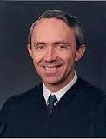Justice David H. Souter
JUSTICE SOUTER delivered the opinion of the Court.

“Facts of the case
After resigning as a lifeguard, Beth Ann Faragher brought an action against the City of Boca Raton and her immediate supervisors, alleging that the supervisors had created a sexually hostile atmosphere by touching, remarking, and commenting. Faragher asserted that this conduct constituted discrimination in violation of Title VII of the Civil Rights Act of 1964. The District Court concluded that Faragher's supervisors' conduct was sufficiently serious to alter the conditions of her employment and constitute an abusive working environment. The court then held that the city could be held liable. In reversing, the en banc Court of Appeals held that Faragher's supervisors were not acting within the scope of their employment when they engaged in the harassing conduct, that knowledge of the harassment could not be imputed to the City, and that the City could not be held liable for negligence in failing to prevent it.

Question
May an employer be held liable under Title VII of the Civil Rights Act of 1964 for the acts of an employee whose sexual harassment of subordinates has created a hostile work environment amounting to employment discrimination?

Conclusion
Yes. In a 7-2 opinion delivered by Justice David H. Souter, the Court held that an employer is vicariously liable under Title VII of the Civil Rights Act of 1964 for actionable discrimination caused by a supervisor. The Court also held that such liability is subject to an affirmative defense looking to the reasonableness of the employer's conduct as well as that of the plaintiff victim. ‘The City had entirely failed to disseminate its policy against sexual harassment among the beach employees and that its officials made no attempt to keep track of the conduct of supervisors like [Faragher's],’ wrote Justice Souter, ‘[u]nder such circumstances, we hold as a matter of law that the City could not be found to have exercised reasonable care to prevent the supervisors' harassing conduct.’” https://www.oyez.org/cases/1997/97-282

August 7, 1998 – Al-Qaega Attacks U.S. Embassies in Nairobi, Kenya and Dar es Salam, Tanzania
FBI - East African Embassy Bombings: https://www.fbi.gov/history/famous-cases/east-african-embassy-bombings
“On August 7, 1998, nearly simultaneous bombs blew up in front of the American embassies in Nairobi, Kenya, and Dar es Salaam, Tanzania, in Africa. Two hundred and twenty-four people died in the blasts, including 12 Americans, and more than 4,500 people were wounded. In the aftermath of the attacks, over 900 FBI agents alone—and many more FBI employees—traveled overseas to assist in the recovery of evidence and the identification of victims at the bomb sites and to track down the perpetrators.
These attacks were soon directly linked to al Qaeda﻿. Extraordinary efforts from our federal and international partners led to the identification, arrest, and extradition to the United States of several members of the al Qaeda terrorist network for their role in the bombings.
Mohammed Sadeek Odeh and Mohammed Rashed Daoud al-Owhali were arrested in Kenya within 20 days of the bombings and rendered to the U.S. shortly thereafter. Both were convicted for their roles in the bombing and sentenced to life in prison in October 2001.
In September 1998, Mamdouh Mahmud Salim was arrested in Germany. He is currently serving a life sentence for stabbing a federal corrections officer in the eye while in prison after being charged in the embassy attacks.
Also in September 1998, Wadih el-Hage—a naturalized American citizen who had been living in Arlington, Texas—was arrested by the FBI for making false statements during questioning. After being indicted for his role in the bombings, he was convicted and sentenced to life in prison in 2001.
On November 4, 1998, Osama Bin Laden and several members of his network, including his military commander Muhammad Atef, were named in an indictment based on the investigation. Both have since been killed.
All told, more than 20 people have been charged in connection with the bombings. Seven are serving life sentences in U.S. prison.”

Feb. 5, 1999: Family Medical Leave Act
U.S. Department of Labor: https://www.dol.gov/agencies/whd/fmla
“The FMLA entitles eligible employees of covered employers to take unpaid, job-protected leave for specified family and medical reasons with continuation of group health insurance coverage under the same terms and conditions as if the employee had not taken leave. Eligible employees are entitled to:
- Twelve workweeks of leave in a 12-month period for:
  - the birth of a child and to care for the newborn child within one year of birth; o the placement with the employee of a child for adoption or foster care and to care for the newly placed child within one year of placement;
  - to care for the employee’s spouse, child, or parent who has a serious health condition;
  - a serious health condition that makes the employee unable to perform the essential functions of his or her job;
  - any qualifying exigency arising out of the fact that the employee’s spouse, son, daughter, or parent is a covered military member on “covered active duty;” or
- Twenty-six workweeks of leave during a single 12-month period to care for a covered servicemember with a serious injury or illness if the eligible employee is the servicemember’s spouse, son, daughter, parent, or next of kin (military caregiver leave).”
Two types of recovery in lawsuits:
The FMLA provides: “It shall be unlawful for any employer to interfere with, restrain, or deny the exercise of or the attempt to exercise, any right provided under this subchapter.” 29 U.S.C. § 2615(a)(1). The FMLA further provides: “It shall be unlawful for any employer to discharge or in any other manner discriminate against any individual for opposing any practice made unlawful by this subchapter.” 29 U.S.C. § 2615(a)(2). Thus, two separate theories of recovery are available under the FMLA: interference with the exercise of FMLA rights, and retaliation against an employee's opposition to an unlawful FMLA practice. Id. at § 2615(a)(1) and (2).

April 20, 1999: COLUMBINE HIGH SCHOOL, COLORADO – MASS SHOOTING
“The Columbine shooting on April 20, 1999 at Columbine High School in Littleton, Colorado, occurred when two teens [12-graders Eric Harris and Dylan Klebold] went on a shooting spree, killing 13 people and wounding more than 20 others, before turning their guns on themselves and committing suicide.”
https://www.history.com/topics/1990s/columbine-high-school-shootings

***

“On April 20, 1999, Eric Davis Harris (1981-1999) and Dylan Bennet Klebold (1981-1999) killed 12 students and one teacher at Columbine High School in Littleton, Colorado before committing suicide. The tragedy sparked national debates about school safety. The FBI assisted local law enforcement by investigating additional threats and Internet leads, conducting witness interviews, and processing physical evidence. The FBI’s file details the initial investigation and contains witness interviews between April 21, 1999 and May 5, 1999.” https://vault.fbi.gov/Columbine%20High%20School%20

***

“Feb. 18, 2025: Anne Marie Hochhalter, Paralyzed in Columbine Shooting, Dies at 43.
Fiercely independent, she publicly discussed the long-term effects of gun violence and spoke of forgiveness…. Sue Townsend, who became close to Ms. Hochhalter after her stepdaughter, Lauren Townsend, was killed in the shooting, said that Ms. Hochhalter had been dealing with lingering effects from her injuries, including a pressure sore and an infection…. Ms. Hochhalter, a junior who was 17, was shot twice — once in the chest and once in the back — and was paralyzed from the waist down. Her brother, Nathan Hochhalter, who was a freshman at Columbine, was trapped in the school for hours until a SWAT team arrived.” https://www.nytimes.com/2025/02/18/us/anne-marie-hochhalter-columbine-shooting-dies.html

June 22, 1999: U.S. Supreme Court - Olmstead v. L.C. (6 to 3) https://supreme.justia.com/cases/federal/us/527/581/

MENTAL DISABILITIES – INSTITUTIONALIZING PEOPLE WITH DISABILITIES IS DISCRIMINATION
https://www.oyez.org/cases/1998/98-536
“[T]wo female patients with mental disabilities, challenged Tommy Olmstead, the Commissioner of Georgia's Department of Human Resources, for the Georgia Regional Hospital's (GRH) decision to keep the two women in psychiatric isolation. [Their attorney] argued that under Title II of the 1990 Americans with Disabilities Act (ADA), the women had to be moved to the most communally integrated setting possible. Defending GRH's decision, Olmstead argued that although the women were medically cleared for a more integrated treatment setting, financial constraints and the need to fundamentally alter treatment programs prevented this from happening.”


Photograph of Lois Curtis and Elaine Wilson.

U.S. Department of Labor (June 20, 2024). https://blog.dol.gov/2024/06/20/the-olmstead-effect-celebrating-25-years-of-positive-change
“Twenty-five years ago this month, a landmark U.S. Supreme Court ruling ushered in an era of profound and positive change for people with disabilities in America—as well as the agencies that serve and support them, including the department. The case was Olmstead v. L.C., and the plaintiffs were two disabled women, Lois Curtis and Elaine Wilson. Even though Curtis and Wilson desired to reside and receive care in a community-based setting and were declared able to do so by doctors, they were both confined to a state-run hospital for several years. Their attorney argued that such unjust institutionalization amounted to discrimination under the Americans with Disabilities Act, and the nation’s highest court agreed.
In the years since it was handed down, the Olmstead ruling has had a resounding ripple effect, setting in motion policy innovations across numerous federal agencies. This month, in honor of Olmstead’s 25th anniversary, our National Center on Leadership for the Employment and Economic Advancement of People with Disabilities (LEAD Center) published a retrospective of the 25 most impactful developments in disability rights and protections since the decision.
Olmstead affirmed that people with disabilities have the right to receive publicly funded services in the most integrated settings possible based on the individual’s requirements. One of the most notable public services is employment services. Olmstead has served as the bedrock of one of ODEP’s major policy priorities since our inception in 2001: advancing competitive integrated employment (CIE), a key pillar of which is people with disabilities working in the community alongside people without disabilities.”

May 1, 2000: U.S. Supreme Court - Christensen v. Harris County (6 to 3) https://supreme.justia.com/cases/federal/us/529/576/

PUBLIC EMPLOYERS MAY IMPLEMENT COMP TIME POLICY

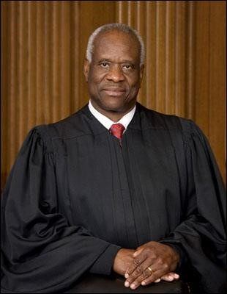 Justice Clarence Thomas
JUSTICE THOMAS delivered the opinion of the Court.

“Facts of the case
The Fair Labor Standards Act of 1938 (FLSA) permits governmental entities to compensate their employees for overtime work by granting them compensatory time in lieu of cash payment. If the employees do not use their accumulated compensatory time, the employer must pay cash compensation under certain circumstances. Harris County, Texas, found that too many of its deputy sheriffs had too many hours of accrued compensatory time. Fearing a budget crisis, the county adopted a policy under which its employees could be ordered to schedule compensatory time at specified times in order to reduce the amount of accrued time that would otherwise require cash payment. Edward Christensen and 128 other deputy sheriffs in Harris County believed they had the right to use their compensatory time when they saw fit. The sheriffs sued, claiming that the FLSA does not permit an employer to compel an employee to use compensatory time in the absence of an agreement permitting the employer to do so. The District Court ruled in favor of the sheriffs, concluding that the policy violated the FLSA. In reversing, the Court of Appeals held that the FLSA did not address the issue in question and thus did not prohibit the county from implementing a compensatory time policy.

Question
Does the Fair Labor Standards Act of 1938 prohibit a public employer from compelling its employees to use their compensatory time without a preexisting agreement?

Conclusion
No. In an opinion delivered by Justice Clarence Thomas, the Court held 6-3 that ‘[n]othing in the FLSA or its implementing regulations prohibits a public employer from compelling the use of compensatory time.’ Justice Thomas wrote for the Court that, ‘under the FLSA, an employer is free to require an employee to take time off work, and an employer is also free to use the money it would have paid in wages to cash out accrued compensatory time. The compelled use of compensatory time challenged in this case merely involves doing both of these steps at once.’” https://www.oyez.org/cases/1999/98-1167

OCT. 30, 2000 – AFG GRANT PROGRAM
[Oct. 30, 2025]: “It’s hard to believe that the Assistance to Firefighters Grant (AFG) Program was signed into law on this day 25 years ago. Passage of the legislation was an uphill battle with many obstacles encountered along the way. At the time, a federal grant program for the fire service seemed like a pipedream. Few in Congress supported the idea, asserting that the federal government should not have a role in funding local fire departments -- that was the role of local and state governments. But a core group of members of Congress – including the leaders of the Congressional Fire Services Caucus – recognized the need for the federal government to provide support to address the growing needs and challenges of local fire departments. They refused to capitulate to the notion that the federal government had no business in supporting local fire departments, affirming that the nation’s safety demands federal investment in the fire service. For two years, they were relentless in advocating for the passage of the authorizing legislation, called the FIRE Act, until President Bill Clinton signed it into law on October 30, 2000 as part of the fiscal year (FY) 2001 National Defense Authorization Act (NDAA).” Congressional Fire Services Institute update@cfsi.ccsend.com

See YouTube summary: https://www.youtube.com/watch?v=CQ6AQ7rsC8U

See Oct. 2000 article:

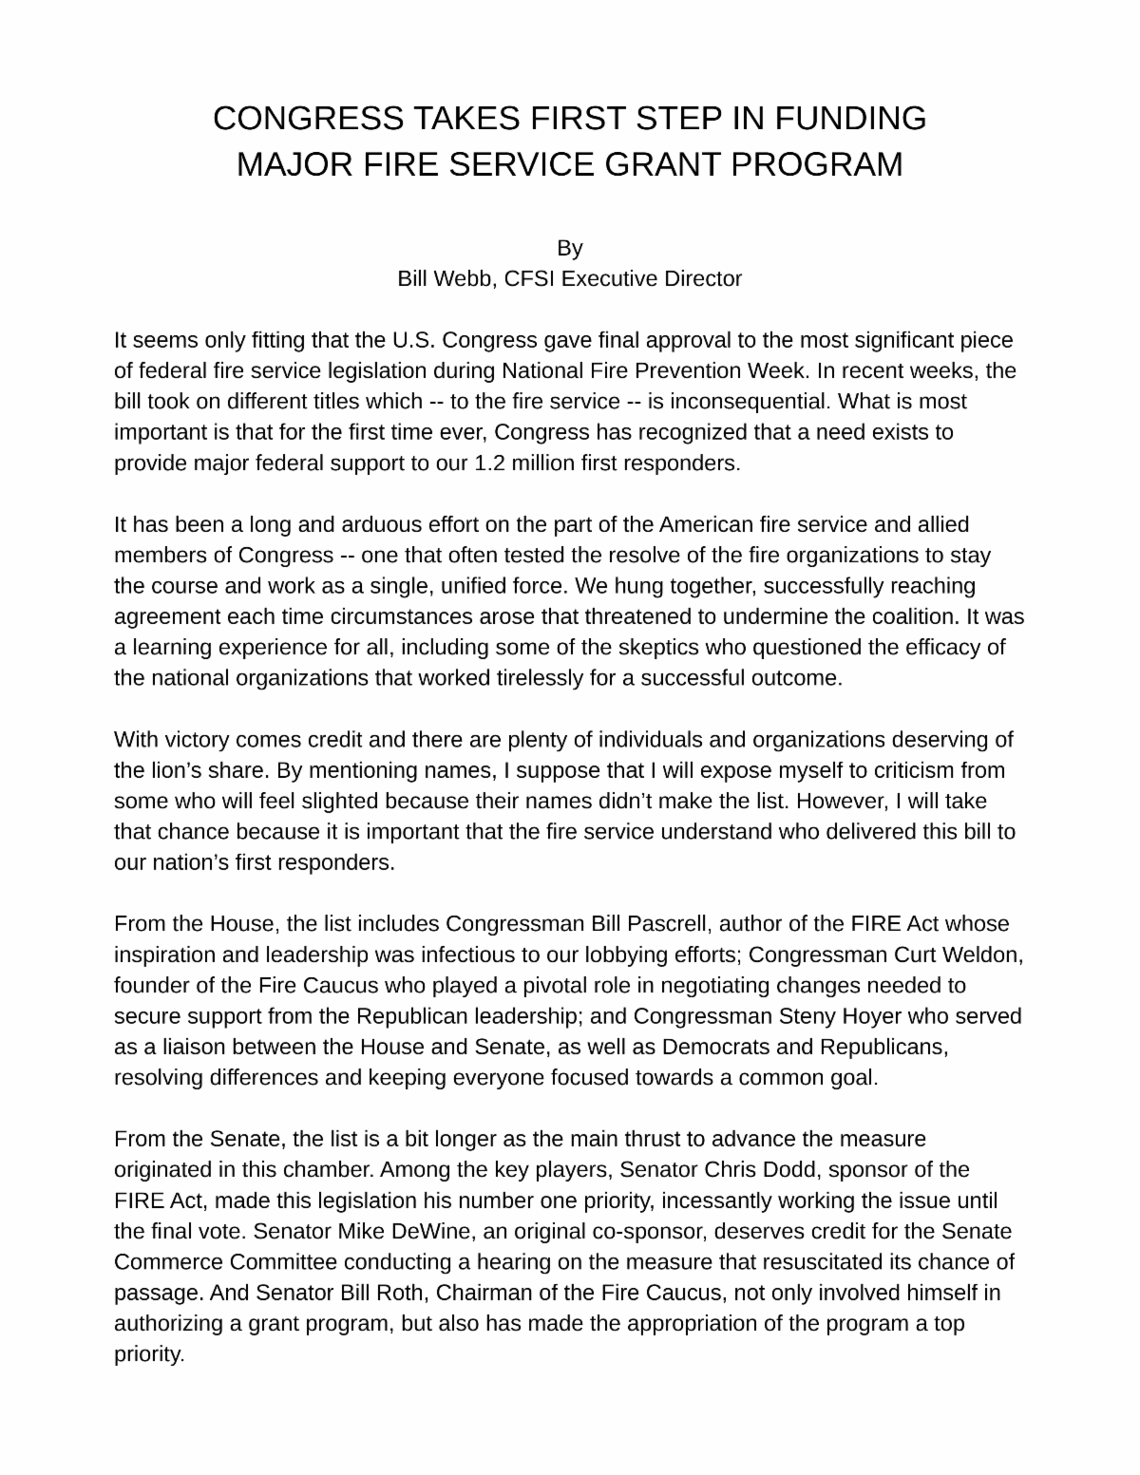

Jan. 20, 2001: PRESIDENT GEORGE W. BUSH – INAURATION
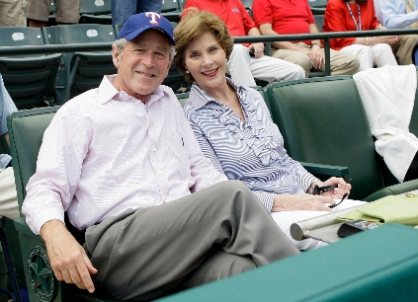
https://georgewbush.com/

Jan. 20, 2001: Bill Blinton – Leaving Office, Personal Note To George W. Bush

“Dear George,

Today you embark on the greatest venture, with the greatest honor, that can come to an American citizen.

Like me, you are especially fortunate to lead our country in a time of profound and largely positive change, when old questions, not just about the role of government, but about the very nature of our nation, must be answered anew.

You lead a proud, decent, good people. And from this day you are President of all of us. I salute you and wish you success and much happiness.

The burdens you now shoulder are great but often exaggerated. The sheer joy of doing what you believe is right is inexpressible.

My prayers are with you and your family. Godspeed.

Sincerely,

Bill”
https://www.washingtonpost.com/history/2025/01/20/inauguration-letter-president-trump-biden-tradition/?utm_campaign=wp_post_most&utm_medium=email&utm_source=newsletter&carta-url=https%3A%2F%2Fs2.washingtonpost.com%2Fcar-ln-tr%2F41281a4%2F67b363a6eb3eba471afc37e7%2F59731235ade4e21a848a56ed%2F23%2F53%2F67b363a6eb3eba471afc37e7

Feb. 18, 2001- Dale Ernhart (age 49) killed at Daytona 500

“That was at least 20 years ago, he says, around the same time NASCAR was issuing sweeping changes in the wake of Dale Sr.’s death. Drivers complained about having to wear head and neck restraints, and cars had to be outfitted with stronger roll bars and carbon fiber seats. Speedway walls were updated with upgraded barriers that dissipated energy during a crash.” https://www.washingtonpost.com/sports/2025/05/22/dale-earnhardt-jr-dad-nascar-death/?utm_campaign=wp_post_most&utm_medium=email&utm_source=newsletter&carta-url=https%3A%2F%2Fs2.washingtonpost.com%2Fcar-ln-tr%2F42afa07%2F682f4d1495e93627b9f1fe1c%2F59731235ade4e21a848a56ed%2F14%2F58%2F682f4d1495e93627b9f1fe1c
https://www.youtube.com/watch?v=qQZPBFI5cc4
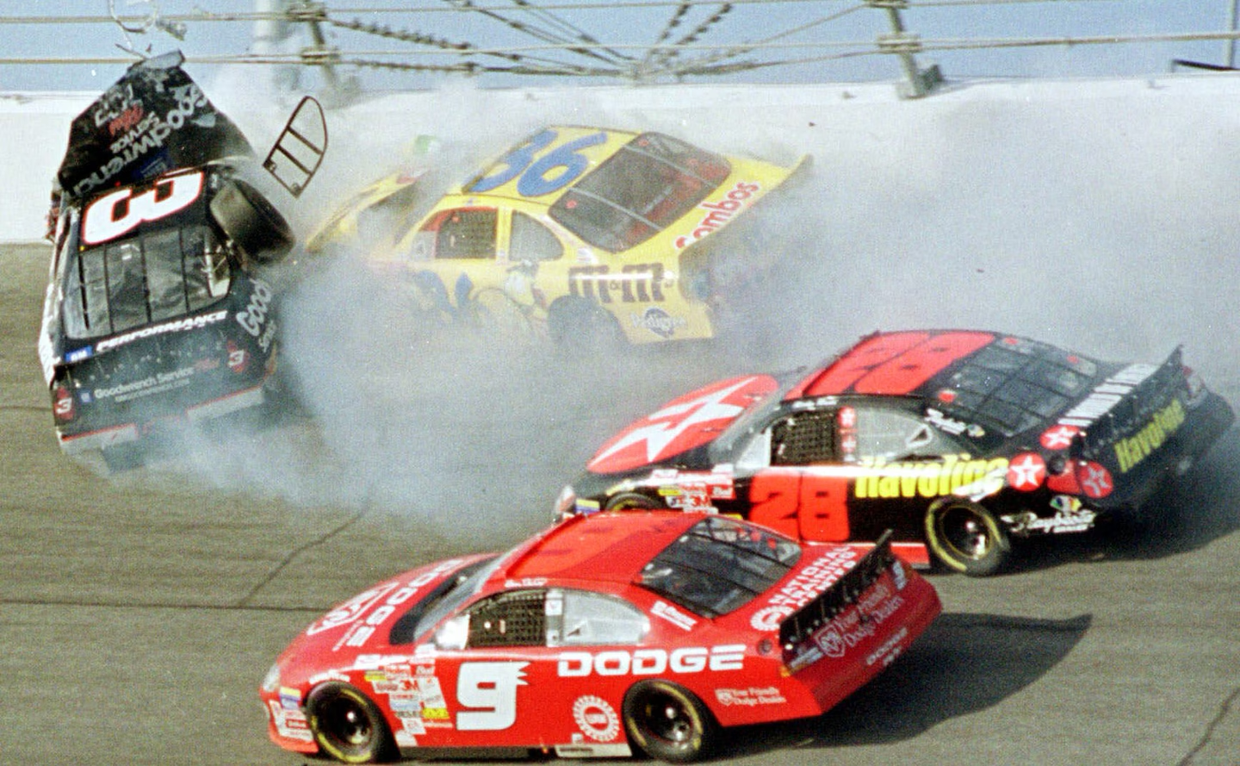

June 11, 2001: United States of America Executed Timothy McVeigh
Tim McVeigh was executed by lethal injection on June 11, 2001, at the U.S. federal penitentiary in Terre Haute, Indiana.
“The execution of Timothy McVeigh: must see TV?”
https://www.ncbi.nlm.nih.gov/pmc/articles/PMC1120354/
“On 19 April 1995, 7000 lbs of explosives detonated alongside the Alfred P Murrah Federal Office Building in Oklahoma City. Without warning the bomb punched a gaping hole through offices and a daycare centre, killing adults and children; 163 died inside the building, four more died outside, and a final victim was killed entering the scene to help the wounded.

Timothy McVeigh, despite his earplugs, heard the deafening roar of the blast and felt the thump of air lift him an inch off the ground. Falling bricks hit him in the leg and a snapped live wire threatened his life. McVeigh, who lit the fuse creating the bloody, horrifying, hideous scene behind him, did not look back. He first saw the devastation via CNN and was momentarily irritated at the sight of the building still standing.”

June 11, 2001: U.S. Supreme Court - Kyllo v. United States (5 to 4) https://supreme.justia.com/cases/federal/us/533/27/

THERMAL IMAGING CAMERA – HEAT FROM MJ LAMPS – ILLEGAL SEARCH

“In 1991 Agent William Elliott of the United States Department of the Interior came to suspect that marijuana was being grown in the home belonging to petitioner Danny Kyllo, part of a triplex on Rhododendron Drive in Florence, Oregon. Indoor marijuana growth typically requires high intensity lamps. In order to determine whether an amount of heat was emanating from petitioner's home consistent with the use of such lamps, at 3:20 a.m. on January 16, 1992, Agent Elliott and Dan Haas used an Agema Thermovision 210 thermal imager to scan the triplex. Thermal imagers detect infrared radiation, which virtually all objects emit but which is not visible to the naked eye. The imager converts radiation into images based on relative warmth-black. *** Where, as here, the Government uses a device that is not in general public use, to explore details of the home that would previously have been unknowable without physical intrusion, the surveillance is a "search" and is presumptively unreasonable without a warrant.
Since we hold the Thermovision imaging to have been an unlawful search, it will remain for the District Court to determine whether, without the evidence it provided, the search warrant issued in this case was supported by probable cause-and if not, whether there is any other basis for supporting admission of the evidence that the search pursuant to the warrant produced.”

Sept. 11, 2001 – Attacks On World Trade Center and Pentagon
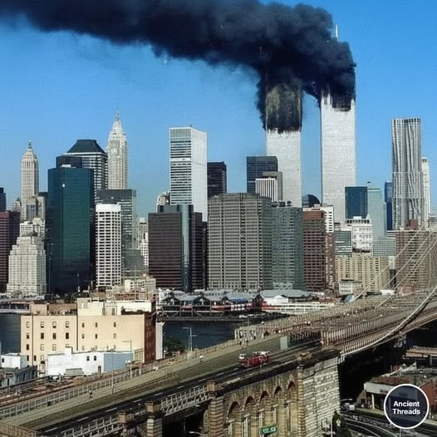
“On September 11, 2001, 2,977 people were killed in the deadliest terrorist attacks in American history.” https://millercenter.org/remembering-september-11/september-11-terrorist-attacks

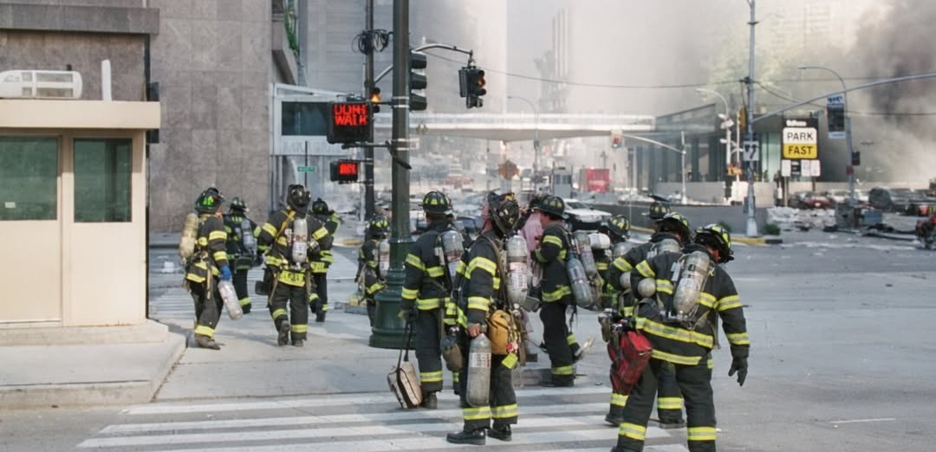
This is the last known photograph of these brave firefighters from Ladder 7 and Ladder 118.
September 11, 2021: Attacks on World Trade Center and Pentagon
FBI Director Christopher Wray: “Hard-Earned Lessons from 9/11 Offer a Playbook for Combating Today’s Threats.” September 10, 2021. https://www.fbi.gov/news/press-releases/hard-earned-lessons-from-911-offer-a-playbook-for-combating-todays-threats-wray-op-ed-091021

September 16, 2001 – Sermon – First Sunday After Attack on World Trade Center and Pentagon
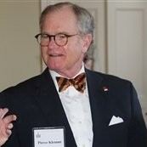
Sermon given on the first Sunday after 911, by Episcopal Minister Pierce Klemmt, Rector of Christ Church [George Washington’ parish church], Alexandria, VA. He was Rector from 1994-2014 and is now retired and living in Alexandria. Posted with his written approval. pklemmt@gmail.com

9/11 Memorial & Museum: https://www.911memorial.org/911-faqs
What happened on 9/11?
“9/11” is shorthand for four coordinated terrorist attacks carried out by al-Qaeda, an Islamist extremist group, that occurred on the morning of September 11, 2001.
Nineteen terrorists from al-Qaeda hijacked four commercial airplanes, deliberately crashing two of the planes into the upper floors of the North and South Towers of the World Trade Center complex and a third plane into the Pentagon in Arlington, Virginia. The Twin Towers ultimately collapsed because of the damage sustained from the impacts and the resulting fires. After learning about the other attacks, passengers on the fourth hijacked plane, Flight 93, fought back, and the plane was crashed into an empty field in western Pennsylvania about 20 minutes by air from Washington, D.C.
The attacks killed 2,977 people from 90 nations: 2,753 people were killed in New York; 184 people were killed at the Pentagon; and 40 people were killed on Flight 93.

9/11 Commission Report: https://www.9-11commission.gov/report/911Report.pdf
“The Terrorism Warning Lights Are Blinking Red Again. Echoes of the run-up to 9/11.” June 10, 2024. https://www.foreignaffairs.com/united-states/terrorism-warning-lights-are-blinking-red-again
“From his confirmation hearing to become director of Central Intelligence in May 1997 until September 11, 2001, George Tenet was sounding an alarm about Osama bin Laden and al Qaeda. In those four years before al Qaeda operatives attacked the World Trade Center and the Pentagon, Tenet testified publicly no fewer than ten times about the threat the group posed to U.S. interests at home and abroad. In February 1999, six months after the group bombed the U.S. embassies in Kenya and Tanzania, he claimed, ‘there is not the slightest doubt that Osama bin Laden . . . [is] planning further attacks against us.’ In early 2000, he warned Congress again that bin Laden was ‘foremost among these terrorists, because of the immediacy and seriousness of the threat he poses’ and because of his ability to strike ‘without additional warning.’ Al Qaeda’s next attacks, Tenet said, could be ‘simultaneous’ and ‘spectacular.’ In private, Tenet was even more assertive. Breaking with standard protocols, he wrote personal letters to President Bill Clinton expressing his deep conviction about the gravity of the threat. And several times in 2001, he personally discussed his concerns about al Qaeda’s plans with President George W. Bush and National Security Adviser Condoleezza Rice. e CIA and the FBI may not have uncovered the time, place, or method of the 9/11 plot, but Tenet’s warnings were prophetic.”

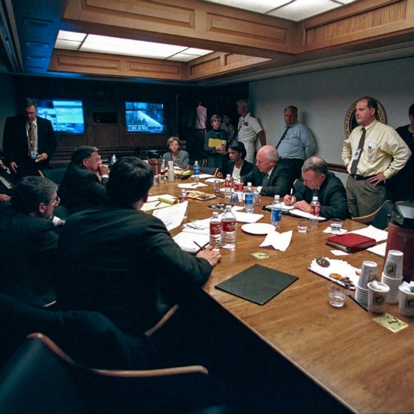

On Sept. 11, 2001, Secret Service agents grabbed Vice President Dick Cheney from his West Wing office and rushed him into a bunker below the East Wing, which had been built as a shelter for Roosevelt during World War II. Cheney headed underground the moment that American Airlines Flight 77 crashed into the Pentagon. The New York Times nytdirect@nytimes.com (10/24/2025)

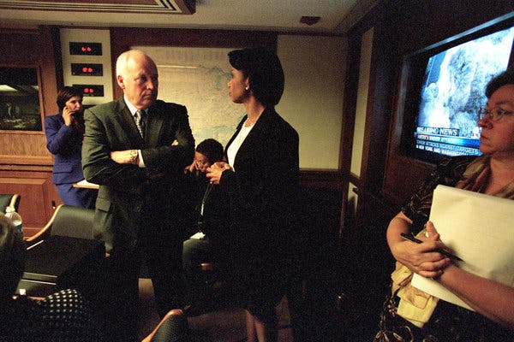
Mr. Cheney with Condoleezza Rice, the national security adviser, on Sept. 11, 2001. With the president traveling and sent to secure locations after the terrorist attacks that morning, it was Mr. Cheney who took charge of the response from the White House.

Oct. 26, 2001 – USA Patriot Act
“Six weeks after the attacks, Mr. Cheney helped engineer a swift, lopsided passage of the USA Patriot Act, a sweeping law that greatly expanded the government’s powers of investigation, surveillance and detention to fight terrorism. With the wounded nation still seething over Sept. 11, public opposition to the law was muted, though civil libertarians warned that it authorized the government to spy on ordinary Americans. Later, it became clear that the act was being used to underpin secret courts, wiretaps without warrants, the unlimited detention of suspects without hearings or charges, and interrogation methods that skirted bans on torture in the Geneva Conventions. There were wide protests and even constitutional challenges. But Mr. Cheney strongly defended the law and its expansion of presidential power, and it remained in force.” https://www.nytimes.com/2025/11/04/us/politics/dick-cheney-dead.html?nl=Breaking+News
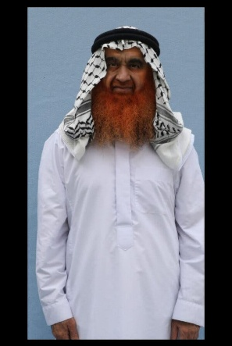
All 15 prisoners at Guantánamo have had access to the program, which began allowing photos in 2009. Khalid Shaikh Mohammed, who is accused of hatching the 9/11 plot that killed nearly 3,000 people, appears in a recent photo in a pressed white robe, his beard dyed.
https://www.nytimes.com/2025/10/23/us/politics/guantanamo-prisoners-portraits.html?nl=The+Evening

2002 – President Bush / Secret NSA Domestic Spying
[See March 11, 2004: President Bush / Reauthorized Secret NSA Domestic Spying Program – “Stellarwind”] https://www.nytimes.com/2026/03/21/us/politics/robert-s-mueller-dead.html?nl=breaking-news&segment_id=217034
Dec. 16, 2005: N.Y. Times: Bush Lets U.S. Spy on Callers Without Courts
Months after the Sept. 11 attacks. https://www.nytimes.com/2005/12/16/politics/bush-lets-us-spy-on-callers-without-courts.html

President Bush secretly authorized the National Security Agency to eavesdrop on Americans and others inside the United States to search for evidence of terrorist activity without the court-approved warrants ordinarily required for domestic spying, according to government officials.
Under a presidential order signed in 2002, the intelligence agency has monitored the international telephone calls and international e-mail messages of hundreds, perhaps thousands, of people inside the United States without warrants over the past three years in an effort to track possible "dirty numbers" linked to Al Qaeda, the officials said. The agency, they said, still seeks warrants to monitor entirely domestic communications.
The previously undisclosed decision to permit some eavesdropping inside the country without court approval was a major shift in American intelligence-gathering practices, particularly for the National Security Agency, whose mission is to spy on communications abroad. As a result, some officials familiar with the continuing operation have questioned whether the surveillance has stretched, if not crossed, constitutional limits on legal searches.

***

In mid-2004, concerns about the program expressed by national security officials, government lawyers and a judge prompted the Bush administration to suspend elements of the program and revamp it.

For the first time, the Justice Department audited the N.S.A. program, several officials said. And to provide more guidance, the Justice Department and the agency expanded and refined a checklist to follow in deciding whether probable cause existed to start monitoring someone's communications, several officials said.

A complaint from Judge Colleen Kollar-Kotelly, the federal judge who oversees the Federal Intelligence Surveillance Court, helped spur the suspension, officials said. The judge questioned whether information obtained under the N.S.A. program was being improperly used as the basis for F.I.S.A. wiretap warrant requests from the Justice Department, according to senior government officials. While not knowing all the details of the exchange, several government lawyers said there appeared to be concerns that the Justice Department, by trying to shield the existence of the N.S.A. program, was in danger of misleading the court about the origins of the information cited to justify the warrants.

June 8, 2002: U.S. Supreme Court - Toyota Motor Mfg. Kentucky, Inc. v. Williams (9 to 0) https://supreme.justia.com/cases/federal/us/534/184/

ADA / DISABILITY MUST BE PERMANENT [CONGRESS PASSED STATUTE IN 2008 WHICH OVERTURNS THIS DECISION - ADA Amendments Act of 2008]

 Justice Sandra Day O'Connor
JUSTICE O'CONNOR delivered the opinion of the Court.

“Facts of the case
In 1997, Toyota Motor Manufacturing, Kentucky, Inc. terminated Ella Williams, citing her poor attendance record. Subsequently, claiming to be disabled from performing her automobile assembly line job by carpal tunnel syndrome and related impairments, Williams sued Toyota for failing to provide her with a reasonable accommodation as required by the Americans with Disabilities Act of 1990 (ADA). Granting Toyota summary judgment, the District Court held that Williams's impairment did not qualify as a disability under the ADA because it had not substantially limited any major life activity and that there was no evidence that Williams had had a record of a substantially limiting impairment. In reversing, the Court of Appeals found that the impairments substantially limited Williams in the major life activity of performing manual tasks. Because her ailments prevented her from doing the tasks associated with certain types of manual jobs that require the gripping of tools and repetitive work with hands and arms extended at or above shoulder levels for extended periods of time, the appellate court concluded that Williams demonstrated that her manual disability involved a class of manual activities affecting the ability to perform tasks at work.

Question
Did the Court of Appeals use the proper standard in determining whether an employee was disabled under the ADA due to carpel tunnel syndrome by showing that her manual disability involved a class of manual activities affecting the ability to perform tasks at work?

Conclusion
No. In a unanimous opinion delivered by Justice Sandra Day O'Connor, the Court held that the Court of Appeals did not apply the proper standard in making its determination because it analyzed only a limited class of manual tasks and failed to ask whether Williams's impairments prevented or restricted her from performing tasks that are of central importance to most people's daily lives. The Court also reasoned that for the purposes of the ADA, an impairment's impact must also be permanent or long-term. ‘Given large potential differences in the severity and duration of the effects of carpal tunnel syndrome, an individual's carpal tunnel syndrome diagnosis, on its own, does not indicate whether the individual has a disability within the meaning of the ADA,’ wrote Justice O'Connor for the Court.” https://www.oyez.org/cases/2001/00-1089
[Note: Congress later amended the ADA, in effect overturning this decision.]

Nov. 25, 2002: U.S. Department of Homeland Security formed
“Eleven days after the September 11, 2001, terrorist attacks, Pennsylvania Governor
Tom Ridge was appointed as the first Director of the Office of Homeland Security in the White House. The office oversaw and coordinated a comprehensive national strategy to safeguard the country against terrorism and respond to any future attacks. With the passage of the Homeland Security Act by Congress in November 2002, the Department of Homeland Security formally came into being as a stand-alone, Cabinet-level department to further coordinate and unify national homeland security efforts, opening its doors on March 1, 2003 [22 Departments].” https://www.dhs.gov/creation-departmenthomeland-security

Feb. 20, 2003: West Warwick, RI - The Station Nightclub Fire

“The fourth deadliest nightclub fire in U.S. history, a blaze at The Station nightclub in W. Warwick, RI, on February 20, 2003, claimed 100 lives. After the fire, NFPA enacted tough new code provisions for fire sprinklers and crowd management in nightclub-type venues. Those provisions mark sweeping changes to the codes and standards governing safety in assembly occupancies.” https://www.nfpa.org/Public-Education/Staying-safe/Safety-in-living-and-entertainment-spaces/Nightclubs-assembly-occupancies/The-Station-nightclub-fire

“For many Station survivors and relatives of dead, fire inspector Larocque culpable for not spotting flammable insulation (Feb. 19, 2013).

“They point to the club owners, Michael and Jeffrey Derderian, who had glued flammable foam to the club’s walls to muffle the music and neighbors’ complaints; the band Great White, whose illegal use of pyrotechnics in a wooden building with 8-foot ceilings ignited the foam; and town officials, most notably Larocque, who inspected the club at least three times in the months before the fire and never cited the foam as a fire hazard. Larocque, a broad man with a thick, graying moustache, had a reputation for being a tough fire inspector. A career firefighter who became the local fire marshal five years earlier, he noticed code infractions and didn’t hesitate to report them, even in businesses owned by friends like Laboissonniere. When investigators first questioned Larocque about the foam, days after the Feb. 20, 2003, fire, he said he didn’t see it because he had been blinded by anger after seeing that an illegal door he had ordered removed had been reinstalled. That door, which swung inward instead of outward -- a potential safety impediment in an emergency -- had the flammable gray, egg-crate-shaped foam glued to its interior side.” https://www.providencejournal.com/article/20130219/SPECIAL-REPORTS/302199997

Graphic Video from scene: https://www.youtube.com/watch?v=rO0ioCCiEe8
NIST re-creation: https://www.youtube.com/watch?v=IxiOXZ55hbc

March 2003 – Stat of Iraq War (until 2011)

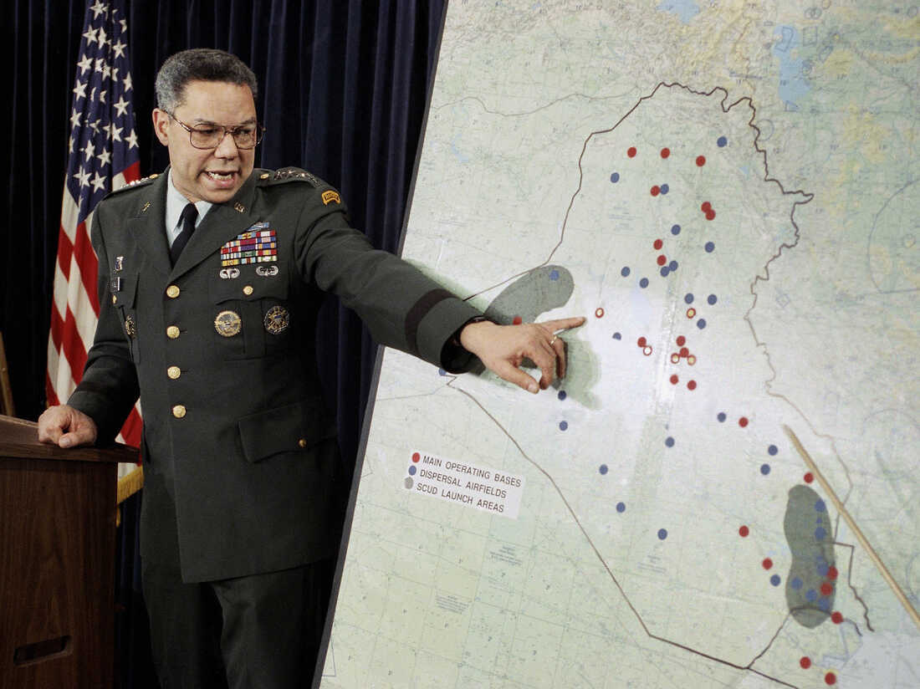
General Colin Powell

“In March 2003, U.S. forces invaded Iraq vowing to destroy Iraqi weapons of mass destruction (WMD) and end the dictatorial rule of Saddam Hussein. When WMD intelligence proved illusory and a violent insurgency arose, the war lost public support. Saddam was captured, tried, and hanged and democratic elections were held. In the years since, there have been over 4,700 U.S. and allied troop deaths, and more than one hundred thousand Iraqi civilians have been killed. Meanwhile, questions linger over Iraq’s fractious political situation.” https://www.cfr.org/timeline/iraq-war

May 27, 2003: U.S. Supreme Court - Nevada Department of Human Resources v. Hibbs (6 to 3) https://supreme.justia.com/cases/federal/us/538/721/

FMLA ALSO COVERS STATE EMPLOYEES

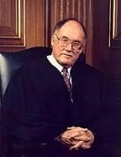Justice William Rehnquist
CHIEF JUSTICE REHNQUIST delivered the opinion of the Court.

“Facts of the case
William Hibbs, an employee of the Nevada Department of Human Resources, sought leave to care for his wife under the Family and Medical Leave Act of 1993 (FMLA). The FMLA entitles an eligible employee to take up to 12 workweeks of unpaid leave annually for the onset of a ‘serious health condition’ in the employee's spouse. The Department granted Hibbs's request for the full 12 weeks of FMLA leave and, after he had exhausted that leave, informed him that he must report to work by a certain date. When Hibbs failed to do so, he was fired. Pursuant to FMLA provisions creating a private right of action ‘against any employer’ that ‘interfered with, restrained, or denied the exercise of’ FMLA rights, Hibbs sued in Federal District Court, seeking money damages for FMLA violations. The District Court concluded that the Eleventh Amendment barred the FMLA claim. The Court of Appeals reversed.

Question
May an individual sue a State for money damages in federal court for violation of the Family and Medical Leave Act of 1993?

Conclusion
Yes. In a 6-3 opinion delivered by Chief Justice William H. Rehnquist, the Court held that State employees may recover money damages in federal court in the event of the State's failure to comply with the FMLA's family-care provision. The Court reasoned that Congress both clearly stated its intention to abrogate the States' Eleventh Amendment immunity from suit in federal court under the FMLA and acted within its authority under section 5 of the Fourteenth Amendment by enacting prophylactic, rather than substantively redefining, legislation. ‘In sum, the States' record of unconstitutional participation in, and fostering of, gender-based discrimination in the administration of leave benefits is weighty enough to justify the enactment of prophylactic [section] 5 legislation,’ wrote Chief Justice Rehnquist. Justices Antonin Scalia and Anthony M. Kennedy, who was joined by Justices Clarence Thomas and Scalia, filed dissents.” https://www.oyez.org/cases/2002/01-1368

Oct. 18, 2003 – Secretary of State Colin Powell – Address UN Security Council - Iraq has weapons of mass destruction. Watch video. https://www.youtube.com/watch?v=DhWlPo3qxak

Feb. 12, 2004: Ohio Public Records Act
149.43 Availability of public records for inspection and copying: http://codes.ohio.gov/orc/149.43
Records not public – firefighter, EMT home address, etc.
(A) As used in this section:
(1) “Public record" does not mean any of the following:
(7) "Designated public service worker" means a peace officer, parole officer, probation officer, bailiff, prosecuting attorney, assistant prosecuting attorney, correctional employee, county or multicounty corrections officer, community-based correctional facility employee, youth services employee, firefighter, EMT, medical director or member of a cooperating physician advisory board of an emergency medical service organization, state board of pharmacy employee, investigator of the bureau of criminal identification and investigation, judge, magistrate, or federal law enforcement officer.
***
(f) The name, the residential address, the name of the employer, the address of the employer, the social security number, the residential telephone number, any bank account, debit card, charge card, or credit card number, or the emergency telephone number of the spouse, a former spouse, or any child of a designated public service worker….
Note: Journalists Exception – Disclose Personal Address
“(9) (a) Upon written request made and signed by a journalist, a public office, or person responsible for public records, having custody of the records of the agency employing a specified designated public service worker shall disclose to the journalist the address of the actual personal residence of the designated public service worker and, if the designated public service worker's spouse, former spouse, or child is employed by a public office, the name and address of the employer of the designated public service worker's spouse, former spouse, or child. The request shall include the journalist's name and title and the name and address of the journalist's employer and shall state that disclosure of the information sought would be in the public interest.
***
(c) As used in division (B)(9) of this section, "journalist" means a person engaged in, connected with, or employed by any news medium, including a newspaper, magazine, press association, news agency, or wire service, a radio or television station, or a similar medium, for the purpose of gathering, processing, transmitting, compiling, editing, or disseminating information for the general public.”
See also: Ohio Attorney General – 2020 Ohio Sunshine Laws: https://www.ohioattorneygeneral.gov/yellowbook
Note: July 23, 2020: New York: “Judge blocks release of NY FF, police discipline records Unions argued that posting unproven or false complaints could sully first responders' reputations and compromise their safety. NEW YORK — A federal judge has halted the public release of police officer disciplinary records in New York, temporarily turning back a state transparency reform enacted in the wake of the police killing of George Floyd. Judge Katherine Polk Failla granted a temporary restraining order late Wednesday barring police departments and other entities in the state from disclosing discipline records until at least Aug. 18, when she'll hear arguments in a union lawsuit challenging their release.” https://www.firerescue1.com/legal/articles/judge-blocksrelease-of-ny-ff-police-discipline-records-
7rj16mVBBulSb3oo/?utm_source=FireRescue1+Member+Newsletter&utm_campaign=4 b0f0b6849-
EMAIL_CAMPAIGN_2020_07_24_08_10&utm_medium=email&utm_term=0_758bdb effe-4b0f0b6849-41607823
See also: June 10, 2020: New York – “The New York state Senate and Assembly passed the 50-a repeal Tuesday night largely along party lines, as Republicans argued the law would allow the release of unsubstantiated or false complaints against officers. *** June
9, 2020: ALBANY, N.Y. — A decades-old law that kept law enforcement officers’ disciplinary records secret in New York appeared to be headed for an overhaul this week as state lawmakers moved to act on a number of police accountability measures prompted by street demonstrations over the death of George Floyd. The state law, known by its section title, 50-a, was passed in the 1970s to prevent criminal defense attorneys from subjecting officers to cross-examinations about irrelevant information in their personnel file. The law applies to jail guards and firefighters, as well.”
https://www.gov1.com/legal/articles/ny-poised-to-overhaul-law-concealing-policedisciplinary-files-we2ftqJQKSrjDE9g/

March 11, 2004: President Bush / Reauthorized Secret NSA Domestic Spying Program – “Stellarwind”
March 21, 2026: Robert S. Mueller III, 81, Dies; Rebuilt F.B.I. and Led Trump Inquiry.
https://www.nytimes.com/2026/03/21/us/politics/robert-s-mueller-dead.html?nl=breaking-news&segment_id=217034

Early in 2004, Mr. Mueller [FBI Director] and his immediate superior at the Justice Department, the deputy attorney general, Mr. Comey, learned that Mr. Bush had authorized the N.S.A. to spy on Americans. The program, code-named Stellarwind, was so secret that very few people were aware of how it worked.

The N.S.A., created to gather foreign intelligence abroad, was eavesdropping freely in the United States, without search warrants, collecting electronic records of millions of telephone conversations, emails and internet addresses. Then it sent the raw data to the bureau. The F.B.I. found that dealing with this deluge was like trying to drink from a fire hose. And the surveillance program had never saved a life, stopped an imminent attack or unveiled a member of Al Qaeda in the United States.

Of greater concern to Mr. Mueller and Mr. Comey was their determination that the program violated the Constitution’s protections against illegal searches and seizures. They convinced Attorney General John Ashcroft that he could not reauthorize Stellarwind. But Mr. Bush did so, unilaterally, on the morning of March 11, 2004, asserting in effect that his power overrode the Constitution.

Mr. Mueller took meticulous notes. He recorded that the president was “trying to do an end run around the law.” At 1:30 a.m. on March 12, he sat at his kitchen table and drafted a letter of resignation. “I am forced to withdraw the F.B.I. from participation in the program,” he wrote; if the president did not back down, he would resign. Both Mr. Comey and Mr. Ashcroft were determined to go with him.
Eight hours later, with the resignation letter in the breast pocket of his suit, Mr. Mueller sat alone with Mr. Bush in the White House.
“I had to make a big decision, and fast,” Mr. Bush wrote in his memoirs. “I thought about the Saturday Night Massacre” — the 1973 Watergate debacle in which President Nixon forced the attorney general and his deputy to resign to protect his secret White House tapes, a desperate move that in time destroyed his presidency.
“That was not,” Mr. Bush observed, “a historical crisis I was eager to replicate.” He could stand his ground “while my administration imploded.” Or he could bow to Mr. Mueller and let the secret programs be scaled back and placed on a legal footing. He chose the second path, though it took years.

Dec. 16, 2005: N.Y. Times: Bush Lets U.S. Spy on Callers Without Courts
Months after the Sept. 11 attacks. https://www.nytimes.com/2005/12/16/politics/bush-lets-us-spy-on-callers-without-courts.html

President Bush secretly authorized the National Security Agency to eavesdrop on Americans and others inside the United States to search for evidence of terrorist activity without the court-approved warrants ordinarily required for domestic spying, according to government officials.
Under a presidential order signed in 2002, the intelligence agency has monitored the international telephone calls and international e-mail messages of hundreds, perhaps thousands, of people inside the United States without warrants over the past three years in an effort to track possible "dirty numbers" linked to Al Qaeda, the officials said. The agency, they said, still seeks warrants to monitor entirely domestic communications.
The previously undisclosed decision to permit some eavesdropping inside the country without court approval was a major shift in American intelligence-gathering practices, particularly for the National Security Agency, whose mission is to spy on communications abroad. As a result, some officials familiar with the continuing operation have questioned whether the surveillance has stretched, if not crossed, constitutional limits on legal searches.

***

In mid-2004, concerns about the program expressed by national security officials, government lawyers and a judge prompted the Bush administration to suspend elements of the program and revamp it.

For the first time, the Justice Department audited the N.S.A. program, several officials said. And to provide more guidance, the Justice Department and the agency expanded and refined a checklist to follow in deciding whether probable cause existed to start monitoring someone's communications, several officials said.

A complaint from Judge Colleen Kollar-Kotelly, the federal judge who oversees the Federal Intelligence Surveillance Court, helped spur the suspension, officials said. The judge questioned whether information obtained under the N.S.A. program was being improperly used as the basis for F.I.S.A. wiretap warrant requests from the Justice Department, according to senior government officials. While not knowing all the details of the exchange, several government lawyers said there appeared to be concerns that the Justice Department, by trying to shield the existence of the N.S.A. program, was in danger of misleading the court about the origins of the information cited to justify the warrants.

April 4 – Sept. 2004: Fallujah, Iraq
“On the night of April 4, 2004, Marines launched their assault on the city, and by sunrise the following morning, Fallujah was surrounded by U.S. Marines. Throughout the next five days, Marines engaged in fierce urban combat with a level of intensity not seen since the Battle of Hue City.” https://www.marines.mil/News/News-Display/Article/3350301/operation-vigilant-resolve/

May 17, 2004: U.S. Supreme Court - Tennessee v. Lane (5 to 4) https://supreme.justia.com/cases/federal/us/541/509/

ELEVATORS FOR DISABELED, COURTHOUSES AND OTHER PUBLIC INVITED LOCATIONS

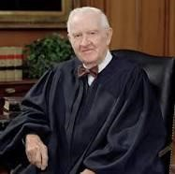 Justice John Paul Stevens
Justice Stevens delivered the opinion of the Court.

“Facts of the case
George Lane and Beverly Jones were disabled and could not access upper floors in Tennessee state courthouses. Lane, Jones, and several others sued Tennessee in federal district court, alleging that by denying them public services based on their disabilities, Tennessee was in violation of Title II of the Americans with Disabilities Act (1990).
According to Title II, no person may be denied access to ‘services, programs, or activities’ on the basis of his disability. The act allows alleged victims of discrimination to sue states for damages.
Tennessee asked that the case be dismissed, claiming that it was barred by the 11th Amendment's prohibition of suits against states in federal courts (the sovereign immunity doctrine). The state cited Alabama v. Garrett (2001), in which the U.S. Supreme Court ruled that Congress had acted unconstitutionally in granting citizens the right to sue states for disability discrimination (such as the denial of employment) under the 14th Amendment's equal protection clause. In that case the Supreme Court reasoned that Congress did not have enough evidence of disability discrimination by states to justify the waiver of sovereign immunity.
The district court rejected the state's argument and denied the motion to dismiss. The Sixth Circuit Court of Appeals panel affirmed. The courts reasoned that because Title II of the ADA dealt with the Due process Clause of the 14th Amendment, not the equal protection clause, the ruling in Garrett did not apply. The court found that while Congress may not have had enough evidence of disability discrimination to waive sovereign immunity for equal protection claims, it did have enough evidence of Due Process violations (such as non-handicap-accessible courthouses) to waive the sovereign immunity doctrine for Due Process claims.

Question
Did the Americans with Disabilities Act violate the sovereign immunity doctrine of the
11th Amendment when, based on Congress's 14th Amendment enforcement powers of
the Due Process clause, it allowed individuals to sue states for denying them services based on their disabilities?

Conclusion
No. In a 5-to-4 opinion written by Justice John Paul Stevens, the Court held that Congress had sufficiently demonstrated the problems faced by disabled persons who sought to exercise fundamental rights protected by the Due Process clause of the 14th Amendment (such as access to a court). The Court also emphasized that the remedies required from the states were not unreasonable - they just had to make reasonable accommodations to allow disabled persons to exercise their fundamental rights. Because Title II was a ‘reasonable prophylactic measure, reasonably targeted to a legitimate end,’ and because Congress had the authority under the 14th Amendment to regulate the actions of the states to accomplish that end, the law was constitutional.” https://www.oyez.org/cases/2003/02-1667

June 14, 2004: U.S. Supreme Court - Pennsylvania State Police v. Nancy Drew Suders (8 to 1) https://supreme.justia.com/cases/federal/us/542/129/

HOSTILE WORK AMOSPHERE, BUT MUST INFORM EMPLOYER
Justice Ruth Bader Ginsburg
Justice GINSBURG delivered the opinion of the Court.

“Facts of the case
Nancy Drew Suders quit her job as a dispatcher for the Pennsylvania State Police in August 1998. She claimed that she had been sexually harassed by her supervisors since she got the job in March of that year, and that she had finally decided to quit after she was accused of theft, handcuffed, photographed and questioned. Two days before quitting, she had contacted the state police equal opportunity officer about the harassment, but did not file a report because, Suders claimed, the woman was unhelpful and unsympathetic.
Suders then filed suit in federal district court, charging that the harassment had forced her to quit. The district court judge, however, granted summary judgment to the state police before the case went to trial. He found that Suders had failed to use the internal procedures set up by the state police to deal with sexual harassment, and that she therefore could not bring suit unless the police had taken a ‘tangible employment action’ that substantially changed her employment status. On appeal, a Third Circuit Court of Appeals panel overturned the district judge's decision, ruling that the harassment had been so bad that Suders had no choice but to quit. While the police had not fired Suders, they had been directly responsible for her resignation and therefore could not use her failure to file a report as a defense.

Question
When a supervisor makes a workplace environment so hostile (through sexual harassment) that an employee has no choice but to quit, may the employee bring suit even if she did not use the internal procedures established by the employer to report sexual harassment claims?

Conclusion
Yes. In an 8-to-1 decision written by Justice Ruth Bader Ginsburg, the Court ruled that an employee faced with a situation in which a ‘reasonable person ... would have felt compelled to resign’ could bring suit even if she had not filed a report with the employer before resigning. Her employer, however, could use her failure to file a report, along with evidence of the safeguards it had in place to prevent harassment, in its defense. If it could prove that she had not attempted to prevent the harassment, and that the safeguards in place would have prevented it if she had, the employer would not be liable.” https://www.oyez.org/cases/2003/03-95

Dec. 6, 2004: U.S. Supreme Court - City of San Diego v. John Roe (9 to 0) https://supreme.justia.com/cases/federal/us/543/77/

POLICE OFFICER PROPERLY FIRED, VIDEO OF HIM STRIPPING OFF POLICE UNIFORM
Per Curiam decision – opinion not authored by one Justice.

“Facts of the case
John Roe, a San Diego police officer, was fired for selling a video on eBay that showed him stripping off a police uniform and masturbating. He then sued the city in federal district court and alleged his firing violated his First Amendment right to freedom of speech. The district court ruled against the officer; the Ninth Circuit reversed.

Question
San Diego fired John Roe from the city police force after he made and sold online a video showing him engaging in sexually explicit acts. Did this violate John Roe's First Amendment right to free speech?

Conclusion
No. In a unanimous per curiam opinion, the Court held that firing Roe for his behavior and ‘speech’ did not violate the First Amendment. Government employers, the Court wrote, could restrict their employees' speech in ways that would be unconstitutional if applied to the general public. But government employees had the right to speak on matters of public concern, such as on government policies of interest to the public. In this case, however, Roe's activities did not inform the public about the police department and were also detrimental to the force.” https://www.oyez.org/cases/2004/03-1669

Jan. 20, 2005: President George W. Bush – Secon Inauguration

June 28, 2004: U.S. Supreme Court - Hamdi v. Rumsfeld (8 to 1)
https://supreme.justia.com/cases/federal/us/542/507/

Enemy Combatant – Right To Challenge Detention

“Declaring that ‘a state of war is not a blank check for the president,’ the Supreme Court ruled on Monday that those deemed enemy combatants by the Bush administration, both in the United States and at Guantanamo Bay, Cuba, must be given the ability to challenge their detention before a judge or other "neutral decision-maker." *** Eight justices, all but Justice Clarence Thomas, said the two-year-long detention of an American citizen, Yaser Esam Hamdi, had either been invalid from the beginning or had become so, for constitutional or statutory reasons. The controlling opinion, by Justice Sandra Day O'Connor, said that Mr. Hamdi's detention was permissible if designation as an enemy combatant proved to be correct, but that his inability so far to appear before a judge, challenge the government's evidence, and tell his side of the story had deprived him of his constitutional right to due process.” https://www.nytimes.com/2004/06/29/politics/justices-affirm-legal-rights-of-enemy-combatants.html
May 11, 2005: REAL ID ACT
The REAL ID Act, passed by Congress in 2005, enacted the 9/11 Commission’s recommendation that the Federal Government “set standards for the issuance of sources of identification, such as driver's licenses and identification cards.” The Act and implementing regulations establish minimum security standards for license issuance and production and prohibit federal agencies from accepting for certain official purposes noncompliant driver’s licenses and identification cards, both physical and digital (also known as Mobile Driver’s Licenses, or “mDLs”). The official purposes covered by the Act and regulations are:
Accessing certain federal facilities;
Boarding Federally regulated commercial aircraft; and
Entering nuclear power plants. https://www.tsa.gov/realid/about-realid

May 30, 2005: U.S. Supreme Court - Garcetti et al v. Ceballos (5 to 4) https://scholar.google.com/scholar_case?case=6711908971660042297&q=Garcetti+et+al+v.+Ceballos&hl=en&as_sdt=6,36&as_vis=1

LIMITED THE FIRST AMENDMENT RIGHTS PUBLIC EMPLOYEES IN PUBLIC COMMENTS
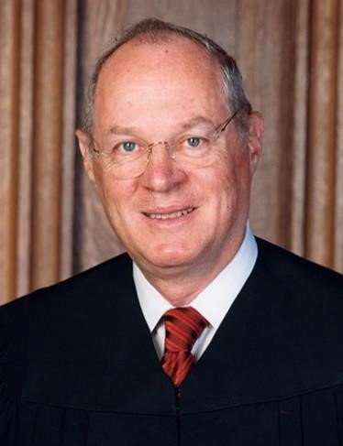 Justice Anthony Kennedy (nominated by President Ronald Regan,
served from 1988 until retired 2018).
 Richard Ceballos, Esq.
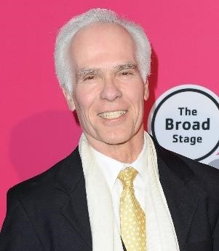Gill Garcetti (LA County Prosecutor, 1992 – 2000)

“Facts of the case
Richard Ceballos, an employee of the Los Angeles District Attorney's office, found that a sheriff misrepresented facts in a search warrant affidavit. Ceballos notified the attorneys prosecuting the case stemming from that arrest and all agreed that the affidavit was questionable, but the D.A.'s office refused to dismiss the case.
Ceballos then told the defense he believed the affidavit contained false statements, and defense counsel subpoenaed him to testify. Seeking damages in federal district court, Ceballos alleged that D.A.s in the office retaliated against him for his cooperation with the defense, which he argued was protected by the First Amendment. The district court ruled that the district attorneys were protected by qualified immunity, but the Ninth Circuit reversed and ruled for Ceballos, holding that qualified immunity was not available to the defendants because Ceballos had been engaged in speech that addressed matters of public concern and was thus protected by the First Amendment.

Question
Should a public employee's purely job-related speech, expressed strictly pursuant to the duties of employment, be protected by the First Amendment simply because it touched on a matter of public concern, or must the speech also be engaged in ‘as a citizen?’

Conclusion
In a 5-to-4 decision authored by Justice Anthony Kennedy, the Supreme Court held that speech by a public official is only protected if it is engaged in as a private citizen, not if it is expressed as part of the official's public duties. Ceballos's employers were justified in taking action against him based on his testimony and cooperation with the defense, therefore, because it happened as part of his official duties. ‘The fact that his duties sometimes required him to speak or write,’ Justice Kennedy wrote, ‘does not mean his supervisors were prohibited from evaluating his performance.’ Justices Stevens, Souter, Ginsburg and Breyer dissented.
https://www.oyez.org/cases/2005/04-473

See article (Dec. 11, 2019): “Tuesday, Deputy District Attorney Richard Ceballos withdrew his candidacy for L.A. County District Attorney. In response, Rachel Rossi issued the following statement.”
“I wish Richard Ceballos all the best as he made a difficult choice to end his race for Los Angeles County District Attorney. Richard was the first candidate to take a stand and challenge the status quo in our District Attorney’s Office eight months ago. I am grateful for his fight in this race and for his career in fighting for reform. I know this won’t be the last we hear from him.” https://rachel4da.com/2019/12/11/statement-on-the-withdrawalof-richard-ceballos-for-district-attorney/

Oct. 2005 - Saddam Hussein executed
“In October 2005 Saddam went on trial before the Iraqi High Tribunal, a panel court established to try officials of the former Iraqi government. He and several codefendants were charged with the killing of 148 townspeople in Al-Dujayl, a mainly Shiʿi town, in 1982. Throughout the nine-month trial, Saddam interrupted the proceedings with angry outbursts, claiming that the tribunal was a sham and that U.S. interests were behind it. The tribunal finally adjourned in July 2006 and handed down its verdicts in November. Saddam was convicted of crimes against humanity—including willful killing, illegal imprisonment, deportation, and torture—and was sentenced to death by hanging. Saddam’s half brother (an intelligence officer) and Iraq’s former chief judge were also sentenced to death. Days after an Iraqi court upheld his sentence in December 2006, Saddam was executed.” https://www.britannica.com/biography/Saddam-Hussein

Oct. 6, 2005: S.397 - Protection of Lawful Commerce in Arms Act https://www.congress.gov/bill/109th-congress/senate-bill/397/text
“Mexico first sued multiple gun companies in 2021, arguing that the cartel bloodshed was “the foreseeable result of the defendants’ deliberate actions and business practices.”
A trial court judge dismissed the case, finding it was barred by a 2005 federal law that limits litigation against gun manufacturers and distributors and has provided immunity from actions brought by the families of people killed and injured by their weapons.”
March 3, 2025: At Supreme Court, Mexico to Offer Culprit for Cartel Violence: Gun Makers. The dispute focuses on whether Mexico can hold U.S. manufacturers liable for gun violence and comes amid rising tensions between the countries. https://www.nytimes.com/2025/03/03/us/politics/supreme-court-mexico-gunmakers.html

Dec. 16, 2005: N.Y. Times: Bush Lets U.S. Spy on Callers Without Courts
Months after the Sept. 11 attacks. https://www.nytimes.com/2005/12/16/politics/bush-lets-us-spy-on-callers-without-courts.html

President Bush secretly authorized the National Security Agency to eavesdrop on Americans and others inside the United States to search for evidence of terrorist activity without the court-approved warrants ordinarily required for domestic spying, according to government officials.
Under a presidential order signed in 2002, the intelligence agency has monitored the international telephone calls and international e-mail messages of hundreds, perhaps thousands, of people inside the United States without warrants over the past three years in an effort to track possible "dirty numbers" linked to Al Qaeda, the officials said. The agency, they said, still seeks warrants to monitor entirely domestic communications.
The previously undisclosed decision to permit some eavesdropping inside the country without court approval was a major shift in American intelligence-gathering practices, particularly for the National Security Agency, whose mission is to spy on communications abroad. As a result, some officials familiar with the continuing operation have questioned whether the surveillance has stretched, if not crossed, constitutional limits on legal searches.

Nov. 8, 2005: U.S. Supreme Court - IBP, Inc. v. Alvarez (9 to 0) https://supreme.justia.com/cases/federal/us/546/21/
FLSA, TIME PUTTING ON SAFETY EQUIPMENT BY BEEF BUTCHERS “ON THE CLOCK”
Justice John Paul Stevens (nominated by President Gerald Ford in 1975, retired 2010)

“Facts of the case
In two separate cases, employees sued Barber Foods and IBP [Iowa Beef Producers] in federal district court. The employees alleged the companies violated the Fair Labor Standards Act by not paying them for time spent walking to the worksite after putting on required equipment. The district court and later the First Circuit ruled against the Barber employees. A separate district court ruled IBP must compensate its employees for the disputed time. The Ninth Circuit agreed. The U.S. Supreme Court consolidated the cases.

Question
Did the Fair Labor Standards Act require employers to pay employees for time spent walking to and from stations that distributed required safety equipment?

Conclusion
Yes. Justice John Paul Stevens, for a unanimous Court, wrote that putting on required safety equipment qualified as a ‘principal activity’ under the FLSA. The workday began when employees started that activity and therefore included the subsequent time spent walking to the worksite. The time spent waiting to put on safety equipment before that, however, was not included in the workday because it was a "preliminary" activity under the Portal-to-Portal Act.” https://www.oyez.org/cases/2005/03-1238

2007: Volunteer Responder Incentive Protection Act (VRIPA)
National Volunteer Fire Council (December 20, 2019): https://www.nvfc.org/volunteerresponder-incentive-protection-act-restored-for-2020-tax-year/
“On December 20, President Trump signed into law appropriations legislation (H.R.
1865), which includes language restoring the Volunteer Responder Incentive Protection Act (VRIPA) in the 2020 tax year. VRIPA exempts nominal volunteer recruitment and retention incentives from being subject to federal income tax and reporting requirements for the 2020 tax year. Specifically, H.R. 1865 exempts property tax benefits and up to $600 per year in other incentives, such as stipends, that volunteer fire and EMS personnel receive as a reward for their service.
***
VRIPA was first enacted in 2007 and was in effect from 2008-2010. Originally, VRIPA exempted property tax benefits and up to $360 per year of other incentives. VRIPA expired in 2011 and 2020 will be the first year that it is back in effect since then. In addition to restoring VRIPA for the 2020 tax year, H.R. 1865 raises the maximum exempted benefits amount for non-property tax benefits from $360 to $600 per year.”

May 29, 2007: U.S. Supreme Court - Ledbetter v. Goodyear Tire & Rubber Co., Inc. (5 to 4) https://supreme.justia.com/cases/federal/us/550/618/

PAY DISCRIMINATION, BUT EEOC CHARGE NOT FILED TIMELY - [DECISION OVERTURNED IN 2009 BY CONGRESS AMENDING TITLE VII – Lilly Ledbetter Fair Pay Act]

Justice Samuel Alito (nominated by President George W. Bush in
2006),
“During most of the time that petitioner [Lilly]Ledbetter was employed by respondent Goodyear, salaried employees at the plant where she worked were given or denied raises based on performance evaluations. Ledbetter submitted a questionnaire to the Equal Employment Opportunity Commission (EEOC) in March 1998 and a formal EEOC charge in July 1998. After her November 1998 retirement, she filed suit, asserting, among other things, a sex discrimination claim under Title VII of the Civil Rights Act of 1964.
The District Court allowed her Title VII pay discrimination claim to proceed to trial. There, Ledbetter alleged that several supervisors had in the past given her poor evaluations because of her sex; that as a result, her pay had not increased as much as it would have if she had been evaluated fairly; that those past pay decisions affected the amount of her pay through-out her employment; and that by the end of her employment, she was earning significantly less than her male colleagues. Goodyear maintained that the evaluations had been nondiscriminatory, but the jury found for Ledbetter, awarding backpay and damages. On appeal, Goodyear contended that the pay discrimination claim was time barred with regard to all pay decisions made before September 26,1997—180 days before Ledbetter filed her EEOC questionnaire—and that no discriminatory act relating to her pay occurred after that date.*** Held: Because the later effects of past discrimination do not restart the clock for filing an EEOC charge, Ledbetter’s claim is untimely.” https://www.supremecourt.gov/opinions/06pdf/05-1074.pdf
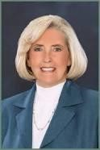 Lilly Ledbetter: https://www.aauw.org/article/a-qa-with-lilly-ledbetter-
fierce-champion-of-equal-pay/

June 18, 2007: Charleston, South Carolina FD – 9 FF LODDs
Watch this video: 9 Charleston Firefighters were killed at the infamous Sofa Super Store Fire. They are Captain Louis Mulkey, Captain Mike Benke, FF Melvin Champaign, Captain Billy Hutchingson, Engineer Brad Baity, FF Earl Drayton, Engineer Mark Kelsey, Engineer Michael French, and FF Brandon Thompson. https://www.youtube.com/watch?v=mqiRN9rygoI

Nov. 15, 2007 – Bary Bonds Indicted – Steroids / Case Later Dropped
“A federal grand jury in San Francisco indicts Bonds on four counts of perjury and one count of obstruction of justice. He is accused of lying when he said he didn't knowingly take steroids given to him by Anderson. He's also is accused of lying that Anderson never injected him with steroids. He is scheduled to appear in U.S. District Court in San Francisco on Dec. 7. Anderson, who had been imprisoned for refusing to testify against Bonds, was ordered released.” Barry Bonds steroids timeline; https://www.espn.com/mlb/news/story?id=3113127
July 21, 2015: “Barry Bonds Steroid Case Is Officially Over. Federal prosecutors' long, long legal pursuit of former San Francisco Giants slugger Barry Bonds is officially over. Melinda Haag, the U.S. attorney for Northern California, filed a brief notice with the 9th U.S. Circuit Court of Appeals on Tuesday morning that the government won't attempt to take its case to the Supreme Court. Bonds was convicted in 2011 of obstruction of justice in connection with a probe into his alleged use of performance-enhancing drugs. The conviction was first upheld by a three-judge 9th Circuit panel, then struck down by an en banc panel of 11 judges. It's that last decision the Justice Department has decided not to appeal to the high court. Prosecutors investigating BALCO, a Peninsula sports lab that had distributed banned substances to elite athletes, had charged Major League Baseball's all-time home-run record holder with perjury and obstruction in connection with his 2003 testimony to a federal grand jury in San Francisco. They said Bonds had lied when he denied using steroids and had tried to mislead the grand jury with an evasive answer about his drug use. The jury failed to reach a verdict on three perjury counts, but convicted him on the obstruction charge because of his ‘I was a celebrity child’ response to a question about whether he'd used injected substances.” https://www.kqed.org/news/10609736/barry-bonds-steroid-case-is-officially-over

June 26, 2008: U.S. Supreme Court – District of Columbia v. Heller (5 to 4) https://supreme.justia.com/cases/federal/us/554/570/
Right to own firearms
“Respondent Dick Heller is a D. C. special police officer authorized to carry a handgun while on duty at the Federal Judicial Center. He applied for a registration certificate for a handgun that he wished to keep at home, but the District refused. He thereafter filed a lawsuit in the Federal District Court for the District of Columbia seeking, on Second Amendment grounds, to enjoin the city from enforcing the bar on the registration of handguns, the licensing requirement insofar as it prohibits the carrying of a firearm in the home without a license, and the trigger-lock requirement insofar as it prohibits the use of “functional firearms within the home.
***
In sum, we hold that the District’s ban on handgun possession in the home violates the Second Amendment, as does its prohibition against rendering any lawful firearm in the home operable for the purpose of immediate self-defense. Assuming that Heller is not disqualified from the exercise of Second Amendment rights, the District must permit him to register his handgun and must issue him a license to carry it in the home.”

Jan. 20, 2009: George W. Bush – Leaving Office, Perdsonal Note To Barack Obama

“Dear Barack,

Congratulations on becoming our President. You have just begun a fantastic chapter in your life.

Very few have had the honor of knowing the responsibility you now feel. Very few know the excitement of the moment and the challenges you will face.

There will be trying moments. The critics will rage. Your ‘friends’ will disappoint you. But, you will have an Almighty God to comfort you, a family who loves you, and a country that is pulling for you, including me. No matter what comes, you will be inspired by the character and compassion of the people you now lead.

God bless you.

Sincerely,

GW”
https://www.washingtonpost.com/history/2025/01/20/inauguration-letter-president-trump-biden-tradition/?utm_campaign=wp_post_most&utm_medium=email&utm_source=newsletter&carta-url=https%3A%2F%2Fs2.washingtonpost.com%2Fcar-ln-tr%2F41281a4%2F67b363a6eb3eba471afc37e7%2F59731235ade4e21a848a56ed%2F23%2F53%2F67b363a6eb3eba471afc37e7

Jan. 20, 2009: President Barack Obama – Inauguration
https://obamawhitehouse.archives.gov/administration/president-obama

May 28, 2009: Lilly Ledbetter Fair Pay Act of 2009
“On January 29, 2009, President Obama signed the first piece of legislation of his Administration: the Lilly Ledbetter Fair Pay Act of 2009 (‘Act’). This law overturned the Supreme Court's decision in Ledbetter v. Goodyear Tire & Rubber Co., Inc., 550 U.S. 618 (2007), which severely restricted the time period for filing complaints of employment discrimination concerning compensation [180 days].
The Act states the EEOC's longstanding position that each paycheck that contains discriminatory compensation is a separate violation regardless of when the discrimination began. The Ledbetter Act recognizes the ‘reality of wage discrimination’ and restores ‘bedrock principles of American law.’ Particularly important for the victims of discrimination, the Act contains an explicit retroactivity provision.
People challenging a wide variety of practices that resulted in discriminatory compensation can benefit from the Act's passage. These practices may include employer decisions about base pay or wages, job classifications, career ladder or other noncompetitive promotion denials, tenure denials, and failure to respond to requests for raises.” https://www.eeoc.gov/eeoc/publications/brochureequal_pay_and_ledbetter_act.cfm

June 29, 2009: U.S. Supreme Court - Frank Ricci v. DeStefano (5 to 4) – https://supreme.justia.com/cases/federal/us/557/557/
NEW HAVEN FIRE DEPARTMENT PROMOTIONS TO PROCEED; TEST WAS PROFESSIONALLY PREPARED
Justice Anthony Kennedy (nominated by President Ronald Regan, served
from 1988 until retired 2018).

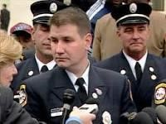Frank Ricci, New Haven Fire Department:
https://www.nhregister.com/news/article/Frank-Ricci-re-elected-fire-union-president13452262.php

“Facts of the case
White and Hispanic candidates for promotion in the New Haven, CT fire department sued various city officials in the United States District Court for the District of Connecticut when the New Haven Civil Service Board (CSB) failed to certify two exams needed for the plaintiffs' promotion to Lieutenant and Captain. The CSB did not certify because the results of the test would have promoted a disproportionate number of white candidates in comparison to minority candidates. The plaintiffs argued that their rights under Title VII of the Civil Rights Act of 1964, 42 U.S.C. Section 2000e, and the 14th Amendment Equal Protection Clause were violated. The federal district court granted the defendants' motion for summary judgment.
On appeal, the United States Court of Appeals for the Second Circuit affirmed. It reasoned that the CSB, by refusing to certify the results of the promotional exam, was trying to fulfill its obligations under the rules utilized by the plaintiffs in their argument and therefore was protected in its actions.

Question
- Can a municipality reject results from an otherwise valid civil service exam when the results unintentionally prevent the promotion of minority candidates?
- Does 42 U.S.C. Section 2000e permit federal courts to relieve municipalities from having to comply with local laws that require strict compliance with race-blind merit selection procedures?

Conclusion
Maybe; fact dependent. Not answered. The Supreme Court held that by discarding the exams, the City of New Haven violated Title VII of the Civil Rights Act of 1964. Justice Anthony M. Kennedy wrote the majority joined by Chief Justice John G. Roberts, and Justices Antonin G. Scalia, Clarence Thomas, and Samuel A. Alito. Before an employer can engage in intentional discrimination for the purpose of avoiding a "disparate impact" on a protected trait (race, color, religion, national origin), the employer must have a "strong basis in evidence" that it will be subject to "disparate impact liability" if it fails to take the discriminatory action. Here, the Court reasoned that New Haven failed to prove it had a ‘strong basis in evidence’ that failing to discard the results of the exam would have subjected it to liability, as the exams were job-related, consistent with business necessity, and there was no evidence that an equally-valid, less-discriminatory alternative was available.”
https://www.oyez.org/cases/2008/07-1428

Jan. 21, 2010: U.S. Supreme Court – Citizens United v.
Federal Election Commission (5 to 4) https://supreme.justia.com/cases/federal/us/558/310/

Limiting independent expenditure on political campaigns by groups such as corporations, labor unions, or other collective entities violates the First Amendment because limitations constitute a prior restraint on speech.
https://www.scotusblog.com/case-files/cases/citizens-united-v-federal-electioncommission/
Justice Anthony Kennedy
“In January 2008, Citizens United released a film entitled Hillary: The Movie. We refer to the film as Hillary. It is a 90–minute documentary about then-Senator Hillary Clinton, who was a candidate in the Democratic Party's 2008 Presidential primary elections. Hillary mentions Senator Clinton by name and depicts interviews with political commentators and other persons, most of them quite critical of Senator Clinton. Hillary was released in theaters and on DVD, but Citizens United wanted to increase distribution by making it available through video-on-demand. *** The law before us is an outright ban, backed by criminal sanctions. Section 441b makes it a felony for all corporations— including nonprofit advocacy corporations—either to expressly advocate the election or defeat of candidates or to broadcast electioneering communications within 30 days of a primary election and 60 days of a general election. Thus, the following acts would all be felonies under § 441b: The Sierra Club runs an ad, within the crucial phase of 60 days before the general election, that exhorts the public to disapprove of a Congressman who favors logging in national forests; the National Rifle Association publishes a book urging the public to vote for the challenger because the incumbent U.S. Senator supports a handgun ban; and the American Civil Liberties Union creates a Web site telling the public to vote for a Presidential candidate in light of that candidate's defense of free speech. These prohibitions are classic examples of censorship. *** Modern day movies, television comedies, or skits on Youtube.com might portray public officials or public policies in unflattering ways. Yet if a covered transmission during the blackout period creates the background for candidate endorsement or opposition, a felony occurs solely because a corporation, other than an exempt media corporation, has made the ‘purchase, payment, distribution, loan, advance, deposit, or gift of money or anything of value’ in order to engage in political speech. 2 U.S.C. § 431(9)(A)(i). Speech would be suppressed in the realm where its necessity is most evident: in the public dialogue preceding a real election. Governments are often hostile to speech, but under our law and our tradition it seems stranger than fiction for our Government to make this political speech a crime. Yet this is the statute's purpose and design. *** Some members of the public might consider Hillary to be insightful and instructive; some might find it to be neither high art nor a fair discussion on how to set the Nation's course; still others simply might suspend judgment on these points but decide to think more about issues and candidates. Those choices and assessments, however, are not for the Government to make. The First Amendment underwrites the freedom to experiment and to create in the realm of thought and speech. Citizens must be free to use new forms, and new forums, for the expression of ideas.”
Note: see comments on the impact of this decision.
“The Supreme Court's 2010 decision in Citizens United v. Federal Election Commission helped unleash unprecedented amounts of outside spending in the 2010 and 2012 election cycles. The case, along with other legal developments, spawned the creation of super PACs, which can accept unlimited contributions from corporate and union treasuries, as well as from individuals; these groups spent more than $800 million in the 2012 election cycle. It also triggered a boom in political activity by tax-exempt ‘dark money’ organizations that don't have to disclose their donors.” https://www.opensecrets.org/news/reports//citizens_united.php
___________________________________________________________________
“Political spending is a form of protected speech under the First Amendment, and the government may not keep corporations or unions from spending money to support or denounce individual candidates in elections. While corporations or unions may not give money directly to campaigns, they may seek to persuade the voting public through other means, including ads, especially where these ads were not broadcast.” https://www.scotusblog.com/case-files/cases/citizens-united-v-federal-electioncommission/

2011: Florida Abolishes “Fireman’s Rule”
https://flsenate.gov/Laws/Statutes/2011/112.182
112.182 “Firefighter rule” abolished.—
- A firefighter or properly identified law enforcement officer who lawfully enters upon the premises of another in the discharge of his or her duty occupies the status of an invitee. The common-law rule that such a firefighter or law enforcement officer occupies the status of a licensee is hereby abolished.
- It is not the intent of this section to increase or diminish the duty of care owed by property owners to invitees. Property owners shall be liable to invitees pursuant to this section only when the property owner negligently fails to maintain the premises in a reasonably safe condition or negligently fails to correct a dangerous condition of which the property owner either knew or should have known by the use of reasonable care or negligently fails to warn the invitee of a dangerous condition about which the property owner had, or should have had, knowledge greater than that of the invitee. History.—s. 1, ch. 90-308; s. 693, ch. 95-147.

September 11, 2012 – Attack On U.S. Mission in Benghazi, Libya

Feb. 6, 2026: “Third Coconspirator in Fatal Benghazi Attacks in U.S. Custody, Charged in Washington D.C. with Murder and Terrorism Counts. Zubayar Al-Bakoush, an armed coconspirator in the 2012 attack on U.S. facilities in Benghazi, Libya, that killed U.S. Ambassador J. Christopher Stevens and three other Americans, was charged in an eight-count indictment unsealed today in U.S. District Court on multiple terrorism and murder counts. *** ‘The FBI and our U.S. government partners have worked tirelessly to hold accountable those responsible for the heinous terrorist attacks in Benghazi, Libya that resulted in the deaths of the U.S. Ambassador, J. Christopher Stevens and U.S. government personnel Sean Smith, Tyrone Woods, and Glen Doherty,’ said FBI Director Kash Patel. ‘The latest result of our efforts is bringing Zubayar Al-Bakoush to the U.S. to face charges for his alleged role in the attacks against our citizens and our facilities in Libya. You can be assured that no matter how long it takes, or where you are located, the FBI remains steadfast in our duty to see justice served against those who harm our citizens. I’m grateful to the men and women of the FBI for their unrelenting efforts to bring us to where we stand today – this defendant will be prosecuted on U.S. soil.’” https://www.justice.gov/opa/pr/third-coconspirator-fatal-benghazi-attacks-us-custody-charged-washington-dc-murder-and

Attorney General Bondi, Director Patel, U.S. Attorney Pirro Make Press Announcement: https://www.justice.gov/opa/video/attorney-general-bondi-director-patel-us-attorney-pirro-make-press-announcement

Jan. 21, 2013: President Barack Obama – Second Inauguration
“Through blood drawn by lash and blood drawn by sword, we learned that no union founded on the principles of liberty and equality could survive half-slave and half-free. We made ourselves anew, and vowed to move forward together.” https://obamawhitehouse.archives.gov/the-press-office/2013/01/21/inaugural-address-president-barack-obama


March 26, 2013: U.S. Supreme Court - Florida v. Jardines (6 to 3) https://supreme.justia.com/cases/federal/us/569/1/
DRUG DOG – FRONT PORCH – ILLEGAL SEARCH
“Here, however, the question before the court is precisely whether the officer’s conduct was an objectively reasonable search. As we have described, that depends upon whether the officers had an implied license to enter the porch, which in turn depends upon the purpose for which they entered. Here, their behavior objectively reveals a purpose to conduct a search, which is not what anyone would think he had license to do.

***

Dissent (Justice Alito): For these reasons, I would hold that no search within the meaning of the Fourth Amendment took place in this case, and I would reverse the decision below.”

April 17, 2013 – TX: 10 Firefighters Killed, West Fertilizer Company

“The City of West is a small rural town in central Texas, approximately 20 miles north of Waco and 75 miles south of Dallas. On the evening of April 17, 2013, the weather in central Texas was typical for spring, with temperatures hovering around 80 degrees F, low humidity, scattered clouds, and winds blowing from the SSE at 20 mph. Everything changed around 19:30, when a devastating explosion at the West Fertilizer Company plant rocked the city. The blast was so powerful that it was felt 80 miles away and registered as a 2.1-magnitude earthquake. The explosion destroyed or damaged more than 500 buildings, including homes, schools and a nursing home; left a massive crater where the plant once stood; and hit the community with an economic loss of over $230 million. The explosion killed 15 and injured more than 280 people. Except for one, all fatalities occurred due to fractures, blunt force trauma, or blast force injuries sustained during the explosion. Among those killed were 10 firefighters ranging in age from 26 to 52:
- Five West volunteer firefighters;
- Four volunteer firefighters attending an EMS class in the city (two from Abbott VFD, one from Bruceville-Eddy VFD, and one from Mertens/Navarro Mills VFD); and
- One off-duty Dallas fire captain who became aware of the incident and responded to the scene to assist.” https://www.firerescue1.com/west-fertilizer-plant-explosion/articles/west-texas-the-fertilizer-plant-explosion-that-killed-10-firefighters-7tdcjYownNurVVFN/?utm_source=Sailthru&utm_medium=email&utm_campaign=FR1-Daily-4-17-26&utm_term=FR1%20Daily

June 13, 2013 – 19 Granite Mountain Hot Shots killed

On June 30, 2013, 19 of the 20 members of the group perished fighting the Yarnell Hill Fire.

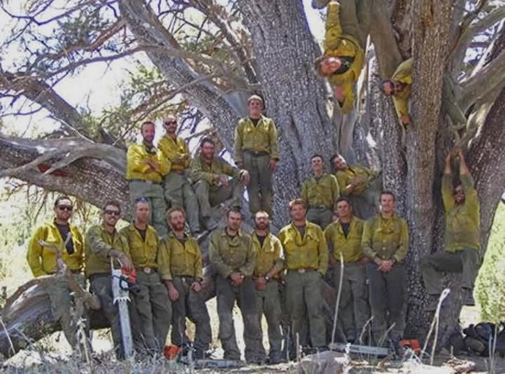
https://azstateparks.com/hotshots/the-hotshots/about-the-hotshots

”The Granite Mountain Interagency Hotshot Crew was a crew within the Prescott Fire Department whose mission was to fight wildfires and when not doing so, engaged in work to reduce growth of fire-prone vegetation. Originally founded in 2001 as a fuels mitigation crew, they were later formed into Crew 7, a Type II IA hand-crew in 2004, and eventually transitioned into a Type I Inter-agency hotshot crew in 2008.”
https://prescottfire.org/who-we-are/granite-mountain-hotshots/

Oct. 22, 2014: White House – Secret Service Canine Stops Intruder
“On Oct. 22, 2014, Hurricane was 6 years old when he spotted a man jumping the White House fence. The intruder fought off another Secret Service canine, Jordan, when he was about halfway across the North Lawn. But then Hurricane, who weighed more than 60 pounds, charged in for a brawl that lasted a few seconds before Hurricane knocked the man to the ground. The suspect, 23-year-old Dominic Adesanya, was taken to a hospital with injuries from a dog bite. Hurricane’s body was covered in bruises, bumps and blood, Mirarchi said, and he was taken to a veterinarian. Mirarchi said he worried Hurricane would die of his injuries.”

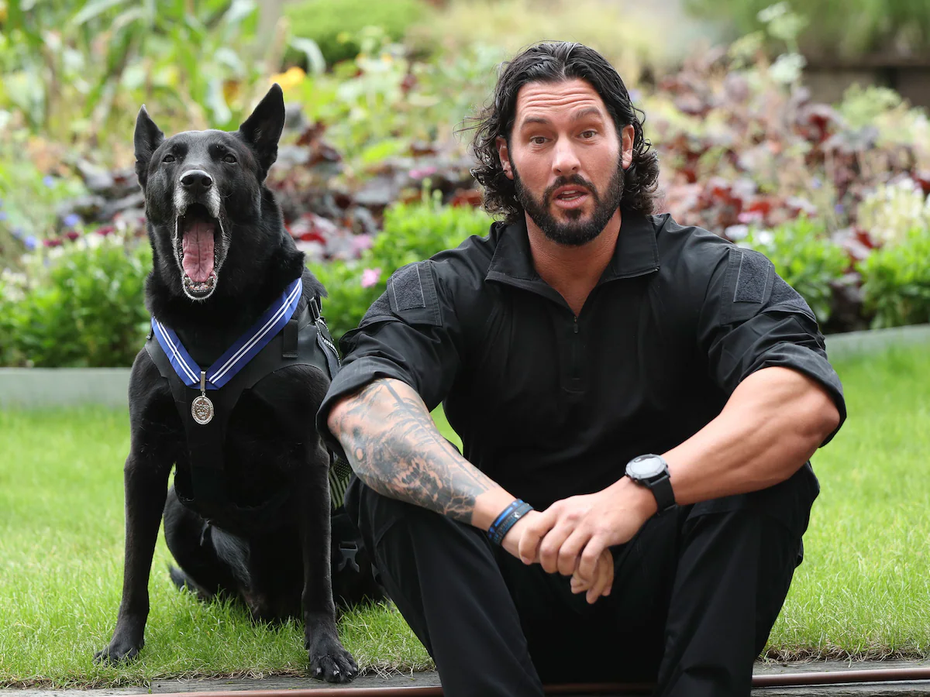
Secret Service Agent Marshall Mirarchi with former Secret Service dog Hurricane. (Yui Mok/AP)
Feb. 19, 2025: Hurricane, the most decorated K-9 in White House history, dies at 15, The Belgian Malinois was lauded for protecting President Barack Obama and his family after an intruder hopped the White House fence in 2014. https://www.washingtonpost.com/nation/2025/02/19/hurricane-dog-white-house-dies/?utm_campaign=wp_post_most&utm_medium=email&utm_source=newsletter&carta-url=https%3A%2F%2Fs2.washingtonpost.com%2Fcar-ln-tr%2F41388bf%2F67b7634333779f2c4a7b7360%2F59731235ade4e21a848a56ed%2F33%2F57%2F67b7634333779f2c4a7b7360

Jan. 19, 2016: U.S. Supreme Court - Hefferman v. City of Patterson (8 to 1) https://supreme.justia.com/cases/federal/us/578/14-1280/
POLICE OFFICER WITH POLITICAL SIGN FOR MAYOR’S OPPONENT MAY SUE FOR RETALIATION

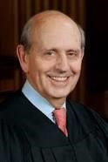Justice Steven Breyer (nominated by President Clinton in 1994)

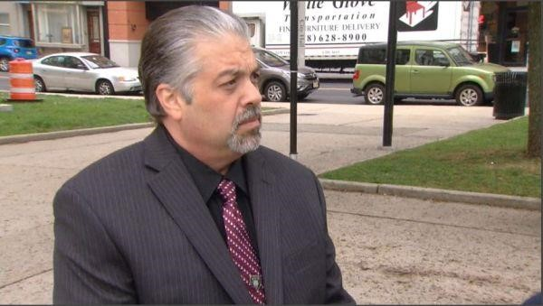 Officer Jeffery Heffernan: https://www.mtsu.edu/first-
amendment/article/1457/heffernan-v-city-of-paterson

“Facts of the case
Jeffrey Heffernan was a police officer for the City of Paterson, New Jersey. A fellow police officer observed Heffernan picking up a campaign sign for the mayoral candidate running against the incumbent. When a supervisor confronted him, Heffernan claimed that he was not politically involved, could not vote in the city of Paterson, and was picking up the sign on behalf of his mother. Heffernan was demoted to a walking post because his actions were considered to be ‘overt involvement in political activities.’
Heffernan sued the city of Paterson and claimed that the city had violated his First Amendment rights to freedom of speech and association. The city filed a motion for summary judgment and argued that, since Heffernan had not actually engaged in constitutionally protected speech, the City’s actions had not violated his First Amendment rights. The district court granted the city’s motion for summary judgment because there was no evidence Heffernan associated himself with the political candidate at issue. Heffernan admitted himself that he was not associated with the candidate, and therefore there is no evidence of a violation of his right to freedom of association. The U.S. Court of Appeals for the Third Circuit affirmed.

Question
Does the First Amendment prohibit the government from demoting a public employee based on a supervisor’s perception that the employee supports a political candidate?

Conclusion
A government employee who is demoted because of perceived involvement in protected political activity is entitled to challenge his demotion under the First Amendment even if the demotion was based on a factual mistake. Justice Stephen G. Breyer delivered the opinion for the 6-2 majority. The Court held that, although there was no First
Amendment case that specifically addressed this issue, there was at least one precedential case in which the employer’s motive was what determined whether the action violated the employee’s First Amendment rights. Therefore, when an employer demotes an employee out of a desire the prevent or punish the employee for engaging in protected speech, that action violates the First Amendment, even if the employer made a factual mistake and no protected speech occurred. The Court also held that this rule tracks the language of the First Amendment because it focuses on the harm the government actor committed, which is the same whether or not the employer made a factual mistake, and does not alter the burden that an employee claiming a First Amendment violation must meet, which is to prove that the defendant had an improper motive.” https://www.oyez.org/cases/2015/14-1280

Jan. 2017: Barack Obama – Leaving Office, Personal Note To Donald Trump
“Dear Mr. President -
Congratulations on a remarkable run. Millions have placed their hopes in you, and all of us, regardless of party, should hope for expanded prosperity and security during your tenure.
This is a unique office, without a clear blueprint for success, so I don’t know that any advice from me will be particularly helpful. Still, let me offer a few reflections from the past 8 years.
First, we’ve both been blessed, in different ways, with great good fortune. Not everyone is so lucky. It’s up to us to do everything we can (to) build more ladders of success for every child and family that’s willing to work hard.
Second, American leadership in this world really is indispensable. It’s up to us, through action and example, to sustain the international order that’s expanded steadily since the end of the Cold War, and upon which our own wealth and safety depend.
Third, we are just temporary occupants of this office. That makes us guardians of those democratic institutions and traditions — like rule of law, separation of powers, equal protection and civil liberties — that our forebears fought and bled for. Regardless of the push and pull of daily politics, it’s up to us to leave those instruments of our democracy at least as strong as we found them.
And finally, take time, in the rush of events and responsibilities, for friends and family. They’ll get you through the inevitable rough patches.
Michelle and I wish you and Melania the very best as you embark on this great adventure, and know that we stand ready to help in any ways which we can.
Good luck and Godspeed,
BO”
https://www.washingtonpost.com/history/2025/01/20/inauguration-letter-president-trump-biden-tradition/?utm_campaign=wp_post_most&utm_medium=email&utm_source=newsletter&carta-url=https%3A%2F%2Fs2.washingtonpost.com%2Fcar-ln-tr%2F41281a4%2F67b363a6eb3eba471afc37e7%2F59731235ade4e21a848a56ed%2F23%2F53%2F67b363a6eb3eba471afc37e7

Jan. 20, 2017: President Donald Trump – First Inauguration



https://www.trumplibrary.gov/trumps/president-donald-j-trump

April 6, 2017: Ohio – Firefighter Cancer - Statutory Presumption Expanded From Cardiovascular, Pulmonary and Respiratory Diseases
https://www.legislature.ohio.gov/legislation/legislation-summary?id=GA131-SB-27

4123.68 Schedule of compensable occupational diseases. http://codes.ohio.gov/orc/4123.68
The following diseases are occupational diseases and compensable as such when contracted by an employee in the course of the employment in which such employee was engaged and due to the nature of any process described in this section.
***
(W) Cardiovascular, pulmonary, or respiratory diseases incurred by firefighters or police officers following exposure to heat, smoke, toxic gases, chemical fumes and other toxic substances: Any cardiovascular, pulmonary, or respiratory disease of a firefighter or police officer caused or induced by the cumulative effect of exposure to heat, the inhalation of smoke, toxic gases, chemical fumes and other toxic substances in the performance of the firefighter's or police officer's duty constitutes a presumption, which may be refuted by affirmative evidence, that such occurred in the course of and arising out of the firefighter's or police officer's employment. For the purpose of this section, "firefighter" means any regular member of a lawfully constituted fire department of a municipal corporation or township, whether paid or volunteer, and "police officer" means any regular member of a lawfully constituted police department of a municipal corporation, township or county, whether paid or volunteer. ***
(X)
- Cancer contracted by a firefighter: Cancer contracted by a firefighter who has been assigned to at least six years of hazardous duty as a firefighter constitutes a presumption that the cancer was contracted in the course of and arising out of the firefighter's employment if the firefighter was exposed to an agent classified by the international agency for research on cancer or its successor organization as a group 1 or 2A carcinogen.
- The presumption described in division (X)(1) of this section is rebuttable in any of the following situations:
  - There is evidence that the firefighter's exposure, outside the scope of the firefighter's official duties, to cigarettes, tobacco products, or other conditions presenting an extremely high risk for the development of the cancer alleged, was probably a significant factor in the cause or progression of the cancer.
  - There is evidence that shows, by a preponderance of competent scientific evidence, that exposure to the type of carcinogen alleged did not or could not have caused the cancer being alleged.
  - There is evidence that the firefighter was not exposed to an agent classified by the international agency for research on cancer as a group 1 or 2A carcinogen.
  - There is evidence that the firefighter incurred the type of cancer alleged before becoming a member of the fire department.
  - The firefighter is seventy years of age or older.
"Michael Louis Palumbo, Jr. Act."- Sub. S.B. 27, 131stGeneral Assembly: https://www.legislature.ohio.gov/download?key=6094&format=pdf
Local firefighter Michael Louis Palumbo Jr. receives hero’s burial (June 3, 2017): https://www.news-herald.com/news/ohio/local-firefighter-michael-louis-palumbo-jrreceives-hero-s-burial/article_e26ca425-9c33-5c68-91b3-e8a9dc2f68ec.html

Oct. 1, 2017 – Las Vegas Mass Shooting – 58 Dead, 800 Injured

FEMA Releases After-Action Report on Las Vegas Shooting.
On Friday, August 24, 2018, the Federal Emergency Management Agency (FEMA) released the “1 October After-Action Report” which details the findings and lessons learned from the October 1, 2017 shooting that left more than 800 people injured and resulted in 58 fatalities. The 13 responding agencies, including the Clark County Fire Department (CCFD) and Las Vegas Metropolitan Police Department (LVMPD), have all been praised for their concerted and efficient response. According to the report, “The cooperation between local fire departments, law enforcement agencies, and local private ambulance companies at the scene was exceptional.” In particular, FEMA notes that “heavy local investment in Multi-Assault Counter-Terrorism Action Capabilities (MACTAC) and Hostile Mass Casualty Incident (MCI) training, as well as other formal training investments by CCFD, LVMPD, and surrounding jurisdictions, also proved especially valuable.” Even though the responding agencies and organizations used strong collaboration to execute a quick and effective response, “when responders encountered communication barriers, these barriers hindered some aspects of their response coordination.” FEMA makes 72 observations in the report, all of which are accompanied by a corresponding recommendation. In sum, all responders met this incident with “courage and knowledge”, and the value of training and exercises is incalculable. FEMA summarizes the key conclusions as:
- Strong cross-agency collaboration is critical for a quick and effective response.
- Response training that is tailored to address an incident of mass violence is an especially valuable preparedness investment.
- Coordinated, cross-agency planning for an incident of mass violence is necessary for successful outcomes. https://www.hsdl.org/c/fema-releases-after-action-report-on-las-vegas-shooting/
Read the report: https://www.hsdl.org/c/abstract/?docid=814668

April 10, 2028 – Kyle Plush / Cincinnati 911
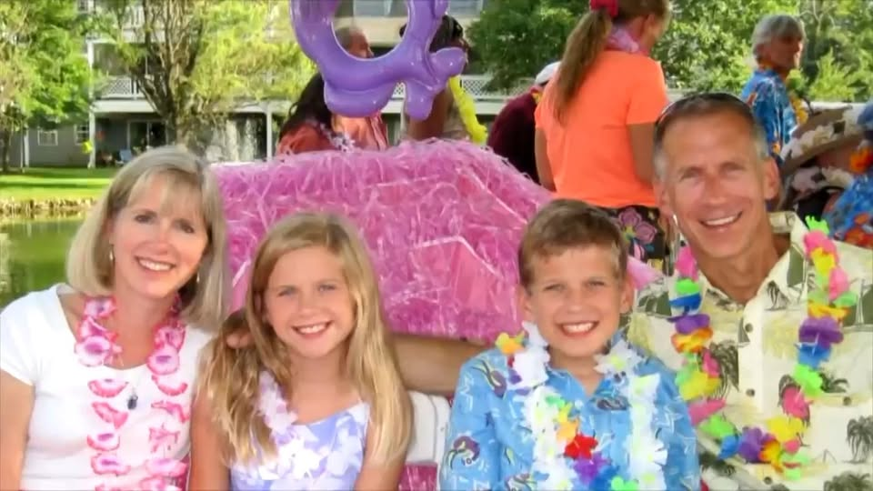
4/9/2021: Family of Kyle Plush reaches $6 million settlement in wrongful death lawsuit…. The 16-year-old Seven Hills student died on April 10, 2018, when he was trapped by a folding seat in the back of a minivan parked in a lot across from his school. The boy was headed to the tennis court but never arrived. Instead, he was pinned by a folding seat in the back of his parked minivan. Plush managed to use the voice activation on his phone to call 911. However, operators and police were unable to locate his van. The teenager was found six hours later by his father. He was unresponsive in the van and pronounced dead a short time later…. The settlement establishes a team of 911 experts from around the country who will work with the director of the ECC to further enhance the city's 911 system. "The scope of the work that these experts will engage in includes fully, thoroughly exploring all the actions that everyone took that failed Kyle, identifying the systemic issues: the training, the quality assurance, the protocol issues and making sure that every one of them gets fixed," Gerhardstein said. "Reports every six months. They will be public. The public will be able to talk directly to the expert team. And they'll be a public hearing at various points whenever any of us want one, in order to bring everybody up to date with what's been done." https://www.wlwt.com/article/family-of-kyle-plush-reaches-settlement-in-wrongful-death-lawsuit/36079929
4/18/2026: CINCINNATI (WKRC) - Eight years after 16-year-old Kyle Plush died after becoming trapped in his family’s car outside a Madisonville school, his parents are continuing to honor his memory by supporting the people who answer 911 calls and by sharing safety tips aimed at helping first responders find callers faster. Ron and Jill Plush, along with volunteers from their organization, the Kyle Plush Answer the Call Foundation, are visiting nearly 30 911 call centers during National Public Safety Telecommunicators Week. They are dropping off items as a way to thank dispatchers and other telecommunicators. https://local12.com/news/local/family-marks-years-since-sons-death-by-visiting-supporting-911-call-centers-dispatch-dispatchers-cops-police-officers-madisonville-kyle-plush-answer-the-call-foundation-telecommunicators-week-public-safety-honoring-memory-cincinnati

June 4, 2018 – U.S. Supreme Court - Masterpiece Cakeshop v. Colorado Civil Rights Commission (7 to 2) https://www.oyez.org/cases/2017/16-111
WEEDING CAKE BAKER – CAN REFUSE TO SELL TO GAY
“In 2018, the court sided with a Colorado baker who had refused to create a wedding cake for a same-sex couple. The result looked like a loss for gay rights. But Justices Kagan and Breyer had helped persuade Justice Kennedy to rule on grounds so narrow they neutered the decision, according to people familiar with the proceedings. The baker won — but the results could not be applied to any other case.
On Monday, Justice Kennedy chose a third path, one that seemed to apply only to the case before the court. Writing for the majority in the 7-to-2 decision, he said the Civil Rights Commission’s ruling against the baker, Jack Phillips, had been infected by religious animus. He cited what he said were “inappropriate and dismissive comments” from one commissioner in saying that the panel had acted inappropriately and that its decision should be overturned.
‘The neutral and respectful consideration to which Phillips was entitled was compromised here,’ Justice Kennedy wrote. ‘The Civil Rights Commission’s treatment of his case has some elements of a clear and impermissible hostility toward the sincere religious beliefs that motivated his objection.’” https://www.nytimes.com/2018/06/04/us/politics/supreme-court-sides-with-baker-who-turned-away-gay-couple.html

June 22, 2018: U.S. Supreme Court – Carpenter v. United States (5 to 4) https://www.supremecourt.gov/opinions/17pdf/16-402_h315.pdf
CELL PHONE LOCATION DATA REQUIRES SEARCH WARRANT UNLESS “EXIGENT CIRCUMSTANCES”
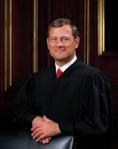Chief Justice John Roberts
“Cell phones perform their wide and growing variety of functions by continuously connecting to a set of radio antennas called ‘cell sites.’ Each time a phone connects to a cell site, it generates a time-stamped record known as cell-site location information (CSLI). Wireless carriers collect and store this information for their own business purposes. Here, after the FBI identified the cell phone numbers of several robbery suspects, prosecutors were granted court orders to obtain the suspects’ cell phone records under the Stored Communications Act. Wireless carriers produced CSLI for petitioner
Timothy Carpenter’s phone, and the Government was able to obtain 12,898 location points cataloging Carpenter’s movements over 127 days—an average of 101 data points per day. Carpenter moved to suppress the data, arguing that the Government’s seizure of the records without obtaining a warrant supported by probable cause violated the Fourth Amendment. The District Court denied the motion, and prosecutors used the records at trial to show that Carpenter’s phone was near four of the robbery locations at the time those robberies occurred. Carpenter was convicted. The Sixth Circuit affirmed, holding that Carpenter lacked a reasonable expectation of privacy in the location information collected by the FBI because he had shared that information with his wireless carriers.
Held:
The Government did not obtain a warrant supported by probable cause before acquiring Carpenter’s cell-site records. It acquired those records pursuant to a court order under the Stored Communications Act, which required the Government to show ‘reasonable grounds’ for believing that the records were ‘relevant and material to an ongoing investigation.’ 18 U. S. C. §2703(d). That showing falls well short of the probable cause required for a warrant. Consequently, an order issued under §2703(d) is not a permissible mechanism for accessing historical cell-site records. Not all orders compelling the production of documents will require a showing of probable cause. A warrant is required only in the rare case where the suspect has a legitimate privacy interest in records held by a third party. And even though the Government will generally need a warrant to access CSLI, case-specific exceptions—e.g., exigent circumstances—may support a warrantless search.” https://www.supremecourt.gov/opinions/17pdf/16-402_h315.pdf

See article: “He Won a Landmark Case for Privacy Rights. He’s Going to Prison
Anyway.” (June 13, 2019). “This week, a federal appeals court [6th Circuit] decided that Mr. Carpenter’s big victory at the Supreme Court won’t spare him from going to prison for the rest of his life. *** But under the good-faith exception to violations of the Fourth Amendment, the court said the agents acted reasonably and in “good faith” — and so whatever they gathered could still be used at trial. The F.B.I. merely followed the law and the rules that applied at the time of the violation. https://www.nytimes.com/2019/06/13/opinion/timothy-carpenter-prison-privacy.html

6th Circuit decision (June 11, 2019):
https://www.opn.ca6.uscourts.gov/opinions.pdf/19a0126p-06.pdf

“This case returns on remand from the Supreme Court. In our prior opinion, the majority held that the Government’s warrantless collection of Timothy Ivory Carpenter’s cell-site location information (CSLI) did not violate the Fourth Amendment. The Supreme Court disagreed. The unconstitutionality of the Government’s search was not clear until after the Supreme Court reversed our decision, which leads us to the question of whether the FBI agents who obtained Carpenter’s CSLI acted in good faith. Because these agents reasonably relied on the Stored Communications Act (SCA), we AFFIRM the judgment of the district court.”
See also: Cell Phone Store Robber Sentenced to 116 Years (April 16, 2014): https://archives.fbi.gov/archives/detroit/press-releases/2014/cell-phone-store-robbersentenced-to-116-years

December 21, 2018: First Step Act [releasing federal prisoners]
On December 21, 2018, President Trump signed into law the First Step Act of 2018 (P.L. 115-391). The act was the culmination of several years of congressional debate about what Congress might do to reduce the size of the federal prison population while also creating mechanisms to maintain public safety. This report provides an overview of the provisions of the act. The act has three major components: (1) correctional reform via the establishment of a risk and needs assessment system at the Bureau of Prisons (BOP), (2) sentencing reform via changes to penalties for some federal offenses, and (3) the reauthorization of the Second Chance Act of 2007 (P.L. 110-199). The act also contains a series of other criminal justice-related provisions. https://crsreports.congress.gov/product/pdf/R/R45558
July 19, 2019: Justice Department officials on Friday announced that 3,100 inmates are being released from federal prisons across the country because of a change in how their good-behavior time is calculated — a significant step, they said, in the implementation of a new criminal justice reform law. https://www.washingtonpost.com/national-security/3100-inmates-to-be-released-as-trump-administration-implements-criminal-justice-reform/2019/07/19/7ed0daf6-a9a4-11e9-a3a6-ab670962db05_story.html

July 25, 2021: The First Step Act aimed to correct the disparities in sentencing of defendants convicted of crack offenses, who were mostly Black, compared to powder cocaine. It contains six provisions that address reducing recidivism, incentivizing rehabilitation, improving where an inmate is confined in relation to their primary residence, correctional reforms such as prohibiting the use of restraints on pregnant inmates, government oversight and sentencing reforms. https://www.washingtonpost.com/nation/2021/07/25/first-step-act/?utm_campaign=wp_evening_edition&utm_medium=email&utm_source=newsletter&wpisrc=nl_evening&carta-url=https%3A%2F%2Fs2.washingtonpost.com%2Fcar-ln-tr%2F343c18f%2F60fdd0e69d2fda945a17bbac%2F59731235ade4e21a848a56ed%2F35%2F48%2F60fdd0e69d2fda945a17bbac

August. 10, 2019 – Jeffrey Epstein Suicide
https://www.brennancenter.org/our-work/analysis-opinion/completely-predictable-death-jeffrey-epstein
“The reported suicide on Saturday of disgraced financier Jeffrey Epstein in a federal jail cell in the heart of Manhattan was both utterly shocking and completely predictable. It’s shocking that the Bureau of Prisons was unable to keep Epstein alive pending his federal sex trafficking trial and that jail officials, knowing the world was watching this case so closely, allowed his death even after Epstein’s apparent failed attempt to take his own life three weeks ago. That’s negligence by definition, whether the celebrity defendant was placed on or taken off ‘suicide watch.’ But inmate suicides are such a regular part of life in American prisons and jails that none of us should be surprised whenever they occur. They are the leading cause of death in jails, and have been for many years, and the problem seems to be getting worse. The latest statistics, from 2014, tell us the rate of suicides in jails was the highest it’s been since at least 2000. This even though there is more public awareness surrounding the phenomenon and a cry for better records (and details) about the number of suicides that take place each year.”

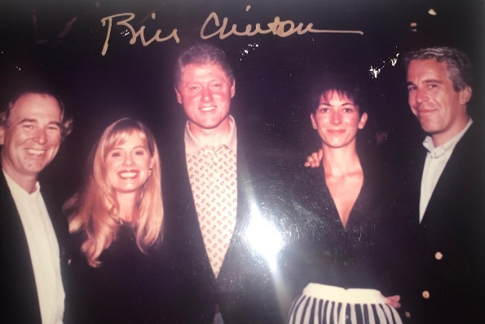

Dec. 12, 2025: “Democrats Release Photos Showing Epstein Ties to Powerful Men. The images, released without context by Democrats on the House Oversight Committee, revealed little new about the deceased sex offender’s ties to prominent men in politics, entertainment and finance.” https://www.nytimes.com/2025/12/12/us/politics/jeffrey-epstein-photos-estate.html

Dec. 14, 2025:
“Mr. Clinton was acquainted with Mr. Epstein — an association the former president described in his memoir — but never visited his private island and cut off contact with him two decades ago. Mr. Clinton took four international trips on Mr. Epstein’s private jet in 2002 and 2003, according to flight logs, and an undated photograph of Mr. Clinton and Mr. Epstein signed by the former president was part of a batch of images released by House Democrats last week highlighting Mr. Epstein’s ties to powerful men.” https://www.nytimes.com/2025/12/14/us/politics/clintons-epstein-inquiry.html?nl=On+Politics&segment_id=212324

Nov. 15, 2019: President Trump Pardons First Lieutenant Clint Lorance
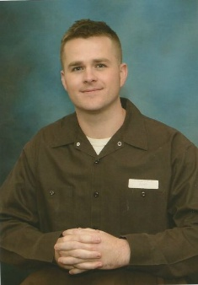Clint Lorance

“One of the pardoned soldiers was First Lt. Clint Lorance, who was turned in by his own troops after he ordered them to fire on unarmed Afghans over 100 yards away from his platoon, killing them. The soldier then radioed a false report claiming the bodies had been removed and couldn’t be searched for weapons. The Army convicted Lieutenant Lorance of second-degree murder and other charges and sentenced him to 19 years in prison.

***

The legal and ethical challenges he will have to overcome to realize his dream of becoming a lawyer are formidable, despite a pardon from President Donald Trump last November that let him out of the U.S. Disciplinary Barracks at Fort Leavenworth, Kansas, after serving six years of a 19-year sentence.” https://www.nytimes.com/2025/02/22/us/politics/hegseth-firings-military-lawyers-jag.html

“His crime: ordering his subordinates to fire on three Afghans riding a motorcycle while on patrol in Kandahar in July 2012…. Lorance, I soon discovered, had been on the ground with his platoon in Afghanistan for only three days when the shooting that landed him in prison occurred. He had replaced another lieutenant, who’d been wounded in a bombing. Lorance, who had previously served in Iraq as an enlisted soldier, was freshly commissioned and 28 years old…. Reading that interview, I started to lose faith in Lorance. Nine members of his platoon testified against him at his trial. Together, they described a man who arrived in Afghanistan determined to get his hands bloody. Fair enough. Combat soldiers are, by nature, hungry for a fight. As a result, a platoon leader who is willing to loosen the reins a little and allow his subordinates to aggressively pursue the enemy will generally be a pretty popular guy. Which is why I was surprised to discover that not a single soldier from Lorance’s platoon testified on his behalf. Even more surprising is the wide discrepancy between the accounts of the incident provided by the soldiers who testified against Lorance and the narrative he and his supporters — none of whom actually witnessed the shooting — have vehemently pressed since the murder investigation began.”
https://taskandpurpose.com/news/think-lt-clint-lorance-murderer/

Jan. 15, 2020: FLSA - U.S. Department of Labor issues its “Final Rule” on benefits that can be given employees, without increasing their overtime “regular rate of pay”
https://www.dol.gov/agencies/whd/overtime/2019-regular-rate/faqs
“The Final Rule focuses primarily on clarifying whether certain kinds of benefits or perks and other miscellaneous payments must be included in the regular rate. In relevant part, the Department revises the current regulations to confirm the following:
- the cost of providing certain parking benefits, wellness programs, onsite specialist treatment, gym access and fitness classes, employee discounts on retail goods and services, certain tuition benefits (whether paid to an employee, an education provider, or a student-loan program), and adoption assistance;
- payments for unused paid leave, including paid sick leave or paid time off;
- payments of certain penalties required under state and local scheduling laws;
- reimbursed expenses including cellphone plans, credentialing exam fees, organization membership dues, and travel, even if not incurred “solely” for the employer’s benefit; and clarifies that reimbursements that do not exceed the maximum travel reimbursement under the Federal Travel Regulation System or the optional IRS substantiation amounts for travel expenses are per se “reasonable payments”;
- certain sign-on bonuses and certain longevity bonuses;
- the cost of office coffee and snacks to employees as gifts;
- discretionary bonuses, by clarifying that the label given a bonus does not determine whether it is discretionary and providing additional examples and;
- contributions to benefit plans for accident, unemployment, legal services, or other events that could cause future financial hardship or expense.”

March 27, 2020: Coronavirus Aid, Relief, and Economics

Security Act (“CARES”)

U.S. Department of Treasury: “The Coronavirus Aid, Relief, and Economic Security (CARES) Act was passed by Congress with overwhelming, bipartisan support and signed into law by President Trump on March 27th, 2020. This over $2 trillion economic relief package delivers on the Trump Administration’s commitment to protecting the American people from the public health and economic impacts of COVID-19.” https://home.treasury.gov/policy-issues/cares

July 30, 2020: The $150k reporting threshold plummets to $10k
“The reporting, which will begin in January of 2021 for all funds received and spent in 2020, will be required of all who have received a total of $10,000 or more. The Terms state that this includes any funds received from HHS under the Coronavirus Aid, Relief, and Economics Security Act (“CARES”), the Coronavirus Preparedness and Response Supplemental Appropriations Act, the Families First Coronavirus Response Act, or any other Act primarily making appropriations for the coronavirus response. Therefore, this lowered threshold will likely mean that almost every EMS and ambulance agency will have to follow the reporting requirements.” Page, Wolfberg & Wirth info@pwwemslaw.com

May 25, 2020: George Floyd death
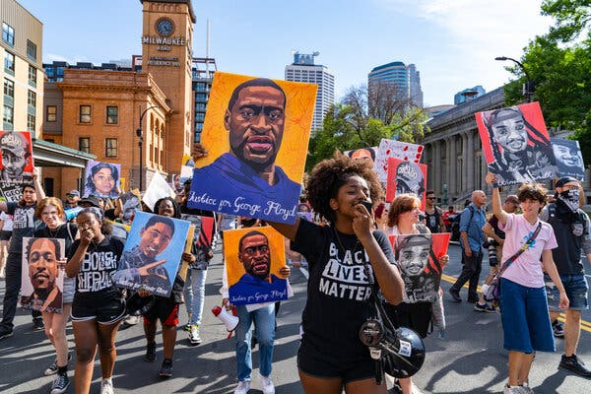
The murder of George Floyd in 2020 set off protests in Minneapolis and across the country. Credit...Aaron Nesheim for The New York Times https://www.nytimes.com/2024/04/14/us/minneapolis-prosecutor-george-floyd-moriarty.html?te=1&nl=the-morning&emc=edit_nn_20240415
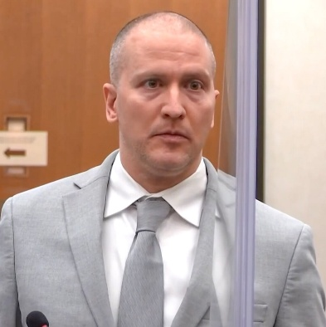
Nov. 24, 2023: Derek Chauvin, the former Minneapolis police officer convicted of murdering George Floyd, was stabbed by another inmate and seriously injured Friday at a federal prison in Arizona, a person familiar with the matter told The Associated Press. The attack happened at the Federal Correctional Institution, Tucson, a medium-security prison that has been plagued by security lapses and staffing shortages. The person was not authorized to publicly discuss details of the attack and spoke to the AP on the condition of anonymity. https://apnews.com/article/derek-chauvin-george-floyd-prison-stabbing-f24cde6aa28877d034530c2dc40ef7ea
March 5, 2025: Chauvin was found guilty of murder and is serving two concurrent sentences for federal and state convictions. If Trump pardoned him on the federal charges, Chauvin would still have to serve the remainder of his 22½-year sentence in a state facility, a prison official told The Minnesota Star Tribune. The New York Times nytdirect@nytimes.com

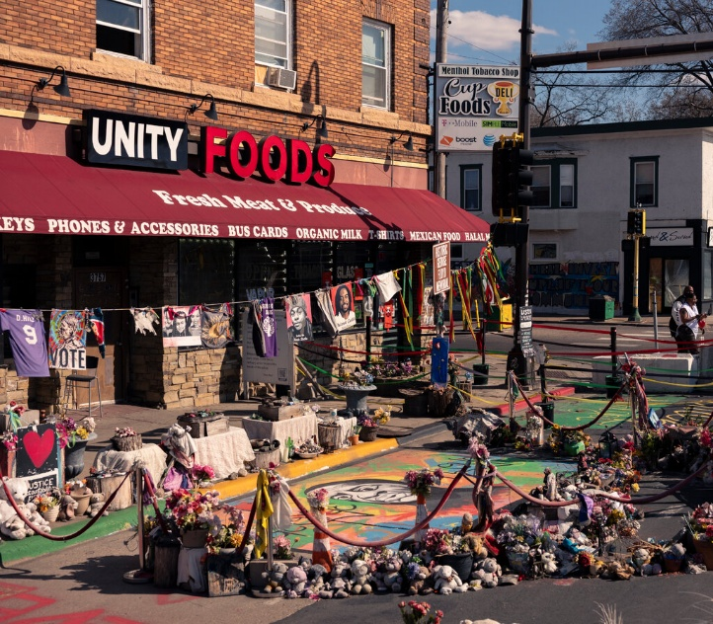

June 15, 2020: U.S. Supreme Court – Bostock v. Clayton County, Georgia (6 to 3) https://www.supremecourt.gov/opinions/19pdf/17-1618_hfci.pdf

TITLE VII PROTECTS TRANSGENDERS
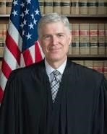 Justice Neil Gorsuch (nominated by President Donald Trump, sworn in
April 10, 2017)
“In each of these cases, an employer allegedly fired a long-time employee simply for being homosexual or transgender. Clayton County, Georgia, fired Gerald Bostock for conduct ‘unbecoming’ a county employee shortly after he began participating in a gay recreational softball league.”
Gerald Bostock

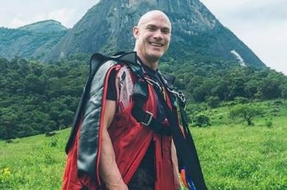
“Altitude Express fired Donald Zarda days after he mentioned being gay.”
Donald Zarda – died in base jumping accident in 2014:
https://nypost.com/2020/06/15/mom-of-late-gay-supreme-court-plaintiff-he-would-bedelighted/
Aimee Stephens
“And R. G. & G. R. Harris Funeral Homes fired Aimee Stephens, who presented as a male when she was hired, after she in-formed her employer that she planned to ‘live and work full-time as a woman.’”
Each employee sued, alleging sex discrimination under Title VII of the Civil Rights Act of 1964. The Eleventh Circuit held that Title VII does not prohibit employers from firing employees for being gay and so Mr. Bostock’s suit could be dismissed as a matter of law. The Second and Sixth Circuits, however, allowed the claims of Mr. Zarda and Ms. Stephens, respectively, to proceed.
Held: An employer who fires an individual merely for being gay or transgender violates Title VII.” https://www.supremecourt.gov/opinions/19pdf/17-1618_hfci.pdf

July 17, 2020: Congressman John Lewis dies – Civil Rights Leader
“John Lewis [and Hosea Williams] led over 600 peaceful, orderly protestors across the Edmund Pettus Bridge in Selma, Alabama on March 7, 1965. They intended to march from Selma to Montgomery to demonstrate the need for voting rights in the state. The marchers were attacked by Alabama state troopers in a brutal confrontation that became known as ‘Bloody Sunday.’ News broadcasts and photographs revealing the senseless cruelty of the segregated South helped hasten the passage of the Voting Rights Act of 1965.” https://johnlewis.house.gov/john-lewis/biography

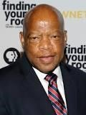

NEW YORK TIMES: Mr. Lewis, the civil rights leader who died on July 17, wrote this essay shortly before his death, to be published upon the day of his funeral. https://www.nytimes.com/2020/07/30/opinion/john-lewis-civil-rights-america.html
6/30/2020: By John Lewis:
“While my time here has now come to an end, I want you to know that in the last days and hours of my life you inspired me. You filled me with hope about the next chapter of the great American story when you used your power to make a difference in our society. Millions of people motivated simply by human compassion laid down the burdens of division. Around the country and the world you set aside race, class, age, language and nationality to demand respect for human dignity.
That is why I had to visit Black Lives Matter Plaza in Washington, though I was admitted to the hospital the following day. I just had to see and feel it for myself that, after many years of silent witness, the truth is still marching on.
Emmett Till was my George Floyd. He was my Rayshard Brooks, Sandra Bland and Breonna Taylor. He was 14 when he was killed, and I was only 15 years old at the time. I will never ever forget the moment when it became so clear that he could easily have been me. In those days, fear constrained us like an imaginary prison, and troubling thoughts of potential brutality committed for no understandable reason were the bars.
Though I was surrounded by two loving parents, plenty of brothers, sisters and cousins, their love could not protect me from the unholy oppression waiting just outside that family circle. Unchecked, unrestrained violence and government sanctioned terror had the power to turn a simple stroll to the store for some Skittles or an innocent morning jog down a lonesome country road into a nightmare. If we are to survive as one unified nation, we must discover what so readily takes root in our hearts that could rob Mother Emanuel Church in South Carolina of her brightest and best, shoot unwitting concertgoers in Las Vegas and choke to death the hopes and dreams of a gifted violinist like Elijah McClain.
Like so many young people today, I was searching for a way out, or some might say a way in, and then I heard the voice of Dr. Martin Luther King Jr. on an old radio. He was talking about the philosophy and discipline of nonviolence. He said we are all complicit when we tolerate injustice. He said it is not enough to say it will get better by and by. He said each of us has a moral obligation to stand up, speak up and speak out. When you see something that is not right, you must say something. You must do something. Democracy is not a state. It is an act, and each generation must do its part to help build what we called the Beloved Community, a nation and world society at peace with itself.
Ordinary people with extraordinary vision can redeem the soul of America by getting in what I call good trouble, necessary trouble. Voting and participating in the democratic process are key. The vote is the most powerful nonviolent change agent you have in a democratic society. You must use it because it is not guaranteed. You can lose it.
You must also study and learn the lessons of history because humanity has been involved in this soul-wrenching, existential struggle for a very long time. People on every continent have stood in your shoes, through decades and centuries before you. The truth does not change, and that is why the answers worked out long ago can help you find solutions to the challenges of our time. Continue to build union between movements stretching across the globe because we must put away our willingness to profit from the exploitation of others.
Though I may not be here with you, I urge you to answer the highest calling of your heart and stand up for what you truly believe. In my life I have done all I can to demonstrate that the way of peace, the way of love and nonviolence is the more excellent way. Now it is your turn to let freedom ring.
When historians pick up their pens to write the story of the 21st century, let them say that it was your generation who laid down the heavy burdens of hate at last and that peace finally triumphed over violence, aggression and war. So I say to you, walk with the wind, brothers and sisters, and let the spirit of peace and the power of everlasting love be your guide.”

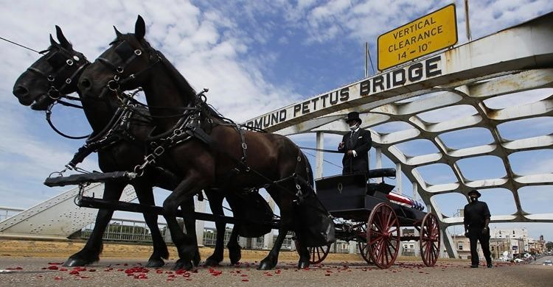

July 30, 2020: Obama speech - call to action in eulogy for Lewis … along with
Presidents Clinton and Bush.
”Standing before Lewis’s flag-draped casket, [President] Obama told the story of Lewis’s courage on his first ‘freedom’ ride on a bus, an unofficial test taken with a Black friend to set the stage for the broader Freedom Ride protests on segregated buses in the South. ‘Imagine the courage of two people Malia’s age, younger than my oldest daughter, on their own,’ the former president said. ‘John was only 20 years old. But he pushed all 20 of those years to the center of the table, betting everything — all of it — that his example could challenge centuries of convention and generations of brutal violence.’”
https://www.politico.com/news/2020/07/30/clinton-bush-obama-john-lewis-funeral-388050

April 14, 2020: PSOB Amended – Public Safety Officers - COVID-19 deaths / injuries
SEC. 3. Public Safety Officer Benefits: https://www.congress.gov/bill/116th-congress/senatebill/3607/text
- Death benefits.—As determined by the Bureau of Justice Assistance, unless competent medical evidence establishes that the death of a public safety officer (as defined in section 1204 of title I of the Omnibus Crime Control and Safe Streets Act of 1968 (34 U.S.C. 10284)) was directly and proximately caused by something other than COVID–19, COVID–19 (or complications therefrom) suffered by the public safety officer shall be presumed to constitute a personal injury within the meaning of section
1201(a) of title I of the Omnibus Crime Control and Safe Streets Act of 1968 (34 U.S.C. 10281(a)), sustained in the line of duty by the officer and directly and proximately resulting in death, if—
  - the officer engaged in a line of duty action or activity between January 1, 2020, and December 31, 2021;
  - the officer was diagnosed with COVID–19 (or evidence indicates that the officer had COVID–19) during the 45-day period beginning on the last day of duty of the officer; and
  - evidence indicates that the officer had COVID–19 (or complications therefrom) at the time of the officer's death.
- Disability benefits.—As determined by the Bureau of Justice Assistance, COVID–19 (or complications therefrom) suffered by a public safety officer shall be presumed to constitute a personal injury within the meaning of section 1201(b) of title I of the Omnibus Crime Control and Safe Streets Act of 1968 (34 U.S.C. 10281(b)), sustained in the line of duty by the officer, if—
  - the officer engaged in a line of duty action or activity between January 1, 2020, and December 31, 2021; and
  - the officer was diagnosed with COVID–19 (or evidence indicates that the officer had COVID–19) during the 45-day period beginning on the last day of duty of the officer.”

Jan. 20, 2021: President Joe Biden – Inauguration

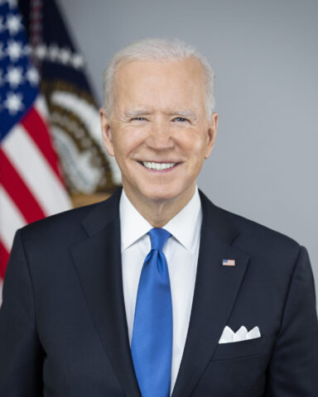
https://www.whitehousehistory.org/bios/joseph-r-biden-jr
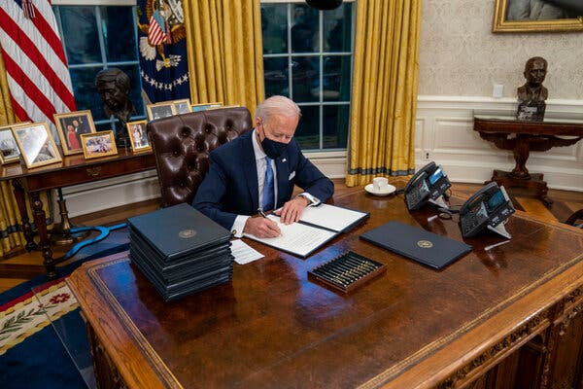President Joseph R. Biden Jr. signing executive orders on his first day in office. https://www.nytimes.com/2025/12/07/us/politics/biden-immigration-trump.html?nl=Breaking+News

June 8, 2021 – Trump Rally - Mob Attacks U.S. Capitol
“More than 140 officers were wounded and three people died as a result of medical emergencies suffered during the riot. Four police officers who worked that day later died by suicide.” https://www.washingtonpost.com/dc-md-va/2025/02/21/enrique-tarrio-proud-boys-arrested-dc-capitol-police/?utm_campaign=wp_post_most&utm_medium=email&utm_source=newsletter&carta-url=https%3A%2F%2Fs2.washingtonpost.com%2Fcar-ln-tr%2F41436f6%2F67b9fa8b99aedb3a29da0fd3%2F59731235ade4e21a848a56ed%2F29%2F56%2F67b9fa8b99aedb3a29da0fd3
***
“The 2020 presidential election was held on November 3, 2020. On December 14, 2020,
the Electoral College met, and a majority of the electors cast their votes for Joseph R. Biden and Kamala D. Harris…. On January 6, 2021, a mob attacked the U.S. Capitol, where the House and Senate were set to count and certify the Electoral College vote. According to the RNC, “[m]any in the mob intended to interfere” with Congress’s counting and certification… And some “attacked Capitol police officers, vandalized portions of the Capitol itself, and forced their way into the Senate chamber.”
Republican National Committee v. Nancy Pelosi, et al., May 1, 2022. https://storage.courtlistener.com/recap/gov.uscourts.dcd.241102/gov.uscourts.dcd.241102.33.0.pdf

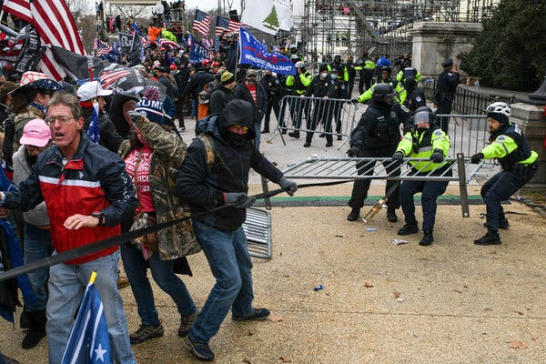

‘You’re a Go’: How Miscues and Confusion Delayed the National Guard on Jan. 6. {May 7, 2024.]
The picture is far from a flattering one: A miscommunication between Christopher C. Miller, the secretary of defense at the time, and Ryan D. McCarthy, the secretary of the Army, resulted in each man leaving a critical exchange on the afternoon of Jan. 6 with a different understanding of how quickly the Guard would be deployed — and who would give word that it was authorized. *** The testimony highlighted a still-simmering feud inside the military over who is to blame for the more than four-hour delay in deploying the National Guard. The pro-Trump mob began assaulting police officers at the Capitol just before 1 p.m. But it took until 5:40 p.m. for the National Guard to arrive on the Capitol grounds, after the Capitol Police and the Metropolitan Police Department had largely put down the riot. https://www.nytimes.com/2024/05/07/us/politics/miscues-confusion-national-guard-delay-jan-6.html?te=1&nl=the-morning&emc=edit_nn_20240509

***
Feb. 20, 2025: Justice Department broadens Trump’s Jan. 6 clemency as it moves to drop gun cases.
“In court papers, DOJ revealed a newly expansive interpretation of the president’s Jan. 6 pardons. The Justice Department now says that President Donald Trump’s clemency for Jan. 6 rioters covers unrelated crimes that were discovered during FBI searches stemming from the attack on the Capitol. Federal prosecutors revealed the new legal position this week in court papers seeking to drop gun charges against two former Jan. 6 defendants. The guns in question were found at the two men’s homes during the Jan. 6 investigation, but the alleged gun crimes themselves were not connected to the riot. Nonetheless, prosecutors moved to dismiss the gun cases by invoking Trump’s Day 1 executive order granting mass clemency to Jan. 6 defendants. That order issued pardons to roughly 1,500 people who had been convicted of “offenses related to events that occurred at or near the United States Capitol” on Jan. 6, 2021. It also directed the attorney general to dismiss all pending prosecutions for “conduct related to” those events. *** A day after Trump ordered Ball released from his Jan. 6 assault case, he was rearrested and returned to Florida where he was charged with being a felon in possession of a firearm. (Ball had prior felonies on his record from 2017 and 2021, according to the indictment.) *** Costianes, for his part, pleaded guilty in 2023 to possessing a firearm while being a user of illegal drugs. He recently began serving his two-year prison sentence — a sentence that the Justice Department sought Wednesday to end immediately.” https://www.politico.com/news/2025/02/20/justice-department-january-6-clemency-guns-00205357

March 3, 2022: SEXUAL HARASSMENT / NO FORCED ARBITRATIONS
“President Biden Signs Bill Prohibiting Mandatory Arbitration and Class Action Waivers for Sexual Harassment and Sexual Assault Claims. President Biden signed the bill into law on March 3, 2022. The law takes effect immediately.*** Today, the Senate passed H. 4445, the Ending Forced Arbitration of Sexual Assault and Sexual Harassment Act (the ‘Act’), by a voice vote. The bill had previously passed the House of Representatives by a vote of 335-97. The White House has indicated President Biden will sign the bill. [The Act amends] the Federal Arbitration Act to prohibit enforcement of mandatory pre-dispute arbitration agreements, as well as agreements prohibiting participation in a joint, class or collective action in any forum, ‘at the election of the person alleging conduct constituting a sexual harassment dispute or sexual assault dispute, or the named representative of a class or in a collective action alleging such conduct.’ The Act also provides that any dispute concerning whether a claim falls within the scope of the Act’s prohibitions will be decided by a court and not an arbitrator, irrespective of whether the arbitration agreement at issue purports to delegate such determinations to an arbitrator. A ‘sexual assault dispute’ is defined as one ‘involving a nonconsensual sexual act or sexual contact, as such terms are defined in section 2246 of title 18 or similar applicable Tribal or State law, including when the victim lacks capacity to consent.’ A ‘sexual harassment dispute’ is defined as one ‘relating to conduct that is alleged to constitute sexual harassment under applicable Federal, Tribal, or State law.’
The new restrictions would apply ‘with respect to any dispute or claim that arises or accrues on or after the date of enactment of this Act,’ meaning that once enacted, millions of American workers could elect to be released from existing arbitration agreements and/or class and collective action waivers as relating to sexual harassment and sexual assault claims that arise after the law goes into effect. However, because the law only addresses pre-dispute arbitration and class/collection action waiver agreements, any agreement to arbitrate claims entered into by the parties after the claims arise remains enforceable.” https://www.lawandtheworkplace.com/2022/02/congress-passes-bill-prohibiting-mandatory-arbitration-and-class-action-waivers-for-sexual-harassment-and-sexual-assault-claims/

June 8, 2022: Armed man went to Justice Kavanaugh’s home to kill him
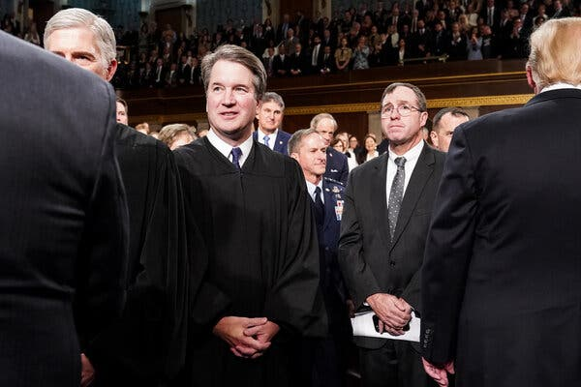
“A man armed with a pistol, a knife and other weapons was arrested near the Maryland home of Justice Brett M. Kavanaugh early Wednesday after he said he traveled from California to kill the Supreme Court justice, federal officials said. Nicholas John Roske, 26, of Simi Valley, Calif., was charged with attempted murder after two U.S. deputy marshals saw him step out of a taxicab in front of the justice’s house in Chevy Chase, Md., early Wednesday morning, federal prosecutors said. Mr. Roske was dressed in black and carrying a suitcase and a backpack, according to a federal affidavit. Inside the suitcase and backpack, the authorities later discovered a “black tactical chest rig and tactical knife,” a pistol with two magazines and ammunition, pepper spray, zip ties, a hammer, a screwdriver, a nail punch, a crowbar, a pistol light and duct tape, in addition to other items, according to the affidavit. His plan was to break into the house, kill the justice and then kill himself, according to the affidavit.”
May 11, 2024 – Comments on security by Justice Kavanaugh: “After the leak of the Dobbs draft, a man with a gun and a knife was detained by police near Kavanaugh’s Maryland home and charged with attempted murder. Nicholas John Roske of Simi Valley, Calif., was upset by the leaked draft as well as the recent school shooting in Uvalde, Tex., according to an affidavit. Kavanaugh called the heightened security measures that are now in place for the justices ‘night and day’ from when he clerked for then-Justice Anthony M. Kennedy in the early 1990s.” https://www.washingtonpost.com/politics/2024/05/10/kavanaugh-thomas-alito-supreme-court-speeches/?utm_campaign=wp_todays_headlines&utm_medium=email&utm_source=newsletter&wpisrc=nl_headlines&carta-url=https%3A%2F%2Fs2.washingtonpost.com%2Fcar-ln-tr%2F3dae9d3%2F663f41a7e01322169e863076%2F59731235ade4e21a848a56ed%2F11%2F54%2F663f41a7e01322169e863076

June 24, 2022: U.S. Supreme Court: Dobbs, State Health Officer of the Mississippi Department of Health v. Jackson Women’s Health Organization (6 to 3)

https://www.supremecourt.gov/opinions/21pdf/19-1392_6j37.pdf

U.S. SUPREME COURT OVERTURNS ROE v. WADE - ABORTION
“The Supreme Court on Friday struck down Roe v. Wade, eliminating the nearly 50-year-old constitutional right to abortion and handing states authority to drastically limit or ban the procedure. The 6-3 decision by a majority of conservative justices to fundamentally reshape American society by overturning the landmark 1973 precedent is certain to ignite a political firestorm and yield a complex patchwork of state laws that will effectively block large swathes of the population from terminating unwanted pregnancies. The ruling upholds Mississippi’s 15-week abortion ban, which directly clashed with Roe’s requirement that states permit abortion up to the point of fetal viability, around 24 weeks, as well as Planned Parenthood v. Casey, a 1992 decision that reaffirmed Roe’s core holding.” https://thehill.com/regulation/court-battles/3523884-supreme-court-strikes-down-roe-v-wade/
6/24/2022: ALITO , J., delivered the opinion of the Court, in which THOMAS, GORSUCH, KAVANAUGH, and BARRETT , JJ., joined. THOMAS , J., and KAVANAUGH, J., filed concurring opinions. ROBERTS , C. J., filed an opinion concurring in the judgment. BREYER, SOTOMAYOR, and KAGAN, JJ., filed a dissenting opinion.

Abortion presents a profound moral question. The Constitution does not prohibit the citizens of each State from regulating or prohibiting abortion. Roe and Casey arrogated that authority. The Court overrules those decisions and returns that authority to the people and their elected representatives. https://www.supremecourt.gov/opinions/21pdf/19-1392_6j37.pdf

June 29, 2022: Pregnant Workers Fairness Act
“This bill prohibits employment practices that discriminate against making reasonable accommodations for qualified employees affected by pregnancy, childbirth, or related medical conditions. A qualified employee is an employee or applicant who, with or without reasonable accommodation, can perform the essential functions of the position, with specified exceptions.
Specifically, the bill declares that it is an unlawful employment practice to
- fail to make reasonable accommodations to known limitations of such employees unless the accommodation would impose an undue hardship on an entity's business operation;
- require a qualified employee affected by such condition to accept an accommodation other than any reasonable accommodation arrived at through an interactive process;
- deny employment opportunities based on the need of the entity to make such reasonable accommodations to a qualified employee;
- require such employees to take paid or unpaid leave if another reasonable accommodation can be provided; or
- take adverse action in terms, conditions, or privileges of employment against a qualified employee requesting or using such reasonable accommodations.
The bill sets forth enforcement procedures and remedies that cover different types of employees in relation to such unlawful employment practices.
The Equal Employment Opportunity Commission must provide examples of reasonable accommodations that shall be provided to affected employees unless the employer can demonstrate that doing so would impose an undue hardship.
The bill prohibits state immunity under the Eleventh Amendment to the Constitution from an action for a violation of this bill.” https://www.congress.gov/bill/117th-congress/senate-bill/1486

June 30, 2022 –Justice Ketanji Brown Jackson - First Female Black Justice

Justice Ketanji Brown Jackson was nominated to the Supreme Court by President Joseph R. Biden Jr. in 2022.

“Her appointment as the first Black female justice was ‘a refutation of past ignominies, a long-anticipated and highly celebrated national achievement,’ she wrote in her memoir. But inside the court, she was the junior justice, assigned to tasks like serving on the cafeteria committee and answering the door to the justices’ private conference room in case of a knock. In those meetings, Justice Jackson spoke only after the others, meaning that unless there was a tie, she had the least influence.” https://www.nytimes.com/2025/10/31/us/politics/supreme-court-kagan-jackson-liberal-justices.html?nl=The+Morning
2023: President Biden – Border Policies
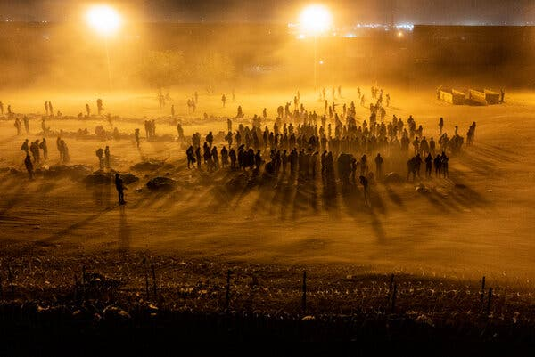Migrants waiting to be processed by Border Patrol agents at a makeshift camp in El Paso, Texas, in 2023.

“Mr. Biden created new legal pathways for migration to ease pressure at the border, under which more than one million people were allowed into the United States, fueling public resistance. And he failed to convince Congress to change immigration laws, dragging his feet on a crucial Senate border deal, according to the lead Republican negotiator, who said the effort might have otherwise succeeded.” https://www.nytimes.com/2025/12/07/us/politics/biden-immigration-trump.html?nl=Breaking+News

April 11, 2023: DC - EEOC – Draft Regulations To Implement the Pregnant Workers Fairness Act.

“On December 29, 2022, President Biden signed the Pregnant Workers Fairness Act (PWFA) into law.^{[1]} The PWFA requires a covered entity to provide reasonable accommodations to a qualified employee's or applicant's known limitation related to, affected by, or arising out of pregnancy, childbirth, or related medical conditions, absent undue hardship on the operation of the business of the covered entity. 42 U.S.C. 2000gg–3 requires the Equal Employment Opportunity Commission (EEOC or Commission) to promulgate regulations to implement the PWFA. *** Example 1636.3 #4: An employee's spouse, on the employee's behalf, requests light duty for the employee because the employee has a lifting restriction related to pregnancy; the employee's spouse uses the employer's established process for requesting a reasonable accommodation or light duty for the employee. The lifting restriction is a physical condition related to the employee's pregnancy, and the employee's representative (their spouse) has identified a change needed at work (light duty). This is a request for a reasonable accommodation under the PWFA.” https://www.federalregister.gov/documents/2023/08/11/2023-17041/regulations-to-implement-the-pregnant-workers-fairness-act

June 29, 2023: U.S. Supreme Court – Students for Fair Admissions, Inc. v. President and Fellows of Harvard College (6 to 3) https://www.supremecourt.gov/opinions/22pdf/20-1199_hgdj.pdf
HARVARD AND UNIVERSITY OF NORTH CAROLINA – RACIAL ADMISSION PROGRAMS VIOLATE 14th AMENDDMENT (EQUAL PROTECTION)
“A benefit to a student who overcame racial discrimination, for example, must be tied to that student’s courage and determination. Or a benefit to a student whose heritage or culture motivated him or her to assume a leadership role or attain a particular goal must be tied to that student’s unique ability to contribute to the university. In other words, the student must be treated based on his or her experiences as an individual—not on the basis of race.” https://www.supremecourt.gov/opinions/22pdf/20-1199_hgdj.pdf

April 17, 2024: U.S. Supreme Court – Jatonya Clayborn Muldrow v. City of St. Louis, Missouri (9 to 0). https://www.supremecourt.gov/opinions/23pdf/22-193_q86b.pdf
FEMALE POLICE OFFICER – JOB TRANSFER “SOME HARM”
On April 17, 2024, in Jatonya Clayborn Muldrow v. City of St. Louis, Missouri, et al., the United States Supreme Court held (9 to 0) that trial court should not have granted summary judgment to the city, and 8th Circuit Court of Appeals had applied too tough a standard for employees claiming job transfer was because of sexual harassment (“materially significant disadvantage”). Sergeant Jatonya Clayborn Muldrow maintains that her employer, the St. Louis Police Department, transferred her from one job to another because she is a woman. Sergeant Muldrow was in Intelligence Division, worked M-F, vehicle, FBI cases, and her new male boss moved her out (back to street patrol) because wanted male sergeant. Under new standard, she must only that that the job transfer brought about some harm with respect to an identifiable term or condition of employment, but that harm need not be significant. https://www.supremecourt.gov/opinions/23pdf/22-193_q86b.pdf

The new “some harm” standard will be widely applied not only in job transfer cases but also a wide variety of other employment decisions.

Note: Justice Michael Kavanaugh in his concurring decision focused on impact of this decision

“All of that said, the Court’s new some-harm requirement appears to be a relatively low bar. Importantly, the Court emphasizes that ‘some harm’ is less than significant harm,
serious harm, or substantial harm. Ante, at 6. Therefore, anyone who has been transferred because of race, color, religion, sex, or national origin should easily be able to show
some additional harm—whether in money, time, satisfaction, schedule, convenience, commuting costs or time, prestige, status, career prospects, interest level, perks, professional relationships, networking opportunities, effects on family obligations, or the like.”

April 26, 2024 – Colorado Paramedics – One Sentenced Prison, One Probation
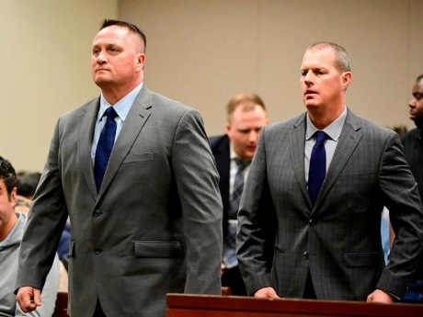
Paramedics Jeremy Cooper, left, and Peter Cichuniec, right, at an arraignment in the Adams County district court at the Adams County Justice Center Jan. 20, 2023.© Andy Cross/MediaNews Group/The Denver Post via Getty Images, FILE
“Former paramedic Jeremy Cooper has been sentenced to a four-year probationary sentence Friday after being found guilty of criminally negligent homicide in the final case connected to Elijah McClain's 2019 death. Prosecutors accused the Aurora, Colorado, paramedic and his co-defendant Peter Cichuniec of administering an excessive amount of ketamine to sedate the 23-year-old McClain after an encounter with police on August 24, 2019. According to department policy, administering ketamine to sedate a suspect is intended ‘to minimize time struggling.’ *** The judge added that Cichuniec was sentenced to five years in prison with a three-year period of parole for assault in the second-degree unlawful administration of drugs and criminally negligent homicide.” https://www.msn.com/en-us/news/crime/paramedic-sentenced-to-4-years-probation-in-connection-with-elijah-mcclain-s-death/ar-AA1nIZU5?ocid=socialshare&pc=U531&cvid=b7f71de9bce545aa9f520c8d0d60b030&ei=22
September 13, 2024:

Paramedic convicted in Elijah McClain's death freed after judge reduces sentence. Peter Cichuniec was serving a five-year prison sentence.
https://abcnews.go.com/US/paramedic-convicted-elijah-mcclain-death-freed-from-prison/story?id=113678258
***

Paramedic convicted in Elijah McClain's death freed after judge reduces sentence. Peter Cichuniec was serving a five-year prison sentence. [TV video.] https://abcnews.go.com/US/paramedic-convicted-elijah-mcclain-death-freed-from-prison/story?id=113678258

April 3, 2024 – Ohio Still Has No Anti-SLAPP Legislation – Protecting Public Speech

“Ohio Looks To Slapp Frivolous Lawsuits Silly
https://www.ficlaw.com/blog/ohio-looks-to-slapp-frivolous-lawsuits-silly
“State Senators Therese Gavarone and Nathan Manning recently introduced a bill in the Ohio Senate whereby Ohio would adopt the ‘Unifor’ Public Expression Protection Act.’ The Act is commonly referred to as an ‘Anti-SLAPP" bill. Whatever it's called, it is high time to adopt it.
***
The bill is an ‘Anti-SLAPP’ law because it seeks to limit the use of ‘Strategic Lawsuits Against Public Participation.’ A ‘SLAPP’ occurs when someone files a lawsuit – regardless of the merits – to bully a speaker on a public issue into shutting up. Even a frivolous lawsuit can force a speaker to shell out thousands of dollars to defend it. And the money is only part of the problem, as the lawsuit can be a drain on time and other resources. Of course, that is exactly why a plaintiff would file the suit.
So, what does an ‘Anti-SLAPP’ bill do exactly? It does several things. First, it allows a defendant named in such a suit to file a motion asking the court to hold an expedited hearing on the case. Once the defendant makes that request, the court must "stay" the case. This means that with limited exceptions, there's no discovery in the case while the motion is pending. In other words, a plaintiff can't send document requests or take depositions. Within sixty days of the filing of the motion for expedited relief, the court must hold a hearing and determine whether the plaintiff ‘stated a claim upon which relief may be granted.’ This could mean that the plaintiff failed to show that the statement was false, or that it was defamatory.
If the court finds that the complaint fails to state a claim for relief, the court shall award reasonable attorney fees and costs to the defendant. But note that this is a two-way street. If the court finds that the motion for expedited review was frivolous, the court must award the plaintiff's reasonable fees and court costs. If the court denies the motion for expedited relief, the defendant may immediately appeal that finding, and the stay remains in place pending the appeal.”

Anti-Slapp Legal Guide
https://www.rcfp.org/anti-slapp-legal-guide/
“Anti-SLAPP laws provide defendants a way to quickly dismiss meritless lawsuits — known as SLAPPs or strategic lawsuits against public participation — filed against them for exercising speech, press, assembly, petition, or association rights. These laws aim to discourage the filing of SLAPP suits and prevent them from imposing significant litigation costs and chilling protected speech.
In recent years, several states have adopted or amended their anti-SLAPP laws. As of September 2023, 33 states and the District of Columbia have anti-SLAPP laws, including Arizona, Arkansas, California, Colorado, Connecticut, Delaware, Florida, Georgia, Hawaii, Illinois, Indiana, Kansas, Kentucky, Louisiana, Maine, Maryland, Massachusetts, Missouri, Nebraska, Nevada, New Jersey, New Mexico, New York, Oklahoma, Oregon, Pennsylvania, Rhode Island, Tennessee, Texas, Utah, Vermont, Virginia, and Washington. Minnesota previously passed an anti-SLAPP law, but it was struck down as unconstitutional, as discussed below.”

April 11, 2024: “Red Flag” Laws

“Citing Constitutional Concerns, Yost Urges DOJ to Scrap ‘Red Flag’ Gun-Confiscation Program.” 4/11/2024
https://www.ohioattorneygeneral.gov/Media/News-Releases/April-2024/Citing-Constitutional-Concerns-Yost-Urges-DOJ-to-S
“(COLUMBUS, Ohio) — Ohio Attorney General Dave Yost and 18 other state attorneys general are opposing a new federal program that promotes aggressive enforcement of ‘red flag’ gun-confiscation laws.
Yost and his counterparts argue in a letter to U.S. Attorney General Merrick Garland that the National Extreme Risk Protection Order (ERPO) Resource Center, launched in March by the Department of Justice, undermines the Second Amendment and other fundamental rights in a flawed attempt to reduce gun violence.
‘The solution to gun violence is not more bureaucracy, and it is certainly not parting otherwise law-abiding men and women from their right to self-defense,’ Yost said.
The state attorneys general raise several concerns with the ERPO Resource Center, most notably how the program advocates for laws that allow government officials to ‘suspend fundamental rights under the Second Amendment with no genuine due process.’
So-called ‘red flag’ laws permit authorities to seek court orders authorizing the confiscation of firearms from people thought to pose a danger. Twenty-one states have enacted such laws; Ohio is not among them.
See April 11, 2024 letter to Attorney General: https://www.ohioattorneygeneral.gov/Files/Briefing-Room/News-Releases/4-11-24-ERPO-Letter-to-AG-Garland.aspx
“And it’s not just the Second Amendment that’s at risk. How can officers enter a home and seize a gun without a warrant in a way that’s consistent with the Fourth Amendment? How can ex parte proceedings unconnected to any criminal wrongdoing or criminal investigation be good enough
under the Fifth and Fourteenth Amendments when they lead to firearms seizures? Both questions have the same answer: They can’t. ‘By depriving individuals of their property and rights without having been formally charged, arraigned, or convicted of a crime, red flag laws violate these constitutional rights.’ … No wonder that Congress has already called out your Department for funding state-level red-flag programs that fail to meet basic statutory and constitutional requirements.”

May 23, 2024: Late Rev. Billy Graham Immortalized In Capitol Hill Statue
https://www.youtube.com/watch?v=h42Ez9DYn6Q

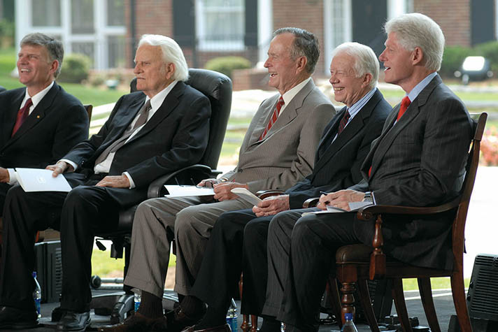

Billy Graham: Pastor to Presidents
https://billygraham.org/story/billy-graham-pastor-to-presidents-2/
Every U.S. President since World War II met with Billy Graham. Both Johnson and Nixon, the two who probably sought him the most, offered him high positions in government—which he quickly and politely refused.
Here are short snippets of their stories:
Harry S. Truman — In 1950 a congressman called Billy and asked, “Would you like to meet the President?” Without any briefing on protocol, he agreed and went in with three colleagues and spoke with President Truman, who told Billy he lived by the Sermon on the Mount. Before he left, the two prayed together. Years later, Truman warmly received Billy at his home in Independence, Missouri.
Dwight D. Eisenhower — “Eisenhower was the first President that really asked my counsel in depth when he was sending troops into Little Rock,” said Mr. Graham. Just before Eisenhower died, Billy was invited to see him at Walter Reed Hospital. After talking again about assurance of salvation, the two men prayed. Eisenhower then said he was ready to die.
“Billy Graham is one of the best ambassadors our country has but he told me, ‘I am an ambassador of heaven.'” — Dwight D. Eisenhower
John F. Kennedy — Four days before he was inaugurated as President, John Kennedy invited Mr. Graham to spend the day with him in Palm Beach. “We drove around in JFK’s white Lincoln convertible,” said Billy. “During our conversations, I became aware that he was concerned about the moral and spiritual condition of the nation.” During Kennedy’s funeral service in the Capitol rotunda, Billy stood about 30 feet from Mrs. Kennedy and the family, and thought about the brevity of life and how people must prepare to meet God.
Lyndon B. Johnson — There was a spiritual side to Lyndon Johnson that many people did not know. Billy was probably closer to Johnson than to any other President. He was invited to the family ranch several times and spent more than 20 nights at the White House during Johnson’s administration. Every time Billy would say to him, “Let’s have a prayer,” the President would get on his knees to pray.
“My mind went back to those lonely occasions at the White House when your friendship helped to sustain a President in an hour of trial.” — Lyndon Johnson in a letter to Billy Graham
Richard M. Nixon — President Nixon and Billy had been personal friends since 1950. Nixon was a private and complex person, but beneath the surface, Billy found him to be warm and compassionate, quite different from popular caricatures. He was rooted in the teachings and prayers of his Quaker faith. Often he asked Billy to pray with him and read the Bible when he would visit. In the last year of Nixon’s presidency, Billy did not get to see him. Someone on the White House later relayed that Nixon said, “Don’t let Billy Graham near me, I don’t want him tarred with Watergate.”
Gerald R. Ford — Answering critics of his relationship with Billy, Gerald Ford said, “I’ve heard the comments from some sources that Billy mixes politics with religion. I never felt that and I don’t think that thousands and thousands of people who listen to him felt that. Billy dropped by the Oval Office on several occasions while I was President. They were get-togethers of old friends. They had no political or other significance.”
Jimmy Carter — “Billy and Ruth Graham have been to visit us both in the governor’s mansion in Georgia and in the White House,” said Jimmy Carter. “His reputation is above reproach or suspicion.” Back in 1966, Carter chaired a BGEA film crusade in Americus, Ga., and when he was governor, served as an honorary chairman of the Atlanta Crusade.
Ronald W. Reagan — Billy met Ronald Reagan a year after he married Nancy. The two remained close friends. “I remember when Reagan was president of the Screen Actors Guild, a union leader, and a very strong Democrat,” Billy said. On March 30, 1981, after the assassination attempt on President Reagan’s life, Billy flew immediately to Washington, D.C., to comfort and pray with Mrs. Reagan, and do anything he could for the President.
“It was through Billy Graham that I found myself praying even more than on a daily basis … and that in the position I held, that my prayers more and more were to give me the wisdom to make decisions that would serve God and be pleasing to Him.” — Ronald Reagan
George H. W. Bush — Mr. Graham has said he found George H.W. Bush easy to talk to about spiritual issues, “easier than other Presidents I have met. He says straight out that he has received Christ as his Savior and that he is a born-again believer.” Billy was with President and Barbara Bush at the White House in 1991, the night that the Gulf War began. “Billy Graham has been an inspiration in my life,” said Bush. “It is my firm belief that no one can be President … without understanding the power of prayer, without faith. And Billy Graham helped me understand that.”
William J. Clinton — President Bill Clinton once recalled, “When I was a small boy, about 12 years old, Billy Graham came to Little Rock, Arkansas, to preach a Crusade.” Mr. Graham would not agree to segregate the audience racially, which made an impression on the young boy. When he was governor of Arkansas, Bill Clinton joined Billy Graham at a Little Rock Crusade in 1989. Mr. Graham also visited Clinton in the Oval Office after he became President.
“Billy and Ruth Graham have practiced the ministry of … being friends with Presidents of both parties … always completely private, always completely genuine.” — William J. Clinton
George W. Bush — In his 1999 campaign autobiography, “A Charge to Keep,” George W. Bush said a turning point in his faith came during a private talk with Billy Graham along the coast of Maine in 1985. Graham’s words planted the “mustard seed in my soul” that eventually led to a decision to “recommit my heart to Jesus Christ,” he wrote.
Barack Obama — President Barack Obama visited Billy Graham at his Montreat, N.C. home at the end of his weekend mountain vacation in April 2010. He is the first sitting president to meet with Graham at his home, where the two of them had a private prayer time and some conversation. A White House spokesman said that the president was “extraordinarily gratified that he (Mr. Graham) took the time to meet with him.” Mr. Graham said he was pleased to have had the president visit his home.
Donald J. Trump — Billy Graham met Donald Trump at the evangelist’s 95th birthday celebration on November 7, 2013. Trump and his wife, Melania, joined hundreds of guests at the event in watching a showing of “The Cross,” a short evangelistic film featuring a message of hope and redemption from Billy Graham, interwoven with life-changing testimonies.

May 20, 2024 – Ohio has no “Red Flag” law, but it does have a “Stand Your Ground” law
“How Gun Violence Spread Across One American City – Columbus, OH had only 100 homicides a year. Then came a pandemic surge. With more guns and loser laws, can the city find its way back to the new normal?”
https://www.nytimes.com/2024/05/20/us/gun-violence-shootings-columbus-ohio.html?te=1&nl=the-morning&emc=edit_nn_20240520
“For more than a decade, the Ohio legislature had been scaling back gun regulations. In 2006, lawmakers pre-empted cities from passing their own gun statutes. In 2014, they rescinded a ban on high-capacity magazines. Then, in 2019, a gunman in Dayton used one to fire 41 rounds in under 30 seconds, killing nine people and wounding 17. The outcry that followed prompted Gov. Mike DeWine, a Republican, to promise changes that included expanded background checks and a ‘red flag’ law allowing for the temporary removal of guns from people deemed dangerous to themselves or others. The proposals went nowhere.
Instead, in 2020 the state enacted a “stand your ground” law supported by gun rights organizations, expanding established limits on when a shooting can be deemed self-defense.
In 2022, Ohio lawmakers allowed school boards to arm teachers who completed 24 hours of training, eliminated permit and training requirements for concealed weapons, and barred cities from prohibiting gun sales during riots. Proponents of expansive gun rights argue that increased regulation only makes it harder for lawful buyers to obtain guns for legitimate reasons, and that criminals will always find ways to skirt stricter laws.

In Ohio, Republican supporters of the permit-less carry bill said that there was little difference between openly carrying a gun, which Ohioans are permitted to do, and concealing that same weapon.
“Killers, rapists, kidnappers and other violent criminals don’t obey this law anyway,” said state Representatives Tom Brinkman and Kris Jordan, the bill’s sponsors, in their written testimony.

Ohio Revised Code: Section 2901.09 | No duty to retreat in residence or vehicle. https://codes.ohio.gov/ohio-revised-code/section-2901.09 Effective:
April 6, 2021
(A) As used in this section, "residence" has the same meaning as in section 2901.05 of the Revised Code.
(B) For purposes of any section of the Revised Code that sets forth a criminal offense, a person has no duty to retreat before using force in self-defense, defense of another, or defense of that person's residence if that person is in a place in which the person lawfully has a right to be.
(C) A trier of fact shall not consider the possibility of retreat as a factor in determining whether or not a person who used force in self-defense, defense of another, or defense of that person's residence reasonably believed that the force was necessary to prevent injury, loss, or risk to life or safety….
Facing a mounting body count in 2021 and 2022, Columbus tried to test the state ban on local lawmaking. The city enacted legislation requiring guns to be safely stored around children and banning high-capacity magazines. But the measures were stalled by court challenges, one by the state attorney general, a Republican, and the other by private citizens. Columbus, in turn, has challenged the 2023 state law that prohibits cities from halting the sale of guns and ammunition during riots.

“I feel like at times we have one or two arms tied behind our back trying to fight gun violence,” said Mayor Ginther, a Democrat who just began his third term. “And it can be very frustrating because the people are angry. They want more to be done.”

June 19, 2024 - AFG and SAFER Reauthorization Bill Passes Senate, Sent to President to Become Law

“On June 18, by a vote of 88 to 2, the Senate passed the Fire Grants and Safety Act (S.870), a bill to reauthorize the Assistance to Firefighters Grant (AFG) and Staffing for Adequate Fire and Emergency Response (SAFER) grant programs, as well as the U.S. Fire Administration (USFA) through fiscal year (FY) 2028. The legislation also extended the sunset date for AFG and SAFER to September 30, 2030. The bill has been sent to the President to be signed into law. Once signed, these programs will be protected for the next several years, ensuring that the fire and emergency services can continue to access vital federal support.” https://www.cfsi.org/

June 21, 2024 – U.S. Supreme Court - United States v. Rahimi (8 to 1) https://www.supremecourt.gov/opinions/23pdf/22-915_8o6b.pdf DISARMING DOMESTIC ABUSERS - UPHELD
“The Supreme Court ruled on Friday that the government can take guns away from people subject to restraining orders for domestic violence, limiting the sweep of a blockbuster decision in 2022 that had vastly expanded Second Amendment rights. Indeed, Friday’s decision amounted to a retreat from what had been an unbroken series of major rulings favoring gun rights that started in 2008, when the court first recognized an individual constitutional right to keep firearms in the home for self-defense. In the 2022 decision, the court established a right to carry guns outside the home and announced a new test to assess all sorts of gun control laws, one that looked to historical practices to judge their constitutionality. That new test has sown confusion in the lower courts, with some judges striking down laws that had been on the books for decades. The case decided Friday, United States v. Rahimi, asked whether a Texas man could be prosecuted under federal law making it a crime for people subject to domestic violence restraining orders to possess guns. Chief Justice John G. Roberts Jr., writing for the majority in the 8-to-1 decision, said that the answer was yes and that Second Amendment rights have limits. The decision amounted to a retreat from what had been an unbroken series of major decisions expanding gun rights that started in 2008.” https://www.nytimes.com/2024/06/21/us/politics/supreme-court-guns-domestic-violence.html?te=1&nl=the-evening&emc=edit_ne_20240621
U.S. Supreme Court decision: https://www.supremecourt.gov/opinions/23pdf/22-915_8o6b.pdf

July 1, 2024 – U.S. Supreme Court – Donald J. Trump v. United States (6 to 3)
BROAD PRESIDENTIAL IMMUNITY
Syllabus: “A federal grand jury indicted former President Donald J. Trump on four counts for conduct that occurred during his Presidency following the November 2020 election. The indictment alleged that after losing that election, Trump conspired to overturn it by spreading knowingly false claims of election fraud to obstruct the collecting, counting, and certifying of the election results. Trump moved to dismiss the indictment based on Presidential immunity, arguing that a President has absolute immunity from criminal prosecution for actions performed within the outer perimeter of his official responsibilities, and that the indictment’s allegations fell within the core of his official duties.”

Chief Justice Roberts – Majority: “The President therefore may not be prosecuted for exercising his core constitutional powers, and he is entitled, at a minimum, to a presumptive immunity from prosecution for all his official acts. That immunity applies equally to all occupants of the Oval Office, regardless of politics, policy, or party.

Justice Sotomayor - Dissent: “Today’s decision to grant former Presidents criminal
immunity reshapes the institution of the Presidency. It makes a mockery of the principle, foundational to our Constitution and system of Government, that no man is above the law.
Relying on little more than its own misguided wisdom about the need for “bold and unhesitating action” by the President, ante, at 3, 13, the Court gives former President Trump
all the immunity he asked for and more. Because our Constitution does not shield a former President from answering for criminal and treasonous acts, I dissent.
https://www.supremecourt.gov/opinions/23pdf/23-939_e2pg.pdf

Sept. 10, 2024: More members of FDNY have died from 9/11-related illness than were killed on day of attack
“Illnesses linked to the September 11 terror attack on the World Trade Center have now killed more members of the New York City Fire Department than were killed on the day of the attack itself. ‘Those insurmountable losses did not end at the World Trade Center site,’ Fire Commissioner Robert Tucker said Monday. ‘Instead, we have seen our members become sick because of time they spent working in the rescue and recovery.’ There were 343 members of the FDNY that died on 9/11. In the 23 years since, more than 370 have died of World Trade Center-related illnesses, the department said.” https://abc7ny.com/post/september-11-more-members-fdny-have-died-911-related-illness-were-killed-day-attack/15282126/

Jan. 17, 2025 – U.S. Supreme Court – TikTok Inc. v. Merrick B. Garland, Attorney General (9 to 0) https://www.supremecourt.gov/opinions/24pdf/24-656_ca7d.pdf
CONGRESS CAN ORDER SALE OF TIKTOK
https://www.supremecourt.gov/opinions/24pdf/24-656_ca7d.pdf
“As of January 19, the Protecting Americans from Foreign Adversary Controlled Applications Act will make it unlawful for companies in the United States to provide services to distribute, maintain, or update the social media platform TikTok, unless U. S. operation of the platform is severed from Chinese control. Petitioners are two TikTok operating entities and a group of U. S. TikTok users. We consider whether the Act, as applied to petitioners, violates the First Amendment. *** There is no doubt that, for more than 170 million Americans, TikTok offers a distinctive and expansive outlet for
expression, means of engagement, and source of community. But Congress has determined that divestiture is necessary to address its well-supported national security concerns regarding TikTok’s data collection practices and relationship with a foreign adversary. For the foregoing reasons, we conclude that the challenged provisions do not
violate petitioners’ First Amendment rights.”

Jan. 20, 2025: President Trump – Second Inauguration

Inaugural address: https://www.whitehouse.gov/remarks/2025/01/the-inaugural-address/

“We now have a government that cannot manage even a simple crisis at home while, at the same time, stumbling into a continuing catalogue of catastrophic events abroad.”

Jan. 29, 2025: President Trump Signs “Laken Riley” Act

“President Trump signed his first piece of legislation into law, the Laken Riley Act on January 29, 2025. This law mandates the federal detention of illegal immigrants who are accused of theft, burglary, assaulting a law enforcement officer, and any crime that causes death or serious bodily injury. A statement from Secretary Noem on the signing of the bill is below: “Thank you, President Trump, for signing the Laken Riley Act. This law restores commonsense to our broken immigration system. Under President Trump, violent criminals and vicious gang members will no longer be released into American communities.” The Laken Riley Act is named after a Georgia nursing student who was killed by a Venezuelan alien who was previously arrested and paroled into the U.S. under the previous administration.” https://www.hstoday.us/subject-matter-areas/border-security/president-trump-signs-the-laken-riley-act-into-law/


Jan. 22, 2025: Stuart Rhodes, Convicted and Pardoned – Visits U.S. Capitol

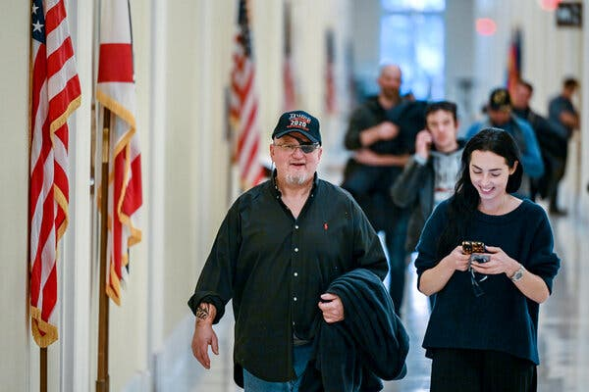

“Stewart Rhodes, convicted of seditious conspiracy and released by Trump, visits Capitol Hill. Stewart Rhodes, the far-right Oath Keepers extremist group founder convicted of seditious conspiracy in the Jan. 6, 2021 attack visited Capitol Hill Wednesday after he was released from prison [18 year sentence] as part of the President

Donald Trump’s sweeping clemency order for the more than 1,500 people charged in the riot. Rhodes was convicted of seditious conspiracy in one of the serious cases brought by the Justice Department in the siege that halted the certification of President Joe Biden’s victory and left more than 100 police officers injured. Rhodes was found guilty of orchestrating a weekslong plot that culminated in his followers attacking the U.S. Capitol in a desperate bid to keep Trump in power.” https://www.pbs.org/newshour/politics/stewart-rhodes-convicted-of-seditious-conspiracy-and-released-by-trump-visits-capitol-hill

***

Among those granted clemency were:
- Mark Ponder, who was prosecuted by Mr. Romano and sentenced to more than five years in prison for repeatedly attacking officers with wooden poles.
- Benjamen Burlew, who was prosecuted by Ms. Levine and pleaded guilty to grabbing an officer and trying to drag him into a crowd of rioters.
- Richard Barnett, who, in a case overseen by Mr. Gordon, was sentenced to more than four years in prison after being convicted of taking a stun gun to the Capitol and propping his feet on a desk in the office of then-Speaker Nancy Pelosi.
- Steven Cappuccio, who was sentenced to seven years in prison for tearing off the gas mask of Officer Hodges and hitting him in the face with his own baton — one of the scenes from Jan. 6 that Mr. Rosen said he would never forget.
https://www.nytimes.com/2025/08/24/nyregion/january-6-capitol-riot-prosecutors.html

Jan. 27, 2025 – Prosecutors Who Investigate Trump Fired

Justice Dept. Fires Prosecutors Who Worked on Trump Investigations
The termination of more than a dozen lawyers who worked with the special counsel, Jack Smith, came hours after the department’s most senior career official was reassigned. https://www.nytimes.com/2025/01/27/us/politics/justice-department-firings-trump-jack-smith.html

***

“One week after Inauguration Day, more than a dozen prosecutors were abruptly fired. The common thread: All had helped the special counsel, Mr. Smith, pursue two criminal cases against Mr. Trump — one examining his role in the efforts to reverse his defeat in the 2020 election, the other his mishandling of classified documents. Their dismissal letters claimed they could no longer be trusted to ‘faithfully implement’ the president’s agenda.” https://www.nytimes.com/2025/08/24/nyregion/january-6-capitol-riot-prosecutors.html

Feb. 25, 2025 – Ohio Bathroom Law – Student Restrooms / birth gender

“Importantly, Ohio Revised Code 3345.90 went into effect on Tuesday, February 25, requiring institutions of higher education to designate multi-occupant student restrooms, student locker rooms, student shower rooms, and student changing rooms, “for the exclusive use by students of the male biological sex only or by students of the female biological sex only.”

ORC 3345.90 - Single-sex facilities and accommodations
(2) No institution of higher education shall knowingly permit a member of the female biological sex to use a student restroom, locker room, changing room, or shower room that has been designated by the school for the exclusive use of the male biological sex. No institution of higher education shall knowingly permit a member of the male biological sex to use a student restroom, locker room, changing room, or shower room that has been designated by the school for the exclusive use of the female biological sex.
https://codes.ohio.gov/ohio-revised-code/section-3345.90#:~:text=male%20biological%20sex.-,No%20institution%20of%20higher%20education%20shall%20knowingly%20permit%20a%20member,of%20the%20female%20biological%20sex.

March 14, 2025: 100 Former D.C. Prosecutors – Letter Against Acting U.S. Attorney Ed Martin

“In 1801, John Thomson Mason, whose uncle was George Mason, a delegate to the
Constitutional Convention and the Father of the Bill of Rights, was nominated by President Thomas Jefferson to serve as the first United States Attorney for the District of Columbia. We are John Thomson Mason’s heirs and the heirs of 51 other men and women who have honorably and faithfully held that position for the past 224 years.
We speak in opposition to Edward Martin to be the next United States Attorney for the
District of Columbia.”
https://www.washingtonpost.com/documents/2ffee413-488d-49cc-9eac-93676f80aa19.pdf?itid=lk_inline_manual_16

May 8, 2025: Trump pulls the nomination of Ed Martin for DC US Attorney after concerns of partisanship. https://apnews.com/article/donald-trump-ed-martin-white-house-justice-department-thom-tillis-cecf801799faa2b56fd1bb4fac48379e

April 7, 2025: U.S. Supreme Court – Donald J. Trump v. J.G.G., et al. (5 to 4) https://www.supremecourt.gov/opinions/24pdf/24a931_2c83.pdf
DEPORTEES ENTITLED NOTICE / OPPORTUNITY TO CHALLENGE REMOVAL
“This matter concerns the detention and removal of Venezuelan nationals believed to be members of Tren de Aragua (TdA), an entity that the State Department has designated as a foreign terrorist organization. *** For all the rhetoric of the dissents, today’s order and per curiam confirm that the detainees subject to removal orders under the AEA are entitled to notice and an opportunity to challenge their removal. The only question is which court will resolve that challenge. For the reasons set forth, we hold that venue lies in the district of confinement. The dissents would have the Court delay resolving that issue, requiring—given our decision today—that the process begin anew down the road. We see no benefit in such wasteful delay.”

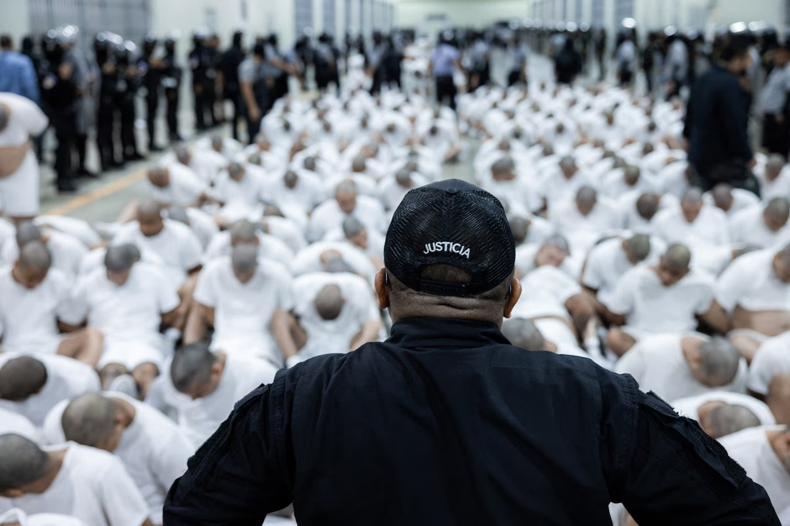Alleged members of the Venezuelan criminal organization Tren de Aragua are assembled at the Terrorism Confinement Center in Tecoluca, El Salvador. (El Salvador Presidential Press Office/AFP/Getty Images)

June 5, 2025: U.S. Supreme Court – Ames v. Ohio Department of Youth Services (9 to 0)

Discrimination against a “majority” plaintiff is also violation Title VII.

“The question in this case is whether, to satisfy that prima facie burden, a plaintiff who is a member of a majority group must also show’ ‘background circumstances to support the suspicion that the defendant is that unusual employer who discriminates against the majority.’ ” 87 F. 4th 822, 825 (CA6 2023) (per curiam). We hold that this additional ‘background circumstances’ requirement is not consistent with Title VII’s text or our case law construing the statute.” https://www.supremecourt.gov/opinions/24pdf/23-1039_c0n2.pdf

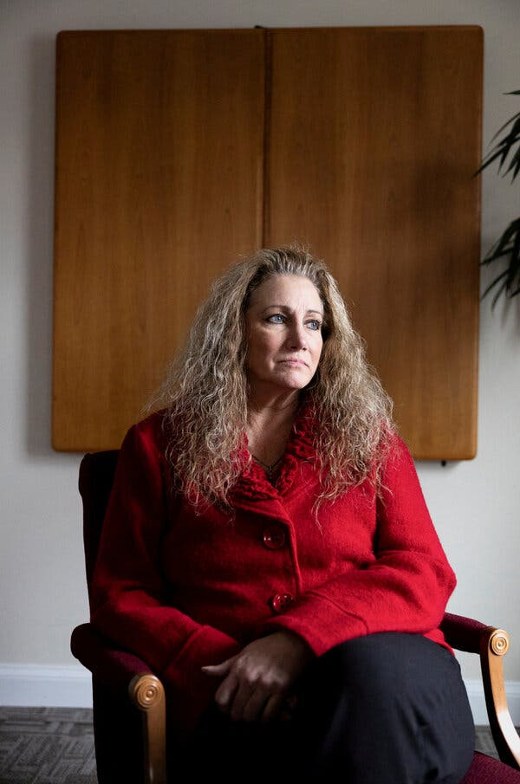 Marlean A. Ames

“Supreme Court Rules for Straight Woman in Job Discrimination Suit
The justices rejected an appeals court’s requirement that members of majority groups meet a heightened standard to win employment discrimination cases. *** The case was brought by Marlean A. Ames, who had worked for the Ohio Department of Youth Services, which oversees parts of the state’s juvenile corrections system. After a decade there, in 2014 she became the administrator of a program addressing prison rape. Five years later, she applied for a promotion. Her supervisors turned her down, saying she lacked vision and leadership skills. They eventually gave the position to a gay woman who had been at the department for a shorter time and, unlike Ms. Ames, lacked a college degree. Not long after denying her the new position, her supervisors removed her from her existing job, telling her that they had concerns about her leadership and offering her a demotion that came with a substantial pay cut. She was replaced by a gay man with less seniority.” https://www.nytimes.com/2025/06/05/us/politics/supreme-court-straight-woman-workplace-discrimination.html?algo=combo_lda_unique_triton_clicks_decay_96_50_ranks&fellback=false&imp_id=3537081671040738&pool=programmingnode%2F0dc6538b-a831-51be-a980-5597993fb6e2&req_id=230724380790231&surface=more-politics-news&variant=0_only_variant

June 20, 2025: U.S. SUPREME COURT – Stanley v. City of Sanford, Florida (6 to 3)
https://www.supremecourt.gov/opinions/24pdf/23-997_6579.pdf
Ms. Stanley sued, claiming the City violated the Americans with
Disabilities Act by providing different health-insurance benefits to
those who retire with 25 years of service and those who retire due to
disability. The district court dismissed her ADA claim, reasoning that
the alleged discrimination occurred after she retired, when she was not
a “qualified individual” under Title I of the ADA, 42 U. S. C. §12112(a),
because she no longer held or sought a job with the defendant. The
Eleventh Circuit affirmed.

June 23, 2025: U.S. SUP. CT – Department of Homeland Security v. D.V.D., et al. (7 to 2)
DEPORTATION INJUNCTION STAYED
On June 23, 2025, in Department of Homeland Security, et al. v. D.V.D., et al, the U.S. Supreme Court (7 to 2; Court Order – no Opinion) has set aside orders by U.S. District Court Judge Brian E. Murphy, Boston, of March 28, 2025 (temporary restraining order) and April 18, 2025 (preliminary injunction) against deporting some illegal aliens to South Sedan, since their home countries refused to accept them. THE COURT HELD: “The April 18, 2025, preliminary injunction of the United States District Court for the District of Massachusetts, case No. 25–cv–10676, is stayed pending the disposition of the appeal in the United States Court of Appeals for the First Circuit and disposition of a petition for a writ of certiorari, if such writ is timely sought. Should certiorari be denied, this stay shall terminate automatically. In the event certiorari is granted, the stay shall terminate upon the sending down of the judgment of the Court.” https://www.supremecourt.gov/opinions/24pdf/24a1153_l5gm.pdf

Two Dissenting Justices - Justice Sonia Sotomayor opinion, joined by Justice Elena Kagan:

“In matters of life and death, it is best to proceed with caution. In this case, the Government took the opposite approach. It wrongfully deported one plaintiff to Guatemala, even though an Immigration Judge found he was likely to face torture there. Then, in clear violation of a court order, it deported six more to South Sudan, a nation the State Department considers too unsafe for all but its most critical personnel. An attentive District Court’s timely intervention only narrowly prevented a third set of unlawful removals to Libya.

***
The Government thus openly flouted two court orders, including the one from which it now seeks relief. Even if the orders in question had been mistaken, the Government had
a duty to obey them until they were ‘reversed by orderly and proper proceedings.’ Maness, 419 U. S., at 459 (quoting United States v. Mine Workers, 330 U. S. 258, 293
(1947)). That principle is a bedrock of the rule of law. The Government’s misconduct threatens it to its core.

***
By rewarding lawlessness, the Court once again undermines that foundational principle. Apparently, the Court finds the idea that thousands will suffer violence in far flung locales more palatable than the remote possibility that a District Court exceeded its remedial powers when it ordered the Government to provide notice and process to which the plaintiffs are constitutionally and statutorily entitled. That use of discretion is as incomprehensible as it is inexcusable. Respectfully, but regretfully, I dissent.”

Note:

Here is the Injunction that was set aside in this case. On May 21, 2025, Judge Murphy issued an ORDER ON REMEDY FOR VIOLATION OF PRELIMINARY INJUNCTION.

“Each of the six individuals must be given a reasonable fear interview in private, with the opportunity for the individual to have counsel of their choosing present during the interview, either in-person or remotely, at the individual’s choosing. Each individual must be afforded access to counsel that is commensurate with the access that they would have received had these procedures occurred within the United States prior to their deportation, including remote access where in-person access would otherwise be available. Each individual must also be afforded the name and telephone number of class counsel, as well as access to a phone, interpreter, and technology for the confidential transfer of documents that is commensurate with the access they would receive were they in DHS custody within United States borders.” https://storage.courtlistener.com/recap/gov.uscourts.mad.282404/gov.uscourts.mad.282404.119.0_1.pdf

See also the June 23, 2025 Press Release: The U.S. Department of Homeland Security announcement it will immediately resume deportation flights – “Fire up the deportation planes.” https://www.supremecourt.gov/opinions/24pdf/24a1153_l5gm.pdf

BREAKING NEWS: “Universal injunctions” by Federal District Court judges have now been struck down by U.S. Supreme Court. The U.S. Supreme Court on June 26, 2025 stayed national-wide so-called “universal injunctions by three Federal District Court judges in MA, WA, MA in a case challenging President Trump’s executive order on citizenship by birth in United States. TRUMP, PRESIDENT OF THE UNITED STATES, ET AL. v. CASA, INC., ET AL. The Court (6 to 3) held that “These injunctions—known as ‘universal injunctions’—likely exceed the equitable authority that Congress has granted to federal courts. We therefore grant the Government’s applications to partially stay the injunctions entered below.” https://www.supremecourt.gov/opinions/24pdf/24a884_8n59.pdf

June 27, 2025 – Invasion of U.S. Capitol - Lead Prosecutor / Others Fired

“Michael Gordon, left, was dismissed as a federal prosecutor after he investigated the storming of the Capitol on Jan. 6, 2021, right…. Greg Rosen led the Justice Department’s Capitol Siege Section, the large task force that prosecuted the Jan. 6 rioters.”



“Reframing Jan. 6: After the Pardons, the Purge

“In its campaign of “uprooting the foot soldiers,” the Trump Justice Department has fired or demoted more than two dozen Jan. 6 prosecutors, even as those they sent to prison walk free.

***

One week after Inauguration Day, more than a dozen prosecutors were abruptly fired. The common thread: All had helped the special counsel, Mr. Smith, pursue two criminal cases against Mr. Trump — one examining his role in the efforts to reverse his defeat in the 2020 election, the other his mishandling of classified documents. Their dismissal letters claimed they could no longer be trusted to “faithfully implement” the president’s agenda. Four days later, about 15 junior prosecutors who had worked on Jan. 6 cases, including Ms. Levine, were also fired. Mr. Trump’s former personal lawyer, Emil Bove III, handpicked to help remold the Justice Department to the president’s liking, informed the fired lawyers that their employment “hindered” Mr. Martin from fulfilling his ‘obligation to faithfully implement the agenda that the American people elected President Trump to execute.’ (Mr. Trump has since appointed Mr. Bove to a lifetime seat as a federal appeals court judge.)

***

To date, the Justice Department has fired or demoted more than two dozen prosecutors who were assigned to hold the rioters accountable — roughly a quarter of the complement. Some were junior prosecutors, like Sara Levine, who had secured a guilty plea from a rioter who had grabbed a police officer. Others were veterans, including Greg Rosen, who had led the department’s Jan. 6 task force. Scores more prosecutors, involved in these and other cases, have left, either in fear of where the ax might next fall or out of sheer disgust.” https://www.nytimes.com/2025/08/24/nyregion/january-6-capitol-riot-prosecutors.html

June 27, 2025: Donald J. Trump v. Casa, Inc. et al. (6 t0 3)
https://www.courthousenews.com/wp-content/uploads/2025/06/trump-casa-opinion-scotus.pdf

Universal Injunctions – Congress has not granted federal courts authority to universally enjoin the enforcement of an executive order [including Trump birthright citizenship order].

“The injunctions before us today reflect a more recent development: district courts
asserting the power to prohibit enforcement of a law or policy against anyone. These injunctions—known as ‘universal injunctions’—likely exceed the equitable authority that Congress has granted to federal courts. Footnote 1: 1 Such injunctions are sometimes called ‘nationwide injunctions,’ reflecting their use by a single district court to bar the enforcement of a law anywhere in the Nation. But the term ‘universal’ better captures
how these injunctions work. …. The plaintiffs—individuals, organizations, and States—sought to enjoin the implementation and enforcement of President Trump’s Executive Order No. 14160.2 See Protecting the Meaning and Value of American Citizenship, 90 Fed. Reg. 8449 (2025). The Executive Order identifies circumstances in which a person born in the United States is not ‘subject to the jurisdiction thereof ‘ and is thus not recognized as an American citizen. See ibid. Specifically, it sets forth the ‘policy of the United States’ to no longer issue or accept documentation of citizenship in two scenarios: ‘(1) when [a] person’s mother was unlawfully present in the United States and the person’s father was not a United States citizen or lawful permanent resident at the time of said person’s birth, or (2) when [a] person’s mother’s presence in the United States was lawful but temporary, and the person’s father was not a United States citizen or lawful permanent resident at the time of said person’s birth.’ Ibid.”

***

“Trump asks Supreme Court to step in on birthright citizenship…. Birthright citizenship was explicitly added to the Constitution in 1868 when the 14th Amendment was adopted following the Civil War. That amendment provides that ‘[a]ll persons born or naturalized in the United States, and subject to the jurisdiction thereof, are citizens of the United States and of the State wherein they reside.’ The United States is one of roughly 30 countries, including neighboring Canada and Mexico, that offer automatic citizenship to everyone born there.” https://www.scotusblog.com/2025/03/trump-asks-supreme-court-to-step-in-on-birthright-citizenship/

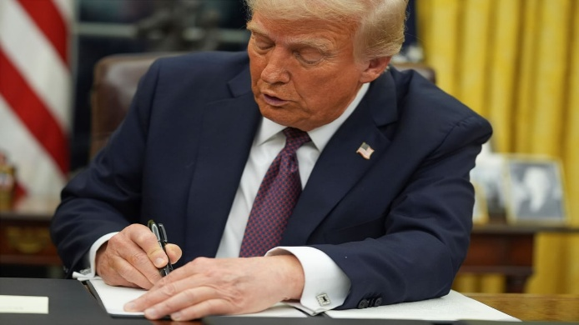 President Donald Trump signs an executive order on birthright citizenship in the Oval Office of the White House in Washington, Jan. 20, 2025.

Nov. 20, 2025: “Trump’s fight to redefine 'American citizen' returns to Supreme Court
After winning round one, President Trump wants the justices to tee up a final showdown on birthright citizenship. In a private session Friday, the Supreme Court will consider putting President Donald Trump’s bid to limit birthright citizenship back on the docket in 2026.
Last term, the policy was postscript to the conservative majority’s blockbuster ruling on universal injunctions — court orders that blocked limits on birthright citizenship nationwide. But if the justices give in to Trump’s updated request, they’ll be forced to confront the administration’s battle to recast citizenship and 150 years of history standing behind the core tenets of what it means to be an American….

The road to round two
After the justices’ 6-3 ruling in late June, a lower court kept Trump’s order from being enforced by certifying children who would be subjected to the policy into a class — a legal process that assesses the commonality between a group of people within a class action. Another court blocked the order within the states that have challenged the policy as unlawful.
An appeals court then ruled that Trump’s executive order unconstitutionally stripped the children of some individuals without legal status of their citizenship rights. The court noted that for over 150 years, the 14th Amendment has guaranteed citizenship to individuals born in the United States with very few exceptions.” https://courthousenews.com/trumps-fight-to-redefine-american-citizen-returns-to-supreme-court/

Opinion: Memo to Trump: Birthright citizenship is a constitutional right. Period. Trump and others argue against birthright citizenship. They’re mistaken.

By George F. Will
August 23, 2024
“In 1868, the Republican Party, then just 14 years old, produced what remains, 156 years later, its greatest accomplishment: the 14th Amendment. *** The issue is birthright citizenship. The amendment’s first sentence says: ‘All persons born or naturalized in the United States, and subject to the jurisdiction thereof, are citizens of the United States and of the state wherein they reside.’ The question is whether birthright citizenship is a constitutional mandate or a mere policy, albeit one sanctified by more than a century of practice. The correct answer is: a mandate. *** This endorsement was primarily for the benefit of African Americans: The citizenship clause repudiated the Supreme Court’s worst decision, Dred Scott v. Sandford, which in 1857 held that African Americans could not be citizens. The clause should, however, also be construed in the context of the American premise, which rejects the pre-modern politics of blood and tribalism. The premise is: Rights-bearing individuals are society’s molecular units. Their natural rights precede governments, which, as the Declaration of Independence proclaims, are instituted to ‘secure’ those rights. Individuals are endowed with a right to recognition of these rights regardless of where birth occurs. Birth on U.S. soil is entry into the community of persons subject to U.S. laws. The citizenship clause’s “subject to the jurisdiction” language was intended to exclude only a few categories of people — e.g., the children of foreign diplomats and tribal Native Americans (to whom Congress extended citizenship in 1924). Congress in 1868 could not, in expected application of the phrase, have contemplated the exclusion of children of illegal immigrants. This is because in 1868 there were none: Until 1875, there were no national immigration laws to violate.”
https://www.washingtonpost.com/opinions/2024/08/23/trump-birthright-citizenship-constitutional/

July 3, 2025: Deportation to South Sudan

DHS Releases Statement on SCOTUS Victory on Criminal Illegal Alien Deportations to South Sudan
https://www.dhs.gov/news/2025/07/03/dhs-releases-statement-scotus-victory-criminal-illegal-alien-deportations-south
These barbaric criminal illegal aliens will be in South Sudan by Independence Day
WASHINGTON – The Department of Homeland Security today released the following statement on the United States Supreme Court Decision to allow U.S. Immigration and Customs Enforcement (ICE) to remove eight barbaric, violent criminal illegal aliens to South Sudan.
“These sickos will be in South Sudan by Independence Day,” said Assistant Secretary Tricia McLaughlin. “A win for the rule of law, safety and security of the American people. We thank our brave ICE law enforcement for their sacrifice to defend our freedoms.”

Oct. 31, 2025: The Debate Dividing the Supreme Court’s Liberal Justices

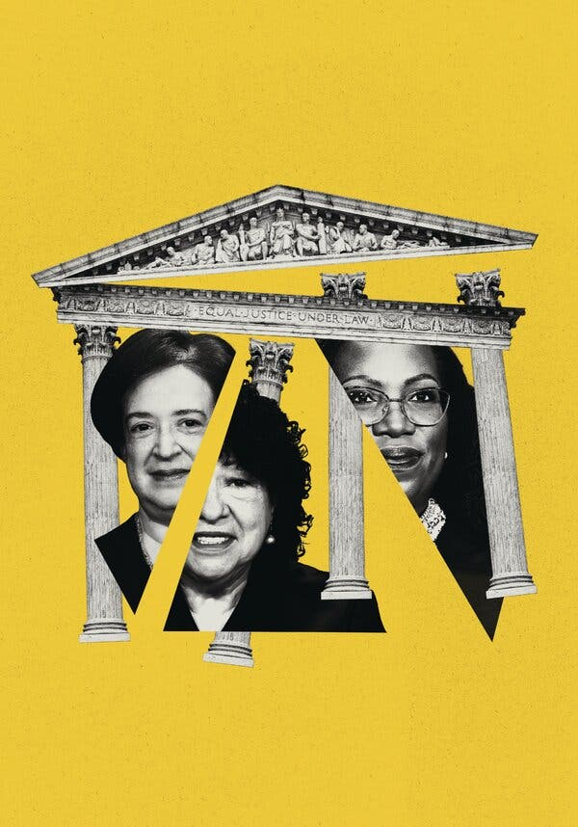

“Outnumbered and facing vast stakes, Justices Kagan and Jackson are split over the best approach: investing in diplomacy inside the court or sounding the alarm outside…. For years, as the court has moved right, Justice Kagan has agonized over whether to be more confrontational, confidantes say, and has mostly concluded that to be effective, she must be careful about rocking the boat. But in recent months, Justice Kagan’s liberal colleague, Justice Ketanji Brown Jackson, has started warning the public that the boat is sinking. In one opinion after another, Justice Jackson has accused the right side of the court of favoring “moneyed interests,” and of “complicity” that enables “our collective demise.” At oral arguments, she has taken up far more speaking time than her colleagues, even though the court several years ago tucked timers into the justices’ imposing wood table to tally each of their ticking minutes, according to several people familiar with the devices.” https://www.nytimes.com/2025/10/31/us/politics/supreme-court-kagan-jackson-liberal-justices.html?nl=The+Morning

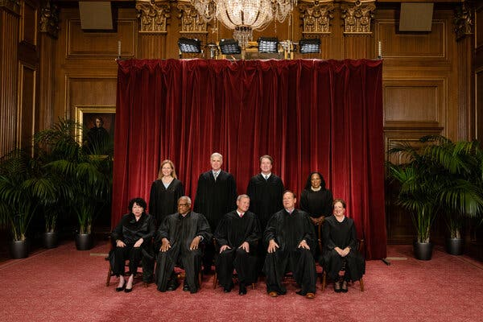

Justice Ketanji Brown Jackson, at the far right of the back row, joined the Supreme Court in 2022 as the third liberal justice.

Nov. 6, 2025: U.S. Supreme Court – Donald J. Trump v. Ashton Orr (6 to 3)

GOVERNMENT CAN REQUIRE PASSPORTS TO LIST SEX AT BIRTH

DONALD J. TRUMP, PRESIDENT OF THE UNITED
STATES, ET AL . v. ASHTON ORR, ET AL.
ON APPLICATION FOR STAY
“This case concerns an Executive Branch policy requiring all new passports to display an individual’s biological sex at birth. The United States District Court for the District of
Massachusetts preliminarily enjoined the Government from enforcing the policy, and the First Circuit declined to stay the injunction pending appeal. The Government then filed this stay application. Applying our familiar stay factors at this preliminary stage, we grant the application. Displaying passport holders’ sex at birth no more offends equal protection principles than displaying their country of birth—in both cases, the Government is merely attesting to a historical fact without subjecting anyone to differential treatment.”

***
Dissent: J USTICE J ACKSON, with whom JUSTICE SOTOMAYOR and
J USTICE KAGAN join, dissenting from the grant of application for stay….
For the past 33 years, across six Presidential administrations, transgender Americans have been able to obtain U. S. passports with sex markers that match their gender identity. From 1992 to 2010, passport applicants who wished to obtain passports with sex markers that were different from the sex assigned to them at birth had to submit
evidence of surgical reassignment. In 2010, the State Department began allowing passport applicants to submit a doctor’s certification avowing that they had undergone clinical treatment for gender transition. Beginning in 2021, the State Department allowed applicants to self-select the sex marker that matched their gender identity…. On January 22, 2025, the agency overhauled the rules for sex markers on passports, reverting to its pre-1992 practices. Its Passport Policy now requires that all new passports reflect the holders’ sex assigned at birth. Why? Because two days earlier, on January 20, President
Trump issued Executive Order No. 14168, characterizing transgender identity as ‘false’ and ‘corrosive’ to American society. 90 Fed. Reg. 8615 (2025).” … Thus, by preventing transgender Americans from obtaining gender-congruent passports, the Government is doing more than just making a statement about its belief that transgender identity is ‘false.’ The Passport Policy also invites the probing, and at times humiliating, additional scrutiny these plaintiffs have experienced. Given this, it is no surprise that each of the plaintiffs credibly testified that they would experience significant anxiety and fear for their safety if required to use passports that reflect their sex assigned at birth rather than their gender identity. https://www.supremecourt.gov/opinions/25pdf/25a319_i4dj.pdf

Nov. 9, 2025

“Why I Am Resigning.”
A federal judge explains his reasoning for leaving the bench.

By Mark L. Wolf
https://www.theatlantic.com/ideas/2025/11/federal-judge-resignation-trump/684845/?gift=vf1DGKhD1xBHQ3siCRuAVcz-qxehhrT47kEa20qvhPE&utm_source=copy-link&utm_medium=social&utm_campaign=share

About the Author
Mark L. Wolf is a retired senior United States district judge in Massachusetts.
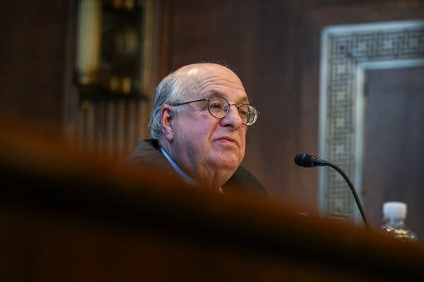

I was 38 years old. At the time, I looked forward to serving for the rest of my life. However, I resigned Friday, relinquishing that lifetime appointment and giving up the opportunity for public service that I have loved.
My reason is simple: I no longer can bear to be restrained by what judges can say publicly or do outside the courtroom. President Donald Trump is using the law for partisan purposes, targeting his adversaries while sparing his friends and donors from investigation, prosecution, and possible punishment. This is contrary to everything that I have stood for in my more than 50 years in the Department of Justice and on the bench. The White House’s assault on the rule of law is so deeply disturbing to me that I feel compelled to speak out. Silence, for me, is now intolerable.

When I accepted the nomination to serve on the U.S. District Court in Massachusetts, I took pride in becoming part of a federal judiciary that works to make our country’s ideal of equal justice under law a reality. A judiciary that helps protect our democracy. That has the authority and responsibility to hold elected officials to the limits of the power delegated to them by the people. That strives to ensure that the rights of minority groups, no matter how they are viewed by others, are not violated. That can serve as a check on corruption to prevent public officials from unlawfully enriching themselves. Becoming a federal judge was an ideal opportunity to extend a noble tradition that I had been educated by experience to treasure.

My public service began in 1974, near the end of Richard Nixon’s presidency, at a time of dishonor for the Department of Justice. Nixon’s first attorney general, John Mitchell, who had also been the president’s campaign manager, later went to prison for his role in the break-in at the Democratic headquarters at the Watergate complex and for perjury in attempting to cover up that crime. His successor, Richard Kleindienst, was convicted of contempt of Congress for lying about the fact that, as instructed by the president, he’d ended an antitrust investigation of a major company after it pledged to make a $400,000 contribution to the Republican National Convention. The Justice Department was also discredited by revelations that FBI Director J. Edgar Hoover had obtained and disseminated derogatory information about political adversaries, including Martin Luther King Jr.

I joined the Department of Justice as a special assistant to the honest and able Deputy Attorney General Laurence Silberman. Soon after, in 1975, President Gerald Ford named Edward Levi as attorney general to restore confidence in the integrity of the department. Levi, then the president of the University of Chicago, had a well-deserved reputation for brilliance, honesty, and nonpartisanship. Ford told Levi that he wanted the attorney general to “protect the rights of American citizens, not the President who appointed him.”

I organized Levi’s induction ceremony and was there when he declared that “nothing can more weaken the quality of life or more imperil the realization of the goals we all hold dear than our failure to make clear by word and deed that our law is not an instrument of partisan purpose.” For the next two years I served as one of Levi’s special assistants, working closely with a man who was always faithful to this principle.

With Levi as my model, in 1981 I became the deputy United States attorney and chief federal prosecutor of public corruption in Massachusetts. In about four years, my assistants and I won more than 40 consecutive corruption cases.
Many convictions were of defendants close to the powerful mayor of Boston at the time. As a result, I received the Attorney General’s Distinguished Service Award and was appointed a federal judge.

Some of the cases over which I presided as judge involved corruption and were highly publicized. Most notable was the prosecution of the notorious Boston mobsters James “Whitey” Bulger and Stephen “the Rifleman” Flemmi. Both, it turned out, were also FBI informants. Agents in the bureau, I discovered, were involved in crimes and egregious misconduct, including murders committed by Bulger and Flemmi. I wrote a 661-page decision detailing my findings. This led to orders that the government pay more than $100 million to the families of people murdered by informants whom the FBI had improperly protected. Their FBI handler was convicted twice and sentenced to serve a total of 50 years in prison.

I also presided over a six-week trial of a former speaker of the Massachusetts House of Representatives. After he was convicted of demanding and accepting bribes, I sentenced him to serve eight years in prison.
I decided all of my cases based on the facts and the law, without regard to politics, popularity, or my personal preferences. That is how justice is supposed to be administered—equally for everyone, without fear or favor. This is the opposite of what is happening now.

As I watched in dismay and disgust from my position on the bench, I came to feel deeply uncomfortable operating under the necessary ethical rules that muzzle judges’ public statements and restrict their activities. Day after day, I observed in silence as President Trump, his aides, and his allies dismantled so much of what I dedicated my life to.

When I became a senior judge in 2013, my successor was appointed, so my resignation will not create a vacancy to be filled by the president. My colleagues on the United States District Court in Massachusetts and judges on the lower federal courts throughout the country are admirably deciding a variety of cases generated by Trump’s many executive orders and other unprecedented actions. However, the Supreme Court has repeatedly removed the temporary restraints imposed on those actions by lower courts in deciding emergency motions on its “shadow docket” with little, if any, explanation. I doubt that if I remained a judge I would fare any better than my colleagues.

Others who have held positions of authority, including former federal judges and ambassadors, have been opposing this government’s efforts to undermine the principled, impartial administration of justice and distort the free and fair functioning of American democracy. They have urged me to work with them. As much as I have treasured being a judge, I can now think of nothing more important than joining them, and doing everything in my power to combat today’s existential threat to democracy and the rule of law.

What Nixon did episodically and covertly, knowing it was illegal or improper, Trump now does routinely and overtly. Prosecutorial decisions during this administration are a prime example. Because even a prosecution that ends in an acquittal can have devastating consequences for the defendant, as a matter of fairness Justice Department guidelines instruct prosecutors not to seek an indictment unless they believe there is sufficient admissible evidence to prove guilt beyond a reasonable doubt.

Trump has utterly ignored this principle. In a social-media post, he instructed Attorney General Pam Bondi to seek indictments against three political adversaries even though the officials in charge of the investigations at the time saw no proper basis for doing so. It has been reported that New York Attorney General Letitia James was prosecuted for mortgage fraud after Deputy Attorney General Todd Blanche, one of Donald Trump’s former criminal-defense lawyers, questioned the legal viability of bringing charges against James. Former FBI Director James Comey was charged after the interim U.S. attorney who had been appointed by Trump refused to seek an indictment and was forced to resign. Senator Adam Schiff, the third target of Trump’s social-media post, has yet to be charged.

Trump is also dismantling the offices that could and should investigate possible corruption by him and those in his orbit. Soon after he was inaugurated, Trump fired, possibly unlawfully, 18 inspectors general who were responsible for detecting and deterring fraud and misconduct in major federal agencies. The FBI’s public-corruption squad also has been eliminated. The Department of Justice’s public-integrity section has been eviscerated, reduced from 30 lawyers to only five, and its authority to investigate election fraud has been revoked.

The Department of Justice has evidently chosen to ignore matters it would in the past have likely investigated. Some directly involve the president. It has been reported that at a lavish April 2024 dinner at Mar-a-Lago, after executives from major oil companies complained about how the Biden administration’s environmental regulations were hurting their businesses, Trump said that if they raised $1 billion for his campaign he would promptly reverse those rules and policies. The executives raised the money, and Trump delivered on his promise. The law may be unclear concerning whether Trump himself could have been charged with conspiracy to bribe a public official or honest-services fraud. In addition, Trump himself may have immunity from prosecution if similar payments for his benefit continued after he became president. However, the companies that made the payments, and the individuals acting for them, could possibly be prosecuted. There is no public indication that this matter has been investigated by Trump’s Department of Justice.

As a prosecutor and judge I dealt seriously with the unlawful influence of money on official decisions. However, Trump and his administration evidently do not share this approach. After Trump launched his own cryptocurrency, $TRUMP, his Department of Justice disbanded its cryptocurrency-enforcement unit. The top 220 buyers of Trump’s cryptocurrency were invited to a dinner with Trump. Sixty-seven of them had invested more than $1 million. The top spender, Justin Sun, who was born in China and is a foreign national, reportedly spent more than $10 million. Sun also reportedly spent $75 million on investments issued by a crypto company controlled by Trump’s family. It is illegal for people who are not U.S. citizens to donate to American political candidates, and the most that anyone can donate directly to one candidate is $3,500. Ordinarily, the Department of Justice would investigate this sort of situation. There is, however, no indication that any investigation has occurred. Rather, a few months after Sun started purchasing tokens from the Trump-family cryptocurrency company, the Securities and Exchange Commission paused its fraud suit against Sun and his companies pending the outcome of settlement negotiations. (Sun and his companies have denied any wrongdoing.)

Trump is not the only member of his administration whose conduct is apparently shielded from investigation. In September of last year, Tom Homan, who became Trump’s “border czar,” reportedly was recorded accepting $50,000 in cash in return for a promise to use his potential future public position to benefit a company seeking government contracts. The FBI had created the fictitious company as part of an undercover investigation. Typically, an investigation of that sort would have continued after Homan became a Department of Homeland Security official, with the FBI seeking any additional evidence of bribery. However, after Trump took office, the investigation was shut down, with the White House claiming there was no “credible evidence” of criminal wrongdoing. Weeks after the FBI investigation was reported, Homan denied taking $50,000 “from anybody” and has said he did “nothing criminal.” An honest investigation could reveal who is telling the truth.

There is also the matter of Trump’s executive orders. A good number are, in my opinion, unconstitutional or otherwise illegal. For example, contrary to the express language of the Fourteenth Amendment, one order declares that not everyone born in this country is a U.S. citizen. Trump’s administration also has deported undocumented immigrants without due process, in many cases to countries where they have no connections and will be in great danger. Although many federal judges have issued orders restraining the government’s effort to implement those executive orders, some appear to have been disobeyed by members of the Trump administration. Trump has responded by calling for federal judges to be impeached, even though the Constitution permits impeachment only for “high crimes and misdemeanors,” such as treason and bribery.

Trump’s angry attacks on the courts have coincided with an unprecedented number of serious threats against judges. There were nearly 200 from March to late May 2025 alone. These included credible death threats, hundreds of vitriolic phone calls, and anonymous, unsolicited pizza deliveries falsely made in the name of the son of a federal judge, who was murdered in the judge’s home in 2020 by a disgruntled lawyer.

Over the past 35 years I have spoken in many countries about the role of American judges in safeguarding democracy, protecting human rights, and combatting corruption. Many of these countries—including Russia, China, and Turkey—are ruled by corrupt leaders who rank among the worst abusers of human rights. These kleptocrats jail their political opponents, suppress independent media that could expose their wrongdoing, forbid free speech, punish peaceful protests, and frustrate every effort to establish an independent, impartial judiciary that could constrain these abuses. These kleptocrats have impunity in their countries because they control the police, prosecutors, and courts.

In my work around the world, I have made many friends, young and old, who have been inspired by the example of American judges, lawyers, and citizens. They have suffered greatly for trying to make their countries more like ours. Among them are impartial judges who have been imprisoned in Turkey, a brilliant young Russian lawyer who was alleged to be a spy and forced into exile, and a Venezuelan law student who almost lost sight in one eye while protesting his country’s oppressive government. They courageously share what have historically been our nation’s convictions. These brave people inspire me.

I resigned in order to speak out, support litigation, and work with other individuals and organizations dedicated to protecting the rule of law and American democracy. I also intend to advocate for the judges who cannot speak publicly for themselves.

I cannot be confident that I will make a difference. I am reminded, however, of what Senator Robert F. Kennedy said in 1966 about ending apartheid in South Africa: “Each time a man stands up for an ideal, or acts to improve the lot of others, or strikes out against injustice, he sends forth a tiny ripple of hope.” Enough of these ripples can become a tidal wave.
And as Nobel Laureate Seamus Heaney wrote, sometimes the “longed-for tidal wave of justice can rise up, and hope and history rhyme.” I want to do all that I can to make this such a time.

Nov. 19, 2025 – National Guard – Injunctions – Chicago; Portland, Oregon

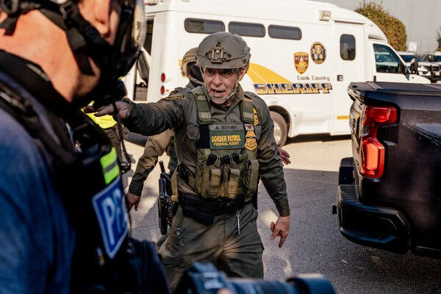Gregory Bovino, a senior official with the Border Patrol, telling demonstrators to clear a driveway used to transport detainees outside an immigration processing center in Broadview, Ill.

“The federal crackdown on illegal immigration that began in the Chicago area in early September goes on, though it has been tamped down somewhat by the courts. Before he departed, Mr. Bovino and federal agents that included Border Patrol personnel had in recent weeks taken some of the most aggressive actions yet. A federal judge condemned agents for using unnecessary force that included using tear gas and pepper spray against Chicago residents without giving them proper warning, and for pointing guns at civilians who were not a physical threat. The judge also said Mr. Bovino had lied to her about his tactics. The Justice Department argued that the tactics were justified because some protesters had become violent.
President Trump has sought to deploy National Guard troops from Illinois and Texas to the city, too, but that effort remains tied up in the courts. Last weekend, the federal government said it was sending 200 Texas National Guard troops back home who had yet to be deployed on Chicago streets….

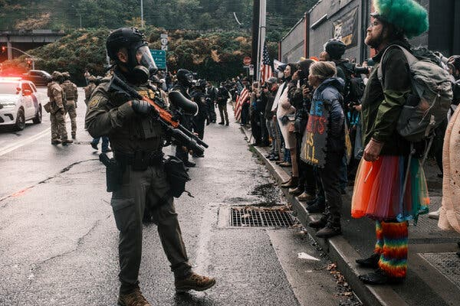Federal agents facing protesters in front of an ICE facility in Portland, Ore., in October.

The Trump administration ramped up its immigration enforcement in the city around June, and a small but persistent group of protesters has held daily demonstrations outside Portland’s ICE building ever since. Skirmishes with the authorities led to the closing of that building for more than three weeks at one point, according to the Department of Homeland Security, but protests had largely fizzled by September. Late that month, however, Mr. Trump tried to send National Guard troops to the city, saying that the ICE building and federal workers there needed to be protected from ‘war-ravaged Portland.’ Portland and Oregon sued, and a federal judge this month issued a permanent block on the deployment. The administration is appealing. Over the weekend, the Pentagon said that it was going to send home about 200 California National Guard troops who had been sent to Portland but never deployed on the streets. About 100 Oregon National Guard troops remain under federal control and on standby.
https://www.nytimes.com/2025/11/18/us/trump-immigration-raids.html?nl=The+Morning

Dec. 10, 2025: “Judge blocks Trump's National Guard deployment in LA with sharp rebuke. The Trump Administration must end its deployment of the National Guard to Los Angeles and return control of the troops to the state, according to a ruling by U.S. District Judge Charles Breyer in San Francisco. Judge Breyer granted a preliminary injunction to California officials who opposed President Trump's use of state troops since June, when the administration seized control of the guard — against Governor Gavin Newsom's wishes — to confront protests against immigration enforcement operations in Los Angeles. The Trump administration filed an appeal on Thursday.” https://www.npr.org/2025/12/10/nx-s1-5639822/national-guard-la-court-judge-trump

Dec. 10, 2025: FEMA
“Exclusive: Trump’s FEMA council to recommend dramatic downsizing and overhaul – but not elimination – of the agency.” https://www.cnn.com/2025/12/10/politics/fema-council-report-recommend-downsizing-overhaul

Dec. 30, 2025: 15 Prisoners From 9/11 Still At Guantanamo Bay, Cuba

“It is part of a Red Cross program that allows detainees in the war against terrorism to communicate with their families through prison-reviewed letters and cards. These protections are outlined in the Geneva Conventions, the international law governing warfare. All 15 prisoners at Guantánamo have had access to the program, which began allowing photos in 2009…. The collection of photos offers a curated view of life today in detention at the Navy outpost where the United States has held about 780 men and boys in the war against terrorism since 2002. Just 15 prisoners remain.”
https://www.nytimes.com/2025/10/23/us/politics/guantanamo-prisoners-portraits.html?nl=The+Morning&segment_id=212909


Khalid Shaikh Mohammed, who is accused of hatching the 9/11 plot that killed nearly 3,000 people, appears in a recent photo in a pressed white robe, his beard dyed.



“In one photo taken in 2024, Abu Zubaydah looks as if he walked out of a yachting magazine, not a prison cell. A black patch he sometimes wears over a false eye, worn around his neck, suggests a cravat…. Abu Zubaydah was the first person to be waterboarded by the C.I.A. and the first prisoner to be held in a secret overseas detention program that was set up by the Bush administration to interrogate prisoners after the Sept. 11 attacks. He has never been tied to the Sept. 11 plot, but he claimed to run a jihadist movement that rivaled Al Qaeda and has been assessed by a U.S. national security panel as too dangerous to release.”

Dec. 31, 2025: Trump Abandons Efforts to Deploy National Guard to 3 Major Cities

“The troops had nearly no presence in two of the cities, Portland and Chicago. But the decision signaled a retreat, at least for now, in one of the president’s most audacious attempts to test his power…. President Trump said on Wednesday that he would abandon, for now, efforts to deploy the National Guard in Chicago, Los Angeles and Portland, Ore.
The decision comes after the Supreme Court ruled last week that Mr. Trump could not deploy troops in the Chicago area over the objections of Illinois officials. The president’s announcement made no mention of the ruling, but he suggested his administration would not hesitate to deploy troops in the future.” https://www.nytimes.com/2025/12/31/us/politics/trump-national-guard.html?nl=The+Morning&segment_id=212982

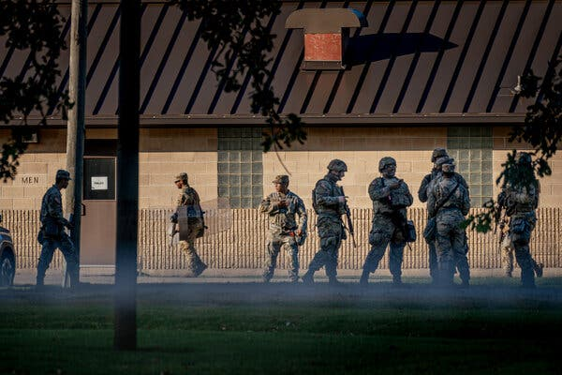Members of the Texas National Guard at a U.S. Army Reserve Training Center in Elwood, Ill., a suburb of Chicago, in October.

See also Professor Bennett’s Dec. 28. 2025 article.

HOMELAND SECURITY TODAY - COLUMN: Supreme Court Blocks National Guard Deployment to Chicago, Restricts Presidential Power Under Title 10
Landmark ruling reshapes federal authority and strengthens governors’ control over National Guard deployments. https://www.hstoday.us/us-national-guard/column-supreme-court-blocks-national-guard-deployment-to-chicago-restricts-presidential-power-under-title-10/

January 3, 2026 – Venezuela - Nicolás Maduro Captured, Flown To NYC

“In 2025, President Donald Trump began a military buildup against Venezuela, accusing Maduro of supporting drug traffickers, which the Venezuelan president denied. In the early hours of January 3, 2026, U.S. forces attacked Venezuela’s capital city of Caracas in a large scale operation to capture Maduro and his wife, Cilia Flores. The two were swiftly flown out of the country, with Maduro facing charges in the Southern District of New York of narco-terrorism, cocaine trafficking, and conspiracy to possess machine guns and destructive devices against the U.S.” https://www.britannica.com/biography/Nicolas-Maduro/Attempts-to-remove-Maduro-from-office

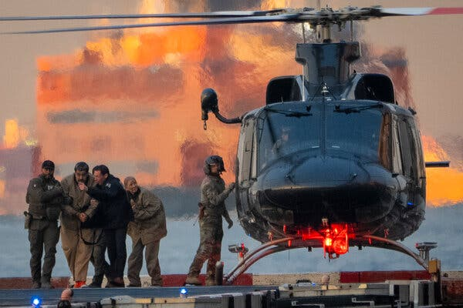
Nicolás Maduro, the ousted leader of Venezuela, and his wife, Cilia Flores, before their arraignment in New York City in January. The New York Times

April 5, 2026: U.S. Air Force Officer – Shot Down Over IRAN – RESCUED

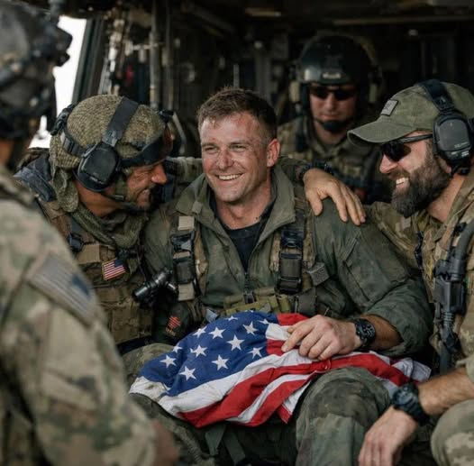

April 6, 2026 – U.S. Supreme Court - Former Cincinnati Councilman PG Sittenfeld Conviction Set Aside

Public corruption – must prove money was for “official acts”

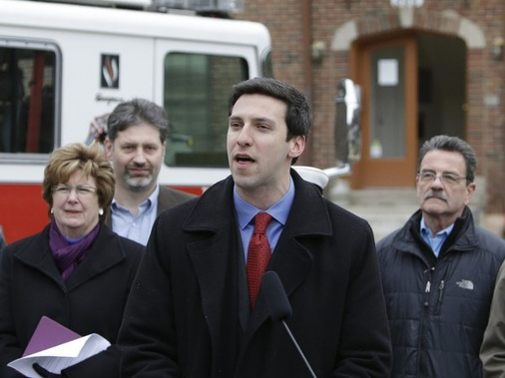

Watch this TV VIDEO: In 2018, FBI agents secretly record former Cincinnati city councilman P.G. Sittenfeld, recordings released
https://www.youtube.com/watch?v=dUyEke_XyPA

U.S. Supreme Court – Orders List - April 6, 2026
https://www.supremecourt.gov/orders/courtorders/040626zor_5iek.pdf

SITTENFELD, ALEXANDER V. UNITED STATES
The petition for a writ of certiorari is granted. The
judgment is vacated, and the case is remanded to the United
States Court of Appeals for the Sixth Circuit for further
consideration in light of the pending motion to dismiss the
indictment.

April 7, 2026: U.S. Supreme Court Overturns PG Sittenfeld Corruption Conviction. https://www.cleveland.com/news/2026/04/us-supreme-court-overturns-pg-sittenfeld-corruption-conviction.html
“The U.S. Supreme Court on Monday granted federal prosecutors’ request to overturn ex-Cincinnati City Councilman PG Sittenfeld’s corruption conviction, opening the door for a lower court to dismiss his case given that President Donald Trump pardoned him last year.
The ruling marks what could be the first time in U.S. Supreme Court history that the nation’s high court accepted an appeal from a defendant who had already received a presidential pardon for a criminal conviction….

Sittenfeld, a 2016 Democratic U.S. Senate candidate, was convicted in 2023 of bribery and attempted extortion after accepting $20,000 from undercover FBI agents in exchange for lining up votes for a Cincinnati development project.
Sittenfeld pleaded innocent, arguing – among other things – that the $20,000 was a political contribution that he had a right to accept under the First Amendment.”

Discuss when an elected official can accept campaign contributions from individuals seeking to do business with that official’s political subdivision. Before you answer, read the below note.

Note: In 2016, the Supreme Court clarified the boundaries of federal political corruption statutes in McDonnell v. United States, in which it examined which actions taken by public officials could be considered “official acts.” The federal bribery statute, 18 U.S.C. § 201, makes it a crime for a public official to "receive or accept anything of value" in exchange for being "influenced in the performance of any official act."

McDonnell v. United States:
Facts of the case.
https://www.oyez.org/cases/2015/15-474
On November 3, 2009, Robert F. McDonnell was elected Governor of Virginia. At the time of his election, he and his family were experiencing economic difficulties; by September 2010, he and his wife had a combined credit card balance of $90,000, and by 2012 the business he and his sister operated had a loan balance of $2.5 million. Shortly after his election, McDonnell met with Jonnie Williams, the founder and CEO of Star Scientific, Inc. (Star), which was trying to market a product called Anatabloc that could be used to treat chronic inflammation. Star wanted the Food and Drug Administration to classify Anatabloc as a pharmaceutical, which would be more profitable than the alternative classification of nutraceutical. However, such a classification would require expensive testing, clinical trials and studies, and Star lacked the funds. Between 2009 and 2012, Williams and McDonnell met several times and agreed that “independent testing [of Anatabloc] in Virginia was a good idea.” Williams also provided expensive gifts to the McDonnells and “was willing to help” with their financial troubles. A launch event for Anatabloc was held at the Governor’s Mansion, and Mrs. McDonnell facilitated meetings between Star officials and officials at the University of Virginia and Virginia Commonwealth University to get the studies started. Mrs. McDonnell also purchased, sold, and gifted Star stock in such as way as to avoid reporting requirements, and McDonnell spoke to various government officials about the benefits of Anatabloc.

The McDonnells were eventually arrested and charged for corruption, under federal statutes that make it a felony to take “official action” in exchange for money, campaign contributions, or any other thing of value. On September 4, 2014, McDonnell was found guilty on 11 counts of corruption. McDonnell appealed his conviction and argued that the jury instructions given at trial did not properly define the term “official action.” The U.S. Court of Appeals for the Fourth Circuit affirmed his conviction and held that the jury instructions in question were adequate.

Conclusion

An “official act” is a decision or action on a question, matter, cause, suit, proceeding, or controversy that involves a specific exercise of formal governmental power. Chief Justice John G. Roberts, Jr. delivered the opinion for the unanimous Court. The Court held that arranging a meeting, contacting another official, or hosting an event -- on its own -- is not sufficient to rise to the level of an “official act” for the purpose of federal bribery statutes. This more limited reading of the statutory text gives each word a meaning that is proper in context and not superfluous, which is the best reading of the statute. Additionally, previous Supreme Court precedent has established that the existence of matters pending before a government official was not sufficient to find that any action related to those matters constituted an “official act.” Adopting a broader reading of the statutory language would likely chill public officials’ interactions with their constituents due to fears of prosecution and therefore make it more difficult for them to do their jobs. Based on this interpretation of the statutory language, the jury instructions at issue were impermissibly broad and did not provide enough guidance to the jury regarding whether the actions in question needed to be formal exercises of governmental power. Therefore, the conviction was vacated.

