“Then I am Praying”: War, Religion, and Shared Suffering in the Pechstein and Kollwitz Prints at the University of Cincinnati Art Collection

Shannon O’Deens
Professor Platts
Senior Seminar
April 20, 2022

The University of Cincinnati Art Collection houses prints by two early 20th century German Expressionist printmakers, Max Pechstein (1881-1955) and Käthe Kollwitz (1867-1945). Pechstein’s Das Vater Unser (The Lord’s Prayer) series (1921) originally a portfolio of twelve, is represented in the University of Cincinnati Art Collection with nine of the bold woodcut prints. Kollwitz’s small postcard lithographs, Two Chatting Women with Two Children (c. 1930) and The Hospital Visit (c. 1926), are intimate and show the artists soft touch. Though formally very different, these prints share a common subject, the suffering of Germans during the interwar period (1918-1939). Both artists personally experienced both World Wars and their tragedies, and while Pechstein rarely addressed it directly, Kollwitz’s career was full of her antiwar sentiments. The prints grapple with the grief, political turmoil, and financial difficulties associated with the interwar period and each artist turns to their own form of religion to exercise their pain.
The nine Pechstein prints in the Collection (Figures 1-9) are visually powerful woodcuts with hand coloring. While mostly black, the white of the paper is used throughout the series to create otherworldly moments of concentrated light. A few key moments of color occur in each print, illuminating figures, depicting God’s power, or emphasizing importance. Red, yellow, and brown are washed on figures or objects. The coloring is not very precise and from examples of the prints in other collections, we know that Pechstein changed the colors he was using or left the uncolored all together. The prints are bold and linear depicting religious subjects in both figural and symbolic ways.
Each print is named after a verse in the Lord’s Prayer and depicts humans praying or begging for deliverance. Some also depict personifications of God, the Trinity, and divine power. Hands are an important motif in this series. They are seen praying, begging, reaching out. In figures 8 and 9 we can particularly see the importance of hands. They are depicted wielding power in the form of light. Often the figures are contorted to fit in the confines of the sheet, as if their power and presence needed more space. The abundance of figures in prints like Und vergieb uns Unsre Schuld (And forgive us our debts) (figure 6) also lends to the importance and scale at which God is depicted. Surrounded by men, God is huge and fills a large portion of the page. The verses of the prayer are scattered around the compositions as if to lead the viewer in devotion. The print, Geheilliget Werde Dein Name (Hallowed Be Thy Name) (figure 3), shows three female figures floating or maybe falling in space as they shout and pray to the heavens. Most of the figures in the series are men, but these three women make up an entire print of their own. (The only other women to appear is the mother in Demm Dein ist das Reich (figure 4) and the nude woman in Und fuhre uns nicht in Versuchung (And lead us not into temptation)(figure 13))
The three missing prints and portfolio cover (figures 10-13), contain more examples of these motifs. The importance of light, for example, is depicted in Dein Reich komme Dein Wille geschehe Wie im Himmel also auch auf Erden (Thy kingdom come Thy will be done on earth as it is in heaven) with the heavens opening up. While the prints work beautifully together, they are each individualized well and can elicit emotion all on their own. The prints are bold and commanding. Pechstien’s choice to make the prints woodblock lends to a simplicity of form and striking angular elements that make up the images. The simplicity makes them feel familiar and inspires contemplation. They demand one’s attention, insist on sharing their message.
Though well known as one of the early German Expressionists, Pechstein was considered a more decorative artist than his peers. This series of prints marked a shift in his oeuvre where he to joined his fellow Expressionists in highly emotional work. Much of the German Expressionist work at the time was dark and arresting. They were facing dark times and their work reflected it. Art historian Alicia Faxon writes that Pechstein and his contemporaries created prints whose, “subjects were interpreted expressively, not literally, and alluded to the universal condition of humanity rather than being primarily illustrational.”
The style of the prints reflects Pechstein’s interest in “Primitivism” which is reflected in his other secular prints. “Primitivism” was an artistic movement that rose out of colonialism which attempted to recreate the “simplicity” and “otherness” of non-western art, often fetishizing these cultures. Pechstein’s short lived excursion to the South Pacific island of Palau in 1914, then a German territory, informed his work for the rest of his life. His trip, however, was cut short by the outbreak of World War I. In the early months of the war the island was seized by Japan, and Pechstein was interned as a prisoner before returning to Germany to serve in the military. His sketches and writings made in Palau in the months before the war would be revisited in 1917 after the end of the war. Pechstein was a member of the Social Democratic Party (SPD) that believed in neocolonialism. Germany had its territories stripped from it as a part of the Treaty of Versailles (1919). Pechsteins work in the late 1910s intended to visually restore the power associated with German colonialism. The geometric and abstracted nature of the prints in the Das Vater Unser series illustrate this influence on Pechstein’s art style. One of the prints in the series, that is not in the University of Cincinnati Art Collection, Und fuhre uns nicht in Versuchung (figure 13), is recognizably primitivist in its sexualization of a nude woman and the demonization of dark mask-like figures in the background. This print may be a depiction of Adam and Eve which is possibly indicated by the snake that slithers between the man and woman. This is called into question by the presence of the other figures and the manner in which the woman appears to be pushing the man away. A similar subject can be seen in prints like, Weib vom Manne begehrt (Woman Desired by Man) (figure 14) in which a woman who is depicted as “other” or non-white, is groped by men.
It is in prints like these (figures 13 and 14) that we can most obviously see the male gaze in Pechstein’s work. Though the Das Vater Unser series is depicting tragedy and universal suffering the prints are not tender. They are loud and attention grabbing. The subjects are not treated with much reverence. They are making a statement. Pechstein is showing the power of personified God as a man with almost entirely men as victims. Women are rarely depicted and when they are they are Madonna’s in the case of the mother in Denn Dein ist das Reich (For Thine is the kingdom)(figure 4), whore’s in the print Und fuhre uns nicht in Versuchung (And lead us not into temptation) (figure 13), or angelic virgins in Geheilliget Werde Dein Name (Hallowed be Thy name). In comparison, Kollwitz deicpicts their shared themes through a women’s lens which will be made more obvious in the coming slides.
The Das Vater Unser prints were his response to the German people’s suffering following World War I. This series of prints marked a turn towards religion in Pechstein’s work which had not previously dealt with such themes. It seems in desperation Pechstein and the German people turned to God. The artist himself was a veteran of World War I and was a founder of the Novembergruppe group of artists (founded in 1918) that supported the newly formed Weimar Republic. This series of prints marks the beginning of Pechstein’s disillusionment with Germany’s government and his pain at the wide suffering experienced by the country. In particular the prints address the financial struggles that followed the First World War. After World War I Germany was saddled with financial reparations and political unrest. Pechstein depicts the suffering of Germans and the pain and fear associated with the financial crisis that haunted the country through the 1920s. Germany’s war reparations debt would haunt the country for decades and repeatedly plunge its citizens into chaos and insecurity.
In contrast, Käthe Kollwitz’s small postcard lithographs take a more intimate approach to their shared subject of suffering and grief. The first, Two Chatting Women with Two Children (figure 15) circa 1930 depicts just that. Two women sit facing each other, the furthest facing the viewer with a child on her lap that is staring at the viewer. The closer woman with her side to us has a child with its back to us as it crawls onto her lap. A bit disheveled, with their lose hair and baggy clothing, all are actively engaged in their conversation. The sketchy, charcoal like effect of the print creates an intimacy and immediacy; it is tender. An earlier, rejected version with a slightly different composition exists (figure 16). In it we can see that the child seated on her mother’s lap is bored; Kollwitz changed the composition to make the child seem confronting, staring at the viewer. One can only wonder why this change was made. From an initial impression the scene is innocuous enough. It does not immediately appear sad in any way. So why is this young girl blankly staring at the viewer? Perhaps she is warning the audience off eavesdropping or maybe challenging them to look closer. Asking the viewer To question their appearance, the way they live or rather survive.
Kollwitz’s second print, The Hospital Visit (figure 17), circa 1926, depicts a mother and father feeding a small child. The mother, farthest back is in shadow. She bends down to be at eye level with the child and holds a cup or bowl to the child’s mouth. Beside her, to the right, the man sits in a chair, hunched over with a bowed head. The child is in a chair on the left side of the image. Leaning forward and eating or drinking, the child’s hand rests on the mother’s. The child is lightly drawn and contains far less shading than the other figures. One can feel the action taking place. It is once again intimate and familiar. The tenderness of Kollwitz’s touch adds to the piece. Both prints in the University of Cincinnati Art Collection are reminiscent of modern genre painting in their depictions of familiar, everyday life.
Käthe Kollwitz spent most of her career depicting the lives of the poor. As in the University of Cincinnati Art Collection prints, she often made work about mothers and their children. Kollwitz broke the rules for women artists of the time. They were allocated to making aesthetically pleasing images of still lives or domestic life. While they were expected, or permitted, to make work on women and children, Kollwitz’s dark themes were anything but. After her marriage Kollwitz moved to a poor neighborhood in Berlin and witnessed the suffering and miserable conditions of the urban poor. Her husband was a doctor and set up his practice to help the less fortunate. Through his work Kollwitz often came face to face with the struggles of the poor. She, like Pechstein, was politically left-leaning and anti-war. After the loss of her youngest son, Kollwitz’s work shifted to focus on grief and suffering, “her name evokes images of bereaved mothers, ailing, fatherless children, anguished parents, and, more generally, suffering and death.”
Another example of Kollwitz’s depictions of mothers and children is Mothers (Mutters)(figure 18). It is once again a soft and intimate scene. The care and love between figures is evident in their body language. Unlike the university prints, however, the scene is more formal. While the prints in the University of Cincinnati collection depict average life, this print is staged, a composition created to elicit a specific feeling. It is not a common scene like the genre painting like collection ones. The print is also a sort of self-portrait. Kollwitz wrote that she drew herself holding her two sons. Here we can clearly see these tender images eliciting feelings of grief and protectiveness. She is holding her sons close to her as if she could hide them from the world.
“Woman with Dead Child” (figure19) is an early example of these themes of grief and loss of a child invading her work. She witnessed the high child mortality rate amongst the poor through her husbands practice and was horrified by the conditions in which so many lived. She used herself and her seven-year-old son, Peter, as models for “Woman with Dead Child.” Eleven years later in 1914 Peter would enlist in the German military and die only a few months into his service. Year later she would also lose her grandson, Peter’s namesake, in World War II.
These losses enforced her lifelong subject of motherhood, inspired her pieta’s, and even encouraged religious beliefs. When speaking of the death of her son and how it changed her portrayals of mothers and their children, Kollwitz said “I am sometimes praying when I remember Peter. I feel the need to kneel down and let him flow through me to feel completely one with him. When I want to express the way to feel him in my work, then I am praying.” In this print the protective aspect we saw in Mothers (Mutters) is once again evident. The mother figure is drawing her son in, holding him as if able to return him to her womb.
Kollwitz also created a woodcut series based on the experiences of World War I. The portfolio was simply titled War and contained seven prints that focused almost entirely on the people left behind, the parents (figures 20-22), widows, and children (figure 17). The woodcuts have a similar graphic quality to Pechstein’s but somehow darker subject and infinitely more delicate tone. Every cut of the block elicits raw emotion.
Pieta (Woman with Dead Child) (figure 23) began as experimentations in sculpture later in Kollwitz’s life. We know that she was thinking of Peter when creating it based on a diary entry from the anniversary of his death in 1937 where she discusses the sculpture, “I am working on the small sculpture that is the result of my sculptural experiments to portray old age. It has become a kind of Pietà. The mother is seated, her dead son lying on her lap between her knees.” Though referencing religious imagery Kollwitz has stated that Pieta is not a religious work. This may have been her intention but nevertheless the connotations stand. Like Pechstein, she draws on religious themes at moments of great fear and pain.
Kollwitz’s grief was also full of guilt. Guilt at having given her son permission to join the military after his endless pleas. She never recovered from the grief or the guilt. In image like Pieta, Mutter, and Mother With Dead Child we can see this intense protection displayed. A need to protect what is no longer there. Kollwitz was all too accustomed to witnessing mothers losing their children. She watched her mother bury three children and the loses of the families her husband treated. Then came her own losses. Perhaps this is why her soft intimate prints like those in the University of Cincinnati Art Collection are so genuine feeling and tender. Maybe this is also the reason even more innocuous prints like the two small postcards are still twinged with a melancholy tone. When discussing why she created Kollwitz stated, “I felt that I have no right to withdraw from the responsibility of being an advocate. It is my duty to voice the sufferings of men, the never-ending sufferings heaped mountain-high. This is my task, but it is not an easy one to fulfil.” Her every depiction of Mothers and children are so full of love, protection, and care. They are also confronting. They scream the dangers of war and contain the cries for peace of mothers throughout history.
The early German Expressionist prints in the Cincinnati Art Collection can be used to illustrate the anti-war attitudes of the time and the suffering experienced by the German people. Both artists lived through World War I and II as well as the harrowing interwar periods in Germany. With the rise of the Nazi Party both artists were labeled degenerate artists and prevented from showing work. Kollwitz died in 1945 only months before then end of World War II but not before experiencing another great loss in her grandson. Pechstein survived the war but had more than three hundred artworks taken out of museums by the Nazi’s. Both Kollwitz and Pechstein suffered greatly alongside the German public in both World Wars and the interwar period. Their bold and dark depictions of the state of Germany at this time gives a window into the depths of the suffering and sheds light on the later inspiration they would become to post war artists.
Work Cited
Artnet Worldwide Corporation. "Past Auction: The hospital visit." Artnet. Accessed March 31, 2022. http://www.artnet.com/artists/käthe-kollwitz/the-hospital-visit-fEtw2PRiZJ3FUm0lgQfscQ2.

Buettner, Stewart. “Images of Modern Motherhood in the Art of Morisot, Cassatt, Modersohn-Becker, Kollwitz.” Woman’s Art Journal 7, no. 2 (1986): 14–21. https://doi.org/10.2307/1358300.

Cardinal, Roger. "Primitivism." Grove Art Online. 2003; Accessed 19 Apr. 2022. https://www-oxfordartonline-com.uc.idm.oclc.org/groveart/view/10.1093/gao/9781884446054.001.0001/oao-9781884446054-e-7000069588.

Clarke, Jay A. "Käthe Kollwitz: An Art of Resistance." Art Institute Chicago. Accessed April 14,2022. https://www.artic.edu/articles/910/kathe-kollwitz-an-art-of-resistance.

Clarke, Jay A. “Käthe Kollwitz and the Face of Grief.” Art in Print 5, no. 5 (2016): 26–27. https://www.jstor.org/stable/26408563.

Chilvers, Ian. "Kollwitz, Käthe." The Oxford Dictionary of Art and Artists. Accessed March 10, 2022. https://www-oxfordreference-com.uc.idm.oclc.org/view/10.1093/acref/9780191782763.001.0001/acref-9780191782763-e-1307.

Chilvers, Ian. "Pechstein, Max." The Oxford Dictionary of Art and Artists. Accessed March 10, 2022. https://www-oxfordreference-com.uc.idm.oclc.org/view/10.1093/acref/9780191782763.001.0001/acref-9780191782763-e-1867.

Detroit Institute of Arts. "Two chatting women with two children." Detroit Institute of Arts. Accessed March 10, 2022. https://www.dia.org/art/collection/object/two-chatting-women-two-children-98274.

Faxon, Alicia. “German Expressionist Prints, A Persistent Tradition.” The Print Collector’s Newsletter 14, no. 1 (1983): 3–4. http://www.jstor.org/stable/24552540.

Gale, Mathew. "The Widow II." Tate. Accessed April 20, 2022. https://www.tate.org.uk/art/artworks/kollwitz-the-widow-ii-p82463.

“German Expressionism.” MoMA, Museum of Modern Art, https://www.moma.org/s/ge/collection_ge/artist/artist_id-4533.html.

Hess, Heather. " And / lead / us not / into temptation (und führe / uns nicht / in Versuchung) from The Lord's Prayer (Das Vater Unser)." German Expressionism. Accessed April 20, 2022. https://www.moma.org/s/ge/collection_ge/artist/artist_id-4533_role-1_sov_page-69.html.

Hess, Heather. " As we forgive / our / debtors (Wie wir vergeben / unsern / Schuldigern) from The Lord's Prayer (Das Vater Unser)." German Expressionism. Accessed April 20, 2022. https://www.moma.org/s/ge/collection_ge/artist/artist_id-4533_role-1_sov_page-69.html.
Käthe Kollwitz Museum Koln. "Pietà (Mother with dead Son)." Kathe Kollwitz Museum Koln. Accessed April 14, 2022. https://www.kollwitz.de/en/pieta-sculpture-en-bronze.

Käthe Kollwitz Museum Köln."Two chatting Women with two Children, final version, 1930." KÄTHE KOLLWITZ MUSEUM KÖLN. Accessed March 31, 2022. https://www.kollwitz.de/en/two-chatting-women-with-two-children-kn-250.

Kollwitz, Käthe, 1867 - 1945. 1930. Zwei schwatzende Frauen mit zwei Kindern (Two Chattering Women with Two Children). Print. Place: Smith College Museum of Art, Northampton, MA, Gift of Selma Erving, class of 1927. https://library-artstor-org.uc.idm.oclc.org/asset/ASMITHIG_10314008570.

Mahler, Luise. "Käthe Kollwitz." MoMa. Accessed April 20, 2022. https://www.moma.org/artists/3201.

“Max Pechstein. and Forgive / Us / Our Debts (UND Vergieb / Uns / Unsre Schuld) from the Lord's Prayer (Das Vater Unser). 1921: Moma.” The Museum of Modern Art, The Museum of Modern Art, https://www.moma.org/collection/works/109162.

McCausland, Elizabeth. “Käthe Kollwitz.” Parnassus 9, no. 2 (1937): 20–25. https://doi.org/10.2307/771494.

Murray, Ann. "Käthe Kollwitz: Memorialization as Anti-Militarist Weapon." Arts 9, no. 1 (2020): 36. doi:http://dx.doi.org/10.3390/arts9010036. https://uc.idm.oclc.org/login?qurl=https%3A%2F%2Fwww.proquest.com%2Fscholarly-journals%2Fk%C3%A4the-kollwitz-memorialization-as-anti-militarist%2Fdocview%2F2377007807%2Fse-2.

Princeton University. "Mothers (Mutter)." Princeton University Art Museum. Accessed April 15, 2022. https://artmuseum.princeton.edu/collections/objects/15584.

Ritchl, Albrecht O. "Reparations, Deficits, and Debt Default: The Great Depression in Germany." In The Great Depression of the 1930s, edited by Nicholas Crafts and Peter Fearson, 110-39.Oxford, UK: Oxford University Press, 2013.

“The Lord's Prayer, Sheet 6 - and Forgive Us Our Sins (Das Vaterunser - Und Vergieb Uns Unsre Schuld).” University of Michigan Museum of Art, University of Michigan Museum of Art, https://quod.lib.umich.edu/m/musart/x-1948-sl-1.428/1948_1.428___jpg.

The Metropolitan Museum of Art. "Mothers (Mütter)." The Met. Accessed April 14, 2022. http://Mothers (Mütter).

The Museum of Modern Art. "Käthe Kollwitz." MOMA. Accessed April 14, 2022. https://www.moma.org/artists/3201.

The Museum of Modern Art. "Käthe Kollwitz Woman with Dead Child (Frau mit totem Kind)." MOMA. Accessed April 14, 2022. https://www.moma.org/collection/works/ 273959?artist_id=3201&page=1&sov_referrer=artist.

Van Hoesen, Brett M. 2009. "Weimar Re-Visions of Germany's Colonial Past: Max Pechstein, Hannah Hoech and László Moholy-Nagy." Order No. 3383177, The University of Iowa. https://uc.idm.oclc.org/login?qurl=https%3A%2F%2Fwww.proquest.com%2Fdissertations-theses%2Fweimar-re-visions-germanys-colonial-past-max%2Fdocview%2F304903205%2Fse-2%3Faccountid%3D2909.

Weyl, Christina. "Kathe Kollwitz: Prints, Process, Politics." Woman's Art Journal 41, no. 2 (2020): 59+. Gale Academic OneFile Select (accessed March 31, 2022). https://link.gale.com/apps/doc/A665915661/EAIM?u=ucinc_main&sid=summon&xid=171450e8.

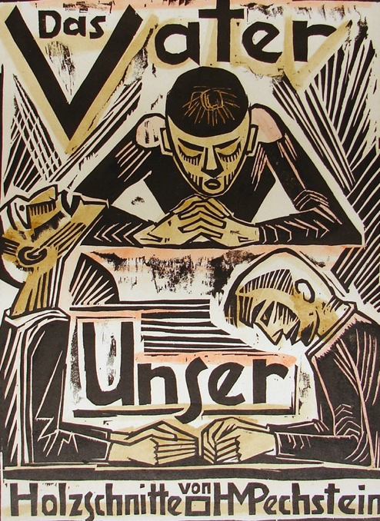
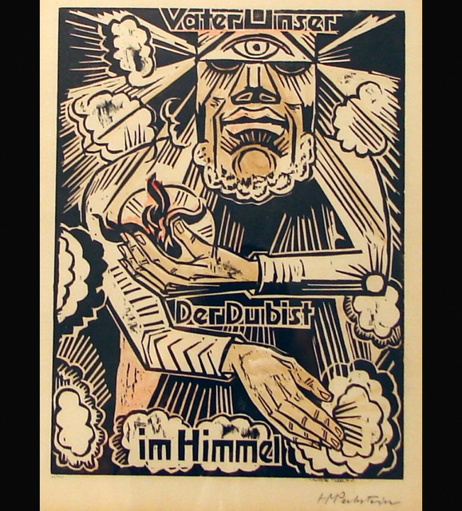
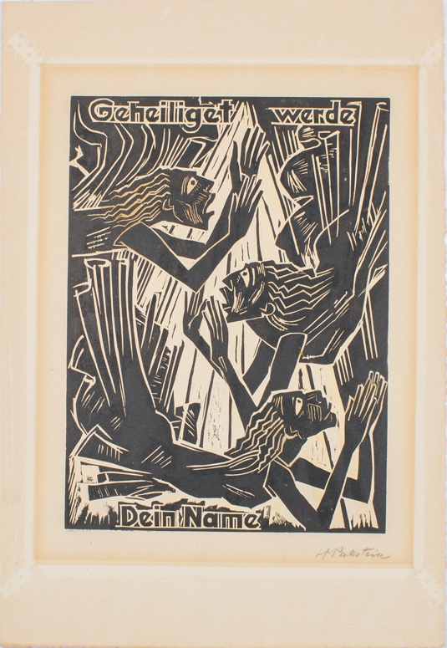
Figure 1- Max Pechstein, Das Vater Unser (The Lord’s Prayer), woodcut and wash on paper, 18 3/4 in x 14 1/2 in., 1921, University of Cincinnati Art Collection

Figure 2- Max Pechstein, Vater unser, Der Du bist im Himmel (Our Father which art in heaven), woodcut and wash on paper, 23 1/2 in x15 11/16 in., 1921, University of Cincinnati Art Collection

Figure 3- Max Pechstein, Geheilliget Werde Dein Name (Hallowed be Thy name), woodcut and wash on paper, 15 7/8 in x 11 3/4 in., University of Cincinnati Art Collection

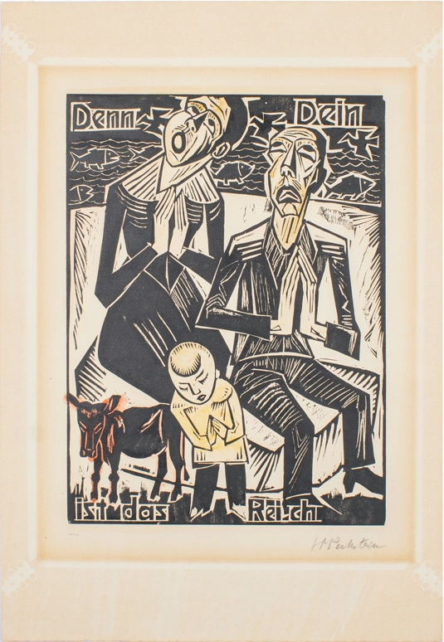
Figure 4- Max Pechstein, Denn Dein ist das Reich (For Thine is the kingdom), woodcut and wash on paper, 15 7/8 in x 11 3/4 in., University of Cincinnati Art Collection

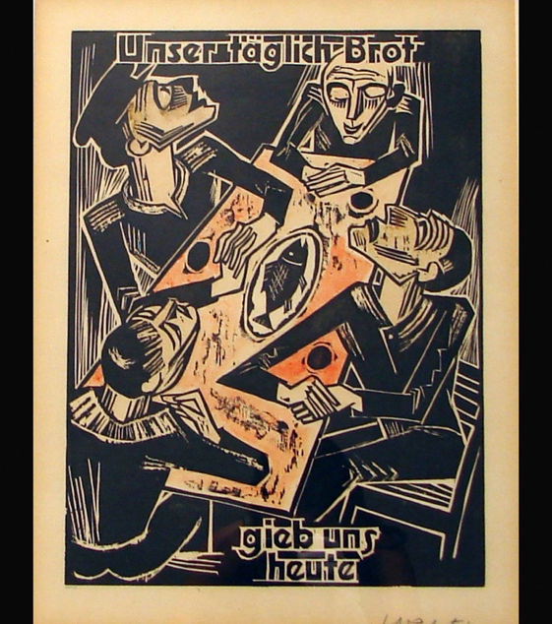
Figure 5- Max Pechstein, Unser täglich Brot gieb uns heute (Give us this day our daily bread), woodcut and wash on paper, 23 1/2 in x 15 11/16 in., University of Cincinnati Art Collection

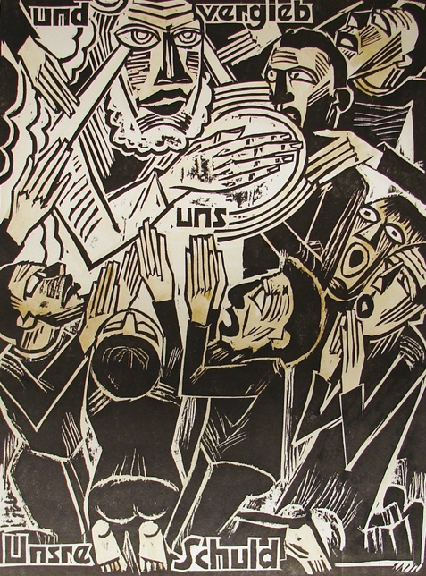
Figure 6- Max Pechstein, Und vergieb uns Unsre Schuld (And forgive us our debts), woodcut and wash on paper, 18 in x 14 in., University of Cincinnati Art Collection

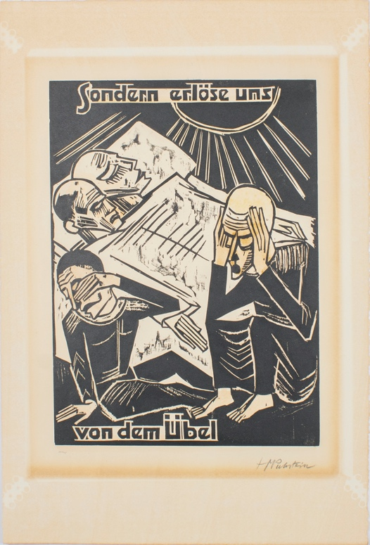
Figure 7- Max Pechstein, Sondern Erlöse uns von dem Übel (But deliver us from evil), woodcut and wash on paper, 15 5/8 in x 11 5/8 in., University of Cincinnati Art Collection

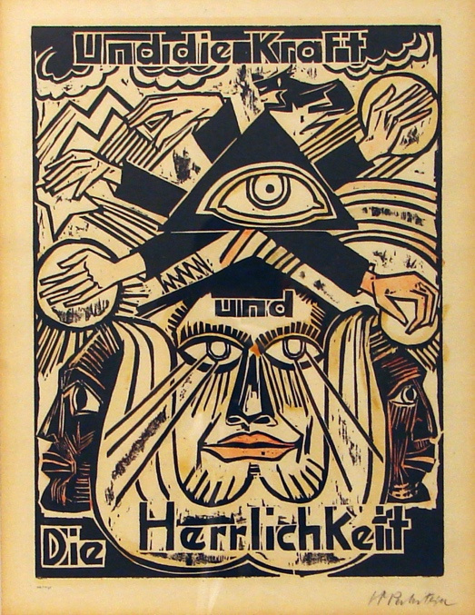
Figure 8- Max Pechstein, Und die Kraft die Herrlichkeit (And the power and the glory), woodcut and wash on paper, 23 ½ in. x 15 5/8 in., University of Cincinnati Art Collection

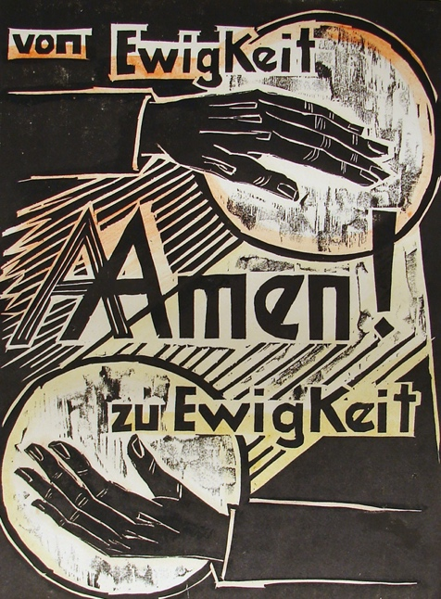
Figure 9- Max Pechstein, Amen (For ever and ever Amen), woodcut and wash on paper, 18x14 in., 1921, University of Cincinnati Art Collection

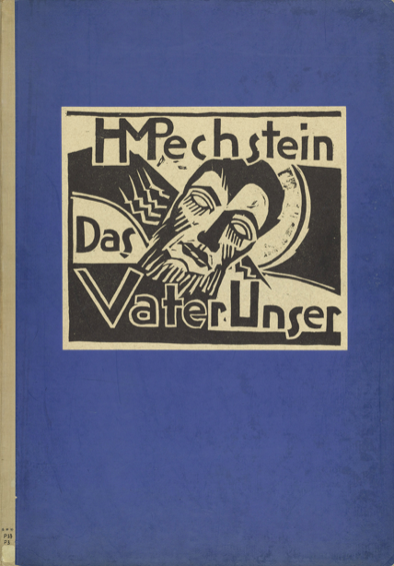
Figure 10- Max Pechstein, Titelohlzschnitt (Cover), woodcut and paper, 9 15/15 x 11 9/16 in., 1921, Museum of Modern Art

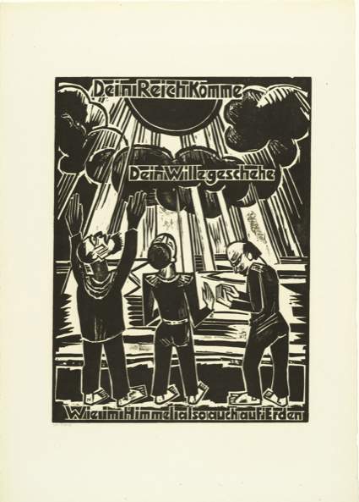
Figure 11- Max Pechstein, Dein Reich komme Dein Wille geschehe Wie im Himmel also auch auf Erden (Thy kingdom come Thy will be done on earth as it is in heaven), woodcut on paper, 15 5/8 x 11 5/8 in., 1921, Museum of Modern Art

Figure 12- Max Pechstein, Wie wir vergeben usern Schuldigern (As we forgive our debtors), woodcut on paper, 15 5/8 x 11 5/8 in., 1921, Museum of Modern Art

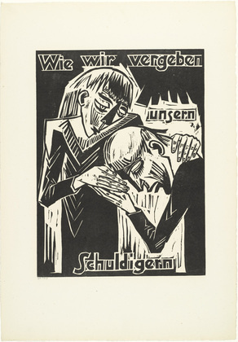
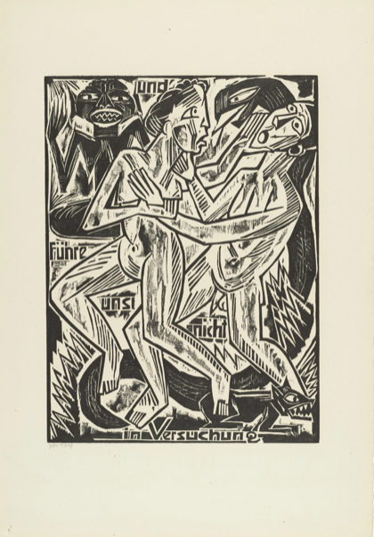
Figure 13- Max Pechstein, Und fuhre uns nicht in Versuchung (And lead us not into temptation), woodcut on paper, 15 11/16 x 11 5/8 in., 1921, Museum of Modern Art

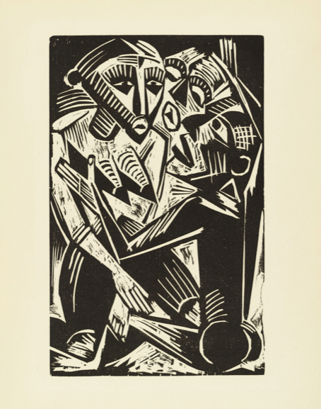
Figure 14- Max Pechstein, Weib vom Manne begehrt (Woman Desired by Man), woodcut on paper, 1919, Museum of Modern Art

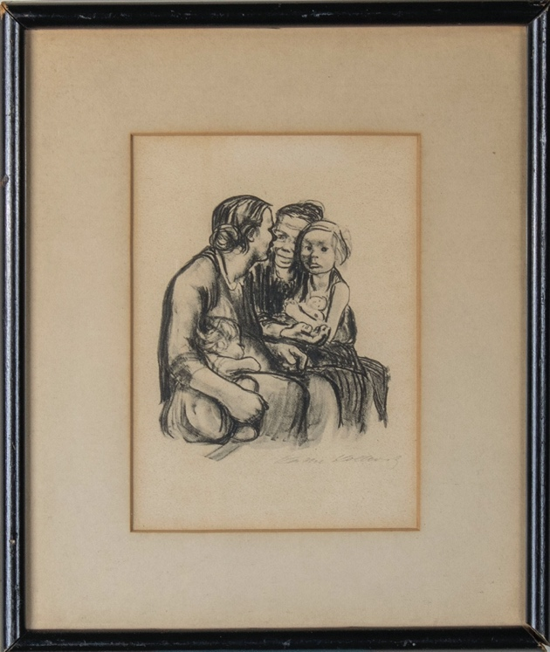
Figure 15- Käthe Kollwitz, Two Chatting Women with Two Children, Crayon Lithograph on paper, ca. 1930, 5 3/8 x 3 7/8 in., University of Cincinnati Art Collection

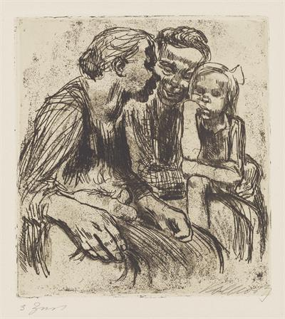
Figure 16- Käthe Kollwitz, Two Chatting Women with Two Children, rejected version, line etching, aquatint, and sandpaper on paper, 1928, 5 3/8 x3 7/8 in., Käthe Kollwitz Museum Köln

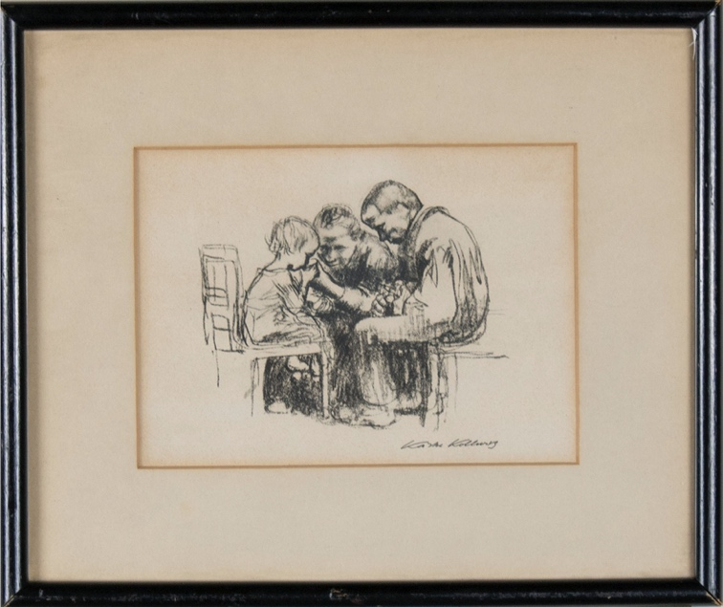
Figure 17- Käthe Kollwitz,, The Hospital Visit, Lithograph on paper, ca. 1926, 5 3/8 x3 7/8 in., University of Cincinnati Art Collection

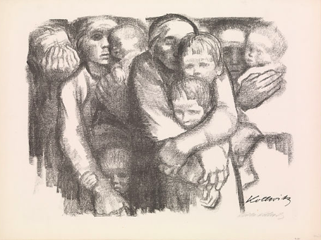
Figure 18- Käthe Kollwitz, Mothers(Mutter), Lithograph, 17 1/16x22 11/16”, 1919, The Metropolitan Museum of Art

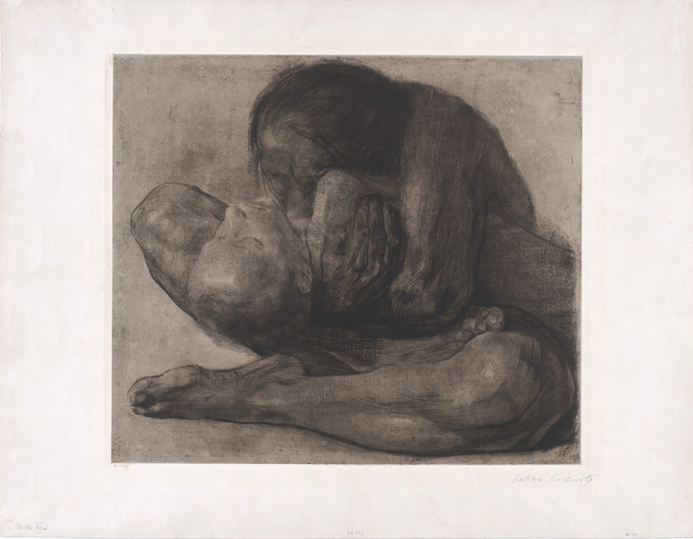
Figure 19- Käthe Kollwitz, Woman with Dead Child (Frau mit Totem Kind), etching with chine colle, 16 1/4x189/16”, 1903, The Museum of Modern Art

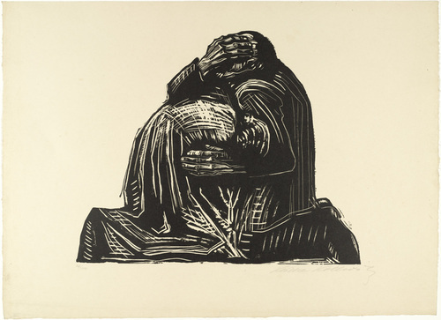
Figure 20- Käthe Kollwitz, Die Eltern (The Parents) , Woodcut from a portfolio of seven, 1921-1922, 13 13/16 x 16 3/4”, Museum of Modern Art

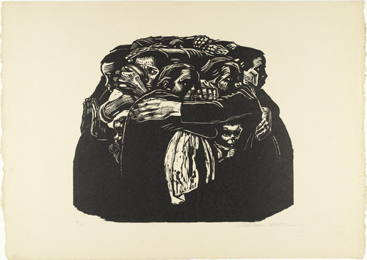
Figure 21- Käthe Kollwitz, Die Mütter (The Mothers), Woodcut from a portfolio of seven, 1921-1922, 13 1/2 x 15 3/4”, Museum of Modern Art

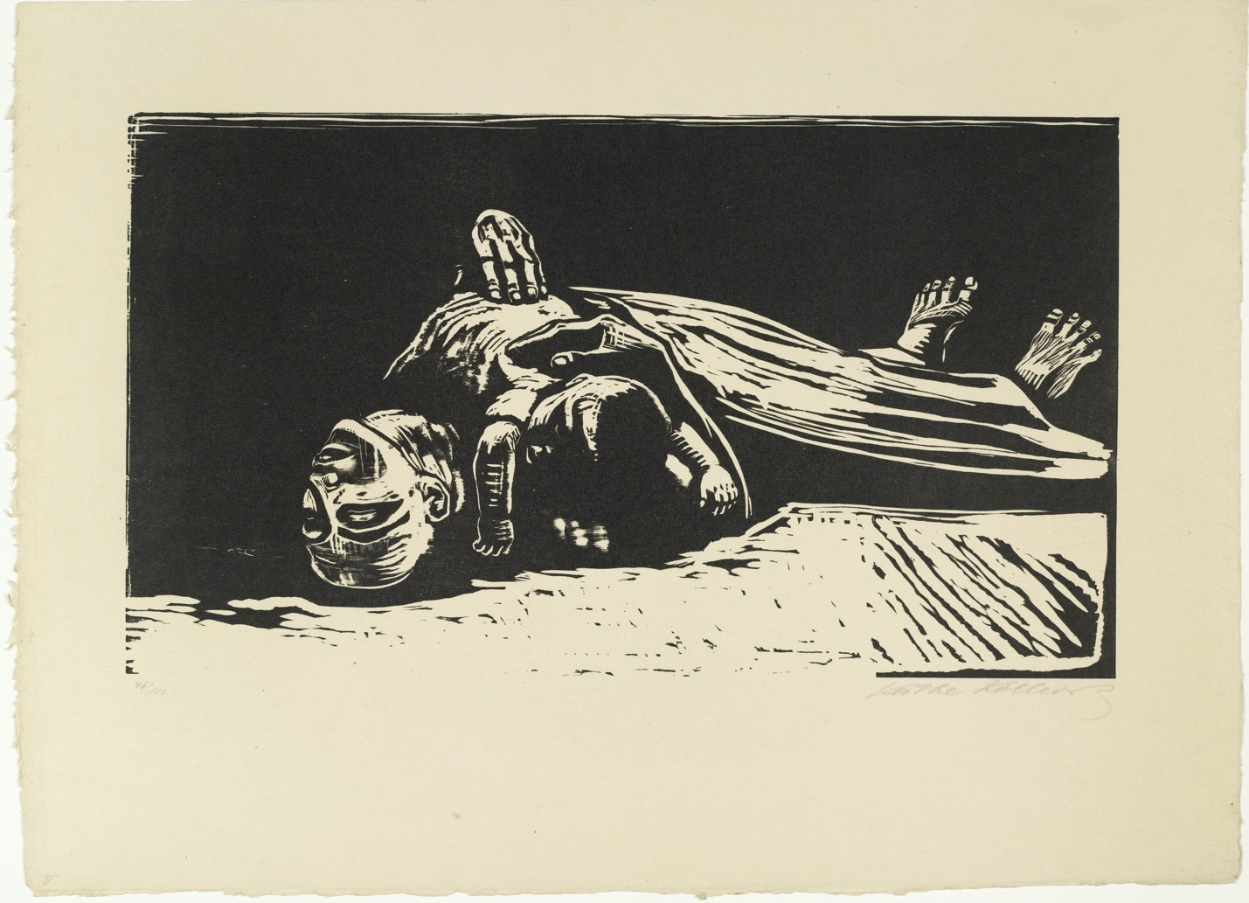
Figure 22- Käthe Kollwitz, Die Witwe II (The Widow II), Woodcut from a portfolio of seven, 1921-1922, 11 13/16 x 20 7/8”, Museum of Modern Art

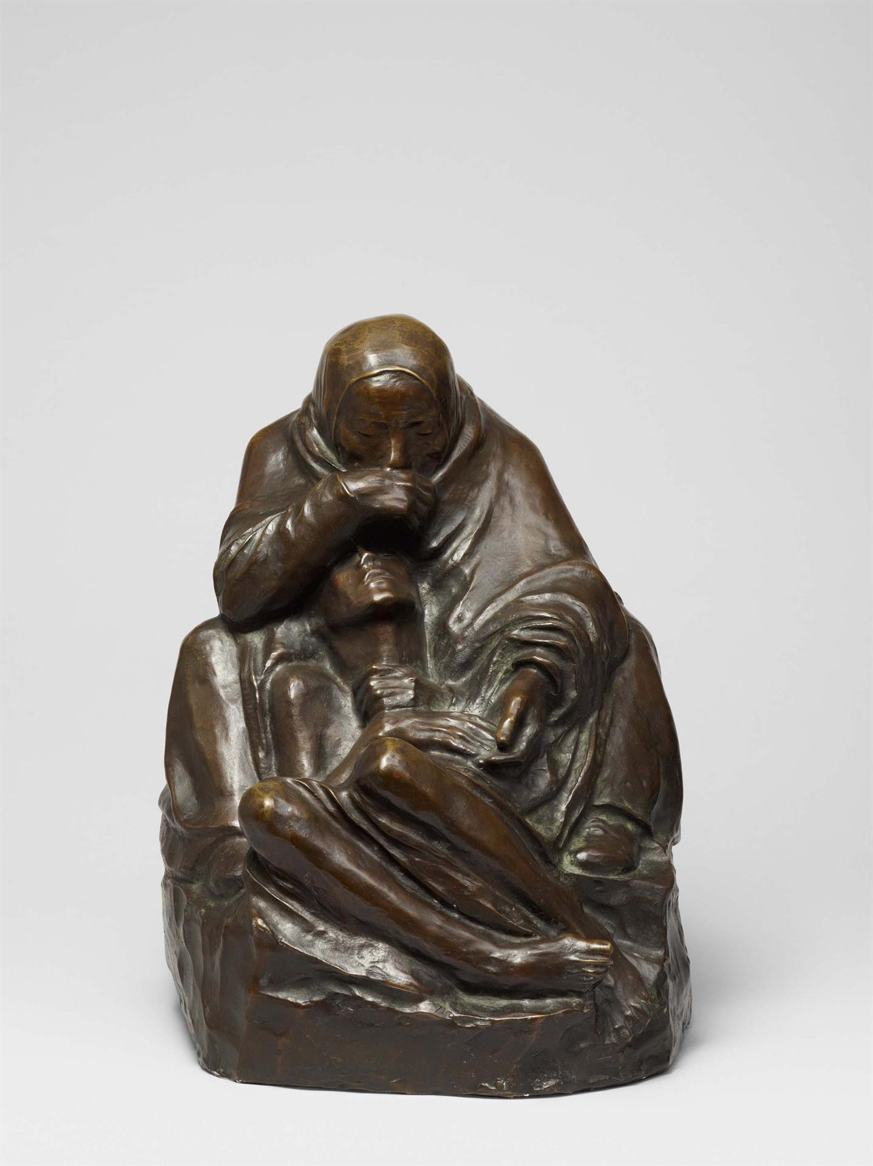
Figure 23- Kathe Kollwitz, Pieta (Woman with Dead Child), Bronze, 1937-1939, Kathe Kollwitz Museum Koln

Alicia Faxon. “German Expressionist Prints, A Persistent Tradition.” The Print Collector’s Newsletter. 14, no. 1. (1983). p. 4. http://www.jstor.org/stable/24552540.
Alicia Faxon. “German Expressionist Prints, A Persistent Tradition.”p. 3.
Van Hoesen, Brett M. "Weimar Re-Visions of Germany's Colonial Past: Max Pechstein, Hannah Hoech and László Moholy-Nagy." p. 45. The University of Iowa. 2009. https://uc.idm.oclc.org/login?qurl=https%3A%2F%2Fwww.proquest.com%2Fdissertations-theses%2Fweimar-re-visions-germanys-colonial-past-max%2Fdocview%2F304903205%2Fse-2%3Faccountid%3D2909.
Cardinal, Roger. "Primitivism." Grove Art Online. 2003. https://www-oxfordartonline-com.uc.idm.oclc.org/groveart/view/10.1093/gao/9781884446054.001.0001/oao-9781884446054-e-7000069588.
Van Hoesen, Brett M. "Weimar Re-Visions of Germany's Colonial Past: Max Pechstein, Hannah Hoech and László Moholy-Nagy." p. 45.
Van Hoesen, Brett M. "Weimar Re-Visions of Germany's Colonial Past: Max Pechstein, Hannah Hoech and László Moholy-Nagy.” p. 45.
Van Hoesen, Brett M. "Weimar Re-Visions of Germany's Colonial Past: Max Pechstein, Hannah Hoech and László Moholy-Nagy.” p. 46.
“Max Pechstein. and Forgive / Us / Our Debts (UND Vergieb / Uns / Unsre Schuld) from the Lord's Prayer (Das Vater Unser).” MOMA, The Museum of Modern Art, https://www.moma.org/collection/works/109162.
Albrecht O. Ritchl, "Reparations, Deficits, and Debt Default: The Great Depression in Germany," The Great Depression of the 1930s, Edited by Nicholas Crafts and Peter Fearson, (Oxford, UK: Oxford University Press, 2013), 110-139.
Käthe Kollwitz Museum Köln. "Two chatting Women with two Children, final version, 1930." Käthe Kollwitz Museum Köln. https://www.kollwitz.de/en/two-chatting-women-with-two-children-kn-250.
"Past Auction: The hospital visit." Artnet Worldwide Corporation. Artnet. http://www.artnet.com/artists/käthe-kollwitz/the-hospital-visit-fEtw2PRiZJ3FUm0lgQfscQ2.
Käthe Kollwitz Museum Köln. "Two chatting Women with two Children, final version, 1930."
The Museum of Modern Art. "Käthe Kollwitz." MOMA. https://www.moma.org/artists/3201.
The Museum of Modern Art. "Käthe Kollwitz Woman with Dead Child (Frau mit totem Kind)." MOMA. https://www.moma.org/collection/works/273959?artist_id=3201&page=1&sov_referrer=artist.
Stewart Buettner. “Images of Modern Motherhood in the Art of Morisot, Cassatt, Modersohn-Becker, Kollwitz.” Woman’s Art Journal 7, no. 2. (1986). 18. https://doi.org/10.2307/1358300.
Clarke, Jay A. “Käthe Kollwitz and the Face of Grief.” Art in Print 5, no. 5 (2016): 26–27. https://www.jstor.org/stable/26408563.
Clarke, Jay A. "Käthe Kollwitz: An Art of Resistance." Art Institute Chicago. https://www.artic.edu/articles/910/kathe-kollwitz-an-art-of-resistance.
Kathe Kollwitz Museum Koln. "Pietà (Mother with dead Son)." Kathe Kollwitz Museum Koln. https://www.kollwitz.de/en/pieta-sculpture-en-bronze.
Mahler, Luise. "Käthe Kollwitz." MoMa. Accessed April 20, 2022. https://www.moma.org/artists/3201.

