KEYNOTE SPEAKERS
COCE 2015 will feature five keynote speakers all of whom will address themes of the conference, including bridging theory and practice. They are presented here in the order in which they appear in the program.
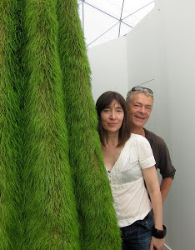 | Heather Ackroyd & Dan Harvey  Ackroyd & Harvey are visual artists. For over 24 years their work has been exhibited in contemporary art galleries, museums and public spaces worldwide; sculpture, photography, architecture, ecology and biology are disciplines that intersect in their work, revealing an intrinsic bias towards process and event and often reflecting environmental and scientific concerns. They are acclaimed for large-scale interventions in sites of architectural interest, focusing on political ecologies by highlighting the temporal nature of processes of growth and decay in the urban space – in 2013 they grew the stone façade of a former British military building in Derry, N. Ireland for the City of Culture; ten years earlier they grew the soaring vertical interior of a deconsecrated church in London and in 2007 created a monumental living intervention on the exterior of the Royal National Theatre. In 2011, they were awarded the prestigious Mapping the Park commission for London 2012, a series of living sculptures entitled History Trees at ten of the major entrances into the Queen Elizabeth Olympic Park.  Ackroyd & Harvey have received many awards for their photographic work utilizing the pigment chlorophyll in making complex bio-chemical photographs; most recently they were presented with the Rose Award at the Royal Academy Summer Exhibition 2014 and in 2012 the Wu Guanzhong Innovation prize for the 3rd Art & Science International Exhibition, Tsinghua University, Beijing.  Interaction with scientists is often key to Ackroyd & Harvey’s practice with groundbreaking research initiated over fifteen years ago with the Institute of Grassland and Environmental Research (now IBERS). Currently, the artists are developing a series of new artworks and initiatives for the University of Cambridge in response to research at the Department and Museum of Zoology, and the Cambridge Conservation Initiative.  Beuys’ Acorns, an ongoing work growing two hundred oak trees from acorns collected from Joseph Beuys’s seminal 7000 Oaks will be exhibited in France throughout autumn 2015, culminating in a major artistic intervention in partnership with scientists at the Institut national de la recherche agronomique (Inra) to coincide with COP 21, the 21st session of the Conference of the Parties to the United Nations Framework Convention on Climate Change.  www.ackroydandharvey.com
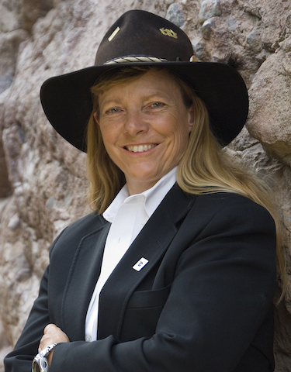 | Hunter Lovins  L. Hunter Lovins is President of Natural Capitalism Solutions (NCS,) a Colorado non-profit that educates senior decision makers in the business case for a Regenerative Economy. NCS, helps companies, communities and countries implement more sustainable practices profitably.  Trained as a sociologist and lawyer (JD), Hunter is a professor of sustainable business management at Bard College, and Denver University; and the chief insurgent of the Madrone Project. Named a Master at the Chinese De Tao Academy, she recently helped launch the Institute for Green Investment in Shanghai.  Lovins has consulted for scores of industries and governments worldwide, including International Finance Corporation, Unilever, Walmart, the United Nations and Royal Dutch Shell, as well as sustainability champions Interface, Patagonia and Clif Bar. She has briefed heads of state, leaders of the numerous local governments, the Pentagon, and about 30 other countries, as well as the UN, and the US Congress.  Hunter lectures regularly to audiences around the globe. She has worked in economic development in countries from Afghanistan to New Zealand, served the King of Bhutan on his International Expert Working Group, charged with transforming the global economy. She sits on the steering committee of the Alliance for Sustainability And Prosperity, and Capital Institute Advisory Board. A founding mentor of the Unreasonable Institute, she teaches entrepreneuring and coaches social enterprises around the world. She is a founding partner in Principium, an impact investing firm.  Hunter has written 15 books and hundreds of articles. The Way Out: Kickstarting Capitalism to Save Our Economic Ass (2012) succeeds her international best-selling book, Natural Capitalism, now used in hundreds of colleges. Her latest, Creating a Lean and Green Business System won the 2014 Shingo Prize for Excellence in Manufacturing Research.  Hunter has worked in sustainability policy since 1972. She was instrumental in creating the fields of Economic Renewal, Green Development, and Sustainable Management. She has helped create several MBA schools and is currently professor of Sustainable Business at Bard MBA. She has won dozens of awards, including the European Sustainability Pioneer award, the Right livelihood Award (the alternative Nobel) and the 2012 the Rachel Carson Award. In 2013 she was inducted into the Hall of Fame of the International Society of Sustainability Professionals. Time Magazine recognized her as a Millennium Hero for the Planet, and Newsweek called her the Green Business Icon.
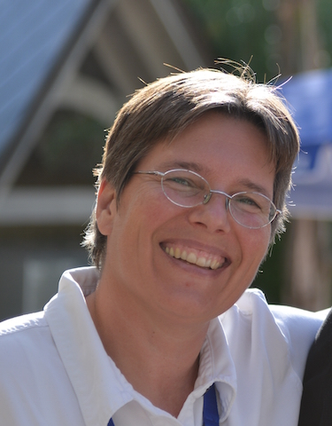 | Susanne Moser  Dr. Susanne Moser is Director and Principal Researcher of Susanne Moser Research & Consulting, in Santa Cruz, CA, USA, a Social Science Research Fellow at Stanford’s Woods Institute for the Environment, and a Research Associate of the Institute for Marine Sciences at the University of California-Santa Cruz. As a nationally and internationally recognized expert in climate change communication for social change, adaptation and science-policy interactions, she works with researchers, governmental and non-governmental organizations in the US, Europe and Australia.  Dr. Moser is a geographer (Ph.D. 1997, Clark University) with broad interdisciplinary expertise, and previously held positions at the National Center for Atmospheric Research in Boulder, Colorado, the Heinz Center in Washington, DC, and the Union of Concerned Scientists. She currently or has in the past served on scientific and advisory boards for Future Earth, the International Social Science Council, the International Human Dimensions Program, the US National Research Council, and numerous other agencies and organizations.  She contributed to the Fourth and Fifth Assessment Reports of the IPCC and served as a Review Editor for the IPCC Special Report on extreme events, disaster risk management and adaptation. She also was a member of the federal advisory committee on the Third US National Climate Assessment, co-lead that committee's Engagement and Communication working group, and served as one of the Convening Lead Authors on the assessment's coastal chapter. She is a fellow of the Aldo Leopold Leadership, Kavli Frontiers of Science, Donella Meadows Leadership, Google Science Communication, and Walton Sustainability Solutions Programs.
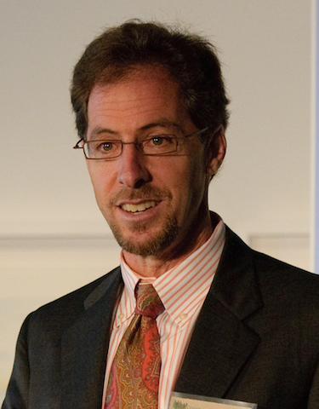 | Edward Maibach  Edward Maibach is a University Professor at George Mason University, and the Director of Mason’s Center for Climate Change Communication. Ed’s research – funded by NSF, NASA and private foundations – focuses on public engagement in climate change. Ed recently co-chaired the Engagement & Communication Working Group for the 3rd National Climate Assessment, and previously served as Associate Director of the National Cancer Institute, Worldwide Director of Social Marketing at Porter Novelli, and Chairman of the Board for Kidsave International. Ed earned his PhD in communication science at Stanford University and his MPH at San Diego State University.

