%% MATLAB (R2021a) CODE TO CALCULATE FIXTURE P-VALUE FROM RAW DATA
% Import data
% INDICATE CORRECT FILE PATH
% 25 days data from lavatory use in the men’s restroom
Data = readtable("C:\FILEPATH\08192022_12082022_MarianSpenceCefeteria_MensRestroom_Lavatory_2.csv");

% 2 days data from lavatory use in the women’s restroom
% INDICATE CORRECT FILE PATH
Data = readtable("C:\FILEPATH\09132022_09142022_MarianSpenceCefeteria_WomensRestroom_Lavatory_2.csv");

% Convert data from Table into vectors
DateData = Data.Date- timeofday(Data.Date); % Delete time to get only date DDMMYY
%StartTime = timeofday(datetime(Data.EventStartTime, 'ConvertFrom', 'datenum')); % Use if data imported from .xlsx
StartTime = timeofday(datetime(Data.EventStartTime)); % Use if data imported from .csv

%EndTime = timeofday(datetime(Data.EventEndTime, 'ConvertFrom', 'datenum')); % Use if data imported from .xlsx
EndTime = timeofday(datetime(Data.EventEndTime)); % Use if data imported from .csv

%Duration = Data.Duration_sec; % Actual measurement in 0.25 seconds fraction
Duration = seconds(EndTime -StartTime); %Calculate duration of flow in full seconds

% Find length of study
StudyDates = unique(DateData);
StudyLength = length(StudyDates); % Number of Unique dates

% Check weekdays and Weekends
DoW = isweekend(StudyDates (:)); % 1 is weekend

%Input Information
NumFix = 2; % ENTER Number of fixtures monitored
Window = 60; % Fixed observation window (minutes)
WinSec = Window*60; % convert Seconds
Intv = 3600*24/WinSec; % Number of intervals per observation window

% Create 24-hour timeline
Time_TL = duration(0,0,1:86400)';

% Create Variables for the results
Res_Sumary = [];
ProbString = [];
PeakHour = [];
Pv_event = [];
Pv_Dur = [];
aaT = [];
aaP = [];
aaDate = [];

ProbTL = zeros(Intv,StudyLength);
PulseTL = zeros(Intv,StudyLength);
DurTL = zeros(Intv,StudyLength);

for i = 1:StudyLength % Loop to calculate daily probability values
% Set i = SPECIFIC NUMBER for a specific date in "StudyDates"

if i==13 || i == 14 % Exclude data on Thanksgiving and next day (zero water use)
continue
else
DailyTL = zeros(86400,1); % date, time, 1=on, 0=off,
Ind = find(DateData==StudyDates(i)); % Indices for single day data

% Extract start and end times for each day
SrtTdata = StartTime(Ind); % Start time
EndTdata = EndTime(Ind); % End time
Durdata = Duration(Ind); %% Duration of flow
DurCheck = [];
% Populate the timeline with flow details in binary numbers
for j = 1:length(Ind)
% Find indice from start to stop time (-1 because start time
% included
TInd = find(and(Time_TL >= SrtTdata(j), Time_TL <= EndTdata(j)-duration(0,0,1)));

DurCheck = [DurCheck; length(TInd)];
DailyTL(TInd,1)= DailyTL(TInd,1)+1; % +1 Binary indicator of busy fixture
end

% Create timeline
%DataTL(:,i)= DailyTL(:,1);

ProbTime=[];
% Calculate probability of use and Number of pulse for each Observation window
for ij = 1:Intv

astrt = Time_TL(((ij-1)*WinSec)+1);
astop = Time_TL(ij*WinSec);
aInd = find(and(Time_TL>=astrt, Time_TL<=astop)); % Indices for each pulse
ProbTime =[ProbTime; astop];
PVCal = sum(DailyTL(aInd,1))/(NumFix*WinSec); % p-value
ProbTL(ij,i) = PVCal; % Save p-value for each observation window on each study day

PulseCnt = find(and(SrtTdata>=astrt, SrtTdata<=astop));

% Duration of flow duration in observation window
DurTL(ij,i)=sum(DailyTL(aInd,1));

% Number of pulses during observation window
PulseTL(ij,i) = length(PulseCnt);
end

% Indices for each observation window with the maximum number of events
MaxEvent = find(PulseTL(:,i)==max(PulseTL(:,i)));

PeakHour =[PeakHour; MaxEvent(1)]; % Hour with maximum number of events
Daily_ProbTL = ProbTL(:,i);
Daily_PulseTL= PulseTL(:,i);

% Peak hour p-values
% If more than one hour with equal maximum number of events , pick the first hour
Pv_event = [Pv_event; ProbTL(MaxEvent(1),i)];

%Fixed the active window between 10am and 10pm (When the business
%is open to the public)
ActiveWindow = and(ProbTime >= duration(10,0,0) ,ProbTime < duration(22,0,0));

MontTime = find(ActiveWindow); %Indices for active times

% Summarize probability values for the time interval
aa = ProbTL(MontTime,i); %P-value Within Active window

aaT = [aaT; ProbTime(MontTime)];
aaP = [aaP; ProbTL(MontTime,i)];
aaDate=[aaDate; repmat(StudyDates(i),length(MontTime),1)];

% Summary of daily p-values and duration of pulses
%[ mean, maximum, std deviation and Sample size]
Res_Sumary = [Res_Sumary; mean(aa) max(aa) std(aa) length(aa)...
min(Durdata) mean(Durdata) std(Durdata) max(Durdata) length(Durdata)];
end
end

% Plot for peak hour probability over study period and
figure
% plot for daily peak hour p-values
subplot(2,1,1)
plot(Pv_event,'O')
ylabel ('Probability')
title ('Daily Peak Hour Fixture Probability Values');
grid on
ax=gca;
ax.XLim = [0 24];
ax.YLim = [0 0.3];
ax.XTick = (0:1:24);

% plot for running average of peak hour p-values
subplot(2,1,2)
Avg_Pv = cumsum(Pv_event')./(1:numel(Pv_event'));
plot(Avg_Pv,'-*')
xlabel ('Study Day')
ylabel ('Probability')
title ('Running Average Peak Hour Probability Values');

grid on
ax=gca;
ax.XLim = [0 24];
ax.YLim = [0 0.3];
ax.XTick = (0:1:24);
% This calculation is for data collected from multiple days at one building.
% The Suggested Fixture P-value would be the average similar fixtures in from various building

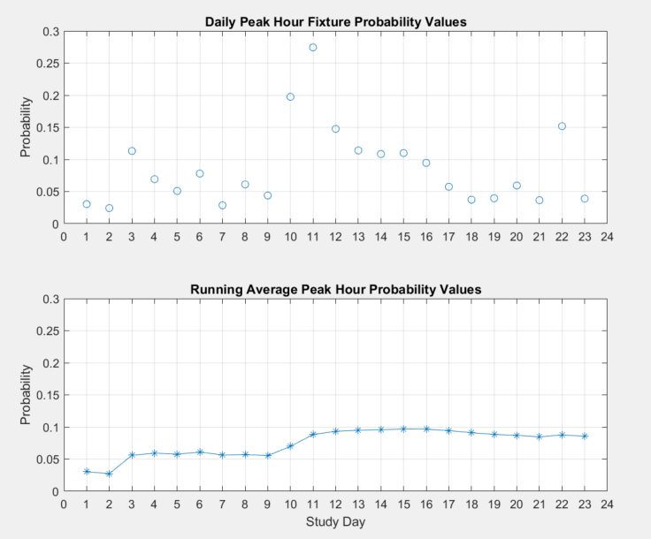
Figure 1: Summary of calculated fixture p-values

% Plots for Visualizing Daily Data (set for last study date)
ST=floor(SrtTdata(1),'minute'); % First pulse of the day
figure
subplot(2,2,1)
% plot for # Busy fixtures
plot(Time_TL,DailyTL(:,1))
hold on
plot(ST:seconds(1):ST+seconds(2),[0 2 0],'-r') % Indicate first pulse
hold off
title ('Fixture Activation Timeline' + string(datetime(StudyDates(i))))
% title("It is currently " + string(datetime(StudyDates(i))))
ylabel ('# Busy Fixtures')
ax=gca;
ax.XLim = [duration(0,0,0) duration(24,0,0)];
ax.YLim = [-0.1 1.1];
ax.YTick = (0:1);
ax.XTick = (duration(0,0,0):duration(6,0,0):duration(24,0,0));
xtickformat('hh:mm')
grid on

% plot for Number of events per hour
subplot(2,2,2)
bar(ProbTime, Daily_PulseTL)
title ('Number of Events on ' + string(datetime(StudyDates(i))))
ylabel ('# Events')
ax=gca;
ax.XLim = [duration(0,0,0) duration(24,0,0)];
ax.YLim = [0 max(Daily_PulseTL)+2];
ax.XTick = (duration(0,0,0):duration(6,0,0):duration(24,0,0));
xtickformat('hh:mm')
grid on

% plot for claculated probability values
subplot(2,2,3)
plot(ProbTime,Daily_ProbTL,'+')
title ('Hourly Probability Values on ' + string(datetime(StudyDates(i))))
ylabel ('Probability')
ax=gca;
ax.XLim = [duration(0,0,0) duration(24,0,0)];
ax.YLim = [0 round(max(Daily_ProbTL),2)*1.2];
ax.XTick = (duration(0,0,0):duration(6,0,0):duration(24,0,0));
xtickformat('hh:mm')
grid on

% Box plot for calculated probability values
subplot(2,2,4)
boxplot(aa)
ylabel ('Probability')
title ('Boxplot of Fixture p-values on ' + string(datetime(StudyDates(i))))
ax=gca;
ax.YLim = [0 round(max(aa),2)*1.2];
ax.YTick = (0:0.01:round(max(aa),2)*1.2);

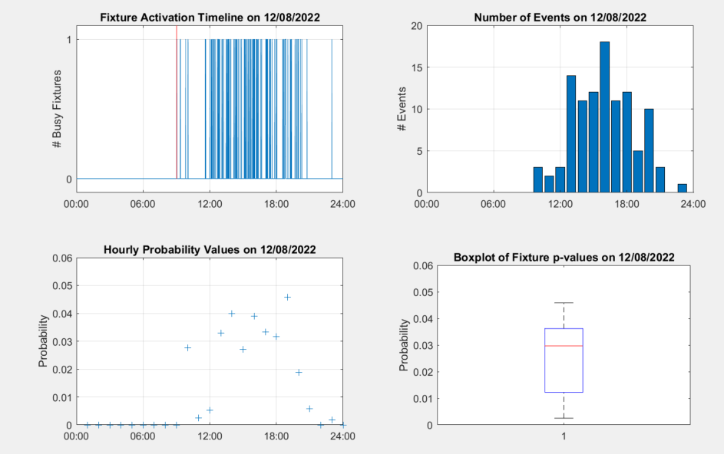
Figure 2: Summary of raw data and calculated fixture p-values on a single day (12//08/22) during the study period

