Emma Crossman
Senior Seminar Spring 2023
La Belle Iseult: William Morris’ Pre-Raphaelite Painting, Medievalism, Design, and the Arts and Crafts Movement
William Morris, a nineteenth-century British textile designer, craftsman, Socialist, and poet, was a prominent figure, whose designs generated the Arts and Crafts Movement in Europe, between the 1850s and the 1890s. Before beginning to design textiles and wallpaper, Morris briefly worked as a painter and founding member of the Pre-Raphaelites, along with other artists. There is little evidence of Morris’ completed paintings;- most of his surviving art related to painting includes sketches and designs. Morris’ later designs in the form of textiles and wallpaper are influenced by floral and medieval motifs. Morris’ enterprise, called Morris, Marshall, Faulkner, and Company, formed in 1861, later changing its name to Morris and Company. It manufactured wallpapers, embroidered wall hangings and textiles, furniture, stained glass windows, and other decorative arts for home furnishings. William Morris’ oil painting in the Pre-Raphaelite style, La Belle Iseult (1858), shows Morris’ interest in medievalism and foreshadows his later art with medievalist allusions and Arts and Crafts movement techniques practices. In this paper I focus on Morris’ only surviving oil painting, La Belle Iseult (The Beautiful Isolde)-, analyzing its subject and composition in light of Morris’ own medieval interests and attention to craftsmanship and design in the arts. La Belle Iseult was based on Arthurian literary sources and late medieval manuscripts, with attention to designs and patterns on textiles. Painted before the creation of Morris and Company in 1861, La Belle Iseult presages the flattened, floral motifs of Morris’ later designs. I discuss Morris’ medieval references in his Pre-Raphaelite painting, providing a fuller picture of the role of medieval art and craftsmanship early in Morris’ career before he became an internationally renowned designer.
Starting in June 1853, Morris took an interest in medieval history while attending Exeter College at Oxford University, where he studied Classics. With a special interest of the fourteenth and fifteenth centuries, Morris’ focus on the Middle Ages began. He became familiar with medieval objects and subjects, such as illuminated manuscripts and Arthurian legends. Medievalism, according to Oxford Reference, is the “Enthusiasm for or imitation of the arts and customs of Europe during the Middle Ages—that is, from about the 8th century to the 15th.” An interest in medievalism can be manifested in ways such as religious faith or chivalry, and the ideological attachment to the values of the Middle Ages. Morris manifests the idea of medievalism in La Belle Isuelt, in looking back to the fourteenth and fifteenth centuries for inspiration.
The Pre-Raphaelite Brotherhood was created in the 1840s, with members including Gabriel Rosetti and John Everett Millais. The Pre-Raphaelite Brotherhood (PRB) “believed that medievalism was a method for making modern objects,” including painting, embroidery, and other decorative arts. A second wave of Pre-Rephaelites then forms around Gabriel Rosetti, including William Morris. The PRB and the Pre-Raphaelite painters were invested in medieval and Arthurian subjects, painting in meticulous, painstaking detail. Working alongside Rosetti and interested in medieval subjects, William Morris paints La Belle Iseult.
William Morris’s most accomplished role was as a designer, especially in the textiles and wallpaper designs of Morris & Company. Designs produced by Morris are inspired by florals and natural motifs, as well as medieval subjects. Evidence of Morris’s artistry and attention to his design is apparent in this early oil painting, in the Pre-Raphaelite style, La Belle Iseult, 1858 (Fig. 1). Worked before the production of wallpapers and textiles from Morris and Company, Morris tries his hand at painting in the Pre-Raphaelite style. William Morris uses Jane Burden as his model, who he later marries in 1859. The painting’s title has been debated as La Belle Iseult or Queen Guenevere, which has been displayed under both at the Tate Britain, where the painting is currently held. This is due to depictions of the same model, Jane Burden (Morris), posing as Guenevere in Gabriel Rosetti’s Pre-Paphaelite paintings. According to Jan Marsh, in July 1901, after Morris’s death, Jane Morris writes to her daughter, May Morris, that “La Belle Iseult is what the dear father always called the picture, and I think we ought to keep that.” Morris’s choice to paint Iseult, a leading character from the medieval chivalric romance of Tristan and Isulet, as a direct depiction of a medieval subject, connects to his interest in medievalism. This chivalric romance comes from Sir Thomas Mallory’s Le Morte D’Arthur, 1485. This text recounts the medieval tales of King Arthur and the Knights of the Round Table. In Le Morte D’Arthur, the tales of one of the knights, Tristan, and his adulterous relationship with Iseult. Tristan’s character is not present in Morris’ rendition of Iseult. Instead, the single female figure is portrayed in her bedchamber.
La Belle Iseult is William Morris’ only surviving oil painting, depicting a female figure dressed in medieval garb, surrounded by examples of William Morris’ pattern design. The painting has a somber feeling, the figure depicted looking introspective and restrained. At the forefront of the painting is a thin female with dark brown wavy hair, featuring sprigs of rosemary and a crown on her head. She stands on a colorful and textural ornamental rug, featuring red, yellow, and white. She is wearing a long, white gown with red sleeves and dark cuffs, and is seen fastening her girdle around her waist. Iseult is seen standing with weight placed on one leg, angling her body to look towards her mirror. Morris depicts Iseult in a dynamic pose, allowing the viewer to see the entire figure, while indicating her attention to the table beside the bed. The white gown has pink ornamentation which shows a repeated textile pattern. This reoccurring pattern consists of diamond shapes with abstracted cone-like florals. At her feet is a large gold pitcher with a handle and a wooden bucket. Iseult absentmindedly and solemnly looks down at her bedside table, which holds a standing mirror, a cord, a brush, an illuminated manuscript, a bowl of oranges, a bottle of wine, and a white ceramic vase with blue detail. The mirror depicted is seen from the side- a rectangle that is stood up, boasting a ribbon with written words as well as a medieval crest. According to Tate Britain, the word ‘dolours’, or grief, is written on the mirror’s ribbon, emphasizing Iseult’s facial emotion of grief and the somber feeling of the painting. The brush and cord in front of the mirror indicate its purpose. The manuscript is open, showing illuminations in blue and gold, and black text. The bedside table is decorated with yellow and red rounded, bulbous, flattened florals on a dark blue background. Over the top of the table is a delicate, white piece of fabric with a checkered pattern. Behind the female figure is a disheveled bed, indicating that she has just risen. The sheets are pushed to the bottom of the bed with a patterned ornamental rug, the pillows are crumpled, and there is a small hound curled up. Hanging above and around the bed is white, heavily draping curtains with a band of pink geometric ornamentation. In the far background of the painting is a deep blue tapestry. The tapestry, although in the back of the composition and slightly shadowed, is as detailed as the rest of the ornamentation featured in the painting. This painted tapestry depicts a repeated pattern of fruit trees wrapped in banners with avian figures. To the right of Iseult, in the background, is a medieval troubadour in a red cloak, holding an instrument, presumably playing a song while she dresses. The entire painting is heavy with detail and medieval symbolism, as well as floral designs.
In Morris’ painting, objects such as the illuminated manuscript, the mirror, and the background’s tapestry are included and painted with care, emphasizing his knowledge of medievalism, although the objects do not appear completely historically accurate. Mirrors in the fifteenth century, typically concave and circular, are completely different from Morris’ flat, rectangular depiction. The mirror’s incorrect depiction can be attributed to a sense of fantastical decorative and imaginative arts. In the mirror’s reflection, although not reflecting a textile in the frame, William Morris takes the opportunity to show his skill in replicating textile designs. The manuscript lacks detail due to its size but is apparent in its intention to replicate an illuminated text. The tapestry in the far background looks to be heavily embroidered. To paint and create an image that Morris could relate to, he simplifies the illuminated manuscript and tapestry and creates a medieval-inspired mirror.
In the painting, there is attention to the floral patterns rather than technique, which highlights Morris’ talent in design, affirming his future career as a textile designer. Morris is less concerned with Iseult’s figure, seen in her lanky body and cadaverous, ghastly face, spindly hands, and elongated neck. Instead, special consideration is placed on the floral ornamentation and pattern of the bedside table and the texturally patterned carpet in the foreground of the painting, and the textile of the figure’s dress, as well as the tapestry in the far background of the painting. According to Fowle from Tate Britain, the tapestries in the background are close in style to the heavy tapestries designed by Morris. Rather than excelling in oil painting in the Pre-Raphaelite style, Morris’ floral ornamentation throughout La Belle Iseult proves his artistry in design, foreshadowing the later applications of florals in Morris’ career.
The tapestry in the background of La Belle Iseult shows a repeated pattern of fruit trees wrapped in banners, between the trees are avian figures. This background is reminiscent of one of the background tapestries depicted in the fifteenth-century manuscript, Chroniques (Chronicles), by Jean Froissart (Fig 2). Depicted in the background wall of the manuscript are two different patterns. On the left, the background of the illumination is a repeated design of fruit trees wrapped in banners with hybrid figures and birds. This tapestry design is simplified and emulated in the background of La Belle Iseult, showing fruit trees wrapped in banners with three flying birds. Morris displays his intimate knowledge of illuminated manuscripts in La Belle Iseult by directly referencing and replicating an illustrated tapestry from the Chroniques manuscript. Next to the aforementioned replicated trees in the background, to the right, the wall pattern depicts florals. In groups of flattened, splayed-out florals and leaves, repeated white daisy motifs are present on a red background, in blue, white, green, and gold.
Morris’s interest in medievalism is seen in his designs of heavy tapestries, such as the Daisy embroidered wall hanging, 1859 (Fig 3). Inspired by the hangings appearing in fifteenth-century illustrations in Froissart’s Chroniques, Morris seems to replicate the flattened forms of the florals. These heavy tapestries were “intended to re-create what Morris imagined to be the sort of hangings used in the English medieval interior”. The daisy embroidered wall is arranged in “four apparently similar but different clumps of flowers which are repeated”, embroidered in red, pink, green, and yellow. The wall hanging is made from indigo dyed surge, embroidered with colored wool. These daisies do not overlap, allowing the viewer to see the entire anatomy of the embroidered flowers with negative space in between. When the Daisy wall hanging was created in 1859, the year after painting La Belle Iseult, Morris looks back to reference and recreate the floral daisy motif in Froissart’s Chroniques.
As seen in the Daisy embroidered wall hanging, William Morris’ early tapestries, wallpapers, and fabric textiles follow a specific set of principles that influenced his floral design. In the lecture titled, ‘Some hints on pattern designing’ (1881), Morris spoke that ornamentation must not be imitative or historical, and one must be inspired by nature, but not from scientific representations. In the same lecture, he states that “ornamental pattern-work… must possess three qualities: beauty, imagination, and order.” This set of design principles can be seen in the first wallpaper printed by Morris and Company, a continuation of William Morris’ daisy motif, in Daisy wallpaper, 1864 (Fig. 4).
The Daisy wallpaper, 1864, is similar in matter and composition to Morris’ 1859 Daisy embroidered wall hanging. In the 1864 rendition of daisies, the background is white, with hatched detailing (Fig 4). The florals are light brown and rose-colored, featuring light green stems and leaves, lined with darker colors to add dimension and depth to the flattened florals. Creating a lightly colored wallpaper design marks a difference in Morris’ wallpaper design, contrasting with the indigo-dyed surge of the Daisy embroidered wall hanging. The florals are also now closer to each other, showing variation and maturity in Morris’ designs. Pivoting to a new medium and practice of wallpaper printing, these designs were a large part of the Arts and Crafts Movement. When interested in medieval subjects and production methods, Morris’ labor-forward processes and flattened floral-inspired decorative arts became popular.
Morris is known as the Grandfather of the Arts and Crafts Movement, with his designs emphasizing “simple functional design without the excess ornament and imitation of past typical of Victorian styles.” The Arts and Crafts Movement was a direct reaction to the industrialization of Europe in the nineteenth century and the Victorian styles of decorative art and home furnishings popular at the time. These latter styles depicted naturalistic, highly detailed textiles, such as florals. In Victorian styles, flowers are “impressively realistic and three-dimensional,” often depicting roses (Fig. 5). The subject matter of florals represents a common nineteenth-century interest, but the simplified, stylized, and flattened florals of Morris are evidently different stylistically. Much flatter than naturalistic, three-dimensional Victorian styles, Morris’ florals employ minimal depth and highlighting in a two-dimensional depiction. Artists of the Arts and Crafts Movement took nature and the quality of the materials used as focal points for production, emphasizing natural beauty and function. In Britain, the Arts and Crafts Movement was partially associated with medievalism, where practitioners “searched for extant traces of the medieval past.” This applies to then-current artistic traditions, such as woodblock printing, which dated back to the Middle Ages. With designs like Daisy, inspired by textiles represented in late medieval illuminated manuscripts and early printed books, Morris’ work was associated with both medievalism and the Arts and Crafts Movement. Art Historian Alan Crawford asserts that “the Arts and Crafts Movement was not organized with collective goals, a manifesto, or a central leader, but rather, members shared attitudes of freedom in technique and learning about the materials being worked.” Artists of the Arts and Crafts Movement were interested in a time when craftspeople were more involved in the handmade creation of decorative arts and furnishings. Craftsmanship stressed the beauty of the materials, nature was used as the key source of inspiration, and there was simplicity, utility, and beauty in the designs. Morris, working alongside his colleagues at Morris and Company, shared the goal of creating decorative arts with truth to the materials and processes employed. Morris’ flattened, nature-inspired designs of leaves, vines, branches, flowers, and birds, are evident in Morris’ hand-printed wood block wallpapers and textiles (Fig. 6).
In order to create decorative textiles such as wallpaper in the nineteenth century, Morris’ hand-drawn designs were used to carve those designs into woodblocks made of pear-wood. Morris would draw compositions for the woodblock cutters, who received and cut the designs at their firm known as Barrett’s in East London. In order to print a single design, woodblocks were carved with a different woodblock for each color to build the design. In addition to the carved wood-blocks, sharp pins were utilized to ensure the block printer has the blocks lined up perfectly on the paper. Scholar Roisin Inglesby describes the processes of printing Morris’ wallpaper designs, stating that the detail employed in Morris’ designs called for a concentrated number of woodblocks, about twenty to twenty-five per area of the design. The high number of individually carved blocks suggests the time and labor that goes into the carving and placing of each block and their coloring in order to produce a large, successfully printed textile. Attention to detail and process stresses how Morris’ medievalist values impacted the success of Morris and Company’s artistic output.
Along with medieval designs that inspired his “Daisy”, Morris was influenced by the modes of production and labor from this earlier time period. He called for simpler methods of production, including turning back to small-scale workshops. Morris used handmade processes to carve and print his textiles, mainly without the use of machinery.
In contrast to Morris’ favored handmade, hand-printed processes, the Industrial Revolution in England brought groundbreaking technology to make factory work quicker and more efficient. Factories employed less skilled employees who worked at a faster pace, resulting in increased production- at a lower level of quality. According to Melinda Watt, in both textile and wallpaper production, “One roller printing machine could print as much yardage as twenty hand-block printers.” Naturally, there was a lack of craftsmanship in the industrial processes, a disconnect between design and manufacture. This contrasts sharply with Morris’ approach, in which he was involved in the processes of production from start to finish, and in which the labor he put in to create the finished product was as important as the creative process itself.
William Morris, a multifaceted 19th-century decorative arts designer, used flattened and stylized floral patterns in his artistic production. Briefly working as a Pre-Raphaelite painter, Morris painted the Arthurian medieval subject, Iseult, in his only surviving painting. Inspired by tapestries in late medieval illuminations, such as Froissart’s Chroniques manuscript, now in the British Library, Morris depicted the background wall hanging of the fifteenth-century manuscript in his painting, La Belle Iseult of 1858. Morris later turned to the fifteenth-century Chroniques manuscript again to replicate the daisies shown in the same background textile when Morris created his own “Daisy” embroidered wall hanging in 1859. Five years later in 1864, Morris and Company released their first wallpaper, entitled “Daisy”, which relates directly to his original “Daisy” design based on the medieval manuscript image. William Morris used medieval subjects and references in his creative ventures and designs, ranging from paintings to wallpapers and textiles.

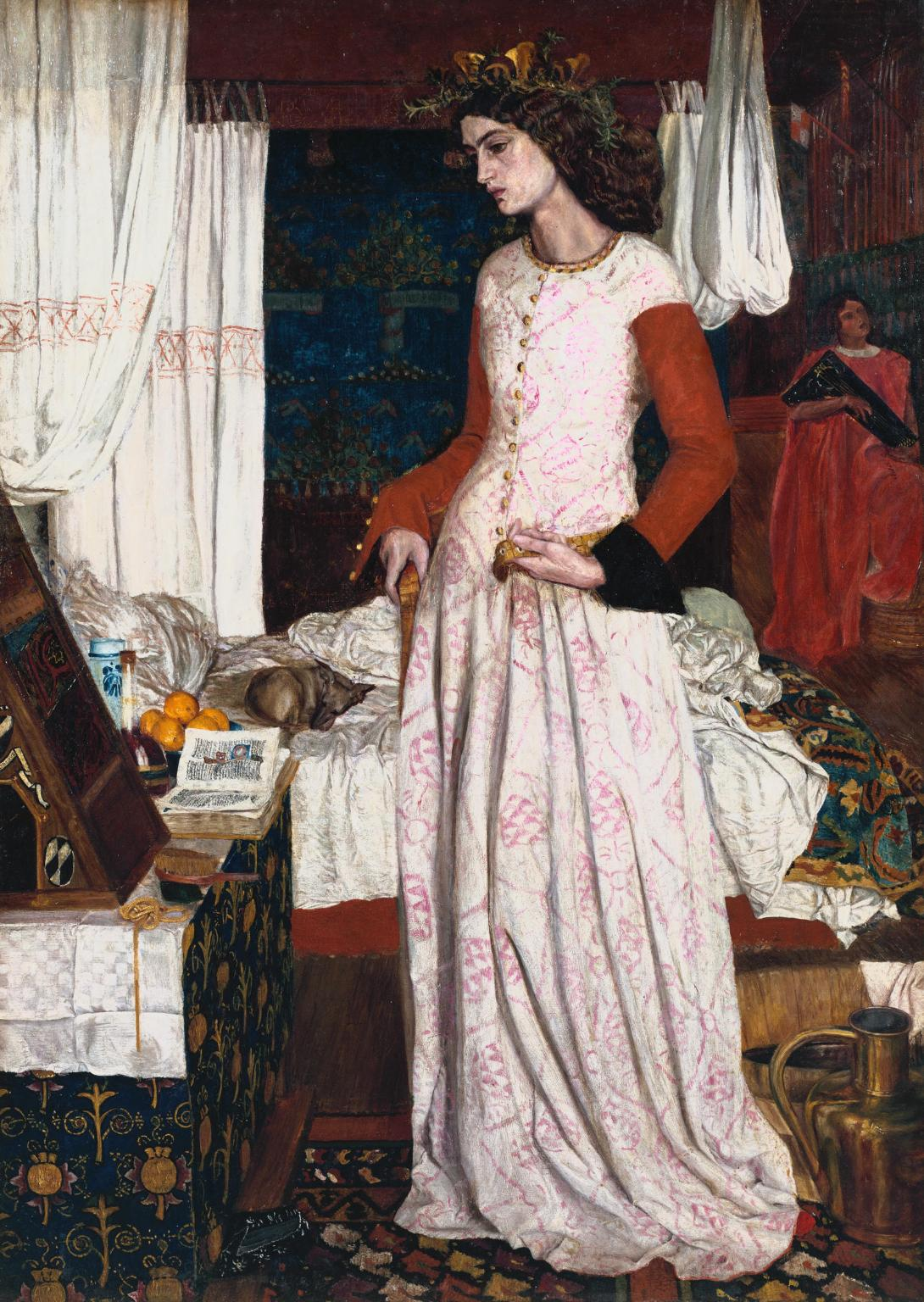
Figures
(Fig. 1) William Morris, La Belle Iseult, 1858. Oil on canvas. 28.26 x 19.76 in, Tate Britain.
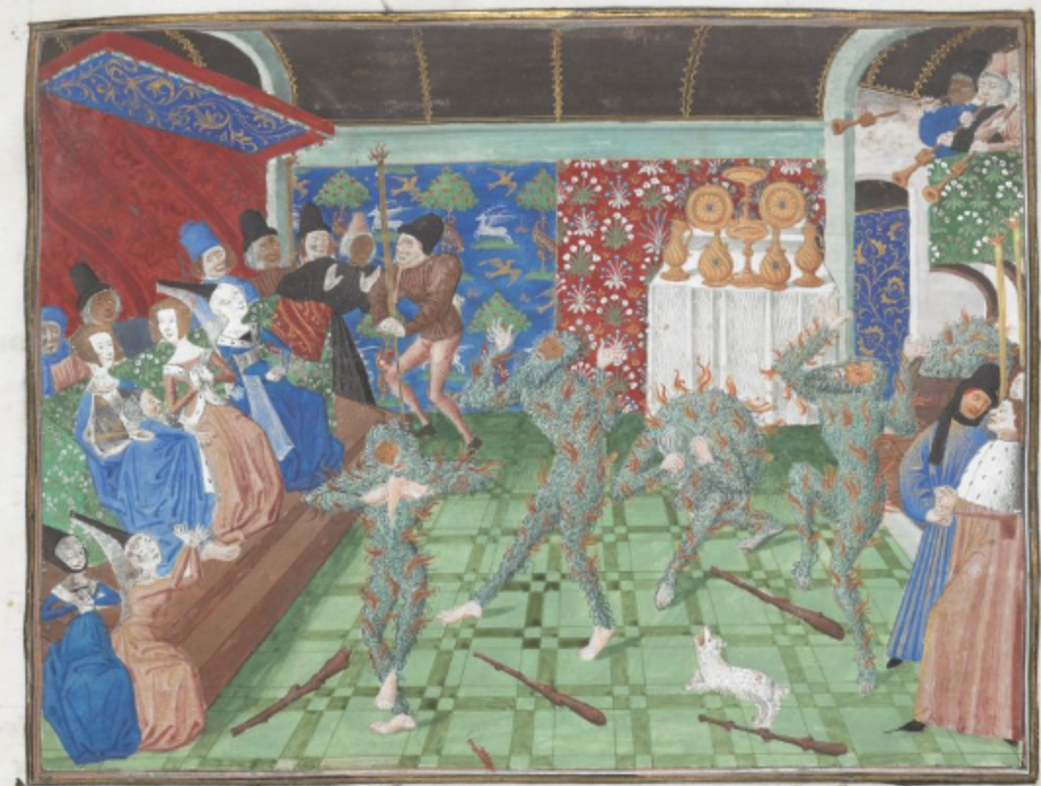
(Fig. 2) Jean Froissart, Chroniques (Chronicles), Volume IV, Part 2, folio 1r, c. 1470-1472. Illuminated Manuscript, The British Library.
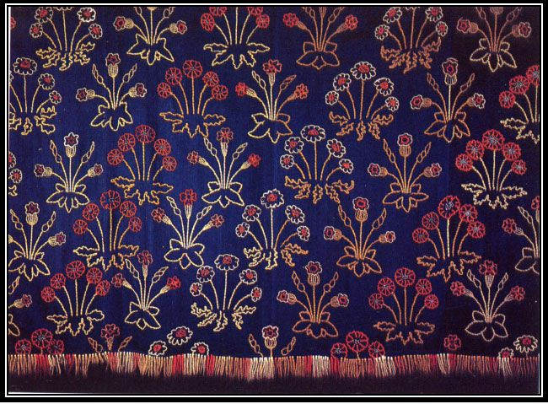
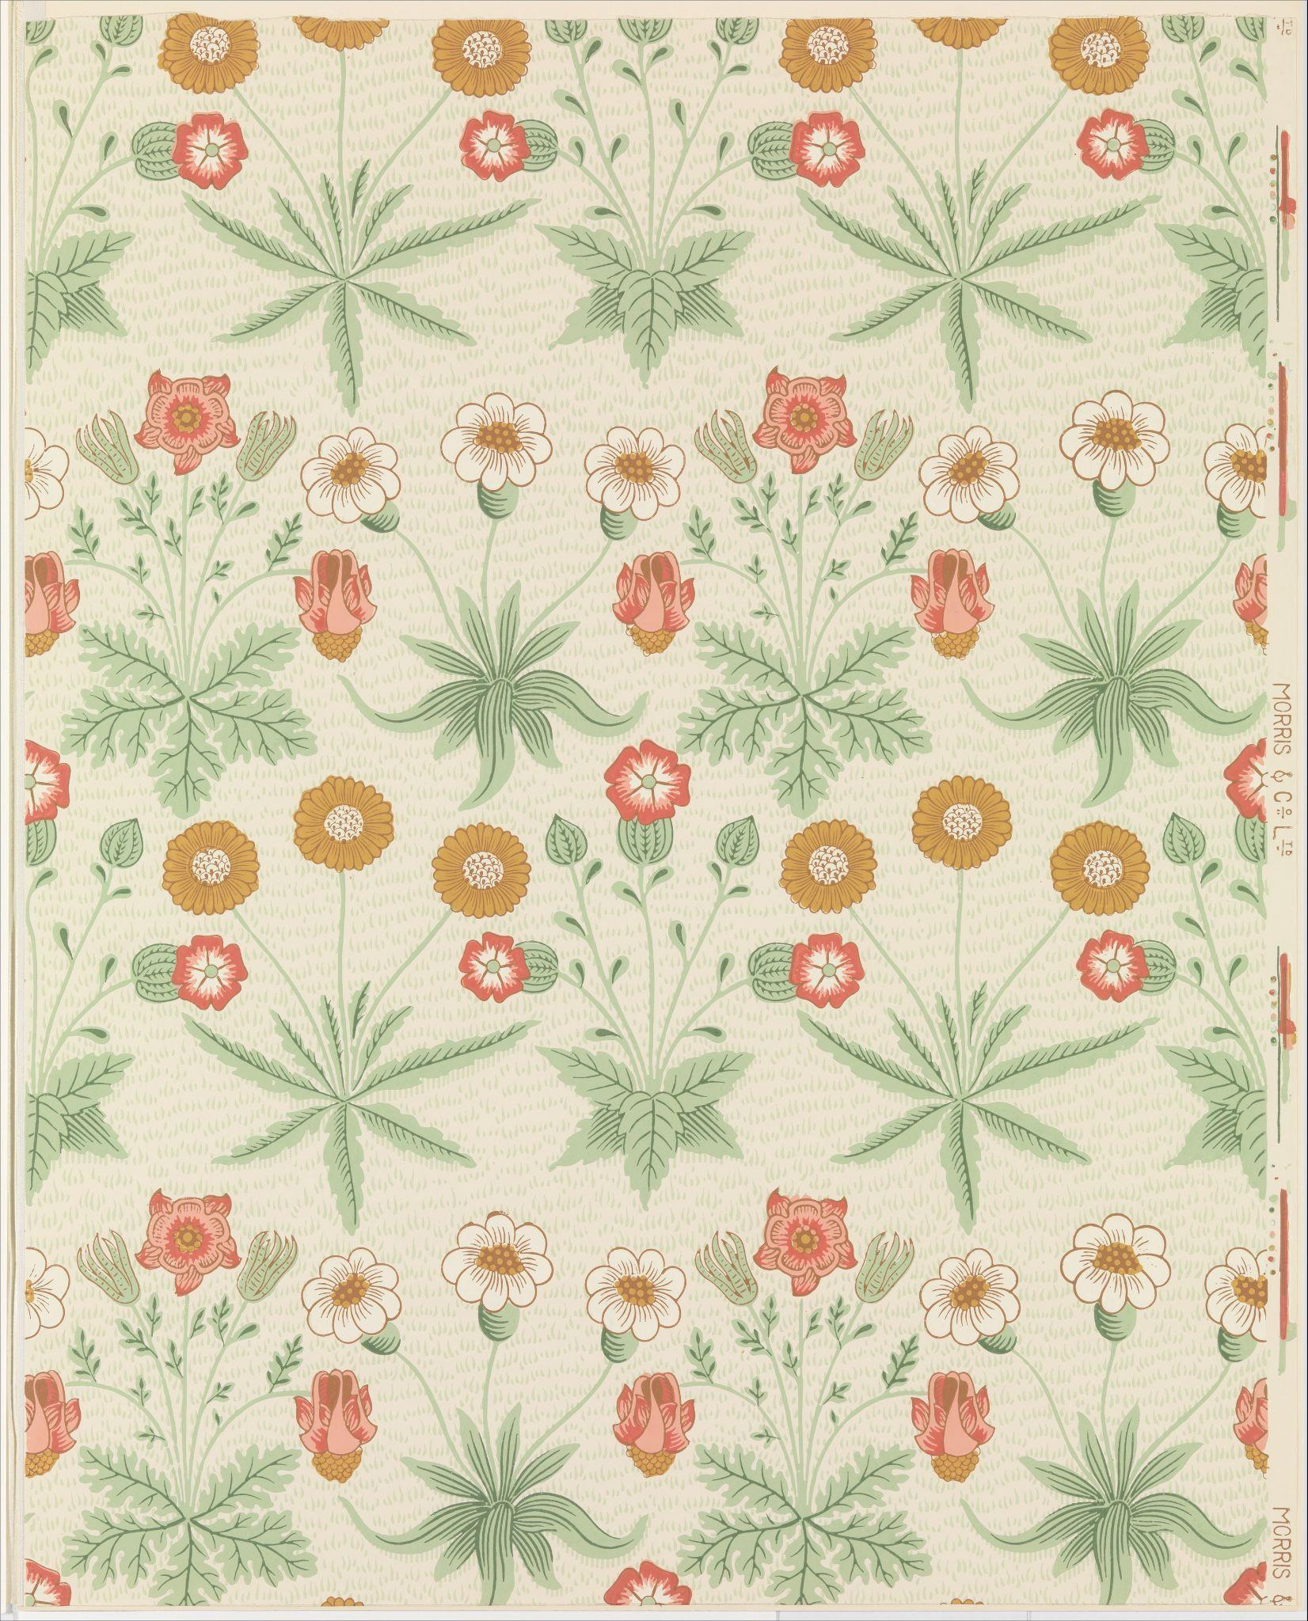
(Fig. 3) William Morris, Daisy embroidered hangings, c. 1859. Embroidery wools on indigo dyed serge, 16.7x206 including fringe.
(Fig 4) William Morris, Daisy wallpaper, 1864. Block-printed in distemper colors, 27 x 21 1/2 in. The Metropolitan Museum, accession no. 23.163.4b.

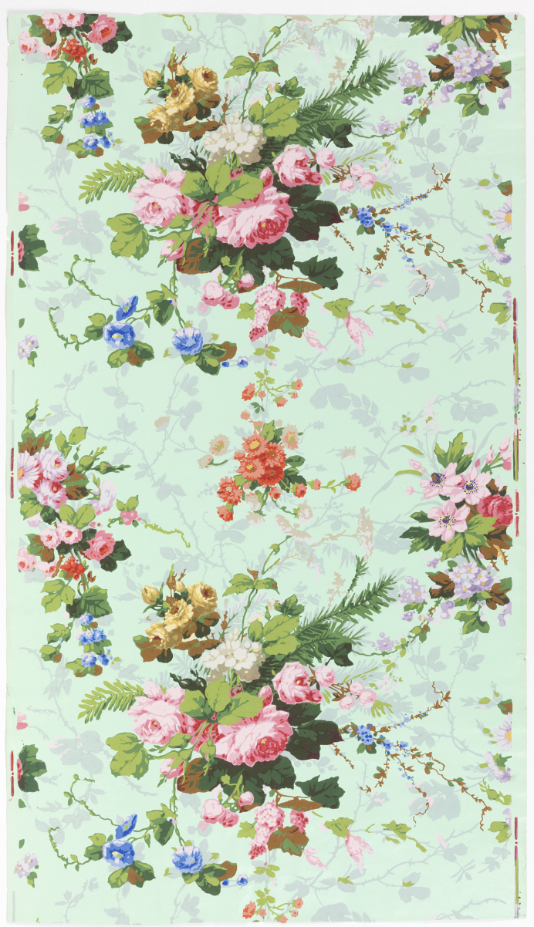
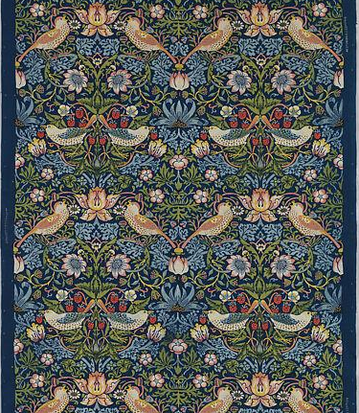
(Fig. 5) Sidewall, France, 1840–70; Block-printed on handmade paper; 87 x 49.5 cm (34 1/4 x 19 1/2 in.), Cooper Hewitt Smithsonian Design Museum, New York.
(Fig. 6) William Morris, Strawberry Thief, 1883. Cotton. The Metropolitan Museum, accession number 23.163.11.

Bibliography
Attwell, Anna Marie. Sexual Politics, Pomegranates and Production: William Morris’s The Defence of Guenevere and La Belle Iseult in Dialogue. https://open.conted.ox.ac.uk/sites/open.conted.ox.ac.uk/files/resources/Create%20Document/(Pages%20113-124)%20ANNA%20A%20(Group%203).pdf
Baker, Derek W. The Flowers of William Morris. Barn Elms, 1996.
Banham, Joanna, et al. William Morris and the Middle Ages: A Collection of Essays, Together with a Catalogue of Works Exhibited at the Whitworth Art Gallery, 28 September-8 December 1984. Manchester University Press, 1984.
British Library, The. “Harley MS 4380, Jean Froissart, Chroniques (the 'Harley Froissart').” Digitised Manuscripts, http://www.bl.uk/manuscripts/FullDisplay.aspx?ref=Harley_MS_4380.
Crawford, Alan. “Arts and Crafts Movement.” Grove Art Online, 2003, https://www.oxfordartonline.com/groveart/display/10.1093/gao/9781884446054.001.0001/oao-9781884446054-e-7000004452#oao-9781884446054-e-7000004452.
Helsinger, Elizabeth. “Pre-Raphaelite Poetry: Medieval Modernism.” The Oxford Handbook of Victorian Medievalism, edited by Joanne Parker and Corinna Wagner, Oxford University Press, 2020.
Ibbotson, Rosie. “Revisiting the Medievalism of the British Arts and Crafts Movement.” The Oxford Handbook of Victorian Medievalism, edited by Joanne Parker and Corinna Wagner, Oxford University Press, 2020.
Inglesby, Roisin. “Arts and Crafts Explained | William Morris and Woodblock Printing | Curator's Corner,” YouTube video, posted by "William Morris Gallery," 27 April 2021, https://www.youtube.com/watch?v=TgctzHOLcoY
Lepine, Ayla, and Corinna Wagner. “The Pre-Raphaelites: Medievalism and Victorian Visual Culture, A Revivalist Revolution: The Pre-Raphaelites and the Middle Ages.” The Oxford Handbook of Victorian Medievalism, edited by Joanne Parker, Oxford University Press, 2020.
“Medievalism.” Oxford Reference, 2023, https://www.oxfordreference.com/display/10.1093/oi/authority.20110803100147125;jsessionid=1F11E31DBE30AF3D5EA0C1FCB8C956D8#:~:text=Enthusiasm%20for%20or%20imitation%20of,8th%20century%20to%20the%2015th
Rasche, Anna. “Wallpaper in Bloom: Cooper Hewitt, Smithsonian Design Museum.” Cooper Hewitt Smithsonian Design Museum, 21 Oct. 2014, https://www.cooperhewitt.org/2014/10/21/wallpaper-in-bloom/.
Tate, The. “'La Belle Iseult', William Morris, 1858.” Summary, Tate Britain, 1 Jan. 1970, https://www.tate.org.uk/art/artworks/morris-la-belle-iseult-n04999.
Watt, Melinda. “Textile Production in Europe: Printed, 1600–1800.” In Heilbrunn Timeline of Art History. New York: The Metropolitan Museum of Art, 2000–. http://www.metmuseum.org/toah/hd/txt_p/hd_txt_p.htm (October 2003).
Watt, Melinda. “Nineteenth-Century European Textile Production.” In Heilbrunn Timeline of Art History. New York: The Metropolitan Museum of Art, 2000–. http://www.metmuseum.org/toah/hd/txtn/hd_txtn.htm (October 2004).

“Medievalism”, Oxford Reference.
A. Lepine, The Pre-Raphaelites, Medievalism and Victorian Visual Culture, The Oxford Handbook of Victorian Medievalism, 488.
E. Helsinger, Pre-Raphaelite Poetry, Medival Modernism, The Oxford Handbook of Victorian Medievalism, 555.
Marsh, La Belle Iseult, Journal of William Morris Studies, 16.
AM Attwell. Sexual Politics, Pomegranates and Production: William Morris’s The Defence of Guenevere and La Belle Iseult in Dialogue,117.
J. Banham and J Harris, William Morris and the Middle Ages: A Collection of Essays, Together with a Catalogue of Works Exhibited at the Whitworth Art Gallery, Catalogue, 119.
The British Library, Harely MS 4380, folio 1 r.
J. Banham and J Harris, William Morris and the Middle Ages: A Collection of Essays, Together with a Catalogue of Works Exhibited at the Whitworth Art Gallery, Catalogue, 113.
Ibid, 118.
Serge is a type of twill fabric.
D. Baker, The Flowers of William Morris, 72.
F. Fowle, “William Morris: La Belle Iseult”, Tate Britian.
A. Rasche, “Wallpaper in Bloom”, Cooper Hewitt Smithsonian Design Museum.
R. Ibbotson, “Revisiting the Medievalism of the British Arts and Crafts Movement”, Oxford Handbook of Victorian Medievalism, 530.
Ibid, 530.
A. Crawford, “Arts and Crafts Movement”, Grove Art Online.
M. Watt. “Nineteenth-Century European Textile Production.” In Heilbrunn Timeline of Art History.
R. Inglesby. “Arts and Crafts Explained | William Morris and Woodblock Printing | Curator's Corner,” YouTube video, 1:16.
Ibid, 1:45.
M. Watt, “Textile Production in Europe: Printed, 1600–1800.” In Heilbrunn Timeline of Art History.

