Squinting at the Details: An Analysis of Guercino’s Mars with Cupid

At a Sotheby’s auction in 1960s London, a painting was sold under the name “Achilles in his Tent, a View of the Battle of Troy in the Distance. Ten years later it would be discovered to be a Guercino, and a few more years to identify its central character. It now hangs in the Cincinnati Art Museum on permanent display correctly labeled as Mars with Cupid (fig. 1).
Since then, thousands of people have passed it in the gallery. Some are drawn in by its life-sized characters while others are attracted to the sense of drama, a key characteristic of the genre, rendered in soft feathery brushstrokes. Approaching the painting creates the illusion one is walking upon the distracted God of War himself, sitting on a rock, with his gaze captivated by something off to the right. He is depicted relaxed, sitting in profile, legs outstretched, and supporting his weight on the arm behind him. These traits seem unusual for the god, predominantly since there appears to be a battle ranging on in the background.
While a walled city is under siege by a wave of men outfitted in ancient armor, the god stares at someone beyond our sight with an almost congenial expression. Cupid can be found flying in the corner, depicted as a blond-haired infant, seen mirroring Mars’s gaze. With a heart in one hand and an arrow in the other, it would appear Cupid is to blame for the inattentive deity. In a symbol of literal disarmament, his sword and shield lay on the ground, forgotten nearby. The artwork is said to express that “love can conquer even the strongest warriors”.
Guercino’s Mars with Cupid is a highly symbolic piece with a narrative that can be revealed once the characters are correctly identified, and their known characteristics applied. It is the goal of this research to look at other elements in the piece, attempting to identify possible references using known historic events and repeating patterns that are found in Guercino’s work. This task is done with the hopes that it will reignite curiosity and assist in solving other mysteries still surrounding the artwork and the artist.
Prior to identifying and discussing the various elements of Mars with Cupid, it is necessary to provide some basic information about Guercino as it pertains to his influences and frame of reference. This task is made easy as the artist is well documented. He has appeared in art history books as early as 1678, recorded by Italian historian Carlo Cesare Malvasia in Felsina Pittrice, a text on baroque artists working in Bologna, Italy. However, the most useful document tends to be the artists own account book which details payments for his work as well as the names of those who commissioned them.
Using these documents one can piece together the life of Giovanni Francesco Barbieri, nicknamed Guercino or “squinter”. It paints the picture of a 17th century self-taught artist, born in Italy, and inspired by the works of Caravaggio and the Carracci. He traveled around his home country throughout his life, including a visit to Rome in 1621 on commission by Pope Gregory XV, before gaining prestige as the lead painter in Bologna after the death of Guido Reni in 1642.
Throughout the course of his career, Guercino depicted Mars numerous times. Each version contains similarities in physical characteristics, while key details remain unique to that piece. The differences become clearer when comparing Mars with Cupid with another work by Guercino, containing the same characters, such as Venus, Mars, and Cupid (fig. 2), completed around sixteen years earlier. From these comparisons it becomes apparent that each work contains a depiction of Mars and Cupid that mirror each other in body shape, facial structure, and hair features, while changes in the architecture and wardrobe highlight specific additions made by the artist that are unique to that artwork. The features that stand out in Mars with Cupid are Mars’s armor, his sword, the walled city, and the village.
Starting with the God himself, he is depicted in armor, common in his representations, and reference to his role in Roman mythology. In Mars with Cupid, it is characterized by layers of scale armor as well as long horizontal segmented bands protecting the upper arm. Known as “Lorica Sqamata” and “Lorica Segmentata” respectively, these traits are found in the armor of Rome from around 31 BCE - 476 CE. In comparison, within Venus, Mars, and Cupid, Mars is seen in full breast plate armour with a distinct conical helmet known to be worn by the Italian military in the 16th century, which would have been more modern for the time the painting was commissioned. This leads to speculations on why Guercino chose to depict Mars with Cupid in ancient Roman armor, and if it could be a reference to the role he plays in the origin myth of Rome; A story in which Mars is the father of Romulus and Remus, who would grow up to be the founders of the city.
A widely celebrated element of the Roman foundation myth is the mother wolf who saved the twin brothers by nursing them herself until a shepherd adopted the boys. A statue of the wolf, referred to as the Lupa Capitolina (fig.3), stands in her honor in Rome today, a classical representation of the story. It also could have been inspiration for another interesting detail found on the ground of Mars’s feet.
As it lays resting on his shield the sword’s wide blade can be viewed in profile gleaming against the dull stone. The blade comes to an abrupt point on one end while the other, known as a pommel, features an animal head. Shown with pointed ears and a long snout it bares the general resemblance to a canine or wolf.
The importance of the sword as a symbol in the artwork is well understood, the act of Mars discarding or ignoring his weapons are key to the narrative. However, what has not been called into question is whether the animal located on the swords pommel has symbolic meaning. In the past it has been established Guercino uses symbols in his painting to have dual meanings. In Mars with Venus and Cupid a quiver lays near Venus as she directs Cupid to shoot his arrow directly at the viewer. At first glance it could be considered something that simply fits the work’s narrative. However, the eagle detail on the quiver was a well-known symbol for the Este family, with documentation showing the painting was commissioned by Francesco I d’Este, the Duke of Modena at the time.
Finding the patron is not always a realistic goal but offers invaluable clues towards possible symbolic references. Guercino’s account book reveals these identities, allowing for a search into their individual backgrounds in an attempt to draw compairison to details in the work. The suggestion to apply this method to Mars with Cupid comes from art historian Dr. John T. Spike who stated, “It is worth considering the possibility that the armed engagement depicted in the background refers to one of [The Patron’s] own experiences” in a text on the museum’s Italian Paintings.
It is documented in Guercino’s account book that General (Baron) Luigi Mattei paid the artist in full on October 15th, 1649, for Mars with Cupid after an initial down payment made by the General early in the same year. General Mattei, a member of a well-known Roman family, had recently led the forces of Pope Urban VIII against the Castro Duchy, a fiefdom in central Italy at the time. The battle was an easy success for the General, meeting little resistance from the city of Castro where the battle was centrally located. When looking at a depiction of the city from the same time period (fig. 4) it becomes possible to compare the architectural structures to determine the possibility that Guercino added specific details to reflect personal references for the General.
In the course of this comparison a number of similarities can be extracted, however it is equally important to look at other identifying features that might assist in the identification of the participants in the war.
In the mid ground men on horses and on foot rush forward to assault the elevated city. They wear battle armor much in the same style as our central character, while one waves a striped flag. These traits may have real life counterparts but have been featured in other Guercino paintings which could simply demonstrate the artist stylistic choices.
In a work titled The Intervention of the Sabine Woman to Make Peace and the Romans and the Sabines (fig. 5) Guercino shows men in much the same armor in another known foundation myth for the city of Rome. The story refers to how the city was populated, which starts first with offering citizenship to the disenfranchised, then kidnapping the women from other local cities. In Guercino’s version he shows the aftermath of the kidnapping in which Romulus and a Sabine leader are stopped from fighting by a Sabine woman in an attempt to make peace between the men of her people and the men of Rome. The only true notable difference between the armor is that in Mars with Cupid it does appear to be more body coverage which could imply a more modern armor.
Of course, the best way to determine the identity of an army is to look at the banner they fly. The flag of the attacking men can be seen in the mid-ground and appears to be made up of a repeating pattern of alternating solid-color horizontal stripes. It is possible that this design can be linked to a specific group led by General Mattie but when again looking at other works by the artist it becomes apparent that he utilized this design before. Titled Saint William Receives the Monastic Habit (fig. 6), Guercino’s work features a number of characters observing Saint William putting on a monk’s habit in the presence of Saint Benedict of Aniane. Behind these central characters a soldier can be seen holding a flag that closely resembles the one in Mars with Cupid. There has been speculation on it’s meaning as the flag closely resembles a sash worn by Saint William, also known as Duke of Aquitaine, with a theory that they are related and imply a connection with Aquitaine, though no research has been done to prove or disprove the claim.
It is impossible to properly examine the battle without attempting to identify the pronounced structure that appears in silhouette within the city. It’s most distinguishable elements, columns, pediment, and portico, are well-known features in Roman architecture. The best example of this design can be seen in the Pantheon, a favored symbol of Rome, that has stood since at least 125 CE.
It is true that after reviewing all the elements of the battle, the attackers, the flag, and the structure, one could end up with many seemingly incompatible references. It is the goal of this research paper to offer an abundance of connections and sources in order to initiate conversation rather than offer conclusive answers. Many issues stand in the way of truly knowing the artist’s mind and even more from knowing his subconscious. When dealing with an artist centralized in Italy it is impossible to know what items in their work are specific recreations of buildings or just minimalist structures grouped together to symbolize a city. This issue comes into play when observing a possible iconographic element that can be seen to the left of the god.
Shown in a darker pallet, a dense city can be seen behind Mars. As the view looks over the roof tops, certain architectural structures can be seen. Some of the buildings come to a pointed roof while others appear as tall defensive towers. Windows are depicted both circular and square with some coming to an arch at the top. The size of the structures indicated both personal and community use.
Attempts at identifying the city have been difficult due to the similarities in building designs of the geographically adjacent locations traveled by the native Italian artist. There is, of course, the possibility that the city is just a continuation of the background, a part of the battle scene shown to the painting’s right. In this case the city could be compared to the view of Castro (fig. 4) and on initial comparison a number of similarities in architecture can be found. However, for arguments sake this city will be treated as its own possible symbolic reference. Even if what is depicted are a grouping of buildings used to symbolize a generic city it would be unlikely the artist didn’t use familiar surroundings to serve as references.
Of the Italian cities to choose from some evidence points to Guercino’s hometown of Cino, Italy. A few years before the commission for Mars with Cupid the approaching War of Castro was becoming too close and caused the artist to move from his home and take up residence in Bologna as its lead painter. Perhaps in remembrance of the town he fled, it should be considered that this depiction is a reference, painted for a man who participated in the event, even if the artist himself did so autogenetically.
Observing and attempting to identify viable references can assist in understanding the artist and the art before us, but it can also aid us in the study of paintings lost to time.
Something that becomes apparent when looking at the varying depictions of Mars the artist had created over time, very rarely does he appear alone. When he does this, it usually means that the painting has a companion piece that features a depiction of Venus. An example would be Guercino’s pendant paintings Mars as a Warrior and, in a separate work, Venus and Cupid (figs. 7, 8). With this pattern, as well as details found in the artists account book, this leads to the likelihood that Mars with Cupid is only half of the narrative with essential details lost with the painting.
Referred to as “La Verene” or “the Venus”in the artist account book, records indicate that the painting was actually completed prior to its Mars counterpart. Both paintings were sent to General Mattie and remained together until around 1721 when part of the inherited collection was sold. Since then, some individuals have attempted to reunite the two by comparing Venus paintings by Guercino to Mars with Cupid. At one point the painting was believed to be found in Bologna but upon further study it was determined that the Venus in question (fig. 9) had been cut down with her Mars appearing next to her before the resize. Since then, others have looked into sketches by the artist for clues to the identity of the true Venus.
It is the position of this paper that the clues within Mars with Cupid will aid in the identification of the overall narrative in which Mars and Venus are participating. Scenes that feature the two as lovers often refer to a story found in the Odyssey. A story in which Venus is married to the god Vulcan with Mars being her secret lover, eventually the two adulterers are found out and captured in a bronze net by Venus’s husband to the shame of both gods. Though based off of the scene in Mars with Cupid this does not appear to be the case, as in Homer’s tale, the God was not motivated by Cupid's arrow. Of course, it could be argued that in the work Cupid is a symbolic representation a Mars’s desire, but based off the winged god's actions in other paintings it is useful to examine his role.
When looking at his roles in Venus, Mars, and Cupid (fig. 2) it is apparent that Venus is directing Cupid to fire his arrow at the viewer, or specifically the patron, but not at Mars. In the pendant to Venus and Cupid (fig. 8) She is pointing to the left of the painting where Mars would be placed. His reaction can be seen in Mars as a Warrior (fig. 7) with him appearing to hold his arm up as a sign of resistance. In Mars with Cupid it is understood that he is affected by the arrow, however Venus’s actions will be left unknown with speculations from encouraging Cupid, to her burning his arrows to put an end to Mars’s infatuation.
The answer to the identity of the lost pendant may be resolved with a close study of the identified half, but even so it is just one of many reasons to study the details of Mars with Cupid. With a speculative examination and historic references, it can become possible to track down what is lost whether that is a painting, or something unknown about the artist. Facts like his location at various points in his career allow us to look at probable influences. Then it is possible to determine the likelihood that the artist saw the Pantheon on his trip to Rome, meanwhile questions about the artist’s mind will have to be left to speculation. Regardless, the artist specifically painted Mars with Cupid to feature the armor, the sword, the walled city, and the village in the way it appears in the painting. Pairing what is depicted with historic records, and patterns in Guercino’s work, it may be possible to solving mysterious, or just lead to a better understanding of Guercino. Without that initial look into the details of Mars with Cupid the painting could still be labeled “Achilles in his Tent, a View of the Battle of Troy in the Distance”.

Bibliography

Butcher, S.H., Lang, Andrew. The Odyssey of Homer. London: The Medici Society Limited, 1924.

Cincinnati Art Museum. Cincinnati Art Museum: Collection Highlights. London: GILES, 2008.

Cincinnati Art Museum. “Explore the Collection.” Cincinnati Art Museum. Cincinnati Art
Museum, 2024. https://www.cincinnatiartmuseum.org/art/explore-the-collection?id=19761060

Ghelfi, Barbara (ed.). Il Libro Dei Conti Del Guercino: 1629-1666. Bologna: Elemond Editorial Association, 1997.

Hansen, William. Handbook of Classical Mythology. Santa Barbara: ABC CLIO Inc., 2004.

Hodge, Susie. The Short Story of Art. Great Britain: Laurence King Publishing, 2017.

La Rocca, Donald J. How to Read European Armor. New York: The Metropolitan Museum of Art, 2017.

Malvasia, Carlo Cesare. Felsina Pittrice. Rome: Marco Pagliarii’s Printing Shop, 1869.

Mahon, Dennis. Guercino: Master Painter of the Baroque. Washington: National Gallery of Art, 1992.

Minneapolis Institute of Art. “Restoring a Masterwork II: Guercino’s Erminia and the Shepherds.” Conservation and the Museum, Minneapolis Institute of Art, 2004, https://archive.artsmia.org/restoration-online/guercino/the-artist.cfm.html.

Mulroy, David. 75 Classical Myths: Condensed from their Primary Sources. California, Cognella, 2012.

National Gallery of Art. “Guercino,” National Gallery of Art. National Gallery of Art, 2024. https://www.nga.gov/collection/artist-info.1364.html#biography.

Olive University. “The Castro Wars,” History and Tourism in Umbria, The Olive University, 2024, https://web.archive.org/web/20170703224505/http://www.oliveuniversity.org/local_color.htm.

Ranogajec, Paul A. “The Pantheon,” Smart History, Smarthistory, 2024, https://smarthistory.org/the-pantheon/.

Robinson, H. Russell. The Armor of Imperial Rome. Michigan, Scribner, 1875.

Spike, John T. Italian Paintings in the Cincinnati Art Museum. Cincinnati: Cincinnati Art Museum, 1993.

Fig. 1
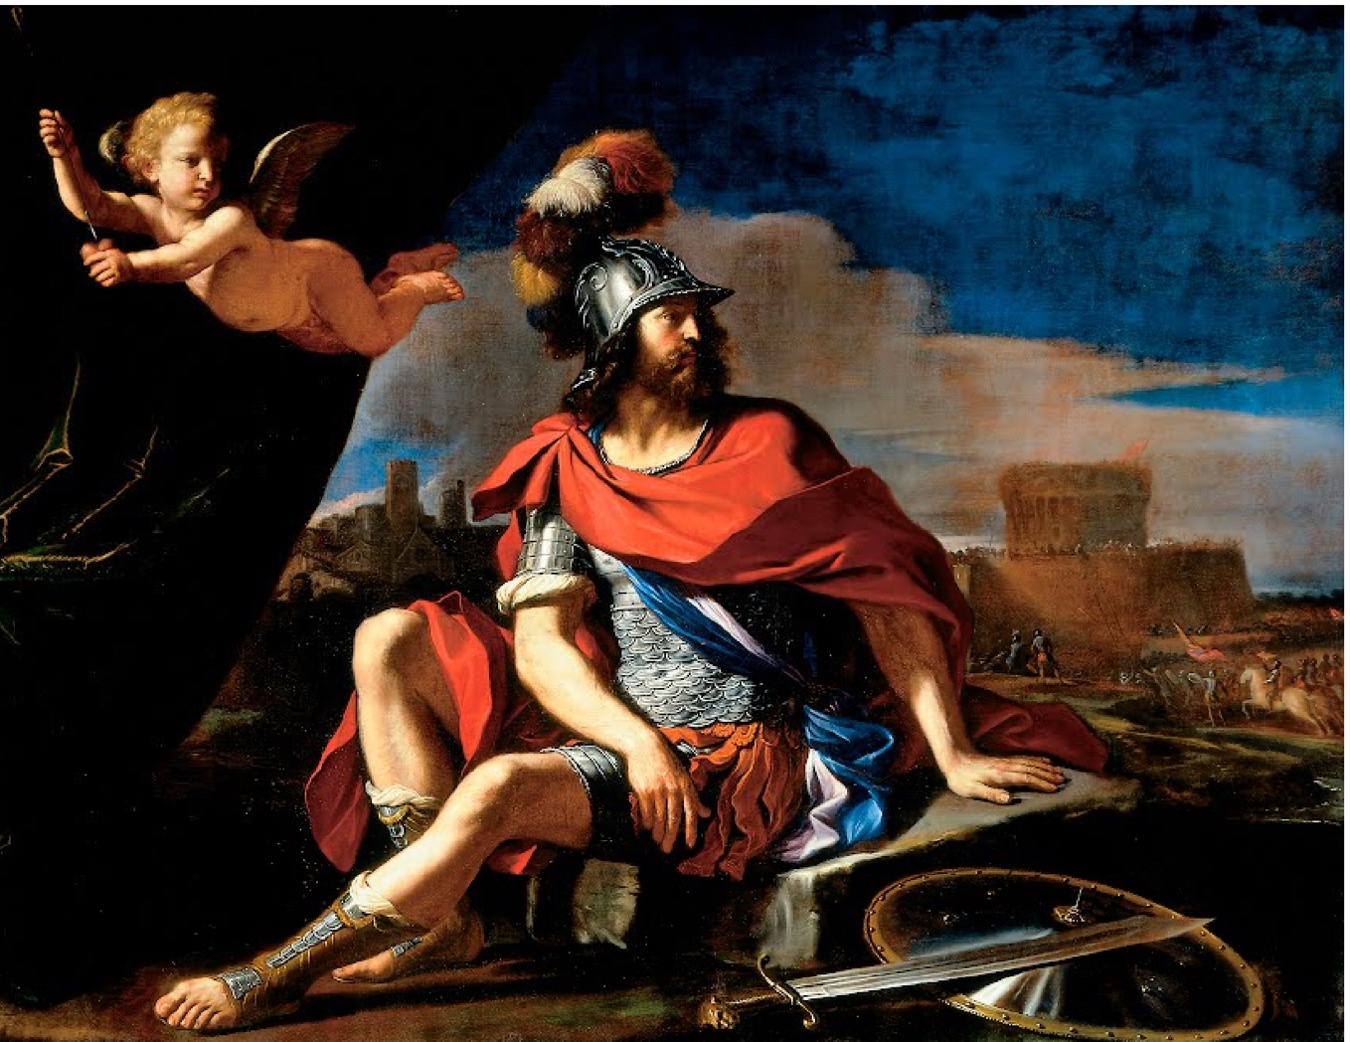
Barbieri, Giovanni Francesco, “Mars with Cupid,” 1649, oil on canvas, 176.8 x 233.7 cm. Cincinnati, Cincinnati Art Museum.

Fig. 2
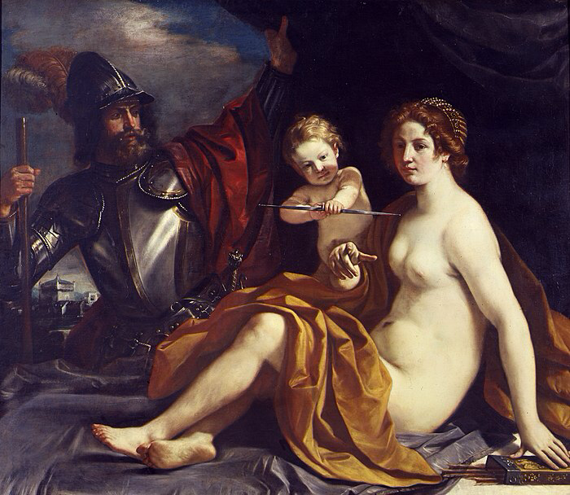

Barbieri, Giovanni Francesco, Venus, Mars, and Cupid, oil on canvas, 139 x 161 cm. Modena, Galleria Estense

Fig. 3
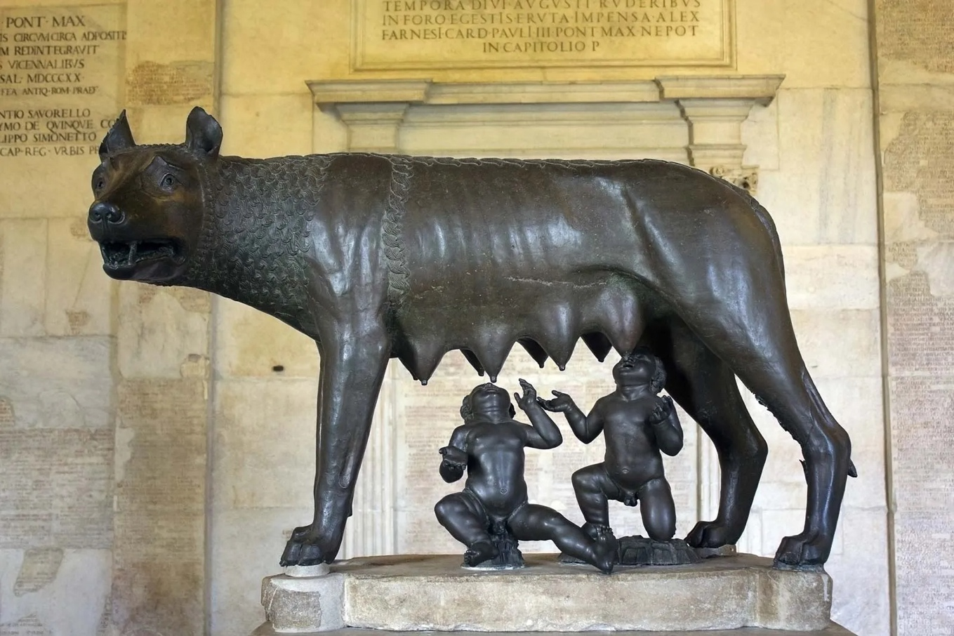

Lupa Capitolina, bronze sculpture, 5th century bc, 75 x 114 cm. Italy, Museo Capitolini.

Fig. 4

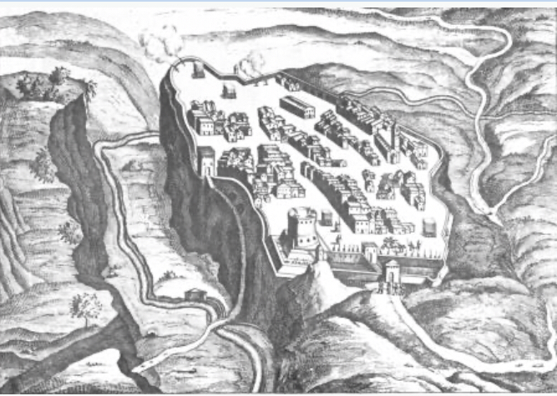

Castro, da J. Blaeu, The Theater of the States and Marvels of Italy, Expressed in the Face of Ancient times by Ioanne Blaeu, p. 251, Amsterdam 1663

Fig. 5
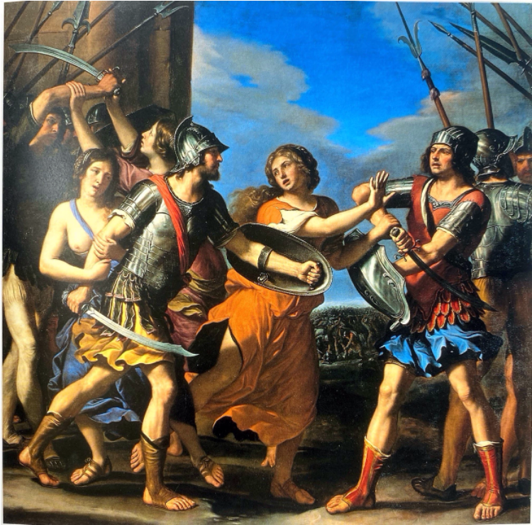

Barbieri, Giovanni Francesco, The Intervention of the Sabine Woman to Make Peace Between the Romans and the Sabines, oil on canvas, 253 x 267 cm, Paris, Musee du Louvre

Fig. 6
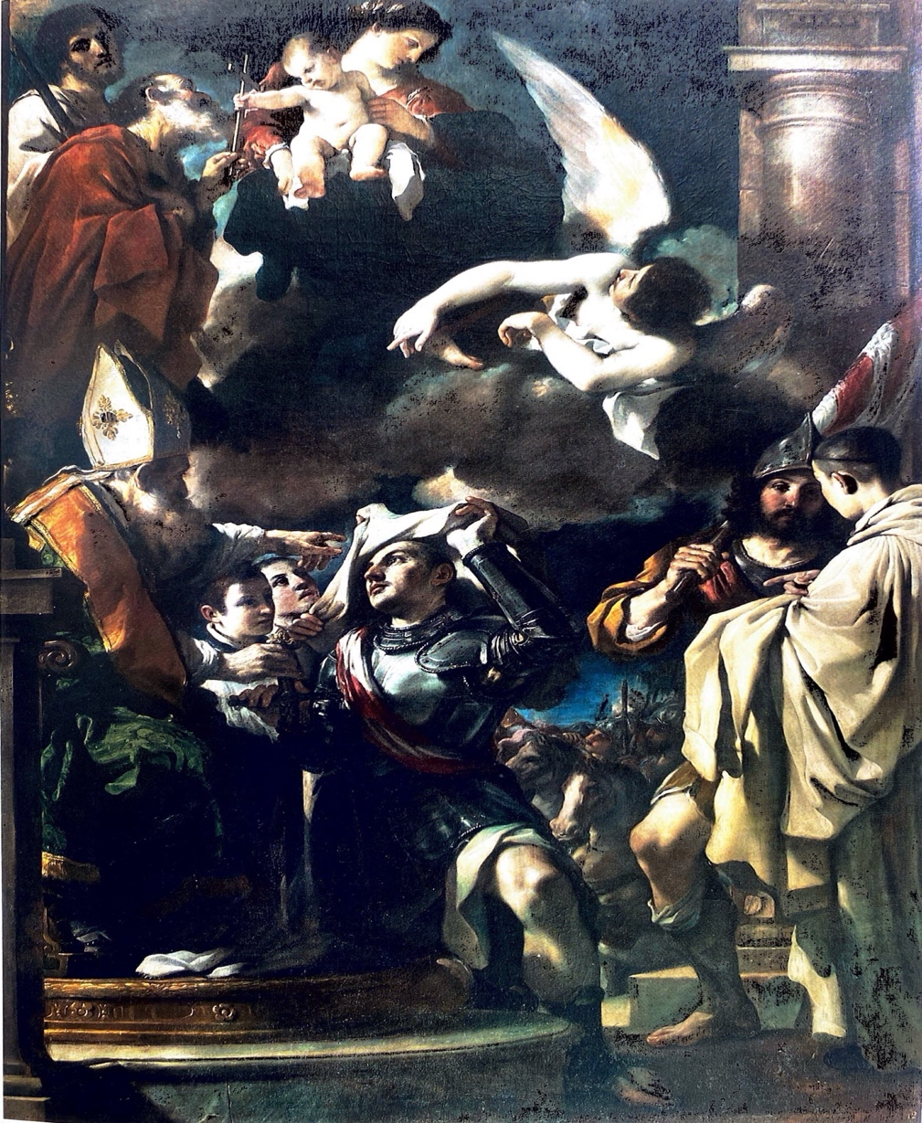

Barbieri, Giovanni Francesco,, Saint William Received the Monastic Habit, 1620, oil on canvas, 340 x 228 cm, Bologna, Pinacoteca Nazionale

Fig 7.
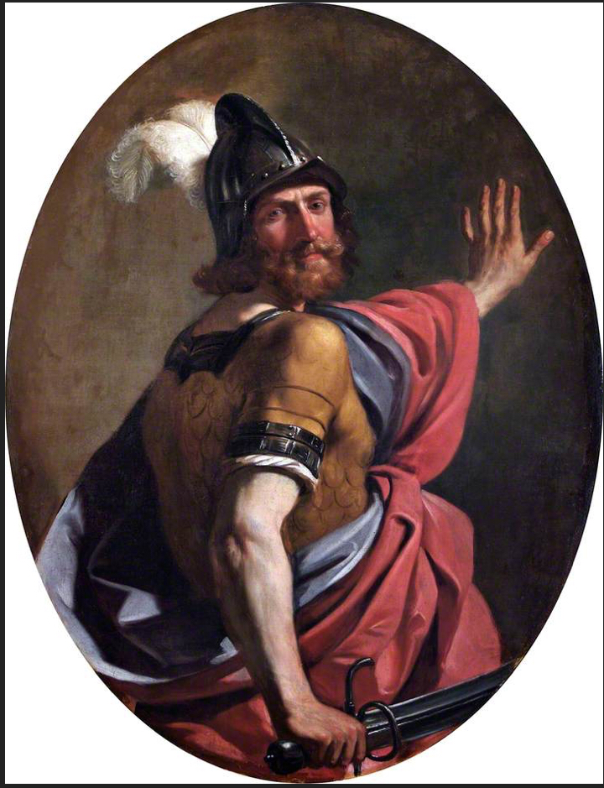

Barbieri, Giovanni Francesco, “Mars as a Warrior” c. 1634, 48 x 66 cm, oil on canvas, London, Victoria and Albert Museum

Fig. 8
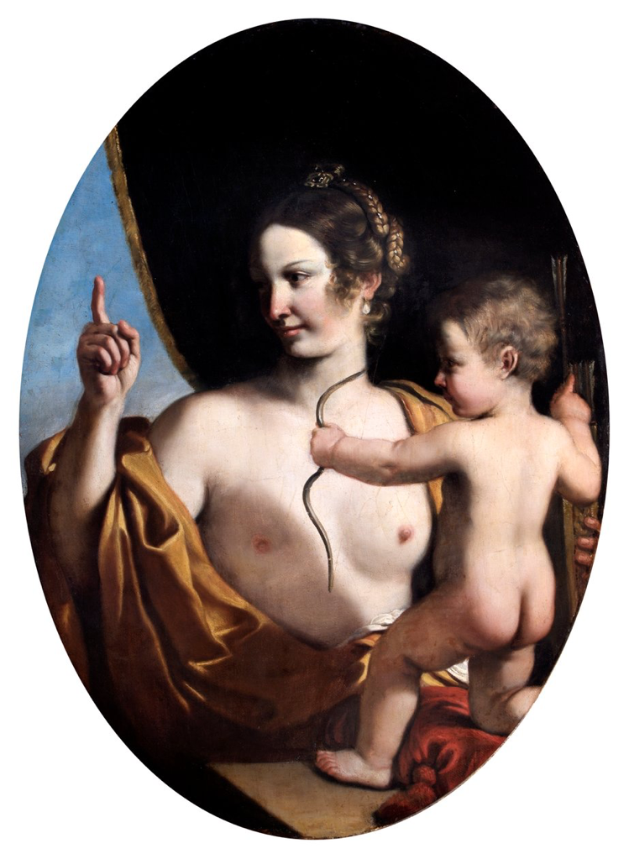
Barbieri, Giovanni Francesco, Venus and Cupid, 1634, 48 x 66 cm , oil on canvas, London, Wellington Museum

Fig. 9
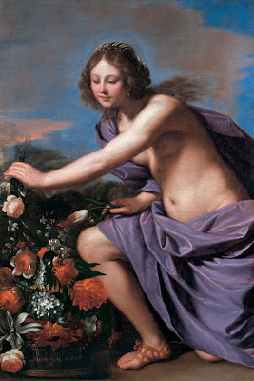
Barbieri, Giovanni Francesco, “La Verene,” 1649,
oil on canvas, 176.8 x 233.7 cm.
Bologna, Fondantico di Tiziana Sassoli.

John Spike, Italian Paintings in the Cincinnati Art Museum (Cincinnati: Cincinnati Art Museum, 1993), 34
Cincinnati Art Museum, “Explore the Collection,” Cincinnati Art Museum. Cincinnati Art Museum, 2024. https://www.cincinnatiartmuseum.org/art/explore-the-collection?id=19761060
Susie Hodge, The Short Story of Art (Great Britain: Laurence King Publishing, 2017), 23.
William Hansen, Handbook of Classical Mythology (Santa Barbara: ABC-CLIO Inc., 2004), 83.
Cincinnati Art Museum. Cincinnati Art Museum: Collection Highlights (London: GILES, 2008),191.
Carlo Cesare Malvasia, Felsina Pittrice (Rome: Marco Pagliarii’s Printing Shop, 1869), 172.
Barbara Ghelfi (ed.), Il Libro Dei Conti Del Guercino:1629-1666 (Bologna: Elemond Editorial Association, 1997), 166.
National Gallery of Art, “Guercino,” National Gallery of Art, 2024. https://www.nga.gov/collection/artist-info.1364.html#biography.
Minneapolis Institute of Arts, “Restoring a Masterwork II: Guercino’s Erminia and the Shepherds,” Conservation and the Museum, Minneapolis Institute of Art, 2004, https://archive.artsmia.org/restoration-online/guercino/the-artist.cfm.html.
Denis Mahon, Guercino: Master Painter of the Baroque (Washington: Nationally Gallery of Art, 1992) 246 – 248.
H. Russell Robinson, The Armor of Imperial Rome (Michigan: Scribner, 1975) 42.
Donald J. La Rocca, How to Read European Armor (New York: The Metropolitan Museum of Art, 2017), 51-55.
David Mulroy, 75 Classical Myths: Condensed from their Primary Sources (California: Cognella, 2012), 136-137.
Mulroy, Guercino, 246.
Spike, Italian Paintings, 34.
Ghelfi, Il Libro Dei Conti, 143.
The Olive University, “The Castro Wars,” History and Tourism in Umbria, The Olive University, 2024, https://web.archive.org/web/20170703224505/http://www.oliveuniversity.org/local_color.htm.
Williams, Handbook of Classical, 85.
Mahon, Guercino, 264
Mahon, Guercino, 195.
Mahon, Guercino, 196.
Paul A. Ranogajec, “The Pantheon,” Smart History, Smarthistory, 2024, https://smarthistory.org/the-pantheon/.
Mahon, Guercino, 314.
Ghelfi, Il Libro Dei Conti, 140.
Spike, Italian Paintings, 34.
S. H. Butcher and Andrew Lang, The Odyssey of Homer (London: The Medici Society Limited, 1924), 92-93.

